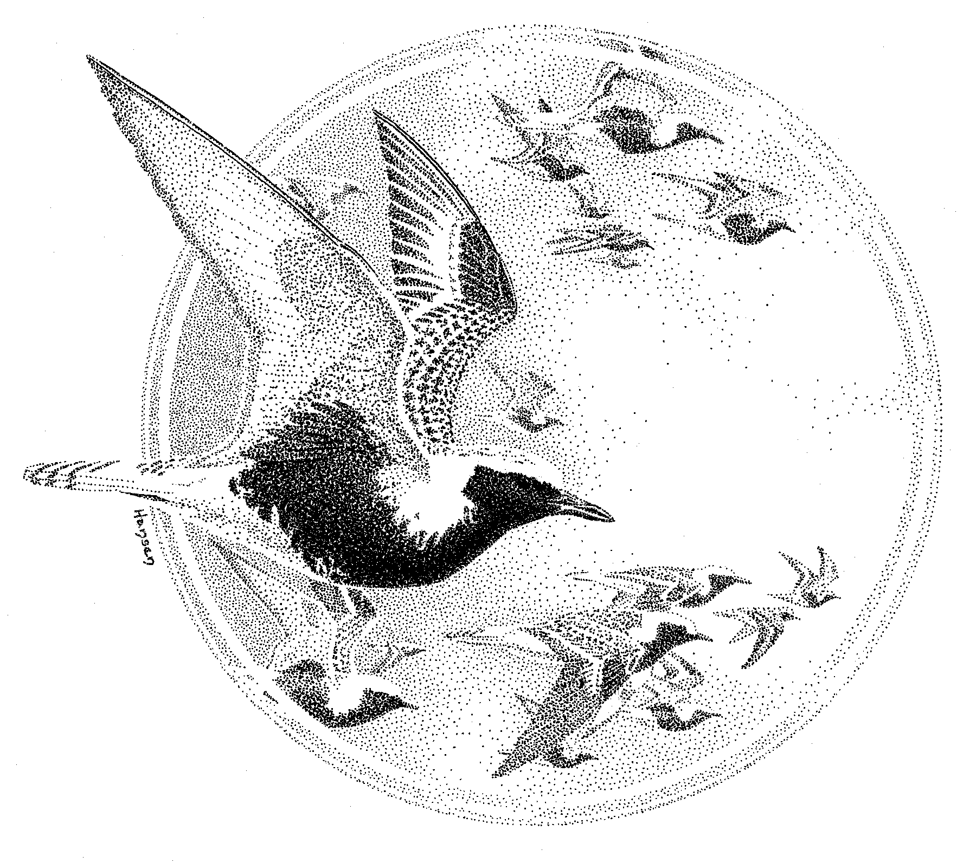U.S. Shorebird Conservation Plan

Lower Mississippi/Western Gulf Coast
Shorebird Planning Region

April 2000

Prepared by:

Gulf Coastal Prairie Working Group
Mississippi Alluvial Valley/West Gulf Coastal Plain Working Groups

Coordinated by:

Lee Elliott
USFWS
6300 Ocean Dr.
Campus Box 338
Corpus Christi, TX 78412

Keith McKnight
Ducks Unlimited, Inc.
One Waterfowl Way
Memphis, TN 38120

Executive Summary

The Lower Mississippi /Western Gulf Coast Region is rich with a variety of shorebird habitats. Shorebird habitats and patterns of use are divided, however, rather distinctly between truly coastal (Gulf Coastal Prairie: GCP) and non-coastal habitats (Mississippi Alluvial Valley/West Gulf Coastal Plain: MAVGCP). Hence, these regions are treated separately throughout the plan.

Gulf Coastal Prairie
Because of the geographic location of the GCP region, and the diversity of habitats provided by rice fields, beaches, coastal marshes and lagoons, large numbers of shorebirds migrate, winter, and breed in the GCP, making this is one of the most important regions in the United States for shorebirds. Of the 35 species regularly occurring in the GCP, four are considered Highly Imperiled, whereas 13 are of High Concern. The GCP is considered to be of extremely high importance for 14 species, and of considerable importance for an additional 21 species. Thirty-five percent of the 17 species with the highest priority scores are found predominately in beach habitats (Piping Plover, Snowy Plover, Wilson’s Plover, Ruddy Turnstone, Sanderling, American Oystercatcher), with an additional 29% found in wet meadow/prairie habitats (American Golden-Plover, Mountain Plover, Long-billed Curlew, Eskimo Curlew, Buff-breasted Sandpiper).

A number of habitat management issues exist in this region, including encroachment of urban and industrial development in coastal areas, disturbance of beach and mudflat habitats, potential for chemical spills and other types of discharges, sea-level rise, decreasing freshwater inflows to coastal wetlands, invasive plant species, and declining rice culture. This plan outlines specific goals, objectives, and biological assumptions associated with each of these issues. Shorebird habitat goals for the region are to (1) ensure at least stable populations of beach-nesting shorebird species (Wilson’s Plover, Snowy Plover, American Oystercatcher); (2) ensure that habitat is not limiting to non-breeding shorebird species that utilize beach habitats; (3) ensure that habitat is not limiting to non-breeding maritime shorebird species that utilize non-beach habitats; and (4) ensure that habitat is not limiting to populations of shorebird species that utilize non-maritime habitats, especially during southward migration.

Attainment of these goals will require effective and much-increased implementation, monitoring, and evaluation. Coordination of these activities will best be accomplished through the Gulf Coast Joint Venture, with technical guidance provided by a shorebird technical advisory team.

Mississippi Alluvial Valley/West Gulf Coastal Plain
Of the 43 species recorded in the MAVGCP, 29 occur regularly. Species of concern span a variety of habitats and foraging guilds – from terrestrial gleaners (American Golden-Plover) to aquatic probers (Least Sandpiper).

Whereas several species winter and breed in MAVGCP, most of the shorebirds found in this region utilize the area as stopover habitat. Clearing of much of the Mississippi Alluvial Valley, with resulting open agricultural fields, has resulted in tremendous potential for providing shorebird habitat. Supplying the necessary mix of water depth and vegetative structure at the appropriate times is the most important management issue in this region.

Habitats in the region that possess the greatest potential for shorebirds include agricultural fields, moist soil impoundments, semi-permanent impoundments, and aquaculture ponds. Recommended management practices for each of these habitat types are described in this plan. Because of the abundance of agricultural and aquacultural land with water control capabilities, and the prevalence of water management for waterfowl in the region, opportunities for shorebird habitat management are substantial. Perhaps the factor most important to maintaining and increasing habitat for shorebirds in the MAVGCP is outreach and education. Providing land managers and supervisors with specific management information (migration chronology, water depth and vegetation density tolerances, etc.) should facilitate an increase in the quality and quantity of shorebird habitat in the region.

Regional habitat objectives previously were set for the Lower Mississippi Valley by the Lower Mississippi Valley Migratory Bird Initiative based on fall population estimates. Two general aspects of these objectives are in particular need of attention: (1) testing assumptions of the model upon which habitat objectives are based, (2) inclusion of the West Gulf Coastal Plain BCR in the model. Because the habitat objectives model is based on untested assumptions regarding population size, obtaining better estimates of population abundance and chronology are the highest research priorities. Of the two assumptions of the model that have been tested, one (food density) appears to be valid and one (habitat carrying capacity; i.e. birds per ha) is suspect.

Coordination of continued planning, implementation, and evaluation of this plan will be provided by the Lower Mississippi Valley Joint Venture Office. Interested members of the Regional Working Group will serve as a technical advisory team, providing input to the LMV Joint Venture with regards to the biological foundation and evaluation of shorebird habitat management objectives.
1.0 Gulf Coastal Prairie

1.1 Description of the Region

The Gulf Coastal Prairie Planning Region is identical to the North American Bird Conservation Initiative (NABCI) Gulf Coastal Prairie Bird Conservation Region (BCR 37), located along the coasts of Texas and Louisiana (Figure 1.1). It is characterized by flat grassland and marsh that extend from the mouth of the Rio Grande, to the rice-growing regions of southeast Texas and southwest Louisiana, and across the great expanse of marsh at the mouth of the Mississippi River. Coastal marshes and tidal flats of the mid and upper coast are particularly important to numerous migrating and wintering species, while the beaches and lagoons of the entire Texas coast are primary wintering areas for both piping and snowy plovers. The vast inland irrigated agricultural area of southeast Texas and southwest Louisiana provides migration and wintering habitat for >1 million shorebirds. There are two Western Hemisphere Shorebird Reserve Network sites of International significance on the Texas Coast (Brazoria NWR Complex and Bolivar Flats) and more than ten National Wildlife Refuges and several state wildlife management areas and refuges that preserve thousands of acres of important shorebird habitat.

Farming has been an important land use along the Gulf Coast for decades. In the mid 1900's the rice industry developed and, until recently, has flourished. The managed flooding of rice fields coincides with spring migration of shorebirds and consequently provides as much as 242,800 ha of freshwater habitat for numerous species. Many of these same fields are managed for waterfowl hunting opportunities during the winter, which provides additional fall and wintering habitat to several species of shorebirds.

Because of the geographic location of the Gulf Coastal Prairies region, and the diversity of habitats provided by rice fields, beaches, coastal marshes and lagoons, large numbers of shorebirds migrate, winter, and breed on the Gulf Coast, making this is one of the most important regions in the United States for this group of birds. However, much of the coastal beaches and marshes have been destroyed or directly impacted by industrial development, urban sprawl, alteration of hydrology within major rivers and streams, and other man-made and natural factors. For example, the Gulf Intracoastal Waterway has substantially altered hydrology and increased erosion of coastal wetlands, and increased recreational use of beach habitats has become a source of disturbance for beach nesting birds, such as Snowy and Wilson’s Plovers.

Shorebird Planning Sub-regions
To facilitate integration with the Gulf Coast Joint Venture and to better identify specific conservation issues and objectives, four distinct sub-regions are recognized in this plan: Mississippi River Coastal Wetlands, Chenier Plain, Texas Mid-Coast, and Laguna Madre
(Figure 1.2).

Mississippi River Coastal Wetlands
This region extends from to the Pearl River on the Mississipi-Louisiana border to Vermilion Bay, Louisiana. This area largely consists of the Mississippi Deltaic Plain, which was formed by deposition of sediments from the Mississippi River over the past 7,000 years. It is characterized by coastal marsh, deltaic flats and tidal marshes, baldcypress-tupelo swamp, bottomland hardwood, barrier islands, mud flats, and extensive estuarine bays. Important shorebird areas include Delta NWR, Pass-a-Loutre WMA, Grand Isle/Grand Terre, Chandeleur Islands and various other barrier islands, Atchafalaya Bay, and the Bonnet Carre Spillway. However, much of this region is composed of relatively inaccessible habitat, therefore other large concentrations of shorebirds may go undetected.

Chenier Plain
The Chenier Plain extends roughly 320 km from Vermilion Bay, Louisiana, to Galvestion Bay, Texas. It extends inland 60-100 km from the expansive coastal marshes bordering the Gulf of Mexico, through the coastal prairie into areas of intensive rice and crawfish cultivation. Rice is the predominate agricultural crop in this region, covering 165,700 ha in 1998, with crawfish basins accounting for approximately 21,450 ha during the same period. Rice fields and crawfish basins contribute significant portions of the shorebird habitat in the Chenier Plain. Important shorebird areas in the Chenier Plain include the East Cameron Jetties (mouth of the Calcasieu River), Sabine NWR, Rockefeller State Refuge, Lacassine NWR, SW Louisiana rice growing region, Anahuac NWR, and Bolivar Flats.

Texas Mid-Coast
This region extends from Galveston Bay south to Corpus Christi, and inland as far as rice production occurs. Historically, inland areas were characterized by tall grass prairie, Post Oak savannah, and bottomland hardwood forest. Most of the tall grass prairie presently is in rice production and range/pasture. Coastal marsh constitutes a relatively narrow band of habitat at the land/Gulf interface, but is an important habitat component for shorebirds in the region. Of the 3.6 million ha in this region, roughly 129,300 ha are coastal marsh, whereas up to 121,400 ha are planted annually in rice. Important shorebird areas in the region include Brazoria NWR, San Bernard NWR, Big Boggy NWR/Mad Island WMA complex, San Luis Pass, Aransas NWR/Guadalupe Delta WMA complex, and Matagorda Island NWR. While not a distinct area of shorebird concentration, rice fields, wetlands within river floodplains, and shallow temporary prairie wetlands collectively are extremely important to shorebird populations in the planning region.

Laguna Madre
The Laguna Madre region encompasses the five counties of the extreme lower coastal plain of Texas, from Nueces Bay to the mouth of the Rio Grande River. The coastal area consists of a prominent barrier island system (Mustang, North and South Padre, and Brazos Islands) with well-developed dunes. Estuarine systems within this area include Nueces and Corpus Christi Bays, and a hypersaline lagoon system (Laguna Madre, Baffin Bay, Alazan Bay, and South Bay). Inland areas are dominated by coastal prairie and sand plains interspersed with freshwater ponds. Important shorebird areas in the region include Laguna Atascosa NWR, Lower Laguna Madre, Lower Rio Grande Valley NWR, South Bay, and Padre Island.

1.2 Shorebird Species Occurrence and Priorities

Thirty-nine species can be found in this region, with 35 species occurring regularly in substantial numbers (Table 1.1). Of these 39 species, the Gulf Coastal Prairie is considered to be of extremely high importance relative to other regions (AI=5) for 14 species, and of considerable importance (AI=4) for an additional 21 species (Table 1.2). Only 4 of the 39 species addressed in this plan have an Area Importance score <4.

Seventeen species have USSCP priority scores >4 (Table 1.2). Snowy Plover, Piping Plover, Eskimo Curlew, and Long-billed Curlew are considered “Highly Imperiled”, whereas American Golden-Plover, Wilson's Plover, Mountain Plover, American Oystercatcher, Whimbrel, Hudsonian Godwit, Marbled Godwit, Ruddy Turnstone, Red Knot, Sanderling, Buff-breasted Sandpiper, American Woodcock, and Wilson’s Phalarope and are of “High Concern”. All of the species considered Highly Imperiled are in the Terrestrial/Aquatic Gleaner or Gleaner/Prober guild (Appendix 1.A). In fact, 35% of the 17 species with priority scores >4 are found frequently in beach habitats (Piping Plover, Snowy Plover, Wilson’s Plover, Ruddy Turnstone, Sanderling, American Oystercatcher), with an additional 29% found in wet meadow/prairie habitats (American Golden-Plover, Mountain Plover, Long-billed Curlew, Eskimo Curlew, Buff-breasted Sandpiper). Importantly, whereas a few species’ scores differ when the Partners In Flight prioritization system is applied, overall patterns with respect to habitat use by priority species does not.

Table 1.1. Seasonal occurrence and abundance of shorebird species in the Gulf Coastal Prairies Planning Region.
Species Name | Seasonal Abundance
Black-bellied Plover | M, W
American Golden-Plover | M
Snowy Plover | M, W, b
Wilson's Plover | m, w(tr), B
Semipalmated Plover | M, w
Piping Plover | M, W
Killdeer | m, W, b
Mountain Plover | m, w(tr)
American Oystercatcher | W, b
Black-necked Stilt | M, W, b
American Avocet | M, W, b
Greater Yellowlegs | M, W
Lesser Yellowlegs | M, W
Solitary Sandpiper | M, w(tr)
Willet | M, W, B
Spotted Sandpiper | M, w
Upland Sandpiper | M
Eskimo Curlew | ?
Whimbrel | M
Long-billed Curlew | M, W
Hudsonian Godwit | M
Marbled Godwit | M, W
Ruddy Turnstone | M, W
Red Knot | m, w
Sanderling | M, W
Semipalmated Sandpiper | M
Western Sandpiper | M, W
Least Sandpiper | M, W
White-rumped Sandpiper | M
Baird's Sandpiper | M
Pectoral Sandpiper | M
Dunlin | M, W
Stilt Sandpiper | M, w
Buff-breasted Sandpiper | M
Short-billed Dowitcher | M, W
Long-billed Dowitcher | M, W
Common Snipe | M, W
American Woodcock | W
Wilson's Phalarope | M
Occurrence code: B = breeding, M = migration, W = winter. UPPER CASE BOLD = region as important as any other to the species; UPPER CASE = region important to the species; lower case = region not important relative to other regions; (tr) = species only occurs in the region sporadically in small numbers.
Table 1.2. Conservation Priority Scores for shorebird species occurring within Gulf Coastal Prairie Region. PT=Population Trend; RA=(Global) Relative Abundance; TB=Threats Breeding; TN=Threats Non-breeding; BD=Breeding Distribution; ND=Non-breeding Distribution; AI=Area Importance.
Species |  | PT | RA | TB | TN | BD | ND | AI | Priority | Rule
Black-bellied Plover |  | 5 | 3 | 2 | 2 | 2 | 1 | 4 | 3 | 3a
American Golden-Plover |  | 4 | 3 | 2 | 4 | 2 | 3 | 5 | 4 | 4a,b
Snowy Plover |  | 5 | 5 | 4 | 4 | 3 | 4 | 4 | 5 | 5a
Wilson's Plover |  | 3 | 5 | 4 | 4 | 4 | 3 | 5 | 4 | 4b
Semipalmated Plover |  | 3 | 3 | 2 | 2 | 1 | 1 | 4 | 2 | 2a
Piping Plover |  | 5 | 5 | 5 | 4 | 4 | 4 | 5 | 5 | 5a
Killdeer |  | 5 | 1 | 3 | 3 | 1 | 2 | 5 | 3 | 3a
Mountain Plover |  | 5 | 5 | 4 | 4 | 5 | 4 | 2 | 4
American Oystercatcher |  | 3 | 5 | 4 | 4 | 3 | 4 | 3 | 4 | 4b
Black-necked Stilt |  | 3 | 3 | 3 | 2 | 1 | 2 | 4 | 2 | 2a
American Avocet |  | 3 | 2 | 3 | 4 | 2 | 3 | 4 | 3 | 3b
Greater Yellowlegs |  | 3 | 4 | 2 | 2 | 2 | 1 | 5 | 3 | 4c
Lesser Yellowlegs |  | 3 | 2 | 2 | 3 | 2 | 1 | 5 | 2 | 2a
Solitary Sandpiper |  | 3 | 4 | 2 | 2 | 3 | 2 | 4 | 3 | 3b
Willet |  | 3 | 3 | 3 | 3 | 3 | 3 | 4 | 3 | 3c
Spotted Sandpiper |  | 3 | 3 | 2 | 2 | 1 | 1 | 4 | 2 | 3b
Upland Sandpiper |  | 2 | 2 | 2 | 4 | 2 | 3 | 5 | 2 | 2b
Eskimo Curlew |  | 5 | 5 | 3 | 4 | 5 | 5 | 5 | 5 | 5a
Whimbrel |  | 5 | 4 | 2 | 2 | 3 | 2 | 5 | 4 | 4a
Long-billed Curlew |  | 5 | 5 | 3 | 3 | 3 | 3 | 5 | 5 | 5a
Hudsonian Godwit |  | 3 | 4 | 3 | 4 | 4 | 4 | 5 | 4 | 4b
Marbled Godwit |  | 4 | 3 | 4 | 4 | 3 | 3 | 4 | 4 | 4a,b
Ruddy Turnstone |  | 4 | 3 | 2 | 4 | 2 | 2 | 4 | 4 | 4a,b
Red Knot |  | 5 | 2 | 2 | 4 | 3 | 3 | 3 | 4 | 4a
Sanderling |  | 5 | 2 | 2 | 4 | 2 | 1 | 4 | 4 | 4a
Semipalmated Sandpiper |  | 5 | 1 | 2 | 3 | 3 | 3 | 4 | 3 | 3a
Western Sandpiper |  | 3 | 1 | 2 | 4 | 4 | 2 | 4 | 3 | 3b
Least Sandpiper |  | 5 | 2 | 2 | 2 | 2 | 2 | 4 | 3 | 3e
White-rumped Sandpiper |  | 3 | 2 | 2 | 2 | 3 | 3 | 5 | 2 | 2a
Baird's Sandpiper |  | 3 | 2 | 2 | 2 | 3 | 3 | 4 | 2 | 2a
Pectoral Sandpiper |  | 3 | 2 | 2 | 2 | 2 | 3 | 5 | 2 | 2a
Dunlin |  | 5 | 2 | 2 | 3 | 2 | 3 | 4 | 3 | 3a
Stilt Sandpiper |  | 3 | 3 | 3 | 4 | 3 | 3 | 5 | 3 | 3b
Buff-breasted Sandpiper |  | 4 | 5 | 3 | 4 | 3 | 4 | 4 | 4 | 4a,b
Short-billed Dowitcher |  | 5 | 2 | 2 | 3 | 3 | 2 | 4 | 3 | 3a
Long-billed Dowitcher |  | 2 | 2 | 2 | 3 | 4 | 3 | 4 | 2 | 2b
Common Snipe |  | 5 | 1 | 2 | 2 | 1 | 2 | 4 | 3 | 3e
American Woodcock |  | 5 | 1 | 4 | 3 | 2 | 3 | 4 | 4 | 4a
Wilson's Phalarope |  | 4 | 1 | 3 | 4 | 2 | 5 | 3 | 4 | 4a
Bold = Priority Category 5
Bold = Priority Category 4

1.3 Habitat Report and Recommendations

Shorebird habitat is present in a variety of forms throughout the region, including tidal flats, tidal marsh, rocky and sandy beach, freshwater depressions and ponds, rice fields, crawfish impoundments, riverine wetlands, temporal prairie wetlands, and pasture.

Data from spring aerial surveys along the Texas coast (focused mostly on public lands) have been used to identify several important areas. Distinct areas with >5% of the shorebirds counted on either of the 1997 or 1998 surveys are as follows: Padre Island Beach from Corpus Christi to Boca Chica, Padre Island (Laguna side), Laguna Atascosa NWR, Matagorda Island NWR, Aransas NWR, Mad Island WMA, San Bernard NWR, Brazoria NWR, Bolivar Flats, and Anahuac NWR (Table 1.3).

Table 1.3. Results of aerial surveys conducted on the Texas coast during spring 1997 and 1998.
 | 1997^{A} |  | 1998^{B}
Location | Number | % | Number | %
Martinez Ranch (Mexico) | 1,756 | 4.2 | - | -
Padre Is. Beach: Corpus Christi – Boca Chica | - | - | 7,287 | 7.6
Padre Is.: Laguna Madre side | - | - | 12,226 | 12.8
South Bay and Lower Laguna Madre | - | - | 1,025 | 1.1
Laguna Atascosa NWR | 8,876 | 21.1 | 11,545 | 12.1
Matagorda Island NWR | 4,977 | 11.8 | 3,028 | 3.2
Aransas NWR | 2,349 | 5.6 | 2,583 | 2.7
Aransas NWR – Whitmire Unit | 1,567 | 3.7 | 4,599 | 4.8
Guadalupe Delta WMA | - | - | 1,277 | 1.3
Mad Island Preserve (TNC) | 661 | 1.6 | 2,344 | 2.4
Mad Island WMA | 2,099 | 5.0 | 1,543 | 1.6
Big Boggy NWR | 287 | 0.7 | 105 | 0.1
Sargent Beach | 93 | 0.2 | 258 | 0.3
San Bernard NWR | 5,690 | 13.5 | 10,083 | 10.5
Peach Point WMA | 967 | 2.3 | 3,737 | 3.9
Brazoria NWR | 7,949 | 18.9 | 12,052 | 12.6
East Galveston Bay: North Shore | 158 | 0.4
Bolivar Flats | - | - | 15,587 | 16.3
Bolivar – Texas Point (Beach) | - | - | 2,222 | 2.3
High Island – McFaddin NWR (Beach) | 370 | 0.9 | - | -
Texas Point NWR | 231 | 0.5 | 703 | 0.7
McFaddin NWR | 1,046 | 2.5 | 522 | 0.5
Anahuac NWR | 2,967 | 7.1 | 3,079 | 3.2
Shading indicates that the site contained >5% of the total counted in the entire survey.
^{A}Data collected 19-21 April 1997
^{B}Data collected 8-10 April 1998

Shorebird habitats have been divided into two broad categories in this plan: (1) Maritime and (2) Non-Maritime.

Maritime Group - Habitat for Shorebirds

Habitats for the shorebirds using maritime and estuarine habitats can be generally defined as: submerged to emergent lands between seagrass beds and upland grasslands on bay sides of barrier islands and the mainland, and as the area between the low intertidal zone (=forebeach) and backshore (=backbeach) on Gulf of Mexico beaches. Maritime habitats are found in all four planning subregions (Figure 1.2).

Texas Gulf Coast habitats have been defined and mapped by the Bureau of Economic Geology, University of Texas, Austin (1972-1980). Using that nomenclature, the following habitats have the potential for use, or are used by this group of shorebirds as nesting, roosting or foraging habitat: Subaerial: 1) beach; 2) washover channel, fan; 3) sandflats, wind-tidal; 4) berms along bay-lagoon margin; 5) intense wind-deflation and wind-tidal activity; 6) barren land, abandoned tidal creeks; 7) made land; Subaqueous: 1) upper shoreface; 2) bay margin; 3) reef flank; 4) subaqueous to subaerial spoil. Table 1.4 contains definitions for each of the habitats. Table 1.5 summarizes the area (square miles) of each habitat found along the Texas Gulf Coast. Similar data are lacking for Louisiana. Table 1.6 indicates use of these habitats by shorebird species.

Table 1.4. Definitions of habitats likely to be used by shorebirds of the maritime guild of birds on the Texas Gulf Coast (Brown et al. 1972, Fisher et al. 1972, Fisher et al. 1973, Brown et al. 1976, Brown et al. 1977, McGowen et al. 1976, Brown et al. 1980). Bold face words are used to refer to the habitat groups in Tables 1.5 and 1.6.

Beach/ Low tide to 1.5 m above sea level, swash zone, high energy, sand
Upper Shoreface shell debris, mollusc and crustacean infauna, back-beach sea-oats and halophytes, dunes, ghost crab. Upper shoreface, strong wave action, surf zone, shifting sands, normal salinity (35 ppt), mollusks, sand dollars and starfish, crustaceans, depth low tide to 4.6 m.

Washover Channel/ Washover channel, fan, and wind-deflation trough and storm
Wind Deflation runnel, sand, local mud, barren, algal mats, local ponds and fesh-water marsh. Intense wind-deflation and wind-tidal activity, erosion of sand sheet, salt-tolerant grasses on small unmapped clay dunes, algal mats on tidal flats.

Tidal Flats/ Sandflats, wind-tidal, local mud, algal mats, emergent-submergent,
Bay-lagoon Margin/ -1’ to +2 MSL; active tidal channels, sand, barren.
Berms/ Barren Land Bay margin, shoal water bordering bay, sand to mud, sparse marine grass, variable salinity and temperature, molluscs, depth to 1 m. Berms along bay-lagoon margin, storm deposits, sand shell, salt-tolerant grasses, grades into local, unmapped salt-water marsh. Barren land, abandoned tidal creeks, small bayside beaches, sand flats.

Made Land/ Made land, filled, graded, sand, mud, and shell, locally some
Spoil vegetation. Subaqueous and subaerial spoil, artificial, sand and silty, poorly sorted, assemblage depends on age of spoil, depth and elevation variable.

Reef flank Reef flank and margin, level bottom between reefs, few clumps of oysters, and, mud, and broken shell, salinity 10-30 ppt, depth 1-2 m.

Table 1.5. Areas (km²) of habitats that are used, or have the potential for use, by the shorebird component of the maritime guild of birds on the Texas Gulf Coast. Bold face words are used to describe the habitat types in Table 1.6.

Beaumont
-Port Galveston Bay City- Port Corpus Brnsville-

HABITAT Arthur -Houston Freeport Lavaca Christi Kingsville Harlingen

Beach 88.1 101.0 81.1 287.0 51.8 62.4 54.1

Washover -- -- -- -- 10.6 180.3 70.2

Tidal Flats 5.7 161.1 137.8 348.6 177.2 506.3 505.6

Made Land 78.7 143.0 54.6 77.4 146.3 46.4 85.5

Reef flank -- 168.4 11.4 57.5 11.9 -- --

Table 1.6. Shorebird species (within the maritime group) using habitats as described in Table 1.4. Information for species using Washover habitat is derived from Zonick (1997) and information for species using Made Land habitat is from Espey, Huston, and Associates (1993).

Species | Beach | Washover | Tidal Flats | Reef Flank | Made Land
Black-bellied Plover | X | X | X |  | X
American Golden Plover |  | X
Snowy Plover | X | X | X |  | X
Wilson's Plover | X | X | X |  | X
Semipalmated Plover |  | X | X
Piping Plover | X | X | X |  | X
Killdeer |  |  | X
American Oystercatcher | X |  | X | X | X
Black-necked Stilt |  |  | X
American Avocet | X |  | X
Greater Yellowlegs | X | X | X |  | X
Lesser Yellowlegs |  | X | X |  | X
Solitary Sandpiper |  |  | X
Willet | X | X | X | X | X
Whimbrel |  |  | X
Long-billed Curlew | X |  | X |  | X
Hudsonian Godwit |  |  | X
Marbled Godwit | X |  | X |  | X
Ruddy Turnstone | X | X | X | X | X
Red Knot | X | X | X
Sanderling | X | X | X |  | X
Semipalmated Sandpiper |  |  | X |  | X
Western Sandpiper | X | X | X | X | X
Least Sandpiper |  | X | X |  | X
White-rumped Sandpiper |  |  | X
Baird's Sandpiper |  |  | X
Dunlin | X | X | X
Stilt Sandpiper |  |  | X
Short-billed Dowitcher |  |  | X |  | X
Long-billed Dowitcher |  |  | X
Wilson's Phalarope |  |  | X
Maritime Group – Threats and Solutions

Many factors have been identified that may play a role in limiting shorebird breeding, migratory, and wintering populations on the Gulf Coastal Prairies. Some of these threats are a direct result of the increasing human population pressure on habitats along the coast. As elsewhere in the country, coastal communities are expanding at an alarming rate. It is estimated that 5.3 million people will be living along the coast of Texas by 2000. Increased development, recreation, and infrastructure resulting from this expanding population will likely result in still greater disturbance to shorebird habitat. Additional impacts result from the use of coastal waters as a commercial transportation corridor, a factor which also plays a role in increasing coastal population pressures.

Development - Direct and Indirect Loss of Wetlands
Coastal wetlands are compromised and converted to upland as a result of filling associated with development in and near these habitats. And the pressure to develop wetland sites in this region continues to increase with the ever increasing influx of people to the coast. Such development can result in loss of wetland habitats important to shorebirds. In addition to the losses resulting from construction of homes and businesses are the losses resulting from development of the infrastructure required by these activities. This infrastructure includes construction and widening of roads and bridges, digging of canals and marinas, and provision of utilities to constructed and proposed facilities. Development of infrastructure associated with coastal development leads to additional indirect impacts, including: 1) changes in hydrology adjacent to road projects, 2) cumulative impacts of induced development along newly formed transportation corridors, 3) non-point source pollution associated with run-off and accidental spills of hazardous materials, and 4) increased access to shorebird habitats which may result in illegal dumping, off-road vehicle disturbance, and other impacts to habitat and birds.

The loss of coastal wetlands may best be addressed through provisions of the Clean Water Act. It is important that the regulatory agencies and resource agencies with comment authority within the permitting process be apprised of the importance of many of these wetlands to shorebirds. In addition, projects designed to mitigate for wetland loss should take into consideration the use of the wetlands by shorebirds. In particular, trade-offs within the mitigation process should avoid plans that compromise shorebird habitats. Indirect impacts to shorebird habitats should also be realized, particularly those impacts associated with infrastructure projects.

Recreational Activities
The beaches and nearby habitats of Texas and Louisiana generally experience less disturbance than similar habitats along the Pacific and upper Atlantic coasts. Nonetheless, coastal areas of Texas and Louisiana have been the focus of increasing tourism. While coastal communities embrace this potential for economic growth, little consideration has been given to the potential impacts that recreational activities may have in this sensitive region . Recreational activities may potentially impact shorebirds in a variety of ways. In general, disturbance of shorebirds during the breeding season can have profound effects on reproductive success due to increased potential for predation, destruction of nest sites, interference with incubating and brooding activities, and disruption of foraging efficiencies of adults and young. Increased predator populations may also result from provision of alternate food resources in the form of urban refuse. Disturbance during other stages of the shorebird annual cycle can disturb foraging and roosting birds, upsetting the energy balance necessary for survival during stressful portions of their life cycle. In addition, vehicular traffic on coastal wetlands may: 1) compact substrate thus reducing productivity of benthic resources, 2) disrupt micro-topography of the substrate potentially leading to subtle changes in site hydrology, and 3) distribute pedestrian activity over broader areas of coastal habitat. Increased boat traffic may also influence shorebird distribution and habitat through direct disturbance of foraging and roosting birds and increased erosional forces on habitat adjacent to boat traffic corridors. One unfortunate consequence of coastal recreation is that beachgoers tend to pressure local government to manicure beach sites, which may have negative impacts on the availability of prey and cover to the birds. Beach management activities may have serious consequences on natural resources of the region (Smith et al. 1995).

Recreational activities may play a particularly important role on Texas beaches, where beach access is legislated through the Open Beaches Act. Efforts to protect certain sections of beach from at least vehicular access have met with some success (Bolivar Flats and Big Reef in Galveston Bay, and Malaquite Beach at Padre Island National Seashore). Outreach and education is likely to play the most important role in modifying behavior to reduce impacts of recreational activities on shorebirds, and in developing a base of public support for activities addressing shorebird conservation.

Freshwater Inflows
Increasing human populations and industrial development along the coast and elsewhere in the region results in competition for freshwater resources. Declines in freshwater inflows to estuarine systems may result in decreased productivity of these habitats. In addition, water control structures and other modifications to streams and rivers have resulted in minimization of scouring flood events which supply sediment and nutrients to coastal habitats and mediate plant succession. Such sediment deprivation modifies geomorphic processes which have historically shaped the coastline.

The importance of inflows to our coastal estuaries has increasingly come under public scrutiny. Such actions as requiring municipalities to maintain minimum inflows, particularly in semi-arid sections of the area, are critical to maintain estuarine ecosystem function. The importance of sediment additions to estuarine systems should also be brought to the attention of regulatory agencies involved in maintaining inflows to estuarine systems.

Pollution
Point and non-point sources of pollution will ultimately affect water quality in bays and estuaries. Such pollution may result from spills of hazardous materials, agricultural run-off, sewage disposal, storm runoff, industrial waste disposal, illegal dumping of plastics and other materials at sea, illegal dumping of solid wastes and debris on wetland habitats, and misapplication of pesticides on agricultural fields (which may impact shorebirds dependent on those habitats). Spills of toxic materials may result from accidents associated with transportation of these materials (by pipelines, tankers, barges, trucks, and rail) or accidents at production facilities (such as oil production platforms). Such spills may result in impacts to shorebirds through external oiling of the birds, ingestion of toxins during preening and foraging, and impacts to their habitat. Impacts to habitat may be manifest through reduction in productivity of prey resources, exclusion of shorebirds from optimal foraging sites, as well as impacts to habitats associated with clean-up activities.

Prevention of spills of toxic materials should be the first step in protecting shorebirds and their habitat. This may best be addressed through design of transportation corridors which minimize the threat of collision, deployment of tankers and barges with additional safety features, and shifts to technology such as pipelines which can minimize the chance of spills. Spills from production facilities should be contained on site and adequate containment equipment and trained personnel should be available on-site. In the event of a spill, response needs to be well planned and the importance of shorebird habitats should be addressed and prioritized within response plans. Mapping of important shorebird habitats would provide necessary information to reduce the impacts of a spill (including impacts associated with spill response) on that habitat.

Industrial Development
Industrial development in coastal areas may impact shorebirds and their habitats through several avenues. Besides impacts associated with effluents, freshwater demands, and construction of facilities and infrastructure, are those impacts associated with construction and maintenance of maritime transportation corridors. These potential impacts are most clearly identified with the Gulf Intracoastal Waterway. Impacts associated with construction and maintenance include: 1) direct disposal of dredge material on tidal flats, 2) inadvertent placement of dredged material on tidal flats resulting from failure of containment levees or washout from contained disposal areas over time, 3) resuspension of toxic substances during dredging operations, 4) resuspension of fine sediments, and 5) changes in hydrology and sediment transport due to channelization. Traffic, salinity changes, and water movement along these transportation corridors may also contribute to erosion of coastal habitats.

The potential impacts to shorebird habitat from dredging operations needs to be included in discussions addressing dredge material placement activities. Comments addressing potential impacts of transportation corridors should be directed to appropriate action agencies, such as the Corps of Engineers, local Port Authorities and Navigation Districts. In addition, impacts associated with past dredge events should be identified and corrected.

Subsidence and Sea-level Rise
While changes in sea level result from a combination of natural and anthropogenic processes (downwarping of landforms, tectonic activity, compaction of sediments, local consolidation, and subsurface fluid withdrawal), impacts associated with these changes may derive from changes in adjacent land uses prior to sea level rises (Withers and Tunnell, 1998). Loss of maritime
shorebird habitat as a result of sea level rise and subsidence is a distinct threat due to the relatively low elevation of most shorebird habitats.

Perhaps the most important aspect of loss of habitat associated with subsidence and sea-level rise is the need to maintain a dynamic coastal shoreline. Development of hard structure erosion control measures and construction of buildings and infrastructure directly adjacent to these

structures will lead to marked reductions in available habitat as water levels continue to rise in the future.

Non-Maritime Group - Habitat for Shorebirds

Non-maritime habitats generally can be characterized as those occurring inland from the upland grasslands on bay sides of barrier islands and the mainland, and from the backbeach inland. These habitats include coastal marsh (saline to fresh), prairie, agricultural lands (rice, crawfish), and inland ponds (including waterfowl impoundments) and depressions.

Coastal Marsh
Open marsh is a significant component of shorebird habitat within the region. Large concentrations of shorebirds in these habitats are common and particularly conspicuous on public managed areas such as Brazoria, Delta, San Bernard, and Anahuac NWRs, Rockefeller State Refuge, and Pass-a-Loutre Wildlife Management Area. Proper management of these habitats often requires prescribed burning. However, in some instances application of this management technique is hindered by smoke regulations, thus impeding effective habitat management for shorebirds and other wildlife.

Loss of coastal wetlands in Louisiana is well documented, and insufficient sedimentation on the marsh surface is considered one of the major contributors to this loss (Turner and Cahoon 1987). Reduced sedimentation is a result of a variety of factors including dredging of the Mississippi River, construction of canals that divert sediment away from the interior marshes, and flood control levees along the Mississippi River that reduce overbank sediment flow. Marsh loss has been especially evident in the Mississippi River Delta. Since the late 1970’s sediment diversion crevasses have been used to promote the natural flow of freshwater through marshes thereby facilitating sediment accretion and marsh restoration in the deltaic plain. Crevasses are created by breaching the natural levees, which subsequently creates “interior deltaic splays”.

Interior deltaic splays represent wetland habitat reclaimed from relatively deep open water. Non-breeding shorebird use of these splays Oct-Mar 1993-94 and 1994-95 was documented by K. Bowman (unpubl. data). The most abundant species were Dunlin, Western Sandpiper, and Long-billed Dowitcher. Dunlin occurred at densities as high as 331 birds/ha. Foraging by small shorebirds was greatest in splays of intermediate age (2-3 yr). Younger splays typically are characterized by deeper water, whereas older splays have substantial areas of vegetation.

To a degree, the foraging activity of Snow Geese enhances some coastal marsh for use by shorebirds. Foraging activity by large numbers of geese removes emergent vegetation, thus creating the unvegetated flats preferred by many shorebirds. It is unknown at what level increased foraging activity by large numbers of geese may lead to habitat degradation with respect to shorebird use.

Waterfowl Impoundments
Wetlands managed primarily for waterfowl provide important migrant shorebird habitat when dewatering or natural drying coincides with passage of shorebirds in spring and fall. Receding water in these impoundments often exposes mudflats rich in invertebrate prey, whereas flooding these areas typically occurs in well-vegetated habitats. Shorebird habitat can be greatly enhanced in “flooded up” impoundments if they are disked immediately prior to flooding.

Agricultural Lands
Shorebirds are abundant in agricultural habitats primarily during migration and winter. Individuals can be found in summer and fall in localized areas, depending on habitat availability. Shorebirds can be subdivided according to site-specific habitat preferences on agricultural fields as follows:

Dry Field Foragers
These birds tend to occur in dry to moist fields (not flooded) that have clumps of vegetation scattered throughout. This group includes species that use shortgrass meadow habitat (American Golden-plover, Buff-breasted Sandpiper, Upland Sandpiper, Long-billed Curlew). Fields used by this group typically are disked, grazed, or burned, and subsequently flooded or accumulated rainfall.

Upland Sandpiper Eskimo Curlew Pectoral Sandpiper
American Golden-plover Least Sandpiper Long-billed Curlew
Buff-breasted Sandpiper

Drying Field Foragers
These species are found in moist fields that may have been flooded , but are in the process of drying . These fields typically are disked and flooded, as in rice planting preparation, or are crawfish ponds or waterfowl impoundments that are being drained. Generally, very little vegetation is present on those fields.

White-rumped Sandpiper Western Sandpiper Baird's Sandpiper
Semipalmated Plover Semipalmated Sandpiper

Flooded Field Foragers
This group commonly occurs in flooded fields with little vegetation, where water is up to the birds’ bellies. These fields are abundant prior to or immediately following rice planting, and also include crawfish ponds or other fields that have accumulated precipitation over the fall or winter months (particularly those that are flooded for waterfowl).

Stilt Sandpiper Black-necked Stilt
Long-billed Dowitcher Greater Yellowlegs
Lesser Yellowlegs White-rumped Sandpiper
Dunlin

Non-specific
Killdeer

The two agricultural practices in the planning region that provide substantial shorebird habitat are rice farming and crawfish production.

Rice Field Habitat
Rice agriculture is a conspicuous feature of the landscape from southwest Louisiana to the mid-Texas coast and is restricted to the Chenier Plain and Texas Mid-Coast planning subregions Figure 1.2). Rice acreage within the planning region in 1997 totaled 161,070 ha and 103,200 ha in Louisiana and Texas, respectively. These fields provide a substantial amount of shorebird habitat, and several studies have documented high shorebird densities on rice fields in various regions of the U.S. (Rosenberg and Sillett 1991, Rettig 1994, Rottenborn 1996, Day and Colwell 1998, Twedt et al. 1998). Recently completed surveys of agricultural fields in the rice prairies (by USGS researchers at the National Wetlands Research Center in Lafayette) may further refine our knowledge of habitat use and chronology.

In spring, fields to be planted with rice are disked, then shallowly flooded (5-18 cm) for up to several weeks. Fields are then quickly drawn down (approx. 2 days) and seeded. After seed germination, fields are flooded again to control weeds. Thus, a given field may be flooded several times during spring migration. At least two of those floodings occur when the fields have minimal vegetation, which greatly benefits shorebirds. Crops remain flooded until harvest. After the first harvest, many fields are re-flooded for a second (“ratoon”) crop. Due to benefits such as weed control, soil conservation, breakdown of stubble, and waterfowl hunting opportunities, many harvested rice fields remain flooded through winter until the following spring. The timing of events in the rice production cycle is critical to their value as shorebird habitat. First-crop rice normally is harvested between mid-July and mid-August. Flooding harvested fields for the ratoon crop provides shallow-water habitat during a time when standing water often is scarce. However, this habitat is valuable only to those shorebird species that tolerate standing rice stubble (e.g. Greater Yellowlegs). Fields that remain flooded through winter benefit many shorebird species that winter in the region. Finally, fields that remain flooded in spring provide valuable foraging habitat for north-bound migrants.

Rice fields in Texas typically are rotated such that rice is grown for 1-2 years, followed by 2-5 years of cattle pasture, other crops (soybeans or grain sorghum), or fallow. Rice fields in Louisiana are typically rotated on a 2-year cycle, with one year of rice followed by one year of another crop (including crawfish), cattle pasture, or fallow. Fields in the pasture or fallow rotation may be of value to short-grass meadow species (American Golden-Plover, Buff-breasted Sandpiper, etc.), depending on the height of the vegetation. Obtaining estimates of the quality and quantity of this habitat is particularly important to conservation planning for high-priority short-grass meadow species.

Management practices on rice fields can have substantial effects on shorebird use. Fields that are flooded receive more shorebird use than those that are not (Day and Colwell 1998, Twedt et al. 1998). Fields that are disked, or have had standing vegetation reduced by some other means, are

more attractive to shorebirds, especially small species, than fields with standing vegetation (Rottenborn 1996, Elphick and Oring 1998).

Crawfish Impoundments
Impoundments managed for commercial crawfish production represent a substantial potential for providing shallow water and mudflat habitat for shorebirds. Land area in crawfish production in 1998 within the 17 parishes located in the Coastal Prairie Planning Region of Louisiana exceeds 66,000 ac (Table 1.7). The majority of this habitat type is located within the Missisippi River Coastal Wetlands and Chenier Plain planning subregions (Figure 2).

Crawfish production follows a general cycle of (a) crawfish--dryland crop (e.g. soybeans) or fallow--rice, or (b) crawfish--rice. Timing of de-watering in the regular production cycle often coincides with periods of high shorebird abundance. For example, if the crawfish harvest (typically no later than May) is to be followed by a fallow period, then water may be left on the field to draw down naturally through late summer/early fall when shorebirds are migrating south.

Daily shorebird densities on crawfish basins experimentally allowed to remain flooded until July/August can be very high (42 birds/ha; J. Huner unpubl. data). Rettig (1994) reported a single-day shorebird density of 133 birds/ha on an 18.8-ha crawfish complex in southwest Louisiana in August 1992. Although this habitat occupies a relatively small portion of the landscape, crawfish ponds often represent a large proportion of the available shallow water habitat in the region during the early period of southward migration of shorebirds (July/August; Rosenberg and Sillett 1991, Rettig 1994).

Table 1.7. Extent (ha) of aquaculture in the GCP planning region of Louisiana in 1998 by type and parish.
Parish | Crawfish | Catfish | Total
Acadia | 4,856 | 137 | 4,994
Allen | 174 | 0 | 174
Calcasieu | 1,619 | 73 | 1,692
Cameron | 405 | 0 | 405
Evangeline | 2,299 | 0 | 2,299
Iberia | 1,619 | 0 | 1,619
Jefferson | 20 | 0 | 20
Jefferson Davis | 2,428 | 0 | 2,428
Lafayette | 1,012 | 0 | 1,012
Lafourche | 2,445 | 10 | 2,455
Orleans | 0 | 0 | 0
Plaquemines | 121 | 0 | 121
St. Bernard | 0 | 0 | 0
St. Landry | 3,809 | 486 | 4,295
St. Mary | 1,052 | 0 | 1,052
Terrebonne | 324 | 0 | 324
Vermilion | 4,856 | 0 | 4,856
TOTALS | 27,039 | 706 | 27,745

Mini-Refuge Program
The Mini-Refuge Program was initiated in 1988 by Lacassine NWR to provide non-hunted habitat to waterfowl, wading birds, and shorebirds in southwest Louisiana. The entire “system” is located within the Chenier Plain subregion. Under this program, private agricultural lands are leased from October through February at a minimal fee ($1.00), and landowners are reimbursed for habitat enhancements such as flooding and discing. In 1997-98, 10 mini-refuges were leased, totaling 5666 ha in 5 parishes (Acadia, Calcasieu, Iberia, Jefferson Davis, and Vermillion).

Planned and funded shorebird management was initiated in 1993. Funding was provided by USFWS Region 2 (1993-1996), and shared by Regions 2 and 4 from 1997 to the present. Shorebird management on mini-refuges consists of extending the lease period to begin in July, and reimbursing farmers for site prep (mechanical manipulation of vegetation) and flooding. In 1997, four properties consisting of 4,693 ac were leased from 25 July to 15 September to provide shorebird habitat. A total of 130 ha of shorebird habitat was maintained at a cost of $14/ha. Peak shorebird numbers for each site ranged from 0 to 1200.

Areas with low shorebird use within mini-refuges had levees <30 m apart or were surrounded by nearby treelines. Furthermore, fields with no site preparation or with no flooding were used very little by shorebirds. In a study of shorebird use of agricultural fields in the rice-growing area of southwest Louisiana, Rosenberg and Sillett (1991) reported that 20-30% of all the shorebirds recorded on their survey routes were found on mini-refuge land. In fact, on 24 April 1991, over 1800 shorebirds of 17 species were counted on one 243-ha refuge (“Vincent Refuge”). Fields with the highest densities of shorebirds in spring were those that had been plowed in preparation for planting, or those with newly planted rice.

Lower Texas Coastal Ponds
The coastal area of South Texas is characterized by numerous inland freshwater ponds, most of which are found within the Laguna Madre planning subregion (Figure 1.2). These potholes or “blowout” wetlands are of shallow to moderate depth, and originally formed by wind erosion. Due to the clay content of the soils lining these basins, water is retained for a portion of the year. Maximum water levels follow tropical storms of the late summer and early fall. McAdams (1987) estimated that after Hurricane Allen in 1980, there were 4,886 ponds within the 1,014 km² inland coastal area (4.8 ponds/km²). These represented 11,238 ha of surface water. Bird use of 12 of these ponds was recorded monthly from September 1980 to February 1982 by Briggs and Everett (1983). Using their mean of 10.8 shorebirds/pond/observation, an average of 52,547 shorebirds are estimated to have been present on these ponds.

Following a drought period (1987-1988), Adair (1990) determined that only 34% of the basins in the coastal zone of McAdams’ (1987) study contained water. In the fall/winter of 1987-88, 52 ponds were randomly sampled twice-monthly for bird use (Adair unpubl. data). These surveys revealed mean total shorebird densities as high as 16 birds/pond. This extrapolates to 26,510 birds using these inland coastal zone ponds, even under extremely dry conditions. Shorebird abundance on inland coastal ponds is highest during fall (Oct-Nov) and spring (Mar). In years when most of the ponds contain water, over 10% of the estimated 13,584 Long-billed Curlews wintering in the Lower Texas coastal region (Anderson et al. 1998) may use these ponds.

Riverine Wetlands
Riverine wetlands provide significant amounts of freshwater foraging and resting habitat for shorebirds during extended periods of low river flowages. In the Texas Mid-Coast, Chenier Plain and Mississippi River Coastal Wetlands subregions, floodplain lakes and wetlands dry from a combination of drainage and evaporation. During dry springs and more frequently late summers, receding waterlines within floodplain lakes and wetlands may provide a substantial percentage of the available shorebird habitat in the region. The primary species using these habitats are Semipalmated, Western , Least, Stilt, Spotted, Solitary, White-rumped, and Pectoral Sandpipers; Lesser Yellowlegs, Black-necked Stilt, Long-billed Dowitcher, Wilson’s Phalarope; and to a lesser extent Hudsonian and Marbled Godwits. The extensive deltaic wetlands produced by these rivers also provide valuable shorebird habitat (see “Coastal Marsh” above).

Non Maritime Habitats – Threats and Solutions

Coastal Marsh
Many of the threats to coastal marsh habitat are similar to those for maritime habitats. Development, reduced freshwater inflow, pollution, subsidence, and sea-level rise threaten the extent and quality of coastal marsh habitat for shorebirds in the region (see “Maritime Group –Threats and Solutions” above). In addition to those threats common to previously discussed maritime habitats, other factors have particular importance with respect to coastal marsh. The juxtaposition of some of these habitats with constructed waterways, coupled with subsidence associated with subsurface extraction of minerals, makes these habitats particularly susceptible to saltwater intrusion. These anthropogenic factors amplify the effects of sea-level rise, a process that may otherwise be somewhat compensated by other geomorphic processes. In these cases, water control structures may play an important role in limiting the adverse effects of saltwater intrusion. In addition, beneficial use of dredge material may be directed towards these sites in order to maintain appropriate water levels for shorebird use. While water control structures may deprive some of these wetlands of sediment (thus exacerbating other saltwater intrusion factors), beneficial use of dredge material may serve to ameliorate the deprivation. With respect to deltaic marsh habitat in particular, it is recommended that the responsible agencies continue creation of crevasses, and continue monitoring of these areas for use by shorebirds.

Rice Field Habitat
Rice production acreage in Texas has declined since 1980 (U.S.D.A. National Agricultural Statistics Service). In the Texas Chenier Plain rice acreage declined from a peak of 66,900 ha in 1980 to 24,400 ha in 1997. The Texas Mid-Coast region has experienced a similar decline (1980: 170,000 ha; 1997: 78,600 ha). The decline in rice production in Texas is due to increased production costs relative to other rice-producing states (i.e. higher than average water pumping and distribution costs, pest management problems such as red rice, etc.). Hence, reversing this trend through the actions of bird conservationists may not be viable. Reduction of rice acreage in Louisiana has not been as dramatic, although there appears to be a trend toward conversion of some rice fields to sugarcane production. A trend towards sugarcane production is negative for shorebirds, because sugarcane fields have little value as shorebird habitat. Given the large number of shorebirds that utilize this habitat, reduction in rice acreage in the Gulf Coastal Prairies highlights the value of managing existing acreage to maximize shorebird values.

Flooding of rice fields during times in which large numbers of shorebirds are in the region is essential if these areas are to be of value to shorebirds. Farmers should be encouraged to flood rice fields in fall and retain water through the following spring. The Texas Prairie Wetlands Project, administered through a partnership among USFWS, Texas Parks and Wildlife, NRCS, Ducks Unlimited, and private landowners, currently is addressing this issue. Over 6400 ha of fall/winter-flooded rice (38%), moist soil (29%), fresh marsh (23%), and lake/pond (9%) habitat have been provided through this program. Many of the moist soil impoundments in this program are flooded in August for early-migrating ducks (eg. Blue-winged Teal). Encouraging landowners to flood 2-3 weeks earlier would result in even greater habitat for south-bound migrants.

Crawfish Impoundments
Availability of shorebird habitat within these basins is unpredictable. Availability of shorebird habitat depends on the timing of water level management and vegetative density. The precise sequence of events within crawfish operations varies among farms and years, depending on rainfall, commodity prices, geographic location, etc. Hence, there may be a variety of opportunities for accommodating shorebirds in particular crawfish farm management schemes. Researchers at the University of Louisiana Lafayette Crawfish Research Center presently are investigating management options that optimize shorebird habitat and crawfish production.

Emphasis should be placed on supporting research efforts aimed at elucidating management schemes that are compatible with crawfish production while simultaneously providing habitat for shorebirds, particularly in late summer/early fall. Opportunities for education and extension relative to the value of crawfish farms to shorebirds and other wildlife (i.e. wading birds) should be explored. Clearly, slight modification of water and vegetation management on a small proportion of the ponds in southwest Louisiana could result in a large increase in critical shorebird habitat.

Mini-Refuge Program
The USFWS should be encouraged to continue funding for reimbursing landowners for site prep and late summer water (i.e. July/August). Also, shorebird management should be targeted on properties with relatively large open fields. For optimum results, farmers should be provided with detailed plans for management, including timing of discing and timing of flooding. Finally, areas intended to be managed for shorebird habitat should be monitored to ensure optimal conditions (i.e. <10cm water, <25% vegetation <10cm tall).

Lower Texas Coastal Ponds
Under present ownership, threats to these ponds are limited. The owners of large cattle ranches, within which most of these ponds occur, have little incentive to alter the ponds. However, proximity to the Gulf of Mexico and other attractive features may render these areas susceptible to development should ownership change. Disposal of intracoastal waterway dredge material in these ponds was considered at one time, but later abandoned. Effort should be made to communicate the importance of these habitats to shorebirds, especially Long-billed Curlew. Continued monitoring and evaluation of habitat availability and shorebird use also are encouraged.

Riverine Wetlands
The value of riverine wetlands as shorebird habitat is reduced by stable, regulated downstream flows, drainage, flood containment practices, and land conversion. Hence, maintaining and/or restoring natural riverine hydrology is necessary for optimal shorebird habitat. This can be accomplished, in part, by restoring natural drainage patterns within floodplains, eliminating unnecessary levees, and minimizing channelization and de-snagging of rivers.

1.4 Regional Goals & Objectives

Maritime Species: Beach Habitat

PRIMARY ASSUMPTIONS:
(1) Populations of beach-nesting shorebirds are limited by reproductive output.
(2) Reproductive output of beach-nesting shorebirds is limited by availability of undisturbed nesting , foraging, and roosting habitat.
(3) Beach habitat restored, created, and protected for breeding shorebirds will fulfill the needs of non-breeding birds
(4) Beach scraping as a beach cleaning practice negatively impacts beach resources upon which breeding and non-breeding birds depend.
(5) Unregulated public use of beaches negatively impacts shorebirds.

GOALS:

(A) Ensure at least stable populations of beach-nesting shorebird species (Wilson’s Plover, Snowy Plover, American Oystercatcher)

(B) Ensure that habitat in the planning region is not limiting to non-breeding shorebird species that utilize beach habitats (see Table 1.6 for species list)

OBJECTIVES:

(1) Identify the most important sites for beach-nesting shorebirds and proceed to develop support needed to protect sites from vehicular traffic

(2) Provide signage and other outreach material on important sites on the Texas and Louisiana Coasts, including:
Texas: Boca Chica (LRGVNWR), at least one other site on South Padre Island, Padre Island National Seashore, Newport Pass (Nueces County Beach), Mustang Island State Park, San Luis Pass, and Sea Rim State Park;
Louisiana: Grand Isle, Fourchon Beach, Rutherford Beach, and areas accessible to the public in the vicinity of Holly Beach and Johnson’s Bayou.

(3) Coordinate with Texas General Land Office (TGLO) and appropriate agency in Louisiana to reduce disturbance on the important areas.

(4) Ensure that beach managers are encouraged to use beach maintenance procedures that reduce impacts to shorebird resources.
- Frequency of beach cleaning activities should be minimized, particularly during periods of high shorebird use (as during migration and nesting)
- Scraping of beaches with heavy equipment should be avoided. Use of light raking equipment would have reduced impacts relative to scraping. Hand picking of garbage would reduce impacts further.

(5) Restore and protect barrier islands through:
- Coordinating with entities planning a second causeway on S. Padre Island to insure that impacts to shorebird habitat are eliminated or minimized
- Establishing contact with regulatory agencies responsible for development activities on barrier islands
- Identifying and prioritizing locations for protection and restoration

(6) Minimize the effects of urban development on important shorebird areas through:
- Support for acquisition of areas on South Padre by Laguna Atascosa NWR
- Support for protection of other important areas by fee title acquisition or easement
- Working locally with developers and municipalities to avoid important areas
Assumption: important shorebird areas will be adversely affected by development without some form of protection

- (7) Ensure minimal negative impacts of discharges on shorebird habitat by Coordinating with:
- Texas General Land Office
- La. Dept. of Environmental Quality
- La. Department of Natural Resources
- La. Dept. of Wildlife & Fisheries to protect important areas from spills

Assumptions:

(1) Spills pose a threat to shorebirds and their habitat.
(2)Important areas can be adequately protected through coordination with responsible agencies.
(8) Stop sea-level rise by encouraging reduction in greenhouse gas production and encouraging carbon sequestration
Assumptions
(1) Rising levels of greenhouse gases are contributing to sea-level rise.
(2) Rising sea-level will reduce nesting, foraging, and roosting habitat for maritime shorebirds.
(3) Reduced greenhouse gas production and increased sequestration will halt sea-level rise.
(9) Minimize the negative effects of sea-level rise by discouraging the development of hard structure erosion control measures and construction of buildings and infrastructure adjacent to them

Maritime Species: Non Beach Habitats

PRIMARY ASSUMPTION:

Populations of non-breeding maritime shorebirds are potentially limited by availability of undisturbed foraging and roosting habitat in the GCP planning region.

GOAL:

Ensure that habitat in the planning region is not limiting to non-breeding maritime shorebird species that utilize non-beach habitats (see Table 1.4 for species list)

OBJECTIVES
6-9 above

(10) Increase the shorebird habitat component of COE mitigation projects and dredge disposal sites through:
- Providing recommendations for optimal location and configuration of placement of dredge material
Assumption: spoil islands and other dredge disposal sites can be designed to provide quality habitat for breeding and non-breeding maritime shorebirds

(11) Work with regulatory agencies and lawmakers to ensure that minimum freshwater inflows and scouring floods critical to nutrient, sediment, and freshwater supplies to estuaries are maintained

Assumptions:
(1) Quality and quantity of shorebird habitat is positively related to freshwater inflows and floods
(2) Minimum critical freshwater inflows can be determined

Non-Maritime Species

PRIMARY ASSUMPTIONS:
(1) Populations of non-maritime shorebirds are limited by availability of undisturbed nesting, foraging , and roosting habitat in the GCP planning region.
(2) Shorebird use of agricultural and aquacultural habitats is limited by availability of habitat

GOAL:

Ensure that habitat in the planning region is not limiting to populations of shorebird species that utilize non-maritime habitats, especially during southward migration

OBJECTIVES
6-11 above

(12) Stop the spread of invasive plant species on all shorebird habitats in the region by:

- Making Chinese tallow (Sapium sebiferum) control a high priority on NWRs and State WMAs, and support funding opportunities for needed chemicals and seasonal staff
- Encouraging exotic plant control on private lands, especially industrial lands
Assumptions:
(1) Invasive species, such as tallow, are reducing foraging and roosting habitat for shorebirds
(2) Current tallow control (and control of other invasive species) is effective in providing/protecting high-quality shorebird habitat

(13) Minimize the negative effects of smoke regulations on shorebird habitat management by:

- Working to modify smoke regulations that hinder management objectives in marsh and prairie habitats
Assumption: Habitat management for shorebirds is significantly hindered by smoke regulations

(14) Increase fall shorebird habitat in the region 25% by 2002 by:

- Making funding for fall water a priority with the USFWS
- Integrating shorebird habitat management in fall blue-wing teal habitat management
- Assisting Texas Prairie Wetlands Project and other private lands programs with education and outreach relative to providing shorebird habitat at critical times
- Encourage landowners in the Mini Refuge program to continue and augment efforts to provide late summer shorebird habitat
Assumptions:
(1) Habitat availability is limiting to shorebird populations during southward migration
(2) Shorebird habitat provided through Private Lands Programs and on mini refuges increases carrying capacity in the region
(3) Shorebird habitat is quantifiable

(15) Increase the quantity of shorebird habitat in rice fields and crawfish impoundments 25% by 2002 through:

- Outreach and education on the value of rice culture to shorebirds.
(An example is the Anahuac NWR observation tower overlooking a rice field demonstration area used for shorebird management)
- Joining with PIF efforts to produce brochure aimed at landowners, publishing pro-bird articles in agricultural magazines, conducting seminars for landowners on habitat management, encouraging programs with monetary incentives for shallow water management
- Encouraging proactive enhancement of agricultural areas, including hydrologic restoration and vegetation manipulation of both active and idle farmland (Texas Prairie Wetlands Project).
- Encouraging modification of rice/crawfish culture to benefit shorebirds
- Incorporation of shorebird issues into rice set-aside programs
- Education and outreach to farmers
Assumptions:
(1) shorebird carrying capacity is limited by habitat availability in rice fields & crawfish impoundments
(2) flooding rice fields increases shorebird carrying capacity in the region
(3) proper management of crawfish impoundments increases shorebird carrying capacity in the region

1.5 Research and Monitoring Needs

The Goals and Objectives listed above are based on several assumptions (stated and implied). The basic assumption related to shorebird conservation in the Gulf Coastal Prairie planning region is that habitats in this region are potentially limiting to the shorebird species that utilize them. This assumption is untested, and it’s validity likely varies among species. Quantitative habitat objectives that are biologically meaningful are difficult to set without some knowledge of limiting factors. Hence, one of the highest priorities for research should be to determine limiting factors for the highest priority species.

With 29% of the highest priority species using wet meadow/prairie habitats, quantification of the amounts of these habitats in the region is important. Furthermore, the value of agricultural habitats, such as fallow rice and associated management (i.e. grazing), to this guild deserves attention.

Researchers at the National Wetlands Research Center in Lafayette, Louisiana, have collected data on shorebird use of agricultural (primarily rice) habitats in the Chenier Plain (Texas & Louisiana) and Texas Mid-coastal sub-region. Once compiled, these data should be valuable in quantifying habitat use, chronology, etc. in the entire “rice-producing” region. Although several studies have been conducted in the planning region, a general lack of essential population, habitat, and related information (especially in Louisiana), make setting habitat and population objectives questionable. Effort should be made to fill these gaps, specifically with respect to:

- Population trends
- Local population sizes (WHSRN Sites)
- Turnover times
- Site Fidelity
- Status of food/habitat base
- Migration routes
- Total population size
- Limiting factors of populations
- Appropriate management practices for various guilds

Recommendations
- Make the collection of this data a priority with the USFWS Ecosystem Team and the Gulf Coast Joint Venture, insuring that study design specifically addresses one or more of these objectives.
- Continue the spring migration aerial surveys of the Texas coast that were initiated by Rick Speer and Bill Howe in 1997, and coordinate ground surveys in conjunction with these. Clarify the focus and the goals of these surveys and, if appropriate, extend surveys to include Louisiana.
- Encourage public land managers to participate in the International Shorebird Survey (i.e., collecting data every 10 days during spring and fall migrations on particular units for long term data)
- Encourage research efforts that evaluate crawfish/rice management schemes which benefit shorebirds and are compatible with production
- Inherent in the habitat-related goals stated in the previous section is the need for monitoring to evaluate success. For example, increasing shorebird habitat %50 on crawfish impoundments and in rice fields by 2002 implies that we are able to estimate habitat in these areas now and in the future. A framework and funding for this endeavor presently do not exist.

1.6 Funding Needs to Meet Regional Goals

The following are basic funding needs.

- Funds to assist with fall watering opportunities should be a priority
- Continued funding for aerial surveys from Migratory Bird Office in Region 2 of USFWS
- Funding for aerial surveys to be extended into Louisiana
- Provide for a regional shorebird technical advisor for the Gulf Coast to assist in survey coordination, outreach efforts, and technical shorebird management advice to public and private land managers

1.7 Management Coordination

A top priority for this region is a Shorebird Coordinator that works with the Gulf Coast Joint Venture (GCJV) in developing conservation strategies, grant proposals, and implementation of projects that integrate the needs of shorebirds. The GCJV and the USFWS should play a significant role in project prioritization and funding. Management and coordination of population surveys and databases will be handled by Clint Jeske and Wayne Norling at the National Wetlands Research Center in Lafayette, LA.

1.8 Recognition of Cooperators

Texas
Rick Speer - USFWS
Keith McKnight - Ducks Unlimited (Memphis)
Winnie Burkett - Audubon Society (Houston)
Lee Elliott - USFWS
Clint Jeske - National Wetlands Research Center (USGS)
Bill Johnson - Texas Parks & Wildlife
Kelly McDowell - USFWS
Todd Merendino - Texas Parks & Wildlife
Tom Moorman - Ducks Unlimited (Southern Regional Office)
Wayne Norling - National Wetlands Research Center (USGS)
Brent Ortego - Texas Parks & Wildlife
Jeff Rupert - USFWS
Patrick Walther - USFWS
Andy Tirpak – Texas Parks & Wildlife

Louisiana
Mike Baldwin – National Wetlands Research Center USGS
Diane Borden-Billiot – USFWS
Steve Cardiff – Museum of Natural Science
Paul Chadwick – National Wetlands Research Center USGS
Carroll Cordes – NWRC
Donna Dittman – Museum of Natural Science
Scott Durham – Sweetlake Land & Oil Co.
Greg Esslinger – USFWS/Gulf Coast JV
Marty Floyd – NRCS
Bill Fontenot – Acadiana Park Nature Station
Glenn Harris – USFWS
Jay Huner – USL Crawfish Research Center
Clint Jeske – NWRC
Greg Linscombe – LDWF
Keith McKnight – Ducks Unlimited (Memphis)
Greg Melancon – LDWF
Tommy Michot – NWRC
Tom Moorman – Ducks Unlimited (Southern Regional Office)
Edmond Mouton – LDWF
Wayne Norling – NWRC
Lori Randall – USGS, NWRC
Virginia Rettig – USFWS
Fred Roetker – FWS, OMBM
Rick Speer – USFWS
Mark Swan – TNC
Wayne Syron – USFWS
Bill Vermillion – LDWF
Barry Wilson - Ducks Unlimited, Inc./Gulf Coast JV
Paul Yakupzack – USFWS

1.9 Literature Cited

Adair, S.E. 1990. Factors influencing wintering diving duck use of coastal ponds in south Texas. M.S. Thesis, Texas A&M Univ., College Station. 201pp.

Anderson, J. T., G. T. Muehl, and T. C. Tacha. 1998. Distribution and abundance of waterbirds in coastal Texas. Bird Populations 4:1-15.

Bowman, K. T. In prep. Nonbreeding shorebird and wading bird use of created wetlands in coastal Louisiana. J. Wildl. Manage.

Briggs, R. J., and D. D. Everett. 1983. Avian use of small aquatic habitats in South Texas. Proc. Annu. Conf. Southeast. Assoc. Fish and Wildl. Agencies 37:86-94

Brown, L. F., Jr., J. H. McGowen, T. J. Evans, C. G. Groat, and W. L. Fisher. 1972. Environmental geologic atlas of the Texas coastal zone: Bay City-Freeport area. Bureau of Economic Geology, University of Texas at Austin. Austin, TX.

Brown, L. F., Jr. J. L. Brewton, J. H. McGowen, T. J. Evans, W. L. Fisher, and C. G. Groat. 1976. Environmental geologic atlas of the Texas coastal zone: corpus Christi area. Bureau of Economic Geology, University of Texas at Austin. Austin, TX.
Brown, L. F., Jr., J. H. McGowen, T. J. Evans, C. G. Groat, and W. L. Fisher. 1977. Environmental geologic atlas of the Texas coastal zone: Kingsville area. Bureau of Economic Geology, University of Texas at Austin. Austin, TX.

Brown, L. F., Jr., J. L. Brewton, T. J. Evans, J. H. McGowen, W. A. White, C. G. Groat, and W. L. Fisher. 1980. Environmental geologic atlas of the Texas coastal zone: Brownsville-Harlingen area. Bureau of Economic Geology, University of Texas at Austin. Austin, TX.

Day, J. H., and M. A. Colwell. 1998. Waterbird communities in rice fields subjected to different post-harvest treatments. Colonial Waterbirds 21:185-197.

Elphick, C. S., and L. W. Oring. 1998. Winter management of Californian rice fields for waterbirds. J. Applied Ecol. 35:95-108.

Fisher, W. L., J. H. McGowen, L. F. Brown, Jr., and C. G. Groat. 1972 Environmental gelogic atlas of the Texas coastal zone: Galveston-Houston area. Bureau of Economic Geology, University of Texas at Austin. Austin, TX.

Fisher, W. L., L. F. Brown, Jr., J. H. McGowen, and C. G. Groat. 1973. Environmental geologic atlas of the Texas coastal zone: Beaumont-Port Arthur area. Bureau of Econommic Geology, University of Texas at Austin. Austin, TX.

McAdams, M. S. 1987. Classification and waterfowl use of ponds in south Texas. M.S. Thesis, Texas A&M Univ., College Station. 112pp.

McGowen, J. H., C. V. Proctor, Jr., L. F. Brown, Jr., T. J. Evans, W. L. Fisher, and C. G. Groat. 1976. Environmental geologic atlas of the Texas coastal zone: Port Lavaca area. Bureau of Economic Geology, University of Texas at Austin. Austin, TX.

Rettig, V. E. 1994. Use of agricultural fields by migrating and wintering shorebirds in southwest Louisiana. M.S. Thesis, Louisiana State Univ., Baton Rouge. 101pp.

Rosenberg, K. V., and T. S. Sillett. 1991. Shorebird use of agricultural fields and mini-refuges in Louisiana’s rice country. Final Report, Louisiana State University Museum of Natural Science, Baton Rouge.

Rottenborn, S. C. 1996. The use of coastal agricultural fields in Virginia as foraging habitat by shorebirds. Wilson Bull. 108:783-796.

Smith, E. H., K. Withers, and K. V. Jenkins. 1995. Evaluation of beach management methods and their effects on natural resources of barrier islands. Report prepared for Texas Parks and Wildlife Department by the Center for Coastal Studies, Texas A&M University-Corpus Christi, Corpus Christi, TX. TAMU-CC-9506-CCS. 120 pp.

Turner, R. E., and D. R. Cahoon. 1987. Causes of wetland loss in the coastal central Gulf of Mexico. Mineral Management Services, New Orleans, LA. OCS Study/MMS 87-0119.

Twedt, D. J., C. O. Nelms, V. E. Rettig, and S. R. Aycock. 1998. Shorebird use of managed wetlands in the Mississippi Alluvial Valley. Am. Midl. Nat. 140:140-152.

Withers, K. and J. W. Tunnell, Jr. 1998. Identification of tidal flat alterations and determination of effects on biological productivity of these habitats within the coastal bend. CCBNEP-26. Texas Natural Resource Conservation Commission, Austin, TX. 180 pp.
Appendix 1.A. Conservation priority of shorebirds in the Gulf Coastal Prairies Region organized by foraging guild.
 |  | Guild
 |  | Terrestrial/Aquatic |  |  | Aquatic/  Terrestrial |  | Aquatic
Priority Level |  | Gleaner | Gleaner/  Prober |  | Gleaner |  | Prober/  Gleaner | Prober | Gleaner | Sweeper | Prober/Prier
Extremely High |  | PIPL * | LBCU *
 |  | SNPL | ESCU *
High |  | AMGP | WHIM |  | REKN |  | SAND | MAGO | WIPH |  | AMOY
 |  | WIPL * | RUTU |  | BBSA |  |  | HUGO *
 |  | MOPL | AMWO
Moderate |  | KILL * | SPSA |  |  |  | SBDO |  | GRYE | AMAV
 |  | BBPL |  |  |  |  | SESA |  | SOSA
 |  |  |  |  |  |  | DUNL |  | WILL
 |  |  |  |  |  |  | STSA *
 |  |  |  |  |  |  | LESA
 |  |  |  |  |  |  | WESA
 |  |  |  |  |  |  | COSN *
Low |  | SEPL |  |  | UPSA * |  | PESA * |  | LEYE * | BNST
 |  |  |  |  |  |  | LBDO
 |  |  |  |  |  |  | BASA
 |  |  |  |  |  |  | WRSA *
Species codes are as follows:
AGPL | American Golden-Plover | ESCU | Eskimo Curlew | PIPL | Piping Plover | SOSA | Solitary Sandpiper
AMAV | American Avocet | GRYE | Greater Yellowlegs | REKN | Red Knot | SPSA | Spotted Sandpiper
AMOY | American Oystercatcher | KILL | Killdeer | REPH | Red Phalarope | STSA | Stilt Sandpiper
AMWO | American Woodcock | LBCU | Long-billed Curlew | RNPH | Red-necked Phalarope | UPSA | Upland Sandpiper
BASA | Baird's Sandpiper | LBDO | Long-billed Dowitcher | RUTU | Ruddy Turnstone | WESA | Western Sandpiper
BBPL | Black-bellied Plover | LESA | Least Sandpiper | SAND | Sanderling | WHIM | Whimbrel
BBSA | Buff-breasted Sandpiper | LEYE | Lesser Yellowlegs | SBDO | Short-billed Dowitcher | WILL | Willet
BNST | Black-necked Stilt | MAGO | Marbled Godwit | SEPL | Semipalmated Plover | WIPH | Wilson's Phalarope
COSN | Common Snipe | MOPL | Mountain Plover | SESA | Semipalmated Sandpiper | WIPL | Wilson's Plover
DUNL | Dunlin | PESA | Pectoral Sandpiper | SNPL | Snowy Plover | WRSA | White-rumped Sandpiper

BOLD with asterisk denotes Area Importance score = 5
BOLD denotes Area Importance score = 4
ALL CAPS denotes Area Importance score = 3
ALL CAPS in italics denotes Area Importance score = 2

Gulf Coastal Prairie Bird Conservation Region

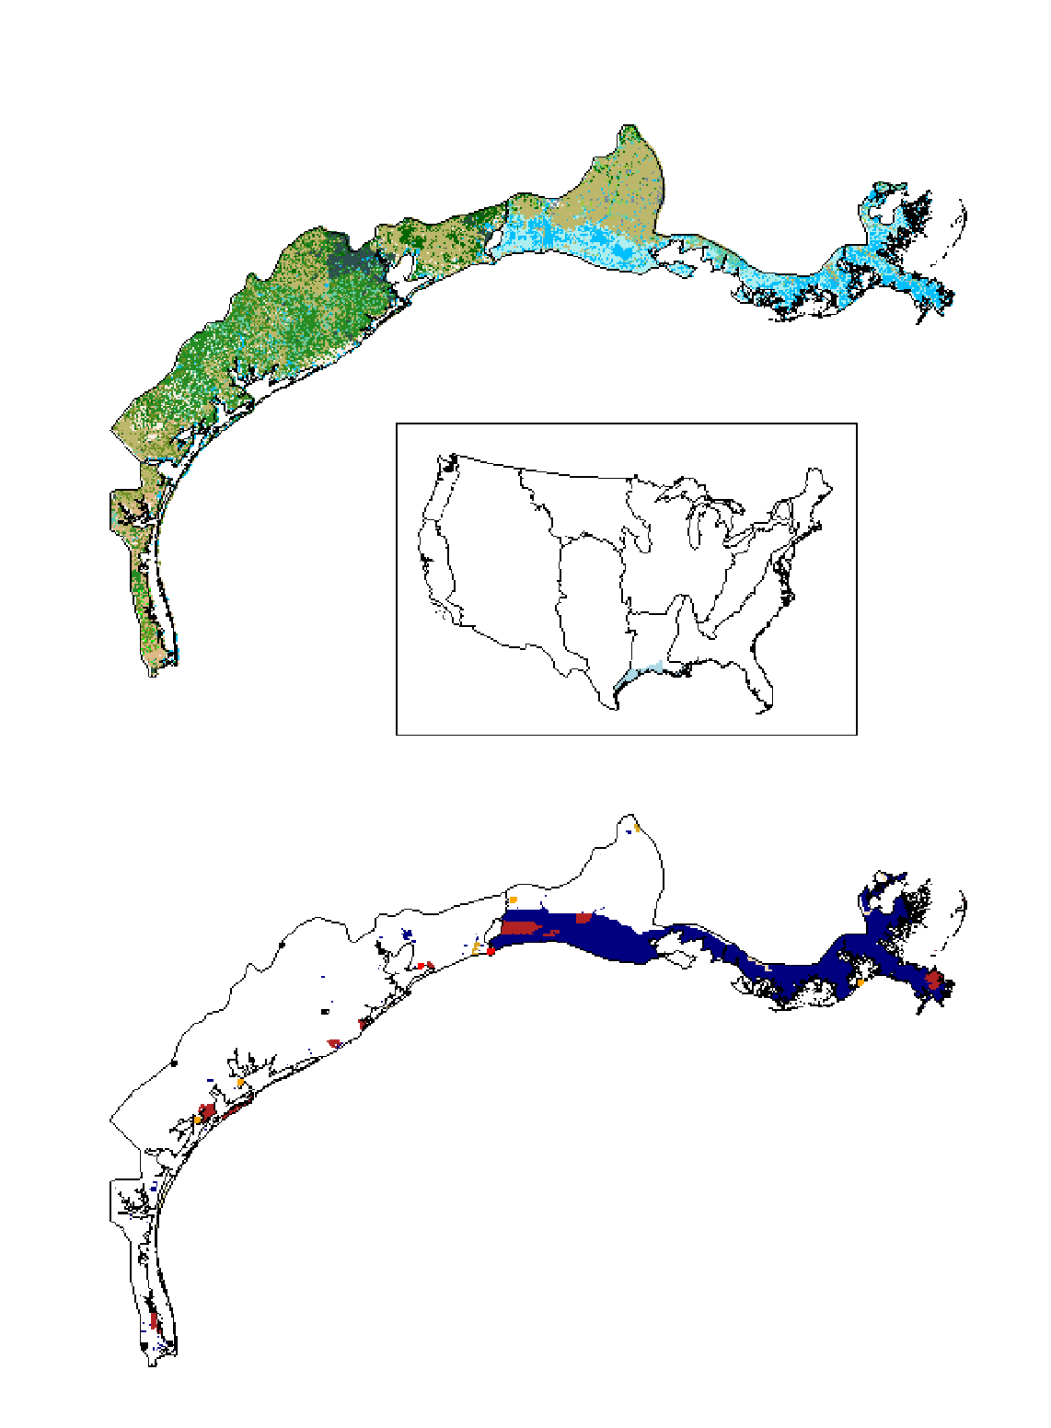
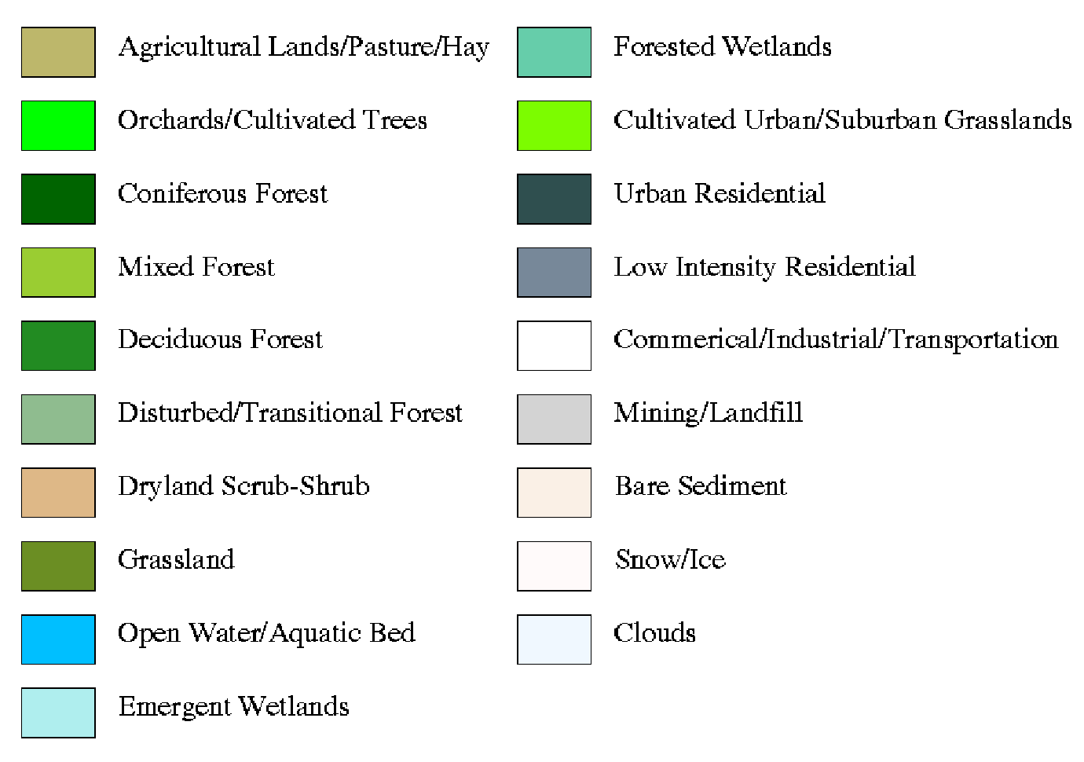
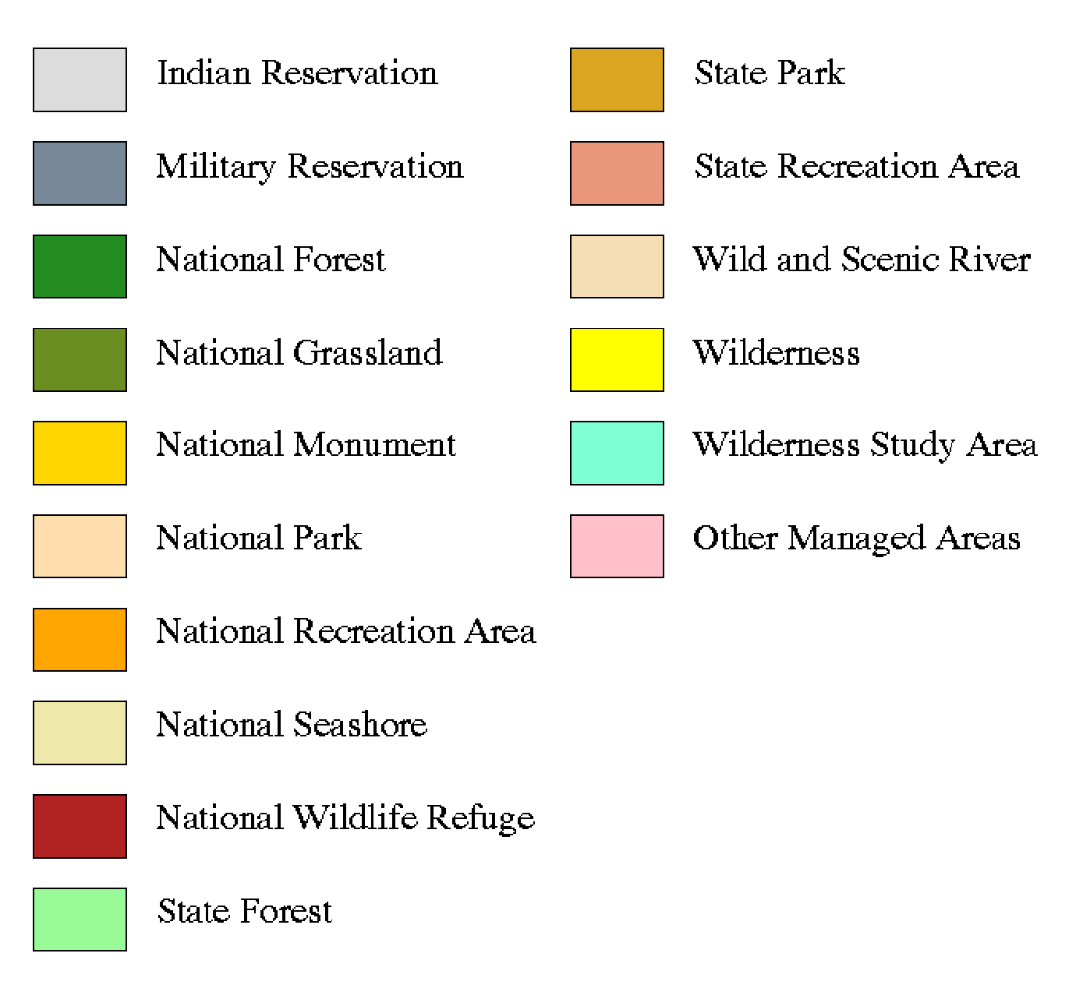


Land Cover
Managed Areas
Figure 1.1. Land cover classification and public managed areas within the Gulf Coastal Prairie.
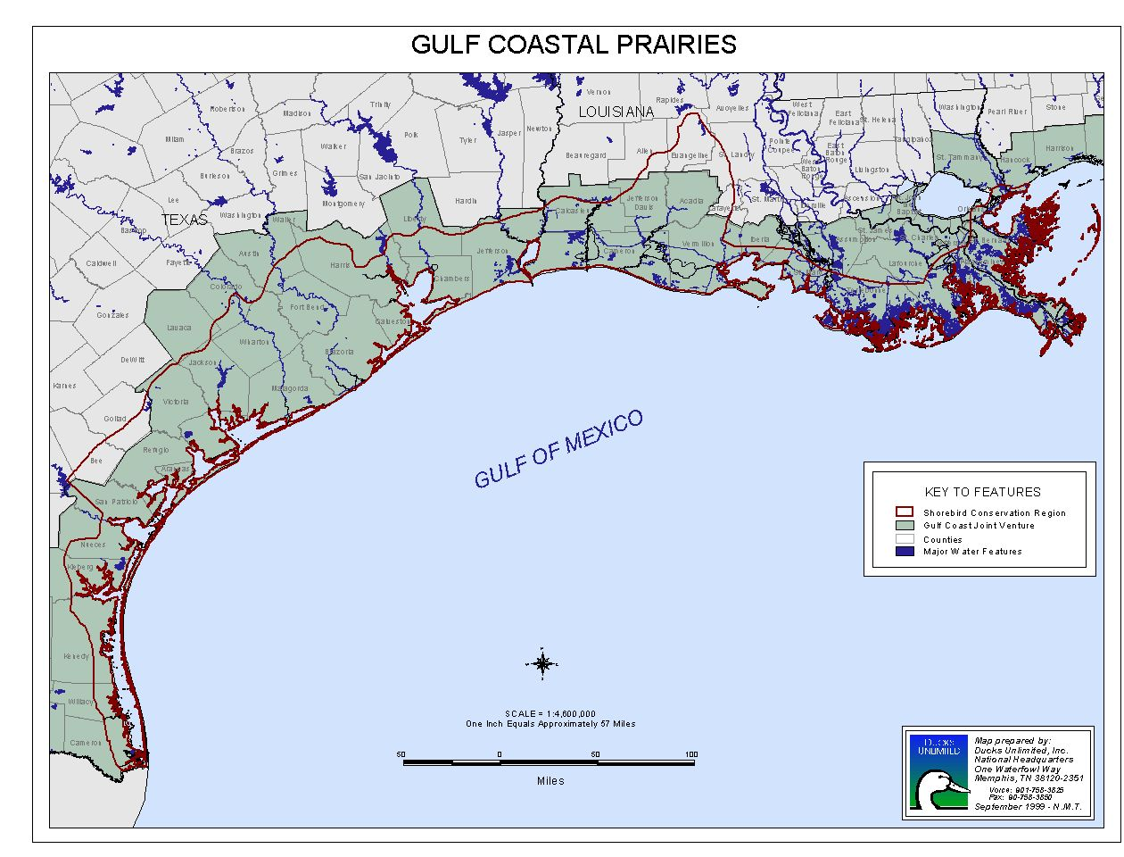
Laguna Madre
Texas Mid-Coast
Chenier Plain
Mississippi River Coastal Wetlands
Figure 1.2. Location of the Gulf Coast Gulf Venture area and management subregions within the Gulf Coastal Prairie.
2.0 Mississippi Alluvial Valley/West Gulf Coastal Plain
2.1 Description of the Region

The Mississippi Alluvial Valley/West Gulf Coastal Plain (MAVGCP) planning region (Figure 2.1) includes portions of Texas, Oklahoma, Arkansas, Louisiana, Missouri, Kentucky, Tennessee, and Mississippi, and consists of two Bird Conservation Regions: the West Gulf Coastal Plain/Ouachitas (WGCP; BCR 25) and the Mississippi Alluvial Valley (MAV; BCR 26; Figures 2.2a and 2.2b). The dominant vegetative component of the WGCP is forest, principally shortleaf pine in the north, longleaf pine in the south, and hardwood dominated systems in the river bottoms and floodplains. This is a relatively heavily populated region, with present rural land use dominated by pine silviculture and hayed/grazed pasture. The MAV is an alluvial floodplain, which was mostly hardwood forest prior to European settlement. Today, roughly 75% of the forest has been cleared and replaced by other land uses, predominantly row crop agriculture. Dominant crops include soybeans, corn, grain sorghum, and rice.

Historically, there likely was substantial shorebird habitat within the extensive mudbars, sandbars, and drying oxbows and sloughs of the major rivers (Arkansas River, Red River, Sabine River, Mississippi River, etc.). However, construction of levees, wingdams, reservoirs, and other changes to the hydrology of these systems has seriously altered their natural functions. Whereas the forest-dominated systems of this region probably offered limited habitat value for most shorebirds (Twedt et al. 1998), clearing of much of the Mississippi Alluvial Valley, with resulting open agricultural fields, has increased this region’s potential for providing shorebird habitat. Water management capability on agricultural fields (particularly rice fields) and aquaculture facilities, along with frequent inundation of fields by spring floodwater further enhance this region’s value to shorebirds. Providing the necessary mix of water depth and vegetative structure at the appropriate times is, perhaps, the most important management issue in this region.

2.2 Shorebird Species Occurrence and Priorities

Forty-three shorebird species have been recorded in the region, with 29 species occurring regularly (Tables 2.1 and 2.2). Few shorebird species breed in the planning region (Killdeer, Black-necked Stilt, Spotted Sandpiper, American Woodcock), whereas many more pass through in migration (Table 2.1). Migrant shorebird populations typically peak in the MAVGCP from August through October, and from April to mid-May.

According to the USSCP prioritization matrix, Piping Plover is the only species in the region considered Highly Imperiled. Because Piping Plover are listed as Threatened by the U.S. Fish and Wildlife Service, this plan will not address their conservation in detail (see Haig 1992). It is important to note, however, that Piping Plover migration routes and ecology in this region remain poorly known (S. Haig, pers. comm.). Furthermore, the Piping Plover Recovery Team no longer exists. Hence, any additional information regarding this species in the planning region is of great value. Among species of High Concern, only American Golden-Plover and American Woodcock have area importance scores >4, whereas Wilson’s Phalarope, Buff-breasted Sandpiper, Ruddy Turnstone, Red Knot, Sanderling, and Marbled Godwit have area importance scores of <3 (Appendix 2.A).

Highly Imperilied and High Concern species span a variety of habitats and foraging guilds, including terrestrial gleaner (Piping Plover, American Golden-Plover), terrestrial/aquatic gleaner/prober (Ruddy Turnstone, American Woodcock), aquatic/terrestrial gleaner (Red Knot, Buff-breasted Sandpiper), aquatic prober/gleaner (Sanderling), and aquatic gleaner (Wilson’s Phalarope: Appendix 2.A). Hence, there is no clear pattern with respect to species priorities and habitat type.

2.3 Habitat Report

Habitat for Shorebirds

Shorebird habitats in the region include riverine mudbars, riverine sandbars, oxbows, margins of borrow pits, margins of stock ponds, margins of large reservoirs, aquaculture (baitfish, crayfish, catfish) ponds, sewage treatment lagoons, flooded agricultural fields, and managed impoundments. Most of the existing and potential shorebird habitat in the region is found in flooded agricultural fields, aquaculture ponds, and managed impoundments.

Agricultural Fields

There are over 5.5 million ha of agricultural land in the Mississippi Alluvial Valley, with the majority occurring in Arkansas, Louisiana, and Mississippi. Aquatic probers and gleaners (i.e. dowitchers, Pectoral Sandpiper) typically utilize shallowly flooded and/or moist ag fields, whereas terrestrial gleaners (i.e. Buff-breasted Sandpiper, Black-bellied Plover) also can be found in drier habitats such as turf farms. The majority of agricultural acreage in the region has no water control capability. However, a significant portion has the capacity for water management. In Arkansas, Louisiana, and Mississippi over 800,000 ha are in rice production, and these areas potentially could be managed for shorebirds. Natural flooding on the remaining agricultural land during spring likely provides a significant amount of shorebird habitat during most years. However, the extent and frequency of this habitat is unknown. Ducks Unlimited and partners in the Lower Mississippi Valley Joint Venture are developing a GIS model that will attempt to quantify the area of the 2-10 year natural flood in the MAV. This information should better elucidate the availability and predictability of naturally flooded habitat.

Specific Management Practices: Winter

Between November and February, when the majority of wintering waterfowl occurs in southern regions, agricultural fields managed for dabbling ducks are typically flooded 20 cm (Ringelman 1990), which is too deep for most shorebirds. Wintering shorebirds in the extreme southern portion of the region, such as Long-billed Dowitchers (Limondromus scolopaceus), require areas with water depth of <10 cm, whereas Dunlin (Calidris alpina) and Western Sandpipers (C. mauri) require mudflats and water depths <5 cm. Staggered water depths within and between fields during this period will provide foraging opportunities for a variety of species. Fields not flooded by irrigation can have levees pulled up or gates put in, for gradual flooding by winter rains. This maneuver will benefit several waterbird groups.

As is generally the case, fields with sparse or no vegetation are more attractive to the most common shorebird species in this region. In agricultural fields in Arkansas and Mississippi, winter shorebird densities were higher in flooded soybean fields than in rice fields or moist soil habitats (Twedt et al. 1998), presumably because soybean fields had less vegetative cover. Augustin (1998), however, found substantially lower benthic invertebrate biomass in a flooded soybean field (0.02 g/m²) than in a flooded moist soil impoundment (1.9 g/m²) during fall in west Tennessee. Furthermore, soybean fields typically are not associated with water control structures, and therefore may offer limited opportunity for managed flooding. Reasons for high densities of shorebirds in soybean fields in Twedt et al.’s (1998) study, given the low biomass of invertebrates found in the west Tennessee soybean field (Augustin 1998) require further investigation.

Specific Management Practices: Spring Migration

In most years there are many areas that are naturally flooded, typically into May. Some agricultural fields flooded for dabbling ducks over winter are drawn down quickly in early spring to prepare fields for planting. These fields, planted in long-season crops, such as corn or rice, can be drawn down slowly beginning in late February through March so that early migrant shorebirds are provided with invertebrates. Fields planned for crops with a shorter growing season, such as soybeans and milo, can be drawn down slowly in late March or early April to provide habitats for later migrating shorebirds. During the spring, fields flooded for winter waterfowl that are to be left fallow (unplanted), should not be drawn down completely until late May to ensure that habitat remains for late migrating shorebirds. Water also should be held as long as possible before preparing fields for later crops such as cover crops or millet.

Specific Management Practices: Summer/Fall Migration

Agricultural fields are harvested from July to November, depending on the number of crops, the planting date, and the type of crop. Between late July and September, shallowly flooded fields (1-15 cm) will provide foraging opportunities for southbound shorebirds such as the Semipalmated (Calidris pusilla) and Pectoral (C. melanotos) Sandpipers, as well as early migrating Blue-winged Teal (Anas discors).

Many fields, such as rice fields, have contour levees used to regulate water depths during the growing season. After harvest, rice fields can be rolled with a water-filled drum or shallowly disked to remove stubble. This creates open areas preferred by shorebirds. Flooding contoured fields to different water depths creates feeding opportunities for different shorebirds. Several level fields without contours should be flooded to different depths to provide foraging opportunities for different waterbird guilds (e.g. 5 cm, 10 cm, 15 cm).

In the southern portion of the planning region, shallow flooding of fallow or harvested fields for shorebirds in late summer typically results in abundant vegetation growth. For these areas to be of maximum use to shorebirds, vegetation must be mechanically reduced by rolling or shallow disking – sometimes as many as 2-3 times during southward migration (June-October).

Aquaculture Ponds

Commercial aquaculture ponds are distributed throughout the region. Crawfish farms are prevalent in Louisiana, catfish farms in Mississippi, and baitfish ponds in Arkansas. These areas likely provide a significant amount of shorebird habitat because they contain numerous small basins that are periodically drawn down. Data collected by U.S. Fish and Wildlife Service biologists in 1995 and 1996 suggests that as many as 531,000 shorebirds may use these habitats in the MAV during southward migration. Whereas all three types of aquacultural practices hold potential for providing shorebird habitat, crawfish production has been studied relatively more extensively in this regard, and is covered in more detail below. Further assessment of shorebird use of aquaculture ponds and realistic opportunities for management (especially on baitfish and catfish production facilities) will be essential to refining habitat goals and objectives.

Crawfish Impoundments

Impoundments managed for commercial crawfish production represent a substantial potential for providing shallow water and mudflat habitat for shorebirds. Land area in crawfish production in 1998 within the West Gulf Coastal Plains Planning Region of Louisiana exceeded 17,000 ha.
Crawfish production follows one of two general cycles of (a) crawfish--dryland crop (e.g. soybeans) or fallow--rice, or (b) crawfish--rice. Timing of de-watering in the regular production cycle often coincides with periods of high shorebird abundance. For example, if the crawfish harvest (typically no later than May) is to be followed by a fallow period, then water may be left on the field to draw down naturally through late summer/early fall when shorebirds are migrating south.

Daily shorebird densities on crawfish basins experimentally allowed to remain flooded until July/August can be very high (42 birds/ha; J. Huner unpubl. Data). Rettig (1994) reported a single-day shorebird density of 133 birds/ha on an 18.8-ha crawfish complex in southwest Louisiana in August 1992. Although this habitat occupies a relatively small portion of the landscape, crawfish ponds often represent a large proportion of the available shallow water habitat in the region during early southward migration (July/August; Rosenberg and Sillett 1991, Rettig 1994).

Even though crawfish ponds can provide substantial shorebird habitat in late summer/fall, availability of habitat within these basins is unpredictable. Availability of shorebird habitat depends on the timing of water level management and vegetative density. The precise sequence of events within crawfish operations varies among farms and years, depending on rainfall, commodity prices, geographic location, etc. Hence, there may be a variety of opportunities for accommodating shorebirds in particular crawfish farm management schemes. Researchers at the University of Louisiana at Lafayette Crawfish Research Center presently are investigating management options that optimize shorebird habitat and crawfish production.

Specific Management Practices

Availability of shorebird habitat within aquaculture ponds depends entirely on timing of drawdown. Timing of drawdowns to coincide with shorebird migration should be similar to that recommended above for agricultural fields. Hence, further attention should be placed on understanding and working with the management of these operations, particularly rotations of crayfish/rice/fallow in crayfish ponds. Emphasis should be placed on supporting research efforts aimed at elucidating management schemes that are compatible with crawfish production while simultaneously providing habitat for shorebirds, particularly in late summer/early fall. Opportunities for education and extension relative to the value of crawfish farms to shorebirds and other wildlife (i.e. wading birds) should be explored. Clearly, slight modification of water and vegetation management on a small proportion of the aquaculture ponds in this region could result in a large increase in shorebird habitat.

Managed Shallow Impoundments

Managed impoundments in the region have been managed predominantly for migrating and wintering dabbling ducks. Management for migrating and wintering dabbling ducks and shorebirds are not mutually exclusive (see Gray et al. 1999, Short 1999). However, shorebird tolerances for vegetative density and water level generally are narrower than those of most dabbling ducks. Furthermore, timing of southward migration in shorebirds is somewhat earlier than for most dabbling ducks species. Hence, to optimize shorebird habitat on managed impoundments, it is necessary to give special consideration to the timing and extent of drawdown, and to vegetation manipulation (Short 1999).

Because shorebirds generally use only the shallowest portions of a wetland (0-18 cm), substantial control over water level in impoundments is desirable. Fine-tuned control of water levels can be facilitated by at least two factors: small basin size and shallow boards in the water control structure. Because less water must be moved in or out, management units of 5-10 ha allow timely maintenance of appropriate depths. Also, 5-cm and 7.5-cm vs. standard 10-cm flashboards allow for more precise maintenance of water depth.

The Lower Mississippi Valley Joint Venture office conducted an intensive survey of all public managed wetlands in the MAV (Table 2.3). The survey specifically tallied acreage of units managed primarily for shorebirds. Managed units were defined as those where hydrology is actively controlled through the use of dikes, levees, or water-control structures to benefit migrating/wintering shorebirds. Shorebird habitat was quantified as the maximum area intentionally flooded in late summer-autumn for migrating shorebirds, and totaled 599 ha.

Specific Management Practices: Spring Migration

Spring shorebird migration in the MAVGCP occurs between mid-February and late May (Helmers 1992). Moist-soil units suitable for spring shorebird management require fall flooding approximately one month before the first heavy freeze, and maintenance of flooded conditions over winter to enable chironomids (Chironomus spp.) and other invertebrates to re-populate, as well as to assure survival of larvae over winter. During the spring migratory period, units should be drawn down slowly, 2-3 cm/week to allow for continuous availability of invertebrates (Rundle and Fredrickson 1981 and Hands et al. 1991). Units planned for spring shorebird management should have extensive areas of open water with generally less than 50% dense emergent vegetation. This will allow shorebirds to forage in open shallow water and mudflats as drawdown occurs (Rundle and Fredrickson 1981, Hands et al. 1991, Helmers 1991). If more than one unit is being drawn down for shorebirds, staggering the initial drawdown dates will extend the availability of habitat and provide resources throughout the migratory period. This slow and staggered drawdown of moist-soil units will not only provide resources for shorebirds and other species, but will also promote a diversity of vegetation communities (Fredrickson 1991).

Specific ManagementPractices: Summer/Fall Migration

The summer/fall shorebird migration period is much more extended than the spring migration, generally occurring between mid-July and late October. Management for summer/fall shorebird habitats includes two different strategies. Moist soil-units that remained flooded through spring and early summer can be drawn down or units that are dry can be reflooded. If units were flooded through spring and early summer to provide habitats for breeding herons and rails, then natural evaporation or slow drawdowns make invertebrates available to shorebirds and concentrate prey for other waterbirds (Reid 1989).

If dry units are to be flooded for shorebirds, units should be shallowly flooded 10-15 cm 2-3 weeks before summer/fall migration begins. This will allow invertebrates to re-populate the newly created habitats (Rundle and Fredrickson 1981, Hands et al. 1991, Helmers 1991). Usually the vegetation must be manipulated by disking before re-flooding to assure shorebird response. The type of disking is critical since the rationale behind this manipulation is to convert plant biomass to a detrital base attractive to invertebrates. Deep disking that completely buries plant material is less desirable than shallow disking that only partially buries plant biomass. Thus, shallow disking acts as man-induced senescence and provides excellent substrates for invertebrates, whereas deep disking buries the plant biomass and reduces the availability of plant material for invertebrate processing (Fredrickson and Reid 1986).

Moist-soil units may need reconditioning every several years to remove undesirable vegetation. Reconditioning units through shallow disking and reflooding can provide excellent opportunities for shorebird management during the summer. As with spring management, staggering the manipulations within several units extends the availability of habitats.

Drawdown management of units through retention of water retained from spring is, perhaps, the most desirable approach to providing shorebird habitat in managed units for several reasons (Twedt et al. 1998). First, floodwater typically is scarce in late summer/fall, and pumping can be expensive. Second, weedy vegetation can rapidly invade areas that have been disked and flooded. Finally, bird densities on areas that have been drawn down tend to be higher than densities in areas that are “flooded up” (Twedt et al. 1998), probably due to greater invertebrate densities in areas that have been inundated for a longer duration.

Semi-permanent Wetlands

Semi-permanent or permanent wetlands without water control capabilities also provide foraging sites for shorebirds if appropriate habitats are available. Short, sparse vegetation, shallowly flooded during early spring, can provide foraging habitats within wet meadow zones (Colwell and Oring 1988, Eldridge 1990). Summer/fall drawdowns from natural evaporation also provide habitats for south-bound migrants (Hands et.al. 1991). During periods of natural drawdown, dense emergent vegetation can be reduced by burning or mowing the edges. When basins are reflooded from precipitation or winter snow melt, shallowly flooded habitats will be available at wetland edges the following spring. Removing dense vegetation from wetlands by burning or mowing after basins have dried in late summer or fall will provide additional foraging areas for migrant shorebirds the following spring.

Semi-permanent and permanent wetlands with water control can be drawn down in a fashion similar to those described for moist-soil units. However, complete drawdowns are not always necessary if wetlands are sufficiently large (>20 ha) and have low relief (< 1 m).

Existing Areas of Importance to Shorebirds

Arkansas Mississippi
Bald Knob NWR Dahomey NWR*
Cache River NWR* Morgan Brake NWR*
Ed Gordon/Point Remove WMA St. Catherine Creek NWR*
Oakwood Unit Coldwater River NWR
Overflow NWR* Yazoo NWR*
Wapanocca NWR*
White River NWR* Missouri
Duck Creek Conservation Area
Louisiana Otter Slough
Bayou Cocodrie NWR*
Catahoula Lake Tennessee
Grand Cote NWR* Eagle Lake State Refuge
Lake Ophelia NWR* Ensley Bottoms (Earth Complex)
Mollicy Unit (Upper Quachita NWR) Island 13
Ouachita WMA Phillipy Pits
Sherburne WMA Black Bayou State Refuge
Tensas River NWR* White Lake State Refuge

*National Wildlife Refuges considered “High Priority Refuges for Shorebird Management” by Rettig and Aycock (1994).

Other sites with potential for high shorebird use

- Bayou Pierre WMA (Louisiana)
- Boeuf WMA (Louisiana)
- Borrow Pits inside Miss. River levees
- Lower Hatchie NWR (Tennessee)
- Mississippi River sandbars and pools
- Old oxbows used by farmers for irrigation]
- Pomme de Terre WMA (Louisiana)
- Red River Valley (Arkansas)
- Reelfoot Lake WMA (Tennessee)
- Soda Lake WMA (Louisiana)

Threats and Solutions

Agricultural Fields

Agriculture in the MAVGCP is among the most productive on the continent, and appears to be under little threat of reduction. However, habitat value of these lands to most shorebirds depends upon the timing and extent of the presence of surface water and the density of standing vegetation. The dominant management issues in this habitat are ensuring that fields are flooded and/or drawn down during periods when shorebirds can use them, and that residual vegetative structure is reduced by mowing, burning, or disking.

Aquaculture Ponds

Maintaining or increasing shorebird habitat on aquacultural facilities will depend on effective information transfer to and from farm operators, while concurrently working to increase knowledge regarding how standard farming practices affect shorebird habitat and how these reasonably can be adjusted to better accommodate shorebirds.

Managed Shallow Impoundments

Because managed shallow impoundments have been traditionally managed primarily for migrating and wintering waterfowl, management of these habitats requires only slight modification to better accommodate shorebirds. One of the “threats” to these basins as habitat for shorebirds is the notion that managing for waterfowl and shorebirds is mutually exclusive. Well-planned and carefully documented demonstration projects whereby the needs of dabbling ducks and shorebirds are included and optimized in the management scheme might help alleviate such concerns (see Short 1999).

All Habitat Types

Actions of public and private organizations, through ongoing non-regulatory programs, have substantial effects on land use practices in the region. Establishing linkages with these organizations which facilitate promotion of shorebird habitat conservation likely will contribute to achieving this plan’s goal.

2.4 Regional Goals & Objectives

Setting conservation objectives for shorebirds is complicated by this region’s uncertain historical and present role in shorebird life history. Channelization, draining, and construction of dams and levees have altered the natural hydrology of most major rivers and tributaries. This likely has reduced the quantity and quality of natural shallow water and mudflat habitats associated with these streams. For example, a free-flowing Mississippi River may have provided abundant shorebird habitat in the form of extensive sandbars, mudflats, and oxbows, especially in fall when stream flow typically is low. Hence, this region may have been relatively important continentally to shorebirds during migration prior to large-scale alteration of rivers and streams.

Substantial numbers of shorebirds presently are found in the MAVGCP during winter and migration. Because of the shift in land use from forest to agriculture, an abundance of actual and potential shorebird habitat now exists. Land cleared for agriculture is the relatively flat, and flood-prone river valleys offer exceptional potential for shorebird habitat. Areas with water control capability, such as rice fields, aquaculture ponds, and moist soil management units offer even greater potential. Hence, there exists an opportunity to capitalize on changes to the landscape in the MAVGCP which may compensate for loss of historic shorebird habitat in the region, as well as habitat loss to the west in the Central Plains and to the east in the Southeastern Coastal Plains. Finally, the relatively high overlap between shorebird and dabbling ducks habitat makes incorporating shorebird management with ongoing management for wintering and migrating waterfowl an attractive and viable option. However, setting population and habitat goals for shorebirds in the planning region is hampered by a general lack of knowledge concerning populations sized, and the relative role and function of the region in the life histories of these populations.

Mississippi Alluvial Valley Migratory Bird Initiative Habitat Objectives

In 1995, the Mississippi Alluvial Valley Migratory Bird Initiative (MBI) developed management objectives for shorebirds within the Mississippi Alluvial Valley. To arrive at habitat objectives, a model with the following assumptions was used:

- Shorebird habitat is most limiting during fall, when surface water is relatively scarce
- Food is the limiting factor
- 500,000 shorebirds move through the LMV in fall
- Average length of stay is 10 days
- Shorebirds feed mainly on Chironomid larvae in fall, and density of this food is 2g/m²
- Average bird mass is 45g

This information, coupled with estimated energetic requirements, yields an estimated 2,000 ha of shorebird habitat needed in fall to meet the needs of shorebirds. The approach of the Lower Mississippi Valley Joint Venture has been to ensure that this habitat is provided on managed public lands, with the understanding that in “good” years adequate habitat is provided on private and un-managed lands. This objective, then, represents a “safety net” during years when habitat conditions outside of public lands are poor (i.e. drought).

The goal for shorebirds according to the MBI is to provide habitat on public managed land sufficient to accommodate all shorebirds that occur in the region during southward migration. This goal was stepped down to specific habitat objectives among the states as follows:

State | Hectares
Arkansas | 520
Illinois | 70
Kentucky | 35
Louisiana | 520
Mississippi | 600
Missouri | 70
Tennessee | 185
Total | 2000

One of the major problems with this approach from the Shorebird Plan perspective is that these figures apply only to the Mississippi Alluvial Valley, not the rest of the planning sub-region (West Gulf Coastal Plain). However, more fundamental questions relating to the assumptions of the model also require attention. These are detailed below.

Spring vs. Fall Habitat Limitation

The issue of spring vs. fall habitat limitation directly affects setting habitat objectives. Additionally, it is an especially important consideration on public areas where limited funds for providing water may preclude drawing units down (hence, providing mudflats) during spring because of the need to store water to provide fall habitat.

Whereas surface water certainly is more abundant in spring than in fall in most years, conservation planning regarding habitat for migrating shorebirds in spring should not be overlooked. Spring habitat conditions may have important implications for reproduction, and the window of opportunity for providing migration habitat is much narrower in spring than in fall. Also, migration patterns of some species would suggest that they are adapted to avoiding the typically dry interior habitats in fall migration, while using these interior habitats when they are wet in spring (e.g. Semipalmated Sandpipers: Gratto-Trevor and Dickson 1994). Finally, presence of shallow water does not necessarily equate to quality shorebird habitat. Hence, data are needed to determine the extent of natural flooding and the density of food present in available flooded habitats in spring.

Population Estimates

Meaningful habitat objectives must be based on population objectives. The MBI took the approach of estimating the number of shorebirds in the region during fall migration, and setting habitat objectives to be met on public managed land. This is a conservative approach, in that its purpose is to accommodate only the number of birds assumed to be in the region, and makes no attempt at increasing that number. This approach recognizes that habitat outside public managed areas exists, and that agencies with management responsibility should be prepared to provide for the habitat needs of shorebirds solely on public lands when habitat conditions elsewhere are poor (i.e. during a dry year). Taking this approach, two aspects of population estimation need to be addressed: (1) estimates of bird numbers in the West Gulf Coastal Plain and (2) refined estimates of birds in the MAV.

As proposed by several members of the working group, a preliminary “snapshot” count of shorebirds at known concentration areas across the planning region was conducted in late August 1999. The purpose of was twofold: (1) initiate the collection of data on shorebird populations that pass through the region, and (2) poll the interest of skilled birders in participating in such an endeavor. A total of 22,981 individuals of 29 shorebird species was counted from 20-22 August 1999. Forty-five people participated in the survey, counting shorebirds at 62 sites in 6 states. Data from this count should be evaluated with the knowledge that the region was exceptionally dry prior to and during the count. Hence, shorebird habitat was very limited. In addition, several observers noted that shorebird numbers at the sites they counted had been declining for several weeks prior to the count. Drought conditions coupled with 2-3 weeks of emigration without noticeable replacement likely resulted in relatively low numbers of birds.

Despite the low bird numbers, several patterns emerge from the data. As might be expected, Pectoral Sandpiper, Least Sandpiper, and Killdeer were the most abundant species across the region. Although density estimates are not available due to lack of habitat area data reported for many sites, number of birds per site varied according to “management type”. The sewage treatment site west of Memphis (Ensley Bottoms) hosted over 1600 shorebirds. This area has been known to hold 2-3 times this number of shorebirds during fall migration. Throughout the region, unmanaged sites had the lowest mean number of birds per site of all management types. Public managed sites (45%) and aquaculture ponds (29%) hosted the majority of birds. Results of this initial effort support the assertion that under dry conditions, public managed sites and aquaculture facilities provide a disproportionate amount of shorebird habitat during late summer/fall in the planning region.

Volunteer response to this opportunity was exceptional. It is intended that in the future the frequency and scope of these counts will be increased throughout fall and spring migrations. Tapping volunteer efforts may provide an efficient means of gaining much-needed population information.

Invertebrate Density

Data now are available relative to macroinvertebrate density in western Tennessee (Augustin et al. in review). Mean macroinvertebrate biomass in mudflats within managed impoundments (Eagle Lake State Refuge, Black Bayou State Refuge) was 2.17 g/m². This is very similar to the 2.0 g/m² assumed by the MBI habitat objectives model. However, benthic invertebrate density can vary by an order of magnitude among moist soil, soybean, and sewage treatment habitats (Augustin 1998, Augustin et al. 1998) during fall. Hence, the model should account for such variation when calculating habitat objectives. Also notable is the fact that Chironomid larvae composed a relatively small portion of the invertebrate biomass measured at these sites. Dominant potential prey items included Oligochaetes, Ceratopogonidae (biting midge larvae), Ostracoda (seed shrimp), Corixidae (water boatman), and baetid mayflies.

Habitat Carrying Capacity

Although the food density assumption of the model appears to be reasonable, data collected in 3 state management areas in west Tennessee (Eagle Lake State Refuge, White Lake State Refuge, and Black Bayou State Refuge/Reelfoot Lake WMA) suggest that shorebird densities on managed impoundments are below those predicted by the model. The MBI model assumes 2500 shorebird use days/ha, whereas in the best case on the management areas in Tennessee shorebird use days/ha were significantly lower (Short 1999). While it may be imprudent to adjust the model based in results of a single study, the relatively lower bird-use-days (compared to predicted carrying capacity) suggests that further validation of the model is needed. It is possible that habitat objectives produced by the MBI model need to be increased to account for this discrepancy, or management techniques need refinement and adjustment to accommodate a greater density of birds.

Based on the few adjusted population numbers provided by the working group (see Table 2.1), the current estimated fall shorebird population of 504,000 birds would require 2016 ha (an additional 16 ha compared to the MBI estimate) of habitat. However, until more data critical to testing the assumptions of the habitat model are available, few biologically-sound revisions to these objectives are possible. At a minimum, population estimates from the West Gulf Coastal Plains portion of the planning region should be incorporated into the model.

U.S. Shorebird Conservation Plan Goals & Objectives

Clearly, much of the information necessary to form a solid biological foundation for shorebird population and habitat objectives in this region is lacking. However, as we work to fill these information gaps, efforts to ensure that habitat for shorebirds in the MAVGCP is not limiting should be encouraged. This notion is especially realistic in light of the fact that the infrastructure (levees, water control structures, water sources, active hydrology management on public and private land, etc.) necessary to provide quality shorebird habitat presently exists. The following Goal and Objectives can be accomplished through education, outreach, and by slight modification of or increase in current practices and programs.

PRIMARY ASSUMPTION: Populations of shorebirds during the non-breeding season in the MAVGCP potentially are limited by foraging habitat, especially during southward migration

GOAL: Ensure that shorebirds using habitats in the planning region are not limited by availability of quality foraging habitat

OBJECTIVE 1: Provide late summer/fall (late July-October) habitat on public managed areas sufficient to accommodate the estimated fall flight of shorebirds through the region. The following specific actions are recommended to achieve this objective:

- Encourage management for early (September) teal season habitat that results in some shorebird habitat in July and August.
- Including but not restricted to reducing standing vegetation by mowing or light disking prior to flooding
- Find sources of funding for water.
- Local Audubon chapters
- State ornithological societies

- Provide technical assistance and encouragement to management area and refuge managers
- Technical handbooks (I.D., habitat management, species chronology, etc.)
- Workshops with follow-up visits to evaluate management

- Leadership by the LMV Joint Venture Office in planning for and monitoring of shorebird habitat on managed public lands has been valuable. Continued participation by the Joint Venture Office in this effort is essential.

OBJECTIVE 2: Increase late summer/fall habitat on private lands 25% by 2002

- Aquaculture may provide some potential avenues for habitat in fall. This could be accomplished by:
- leaving water control structures closed after “normal” draining to hold rainwater in idle basins
- providing monetary and other incentives to farm operators for late summer drawdown

OBJECTIVE 3: Increase winter-flooded rice field acreage 25% by 2002 to provide winter and early spring migration habitat
- Work with Rice Federation, extension services, private conservation organizations, and agricultural groups to increase awareness of the benefits of winter-flooded rice field management
- Encourage farm operators to allow some water to remain on fields through March to accommodate early spring migrants

OBJECTIVE 4: Establish mechanisms and/or linkages that advance shorebird conservation in all relevant non-regulatory agencies and programs by 2001
Objectives 1-3 could be greatly enhanced by incrasing awareness within and working through existing public and private organizations and non-regulatory programs, such as:

- Arkansas RICE program
- Natural Resources Conservation Service
- Corps of Engineers
- Private lands programs
- Timber companies with managed water
- others

Much of this may be accomplished through partnerships already established within the LMV Joint Venture.

2.5. Research and Monitoring Needs

Current shorebird habitat objectives for this region are based on untested assumptions regarding shorebird population number and chronology during fall migration. Obtaining an improved population estimate based on sampling is the highest priority research need in the MAVGCP. Specifically, a more biologically sound habitat objective will require:

- minimum absolute abundance estimate for fall migration, and a
- measure of turnover rate.

Other assumptions of the MBI model (e.g. food density, carrying capacity) also require validation. Further, inherent in habitat-based objectives is the ability to monitor existing and future shorebird habitat. The framework and resources to accomplish this do not presently exist. Specific recommendations relative to detailed study descriptions and prioritization of research topics are being formulated by the Shorebird Working Group of the Lower Mississippi Valley Joint Venture Migratory Bird Science Team.

2.6. Funding Needs to Meet Regional Goals

Management Costs
- Pumping costs in late summer/fall
- Two-inch boards (to replace or augment standard 4-inch boards) for water control structures
- Addition of low semi-permanent levees within large basins to allow greater precision in water-level management

Technical Assistance
- Regional “Shorebird Technical Advisor” as central point of contact to:
- Facilitate and oversee timely updates of the conservation plan
- Conduct education and outreach to land owners, farmers, and general public
- Develop technical information manuals, pamphlets, etc.
- Generate interest and funding for shorebird conservation projects
- Provide technical input to the Joint Venture
- Management techniques manual
- Workshops and seminars for public and private land managers

  - Management Coordination

The Lower Mississippi Valley Joint Venture office will continue to provide management coordination within the planning region. The Shorebird Working Group of the Lower Mississippi Valley Joint Venture Migratory Bird Science Team will assist the Joint Venture office in planning, implementing, and evaluating conservation action on behalf of shorebirds.
2.8 Recognition of Contributors

This report is the result of exceptional efforts by numerous individuals and organizations. Doug Helmers’ draft shorebird conservation plan for the Mississippi Alluvial Valley was used extensively in this report, especially with respect to specific management actions. Ducks Unlimited, Inc. contributed substantial amounts of staff time and funding to this effort. The following individuals and working group members contributed to this report:

Fred Broerman - U.S. Fish and Wildlife Service
Paul Brown - Tennessee Wildlife Resources Agency
David Buehler – University of Tennessee Knoxville
Tom Edwards - U.S. Fish and Wildlife Service
Dan Fuqua – Tennessee Wildlife Resources Agency
Jack Grubaugh – University of Memphis
Joe B. Guinn
Doug Helmers – Natrual Resources Conservation Service
Michael Hill – Arkansas Game and Fish Commission
Joe Hopper – Tennessee Wildlife Resources Agency
Dale Humburg – Missouri Department of Conservation
Jay Huner – University of Louisiana at Lafayette Crawfish Research Center
Chuck Hunter – U.S. Fish and Wildlife Service
Brad Jacobs – Missouri Department of Conservation
Lake Lewis – Arkansas Game and Fish Commission
Jeff Martin – Tennessee Wildlife Resources Agency
Keith McKnight - Ducks Unlimited (Memphis)
Don Miller – Tennessee Wildlife Resources Agency
Tom Moorman – Ducks Unlimited (Jackson, MS)
Allan J. Mueller - U.S. Fish and Wildlife Service
Keith Ouchley – The Nature Conservancy
Rochelle Renken – Missouri Department of Conservation
Karen Rowe – Arkansas Game and Fish Commission
Susan Skagen – (USGS/BRD)
Rick Speer - U.S. Fish and Wildlife Service
Steve Thomas – Kentucky Department of Fish and Wildlife Resources
Bill Uihlein – USFWS Lower Mississippi Valley Joint Venture Office
David Vandergrift – Tennessee Wildlife Resources Agency
Bill Vermillion – Louisiana Department of Wildlife and Fish
Francisco Vilella – Mississippi State University
Mark Vrtiska – formerly Ducks Unlimited (Jackson, MS)
Jeff R. Wilson
Jim Wilson – Missouri Department of Conservation
Janet York – Tennessee Wildlife Resources Agency

2.9 Literature Cited

Augustin, J. C. 1998. Masters Thesis. Univ. Memphis, Memphis, TN.

Augustin, J. C., J. W. Grubaugh, and M. R. Marshall. Validating macroinvertebrate assumptions of the shorebird management model for the lower Mississippi Valley. J. Wildl. Manage. In review.

Burger, J., M. A. Howe, D. c. Hahn, and J. Chase. 1977. Effects of tidal cycles on habitat selection and habitat partitioning by migrant shorebirds. Auk 94:743-758.

Colwell, M. A., and L. W. Oring. 1988. Habitat use by breeding and migrating shorebirds in southcentral Saskatchewan. Wilson Bull. 100:554-566.

Fredrickson, L. H. 1991. Strategies for water manipulations in moist-soil systems. U.S. Fish and Wildl. Serv. Leafl. 13.2.1. 8pp.

Gratto-Trevor, C. L., and H. L. Dickson. 1994. Confirmation of elliptical migration in a population of semipalmated sandpipers. Wilson Bull. 106:78-90.

Gray, M. J., R. M. Kaminski, G. Weerakkaody, B. D. Leopold, and K.C. Jensen. 1999. Aquatic invertebrate and plant responses following mechanical manipulations of moist-soil habitat. Wildl. Soc. Bull. 27:770-779.

Hands, H. M., M. R. Ryan, and J. W. Smith. 1991. Migrant shorebird use of marsh, moist-soil, and flooded agricultural habitats. Wildl. Soc. Bull. 19:457-464.

Haig, S. 1992. Piping Plover. In The Birds of North America, No. 2 (A. Poole and F. Gill, eds.). The Academy of Natural Sciences, Philadelphia, PA, and The American Ornithologists’ Union, Washington, DC.

Helmers, D. L. 1991. Habitat use by migrant shorebirds and invertebrate availability in a managed wetland complex. M. S. Thesis, Univ. of Missouri-Columbia. 135pp.

Helmers, D. L. 1992. Shorebird management manual. Western Hemisphere Shorebird Reserve Network, Manomet, Mass. 58 pp.

Hunter, W. C., D. J. Twedt, C. R. Loesch, K. Tripp, and M. S. Woodrey. 1996. Development of management and assessment objectives for shorebirds within the Mississippi Alluvial Valley Migratory Bird Initiative. Pages 127-137 in The Delta: connecting points of view for sustainable natural resources. Proceedings of the August 13-16 1996 conference.

Johnsgard, P. A. 1981. The plovers, sandpipers and snipes of the world. University of Nebraska Press, Lincoln. 493pp.

Reinecke, K. J., R. M. Kaminski, D. J. Moorhead, J. D. Hodges, and R. J. Nassar. 1989. Mississippi alluvial valley. Pages 203-247 in L. M. Smith, R. L. Pederson, and R. M. Kaminski, eds. Habitat management for migrating and wintering waterfowl in North America. Texas Tech University Press, Lubbock.

Ringleman, J. K. 1990. Managing agricultural foods for waterfowl. Fish and Wildl. Serv. Leafl. 13.4.3 4pp.

Rundle, W. D. and L. F. Fredrickson. 1981. Managing seasonally flooded impoundments for migrant rails and shorebirds. Wild. Soc. Bull. 9:80-87.

Short, M. R. 1999. Shorebirds in Western Tennessee: migration ecology and evaluation of management effectiveness. Technical Report 99-9, Tennessee Wildlife Resources Agency, Nashville, TN. 145pp.

Sykes, P. W., Jr. and G. S. Hunter. 1978. Bird use of flooded agricultural fields during summer and early fall and some recommendations for management. Fla. Field Nat. 6:36-43.

Twedt, D. J., C. O. Nelms, V. E. Rettig, and S. R. Aycock. 1998. Shorebird use of managed wetlands in the Mississippi Alluvial Valley. Am. Midl. Nat. 140:140-152.
Table 2.1. Population estimates and season of occurrence of shorebirds in the Mississippi Alluvial Valley/West Gulf Coastal Plain planning region.
Species | MAVGCPª | Modified MAVGCP^{b} | Seasonal  abundance^{c}
Black-bellied Plover | 769 |  | s, f
American Golden-Plover | 449 | 3000 | S, f
Snowy Plover | ? | 10 | s (tr), f (tr)
Wilson's Plover | ? |  | f (tr)
Semipalmated Plover | 4,765 |  | s, f
Piping Plover | 121 |  | s, f
Killdeer | 91,838 |  | S, F, W, B
Mountain Plover | ? |  | w (tr)
Black-necked Stilt | 778 |  | s, f, b
American Avocet | 232 |  | s, f
Greater Yellowlegs | 3,235 |  | S, F, w
Lesser Yellowlegs | 21,120 |  | S, F, w
Solitary Sandpiper | ? | 1000 | s, f, w
Willet | 92 |  | s, f
Spotted Sandpiper | 4,112 |  | s, f, w, b
Upland Sandpiper | 237 |  | s, f
Whimbrel | ? |  | s (tr), f (tr)
Long-billed Curlew | ? |  | s (tr), f (tr)
Hudsonian Godwit | ? |  | s (tr)
Marbled Godwit | 39 |  | s (tr), f (tr)
Ruddy Turnstone | 405 |  | s (tr), f
Red Knot | 162 |  | s (tr), f
Sanderling | 5,052 |  | s, f
Semipalmated Sandpiper | 37,713 |  | S, F
Western Sandpiper | 3,382 |  | s, f, w
Least Sandpiper | 151,119 |  | S, F, w
White-rumped Sandpiper | 221 | 500 | s, f
Baird's Sandpiper | 690 |  | s, f
Pectoral Sandpiper | 121,077 |  | S, F
Dunlin | 7,866 |  | s, f, w
Stilt Sandpiper | 3,310 |  | s, f
Buff-breasted Sandpiper | 964 |  | s, f
Short-billed Dowitcher | 1,121 |  | s, f
Long-billed Dowitcher | 1,121 |  | S, F, w
Common Snipe | 2,374 |  | S, F, W
American Woodcock | ? |  | W, B
Wilson's Phalarope | 171 |  | S
Red-necked Phalarope | ? |  | s(tr), f(tr)
Red Phalarope | ? |  | f (tr)
ªfrom Hunter et al. (1996)
^{b}Based on single-day maximum counts and other information from the working group.
^{c}b=breeding, f=fall migration, s=spring migration, w=winter, (tr)=species occurs sporadically in very small numbers. BOLD UPPER CASE = region as/more important than other regions; UPPER CASE = region important; lower case = region not important relative to other regions.

Table 2.2. Conservation Priority Scores for shorebird species occurring within MAVGCP Region. PT=Population Trend; RA=(Global) Relative Abundance; TB=Threats Breeding; ; TN=Threats Non-breeding; BD=Breeding Distribution; ND=Non-breeding Distribution; AI=Area Importance.
 | Priority score categories |  |  |  |  |  |  |  | Overall
Species | PT | RA | TB | TN | BD | ND | AI |  | regional priority
Black-bellied Plover | 5 | 3 | 2 | 2 | 2 | 1 | 2 |  | 3
American Golden-Plover | 4 | 3 | 2 | 4 | 2 | 3 | 5 |  | 4
Snowy Plover | 5 | 5 | 4 | 4 | 3 | 4 | 1 |  | 1*
Wilson's Plover | 3 | 5 | 4 | 4 | 4 | 3 | 1 |  | 1*
Semipalmated Plover | 3 | 3 | 2 | 2 | 1 | 1 | 3 |  | 2
Piping Plover | 5 | 5 | 5 | 4 | 4 | 4 | 3 |  | 5
Killdeer | 5 | 1 | 3 | 3 | 1 | 2 | 4 |  | 3
Mountain Plover | 5 | 5 | 4 | 4 | 5 | 4 | 1 |  | 1*
Black-necked Stilt | 3 | 3 | 3 | 2 | 1 | 2 | 2 |  | 2
American Avocet | 3 | 2 | 3 | 4 | 2 | 3 | 2 |  | 3
Greater Yellowlegs | 3 | 4 | 2 | 2 | 2 | 1 | 4 |  | 3
Lesser Yellowlegs | 3 | 2 | 2 | 3 | 2 | 1 | 5 |  | 2
Solitary Sandpiper | 3 | 4 | 2 | 2 | 3 | 2 | 3 |  | 3
Willet | 3 | 3 | 3 | 3 | 3 | 3 | 3 |  | 3
Spotted Sandpiper | 3 | 3 | 2 | 2 | 1 | 1 | 3 |  | 2
Upland Sandpiper | 2 | 2 | 2 | 4 | 2 | 3 | 3 |  | 2
Whimbrel | 5 | 4 | 2 | 2 | 3 | 2 | 1 |  | 1*
Long-billed Curlew | 5 | 5 | 3 | 3 | 3 | 3 | 1 |  | 1*
Hudsonian Godwit | 3 | 4 | 3 | 4 | 4 | 4 | 1 |  | 1*
Marbled Godwit | 4 | 3 | 4 | 4 | 3 | 3 | 2 |  | 4
Ruddy Turnstone | 4 | 3 | 2 | 4 | 2 | 2 | 2 |  | 4
Red Knot | 5 | 2 | 2 | 4 | 3 | 3 | 2 |  | 4
Sanderling | 5 | 2 | 2 | 4 | 2 | 1 | 2 |  | 4
Semipalmated Sandpiper | 5 | 1 | 2 | 3 | 3 | 3 | 4 |  | 3
Western Sandpiper | 3 | 1 | 2 | 4 | 4 | 2 | 3 |  | 3
Least Sandpiper | 5 | 2 | 2 | 2 | 2 | 2 | 4 |  | 3
White-rumped Sandpiper | 3 | 2 | 2 | 2 | 3 | 3 | 3 |  | 2
Baird's Sandpiper | 3 | 2 | 2 | 2 | 3 | 3 | 3 |  | 2
Pectoral Sandpiper | 3 | 2 | 2 | 2 | 2 | 3 | 5 |  | 2
Dunlin | 5 | 2 | 2 | 3 | 2 | 3 | 3 |  | 3
Stilt Sandpiper | 3 | 3 | 3 | 4 | 3 | 3 | 3 |  | 3
Buff-breasted Sandpiper | 4 | 5 | 3 | 4 | 3 | 4 | 3 |  | 4
Short-billed Dowitcher | 5 | 2 | 2 | 3 | 3 | 2 | 3 |  | 3
Long-billed Dowitcher | 2 | 2 | 2 | 3 | 4 | 3 | 4 |  | 2
Common Snipe | 5 | 1 | 2 | 2 | 1 | 2 | 4 |  | 3
American Woodcock | 5 | 1 | 4 | 3 | 2 | 3 | 4 |  | 4
Wilson's Phalarope | 4 | 1 | 3 | 4 | 2 | 5 | 3 |  | 4
Red-necked Phalarope | 4 | 1 | 2 | 3 | 1 | 3 | 1 |  | 1*
Red Phalarope | 4 | 1 | 2 | 3 | 2 | 1 | 1 |  | 1*
* Low regional priority due to its relatively low occurrence in the region (AI=1)
Curlew Sandpiper, Purple Sandpiper, Ruff, and Sharp-tailed Sandpiper also have been recorded in the planning region.
Table 2.3. Area of habitat (ha) managed primarily for shorebirds during fall migration (late July – late September) in the Mississippi Alluvial Valley region of the MAVGCP planning region as of July 1999. Data collected by Lower Mississippi Valley Joint Venture Office, Vicksburg, MS.
State | Area | Area actively managed (ha) | MBI Objectives | % of Objective
Arkansas | Bald Knob NWR | 58.8
 | Oakwood NWR | 86.0
 | Wapannocca NWR | 3.8
 | Subtotal | 148.6 | 520 | 29
Kentucky |  | 0 | 35 | 0
Louisiana | Grand Cote NWR | 15.6
 | Lake Ophelia NWR | 22.9
 | Tensas NWR | 4.5
 | Subtotal | 43.0 | 520 | 8
Mississippi | Morgan Brake NWR | 45.5
 | Panther Swamp NWR | 6.8
 | St. Catherine Creek NWR | 69.5
 | Tallahatchie NWR | 108.1
 | Yazoo NWR | 82.6
 | Subtotal | 312.5 | 600 | 52
Missouri | Otter Slough CA | 39.9
 | Ten Mile Pond CA | 15.1
 | Subtotal | 55.0 | 70 | 79
Tennessee | Eagle Lake State Refuge | 22.3
 | Black Bayou State Refuge | 6.1
 | Whites Lake WMA | 10.8
 | Subtotal | 39.2 | 185 | 21
 | Total | 598.4 | 2000 | 30

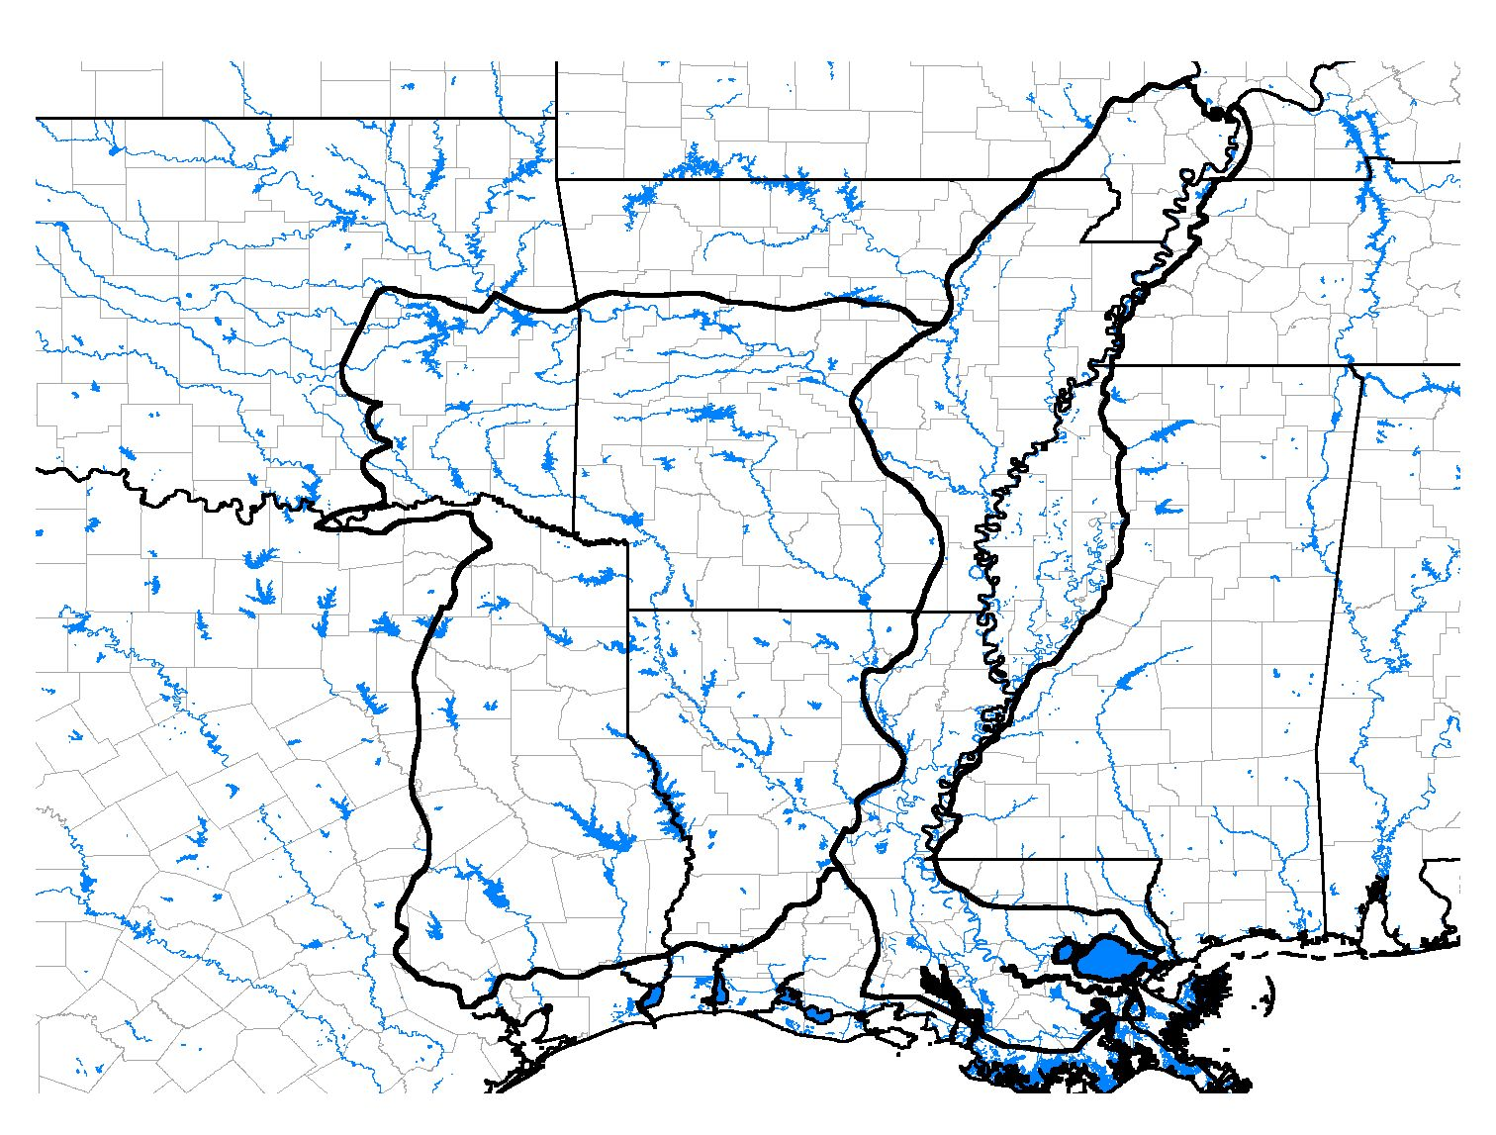
Figure 2.1 MAVGCP Planning Region
TX
OK
AR
LA
KY
MS
TN
MOO

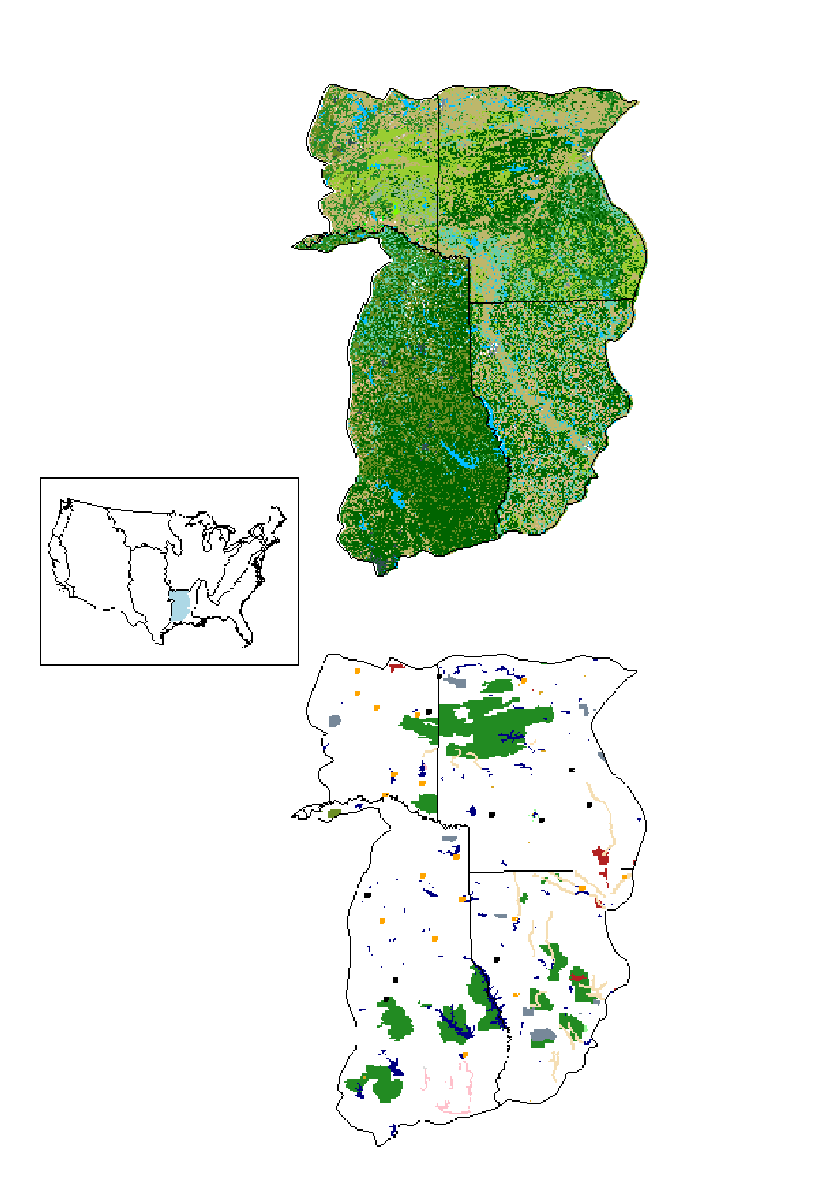
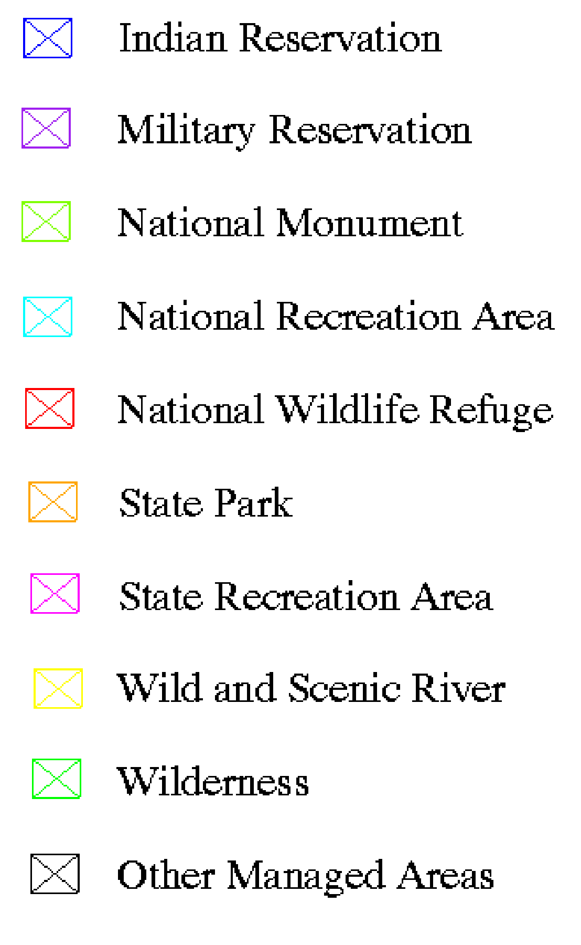
Figure 2.2a. West Gulf Coastal Plain/Ouachitas
Land Cover Type
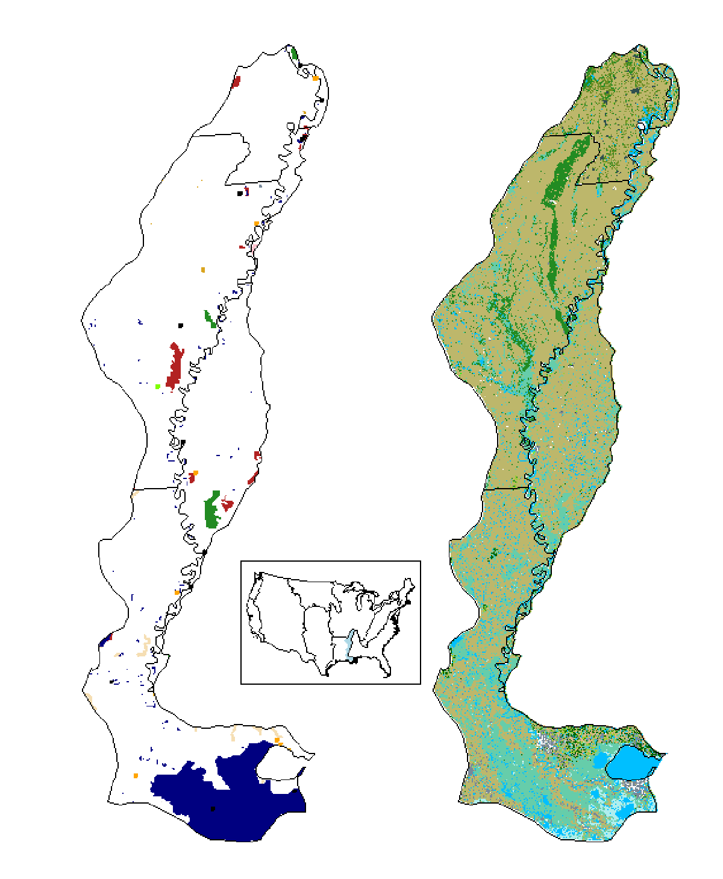
Figure 2.2b. Mississippi Alluvial Valley
Managed Areas
Land Cover Type

Appendix 2.A. Conservation priority of shorebirds in the Lower Mississippi Valley/Western Gulf Coastal Plain organized by foraging guild.
 |  | Guild
 |  | Terrestrial/Aquatic |  |  | Aquatic/  Terrestrial |  | Aquatic
Priority Level |  | Gleaner | Gleaner/  Prober |  | Gleaner |  | Prober/  Gleaner | Prober | Gleaner | Sweeper | Prober/Prier
Highly Imperiled |  | PIPL
High Concern |  | AMGP * | RUTU |  | REKN |  | SAND | MAGO | WIPH
 |  |  | AMWO |  | BBSA
Moderate |  | KILL |  |  |  |  | LESA |  | GRYE | AMAV
Concern |  | BBPL |  |  |  |  | SBDO |  | SOSA
 |  |  |  |  |  |  | SESA |  | WILL
 |  |  |  |  |  |  | DUNL
 |  |  |  |  |  |  | STSA
 |  |  |  |  |  |  | WESA
 |  |  |  |  |  |  | COSN
Low Concern |  | SEPL | SPSA |  | UPSA |  | PESA * |  | LEYE * | BNST
 |  |  |  |  |  |  | LBDO
 |  |  |  |  |  |  | BASA
 |  |  |  |  |  |  | WRSA

Species codes:
AGPL | American Golden-Plover | ESCU | Eskimo Curlew | PIPL | Piping Plover | SOSA | Solitary Sandpiper
AMAV | American Avocet | GRYE | Greater Yellowlegs | REKN | Red Knot | SPSA | Spotted Sandpiper
AMOY | American Oystercatcher | KILL | Killdeer | REPH | Red Phalarope | STSA | Stilt Sandpiper
AMWO | American Woodcock | LBCU | Long-billed Curlew | RNPH | Red-necked Phalarope | UPSA | Upland Sandpiper
BASA | Baird's Sandpiper | LBDO | Long-billed Dowitcher | RUTU | Ruddy Turnstone | WESA | Western Sandpiper
BBPL | Black-bellied Plover | LESA | Least Sandpiper | SAND | Sanderling | WHIM | Whimbrel
BBSA | Buff-breasted Sandpiper | LEYE | Lesser Yellowlegs | SBDO | Short-billed Dowitcher | WILL | Willet
BNST | Black-necked Stilt | MAGO | Marbled Godwit | SEPL | Semipalmated Plover | WIPH | Wilson's Phalarope
COSN | Common Snipe | MOPL | Mountain Plover | SESA | Semipalmated Sandpiper | WIPL | Wilson's Plover
DUNL | Dunlin | PESA | Pectoral Sandpiper | SNPL | Snowy Plover | WRSA | White-rumped Sandpiper

BOLD with asterisk denotes Area Importance score = 5
BOLD denotes Area Importance score = 4
ALL CAPS denotes Area Importance score = 3
ALL CAPS in italics denotes Area Importance score = 2

