STATEMENT OF
CHRISTOPHER MILLY
RESEARCH HYDROLOGIST
U.S. GEOLOGICAL SURVEY
U.S. DEPARTMENT OF THE INTERIOR
BEFORE THE
COMMITTEE ON ENERGY AND NATURAL RESOURCES,
SUBCOMMITTEE ON WATER AND POWER,
UNITED STATES SENATE,
HEARING ON
IMPACTS OF CLIMATE CHANGE ON
WATER SUPPLY AND AVAILABILITY IN THE UNITED STATES,
AND RELATED ISSUES FROM A WATER USE PERSPECTIVE

JUNE 6, 2007

Introduction

Mr. Chairman and Members of the Subcommittee, thank you for this opportunity to present testimony on the impacts of climate change on water supply and water availability in the United States.

Water is the life-blood of the Nation. Water keeps our bodies hydrated and clean and sanitizes our living spaces. Water in the soil grows the food we eat. We use water in the processing of food and fuel and the manufacture of products. Water flowing through our rivers produces electricity and transports cargo. Water is habitat and highway for fish and fowl. Water, liquid or frozen, is the Nation’s playground in summer and winter.

The distribution of water across the Nation depends largely on climate. Changing climate is now affecting the availability of water in the United States.

Water availability can be measured in many ways: precipitation, streamflow, reservoir levels, snow pack, soil moisture, glaciers, and water tables. Precipitation is the gross income of our Nation’s water budget; streamflow is the net income—what remains after the evapotranspiration tax has been extracted. Snow pack, reservoir levels, soil moisture and water tables represent the contents of our water bank accounts. The bank accounts are important for getting us through hot dry summers or the inevitable years of drought, but ultimately streamflow is the single best measure of disposable income in our national water budget.

How might water availability be expected to respond to a general climatic warming? The behavior of the water substance is very sensitive to temperature variations. Warm ice melts. Warm water expands. Warm air can hold more water vapor. Together with some more advanced atmospheric physics, which predicts subtle shifts in atmospheric circulation, these facts suggest the changes in water availability that can result from warming:

- Systematic regional increases and decreases of total annual streamflow.

- Rising sea level, resulting in increasing risk of contamination of coastal water supplies.

- Loss of snow pack, resulting in increased winter streamflow and winter flood risk and decreased summer streamflow.

Observed Streamflow Changes

During the last several decades, annual streamflow in the United States fluctuated widely over time. In 1988, the Ohio River gave 115 million acre feet of water to the Mississippi; the next year it gave 270 million acre feet. Such wide variation is a normal state of affairs.

The normal ups and downs of annual streamflow are superimposed upon more subtle, longer-term changes. In recent decades, the U.S. Midwest and Alaska became wetter, while the U.S. Southwest became drier. For example, the flow of the Ohio River at Metropolis, Ohio, during the last 30 years was 12 percent higher than during the preceding 48 years of observations. The flow of the Colorado River at Lees Ferry, Arizona, was 3 percent lower than during the preceding 71 years (after making adjustments for flow decreases associated with water withdrawals). The flow of the Yukon River at Eagle, Alaska, was 3 percent higher than during the preceding 26 years.

Long-term changes in seasonal timing of streamflow, possibly related to warming-induced changes in snowfall and snowmelt, have also been observed. As the western United States has warmed during recent decades, a tendency toward earlier timing of streamflow has been noted. Similar trends toward earlier streamflow have been seen in the northern tier of the eastern United States. In both regions, seasonal streamflows are typically rising and falling about a week earlier in the year during recent decades than in the prior period of record.

Causes of Observed Streamflow Changes: Normal Variability vs. Forced Climate Change

On the basis of statistical analyses of streamflow measurements, tree-ring records, and models, it appears that the recent long-term changes in annual streamflow observed over large areas of the United States were not unprecedented. Consequently, taken alone, these streamflow changes are not unequivocal evidence of forced climate change, but might be explained as mere manifestations of natural, internal variability in the climate system.

However, these data need not be taken alone. We have other sources of information, including streamflow measurements from around the world and computer simulations of changing climate in the United States and the rest of the world. The observed pattern of a wetter Midwest, a drier Southwest, and a wetter Alaska is also the pattern that emerges from climate models when they try to simulate streamflow during the 20th century. And, when we look at a global comparison of observed and climate-modeled changes in annual streamflow during the 20th century, this rough agreement for the United States is repeated over and over on the other continents. Analysis suggests that such a level of agreement across the globe would be very unlikely to arise simply by chance. On the basis of this global perspective, we conclude that the same factors causing global warming are changing the global water cycle. The change in the global water cycle, in turn, contributes to the observed changes in streamflow and water availability in the
United States.

The earlier streamflow timing observed in the western and northeastern United States has been correlated with rising temperatures, but changes in precipitation amounts and timing have also played a role. Changes in streamflow timing have not been clearly attributed to forced climate change. However, we can say that the observed changes in streamflow timing are qualitatively consistent with expected impacts of forced climate change.

Predicting Future Water Availability

It is not valid simply to extrapolate the observed past changes in water availability forward into the future. However, the demonstrated skill of climate models in simulating the global pattern of 20th-century change in annual streamflow means that those models are credible, though far from perfect, tools for looking into the future. Given best assumptions about future atmospheric carbon dioxide concentrations and other drivers of climate change, these models project a long-term drying trend in the Southwest and moistening trends in the Midwest and Alaska. The drying trend in the Southwest can be expected to imply also an increasing probability of occurrence of Southwestern drought.

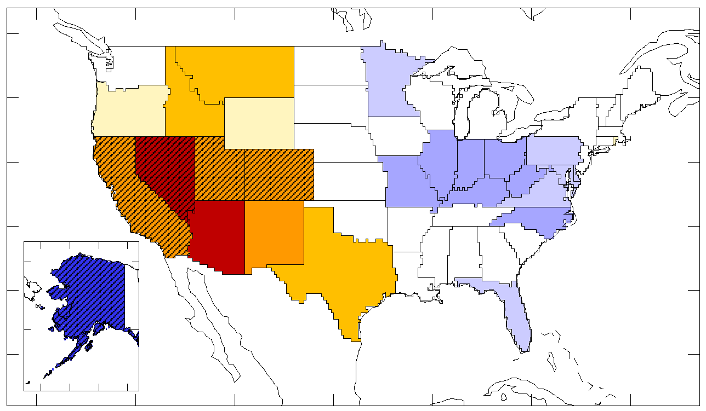
Figure. Model-projected percentage change in production of streamflow, by State, from 1900-1970 to 2041-2060. Colored States: more than 66 percent of 12 climate models agreed on the direction (increase vs. decrease) of change. Diagonal stippling: more than 90 percent of models agreed.

These projections, at best, are only crude caricatures of the real future. Are they the best that we can realistically hope for? Not at all. There is much room for improvement:

- Climate models typically represent conditions over areas larger than the State of Maryland by a single point. Such an approach has been adequate to assess global warming. However, climate varies geographically on a much finer scale, especially in mountainous regions. Therefore, to assess practical impacts on water and to design, plan, and implement needed adaptations, water managers need information on a much finer spatial scale, more like that of a county. To deliver this, much-higher-resolution climate models are needed.

- The Nation has no comprehensive network of streamflow measurement stations dedicated to monitoring long-term changes in streamflow in natural, developed, and developing environments across the national landscape. The available measurements, assembled from stations established for other purposes, have proven critical for the progress that has been made in detecting global changes in water availability. However, keeping higher-resolution models honest and tracking ongoing changes in water availability will require higher-resolution measurements.

- Climate models currently ignore the effects of water-resource development, land use, and land-cover change on climate. This has not been identified as a crucial impediment for global analyses, but it probably matters at the finer spatial scale of water management.

- Water shortages come about when supply falls short of demand. Increased demand can create shortage, even when supply is stable. A change in climate causes a change in water demand, e.g., for irrigation and for natural ecosystems. Our understanding of this relation between climate and water demand needs improvement.

- Production of better climate information is necessary but not sufficient to assess future impacts. Climate information needs to come in a form that is relevant to water management. In order to ensure the relevance of climate-model information to water managers, accelerated and continuing dialogue will be needed between climate science and water managers.

- To make best use of available information in a changing climate, water management will need to adopt more flexible tools than those that have sufficed in the past. These new tools, unlike those that currently do the lion’s share of water-system planning and design, must recognize that climate will change during the lifetime of a project and that estimates of the changing climate are uncertain. This will require a sea change in the field of water management. Such a change will not be accomplished without a concerted effort by government, academia, and professional societies.

Mr. Chairman, thank you for this opportunity to present testimony. I will do my best to answer any questions that you or other Members of the Subcommittee may have on this topic.

