Gigacam R&D

There are three development areas and one research area related to the physical packaging of the optical imager. The development areas are a concept for the CCD mount, the mounting of the CCDs into a focal plane array, and a thermal/particle shield for the array. The research area is to establish procedures for on-orbit calibration and performance tracking of the focal plane array.

Mass and moments of the focal plane array and its shield need to be estimated to feed into the overall spacecraft design. The size of heat radiator is driven by the thermal load, both black body and electrical, on the focal plane. An interface between the focal plane and the radiator needs to be conceptualized.

Calibration needs will impact the observation program and support equipment may need to be located within other components of the spacecraft.

The R&D tasks described below are
- Develop concepts.
- Prototype concepts.
- Build small system concept prototype.
- Develop calibration procedures.
- CD1 planning.

Develop concepts

This set of activities develops our concepts for packaging CCDs into modules, populating a focal plane array with these modules, cooling the array, and shielding it from thermal and particle backgrounds.

CCD mount

We want a CCD package that is four-side abuttable so that a densely packed focal plane array with small dead space can be populated. The package needs to provide mechanical and thermal attachment to the array cold plate and to provide a means for bringing the CCD bond pads out to a connector. A goal is to make to the assembly process simple and fool proof and at the same time build in the required mechanical tolerances so that the focal plane array can be assembled without adjusting each CCDs position. Easy replacement of any CCD within the array is also desirable. We have developed a early concept that achieves these mechanical goals and have made a 3 x 3 mechanical model in aluminum.

Preliminary concept for CCD module assembly.

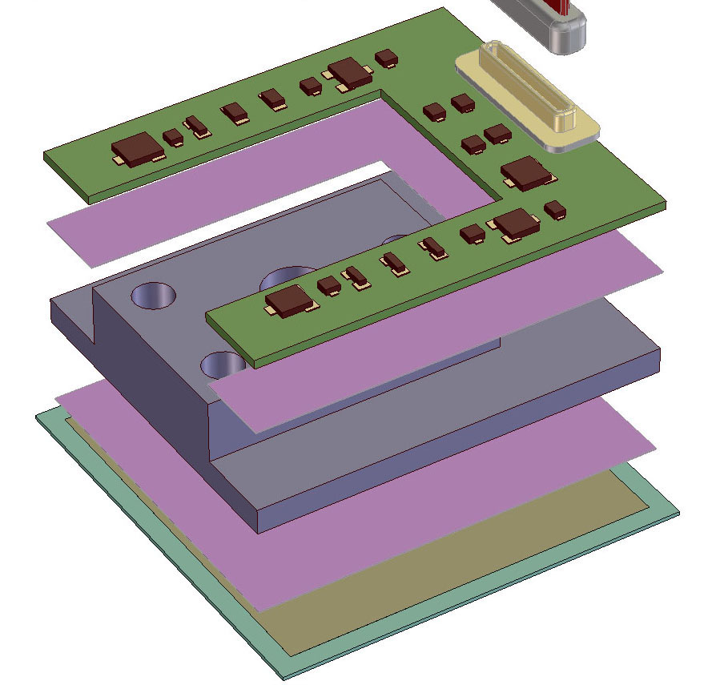
Glue

Glue

PCB
Invar/Mo base

Si Detector
Connector

Alignment and gluing fixture concept.

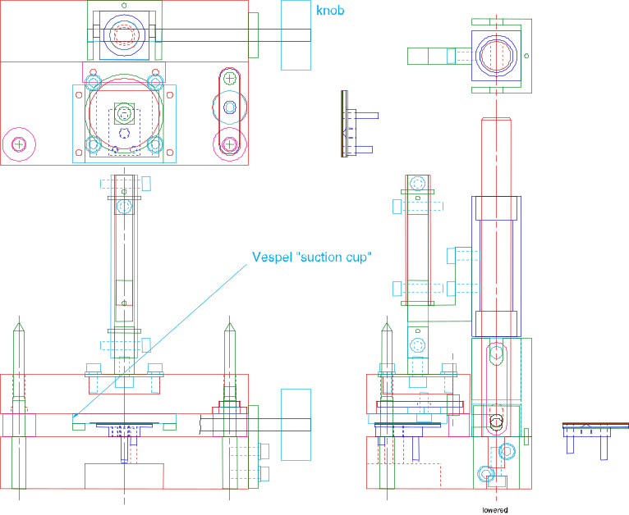

Preliminary concept for focal plane array assembly.

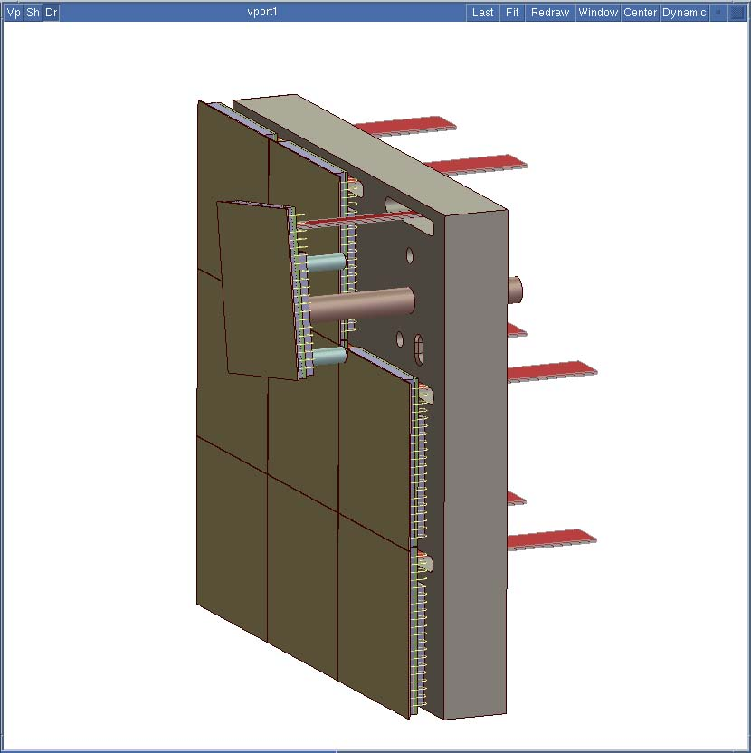
Cold plate Detector

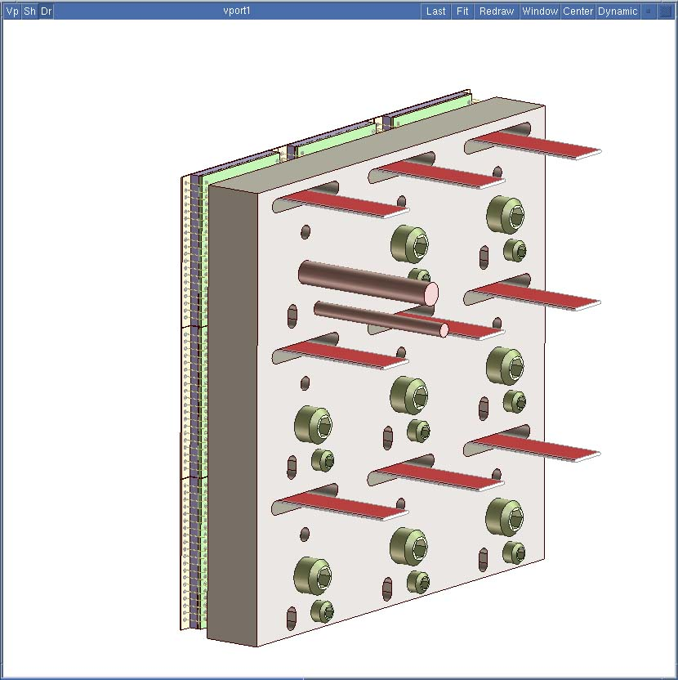

Base plate

The concept for the base plate, which serves as the mechanical mount for the CCDs and the thermal path to the heat radiator, is developed in parallel with the CCD mount. It must provide enough strength to withstand launch loads and enough thermal mass to buffer dynamic heat loads if we choose to power cycle the on-CCD electronics. A concept for attaching to the heat radiator will be developed.

Shield

Black body radiation from other spacecraft components can represent a major fraction of the thermal load on the focal plane array. Solar protons will be responsible for the majority of radiation damage to the CCDs. We are working on a concept of a dual-purpose shield to reduce the solid angle for black body radiation and to attenuate the sub-100 MeV proton flux.

Prototype concepts

During this set of activities we are prototyping our concepts for CCD packaging and mounting. We are also software modeling concepts for thermal and particle shielding.

A concept for the CCD mounting system and shield and some initial prototyping will be complete at the time of the July 2001 ZDR.

CCD mount

Materials measurements — radiological, chemical, and mechanical — are underway to ensure their compatibility with the silicon of the CCDs. The optical prescription of the telescope is being used to develop mechanical placement tolerances for the packaged CCD modules. A series of 3 x 3 arrays will be prototyped, the first using scrap silicon cut to the size of a SNAP CCD with expected sawing tolerances. We can verify that the CCDs are easily assembled with the required tolerance and can also measure mechanical motion and deformation at 150 K using TV holography. The second prototype will contain actual SNAP CCDs and can potentially be readout albeit probably only at room temperature. A third prototype round is scheduled if needed.

As soon as possible, this CCD mount will become the default packaging for all testing of SNAP-format CCDs.

Model radiation flux and shielding

The deployment of material in the thermal and particle shield requires great care to insure that punch-through debris particles do not amplify the sub-100 MeV particle flux compared to no shielding at all. Standard computer transport codes will be run using measured fluences of solar and galactic particles as input to optimize this shield.

Perform thermal and mechanical FEA

We will construct a mechanical conceptual model of the focal plane, shield, mounts, and other attachments. Using standard FEA codes we can explore the mechanical and thermal performance issues of the imager, such as

- Thermal transients from electronic loads.
- Dissipation of black body load.
- Cable heat conduction.
- Support heat leaks.
- Radiator attachment efficiency.
- Static mechanical stresses and deflections.
- Launch vibration/acoustic loads.
- Kinematic mounting system.

Build small system concept prototype

The culmination of the imager development is the construction of a 4 x 4 section of the focal plane and an accompanying cryostat. This demonstration unit will be electronically viable and can be cooled to operating temperature so that a system performance test can be done when the readout electronics is available.

Develop calibration procedures

The important research endeavor of establishing how to calibrate the imager while in orbit resides in this activity for no logical reason. One path of research is to determine types of calibration are required by our use of the instrument, for example

- Types of flat fields and how to acquire them.
- Cross wavelength absolute calibration among filters.
- Standard set of reference stars.
- On-board radioactive and optical sources.

The other research path is learn what has been done and will be done with large ground-based and space-based focal plane arrays.

CD1 planning

A major deliverable at the end of R&D is a cost and schedule for the construction of the mechanical components of the focal plane array. Prototype packaging will help establish materials and labor costs. FEA modeling will produce refined estimates of the mass, mass distribution, and radiator heat loads that can be used in the design of the spacecraft.

Planning for long lead procurements

At this time, no long lead procurements are anticipated.

R&D deliverables

The table below lists deliverables generated during the R&D effort.

Deliverable | Completion Date
CCD mount design | 13-Feb-2002
Build system prototype | 30-Sep-2002
Calibration requirements | 2-Oct-2002
Construction cost and schedule | 2-Oct-2002

Risk assessment

We cannot identify any high risk issues associated with developing the CCD packaging.

Manpower

The table below shows the manpower estimates that have been derived from a resource load schedule.

Personnel | Category | FTE
 |  | FY01 | FY02
J. Bercovitz | Engineer | 1.00 | 1.00
Mech. Designer | Designer | 0.25 | 0.25
N. Hartman | Engineer | 0.10 | 0.10
Mech. technician | Technician | 0.75 | 0.75
Scientist | Scientist | 1.00 | 1.00
M. Metzger | Scientist | 0.50 | 0.50

A brief description of the personnel follows:
- John Bercovitz is an LBNL engineer with experience in building precision experiment components and assembly fixtures.
- Neil Hartman is an LBNL engineer whose expertise is finite element analysis.
- The mechanical designer will either come from the pool at LBNL or one of the collaborating institutions. Candidates have been identified.
- The mechanical technician will either come from the pool at LBNL or one of the collaborating institutions.
- Mark Metzger is
- The scientist is a graduate student or post doc. No one has been identified yet.

Budget summary

The table below contains the budget summary in k$ excluding scientist salaries.

WBS |  | FY01 |  |  | FY02
 | EDIA | Material | Total | EDIA | Material | Total
A.1.12.2 | 349 | 82 | 430 | 365 | 58 | 423

Schedule summary

A schedule summary is shown below which tracks the narrative above. The fully expanded schedule is provided elsewhere.



