Sustainable Development in the United States: An Experimental Set of Indicators

A Progress Report Prepared by the
U.S. Interagency Working Group on Sustainable Development Indicators
Washington, D.C.
December 1998
Table of Contents
The U.S. Interagency Working Group on Sustainable Development Indicators welcomes public participation in the discussion and selection of indicators for sustainable development. Please send your comments to the following address:
David Berry
Executive Director
U.S. Interagency Working Group on Sustainable Development Indicators
c/o Council on Environmental Quality
722 Jackson Place, NW
Washington, D.C. 20503-0002
Email address: sdi@ios.doi.gov
Table of Contents
Foreword
Acknowledgments
Executive Summary
Chapter 1. Introduction
Chapter 2. Sustainable Development: A Working Definition and a Framework for Indicators
Chapter 3. Sustainability Issues and Criteria for Selecting Indicators
Chapter 4. An Experimental Set of Sustainable Development Indicators
List of Indicators
Economic Indicators
Environmental Indicators
Social Indicators
Chapter 5. What the Indicators Do and Do Not Tell Us about Sustainable Development
Chapter 6. Future Work on Sustainable Development Indicators
Appendices
A. Acronyms
B. Inventory of Candidate Indicators
C. Indicators Developed by the OECD, UNCSD, and the PCSD
D. Outreach Efforts
E. List of Regular Participants U.S. Interagency Working Group on Sustainable Development Indicators September 1997
Foreword

"This report is unique in presenting a diverse mix of U.S. indicators in the context of sustainable development...
Its main goal is to stimulate further thought and discussion."
Sustainable development is an evolving process that improves the economy, the environment, and society for the benefit of current and future generations. The actions we take today must provide for our needs without diminishing the assets, resources, and capabilities available to our descendents.
This report of the U.S. Interagency Working Group on Sustainable Development Indicators (SDI Group) marks an important first step in examining the United States’ progress along a path of sustainable development. It includes a framework for organizing indicators and an experimental set of 40 indicators that relate to various aspects of sustainability. Some of the individual indicators appear in other documents, but this report is unique in presenting such a diverse mix of U.S. economic, environmental, and social indicators in the context of sustainable development. Among the 40 indicators, 30 showed trends with a clear impact relevant to sustainable development and of these 17 recently moved in a favorable direction.
Information about current and long-term conditions and about the processes that affect those conditions is essential to evaluating our progress in pursuit of sustainable development. Indicators, such as those described in this report, provide a useful tool for simplifying, quantifying, and communicating vast amounts of information in ways that are more easily understood. Indicators provide a useful feedback mechanism for highlighting areas where we are doing well and for alerting us to areas that may need greater attention. This feedback is particularly important as people across the country work to put the Nation on a path toward greater economic, environmental, and social well-being.
In its initial report "Sustainable America," the President’s Council on Sustainable Development (PCSD) recommended that the Federal Government, in collaboration with the private sector and non-governmental organizations, develop national indicators of progress toward sustainable development and regularly report on these indicators to the public. This report represents an initial response to that recommendation.
As we learn more about the conditions and processes that support sustainable development, the indicators that are the most meaningful will undoubtedly change. In presenting this report, our primary goal is to stimulate further thought and discussion within and outside the Federal Government, on which measures are most useful in assessing and furthering the Nation’s progress toward a more sustainable future. The next report of the SDI Group will reflect that discussion.
Acknowledgments
This report would never have been possible without the help and support of many individuals and organizations, both within and outside the Federal Government. We would like to extend a special thanks to the White House Office of Environmental Quality and its staff, particularly Keith Laughlin and Carolyn Mosely, for their encouragement, guidance, and support.
We would also like to thank all of the Federal agencies that participated in the SDI Group and especially those that provided the funding and staff support that made this project possible. A number of individuals contributed significant time and energy to the SDI Group. These included:
• those who served as detailees to the Secretariat, including Don Rogich, Department of the Interior (DOI); Tim Stuart and Rick Cothern, Environmental Protection Agency (EPA); and Kevin Schaefer, National Aeronautics and Space Administration (NASA);
• Brand Niemann (EPA), who developed an electronic version of this report for dissemination over the Internet;
• Evert Byington (EPA), who compiled many of the indicators and steered the draft report through the interagency review and revision process;
• Ted Heintz (DOI), who provided leadership in developing a framework for sustainable development indicators;
• Rebecca Moser, Department of Commerce (DOC), who served as chief writer/editor and helped develop a report that could be embraced by all participants; and
• David Berry, who served as Executive Director of the SDI Group and played an essential role in gaining the Administration's support for this project, in facilitating interagency participation, and in inviting comments and suggestions from all those with an interest in sustainable development.
In addition, we would like to thank Nick Fedoruk, a volunteer who helped with the SDI Group's outreach efforts, and all of the interns who provided staff support and conducted research for the Secretariat.
We would also like to express our appreciation to those individuals outside the Federal government who so willingly shared their knowledge and expertise about indicators, including Albert Adriaanse (formerly Minister of Housing, Spatial Planning, and the Environment, The Netherlands), Allen Hammond and Eric Rodenburg (World Resources Institute), and John O’Connor (formerly of The World Bank).
Finally, the SDI Group would like to thank the many individuals who have reviewed and provided comments on the work of the SDI Group. Their input will continue to be important in developing a set of indicators that is useful and meaningful to policy makers and the public.
Executive Summary

"This set of indicators is not a complete assessment, but rather a first look at U.S. progress toward greater economic, environmental, and social well-being."

What does sustainable development really mean? How do we know if we are making progress? And what measures are most useful in evaluating our progress? These are just a few of the questions the SDI Group asked in developing this experimental set of 40 indicators. This set is not a complete assessment of the United States' progress toward sustainable development, nor is it a recommended set of indicators for the Nation. Rather it is a first look at some of the key economic, environmental, and social factors that may be important. The purpose of this first look is to encourage a national dialogue that will ultimately result in a set of national indicators of sustainable development.
One of the greatest challenges in measuring sustainability is capturing its breadth, richness, and complexity. In 1987, the Brundtland Commission defined it as "development that meets the needs of the present without compromising the ability of future generations to meet their own needs." Many of the issues are global--from climate change and biodiversity, to human rights, world peace, and international security--and no one country can realize sustainable development on its own. Recognizing that sustainability is global, the nations of the world came together in Rio de Janeiro in 1992 for the United Nations Conference on Environment and Development (UNCED). Together, they developed a bold new agenda for the 21st Century, known as Agenda 21, and agreed to take concrete steps to implement it within their own borders and worldwide.
In the United States, President Clinton responded to Agenda 21 by appointing the President's Council on Sustainable Development (PCSD). The Council set forth a new vision for the nation:
"Our vision is of a life-sustaining Earth. We are committed to the achievement of a dignified, peaceful, and equitable existence. A sustainable United States will have a growing economy that provides equitable opportunities for satisfying livelihoods and a safe, healthy, high quality of life for current and future generations. Our nation will protect its environment, its natural resource base and the functions and viability of natural systems on which all life depends."
This is a vision of economic prosperity, a healthy environment, and a just and equitable society. If we can make sustained progress in all three areas, both at home and abroad, then we will leave the world in at least as good a state as the one we inherited. Within the context of Agenda 21 and the PCSD's vision statement, and for the purpose of selecting indicators, the SDI Group defined sustainable development as "an evolving process that improves the economy, the environment, and society, both today and over the long term."
A key to sustainability is to conserve and use available resources wisely. We draw upon these resources--economic, environmental, and social--to meet our own needs and then we pass them along to future generations. We must pay attention to how our own actions today could affect the future well-being of our nation and the world.
The SDI Group organized the set of 40 indicators in two ways: (1) economic, environmental, and social; and (2) long-term endowments and liabilities; processes; and current results. The first categorization helps us think about the indicators in a conventional way; the second focuses our attention on the need to take a long-term view.
Long-term endowments and liabilities include things like capital assets, natural resource stocks, or hazardous wastes --things that could affect our well-being today and in the future. Processes include things like investment or pollution which could affect either long-term endowments or current conditions. Current results include those things that we experience or hear about in our everyday lives, such as crime rates, air quality, or the gross domestic product.
The SDI Group gave equal consideration to the economy, the environment, and society in selecting this set of indicators. Yet because some indicators are more highly aggregated than others, an exact balance among the different types of indicators is not necessarily required. For some issues, the sustainability connection seems clear; while for others, the relationship is more complex. This set of indicators includes both those with a clear link to sustainability, and those that have mixed or uncertain impacts now and potentially major impacts over the long term.
By looking at this diverse group of indicators, we can begin to get a sense of the conditions or processes that may be important in realizing sustainability. Among the 40 indicators, 30 showed trends with a clear impact relevant to sustainable development and of those 17 are moving in a favorable direction. The remaining 10 indicators have mixed or uncertain impacts. This illustrates the many unanswered questions that we still have about the nature of sustainability. Indicators therefore can be a useful tool not only for monitoring progress, but also for helping us explore the issues in greater depth.
Table 5.4 Summary of Indicators
SDI Framework Subcategory | Total No. of Indicators | Relevance of Trends to Sustainable Development
 |  | No. of Indicators with Trends that Result in Favorable Impacts | No. of Indicators with Trends that Result in Unfavorable Impacts | No. of Indicators with Trends that Result in Mixed or Uncertain Impacts
Economy | 13 | 7 | 2 | 4
Environment | 16 | 5 | 7 | 4
Society | 11 | 5 | 4 | 2
Total | 40 | 17 | 13 | 10

The SDI Group presents this document as a "work in progress" and hopes that it will stimulate further thought and discussion. As we learn more about the nature of sustainability, the indicator sets that are most useful will surely change. Because the creation of sustainable development indicators is still in its infancy, there are several possible approaches for developing, organizing and relating indicators. Some practitioners seek to eventually develop a smaller set of non-redundant indicators that summarize a wide range of information for decision makers and other users. Other practitioners think a larger set of overlapping indicators better demonstrates the relatedness of economic, environmental and social results and that decision makers are best served by having the flexibility to pick from such a “suite” of interrelated indicators. The SDI Group does not attempt to resolve this issue in this report, and over time, it will evaluate a variety of approaches.
In the coming months, the SDI Group will continue its work to refine the current set of indicators, examine other indicators, evaluate alternative approaches to indicator development, and study the relationships among various sustainability issues. We welcome input from all interested parties--government, industry, nongovernmental organizations, and communities-- in developing a set of indicators that is truly useful in monitoring and advancing the Nation's progress toward sustainability.
Chapter 1. Introduction

"The main challenge of sustainability is to integrate our various goals and aspirations over the long-term."

The concept of sustainable development touches many different aspects of our lives--from pursuing economic prosperity, to utilizing natural resources, to enhancing the environment, to pursuing peace and social justice for people around the world. The main challenge in actually pursuing sustainability is in learning how to integrate our various goals, aspirations, and competing demands in ways that improve economy, the environment, and society over the long term.
In June 1993, President Clinton established the President’s Council on Sustainable Development (PCSD) with a mandate to develop recommendations on steps the United States could take to realize sustainable development. The Council presented its initial findings to the President in March 1996 in the document Sustainable America: a New Consensus for Prosperity, Opportunity, and a Healthy Environment for the Future. In this report, the Council noted the importance of monitoring the Nation’s progress toward national sustainability goals. It recommended that the Federal Government intensify its efforts to develop national indicators of progress toward sustainable development in collaboration with nongovernmental organizations and the private sector.1
In response to this recommendation, the Administration established the U.S. Interagency Working Group on Sustainable Development Indicators (SDI Group). This action formalized the activities of a group of agency representatives who had been meeting informally since early 1994 to discuss various approaches for developing a set of sustainable development indicators. The SDI Group reports to the Council on Environmental Quality in the Executive Office of the President and is supported through voluntary contributions of staff and resources by participating Federal agencies. In the coming months, the SDI Group will continue to maintain its own identity, and some members may also participate in discussions of the PCSD’s Evaluating Progress Working Group.
This report summarizes the work of the SDI Group from 1996 through 1998. The Group’s major activities during this period have included the following:
• Developing the SDI Framework. The Group developed a conceptual framework for indicators that reflects the multidisciplinary and intergenerational nature of sustainable development. This framework builds on indicator frameworks developed by others.
• Establishing A Process For Selecting Indicators. The Group developed a process for examining and selecting an experimental set of indicators which involved extensive discussions among the Federal agencies and a number of outside groups.
• Selecting a Set of 40 Indicators. The Group selected an experimental set of 40 economic, environmental, and social indicators that represent a cross-section of many of the issues that are judged to be relevant to sustainable development. This set of indicators was selected from an inventory of more than 400 indicators identified by Federal agencies; the PCSD; the United Nations Commission on Environment and Development (UNCSD); the World Bank; other countries; and various nonprofit groups, businesses, and communities.
• Establishing World Wide Web Site. The Group established a World Wide Web site (http://www.sdi.gov) to facilitate public access to its work products.
• Identifying Areas for Future Work. SDI Group participants identified a number of issue areas that they feel are inadequately represented in the current set of indicators (see Chapter 6). The development of indicators of sustainability is still at an early stage, and future work of the SDI Group could include joint efforts with the academic community and/or others to develop additional indicators of sustainability.
Many of the individual indicators presented in this report appear in other Federal agency publications, but they have not previously been published in the same document. By presenting this diverse group of indicators together, we hope to communicate the integrated nature of sustainability.
Each type of indicator helps us assess sustainability in a somewhat different way. Indicators that reflect current conditions can provide easy-to-understand information on how well we are doing in meeting near-term objectives. Many of these indicators of current results are quite familiar and include such things as the gross domestic product (GDP), the crime rate, unemployment rates, and educational achievement rates. Some indicators provide information on the assets, resources, or liabilities that we pass on to the future. They include such things as water resources or the quantity of spent nuclear fuel we pass on to our children and grandchildren. Other indicators provide information on processes and driving forces that affect current or long-term conditions. These include such things as the utilization of fisheries, emissions of greenhouse gases, or investment in research and development. Many of the indicators on long-term endowments or liabilities or on processes can serve as early warning signals of challenges that we may face in the future.
Over the past several years, the SDI Group has gained profound humility about its ability to understand and measure sustainable development. We do not yet understand many of the relationships among sustainability issues, and we are still unsure how to measure some important parameters. This report focuses primarily on indicators for which data are currently available, but it does not preclude the development of new measures at some point in the future. In the coming months, the SDI Group plans to examine a number of sustainability themes and indicators in greater depth.
1 President’s Council on Sustainable Development, Sustainable America: A New Consensus, Chapter 3, Information and Education, p. 66, U.S. Government Printing Office, 1996.
Chapter 2. Sustainable Development: A Working Definition and a Framework for Indicators

"Sustainable development: an evolving process that improves the economy, the environment, and society way for the benefit of current and future generations."
One of the SDI Group’s activities has been to develop a working definition of sustainable development and a conceptual framework for indicators of progress. The Group’s discussions began with the definition of sustainable development proposed by the Brundtland Commission in 1987: which is, "development that meets the needs of the present without compromising the ability of future generations to meet their own needs.” This definition can be interpreted in various ways.
For purposes of this report, the SDI Group considers sustainable development to be an evolving process that improves the economy, the environment, and society for the benefit of current and future generations. If we achieve sustained progress in all three areas, then it is likely that we will leave the world in as good a state as the one we inherited, if not better.
Sustainable development is a journey, and measuring progress on that journey can never be an absolute process because the journey involves a complex mix of biophysical realities and human values. Ideally, we would like to have balanced and continuous social, economic and environmental progress down the path of sustainable development. Ideally, we would also like to monitor accurately and frequently our rate of progress on the journey. But in reality, achieving such balanced and continuous progress will be difficult because of the complexities involved. Variations in climate, cycles in the economy, shifts in social values, and advances in science and technology are among the many unpredictable forces currently limiting our ability to predict and monitor accurately our rate of progress on the sustainable development journey.
Finding opportunities to minimize these limitations continues to be central to the work of the SDI Group. The Group is still far from achieving an ideal indicator set for monitoring the rate of social, economic and environmental progress toward sustainable development. But at this time, there is sufficient understanding of the nature of sustainable development to prepare an experimental set of indicators that can be used for a comparative qualitative assessment to determine if the Nation is at least proceeding in the right direction on the path of sustainable development. In such an assessment, the number of indicators showing a positive trend can be compared to the number showing a negative trend. If the net difference is positive, this would be a general indication that the Nation is moving in the right direction.
If we think of sustainable development as a three-legged stool, then one leg can be thought of as representing the economy, another as representing the environment, and the third as representing society or equity. The legs of the stool are grounded in traditional academic disciplines, such as the social, economic, political, biological, and physical sciences. Over the years, each academic discipline has developed its own concepts, statistical programs, and classification systems and is often treated separately by government agencies and the private sector.
Concerns about job creation, economic growth, or investment have often been considered apart from concerns about environmental quality or education, with less than optimal results. For example, efforts to further economic growth in a particular geographical region without adequate consideration of the region’s environment, natural resources, and social character may lead to urban sprawl, the disintegration of inner city neighborhoods, pollution, and/or the destruction of habitat. On the other hand, efforts to avoid any changes in natural habitat or the environment may hamper a region’s ability to meet the economic and social needs of its residents.
Each economic, environmental, and social issue requires attention, but from the standpoint of sustainable development, we must examine the issues together, rather than in isolation. There will always be trade-offs among different interests, but this does not preclude us from making decisions that advance all interests over the long term. For example, as a Nation, we have agreed that we want clean air and water, protection from hazardous wastes, and a healthy environment; and we have instituted a number of environmental regulations to further the achievement of those goals. At the same time, we have not decided to eliminate all anthropogenic pollution, since that would require us to halt many activities--from manufacturing, to transportation, to information services--which improve our economic well-being. The income provided by these activities makes it possible for us to invest in research and development, to invest in improved technologies and infrastructure, to improve education, and to purchase food and shelter. Trade-offs among the environment, the economy, and society will always occur, and there may be more progress in one area than another at any particular point in time. Nevertheless, by adopting multidisciplinary decision-making processes, we can develop approaches that do a better job of advancing progress in all three areas over the long term.
We frequently pay more attention to our wants and needs than we do to the potential long-term consequences of our actions. While we know that future development depends on having adequate assets and resources, concerns about the future often pale in comparison to immediate and pressing needs (e.g., for public safety or jobs). Consideration of the future becomes even more difficult when there are uncertainties about environmental trends, ecosystem carrying capacities, economic interactions, and future technological advances.
A set of indicators that reflects today’s conditions as well as the assets and liabilities we pass on to future generations can be an important tool in fostering integrated decision-making processes. The indicators selected by the SDI Group are based on data that are currently available, primarily from the Federal agencies. The SDI Framework organizes the indicators into three major categories representing (1) long-term endowments and liabilities, (2) processes, and (3) current results. These categories are then divided into subcategories for the economy, the environment, and society.
One category of indicators chosen by the SDI Group--the current results indicators--reveals the United States’ progress or shortcomings in improving current conditions and experiences (e.g., GDP, air quality, or educational achievement). These indicators focus on human experiences today and often receive the most attention in the day-to-day media. A second category of indicators--long-term endowments/liabilities--provides insights into possible future challenges by measuring the status of resources, capacities, and liabilities that we pass on to future generations (e.g., capital assets, endangered ecosystems, or population). These indicators are a key to understanding the evolving and intergenerational nature of sustainable development. A third category of indicators--process indicators--includes the processes and driving forces that affect either long-term endowments and liabilities or current results (e.g., investment in research and development, emissions of greenhouse gases, or births to single mothers). In many cases it is these processes that we may need to change if we are to design a path toward greater sustainability.
The SDI framework emphasizes the links between the resources we inherit and utilize to meet today’s needs and those that we pass on to future generations. It also encourages us to think about the economy, the environment, and society together, rather than in isolation. By examining a diverse set of indicators together, we can begin to understand the conditions and approaches that will support sustainable development. If we can do a better job of meeting today’s needs, while also enhancing the assets and resources we ourselves inherited, then we will be a step closer to designing a path of sustainable development.
In developing the SDI Framework, the SDI Group drew upon the indicator work that has been done by Federal agencies, by colleagues in The Netherlands and Canada, and by groups such as the PCSD, the Organization for Economic Cooperation and Development (OECD), the UNCSD, the World Bank, and the World Resources Institute. A commonly-used framework for organizing environmental indicators is the Pressure-State-Response (P-S-R) model.
Figure 2.1. Pressure-State-Response Framework
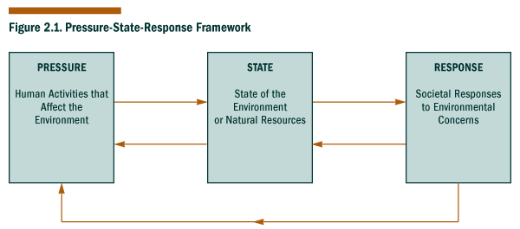
The P-S-R model is based on environmental pressures (e.g., emissions or the use of natural resources), environmental conditions or states, and human responses to those conditions. From the standpoint of sustainable development, one drawback of the P-S-R model is that it does not readily accommodate the full range of economic and social variables and time scales that are relevant to sustainability. In addition, it is not well-suited to accommodating the uniquely human skills of anticipation, prevention, and design. A useful framework for sustainable development indicators should be able to incorporate our ability to imagine and design alternative futures, including sustainable ones. If we focus only on damage control, then we are likely to miss opportunities for innovation and new ways of thinking.
The SDI Framework builds on the P-S-R model, but it accommodates a range of processes--both positive and negative--related to the economy, the environment, and society. It divides the “state” category in the P-S-R model into two separate categories: ”long-term endowments and liabilities” and “current results”. This division emphasizes the multi-generational nature of sustainability.
The SDI Framework also builds on the familiar economic concept of stocks and flows. One can sometimes think of processes as the activities that utilize initial stocks to yield current goods and services, as well as the resulting stocks that are passed on to future generations. The endowments that are available in the future may be smaller or larger than today’s stocks depending on how much we use and whether we are able to restore or enhance those stocks (e.g., through new technologies or environmental restoration).
Figure 2.2. Sustainable Development Indicator Framework
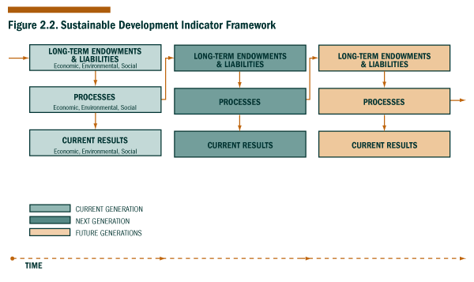
As illustrated in Figure 2.2, sustainable development is not an end in itself, but rather an evolving process. All components of the Earth system--including human knowledge and technological development--are constantly changing, and in our effort to realize sustainable development, we must recognize and respond to these changes. In evaluating our progress, we can examine some of the parameters that appear to be most important today, even though these parameters are likely to change over time.
It may be useful to take a closer look at the major categories of the framework.
Long-term Endowments and Liabilities
We inherit various assets, resources, and capacities from our predecessors, utilize some of them to meet our own needs and wants, and then pass them on to future generations. We also inherit a variety of challenges such as hazardous wastes, income disparity, and racial tensions that can carry over from generation to generation. Children can also be seen as another kind of endowment--one with very special characteristics--that is provided by each generation to the future. Indicators that reflect these long-term assets and challenges are labeled as "long-term endowments and liabilities" in the SDI Framework. These indicators are especially important in assessing sustainability since they emphasize the need to consider the impacts of current actions on the well-being of future generations.
As an analogy, one can think about the endowment of a university as the long-term capital base that the university needs to ensure adequate funding for current operations. This endowment must be maintained to provide the income the university needs for the future. Indicators of long-term endowments and liabilities reflect the legacy we pass on to the next generation.
Processes
In the SDI Framework, general processes include (1) the human activities that utilize endowments to yield current goods and services; (2) natural Earth system processes (e.g., hydrological, atmospheric, terrestrial, biological, or chemical); and (3) social, cultural, or political processes. Processes can include things as diverse as manufacturing, atmosphere/ocean interactions, and democratic governing processes.
These processes give rise to a number of driving forces--both desirable and undesirable--that directly affect the status of long-term endowments. For example, the industrial production of paper is a process that provides paper for consumers and jobs for some workers (current results), while also giving rise to the harvesting of timber and the release of chemicals (driving forces) that could affect the long-term status of forested and aquatic ecosystems (endowments).
Many of the general processes are affected by decision-making processes of government, industry, communities, and individuals. Decision-making includes things such as law-making, regulating, developing policies and management approaches, and evaluating consumer choices. Decision-making is guided by information--such as that provided by indicators--about current results, driving forces, and endowments. For example, consider the production of wooden furniture (the general process): the decision-making processes that determine the level and type of production would be guided by information about supply versus demand for wooden furniture and associated economic costs (current results), by information about the balance between forest growth and removals (a driving force), and by information about the status of forested areas (the endowment).
Other examples of decision-making processes that regulate driving forces directly affecting endowments are the government regulatory processes controlling the rate of wetland conversion; and private sector decision-making processes resulting in shifts from high-sulfur to low-sulfur coal for generating electricity.
The SDI Group did not identify a suitable decision-making indicator for inclusion in this report. However such indicators will be considered in the future because many government agencies, in implementing their missions, often directly affect economic, environmental, and social sustainable development. A further opportunity for developing decision-making indicators that will capture the linkages between sustainable development and government decision making is the current effort by Federal Agencies to develop and monitor performance standards under the Government Performance and Results Act (GPRA). GPRA data collection and analysis strategies that include both monitoring the achievement of program standards and assessing the broader impact of program implementation on natural, built, human and social capital could create a greater synergism between SDI and GPRA efforts.
Current Results
In the SDI Framework, current results include the goods, services, and conditions that are enjoyed or experienced by present generations. Indicators of current results focus on human well-being today and in the near-term. Many of the indicators with which we are most familiar--such as the gross domestic product, unemployment rates, or crime rates--are indicators of current results.
Figure 2.3. Sustainable Development Indicator Framework with Flow of Information
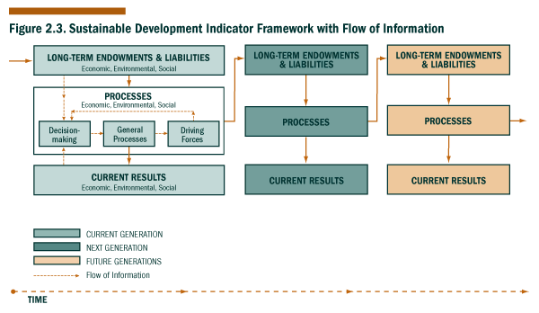
Table 2.1. Framework Categories
Category | Definition | Rationale | Examples
Long-Term Endowments & Liabilities | The assets, resources, capacities, and liabilities inherited from our predecessors and from nature and passed on to future generations. We draw upon many endowments to meet current and future needs and wants. | To track the condition of the assets, resources, capacities, and liabilities that we pass on to future generations. | * Built capital such as public infrastructure, houses, and telecommunications systems  * Natural resources such as forests, fisheries, oil and mineral reserves, air, water, and soil  * Environmental conditions such as the quantity and/or quality of air, water, or soil; or toxic contamination and hazardous wastes.  * Capacity of natural systems to provide aesthetic enjoyment and recreational activities  * Social systems including families, educational institutions, community organizations, and governments; and cultural and historical resources  * Human capital, particularly status of children.
Processes | (1) General processes such as human activities that utilize assets and resources (endowments) to yield current goods and services; (2) general Earth system processes; (3) general social, cultural, or political processes; (4) driving forces arising from human or Earth system processes that directly affect the condition of long-term endowments; and (5) decision-making processes that utilize information about current results, endowments, or driving forces and affect human activities. | To track the human and natural processes that ultimately determine the extent to which current and future needs and wants can be satisfied. | * General human-related processes, such as the production of consumer goods and services  * General Earth system processes, such as hydrological, atmospheric, terrestrial, biological, and chemical processes  * General societal processes such as education or democratic processes  * Driving forces such as the generation of pollutants or the consumption or enhancement of natural resources  * Driving forces such as investment in capital and research and development  * Socioeconomic driving forces such as poverty  * Decision-making processes such as law-making, regulating, developing policies and management approaches, and marketing
Current Results | The goods, services, and conditions enjoyed or experienced by current generations. The emphasis is on the present, rather than on the future. | To track our success in meeting the needs of current generations. | * Food, clothing, and shelter  * Income, financial security, and employment  * Personal and professional services  * Safety and low pollution  * Recreational opportunities  * Freedom from crime, and national security  * Civil rights, personal freedom, and personal fulfillment  * Educational achievement

The inclusion of an indicator in a particular category or subcategory of the SDI Framework depends to some extent on the questions one asks. For example, an indicator on population could be categorized as an endowment in the sense that it reflects workforce capabilities or as a current result in the sense that it reflects current conditions. Another indicator such as income distribution, which is categorized in this document as an economic indicator, could also be categorized as a social indicator since it is so closely connected to a number of societal issues.
Using the Framework to Organize Indicators Related to a Particular Sustainability Issue
The SDI Group has found the framework useful in thinking about the many dimensions of various sustainability issues. The example of the framework below includes some of the indicators that relate to energy and climate change. It is not intended to be a complete model of all of the relevant factors, but simply an illustration of how the framework can be used to organize a number of related indicators. Just a few of the indicators in the diagram are actually included in the set of 40 indicators selected by the SDI Group and described in this document (e.g., greenhouse gas emissions, energy consumption, investment in research and development, and the Greenhouse Climate Response Index). This diagram is based on some of the changes we might expect if current greenhouse gas emission patterns continued into the future, that is, a “business as usual” scenario.
Figure 2.4. Framework-Energy & Climate: Initial Endowments & Liabilities
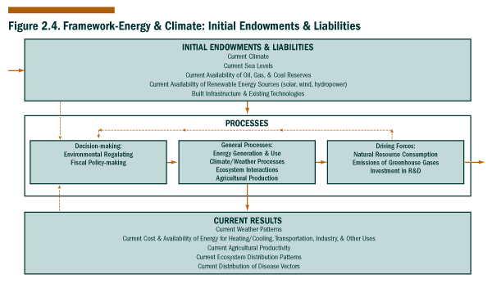

Figure 2.5. Framework-Energy & Climate: Future Endowments & Liabilities
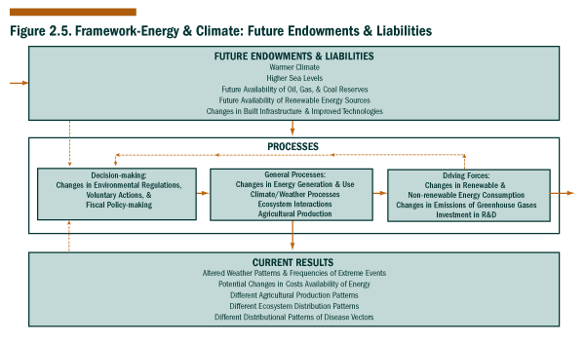

At this point, the SDI Framework should be viewed as an experimental tool. In the coming months, the SDI Group will begin to explore how the framework might be made more useful, and outside comments and suggestions would be welcomed.
Chapter 3. Sustainability Issues and Criteria for Selecting Indicators

"This set of 40 indicators was selected from a list of over 400 candidates."
In developing a set of sustainable development indicators, the SDI Group felt that it was important to build on the work that had already been done in this area. The Group drew upon related efforts by Federal agencies; by The Netherlands and Canada; and by organizations such as the PCSD, the OECD, the UNCSD, and the World Bank. The indicators which some of these groups identified as being important to sustainability are listed in the appendix.
The SDI Group also wanted to ensure that a full range of potential issues and indicators--not just those that had already been identified--could be considered for inclusion in the SDI Group’s indicator set. The Secretariat for the SDI Group convened a number of thematic meetings--focused on the economy, the environment, or society--to discuss sustainability issues and indicators that one might wish to track, either now or in the future. These meetings included representatives from the Federal agencies, the academic community, the private sector, and nongovernmental organizations. The lack of fully developed indicators or existing data did not preclude an issue or indicator from being considered.
General Selection Criteria
The SDI Group developed the following general selection criteria to screen lists of existing indicators and identify those indicators that might be considered as candidates for the SDI Group’s set of indicators. A candidate indicator was required to meet all of these general criteria, with the possible exception of the last (i.e., being scalable to regional, state, and local levels)
• Represent an issue that is important to sustainable development;
• It is understandable to a general audience, even if the methodology behind the indicator is more complicated;
• It is quantifiable;
• It is based on available data (indicators identified for future development may be based on data that are not currently available);
• It is national in scope or relevant to an issue of national concern; and
• It is scalable to regional, state, and local levels if appropriate for the issue under consideration.
Using these general criteria, the SDI Group compiled a list of over 400 candidate indicators that could potentially be included in its set of sustainable development indicators (see Appendix B).
Specific Selection Criteria
The SDI Group developed the following more specific criteria to narrow this list of candidate indicators to a more manageable set and to guide the consideration of input from the thematic meetings. Each indicator selected for the SDI Group’s indicator set was required to meet at least one of these criteria:
• reflects changes in important endowments (e.g., public infrastructure, air or water quality, natural resource stocks, and governmental institutions);
• reflects an issue that could have significant costs or benefits for current or future generations (e.g., technological advances; political stability; loss of biodiversity, status of children, and desertification);
• reflects an issue that can only be addressed over a period of years, decades, or centuries (e.g., global climate change); or
• reflects an issue that involves thresholds beyond which small changes could potentially lead to irreversible effects (e.g., endangered species becoming extinct).
Each participating Federal agency was asked to review the list of candidate indicators and to identify the ten indicators that it felt should be included in the SDI Group’s indicator set. The initial result was a list of 32 different indicators.
It should be noted that in a few instances, the selection of indicators was based on the availability of Federal data and estimates, rather than on what one might consider to be an ideal measure. For example, the indicators on surface water quality and air quality are based on enforcement and/or compliance data (e.g., metropolitan air quality non-attainment areas), rather than on the observed environmental data itself. The SDI Group recognized that this approach is not ideal, since changes in environmental regulations, rather than changes in environmental quality, could generate fluctuations in the data and result in misleading interpretations of the indicators. In the coming months, the SDI Group will work to identify more appropriate measures for these areas.
Follow-up discussions among participants from the SDI Group and outside organizations resulted in the expansion of the set of 32 indicators to a set of 40 indicators. (The outreach process is described in the appendix.) Interestingly, the comment most frequently heard by members of the SDI Group was, “You have too many indicators in the set, but you need to add one more indicator on . . . ” The 40-indicator set seemed to provide the most acceptable balance between the desire to paint a complete picture of the Nation’s progress and the need to communicate progress in simple and effective ways. Further discussion, research, and public outreach will be required to develop a more complete picture of any given issue and of the interactions among issues.
Table 3.1 represents some of the sustainability issues that were identified by the SDI Group and the related indicators that were selected for inclusion in the SDI Group’s indicator set. The order of the indicators on the following pages is not intended to imply an assignment of priorities. The individual indicators are described in the next chapter.
Table 3.1. U.S. Interagency Working Group on Sustainable Development Indicators Issues & Indicators

Issue | Selected Indicators
Economic Prosperity | Capital Assets  Labor Productivity  Domestic Product
Fiscal Responsibility | Inflation  Federal Debt to GDP Ratio
Scientific & Technological Advancement | Investment in R&D as a Percentage of GDP
Employment | Unemployment
Equity | Income Distribution  People in Census Tracts with 40% or Greater Poverty
Housing | Homeownership Rates  Percentage of Households in Housing Problems
Consumption | Energy Consumption Per Capita & Per $ of GDP  Materials Consumption Per Capita & Per $ of GDP  Consumption Expenditures Per Capita
Status of Natural Resources | Conversion of Cropland to Other Uses  Soil Erosion Rates  Ratio of Renewable Water Supply to Withdrawals  Fisheries Utilization  Timber Growth to Removals Balance
Air & Water Quality | Surface Water Quality  Metropolitan Air Quality Non-attainment
Contamination & Hazardous Materials | Contaminants in Biota  Identification and Management of Superfund Sites  Quantity of Spent Nuclear Fuel
Ecosystem Integrity | Acres of Major Terrestrial Ecosystems  Invasive Alien Species
Global Climate Change | Greenhouse Gas Emissions  Greenhouse Climate Response Index
Stratospheric Ozone Depletion | Status of Stratospheric Ozone
Population | U.S. Population
Family Structure | Children Living in Families with Only One Parent Present  Births to Single Mothers
Arts & Recreation | Outdoor Recreational Activities  Participation in the Arts & Recreation
Community Involvement | Contributing Time & Money to Charities
Education | Teacher Training Level and Application of Qualifications  Educational Attainment by Level  Educational Achievement Rates
Public Safety | Crime Rate
Human Health | Life Expectancy at Birth

Chapter 4. An Experimental Set of Sustainable Development Indicators

"The indicator set will change over time, as we learn more about the conditions that support sustainable development."
This chapter presents data on the 40 individual indicators of sustainable development selected by the SDI Group. The criteria that were used to select these indicators are described in Chapter 3, and a general assessment of the indicator set as a whole is provided in chapter 5.
This set of indicators focuses on a number of issues that we currently believe to be important to sustainability. The indicators are organized according to the SDI Framework which was presented in Chapter 2. They fall into three overarching categories--long-term endowments and liabilities, processes, and current results. Each of these categories is further divided in subcategories for the economy, the environment, and society. This categorization is not rigid, and a number of the indicators could have been categorized in several ways, depending on the questions that one asked. But for the sake of clarity, each indicator is listed in just one category. The main objective of this categorization is to reflect the multidisciplinary, intergenerational, and evolving nature of sustainable development.
The indicators listed in the long-term endowments and liabilities category relate to issues that carry over from one generation to the next. They can provide some insights into the challenges or opportunities that we may face in the future, such as toxic contamination or global climate change.
All of the process indicators selected by the SDI Group reflect driving forces that have a direct effect on long-term endowments or liabilities, such as fisheries utilization or soil erosion rates. These indicators focus our attention on the processes that we may need to change if we are failing to meet current human needs or if we are depleting our endowments (economic, environmental, or social).
The indicators that are included in the current results category relate to our ability to meet today’s needs and wants. The SDI Group recognized that the results measured by some of the current results indicators may not necessarily be desirable in the long term; they are included because meeting current needs, as we perceive them, is an important element of sustainability. Any trends that indicate a failure to meet our own needs would suggest problems related to our endowments or to the processes by which we use them. Identifying and addressing such problems is essential in realizing a path of sustainable development.
The selection of an appropriate length for data time series to be used in developing a set of indicators is an important issue. Initially, the SDI Group recommended that the time series for each indicator start with 1970 data and end with the most current data available. Using such a standard time series would make it easier to compare trends from indicator to indicator. However, as the agencies developed indicators, they found they needed flexibility in selecting time series for each indicator. In some cases, our society has only recently identified important endowments and processes that need to be measured and assessed.
Consequently, available data series for several important indicators cover only a few years. Despite these limitations, several such indicators are included in the experimental set to provide support for continuing to collect such data, and to establish a base line for assessing trends in the future.
In some cases, very long data series are required to accurately access trends in endowment status. For example, assessing the status of natural ecosystems requires a time series going back before European settlement to establish an accurate baseline so this generation can adequately assess what it inherited and what is being passed on to future generations. Ecosystem coverage prior to European settlement can be estimated from soil data, the distribution of native flora and fauna, and historical records. From estimates of coverage, we see that over half of our wetlands were lost before 1950. Since then, we have greatly slowed the rate of loss but have not succeeded in establishing a significant trend towards restoration.
At this point, no attempt has been made to prioritize or assign different weights to the 40 indicators or to combine them into aggregated indices; nor has any attempt been made to conduct a comprehensive assessment. In the coming months, the SDI Group will strive to gain a better understanding of the interactions, trade-offs, and relative importance of various sustainability issues and indicators. One of the Group’s tasks will be to explore the development of a set of indicators that relate to various sustainability themes (e.g., economic prosperity, consumption, natural resources, equity, or quality of life). Although continuity from year to year might be desirable, it seems likely that the set of indicators that is most useful will change as our base of knowledge expands and our priorities shift. The ultimate goal is to develop the types of informational tools that will be most useful to policy makers and the public in making decisions that further sustainability.
The following three tables list the 40 indicators selected by the SDI Group. Table 4.1 organizes the indicators based on the economic, environmental, and social subcategories of the SDI Framework; Table 4.2 organizes the indicators based on the SDI Framework categories of long-term endowments and liabilities, processes, and current results; and Table 4.3 is a combination of the first two tables. The tables are followed by a brief description of each indicator.
Each indicator is presented using one or more graphs. The data used to generate these graphs is available on the SDI Group Website: http://www.sdi.gov . If you have questions about the data for a specific indicator that cannot be resolved using the reference material, contact the representative of the agency that provided the indicator, or contact the SDI Group at sdi@ios.doi.gov. Names and addresses for agency representatives are listed in Appendix E.
List of Indicators
Economic Indicators
Environmental Indicators
Social Indicators
Economic Indicators
Capital Assets
Labor Productivity
Federal Debt to GDP Ratio
Energy Consumption Per Capita & Per $ of GDP
Materials Consumption Per Capita and Per $ of GDP
Inflation
Investment in R&D as Percentage of GDP
Domestic Product
Income Distribution
Consumption Expenditures per Capita
Unemployment
Homeownership Rates
Percentage of Households in Problem Housing
Environmental Indicators
Surface Water Quality
Acres of Major Terrestrial Ecosystems
Contaminants in Biota
Quantity of Spent Nuclear Fuel
Status of Stratospheric Ozone
Greenhouse Climate Response Index
Ratio of Renewable Water Supply to Withdrawls
Fisheries Utilization
Invasive Alien Species
Conversion of Cropland to Other Uses
Soil Erosion Rates
Timber Growth to Removals Balance
Greenhouse Gas Emissions
Identification & Management of Superfund Sites
Metropolitan Air Quality Non-attainment
Outdoor Recreation Activities
Social Indicators
U.S. Population
Children Living in Families with One Parent Present
Teacher Training Level and Application of Qualifications
Contributing Time & Money to Charities
Births to Single Mothers
Educational Attainment by Level
Participation in the Arts & Recreation
People in Census Tracts with 40% or Greater Poverty
Crime Rate
Life Expectancy at Birth
Educational Achievements Rates

Table 4.1. Economic, Environmental, and Social View of Indicators
Economic | Environmental | Social
Capital Assets | Surface Water Quality | U.S. Population
Labor Productivity | Acres of Major Terrestrial Ecosystems | Children Living in Families with Only One Parent Present
Federal Debt to GDP Ratio | Contaminants in Biota | Teacher Training Level and Application of Qualifications
 | Quantity of Spent Nuclear Fuel | Contributing Time & Money to Charities
Energy Consumption Per Capita & Per $ of GDP | Status of Stratospheric Ozone | Births to Single Mothers
Materials Consumption Per Capita & Per $ of GDP | Greenhouse Climate Response Index | Educational Attainment by Level
Inflation | Ratio of Renewable Water Supply to Withdrawals | Participation in the Arts & Recreation
Investment in R&D as a Percentage of GDP | Fisheries Utilization | People in Census Tracts with 40% or Greater Poverty
Domestic Product | Invasive Alien Species | Crime Rate
Income Distribution | Conversion of Cropland to Other Uses | Life Expectancy at Birth
Consumption Expenditures per Capita | Soil Erosion Rates | Educational Achievement Rates
Unemployment | Timber Growth to Removals Balance
Homeownership Rates | Greenhouse Gas Emissions
Percentage of Households in Problem Housing | Identification & Management of Superfund Sites
 | Metropolitan Air Quality Non-attainment
 | Outdoor Recreational Activities

Table 4.2. Long-term Endowments & Liabilities, Processes, and Current Results View of Indicators
Long-term Endowments & Liabilities | Processes | Current Results
Capital Assets |  | Domestic Product
Labor Productivity | Energy Consumption Per Capita & Per $ of GDP | Income Distribution
Federal Debt to GDP Ratio | Materials Consumption Per Capita & Per $ of GDP | Consumption Expenditures per Capita
Surface Water Quality | Inflation | Unemployment
Acres of Major Terrestrial Ecosystems | Investment in R&D as a Percentage of GDP | Homeownership Rates
Contaminants in Biota | Ratio of Renewable Water Supply to Withdrawals | Percentage of Households in Problem Housing
Quantity of Spent Nuclear Fuel | Fisheries Utilization | Metropolitan Air Quality Non-attainment
Status of Stratospheric Ozone | Invasive Alien Species | Outdoor Recreational Activities
Greenhouse Climate Response Index | Conversion of Cropland to Other Uses | Crime Rate
U.S. Population | Soil Erosion Rates | Life Expectancy at Birth
Children Living in Families with Only One Parent Present | Timber Growth to Removals Balance | Educational Achievement Rates
Teacher Training Level and Application of Qualifications | Greenhouse Gas Emissions
 | Identification & Management of Superfund Sites
 | Contributing Time & Money to Charities
 | Births to Single Mothers
 | Educational Attainment by Level
 | Participation in the Arts & Recreation
 | People in Census Tracts with 40% or Greater Poverty

Table 4.3. Multiple Views of Indicators
Long-term Endowments & Liabilities
Economic | Environmental | Social
Capital Assets | Surface Water Quality | U.S. Population
Labor Productivity | Acres of Major Terrestrial Ecosystems | Children Living in Families with Only One Parent Present
Federal Debt to GDP Ratio | Contaminants in Biota | Teacher Training Level and Application of Qualifications
 | Quantity of Spent Nuclear Fuel
 | Status of Stratospheric Ozone
 | Greenhouse Climate Response Index
Processes
Economic | Environmental | Social
 | Ratio of Renewable Water Supply to Withdrawals | Contributing Time & Money to Charities
Energy Consumption Per Capita & Per $ of GDP | Fisheries Utilization | Births to Single Mothers
Materials Consumption Per Capita & Per $ of GDP | Invasive Alien Species | Educational Attainment by Level
Inflation | Conversion of Cropland to Other Uses | Participation in the Arts & Recreation
Investment in R&D as a Percentage of GDP | Soil Erosion Rates | People in Census Tracts with 40% or Greater Poverty
 | Timber Growth to Removals Balance
 | Greenhouse Gas Emissions
 | Identification & Management of Superfund Sites
Current Results
Economic | Environmental | Social
Domestic Product | Metropolitan Air Quality Non-attainment | Crime Rate
Income Distribution | Outdoor Recreational Activities | Life Expectancy
Consumption Expenditures Per Capita |  | Educational Achievement Rates
Unemployment
Homeownership Rates
Percentage of Households in Problem Housing

Economic Indicators--Long-term Endowments and Liabilities
Capital Assets
Labor Productivity
Federal Debt to GDP Ratio
Energy Consumption Per Capita & Per $ of GDP
Materials Consumption Per Capita and Per $ of GDP
Inflation
Investment in R&D as Percentage of GDP
Domestic Product
Income Distribution
Consumption Expenditures per Capita
Unemployment
Homeownership Rates
Percentage of Households in Problem Housing
Capital Assets
Capital assets are one measure of the economic endowment that we pass on to the future. If a nation continues to invest sufficiently and successfully, its net tangible wealth increases.
A common measure of capital assets is the net stock of fixed reproducible tangible. This measure comprises fixed private capital, fixed government capital, and consumer durables, such as automobiles and other goods with an expected service life of three years or more. It also includes equipment and structures (such as bridges, highways, and houses). This measure reflects annual investment and depreciation by the private sector and government, but it does not include human capital, such as direct investments in education and training.
Labor and the stock of capital, primarily in the form of structures and equipment--combined with the unmeasured but essential stock of knowledge--are used to produce the current output of goods and services.
Figure 4.1 shows that since 1970, the net stock of fixed reproducible tangible wealth doubled. This upward trend in capital assets is one indicator of our progress in creating a solid economic foundation for future generations.
Figure 4.1. Net Fixed Reproducible Wealth, 1970-1994
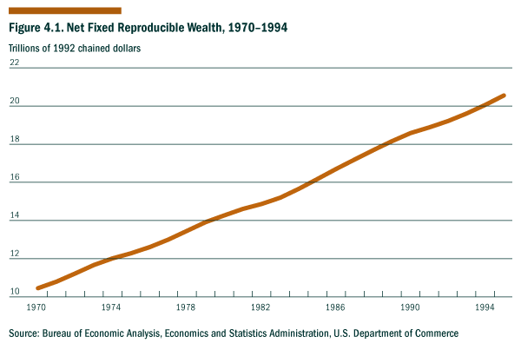
Source: Bureau of Economic Analysis, Economics and Statistics Administration, U.S. Department of Commerce
For a discussion of chained dollars, see the “Preview of the Comprehensive Revision of the National Income and Product Accounts: BEA’s New Featured Measures of Output and Prices,” by Steven Landefeld and Robert Parker in the Survey of the Current Business, July 1995, pp. 31-38.
Economic Indicators--Long-term Endowments and Liabilities
Labor Productivity
Labor productivity is one of the capacities that makes economic prosperity possible--along with natural resources, materials, and energy discussed in other indicators--and in this sense, it is an important variable to track in the context of sustainable development. It can be measured as the output of all workers per hour. In general, as workers produce more per hour, wages increase and standards of living rise. Total labor productivity in the United States has increased since 1970, but the annual rate of increase has slowed. (see Figure 4.2.)
A number of factors drive increases in labor productivity and economic growth, such as increases in physical capital, improvements in human capital, and technological changes. In general, if labor productivity continues to rise, future generations will be able to produce more goods and services with a given amount of labor.
Figure 4.2. Productivity, 1970-1997
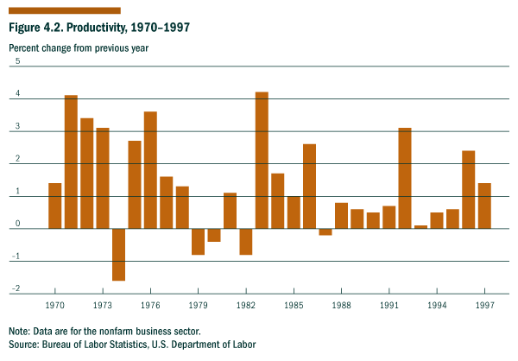
Note: Data are for the nonfarm business sector.
Source: Bureau of Labor Statistics, U.S. Department of Labor
Economic Indicators--Long-term Endowments and Liabilities
Federal Debt to GDP Ratio
The measure of Federal debt that closely reflects the Federal government’s true debt obligations is “debt held by the public,” defined as gross Federal debt less the debt held in Federal government accounts. As the chart shows, following World War II, Federal debt held by the public was 111% of Gross Domestic Product (GDP) in 1946. It then fell steadily as a percent of GDP to 23.9% in 1974. From 1974 to 1993, debt held by the public rose from 23.9% to 50.2% of GDP. By 1996, debt held by the public had declined to 49.9% of GDP.
Some regard the Federal debt as a sustainable development problem because of the constraints it may place on future generations. But unlike personal and corporate debt which limit future spending by individuals and corporations, the greatest concerns about public debt relate to distributional issues and to the desire to demonstrate fiscal responsibility. For every debt owed by one institution, there is an equal asset on the books of other institutions or individuals to whom the debt is owed. With Federal debt, the burden of financing the debt is shared across the American population, while the benefits accrue only to those who can afford to hold the bonds (both in this country and abroad).
Figure 4.3. Federal Debt Held by the Public, 1945-1995
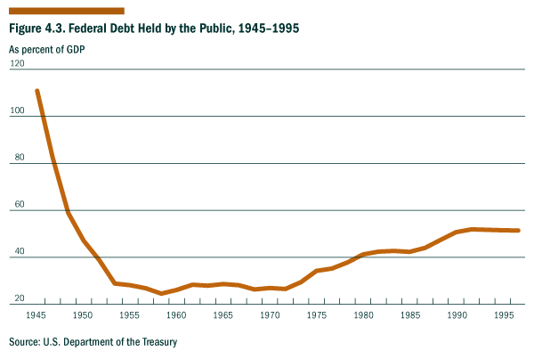
Source: U.S. Department of the Treasury
Economic Indicators--Processes
Energy Consumption Per Capita and Per $ of GDP
Energy consumption per capita is calculated as the sum of all energy consumed in the Nation in a given year divided by the population. Consumption for all forms of energy is presented in British Thermal Units (BTUs) to produce a common unit of measure.
Energy consumption per capita and energy consumption per dollar of gross domestic product (GDP) are two widely used indicators of energy consumption. Over the last 50 years, energy consumption per capita has generally increased, while energy consumption per dollar of GDP has decreased.
End use energy consumption is total energy consumption less losses incurred in the generation, transmission, and distribution of electricity, less power plant electricity use and unaccounted for electrical system energy losses.
Energy consumption per capita reflects personal access to and use of energy services such as heat, light, and mobility; but it does not tell us what mix of energy services were actually utilized or what the environmental and social effects of that energy use were. Energy consumption per dollar of GDP highlights the economic efficiency of use. Indicators of energy consumption can reflect the average material well-being (access to warmth, transportation, electricity, and economic activity), as well as the average efficiency of industrial processes across the Nation.
It may also be useful to examine energy production and use related to various sectors of the economy. For example, total vehicle-miles traveled may be a useful indicator in assessing the contribution of transportation sector to the nationwide consumption of energy. In 1994, the Federal Highway Administration estimated that the total vehicle-miles traveled in the United States was 2.36 trillion miles, and that the average number of miles traveled per vehicle was 11,697 miles. Total annual fuel consumption was 140.5 billion gallons or an average of 705 gallons per vehicle. This is a decrease since 1970, when the average annual fuel consumption per vehicle was 830 gallons; but it is an increase since 1990, when the average annual fuel consumption per vehicle was 677 gallons.
Energy consumption is important from an environmental standpoint since the combustion of fossil fuels, which accounts for about 85% of current U.S. energy supply, results in the emission of greenhouse gases such as carbon dioxide. Increasing atmospheric concentrations of greenhouse gases can contribute to global climate change.
Note:
A comprehensive review of the National Income and Protection Accounts was released by the U.S. Dept. of Commerce in early 1996 that resulted in changes to the entire Gross Domestic Product (GDP) series; the revised values for energy consumption per dollar of GDP for the years 1949-1958 were not available for inclusion in this graph.
Reference: Council on Environmental Quality, 25th Annual Report, 1994.
Figure 4.4. Energy Consumption Per Capita, 1949-1995
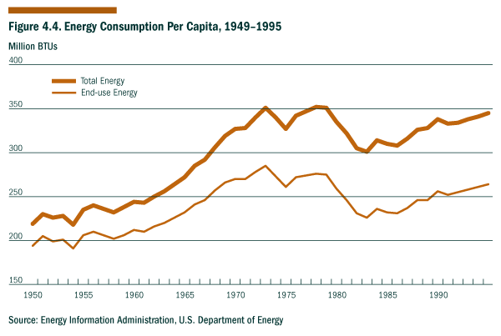
Source: Energy Information Administration, U.S. Department of Energy
Figure 4.5. Energy Consumption per Dollar of GDP, 1959-1995
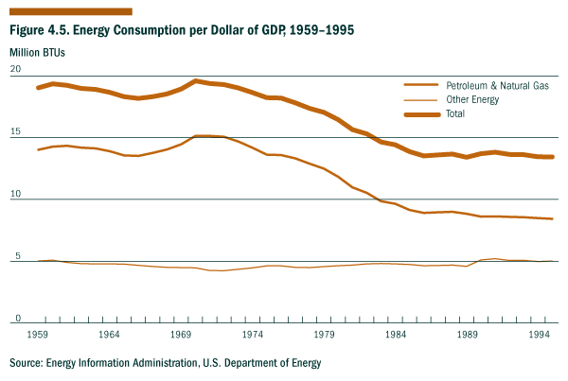
Source: Energy Information Administration, U.S. Department of Energy
Economic Indicators--Processes
Materials Consumption Per Capita and Per $ of GDP
Materials use is shown here as the weight of materials consumed annually per capita and per million dollars of gross domestic product (GDP). The term “materials” includes all raw materials used in manufacturing and construction, such as wood, paper, metals, industrial minerals, construction materials, and organic materials (e.g., asphalt and plastics). It does not include the raw materials used for fuel or food. In these indicators, the consumption of materials is measured by weight, so the indicators are dominated by the heavier materials. (Alternatively, materials use could be measured by volume.)
There continue to be abundant reserves of many materials; and advances in product design, production, and recovery of materials are improving the efficiency of utilization. At the current time, ensuring the availability of most materials for future generations is not a major concern in the United States. There are a few exceptions, such as fertilizers and hardwood lumber. Total material use has risen dramatically throughout this century, as has materials use per capita. As the global population continues to grow, the availability of materials could potentially become a concern, but it will depend on factors such as the use per capita, advances in energy efficiency, and the potential extraction of previously unavailable reserves.
A more immediate concern regarding materials is the impact of materials extraction, processing, and utilization on the environment. The extraction of materials can lead to the potential disruption of natural habitats and ecosystems. In addition, toxic wastes can be released into the environment when the materials are processed and manufactured into products or when the resulting products are used and then disposed by consumers. Other indicators related to ecosystems, the contamination of biota, and air and water quality reflect these problems.
In recent years, the U.S. economy has become more dependent on the delivery of services rather than on the traditional manufacturing and industrial sectors. The slight decline in materials use per unit of GDP over the past decade may be due in part to this shift in economic activity. Yet other than for wood and primary metals, the decline in consumption relative to GDP is not statistically significant at this point in time. Foreign goods represent a rising percentage of the products purchased by U.S. consumers, and the materials used to make these imported goods are not included in the data presented here. On the other hand, materials shipped overseas as U.S. exports or foreign aid are included in the data. A more complete picture of U.S. materials consumption could be obtained by including the weight of imported materials and subtracting the weight of materials shipped overseas.
A recent study by institutions in the United States, The Netherlands, Germany, and Japan adds to direct material inputs the “hidden flows” of materials that result from economic activity. Examples include the wastes in ore that are removed by mining and smelting, the earth moved for the construction of infrastructure, and the erosion of soil due to agriculture. These hidden flows are not part of the indicator pictured above, but we may wish to incorporate these and other factors into this indicator in future years. (A separate indicator on soil erosion appears later in this chapter.)
Reference: World Resources Institute, Resource Flows: The Material Basis of Industrial Economies.
Figure 4.6. Intensity of Materials Use by Population, 1910-1990
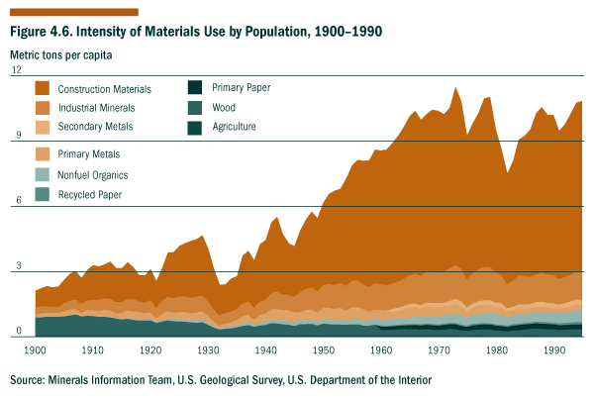
Source: Minerals Information Team, U.S. Geological Survey, U.S. Department of the Interior
Figure 4.7. Intensity of Materials Use by GDP, 1910-1990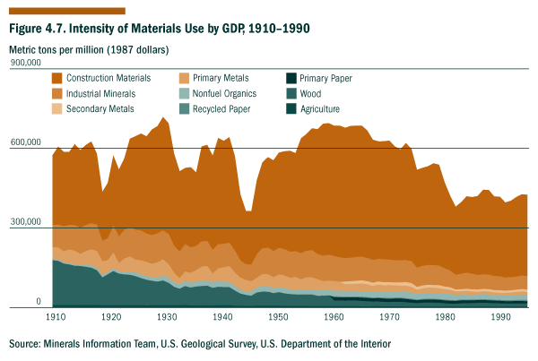
Source: Minerals Information Team, U.S. Geological Survey, U.S. Department of the Interior
Economic Indicators--Processes
Inflation
The Consumer Price Index (CPI) is the most widely quoted figure measuring inflation. It reflects the overall rate of price change for a market basket of goods and services bought by households. When inflation rises, it may be more difficult for some consumers to purchase needed goods and services (e.g., food, clothing, and shelter), especially if wages do not keep pace with inflation. Those members of society who live on fixed incomes are more likely to experience economic stress than those who can adapt to the economic instability; and this can accentuate economic distributional issues.
This chart illustrates that inflation, as measured by the CPI, has been low and stable in recent years. Since 1992, the annual increase in prices has been 3% or less. However, there have been a few periods in U.S. history when prices have increased rapidly; the most recent episode was in the late 1970s when prices rose by more than 13%.
Figure 4.8. The Consumer Price Index, 1970-1998
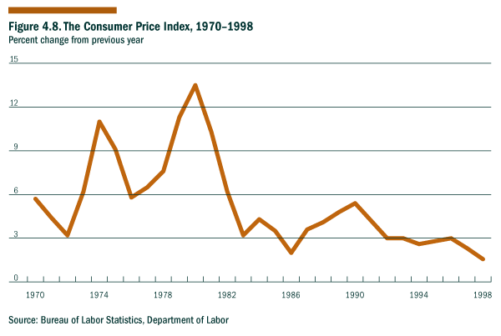
Source: Bureau of Labor Statistics, U.S. Department of Labor
Economic Indicators--Processes
Investment in Research and Development as a Percentage of GDP
Scientific-technological advancements often result from expenditures for basic and applied research and development (R&D). Basic research can advance general scientific knowledge about natural phenomena. Applied research is directed at discovering scientific knowledge with specific benefits to human society and commerce. Development is the systematic use of scientific knowledge to develop advanced technologies and approaches that benefit the economy, the environment, and society as a whole. In the early 1950s, U.S. R&D expenditures were approximately 1.5% of the gross domestic product (GDP) and the Federal government provided about 55% of the total. However, by 1975 as indicated in Figure 4.9, over 2% of GDP was going to R&D, and by the 1990s, R&D expenditures ranged between 2.5% and 2.8% of GDP and the Federal share had dropped to about 35%.
Investment in R&D and the resulting scientific and technological advances can enhance sustainability by improving our understanding of the Earth system and how we interact with it and by providing a broader range of options for responding to various challenges (economic, environmental, or social). At the same time, the new technologies may have unintended consequences related to employment, environmental quality, or ensuring equal opportunity for all individuals, regardless of economic status. A truly meaningful evaluation of how R&D expenditures affect sustainability should include an assessment of the full range of costs and benefits that result from the scientific and technological advances.
Figure 4.9. U.S. Total and Non-Defense R&D Expenditures as a Percentage of GDP, 1975-1990
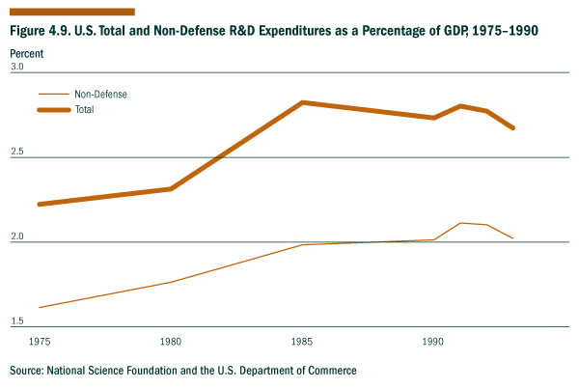
Source: National Science Foundation and the U.S. Department of Commerce
Economic Indicators--Current Results
Domestic Product
Gross domestic product (GDP) is one of the most widely used indicators of economic prosperity, and it includes the total output of goods and services for final use produced by labor and capital located in the United States. Net domestic product (NDP) adjusts GDP for the consumption of capital goods and infrastructure, but neither measure accounts for changes in stocks of natural resources or in the aesthetic value of the environment. While it may be conceptually preferable in the context of sustainable development to use NDP as an indicator of economic prosperity, the movement of the two series is virtually identical. Either indicator shows that aggregate domestic output has more than doubled since 1970, after adjusting for inflation.1 At the same time, it is important to note that these traditional measures of economic output do not adequately represent related environmental and societal variables that are important to sustainable development. Some economic transactions included in GDP may reflect environmental and social costs (e.g., costs associated with protection against crime or with recovery efforts following natural disasters), rather than contributions to the Nation’s overall prosperity.
Note:
1 This series is adjusted for inflation using chained 1992 dollars. For a discussion, see the “Preview of the Comprehensive Revision of the National Income and Product Accounts: BEA’s New Featured Measures of Output and Prices,” by J. Steven Landefeld and Robert Parker in the Survey of Current Business, July, 1995, pp. 31-38.
Figure 4.10. Domestic Product, 1970-1994
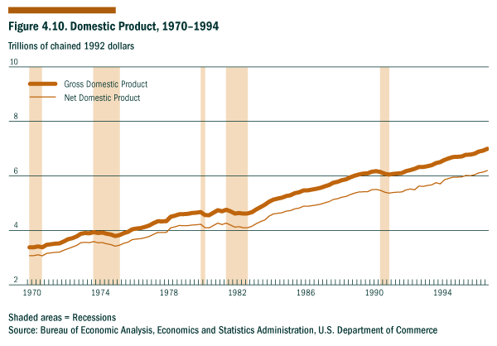
Source: Bureau of Economic Analysis, Economics and Statistics Administration, U.S. Department of Commerce
Economic Indicators--Current Results
Income Distribution
One indicator of income distribution is the change in average income of each fifth of households. This indicator is affected by—but does not make explicit—the movements of specific households between income groups over time.1 Since 1970 average household income for the top fifth of households increased by 37% while the bottom fifth increased by 12%. The top 5% of households had an even larger increase of 54%. The lower middle fifth shows the lowest increase, only 2%. The middle and upper middle groups, with increases of 6 and 16%, respectively, also gained less than the top fifth. The long-term increase in income disparity for all income groups relative to the top fifth is influenced by many factors, including labor market and social changes.2 When examined over a period of years, income distribution can provide a useful measure of equity from one generation to the next. This intergenerational equity is a central component of sustainable development.
Notes:
1 See “Moving Up and Down the Income Ladder,” by Wilfred Masumura, Current Population Reports, P-70-56, June, 1996. According to unpublished Census data, about 35% of the population experiences an income change of 20% or more each year, and Masumura estimates that three-fourths see their income go either up or down by at least 5%.
2 See “A Brief Look at Postwar U.S. Income Inequality,” by Daniel Weinberg, Current Population Reports, P-60-191, Census Bureau, June, 1996.

Figure 4.11. Average Income Trends, 1970-1994
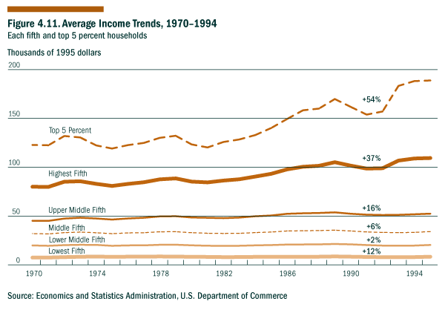
Source: Economics and Statistics Administration, U.S. Department of Commerce
Economic Indicators--Current Results
Consumption Expenditures Per Capita
One measure of standard of living used by economists is personal consumption expenditures (PCE) per person adjusted for inflation. PCE measures the value of goods and services purchased by residents in the United States. It includes purchases of autos, major appliances, food, clothing, medical care, utilities, housing services, insurance, used goods, and purchases abroad by U.S. residents.
Per capita PCE is an indicator of current economic prosperity. Except for recessionary periods, inflation-adjusted PCE per person has shown an upward trend over the last 25 years and has increased more than 60% during that period.
It should be noted that per capita PCE reflects only the amount of money one is able to spend on goods and services and not necessarily the value of those goods and services from the standpoint of sustainable development. For example, some equally-priced products may last longer or be produced through more environmentally-sound processes than others; these differences in sustainability value are not reflected by PCE. In addition, some expenditures are incurred to protect oneself against negative experiences (e.g., security systems are purchased as protection against crime); these are expenditures that one might prefer not to need or want. In the context of sustainable development, it might be useful to develop a complementary indicator that reflects the value that people feel they are getting from their purchases of goods and services.
Figure 4.12. Personal Consumption Expenditures Per Person, 1970-1995
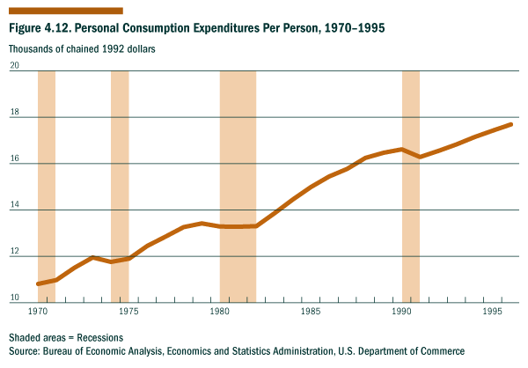
Source: Bureau of Economic Analysis, Economics and Statistics Administration, U.S. Department of Commerce
Economic Indicators--Current Results
Unemployment
Unemployment rate is the percentage of persons in the labor force who are seeking employment. The labor force is defined as those employed plus those who are actively looking for employment. The unemployment rate is a major indicator of the degree to which the economy provides jobs for those seeking work.
Since 1970, the average annual rate of unemployment has fluctuated from a high of 9.7% in 1982 to 5.6% in 1994. In recent years, it has fallen below 5%, reaching a low of 4.5% in 1998.
In the context of sustainable development, the particular unemployment rate in any given year--which depends largely on the business cycle and other short-term economic variables--is not as important as the impacts of unemployment on individuals, families, and society as a whole. Those who are chronically or repeatedly unemployed or who become unemployed during recessionary periods may be unable to meet their basic needs (e.g., for food, clothing, and shelter). In addition, when unemployment rates are high, it puts additional strain on the Nation’s social service programs and diverts resources from other pressing needs.
Figure 4.13. Civilian Unemployment rate, 1970-1998
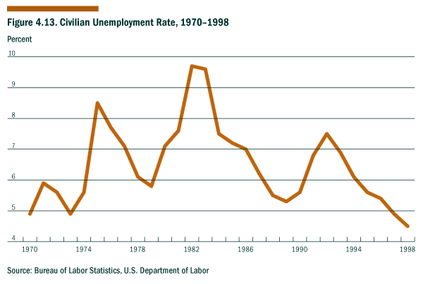
Source: Bureau of Labor Statistics, U.S. Department of Labor
Economic Indicators--Current Results
Homeownership Rates
The homeownership rate is the percentage of total occupied units which are owner-occupied. It provides a useful measure of national economic and social well-being. Homeownership continues to be an important part of the American dream, and although some people prefer to rent, the majority of Americans want to own a home.
In 1949, the United States set a national housing goal of a decent home in a suitable environment for every American. After World War II, when homeownership was about 45%, the rate rose steadily to reach a peak of 65.6% in 1980. After a period of lower rates, homeownership has begun to rise again and in 1997, it reached 65.7%, passing the peak set in 1980.
Figure 4.14. Homeownership Rates, 1965-1997
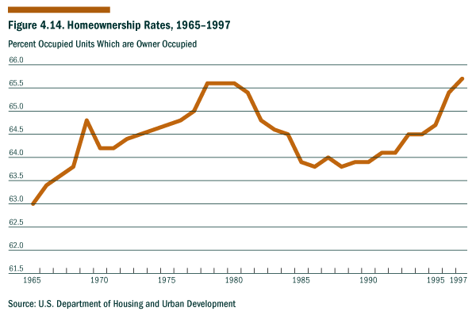
Source: U.S. Department of Housing and Urban Development
Economic Indicators--Current Results
Percentage of Households in Problem Housing
In 1993, 29% of U.S. households had one or more of three housing problems: physically inadequate housing, crowded housing, or housing that costs more than 30% of household income. Crowded housing is defined as housing in which there is more than one person per room. Crowded housing decreased from 4.1% in 1978 to 2.5% in 1993. Inadequate housing is defined as housing that has moderate or severe physical problems; this has also become less common, decreasing from 8.7% in 1978 to 6.4% in 1993. The percentage of houses with severe physical problems has also declined from 3.4% in 1978 to 2% in 1993.
Improvements in housing conditions have been accompanied by rising housing costs. Between 1978 and 1993, households paying more than 30% of their income for housing increased from 16% to 25%. The percentage of households with severe cost burdens--paying more than half of their income for housing--increased from 7% to 10%. The percentage of households with priority housing problems--those with severe cost burdens and/or severe physical problems--increased from 9% in 1978 to 11% in 1993. Renters are more likely than owners to experience housing problems. In 1993, 39% of renters had one or more housing problems, compared to 22.5% of owners; and renters were more than twice as likely as owners to have priority housing problems (i.e., severe cost burdens and/or severe physical problems).
This indicator reflects the current housing stock and its distribution--important factors in assessing human well-being today. It also provides some insights on the extent to which our children and grandchildren may be faced with housing issues, since the housing problems that are not solved today are passed on to the next generation.
Figure 4.15. Housing Problems, 1978-1993
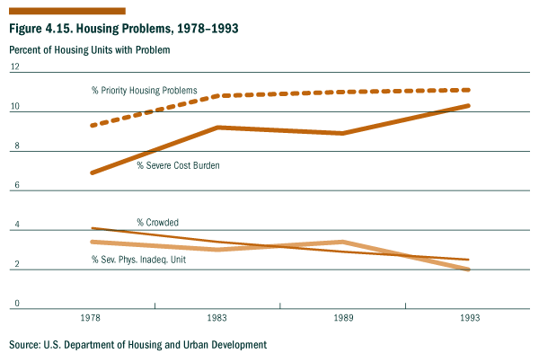
Source: U.S. Department of Housing and Urban Development
Environmental Indicators--Long-term Endowments and Liabilities
Surface Water Quality
Acres of Major Terrestrial Ecosystems
Contaminants in Biota
Quantity of Spent Nuclear Fuel
Status of Stratospheric Ozone
Greenhouse Climate Response Index
Ratio of Renewable Water Supply to Withdrawls
Fisheries Utilization
Invasive Alien Species
Conversion of Cropland to Other Uses
Soil Erosion Rates
Timber Growth to Removals Balance
Greenhouse Gas Emissions
Identification & Management of Superfund Sites
Metropolitan Air Quality Non-attainment
Outdoor Recreation Activities
Surface Water Quality
A clean, abundant supply of water is essential to sustainable development because it is required by all forms of life (humans, other animals, plants, and other organisms) and supports a range of human activities such as agriculture, recreation, mining, and manufacturing. The United States is a water-rich nation with 3.5 million miles of rivers and streams and 41 million acres of lakes. Many of these surface waters, however, are polluted. Over the past 25 years, water quality has improved and the most conspicuous point sources of pollution have been eliminated; but water pollution continues to be a problem. Agriculture is a major source of pollution for streams, rivers, and lakes today. Other important sources of pollution include industrial and municipal point sources, urban runoff, mining, and runoff and siltation associated with the destruction of natural habitat.
Since the passage of the Clean Water Act, the quality of U.S. surface waters has gradually improved even though the population and economy have expanded (Figure 4.16). The most positive trend has been for total phosphorus: concentration levels for total phosphorus have dropped at 22% of the stations analyzed in the U.S. Geological Survey’s National Stream Quality Assessment Network and shown no change in trends at 73% of the stations. In contrast, nitrate levels have decreased at only 8% of the stations and shown no trend at 86% of the stations. Suspended sediments have decreased at 11% of the stations and shown no trend at 87% of the stations; and dissolved solids have decreased at 14% of the stations and shown no trend at 78% of the stations. Concentrations of heavy metals and persistent toxic chemicals in lakes increased until the 1970s but have declined since then due to regulatory controls. However, since lakes tend to flush their contents very slowly, these toxic substances (particularly mercury) continue to limit the use of some lake resources.
Using water quality measurements by Federal and state agencies, a portion of U.S. surface waters are periodically assessed to determine their suitability for designated uses such as supporting aquatic life, recreation, agriculture, and domestic uses. In 1994, roughly 50% of the surface waters fully supported designated uses (Figures 4.17, 4.18, and 4.19). Threatened waters support designated uses at the current time, but they may not support these uses in the future unless actions are taken to control pollution. Partially supporting waters are in fair condition and fail to meet designated uses on some occasions. Waters that do not support designated uses are in poor condition and frequently fail to meet criteria. Siltation, nutrients, pathogens, and pesticides are the most common pollutants in streams and rivers; while metals, nutrients, organic enrichment, and siltation are the most common causes of pollution in lakes.
Reference:
Council on Environmental Quality, Environmental Quality, 24th Annual Report, 1993; and Council on Environmental Quality, Environmental Quality, 25th Annual Report, 1994-1995.
Figure 4.16. Ambient Water Quality in U.S. Rivers & Streams, 1975-1993
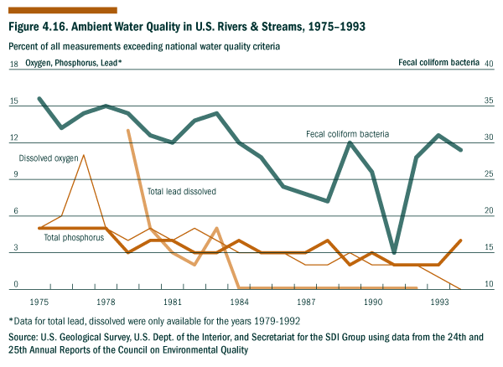
* Data for total lead and dissolved oxygen were only available for the years 1979-1992.
Source: U.S. Geological Survey, U.S. Department of the Interior, and Secretariat for the SDI Group using data from the 24th and 25th Annual Reports of the Council on Environmental Quality
Figure 4.17. Percent of Assessed U.S. Rivers & Streams Supporting Designated Uses, 1994.
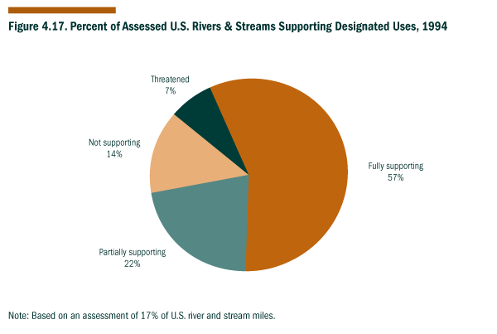
Note: Based on an assessment of 17% of U.S. river and stream miles.
Figure 4.18. Percent of Assessed U.S. Lakes, Ponds & Reservoirs Supporting Designated Uses, 1994.
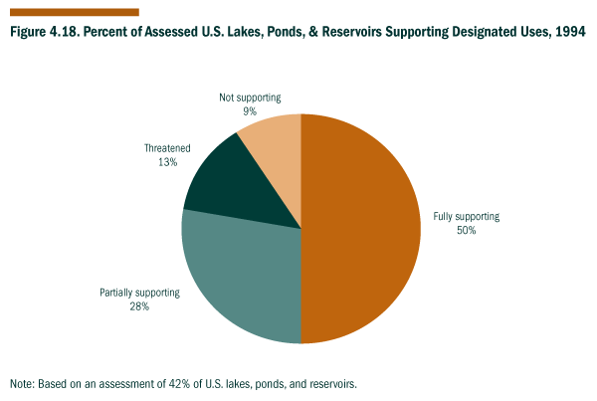
Note: Based on an assessment of 42% of U.S. lakes, ponds, and reservoirs.
Figure 4.19. Percent of Assessed U.S. Estuaries Supporting Designated Uses, 1994.
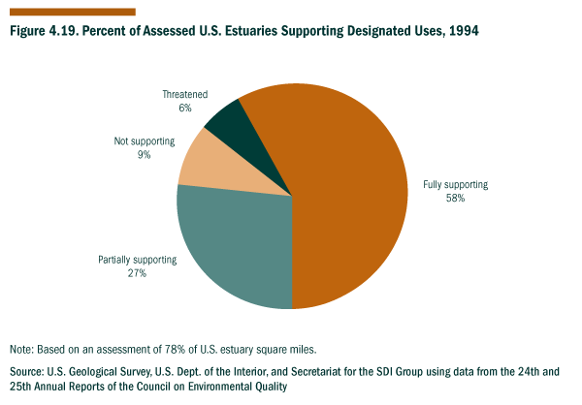
Note: Based on an assessment of 78% of U.S. estuary square miles.
Source: U.S. Geological Survey, U.S. Department of the Interior, and Secretariat for the SDI Group using data from the 24th and 25th Annual Reports of the Council on Environmental Quality
Environmental Indicators--Long-term Endowments and Liabilities
Acres of Major Terrestrial Ecosystems
Ecological systems, conventionally referred to as ecosystems, are interconnected communities of living organisms, including humans, and the physical environment (e.g., climate, fire, hydrology, geology, topography) in which they interact. Stressed ecosystems are those ecological systems that are diminished or degraded through habitat loss, fragmentation, or contamination and that no longer support complete, thriving populations of native flora and fauna. These ecosystems are unable to sustain the full range of ecological functions (e.g., supporting normal animal migration patterns).
Ecosystems and their component species provide us with food, fuel, fiber, medicines, and natural capacities for cleansing the air and water. The full function of most species is not completely understood, but each has an important role to play in the “web of life.” As we gain a better understanding of the structure and function of ecosystems, we are better able to identify and implement the steps needed to restore ecosystems that are in decline.
There have been significant changes in the size and ecological integrity of some ecosystems since the middle of the 18th century. Approximately 21 ecosystems in the United States have been identified as being particularly stressed:
• South Florida landscape
• Southern Appalachian spruce-fir forest
• longleaf pine forests and savannas
• eastern grasslands, savannas, and barrens
• northwestern grasslands and savannas
• California native grasslands
• coastal communities in the lower 48 states and Hawaii
• southwestern riparian forests
• Southern California coastal sage scrub
• Hawaiian dry forest
• large streams and rivers in the lower 48 States and Hawaii
• cave and karst systems
• tallgrass prairie
• California riparian forests and wetlands
• Florida scrub
• ancient eastern deciduous forest
• ancient forest of Pacific Northwest
• ancient red and white pine forest of the Great Lakes States
• ancient Ponderosa pine forest
• midwestern wetlands
• southern forested wetlands
It should be emphasized that the graph shown above does not include agricultural ecosystems, and most of the declines we have seen in other terrestrial ecosystems have been due to agricultural conversion. Although this indicator reflects the success of efforts to restore forests, rangelands, and wetlands in recent years, it does not reflect the important trade-offs between maintaining those ecosystems and meeting agricultural and urban land needs.
References:
• Dahl, T. E and G. J. Allord, “History of Wetlands in the Conterminous United States,” in USGS National Water Summary on Wetland Resources, Water Supply Paper 2425, 1996.
• Council on Environmental Quality, Environmental Trends, 1989.
• Council on Environmental Quality, Environmental Quality: 25th Annual Report, 1994-95.
• Noss, R. F. and R. L. Peters, Endangered Ecosystems: A Status Report on America’s Vanishing Habitat and Wildlife, The Defenders of Wildlife, 1995.
• Noss, R. F., E. T. LaRoe III, and J. M. Scott, Draft Report: Endangered Ecosystems of the United States: A Preliminary Assessment of Loss and Degradation, U.S. Department of the Interior, 1995.
Figure 4.20. Estimated Acres of Major Terrestrial Ecosystems, 1650-1995
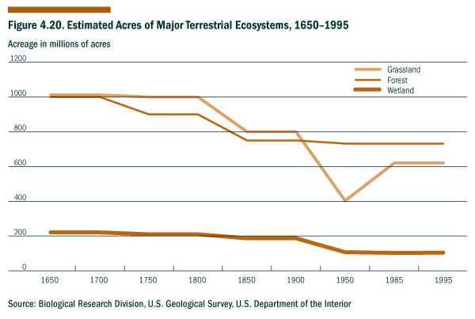
Source: Biological Research Division, U.S. Geological Survey, U.S. Department of the Interior
Environmental Indicators--Long-term Endowments and Liabilities
Contaminants in Biota
Biota (living organisms) can become contaminated with toxic substances by ingesting contaminated water, food, or other substances; inhaling toxic substances in the atmosphere; respiring contaminated water; or bathing or swimming in contaminated waters. Biota often become contaminated when they are exposed to substances that they can not readily metabolize or excrete at high enough concentrations or frequencies. The contamination of biota is often manifested in altered metabolic or endocrine processes, developmental or reproductive abnormalities, or the rapid and aberrant growth of certain cells (as in tumors or cancers). In many cases, the contamination of terrestrial, freshwater, or marine organisms can be an indicator of the impacts of human activities on the environment, as well as a warning sign of the potential contamination of human populations. An upward trend would not be sustainable indefinitely.
Extensive monitoring of the contamination of freshwater fish and birds by persistent pesticides and other synthetic organic compounds has been conducted since the early 1970s. Figure 4.21 demonstrates that the overall concentrations of dichloro-diphenyl-trichloroethane (DDT) and its derivatives and polychlorinated biphenyls (PCBs) have declined in freshwater fish since the 1970s. In the 1960s and early 1970s, DDT (a pesticide) and PCBs (a family of industrial compounds) were widely used, and they eventually washed into rivers and lakes and accumulated in fish and other organisms. Contaminated fish were eaten by eagles, which in turn accumulated the DDT, impairing their ability to produce viable eggs. As the use of DDT and PCBs was curtailed during the 1970s, fish became less contaminated and the eagle populations grew. We have made major progress in reducing the exposure of humans and other organisms to DDT and PCBs in North America.
The contamination of marine organisms is an important concern for growing coastal populations. Today more than 50% of the U.S. population lives within 80 miles of an ocean or Great Lake, and population densities are more than five times the national average. Since 1986, the Mussel Watch Project of the National Status and Trends Program has conducted measurements on surface sediments and on mussels and oysters from about 250 coastal and estuarine sites. Samples are analyzed to determine the levels and trends of synthetic chlorinated compounds (e.g., DDTs), PCBs, polycyclic aromatic hydrocarbons (PAHs), and trace metals such as mercury (Hg), lead (Pb), and cadmium (Cd). It should be noted that not all 250 sites are sampled every year, that the sites selected for sampling vary from year to year, and that mussels are collected at some sites and oysters at other sites. At least four years of data are needed to determine whether statistically significant trends in concentrations are occurring, and it is overall trends that matter--not year-to-year variations.
Since 1986, the overall levels of chlorinated hydrocarbons and cadmium in coastal biota have decreased; these changes were not unexpected since chlorinated hydrocarbons have been banned for use in the United States, and the use of cadmium in electroplating, rust-proofing, stabilizers in plastics, and pigments has declined. Chlordane and tributyltin have also decreased due to bans or restrictions on their use. The levels of most other chemicals (e.g., PAHs, mercury, and lead) have remained about the same since 1986, and no significant chemicals show an increasing trend in concentration. Based on the overall data from 1986 through 1995, we can say that coastal contamination has generally decreased for those monitored persistent contaminants whose use has been curtailed.
It should be noted that despite improvements in a number of persistent contaminants, there is some concern that other substances, such as chlorine-containing compounds, released through a variety of human activities may disrupt the normal functioning of endocrine systems in humans and animals. Additional measures may be needed to track their use and effects on biota.
References:
• O’Connor, T.P. and B. Beliaeff, Recent Trends in Coastal Environmental Quality: Results from the Mussel Watch Project, National Oceanic and Atmospheric Administration, U.S. Department of Commerce, Silver Spring, Maryland; 40pp; 1995.
• O’Connor, T.P. “Trends in Chemical Concentrations in Mussels and Oysters Collected along the U.S. Coast from 1986-1993,” Marine Environmental Research, Vol. 41, pp. 183-200: 1996.
• Schmitt, C.J. and C.M. Bunck. “Persistent Environmental Contaminants in Fish and Wildlife” Our Living Resources, National Biological Survey, U.S. Dept. of the Interior, Washington DC, 1995.
Figure 4.21. Contaminants in Eagle food, 1970-1985
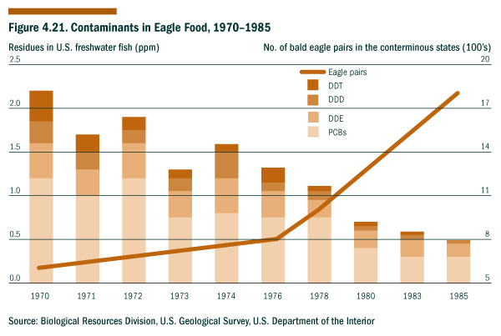
Source: Biological Resources Division, U.S. Geological Survey, U.S. Department of the Interior
Figure 4.22. Annual Median Concentration of Chemicals in Mollusks, 1986-1995
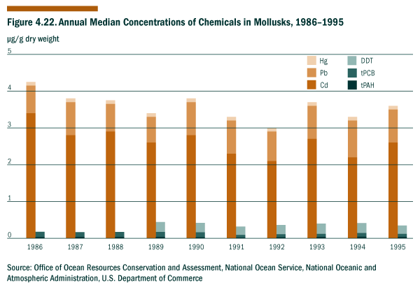
Source: Office of Ocean Resources Conservation and Assessment, National Ocean Service, National Oceanic and Atmospheric Administration, U.S. Department of Commerce
Environmental Indicators--Long-term Endowments and Liabilities
Quantity of Spent Nuclear Fuel
Commercial nuclear reactors provided about one fifth of U.S. electricity in 1994. The 109 commercial reactors, located at 70 sites across the United States, produced almost no greenhouse gases or atmospheric pollutants but did generate about 2,000 metric tons of spent nuclear fuel. Total U.S. commercial spent nuclear fuel from activities occurring between 1968 and 1995 amounted to 32.3 thousand metric tons of uranium. Estimates of the total volume to be accumulated by 2015 are about 74-75 thousand metric tons.
Reactor fuel consists of small pellets of uranium oxide sealed in long tubes. Fission by-products build up in the fuel tubes during use and gradually inhibit the reaction; at that time, the tubes are removed as "spent fuel." The spent fuel includes highly radioactive nuclides which can cause illness or death, depending on the level of exposure. The spent fuel must be safely stored at U.S. nuclear power plants or away-from-reactor storage facilities in order to protect human health and the environment. This spent nuclear fuel represents a long-term liability in the sense that it imposes costs on future generations.
Developing and maintaining sufficient capacity for the safe very long-term storage of spent fuel is one of the challenges involved in continued use of nuclear power. A reactor loses the authority to operate when there is insufficient storage space for its spent fuel. As of December 31, 1994, thirty-one reactors had filled over half of their on-site pool storage capacity. As a consequence, a number of utilities are planning or building on-site dry storage facilities or Independent Spent Fuel Storage Installations. The Nuclear Waste Policy Act directs that a permanent geologic repository shall be developed for the long-term storage of spent nuclear fuel and other high-level radioactive waste from commercial and defense activities. The Nuclear Waste Policy Amendments of 1987 designated the Yucca Mountain, Nevada, site for detailed scientific investigation to evaluate the site's suitability for a geologic repository. Site characterization analyses for this assessment are underway but the preparation and filing of a license application for the repository has been deferred. Since spent fuel remains hazardous for thousands of years, spent fuel disposal and management is one of the longest-term challenges for sustainable development.
References:
EIA, Spent Nuclear Fuel Discharges from U.S. Reactors 1994, SR/CNEAF/96-01, February 1996; EIA, Nuclear Power Generation and Fuel Cycle Report 1996, DOE/EIA-0436(96), October 1996.

Figure 4.23. Spent Nuclear Fuel Discharges, 1968-1994
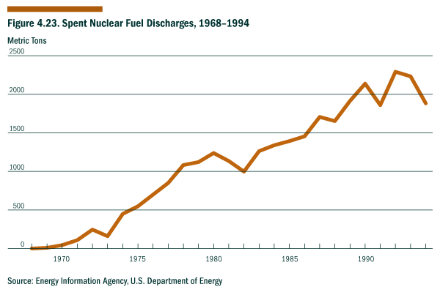
Sources: Energy Information Agency, U.S. Department of Energy
Environmental Indicators--Long-term Endowments and Liabilities
Status of Stratospheric Ozone
Human activities that result in the emission of gases that contain chlorine and bromine have resulted in the depletion of stratospheric ozone. The stratospheric ozone layer is important because it shields the Earth from harmful ultraviolet (UV)-B radiation. Reduced levels of stratospheric ozone allow more UV-B radiation to reach the earth, and this radiation is known to be harmful to certain biological systems and is believed to be related to an increased incidence of skin cancer in humans. A continuing increase in UV-B radiation over the long term could potentially affect the health of all forms of life.
The total atmospheric column ozone for the United States is measured at a number of U.S. stations with Dobson spectrophotometers by the National Oceanic and Atmospheric Administration (NOAA), U. S. Department of Commerce (DOC). Figure 4.24 shows that the average monthly total column ozone over the United States has declined by about 7% since 1979 (based on measurements at Fresno, California; Boulder, Colorado; Nashville, Tennessee; and Wallops Island, Virginia).
The largest ozone depletions related to chlorine and bromine emissions have been observed in Antarctica during the austral spring. Figure 4.25 shows that more than 50% of the springtime ozone at the South Pole has been lost compared to pre-1970 values.
Regulations on the emission of certain ozone-depleting gases became effective on January 1, 1996. NOAA measurements indicate that the total ozone depleting potential of these gases reached a peak at the surface in 1994, presumably due to steps taken in anticipation of the regulations. Based on this data, the concentrations of these ozone-depleting gases in the stratosphere are expected to peak by the turn of the century.
It is likely that the first evidence of stratospheric ozone recovery will be seen at the South Pole since the springtime depletion there is very large compared to natural variability. Based on atmospheric chemistry models, the implementation of international agreements, and current regulations, the beginning of stratospheric ozone recovery is expected to occur early in the 21th century. This recovery will be harder to detect in the mid-latitudes--for example, over the United States--since the depletion there is of the same order of magnitude as natural variability.
If the stratospheric ozone layer does begin to recover, as expected, it will demonstrate the success of the scientific community, international policy makers, the private sector, and the public in protecting the environment, while also addressing the related economic concerns through the development and phase-in of ozone-friendly substitutes.
Reference:
NOAA Climate Monitoring and Diagnostics Laboratory (CMDL), Summary Review (Bi-Annual); NOAA Climate Prediction Center, Northern Hemisphere Winter Summary.
Figure 4.24. Stratospheric Ozone Reduction in the U.S. Since 1979
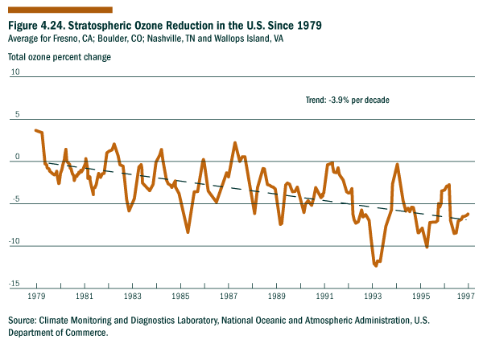
Source: Climate Monitoring and Diagnostics Laboratory, National Oceanic and Atmospheric Administration, U.S. Department of Commerce.
Figure 4.25. South Pole Ozone Hole, 1960-1990
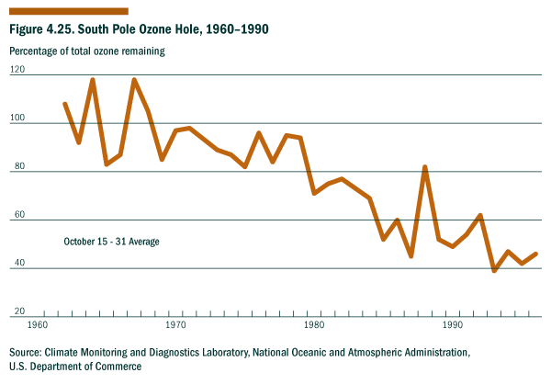
Source: Climate Monitoring and Diagnostics Laboratory, National Oceanic and Atmospheric Administration, U.S. Department of Commerce.
Environmental Indicators--Long-term Endowments and Liabilities
Greenhouse Climate Response Index
The U.S. Global Climate Response Index (GCRI) is comprised of five different indicators of weather conditions over the United States. It can be used as a tool to determine whether U.S. weather patterns have changed in a manner consistent with global greenhouse warming. The expected value for the GCRI in any given year under stable conditions is 10%. As depicted in Figure 4.26, the GCRI has averaged 13.3% since 1980; this is 3.3% above the average from previous years in the century. Although there is a 5 to 10% chance that this trend could occur under stable conditions, the tendency toward increased values of the U.S. GCRI over the past two decades suggests that the climate of the United States is changing in ways that would be expected with global greenhouse warming.
The Intergovernmental Panel on Climate Change (established jointly by the United Nations Development Program and the World Meteorological Organization) has stated that observations suggest “a discernible human influence on global climate.” Since the turn of the century, the average daily temperature in the United States (for the 48 conterminous states) has risen by about .3o Centigrade (.7o Fahrenheit), and most of the increase has occurred in the last 30 years. This trend is consistent with the best estimates for the Earth as a whole over the same period of time. Changes in global climate could lead to changing weather patterns and rising sea levels and have major impacts on ecosystems, agriculture, transportation, water resources management, and communities.
If greenhouse warming is indeed occurring, we would expect to see changes in local weather patterns over a period of years. The United States has some of the most complete and continuous meteorological records in the world, and we can examine these records to see if weather patterns have changed as we would expect with greenhouse warming. Although the United States covers only 2% of the Earth’s surface, weather trends we detect in the United States could also be a bellweather of global change.
It should be noted that weather patterns can change due to random events or to human-induced or natural changes over the long term. The challenge for scientists is to separate the background noise from meaningful signals. By examining a number of weather variables together over a period of years, we can begin to see the whole picture.
The Greenhouse Climate Response Index (GCRI) combines the following five climate indicators into a single index. The weight of each indicator increases in proportion to our confidence in the projected changes in weather and climate due to rising atmospheric concentrations of greenhouse gases. The five indicators are:
(1) the percent of the United States with much above normal temperature (i.e., temperatures falling in the upper tenth percentile of the local, century-long record)
(2) the percent of the United States with much above normal precipitation (i.e., precipitation in the upper tenth percentile of the local, century-long record) during the cold season (October through April);
(3) the percent of the United States in extreme or severe drought (i.e., precipitation in the lower tenth percentile of the local, century-long record) during the warm season (May through September);
(4) the percent of the United States with a much greater than normal proportion of precipitation derived from heavy rainfall events (over 2 inches or 50.8 mm); and
(5) the percent of the United States with much below normal day-to-day temperature differences.
As stated above, the expected value for the GCRI in any given year under stable conditions is 10%. Since 1980, the GCRI has averaged 13.3%, suggesting that U.S. climate is changing in a manner consistent with global greenhouse warming.
Reference:
Karl, T., R. Knight, D. Easterling, and R. Quayle. “Indices of Climate Change for the United States,” Bulletin of the American Meteorological Society, Volume 77, Number 2, February 1996.
Figure 4.26. U.S. Greenhouse Climate Response Index, 1900-1995
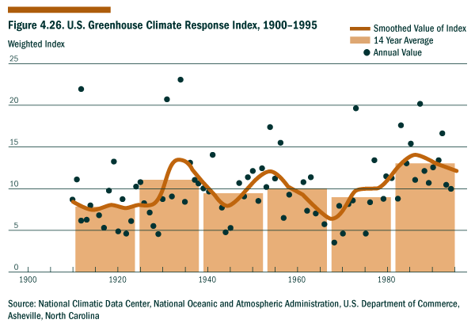Source: National Climatic Data Center, National Oceanic and Atmospheric Administration, U.S. Department of Commerce, Asheville, North Carolina.
Environmental Indicators-Processes
Ratio of Renewable Water Supply to Withdrawals
Water is critical for human survival and well-being and important to many sectors of the economy including recreation and tourism, transportation, real estate, agriculture, energy, manufacturing, and mining. It is essential to balance the rate of water use with the rate at which it can be renewed by natural hydrological processes and by human reuse/recovery efforts. The United States as a whole has a favorable ratio of renewable water supply to withdrawals, but some parts of the country (e.g., the arid West) do not.
Estimates of surface and ground water withdrawals in the United States show continued increases from 1950 through 1980, but a drop in overall use in both 1985 and 1990; but public supplies of water have increased continuously since 1950, reflecting the growth in the U.S. population. Thermoelectric power generation plants withdraw the greatest amounts of surface water, while agriculture withdraws the highest amounts of ground water and the second highest amounts of surface water. The average amount of water applied per acre for agricultural irrigation in the United States during 1985 was about 2.1 acre-feet. This is about the same as in 1990, slightly less than the 1985 average of 2.2 acre-feet, and well below the 1975 and 1985 average of 2.5 acre-feet. Irrigation application rates depend on annual rainfall, surface water availability, energy costs, farm commodity prices, application technologies, and on farmers’ understanding of the advantages of conserving water.
In the context of national sustainable development, it may be important to recognize not only problems that affect all regions of the country, but also problems that affect the ability of specific regions and communities to meet their basic needs.
Reference:
U.S. Geological Survey, Estimate Use of Water in the United States, USGS Circular #1081; 1990.

Figure 4.27. Ratio of Renewable Water Supply to Fresh Ground and Surface Water Withdrawl, 1960-1995
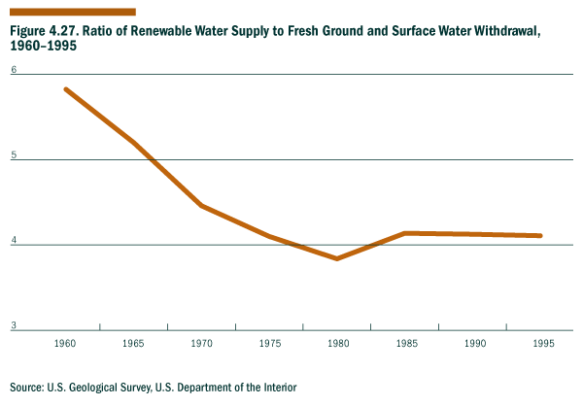
Source: U.S. Geological Survey, U.S. Department of the Interior
Figure 4.28. Fresh Ground and Surface Water Withdrawls in the United States, 1960-1995
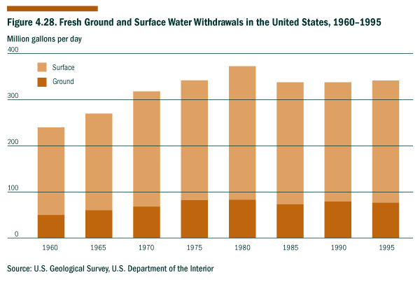
Source: U.S. Geological Survey, U.S. Department of the Interior
Environmental Indicators--Processes
Fisheries Utilization
The United States has consistently ranked fifth in worldwide fisheries production during the 1990s (5% of the total catch or 5.6 million metric tons annually). In 1996, commercial marine fisheries contributed 0.3% to the Gross National Product ($21 billion in value added to a $6,932 billion GNP); more than 8 million people engaged in marine recreational fisheries, completing an estimated 64 million trips. In the same year, consumer expenditures for all commercial marine fishery products was estimated at $41.2 billion. The U.S. Exclusive Economic Zone (EEZ) is the world’s largest and takes in 2,831,400 sq. n.m. or about 1.7 times the entire land area of the U.S. and its territories (e.g., 3.9 billion acres vs. 2.3 billion acres). Management within the 3-to-200 n.m. EEZ is the responsibility of the Federal government and regional Fishery Management Councils.
Historically, overfishing definitions were not available as a management tool. Recent changes in law now set the basis for the identification of overfished stocks in the current overfishing definitions found in the Fishery Management Plans (FMPs) developed to manage fishery resources in Federal waters.1
Simply put, "overfishing" occurs when the rate or level of fishery removals jeopardizes the ability of the resource (i.e., species or stock) to produce the maximum sustainable yield on a continuing basis. For most species, the existing overfishing definitions are based wholly or in part on a estimated fishing mortality rate. Such definitions typically assess the species on the basis of whether overfishing (as a rate of removals) is currently taking place (i.e., whether the current fishing mortality rate is greater than the maximum allowable rate specified in the definition). FMPs that base their definition on something other than a fishing mortality rate, such as stock biomass, typically assess overfishing of the species on the basis of the current status of stock relative to a stock or index level specified in the definition of overfishing. A fishery will be classified as "approaching a condition of being overfished" if, based on trends in fishing effort, fishery resource size, and other appropriate factors, the fishery will become overfished within two years. Whenever possible, species were assessed using existing overfishing definitions in FMPs or FMPs under development; the remainder were evaluated using the 1995 edition of Our Living Oceans.
Employing these criteria in 1997, the Fisheries Service finds that 86 species (12%) are "overfished," 183 species (25%) are "not overfished," and 10 species (1%) are considered to be approaching an overfished condition; for 448 species (62%), their status relative to overfishing is currently unknown. Trend data in this format is not yet available since prior efforts focused on other reporting objectives (e.g., Our Living Oceans, Fisheries of the U.S.); however, the 1997 overfishing assessment will be the benchmark for future reports to Congress and for trend analyses.
The "not overfished" condition of a fishery stock is the most beneficial since it represents the most efficient use of the resource, with fishing effort neither significantly greater than or less than the level needed to achieve the stock’s long-term potential yield. The relative number of stocks that are not overfished (i.e., fully utilized) can be used as a measure of our success in managing fisheries to maintain the underlying stocks at levels needed to produce high average yields over the long term.
From the standpoint of sustainable development, one of the key questions regarding fisheries is whether we will be able to meet society’s future demand for fish and shellfish. It seems likely that this demand will be met through both the wise management of natural fisheries stocks and the development of aquaculture.
References:
• National Advisory Commission on Ocean and Atmosphere. The Exclusive Economic Zone of the US: Some Immediate Policy Issues, Washington, D.C., May 1984.
• National Marine Fisheries Service, National Oceanic and Atmospheric Administration, Fisheries of the United States, 1996, Silver Spring, Maryland, July 1997.
• National Marine Fisheries Service, National Oceanic and Atmospheric Administration, Report to Congress - Status of Fisheries of the United States, Silver Spring, Maryland, September 1997.
• National Marine Fisheries Service, National Oceanic and Atmospheric Administration, Our Living Oceans, Report on the Status of U.S. Living Marine Resources, Silver Spring, Maryland, February 1996.
Notes:
1 The Sustainable Fisheries Act [SFA (Public Law 104-297)], which reauthorizes and amends the Magnuson-Stevens Fishery Conservation and Management Act (Magnuson-Stevens Act) was signed into law by President Clinton on October 11, 1996. The reauthorized Magnuson-Stevens Act requires the Secretary of Commerce (through the National Marine Fisheries Service) to report to Congress annually on the status of fisheries within each Fishery Management Council’s geographical area of authority and identify those fisheries that are overfished or are approaching a condition of being overfished.
Figure 4.29. Status of Fisheries Utilization of 727 Fishery Management Plan Species
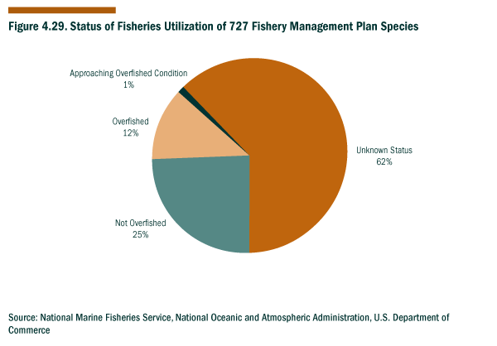
Source: National Marine Fisheries Service, National Oceanic and Atmospheric Administration, U.S. Department of Commerce.
Environmental Indicators--Processes
Invasive Alien Species
Invasive alien species are plants, animals, insects, microorganisms, or parasites that are not native to all or parts of the United States which have been introduced from other nations or other parts of the United States, often unintentionally. They are frequently referred to as exotic, non-native, or nonindigenous species. An increasing number of alien species are being found in landscapes across the United States--natural, rural, and urban--and they frequently displace indigenous species, sometimes with very costly results.
In 1992, the number of invasive alien species was estimated by the Office of Technology Assessment to be over 4542 (>2000 plants, 142 terrestrial vertebrates, > 2000 insects and arachnids, 70 fish, 91 non-marine mollusks, and 239 plant pathogens). In the context of sustainable development, an increase in the number of alien species can lead to major disruptions of local and regional ecosystems which continue into the future.
Many of these alien species are introduced through human travel or commerce. Once they become established, these non-native species tend to displace indigenous species, out-competing them for limited food supplies and habitat. Native populations that are fragmented or under stress from natural or human causes are especially vulnerable to the invasion of non-native species. Major outbreaks of disease often occur when pathogens enter new host populations of humans and other species. Newly emerging or re-emerging diseases are of increasing international concern because of the potentially devastating effects they can have on the economy, the environment, and society.
Alien species often spread extremely rapidly due to the lack of natural barriers in their new habitat. Examples include the intrusion of cheat grass in western rangelands; the invasion of zebra mussels in the Great Lakes and the Mississippi River and its tributaries; the appearance of raccoon rabies in the eastern United States; mycoplasmosis in song birds in the United States and Canada; and in the past, fungal chestnut blight and Dutch elm disease which obliterated the American chestnut and elm trees in North America.
References:
• Office of Technology Assessment, U.S. Congress, Harmful Non-indigenous Species in the U.S. 1993
• Friend, M. “Increased Avian Diseases with Habitat Change,” Our Living Resources, National Biological Service, U.S. Department of the Interior, Washington, D.C. 1995.
• National Strategy for Invasive Plant Management, prepared by a national consortium of Federal and non-Federal organizations, 1997.
Figure 4.30. Invasive Alien Species, 1790-1990
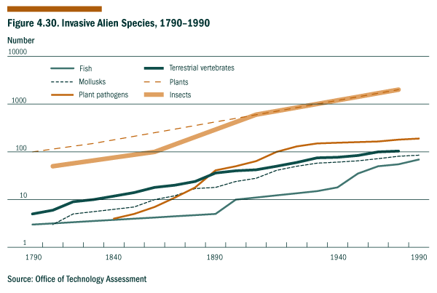
Sources: Office of Technology Assessment.
Environmental Indicators--Processes
Conversion of Cropland to Other Uses
The United States’ use of its land has varied with time. Between 1982 and 1992, the net amount of land devoted to crops, pasture, and range, respectively, declined by 39 million cropland acres (of which 36.4 million were enrolled in the Conservation Reserve program), 6 million pasture acres, and 10 million rangeland acres. Forest land showed a modest increase during the period.
The net acreage gained or lost to different land uses reveals only part of the story. Although 60 million acres shifted from cropland to other uses between 1982 and 1992, about 21 million acres shifted from other uses into cropland during this same period. Nearly 3 million acres of cropland were developed for residential purposes (or 68% of total conversions). But this rate had slowed compared to earlier decades. The ten-year rate of expansion in urban areas was 18%, which was half the rate of growth in the 1950s (39%).
Although the rate of cropland conversion has been decreasing, we know that we can not continue to convert the Nation’s cropland indefinitely without jeopardizing the ability of future generations to meet their needs for food and fiber. How much agricultural land we need in the future will depend on many different variables such as population, dietary patterns, world trading patterns, and advances in science and technology.
Reference:
Natural Resource Conservation Service, U.S. Department of Agriculture, America’s Private Land: a Geography of Hope. Program Aid 1548. Washington, D.C., December 1996.
Figure 4.31. Cropland Converted to Developed Land, 1982-1992
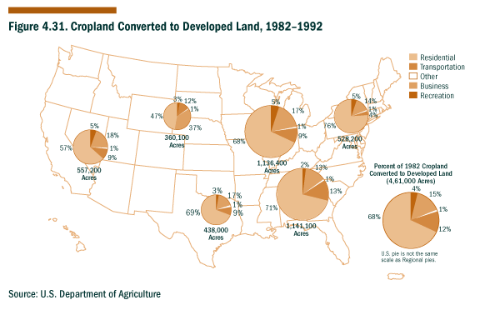
Source: U.S. Department of Agriculture
Environmental Indicators--Processes
Soil Erosion Rates
Maintaining adequate supplies of food and fiber to meet the needs of the human population is essential to sustainable development. Crops, forage plants, and trees are our main sources of food and fiber, and excessive soil erosion can have an adverse effect on agricultural productivity and communities (e.g., as occurred during the Dust Bowl of the 1930s). It will become increasingly important to protect the soil from erosion due to the rising food needs of the world’s growing population and the potential impacts of global climate change on agricultural patterns.
While soil erosion occurs naturally on all land, at least 40% of the total soil erosion in the United States results from non-agricultural activities such as construction, logging, and off-road vehicle use, or from natural events such as floods and droughts. Erosion reduces soil productivity and can affect the quality of both air and water resources. A limited amount of soil erosion is tolerable in terms of soil productivity, and this tolerable level of erosion (T) varies with factors such as soil type and the time required for new soil to form.
Soil erosion rates greater than the tolerable level can threaten agricultural productivity. Sheet erosion and rill erosion tend to be a greater problem in the humid East than elsewhere in the country, while wind erosion is a greater problem in the arid and semi-arid West. Estimates of streambank, gully, irrigation-induced, and ephemeral gully erosion are not currently included in standard soil erosion assessments, although such forms of erosion can be substantial in certain situations.
In 1982, erosive forces moved nearly 3.1 billion tons of soil from our Nation’s cropland (1.4 billion tons via wind and 1.7 billion tons via water). In 1992, erosive forces moved nearly 2.1 billion tons of soil from our Nation's cultivated cropland. About 1 billion tons less than were moved in 1982--About 0.9 billion tons from wind erosion and 1.2 billion tons from sheet and rill erosion. Between 1982 and 1992, the number of cultivated cropland acres where sheet and rill erosion and wind erosion were occurring at levels above the tolerable rate (T) declined by 5.5% and 5%, respectively.
Figure 4.32. Average Annual Soil Erosion on Cultivated Cropland as a Proportion of the
Tolerable rate (T), 1982
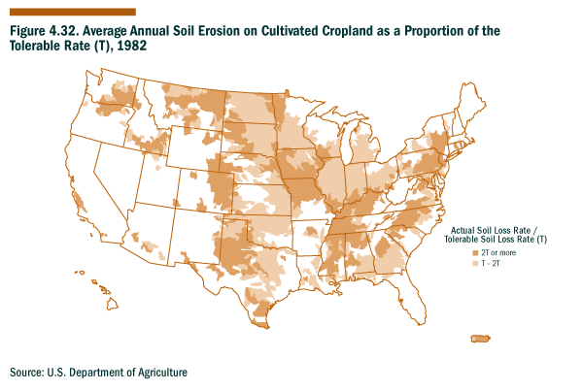
Source: U.S. Department of Agriculture
Figure 4.33. Average Annual Soil Erosion on Cultivated Cropland as a Proportion of the Tolerable rate (T), 1992
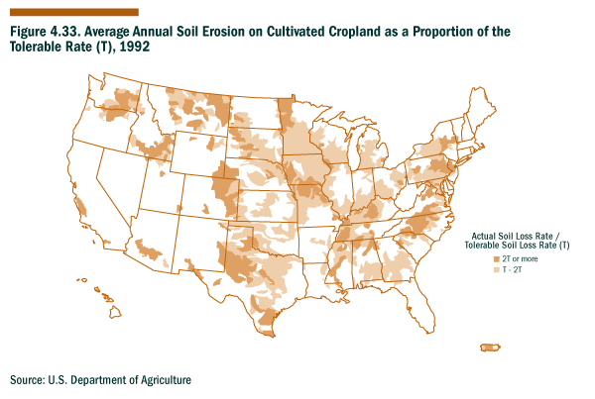
Source: U.S. Department of Agriculture
Figure 4.34. Average Annual Soil Erosion on Cultivated Cropland as a Proportion of the Tolerable rate (T), 1992
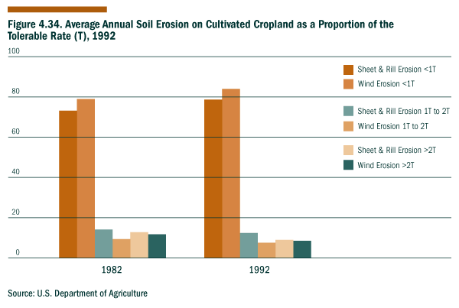Source: U.S. Department of Agriculture
Environmental Indicators--Processes
Timber Growth to Removals Balance
A comparison of the net growth of timber stands to the removals of timber provides a measure of the status of the timber inventory. Harvesting timber more rapidly than the timber stands are able to grow will reduce our ability to meet demands for forest products.
When growth exceeds removals, the growth/removal balance is greater than 1. The value of the timber growth/removals balance has fluctuated from year to year, but in every benchmark year since 1952 when the U.S. Department of Agriculture Forest Service began collecting the data, the growth of timber has exceeded removals. The most recent data were collected in 1992, and the growth/removals balance at that time was 1.33, meaning that the United States grew 33 percent more timber than it cut. Although the total growth of timber stands exceeds the rate of harvest at a national level, it is important to note that the type and composition of U.S. forests are changing and that the United States currently imports about half of its paper pulp.
Americans have begun to debate the role of forests in relation to biodiversity, climate change, water quality, recreation, and an aesthetically pleasing environment. In the context of sustainable development, the full range of products, services, and benefits provided by forests--from wood products to biodiversity--must ultimately be considered.
Figure 4.35. Timber Growth and removal Data for Selected years, 1952-1992
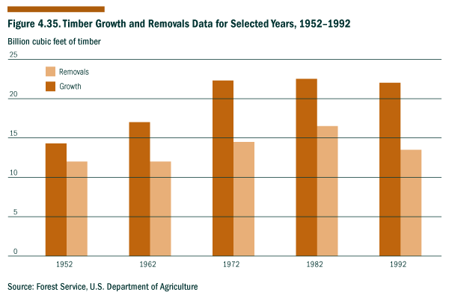
Source: Forest Service, U.S. Department of Agriculture
Environmental Indicators--Processes
Greenhouse Gas Emissions
The composition of the Earth’s atmosphere is a key factor in determining the Earth’s temperature, and temperature has a critical effect on the conditions and limits for life on Earth. Many human activities result in the emission of gases that could contribute to changes in the Earth’s climate for generations to come. Each year, the emissions of ten categories of greenhouse gases are estimated from reports of energy consumption prepared by the Energy Information Administration, U.S. Department of Energy, and from emissions data reported to the U.S. Environmental Protection Agency. The categories of monitored gases include carbon dioxide; methane; nitrous oxide; chlorofluorocarbons-11, -12, and -13; chlorodifluoromethane; hydrofluorocarbons; perfluorocarbons; methyl chloroform; carbon monoxide; nitrogen oxides; and nonmethane volatile organic compounds. The emissions of gases are converted to million metric tons of carbon or carbon equivalents based on their respective global warming potentials. Between 1990 and 1994, the weighted total U.S. emissions rose by 3.9%; and between 1990 and 1995, U.S. emissions of carbon dioxide rose 5.1%.
Reference:
Energy Information Administration, U.S. Department of Energy, Emissions of Greenhouse Gases in the United States, 1995.
Figure 4.36. U.S. Greenhouse Gas Emissions, 1988-1995
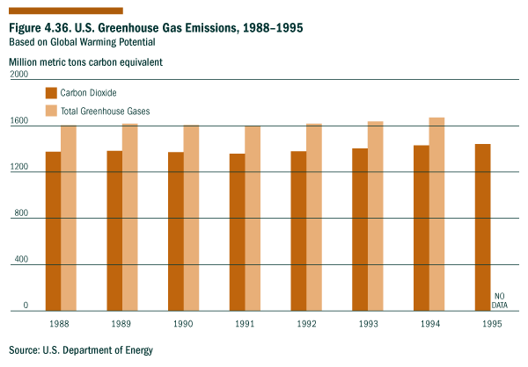
Source: U.S. Department of Energy
Figure 4.37. Difference in U.S. Greenhouse Gas Emissions, 1990 vs. 1994*
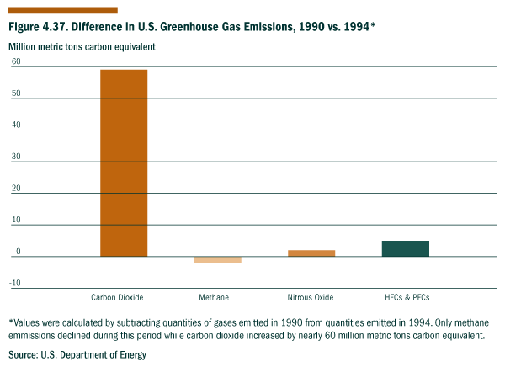
Source: U.S. Department of Energy
*Values were calculated by subtracting quantities of gases emitted in 1990 from quantities emitted in 1994. Only methane emissions declined during this period while carbon dioxide increased by nearly 60 million metric tons carbon equivalent.
Environmental Indicators--Processes
Identification and Management of Superfund Sites
Decades of improper and inadequate disposal of toxic substances have left a nation-wide legacy of hazardous waste sites that are potentially dangerous to public health and the environment. We are currently incurring the costs of cleaning up contamination caused by our predecessors, and unless sufficient remedial actions are taken, these costs will be passed on to future generations. Realizing a path of sustainable development depends on our being able to halt the improper disposal of toxic substances and to restore those sites that are already contaminated.
The extent and nature of the risks associated with contaminated sites are not fully known, but regulatory and technological processes are now in place to control the toxic pollution from these sites. In 1980, Congress passed the first comprehensive Federal law--the Comprehensive Environ mental Response, Compensation, and Liability Act (CERCLA), commonly known as "Superfund"-- to address abandoned and uncontrolled hazardous waste sites. Superfund activities include identifying and classifying sites; responding to emergencies and immediate threats; and studying, designing, and constructing long-term solutions to clean up hazardous waste sites and restore natural resources.
In administering the Superfund Program, EPA is required to focus on those sites where contamination presents the most serious threat to human health and the environment. These sites are placed on the National Priority List (NPL). Through September 1998, over 41,500 potentially hazardous waste sites have been identified; and of this total, 1,436 sites are currently listed on the NPL as follows: 66 proposed, 1194 final, and 176 deleted.
The EPA continues to remove sites from CERCLIS after determining no further federal Superfund work is needed. Through the end of FY98, the total number of sites removed rose to 31,000. Sites removed from CERCLIS are not necessarily clean, but based on current information, they are not targeted for further work under the Federal Superfund Program. However, the states are informed about sites removed from CERCLIS and they may conduct further work on the sites. In FY95, EPA's Superfund program removed 24,000 sites with no further Federal Superfund interest from the active inventory of CERCLIS sites in support of the Agency's Brownfields Economic Redevelopment Initiative.
Fifty million people live within four miles of the NPL sites, but living near a site does not necessarily put people at risk. A risk assessment is to be conducted at each site, and appropriate immediate and long-term response actions are implemented depending on the amount and toxicity of the hazardous wastes and the potential for human and environmental exposure.
If there is an immediate threat at either an NPL or non-NPL site, emergency clean-up actions are taken to ensure safety. Between 1980 and 1997, over 2,500 removals and emergency actions have been taken to remove immediate threats. As part of these actions, 14,341 people have been relocated and 338,767 people have been provided with alternative water supplies.
After emergency actions have been taken, long-term actions are initiated to clean up contaminated sites permanently. EPA has initiated or completed construction activity--rapid action or long-term cleanups--at 72% of the sites on the NPL. Construction has been completed at over 585 sites--40% of the sites on the NPL.
Figure 4.38. Short-term Actions Taken at Superfund Sites to Protect Human Health and the Environment, 1980-1997
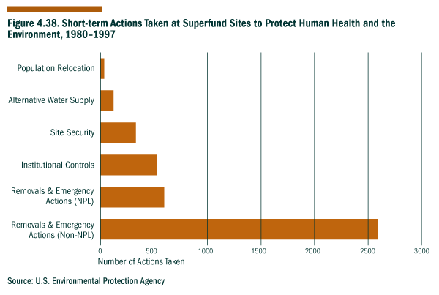
Source: U.S. Environmental Protection Agency
Environmental Indicators--Current Results
Metropolitan Air Quality Non-attainment
Poor air quality can have significant adverse effects on human health, the built environment, and ecosystems, as well as on property values and recreational values. It is important to achieve and maintain good air quality if we are to ensure a healthy environment now and in the future.
From 1970 to 1990, increases in the Nation’s population and economic growth were accompanied by increasing air pollution. Over this period of time, emissions of nitrogen oxides increased by about 700%, emissions of volatile organic compounds increased by about 250%, and emissions of sulfur oxides increased by about 200%. Many of the things that contributed to air pollution--such as low-cost automobile fuel--also had important economic and societal benefits.
The good news is that since the passage of the Clean Air Act in 1970 (which required the industrial and automobile sectors to reduce emissions of air pollutants), the atmospheric concentrations of many air pollutants in the United States have been substantially reduced. The major exceptions are carbon monoxide and ground-level ozone, which continue to pose serious problems.
As indicated in Figure 4.39, in 1996, approximately 165 metropolitan areas still had unhealthy air, potentially affecting the health of 123 million people. However as indicated in Figure 4.40, there has been a substantial drop in the number of metropolitan areas not attaining air quality standards. In the context of sustainable development, the full economic, environmental, and social costs and benefits of further reducing air pollution must be considered.
References:
Council on Environmental Quality, Environmental Quality, 25th Anniversary Report.
Figure 4.39. People Living in Metropolitan Areas Not Meeting Air Quality Standards, 1991-1996
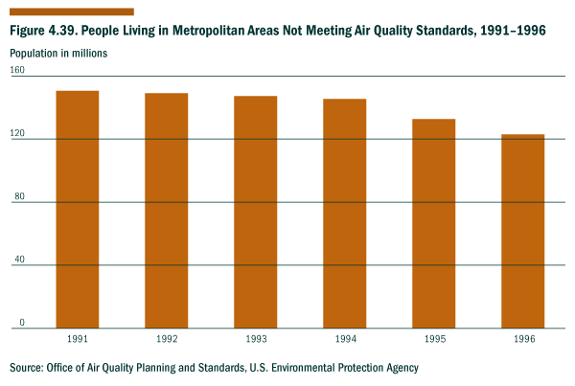
Source: Office of Air Quality Planning and Standards, U.S. Environmental Protection Agency
Figure 4.40. Number of Metropolitan Air Quality Non-attainment Areas, 1991-1996
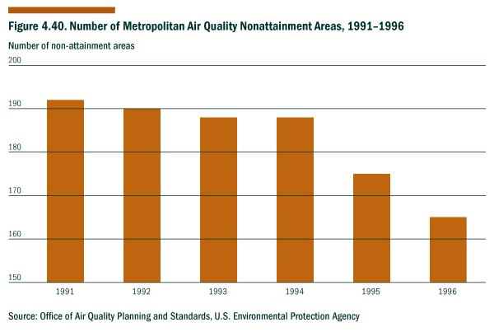
Source: Office of Air Quality Planning and Standards, U.S. Environmental Protection Agency
Environmental Indicators--Current Results
Outdoor Recreational Activities
The enjoyment and services we receive from the natural environment through outdoor recreational activities are not fully captured by the indicator on personal consumption expenditures. This indicator on the participation in outdoor recreational activities reflects our changing interests in various environmental services. In the context of sustainability, it will ultimately be important to monitor not only the participation in various outdoor activities, but also the degree to which the natural habitat and environmental quality are maintained, enhanced, or degraded by these activities.
By examining trends in outdoor recreation activities in the United States, we can gain some insight into environmental conditions, the availability of recreational services, and the amount of leisure time and economic resources available for these activities. This indicator shows a marked increase in the use of natural areas for camping and hiking from 1982 to 1995, but it is difficult to draw any conclusions about this trend based on these data alone.
The original National Survey on Recreation was established in 1960 by the U.S. Department of the Interior (DOI). The most recent survey was expanded to include information on environmental concerns, and it was renamed as the National Survey on Recreation and the Environment. The U.S. Department of Agriculture's Forest Service provided organizational and technical leadership in conducting the most recent survey, and other survey collaborators included the Bureau of Land Management, the National Park Service, the U.S. Army Corps of Engineers, and the Sporting Goods Manufacturers Association. This survey information is useful to private industry and public decision-makers as they strive to understand and meet the public demand for outdoor recreational activities.
Reference:
Forest Service, U.S. Department of Agriculture, National Survey on Recreation and the Environment, 1995.
Figure 4.41. Percent Change in Participation in Outdoor Recreational Activities, 1982-1995
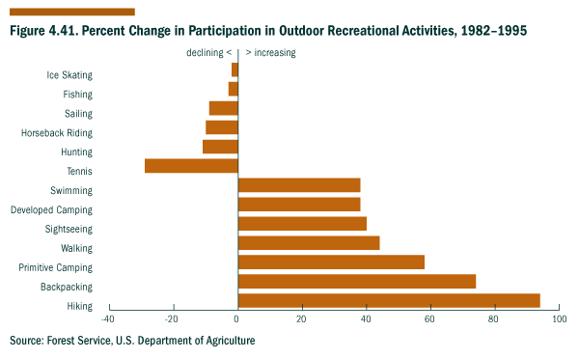
Source: Forest Service, U.S. Department of Agriculture
Social Indicators--Long-term Endowments and Liabilities
U.S. Population
Children Living in Families with One Parent Present
Teacher Training Level and Application of Qualifications
Contributing Time & Money to Charities
Births to Single Mothers
Educational Attainment by Level
Participation in the Arts & Recreation
People in Census Tracts with 40% or Greater Poverty
Crime Rate
Life Expectancy at Birth
Educational Achievements Rates
U.S. Population
The U.S. population was 266.5 million as of January 1997, and it is continuing to grow by about 2.5 million persons per year, or 1% annually. The Census Bureau projects that if current trends continue, the U.S. population will reach 347 million by 2030.
While there is no consensus on the ideal population level or rate of growth, there is general agreement that if the world’s population continues to increase at current rates, the related consumption of resources and the generation of wastes could have detrimental impacts on the environment, the economy, and society. At the same time, increases in population can also augment the workforce and the intellectual capacities needed to address future challenges.
Although it may not be feasible for the U.S. population to grow indefinitely, it is difficult to draw conclusions about the sustainability of a specific population level or rate of growth without examining factors such as the Nation’s natural resource base, social service capabilities, and ability to ensure that all members of society have opportunities to succeed. Policy makers need a wide range of information as they respond to the needs of a growing and aging population and develop and implement immigration policies. Additional work is needed in this area if we are to develop an indicator that captures the full range of variables that relate to population in the context of sustainable development.
Figure 4.42. U.S. Population, 1970-1994
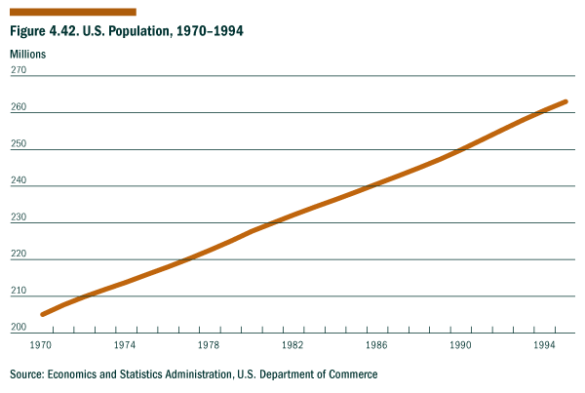
Source: Economics and Statistics Administration, U.S. Department of Commerce
Social Indicators--Long-term Endowments and Liabilities
Children Living in Families with Only One Parent Present
In 1995, there were 68.4 million children under 18 years old living in 37.2 million family groups. Nearly 28% of these children were living in the 11.5 million family groups with only one parent present. In 87% of these single-parent groups, the mother was present; and 72% of the children in these cases lived in families with incomes of less than $25,000. In contrast, for families with two parents present, only 20% of the children were living in households with incomes of less than $25,000; and 45% of the children were living in families with incomes over $50,000.
Single parenthood--especially when the parent is a young woman--can increase the risk of poverty since the family is relying on the earning abilities of only one parent, and child-rearing responsibilities limit the parent's ability to work outside the home and to further her education. At least one-third of the births in the United States are to unmarried women, many of whom became pregnant as teenagers. These young females with children--especially when they are disadvantaged in other ways--form the core of the rising problem of child poverty in the United States. In practice, single parents--most of whom are mothers--often turn to their parents for support. As a result, more than 2.5 million U.S. children today are living in households maintained by grandparents with single parents present.1
The most serious problem among families with one parent present, especially if that parent is a woman, appears to be poverty. Children growing up in poor, single-parent families often start out with socioeconomic disadvantages that can predispose them to lower educational achievement rates, lower incomes as adults, and a greater chance of forming single-parent families themselves. A rising trend in the percentage of children living in one-parent households suggests that for many of these children, there will be significant economic and social burdens in the years to come.
Note:
1 U.S. Census Bureau, economics and Statistics Administration, U.S. Department of Commerce and U.S. Department of Health and Human Services.
Figure 4.43. Percentage of Family Groups with One Parent and Children Under 18 Years Old, 1970-1995
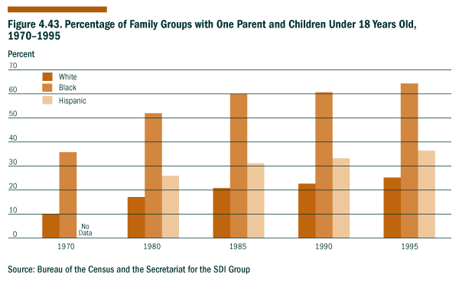
Source: U.S. Department of Health and Human Services and Secretariat for the SDI Group
Social Indicators--Long-term Endowments and Liabilities
Teacher Training Level and Application of Qualifications
Teacher training levels provide a general indicator of teacher capabilities and can be an important factor in determining the overall quality of instruction and knowledge acquired by the students. The better educated U.S. teachers are, the better prepared students will be to meet the challenges of achieving sustainable development. For example, Figure 4.44 shows the percentage of secondary teachers with Master's Degree or more. In 1961, 14.6% of secondary teachers had less than a bachelor’s degree, but by 1996, the percentage was only 0.3%. Graduate-level training also increased during this period as indicated in the first figure. The percentage of public secondary school teachers having a master’s degree or higher in education, a subject matter discipline, or another professional field has more than doubled between 1961 and 1996.
Teachers’ knowledge of the subject matter they are teaching is also an important factor in determining the overall quality of instruction and the knowledge acquired by students. One indicator of teacher subject-matter knowledge presented in the second figure is the percentage of students taking classes from teachers who have academic training, either at the undergraduate or graduate level, in the subjects they are teaching. Teachers who are teaching subject areas where they have not been trained are less likely to be able to communicate challenging content in those subject areas when compared with teachers having stronger academic backgrounds in those subjects. (See Figure 4.45.) Teachers may not be teaching subjects for which they are well prepared because there is a lack of well-qualified candidates in some locations, the assignment policies of school districts, or for other reasons.
Figure 4.44. Percentage of Teachers in Public Secondary Schools with Master's Degree or More, 1961-1996
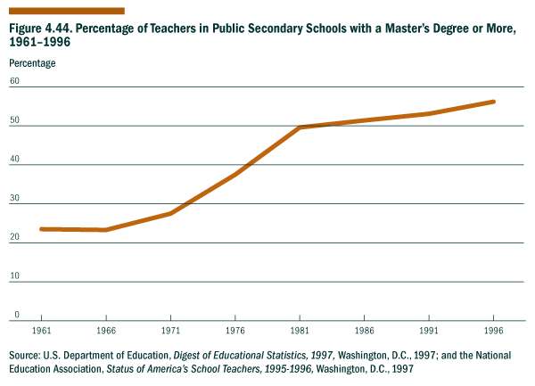
Source: U.S. Department of Education, Digest of Educational Statistics, 1997, Washington, 1997; and the National Education Association, Status of America’s School Teachers, 1995-1996, Washington, DC, 1997
Figure 4.45. Percentage of Public Secondary Students in Classes Whose Teachers Were Trained in the Subject Taught, 1993-1994
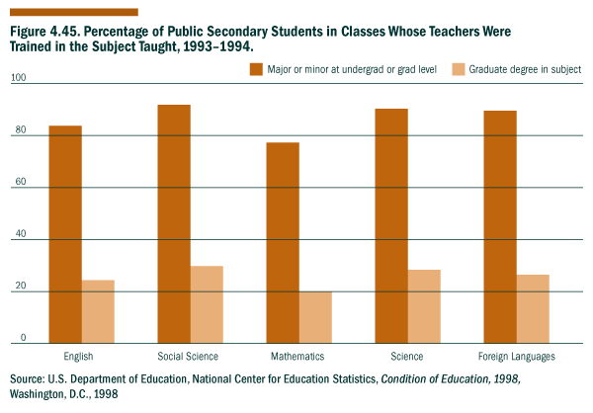
Source: U.S. Department of Education, National Center for Education Statistics, Condition of Education, 1998, Washington, D.C., 1998

Social Indicators--Processes
Contributing Time and Money to Charities
Americans contribute significant amounts of time, money, and goods (e.g., food and clothing) to formal charitable organizations that are involved in such things as the arts, education, the environment, health and human services, international affairs, politics, recreation, religion, and youth services. In 1993, Americans contributed $102 billion in individual gifts and bequests and 15 billion hours of volunteer service. Corporations contributed an additional $6.1 billion.
In addition to these formal contributions, there is a significant amount of informal giving which is largely unmeasured. Informal giving occurs on an ad hoc basis and includes giving money and goods directly to friends, neighbors, co-workers, and family members not in one’s household. Informal contributions of time are also significant and include a broad range of activities such as caring for children, the elderly, and the homebound and providing transportation services, preparing meals, and making home repairs for those in need.
Realizing a path of sustainable development will depend to some extent on the willingness of individuals to become involved in their communities. Contributing money and time to charities is one indicator of this community involvement. The willingness to contribute time and/or money reflects how people perceive their own situation in relation to the needs of others, as well as their faith in the ability of the Nation’s social, economic, and political institutions to address societal needs. Factors that seem to affect contribution patterns include income, tax policies, education, voting in presidential elections, the length of time one has lived in a community, and whether or not one has had a positive experience during youth with charitable giving and volunteering. The single best predictor of charitable contributions of money and time is membership in religious, civic, and other voluntary organizations.
Reference:
Independent Sector, Giving and Volunteering in the United States; Washington, D.C., 1996.
Figure 4.46. Contributing Time and Money to Charities, 1987-1995
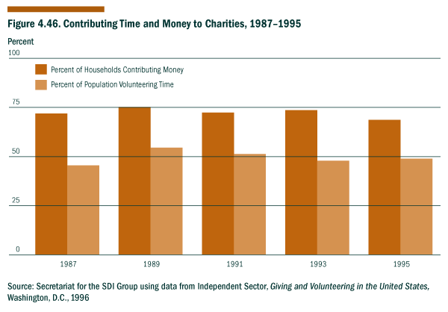
Source: Secretariat for the SDI Group using data from Independent Sector, Giving and Volunteering in the United States, Washington, D.C., 1996
Figure 4.47. Percentage of Households Contributing Time and Money to Different Types of Charities for Years Surveyed, 1987-1995
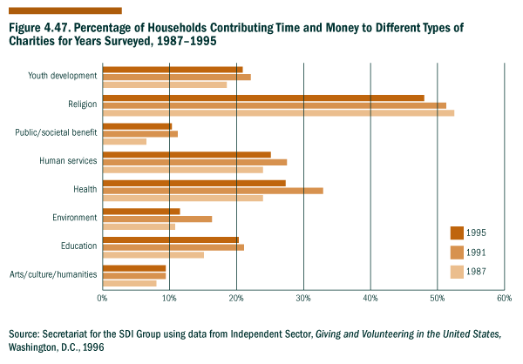
Source: Secretariat for the SDI Group using data from Independent Sector, Giving and Volunteering in the United States, Washington, D.C., 1996
Social Indicators-Processes
Births to Single Mothers
Widespread poverty can prevent families from obtaining adequate food, housing, educational, and health care and from participating in a broad range of community activities. These limitations can impede progress along a path of sustainability by making it harder for the children reared in these families to realize their full potential or to experience a true sense of community.
One of the greatest concerns regarding births to young, single women is that the children of these women are more likely to be reared in poverty. In 1995, 32% of female heads of households with children under 18 years old and no husband present were below the poverty line. In addition, teenage mothers, particularly those who are single, often have a very difficult time in pursuing their education or job training because of the costs and responsibilities of caring for their children.
In 1994, the median income for a two-parent household was $45,041. In contrast, the median income for a single-parent household led by a woman was $19,872. (For black and Hispanic female heads of households, the median income was $14,650 and $13,200, respectively.)
The number of births to all teenage mothers decreased from 656,000 in 1970 to 500,000 in 1997; however, the number of births to single teenage mothers increased from 200,000 in 1970 to 390,000 in 1997. In 1970, 30% of the teenage females who had children were single; but by 1997, this percentage had increased to 78%
Despite the large number of single teenage mothers, the majority of single mothers giving birth in recent years were 20 years old or older. In 1997, there were 3.9 million live births to females of all ages in the United States. Single mothers of all ages accounted for 32% of these 3.9 million births; about 10% of all births were to single teenage mothers, while 17% of all births were to single mothers ages 20 through 29.
Between 1970 and 1997, births to single white women increased by 355% resulting in 25.8% of all white births in 1997 being to single women. During the same period, births to single black women increased by 93%, resulting in 69.1% of black births being to single women. Most of this increase occurred during the 1980s. More recently, between 1994 and 1997, births to single white and black women have stabilized, increasing very little. These long-term trends are linked to delays in marriage, declines in birth rates for married women, and increases in birth rates for unmarried women.
Pregnancies among teenagers can have serious implications for the health and future well-being of the children born. For example, teenage pregnancies are more likely to result in the birth of low birth weight infants. In 1996, 6.9% of all of the infants born to non-smokers had low birth weights (under 2500 grams); but for mothers 15 to 19 years old, 9.3% of the babies born had low birth weights; and for mothers under 15 years old, 13.2% of the babies born had low birth weights. Low birth weights can be associated with a range of medical and developmental complications.
References:
• Economics and Statistics Administration, U.S. Department of Commerce, Statistical Abstract of the United States, 1996, Tables 14, 92, 98, 113, and 713.
• Ventura, S.J., Births to Unmarried Mothers: United States, 1980-1992. National Center for Health Statistics, Series 21, Number 53, 1995.
• Ventura, S.J., Martha, J.A., Curtin, S.C., Mathew, T.J. Report of final natility statistics, 1996, Monthly Vital Statistics Report, Vol. 46, No. 11, Supplement. Hyattsville, Maryland, National Center for Health Statistics, 1998.
Figure 4.48. Live Births to Single Women, 1970-1997

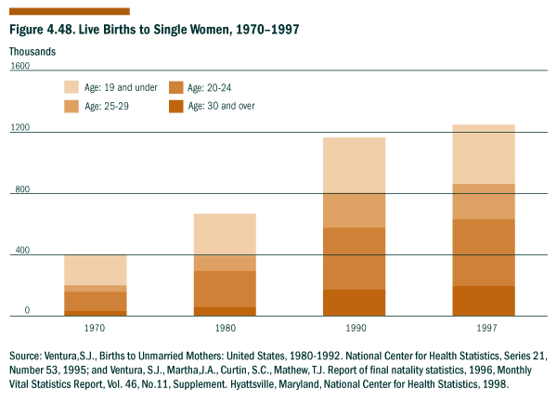Source: Ventura, S.J., Births to Unmarried Mothers: United States, 1980-1992. National Center for Health Statistics, Series 21, Number 53, 1995; and Ventura, S.J., Martha, J.A., Curtin, S.C., Mathew, T.J. Report of final natility statistics, 1996, Monthly Vital Statistics Report, Vol. 46, No. 11, Supplement. Hyattsville, Maryland, National Center for Health Statistics, 1998.
Figure 4.49. Live Births to Single Women By Race, 1970-1997
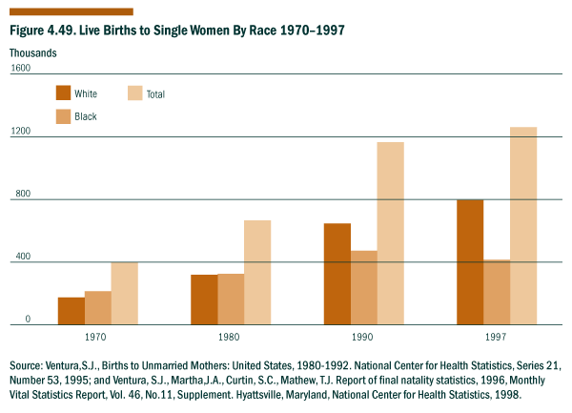
Source: Ventura, S.J., Births to Unmarried Mothers: United States, 1980-1992. National Center for Health Statistics, Series 21, Number 53, 1995; and Ventura, S.J., Martha, J.A., Curtin, S.C., Mathew, T.J. Report of final natality statistics, 1996, Monthly Vital Statistics Report, Vol. 46, No. 11, Supplement. Hyattsville, Maryland, National Center for Health Statistics, 1998.

Social Indicators--Processes
Educational Attainment by Level
Sustainable development is facilitated when the citizenry has the knowledge and skills needed to address a range of economic, social and environmental opportunities and challenges in an informed and integrated way. One indicator for measuring the extent of the population’s knowledge and skills is the level of formal education that people have completed by the time they reach adulthood. In the figure, these levels of attainment are defined as the percentage of 25- to 29- year old individuals who have completed high school or beyond; one or more years of college, and a bachelor’s degree or higher. This age group is often measured because it takes into account young people who dropped out of school for a period before returning to complete their education.
Higher levels of education in the population are consistently related to rates of economic growth and development, the population’s health, participation in the community, further training and education in later life, and many other variables. Recently, the percentage of the population completing at least some college education has accelerated in the U.S., reflecting demands, particularly economic, for higher levels of education and skill. The percentage of 25- to 29- year-old people who are high school dropouts decreased from 22.3% in 1971 to 12.7% in 1996.
Figure 4.50. Percentage of 25- to 29-Year Olds in the U.S. Population Attaining Different Levels of Education, 1971-1996
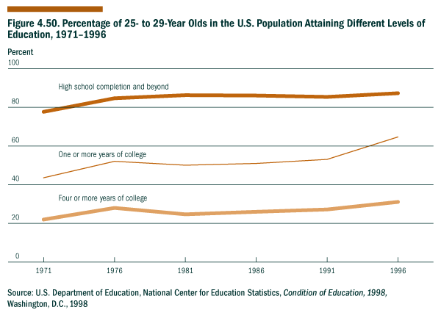
Source: U.S. Department of Education, National Center for Education Statistics, Condition of Education, 1998, Washington, DC, 1998.
Social Indicators--Processes
Participation in the Arts and Recreation
In the United States, we believe that the freedom of assembly and expression--particularly the expression of shared community interests and cultural values--are important in fostering the development of social capital essential to sustainable development. Developing indicators of processes that contribute to creating social capital is still in its infancy and much work must be done to identify appropriate indicators and associated data sets. Participation in the arts and recreation that brings people together from diverse backgrounds are thought to be processes that contribute to building social capital. The information presented in this indicator is a first step in trying to assess trends in such participation by examining data on attendance, expenditures and employment.
Availability of long-term data on participation and expenditures for arts and recreation that brings people together is limited. However, as shown in Figure 4.51, there is data for the period 1992-1996. Expenditures for books and maps were approximately equal to combined admissions to motion picture theaters, the performing arts, and spectator sports. During this period, expenditures remained nearly constant in terms of percentage of GDP. In 1996, expenditures for attendance to motion picture theaters, spectator sports, and the performing arts totaled $80.8 billion. This was about 0.3% of GDP and 4.3% of all expenditures on recreation. These numbers do not reflect the substantial participation in these activities through television, radio, recordings, and other media. These numbers also do not reflect the number of individuals who performed artistic and sports activities in public and private locations.
In 1992, adult attendance--in millions--in seven categories of arts events was as follows: art museums--49.6, musicals--32.3, plays--25.1, classical music--23.2, jazz--19.7, opera--6.1, and ballet--8.7. In addition, 75.6 million people attended art/craft fairs. In comparison, attendance was 1.3 billion at motion picture theaters; 106.7 million at professional sporting events; and 68 million at NCAA college football and basketball. Horse and greyhound racing attendance was 77.3 million.
The second figure presenting data on employment in selected cultural and recreational businesses indicates that since 1964 there has been a steady increase in employment in these activities.
References:
National Endowment for the Arts; Research Division Note #59; based on information supplied by the Bureau of Economic Analysis, U.S. Department of Commerce, Statistical Abstract of the United States, 1996.
Bureau of the Census, U.S. Department of Commerce, County Business Patterns.
National Endowment for the Arts news release concerning research results that show low participation in the arts by “baby boomers,” Washington, D.C., May 15, 1996.
Figure 4.51. Total Personal Expenditures for Selected Cultural and Recreational Choices as a Percentage of Real GDP, 1992-1996
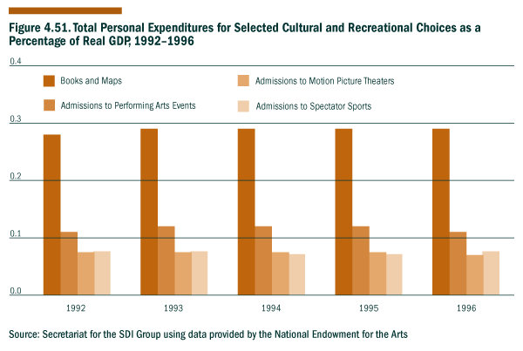
Source: Secretariat for the SDI Group using data provided by the National Endowment for the Arts
Figure 4.52. People Working in Selected Cultural and Recreational Private Businesses, 1964-1994
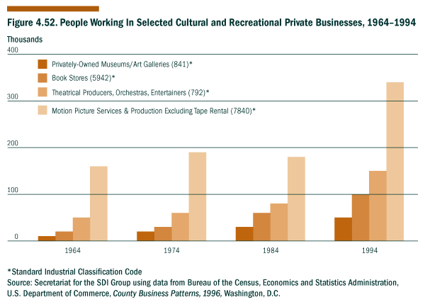
Source: Secretariat for the SDI Group using data from Bureau of the Census, Economics and Statistics Administration, U.S. Department of Commerce, County Business Patterns, 1996, Washington, D.C.
Social Indicators--Processes
People in Census Tracts with 40% or Greater Poverty
Census tracts have been defined for metropolitan areas which cover 75% of the total U.S. population. The poverty line is defined as the income level at which the estimated cost of a low-cost food plan for a family of three or more would consume 33% of the family’s total income. A high poverty census tract is defined as one in which 40% or more of the population is below the poverty line. The percentage of poor people living in high poverty census tracts is a measure of the concentration of poverty in urban areas. It is widely believed that poor people are worse off living in areas of concentrated poverty than they would be in other areas, and that society as a whole suffers when these areas of concentrated poverty exist. Furthermore, growth in areas of concentrated poverty has negative implications for the future because children reared in very poor neighborhoods are at risk of poor developmental outcomes.
The graph shows three measures of the concentration of poverty in urban areas:
(1) the percentage of the population below the poverty line living in high poverty census tracts (from 16.5% in 1970 to 28.2% in 1990);
(2) the percentage of census tracts which are defined as “high poverty” with 40% or more of the population in the tract below the poverty line (from 6% in 1970 to 13.7% in 1990); and
(3) the percentage of total population living in high poverty census tracts (from 5.2% in 1970 to 10.7% in 1990).
Figure 4.53. High Poverty Census Tracts: 40% or More of Population Below the Poverty Line, 1970-1990
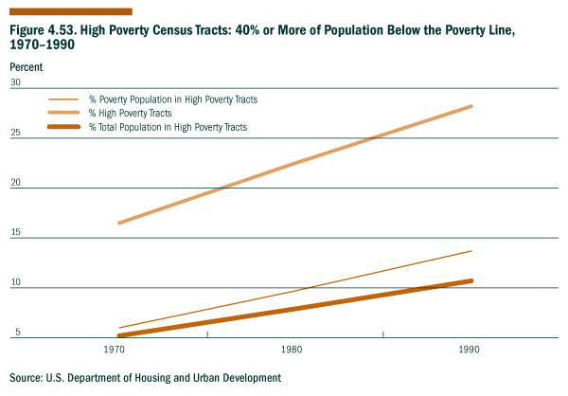
Source: U.S. Department of Housing and Urban Development
Social Indicators--Current Results
Crime Rate
Crime clearly affects a community’s safety and sense of security, and it is also believed to have major impacts on neighborhood stability, urban economic development, education, social integration, and the perceived quality of life. Today, crime and disorder are often viewed as a cause, as well as an effect, of the decline of many inner city neighborhoods.
In the graph below, household crimes include burglary, residential larceny, and motor vehicle theft; personal theft includes theft and personal larceny with contact; and violent crimes include murder and non-negligent homicide, rape, robbery, and assault. Estimates of major crimes other than homicides are provided annually through the National Crime Victimization Survey. This survey is conducted by the Census Bureau, U.S. Department of Commerce, on behalf of the U.S. Department of Justice. Estimates of homicides are provided by the Federal Bureau of Investigation (FBI) and published in its Uniform Crime Reports. These estimates are based on a national tabulation of murders and non-negligent homicides known to the police. These two inventories do not capture all crime (e.g., many types of fraud) and are believed to present an incomplete counting of other crimes, such as domestic violence. Nevertheless, they are the best figures currently available and they are generally considered to be more accurate than those of other nations.
Figure 4.54. Crime Rates, 1973-1994
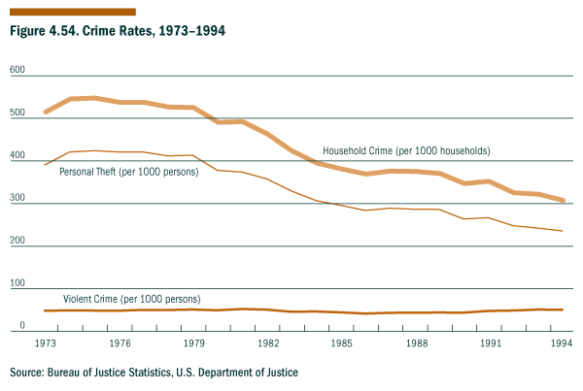
Source: Bureau of Justice Statistics, U.S. Department of Justice
Social Indicators--Processes
Life Expectancy at Birth
Life expectancy is a widely accepted and standard measure of health outcomes. It is revised annually based on mortality data collected from the States. The latest published data, for 1994, show a life expectancy in the United States of 75.7 years (72.4 years for males and 79.0 years for females). This level has changed slowly in recent years.
Life expectancy is included in this set of U.S. sustainable development indicators as a broad-based measure of health. Human health is one of the most important parameters of sustainable development; if poor health prevents us from working and being able to contribute to society as a whole, we may be unable to meet our own needs and to lay a solid foundation for future generations.
There is a direct and substantial relationship between economic development, life expectancy, and other measures of health such as infant mortality and other types of premature death. As might be expected, developing countries with widespread poverty often lack the resources to provide for such basic needs as food, shelter, clothing, and medical care and this can adversely impact on life expectancy at birth. However, even for developed countries, protracted changes in life expectancy can result from significant shifts in a variety of social, economic and environmental factors important to maintaining a healthy population. Unfavorable changes in U.S. life expectancy at birth would indicate the need to consider other indicators linked to the overall health of the population.
Figure 4.55. Life Expectancy, 1940-1990
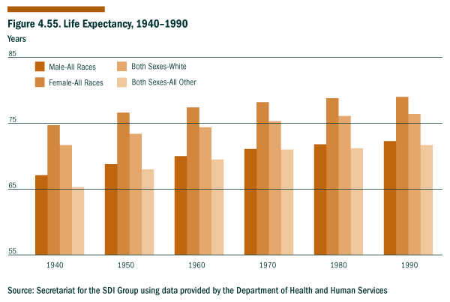
Source: Secretariat for the SDI Group using data provided by the Department of Health and Human Services
Social Indicators--Processes
Educational Achievement Rates
Educational achievement-as measured by student proficiency in mathematics-provides a measure to what extent the leaders of tomorrow are being educated. A central goal of high-quality formal schooling is to ensure that students acquire a solid foundation of knowledge in subject areas, such as mathematics. In recent years, there has been a positive trend in achievement rates in the three grades measured.
Mathematics achievement has been shown to affect many aspects of student development: thinking ability, the likelihood of going to college, employment, earnings in the labor market, and career success.
The mathematics achievement of students is represented by test score results from the National Assessment of Educational Progress (NAEP) from grades 4, 8, and 12. NAEP has defined national standards of achievement according to what students should know and be able to do at different grades. The Basic level means that students have partial mastery of the prerequisite knowledge and skills that are required for proficient work at a designated grade level. The Proficient level means solid academic performance and demonstrated competency in concepts and applications.
Figure 4.56. Trends Achievement in 4th Grade Mathematics: National Assessment of Educational Progress, 1990-1996
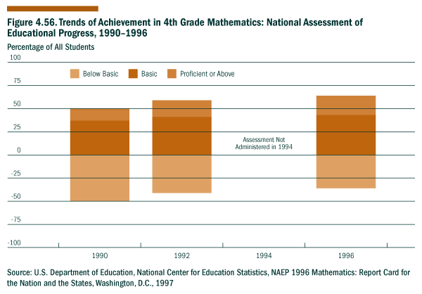
Source: U.S. Department of Education, National Center for Education Statistics, NAEP 1996 Mathematics: Report Card for the Nation and the States, Washington, DC, 1997.
Figure 4.57. Trends Achievement in 8th Grade Mathematics: National Assessment of Educational Progress, 1990-1996
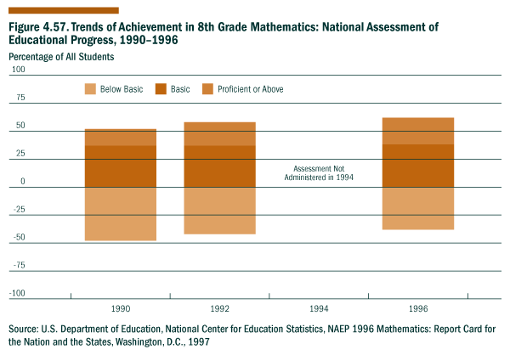
Source: U.S. Department of Education, National Center for Education Statistics, NAEP 1996 Mathematics: Report Card for the Nation and the States, Washington, DC, 1997.
Figure 4.58. Trends Achievement in 12th Grade Mathematics: National Assessment of Educational Progress, 1990-1996
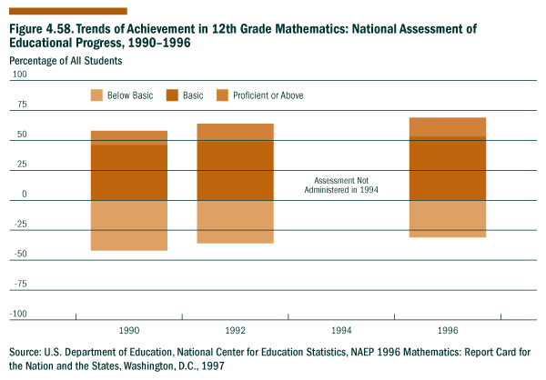
Source: U.S. Department of Education, National Center for Education Statistics, NAEP 1996 Mathematics: Report Card for the Nation and the States, Washington, DC, 1997.
Chapter 5. What the Indicators Do and Do Not Tell Us about Sustainable Development

"Indicators can be a useful tool for understanding the challenges, opportunities, and trade-offs involved in sustainable development."

This chapter looks at the full set of indicators to see what they do and do not tell us about the Nation’s progress toward sustainability. This does not represent a full assessment, and further work will be needed to understand the relationships among the indicators or to combine them in ways that are most useful to policy makers and the public.
For some indicators (e.g., water quality or crime rates), the meaning for current and future generations seems clear. But for others (e.g., materials and energy consumption), the meaning for future sustainability is less clear and may depend in part on future advances in science and technology.
Although this experimental set of indicators does not provide a single answer regarding our progress toward sustainable development, it does provide a tool for examining many of the factors we believe to be important. The information provided by these and other indicators may make it possible for society to have a more informed debate about the challenges, opportunities, and trade-offs involved in pursuing sustainable development. Ultimately, we must all take responsibility for adopting practices, policies, and approaches that will be beneficial to all generations.
The following tables and discussion provide a summary of the 40 indicators and the expected impacts of trends in these indicators on sustainable development.
Go to Discussion and Further Considerations

Table 5.1 Economic Indicators & Sustainable Development
Indicator | Trend | Relevance to Sustainable Development
- | - | Impact of Trend |  |  | Comments
- | - | + | - | ? | -
Capital Assets |  | X | - | - | Net fixed reproducible tangible wealth has increased by more the 90% since 1970.
Labor Productivity |  | X | - | - | Productivity growth has averaged 1.1% since 1973.
Federal Debt to GDP Ratio |  | - | - | X | Debt held by the public has declined only slightly, from 50.2% of GDP in 1993 to 49.9% of GDP in 1996.
Energy Consumption Per Capita & Per $ of GDP | per capita  per GDP | - | - | X | Energy consumption per capita reflects personal access to energy (heat, transportation, electricity), and increases are often considered to be beneficial. However, this measure alone does not capture important distributional, intergenerational, environmental, or consumer conservation issues. Energy consumption per GDP highlights the efficiency of use, and in the United States, decreases would generally be considered to be beneficial. We can not be certain whether future increases in energy use per capita or for the population as a whole could be sustained--even with improvements in energy efficiency--without examining all of the related economic, environmental, and social impacts.
Materials Consumption Per Capita & Per $ of GDP | per capita since 1970  per GDP since 1900 and since 1970 | - | - | X | Since 1900, the U.S. consumption of materials per capita has increased substantially; but it is lower today than it was in 1970. Like energy, increasing materials consumption can reflect greater material well-being, but this measure does not capture important distributional, intergenerational, environmental, or consumer conservation issues. The consumption of materials per GDP has decreased since 1900 and since 1970, possibly reflecting greater efficiency as well as a shift toward a more service-oriented economy. We can not be certain whether future increases in materials use per capita or for the population as a whole could be sustained--even with improvements in production efficiency--without examining all of the related economic, environmental, and social impacts.
Inflation |  | X | - | - | Since 1992, the annual increase in inflation has been 3% or less.
Investment in R&D as a Percentage of GDP | since 1991 | - | X | - | Investment in R&D has decreased since 1991. R&D can potentially lead to scientific and technological advances that help us address various sustainability issues (e.g., pollution and climate change). A complete assessment of the benefits of R&D investment should include an analysis of the costs and benefits of the resulting technologies.
Domestic Product |  | X | - | - | Gross domestic product--an aggregate measure of economic performance--has more than doubled since 1970, after adjusting for inflation.
Income Distribution | income levels  distribution  among income groups | - | - | X | Since 1970, average income has generally increased for all income groups; but the increase has been greatest for those in the two highest income groups and lowest for those in the middle and low-middle income groups.
Consumption Expenditures Per Capita |  | X | - | - | Personal consumption expenditures (PCE) per person, adjusted for inflation, have increased more than 60% over the past 25 years. This is generally accepted as evidence of an improved standard of living and is thus scored as a positive impact. While PCE measures the value of goods and services purchased by U.S. residents, it does not reflect many of the related distributional, environmental, or social issues that may be important to long-term sustainability. To the extent possible, these concerns are addressed by other indicators in the SDI set.
Unemployment |  | X | - | - | Unemployment has decreased from a high of 9.7% in 1982 to below 5% in recent years.
Homeownership Rates |  | X | - | - | Homeownership rates rose steadily after World War II to reach a peak of 65.6% in 1980. After a period of somewhat lower rates in the mid-1980s and early 1990s, rates began to rise again and have nearly reached the 1980 peak.
Percentage of Households With Housing Problems |  | - | X | - | Although the prevalence of physically inadequate housing and crowding in housing declined from 1978 to 1993, the percentage of U.S. households that pay more than 30% of their income for housing has increased from 16% in 1978 to 25% in 1993. When considered together, the percentage of households with either severe cost burdens or severe physical problems increased from 9% in 1978 to 11% in 1993.

Table 5.2 Environmental Indicators & Sustainable Development
Indicator | Trend | Relevance to Sustainable Development
- | - | Impact of Trend |  |  | Comments
- | - | + | - | ? | -
Surface Water Quality |  | X | - | - | Since 1972, there have been substantial improvements in surface water quality, primarily due to the reduction of the most conspicuous point-sources or contamination.
Acres of Major Terrestrial Ecosystems | since 1750 | - | - | X | There has been a significant decline in the acres and ecological integrity of pristine ecosystems since the middle of the 18th century. In recent years, reclamation has resulted in the partial rebound of some ecosystems. As restoration techniques become more sophisticated, significant improvements to ecosystem conditions can be expected.
Contaminants in Biota |  | X | - | - | Based on data from 1986 through 1995, concentrations of many of the contaminants measured declined for the contaminants whose use had been banned or restricted. There continue to be significant scientific concerns concerning the release of substances into the environment that may disrupt the normal functioning of endocrine systems.
Quantity of Spent Nuclear Fuel |  | - | X | - | The safe storage of spent nuclear fuel will create a burden for generations to come at a cost of millions of dollars per year. In the coming years, we will need to balance the dangers, costs, and benefits of nuclear energy with the full costs and benefits (economic, environmental, and social) of other energy sources and technologies (e.g., fossil fuels, renewable forms of energy, and energy efficiency).
Status of Stratospheric Ozone |  | - | X | - | Stratospheric ozone across the United States has declined by about 7% since 1978; and more than 50% of springtime ozone has been lost over the South Pole since 1970. The good news is that due to regulations on ozone-depleting gases (e.g., chlorofluorocarbons) which became effective January 1, 1996, the concentrations of these gases in the stratosphere are expected to peak by the turn of the century. We expect to see the first evidence of stratospheric ozone recovery early in the 20th century and the beginning of recovery will first be observed at the South Pole since the springtime depletion there is very large compared to natural variability.
Greenhouse Climate Response Index |  | - | X | - | Under stable conditions, the greenhouse climate response index would be 10%. Since 1980, the greenhouse climate response index has averaged 13.3%, suggesting that U.S. climate is changing in a manner consistent with greenhouse warming.
Ratio of Renewable Water Supply to Withdrawals | since 1980 | X | - | - | The ratio of renewable water supply to withdrawals decreased from 1950 to 1980, but there was an increase from 1980 to 1985 and 1990. The Nation as a whole has a favorable ratio of supply to withdrawals, although some regions of the country do not (e.g., the arid West).
Fisheries Utilization | Trend data not yet available for U.S. fisheries as a whole. | - | - | X | In 1997, the National Marine Fisheries Service found that 86 species (12%) were overfished, 183 species (25%) were not overfished, and 10 species (1%) were considered to be approaching an overfished condition. For 448 species (62%), their status relative to overfishing is currently unknown. Overfished stocks may be at risk of severe or irreversible depletion.
Invasive Alien Species |  | - | X | - | The number of invasive alien species of plants, animals, insects, microorganisms, and pathogens has continued to increase. These non-native species often displace indigenous species, and the associated environmental, economic, and social costs can be significant.
Conversion of Cropland to Other Uses |  | - | - | X | The rate of cropland conversion to other uses has declined in recent years, as has the rate of expansion in urban areas. This seems to be a positive trend, but we know that even if the rate of conversion is decreasing, cropland conversion can not continue indefinitely without having a detrimental impact on the ability of future generations to meet their food needs. There is a good deal of uncertainty (scientific, technological, and societal) about how much cropland will be needed to meet the food needs of future generations.
Soil Erosion Rates |  | - | - | X | Cropland erosion rates have generally declined since 1982, but there are still areas where erosion rates exceed soil regeneration rates. The current trend is favorable, but it is not clear whether it is sustainable in the long-term.
Timber Growth to Removals Balance | since 1952 | X | - | - | In every year since 1952, the growth of timber has exceeded removals. In 1992, the timber growth/removal ratio was 1.33 meaning that the U.S. grew 33% more timber than it cut.
Greenhouse Gas Emissions |  | - | X | - | Between 1990 and 1994, the weighted total U.S. emissions of greenhouse gases rose by 3.9%; and between 1990 and 1995, the U.S. emissions of carbon dioxide rose by 5.1%.
Identification & Management of Superfund Sites |  | - | X | - | The number of Superfund sites grew from 8,689 in 1980 to 39,099 in 1994. In 1994, there were 1360 National Priority List sites, and removal actions had been completed at a total of 1516 NPL and non-NPL sites. Yet of the approximately 40,000 Superfund sites, 16,000 still require the on-site treatment or removal of industrial or hazardous wastes in order to protect human health and the environment. In addition, there are a number of non-Superfund abandoned industrial and hazardous sites known as brownfields that require attention.
Metropolitan Air Quality Non-attainment |  | X | - | - | Since 1991, both the number of metropolitan areas that failed to attain air quality standards and the number of people living in non-attainment areas decreased.
Outdoor Recreational Activities |  | - | - | X | Since 1982, the participation in a number of outdoor recreational activities has increased. This indicator could reflect not only current environmental conditions, but also changing societal interests, leisure time, personal economic resources, and the availability of recreational services. Even though increasing demand for outdoor recreational activities probably reflects positive changes in our current quality of life, it could put increasing pressures on the environment (e.g., through habitat degradation or littering) unless appropriate management measures are put in place.

Table 5.3 Social Indicators & Sustainable Development
Indicator | Trend | Relevance to Sustainable Development
- | - | Impact of Trend |  |  | Comments
- | - | + | - | ? | -
U.S. Population |  | - | - | X | The U.S. population is growing by about 2.5 million persons or 1% per year. In the United States, it is difficult to draw any conclusions about the population size or rate of growth in the context of sustainable development without also examining factors such as the Nation’s natural resource base, international trading patterns, social service capabilities, and ability to draw upon and enhance the contributions that each individual can make to society as a whole.
Children Living in Families with Only One Parent Present |  | - | X | - | The percentage of children living in families with one parent present has increased in white, black, and Hispanic families. The mother was the parent present in 87% of the cases, and 72% of single parent families had incomes less than $25,000. Although each parent makes a distinct contribution to a child’s social development, a key problem among single-parent families is poverty.
Teacher Training and Application of Qualifications |  | - | - | X | The percentage of teachers with a masters degree or higher has steadily increased in secondary public schools; however, approximately 10% of students are taught by teachers teaching subjects outside their major or minor.
Contributing Time & Money to Charities |  | - | X | - | Although Americans continue to contribute billions of dollars and hours of volunteer service to charity each year, the percentage households that contribute and the percentage of the population volunteering has decreased since 1989.
Births to Single Mothers |  | - | X | - | The percentage of births to single women has increased from 1970 to 1993. The increases were most marked among women older than 20 years old (versus teenagers) and among white women (versus black women).
Educational Attainment by Level |  | X | - | - | Educational attainment at high school and college levels has steadily increased since 1971.
Participation in the Arts & Recreation |  | X | - | - | Millions of Americans participate in cultural and recreational activities each year; this participation reflects both leisure time and shared community interests and cultural values.
People in Census Tracts with 40% or Greater Poverty |  | - | X | - | The percentage of the total population living in high poverty census tracts has risen from 5.2% in 1970 to 10.7% in 1990.
Crime Rate |  | X | - | - | Since 1970, overall crime rates--including household crimes, personal theft, and violent crimes--have declined.
Life Expectancy at Birth | since 1984 | X | - | - | Life expectancy is a standard measure of overall health. It is higher than it was in 1984, but it has remained stable for several years.
Educational Achievement Rates |  | X | - | - | Educational achievement rates--as reflected in average math proficiency--have increased slightly since 1990. The high school dropout rate has declined since 1971, to about 12%.

Discussion and Further Considerations
It may be useful to take a closer look at indicators that relate to the economy, the environment, and society to understand where progress has been made and where additional attention is needed. The following description is primarily intended to initiate a discussion of what these indicators can tell us about sustainable development.
Economic Indicators
Assessing economic progress in the context of sustainable development requires us to look not only at current goods and services but also at the long-term capacity to provide for human needs. A major challenge in interpreting current economic results is to determine whether changes are outside the range of normal variability.
The media generally pay closest attention to short-term economic indicators, such as monthly or quarterly unemployment and GDP, but in the context of sustainable development, we must also consider long-term trends. It seems likely that future generations will want a somewhat different mix of goods and services than we consume today, so we would eventually like to be able to measure the capacity of our economic system to adjust to changing needs and wants.
A widely used indicator of current economic output is the gross domestic product (GDP). In general, GDP has grown over the past 25 years, as has net domestic product (NDP, or GDP minus depreciation). NDP adjusts for the depreciation of reproducible capital, but it does not adjust for changes in other variables that affect production such as natural resource stocks, human capital, advances in knowledge and technology, or innovation.
Inflation has varied with the business cycle, but it is lower today than it was in the mid-1970s and early 1980s. The civilian unemployment rate has also varied with the business cycle, but it has been below 6% for the past two years. These are positive economic trends, but these indicators alone can not tell us whether current patterns of economic growth are sustainable over the long term.
A key question in assessing progress toward sustainable development is whether we are maintaining the basic resources and productive capacities we need to provide for current and future needs. Two key sample indicators that provide some information about the capacity of our economic endowments to support current and future needs are (1) capital assets, as measured by net fixed reproducible tangible wealth, and (2) labor productivity in the non-farm business sector. Both capital assets and labor productivity have grown substantially since 1970.
These economic indicators have some limitations in the context of sustainable development. Capital assets and labor productivity do not provide us with related, important information on the environment, natural resources, or advances in knowledge and technology.
Like all endowments, capital assets, labor productivity, and a skilled labor force must be maintained through investment. The stock of fixed capital must be rebuilt to offset depreciation, and productive capacity can be enhanced by the development of improved technologies and investments in new capital (including research and development and the education and training of the workforce).
In addition to looking at overall economic performance and investment, it is important to look at economic distributional issues. The distribution of income has important consequences for society as a whole. The indicator on income trends shows that the top income groups are making greater gains in income than the middle and lower income groups. Although there is no broad consensus in the United States on what constitutes an equitable income distribution, it seems likely that a long-term trend of increasing income inequality could exacerbate some societal problems. When examined over a period of years, income distribution can provide a useful measure of equity from one generation to the next. Consideration of intergenerational equity is particularly important in the context of sustainable development.
A second key distributional indicator is the percentage of the population in problem housing. Although the prevalence of physically inadequate housing and crowded housing have declined, increases in housing costs have forced 25% of U.S. households to pay more than 30% of their income for housing in 1993, compared to 16% of households in 1978. Without additional information, it is difficult to interpret the implications of such a trend for sustainable development. If the burden falls more on the lower income groups, it could suggest inequities in the availability of affordable housing. It could also reflect demographic changes, changing preferences for housing relative to other goods and services, or changing preferences for more expensive locations. A related indicator--home ownership--is rising and has nearly reached the previous peak of 65.6%, which occurred in 1980. The decrease in physically inadequate housing and in crowding and the increase in home ownership rates should have positive impacts on social stability and community pride.
Two of the economic indicators provide a starting point for considering related environmental and social variables: energy use per capita and per dollar of GDP and materials consumption per capita and per dollar of GDP. Over the past 50 years, U.S. energy consumption per capita has increased. Energy consumption per capita reflects personal access to and use of energy (e.g., heat, transportation, electricity); and from a short-term economic perspective, increases in energy consumption can be beneficial, particularly in developing countries. But this measure does not adequately reflect important distributional, intergenerational, environmental, or conservation issues. Energy consumption per dollar of GDP has decreased over the past 50 years due to increasing efficiency of use, and this trend is beneficial. Nevertheless, in order to meet future energy needs without harming the environment, significant changes in consumption patterns, the efficiency of use, and/or energy sources may still be needed.
We could say similar things about the consumption of materials per capita and per dollar of GDP. U.S. per capita use of materials has grown dramatically since 1900, but it has decreased since 1970. Like energy, increasing materials consumption per capita may represent greater material well-being, but it does not capture important distributional, intergenerational, environmental, or conservation issues. The decrease in materials use per capita since 1970 could be due in part to a shift toward a more service-oriented society. The consumption of materials per GDP has decreased since 1900, perhaps reflecting both greater production efficiencies and changing market forces. We can not be certain whether future increases in materials use per capita or for the population as a whole could be sustained--even with improvements in production efficiency--without examining all of the related economic, environmental, and social impacts.
The sample set of economic indicators also includes Federal debt per dollar of GDP. In the context of sustainability, the major concern about debt relates to distributional issues. For every debt owed by one institution, there is an equal asset on the books of other institutions or individuals to whom the debt is owed. With Federal debt, the burden of financing the debt is shared across the American population, while the benefits accrue only to those who can afford to hold the bonds, both in this country and abroad.
Environmental Indicators
The environmental indicators selected by the SDI Group reflect a wide range of natural resource and environmental issues and provide a starting point for thinking about the environmental components of sustainability. In some cases, the indicators clearly point to positive or negative trends; but in other cases, scientific and technological uncertainties make it difficult to assess the long-term implications of current trends.
The environmental indicators show that we are continuing to improve surface water quality, reduce the contamination of biota, and reduce air pollution. Since 1972, there have been substantial improvements in surface water quality, due primarily to the reduction of some of the most conspicuous point sources of contamination. The overall concentrations of contaminants of coastal biota decreased from 1986 to 1995, due to restrictions or bans on the use of some of the most toxic substances. Yet, in spite of these improvements, a number of states must still issue advisories warning against the consumption of fish and shellfish from coastal waters. Substantial progress has been made in reducing air pollution, but there are still 165 metropolitan areas that do not yet meet national air quality standards.
One issue that has received significant international attention is the depletion of stratospheric ozone. The depletion of stratospheric ozone relates to human activities that result in the emission of chlorine and bromine-containing gases. Reduced ozone levels can result in increased UV-B radiation at the Earth’s surface, and this increased radiation is known to be harmful to certain biological systems and is believed to be associated with an increased incidence of skin cancer in humans. Stratospheric ozone levels over the United States have declined by about 7% since 1978, and more than 50% of springtime ozone has been lost over the South Pole since 1970. Due to regulations on ozone-depleting gases (e.g., chlorofluorocarbons) which became effective on January 1, 1996, the concentrations of these gases in the stratosphere are expected to peak by the turn of the century. We expect to see the first evidence of stratospheric ozone recovery early in the 20th century, and the beginning of that recovery will be observed first at the South Pole since the springtime depletion in that part of the world is very large compared to natural variability.
Other environmental indicators raise serious concerns. U.S. emissions of greenhouse gases increased by 3.9% between 1990 and 1994, and between 1990 and 1995, the U.S. emissions of carbon dioxide rose by 5.1%. The Intergovernmental Panel on Climate Change has stated that observations suggest a “discernible human influence on global climate”, and although the impacts of global warming on sustainable development are not entirely clear, they could be substantial.
The Global Climate Response Index is composed of five different indicators of weather patterns (e.g., percent of the U.S. with much above normal temperatures or with much greater than normal proportion of precipitation derived from heavy rainfall events). This index provides us with a tool that we can use to determine whether U.S. weather and climate patterns have changed as we would expect with greenhouse warming. Under stable conditions, the expected value of this index in any given year would be 10%. But since 1980, the GCRI has averaged 13.3%; this is 3.3% above the average from previous years in the century. Although there is a 5-10% chance that this trend could occur under stable conditions, the tendency toward increased values of the index over the past two decades suggests that the climate of the United States is changing in a manner consistent with greenhouse warming.
Another area for concern is the generation of highly radioactive spent nuclear fuel from commercial reactors. The safe storage of this spent fuel will create a burden for generations to come at a cost of millions of dollars per year. The high costs associated with ensuring safe and efficient nuclear energy operations and storage could reduce the generation of nuclear energy and the resulting spent nuclear fuel in the years to come. But if the generation of nuclear energy decreases, we may need to rely on other energy sources--such as fossil fuels--to a greater degree and those alternatives are associated with their own environmental consequences (e.g., greenhouse gas emissions and pollution). Greater energy efficiency measures and an increase in the use of renewable forms of energy hold the promise of providing environmentally favorable energy services for the next century.
We are making progress in conserving some natural resources and utilizing them in a more sustainable manner. Important regional differences exist, but at the national level, timber growth exceeds removals and soil erosion is declining. The United States as a whole has a favorable ratio of renewable water supply to withdrawals, but some parts of the country continue to experience water shortages.
In the case of fisheries, we need to do more to ensure that natural resource stocks are adequate for current and future generations. In 1997, the National Marine Fisheries Service found that 86 species (12%) were overfished, 183 species (25%) were not overfished, and 10 species (1%) were approaching an overfished condition. For 448 species (62%), their status relative to overfishing is currently unknown. There is clearly a need for further scientific research and sustainable fishery management practices.
There is a growing demand for outdoor recreational services, and this implies that the natural environment supporting these activities is adequate and aesthetically pleasing. Although an increase in outdoor recreation probably represents positive changes in our current quality of life, continued increases in demand could place increasing pressure on the environment (e.g., through habitat degradation) unless appropriate management measures are put in place.
Social Indicators
There are a number of factors that make it difficult to identify and analyze indicators of social sustainability. The selection of social indicators is particularly affected by one’s cultural and social values, personal background, and experiences; and it is difficult to identify the indicators that will ultimately be the most useful in measuring equity, social cohesiveness, and societal well-being.
One way to think about the social aspects of sustainability is to focus on the factors that affect the well-being of individuals, families, or communities. A number of the indicators relate to communities as a whole; examples include population, teacher training levels, the prevalence of poverty, participation in the arts and recreational activities, contributions of time and money to charities, and the crime rate. Several other indicators--such as children living in families with one parent present or births to single mothers--focus on the family. And the remaining indicators, such as life expectancy, focus on the individual.
The U.S. population is continuing to grow at the rate of approximately 2.5 million people or 1% per year. Increases in population can result in positive economic growth and provide new sources of labor and social capital, but they can also put increasing pressures on the environment, natural resources, and social institutions. There is currently no consensus on what the optimal U.S. population level is, and if consensus is ever reached, it will depend on a broad-based examination of all of the related economic, environmental, and social factors, including advances in science and technology, in both short-term and long-term.
A few of the trends in social indicators raise concerns. The percentage of the total population living in high poverty census tracts has risen from 5.2% in 1970 to 10.75% in 1990. This trend has significant negative implications because of the harmful effects of concentrated poverty on children's development and the social capital of our inner cities.
Americans contribute billions of dollars to charity and billions of hours to volunteer activities each year, but the percentage of households that contribute time and money to charity has decreased slightly since 1989. The reasons for this decline are unclear, but they could be related to factors such as the increasing dependence of many families on two wage earners, longer commuting times, personal and financial stress, and efforts to spend more time with one’s own family.
One of the most important issues for communities across the country is crime prevention. Crime has far-reaching effects on individuals and communities. It not only affects the sense of personal safety and security, but it also has major impacts on neighborhood stability, urban economic development, education, and the perceived quality of life. The good news is that crime rates for the Nation as a whole--including household crimes, personal theft, and violent crimes--have been declining. The improvement could be due to a range of factors such as better law enforcement, community policing, crime prevention programs, and the improvement of economic or social conditions.
One positive social indicator is the increase in the level of education attainment since 1971. Graduation rates have fluctuated in recent years, and elementary and secondary school enrollment rates have remained stable for a number of years. Educational achievement rates--as reflected in the average proficiency in mathematics--have increased slightly since 1990, and teacher training levels in secondary schools have increased, but about 10% of students are attending classes where teachers are teaching subjects outside their major or minor. We know that education will be a key to ensuring a sustainable future, and a great deal more needs to be done to improve the quality of education across the country.
Family structure has changed significantly over the past 25 years. Between 1970 and 1995, the number of children living in families with one parent present increased in white, black, and Hispanic families. In 1995, the mother was the parent present in 87% of the time. One of the most serious problems for many single-parent families is poverty: in 1995, 72% of single-parent families had incomes of less than $25,000.
Births among single women of all ages increased from 1970 to 1993, and the majority of these births were to single women 20 years old or older. The number of births to all teenage mothers decreased from 1970 to 1993, but the number of births to single teenage mothers increased from 200,000 to 368,000. In 1970, 31% of teenage mothers were single, but by 1993, 74% of teenage mothers were single. As noted in the discussion of single-parent households, one of the greatest concerns regarding pregnancies to single teenage mothers is the increased risk that the children will be reared in poverty. It becomes extremely difficult for single teenage mothers as the only parent present to pursue educational or job training opportunities when faced with the costs and responsibilities of caring for their children.
Americans typically enjoy long life-spans, and although life expectancy has been stable over the past few years, it has risen substantially over the past 50 years. The aging of the baby boomers (individuals born between 1946 and 1964) means that in the next few decades, the largest percentage of the U.S. population in history will be retired. Even if there are only modest increases in the overall population, the increasing age structure of the U.S. population could strain the ability of working-age adults to provide support for older Americans.
The Overall Picture
The total number of economic, environmental, and social indicators that show trends which may result in favorable, unfavorable, or mixed or uncertain impacts on sustainable development are shown in Table 5.4. The SDI Group recognized that the conclusions that one draws from this indicator set depend in part on the judgements that were made during the indicator selection process. The selection of indicators is guided not only by objective criteria, but also by values and priorities, and it is important to keep in mind that the selection of different indicators could lead to a different conclusion about the Nation’s progress in realizing a path of sustainability.
Table 5.4 Summary of Indicators
SDI Framework Subcategory | Total No. of Indicators | Relevance of Trends to Sustainable Development
- | - | No. of Indicators with Trends that Result in Favorable Impacts | No. of Indicators with Trends that Result in Unfavorable Impacts | No. of Indicators with Trends that Result in Mixed or Uncertain Impacts
Economy | 13 | 7 | 2 | 4
Environment | 16 | 5 | 7 | 4
Society | 11 | 5 | 4 | 2
Total | 40 | 17 | 13 | 10

In selecting indicators, the SDI Group agreed that the environment, the economy, and society should be given equal consideration. However, some of the indicators incorporate many different variables and are highly aggregated [e.g., gross domestic product or inflation (as measured by the Consumer Price Index)], while others represent a comparatively small number of variables (children living in households with one parent present). This means that an exact balance among the number of economic, environmental, and social indicators is not necessarily required.
In addition, for the sake of clarity, each indicator is listed in just one subcategory (economy, environment, or society), even though many of the indicators relate to several subcategories. For example, energy consumption could have been listed as an economic and/or environmental indicator and housing problems could have been listed as an economic and/or social indicator; but in the SDI set of indicators, they are listed only as economic indicators. In some cases, we do not yet know how best to measure the factors we believe to be important to sustainability, such as social cohesion, societal values, and personal and corporate responsibility.
Given all of these factors--the different degrees of aggregation, the inexact categorization of indicators, and uncertainties about the most appropriate measures to use--an exact balance among the number of economic, environmental, and social indicators is not necessarily required. In assessing progress toward sustainability, we must give equal consideration to the economy, the environment, and society, but this balance can potentially be achieved even when the number of indicators in each subcategory varies.
At this point, the SDI Group has not attempted to judge whether one individual indicator is more important than another, and for purposes of calculating totals, the indicators were assumed to be of equal weight. With further examination and analysis, it may make sense to assign different weights to various indicators depending on their degree of aggregation or on their potential impacts on long-term sustainability.
Given the need for further analysis, we can not yet conclude that the United States is on a path toward greater sustainability. There are still a number of areas that require greater attention (e.g., global climate change); and other areas (e.g., consumption) where it is not entirely clear whether or for how long the trends we are seeing can be sustained without having negative impacts on the environment, the economy, or society. In addition, there are some important scientific and technological uncertainties that make it difficult to draw definite conclusions about the future. Yet even with these caveats, we can still say that among the 40 indicators, 30 showed trends with a clear impact relevant to sustainable development, and of these, 17 show positive trends.
In the months ahead, one of the SDI Group’s tasks will be to explore the development of a set of cross-cutting indicators that focus on various sustainability themes (e.g., economic prosperity, consumption, the status of natural resources, equity, or the quality of life). By examining the current set of indicators and possible future sets in the context of sustainable development the SDI Group hopes to stimulate the types of thinking and analysis that will further the simultaneous pursuit of economic prosperity, a safe and healthy environment, and social equity.
Chapter 6. Future Work on Sustainable Development Indicators

"By studying thematic groups of indicators, we could shed some light on the trade-offs and interactions that are involved in pursuing long-term sustainability."

When the SDI Group was first established, many participants envisioned developing a set of about ten highly aggregated indicators that could communicate U.S. progress toward sustainable development to a wide range of users. It quickly became clear that achieving this objective would require not only broad-based consensus on which issues are the most important, but also additional research and the development of methodologies for weighting and aggregating the indicators. It also become evident that no single set of indicators would be able to satisfy the needs of all potential users.
The most feasible starting point seemed to be to develop a set of indicators based on available data for some of the issues that the SDI Group judged to be important to sustainable development. The SDI Group felt that the development of this set would be the most practical and useful to Federal agencies in the short-term, since it would build on existing data holdings and familiar concepts and also further interagency discussions of sustainable development.
Identifying and evaluating alternative approaches for selecting, grouping and analyzing indicators are among the most important and challenging tasks the SDI Group must address in its next round of work. The conceptual framework, experimental set of 40 indicators and qualitative assessment presented in this progress report are important first steps in finding the best approach to meet the national need for indicators. Over the next period of work, the SDI Group will consider alternative conceptual approaches and methodologies to find those that are most effective in relating indicators to concepts of sustainability, improving clarity of data presentation and assessment, reducing excessive redundancy between indicators, and identifying linkages between social, economic and environmental endowments and processes. Feedback on the results presented in this progress report from the public and private sectors will be vital to moving foreword efficiently to complete these tasks.
Refining Indicators for Sustainable Development
In the coming months, the initial task for the SDI Group will be to foster discussions on the proposed set of indicators, both within and outside the Federal government, and to refine the indicators. Continued outreach and research is needed to understand the issues that are most important to sustainable development and to determine which indicators best reflect those issues. We may find that the current set does not adequately represent an important issue, and we may need to identify additional or alternative indicators.
In many cases, the importance of an indicator trend may change over time. For example, the current rate of conversion of cropland to other uses may be sustainable 10 or 20 years from now, but perhaps not 50 years from now. In other instances, an indicator may point to an issue that is of major concern in some parts of the country, but not in others. Examples might include crime rates, air pollution, or water supplies. Further work will needed to develop effective ways of examining and relating indicators on different temporal and spatial scales.
As we identify trends in indicators, we will need to conduct a more careful analysis of what those trends mean for sustainability over time. Leading indicators that give advance warning of conditions or processes that enhance or hinder sustainability could be particularly useful in focusing our attention on important long-term issues.
The indicators that are most useful will undoubtedly change over time as we gain new knowledge and experience. The concerns we have today about issues such as global greenhouse warming may increase or diminish in the years ahead depending on factors such as the implementation of international agreements, the use of renewable energy sources and energy efficient technologies, and energy conservation efforts by government, industry, communities, and individuals. As the issues and variables we wish to track change over time, the art of indicator development and selection must continue to evolve.
It may be useful to develop decision-making indicators that relate the decisions of government, industry, and individuals to processes and conditions (both short-term and long-term). The SDI Group could potentially work more closely with those in the Federal agencies who are developing performance measures under the Government Performance and Results Act (GPRA). In other cases, coordination with other Federal agency indicator efforts could be useful (e.g., the National Ecosystem Status Report or the Department of Housing and Urban Development’s Metropolitan Competitiveness Index). In addition, members of SDI Group have been invited to participate in discussions of the PCSD’s Evaluating Progress Working Group.
In the coming months, the SDI Group plans to begin examining indicators that relate to various sustainability themes. The themes might include things such as economic competitiveness, social cohesion, energy, food, and materials availability, waste management, ecological integrity, national security, equity, or others. This approach should shed some light on the potential interactions and tradeoffs among various sustainability issues.
In the long-term, the most important contribution the SDI Group hopes to make is to develop a robust, transparent, and effective approach for integrating and assessing indicators and to provide insights into the conditions and approaches that support sustainability. We have identified many of the factors that seem to be important to sustainable development, but the real challenge will be to get a sense of the overall picture.
Development of Additional Indicators
In the process of selecting the current set of indicators, members of the SDI Group identified a number of other areas that they feel are important. For some of these areas--such as eutrophication or total managed wastes--much of the data needed to construct indicators is available, but simple national-level indicators have not yet been fully developed. For other areas--such as brownfields--we still lack much of the data that is needed for a national-level indicator. And for other areas--societal values, arts and culture, and equity--it is not completely clear which measures are the most appropriate.
Some of the areas that SDI Group members identified as needing additional work are listed below.
• Societal Values: Societal values underlie much of the behavior we exhibit and observe in the United States--from consumption patterns, to environmental stewardship, to community service. It is not yet clear which indicators could best represent these values, and additional effort is needed in this area.
• Public Opinions and Perceptions: Public opinions and perceptions play a major role in influencing behavior. For example, if a community invests in additional safety measures (e.g., by increasing the funding available for the police department or by installing new lighting), people may feel safer walking alone at night, even if the crime rates have not declined significantly. Another example might be consumer confidence. If an individual feels confident in the strength of the overall economy, he or she may be more willing to invest in or spend money on certain types of goods and services. It is not clear what measures might be most useful for gauging public opinions and perceptions, but it is an area that warrants further work.
• Arts and Culture: The current set of indicators includes indicators for participation in the arts and recreation and contributions of time and money to charities, but there are a number of other issues that could be represented. For example, we may want an indicator that reflects the level of understanding of community culture and history or an indicator that reflects the level of acceptance and respect for different cultures, races, religions or generations.
• Equity: The current set of indicators includes indicators that reflect economic disparities (e.g., income distribution and poverty), but these indicators do not adequately capture the degree to which all Americans are treated fairly and equitably and provided with equal opportunities to succeed. Such an indicator could reflect differences in experiences or opportunities that may be associated with sex, race, religion, sexual preference, education, and/or socio-economic status.
• Food Distribution and Nutrition: The current set of indicators includes measures such as income distribution and poverty that could relate to the distribution of food, but these indicators do not tell us the extent to which certain populations are underfed or malnourished. Indicators on food distribution and general nutrition could be helpful in assessing how well the United States is doing in meeting the basic food needs of its population.
• Agricultural Productivity: The current set of indicators includes indicators on soil erosion and the rate of cropland conversion, but it does not include any direct indicators of agricultural productivity. Yields-per-acre of agricultural crops have generally increased over the last century due to advances in biotechnology, the development of new pesticides, and agricultural production improvements, but it is uncertain whether these trends will continue at the current rate. The current indicators on cropland conversion and soil erosion could be more meaningful in the context of sustainable development if presented along with an indicator of agricultural productivity.
• Transportation: The usefulness of the indicator set would be improved by more fully integrating such measures as vehicle-miles traveled and the condition of transportation capital stock into broader indicators of energy use and infrastructure endowment. The Nation’s transportation infrastructure includes highways, bridges, pipelines, railroads, the airline fleet and the air traffic control system, waterways, and the merchant marine. This infrastructure is an important endowment that is passed on from one generation to the next.
• Telecommunication and Information Systems Technologies: Advances in telecommunication and information systems technologies are changing the fundamental ways in which we communicate and collect, analyze, and distribute information. These advances have already had major impacts on the economy and society (e.g., educational/training needs and jobs), and indicators that reflect these advances and/or their impacts could be meaningful in the context of sustainable development.
• Health: The current set of indicators includes an indicator on life expectancy, but this is the only indicator that is directly related to health. Good health is critical to human well-being and to meeting our needs, both now and in the future. When individuals, communities, or nations are faced with disease, malnutrition, poor environmental conditions, or war-related or natural-disaster related injuries and deaths, little attention can be paid to anything other than recovery or survival. Poor health conditions can exhaust economic resources, diminish one’s resilience to other hardships, and make it difficult or impossible to meet one’s own needs, much less the needs of future generations. It would be useful to include one or more additional indicators of health in the United States.
• Coastal Eutrophication: U.S. estuaries have been receiving increased levels of nitrogen and phosphorus for many years, primarily from sewage and urban and agricultural runoff. These high nutrient levels have led to widespread blooms of algae which reduce light penetration and deplete the bottom waters of dissolved oxygen. In many cases, this results in fish kills and the die-off of submerged aquatic vegetation (SAV), which can then have major impacts on coastal economies. Changes in water quality parameters (e.g., chlorophyll a, bottom water dissolved oxygen, nutrient concentrations, the extent of SAV, and the extent and duration of anoxic and hypoxic events) could be combined into an aggregate indicator for eutrophication. Work in this area is being pursued by the National Oceanic and Atmospheric Administration, U.S. Department of Commerce.
• Endocrine Disrupters: There is growing scientific concern about the release of chemicals into the environment (e.g., from industrial processes, cleaning compounds, or food containers) that could affect the normal functioning of endocrine systems. These endocrine disrupters can lead to serious developmental, reproductive, and metabolic abnormalities. It could be useful to develop an indicator that tracks the release and/or impacts of endocrine disrupters.
• Total Managed Wastes: The current set of indicators includes an indicator for spent nuclear fuel, but it would also be useful to have an indicator on total managed wastes. Such an indicator would provide information on the stocks of wastes that must be managed appropriately to prevent the release of harmful substances into the environment. It could include data on the stocks of municipal and industrial wastes, as well as the stocks of spent nuclear fuel and various radioactive wastes.
• Brownfields: There are many abandoned industrial and hazardous waste sites across the country that do not quality for clean-up under the Superfund Program. Fear of contamination from these sites and the associated liability often prevent the sale and reuse of these sites. It could be quite useful to develop an indicator that reflects the national extent of the brownfields problem and the extent of progress that is being made in redeveloping these sites.
• Natural Disaster Reduction: In recent years, U.S. losses due to natural disasters have averaged approximately $50 billion per year. Worldwide insurance industry data suggest that losses to natural disasters, expressed in constant dollars, have doubled or tripled over each of the last several decades. An indicator that increases public awareness of the problem and encourages steps to mitigate the impacts of natural hazards (e.g., by avoiding development in hazard-prone areas) could be important in building a society that is resilient to natural hazards. One such indicator might be the annual loss due to all types of natural hazards (e.g., hurricanes, tornadoes, floods, droughts, earthquakes, volcanic eruptions, or landslides); it would need to address fatalities, injuries, structural and property losses, direct and indirect business losses, and estimates of losses to managed and natural ecosystems.
• International Relations: The current set of indicators does not reflect the relationship of the United States to the rest of the world. There are at least three areas for which we may want to develop indicators: regional or global stability (political, ethnic, racial, economic, or environmental); global markets and international trade; and international cooperation and collaboration in addressing global environmental, economic, and social issues. Sustainable development must ultimately be realized on a global scale.
Other Possible Approaches for Future Indicator Work
In addition to developing new individual indicators or examining the links among indicators, the future work of the SDI Group could include the development of several different types of indicator sets. These might include the following:
• a larger, more comprehensive set of indicators to provide a broader base of information for assessment purposes;
• a set of indicators that relates conditions and processes in the United States to those on a worldwide basis; in particular, sets of transboundary flow indicators across international boundaries and between the Nation's regional and local subdivisions to determine when sustainable development in one location is being achieved by transferring non-sustainable activities to another location;
• a smaller set of indicators to draw public attention to a few key issues;
• sets of regional, state, and local indicators that relate national-level indicators to the interests and concerns of state and local governments, members of Congress, and communities; and/or
• sets of indicators that relate to particular economic sectors or societal or environmental issues.
A larger set of indicators than the one presented in this document could be useful in conducting a full assessment of the United States’ progress in realizing sustainable development. A larger set is also needed if we wish to evaluate progress on each of the issues identified in Agenda 21. The experimental set of 40 indicators will provide a good starting point, but we may also wish to develop an expanded set of indicators for the United States that address a broader range of international sustainability issues.
A set of indicators that relates conditions and processes in the United States to those worldwide could also be useful. We operate in the global context of world trade, international agreements, regional conflicts, and political instability in many places around the world. Our own efforts to realize sustainable development must recognize and respond to the global forces around us. National-level indicators that do not relate the United States’ status and relationships to the rest of the world may be insufficient in the long-term.
A smaller set of indicators could be more useful than the current set of indicators in drawing public attention to a few key issues. It is not practical to try to communicate 40 indicators through the news media on a regular basis, but this type of media communication will probably be needed if sustainable development is to become a household word. Developing a smaller set of indicators would require us to reach broad public consensus on key sustainability issues and to improve the scientific and technical methodology for analyzing various data sets. A limited number of easy-to-understand indicators that focus on a few key issues could be important in garnering public support for the decision-making processes needed to support long-term sustainability.
For some potential users--members of Congress, state and local governments, and communities--the indicators of most interest may relate to specific regional, state, or local concerns. Indicators that compare conditions in one community with those in other communities or with conditions nationwide often draw widespread attention from both the public and private sectors. State and local indicators tend to have more direct meaning for the general public since they relate to personal experiences and concerns. In some states (e.g., Oregon and Minnesota), indicators are being used to help monitor government performance and guide budget priorities. In these cases, indicators have been effective in drawing public attention to critical issues and in building support for tangible actions to address the most pressing problems. It would be useful to be able to relate national-level indicators to similar indicators at the regional, state, and local levels to determine the degree to which a national-level problem affects particular communities. Geographic information systems are likely to be an essential tool for visualizing conditions across the Nation.
For the private sector, various interest groups, and the academic community, sets of indicators that focus on specific economic sectors or environmental or social issues may be the most useful. For example, the Netherlands has developed indicators for sectors such as agriculture and traffic/transportation that reflect both the economic and environmental performance of those sectors. They have also developed a set of aggregated indicators for environmental issues such as climate change and the dispersion of toxic compounds.
Research and Public Outreach--Essential Components of Future Indicator Work
Further work to refine the current experimental set of indicators or to develop additional individual indicators or sets of indicators will require a wide range of research and public outreach with a number of interested parties. As mentioned above, there are a number of uncertainties that present challenges in assessing whether we are making progress toward sustainable development. These uncertainties raise questions about natural Earth system processes, to the impacts of human activities on the environment, to the interactions among the environment, the economy, and society, and to the importance of societal and cultural values. Further research in many of these areas--both discipline-specific and multidisciplinary research--will be required if we are to develop indicators that reflect the true nature of sustainable development.
A critical component of future indicator work will be public outreach. One of the challenges in developing a set of sustainable development indicators is that it involves not only scientific data and objective information, but also values and subjective judgments. Broad input from a wide range of stakeholders, both within and outside the Federal Government, is essential if we are to develop a set of indicators that will be widely-accepted and used by policy makers and the public.
During the first phase of its work, the SDI Group received input from a number of individuals and organizations outside the Federal Government, but additional input from a wider range of potential users is still needed. In the coming months, the SDI Group will be seeking additional comments, suggestions, and new ideas from a number of organizations and individuals. These could include the following:
• the PCSD, through its Evaluating Progress Working Group
• the Joint Center for Sustainable Communities, which is operated jointly by the National Association of Counties and the U.S. Conference of Mayors
• nonprofit organizations
• the private sector, including small businesses
• the Federal agencies
• members of Congress
• the academic community
• professional organizations
• the media
• communities, including low-income communities
• state and local governments
• the UNCSD
• the World Bank
• colleagues in the international community
These groups will be asked to identify which indicators are the most important and to provide input on any other critical areas that should be represented in a set of national-level indicators. It seems likely that different user groups will have different recommendations for the development of indicators. Depending on the input received, the SDI Group may wish to pursue several different areas of indicator work.
As a means of facilitating outreach, the SDI Group will make greater use of the Internet in the coming months. This report is available on-line, and notices about SDI activities will be posted on a variety of bulletin boards. A mechanism will be provided for interested parties to provide comments electronically to the SDI Secretariat.
Organizational Arrangements
The SDI Group has considered several possible arrangements that could facilitate its future work. Whatever arrangement is chosen, it must facilitate outside comments, protect the integrity of data and information, and ensure that the processes and methods used to construct indicators are transparent and accessible.
The SDI Secretariat currently reports to the Chair of the Council on Environmental Quality, and office space is provided by the U.S. Department of the Interior. The Secretariat is supported by contributions of funding and staff from participating Federal agencies. The Secretariat staff is currently composed of five Federal agency detailees and several interns and volunteers. Much of the data collection and indicator development have been provided by SDI Group participants, with support from their respective agencies.
This arrangement has worked well for the beginning stages of the SDI Group’s work and has provided the flexibility needed to enlist the participation of as many agencies as possible. As one of the interagency groups established by the Administration to implement the recommendations of the PCSD, the SDI Group has had a ready mechanism for communicating with PCSD members. If participating agencies wish to continue the current arrangement, some mechanism must be found to ensure greater certainty of funding and staff resources over the long-term (perhaps through annual agency budget requests and the formal identification of detailees for the activity each year).
The SDI Group has identified several possible organizational options for the long-term development of sustainable development indicators:
• The current arrangement: an interagency effort that reports to an office in the White House (e.g., Council on Environmental Quality). Secretariat facilities would be provided by one of the participating agencies, with other agencies contributing funding and staff resources.
• An interagency effort that reports to and is supported by an office in the White House. The difference between this and the current arrangement is that Secretariat support would be provided by the White House office. This arrangement has not been feasible in the past due to funding and staffing restrictions, but it may still be an option to consider in the long-term.
• Establishing a Federal contract with a nonprofit organization or university to conduct research, coordinate development, and report on sustainable development indicators. The organization would draw on the expertise and data holdings of the Federal government and possibly other sources. Oversight and approval of publications would be provided by a Federal steering committee or an office in the White House.
Conclusion
A true understanding of the breadth and richness of sustainable development can only be achieved by examining the links among various components of our life experience--economic, environmental, and social. By examining a broad cross-section of indicators together, the SDI Group has taken a first step toward evaluating our progress toward sustainability. In the coming months, the SDI Group may pursue a number of indicator activities, but a continuing goal will be to advance our understanding of the integrated nature of sustainability. The SDI Group looks forward to working with all interested parties in the coming months.
Appendices
Appendix A: Acronyms
Appendix B: Inventory of Candidate Indicators
Appendix C: Indicators Developed by the OECD, UNCSD, and the PCSD
Appendix D: Outreach Efforts
Appendix E: List of Regular Participants
Appendix A: Acronyms
BTUs | British Thermal Units
Cd | Cadmium
CEQ | Council on Environmental Quality
CERCLA | Comprehensive Environmental Response, Compensation, and Liability Act
CPI | Consumer Price Index
DDT | Dichloro-diphenyl-trichloroethane
GCRI | U.S. Global Climate Response Index
GDP | Gross Domestic Product
GPRA | Government Performance and Results Act
Hg | Mercury
NAEP | National Assessment of Educational Progress
NDP | Net Domestic Product
OECD | Organization for Economic Cooperation and Development
Pb | Lead
PCBs | Polychlorinated biphenyls
PCE | Personal Consumption Expenditures
PCSD | President’s Council on Sustainable Development
P-S-R | OECD Pressure-State-Response framework for environmental indicators
R&D | Research and development
SDI Group | Sustainable Development Indicator Group (i.e., Interagency Working Group on Sustainable Development Indicators)
UNCSD | United Nations Commission on Sustainable Development

Appendix B: Inventory of Candidate Indicators
Environmental
Economic
Social
Legend:
* PCSD Indicators
# UNCSD Indicators
ENVIRONMENTAL
Forests with Reduced Ecosystem Function
Desertification Rate
Threatened Ecosystems by Area
Ecosystem Fragmentation by Ecotype
*Endangered Species
Forest Diversity by Age
Forest Diversity by Type
Species Populations by Ecotype
*Genetically Threatened Species
Forest Land Cover by Ecotype
*Old Growth Forest Area
Forest Species with Reduced Range
*Ecosystem Health
*Number of Exotic Species in U.S.
Area of Exotic Species in Plantations
Exotic Species Introduction Rate
Research Dollars for Improved Management
Land Conversion Rates
Major Land Uses Including Urban
*Native Grass & Shrub Lands
Modified Forest Land
Modified Grass & Shrub Lands
#Area of Reclaimed Land
Species Extinction Rates
#Fuel Wood Consumption
#Livestock/Unit Area on Arid Lands
#Percent Native Species Threatened
#Desertification Index
Forest Management Spending
Forest Product Mass
Polluted Forest Land
Toxic Forest Land
#Fertilizer Use
#Forest Area
#Natural Resource Industries Share of GDP
Non-Timber Forest Products Taken
#Renewable to Non-Renewable Energy Used
*Renewable Resource Use
Timber Harvest to Growth Ratio
Diminished Forest Soils
Soil Chemistry by Location
Forest Soil Compaction
*Soil Erosion
Soil Moisture Content
Soil Nutrients
Soil Structure
Soil Types
ENSO
Value of all forest products
#Agricultural Pesticide Use
Forest Management Spending
Value of wood products
Forest Product Mass
Value of non-wood forest products
#Soil Erosion Index
Modified Forest Streams
#Irrigated Arable Land
#Salination and Waterlogging
#Arable Land Per Acre
Consumption of Non-Wood Forest Products
#Deforestation Rate
Land Available for Timber Production
Lumber Harvest Rate
#Protected Land by Forest & Other Ecotype
#Reforestation Rate
#Acres of Reforested Land
#Roundwood Production
#Tender Stocks
Total Tree Growing Stocks
Total Wood Product Removal
Wood Product Consumption
Forest Data Users
Forest Indicators
Forest Measurements
Agricultural Land Conversion
Forest Recreation Facilities
Forest Visitor Days
Land Managed Primarily for Recreation
Outdoor Recreational Services
Park Visitors
Wetlands by Area
Aquatic Endangered Species
*Wetland Area Lost
Coastal Water Biodiversity
Changes in Sea Mammal Populations
Water Constituents
Shellfish Areas Harvestable
Contaminants in Biota
Contaminants in Shellfish
Adverse Impacts on Estuarine Biota
Marine Biota Contaminants
Shellfish Quantities & Qualities
*Healthy Lakes
#Algae Index
Algal Blooms & Ecological Impacts
#Coastal Water Nutrient Release/Loading
Acid Lakes
Groundwater Contamination
Coastal Water Fish Kills
Coastal Water Heavy Metals
Coastal Oil Spills & Resource Damage
Water Quality Index
#Coastal Water Oil & Grease Discharges
Terrestrial Oil and Chemical Spills
Total Water Discharges into Fresh Waters
Toxic Release Inventory
#Fresh Water Fecal Coliform
Usable Surface Waters
Heavy Metals in Water
Lakes Requiring Clean Up
Surface Water Thermal Pollution
#Oxygen Level in Water
*#Access to Safe Drinking Water
Coastal Water Pesticides
#Coastal Population Growth
Coastal Population
Coastal Housing Trends
Fish Catch
Fragmented Water Systems
#Withdrawals of Ground & Surface Water
Groundwater Drawdown
#Groundwater Reserves
#Wastewater Treatment Capability
Water Consumption by Use
#Water Consumption per Capita
Water Consumption/ Renewal Ratio
Water Resource Availability
Areas with Water Shortages
#Poor People on Arid Lands
Fish Catch to Growth Ratio
Fish Stock Use
#Marine Max. Sustained Yield
#Marine Species Catches
#Marine Max. Sustained Yield Ratio
Snow Water Equivalent
Streamflow Forecasts
Seasonal Water Bodies
Snow Cover and Survey
Climate Extreme Index
Acid Rain
Drought Intensity
#Drought Frequency
McKee Drought Severity Index
Palmer Drought Severity Index
Precipitation Extremes
Snow Cover
Total Precipitation
Precipitation Distribution
Arctic Optical Depth
Carbon Dioxide
#Ozone Depletors
*Global Climate Change
*Global Environmental Research
Greenhouse Climate Response Index
#Greenhouse Gas Emissions & Reductions
Maximum Temperature
Methane & Isotopes
Minimum Temperature
Ocean Surface Temperature
Ultraviolet-B Radiation
Optical Depth
Sea Ice Volume
Stratospheric Water Vapor
Temperature Gradients
Vegetation Index
Chloroflorocarbon Production
Skin Cancer Rates
Stratospheric Ozone Concentration
Stratospheric Temperature
Flood Prone Cities
#Natural Disaster Loss
Tornado Frequency
#SOX and NOX Emissions
#Reductions in SOX & NOX Emissions
Ambient Toxin in Air
#Ambient Urban Pollutants
#People Exposed to Air Pollution
Lead Emissions
People Exposed to Ozone
Particulate Emissions
*People in Non-Attainment Areas
Toxic Land Area
Tropospheric Ozone
Non-Attainment Areas
Non-Attainment Days
VOC Compound Emission
*Toxic Exposures
*Toxin Diseases
#Hazardous Waste Contaminated Land
*Nutrients & Toxics Released/yr
Deposition of Atmospheric Nitrogen
Accumulation of Waste
#Hazardous Waste Generation
#Hazardous Waste Import/Export
Nuclear Waste Production
Permanent Nuclear Waste Storage
Temporary Nuclear Waste Storage
Forest Product Recycling
Hazardous Waste Accidents
#Hazardous Waste Spending
#Industrial & Municipal Waste
Missing Waste
Superfund sites
Total Managed Waste
#Expenditures per Capita for Waste Collection
#Waste Disposal per Capita
#*Waste Recycling by Percent and Mass
#Waste Recycling by Type Material
#Waste Reduction Rates per Unit GDP
#Municipal Waste per Capita
#Energy Consumption By Type
Energy Consumption by Use
#Energy Consumption Per Capita
#Energy Imports by Type
Energy Reserves by Type
#Energy Reserves Lifetime
Fossil Fuel Reserves
Nuclear Material Used
Renewable Energy Consumption
Urban Energy Consumption
#Wood Energy Consumption
#Mineral Depletion
Mineral Depletion Rate
#Mineral Reserves
ECONOMIC
Consumer Benefits Per Capita
*GDP and NDP
#GDP Per Capita & Growth Rate
#GDP Value Added
#GDP EDP
#Environmental Accounting
Forest Resource Accounting
*Natural Resource Accounting
Environmental Dependent Jobs
Forest Industry Growth and Jobs
Forest Worker Wages
Work Force Skill Level
#National Debt
#National Debt Relief
Inflation Rate
Federal Debt/GDP Ratio
#National Debt Service
#Export Concentration
#Exports
#Imports
#Manufactures in Merchandise Export
#Employment Rate
Median Wage Level
*Unemployment Rate
#Biotechnology Research Staff
#Biotechnology Research Funding
*Environmental Technology Exports
Env. Technology Sales in U.S.
Capital Assets
Forest Investment per Dollar Extracted
Forest Research
Investment per Capita
*Capital Investment as Percent GDP
New Technology Spending
*Savings per Capita
#Telephone Lines per Capita
Infrastructure Requiring Repair
#Public Infrastructure Spending per Capita
*Productivity per Capita
Env. Technology Sales in U.S.
Energy Consumption per Capita
Energy Consumption per GDP
*Energy Efficiency
Materials Consumption per Capita
Materials Consumption/ GNP
*Material Consumption/ Unit Output
#Commuting Time
*Public Transportation Use
#Transportation Fuel Use
SOCIAL
Test Score by Economic Group
Funding of Education
#Educational Spending as Share of GDP
Graduates with Jobs
*Lifelong Learning Communities
#Primary School Enrollment
#School Age Population Growth
#Secondary School Enrollment
Student Teacher Ratio
Teacher Capabilities & Training
Teacher Training Capacity
#5th Grade Education
#Adult Literacy Rates
#*Graduation Rate
*National Achievement Test Scores
*Community Information Use
Distance to Library
*School Internet Access
*Internet Access
Silviculture Logger Training
Nat. Resource Management Schools
*National Standards for Sustainability
*Environmental Equity
*Income of Women
#Male-Female Wage Ratio
#Women in Work Force
*Homeless People
#House Price v. Income
#Number of Housing Loans
Discrimination Cases
Homeownership Rates
% in Substandard Housing
Hate Crimes
*Social Equity
*Urban Land Conversion
Urban Decay
Urban Migration
*Urban Parks
High Growth Urban Areas
#People with adequate sanitation
*Income Trends
*Urban & Suburb Income
*Community Income per Capita
*Decrease of People in Poverty
Income Distribution
People Below Poverty Line
Families Below Poverty Line
#People in Absolute Poverty
Welfare Dependents
Welfare Spending
Concentration of Poverty
Nearby Recreation Opportunities
Time Used Traveling in Cars
*Public-Private Collaborations
Suicide Rate
TV Viewing Time
Voter Sentiments
Divorce Rates
Family Effectiveness
Single Parent Families
Time Spent With Children
*Community Group Participation
*Community Organization Participation
Community Groups
*Voter Turnout
Contributing to Charities
Participation in Arts & Cultural Activities
Television Viewing Time
Acts of Terrorism
Terrorist Groups
Prison Capacity
Combat Casualties
Faith in Justice System
Legal Prosecution Efficiency
Prison Population
*Violent Crime Rate
Drug Abuse
Lawsuits per Year
Lawsuit Damage Awards
#Biosafety Regulations
#Environmental Protection Funding
#Environmental Taxes & Subsidies
Land and Water Management Laws
Natural Resources Law Enforcement
Environmental Law Enforcement
Legal Framework for Property Rights
U.S. Environmental Aid To Other Nations
#Maritime Agreements
#Ratified International Treaties
#Regional Trade Agreements
U.S. Aid to Sustainable Development
#Environmental Strategy Programs
Forest Planning Policy & Regulations
Public Hearings on Environmental Issues
Trade Policies on Natural Resource Products
Natural Resource Valuation
#Land Reform Policy
#Land Mapping by Type & Use
Decentralized Nat. Resource Management
#Required Env. Impact Assessments
#National Council on Sustainable Develop’t
#Agricultural Research Spending
Biodiversity Protection Programs
Support of Ecological Research
*Schools Teaching Sustainability Concepts
#Net Resource Transfer/GDP
#Spending on Sustainable Development
National Security Spending
National-State-Local Cooperation
U.S. Foreign Aid
#ODA (Official Development Assistance)
#Sustainable Development Strategies
*Illegal Immigrants
#Fertility Rate
#Megacities (>10 million)
#Population Density
#Population Growth Rate
#Population Migration Trends
#Total and Region Population Growth
#Urban Population
#Urban Population Growth
#Informal Settlements
*Teen Pregnancies
Number of Abortions
Number of Adoptions
*Unintended Pregnancies
#Equitable Health Care Coverage
#Immunized People
*Infant Mortality by Economic Group
Health
Care Spending-Total & Growth
#Health Care Spending/ GDP
Percent National Funds to Local Services
#People With Inadequate Food
*Spending on Maternal & Child Care
#Infant Mortality Rate
Life Expectancy
Maternal Mortality Rate
#Women Family Planning Access
Appendix C: Indicators Developed by the OECD, UNCSD, and the PCSD
OECD
UNCSD
PCSD
The following tables provide examples of indicator themes and/or indicators identified by OECD, the UNCSD, and the PCSD.
Organization for Economic Cooperation and Development (OECD) Environmental Indicator Themes
climate change
eutrophication
acidification
toxic contamination
landscapes
waste
soil degradation
water resources
forest resources
fish resources
biodiversity
ozone layer depletion
urban environmental quality
general indicators (e.g., GDP, consumption expenditures, industrial production, population growth & density, etc.)

United Nations Commission on Sustainable Development Working List of Indicators of Sustainable Development (and Chapter in Agenda 21)
CATEGORY: SOCIAL
Chapter 3: Combating poverty
Driving Force Indicators:
Unemployment rate
State Indicators:
Head count index of poverty
Poverty gap index
Squared poverty gap index
Gini index of income inequality
Ratio of average female wage to male wage
Response indicators: None
Chapter 5: Demographic dynamics and sustainability
Driving force Indicators:
Population growth rate
Net migration rate
Total fertility rate
State Indicators:
Population density
Response Indicators: None
Chapter 36: Promoting education, public awareness and training
Driving Force Indicators:
Rate of change of school-age population
Primary school enrollment ratio(gross and net)
Secondary school enrollment ratio(gross and net)
Adult literacy rate
State Indicators:
Children reaching grade 5 of primary education
School life expectancy
Difference between male and female school enrolment ratios
Women per hundred men in the labor force
Response Indicators:
GDP spent on education
Chapter 6: Protecting and promoting human health
Driving Force Indicators: None
State Indicators:
Basic sanitation: Percent of population with adequate excreta disposal facilities
Access to safe drinking water
Life expectancy at birth
Adequate birth weight
Infant mortality rate
Maternal mortality rate
Nutritional status of children
Response Indicators:
Immunization against infectious childhood diseases
Contraceptive prevalence
Promotion of potentially hazardous chemicals monitored in food
National health expenditure devoted to local health care
Total national health expenditure related to GNP
Chapter 7: Promoting sustainable human settlement development
Driving Force Indicators:
Rate of growth of urban population
Per capita consumption of fossil fuel by motor vehicle transport
Human and economic loss due to natural disasters
State Indicators:
Percent of population in urban areas
Area and population of urban formal and informal settlements
Floor area per person
House price to income ratio
Response Indicators:
Infrastructure expenditure per capita
CATEGORY: ECONOMIC
Chapter 2: International cooperation to accelerate sustainable development in countries and related domestic policies
Driving Force Indicators:
GDP per capita
Net investment share in GDP
Sum of exports and imports as a percent of GDP
State Indicators:
Environmentally adjusted Net Domestic Product
Share of manufactured goods in total merchandise exports
Response Indicators: None
Chapter 4: Changing consumption patterns
Driving Force Indicators:
Annual energy consumption
Share of natural-resource intensive industries in manufacturing value-added
State Indicators:
Proven mineral reserves
Proven fossil fuel energy reserves
Lifetime of proven energy reserves
Intensity of material use
Share of manufacturing value-added in GDP
Share of consumption of renewable energy resources
Response Indicators: None
Chapter 33: Financial resources and mechanisms
Driving Force Indicators:
Net resources transfer/GNP
Total ODA given or received as a percentage of GNP
State Indicators:
Debt/GNP
Debt service/export
Response Indicators:
Environmental protection expenditures as a percent of GDP
Amount of new or additional funding for sustainable development
Chapter 34: Transfer of environmentally sound technology, cooperation and capacity-building
Driving Force Indicators:
Capital goods imports
Foreign direct investments
State Indicators:
Share of environmentally sound capital goods imports
Response Indicators:
Technical cooperation grants
CATEGORY: ENVIRONMENTAL
Chapter 18: Protection of the quality and supply of freshwater resources
Driving Force Indicators:
Annual withdrawals of ground and surface water
Domestic consumption of water per capita
State Indicators:
Groundwater reserves
Concentration of fecal coliform in freshwater
Biochemical oxygen demand in water bodies
Response Indicators:
Waste-water treatment coverage
Density of hydrological networks
Chapter 17: Protection of the oceans, all kinds of seas and coastal areas
Driving Force Indicators:
Population growth in coastal areas
Discharges of oil into coastal waters
Releases of nitrogen and phosphorus to coastal waters
State Indicators:
Maximum sustained yield for fisheries
Algae index
Response Indicators: None
Chapter 10: Integrated approach to the planning and management of land resources
Driving Force Indicators:
Land use change
State Indicators:
Changes in land condition
Response Indicators:
Decentralized local-level natural resource management
Chapter 12: Managing fragile ecosystems: combating desertification and drought
Driving Force Indicators:
Population living below poverty line in dryland areas
State Indicators:
National monthly rainfall index
Satellite derived vegetation index
Land affected by desertification
Response Indicators: None
Chapter 13: Managing fragile ecosystems: sustainable mountain development
Driving Force Indicators:
Population change in mountain areas
State Indicators:
Sustainable use of natural resources in mountain areas
Welfare of mountain populations
Response Indicators: None
Chapter 14: Promoting sustainable agriculture and rural development
Driving Force Indicators:
Use of agricultural pesticides
Use of fertilizers
Irrigation percent of arable land
Energy use in agriculture
State Indicators:
Arable land per capita
Area affected by salinization and waterlogging
Response Indicators:
Agricultural education
Chapter 11: Combating deforestation
Driving Force Indicators:
Wood harvesting intensity
State Indicators:
Forest area change
Response Indicators:
Managed forest area ratio
Protected forest area as a percent of total forest area
Chapter 15: Conservation of biological diversity
Driving Force Indicators: None
State Indicators:
Threatened species as a percent of total native species
Response Indicators:
Protected area as a percent of total area
Chapter 16: Environmentally sound management of biotechnology
Driving Force Indicators: None
State Indicators: None
Response Indicators:
R & D expenditure for biotechnology
Existence of national biosafety regulations or guidelines
Chapter 9: Protection of the atmosphere
Driving Force Indicators:
Emissions of greenhouse gasses
Emissions of sulphur oxides
Emissions of nitrogen oxides
Consumption of ozone depleting substances
State Indicators:
Ambient concentrations of pollutants in urban areas
Response Indicators:
Expenditure on air pollution abatement
Chapter 21: Environmentally sound management of solid waste and sewage-related issues
Driving Force Indicators:
Generation of industrial and municipal solid waste
Household waste disposed per capita
State Indicators: None
Response Indicators:
Expenditure on waste management
Waste recycling and reuse
Municipal waste disposal
Chapter 19: Environmentally sound management of toxic chemicals
Driving Force Indicators: None
State Indicators:
Chemically induced acute poisonings
Response Indicators:
Number of chemicals banned or severely restricted
Chapter 20: Environmentally sound management of hazardous wastes
Driving Force Indicators:
Generation of hazardous wastes
Imports and exports of hazardous wastes
State Indicators:
Area of land contaminated by hazardous wastes
Response Indicators:
Expenditure on hazardous waste treatment
Chapter 22: Safe and environmentally sound management of radioactive wastes
Driving Force Indicators:
Generation of radioactive wastes
State Indicators: None
Response Indicators: None
CATEGORY: INSTITUTIONAL
Chapter 8: Integrating environment and development in decision-making
Driving Force Indicators: None
State Indicators: None
Response Indicators:
Sustainable development strategies
Programme of integrated environmental and economic accounting
Mandated environmental impact assessment
National councils for sustainable development
Chapter 35: Science for sustainable development
Driving Force Indicators: None
State Indicators:
Potential scientists and engineers per million population
Response Indicators:
Scientists and engineers engaged in R & D per million population
Expenditure on R & D as a percent of GDP
Chapter 37: National mechanisms and international cooperation for capacity-building in developing countries
Driving Force Indicators: None
State Indicators: None
Response Indicators: None
Chapter 38: International institutional arrangements
Driving Force Indicators: None
State Indicators: None
Response Indicators: None
Chapter 39: International legal instruments and mechanisms
Driving Force Indicators: None
State Indicators: None
Response Indicators: None
Ratification of global agreements
Implementation of ratified global agreements
Chapter 40: Information for decision-making
Driving Force Indicators: None
State Indicators:
Main telephone lines per 100 inhabitants
Access to information
Response Indicators:
Programmes for national environmental statistics
Chapter 23-32: Strengthening the role of major groups
Driving Force Indicators: None
State Indicators: None
Response Indicators:
Representation of major groups in national councils for sustainable development
Representatives of ethnic minorities and indigenous people in national councils for sustainable development
Contribution of NGOs to sustainable development

President’s Council on Sustainable Development Goals (10) and Indicators (52)
Goals | Indicators
health & environment | clean air  drinking water  toxic exposures  diseases & mortality
economic prosperity | economic performance  employment  poverty  savings & investment rates  natural resources & environmental accounting  productivity
equity | income trends  environmental equity  social equity
conservation of nature | ecosystems  habitat loss  threatened and endangered species  nutrients and toxics  alien species  global environmental change (e.g., greenhouse gases & stratospheric ozone)
stewardship | materials consumption  waste reduction  energy efficiency  renewable resource use
sustainable communities | community economic viability  safe neighborhoods  safe neighborhoods  investment in future generations  transportation patterns  community access to information  shelter  metropolitan income patterns  infant mortality
civic engagement | public participation  social capital  citizen participation  collaborations
population | population growth  status of women  unintended pregnancies  teen pregnancies  immigration
international responsibility | international assistance  environmental assistance  assessment of progress  environmental technology exports  research leadership
education | information access  curriculum development  national standards  community participation  national achievement  graduation rates

Appendix D: Outreach Efforts
Throughout the work of the SDI Group, there has been a healthy tension between the desire to represent as many sustainability issues as possible and the desire to present a clear and concise picture of the United States’ progress in realizing sustainable development. The 40 indicators presented in this document represent just some of the measures that could be relevant to sustainable development, and many other indicators could have been selected for inclusion.
The indicator selection criteria developed by the SDI Group are described in Chapter 3. Initial efforts by the Group resulted in a list of over 400 candidate indicators and a smaller list of 32 indicators that Federal agency participants recommended for inclusion in the SDI Group’s indicator set. The Group strongly believed that if the indicators were to be useful to a wide range of users, they would need to reflect the values and priorities of society as a whole. A concerted outreach effort was needed to solicit the input of state and local government agencies, the academic community, the private sector, nongovernmental organizations, communities, and citizens.
The SDI Secretariat convened four meetings to solicit outside input on the measures that should be included in a set of sustainable development indicators. These meetings involved (1) high school and college students, (2) industry, (3) nongovernmental organizations, and (4) community representatives. The list of 400 candidate indicators, the taxonomy of possible sustainability themes and indicators, and the list of 70 indicators recommended for inclusion by the Federal agencies provided a good starting point for discussions with outside groups.
The meeting with young people was organized through the Foundation for the Future of Youth and the Native Youth Alliance. It was held on October 1, 1996, in Washington, D.C., and included junior and senior high school students who had worked on environmental and social issues. Their comments were useful in clarifying the language used to describe the indicators and in making the indicators as inclusive as possible. They also encouraged the SDI Group to include more indicators for the social parameters of sustainable development.
The meeting with industry representatives was sponsored in conjunction with the nongovernmental organization Redefining Progress on October 9, 1996, in Washington, D.C. It included representatives from Monsanto, Johnson & Johnson, IBM, Sun Company, AT&T, BP America, General Motors, Dow Chemical, Browning-Ferris Industries, 3M, Intel Corporation, American Electric Power, Chase Manhattan, and the National Alliance of Business, as well as representatives of the Departments of Commerce and Interior, the Council on Environmental Quality, and the Office of Science and Technology Policy. Participants emphasized the importance of cyclical, non-waste generating processes and eco-efficient practices, and they suggested that indicators be developed to reflect these improved approaches to environmental protection and enhancement. They also suggested that the set of SDI Group indicators place more attention on areas in which we have already made significant progress (e.g., we expect the depletion of stratospheric ozone to diminish in the future). Participants urged the SDI Group to examine the relationships among indicators and to develop leading indicators of sustainable development, that is, indicators that could give advanced warning that particular activities are not sustainable. [For comparison, leading economic indicators published by the Conference Board often provide advance warning of changes in the business cycle (e.g., a recession); other economic indicators may be coincident with or lag behind changes in the business cycle.]
An outreach meeting with nongovernmental organizations was held in Washington, D.C., on October 10, 1996. It included representatives of the American Catholic Conference, Zero Population Growth, the Institute for Educational Leadership, Resources for the Future, the National Association of Counties, the Natural Resources Defense Council, and other organizations. Individual participants provided a number of specific suggestions such as differentiating between the consumption of renewable energy (e.g., solar, wind, hydrological) and nonrenewable energy (oil, gas, coal), including an indicator on crime, and examining which indicators might best reflect educational concerns. In general, participants felt that more attention should be devoted to social indicators.
In collaboration with the Colorado Trust and Redefining Progress, the SDI Group convened a meeting of community organizations in Denver, Colorado, on November 22-23, 1996. Participants came from as far away as Florida and Hawaii and shared information about the development and use of indicators in their respective communities. A number of participants emphasized the importance of working closely with concerned citizens to develop indicators that those citizens believe are important. They also emphasized the need to select indicators that are easy to understand and communicate to the media and the public. Several individuals stated how useful it had been to share information about indicators and urged the SDI Group to continue involving state and local representatives. As had occurred with the other three outreach meetings, many of the community representatives reaffirmed the need to give more attention to social indicators and to develop a better understanding of the relationships among indicators.
Based on the results of these outreach meetings and additional suggestions from the Rockefeller Foundation and ideas from participating in the Federal Interagency Forum on Child and Family Statistics, the SDI Group agreed to expand the initial 32-indicator set to a set of 40 indicators. The resulting set of indicators does not cover all possible sustainability issues, but it does represent a cross-section of important driving forces and conditions--economic, environmental, and social and both short-term and long-term. As we gain further knowledge about Earth system processes, the impacts of human activities, and the relationships among different types of indicators, we will be better positioned to assess our progress toward sustainability. Continuing outreach efforts will be essential in developing a set of indicators that is widely accepted and useful to policy makers, managers, and the public.
Appendix E: List of Regular Participants
U.S. Interagency Working Group on Sustainable Development Indicators
September 1997
The address is provided for members of the team who assisted in designing and reviewing the drafts of the report.
Member Agency Representatives
Liaisons from Other White House Offices and Councils
Other Participants
Member Agency Representatives:
Department of Agriculture
Tom Iivari
Natural Resources Conservation Service
Natural Resources Inventory Division
Room 6248-5
P.O. Box 2890
Washington, DC 20013
Phone: 202-690-0024
Email: tiivari@usda.gov
Greg Ruark
Forest Service
U.S. Dept. of Agriculture
201 14th St., SW
Washington, DC 20250
Phone: 202-205-1522
Fax: 202-205-1530
Email: gruark/wo@fs.fed.us
Timothy C. (Tim) Strickland
Cooperative State Research, Education, & Extension Service
U.S. Dept. of Agriculture
Mail Stop 2240
1400 Independence Ave., SW
Washington, DC 20250-2240
Phone: 202-205-5952
Fax: 202-401-1782
Email: tstrickland@reeusda.gov
Department of Commerce
Laurence Campbell
Economic & Statistics Administration
U.S. Dept. of Commerce, Rm. 4857
Washington, DC 20230
Phone: 202-482-3038
Fax: 202-482-0325
Email: lcampbell@doc.gov
Rebecca Moser
National Oceanic & Atmospheric Admin.
U.S. Dept. of Commerce, Rm. 5128
14th St. & Constitution Ave., NW
Washington, DC 20230
Phone: 202-482-3436
Fax: 202-408-9674
Email: Rebecca.G.Moser@noaa.gov
Department of Education
John Wirt
National Center for Educational Statistics
Office of Educational Research and Improvement
U.S. Department of Education
Washington, D.C. 20202
Phone: 202-219-2252
Department of Energy
David Bassett
Energy Efficiency & Renewable Energy
U.S. Dept. of Energy, Rm. 1J009
1000 Independence Avenue, SW
Washington, DC 20585
Phone: 202-586-7943
Fax: 202-586-9847
Email: david.bassett@ios.doi.gov
Alan Schroeder
U.S. Dept. of Energy
1000 Independence Ave., SW, EE-24
Washington, DC 20585
Phone: 202-208-4923
Fax: 202-208-5602
Email: alan.schroeder@hq.doe.gov
Department of Housing and Urban Development
Lark Stevens
Office of the Chief Financial Officer
U.S. Dept. of Housing & Urban Development
451 7th St., SW
Washington, DC 20410-0100
Phone: 202-708-0614, x3872
Fax: 202-619-8025
Email: Lark_I._ Stevens@hud.gov
Department of the Interior
David Berry
Executive Director, SDI Group
722 Jackson Place, NW
Washington, DC 20503
Phone: 202-208-4839
Fax: 202-208-5602
Email: David_Berry@ios.doi.gov
Michalann Harthill
Biological Resources Division
U.S. Geological Survey
U.S. Dept. of the Interior
12201 Sunrise Valley Drive
Reston, VA 20192
Phone: 703-648-4071
Fax: 703-648-4238
Email: Michalann_Harthill@nbs.gov
Ted Heintz
U.S. Dept. of the Interior
PPA 4458, MS 4429
1849 C St., NW
Washington, DC 20240
Phone: 202-208-4939
Fax: 202-208-5602
Email: theintz@ios.doi.gov
Tim Smith
U.S. Geological Survey
U.S. Dept. of the Interior
12201 Sunrise Valley Drive
Reston, VA 20192
Phone: 703-648-5022
Fax: 703-648-5295
Email: etsmith@usgs.gov
Department of Justice
Dick Lahn
ENRD, P.O. Box 7754, MS S.620
U.S. Dept. of Justice
801 Pennsylvania Ave., NW
Washington, DC 20044
Phone: 202-616-3098
Fax: 202-616-3362
Email: dick.lahn@justice.usdoj.gov
Environmental Protection Agency
Evert Byington
Office of Pesticide Programs
U.S. Environmental Protection Agency
Mail Code 7503W
401 M St., SW
Washington, DC 20460
Phone: 202-208-6234
Fax: 202-208-5602
Email: evert_byington@ios.doi.gov
Rebecca Dils
Office of Policy, Planning, & Evaluation
U.S. Environmental Protection Agency
401 M St., SW, Mail Code 2165
Washington, DC 20460
Phone: 202-260-1957
Fax: 202-260-2704
Email: Dils.Rebecca@epamail.epa.gov
Steve Keach
Office of Policy, Planning, & Evaluation
U.S. Environmental Protection Agency
401 M St., SW, Mail Code 2162
Washington, DC 20460
Phone: 202-260-2781
Fax: 202-260-2704
Email: Keach.Steve@epamail.epa.gov
Brand L. Niemann
Center for Environmental Information & Statistics
U.S. Environmental Protection Agency
401 M St., SW, MS-2164
Washington, DC 20460
Phone: 202-260-2510
Fax: 202-260-4903
Email: Niemann.Brand@epa.gov
Liaisons from Other White House Offices and Councils:
Council on Environmental Quality
Keith Laughlin
Council on Environmental Quality
722 Jackson Place, NW
Washington, DC 20503
Phone: 202-456-6224
Fax: 202-456-2710
Email: laughlin_k@eop.gov
Office of Science and Technology Policy
Don Pryor
Office of Science & Technology Policy
Executive Office of the President
Washington, DC 20502
Phone: 202-456-6135
Fax: 202-456-6025
Email: Donald_Pryor@oa.eop.gov
U.S. Global Change Research Program
Tony Socci
U.S. Global Change Research Program
400 Virginia Ave., SW, Suite 750
Washington, DC 20024
Phone: 202-314-2235
Fax: 202-488-8676 or -8679
Email: tsocci@usgcrp.gov
Other Participants
Department of Agriculture
Joe Aldy
Julia Jones
Susan Ferenc
Mike Funston
Tom Iivari
Katherine Jesch
Rob Maangold
Department of Commerce
Gerry Barton
Department of Education
Carole Wacey
Allen Schmeider
Department of Energy
Beth Campbell
Ray Prince
Department of Health and Human Services
Walton Francis
Matt Stagner
Department of Housing and Urban Development
Andrew Euston
Department of the Interior
Jim Lemons
Louella Snyder
Department of Labor
Karen Wargo
Department of State
George Herrfurth
Department of Transportation
Dave Mednick
Department of Tresury
John Kitchen
Environmental Protection Agency
Rick Cothern
Ron Schafer
Tim Stuart
National Aeronautics and Space Administration
R. K. Reider
Kevin Schaefer
National Endowment for the Arts
Tom Bradshaw
National Science Foundation
Leila Harris
President's Council on Sustainable Development
Gary Larson
Jane Siegel
Marty Spitzer
Volunteers:
Tracy Bowen
Nick Fedoruk
Interns:
Sam Corbett
Jennifer Horsley
Mike Myers
Mikal Reynolds
Harsha Thirumurthy
Amanda Tipton
Kala Venugopal
Timothy Woolsey

