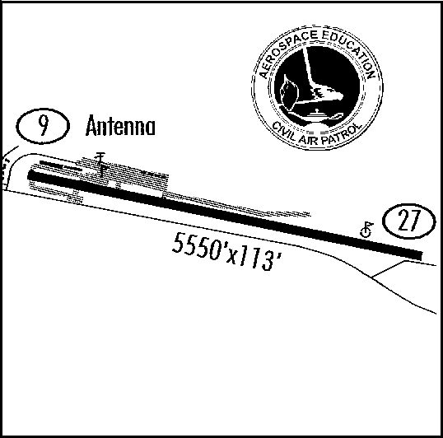
Airport Worksheet (Los Alamos)
Los Alamos, NM Municipal (LAM)
Coord: N35-52.78; W106-16.16
Elev: 7171 MSL
Pat. Alt: See NOTE
Mag.Var: 11 E

CTAF: 123.00
AWOS: 124.175
VOR: SAF 110.6, 321, 22.7NM
FSS: ABQ 122.2
APP: ABQ Ctr. 132.8
CAP: Shiprock 148.15MHz
Tel: (505) 662-8420
WXBrief: (800) 992-7433
CAP Tel: (505)

Weather Information

Time: __________Zulu

Winds:______ deg. @ _____K _____ gusts

Visibility: ________Miles

Ceiling: __________ feet

Temp: ______C Dew Point: ______C

Altimeter: __________ in/Hg

NOTE:
Depart RW 9 only
No higher than 7700MSL over “Y”
Climb unrestricted on RW heading
until crossing Rio Grand before
course change.

Approach to RW 27 only.
NE: 8500MSL over Otowi Bridge.
No lower than 8000 at “Y”.
SE: 8500MSL over Ball Parks.
No lower than 8000 at “Y”.

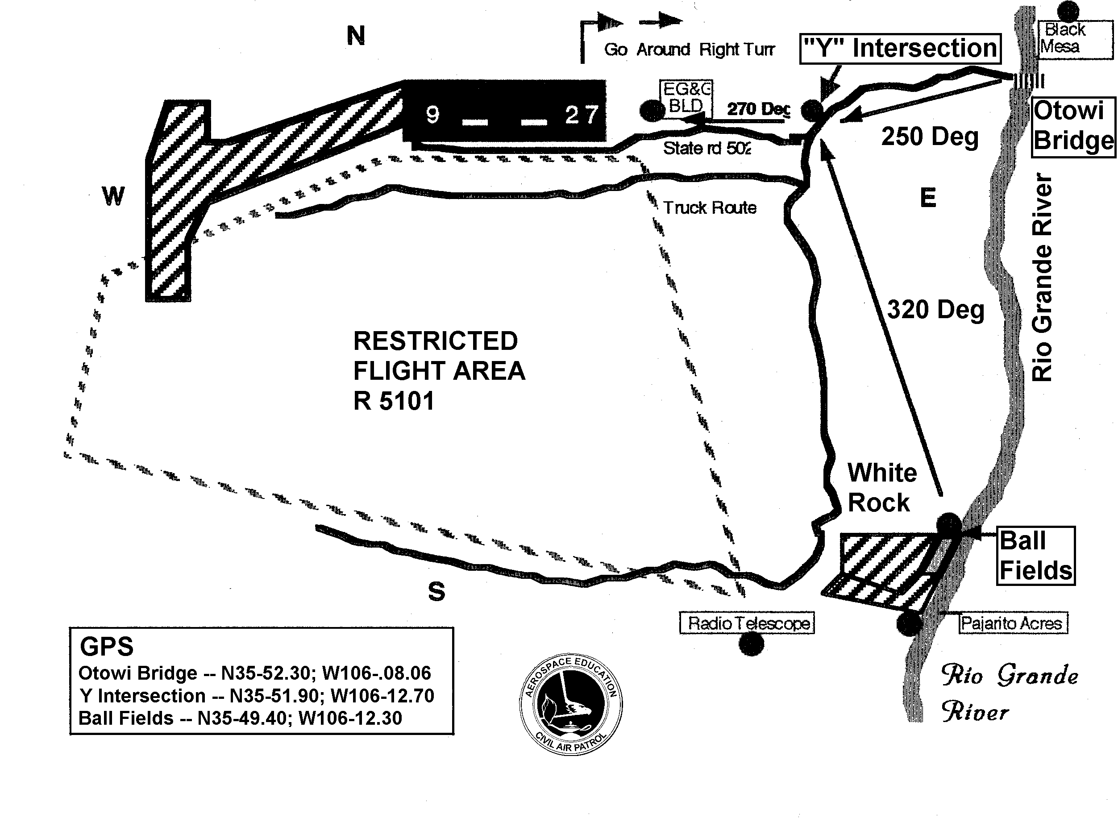

This and other New Mexico airport plates can be found at
http://nmwg.cap.gov/santafe/AirportPlates/Airports.htm

ADVISORY
This worksheet is intended only for planning purposes.
Never trust this or any internet source without official verification.

Pilot / Observer Worksheet
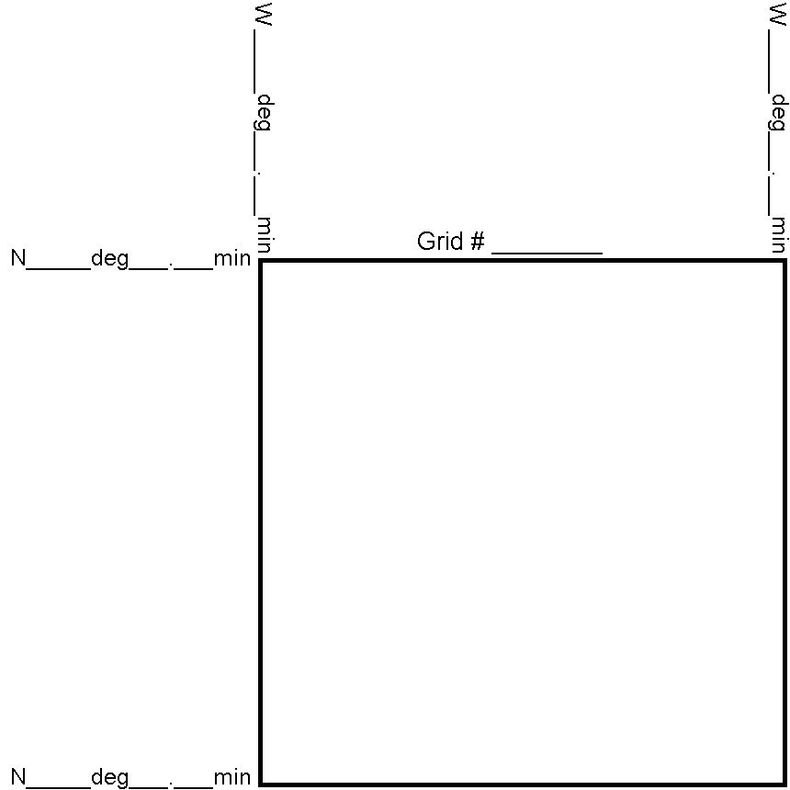

Radio Frequencies

Base: ________

Air: ________

Ground: ________

Other: ________

Search Parameters

Pattern: _______________

Visibility: _______________

Altitude: _______________

Speed: _______________

Spacing: _______________

Target Description | Position (Lat/Long) | Remarks
 | N ° ’/W ° ’
 | N ° ’/W ° ’
 | N ° ’/W ° ’

Remarks / Description of Search

