


Kentucky Reading First Evaluation
June 1, 2006 - May 31, 2007

Volume III: Kentucky Reading First Case Study Schools

Reading First Evaluation Team

Principal Investigator
Paige Carney, Ed. D.

Statistician
Melissa Pittard, Ph.D.

Evaluation Team
Cynthia Branstetter
Charlie Hardy
Ann Hendrix
Nancy Huffstutter
Lauren Jones
Vicki McGinnis
Jill Perez
Michelle Sapp
Mary Jane Scaggs
Pam Seales
Elizabeth Turner
Kaye Warner

Dr. Paige Carney
120 Quinton Ct.
University of Kentucky
Lexington, KY 40509
(859) 257-4212
jpcarn00@uky.edu

The mission of CCLD is to promote literacy achievement through professional development and research. In collaboration with its partners at Kentucky’s eight public universities and the National Center for Family Literacy, CCLD achieves this mission through initiatives geared for improving literacy instruction for learners, childhood through adulthood.

Cover and Photo design: Keith Lyons
Typeset: Lauren Jones and Michelle Sapp
Editor: Emily Papadopoulos
TABLE OF CONTENTS
Volume III
Page
Chapter 1:
Case Study Description 1
Demographic Information 2
Map of Year III Case Study Sites 4
Case Study Sites 2006-2007 5
Case Study Sites 2007-2008 6
Map of Year IV Case Study Sites 6

Chapter 2:
Evaluation Team Role 7
Evaluation Team Responsibilities 9

Chapter 3: Classroom Observations – 2006-2007 12
Evidence Sections
Part 1: Analysis of Classroom Observations 13
Part 2: Analysis of Five Reading Components 23
Part 3: Analysis According to Grades P1-P4 30
Part 4: Analysis of Lessons, Groupings, and Reading 56
Part 5: Analysis of Whole Group and Individual Reading Times 61
Part 6: Analysis of Instructional Groupings 80
Part 7: Analysis of Practices Occurring During the Reading Block 83

Chapter 4:
Case Study Reports 90

Chapter 5:
District Coach Interviews 96

Chapter 6:
Principal Interviews 106

Chapter 7:
School Coach Interviews 111
Section A: Fall 111
Section B: Winter 120
Section C: Spring 125
TABLE OF CONTENTS
Volume III (cont.)

Chapter 8:
Teacher Questionnaires 133

Chapter 9:
Supplemental and Intervention Observations 141
Section A: Supplemental Instruction Observations 141
Section B: Intervention Instruction Observations 145

Chapter 10:
Supplemental and Intervention Teacher Interviews 149
Section A: Supplemental Teacher Interviews 149
Section B: Intervention Teacher Interviews 154

Chapter 11:
Literacy Center Observations 161

Chapter 12:
Parent Surveys 164

Chapter 13:
Student Interviews 179

Chapter 14:
Volume III Summary 191
Appendixes: pp. 194-223

- Case Study Report Letter
- Observation Protocol Glossary
- Case Study Report Form
- District Coach Interview Questions
- Principal Interview Questions
- School Coach Interview Questions- Fall 2006
- School Coach Interview Questions- Winter 2007
- School Coach Interview Questions- Spring 2007
- Teacher Questionnaire-Winter 2007
- Supplemental/Intervention Interview Questions
- Literacy Center Observation Form
- Parent Survey
- Student Interview Questions

Chapter 1

Case Study Description

The purpose of the case study evaluation is to continue to explore Reading First study goals as described in Volume I. These goals are to
- examine Kentucky’s Reading First (RF) program implementation;
- analyze reading achievement gains of students; and
- recognize Reading First’s impact on reducing the numbers of students reading below grade level.

The case study evaluation process is similar to the non-case process in that it involves both qualitative and quantitative analysis of data. Additionally, the Collaborative Center for Literacy Development’s (CCLD) site evaluators conduct and summarize research findings in all case study sites.

Case Study Selection Process
In April 2006, researchers selected seventeen 2006-2007 case study sites. Schools were identified on the basis of core reading programs, demographics, geographical location, and supplemental and intervention programs (See Chart 2 for demographics). Additionally, ethnicity and size of school were taken into consideration during the selection process. Therefore, a representative sample of Kentucky schools was selected. Chart 2 presents core programs, schools, and district for the 2006-2007 study, and the map depicts the geographic location of each case study site. Once the selection process was complete, a letter was sent to each case study site (see Appendix A for letter).

Chart 1
Demographic Information
Reported by 2006-2007 Reading First Case Study Schools

C=Caucasian AA=African American H=Hispanic A=Asian B=Bosnian
NA=Native American O=Other L=Liberian *ELL=English Language Learners
School | District #  School # | Location | Enrollment | Race | Free and Reduced Lunch
Allen County Primary | 050  010 | Rural | 924 | AA=1%  C=96%  H=1.2%  A=1%  O=.8% | 59%
Campbell Elementary | 502  010 | Rural | 292 | AA=1%  C=98%  H=1% | 38%
Catlettsburg  Elementary | 045  095 | Urban  (small town) | 305 | AA=1.85%  C=95.94%  H=.74%  O=1.48% | 80%
Chandlers Elementary | 351  013 | Rural | 423 | AA=2%  C=98%  A=.002% | 56%
Crab Orchard Elementary | 341  040 | Rural | 375 | C=99.5%  O=.5% | 49%
Eden Elementary | 385  051 | Rural | 347 | C=99%  H=<1%  O=<1% | 77%
Fairdale Elementary | 275  010 | Rural | 493 | AA=31.24%  C=63.49%  H=1.42%  A=.61%  O=3.25% | 75.2%
Garrison Elementary | 335  040 | Rural | 359 | AA=.01%  C=99.9% | 81%
Harrison Elementary | 165  038 | Urban | 205 | AA=52%  C=38.5%  H=6%  A=<1%  O=1.4% | 98%
Chart 1
Demographics (Continued)

C=Caucasian AA=African American H=Hispanic A=Asian B= Bosnian
NA=Native America O=Other L=Liberian *ELL=English Language Learners

School | District #  School # | Location | Enrollment | Race | Free and Reduced Lunch
Jones Park Elementary | 111  026 | Rural | 530 | AA=.01%  C=98%  H=.01%  A=.01% | 68%
Morganfield Elementary | 525  020 | Rural | 460 | AA=21%  C=76%  H=<1%  A=<1% | 65%
Nancy Elementary | 501  280 | Rural | 377 | C=98%  H=2% | 55%
Owen Co. Primary | 471  020 | Rural | 627 | AA=.01%  C=95%  H=.03%  NA=.001%  A=.001%  O=.003% | 54.7%
Owingsville  Elementary | 025  030 | Rural | 405 | AA=1.28%  C=98.08%  H=.32%  NA=.16%  O=.16% | 86%
Parker Bennett Curry Elementary | 042  057 | Urban | 436 | AA/L=36.47%  C/B= 26.38%  H=31.88%  NA=.23%  A=3.67%  O=1.38%  *ELL=41% | 93.8%
Pembroke Elementary | 115  130 | Rural | 400 | AA=28%  C=62%  H=.07%  NA=.0075%  A=.0075%  O=.01% | 62%
Taylor Elementary | 055  050 | Rural | 460 | C=99.7%  H=<1% | 48%

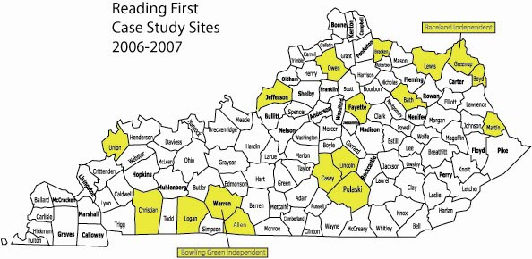

Chart 2
2006-2007 Reading First Case Study Sites

School | District | Core Program
Taylor Elementary | Bracken County | Open Court
Fairdale Elementary  Crab Orchard Elementary | Jefferson County  Lincoln County | Rigby
Campbell Elementary  Catlettsburg Elementary | Raceland Independent  Boyd County | Breakthrough to Literacy
Chandlers Elementary  Garrison Elementary  Parker Bennett Curry Elem.  Morganfield Elementary  Jones Park Elementary  Harrison Elementary | Logan County  Lewis County  Bowling Green Ind.  Union County  Casey County  Fayette County | Houghton Mifflin
Pembroke Elementary  Allen County Primary | Christian County  Allen County | Scott Foresman
Eden Elementary | Martin County | Success for All
Nancy Elementary  Owen County Elementary  Owingsville Elementary | Pulaski County  Owen County  Bath County | Harcourt

The following chart and map represent the case study schools for the 2007-2008 study:

2007-2008 Reading First Case Study Schools

School | District | Core Program
Caldwell County Elementary  Goose Rock Elementary  Ewing Elementary | Caldwell County  Clay County  Fleming County | Houghton-Mifflin
Burnside Elementary  Lancaster Elementary  Cumberland Trace | Pulaski County  Garrard County  Warren County | Scott Foresman
East Valley Elementary  Hickman County Elementary | Morgan County  Hickman County | Harcourt Trophies
Gilmore Lane Elementary  Mary Todd Elementary | Jefferson County  Fayette County | Rigby

Map of Year IV Case Study Sites

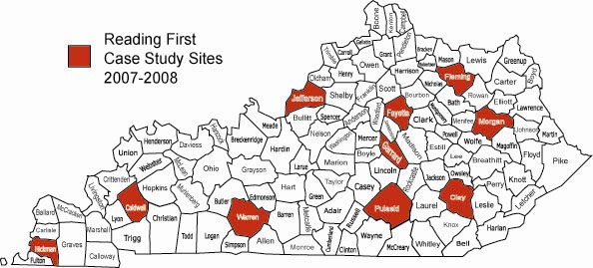
Chapter 2

Evaluation Team Role
The role of CCLD’s Reading First Evaluation Team is to serve as the outside evaluators for Kentucky’s Reading First evaluation study. The evaluation team conducts extensive research with the case study schools through a variety of research methods. The following chart lists research components conducted by team members in case study sites:

Case Study Data
Classroom Observations P1 – P 4
Teacher Questionnaires
Principal Questionnaires
Intervention Instruction Observations
Supplemental Instruction Observations
School Coach Interviews
Principal Interviews
District Coach Interviews
Student Interviews
Parent Surveys
Literacy Center Observations
Supplemental Interviews
Intervention Interviews

Prior to beginning the 2005-2006 case study, four RF evaluation team members designed an observational protocol based on research from a variety of sources. The protocol was then piloted at several schools to determine reliability and validity. Revisions were made based on observations and discussions regarding the protocol’s format and content. Additionally, a glossary was created to provide consistency of reading terms and concepts (See Appendix B for glossary). In preparing for the Year III study, evaluation team members revised the protocol by adding a variety of reading structures. This change allowed the evaluators to record different types of reading instruction (i.e. guided, shared, independent) and the number of minutes teachers and students participated in reading.

Next, the evaluation team attended Summer RF Institutes and training meetings in order to develop knowledge of RF components and to understand how to effectively use all research protocols. The purpose of these training sessions was to ensure the reliability of protocols used in the study. Several instructional training videos with real RF classrooms were provided for practice and discussion. The following agenda items depict the major topics, issues, and requirements discussed at various team meetings.
Reading First Evaluation Team Meeting Agenda Items

August 2006

Define goals of Reading First Evaluation Study
Identify data sources
Review process of data collection
Identify effective observation characteristics
Outline protocol for site visits
Determine Evaluation Team schedule for 2006-2007

December 2006

Review first case study site visits
Preview winter site visit objectives/protocols
Discuss supporting case study report rankings with documented evidence
View Reading First classroom instruction video and practice note taking
Following video, discuss evaluators’ interpretations with team members
Create mock case study report from video observation

February 2007

Review progress of schools according to assessment data
View Reading First study findings from Year I implementation to present
Review second case study site visits
Summarize collected data for future analysis
Assign team members’ writing responsibilities
Evaluate feedback form procedures
Determine interview questions for final site visit

May 2007

Summarize collected data for analysis
Evaluate process of data collection/reporting for 2006-2007
Develop interview protocols for 2007/2008 case studies
Determine team members’ case study school assignments for 2007-2008
Determine team members’ Summer Institute assignments
Determine writing responsibilities for Annual Performance Report

After the fall, winter, and spring GRADE and DIBELS testing windows, trained evaluators began conducting the study and spent a total of three days in each of the seventeen schools located across the state for a total of 51 days on site. Each evaluator summarized his or her observation and interview findings and completed a case study report form highlighting major strengths and questions from the visit (see Appendix C for feedback form). The Principal Investigator reviewed the reports and then sent the forms directly to each school to promote discussions about RF implementation.

Additional follow up meetings were held at the completion of each round of site visits. The purpose of these meetings was to have conversations about the site experience, discuss findings, summarize data, and discuss next site visit goals and requirements. In May of 2007, evaluators participated in summarizing data in a specific format for this annual report. The following schedule lists activities that occurred during the site visit year.

2006-2007 Evaluation Team Schedule
August 24 | Team orientation & training
September 18 - October 25 | First case study site visit window
October 18 | Principals’ Institute III
December 7 | Team meeting following first site visits
January 9 - February 19 | Second case study site visit window
February | Regional Principals’ Institute
February - April | Longitudinal Schools’ site visits
March 19 - April 13 | Final case study site visit window
May 17 | Team meeting following final site visits
June - July | Reading First Summer Institutes

Evaluation Team Responsibilities
Team members are provided with a scope of work that clearly defines their roles and responsibilities for the research study. The team member roles are defined below:

Case Study Project Statistician serves as the statistician for research collected in all case study schools. The primary responsibility of the case study statistician is to report classroom observation data, survey data, and assessment data through statistical methods. Data is then shared through visual charts and graphs to represent overall findings and is integrated into RF presentations, Federal Annual Performance Report, and Annual RF Report.

Research Assistant (RA) facilitates the collection of all data for the Evaluation Team. Data collection tools must be photocopied and organized to distribute to Evaluation Team members. These tools include
the observation protocol, interview questions, consent forms, and additional checklists. Once data is collected, the assistant compiles the information to distribute to team members for analysis. The RA records and mails the case study and Year I case study school reports following each site visit, organizes records of correspondence between the CCLD, RF office and schools, compiles evaluation team meeting minutes, and creates and disseminates calendars and site-visit schedules. Additionally, the RA attends RF professional development and state and national conferences, assists the principal investigator (PI) with communication with RF personnel, conducts site visits and evaluations, develops data collection tools, and writes summaries for the annual report.

Case Study Researchers observe, interview, and survey RF participants during the fall, winter, and spring site visits. The researchers work as a team and conduct site visits to conduct classroom observations, school coach interviews, principal interviews, principal surveys, P1 – P 4 teacher surveys, parent interviews, student interviews, district coach interviews, focus group meetings, and special education teacher meetings. Supplemental and intervention teacher interviews and classroom observations are conducted during the winter site visits.

Additionally, researchers facilitate a longitudinal study in eight of the 2004-2005 (Year 1) case study schools. Researchers observe in classrooms, interview principals and school coaches, and administer teacher surveys.

Overall, each researcher is responsible for submitting research documents, summarizing site visits, providing the Principal Investigator with the site visit school case study report, participating in Evaluation Team meetings, attending Summer Institutes, and assisting with writing and editing the final annual report.

2006-2007 Case Study
For the 2006-2007 case studies, site evaluators worked in teams to conduct observations and interviews during fall, winter, and spring site visits. This team concept provided more in-depth information and multiple perspectives regarding RF implementation.

In the fall of 2006, a special education study was integrated into the existing study to analyze and determine the effects of Reading First instruction on the reading achievement of Kentucky's population of students receiving special education services. Additionally, the special education study provides a description of how the Reading First initiative is implemented within schools' existing special education programs, how students with disabilities are participating in Reading First, and to what extent they are receiving instruction in the five components of reading.
New personnel were needed and positions created to assist with designing, organizing, and conducting these new research initiatives. The position responsibilities are described below.

Special Education Project Coordinator (SEPC) will primarily be responsible for implementation of the RF Special Education Study. The SEPC will assist the PI with designing the research study, creating parallel research protocols, and obtaining consent for the implementation of study from the Institutional Review Board. In addition, the SEPC will assist with selecting the special education evaluation team, conducting observations and interviews with study participants, creating special education teacher surveys, assisting with both quantitative and qualitative data analysis and synthesis, providing periodic reports to the PI and KDE, and writing and editing research findings for the RF annual report.

Special Education Researchers will serve as researchers for the RF special education study. The contractors will collect data in selected schools and conduct observations, interviews, and focus group meetings. Additionally, they will assist with creating research protocols and attend Special Education Summer Institutes. These contractors will be expected to summarize research findings and provide summaries to the PI and Special Education Research Coordinator.

Chapter 3

I. Classroom Observations: 2006-2007

Seventeen Reading First schools were selected to participate as case study schools for the 2006-2007 school years. The Reading First Evaluation Team conducted fall, winter, and spring site visits for each of these seventeen schools in teams of two. At each school, evaluation team members observed four random P1-P4 primary classrooms during the core reading time for a total of 203 classrooms. During the observations, each team collected data in the classroom using a common observation protocol. The protocol allowed the observers to rate areas such as the learning environment, student grouping, authentic assessment, mode of delivery, literacy centers, and each of the five essential Reading First components. The ratings were based on the following:

- low evidence – nominal to no implementation of the instructional component;
- minimal evidence – minimal (below average) implementation of the instructional component;
- moderate evidence – moderate (average) implementation of the instructional component; and
- extensive evidence – extensive content (broad in scope) and demonstrates optimal (superior) instructional implementation of the component.

Evaluators recorded not observed when evidence for the area did not exist. In addition, the evaluators marked various checklists (i.e. resources and materials, instructional delivery) throughout the protocol related to reading instruction.
At the completion of each fall, winter, and spring site visits the observation protocols were compiled and grouped together according to each area both by a statistician and by selected team members. Using this data, summaries were completed, and themes were noted. Included in the following section is information related to the protocol in the form of charts and graphs with abstracts that summarize the themes observed during the classroom observations.

II. Themes

Overall Successes based on evidence from observation protocols:
- Ninety-seven percent of the classrooms had extensive evidence of reading resources and materials;
- Out of the P1-P4 classrooms, vocabulary, fluency, and comprehension show the highest percentages at the P4 level;
- Guided practice of concept/skill appeared consistently high during the fall (90%), winter (84%), and spring (72%) observations;
- Ninety-seven percent and above of the classrooms observed were not conducting spelling and handwriting instruction; and
- Seventy-five percent and above teachers implemented mode of delivery, student-teacher interactions, student engagement, and higher-level questioning at the moderate and extensive levels.

Concerns based on evidence from the observation protocols:
- Data revealed that authentic assessment was rated at the extensive level at only 27.4%;
- Thirty-one percent of literacy centers showed low evidence of implementation;
- Reading instruction is primarily conducted in whole groups at 70.4%;
- All five reading components were rated 50% or below at the moderate and extensive levels;
- Only 26.5% of the classrooms provided a summary of the lesson; and
- Observations revealed limited opportunities for students to engage in different types of reading (i.e. shared, choral, readers’ theater) for extended time periods.

III. Evidence-Part 1: Analysis of Classroom Observations

The Reading First Evaluators rated observations in specific categories based on the scale of low evidence, minimal evidence, moderate evidence, to extensive evidence. The following charts and graphs present results from the observations conducted during the site visits. Areas of strength were as follows:
- Extensive ratings included instructional resources and materials (97%), literate learning environments (51.7%), a variety of grouping (40.3%), and mode of delivery (46.8%);
- Moderate ratings included higher level questioning (44.8%), authentic assessment (40.8%), and student teacher interaction (44.8%);
- Low level literacy centers were only rated at 31.3% of the classrooms; and
- Student engagement was rated the same percentage (38.1%) for the moderate and extensive levels.

Recommendations based on evidence in this section:
- Continue to develop ways to improve and show growth in the instructional practices of higher level questioning, student-teacher interactions, and student engagement;
- Teachers need to conduct more authentic assessments before, during and after the instructional process;
- Analyze components of optimal literacy centers and develop ways to increase the quality of these centers during the core reading block; and
- Increase the implementation of a variety of grouping structures during the core (i.e. small group, partner-paired, cooperative groups).
Resource/Materials

Observation Response | Fall | Winter | Spring | Year Total | Year Total Percentage
Low level evidence | 0 | 0 | 0 | 0 | 0.0
Minimal level evidence | 1 | 0 | 0 | 1 | 0.5
Moderate level evidence | 5 | 0 | 0 | 5 | 2.5
Extensive level evidence | 62 | 67 | 67 | 197 | 97.0
Total | 68 | 67 | 67 | 203
Missing | 0 | 1 | 0 | 1

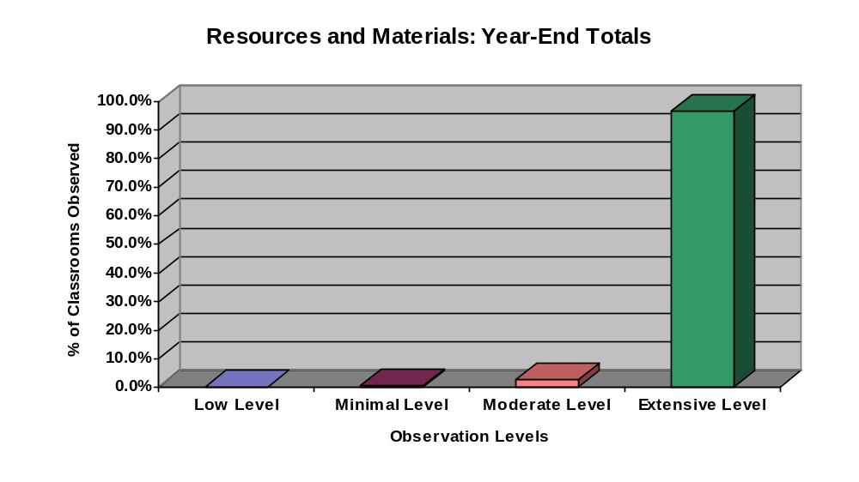

Learning Environment

Observation Response | Fall | Winter | Spring | Year Total | Year Total Percentage
Low level evidence | 1 | 1 | 0 | 2 | 1.0
Minimal level evidence | 9 | 6 | 3 | 18 | 8.9
Moderate level evidence | 30 | 26 | 22 | 78 | 38.4
Extensive level evidence | 28 | 35 | 42 | 105 | 51.7
Total | 68 | 68 | 67 | 203
Missing | 0 | 0 | 0 | 0

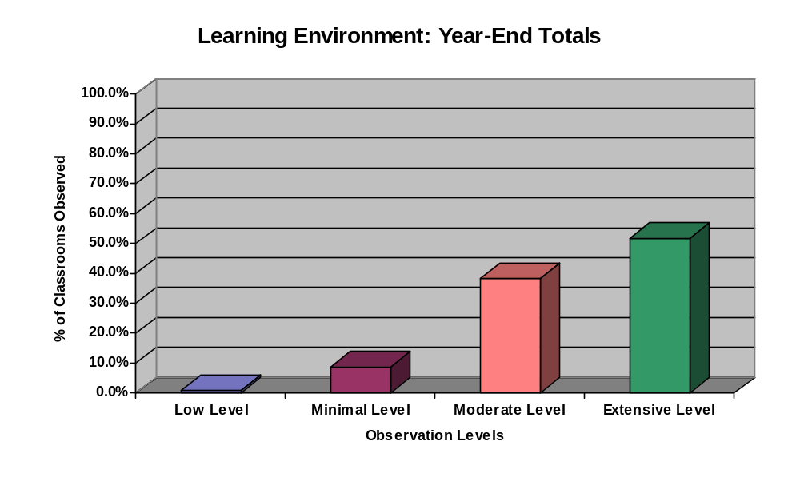

Mode of Delivery

Observation Response | Fall | Winter | Spring | Year Total | Year Total Percentage
Low level evidence | 1 | 0 | 0 | 1 | 0.5
Minimal level evidence | 8 | 5 | 5 | 18 | 8.9
Moderate level evidence | 38 | 29 | 22 | 89 | 43.8
Extensive level evidence | 21 | 34 | 40 | 95 | 46.8
Total | 68 | 68 | 67 | 203
Missing | 0 | 0 | 0 | 0

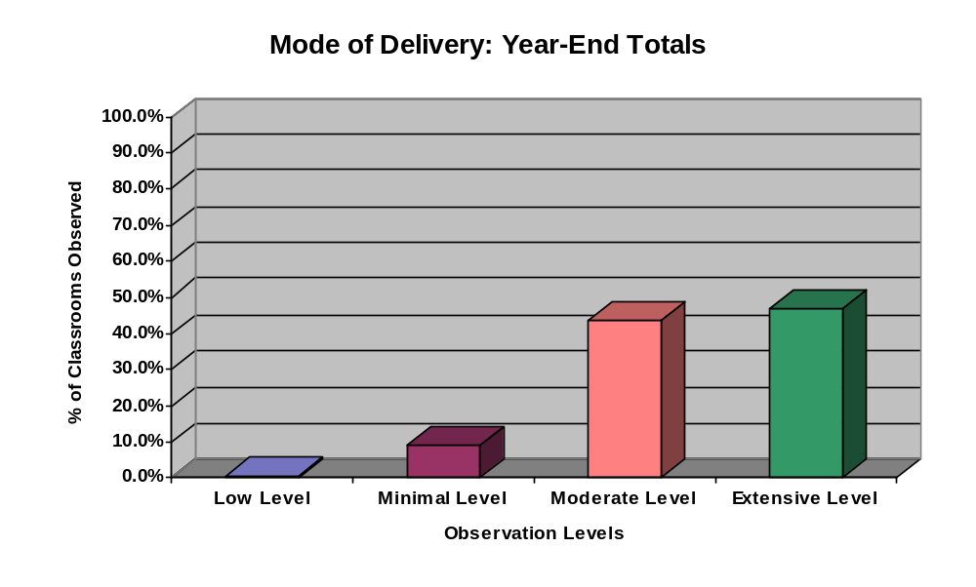

Literacy Centers

Observation Response | Fall | Winter | Spring | Year Total | Year Total Percentage
Low level evidence | 15 | 23 | 25 | 63 | 31.3
Minimal level evidence | 8 | 11 | 3 | 22 | 10.9
Moderate level evidence | 25 | 22 | 12 | 59 | 29.3
Extensive level evidence | 18 | 12 | 27 | 57 | 28.4
Total | 66 | 68 | 67 | 201
Missing | 2 | 0 | 0 | 2

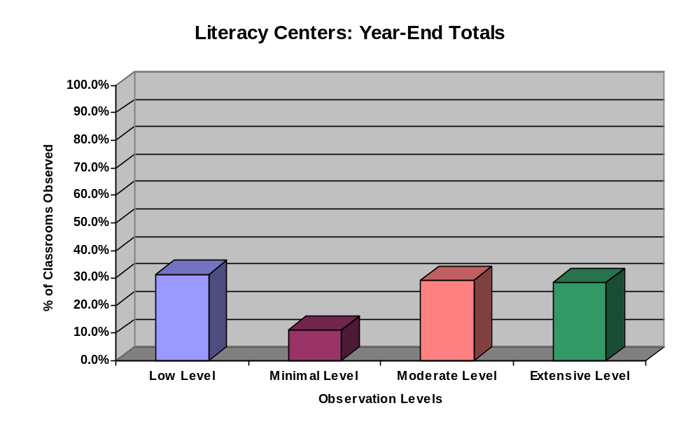

Grouping

Observation Response | Fall | Winter | Spring | Year Total | Year Total Percentage
Low level evidence | 7 | 8 | 10 | 25 | 12.4
Minimal level evidence | 14 | 10 | 15 | 39 | 19.4
Moderate level evidence | 17 | 26 | 13 | 56 | 27.9
Extensive level evidence | 29 | 24 | 28 | 81 | 40.3
Total | 67 | 68 | 66 | 201
Missing | 1 | 0 | 1 | 0

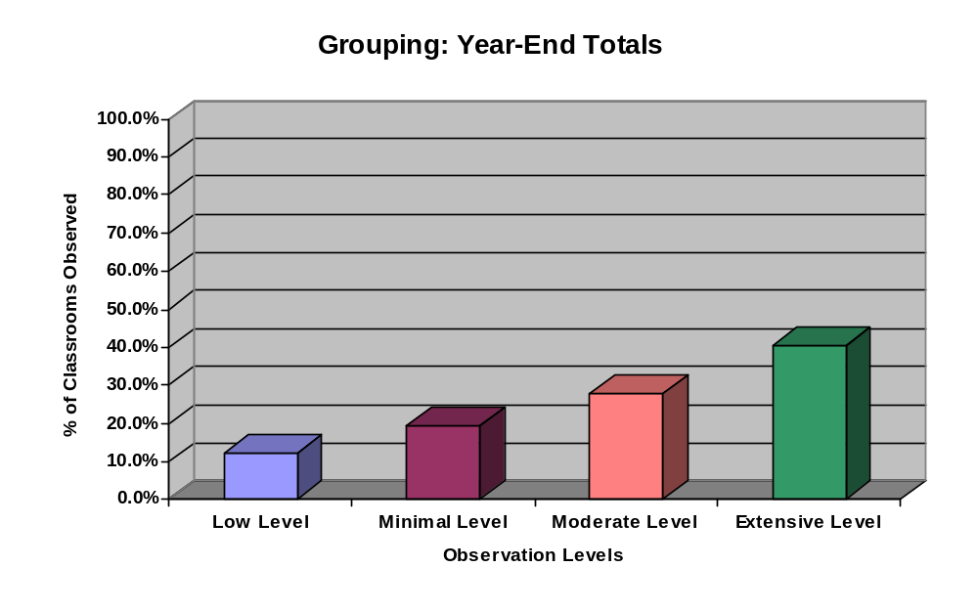

Authentic Assessment
Observation Response | Fall | Winter | Spring | Year Total | Year Total Percentage
Low level evidence | 0 | 6 | 5 | 11 | 5.5
Minimal level evidence | 4 | 30 | 19 | 53 | 26.4
Moderate level evidence | 36 | 20 | 26 | 82 | 40.8
Extensive level evidence | 27 | 12 | 16 | 55 | 27.4
Total | 67 | 68 | 66 | 201
Missing | 1 | 0 | 1 | 2

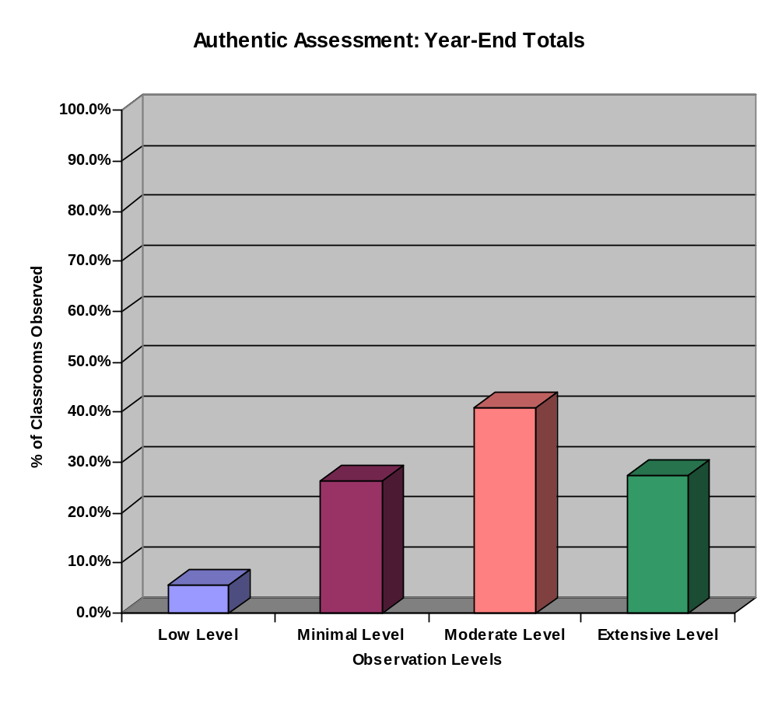

Student Engagement

Observation Response | Fall | Winter | Spring | Year Total | Year Total Percentage
Low level evidence | 8 | 0 | 0 | 8 | 4.0
Minimal level evidence | 31 | 3 | 6 | 40 | 19.8
Moderate level evidence | 22 | 32 | 23 | 77 | 38.1
Extensive level evidence | 6 | 33 | 38 | 77 | 38.1
Total | 67 | 68 | 67 | 202
Missing | 1 | 0 | 0 | 1

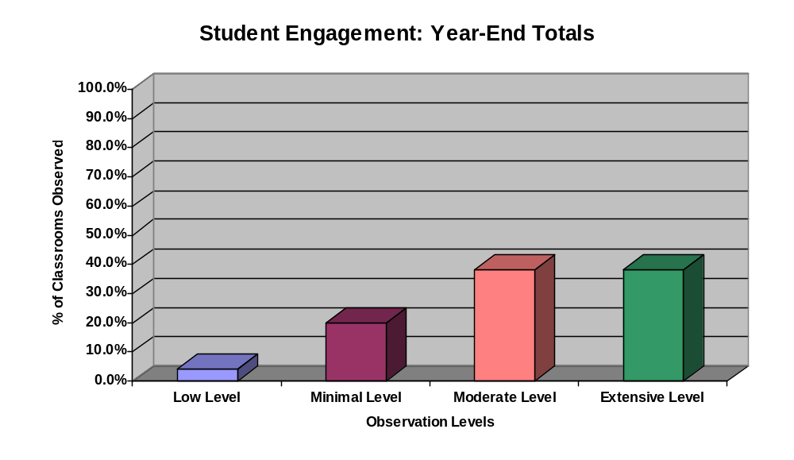

Student-Teacher Interactions

Observation Response | Fall | Winter | Spring | Year Total | Year Total Percentage
Low level evidence | 0 | 18 | 0 | 18 | 9.0
Minimal level evidence | 7 | 15 | 7 | 29 | 14.4
Moderate level evidence | 34 | 22 | 34 | 90 | 44.8
Extensive level evidence | 26 | 12 | 26 | 64 | 31.8
Total | 67 | 67 | 67 | 201
Missing | 1 | 1 | 0 | 2

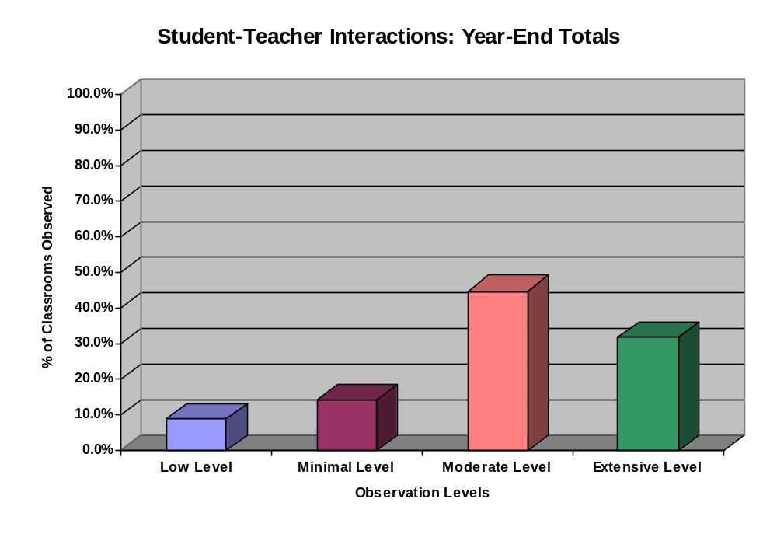

Higher-Level Questioning

Observation Response | Fall | Winter | Spring | Year Total | Year Total Percentage
Low level evidence | 0 | 3 | 1 | 4 | 2.0
Minimal level evidence | 20 | 6 | 11 | 37 | 18.2
Moderate level evidence | 34 | 33 | 24 | 91 | 44.8
Extensive level evidence | 14 | 26 | 31 | 71 | 35.0
Total | 68 | 68 | 67 | 203
Missing | 0 | 0 | 0 | 0

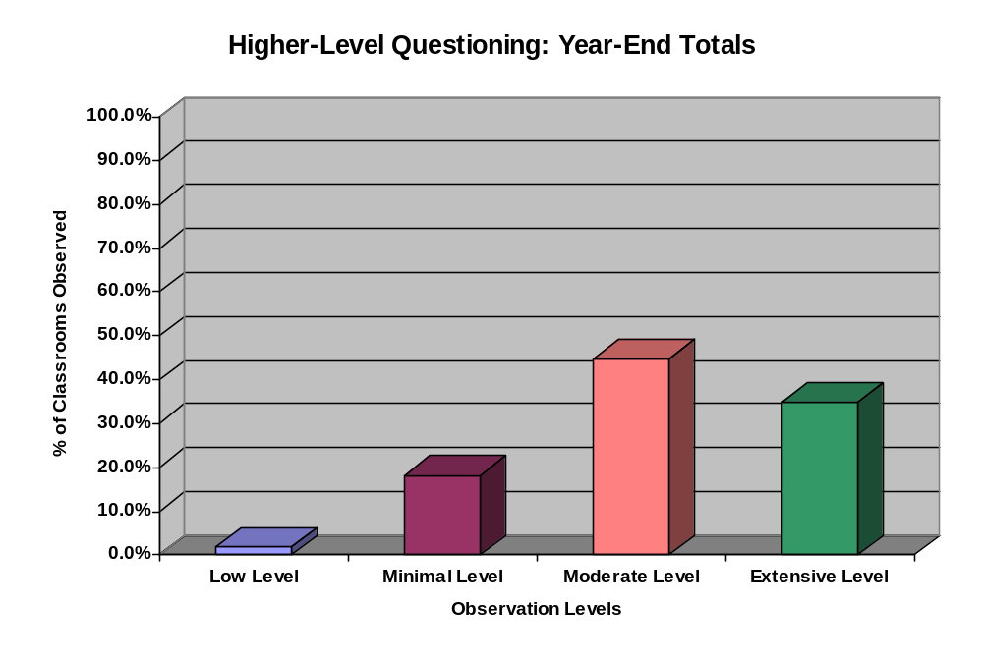

Evidence – Part 2: Analysis of Five Reading Components

The following charts and graphs present results from the observations conducted during the fall, winter, and spring site visits. The Reading First Evaluators rated observations based on the instructional delivery of the five reading components: phonemic awareness, phonics, fluency, vocabulary, and comprehension. The rating scale for the five components was not observed, minimal evidence, moderate evidence, and extensive evidence. For this case study, the findings revealed all five reading components scored the highest at the moderate level. The following are the percentages for each component at the moderate level:
- phonemic awareness 18.2%
- phonics 29.9%
- vocabulary 31.2%
- fluency 43.3%
- comprehension 40.9%

There was little evidence of significant growth from fall to spring in regard to each component. The graph at the end of this section shows overall total percentages for each rating. The highest percentages for each level were as follows:
- extensive level – 36% comprehension;
- moderate level – 43.3% fluency; and
- minimal level – 12.1% phonemic awareness.

Recommendations based on the evidence in this section:
- Continue to analyze ways to increase all components to the extensive instructional level.

Phonemic Awareness

Observation Response | Fall | Winter | Spring | Year Total | Year Total Percentage
Not Observed | 33 | 39 | 37 | 109 | 55.1
Minimal level evidence | 12 | 8 | 4 | 24 | 12.1
Moderate level evidence | 15 | 9 | 12 | 36 | 18.2
Extensive level evidence | 7 | 9 | 13 | 29 | 14.6
Total | 67 | 65 | 66 | 198
Missing | 1 | 3 | 1 | 5

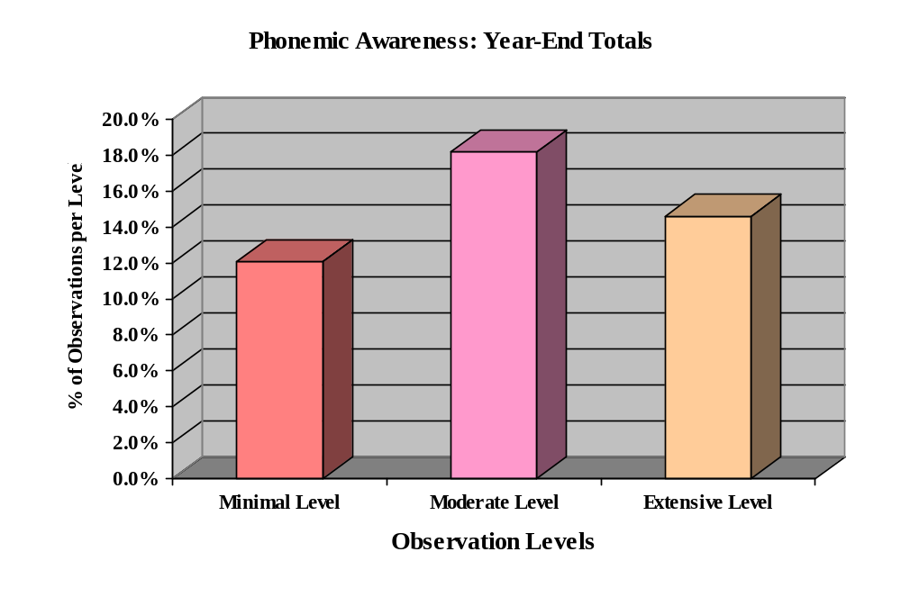

Phonics

Observation Response | Fall | Winter | Spring | Year Total | Year Total Percentage
Not Observed | 24 | 22 | 14 | 60 | 29.9
Minimal level evidence | 9 | 12 | 9 | 30 | 14.9
Moderate level evidence | 20 | 19 | 21 | 60 | 29.9
Extensive level evidence | 15 | 15 | 21 | 51 | 25.4
Total | 68 | 68 | 65 | 201
Missing | 0 | 0 | 2 | 2

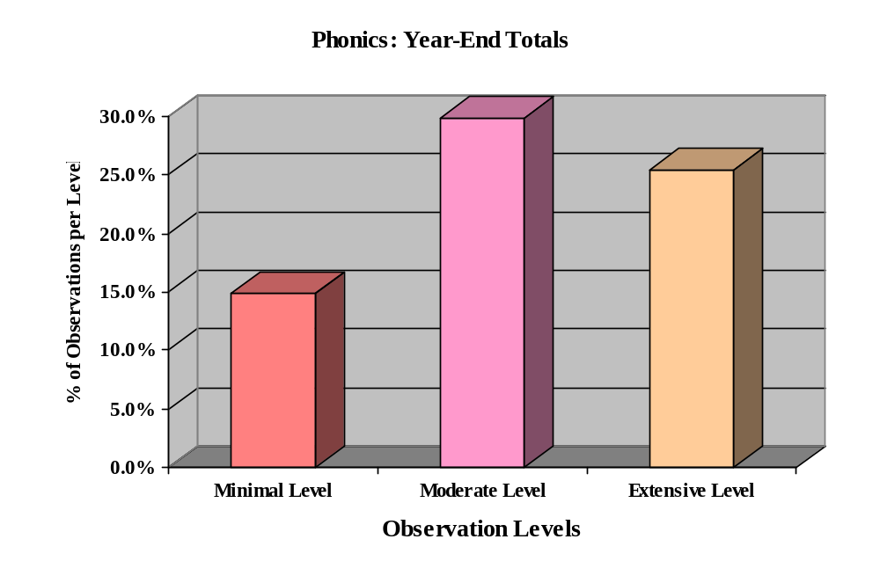

Vocabulary

Observation Response | Fall | Winter | Spring | Year Total | Year Total Percentage
Not Observed | 23 | 20 | 14 | 57 | 28.2
Minimal level evidence | 9 | 9 | 7 | 25 | 12.4
Moderate level evidence | 25 | 16 | 22 | 63 | 31.2
Extensive level evidence | 11 | 23 | 23 | 57 | 28.2
Total | 68 | 68 | 66 | 202
Missing | 0 | 0 | 1 | 1

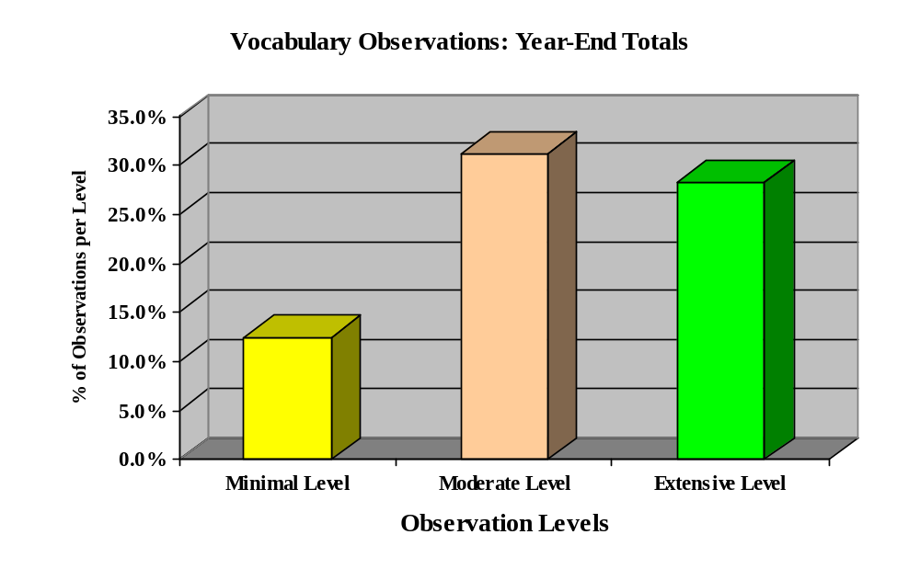

Fluency

Observation Response | Fall | Winter | Spring | Year Total | Year Total Percentage
Not Observed | 14 | 18 | 10 | 42 | 20.9
Minimal level evidence | 6 | 15 | 5 | 26 | 12.9
Moderate level evidence | 32 | 22 | 33 | 87 | 43.3
Extensive level evidence | 16 | 12 | 18 | 46 | 22.9
Total | 68 | 67 | 66 | 201
Missing | 0 | 1 | 1 | 2

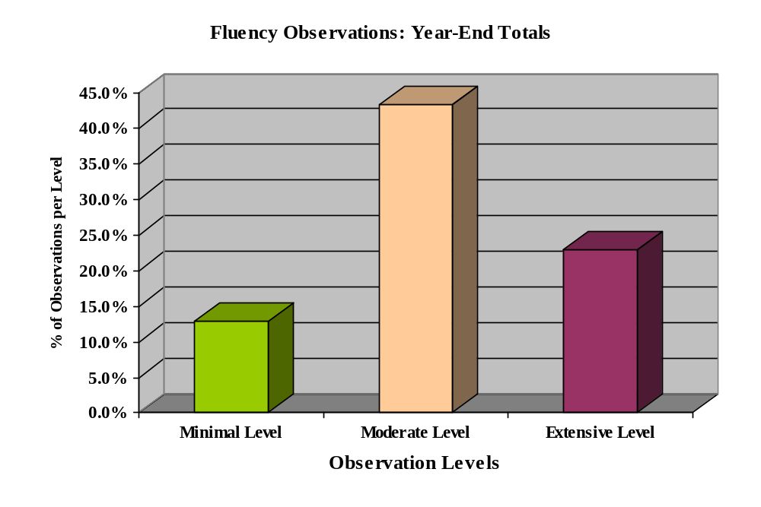

Comprehension
Observation Response | Fall | Winter | Spring | Year Total | Year Total Percentage
Not Observed | 4 | 4 | 8 | 16 | 7.9
Minimal level evidence | 15 | 8 | 8 | 31 | 15.3
Moderate level evidence | 29 | 34 | 20 | 83 | 40.9
Extensive level evidence | 20 | 22 | 31 | 73 | 36.0
Total | 68 | 68 | 67 | 203
Missing | 0 | 0 | 0 | 0

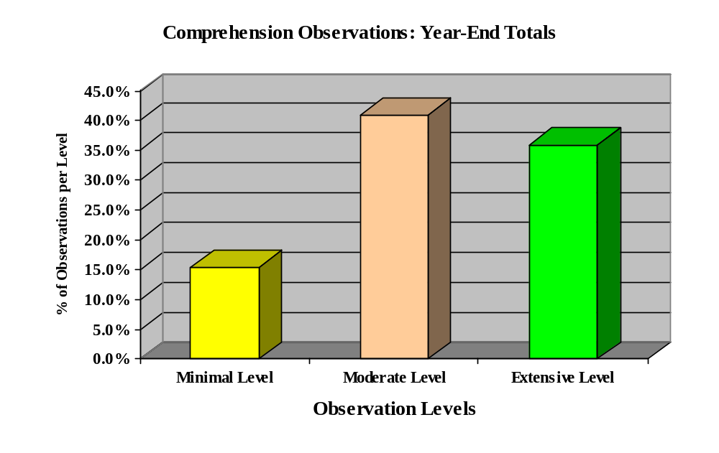

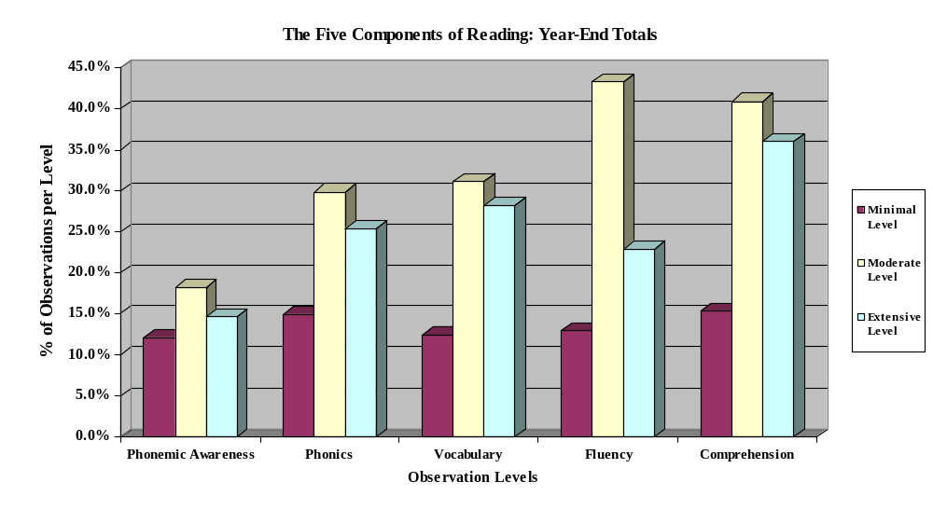
Evidence – Part 3: Analysis According to Grades P1-P4

The following charts and graphs present results by grade level for each of the five reading components, based on this rating scale: not observed, minimal evidence, moderate evidence, to extensive evidence. The findings reveal that P1 (kindergarten) had the highest percentage at the extensive level, 32% for phonemic awareness and phonics at 34%. P4 (third grade) revealed the lowest percentages at 1% for phonemic awareness and 17.6% for phonics. However, it should be noted that phonemic awareness and phonics are not normally taught at the P3 (second) and P4 (third) grade levels. The focus of P2 and P3 grades is most often vocabulary, fluency, and comprehension.

P4 (third) had the highest extensive level percentages for comprehension (45.1%), vocabulary (35.3%), and fluency (29.4%). The lowest extensive level percentage for vocabulary was at the P1 (kindergarten) level at 19.6%. The lowest extensive level percentages for fluency (12%) and comprehension (31.4%) were in grade P1 (kindergarten).

The rating with the highest percentages overall was the moderate category.

Moderate Ratings by Grade Level
Grade Level | Reading Component | Percentage
P1 | Phonemic awareness | 38%
P1 | Phonics | 46%
P2 | Vocabulary | 46.9%
P3 | Fluency | 48%
P2 | Comprehension | 46%

The following charts and graphs are presented by individual grade levels, and provide more in-depth information in relation to each grade level’s reading component data. At the end of this section, the year-end comparison graphs illustrate the highest percentages for the minimal, moderate, and extensive levels.

PHONEMIC AWARENESS

P1 (Kindergarten)
Observation Response | Fall | Winter | Spring | Year Total | Year Total Percentage
Not Observed | 1 | 2 | 4 | 7 | 14.0
Minimal level evidence | 3 | 4 | 1 | 8 | 16.0
Moderate level evidence | 10 | 6 | 3 | 19 | 38.0
Extensive level evidence | 3 | 4 | 9 | 16 | 32.0
Total | 17 | 16 | 17 | 50 | 100%

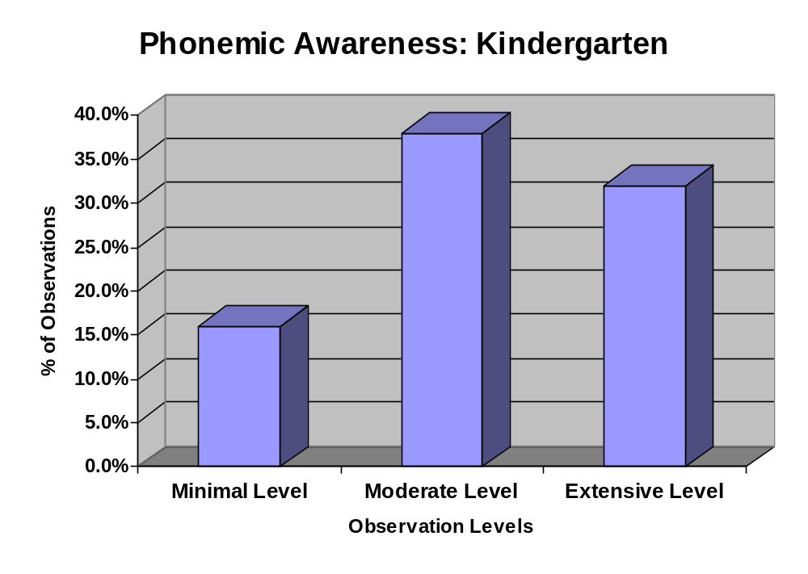

Phonemic Awareness

P2 (1st Grade)

Observation Response | Fall | Winter | Spring | Year Total | Year Total Percentage
Not Observed | 8 | 6 | 4 | 18 | 38.3
Minimal level evidence | 6 | 2 | 1 | 9 | 19.1
Moderate level evidence | 0 | 3 | 6 | 9 | 19.1
Extensive level evidence | 3 | 4 | 4 | 11 | 23.4
Total | 17 | 15 | 15 | 47 | 100%

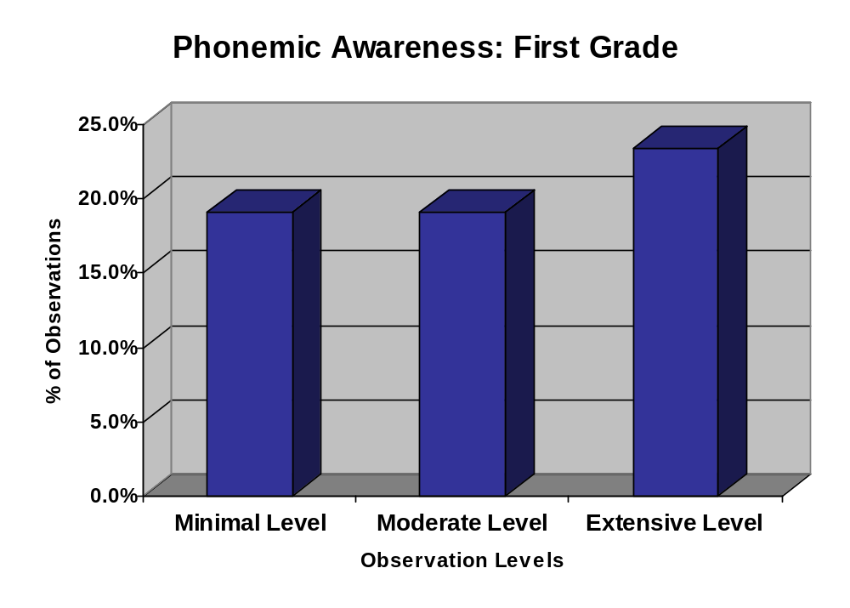

Phonemic Awareness
P3 (2nd Grade)

Observation Response | Fall | Winter | Spring | Year Total | Year Total Percentage
Not Observed | 10 | 16 | 14 | 40 | 80.0
Minimal level evidence | 1 | 1 | 2 | 4 | 8.0
Moderate level evidence | 4 | 0 | 1 | 5 | 10.0
Extensive level evidence | 1 | 0 | 0 | 1 | 2.0
Total | 16 | 17 | 17 | 50 | 100%

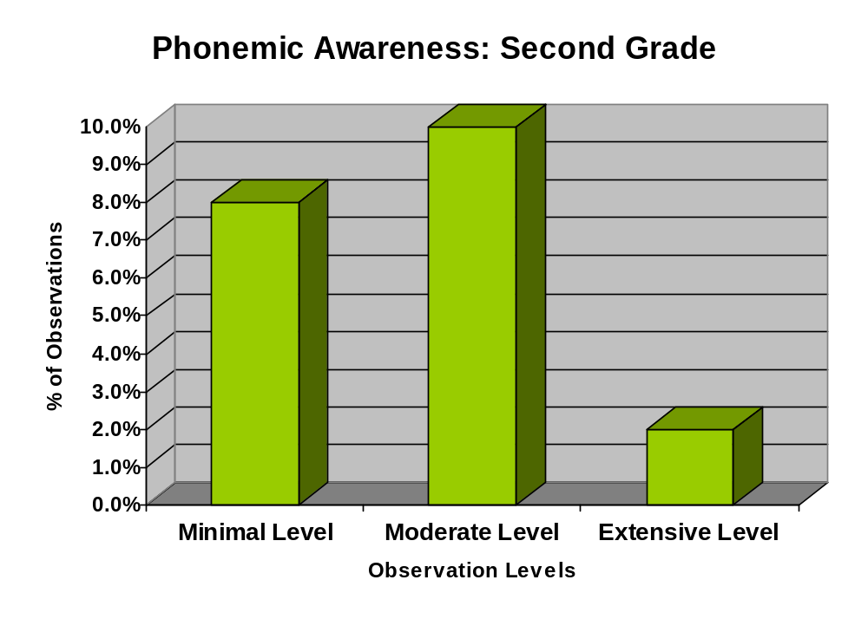

Phonemic Awareness
P4 (3rd Grade)

Observation Response | Fall | Winter | Spring | Year Total | Year Total Percentage
Not Observed | 0 | 14 | 15 | 15 | 44
Minimal level evidence | 1 | 2 | 1 | 0 | 3
Moderate level evidence | 2 | 1 | 0 | 2 | 3
Extensive level evidence | 3 | 0 | 1 | 0 | 1
Total | 17 | 17 | 17 | 51 | 100%

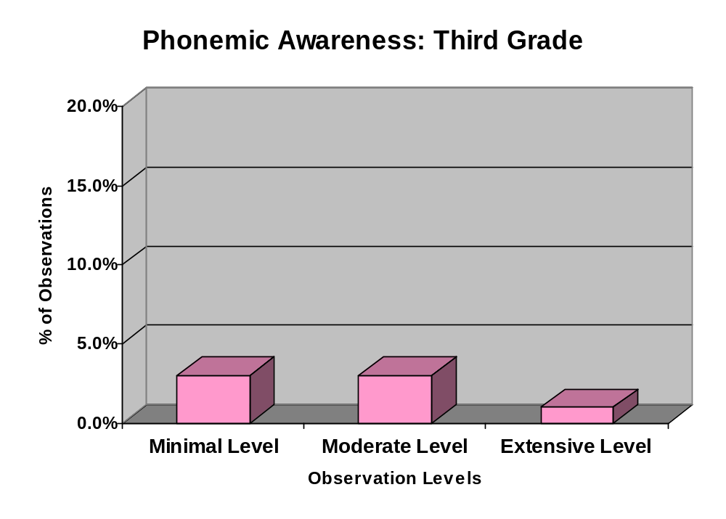

Phonics

P1 (Kindergarten)

Observation Response | Fall | Winter | Spring | Year Total | Year Total Percentage
Not Observed | 1 | 2 | 0 | 3 | 6
Minimal level evidence | 4 | 2 | 1 | 7 | 14
Moderate level evidence | 8 | 9 | 6 | 23 | 46
Extensive level evidence | 4 | 4 | 9 | 17 | 34
Total | 17 | 17 | 16 | 50 | 100%

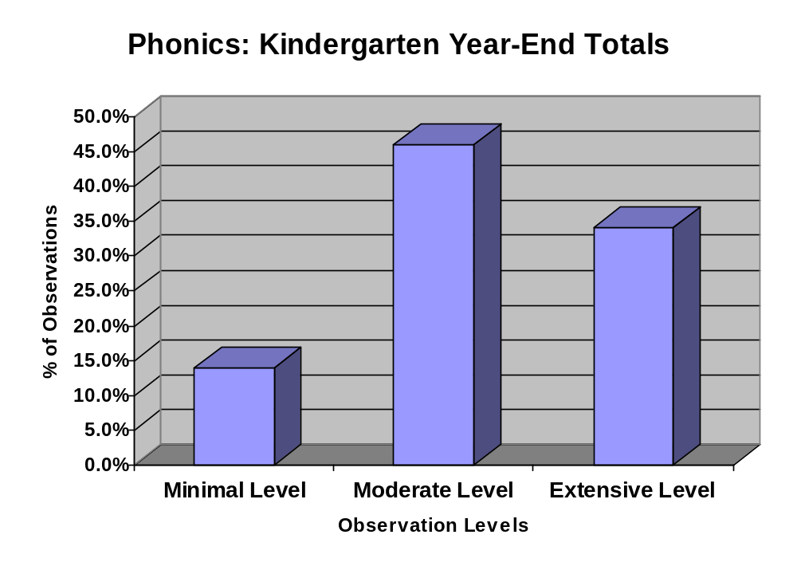

Phonics

P2 (1st Grade)

Observation Response | Fall | Winter | Spring | Year Total | Year Total Percentage
Not Observed | 6 | 4 | 2 | 12 | 24
Minimal level evidence | 2 | 5 | 1 | 8 | 16
Moderate level evidence | 5 | 3 | 8 | 16 | 32
Extensive level evidence | 4 | 5 | 5 | 14 | 28
Total | 17 | 17 | 16 | 50 | 100%

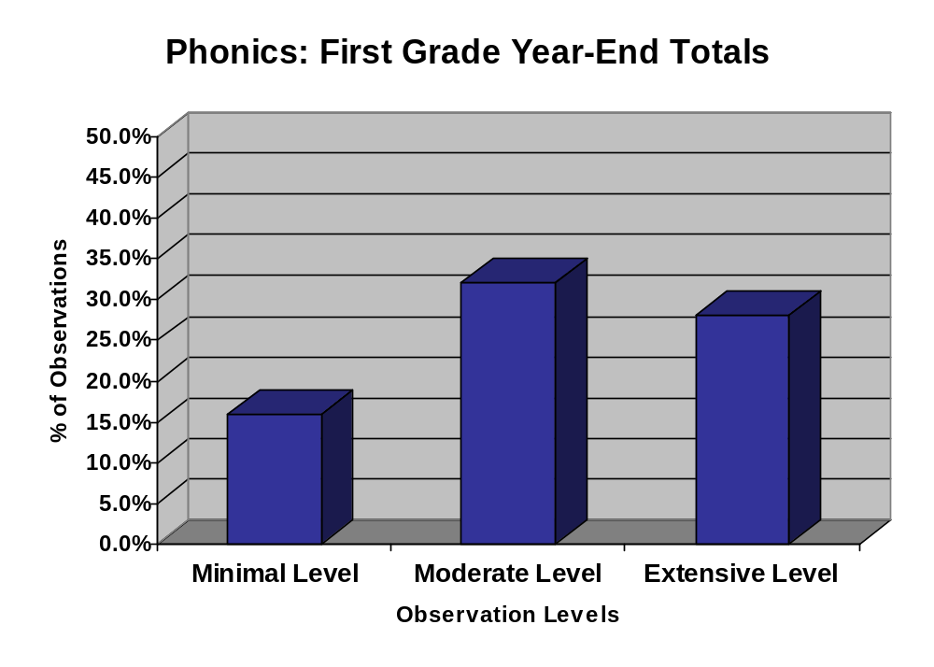

Phonics

P3 (2nd Grade)

Observation Response | Fall | Winter | Spring | Year Total | Year Total Percentage
Not Observed | 7 | 6 | 5 | 18 | 36
Minimal level evidence | 2 | 3 | 4 | 9 | 18
Moderate level evidence | 5 | 4 | 3 | 12 | 24
Extensive level evidence | 3 | 4 | 4 | 11 | 22
Total | 17 | 17 | 16 | 50 | 100%

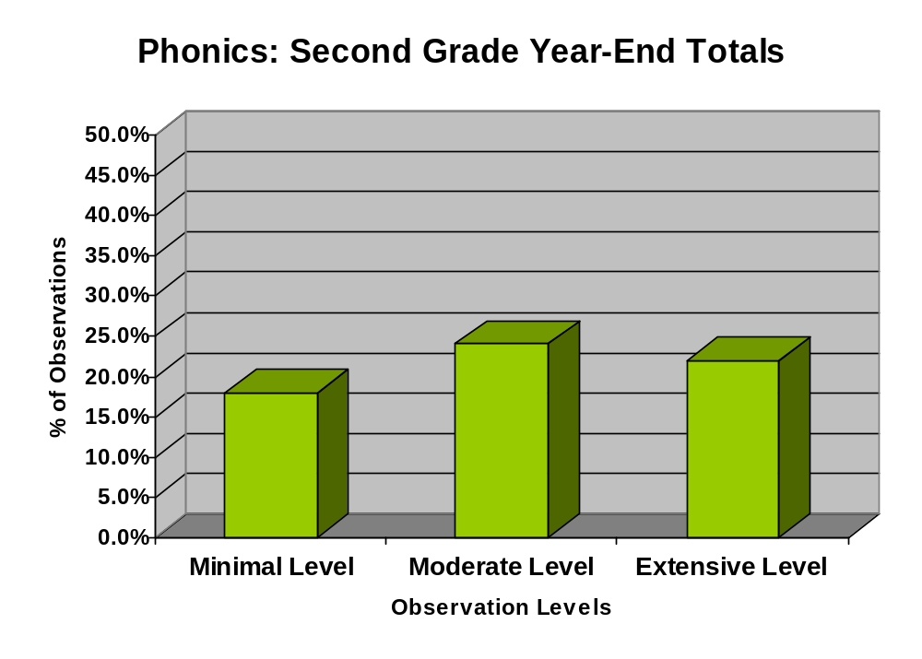

Phonics
P4 (3rd Grade)

Observation Response | Fall | Winter | Spring | Year Total | Year Total Percentage
Not Observed | 10 | 10 | 7 | 27 | 52.9
Minimal level evidence | 1 | 2 | 3 | 6 | 11.8
Moderate level evidence | 2 | 3 | 4 | 9 | 17.6
Extensive level evidence | 4 | 2 | 3 | 9 | 17.6
Total | 17 | 17 | 17 | 51 | 100%

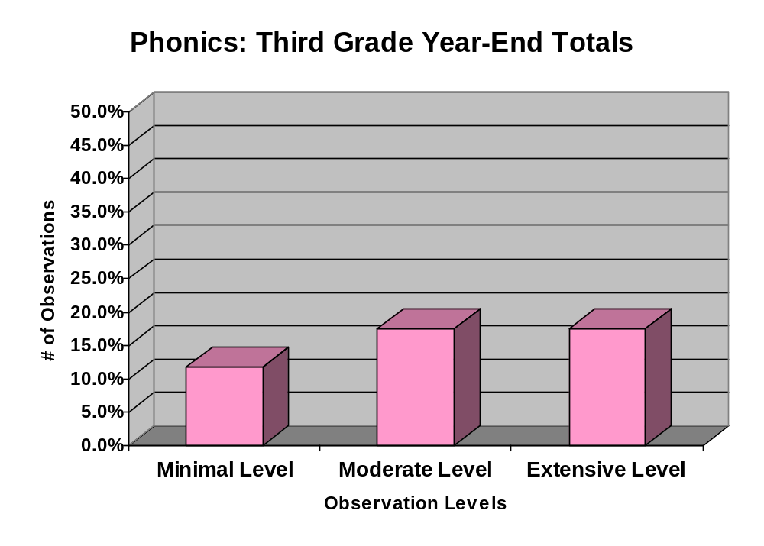

Vocabulary

P1 (Kindergarten)

Observation Response | Fall | Winter | Spring | Year Total | Year Total Percentage
Not Observed | 7 | 9 | 6 | 22 | 43.1
Minimal level evidence | 2 | 3 | 1 | 6 | 11.8
Moderate level evidence | 6 | 2 | 5 | 13 | 25.5
Extensive level evidence | 2 | 3 | 5 | 10 | 19.6
Total | 17 | 17 | 17 | 51 | 100%

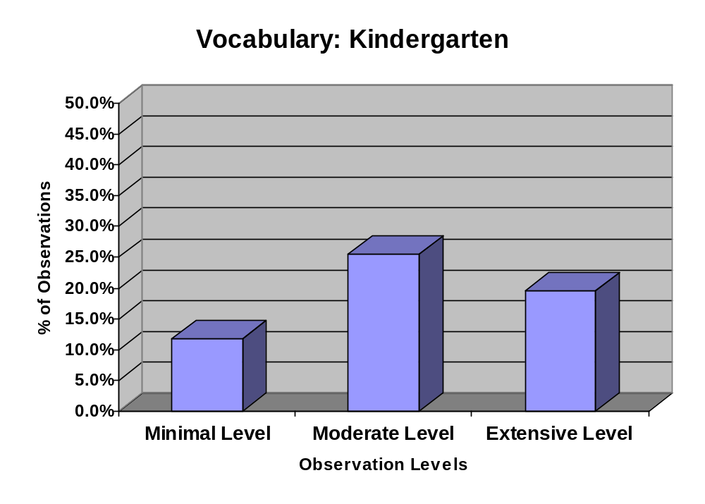

Vocabulary

P2 (1st Grade)

Observation Response | Fall | Winter | Spring | Year Total | Year Total Percentage
Not Observed | 5 | 3 | 4 | 12 | 24.5
Minimal level evidence | 1 | 0 | 0 | 1 | 2.0
Moderate level evidence | 9 | 7 | 7 | 23 | 46.9
Extensive level evidence | 2 | 7 | 4 | 13 | 26.5
Total | 17 | 17 | 15 | 49 | 100%

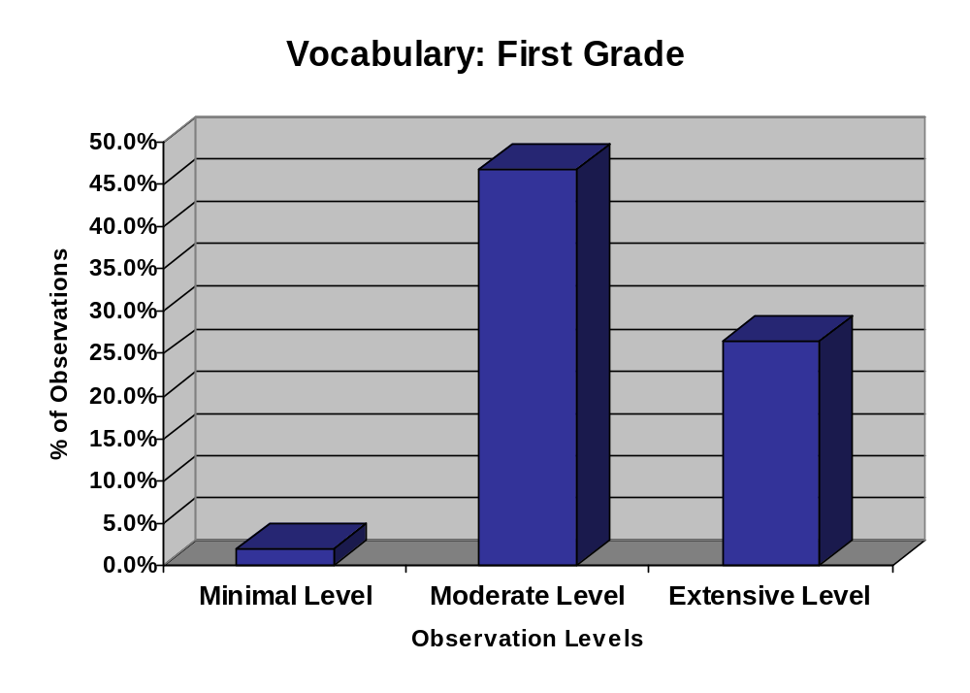

Vocabulary

P3 (2nd Grade)

Observation Response | Fall | Winter | Spring | Year Total | Year Total Percentage
Not Observed | 5 | 4 | 3 | 12 | 23.5
Minimal level evidence | 3 | 3 | 1 | 7 | 13.7
Moderate level evidence | 6 | 3 | 7 | 16 | 31.4
Extensive level evidence | 3 | 7 | 6 | 16 | 31.4
Total | 17 | 17 | 17 | 51 | 100%

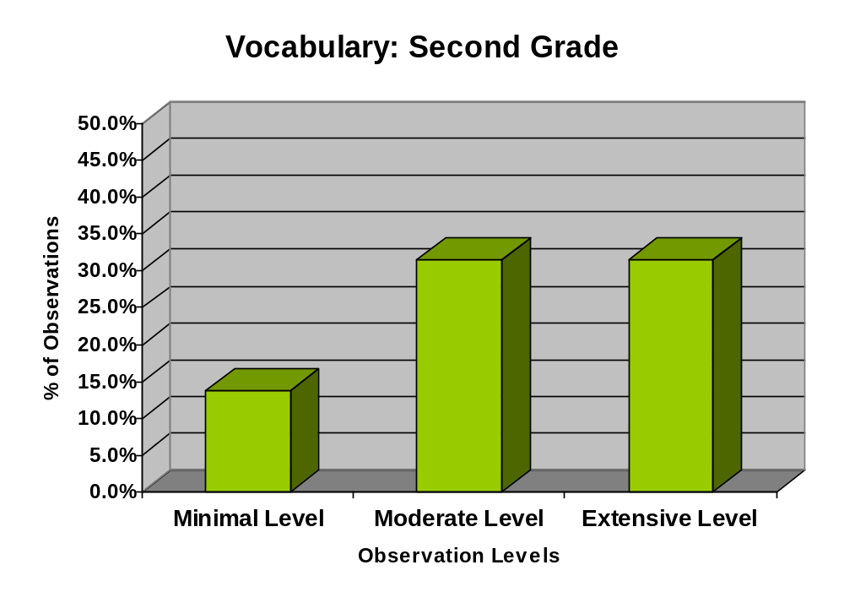

Vocabulary

P4 (3rd Grade)

Observation Response | Fall | Winter | Spring | Year Total | Year Total Percentage
Not Observed | 6 | 4 | 1 | 11 | 21.6
Minimal level evidence | 3 | 3 | 5 | 11 | 21.6
Moderate level evidence | 4 | 4 | 3 | 11 | 21.6
Extensive level evidence | 4 | 6 | 8 | 18 | 35.3
Total | 17 | 17 | 17 | 51 | 100%

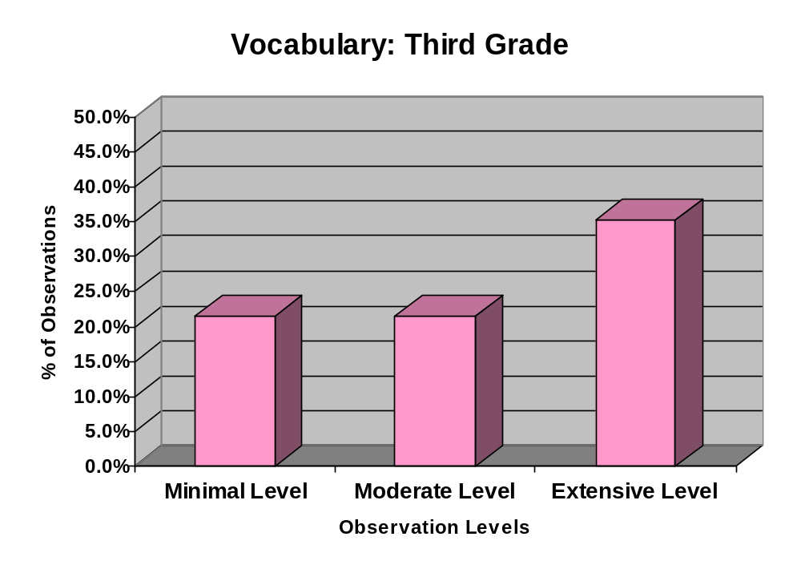

Fluency

P1 (Kindergarten)

Observation Response | Fall | Winter | Spring | Year Total | Year Total Percentage
Not Observed | 7 | 7 | 3 | 17 | 34
Minimal level evidence | 1 | 3 | 2 | 6 | 12
Moderate level evidence | 7 | 6 | 8 | 21 | 42
Extensive level evidence | 2 | 1 | 3 | 6 | 12
Total | 17 | 17 | 16 | 50 | 100%

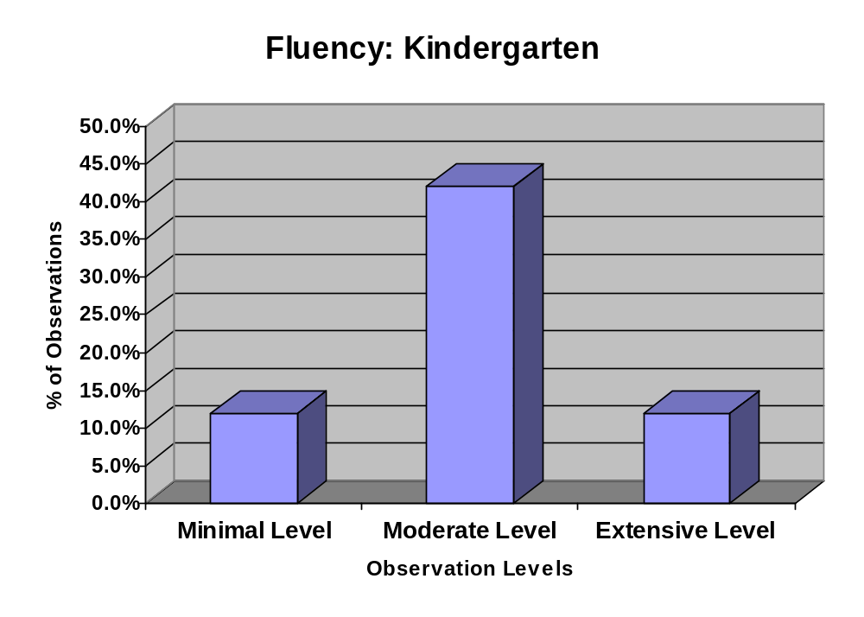

Fluency

P2 (1st Grade)

Observation Response | Fall | Winter | Spring | Year Total | Year Total Percentage
Not Observed | 4 | 5 | 4 | 13 | 26
Minimal level evidence | 1 | 2 | 1 | 4 | 8
Moderate level evidence | 8 | 7 | 7 | 22 | 44
Extensive level evidence | 4 | 3 | 4 | 11 | 22
Total | 17 | 17 | 16 | 50 | 100%

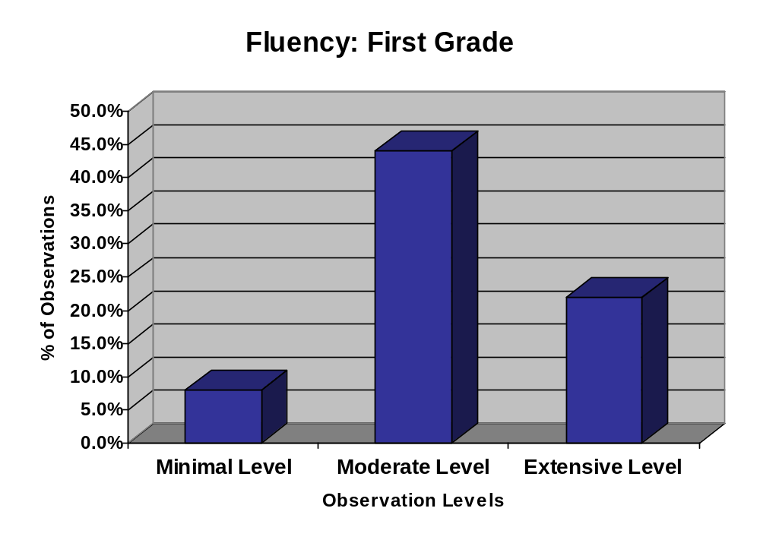

Fluency

P3 (2nd Grade)

Observation Response | Fall | Winter | Spring | Year Total | Year Total Percentage
Not Observed | 1 | 2 | 0 | 3 | 6
Minimal level evidence | 3 | 5 | 1 | 9 | 18
Moderate level evidence | 7 | 5 | 12 | 24 | 48
Extensive level evidence | 6 | 4 | 4 | 14 | 28
Total | 17 | 16 | 17 | 50 | 100%

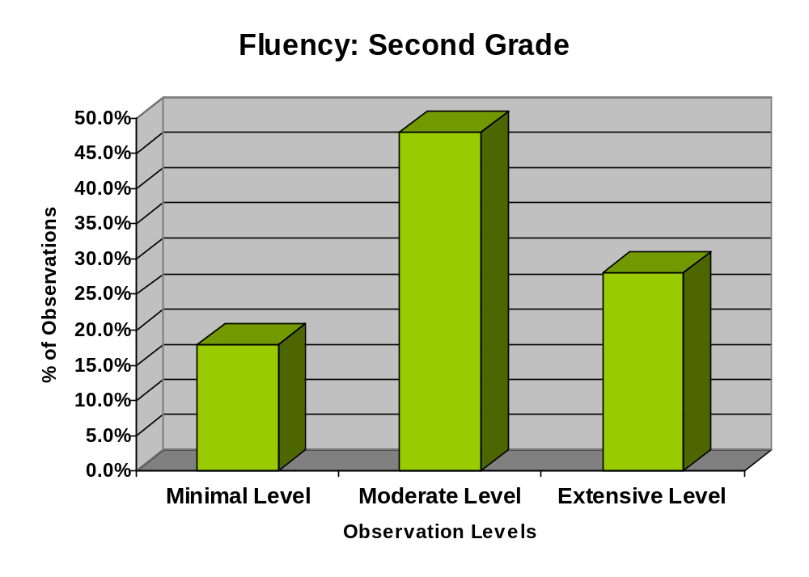

Fluency

P4 (3rd Grade)

Observation Response | Fall | Winter | Spring | Year Total | Year Total Percentage
Not Observed | 2 | 4 | 3 | 9 | 17.6
Minimal level evidence | 1 | 5 | 1 | 7 | 13.7
Moderate level evidence | 10 | 4 | 6 | 20 | 39.2
Extensive level evidence | 4 | 4 | 7 | 15 | 29.4
Total | 17 | 17 | 17 | 51 | 100%

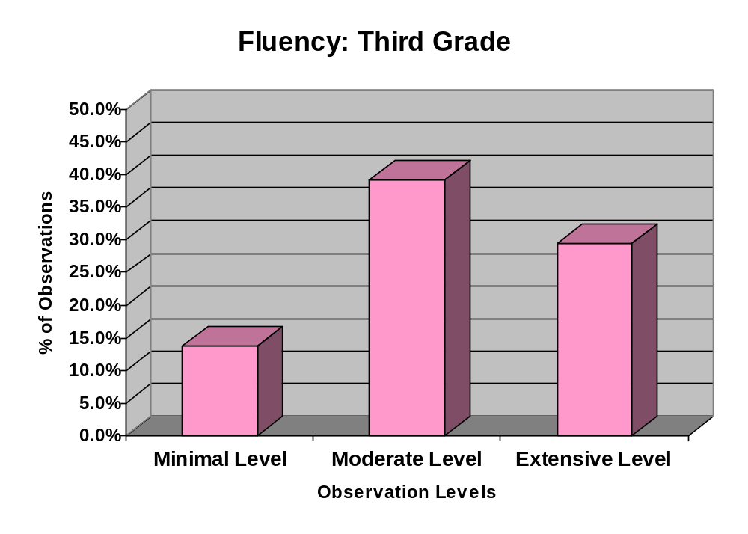

Comprehension

P1 (Kindergarten)

Observation Response | Fall | Winter | Spring | Year Total | Year Total Percentage
Not Observed | 2 | 3 | 2 | 7 | 13.7
Minimal level evidence | 5 | 3 | 1 | 9 | 17.6
Moderate level evidence | 5 | 7 | 7 | 19 | 37.3
Extensive level evidence | 5 | 4 | 7 | 16 | 31.4
Total | 17 | 17 | 17 | 51 | 100%

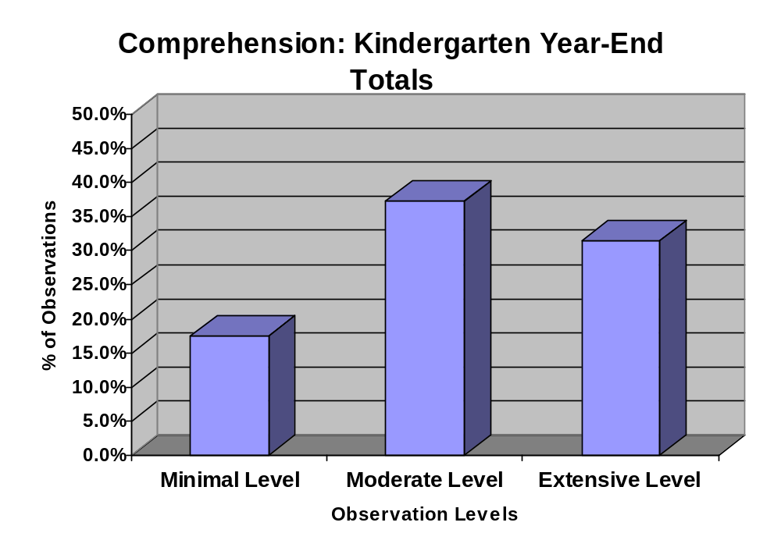

Comprehension

P2 (1st Grade)

Observation Response | Fall | Winter | Spring | Year Total | Year Total Percentage
Not Observed | 0 | 0 | 3 | 3 | 6.0
Minimal level evidence | 5 |  | 3 | 8 | 16.0
Moderate level evidence | 8 | 13 | 2 | 23 | 46.0
Extensive level evidence | 4 | 4 | 8 | 16 | 32.0
Total | 17 | 17 | 16 | 50 | 100%

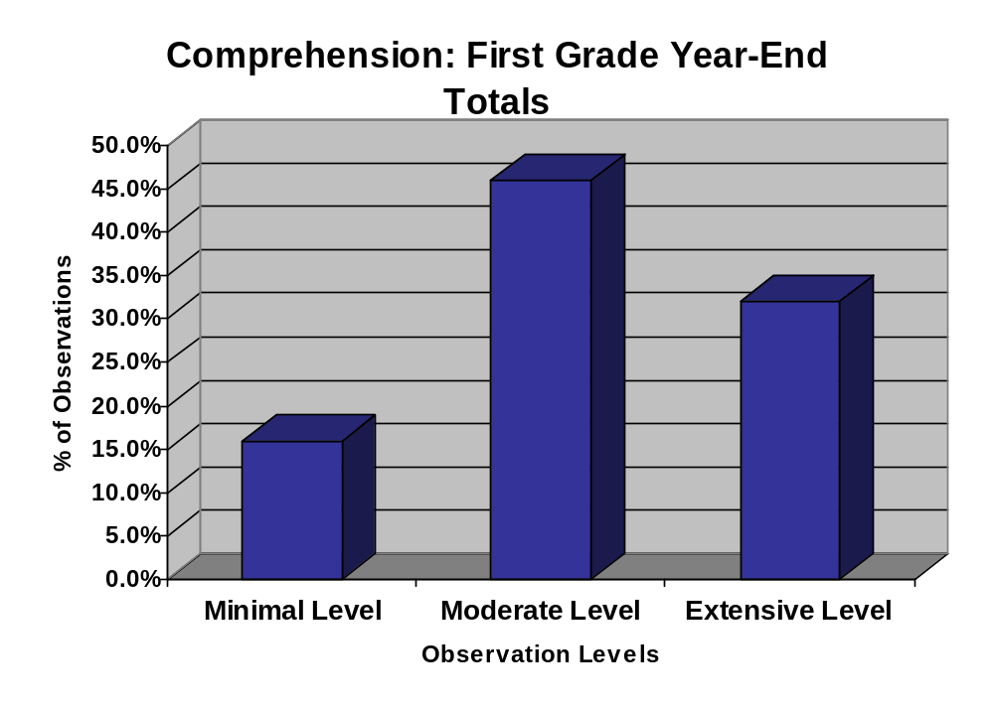

Comprehension

P3 (2nd Grade)

Observation Response | Fall | Winter | Spring | Year Total | Year Total Percentage
Not Observed | 2 | 1 | 2 | 5 | 9.8
Minimal level evidence | 3 | 3 | 2 | 8 | 15.7
Moderate level evidence | 7 | 6 | 7 | 20 | 39.2
Extensive level evidence | 5 | 7 | 6 | 18 | 35.3
Total | 17 | 17 | 17 | 51 | 100%

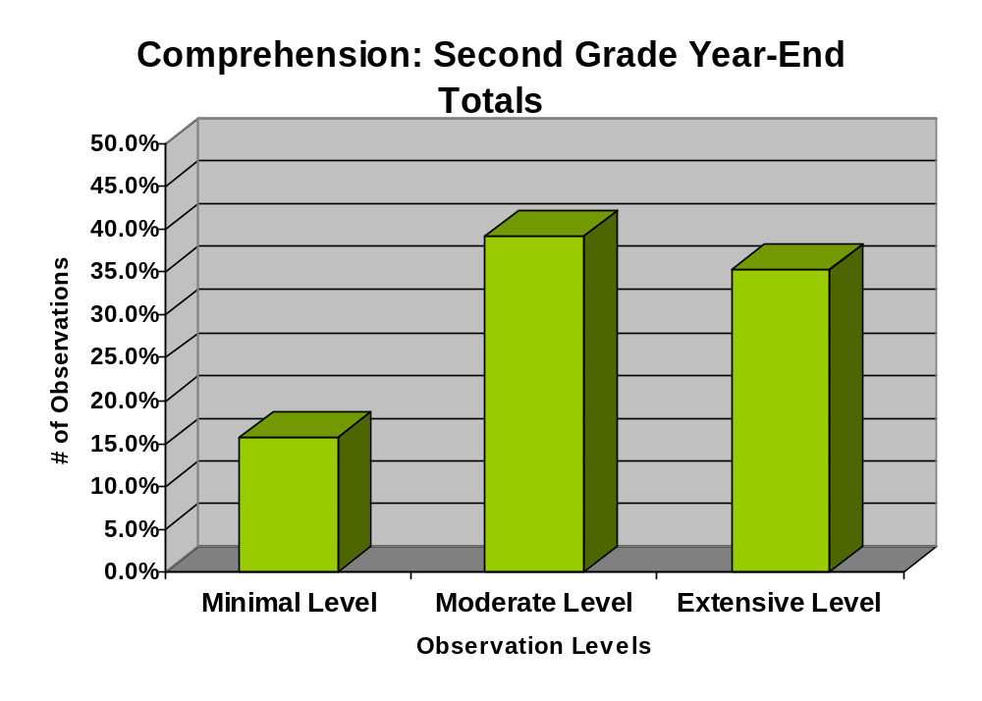

Comprehension
P4 (3rd Grade)

Observation Response | Fall | Winter | Spring | Year Total | Year Total Percentage
Not Observed | 0 | 0 | 1 | 1 | 2.0
Minimal level evidence | 2 | 2 | 2 | 6 | 11.8
Moderate level evidence | 9 | 8 | 4 | 21 | 41.2
Extensive level evidence | 6 | 7 | 10 | 23 | 45.1
Total | 17 | 17 | 17 | 51 | 100%

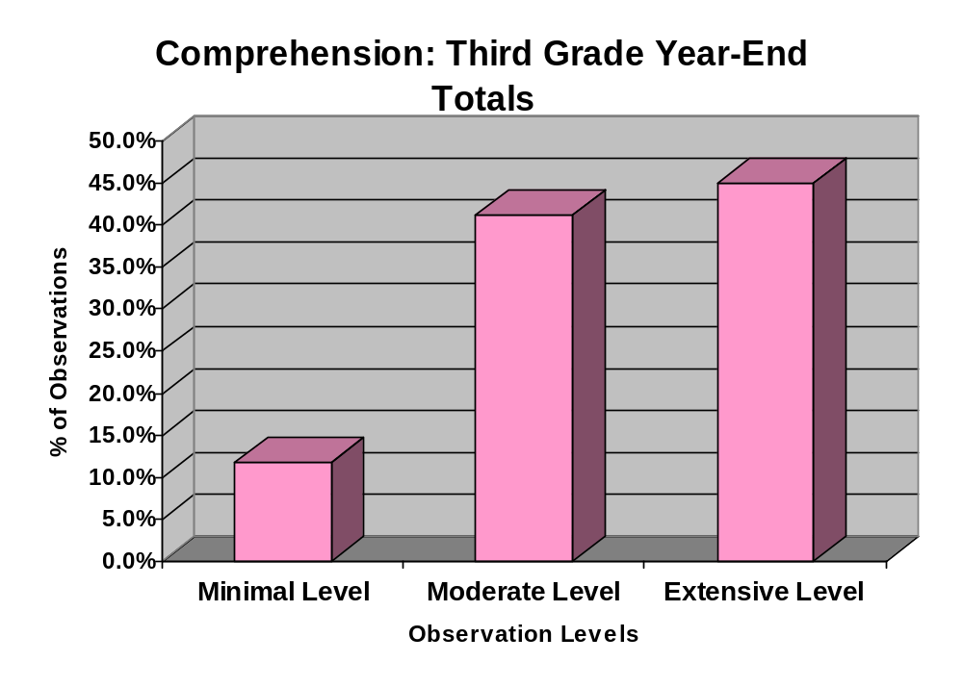

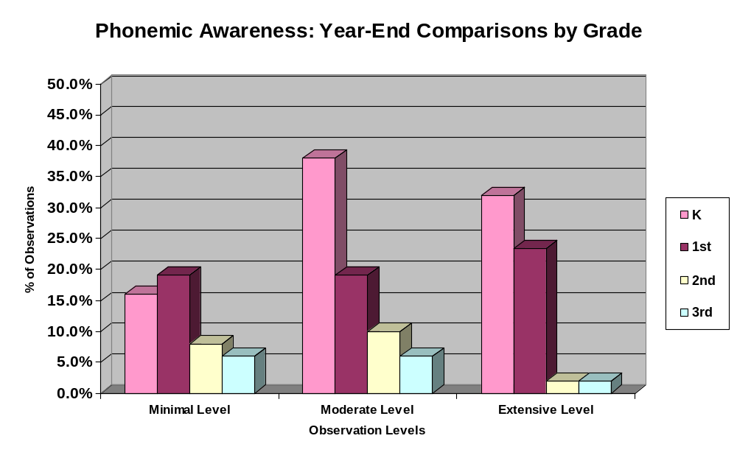
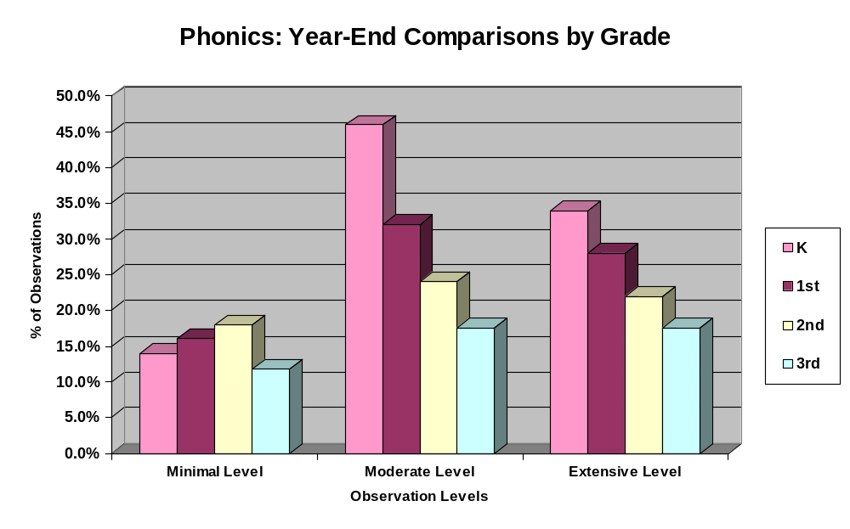

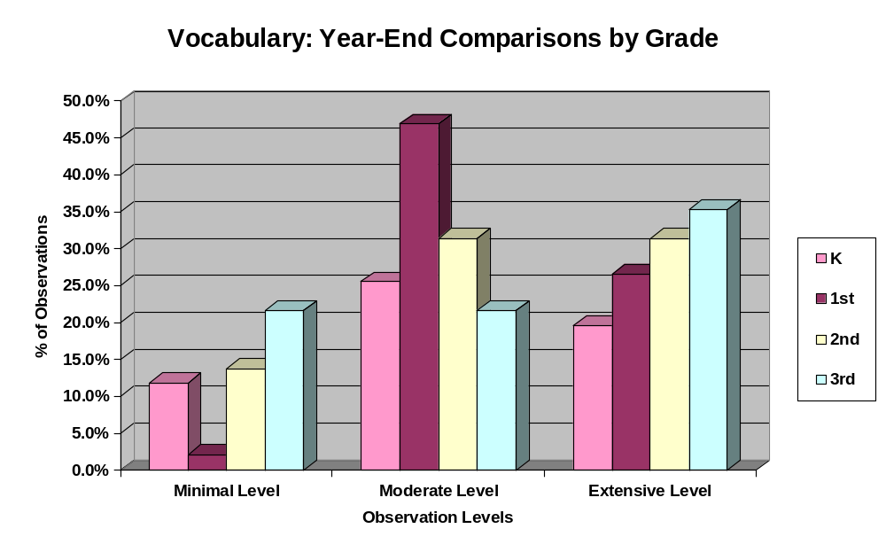

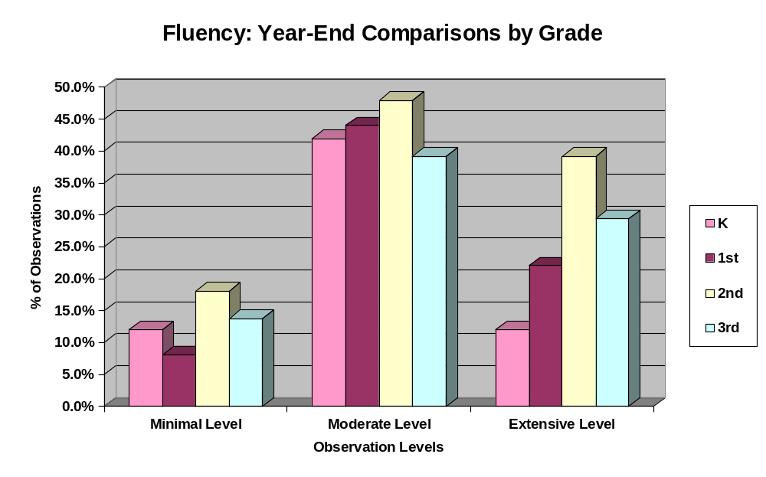

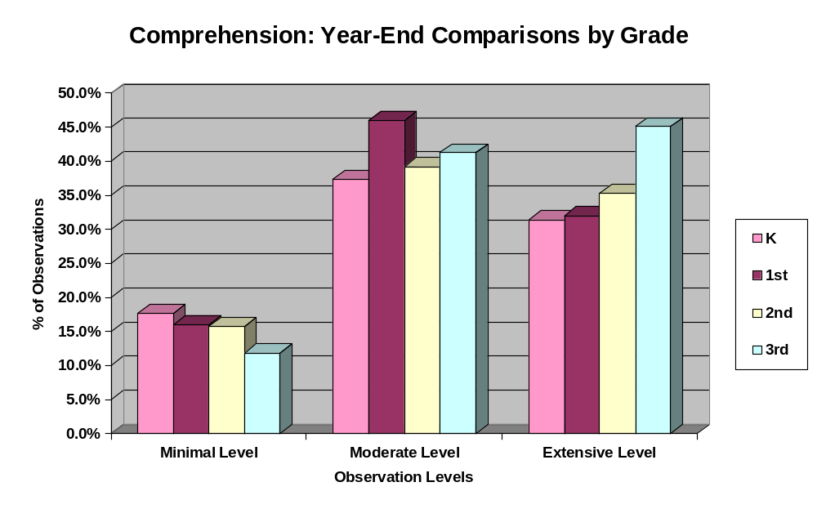

Evidence - Part 4: Analysis of Groupings, Lessons, and Reading

In this section the tables and graphs present results from data collected during the P1 to P4 classroom observations. These results show only those classrooms where specific instructional components were observed on a variety of checklists. The categories for the checklists include student grouping, lesson components, and student reading. The following table shows the highest area percentages from the fall, winter, and spring observations:

Grouping Checklist Table 1
Time period | Checklist item | Percentage
Fall | Small group | 75%
Winter | Small group | 73.5%
Spring | Whole group | 80.6%

Lesson Checklist Table 2
Time period | Checklist item | Approximate percentage
Fall | Guided practice of concept/skill | 89.7%
Winter | Guided practice of concept/skill | 83.8%
Spring | Guided practice of concept/skill | 71.6%

Reading Checklist Table 3
Time period | Checklist item | Approximate percentage
Fall | Guided reading with teacher | 57.4%
Winter | Independent reading | 64.7%
Spring | Independent reading | 59.7%

Recommendations based on the evidence from the checklists:
- Implement a variety of reading practices in all P1 to P4 classrooms;
- Review effective lesson components (i.e. summary, summarization of “how” and “why” the concept/skill applies to reading, instructional feedback) and develop ways to integrate these into all reading lessons; and
- Analyze daily grouping structures and create ways to implement a variety within daily instruction.

The following charts and graphs illustrate each category and percentages:

Grouping | Fall | Winter | Spring | Total
whole group | 63.2 | 67.6 | 80.6 | 70.4
small groups | 75.0 | 73.5 | 61.2 | 70.0
independent | 44.1 | 48.5 | 55.2 | 49.3
lit centers | 67.6 | 55.9 | 58.2 | 56.2
cross-grade | 7.4 | 4.4 | 6.0 | 5.9
coop learning | 11.8 | 14.7 | 7.5 | 11.3
partnered/paired | 38.2 | 41.2 | 40.3 | 39.9

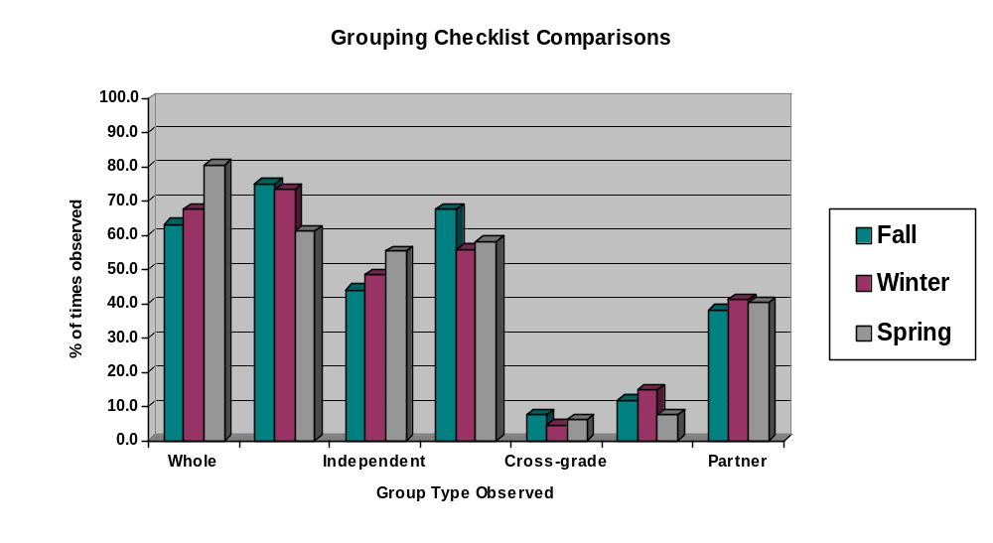
Lesson Checklist Letters Represent the Following:

A = Objective is clearly stated
B = Concept/skill explained and modeled
C = Scaffolding instruction
D = Guided practice of concept/skill
E = Independent practice of concept/skill (verbal or written)
F = Assistants provide reading instruction
G = High level questioning

Lesson Checklist | Fall | Winter | Spring | Total
A | 67.6 | 58.8 | 65.7 | 64.0
B | 70.6 | 76.5 | 71.6 | 72.9
C | 35.3 | 44.1 | 58.2 | 45.8
D | 89.7 | 83.8 | 71.6 | 81.8
E | 58.8 | 61.8 | 65.7 | 62.1
F | 44.1 | 51.5 | 37.3 | 44.3
G | 47.1 | 58.8 | 59.7 | 55.2

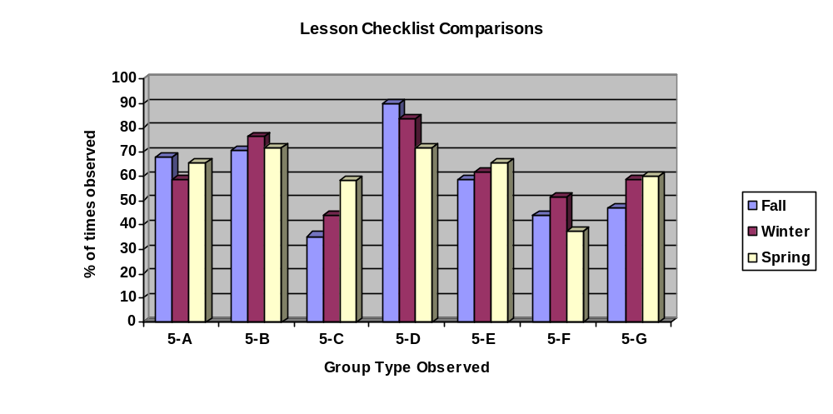
Lesson Checklist Letters Represent the Following:

H = High level of instructional feedback
I = Application of concept or skill
J = Effective transitions
K = “Hands-on” activities
L = Making connections (i.e. to other subjects, concepts, or experiences)
M = Skill practice
N = Summarization of “how” and “why” concept applies to reading
O = Summary

Lesson Checklist | Fall | Winter | Spring | Total
H | 36.8 | 45.6 | 37.3 | 36.8
I | 61.8 | 64.7 | 56.7 | 61.8
J | 63.2 | 70.6 | 71.6 | 63.2
K | 57.4 | 51.5 | 53.7 | 57.4
L | 72.1 | 63.2 | 65.7 | 72.1
M | 39.7 | 51.5 | 52.2 | 39.7
N | 36.8 | 30.9 | 35.8 | 36.8
O | 26.5 | 28.4 | 43.3 | 26.5

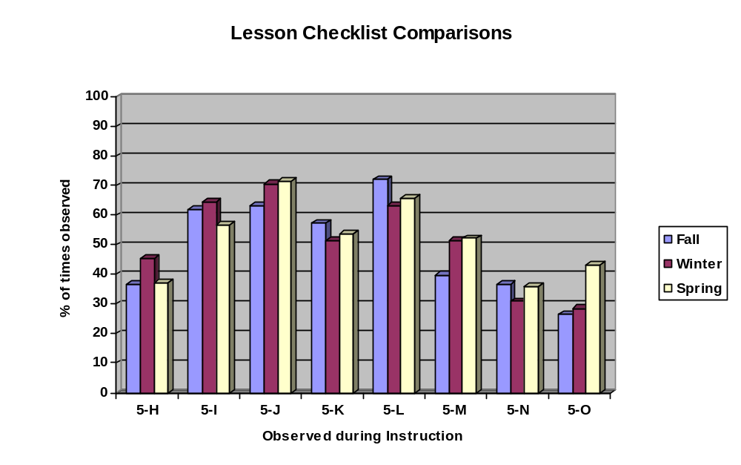
Student Reading Checklist Letters Represent the Following:

A= Independent Reading
B= Shared Reading
C= Partnered/Paired Reading
D= Choral Reading
E= Guided Reading (with teacher)
F= Dramatic/Readers’ Theater
G= Echo Reading
H= Read Alouds
I= Tape Assisted Reading (winter and spring only)

Student Reading | Fall | Winter | Spring | Total
Independent | 50.0 | 64.7 | 59.7 | 58.1
Shared | 8.8 | 17.6 | 4.5 | 10.3
Partner/Paired | 35.3 | 36.8 | 29.9 | 34.0
Choral | 39.7 | 44.1 | 58.2 | 47.3
Guided | 57.4 | 57.4 | 55.2 | 56.7
Dramatic | 1.5 | 1.5 | 3.0 | 2.0
Echo | 27.9 | 13.2 | 13.4 | 18.2
Read Alouds | 44.1 | 51.5 | 53.7 | 49.8
Tape Assisted |  | 26.5 | 28.4 | 27.4

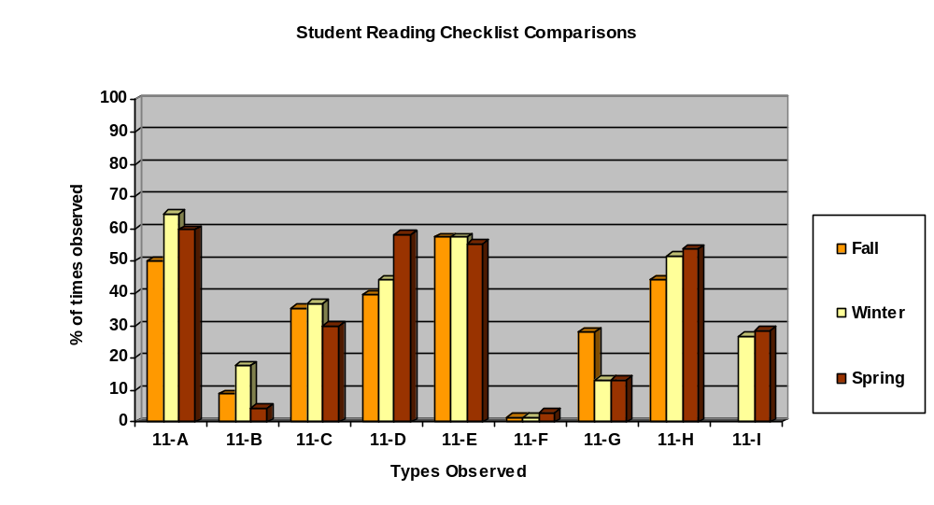
Evidence - Part 5: Analysis of Whole Group and Individual Reading Times

In this section the tables and graphs present results from data collected specifically regarding whole group and individual reading times. One student was randomly selected by the evaluator and was observed during the 45 minute observational period. Evaluators noted the type of reading and recorded time read in increments of 0 minutes, 1-5 minutes, 6-10 minutes, 11-15 minutes, 16-20 minutes, and 21 plus minutes.

Whole group reading results from winter and spring showed the rating with the highest percentage was 1-5 minutes, in independent reading, shared reading, partner/paired reading, choral reading, echo reading, and read alouds. Increases from winter to spring were minimal. Tape assisted whole group reading showed consistent percentages both in the winter and spring for 6-10 minutes at 1.6%. Overall, during whole group instruction, the data indicates that the students themselves were not reading (see charts for specific percentages).

Winter individual student reading results indicated the largest number of students read 1-5 minutes independently (19.7%) and chorally (19.7%). However, in the spring, results reveal guided reading on top at 15.9% for 11-15 minutes. The only reading categories that rated 21 plus minutes were independent, partner/paired, and guided reading. Overall, the data indicated during the 45 minute observation period that students are not reading individually for large increments of time (see charts and graphs for specific percentages).

Recommendations based on evidence:
- Encourage staff to review core reading lessons to evaluate the number of opportunities for students to read;
- Once core reading lessons have been reviewed, then discuss how to integrate more reading on a daily basis;
- Facilitate a variety of different types of reading practices; and
- Increase the amount of time for students to read throughout the core reading block.

Independent Reading: Whole Group | 0 min | 1-5 min | 6-10 min | 11-15 min | 16-20 min | 21+ min
Winter | 80.3 | 13.6 | 3.0 | 3.0 | 0 | 0
Spring | 76.6 | 14.1 | 7.8 | 1.6 | 0.0 | 0.0

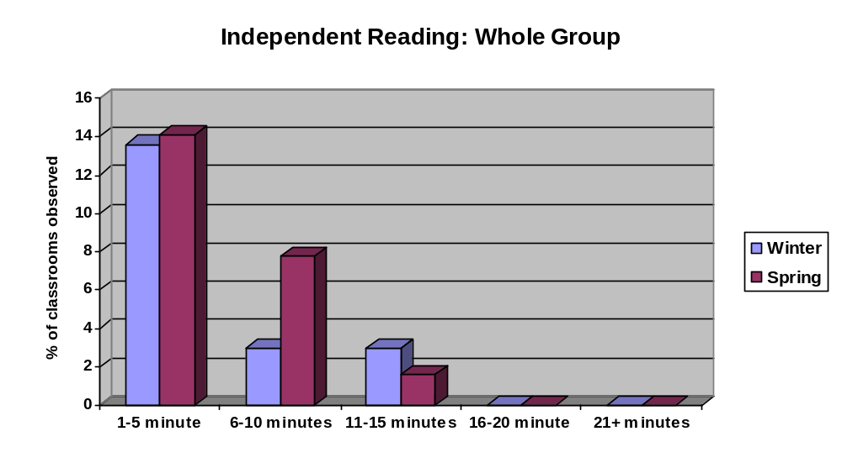

Independent Reading: Individual | 0 min | 1-5 min | 6-10 min | 11-15 min | 16-20 min | 21+ min
Winter | 42.4 | 19.7 | 15.2 | 9.1 | 9.1 | 4.5
Spring | 62.5 | 7.8 | 15.6 | 9.4 | 4.7 | 0.0

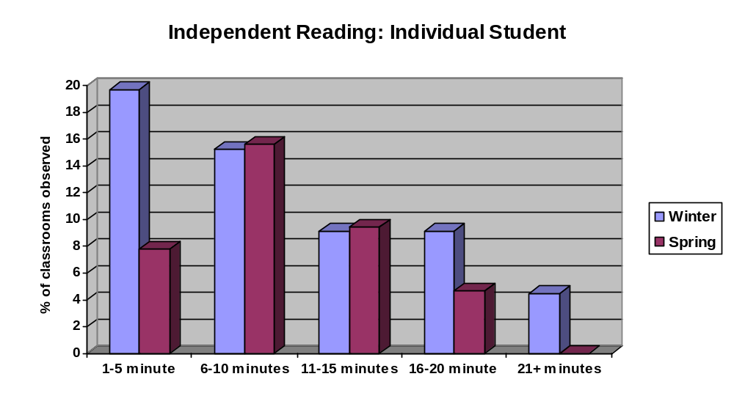

Shared Reading: Whole Group | 0 min | 1-5 min | 6-10 min | 11-15 min | 16-20 min | 21+ min
Winter | 88.2 | 8.8 | 2.9 | 0.0 | 0.0 | 0.0
Spring | 95.5 | 3.0 | 0.0 | 1.5 | 0.0 | 0.0

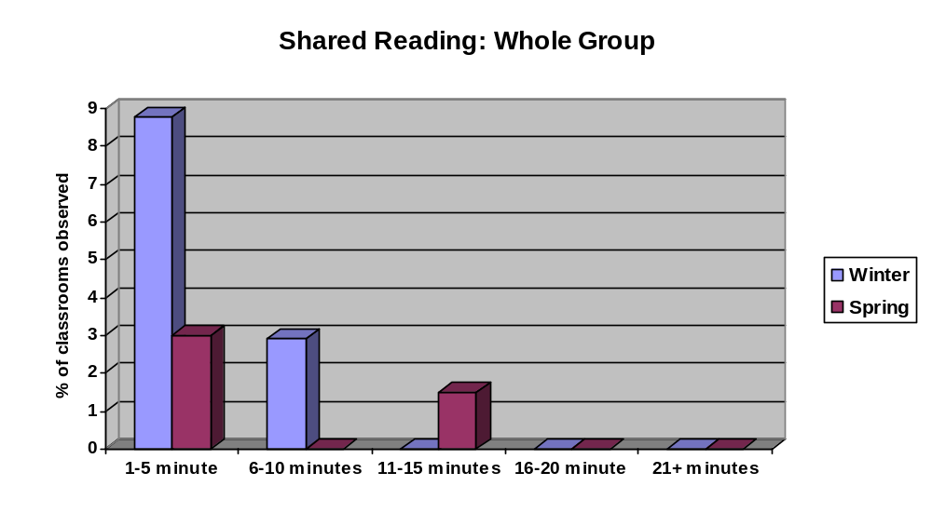

Shared Reading: Individual | 0 min | 1-5 min | 6-10 min | 11-15 min | 16-20 min | 21+ min
Winter | 91.2 | 1.5 | 4.4 | 2.9 | 0.0 | 0.0
Spring | 100 | 0.0 | 0.0 | 0.0 | 0.0 | 0.0

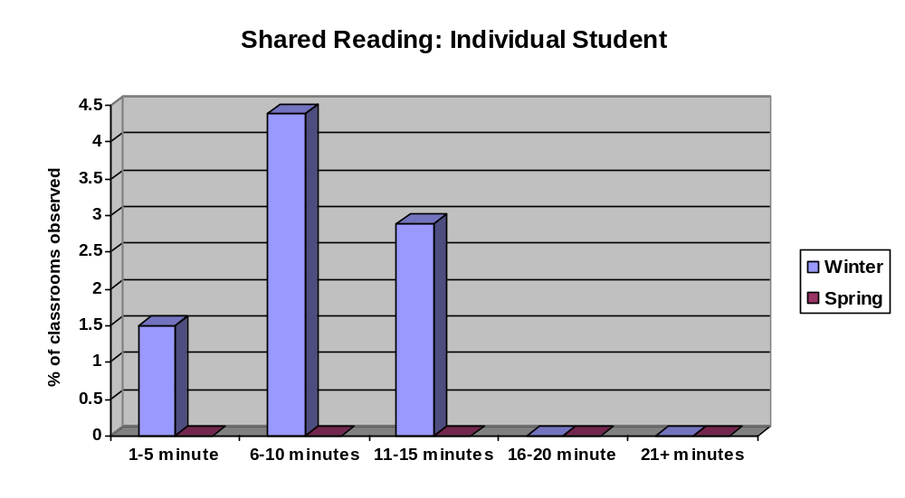

Partner/ Paired: Whole Group | 0 min | 1-5 min | 6-10 min | 11-15 min | 16-20 min | 21+ min
Winter | 86.4 | 7.6 | 3.0 | 3.0 | 0.0 | 0.0
Spring | 92.3 | 4.6 | 1.5 | 1.5 | 0.0 | 0.0

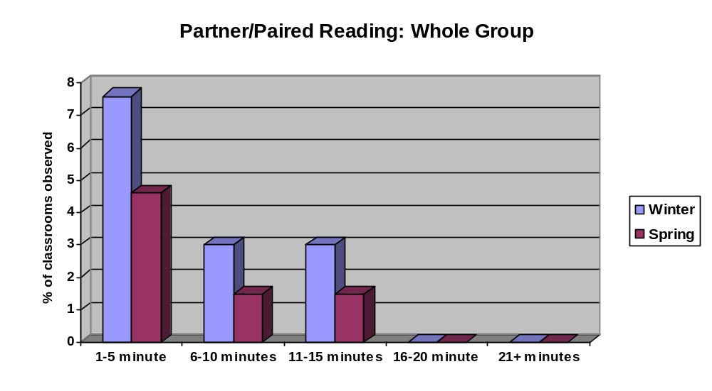

Partner/ Paired: Individual | 0 min | 1-5 min | 6-10 min | 11-15 min | 16-20 min | 21+ min
Winter | 72.7 | 10.6 | 12.1 | 3.0 | 0.0 | 1.5
Spring | 78.5 | 13.8 | 3.1 | 4.6 | 0.0 | 0.0

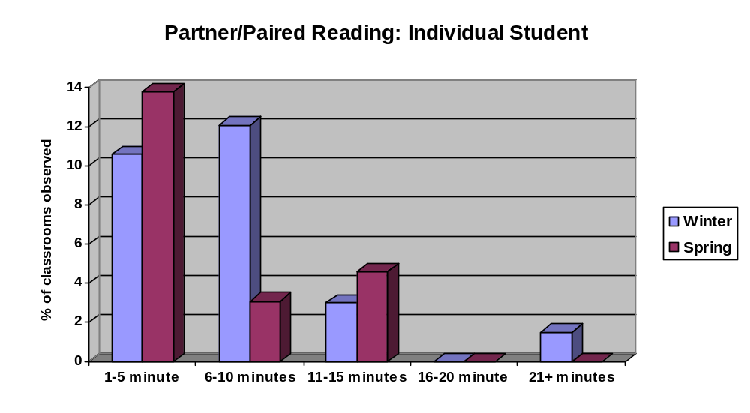

Choral Reading: Whole Group | 0 min | 1-5 min | 6-10 min | 11-15 min | 16-20 min | 21+ min
Winter | 77.3 | 21.2 | 1.5 | 0.0 | 0.0 | 0.0
Spring | 60.6 | 30.3 | 9.1 | 0.0 | 0.0 | 0.0

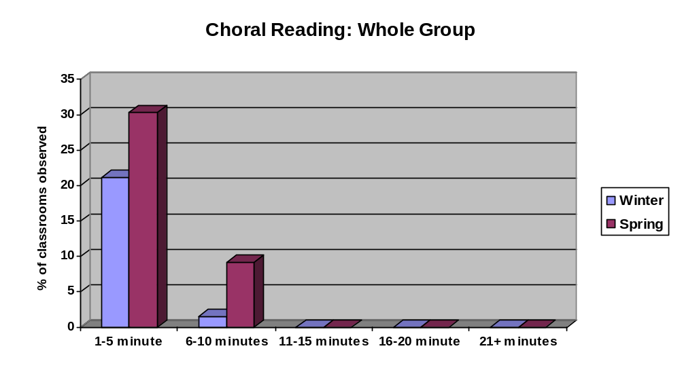

Choral Reading: Individual | 0 min | 1-5 min | 6-10 min | 11-15 min | 16-20 min | 21+ min
Winter | 74.2 | 19.7 | 3.0 | 3.0 | 0.0 | 0.0
Spring | 78.8 | 12.1 | 4.5 | 4.5 | 0.0 | 0.0

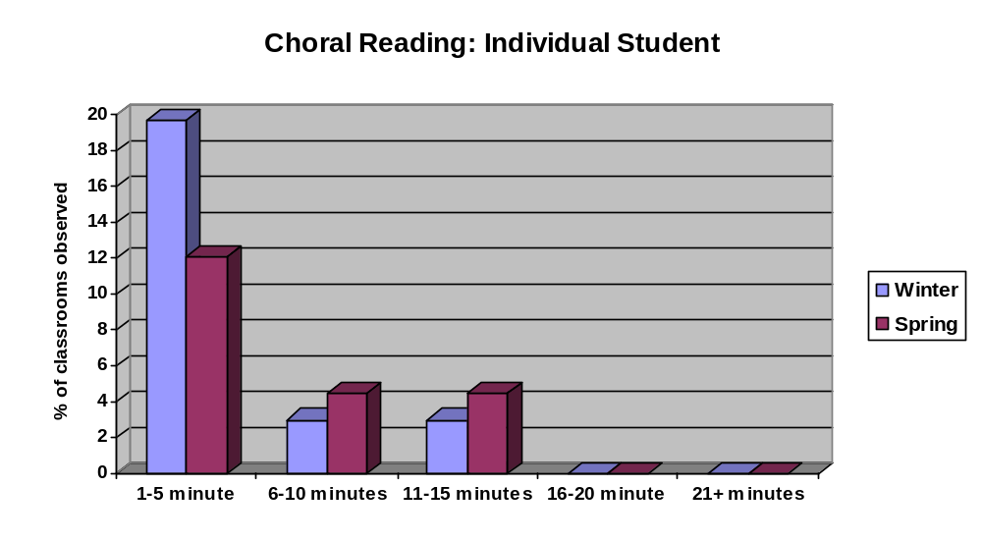

Guided Reading: Whole Group | 0 min | 1-5 min | 6-10 min | 11-15 min | 16-20 min | 21+ min
Winter | 90.6 | 0.0 | 1.6 | 3.1 | 0.0 | 4.7
Spring | 84.1 | 7.9 | 6.3 | 1.6 | 0.0 | 0.0

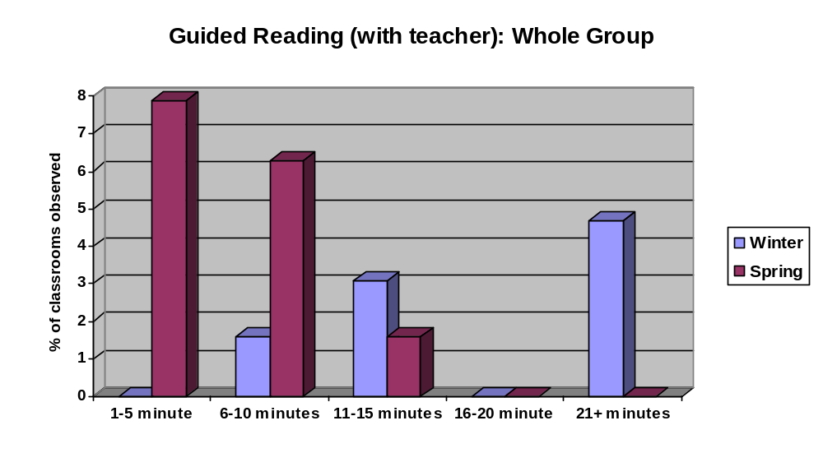

Guided Reading: Individual | 0 min | 1-5 min | 6-10 min | 11-15 min | 16-20 min | 21+ min
Winter | 50.0 | 18.8 | 7.8 | 9.4 | 9.4 | 4.7
Spring | 55.6 | 11.1 | 9.5 | 15.9 | 7.9 | 0.0

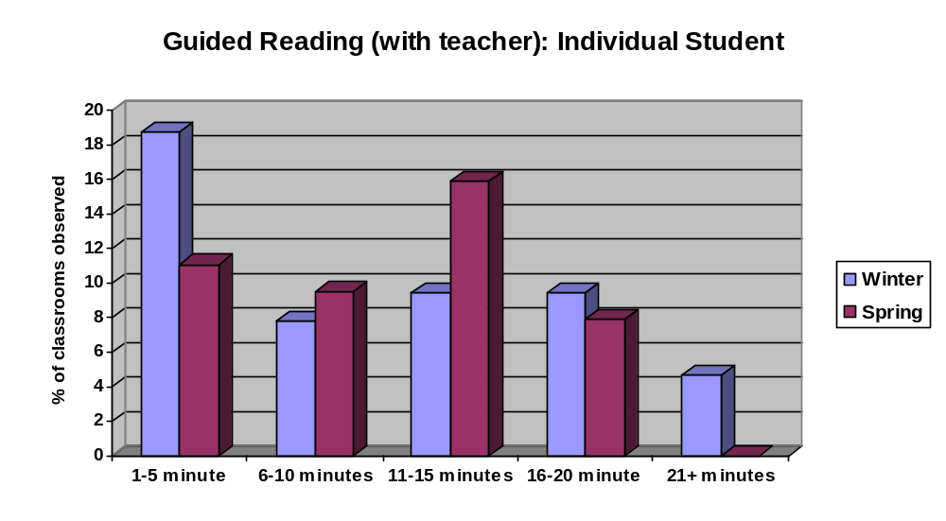

Dramatic Reading: Whole Group | 0 min | 1-5 min | 6-10 min | 11-15 min | 16-20 min | 21+ min
Winter | 98.5 | 0.0 | 1.5 | 0.0 | 0.0 | 0.0
Spring | 100.0 | 0.0 | 0.0 | 0.0 | 0.0 | 0.0

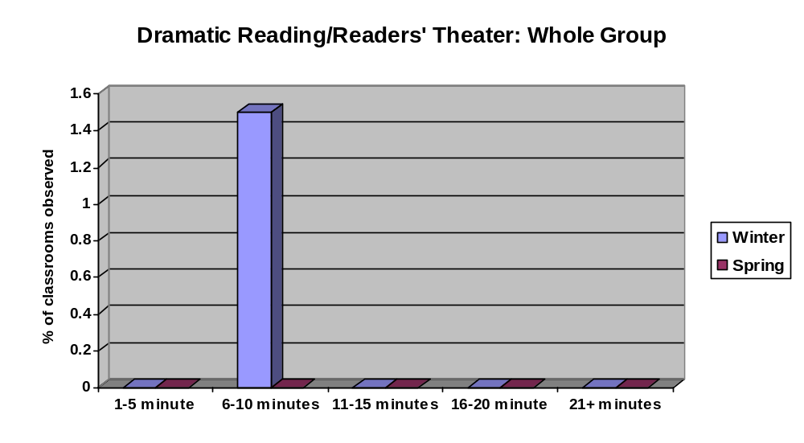

Dramatic Reading: Individual | 0 min | 1-5 min | 6-10 min | 11-15 min | 16-20 min | 21+ min
Winter | 100.0 | 0.0 | 0.0 | 0.0 | 0.0 | 0.0
Spring | 97.0 | 0.0 | 1.5 | 0.0 | 1.5 | 0.0

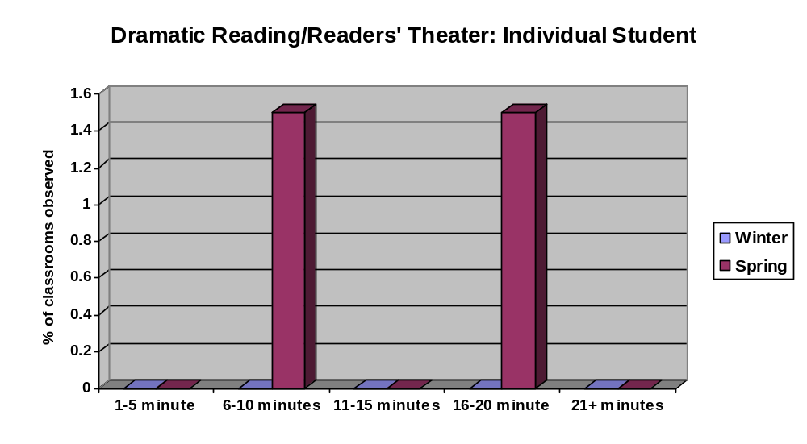

Echo Reading: Whole Group | 0 min | 1-5 min | 6-10 min | 11-15 min | 16-20 min | 21+ min
Winter | 94.1 | 5.9 | 0.0 | 0.0 | 0.0 | 0.0
Spring | 92.5 | 3.0 | 3.0 | 1.5 | 0.0 | 0.0

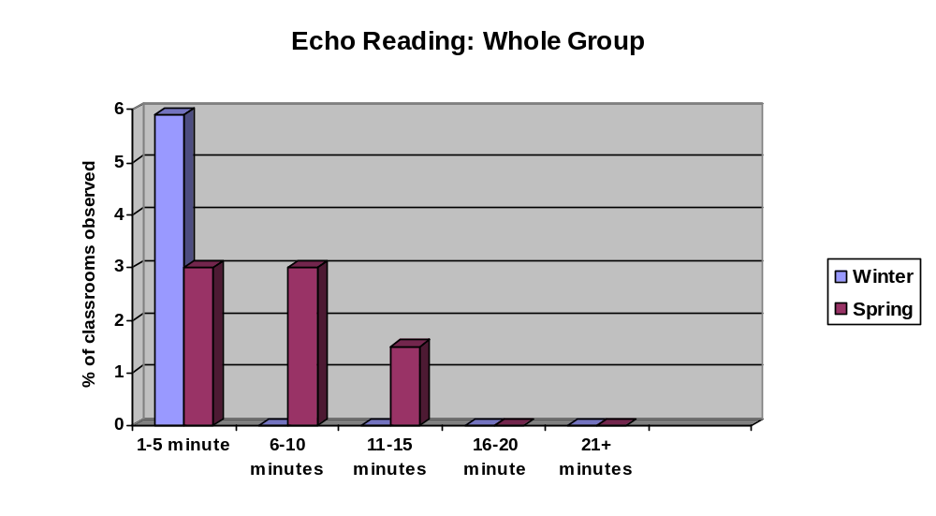

Echo Reading: Individual | 0 min | 1-5 min | 6-10 min | 11-15 min | 16-20 min | 21+ min
Winter | 92.6 | 5.9 | 0.0 | 1.5 | 0.0 | 0.0
Spring | 94.0 | 3.0 | 3.0 | 0.0 | 0.0 | 0.0

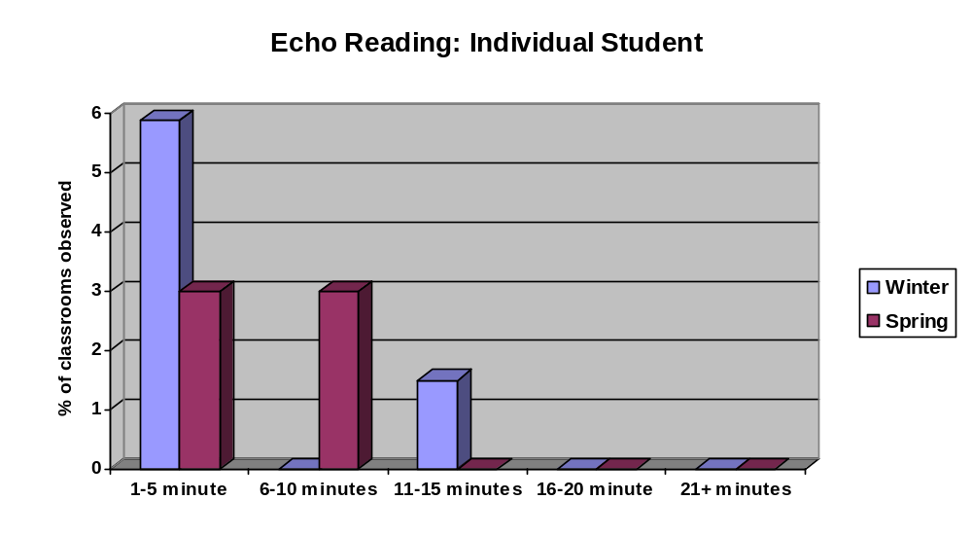

Read Alouds: Whole Group | 0 min | 1-5 min | 6-10 min | 11-15 min | 16-20 min | 21+ min
Winter | 64.7 | 23.5 | 8.8 | 1.5 | 1.5 | 0.0
Spring | 56.9 | 18.5 | 15.4 | 6.2 | 3.1 | 0.0

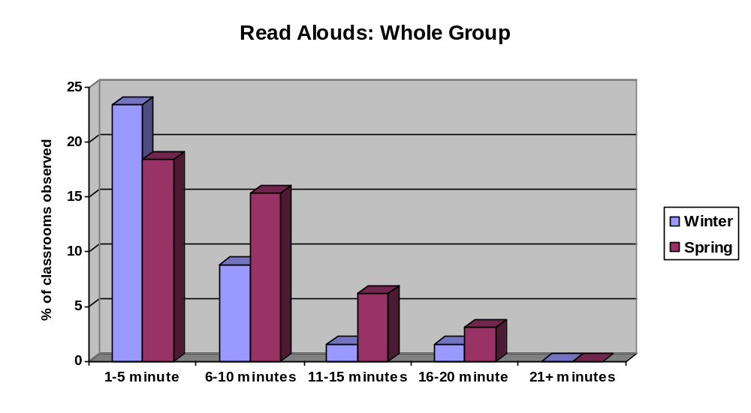

Read Alouds: Individual | 0 min | 1-5 min | 6-10 min | 11-15 min | 16-20 min | 21+ min
Winter | 75.0 | 17.6 | 5.9 | 0.0 | 1.5 | 0.0
Spring | 83.1 | 13.8 | 3.1 | 0.0 | 0.0 | 0.0

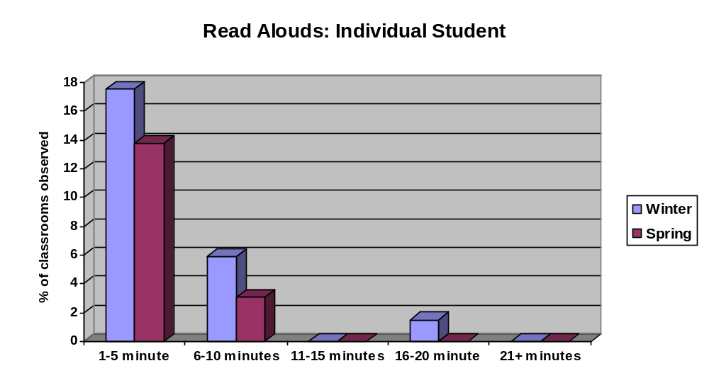

Tape Assisted Reading: Whole Group | 0 min | 1-5 min | 6-10 min | 11-15 min | 16-20 min | 21+ min
Winter | 98.4 | 0.0 | 1.6 | 0.0 | 0.0 | 0.0
Spring | 98.4 | 0.0 | 1.6 | 0.0 | 0.0 | 0.0

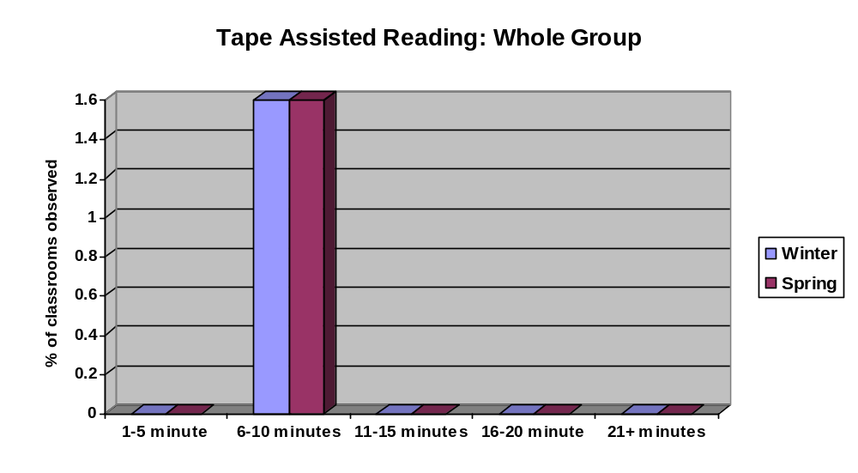

Tape Assisted Reading: Individual | 0 min | 1-5 min | 6-10 min | 11-15 min | 16-20 min | 21+ min
Winter | 82.3 | 3.2 | 4.8 | 6.5 | 3.2 | 0.0
Spring | 75.0 | 10.9 | 12.5 | 0.0 | 1.6 | 0.0

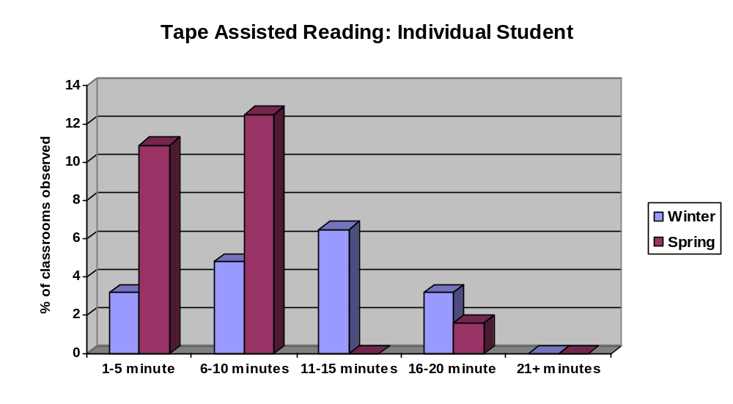

Evidence- Part 6: Analysis of Instructional Groupings

The following graphs present results from data collected pertaining to groups observed during the core reading time. The Reading First evaluators checked only those areas observed within the observation time period. The largest percentage was 70% and illustrated whole group to be the primary grouping structure during the core reading time. This percentage is followed by literacy centers at 56% and independent work at 49%. The most significant percentages for grouping structures not observed during instruction were cross-grade grouping at 94%, cooperative learning at 89%, and partner/pair at 60%. Small group instruction observed was only at 30%.

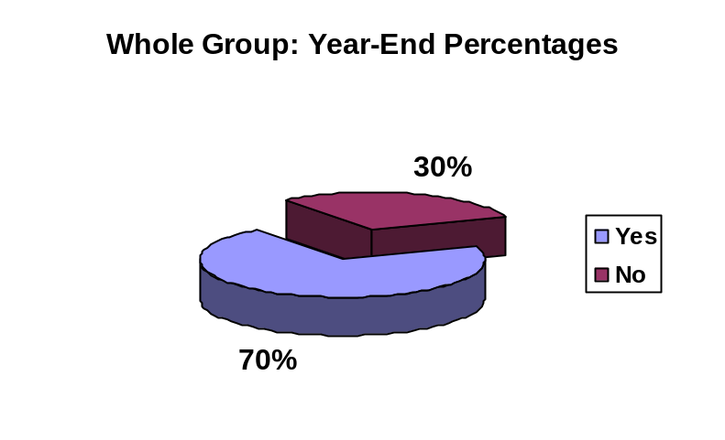

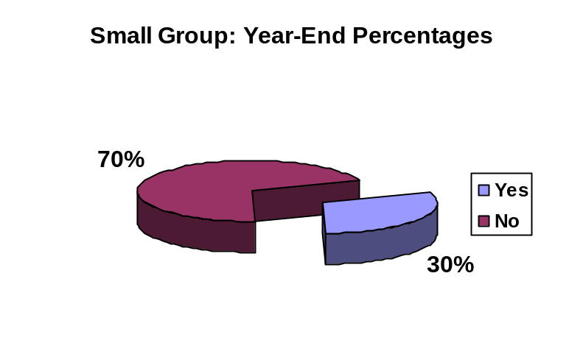

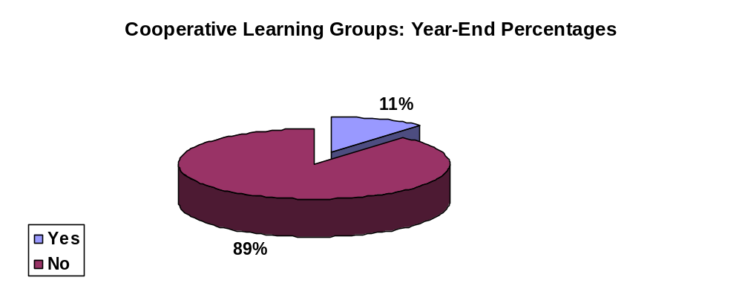

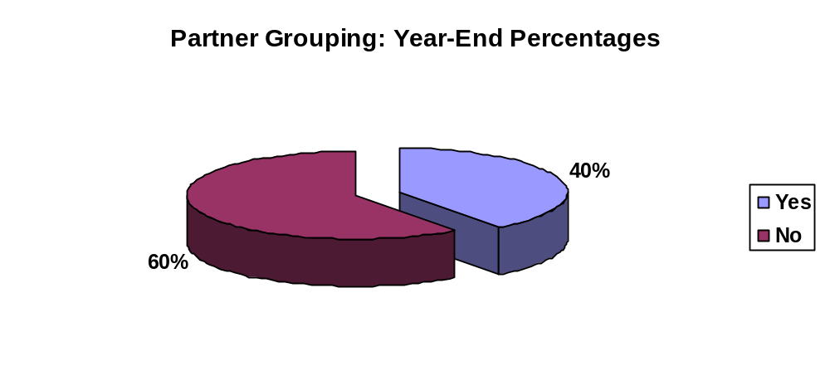

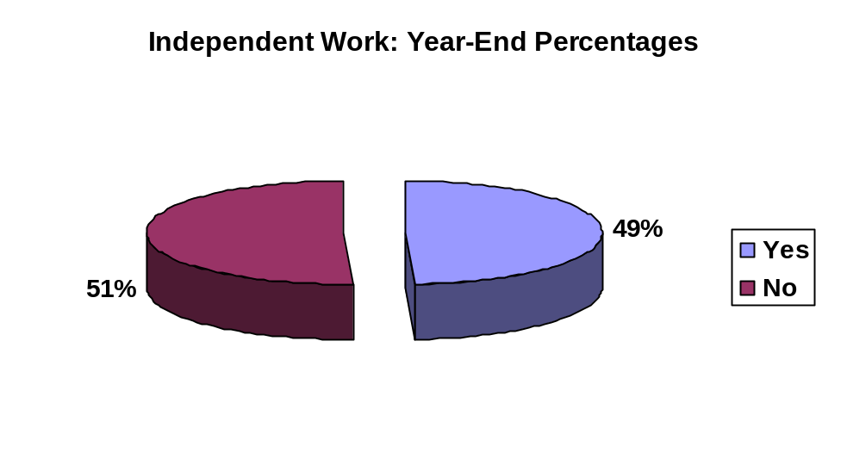

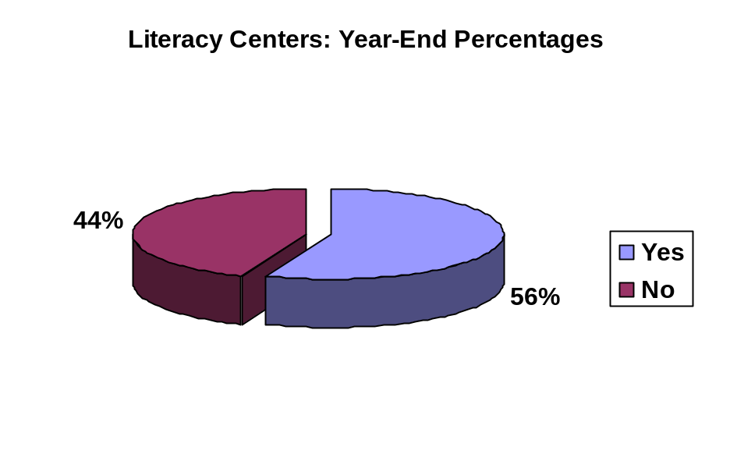

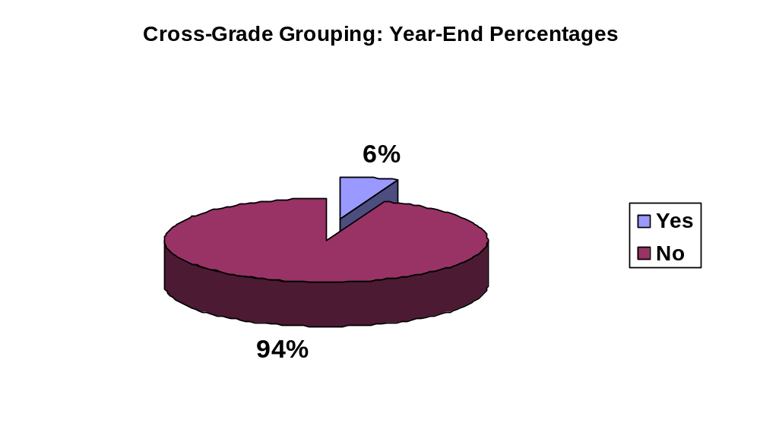

Evidence - Part 7: Analysis of Practices Occurring During the Reading Block

The following charts and graphs present findings for areas that were observed or not observed. The areas are spelling, spelling tests, handwriting, grammar, classroom interruptions, and writing process. According to the grant guidelines, these practices should not be occurring during the core instructional reading time. The data indicates high percentages of “not observed” in all practices. The largest area for not observed at 100% was grammar instruction. All areas for not observed were above 90 percent, except for classroom interruption at 74.9%. Out of 203 classrooms observed, there were 49 interruptions observed from the fall, winter, to spring for a low percentage of 25.1%.

Recommendations based on the evidence in this section:
- Continue to follow the grant guidelines for not implementing these specific areas; and
- Discuss at the school level how to minimize classroom interruptions during the core reading time.

Interruptions
Observation Response | Fall | Winter | Spring | Year Total | Year Total Percentage
Not observed | 44 | 52 | 50 | 146 | 74.9
Observed | 20 | 14 | 15 | 49 | 25.1
Total | 64 | 66 | 65 | 195
Missing | 4 | 2 | 2 | 8

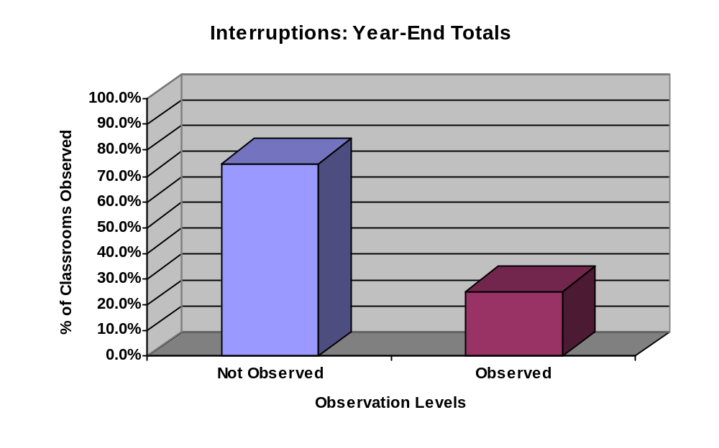

Spelling
Observation Response | Fall | Winter | Spring | Year Total | Year Total Percentage
Not observed | 61 | 62 | 65 | 188 | 96.4
Observed | 3 | 4 | 0 | 7 | 3.6
Total | 64 | 66 | 65 | 195
Missing | 4 | 2 | 2 | 8

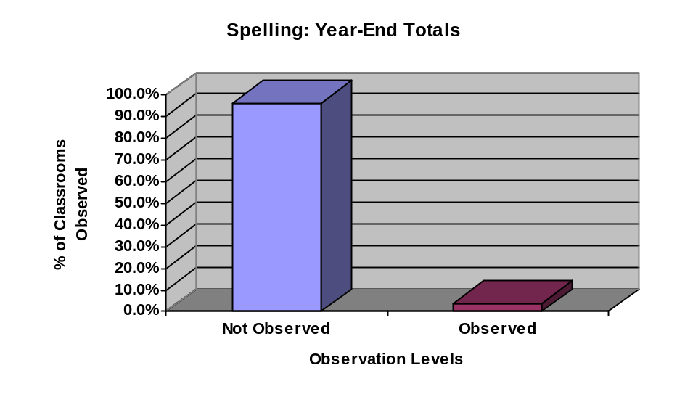

Spelling Tests
Observation Response | Fall | Winter | Spring | Year Total | Year Total Percentage
Not observed | 58 | 64 | 66 | 188 | 99.5
Observed | 0 | 1 | 0 | 1 | 0.5
Total | 58 | 65 | 66 | 189
Missing | 10 | 3 | 1 | 14

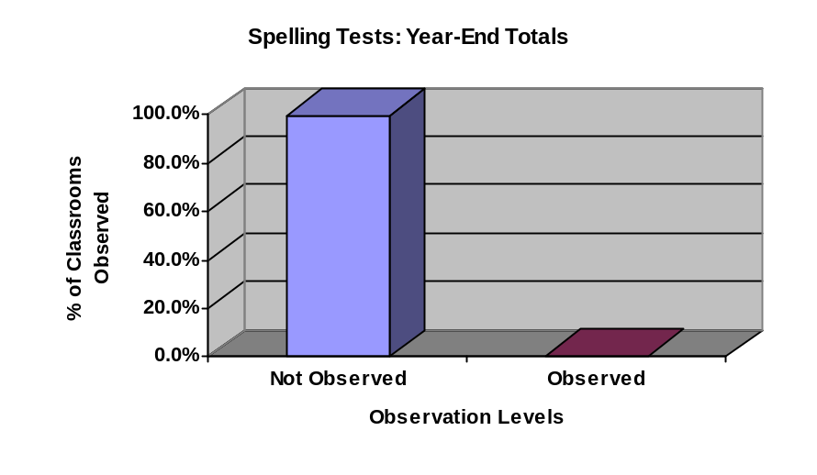

Grammar
Observation Response | Fall | Winter | Spring | Year Total | Year Total Percentage
Not observed | 62 | 67 | 65 | 194 | 100
Observed | 0 | 0 | 0 | 0 | 0
Total | 62 | 67 | 65 | 194
Missing | 6 | 1 | 2 | 9

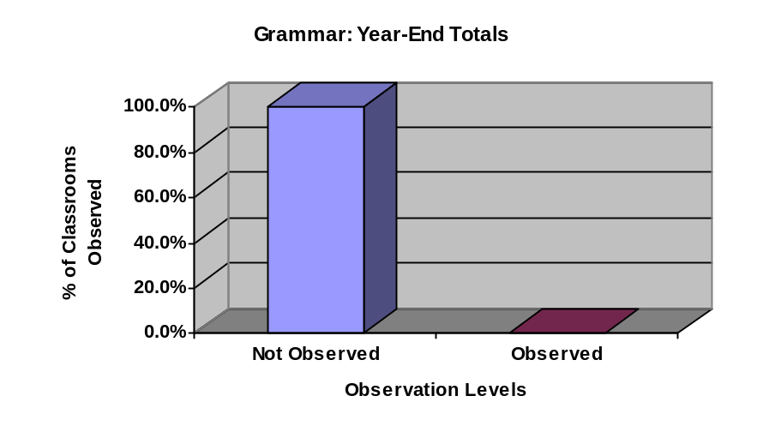

Handwriting
Observation Response | Fall | Winter | Spring | Year Total | Year Total Percentage
Not observed | 61 | 65 | 65 | 191 | 97.4
Observed | 2 | 2 | 1 | 5 | 2.6
Total | 63 | 67 | 66 | 196
Missing | 5 | 1 | 1 | 7

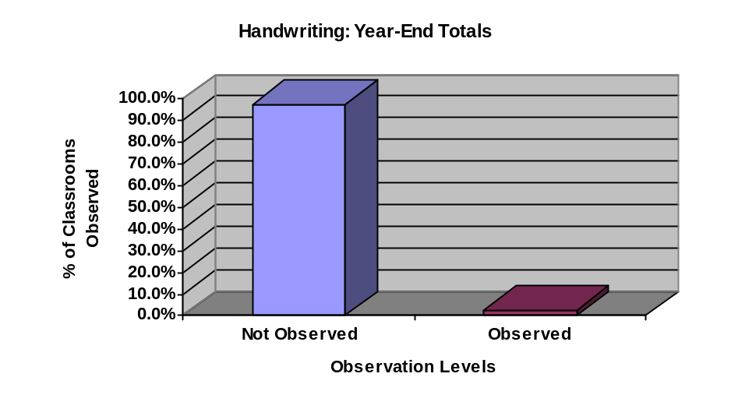

Writing
Observation Response | Fall | Winter | Spring | Year Total | Year Total Percentage
Not observed | 60 | no data | 62 | 122 | 95.3
Observed | 4 | no data | 2 | 6 | 4.7
Total | 64 | no data | 64 | 128
Missing | 4 | no data | 3 | 7

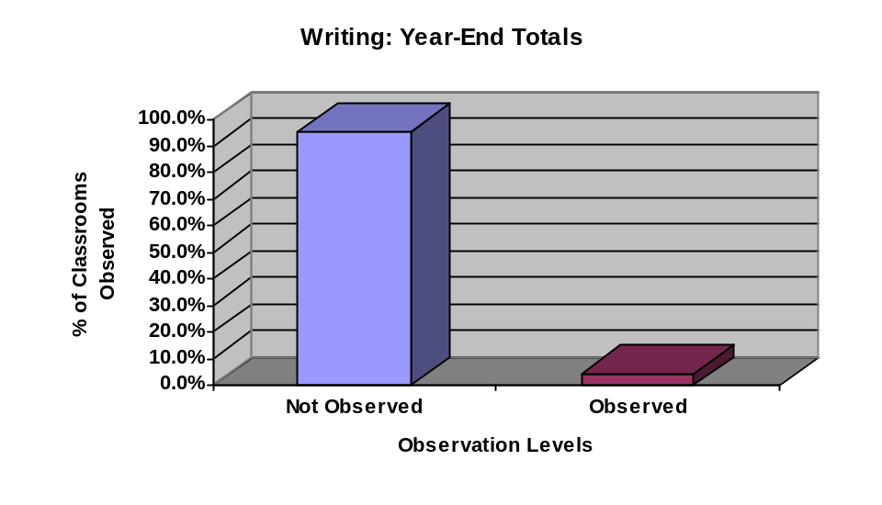

Chapter 4

Case Study School Reports

The seventeen schools that were observed by the Collaborative Center for Literacy Development’s (CCLD) Reading First Evaluation Team during the final site visit for the school year 2006-2007 were sent follow-up case study reports after each site visit. (See Appendix A and C for letter and form.) Therefore, each school participating in the case study received a total of three feedback reports from CCLD. These reports included information based on interviews and either the four classrooms observed during the fall and winter visits, or the two classrooms during the final site visit. Each report included information about each of the five Reading First components, grouping, core program information, learning environment, literacy centers, instruction, and concerns and strengths observed during the visit.

Reports from the 2006-2007 school year were compiled and grouped together according to the feedback given for each area. Using this data, summaries were completed, and themes were noted.

Five Components

Strengths:
All five components were observed in all classrooms, specifically with the greatest improvement noted in vocabulary and comprehension. Teachers are learning to teach all of the components, and the components are implemented throughout reading instruction. CCLD observed specific ways teachers are reinforcing comprehension strategies, teaching phonemic awareness, and using vocabulary.
Concerns:
The questions raised regarding the five components remained consistent from fall to spring and mainly focused on consistency, full inclusion of all five components, and focus on explicit instruction, especially of vocabulary. Based on the observations, daily, full implementation of the five components is necessary in all classrooms. Evaluators seemed particularly concerned that vocabulary be more prominent in planning and teaching, and be connected to students’ prior knowledge. School coach interviews revealed that phonics is addressed extensively, comprehension is the component needing the most improvement, and fluency is only addressed minimally.

Literacy Centers

Strengths:
Literacy centers address the five components, are well organized, and contain meaningful activities that reinforce instruction. There is evidence that teachers
are continuing to improve and refine centers and that the school coaches have worked to improve centers, especially by addressing differentiation. Labeling and task cards in centers are visible and easy to follow. Transitions in centers are timely and smooth. Students find center activities engaging.

Concerns:
Concerns regarding literacy centers focus on differentiated activities to meet the needs of all students and management. Accountability and assessment for center activities and ignoring off task students are just a few of the management issues. The general effectiveness of centers was also questioned. In the area of student engagement, suggestions for improving literacy centers included providing more student choice, more hands-on activities, less paper and pencil activities, and more varied reading opportunities (i.e. dramatic reading partner/paired reading).

In response to questionnaires, teachers continue to express the need for more time and ideas to plan for center activities and particularly for differentiated activities.

Instruction

Strengths:
Best practices, explicit instruction, good lesson plans, differentiation, various grouping, and clear statements of objectives as well as summaries were observed in Reading First classrooms. Small group instruction appears to elicit the most resourcefulness of teachers. Spring observations by CCLD revealed much improvement in instruction, including the use of data to plan instruction, scaffolding and higher level questioning, specific improvements observed by school coaches, use of new phonics and comprehension strategies, and assessment of students’ prior knowledge.
Spring interviews with school coaches revealed that half of the coaches report an increase in explicit instruction at their schools, 100% report observing more than one strategy to deal with struggling students, and over half report implementing new information from read aloud and vocabulary models gained through professional development.

Concerns:
Providing time for student reflection and sharing is a concern; additionally, the use of higher level questioning techniques was suggested. There is still a need for teachers to make their instruction explicit, answering the what, why, when,
and how questions. Allowing time for post-reading activities, instead of only pre-reading, was emphasized, as was more daily utilization of best practices when delivering the five components.

Learning Environment

Strengths:
Evidence demonstrating a positive learning environment included displays of student work in classrooms and hallways, celebrations of student success, positive communication between teachers and students, and posters displaying reading strategies. Classrooms are colorful, inviting, and print rich, with a variety of materials for reading. They are also arranged for a variety of activities and groupings. Positive attitudes are evident, and classroom management is strong.

Concerns:
In one new school, teachers were asked not to display student work on the walls. In other schools, they are still looking for ways to display and showcase student work.

Leadership

Strengths:
CCLD found evidence that district and school coaches, in addition to the school principal, go into classrooms on a regular basis to observe and assist with instruction. Moreover, they monitor lesson plans and provide support for Reading First. School coaches are assisting with explicit lessons, data assessment, modeling, providing professional development, and planning. In school coach interviews, they indicated that they are spending more time observing and conferencing with teachers. This is a significant change from previous years when they emphasized paperwork as an overwhelming task. In general, strong leadership for Reading First is present school wide.

Concerns:
Some Reading First school coaches perceive a lack of support from the principal and district coach.

Student Engagement / Higher Level Questioning

Strengths:
A variety of activities and groupings engage learners. Classroom management practices promote active engagement and participation in class discussion. Moreover, students are able to work independently also. Resources such as white boards, charts, easels, computers, and vocabulary and picture cards
enhance engagement. Students enjoy reading time and are on task. To further enhance student engagement and provide differentiation, teachers are asking higher level questions, some of which require students to make connections between text and real life.

Concerns:
Disruptive behavior in some classrooms seems to result from poor engagement, lack of student-centered activities, and few opportunities for creative expression. Evaluators question how teachers can design small group lessons with student-centered discussions and time for summary and reflection on reading instruction. A variety of groupings such as cooperative learning groups, guided with teacher, drama, Reader’s Theater, and tape-assisted were suggested to stimulate engagement. Evaluators also expressed that higher level questioning needs to be more evident and time should be offered for students to reflect and develop their own questions regarding a text. A concern with the frequency of low level questioning remains.

Supplemental and Intervention Programs

Strengths:
Intervention teachers are meeting weekly, and there is evidence of extensive collaboration between intervention and regular classroom teachers. Individual instruction occurs during intervention. Interviews with intervention teachers revealed that they are maintaining small groups of 1-6 students, and 81% of teachers interviewed are spending 16-30 minutes for each intervention lesson. Observations of intervention groups showed an extensive level of student engagement and that the majority of them were free of distractions. Supplemental teacher interviews reveal that the majority of supplemental groups meet 16-30 minutes each day, and students are monitored regularly.

Concerns:
Professional training for supplemental instruction is weak; only 50% of supplemental teachers interviewed report receiving specific supplemental training. Professional development for intervention teachers also varies and is not specific to intervention programs. In interviews, intervention teachers report that there is no formal communication process in place with classroom teachers and that scheduling remains a problem, especially for subjects students miss during intervention. Is the intervention provided assisting struggling readers, and can supplemental and intervention be better organized?

Family Involvement

Strengths:
Attempts are made at family involvement, and some literacy events are well planned and attended. Monthly activities are offered for family involvement and to celebrate student success. Parent surveys indicate they are knowledgeable of Reading First, support the program, and are pleased with their child’s progress. Surveys also revealed that 83% of parents read with their children at home, and 92% of parents strongly agree that they feel comfortable talking with their child’s teacher about reading progress. Beyond parent volunteers, there is evidence of community volunteers providing tutoring, and collaboration with the community on events such as reading carnivals.

Concerns:
How can staff encourage more parental involvement and participation in literacy events is the principle question regarding family involvement. The majority of parents are not attending family reading activities at schools. Parent surveys show that while 52% of parents strongly agree that family reading events are convenient to them, only 24% strongly agree that they attend.

Reading Practice

Strengths:
Students are practicing different ways of reading, especially in the 1st and 2nd grades. Observations reveal that many minutes are spent actively reading during instruction in some classrooms and that reading is practiced in various groupings during whole group and center time.

Concerns:
The amount of time spent actually reading seems to be the primary concern in reading practice. For example, in one 45 minute observation, students read as little as three to five minutes. Time spent reading by students needs to increase, as well as different groupings and ways of reading. CCLD evaluators suggested integrating more reading into core reading time and that time for reading exceed the 1-5 minutes observed.

Instructional Assistance / Paraprofessionals

Strengths:
The assistance of paraprofessionals has provided much needed help during core time. Paraprofessionals have also been assisting during supplemental and center time. They provide positive support for teachers and effective reading
instruction for students. Some classroom assistants are also working with small groups and progress monitoring individual students.

Concerns:
How can paraprofessionals be used more effectively to benefit student achievement and enhance the efficiency of classroom teachers?

Student Achievement / Data / Assessment

Strengths:
Gains are being made in student achievement, as demonstrated by assessments. Many ESL students are progressing, as teachers are removing barriers. Some schools are “opening their doors to other schools” for Reading First instruction to strengthen reading programs.
Data boards are being used to track student achievement, and data is being used to plan instruction. Fifty percent of school coaches interviewed in the spring reported using data to inform or drive instruction as their “biggest success” this year. Moreover, 83% of teachers are finding Reading First assessments easier to manage. Teachers maintain assessment binders to organize progress monitoring and aid in analyzing assessment data.

Concerns:
Teachers continue to need assistance in interpreting data and planning effective lessons to target individual needs. The extent to which teachers, not school
coaches alone, are using data boards was questioned. Interestingly, only 44% of school coaches interviewed state that data analysis is a way to sustain Reading First objectives after the grant expires. Receiving data in a timely manner remains an issue for planning and responding to results. Observers questioned if teachers have the opportunity to do authentic assessments in reading and if these could be done during small group reading instruction. Checklists, timed repeated reading, inventories, or running records were suggested. Finally, evaluators asked teachers to consider ways they can help students retain skills through the summer.

Chapter 5

I. District Coach Interview

Seventeen district coaches for the 2006-2007 case study schools were interviewed during the fall by the Collaborative Center for Literacy Development’s (CCLD) Reading First Evaluation Team. Their responses were compiled and grouped together according to the individual questions and responses (See Appendix D for interview questions). Using this data, the following themes and summaries emerged.

II. Themes

Overall successes based on evidence from district coach interviews:

- Twenty-four percent of district coaches noted observed improvement in classroom instructional practices;
- In the third year of implementation, 17% of district coaches feel their district is offering stronger leadership and support to RF school coaches and teachers; and
- Thirty-five percent of district coaches identify professional development as a successful district initiative.

Overall concerns based on evidence from the district coach interviews:

- Twenty-five percent of district coaches are concerned about addressing the varying needs of students;
- Twenty-one percent of district coaches are concerned about improvements in classroom instruction which still need to occur;
- Twenty-one percent of district coaches voiced concerns over schools’ struggles with training new teachers due to turnover, teachers resisting commitment to RF, and teacher morale; and
- Twenty-three percent of district coaches continue to have difficulty managing to meet the requirements of the grant.

III. Evidence

1. How is the district leadership involved in the coordination of RF activities for the entire district? (Explain)

According to district coaches, district leadership has coordinated RF activities in the following areas for the entire district:
- Development and presentation of professional development
- Participation on the district literacy team
- Organizing assessments in non-funded elementary, middle, and high schools
- Analyzing student assessment data
- Conducting classroom walk-throughs
- Sharing RF information and strategies with non-funded schools
- Communicating between district leadership, school board, and RF schools.

2. Regarding the district, what changes have occurred from RF year one implementation to now?

The changes shared by the 17 district coaches are listed in the following four categories: Professional Growth, Leadership, Assessment, and Implementation.

Professional Growth:
- Level of knowledge of classroom teachers, particularly in RF schools
- Knowledge in all district schools regarding SBRR
- More focused and clearer on five components
- More conversations about reading
- General awareness across district

Leadership:
- Consistent district leader dedicated to RF
- District office has become more accessible and serves as a resource for principals and teachers
- District wide literacy team including a reading specialist for the district

Assessment:
- Created a display board of children, by classroom, to view student achievement
- The district did not do district wide assessment
- Increased assessment results
- Assess professional development needs for teachers
Implementation:
- Augmenting core program lessons to meet the students’ needs
- Teachers are more comfortable and share ownership of the program.
- District coach attends grade level meetings.
- Looking at instructional changes needing to be made
- Created a solution team to focus on IARP
- Aligning Supplemental and Intervention programs with students’ needs
- Progress with computer program implementation program
- Focus on explicit planning
- Increased involvement with public library
3. What specific activities/communication have the district implemented with non-funded schools as well as private schools regarding RF?

A district coach shared, “We take the good things happening in funded schools to the non-funded schools.” The process of sharing information with the non-funded schools is described by district coaches in a variety of ways. For example, one non-funded school principal asks a school leader to attend district meetings. One district coach said she meets with the non-funded schools for a monthly professional development concerning the five components and data analysis, while another district coach leads all the district primary schools in continuous training with the district wide intervention program.

Six districts have private schools who regularly participate in Reading First meetings and professional development. Some private schools will include their entire staff while others may send teacher leaders. Two districts have invited private schools to participate in Reading First professional development; however, the schools have shown no interest. Two district coaches said they also extend professional development invitations to home schools.

Three of the 17 case study schools are the only primary schools in their district, making this question not applicable to them.
4. What are your top three responsibilities regarding RF for your district?

The responsibility most frequently mentioned by the 17 district coaches was to assist in developing and providing professional development for teachers. The chart indicates responsibilities given by three or more coaches.
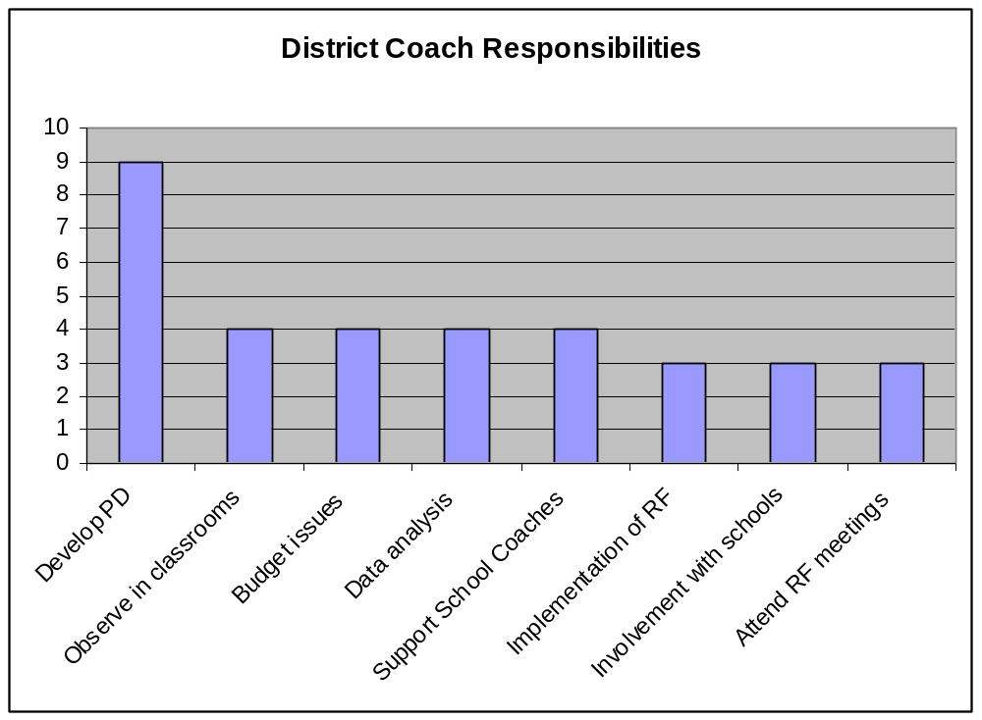

Additional responsibilities listed by district coaches:

One Response | Two Responses
District Liaison | Instructional support for teachers
Walk-throughs and feedback to teachers | Support all RF schools
Help present action plans to KDE | Provide teachers with materials they need
Lead team effort | District literacy team
Communicate with school coach | Communication
Assist with scheduling
Scan GRADE assessment
Meeting goals set by state

5. What are three areas that are causing you the most concern regarding RF implementation across the district?

The graph indicates the five areas of district concerns given by the 17 district coaches, with meeting students’ needs with the majority of responses. A detailed list of concerns follows the graph.

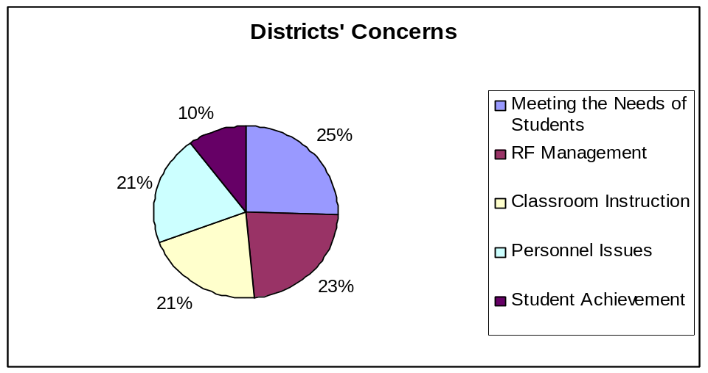

Meeting the needs of students  - Number of needy children  - Transient student population  - Diversity unlike any other  - Cannot rely on state for PD for ESL  - 3 Tier model ; Be sure students are  placed in intervention based on  specific needs  - Finding what works with intensive students  - Intervention for the students with most needs  - Need for more intervention teachers  - Applying RF principles beyond 3rd grade; What can be done for struggling readers in middle and high school? | Management  - Time to address state mandates, state coach, school requirements  - Amount of paperwork, documentation  - Overwhelmed with work of the grant  - Would not apply for another grant such as RF  - Time for all schools  - Schedules  - Money  - Be able to get more research based information to all schools  - Developing a plan to sustain after RF
Personnel  - Teacher turn over; Level with others already implementing RF  - Keeping teachers trained; turnover  - Motivate veteran teachers  - Additional work load for teachers  - Difference in reading philosophy among elementary schools  - Teacher morale  - Resistance among teachers  - PD is good, but needs to improve; Needs to be more teacher specific | Classroom Instruction  - Comprehension  - Flexible grouping  - Eliminate down time regarding the daily start at centers and change between whole group to small group  - Transition times  - Observing paraprofessional and teacher relationships giving quality of instruction  - Writing has no connection with RF  - Core content; integrate in 90 minutes core  - Continue to improve in differentiating instruction
Student Achievement  - Goals of testing benchmark need to be factored in for ESL  - Not seeing results we had expected  - Still have students not progressing  - Not seeing enough movement of IARP and special education | Additional Concerns  - Core program is different from the district adoption  - Continuing to improve in using data to drive instruction  - Need to improve interventions  - Really not concerned

6. What are three of the most successful initiatives being conducted in the district regarding RF?

District coaches identified professional development as the district’s most successful initiative. The following graph indicates the seven initiatives district coaches have found to be the most successful.

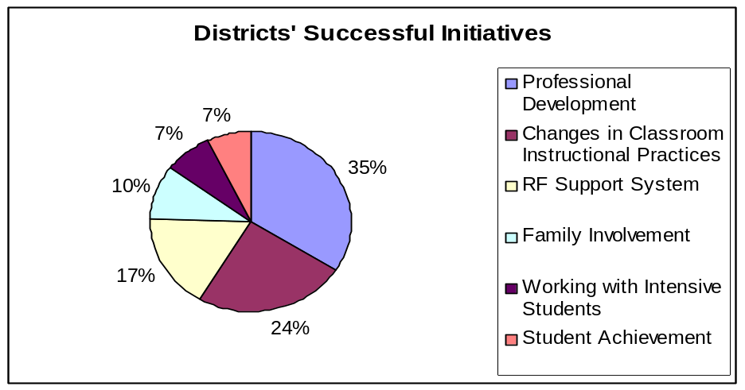

7. How would you describe this school’s implementation of Reading First?

When the 17 district coaches were asked to answer this question by rating the school’s implementation as minimal, moderate, or extensive, 14 coaches rated their school as having extensive implementation while 3 coaches rated their school as exhibiting moderate implementation.

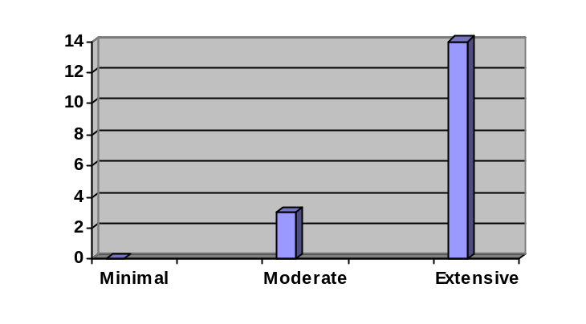
8. What involvement has the district had that directly impacts this school’s RF implementation process?

Among the 17 coaches, the following responses were given as their districts’ involvement directly impacting RF implementation in the schools:

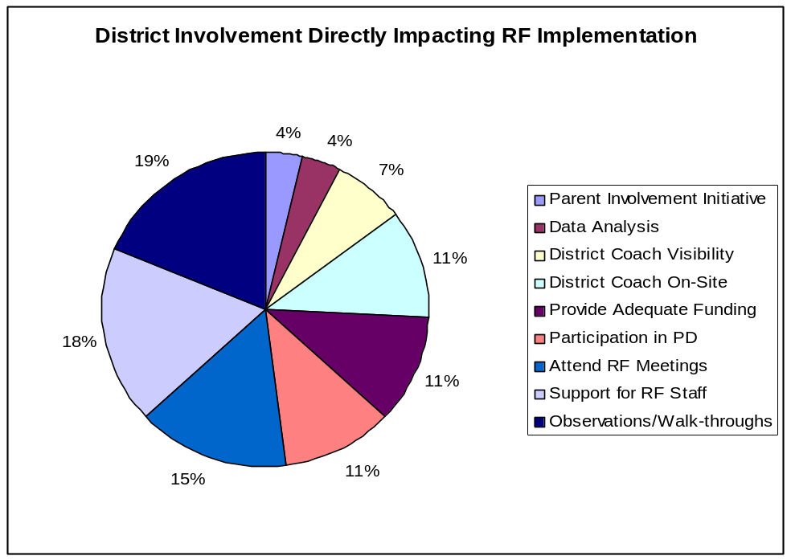

9. How do you provide feedback to this school?

Informal conversations, e-mails, and conferences are the three most common methods used by the 17 district coaches to provide feedback to RF schools.

Methods of Providing Feedback
Method | # of Responses
Informal conversations | 16
E-mail | 14
Conferences | 14
Formal written documents | 7
Staff Meetings/ Grade Level Meetings | 6
Site Visits | 1
Phone | 1
Professional Development | 1

10. How often do you observe and monitor what is happening in this school?

Almost half of the 17 district coaches state they observe and monitor RF implementation in their schools once a week.

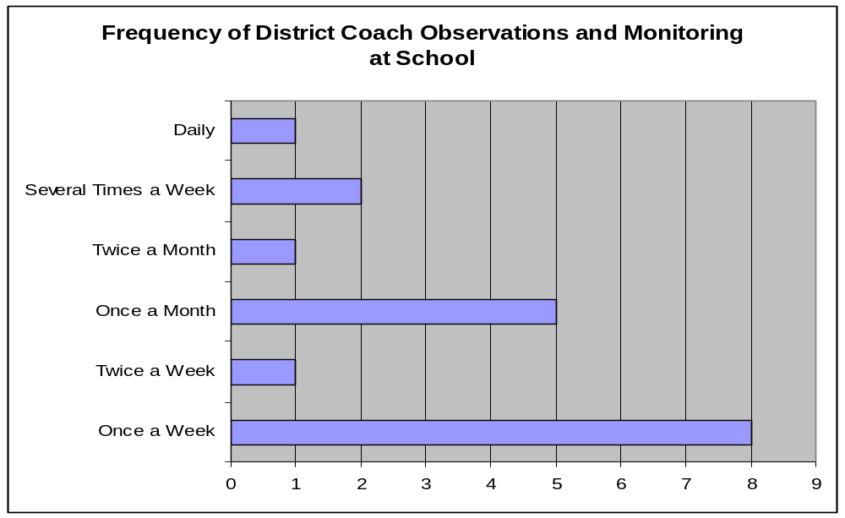

11. What are three areas that are causing you the most concern regarding RF implementation for this school?

Fourteen district coaches expressed concern about their school’s classroom instruction. Some of their concerns include transition time between whole group and small group, improving literacy centers, lack of fluency instruction, explicit instruction, and addressing writing during the core.

The following chart indicates the areas of concern for district coaches.
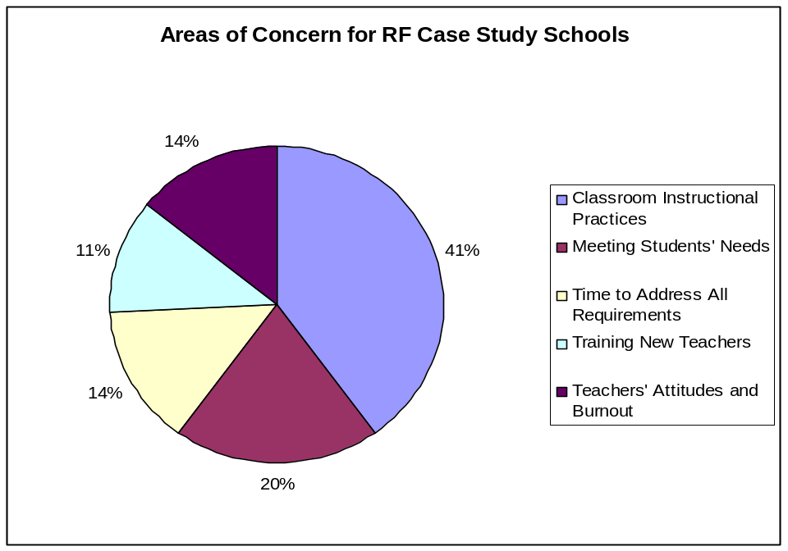

12. What are three areas that this school is most successful in implementing regarding RF at this school?

Just as the majority of district coaches find classroom instruction to be an area of concern, thirteen district coaches listed areas of classroom instruction as their school’s success. Specifically, the successful areas in classroom instruction include teaching the five components, implementation of the core program, and literacy centers.

The following graph indicates the other successful areas shared by the district coaches:

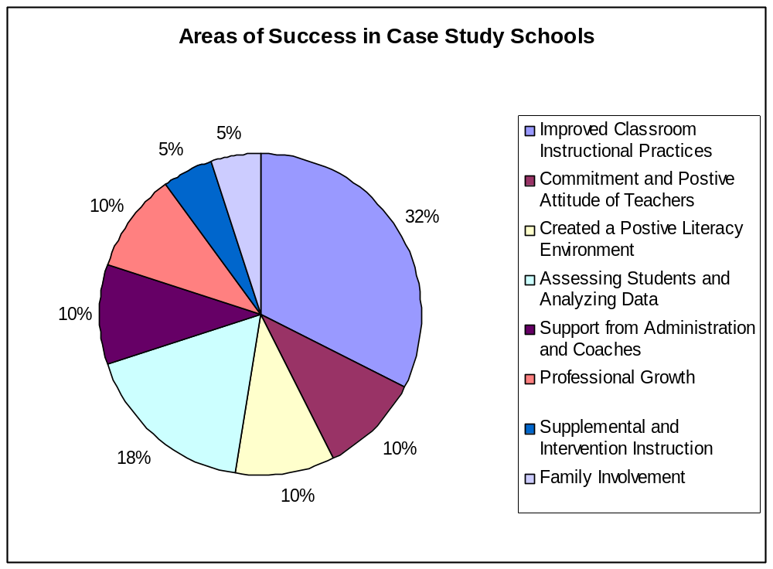

Chapter 6

I. Principal Interviews

The seventeen Reading First case study school principals were interviewed by the Collaborative Center for Literacy Development’s (CCLD) Reading First Evaluation Team during the fall of 2006. Notes from these interviews were compiled according to the individual questions. Based on this data, summaries were completed, and themes noted. This section includes the questions presented to the principals (See Appendix E), quotes, and diagrams or charts that summarize the themes from the data analysis.

II. Themes

Overall successes based on evidence from principal interviews:

- Principals are observing in classrooms and providing feedback to teachers on a regular basis;
- Principals are regularly attending professional development with their teachers, and regularly attending Reading First Literacy Team meetings;
- Reading test scores continue to improve; and
- Fidelity to the grant and implementation continue to be on target.

Overall concerns based on evidence from principal interviews:

- Time constraints, scheduling problems, and funding issues continue to be a problem;
- State regulations, expectations, and information are frequently changing;
- Large amounts of paperwork take away time from explicit planning;
- Supplemental and intervention programs continue to be a challenge; and
- The rigidity of the grant guidelines minimize time for writing and other content area instruction.

III. Evidence

Listed below is each question asked along with charts and graphs to summarize responses given during the 17 principal interviews.

  - How much time do you spend in the Reading First classrooms per week?

The majority of principals interviewed spend over 40 minutes per week in classrooms observing Reading First instruction.

0-20 Minutes | 21-40 Minutes | 41-60 Minutes | 60 + Minutes
5% | 11% | 17% | 67%

  - How much time do you spend conferencing with teachers about their reading instruction per week?

0-20 Minutes | 21-40 Minutes | 41-60 Minutes | 60 + Minutes
22% | 28% | 28% | 22%

  - How do teachers receive feedback?

All seventeen principals reported using multiple methods of feedback. The following table shows the number of responses for each type of feedback.

Informal Conversations | 14
Formal Conversations | 11
Written Form | 9
E-mail | 8
Other-(team meetings) | 3

  - Do you regularly attend the professional development scheduled for
teachers for Reading First?

- Sixteen out of seventeen (94%) responded “yes.”
- One out of seventeen (6%) responded “some.”
- One out of seventeen (6%) was new, and had not yet attended the PD.

  - What areas of reading continue to need the most attention at your
school?

Principals were asked to give their top three areas of concern at their school, and the answers varied widely. Overall, the top five responses were:

Comprehension | 66%
Fluency | 55%
Vocabulary | 39%
Intervention Programs | 17%
Phonics | 17%

The following responses were given no more than twice (out of seventeen principals): literacy centers, open response, teacher turn over, phonemic awareness, pacing for instruction, context clues, analyzing data, test taking skills, home support for the core program, grouping students, addressing all five components in instruction, and maintaining gains from P1/P2 up to grades P3/P4.

  - If you could change any aspect of Reading First, what would it be?

Answers to this question varied widely, but generally fell into three main categories: flexibility, time, and administrative concerns.

Principals would like more flexibility to:
- Amend the grant, adopt a new series
- Use alternate materials for ESL students
- Use time (for other content areas, etc.)
- Adjust PD requirements to correlate with teacher experience
- Continue the program in 4-6th grades
- Have more gradual implementation.

Principals are concerned about the amount of time regarding:
- Professional Development—too much in addition to what they already have done
- Paperwork—too much time spent to amend grant, maintain grant
- GRADE—results take too long to get, not able to use diagnostically for planning.

Principals have administrative concerns regarding:
- The continual changes of information and expectations from KDE
- The coordination of the Reading First action plan and their school’s comprehensive plan
- Establishing guidelines for coaches regarding job experience.

  - What plans does your school have in place to sustain any positive
changes that have occurred as a result of Reading First?

Principals provided a variety of answers to this question. The top six responses were:
Action % Principals Responding
Continue testing with  GRADE and DIBELS | 33%
Keep reading coach | 22%
Continue small groups, interventions, literacy centers | 22%
Continue Professional Development | 16%
Continue supplemental instruction | 16%
Continue five key components | 16%

Other responses given related to expanding the program up through middle school, hiring subs so teachers can do explicit planning, and continuing the 90 minute reading block.

  - Are you involved with the Reading First Literacy Team?

- 88% of principals interviewed responded “yes.”
- 12% of principals interviewed responded “no.”

  - Given the selected eight characteristics from the Marzano study of
effective leadership, choose the three that are most important for
implementing Reading First at your school.

The following table shows the responses to this question:

Characteristic Number of Responses
Curriculum, instruction, assessment | 15
Communication | 13
Culture | 9
Evaluate | 8
Beliefs | 5
Visibility | 3
Affirm | 1
Optimize | 0

  - What threatens the success of Reading First in your school?

Principals reported a range of issues that could threaten the success of Reading First at their schools. These issues generally fell into three categories, relating to teachers, time constraints, and students.
Issues related to teachers:
- High teacher turnover rate
- Discouragement of teachers when test results are not showing progress
- Older teachers much slower to embrace RF changes
- Lack of support for teachers from state coach
- Difficulties following grant requirements and meeting needs of special education and ESL students
- Constant changes in the grant, info from KDE
- Rigid PD requirements

Issues related to time constraints:
- Duplicate work
- Special activities always interrupt other content area instruction
- Students miss writing and content area instruction during intervention instruction
- Not enough time to explore all resources related to core
- Progress monitoring is very time consuming

Issues related to students:
- Student population is very large—42 classrooms
- High number of transient students
- Students have frequent late attendance, miss core work

Two principals (11%) reported “no threats” to Reading First at their schools. One stated,” Teachers see that the research based methods are better than what they were doing….Test results are so positive…(RF) has been an asset to our school.” It is interesting to note that on the 2005 principal survey the same question was asked, and 50% of the principals interviewed reported “no threats” to the success of Reading First at their schools.

Chapter 7

I. School Coach Interviews

Chapter 7 includes three sections: A, B, and C. Section A is the summary of the Fall 2006 school coach interviews (See Appendix F). Section B is the summary of the Winter 2007 school coach interviews (See Appendix G), and Section C is the summary of the Spring 2007 school coach interviews (See Appendix H).

Section A – Fall 2006

IA. School Coach Interviews

During the fall of 2006, the Collaborative Center for Literacy Developments’ (CCLD) Evaluation Team observed all seventeen of the selected case study schools for the 2006-2007 school year. During these observations, the evaluators conducted an interview with the school coach at each school. One of these schools now has two reading coaches, and at that school, both coaches were interviewed individually. Interview responses from the school coaches were compiled and grouped together according to the individual questions. Using this data, summaries were completed and themes were noted. Included in this section are the overall successes and concerns that summarize the trends or themes of the school coach interviews, the individual questions asked, the coaches’ responses, and selected quotes and comments given by the school coaches during the interviews.

IIA. Themes

Overall successes based on evidence from Fall 2006 school coach interviews:
- Coaches place a high importance on modeling in the classrooms, assisting teachers with testing, and conferencing with teachers;
- The majority of school coaches interviewed feel the Kentucky Department of Education (KDE) along with their principals provide an extensive amount of support at their school for RF;
- The majority of the coaches report that 100% of their participating RF teachers are implementing “best practices” in their classrooms for reading instruction;
- The majority of the schools report they are monitoring their intensive students more often than any other students; and
- All of the schools, with the exception of one, have identified specific goals for the implementation of RF at their schools for this school year.

Overall concerns based on evidence from the Fall 2006 school coach interviews:

- Only two school coaches reported “explicit lesson plans” as an area for development at their participating RF school;
- All of the school coaches, except one, reported specific goals for their schools reading instruction this year; yet, according to school coaches only 37% of these goals are measurable goals; and
- The majority of the school coaches (73%) are spending less than 40 minutes modeling in classrooms on a daily basis.

IIIA. Evidence

Listed below is each question asked along with charts and graphs to summarize responses given by all seventeen school coaches.

1. How would you rank your school coaching duties in order of importance?

The following chart represents the mode as given by the school coaches as how they would rank the listed responsibilities. One is the highest ranking and what the school coaches deem as the most important duties of school coaches and seven is the lowest ranking and what coaches regard as the least important duties of school coaches.
Lowest 7 | Completing necessary administrative tasks
6 | Attending and chairing RF meetings
5 | Testing
4 | Providing professional development
3 | Conferencing with teachers
2 | Observing in the classroom
Highest 1 | Modeling lessons in classroom

2. Do you have an assistant?

Out of the 17 school coach interviews, 50% of the coaches reported they do not have an assistant, and 50% reported that they do have an assistant at some time during the school day.

3. Do you have a RF literacy team in place?

Out of the 17 school coach interviews, with the exception of one, all of the coaches declared they have a Reading First literacy team in place.
4. If yes, who sets the agenda for the RF literacy team?

The majority of the school coaches (89%) set the agenda for the Reading First literacy teams. Two coaches reported otherwise. One school coach reported the district coach as the responsible party for setting the agenda, and the other coach reported determining the agenda with the assistance of the principal.

5. If yes, what does the RF literacy team do?

Listed below are several tasks of the RF literacy teams:

- Review and analyze school data;
- Update teachers on events and progress;
- Plan literacy nights and home/school connections;
- Create and complete monitoring tools;
- Create reports and action plans;
- Review IARPs;
- Review budget, plan spending;
- Plan PD and support for teachers;
- Pinpoint intensive and strategic students;
- Discuss “best practices” for teachers; and
- Plan interventions and discuss individual students.

6. How would you rate your support from KDE?

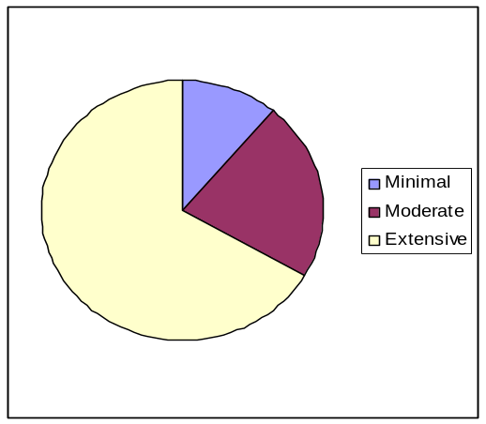

7. How would you rate your support from your district?

Minimal
Moderate
Extensive

8. How would you rate your support from your principal?

Minimal
Moderate
Extensive

9. On an average day, how much of your time is spent in the classrooms modeling reading lessons?

The following chart represents the percentage of time school coaches spend in the classrooms modeling reading lessons.

0-20 minutes | 21-40 minutes | 41-60 minutes | 61+ minutes
47% | 26% | 16% | 11%

10. On an average day, how much of your time is spent in the classrooms observing?

The following chart represents the percentage of time school coaches spend in the classrooms observing.

0-20 minutes | 21-40 minutes | 41-60 minutes | 61+ minutes
17% | 17% | 27% | 39%

11. On an average day, how much of your time is spent conferencing with individual teachers?

The following chart represents the percentage of time school coaches spend conferencing with individual teachers.

0-20 minutes | 21-40 minutes | 41-60 minutes | 61+ minutes
17% | 44% | 28% | 11%

12. How often are you progress monitoring students per month?

The following charts below represent progress monitoring and how many times per month each school monitors students for that area. The majority of the schools reported monitoring intensive students more often than benchmark students.

Times/month intensive students  are being monitored | Percentage of schools monitoring
4 | 55.5%
3 | 5.5%
2 | 39%

Times/month strategic students  are being monitored | Percentage of schools monitoring
3 | 6%
2 | 72%
1 | 22%

Times/month benchmark students  are being monitored | Percentage of schools monitoring
3 | 12%
2 | 0%
1 | 88%

13. How many total classroom teachers participate in RF?

The chart below represents the number of teachers participating in Reading First at the participating schools.

Number of participating  teachers | Number of  schools
11 | 1
12 | 1
13 | 2
14 | 4
15 | 3
16 | 1
21 | 1
23 | 1
25 | 1
31.5 | 1
47 | 1

14. How many RF teachers are implementing “best practices” at your school during reading instruction?

While the majority of the school coaches feel 100% of their teachers are implementing “best practices” during reading instruction, there was a range of responses to this question with the lowest percentage being 71% and the highest being 100%. About 1/5th of the school coaches reported their teachers as implementing “best practices” between 71% and 81% of the time.

15. What areas of reading continue to need the most attention at your school?

The following table represents the areas school coaches have identified as areas of attention for their schools. While the five components are all still a main focus, comprehension (21% of the responses) is the most common focus. Literacy centers (12% of the responses) and monitoring and analyzing data (7% of the responses) are also areas that school coaches have identified as areas of need for participating schools.

Comprehension | 9
Effective literacy/reading centers | 5
Vocabulary | 4
Phonemic awareness | 3
Fluency | 3
Analyzing and monitoring data | 3

Phonics | 2
Small group instruction | 2
Using data to drive instruction | 2
Individual school coaches reported these areas: focus on students reading, differentiation, reducing worksheets, higher level questions, explicit lesson plans, classroom pacing, intervention, time management, PD, and intensive instruction for IARP students | 1

16. Are you implementing new changes for RF at your school this year?

All schools, except one, reported making new changes for RF at their school this year. The new changes to their implementation included:

- focusing on explicit teaching;
- using data to plan instruction;
- explicit lesson planning;
- adding a new additional coach;
- more of a focus on comprehension, vocabulary, and/or phonics;
- specific focus on word identification strategies;
- using lesson plan grids to address the five components of RF;
- amending the grant to change assessment;
- adding a new coach or new personnel;
- adding a phonics program or new intervention program;
- teaching strategies for test taking skills;
- additional literacy nights;
- changing PD activities relating to data results; and
- focus on explicit lesson plans or instruction.

17. Has your school identified specific goals for this year’s reading instruction?

All of the schools, except one, reported identifying specific goals for this year’s reading instruction. For all of the schools, the goals were very specific for their school. Schools reported goals that were specific to their assessment results. Goals identified include:
- working on fluency
- phonemic awareness and comprehension
- focusing on explicit instruction in all five RF components
- improving classroom libraries
- being more strategic during reading instruction
- incorporating oral language during instruction
- decreasing the gap with special education students
- reducing the number of strategic and intensive students
- setting a specific goal for the entire school of 75% for GRADE
- getting all students by 3rd grade reading at or above grade level
- challenging higher level students
- moving every tier to progress
- intervention at 2nd and 3rd grade
- planning more specific professional development
- getting 80% of students to benchmark
- explicit lesson plans
- higher level questioning during reading instruction.

18. What on-going professional development (PD) is planned for this school?

The most common types of PD planned for the schools participating included a focus on the five components with an intense focus on vocabulary, fluency, and/or comprehension, adding book studies for teachers, data analysis, explicit lesson planning, collaboration with grade level teams, and differentiating instruction.

19. How are you collaborating with other non RF schools and non RF districts for professional development?

Most of the school coaches (83%) reported collaborating with other schools through their PD at their district level or simply by inviting other schools in the district to attend their RF planned PD at their schools, including their book studies, demonstrations, or district team meetings. Inviting non-RF schools to participate in GRADE and/or DIBELS training and sharing in demonstrations (33%) were additional common approaches to collaboration. There was a small percentage of schools (17%) reporting no collaboration.

20. How many school-wide family literacy events do you have planned for this school year?

Out of the seventeen school coaches reporting, 35% reported to have planned one family literacy event per month for the year. The second highest percentage was 18% with four family literacy nights planned for the entire year. The rest of the schools reported either one grade per month, one to five per year, and four times per month. Examples of family literacy nights include back to school bash, family reading night, storytelling, reading carnival, family literacy nights, open house, doughnuts with dads, and muffins with moms.

21. What plans does your school have in place to sustain the positive changes that have occurred as a result of RF?

Out of the thirty different responses about areas that schools will sustain positive changes that have occurred as a result of RF, four school coaches reported they have no plans. The following chart represents the areas that will be sustained when the grant is completed and the percentage of school coaches responding to that specific area to be maintained.

0
5
10
15
Reading Coach Position
90 minute reading block
5 RF components
RF assessments
Research based PD
Family literacy nights
Explicit instruction
Data driven instruction
RF materials
"Best practices" for teachers
Intervention teacher
Grade level teacher leaders

Section B – Winter 2007

IB. School Coach Interviews

The Collaborative Center for Literacy Development (CCLD) Reading First Evaluation Team interviewed 17 Reading First Literacy Coaches during the Winter 2007 site visits. (There are 17 case study schools for 2006-2007, with one school so large it has 2 Reading First School Coaches.) Questions were asked regarding use of time, professional development, core programs, and data analysis. Data from these 17 interviews was compiled, summarized, and analyzed; discussion of themes, concerns and questions may be found in the sections below.

IIB. Themes

Overall successes based on evidence from winter school coach interviews:

- 70% report spending at least 40 minutes a day observing in classrooms, and 56% report spending at least 40 minutes a day conferencing with teachers.
- 95% report they are in the process of meeting their school’s needs, or have already met their school’s needs through on-going professional development.
- 47% of school coaches report grade level data analysis is done on a weekly basis, or at least 8-12 times since the beginning of the school year.
- 72% report progress has been made during the current school year to reach specific goals regarding GRADE/DIBELS scores, and/or fluency and comprehension achievement goals.
- 84% report moderate or extensive support from their state coach.

Questions and concerns based on evidence from winter school coach interviews:

- 83% report comprehension needing the most improvement at their school.
- 28% report either fluency or vocabulary needing the most improvement at their school.
- 73% report their core program minimally addresses fluency, vocabulary, or comprehension.
- 95% report spending less than 40 minutes a day in classrooms modeling reading lessons.
- 5% report progress toward specific goals on explicit planning; 22% report successful professional development regarding explicit planning.
- 55% report having one or two family literacy events. 50% report the overall success of their family literacy events was moderate.
IIIB. Evidence

  - Currently, how much of your time is spent in the classrooms modeling reading lessons on an average day?

Minutes per Day School Coaches Model Reading Lessons in Classrooms

0-20 | 21- 40 | 41- 60 | 60 +
56% | 39% | 0% | 5%

  - Currently, how much of your time is spent in the classrooms observing on an average day?

Minutes per Day School Coaches Observe in Classrooms

0-20 | 21-40 | 41-60 | 60+
5% | 5% | 28% | 62%

  - Currently, how much of your time is spent conferencing with individual teachers on an average day?

Minutes per Day School Coaches Conference with Individual Teachers

0-20 | 21-40 | 41-60 | 60+
11% | 33% | 28% | 28%

  - Considering the school’s on-going professional development, how would you describe the level of accomplishment to meet your school’s needs?

- Currently planning: 5%
- Planned, but not implemented: 39%
- Already implemented: 56%

  - Describe one successful professional development your school has participated in this year.

Answers to this question varied. The top four responses were:
    - Data analysis (22%)
    - Explicit planning (22%)
    - Focus on all five components (17%)
    - Vocabulary instruction (17%)
Other successes mentioned included using data boards, learning center development, and small group instruction for struggling readers.

6. Which of the five components does your core program address extensively?

Components Addressed Extensively in Core

Phonics | Phonemic Awareness | Fluency | Vocabulary | Comprehension
61% | 22% | 5% | 11% | 22%

*Some coaches marked more than one response to this question.

7. Which of the five components does your core program address
minimally?

Components Addressed Minimally in Core

Phonics | Phonemic Awareness | Fluency | Vocabulary | Comprehension
11% | 17% | 39% | 17% | 17%

*Some school coaches selected more than one response on this question.
*One school coach noted, “It (the core) addresses them all”

- After analyzing student assessment data, which component have your teachers identified as needing the most attention?

Core Component Needing Most Improvement

Phonics | Phonemic Awareness | Fluency | Vocabulary | Comprehension
5% | 5% | 17% | 11% | 83%

- How many times has your school analyzed student data this school year?

This question was divided into three parts, summarized below:

School wide analysis of student data this year:

- None (18%)
- Once (11%)
- Twice (50%)
- 3-6 times (5% for each)
Grade level analysis of student data this year:

- None (11%)
- Weekly (18%)
- Every other week (5%)
- 3,6,10 times (5% each)
- 5 times (22%)
- 8 times (11%)
- 12 times (18%)

Individual teacher analysis of student data this year:

- None (11%)
- Weekly (22%)
- As needed (18%)
- 5,6,13 (5% each)
- 12 times (18%)

- To this date, how many family literacy events have you held?

- 5 family literacy events (44%)
- 2 family literacy events (33%)
- 1 family literacy event (22%)

- How would you rate the overall success of these events?

Minimal Moderate Extensive
17% 50% 33%
- Please describe the progress you have made toward the specific goals you set for this school year.

Responses to this question varied.
- Specific improvements related to GRADE and DIBELS scores (33%)
- Improvements specifically in fluency (22%)
- Improvements specifically in comprehension (17%)
- Data driven instruction (11%)
- Literacy center planning/activities (11%)
- ESL, classroom libraries, explicit planning (5% each)

- How would you rate the support you receive from your state coach?

Minimal Moderate Extensive
11% 17% 67%
- Describe one specific support from the state coach you have received this year.

Answers to this question varied.
- Data analysis (22%)
- Focus on supplemental/intervention instruction (11%)
- Assistance with IARP’s (11%)
- Assistance with classroom observations, coaching teachers (11%)
- Source of information on research, state expectations (11%)
- Explicit lesson planning, professional development, data boards (5% each)

Section C – Spring 2007

IC. School Coach Interviews

The Collaborative Center for Literacy Development (CCLD) Reading First Evaluation Team interviewed 17 Reading First School Coaches during the Spring 2007 site visits. (There are 17 case study schools for 2006-2007, with one school so large it has 2 Reading First school coaches.) Questions were asked regarding implementation successes/concerns, instructional improvements achieved and desired, and action plans for next year and beyond the grant. Data from these 17 interviews was compiled, summarized, and analyzed; discussion of themes, concerns, and questions may be found in the sections below.

IIC. Themes

Overall strengths based on evidence from spring school coach interviews:

- 50% report their “biggest success” this year was using data to inform or drive instruction.
- 61% report implementing new information from the Susan Hall (read alouds) or Tonya May (vocabulary) during this school year.
- 50% report an increase in explicit instruction; in the Winter 2007 school coach interviews, only 5% reported progress toward explicit planning goals.
- 44% report an increase in differentiation during instruction.
- 83% report teachers finding the RF assessments easier to manage.
- 100% report using more than one strategy to address the needs of students who are still struggling.

Overall Concerns based on evidence from spring school coach interviews:

- 33% report a need for improvement in explicit instruction. Only 11% report explicit planning as a component of their action plans for next year. While half the school coaches reported improvements in this area, one third still see it as a need, and less than a third have it as a focus for next year.
- Less than half (44%) report data analysis as a school-based structure to sustain RF objectives after the grant expires. If data analysis is not sustained in all RF schools, will student needs continue to be met, and reading achievement continue to increase?
- 33% report plans to continue the school coach position after the grant expires. If this leadership is not available to teachers, are there others on the faculty prepared to assist in leading their peers? (i.e. experienced teachers, district personnel.)

IIIC. Evidence

  - What has been your biggest success this year with Reading First implementation?

School coaches have more than one response to this question, with half citing the use of data to inform or drive instruction.

Reading First Success Response
Use of data to inform or drive instruction | 50%
Test scores improved | 33%
More individual student needs met | 33%
Teachers more knowledgeable regarding instruction | 22%
Teachers using explicit instruction | 11%
Child Study Team created to target struggling students | 6%
Second school coach added to faculty | 6%

  - What do you consider your biggest concern?

Responses about concerns were more varied than successes; 22% of school coaches cited multiple concerns.

Reading First Concerns Response
Some students still not on grade level  despite multiple and varied interventions | 28%
Funding not available from other sources  after grant ends | 17%
School coach position will not be continued  after grant ends | 17%
Turnover in school leadership or teachers | 11%
Core program/instruction not continuing  after grant ends | 11%
Inconsistencies among teachers  regarding instruction | 11%
Large amount of testing, especially for  3rd graders—time consuming | 11%
Teacher buy-in to program | 6%
Core will be switched after grant ends | 6%
Scheduling time to fit 90 minutes, intervention  supplemental into instructional day | 6%
ELL students—challenges teaching and testing | 6%
Improvements in explicit instruction will not continue | 6%
Time management throughout instructional day | 6%

  - Have you applied new information from conferences or seminars attended this school year?

The majority of school coaches (89%) responded that their teachers applied specific new ideas, programs, or strategies this school year. The remaining 11% responded with general comments, stating they had used new information received at conferences or seminars. Listed below is a summary of the specific information school coaches shared in response to this question.

- 44% reported implementation of read aloud strategies from Susan Hall
- 17% reported implementation of vocabulary strategies from Tonya May
- 11% reported application of strategies regarding the following:

Quick Phonics Screener, data analysis, explicit instruction

- 6% reported implementation of strategies regarding the following:

Questioning strategies
Student engagement
Struggling readers
Comprehension
Marie Carbo
IARP’s
Literacy centers
Walk throughs
Summer school ideas
Family literacy
Differentiation in instruction
ELL—instruction strategies
GRADE analysis (type)

4. Describe specific improvements you have observed in teachers’
instruction over the course of the year.

School coaches gave multiple responses to this question, with the top three relating directly to instructional delivery.

Teacher Areas of Improvement

Increase in explicit instruction | 50%
Increase in differentiation | 44%
Teaching specific strategies to students | 22%
Data driven instruction | 22%
Mentoring teachers new to RF | 6%
Teacher confidence has increased | 6%
Increase in higher level questioning | 6%
Use of flexible groups during literacy centers | 6%

5. Are there specific instructional improvements to be made by your
teachers?

School coaches noted a wide variety of specific areas they would like to target for teacher improvement.

Teacher Improvement Targets for 2007-2008

33% | Explicit Instruction
22% | Comprehension strategies
17% | Differentiation of instruction, Small group instruction
11% | Vocabulary instruction, Literacy centers, Scaffolding instruction, Continue to refine instruction
6% | Prepare students for portfolios, Whole group instruction, Special needs students, Assist first year teachers, Increase higher level questioning, Improve communication, Phonics, Lesson modifications, Supplemental

6. Do you and the teachers find the assessments easier to manage?

The majority of school coaches (83%) answered positively, many with specific examples of what they are doing to manage RF assessments. The remainder (17%) expressed concern about the difficulties of managing the required assessments, combined with other state mandated assessments. More specifically:

- 17% discussed data analysis and management
- 11% discussed collaboration and use of teachers to assist with administering assessments
- 6% discussed teacher use of the GRADE resource library

On a positive note, one coach shared:

“Teachers have finally begun to feel more comfortable doing assessments because they can access the results themselves. They feel ownership in the assessment process.”

Others stated:

“This year we have really learned how to look and better understand our data. We are constantly looking and re-looking at data, because we understand what we are looking for. Teachers are understanding the purposes of the different assessments and are more willing to use them to drive their instruction.”

“We are more comfortable with and understand assessment. They are getting better with it, and they see the overall purpose for assessment. They understand how to use assessment information for individual instruction. It is still stressful. Progress monitoring has become old hat. They are using the GRADE resource library more.”

A few shared these notes of concern:

“Still difficult to manage—lots of assessments, especially with progress monitoring and SFA (Success for All) assessments.”

“The end of year testing will be hard to manage for 3rd grade—Terra Nova, state testing in math and reading, DIBELS, GRADE—hard for ELL (English Language Learner) students particularly.”
- What school-based structures are in place to sustain Reading First
objectives after the grant expires? (i.e. grade level meetings, data
analysis, etc.)

The majority of school coaches (83%) discussed multiple structures to assist in sustaining RF goals at their school. Only one school coach shared that there were “no definite plans in place” to sustain RF objectives. The table below summarizes their responses:

Structures to Sustain Reading First Objectives
61% | 44% | 33% | 17% | 11% | 6%
*Grade  level  meetings | *Data  analysis | *Continuing  school  coach  position | *Planning  days (with subs for  teachers) | *Teacher  knowledge  of 5 key  components  *Explicit lesson  planning  *Leadership  team  *Training in  core  program/PD  *Common  planning  times for  teachers | *Literacy team  *Light Span  Lab  *Bookroom of  teacher  resources  *Reading  Recovery  small group  intervention  *Child Study  Team  *Response to  Intervention  Team  *Keep 90  minute  reading block  *Improvements  in teacher  attitude

- What have you done to address students who are still struggling with
making progress?

All of the school coaches shared multiple responses to this question, ranging from 2-7 strategies/actions to address the needs of struggling students. The table below summarizes their responses:

Strategies and Resources Used to Address Struggling Students

39% | 33% | 28% | 22% | 17% | 11% | 6%
*IARP’s | *Small group instruction | *Better  use  of teachers, schedules | *Regroup  students | *School  coach  meets  with  teacher  to  assist, discuss  individuals | *ESS  *Literacy/  Leadership  Teams  *Pull out  intervention  *Differentiation  of instruction  *More 1 on 1  instruction | *Intervention  program  *Use of  volunteers  *School coach  assists with  assessments  *GRADE Resource  library  *Incentives/rallies  *Hot List of  students  *Reading  readiness  instruction  *Mentors for new  teachers  *Response to Intervention Team  *Phonics  screener  *Family literacy  Events

- What will be your action plan for next year’s implementation?

The majority (89%) of school coaches described more than one “action” for their coming year’s action plan. Answers ranged from general comments to very specific ideas. For example, one school coach shared:
“After the initial round of testing we have decided to pull out those students who score in the 30’s and 40’s percentiles three days/week for interventions. The intensive students will receive interventions in the regular classroom. ESS will also be offered to those struggling students.”
Another shared:
“Improve in delivery of instruction. Improve in lesson planning process. These two go hand in hand and are two areas we need to concentrate on. PD more needs based—individualized according to teacher needs. Work earlier in the year with struggling students.”

The table below summarizes their responses:
Action Plan Components for Coming School Year
33% | 17% | 11% | 6%
- Lesson plan adaptations | - Teaching specific  strategies  - Differentiated  Instruction  - Literacy centers | - Focus on vocabulary  strategies  - Growth in writing  - Explicit instruction  - Parent/home connection | - Work earlier with struggling students  - Growth in open response  - Extra PD—targeted to teacher needs  - Literacy First PD  - New materials on 5 key components  - Growth in assessment  - Teaching specific literacy skills  - Pull out intervention for students scoring in 30/40 percentiles  - ESS  - Data analysis  - Building teacher leadership  - Marie Carbo training to become a model school
Chapter 8

I. Teacher Questionnaire

During the winter of 2007, the CCLD asked school coaches at each of the 17 case study schools to distribute questionnaires (See Appendix I) to eight teachers. Of the 127 questionnaires returned, 124 were completed by female teachers and 3 by male teachers. All primary grade levels were represented equally with grades 1-3 returning 32 questionnaires each. Kindergarten teachers’ returned responses totaled 31. Responding teachers exhibited a range of teaching experience. Fifty-seven percent of teachers indicated 0-9 years of teaching experience while forty-three percent of respondents indicated 10-17 or more years of experience. This chapter contains the questions teachers were asked and a summary of their responses.

II. Themes

Overall successes based on evidence from teacher questionnaires:
- The majority of teachers (88%) approve of their core reading program.
- Teacher responses regarding reading strategies they are teaching students indicated a focus on comprehension at all grade levels, K-3.
- Seventy-six percent of teachers said they talk about books they are reading with students.

Overall concerns based on evidence from teacher questionnaires:
- Teachers (67%) expressed difficulty managing, organizing, creating new activities, and developing differentiated activities for literacy centers.
- Teachers (35%) indicated time for planning activities was the most needed resource for center development. Many noted planning with colleagues, make-it take-it workshops, and observing successful centers in teachers’ classrooms as needed professional development opportunities.

III. Evidence

Core Reading Program

Overall, do you like your core reading program?
Do you like the stories in your core reading program (i.e. are they interesting, engaging, culturally responsive?)

The majority of teachers (88%) said they like their school’s core reading program. Eighty-nine percent of teachers said they like the program’s stories.

Does your core program connect to other content areas?

Thirty-three percent of teachers find their programs always integrate other content areas within its curriculum. Over half of the teachers (66%) find their programs sometimes connect to other content areas, and one percent of teachers never see the program’s connections.

How would you rate the overall comprehensiveness of your core reading program? Minimal Moderate Extensive

The following chart shows teachers’ rating of their core programs’ comprehensiveness:

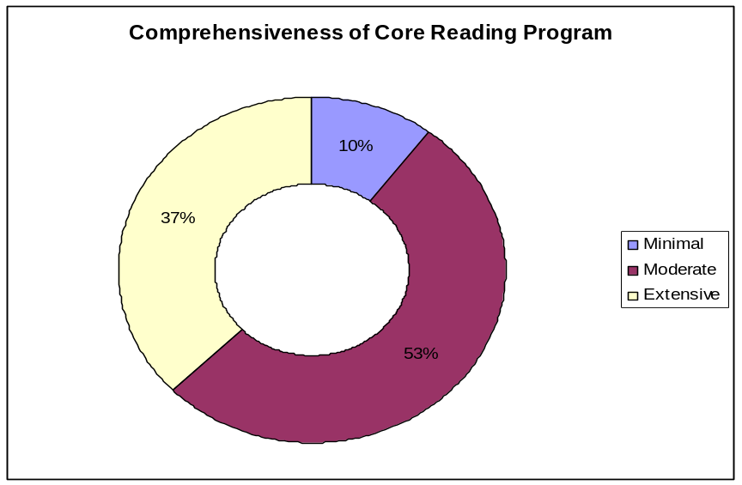

The three genres appearing most frequently in schools’ core reading programs include animal stories, expository text, and fairytale or fantasy stories, respectively.

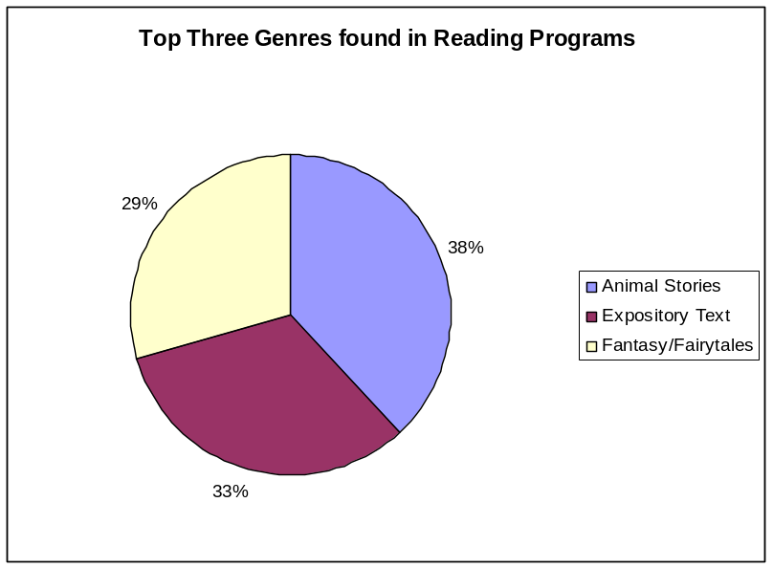

Literacy Centers

The majority of teachers (87%) answered “yes” when asked if literacy centers are beneficial for students. Teachers plan center activities to reinforce lesson concepts, address the five components, and provide opportunities for writing. Eighty-seven percent of teachers plan for students to work in literacy centers five days a week. Nine percent have centers four days a week, while four percent have centers only three days per week. Teachers indicated a variety of intervals for which they change center activities. These intervals are indicated in the following chart:

How often do you change center activities?
Once a month | 9%
Twice a month | 15%
Twice a week | 15%
Once a week | 61%

Only twenty-nine percent of teachers rated their literacy centers as having an extensive quality level. The majority (66%) rated center quality as moderate, and 5% rated their centers with minimal quality.

Center Quality Ratings
Minimal | 5%
Moderate | 66%
Extensive | 29%
Thirty-nine percent of teachers spend between 0 and 2 hours a week planning center activities. This is the same percentage reported for teachers spending 3 to 4 hours per week. Teachers spending the most time planning centers are included in the chart below.

Literacy Center Planning Per Week
0-2 hours | 39%
3-4 hours | 39%
5-6 hours | 13%
7-8 hours | 6%
8+ hours | 3%

As indicated by teacher responses, creating literacy center activities is time consuming. Forty-five percent of teachers create their own center activities. Many teachers (50%) use commercially produced centers in addition to creating their own activities. Seven percent of teachers use only commercially produced activities in their centers.

What area of improvement would you identify for your literacy centers?

Teachers identified six main areas for center improvement. This chart exhibits these areas and a list of examples.

Improvement Areas | Examples
Management | Organization, Time to do centers, Rotation, Developing easy directions, Task cards, Change them more often, Students staying on task, Storage
Activities | More creativity with activities, More hands-on, Fewer worksheets, Activities to connect to core, More specific with skills, Connect activities to other content areas, More ideas
Differentiation | Differentiated activities, Provide more choices for students, Appeal to advanced readers
Components | More comprehension activities, Fluency activities, Phonics practice without worksheets
Accountability | Better assessment, Student accountability
Materials | Need books on tape, More manipulatives, Extra game materials

What resource do you need to help you successfully develop and implement literacy centers in your classroom?

Teachers identified eight areas which would help them develop and implement literacy centers. This chart exhibits these areas with a list of examples following the chart.

Resources Needed for Center Development
0
5
10
15
20
25
30
35
40
45
Time to Plan
More Materials
More Ideas
Additional Person
Professional Development
Class Size
Money
Space

Resource | Example
Time to plan | Time to work with colleagues to develop activities, Time to teach students how to use centers independently, Time to make centers
More Ideas | Resource books with center ideas, Activities to correlate with core program, Easy to challenging activities
More Materials | Computers, Manipulatives, Ready-made centers, Phonics materials
Additional Person | Instructional assistant during centers
Professional Development | PD on center development, Observe successful teachers’ center time, Make-it, Take-it workshop for centers
Class Size | Smaller class size to manage
Space | Space to organize centers
Money | Additional money to purchase center materials

Reading Instruction

During reading instruction, which group do you utilize most often? Please rank the top three groups, with one being the group you utilize most often, two being the group you utilize often and three being the group you utilize least.

The most frequently used grouping for reading instruction rated 1 to 3 by teachers is small group instruction. Whole group is rated second in frequency, and partner/paired groups are third, with independent reading practice a close fourth. Five percent of teachers said they use dramatic reading as the third most frequent method for reading practice. The following chart indicates the percentage of teachers who ranked reading practices from 1-3:

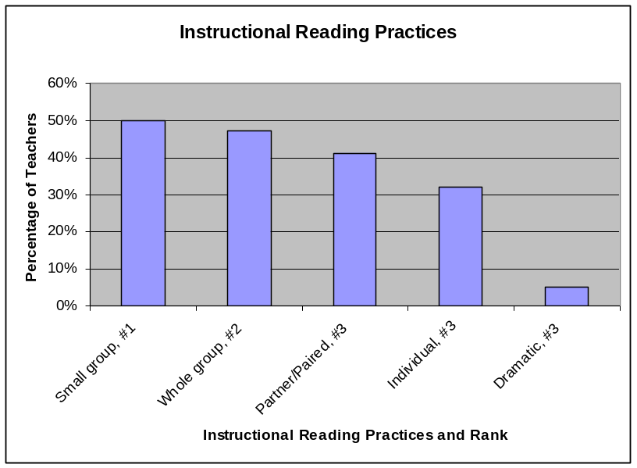

What do you feel is an important skill/strategy you have taught your students in order to make them better readers?

Many of the teachers’ responses indicated comprehension and decoding strategies as important in helping their students to become better readers. The following table includes examples of the skills and strategies listed by teachers based on grade level.

Grade Level | Skills and Strategies
P1 | Tracking print from left to right, Blending and segmenting sounds, Reading for interest and enjoyment, Sight words, Phonics, Phonemic awareness, Rereading, Making connections, Summarizing, Predicting, Asking questions, Mental imagery, Decoding skills

P2 | Decoding strategies, Use of context clues, Monitoring, Predicting, Questioning, Rereading, Summarizing, Making connections, Reading for purpose and enjoyment, Prosody
P3 | Making inferences, Rereading, Decoding skills, Prosody, Chunking, Vocabulary development, Story elements, Questioning
P4 | Monitoring, Predicting, Making connections and inferences, Retelling, Summarizing, Visualizing, Decoding

What do you feel is a skill/strategy students have difficulty applying to their reading practice?

Comprehension skills and strategies were indicated most often by teachers as difficult for students to apply to their reading practice. The following table includes examples listed by teachers based on grade level.

Grade Level | Difficult Skills and Strategies
P1 | Retelling, Summarizing, Monitoring, Clarifying, Building background knowledge, Questioning, Applying word families to text, Blending, Segmenting
P2 | Clarifying, Monitoring, Making inferences, Retelling, Questioning, Summarizing, Decoding strategies
P3 | Questioning, Main idea, Making inferences, Cause/Effect, Summarizing, Context clues, Decoding strategies, Prosody
P4 | Making inferences, Questioning, Main idea, Visualizing, Prosody

Reading at Home

The responses to the following questions are summarized below:

Do you require students to read at home?
Do you tell your students about books you have read regularly?
Do you have time to read at home during the week?
If you have a chance to read, which type of book would you likely read?

Ninety-four percent of teachers said they require students to read at home, while 72% said they have time to read at home during the week. Seventy-six percent of teachers said they tell students about the books they read on a regular basis.

Although 72% of teachers said they have time to read at home, only 18% indicated reading as an after-school activity. Seventy-two percent of teachers
chose work related activities such as grading papers as an after-school activity. The following chart indicates the variety of reading materials teachers choose to read at home.

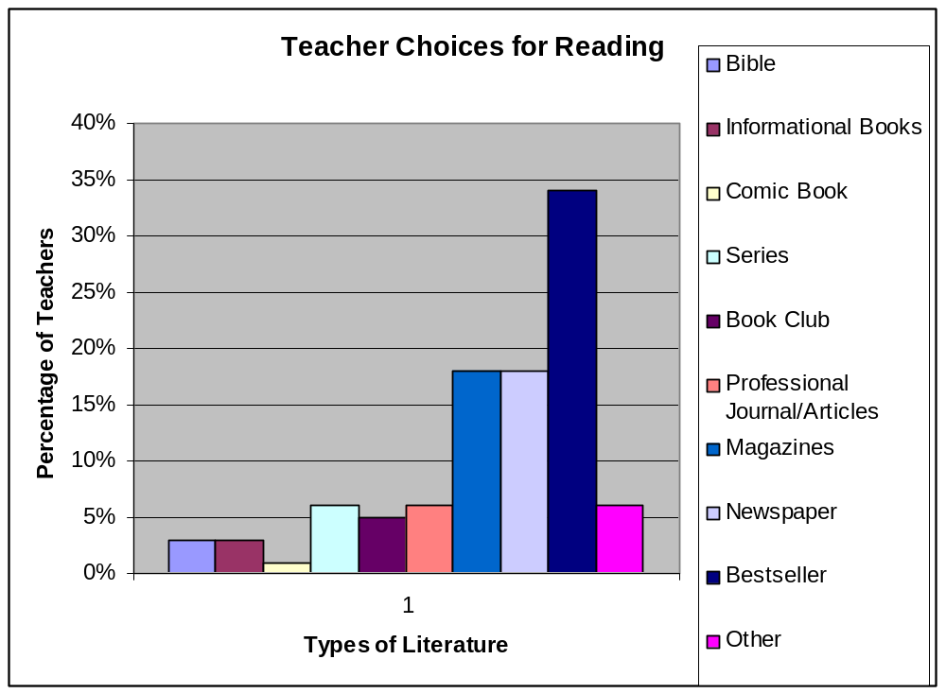

Chapter 9

I. Supplemental and Intervention Observations

Section A - Supplemental Instruction Observation

IA. Introduction

Sixteen supplemental programs were observed by the Reading First Evaluation Team during the winter site visit. Evaluators rated the instructional process and reading components, recorded classroom reading practices, and took anecdotal notes during the thirty minute observation. The ratings and notes were analyzed and summarized based on common trends and themes. Included in this section are the overall themes and specific evidence acquired during the observations.

IIA. Themes

Overall successes based on evidence from supplemental observations:
- Student engagement and mode of delivery were at the extensive level with 53.3% and 43.8% respectfully;
- 75% of supplemental instruction was delivered with little or no distractions
- Phonemic awareness was rated at the extensive level 40% of the time, while phonics was rated extensive 41.7%;
- Instructional checklists revealed high frequency on the categories of guided practice of skill (75%), concept explained and modeled (62.5%), teacher provides statement of objective (62.5%), and teacher provides positive, specific feedback (62.5%);
- Large percent (68.8%) of the supplemental groups conducted guided reading; and
- Variety of hands-on learning opportunities and types of reading were observed.

Overall concerns based on evidence from supplemental observations:
- 50% of vocabulary instruction was rated minimal;
- Fluency was rated extensive on only 7.7%, vocabulary 8.3%, and high level questioning 18.8%;
- None of the supplemental groups employed tape assisted reading and only one group (6.3%) used dramatic / readers theater;
- Only 12.5% of supplemental groups engaged students in meaningful discussions or had student generated questions, and only 18.8% practiced fix-up strategies; and
- 43.8% of supplemental groups offered no hands-on manipualtives during instruction.
IIIA. Evidence
1. The following contains the grade levels observed, number of students in supplemental groups, and description of the supplemental learning environment.

Supplemental observations ranged from grades P1 to P4; however, P2 was the grade level most often observed by the evaluators. The number of students in groups ranged from three students to twenty-three students. The mode of students most often observed was a total amount of five students. The most frequent location of supplemental instruction was in the classroom at 87.5%, one intervention group took place in a resource room, and one group met in a Light Span lab.

2. The following depict the minimal, moderate, and extensive percentage ratings from a variety of instructional categories and reading components. Note however, that the percentages for the reading components may appear higher due to the fact that not all observations were rated all five components:

Category/Component | Minimal | Moderate | Extensive
Mode of delivery | 6.3% | 50% | 43.8%
Student teacher interactions | 25% | 50% | 25%
Student engagement | 6.7% | 40% | 53.3%
Higher level questioning | 25% | 56.3% | 18.8%
Phonemic awareness | 30% | 30% | 40%
Phonics | 8.3% | 50% | 41.7%
Vocabulary | 50% | 41.7% | 8.3%
Fluency | 30.8% | 61.5% | 7.7%
Comprehension | 33.3% | 41.7% | 25%

3. Supplemental instruction is presented with little or no distractions. Seventy-five percent of the supplemental instruction had little or no distractions; twenty-five percent had distractions during the instructional process.

4. There were a variety of hands-on learning experiences observed
during supplemental instruction. These were:
  - 6 out of 16 supplemental classrooms used a variety of hands-on experiences (i.e. letter tiles, sentence strips, word cards, white boards, Light Span games);
  - 3 of 16 supplemental lessons used worksheets; and
  - 7 of 16 used no hands-on manipulatives.
5. Evaluators were asked to use a small group instructional checklist to
record the number of times different items were observed. The following
table provide the results:

Checklist component | Observed frequency of component
Teacher provides statement of objectives prior to lesson | 10
Concept/skill explained and modeled | 10
Guided practice of concept/skill | 12
Students engage in meaningful discussions | 3
Independent practice of concept/skill | 9
Text introduction, previewing text and/or making connections | 5
Questions generated by students throughout lesson | 2
Students practice fix-up strategies (i.e. clarifying, restating  sentences in own words, making connections,) | 3
Decoding strategies (chunk-it, use context clues, reread, picture clues) | 7
Comprehension strategies (questioning, retelling, compare and  contrast, clarifying, graphic organizers, preview text, prediction) | 7
Teacher provides positive, corrective, and specific feedback | 10
One-on-one instruction provided | 4
“I do it, you do it, we do it” | 7
Summary of lesson | 6

6. Evaluators observed and checked the number of reading practices
during the supplemental instruction. The following are the results:

Reading Type | Frequency observed
Independent reading | 7
Shared reading | 3
Partnered/paired reading | 3
Choral | 8
Guided (with teacher) | 11
Dramatic/readers’ theater | 1
Echo reading | 2
Read alouds | 3
Tape Assisted Reading | 0
Note: One group observed participated in no reading practices.

7. Concluding observations:

A variety of reading practices (i.e. guided, choral, independent, partner/ paired) were observed during the 30 minute observation. The majority of the instruction occurred in small group except for two supplemental lessons that were conducted with the entire class. Evaluators noted that four teachers provided extensive phonemic awareness and phonics lessons. Additionally, four classrooms were indicated as positive learning environments.
One teacher used a checklist and provided immediate feedback. Three lessons included high frequency word practice. Two teachers offered reference of text to self. For example, during a homophone lesson, the teacher shook the child’s hand and said “nice to meet you”. One supplemental lesson implemented readers theater as the students took turns reading different character roles. Two classrooms had three teachers in the room during supplemental instruction.

Section B: Intervention Instruction Observation

IB. Introduction

Seventeen intervention programs were observed by the Reading First Evaluation Team during the winter site visit. Evaluators rated the instructional process and reading components, recorded classroom reading practices, and took anecdotal notes during the thirty minute observation. The ratings and notes were analyzed and summarized based on common trends and themes. Included in this section are the overall themes and specific evidence acquired during the observations.

IIB. Themes

Overall successes based on evidence from intervention observations:

- Mode of delivery, student engagement, student teacher interactions, and higher level questioning were at the extensive level with 47% or above;
- Phonics and fluency components were rated at the extensive level at 53.8% and 43.8% respectfully;
- Eighty-eight percent of intervention groups observed had little or no instructional distractions, and 65% of the interventions observed were in self-contained resource rooms;
- Instructional checklists revealed high frequency on the categories of student guided practice of concept/skill (82.3%), independent practice of concept/skill (76.4%), and concept/skill explained and modeled (70.5%);
- Large percent (70.5%) of the intervention groups conducted guided reading; and
- Multiple opportunities for students to engage with hands-on learning experiences.

Overall concerns based on evidence from intervention observations:

- Evidence revealed that only 16.6% of vocabulary observed was at the extensive level;
- Only 29.4% of intervention groups provided opportunities for students to generate questions, and only 23.5% of the groups practiced using fix-up strategies and utilized comprehension strategies during instruction;
- None of the intervention groups employed dramatic/readers’ theater and tape assisted reading;
- Decrease the use of worksheets during intervention instruction; and
- Avoid instruction related to learning spelling words during intervention.
IIIB. Evidence

1. The following contains the grade levels observed, number of students in intervention groups, and description of the intervention learning environment.

Intervention observations ranged from grades P1 to P4; however, P3 was the grade level most often observed by the evaluators. The number of students in groups ranged from two students to 14 students. The mode of students most often observed was a total amount of four students. The most frequent location of intervention instruction was in a self-contained resource room at 65%, followed by in class instruction at 29%, and one intervention group took place in the hallway.

2. The following depict the minimal, moderate, and extensive percentage ratings from a variety of instructional categories and reading components. Note, however, that the percentages for the reading components may appear higher due to the fact that not all observations rated all five components:

Category/Component | Minimal | Moderate | Extensive
Mode of delivery | 23.5% | 29.4% | 47%
Student teacher interactions | 29.4% | 23.5% | 47%
Student engagement | 11.7% | 23.5% | 64.7%
Higher level questioning | 29.4% | 17.6% | 52.9%
Phonemic awareness | 25% | 50% | 25%
Phonics | 0% | 46.1% | 53.8%
Vocabulary | 41.6% | 41.6% | 16.6%
Fluency | 21.4% | 35.7% | 42.8%
Comprehension | 20% | 50% | 30%

3. Intervention instruction is presented with little or no distractions. Eighty-eight percent of the intervention instruction had little or no distractions, whereas twelve percent had distractions during the instructional process.

4. There were a variety of hands-on learning experiences observed during intervention instruction, including the following:
  - Three out of the four interventions observed used white boards during the instructional process; and
  - Eight out of 17 intervention classrooms used a variety of hands-on experiences (i.e. letter tiles, students using word cards, sentence strips).

5. Evaluators were asked to use a small group instructional checklist to record the number of times different items were observed. The following table provides the results:

Checklist component | Observed frequency of component
Teacher provides statement of objectives prior to lesson | 8
Concept/skill explained and modeled | 12
Guided practice of concept/skill | 14
Students engage in meaningful discussions | 7
Independent practice of concept/skill | 13
Text introduction, previewing text and/or making connections | 6
Questions generated by students throughout lesson | 5
Students practice fix-up strategies (i.e. clarifying, restating  sentences in own words, making connections,) | 4
Decoding strategies (chunk-it, use context clues, reread, picture clues) | 7
Comprehension strategies (questioning, retelling, compare and  contrast, clarifying, graphic organizers, preview text, prediction) | 4
Teacher provides positive, corrective, and specific feedback | 11
One-on-one instruction provided | 9
“I do it, you do it, we do it” | 10
Summary of lesson | 9

6. Evaluators observed and checked the number of reading practices during the intervention instruction as follows:

Reading Type | Frequency observed
Independent reading | 8
Shared reading | 1
Partnered/paired reading | 2
Choral | 8
Guided (with teacher) | 12
Dramatic/readers’ theater | 0
Echo reading | 5
Read alouds | 2
Tape Assisted Reading | 0
Note: One group observed participated in no reading practices.

7. Concluding observations:

Overall, a variety of instructional strategies (i.e. games, read alouds, manipulatives, Alpha friend character) were observed during the 30 minute observation. The majority of the instruction occurred in small groups except for one intervention that was conducted with the entire class. Evaluators indicated that four teachers provided immediate feedback to students and recorded anecdotal notes related to students’ reading abilities and two teachers conducted picture walks prior to reading text. Another teacher conducted one-on-one individualized assessment checks for consonants and skills.
In addition, an evaluator noted that one teacher used time efficiently and was well-organized. More importantly, in this classroom the students knew what was expected of them and stayed engaged for the entire 30 minute instructional period. Also interesting to note, was that one group focused on learning spelling words and five groups of students completed worksheets. Three teachers provided connections from school to home reading by offering suggestions on how to practice reading at home. For example, one teacher encouraged her students to use a microwave timer when practicing fluent reading. This directly related to the intervention instruction by the teacher using a timer during timed reading experiences.

Chapter 10

Supplemental and Intervention Teacher Interviews
This chapter includes two sections: A and B. Section A is a summary of supplemental teacher interviews (See Appendix J). Section B is a summary of intervention teacher interviews (See Appendix J).

Section A: Supplemental Teacher Interviews

IA. Introduction

During the winter of 2007, the Collaborative Center for Literacy Developments’ (CCLD) Evaluation Team interviewed one randomly selected supplemental teacher from all seventeen of the selected case study schools for the 2006-2007 school year. These interview notes were compiled and grouped together according to the individual questions. Using this data, summaries were completed and themes were noted. Included in this section are overall successes and concerns that summarize the trends or themes of the supplemental teacher interviews, the individual questions asked, the supplemental teachers’ responses, and selected quotes and comments given by the supplemental teachers during the interviews.

IIA. Themes

Overall successes based on evidence from supplemental teacher interviews:

- Supplemental groups appear to change regularly throughout the year, based on needs of the students;
- The majority of supplemental groups meet 16 -30 minutes each day; and
- Students are monitored regularly, either weekly or twice a month, in the majority of the supplemental groups.

Overall concerns based on evidence from supplemental teacher interviews:

- The professional training for supplemental instruction is weak, (50% of the supplemental teachers reported receiving no specific supplemental training), and PD is not regular or specific to individual supplemental programs used in the classrooms; and
- There is not a formal plan in place to take higher achieving readers beyond the supplemental work, nor are there plans to include them in the labs and/or classrooms where supplemental instruction is taught to the entire class.
IIIA. Evidence

1. Name of Supplemental Program:

Several teachers identified specific publishers, and others identified specific programs that are utilized during supplemental instruction. Below are the programs and/or publishers identified:

- Leapfrog/Leapstart
- Breakthrough to Literacy
- Scott Foresman
- Light Span Lab
- Houghton Mifflin
- Hunks and Chunks, Word Families
- Classroom Connections
- Literacy Launch
- Harcourt
- Earobics
- Reading Mastery

2. Grade/s taught:

Twelve of the teachers interviewed provide supplemental instruction for only one grade. Four of the teachers interviewed are responsible for more than one grade for supplemental instruction. All four grades were represented during the interview process.

3. Qualifications:

All of the supplemental teachers interviewed, with the exception of one, are “certified teachers.”

4. Location:

All of the supplemental teachers interviewed (with the exception of one using a “self contained lab”) utilize the classroom during supplemental instruction.

5. How many students are in your supplemental groups?

The chart below represents the number of students in supplemental groups and the number of teachers utilizing groups of that identified size.

Number of students in supplemental group: | Number of teachers teaching groups of corresponding number:
0-3 | 1
4-6 | 8
7-9 | 2
10+ | 5

6. How many times do your supplemental groups meet per week?

Out of the sixteen teachers reporting, the majority of the teachers (13) reported meeting for supplemental instruction five times per week, two teachers reported meeting four times per week, and only one teacher reported meeting one time per week.

7. How long is supplemental instruction?

According to the data collected during the interviews, the majority of the teachers (75%) spend 16-30 minutes for each supplemental lesson.

Minutes of Supplemental
Instruction
0-15
16-30
30+

8. What content area are students pulled from for supplemental instruction?

According to the supplemental teacher interviews, the majority of the students are not pulled from content area instruction, but are pulled during morning work time, or regular supplemental time that is built into the schedule. Five teachers out of the seventeen reported pulling students either from writing, language arts, math, science, social studies, or reading.

9. How often do your groups change?

Twice a month | 2
Once a month | 3
Twice a year | 3
Other | 1 flexible everyday with teachers  1 change as test data shows needed areas of growth  1 same group all year  1 based on need  1 based on assessments and observations  2 5x per year (every 9 weeks approx.)

10. Describe the process used to place student in supplemental groups:

The majority of the supplemental teachers (70.5%) reported using DIBELS and GRADE assessments for student placement for supplemental reading groups. Although most of the teachers utilize these two assessments, other information is often used with DIBELS and/or GRADE to place students into supplemental groups. This includes DRA scores, other classroom assessments, observations, teacher recommendation, and weekly anecdotal records.

11. How do you design instruction for individual children?

Teachers varied widely in their responses to how they design instruction for individual students due to factors such as the focus and structure of their supplemental instruction, observations, years of teaching experience, test scores, and student needs.

12. How often is progress monitoring conducted with your supplemental students?

The chart below represents the number of supplemental teachers reporting how often students receive progress monitoring:

How often students receive progress monitoring: | Number of teachers:
Weekly | 6
Twice a month | 7
Once a month | 2
Other: 5x per year | 1

13. What type of PD (professional development) have you attended for the supplemental program?

Out of the seventeen supplemental teachers interviewed, only 29% reported receiving PD specifically for their supplemental program. These five teachers reported receiving specific PD for supplemental instruction, yet only one out of these five teachers reported having “extensive training” for their specific program. The remaining 52% teachers reported receiving either “no specific” training for supplemental instruction or informal training only.

14. How do you communicate with the classroom teachers?

The teachers varied in their answers as to how they communicate with classroom teachers. There were several supplemental teachers who are actually the classroom teachers. The remaining interviewed teachers mentioned weekly planning, school coach meetings, and grade level meetings as being an avenue for formal communication. One teacher reported communicating through casual discussions in the lunchroom or hallway, and another reported there is no
communication between supplemental teachers and classroom teachers at their school.

15. Additional comments:

Teachers were given the opportunity to list any additional comments they may have about the supplemental instruction or the overall RF instruction at their school. Below are a few of the comments sorted by supplemental teachers’ responses:

Strengths
- “I really love it (our supplemental program)!” We have “science links” to expand what I am teaching, and it often goes along with reading strategies I am using in the classroom.
- “It is my belief that the weekly/monthly team meetings are very beneficial to the overall RF program.”
- “It (RF) has taught me a lot. I had been teaching 20 years before RF, but the PD has taught me so much more about teaching reading than I had ever heard of or thought of before.”
Concerns
- “I don’t like our (supplemental) program. I’m not a center oriented teacher. We need to keep our homeroom class together for instruction. When my students come back from reading core I do not know what strategies they know or are capable of doing.”
- “The paperwork is overwhelming and RF is not a one size fits all. I need to be able to do what my students need and not spend so much time on lesson plans.”
- “We have problems with our core program due to no scope and sequence.”

Section B: Intervention Teacher Interviews

IB. Introduction

During the winter of 2007, the Collaborative Center for Literacy Developments’ (CCLD) Evaluation Team interviewed one randomly selected intervention teacher from all selected case study schools for the 2006-2007 school year. The interview notes were compiled and grouped together according to the individual questions. Using this data, summaries were completed and themes were noted. Included in this section are overall successes and concerns that summarize the trends or themes of the intervention teacher interviews, the individual questions asked, the intervention teachers’ responses, and selected quotes and comments given by the intervention teachers during the interviews.

IIB. Themes

Overall successes based on evidence from intervention teacher interviews:

- The majority of intervention teachers are meeting with their students on a daily basis; and
- The majority of intervention teachers interviewed maintain small groups for intervention with a range of 1-6 students.

Overall concerns based on evidence from intervention teacher interviews:

- Many intervention teachers have no formal method of communication in place to discuss student progress and needs with classroom teachers;
- Professional Development for intervention teachers varies and is not specific to their intervention program or to intervention students; and
- Scheduling still remains a problem, especially with what subjects students are missing when they attend intervention instruction.

IIIB. Evidence

1. Name of Intervention Program:

Several teachers identified specific publishing companies, yet others identified the specific name of the program that is utilized during intervention instruction. Below is a sample of the programs and/or publishers that these teachers identified:
- Houghton Mifflin
- Reading Mastery
- Build Up
- Earobics
- Harcourt Trophies
- Reading Recovery
- Sound partners
- Open Court: Leveled Readers
- Voyager
- Soar to Success/Early Success

2. Grade/s taught

Intervention teachers often provide instruction for more than one grade. All of the primary grades (P1-P4) were represented by intervention teachers in the interviews. The chart below represents what grades the teachers provide intervention instruction for:

Grade: | Number of teachers providing instruction:
P1 | 7
P2 | 11
P3 | 7
P4 | 4

3. Qualifications:

All of the intervention teachers interviewed, with the exception of one, are “certified teachers.”

4. Location:

The chart below identifies the location of the intervention instruction by the teachers interviewed:

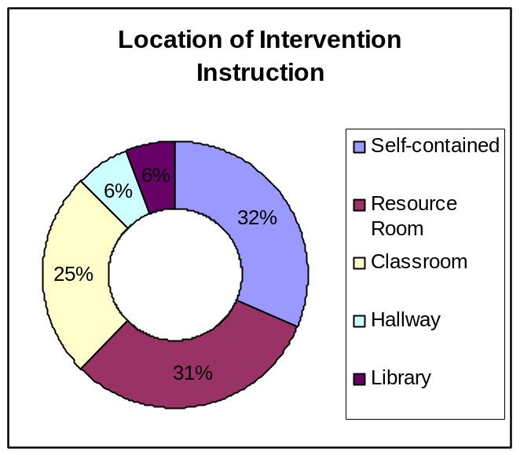

5. How many students are in your intervention groups?

The chart below represents the number of students in regular intervention groups, and the number of teachers utilizing groups of that identified size.

Number of students in supplemental group: | Number of teachers teaching groups of corresponding number:
0-3 | 2
4-6 | 12
7-9 | 1
10+ | 1

6. How many times do your intervention groups meet per week?

Out of the sixteen teachers reporting, the majority of the teachers (14) reported providing intervention instruction five times per week; and two teachers reported providing intervention instruction four times per week.
7. How long is intervention instruction?

According to the data collected during the interviews, the majority of the teachers (81%) spend 16-30 minutes for each intervention lesson.

Minutes of Instruction | Number of Teachers Responding
0-15 minutes | 1
16-30 minutes | 13
30+ minutes | 2

8. What content area are students pulled from for intervention instruction?

Intervention teachers shared that students who are pulled out during an “extended reading time” after the core reading block. Others claim the intervention instruction is often built into the schedule. Only one teacher mentioned that intervention students would miss math, and one mentioned portions of science would be missed.

9. How often do your groups change?

Intervention teachers responded how often their intervention groups change throughout the year. The following chart represents how often these groups change. Although the teachers varied in their responses, 31% did acknowledge changing intervention groups at least once a month.

How Often Intervention Groups
Change for Instruction
Weekly
Twice a Month
Once a Month
Twice a Year
Other:
Every Nine
Weeks
10. Describe the process used to place students in intervention groups:

Most of the intervention teachers interviewed reported utilizing data from DIBELS and GRADE as their primary sources for placing students into intervention groups. Although most of the teachers use DIBELS and/or GRADE (62.5%-87.5%), they also mentioned utilizing other resources including teacher recommendations and classroom observations. The chart below represents the types of resources used for placement as well as the frequency or use according to the intervention teachers.

Process for Placing Intervention Students
Teacher
Recommendation/Observations
DIBELS
GRADE
Reading Recovery
STAR testing
Teacher-made Data
Running Records
IARP
PAR
Classroom Performance

11. How do you design instruction for individual children?

Most of the groups are already designed for individual students. The teachers use assessments and other methods as listed above to group students together with similar needs and weaknesses. As the students progress in their groups, and skills are not mastered, teachers often “pull from different materials to meet individual needs.”

12. How often is progress monitoring conducted with your intervention students?

The chart below explains how often students receive progress monitoring according to the intervention teachers responses, with 62.5% reporting that they provide progress monitoring for intervention instruction weekly.

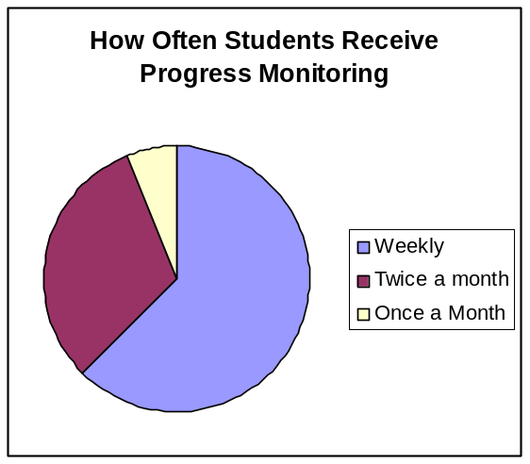
13. What type of PD have you attended for the intervention program?

Although intervention teachers are receiving Reading First PD, the majority of the teachers responding to this question did not mention receiving specific training for their intervention program. Only three teachers (18%) mentioned receiving specific training; one teacher received training for her intervention program from a specialist who trained every three months, and the other two teachers received training specifically for their program through watching a video.

14. How do you communicate with the classroom teachers?

The majority of the teachers communicate informally with the classroom teachers about the progress of intervention students. Informal communication includes messages in student folders, verbal discussions, email, or notes in mailboxes. One teachers notes:

it “would be good to complete a progress report so teachers could have a written component.”

Three intervention teachers (18%) mentioned communicating formally through grade level or common planning meetings or during weekly conferences.
15. Additional comments:

Intervention teachers were given the opportunity to list any additional comments they may have about the intervention program or the overall RF instruction at their school. Below are a few of the quotes of the intervention teachers:

Strengths
- “Have seen success with RF among students.”
- “District coach and principal analyzed data and regrouped kids, has been very beneficial and meeting IEP goals.”
- “Have lots of materials to use; lots more help out there now than when I was a classroom teacher. “
- “RF has connected everybody; school is a lot closer, know what our goals are; so much more information to use such as DIBELS and other test scores.”
- “It’s a good program. Have fewer referrals to special education programs. Most students by third grade don’t qualify anymore. I see a big difference in reading ability.”
- “Students are making gains every day, and they respond well. They need that extra push to help them succeed.”
Concerns
- “Eighty hours for PD is time consuming. More time could better be spent on planning the core program/lesson plans.”
- “More training would be helpful.”
- “I wish more kindergarten materials were available.”
- We need to “keep numbers low; work with students on the same level. More intervention teachers would help decrease size of group.”

Chapter 11

Literacy Center Observations

I. Introduction

During the fall of 2006, CCLD evaluators conducted classroom literacy center observations. Evaluators completed a classroom literacy center checklist rating literacy center standards as not observed, minimal, moderate, or extensive (see appendix K). This section includes overall themes of the literacy centers observed, the evaluators’ ratings for each literacy center standard, and a listing of classroom center activities.

II. Themes

Overall successes based on evidence from the Fall 2006 literacy center observations:

- Thirty-eight percent of the literacy center activities observed incorporated the five reading components at an extensive level;
- An organizational system for centers was extensively evident in 56% of classrooms;
- Fifty-six percent of centers observed had extensive evidence of prepared, organized, and easily accessible materials for students;
- The majority (79%) of literacy centers observed kept students moderately or extensively engaged with 35% containing and extensive level of meaningful activities; and
- Thirty-eight percent of students worked in an extensive variety of grouping structures during center time.

Overall concerns based on evidence from the Fall 2006 literacy center observations:

- Almost half (47%) of the centers observed did not have clear objectives for center tasks, posted;
- Fifty-three percent of observed classroom center activities did not have evidence of differentiation to meet the needs of a variety of learners;
- Sixty-two percent of centers observed did not contain or minimally contained multiple tasks or activities for students who finished their center work early; and
- Sixty-five percent of classrooms did not have a system or showed minimal evidence of a system in place to help students or answer their questions during center time.
III. Evidence

Evaluators observed thirty-four classroom literacy centers. The following table indicates the number of classrooms, listed under the level of evidence observed, for each literacy center standard.

 | Not  Observed | Minimal Evidence | Moderate Evidence | Extensive Evidence
1. Centers focus on literacy/ the five essential components of reading |  | 6 | 13 | 13
2. Organizational pattern of centers is posted  (work board, center chart, etc.) | 6 | 3 | 4 | 19
3. Students are actively engaged |  | 5 | 14 | 13
4. Centers have clear objectives (i.e., task cards posted) | 10 | 6 | 6 | 12
5. Materials are prepared, organized, and easily accessible to students |  | 3 | 11 | 19
6. Center activities maximize use of time/learning |  | 8 | 16 | 10
7. Center tasks are meaningful (activities or tasks that require high level/critical thinking and application of previously taught material) | 1 | 9 | 11 | 12
8. Center tasks are engaging (use of manipulatives, games, activities) | 2 | 10 | 12 | 11
9. Centers include an assessment/accountability component | 4 | 9 | 7 | 12
10. Centers have multiple tasks/”finish early” activities where appropriate | 15 | 6 | 7 | 4
11. Evidence of differentiation to meet the needs of a variety of learners | 8 | 10 | 13 | 2
12. Students work in various groupings (individual, partner, team, group) | 2 | 8 | 10 | 13
13. Help system for students is evident (i.e., center captains) | 21 | 1 | 3 | 5
14. Specific location for student work – complete and incomplete (task folder, pocket folder, hanging folder, basket, etc.) | 8 | 1 | 9 | 13
15. Students’ behavior follows classroom rules/learner expectations |  | 5 | 17 | 12
16. Student movement between centers/transitions are organized | 4 | 5 | 13 | 11

Source: KDE Reading First State Coaches
The following is a sample of the kinds of centers observed by evaluators.

- Listening centers
- Letter (Alphabet) centers-make letters using Wicki Stix; make letters using dough
- Writing centers
- Reading centers-read book and write script for play
- Computer centers- correlating software with core program
- Spelling centers-puzzle with plural nouns
- Vocabulary centers-match vocabulary word with definition, draw picture illustrating word (related to story)
- Suffix matching-make as many words as possible, record
- Comprehension centers-draw picture of favorite part of story
- Phonics centers-building words with “all”; word sorts
- Art centers-drawing pictures
- Fluency centers-two students reading and using a timer; choices of story to read
- Inquiry center-worksheet on natural resources
- Word Work centers-verb tense game; high frequency word game; ending sounds to build words, rhyming word game; synonyms; antonyms

Chapter 12

Parent Survey

I. Introduction

During the spring of 2007, the Reading First (RF) Evaluation Team provided surveys (See Appendix L) to the case study schools to be sent home (in each of the primary grades) and completed by two selected and willing parents. One hundred thirty-six parents completed these surveys at home, gave them to the school coaches, and then the RF team evaluators collected the surveys at the final site visit in the spring of 2007. Using this data, summaries were completed and themes were noted. Included in this chapter is overall success and concerns that summarize the trends or themes of the parent surveys, the individual questions asked, the parents’ responses, and selected quotes and comments given by the parents in these surveys.

II. Themes

Overall successes based on evidence from parent surveys:

- Ninety-two percent of parents strongly agree that they feel comfortable speaking with the teacher about their child’s reading progress.
- Eighty percent of parents strongly agree that they are kept informed about their child’s reading progress.
- Seventy-seven percent of parents strongly agree that their teachers, principals, and school staff work together to make all children successful readers.
- Parents (eighty-three percent) are reading with their children at home.
- The majority of children (seventy-four percent) are reading independently at home.
- Eighty-three percent of parents strongly agree that the teachers share the results of their child’s reading assessments with them.
- Sixty-five percent of parents strongly agree that RF has made a difference in their child’s reading ability.

Overall concerns based on evidence from parent surveys:

- There is not a majority of parents attending family reading activities at the schools. Fifteen percent of parents strongly disagreed that they attend family reading activities. Another fourteen percent disagree that they attend family reading activities. The rest of the parents were split among the other levels; and
- Parents commented minimally (9% of the time) about topics related to family involvement.
III. Evidence

The chart below represents the primary grade levels of the children represented by the parents completing the surveys. Each grade level was represented.

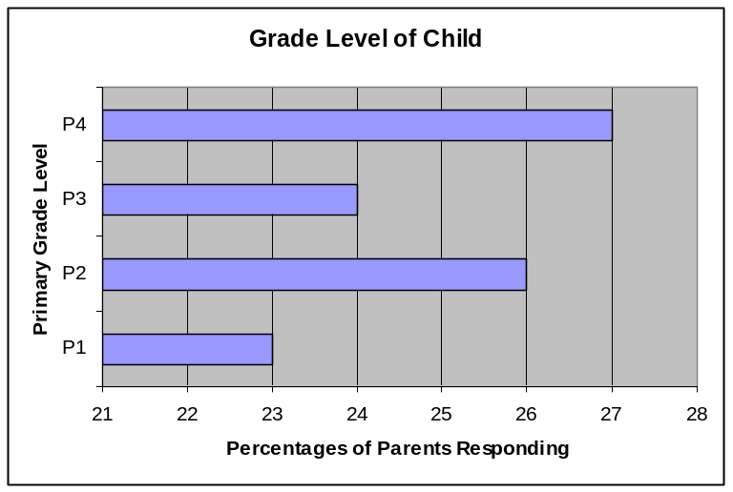

The chart below represents how many years the children of the parents completing the survey have attended RF schools. The majority of the students have attended one to four years at the current RF school.

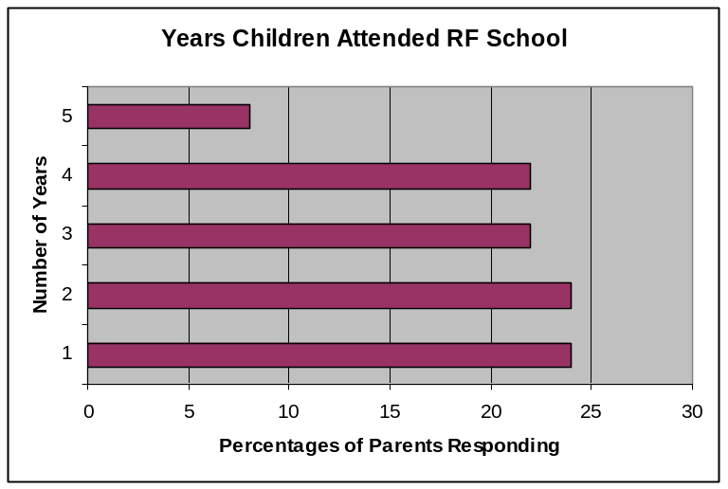

1. I feel RF has been beneficial to my child and has raised his/her reading scores.

The following chart represents the percentages of each given parent response; one is “strongly disagree” and five is “strongly agree.” Sixty-four percent of parents strongly agree that RF has been beneficial to their child and has raised his/her reading scores.

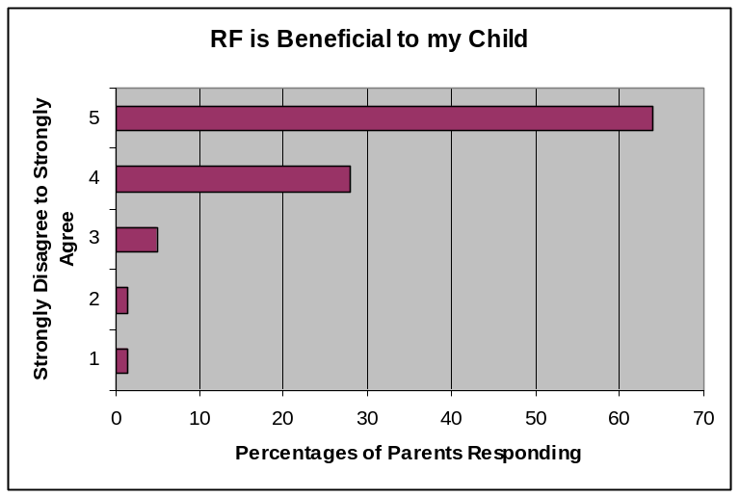

2. I feel the school has offered assistance to me in helping my child with reading at home.

The following chart represents the percentages of each given parent response; one is “strongly disagree” and five is “strongly agree.” Sixty-six percent of parents strongly agree that the school has offered assistance to them in helping with reading at home with their child.

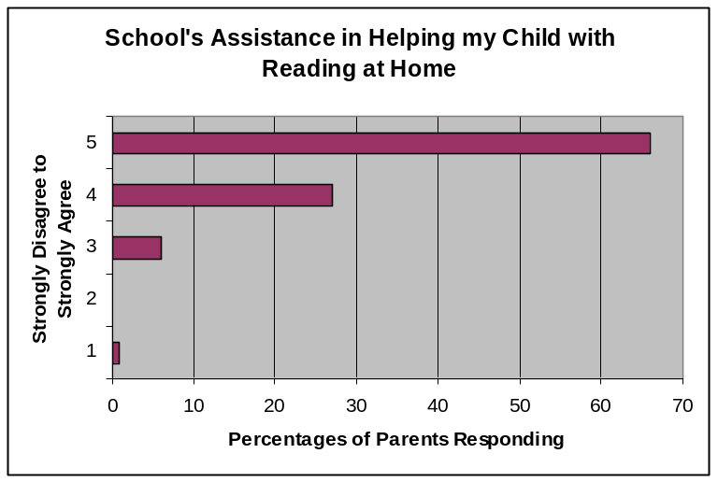

3. Family reading events are offered at times convenient for me.

The following chart represents the percentages of each given parent response; one is “strongly disagree” and five is “strongly agree.” Fifty-two percent of parents strongly agree that family reading events are convenient to them.

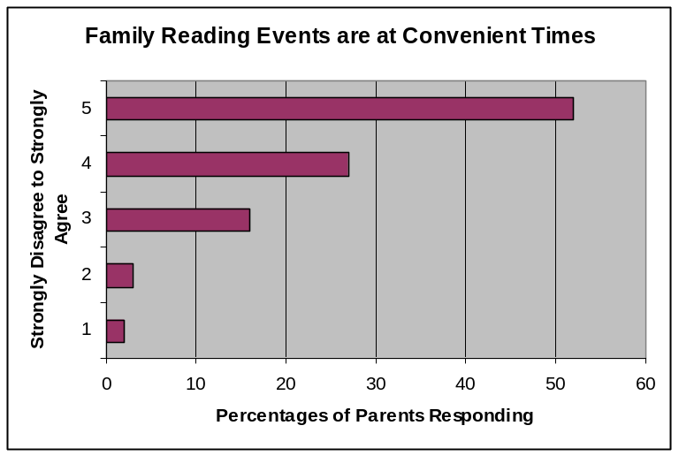

4. I attend family reading activities at this school.

The following chart represents the percentages of each given parent response; one is “strongly disagree” and five is “strongly agree.” Twenty-four percent of parents strongly agree that they attend family reading activities at this school.

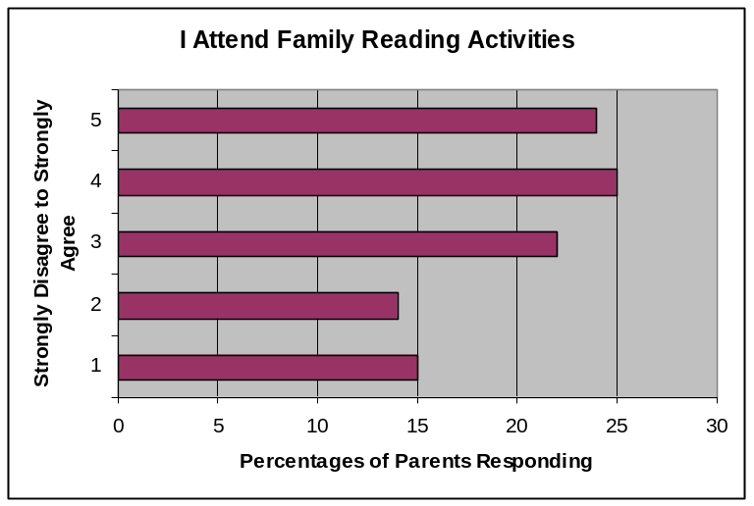

5. I have observed an increase in my child’s interest in reading.

The following chart represents the percentages of each given parent response; one is “strongly disagree” and five is “strongly agree.” Fifty-seven percent of parents strongly agree that their child has an increased interest in reading.

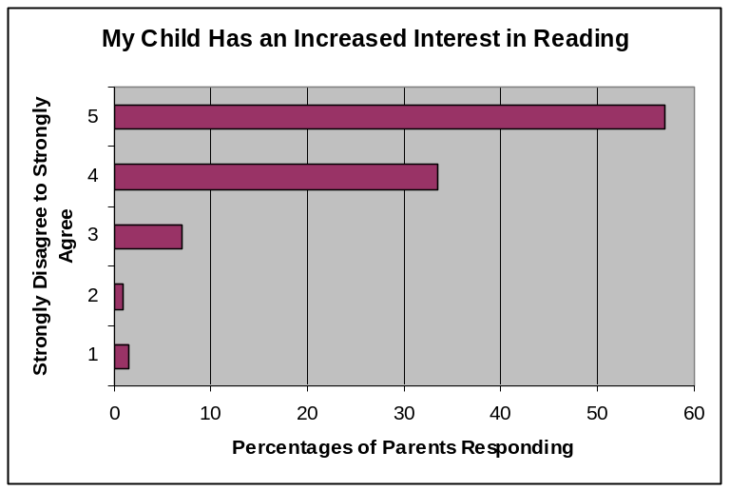

6. I feel comfortable speaking with the teachers about my child’s reading
progress.

The following chart represents the percentages of each given parent response; one is “strongly disagree” and five is “strongly agree.” Ninety-two percent of parents strongly agree that they feel comfortable speaking with the teacher about their child’s reading progress.

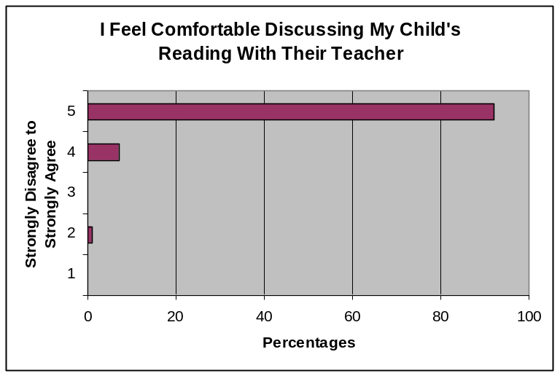

7. I am kept informed about my child’s reading progress.

The following chart represents the percentages of each given parent response; one is “strongly disagree” and five is “strongly agree.” Eighty percent of parents strongly agree that they are kept informed about their child’s reading progress.

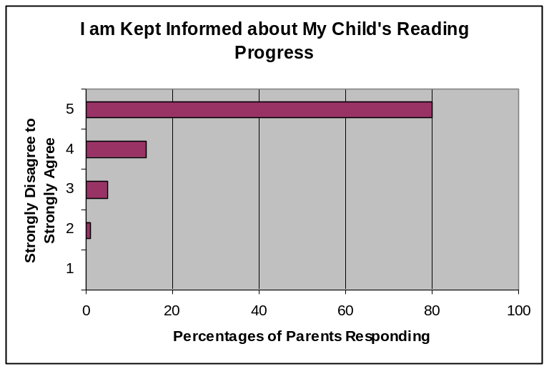

8. I feel the teachers, principals, and school staff work together to make all children successful readers.

The following chart represents the percentages of each given parent response; one is “strongly disagree” and five is “strongly agree.” Seventy-seven percent of parents strongly agree that their teachers, principals, and school staff work together to make all children successful readers.

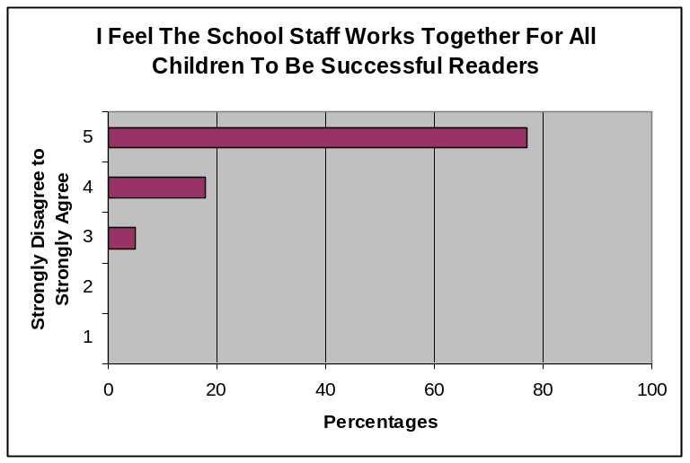

9. My child talks to me about reading activities that they are participating in at school.

The following chart represents the percentages of each given parent response; one is “strongly disagree” and five is “strongly agree.” Sixty-two percent of parents strongly agree that their children talk to them about reading activities that they are participating in at school.

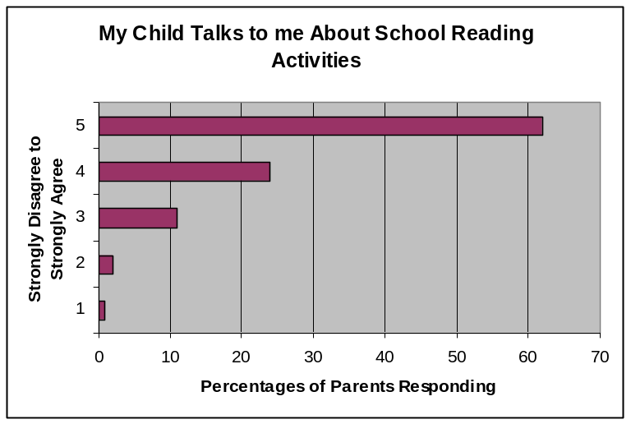

10. I read with my child.

The following chart represents the percentages of each given parent response; one is “strongly disagree” and five is “strongly agree.” Eighty-three percent of parents strongly agree that they read with their children.

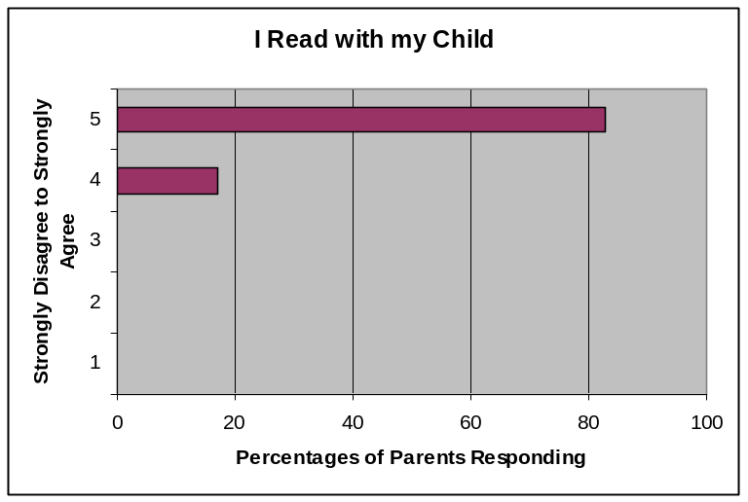

11. My child reads independently at home.

The following chart represents the percentages of each given parent response; one is “strongly disagree” and five is “strongly agree.” Seventy-four percent of parents strongly agree that their child reads independently at home.

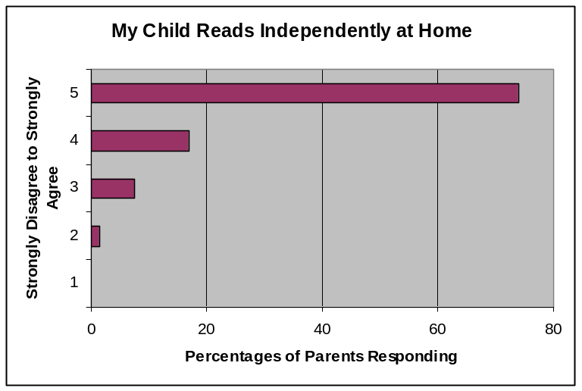

12. The teacher requires my child to record minutes or pages read daily at home.

The following chart represents the percentages of each given parent response; one is “strongly disagree” and five is “strongly agree.” Fifty-seven percent of parents strongly agree that the teacher requires their child to record minutes or pages read daily at home.

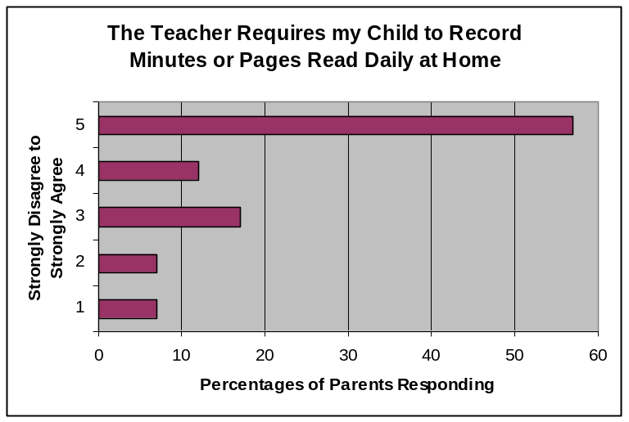

13. My child seems excited about reading.

The following chart represents the percentages of each given parent response; one is “strongly disagree” and five is “strongly agree.” Sixty-three percent of parents strongly agree that their child seems excited about reading.

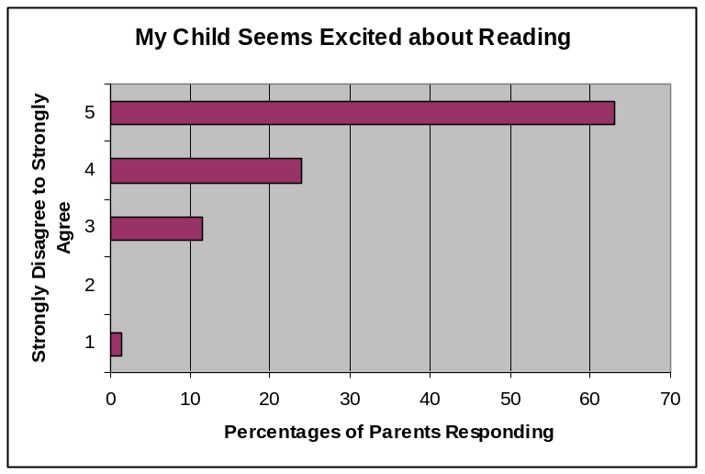

14. The school provides me with information about RF.

The following chart represents the percentages of each given parent response; one is “strongly disagree” and five is “strongly agree.” Sixty-six percent of parents strongly agree that the school provides them with information about RF.

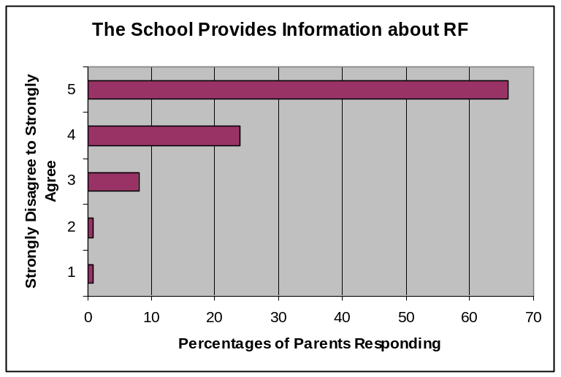

15. I am kept informed about reading through various ways (i.e. newsletters, conferences).

The following chart represents the percentages of each given parent response; one is “strongly disagree” and five is “strongly agree.” Sixty percent of parents strongly agree that they are kept informed about reading through various ways.

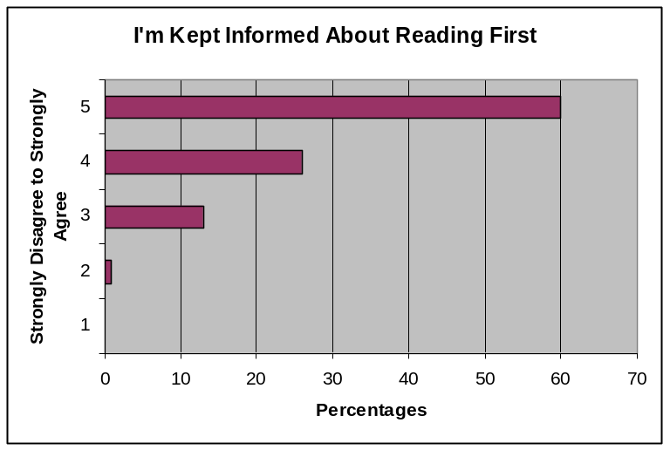

16. I understand what the different assessments are used for in the classroom (i.e. Grade and DIBELS).

The following chart represents the percentages of each given parent response; one is “strongly disagree” and five is “strongly agree.” Sixty-one percent of parents strongly agree that they understand what the different assessments are used for in the classroom.

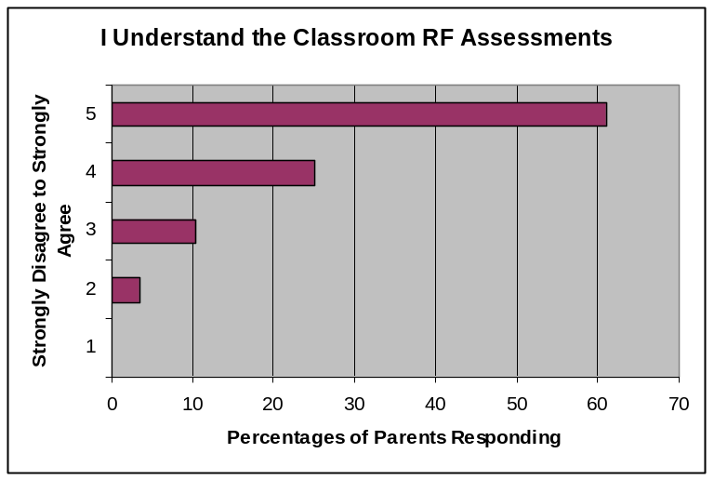

17. The teachers share my child’s reading assessment results with me.

The following chart represents the percentages of each given parent response; one is “strongly disagree” and five is “strongly agree.” Eighty-three percent of parents strongly agree that the teachers share the results of their child’s reading assessments with them.

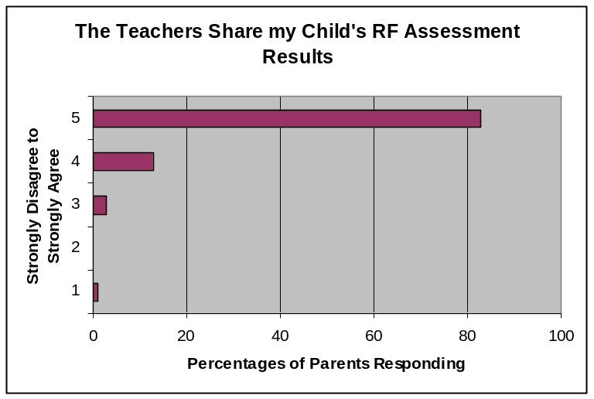

18. Overall, I feel that RF has made a difference in my child’s reading ability.

The following chart represents the percentages of each given parent response; one is “strongly disagree” and five is “strongly agree.” Sixty-five percent of parents strongly agree that RF has made a difference in their child’s reading ability.

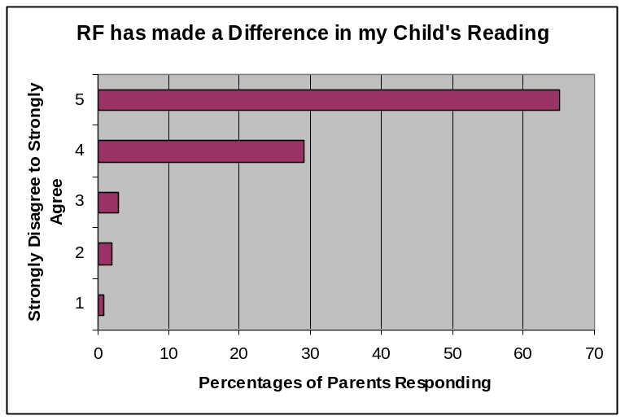
19. Please share one thing you “like” about RF or reading in your child’s school.
20. Please share one thing you “wish were different” in your child’s school in regard to reading.

The following table represents the areas that parents “like” about RF and the areas they would “like to change”. The areas have been grouped into topics due to the responses of the parents.

 | “Likes” | “Needed RF Changes”
Motivation to Read  Self/Esteem | (14%) Parents responded in this area. Included is a sample of the parent responses:  - My child enjoys reading so much that it has made her a more confident child in many ways.  - She has more interest in reading.  - My child has developed an interest in reading and likes to read her take home books.  - He loves to read more now than before.  - I like the excitement my child has when he reads  - I like the way they reward her with small prizes and tell her she is improving. Self esteem goes up!  - My daughter’s teachers have made reading very fun, and that makes her interested. I feel she has been taught a great deal about how important reading is. | (2%) Parents responded in this area. Included is a sample of the parent responses:  - Reading is very important to any child. I think if a child can read well, they will have more confidence in all other subjects. More resources and confidence in all other subjects. More resources and time needs to be put forth towards reading.  - I wish RF was dropped and taken out. I feel that it takes away the teacher ability to teach other things in a way more sufficient so more kids can learn more things that are lacking. Go back to old school in the way things are taught. If learning can be made fun, then children learn more. RF stops that.
The Overall RF Program | (25%) Parents responded in this area. Included is a sample of the parent responses:  - Reading is designed to meet my child at his point of need  - The way the program is structured, it is very easy for children to learn to read.  - I have seen my child’s reading improve greatly over the year. I believe the program and her teacher have worked great together  - The amount of time given to reading:90 minutes uninterrupted reading  - The gifted program has really pushed my child.  - Reading is the main priority in my child’s school.  - It is very structured.  - I like the reading program being used throughout the entire school, continuity is important for student learning. | (15%) Parents responded in this area. Included is a sample of the parent responses:  - One thing I wish were different is the pressure put on teachers and students to perform.  - I feeling Reading block is too long to keep the children interested.  - I wish I knew about what level she is on.  - The only complaint is spending almost 3hrs in the morning ONLY doing reading activities  - I’m afraid this program is not challenging my child  - I would like to see more advanced activities with children with higher reading levels.  - To understand how the program is working with my child.  - It takes a lot of time and time away from other subjects
Grouping | (5%) Parents responded in this area. Included is a sample of parent responses:  - I like that they have a lesson in whole group, and then break into smaller groups for specific individualized needs.  - The reading program specifically targets my child’s reading needs.  - I like the individualized instruction  - My child can read at her level and is not held back because others may be at a lower level than she. | (4%) Parents responded in this area. Included is a sample of the parent responses:  - Stay with homeroom teacher.  - Don’t switch to other rooms, but they have to with SFA.  - More one on one help.  - SFA grouping.  - Longer small groups.
Family Involvement | (8%) Parents responded in this area. Included is a sample of the parent responses:  - It will promote or encourage reading in the homes where it is very little to nonexistent.  - I like RF because it allows children to learn to read with the help of parents and allows reading to be fun!  - I have really enjoyed the reading nights at school  - I love how informed I am!  - It helps me to know if my child needs help in certain areas.  - Reading homework each night, the extra practice helps. | (9%) Parents responded in this area. Included is a sample of the parent responses:  - More family reading events!  - I would prefer more advanced notice of family reading activities.  - More updates on how my child is doing  - That I would get more information on the programs that she is in. I have no idea what this class is… no information on it.  - I wish that I could have attended some after school activities. Due to my schedule, I could not.  - Would like to know more about the family reading events and school reading activities.  - I believe that parents should be allowed to observe/participate in their child’s education at any time during the day not only after 10:30 am.
Assessments | (6%) Parents responded in this area. Included is a sample of the parent responses:  - Reading scores have increased, especially my child’s.  - I like the computerized test results  - I like the continuous assessment of student progress. Teachers can gauge their instruction by progress.  - I like knowing where he is (WPM) and where he needs to be. | (4%) Parents responded in this area. Included is a sample of the parent responses:  - Timed tests are often frustrating for children and don’t always well represent child’s reading ability and understanding  - More explanation on how children are evaluated.  - My children get ‘burned out’ with so much emphasis on reaching ‘levels’ and ‘benchmarks’ too much stress  - I do not agree with testing beginning with kindergarteners. It is not developmentally appropriate for 5 and 6 year olds to take standardized written tests.
Materials | (7% )Parents responded in this area. Included is a sample of the parent responses:  - I like the variety of materials used in the program.  - Love the take home books!  - I like the fact that our children are getting books on topics that entertain them and that they can keep.  - The book choices are varied and plentiful.  - The opportunity for free books and magazines at grade level | (6%) Parents responded in this area. Included is a sample of the parent responses:  - I do not like the books. I think the words are too hard. With not enough time to develop fluency. I also do not like that it is based solely on time!!  - I wish that our school had been allowed to adopt new reading textbooks when the rest of the district adopted their textbooks.  - A wider variety of books would be great  - I wish they didn’t have to read the same story over and over again.  - Wish the books were more challenging

Chapter 13

Student Interviews

I. Introduction

During the winter of 2007, the Reading First Evaluation Team interviewed randomly selected students from each primary grade from all seventeen of the selected case study schools. These interviews consisted of sixty-three primary grade students. The notes were compiled and grouped together according to the individual questions (see appendix M for questions). Using this data, summaries were completed and themes were noted. Included in this section are overall successes and concerns that summarize the trends or themes of the student interviews, the individual questions asked, the students’ responses, and selected quotes and comments given by the students during the interviews.

II. Themes

Overall successes based on evidence from student interviews:

- Students overwhelmingly agree that they like reading at school.
- Students enjoy the stories they are reading with their teachers at school.
- Students enjoy their literacy centers (76% claim they are “fun”).
- Students report they enjoy reading after school.
- Sixty-two percent of the students interviewed stated they read at least a medium amount at home or as much as they can. Only five percent of the students stated they do not read at home after school at all.
- Students see reading as important. One student stated, “Reading is important because it entertains me. It’s exciting. I can find out things about the world or a person.”

Overall concerns based on evidence from student interviews:

- Parents of primary grade students are not consistently supporting reading at home by modeling reading or discussing books with their children.
- Students have multiple options for after school activities, and many of these activities do not involve reading.

III. Evidence

1. Please circle one:

Twenty-six male students and thirty-six female primary grade students were interviewed as indicated in the chart below.

Gender of Students | Number of Students
M | 26
F | 37

2. Please circle one grade:

All of the primary grades were represented by students interviewed as indicated in the chart below.

Grades | Male Students | Female Students
P1 | 6 | 8
P2 | 7 | 8
P3 | 6 | 11
P4 | 7 | 10

3. Do you like reading at school?

All of the female students (100%) interviewed responded positively and answered “yes” when asked if they liked reading at school. All of the male students, with the exception of one, responded positively as well. The other male student said he “sometimes” liked reading at school.

4. Do you like the stories you read with your teacher at school?

All of the female students (100%) interviewed responded positively and answered “yes” when asked if they like the stories that they read with their teacher at school. The majority of the boys (92%) also responded positively, yet one male student said “no,” and the other student said, “sometimes” he likes the stories he reads at school.

5. During your reading time at school, which group do you like to read in best? (Read the list to the student and mark number 1 for their favorite type of group. What is your second favorite group for reading? What about your third favorite group for reading?)

According to the interviews, male primary grade students preferred reading alone first; whole group was the mode for the second choice; and for the third choice, male students responded with small groups or with partners. Female primary
grade students preferred reading alone as well, whole group was also the mode for their second choice, and small group was their favorite third reading practice.
Gender was not a factor in determining which reading group primary students preferred since both male and female students have similar responses.

First Choice: Favorite Reading Practices/Male Students

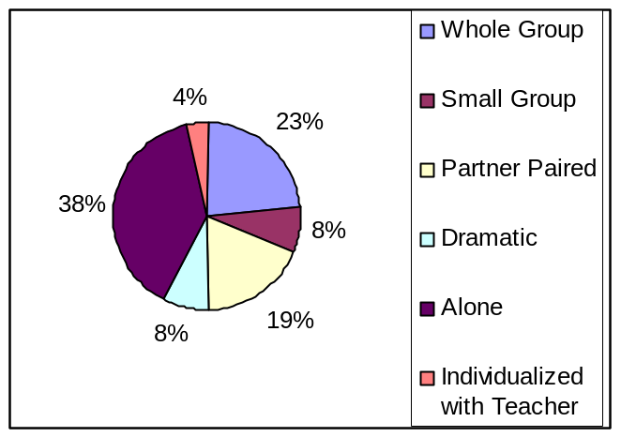

First Choice: Favorite Reading Practices/Female Students

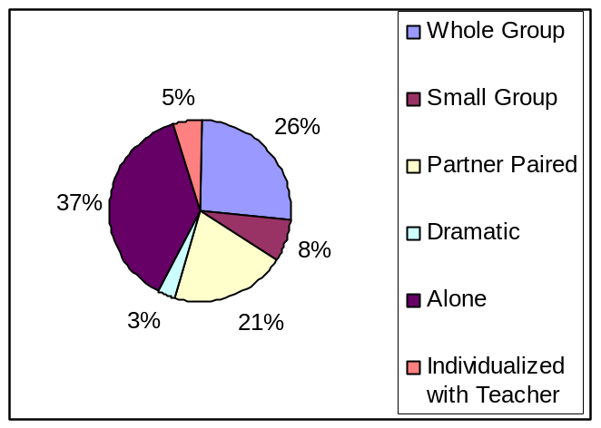

Second Choice: Favorite Reading Practices/Male Students

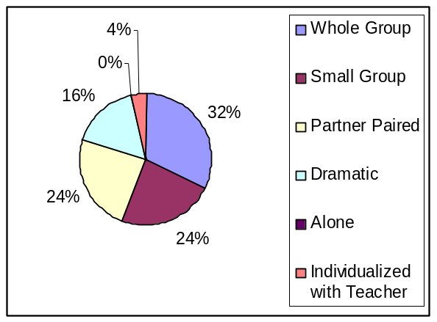

Second Choice: Favorite Reading Practices/Female Students

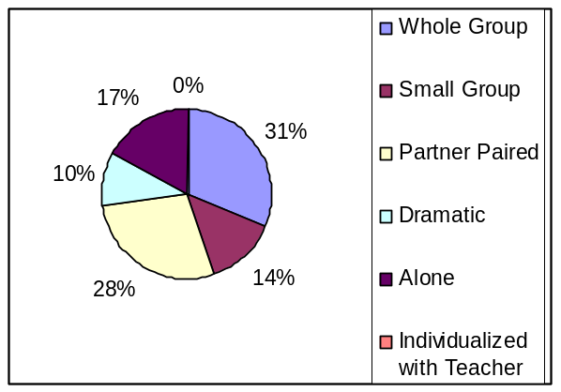

Third Choice: Favorite Reading Practices/Male Students

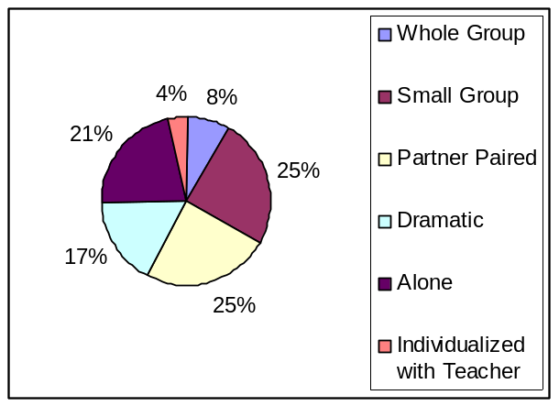

Third Choice: Favorite Reading Practices/Female Students

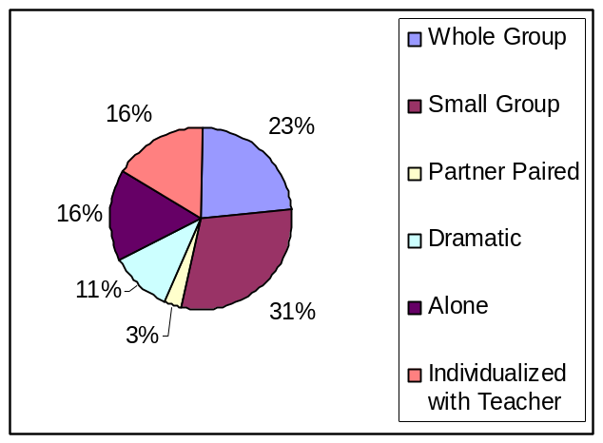

6. I’m going to list some genres or types of stories. Tell me which one you like to read the most. What is your second favorite type of story to read? What is your third favorite type of story to read?

According to the interviews, male and female primary grade students ranked the following genres as their favorite, second favorite, and third favorites. The following charts represent the results from their responses.

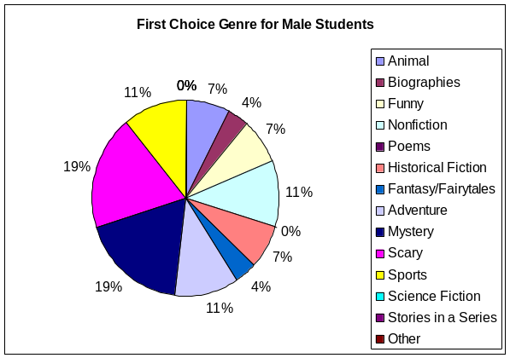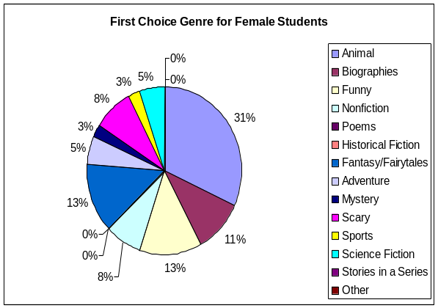
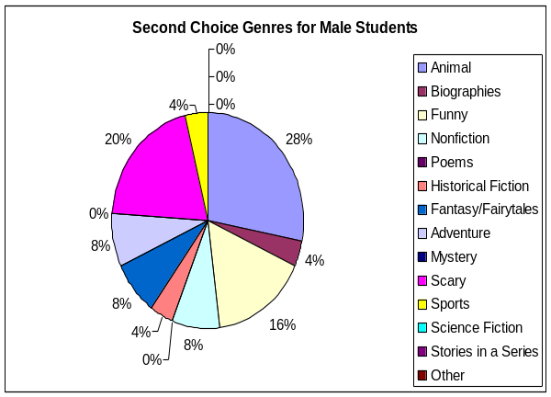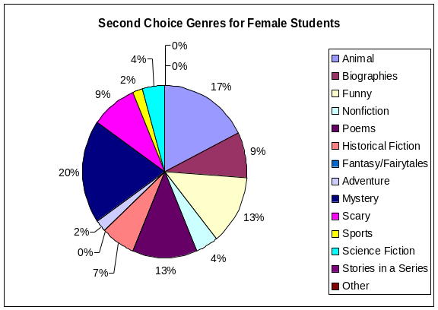

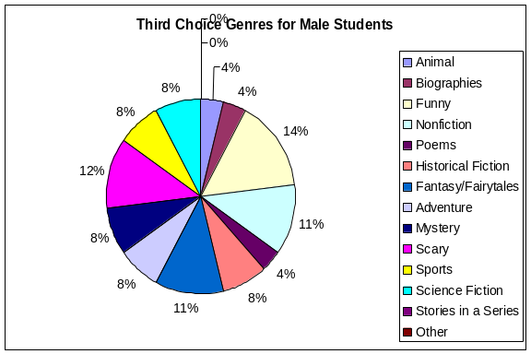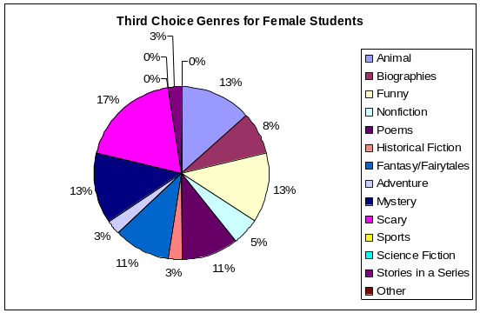

7. Do you have some of these favorite stories in your classroom that you can read?

All of the female primary grade students (100%) said they have favorite stories in their classroom that they can read. All of the males, with the exception of one, claim they have favorite stories in their classroom as well. One student said he did not.
8. What is your favorite classroom literacy center?

The graph below represents the primary boys and girls interviewed and their responses as to the literacy center that was their “favorite” center. Girls enjoyed computer, reading corner, and writing for their top three favorite centers, and boys ranked computers, writing, and “other” as their favorites.

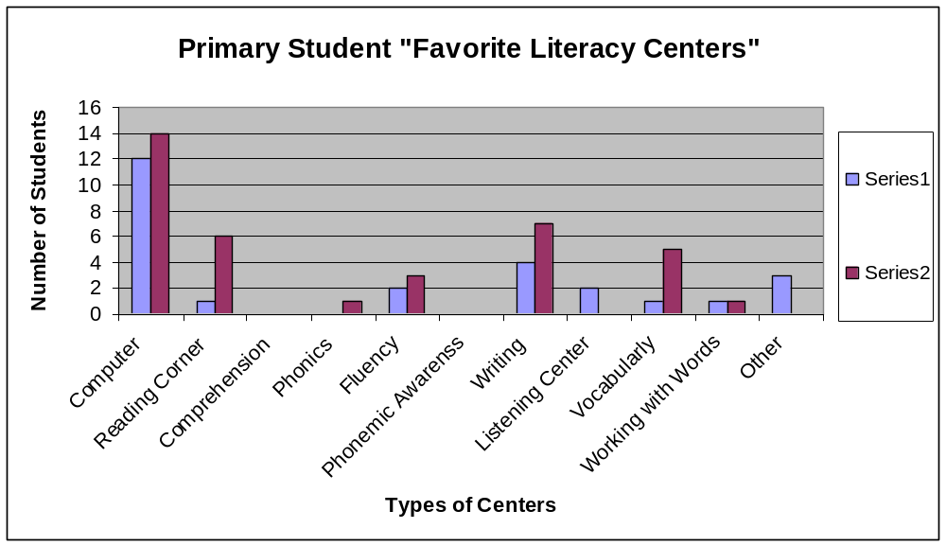

9. How do you think this center helps you with reading?

Listed below are samplings of quotes from the students about how they feel the literacy center helps them with their reading. Many students mentioned learning new words (vocabulary) or reading faster (fluency) as areas of improvement due to literacy centers.

- The centers help me to “read faster, so I can be better at reading.”
- “By chunking out words, (I can) read words (I) don’t know using strategies.”
- The centers “help me predict and build fluency.”
- “The computer (center) helps me with words I don’t know. It shows me the word and says the word.”
- “If you don’t know the words, you won’t know the words and won’t know what the story is about.”
- “By spelling words, because the words might help you when you see them in a story.”
- “Matching cards, definitions, pictures, in a sentence. Helps me learn what words mean.”
- “Learning about letters (by) coloring and drawing.”
- “Read with more expression, read harder levels.”

and finally…
- “Don’t really think it helps with reading, but it is fun.”

10. How would you rate your literacy centers?

The charts below represent the student responses as to how they rated their classroom literacy centers:

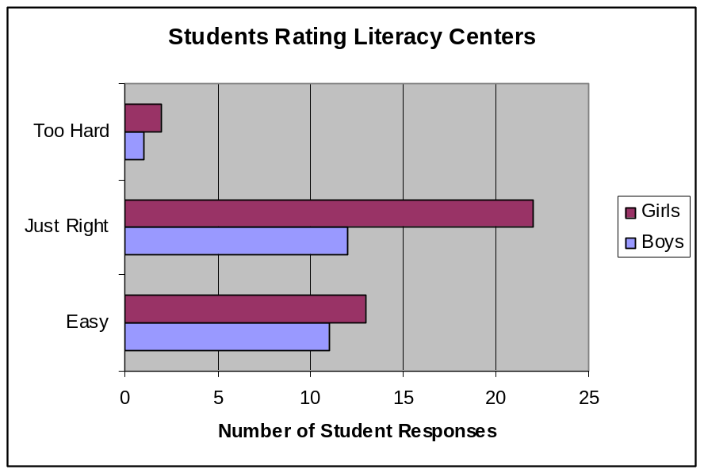

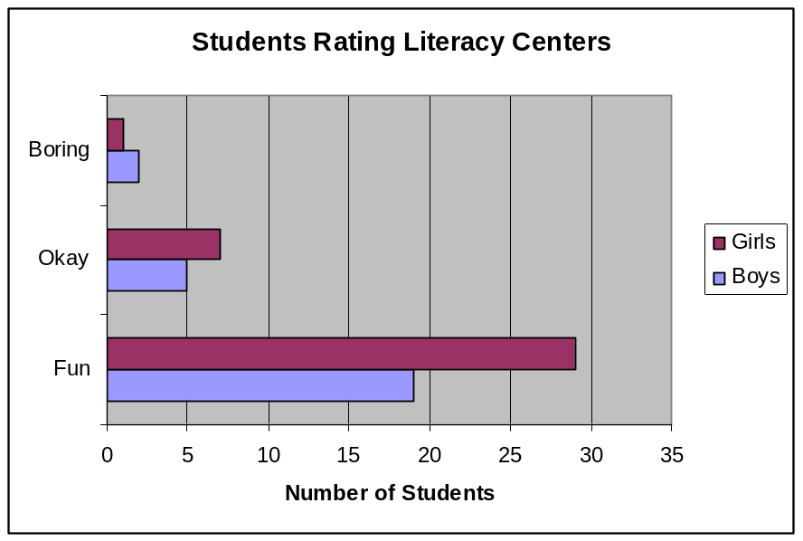

11. Does your teacher ever tell you about books s/he has read?

The majority of the students responded “yes” to this question. Only twenty-four percent reported their teachers not discussing books to their students. One student did not know.

12. What has your teacher taught you that will help you become a better reader?

Listed below are samplings of quotes from the students about what they believe their teacher has taught them in order to help them become a better reader.

My Teacher has taught me how to…
- “…sound out words in stories.”
- “…comprehend.”
- “…read with fluency… prosody.”
- “…skip words, think about the meaning of the story, look for little words within the word, and look at the picture”
- “…read big words and little words, taught me the word wall words.”
- “…understand reading by reading it more than one time, go back to read it better.”
- “…listen. When we listen, we learn.”
- “…chunk words; sound out words, and summarize (the) story.”
- “…read fluently. It’s like reading like you talk; don’t read too fast or too slow.”
- “…take tests over the story.”
- “…sound out words and use pictures to help.”
- “…read with more expression, I love to read!”

My teacher has taught me about…
- “…listening to books.”
- “…all sounds”
- “…letter sounds.”
- “…rate, punctuation, and getting all of the words correct.”

Two students said their teacher taught them “nothing” that would help them become a better reader.

13. Do you like to read after school?

A large majority of the students like to read after school. Only fourteen percent reported they did not like to read after school, and two boys reported they like to read “sometimes” after school.

14. About how long do you read after school?

The chart below represents the girls’ and boys’ responses to how long they read after school. Although forty-six percent of the girls responded “as much as I can,” another thirty percent responded “just a little bit.” The boys’ responses increased steadily with the rate of how much they read at home.

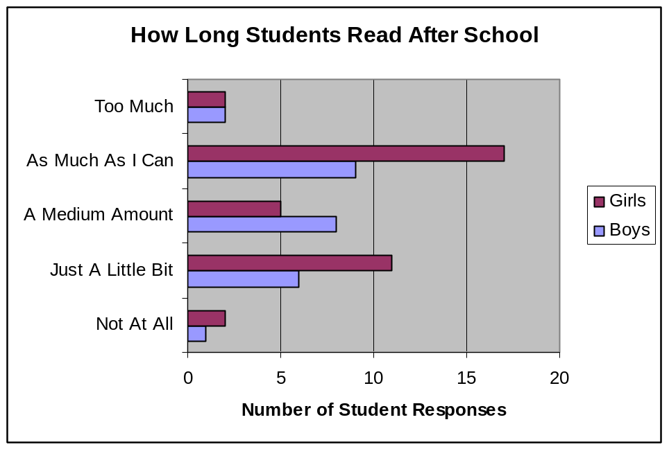

15. I’m going to read to you another list. Can you tell me in this list what your favorite after school activity is?

The following chart represents the mode for the responses from the male and female students as to their favorite after school activities. Girls enjoy reading, watching television, drawing or coloring, and playing on the computer. Boys enjoy playing on a game system, playing outside, and watching television or drawing and coloring.

Description | Males | Females
Play Outside | 2nd Choice
Play on the Computer |  | 3rd Choice (Tie)
Read |  | 1st Choice
Watch TV | 3rd Choice (Tie) | 2nd Choice
Play with Toys |  | 3rd Choice (Tie)
Draw or Color | 3rd Choice (Tie) | 3rd Choice (Tie)
Play on a Game System | 1st Choice

16. If you are going to read by yourself, which type of book would you like to read the most?

The following chart represents the responses given by the students during the interview as to which types of books they prefer to read alone.

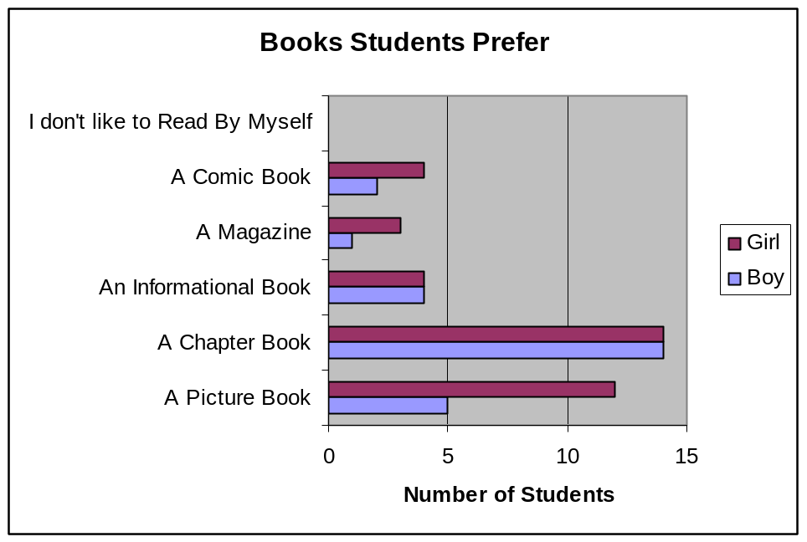

17. Does your mom or dad read at home?

Seventy-nine percent of the students responded “yes” their mothers and fathers read at home.

18. If yes, do you know what they like to read?

According to the students responding “yes” to the prior question, parents are reading magazines, newspapers, the Bible, and bestsellers of different genres.

19. Does your mom or dad ever tell you about books s/he has read?

Fifty-two percent of the students said that “yes” their parents talk to them about what they are reading. Forty-one percent said that “no” their parents do not mention books they have read.

20. Please complete this sentence for me.

A reading strategy that I use is….

Below is a sample of completed sentences from the students:

- “…reread the story.”
- “…sounding out.”
- “…chunking words.”
- “…get your mouth ready to make the first sound.”
- “…ask myself questions while I am reading.”
- “…go ahead of the word and try to figure out what it is saying, go back and try to figure out the word.”
- “…visualizing what I read.”

21. And the last question! Please complete this sentence for me.

Reading is important because…

Below is a sample of completed sentences from the students:

- “…if you can’t read, you can’t do anything.”
- “…readers can think.”
- “…you get to learn new things.”
- “…it helps you learn.”
- “…it helps you to be smart. The more you read, the better your imagination.”
- “…you can learn bout math and science cause there’s books about them.”
- “… if you can read, you can picture yourself there. Maybe you couldn’t do it in real life.”
- “…it will help you when you grow up and have to pay your bills. If you don’t pay your bills you won’t have electric or a house.”
- “…when you get older you might really need it for your job. It is fun and if I am bored, I can just pull out my book.”
- “…it entertains me…it’s exciting. I can find out things about the world or a person.”

Chapter 14

Volume Three Summary

Purpose
The purpose of the case study evaluation process is to continue to explore at a deeper level the goals of Reading First. These goals are to examine Kentucky’s Reading First (RF) program implementation, analyze reading achievement gains of students, and recognize Reading First’s impact on reducing the numbers of students reading below grade level. To meet these research goals both quantitative and qualitative data were collected and analyzed by a statistician and evaluation team members. Data sources included over 200 classroom observations, questionnaires, surveys, interviews, and evaluations of institutes and professional development.

Classroom Observations
Moderate or extensive evidence of the following were observed in 75% or more of the classrooms: mode of delivery, student teacher interactions, student engagement, and higher level questioning. Guided practice of concept/skill was consistently high on fall (90%), winter (84%), and spring (72%) observations, and vocabulary, fluency, and comprehension showed highest percentages in P4 classrooms. Concerns based on classroom observations include limited opportunities for students to engage in different types of reading (whole group instruction was observed 70.4% of time), authentic assessment rated below extensive 72.6% of the time, and summaries of lessons were only observed in 26.5% of classrooms.

Teachers and Literacy Centers
Based on questionnaire responses, the majority (88%) of teachers approved of their core reading program and are focusing on comprehension at all grade levels. Challenges for teachers include managing, organizing, and planning differentiated activities for literacy centers. During case study site visits, the majority (76%) of literacy centers observed kept students moderately or extensively engaged, and 56% of centers observed were organized with materials that were easily accessible for students. Specific concerns based on literacy center observations include a lack of time and structure to address student questions during center time (65%), the absence of multiple tasks to do in case of early completion of work (62%), and a lack of clear objectives for center tasks (47%).

Supplemental and Intervention Instruction
Supplemental teacher interviews indicate that supplemental groups change regularly (based on student needs) and are monitored regularly throughout the year. Professional training for supplemental instruction is weak and there is a lack of formal planning to take higher achieving readers beyond their supplemental work. Regarding intervention for struggling students, the majority of intervention teachers meet with their targeted students daily, usually in small groups (1-6 students). Formal, planned communication is lacking between many intervention and regular classroom teachers and program specific professional development for intervention teachers remains a challenge.

Principals
Principals report they are doing the following activities on a regular basis: observing in classrooms providing feedback to teachers, and attending professional development and Reading First Literacy Team meetings. They note reading scores continue to improve, and implementation and fidelity to the grant continue to be on target. Problems principals face include time constraints,
scheduling, funding issues, frequently changing state regulations and expectations, large amounts of paperwork (less time for explicit planning), and the rigidity of grant guidelines that leave minimal time for writing and content area instruction.

School Coaches
According to school coach interviews, 70% spend at least 40 minutes/day observing in classrooms, and 56% spend at least 40 minutes/day conferencing with teachers. Overall, 83% indicate the Reading First assessments are easier to manage, and 61% are incorporating new material from their professional development during the school year. In spring, 50% indicated an increase in explicit instruction at their school, an increase from 5% in the winter interviews. Every coach reported the use of more than one strategy to address struggling students. Concerns for school coaches include 73% indicate their core program minimally addresses fluency, vocabulary, or comprehension; 95% indicate spending less than 40 minutes/day in classrooms modeling lessons, and only 11% indicate explicit planning is a component in their action plans for the coming school year.

District Coaches
District coaches report improvement in classroom instructional practices, stronger leadership and support to Reading First school coaches and teachers, and successful professional development. Concerns for district coaches include
addressing the varying needs of students, struggles with teacher turnover and training for new Reading First teachers, teacher morale, and managing all the requirements of the Reading First grant.

Parents
Parent surveys indicated 92% strongly agree they are comfortable speaking with their child’s teacher about his/her reading progress, 80% strongly agree they are kept informed of their child’s reading progress, 83% read to their children at home, and 74% of their children are reading independently at home. Sixty-five percent strongly agree Reading First has made a difference in their child’s reading ability. However, parent surveys indicate a low level of participation in family literacy activities at the schools.

Students
Based on student interviews, students overwhelmingly agree they like reading at school, enjoy the stories their teachers read, think literacy centers are “fun,” choose to read after school, and see reading as important. Only 5% indicated they do not read at home at all, and (based on student interviews) parent support of reading at home is not consistent.

Appendixes

Appendix A
Case Study Report Letter
March 10, 2006

Dear Principals and School Reading Coach,

Thank you for allowing us to observe and talk with your teachers regarding Reading First implementation for a second time. Again, the goals of the two day visit were to gather information about your school’s implementation of Reading First, to begin recognizing successes occurring at the twenty case study schools, and to assist with summarizing common themes of implementation for the annual report.

By recognizing and documenting these successes, the Collaborative Center for Literacy Development along with the Kentucky Department of Education can share these successes with other Reading First and non-Reading First schools. More importantly, these successes can provide insight into how to improve reading instruction for all students.

Our intention in the enclosed mini-report is to provide feedback to schools about what we did observe, highlight some strengths, and ask some questions that we were left with after our two day visit. We hope that these questions will be considered in your ongoing conversations about the Reading First implementation process at your school.

The evaluation team observed for 45 minute time periods in a P1, P2, P3 and P4 classroom. Due to the limited time in the classroom, the team did not expect to observe all areas on the observation protocol. The feedback report is based on a summary and analysis of the observations, and interviews with teachers, principals, and school coaches. Overall, the feedback report focuses on the following:

- Existence of the core reading program
- Implementation of the Supplemental & Intervention Programs
- Establishment of a supportive learning environment
- Explicit and systematic teaching of the five reading components
- Effective instructional delivery

We appreciate your efforts in ensuring that the observations were able to take place and we look forward to continuing our involvement with your school. This spring your site evaluator will be contacting you to schedule the next site visit. This visit will be conducted in one day and take place sometime in April or early May.

As stated in the fall letter, it is our intent that the feedback provided will be useful and further assist your school with successful implementation of Reading First. Thank you for your continued efforts in working to improve reading achievement for all Kentucky students.

Sincerely,
Paige Carney, Ed.D.
Reading First Principal Researcher

Appendix B
Glossary for Classroom Observation Protocol
Reading First

Authentic Assessment: the process of gathering data in order to better understand the strengths and weaknesses for students’ literacy concepts and skills (i.e. portfolios, observations, checklists, conferences, time re-reading, anecdotal records, and running records)

Automaticity: fast, accurate, and effortless word identification

Call and response method: an instructional method that includes the teacher asking questions and students responding verbally; also referred to direction instruction

Choral reading: two or more students reading aloud from the same text

Comprehension: understanding what one is reading

Consonant Digraph: two consonants together that represent one phoneme, or sound (i.e. ch, sh)

Cooperative Learning: students working in groups on a specific task to promote learning

Derivative: a word formed by adding an affix to a root or stem; derived form; as adding pre before fix to make prefix.

Direct instruction: instruction delivered primarily through lecture

Echo reading: reading a text where the teacher reads a line aloud and the students repeat the line aloud

Etymology: the origin of a word and the historical development of its meaning

Explicit instruction: Teacher-led, interactive instruction in which the teacher directly presents materials and relationships that need to be learned; teacher models expectations, then supports the students by providing immediate corrective feedback as the students demonstrate their learning

Fix-up strategies: strategies to enhance comprehension such as restating sentences in own words, looking back through the text for information, etc.

Fluency: the ability to read text quickly, accurately, and with proper expression
Grammar: instruction in isolation focusing on specific skills related to grammar (i.e. conventions and forms, sentence structure, prefixes, suffixes, etc.)

Graphic organizers: a diagram or pictorial device that illustrates, summarizes, and portrays the relationships among concepts in text

Guided reading: teacher works with a group of students similar in strengths and needs and provides instructing through mini-lessons

Handwriting: physical practice of handwriting (i.e. copying letters, sentences, numbers, etc.)

Higher instructional feedback: encouraging students to engage in inferential, critical, and creative thinking rather than engage in literal thinking

Higher level thinking: questions requiring students to expand their thinking (i.e. comprehension, application, analysis, synthesis, and evaluation questions)

Incidental Word Learning: word learning occurring through oral language and wide reading experiences

Independent reading: when students read silently

Indirect instruction: instruction primarily delivered through group work with teacher serving as a facilitator

Letter-sound correspondence: making the connection between the written letter and its sound

Literacy centers: centers that promote reading concepts and/or skills that contain specific objectives and task cards (i.e. listening, ABC, book/library, poetry, drama, and computer centers)

Manipulatives: activities that can be manipulated to deepen understanding of concept through hands-on interactions

Meta-cognitive skills: strategies that encourage students to “think about thinking” or monitor their own thoughts such as clarify purpose or reading, preview text, etc.

Modeled reading: teach read alouds selections to students

Monitoring: actively thinking about learning or understanding the material, activities, or reading in which they are engaged

Morpheme: the smallest meaningful unit of language
Onset: the initial consonant or consonants in a word (i.e. in the word sat, s is the onset, at is the rime)

Partner/paired reading: two students and/or teacher/student reading texts to further comprehension and fluency

Phonemic Awareness: the ability to notice, think about, or manipulate the individual phonemes (sounds) in words

Phoneme addition: making a new word by adding a phoneme to an existing word (i.e. add s to park; spark)

Phoneme blending: listening to a sequence of separately spoken phonemes, then combining the phonemes to form a word (i.e. /b/ /i/ /g/ is big)

Phoneme categorization: recognizing the word in a set of three or four words that has the “odd” sound (i.e. in bus, bun, rug; rug has the odd sound)

Phoneme deletion: recognizing the word that remains when a phoneme is removed from another word (i.e. smile without s is mile)

Phoneme identity: recognizing the same sounds in different words
(i.e. fix, fall, and fun)

Phoneme isolation: recognizing individual sounds in a word

Phoneme segmentation: separating a word into its individual sounds, saying each sound as they tap out or count it (i.e. grab is /g/ /r/ /a/ /b/)

Phoneme substitution: substituting one phoneme for another to form a new word (i.e. bug, change /g/ to /n/; bun)

Phonics: the study of the relationships between letters and the sounds they represent; sound-symbol correspondences

Prosody: reading with expression, proper intonation, and phrasing

Reader’s theater: when the teacher or students adapt short script from shared reading selections and the students act-out a dramatic presentation of the script

Reading conferences: the teacher talks with a student individually about his or her strengths and weaknesses in reading

Repeated reading: reading the same text 2-4 times to achieve fluency
Rime: the vowel and any consonants that follow it in a word (i.e. in the word flip, fl is the onset, ip is the rime)

Scaffolding: instructional assistance and support given to students from teachers, assistants, or peers to assist in promoting learning

Semantic organizers: a graphic organizer that is organized around a word that represents an important concept; forms a network of related words

Shared reading: teacher reads a book to the children several times; initially the teacher reads most of the book; as students become more familiar with the book, they join in and share the reading with the teacher

Story structure: plot and important elements of story; the beginning, middle, and end of a story; listing the main events of a story

Student centered: interactions and activities within the classroom that focus on students’ interest and/or involvement

Student discussion: discussion between students about reading activities

Student friendly definitions: word meanings related to or created by students in terms based on their experience

Syllable blending: blending syllable sounds of a word together to pronounce the entire word

Syllable segmentation: separating syllables of a word while clapping or tapping

Systematic Instruction: a carefully planned sequence for instruction designed prior to planning lessons and activities; lessons build on previously taught information, from simple to complex

Tape-assisted reading: reading aloud, simultaneously or as an echo with an audio-taped model

Teacher interactions: interactions that focus primarily on teacher direction

Teacher/student read aloud: the student or teacher reads a text aloud

Technology: consists of computers, VCR’s, DVD’s, tape recorders, overhead projectors, and listening centers

Think-pair-share: students reflect individually on topic presented, discuss their ideas with a partner, then share ideas with a large group

Transitions: the flow from one activity to the next with ease

Word wall: a list of words posted in the classroom that lists frequently used words to assist students in reviewing words they may use while reading or writing

Visual imagery: creating an image in the mind while listening to a story’s details and descriptive words

Vocabulary: all the words of our language and their meanings

Vowel Digraph: two vowel together that represent one phoneme, or sound
(i.e. ea, ai, oa)

Word building: working with letters individually or in a group to make words

Word consciousness: an awareness of and interest in words, their meanings, and their power

Word families: words having different onsets, but the same rime (i.e. sat, cat, hat, and pat)

Word studies: exploring word meanings and make associations among words
(i.e. etymological, derivational)

References

Armbruster, B. Osborn, J. (2001) Put Reading First. Center for the Improvement of Early Reading Achievement. National Institute for Literacy. Office of Education Research and Improvement. Administered by U.S. Department of Education. Washington D.C.

Lehr, F. Osborn, J. Hieber, E. (2004) Focus on Vocabulary. Pacific Resources for Education and Learning. Honolulu, Hawaii

Kentucky Reading First State Coaches Observation Checklist, 2005

Kentucky Reading First Summer Institute Glossary of Terms, 2004

Read to Achieve Observation Protocol, 2005

Tompkins, G. (2005) Language Arts Patterns of Practice. Pearson & Prentice Hall: NJ

Questioning techniques, http://pigseye.kennesay.edu/~rouyang/ece4473/q-techni.html

Appendix C
Kentucky Reading First
Case Study Report- Winter 2007

School: Date:

Observers:

Grades Observed: P1 P2 P3 P4

Core Program: Success for All

__ Observed
__ Not Observed

The Reading First Components observed were: (Note: If any of the five reading components were not observed during the four observations, the unobserved component was not scored.)

- Minimal: the least possible, there is very little evidence
- Moderate: being within reasonable or average limits, not excessive or
extreme, average evidence including both minimal and extensive evidence during observations
- Extensive: broad in scope or content, large in extent, range or amount,
being above average in evidence

Phonemic Awareness: Observed in __ out of four classrooms

___ Minimal Evidence
___ Moderate Evidence
___ Extensive Evidence

Phonics: Observed in __out of four classrooms

___ Minimal Evidence
___ Moderate Evidence
___ Extensive Evidence

Vocabulary: Observed in __ out of four classrooms

___ Minimal Evidence
___ Moderate Evidence
___ Extensive Evidence

Fluency: Observed in __out of four classrooms

___ Minimal Evidence
___ Moderate Evidence
___ Extensive Evidence

Comprehension: Observed in __ out of four classrooms

___ Minimal Evidence
___ Moderate Evidence
___ Extensive Evidence

Learning Environment: classroom is organized with literacy centers, multiple-types of reading materials, instructional reading activities, and manipulatives. There are additional spaces for Readers’ Theater and Author’s Chair with a variety of charts, signs, labels, & quotations that promote reading.

___ Not Observed
___ Minimal Evidence
___ Moderate Evidence
___ Extensive Evidence

Mode of Delivery: reading instruction is explicit and systematic with clear objectives, connections made to students’ prior and current knowledge, opportunities for active participation and practice of concept: “I do it, We do it, and You do it” and summary of lesson.

___ Not Observed
___ Minimal Evidence
___ Moderate Evidence
___ Extensive Evidence

Literacy Centers: centers present and utilized during the core reading block time. Centers are engaging and promote literacy concepts, provide differentiated activities, contain clear objectives, task cards, and opportunity for student response-methods.

___ Not Observed
___ Minimal Evidence
___ Moderate Evidence
___ Extensive Evidence

Student Engagement: students are highly engaged in the learning process.

___ Not Observed
___ Minimal Evidence
___ Moderate Evidence
___ Extensive Evidence

Student-Teacher Interactions: student-teacher interactions are open-ended, student focused, and provides meaningful and specific instructional feedback.

___ Not Observed
___ Minimal Evidence
___ Moderate Evidence
___ Extensive Evidence

Higher-Level Questioning: teacher provides multiple levels of questions requiring students to expand their thinking and learning.

___ Not Observed
___ Minimal Evidence
___ Moderate Evidence
___ Extensive Evidence

Classroom Reading Practices: the following reading practices were observed either during large group time or during small group/literacy centers.

Reading  Practice | Reading practices observed: | Range of reading time for whole group: | Range of reading time for individual  student:
Independent: individual students read silently on their own | out of 4 classrooms
Shared: teacher reads a book to the children several times; initially the teacher reads; as students become more familiar with the book, they join in and share the reading with the teacher | out of 4 classrooms
Partner/Paired: two students and/or teacher/student reading texts to further comprehension and fluency | out of 4 classrooms
Choral: two or more students reading aloud from the same text | out of 4 classrooms
Guided  (with teacher): teacher works with a group of students similar in strength and needs and provides instruction through mini-lessons | out of 4 classrooms
Dramatic/  readers’ theater: the teacher or students adapt a story script from shared reading selections and the students act out a dramatic presentation of script | out of 4 classrooms
Echo reading: the teacher reads a line of text aloud and the students repeat the line | out of 4 classrooms
Read alouds: teacher reading text to students modeling fluency | out of 4 classrooms
Tape assisted reading: students read silently along with an audio book | out of 4 classrooms

Strengths recognized during the observations and interviews:

Questions arising from the observations and interviews:
Appendix D


District Coach Interview Questions- Fall 2006

1. How is the district leadership involved in the coordination of RF activities for the entire district? (Explain)

2. Regarding the district, what changes have occurred from RF year one implementation to now?

3. What specific activities/communication has the district implemented with non-funded schools as well as private schools regarding RF?

4. What are your top three responsibilities regarding RF for your district?

5. What are three areas that are causing you the most concern regarding RF implementation across the district?

6. What are three of the most successful initiatives being conducted in the district regarding RF?

7. How would you describe this school’s implementation of Reading First?

8. What involvement has the district had that directly impacts this school’s RF implementation process?

9. How do you provide feedback to this school?

10. How often do you observe and monitor what is happening in this school?

11. What are three areas that are causing you the most concern regarding RF implementation for this school?

12. What are three areas that this school is most successful in implementing regarding RF at this school?

Appendix E
Principal Interviews
Fall 2006

1. How much time do you spend observing in the reading first classrooms per week?
0-20 21-40 41-60 60+ minutes

2. How much time do you spend conferencing with teachers about their reading instruction per week?
0-20 21-40 41-60 60+ minutes

3. How do teachers receive feedback from your observations?
_____ they do not receive any
_____ by email
_____ by informal conversations
_____ by formal conversations
_____ by a written form
_____ other

4. Do you regularly attend the professional development scheduled for teachers for Reading First?

5. What areas of reading continue to need the most attention at your school?
(List the top three)
a. ____________________
b. ____________________
c. ____________________

6. If you could change any aspect of Reading First, what would it be?

7. What plans does your school have in place to sustain any positive changes that have occurred as a result of Reading First?

8. Are you involved with the Reading First literacy team?

9. Given the selected eight characteristic from the Marzano study of effective leadership, choose three that are the most important for implementing Reading First at your school:
_____ Communication
_____ Affirmation
_____ Culture
_____ Beliefs, ideas
_____ Curriculum, instruction, assessment
_____ Visibility
_____ Evaluate, monitor
_____ Optimize

10. What threatens the success of Reading First in your school? (Explain)

Complete these sentences:

11. I see Reading First as a program that…
12. Children in the Reading First program will…
13. Reading First has not addressed…
14. Due to Reading First teachers…
15. Reading First has changed…

Appendix F
School Coach Interview
Fall 2006
Interview survey:

1. How would you rank your school coaching duties in order of importance?
(1 being the most important…)
_____ modeling lessons in the classroom
_____ testing
_____ observing in the classroom
_____ providing professional development
_____ conferencing with teachers
_____ attending and chairing Reading First meetings
_____ completing necessary administrative tasks

2. Do you have an assistant?

3. Do you have a Reading First literacy team in place?

4. If yes, who sets the agenda for the Reading First literacy team? (Check one)
The school coach: __________
The principal: __________
Other: __________

5. If yes, what does the Reading First Literacy team do?

6. How would you rate your support from KDE? (Circle one)
Minimal Moderate Extensive

7. How would you rate your support from your district? (Circle one)
Minimal Moderate Extensive

8. How would you rate your support from your principal? (Circle one)
Minimal Moderate Extensive

9. On an average day, how much of your time is spent in the classrooms
modeling reading lessons? (Circle one)
0-20 minutes 21-40 minutes 41-60 minutes 60+ minutes

10. On an average day, how much of your time is spent in the classrooms observing? (Circle one)
0-20 minutes 21-40 minutes 41-60 minutes 60+ minutes

11. On an average day, how much of your time is spent conferencing with individual teachers? (Circle one)
0-20 minutes 21-40 minutes 41-60 minutes 60+ minutes

12. How often are you progress monitoring students/month? (Circle one for each)
Intensive 1 2 3 4
Strategic 1 2 3 4
Benchmark 1 2 3 4

13. How many classroom teachers participate in Reading First?
(Total number of primary school teachers, special education teachers, etc.)
__________

14. How many Reading First teachers are implementing “best practices” at your school during reading instruction?
__________ out of __________

15. What areas of reading continue to need the most attention at your school?
(List top three)
a. _________________________
b. _________________________
c. _________________________

Interview discussion questions:

16. Are you implementing new changes for Reading First at your school this year?

17. Has your school identified specific goals for this year’s reading instruction?

18. What on-going professional development is planned for this school?

19. How are you collaborating with other non Reading First schools and non Reading First districts for professional development?

20. How many school-wide family literacy events do you have planned for this school year? (Describe)

21. What plans does your school have in place to sustain the positive changes that have occurred as a result of Reading First?

Please complete these sentences:
22. I see Reading First as a program that…
23. Children in the Reading First program will…
24. Reading First has not addressed…
25. Due to Reading First teachers…
26. Our school has been successful…
Appendix G
Kentucky Reading First
School Coach Interview
Winter 2007

- Currently, how much of your time is spent in the classrooms modeling reading lessons? (Circle one)
0-20 minutes 21-40 minutes 41-60 minutes 60+minutes

- Currently, how much of your time is spent in the classrooms observing?
(Circle one)
0-20 minutes 21-40 minutes 41-60 minutes 60+minutes

- Currently, how much of your time is spent conferencing with individual
teachers? (Circle one)
0-20 minutes 21-40 minutes 41-60 minutes 60+minutes

- Considering the school’s on-going professional development, how would you describe the level of accomplishment to meet your school’s need?
Currently planning Planned, but not implemented Already implemented

- Describe one successful professional development your school has participated in this school year.

- Which of the five components does your core program address
extensively?

- Which of the five components does your core program address minimally?

- After analyzing student assessment data, which component have your teachers identified for needing the most attention?

- How many times has your school analyzed current student data this school year?

School-wide, as a faculty ____
Grade level meetings ____
Individual teachers ____

- To this date, how many family literacy events have you held? ______

- How would you rate the overall success of these events? (Circle one)
Minimal Moderate Extensive

- Please describe the progress you have made towards the specific goals you set for this school year?
Fall Goals: ____________________________________

- How would you rate the support you receive from your state coach?
Minimal Moderate Extensive

- Describe one specific support from the state coach you have received
this school year.

Please complete these sentences:

- KDE has...........

- The district coach..............

17. The principal...............

Appendix H
Reading First School Coach Interview
Spring 2007
(Created by Paige Carney Ed.D., Pam Seales, and Lauren Jones)

- What has been your biggest success this year regarding RF
implementation?

- What do you consider your biggest concern?

- Have you applied new information from conferences or seminars attended this school year? Yes or No
(If yes, explain)

- Describe specific improvements you have observed in teachers’ instruction over the course of this year.

- Are there specific instructional improvements to be made by your teachers? (Explain)

- Do you and the teachers find assessments easier to manage? Yes or No
(Explain)

- What school based structures are in place to sustain Reading First objectives after the grant expires (i.e. grade level meetings, data analysis)?

- What have you done to address students who still are struggling with making progress?

- What will be your action plan for next year’s implementation?

Complete these sentences.

10. Our comprehension instruction is......................................................

- Over the last three years, our students have grown in..........................

12. Over the last three years, our teachers have grown in...................

Appendix I
Kentucky Reading First
Teacher Questionnaire
Winter 2007

1. Please circle one: M or F

2. Please circle which grade you are currently teaching: K 1st 2nd 3rd

3. How many years of teaching experience? (Circle one)

0-3 4-6 7-9 10-13 14-16 17+

AT SCHOOL
4. Overall, do you like your core reading program? (Circle one) Y or N

5. Check which describes the overall comprehensiveness of your core reading program. (i.e. five essential reading components are explicitly and systematically covered, and lessons are organized well.)

____ Minimally comprehensive
____ Moderately comprehensive
____ Extensively comprehensive

6. Do you like the stories in your core reading program? (I.e. are they interesting? Are they engaging? Are they culturally responsive?)(Circle one) Y or N

7. Does your core program connect to other content areas? (Check one)

_____ Never
_____ Sometimes
_____ Always

8. During reading instruction, which group do you utilize most often? Please rank the top three groups, with one being the group you utilize most often, two being the group you utilize often and three being the group you utilize the least.

___ Whole group (the whole classroom together)
___ Small group (the teacher works with just a few students)
___ Individual (the teacher works with an individual student)
___ Partners/paired (students work together)
___ Dramatic (students act out or read a play or story dramatically)
___ Alone (students read alone)
9. Please rank the top three genres found in your core program. Please list which genre your core program uses most often for stories: 1 is the highest and 3 the lowest.

___ Animal stories
___ Autobiographies and
Biographies
___ Funny stories
___ Nonfiction
___ Poems
___ Historical fiction
___ Fantasy or fairytales
___ Adventure stories
___ Mystery stories
___ Scary stories
___ Science fiction
___ Sport stories
___ Stories in a series
___ Other: _____________

10. Do you think literacy centers are beneficial to students? (Circle one) Y or N

11. How many days a week do your students work in literacy centers?

12. When planning your classroom literacy centers, how would you rank the importance of the following items to be reinforced during center time?
(Rank 1 for the highest and 7 for the lowest)

___ Phonemic awareness
___ Phonics
___ Vocabulary
___ Fluency
___ Comprehension
___ Writing
___ Lesson concepts (i.e. reinforcing core program lesson objectives)

13. How often do you change the literacy centers in your classroom? (Circle one)

once a month twice a month twice a week once a week

14. How much time do you spend developing literacy center material each week? (Circle one)

0-2 hours 3-4 hours 5-6 hours 7-8 hours 8+ hours

15. How would you rate the quality of your literacy centers? (Circle one)

Minimal Moderate Extensive

16. What type of literacy centers do you utilize most frequently? (Check one)

_____ teacher created
_____ commercially produced
_____ both (teacher and commercially produced) equally utilized

17. What area of improvement would you identify for your literacy centers?

18. What resource do you need to help you successfully develop and implement literacy centers in your classroom?

19. Do you tell your students about books you have read regularly?
(Circle one) Y or N

20. What do you feel is one of the most important skills/strategies you have taught your students in order to make them better readers?

21. What do you feel is one of the most difficult skills/strategies to teach your students at this age to become better readers?

AT HOME
22. Do you require students to read at home? (Circle one) Y or N

23. Do you have time to read at home during the week? (Circle one) Y or N

25. Please rank the following list with the activity you would most likely do after school. Please list only the top three activities you participate in after school.

___ Gardening outside
___ Mom/Dad’s taxi service
___ Hiking/biking
___ Sports
___ Computer
___ Work/grading/
lesson plans
___ Reading
___ Watching Television
___ Playing an instrument
___ Cooking
___ Sewing/doing crafts
___ Shopping
___ Spending time with
friends
___ Talking on the telephone
___ Other: ______________

26. If you have a chance to read, which type of book would you most likely read? (Check one)
___ bestseller
___ book club
___ series
___ informational
___ professional
___ journals/articles
___ magazine
___ comic book
___ newspaper
___ other:

27. Please complete the following sentence:

My school coach….

28. Please complete the following sentence:

Reading First is…

Appendix J
Kentucky Reading First
Supplemental / Intervention Interview Questions
Winter 2007

- Name of intervention program/s: ___________________________

2. Grade/s taught (Circle one) P1 P2 P3 P4

3. Qualifications: Classified or Certified

4. Location: self-contained classroom cafeteria
hallway library other: ________________

5. How many students are in your intervention groups?
0-3 4-6 7-9 10+

6. How many times do your intervention groups meet per week?
1 2 3 4 5

7. How long is intervention instruction?
0-15 minutes 16-30 minutes 30+ minutes

8. What content area are students pulled from for intervention instruction?

9. How often do your groups change? (Check one)
_____ weekly
_____ twice a month
_____ once a month
_____ twice a year
_____ once a year
_____ other: _________________

10. Describe the process used to place students in intervention groups.
(Tier II or strategic groups)

11. How do you design instruction for individual children?

12. How often is progress monitoring conducted with your intervention students? (Check one)
_____weekly
_____ twice a month
_____ once a month
_____ twice a year
_____once a year
_____ other: _________________

13. What type of professional development have you attended for the
intervention program?

14. How do you communicate with the classroom teachers?

15. Additional comments:

Appendix K

Reading First Literacy Center Observation
Case Study Schools Fall 2006

School Name:
Evaluator’s Name:
Grade/Level:
Number of Students:

Please rank each item based on the following scale during the 30 minute literacy center observation.

 | Not  Observed | Minimal Evidence | Moderate Evidence | Extensive Evidence
1. Centers focus on literacy/ the five essential components of reading
2. Organizational pattern of centers is posted
(work board, center chart, etc.)
3. Students are actively engaged
4. Centers have clear objectives (i.e., task cards posted)
5. Evidence of student accountability
6. Materials are prepared, organized, and easily accessible to students
7. Center activities maximize use of time/learning
8. Center tasks are meaningful (activities or tasks that require high level/critical thinking and application of previously taught material)
9. Center tasks are engaging (use of manipulatives, games, activities)
10. Materials are prepared, organized, and accessible
11. Centers include an assessment/accountability component
12. Centers have multiple tasks/”finish early” activities where appropriate
13. Evidence of differentiation to meet the needs of a variety of learners
14. Students work in various groupings (individual, partner, team, group)
15. Help system for students is evident (i.e., center captains)
16. Specific location for student work – complete and incomplete (task folder, pocket folder, hanging folder, basket, etc.)
17. Students’ behavior follows classroom rules/learner expectations
18. Student movement between centers/transitions are organized

Additional Notes:
Appendix L
Reading First Parent Survey
Directions: Read the following statements and rate each statement from 1 to 5, with 5 being strongly agree and 1 being strongly disagree. Your responses will be kept confidential and anonymous.

- Grade level of child:_____________________________________
- Years your child has attended this school:____________________

Strongly Strongly
Agree Disagree
1. I feel Reading First has been beneficial to my child and has raised his/her reading scores. | 5 | 4 | 3 | 2 | 1
2. I feel the school has offered assistance to me in helping my child with reading at home. | 5 | 4 | 3 | 2 | 1
3. Family reading events are offered at times convenient for me. | 5 | 4 | 3 | 2 | 1
4. I attend family reading activities at this school. | 5 | 4 | 3 | 2 | 1
5. I’ve observed an increase in my child’s interest in reading. | 5 | 4 | 3 | 2 | 1
6. I feel comfortable speaking with the teachers about my child’s reading progress. | 5 | 4 | 3 | 2 | 1
7. I’m kept informed about my child’s reading progress. | 5 | 4 | 3 | 2 | 1
8. I feel the teachers, principals, and school staff work together to make all children successful readers. | 5 | 4 | 3 | 2 | 1
9. My child talks to me about reading activities that they are participating in at school. | 5 | 4 | 3 | 2 | 1
10. I read with my child. | 5 | 4 | 3 | 2 | 1
11. My child reads independently at home. | 5 | 4 | 3 | 2 | 1
12. The teacher requires my child to record minutes or pages read daily at home. | 5 | 4 | 3 | 2 | 1
13. My child seems excited about reading. | 5 | 4 | 3 | 2 | 1
14. The school provides me with information about Reading First. | 5 | 4 | 3 | 2 | 1
15. I’m kept informed about reading through various ways (i.e. newsletters, conferences). | 5 | 4 | 3 | 2 | 1
16. I understand what the different assessments are used for in the classroom (i.e. GRADE and DIBELS). | 5 | 4 | 3 | 2 | 1
17. The teachers share my child’s reading assessment results with me. | 5 | 4 | 3 | 2 | 1
18. Overall, I feel that Reading First has made a difference in my child’s reading ability. | 5 | 4 | 3 | 2 | 1

- Please share one thing you like about Reading First or reading in your child’s school.

- Please share one thing you wish were different in your child’s school in regard to reading.

Thank you for completing this survey.

Appendix M
Kentucky Reading First
Student Interview - Winter 2007
Created by: Paige Carney, Lauren Jones, Pam Seales

1. Please circle one: M or F

2. Please circle one grade: P1 P2 P3 P4

AT SCHOOL

3. Do you like reading at school? Y or N

4. Do you like the stories you read with your teacher at school? Y or N

5. During your reading time at school, which group do you like to read in best? (Read the list to the student and mark number 1 for their favorite type of group.)

___ Whole group (the whole classroom together)
___ Small group (the teacher works with just a few students)
___ Individual (the teacher works just with you)
___ Partners/paired (you work with another student)
___ Dramatic (you get to read a play or act out a play)
___ Alone (you like to read just by yourself)

- What is your second favorite group for reading? (Read the list again and mark a number 2 for their second favorite.)
- What about your third favorite group for reading? (Read the list again and mark number 3 for their third favorite.)

6. Now I’m going to list some genres, or types of stories. Tell me which one you like to read the most. (Read the list to the student and mark number 1 for their first favorite genre.)
___ Animal stories
___ True stories about people
___ Funny stories
___ Nonfiction (true events or true facts)
___ Poems
___ Historical fiction (stories from history)
___ Fantasy or fairytales
___ Adventure stories
___ Mystery stories
___ Scary stories
___ Sports stories
___ Science fiction
___ Stories in a series
___ Other: __________________________
- What is your second favorite type of story to read? (Read the list again and mark a number 2 for their second favorite.)
- What is your third favorite type of story to read? (Read the list again and mark a number 3 for their third favorite.)

7. Do you have some of these favorite stories in your classroom that you can read?
Y or N

8. What is your favorite classroom literacy center? (Please check appropriate response or write “other.”)

___ Computer
___ Reading Corner
___ Comprehension
___ Phonics
___ Fluency
___ Phonemic Awareness
___ Writing
___ Listening center
___ Vocabulary
___ Working with words
___ Other: __________

9. How do you think this center help you with reading?

10. How would you rate your literacy centers? (Please circle one description for both a and b.)

a. easy just right too hard

b. fun okay boring

11. Does your teacher ever tell you about books s/he has read? Y or N

12. What has your teacher taught you that will help you become a better reader?

AT HOME
13. Do you like to read after school? (Circle one) Y or N

14. About how long do you read after school? (Check one)

___not at all
___just a little bit
___a medium amount
___as much as I can
___too much

15. I’m going to read to you another list. Can you tell me in this list what your favorite after school activity is? (Read the list and mark a 1 for their favorite.)

___ Play outside
___ Play on the computer
___ Read
___ Watch TV
___ Play with my toys
___ Draw or color
___ Write stories
___ Play an instrument
___ Play on a game system (i.e. gameboy, Xbox, gamecube, playstation)

- What after school activity do you like to do the second best? (Read the list again and mark a number 2 for their second favorite.)
- And then what is the third activity you like to do? (Read the list again and mark a number 3 for their third favorite.)

16. If you are going to read by yourself, which type of book would you like to read the most? (Check one)

___ a picture book
___ a chapter book
___ an informational book
___ a magazine
___ a comic book
___ I don’t like to read by myself

17. Does your mom or dad read at home? Y or N

18. If yes, do you know what they like to read? (Have the student explain if they can, for example, the newspaper, a magazine, books, etc…)

19. Does your mom or dad ever tell you about books s/he has read? (Circle one)

Y or N

20. Please complete this sentence for me:

A reading strategy that I use is…

21. And the last question!!!….Please complete this sentence for me:

Reading is important because…

