FAA, William J. Hughes Technical Center, Inside the Fence, August 2007 edition
http://www.tc.faa.gov/act4/insidethefence/
Technical Center Director Receives International Honor
By Dot Buckanin
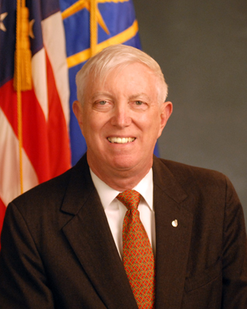
Wilson Felder
On Monday, May 14, the American Institute of Aeronautics and Astronautics (AIAA) named Dr. Wilson Felder, Director of the Technical Center, as an AIAA Fellow. AIAA is the world's largest professional society devoted to the progress of engineering and science in aviation, space, and defense. Becoming an AIAA Fellow is a high honor reserved for the few individuals in the world who have made significant contributions to the aviation and aerospace industry. AIAA honored Dr. Felder "for relentless dedication to the transformation of the National Airspace System through technical innovation, inspired leadership, and public advocacy over two decades." At the subsequent Gala awards, more than 400 representatives from leading industry, academic and government agencies throughout the world attended the announcement of AIAA's 2007 Fellows. Leaders from the aviation industry, the NASA Administrator, the Secretary of the Air Force, Congressman David Hobson (7 th, OH), and the former Chairman of Continental Airlines applauded the naming of the 2007 Fellows.
Prior to his current assignment, Dr. Felder led the Office of Technology Development in FAA's Air Traffic Organization in Washington DC. He was responsible for field demonstration of advanced technologies. Dr. Felder joined the FAA after 23 years of service at TRW where he was Vice President of Aviation Services, leading the company's engineering services business with the FAA and the aviation community. He is also a certified pilot who has long been active in the aviation community. Dr. Felder dedicates his time to serving southern New Jersey on the Dean's Advisory Board of the Rowan University School of Engineering, the Board of the United Way of Atlantic County, The Atlantic City Chamber of Commerce, and the Executive Board of the Jersey Shore Council Boy Scouts of America. Dr. Felder served our country for 24 years as an active and reserve Naval Officer, retiring from the active reserve with the rank of Commander.

ATO Operations Planning All Hand’s Meeting
By Tammy J. Lusk, Esq.
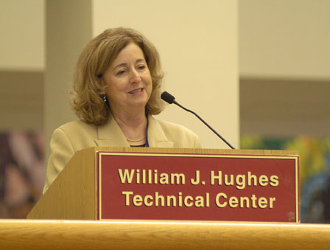

On July 9, 2007, ATO Operations Planning Vice President, Vicki Cox held an All Hands Meeting at the Technical Center with an “all star” appearance including, Vicki Cox (via pre-recorded message), Director of Systems Engineering and Safety, James Williams; Director of Performance Analysis and Strategy, David Chin; Acting Director of Research and Technology Development, Barry Scott; Manager of Operational Evolution Partnership Integration and Implementation, Giselle Mohler; Director of International Office, Carey Fagen; Manager of Comptroller Office, Molly Vorce; Manager of Administration, Brenda Willingham and finally our own Technical Center Director, Wilson Felder. A Video highlighting thoughts on NextGen was shown. This featured the reasons given to Congress for needing NextGen and the importance of the NextGen project as we are about to enter a new fiscal year.
The meeting started with Leroy Dickerson and Gerry Berry receiving 50 Year Service Certificates.
Then, a presentation entitled “Ensuring A Viable Future: Our Restructure” was given. The presentation stated that today’s Air Transportation System is ground based, human-centric and un-automated with a single channel voice control and aging infrastructure. OEP is the bridge to NextGen defining the framework for FAA’s Implementation Plan and defining how FAA’s integration and implementation will be executed. OEP also aligns R& D with NextGen objectives, provides “big picture” content and initiates industry collaboration. Reasons given for needing NextGen included the fact that there is an increased demand on our airspace and an average of an 18-minute delay in flights. The new organizational chart was shown with the Directors in attendance. Each Director highlighted their functions and NextGen objectives.
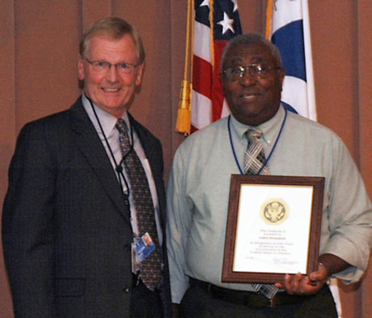
Barry Scott giving Leroy Dickerson his 50 Year Service Certificate
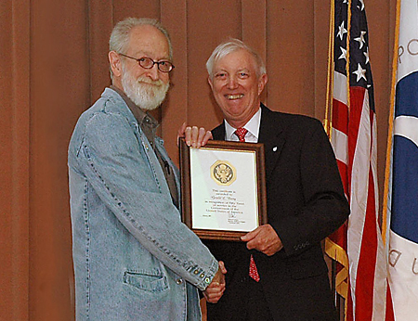
Gerry Berry receiving his 50 Year Service Certificate from Center Director Wilson Felder
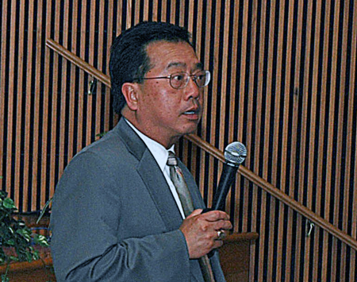
Dave Chin, Director of Performance Analysis & Strategy speaking
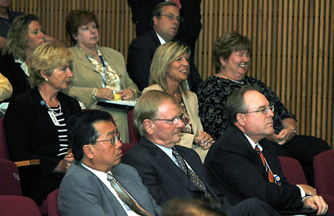
Seated in Second Row Left to Right: Giselle Mohler, Manager OEP; Molly Vorce, ATO-P Comptroller, Brenda Willingham, Administration Office Manager; Seated in Front Row Left to Right: Dave Chin, Director Performance Analysis & Strategy; Barry Scott, Director Research & Technology Development; Jim Willams, Director Systems Engineering.

New State-of-the-Art Digital Radar Laboratory Opens at the Technical Center
By Michael Prata
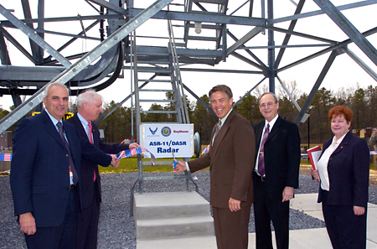
From left to right: Joseph Paone, Raytheon Corporation; Dr. Wilson Felder, Center Director; Scott Farnsworth, USAF; Nelson Barber, FAA; and Dot Buckanin, FAA, cut the ribbon at our new lab.
The Airport Surveillance Radar Model 11 (ASR-11) laboratory began operations at the Technical Center, with a ribbon-cutting ceremony on May 2, 2007. It is located at the building 162 test site on Tilton Road. Throughout the nation, the ASR-11 is replacing current aging analog radars at more than 60 of the nation’s civilian airports as well as at numerous DOD airfields. The system detects aircraft position and weather conditions in the vicinity of civilian and military airfields. The ASR-11 will replace existing ASR-7, ASR-8 and counterpart military radars. These older radars, some up to 20 years old, are being replaced to improve reliability, provide additional weather data, reduce maintenance costs, improve performance, and provide digital automations for presentation on air traffic controller displays.
This effort is a joint partnership between the Federal Aviation Administration, the Department of Defense (DOD) and Raytheon Corporation.
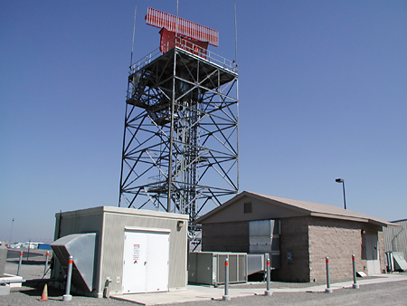
A complete ASR-11 radar tower located in Stockton California, where Technical Center personnel completed initial OT&E testing.
The ASR-11 will interface with present and future automation systems to provide air traffic controllers with state-of-the-art aircraft and weather detection in the airport environment. Surveillance and weather data outputs are fully digital, which is necessary for interfacing with the new Standard Terminal Automation Replacement System (STARS) and other digital automation systems. The ASR-11 also has the capability to produce simultaneous outputs in several formats compatible with FAA and DOD non-digital automation systems.
The ASR-11 radar located at the Technical Center will support joint FAA, DOD and Raytheon test efforts for the ASR-11 Advanced Signal Data Processor (ASDP) effort. The ASR-11 ASDP replaces the current signal data processor that will no longer be produced. The FAA, DOD and Raytheon will use the ASR-11 ASDP system for test and evaluation of the new processor. Raytheon engineers will use the system to conduct on-site Test and Evaluation. Both FAA and DOD engineers will witness this T&E. The FAA and DOD will conduct Operational Testing and Evaluation to verify that the new processor integrates with the air traffic automation and communications systems. Engineers from the ATC Surveillance Team located at the Technical Center will be responsible for all of the FAA ASR-11 testing conducted at the site.

The 2007 ATCA/FAA/NASA Technical Symposium
By Tammy J. Lusk, Esq.
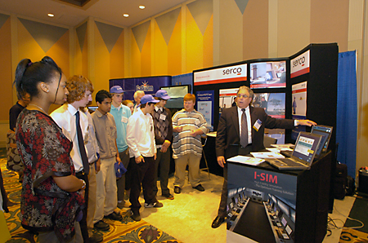
Local Students visit ATCA Exhibits

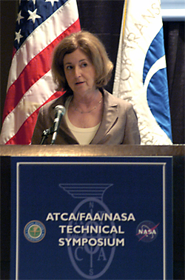  Speaker Vicki Cox pictured | The 2007 ATCA/FAA/NASA Technical Symposium was held in Atlantic City from May 8 th through May 10 th. The theme this year was “Bridging the Gap from Concept to Reality with Technology.” Pete Dumont, President of the Air Traffic Control Association (ATCA) opened the convention. Among the introductory and keynote speakers were Wilson Felder, Director of the Technical Center, and Vicki Cox, Vice-President, Operations Planning, who emphasized upcoming technologies and pertinent issues facing the agency. The Technical Center was also represented by a number of speakers including Jim Williams, Ben Willems, and Bill Benner.
The Technology Transfer program from the Technical Center was one of the exhibitor booths and displayed some of the FAA’s latest innovative technologies and commercial partnerships. Among the new technologies displayed was Dr. Todd Truitt’s two patent pending prototype data systems: the Tower Operations Digital Data System (TODDS), which combines textual electronic flight data with airport surface surveillance displays; and the Perceptual-Spatial Tower Operations Digital Data System, which makes use of airport surface maps, rather than rely on surface surveillance. Other items displayed included Lou Delemarre’s patent pending Aircraft Geometric Height Measurement Element (AGHME), developed in support of the Domestic Reduced Vertical Separation program (DRVSM). Finally, the patented Adiabatic Expansion Nozzle was also displayed which performs faster, cleaner and more efficiently than traditional fire extinguishers.
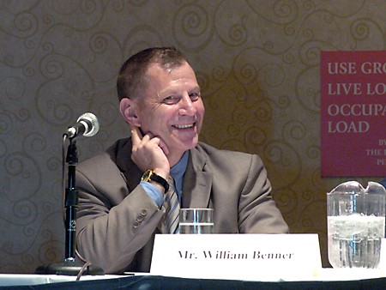
Speaker Bill Benner pictured

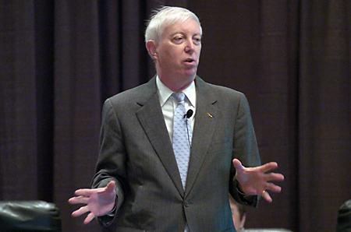
Speaker Wilson Felder pictured
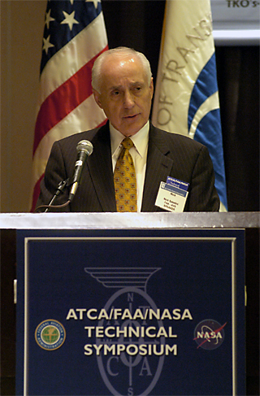
Speaker Nick Sabatini pictured
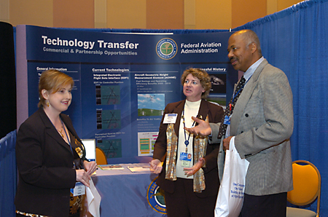
FAA’s Technology Transfer booth with Tammy Lusk, Deborah Germak and Rodney Guishard pictured from left to right
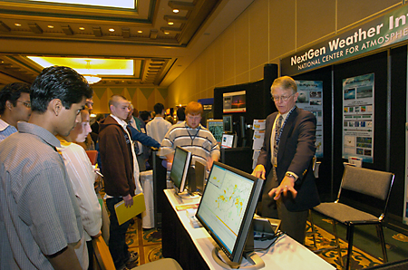
Local Students visit ATCA Exhibits
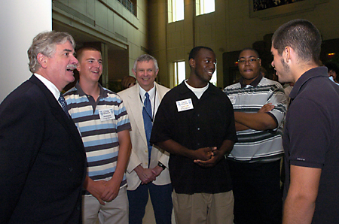
Local Students visit ATCA Exhibits

V&V: The New Way of Doing Business
By Jason McGlynn
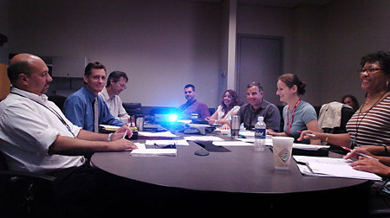
TSB members meet
Verification and Validation (V&V) has been a popular topic around the Technical Center lately. What exactly is it, how will it help, and what will be the impact on the work here?
To ensure the quality and reliability of new NAS systems, and improvements to the NAS, they must be tested and evaluated thoroughly before they are put into operational service. V&V is a business approach that standardizes test processes and procedures and will enable us to do our work more effectively and efficiently. The intent of implementing standards is to help us reduce latent defects, and minimize the cost and time required for the test. Producing the best product requires the highest level of quality to be built into every stage of T&E. V&V asks two basic questions:
Verify if the system or service is built right?
Validate whether we are building the right system to satisfy the end mission and meet the customer’s needs?
The Test Standards Board (TSB) is a key component of the V&V infrastructure at the Tech Center and is the primary group responsible for developing, implementing, and administering V&V practices and methods to ensure high quality T&E products and services. TSB core members are experienced testers and subject matter experts (SME) who provide valuable inputs to overall T&E program direction. Testers will see that V&V will facilitate and expedite the overall T&E process as the new processes are used and become familiar. The T&E Handbook was written by the TSB to document standard practices and methods for the tester to follow. To help make the test process quicker and easier, a T&E standards repository, that contains templates and samples in electronic form of items called out in the handbook, will be provided.
The TSB will oversee developmental and operational test activities to ensure quality, assess process conformance, and continually improve processes. The TSB members serve as technical experts that perform independent reviews and provide recommendations on test strategies, plans, conduct, and reporting. TSB members are a respected group that search out and apply best practices, make recommendations, and update policies as needed. The documented technical recommendations that the TSB makes will support the implementation of quality test programs and will be a critical factor that ATO executives use to assist in major program business decisions.
The processes documented in the T&E Handbook represent test practices and procedures with improvements that address known deficiencies in the test processes. Much of the detailed processes that testers will see in the handbook will be similar to how they currently perform testing. The handbook will also include some best practices that other agencies have implemented to help ensure quality. As part of the V&V process development effort, the TSB examined our current practices and looked at problem areas that the FAA and other agencies have encountered during testing in the past. The lessons learned have been incorporated into practices to ensure that we don’t repeat the same errors.
. . . . . . . . . . . . . . . . . . . . . . . . . . . . . . . . . . . . . . . . . . . . . . . . . . . . . . . . . .
A V&V Dry Run
By Jason McGlynn
The VP for Operations Planning asked the Technical Center to institutionalize consistent and quality industry-standard verification and validation ( V&V) practices and to establish accountability and oversight for test and evaluation (T&E) activities. The intent is to reduce latent defects in fielded systems, to promote data driven, best-value decision making throughout the respective life cycles of these systems, and to minimize the cost and time required for testing. To achieve this goal, the Center Director created the Test Standards Board (TSB), a group of highly experienced testers and subject matter experts chartered to develop, implement, and administer V&V practices and methods.
The TSB has written the T&E Handbook and V&V Operations Guide to document quality test processes and procedures that will enable the Center to do its work more effectively and efficiently. These documents are designed to become the standard way to conduct testing. While they define the standard T&E processes necessary to consistently conduct V&V throughout the system lifecycle, the processes are tailored to meet the specific needs of an FAA acquisition program.
Now that the initial versions of these documents have been completed, the next step is to see how well these processes can be followed. Hence, on August 31, 2007, two programs (ERAM and Data Comm) began participation in an 8-month formal pilot program. These test programs will dry run the standards and processes documented in the T&E Handbook and V&V Operations Guide and give the TSB feedback on the practicality of processes and the usability of the documents and tools. Before the pilot program began, test teams from the three pilot programs received familiarization briefings on the T&E Handbook and V&V Operations Guide. The programs that participate in the pilot will maintain T&E schedules, forward major program documents for TSB review and coordinate with the TSB on program activities and issues. TSB members will attend program reviews and conduct midpoint reviews to solicit feedback and adjust processes.
During this pilot period, to get additional input, testers from other test programs will be invited to make use of these standard processes on a voluntary basis. This pilot program will also give the TSB the opportunity to exercise the newly appointed duties of TSB and to refine and improve their operations prior to fully institutionalizing the standards. These activities will be carefully managed by the TSB to ensure that program schedules and costs are not adversely impacted. These T&E standards will be continuously assessed by the TSB to determine if the process adds value to the overall program.
After the final V&V pilot debriefings are conducted, the findings will be incorporated into the formalized version of the T&E Handbook and V&V Operations Guide. The objective of these activities is to produce a quality and practical T&E Handbook, V&V Operations Guide, and associated project management methods that will address the goal to formally initiate an enhanced V&V Protocol of Operations by September 2008, as stipulated in the Strategic Management Plan.

Best Wishes Upon Allan Oswald’s Retirement
By Natalie Reed
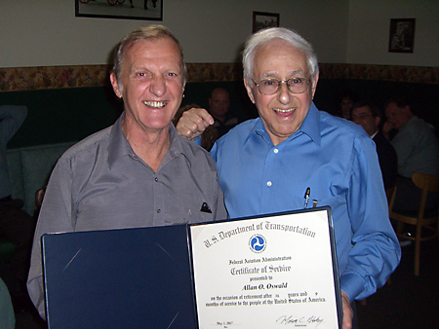
Al Oswald receiving retirement certificate from Murray Karlin
After 36 years and 9 months of Government service, Allan Oswald has retired. Al and his wife, Roberta, will reside in Port St. Lucie, Florida. Al was an expert in Financial Management, Acquisition Planning, Information Technology, Human Capital, and Strategic Planning. He contributed to the success of many efforts at the Technical Center. He also served as a facilitator for Mediation Counseling. His knowledge and breath of experience was a positive contribution to the Technical Center.
Al Oswald received his Bachelors degree in Economics and Business from William Patterson College and his Masters in Business Administration from Monmouth College. In 1974, Al joined the National Aviation Facilities Experimental Center (NAFEC) and started as a budget analyst for Frank Meehan. He became a Manager of Budget and a knowledgeable resource for all who knew him. During his Federal career, Al was detailed to Washington where he was the focal point for the Technical Center implementation plan for the New Core Compensation System. He was a key contributor to the acquisition of our new aircraft N47, the Bombardier Global 5000. The airplane has become a key flying laboratory for the R&D Flight Program and is a vital component for test and demonstration of new technologies for the National Airspace System and the Next Generation Air Transportation System (NEXTGEN). After Al's success of acquiring funding for the new aircraft, he transitioned to project lead for the Enterprise Project Management System (EPMS).
As many of you know, Al loved to travel and he will probably visit new places and meet new friends all over the world in his "retirement". We all wish Al the best of luck.

Baxter Stretcher Retires
By Kerry Bowers
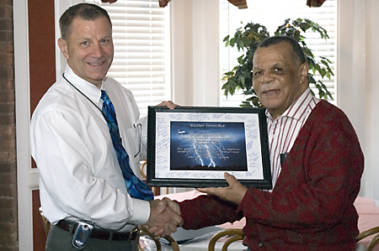
Baxter receives a gift from his co-workers, and his certificate of retirement, from Bill Benner, Manager, Weather Processors Group.
Baxter Stretcher retired from the Technical Center this spring after over 27 years of service. Baxter served in the United States Army. Following his honorable discharge he was employed by the RCA Corporation. Baxter then worked at the Atlantic County Welfare Office before beginning his employment at the Technical Center in 1985 as a mathematician.
During his time at the Center, Baxter worked in the various incarnations of the weather branches, groups, and teams, supporting the major weather systems including Next Generation Weather Radar (NEXRAD), Terminal Doppler Weather Radar (TDWR), Weather Sensors Processor (WSP), and Automated Weather Sensors Systems (AWSS).
In addition, his collateral duties included serving on the Center Diversity Council and acting as an EEO Counselor.
Baxter’s son, Vincent resides in Atlanta. Baxter is active in his church in Atlantic City, and rumor has it, Baxter will be enjoying his retirement on the Boardwalk and in the Casinos.
Baxter is the true essence of a gentleman, and he will be missed by his friends and colleagues here at the Technical Center.

Tech Center Legend: Gerry Spanier
By Stan Ciurczak
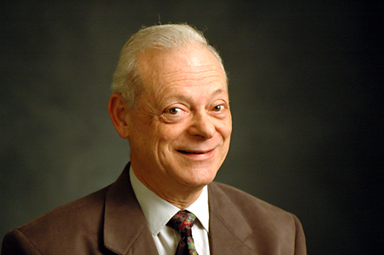
Gerry Spanier
Recently I had the opportunity to interview longtime FAA employee Gerard (Gerry) Spanier about his long and distinguished Government career. I interviewed Gerry on February 28, 2007, which was the day after family, friends and co-workers honored him at a retirement luncheon at the Italian Gourmet Restaurant in Galloway.
Gerry went to work for the FAA’s National Aviation Facilities Experimental Center (NAFEC) in 1961, shortly after graduating from the Engineering School at Johns Hopkins University in Baltimore, where he was co-editor of the campus newspaper. During the interview, which you can see and hear below, Gerry describes the engineering program from which he graduated as a general education in engineering. He also said he minored in experimental psychology, the forerunner of what we call human factors today.
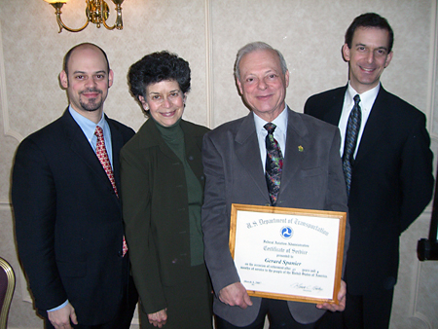
Anyone who has had the opportunity to get to know Gerry, even a little bit, knows that he brought an encyclopedic knowledge of his chosen field, a zeal for all things aviation and a diplomatic style that served him well. Gerry is synonymous with what one might call old-fashioned common decency, something viewers will see throughout his taped interview.
Gerry was one of the first people to be hired by NAFEC when it was in its infancy. During nearly a half-century of civil service, he saw this institution morph from an experimental center into the FAA Technical Center and eventually into the FAA William J. Hughes Technical Center.
You can click on any, or all, of the links below to see and hear Gerry describe his recollections of his workplace. Comments or questions can be directed to me by sending mailto:stan.ciurczak@faa.gov
0:00 to 4:53 The Early Days of NAFEC
4:54 to 6:53 Data Processing Central; Early Radar Displays
6:54 to 10:29 Gerry Spanier invents a Solid State Pentiometer
10:30 to 13:30 In-Service Improvements in the Age of "Shrimp Boats"
13:31 to 18:24 NAFEC provides New Tools to Controllers; the NAS is born
18:25 to 22:21 New Technologies inspired by the FAA
22:22 to 28:58 Digital Voice; Satellite Communications
28:59 to 36:20 Gerry Spanier assists the U.S. Justice Department in a Patent Case
36:21 to 38:25 The Original NAS Plan; Early System Engineering
38:26 to 40:33 The FAA goes "Big Time"
40:34 to 45:22 "Save NAFEC" Committee is formed; the Tech Center is born
45:23 to 49:4 Professionalism at NAFEC
49:4 to 55:11 German Rail Guru Hans Giesecke relocates to NAFEC
55:12 to 1:01.40 Air Traffic Control Towers
1:01.41 to 1:07.58 Technology Management; the STARS Program
1:07.59 to 1:11.46 Lessons Learned from 9/11

Retirement Interview: Jack Berry
By Stan Ciurczak
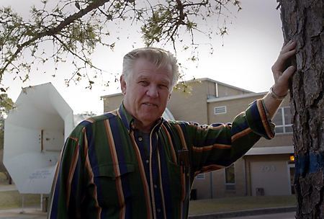
Editor’s Note: Stan Ciurczak recently interviewed Jack Berry in the Air Flow Induction Test Facility, which is where he worked at the time of his retirement on April 3, 2007. Jack originally worked for NAFEC as a carpenter, and prior to that served in the U.S. Navy. Jack enjoys local, aviation and naval history (and old cars), and helped me out on a number of occasions through the years when I was writing stories for the Intercom and Inside the Fence. Here’s wishing Jack and his wife all the best in retirement!

STAN: How many years of service do you have?
JACK: 29 years and one month working for the FAA plus 4 years in the military for a total of 33 years and one month of Federal service.
STAN: What is your current position here?
JACK: Aerospace Engineering Technician.
STAN: I know you grew up in this area. Can you talk about the good old days, let’s say, before you even went into the Navy? Please talk about South Jersey a little bit.
JACK: I was born in Pleasantville and grew up in Galloway Township in the Absecon Highlands section. I went to the old school on 6 th Avenue, which has since been torn down. Our house was kind of like off the runway and the Navy was here and I remember that it was after WWII.
STAN: Which runway was that?
JACK: The main runway at Naval Air Station Atlantic City in Pomona.
STAN: Tell me more.
JACK: We used to go outside in the summer time when it was nice and there was a field behind the housed with an old farm. The planes made their turn on approach right around our house on the field, and we used to wave to the pilots and they waved back. I guess they were probably low enough, that if we new where to look and could read their tags or their names. That was the day of the old props. During grade school age they used to come up with tours over here on the base when we were little. They would bring us out here on a bus and then the Navy would take us for a trip to the Mess Hall and give us milk and cookies. We went through the hangers and toured some of the planes. I remember one guy there in a parachute outfit. They hooked him all up in a parachute and everything and had him pop it, and then they had to pack the whole suit over again. That was a big treat back then. They had a lot of interesting things for young people to see, including uniforms, guns and aircraft.
Then they had a super show out here on Armed Forces Day. They had Army and National Guard out of Atlantic City come over here and they worked in conjunction with the planes, like they were invading something and making a landing somewhere. They even had fly-bys, bombs and artillery going and the troops running across the apron. There were lots of interesting things.
Then they had the commercial aspect, which was a special Sunday treat when Dad would take us out for a ride and sometimes we would come out here and go to the airport. You used to be able to go up on the observation deck. You could stand up there and watch the commercial planes come in and out. The DC-4 was the first 4-engine plane here and when they came in they were monsters, at least back then. Now they would look like a piper cub. We used to go up there and watch the Navy pilots flying and practicing landings on carriers. They had an area marked off to look like a carrier deck and the planes would come in and do touch and goes.
STAN: How did they mark it off because I heard about that before?
JACK: It was a painted outline of an aircraft carrier on the runway itself. Of course they had their share of crashes back in those days. There was an old farmer over on 6 th Avenue in Absecon Highlands that had one of the planes crash right in front of his house one time. Another time in a thunderstorm, a jet went down behind his house.
STAN: 6 th Avenue in Pleasantville?
JACK: No, Galloway – Absecon Highlands. There were quite a few crash scene areas around the place. We used to know where they all were but I wouldn’t be able to find them now that the area is so built up.
STAN: Is that because they were rushing to train pilots for World War II?
JACK: Some I guess were just operational incidents, that’s all. Probably a lot of them were. I think there were a couple of them that hit together one time during practice formation flying. Some of the old planes weren’t nearly as reliable as the jet engines are today. I don’t know – we used to go around and find all those rare treasures that you might find in an oxygen bottle that was wrapped in wire so that it would not explode at high altitude, or a number of things that might fly off the plane. I know one person had one of the propeller blades he got from a crash. I kind of outgrew all that by the time I started high school.
STAN: Where did you go to high school?
JACK: Pleasantville. I attended the old Pleasantville High School (Class of 1960), which is where I got my first car. It was an old one and I had a few things go wrong with it and I had a friend of mine worked in a gas station in Absecon and he took me down there and introduced me to a guy that worked nights, who was Richard Johnson. That’s how I got to know him and that was in 1958 when I first got my driver’s license.
Stan – What gas station was that?
JACK: Zona’s Texaco at the corner of Rt. 9 and the White Horse Pike. He would let me read the books at night on how to do something on the car. I would go down and read what to do, come home from high school and run out and do that and then go down and see what the next step was, until I got all that down and got the parts that were bad – fixed. Just reversed the operation to put it back together. I got to know him pretty well and he had a pilot’s license. My favorite Uncle went into the Navy, actually during WWII, and just after he went in they quit (WWII) and the war was over. That was my favorite Uncle and that’s why I wanted to always go into the Navy.
STAN: Did you go to high school with any of the people who work here?
JACK: Quite a few.
STAN: Can you remember their names? Are any of them still working here?
JACK: Yes, Ernie Heintz, Thomasena Brown, Billy Jerdan and Wes Norton come to mind. Ernie still works here as a contractor.
I got talking to Dick Johnson and learned he had a pilot’s license. I used to go with him on Sunday mornings. We used to go and run a super cub out of Bader Field for about an hour, which was a weekly thing. In 1960 I got out of high school and went into the Navy. I became an aviation electrician. Unfortunately I got put on a carrier the whole time, on the U.S.S. Constellation. I’m a member of the Plank Owners Association from the U.S.S. Constellation before it was commissioned in October 1961 at the New York Shipyard. I was on that for a little over a couple years and then on the U.S.S. Wright, which was a communication ship. It actually was President Kennedy’s idea – it had all radio equipment on it that you could communicate all around the world and it was supposed to be to protect Washington, D.C. if it came on attack that he could fly onto that and operate from there.
Actually it was redone in Bramington, Washington and we were leaving and went over to Seattle, Pier 91 for 2-3 days before we left. We were supposed to leave at 1300 but at 11:00 AM that morning is when President Kennedy got shot. We were held there a couple more days before we came back to the East Coast. We came back through the Panama Canal and on up that way. We went through the Virgin Islands to Norfolk, VA. Looking back now, the Constellation was decommissioned after 43 years of active service. I think I was just 20 – when it was commissioned. Basically it was looking like your own working life. I got out of the Navy, got married and became a father. I worked in construction for a few years. I had an application here for 10 years and I finally got a job here in the Carpenter Shop. I worked there for 5 years and then there was an opening in the R&D in Fire Safety and I have been here ever since.
STAN: What year was that?
JACK: I started at the base (NAFEC) on November 5, 1978.
STAN: Who was the Center Director then?
JACK: Bob Faith was the director when I started working here.
STAN: That was here on the old side?
JACK: Yeah that was before the Technical and Administrative Building (Bldg. 300) was built. I was in the Carpenter Shop, Bldg. 62.
STAN: Is anyone you started with in the Carpenter’s Shop still here?
JACK: Yes, Jim Woerner, a supervisor in one of the shops over in the Technical Services Facility (TSF), and Cliff Bailey, who works on mock-ups of tower cabs over in Bldg. 170, both still work here. They were actually the ones that designed the modern towers, controls, instruments and all their equipment – Air Traffic Control Group that is in the T&A. They turned out some nice work and really streamlined their operation while I’ve been out over here in the R&D area setting planes on fire, and all that fun stuff.
STAN: When you started working here, whom were you working for?
JACK: I was working under Dick Hill.
STAN: Was he the Manager?
JACK: Well, he was the top guy in the actual work part. He wasn’t up in management like he is now. It was probably a little looser then. Everybody knew everybody and eventually I got assigned with Harry Webster who I worked with for at least the last 15 years. We did a big burn project out at Bldg. 311; the old blast area and Convair 880 and reenacted the Manchester incident. That was probably the highlight of my career. I had more fun working on that plane. We set it up to resemble the plane that had been there, removed two of the four engines and made it like a twin-engine plane. It is kind of amazing – the inside the way the smoke came in, the way the fire went and the whole bit. That was one of the most interesting and must fun jobs that I’ve done my whole working life.
STAN: That was the Manchester project?
JACK: Yes, the Manchester Reenactment.
STAN: What year?
JACK: That’s been a long time – about 13 years ago.
STAN: So it was around 1993?
JACK: Yes – something like that. Actually Harry Webster was the working engineer who did all the designs and test instruments. Joe Rosen and I were the ones who put it all together. That was one fun job! It really felt like you had done something.
STAN: Tell me about the plaque that is hanging in the conference room in the Air Induction Test Facility.
JACK: The plaque honors the memory of Bill Neese.
STAN: I understand that you helped to make the plaque.
JACK: Harry and I worked on it and it was Harry’s idea to make the plaque. Bill Neese came here originally from what was then the CAA Technical Development and Evaluation Center in Indianapolis. The large wind tunnel at the Tech Center originally was used for Surface-to-Air Missile Program testing by the U.S. Navy in California. Bill Neese basically set up the large wind tunnel here, after the FAA acquired it from the Navy. The barge was shipped from California through the Panama Canal and up to Philadelphia by ship, where it was loaded on a barge headed for Mays Landing. The last leg of the trip was on a flatbed truck past the old Caesar’s Restaurant.
Bill maintained it and did a lot of testing with it, and he gave Harry Webster and I an orientation to it. Harry Webster and I picked up where he left off after Bill retired, and Harry is the main force now on it. I have been doing the maintenance work and running the engines and setting up things.
We have some pretty interesting things that have been done here. We tested the soft-concrete arresting system with Jim White. We’ve done a lot of work with that. We qualified life rafts for the Coast Guard to withstand 70-mile an hour winds that we did in our low speed section. We have been working on the new material there – composites. We are testing for heat transfer. If there is fire inside, aluminum will pass off the heat and the air stream. Our testing was to try to see if the composite reacts – to see if it passes it or holds it. The composites seem like they are holding up pretty well so far with the tests we have done. In another part of our group, Steven Summer just completed the wing fuel tank test, including heating it and studying the effects of airflow over it. They also are working on straight fuel tanks. It is interesting work that goes on here at the Tech Center. I personally enjoyed figuring out how to mount things the right way and get some results out of the test. It is pretty interesting work.
STAN: Good. What are you going to do when you retire?
JACK: Basically I plan to become a gentleman farmer. I’ll plant a dozen tomato plants and watch them grow; that is when I have time. I joined the Wildwood Naval Air Museum and I kind of plan on a day a week down there. We just built a new house and I have all the landscaping to do along with some odds and ends. I own a hot rod car that maybe I’ll get finished now. I’ve been down to doing the interior for the last 5 years but haven’t gotten to it yet.
STAN: Do you belong to a hot rod club?
JACK: Yes, we belong to Cruising Nights in Mays Landing. We go to a few car shows around the region including Pennsylvania and Delaware. It is a lot of fun when you get together; it’s like a parade wherever you go.
STAN: Are you going to help restore things at the Naval Air Museum in Wildwood?
JACK: Yes, I probably will.
STAN: Are you going to work with Dr. Joe Salvatore?
JACK: Yes.
STAN: I haven’t met him but I’ve heard his name.
JACK: Dr. Joe Salvatore.
STAN: Is he a physician?
JACK: I don’t really know what he is. I guess he is retired and he is into this thing real deep. He has been a hard driver on it. I didn’t even know it was down there and I heard about it some how and went down there and met him then. A very nice person.
STAN: I did hear or read that the wooden hangar down there was based on a standard design for Navy hangars during World War II and is identical to the one that used to be here at Naval Air Station Atlantic City, so you should feel right at home down there.
JACK: I don’t know if I was ever in the hangar here. I guess I was during grade school tours but I really don’t remember too much about them. They were gone before I started work here. I remember there was a third Navy training site near here.
STAN: Yes, it was in Woodbine.
JACK: That’s right. The one in Wildwood was used for bombing. The one in Atlantic City was for fighters and I think the one in Woodbine was for patrol. I never knew they were down there all these years. That’s not saying a lot because before I went to high school I didn’t know what the world past St. Pete’s in Pleasantville was either. We never went any further than Pleasantville. Pleasantville was a big special shopping trip. It had an Acme, an A&P and a meat market. There were other stores in Absecon. About everything you needed was in Absecon, but for something special or extra special things, you went to Pleasantville maybe once a month. When I was little, I used to go to the Steel Pier in the summer. To go shopping in Atlantic City during Christmas time was a treat in itself. Those were the old days when department stores had model trains and the whole town was lit up at night; it was a whole different world then from what it is now. Good memories.
STAN: You watched the area build up quite a bit. For example, Egg Harbor Township (EHT) really has come a long way in recent years.
JACK: Yes, in fact we recently moved out of EHT and out into the woods of Dorothy.
STAN: Good for you. I really appreciate your taking the time to share your memories of the local area and your career with me. All the best to you in your retirement!

Rodney Guishard Receives 40 Year Service Award
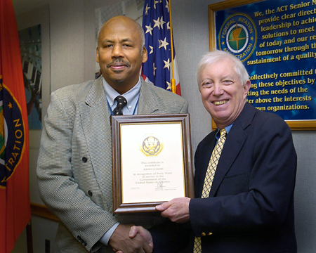
Rodgney Guishard receives 40 Year Award from Wilson Felder
Center Director Dr. Wilson Felder recently honored Rodney Guishard with a 40-year Service Award. Guishard currently serves as Manager, Test Standards and Program Assessment Team, Technical Strategies and Integration Group, Operations Planning. Congratulations, Rodney!

2007 Administrator’s EEO Award - Keeping the Promise
By Pete Castellano
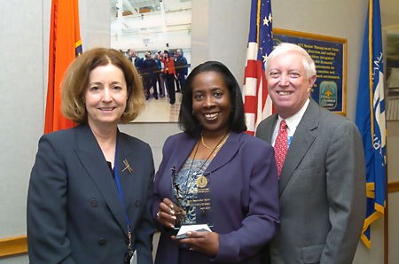
Vicki Cox, Carolyn McKinney-Bobo and Wilson Felder pictured.
Al Jefferson, Chinita Roundtree-Coleman and Carolyn McKinney-Bobo were among the recipients of the 2007 Administrator’s EEO Award, or as they are now called, the Keeping the Promise award. Basilyn Bunting was also nominated for an award. Al’s award was based his work in the area of EEO Mediation. He participated in 6 mediations, all in the Eastern Region, along with another mediator. Four of the mediations resulted in agreements. He demonstrates a great deal of knowledge and expertise in the mediation arena and has been a mediator for 10 years. Chinita and Carolyn developed analysis and measurement tools and protocols that assess EEO compliance. Additionally, they served as auditors for the assessment conducted at the Eastern Regional Office. Congratulations to Al, Chinita, and Carolyn on your efforts, and for receiving these prestigious awards!
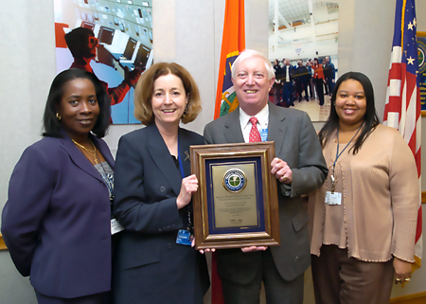
Carolyn McKinney-Bobo and Chinita Roundtree-Coleman receiving 2007 Administrator’s EEO Award by Vicki Cox and Wilson Felder. Pictured from left to right Carolyn McKinney-Bobo, Vicki Cox, Wilson Felder and Chinita Roundtree-Coleman.
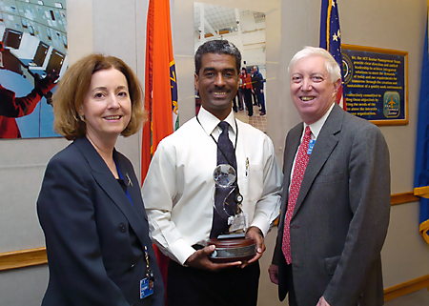
Vicki Cox and Wilson Felder presenting Al Jefferson will the 2007 Administrator’s EEO Award. Pictured from left to right Vicki Cox, Al Jefferson and Wilson Felder

Jim White Receives Elmer A. Sperry Award
By Terry Kraus
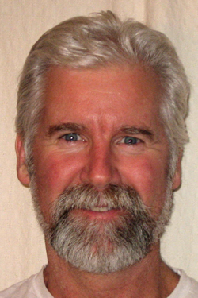
Jim White
The Society of Automotive Engineers (SAE) International, American Institute of Aeronautics and Astronautics(AIAA), Institute of Electrical and Electronics Engineers(IEEE), American Society of Civil Engineers(ASCE), and the Society of Naval Architects and Marine Engineers selected Operations Planning, Research and Development 's Jim White to receive the 2007 Elmer A. Sperry Award along with industry co-developers of the Engineered Materials Arresting System (EMAS), Bob Cook, Peter Mahal, and Pam Phillips.
EMAS, developed by the FAA's Airport Technology R&D program, the Port Authority of New York and New Jersey, and Engineered Systems Company (ESCO) of Ashton, Pennsylvania, is made of water, foam, and cement, and deforms readily and reliably under the weight of an aircraft tire. As the tires crush the material, the drag forces decelerate the aircraft, bringing it to a safe stop. The technology is now in place on 23 runway ends at 18 airports, with eight additional EMAS projects under contract at six U.S. airports. In addition, arrestor beds have gone global; EMAS is installed at Jiuzhai-Huanglong Airport, which is on a mountaintop in China, and projects are underway for two runways at Madrid-Barajas International Airport, Spain.
The Elmer A. Sperry Award annually recognizes distinguished engineering contributions that, through application proved in actual service, have advanced the state of the art of transportation whether by land, sea, or air. It honors Elmer A. Sperry, who was renowned for his navigational gyroscope and who coined the word automotive, giving SAE its name. Past recipients have included Donald Douglas, Ferdinand Porsche, Sir Geoffrey De Havilland, Igor Sikorsky, and Charles Draper.

John Wiley Named ITEA Conference Chair; Dot Buckanin, Technical Co-chair
By Holly Baker
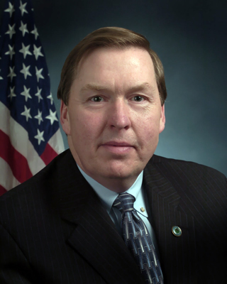
John Wiley
The International Test and Evaluation Association (ITEA) has named John Wiley, Technical Center Technical Strategies and Integration Manager, the chair for its 2008 annual symposium. Wiley serves on ITEA’s Board of Directors as a government non-Department of Defense (DOD) member.
ITEA is the leading association for professionals in the field of test and evaluation, with more than 2100 individual and 84 corporate members, worldwide. The non-profit educational organization was founded in 1980 to further the advancement and exchange of technical information in the test and evaluation arena. Its membership has predominantly encompassed the DOD, since it began.
The ITEA Board has targeted its efforts on growing and expanding the scope of its membership in recent years. The 2008 symposium will present a forum and program that attracts a more global test and evaluation community, embracing the transportation and aviation industries, academia and government. Dot Buckanin, Technical Center Special Assistant to the Director, has been selected technical co-chair of the symposium. She will focus on achieving this global perspective, as the symposium program develops.
FAA leadership in the ITEA symposium has important implications for introducing new aviation technologies to an international audience, and reinforcing the paramount importance of advancing the Next Generation Air Transportation System – NextGen.
The symposium will take place the week of November 10, 2008 in Atlantic City and will be co-hosted by the South Jersey and Francis Scott Key ITEA Chapters. This is a season of “firsts” for both ITEA and the FAA – the first FAA chair, the first FAA ITEA-affiliated chapter as conference co-host, and the first time Atlantic City will host this prestigious symposium.
Wiley has more than 30 years of technical experience in the aviation industry, 21 of those years in management. He previously served as Director of the Technical Center’s Office of Integrated Engineering Services. Also, he served on the FAA Air Traffic Organization’s Transition Team in Washington, D.C., where he provided strategy and direction in defining, communicating and implementing a broad spectrum of new agency management initiatives. Wiley is an active member of the Rowan University Electrical and Computer Engineering Industrial Advisory Board and the Air Traffic Control Association. He is a former president of the ITEA South Jersey Chapter.
Additional information on ITEA and on-line membership applications can be found at http://www.itea.org/

The Launch of the Automated Telephone Attendant
By Maria Lemmetti-Fane
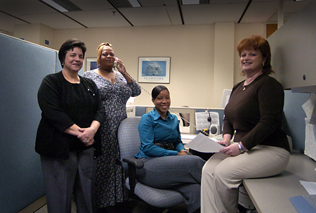
Pictured from left to right Bernice Benitez, Geraldine Harvey, Nicole Hite, Maria Lemmetti-Fane
The Technical Center has taken another step into the era of technology. Through the combined efforts of Peter Callaghan of the Telecommunications Group and members of the Service Liaison Staff, the Automated Telephone Attendant is being launched. For over 6 months, the Service Liaison Staff has been gathering data on what types of phone calls the telephone operators have been receiving. The staff looked at external callers versus internal callers, and requests for specific organizations versus a specific individual. The findings were very interesting. The majority of the calls (56 percent) were from internal employees looking for specific individuals.
The Auto Attendant is being implemented and individuals calling 609 485-4000 or dialing “0” for the operator will be prompted to select various options to reach their desired party. Due to resource limitations, the operators will not be providing telephone numbers to callers. Employees are urged to use 411 or the automated system.
Over the upcoming months, the data will continue to be monitored and modifications will be made to the Auto Attendant system as needed. Your feedback is encouraged. Please provide any comments or suggestions via our mailbox at 9-ACT-AUTOMATED-ATTENDANT@FAA.GOV . Thank you in advance for your cooperation in this initiative.

Tech Center Team Makes Elevators Safer
By Jason McGlynn
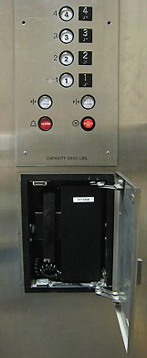
Elevator open call box
Have you ever thought about what you would do if you got stuck in an elevator? Suppose there was a phone in the elevator, but you were unable to pull the call box door open to get to the phone due to your physical disability. This is what happened to me a few months ago. When I was finally rescued, I alerted security, my boss, and Sam Wilson, the Program Coordinator for People with Disabilities. This is when the real work began, and many people from different organizations came together to solve the problem.
Mike Dawson, COTR for maintenance of the elevators (the Center Operations & Maintenance Services (COMS) contract), was sent to resolve the issue. Although the phone worked, Mike had trouble opening the call box not only because the handle on the cover was small and difficult to grasp but also because it was difficult to even pull the door open. He soon realized that the call box handles on all 17 elevators on base were not compliant with the Americans with Disabilities Act (ADA).
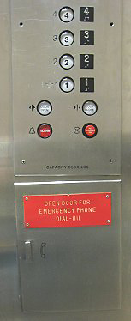
Small handled call box displayed
In an effort to make the elevators ADA compliant, Mike recalled the Viking call boxes that were in use where he used to work. The call boxes required a user to push a single button to call the security dispatcher. Mike asked Jim Lasch, the COMS contractors’ Automated Security Specialist, to see if the technology could be used to resolve the elevator issue. Frank Seman, Manager, Facility Services Infrastructure Team, assigned Chuck Hathaway to work on the ADA infrastructure issue; and Adrienne Calderone, to work on the communication requirements.
Once Jim Lasch identified several options for ADA compliant call boxes and Chuck Hathaway researched current ADA compliance, elevator warranties, applicable codes, etc., a decision was made to purchase 17 call boxes for the elevators. Chuck did some thorough fieldwork, came up with a scope of work, and obtained a government estimate. Chuck and Jim decided on a model that was both cost-effective and dependable. Though the 17 call boxes were purchased, there was a long lead-time for manufacturing and delivery because they were a specialty item.
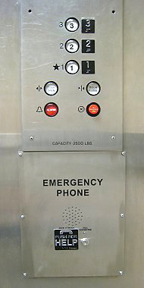
Emergency phone call box with call button
Paul Lawrence from the safety office and Sam Wilson were kept abreast of the developments. In the meantime, all employees with disabilities were given an operational two-way radio to carry with them in the event of an emergency.
Once the materials arrived, the elevators had to be shut down so that the call boxes could be installed. Additional materials would be required to modify the different types of elevators we have at the Center. Because the phone technicians, the metal shop personnel, and the fire inspectors had to be available for the installations, much coordination was required. Since the project began in April, five elevators have been completed and tested. The project will continue until all 17 elevators are done.
Thanks go out to: Sam Wilson, Frank Seman, Adrienne Calderone, Chuck Hathaway, Paul Lawrence, Shelia Franklin-Smallwood, Jim Vena, Hank Webber, Steve Anderson, Jim Lasch, Barry Lewin, and Al Schwegel for all of their efforts.

Vicki Cox visits Stevens Institute of Technology Systems Supportability and Logistics class at the Technical Center, April 16, 2007
By Carolyn McKinney-Bobo
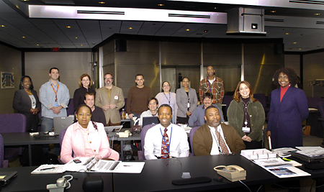
1st row starting from left: Annie Clark, Patrick Eigbe, Darren Fields, Wanda Lopez – Maudie Powell – Program Director – Organizational Excellence Group; 2nd row left – Brian Jefferson, Mike Wiley, Clayton Carr; 3rd Row left – Carolyn McKinney-Bobo, Organizational Excellence Group Stevens Institute Training Coordinator, David Ingegneri, Vicki Cox – Vice President ATO, Dr. David Nowicki, Stevens Institute Instructor, Omar Merced, Bernice Merly, Beverly Hite, Anthony Long, not pictured, Andre’ Alleyne
Vicki Cox, Vice President, Operations Planning, ATO, stopped by the Central Viewing Area (CVA) where Technical Center organizations, Technical Operations, Acquisition Workforce and System Engineering organizations sponsored a Stevens Institute of Technology class titled “Systems Supportability and Logistics”. Most of the Technical Center students participating in this class are one class and a project thesis away from obtaining their Master’s Degree in Systems Engineering, which if funding becomes available is targeted for FY-08.
Vicki expressed how this type of course is of mutual benefit to the students and the ATO, as described in the Flight Plan, “improve and upgrade aviation related scientific, technical, engineering, and mathematical skills in the emerging and future aviation workforce.”
She applauded the hard work and dedication of the students, saying she knew how difficult it was to take courses and work fulltime, tend to families, etc. She also encouraged them to continue on the systems engineering path because the future of the FAA will involve work around NGATS for which they are preparing. She also told them that she hopes to come back for their graduation in 2008.
Previously, Vicki gave the keynote address to a little over 20 FAA Technical Center students receiving their Graduate Certificates in Systems Engineering and Architecting, which was held in 2006 in the atrium.

Identity Theft Prevention
By Holly Cyrus
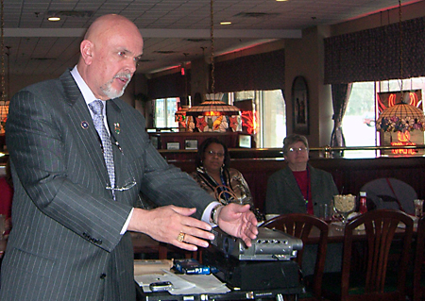
Mr. James Lavery speaks to the group
The Women in Engineering Affinity Group of the IEEE hosted a Speaker Series luncheon on April 4. The topic, presented by Mr. James Lavery of the NJ Department of Banking and Insurance, was Identity Theft.
In a very entertaining way, Mr. Lavery provided the audience with valuable information on common approaches to handling banking transactions, credit card use, and the availability of personal information that can lead to harmful consequences. He also distinguished between two types of identity theft: amateur and professional.
The amateur identity thief is anyone who seizes an opportunity to collect or use information of yours that comes readily to hand. This can include: guests who can easily access personal or financial information in the home, someone who gets access to your checkbook and removes a couple of checks from the back of the book (or from your supply of checks), a gas station attendant who uses your card to charge another transaction after yours is completed (closes the lane and invites a friend to fill his vehicle), someone who can easily get to the information in your wallet or purse, someone who can easily access your mail and use credit card offers or checks, someone who can look over your shoulder at the bank, at the DMV, or other institution to get your personal information.
Professional identity thieves do not generally come in direct contact with their victims – they will often employ staff at restaurants, hotels, and other service centers to collect credit information by swiping your credit card onto a separate device that holds the information from a couple hundred cards. The information on the device is then sold, at a price determined by the value that is left on the card.
What can happen – thieves can obtain fraudulent credit accounts, secure deposits on cars and housing, obtain employment opportunities, create fraudulent insurance opportunities, and rob your retirement savings.
What can you do – don’t carry, unless specifically needed, extra credit cards, social security cards, birth certificates or passports. There are many other proactive actions you can take - find more information at www.NJDOBI.org under Consumers, Personal Finance.
If you believe you are a victim of identity theft, contact your local law enforcement agency, credit card companies, banks, investment companies, licensing agencies, etc., the Federal Trade Commission at 1-877-IDTHEFT (1-877-438-4338), the Social Security Administration, credit bureaus – have fraud alerts placed on your files.

Technical Center Hosts Visitors from China
By Carol A. Lowman and Stan Ciurczak
Visitors from the Civil Aviation Authority of China and Aviation Data Communications Corporation recently traveled to the Technical Center for meetings with the Separation Standards Analysis Sub-Team. Brian Colamosca is the manager of the FAA’s Separation Standards Analysis Sub-Team.
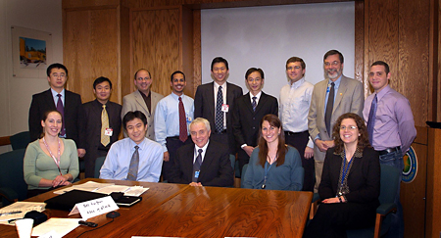
Starting in the back row from left to right: Li Quan, R&D Department, Air Traffic Management Bureau, Civil Aviation Authority of China; Zang Tao, Engineer, Air Traffic Management Bureau, Civil Aviation Authority of China; Jose Perez-Torres, Separation Standards Analysis Sub-Team, AJP-7141; Manuel Gonzalez, Separation Standards Analysis Sub-Team, AJP-7141; Tang Jinxiang, Project Manager, Aviation Data Communications Corporation; Cai KaiQuan, Aviation Data Communications Corporation; Scott Ellis, Separation Standards Analysis Sub-Team, AJP-7141; Wayne Smoot, Separation Standards Analysis Sub-Team, AJP-7141; Juan C. Gonzalez, Separation Standards Analysis Sub-Team, AJP-7141
The individuals in the front row from left to right are: Theresa Brewer-Dougherty, CSSI, Inc.; Gu Xiang Gang, Engineer, Air Traffic Management Bureau, Civil Aviation Authority of China; Brian Colamosca, Manager, Separation Standards Analysis Sub-Team, AJP-7141; Lauren Martin, Separation Standards Analysis Sub-Team, AJP-7141; Christine Gerhardt-Falk, Separation Standards Analysis Sub-Team, AJP-7141
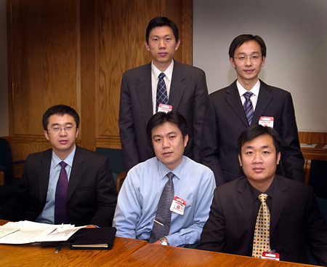
Starting in the back row from left to right are: Tang Jinxiang, Project Manager, Aviation Data Communication Corporation;. Cai KaiQuan, Aviation Data Communications Corporation
The individuals in the front row from left to right are: Li Quan, R& D Department, Air Traffic Management Bureau, Civil Aviation Authority of China; Gu Xiang Gang, Engineer, Air Traffic Management Bureau, Civil Aviation Authority of China; Zang Tao, Engineer, Air Traffic Management Bureau, Civil Aviation Authority of China

Our Drinking Water is Safe
Editors Note: The following appeared in the Center Director’s Technical Center Highlights on Monday, August 20.

First, I want to reiterate the various messages stating that the drinking water emergency alert is cancelled - our drinking water is safe for consumption. Last Friday, the Technical Center received routine test results indicating a positive for E. Coli at a sample tap in the Research and Development Area. Ten confirmation samples were immediately collected Friday for repeat analysis, in accordance with environmental regulations. As an interim precautionary measure, a diverse response team was immediately activated to handle deploying an alternate drinking water supply, and other safety and communications aspects of the situation. Led by Howard Kimpton, Carleen Houston, and Walt Vernon, the team obtained and placed bottled water dispensing stations throughout the Center and its tenant facilities, and communicated the emergency notification alert through multiple means to ensure everyone was advised. Ten supplemental precautionary samples were collected and submitted for analysis the following Monday. The results of all confirmation and precautionary samples were negative. You will see that the bottled water and dispensers are removed. I greatly appreciate the time and professional commitment of the response team in resolving this situation. The team was extremely proactive. They went above and beyond the call of duty, and took every extra precaution to ensure the health and safety of our employees and visitors. Well done.

