Serving the aviation community through world-class research, the FDDRL works to increase the capabilities of the flightdeck crew by expanding their roles and responsibilities with the use of new tools and concepts, to increase airspace capacity and safety.
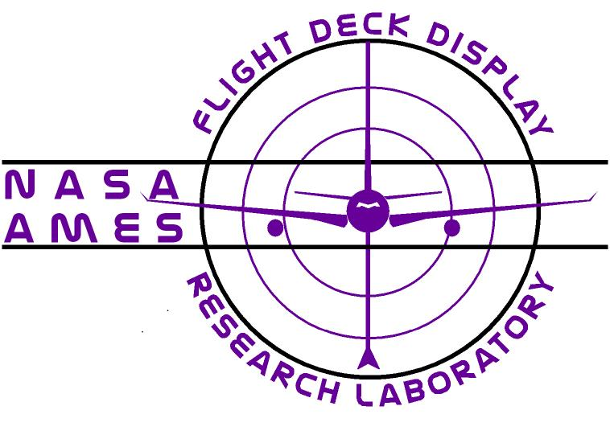

Flight Deck Display Research Laboratory (FDDRL) Capabilities
Human Systems Integration Division
Ames Research Center

POC: Walter Johnson (wjohnson@mail.arc.nasa.gov)
and Vernol Battiste (vernol.battiste-1@nasa.gov)

The FDDRL supports the R&D of airside displays and interfaces. To that end, researchers and developers collaborate to prototype and vet concepts. Experiments are designed to focus on particular issues of interest and are appropriately scaled in scope. The research concepts are refined and matured iteratively between development and experimentation.

The lab's principal product is the Cockpit Situation Display (CSD). The CSD, designed around the lab’s advanced Cockpit Display of Traffic Information (CDTI), was originally built for, and incorporated into, the 2004 Distributed Air-Ground Traffic Management (DAG-TM) simulations. In that project it served as the primary visual interface for both medium-fidelity single and multi-pilot simulators. It also served as the primary visual interface for the high-fidelity full-mission Advanced Concepts Flight Simulator at the Ames Crew Vehicle System Research Facility. Since its inception, many of the lab's part-task experiments have examined, or leveraged, CSD technologies. CSD stations have been deployed at several institutions throughout the country where they have been used collaboratively with the FDDRL to study significant human-in-the-loop (HITL) issues.

The CSD has been designed to be easy to configure, allowing its various features and embedded tools to be selectively enabled or disabled. This, in turn, has made it an easily used research platform, and the basis for much experimentation and exploration. Within the FDDRL the CSD forms the basis for fast prototyping and subsequent HITL examination of near and far-term airspace concepts and flight deck procedures

Supporting Hardware
A networked cluster of PC's, including a central server/repository for Computer-Aided Software Engineering tools and documentation, supports the development team. Within the FDDRL lab itself several separate facilities with varying levels of equipment - appropriate to the complexity of the issues being investigated - support the activities of the research staff. The lab supports 8 single-pilot stations and 4 multi-pilot stations, each consisting of 2 high-end PC's running CSD and multi-aircraft control stations (MACS), plus real-time screen-capturing software. There are also two stations for experimental control and monitoring and data collection.

The lab contains two additional stations for conducting small scale, part-task experiments. The first station contains an eye and head tracker controlled by a PC, and a PC capable of running the CSD. The second station contains an immersive environment lab with a 160-degree field-of-vision (FOV) parabolic VisionStation. The VisionStation is driven by a PC, which can run either the CSD or another custom experimental software application. This station contains a virtual reality (VR) cyber-glove with vibro-tactile feedback with 6 degree-of-freedom wrist tracking, a 3D space-mouse device and a second PC for control and data collection. A stereo see-through XGA helmet mounted display (HMD) and a semi-transparent goggle style HMD complete the equipage for this station, which is intended for investigating Augmented Reality/Virtual Reality applications and controller interfaces.

The FDDRL also houses a fixed-base flight simulator configured with a full flight console, power quadrant, pedals, side-by-side seats, and four 50 inch plasma monitors for the out-the-window view. The console is outfitted with avionics stack and other instrumentation, including FMC and glass cockpit displays for emulating Boeing 777 capabilities. It is driven by multiple high performance PC's, linked together in a distributed LAN (local area network). The high-performance PC’s enable the running of a mixture of proprietary and off-the-shelf software that includes a flight management system (FMS), instrument display applications, user interaction modules, and the graphics for the simulated out-the-window viewing. Finally, several cameras have been installed to monitor and record crew activity.

The initial phases of integrating the CSD into the B-777 simulator as the primary navigation display are complete, with additional hardware on order to allow driving the console display from a workstation powerful enough to take full advantage of the CSD 3D capability.

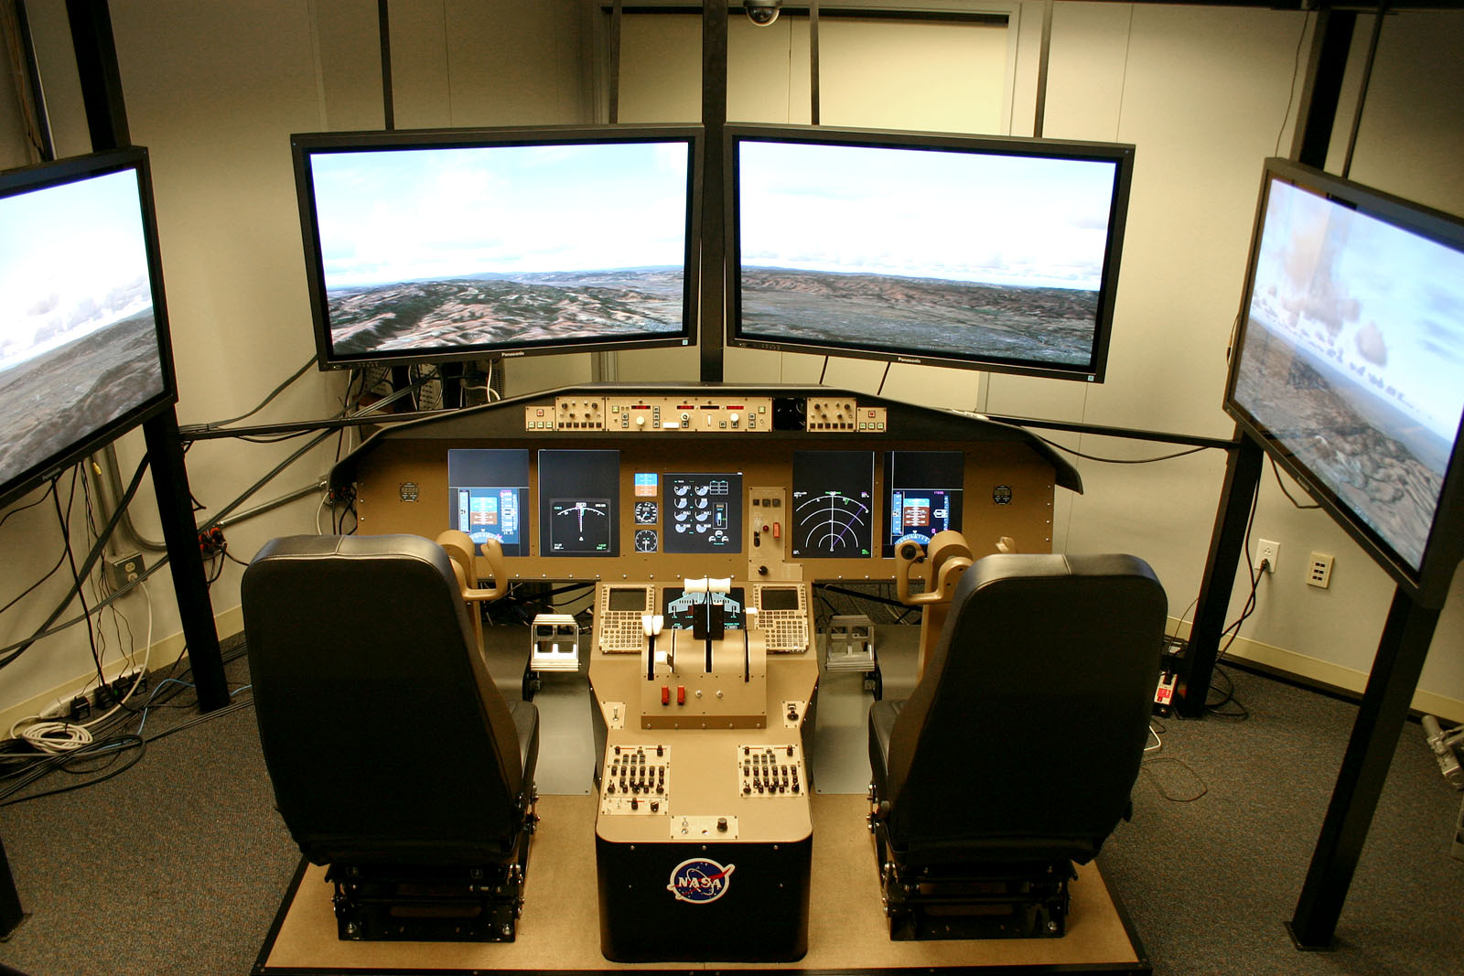

FDDRL CSD Compatibility with JPDO Migration Roadmap Requirements: Many of the future concepts included in the Next Generation Air Transportation System Report have been successfully tested by the FDDRL. The FDDRL is capable of generating airspace traffic levels to reflect those of current day operations up to greater than three-times current levels thereby creating a realistic multi-sector environment. Each aircraft enters the airspace following a flight plan. A “pseudo-pilot” (experimental confederate) can manipulate this flight plan in order to follow instructions of an air traffic controller (ATC), or following a scripted procedure provided to the pseudo-pilot in advance. This provides a realistic traffic scenario in which to evaluate the performance of experimental test participants (single aircraft pilots and air traffic controllers). To date, the majority of the FDDRL studies have used the Dallas-Fort Worth (DFW) airport, airspace and TRACON.

Research documents can be obtained on the group website: http://human-factors.arc.nasa.gov/ihh/cdti/index.html or by contacting the POC listed above.

Cockpit Situation Display Description
The FDDRL CSD supports both traditional 2D and advanced 3D visualization modes. In its most fundamental configuration the CSD emulates a standard 2D glass cockpit navigation display. However, both the 2D and the 3D modes can provide any or all of a rich set of symbologies, functionalities, and tools that have been designed 1) to depict the 4D interrelationship of traffic, terrain, and weather within the airspace volume, and 2) to provide a graphical user interface (GUI) to the Flight Management System. The latest graphics technologies are used to enhance immersion and situation awareness, allowing the flight crew to move effortlessly and smoothly between 2D and 3D views. Specifically, the display is based on a cylindrical container-like metaphor, and the flight crew can simply rotate this cylindrical space into various orientations for preferred viewing angles. In addition to manually rotating the display volume, the flight crew is given several pre-set buttons that are pre-configured to various canonical vantage points, or which the user can configure to user-preferred vantage points. Panning, zooming, anisotropic scaling, and several selectable viewing modes are morph-animated between transitions to maximize continuous orientation awareness. Environmental visualizations such as weather objects and terrain features not only provide useful positional and hazard cues along a proposed route, but aid in sustaining the immersive experience.

Some of the key enabling tools for enhancing pilot performance that have been implemented on the CSD include:

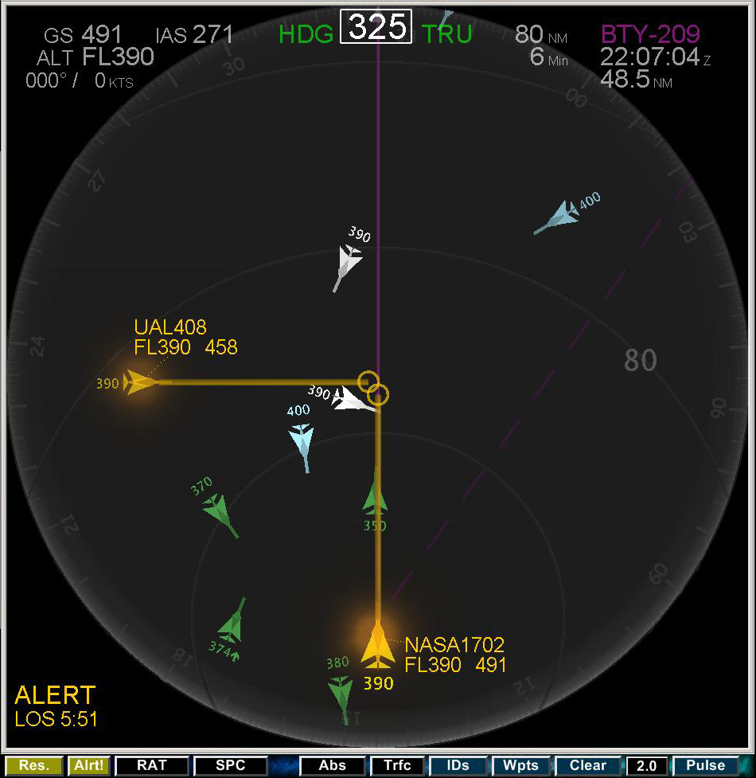
Conflict Detection and Resolution (CD&R). The original detection component of CD&R, developed at MIT, has been enhanced to provide both deterministic and probabilistic alerting. CSD alerts are depicted for strategic conflict detection as opposed to tactical conflict detection. The alerting logic detects upcoming conflicts (or losses of separation) based on an algorithm which takes into account the aircraft intent information and/or aircraft state information (current heading, altitude, speed). Conflict resolution responsibility is determined by AI-based rules-of-the-road, which unambiguously assign conflict-resolution responsibility to a single aircraft. The automated resolution component is derived from a geometric algorithm developed at NASA Ames. This but which has been heavily modified to accommodate FMS information and constraints to calculate speed, altitude, and lateral maneuvers.

In the near future, Heinz Herzberger's Advanced Airspace Concept Conflict Resolution Logic will be added to the existing CD&R tool. The algorithm of choice will be configurable at runtime. While both algorithms compute resolution maneuvers based on geometric analysis, they differ primarily in how the burdened aircraft (the aircraft burdened to resolve the conflict) is selected. The first and original resolution as described above is based on rules-of-the-road and is ownship-centric. The second resolution algorithm considers all possible maneuvers among all aircraft involved in the conflict. Burdening is then assigned to the aircraft that has the optimal solution available, regardless of the rules-of-the-road. This is therefore a multi-aircraft solution driven algorithm. Both algorithms will fully support the CSD Route Assessment Tool (RAT), described in the following section.

FDDRL CSD Compatibility with JPDO Migration Roadmap Requirements: primary satellite navigation (2008), initial air/ground trajectory navigation (2008), reduced separation standards (2016), incident coordination (2016), 4D contracts for airspace (2016), multi-aircraft per runway (2020), delegated separation (2020)

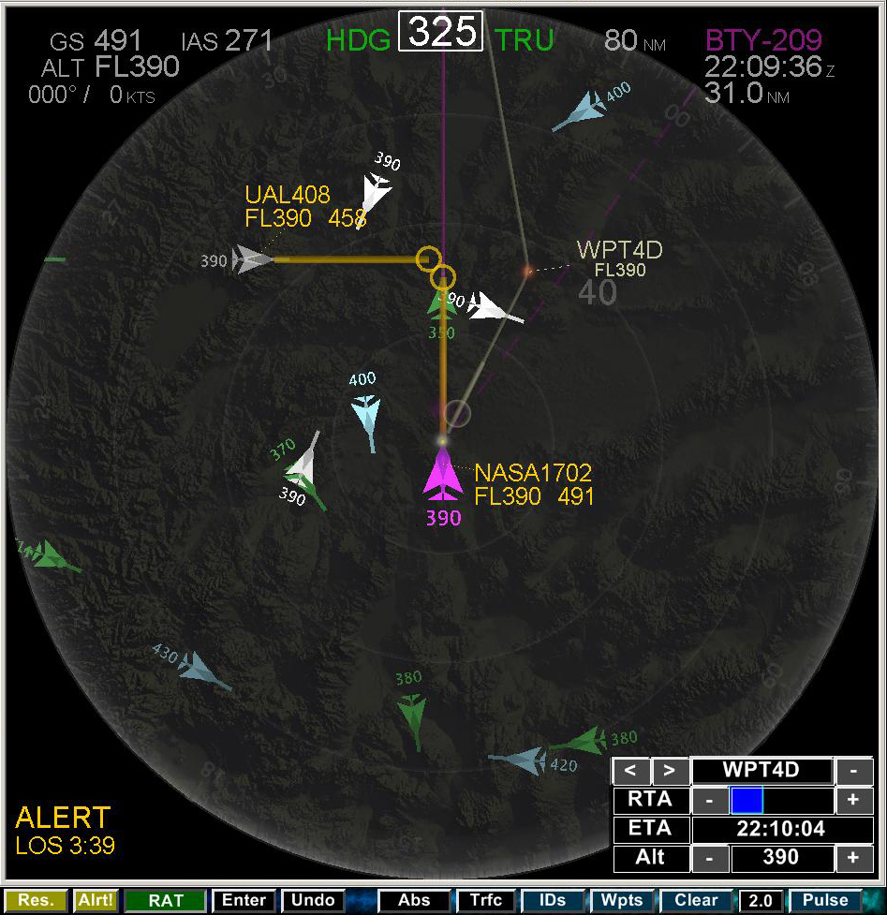
The Route Assessment Tool (RAT) provides the ability to create and visualize in-flight route modifications, submit proposed route modifications to ATC, receive route modifications from ATC, and execute any of these modifications depending on flight status. The planning and implementation of these flight plan modification possibilities are subject to provisional alerting and are made available for 1) strategic conflict resolution, 2) RTA requirements, 3) weather avoidance, 4) direct route efficiency, 5) dynamic Special Use Airspace (SUA) avoidance, and eventually 6) terrain avoidance.

FDDRL CSD Simulation Compatibility with JPDO Migration Roadmap Requirements: time-based metering (2008). Primary satellite navigation (2008), initial air/ground trajectory navigation (2008), Wx-cognizant strategic traffic management automation (2008). Unique aircraft ID and broadcast/listen of position /intent (2008). Reduced separation standards (2016), 4D contracts for airspace (2016) delegated separation (2020).

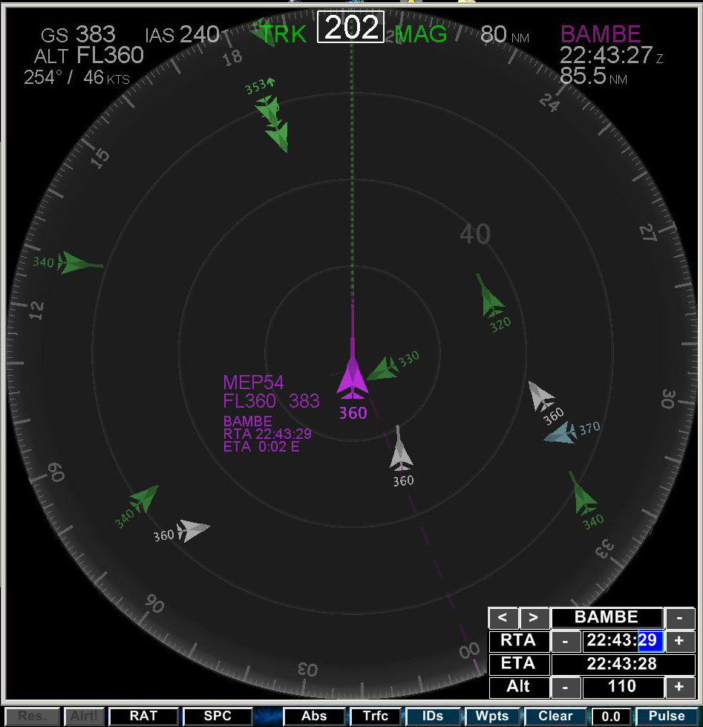
The Required-Time-of-Arrival (RTA) algorithm generates speed advisories for meeting an assigned RTA at the metering gate. The RTA is set using the RAT, which attempts to assign airspeeds that achieve this RTA. As with all the other CSD tools, the RTA tool was designed for intuitive interaction.
FDDRL CSD Compatibility with JPDO Migration Roadmap Requirements: time-based metering (2008). Unique aircraft ID and broadcast/listen of position/intent (2008), primary satellite navigation (2008)). Aircraft self-separation per clearance (2016). Reduced separation standards (2016) delegated separation (2025).

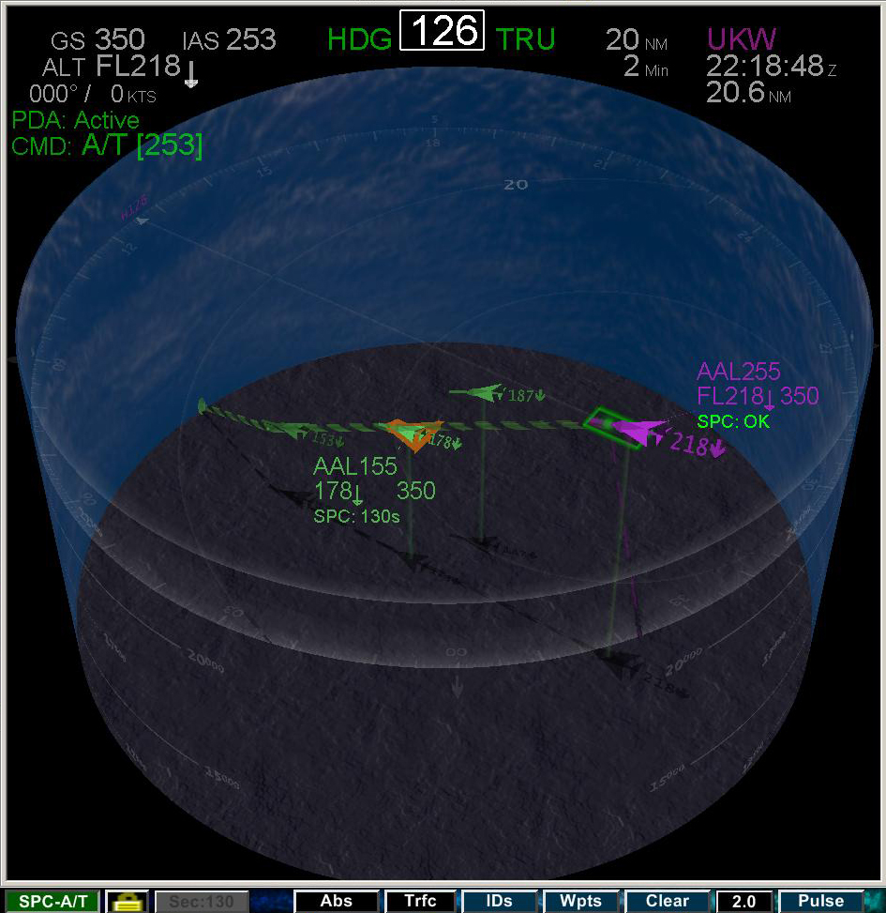
The Spacing Tool allows for self-spacing behind a designated lead aircraft (e.g., maintain 90 seconds behind aircraft XYZ). The spacing tool requires an input of the assigned en trail spacing value while algorithms work to adjust Ownship’s speed in order to maintain the required interval. While the tool is active, the pilot is provided with updated visual information regarding the current spacing status.
FDDRL CSD Compatibility with JPDO Migration Roadmap Requirements: unique aircraft ID and broadcast/listen of position/intent (2008). Primary satellite navigation (2008)). Aircraft self-separation per clearance (2016). Reduced separation standards (2016) delegated separation (2020).

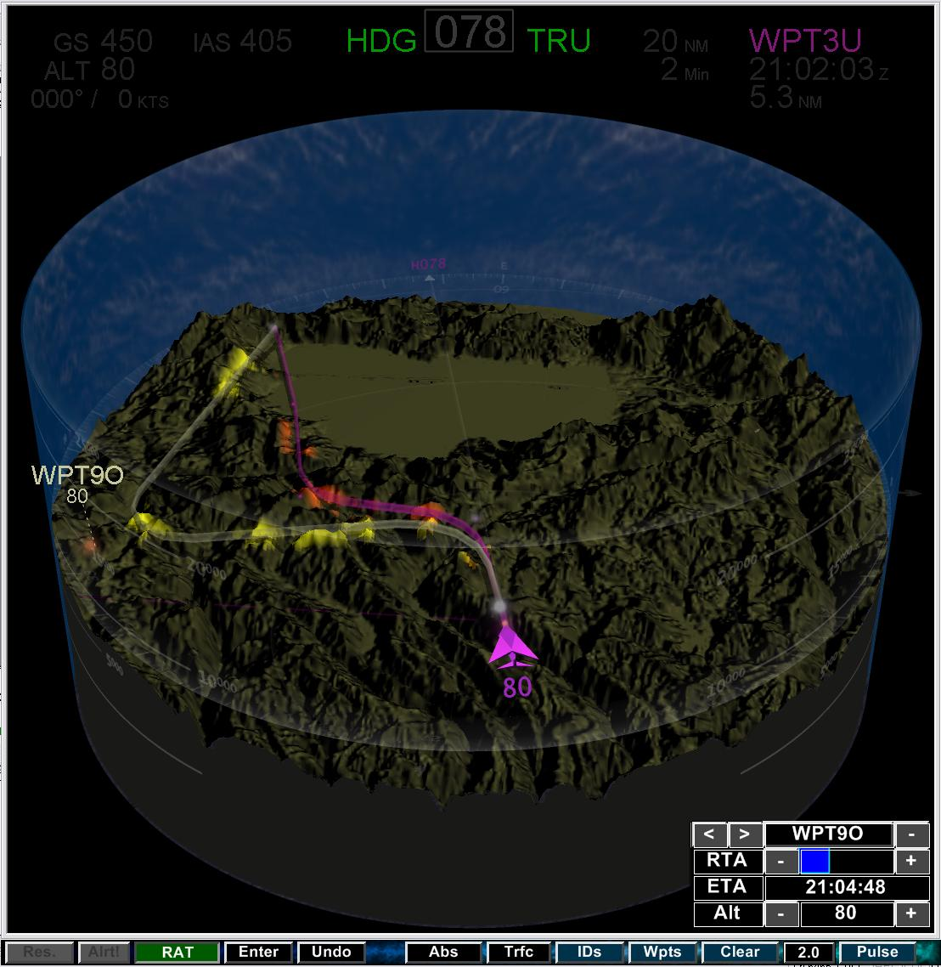
The 3D Terrain Display provides location and hazard cues to pilots. Topographic information including bodies of water are presented in a three dimensional format that is proportional to vertical scaling. An uncluttered format is also available that projects the surface detail onto a flat plane. The database consists of high resolution mapping (down to 30 meter detail) of the continental US. Flight planning incorporates real-time interactive hazard detection of terrain by highlighting proximal regions of terrain along the proposed path.
FDDRL CSD Compatibility with JPDO Migration Roadmap Requirements: proactive risk-based safety (2005 – 2020).

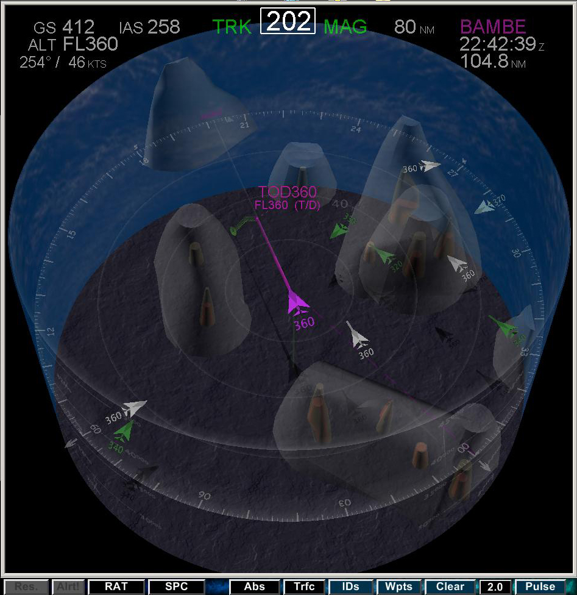
2D/3D Weather Display. Pilot-selectable 2-D and 3-D depictions of weather objects and terrain features are integrated into the display, and allow intuitive and direct evaluation of the relationship of these hazards to the intended route. A weather data collection and delivery system was developed to meet the needs of the FDDRL for providing realistic weather scenarios in its simulations. It is comprised of three subsystems. The Wx Collection subsystem acquires real-world weather data from NOAA and NWS portals, and correlates and stores them. The Wx Scenario Generator accesses the data repository and provides for searching and viewing/editing capabilities to create a suitable weather environment in a scenario. The Wx Server coordinates scenario access functions via network commands or a web interface from connected clients, and distributes the data. The FDDRL CSD is the first such client, rendering a 3D stylized representation of the weather.
FDDRL CSD Compatibility with JPDO Migration Roadmap Requirements: common weather picture (2008), probabilistic weather tools (2016).

A highly flexible graphical-user-interface with configurable independent windows and a nascent speech recognition system completes the user-interface feature set of the CSD.

Other Products and Lab Capabilities
Ancillary products, developed primarily for the FDDRL but with uses in other environs, are available.

Voice-over IP. A multiple channel voice communication system utilizing voice-over-IP technology has been developed. It is called DagVoice commemorating its first application in the DAG-TM simulation as a radio communication emulator. DagVoice is capable of accommodating up to 50 users conversing simultaneously. Since it is essentially software-based, it not only replaces a host of communication equipment and dedicated wiring, but it can be easily reconfigured, scaled, and massively deployed. Each user requires one computer host and a network link.
FDDRL CSD Compatibility with JPDO Migration Roadmap Requirements: Adds realism to simulations by allowing for pilot-controller interaction using pilot push-to-talk headsets.

Interlab Connectivity. The Aeronautical Datalink and Radar Simulator developed at the NASA Ames Airspace Operations Laboratory (ADRS: Prevot, T. (2004). Rapid Prototyping and Exploration of Advanced Air Traffic Concepts.) is the “distributed simulation hub” and air traffic host computer emulator. The ADRS maintains all aircraft state and trajectory information and all pilot and controller flight data inputs. A network of ADRS servers can be launched that distributes the communication load and provides access points for a nearly unlimited number of MACS and CDTI client processes. It also provides access points for other simulators like full mission flight simulators or other air traffic laboratories. To date, the following sources have connected to the ADRS to work collaboratively with the FDDRL: Air Traffic Operations Laboratory at NASA Langley Research Center, the Advanced Concepts Flight Simulator, the Department of Psychology Aviation Lab at California State University Long Beach and the Future Flight Central Tower simulator at NASA Ames Research Center.
FDDRL CSD Compatibility with JPDO Migration Roadmap Requirements: This capability enables the FDDRL to run joint studies with the Airspace Operations Lab (AOL). The AOL provides an advanced air traffic control simulation environment to the simulations. This environment can be shared with other labs that have the capability to connect to the ADRS.

