BLM News

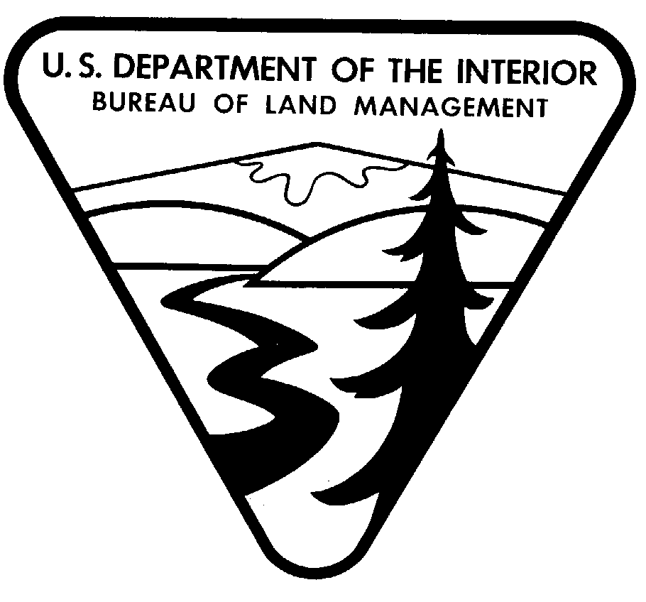
NEVADA STATE OFFICE NO. 2003-22
FOR RELEASE: February 10, 2003
CONTACTS: Maxine Shane, (775) 861-6586 or Shayne Banks (601) 977-5405

BLM Presents Donation Check
to National Wild Horse & Burro Foundation

The Bureau of Land Management (BLM) will be presenting a check to the National Wild Horse and Burro Foundation in Reno, Nevada, on Wed, Feb. 12. The $11,000 donation is a joint contribution from Breyer Animal Creations and Tractor Supply Company. The BLM’s Eastern States Office facilitated the donation and will make the presentation jointly with the BLM’s Nevada State Office.

The donation comes from a portion of the proceeds of the sale of a Breyer model horse, No. 300102, Nevada Joe Sterling. This model is a limited edition and is available only from Tractor Supply Stores. “Joe” was adopted from the BLM in August 2001, by the Wahl Clipper Corporation in conjunction with Horse Illustrated Magazine and Tractor Supply Company to be part of a special adoption project. The purpose of this project is to assist the BLM in their committed efforts to provide education to potential adopters.

“Joe” was captured in Washoe County, Nevada, as part of a small herd located within the Fox and Lake Range Herd Management Area. Joe was appropriately named Nevada Joe Sterling as he was born in Nevada, is an average Joe and currently resides in Sterling, Illinois.

The National Wild Horse and Burro Foundation is a nationwide non-profit organization dedicated to finding loving homes for America’s wild horses and burros. It is headquartered in Reno. Some years, the BLM gathers more than 10,000 wild horses and burros off America’s public land in order to keep the wild herds healthy and to preserve the quality of the range. The National Wild Horse and Burro Foundation has a goal of finding new homes for these “excess” horses and burros.

For individuals interested in adopting, wild horses are regularly up for adoption at the National Wild Horse and Burro Center at Palomino Valley which is open Monday through Friday from 8 a.m. to 4 p.m., except for Federal holidays. From Interstate 80, take exit 18 and follow Pyramid Way (State Route 445) north about 20 miles to Ironwood Road. Turn east on Ironwood to reach the corrals and office. The phone number is (775) 475-2222. Applications are available at www.wildhorseandburro.blm.gov and descriptions of Herd Management Areas may be viewed at the Nevada wild horse and burro site, which is linked to this national wild horse Internet site.
- -MORE-
BLM PRESENTS DONATION CHECK – 2222

If you can’t adopt, the National Wild Horse and Burro Foundation makes it possible for you to help in other ways. For more information or to contribute, contact the National Wild Horse and Burro Foundation, P. O. Box 2790, Reno, Nevada 89505 or call 1-800-551-9209. The Foundation’s website is www.wildhorsefoundation.com.

###

EDITORS: To obtain a photo of Nevada Joe Sterling, go to www.nv.blm.gov and click on NEWS.

