TRAVEL INFORMATION

CONFERENCE HOTELS

DIRECTIONS

LOCAL ATTRACTIONS

LOCAL GUIDES
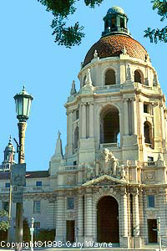
Los Angeles Convention and Visitors Bureau

Pasadena City Hall

Pasadena Convention and Visitors Bureau

Pasadena Convention Center

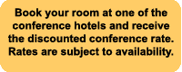CONFERENCE HOTELS

Official SMC-IT Conference Hotels:

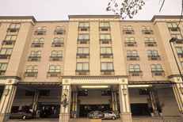

Old Pasadena Courtyard by Marriott
180 North Fair Oaks Avenue
Pasadena, CA 91103
626-403-7600 - phone
626-403-7700 - fax

Reserve your room now!

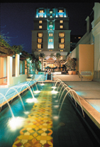

The Doubletree Hotel Pasadena
191 North Los Robles Avenue
Pasadena, CA 91101
626-792-2727 - phone
626-795-7669 - fax

Reserve your room now!

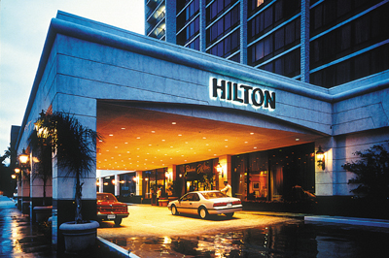

Hilton Pasadena
168 South Los Robles Avenue
Pasadena, CA 91101
626-577-1000 - phone
626-584-3148 - fax

Reserve your room now!

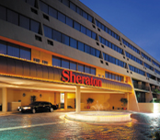

The Sheraton Pasadena Hotel
303 East Cordova Street
Pasadena, CA 91101
626-449-4000 - phone
626-584-1390 - fax

Reserve your room now!

DIRECTIONS

FROM LOS ANGELES:

Pasadena Freeway 110 north to the end of the freeway. Follow Arroyo Parkway north to Green Street. Turn right and go two blocks to the Pasadena Convention Center. The Pasadena Convention center is on the corner of Marengo Avenue and Green Street.

FROM ORANGE COUNTY AREAS (SOUTH):

10, 5, or 405 freeways north to 605 freeway. Take 605 freeway north to 210 west, 210 freeway to Marengo Avenue exit. Left turn at Marengo Avenue to Green Street. The Pasadena Convention Center is at the corner of Green Street and Marengo Avenue.

FROM SAN FERNANDO VALLEY AREA (WEST):

Take 134 freeway east into Pasadena. Exit at Fair Oaks Avenue. Turn right on Fair Oaks Avenue and go to Green Street. Turn left on Green Street and go three blocks to Marengo Avenue. The convention center will be on your right after you cross Marengo Avenue.

FROM SAN FERNANDO VALLEY AREA (NORTH):

Take 210 freeway east into Pasadena. Exit at Colorado Boulevard. Left on Colorado; take Colorado to Marengo Avenue and turn right. The Pasadena Convention Center is on the corner of Marengo Avenue and Green Street.

FROM LOS ANGELES INTERNATIONAL AIRPORT (LAX):

By Public Transportation:
Take the airport bus to the Pasadena Hilton which is one block east of the Pasadena Convention Center. Also, several van shuttle organizations offer door-to-door service from the airport.

Distance from the Convention Center: 35 mi.
Drive time: 1 hr.
Directions: Take I-105 East to the 110 North. The 110 will end in Pasadena and become Arroyo Parkway. Continue on Arroyo Parkway until you come to Green Street. Turn right onto Green Street and the Convention Center will be located on the right-hand corner one block down.

Getting to and from the Airport
Bus Service: typical minimum charge is USD 12.00
Limousine: typical minimum charge is USD 61.50
Taxi: typical minimum charge is USD 40.00

FROM BURBANK AIRPORT (BUR):

Distance from the Convention Center: 15 mi.
Drive time: 20 min.
Directions: Take the I-5 South to the 134 Freeway East to 210 East. Exit at Fair Oaks/Marengo Avenue, head on South on Fair Oaks to Green Street, turn left on Green Street, and keep going east until you come to Marengo Avenue. The Convention Center will be located on the right-hand corner.

Getting to and from the Airport
Limousine: typical minimum charge is USD 61.50
Taxi: typical minimum charge is USD 25.00

LOCAL ATTRACTIONS
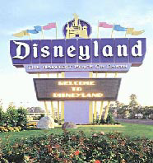

PLACES TO GO:

Theme Parks
Disneyland
Knott’s Berry Farm
Six Flags Magic Mountain
Universal Studios Hollywood

Museums
Autry Museum of Western Heritage
Huntington Library and Gardens
The Getty Center
Los Angeles County Museum of Art
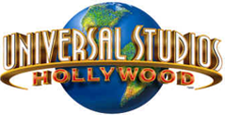Natural History Museum of Los Angeles County
Norton Simon Museum

Beaches
Santa Monica
Venice Beach
Huntington Beach
Newport Beach
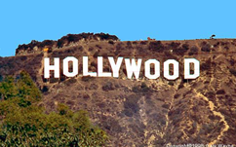
Sports
Anaheim Angels
The Dodgers
Santa Anita Race Track (Arcadia)

Music/Concerts
Hollywood Bowl
Kodak Theatre
The Music Center

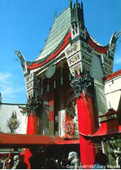Other Points of Interest
California Institute of Technology
California Science Center
Catalina Island
Chinese Theatre
Descanso Gardens
Jet Propulsion Laboratory
Kelp Forests (for SCUBA divers)
Queen Mary
The Arboretum of Los Angeles County
The Ice House
The Magic Castle

PLACES TO SHOP:

Beverly Center
Burbank Media Mall
Farmers Market
Glendale Galleria
Highland Complex
Paseo Colorado
Santa Monica Third Promenade
South Lake Avenue
South Coast Plaza
Westfield Shopping Town Santa Anita (Arcadia)

