U.S. Census Bureau
U.S. Bureau of Economic Analysis

NEWS

U.S. Department of Commerce • Washington, DC 20230

For Immediate Release
8:30 A.M. EDT TUESDAY, AUGUST 12, 2008

For information on goods contact: |  | For information on services contact:
U.S. Census Bureau: |  | U.S. Bureau of Economic Analysis:
Nick Orsini | 301-763-6959 | Technical: Christopher Bach | 202-606-9545
Maria Iseman | 301-763-2311 | Media: Ralph Stewart | 202-606-2649
 |  | CB08-121, BEA08-37, FT-900 (08-06)

U.S. INTERNATIONAL TRADE IN GOODS AND SERVICES

June 2008

Goods and Services

The U.S. Census Bureau and the U.S. Bureau of Economic Analysis, through the Department of Commerce, announced today that total June exports of $164.4 billion and imports of $221.2 billion resulted in a goods and services deficit of $56.8 billion, down from $59.2 billion in May, revised. June exports were $6.4 billion more than May exports of $158.0 billion. June imports were $3.9 billion more than May imports of $217.2 billion.

In June, the goods deficit decreased $2.1 billion from May to $70.0 billion, and the services surplus increased $0.4 billion to $13.3 billion. Exports of goods increased $5.7 billion to $116.7 billion, and imports of goods increased $3.6 billion to $186.7 billion. Exports of services increased $0.7 billion to $47.7 billion, and imports of services increased $0.3 billion to $34.5 billion.

In June, the goods and services deficit decreased $2.4 billion from June 2007. Exports were up $28.7 billion, or 21.1 percent, and imports were up $26.3 billion, or 13.5 percent.

Goods

The May to June change in exports of goods reflected increases in industrial supplies and materials

($2.8 billion); capital goods ($1.2 billion); foods, feeds, and beverages ($0.9 billion); consumer goods ($0.7 billion); and automotive vehicles, parts, and engines ($0.6 billion). A decrease occurred in other goods ($0.2 billion).

The May to June change in imports of goods reflected increases in industrial supplies and materials ($5.6 billion); other goods ($0.1 billion); and automotive vehicles, parts, and engines ($0.1 billion). Decreases occurred in capital goods ($1.4 billion); consumer goods ($0.6 billion); and foods, feeds, and beverages ($0.1 billion).
The June 2007 to June 2008 change in exports of goods reflected increases in industrial supplies and materials ($10.0 billion); capital goods ($3.9 billion); foods, feeds, and beverages ($3.8 billion); consumer goods ($2.3 billion); automotive vehicles, parts, and engines ($0.8 billion); and other goods ($0.6 billion).
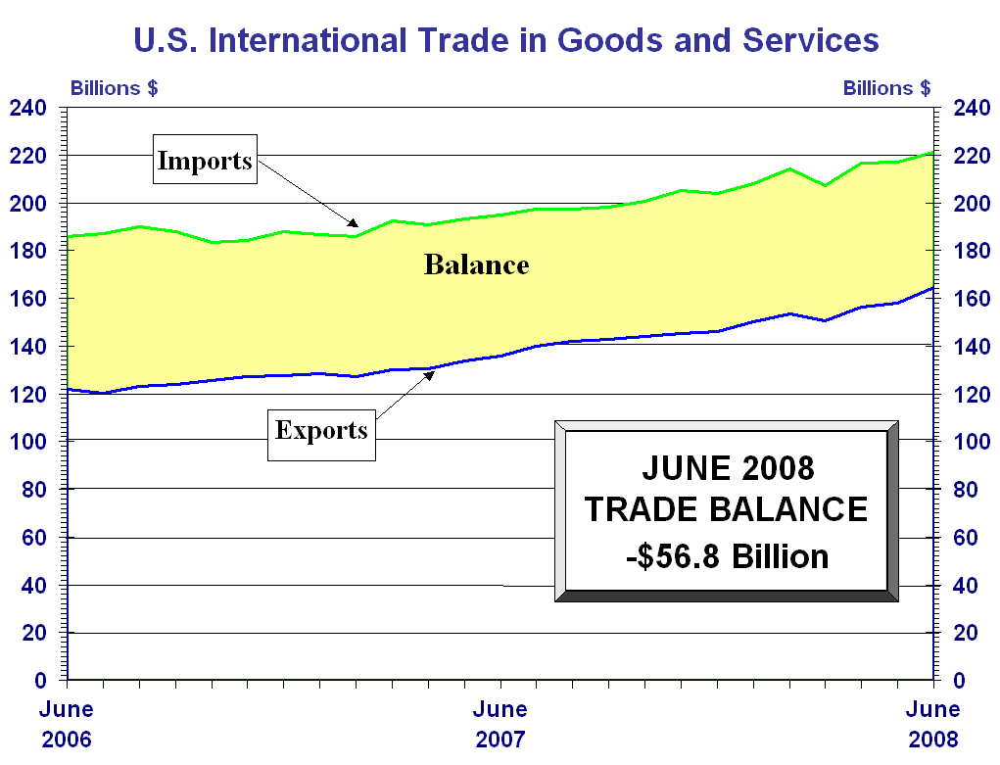

The June 2007 to June 2008 change in imports of goods reflected increases in industrial supplies and materials ($19.8 billion); consumer goods ($1.8 billion); capital goods ($1.2 billion); foods, feeds, and beverages ($0.7 billion); and other goods ($0.4 billion). A decrease occurred in automotive vehicles, parts, and engines ($0.9 billion).

Services

Services exports increased $0.7 billion from May to June. The increase was mostly accounted for by increases in other private services (which includes items such as business, professional, and technical services, insurance services, and financial services), royalties and license fees, passenger fares, and other transportation (which includes freight and port services).

Services imports increased $0.3 billion from May to June. The increase was mostly accounted for by increases in other private services and passenger fares. Changes in other categories of services imports were small.

From June 2007 to June 2008, services exports increased $6.8 billion. The largest increases were in other private services ($2.3 billion), travel ($1.7 billion), other transportation ($1.1 billion), and royalties and license fees ($1.0 billion). Within other private services, the largest increase was in business, professional, and technical services.

From June 2007 to June 2008, services imports increased $3.1 billion. The largest increases were in other private services ($1.2 billion), travel ($0.6 billion), and other transportation ($0.6 billion). Within other private services, the largest increases were in business, professional, and technical services and insurance services.

Goods and Services Moving Average

For the three months ending in June, exports of goods and services averaged $159.5 billion, while imports of goods and services averaged $218.4 billion, resulting in an average trade deficit of $58.8 billion. For the three months ending in May, the average trade deficit was $58.7 billion, reflecting average exports of $154.9 billion and average imports of $213.7 billion.
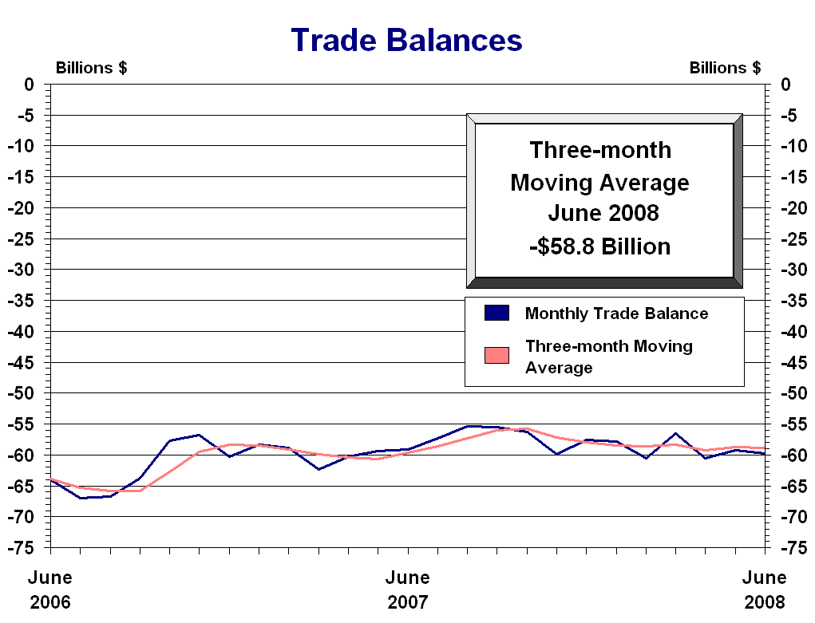

Selected Not Seasonally Adjusted Goods Details

The June figures showed surpluses, in billions of dollars, with Hong Kong $1.8 ($1.4 for May), Singapore $1.5 ($1.3), Australia $1.0 ($1.1), and Egypt $0.4 ($0.3). Deficits were recorded, in billions of dollars, with China $21.4 ($21.0), OPEC $18.1 ($17.9), the European Union $8.2 ($7.9), Canada $7.2 ($5.4), Japan $6.1 ($5.0), Mexico $5.7 ($6.6), Venezuela $4.6 ($3.9), Nigeria $3.3 ($3.2), Taiwan $0.6 ($0.6), and Korea $0.5 ($1.1).

Advanced technology products (ATP) exports were $25.0 billion in June and imports were $28.9 billion, resulting in a deficit of $3.9 billion. June exports were $1.0 billion more than the $24.1 billion in May, while imports were $1.3 billion more than the $27.6 billion in May.

Revisions

Goods carry-over in June was $0.8 billion (0.7 percent) for exports and $1.4 billion (0.7 percent) for imports. For May, revised export carry-over was $0.2 billion (0.1 percent), revised down from $0.7 billion (0.6 percent). For May, revised import carry-over was $0.1 billion (0.1 percent), revised down from $1.5 billion (0.8 percent).

Services exports for May were revised up $0.3 billion to $47.0 billion. The revision was mostly accounted for by upward revisions in travel and passenger fares. Services imports for May were revised up $0.1 billion to $34.1 billion. The revision was more than accounted for by an upward revision in travel.

Table of Contents

Seasonally Adjusted

Exhibit 1 | U.S. International Trade in Goods and Services . . . . . . . . . . . . . . . . . . . . . . . . . . . . . . . . | 1
Exhibit 2 | U.S. International Trade in Goods and Services Three-month Moving Averages. . . . . . . | 2
Exhibit 3 | U.S. Services by Major Category – Exports . . . . . . . . . . . . . . . . . . . . . . . . . . . . . . . . . . . | 3
Exhibit 4 | U.S. Services by Major Category – Imports . . . . . . . . . . . . . . . . . . . . . . . . . . . . . . . . . . . | 4
Exhibit 5 | U.S. Trade in Goods. . . . . . . . . . . . . . . . . . . . . . . . . . . . . . . . . . . . . . . . . . . . . . . . . . . . . . | 5
Exhibit 6 | Exports and Imports of Goods by Principal End-Use Category . . . . . . . . . . . . . . . . . . . . | 6
Exhibit 7 | Exports of Goods by End-Use Category and Commodity. . . . . . . . . . . . . . . . . . . . . . . . . | 7
Exhibit 8 | Imports of Goods by End-Use Category and Commodity. . . . . . . . . . . . . . . . . . . . . . . . . | 9
Exhibit 9 | Exports, Imports, and Balance of Goods, Petroleum and Non-Petroleum End-Use Category Totals . . . . . . . . . . . . . . . . . . . . . . . . . . . . . . . . . . . . . . . . . . . . . . . . . . . . . . . . . | 11
Exhibit 10 | Real Exports and Imports of Goods by Principal End-Use Category (2000 Chain-weighted dollars) . . . . . . . . . . . . . . . . . . . . . . . . . . . . . . . . . . . . . . . . . . . . . . . . . . . . . . . . | 12
Exhibit 11 | Real Exports, Imports, and Balance of Goods, Petroleum and Non-Petroleum End-Use Commodity Category Totals (2000 Chain-weighted dollars) . . . . . . . . . . . . . . . . . . . . . . | 13

Not Seasonally Adjusted

Exhibit 12 | U.S. Trade in Goods. . . . . . . . . . . . . . . . . . . . . . . . . . . . . . . . . . . . . . . . . . . . . . . . . . . . . . | 14
Exhibit 13 | Exports and Imports of Goods by Principal End-Use Category . . . . . . . . . . . . . . . . . . . . | 15
Exhibit 14 | Exports, Imports, and Balance of Goods by Selected Countries and Areas. . . . . . . . . . . . | 16
Exhibit 15 | Exports and Imports of Goods by Principal SITC Commodities. . . . . . . . . . . . . . . . . . . . | 18
Exhibit 16 | Exports, Imports, and Balance of Advanced Technology Products. . . . . . . . . . . . . . . . . . | 20
Exhibit 16a | Exports, Imports, and Balance of Advanced Technology Products by Technology  Group and Selected Countries and Areas. . . . . . . . . . . . . . . . . . . . . . . . . . . . . . . . . . . . . . | 21
Exhibit 17 | Imports of Energy-Related Petroleum Products, Including Crude Oil . . . . . . . . . . . . . . . | 22
Exhibit 18 | Exports and Imports of Motor Vehicles and Parts by Selected Countries. . . . . . . . . . . . . | 23
Information on Goods and Services.. . . . . . . . . . . . . . . . . . . . . . . . . . . . . . . . . . . . . . . . . . . . . . . . . . . . . . |  | A-1

