Spaceward Bound Report

L. Powers and S. Rich
Utah State University and MicroBioSystems of Utah, LLC

Using a unique combination of leading-edge technologies, we have developed a hand-held, continuous, real-time monitor for detection of microbes, together with microbe capture technology for identification. This system is sensitive enough to detect very low levels [~20 cells/cm² on surfaces or ~100 cells/50 mL solution] of microbes in minutes. The detection of microbes is based upon intrinsic fluorescence of the cells and spores such as that from metabolites, amino acids, and other specific cell components. The multi-wavelength fluorescence detection device requires no reagents or sample contact and distinguishes viable cells, non-viable cells, and spores. This technology can detect bacterial cells and spores in soils and on rocks employing pattern recognition algorithms. The appended document describes this instrument detail. Our goal was to locate microbial life map its location on site and, later, identify it.

Preliminary tests of the utility of this instrumentation looking for life in extreme environments have been performed on soil [containimg rocks and salt] samples collected in the western US [including the Mars Desert Research Station, Hanksville, UT], Kilimanjaro, and the Atacama Desert. Algorithms were developed to deal with the background and interferences presented by soils and rock based on these preliminary studies. A prototype instrument [owned by MBSU] was outfitted for use in the Atacama Desert in two modes: 1) mounted at a stationary position where samples were placed in a small sterile cups for measurement [transect] and 2) carried to a position and placed over the sample for measurement [Volcan Lascar]. Both methods were used.

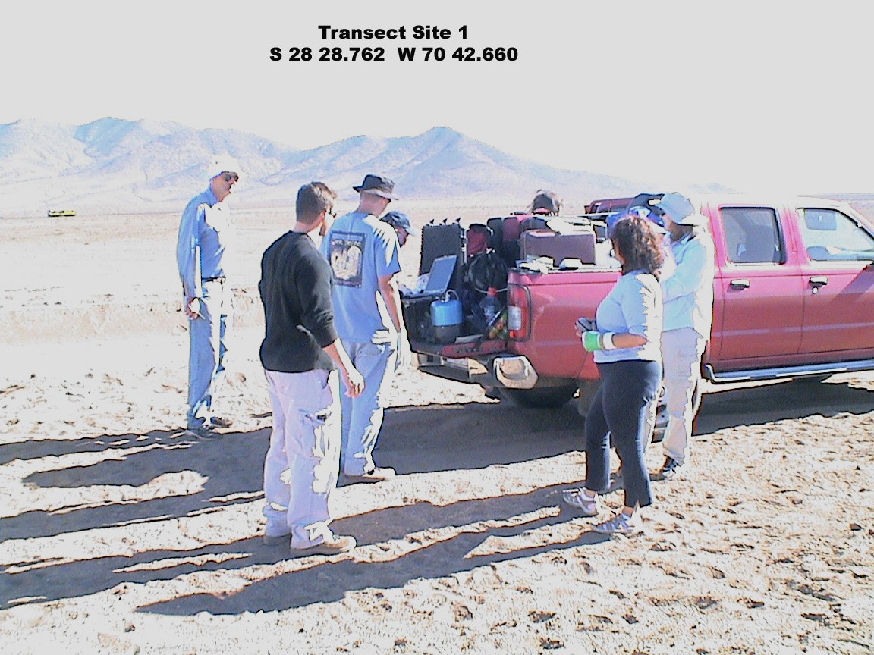
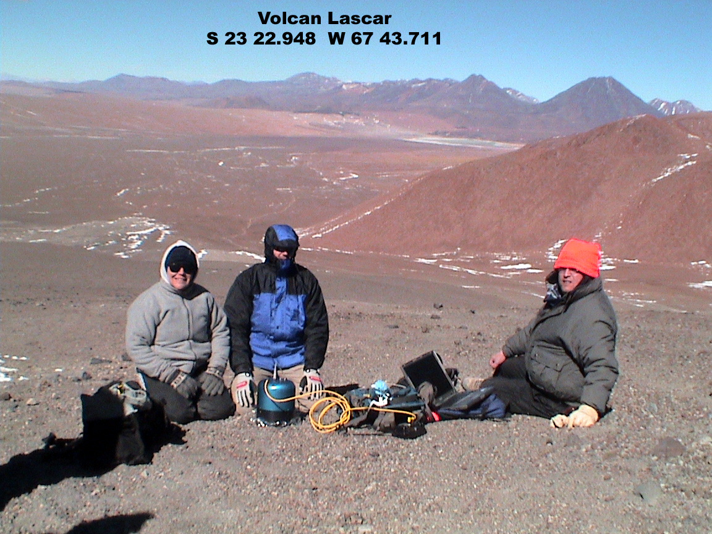

Measurements made with the instrument at the various sites are largely confirmed by the preliminary outgrowth studies that have been completed [others are still in progress]:
- largely Actinomyes and Bacillus spp. have been found together with a variety of highly colored fungi
- ‘patches’ are found at desert station area and Cerro Buenos Aires where some areas are very low [10²/g] while others nearby [3-30m] are very high [10⁶/g] near a. desert station
rock garden area was low,
salt flats and wadis slightly higher
under a big rock very high
pothole on rock surface was low
water was added and after an hour or so, the reading was high
b. Cerro Buenos Aires
very high except for the area facing the wind and sun which was very low
- Volcan Lascar surface as very low
- Valley of the Moon was very high except for a very rocky sheltered area

We are also using other analytical methods to identify the microbial flora and characterize the soil composition. We are only a little way into the complete analysis.

Our effort had several teachers work closely with us [3 Chileans, 8 Americans] and 2 joined us on our long trek across the Atacama and to the top of two volcanoes. Both in the field and at Yungai, they participated in all aspects of sample/data collection, data organization and recording, data integration/analysis, and discussions. They helped identify places to measure/sample and made sure we had all the equipment we needed for the tasks. In all, they were a tremendous addition to our efforts and we collected considerably more samples and data then we could possibly have without them. In addition, they were eager to learn and that makes even not so exciting [boring] tasks fun. We had several long discussions about underlying theory, possibilities, and applications and I sent them information about our technology after I returned. Two of those who worked with us have contacted me to see if they could work with us during the summers and I am working on that possibility.

I believe the benefit to them was great for and for as well, but even greater for their students. First, they were fired up to learn something new and this attitude spreads like wild fire when they are in contact with students. Second, they were introduced to the excitement of discovery – a very addicting potion. The long trek up two volcans [I view it as quite godly] and hours of riding in a crowded 4X4 across the desert with no help available for possibly days [could be viewed as ungodly, I guess] should there have been a problem made them appreciate the commitment it takes and the rewarded them with the satisfaction of having accomplished it. These are just the ingredients we want to convey to students! One of the teachers who went with me [up both volcans] is writing a book for his students on his experiences. This multiples the investment by an unimaginable factor!

