C-A OPERATIONS PROCEDURES MANUAL

ATTACHMENT

9.2.1.g NSRL Users Experimental Safety Approval Form

C-A OPM Procedures in which this Attachment is used.
9.2.1

Hand Processed Changes

HPC No. | Date | Page Nos. | Initials
____________ | ____________ | ____________ | ____________
____________ | ____________ | ____________ | ____________
____________ | ____________ | ____________ | ____________

Approved: ________________________________________ _____
Collider-Accelerator Department Chairman Date

P. Cirnigliaro, A. Emrick
NSRL USERS EXPERIMENTAL SAFETY APPROVAL FORM

You must complete this form for all work listed on the proposal, not for any individual runs
1. NSRL PROPOSAL NUMBER: | Date Submitted:  Expected Start Date: March 2007
2. EXPERIMENT TITLE: Induction of mitotic catastrophe by high-LET iron ions.

- CONTACT PERSON FOR QUESTIONS REGARDING THIS EXPERIMENT:
Name of person: Fiorenza Ianzini
Phone Number (at home institution): 319-335 6637
Email: fiorenza-ianzini@uiowa.edu

.

4. EXPERIMENTERS who will be working on this project. Indicate Principal Investigator. All experimenters must satisfy all training requirements for the experiment.
First Name | Last Name | Affiliation | Phone | Email
Fiorenza | Ianzini | University of Iowa Department of Pathology 145B MRC – Iowa City, IA 52242 | 319-335-6637 | fiorenza-ianzini@uiowa.edu
Elizabeth A. | Kosmacek | University of Iowa Department of BME B180ML - Iowa City, IA 52242 | 319-335-6544 | ekosmace@engineering.uiowa.edu
Christina L. | Sjogren | University of Iowa Department of Pathology 145 MRC – Iowa City, IA 52242 | 319-335-6544 | christina-sjogren@uiowa.edu

5. TASK AND HAZARD ANALYSIS: Discuss what you will bring to BNL, how it will be shipped here, what special precautions you will take when using it and transporting it on-site, and how it will be disposed of and/or shipped back to your home institution. Include Radioactive items, materials and samples, hazardous materials, as well as non-radioactive and non-hazardous items and materials.
All materials will be shipped to BNL and back to Iowa City by carrier
We will bring:
Plastic ware
Cells
Complete media
Chemicals to prepare samples for end-points
Microscope slides
Samples will be collected for:
Flow Cytometry (FCM)
Western Blotting
RT-PCR
Cellular preparation (microscopic slides)
Mutation assay
Live cell imaging
Samples will be collected according to the following protocols:
COMPLETE MEDIA and BUFFERS

Specific medium for each cell line
Penicillin/Streptomycin
Serum
PBS
EDTA

CELL PREPARATION (c/p)
Sample collection:

- resuspend cells in monolayer collecting all the suspension fluids (media, PBS and cells
in 2 mM EDTA) using either a 50 ml or 15 ml conical tube (depending on the volume of cell suspension);
- centrifuge cells at 1200 rpm for 5 min at 5°C;
- discard supernatant and resuspend cell pellet by finger tapping;
c/p sample preparation:

- add 5 ml PBS to resuspended cells;
- centrifuge as above;
- discard supernatant and resuspend cell pellet by finger tapping;
- add 5 ml 0.075 M KCl and incubate for 8 min at r. t.
- centrifuge as above;
- discard supernatant without re-suspending the pellet
(this is crucial pay attention!!!);
- fix cells in the pellet with about 2 ml of MeOH : GAA 3 : 1 (v : v) using a Pasteur pipette, fix for 5 min at r. t.;
- add more fixative so to have a clear milky cell suspension;
- prepare slides spreading fixed cells on a previously moisturized (in fresh cold distilled
water) microscope slide;
- make 4 slides per group;
- store slides in microscope slide boxes
- store box at r. t.

RT-PCR SAMPLE PREPARATION

RNA Isolation:

Homogenization with Qiashredder
- Collect appropriate number of cells by centrifugation at 1200 rpm, 4ºC, 5 min. , (one T25 should yield around 50 µg RNA)
- Decant supernatant and blot edge of tube on paper towel to remove residual
medium
- Lyse cells in 350 – 600 µl Buffer RLT + β-mercaptoethanol by pipetting
(add 10 µl ß-mercaptoethanol per 1 ml Buffer RLT, stable for 1 month at room
temp.)
- Transfer lysate to a Qiashredder column and centrifuge at top speed for 2 min.
- Discard column and put a cap on tube
- Store at -80ºC
(lysates are stable for several months, and can be stored left 20ºC for shorter
term storage ~1 week)

SDS-PAGE ELECTROPHORESIS/WESTERN BLOTTING SAMPLE PREPARATION

Protein Isolation:

- Thaw protease inhibitors and DTT on ice and make fresh lysis buffer

1X Lysis Buffer Recipe – make fresh
Component | Storage | Volume (µl) per 1 ml buffer
2X WE16 Buffer | 4º | 500
0.5 M DTT | -20º | 2
20 mg/ml Pefabloc | -20º | 25
1 mg/ml Leupeptin | -20º | 25
1 mg/ml Pepstatin | -20º | 10
1 mg/ml Aprotinin | -20º | 10
1M ß- glycerophosphate | 4º | 80
0.1 M Na₃VO₄ | 4º | 5
1M NaF | 4º | 50
H₂O | n/a | 293

2X WE16 Buffer (4ºC)
50 mM Tris-HCl pH 7.5
250 mM NaCl
5 mM EDTA
0.1% SDS
1% NP40
1% deoxycholic acid
20% glycerol

- Detach cells collecting media and PBS,
- Centrifuge at 1200Xrpm, 5º, 5 min.
- Resuspend pellet in 5 ml COLD 1X PBS by pipetting up and down 3 times
- Centrifuge again as above
- Pour off PBS and invert tube on paper towel to remove as much residual PBS as
possible
- Resuspend pellet in 200 µl freshly made lysis buffer per 2-3 x 10⁶ cells, scale
accordingly (save leftover lysis buffer for Bradford assay, store the leftover at
-20°C, when ready to process thaw on ice before centrifugation)
- Transfer lysate to 1.5 ml Eppendorf tube
- Centrifuge in Eppendorf centrifuge at 14K rpm, 15’
- Remove supernatant to a clean 1.5 ml Eppendorf tube
- Store at -80ºC

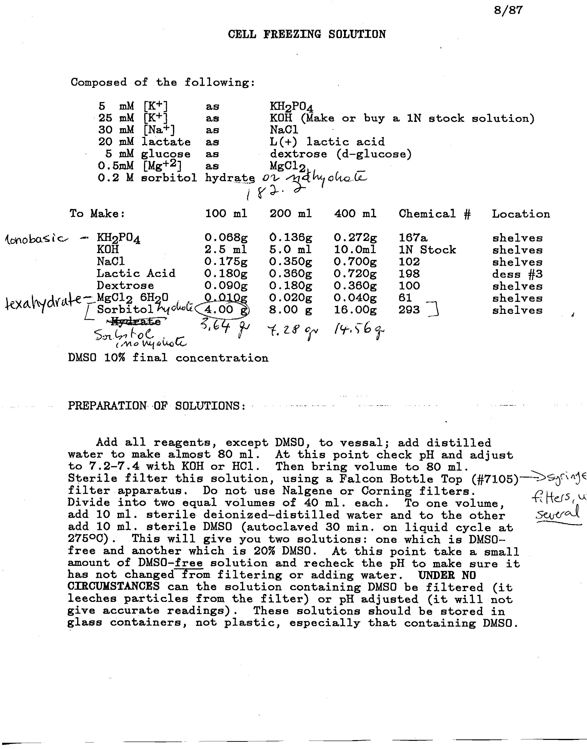

We will bring compounds already dissolved in the appropriate buffers.
The majority of the chemicals used in the protocols reported above are not toxic. The toxic chemicals we will use/bring are the following: MeOH (methanol), GAA (Glacial acetic acid), β-mercaptoethanol, DTT (dithiotheitol), Na₃VO₄ (sodium orthovanadate), NaF (sodium floride),
                                                              DMSO (dimethyl sulfoxide), BrdU (Bromodeoxyuridine), HCl (hydrochloric acid).
We are not using radioactive materials.
We will not use hazardous procedure.
The bio-hazardous materials we will bring are the cell lines to be used in the irradiation experiments. The cell lines we will bring are as follows: mouse embryonic fibroblasts (MEF12(1)), mouse embryonic fibroblasts (MEF10(1)), human normal lung fibroblasts (MRC5), human normal skin fibroblasts (CCD32Sk), human bronchial/tracheal epithelium (NHBE).
Waste: we will generate only plastic-ware and residual culture medium. Culture flasks, centrifuge tubes and pipettes will be treated with 10% sodium hypochlorite (bleach) before disposal according to BNL procedures. Culture Media will be neutralized with 10% sodium hypochlorite before disposal according to BNL procedures. All the other solutions will be prepared at appropriate volumes for sample preparations so that there will not be residuals (see procedures for sample preparations above).
Shipping the samples back to Iowa City:
Samples preparations of microscope slides will be shipped at room temperature,
FCM samples will be shipped at 4°C as cell pellet fixed in 95% ethanol,
Lysate from cell samples for SDS-PAGE/Western Blotting will be shipped in dry ice,
Lysate from cell samples for RT-PCR will be shipped in dry ice,
Pelleted frozen cells for mutation experiments and live cell imaging will be shipped in dry ice
- MATERIALS TO BE USED Please use only the minimum quantity and the least hazardous chemicals available to do your experiment successfully:
Please, refer to point 5 above.
6a) Chemicals: List all chemicals including toxic and experimental substances, controlled substances, compressed gases, and cryogens:
Name of Chemical | Quantity | Storage Location (Medical, NSRL, Biology) | Location of use (Medical, NSRL Biology) | Return to Home Institution? | Special Handling  Requirements
Eagle’s Minimal Essential Medium | 40 liters | Medical | Medical and NSRL | will all be used, if left over then YES | none
Bronchial Epithelial Growth Medium | 40 liters |  | Medical and NSRL | will all be used, if left over then YES | none
Dulbecco’s Modified Eagle’s Medium | 40 liters | Medical | Medical and NSRL | will all be used, if left over then YES | none
Penicillin/ streptomycin | 200 ml for 40 liters of media | Medical | Medical and NSRL | will all be used, if left over then YES | none
NEAA | 400 ml for 40 liters of media | Medical | Medical and NSRL | will all be used, if left over then YES | none
fetal bovine serum | 4 liters for 40 liters of media | Medical | Medical and NSRL | will all be used, if left over then YES | none
1x PBS | 40 liters | Medical | Medical and NSRL | will all be used, if left over then YES | none
2 mM EDTA | 4 liters | Medical | Medical and NSRL | will all be used, if left over then YES | none
0.075 M KCl | 2.4 liters | Medical | Medical and NSRL | will all be used, if left over then YES | none
MeOH | 2 liters | Medical | Medical and NSRL | will all be used, if left over then YES | none
GAA | 2 liters | Medical | Medical and NSRL | will all be used, if left over then YES | none
RLT buffer | 240 ml | Medical | Medical and NSRL | will all be used, if left over then YES | none
β- mercaptoethanol | 2.4 ml | Medical | Medical and NSRL | will all be used, if left over then YES | none
Lysis Buffer for Western Blotting samples | 100 ml  this buffer contains:  WE16 Buffer* (50 ml)  DTT (0.2 ml)  Pefabloc (2.5 ml)  Leupeptin (2.5 ml)  Pepstatin (1 ml)  Aprotinin (1 ml)  Glycerophosphate  (8 ml)  Na₃VO₄ (0.5 ml)  NaF (5 ml)  H₂0  *WE16 Buffer contains:  50 mM Tris-HCl  250 mM NaCl  5 mM EDTA  0.1% SDS  1% NP40  1% deoxycholic acid  20% glycerol | Medical | Medical and NSRL | will all be used, if left over then YES | none
Freezing solution | 800 ml  solution contains:  5 mM K₂PO₄  25 mM KOH  30 mM NaCl  20 mM L(+) lactic acid  5 mM dextrose  0.5 mM MgCl₂  0.2 M sorbitol  20% DMSO | Medical | Medical and NSRL | will all be used, if left over then YES | none

6b) BIOLOGICALS: List all animals, cell lines (and note if they are primary or not), blood or body fluids, viruses, viable bacteria, or toxins of biological origin. Please list detailed description of organisms below. You may need Institutional Animal Care and Use Committee (IACUC), Institutional Biosafety Committee (IBC) and/or Institutional Review Board (IRB) Approval:

Name of Biological | Description | Disposal method at BNL or note return to Home Institution | Special Handling/Approval (IRB, IBC)
mouse embryonic fibroblasts (MEF12(1) | Cell line | Residual cells will be neutralized with 10% sodium hypochlorite before disposal. Residual culture media will be neutralized with 10% sodium hypochlorite before disposal. | N/A
mouse embryonic fibroblasts (MEF10(1) | Cell line | As above | N/A
human normal lung fibroblasts (MRC5) | Cell line | As above | N/A
human normal skin fibroblasts (CCD32Sk) | Cell line | As above | N/A
human bronchial/tracheal epithelium (NHBE) | Cell line | As above | N/A

6c) Radioactive Materials: List any radioactive materials, include any handling of activated materials:

Name | Quantity | Storage Location (Medical, NSRL, Biology) | Location of use (Medical, NSRL Biology) | Disposal method at BNL or note return to Home Institution | Special Handling  Requirements

If you are required to handle materials shortly after beam exposure (activated materials) indicate time frame required:

Time Required | Description
Soon as the beam is off – would need 30 minutes per beam | We will need to collect zero time points immediately after irradiation. Next time points will be at 8 h post-irradiation.

7. EQUIPMENT: List any equipment you will bring to BNL. Please list where you will use it (NSRL, Medical, Biology). Listing of Potentially Hazardous Equipment Must Include: electric equipment not UL approved or certified to meet National Electrical Code, electronic equipment, detectors with flammable gases and flammable gas targets, flammable-combustible (e.g. plastic detector materials), samples, reactive metals etc, lasers, ovens, pumps, cryostats, pressure devices or pressure vessels, vacuum windows or vacuum vessels, liquid or gas mixing or containment systems, UV lamps, high-temperature devices, material handling devices, solenoids, spectrometer magnets, structures supporting heavy loads, compressed air or gas systems, RF or microwave devices, sound systems or noise greater than 85 dBA, items that emit liquids, gases, or vapors from the experiment, welding or burning tools, or any equipment or activities that require special written procedures by the User.

Description:
No equipment will be brought to BNL
8. WASTES: (including clean waste, hazardous waste, radioactive waste, medical/biohazard waste.)
Name of Waste | Description | Anticipated quantity | Disposal Method
Plastic-ware | Culture flasks  Pipettes | 1200 flasks  2000 pipettes | Residual media in flasks will be neutralized with 10% sodium hypochlorite and disposed of according to BNL procedures
Mouse and human (not primary) cells | Residual from cell passages | Few hundred of ml (cells will mostly all be used, not disposed of) | Residual cells will be neutralized with 10% sodium hypochlorite and disposed of according to BNL procedures

9. USER COMMENTS:
I have already completed all the required web-training
I was at BNL for on-site training November 8th, 2006

10. TRAINING: Training requirements for each experiment will be posted on the NASA website. Listed below are the specific training requirements based on the work to be performed.
For return users, you may check your training status on-line at http://training.bnl.gov to see which courses you need to complete again.
All NSRL Users must complete the following 4 courses:
- C-A Radiobiology Users Training
- Initial training - Classroom training necessary - contact userscenter@bnl.gov for schedule.
- Renewals- every 24 months, complete Challenge exam at http://training.bnl.gov (study guide is available), or repeat classroom training.

- Radiological Worker 1
- Part 1 can be done on-line at http://training.bnl.gov
- Part 2 consists of a challenge exam to be taken at BNL. Study guide is at http://training.bnl.gov
(Note: If you are from another DOE facility you can apply for DOE Radiation Worker Reciprocity by completing exemption form).
- Cyber Security online at http://training.bnl.gov. Initial training only (no requalification required)
- Guest Site Orientation online at http://training.bnl.gov. Initial training only (no requalification required)
In addition, ALL participants using laboratory facilities in the Medical or Biology Departments must complete the following.
If you are using chemicals, as noted in this experimental safety review, you must complete the following on-line courses
- Laboratory Standard (required every two years)
- Hazardous Waste Generator (required annually)
- Regulated Medical Waste Generator Training (initial training only)
If you are using Human blood, tissues, or primary human cells:
- Bloodborne Pathogens Training (required annually)

If you are using cryogens (liquid nitrogen or helium), you must complete the following on-line course:
- Cryogen Safety Awareness (initial training only)
If you are using compressed gases, you must complete the following on-line course:
- Compressed Gas Safety (initial training only)
If you are using dispersible Radioactive Materials such as tagged cells, or will handle your samples while activated from beam exposure, you must complete the following:
- Radioactive Waste Generator (HP-RADIGEN) available on-line
- Benchtop Dispersibles Training (required every two years) - contact Ann Emrick, emrick@bnl.gov, to arrange for course)
If you are using Animals:
- Laboratory Animal Training (LAT I): will be administered upon arrival. (Initial training only, no requalification)
If you are using Controlled Substances:
- Controlled Substance Awareness
- DEA Background Check: Contact Medical Chairman’s Office at (631)344-3715

ALL USERS MUST READ AND SIGN THE LOW HAZARD-SKILL OF THE CRAFT WORK PLAN SPECIFIC FOR THE EXPERIMENTAL RUN THEY ARE ATTENDING

EXPERIMENTAL SPOKESPERSON – PRINCIPAL INVESTIGATOR, PLEASE SIGN AND DATE BELOW:

SIGNATURE:___Fiorenza Ianzini Nivember 14, 2006_______________

Life Sciences Experimental Review Committee Designee Approval:
C-A Experimental Safety Review Committee Designee Approval:
Environmental Safety &Health Staff Comments and Requirements:
Approval Date

