TABLE OF CONTENTS

1 GENERAL INFORMATION AND THE LAW 2
2 VENTILATION 10
3 FUEL SYSTEMS 14
4 FIRE AND FIREFIGHTING 16
5 AUXILIARY SYSTEMS 25
6 SAFETY EQUIPMENT 27
7 RULES OF THE ROAD 33
8 VESSEL OPERATIONS 41
9 NAVIGATION 50
10 WEATHER 55
11 SPECIAL ACTIVITIES 56
12 FIRST AID 67
13 GLOSSARY OF BOATING TERMS 70
14 TERMINOLOGY 72
15 CHAPTER REVIEW New Study Guide 73
16 VESSEL INSPECTION REPORT 76
17 MASTER’S PRACTICAL EXAM 78
18 ACCIDENT REPORT FORM 79


PV - 2004

NYS Office of Parks, Recreation & Historic Preservation
Marine Services Unit
Nelson A. Rockefeller Empire State Plaza
Agency Building 1, 11th Floor
Albany, NY 12238
518-474-0445 518-408-1030 (fax)

- GENERAL INFORMATION AND THE LAW

  - DEFINITION OF A PUBLIC VESSEL

As stated by the New York State Navigation Law, the term "Public Vessel" shall mean and include every vessel which is propelled in whole or in part by mechanical power and is used or operated for commercial purposes on the navigable waters of the state; that is either carrying passengers, carrying freight, towing, or for any other use for which compensation is received, either directly or where provided as an accommodation, advantage, facility, or privilege at any place of public accommodation, resort, or amusement. (Section 2.6(a), NYS Navigation Law)

  - REGISTRATION

New York State law requires that every mechanically propelled vessel operated primarily on the navigable waters of the state or any waters within the boundaries of the state be registered with the Department of Motor Vehicles in accordance with article 48 of the Vehicle and Traffic Law. A mechanically propelled vessel is one equipped with a motor (gasoline, diesel, electric, etc) regardless of whether or not the motor is the primary means of propulsion (i.e. an auxiliary sailboat or a canoe with a trolling motor). Upon registration of the vessel, the owner will receive a registration certificate, indicating the vessel's assigned number, and a set of validating stickers. Vessel registration must be renewed every three years. The requirement for a vessel to be registered is separate and distinct from the requirements of Public Vessel certification but failure to prove that the vessel is properly registered may result in the vessel not receiving certification.

    - Registration Certificate

The registration certificate is a pocket sized card which contains the name and address of the owner and vessel information such as hull material, propulsion, length, model year, manufacturer, hull identification number, and type of use, in addition to the registration number awarded. It serves as proof that the vessel is registered. It is also proof of ownership unless the vessel is titled or documented. It is required that the registration certificate be on board the vessel at all times when it is in operation.

    - Registration Number

The registration number consists of the letters NY followed by no more than four numbers and then two capital letters. A two-inch space or hyphen must separate the letter and number groups (NY 1234 AA or NY-1234-AA). The number should be painted on or permanently affixed to each side of the forward half of the vessel. It should read from left to right, be in block letters not less than three inches high, and be of a color that contrasts with the color of the hull. It should be clearly visible and readable from a distance of 100 feet during daylight hours. Except for the PV lettering described in the following section, no other letters or numbers may be displayed on the forward half of the vessel. Once assigned to the vessel, the registration number will remain with it until the vessel is destroyed or permanently removed from the state.

    - Public Vessel Identification

When a vessel is approved and certified as a Public Vessel, the letters PV must be displayed above or below the registration number on both sides of the forward half of the vessel. These letters are to be not less than five inches in height and maintained in a legible condition so that they are readily discernible during daylight hours at a distance of 200 feet.

  - INSPECTION OF PUBLIC VESSELS

    - Requesting Inspection

Any owner who intends to operate a Public Vessel must contact the Bureau of Marine and Recreational Vehicles (M&RV) to request certification of the vessel. The owner will be sent a Vessel Inspection Report form in the mail. The top portion of the form pertaining to vessel and owner data should be completed and given to the inspector at the time of inspection. The owner should arrange the time, date and location of the inspection as early in the season as possible. During peak inspection season - May, June & July - scheduling may be difficult, and the inspectors may not be able to complete the inspection prior to scheduled operation as a PV.

    - Inspection Criteria and Certification

A Public Vessel must be inspected before it is placed in service and annually thereafter. The inspection includes a complete examination of the hull, propulsion system, control systems, fuel system, ventilation, electrical system, and all required safety equipment. If the vessel is found to be in compliance with all inspection criteria, the inspector will certify the vessel as a Public Vessel. The inspector will also make a determination on the number of passengers the vessel may carry and the manning requirements. All information will be recorded on the vessel inspection report. The top copy of the report, when signed by the inspector and the vessel owner, will serve as a temporary Certificate of Inspection valid for thirty days. A formal Certificate will normally be received within two to three weeks. For more information on specific inspection criteria consult the applicable chapters of this book or call the Bureau of Marine and Recreational Vehicles. A copy of the inspection report appears in the appendices.

    - Deficiencies and Failures

Any deficiencies discovered during the vessel inspection will be listed on the inspection report. The quantity and seriousness of the deficiencies will be the determining factor in whether or not the vessel passes inspection. Identical deficiencies in consecutive years will be immediate cause for failure. All listed deficiencies must be corrected prior to placing the vessel in service. If the vessel does not pass inspection, a temporary permit will not be granted. The owner of the vessel will receive a copy of the inspection report noting all deficiencies and the inspector's instructions for correcting them. When all deficiencies have been corrected, the owner is required to mail a signed, notarized letter to M&RV certifying that corrective action has been taken. The inspector may then either schedule a second inspection of the vessel or issue a Certificate of Inspection.

    - Posting of Certificate of Inspection

The Certificate of Inspection or a legible photocopy is required to be posted in a conspicuous place on the vessel approved by the inspector (usually the pilothouse). Vessels under ten tons displacement are exempt from the posting requirement, however, the Certificate of Inspection must always be on board when the vessel is operating as a Public Vessel.

    - Fees

The inspection fee for each Public Vessel must be paid upon receipt of an invoice issued to the owner/operator regardless of whether or not the vessel passes inspection. There is no charge for follow-up inspections. The fees are established by the State Legislature and are based upon the displacement tonnage of the vessel as follows:

Vessel Size | Fee
10 tons and under | $20.00
Over 10 to 20 tons | $30.00
Over 20 to 50 tons | $40.00
Over 50 to 100 tons | $50.00
Over 100 tons displacement | $100.00
NOTE: Payment must be made by check or money order.

    - Repairs, Major Alterations and Hull Inspections

Whenever repairs beyond basic maintenance and upkeep to any of a Public Vessel's systems are anticipated, the vessel owner should contact M&RV to provide information on the nature and extent of the repairs. Based on the information provided the inspector will determine if an inspection is required prior to placing the vessel back in service.

This is especially important if major alterations to the vessel's hull or structure are to be accomplished, or when a propulsion engine receives major repairs or replacement. It is the duty of the owner to promptly report the same to the inspector, so that he may make a thorough inspection, if the inspector determines that such an examination is necessary. Failure to do so may void the vessel's Certificate of Inspection and delay operation as a Public Vessel until a thorough reinspection is conducted.

  - LICENSING OF PUBLIC VESSEL OPERATORS

Public Vessels, when underway, must have on board the licensed personnel and crew required by the Certificate of Inspection. Operating a Public Vessel without the appropriate license is a misdemeanor offense punishable by fine, imprisonment or both. An owner who permits unlicensed operation is also guilty of a misdemeanor. On all vessels, the license must be posted in the same manner as required for the display of the Certificate of Inspection.

    - Original License General Requirements and Procedures

All license candidates must complete and sign a license application form. The applicant must provide all requested personal information and information relating to ability, character, education and experience. Failure to provide the requested information is grounds for license denial. Unless specifically waived by the inspector, all license applicants must pass a written examination. All applicants must meet the following requirements before taking the written examination:

- Present valid photo identification (driver's license, passport) and proof of age.
- Non-U.S. citizens must present proof they are legally in the United States.
- Present evidence of completing a boating safety course approved by the National Association of State Boating Law Administrators (NASBLA). Acceptable certificates include the following:
- New York Safe Boating Course - for course availability check our web site at www.nysparks.com/boats/yb
- United States Coast Guard Auxiliary Courses - Boating Safely or Boating Skills & Seamanship (BS&S) courses. For course availability contact a local Flotilla or go to www.cgaux.com .
- United States Power Squadrons Courses - Boat Smart or The Squadron Boating Course. For course availability contact your local Squadron or visit www.usps.org .
- Boating Course of Another State - A boating safety certificate issued by the government of another state that clearly indicates it was issued for completion of a NASBLA approved boating course.
- On-line Boating Courses - There are two courses currently accepted. They are the Boat US online General Boating Course at www.boatus.com/foundation and America's Boating Course which is a joint effort of the Coast Guard Auxiliary and U.S. Power Squadrons available at www.americasboatingcourse.com
- Courses not listed above are probably not acceptable. If you are in doubt, call 518-474-0445 and ask for a Marine Inspector.
- This requirement may be waived for anyone possessing a current U.S. Coast Guard license.
- Applicants must have at least 30 hours of experience operating motorboats of a similar class. This requirement may also be waived for anyone possessing a current U.S. Coast Guard license.

Upon successful completion of the written examination and any requirements specific to the type of license being sought, the candidate is issued a temporary license valid for sixty days. The official license is normally issue within one month and is valid for one year from the date of examination. License candidates should contact this office early to request placement on the inspection/testing schedule. It may be necessary for the applicants to travel to Albany if they can not be accommodated in the regular schedule.

    - Specific License Types And Requirements

Master - A Master's license is required for the operation of any Public Vessel that exceeds any of the following criteria: 65-foot length; 50-ton displacement; or 65 passengers. The applicant must successfully exhibit to the inspector, during a practical examination, a thorough knowledge of seamanship, ship handling, Rules of the Road, piloting, emergency procedures plus the accepted practices of supervision and leadership of a vessel's crew. A written examination may also be required. The applicant must also, in most cases, have served at least one season as an Apprentice Master aboard the vessel with a minimum of sixty hours of piloting documented in the vessel's logbook. A letter of recommendation from the vessel's owner must be submitted with each application for a Master's license.

Joint Pilot & Engineer - This license is for use on smaller vessels, not meeting the criteria for a Master's license that requires only one person for safe operation. The applicant must demonstrate, on a written examination, a general knowledge of small boat handling, engine operation, Rules of the Road, the New York State Navigation Law, the use and maintenance of safety equipment and a thorough knowledge of emergency procedures such as fire fighting, man overboard, flooding, etc. The inspector may also require a practical exam.

Apprentice Master - This license is normally the first step for personnel seeking a Master's license on larger vessels. The applicant must demonstrate a minimum of thirty trips (documented in vessel's logbook) as a deck hand on the vessel for which he/she desires a license and demonstrate the same level of knowledge on a written examination as the Joint Pilot & Engineer. If the applicant has held a Joint Pilot & Engineer license for at least one year immediately preceding the application the license can be upgraded to Apprentice Master without examination. Once the license is issued the licensee may begin training as a Master under the direct supervision of a licensed Master. No person may train to operate or pilot a Public Vessel requiring a Master without first obtaining an Apprentice Master's license. All training of an Apprentice Master must be documented in the vessel's logbook for later reference by the inspector..

Engineer - This license is required on those larger vessels having engine spaces which require tending by someone other than the vessel's operator. In general, any vessel meeting the criteria requiring a licensed Master will also be evaluated for the need to carry an Engineer. The final determination will be made based on the following criteria:

a) Any vessel utilizing steam propulsion systems must carry an engineer.
b) Any vessel in which the propulsion machinery cannot be completely controlled from the Pilot House must carry an engineer.
c) All other vessels will be evaluated on an individual basis by the following characteristics:
1) Complexity of the Engineering Plant - This may include but is not limited to: the size, number, and horsepower of the engines; the quantity, rating and complexity of the onboard electrical generating system; the need to utilize shore power when pierside; and the complexity of operating and start-up procedures.
2) Accessibility and proximity of propulsion and auxiliary machinery spaces to Pilot House
3) Whether or not emergency equipment such as fire pumps, bilge pumps, and firefighting systems are controllable from the bridge;

Applicants for this license must exhibit, on a written and practical examination, a thorough knowledge of the entire marine plant. This includes but is not limited to basic propulsion theory, systems and operation, electric power generation, sanitary system, fire pumps, steering systems, and related auxiliary gear. They must also exhibit a complete understanding of marine safety and firefighting techniques.

    - Waivers for Licensing Requirements

Waivers may be granted for some or all of the requirements of a given license. Waivers are not automatic and are granted on case by case basis at the discretion of the inspector. All requests for waivers must be accompanied by sufficient documentation to support the waiver request. For example, an applicant seeking a waiver based on a U.S. Coast Guard license must provide a copy of both sides of the license.

    - License Requirement Summary Table

LICENSE | JOINT P & E |  | APPR. MASTER |  | MASTER |  | ENGINEER
AGE  (proof required) | 18 |  | 21 |  | 21 |  | 21
BOATING SAFETY COURSE |  | YES |  | YES |  | YES |  | YES
WRITTEN EXAM | YES - JP&E |  | YES - unless holding JP&E license |  | May be required at inspectors discretion |  | YES - general questions re: power plants, fire fighting, etc.
PRACTICAL EXAM | Not Normally Required |  | At Inspector's Discretion |  | YES - Vessel must be conned under inspectors observation |  | YES - Must operate and explain various engineering systems
EXPERIENCE | Thirty hours of experience operating motorboats |  | One season(30 trips) as a deck hand, or 1 year as a JP&E |  | Serve as an Apprentice Master under the direct supervision of licensed master; min. of 60 hours bridge time, certified in the vessel's logbook. |  | One season working in the engine room under the supervision of a licensed engineer. Two months required if candidate is a licensed stationary engineer.
WAIVERS  (all at discretion of inspector) | Waiver of written examination, experience and boating safety course with a valid USCG license as Master, Mate or Operator of Uninspected Passenger Vessels (6-pack) |  | Waiver of written examination, boating safety course, and some or all experience with a valid USCG license as Master, Mate or Operator of Uninspected Passenger Vessels (6-pack) |  | Waiver of written examination, boating safety course, and some or all experience with a valid USCG license as Master, Mate or Pilot for a vessel of comparable size/tonnage. A practical exam is usually still required |  | USCG licensed engineer for a vessel of comparable size/horsepower /propulsion plant

    - License Renewals

All licenses must be renewed annually. Re-examination is usually not required; however, a short open book renewal examination will be given every five years in order to keep all licensed operators up to date on changes in the law and other safety related items. Any licensee who fails to renew his/her license by the expiration date will have until August 1st of the following year to renew the license. For example, if your license expired in June 1998, you would have until August 1, 1999 to renew without reexamination. M&RV will not notify licensees of impending license expirations. Failure to renew the license within the grace period will require reexamination prior to a new license issuance. No person may operate a Public Vessel beyond the expiration date on the license.

    - License Fees (All Classes)
NOTE: Fees are established by the State Legislature and are payable by check or money order only, upon receipt of invoice.  Original License | $20.00
License Renewals | $10.00

    - Suspension or Revocation of Licenses

The inspector may suspend or revoke any license issued pursuant to the provisions of Article 4 of the New York State Navigation Law upon satisfactory proof of: recklessness; carelessness; intemperance; incompetence; willful dereliction of duty; or willful disobedience of any lawful rule, or regulation duly made and promulgated by the Commissioner of the Office of Parks, Recreation and Historic Preservation in the Executive Department of the State New York.

Whenever any license is suspended, the holder shall forthwith deliver up his license to the inspector, who shall retain it until the time of suspension shall expire. Any such suspended person who shall refuse to deliver up such license shall be subject to a penalty of one hundred dollars for each day following such refusal.

  - CREW REQUIREMENTS
As the passenger carrying capacity increases on a Public Vessel, the need for additional crewmembers to assist the operator increases. In the event of an emergency, the vessel's operator may be too busy with other tasks to personally assist the vessel's passengers. Additionally, larger vessels often require more than the operator to provide a proper lookout, safely dock/undock the vessel, and generally carry out the vessel's routine underway. In such cases the operator must have personnel under his/her direction to carry out the necessary tasks. Realizing this, the following minimum crew requirements have been established by the marine inspectors. The number of crewmembers required is based on the number of passengers the vessel is carrying and is in addition to any licensed personnel required for the vessel. On vessels required to carry an Engineer, the Engineer may count as one of the crewmembers provided that such duties do not interfere with the operation or safety of the engineering plant. The Marine Inspector will make this determination.

Number of Passenger | Crew Members
0 - 20 | 0
21 - 50 | 1
51 - 100 | 2
101 - 150 | 3*
151 - 200 | 4*
Over 200 | One for each additional 50 passengers*
*Vessels of this size may carry fewer crewmembers when passenger total is lower. However, they may never carry less than 2 crewmembers under any circumstances.

  - NUMBER OF PASSENGERS

The marine inspector determines the number of passengers, licensed personnel and crew a Public Vessel may carry when the vessel is initially certified. This is noted on the Certificate of Inspection. It is unlawful to take aboard any Public Vessel a number of passengers greater than the number allowed on the Certificate of Inspection. For every violation of this provision, the Master, Pilot, Joint Pilot & Engineer, or owner shall be guilty of a misdemeanor.

  - LAW ENFORCEMENT

Every owner or operator of Public Vessels must show certificates, licenses, equipment, etc., to any law enforcement officer upon request. When a summons is issued to a Public Vessel owner or operator, a copy is sent to the inspector who may take further action. When a vessel fails to pass inspection and a Certificate of Inspection is terminated or denied, local law enforcement agencies are notified.

  - SPEED AND RECKLESS OPERATION

Every licensed operator of a vessel shall, at all times, navigate the vessel in a careful and prudent manner and at such rate of speed as not to unreasonably interfere with the free and proper use of the Navigable Waters of the State or unreasonably endanger any vessel, or person. No vessel shall be operated within 100 feet of the shore, a dock, pier, raft, float or an anchored or moored vessel at a speed exceeding 5 miles per hour. In addition to possible license suspension or revocation, a violation of this provision of the navigation law shall constitute an offense, which is punishable as per the table to the right.
FIRST OFFENSE: Fine not exceeding $100 or imprisonment up to 30 days or both.
SECOND OFFENSE: Fine not less than $50 nor more than $200 or imprisonment up to 90 days or both.
THIRD OFFENSE: Fine not less than $l00 nor more than $500 or imprisonment up to 180 days or both.

  - BOATING WHILE INTOXICATED

No persons may operate a vessel, on the waters of New York State while intoxicated or while their ability to operate such vessel is impaired by the use of alcohol or drugs. Public Vessel operators are held to a higher standard than other boaters: blood alcohol content as low as .04% constitutes a violation, as opposed to a B.A.C. of .10% for others. The law calls for heavy fines and/or imprisonment on all convictions of operating while intoxicated. In addition, a Public Vessel operator may have his license suspended or revoked. The law pertains only to the operator of a vessel and does not prohibit the consumption of alcohol by passengers.

On the water or on land, alcohol, even in small amounts, will affect one's ability to function in three critical areas. A person's balance, coordination, and judgment are all in jeopardy when alcohol is consumed. Additionally, Coast Guard studies have shown that people on a boat underway are affected by environmental conditions such as heat, glare, engine noise, vibration, and the boat's motion through the water. These conditions called stressors, cause fatigue and slow reaction time. This effect is increased with alcohol consumption and the combination can be deadly.

Falls overboard are one of the leading causes of boating fatalities. A boat is a constantly moving platform, even in calm water under normal conditions a passenger may be thrown off balance by the vessel's motion. After only a couple of drinks, the affect on balance and equilibrium may result in a fall within the vessel or overboard. A person who has been drinking and fallen overboard is likely to have difficulty treading water or swimming. He or she may also find it harder to grab onto a rescue device or don a PFD. In cold water (less than 70º F) the victim of a fall overboard is at risk for hypothermia. Alcohol consumption will accelerate the onset of hypothermia symptoms. There have also been documented cases where a people suddenly immersed in water after consuming alcohol became so disoriented that instead of swimming back to the surface they swam downward and drowned.

Alcohol will affect a person's judgment and may lure him into performing maneuvers well beyond his ability. After a drink or two, people tend to lose their inhibitions and feel they can do things they normally wouldn't or can't do. There was an incident on a tour boat operating on Lake Ontario where a passenger, after several drinks started boasting to friends that he could swim to shore and jumped overboard. Fortunately, an alert captain and crew saw him jump and immediately initiated procedures to rescue him. The operator of a Public Vessel that serves or permits alcoholic beverages on board must be aware of the affect alcohol may have on his passengers and take whatever steps are necessary to ensure the safety of all on board. Even if alcohol is not served or permitted on board passengers may come aboard after drinking. Once they are on board they are the operator's responsibility.

  - ACCIDENT REPORTING

With the heavy volume of boat traffic and the variety of activities that take place on New York's Waterways the possibility of accidents occurring is always present. The New York State Navigation Law requires any vessel involved in an accident or mishap to submit an accident report if someone dies or disappears, is injured beyond basic first aid, or when there is property damage in excess of five hundred dollars. An accident or mishap involving a Public Vessel is of particular concern to M&RV because of the increased potential for a catastrophe involving multiple injuries or deaths. Any incident involving a Public Vessel, even if it doesn't meet the Navigation Law thresholds above, must be reported to a Marine Inspector by phone at 518-474-0445 as soon as practical. The inspector may request a written follow-up. If a Public Vessel is involved in an accident meeting the accident thresholds of the Navigation Law, the owner and/or operator must accomplish the following steps in order and time frame specified.

a) If the vessel is in immediate danger of sinking, must be abandoned, or there is a major fire, put out a distress call by the quickest means available (VHF radio, Citizens Band, Visual distress signals, etc). This step must be accomplished first so that if the vessel sinks and the crew and passengers end up in the water, authorities will know what has happened and can initiate rescue procedures.
b) The next step is to reduce the immediate threat to life, limb, or the vessel. The order in which casualties are handled depends upon the situation. The casualty which poses the most danger should be handled first. For example, if a fire breaks out and someone is burned, the first priority should be to extinguish the fire to prevent it from spreading causing more injuries and possibly sinking the vessel. The vessel's operator/master has the responsibility for making this decision based on the situation. If the accident or mishap is minor and there is no immediate threat which may require outside assistance steps 1 and 2 may be reversed.
c) In any event the operator must contact the local marine patrol or other law enforcement agency to inform them of the accident so that an investigation may be conducted. This should be done prior to leaving the accident scene, if safe and practicable.
d) Gather all information pertaining to the accident (i.e. names, addresses of parties involved and witnesses, location, time of day, weather conditions, etc)
e) Complete a written report in detail (see Appendix E for a sample Boating Accident Report). It may be supplemented by additional materials such as witness statements, photographs, etc. The written report must be sent to this office within forty-eight hours if the accident involves a death or disappearance or within seven days for all other accidents. Failure to report an accident may be grounds for the revocation or suspension of the operator's license, the vessel's Certificate of Inspection, or both.

  - AID IN DISTRESS

The state Navigation Law requires any vessel operator to render assistance to any other vessel in distress. The type and level of assistance provided depends on three criteria:

- Safety - The operator should not endanger his or her vessel, passengers or crew
- Capability - The operator is not required to render assistance that is beyond the capability of his or her vessel and equipment, or beyond his or her skill level
- Practicality/Necessity - The operator is required to render assistance to the extent it is practical and necessary

- VENTILATION

  - DEFINITIONS AND CONCEPTS

Ventilation - The changing of air within a space by introducing a directed current of air from the open atmosphere, to a space containing potentially explosive vapors and back to the open atmosphere. This may be accomplished using natural means, mechanical means (blower), or both.

Open to the Atmosphere - A space that is open to the atmosphere has at least 15 square inches of open area directly exposed to the atmosphere for each cubic foot of compartment volume.

Open Motorboat - A motor boat where flammable vapors are dissipated by the scouring effect of complete exposure to the atmosphere. It must not have any enclosed spaces where explosive vapors might accumulate. The term open motorboat and outboard boat are not interchangeable. Many modern outboards have installed fuel tanks or enclosed spaces where extra fuel tanks may be stored and vapors may accumulate.

Gasoline Powered - Any auxiliary engine or propulsion system which uses as its fuel gasoline or any product containing gasoline having a flash point of -36 to -45 F is considered gasoline powered.

Diesel Powered - Any auxiliary engine or propulsion system except steam systems, which uses as its fuel diesel oil or its derivatives having a flash point of 140 to 180º F is considered diesel powered.

Natural Ventilation - A ventilation system that utilizes the natural movement of external air (i.e. wind or vessel movement) as its motive force.

Power Ventilation - A ventilation system that uses an electric exhaust blower or other mechanical means to force air through the system.

  - FLAMMABLE VAPOR/GAS HAZARDS ABOARD VESSELS

    - Gasoline

The use of gasoline in boats will always present a safety hazard. It is extremely volatile, highly flammable and its vapors will ignite with explosive results in confined spaces such as the engine space on a vessel. Gasoline will produce explosive vapors in temperatures as low as -45 F. These vapors are heavier than air, tend to settle into the lowest areas of the bilge, and flow much like water. If the engine or fuel compartment bulkheads are not liquid tight for either twelve inches or one third of the bulkhead height, then the likelihood of the vapors passing into adjacent compartments is greatly increased. Gasoline vapors will not float or drift out of the boat but must be forced out of the boat by directed currents of air or drawn out by a blower.

    - Diesel Fuel

As previously mentioned diesel fuels have a flash point of 140 - 180ºF. Under most circumstances diesel will not create a hazard, however, it should not be assumed to be safe. It can still be a source for a fire.

    - Hydrogen Gas

The charging of batteries either when the engine or generator is operating or when the battery is hooked to a charger normally produces hydrogen gas on vessels. Hydrogen is extremely flammable in almost all concentrations and when ignited burns very rapidly creating a violent explosion. Hydrogen is ten times lighter than air and is easily dissipated under normal circumstances. Hydrogen becomes a greater hazard on vessels which have banks of batteries or when inadequate ventilation is provided during charging.

    - Liquefied Petroleum Gas (LPG) and Compressed Natural Gas (CNG)

These two gases have come into use on vessels primarily for cooking and to some extent for heating. Both gases are very flammable and tend to rapidly diffuse throughout the entire vessel in a short time thus making it likely that when ignited a fire and explosion will result in all adjoining compartments. LPG is heavier than air and tends to sink to the bottom of a compartment. CNG is lighter than air so it tends to rise to the top of the compartment. This increases the likelihood it will dissipate if a cabin window or overhead hatch is open. Both gases have an odorant added to permit their detection. CNG has the additional hazard of being stored under high pressure (2000 psig). The hazards created by use of these gases can be minimized if caution is exercised. Turn off the gas at the source when not in use. Ensure adequate ventilation, especially when lighting the appliance. Store bottles in a well ventilated space away from accommodation or passenger spaces. The use of LPG and CNG is currently prohibited on Public Vessel unless a specific exemption is granted for a system that meets the installation standards specified by the American Boating and Yachting Council. The storage of spare gas bottles is prohibited.

  - 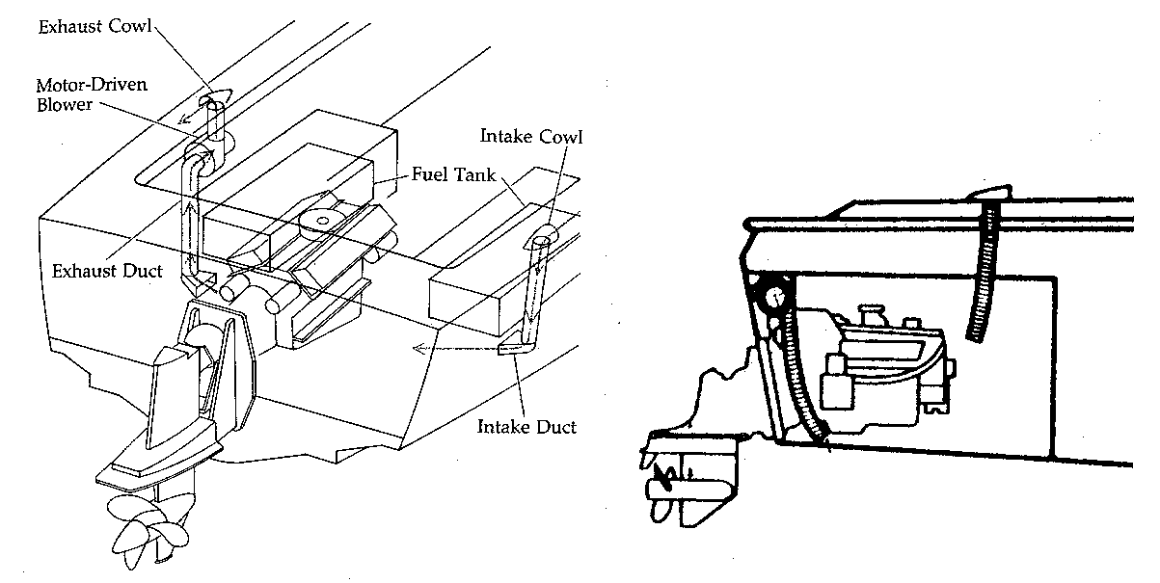REQUIREMENTS FOR GASOLINE POWERED VESSELS
    - Natural Ventilation (when required)

Every Public Vessel which uses gasoline engines, for electrical power generation or propulsion (i.e. inboard, outboard, I/O) must provide a natural ventilation system to service each compartment, not open to the atmosphere, that meets one or more of the following criteria:

- Compartments that contain a permanently installed gasoline engine.
- Each compartment that has openings between it and a compartment that requires ventilation, where the aggregate area of those openings exceeds 2 percent of the area between the compartments. (Exception: An accommodation compartment above a compartment requiring ventilation that is separated from the compartment requiring ventilation by a deck or other structure).
- Each compartment that contains a permanently installed fuel tank and an electrical component that is not ignition protected.
- Each compartment that contains a fuel tank which vents into that compartment, such as a portable gas tank used with most outboards.
- Contains a non-metallic fuel tank. Many portable gas tanks used with outboards are now made of plastic.

    - Power Ventilation(when required)

Every gasoline powered Public Vessel, regardless of the year in which it was built, must have a power ventilation system to service each compartment that contains a permanently installed engine (i.e. inboard, inboard/outdrive, generator). An engine located in a compartment that is open to the atmosphere is exempt from this requirement. Personal watercraft (i.e. Jet-Ski, Sea-Doo, etc.) are exempt from the federal manufacturing standard requiring a blower.

A power ventilation system consists of an electric exhaust blower or blowers and a duct system. Each blower must be ignition protected and mounted in an exhaust duct such that it does not interfere with the free flow of air through the duct when the blower is not operating. The blower shall be mounted above the normal level of accumulated bilge water, preferably next to the exhaust cowl. The blades of the blower shall be non-sparking in relation to their housing. Additionally, the blower must have an air flow rate and capacity such that it will accomplish a complete change of air in the protected in the four-minute time frame. Blowers shall be installed with ducts whose intake openings are:

a) Permanently fixed;
b) Located in the lower one-third of the compartment;
c) Above the normal level of accumulated bilge water; and
d) As nearly as practicable below the engine (s) which it serves.

The power exhaust ventilation blower switch shall be located at the helm position and must be independent of the ignition switch! A conspicuous placard shall be mounted adjacent to this switch, which shall contain the following legend:
WARNING
Gasoline vapors can explode

Before starting the engine:
Check engine compartment for gasoline or vapors.
Operate the blower for at least four minutes.
Run the blower below cruising speed.
  - OPERATION

The use of gasoline in the engines of equipment we routinely use such as automobiles, trucks, tractors, and lawn mowers, has led many of us to take for granted some of the hazards associated with its use. Overlooking the dangers of gasoline on a boat can be a fatal oversight. Unlike an automobile, a boat's engine is completely enclosed in a space that is not open to the atmosphere on the bottom. On a boat, gasoline vapors settle at the bottom of the compartment and spread along the bilge area. This creates a dangerous mix of gasoline and air that needs only a spark to create a catastrophe. Additionally, gasoline vapors are hazardous to personnel breathing them for a prolonged period. This is why it is vitally important to have a properly installed and functioning ventilation system. Most importantly you must use it each time you start your engine. The following steps must be taken prior to starting your engine:

- Open the engine compartment and check for gasoline vapors. Your nose can easily detect the strong sharp smell of gasoline. Gas detectors are available which can detect vapors in small concentrations and give an alarm but they are expensive and are not as reliable as your nose.
- If you smell gasoline, check the engine fuel lines connections and filters for leaks. Also check the bilge for gasoline. It will produce a rainbow colored sheen when floating on water. If the bilges are clear and no leaks are found proceed to step d.
- If raw gasoline is present in the bilges from a fuel system failure or spillage, ventilating the compartment will actually increase the danger of an explosion. The presence of liquid fuel generally creates a vapor mixture that is too rich (not enough air) to burn. Supplying air to the compartment by ventilation could bring the vapor within its explosive range. If gasoline is found in the bilges take the following actions:

1) Locate the source of the fuel; it had to come from somewhere;
2) Correct the problem;
3) Wipe up all gasoline from the engine and bilges. (Dispose of waste properly).
4) Ventilate the engine compartment thoroughly, and all connecting spaces

d) Operate the power blower for at least four minutes then start the engine.

NOTE: Outboards are not immune to explosions or fires resulting from gasoline or gasoline vapors in the bilge! Take the same precautions on outboards with enclosed spaces as you would on inboards.

  - MAINTENANCE

As with any system, maintenance of your vessels ventilation system is essential to its continued effective operation. Ventilation systems are relatively simple and maintaining them is primarily a matter of making frequent visual inspection. This should include:

- Check intake and exhaust cowls for clogging by debris such as insect or bird nests, leaves, etc;
- Check intake and exhaust ducts to ensure that they are properly supported free of damage and kinks and are not full of water in flat or sagging sections. Ensure the ends are above normal bilge level. Mice, squirrels, and other small animals find these to be ideal nest locations
- Check blower to be sure it operates when the switch is turned on.
- Each time, while operating the blower for four minutes prior to starting the engine, place your hand over the exhaust cowl. You should feel a strong rush of air exiting the cowl. If not, something is wrong and a closer inspection should be made.
- If any problems are detected, correct them immediately.

- FUEL SYSTEMS

Most power driven vessels utilize either gasoline or diesel engines. The use of these engines brings about the need to store large quantities of fuel on board the vessel and to provide a means of moving the fuel from where it is stored to the engine. This is accomplished by the vessel's fuel system. While fuel system design and installation varies with manufacturers and specific models, most reputable manufacturers comply with the Federal Regulations of the U.S. Coast Guard and the voluntary standards established by the American Boat and Yacht Council, the National Fire Protection Association, and Underwriters Laboratories. The purpose of this chapter is to give the Public Vessel owner/operator a basic knowledge of fuel system operation and safety features, as well as providing background on the inspection criteria for fuel systems.

  - DEFINITIONS

Fuel System - System designed to store fuel and distribute it to the engine(s) which it serves, including the fuel tank, fill, vent, distribution lines, pumps, valves, strainers, filters, and carburetors.

Permanently Installed - Securely fastened so that tools such as wrenches and screwdrivers must be used for removal.

Portable Fuel Systems - Tanks, fuel lines, and related accessories that are not intended for permanent installation but are used to supply fuel to an engine.

Portable Fuel Tanks - Tanks of not more than seven (7) gallons rated capacity design to store and supply fuel to an engine via flexible fuel lines and connection fittings.

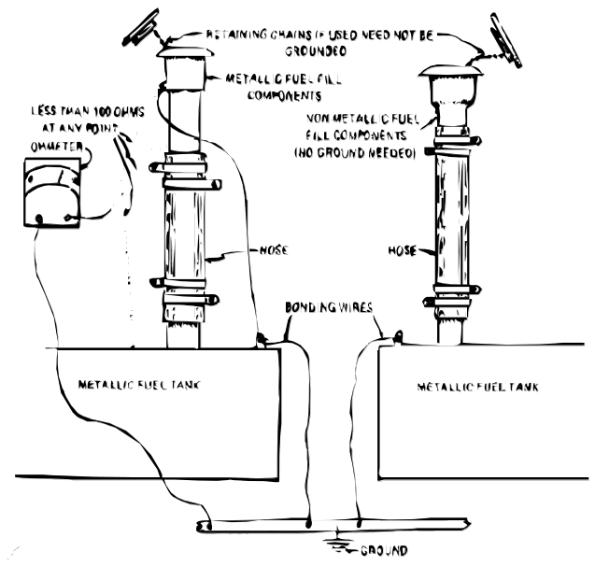
Accessible - Capable of being reached for inspection, removal, or maintenance without removal of permanent boat structure.

  - FUEL TANK FITTINGS AND CONNECTIONS

    - Fuel Fill

The fuel fill system and associated deck fitting provide the means to fill the fuel tank. The minimum inside diameter of the fill pipe must be 1 1/4 inch or if hose is used, a minimum of 1 1/2 inch. It must be large enough to prevent the blow back of fuel through the fill fitting when fueling at normal rates and the tank is 1/4 to 3/4 full. The fuel fill line shall run as directly as possible from the deck opening to the top of the fuel tank with as few bends as possible. A short straight section is ideal. The fuel fill deck opening must be located a minimum of 15 inches from any ventilation opening and positioned such that no fuel can enter the vessel if an overflow occurs while fueling. All connections in the fuel fill line must be liquid and vapor tight. If hose is used for the fuel fill it must be fire resistant, USCG Type A hose unless it is self-draining and not located in the engine compartment. The deck plate at the opening must have a permanent marking to indicate the type of fuel.

    - Grounding/Bonding

A metal fuel tank and any metallic part of the fuel fill system that comes into contact with the fuel must be bonded to the vessels grounding system (usually the negative battery terminal). When flexible hose is used anywhere in the fill system a grounding wire must connect metal fittings that the hose separates. These wires must not be clamped between the hose and the fitting because this will allow leakage. The reason for grounding the vessel's fuel fill system is so that the static electricity generated by flowing fuel will be dissipated and not cause a spark which could result in an explosion. This is also why the nozzle of the fuel pump must be kept in contact with the fill opening when fueling.

    - 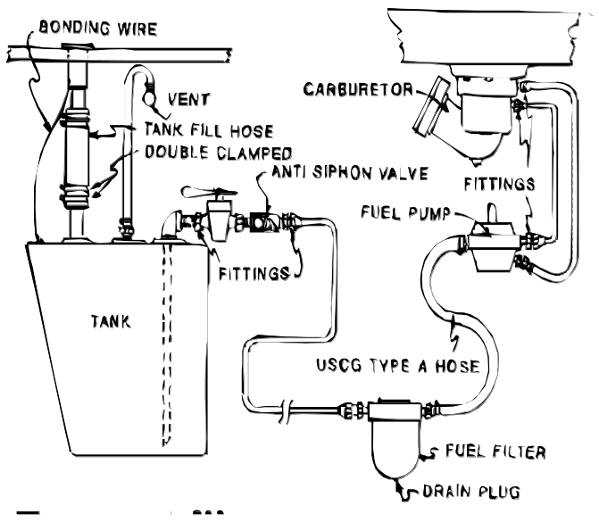Vent Lines

Every installed fuel tank must be fitted with a vent line to allow the escape of fuel vapors when filling the tank and to prevent a vacuum from forming in the tank as the fuel is used. It must be completely independent of the fuel fill pipe or line. The vent line must have a minimum inside diameter of 7/16 inches (9/16 for flexible hose) and must be connected to the highest point of the fuel tank (under normal trim conditions). If a non-metallic material is used for the vent line it must be fire resistant hose marked as "USCG Type A Hose" unless it is self draining and located entirely outside the engine compartment. The hull termination fitting for the vent line must be located as far as practicable from any hull opening to prevent fuel vapors from reentering the vessel and to prevent fuel overflowing at a rate of 2 gal/min or less from entering the vessel. It must be capable of minimizing the intake of water under normal operating conditions without restricting the continuous release of vapor from the fuel tank. The opening itself must be fitted with corrosion resistant, cleanable flame screens. The flame screen must be designed so that a spark or flame near the vent opening will not ignite vapors in the line allowing flames to reach the fuel tank and cause an explosion. It must be emphasized the vent line is not intended to be a fuel overflow. The practice of using it as such is a poor one that is both dangerous and a violation of the oil pollution laws.

  - FUELING PROCEDURES

Improper fueling practices cause a large number of all boat fires and explosions. Below are listed some of the basic safety rules to follow when fueling.

a) Fueling should be completed before dark except in emergencies.
b) Whenever moored at a fueling dock:
1) Do not smoke, strike matches, or operate electrical switches;
2) Stop all engines, motors, fans, and electrical devices;
3) Put out all lights and galley fires.
c) Before starting to fuel:
1) See that the boat is securely tied to the dock and that no passengers are aboard;
2) Close al ports, windows, doors and hatches;
3) Check condition of fuel tank vents, connections and flame screens;
4) Ascertain the amount of additional fuel the tank will hold;
5) Remove portable fuel tanks and fill on the dock.
d) During fueling:
1) Keep nozzle of hose or spout in contact with fuel fill opening (including portable tanks)
2) See that no fuel spills enter the bilge or interior of the boat
e) After fueling:
1) Close fill opening
2) Wipe up spilled fuel
3) Open all ports, windows, door and hatches
4) Ventilate the boat for at least 4 minutes using the blower, if equipped
5) Sniff for fuel odors in the bilges or below deck spaces

- FIRE AND FIREFIGHTING

  - DEFINITIONS

Flash Point - Temperature at which a liquid fuel gives off sufficient vapor to form an ignitable mixture near its surface. When ignited the flame will flash across the surface and go out.

Fire Point - Temperature at which a liquid fuel will sustain combustion once ignited.

Ignition Temperature - Lowest temperature at which a fuel will burn without the application of a spark or flame. May sometimes be referred to as the auto ignition temperature.

Spontaneous Combustion or Ignition - A fire that occurs without a flame, spark, hot surface or other outside source of ignition.

Explosive Range (Flammable Range) - A range defined by the mixture of air and flammable gas or vapor of liquids that must be present in the proper proportions for the mixture to be ignited. The range has upper and lower limits.

Lower Explosive Limit - The minimum concentration of fuel vapor in air by volume that will ignite. A mixture below this concentration is said to be too lean.

Upper Explosive Limit - The maximum concentration of fuel vapor in air by volume that will ignite. A mixture above this concentration is said to be too rich.

Combustible Liquid - Any liquid having a flash point above 80 degrees Fahrenheit.

Flammable Liquid - Any liquid having a flash point at or below 80 degrees Fahrenheit.

Fire - A chemical reaction known as rapid oxidation that produces heat and light in the form of flame along with gaseous vapors and smoke.

  - NATURE AND CHEMISTRY OF FIRE
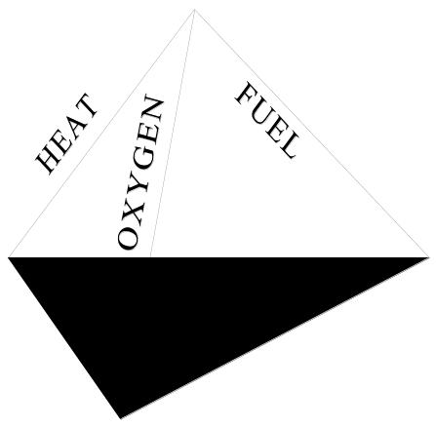

    - The Fire Tetrahedron

As defined above, fire is a chemical reaction. Fire may also be referred to as combustion. Controlled combustion can be very useful. It is used in stoves to cook food and in furnaces to heat homes. It is also the process by which engines operate. When a fire is not controlled it can be destructive and deadly.

In order for a fire to occur, all four of the following elements must be present:
a) Fuel (any combustible or flammable material)
b) Oxygen (21% of the atmosphere)
c) Heat (initially from an ignition source)
d) Chemical Chain Reaction (reaction generates enough heat to become self sustaining)

A four sided pyramid shape called the fire tetrahedron graphically represents this method of explaining fire. Its base represents the chemical chain reaction that sustains combustion. The three sides represent the three other elements necessary for combustion to take place. Fire cannot exist or start if one of these four is missing. Once started, a fire will grow in size and intensity at an increasing rate as long as all four elements are available. In order to extinguish a fire one or more of the elements represented by the tetrahedron's sides must be removed.

    - Classification of Fires

Fire is classified into four types according to the fuel source or combustible material involved. Only three of the four classes of fire are likely to be encountered on board public vessels. Fire classes are designated by a letter and are as follows:
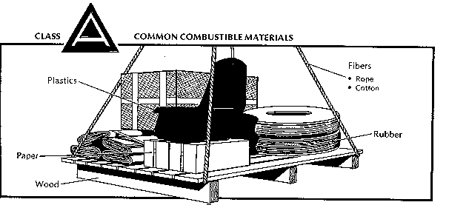

Class A
Class A fires are fires that involve wood, paper, cloth, plastics and rubber.

Class B
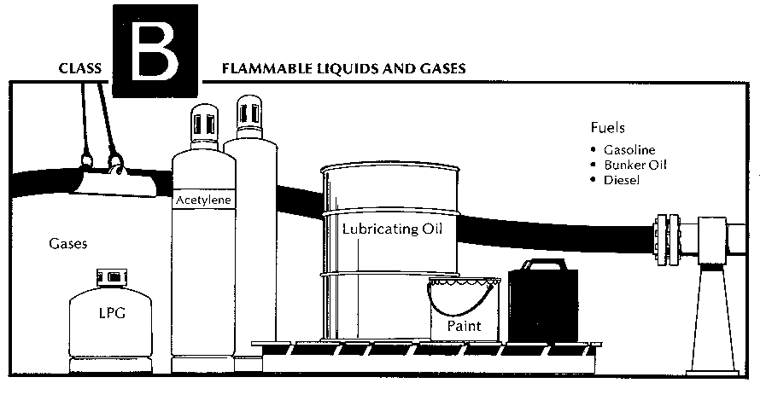
Class B fires are fires that involve gasoline, diesel fuel, oils, fats, paint, or other flammable liquids. This is the most common type of boat fire.
Class C
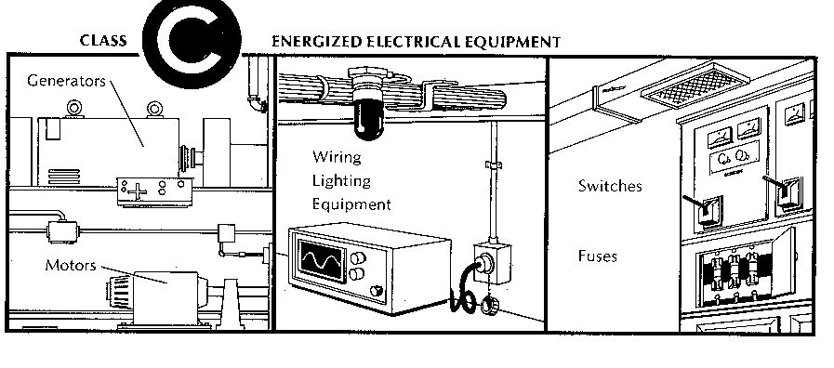
Class C fires are fires that involve energized electrical equipment, conductors, or appliances.

  - FIRE PREVENTION

The federal government, through the U.S. Coast Guard, has enacted several regulations that govern the construction of recreational and commercial vessels. Most of these regulations were specifically designed to prevent fires and explosions aboard boats. They cover the installation of fuel systems, electrical systems, ventilation of engine and fuel tank compartments, back fire flame arresters on gasoline engines and the installation of ignition protected electrical components. The net result is that most vessels are relatively safe when they leave the factory. It is the responsibility of public vessel owners and operators to ensure their vessel remains safe to carry passengers. The best way to keep a vessel safe from the dangers of an onboard fire is to prevent a fire from occurring in the first place. Preventing fires is not really that difficult. It only requires awareness of the causes of fire, attentiveness to recognize the hazards and action to eliminate them.

    - Smoking

Careless smoking and the careless disposal of lit cigarettes, cigars, pipe tobacco and matches can pose a significant threat to the safety of passengers and crews of public vessels. The number of people who smoke has declined significantly in recent years but there are still many people who can't resist the urge to "light up". They often do so without regard to the circumstances or hazards that may exist. A small fire created by careless smoking can erupt into a much larger fire if it is not detected and extinguished before it can ignite additional flammable materials nearby.

If smoking is permitted aboard a public vessel, adequate safeguards must be in place to ensure it does not present a hazard. These should include:

Proper disposal of smoking materials: Glowing ashes and tobacco contain enough heat to start a fire in paper, cardboard, plastics and other materials commonly found in trash receptacles. Therefore, matches, ashes and cigarette butts must be disposed of in noncombustible containers. An adequate number of ashtrays should be placed on the vessel in any location where smoking is permitted and their use must be enforced. Before being emptied, ashtrays should be check to ensure that they do not contain any glowing embers. Soaking the contents with water prior to disposal can ensure this.
Pay extra attention if people are drinking: The law does not prohibit passengers on public vessels from drinking alcoholic beverages. A person who drinks can become careless. If that person is also smoking, he or she can be dangerous. Pay extra attention to anyone who smokes and drinks to ensure they do not endanger the vessel with careless smoking.
No smoking areas: Smoking must be prohibited in the vicinity of an open engine compartment, fuel compartments, fuel fill openings and vents, and any other location where flammable materials are stored. When fueling the vessel smoking is not permitted on board or in the vicinity of the fuel dock.

    - Spontaneous Ignition

Spontaneous ignition is phenomenon with which most people are unfamiliar. Many common materials, under the right conditions may cause a fire without an ignition source. An example of spontaneous ignition that could occur aboard a vessel might be a rag that has been used to wipe up oil or oil based paint that has been discarded in the corner of a work area, engine space, or storage area where it is warm and there is little ventilation. The oil on the rag will begin to oxidize or chemically react with the surrounding air. Oxidation is a natural process that produces heat. The heat causes the remaining oil to oxidize faster which in turn produces more heat. If there is no ventilation to dissipate the heat it will increase around the rag. Eventually, the rag may become hot enough to burst into flames and ignite any flammable materials nearby. Good housekeeping and proper disposal of materials subject to this phenomenon is the best way to prevent a fire from occurring.

    - Electrical Hazards

Electricity is a safe and convenient source of power for essential equipment and many conveniences aboard a vessel. As a vessel ages, worn, misused, or poorly wired electrical components may create a fire hazard in the form of heat or a spark. To avoid this hazard, the following practices should be observed:

Only use electrical components designed for the marine environment: If any new electrical components are installed or existing ones replaced, be sure they are designed for use aboard boats. Electrical components that are installed in engine or fuel tank compartments must be ignition protected. They are designed so that if they spark or fail any flammable or explosive vapors in the surrounding compartment will not be ignited. Ignition protected components include starters, alternators, switches, breakers, and bilge pumps.

Don't "jury-rig" or overload electrical circuits: Poor or loose electrical connections can cause overheating and sparking which could ignite the wire insulation or nearby flammable materials. Newly installed equipment must be properly wired and connected in accordance with accepted standards. Multiple appliances or equipment should not share a single outlet or circuit through the use of power strips and similar devices. This will overload a circuit that could generate enough heat to cause a fire.

Check electrical wiring and equipment often for signs of wear or damage: Electrical wiring and equipment installed on boats is subject to moisture, vibration and heat. Over time these will cause corrosion of exposed metal connections or components; brittleness, chafing and cracking of electrical insulation; and loosening of connections.

Cover exposed light bulbs: A lighted electric bulb can ignite combustible material that comes into direct contact with it. A light bulb that is accidentally broken while energized will create a spark that could ignite any flammable vapors present. For this reason, all light bulbs on public vessels must have a cover to prevent material from contacting the bulb. In spaces where flammable vapors may be present, a glass globe and metal cage is required to prevent breakage of the bulb.
Ensure adequate ventilation when charging batteries: Storage batteries produce hydrogen gas when being charged. Hydrogen is an extremely flammable gas. Ensure there is adequate ventilation when batteries are being charged. This is especially important if batteries are charged on a charger or shore power when the boat is idle for an extended period.

    - Flammable Liquid Hazards

Fires involving fuel or oil (Class B) are the most common aboard boats. The greatest danger from fuels, especially gasoline, is an explosion. The vapors from only one ounce of gasoline can create an explosion equivalent to fifteen sticks of dynamite. Fires involving flammable liquids can spread very quickly if the fuel source is not contained. The following measures should be taken to prevent these fires from occurring:

Observe proper fueling practices: The potential for fire or explosion aboard a boat is greatest when taking on fuel. Observing the procedures listed in the fuel systems section of this guide will significantly reduce this risk.

Properly maintain equipment: Poorly maintained engines or generators that leak fuel or oil greatly increase the risk of fire or explosion. A fuel leak from a fuel line under pressure will create an atomized spray that readily mixes with air. All that is needed to ignite it is a hot surface (exhaust pipe) or spark (electric motor or switch). A backfire flame arrester that is dirty or damaged may not function properly and permit flammable vapors in the engine space to ignite.

Use proper ventilation procedures before starting gasoline engines: Always run the exhaust blower for at least four minutes prior to starting the engine. Before operating the blower, check for fuel leaks or fuel in the bilge. Under normal conditions operating the blower will dilute any vapors present and lower the air/fuel ratio below the lower explosive limit. When liquid fuel is present it is very likely that the air/fuel mixture in the space is above the upper explosive limit for gasoline. If the blower is operated under these conditions the additional air may bring the mixture into the explosive range.

Use good housekeeping practices: Keep bilges clean and free of oil. Wipe up fuel or oil spills immediately. Do not store excessive amounts of flammable liquids on board.

  - FIGHTING A FIRE

If a fire occurs aboard a public vessel it must be attacked quickly, aggressively, and effectively. If not, it will spread rapidly and get out of control, endangering everyone on board. While speed is critical to gaining control of a fire, it does no good if the fire is attacked with the wrong agent or using poor techniques. This section will provide a basic understanding of the tools and techniques needed to effectively extinguish a fire.

    - Fire Extinguishing Agents

An extinguishing agent is a substance that will put out a fire. Every extinguishing agent operates by attacking one or more sides of the fire tetrahedron. The specific actions involved are the following:

Cooling: Reduces the temperature of the fuel below its ignition temperature. This is a direct attack on the heat side of the fire tetrahedron.
Smothering: Separates the fuel from the oxygen. This can be considered as an attack on the edge of the fire tetrahedron where the fuel and oxygen sides meet.
Oxygen dilution: Reduces the amount of available oxygen below that needed to sustain combustion. This is an attack on the oxygen side of the tetrahedron.
Chain breaking: Disrupts the chemical process that sustains the fire. This attacks the chemical chain reaction base of the fire tetrahedron.

      - Water
Water extinguishes a fire by cooling. It soaks and cools the burning material and is more effective than any other extinguishing agent at absorbing the heat produced by the fire. If the water used on a fire absorbs enough heat it will turn to steam. This process absorbs an even larger amount of heat. In addition, when water converts to steam its volume increases nearly 1700 times. This large volume of steam blankets the fire and displaces the air that provides oxygen to the fire causing a secondary smothering effect.

Obviously, the supply of water available to fight a fire on a vessel is unlimited. Getting the water to the fire is another matter. For a small class A fire a bucket of water thrown at the fire may be effective. Boats equipped with a fire pump or water washdown pump can use a hose to deliver water to the fire.
Water is the best means of extinguishing a class A fire. A hose with a nozzle that can produce both a spray and a straight stream of water is ideal. The fire can be approached using the spray on the flames. This provides a greater cooling effect than a straight stream because the fine droplets quickly absorb heat and turn to steam. Once the flames have been knocked down, the straight stream can be used to break up the burning material and cool the embers.

A water spray can also be effective against class B fires. The spray will rapidly cool the fire as it turns to steam. The steam will provide the added smothering effect to extinguish the fire. A straight stream of water should NEVER be used on a class B fire. It will cause the burning liquid splatter and spread.

Water must never be used on a class C fire. Water is an excellent conductor of electricity and using it on energized electrical circuits will provide a direct path for the electricity to follow from the source to the person fighting the fire. The resulting electrical shock could be fatal.

      - Carbon Dioxide (CO2)
Carbon dioxide extinguishes fire by smothering it. It is a colorless, odorless, non-corrosive, and non-conductive inert gas that does not support combustion. When stored in a cylinder under pressure it becomes a liquid that reverts to gaseous form when released. It does not leave a residue that might damage machinery or electrical apparatus. Carbon dioxide is about 1.5 times heavier than air. It blankets the fire and dilutes the surrounding air until the oxygen content is too low to support combustion. Although this property makes CO2 an effective extinguishing agent, it can create a suffocation hazard to personnel if used in a confined area.

Carbon dioxide is effective on class B fires because of it's ability to form a gaseous layer above the fuel source thereby separating the flammable vapors from the oxygen in the air. It is also an excellent choice for extinguishing class C fires because it is not conductive and does not leave a residue that may damage electrical equipment. CO2 may be used to initially extinguish a class A fire but should be followed up by soaking the burning material with water to cool any "hot spots" which could cause it to re-ignite.

Carbon dioxide is most effective when discharged into a confined space where it can’t be easily dissipated by air movement or from spreading out over a large area. It works very well in fixed extinguishing systems used in enclosed engine spaces because it can flood the compartment and completely displace the oxygen. When fighting a fire topside, or other open area, the vessel should be maneuvered to minimize the wind. The fire should be approached from upwind so that the CO2 drifts over the fire. Once the fire is out personnel must be prepared for a re-flash if the CO2 dissipates before the burning material cools below its ignition temperature. Despite the frost that may appear when discharging CO2, it has very limited cooling ability.

      - Dry Chemical
Dry chemical agents extinguish a fire by interrupting the chemical chain reaction. These extinguishers contain an alkaline base powdered chemical agents combined with other chemicals that allow them to flow freely when discharged. When discharged, the chemicals form a dense powder fog that quickly covers the burning material. Dry chemical agents leave a residue which, when combined with the abundant moisture in the marine environment, may have a corrosive effect on machinery or electrical equipment. They are considered non-toxic but a dense cloud of the agents may cause breathing difficulties. The agents may also be irritating to the moist tissues of the lungs, mouth, nose and eyes.

Dry chemical agents are very effective on class B and C fires. They are the best choice for class B fires because they settle on the surface of the burning liquid and are not easily dissipated like carbon dioxide. Their use on class C fires is less desirable than CO2 because of the corrosive and insulating effect on the equipment.

One type of dry chemical, monoammonium phosphate, is referred to as a multipurpose or ABC extinguishing agent. As the name implies it is effective on class A, B and C fires. This capability will be clearly indicated on the extinguisher's label. When using this agent on a large or deep-seated class A fire it is best to follow up with water to ensure re-ignition does not occur. Other properties of this chemical are the same as those indicated for other dry chemical agents.

      - Liquid Chemical Extinguishing Agents
The best known of these are halogenated or Halon agents. Halon extinguishers contain a liquid agent, pressurized with nitrogen that discharges as a vapor at high velocity. Halon quickly blankets the fire and extinguishes the fire by interrupting or breaking the chemical chain reaction. It is capable of penetrating difficult to see and hard to reach areas. It leaves no residue after discharge and won’t damage electrical equipment. Pound for pound Halon is two to three times more effective than carbon dioxide. It has been used in both portable extinguishers and fixed systems. Two types of this agent have been used effectively in the marine environment, Halon 1211 and 1301. Halon 1211 is found primarily in portable fire extinguishers. Halon 1301 proved to be the best agent for fixed extinguishing systems. Unfortunately, halogenated agents are part of a class of chemicals identified to be detrimental to the Earth’s ozone layer and are no longer manufactured. Systems using these agents may no longer be manufactured or sold but existing systems may still be used.

Replacement agents have been developed in recent years. These new products are referred to as "Clean Agents." The are designed to be non-conductive and do not leave any residue to clean up. Clean Agents fall into two categories, halocarbons and inert agents. Both types of agents are designed for use in portable extinguishers and fixed extinguishing systems. In terms of effectiveness compared to other agents (volume for volume), clean agents are generally more effective than carbon dioxide but not quite effective as Halon. In other words, you will need a larger volume of clean agents than Halon to protect the same size space in fixed extinguishing systems.

Halocarbons are chemical compounds that use as the primary component an organic compound with fluorine, chlorine, bromine, or iodine. They are marketed with brand name such as FM 200, FE241 and Halotron. These agents primarily extinguish a fire by cooling it at the molecular level. There is also a secondary affect on the chemical chain reaction.

An inert gas agent is one that contains as primary components one or more of the gases helium, neon, argon, or nitrogen. Inert gas agents extinguish a fire by creating an inert atmosphere and reducing the oxygen level in the space below the level necessary to sustain combustion. In this regard, they are similar to carbon dioxide and pose the same asphyxiation hazard in confined spaces.

The properties of liquid extinguishing agents vary but most are design to be very effective against Class B and C fires. Some may also be effective on Class-A fires but, like dry chemical agents, should be followed up with water. Before using any liquid extinguishing agent aboard a Public Vessel check the label. Make sure it is Coast Guard or Underwriters Laboratories approved for marine use. Read the directions for use and any hazards it may present.

  - PORTABLE FIRE EXTINGUISHERS

On most Public Vessels, portable fire extinguishers will be the first line of defense against a fire on board. If the vessel is not equipped with a fire hose they may be the only defense. It is critical that the operating personnel aboard every Public Vessel possess a thorough knowledge of portable fire extinguishers and their use. This knowledge could be the crucial factor in preventing injury, death and loss of the vessel.

    - Classification of Portable Extinguishers
A portable fire extinguisher is classified in two ways. By the type of fire(s) it will extinguish and by its relative size or effectiveness at fighting a fire. The classification is indicated on the extinguisher label by a letter and numeral designation. The letter corresponds to the classes of fires A, B, or C. All extinguishers approved for marine use must be capable of extinguishing a class B fire. The numerals indicate the relative size or ability of the extinguisher to put out that class of fire. The U. S. Coast Guard uses Roman numerals to make this designation. There are two classes that are considered hand portable for marine use, B-I and B-II. The National Fire Protection Association (NFPA) uses Arabic numerals for this purpose (i.e. 10B:C). The labels on most extinguishers will carry both designations. In both cases, the larger the number, the more extinguishing agent it contains and the more effective it is.

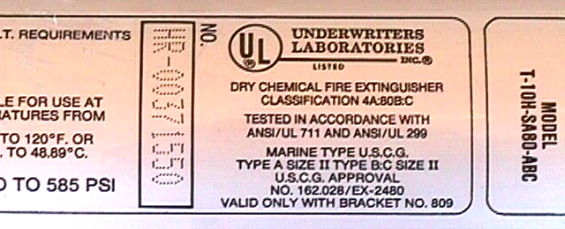
    - Carriage Requirements

Any fire extinguisher used on a public vessel must be U.S. Coast Guard approved for marine use. It must be secured in position with a quick release type bracket designed for use with the model extinguisher used. It must be located so that it is easily accessible to the operator and, if possible, out of the reach of children. The operator should check frequently to ensure fire extinguishers are in their proper storage brackets and free of damage and corrosion. Damaged or dry-rotted hoses should be replaced. Nozzles should be kept free of obstructions. Extinguishers with pressure gauges should read within the "charged" area (usually green). Locking pins and sealing wires should be checked to assure that the extinguisher has not been used or tampered with since it was last recharged. While the vessel owner may do many of the inspections required for fire extinguishers, it is strongly urged that personnel qualified in such areas (i.e. local fire co.) perform them. The table below lists the minimum number of fire extinguishers that must be carried by a Public Vessel based on its length.

Length of Vessel | Number of Portable Extinguishers Required
Boats under 26 feet | One B-I
Boats 26 feet to less than 40 feet | Two B-I or One B-II
Boats 40 feet and longer | As directed by the inspector but minimum of three B-I
Notes:
1. At least one extinguisher must be located near the operator's station.
2. Any vessel with other than outboard propulsion that is exempted from installing a fixed extinguishing system must carry one additional B-I extinguisher.

    - Using Portable Fire Extinguishers

A fully charged and well-maintained portable extinguisher is of little use if the operator or crew of the vessel do not know how to use it properly. For starters, all operating personnel should know the location and type of every portable extinguisher on board. They should read the label on each one and be familiar with its operation.

The effective range and duration (continuous burst) of a portable fire extinguisher depends on the agent used and the size of the extinguisher. The table below indicates the range of various types and classifications of portable fire extinguishers.

Agent | Size | Range (feet) | Duration(seconds)
Carbon Dioxide | B-I | 3 to 8 | 8 to 30
 | B-II | 3 to 8 | 8 to 30
Regular Dry Chemical  (Sodium Bicarbonate) | B-I | 5 to 8 | 8 to 12
 | B-II | 5 to 20 | 8 to 25
Multipurpose (ABC)  Dry Chemical | B-I | 5 to 12 | 8 to 15
 | B-II | 5 to 20 | 10 to 25
Halon 1211 | B-I | 6 to 10 | 8 to 10
 | B-II | 14 to 16 | 10 to 18
Halocarbon | B-I | 6 to 15 | 9
 | B-II | 9 to 18 | 9 to 14

The basic technique used for fighting a fire with a portable extinguisher, however, is the same regardless of the type or size used. To remember the steps use the acronym "PASS".

Some general precautions when using portable fire extinguishers are listed below:

1. Make sure someone else knows about the fire.
2. Never pass by the fire to get to an extinguisher.
3. Never let the fire get between you and your escape route.
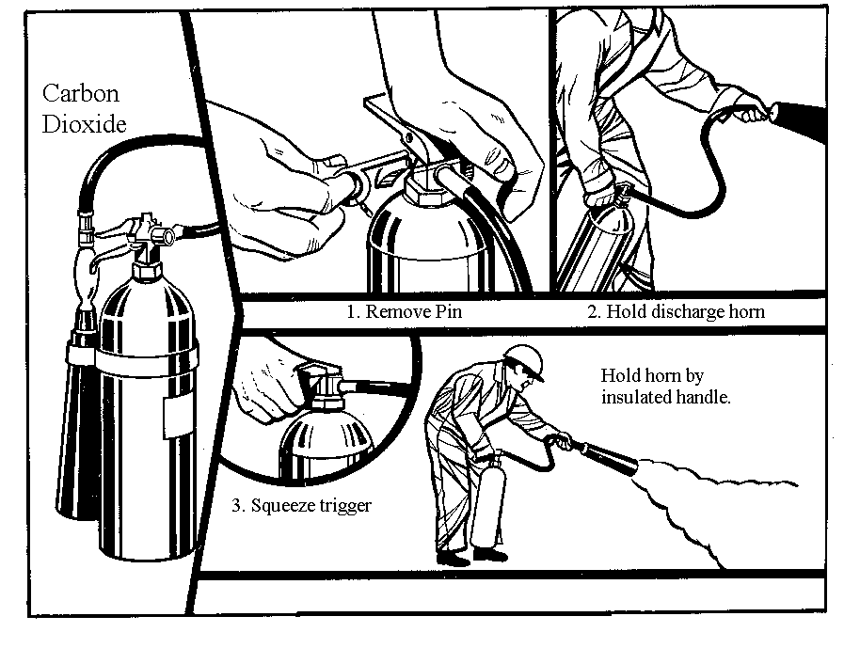
4. De-energize electrical circuits before fighting a class C fire, if possible.
5. Secure the fuel source to a class B fire before attempting to fight it.
6. Follow up all class A fires with water.
7. If topside, approach the fire from upwind for your safety and to ensure the extinguishing agent is not blown away from the fire.
Pull the pin after breaking the tamper resistant seal
Aim the nozzle at the base of the fire
Squeeze the discharge lever or trigger using short bursts
Sweep the nozzle from side to side across the flames while moving toward the fire
8. When using a CO2 extinguisher always hold the nozzle by the insulated handle to avoid frostbite.
9. If your attempt to fight the fire fails, get away from it immediately. Attempt to contain it by closing doors or accesses and re-assess your options.

  - FIXED FIRE EXTINGUISHING SYSTEMS

Fixed fire extinguishing systems are total flooding systems that use either carbon dioxide or liquid chemical extinguishing agents. The use of Halon 1301 was very prevalent in these systems until its negative affect on the ozone layer was discovered. Newer systems predominantly use one of the clean agents discussed previously. Fixed systems, as the name implies, are permanently installed in compartments where fire is most likely to occur (i.e. engine spaces). These systems are ideal for quickly and effectively extinguishing class B fires in enclosed spaces. They are more efficient and much safer than trying to extinguish this type of fire with a hand held extinguisher.

Fixed systems are required on all public vessels with enclosed engine spaces unless specifically exempted in writing on the Certificate of Inspection. The components and installation of a fixed system is dependent upon the extinguishing agent used. The volume of the space to be protected and the relative effectiveness of the agent used determine the size of the system (amount of agent). Operation of the system may be either manual or automatic. If manually activated, the actuating device must be located outside the protected space near the operator. All fixed extinguishing systems used aboard Public Vessels must be U.S. Coast Guard approved.
When a fixed extinguishing system is activated, it is important to ensure that no one is within the protected area. To ensure maximum effectiveness, its is also important to secure all hatches and openings to the affected space to prevent the extinguishing agent from escaping and to keep a fresh supply of air from entering the space. Once the extinguishing agent has been discharged the space should remain closed off for at least 15 - 30 minutes after the fire is out to allow the space to cool. Opening the hatch too soon could cause the fire to re-ignite.

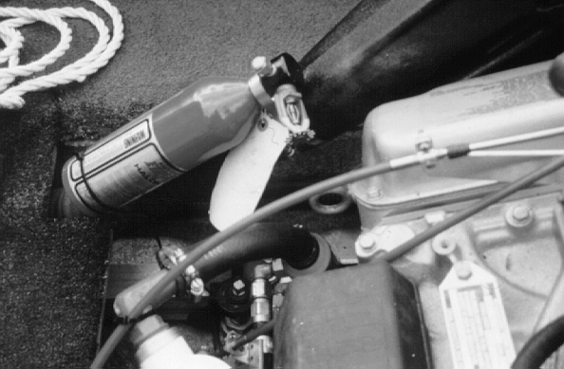
Fixed extinguishing system components should be inspected periodically to ensure that cylinders are free of corrosion, that discharge nozzles are free of obstructions, and that the system is generally in good working order. In addition the cylinders or containers holding the extinguishing agent should be removed and taken to qualified personnel to be inspected, weighed, and if necessary recharged. A tag should be attached to the cylinder indicating the date and name of the person performing this inspection. This should be done once every three years.

- AUXILIARY SYSTEMS

The intent of these requirements is not to provide a detailed maintenance schedule for the Public Vessel owner since this should be done in accordance with the service or maintenance manual for each piece of equipment, but to set forth the minimum standards necessary to ensure the safety of the vessel and its passengers.
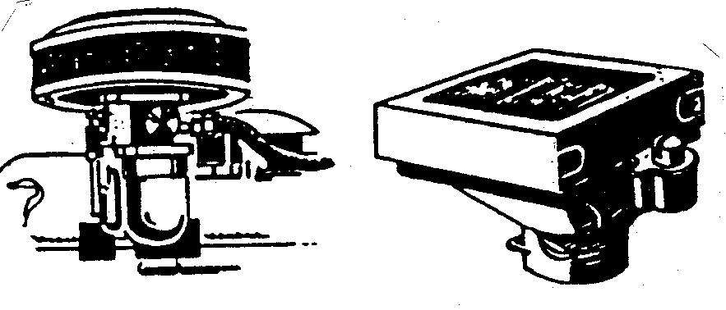
  - BACKFIRE FLAME ARRESTOR (gasoline engines only)

The backfire flame arrestor is designed to prevent the hot flames of a backfire from leaving the engine and reaching the surrounding engine compartment where it could ignite any explosive vapors that may be present. It accomplishes this through the use of wire or metal mesh which is designed to absorb the heat from the flames thus rendering them harmless. The flame arrestor is mounted on top of the carburetor intake and bears some resemblance to an air filter. During normal engine operation the device allows air to flow freely into the carburetor. It does provide some filtering effect but this is not its function.

All gasoline powered engines except outboards must be equipped with a U.S. Coast Guard approved backfire flame arrestor, a U.S. Coast Guard accepted fuel and air induction system, or be designed such that the flames from a backfire would be dispersed to the atmosphere outside the vessel's hull where it would not endanger the vessel or persons on board. Regardless of the means used, all connections must be flame tight and firmly secured to withstand the vibration and shock of the marine environment and the pressure of an engine backfire. Any materials with which flames may come in contact must be metallic.

In addition to checking for compliance with the above paragraph, the marine inspector will check to ensure the wire mesh or grid elements of the flame arrestor are not separated or damaged which would defeat its function. The flame arrestor should not be dirty or fouled with deposits. While this will not affect its ability to arrest flames it may badly degrade engine performance. It may be cleansed using soap or a degreaser with water; be careful not to use flammable solvents.
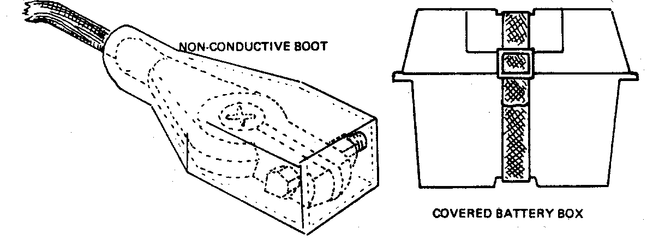
  - STORAGE BATTERY

The wet cell storage battery is a temporary reservoir in which electrical energy is stored as chemical energy and converted back to electrical energy as the battery is discharged to provide power to the engine cranking motor and vessel accessories when the engine is not operating. The battery is recharged when excess electrical current from a generator, alternator, battery charger, or other electrical source, flows to the battery in the opposite direction of the discharge current. The marine inspector will check for compliance with the following:

a. The battery(ies) must be installed in a location where it is easily accessible for maintenance or removal and above the normal level of bilge water accumulation.
b. The battery(ies) will be secured using a strap or other means such that it will not move more than one inch in any direction.
c. To prevent accidental contact of the ungrounded battery terminal to ground, each battery shall be protected so that metallic objects cannot come into contact with the ungrounded (positive) battery terminal. This may be accomplished by means such as:
(1) Covering the ungrounded battery terminal with a boot or nonconductive shield,
(2) Installing the battery in a covered battery box, or
(3) Installing the battery in a compartment specially designed only for the battery(ies).

  - BILGES

A vessel’s bilge, being the lowest point in the hull, probably receives a greater amount of abuse than any other part of the vessel. Everything that leaks or spills eventually finds its way into the bilge, and mixes with stagnant fuel and oil. Perhaps a few rusty nuts and bolts, and a hefty accumulation of dirt and dust. Fuel and oil in the bilges constitute both a fire and pollution hazard and may also be an indication of a problem in the engine, fuel, or lubrication systems. Dirt and debris in the bilges constitute an indirect flooding hazard in that they may clog the inlet of the bilge pump causing it to burn up or lose suction. The bottom line is that dirty bilges are hazardous, unacceptable, unnecessary. A dirty bilge indicates a lack of good engineering practices, and if bad enough, may be grounds for failing the inspection.

    - Bilge Cleaning

Bilges should be cleaned as often as necessary using bilge cleaning solution, soap, or detergent with water. If oil or fuel consistently shows up in your bilges you should isolate the source, correct it, and then clean the bilges. When bilge cleaning is completed, the washings or slops should be properly disposed of ashore as they will likely contain substances which may pollute the water. State and federal pollution laws allow severe penalties for the discharging of any substance containing oil, fuel, or other petroleum distillates into any waterway. Any discharge of oil or other substance which produces a slick or sheen on the water must be reported to the New York State Department of Environmental Conservation's Oil Spill Hotline at 1-800-457-7362,

    - Bilge Pumping System

All Public Vessels are required to have a bilge pump. The bilge pump(s) should be installed as described below and should service all bilge spaces. Bilge pump types and the requirements for their installation are listed below.

      - Manually Operated
A manually operated bilge pump is a portable pump that requires a person to physically operate the pump by hand or foot. It is required to be readily accessible and must have a capacity of at least five gallons per minute (5 gpm).

      - Power Operated (Small Capacity)
A power operated bilge pump is a permanently installed pump that may be driven by the main engine, an electric motor or other source of power. It must have a capacity of at least ten gallons per minute (10 gpm).

      - Power Operated (Large Capacity)
A self priming power operated bilge pump, permanently connected to the bilge main or suction manifold with a capacity of at least twenty-five gallons per minute (25 gpm). It may be driven off the main engine by electric motor or other source of power.

    - Type Required

Public Vessels must be equipped with a bilge pump(s) as follows:
a) Vessels less than twenty-six feet - a minimum of one hand operated bilge pump;
b) Vessels twenty-six feet to less than forty feet - a minimum of one power operated pump (small capacity) and one hand operated pump;
c) Vessels forty feet or greater - one power operated bilge (large capacity) with suction piping to service every space separated by a watertight bulkhead. In vessels where the installation of a piping system is not practicable the inspector may permit the substitution of a power operated pump (small capacity) in each watertight compartment less than forty feet in length provided each pump is individually controlled.
d) Automatic or float activated type bilge pumps are not required but are recommended for pumps that are in spaces not usually manned or if the vessel is going to be left unattended for long periods of time. Automatic pumps, when installed, should be wired directly to the battery.
- SAFETY EQUIPMENT

  - PERSONAL FLOTATION DEVICES (PFDs)

    - Types of PFDs

Personal flotation devices are categorized in five different types. Each type of PFD has its own characteristics: the amount of flotation it contains; its ability or inability to turn an unconscious victim face up in the water; its intended use; and whether or not it is designed to be worn. The sections that follow describe each type.
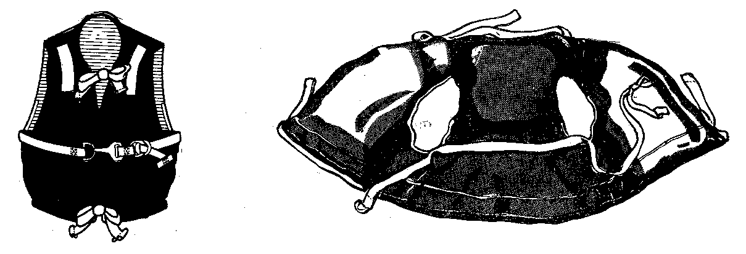
      - Type I (Off-shore Life Jacket)
A Type I PFD has the greatest required buoyancy (22 pounds in the adult device) and is designed to turn most unconscious persons in the water from a face down position to a vertical and slightly backward position and to maintain the person in that position. This design characteristic greatly increases the chances of survival and recovery. The Type I PFD is suitable for all waters, especially for cruising on waters where there is a probability of delayed rescue, such as large bodies of water where it is not likely that a significant number of boats will be in close proximity. This type PFD is the most effective in rough water. The Type I PFD is easiest to don in any emergency because it is reversible and available in only two sizes; adult (90 lb. or more) and child (less than 90 lb) which are universal sizes designed to fit all persons in the appropriate category.

Approved Type I PFDs are of either the jacket or bib design. They may utilize either unicellular foam or sealed pouches of kapok or fibrous glass as the buoyant material. They have a vinyl dipped, nylon, or cloth covering and are fitted with a maximum of three straps or ties. The jacket design has a covering of continuous construction whereby the flotation cells are not joined merely by straps, but are constructed as part of the jacket. Type I PFDs are required to be manufactured in an international orange. Some older Type I PFDs may utilize cork or balsa wood as the bouyant material installed in a canvas cover. These devices are no longer approved by the U.S. Coast Guard, but they may be accepted by the Marine Inspector if they are still in serviceable condition.
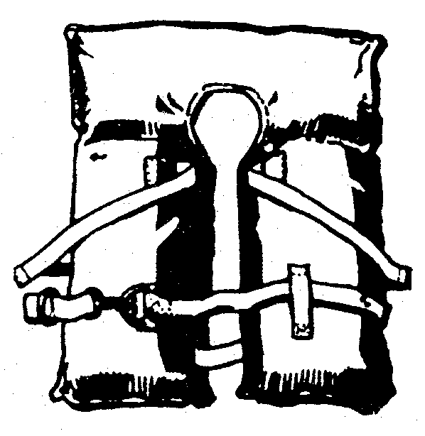
      - Type II (Near-Shore Buoyant Vest)
This device has less inherent buoyancy that the type I device (15.5 pounds in the adult device) and may turn an unconscious victim face up. It is design so that it will maintain the wearer in a vertical or slightly backward position. It is not suitable for use in rough or cold waters and is designed primarily for use on pleasure vessels operating on inland waters or where rescue is likely to be quick.

Approved Type II devices are of either the bib or yoke design. They may utilize either unicellular foam or sealed pouches of kapok or fibrous glass as the buoyant material. They have a vinyl dipped, nylon, or cloth covering fitted with the necessary straps and ties, and like the Type I, are required to be international orange in color. Type II devices are available in a variety of sizes.
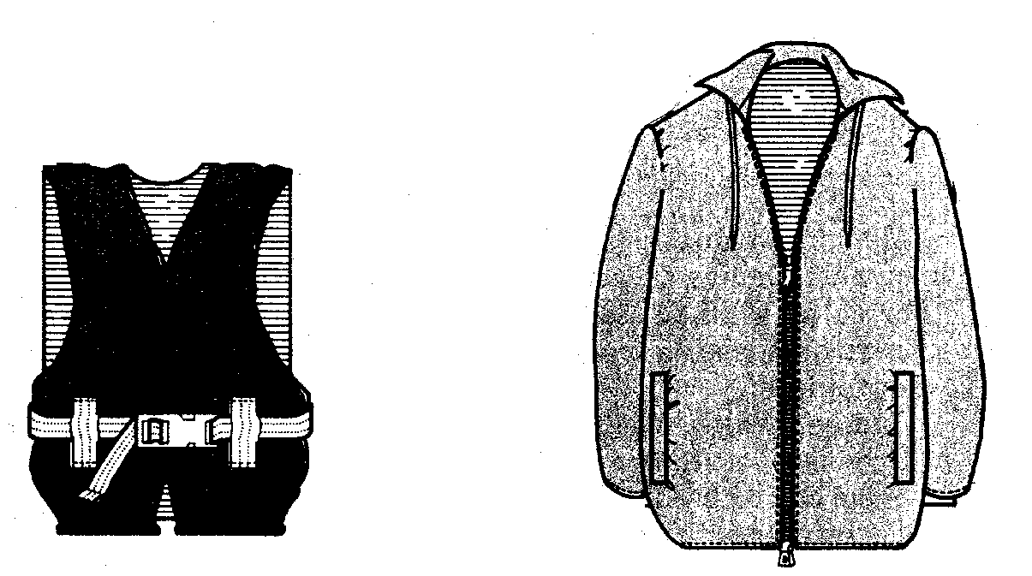
      - Type III (Flotation Aid)

This device has the same amount of inherent buoyancy as the type II device but has little or no righting ability. It is not designed to turn the wearer face up but will float the wearer in whatever position he or she assumes in the water, including face down. This device was designed as a compromise between comfort and capability. It is more comfortable to wear than the Type I or II devices. It was hoped that by being so more people would wear it. It is not suitable for use in rough or cold waters and is intended for use in inland waters where rescue is likely to be quick. Approved Type III devices come in a variety of designs and styles. They generally utilize unicellular foam as the buoyant material and have vinyl dipped or nylon coverings. The number, design and placement of straps or fasteners varies with manufacturer and model. The Type III PFD is available in a variety of colors and sizes (usually by chest size and weight).

      - Type IV (Throwable Device)
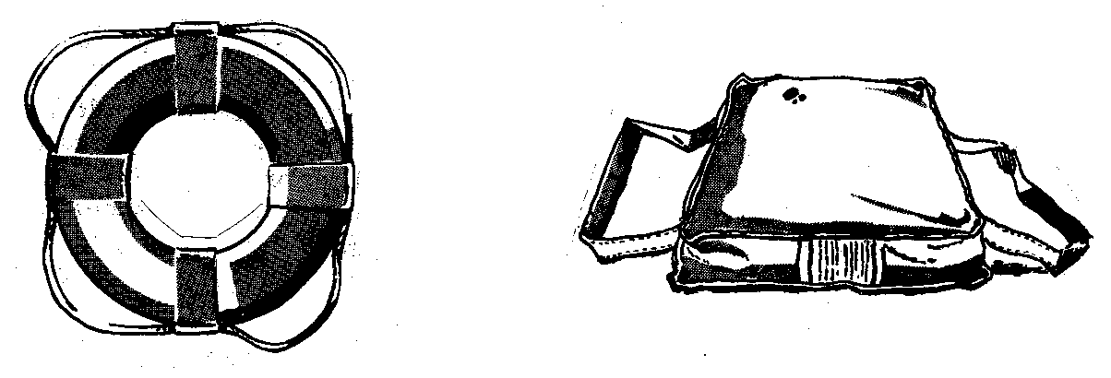
This type covers a number of devices which are designed to be thrown, not worn. While they are permitted on small recreational boats in lieu of the wearable types, they are primarily intended as a rescue device to be thrown to persons who fall overboard. They can cling to the device until rescued. There are two styles of Type IV PFDs, the ring buoy and the buoyant cushion.

a) Ring Buoys - Currently, ring buoys are constructed of plastic foam covered with a special coating of rubberized vinyl. Ring buoys manufactured prior to 1978 were usually constructed of balsa wood or cork, fitted with a canvas cover. Cork and balsa wood ring buoys are still acceptable if they are in good condition. The covering is usually white or international orange in color. All ring buoys must be fitted with a grab line usually constructed of nylon, polypropolene, or other synthetic material which must be orange, white, or black in color. Approved ring buoys must have a minimum buoyancy of 16.5 pounds and must be at least twenty (20) inches in diameter.

b) Buoyant Cushions - The buoyant material of currently approved cushions may be kapok, fibrous glass, or plastic foam covered with various types of fabric. The material may be covered with upholstery cloth or vinyl dipped materials. Buoyant cushions are fitted with grab straps and come in a variety of colors. They have a minimum buoyancy of 18 pounds. The cushion is designed to be a grasping device. It is unsafe to wear it on the back since it will actually push the victim's head underwater.. For this reason, the warning "DO NOT WEAR ON BACK" is placed on the label.

      - Type V (Special Use and Hybrids)
A Type V device is any approved device designed for specific and restricted use. The specific approved use of a Type V and any restrictions or limitations will be described on the device label. Some Type V PFDs are, under certain conditions, approved as a replacement for a Type III or other device usually with the provision that they be worn.

    - PFD Carriage Requirements

All PFDs carried on Public Vessels must be U.S. Coast Guard approved, in good serviceable condition and in the quantity, type, and size stated in the following sections.

      - Wearable Devices
All Public Vessels are required to carry a minimum of one Type I Adult size PFD for each passenger and crew member as specified on the vessel's Certificate of Inspection, regardless of how many people are actually on board. In addition to this amount, each vessel must carry an amount of Type I child size PFDs equal to ten percent of the adult requirement. If the vessel's operation is such that large numbers of children under 90 pounds are often carried, the owner must provide sufficient numbers of child size PFDs. Conversely, if children are never carried on board, the ten percent requirement may be waived and this will be noted on the Certificate of Inspection. Wearable PFDs must be readily accessible to all passengers.

      - Exception to Type I PFD Requirement
The inspector MAY permit a vessel engaged in water skiing activities to substitute Type III PFDs for the required Type I with the stipulation that they must be worn. This stipulation includes the skier. If this exception is found to be abused it may be revoked at the inspectors discretion.

      - Throwable/Rescue Devices
All Public Vessels must carry one or more Type IV PFDs, as listed below, which must be immediately accessible to either the operator or crew. It must be capable of being cast loose in an emergency and shall not be permanently secured to the vessel in any way.
a) Vessels less than 26 feet must carry at least one Type IV PFD ring buoy or buoyant cushion.
b) Vessels 26 feet to less than 65 feet in length must carry at least two ring buoys. A cushion is not acceptable.
c) Vessel 65 feet or more must carry four or more ring buoys as determined by the Marine Inspector. One located on each side of the pilot house and the remainder to be placed in accessible locations elsewhere on the vessel as directed by the inspector.

    - Stowage of PFDs

PFDs must be stowed in a location where they are readily accessible to all passengers and crew. They may be stowed in boxes, lockers, in overheads, or secured under fixed seating. The stowage space or area should be dry and well ventilated to protect the PFDs especially if the coverings or straps are made of cloth. They also should not be stowed where they will be exposed to direct or reflected sunlight because this may cause the materials to deteriorate. PFD stowage locations must be clearly marked in lettering at least 1 1/2 inches in height and of a contrasting color on larger vessels. PFDs must be adequately dispersed throughout the vessel for ease of access and to prevent congestion in one area during an emergency. Overhead stowage for PFDs must be such that space is left between the device and the overhead to allow for ventilation and easy removal. Wooden slats or ropes used to hold the devices in the overhead must be installed so that the PFDs may be quickly removed with minimal effort.

    - Care of PFDs

Proper care of your PFDs is essential to ensure they remain in serviceable condition and to extend their service life. Inspect each PFD prior to stowage aboard the vessel. Check to ensure that all straps and ties are firmly attached and not torn or missing. Ensure the covering is intact and has no tears. For the type of PFD that uses kapok pouches, squeeze each pouch to ensure there are no air leaks indicating a tear or puncture in the pouch. This could lead to the device becoming water logged rendering it not only useless, but also possibly dangerous. Aside from these defects, most modern PFDs are impervious to deterioration by natural means such as dry rot. Dry rot will affect only canvas cloth covered PFDS. These are the same criteria the marine inspector will use when examining the PFDs on your vessel.

The PFDs should be stowed as indicated in section 6.1.3.0. in a location where they will not be damaged by sharp objects. PFDs should not be sat upon or used as seat cushions. This is particularly true of devices using kapok pouches, especially Type IV buoyant cushions, because the weight and bouncing of a person may cause the pouches to rupture. Wet PFDs should be hung to dry prior to re-storage. Do not attempt to dry them over a heat source since this will damage the covering.

During the off-season all PFDs should be removed from the vessel and stowed in a dry, well ventilated place. Care should be taken to ensure that small animals such as rats, mice, squirrels, and chipmunks cannot gain access to your PFDS. These animals like using PFDs materials to line their nests and can take a heavy toll in PFD destruction.

  - VISUAL DISTRESS SIGNALS (VDS)

All Public Vessels sixteen feet or more in length must carry U. S. Coast Guard approved visual distress signals on board at all times. Vessels less than sixteen feet are only required to carry VDS if operating after sunset. Each vessel shall have three day-night, hand-held flares, or one orange distress signal flag and three night flares. The prescribed distress flag must be at least 3 feet by 3 feet with a black square and ball placed on the orange background. Electric distress lights that automatically flash the international "SOS" distress signal are also acceptable. The table below indicates acceptable devices and the amounts required to be carried.

All approved pyrotechnic devices (flares and smoke) are marked with an expiration date that is 3 1/2 years from the date of manufacture. Devices that have exceeded their expiration date are no longer serviceable and must be replaced. Stow pyrotechnics in a cool dry space that is readily accessible in an emergency. Care should be taken to prevent puncture or other damage to the flare covers. Keep all pyrotechnics out of the reach of children.

Device Description  (USCG Approval No.) | Accepted for Use During... | Number Required
Hand held flares (160.021) | Day & Night | 3
Hand-held or Floating Orange Smoke Signals (160.022) | Day only | 3
Pistol Launch Aerial Red Meteor or Parachute Flares with approved launcher  (160.024) | Day & Night | 3
Hand held rocket propelled aerial or parachute red flare (160.036) | Day & Night | 3
Hand held orange smoke (160.037) | Day only | 3
Floating orange smoke (160.057) | Day only | 3
Orange Flag (160.072) | Day only | 1
Electric distress light (161.013) | Night only | 1

  - ANCHOR AND RODE

All Public Vessels must carry an anchor of an appropriate type, weight, and strength to hold the vessel securely during all weather conditions characteristic to the waterway upon which the vessel will operate.

Anchors are available in a variety of designs and sizes. The most popular anchor used on all but the largest of vessels is the Danforth or lightweight type. Its widespread use stems from its superior holding power compared to its relatively light weight. The Danforth anchor has excellent holding ability in mud and sand, and, with caution, can be used on rocky bottoms. It does not hold as well in grassy bottoms, however, neither do most other anchors. While anchor types other than the Danforth are permitted for use on Public Vessels, the mushroom and grapnel hook type anchors are not recommended for most applications.

In addition to carrying an anchor, each Public Vessel must have a rode or anchor line of sufficient length and strength to match the anchor and hold the vessel in place. The anchor rode must be made up or attached to the anchor at all times. The anchor rode for most vessels usually consists of synthetic fiber line (such as nylon), chain, wire, or a combination of synthetic line and chain. While an all-chain rode is the strongest alternative and provides the most holding power, it is generally not recommended for small vessels because its weight normally requires a means of power to retrieve it. The added weight in the bow may also adversely affect the vessels stability and handling characteristics. Nylon line works well for an anchor rode. It has considerable strength despite its relatively light weight. Nylon's biggest advantage is its elasticity. It safely stretches 15% to 25% beyond its original length when placed under a load. This allows it to absorb some of the heavy shock load placed on the vessel, anchor, and fittings as the vessel moves in the water. The disadvantage of using nylon instead of chain is that nylon's lighter weight on the shank of the anchor does not assist the anchor to "dig in" as well. Thus, the ideal arrangement for vessels where the use of chain alone is impractical is a combination of nylon line and chain. A length of chain is shackled to the anchor which in turn is shackled to the nylon line which makes up the majority of the rode. The chain will provide the weight to help the anchor get a good bite in the bottom and prevent chafing, abrasion, or cutting that a nylon line might suffer when in contact with any sharp objects on the bottom such as rocks or debris.

The normally recommended length of the rode is five to seven times the depth of the water in which the vessel will anchor. To determine the length to be carried the Public Vessel should determine water depths where the vessel normally operates. A vessel will not normally be anchored in deep open waters so depths nearer to shore where the vessel may need to anchor in an emergency should be used. The table below shows the recommended anchor size and rode length for vessels of ten to sixty feet in length. Larger vessels should contact M&RV or anchor manufacturers for recommendations regarding anchor and rode specifications.

The table assumes the use of a standard Danforth type anchor with a combined chain and nylon rode. It further assumes the vessel is anchored with a rode that is seven times the water depth in an anchorage with fair holding ground, less than 30 knots and moderate shelter from heavy seas.

Boat Length (ft) | Anchor Weight (lbs) | Rode - Nylon | Rode - Chain
10 | 4 | 80' X 1/4" | 3' X 3/16"
15 | 8 | 100' X 1/4" | 3' X 3/16"
20 | 8 | 120' X 1/4" | 3' X 3/16"
25 | 8 | 150' X 3/8" | 3' X 3/16"
30 | 13 | 180' X 3/8" | 4' X 1/4"
35 | 22 | 200' X 3/8" | 4' X 1/4"
40 | 22 | 250' X 7/16" | 5' X 5/16"
50 | 40 | 300' X 1/2" | 6' X 3/8"
60 | 65 | 300' X 1/2" | 6' X 3/8"

  - HORN or WHISTLE

All Public Vessels must be equipped with a horn or whistle capable of producing a four-to-six second blast, audible at a range of at least one-half mile from the vessel. The whistle and its actuating mechanism must be permanently installed in the vessel. It must be electro-mechanical, air, or steam actuated and capable of being sounded by the operator at the helm.

Public Vessels less than thirty-nine feet in length may utilize a portable sound signaling device such as a mouth whistle, hand-held air horn, or similar device in lieu of a permanently installed device provided it meets all of the criteria listed above. A portable device must be kept in a position that is immediately accessible to the operator of the vessel.

  - BELL

Public Vessels greater than thirty-nine feet in length are required to be equipped with a bell. The bell must be permanently mounted to the vessels exterior structure in the vicinity of the control station. A lanyard or wire must be attached to the bell's clapper to enable the operator to sound the bell from the control station.
  - PORTABLE FIRE EXTINGUISHERS

Portable fire extinguishers were discussed in detail in chapter 4 of this manual. For detailed information in selecting a type of extinguisher to use, please see that section.

  - EQUIPMENT MARKING

All Public Vessel equipment listed in this chapter must be stenciled with the vessels name or registration number. This requirement serves as a means of identification in the event of a casualty, loss, or theft. It further serves to ensure that equipment is not easily transferred between vessels.

  - SUMMARY OF EQUIPMENT CARRIAGE REQUIREMENTS

Item | Vessels Under 26' | Vessels 26 - 40' | Vessels Over 40'
Anchor | 1  appropriate size | 1  appropriate size | 2  appropriate size
Rode | 5 - 7 X depth | 5 - 7 X depth | 5 - 7 X depth
Horn | Yes-installed or portable | Yes - installed  <39' portable allowed | Yes - installed
Bell | No | Over 39' - Yes | Yes
PFD - Adult | 1 Type I per person | 1 Type I per person | 1 Type I per person
PFD - Child | 10% of capacity | 10% of capacity | 10% of capacity
Type IV PFD | 1 cushion or ring | 2 ring buoys | 2 ring buoys  4 ring buoys over 65'
Portable Extinguishers | 1 size B-1 | 2 size B-1 | as directed
Installed Extinguishers | Outboard - No  Inboard or I/O - Yes | Outboard - No  Inboard or I/O - Yes | Outboard - No  Inboard or I/O - Yes
Distress Equipment | Yes - see table in Section 6.2  <16' not required except at night. PWC must have flag | Yes - see table in Section 6.2 | Yes - see table in Section 6.2
Backfire Flame Arrester | Outboard - No  Inboard or I/O - Yes | Outboard - No  Inboard or I/O - Yes | Outboard - No  Inboard or I/O - Yes
Blower | Inboard Gasoline Engines | Inboard Gasoline Engines | Inboard Gasoline Engines
Bilge Pump | 1 hand or power | 1 hand & 1 power | 1 or more powered pumps (25gpm) as directed
Log Book /Station Bill | No | No | Yes - vessels over 65', 50 tons or  65 passengers

- RULES OF THE ROAD

Below are excerpts from the Unified Inland Rules of the Road as they apply to Public Vessels operating on the navigable waters of New York State. Before operating a Public Vessel it is imperative that the operator be familiar with these rules and their application.

  - RESPONSIBILITY

Nothing in these Rules shall exonerate any vessel, or the owner, master, or crew thereof, from the consequences of any neglect to comply with these Rules or of the neglect of any precaution which may be required by the ordinary practice of seamen, or by the special circumstances of the case. In construing and complying with these Rules due regard shall be had to all dangers of navigation and collision and to any special circumstances, including the limitations of the vessels involved, which may make a departure from these Rules necessary to avoid immediate danger.

  - GENERAL DEFINITIONS

For the purpose of these Rules, except where the context otherwise requires:

    - Vessel - includes every description of water craft, including non-displacement craft and seaplanes, used or capable of being used as a means of transportation on water;

    - Power-driven vessel - any vessel propelled by machinery;

    - Sailing vessel - means any vessel under sail (including sailboards) provided that propelling machinery, if fitted, is not being used;

    - Non-powered vessel - any vessel propelled exclusively by human power by means of oars, paddles, or similar means.

    - Vessel engaged in fishing - any vessel fishing with nets, trawls, or other fishing apparatus which restricts maneuverability;

    - Underway - a vessel is not at anchor, or made fast to the shore, or aground;

    - In sight of one another - when one vessel can be observed visually from the other;

    - Restricted visibility - any condition in which visibility is restricted by fog, mist, falling snow, heavy rainstorms, or any other similar causes;

NOTE: Measurements in the Unified Inland Rules are expressed in meters. For the reader's information 1 meter is equal to approximately 3.3 feet.

  - STEERING AND SAILING RULES

Conduct in ANY Condition of Visibility

    - Look Out
Every vessel shall at all times maintain a proper look-out by sight and hearing as well as by all available means appropriate in the prevailing circumstances and conditions so as to make a full appraisal of the situation and of the risk of collision.

    - Safe Speed
Every vessel shall at all times proceed at a safe speed so that she can take proper and effective action to avoid collision and be stopped within a distance appropriate to the prevailing circumstances and conditions.

In determining a safe speed the following factors shall be among those taken into account:

a) State of visibility;
b) Traffic density;
c) Maneuverability of the vessel with regard to stopping distance and turning ability in the prevailing conditions;
d) At night the presence of background light such as from shore lights or from the back scatter of her own lights;
e) State of wind, sea, and current, and the proximity of navigational hazards;
f) Draft in relation to the available depth of water.
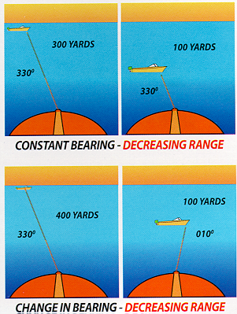
    - Risk of Collision
a) Every vessel shall use all available means appropriate to the prevailing circumstances and conditions to determine if risk of collision exists. If there is any doubt, such risk shall be deemed to exist.
b) Assumptions shall not be made on the basis of scanty information.
c) In determining if risk of collision exists the following consideration shall be among those taken into account:
1) such risk shall be deemed to exist if the compass bearing of an approaching vessel does not appreciably change as range decreases (Constant Bearing, Decreasing Range - CBDR) and;
2) such risk may sometimes exist even when an appreciable bearing change is evident, particularly when approaching a very large vessel or a tow or when approaching a vessel at close range.

    - Action To Avoid Collision
a) Any action taken to avoid collision shall, if the circumstances of the case admit, be positive, made in ample time and with due regard to the observance of good seamanship.
b) Any alteration of course or speed to avoid collision shall, if the circumstances of the case admit, be large enough to be readily apparent to another vessel observing visually. A succession of small alterations of course or speed should be avoided.
c) If there is sufficient sea room, alteration of course alone may be the most effective action to avoid a close-quarters situation provided that it is made in good time, is substantial and does not result in another close-quarters situation.
d) Action taken to avoid collision with another vessel shall be such as to result in passing at a safe distance. The effectiveness of the action shall be carefully checked until the other vessel is finally past and clear.
e) If necessary to avoid collision or allow more time to assess the situation, a vessel shall slacken her speed or take all way off by stopping or reversing her means of propulsion.

    - Narrow Channels
a) A vessel proceeding along the course of a narrow channel or fairway shall keep as near to the outer limit of the channel or fairway which lies on her starboard side as is safe and practicable.
b) A vessel of less than 20 meters in length including, but not limited to, sailing vessels, water ski boats, parasail operations, and personal water craft, shall not impede the passage of a vessel that can safely navigate only within a narrow channel or fairway.
c) A vessel engaged in fishing shall not impede the passage of any other vessel navigating within a narrow channel or fairway.

d) A vessel shall not cross a narrow channel or fairway if such crossing impedes the passage of a vessel which can safely navigate only within that channel or fairway. The latter vessel shall use the danger signal if in doubt as to the intention of the crossing vessel.
e) A vessel nearing a bend or an area of a narrow channel or fairway where other vessels may be obscured by an intervening obstruction shall navigate with particular alertness and caution and shall sound the appropriate signal.
f) Every vessel shall, if the circumstances of the case admit, avoid anchoring in a narrow channel.

Conduct When In Sight of One Another

    - Sailing Vessels
a) When two sailing vessels are approaching one another, so as to involve risk of collision, one of them shall keep out of the way of the other as follows:
1) when each has the wind on a different side, the vessel which has the wind on the port side shall keep out of the way of the other;
2) when both have the wind on the same side, the vessel which is to windward shall keep out of the way of the vessel which is to leeward; and
3) if a vessel with the wind on the port side sees a vessel to windward and cannot determine with certainty whether the other vessel has the wind on the port or on the starboard side, she shall keep out of the way of other.
b) For the purpose of this rule the windward side shall be deemed to be the side opposite to that on which the mainsail is carried.

    - Overtaking
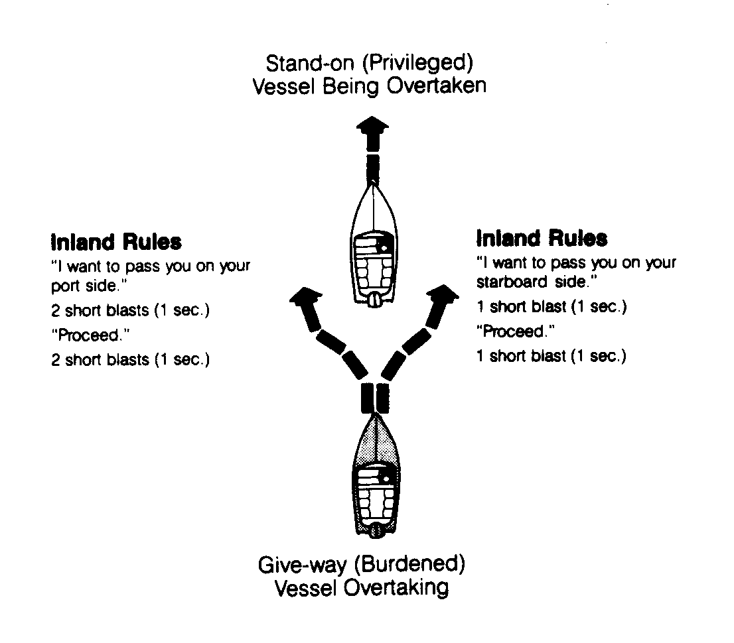
a) Any vessel, sail or power, overtaking any other shall keep out of the way of the vessel being overtaken.
b) A vessel shall be deemed to be overtaking when coming up with another vessel from a direction more than 22.5 degrees abaft her beam; that is, in such a position with reference to the vessel she is overtaking, that at night she would be able to see only the stern light of that vessel but neither of her sidelights.
c) When a vessel is in any doubt as to whether she is overtaking another, she shall assume that this it the case and act accordingly.
- Any subsequent alteration of the bearing between the two vessels shall not make the overtaking vessel a crossing vessel within the meaning of these rules or relieve her of the duty of keeping clear of the overtaken vessel until she is finally past and clear.

    - 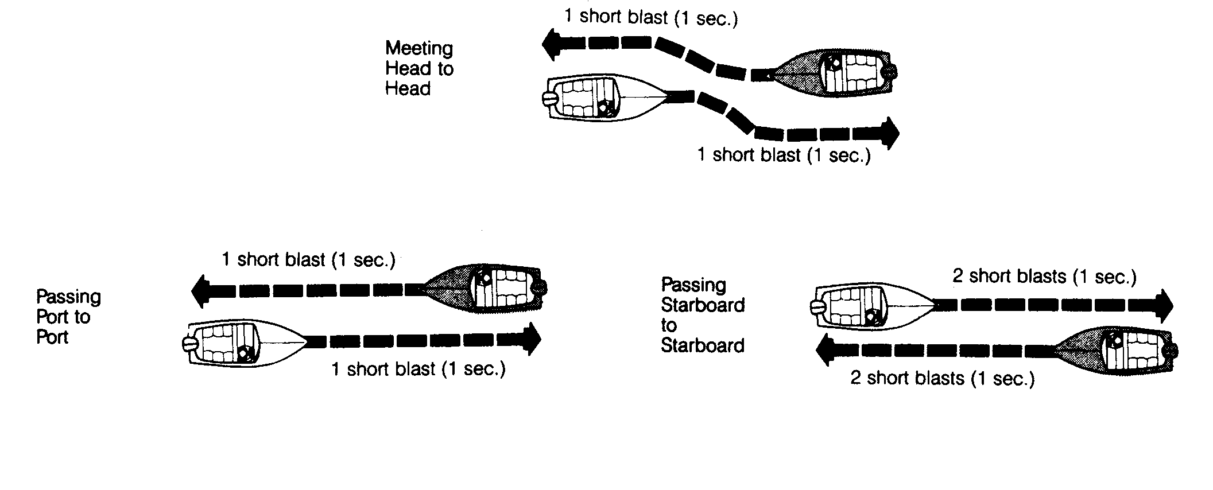Head-On Situation
a) When two power-driven vessels are meeting on reciprocal or nearly reciprocal courses so as to involve risk of collision each shall alter her course to starboard so that each shall pass on the port side of the other.

b) Such a situation shall be deemed to exist when a vessel sees the other ahead or nearly ahead and by night she could see the masthead lights of the other in a line or nearly in a line or both sidelights and by day she observes the corresponding aspect of the other vessel.
c) When a vessel is in any doubt as to whether such a situation exists she shall assume that it does exist and act accordingly.

NOTE: When the courses of such vessels are so far to the starboard of each other as not to be considered meeting head on head, either vessel shall immediately give two short blasts of her whistle, which the other shall answer with two blasts if in agreement. The two vessels shall then pass starboard to starboard.

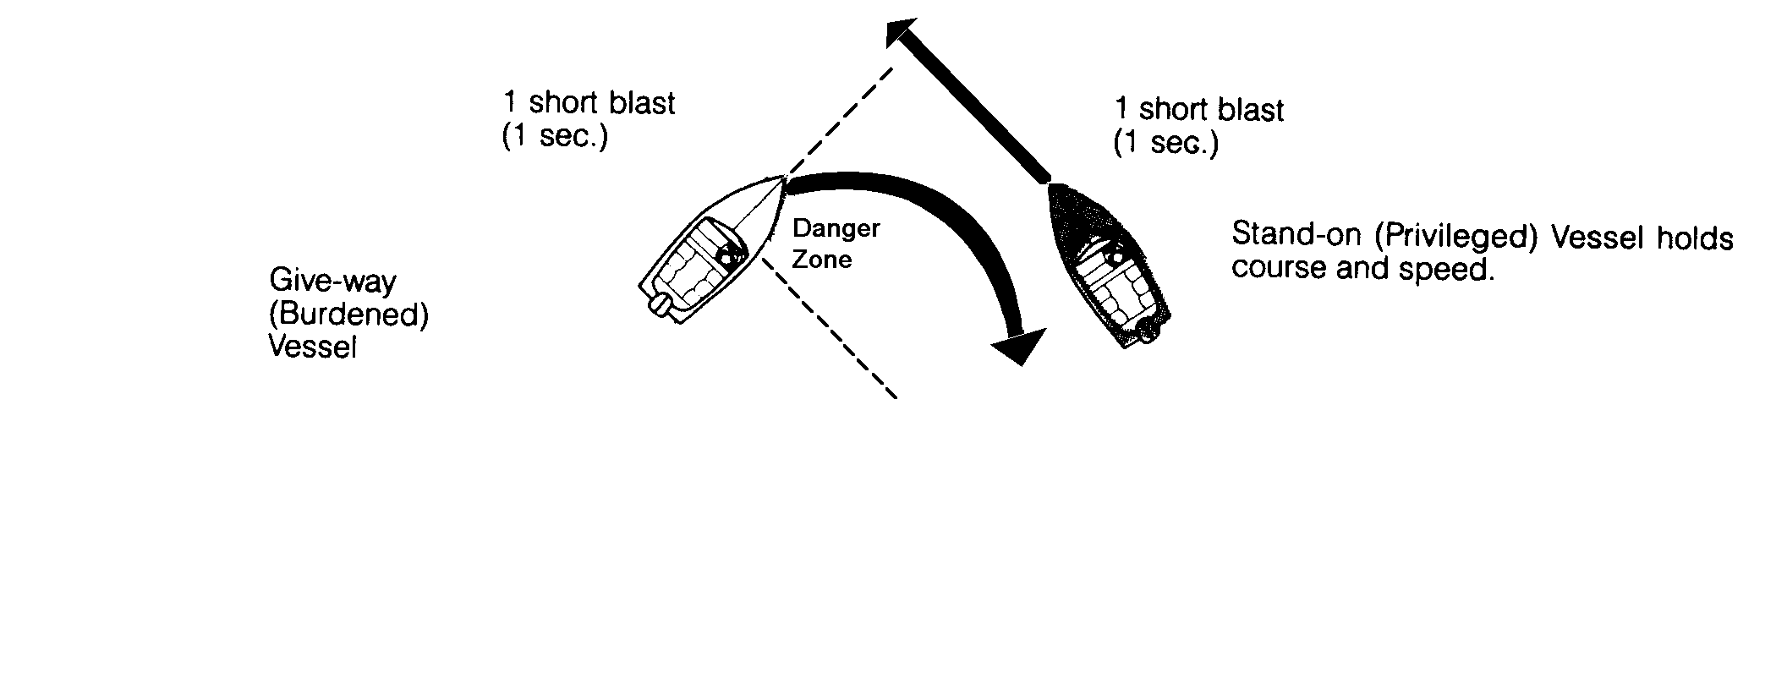
    - Crossing Situation
a) When two power-driven vessels are crossing so as to involve risk of collision, the vessel which has the other on her starboard side shall keep out of the way and shall, if the circumstances of the case admit, avoid crossing ahead of the other vessel.
b) A vessel crossing a river shall keep out of the way of a power-driven vessel ascending or descending the river.

    - Action By Give-Way Vessel
Every vessel which is directed to keep out of the way of another vessel shall, so far as possible, take early and substantial action to keep well clear.

    - Action By Stand-On Vessel
a) Where one of two vessels is to keep out of the way, the other shall keep her course and speed. The latter vessel may, however, take action to avoid collision by her maneuver alone, as soon as it becomes apparent to her that the vessel required to keep out of the way is not taking appropriate action in compliance with these Rules.
b) When, from any cause, the vessel required to keep her course and speed finds herself so close that collision cannot be avoided by the action of the give-way vessel alone, she shall take such action as will best aid to avoid collision.
c) A power-driven vessel which takes action in a crossing situation in accordance with subparagraph (a)(ii) of this Rule to avoid collision with another power-driven vessel shall, if the circumstances of the case admit not alter course to port for a vessel on own port side.
d) This rule does not relieve the give-way vessel of her obligation to keep out of the way.

    - Responsibilities Between Vessels
Except where the Rules on Narrow Channels and Overtaking require otherwise:
a) A power-driven vessel underway shall keep out of the way of:
1) a vessel engaged in fishing
2) a sailing vessel.
3) a non-powered vessel.
b) A sailing vessel underway shall keep out of the way of:
1) a vessel engaged in fishing.
2) a non-powered vessel.
c) A seaplane on the water shall, in general, keep well clear of all vessels and avoid impeding their navigation. In circumstances, however, where risk of collision exists, she shall comply with Rules of this Part.

    - Conduct in Restricted Visibility
a) This Rule applies to vessels not in sight of one another when navigating in or near an area of restricted visibility.

b) Every vessel shall proceed at a safe speed adapted to the prevailing circumstances and conditions of restricted visibility. A power-driven vessel shall have her engines ready for immediate maneuver.
c) Every vessel shall have due regard to the prevailing circumstance and conditions of restricted visibility.
d) Except where it has been determined that a risk of collision does not exist, every vessel which hears apparently forward of her beam the fog signal of another vessel, or which cannot avoid a close quarters situation with another vessel forward of her beam, shall reduce her speed to the minimum at which she can be kept on course. She shall if necessary take all her way off and, in any event, navigate with extreme caution until danger of collision is over.

  - SOUND SIGNALS

    - Definitions

      - Whistle - shall mean any sound-producing device capable of producing the prescribed blasts and audible to a distance of at least l/2 mile.

      - Short blast - means a blast of about 1 second's duration.

      - Prolonged Blast - means a blast of from 4 to 6 seconds duration.

    - Maneuvering and Warning Signals
a) When vessels are in sight of one another and meeting or crossing each vessel underway, when maneuvering as authorized or required by these Rules:
1) Shall indicate that maneuver by the following signals on her whistle: one short blast to mean "I intend to leave you on my port side" (turn to starboard); two short blasts to mean "I intend to leave you on my starboard side" (turn to port); and three short blasts to mean "I am operating astern propulsion".
2) Upon hearing the one or two blast signal of the other shall, if in agreement, sound the same whistle signal and take the steps necessary to effect a safe passing. If, however, from any cause, the vessel doubts the safety of the proposed maneuver, she shall sound the danger signal specified in paragraph (c) of this Rule and each vessel shall take appropriate precautionary action until a safe passing agreement is made.
b) When in sight of one another:
1) A power-driven vessel intending to overtake another power driven vessel shall indicate her intention by the following signals on her whistle: one short blast to mean "I intend to overtake you on your starboard side" (turn to starboard); two short blasts to mean "I intend to overtake you on your port side" (turn to port); and
2) The power-driven vessel about to be overtaken shall, if in agreement, sound a similar sound signal. If in doubt she shall sound the danger signal, 5 or more short blasts.
c) When vessels in sight of one another are approaching each other and from any cause either vessel fails to understand the intentions or actions of the other, or is in doubt whether sufficient action is being taken by the other to avoid collision, the vessel in doubt shall immediately indicate such doubt by giving at least five short and rapid blasts on the whistle.
d) A vessel nearing a bend or an area of a channel or fairway where other vessels may be obscured by an intervening obstruction shall sound one prolonged blast. This signal shall be answered with a hearing around the bend or behind the intervening obstruction.
e) When a power-driven vessel is leaving a dock or berth, she shall sound one prolonged blast.

NOTE: The use of cross signals (the answering of one blast with two blasts or vice versa) is prohibited.

    - Sound Signals in Restricted Visibility

In or near an area of restricted visibility, whether by day or night, the signals below shall be used:
a) A power driven vessel making way through the water shall sound at intervals of not more than 2 minutes one prolonged blast.
b) A power driven vessel underway but stopped and making no way through the water shall sound at intervals of not more than 2 minutes two prolonged blasts in succession with an interval of about 2 seconds between them.
c) A sailing vessel; a vessel engaged in fishing, whether underway or at anchor; and a vessel engaged in towing or pushing another vessel shall, instead of the signals prescribed in paragraphs (a) or (b) of this Rule, sound at intervals of not more than 2 minutes, three blasts in succession; namely, one prolonged followed by two short blasts.
d) A vessel towed, if manned, shall at intervals of not more than 2 minutes sound four blasts in succession; namely, one prolonged followed by three short blasts. When practicable, this signal shall be made immediately after the signal made by the towing vessel.
e) A vessel at anchor shall at intervals of not more than one minute ring the bell rapidly for about 5 seconds. A vessel at anchor may in addition sound three blasts in succession; namely, one short, one prolonged and one short blast, to give warning of her position and of the possibility of collision to an approaching vessel.
f) A vessel of less than 12 meters in length shall not be obliged to give the above mentioned signals but, if she does not, shall make some other efficient sound signal at intervals of not more than 2 minutes.

    - Signals To Attract Attention

If necessary to attract the attention of another vessel, any vessel may make light or sound signals that cannot be mistaken for any signal authorized elsewhere in these Rules, or may direct the beam of her searchlight in the direction of the danger, in such a way as not to embarrass any vessel.

  - VESSEL LIGHTING

Every vessel shall carry and exhibit from sunset to sunrise, and during periods of restricted visibility, the lights required by this section when underway. During such times, no other lights which may be mistaken for those described shall be exhibited.

    - Definitions

      - Masthead Light - A white light placed over the fore and aft centerline of the vessel showing an unbroken light over an arc of the horizon of 225 degrees from dead ahead to 22.5 degrees abaft the beam on either side of the vessel, except that on a vessel of less than 12 meters in length the masthead light shall be placed as nearly as practicable to the fore and aft centerline of the vessel.

      - Sidelights - A green light on the starboard side and a red light on the port side each showing an unbroken light over an arc of the horizon of 112.5 degrees and so fixed as to show the light from right ahead to 22.5 degrees abaft the beam on its respective side. On a vessel of less than 20 meters in length the sidelights may be combined in one lantern carried on the fore and aft centerline of the vessel, except that on a vessel of less than 12 meters in length the sidelights when combined in one lantern shall be placed as nearly as practicable to the fore and aft centerline of the vessel.

      - Sternlight - A white light placed as nearly as practicable at the stern showing an unbroken light over an arc of the horizon of 135 degrees and so fixed as to show the light 67.5 degrees from right aft on each side of the vessel.

      - All-Round Light - A light showing an unbroken light over an arc of the horizon of 360 degrees.

      - Restricted Visibility - Any condition in which visibility is restricted by fog, mist, falling snow, heavy rainstorms, sandstorms, and any other similar causes.

    - Visibility of Lights

The lights prescribed in this section shall have an intensity so as to be visible at the following minimum ranges:

      - Vessels 50 meters or more in length:
- a masthead light, 6 miles;
- a sidelight, 3 miles;
- a sternlight, 3 miles;
- a white, red, green or yellow all-round light, 3 miles

      - Vessels 12 meters to less than 50 meters in length:
- a masthead light, 5 miles; except that where the length of the vessel is less than 20 meters, 3 miles;
- a sidelight, 2 miles;
- a sternlight, 2 miles;
- a white, red, green or yellow all-round light, 2 miles

      - Vessels less than 12 meters in length:
- a masthead light, 2 miles;
- a sidelight, 1 mile;
- a sternlight, 2 miles;
- a white, red, green or yellow all-round light, 2 miles

    - Mechanically Powered Vessels Shall Exhibit:
a) A masthead light forward, except that a vessel of less than 20 meters in length need not exhibit this light forward of amidships, but shall exhibit it as far forward as practicable;
b) A second masthead light abaft of and higher than the forward one; except that a vessel of less than 50 meters in length shall not be obliged to exhibit such light but may do so;
c) Sidelights;
d) Sternlight.
e) A mechanically propelled vessel less than 12 meters in length may, in lieu of the prescribed lights above, exhibit an all-round white light and sidelights.

    - Sailing Vessels Underway By Sail Power Only Shall Exhibit:
a) Sidelights
b) Sternlight
c) In addition to the lights prescribed above, a sailing vessel underway may exhibit at or near the top of the mast, where best seen, two all-round lights in a vertical line, the upper being red and the lower green.
d) In a sailing vessel of less than 20 meters in length, the lights prescribed in part (a) of this section may be combined in one lantern carried at or near the top of the mast where best seen. The combined lantern may not, however, be exhibited in conjunction with those lights described in part (b) of this section.
e) In a sailing vessel of less than 7 meters in length or a vessel under oars or paddle, the lights prescribed in parts (a, b and c) of this section may be exhibited, but if she does not, she shall have ready at hand an electric torch or lighted lantern showing a white light which shall be exhibited in sufficient time to prevent collision.
f) A vessel underway being propelled by both mechanical and sail power shall carry the lights prescribed for a mechanically propelled vessel.
g) Underway during the day, a black conical shape apex pointed downward shall be exhibited where best seen. The cone shape shall have a base diameter of not less than 0.6 meters and a height equal to its diameter. Vessels less than 12 meters in length are exempt.

    - Law Enforcement Vessels

A flashing blue light may only be displayed by law enforcement vessels of the United States, the State of New York, or it’s political subdivisions when engaged in direct law enforcement activities. Placement of this light shall not interfere with the visibility of the vessel’s navigation lights.

    - Towing Vessels

Every mechanically propelled vessel when towing or pushing another vessel shall, in addition to her sidelights, carry two all-round white lights in a vertical line, one over the other, not less than one meter apart. Any vessel being towed shall carry sidelights and a sternlight, but not the masthead light prescribed earlier in this section. Vessels being pushed shall show only sidelights.

    - Vessels at Anchor

A vessel at anchor shall exhibit where it can best be seen:
a) An all-round white light on the forward part of the vessel at a height of not less than 6 meters above the hull.
b) A second all-round white light at or near the stern at least 4.5 meters lower in height than the light required in paragraph a.

A vessel less than 50 meters in length may exhibit a single all-round white light where best seen instead of the lights required in paragraphs a & b above.

A vessel less than 20 meters in length when anchored in a special anchorage area designated by rule, regulation or order of the commissioner shall not be required to exhibit the lights required by this section.

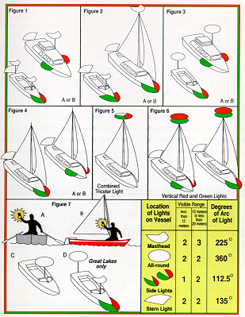
    - Searchlights

No person shall shine a searchlight, or similar light, into the pilot house of any other vessel so as to impair the vision of the operator of that vessel while it is underway. Any person violating the above provision shall be guilty of a class B misdemeanor. In addition, the Bureau of Marine and Recreational Vehicles may revoke or suspend the license of any person who violates the provisions of this section.

- VESSEL OPERATIONS

Boat and ship handling require an understanding of the many variable and complex aspects of seamanship. The basic principles involved in handling small boats are essentially the same as those used in handling larger craft. Fundamentally, vessels using outboard or inboard/outboard propulsion are handled in the same manner as inboard vessels of the same size and power.

  - BOAT HANDLING

    - Vessel Design
The design of a vessel includes the size and shape of the hull, draft, trim, weight and amount of superstructure. Vessels with shallow draft, low superstructure, and slim design normally handle more easily than vessels with high superstructure, deep draft, and wide beam because they are less affected by wind and current and respond more rapidly to the rudder. Deep draft vessels are normally more affected by currents; large superstructures impose a "sail" effect when maneuvering or when under way.

    - Power
Each phase of motive force, as it reacts on the vessel, has its own peculiarities, and no set of rules can be devised to cover all types. Every vessel has its own power characteristics which the operator must learn in order to determine their effect upon handling the vessel.

    - Propeller
A propeller draws its supply of water from every direction forward and around the blades, forcing it in a powerful stream toward the stern. This moving current which provides the power for propulsion is called screw current. The water flowing into the propeller is called suction screw current; that being ejected is called discharge current.

      - Characteristics
a) Pitch - The pitch of a propeller is the distance the propeller would advance in one revolution if the water were a solid medium.
b) Slip - The difference between the speed of the boat and the speed of the propeller is known as the slip. Slip is caused by the yield of the water against the propeller thrust. In other words, it is the percentage of distance lost because water is a yielding substance.
c) Cavitation - This phenomenon occurs when the blade-tip speed is excessive for the size and shape of the propeller, or the vessel is riding high in the water, and there is an unequal pressure on the lower and upper blade surfaces. This condition produces air pockets or bubbles around the propeller known as cavitation. The result is an increase in revolutions per minute without an equivalent increase in thrust. This results a in loss of efficiency. When cavitation is fully developed, it limits a vessel's speed regardless of the available engine power.
d) Rudder action - The rudder acts the same on a large vessel as on a small craft. The rudder is directly behind the propeller to use the powerful discharge current to turn the boat. Moving the rudder to the right deflects the discharge current to the right, thus forcing the stern to the left. This action is reversed when the left rudder is applied. At very slow propeller speed and with very little way on, there may not be sufficient control over a boat to maneuver it, especially if other forces are acting upon it at the same time. When this condition prevails, the propeller may be speeded up enough to give it a more powerful thrust against the rudder. Using sudden thrusts of power to kick (move) the stern in this manner is one of the fundamental principles of vessel handling. A vessel can often be turned in twice its length by kicking the stern in this manner.

  - SINGLE SCREW VESSELS

Characteristics or factors, such as the power, propeller, rudder, and design of a vessel affect handling in various ways. For the purpose of illustrating the effects of these factors, it will be assumed that the sea is calm, there is neither wind nor current, and the vessel has a right-handed propeller.

    - Vessel and Propeller Going Forward
With the vessel and propeller going in the forward direction and the rudder amidships, the bow will tend to veer slightly to port due to the propeller torque (propeller torque is the tendency of the propeller to pull the stern in the direction of propeller rotation). When the rudder is put over, either to the right or left, the water through which the vessel is moving strikes the rudder face, forcing the stern in the opposite direction. At the same time, discharge current from the propeller strikes the rudder face and pushes the stern over farther. As a result of these forces, the bow moves in the direction in which the rudder has been thrown. The point to remember, in all cases, is that the vessel will react to the strongest forces acting against the hull and the rudder.
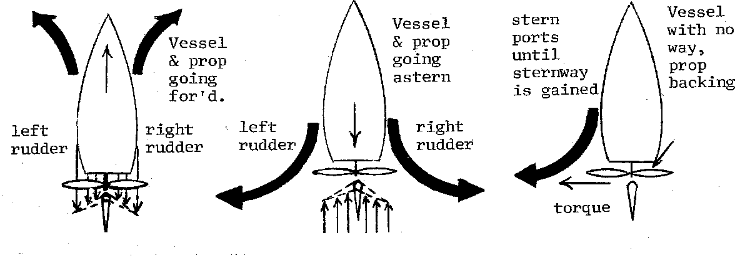

    - Vessel with Sternway, Propeller Backing
When the propeller is backing (turning counter-clockwise), in addition to the propeller torque pulling the stern to port, the discharge current from the propeller reacts against the hull. This current is rotary, therefore, when backing, this current strikes the hull high on the starboard side and low on the port side, exerting a greater force on the starboard side which tends to throw the stern to port. These two forces will move the vessel's stern to port when backing with the rudder amidships. When the rudder is put over to starboard, another force is brought into play that of the suction current striking the rudder face, tending to throw the stern to starboard. Considerable sternway must be attained before the rudder force can overcome the tendency to back to port. Once a substantial amount of sternway has been attained, gradually increasing the angle of the rudder to starboard (thereby increasing the area that the suction current can strike on the rudder face), will begin backing the vessel to starboard. It is important to remember that sternway is essential for the rudder to have any effect when backing.

  - TWIN SCREW VESSELS

The twin-screw vessel has two propellers--one on each side of the centerline; they are controlled by separate throttle controls. Generally the propellers are out-turning; that is, the starboard propeller is right-handed and the port, left-handed. This balances the sidewise pressure of the propellers and makes it possible to keep the ship on a straight course without rudder force, especially when backing. Discounting outside influences, the twin screw vessel backs with equal maneuverability to port or starboard.

The various forces affecting the action of the single-screw boat are still present, but normally a twin-screw vessel is not affected by these forces as much as a single-screw vessel. This is because the forces from one screw counteracts the forces from the other.

One powerful force is the momentum of the vessel ahead or astern, acting through the center of gravity. When a twin-screw vessel is going ahead and one screw is reversed, two opposing forces are set in motion; namely, the force of the backing screw acting in one direction and the weight of the vessel acting in the opposite direction. This is in addition to the forces imposed by the rudder if used. The added control and maneuverability allowed by the use of opposing engine forces is what sets the twin screw vessel apart from the single screw vessel.

  - EFFECT OF NATURAL PHENOMENON ON HANDLING

    - Wind

The wind acts upon the freeboard and superstructure of a vessel in much the same way as it acts on the sails of a sailboat. Its effect must be considered when turning, especially at low speeds. Even if the superstructure is equally distributed, there is usually a higher freeboard at the bow than at the stern. This makes the forward part of the vessel act as a headsail, having some effect when a vessel is going ahead and more when it is going astern. A vessel will usually back into the wind because the propeller acts as a pivot and the pressure of the wind on the bow and superstructure swings the vessel around with the stern into the wind. The stronger the wind, the stronger the tendency to back into the wind. This tendency can be used to facilitate a turn when maneuvering in narrow turning areas.

    - Sea Conditions

The condition and relative direction of the sea affect both the progress and steering of the vessel through their effect on the underwater body. Any sea forward of the beam will retard the speed of the vessel, whereas any sea abaft the beam will accelerate it. The general effect of the sea on steering is to cause the vessel to seek the trough. When the sea is on the bow or quarter, it may be necessary to carry a definite amount of either right or left rudder to maintain the course. This will result in some loss of speed because of rudder resistance.

When bucking a heavy sea in a gale, it is usually necessary to slow down. The slow engine speed opposed to the force of the waves results in less steering control. Under these conditions, the tendency of the vessel to fall off course and into the trough is more pronounced. With a following sea, a vessel yaws excessively and tends to go off course; this requires the use of more rudder to keep her steady. This extreme rudder will slow the vessel and partially offset the advantage of a following sea. All the effects of the sea described above are more noticeable at low speeds than at high speeds and may vary if the wind and sea come from different directions.

    - Current

Current affects the underwater hull area of the vessel. It is especially important because its existence may not always be realized. Known currents may have shifted, accelerated, diminished, or even been reversed by winds blowing steadily in one direction over a long period of time. Observation of the shape of the shoreline and of the direction in which buoys are are leaning will give a good check on the force and direction of the current. The general effect of a current on the underwater body of a vessel is to move it bodily in the same direction as the current is running. When turning in a current, the completion of the turn may have set the vessel well down in the direction of the current, when compared to its position when the turn was started. When at anchor or moored, the vessel usually assumes the position that gives the current the least resistance. For this reason, an anchored vessel heads into the current unless the wind is strong enough to overcome it. Likewise, a vessel at anchor will swing with a change in the tidal current. Current is often used to an advantage when docking or undocking a vessel. Steering is always easier when heading into a current than when going with it.

  - DOCKING AND UNDOCKING

There are many characteristics pertaining to the vessel, the weather, sea and current conditions, etc., which must be considered when docking and undocking. Therefore, a firm set of rules cannot be established to guide the operator in any case. However, if the operator will practice basic principles of boat handling as outlined above, remember the following safety precautions, and use common sense, no such guide is necessary.

    - Basic Precautions
a) Remember, a boat doesn't steer like an automobile. An automobile's turning motion is normally initialed at the front of the vehicle, with the rear following in a reduced arc. The boat's turning motion is initialed at the rear (stern) of the vessel, with the stern always making a greater arc than the bow.
b) Reduce speed sufficiently to maintain steerageway and keep a sharp lookout for swimmers, skiers, etc.
c) Advise passengers to stay seated until the boat is secure.
d) When undocking, be sure that lines are inboard and stowed.
e) Watch your wake, it can do damage to property.
f) Remember, rudder effect decreases when speed is reduced.
g) Make allowance for wind and current.

  - ANCHORING/MOORING

    - Anchoring

The primary purpose of an anchor is to prevent the vessel from drifting due to the effect of winds, tides, and currents. Anchoring may be used as a part of the vessel's normal routine or its use may be necessitated by an emergency such as to prevent the vessel from running aground following loss of the engines. Proper anchoring under all conditions will help to prevent injury to personnel or damage to the vessel and equipment. When determining an anchorage site, a muddy or sandy bottom should be selected over a rocky bottom, if possible. An anchor taking hold in a rocky bottom may occasionally slip loose or become stuck. In any case, anchorage in a bed of rocks generally does not prove dependable.

When preparing to anchor a craft, head into the wind or current, whichever is stronger. Under no circumstances should a vessel anchor by the stern. Particularly in swift moving waters where the anchor may cause the stern to be pulled underwater. Lower the anchor over the side until it hits bottom, then back down slowly until sufficient scope is out. Under no circumstances should an anchor be dropped while the vessel still has headway. The line may become entangled in the propeller or the anchor suddenly engaging the bottom may cause the vessel to come to an abrupt halt resulting in injury to personnel or equipment damage.

When raising the anchor the craft should be moved forward until the anchor line is vertical and then the anchor raised slowly and carefully. All lines should be coiled immediately and the anchor secured when brought aboard.

    - Mooring

As in anchoring, a vessel should approach a mooring buoy into the current or heading into the wind, whichever force is stronger. A vessel with a single right-handed propeller should approach the buoy, keeping it slightly to starboard to allow for the bow swing when the engine is backed. It is good practice, on small vessels, for one end of the mooring cable, or chain, to be secured on the vessel, then the other end passed through the eye of the buoy and returned back to the vessel and secured. This is known as "riding to the bight" and is an easy method of adjusting the scope of the mooring cable without the use of engine power, and is also a quick method of "slipping the mooring" in case of an emergency.

  - EMERGENCY RESPONSE PLAN

An emergency response plan should be implemented on designated vessels so that in the case of an emergency no time is lost in providing any needed medical care. This plan need not be lengthy in detail but should include as many emergency response teams and local law enforcement agencies as possible. A copy of this plan should be on on board at all times, and a copy given to each organization involved.

An emergency response plan should have the following:
a) A listing of phone numbers for:
1) Vessel's Owner/Operator
2) Ambulance Squads in Localities
3) Fire Departments
4) Local Marine Patrols/Law Enforcement Agencies
5) Hospitals
b) A listing of radio channels and call signs of (2) thru (5) above.
c) A listing of locations with directions where your vessel can land along its route if the need arises for passengers to be evacuated.
d) A chart showing locations of possible landing sites showing all major and minor roads leading to and from landing sites.

  - MAN OVERBOARD

Whenever a vessel carrying passengers is operating, the possibility of a person falling overboard exists. This danger is increased as more passengers are carried, particularly if they are inexperienced around boats and the water or have been drinking alcoholic beverages. Anytime someone falls overboard an emergency condition exists. The degree of danger to the victim is dependent upon several factors.

    - Dangers
The immediate danger to the victim is from the vessel itself. Depending on where the person fell over in relation to the vessel, the possibility exists that the victim may be struck by the vessel's hull, or worse, by the propeller rendering him unconscious or seriously injured.

Assuming the victim safely clears the vessel, the next danger is that of drowning. If the victim is a strong swimmer, was wearing a PFD, or was able to reach a PFD thrown from the vessel, the risk of drowning before being picked up is greatly decreased.

Another danger which threatens a person who has fallen overboard is that of hypothermia. Hypothermia is a condition where the body loses heat faster than the body it can produce it. This results in a lowering of the body's core temperature below the normal 98.6ºF. Hypothermia can result in violent shivering, loss of muscle control, unconsciousness, and eventually death.

Heat loss is increased as water temperature decreases and is even more rapid if the victim is thrashing around, as would a victim without a PFD. Hypothermia is a very real danger on the waters of New York State. Many of the state's lakes where Public Vessels operate are fed by cold water springs and mountain runoff which keeps most lakes cold throughout the boating season except in shallow beach areas. The length of time a victim may be expected to survive after falling overboard is directly proportional to water temperature and is listed in the table below.

Water Temperature  Degrees Fahrenheit | Time Before Exhaustion or Unconsciousness | Expected Survival Time
32.5 | less than 15 min. | less than 15 - 45 min.
32.5 - 40.0 | 15 - 30 min. | 30 - 90 min.
40 - 50 | 30 - 60 min. | 1 - 3 hours
50 - 60 | 1 - 2 hr. | 1 - 6 hr.
60 - 70 | 2 - 7 hr. | 2 - 40 hr.
70 - 80 | 3 - 12 hr. | 3 - indefinitely
Over 80 | Indefinitely

*Assumes victim is wearing a PFD

    - Recovery Procedures

Having discussed the dangers associated with falling overboard, it should be apparent that a good man overboard procedure must lessen the effect of those dangers and get the victim back on board the vessel in the shortest amount of time. Every Public Vessel operator should have a plan for a man overboard recovery and it should be practiced frequently by the operator and crew. Any man overboard procedure should include the following steps. The exact way in which the steps are carried out and by whom depends on the vessel and the size of the crew. All personnel involved in the recovery of a man overboard must don a PFD to assure their own safety.

    - Immediate Response

The first person to see or realize that someone has fallen overboard and their immediate actions are the key to a successful rescue. That person should simultaneously if possible:

a) Pass the word either directly to the operator or, on larger vessels, by relaying the word through another crew member that someone has fallen overboard. The word to be passed is, "Man Overboard, Port/Starboard side!"

b) Throw a ring buoy, buoyant cushion, or other PFD to the victim. If readily available, more than one item should be thrown. If the above items are not immediately available, throw anything that floats. They should be thrown to land near but not on the victim to prevent injury. The floating object will serve two functions. The first and most obvious is that it will provide something for the victim to cling to and decrease the chance of drowning before being rescued. The second reason is that it will provide a reference point for the operator to steer towards.

c) Point to the victim. The person announcing the man overboard should attempt to keep the victim in sight at all times and call out relative bearings and range to the operator. Other persons on deck should also attempt to sight the victim and point to him in the event the original person loses contact.

The operator of the vessel must act immediately upon receiving the word that someone has fallen overboard. The operator's first action should be to turn the vessel sharply in the direction over which the person fell (i.e. turn to port for a victim falling over the port side). This is the traditional and long accepted procedure used on larger vessels (i.e. over 65 ft.) to throw the stern and the propeller away from the victim thus preventing injury from the vessel itself. This action is less critical on smaller vessels since it is likely that the vessel will be past the victim by the time the operator gets the word. While it is acceptable in a smaller vessel to turn in either direction, it is best to train all operators' to respond by turning to the side over which the person fell. What an operator should not do is come to an immediate stop or back down.

    - Recovery Maneuvers

Once the vessel operator has taken his initial action he should continue maneuvering to pick up the victim using one of the following methods.
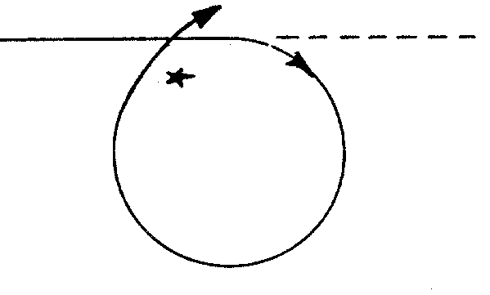

      - Anderson or One Turn Method.
This method should be used during daylight hours when visibility is good and the victim can be kept in sight. After executing the initial turn, the operator continues a sharp turn in the same direction thus completing a full circle. As the operator nears completion of the circle, he should begin to adjust course and speed to make his approach on the victim for recovery. This method is very simple and works very well on vessels that are very maneuverable. It is also the fastest recovery method.

      - Williamson Turn.
This method is best used during conditions of reduced visibility (i.e. darkness, fog, rain, etc.) or when the time the person actually fell overboard is unknown. The primary advantage of the Williamson Turn is that it returns the vessel to its original track on the reciprocal heading thus increasing the chances of finding the victim by backtracking through the "same" water. After putting the wheel hard over, the operator continues turning sharply until the vessel is 60 degrees off the vessel's original heading. Without steadying on a new heading, the operator then shifts the helm to turn sharply in the opposite direction until the vessel is on the reciprocal heading of the original track. The vessel should be kept at full speed until the maneuver is complete at which time the vessel should be slowed and the search for the victim begun.
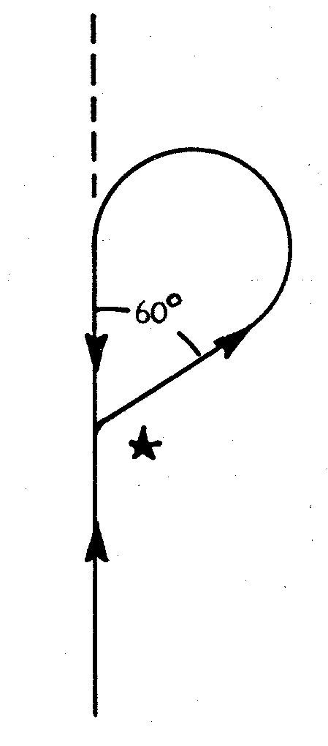
    - The Approach.

There are two recommended approaches for picking up someone who has fallen overboard.

      - Upwind Approach.
In this approach the vessel is maneuvered to a position upwind of the victim with the vessel aligned such that it will drift down towards the victim. This eliminates the need, in most cases, to use engines to maneuver the vessel next to the victim. The disadvantage to this approach, particularly for smaller vessels with a shallow draft, is that the vessel may drift over the victim. Additionally, when the water is rough it may not be advisable to have the vessel's beam to the swell and the rolling may make recovery difficult.

      - Leeward / Downwind Approach.
This approach is very similar to making an approach on a mooring buoy. The approach is started downwind of the victim. The bow is pointed into the wind or current whichever is stronger and enough power is used to maintain positive control of the vessel while maneuvering toward the victim. Once the victim is alongside the vessel the engines should be placed in neutral to avoid injury. The advantage of this approach is that the vessel is under positive control until the victim is alongside and the negative effects of wind and swell can be minimized. The disadvantage is that there is a limited amount of time to recover the victim before wind and/or current cause the vessel to drift away from the victim. Remember, the engines must be kept in neutral while the victim is alongside the vessel. Also if the vessel goes beyond the victim, NEVER back down towards the victim.

    - Recovery

Once the vessel is maneuvered into position near the victim a determination must be made as to how to get him or her back aboard. The method used depends on the condition of the victim. If the victim is conscious and uninjured, recovery is much easier. If the vessel is close to the victim, the victim may be able to swim over and climb back aboard. Otherwise, the operator should direct someone to cast out a line to the victim. The victim should catch the line and be hauled in next to the vessel where he or she can be assisted. If the victim is injured, unconscious, or incapable of grabbing the rescue line, recovery is more complicated. Normally this situation requires the use of a rescue swimmer. The rescue swimmer should be warmly dressed and wearing a PFD with a safety harness or tending line attached. The rescue swimmer swims to the victim, gets a secure hold on him, and is hauled back to the vessel by the tending line. Care must be taken when bringing the victim back aboard not to aggravate any injuries that may have been incurred during the fall overboard. Necessary first aid should be administered and all victims should be treated for shock whether they are conscious or not. A doctor should see all persons who have fallen overboard.

    - Additional Tasks to be Performed

The operator or a crewmember should complete the following tasks as soon as possible after a person falls overboard:

a) Determine the vessel's position at the time the person fell overboard. If the vessel is equipped with a Loran C unit that has a memory button, push it to mark the vessel's location at the time of the alarm. If the vessel is not equipped with Loran C, the vessel operator should use all available means to determine the position. A quick check of prominent landmarks can be used to estimate the position.

b) The operator should sound six short blasts of the horn or whistle. This is the recognized signal to alert other boats in the area that you are performing an emergency turn to pick up a man overboard.

c) If you are unable to locate and/or immediately rescue the man overboard a call should be made using VHF marine radio or other available means to request assistance from the local marine patrol or other available agencies. "May Day" should not be used since the vessel itself is not in distress. A radio request should also be made for medical assistance to the victim upon the vessel's return to shore. If you cannot locate the man overboard you should not leave the area until relieved by local authorities who will take over the search. If you must leave the area, a marker should be anchored in the area to indicate the rough location of the victim's position. This will give authorities a starting point (datum) from which to commence their search.

d) The incident and all details should be reported to M&RV as soon as possible.

  - FIRE

A fire on a vessel is a serious matter. Unlike a fire on land the vessel's occupants cannot simply evacuate the building and stand clear until the local fire department arrives and puts out the fire. On a vessel the fire must be extinguished or people will end up in the water where the danger of drowning or death by hypothermia exists. The danger fire presents is even greater on a Public Vessel where passengers are carried and the potential for injury and panic is greatly increased. The Public Vessel operator and his crew must remain calm and act quickly to ensure the safety of his passengers and extinguish the fire. The following guidelines should be followed when a fire is discovered.

    - Discovering a Fire

a) On smaller vessels the presence of a fire and its location should be readily apparent to the operator. On larger vessels, however, the person spotting the fire should close off the affected compartment and immediately report the fire and its location to the vessel's master or operator.

b) The operator and crew should inform the passengers of the situation, instruct them to move to a safe location on the vessel and have them don PFDs.

c) If the fire is in the engine compartment the operator should immediately shut off the engines, generators, and ventilation systems in the affected compartment. This will ensure that:
1) Fresh air will not be sucked into the fire area thus feeding the fire more oxygen.
2) If it is a fuel fire, more fuel will not be pumped into the fire.
3) Fire fighting agents being used to extinguish the fire, are not vented to the atmosphere
before they can be effective.

d) If the fire is in a space other than an engine compartment all ventilation and electrical power to the affected space should be secured.

e) If the vessel is equipped with a VHF marine radio or other means of communication, a "May Day" call should be initiated to inform rescue agencies of your situation so they may send assistance or provide rescue services in the event the fire is not extinguished and the vessel must be abandoned.

    - Fire Fighting

a) Fight the fire using portable fire extinguishers, fire hoses, etc. or activate the fixed fire fighting system if installed in the affected compartment and it has not activated automatically.

b) Maneuver the vessel to reduce the effect of the wind on the fire. Underway, wind caused by the vessel's motion fans the flames. Stop the vessel or reduce speed to reduce this effect. Also turn the vessel so that the fire is down wind (i.e. blows away from the rest of the vessel). For example, if the fire is aft, point the bow of the vessel into the wind; if the fire is forward, put the stern into the wind; if the fire is in the middle of the vessel, turn the vessel beam to the wind. This will minimize the spread of the fire and keep the smoke away from the vessel.

c) Wet down areas surrounding the compartment on fire, especially areas containing flammable or combustible materials. This will help contain the fire within the affected space.

    - Abandon Ship

If efforts to extinguish the fire are not successful, preparations should be made to abandon the vessel and get everyone as far away as possible. The decision to "abandon ship" rests with the vessel's operator. Before abandoning the vessel the operator should send a final "Mayday" call and fire flares to mark the vessel's location. The operator must ensure that everyone is wearing a PFD prior to going over the side.

    - When the Fire is Extinguished

a) Provide assistance and emergency first aid to those passengers and crew in need of it.
b) Take any steps necessary to prevent a re-flash. If the fire was in an enclosed space protected by a fixed extinguishing system, the space should be kept tightly closed to prevent the escape of extinguishing agent and the entrance of fresh air until the area has cooled sufficiently (usually a minimum of 30 minutes). If the fire was a class A fire thoroughly soak the area with water.
c) After the fire area has cooled, open all hatches and accesses and thoroughly ventilate the space to remove extinguishing agents and any flammable vapors that may be present.
d) Assess the damage to the vessel. If the vessel can be safely operated, return to shore as soon as possible. If the vessel cannot be safely operated, anchor and radio for assistance or use a visual distress signal to get help.

    - Once the Vessel has Returned to the Dock

a) If it has not already been done, report the accident to the local marine patrol.

b) Report the incident by phone to M&RV immediately (within 24 hrs.) especially if serious injury or loss of life has occurred.

c) With the assistance of the local marine patrol and possibly the marine inspector determine the cause of and contributing factors to the fire.

d) File a written accident report.

- NAVIGATION

  - THE COMPASS

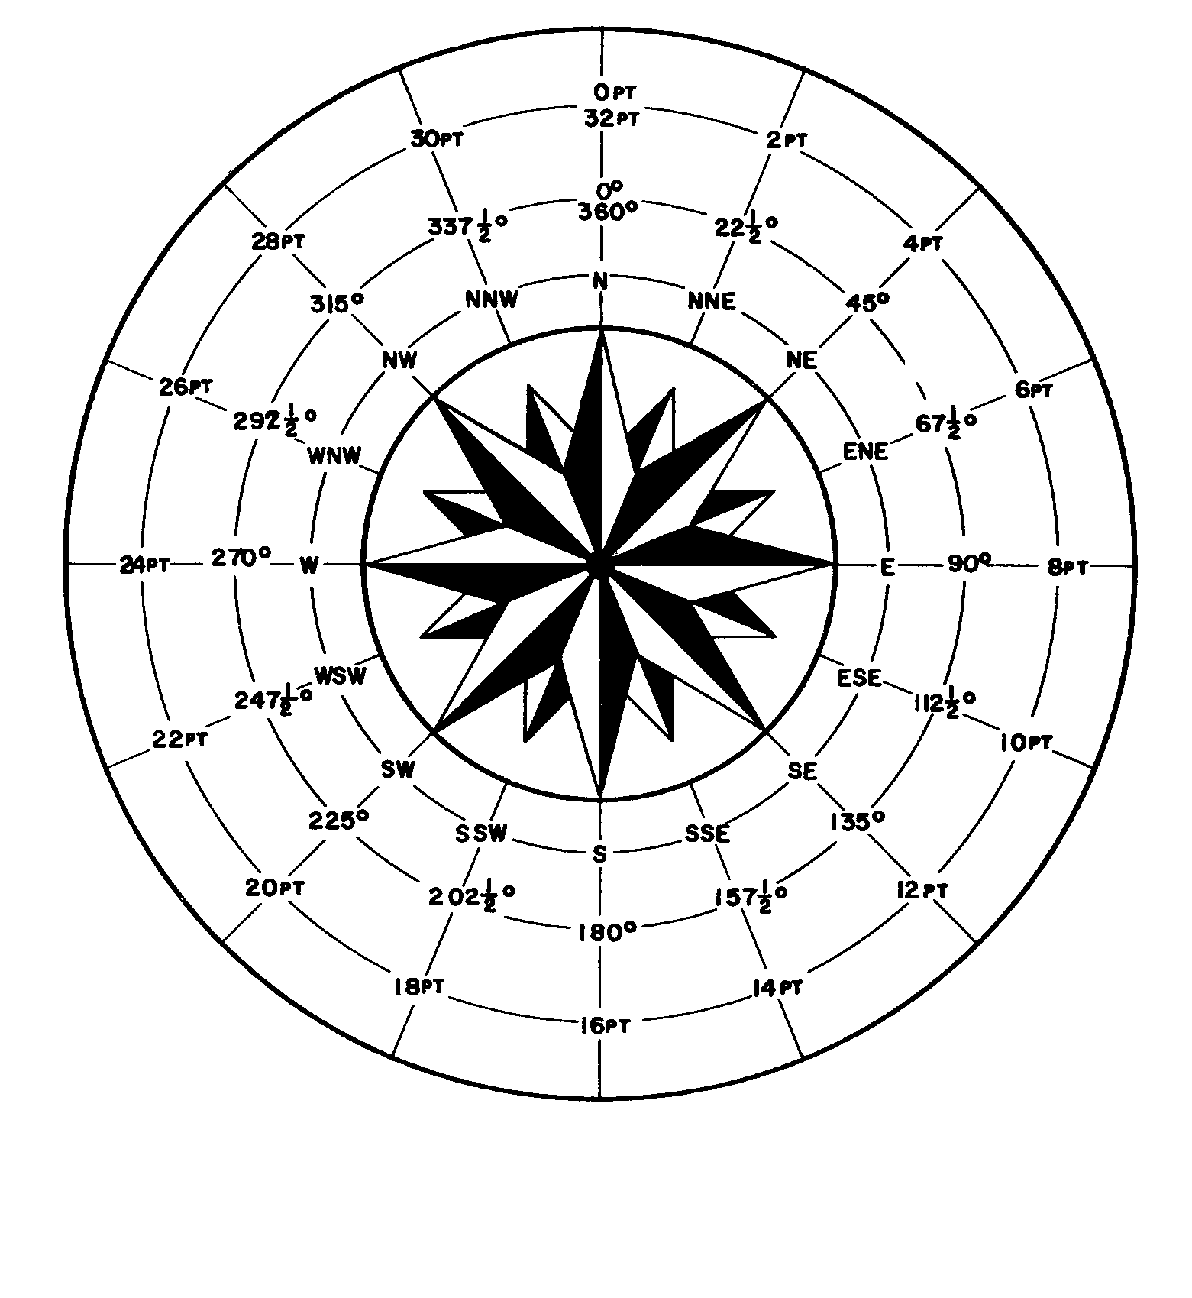
    - Components

Basically a compass consists of magnetized needles, pointers, or bars that are fastened to a graduated card which is then mounted on a pivot permitting free rotation. Rotation upon the pivot allows the magnetized object to align itself in a northerly and southerly direction. This is due to the lines of force formed by the earth's magnetic north and south poles. Generally this assembly is then placed into a sealed bowl which is filled with a low freezing point liquid. The liquid serves to slow the rotation of the compass so that constant spinning and wandering does not take place with each minor change in course.

To permit readings based on magnetic north, a permanent point of reference is necessary. This is accomplished by scribing a line on the forward part of the compass bowl known as the lubbers line. The entire compass assembly is then mounted so that the lubber's line is parallel to the keel of the craft. Courses then may be planned and changes readily seen.

The compass is generally divided either by degrees (360) or by 32 equal points of 11 1/4 degrees each. The vessels heading or course is that point or degree indicated by the "lubbers line." The most important thing to remember is that the vessel, including the compass bowl and lubbers line, revolves about the compass card, and not reverse of this situation.

    - Compass Errors

A compass depends upon the magnetic impulses emanating from the magnetic north pole of the earth. A compass should be mounted in a position that keeps it away from iron, steel, electrical devices and wiring, and other magnetic sources. These materials either contribute to or retain magnetism in an area, and will cause reading errors. This error is called compass deviation and often can be corrected by mounting compensating magnets around the compass. Another method is to record the amount of error on various headings and apply it accordingly.

Due to the fact that the magnetic compass points to "magnetic north," there is a relatively constant error called "variation" which must also be applied to the reading in order to get true north. The current compass variation for any area may be found on a chart of that area.

When a compass is mounted it is necessary that daylight practice be undertaken by running known courses until all error is known or eliminated, and complete confidence can be vested in the compass. The compass should always be relied upon when visibility is limited and navigation aids either lacking or obscured.

  - RELATIVE BEARINGS

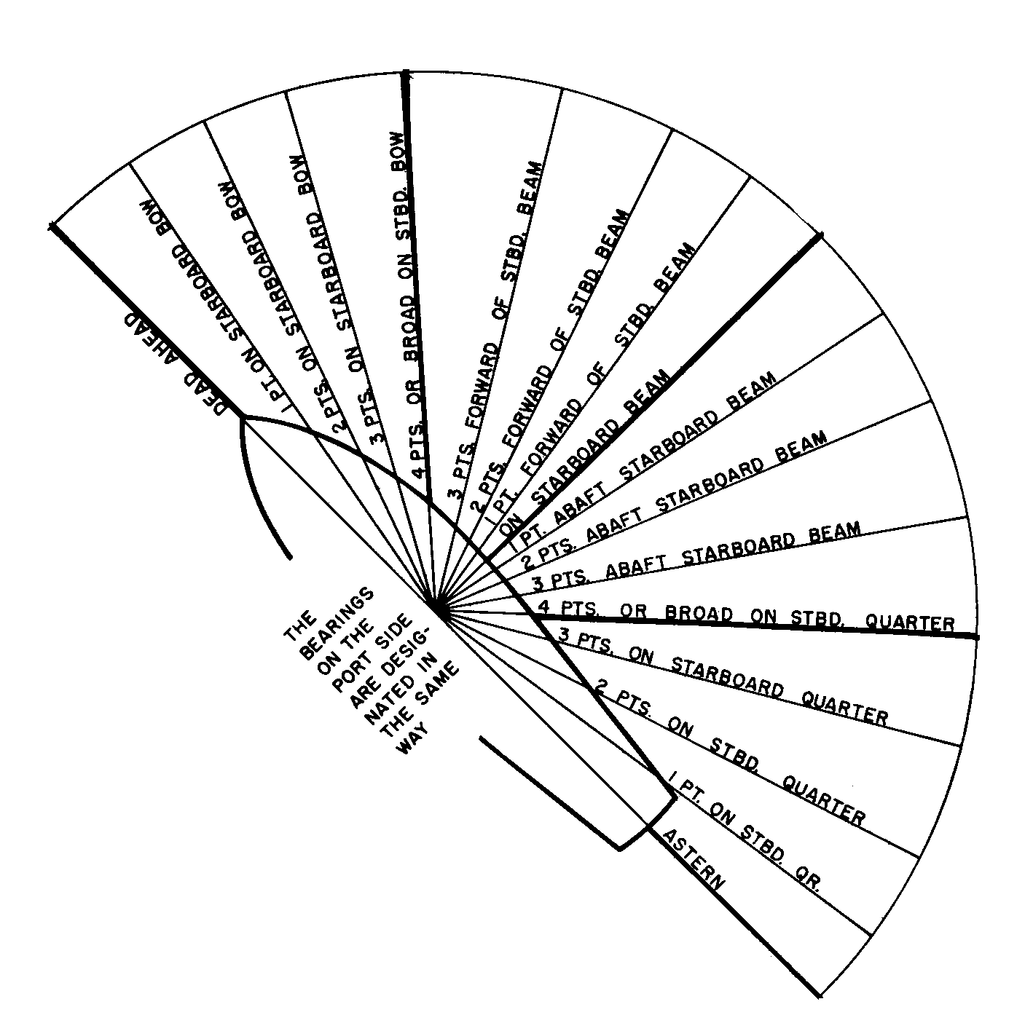
Relative bearings are used to describe the position of an object or another vessel relative to the bow of your own vessel. Relative bearings may be expressed in degrees measured from the bow clockwise 360 degrees. They may also be expressed in terms of points (11 1/4 degrees each) from major points which have names. For example, an object that had a relative bearing of three points on the starboard bow would bear 033 3/4 degrees relative. If the vessel was steering a course of 045º magnetic the object would bear 078 3/4 degree on the vessel's magnetic compass. Relative bearings are useful in navigation where taking a bearing using the magnetic compass may be difficult or impractical. Relative bearings are also useful in tracking other vessels to determine a proper course of action in accordance with the rules of the road.

  - AIDS TO NAVIGATION

Public Vessels operating on New York's waterways rarely operate outside the sight of land. An operator who knows the waters on which he is operating will have little difficulty identifying his position based on prominent landmarks and geography. Even an operator who is not so familiar with the waterway will often be able to identify landmarks from a chart, if one is available. While electronic navigation aids such as loran, radar, radio direction finders, and satellite navigators may be nice to have and useful in some evolutions such as man overboard or operation in reduced visibility, they are not really necessary for the safe operation of the vessel. All the operator really needs is some means to identify the waters in which it is safe to operate. This means is provided on nearly all state waters by aids to navigation (ATONS), specifically buoys. A thorough working knowledge of the ATONS on New York's waters and the system under which they are employed is essential for the safe operation of a Public Vessel.

    - Uniform State Waterway Marking System

Markers placed on New York State waters are placed in accordance with the Uniform State Waterway Marking System (USWMS). The USWMS is a system that was devised for use on lakes, ponds, and rivers within state boundaries. This system is also employed on the State Canal System. The USWMS was adopted by many states throughout the country although some states have modified the system slightly to suit state regulations and local conditions. The system employs two basic kinds of waterway markers - regulatory markers and channel markers. Some markers may be lighted, especially those in critical or particularly dangerous locations. Markers currently used on New York waters are not equipped with sound producing devices, radar reflectors, or other special devices. Most markers placed on state waters under the USWMS are placed by the M&RV Navigational Aids Team.

    - Buoys

All USWMS markers installed by the state are buoys. For this reason only the characteristics of buoys are discussed in this manual. Some markers installed by local governments and law enforcement agencies may be in the form of signs or day markers placed on shore or structures near the water. These signs or markers, when installed, should conform to color and marking scheme of the USWMS.

    - Shapes

Buoys used on state waters are of three basic shapes.

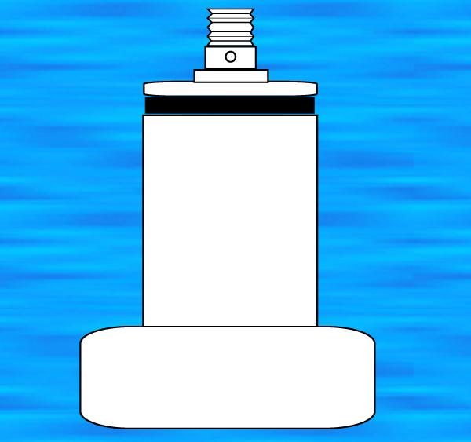
      - Can (left)
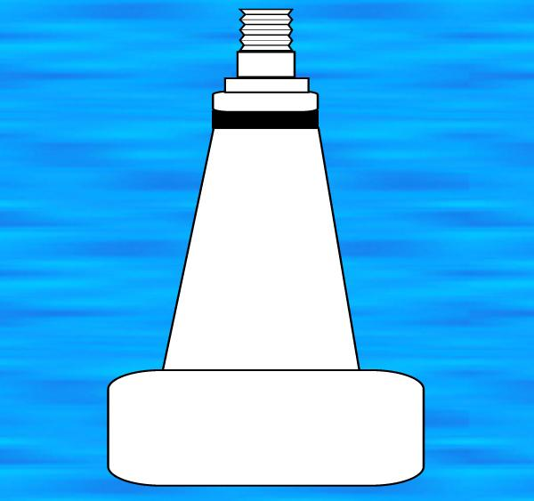
This is a cylindrically shaped buoy having the appearance of an oil drum at a distance. Can buoys are used to mark the port or left hand side of a channel, for regulatory markers, and for some mooring buoys (though most are spherical in shape). A can may be lighted.

      - Nun (right)
This buoy has a short cylindrical bottom topped by a taller blunted conical section Nun buoys are used to mark the starboard or right hand side of a channel. A nun may be lighted.

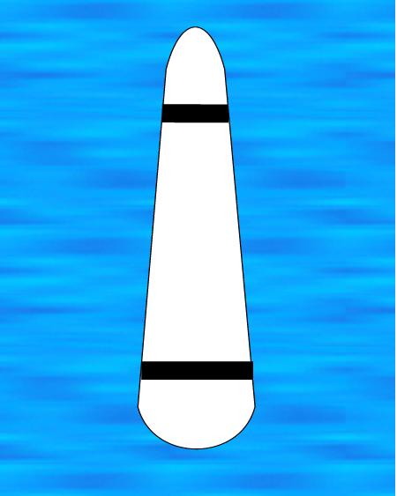

      - Spar
This is a slender tapering buoy that is narrower and rounded at the top. It is much smaller than a can or nun buoy. The spar may be used in place of a nun or can buoy to mark either side of a channel or as a regulatory marker. Its color and markings can determine the spar's purpose. Spars are used to replace all cans and nuns during winter months because they are less susceptible to ice damage. Spars are not equipped with lights.

    - Colors

Channel markers used in the USWMS are red or green in color. A white buoy with orange symbols is used for regulatory markers. A blue horizontal band is used on a white buoy to indicate a private mooring. A plain white buoy with black lettering is used to indicate the outer limits of a special anchorage area.

    - Lighting

Lights are used on some can or nun type buoys. Lights are not used on spars.

      - Color
The color of the light used reflects the buoy's purpose. Red and green lights are used on channel markers. White lights are used on all regulatory markers and mooring buoys. Yellow flashing lights are used on special anchorage area markers.

      - Characteristic
The characteristic of a light describes whether or not the light flashes and if so the length of the on/off time intervals. Characteristics of lights are as follows:
a) Fixed - Light is always on. A mooring buoy is not usually required to be lighted but if lighted must use a fixed white light to distinguish it from a regulatory marker.
b) Flashing - The light is off longer than it is on. Thus, periods of darkness are interrupted by short flashes of light. The light flashes at a rate of 50 or less flashes per minute. The normal rate is one flash every 2 1/2, 4, or 6 seconds. This light may be used on any buoy.
c) Occulting - The light is on longer than it is off. This light is steady with short eclipses of darkness. This is basically the opposite of a flashing light. May be used on any buoy.
d) Quick Flashing - A flashing light with a rate greater than 50 flashes per minute. Usually reserved for use on danger buoys where the hazard is especially severe.

    - Numbering
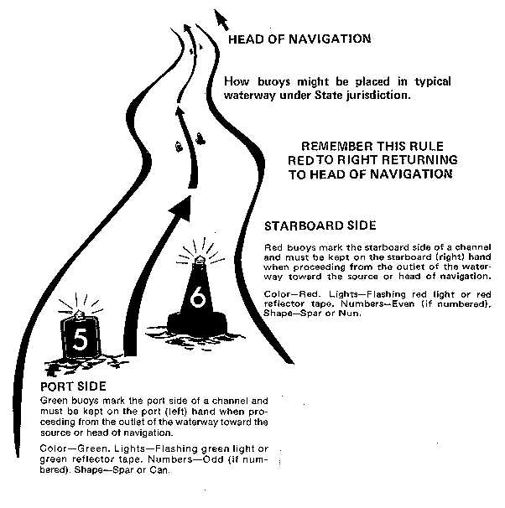

All buoys installed by the state have numbers or letters on them which identify their position on the body of water relative to the head of navigation or inlet. Regulatory markers are identified by letters or a combination of letters and numbers which increase going towards the head of navigation or when proceeding clockwise from the inlet of a lake. Numbers used on regulatory markers are black. For example the first danger or obstruction would have a danger buoy marked with the letter "A". If more than one buoy was required to mark that particular danger the buoys would be marked "A, A1, A2, A3, ..." respectively. Channel markers are identified using numbers only. Red nun buoys are
identified by even numbers and green can buoys are identified by odd numbers. The numbers increase when proceeding towards the head of navigation. Numbers are placed on channel markers using white reflective tape.

    - Head of Navigation

A thorough understanding of the term "Head of Navigation" is essential to any discussion of waterway markers, their placement, and their use. On a large body of water such as the ocean, Long Island Sound or Great Lakes you proceed toward the head of navigation as you enter port or return from sea. On a river you proceed toward the head of navigation when going upstream. When operating on an inland lake the head of navigation is the inlet to that lake. If there is more than one inlet, usually the largest one will be designated as the head of navigation. If there is doubt as to where the head of navigation is located for a particular body of water talk with the local marine patrol or the agency responsible for buoyage on that waterway.

    - Channel Markers

Channel markers are utilized in areas where safe navigation may only occur within a limited area of the available water. The buoys will usually be used in pairs to mark a channel where the most water is available and where most vessels may safely pass. The fact that a channel is marked does not guarantee safe passage for all vessels. Available depth in the channel should be checked before using it for the first time.

When operating in a marked channel, red, even numbered, nun buoys or red, even numbered spars will mark the right or starboard side of the channel when proceeding toward or returning to the head of navigation. Green, odd numbered can buoys or green, odd numbered spars will mark the left or port side of the channel. The rule to remember when operating in a channel is, "Red, Right, Returning".

    - Regulatory Markers

Regulatory markers consist of buoys and signs which provide general information, information pertaining to rules and regulations affecting the area, or indicate local dangers to navigation. Regulatory markers are white buoys or spars with orange symbols. The orange color makes the marker visible at a distance alerting the boater to approach with caution. The shape of the symbol on the buoy indicates the marker's purpose. Lettering on the marker may be present to provide specific information on the nature of the danger or control indicated. There are four types of regulatory markers.

    - Danger Buoys

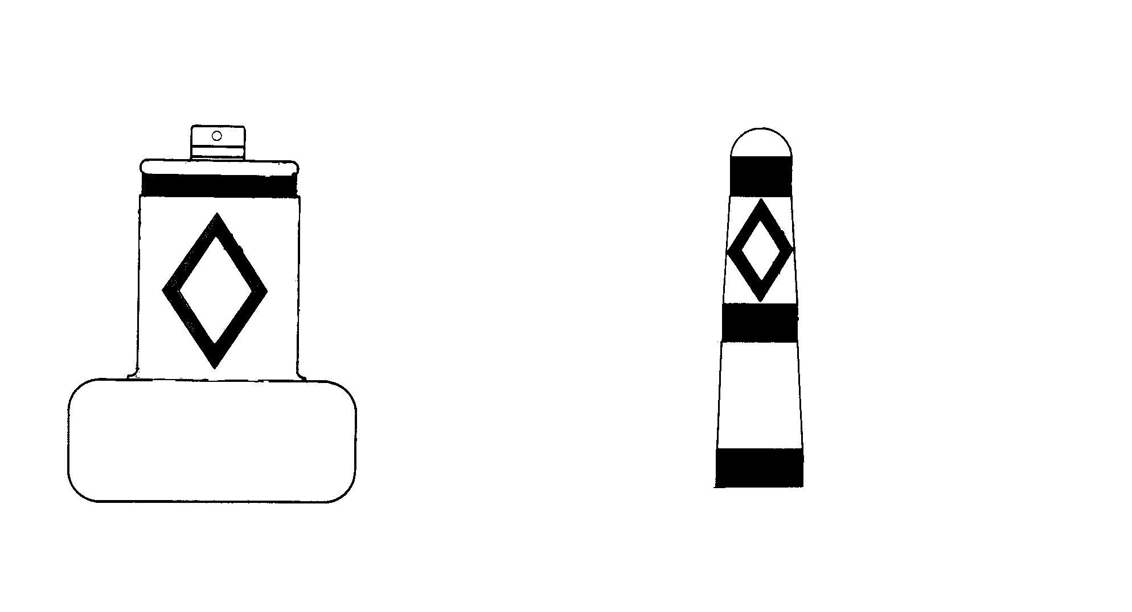
Danger buoys use a diamond symbol to convey their meaning. They may be used to mark the location of rocks, wrecks, submerged logs, or other hazards to navigation. When a marker is located near shore, do not pass between the buoy and the shore. A ring of buoys will mark large offshore obstructions while a single buoy may mark smaller obstructions. Always stay well clear of any danger buoy.

    - Vessel Exclusion Area Markers

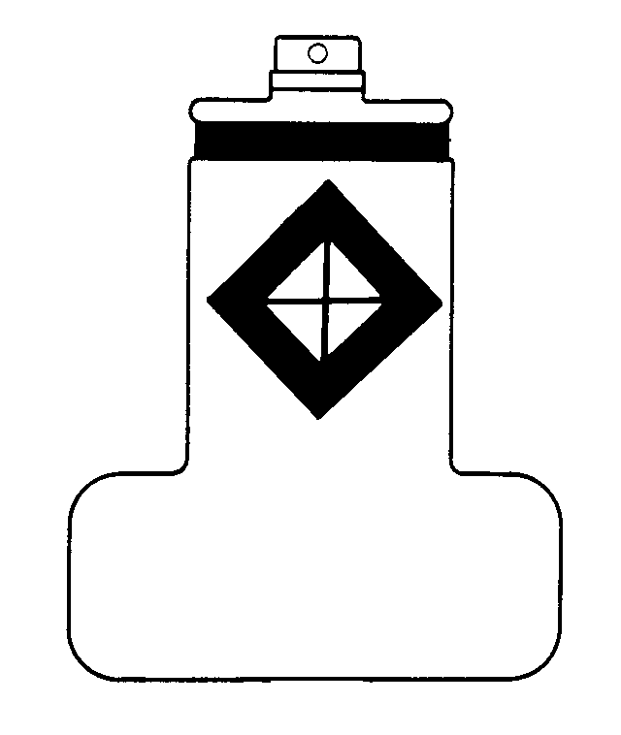
A marker using a diamond with a cross in the center indicates a vessel exclusion area. All vessels are prohibited from entering the marked area. This type of marker is usually used to indicate swimming areas, waterfalls, or other areas where entering the area could have a severe or life threatening impact upon the vessel operator or other persons in the area.

    - Vessel Control or Regulation Marker

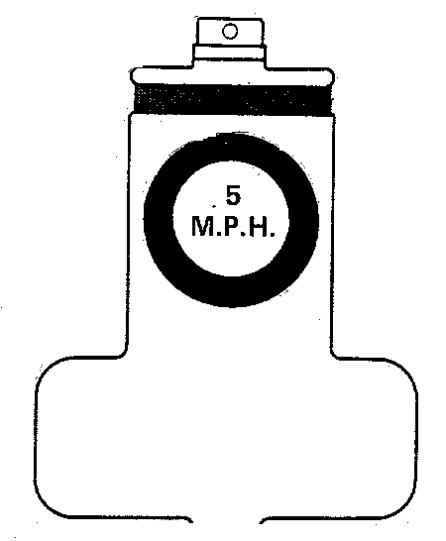
A marker using a circular symbol indicates an area where vessel operation is restricted or regulated in some manner. The most common use of this type of marker is to indicate speed limits or no wake zones. Violating the restriction indicated on the marker, is a violation of the law.

    - Informational Markers

Markers used for informational purposes only will utilize a square symbol to indicate their purpose. These markers have no navigational significance and may be used to give directions, a location, or distances. They are similar in use to highway exit or services signs.

- WEATHER

  - READING THE WEATHER

Weather is never certain. There are no rules or sayings that are always true. A dark sky may not create a weather disturbance, and the clearest day may develop a storm in just a few moments.

Weather changes usually move from west to east in this part of the country. This has led to a saying that bad weather generally comes from a westerly direction. Chances are that a storm to the west will be upon you soon and seldom pass your area without presenting a storm condition. Storms to the north or east occasionally pass over, but this cannot be depended upon and generally when a storm is suspected, Public Vessels with passengers should head for the nearest port or protected harbor.

Be alert to shifts or changes in the direction of the wind. When the wind shifts it generally means that a weather change is on hand. This also applies when poor weather is present, indicating that more favorable boating conditions may soon appear.

Storms usually occur when two air masses of different temperatures come together, and one overrides the other. This causes an unstable condition and affects the ability of the air mass to hold water vapor as the temperature changes. These points where the air masses meet are called fronts. Storm fronts are normally associated with low atmospheric pressure, therefore a falling barometer indicates the possibility of bad weather. The more rapidly the pressure falls the more likely the storm will be severe. A rising barometer usually indicates the approach of better weather.

Clouds can also be a good weather indicator. High clouds are generally associated with good weather. Lower cloud formations usually mean rain. Dark cumulonimbus clouds with high vertical development indicate a thunderstorm is imminent.

  - STORM WARNINGS

The responsible Public Vessel operator must be constantly mindful of his course and have his senses tuned to changing weather conditions. Storms cause their greatest havoc when the operator is not prepared for them. In general, Public Vessels should not leave the dock when there is knowledge that a storm is on its way. The operator must pay close attention to all weather forecast media including marine band facilities on radio, newspapers, and long-range forecasting as furnished by the United States Weather Bureau. In addition, weather information should be garnered from knowledge of local conditions and a constant scanning of the sky to determine if changes are taking place.

Storms can produce strong winds and heavy rain which may be accompanied by lightning. All three can affect the operation of a vessel and endanger its passengers. Heavy rain may significantly reduce visibility. It may also cause smaller boats to fill with water faster than the bilge pump can remove it. Strong winds may affect the operator's ability to steer the boat as the wind and waves may work against the forces of the propeller and rudder. Strong winds travelling over a distance on water can also produce waves that could swamp or capsize smaller vessels. The dangers of lightning on a boat are similar to those on land except that a boat on the water is more likely to be struck.

Under no circumstances should a Public Vessel take passengers aboard when storm warnings are present. The United States Weather Bureau and the United States Coast Guard provide small craft storm warning information which is generally relayed into boating areas. Occasionally, yacht clubs have taken upon themselves the responsibility for hoisting these warnings through the use of pennants or flags during the daylight hours. Be constantly alert for such warnings. In the evening and at night, lights are used. A red light over a white light is a small craft storm warning and should this be seen at night, head for the nearest safe port.

It is to the advantage of every boat operator to familiarize himself with weather forecasting procedures and to learn to spot possible weather trouble by observation of existing natural conditions.

- SPECIAL ACTIVITIES

  - WATER SKIING AND OTHER TOWED ACTIVITIES

The Public Vessel operators using their craft for water skiing and other related towing activities must exercise extreme caution in its operation. They are responsible not only for the safety of the boat and its passengers but also for the safety of the towed individual and other water users in the area. Consequently, the laws that cover them are not only those that would apply to any Public Vessel, but also those that apply specifically to vessels involved in these type of activities. Failure to comply with either group of these laws can lead to revocation of operator's license in addition to other penalties.

    - The Law
A VIOLATION OF THIS SECTION OF THE NAVIGATION LAW WILL RESULT IN THE ISSUANCE OF A SUMMONS AND A FINE OF $25 FOR EACH OFFENSE.
Persons engaged in any activity involving the towing of persons behind a boat, including, but not limited to waterskiing, kneeboarding, wakeboarding, barefooting, and parasailing must observe the following:
a) There must be an observer in addition to the operator in every boat towing a water skier, at least 10 years of age.
b) These activities are prohibited between sunset and sunrise.
c) Any person being towed behind a vessel must wear a USCG approved Personal Floatation Device.

    - The Boat Operator

The operator's primary responsibility is to ensure that the course of the vessel is constantly clear of obstructions and safe for the traverse of the person towed. The operator's attention should be directed to the operation of the vessel and serving as a lookout for traffic and other hazards that could endanger the towed individual or the vessel. The operator should not serve as an additional pair of eyes to observe the towed individual. This is why the law requires an observer and the operator must respond to the information relayed to him by the observer. It is important for the operator of such a vessel to remember that he receives no special consideration under the Rules of the Road. Therefore, should a situation arise he must respond as any other vessel under power. Other vessels may, out of courtesy, stay clear of you but are not required to do so.

In general, when bringing a water skier or person towed from the shore or a dock area, the operator should take a direct course into the operating area only after being completely assured that the course is clear for entry. He or she should use only sufficient power to proceed to the area and to carry on those activities required in this form of recreation. The ability and desires of the person towed as relayed through the observer should govern boat speed. The operator should not use excessive speeds at any time. The boat should not make unnecessary sharp turns while towing a person. The operator is responsible for ensuring that proper instruction and safety principles are observed at all times.

    - The Observer

As stated above, any vessel involved in water skiing or towing an individual must carry an observer in addition to the operator. The observer must be at least ten years of age and is charged with the sole responsibility of observing the person towed. This includes observing, in addition to the person towed, the boat's wake, the tow rope, and any other important factors which may directly affect the performance or safety of the skier. The observer must relay this information to the operator of the vessel so that he can take appropriate action. It is recommended that the observer also be qualified to assist in water rescue of disabled skiers and trained to recognize the capabilities of the person towed to undertake activities being engaged in of increasing difficulty.

    - Equipment

Vessels engaged in water skiing must meet the same equipment requirements that any other Public Vessel must meet with one exception. The inspector, at his discretion, MAY permit a vessel engaged in water towed recreational activities to substitute Type III buoyant vests for the required Type I with the stipulation that they must be worn. This stipulation includes the person towed. If this exception is found to be abused it may be revoked at the inspectors discretion. The wearing of personal flotation devices is strongly encouraged regardless of the type used. The skier must wear one at all times.

Tow ropes when released by the person towed should be immediately retrieved and not allowed to trail except for pick up of the person towed.

The operator of the vessel should check all of his equipment prior to each trip to ensure that all necessary gear is present, in good condition, and functionally sound.

    - Water Skiing Hand Signals

Prior to taking a skier out, the operator of the craft should be sure that the water ski signals to be used by the skier (in communicating with the observer) are completely understood so that the information which the observer relays to the operator will be factual, rather than assumptive. In general, the skier should be depended upon to signal his intent, and the flow of communication from the observer to the operator must be continuous and clear. All actions taken by the operator must be in keeping with safe, prudent operation of the craft at all times. Hand signals are shown below.
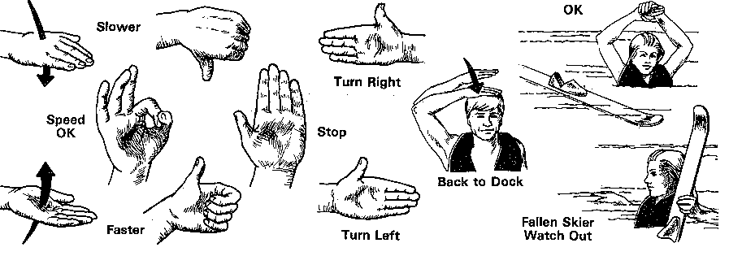

  - PARASAILING

Parasailing is a relatively new and innovative sport with limits that have yet to be fully explored. Therefore, the Public Vessel operator engaged in this activity must take additional precautions to ensure the safety of the parasailer. The vessel operator must comply with all laws applying to Public Vessel as well as any state or local regulations governing this activity. In general, the operator of the vessel engaged in parasailing should follow the basic rules governing water skiing. In particular, the operator may not engage his vessel in parasailing during the period from sunset to sunrise and while towing a parasailer he must have an observer in the boat. A person watching the parasailer from the launching and landing raft is not a valid observer and is unacceptable.

    - The Tow Boat Operator



The responsibility of the vessel operator is the same as that of the ski boat operator; to safely operate the towboat with due regard to any hazards and in compliance with the rules of the road. He must maintain a proper lookout both on the water and airspace along the course ahead. He is not to act as an additional set of eyes observing the person being towed.

  - The Observer

The observer must be at least ten years of age and is charged with the full time responsibility of observing the parasailer and any hazards which may affect his safety. The observer must relay the information to the operator who must take appropriate action with due regard to the safety of his tow and his surroundings. The observer should be qualified to perform his task in that he should have a thorough understanding of the sport and how various factors such as wind, boat speed, etc. affect the parasailer. He should be able to rescue a downed parasailer should it be necessary.

    - Equipment

The safety of the person being towed greatly depends on the condition of the parachute, harness, and tow line. It is essential that they be checked frequently to ensure that they are functionally sound and in good condition. If any defect is discovered it must be rectified by repair or replacement before parasailing is continued. In addition to the above equipment, the operator must require that the parasailer wear a U. S. Coast Guard approved personal flotation device at all times while being towed.

  - SCUBA DIVING AND SNORKELING

Persons trained in the use of diving and snorkeling equipment are undertaking much valuable work in regard to salvage and search under water. Scuba diving and snorkeling are also very popular recreational activities.

Generally, it is impossible to tell at a glance what the purpose of the person in the water may be, but this is of small concern when the Public Vessel operator remembers that it is his responsibility to insure the safety of all persons using the waterways, for whatever purpose.

The traditional skin divers flag is red with a white diagonal stripe and has been adopted for use by persons engaging in underwater activities. If however, a vessel engaged in diving operations is restricted in its ability to maneuver, it must display a rigid replica of the international code flag "A" which is to be one meter in height. The traditional red and white divers flag may be shown in conjunction with the alpha flag. Public Vessels engaged in diving operations are required to display one or both of the flags at all times when they have divers or snorkelers in the water. Divers are required to remain within a hundred feet of the dive platform at all times unless they are tethered to a separate float with a diver's flag displayed.

It is also important that operators of vessels not engaged in diving operations understand the meaning of these flags. Recognition of these flags may save a diver's life. If you see the flag floating, do not approach within 100 feet. If you see air bubbles on the surface of the water stop your engines immediately and do not pass over the area!
!
  - PERSONAL WATERCRAFT

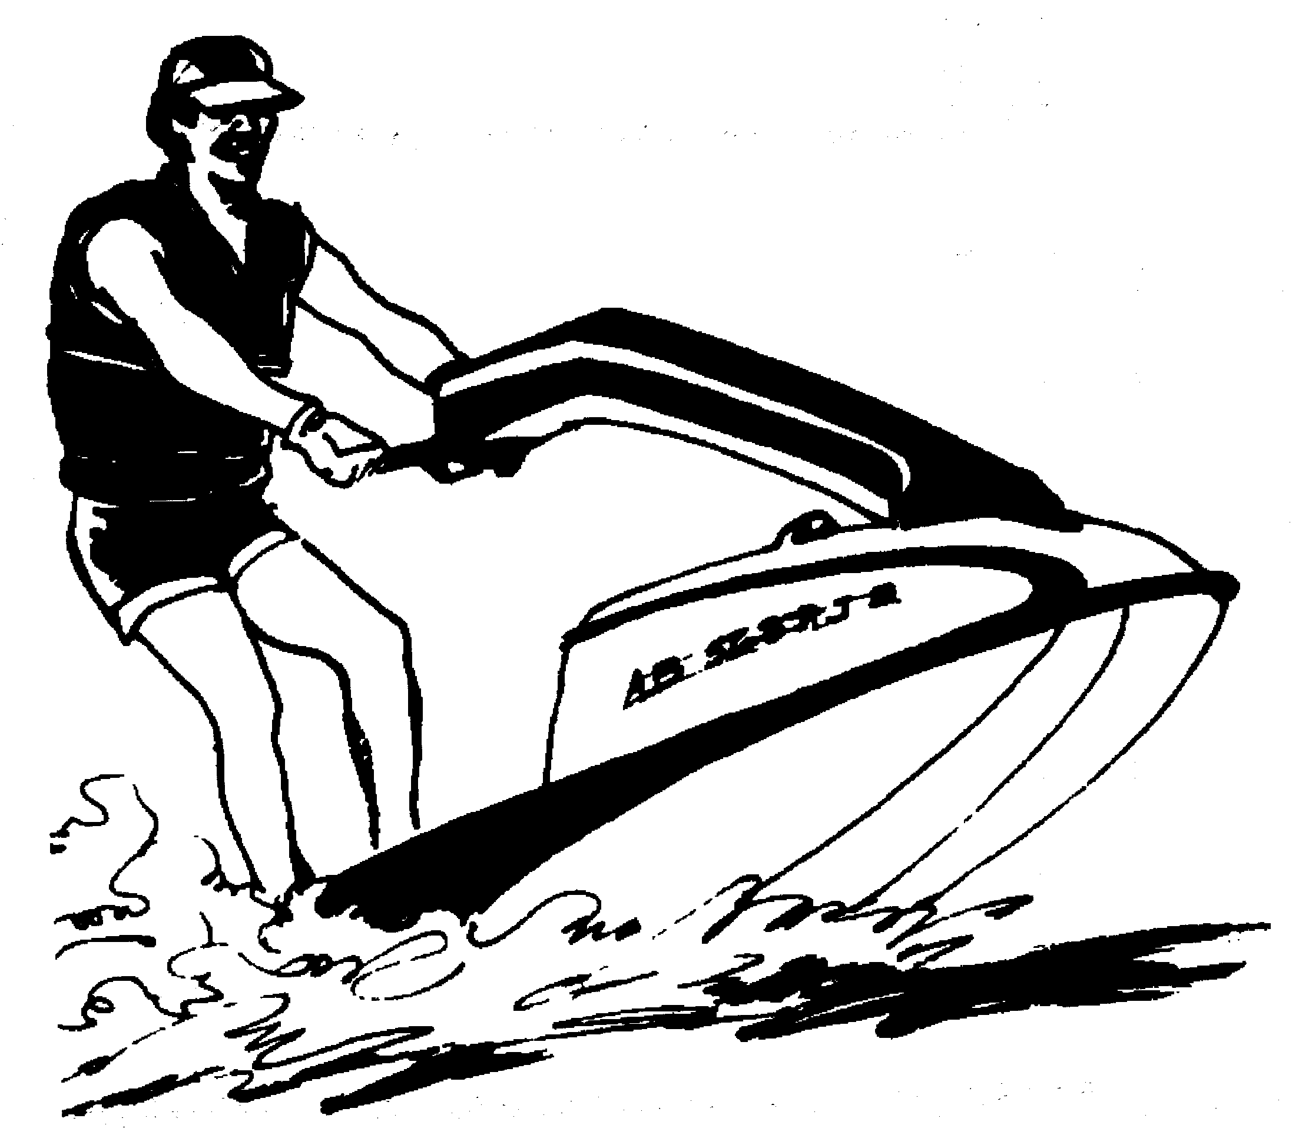
Personal Watercraft(PWC) is a generic term for the small boats sold under the brand names of Jet-Ski(Kawasaki), Wave Runner(Yamaha), and Sea-Doo(Bombardier) to name just a few. The original models were designed to be operated in the standing position and were relatively difficult to operate. Since the 1980's most manufacturers have introduced models that can be operated in the sitting position. These craft, which now dominate the PWC market, have greater stability, are more comfortable to ride and easier to control. These characteristics appealed to a much larger segment of the population than the original designs. The popularity and sales of these models has soared since their introduction and continues to grow. Some of the reasons for dramatic growth in sales and popularity are:

Speed - Some newer PWCs are capable of speeds in excess of 50 mph. Most waterways have no speed limits once away from shore. Riders enjoy the freedom of going full throttle.
Easy to Operate - It doesn't take very long and it isn't very difficult to learn the basics of handling a PWC.
Very Maneuverable - PWC are fast, accelerate quickly, and can turn in very short distances. These machines are more responsive and able to perform maneuvers that traditional boats can't.
Affordable- Depending on the machine, you can buy a new PWC with trailer for much less than most conventional motorboats.
Economical to Operate - Fuel, oil, and maintenance costs are relatively low.
Easy to Trailer, Launch and Retrieve- Because of their relatively light weight, PWCs can be towed behind just about any vehicle, put in the bed of a pickup truck, or inside a van with a special launching device. They can also be launched from almost anywhere even
unimproved ramps.
Operate almost anywhere - Due to a shallow draft and the lack of a propeller or other components that extend below the hull, PWCs can go just about anywhere. They can go into the shallow waters where traditional boaters dare not go.
Can be used as a dinghy or tender. Some owners of larger traditional boats have discovered that PWC are an excellent way to get to and from their boat when anchored.
Fun to Ride - Like those who have operated or taken a ride on a motorcycle, ATV, or snowmobile, most people who have shared the PWC experience find them exciting and fun to ride.

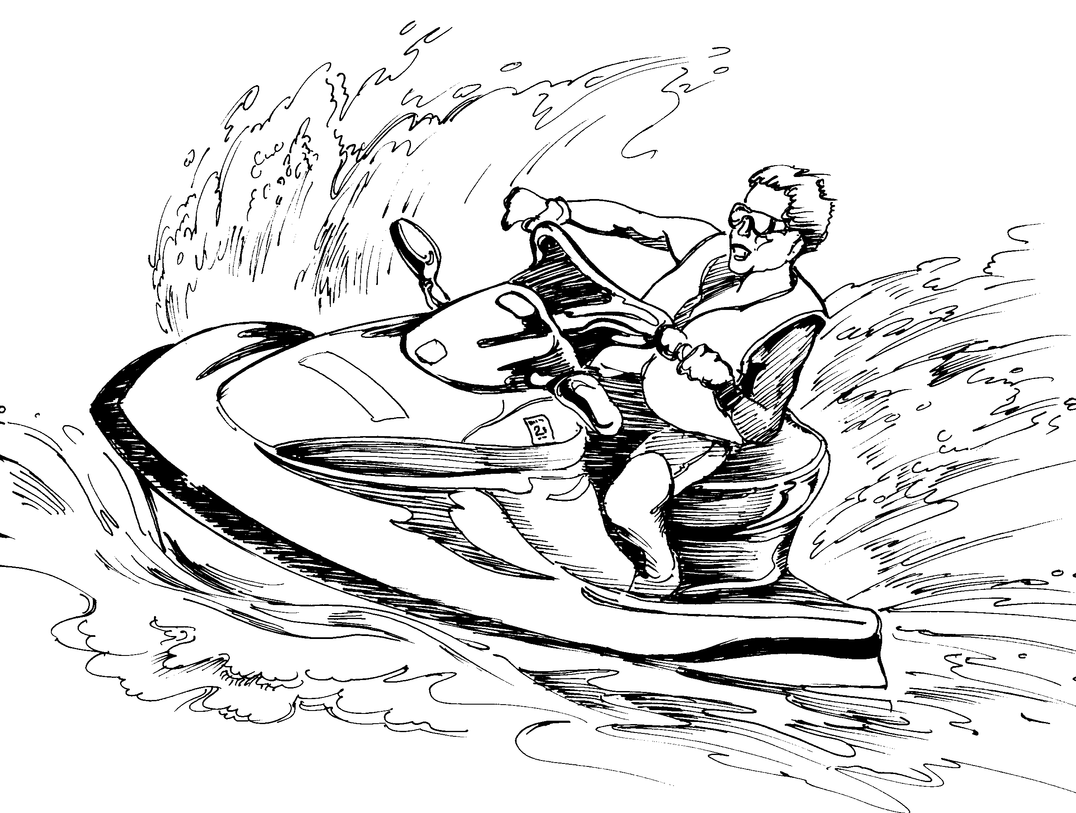
The rapid and dramatic entrance of the PWC onto New York's numerous waterways has not been without problems. Their speed, maneuverability and ability to do things traditional boats can't combined with the reckless, irresponsible behavior of some operators has created many conflicts with other waterway users and shoreside property owners. The number of PWC involved in boating accidents has increased dramatically accounting for nearly thirty percent of all boating accidents. This has attracted attention and concern by many groups including other boaters, shoreside resident, law enforcement, and state government.

Most of the problems associated with PWC stem from one or more of the following:

Lack of Boating Knowledge and Experience - Many people who operate boats, including PWC, have never taken a boating safety course and have very little boating experience prior to buying their first boat.
PWC Operators don't think of their craft as a boat. Because of its unique characteristics and ability to do things other types of boats can't.
Riding Habits or Behaviors that Annoy Others. These will be discussed in detail later.
Lack of Respect for Others - Some riders act as though they are the only ones trying to enjoy the water. There are many recreational activities that can be enjoyed in and around the water such as fishing, swimming, diving, and boating. Some people just want to enjoy peace and the quiet beauty of nature near the water. PWC riders should realize that what is a lot of fun to them may be completely ruining someone elses enjoyment.
Irresponsibility - This is probably the worst type of behavior because it leads to acts that may seriously injure or kill someone. Irresponsible riders are, or should be, aware that their actions may endanger themselves or others but choose to continue them.
Tunnel Vision - Some operators become so excited and involved in riding the PWC that they can lose track of what is going on around them or the effect their actions may have on others. This is not only inconsiderate but could be dangerous to others or themselves.
Operator Too Young - Younger operators may lack the strength and coordination to properly control the machine. They may also be too young to exercise good judgement and common sense. Most companies that make PWCs recommend 16 as the minimum operating age.

There is one thing that each item in the above list has in common, the operator. The problems attributed to PWC are caused by the operator NOT the machine. This means the problems can be fixed or made better by learning and using positive behaviors. PWC can be operated responsibly and still be a lot of fun.

11.4.1 WHAT IS A PERSONAL WATERCRAFT AND WHY ARE THEY DIFFERENT?

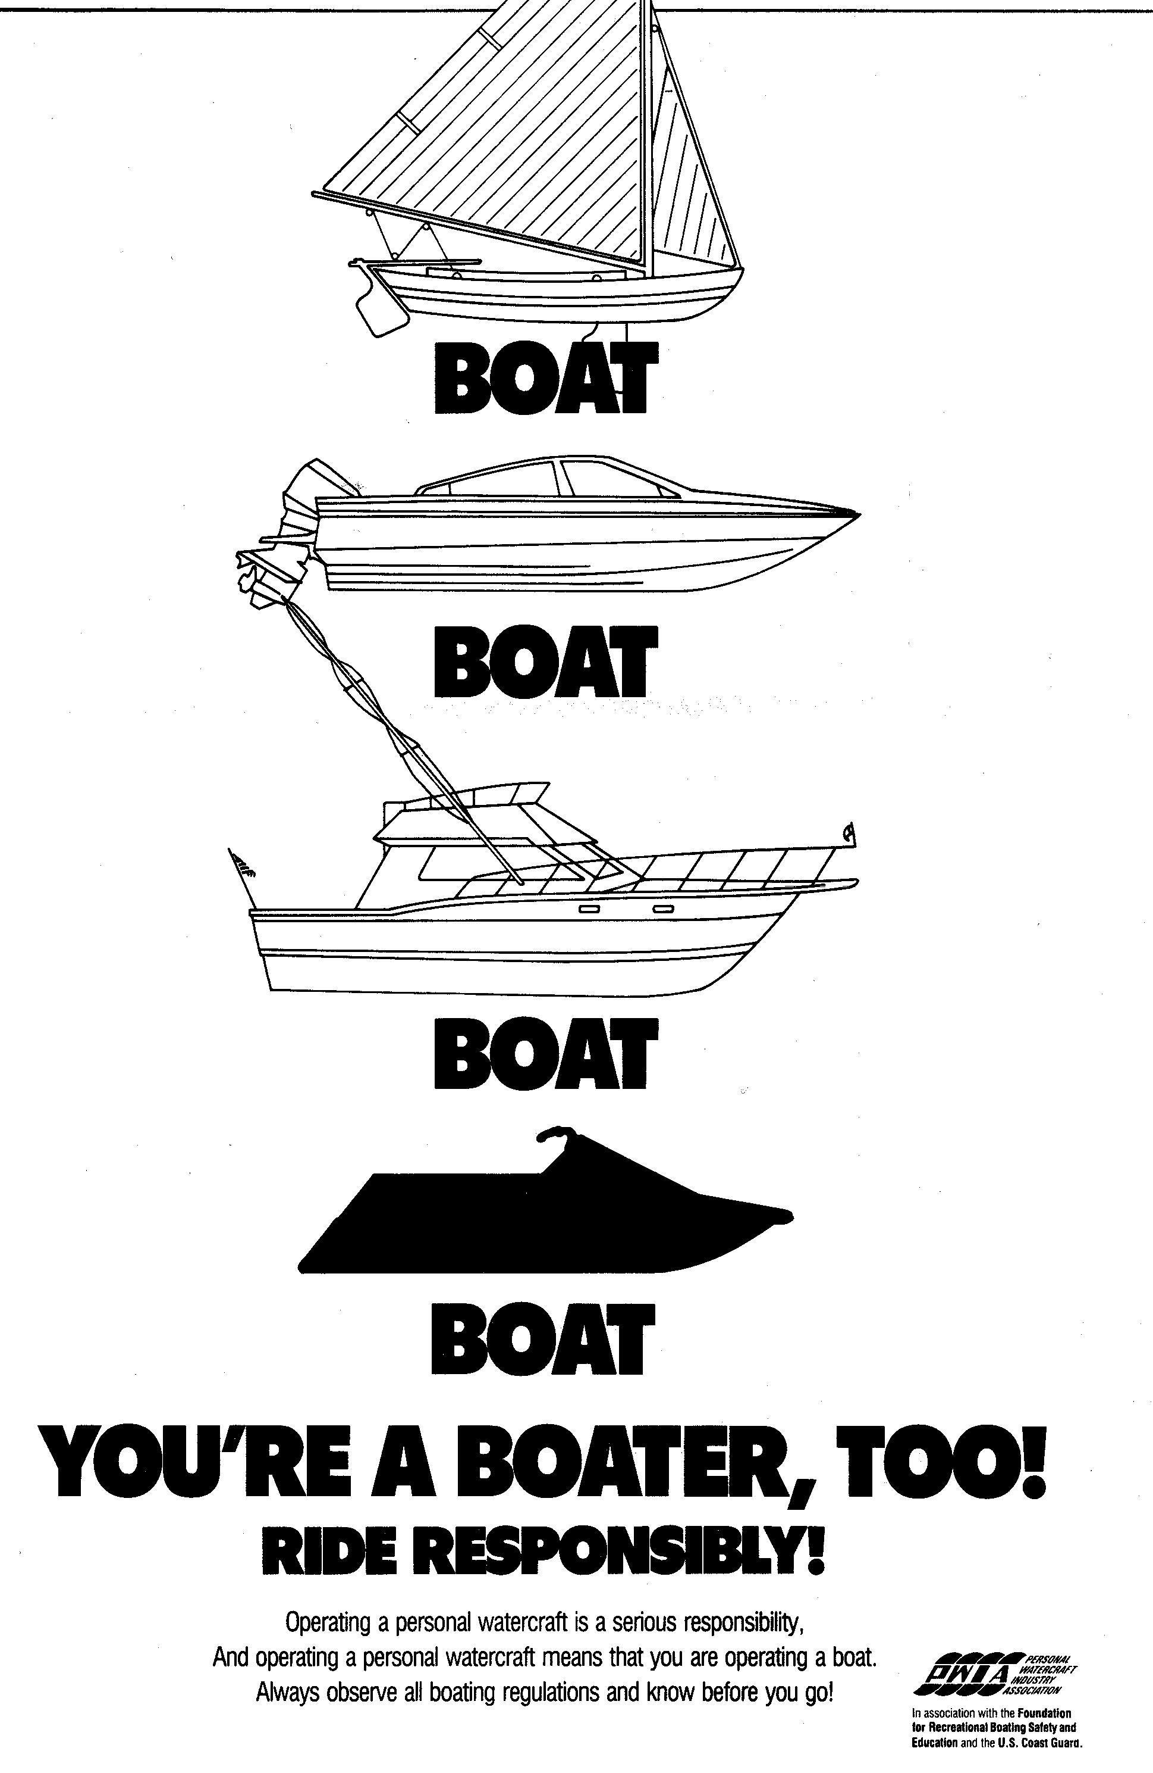
A Personal Watercraft IS A BOAT!!
The first thing that every rider of a PWC must realize and accept is that the craft they are operating is a boat, subject to many of the same laws as conventional boats including:

Rules of the Road
Registration
Boating under the influence of drugs or alcohol
Speed limits
Waterskiing
Reckless Operation
Pollution
Noise

    - Personal Watercraft Defined

The New York State Navigation law defines a personal watercraft as:

"...a vessel which uses an inboard motor powering a water jet pump as its primary source of motive power and which is designed to be operated by a person sitting, standing, or kneeling on, or being towed behind the vessel rather than in the conventional manner of sitting or standing inside the vessel.”

Two key elements in the above definition distinguish PWC from other boats:

1. Water-Jet pump drive
2. Sit or stand ON versus IN the craft

Based on this definition, it may seem pretty simple to identify a particular craft as a PWC. But the distinctions are becoming increasingly blurred. For example, many traditional boat manufacturers are producing models equipped with water jet drive. While these boats handle much like a PWC, they are not PWC because they are designed for the operator to sit inside the boat in the traditional manner. Boats like the "Jazz"(Bayliner), "Rage"(Boston Whaler) or Sea Raider (Sea Ray) are good examples.

11.4.3 How Do Personal Watercraft Work?
It is very important that you learn the basic operating principles of a PWC before getting on one. This section covers the design and operation of the water jet drive, how to control its thrust to maneuver the machine, and how you can use your body weight to assist in that control.

a) Water Jet Drive - The water jet drive is nothing more than a pump designed to move and control water flow. It consists of three basic parts, the intake, the impeller, and the steerable exhaust nozzle.

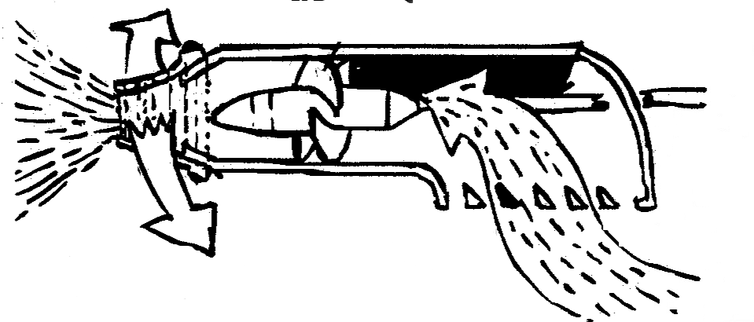
Intake - Water enters the unit through the intake which is located on the bottom of the hull. The intake is usually equipped with a protective grate to prevent debris from getting into the unit where it could damage the impeller or injure someone if it shot out the nozzle.
Impeller - The impeller is the heart of the drive unit. It draws water through the intake, increases its pressure to create thrust, and forces it out the stern causing the craft to move forward. The impeller is connected to the engine by a sealed shaft. The impeller is like a propeller inside a tube. There is no transmission so the impeller is always turning and moving water (in one direction only) whenever the engine is running.
Steerable Exhaust Nozzle - The water exits the drive unit through a steerable exhaust nozzle at the stern of the craft. The exhaust nozzle is connected to the craft's handlebars by a steering linkage or cable allowing the exiting jet of water to be turned from side to side.
Reversing Mechanism - Some PWC are equipped with a reverse capability. These models have a reversing mechanism attached to the exhaust nozzle. It is often called a "clam shell" because of its shape. It is connected to a lever located near the operator. When the operator moves the lever to the reverse position it lowers the reversing mechanism into the exiting stream of water which redirects the thrust under the hull causing the craft to move in reverse. The reverse capability is very limited and controlling the craft can be erratic. It should not be used as a brake at higher speeds because it could cause the operator to lose control or be thrown off the machine.

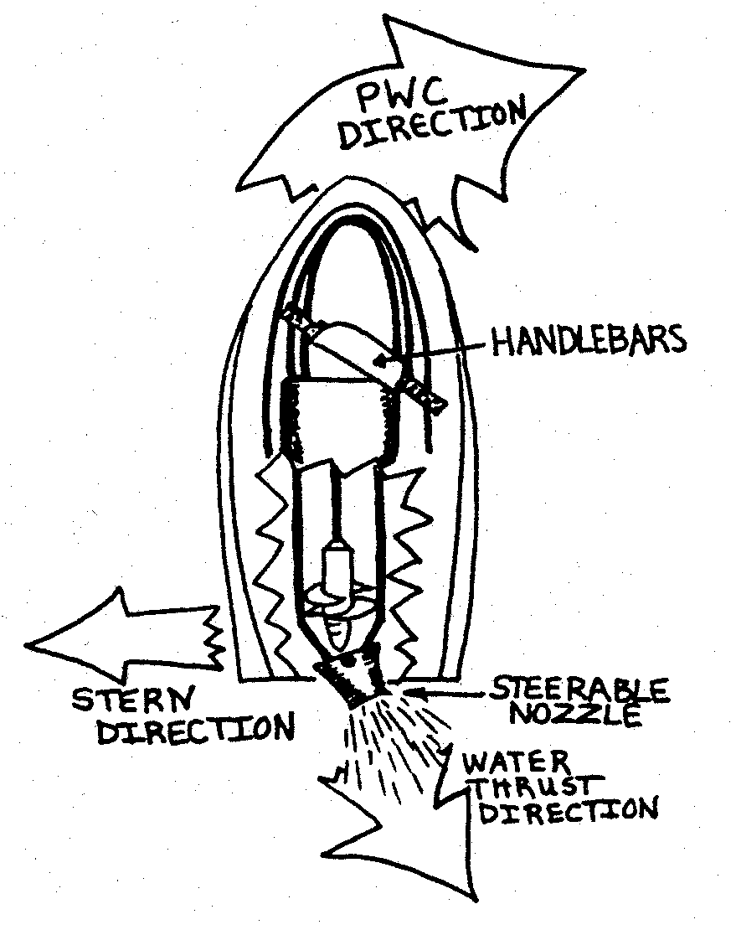
b) Steering - There are three ways to steer a PWC. Using the handlebar, using body movement, or both.
The handlebar is the primary means of turning a PWC. When the handlebar is turned, it turns the steerable exhaust nozzle in the same direction. The thrust from the water jet pushes the stern of the craft in the opposite direction causing the bow to turn in the desired direction. Using the handlebar is effective under all conditions except when there is no thrust being generated (i.e. engine idling or stalled).

Using body movement can also be effective in controlling the direction of a PWC. It is most effective at higher speeds and is done by shifting body weight or leaning in the desired direction. Since the operator's weight is located aft of the craft's pivot point, this causes the stern to "slide" in the opposite direction and bow to point in the desired direction.

Using the handlebar and body movement together is very effective for making very sharp, quick turns. It requires less distance to complete the turn and is effective at most speeds. If done too quickly at high speed it may cause the operator to lose control of the craft and possibly fall off.

c) Controlling the speed of a PWC - This is done using the throttle mechanism usually located near the right hand grip. It may be a trigger control (pull) or thumb control (push) type. The control is connected to the engine by a spring-loaded cable mechanism. Squeezing the control increases engine speed. Releasing the control completely returns the engine to idle speed. It is important to remember that a PWC, like any other boat, does not have brakes and that the craft will continue to move through the water after the throttle is released.

d) Off-Power or Off-Throttle Steering- A unique maneuvering feature of the water jet drive is that it requires no components that extend below the hull of the craft to control it. There are no propellers, skegs, outdrives, or rudders. This makes reboarding a PWC, after falling, safer and easier. This feature can cause difficulties when attempting to turn the machine under certain circumstances or in an emergency. On traditional boats these underwater components can be used to steer the craft with the transmission in neutral as long as the craft is moving through the water. Since steering the thrust created by the jet drive is the only way to turn a PWC, the impeller must be producing enough thrust to overpower the craft's forward motion in order to turn. If the PWC is moving at high speed and the operator releases the throttle to slow down then attempts to turn, the craft will normally not turn because the thrust isn't strong enough. It is extremely important that you remember this unique maneuvering characteristic in an emergency because a "normal" reaction is to slow down and turn. The proper way to turn without significantly increasing forward speed is to turn the handlebar and quickly squeeze and release the throttle to generate some thrust.

11.4.4 Other Unique Features of a PWC.

Personal watercraft are able to operate in ways that many traditional boats can't. The water jet drive combined with a relatively large horsepower to weight ratio make these craft highly maneuverable, very responsive, and fast. Most riders quickly discover that these craft can do "tricks" and jumps. It is this ability that makes them fun to ride and has caused them to be called "thrill" craft. It is also what gets many operators in trouble when not used responsibly.

PWC have a very low physical profile. They are smaller and the operator is nearer to the water's surface than on most other boats. This makes it difficult for other boats to see them until they are very close, particularly if the rider has fallen off the machine. This characteristic of the PWC also limits the distance at which the PWC operator can see other craft or dangers, especially if there are any waves or wakes in the area. For this reason, PWC operators must be very alert and maintain a sharp lookout in all directions at all times.

You should plan on getting wet. A PWC's low profile does not offer much protection from waves and spray. On many machines it is fairly common for the footboard area to have water in it, especially when the machine is not moving. Additionally, it is not uncommon for the inexperienced rider to fall off the PWC many times while learning how to ride. This is especially true when learning some of the more difficult maneuvers. Some riders would even say that it's part of the PWC experience to get wet. In any event, you should be prepared to get wet and dress accordingly. Remember that water temperatures on many of New York's waters are still pretty cold in the spring and early summer.

PWC can operate in very shallow water. The draft of most machines is less than eight inches but they should not be operated in less than two feet of water because the impeller may be damaged or the intake clogged by debris, weeds, or sand. This feature makes it possible for these craft to go many places that conventional boats can't. This feature can be an advantage in some cases but it also allows PWC operators to enter areas where they should not be such as areas that are environmentally sensitive. As a generally rule, shallow areas should be avoided unless there is a specific reason to enter the area. The operator should check with local authorities or conservation groups to ensure entering the area will not cause damage or disturb native animal or plant species.
In all cases extreme caution should be exercised to prevent hitting submerged objects or running aground.

Know Your Own Machine!
The preceding information is general and should apply to most PWC. The machine you ride may be a little different. It is very important that you learn all the details about your own machine. Before going out for the first time you should read the owner's manual thoroughly giving extra attention to all safety precautions. Learn the location and operation of all controls and features. Be sure you know how to clear a clogged intake and how to reboard and start the PWC after a fall. Know how to check your fuel and oil levels and review the proper fueling procedures for your particular machine. Not knowing some of these basic procedures could quickly turn a day of fun into a long wait for help or worse.

When you begin to ride start out slowly and become familiar with the unique operating characteristics of your craft. It's a good idea to learn to ride in a safe area that has as little traffic and other hazards as possible. Learning will be easier, safer, and more enjoyable if you learn to ride with a responsible and experienced rider.

11.4.5 EQUIPMENT

Equipment needed to operate a PWC falls into two categories, required and recommended equipment. Some required equipment is installed by the manufacturer, while other equipment is the responsibility of the operator each time he or she goes for a ride.

11.4.5.1 Required Equipment (Provided by manufacturer)

Equipment in this category includes the Backfire Flame Arrestor, Natural Ventilation System, and a Muffled Engine Exhaust System. PWC are exempt from the federal boat manufacturing requiring a blower to be installed in the engine compartment.

When a new PWC leaves the factory it should meet all of these requirements. Except for normal maintenance in accordance with the manufacturer's instructions, the only responsibility the owner has for these systems is to LEAVE THEM ALONE. Altering any of these required systems could make your machine illegal to operate and could be dangerous.

11.4.5.2 Required Equipment (Operator's responsibility)

There are four special equipment requirements for PWC that are the responsibility of the operator. The operator must check to ensure he or she meets the requirements every time before leaving the shore.

a.)Personal Flotation Device (PFD). There must be a U.S. Coast Guard approved type I, II, III, or V device of the proper size for each person on board or being towed. The key difference in the requirement for PWC is that PFDs must be worn at all times. A type III device that has an impact rating (check the label) or a type V device designed for use on a PWC are the best choices. These devices are designed to withstand impact with the water so that they will not come off or be destroyed leaving the wearer with no flotation. Inflatable PFDs are not recommended for PWCs because they are not designed for impact.

b.) Engine Cutoff Lanyard. The purpose of this piece of equipment is to shut off the engine in the event the operator falls off the machine. It is a stretchable cord with special clip on one end that is attached to the machine. The PWC will not start without this end attached. The other end of the lanyard is usually equipped with a wrist cuff or clip. This end must be attached to the operator whenever the craft is underway. Some machines are designed to slowly circle when the operator falls off. These PWCs are not equipped with a lanyard. Consult your owner's manual to determine which type you have.

c.) Sound Producing Device. Every PWC when underway must have a horn or whistle capable of producing a blast of two or more seconds duration that can be heard at a distance of at least one half mile. A mouth whistle on a lanyard that is attached to the machine or your PFD works well.
d.) Visual Distress Signal. New York State law requires all PWC regardless of length to carry visual distress signals. A fluorescent (international) orange flag that is at least one square foot in size is the minimum requirement. You may carry any other U.S. Coast Guard approved visual distress signal (in the required quantity) instead of, or in addition to, the flag.

      - Recommended Equipment

The equipment covered in this section is not required by State law but is recommended for added safety and comfort.

Footwear - Deck shoes, athletic shoes, or wet suit booties will help protect your feet from cuts, scrapes, and cold water. They will also provide better traction on the craft's footboards giving you better control.

Eye Wear - Sunglasses or shaded goggles will keep water spray out of your eyes and reduce the effect of glare on your visibility.

Gloves - Neoprene or thin leather gloves will give you a better grip on wet handlebars and controls. They will also provide protection from wind and cold water.

Wet Suit - This will keep you warm even in the summer when the water on many of New York's waterways can still be 20-30 lower than your normal body temperature. A wetsuit will also provide some protection against injury when you impact the water after a fall.

Fire Extinguisher - Most PWCs have a special place to store a fire extinguisher but it is usually not readily accessible. The best thing to do if a fire occurs on a PWC is to get away from it. If you do carry a fire extinguisher you may be able to assist someone else. NOTE - State law does not require a PWC to carry a fire extinguisher but federal law does. If you intend to ride on a body of water that is actively patrolled by the Coast Guard you should make sure you have one.

    - OPERATING RESTRICTIONS

There are a few special rules that apply only to PWC because of their unique characteristics. Failure to obey these special-operating restrictions is not only against the law it can be extremely dangerous to the PWC rider or others.

No Night Operation - PWC can not be operated during the hours between sunset and sunrise. A PWC is very difficult for other boaters to see because of its low profile. It is even more difficult to see one at night. PWC manufacturers do not recommend operating these craft at night because of this danger. That's why they are not equipped with lights. Before going out on your PWC you should know the time of sunrise and sunset so you can plan accordingly. You can get these times from the newspaper or from the local weather forecast on radio or television. Remember that there is about 20-30 minutes of light before sunrise and after sunset. If you are out during this period you are in violation of the law and it could be dangerous.

Reckless Operation - Reckless operation of any boat can be very dangerous and is against the law. The New York State Navigation law lists three specific actions that are considered reckless operation of a PWC.

Weaving through congested vessel traffic is very dangerous. It will confuse other vessel operators about your intentions and the actions they should take in accordance with the rules. Whenever you are operating in or near a channel or in other areas where there is heavy traffic you must use extreme caution. You should keep a sharp lookout and follow the rules of the road. Also, a nearby boat may block you from seeing another boat. Either way, the likely result is a very dangerous situation or collision. In a collision with a larger boat you will be more severely hurt because a PWC does not give you much protection. It's like a motorcycle crashing into a car or truck.


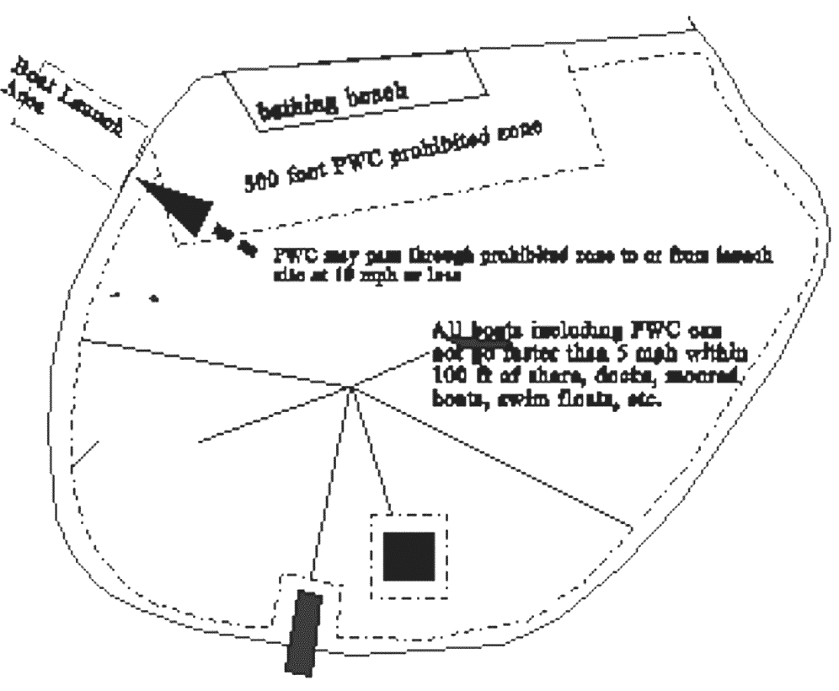
Jumping the wake of another vessel unreasonably or unnecessarily close to that vessel or when the visibility around the other vessel is obstructed. Wake jumping can be a very dangerous practice. What is unreasonably or unnecessarily close? If you are jumping so close that there is any possibility you could hit the other boat or even splash water on them, you are definitely too close. Remember, the other vessel may slow down or turn and may not see you. If you are close enough to make the operator of the other boat uncomfortable or angry, you're too close. If you think to yourself that it may be even a little risky, it's too close. If you can't clearly see what may be on the other side of the vessel there's a real good chance you're going to hit it.
Swim Area
Boats Keep Out

Swerving at the last possible moment to avoid a collision - The rules of the road require you to take early action to avoid a collision. Failure to do so is likely to confuse the operator of the other vessel about what you are doing. Waiting to long to turn in a head-on or meeting situation is especially dangerous because the distance between you and the other boat decreases very quickly, leaving little room for error. If you turn quickly and fall off your machine, there's a good chance the other boat will run you over or hit you with it's propeller. Intentionally waiting too long to turn (playing chicken) is not only dangerous and against the law, it's just stupid.

Stay Clear of Swim Areas - PWC are prohibited from operating within 500 feet of a designated swimming or bathing area. These areas are usually marked with buoys and floats but even if they're not you should keep well clear of swimmers. If the opposite shore is less than 500 feet from the swim area you may operate inside the 500 feet but at no more than 10 miles per hour (very slow). You may also get within 500 feet of the swim area if you are going to or from shore for the purpose of launching or trailering your PWC. Again you should not exceed 10 mile per hour and shouldn't get any closer to the swim area than necessary. You must still obey the general 5 mph speed limit within 100 feet of shore, docks, etc. as well as any local speed limits. Under no circumstances are you permitted to enter the swim area.
11.4.7 OPERATING BEHAVIORS THAT SHOULD BE AVOIDED
Up to this point we have covered the legal requirements that apply to PWC and operating restrictions that prohibit certain dangerous maneuvers. These dangerous and illegal activities are the cause of many PWC accidents. The operating behaviors covered in this section, however, probably make more enemies for PWC operators. These activities are not illegal but may raise serious safety concerns. Some may generate complaints about noise, wake damage, or shore erosion. All of them can be very annoying to others and contribute to the negative image that many people have of the PWC operator. Complaints will also attract the attention of law enforcement personnel. Remember, if you are not careful and if you cause enough people to be concerned or complain, it probably won't be long before you find yourself on the wrong side of the fine line between "annoying" and "illegal".

Operating continuously in the same area for long periods of time, especially close to shore, near anchored or moored vessels, around boaters trying to fish or near just about anybody trying to have a quiet day on or near the water will cause them to become more and more annoyed the longer you are there. Operating in a group greatly increases the level of annoyance.

A frequent complaint resulting from these activities is about noise. All factory stock model PWCs meet New York's vessel noise law standard. In fact, they are quieter than many traditional powerboats. Constant PWC noise, especially from several in the same area, is perceived as annoying because of the quality of the sound. A PWC is loudest when it becomes airborne with the exhaust and pump intake out of the water. Activities that cause this to happen should be avoided where the sound may annoy others. The noise from your PWC may also annoy shore-side residents if you start riding too early in the morning. Remember that there are times during the year when sunrise occurs very early in the morning.

Do yourself a favor and move on! It's better to cruise around or go to a more isolated area than to stay in one place. Try packing a lunch and exploring different locations. Most of all try to be courteous to others and respect their right to enjoy the water too.

The PWC industry estimates that for every PWC there are six riders. It is very likely you will have friends or family who will want to "check out" your PWC. Obviously, these other riders will not all have the same stake in your PWC that you do and probably at least one other rider will annoy someone with your machine. It's also likely they will have less knowledge and experience with a PWC than you. It is your job to make sure that others who want to borrow your PWC know how to ride it safely and courteously. Remember that you may get the ticket if some other rider violates the law on your machine. At best, another rider can make an enemy for you, and PWC riders in general, if he or she doesn't care or behave responsibly. At worst, they may get hurt or damage your machine.

11.4.8 CLOSING
The bad reputation that PWC riders have gotten because of few irresponsible riders will take a lot of "good" behavior to change. It won't be easy and it will probably take some time but it can be done. You must do your part and encourage your fellow PWC users to do theirs by remembering to always:
1. Obey all laws. Remember your PWC is a boat.
2. Use common sense and good judgement
3. Be courteous and respect others rights
4. Be responsible and always present a positive image.

- FIRST AID

  - OVERVIEW

The following information is a very brief overview of some of those first aid techniques that are important to boating activities. It is not designed to make you an expert in first aid treatment, merely to give you enough information to handle the most likely emergencies until you can obtain assistance from someone more qualified in first aid. You are strongly urged to contact the American Red Cross Chapter nearest you to become certified in basic first aid and cardiopulmonary resuscitation (CPR). This knowledge could save a life when you are on the water and out of immediate reach of assistance.

When an emergency occurs such as a fall overboard, fire, collision, etc., there are some basic steps that generally apply. An attempt should be to prevent further injury to victims and other persons on board. This means in the case of a fall overboard you would want to throw the victim a flotation device and get them back aboard as soon as possible. In the case of a fire you should move the victims as far from the fire as possible before treatment. On a boat an attempt should be made to extinguish the fire prior to actually treating victims so as to protect other persons on board. Both may be done simultaneously if sufficient personnel are available. A similar philosophy applies to collisions. First remove the victims from immediate danger (i.e. place them into PFD's). Then attempt to keep the vessel afloat (if possible) to provide a platform upon which you may then treat the injured.

Another important step would be to obtain assistance. This may be done in several ways. The best would be to radio for assistance. Another way would be to make use of visual distress signals. If your vessel is still maneuverable, you might try to make shore (if it is not too far and the victim's condition can wait) to obtain assistance. You could treat the injured and get someone else to signal for assistance.

  - INITIAL RESPONSE

The initial actions required for any accident victim, once they have been removed from immediate danger, are as follows:
a) Ensure that the victim is breathing. If not apply rescue breathing techniques.
b) Control severe bleeding.
c) Check for further injuries such as broken bones.
d) Give additional First aid as needed.
e) Treat for shock.
f) Obtain professional medical assistance as soon as possible.

The order in which you complete any of the above steps will be determined by the situation and the above sequence should not be considered hard and fast for all situations.

  - DROWNING

If you jump in the water to rescue a drowning victim be sure you are wearing a PFD with a tether line attached and tended by someone aboard the vessel. It will help you and the victim to stay afloat and make it easier to maneuver the victim through the water. Get the victim back on board the vessel or to shore as soon as possible. Begin rescue breathing immediately if necessary. Once the victim is breathing, check for further injuries and treat for shock. Take the victim to see a doctor immediately upon your return to shore. This must be done even if the victim appears to be okay.

  - SHOCK

Shock is a condition that may be brought on by severe injuries, infection, heart attack, stroke, poisoning, excess alcohol intake, drug overdose, cold water immersion, trauma, or lack of oxygen.

Symptoms of shock include pale or bluish skin that is cold to the touch. This is especially notable on the inside of the mouth and lips, under the eyelids, and at the fingernails. The skin may be moist and clammy. The victim is weak and the pulse is usually rapid and weak. The victim's breathing may be shallow and rapid or deep and irregular. As shock progresses the victim may become apathetic and unresponsive (or slow). The victim may have a vacant expression on his face and the pupils will be dilated (large). The victim will eventually lose consciousness. Treatment for shock includes getting the victim to lie down, elevating the feet, and keeping them warm. The main objectives are to improve blood circulation, ensure adequate oxygen supply, and to maintain body temperature. Medical attention should be obtained as soon as possible.

  - HYPOTHERMIA

Hypothermia often occurs when a person is suddenly immersed in cold water. Although it may take from 10 to 15 minutes for the temperature of the heart and brain to drop, cooling of the skin and nearby tissues is very rapid. Early symptoms include shivering, numbness, drowsiness, and muscular weakness. When a person's core temperature reaches 90 degrees Fahrenheit, he may become unconscious, at 85 degrees Fahrenheit heart failure usually occurs.

Cold water survival depends on several factors. First to be considered in the individual's body size. Large people cool more slowly than small people while overweight people cool more slowly than thin people. Children, since they are smaller, tend to cool faster than adults. The amount of activity in the water may also determine how long you'll survive the cold. Swimming and treading water may accelerate body cooling while floating in a fetal posture (if alone) or huddling together (if with two or more persons) will help preserve body heat. Wearing a PFD or having some means of flotation will allow less energy to be expended staying afloat and increase survival time.

Swimming for shore is recommended ONLY when no chance of rescue exists or you are very close to the shoreline. Remember, swimming increases body cooling and distances on the water can be deceptive.

In aiding a hypothermia victim quickly move the individual to a sheltered area and remove all wet clothing. Handle the person gently and don't allow him to walk. Gradually apply heat to the victim's trunk with either a warm bath or heated blanket. If neither of these is available a rescuer may use his own body heat in aiding the victim. When aiding a hypothermia victim NEVER:

a) Give the victim alcohol.
b) Rub the body with snow.
c) Attempt to warm the extremities (arms, legs) before warming the trunk (chest, head).

  - BURNS

Next to capsizing and falls overboard, fires and explosions are among the leading types of boating accidents. It is therefore appropriate that the treatment of burns caused by fire and heat be discussed.

    - Degrees of Burns

There are three classifications of burns and each has its own treatment. An affected area may have all three degrees of burns within it. The classifications are:

      - First Degree - This is the type of burn that usually results from overexposure to the sun, light contact with hot objects, or scalding by hot water or steam. This type of burn usually causes redness or discoloration, along with mild swelling and pain. First degree burns usually heal quickly.

      - Second Degree - Burns of this type result from a very deep sunburn, contact with hot liquids, and flash burns from gasoline, kerosene, and other products. This type of burn is very painful. This type of burn has a greater depth of damaged tissue than first degree burns. The area has a red or mottled appearance, accompanied by the development of blisters. Considerable swelling may occur after a few days. There is usually a wet appearance of the skin surface due to the loss of plasma through the damaged layers of the skin.
      - Third Degree - These are the most serious type of burns and are recognized by deep tissue destruction, white or charred appearance (it may resemble a second degree burn at first), and complete loss of all skin layers. The pain of a third degree burn may be less than that of a second degree because of extensive damage to nerve endings. This type of burn is usually caused by contact with flame, ignited clothing, immersion in hot water, or electricity.

    - First Aid for Burns

First degree burns are rather simple to treat. Place the affected area into cold water or use cold cloths and apply a dressing if necessary.

Second degree burns should be treated by applying a dry sterile gauze or clean cloth over the area to protect it. Do not break any blisters or attempt to remove any damaged tissue. Do not use any ointments or sprays if the area is severely burned. Elevate burned arms or legs to reduce swelling. Victim must be treated by a doctor/hospital as soon as possible.

Third degree burns are very serious and professional medical assistance should be obtained as soon as possible. Before assistance arrives cover the affected area with thick sterile dressings or a very clean sheet. When applying dressings do not attempt to remove charred clothing or other articles that may be burned into the skin. Also, do not use any ointments, sprays, etc. as these may do more harm than good. Keep the affected area elevated and do not allow victim to walk around. Victims with face burns should be placed in the sitting position and observed for breathing difficulty. Maintain an open airway should problems occur. Do not give the victim alcohol.

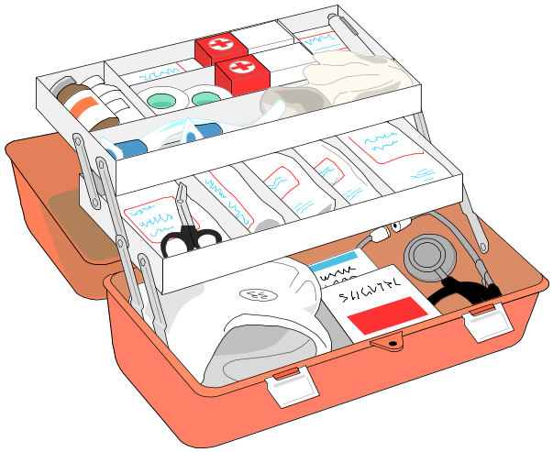
REMEMBER: The procedures in this chapter are very limited in scope and you are strongly urged to become more qualified in first aid procedures and CPR by taking the courses offered through the American Red Cross. The knowledge you learn may save a life. Contact the American Red Cross for further training.

- GLOSSARY OF BOATING TERMS

ABAFT - Toward the stern.
ABEAM - At the side of the vessel amidships, or at right angles.
ABREAST - Alongside of. Side by side.
AFT - Toward the stern of a vessel.
AMIDSHIPS - In the center of a vessel.
ASTERN - Towards the stern.
ATHWART - Across.
BAIL - To remove water from a vessel.
BALLAST - Heavy material, such as; iron, lead, or stone, placed in the bottom of the hold, to keep a vessel steady.
BEARING - The direction, or point of the compass in which an object is seen, from the person looking.
BELAY - To make a line fast to a cleat or belaying pin. Also to cancel an order.
BILGE - The lower internal part of a vessel's hull, adjacent to the keel.
BITTS - Perpendicular pieces of timber or metal going through the deck, to secure lines to.
BOLLARD - A strong post for holding lines fast.
BOW - The forward part of a vessel.BULKHEAD - Vertical partition in a vessel.
BUS - Conductor or group of conductors serving as a common connection for three or more circuits. Usually in the form of a block terminal or solid bar.
CAMBER - The arch of a deck, sloping downward from the center toward the sides.
CAULKING - Forcing a quantity of material into the seams of the planks in a vessel's deck or sides to make it watertight.
CABLE - A large strong line secured to the anchor, by which the vessel is secured. A cable-length is 120 fathoms.
CHART - A map of a body of water that contains necessary piloting information.
CLEAT - A piece of wood or metal with projecting ends to which lines are made fast.
COAMINGS - Raised work around the hatches, to prevent water going into the hold.
CONNING - Directing the helmsman in steering a vessel.
COUNTER - The bottom after part of the stern of a vessel.
CURRENT - The movement of the water in a horizontal direction.
DEAD RISE - The upward slope of a vessel's bottom from the keel to the point where the bottom joins the side of the vessel.
DRAFT - The depth of the vessel below the water line, measured vertically to the lowest part.
DRY ROT - A fungus decay which causes wood to become brittle and to fall apart.
FATHOM - Six feet.
FENDERS - Objects hung alongside the vessel to protect the hull from chafing.
FLARE - The outward spread of a vessel's sides, at the bow, from the water line to the gunwale.
FORE - Used to distinguish the forward part of the vessel, or things forward of amidships. (The opposite of AFT or AFTER).
FRAME - The skeleton of a vessel, or ribs of the hull, extending from the keel to the highest continuous deck.
FREEBOARD - The vertical distance from the waterline to the edge of the gunwale or uppermost continuous deck (weather deck) measured at the vessel's side.
GANGWAY - Structure used for people to pass from the vessel to the dock or vice-versa. Also, when used in a command, means 'clear the way'.
GUNWALE - The upper edge of a vessel's side. (Pronounced "gunnel.")
HATCH - An opening in a vessel's deck to allow persons or cargo to go up or down.
HELM - The wheel or tiller by which a vessel is steered.
HULL - The body of a vessel.
KEEL - The main center-line structural member, running fore and aft along the bottom of a vessel. (The back-bone of a vessel).
KNOT - A unit of speed equal to one nautical mile (6,080.26 feet) an hour. Also, to bend a line.
LEEWARD - Situated on the side away from the wind. (Opposite of windward.)
LIST - The inclination of a vessel to one side.
LONGITUDINALS - Generally refers to structural members of the vessel's hull which run continuously fore and aft. The keel is an example of a longitudinal.
PAINTER- A line attached to the bow of a boat, used for making her fast.
PITCH - The vertical motion of the bow and stern rising and falling, due to wave action.
PORT - The left side of a vessel, viewed from the stern and facing forward.
RUDDER - That by which a vessel is steered, attached to the sternpost, except in the case of outboard motors.
SAMSON POST - A single bitt in the bow of a small boat.
SCUPPER - Hole cut in the water-ways for the water to run off the deck.
SHEER - Is the longitudinal upward curvature of a deck, at sides, between stem and stern.
SKEG - Timber or metal used to deepen the after part of a keel, or an extension of the keel protecting the propeller, and sometimes supporting the rudder.
SPRING LINE - A line used at the dock to prevent the vessel from moving ahead or astern.
STARBOARD - The right side of a vessel, viewed from the stern and facing forward.
STEM - The upright post or bar of the bow extending from the keel, and to which the two sides of the vessel are secured.
STERN - The after end of the vessel.
TRANSVERSE - Generally refers to structural members of the vessel's hull which provide strength in the athwartship direction. These are the "ribs" of the vessel.
TACKLE - A purchase, formed by a rope rove through one or more blocks. (Pronounced 'tak-el'.)
TAUT - Tight, snug.
THWARTS - The seats extending across a boat, upon which the oarsmen sit.
TIDE - The alternate rise and fall of waters caused by the gravitational attraction of moon and sun.
TILLER - A bar or handle for turning a boat's rudder, or an outboard motor.
TRANSOM - The transverse planking which forms the after end of a small square-ended boat. (Outboard motors are usually attached to the transom).
TRIM - To arrange weights in a vessel in such a manner as to obtain desired draft at bow and stern.
WARP - To move a vessel from one place to another, by means of a rope made fast to some fixed object.
WAY - Movement of a vessel through the water. Technically, she is UNDERWAY when not at anchor, aground, or made fast to the shore or dock.
WHEEL - The instrument attached to the rudder by which a vessel is steered.
WINDWARD - The direction from which the wind blows, as distinguished from leeward.
WAKE - The moving waves, track or path that a boat leaves behind it when moving across the water.
YAW - The motion of a vessel when she goes off her course.

- TERMINOLOGY

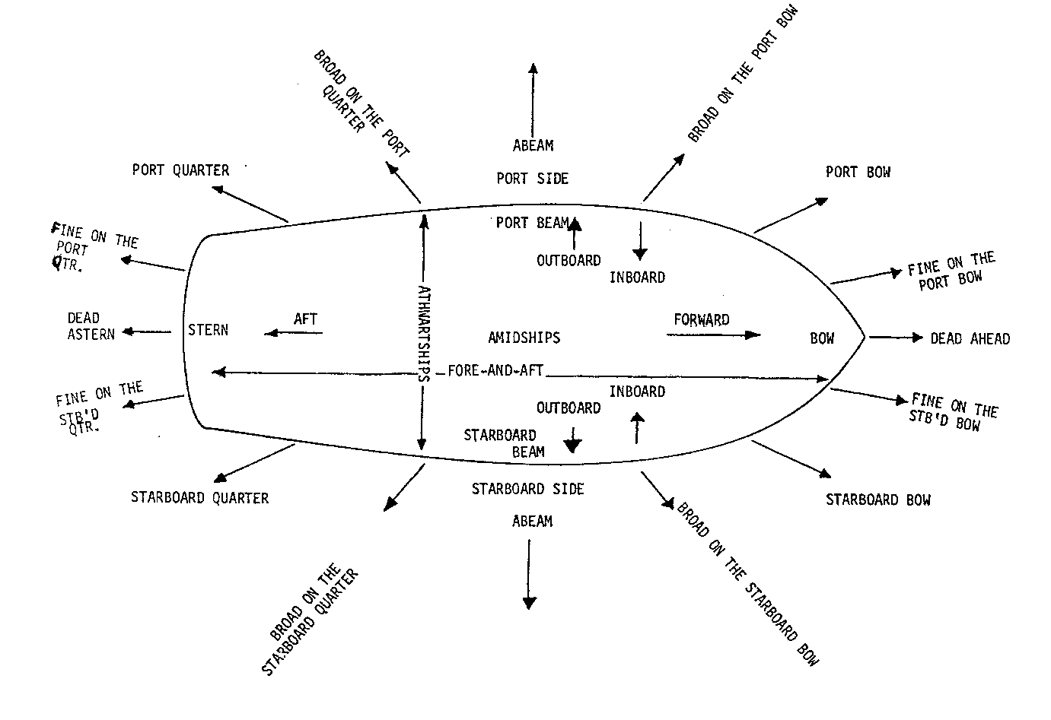

- CHAPTER REVIEW

REGISTRATION

What boats need to be registered?

Describe the display of registration numbers

How can you tell which boat is a Public Vessel?

PUBLIC VESSEL LAW

Describe what a Public Vessel Operator must do:

For a vessel inspection

About deficiencies and failures?

What repairs must be made to a boat?

What an operator must do when a modification is made to a PV?

Describe the licensing requirements for a Public Vessel Operator

Original license,

Renewal license and

Suspension of license

What is Joint P&E, Engineer, Apprentice and Masters license?

NAVIGATION LAW

What is Reckless operation?

What is Boating While Intoxicated?

What constitutes an accident and what must a PV Operator to do?

What do we mean by "aid in distress"?

What is Ventilation?

What is an open boat?

What type of flammable vapors are found on a boat?

Which are hazardous and why.?

When is power ventilation required?

When is powered ventilation not required?

What are the parts of a powered ventilation system?

VENTILATION

When must you use power ventilation?

What must you do when you encounter strong odors of gas?

What maintenance needs to be done to a powered ventilation system?

FUEL SYSTEMS

What does "Accessible" mean?

What is the difference between a permanent and a portable system?

What are the three parts of a fuel system and why each is important?

Where is each located on a boat?

What are the proper steps before, during and after fueling?

FIRE AND FIREFIGHTING

Know the definitions in Section 4.1

Why is the fire triangle different from the fire tetrahedron?

What are the three classes of fire?

What are the four fire extinguishing agents?

How do the four fire extinguishing agents attack a fire?

What are the carriage requirements for portable extinguishers?

How do you use a portable extinguisher?

What is a fixed fire extinguisher system?

What type of public vessel must carry a fixed system?

AUXILIARY SYSTEMS

What is a Backfire Flame Arrestor(BFA)?

What type of Public Vessel must carry one?

Where is the bilge located?

What do you find in the bilge and why can it be hazardous?

What types of bilge pumps can you find on a boat?

What type of bilge pump is required on a Public Vessel?

What does a Marine Inspector look for when inspecting these auxiliary systems?

SAFETY EQUIPMENT

What equipment is USCG Approved?

What are the 5 types of personal flotation devices(pfd's)?

What is the difference between a type IV pfd and the other types of pfd's?

What is the PFD carriage requirement for a public vessel?

What is VDS?

What do you have to carry on a public vessel?

What is an anchor rode and how long should it be?

What type of horn/whistle must be carried on a public vessel?

What does a Marine Inspector look for when inspecting safety equipment?

RULES OF THE ROAD

Know and understand the definitions in this chapter.

Understand:

When you need a lookout?

What is safe speed?

How to determine Risk of Collision?

What actions to avoid a collision?

Know what to do in each of these situations:

Overtaking?

Crossing?

Head on?

How do you determine if you are the give-way or stand-on vessel in the above

situations?

What actions can a give-way or stand-on vessel take in the above situations?

As a public vessel what types of vessels must you keep out of the way of?

Know your maneuvering and warning signals and how you would use them in the

above situations.

What color lights do you see on a vessel?

Where on the boat is each located?

VESSEL OPERATIONS

Know the following definitions:

Hull

Draft

Trim (think of the boat as a seesaw)

Displacement - the amount of water that is displaced by the vessel

Beam - the width of the boat at it's widest part

Superstructure - Cabin, gunwhales, or other projection that may act as a sail.

How does a propeller work?

What is pitch?

What does slip and cavitation do to affect the speed of the vessel?

What is the primary job of the rudder?

What happens to the vessel when you go forward or back without a rudder?

What is the difference between single and twin screw?

How does the wind, sea conditions and current affect the boat?

What are the proper docking procedures?

How do you anchor a boat?

How do you moor a boat?

What is an emergency response plan?

What are the two dangers of a man overboard?

What response do you take in a man overboard situation?

Initial response

Recovery maneuvers

Recovery

What steps are taken by a public vessel operator when encountering a fire

onboard?

Know when to report an accident

NAVIGATION

What is a compass and how does it work?

What errors does a compass have and how are they caused?

NAVIGATION (cont.)

Know the uniform State Waterways Marking System.

Buoy shapes, colors and lights

Channel markers

Regulatory Markers

WEATHER

How does weather affect a boat?

What does a public vessel operator have to be vigilant about when it comes to

weather?

Why is a shift in wind important to the vessel operator?

SPECIAL ACTIVITIES

What is the law regarding people engaged in water-skiing?

What is the water-ski team and what are their functions?

What equipment must be carried on a water-ski boat?

Know your hand signals

What do you need to look for on the water to know that a diver is in the area?

What special precautions must you take when you are tending a diver?

Personal watercraft - Know sections 11.4.1 through 11.4.4

FIRST AID

Know the chapter

GLOSSARY and TERMINOLOGY

Know the chapter

- VESSEL INSPECTION REPORT

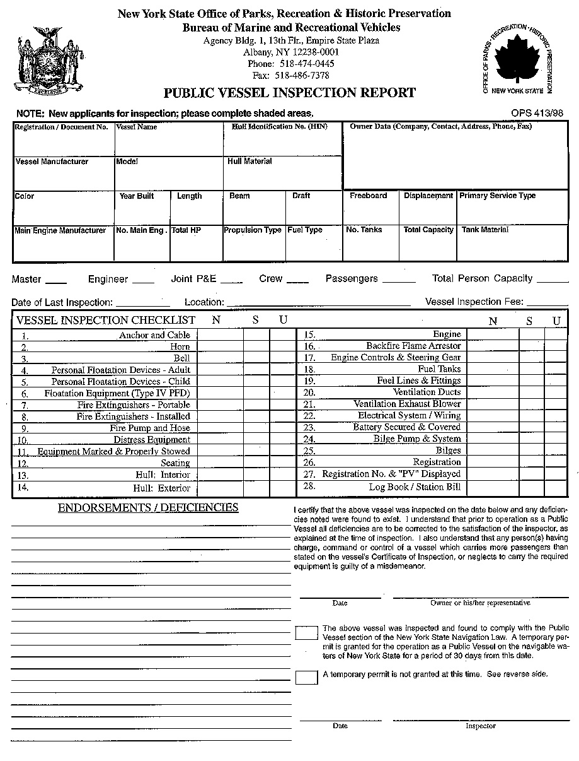

- MASTER’S PRACTICAL EXAM
Preparation
Log Book Opened/Entries Made YES / NO
Chart Available YES / NO
Radio Checked YES / NO
Engine Order Device Checked YES / NO
Bridge to E/R Communication Checked YES / NO
Navigational Equipment Checked YES / NO
Helm Checked YES / NO

Undocking
Public Address Announcement YES / NO
Letting Go Safety Observed Inattentive to Safety, Haste
Engine Orders Proper, Effective Improper, Ineffective
Rudder Commands Discernible, Effective Improper, Ineffective
Sound Signals Observed / Neglected
Alertness to Traffic Good / Fair / Poor

Underway
Attention to Helm Good / Fair / Poor
Attention to Traffic Good / Fair / Poor
Rules of Road/ Signals & Maneuvers Good / Fair / Poor
Knowledge of Handling Characteristics Good / Fair / Poor
Knowledge of Waterway/Routes Good / Fair / Poor
Emergency Response Plans Good / Fair / Poor

Man Overboard Drill
Attentiveness to Passed Word Alert, Responsive Slow to Respond
Not Knowledgeable of Response
Rudder Commands Quick, Effective Slow, Wrong
Sound Signal Observed / Neglected
Engine Orders Timely, Proper Late, Unobserved
Victim Sighted Yes / No
Crew Response / Rescue Good / Fair / Poor
Proper Lifesaving Gear Used Yes / No

Fire and Emergency Drill
Attentiveness to Passed Word Alert, Responsive Slow to Respond
Not Knowledgeable of Response
Engine Orders Observed / Neglected
Sound Signals Observed / Neglected
Maneuvering Observed / Neglected
Response to Hypothetical Situation Knowledgeable, Proper Unsure, Wrong
Gear Used Yes / No
Extinguisher Suggested / Method Proper / Improper
Hoses Led Out Yes / No
Fire Pump Charged Yes / No

Docking
Approach to Dock Proper Angle, Prudent Speed Poor Approach, Too Fast
Public Address Announcement Yes / No
Engine Orders Timely, Proper Excessive, Wrong
Rudder Command Effective / Excessive
Making Fast Good / Fair / Poor

- ACCIDENT REPORT FORM


