SRH Java Training Collaboration Account

Installation of Developer Collaboration Module:
- Open the NetBeans IDE Software.
  - A desktop icon should be available to start the program.
  - Access to starting the NetBeans 6.0 IDE application is also available through the Windows XP “Start Menu”.

- Once the NetBeans 6.0 application loads…
  - In the menu bar select:
    - Tools
    - Plugins

- This will open the Plugins GUI
  - Click on the Installed tab (highlighted/ARROW red in image below) and determine if the “Developer Collaboration Plugin” is already installed.
  - If installed, it will appear in this list of plugins. ( orange highlight/ARROW in image below).
    - If already installed skip to section titled “To create a Collaboration account:”.
    - Otherwise continue to step 4 in order to install the developer collaboration module.
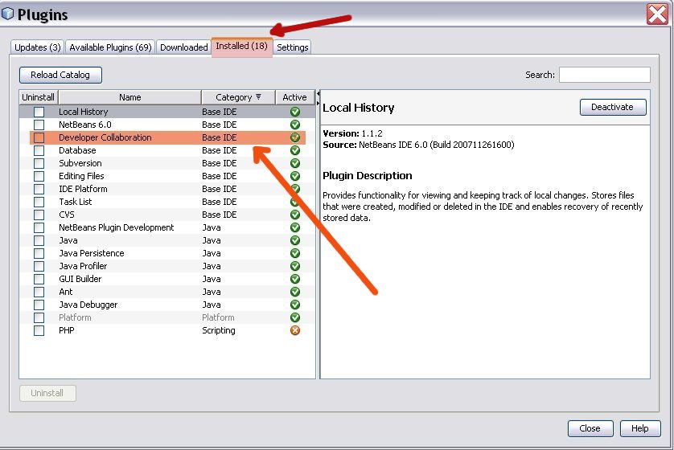

- Installing the Developer Collaboration Module…
  - Click on Available Plugins tab (highlighted red in image below)
    - Scan through list to find “Developer Collaboration”
      - Select It. (highlighted orange in image below)
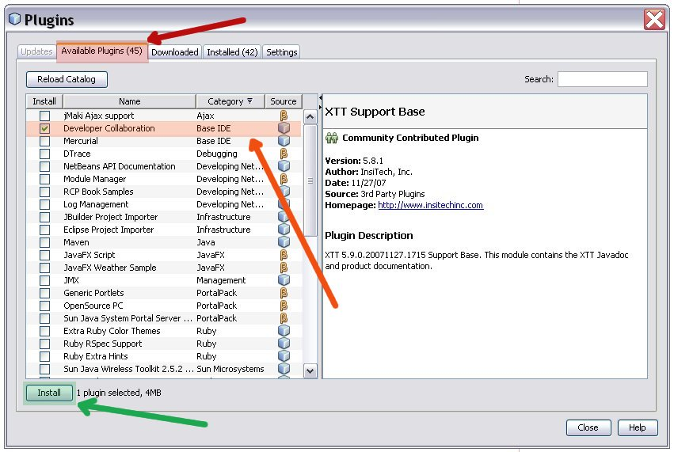
      - Click on Install. (highlighted green in image below)

- Verify Developer Collaboration plugin installation and Click Next.
- Accept the license agreement and Click Install.
- Wait for the update operation to complete (It will take a few minutes for the package to download & install). Click Finish.

- Installation of the Developer Collaboration Module is now complete.
  - You should have a new menu item in NetBeans called Collaboration.

- You can now create a Collaboration account for the SRH Java Training.

To create a Collaboration account:
- From the main menu select:
  - Collaboration (highlighted red with red arrow in image)
  - Login…
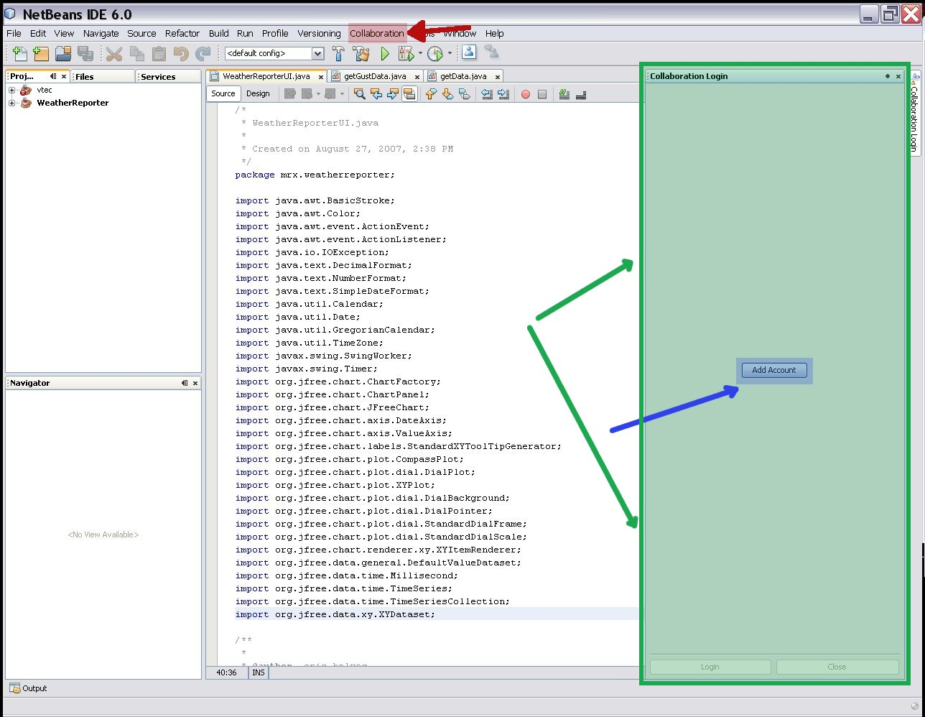
- This will open the Collaboration Login Panel (GREEN Highlight/ARROW in image)

- In the Collaboration Login Panel
  - Click the Add Accounts link (BLUE Highlight/ARROW)

- This launches the Add Collaboration Account Wizard, which you will use to add an account to the collaboration server.

- There are five steps to setting up a new collaboration account in the wizard.
  - Step 1: Account Creation
  - Select Second Button: I want to register for a new collaboration account on a different collaboration server. (red highlight)
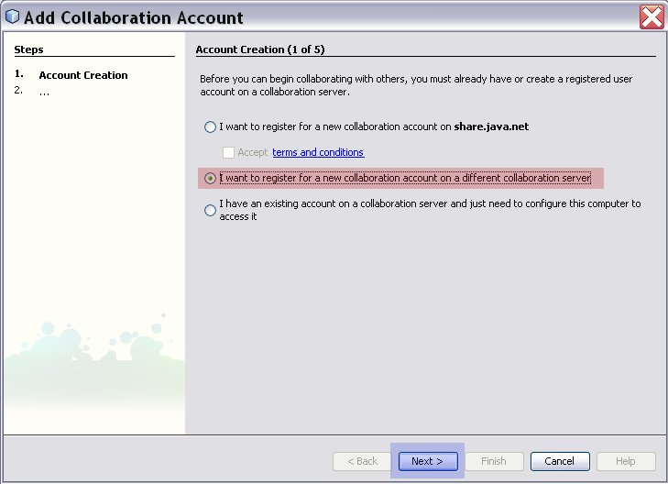
  - Click Next (blue highlight)

- Step 2: Account Name
  - Type in the display name that will identify you online. (red highlight)
  - Cannot be modified once registered. Would have to delete the account and re-create.
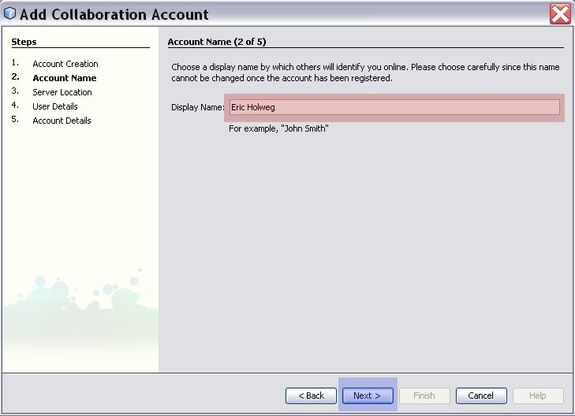
  - Click Next (blue highlight)

- Step 3: Server Location
  - Type in the server hostname (red highlight):

lucretia.srh.noaa.gov

  - Ensure that button “A proxy is not required to connect to the collaboration server (direct connection)” is toggled on. (orange highlight)
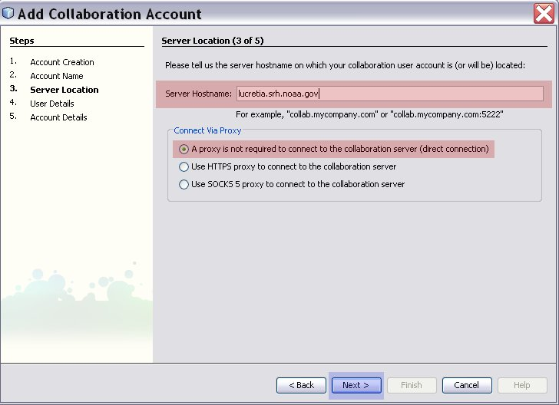
  - Click Next (blue highlight)

- Step 4: User Details
  - Enter the details for the account. First name, last name, and email address. (red highlight)
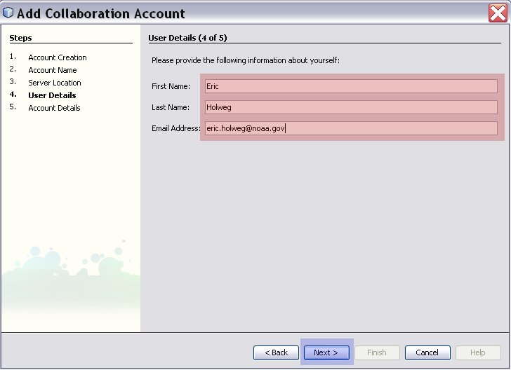
  - Click Next (blue highlight)

- Step 5: Account Details
  - Enter the account user name and set the account password (red highlight)
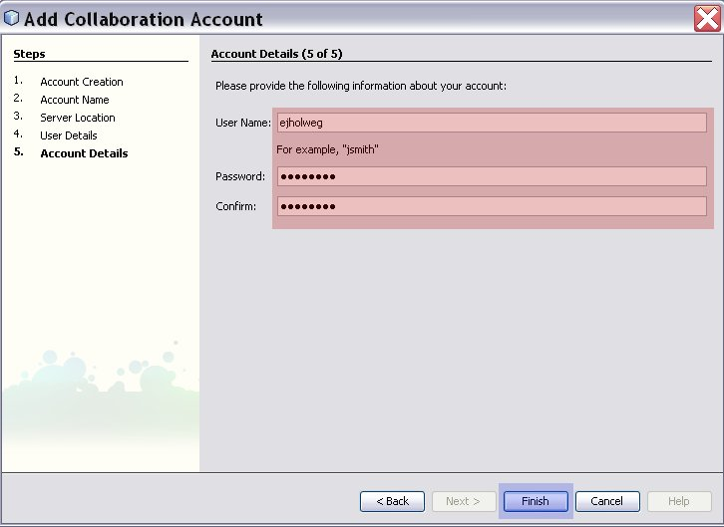
  - Click Finish (blue highlight)
- Please wait while the collaboration account details are now sent to the server and the account is established.
  - A Pop-Up will display indicating that the collaboration account is created and ready for use.

Login with existing Collaboration account:
With an already existing account on lucretia, simply login via the collaboration menu.
- From the main menu select:
  - Collaboration (RED HIGHTLIGHT)
  - Login…
- From the Collaboration Login Screen
  - Ensure that your account is selected (BLUE HIGHLIGHT)
  - Enter account password (GREEN HIGHLIGHT)
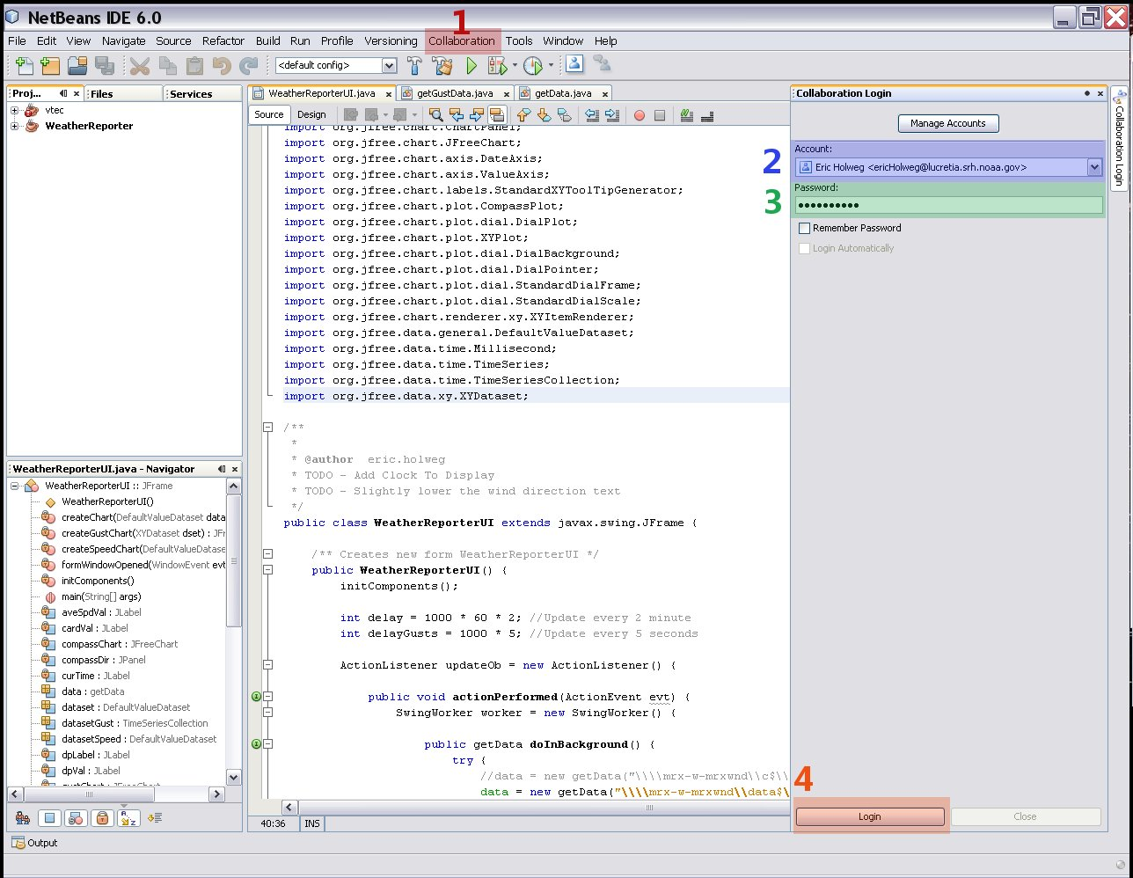
  - Click Login (ORANGE HIGHTLIGHT)

To manage and delete Collaboration accounts:
- On the Collaboration Login panel click the Manage Accounts link found at the top of the window.
- This opens the Account Management window.
- Account options are displayed for each user whose accounts you manage.
- Use this screen to change/delete account information.
  - Changes take effect the next time the user logs in.

