Frequently Asked Questions (FAQs) for the

Implementation of URG-3000N Carbon Monitors in the

PM_{2.5} Chemical Speciation Network (CSN)

June 2007

The following is a list of frequently asked questions (FAQs) received so far in the process of implementing new URG-3000N carbon sampling devices in the PM_{2.5} Chemical Speciation Network (CSN). This list is provided to communicate some of the issues and questions faced and to provide answers and guidance on how they should be addressed.

- How do I obtain the needed information from the URG-3000N sampler in order to complete my Chain of Custody (COC) and Field Data Form?

Answer: A number of PM_{2.5} CSN Chain of Custody (COC) and Field Data Forms have been returned with no sampler information. If the form is blank and the data is not written to the memory card it will result in an invalid sampling event. When an operator is at the site to remove the exposed (completed sample) cassette cartridge and memory card, they must follow the Filter Change Procedure in the exact order as prompted by the software. URG will create a laminated Filter Change Quick Guide and supply copies to RTI to send to the sites. The site operators should attach these to the inside of the door of the URG Sampling Module. During the Filter Change Procedure, the values below are displayed for the last completed sample:
  - Elapsed Time in minutes (should be around 1440)
  - Sample Volume in m-3 (should be around 30)
  - Flow Average in LPM & CV ( should be around AVG=22 CV=.1)
  - Temperature Average, Minimum & Maximum
  - Barometric Pressure Average, Minimum & Maximum
These values are stored in the controller RAM. The URG-3000N software does NOT allow the sampler to read any data on the memory card. The site operator MUST write these values down when they are displayed during the Filter Change Procedure. If the Filter Change Procedure is completed without writing these values down, the values will be cleared from the RAM and will NO LONGER BE AVAILABLE.
Alternative Data Retrieval Procedure:
The operator can view this data prior to performing the Filter Change Procedure by advancing through the software to the Calibration, Maintenance & Audit menu. See page 8 of this document or page 36 of the complete URG-3000N Operations Manual version 5.4 for a detailed menu tree (a copy of the complete URG-3000N Operations Manual version 5.4 can be downloaded from: http://epa.gov/ttn/amtic/specurg3000.html. The only parameter that is NOT displayed is the “Elapsed Time”. This can be accessed through the View Settings/Site Configuration menu. See page 9 of this document or page 38 of the complete URG-3000N Operations Manual for a detailed menu tree. This can be done several times and the data will continue to be available through this section of the menu until the operator performs the Filter Change Procedure.

- It is important that the sampler has a serial number entered into the sampler settings. How do I verify whether the serial number has been entered and enter one if it is missing?

Answer: A number of the samplers do not have a serial number entered into the sampler configuration settings. This is important because the data files on the memory card are identified by serial number. If the serial number is missing, the site operator must enter the sampler’s Controller Module Serial Number (located on the inside of the Controller Module door) by following the Site Configuration menu. See page 9 of this document or page 38 of the complete URG-3000N Operations Manual version 5.4 for a detailed menu tree.
IMPORTANT: A complete URG-3000N sampler has (3) different serial numbers. One on the Controller Module, one on the Module C, and one on the Lower Stand (pump/mass flow controller). The serial number on the Controller Module is the one that must ALWAYS be used to identify your sampler.
NOTE: Once the serial number has been entered into the sampler, it will NOT be erased during a power outage, etc.
- My sampler does not have the AQS site identification (ID) and Parameter Occurrence Code (POC) numbers entered into the sampler configuration settings. How do I enter these into the sampler configuration?

Answer: The 9-digit AQS site ID and POC values should be entered to identify the sampler location POC (Location Code). These values can be entered by following the Site Configuration menu. See page 9 of this document or page 38 of the complete URG-3000N Operations Manual version 5.4 for a detailed menu tree.
NOTE: Once the AQS site ID and POC number has been entered into the sampler, they will not be erased during a power outage, etc.
- I am told that my sample event "Q" number and the inventory Component ID number are not being entered correctly at sample setup. How do I enter these values correctly?

Answer: We are seeing many of the "Q" numbers being truncated - missing the last digit. This seems to be more prevalent if the last digit is a letter rather than a number. Many site operators are also entering the Component ID number from the memory card instead of the filter cassette cartridge during Filter Change Procedure. These values are both listed on the PM_{2.5} CSN COC and Field Data Form in Section C. See page 6 of this document or page 35 of the complete URG-3000N Operations Manual version 5.4 for a detailed menu tree.
NOTE: Some of the Q numbers include both alpha & numeric characters. You can enter letters via the Controller Keypad by pressing the F1 key several times. F1 will step forward through numbers 0-9 and then continue to step through letters A-Z. You can use the F2 key to go back to previous numbers and/or letters already passed when using F1.

- My memory cards have been returned to RTI with only 1 data file. Why is this happening and how can I resolve this problem?

Answer: The card should have two small "f" files and one large "r" file. There are several different situations that have resulted in the memory card not containing correct and/or complete data from the previous sample run. A few things such as the card not being removed or installed in the right order during the Filter Change Procedure, or the card not being installed completely were some of the examples of what might cause the memory card to have incorrect/incomplete data. After the new memory card is installed, the software will display whether the memory card is “OK” or “Card Not Found”. If “Card Not Found” is indicated on the display and the operator continues to proceed through the menu, the sampler will operate without the memory card and no data will be recorded for that sample run.
Detailed instructions for the order in which you remove the old memory card and install the new memory card will be included in the Filter Quick Guide and will also be added to the URG-3000N Operations Manual. Both of these documents will stress the importance of confirming that the software displays “Card Is OK” before proceeding through the rest of the Filter Change Procedure menu screens.
- My pump does not come on during the 300 second warm up that occurs during the Filter Change Procedure. My sampler runs fine when collecting a routine sample. Is this normal?

Answer: The vacuum pump will occasionally contain some residual vacuum from the previous sample run. Even a small amount of residual vacuum can prevent the pump from starting. If this occurs, disconnect the black air line from the side of the sampler lower stand and then plug it back in. This will release the residual vacuum and allow the pump to start again.

- It is time to remove my filter cassette cartridge and memory card from the sampler for the previous run, but I do not have the cartridge and card to install for the next sample run. What should I do?
Answer: The software does not have a procedure for removing the cartridge and card for a completed sample without having to install the new cartridge and card.

- In order to ONLY REMOVE a filter cartridge and memory card, follow the portion of the “Filter Change Procedure” detailed in section 7.1.1 (page 45 of the complete URG-3000N operations manual).
- After completing ONLY the instructions in section 7.1.1, you can remove the memory card and the exposed filter cassette cartridge. Do NOT advance any further through the “Filter Change Procedure” until you return to the sampler with the NEW filter cartridge and memory card.

- Upon arriving with the new filter cartridge and memory card, immediately insert the new memory card.

The software should pick up exactly where it left off. If for some reason it does not, turn the Controller Module power off and then back on (by unplugging the cord). This should allow you to continue through the rest of the “Filter Change Procedure”.

- My site is scheduled to collect a sample on a Friday, but I am unable to access the sampler on the weekend in order to change the sampling cartridge and memory card in time for the next sample on Monday. How do I configure the sampler so that it will not collect a Monday sample on top of the initial sample that was collected on Friday?

Answer: No action is needed. After the sample has been collected, the sampler display will read “Sample Completed”. The software contains a “lock out” feature that prevents the collection of another sample until the site operator performs and completes the Filter Change Procedure. See pages 48 and 64 of the URG3000N Operations Manual version 5.4.

- Is it necessary to return my filter cassette cartridge with the red filter caps installed?

Answer: Yes, the red caps MUST be installed onto the cassette(s) before returning the cartridge to RTI to protect the sample filter during return shipment. These caps are also used for new cartridges to protect the unused filter prior to sampling.
- Is there a way to access data that was written to the memory card through the sampler software?

Answer: It is NOT possible to access data written to the memory card through the sampler software. The Elapsed Time, Sample Volume, and other data from the previous sample run is stored in RAM, and is reset (deleted) after the operator completes the Filter Change Procedure. Details about using an alternate method for viewing these values BEFORE performing the Filter Change Procedure are addressed in Question 1 above. The memory card can also be read via an inexpensive memory card reader. The card reader is typically used in conjunction with a personal computer and the files read using Microsoft® Notepad.

- Is there a way to remotely access the URG-3000N sampler to monitor its operation?

Answer: It is currently NOT possible to remotely access the URG-3000N for sampler monitoring, control, or viewing operational parameters.

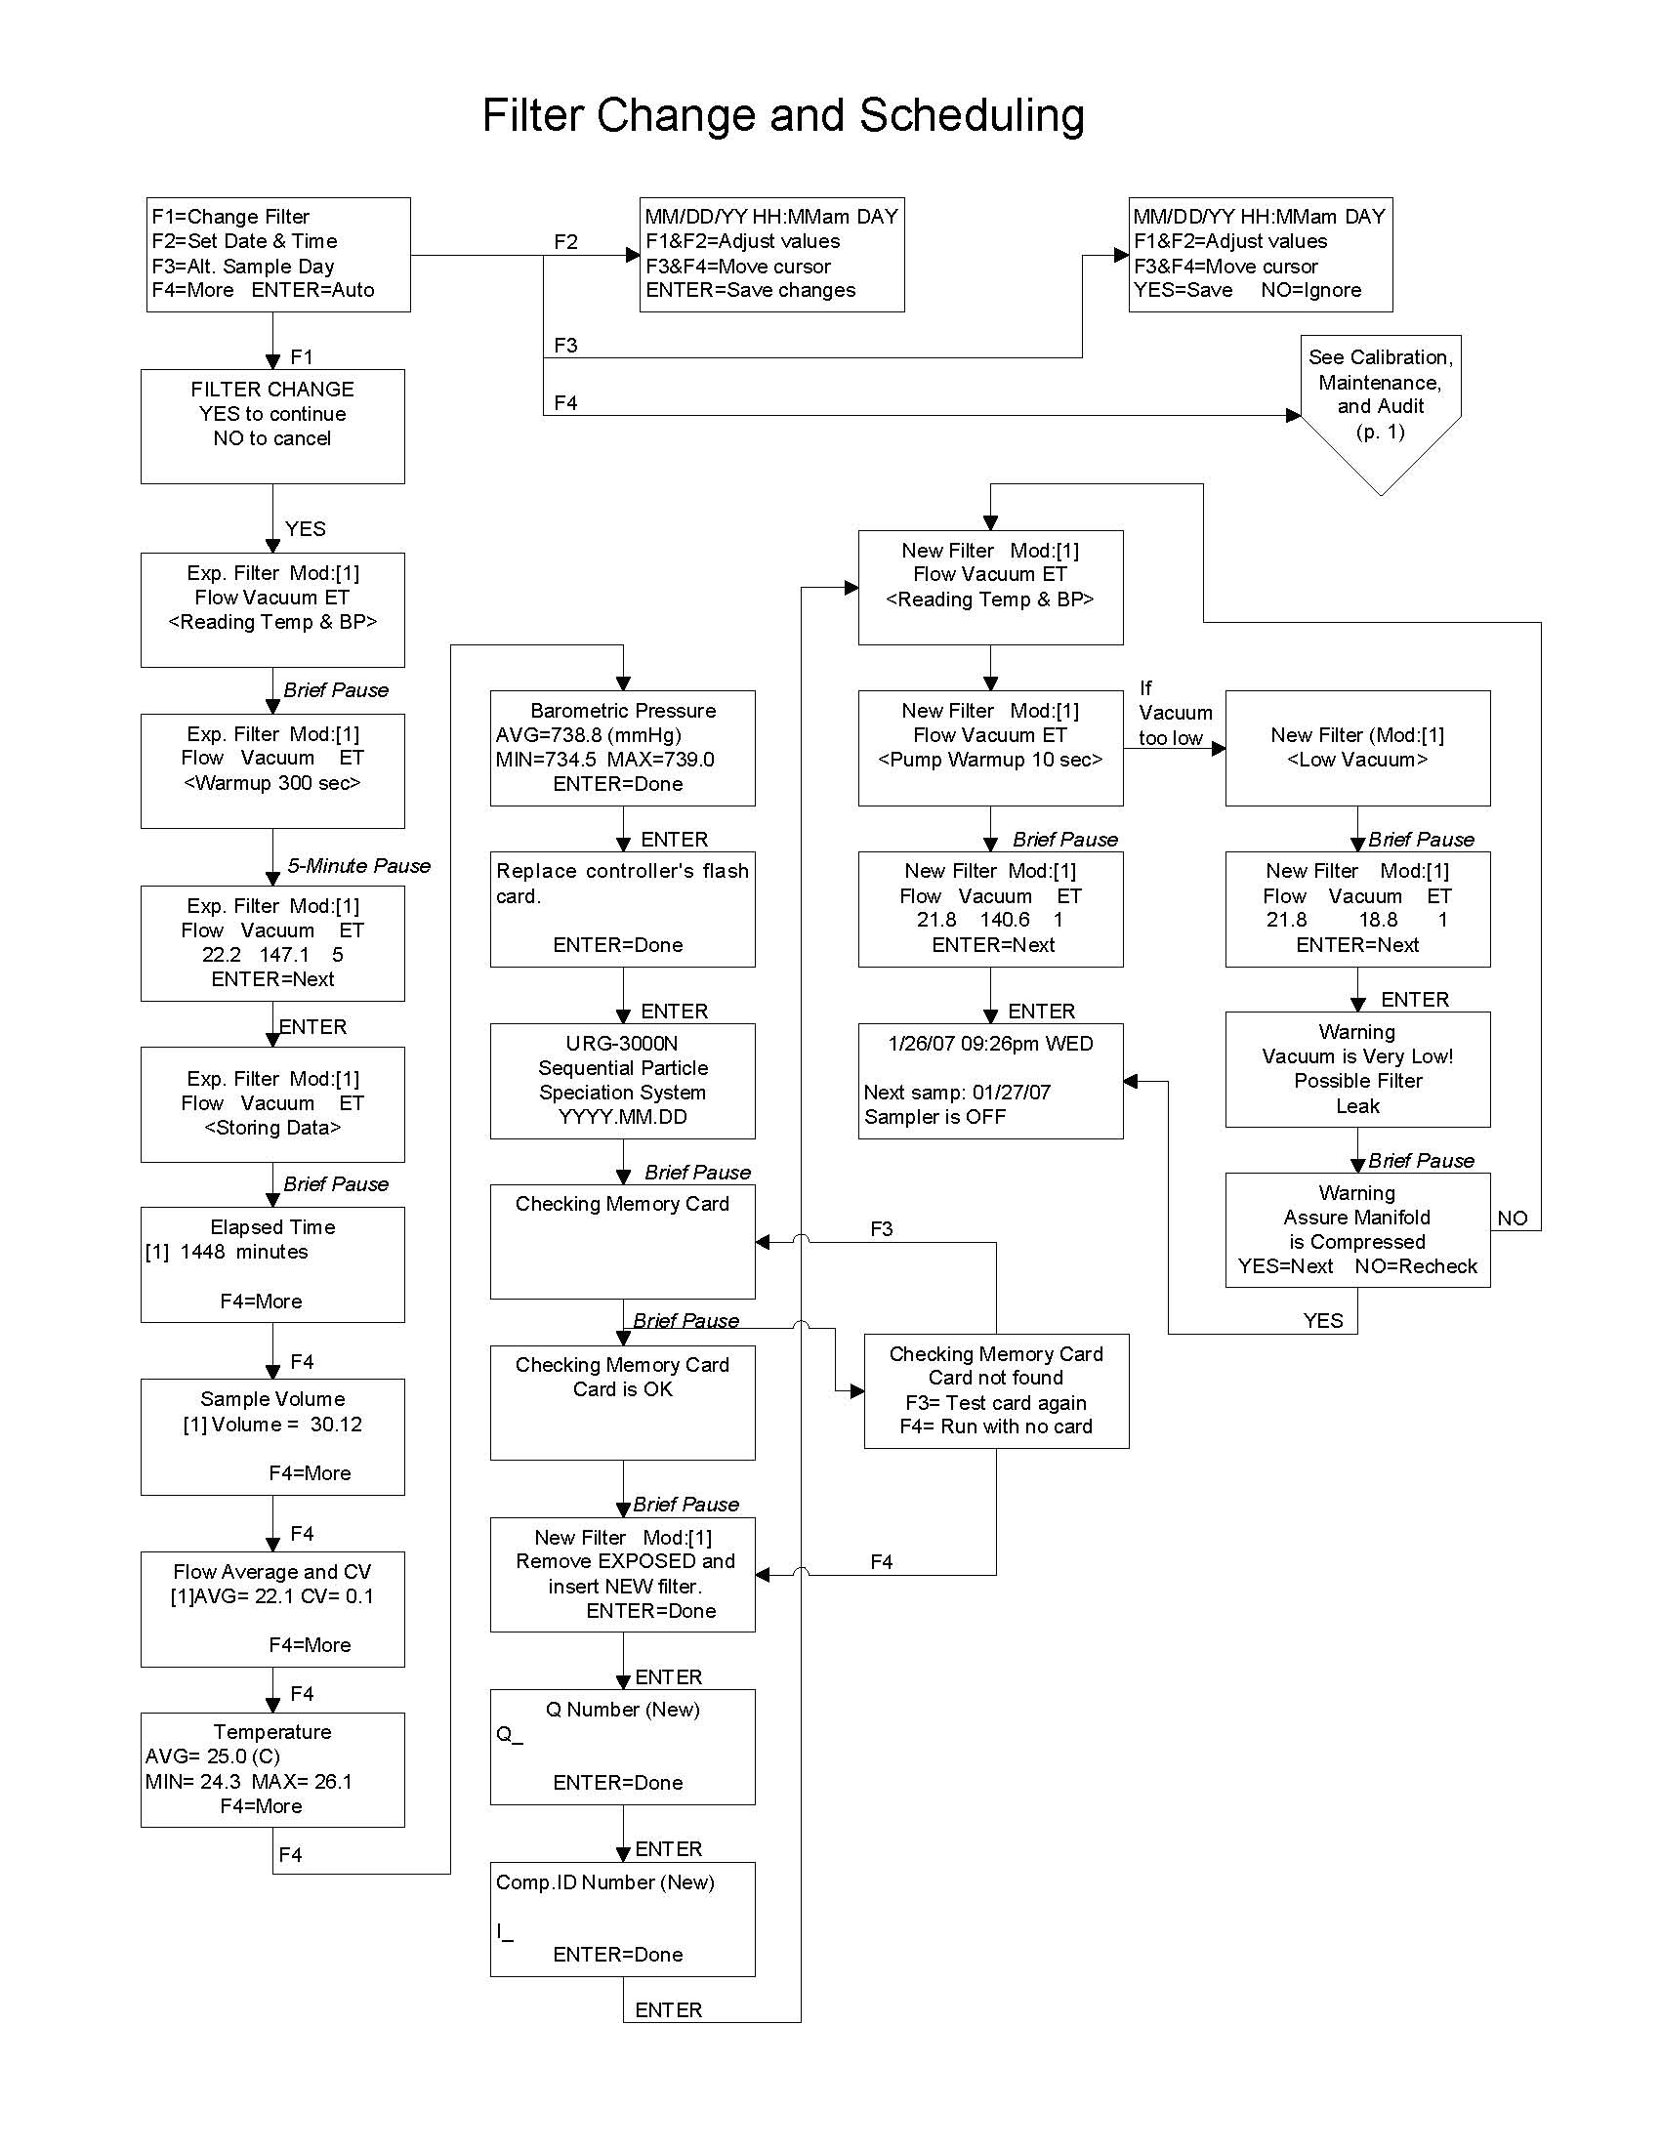
COMPLETE URG-3000N SOFTWARE MENU TREE


