
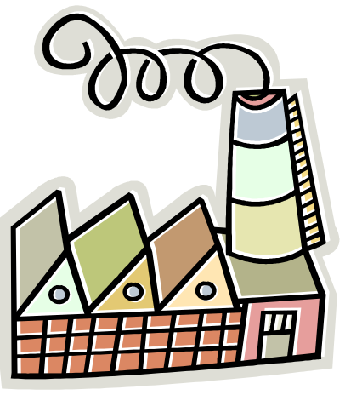
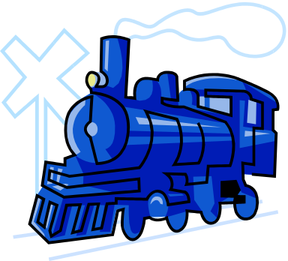

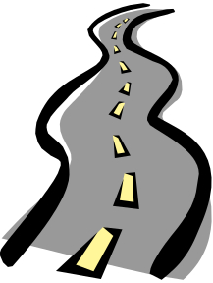
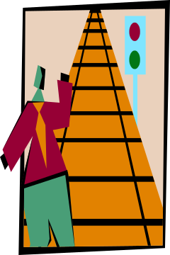

LET’S DO A

HISTORY SEARCH!


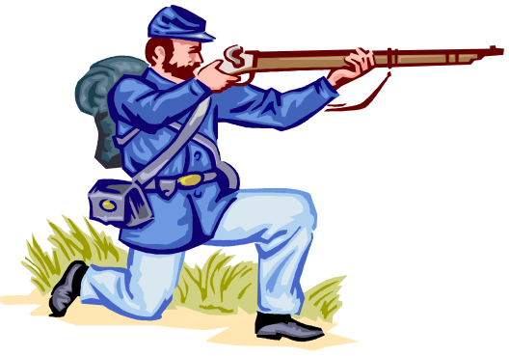

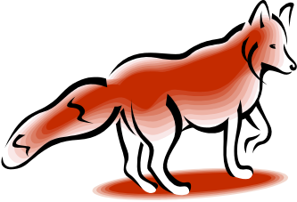

Welcome to Harpers Ferry National Historical Park. The history of Harpers Ferry is a very important chapter in the history of the United States. It is more than one event, one date, or one individual. While completing this History Search you will learn about some of these people and events. You will go to places where history happened.


Put on your thinking cap, engage your brain, and switch on your imagination because those will be the sources for most of your answers. You will not find them on a sign or in an exhibit. Use the map on the bottom of this page to find locations listed in the search. The places and terms in bold will help guide you to the area or museum where you can find the answers.

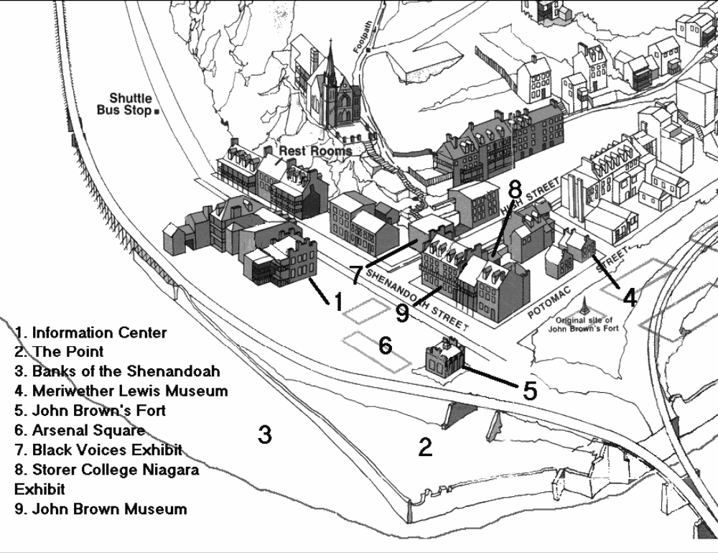
You will be sharing the park with other visitors today. Museums and exhibits may be crowded causing you to wait. You may want to go to another question and come back! Please be patient and courteous. Put trash in trash barrels. Watch out for traffic and have fun. Good luck on your history adventure.
10. Industry Museum
10
11. Defeat and Victory Museum
11

- Many people feel Harpers Ferry is a beautiful town. Looking around
“This scene is worth a voyage across the Atlantic." – Thomas
Jefferson
you will see mountains and rivers. These mountains and rivers were
some of the reasons why people chose to live here. Robert Harper
who started Harpers Ferry thought it would be a great place for a town.
In 1751 he gained 125 acres of land and began to build.

Would you want to live here? ________________

- At the Industry Museum (#10) you can learn about the different types of transportation that were here in Harpers Ferry.

a) Today which method of traveling goes the fastest? Answer fast, faster, and fastest in the blanks below each picture.
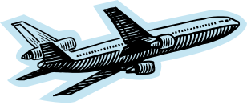
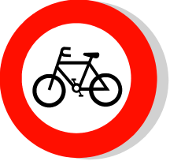
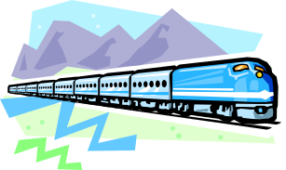

*
__________________ ______________ ___________________

b) In the 1800s which one do you think went the fastest? Answer fast, faster, and fastest in the blanks below each picture.

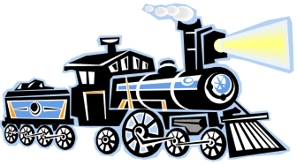
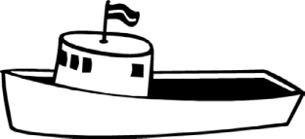
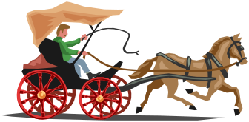

_______________________ __________________ ___________________

c) Use the word bank to the right to put the words the appropriate places in the poem.
boats horses buggies trains
faster race
_________________ and _________________ were too slow,
So _______________ and _______________ were the way to go!
A _______________ began between the two_________________
Which was ___________________, do you know who?

d) Match the conductor, captain, and driver with the appropriate type of transportation by drawing a line between the two.
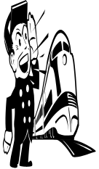

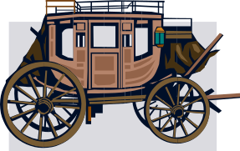
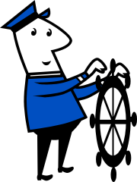

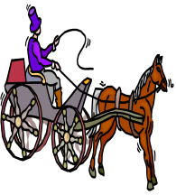

*

Did you know that in the 1800s Harpers Ferry was an industrial town? Many of the buildings here were part of the United States Armory, which made guns. The armory was so big that it stretched six football fields long!

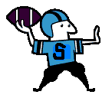
e) How many yards do you think Stan the Man can throw the football?
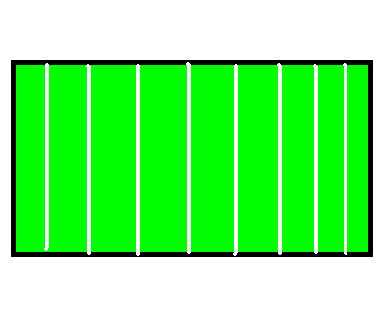
1 2 3 4 5 6

f) This was a busy factory town
With people working from dusk to dawn.
Hard work it must have been, though I’m sure they had some fun.
Now take a look at what was made, the number one item was a ______________.
(Hint: It rhymes with fun.)

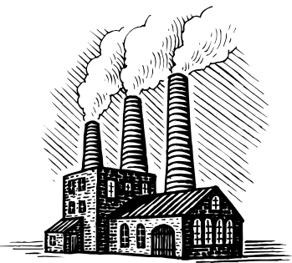
g) Other items were made here as well. In this museum you will some examples of factory-made items. Draw a picture of an item that was made in Harpers Ferry.
*

3. At The Point (#2 on the map), you can see that

Two rivers meet at this spot,
They sometimes roar and flood this plot.
The Potomac and Shenandoah are their names.
Beauty and grace gave them fame.

Now make your own funny poem by adding your own words.
a) Two _______________ meet at this _________________,
They sometimes ______________and ______________this ______________.
The ___________________ and __________________ are their names.
________________ and _______________ gave them ___________________.

b) Let’s play ‘I Spy’ and circle below what you spy near the river!

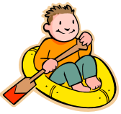
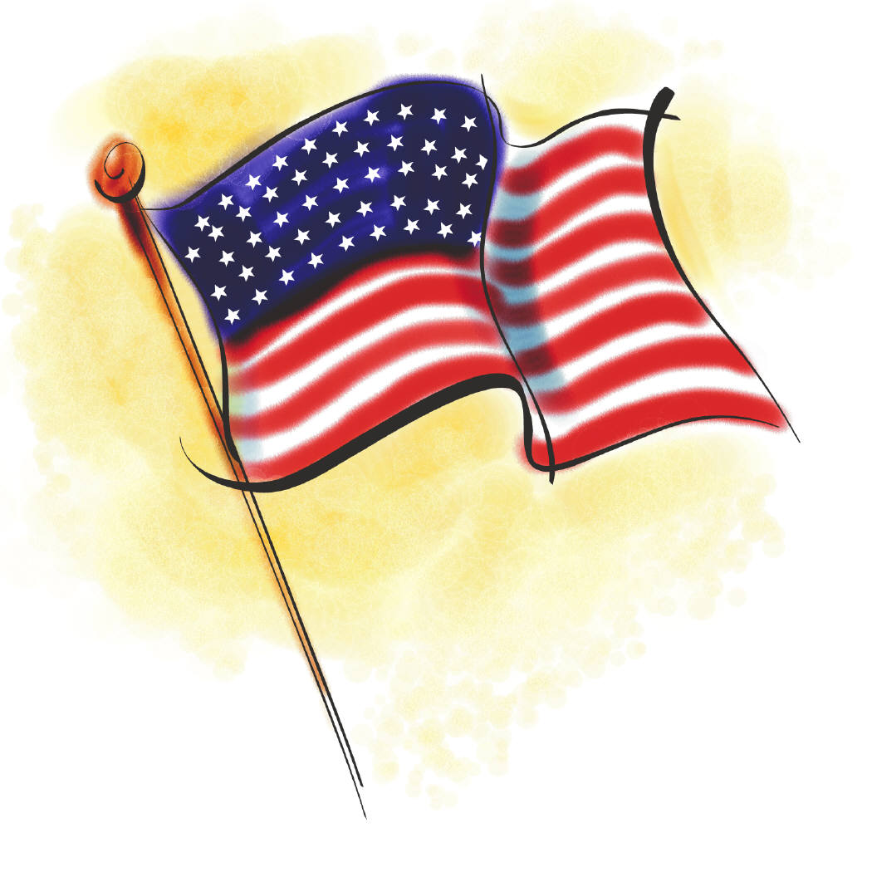
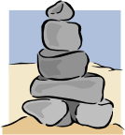
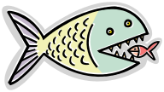

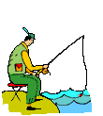
Flag Fish Raft Tree Rocks

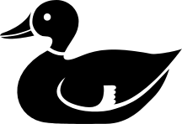
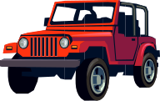
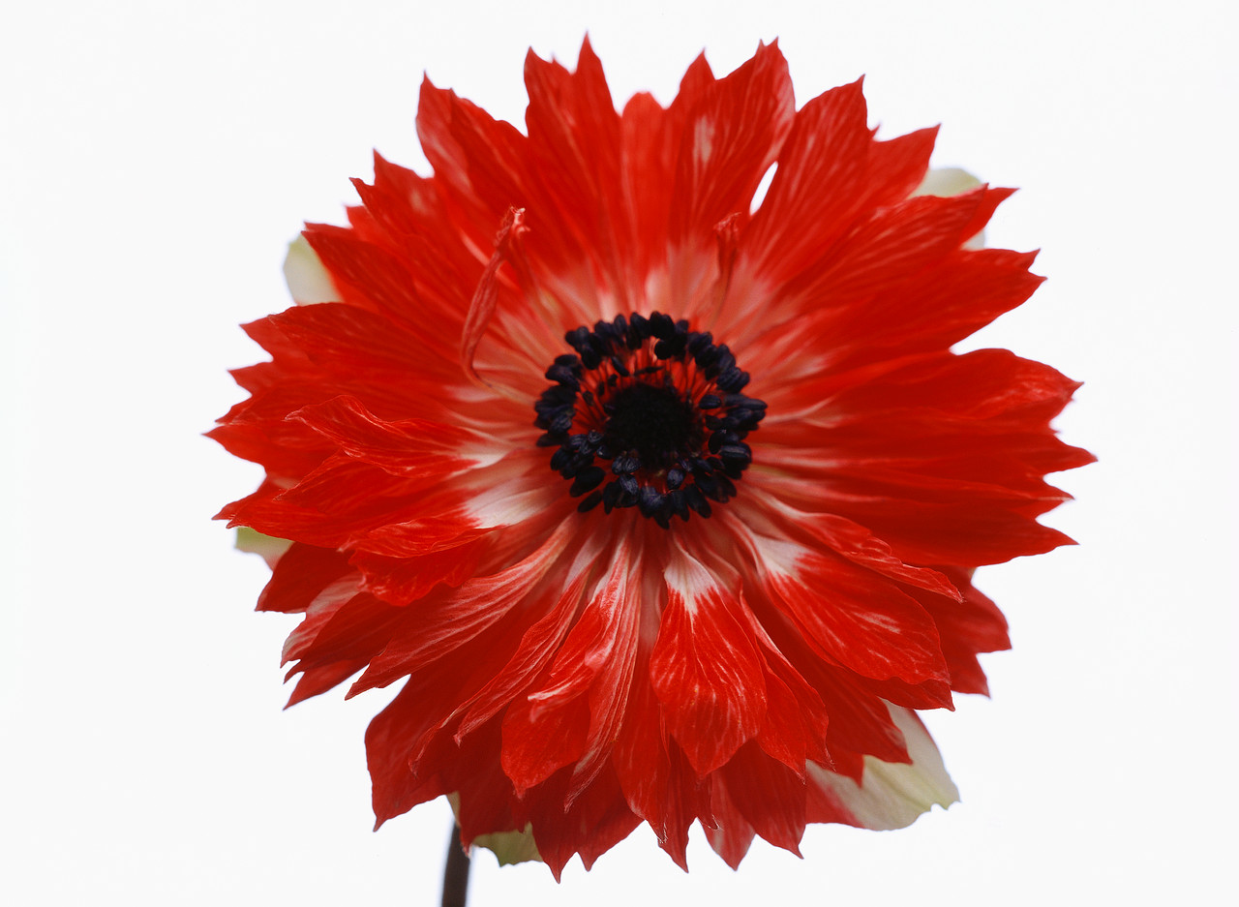

Fisherman Car/Truck Duck Train Flower

- At the Meriwether Lewis Exhibit (#4) you will learn how Meriwether Lewis began his trip to the West in 1803. He gathered supplies and tools from Harpers Ferry.

a) Draw an animal or plant that you think Meriwether Lewis may have seen on his journey.

For three long years
I explored lands that were not near.
New animals and plants I saw
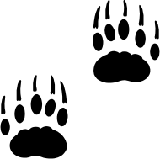
All of which I had to draw.
*

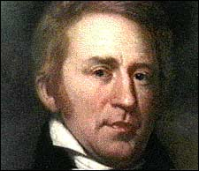
b) My partner’s name you will find in this room
Now tell me quick, my friend is whom?

(Hint: Look for this picture)

____________________________________ Ω

- John Brown’s Fort (#5), or Fire Engine House, is where John Brown fought to end enslavement in 1859. John Brown wanted to free the enslaved people so much that on October 16, 1859 he led an attack on Harpers Ferry. This building is important because it means freedom for many people.

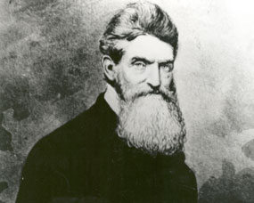
This is the site
Of John Brown’s fight.
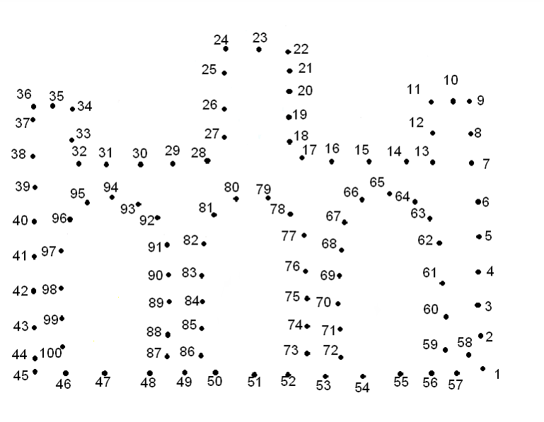
Connect the dots with your pen
To see the fort of his men.

§

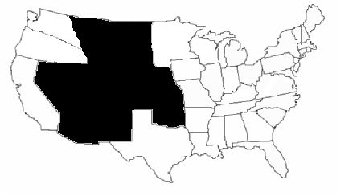
- The John Brown
Museum (#9)

a) The Civil War split the country in two.
One side was Gray and the other Blue.
Find the map marked with an 1852 date
Then look right and color in the Free States.

Note: The black sections already shaded are territories, which are areas that have yet to become states. So chose from the light states when coloring in your answers.

In the John Brown Museum you can learn more about John Brown’s raid on Harpers Ferry and on those who helped John Brown.

b) Name one person who was here during the raid. ___________________.

- In the Defeat and Victory Museum (#11), you can explore the Civil War history of Harpers Ferry. For four long years this town was in the middle of the war and many buildings were destroyed. It was a scary time for people to live in the town. In this museum you will see Civil War army weapons and maps of the battles.

In the back room
Search for a thing that went boom!
It is big and round
And weighs a hundred pounds!


Which best matches this object in size?

Baseball
Beach ball
Soccer ball



*
- After the Civil War, African Americans still had to fight -- this time for their rights to go to school, to vote, and to even eat at the same restaurants as white people. In the Storer College Exhibit (#8) you will learn about key people who made a difference for African Americans here at Harpers Ferry.

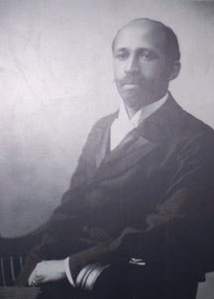
Draw a line to match the name with the correct picture.

Frederick Douglass escaped slavery and became famous as a speaker and freedom fighter.
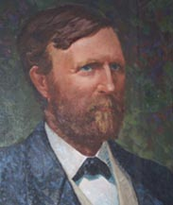

W.E.B. Dubois was the leader of the Niagara Movement and wanted equal rights for all. He graduated from Harvard and wrote books.
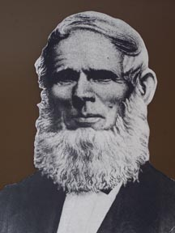

Booker T. Washington was the first principal of Tuskegee University in 1881. He believed that hard work and labor by your hand was the road to a better life for African Americans.

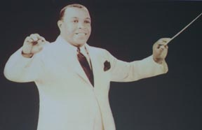

John Storer gave $10,000 to open a school in Harpers Ferry. He gave the money on the condition that the school was an equal opportunity school open to anyone.

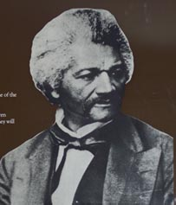

Nathan Cook Brackett started Storer College in 1867 so that anyone could attend and learn.

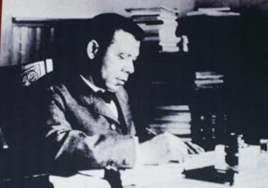
A graduate of Storer College, Don Redman was nicknamed “the little giant of jazz.” He composed lots of music that would affect the style of jazz and swing.
§

Answer Key:

1. Answers will vary.
2. a) fastest (airplane); fast (bicycle); faster (train)
b) fastest (train);
c) Horses; buggies; boats; trains; race; faster
d) conductor (top left) goes with train (bottom right); captain (middle left) goes with boat (top right);
driver (bottom left) goes with stagecoach (middle right)
e) Answers will vary.
f) gun
g) pictures will vary
3. a) answers will vary
b) answers will vary
4. a) pictures will vary
b) William Clark
5. Connect the dots to see John Browns Fort
6. a) Free states were: Washington Territory, Oregon Territory, California, Minnesota Territory, Iowa,
Wisconsin, Illinois, Michigan, Indiana, Ohio, Pennsylvania, New York, New Jersey, Massachusetts, Connecticut, Rhode Island, Vermont, New Hampshire, Maine.
b) Answers will vary
7. Soccer ball.
8. The pictures from top to bottom are: W.E.B. Dubois, Nathan Cook Brackett, John Storer, Don Redman, Frederick Douglass, Booker T. Washington.

Initial Drafts – K. Kai and S. Peden
Final Drafts – M. R. Crosby
Revised 5/07- J. Dawson and A. Cook
Bibliography of Images

*All images under this sign are from Clipart in Microsoft Word
Ω The image of William Clark are from
www.nps.gov/lecl?historyculture/williamclark.htm
§ All images under this symbol are taken from various exhibits throughout Harpers Ferry National Historical Park. The image of Don Redman is taken from the Harpers Ferry website at www.nps.gov/hafe.

 

