Utilization of Remotely Sensed Data and Geographic Information Systems (GIS) for Agricultural Statistics in the United States and the European Union

By

George Hanuschak

Director, Research and Development Division, United States Department of Agriculture (USDA), National Agricultural Statistics Service (NASS), USA

And

Jacques Delincé

Unit Head, AGRIFISH Unit, MARS Project, Joint Research Center (JRC), European Commission.

Abstract: The paper will cover the activities in the United States and the European Union with regard to the utilization of remotely sensed data for input to official agricultural statistics and for crop condition and production forecasting, estimation and mapping. Both the U.S. and the EU programs in this topic area are longstanding programs and recent developments since the International Conference on Agricultural and Environmental Statistical Applications in Rome, Italy in 2001. Among the developments in the U.S. are research on the use of administrative data from a GIS to supplement conventional statistical data, research on the use of very high-resolution imagery for citrus tree counting purposes, and the expansion of a crop mapping program to more States with resource leveraging partnerships. Among the developments in the EU are the expansion of the Monitoring Agriculture with Remote Sensing (MARS) project into more countries, the continual improvements in their data dissemination bulletin and their use of the French SPOT/vegetation sensor data for crop condition monitoring. Both programs are also evaluating the cost/benefits of their outputs to the statistical agencies and the general public to improve the relevance, timeliness, accuracy and cost effectiveness of their outputs and programs.

Keywords: Remotely sensed data, geographic information systems, crop production estimation, cropland data layer

1. USDA NASS experience with acreage estimation and cropland data layer public use GIS files and maps

Since the launch of Landsat I in 1972, NASS staff have been involved in information extraction techniques for agricultural monitoring and statistics purposes. NASS has used Landsat as an operational input to building new area sampling frames since 1976. NASS staff chose to develop a regression estimator for crop area estimates with Landsat as the auxiliary variable and ground gathered data from an area sampling frame as the primary variable [Wigton, 1982]. This approach has served NASS well as an input to State, district and county levels, but it is only available at the end of the crop season. NASS considers these inputs along with its traditional area sample based and multiple frame sample based crop area survey indicators. The regression estimator is currently available as an input in eight major crop producing states. However, in the last several years, the development of statewide crop specific classification, called the cropland data layer, of Landsat pixels released to the public. An example of the cropland data layer and crop rotation across years is provided in Figure 1. It is released to the public as a geographic information system data layer and has become quite popular with a variety of data users in the agricultural sector of the economy. Some of the data uses are: watershed monitoring, crop rotation mapping and analysis, agribusiness uses such as planning a site for a new plant, soil and crop interaction analysis, deep stratification for area sampling frames, water quality monitoring, animal habitat assessments, etc. The program has grown over the last decade by leveraging resources among other federal and state government agencies and universities [Craig, 2001].

Figure 1 – Cropland Data Layer with Crop Rotation Across Years
2002
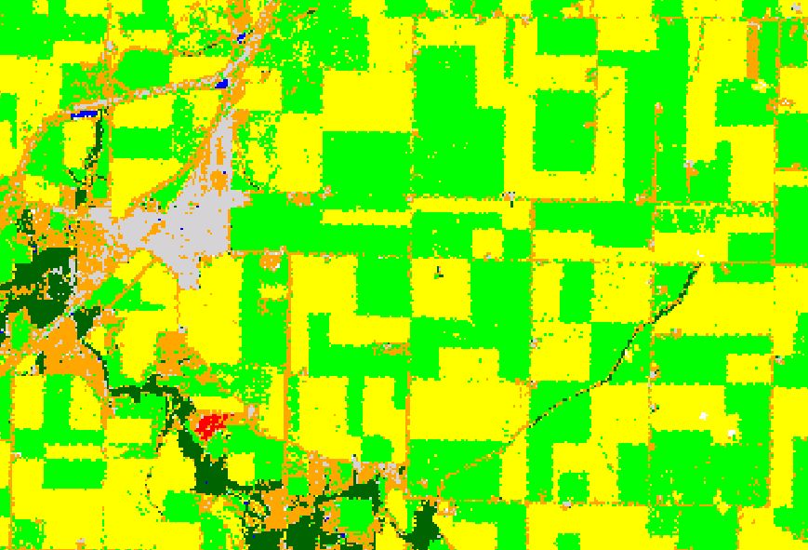
2003
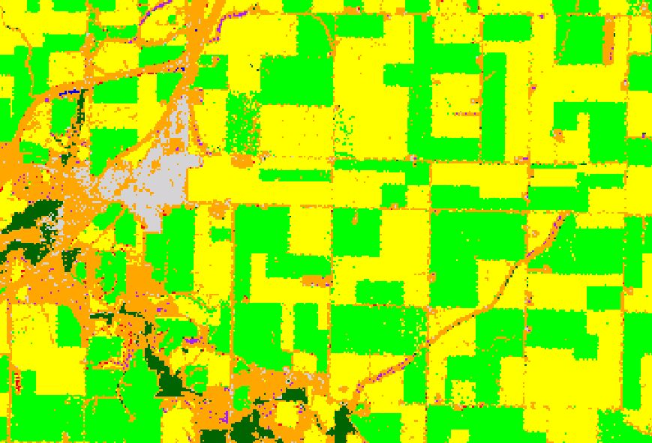

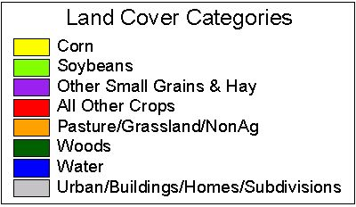

There are new concerns about the Landsat data though as Landsat 5 is now 18 years old and Landsat 7 is not applicable for wall-to-wall projects, such as the cropland data layer. The Landsat Data Continuity mission schedule is slipping and there is a strong possibility of a rather long (several years) data gap from Landsat. Therefore alternative sensors and systems will be evaluated, such as French SPOT, Indian LISS and AWIFS, and German RapidEye for the cropland data layer over the next few years.

2. USDA NASS experience with wide area crop condition (vegetative index) mapping

The history and experience of USDA NASS staff with wide area (national) crop condition monitoring is shorter but still extensive. NASS partnered with the USDA Agricultural Research Service (ARS) starting in 1990 with the goal of wide area crop condition monitoring using AVHRR data. After several years of research and software development, NASS began putting out an operational national crop condition (vegetative index) mapping program in 1994. When both the current period and any historic period of comparison are relatively free from serious atmospheric interference, the images are quite informative on vegetative condition. However, when there is serious atmospheric interference, the images are less valuable and users must view the metadata cautions about these occurrences and how to recognize them. Just viewing the images with atmospheric interference without recognizing that, can cause problems with map interpretation.

3. USDA NASS experience with crop yield modeling using remote sensing as an input

The history of the crop yield modeling research program coincides with the crop condition mapping program. NASS partnered with USDA ARS to develop and test crop yield models that used weather data, soils data, crop specific categorized Landsat data and AVHRR or MODIS data as inputs. The results of this research program have been mixed. At the state level, NASS’ conventional yield program that uses farmer reported yields and objective yield inputs, such as fruit counts and weights, are the primary inputs to the state level yield forecasting and estimation. However, through a new project emphasis and joint partnership with ARS and NASA, NASS will explore a new small area estimation approach, which seems promising at this stage. The approach is to take the official NASS State crop forecast or estimate for yield and to dis-aggregate it to the Agricultural Statistics District level (about 10 counties) and then further to the county level. This combines the strengths of the operational NASS yield program (National and State probability surveys–objective and farmer reported) and the geospatial distribution strengths of the remotely sensed data, weather data and soils data [Doraiswamy, 2003].

4. USDA NASS experience with the utilization of geographic information systems

USDA NASS research staff began using geographic information systems around 1990 as well. The original applications were area sampling frame construction and geospatial data displays of NASS data at the county level. Those applications went quite well and have now expanded to the Census of Agriculture Agricultural Atlas (of different types of maps), visualization of a crop season using survey data [Wade, 1997], remotely sensed data and weekly agricultural expert opinion at the county level, the beginning of fruit frames as GIS based sampling frames, displays of the Cropland Data Layer and AVHRR national vegetative index maps and the beginning of using administrative data from the USDA Farm Service Agency in a GIS to complement NASS data collection and alleviating some response burden. GIS applications in NASS are still growing and some need to transfer from applied research to operational. An example from the Agricultural Atlas follows in Figure 2. NASS remote sensing and GIS activities and products can be viewed at http://www.nass.usda.gov/research.
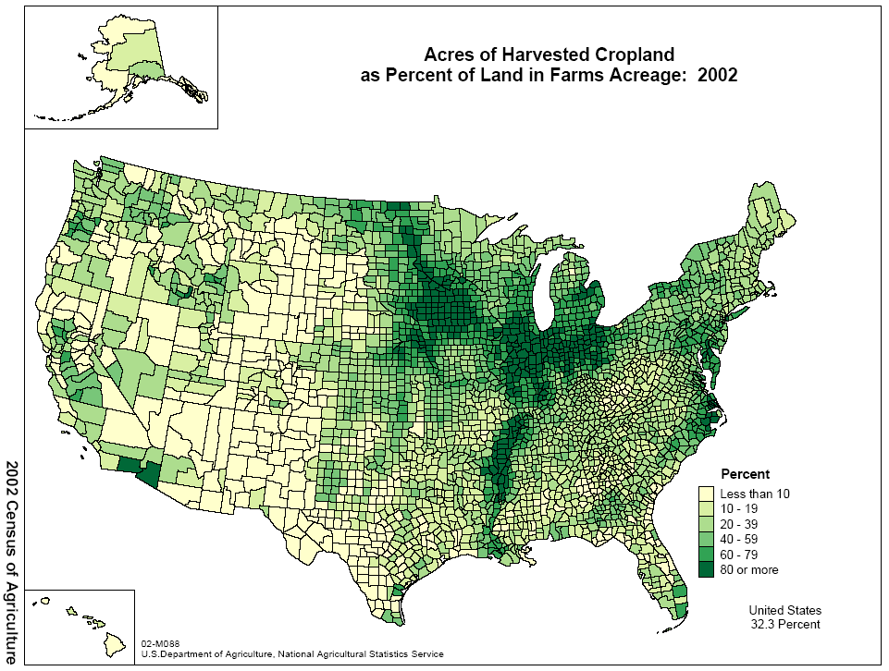

Figure 2 – Agricultural Atlas

5. USDA NASS experience with citrus tree counting using very high resolution satellite imagery

In the summer of 2002, NASS research staff were approached by the Florida Department of Citrus (FDOC) to evaluate the use of very high resolution satellite imagery, QuickBird, for citrus tree counting. An example of a QuickBird in a Florida citrus grove follows in Figure 3. NASS conducted a small pilot level project in Florida to determine the technical feasibility and reliability of tree counting from very high resolution imagery. The pilot had mixed results [Mueller, 2003]. Mature citrus blocks without substantial disease were the easiest to get accurate tree counts from. However, mixed blocks of some mature and some replants and some diseased trees in a block caused accuracy issues with any of the manual or automated techniques tried to date. There are two promising automated techniques or algorithms. The first is software from the University of Singapore called CRISP. The second is software called OLICOUNT and POLYCOUNT from the European Union MARS project. This is a lead in to the second portion of this paper, which gives an update of activities in the European Union.
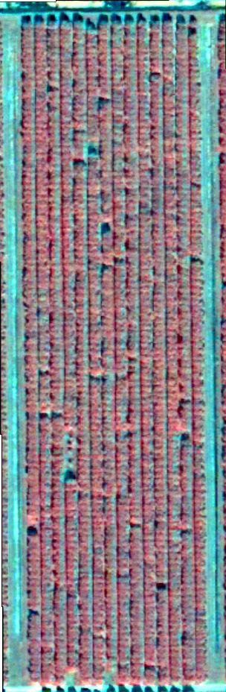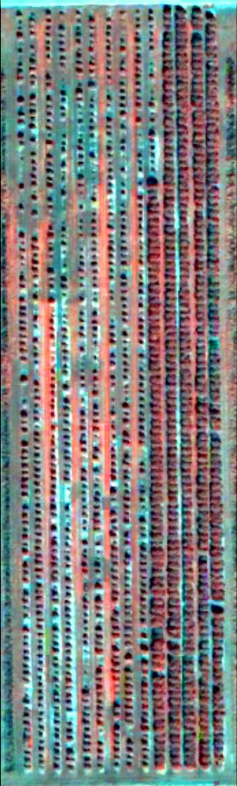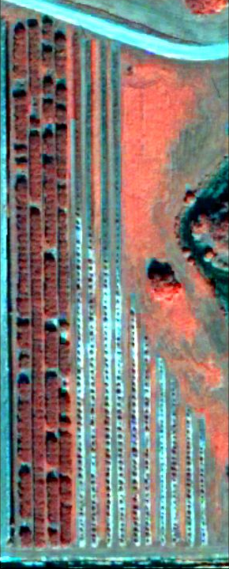

Figure 3 – QuickBird in a Florida Citrus Grove

6. The EU uses of GIS and Remote Sensing in Agricultural Statistics

Considering that the production of official agricultural statistics in the EU25 is steered by EU regulations (Reg. n°837/1990, 959/1993) but remains a national competence and official responsibility, several past and current applications can be mentioned on the utilization of remote sensing and GIS for improvement of the agricultural statistics:
- At EU level, the JRC MARS project started, in 1988, different RS activities relating to the production of crop area regional statistics [Taylor, 1997], to the timely estimation of EU level crop acreages [Genovese and Meyer-Roux, 1998], and to the use of agro meteorological models for yield estimation [Genovese, 1998]. This activity is on going and has even been extended to regions outside the European Union [Nègre, 2003].
- Through the TAPAS program and the Land Use land cover activities, EUROSTAT initiated in house studies and financed programs in Finland [Tuikkanen, 2003; EC, 2001; Duhamel, 1996].
- At Member States level, operational projects use remotely sensed data and GIS information for the production of official statistics. The AGRIT project in Italy [Greco, 2001] uses several complete coverages of Landsat imagery yearly. The Fömi activities in Hungary produce county, regional, plus national acreages and yields estimates based on Landsat, IRS, SPOT and NOAA AVHRR data [Csornai, 2003]. In Belgium, the SAGRIWATEL project aims at the integration of agricultural control and statistical activities integrating modern techniques like remote sensing, GIS and crop growth modeling [Tychon, 2003]
- The CORINE Land Cover mapping project [EEA, 2001], lead by the European Environmental Agency, offers a complete updated mapping of the EU25 at a 100.000 scale which, including the LANDSAT Image 2000 coverage, offers useful tools for survey stratification or landscape characterization.
- More recently the European Commission and the European Space Agency joined their effort on the GMES (Global Monitoring for Environment and Security) initiative. Of particular interest is the GMFS (Global Monitoring for Food Security) project whose objective is to favor access to the RS information needed in Africa for timely monitoring of crop productions [GMFS, 2003].

7. JRC/MARS monthly European Yield Forecasts

The knowledge in real time of crop conditions in the 25 EU Member States is essential to DG Agriculture for the agricultural market management. In complement to the information collected from Member States through EUROSTAT, the MARS project has been entrusted to produce periodical bulletins describing the current crop growing conditions and forecasting the yields of the major European crops.

On the base of archive and real time satellite data (SPOT-Vegetation and NOAA-AVHRR) and meteo data (30 daily parameters on 1500 stations), a crop growth model (derived from the WOFOST model) is run daily and results in four outputs:
- Updates of the MARSOP website (http\\marsop.info), where pre-processed products can be freely accessed and where authorized users can obtain dedicated products;
- Bi-weekly bulletins sent to DG Agriculture, commenting on the weather conditions as well as short term meteo forecasts;
- Monthly input to the EUROSTAT AGROMET letter sent to Member States to support them in the elaboration of the national early production estimates that they provide monthly to EUROSTAT; and
- Periodical bulletins (7 per year) presenting the expected yields at EU and Member states level.

This system allowed, in August 2003, a real time and independent quantification of the influence on the crop yields of the extreme hot and dry conditions faced in Europe and supported the EU decision-making process in order to minimize the effects of the crisis.

8. The European Area Estimates: LUCAS and associated research

The early estimation of crop acreages is a more difficult exercise than the yield prediction. To be useful, estimates have to be obtained early (first data in February, thus 3-4 months before harvest), have to be precise (for a fixed and stable potential area, changes are limited to weather constraints and economical conditions) and should ideally be low cost.

The actual EU strategy to get EU wide crop acreages consists of the LUCAS survey [Delincé, 2001]. Realized every two years in EU15 since 2001, the survey is a point area frame survey composed of 100.000 systematic sample points clustered in 10.000 Primary Sampling Units. Under EUROSTAT supervision, the June-July field survey usually provides aggregated results by end of July.

The possible enhancements of the LUCAS survey are mainly:
- The date of first availability of results: the LUCAS data are available on all MS by end of July (roughly at the date of harvest). Anyway, more early information is needed for market management.
- The estimate’s precision, as the observed variances are still too large.
- The nomenclature (including definitions) has still to be worked so that inter annual evolution do not confound with methodological changes and so that the LUCAS limited nomenclature fits with the national ones.

In that spirit, the MARS project tested the integration of IACS data and MODIS satellite data with the LUCAS 2001 survey [ITA, 2002].

- Using GIS possibilities, the integration of administrative data from farmer declarations with LUCAS survey was tried in Italy on 2001 data. Using a regression estimator approach, the 9,250 LUCAS sampling points were linked with the IACS (Integrated Administrative and Control System, Reg. 1782/2003) data through the cadastral references. This allowed the calculation at PSU level of the correlation between the LUCAS and the IACS land covers.

Table 1 – Comparison between the LUCAS estimate (systematic sampling) and the regression estimator, using the IACS declarations as auxiliary variable (case of Italy)

 | [a] LUCAS |  |  | [b] Regression |  |  | Rel. Eff. [b]/[a] | Diff. [b]-[a]
 | Sup (ha) | s.e. (ha) | Cv (%) | Sup (ha) | s.e. (ha) | Cv (%) | Rel. Eff. [b]/[a] | Sup(ha) | %
Common wheat | 603558 | 55489 | 9.2 | 629137 | 45543 | 7.2 | 1.48 | 25579 | 4.24
Durum Wheat | 1541286 | 104388 | 6.8 | 1566513 | 79554 | 5.1 | 1.72 | 25227 | 1.64
Maize | 1501052 | 99291 | 6.6 | 1566717 | 53744 | 3.4 | 3.41 | 65664 | 4.38
Rice | 208554 | 55316 | 26.5 | 215136 | 15212 | 7.1 | 13.22 | 6582 | 3.16
Sugar beet | 202493 | 37536 | 18.5 | 216208 | 25747 | 11.9 | 2.13 | 13715 | 6.84
Sunflower | 205345 | 32307 | 15.7 | 218155 | 23709 | 10.9 | 1.86 | 12810 | 6.24
Soya | 192511 | 35229 | 18.3 | 265926 | 22953 | 8.6 | 2.36 | 73415 | 38.20

The use of administrative data as an auxiliary variable generally improves the accuracy of the estimates, at times with significant increments in efficiency (ex. Maize). On the whole, the variation coefficient for the cereals aggregate is reduced from 3.55 to 2.77.

But the difference in the surface area estimates cannot be disregarded: the use of regression always leads to a systematic increment in the estimate. It is highly probable that the declarations “lost” on a sampling unit level due to errors in the codification of the cadastral parcel identification explain the discrepancy. In conclusion, even if the administrative data potentially constitute a useful source of auxiliary information for improving the efficiency of the LUCAS survey, the analysis of the Italian data showed that a reliable and complete geo-referencing system is a condition for operational use.

- Medium resolution satellite data (MODIS or MERIS) present interest to get crop acreage statistics early in the season. The limitations faced with high resolution SPOT or LANDSAT satellite (high costs, low probability of availability due to cloud coverage, limited radiometric information) could be overcome due to a daily coverage and to an increased number of channels (15 for MERIS). In that context, a study was done on two Italian regions (Marche and Sicily) on November 2000 and April 2001 MODIS images. In the Marche region, the estimated acreages of winter cereals on the MODIS data amounted to 210.079 ha, in good agreement with the 218.587 ha estimated in the AGRIT 2001 Project. Further analysis of the quality of the classification was performed, by comparing the MODIS classification results with LANDSAT classification results at MODIS pixel level (1km²)

Figure 4 – Relation between the multi-temporal MODIS and LANDSAT image classifications of winter cereals in the Marches region in 2001.

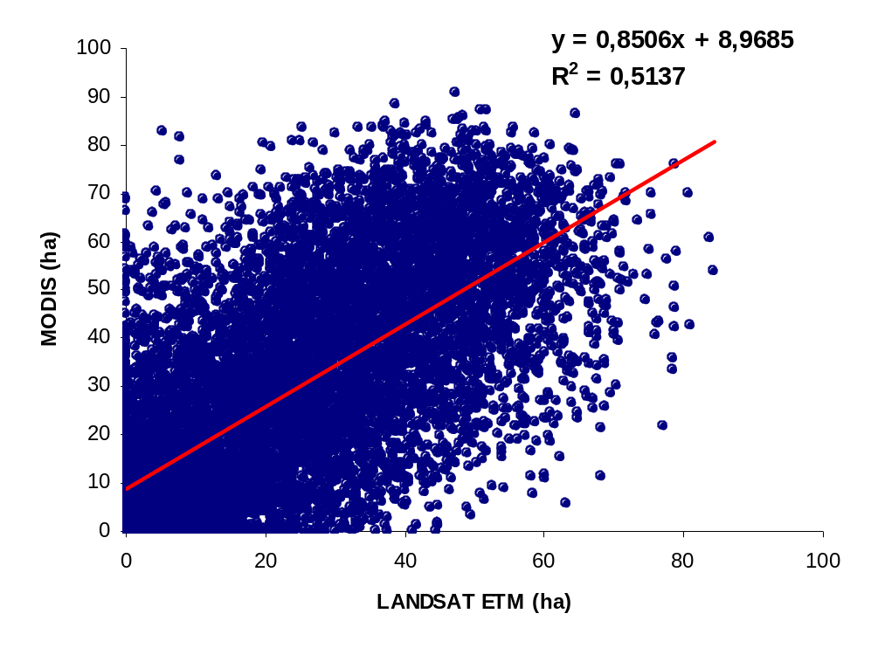

9. MARS tree counting software: POLYCOUNT

During the 1998 OLISTAT survey (Estimation of number and areas of Olives trees at Member States level), the “OLICOUNT” software was developed in order to automatically count, locate and measure areas of olive trees/groves. In the context of the Olives GIS (Reg. 2366/1998), all Member States adapted and adopted the MARS/JRC algorithm, allowing a uniform definition of these parameters in the EU administrative data. More recently, studies were conducted in order to open the software to multi-spectral digital data (QuickBird, ADS40) and to cover classification of other species (citrus, nuts).

10. JRC/MARS activities in Food Security

MARS-FOOD’s main focus is to develop and operate improved methods for crop forecasting in regions outside of Europe, in particular in regions stricken by recurrent food shortages. Global data (satellite, meteo) are received daily and ten-daily. Global meteorological and agrometeorological data are derived from the ECMWF (European Centre for medium-Range Weather Forecast) global model, at one-degree spatial resolution. Global ten-day NDVI satellite syntheses from the SPOT-Vegetation instrument are used too. Different agrometeorological models are used according to the geographical area. A modified CGMS model is used for Russia, Central Asia and the Mediterranean Basin. For the rest of the world, a more simple approach based on the FAO Crop Specific Water Balance is being put into place. Dry matter productivity is also calculated on a ten-day basis using a Monteith model approach with radiation derived from the ECMWF and interception efficiency from the SPOT-Vegetation data. Based on these methods, analysis is done on a regular basis and in real-time at regional level on Russia and Central Asia, the Mediterranean Basin, the Horn of Africa and at national level for Somalia. Prospects are to soon extend the bulletin production also to South America and to Sudan. Close collaboration exists with FAO, both on scientific and organizational matters.
As for MARS-STAT, links with the national services are strong. A particular effort has been done, jointly with FAO, to develop regional (sub-continental), thematic networks on crop monitoring for food security. Two networks were initiated for South-America (November 2002) and Eastern Africa (January 2003), with the organization of two dedicated workshops in Cordoba (Argentina) and Nairobi (Kenya). Access to information is opened to national services interested, either for bulletins such as Table 2 (at http://agrifish.jrc.it/marsfood/Bulletins/) or for real-time maps (at http://www.marsop.info).

Table 2 - 2004 Winter Wheat Yield expectation in Russia and Central Asia
(from Mars-Food bulletin end-June 2004)
Country | Comparing with previous year |  | Winter Wheat Yield 2004  expectation  (t/ha)
Country | Meteorological conditions during May-June | Winter crop status at the end of June | Winter Wheat Yield 2004  expectation  (t/ha)
Russia | + | + | 2,2-2,5
Armenia | + | + | 2,3-2,7
Azerbaijan | - | = | 2,2-2,5
Georgia | + | + | 2,0-2,3
Kazakhstan | - | - | 0,8-1,2
Kyrgyzstan | - | - | 2,1-2,3
Tajikistan | - | - | 1,5-1,8
Turkmenistan | - | - | 2,6-2,8
Uzbekistan | - | - | 2,7-3,0
Afghanistan | - | - | n/d
Iraq | = | = | 0,7-0,9
Iran | + | = | 1,8-2,0
Kuwait | = | = | 2,3-2,5
Northern India | - | = | n/d
Northern Nepal | = | = | n/d
Northern Pakistan | = | = | n/d
Western China | - | = | n/d
+ indicates figures which are higher than normal, - indicates figures which are lower than normal, and = indicates figures, which are close to normal.

Bibliography

Craig, M. (2001), “A Resource Sharing Approach to Crop Identification and Estimation,” 2001 ASPRS/ACSM Annual Convention Technical Papers, available on CD, Proceedings of the ASPRS 2001 Conference, Bethesda, MD – USA.

Doraiswamy, P. (2002), “Remote Sensing Applications in Agrometeorology,” CagM-XIII Open Forum Sessions, Ljubljana, Slovenia.

Mueller, R., Boryan, C., Craig, M., Fleming, M. and Hanuschak, G. (2003), “Pilot Research Project: Investigation of Very High Resolution Spaceborne Imagery for Citrus Tree Counting,” Report for FDOC Contract No. 02-17.

Wade, L., Craig, M. and Hanuschak, G. (1997), “Using Geographical Information Systems (GIS) For Dissemination of U.S. Agricultural Statistics,” Geographic Information Systems Work Session sponsored by the United Nations Economic Commission for Europe (UN-ECE), Brighton, United Kingdom.

Wigton, W., Allen, R. and Hanuschak, G. (1982), “Integration of Landsat Data Into The Crop Estimation Program of USDA’s Statistical Reporting Service,” Proceedings of the 1982 Machine Processing of Remotely Sensed Data Symposium, Eighth International Symposium, LARS, Purdue University, West Lafayette, IN – USA, pp. 45-56.

Csornai G., Wirnhardt Cs., Suba Zs., Nador G., Martinovitch L., Tikasz L., Lelkes M., Kocsis A., Zelei Gy. (2003) The Operational Crop Monitoring and Production Forecast Program (CROPMON 1997) and others RS based Applications. Geoinformation for European wide Integration. Proceeding of the 22nd Symposium of the European Association of Rempote Sensing Laboratories, Prague, Czech Republic, 4-5 June 2002, Millpress Rotterdam Ntherlands, p561-566.

Delincé J. (2001) A European Approach to Area Frame Surveys. In CAESAR, vol II, pp463-472.

De Longueville F., Pekel J.F., Quintin L., Oger R., Tychon B., Defourny P., Debouche C., Vanhalle L., Leteinturier B. (2004) Monitoring of the Walloon Agriculture State with Remote Sensing – SAGRIWATEL. Poster Sesion at Workshop Stereo-Vegetation, 3rd Belgian EO day, Brussels, May 6 2004.

Duhamel C. (1996) Télédétection et Statistique. In : Statistique et Géographie, SIGMA 1996, EUROSTAT CA-AB-96-002-FR-C, pp 29-33.

European Commission (2001) Manual of Concepts on land Cover and Land Use Information Systems. Theme 5: Agriculture and fisheries, Collection: Methods and Nomenclatures, EUROSTAT, Luxembourg, 106pp.

European Environment Agency (2001) Towards Agri Environmental Indicators: Integrating Statistical and Administrative Data with Land Cover Information. Topic Report 6/2001, Copenhagen, 131pp.

Genovese G. (1998) The methodology, the results and the evaluation of the MARS crop yield forecasting system. In: Agrometeorological Applications for Regional Crop Monitoring and Production Assesment. Riks, Terres, Vossen Eds. EUR Publication 17735 EN, Ispra, Italy 100p.

Genovese G. Meyer-Roux J. (1998) Rapid Estimates of Area Changes of the Main Crops at European Level, overview of the Methodology, Results and Orientations. Special Issue pf GEO-Observateur, n°9, CRTS, ISSN 113-4410, pp91-99.

GMFS (2003) Global Monitoring for Food Security: Satellite data support service for existing early warning Systems. ESA/VITO Brochure, 6pp.

Greco M. and Martino L (2001) The Agricultural Satistical System in Italy. In CAESAR, vol II pp 451-462.

ITA (2002) ICARE: Integrated Crop Area Estimates, Final MARS/JRC Report, 71pp.

NEGRE T., REMBOLD F., ROJAS O. (2003)- Integrated agricultural monitoring and yield forecasting for Eastern Africa: the JRC approach. In: Proceedings International Workshop on Crop monitoring and Early Warning for Food Security, 28-30 January 2003, Nairobi (Ke). EUR 20869 EN

Taylor C., Sannier C., Delincé J., Gallego F.J. (1997) Regional Crop Inventories in Europe assisted by Remote Sensing: 1988-1993, Synthesis report of the MARS Project-Action 1. JRC Technical report EUR 17319, European Commission, Italy, 71pp.

Tuikkanen M. (2003) TAPAS report: Development and improvement of early estimations of areas and production of most important crops in Finland. EUROSTAT report, Luxembourg.

