Abstract—We report on the fabrication, assembly, and test of the Nb₃Sn dipole magnet HD2. The magnet, aimed at demonstrating the feasibility of Nb₃Sn superconductor in high field accelerator-type dipoles, features a 36 mm clear bore surrounded by block-type coils with tilted ends. The coil design is optimized to minimize geometric harmonics in the aperture and the magnetic peak field on the conductor in the coil ends. The maximum expected bore field of 15 T at 4.3 K is determined through critical current measurements of extracted strands. The coils are horizontally pre-stressed during assembly using an external aluminum shell pre-tensioned with water-pressurized bladders. Axial pre-loading of the coil ends is accomplished through two end plates and four aluminum tension rods. The strain in coil, shell, and rods is monitored with strain gauges during assembly, cool-down and magnet excitation, and compared with 3D finite element computations. Magnet’s training performance, quench locations, and ramp-rate dependence are then analyzed and discussed.
Assembly and Test of HD2, a 36 mm bore high field Nb₃Sn Dipole Magnet
P. Ferracin, B. Bingham, S. Caspi, D. W. Cheng, D. R. Dietderich, H. Felice, A. Godeke, A. R. Hafalia, C. R. Hannaford, J. Joseph, A. F. Lietzke, J. Lizarazo, G. Sabbi, F. Trillaud, and X. Wang

Index Terms—Dipole magnet, Nb₃Sn

INTRODUCTION
THE Superconducting Magnet Program at Lawrence Berkeley National Laboratory (LBNL), as part of the development of Nb₃Sn high field magnets for the next generation of HEP colliders [1], has fabricated and tested the Nb₃Sn dipole magnet HD2. After a preliminary description of goals and a conceptual design reported in [2], we presented the results of a detailed mechanical analysis of coil and structure in [3], and documented the final design, the fabrication and assembly procedure, as well as the field quality expectations, in [4]. In this paper, after an overview of the magnet design parameters, the results of three tests carried out at the LBNL test facility are presented, including strain gauges measurements, training performance, quench locations, and ramp-rate studies.

Magnet Design
The HD2 magnet design (Fig. 1, left) features two block-type coils wound around a titanium alloy pole.
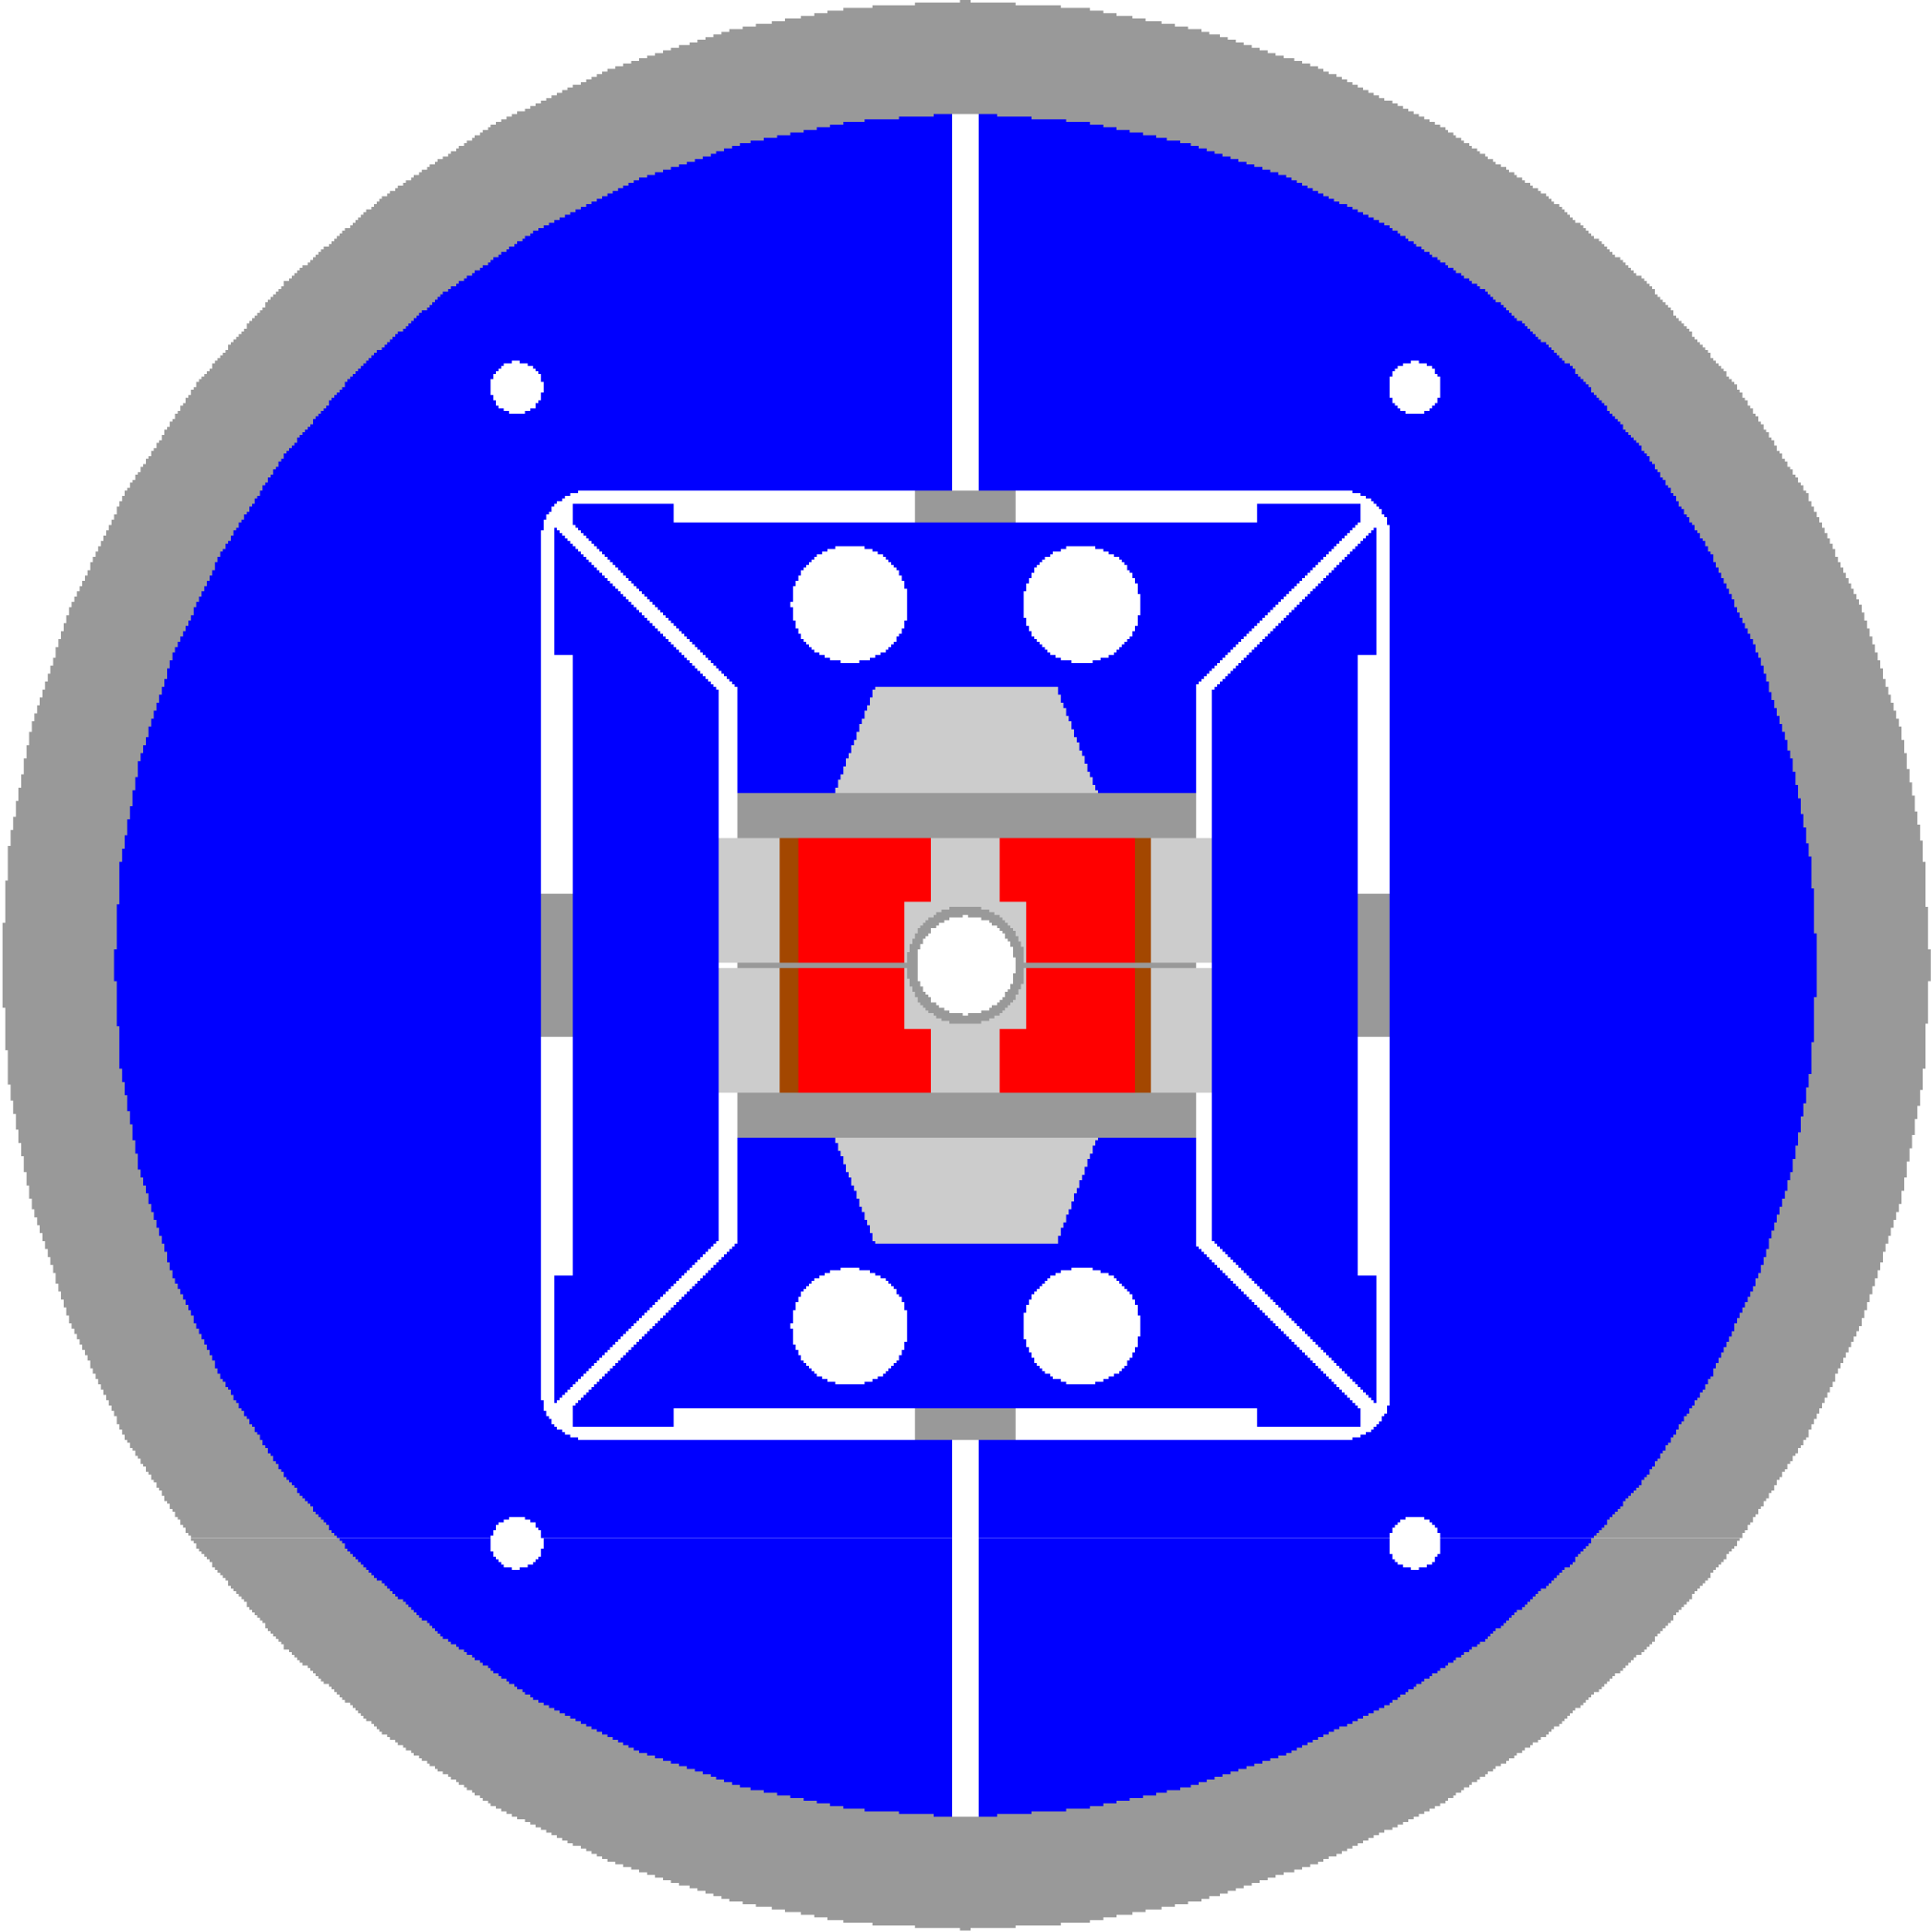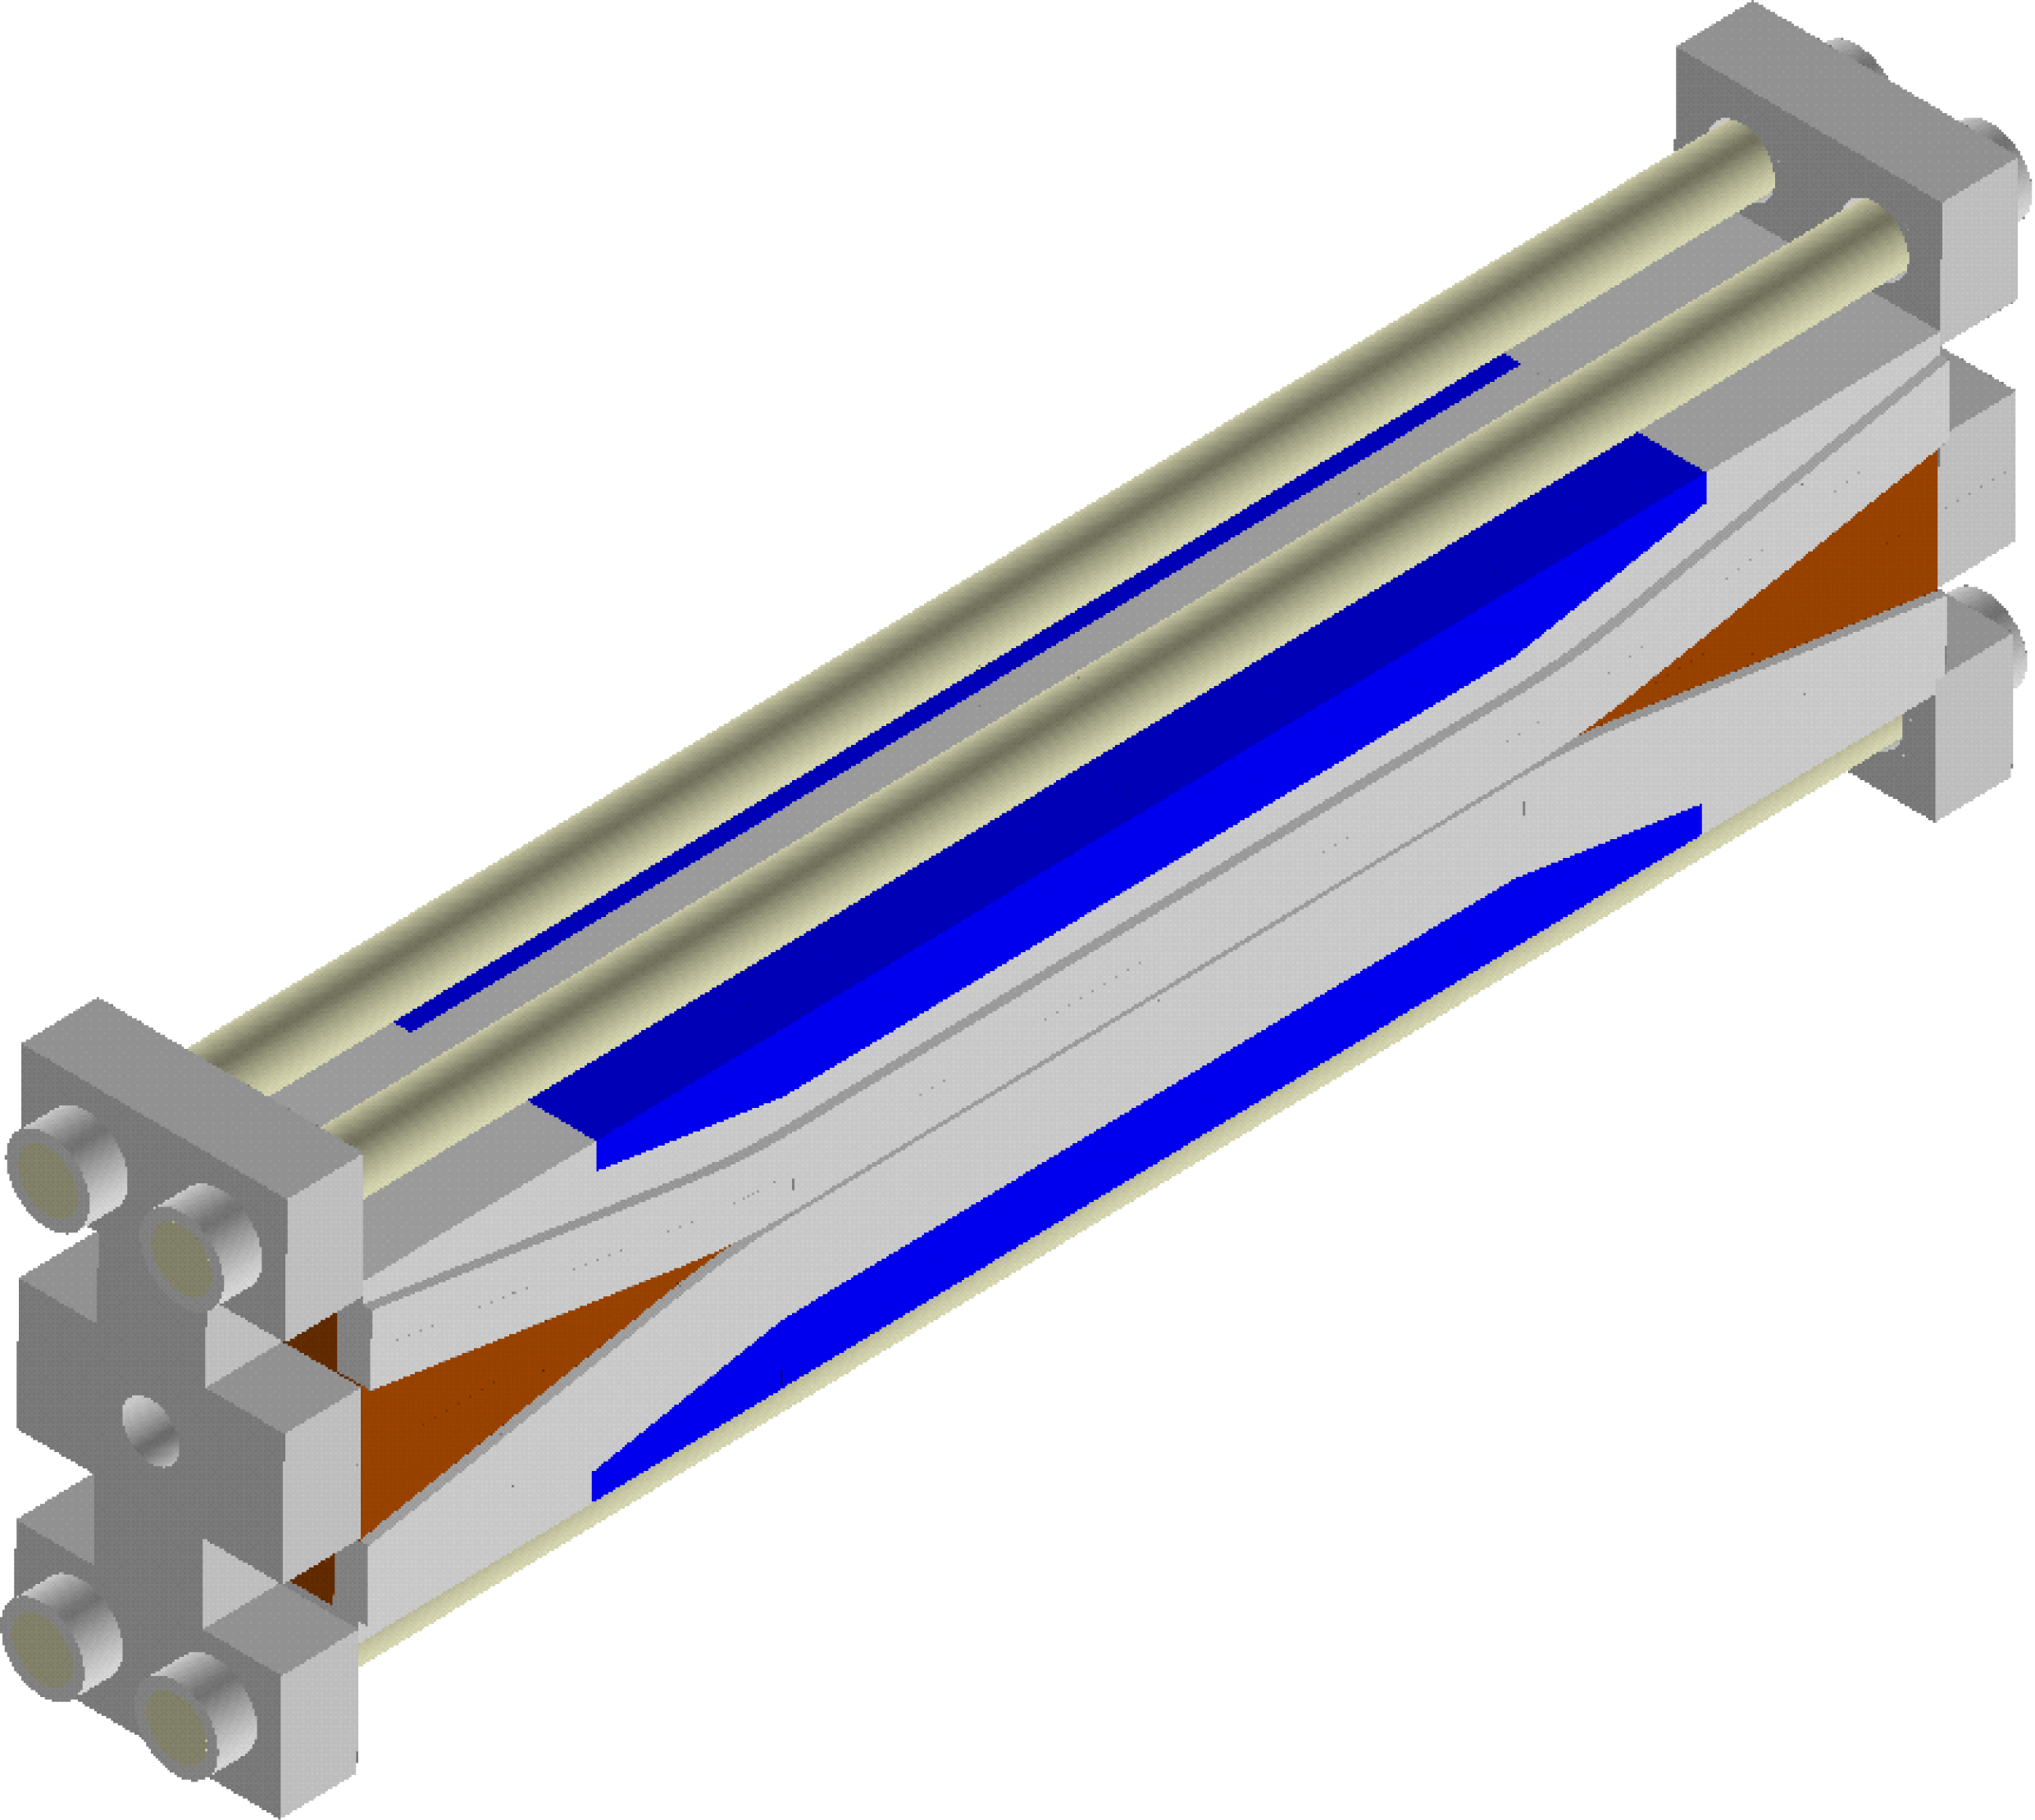
Fig. 1. HD2 cross-section (left) and coil end support system (right).

The pole includes a round cutout to provide room for a 3.65 mm thick stainless steel bore tube with a clear aperture of 36 mm. The coil has a straight section of 475 mm, and it tilts up (flares) at a 10º angle in both ends through hard-way bends. The peak field is located in the straight section of layer 2 pole turn: layer 1 pole turn and the coil ends have a field margin of respectively 4% and 6%. The coil cross-section has been optimized to have, in the current range of 2-17 kA, b₃ ranging from +2.4 to -0.1 units, and a b₅ variation from -0.4 to -0.2 units at a R_{ref} = 10 mm. The support structure is based on an external 41 mm think aluminum shell with an outer diameter of 705 mm (see Fig.1, left). The shell is pre-tensioned with water-pressurized bladders. With a pre-load level for a 15 T bore field, the coil reaches a peak stress of 180 MPa in the pole turn of layer 1. Two 50 mm thick endplates, connected by four 18.5 mm diameter aluminum rods, provide support the coil ends (see Fig.1, right). The complete magnet assembly is shown in see Fig. 2.

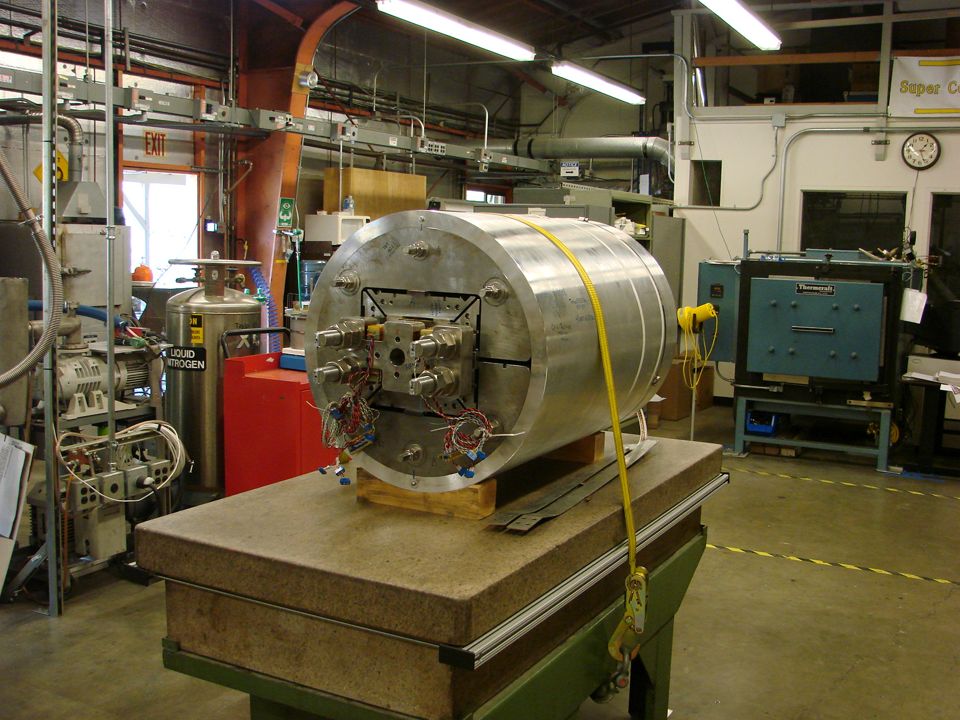
Fig. 2. HD2 assembled and pre-loaded.

Conductor and Magnet Parameters
Three coils, composed of two layers wound from a continuous length of cable made of 51 RRP strands with a 0.8 mm diameter, were fabricated and tested. The strand and cable parameters are listed in Table I: the strand used for coil 1 features a lower RRR and non-Cu ratio. Both virgin (round) strands and strands extracted from cables were reacted with the coils to analyze magnet performance. In Fig. 3 and Fig 4 the critical current measurements are plotted as a function of the total magnetic fields, both for virgin and extracted strands. A self field correction of 0.4858 T/kA is included. Data are fitted and extrapolated at different temperatures using the ITER standard parameterization as described in [5]. At 12 T and 4.2 K, the strands exhibit a critical current degradation after cabling of 4% in coil 1 and 2% in coil 2 and 3.
Fig. 3. Critical current (A) vs. total magnetic field (T) measurements and parameterization curves of round (RW) and extracted wires (XS) for coil 1.
Fig. 4. Critical current (A) vs. total magnetic field (T) measurements and parameterization curves of round (RW) and extracted wires (XS) for coil 2-3.

The magnet current limits (short sample current I_{ss}) at the magnet test temperature of 4.3 K and at 1.9 K are estimated by intersecting the parameterization curves with the magnet load-line. The load-line represents the peak field in the straight section of the layer 2 pole turn computed as a function of current. The predicted short sample current at 4.3 K is 17.3 kA or 18.1 kA, assuming respectively coil 1 or coil 2 and 3 properties (see Table II for all magnet parameters). At 1.9 K, an increase of 1.5 T is expected in the short sample bore field.
TABLE I Cable Parameters
Parameter | Unit | Coil 1 | Coil 2-3
Strand diameter (before reaction) | mm | 0.802 | 0.801
Process |  | RRP
Stack |  | 54/61
Non Cu % |  | 51 | 54
RRR |  | 16 | 287
Twist | mm | 13 | 14
No. strands |  | 51
Cable width (bare) | mm | 22.008 | 21.999
Cable thickness (bare) | mm | 1.401 | 1.406
Insulation thickness | mm | 0.095 | 0.095

TABLE II Magnet Parameters
Parameter | Unit | HD2a-b | HD2c
Clear aperture | mm | 36
Magnet outer diameter | mm | 705
No. turns in layer 1 (quadrant) |  | 24
No. turns in layer 2 (quadrant) |  | 30
Short sample current I_{ss} at 4.3/1.9 K | kA | 17.3/19.2 | 18.1/20.0
Bore field at 4.3/1.9 K I_{ss} | T | 15.0/16.5 | 15.6/17.1
Coil peak field at 4.3/1.9 K I_{ss} | T | 15.9/17.4 | 16.5/18.1
Fx/Fy layer 1 (quadrant) at 17.3 kA | MN/m | +2.3/-0.4
Fz layer 1 (quadrant)at 17.3 kA | kN | 90
Fx /Fy layer 2 (quadrant) at 17.3 kA | MN/m | + 3.3/-2.2
Fz layer 2 (quadrant) at 17.3 kA | kN | 126
Stored energy at 17.3 kA | MJ/m | 0.84
Inductance | mH/m | 5.6
HD2a and HD2b were assembled with coil 1 and coil 2. HD2c was assembled with coil 2 and coil 3.

Test Overview
HD2 was assembled and pre-loaded at LBNL and it underwent three tests at 4.3 K: HD2a and HD2b with coil 1 (limiting coil) and coil 2, and HD2c with coil 2 and coil 3. The shell and the aluminum rods were instrumented with strain gauges, and their stress conditions were monitored and recorded during all room-temperature loadings, cool-downs, and tests. Fig. 5 and Fig. 6 show the evolution of the shell and rod stress, with a comparison with the expectations from a 3D finite element model of the entire magnet assembly [2].
In order to mechanically characterize the structure and validate the numerical model, a first cool-down to LN temperature was performed. Coil 1 and coil 2 were assembled and pre-loaded inside the structure. During cool-down, the tension increased from 49 MPa to 135 MPa in the shell and from 34 MPa to 83 MPa in the rods. Since the date we considered consistent with model expectations, after warm-up, the magnet was cooled-down to 4.3 K, without disassembly or chanage in pre-load, and tested (HD2a). At 4.3 K the measured shell stress was 144 MPa, while a total axial force of 560 kN was provided to the coil ends by the rods tensioned to 90 MPa. According to the model, this stress conditions in the structure results in a coil peak stress in the straight section of 149 MPa and ensures no separation coil-pole, both in the straight section and in the end region, up to a 14 T bore field.
HD2b test was carried out after a minor adjustment of the coil end support, without unloading the shell. The last tests (HD2c) followed a complete disassembly where coil 1 was replaced by coil 3 and the shell tension was increased by 13 MPa at room temperature, from 36 MPa to 49 MPa.
Fig. 5. Azimuthal stress (MPa) of the 41 mm thick shell during pre-load and tests: measured values (markers) and model expectations (dashed lines).
Fig. 6. Axial stress (MPa) of the four 18.5 mm diameter rods during pre-load and tests: measured values (markers) and model expectations (dashed lines).

Test Results

Training Quenches
The training histories of the three tests are shown in Fig. 7, where the bore field is plotted for all the quenches occurred with a ramp-rate ≤ 20 A/s. The bore field was measured with a Hall probe placed in the longitudinal center of the magnet (see Fig. 8 for a measured and computed bore field vs. current).
HD2a, ramped at 20 A/s, had a first quench at 11.4 T (73% of I_{ss}). After 16 quenches it reached a maximum bore field of 13.3 T (87% of I_{ss}), corresponding to an estimated coil peak field of 14.0 T. In the second test (HD2b), the magnet, still at a ramp-rate of 20 A/s, did not exhibit memory of the previous quench performance, and, after a first quench at 11.0 T (71% of I_{ss}), it trained to the same maximum field after 12 quenches. Because of a failure of the extraction system during quench #12, the number of MIITS released to coil 1 (quenching coil) increased from 16 to 23. As a result, higher ramp-rate sensitivity was observed, and the magnet managed to achieve the previous level of bore field only after a reduction of the ramp-rate from 20 to 10 A/s (quenched #15 and #16). A detailed comparison of the voltage signals recorded before and after training quench #12 is presented in [6].

Fig. 7. Training quenches in HD2a, HD2b, and HD2c. The short limit of 15.0 (15.6) T bore field corresponds to a coil peak field of 15.9 (16.5) T. All the plotted quenches occurred at a current ramp rate ≤ 20 A/s.
Fig. 8. Measured and computed bore field (T) vs. magnet current (A).

After a 13 MPa increase of shell tension and the replacement of coil 1 with coil 3, the magnet was retested as HD2c. Despite an increase of the expected short sample limit (see Table II), the training was similar as in the previous tests; the magnet, at a ramp rate of 5 A/s, reached a maximum bore field of 13.8 T (87% of I_{ss}) at quench #30, corresponding to an estimated peak field of 14.5 T.

Quench Locations
The time-of-flight method was used to locate the quench origins. The voltage signals were monitored using derivative amplifier with a resolution of 5 kHz. Normal zone propagation velocity was determined based on the correlation between the I_{q}/I_{ss} and the velocity v given by v = a ⋅ exp(b ⋅ I_{q}/I_{ss}), where a = 0.590, b = 4.554, I_{q} is the quench current, and I_{ss} is the current limit of the quenching segment. The correlation was obtained from test results of the SQ02 magnet [7]. Equal and constant velocities of both normal fronts were assumed. In Fig. 9 to Fig. 11, the quench origins in HD2a, b and c are plotted. The inner and outer loops represent respectively the pole turn of layer 2 and layer 1, while the vertical dashed lines indicate the end of the straight section, approximately where the cable hard-way bend starts. For each magnet test, the origins are projected to a plane parallel to the coil mid-plane.
Fig. 9. HD2a quench locations: coil 1 (diamond markers) and coil 2 (round markers).

Fig. 10. HD2b quench locations: coil 1 (diamond markers) and coil 2 (round markers).

Fig. 11. HD2c quench locations: coil 3 (diamond markers) and coil 2 (round markers).

The voltage signals recorded during the HD2a test allowed determining the position of 14 training quenches, out of a total of 16. The quenches were almost evenly distributed between the coils: 6 in coil 1 and 8 in coil 2 (which features a higher expected short sample current). They all occurred in the pole turn of layer 1, which has a 4% margin in field with respect to the pole turn in layer 2. In addition, they were all located towards the end of the straight section, close to the region where the conductors are hard-way bent.
All the training quench locations of HD2b were identified but one. Before quench #12, 4(6) quenches occurred in coil 1(2), confirming that the lower current limit of coil 1 was not affecting the magnet training. After quench #12, the remaining four quenches took place all in coil 1. Most of the quenches (12) were again located towards the end of the straight section of layer 1 pole turn, while three occurred in the pole turn of layer 2 in coil 1 (peak field region), still close to the beginning of the hard-way bend.
In the HD2c test, coil 1 was replaced by coil 3. Out of 30 training quenches, 28 positions were determined. All but one were again located in the pole turn of layer 1. Most of the 16 quenches occurred in coil 3 were concentrated towards to center of the coil, around 90 mm away from the beginning of the ramp. The 12 quenches in coil 2 spread in the straight sections of both the lead and return side. It was also recorded that, for 11 times during training, quenches occurred simultaneously (within 1 ms) in both coils and in adjacent locations (pole turn, layer 1, similar longitudinal location, same coil side), raising the possibility of a shift of the stainless steel mid-plane shim placed between the two coils.

Ramp-rate dependence study
Ramp-rate dependence studies were performed during the HD2c test. Ramp-rate was varied from 300 A/s to 5 A/s. In Fig. 12, we plot the ratio of quench current with respect to the short sample current as a function of ramp-rate. For each ramp rate, only the highest quench is shown. High ramp-rate quenches were originated both before and after magnet training: no degradation was observed.
Fig. 12. Ratio of quench current with respect to I_{ss} as a function of ramp-rate

Conclusions
The Nb₃Sn dipole magnet HD2 was assembled, loaded, and tested at 4.3 K at LBNL. The magnet has a clear aperture of 36 mm, with coil optimized to minimize geometric harmonics. Three tests were performed: the magnet reached a maximum bore field of 13.8 T (87% of I_{ss}), corresponding to an estimated peak field of 14.5 T. The quenches were almost evenly distributes among the three coils, being coil 1 short sample limit lower than coil 2 and 3. In addition, they were almost all located at the end of the straight section of the layer 1 pole turn, where the field is about 4% lower than in layer 2. At the moment, the quench performance seems to point out a lack of mechanical support in the mid-plane area close to the coil hard-way bend. Further tests are considered in the coming months to perform field quality measurements, to increase the clear aperture, and to optimize coil pre-load.
References
- A. F. Lietzke, et al., “Test results for HD1, a 16 Tesla Nb3Sn dipole magnet”, IEEE Trans. Appl. Supercond., vol. 14, no. 2, June 2004, pp. 345-348.
- G. Sabbi, et al., “Design of HD2: a 15 T Nb₃Sn dipole with a 35 mm bore”, IEEE Trans. Appl. Supercond., vol. 15, no. 2, June 2005, pp. 1128-1131.
- P. Ferracin, et al.,“Mechanical design of HD2, a 15 T Nb₃Sn dipole magnet with a 35 mm bore”, IEEE Trans. Appl. Supercond., vol. 16, no. 2, June 2006, pp. 378-381.
- P. Ferracin, et al., “Development of the 15 T Nb₃Sn Dipole HD2”, IEEE Trans. Appl. Supercond., vol. 18, no. 2, June 2008, pp. 277-280.
- A. Godeke, B. ten Haken, H. H. J. ten Kate, and D. C. Larbalestier, “A general scaling relation for the critical current density in Nb₃Sn”, Supercond. Sci. Technol., vol. 19, 2006, pp. R100–R116.
- J. Lizarazo, et al., “”, presented at 2008 Applied Superconductivity Conference, Chicago, IL, USA, August 17-22, 2008.
- P. Ferracin, et al., “Assembly and Tests of SQ02, a Nb3Sn Racetrack Quadrupole Magnet for LARP”, IEEE Trans. Appl. Supercond., vol. 17, no. 2, June 2007, pp. 1019-1022.

 Manuscript received 19 August 2008. This work was supported by the Director, Office of Energy Research, Office of High Energy and Nuclear Physics, High Energy Physics Division, U. S. Department of Energy, under Contract No. DE-AC02-05CH11231. All authors are with Lawrence Berkeley National Lab, Berkeley, CA 94720 USA (phone: 510-486-4630; fax: 510-486-5310; e-mail: pferracin@lbl.gov).).

