SafeStat
Motor Carrier
Safe | ty | Stat | us
Measurement System

Methodology: Version 8.6

January 2004
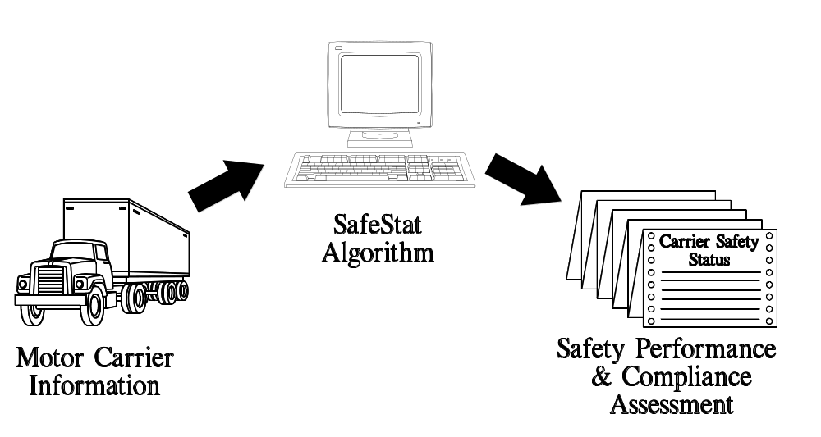

Prepared for: | Prepared by:
Federal Motor Carrier Safety Administration | John A. Volpe National Transportation Systems Center
400 Seventh Street SW | Motor Carrier Safety Assessment Division, DTS-47
Washington, D.C. 20590 | Kendall Square
 | Cambridge, MA 02142
200401
Preface

This report documents the Motor Carrier Safety Status (SafeStat) Measurement System analysis methodology developed to support an improved process for motor carrier safety fitness determination for the Federal Motor Carrier Safety Administration (FMCSA). It provides a complete description of the SafeStat methodology as of January 2004 (SafeStat Version 8.6).

The concept of SafeStat originated from a research project at the U.S. Department of Transportation’s John A. Volpe National Transportation Systems Center (the Volpe Center) in Cambridge, MA, under a project plan agreement with the FMCSA. The goal of the project was to define an improved process for motor carrier safety fitness determination. SafeStat was defined as one of the major components of a proposed improved process.

SafeStat was first implemented as part of the federal/state Performance & Registration Information Systems Management (PRISM) (formerly the Commercial Vehicle Information System (CVIS)) program, which was authorized under the Intermodal Surface Transportation Efficiency Act (ISTEA) of 1991. PRISM provided the opportunity to develop and test the SafeStat concept, and satisfy that program’s requirement for a motor carrier safety fitness test. The Volpe Center designed, developed and implemented SafeStat for PRISM in a succession of improved versions. Since 1995 SafeStat has been implemented in approximately six-month cycles to identify carriers for PRISM. With each cycle of PRISM, the algorithm has been revised and improved, thereby leading to successive, improved versions of SafeStat. Also, starting in March 1997, concurrent with the fourth cycle of PRISM and continuing with succeeding SafeStat runs, the FMCSA implemented SafeStat nationally to prioritize motor carriers for on-site compliance reviews (CRs). Since December 1999, SafeStat results have been made available to the public via the Internet on the Analysis & Information (A&I) website at www.ai.volpe.dot.gov/. This document presents the methodology for the latest version of SafeStat, Version 8.6, implemented in January 2004. Improvements made in Version 8.6 and earlier versions are shown in Appendix C. Further improvements may be defined in future versions of SafeStat.

Ongoing evaluation of the SafeStat methodology has been provided by the Volpe Center, the PRISM Federal/State Working Groups, the motor carrier industry, and other stakeholders in the process. A formal evaluation of SafeStat for the CVIS/PRISM program has been conducted by the Volpe Center with the assistance of Dr. Thomas Corsi, Transportation and Logistics Department, Robert Smith School of Business, at the University of Maryland. An evaluation of SafeStat effectiveness in identifying carriers most likely to have crashes was also performed and is described in Chapter 7 of this document.

The Volpe Center technical project manager is Donald Wright of the Motor Carrier Safety Assessment Division in the Office of System and Economic Assessment. The design and analysis leading to the SafeStat methodology was performed by Donald Wright and David Madsen. Systems development support is being led by Dennis Piccolo of EG&G Services, under contract to the Volpe Center. Implementation of SafeStat at the FMCSA is under the direction of Linda Giles of the Information Systems Division, with support from Allan Day of Dayco Systems, Inc. Technical writer Robert Marville of EG&G Services assisted in the preparation of this report.

TABLE OF CONTENTS

1 Introduction
1.1 SafeStat Concept 1-2
1.2 SafeStat Roles 1-2
1.3 Organization of this Report 1-3
2 SafeStat Design Overview
2.1 Computation of the SEA Values 2-2
2.2 SafeStat Score 2-4
2.3 Categories 2-5
2.4 Weighting 2-5
2.5 Percentile Ranking 2-6
3 Accident SEA
3.1 Accident Involvement Indicator (AII) 3-1
3.2 Recordable Accident Indicator (RAI) 3-4
3.3 Calculation of the Accident SEA Value 3-5
4 Driver SEA
4.1 Driver Inspections Indicator (DII) 4-1
4.2 Driver Review Indicator (DRI) 4-4
4.3 Moving Violations Indicator (MVI) 4-5
4.4 Calculation of the Driver SEA Value 4-7

5 Vehicle SEA
5.1 Vehicle Inspections Indicator (VII) 5-1
5.2 Vehicle Review Indicator (VRI) 5-4
5.3 Calculation of the Vehicle SEA Value 5-4
6 Safety Management SEA
6.1 Enforcement History Indicator (EHI) 6-1
6.2 HM Review Indicator (HMRI) 6-3
6.3 Safety Management Review Indicator (SMRI) 6-3
6.4 HM Inspections Indicator (HMII) 6-3
6.5 Calculation of the Safety Management SEA Value 6-4
7 SafeStat Evaluation
7.1 Description of the Effectiveness Study 7-1
7.2 Results 7-3
7.3 Conclusions 7-5

Appendix
A SafeStat Reports
A.1 Field Definitions for the SafeStat Analysis Report A-2
A.2 Field Definitions for the SafeStat Analysis Report -- Supplemental List A-5
A.3 Field Definitions for the Motor Carrier Safety Record Report A-8
Appendix B Calculating Review Measures
Appendix C Improvements for SafeStat C.1 Changes for Version 8.6 (January 2004) C-1
C.2 Changes for Version 8.5 (January 2003) C-1
C.3 Changes for Version 8.4 (March 2002) C-1
C.4 Changes for Version 8.3 (September 2001) C-2
C.5 Changes for Version 8.2 (March 2001) C-2
C.6 Changes for Version 8.1 (September 2000) C-2
C.7 Changes for Version 8 (March 2000) C-3
C.8 Changes for Version 7 (September 1999) C-5
C.9 Changes for Version 6.1 (September 1998) C-6
C.10 Changes for Version 6 (March 1998) C-6
C.11 Changes for Version 5 (September 1997) C-7

LIST OF ILLUSTRATIONS
Figures
2-1. SafeStat Score Computational Hierarchy. 2-1
2-2. Generic SEA Value Computational Hierarchy 2-2
2-3. SafeStat Score Calculation 2-5
3-1. Accident SEA Value Computational Hierarchy 3-1
4-1. Driver SEA Value Computational Hierarchy 4-1
5-1. Vehicle SEA Value Computational Hierarchy 5-1
6-1. Safety Management SEA Value Computational Hierarchy 6-1
7-1. Effectiveness Analysis Timeline 7-2
7-2. Crash Rates for the Three Groups of Carriers 7-3

Tables
2-1. CFR Parts Reviewed During a Compliance Review 2-3
2-2. SafeStat Categories 2-5
2-3. SafeStat Categories for Carriers with no SafeStat Score 2-5
7-1. Post-Selection Crash Rates 7-3
7-2. Crash Rates of Carriers with and without High SEAs 7-4

Glossary

AII | Accident Involvement Indicator
AIM | Accident Involvement Measure
CR | Compliance Review
CVIS | Commercial Vehicle Information System
DII | Driver Inspections Indicator
DIM | Driver Inspections Measure
DRI | Driver Review Indicator
DRM | Driver Review Measure
DOT | Department of Transportation
EHI | Enforcement History Indicator
ESM | Enforcement Severity Measure
FMCSA | Federal Motor Carrier Safety Administration
FMCSR | Federal Motor Carrier Safety Regulations
HAZMAT | Hazardous Materials
HMR | Hazardous Material Regulations
HMRI | Hazardous Material Review Indicator
HMRM | Hazardous Material Review Measure
ISS | Inspection Selection System
ISTEA | Intermodal Surface Transportation Efficiency Act of 1991
JOOM | Jumping Out-of-Service Multiplier
MCMIS | Motor Carrier Management Information System
MCSAP | Motor Carrier Safety Assistance Program
MCSIP | Motor Carrier Safety Improvement Process
MVI | Moving Violation Indicator
MVM | Moving Violations Measure
NGA | National Governors Association
OOS | Out-of- Service
PCAP | Progressive Compliance Assurance Program
PRISM | Performance & Registration Information Systems Management
PU | Power Unit
RC | Recordable Crash
RAI | Recordable Accident Indicator
RAR | Recordable Accident Rate
RSPA | Research and Special Programs Administration
SafeStat | Motor Carrier Safety Status Measurement System
SEA | Safety Evaluation Area
SMRI | Safety Management Review Indicator
SMRM | Safety Management Review Measure
VII | Vehicle Inspection Indicator
VIM | Vehicle Inspection Measure
VMT | Vehicle Miles Traveled
VRI | Vehicle Review Indicator
VRM | Vehicle Review Measure

Introduction

In 1993, the U.S. Department of Transportation’s Volpe National Transportation Systems Center (the Volpe Center) began a multi-year research effort to define and propose an improved process to assess motor carrier safety fitness for the Federal Motor Carrier Safety Administration (FMCSA). The objectives of the research project included the development of a single methodology of measuring motor carrier safety fitness and the definition of a comprehensive process to improve the safety status of unsafe carriers. The intent of the FMCSA was to better utilize the improved safety data reporting and information systems technologies not previously available and to take advantage of prior Volpe Center experience in developing safety measurement methodologies for regulated carriers.
As part of this research effort, many ideas, concerns, and suggestions were collected in a series of stakeholder meetings and direct discussions with individuals and organizations that are affected by and/or have an interest in the process. These stakeholders included motor carriers, the insurance industry, FMCSA field staff, state enforcement agencies, and Canadian federal and provincial officials. At these meetings and discussions, stakeholders were asked to describe the criteria they considered to be most important in assessing motor carrier safety fitness, the strengths and weaknesses of the safety-fitness determination process that was in use by the FMCSA, and their reactions to the emerging Volpe Center proposals for an improved process, which included an automated safety performance monitoring system.
In defining the improved process and eventual SafeStat methodology, the shortcomings in the safety-fitness determination process in use at the time were addressed. Several of these limitations were the result of determining safety fitness and carrier safety ratings based solely upon one-time on-site safety audits, called compliance reviews (CRs), which used a three-tiered safety rating scheme (Satisfactory, Conditional, and Unsatisfactory). These limitations included:

- Lack of Coverage of the Motor Carrier Population - Only reviewed carriers are issued safety ratings. Compliance reviews are performed on a small percentage of the motor carrier population (roughly 10,000 reviews annually out of over 500,000 carriers).
- Obsolete Safety Ratings – The safety rating remains in effect until another compliance review is performed, regardless of the carrier’s safety performance after the compliance review was conducted.
- Low Performance Data Utilization - The process was compliance-oriented and had limited or no use of data on state-reported crashes, roadside inspections, enforcement actions, or moving violations.
- Labor Intensive Manual Process - Compliance reviews often require several days to conduct, as opposed to a computer-performed analysis based on an algorithm and databases of safety information.

SafeStat Concept
As a result of the research into designing an improved process for safety fitness determination, SafeStat was conceived. SafeStat (short for Motor Carrier Safety Status Measurement System) is an automated, data-driven analysis system designed to incorporate current on-road safety performance information on all carriers with on-site compliance review and enforcement history information, when available, in order to measure relative motor carrier safety fitness. The system allows the FMCSA to continuously quantify and monitor changes in the safety status of motor carriers, especially unsafe carriers. This allows FMCSA enforcement and education programs to efficiently allocate resources to carriers that pose the highest risk of crash involvement.
The concept of SafeStat departs significantly from the previous approach employed by the FMCSA, which relied on the on-site compliance review to provide the only means of assessing safety fitness. This previous approach incorporated only the limited amount of safety performance data that was available at the time of the on-site review with the on-site review findings, to generate one of three safety ratings. This rating did not change until another compliance review was performed, regardless of safety performance after the compliance review. Conversely, SafeStat accesses all current safety performance data to continuously assess the safety status of carriers, rather than limiting the use of safety performance data to selected data that are available at the time of a compliance review. SafeStat treats the results from a compliance review as a source of information (albeit a very important source), but emphasizes safety performance data (e.g., crashes, roadside inspections, enforcement actions, etc.) to assess a carrier's overall safety status.
SafeStat has been designed to maximize the use of state-reported data and centralized federal data systems. SafeStat is also designed to be improved through version upgrades that can accommodate additional data sources and indicators as they are developed. The expansion of SafeStat to include these additional data sources will allow the coverage of more carriers and strengthen the results for the carriers covered.

SafeStat Roles
The primary use of SafeStat is to identify and prioritize carriers for FMCSA and state safety improvement and enforcement programs. Currently, SafeStat plays an important role in determining motor carrier safety fitness in several FMCSA/state programs including the Performance & Registration Information Systems Management (PRISM), National CR Prioritization, and the roadside Inspection Selection System (ISS).
- Performance & Registration Information Systems Management (PRISM)
PRISM is a federal/state program that ties motor carrier safety fitness to state commercial vehicle registration. PRISM places carriers with poor safety performance into a sanctioning process that can ultimately lead to unsafe carriers being placed out of service with their commercial vehicle registrations suspended or revoked. SafeStat is currently being used to identify poorly performing carriers and monitor their status while in the program. Since PRISM has been operational, it has relied on SafeStat and acted as a "laboratory" in which to improve the SafeStat methodology through successive versions corresponding to the PRISM cycles.
- National Prioritization for FMCSA Compliance Reviews
In the FMCSA’s current effort to become a more data- and analysis-driven organization focusing on performance, the FMCSA is using SafeStat biannually to identify and prioritize carriers to receive compliance reviews. Starting in March 1997, concurrent with the PRISM cycle, the FMCSA has used SafeStat to identify and prioritize carriers for compliance reviews nationwide.
- Inspection Selection System (ISS)
The ISS was designed to aid roadside inspectors by recommending driver and vehicles for inspections based primarily on the safety status of the responsible motor carrier. Therefore, the main goal of the ISS is to prioritize and target carriers with poor safety performance. SafeStat provides the ISS with the safety status information needed to achieve this goal.
Potential Roles
Potential additional applications of SafeStat by the FMCSA include carrier safety rating and unfit determination. Also, SafeStat can provide focused safety performance assessments of specific carrier groups, such as hazardous material carriers, new entrant carriers, and foreign carriers operating in the U.S. Additional uses include carrier safety screening and monitoring by other Federal agencies that employ motor carriers, such as the Department of Energy (transport of radioactive hazardous materials) and the Department of Defense (transport of munitions and other goods).

Other Roles
SafeStat results are available to the public via the Internet on the Analysis & Information (A&I) website at www.ai.volpe.dot.gov. Easy access to SafeStat results encourages improvements in motor carrier safety by:
- Providing carriers (that have sufficient safety data) with a quantified measure of their current relative safety status broken out by Safety Evaluation Area (SEA). This breakdown will enable carriers to assess the strengths and weaknesses of the their own safety status.

- Assisting firms that are involved with carriers (e.g., shippers, insurers, and lessors, etc.) in making certain business decisions in which the safety status of a carrier is a factor.

Organization of this Report
The remainder of this report describes the design of SafeStat and documents the algorithms used in the SafeStat methodology. It is divided into the following sections:
- Section 2 provides an overview of SafeStat methodology. It describes the overall design of SafeStat, including the four Safety Evaluation Areas (SEAs) and the computational logic used to combine the SEA values and arrive at the SafeStat score.

- Sections 3 through 6 detail the specific algorithms used in the calculations in each of the four SEAs.

- Section 7 describes an evaluation of SafeStat.

- Appendix A contains examples of lists generated by SafeStat.
- Appendix B provides details on calculating measures from violations of acute and critical regulations in compliance reviews.
- Appendix C shows the incremental improvements made to SafeStat.

SafeStat Design Overview

SafeStat is designed to maximize the use of available federal motor carrier safety data to measure the relative safety status of motor carriers overall and in four Safety Evaluation Areas (SEAs). The four analytical SEAs are:
- Accident SEA
- Driver SEA
- Vehicle SEA
- Safety Management SEA

All four evaluation areas serve to measure the carrier's past safety performance and assess its risk of having future crashes (See Section 7, SafeStat Evaluation, for a discussion of SafeStat's ability to identify carriers with higher than normal crash risk). Carriers with the worst records (being in the worst quartile in two or more SEAs) are given SafeStat scores, which represent the carriers' overall safety statuses in relation to their peers.
The four-SEA framework evaluates the SEA-specific strengths and weaknesses of each individual carrier’s safety performance and compliance. This design also provides the flexibility to assign higher or lower relative emphasis (weight) to each SEA. For example, since accident history and driver factors have emerged as the SEAs most associated with future crash risk, these SEAs are given additional weight in determining a carrier's overall safety status. In addition to producing an overall safety fitness status, SafeStat ranks carriers in each SEA to focus FMCSA and state safety improvement efforts. Figure 2-1 shows the computational hierarchy used to calculate a SafeStat score.

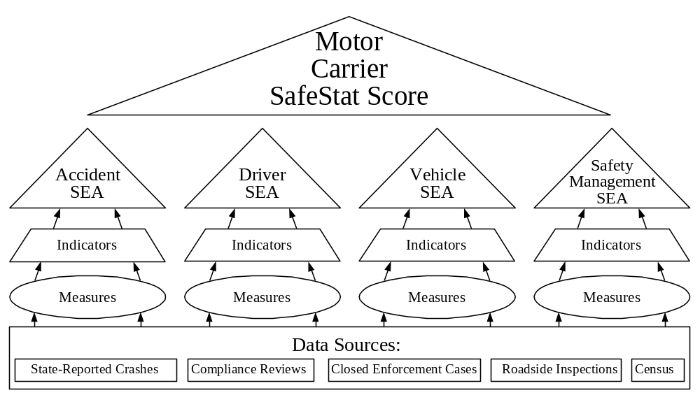
Figure 2-1. SafeStat Score Computational Hierarchy

Computation of the SEA Values
For each SEA, SafeStat proceeds from data to the SEA value in the following stages:
- Data -- Both safety-event (such as crashes and safety regulation violations) and carrier-descriptive data are at the foundation of the computation hierarchy. Carrier-descriptive data, such as the number of power units or number of roadside inspections, are used to normalize a carrier's safety-event data.
- Measures -- The data are used to calculate weighted, normalized safety measures, each of which summarizes some aspect of a carrier's performance in a single number.
- Indicators -- Carrier measures are ranked relative to those of other carriers, producing indicator percentiles of the carrier's standing within the peer group, and allowing direct comparison of a carrier with others in the group.
- SEA Values – Related indicators are used to compute SEA values, which are also percentiles assessing the carrier's performance in the four SEAs.

Figure 2-2 shows a hypothetical computational hierarchy used to calculate a SEA value. The SEA value shown here is based on three indicators, A, B, and C. Indicators A, B, and C are based on measures derived from data sources A, B, and C. Sections 3 through 6 of this document contain the specific diagrams for each of the four SEAs, followed by discussions of the computations for each measure and indicator within the SEA.
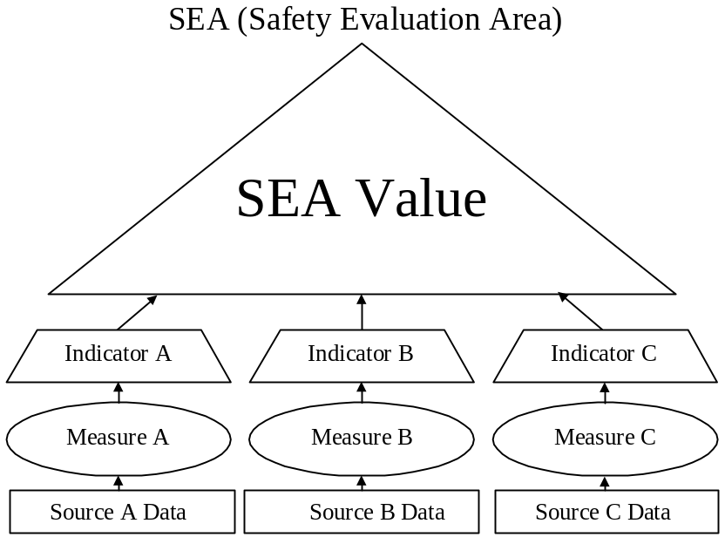
Figure 2-2. Generic SEA Value Computational Hierarchy

Data
SafeStat currently uses five sources of data. The first four sources listed below provide the carrier's actual performance and compliance data, while census data are used only for identification and normalization of safety-event data.
- State-Reported Commercial Vehicle Crash Data provide information on reportable crash involvement from crash reports filled out by state and local police officials according to the standards prescribed by the National Governors’ Association (NGA).
- Compliance Reviews (CRs) performed on-site by FMCSA safety investigators and their state counterparts determine carriers’ compliance with Federal Motor Carrier Safety Regulations (FMCSR) (and compliance with Hazardous Material Regulations (HMR), for HM carriers). The number and extent of violations of acute, critical, and severe regulations discovered are used by SafeStat in the three SEAs to which they are related. Table 2-1 shows the parts of the FMCSR used in conducting compliance reviews.

Table 2-1. CFR Parts Reviewed During a Compliance Review
Part | Title
382 | Controlled Substances and Alcohol Use and Testing
383 | Commercial Driver’s License Standards
387 | Minimum Levels of Financial Responsibility for Motor Carriers (Insurance)
390 | General
391 | Qualifications of Drivers
392 | Driving of Commercial Motor Vehicles
393 | Parts and Accessories Necessary for Safe Operations
395 | Hours of Service for Drivers
396 | Inspection, Repair, and Maintenance
397 | Transportation of Hazardous Materials; Driving and Parking Rules

The safety investigators also obtain data (number of recordable crashes and number of vehicle-miles traveled in the 12 months preceding the review) to compute a crash rate, which is used to compute the Recordable Accident Indicator in the Accident SEA.

- Closed Enforcement Cases result in penalties (e.g., fines, sanctions) based on major violations of the FMCSR and/or HMR. These violations are discovered during CRs and terminal audits. Closed enforcement case history may show a pattern of violations indicating a carrier management’s serious lack of commitment to safety, and is used in the Safety Management SEA.
- Roadside Inspections performed by Motor Carrier Safety Assistance Program (MCSAP) inspectors on individual commercial motor vehicles and drivers provide data on FMCSR and HMR violations. Serious violations result in driver or vehicle out-of-service (OOS) orders, which must be corrected before the affected driver or vehicle can return to service. Drivers that ignore existing OOS orders (returning to service without taking the proper corrective action) are issued OOS order violations. Moving violations also may be recorded in conjunction with a roadside inspection. These data are the basis for measures and indicators in the Driver and Vehicle SEAs.
- Motor Carrier Census Data (identification, size, operations) are initially gathered when carriers obtain USDOT Numbers. The FMCSA records this information (including number of power units, number of drivers, types of cargo carried) in the Motor Carrier Management Information System (MCMIS) and updates data during compliance reviews, during commercial vehicle registration in states participating in PRISM, and upon request of the motor carrier.

Measures
SafeStat uses normalized safety-event data to measure safety compliance and performance of individual carriers. It uses carrier-descriptive data, such as the number of power units or number of roadside inspections, to normalize a carrier's safety-event data by carrier size or amount of exposure. For example, when using crash data, the crash rate takes into account differences in exposure, making it possible to compare the safety of carriers relative to each other, rather than just comparing numbers of events.

Indicators
SafeStat uses the measures to calculate indicators. Whereas a measure, such as a recordable crash rate of .XXX crashes per million vehicle-miles traveled, quantifies the performance of a carrier, an indicator ranks that performance relative to the carrier’s peers. SafeStat ranks each carrier's measure relative to its peers on a percentile (0-100) scale. This percentile number is assigned to the indicator.
Additional decision rules addressing data-sufficiency issues are applied before an indicator is assigned a percentile number. This ensures that the measure is based on enough data so that the corresponding indicator is statistically meaningful in terms of carrier safety status. For example, a minimum number of roadside inspections is required before an inspection indicator can be used.

SEA Values
Indicators within the same SEA are combined to generate a SEA value. For each SEA, values ranging from 0-100 are determined for all carriers with sufficient safety data related to that SEA. Each carrier's SEA value approximates the carrier's percentile rank relative to all other carriers with sufficient data to be assessed within that same SEA. By using the percentile rank for each SEA, SafeStat avoids using arbitrary predetermined levels or scoring thresholds, while providing an easily understandable value for each SEA.
The higher a carrier's SEA value, the worse its safety status. Therefore, an Accident SEA Value of 80 indicates that approximately 80% of the carrier population with sufficient data had better safety performance than that carrier with respect to crashes and 20% had worse.

SafeStat Score
A primary purpose of SafeStat is to identify carriers for safety improvement programs. For this purpose, SafeStat does not give overall SafeStat scores to all carriers. To obtain a SafeStat score, a carrier must be deficient in at least two different SEAs. A SEA with a value from 75 to 100 is defined as deficient. This range approximates the worst 25% of the carriers assessed within a particular SEA. Therefore, SafeStat requires a "critical mass" of poor performance data before a carrier is scored.
Carriers that meet the criterion of two deficient SEAs are given a SafeStat score that is equal to the sum of the deficient SEA values for the Vehicle and Safety Management SEAs, plus 2 times the deficient Accident SEA Value plus 1.5 times the deficient Driver SEA value. SEA values that are less than 75 are not used by SafeStat in calculating the SafeStat score. Figure 2-3 shows this calculation in diagram form. SafeStat ranks SafeStat-scored carriers in descending order by their score, starting with the carrier with the worst safety status (i.e., the highest SafeStat score). The SafeStat score is only relevant to identifying and ranking carriers with safety deficiencies.
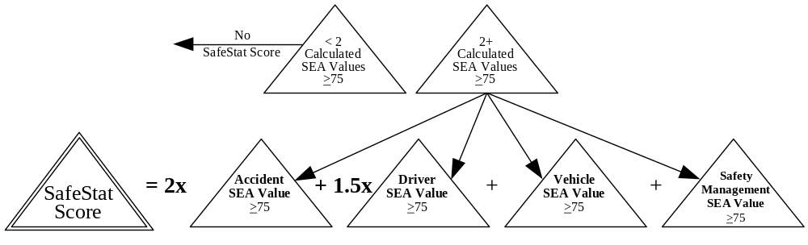
Figure 2-3. SafeStat Score Calculation

Categories
Categories also pertain to carriers with safety deficiencies. SafeStat assigns each scored carrier into Category A, B, or C, as defined by the SafeStat score ranges shown in Table 2-2.

Table 2-2. SafeStat Categories
Category | SafeStat Score Range | Includes SEA Values of 75 or Higher
A | >350 to <550 | All 4 SEAs  3 SEAs that result in a Weighted Score of 350 or more
B | >225 to <350 | 3 SEAs that result in a Weighted Score of less than 350  2 SEAs that result in a Weighted Score of 225 or more
C | >150 to <225 | 2 SEAs that result in a Weighted Score of less than 225

SafeStat computes an overall SafeStat score only for carriers with poor safety status so that these carriers can be identified and monitored for various safety programs.
SafeStat also assigns categories to carriers that did not receive a SafeStat score, but had enough information on bad safety events to be evaluated as deficient in one SEA. These categories, D to G, help to prioritize carriers for roadside inspections in the ISS. Carriers that are deficient in one SEA, either Accident, Driver, Vehicle, or Safety Management, are ranked in Categories D, E, F, and G, respectively, as shown in Table 2-3.

Table 2-3. SafeStat Categories for Carriers with no SafeStat Scores
Single SEA Category | Specific SEA | SEA Value
D | Accident | 75-100
E | Driver | 75-100
F | Vehicle | 75-100
G | Safety Management | 75-100

Weighting
SafeStat uses weighting at various stages to improve the accuracy of the safety status assessment. As previously mentioned, deficient Accident SEA and Driver SEA Values are given more weight in the SafeStat Score calculation than deficient Vehicle and Safety Management SEA Values, because problems with accident history and driver factors were shown to be most closely associated with future crash risk. (See Chapter 7 for details). Weighting is also applied to the data to account for the timeliness and severity of certain safety events.

Time Weighting
SafeStat applies time weighting to all of the safety-event data; more importance is given to the results of recent safety events than to the results of older safety events. For instance, the results of a vehicle roadside inspection performed within the past six months have three times more influence on a carrier’s safety status in the Vehicle SEA than a vehicle inspection that was done two years ago. Safety events "age to zero" after thirty months.
Safety events must occur within certain periods of time (depending on the source data) to be considered in the SafeStat calculation. Each time window moves with each calculation of SafeStat. For example, the results of a compliance review (CR) have a time window of 18 months, which means that SafeStat uses the results only if the compliance review occurred within the last 18 months. If a carrier has a compliance review that is 17 months old, SafeStat will use it in its calculations. When SafeStat is run six months later, the compliance review will then be 23 months old, five months beyond the time window of 18 months, and therefore, will no longer be used by SafeStat due to its age. Time-weighting stresses the outcome of more recent safety events, which are more relevant to current safety status, and phases out safety-event data as they become older and less likely to reflect current safety status. This allows a carrier to reflect improvement in subsequent SafeStat runs if there are fewer or no new adverse safety events.

Severity Weighting
Where appropriate, safety measures are severity weighted. For example, the Accident SEA assigns a weight of 1, or 2 to a crash, depending on whether it involved (1) property damage only (towed vehicle), or (2) injuries or fatalities. Additional weight is placed on a reportable crash if hazardous material is released.

Percentile Ranking
An important objective of the SafeStat calculations is to compare the performance of individual carriers to their peers, producing an easily-understood measure of performance not tied to arbitrary point values. Therefore indicators and SEA values are expressed as percentiles reflecting the carrier’s status relative to others. For instance, the Driver Review Indicator is produced by calculating the Driver Review Measure for all carriers that had recent reviews, ranking them in ascending order, and giving each carrier a corresponding percentile rating from 0 to 100. The highest numbers indicate the worst performers among all carriers for which sufficient data are available.

Accident SEA

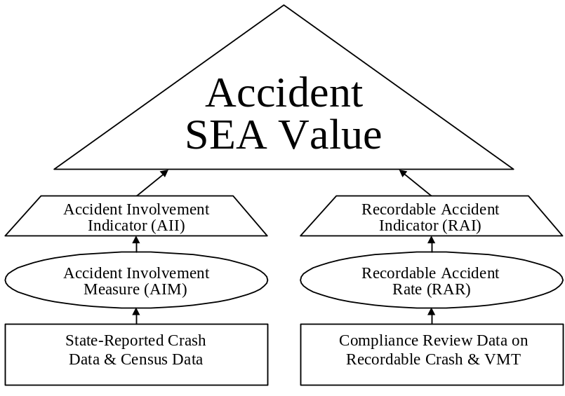
The Accident SEA Value reflects a carrier’s crash experience relative to its peers. The Accident SEA Value is based on the Accident Involvement Indicator (AII) and the Recordable Accident Indicator (RAI). The AII uses measures derived from state-reported crash data normalized by power unit data from the Motor Carrier Census. The RAI uses measures based on recordable crash and annual vehicle-miles traveled (VMT) data gathered at the most recent compliance review. The sections that follow present the specific computations for each measure, indicator, and the Accident SEA Value. Figure 3-1 shows the computational hierarchy used to calculate an Accident SEA Value.

Figure 3-1. Accident SEA Value Computational Hierarchy

Accident Involvement Indicator (AII)
SafeStat uses the state-reported crash data and Motor Carrier Census power unit (trucks, tractors, hazardous material tank trucks, motor coaches, and school buses) data to calculate the Accident Involvement Measure (AIM) for all carriers. SafeStat uses only vehicles involved in crashes that have occurred within the last 30 months and time weights the data to give more relevance to recent crashes than to older crashes. It also weights individual crashes based upon the consequences of the crash (i.e., vehicle towed, injury, fatality, and release of hazardous material). SafeStat then normalizes this weighted crash information by the number of power units to obtain the AIM. Carriers with similar numbers of state-reported crashes are grouped, compared to one another by their AIMs, and ranked on a percentile basis. SafeStat assigns a percentile number (from 0-100) to the AII of each carrier, based on that rank. A carrier must have two or more crashes to have the potential to receive a deficient AII, i.e., 75 or higher.

State-Reported (Reportable) Crash Data
States provide a crash report for each commercial motor vehicle involved in a crash that meets the reportable crash standard. A reportable crash involves a vehicle being towed from the scene, or an injury or fatality. Each crash report is counted as a crash by SafeStat. SafeStat uses the following data elements from the reportable crash data to calculate the carrier’s AII:

- Date of the crash
- Injuries
- Fatalities
- Release of Hazardous Material (HM)

Census Power Unit Data
SafeStat computes the AII using state-reported crash data, which are normalized by the number of owned, term-leased, and trip-leased power units (trucks, tractors, hazardous-material tank trucks, motor coaches, and school buses) contained in the Census data. The primary source of power unit information in the Census is Forms MCS-150 and MCS-151. Carriers are required to update their MCS-150 information biennially. When the number of power units for a carrier is suspect, specific state/federal organizations are notified to obtain the most accurate value.

Accident Involvement Measure (AIM)
SafeStat uses the reportable crash data that fall within three time windows. It time weights the data to give more relevance to recent crash involvement than to older crash involvement. It also weights individual crashes based upon the consequences of the crash (i.e., vehicle towed, injury, fatality, and release of hazardous material). SafeStat combines these two weighting aspects into a quantity called the Total Consequence/Time Weighted Crashes (TCTWC). SafeStat calculates the AIM by dividing the TCTWC by the average number of power units (PU) for the carrier to normalize the measure. The basic equation for the AIM is shown below. The steps that follow the equation detail SafeStat’s calculation of the AIM.

AIM = TCTWC / PU

- Begin to compute the TCTWC by aggregating each carrier’s reportable crash data into three time periods based on the age of each crash: 0 to 6 months, 7 to 18 months, and 19 to 30 months.
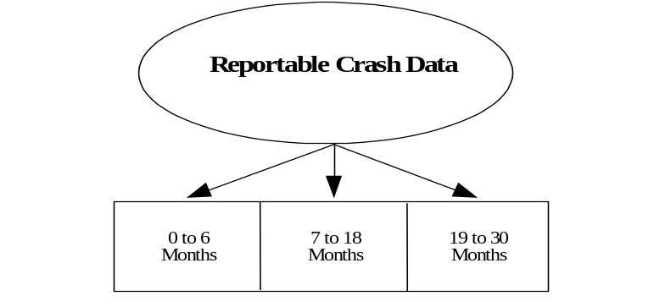

B. Within each time period, weight each crash for severity by assigning a severity score of 1 for crashes which involved a vehicle being towed (but no injuries), and 2 for crashes which involved injury or fatality. Add 1 to the severity score if a carrier vehicle released hazardous materials.
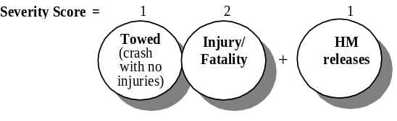

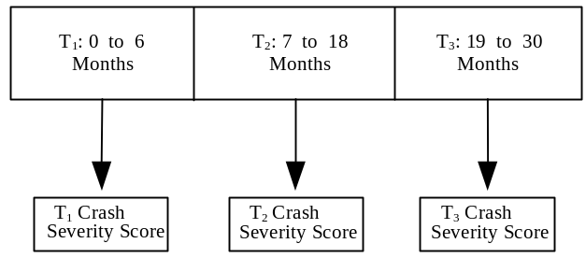
C. Within each time period, sum the severity scores to get a total crash severity score for the time period:

D. Time weight the severity scores for the three time periods so that the most recent crashes receive the most weight, then sum the weighted scores for all three periods to produce the Total Consequence/Time-Weighted Crashes (TCTWC).
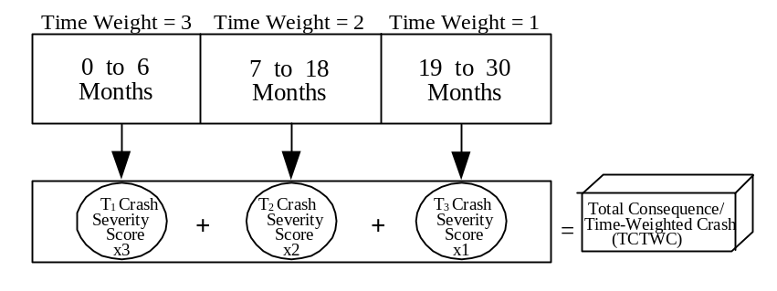

E. Calculate the average number of PUs over 30-month time frame by determining the number of PUs at the end of each of the three time periods.
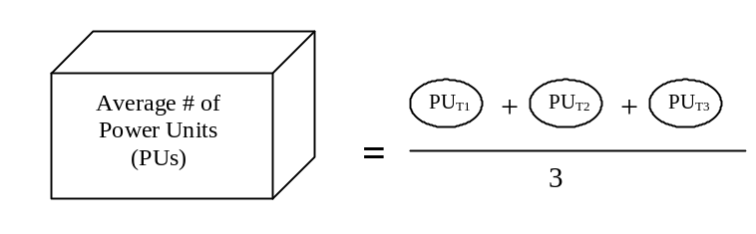

F. Compute AIM by dividing the TCTWC by the average number of PUs (trucks and buses owned, term-leased, and trip-leased).
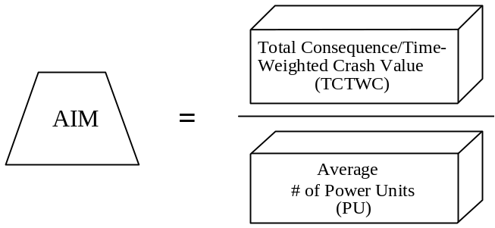

Calculation of the Accident Involvement Indicator (AII)
SafeStat uses the Accident Involvement Measure (AIM) to calculate the Accident Involvement Indicator (AII). The following steps detail SafeStat’s calculation of AII.

A. Determine the total number of each carrier’s vehicles involved in crashes over the last 30 months (no time or severity weighting), and place each carrier into one of the groups below:

Group | Number of Vehicles Invovlved in State-Reported Crashes
0 | 0
1 | 1
2 | 2-3
3 | 4-8
4 | 9-20
5 | 21-88
6 | 89+

- For Group 0: Assign an AII of 0.

For Group 1: Insufficient information to calculate a percentile ranking. No AII assigned.

For Groups 2 through 6: within each group, rank all the carriers’ AIM values in ascending order. Transform the ranked values into percentiles from the 0 percentile (representing the lowest AIM) to the 100th percentile (representing the highest AIM). Assign the percentile value to the AII. If a carrier has no crashes within the past 24 months, the AII will be capped at 74.

Recordable Accident Indicator (RAI)
SafeStat uses recordable crash and vehicle-miles-traveled (VMT) data gathered during compliance reviews to calculate the Recordable Accident Rate (RAR) for all carriers that have had compliance reviews within the past 12 months. SafeStat takes the number of recordable crashes and normalizes it by VMT to obtain an RAR. Carriers with similar numbers of recordable crashes are grouped, compared to one another by their crash rates, and ranked on a percentile basis. SafeStat assigns a percentile number (from 0-100) to each carrier based on that rank. A carrier must have two or more crashes to potentially receive a deficient RAI, i.e., 75 or higher.

Compliance Review Data
The data items used in assessing recordable crashes are the following:

- Date of the review
- Number of recordable crashes (RC) within 12 months prior to the review
- Total number of vehicle miles traveled (VMT) by a carrier within 12 months prior to the review

Calculation of the Recordable Accident Rate (RAR) Measure
SafeStat uses the recordable crash data described above from the most recent review of a carrier that was performed within the last 12 months to produce a measure called the Recordable Accident Rate (RAR). The RAR is computed by dividing the total number of recordable crashes (RC) by the number of annual vehicle miles traveled (VMT) and then multiplying this quotient by a convenient constant (in this case, 1,000,000) to establish a manageable RAR size. The basic equation for RAR follows. The steps following the equation detail SafeStat’s calculation of the RAR.

 | RAR = | 1,000,000 x RC  VMT

A. Identify all carriers whose most recent compliance review was performed within the last 12 months.

B. Compute the RAR according to the following formula:
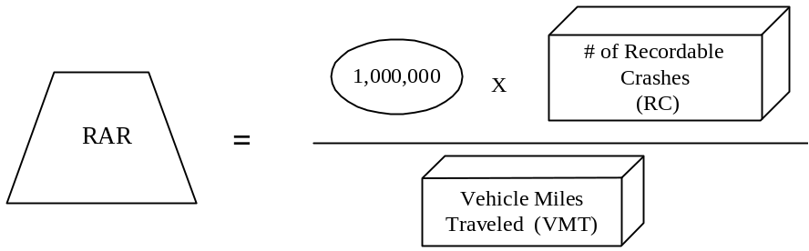

Calculation of the Recordable Accident Indicator (RAI)
SafeStat calculates the Recordable Accident Indicator (RAI) by ranking the RAR values and transforming them into percentiles. The following steps detail SafeStat’s calculations.

A. Determine the total number of crashes for each carrier (no time or severity weighting), and place each carrier into one of the groups below:

Group | Number of Recordable Crashes
0 | 0
1 | 1
2 | 2-4
3 | 5-19
4 | 20+

- For Group 0: Assign a RAI of 0.

For Group 1: Insufficient information to calculate a percentile ranking. No RAI is assigned.

For Groups 2 through 4: within each group, rank all the carriers’ RAR values in ascending order. Transform the ranked values into percentiles from the 0 percentile (representing the lowest RAR) to the 100th percentile (representing the highest RAR). Assign the percentile value to the RAR.

Calculation of the Accident SEA Value
The Accident SEA Value establishes the carrier’s safety status concerning its crash history. SafeStat uses the Accident Involvement Indicator (AII), the Recordable Accident Indicator (RAI), and any state-reported crashes that have occurred since the CR was performed to calculate the Accident SEA Value. Several possible cases exist in determining the Accident SEA Value. SafeStat determines which case exists for each carrier and calculates the Accident SEA Value accordingly.

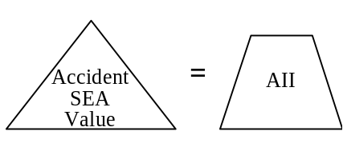
Case 1: If no CRs were conducted in the past 12 months, AII is assigned to the Accident SEA Value. (If the AII was not assigned in the case of only one crash, then the Accident SEA is also not assigned a value).

Case 2: If a CR was conducted within the past 12 months and no new state-reported crashes have occurred since the CR was conducted, then assign the RAI to the Accident SEA Value. (If the RAI was not assigned in the case of only one crash, then the AII is assigned to the Accident SEA Value).
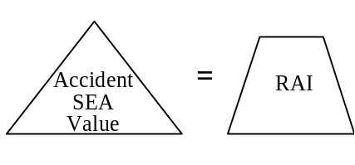
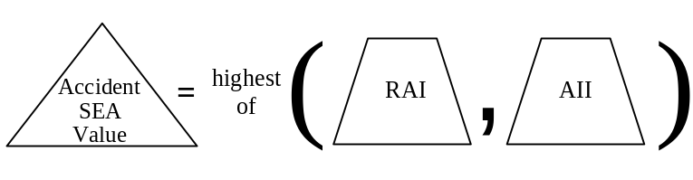
Case 3: If a CR was conducted within the past 12 months and a new state-reported crash has occurred since the CR was conducted, then assign the higher value of AII and RAI to the Accident SEA.

Driver SEA

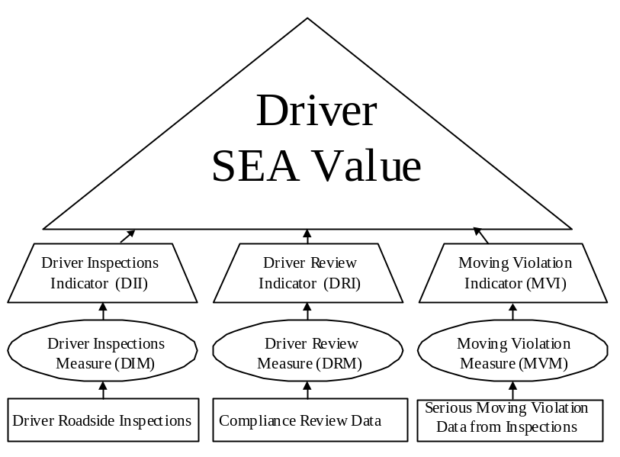
Within the Driver SEA, SafeStat evaluates a carrier’s driver-related safety performance and compliance. The Driver SEA Value reflects a carrier’s driver safety posture relative to its peers. SafeStat calculates the Driver SEA Value based on the Driver Inspections Indicator (DII), the Driver Review Indicator (DRI), and the Moving Violations Indicator (MVI). The DII is based on driver roadside OOS inspection violations. The DRI is based on the violations of driver-related acute and critical regulations discovered during a compliance review. The MVI is based on moving violations recorded in conjunction with roadside inspections. The sections that follow present the specific computations for each safety measure, indicator, and the Driver SEA Value. Figure 4-1 presents the computational hierarchy used to calculate a Driver SEA Value.

Figure 4-1. Driver SEA Value Computational Hierarchy

Driver Inspections Indicator (DII)
Using driver roadside inspection data from inspections performed within the last 30 months, SafeStat calculates the DII for all carriers that have had a minimum of 3 driver inspections. SafeStat weights each inspection by its age and the number of driver OOS violations found, and then normalizes the weighted driver OOS results by the number of driver inspections to obtain a weighted driver OOS rate known as the Driver Inspections Measure (DIM). The DIM is adjusted upward in instances where the driver was found “jumping,” or violating, OOS orders. Carriers with similar numbers of driver inspections are assigned to one of four groups. Within each group they are compared to one another and ranked by their DIM. SafeStat assigns a percentile number (from 0 to 100) based on that rank. The percentile number becomes the carrier’s DII. A carrier must have 3 or more driver OOS inspections to have the potential to receive a deficient DII, i.e., 75 and higher.

Driver Roadside Inspection Data
SafeStat uses only those roadside inspections that have been performed within the last 30 months and pertain to the driver, i.e., inspection levels 1, 2, and 3 when calculating the DIM. SafeStat uses the following data elements from roadside inspections in its calculations of the DIM:

- Number of Driver OOS Violations
- Number of Drivers Placed OOS
- Number of Driver Inspections
- Number of Violations of OOS Orders
- Jumping Vehicle OOS Orders (this is done by the driver)
- Jumping Driver OOS Orders.

Calculation of the Driver Inspections Measure (DIM)
SafeStat calculates the DIM by adding the time-weighted number of driver OOS inspections to the time-weighted number of driver OOS violations and then dividing by the total time-weighted number of driver inspections. It then adjusts this rate by the jumping OOS order multiplier (JOOM), which is based on the number of times the carrier’s drivers were found in violation of OOS orders. The equation for the DIM is:

where JOOM is:
Number of Times of Jumping OOS Orders | (JOOM)
0 | 1.0
1 | 1.2
2 | 1.4
3 | 1.6
4+ | 2.0

SafeStat uses driver roadside inspection data from the last 30 months. It time-weights inspection data to give more importance to recent inspections. The use of total driver OOS violations in the formula has the effect of “severity weighting” the DIM. The following steps detail SafeStat’s calculation of the DIM.

A. Using the results of the levels 1, 2, and 3 driver inspections, aggregate each carrier’s inspections into three time periods based on the age of each inspection: 0 to 6 months, 7 to 18 months, and 19 to 30 months.

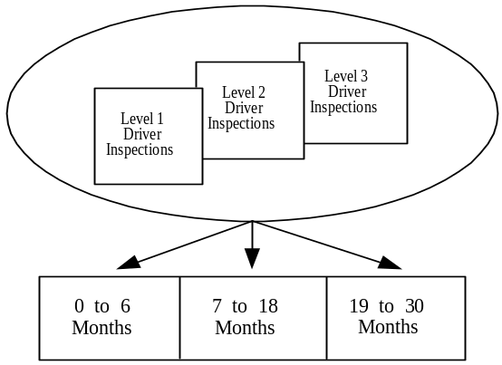

B. Aggregate the following for each time period:
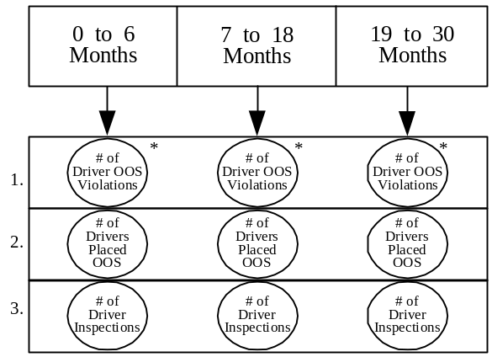
*The limit for the maximum number of Driver OOS violations for any one inspection is 5.

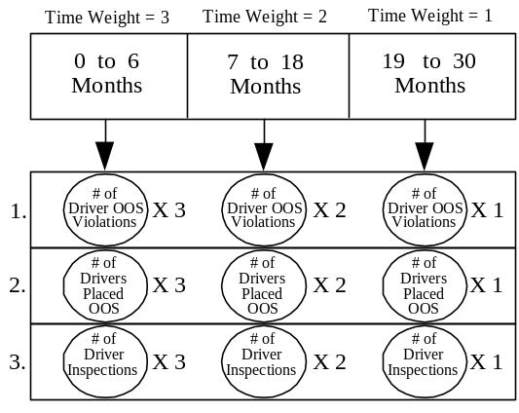
- Weight the time periods giving the most weight to most recent inspections (3 for 0 to 6 months, 2 for 7 to 18 months, and 1 for 19 to 30 months).

D. Sum the weighted data for:

- Number of Driver OOS Violations
- Number of Drivers Placed OOS
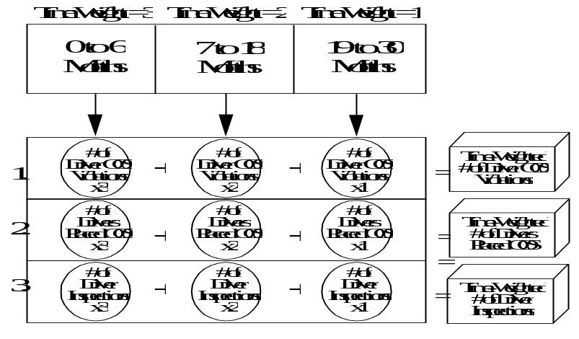
- Number of Driver Inspections

- Determine the number of inspections that uncovered violations of OOS orders [jumping vehicle OOS orders (396.9(c) and 396.9(c)(2)) and jumping driver OOS orders (395.13(d) and 392.5(c)2)] that have occurred within the last 30 months, and calculate the JOOM from the following table.

Number of Times of Jumping OOS Orders | (JOOM)
0  JOOM | 1.0
1 | 1.2
2 | 1.4
3 | 1.6
4+ | 2.0

F. Calculate a driver OOS violation rate by adding the Time-Weighted Number of Driver OOS Violations and the Time-Weighted Number of Drivers Placed OOS and dividing the sum by the Time-Weighted Number of Driver Inspections. Adjust this rate by multiplying this number by the JOOM to arrive at the DIM.
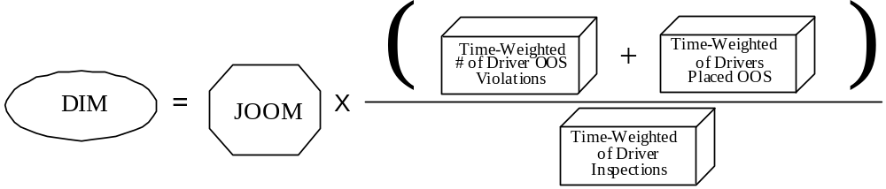

Calculation of the Driver Inspections Indicator (DII)
SafeStat uses the Driver Inspections Measure (DIM) along with the number of driver inspections performed within the last 30 months (without application of time weighting) to calculate the Driver Inspections Indicator (DII). The following steps detail the calculation of DII.

- Using level 1, 2, and 3 inspections performed within the last 30 months, calculate the carrier’s total number of driver inspections and assign the carrier to one of four peer groups. Withhold carriers with fewer than 3 driver inspections from further consideration.

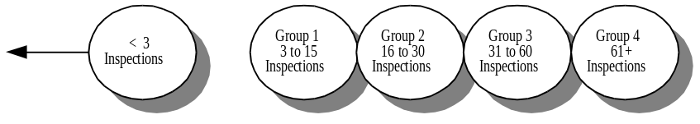

B. For each group, rank carriers’ DIM in ascending order. Transform the ranked measures to percentiles from the 0 percentile (representing the lowest DIM) to the 100th percentile (representing the highest DIM). Assign the percentile value to the DII. If a carrier has fewer than 3 driver OOS inspections then the DII will be capped at 74. Also, if a carrier has no driver OOS inspections, then it will receive a DII of 0.

Driver Review Indicator (DRI)
Using the results from compliance reviews performed within the last 18 months, SafeStat calculates the DRI. SafeStat quantifies the number and severity of violations of driver-related acute/critical regulations (defined in Part 385 Appendix B of the FMCSR) cited at a carrier’s most recent compliance review into the Driver Review Measure (DRM). All of the carriers’ DRMs are compared to one another and are ranked on a percentile basis from 0 to 100. SafeStat assigns the percentile number to the DRI for each carrier with at least one violation of acute and critical regulations.
Calculation of the Driver Review Indicator (DRI)
A. SafeStat calculates the Driver Review Measure (DRM) for each carrier as described in Appendix B.

B. The Driver Review Indicator (DRI) is calculated by taking DRMs for all selected carriers (including those with DRMs of 0) and ranking them in ascending order. The ranked values are transformed into percentiles from 0 (representing the lowest DRM) to 100 (representing the highest DRM). Each carrier with a non-zero DRM is assigned a DRI equal to its percentile rank.

Moving Violations Indicator (MVI)
Using (1) moving violation data collected in conjunction with roadside inspections within the last 30 months and (2) the number of drivers from the Motor Carrier Census, SafeStat calculates the MVI. For each carrier with a minimum of 3 moving violations, SafeStat weights each moving violation by its age, and then normalizes the weighted number of violations by the number of drivers to obtain the Moving Violations Measure (MVM). Carriers with similar numbers of violations are grouped, compared to one another by their MVM rates, and ranked by percentile within each group. SafeStat assigns a percentile number to each carrier’s MVI, based on that rank.

Moving Violation Data
In calculating the MVI, SafeStat uses moving violations recorded in conjunction with roadside inspections over the last 30 months. There is a minimum number of moving violations per carrier (3 or more) required for SafeStat to consider the data sufficient. SafeStat uses the following data elements from roadside inspections in its calculations of the MVI:
- Number of Moving Violations
- Date of Moving Violation

Moving Violations are identified as follows:

Cite # | Moving Violation
392.2C | Failure to obey traffic control device
392.2FC | Following Too Closely
392.2LC | Improper Lane Change
392.2P | Improper passing
392.2R | Reckless Driving
392.2S | Speeding
392.2T | Improper turn
392.2Y | Failure to yield right of way
392.4, 392.4A | Use or Possession of Drugs
392.5, 392.5A | Use or Possession of Alcohol

Census Driver Data
SafeStat computes the MVI using the number of moving violations normalized by the number of drivers contained in the Census data. The primary source of driver information in the Census is Forms MCS-150 and MCS-151. When the Census data on the number of drivers for a carrier are suspect, specific state/federal organizations are notified to obtain the most accurate value.

Calculation of the Moving Violations Measure (MVM)
SafeStat calculates the MVM by adding the time-weighted number of moving violations and dividing by the number of drivers. The equation for MVM is:



SafeStat time-weights violation data to give more relevance to recent violations. The following steps detail SafeStat’s calculation of the MVM.

- Using the moving violations (MV) listed in roadside inspection data, aggregate each carrier’s moving violations into three periods based on the age of each violation: 0 to 6 months, 7 to18 months, and 19 to 30 months.
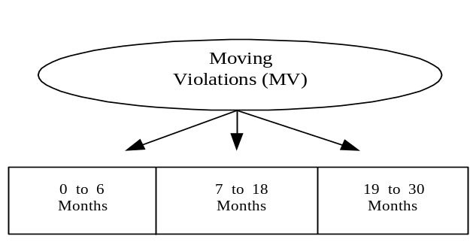

- Multiply the appropriate time weight (3 for 0 to 6 months, 2 for 7 to 18 months, 1 for 19 to 30 months) by the number of moving violations in each of the three time periods and sum all three groups to obtain the time-weighted number of moving violations.

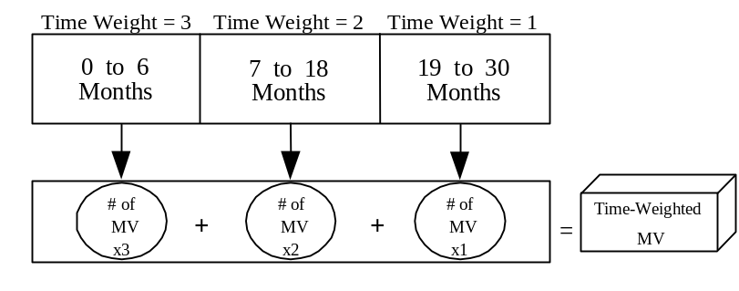

- Divide the time-weighted number of moving violations by the number of drivers to obtain the MVM.
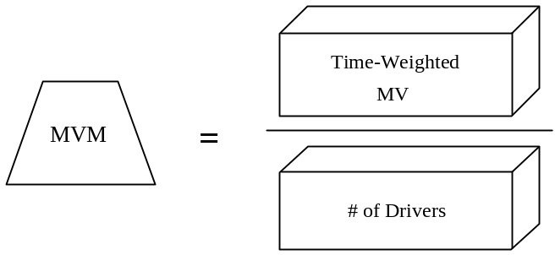

Calculation of the Moving Violations Indicator (MVI)
SafeStat uses the MVM to calculate the MVI. The following steps detail SafeStat’s calculation of MVI.
A. Determine the total number of moving violations for each carrier (no time weighting), and place each carrier into one of four groups shown below:

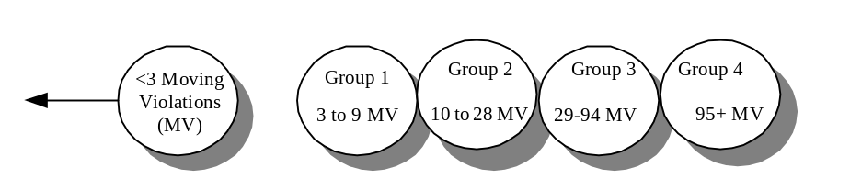

B. Within each group, rank all the carriers’ MVM values in ascending order. Transform the ranked values into percentiles from 0 percentile (representing the lowest MVM) to 100th percentile (representing the highest MVM). Assign the percentile value to the MVI.

Calculation of the Driver SEA Value
The Driver SEA Value establishes the carrier’s safety status concerning driver operations. SafeStat uses the Driver Inspections Indicator (DII) and the Driver Review Indicator (DRI) and the Moving Violations Indicator (MVI) with their associated indicator weights to calculate the Driver SEA Value.

The Driver SEA Value calculation is the maximum of the DRI and DII and uses the MVI when its value is greater than the DRI and DII. If the MVI is greater than the maximum of the DRI and DII then the Driver SEA will equal the weighted average of the MVI and the maximum of the DII and DRI, (placing twice as much weight on the DII/DRI than the MVI).

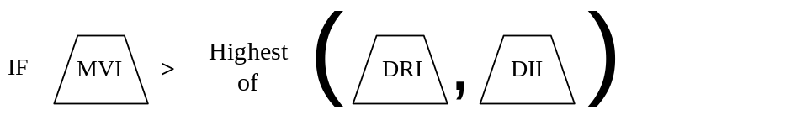

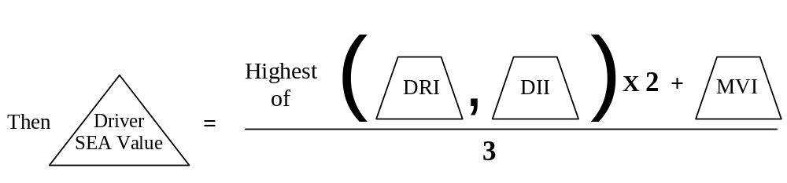
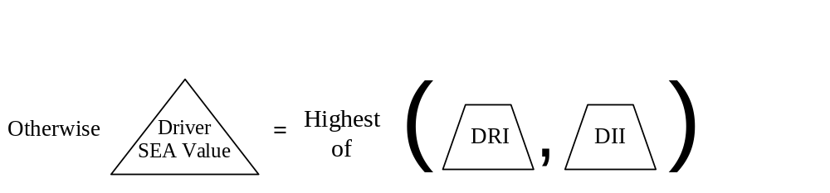

If none of the indicators exist (DRI, DII, or MVI) then the carrier has insufficient data for SafeStat to calculate a Driver SEA Value.

Vehicle SEA

Within the Vehicle SEA, SafeStat evaluates a carrier’s vehicle-related safety performance and compliance. The Vehicle SEA Value reflects a carrier’s vehicle safety posture relative to its peers. SafeStat calculates the Vehicle SEA Value based on the Vehicle Inspections Indicator (VII) and the Vehicle Review Indicator (VRI). The VII is based on vehicle roadside OOS inspection violations. The VRI is based on the vehicle-related violations of acute and critical regulations discovered during compliance reviews. The sections that follow present the specific computations for each safety measure, indicator, and the Vehicle SEA Value. Figure 5-1 presents the computational hierarchy used to calculate a Vehicle SEA Value.

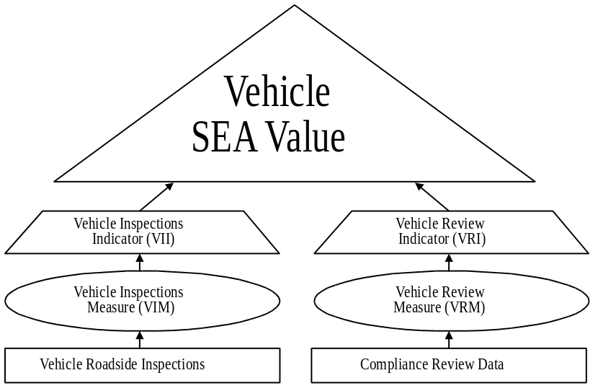

Figure 5-1. Vehicle SEA Value Computational Hierarchy

Vehicle Inspections Indicator (VII)
Using vehicle roadside inspection data from inspections performed within the last 30 months, SafeStat calculates the VII for all carriers that have had a minimum of 3 vehicle inspections. SafeStat weights each inspection by its age and the number of vehicle OOS violations, and then normalizes the weighted vehicle OOS results by the number of vehicle inspections to obtain a weighted vehicle OOS rate, known as the VIM. Carriers with similar numbers of vehicle inspections are assigned to one of three groups. Within each group they are compared to one another and ranked by their VIMs. SafeStat assigns a percentile number (from 0-100) based on its rank. The percentile number becomes the carrier’s VII. A carrier must have 3 or more vehicle OOS inspections to have the potential to receive a deficient VII, i.e., 75 and higher.

Vehicle Roadside Inspections Data
SafeStat uses data from roadside inspections that have been performed within the last 30 months and pertain to vehicles, i.e., inspection levels 1, 2, and 5 when calculating the VIM. SafeStat uses the following data elements from roadside inspections in its calculations of the VIM.

- Number of Vehicle OOS Violations
- Number of Vehicles Placed OOS
- Number of Vehicle Inspections
Calculation of the Vehicle Inspections Measure (VIM)
SafeStat calculates the VIM by adding the time-weighted number of vehicle OOS inspections to the time-weighted number of Vehicle OOS violations and then dividing by the total time-weighted number of vehicle inspections. The basic equation for the VIM is:

SafeStat uses vehicle roadside inspection data from the last 30 months. It time-weights inspection data to give more importance to recent inspections. The use of total vehicle OOS violations in the formula has the effect of “severity weighting” the VIM. The following steps detail SafeStat’s calculation of the VIM.

A. Using the results of level 1, 2, and 5 vehicle inspections, aggregate each carrier’s inspections into three time periods based on the age of each inspection: 0 to 6 months, 7 to 18 months, and 19 to 30 months.
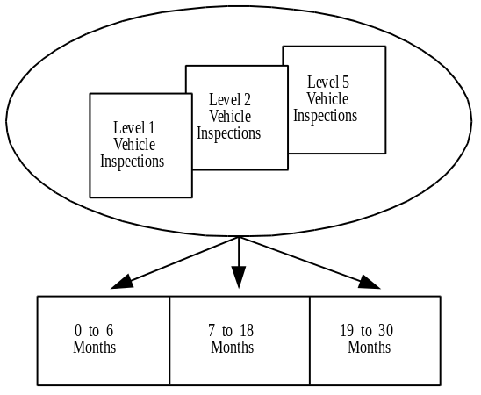

B. Aggregate the following for each time period:

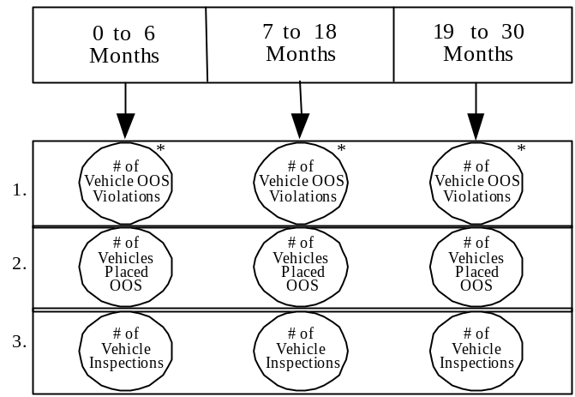
* The limit for the maximum number of Vehicle OOS violations for any one inspection is 5.
- Weight the time periods giving the most weight to the most recent inspections (3 for 0 to 6 months, 2 for 7 to 18 months, and 1 for 19 to 30 months).

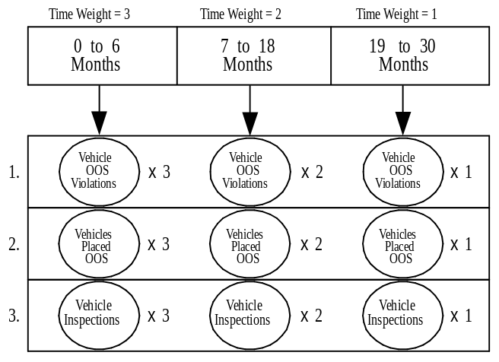

D. Sum the weighted data for:

- Number of Vehicle OOS Violations
- Number of Vehicles Placed OOS
- Number of Vehicle Inspections

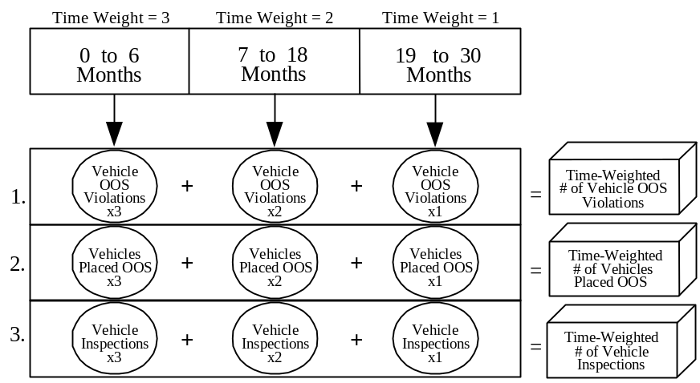

E. Calculate a vehicle OOS rate by adding the Time-Weighted Number of Vehicle OOS Violations and the Time-Weighted Number of Vehicles Placed OOS and dividing the sum by the Time-Weighted Number of Vehicle Inspections to arrive at the VIM.
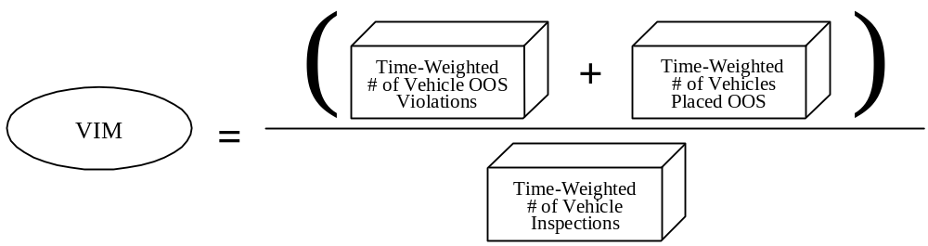

Calculation of the Vehicle Inspections Indicator (VII)
SafeStat uses the Vehicle Inspections Measure (VIM) along with the number of vehicle inspections performed within the last 30 months (without application of time weighting) to calculate the Vehicle Inspections Indicator (VII). The following steps detail SafeStat’s calculation of VII.

A. Using level 1, 2, and 5 inspections for each carrier performed within the last 30 months, calculate the carrier’s total number of vehicle inspections and assign the carrier to one of 3 peer groups. Withhold carriers with fewer than 3 vehicle inspections from further consideration.
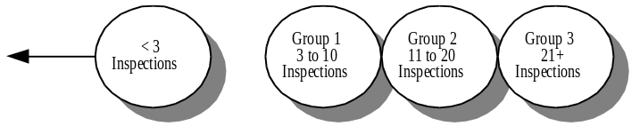

B. For each group, rank carriers’ VIM in ascending order. Transform the ranked measures to percentiles from the 0 percentile (representing the lowest VIM) to the 100th percentile (representing the highest VIM). Assign the percentile value to the VII. If a carrier as fewer than 3 vehicle OOS inspections then the VII will be capped at 74. Also, if carrier has no vehicle OOS inspections, then it will receive a VII of 0.

Vehicle Review Indicator (VRI)
Using the results from compliance reviews performed within the last 18 months, SafeStat calculates the VRI. SafeStat quantifies the number and severity of violations of vehicle-related acute/critical regulations (defined in Part 385 Appendix B of the FMCSR) cited at a carrier’s most recent compliance review into the Vehicle Review Measure (VRM). All of the carriers’ VRMs are compared to one another and are ranked on a percentile basis from 0 to 100. SafeStat assigns the percentile number to the VRI for each carrier with at least one violation of acute and critical regulations.

Calculation of the Vehicle Review Indicator (VRI)
A. SafeStat calculates the Vehicle Review Measure (VRM) for each carrier as described in Appendix B.

B. The Vehicle Review Indicator (VRI) is calculated by taking VRMs for all selected carriers (including those with VRMs of 0) and ranking them in ascending order. The ranked values are transformed into percentiles from 0 (representing the lowest VRM) to 100 (representing the highest VRM). Each carrier with a non-zero VRM is assigned a VRI equal to its percentile rank.

Calculation of the Vehicle SEA Value
The Vehicle SEA Value establishes the carrier’s safety status concerning vehicles. SafeStat uses the Vehicle Inspections Indicator (VII) and the Vehicle Review Indicator (VRI) with their associated indicator weights to calculate the Vehicle SEA Value.
The Vehicle SEA calculation is the maximum of the VRI and VII.


If only one of the two indicators (VRI or VII) exists, then that indicator is assigned to the Vehicle SEA Value. If neither of the indicators exists, then the carrier has insufficient data for SafeStat to calculate a Vehicle SEA Value.

Safety Management SEA

The Safety Management SEA Value reflects the carrier’s safety management posture relative to its peers. The Safety Management SEA Value is based on the Enforcement History Indicator (EHI), the Hazardous Material Review Indicator (HMRI), and the Safety Management Review Indicator (SMRI). The EHI uses the Enforcement Severity Measure (ESM) based on the results of violations cited in closed enforcement cases. The HMRI and the SMRI use violations of hazardous material-related acute, critical, and severe regulations and violations of safety management-related acute and critical regulations, respectively, that were discovered during a compliance review. The sections that follow present the specific computations for each safety measure, indicator, and the SEA value within the Safety Management SEA. Figure 6-1 shows the computational hierarchy used to calculate a Safety Management SEA Value.
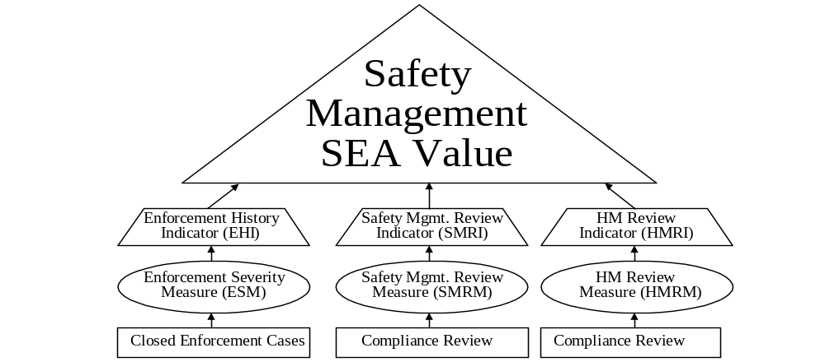
Figure 6-1. Safety Management SEA Value Computational Hierarchy

Enforcement History Indicator (EHI)
Closed enforcement cases result in penalties based on major violations of the FMCSR/HMR. These violations are discovered during CRs and terminal audits. The FMCSA initiates the enforcement case against the carrier and tracks it from initiation through settlement. A carrier’s closed enforcement case history may contain a pattern of violations that indicates a serious lack of commitment to safety on the part of the carrier’s management. The purpose of this indicator is to measure the historical pattern of safety enforcement. SafeStat calculates the EHI based on a carrier’s closed enforcement case history over the last 6 years. Closed enforcement cases in this time frame are time and severity weighted and an ESM is calculated. All carriers with ESMs are compared to one another and ranked on a percentile basis. SafeStat then assigns a percentile number to each such carrier’s EHI based on that rank.

Calculation of the Enforcement Severity Measure (ESM)
SafeStat requires that a carrier had at least 1 enforcement case that has been initiated and closed within the past 30 months or at least 2 enforcement cases closed within the past 6 years to calculate the ESM. Each closed enforcement case initiated on a carrier over the past 6 years is assigned a time weight and a severity weight. SafeStat multiplies these weights together to obtain an enforcement case value for each closed enforcement case. It then adds the enforcement case values to get the ESM. The equation for each carrier is:

ESM = Sum of all (Time Weight for Closed Enforcement Case x Severity Weight for Closed Enforcement Case)

The following steps detail SafeStat’s calculation of the ESM.

A. Identify all carriers with (1) at least 1 closed enforcement case that has been initiated by a CR or terminal audit within the last 30 months or (2) at least 2 closed enforcement cases that have been initiatied by CRs or terminal audits within the last 6 years.

B. For the carriers identified in step A, determine the age of each enforcement case based on the initiation date (the date the associated CR investigation was completed). Assign each enforcement case a time weight (the more recent the initiation date, the greater the weight applied), using the following table:
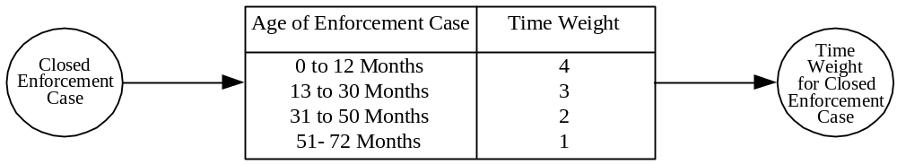

C. Assign a severity weight to each enforcement case by applying the number of different types of violations cited in the case (the more different violations cited, the greater the weight applied), using the following table:

# of Different Violations Cited  Closed  Enforcement  Case | Severity Weight  Severity  Weight Closed Enforcement Case
1 | 1
2 to 3 | 2
4+ | 3

- For each closed enforcement case, multiply the time weight by the severity weight to obtain its enforcement case value.
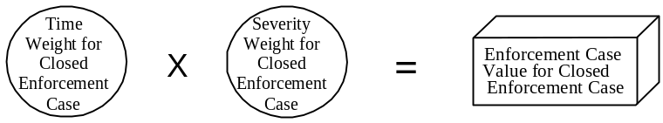

E. Add the enforcement case values for all closed enforcement cases to calculate the Enforcement Severity Measure (ESM).

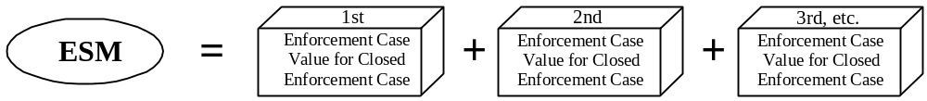

Calculation of the Enforcement History Indicator (EHI)
SafeStat assigns an EHI to a carrier based on a percentile ranking of its Enforcement Severity Measure (ESM), the age of the most recent closed enforcement case, and whether the most recent subsequent compliance review resulted in violations of acute/critical regulations. The following steps detail SafeStat’s calculation of EHI and ensure that only carriers with closed enforcement cases initiated by a CR or terminal audit within in the past 30 months will be eligible to receive a high EHI of 75 and higher:

A. Place all carriers with an ESM into one of two groups:

Group 1:
(1) had a recent CR (or terminal audit)-initiated closed enforcement case (within 30 months) and no subsequent compliance review or
(2) had a recent CR (or terminal audit)-initiated closed enforcement case (within 30 months) and the most recent subsequent compliance review resulted in violations of acute/critical regulations.

Group 2:
(1) had a recent CR (or terminal audit)-initiated closed enforcement case (within 30 months) and the most recent subsequent compliance review resulted in no violations of acute/critical regulations.
(2) had no recent closed enforcement cases (within 30 months) but at least 2 CR (or terminal audit)-initiated closed enforcement cases between 31 months and 6 years ago.

B. Rank carriers in Group 1 in ascending sequence by their respective ESMs. Assign each carrier’s EHI a percentile ranking from 75 to 100 based on the carrier’s ESM. The higher the ESM, the higher the percentile, and the worst the safety posture.

C. Rank carriers in Group 2 in ascending sequence by their respective ESMs. Assign each carrier’s EHI a percentile ranking from 50 to 74 based on the carrier’s ESM.

HM Review Indicator (HMRI)
Using results from compliance reviews performed within the last 18 months, SafeStat calculates the HMRI. SafeStat quantifies the number and severity of violations of hazardous material-related acute, critical, and severe regulations cited at a carrier’s most recent compliance review to obtain an HM Review Measure (HMRM). Violations of acute and critical regulations are defined in Part 385 Appendix B of the FMCSR. Violations of hazardous material-related severe violations are defined in Chapter 13 of the US DOT FMCSA Field Operations Training Manual. All violations used are listed in Tables B-1 to B-5 in Appendix B of this document. SafeStat calculates the HMRM for each HM carrier as described in Appendix B. All of the carriers’ HMRMs are compared to one another and are ranked on a percentile basis from 0 to 100. SafeStat assigns the percentile number to the HMRI for each carrier with at least 1 violation of acute ,critical or severe regulations.

Safety Management Review Indicator (SMRI)
Using the results from compliance reviews performed within the last 18 months, SafeStat calculates the SMRI. SafeStat quantifies the number and severity of violations of safety management-related acute and critical regulations (defined in Part 385 Appendix B of the FMCSR) cited at a carrier’s most recent CR into the Safety Management Review Measure (SMRM). SafeStat calculates the SMRMs for each carrier as described in Appendix B. All of the carriers’ SMRMs are compared to one another and are ranked on a percentile basis from 0 to 100. SafeStat assigns a percentile number to the SMRI for each carrier with at least one violation of acute and critical regulations.

HM Inspections Indicator (HMII)
The HMII is based on roadside inspections and the resulting Hazardous Material Out-of-Service (HMOOS) violations. It was used in earlier versions of SafeStat (versions 3 & 4), but its use has been suspended from the algorithm. This indicator was found to be ineffective in identifying unsafe motor carriers. While there is still merit for incorporating an indicator based on HMOOS violations, improvements need to be made to the normalization data before reconsidering the inclusion of the indicator. See Appendix C for more details. It is important to note that roadside HMOOS violations are currently used in the Driver and Vehicle Inspection Indicators (DII and VII).

Calculation of the Safety Management SEA Value
The Safety Management SEA Value establishes the carrier’s safety status concerning its safety management practices. SafeStat uses the Enforcement History Indicator (EHI), the HM Review Indicator (HMRI), and the Safety Management Review Indicator (SMRI) to calculate the Safety Management SEA Value.

The Safety Management SEA calculation is the highest of the EHI, HMRI and SMRI.

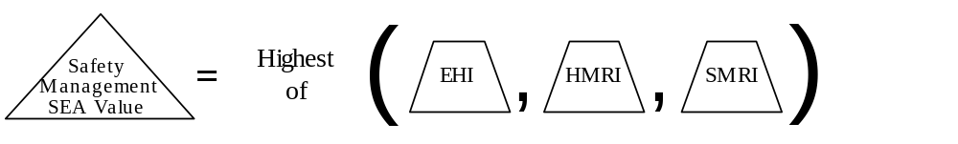

If only one of the three indicators (EHI, HMRI, or SMRI) exists, then that indicator is assigned the Safety Management SEA Value. If none of the indicators exists, then the carrier has insufficient data for SafeStat to calculate a Safety Management SEA Value.

SafeStat Evaluation
Following its implementation in the CVIS (now PRISM) program, SafeStat was evaluated in conjunction with that program’s evaluation. PRISM’s success is dependent upon the ability to evaluate interstate motor carrier safety performance and link that performance to vehicle registration privileges. Also, any system that the FMCSA uses to determine safety status must have the confidence of both the public and private stakeholders.
The evaluation of SafeStat consisted of a comprehensive set of evaluation criteria to satisfy FMCSA and CVIS objectives:
1) Effectiveness in identifying unsafe carriers

2) Ability to determine an unbiased standard of safety fitness

3) Ability to be comprehensive, relevant, and current

4) Ability to rank carriers relative to overall safety risk

5) Ability to identify specific performance and regulatory compliance deficiencies

6) Consistency over time and adaptability to changing requirements

The evaluation also addressed other important issues related to SafeStat performance, in particular, data issues. Also, emphasis in the evaluation was given to the first criterion that addressed SafeStat's effectiveness in identifying carriers likely to be at risk (have greater than average crash rates). This evaluation, called the Effectiveness Study, is summarized below.

Description of the Effectiveness Study
As part of the evaluation of CVIS/PRISM, an effectiveness study was devised to confirm that the carriers that SafeStat was identifying were indeed high safety risk carriers. Safety risk at any given time is defined as the likelihood of having crashes in the near future. By examining the SafeStat post-identification crash experience of identified carriers, this study essentially tested SafeStat’s crash rate prediction capability and represents the “bottom-line” assessment of its performance. Beyond confirming SafeStat’s effectiveness, the results of this study are being used to refine SafeStat to further emphasize the components of the system that are the most closely related to high future crash rates and to evaluate the contribution of potential new measures and indicators.

The effectiveness study was accomplished by: (1) performing a simulated SafeStat carrier identification using historical data; (2) observing the crash involvement over the immediate 18 months after SafeStat was run for both the carriers identified by SafeStat as having poor safety status and other carriers not so identified by SafeStat, but which had sufficient data to be identified; and (3) comparing the post-identification crash rates of both groups of carriers. If SafeStat is effective in identifying unsafe carriers (i.e., carriers having a high risk of being involved in future crashes), then the carriers identified as having a poor safety status would be expected to have higher post-selection crash rates than the carriers that were not identified by SafeStat. The greater the post-selection crash rate for the identified carriers relative to those carriers not identified, the more effective SafeStat would be in identifying unsafe motor carriers.

Rather than use the most recent available data and having to wait for a period of time to collect post- identification crash data, the analysis was performed using historical data. The study was conducted by simulating a carrier identification by SafeStat on data available at an earlier date (April 1, 1996) and then observing the carriers’ crash involvement that occurred over the next 18 months (from April 1996 to October 1997). This procedure simulated carrier identification by SafeStat as if it had been run as of April 1, 1996 using safety events that occurred prior to that date, and allowed for sufficient subsequent crash reporting to accurately measure the post-identification crash rates.
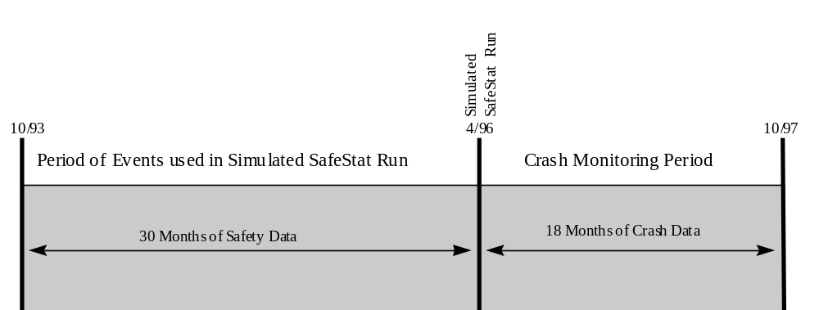
Figure 7-1. Effectiveness Analysis Timeline

From this simulation run of SafeStat, carriers that had sufficient data to be scored were placed into the following groups based on their overall SafeStat results in order to compare the “post-selection crash performance”:

- carriers identified as “at-risk” (worst SafeStat Scores)
- other carriers identified as having a poor safety status according to SafeStat
- carriers with sufficient data but not identified by SafeStat as having a poor safety status

The post-identification crash rate of each group was calculated as the number of reported crashes per 1000 power units (PUs). The number of PUs is defined by the total number of trucks, tractors, hazardous material tank trucks, motor coaches, school buses, minibuses/vans, and limousines that are owned or term leased by a motor carrier. The carrier PU information was based on census data that reside in the centralized FMCSA national database, the Motor Carrier Management Information System (MCMIS).

The crash data were based upon the crashes reported by the states (according to the National Governors’ Association (NGA) standard) that occurred during the post-selection period (April 1996 to October 1997). These data also reside in the MCMIS. Each reported crash was weighted based on the severity and timing of the crash.

The severity weighting scheme placed emphasis on crashes with greater consequences, while the time weighting placed emphasis on crashes that occurred soon after the SafeStat identification run. Severity- weights were assigned as follows: a weight of 0.5 for property damage only, a weight of 1.0 for crashes involving injuries/fatalities or hazardous material release, and a weight of 1.5 for crashes involving injuries/fatalities and hazardous material release. Time weights were assigned to each crash as follows: a weight of 1.5 for crashes that occurred within the first six months of 18 month post-selection time period, a weight of 1.0 for crashes that occurred 7 to 12 months into the post-identification time period, and a weight of 0.5 for crashes that occurred in the last 6 months of the time period. Each crash had its severity weight multiplied by its time weight to obtain on overall weight. In each carrier group, the weighted crashes were summed and divided by the number of PUs to provide a weighted crash rate for the group. The following section discusses the results for each carrier group.

Results
Overall Effectiveness of SafeStat
The post-selection crash rates for the SafeStat identified and not identified carrier groups were examined both in terms of their overall SafeStat Scores and in terms of the four Safety Evaluation Areas (SEAs) ⎯ Accident, Driver, Vehicle, and Safety Management ⎯ that determine the overall SafeStat Scores. The rates are shown in Table 7-1 and in Figure 7-2.

Table 7-1. Post-Selection Crash Rates

Carrier Group | Number of Carriers | Weighted Crash Rate* | % Higher than Not Identified Carriers
All Identified | 4,276 | 56.4 | 85%
At-Risk (with Worst  SafeStat Scores) | 1,450 | 82.3 | 169%
Other Identified (with  Poor SafeStat Scores) | 2,826 | 43.2 | 41%
Not Identified | 69,797 | 30.5 | -
* Number of weighted crashes per 1000 power units from 4/1996 to 10/1997.

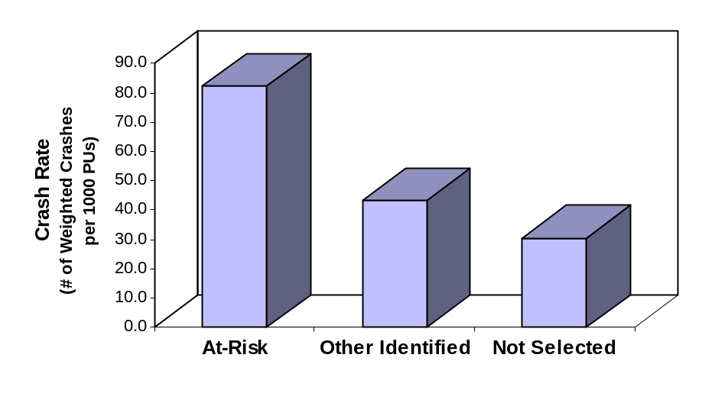
Figure 7-2. Crash Rates for the Three Groups of Carriers

These results confirm that SafeStat did identify carriers with a higher crash risk. The group of all carriers that SafeStat identified as poor performers had an 85% higher crash rate than carriers that were not identified. The carriers designated as “at-risk” by SafeStat had a much higher crash rate (169% greater) than the carriers that were not identified. A majority of these “at-risk” carriers were identified in part because they had previous problems with respect to their crash rates (i.e., they had deficient Accident SEA values).

However, even the SafeStat identified carriers in the “other identified” group, which did not have high Accident SEA values but were in the worst 25th percentile in two of the other SEAs, posed a 41% greater crash risk than the carriers that were not identified. This result shows that SafeStat has the proactive capability to identify carriers that are likely to be involved in crashes even though they previously did not have exceptionally high crash rates.

Effectiveness of Individual SEAs
Further testing was done to determine the effectiveness of the principal components of SafeStat. This was accomplished by placing carriers into groups based on their performance results for each particular SEA (i.e., Accident, Driver, Vehicle, or Safety Management).

The results for carriers with high individual SEA values compared to those with lower SEA values are as follows (Carriers with high SEA values were in the worst 25th percentile and were designated as the worst performers in that particular evaluation area. Conversely, carriers with no high SEA values were not in the worst 25th percentile, and therefore, were not among the poorest performers in that SEA.):

Table 7-2. Crash Rates of Carriers with and without High SEAs

Safety Evaluation Area | Number of Carriers | Weighted  Crash Rate* | % Greater than Carriers without the High SEA
High Accident SEA | 2,596 | 81.4 | 172%
No High Accident SEA | 71,477 | 29.9 | -
High Driver SEA | 7,036 | 56.2 | 90%
No High Driver SEA | 67,037 | 29.5 | -
High Vehicle SEA | 12,456 | 38.3 | 22%
No High Vehicle SEA | 61,617 | 31.4 | -
High Safety Mgmt. SEA | 4,442 | 42.0 | 35%
No High Safety Mgmt. SEA | 69,631 | 31.0 | -
* Number of weighted crashes per 1000 power units from 4/1996 to 10/1997.

Accident SEA - The results confirm what may seem intuitively to be obvious: carriers with high crash rates in the past are likely to continue to have high crash rates in the future. In other words, past crash rate performance is a good indicator of future crash rate performance. The effectiveness study shows a 172% greater post-selection crash rate for carriers with poor Accident SEAs compared to carriers that were not identified as having poor Accident SEAs. Comparing SEAs, the Accident SEA is by far the most effective SEA for identifying high-risk carriers, thereby justifying the “double-weighting” of the Accident SEA in SafeStat.

Driver SEA - The Driver SEA (with a 90% higher crash rate for carriers with poor Driver SEAs) is the next most effective SEA. These results from the study are especially impressive because the criteria for the Driver SEA are based on violations and are independent of crash history.

Vehicle SEA - Carriers with poor Vehicle SEAs did have a higher crash rate (22%) than carriers without poor Vehicle SEAs. Although the difference is not as great as the crash rate differences in the Accident and Driver SEAs, it is significant. As with the Driver SEA, the criteria for the Vehicle SEA are based on violations and are independent of crash history. Also, it should be noted that due to the larger amount of vehicle roadside inspection data, the Vehicle SEA was computed over many more carriers (12,456 as opposed to the Accident SEA’s 2,596 and the Driver SEA’s 7,036) and, thus, it has the potential of identifying more carriers in absolute terms.

Safety Management SEA - The Safety Management SEA is also effective in identifying carriers with high crash rates. Indicators in this SEA are based on safety regulation compliance supporting the association of safety regulations with crash risk. Carriers with high Safety Management SEAs had a 35% higher post-identification crash rate than carriers that did not have high Safety Management SEAs. Recent improvements made to this SEA in SafeStat have substantially increased its effectiveness.

Conclusion
SafeStat does work. The effectiveness study shows that all of the individual parts of SafeStat and SafeStat as a whole do indeed identify carriers that are likely to have significantly higher crash rates than carriers not identified. The effectiveness study has also proven to be a useful tool in quantifying the performance of SafeStat. Also, since SafeStat was designed to be continuously improved, the results of the study enable SafeStat developers and the FMCSA to assess the relative strengths of SafeStat’s component parts and to continue to make enhancements to improve its efficiency. Finally, SafeStat continues to be strengthened and improved through the addition of better data and new indicators (most recently, a Moving Violation Indicator in the Driver SEA, which a separate analysis has shown will further increase SafeStat’s effectiveness).

Appendix A
SafeStat Reports

SafeStat generates standard report files as the result of each run. This appendix contains short examples of three of these reports, with definitions of all fields for each report. The examples are entirely fictitious, containing no data from actual carriers.
The following reports are included:
1. SafeStat Analysis Report
This report lists all carriers with SafeStat scores, and includes SafeStat-calculated data and certain safety event data for a specified state. It is divided by SafeStat categories.

2. Supplementary SafeStat Analysis Report
This report has the same overall purpose as the SafeStat Analysis Report, but provides more detailed supporting data to supplement the primary report.

3. Motor Carrier Safety Record Report
The report contains safety evaluation summary data and a list of safety event data that SafeStat used to calculate the carrier’s safety status. It has two sections: safety evaluation summary and safety evaluation area detail. The detail section has a potential of four sub-sections, one for each SEA. SafeStat reports only the SEAs that are in the unsafe margin.

A.1 Field Definitions for the SafeStat Analysis Report

State Rank | Ranks carriers within a state - first stratified by category (Category A has SafeStat Scores 350-550, Category B has SafeStat Scores 225-350, and Category C has SafeStat Scores of 150-225) and then are sorted by the SafeStat Score within each category.
Comb. Rank | Ranks carriers within carrier population nationwide - first stratified by category (A, B, and C) and then are sorted by the SafeStat Score.
DOT# | US DOT number
Carrier Name | The name of the carrier
City | The city in which the carrier is domiciled
ST | The state in which the carrier is domiciled
CNT CDE | County Code where carriers is domiciled
HM/PASS | Identifies if motor carrier hauls hazardous material or is a passenger carrier.
# of Power Units | Number of power units owned, term-leased, and trip-leased usually comes from the census data on Forms MCS-150 and 151
SafeStat Indicatr | Carriers with 2 or more deficient SEAs (deficient defined as SEA values of 75 or higher) are given a SafeStat Score that is equal to the sum of the deficient SEA values for the Vehicle and Safety Management SEAs, plus 2 x the deficient Accident SEA, plus 1.5 x the deficient Driver SEA. SEA values of less than 75 are not be used in calculating the SafeStat Score.
Acc. SEA Value | Accident SEA Value is calculated on a 0-100 scale. The higher the value, the worse the performance. Only Accident SEA Values of 75 or greater are used in calculating the SafeStat Score. Accident SEA Values of less than 75 are placed in parenthesis
Dr. SEA Value | Driver SEA Value is calculated on a 0-100 scale. The higher the value, the worse the performance. Only Driver SEA Values of 75 or greater are used in calculating the SafeStat Score. Driver SEA Values of less than 75 are placed in parenthesis. If the Driver SEA Value is blank, there were not sufficient data to provide a Driver SEA Value.
Safety Mgmt SEA Value | Safety Management SEA Value is calculated on a 0-100 scale. The higher the value the worse the performance. Only Safety Management SEA Values of 75 or more are used in calculating the SafeStat Score. Safety Management SEA Values of less than 75 are placed in parenthesis. If the Safety Management SEA Value is blank, there were not sufficient data to provide a Safety Management SEA Value.
Veh. SEA Value | Vehicle SEA Value is calculated on a 0-100 scale. The higher the value the worse the performance. Only Vehicle SEA Values of 75 or more are used in calculating the SafeStat Score. Vehicle SEA Values of less than 75 are placed in parenthesis. If the Vehicle SEA Value is blank, there were not sufficient data to provide a Vehicle SEA Value.
Rev. Date | Date of most recent Compliance Review (CR) within the last 18 months. If the most recent CR is older than 18 months the CR data will not be displayed on the SafeStat Report.
Overall Rating | Overall Safety Rating from the most recent CR; S - Satisfactory; C - Conditional; and U - Unsatisfactory
# of Enf | Number of closed enforcement cases since 1986

Example A.1: SafeStat Analysis Report – SafeStat Scored Carriers for Combined States
All carrier names and DOT numbers are fictitious, intended for illustration purposes only.

A.2 Field Definitions for the SafeStat Analysis Report -- Supplemental List

DOT# | US DOT number
Carrier Name | The name of the carrier.
ST | State in which the carrier is domiciled
Compliance Review Factors: | Individual factor ratings from the latest CR performed within the last 18 months: S - Satisfactory, C - Conditional, & U - Unsatisfactory
1 | Rating in Factor 1 (General)
2 | Rating in Factor 2 (Driver)
3 | Rating in Factor 3 (Operational)
4 | Rating in Factor 4 (Vehicle)
5 | Rating in Factor 5 (Haz. Mat.)
6 | Rating in Factor 6 (Accident)
CR-Violations : | Number of violations of Acute and Critical regulations from the latest CR performed within the last 18 months:
DR A-C | Number of violations of Driver-related Acute and Critical regulations. Violations are used in the Driver Review Indicator (DRI).
VH A-C | Number of violations of Vehicle-related Acute and Critical regulations. Violations are used in the Vehicle Review Indicator (VRI).
SM A-C | Number of violations of Safety Management-related Acute and Critical regulations. Violations are used in the Safety Management Review Indicator (SMRI).
HM A-C | Number of violations of Hazardous Material-related Acute and Critical regulations. Violations are used in the HM Review Indicator (HMRI).
# of NGA Acc. | Number of state-reported crashes involving the carrier in the last 30 months.
# of Recdbl. Acc. | Number of Recordable crashes found during a CR within the last 12 months. All findings from the review are displayed, even if no Recordable crashes were found.
Veh. Insp. | Number of vehicle roadside inspections in the last 30 months
Drv. Insp. | Number of driver roadside inspections in the last 30 months
Veh. OOS Rate | Vehicle OOS rate using the last 30 months of data. This is the number of vehicles placed OOS divided by the number of vehicle inspections. This rate is not time-weighted.
Veh. OOS Viol. Rate | Shows the average number of vehicle OOS violations issued per vehicle OOS inspection. For example, if a carrier had 2 inspections that resulted in the vehicle being place OOS, one inspection resulted in 3 vehicle OOS violations and the other inspection resulting in 1 vehicle OOS violations, the Vehicle OOS Violation Rate would be (1 + 3) / 2 = 2. Note, this number will always be greater than 1.
Drv. OOS Rate | Driver OOS rate using the last 30 months of data. This is the number of drivers placed OOS divided by the number of driver inspections. This rate is not time-weighted.
Drv. OOS Viol. Rate | Shows the average number of driver OOS violations issued per driver OOS inspection. Note, this number will always be greater than 1.
Viol. OOS Order | Number of violations of OOS orders (i.e., jumping OOS orders, both vehicle and driver) in the last 30 months
# of HM OOS Insp | Number of HM OOS inspections in the last 30 months
# of Mov. Viol. | Number of moving violations issued in conjunction with roadside inspections over the past 30 months.
Moving Viol. Indic. | Moving Violation Indicator (MVI) are calculated on a 0-100 scale. The higher the MVI, the worse the performance. Only MVIs of 75 or higher are shown and used in calculating the Driver SEA. If the MVI is blank, there were not enough moving violations to reach an indicator of 75 or higher
Total # of Drv. | Number of drivers used to normalize the number of moving violations in the MVI.
#LTR | Number of Safety Status letters previously sent to motor carrier.
Example A.2: SafeStat Analysis Report – Supplemental List

All carrier names and DOT numbers are fictitious, intended for illustration purposes only.

A.3 Field Definitions for the Motor Carrier Safety Record Report
In the states participating in PRISM, some of the SafeStat-scored carriers were sent warning letters. The following Motor Carrier Safety Record Report is an example of the warning letter attachment that was mailed to the carrier. This report presents the census and safety information that led to the carrier’s SafeStat score.

Section I; Safety Evaluation Summary - provides descriptive information and indicates the safety areas where the carrier is deficient.

Identifying Information
Carrier Legal Name | The carrier name used in legal transactions.
Carrier ‘Doing Business As’ Name | The carrier name used in normal practice.
US DOT# | A unique number assigned by the U.S. Department of Transportation to the carrier reported under the carrier name. Carriers that provide interstate service, haul hazardous material, or carry passengers are required to apply for this number.
Telephone Number | The carrier’s telephone number includes the 3-digit area code, 3-digit local exchange and 4-digit number.
Street (physical address) | The number and street at which the carrier is located.
Street (mailing address) | The number and street at which the carrier’s mail is delivered.
City (physical address) | The city in which the carrier is located.
City (mailing address) | The city in which the carrier’s mail is delivered.
State (physical address) | The state in which the carrier is located.
State (mailing address) | The state in which the carrier’s mail is delivered.
Zip (physical address) | The 5-digit Zip number appropriate to the physical location of the carrier.
Zip (mailing address) | The 5-digit Zip number used in delivering mail to the carrier.
Expanded Zip Code (mailing address) | The 4 digit expanded Zip number amended to the Zip used in delivering mail to the carrier.
County Name (physical address) | The name of the county in which the carrier is located.
Hazardous Material Carrier | ‘N’ if the carrier does not haul hazardous material, ‘Y’ if the carrier hauls hazardous material.
Passenger Carrier | ‘N’ if the carrier does not carry passenger, ‘Y’ if the carrier carries passenger.
Number of Power Units Owned and Term-Leased | The number of tractors, trucks, and buses owned and term-leased by the carrier.

Safety Evaluation Summary
Each of the four Safety Evaluation Areas (i.e., Accident, Driver, Vehicle, and Safety Management) is enumerated. When a carrier’s performance is found to be deficient with respect to a SEA, a mark ‘X’ is displayed beside the SEA.

Section II; Safety Evaluation Area Detail - There are four subsections that provide details on the respective SEAs (i.e., Accident, Driver, Vehicle, Safety Management). When data for a SEA are available, that report subsection is generated and amended to the report.

Accident
State-Reported Crashes (used in the Accident Involvement Indicator):
Accident Date | The date in which the crash occurred.
Event State | The state in which the crash occurred.
Location | A brief description of the location where the crash occurred.
Acc Rpt Number | The number that identifies the police crash report.
Fatalities | The number of persons killed in or outside a vehicle at the scene of the crash.
Injuries | The number of persons injured in or outside a vehicle at the scene of the crash.
Driver’s Lic State | The state in which the driver involved in the crash is licensed.
Vehicle ID (VIN) | The vehicle identification number is a unique combination of alphanumeric characters formulated by the manufacturer of the first vehicle listed in the state crash report.
Veh Lic State | The state/district issuing the license plate of the motor vehicle.
Vehicle Plate Number | The numeric, alphanumeric, or alphabetic characters, exactly as displayed, on the plate or tag affixed to the motor vehicle.
Number of Power Units Owned and Term-Leased | The number of tractors, trucks, and buses owned and term-leased by the carrier.

Compliance Review (review data used for the Recordable Accident Indicator)
Date of Last Review | The date of the last compliance review done on the carrier, if conducted within the last 12 months.
Recordable Accident in 12 Months Prior to Review | The number of recordable crashes that occurred within the year previous to the last review.
Vehicle Miles Traveled in 12 Months Prior to Review | The number of vehicle miles traveled within the year previous to the last review.

Driver
Roadside Inspections (Inspections that resulted in a driver being placed Out-of-Service within the last 30 months). For each roadside inspection:
Inspection Date | The date in which the inspection was conducted.
Event State | The state in which the inspection was conducted.
Inspection Report Number | A unique number identifying the inspection report.
Inspection Level | There are five types of inspection levels: full inspection, walk-around inspection, driver only inspection, special study inspection, and terminal inspection.
Driver’s Last Name | The last name of the inspected driver.
Driver’s First Name | The first name of the inspected driver.
Number of Driver OOS Violations | The number of driver Out-Of-Service violations found in the inspection.

Moving Violations (Moving Violations found in conjunction with Driver Inspections within the last 30 months):
Inspection Date | The date in which the inspection was conducted.
Event State | The state in which the inspection was conducted.
Inspection Report Number | A unique number identifying the inspection report.
Inspection Level | There are five types of inspection levels: full inspection, walk-around inspection, driver only inspection, special study inspection, and terminal inspection.
Driver’s Last Name | The last name of the inspected driver.
Driver’s First Name | The first name of the inspected driver.
Violation Code/ Description | Violation Code and description of moving violation.
Drivers | Total number of Interstate and Intrastate drivers.

For statistics on recent driver inspections:
Total Driver Inspections within the last 30 months of report date | The total number of driver inspections conducted within the last 30 months of the date of the report.
Total Out-Of-Service Orders Violated | The total number of occurrences in which drivers violate an OOS order within the last 30 months of the date of the report.

Compliance Review
Date of Last Review | The date of the last compliance review done on the carrier, if conducted within the last 18 months.
Primary Federal Regulation | Primary citation number for this violation.
Secondary Federal Regulation | Secondary citation number for this violation.
Violation Type | Acute or Critical.

Vehicle
Roadside Inspections (Inspections that resulted in vehicles placed Out-of-Service within the last 30 months). For each roadside inspection:
Inspection Date | The date in which the inspection was conducted.
Event State | The state in which the inspection was conducted.
Inspection Report Number | A unique number identifying the inspection report.
Inspection Level | There are five types of inspection levels: full inspection, walk-around inspection, driver only inspection, special study inspection, and terminal inspection.
Driver’s Last Name | The last name of the inspected driver.
Driver’s First Name | The first name of the inspected driver.
Number of Vehicle OOS Violations | The number of vehicle Out-Of-Service violations found in the inspection.
Vehicle Plate Number | The numeric, alphanumeric, or alphabetic characters, exactly as displayed, on the plate or tag affixed to the motor vehicle.

For statistics on recent vehicle inspections:
Total Vehicle Inspections within the last 30 months of report date | The total number of vehicle inspections conducted within the last 30 months of the date of the report.

Compliance Review
Date of Last Review | The date of the last compliance review done on the carrier, if conducted within the last 18 months.
Primary Federal Regulation | Primary citation number for this violation.
Secondary Federal Regulation | Secondary citation number for this violation.
Violation Type | Acute or Critical.

Safety Management
DOT/OMCHS Federal Safety Regulation Enforcement (closed enforcement cases from 11/87 to the present). For each closed case:
Date Enforcement Case Closed | The date in which the enforcement case was closed.
Investigation # | An alphanumeric combination of characters which uniquely identifies the federal case.
Violation Section # | The violation sections cited in the enforcement case.
Counts Settled | The number of counts settled for the specific violation section # addressed in the case.

Compliance Review
Date of Last Review | The date of the last compliance review done on the carrier, if conducted within the last 18 months.
Hazardous Materials related violations

Primary Federal Regulation | Primary citation number for this violation.
Secondary Federal Regulation | Secondary citation number for this violation.
Violation Type | Acute or Critical.
Safety Management related violations

Primary Federal Regulation | Primary citation number for this violation.
Secondary Federal Regulation | Secondary citation number for this violation.
Violation Type | Acute or Critical.

Example A.3a: Page 1 of the Motor Carrier Safety Record Report

All carrier names and DOT numbers are fictitious, intended for illustration purposes only.
Example A.3b: Page 2 of the Motor Carrier Safety Record Report

All carrier names and DOT numbers are fictitious, intended for illustration purposes only.
Example A.3c: Page 3 of the Motor Carrier Safety Record Report

All carrier names and DOT numbers are fictitious, intended for illustration purposes only.
Example A.3d: Page 4 of the Motor Carrier Safety Record Report

All carrier names and DOT numbers are fictitious, intended for illustration purposes only.
Example A.3e: Page 5 of the Motor Carrier Safety Record Report

All carrier names and DOT numbers are fictitious, intended for illustration purposes only.

B
Calculating Review Measures

Review measures DRM, VRM, SMRM, and HMRM are calculated for DRI in the Driver SEA, the VRI in the Vehicle SEA, and the SMRI and HMRI in the Safety Management SEA, respectively. Each of these four review measures has a specified set of associated acute and critical regulations, and in the case of the HMRI, hazardous material-related severe regulations. See Tables B-1 to B-5 at the end of this appendix for a list of associated acute, critical, and severe regulations. A review measure is scored based on the number and severity of each violation of associated regulations. The following steps detail SafeStat's calculation of the carrier's review measure:

A. Identify all violations of acute, critical, and severe regulations related to the given review measure, should such violations exist. If a carrier does not have any violations of acute, critical, or severe regulations related to the measure, the review measure is assigned a value of 0.

B. If the carrier has one or more violations of acute and critical regulations related to the measure, obtain the following information:

 | Violations of Critical Regulations: | # of Occurrences
 |  | # of Records Checked
 | Violations of Acute Regulations: | # of Occurrences

- Assign the severity weight to each violation of acute and critical regulations using the Table B-1 at the end of this appendix.

Each violation of acute and critical regulations has a corresponding severity weight that depends on the nature of the violation. The severity weight for each violation was determined by the following criteria:

 | Severity weight |  | Criterion
 | 1 |  | Violations of critical regulations that are compliance or paperwork oriented.
 | 1 |  | Violations of hazardous material-related severe regulations.
 | 2 |  | Violations of critical regulations that are performance oriented.
 | 3 |  | Violations of all acute regulations.

D. Calculate the weighted Violation Value for each violation, as follows:

- For each violation of critical regulations:

Violation Value = Severity Weight x (10 + (Violation Rate x 10))

where Violation Rate = # of Occurrences / # of Records Checked

For example, if a violation of a critical regulation was cited in the CR as having had occurred 10 times out of 20 records check (violation rate of 0.5) and was considered “performance oriented” (severity weight of 2), then
Violation Value = 2 x (10 + (0.5 x 10)) = 2 x (10 + 5) = 2 x 15 = 30

- For each violation of acute regulations:

Violation Value = Severity Weight x (10 + # of Occurrences)

where # of Occurrences is set to a maximum of 10
and the severity weight of non-ratable and ratable violations of acute regulations are 1 and 3 respectively

For example, if a violation of an acute regulation was cited in the CR as having had occurred 5 times then
Violation Value = 3 x (10 + 5) = 3 x 15 = 45

- For each violation of hazardous material-related severe regulations:
Violation similar in nature to a violation of critical regulations that inidicate breakdowns in management and/or operational controls will be calculated the same as a violation of critical regulations
Violation similar in nature to violations of acute regulations that demand immediate corrective action will be calculated that same as a violation of acute regulations

E. Obtain the carrier's review measure for the given SEA by summing all of the violation values associated with the measure. Using the two violation value examples in Step C of 30 and 45, SafeStat will calculate the review measure as 75 (30 + 45).

Table B-1. Driver Review Measure | Severity  Weight | 3 | 3 | 3 | 3 | 3 | 3 | 2 | 3 | 3 | 2 | 3 | 3 | 3 | 3 | 3 | 2 | 3 | 3 | 3 | 2 | 2 | 2 | 2
Table B-1. Driver Review Measure | Acute/  Critical | A | A | A | A | A | A | C | A | A | C | A | A | A | A | A | C | A | A | A | C | C | C | C
Table B-1. Driver Review Measure | Description | Using a driver known to have an alcohol concentration of 0.04 or greater. | Using a driver who has refused to submit to an alcohol or controlled-substances test required under part 382. | Using a driver known to have used a controlled substance. | Using a driver known to have tested positive for a controlled substance. | Using a driver who has not undergone a return-to-duty alcohol test. | Using a driver who has not undergone a return-to-duty controlled-substances test with a result indicating a verified negative result for controlled substances. | Allowing a driver to perform safety-sensitive function, after engaging in conduct prohibited by Subpart B, without being valuated by a substances-abuse professional, as required by § 382.605. | Using a driver within 24 hours after being found to have an alcohol concentration of 0.02 or greater, but less than 0.04. | Using a driver who has not undergone a return-to-duty alcohol test with a result indicating an alcohol concentration of less than .02 or with verified negative test result, after engaging in conduct prohibited by part 382 subpart B. | Operating a commercial motor vehicle without a valid commercial driver's license. | Knowingly allowing, requiring, permitting, or authorizing an employee with a Commercial Driver's License which is suspended, revoked, or canceled by a state or who is disqualified to operate a commercial motor vehicle. | Knowingly allowing, requiring, permitting, or authorizing an employee with more than one commercial driver's license to operate a commercial motor vehicle. | Knowingly allowing, requiring, permitting, or authorizing a driver to drive who is disqualified to drive a commercial motor vehicle. | Using a physically-unqualified driver. | Using a disqualified driver. | Operating a motor vehicle not in accordance with the laws, ordinances, and regulations of the jurisdiction in which it is being operated. | Requiring or permitting a driver to drive while under the influence of, or in possession of, a narcotic drug, amphetamine, or any other substance capable of rendering the driver incapable of safely operating a motor vehicle. | Requiring or permitting a driver to drive a motor vehicle while under the influence of, or in possession of, an intoxicating beverage. | Requiring or permitting a driver who shows evidence of having consumed an intoxicating beverage within 4 hours to operate a motor vehicle. | 392.6 Scheduling a run which would necessitate the vehicle being operated at speeds in excess of those prescribed. | Requiring or permitting a driver to drive without the vehicle’s cargo being properly distributed and adequately secured. | Effective through January 3, 2004: Requiring or permitting a driver to drive more than 15 hours. (driving in Alaska).  Effective January 4, 2004: Requiring or permitting a property-carrying commercial motor vehicle driver to drive more than 15 hours. (driving in Alaska). | Effective through January 3, 2004: Requiring or permitting a driver to drive after having been on duty 20 hours. (driving in Alaska)  Effective January 4, 2004: Requiring or permitting a property-carrying commercial motor vehicle driver to drive after having been on duty 20 hours. (driving in Alaska)
Table B-1. Driver Review Measure | Primary  Federal  Section | 382.201 | 382.211 | 382.213(b) | 382.215 | 382.309(a) | 382.309(b) | 382.503 | 382.505(a) | 382.605(c)(1) | 383.23(a) | 383.37(a) | 383.37(b) | 383.51(a) | 391.11(b)(4) | 391.15(a) | 392.2 | 392.4(b) | 392.5(b)(1) | 392.5(b)(2) | 392.6 | 392.9(a)(1) | 395.1(h)(1)(i) | 395.1(h)(1)(ii)

Table B-1. Driver Review Measure (continued) | Severity  Weight | 2 |  | 2 |  | 2 | 2 |  | 2 |  |  | 2 | 2 |  | 2 |  | 2 |  | 2 |  |  | 2 |  |  | 2 | 2 | 2 | 2
Table B-1. Driver Review Measure (continued) | Acute/  Critical | C |  | C |  | C | C |  | C |  |  | C | C |  | C |  | C |  | C |  |  | C |  |  | C | C | C | C
Table B-1. Driver Review Measure (continued) | Description | Effective through January 3, 2004: Requiring or permitting a driver to drive after having been on duty more than 70 hours in 7 consecutive days. (driving in Alaska)  Effective January 4, 2004: Requiring or permitting a property-carrying commercial motor vehicle driver to drive after having been on duty more than 70 hours in 7 consecutive days. (driving in Alaska) |  | Effective through January 3, 2004: Requiring or permitting a driver to drive after having been on duty more than 80 hours in 8 consecutive days. (driving in Alaska)  Effective January 4, 2004: Requiring or permitting a property-carrying commercial motor vehicle driver to drive after having been on duty more than 80 hours in 8 consecutive days. (driving in Alaska) |  | Effective January 4, 2004: Requiring or permitting a passenger-carrying commercial motor vehicle driver to drive more than 15 hours. (driving in Alaska). | Effective January 4, 2004: Requiring or permitting a passenger-carrying commercial motor vehicle driver to drive after having been on duty 20 hours. (driving in Alaska) |  | Effective January 4, 2004: Requiring or permitting a passenger-carrying commercial motor vehicle driver to drive after having been on duty more than 70 hours in 7 consecutive days. (driving in Alaska) |  |  | Effective January 4, 2004: Requiring or permitting a passenger-carrying commercial motor vehicle driver to drive after having been on duty more than 80 hours in 8 consecutive days. (driving in Alaska) | Effective January 4, 2004: Requiring or permitting a short-haul property-carrying commercial motor vehicle driver to drive after having been on duty 16 consecutive hours. |  | Effective through January 3, 2004: Requiring or permitting a driver to drive more than 10 hours.  Effective January 4, 2004: Requiring or permitting a property-carrying commercial motor vehicle driver to drive more than 11 hours. |  | Effective through January 3, 2004: Requiring or permitting a driver to drive after having been on duty 15 hours.  Effective January 4, 2004: Requiring or permitting a property-carrying commercial motor vehicle driver to drive after the end of the 14th hour after coming on duty. |  | Effective through January 3, 2004: Requiring or permitting a driver to drive after having been on duty more than 60 hours in 7 consecutive days.  Effective January 4, 2004: Requiring or permitting a property-carrying commercial motor vehicle driver driver to drive after having been on duty more than 60 hours in 7 consecutive days. |  |  | Effective through January 3, 2004: Requiring or permitting a driver to drive after having been on duty more than 70 hours in 8 consecutive days.  Effective January 4, 2004: Requiring or permitting a property-carrying commercial motor vehicle driver driver to drive after having been on duty more than 70 hours in 8 consecutive days. |  |  | Effective January 4, 2004: Requiring or permitting a property-carrying commercial motor vehicle driver to restart a period of 7 consecutive days without taking an off-duty period of 34 or more consecutive hours. | Effective January 4, 2004: Requiring or permitting a property-carrying commercial motor vehicle driver to restart a period of 8 consecutive days without taking an off-duty period of 34 or more consecutive hours. | Effective January 4, 2004: Requiring or permitting a passenger-carrying commercial motor vehicle driver to drive more than 10 hours. | Effective January 4, 2004: Requiring or permitting a passenger-carrying commercial motor vehicle driver to drive after having been on duty 15 hours.
Table B-1. Driver Review Measure (continued) | Primary  Federal  Section | 395.1(h)(1)(iii) |  | 395.1(h)(1)(iv) |  | 395.1(h)(2)(i) | 395.1(h)(2)(ii) |  | 395.1(h)(2)(iii) |  |  | 395.1(h)(2)(iv) | 395.1(o) |  | 395.3(a)(1) |  | 395.3(a)(2) |  | 395.3(b)(1) |  |  | 395.3(b)(2) |  |  | 395.3(c)(1) | 395.3(c)(2) | 395.5(a)(1) | 395.5(a)(2)
Table B-1. Driver Review Measure (continued) | Severity  Weight | 2 | 2 | 2 | 2 | 2 | 2 |  |  | Table B-2. Vehicle Review Measure | Severity  Weight |  | 3 | 3 | 3 |  | Table B-3. Safety Management Review Measures | Severity  Weight |  | 3 | 2 | 2 | 3 | 2 |  | 2 | 2 |  | 3 |  | 1
Table B-1. Driver Review Measure (continued) | Acute/  Critical | C | C | C | C | C | C |  |  | Table B-2. Vehicle Review Measure | Acute/  Critical |  | A | A | A |  | Table B-3. Safety Management Review Measures | Acute/  Critical |  | A | C | C | A | C |  | C | C |  | A |  | C
Table B-1. Driver Review Measure (continued) | Description | Effective January 4, 2004: Requiring or permitting a property-carrying commercial motor vehicle driver to restart a period of 8 consecutive days without taking an off-duty period of 34 or more consecutive hours. | Effective January 4, 2004: Requiring or permitting a passenger-carrying commercial motor vehicle driver to drive more than 10 hours. | Effective January 4, 2004: Requiring or permitting a passenger-carrying commercial motor vehicle driver to drive after having been on duty 15 hours. | Effective January 4, 2004: Requiring or permitting a passenger-carrying commercial motor vehicle driver to drive after having been on duty more than 60 hours in 7 consecutive days. | Effective January 4, 2004: Requiring or permitting a passenger-carrying commercial motor vehicle driver to drive after having been on duty more than 70 hours in 8 consecutive days. | False reports of records-of-duty status. |  |  | Table B-2. Vehicle Review Measure | Description |  | Failing to correct out-of-service defects listed by driver in a driver vehicle-inspection report before the vehicle is operated again. | Failing to promptly repair parts and accessories not meeting minimum periodic inspection standards. | Requiring or permitting the operation of a motor vehicle declared "out-of-service" before repairs were made. |  | Table B-3. Safety Management Review Measures | Description |  | Failing to implement an alcohol and/or controlled-substances testing program. | Using a driver before the motor carrier has received a negative pre-employment controlled-substance test result. | Failing to conduct post-accident testing on driver for alcohol and/or controlled substances. | Failing to implement a random controlled-substances and/or an alcohol testing program. | Failing to conduct random alcohol testing at an annual rate of not less than the applicable annual rate of the average number of driver positions. |  | Failing to conduct random controlled-substances testing at an annual rate of not less than the applicable rate of the average number of driver positions. | Failing to subject a driver who has been identified as needing assistance to at least six unannounced follow-up alcohol and controlled-substance tests in the first 12 months following the driver's return-to-duty. |  | Operating a passenger carrying vehicle without having the required minimum levels of financial responsibility in effect. |  | Failing to maintain at principal place of business required proof of financial responsibility for passenger vehicles.
Table B-1. Driver Review Measure (continued) | Primary  Federal  Section | 395.3(c)(2) | 395.5(a)(1) | 395.5(a)(2) | 395.5(b)(1) | 395.5(b)(2) | 395.8(e) |  |  | Table B-2. Vehicle Review Measure | Primary  Federal  Section |  | 396.11(c) | 396.17(g) | 396.9(c)(2) |  | Table B-3. Safety Management Review Measures | Primary  Federal  Section |  | 382.115(a) | 382.301(a) | 382.303(a) | 382.305 | 382.305(b)(1) |  | 382.305(b)(2) | 382.605(c)(2)(ii) |  | 387.31(a) |  | 387.31(d)

Table B-3. Safety Management Review Measures (continued) | Severity  Weight | 3 | 1 | 1 | 3 | 2 | 2 | 1 | 1 | 1 | 2 | 1 | 1 | 1 | 2 | 1 |  | Table B-4. Hazardous Material Review Measure (Violations of Acute/Critical Regulations) | Severity  Weight | 1 | 1 | 1 | 1 | 1 | 1 | 3 | 2 | 2 | 1 | 1
Table B-3. Safety Management Review Measures (continued) | Acute/  Critical | A | C | C | A | C | C | C | C | C | C | C | C | C | C | C |  |  | Acute/  Critical | C | C | C | C | C | C | A | C | C | C | C
Table B-3. Safety Management Review Measures (continued) | Description | Operating a motor vehicle without having the required minimum levels of financial responsibility coverage in effect. | Failing to maintain required proof of financial responsibility at principal place of business. | Failing to maintain copies of all accident reports required by State or other governmental entities or insurers. | Making, or causing to make fraudulent or intentionally-false statements or records and/or reproducing fraudulent records. | Using a driver not medically examined and certified. | Using a driver not medically examined and certified each 24 months. | Failing to maintain driver-qualification file on each driver employed. | Failing to maintain inquiries into driving record in driver's qualification file. | Failing to maintain medical examiner's certificate in driver's qualification file. | Failing to require a driver to make a record-of-duty status. | Failing to require a driver to forward the original of the record-of-duty status within 13 days of completion. | Failing to preserve driver's record-of-duty status for 6 months. | Failing to require driver to prepare driver vehicle-inspection report. | Using a commercial motor vehicle not periodically inspected. | Failing to keep minimum records of inspection and vehicle maintenance. |  |  | Description | Carrier failing to give immediate telephone notice of an incident involving hazardous materials. | Carrier failing to report in writing an incident involving hazardous materials. | Failing to instruct a category of employees in hazardous-materials regulations. | Transporting a shipment of hazardous materials not accompanied by a properly prepared shipping paper | Failing to maintain proper accessibility of shipping papers. | Moving a transport vehicle containing hazardous material that is not properly-marked or placarded. | Transporting a package bearing a poison label in the same transport vehicle with material marked or known to be foodstuff, feed, or any edible material intended for consumption by humans or animals unless an exception in §177.841(e)(i) or (ii) is met. | Transporting a shipment of hazardous material in a cargo tank that has not been inspected or retested in accordance with §180.407. | Failing to periodically test and inspect a cargo tank. | Failing to mark a cargo tank which passed an inspection or test required by § 180.407. | Failing to retain cargo tank manufacturer’s data report or certificate and related papers, as required.
Table B-3. Safety Management Review Measures (continued) | Primary  Federal  Section | 387.7(a) | 387.7(d) | 390.15(b)(2) | 390.35 | 391.45(a) | 391.45(b)(1) | 391.51(a) | 391.51(b)(2) | 391.51(b)(7) | 395.8(a) | 395.8(i) | 395.8(k)(1) | 396.11(a) | 396.17(a) | 396.3(b) |  |  | Primary  Federal  Section | 171.15 | 171.16 | 177.800(c) | 177.817(a) | 177.817(e) | 177.823(a) | 177.841(e) | 180.407(a) | 180.407(c) | 180.415 | 180.417(a)(1)

Table B-4. Hazardous Material Review Measure (Violations of Acute/Critical Regulations) (continued) | Severity  Weight | 1 | 1 | 1 | 3 | 1 | 1 | 1 |  | Table B-5. Hazardous Material Review Measure (Violations of Hazardous Material-Related Severe Regulations) | Severity  Weight | 1 | 1 | 1 | 1 | 1 | 1 | 1 | 1 | 1 | 1 | 1
 | Acute/  Critical | C | C | C | A | C | C | C |  |  | Similar to Acute/  Critical* | C | A | A | C | C | C | C | A | C | C | C
 | Description | Failinf to retain copies of cargo tank manufacturer’s certificate and related papers (or alternative report) as required. | Permitting a person to smoke or carry a lighted cigarette, cigar, or pipe within 25 feet of a motor vehicle containing Class 1 materials, Class 5 materials, or flammable materials classified as Division 2.1, Class 3, Division 4.1 an 4.2. | Failing to furnish a driver of motor vehicle transporting Division 1.1, 1.2, or 1.3 (explosive) materials with a copy of the rules of part 397 and/or emergency response instructions. | Failing to ensure a motor vehicle containing Division 1.1, 1.2, or 1.3 (explosive) material is attended at all times by its driver or a qualified representative. | Requiring or permitting the operation of a motor vehicle carrying Division 1.1, 1.2, or 1.3 explosives in that is not accompanied by a written route plan. (critical) (Number checked is the number of instances checked for compliance with § 397.67(d).) | Parking a motor vehicle containing Division 1.1, 1.2, or 1.3 materials within 5 feet of traveled portion of highway. | Parking a motor vehicle containing hazardous material(s) other than Division 1.1, 1.2, or 1.3 materials within 5 feet of traveled portion of highway or street. |  |  | Description | Manufacturing, assembling, certifying, inspecting, or repairing a cargo tank or cargo tank motor vehicle manufactured to a DOT specification, without registering. | Representing, marking, certifying, selling or offering a package or container as meeting the requirements of this subchapter, whether or not it is used or intended to be used for the transportation of a hazardous materials when it was not manufactured, fabricated, marked, maintained, reconditioned, repaired, or retested in accordance with this subchapter. | Offering a hazardous material without preparing a shipping paper. | Failing to enter the proper description of a hazardous material on a shipping paper. | Failing to enter on a shipping paper the notation "DOT-E" followed by the exemption number. | Failing to enter the hazardous substance constituent on a shipping paper when not identified by the proper shipping name. | Failing to include on shipping papers for a shipment of radioactive material physical and chemical form, activity, and category of label. | Failing to enter the words "Poison Inhalation Hazard" or "Toxic Inhalation Hazard" on the shipping paper when required. | Failing to enter the word "HOT" on the shipping paper for elevated temperature materials as required. | Offering a hazardous waste without a hazardous waste manifest. | Failing to prepare the hazardous waste manifest in accordance with 40 CFR Part 262.
 |  |  |  |  |  |  |  |  |  |  | Secondary Federal Section
 | Primary  Federal  Section | 180.417(a)(2) | 397.13(a) | 397.19(a) | 397.5(a) | 397.67(d) | 397.7(a)(1) | 397.7(b) |  |  | Primary  Federal Section | 107.502(b) | 171.2(c) | 172.200(a) | 172.202(a) | 172.203(a) | 172.203(c)(1) | 172.203(d) | 172.203(m) | 172.203(n) | 172.205(a) | 172.205(b)

Table B-5. Hazardous Material Review Measure (Violations of Hazardous Material-Related Severe Regulations) (continued) | Severity  Weight | 1 | 1 | 1 | 1 | 1 | 1 | 1 | 1 | 1 | 1 | 1 | 1 | 1 | 1 | 1 | 1 | 1 | 1 | 1 | 1 | 1 | 1 | 1 | 1 | 1 | 1
 | Similar to Acute/  Critical* | C | A | C | C | C | C | C | C | C | C | C | C | C | C | A | A | A | A | A | A | C | C | A | C | C | C
 | Description | Failing to properly mark a non-bulk package of hazardous material with the proper shipping name and identification number. | Failing to mark a package of hazardous materials with the words "Inhalation Hazard" when required. | Failing to mark a package containing Class 1 material with the appropriate EX-number. | Failing to properly mark a portable tank of hazardous materials with the proper shipping name and identification number. | Failing to provide to a motor carrier the required identification numbers for a portable tank. | Failing to provide to a motor carrier the required identification numbers for cargo tank. | Failing to properly label a package of hazardous materials. | Failing to affix the correct label to a package of radioactive material. | Failing to provide the required placards to a motor carrier. | Failing to provide emergency-response information. | Failing to provide an emergency-response telephone number. | Failing to provide an emergency-response telephone number which is monitored at all times that a hazardous material is in transit. | Failing to provide the 24-hour emergency-response telephone number of a person who is knowledgeable of the hazards and characteristics of the hazardous materials being shipped of a person who does not have comprehensive emergency-response and accident-mitigation information. | Failing to train hazardous-material employees as required. | Offering a forbidden material for transportation. | Offering for transportation materials which if combined, would likely cause a dangerous evolution of heat, flammable or poisonous gas or vapor, or corrosive material | Offering a hazardous material in an unauthorized package. | Transporting hazardous materials in a portable tank which has an identifiable release of hazardous materials to the environment. | Offering for transportation a hazardous material in a package which resulted in the effectiveness of the package being substantially reduced. | Loading a cargo tank with a hazardous material which exceeds the maximum weight of lading marked on the specification plate. | Failing to brace containers of hazardous materials to prevent relative motion between containers. | Loading into or on, or unloading a Class 1 (explosive) material from a motor vehicle with the engine running. | Loading hazardous materials not in accordance with the segregation table. | Offering manifolded (interconnected) cylinders except as authorized. | Offering a charged/filled cylinder that has a container pressure at 70 ^{O}F (21.1^{O} C) which exceeds its marked or designated service pressure. | Offering a charged/filled cylinder that has a container pressure at 130^{O}F (54.4^{O}C) which exceeds 5/4 times its marked or designated service pressure.
 | Secondary Federal Section |  |  |  |  |  |  |  |  |  |  |  |  |  |  |  |  |  |  |  |  | 177.834(g) | 177.835(a) | 177.848(d)
 | Primary  Federal  Section | 172.301(a)(1) | 172.313(a) | 172.320(a) | 172.326 | 172.326(c)(2) | 172.328(a)(1) | 172.400(a) | 172.403 | 172.506(a)(1) | 172.600(c)(1) | 172.604(a) | 172.604(a)(1) | 172.604(a)(2) | 172.704(a) | 173.21(a) | 173.21(e) | 173.22(a)(2) | 173.24(b)(1) | 173.24(b)(2) | 173.24(b)(d)(2) | 173.30 | 173.30 | 173.30 | 173.301(d) | 173.301(e) | 173.301(f)
Table B-5. Hazardous Material Review Measure (Violations of Hazardous Material-Related Severe Regulations) (continued) | Severity  Weight | 1 | 1 | 1 | 1 | 1 | 1 | 1 | 1 | 1 | 1 | 1 | 1 | 1 | 1 | 1 | 1 | 1 | 1 | 1 | 1 | 1 | 1 | 1 | 1 | 1 | 1 | 1
 | Similar to Acute/  Critical* | A | A | A | A | A | A | A | A | C | C | A | A | A | C | C | A | A | A | C | C | C | C | C | A | A | A | C
 | Description | Offering a charged/filled cylinder with flammable, corrosive, or noxious gases without a prescribed valve protection device. | Offering a charged/filled cylinder that was manufactured outside the United States, not in accordance with prescribed DOT specifications. | Offering or accepting for transportation a hazardous material in an unauthorized cargo-tank motor vehicle. | Transporting or loading two or more materials in a cargo-tank motor vehicle which resulted in an unsafe condition (fire, explosion, etc.) | Transporting a hazardous material in a cargo-tank motor vehicle which had a dangerous reaction when in contact with the tank. | Loading a division 6.1 material in a cargo tank having a maximum-allowable working pressure of less than 25 psig. | Transporting Division 6.1 material oxidizer liquid, liquid organic peroxide, or corrosive liquid in cargo-tank piping without bottom damage protection devices meeting the requirements of §178.337-10 or § 178.345-8(b). | Offering a cylinder that is not free of leaks, bulges, defective valves or safety devices, or bears evidence of physical abuse. | Offering a charged/filled cylinder for which required markings have not been properly maintained. | Offering a cylinder charged with fluorine equipped with a safety relief device. | Offering a cylinder that has not been retested and marked as required. | Offering a cylinder charged/filled with a poisonous material without providing additional protection as required. | Using a Type B package not designed and constructed in accordance with all applicable requirements contained in 10 CFR 71. | Offering a radioactive material described, marked and packaged as a limited quantity that exceeds .5 mr on the surface of a package. | Offering a radioactive material for transportation not in proper condition for shipment. | Offering or accepting for transportation in a type A package a quantity greater than that authorized. | Offering for transportation in a type B package a quantity greater than that authorized. | Offering a package of radioactive material that exceeds allowable external radiation levels. | Offering a package of radioactive material exceeding 122^{O} F on the external surface of the package. (Non-exclusive use) | Offering a package of radioactive material exceeding 185 ^{O} F on the external surface of the package. (Exclusive use) | Offering a package of radioactive material with removable contamination in excess of 22 dpm/square cm. | Offering a package of radioactive material with removable contamination in excess of 220 dpm/square cm. | Offering a package of radioactive material with removable contamination in excess of 220 dpm/square cm. | Storing in one area packages of radioactive material that exceed a total Transport Index of 50. | Offering a fissile material, controlled shipment in a conveyance containing other packages of any Class 7 (radioactive) material required to bear one of the labels prescribed in 49 CFR 172.403. | Transporting a forbidden material. | Operating a specification cargo tank containing a hazardous material which does not conform to the retest and inspection requirements set forth in part 180.
 | Secondary Federal Section
 | Primary  Federal  Section | 173.301(g) | 173.301(i) | 173.33(a) | 173.33(a)(2) | 173.33(b)(1) | 173.33(c)(5) | 173.33(e) | 173.34(a) | 173.34(c) | 173.34(d)(4) | 173.34(e) | 173.40(d) | 173.413 | 173.421 | 173.422 | 173.431(a) | 173.431(b) | 173.441 | 173.442(b)(1) | 173.442(b)(2) | 173.443(a) | 173.443(b) | 173.443(b) | 173.447 | 173.457(b)(3) | 177.801 | 177.824

Table B-5. Hazardous Material Review Measure (Violations of Hazardous Material-Related Severe Regulations) (continued) | Severity  Weight | 1 | 1 | 1 | 1 | 1 | 1 | 1 | 1 | 1 | 1 | 1 | 1 | 1 | 1 | 1 | 1 | 1 | 1 | 1 | 1 | 1
 | Sililar to Acute/  Critical* | A | A | A | A | C | C | C | A | C | A | A | A | A | A | C | C | C | C | C | C | C
 | Description | Failing to attend a cargo tank during loading (or unloading). | Transporting a Division 6.1 or Class 3 or Class 8 material in a cargo tank while failing to have all manhole closures closed and secured (all valves and other closures in the liquid discharge system closed and free of leaks). | Representing, marking, certifying, selling, or offering a package or container as meeting a requirement of 49 CFR part 180 or a DOT exemption issued under 49 CFR part 107, when it was not marked, maintained, reconditioned, repaired, or retested in accordance with part 180. | Marking or certifying a cargo tank to a specification no longer authorized. For marking or certification of 306, 307, and 312 series cargo tanks after 08/31/95. | Failing to equip a cargo tank with manhole assemblies conforming with § 178.345-5. Ensure the assembly does not meet an exception. | Failing to replace a reclosing pressure relief valve with a valve meeting the requirements of § 178.345-10. Note: Only applicable when valve is being replaced. There is no retrofit requirement. | Offering a DOT specification cargo tank which has not successfully completed a test or inspection which has become due as specified in § 180.407(c). | Subjecting a cargo tank to a pressure greater than its design pressure or maximum allowable working pressure (MAWP). Except during a pressure test, loading, or unloading. | Performing or witnessing a test or inspection on a cargo tank without meeting the minimum qualifications prescribed in §180.409. | Failing to test and inspect a cargo tank which shows evidence of bad dents, corroded or abraded areas, leakage, or any other condition that might render it unsafe for transportation. | Failing to test and inspect a cargo tank which has been in an accident and has been damaged to an extent that may adversely affect its lading retention capability. | Failing to conduct a pressure test in accordance with § 180.407(g) on a cargo tank which has been out of hazardous materials transportation service for a period of one year or more. | Failing to test and inspect a cargo tank which has been modified from its original design specification. | Failing to conduct a test or inspection on a cargo tank when required by the Department of Transportation. | Failing to perform an external visual inspection as prescribed. | Failing to perform an internal visual inspection as prescribed. | Failing to perform a lining inspection as prescribed. | Failing to perform a pressure retest as prescribed. | Failing to perform a wet fluorescent magnetic particle test on an MC-330/331 cargo tank. | Failing to perform a leakage test as prescribed. | Failing to perform a thickness test as prescribed.
 | Secondary Federal Section
 | Primary  Federal  Section | 177.834(i) | 177.834(j) | 180.3(a) | 180.405(b) | 180.405(g) | 180.405(h) | 180.407(a)(1) | 180.407(a)(2) | 180.407(a)(3) | 180.407(b)(1) | 180.407(b)(2) | 180.407(b)(3) | 180.407(b)(4) | 180.407(b)(5) | 180.407(d) | 180.407(e) | 180.407(f) | 180.407(g) | 180.407(g)(3) | 180.407(h) | 180.407(i)

Table B-5. Hazardous Material Review Measure (Violations of Hazardous Materials-Related Severe Regulations) (continued) | Severity  Weight | 1 | 1 | 1 | 1 | 1 | 1 | 1 | 1 | 1 | 1 | 1 | 1 | 1 | 1 | *Indicates whether the violation of the severe regulation is calculated the same as a violation of an acute regulation (A) or a violation of a critical regulation (C).
 | Similar to Acute/  Critical* | A | A | A | C | C | A | A | A | A | A | C | C | C | C
 | Description | Performing a repair of a non-ASME Code stamped cargo tank while failing to hold a valid ASME Certificate of Authorization for the use of the “U” Stamp or a National Board Certificate of Authorization for the use of the “R” stamp. Non-ASME tanks only. | Performing a repair of an ASME Code “U” stamped cargo tank while failing to hold a valid National Board Certificate of Authorization for the use of the “R” stamp. ASME tanks only. | Failing to perform a repair of an ASME Code “U” stamped cargo tank in accordance with the National Board Inspection Code. ASME tanks only. | Failing to verify the suitability of a repair affecting the structural integrity of the cargo tank by testing as prescribed in the applicable specification or in § 180.407(g)(1)(iv). | Failing to leak test repairs done to piping or valves. Note: Not a leakage test as prescribed in § 180.407(h). | Performing a (stretching, modification, or rebarrelling) of a non-ASME Code stamped cargo tank while failing to hold a valid ASME Certificate of Authorization for the use of the “U” Stamp or a National Board Certificate of Authorization for the use of the “R” stamp. Non-ASME tanks only. | Performing a stretching, modification, or rebarrelling of an ASME Code “U” stamped cargo tank while failing to hold a valid National Board Certificate of Authorization for the use of the “R” stamp. ASME tanks only | Failing to performing a stretching, modification, or rebarrelling of a cargo tank to the applicable specification. | Failing to have a stretching, modification, or rebarrelling of a cargo tank certified by a Design Certifying Engineer. | Failing to perform a (stretching, modification, or rebarrelling) of an ASME Code “U” stamped cargo tank in accordance with the National Board Inspection Code. | Failing to verify the suitability of a modification affecting the structural integrity of the cargo tank with respect to pressure by testing as prescribed in the applicable specification or in §180.407(g)(1)(iv). | Failing to retain records of repair, modification, stretching, or rebarrelling made to each tank, as required. | Failing to retain a copy of test and inspection reports as required. | Failing to retain a copy of the pressure test report as required. MC 330 and MC 331 cargo tanks only
 | Secondary Federal Section
 | Primary  Federal Section | 180.413(b)(1) | 180.413(b)(2) | 180.413(b)(5) | 180.413(b)(6) | 180.413(c) | 180.413(d)(1) | 180.413(d)(2) | 180.413(d)(3) | 180.413(d)(5) | 180.413(d)(9) | 180.413(d)(10) | 180.413(e) | 180.417(b)(2) | 180.417(c)(2)

Appendix C
Improvements for SafeStat

C.1 Changes for Version 8.6 (January 2004)
Enforcement History Indicator (EHI) will use only closed enforcement cases initiated from compliance reviews (CRs) or terminal audits. Carriers will still need CR (or terminal audit)-initiated enforcements within the past 30 months to receive a deficient EHI of 75 or higher. Also, EHIs will not be calculated for carriers with a single closed enforcement case that is older than 30 months. The prior version of SafeStat calculates an EHI for any carrier with an enforcement case within the past six years. This change will allow the EHI to be more responsive in assessing carriers with more current problems or a pattern of long-term problems. Note that carriers with a closed enforcement case within last 30 months and carriers with multiple closed enforcements over the last 6 years will still receive an EHI.

C.2 Changes for Version 8.5 (January 2003)
Indicators in the Accident SEA (both the AII and RAI) based on only one crash will not be calculated.

Reason:
Crash rates based on only one crash do not provide enough information to compute meaningful numerical percentile rankings.

C.3 Changes for Version 8.4 (March 2002)
- The power unit (PU) figures used in the Accident Involvement Indicator (AII) will be an average of the carrier’s PU totals at the end of the three time periods used for time-weighting in the AII calculation (0-6 months, 6-18 months, and 18-30 months). The PUs numbers are used as a measure of exposure in the AII to estimate the number of power units operated over a 30-month time period when reportable crashes could have occurred. Due to the potentially significant changes in exposure of individual carriers over the course of 30 months (via downsizing, mergers, etc.), an average number of PUs provides a better estimation of vehicle exposure for carriers that have updated their MCS-150 Motor Carrier Census information.

- The trip-lease power unit (PU) numbers are added to the owned and term-leased PUs to determine the total number of PUs of a carrier. SafeStat uses this number of PUs when accounting for a carrier’s exposure to crashes in the Accident Involvement Indicator (AII). Including accurate trip-leased PU figures will improve the accuracy of exposure for carriers that extensively used this type of leasing arrangement.

- Enforcement History Indicator (EHI) will use all closed enforcement cases, including those not initiated from compliance reviews (CRs) or terminal audits. Enforcement cases not initiated from CRs or terminal audits will receive a significantly lower severity weight than cases initiated from CRs. Carriers will still need CR (or terminal audit)-initiated enforcement within the past 30 months to receive a deficient EHI of 75 or higher. The distinction between enforcement cases based on CR/terminals audit and those from other sources is made because CR/terminal audit-initiated enforcement cases are based on a more comprehensive investigation of a carrier’s operations than other initiating sources such as roadside or dock inspections.

C.4 Changes for Version 8.3 ( September 2001)
Prior versions of SafeStat used only the violations of acute and critical regulations that were used as part of the safety rating as defined in Part 385 Appendix B of the FMCSR. In an effort to incorporate more information from compliance reviews, the HM Review Indicator (HMRI) has been expanded to include non-ratable violations of acute and critical regulations. These HM-related non-ratable violations that are listed in Chapter 12 of the FMCSA Field Operations Training Manual are severe, and often result in enforcement action from FMCSA. A full listing of the non-ratable (and ratable) violations are listed in Appendix B of this document. The following table lists the severity weighting for the violations used in the HRMI calculation:

 | Severity weight |  | Criterion
 | 1 |  | Ratable violations of critical regulations that are compliance or paperwork oriented.
 | 1 |  | Non-ratable violations of acute and critical regulations.
 | 2 |  | Ratable violations of critical regulations that are performance oriented.
 | 3 |  | Ratable violations of all acute regulations.

C.5 Changes for Version 8.2 (March 2001)
The Enforcement History Indicator (EHI) is limited to only using data from enforcement cases initiated by compliance reviews or terminal audits.

C.6 Changes for Version 8.1 (September 2000)
- The violation list of acute/critical regulations has been updated.
- The following improvements have been made to the calculation of the Enforcement History Indicator (EHI):
- Uses only closed enforcement cases that were initiated within the past 6 years.
- EHI of 75-100 are applied to each carrier that:

(1) had a recent closed enforcement case (within 30 months) and no subsequent compliance review or

(2) had a recent closed enforcement case (within 30 months) and its the most recent subsequent compliance review resulting in violations of acute/critical regulations.
- EHI of 50-74 are applied to each carrier that:

(1) had its most recent closed enforcement case more than 30 months ago or

(2) had a recent closed enforcement case (within 30 months) and its most recent subsequent compliance review was "clean" (i.e., resulted in no acute/critical violations).
Reason:
- Carriers with a prior enforcement history who demonstrate good safety practice through a recent compliance review will no longer be viewed as "deficient".
- The Enforcement History Indicator range was expanded to include the 50-100 percentile (previously the indicator range included the 75-100 percentile). This change will provide information on more carriers.
- The EHI uses only closed enforcement cases within the past 6 years, which is consistent with FMCSA's policy, Uniform Fine Assessment.

C.7 Changes for Version 8 (March 2000)
A full-scale review was performed on the SafeStat algorithm by the developers with the objective of improving consistency in the indicator calculations and the determination of the SEA values for all four SEAs. The focus was on making improvements and achieving greater consistency in the calculations while maintaining the underlying methodology and preserving the best aspects of the algorithm. Many of the changes have no effect on CR prioritization, but give the safety investigators and other stakeholders important additional information on the carrier’s status in each SEA and make SafeStat better able to support additional applications. The improvements bring SafeStat closer to being capable of providing a complete safety status assessment of all carriers with sufficient data.

General Summary of Improvement Objectives:
- Increase the consistency of the SEA and indicator calculations while simplifying the algorithm.
- Eliminate the possibility of offsetting bad performance with other information. This focuses the attention on the deficient areas in order to find opportunities for safety improvement.
- Provide a more complete coverage of carriers with indicators and SEA values. Although emphasis remains on identifying the worst 25th percentile in each SEA, indicators and SEA values below 75 will now be calculated for many more carriers. In Version 8, every carrier that meets the data sufficiency tests will be provided with an indicator and SEA value. This is accomplished without compromising existing rules that require a “critical mass of bad data” (e.g., 2 crashes, 3 OOS violations) to obtain deficient values of 75 or higher.
- Preserve underlying SafeStat measures that determine the indicators, and in turn, the SEA values and SafeStat Score. This allows for comparisons of measures and the detection of possible trends from cycle to cycle.

The following lists the changes for Version 8 in each SEA as well as changes in the SafeStat Categories.

Accident SEA

Accident Involvement Indicator (AII) Improvements:
- Assign all carriers with 0 crashes an indicator of 0.
- Carriers with 1 crash will be assigned an indicator from 0 to 74 based on the crash rate (AIM).
- Carriers with no crashes within the last 24 months will be limited to a maximum indicator of 74.

Recordable Accident Indicator (RAI) Improvements:
- Assign all carriers with 0 crashes an indicator of 0.
- Carriers with 1 crash will be assigned an indicator from 0 to 74 based on the crash rate (RAR).

Driver SEA

Driver Inspection Indicator (DII) Improvements:
For all carriers with 3 or more driver inspections:
- Carriers with no driver OOS inspections will be assigned an indicator (DII) of 0.
- Carriers with 1-2 driver OOS inspections and a DII value > 74 will be assigned an indicator (DII) capped at 74.

Driver Review Indicator (DRI) Improvements:
Carriers with a CR and no violations (critical/acute and non-critical/acute) will be assign a DRI (and SMRI, VRI, and, if applicable, HMRI) of 0.

Moving Violation Indicator (MVI) Improvements:
The computation of the MVI remains the same, but now values below the 75th percentile will be assigned.

Driver SEA Calculation Improvements
The driver-review exclusion rule will be eliminated. Previously, the Driver SEA was assigned no value when a compliance review was performed within 6 months that resulted in no driver-related acute/critical violations regardless of other driver data. The Driver SEA calculation will now be the maximum of the review (DRI) and inspection (DII) indicators, and will only use the MVI when its value is greater than the DRI and DII. If the MVI is greater than the maximum of the DRI and DII then the Driver SEA will equal the weighted average of MVI and the maximum of the DII and DRI, (placing twice as much weight on the DII/DRI as the MVI). Previously, the Driver SEA was calculated using a complex weighted average of all three indicators resulting in some undesired situations. The following illustrates the new Driver SEA calculation:

If MVI > MAX(DII, DRI), then:
Driver SEA = (MVI+ (2 x MAX(DII, DRI))) / 3
Else:
Driver SEA = MAX(DII, DRI)

Vehicle SEA

Vehicle Review Indicator (VRI) Improvements:
- Made consistent with DRI.
- See DRI Improvements.

Vehicle Inspection Indicator (VII) Improvements:
- Made consistent with DII.
- For all carriers with 3 or more vehicle inspections:
- Carriers with no vehicle OOS inspections will be assigned an indicator (VII) of 0.
- Carriers with 1-2 vehicle OOS inspections and a VII > 74 will be assigned an indicator (VII) capped at 74.

Vehicle SEA Calculation Improvements
- Made consistent with the other SEAs.
- Vehicle SEA calculation will be the maximum of the review (VRI) and inspection (VII) indicators, instead of a complex weighted average used previously.

Vehicle SEA = MAX(VII,VRI)

Safety Management SEA

Safety Management/Haz Mat Review Indicators (SMRI/HMRI) Improvements:
- Made consistent with DRI/VRI.
- See DRI Improvements.

Enforcement History Indicator (EHI) Improvements:
Re-calibrate the EHI range of 85-100 to 75-100 in order to reflect the increase in the enforcement rates and expand scoring to the worst 25th percentile used throughout SafeStat.

SafeStat Score/Category Ranges

Change the SafeStat Score threshold between Category A & B from 300 to 350. This new threshold assures that Category A carriers will have an Accident SEA value of 75 or higher along with 2 other SEA values of 75 or higher.

Category Previous SafeStat Runs Current SafeStat Run (Version 8)
A >=300 and <=550 >=350 and <= 550
B >=225 and < 300 >=225 and <350

C.8 Changes for Version 7 (September 1999)
(1) Increase the Driver SEA weight (from 1 to 1.5) in calculating the SafeStat score. SafeStat-scored carriers will still be required to have at least two deficient SEAs. (A SEA with a value from 75 to 100 is defined as deficient). Therefore, the SafeStat score is calculated as follows:

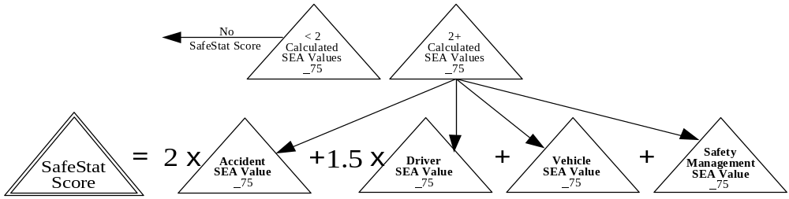

Reason: This change is based on the SafeStat Effectiveness Study results (see chapter 7) showing that carriers with deficient Driver SEAs with values of 75 and higher have higher future crash rates than carriers with deficient Vehicle SEAs or Safety Management SEAs. Therefore the increased weighting of carriers with deficient Driver SEAs makes SafeStat more efficient in prioritizing carriers likely to have crashes.

(2) Modify the SafeStat Score ranges for Categories A, B, and C as follows:

Category Previous SafeStat Runs Current SafeStat Run (Version 7)
A >=300 and <=500 >=300 and <= 550
B >=225 and < 300 >=225 and <300
C >=150 and < 200 >=150 and <225

Reason: The increased weighting placed on the Driver SEA necessitated recalibrating the SafeStat score range for Categories A, B, and C. Although there will be no additional SafeStat-scored carriers, scored carriers are reprioritized leading to possible changes in their category assignments if they have a Driver SEA of 75 or higher.

- Change the way the indicators in the Accident SEA (Accident Involvement Indicator (AII) and Recordable Accident Indicator (RAI)) are combined to allow for Accident SEA values under 75.

Reason: While SEA values under 75 are not needed for CR prioritization, stakeholders and other safety programs may want to use Accident SEA values below 75 in making decisions related to motor carrier safety.

(4) Recalibrate RAI group 1 to 2-4 crashes (previously 2-5) and group 2 to 5-19 crashes (previously 6-19).

Reason: RAI groups are defined by having the same proportion of crashes in each group. Changes in recordable crash distribution necessitate periodic recalibrations of crash groupings used in the AII and RAI within the Accident SEA.

(5) Incorporate 392.5C2 violations into SafeStat as a jumping OOS order violation in the Driver Inspection Indicator (DII) in the Driver SEA.

Reason: A 392.5C2 violation occurs when a driver has violated the OOS orders related to a 392.5 violation (use or possession of alcohol). 392.5C2 should be included with the other jumping OOS orders violations (396.9C2, 395.13C1, 395.13D1, & 395.13D2).

(6) Add 392.4A violations into SafeStat as a moving violation used in the Moving Violation Indicator (MVI).

Reason: A 392.4A violation occurs when the driver is found using or possessing drugs. 392.4A should be incorporated with the other moving violations which already include a similar violation cite, 392.4.

C.9 Changes for Version 6.1 (September 1998)
Expanded the new indicator, the Moving Violations Indicator, from being used in only PRISM states to being used in all states.

Reason: The MVI proved to be an effective indicator identifying poor performing carriers when tested on carriers in the PRISM states. With minor modifications, the MVI is now being applied to all motor carriers nationally.

C.10 Changes for Version 6 (March 1998)
- Change the Recordable/Preventable Accident Indicator (RPAI) to the Recordable Accident Indicator (RAI).

Reason: Due to recent changes in the Compliance Review (CR) methodology, “preventability” of recordable crashes is no longer being captured in the CR data available to SafeStat. To accommodate this change, the RPAI will be replaced with the RAI. The RAI follows the same basic methodology as the RPAI with only minor changes. The RAI will use all recordable crashes as opposed to the RPAI’s recordable/preventable crashes. The peer groupings for the RAI were slightly altered to account for larger number of crashes being recorded.

(2) Change the calculation of the Accident SEA. Previously, SafeStat considered a “Satisfactory” rating for the Accident Factor (factor 6) issued within the past 6 months when combining the RPAI and Accident Involvement Indicator (AII) to obtain an Accident SEA value. The new methodology considers if there have been any state-reported crashes after a review has been performed when combining the RAI and AII.

Reason: Because “Satisfactory” ratings are no longer issued according to the new CR methodology, it will not be incorporated into the SafeStat methodology. The improved approach uses the latest state-reported crash data available (reportable crashes that have occurred after the CR was performed) with the RAI and AII to calculate the Accident SEA Value.

(3) FOR PRISM STATES ONLY: Test a new indicator, Moving Violations Indicator (MVI), that uses moving violations recorded during roadside inspections.

Reason: Since more moving violation information is being collected during roadside inspections, there is a great potential to use such information in determining motor carrier safety status. Preliminary tests have shown that there is a positive relationship between the MVI and high crash rates.

The MVI uses methodology similar to that currently being used in the Accident Involvement Indicator (AII). Note that the MVI will be used only on carriers domiciled within the five PRISM states. There is a potential to incorporate carriers domiciled in others states in the future.

C.11 Changes for Version 5 (September 1997)
- Using the enforcement initiation date - State_Investigation_Completed field (as opposed to the currently used closed enforcement date) to determine the age of closed enforcement cases.

Reason: The date currently used in the algorithm, closed enforcement case date, is the day that the enforcement case is closed. For non-safety reasons such as due process, the closed enforcement case date can be years after the case was initiated, thereby making the date somewhat inaccurate for determining the safety status of carriers. The State Investigation Completed date best represents when serious violations have been found that result in an enforcement case being initiated. This date can be used to obtain an accurate age of the enforcement case. It is important to note that SafeStat will still only use closed enforcement cases.

(2) Delete the “reformed” carrier rule used in calculating the Enforcement History Indicator (EHI). The rule states that if a carrier has a CR that is more recent than the enforcement case and the CR results in an overall satisfactory rating, the carrier does not receive an EHI. The logic of this rule was to provide carriers with poor enforcement histories a means of redeeming themselves based on a subsequently review that resulted in an overall Satisfactory rating.

Reason: The “reformed” carrier rule was re-assessed because the rule uses the overall ratings, which, as of April 1997, were no longer being issued. The effectiveness study results show that, using the current reformed carrier rule, the “reformed” carriers performed significantly worse (59% higher crash rate than the total carrier average) than the “non-reformed” carriers (10% higher crash rate). This defeats the purpose of the rule which was to exclude carriers that do not pose a high crash risk. Deleting the rule altogether will improve the effectiveness of the EHI and simplify the algorithm. The indicator will work as it was originally intended - to identify carriers with a history of enforcement cases. Analogous to convictions on a criminal record or incidents on a credit check, these events (enforcement cases) will remain with the carrier for an extended period of time and not be overwritten simply by short-term good behavior (e.g., good recent CR results).

(3) Suspending the use of the Hazardous Material Inspection Indicator (HMII) until roadside inspection data can indicate that a particular inspection involved examining for HM violations.

Reason: The results of the effectiveness study show that this indicator is ineffective in predicting carriers with high crash rates. The ineffectiveness of the HMII is probably partially due to the fact the HMII does not normalize by the number of HM inspections and instead uses the total number of inspections. Using this normalization factor leads to identifying large, exclusively HM carriers by default. These carriers tend to be safer than most other carriers. There is still merit for incorporating an indicator in SafeStat that uses HM OOS violations. Before such an indicator can be used, it is imperative that good normalization data (i.e., HM inspections) be collected. However, until there is a means of obtaining a carrier’s total number of HM inspections, the HM OOS violations data will be excluded from SafeStat.

(4) Changing severity weighting of crashes used in AII from:
Towaway = 1
Injury = 2
Fatal or HM Release = 3
To:
Towaway = 1
Injury or Fatal = 2
Add 1 if HM was released

Reason: This change in crash severity weighting gives the crashes with a fatality the same weight as an crash resulting in injury. The justification for this weighting is that a fatal crash is a type of injury crash. Once a crash has occurred, whether one of the injured participants survives or not depends on a myriad of factors (e.g., type of car/truck involved, age, height, weight, health, and number of participants, seat belt use, quality and speed of emergency services, etc.) that are largely inconsequential to the safety status of the motor carrier involved.

The proposed Improved Process consists of three components: a New Entrant Program, SafeStat, and the Progressive Compliance Assurance Program (PCAP). A description of this process is contained in “Motor Carrier Safety Fitness Determination: Proposals for an Improved Process,” June 1997. This report is available from the Volpe Center, Economic Analysis Division, DTS-42, 55 Broadway, Cambridge, MA 02142.
See Section 7, SafeStat Evaluation, for an explanation of the relationship of crash risk and SafeStat results.
A full listing of acute and critical regulations can be found in Part 385 Appendix B of the FMCSR, titled “Explanation of Safety Rating Process.”

