ATTACHMENT J-5

DATA REQUIREMENTS LISTING (DRL)
AND DATA REQUIREMENTS DESCRIPTIONS (DRDS)

1. Line item no. | 2. DRD Title | 3. Data type: |  |  | (1) Written approval | 4. Frequency | 5. As-of-date | 6. 1st subm. date | 7. Copies
1 |  |  | (2) Mandatory Submittal |  |  |  |  | 30 days after | a. Type | b. Number
 | Management Plan |  | (3) Submitted upon request |  |  | RT |  | contract start | Other*
 | 8. Distribution (Continue on a blank sheet if needed) |  |  |  |  | 9. Remarks
 | BL/Contracting Officer (1 electronic & 1 hardcopy)  BL/Contract Specialist  SA/COTR |  |  |  |  | * One Electronic Copy, compatible with the standard JSC software load, for each person on distribution & 1 hardcopy for archives per distribution.
1. Line item no. | 2. DRD Title | 3. Data type: |  |  | (1) Written approval | 4. Frequency | 5. As-of-date | 6. 1st subm. date | 7. Copies
2 |  |  | (2) Mandatory Submittal |  |  | ** |  | See DRD | a. Type | b. Number
 | Contractor Financial Management Reports |  | (3) Submitted upon request |  |  |  |  |  | **
 | 8. Distribution (Continue on a blank sheet if needed) |  |  |  |  | 9. Remarks
 | See DRD |  |  |  |  | ** See DRD
1. Line item no. | 2. DRD Title | 3. Data type: |  |  | (1) Written approval | 4. Frequency | 5. As-of-date | 6. 1st subm. date | 7. Copies
3 | Cost Performance Report |  | (2) Mandatory Submittal |  |  | MO |  | See DRD | a. Type | b.
 |  |  | (3) Submitted upon request |  |  |  |  |  | Other*
 | 8. Distribution (Continue on a blank sheet if needed) |  |  |  |  | 9. Remarks
 | BL/Contracting Officer (1 electronic & 1 hardcopy)  SA/COTR  LE Budget/Program Analyst |  |  |  |  | * One Electronic Copy, compatible with the standard JSC software load, for each person on distribution & 1 hardcopy for archives per distribution.
1. Line item no. | 2. DRD Title | 3. Data type: |  |  | (1) Written approval | 4. Frequency | 5. As-of-date | 6. 1st subm. date | 7. Copies
4 | Wage/Salary and Fringe Benefit Data |  | (2) Mandatory Submittal |  |  | AN |  | See DRD | a. Type | b.
 |  |  | (3) Submitted upon request |  |  |  |  |  | Other*
 | 8. Distribution (Continue on a blank sheet if needed) |  |  |  |  | 9. Remarks
 | BL/Contracting Officer (1 electronic & 1 hardcopy) |  |  |  |  | * One Electronic Copy, compatible with the standard JSC software load, for each person on distribution & 1 hardcopy for archives per distribution.
1. Line item no. | 2. DRD Title | 3. Data type: |  |  | (1) Written approval | 4. Frequency | 5. As-of-date | 6. 1st subm. date | 7. Copies
5 | Weekly and Monthly Activity Reports |  | (2) Mandatory Submittal |  |  | Wk/Mo |  | Conract | a. Type | b.
 |  |  | (3) Submitted upon request |  |  |  |  | Start | Other*
 | 8. Distribution (Continue on a blank sheet if needed) |  |  |  |  | 9. Remarks
 | SA/ T/DO Technical Monitors (1 electronic & 1 hardcopy)  Quality Monitor |  |  |  |  | * One Electronic Copy, compatible with the standard JSC software load, for each person on distribution & 1 hardcopy for archives per distribution.
1. Line item no. | 2. DRD Title | 3. Data type: |  |  | (1) Written approval | 4. Frequency | 5. As-of-date | 6. 1st subm. date | 7. Copies
6 | Project Resource Status |  | (2) Mandatory Submittal |  |  | QU |  |  | a. Type | b.
 |  |  | (3) Submitted upon request |  |  |  |  |  | Other*
 | 8. Distribution (Continue on a blank sheet if needed) |  |  |  |  | 9. Remarks
 | BL/Contracting Officer (1 electronic & 1 hardcopy)  SA/COTR  SA/ T/DO Technical Monitors |  |  |  |  | * One Electronic Copy, compatible with the standard JSC software load, for each person on distribution & 1 hardcopy for archives per distribution.
1. Line item no. | 2. DRD Title | 3. Data type: |  |  | (1) Written approval | 4. Frequency | 5. As-of-date | 6. 1st subm. date | 7. Copies
7 | Organization Chart |  | (2) Mandatory Submittal |  |  | RT |  | CSD+1MO. | a. Type | b.
 |  |  | (3) Submitted upon request |  |  |  |  |  | Other*
 | 8. Distribution (Continue on a blank sheet if needed) |  |  |  |  | 9. Remarks
 | BL/Contracting Officer  BL/Contract Specialist  SA/COTR  NT211/Procurement Quality Assurance |  |  |  |  | * One Electronic Copy, compatible with the standard JSC software load, for each person on distribution.
1. Line item no. | 2. DRD Title | 3. Data type: |  |  | (1) Written approval | 4. Frequency | 5. As-of-date | 6. 1st subm. date | 7. Copies
8 | Employee Phone list |  | (2) Mandatory Submittal |  |  | QU |  | CSD+1MO. | a. Type | b.
 |  |  | (3) Submitted upon request |  |  |  |  |  | Other*
 | 8. Distribution (Continue on a blank sheet if needed) |  |  |  |  | 9. Remarks
 | BL/Contracting Officer  BL/Contract Specialist  SA/COTR |  |  |  |  | * One Electronic Copy, compatible with the standard JSC software load, for each person on distribution.

1. Line item no. | 2. DRD Title | 3. Data type: |  |  | (1) Written approval | 4. Frequency | 5. As-of-date | 6. 1st subm. date | 7. Copies
9 | Information Technology (IT) Capital |  | (2) Mandatory Submittal |  |  | AN |  |  | a. Type | b.
 | Investment Planning (CIP) |  | (3) Submitted upon request |  |  |  |  |  | Other*
 | 8. Distribution (Continue on a blank sheet if needed) |  |  |  |  | 9. Remarks
 | SA/COTR  SA/CIO (1 electronic & 1 hardcopy) |  |  |  |  | * One Electronic Copy, compatible with the standard JSC software load, for each person on distribution & 1 hardcopy for archives per distribution.
1. Line item no. | 2. DRD Title | 3. Data type: |  |  | (1) Written approval | 4. Frequency | 5. As-of-date | 6. 1st subm. date | 7. Copies
10 | Automated Information Systems (AIS) |  | (2) Mandatory Submittal |  |  | AR |  | See Block 9 | a. Type | b.
 | Security Documentation |  | (3) Submitted upon request |  |  |  |  |  | Other*
 | 8. Distribution (Continue on a blank sheet if needed) |  |  |  |  | 9. Remarks
 | Originals submitted to SP5/AIS Security Officer for approval. (1 electronic & 1 hardcopy)  Copy distribution per Technical direction. |  |  |  |  | 6. Per Technical Direction 7a. Originals to be submitted for NASA signoff and release, as directed. * One Electronic Copy, compatible with the standard JSC software load, for each person on distribution & 1 hardcopy for archives per distribution. 7b. Per Technical Direction.
1. Line item no. | 2. DRD Title | 3. Data type: |  |  | (1) Written approval | 4. Frequency | 5. As-of-date | 6. 1st subm. date | 7. Copies
11 | NASA Advisory & GIDEP ALERT |  | (2) Mandatory Submittal |  |  | AR |  |  | a. Type | b.
 | Plan |  | (3) Submitted upon request |  |  |  |  |  | Other*
 | 8. Distribution (Continue on a blank sheet if needed) |  |  |  |  | 9. Remarks
 | JSC GIDEP/ NASA Advisory Coordinator (1 electronic & 1 hardcopy) |  |  |  |  | GIDEP = Government-Industry Data Exchange Program  ALERT = Acute Launch Emergency Reliability Tip.  * One Electronic Copy, compatible with the standard JSC software load, for each person on distribution & 1 hardcopy for archives per distribution.
1. Line item no. | 2. DRD Title | 3. Data type: |  |  | (1) Written approval | 4. Frequency | 5. As-of-date | 6. 1st subm. date | 7. Copies
12 | Problem Reporting and Corrective Action |  | (2) Mandatory Submittal |  |  | AR | See Blk 9 | See Blk 9 | a. Type | b.
 | (PRACA) |  | (3) Submitted upon request |  |  |  |  |  | Other*
 | 8. Distribution (Continue on a blank sheet if needed) |  |  |  |  | 9. Remarks
 | Per PRACA DRD |  |  |  |  | per PRACA DRD  Submit report per JSC28035  * See DRD.

1. Line item no. | 2. DRD Title | 3. Data type: |  |  | (1) Written approval | 4. Frequency | 5. As-of-date | 6. 1st subm. date | 7. Copies
13 | SA-1-1, Safety and Health Plan |  | (2) Mandatory Submittal |  |  | AN |  |  | a. Type | b.
 |  |  | (3) Submitted upon request |  |  |  |  |  | Other*
 | 8. Distribution (Continue on a blank sheet if needed) |  |  |  |  | 9. Remarks
 | See DRD |  |  |  |  | * One Electronic Copy, compatible with the standard JSC software load, for each person on distribution & 1 hardcopy for archives per distribution.
1. Line item no. | 2. DRD Title | 3. Data type: |  |  | (1) Written approval | 4. Frequency | 5. As-of-date | 6. 1st subm. date | 7. Copies
14 | SA-1-3, Safety & Health Program Self |  | (2) Mandatory Submittal |  |  | AN |  |  | a. Type | b.
 | Evaluation |  | (3) Submitted upon request |  |  |  |  |  | Other*
 | 8. Distribution (Continue on a blank sheet if needed) |  |  |  |  | 9. Remarks
 | NS2/Occupational Safety (1 electronic & 1 hardcopy)  SD13/Occupational Health Officer |  |  |  |  | Due September 30 of each year  * One Electronic Copy, compatible with the standard JSC software load, for each person on distribution & 1 hardcopy for archives per distribution.
1. Line item no. | 2. DRD Title | 3. Data type: |  |  | (1) Written approval | 4. Frequency | 5. As-of-date | 6. 1st subm. date | 7. Copies
15 | SA-1-8 System Safety Program Plan |  | (2) Mandatory Submittal |  |  | AR |  | See Blk. 9 | a. Type | b.
 |  |  | (3) Submitted upon request |  |  |  |  |  | Other*
 | 8. Distribution (Continue on a blank sheet if needed) |  |  |  |  | 9. Remarks
 | NS2/Occupational Safety (1 electronic & 1 hardcopy) |  |  |  |  | Due 30 days prior to the start of a project with maintainence thereafter.  * One Electronic Copy, compatible with the standard JSC software load, for each person on distribution & 1 hardcopy for archives per distribution.
1. Line item no. | 2. DRD Title | 3. Data type: |  |  | (1) Written approval | 4. Frequency | 5. As-of-date | 6. 1st subm. date | 7. Copies
16 | SA-1-14 Monthly Safety and Health Metrics |  | (2) Mandatory Submittal |  |  | M |  |  | a. Type | b.
 |  |  | (3) Submitted upon request |  |  |  |  |  | Other*
 | 8. Distribution (Continue on a blank sheet if needed) |  |  |  |  | 9. Remarks
 | NT2/Occupational Safety Branch (1 electronic & 1 hardcopy)  SD26/Occupational Health Officer  SA/COTR |  |  |  |  | * One Electronic Copy, compatible with the standard JSC software load, for each person on distribution & 1 hardcopy for archives per distribution.

1. Line item no. | 2. DRD Title | 3. Data type: |  |  | (1) Written approval | 4. Frequency | 5. As-of-date | 6. 1st subm. date | 7. Copies
17 | SA-1-15, Lessons Learned |  | (2) Mandatory Submittal |  |  | See DRD |  |  | a. Type | b.
 |  |  | (3) Submitted upon request |  |  |  |  |  | Other*
 | 8. Distribution (Continue on a blank sheet if needed) |  |  |  |  | 9. Remarks
 | NT2/Occupational Safety Branch (1 electronic & 1 hardcopy)  SA/COTR |  |  |  |  | * One Electronic Copy, compatible with the standard JSC software load, for each person on distribution & 1 hardcopy for archives per distribution.
1. Line item no. | 2. DRD Title | 3. Data type: |  |  | (1) Written approval | 4. Frequency | 5. As-of-date | 6. 1st subm. date | 7. Copies
18 | Quality Plan |  | (2) Mandatory Submittal |  |  | RT | See Blk 9 | See Blk 9 | a. Type | b.
 |  |  | (3) Submitted upon request |  |  |  |  |  | Other*
 | 8. Distribution (Continue on a blank sheet if needed) |  |  |  |  | 9. Remarks
 | BL/Contracting Officer (1 electronic & 1 hardcopy)  NT211/Procurement Quality Assurance (1 electronic & 1 hardcopy)  NT/NASA Quality Monitor  SA/COTR |  |  |  |  | Submittal with proposal  * One Electronic Copy, compatible with the standard JSC software load, for each person on distribution & 1 hardcopy for archives per distribution.
1. Line item no. | 2. DRD Title | 3. Data type: |  |  | (1) Written approval | 4. Frequency | 5. As-of-date | 6. 1st subm. date | 7. Copies
19 | EEE Parts Control Plan |  | (2) Mandatory Submittal |  |  | RT | See Blk 9 | See Blk 9 | a. Type | b.
 |  |  | (3) Submitted upon request |  |  |  |  |  | Other*
 | 8. Distribution (Continue on a blank sheet if needed) |  |  |  |  | 9. Remarks
 | NX/Technology Division (1 electronic & 1 hardcopy) |  |  |  |  | 1st Submittal 60 Days after contract award.  * One Electronic Copy, compatible with the standard JSC software load, for each person on distribution & 1 hardcopy for archives per distribution.
1. Line item no. | 2. DRD Title | 3. Data type: |  |  | (1) Written approval | 4. Frequency | 5. As-of-date | 6. 1st subm. date | 7. Copies
20 | Software Quality Assurance Plans, Reports |  | (2) Mandatory Submittal |  |  | RT | See Blk 9 | See Blk 9 | a. Type | b.
 |  |  | (3) Submitted upon request |  |  |  |  |  | Other*
 | 8. Distribution (Continue on a blank sheet if needed) |  |  |  |  | 9. Remarks
 | NT3/GFE Branch (1 electronic & 1 hardcopy)  NT2/NASA Quality Monitor |  |  |  |  | * One Electronic Copy, compatible with the standard JSC software load, for each person on distribution & 1 hardcopy for archives per distribution.
1. Line item no. | 2. DRD Title | 3. Data type: |  |  | (1) Written approval | 4. Frequency | 5. As-of-date | 6. 1st subm. date | 7. Copies
21 | Reliability and Maintainability (R&M) Plan |  | (2) Mandatory Submittal |  |  | AR | See Blk 9 | See Blk 9 | a. Type | b.
 |  |  | (3) Submitted upon request |  |  |  |  |  | Other*
 | 8. Distribution (Continue on a blank sheet if needed) |  |  |  |  | 9. Remarks
 | NT3/GFE Branch (1 electronic & 1 hardcopy)  OB5/logistics and Maintenance |  |  |  |  | * One Electronic Copy, compatible with the standard JSC software load, for each person on distribution & 1 hardcopy for archives per distribution. Initial submittal 30 days prior to PDR and CDR, revisions as required until all data elements are completed. Final submittal 30 days prior to FRR.
1. Line item no. | 2. DRD Title | 3. Data type: |  |  | (1) Written approval | 4. Frequency | 5. As-of-date | 6. 1st subm. date | 7. Copies
22 | Reprocurement Data Package |  | (2) Mandatory Submittal |  |  | OT | See Blk 9 | See Blk 9 | a. Type | b.
 |  |  | (3) Submitted upon request |  |  |  |  |  | Other*
 | 8. Distribution (Continue on a blank sheet if needed) |  |  |  |  | 9. Remarks
 | BL/Contracting Officer (1 electronic & 1 hardcopy)  SA/COTR  BD/Pricing Office |  |  |  |  | * One Electronic Copy, compatible with the standard JSC software load, for each person on distribution & 1 hardcopy for archives per distribution.  180 days prior to contract expiration (includes exercised options that extend the period of performance)
1. Line item no. | 2. DRD Title | 3. Data type: |  |  | (1) Written approval | 4. Frequency | 5. As-of-date | 6. 1st subm. date | 7. Copies
23 | Acceptance Data Package (ADP) |  | (2) Mandatory Submittal |  |  | AR |  |  | a. Type | b.
 |  |  | (3) Submitted upon request |  |  |  |  |  | Other*
 | 8. Distribution (Continue on a blank sheet if needed) |  |  |  |  | 9. Remarks
 | One Copy With End Item (1 electronic & 1 hardcopy) |  |  |  |  | * One Electronic Copy, compatible with the standard JSC software load, for each person on distribution & 1 hardcopy for archives per distribution.
1. Line item no. | 2. DRD Title | 3. Data type: |  |  | (1) Written approval | 4. Frequency | 5. As-of-date | 6. 1st subm. date | 7. Copies
24 | Certification and Acceptance Requirements |  | (2) Mandatory Submittal |  |  | AR | See Blk 9 | See Blk 9 | a. Type | b.
 | Document (CARD) |  | (3) Submitted upon request |  |  |  |  |  | Other*
 | 8. Distribution (Continue on a blank sheet if needed) |  |  |  |  | 9. Remarks
 | NT3/GFE Branch (1 electronic & 1 hardcopy) |  |  |  |  | * One Electronic Copy, compatible with the standard JSC software load, for each person on distribution & 1 hardcopy for archives per distribution. Initial submittal 30 days prior to PDR and CDR, revisions as required until all data elements are completed.

1. Line item no. | 2. DRD Title | 3. Data type: |  |  | (1) Written approval | 4. Frequency | 5. As-of-date | 6. 1st subm. date | 7. Copies
25 | Certification Data Package |  | (2) Mandatory Submittal |  |  | AR | See Blk 9 | See Blk 9 | a. Type | b.
 |  |  | (3) Submitted upon request |  |  |  |  |  | Other*
 | 8. Distribution (Continue on a blank sheet if needed) |  |  |  |  | 9. Remarks
 | NT3/GFE Branch (1 electronic & 1 hardcopy) |  |  |  |  | * One Electronic Copy, compatible with the standard JSC software load, for each person on distribution & 1 hardcopy for archives per distribution.  Submittal concurrent with GCAR DRD
1. Line item no. | 2. DRD Title | 3. Data type: |  |  | (1) Written approval | 4. Frequency | 5. As-of-date | 6. 1st subm. date | 7. Copies
26 | Government Certification Approval Request |  | (2) Mandatory Submittal |  |  | AR | See Blk 9 | See Blk 9 | a. Type | b.
 |  |  | (3) Submitted upon request |  |  |  |  |  | Other*
 | 8. Distribution (Continue on a blank sheet if needed) |  |  |  |  | 9. Remarks
 | NT3/GFE Branch (1 electronic & 1 hardcopy) |  |  |  |  | * One Electronic Copy, compatible with the standard JSC software load, for each person on distribution & 1 hardcopy for archives per distribution.  Submit at least one week before bench review that includes the GFE item.
1. Line item no. | 2. DRD Title | 3. Data type: |  |  | (1) Written approval | 4. Frequency | 5. As-of-date | 6. 1st subm. date | 7. Copies
27 | Limited Life Items List |  | (2) Mandatory Submittal |  |  | AR | See Blk 9 | See Blk 9 | a. Type | b.
 |  |  | (3) Submitted upon request |  |  |  |  |  | Other*
 | 8. Distribution (Continue on a blank sheet if needed) |  |  |  |  | 9. Remarks
 | NT3/GFE Branch (1 electronic & 1 hardcopy) |  |  |  |  | * One Electronic Copy, compatible with the standard JSC software load, for each person on distribution & 1 hardcopy for archives per distribution. Initial submittal 30 days prior to PDR and CDR, revisions as required until all data elements are completed. Final submittal 30 days prior to FRR.
1. Line item no. | 2. DRD Title | 3. Data type: |  |  | (1) Written approval | 4. Frequency | 5. As-of-date | 6. 1st subm. date | 7. Copies
28 | Nonconformance Record |  | (2) Mandatory Submittal |  |  | UR | See Blk 9 | See Blk 9 | a. Type | b.
 |  | x | (3) Submitted upon request |  |  |  |  |  | Other*
 | 8. Distribution (Continue on a blank sheet if needed) |  |  |  |  | 9. Remarks
 | NT211/Flight Equipment Division Quality Team (1 electronic & 1 hardcopy) |  |  |  |  | * One Electronic Copy, compatible with the standard JSC software load, for each person on distribution & 1 hardcopy for archives per distribution.  Records to be made available upon request.
1. Line item no. | 2. DRD Title | 3. Data type: |  |  | (1) Written approval | 4. Frequency | 5. As-of-date | 6. 1st subm. date | 7. Copies
29 | Risk Assessment Executive Summary Report |  | (2) Mandatory Submittal |  |  | AR | See Blk 9 | See Blk 9 | a. Type | b.
 | (RAESR) |  | (3) Submitted upon request |  |  |  |  |  | Other*
 | 8. Distribution (Continue on a blank sheet if needed) |  |  |  |  | 9. Remarks
 | Safety & Mission Assurance, NT3 (1 electronic & 1 hardcopy) |  |  |  |  | * One Electronic Copy, compatible with the standard JSC software load, for each person on distribution & 1 hardcopy for archives per distribution.
1. Line item no. | 2. DRD Title | 3. Data type: |  |  | (1) Written approval | 4. Frequency | 5. As-of-date | 6. 1st subm. date | 7. Copies
30 | Space Shuttle GFE Safety Analysis Report |  | (2) Mandatory Submittal |  |  | AR | See Blk 9 | See Blk 9 | a. Type | b.
 | (SAR) and Hazard Report (HR)[HR_1] |  | (3) Submitted upon request |  |  |  |  |  | Other*
 | 8. Distribution (Continue on a blank sheet if needed) |  |  |  |  | 9. Remarks
 | NT52/SMART Executive Secretary (1 electronic & 1 hardcopy) |  |  |  |  | * One Electronic Copy, compatible with the standard JSC software load, for each person on distribution & 1 hardcopy for archives per distribution. Initial submittal 30 days prior to PDR and CDR, revisions as required until all data elements are completed. Final submittal 30 days prior to FRR.
1. Line item no. | 2. DRD Title | 3. Data type: |  |  | (1) Written approval | 4. Frequency | 5. As-of-date | 6. 1st subm. date | 7. Copies
31 | Space Station Hazard Reports (HR's)/System |  | (2) Mandatory Submittal |  |  | AR | See Blk 9 | See Blk 9 | a. Type | b.
 | Descriptions [HR_2] |  | (3) Submitted upon request |  |  |  |  |  | Other*
 | 8. Distribution (Continue on a blank sheet if needed) |  |  |  |  | 9. Remarks
 | NT52/SMART Executive Secretary (1 electronic & 1 hardcopy) |  |  |  |  | * One Electronic Copy, compatible with the standard JSC software load, for each person on distribution & 1 hardcopy for archives per distribution. Initial submittal 30 days prior to PDR and CDR, revisions as required until all data elements are completed. Final submittal 30 days prior to FRR.
1. Line item no. | 2. DRD Title | 3. Data type: |  |  | (1) Written approval | 4. Frequency | 5. As-of-date | 6. 1st subm. date | 7. Copies
32 | Space Station GFE Failure Modes Effects |  | (2) Mandatory Submittal |  |  | AR | See Blk 9 | See Blk 9 | a. Type | b.
 | And Analysis (FMEA) and Critical Items List |  | (3) Submitted upon request |  |  |  |  |  | Other*
 | 8. Distribution (Continue on a blank sheet if needed) |  |  |  |  | 9. Remarks
 | NT52/SMART Executive Secretary (1 electronic & 1 hardcopy) |  |  |  |  | * One Electronic Copy, compatible with the standard JSC software load, for each person on distribution & 1 hardcopy for archives per distribution. Initial submittal 30 days prior to PDR and CDR, revisions as required until all data elements are completed.

1. Line item no. | 2. DRD Title | 3. Data type: |  |  | (1) Written approval | 4. Frequency | 5. As-of-date | 6. 1st subm. date | 7. Copies
33 | Shuttle/Station Payload Safety Data Package |  | (2) Mandatory Submittal |  |  | AR |  | See Blk 9 | a. Type | b.
 | (SDP) |  | (3) Submitted upon request |  |  |  |  |  | Other*
 | 8. Distribution (Continue on a blank sheet if needed) |  |  |  |  | 9. Remarks
 | NC, PSRP Executive Secretary (1 electronic & 1 hardcopy) |  |  |  |  | * One Electronic Copy, compatible with the standard JSC software load, for each person on distribution & 1 hardcopy for archives per distribution.  Block 6: Defined by the Delivery Order (DO)
1. Line item no. | 2. DRD Title | 3. Data type: |  |  | (1) Written approval | 4. Frequency | 5. As-of-date | 6. 1st subm. date | 7. Copies
34 | Space Station Reliability and |  | (2) Mandatory Submittal |  |  | AR |  | See Blk 9 | a. Type | b.
 | Maintainability Predictions Report |  | (3) Submitted upon request |  |  |  |  |  | Other*
 | 8. Distribution (Continue on a blank sheet if needed) |  |  |  |  | 9. Remarks
 | OC, Chief (1 electronic & 1 hardcopy) |  |  |  |  | * One Electronic Copy, compatible with the standard JSC software load, for each person on distribution & 1 hardcopy for archives per distribution.  Block 6: Defined by the Delivery Order (DO)
1. Line item no. | 2. DRD Title | 3. Data type: |  |  | (1) Written approval | 4. Frequency | 5. As-of-date | 6. 1st subm. date | 7. Copies
35 | Annual Assessment of Baseline |  | (2) Mandatory Submittal |  |  | AN |  | See Blk 9 | a. Type | b.
 | Operational Readiness |  | (3) Submitted upon request |  |  |  |  |  | Other*
 | 8. Distribution (Continue on a blank sheet if needed) |  |  |  |  | 9. Remarks
 | BL/Contracting Officer  BL/Contract Specialist  SA/COTR (1 electronic & 1 hardcopy) |  |  |  |  | * One Electronic Copy, compatible with the standard JSC software load, for each person on distribution & 1 hardcopy for archives per distribution.
1. Line item no. | 2. DRD Title | 3. Data type: |  |  | (1) Written approval | 4. Frequency | 5. As-of-date | 6. 1st subm. date | 7. Copies
36 | Electronic Work Instructions |  | (2) Mandatory Submittal |  |  | UR |  | See Blk 9 | a. Type | b.
 |  |  | (3) Submitted upon request |  |  |  |  |  | Other*
 | 8. Distribution (Continue on a blank sheet if needed) |  |  |  |  | 9. Remarks
 | BL/Contracting Officer  BL/Contract Specialist  SA/COTR |  |  |  |  | * One Electronic Copy, compatible with the standard JSC software load, for each person on distribution.
1. Line item no. | 2. DRD Title | 3. Data type: |  |  | (1) Written approval | 4. Frequency | 5. As-of-date | 6. 1st subm. date | 7. Copies
37 | Revisions to the Baseline Operational Readiness Plan |  | (2) Mandatory Submittal |  |  | AR |  | See Blk 9 | a. Type | b.
 |  |  | (3) Submitted upon request |  |  |  |  |  | Other*
 | 8. Distribution (Continue on a blank sheet if needed) |  |  |  |  | 9. Remarks
 | BL/Contracting Officer  BL/Contract Specialist  SA/COTR (1 electronic & 1 hardcopy) |  |  |  |  | * One Electronic Copy, compatible with the standard JSC software load, for each person on distribution & 1 hardcopy for archives per distribution.
1. Line item no. | 2. DRD Title | 3. Data type: |  |  | (1) Written approval | 4. Frequency | 5. As-of-date | 6. 1st subm. date | 7. Copies
38 | Space Shuttle GFE Failure Modes |  | (2) Mandatory Submittal |  |  |  |  |  | a. Type | b. Number
 | and Effects Analysis (FMEA) and  Critical Items List (CIL)[FMEA_1] |  | (3) Submitted upon request |  |  | AR | See Blk 9 | See Blk 9 | Other*
 | 8. Distribution (Continue on a blank sheet if needed) |  |  |  |  | 9. Remarks
 | NT52/SSRP FMEA/CIL Focal (1 electronic & 1 hardcopy) |  |  |  |  | *One electronic copy, compatible with the standard JSC software load, for each person on distribution & one hardcopy for archives per distribution. Initial submission 30 days prior to PDR and CDR, revisions as required until all data elements are completed. Final submittal 30 days prior to FRR.

1. DRD Title |  |  | 2. Current Version Date |  |  |  | 3. DRL Line Item No. |  |  | RFP/Contract No. (Procurement completes)
Management Plan |  |  |  |  |  |  | 1 |  |  | NAS 9-02078
4. Use (Define need for, intended use of, and/or anticipated results of data)
To provide an overall plan for the management, implementation, coordination, and execution of all contract technical and administrative tasks.
5. DRD Category: (check one) |  | Technical |  |  | X | Administrative |  |  | SR&QA
6. References (Optional) |  |  |  | 7. Interrelationships (e.g., with other DRDs) (Optional)
8. Preparation Information (Include complete instructions for document preparation)

The management plan shall include plans for management, and for implementation of all the technical and administrative tasks identified in the statement of work (SOW) of the Bioastronautics Contract (BC). The plan shall include contract administration, resources management, documentation management, and acquisition management. The plan shall address the specific management needs of each of the major technical areas identified in the SOW. The Management Plan shall be updated to reflect significant changes which occur after initial publication.

The Plan shall include the following:

1. Significant policies and plans for all aspects of each area.

2. Definition of the organization of the BC and each area including organization charts with emphasis on roles and responsibilities.

3. Flow of authority.

4. External interfaces.

5. Functional relationships which exist between internal organizational elements.

6. Plans and procedures for the coordination and integration of all products and deliverables

Reviewed By:
Original Signed By: Sandra C. Gordon for Janice A. Nesbitt 07/01/02
_________________________________________________ ___________
Chief, Cost Accounting, Reports, and Property Branch Date
Financial Management Division

Concurred By: Gail Hammond
Original Signed By: John H. Beall 07/02/02
___________________________________________ ___________
Chief Financial Officer Date

1. DRD Title  Financial Management | 2. Date of Current Version | - DRL Line Item No.  2 | RFP/Contract No.  (Procurement Completes)  NAS 9-02078
4. Use (Define need for, intended use of, and/or  anticipated results of data)  Provide a basis for reporting and evaluating cost and expenditure in support of this contract. The data contained in the reports must be auditable using Generally Accepted Accounting Principles. Supplemental cost reports submitted in addition to the NF 533 must be reconcilable to the NF 533. |  | 5. Category: Check One  _____ Technical  X Administrative  _____ SR&QA
6. References (Optional) NHB 9501.2D |  | 7. Interrelationships (e.g., with other DRD’s)  (Optional)
8. Preparation Information (Include complete instructions for document preparation)

A. The NASA Form 533 (NF 533) reports provide data necessary for the following:

- Projecting costs and hours to ensure that dollar and labor resources realistically support project and program schedules.

- Evaluating contractors’ actual cost and fee data in relation to negotiated contract value, estimated costs, and budget forecast data.

- Planning, monitoring, and controlling project and program resources.

- Accruing cost in NASA’s accounting system, providing program and functional management information and resulting in liabilities reflected on the financial statements.

The Contractor shall provide the following:

- A contract summary page shall be required where all elements of cost referenced shall be shown.

- A separate summary page shall be required for each division/office supported under the contract. See the attached form A, B, and C detailing the elements of cost required for each of the following categories where appropriate: Part 1 – Bioastronautics Core Capabilities, and Part 2 – Task/Delivery Orders (T/DO’s), and Level of Effort Task’s (LOET’s). A separate summary page reflecting total cost shall be provided for Contract Management and Administration, and Baseline Operational Readiness.

- A Task/Delivery Order (T/DO) and Subtask (ST) level report shall be required to report referenced cost elements at the T/DO and ST level for each division/office supported. This section of the 533 shall include T/DO’s and LOET’s.

- Supplemental financial information by Office of Bioastronautics Work Breakdown Structure (WBS), project or function shall be provided.

- Distribution:
  - One complete file copy of the NF 533 shall be electronically deposited into a secured electronic system for each division/office support including Baseline Operational Readiness (BOR), and Contract Management Administrator (CMA) on a monthly basis on or before the due date. The Contractor shall also submit an electronic version of the report compatible with the current version of Microsoft Excel used by JSC budget analysts.
  - One complete hard copy of the NF 533 shall be delivered on a monthly basis on or before the due date to the BC Contracting Officer.
  - One hard copy of the NF 533 BC Contract Level Summary which reconciles with the electronic version shall be delivered to LF6/Cost Accounting.
  - Other distributions are described in the Report Distribution List at the end of this document.

- Maintenance:
Changes shall be incorporated by change pages or complete reissue with a footnote or attached supplemental narrative describing in detail the change(s) made.

- Contractor Accounting Calendar Report:
The Contractor shall provide, within 10 days of contract start date, the contractor’s
accounting calendar for each contract year and for each Government fiscal year, which lists accounting months, number of workdays in each month, number of work hours included in each month, and all holidays applicable to the Contractor for the duration of the contract.

Cost is a financial measurement of resources used in accomplishing a specified purpose, such as performing a service, carrying out an activity, acquiring an asset, or completing a unit of work or project. NASA Contractor Financial Management Reporting, NASA Procedures and Guidelines (NPG) 9501.2D, or its most current revision, identifies the cost reporting requirements for a contract.

NASA is required by law to maintain accrual accounting, which requires cost to be reported in the period in which benefits are received, without regard to time of payment. Examples of accrual accounting for common cost elements reported on the NF 533 follow:

Cost Element

Labor Reported to NASA as hours are incurred.

Equipment and Materials Generally reported to NASA when received and
(Commercial-Off-The-Shelf) accepted by the contractor.

Manufactured Equipment Defined as any equipment that is produced to specific requirements that make it useless to anyone else without rework. Cost should be reported to NASA as the equipment is being manufactured. The straight-line method for estimating accrued costs or the use of supplemental information obtained from the vendor are acceptable methods used to calculate the cost accrual amount.

Leases Reported to NASA using a proration over the life of the lease.

Travel Reported to NASA as costs are incurred.

Subcontracts Actual and estimated costs reported by prime contractors shall include subcontractors’ incurred costs for the same accounting period. Where subcontract costs are material, they should be separately identified on NF 533 reports. The prime contractor shall include in the total cost of each subdivision of work the accrued cost (including fee, if any) of related subcontractor effort. Subcontractors should, therefore, be required to report cost to the prime contractor, using the accrual method of accounting. If the G&A and fee reported by a subcontractor are at the total subcontractor level, these costs must be allocated to specific subdivisions of work. Data submitted by the subcontractor should be structured similar to the prime contractor’s NF 533 to enable the prime contractor to properly report to NASA. For Firm-Fixed Price subcontracts with a contract value greater than $500,000, the prime contractor is required to document the methodology used to generate the subcontractor costs reported and provide this information to the Contracting Officer and Center Deputy Chief Financial Officer (Finance).

Unfilled Orders Reported as the difference between the cumulative cost incurred to date and amounts obligated to suppliers and subcontractors.

Fee Should be accrued as earned using a consistent and auditable method to determine the amount. For example: an acceptable method would be to use historical data to determine the amount to accrue each month. Fee should be reported on the NF 533 following the “Total Cost” line. Award fee must be reported by the following categories: Base Fee, Fee Earned, Interim Fee, Provisional Fee, Potential Additional Fee, and Total Fee. If any of the above fee categories do not pertain, they should not be included in the NF 533.

Prompt Payment Discounts Cumulative cost reported to NASA should be the full-incurred cost. The prompt payment discount amount taken should be reported as a separate line item on the NF 533 below the cumulative cost amounts for the contract.

The NF 533 reports are the official cost documents used at NASA for cost type, price redetermination,
and fixed price incentive contracts. The data contained in the reports must be auditable using
Generally Accepted Accounting Principles. Supplemental cost reports submitted in addition to the NF
533 must be reconcilable to the NF 533.

The due dates for the NF 533M and NF 533Q reports are outlined in Chapter 3 of NPG 9501.2D. The
following is a summary of the NF 533 due date requirements.

NF 533 Report Due Date
NF 533M Due not later than the 12th calendar day of the month.

NF 533Q Due not later than the 15th day of the month preceding the quarter being reported.

The due dates reflect the date the NF 533 reports are received by personnel on the distribution list, not the date the reports are generated or mailed by the contractor. It is critical that the NF 533 reports are submitted in a timely manner to ensure adequate time for NASA to analyze and record the cost into the NASA accounting system.

Uncompensated overtime hours worked should be reported on NF 533 reports as a separate line item or in the footnotes.

For contracts which have multiple schedules, a summary NF 533 is required to provide a cumulative from inception cost for the contract, regardless of schedule.

An initial NF 533 report is required in the NF 533Q format to be used as a baseline for the life of the contract. The initial (baseline) NF 533Q report shall be submitted by the contractor within 30 days after authorization to proceed has been granted. The initial report shall reflect the original contract value detailed by negotiated reporting categories and shall be the original contract baseline plan. In addition to the initial (baseline) report, monthly NF 533 reporting shall begin no later than 30 days after the incurrence of cost.

Column 7b (planned cost incurred/hours worked for the month) and 7d (cumulative planned cost incurred/hours worked) of the NF 533M represent the negotiated baseline plan for the contract. There may not be a relationship between the estimates provided in columns 8 of the NF 533M to column 7b and 7d. Columns 7b and 7d represent the legally binding contract negotiated baseline plan plus all authorized changes.

Short and long-term cost estimates, which include all data entered in columns 8 and 9a on the NF 533M and NF 533Q reports, shall be based on the most current and reliable information available.

Prior period cost adjustments should be reported in column 7a and 7c of NF 533M and column 7a of the NF 533Q with a footnote discussing the reasons for and amounts of the adjustments.

Monthly NF 533 reporting is no longer required once the contract is physically complete, provided the final cost report includes actual cost only (no estimates or forecasts). The contractor must continue to submit monthly NF 533 reports as long as estimates for the following period are included. If the final cost of a contract changes after the submission of the “final” contractor cost report, the contractor must submit a revised NF 533 report in the month the cost change is recognized.

B. Variance Analysis Report

The contractor shall provide variance reports as described below no later than the 10th day of the month.

- A contract level variance analysis report shall be provided for variances of 5 percent or greater between the monthly actual as compared to the estimate (column 7a compared to 8a of the following month). In addition, provide an explanation when the current month actual varies from the estimate by +/-05 percent. Furthermore, provide an explanation when the GFY EAC changes from the prior month +/-5 percent.

- A variance report shall be provided for each WBS, division level T/DO, or subtask with variances of 5 percent or greater between the monthly actual as compared to the estimate (column 7a compared to 8a of the following month).

- A variance report shall include explicit information to substantiate the explanation. For example, if the variance is caused by a delay in expected delivery of materials, list the materials and anticipated delivery dates. If labor is the cause of variance due to unfilled priorities, provide a detailed explanation of when the priorities are anticipated to be filled and the rationale/basis of your estimate. If a project is delayed, provide a rationale for the schedule slip and when it is projected to be back on schedule. Variance reporting should be at the +5 percent subtask level.

C. Task/Delivery Order Status Report (T/DOSR)

The T/DOSR is a functional division/office summary report of authorized task order resource information used for monitoring approved resources and costs and tracking T/DO approval status on a weekly basis.

The T/DOSR entries shall include at a minimum for the current fiscal year:

a. T/DO Number, ST Number, and Revision Identifier.
- T/DO Title.
- Contractor T/DO Project Manger.
- NASA Technical Monitor and Organization Code.
- Authorized Labor Hours.
- Authorized Labor Dollars.
- Authorized Equivalent Persons (EP’s).
- Authorized Unburdened Material Dollars.
- Authorized Unburdened Travel Dollars.
- Authorized Baseline Operational Readiness Dollars.
- Authorized Contract Management and Administration Dollars.
- Total Authorized Dollars.
- NASA Authorization.
- Approval Date.

NOTE: There should be a distinction made to identify between a T/DO and ST.

- The T/DOSR shall be sorted by each functional division/office supported by the contract. Within each function division/office sort, the report shall be sorted in ascending order of T/DO, ST, and also sorted by the type: Indefinite Delivery/Indefinite Quantity (IDIQ) T/DO’s followed by LOET’s.

- A total calculation of authorized labor hours, EP’s, material dollars, travel dollars, and total dollars shall be provided at the functional division/office levels, at the Directorate level, and at the contract level with subtotals for the IDIQ T/DO’s and LOET’s.

- Total number of approved T/DO’s and ST’s, by IDIQ T/DO and LOET’s, for each functional division/office, Directorate, and total contact shall be included.

- Percentages of IDIQ T/DO’s and LOET’s shall be computed and reflected on the report by authorized total cost for each functional division/office, Directorate, and total contract. A contract summary for these percentages shall be provided for each fiscal year beginning with the current.

- Reporting precision shall be to the $1 for travel, material, and authorized costs and to the nearest 1/10 EP for EP’s. All labor hours authorized shall be reported.

- Sufficient title, date, and other reference information to properly identify and utilize the T/DOSR shall be included.

- Distribution:
  - One complete file copy of the T/DOSR shall be electronically deposited into a secured electronic system on a weekly basis. Also, a monthly T/DOSR that coincides with the monthly NF 533 shall be deposited into a secured electronic system on the same date as the NF 533 is delivered and shall be delivered with the NF 533 as specified in the NF 533 distribution list.

  - There is no hard copy requirement for this report.

D. Unfilled Orders Report

- This report shall include:
  - T/DO and ST Numbers.
  - Division.
  - PO Number.
  - Delivery Date.
  - Company.
  - Description.
  - Amount.

E. Electronic Load Report*

The contractor shall provide two reports, one used for electronic uploading and one for the business manager. The elements used in both reports are described below.

- These reports shall include:
  - T/DO Number.
  - Current Month Workforce.
  - Current Month Cost Actuals.
  - Next Month Workforce Estimate.
  - Next Month Cost Estimate.

- Distribution:
  - This report shall be electronically deposited into a secured electronic system on or before the same date as the NF 533.
  - There is no hard copy requirement for this report.

*Format for electronic file will be provided to the contractor.

F. Resources Management Report and Briefing

- The Contractor shall provide a Resources Management Report, which contains the actual and planned contract expenditures cost and workforce. The actuals shall be reported monthly from the beginning of the Government fiscal year. Projected cost and workforce shall be provided by month for the balance of the current government fiscal year, by quarter for the following fiscal year, and annually thereafter for the remainder of the contract years. Data records shall include:

  - The Office of Bioastronautics WBS (including all tasks and subtasks elements).
  - Workforce (EP), labor hours, labor costs, materials and subcontracts, and other direct costs, with Core (Part 1 – Bioastronautics Core Capabilities), M&A and Fee spread to all (Part 2 – Bioastronautics Operations, Research, and Flight Hardware) WBS (including all tasks and subtasks elements) levels.

- The Contractor shall provide a Resources Briefing on the approved Resources Management Report for the current fiscal year, updated for Contracting Officer/Contracting Officer’s Technical Representative (CO/COTR) approved adjustments. Changes to the Resources Management Report directed by the CO/COTR shall be incorporated in the published version of the Report. Resources Management Reports and briefings shall include:

  - Reconciliation of plan versus actual to NF 533 reports and an analysis of plan versus actual.
  - Summaries for each WBS (including all tasks and subtasks elements).
  - Cost versus plan at the total contract level.

G. Statement of Work Modification Reports

1. Estimated Workforce Equivalent Persons and Hours and Costs for Proposed Changes – The estimated workforce and hours and costs for proposed changes shall be used to document cost estimates for proposed Statement of Work (SOW) modifications in response to Bioastronautics Contract Change Approval Documents received from the Contracting Officer. These estimates shall be broken down into the same cost elements as reported on the NF 533M and shall be spread across fiscal year(s) and contract year(s) consistent with the proposed project schedule. Such cost estimates shall include Baseline Operational Readiness, M&A and Fee at all WBS levels (including all tasks and subtasks elements).

2. Changes in Original Baseline – A reconciliation of changes in the original negotiated contract baseline (as reflected in the initial baseline NF 533Q) shall be included as part of the Contractor’s narrative remarks for the month in which the change occurs. Changes shall be reconciled first to the present contract value by including only negotiated changes (supplemental agreements) and then to the Contractor’s Estimated Final Cost by including changes authorized but not finalized. If the Contractor’s Estimated Final Cost includes any overruns or underruns, they should be fully identified and explained. In addition, the Contractor may have proposed changes which have not been approved by NASA, but for which tentative costs have been determined. These items should be reported as “ Changes Under Consideration But Not Authorized.” A sample format for “Reconciliation of Changes” appears on page 3-22 (Figure 11) of NPG 9501.2D.

REPORT DISTRIBUTION LIST

Hardcopy or Electronically

Hardcopy:

- BH/Contracting Officer (1 Total Contract Level; A, B, C, D)

- LF6/Cost Accounting (1 Contract Level Summary; A)

Electronic:

- EB/Biomedical Engineering Division (1 Applicable Division Level; A, B, E)

- SA/Space and Life Sciences Directorate (1 Applicable Division Level; A, B, E)

- SD/Space Medicine and Health Care Systems Office (1 Applicable Division Level; A, B, E)

- SF/Habitability and Environmental Factors Office (1 Applicable Division Level: A, B, E)

- SJ/Biological Systems Office (1 Applicable Division Level: A, B, E)

- SK/Human Adaptation and Countermeasures (1 Applicable Division Level: A, B, E)

- SL/Program Integration Office (1 Applicable Division Level: A, B, E)

- SM/Mission and Project Management Office (1 Applicable Division Level; A, B, E)

- LE/Budget Analyst for EB Division noted above.

- LS/Budget Analysts for each division/office noted above.

Names associated with positions identified on this listing shall be updated and retained by the Contractor’s Contract Management Team.

This DRD is structured to reflect the current Space and Life Sciences Directorate as of the effective date of this DRD. Any subsequent changes to the JSC organization will be updated by the Contracting Officer’s Technical Representative.

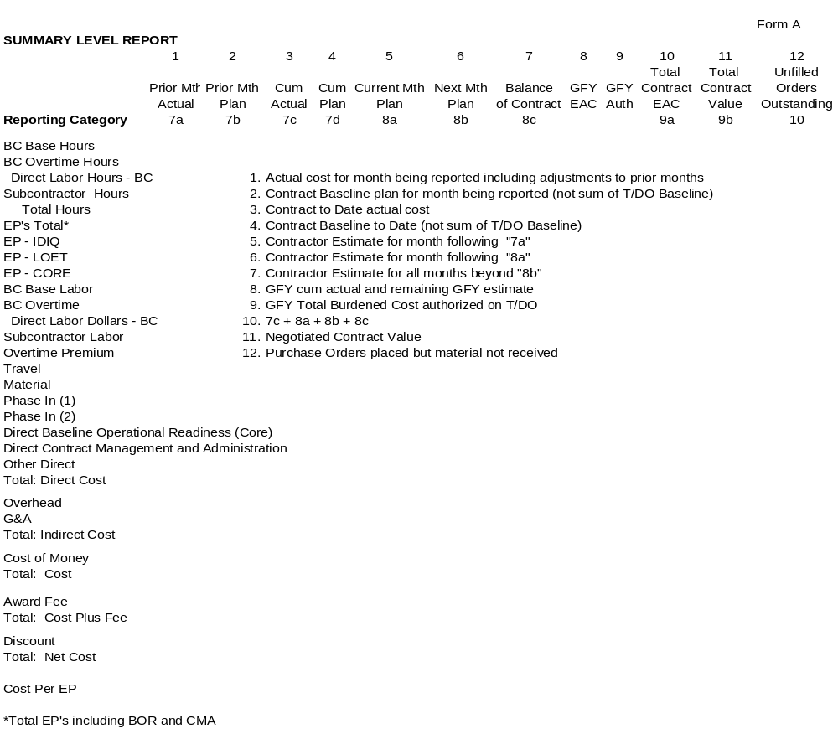
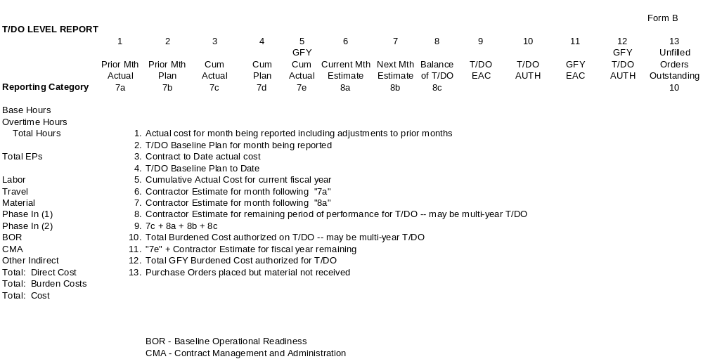

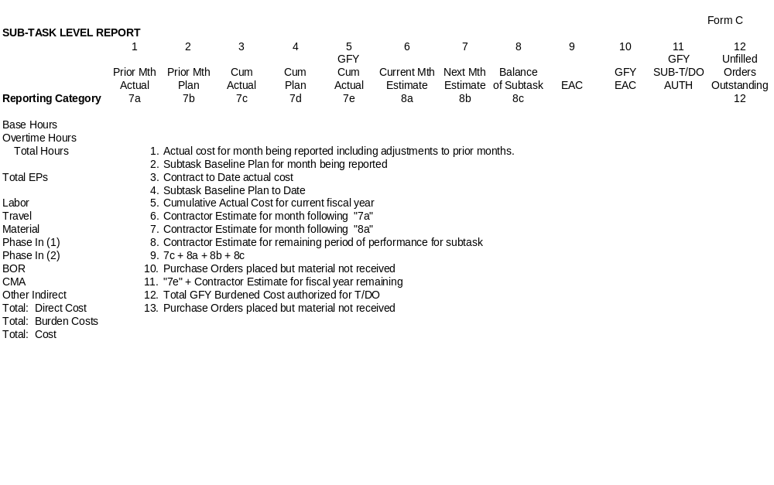

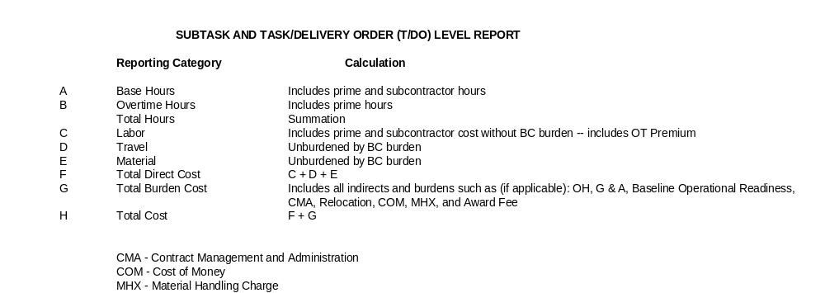
1. DRD Title |  |  | 2. Current Version Date |  |  |  | 3. DRL Line Item No. |  |  | RFP/Contract No.
Cost Performance Report (CPR) |  |  | 6/1/02 |  |  |  | 3 |  |  | NAS 9-02078
4. Use (Define need for, intended use of, and/or anticipated results of data)
This report consists of five formats containing cost and related data for measuring contractors' cost and schedule performance on NASA acquisition contracts. Format 1 (Sample Format 1) provides data to measure cost and schedule performance by summary level Work Breakdown Structure (WBS) elements, the hardware, software and services the Government is buying. Format 2 (Sample Format 2) provides the same data by the contractor's organization. Format 3 (Sample Format 3) provides the budget baseline plan against which performance is measured. Format 4 (Sample Format 4) provides staffing forecasts for correlation with the budget plan and cost estimates. Format 5 (Sample Format 5) is a narrative report used to explain significant cost and schedule variances and other identified contract problems and topics.
CPR data will be used by NASA system managers to: (a) integrate cost and schedule performance data with technical performance measures, (b) identify the magnitude and impact of actual and potential problem areas causing significant cost and schedule variances, and (c) provide valid, timely program status information to higher management.
The CPR is a management report. It should provide timely, reliable summary-level data with which to assess current and projected contract performance. The CPR's primary value to government program management is its ability to reasonably reflect current contract status. If the CPR contains excessively detailed or outdated information, management's ability to make informed, timely decisions may be impaired. It is important that the CPR be as accurate as possible so it can be used for its intended purpose. It should be used by the NASA staff, including Program Managers, engineers, cost estimators and financial management personnel, to confirm, quantify and track known or emerging contract problems and as a basis for communicating with the contractor. The contractor should ensure that CPR data accurately reflect how work is being performed and is consistent with the actual contract status.
5. DRD Category: (check one) |  | Technical |  |  | x | Administrative |  |  | SR&QA
6. References (Optional) |  |  |  | 7. Interrelationships (e.g., with other DRDs) (Optional)
NPD 9501.3, DoD Earned Value Management Implementation Guide, |  |  |  | See below
8. Preparation Information (Include complete instructions for document preparation)

- Interrelationships (e.g., with other DRDs) (Optional) NF533, Schedules, Metrics, WBS,
  - This Data Requirement Description (DRD) contains the format and content preparation instructions for the data product generated by the specific and discrete task requirements as delineated in the contract.
  - The CPR will be used to obtain cost and schedule performance information on contracts requiring compliance with the Cost/Schedule Control Systems Criteria (C/SCSC). (Refer to NFS 1852.242-75.) It may also be used on contracts not requiring C/SCSC compliance ("CPR - No Criteria"), but on which NASA requires more data than is available on a Modified Cost Performance Report. When compliance with the C/SCSC is contractually required, the CPR data elements shall reflect the output of the contractor's C/SCSC-compliant integrated management system. When compliance with the C/SCSC is not contractually required ("CPR - No Criteria"), the CPR data elements shall be as specified in the contractor's summary management procedures or as subsequently negotiated. (Refer to NFS 1852.242-76.)
  - Unless otherwise provided in the contract, the CPR will be required on a monthly basis and submitted to the procuring activity no later than 15 calendar days following the reporting cutoff date. Reports may reflect data either as of the end of the calendar month or as of the contractor's accounting period cutoff date.

  - Data reported in the CPR will pertain to all authorized contract work, including both priced and unpriced effort. However, the Government and the contractor may agree to exclude from CPR reporting portions of the contract for which performance reporting is not needed, such as firm fixed price contract line items.
  - Certain aspects of the report are subject to negotiation between the Government and the contractor, such as:
    - The WBS levels to be reported on Format 1. The level of detail to be reported on Format 1 normally will be limited to level three of the Contract WBS or higher, but lower levels may be specified for high-cost or -risk items. The Government and the contractor should periodically review and adjust as necessary WBS reporting levels on Format 1 to ensure they continue to provide appropriate visibility without requiring excessive information. If there is a significant problem at a lower level, detailed reporting for that WBS element may be required until the problem is resolved.
    - The formats which are specified for regular reporting. The Government and the contractor may agree to exclude certain formats from regular reporting. Any of the five formats may be excluded, but a Format 1 or a Format 2 is required. Formats may be deleted entirely, or they may be submitted on a less frequent basis. If the contractor is organized by product, Format 2 may not be required because it should resemble Format 1. The decision to exclude a format(s) should be based on an assessment of minimum management information needs. The Government should buy only the information it plans to use. (Note: When a Format 1 is not required, the information in Blocks 5 through 7 on Format 1 will still be required. Also, if a formal reprogramming (Over Target Baseline) has been implemented and Format 1 is not required, the information in Columns (12) and (13) of Block 8 on Format 1 and the information in Block 9 on Format 1 will still be required.)
    - The variance analysis thresholds which, if exceeded, require problem analysis and narrative explanations in Format 5. If the contract does not specify variance analysis thresholds, the contractor will provide appropriate variance analyses (see 8.2.2.6.3.2.4 below). Variance analysis thresholds should be reviewed periodically and adjusted as necessary to ensure they continue to provide appropriate visibility.
    - The specific time increments to be used for the baseline and staffing projections required by Formats 3 and 4. If the contract does not specify time increments, the contractor will determine the increments to be used.
    - The reporting provisions which apply to the Cost of Money line on Formats 1 and 2.
    - The reporting provisions which apply if compliance with C/SCSC is not contractually required, known as "CPR - No Criteria." Procedures used to develop CPR data will be documented in the contractor's summary management procedures and are subject to negotiations. (Refer to NFS 1852.242-76)
    - Organizational categories for Format 4, if different from Format 2. The Government may request that different organizational categories be used for reporting staffing in Format 4. If so, the Government and the contractor will negotiate the Format 4 categories. The Format 2 categories shall reflect the contractor's internal organization being used to perform the contract at hand.
  - In all cases, the CPR DRD is subject to "tailoring." Tailoring is defined as deleting requirements from this DRD. Requiring more information in the CPR DRD than specified in this DID is prohibited. All negotiated reporting provisions will be specified in the contract.
  - This Data Item Description supersedes DI-F-6000C.

8. Preparation Information (Include complete instructions for document preparation)
  - Special Instructions
    - The CPR shall be submitted monthly by the 15th working day of the month following the month being reported.
    - The CPR shall include a table of contents with page numbers.
    - Because of the distributed management control responsibilities within the NASA Program Office, NASA requires a separate submission of this report for each Task Order as well as a summary level CPR including CORE, IDIQ, and LOE.
      - Each report shall consist of Formats 1, 3 and 5.
      - Formats 1 and 5 shall display subtask-level information. Format 3 shall break out individual BCWS changes at the subtask level.
    - Thresholds for variance analysis will be applied at the subtask level for schedule variance (current period and cumulative to date) and cost variance (current period, cumulative to date, and at completion). Those thresholds are as follows:
 | Current Period | Cum-to-date | At Completion
Schedule Variance | 10% and $50K | 10% and $50K | N/A
Cost Variance | 10% and $50K | 10% and $50K | 5% and $100K
    - The time increments to be used in Format 3 will correspond (within the limits of the contractor’s disclosed fiscal calendar) with the government fiscal year.
    - Distribution: The PMSR shall be distributed to the following NASA offices:
BH23 Contract Specialist 1 Copy
BH23 Contracting Officer 1 Copy
SD Budget Analyst 1 Copy
SD3 COTR/ 2 Copies
    - Applicable Forms
      - DD Forms are available and will be used to submit required formats as follows:
CPR Format | DD Form Number | Sample Format No.
Work Breakdown Structure | 2734/1 | 1
Organizational Categories | 2734/2 | 2
Baseline | 2734/3 | 3
Staffing | 2734/4 | 4
Explanations and Problem Analyses | 2734/5 | 5
Those Forms are reproduced at the end of this document.
      - Contractor formats should be substituted for CPR formats whenever they contain all the required data elements at the specified reporting levels in a form suitable for NASA management use.
      - The American National Standards Institute (ANSI) X12 standards (transaction sets 839 for cost and 806 for schedule), or the United Nations Electronic Data Interchange for Administration, Commerce and Transport (EDIFACT) equivalent, will be used for Electronic Data Interchange. More information is available at http://www.acq.osd.mil/pm/edi/edi.htm.
      - Distribution of the ANSI transaction sets shall be made to ___(TBD – COTR to be named at a later date) _
  - Data Submission
    - Format. Contractor formats should be substituted whenever they contain all the required data elements at the specified reporting levels in a form suitable for NASA management.
    - Content. The Cost Performance Report shall contain the following:
      - Heading Information - Formats 1 - 5. Preparation instructions for Heading Information (Blocks 1 through 4) apply to Formats 1 through 5.
        - Contractor. Enter in Block 1.a the contractor's name and division, if applicable. Enter in Block 1.b the plant location and mailing address of the reporting contractor.
        - Contract. Enter the contract name in Block 2.a, the contract number in Block 2.b, the contract type in Block 2.c and the contract share ratio, if applicable, in Block 2.d.
        - Program. Enter in Block 3.a the program name, number, acronym and/or type, model, and series, or other designation of the prime item(s) purchased under the contract. Indicate the program phase, RDT&E or Production, in Block 3.b.
        - Report Period. Enter the beginning date in Block 4.a and the ending date in Block 4.b of the period covered by the report.
        - Security Classification. Enter the appropriate security classification at the top and bottom of each page.
        - Dollars in _________. If reported dollar amounts have been factored down by a thousand, a million or a billion, enter the factor at the top of each page.
      - Format 1 - Work Breakdown Structure.
        - Contract Data.
          - Quantity. Enter in Block 5.a the number of prime items to be procured on this contract.
          - Negotiated Cost. Enter in Block 5.b the dollar value (excluding fee or profit) on which contractual agreement has been reached as of the cutoff date of the report. For an incentive contract, enter the definitized contract target cost. Amounts for changes will not be included in this item until they have been priced and incorporated in the contract through contract change order or supplemental agreement. For a cost plus fixed fee or award fee contract, enter the estimated cost negotiated. Changes to the estimated cost will consist only of amounts for changes in the contract scope of work, not for cost growth ("overrun") from the original estimated cost.
          - Estimated Cost of Authorized, Unpriced Work. Enter in Block 5.c the amount (excluding fee or profit) estimated for that work for which written authorization has been received, but for which definitized contract prices have not been incorporated in the contract through contract change order or supplemental agreement.
          - Target Profit/Fee. Enter in Block 5.d the fee or percentage of profit which will apply if the negotiated cost of the contract (see 8.2.2.2.1.2, above) is met.
          - Target Price. Enter in Block 5.e the target price (negotiated contract cost plus profit/fee) applicable to the definitized contract effort.
          - Estimated Price. Based on the most likely estimate of cost at completion for all authorized contract work and the appropriate profit/fee, incentive, and cost sharing provisions, enter in Block 5.f the estimated final contract price (total estimated cost to the Government). This number will be based on the most likely management estimate at completion in Block 6.c.1 and normally will change whenever the management estimate or the contract is revised.
          - Contract Ceiling. Enter in Block 5.g the contract ceiling price applicable to the definitized effort.
          - Estimated Contract Ceiling. Enter in Block 5.h the estimated ceiling price applicable to all authorized contract effort including both definitized and undefinitized effort.
        - Estimated Cost at Completion. These blocks will present the contractor's range of estimated costs at completion. The range of estimates is intended to allow contractor management flexibility to express possible cost outcomes. Contractors are encouraged to provide the most accurate EACs possible through program-level assessments of factors that may affect the cost, schedule or technical outcome of the contract. Where possible, such program-level assessments should include consideration of known or anticipated risk areas, and planned risk reductions or cost containment measures. EACs should be reported without regard to contract ceiling, if applicable. The methods used to develop worst case, best case and most likely management estimates at completion need not be described in the contractor's C/SCSC-compliant management control system description or CPR-No Criteria management procedures.
          - Management Estimate at Completion - Best Case. Enter in Block 6.a.1 the contractor's best case estimate at completion. The best case estimate is the one that results in the lowest cost to the Government. This estimate should be based on the outcome of the most favorable set of circumstances. If this estimate is different from the most likely estimate at completion (Block 6.c.1), the assumptions and conditions underlying this estimate should be explained briefly in Format 5. This estimate is for informational purposes only; it is not an official company estimate. There is no requirement for the contractor to prepare and maintain backup data beyond the explanation provided in Format 5.
          - Management Estimate at Completion - Worst Case. Enter in Block 6.b.1 the contractor's worst case estimate at completion. The worst case estimate is the one that results in the highest cost to the Government. This estimate should be based on the outcome of the least favorable set of circumstances. If this estimate is different from the most likely estimate at completion (Block 6.c.1), the assumptions and conditions underlying this estimate should be explained briefly in Format 5. This estimate is for informational purposes only; it is not an official company estimate. There is no requirement for the contractor to prepare and maintain backup data beyond the explanation provided in Format 5.
          - Management Estimate at Completion - Most Likely. Enter in Block 6.c.1 the contractor's most likely estimate at completion. This estimate is the contractor's official contract EAC and, as such, takes precedence over the estimates presented in Column (15) of Formats 1 and 2 and Blocks 6.a.1 and 6.b.1. This EAC is the value that the contractor's management believes is the most likely outcome based on a knowledgeable estimate of all authorized work, known risks and probable future conditions. This value need not agree with the total of Column (15) (Block 8.e). However, any difference should be explained in Format 5 in such terms as risk, use of management reserve, or higher management knowledge of current or future contract conditions. This EAC need not agree with EACs contained in the contractor's internal data, but must be reconcilable to them. The most likely EAC also will be reconcilable to the contractor's latest statement of funds required as reported in the Contract Funds Status Report, or its equivalent, if this report is a contractual requirement.
          - Contract Budget Base. Enter in Block 6.c.2 the total of negotiated cost (Block 5.b) and estimated cost of authorized, unpriced work (5.c).
          - Variance. Enter in Block 6.c.3 the Contract Budget Base (Block 6.c.2) minus the most likely estimate at complete (Block 6.c.1). This value will be explained in Format 5 according to applicable contractual requirements.
        - Authorized Contractor Representative. Enter in Block 7.a the name of the authorized person signing the report. Enter that person's title in Block 7.b. The authorized person will sign in Block 7.c. Enter the date signed in Block 7.d.
        - Performance Data.
          - Work Breakdown Structure Element. Enter in Column (1) of Block 8.a the noun description of the WBS items for which cost information is being reported. WBS items or levels reported will be those specified in the contract. (See 7.6.1 above.)
          - Cost of Money. Enter in Columns (2) through (16) of Block 8.b the Facilities Capital Cost of Money applicable to the contract.
          - General and Administrative (G&A). Enter in Columns (2) through (16) of Block 8.c the appropriate G&A costs. If G&A has been included in the total costs reported in Block 8.a above, G&A will be shown as a nonadd entry on this line with an appropriate notation. If a G&A classification is not used, no entry will be made other than an appropriate notation to that effect.
          - Undistributed Budget. Enter the amount of budget applicable to contract effort which has not yet been identified to WBS elements at or below the reporting level. For example, contract changes which were authorized late in the reporting period should have received a total budget; however, assignment of work and allocation of budgets to individual WBS elements may not have been accomplished as of the end of the period. Budgets which can be identified to WBS elements at or below the specified reporting level will be included in the total budgets shown for the WBS elements in Block 8.a and will not be shown as undistributed budget. Enter in Column (15) of Block 8.d the estimate at completion for the scope of work represented by the undistributed budget in Column (14) of Block 8.d. Enter in Column (16) of Block 8.d the variance, if any, and fully explain it in Format 5. All undistributed budget will be fully explained in Format 5.
            - Use of Undistributed Budget. The provisions made in this report for undistributed budget are primarily to accommodate temporary situations where time constraints prevent adequate budget planning or where contract effort can only be defined in very general terms. Undistributed budget should not be used as a substitute for adequate contract planning. Formal budgets should be allocated to contract effort and responsible organizations at the earliest possible time, preferably within the next reporting period.
          - Subtotal (Performance Measurement Baseline). Enter the sum of the direct, indirect, Cost of Money, and G&A costs and budgets in Columns (2) through (16) of Block 8.a through e. This subtotal is also referred to as the Performance Measurement Baseline because it represents the allocated budget baseline (less management reserve) against which performance is actually measured.
          - Management Reserve. Management reserve is an amount of the overall contract budget withheld for management control purposes rather than for the accomplishment of a specific task or set of tasks. It is not a contingency fund, and may not be eliminated from contract prices by the Government during subsequent negotiations nor used to absorb the cost of contract changes. In Column (14) of Block 8.f enter the total amount of budget identified as management reserve as of the end of the current reporting period. The amounts shown as management reserve in Formats 1, 2 and 3 will agree. Amounts of management reserve applied to WBS elements during the reporting period will be listed in Block 6.b of Format 3 and explained in Format 5.
            - Negative Management Reserve. Negative entries will not be made in Management Reserve (Column (14) of Block 8.f). There is no such thing as "negative management reserve." If the contract is budgeted in excess of the Contract Budget Base (the negotiated contract cost plus the estimated cost for authorized, unpriced work), the provisions applicable to formal reprogramming and the instructions in paragraphs 8.2.2.2.5.1, 8.2.2.2.5.2, 8.2.2.2.6.6, 8.2.2.2.6.7 and 8.2.2.4.1.7 apply.
          - Total. Enter the sum of all direct, indirect, Cost of Money, G&A cost, undistributed budgets and management reserves, if applicable, in Columns (2) through (14) of Block 8.g. The Total lines of Format 1 (Block 8.g) and Format 2 (Block 5.g) will agree. The total of Column (14), Block 8.g, will equal the Total Allocated Budget shown in Block 5.f on Format 3.
        - Reconciliation to Contract Budget Base.
          - Formal Reprogramming. In exceptional cases, the procuring agency may authorize the contractor to establish performance measurement budgets that in total exceed the Contract Budget Base. This process is called formal reprogramming. The contractor and the Government will agree on how the results of a formal reprogramming will be reported in the Cost Performance Report before the formal reprogramming is initiated. This agreement and any other pertinent details on the reporting of the formal reprogramming will be included in Format 5. Blocks 9.a and 9.b provide the contractor the opportunity to reconcile the higher performance measurement budgets, also called an "Over Target Baseline," to the Contract Budget Base. (See 8.2.2.2.6.6, 8.2.2.2.6.7, 8.2.2.4.1.7, and 8.2.2.6.5 below for more information on reporting Over Target Baselines.)
          - Variance Adjustment. In reporting the results of a formal reprogramming (Over Target Baseline) the contractor may 1) apply the additional budget to completed work, thereby eliminating some or all of the existing cost or schedule variances, 2) apply the additional budget to remaining work, 3) apply some of the additional budget to completed work and some to remaining work, or 4) apply some of the additional budget to management reserve. If the contractor uses a portion of the additional budget to eliminate variances applicable to completed work, the total adjustments made to the cost and schedule variances will be shown in Columns (10) and (11) of Block 9.a. The total cost variance adjustment entered in Column (11) of Block 9.a will be the sum of the individual cost variance adjustments shown in Column (12) of Blocks 8.a through g.
          - Total Contract Variance. In Columns (10) and (11) of Block 9.b, enter the sum of the cost and schedule variances shown on the Total line (Block 8.g) and on the Variance Adjustment line (Block 9.a). In Column (14) enter the Contract Budget Base from Block 6.c.2. In Column (15) enter the management estimate at completion from Block 6.c.1. In Column (16) of Block 9.b enter the difference between Columns (14) and (15) of Block 9.b.
        - Columns (2) Through (16). When compliance with the C/SCSC is contractually required, the data in Columns (2) through (16) shall reflect the output of the contractor's C/SCSC-compliant integrated management system (refer to NFS 1852.242-75). When compliance with the C/SCSC is not contractually required ("CPR - No Criteria"), the data in these columns shall be derived using the contractor's summary management procedures (refer to NFS 1852.242-76).
          - Column (2) and Column (7) - Budgeted Cost - Work Scheduled. For the time period indicated, enter the Budgeted Cost for Work Scheduled (BCWS) in these columns.
          - Column (3) and Column (8) - Budgeted Cost - Work Performed. For the time period indicated, enter the Budgeted Cost for Work Performed (BCWP) in these columns.
          - Column (4) and Column (9) - Actual Cost - Work Performed (ACWP). For the time period indicated, enter the Actual Cost of Work Performed without regard to ceiling. In all cases, costs and budgets will be reported on a comparable basis.
          - Column (5) and Column (10) - Variance - Schedule. For the time period indicated, these columns reflect the differences between BCWS and BCWP. For the current period, Column (5) (schedule variance) is derived by subtracting Column (2) (BCWS) from Column (3) (BCWP). For the cumulative to date, Column (10) (schedule variance) is derived by subtracting Column (7) (BCWS) from Column (8) (BCWP). A positive figure indicates a favorable variance. A negative figure (indicated by parentheses) indicates an unfavorable variance. Significant variances as specified in the contract will be fully explained in Format 5. If the contract does not specify variance analysis thresholds, the contractor will provide appropriate variance analyses. (See 8.2.2.6.3.2.4 below.)
          - Column (6) and Column (11) - Variance - Cost. For the time period indicated, these columns reflect the difference between BCWP and ACWP. For the current period, Column (6) (cost variance) is derived by subtracting Column (4) (ACWP) from Column (3) (BCWP). For cumulative to date, Column (11) (cost variance) is derived by subtracting Column (9) (ACWP) from Column (8) (BCWP). A positive figure indicates a favorable variance. A negative figure (indicated by parentheses) indicates an unfavorable variance. Significant variances as specified in the contract will be fully explained in Format 5. If the contract does not specify variance analysis thresholds, the contractor will provide appropriate variance analyses. (See 8.2.2.6.3.2.4 below.)
          - Column (12) Reprogramming Adjustments - Cost Variance. Formal reprogramming (Over Target Baseline) results in budget allocations in excess of the Contract Budget Base and, in some instances, adjustments to previously reported variances. If previously reported variances are being adjusted, the adjustment applicable to each reporting line item affected will be entered in Column (12). The total of Column (12) will equal the amount shown on the Variance Adjustment line (Block 9.a) in Column (11).
          - Column (13) Reprogramming Adjustments - Budget. Enter the total amounts added to the budget for each reporting line item as the result of formal reprogramming (Over Target Baseline). The amounts shown will consist of the sum of the budgets used to adjust cost variances (Column (12)) plus the additional budget added to the WBS element for remaining work. Enter the amount of budget added to management reserve in the space provided on the management reserve line (Block 8.f). The total of Column (13) will equal the amount the Total Allocated Budget has been budgeted in excess of the Contract Budget Base as shown in Block 5.g of Format 3. An explanation of the reprogramming will be provided in Format 5.
            - Formal Reprogramming Reporting. Columns (12) and (13) are intended for use only in situations involving formal reprogramming (Over Target Baseline). Internal replanning actions within the Contract Budget Base do not require entries in these columns. Where contractors are submitting CPR data directly from automated systems, the addition of Columns (12) and (13) as shown may not be practical due to computer reprogramming problems or space limitations. In such cases, the information may be provided on a separate sheet and attached as Format la to each subsequent report. Contractors will not be required to abandon or modify existing automated reporting systems to include Columns (12) and (13) if significant costs will be associated with such change. Nor will contractors be required to prepare the report manually solely to include this information.
            - Formal Reprogramming Timeliness. Formal reprogramming (Over Target Baseline) can be a significant undertaking that may require more than a month to implement. To preclude a disruption of management visibility caused by a reporting hiatus, the contractor should implement the formal reprogramming expeditiously. If a reporting hiatus is needed, the contractor and the Government will agree on the date and duration of the hiatus before the formal reprogramming is initiated.
          - Column (14) - At Completion - Budgeted. Enter the budgeted cost at completion for the items listed in Column (1). This entry will consist of the sum of the original budgets plus or minus budget changes resulting from contract changes, internal replanning, and application of management reserves. The total (Block 8.g) will equal the Total Allocated Budget shown in Block 5.f on Format 3.
          - Column (15) - At Completion - Estimated. Enter the latest revised estimate of cost at completion including estimated overrun/underrun for all authorized work. If the subtotal (Block 8.e) does not agree with the most likely management estimate at completion (Block 6.c.1), the difference will be explained in Format 5. (See 8.2.2.2.2.3 above.)
          - Column (16) - At Completion - Variance. Enter the difference between the Budgeted - At Completion (Column (14)) and the Estimated - At Completion (Column (15)) by subtracting Column (15) from Column (14). A negative figure (indicated by parentheses) reflects an unfavorable variance. Significant variances as specified in the contract will be fully explained in Format 5. If the contract does not specify variance analysis thresholds, the contractor will provide appropriate variance analyses. (See 8.2.2.6.3.2.4 below.)
      - Format 2 - Organizational Categories.
        - Performance Data.
          - Column (1) - Organizational Category. In Block 5.a list the organizational categories which reflect the contractor's internal management structure. This format will be used to collect organizational cost information at the total contract level rather than for individual WBS elements. The level of detail to be reported will normally be limited to the organizational level immediately under the operating head of the facility. The contractor shall be given flexibility to report this information according to its own internal management structure. If the contractor is organized by product teams, this format may not be needed because it should resemble Format 1.
          - Cost of Money. Enter in Columns (2) through (16) of Block 5.b the Facilities Capital Cost of Money applicable to the contract.
          - General and Administrative. Enter in Columns (2) through (16) of Block 5.c the appropriate G&A costs. (See 8.2.2.2.4.3 above.)
          - Undistributed Budget. Enter in Column (14) of Block 5.d the budget applicable to contract effort which cannot be planned in sufficient detail to be assigned to a responsible organizational area at the reporting level. The amount shown on this format may exceed the amount shown as undistributed budget on Format 1 if budget is identified to a task at or below the WBS reporting level but organizational identification has not been made; or may be less than the amount on Format 1 where budgets have been assigned to organizations but not to WBS elements. Enter in Column (15) of Block 5.d the estimate at completion for the scope of work represented by the undistributed budget in Column (14) of Block 5.d. Enter in Column (16) of Block 5.d the variance, if any, and fully explain it in Format 5. (See 8.2.2.2.4.4 above.)
          - Subtotal (Performance Measurement Baseline). Enter the sum of the direct, indirect, Cost of Money, and G&A costs and budgets in Columns (2) through (16) of Block 5.a through e. (See 8.2.2.2.4.5 above.)
          - Management Reserve. In Column (14) of Block 5.f enter the amount of budget identified as management reserve. The Management Reserve entry will agree with the amounts shown in Format 1 and 3. (See 8.2.2.2.4.6 above.)
          - Total. Enter the sum of all direct, indirect, Cost of Money, and G&A costs and budgets, undistributed budgets and management reserves, if applicable, in Columns (2) through (14) of Block 5.g. The totals on this page will equal the Total line on Format 1. The total of Column (14) will equal the Total Allocated Budget shown in Block 5.f on Format 3.
        - Columns (2) Through (16). The instructions applicable to these columns are the same as the instructions for corresponding columns on Format 1. (See 8.2.2.2.6 and 8.2.2.2.6.1 through 8.2.2.2.6.10 above.)
      - Format 3 - Baseline.
        - Contract Data.
          - Original Negotiated Cost. Enter in Block 5.a the dollar value (excluding fee or profit) negotiated in the original contract. For a cost plus fixed fee or award fee contract, enter the estimated cost negotiated. For an incentive contract, enter the definitized contract target cost.
          - Negotiated Contract Changes. Enter in Block 5.b the cumulative cost (excluding fee or profit) applicable to definitized contract changes which have occurred since the beginning of the contract.
          - Current Negotiated Cost. Enter in Block 5.c the sum of Blocks 5.a and 5.b. The amount shown should equal the current dollar value (excluding fee or profit) on which contractual agreement has been reached and should be the same as the amount in Negotiated Cost (Block 5.b) on Format 1.
          - Estimated Cost of Authorized, Unpriced Work. Enter in Block 5.d the estimated cost (excluding fee or profit) for contract changes for which written authorizations have been received, but for which contract prices have not been incorporated in the contract, as shown in Block 5.c of Format 1.
          - Contract Budget Base. Enter in Block 5.e the sum of Blocks 5.c and 5.d.
          - Total Allocated Budget. Enter in Block 5.f the sum of all budgets allocated to the performance of the contractual effort. The amount shown will include all management reserves and undistributed budgets. This amount will be the same as that shown on the Total line in Column (14) on Format 1 (Block 8.g) and Format 2 (Block 5.g).
          - Difference. Enter in Block 5.g the difference between Blocks 5.e and 5.f. In most cases, the amounts shown in Blocks 5.e and 5.f will be identical. If the amount shown in Blocks 5.f exceeds that shown in Block 5.e, it usually is an indication of a formal reprogramming (Over Target Baseline). The difference should be explained in Format 5 at the time the negative value appears and subsequently for any change in the value.
          - Contract Start Date. Enter in Block 5.h the date the contractor was authorized to start work on the contract, regardless of the date of contract definitization. (Long lead procurement efforts authorized under prior contracts are not to be considered.)
          - Contract Definitization Date. Enter in Block 5.i the date the contract was definitized.
          - Planned Completion Date. Enter in Block 5.j the completion date to which the budgets allocated in the Performance Measurement Baseline have been planned. This date should represent the planned completion of all significant effort on the contract. The cost associated with the schedule from which this date is taken is the Total Allocated Budget (Block 5.f of Format 3).
            - Performance Measurement Schedule Inconsistent With Contractual Schedule. In exceptional cases, the contractor may determine that the existing contract schedule cannot be achieved and no longer represents a reasonable basis for management control. With Government approval, the contractor may rephase its performance measurement schedule to new dates which exceed the contractual milestones, a condition known as "Over Target Schedule." These new dates are for performance measurement purposes only and do not represent an agreement to modify the contract terms and conditions. The Government and the contractor will agree on the new performance measurement schedule prior to reporting it in the Cost Performance Report. The contractor should provide pertinent information in Format 5 on any schedule milestones that are inconsistent with contractual milestones, beginning the month the schedule is implemented and each month thereafter.
            - Indicators of a Performance Measurement Schedule Inconsistent With the Contractual Schedule. Formal reprogramming or internal replanning may result in performance measurement milestones that are inconsistent with the contractual milestones (Over Target Schedule). A difference between the planned completion date (Block 5.j) and the contract completion date (Block 5.k) indicates that some or all of the performance measurement milestones are inconsistent with the contractual milestones. However, some performance measurement milestones may be inconsistent with contractual milestones even if these dates are the same.
          - Contract Completion Date. Enter in Block 5.k the contract scheduled completion date in accordance with the latest contract modification. The cost associated with the schedule from which this date is taken is the Contract Budget Base (Block 5.e of Format 3).
          - Estimated Completion Date. Enter the contractor's latest revised estimated completion date. This date should represent the estimated completion of all significant effort on the contract. The cost associated with the schedule from which this date is taken is the most likely management estimate at completion (Block 6.c.1 of Format 1).
        - Column (1) - Item.
          - Performance Measurement Baseline (Beginning of Period). Enter in Block 6.a the time-phased Performance Measurement Baseline (PMB) (including G&A) which existed at the beginning of the current reporting period. Most of the entries on this line are taken directly from the PMB (End of Period) line on the previous report. For example, the number in Column (4) on the PMB (End of Period) line from last month's report becomes the number in Column (3) on the PMB (Beginning of Period) line on this report. The number in Column (5) (end of period) last report becomes Column (4) (beginning of period) on this report, etc. This rule pertains through Column (9) where the time increments change from monthly to some other periods of time. At this point, a portion of Column (10) (end of period) would go into Column (9) (beginning of period) and the remainder of Column (10) (end of period) would go into Column (10) (beginning of period). Columns (11) through (16) simply move directly up to the (beginning of period) line without changing columns.
          - Baseline Changes. List by number in Block 6.b, the contract changes and supplemental agreements authorized during the reporting period. All authorized baseline changes should be listed whether priced or unpriced. The amount of management reserve applied during the period should also be listed.
          - Performance Measurement Baseline (End of Period). Enter in Block 6.c the time-phased PMB as it exists at the end of the reporting period. The difference between this line and the PMB (Beginning of Period) should represent the effects of the authorized changes and allocations of management reserves made during the period. Significant differences should be explained in Format 5 in terms of reasons for necessary changes to time-phasing due to internal replanning or formal reprogramming, and reasons for the application of management reserve.
          - Management Reserve. Enter in Block 7 the total amount of management reserve remaining as of the end of the reporting period. This figure will agree with the amounts shown as management reserve in Formats 1 and 2.
          - Total. Enter in Column (16) of Block 8 the sum of Column (16) of Block 6.c (PMB (End of Period)) and Column (16) of Block 7 (Management Reserve). This amount should be the same as that shown on the Total line (Block 8.g) in Column (14) on Format 1.
        - Column (2) - BCWS - Cum To Date. On the PMB (Beginning of Period) line (Block 6.a), enter the cumulative BCWS as of the first day of the reporting period. This should be the same number reported as BCWS - Cum To Date on the Total line (Column (7) of Block 8.g) of Format 1 of the previous CPR. On the PMB (End of Period) line (Block 6.c), enter the cumulative BCWS as of the last day of the reporting period. This should be the same number reported as BCWS - Cum to Date on the Total line (Column (7) of Block 8.g) of Format 1 for this CPR.
        - Column (3) - BCWS For Report Period. On the PMB (Beginning of Period) line (Block 6.a), enter the BCWS planned for the reporting period. This should be the number in Column (4) on the PMB (End of Period) line (Block 6.c) on the preceding month's report.
        - Columns (4) Through (14). Enter the names of the next six months in the headings of Columns (4) through (9) of Block 6, and the names of the appropriate periods in the headings of Columns (10) through (14). In the PMB (Beginning of Period) line (Block 6.a), enter the BCWS projection reported in the previous CPR as PMB (End of Period) (Block 6.c). In the PMB (End of Period) line (Block 6.c) of this report, enter the projected BCWS (by month for six months and by periodic increments thereafter, or as negotiated with the procuring activity) for the remainder of the contract. The time-phasing of each item listed in Column (1) of Block 6.b need not be shown in Columns (4) through (14).
        - Column (15) - Undistributed Budget. On the PMB (Beginning of Period) line (Block 6.a), enter the number from Column (15) on the PMB (End of Period) line (Block 6.c) from the preceding report. On the PMB (End of Period) line, enter the undistributed budget shown in Column (14) of Block 8.d on Format 1 of this report.
        - Column (16) - Total Budget. On the PMB (Beginning of Period) line (Block 6.a) enter the number from Column (16) on the PMB (End of Period) line (Block 6.c) from the preceding report. In the section where baseline changes that occurred during the period are listed (Column (1) of Block 6.b), enter the amount of each of the changes listed. On the PMB (End of Period) line (Block 6.c), enter the sum of the amounts in the preceding columns on this line. On the Management Reserve line (Block 7), enter the amount of management reserve available at the end of the period. On the Total line (Block 8) enter the sum of the amounts in this column on the PMB (End of Period) line and the Management Reserve line. (This should equal the amount in Block 5.f on this format and also the amount of the Total line in Column (14), Block 8.g, of Format 1.)
      - Format 4 - Staffing.
        - Performance Data. For those organizational categories shown in Column (1) of Block 5, equivalent months will be indicated for the current reporting period, cumulative through the current period, and forecast to completion. Direct equivalent months will be shown for each organizational category for the contract. An equivalent month is defined as the effort equal to that of one person for one month. Figures should be reported in whole numbers. (Partial months, .5 and above, will be rounded to 1; below .5 to 0.) When the Government and the contractor agree, staffing may be reported in equivalent days or hours.
          - Organizational Category. List the organizational categories that reflect the contractor's internal management structure in Block 5. Format 4 categories may differ from those reported in Format 2. If the Government needs different categories in Formats 2 and 4, the Format 4 categories will be addressed during negotiations. (See 7.6.7 above.)
          - Total Direct. In Block 6, Columns (2) through (15), enter the sum of all direct equivalent months for the organizational categories shown in Column (1).
        - Column (2) - Actual - Current Period. Enter the actual equivalent months incurred during the current reporting period.
        - Column (3) - Actual End of Current Period (Cum). Enter the actual equivalent months incurred to date (cumulative) as of the end of the report period.
        - Columns (4) Through (14) - Forecast (Non Cumulative). Enter a staffing forecast by month for a six-month period following the current period and by periodic increment thereafter, as negotiated with the procuring activity (see 7.6.4 above). The forecast will be updated at least quarterly unless a major revision to the plan or schedule has taken place, in which case forecasts will be changed for all periods involved in the report submitted at the end of the month in which the change occurred.
        - Column (15) - Forecast at Completion. Enter the estimate of equivalent months necessary for the total contract in Column (15) by organizational category. This estimate should be consistent with the most likely management estimate at completion shown in Block 6.c.1 of Format 1. Any significant change in the total number of equivalent months at completion of the contract (i.e., Column (15) Total) should be explained in Format 5.
      - Format 5 - Explanations and Problem Analyses.
        - General. Format 5, Explanations and Problem Analyses, is a narrative report prepared to supplement the other CPR formats. Format 5 will normally address 1) contractually required cost, schedule and estimate at completion variance analyses, 2) management reserve changes and usage, 3) undistributed budget contents, 4) differences between the best case, worst case, and most likely management estimate at completion, if any, 5) the difference between the most likely management estimate at completion and the estimate in Block 8.e of Column (15), if any, 6) significant differences between beginning of period PMB timephasing and end of period PMB timephasing in Format 3, 7) performance measurement milestones that are inconsistent with contractual milestones (Over Target Schedule), 8) formal reprogramming (Over Target Baseline) implementation details, and 9) significant staffing estimate changes in Format 4. However, any topic relevant to contract cost, schedule or technical performance can be addressed in this format.
        - Total Contract. Provide a summary analysis, identifying significant problems affecting performance. Indicate corrective actions required, including Government action where applicable. Significant changes since the previous report should be highlighted. Discuss any other issues affecting successful attainment of contract cost, schedule or technical objectives which the contractor deems significant or noteworthy. This section should be brief, normally one page.
        - Cost and Schedule Variances. Explain all variances which exceed specified variance thresholds. Explanations of variances must clearly identify the nature of the problem, significant reasons for cost or schedule variance, effect on the immediate task, impact on the total contract, and the corrective action taken or planned. Explanations of cost variances should identify amounts attributable to rate changes separately from amounts applicable to hours worked; amounts attributable to material price changes separately from amounts applicable to material usage; and amounts attributable to overhead rate changes separately from amounts applicable to overhead base changes or changes in the overhead allocation basis. To reduce the volume of variance analysis, the Government may allow the contractor to refer to a prior CPR's variance analysis explanations if the explanation for the current CPR's variance has not changed significantly.
          - Setting Variance Analysis Thresholds. The Government should require the minimum amount of variance analysis in Format 5 which satisfies its management information needs. Excessive variance analysis is burdensome and costly, and detracts from the CPR's usefulness, while too little information is equally undesirable. The contract should include a provision to review cost and schedule variance analysis thresholds periodically, normally semiannually, to determine if they continue to meet the Government's information needs. If they do not, the thresholds should be changed at no cost to the Government.
          - Identifying Significant Variances. There is no prescribed basis for identifying which cost and schedule variances are to be explained in Format 5. The Government may specify any one of several ways to identify such variances, including, but not limited to the following:
            - Fixed Number of Variances. Specify a number of significant variances. These variances can be either current month, cumulative, or at-completion. Any number of significant variances may be selected, but the Government should be careful to select only the number that it feels are necessary.
            - Percentage or Dollar Thresholds. Select variances based on percentage or dollar thresholds. Significant schedule variances are identified based on their size or percentage to Budgeted Cost for Work Scheduled, and significant cost variances are identified based on their size or percentage to Budgeted Cost for Work Performed. For example, all current month, cumulative or at-completion variances greater than 10% or $500K may be selected for analysis. This method usually results in a larger number of variances requiring reporting. Consequently, the thresholds should be reviewed periodically to ensure they continue to provide a reasonable amount of useful information.
            - Specific Variances. Select variances for analysis only after reviewing Formats 1 or 2. Under this method, the CPR is delivered promptly after the contractor's accounting period ends with all required information in Formats 1 through 5 except variance analyses. Once the Government has reviewed this performance data, it selects specific variances for analysis. This method may be the most efficient in that the Government can pinpoint areas to be analyzed. It is also the most flexible because there may be some months where a review of the performance data yields few or no variance analysis candidates. However, this method should only be used if the Government is certain it has sufficient resources to review the CPR early and select variances each month.
            - No Variance Analysis Thresholds Specified. If the contract does not specify variance analysis thresholds, the contractor will determine what significant variance explanations are reported. These explanations should focus on 1) areas where the Government should be informed of developing issues or problems, 2) areas of identified program risk or management interest, or 3) areas of significantly unfavorable cost or schedule performance.
        - Other Analyses. In addition to variance explanations, the following analyses are mandatory:
          - Management Estimate at Completion. If the best or worst case management estimates at completion differ from the most likely estimate, the contractor must provide a brief explanation of the difference. Also, if the most likely management estimate at completion differs from the total entered in Column 15 of Format 1 or 2, the contractor must explain the difference. The explanations should focus on such areas as differences in underlying assumptions; a knowledgeable, realistic risk assessment; projected use of management reserve; estimate for undistributed budget; and higher management knowledge of current or future contract conditions.
          - Undistributed Budget. Identify the effort to which the undistributed budget applies. Also, explain any variance between the undistributed budget and the estimate for undistributed budget in Formats 1 and 2.
          - Management Reserve Changes. Identify the sources and uses of management reserve changes during the reporting period. For management reserve uses, identify the WBS and organizational elements to which applied, and the reasons for application.
          - Baseline Changes. Explain reasons for significant shifts in time-phasing of the PMB shown on Format 3.
          - Staffing Level Changes. Explain significant changes in the total staffing estimate at completion shown on Format 4. Also, explain reasons for significant shifts in time-phasing of planned staffing.
        - Formal Reprogramming (Over Target Baseline). If the difference shown in Block 5.g on Format 3 becomes a negative value or changes in value, provide information on the following:
          - Authorization. Procuring activity authorization for the baseline change which resulted in negative value or change.
          - Reason. A discussion of the reason(s) for the change.
          - CPR Reporting. A discussion of how the change affected CPR reporting (i.e., amount allocated to management reserve, adjustments to cost or schedule variances, etc.).
          - Schedule. Indicate whether the contract schedule was retained for performance measurement or was replaced with a schedule that exceeds the contractual schedule (Over Target Schedule).
          - Over Target Schedule. If a performance measurement schedule exceeding the contractual schedule (Over Target Schedule) has been implemented, provide a discussion of the pertinent information, such as authorization, reasons and significant dates.
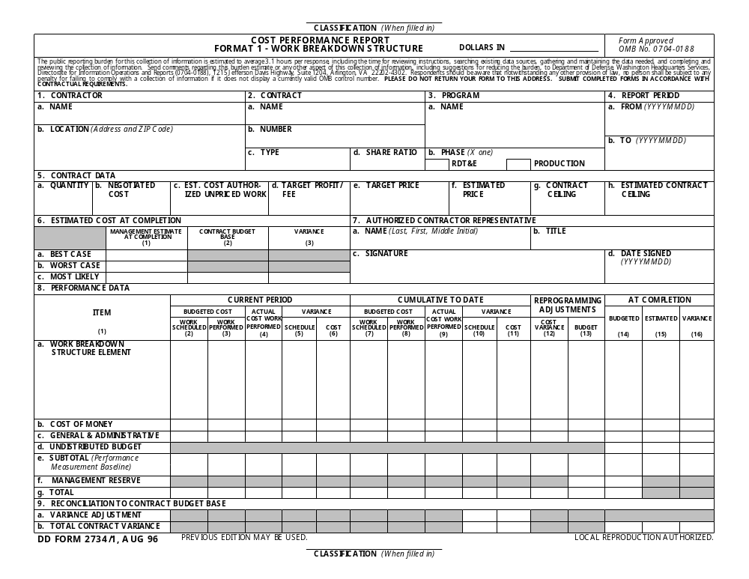
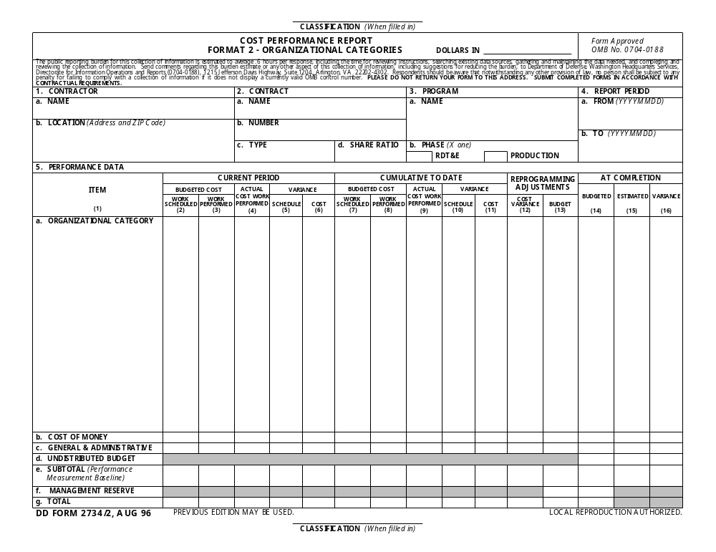
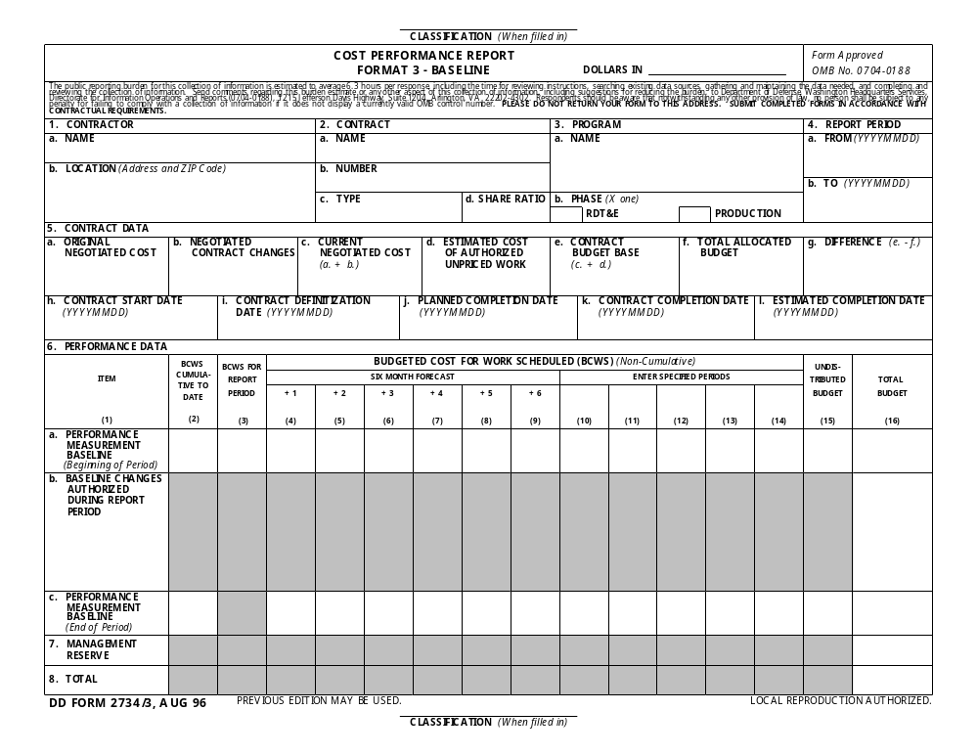
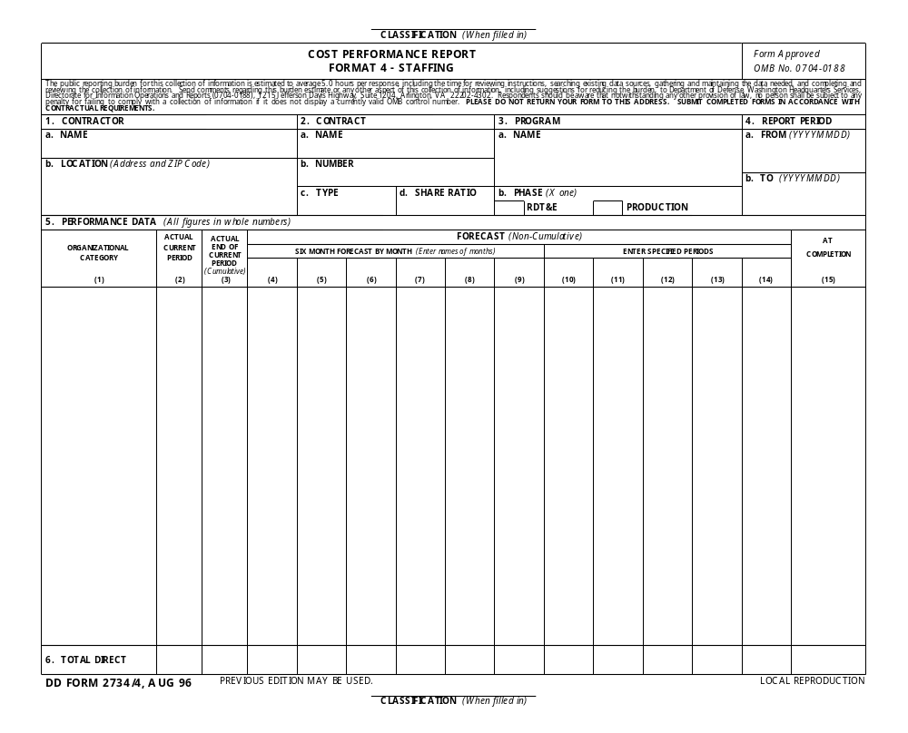
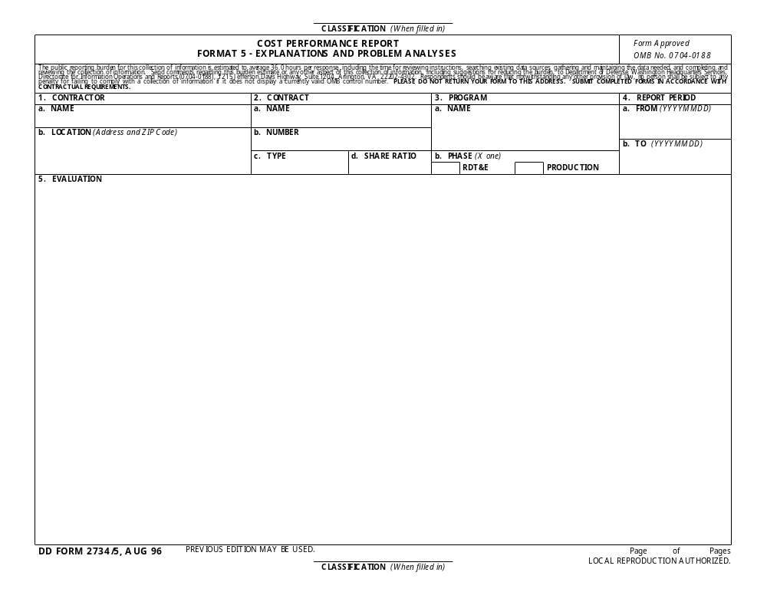
1. DRD Title | 2. Date of current version | 3. DRL Line Item No. |  |  | RFP/Contract No. (Procurement completes)
Wage/Salary and Fringe Benefit Data |  | 4 |  |  | NAS 9-02078
4. Use (Define need for, intended use of, and/or anticipated results of data) |  |  | 5. DRD Category: (check one)
The Wage/Salary and Fringe Benefit Data will be used by the NASA Contracting Officer and the Labor Relations Office to provide the necessary data for submittal of Standard Form (SF) 98. Notice of Intention to Make a Service Contract and Response to Notice, to the Department of Labor, and to assist in the monitoring of Service Contract Act compliance. |  |  |  | Technical  Administrative  SR&QA
6. References (Optional) | 7. Interrelationships (e.g., with other DRDs) (Optional)
 | FAR 52.222-41
8. Preparation Information (Include complete instructions for document preparation)

DISTRIBUTION: BL/Contracting Officer

INITIAL SUBMISSION: Contract start.

SUBMISSION FREQUENCY: Annually (90 days prior to anniversary date).

DATA PREPARATION INFORMATION:

SCOPE: The Wage/Salary and Fringe Benefit Data shall be submitted by the contractor, and any subcontractors which are subject to the provisions of the Service Contract Act, to the Contracting Federal Agency. In accordance with FAR regulations 22.1007 and 22.1008, the Contracting Officer is required to submit a SF 98 to the department of Labor, Wage and Hour Division.

APPLICABLE DOCUMENTS: None

CONTENTS: The Wage/Salary and Fringe Benefit Data shall contain the data included in the enclosed DRD forms, titled “Wage/Salary Rate Information”, “Fringe Benefit for Service Employees”, and “Fringe Benefits per Collective Bargaining Agreement”. The Wage/Salary Rate Information shall contain a listing of all exempt and nonexempt labor classifications working on the contract. Separate forms should be utilized for classifications working in different geographic areas and for each subcontractor. Wage determination numbers, appropriation labor organization names, and subcontractor names, must be reflected. All nonexempt labor classifications must be matched tow age determination classes or to CBA classifications for represented classes. Annotate exempt or nonexempt and union or nonunion. The current hourly rates should reflect the actual lowest and highest paid employees, along with a computed average rate. State the number of employees working in each category. Separate Fringe Benefits forms should be completed for nonrepresented classifications and for each separate CBA. A separate form must be completed for the prime and each subcontractor. Three copies of each collective Bargaining Agreements are required.

FORMAT: The Wage/Salary and Fringe Benefit Data should be in a format substantially the same as enclosed with this DRD. (Forms 2, 3, and 3A).

MAINTENANCE: Change shall be incorporated as required by change page or complete reissue.
FORM 2

WORK SHEET FOR SF-98 DATA
WAGE RATE INFORMATION

CONTRACTORS LABOR CLASSIFICATION | WAGE DETERMINATION CLASSIFICATION | EXEMPT  OR NONEXEMPT | UNION  OR NONUNION | CURRENT HOURLY RATE | MYE NO OF  EMPLOYEES
Illustration of required data:
Project Manager | Not Required | E | N | $25.00 | 1
Supervisor | Not Required | E | N | $20.00 | 1
Electrical Engineer | Not Required | E | N | $16.50-$20.00 | 3
Technician, Jr. | Elect Tech Main I | N | U | $12.78-$15.50 | 12
Technician, Sr. | Elect Tech Main II | N | U | $18.20-$20.00 | 4
Secretary | Secretary I | N | N | $11.11-$12.50 | 2
File Clerk | General Clerk I | N | N | $8.29 | 1
Clerical Data Entry | Word Processor I | N | N | $9.25-$10.90 | 2

Submit data in the above illustrated format for all labor classifications used, or planned to be used, on this contract. All contract labor classifications must be matched to wage determination classes listed in CBA’s represented classes or classes shown in WD 94-2516 for nonrepresentated classes.

CONTRACTORS LABOR CLASSIFICATION | WAGE DETERMINATION CLASSIFICATION | EXEMPT  OR NONEXEMPT | UNION  OR NONUNION | CURRENT HOURLY RATE | MYE NO OF  EMPLOYEES

FORM 3
Page 1 of 2

FRINGE BENEFITS PER COLLECTIVE BARGAINING AGREEMENT

For period from ______________________________to___________________________

Contractor:

Contract Number:

Number of employees in bargaining unit_______________

Total number of employees on contract _______________

- Shift Differential: (Describe any pay orver and above base rates for 2nd, 3rd, weekends, or other shifts).

- Health and Welfare Items and Other Fringe Items: (Indicate whether or not coverage is provided to employees and state current average hourly cost per employee covered by a Collective Bargaining Agreement).

Item | Coverage Provided  (Yes or No) | Average Hourly Cost
a. Life Insurance
b. Accidental Death
c. Disability
d. Medical and Hospital
e. Dental
f. Retirement Plan
g. Savings/Thrift Plan
h. Sick Leave
i. Tuition
j. Other (Describe)
TOTAL

FORM 3
Page 2 of 2

FRINGE BENEFITS PER COLLECTIVE BARGAINING AGREEMENT

Service Requrement Days per Year

1. Paid Absences:

a. Vacation
b. Holiday
c. Sick Leave
d. Jury Leave
e. Funeral Leave
f. Military Leave
g. Other (Describe)

2. Severance Pay: (Briefly describe terms and amounts).

3. Other Fringe Benefits: (Describe any other fringe benefits not included above, and show average hourly cost).

4. Premium Pay: (Discuss all premium pay provisions not previously shown on this form).

__________________________________ _________________________
Signature of Company Representative Date
FORM 3A

FRINGE BENEFITS FOR SERVICE EMPLOYEES

For period from ______________________________to___________________________

Contractor:

Number of nonexempt employees on contract__________

Total number of employees on contract _______________

1. Health and Welfare Items and Other Fringe Items: (Indicate whether or not coverage is provided to employees and state current average hourly cost per service employee).

Item | Coverage Provided | Average Hourly Cost
a. Life Insurance
b. Accidental Death
c. Disability
d. Medical and Hospital
e. Dental
f. Retirement Plan
g. Savings/Thrift Plan
h. Sick Leave
i. Tuition
j. Other (Describe)
TOTAL

2. Paid Absences:

a. Vacation
b. Holiday
c. Sick Leave
d. Jury Leave
e. Funeral Leave
f. Military Leave
g. Other (Describe)

__________________________________ _________________________
Signature of Company Representative Date

1. DRD Title |  |  | 2. Current Version Date |  |  |  | 3. DRL Line Item No. |  |  | RFP/Contract No. (Procurement completes)
Weekly and Monthly Activity Reports |  |  |  |  |  |  | 5 |  |  | NAS 9-02078
4. Use (Define need for, intended use of, and/or anticipated results of data)
To track periodic performance progress, to document significant accomplishments, and update management of scheduled work element strategy planning.
5. DRD Category: (check one) |  | Technical |  |  | X | Administrative |  |  | SR&QA
6. References (Optional) |  |  |  | 7. Interrelationships (e.g., with other DRDs) (Optional)
8. Preparation Information (Include complete instructions for document preparation)

Each T/DO must submit a weekly activity report. A monthly activity report shall be prepared covering all technical activity pertaining to this contract. These reports must include milestone completion, new starts, and progress on ongoing efforts. Any special events such as scientific meetings and conferences, or other specific activities must also be included in the report. Specific issues like methodological problems, schedule slips, and any flight-related critical timelines status must be included.

JSC Form 2341
Page 1 of 1

1. DRD Title | 2. Date of current version | 3. DRL Line Item No. |  |  | RFP/Contract No. (Procurement completes)
Project Resource Status |  | 6 |  |  | NAS 9-02078
4. Use (Define need for, intended use of, and/or anticipated results of data) |  |  | 5. DRD Category: (check one)
This DRD provides techncial information necessary for NASA to evaluate the resource utilization of the contractor by tracking the changes in the projected manpower due to NASA approved changes since issuance of the inital Task/Delivery Order (T/DO). |  |  |  | Technical  Administrative  SR&QA
6. References (Optional) | 7. Interrelationships (e.g., with other DRDs) (Optional)
 | Contractor Financial Reporting
8. Preparation Information (Include complete instructions for document preparation)

SCOPE:
The report documents the relationship between the changes in the planned manpower for an active T/DO and amendments to T/DOs that have been issued by NASA. It also presents the contractor's projected resources to complete a Work Breakdown Structure task and compares this with the original estimate and the original estimate modified by amendments to T/DOs.

CONTENTS:
It is likely that work defined by a T/DO will be impacted by changes to the project that will require changes to the resources to perform tasks defined by the T/DO. Changes may be approved programmatic technical changes that are implemented through amendments to T/DOs or a large number of NASA decisions that impact overall resources. The manpower for tasks that have been identified at the reportable WBS level for the Contractor Financial Report defined by the T/DO are to be broken down to the following categories: original proposed plan, change based on T/DO amendment(s), changes based on other unplanned NASA events/decisions, and unplanned contractor changes. As each of these categories develops, the cause of the change shall be recorded for each WBS that is affected by the change.

MAINTENANCE:

This report is submitted quarterly with summary data being reported within the Monthly Status Report.

1. DRD Title | 2. Date of current version | 3. DRL Line Item No. |  |  | RFP/Contract No. (Procurement completes)
ORGANIZATION CHART |  | 7 |  |  | NAS 9-02078
4. Use (Define need for, intended use of, and/or anticipated results of data) |  |  | 5. DRD Category: (check one)
For use by NASA Technical personnel to identify manpower reporting structures, assist in evaluating manpower status and identify by personnel. |  |  |  | Technical  Administrative  SR&QA
6. References (Optional) | 7. Interrelationships (e.g., with other DRDs) (Optional)
8. Preparation Information (Include complete instructions for document preparation)

- The contractor shall submit a detailed organization chart which identifies the contractors’ management reporting structure. Names of individuals will be included, and if supervisory or lead, so designated.

- All personnel will be listed on the chart.

- The location (building number) will be shown by the name of all JSC on-site contractor personnel.

- This report will be submitted quarterly, except in the event there are significant changes in key personnel or in the reporting structure, the report will be submitted within 5 working days of such changes.

- The first report will be submitted within one month after the contract start date.

The total number of on-site and offsite personnel shall be indicated.

1. DRD Title | 2. Date of current version | 3. DRL Line Item No. |  |  | RFP/Contract No. (Procurement completes)
Employee Phone List |  | 8 |  |  | NAS 9-02078
4. Use (Define need for, intended use of, and/or anticipated results of data) |  |  | 5. DRD Category: (check one)
For use by NASA Technical personnel to identify and locat contractor personnel. |  |  |  | Technical  Administrative  SR&QA
6. References (Optional) | 7. Interrelationships (e.g., with other DRDs) (Optional)
8. Preparation Information (Include complete instructions for document preparation)

- The contractor shall submit a detailed phone list including Name, Mail Code, Location and pager number

- All personnel will be listed.

1. DRD Title | 2. Date of current version | 3. DRL Line Item No. |  |  | RFP/Contract No. (Procurement completes)
Information Technology (IT) Capital Investment Planning (CIP) | 5/9/02 | 9 |  |  | NAS 9-02078
4. Use (Define need for, intended use of, and/or anticipated results of data) |  |  | 5. DRD Category: (check one)
To document the contractor's compliance with Federal and NASA IT CIP Planning and Reporting regulations and requirements |  |  |  | Technical  Administrative  SR&QA
6. References (Optional) | 7. Interrelationships (e.g., with other DRDs) (Optional)
See Section 8.3 of Reference Documents
8. Preparation Information (Include complete instructions for document preparation)
The contractor’s IT CIP process, which includes IT POP, IT Capital Plans, and IT Standards, document the contractor's compliance with Federal and NASA IT planning and reporting regulations and requirements.

- IT CIP Requirements:

- The contractor shall comply with the IT CIP requirements as documented in the memo AI-01-164, subject: “JSC IT Planning Process for Fiscal Year 2002 (FY02)”, the IT POP, as well as all updates and/or replacements to those documents. The current documents can be viewed on the JSC CIO and CFO web sites.

- Processes- The contractor shall establish and document processes for complying with the requirements in “a.” above. The IT CIP process shall be presented to ISD for concurrence and to the JSC CIO for approval. Upon approval of the contractor’s IT CIP process by the JSC CIO, the contractor is then authorized by the JSC CIO to use its planning processes to complete its IT POP, Capital Plans, IT Standards, etc. Submission Frequency: Generally, the IT CIP process is submitted once and subsequent submittals shall be required only if there are significant changes in the process or if required by the JSC CIO or ISD. IT POP and Capital Plans are submitted annually. IT Standards are submitted once and subsequent submittals shall be required only if there are significant changes or if required by the JSC CIO or GA CIO.
- Annually, JSC submits its response to the Agency IT POP call. The contractor shall provide the data necessary for GA to provide their budget and focus area submits as specified in the IT POP (as published on the JSC CFO Web site). The contractor shall be prepared to interface and coordinate with GA at the TWP level to collect the necessary information for NASA’s 5-year POP plans. This supports the NASA Program Operating Plan released by the JSC CFO to the JSC technical organizations normally during the spring of each year requesting their high-level budgetary requirements for the next five fiscal years.
- Contractor Standards
The contractor should evaluate and select, whenever feasible, an IT product common at the Center that will meet the requirements. The contractor may elect, at their option, to use JSC and/or JSC organizational standards. Those areas that have a requirement that cannot be met sufficiently by a JSC or organizational standard, should submit an IT Standard per the approved process.
The contractor standards will be submitted for JSC CIO approval and when approved they will reside on the JSC CIO server and will be under JSC CIO configuration management. Any changes to the approved contractor standards must be accompanied by JSC form 1209, which identifies the standard to change, an updated table with the change, and the reason for the change.
Current IT Standards are documented on the JSC CIO web site.
.
- Compliance With Section 508 of the Rehabilitation Act
The contractor must also abide by all Section 508 requirements prior to the purchase of IT. On June 21, 2001, NASA Procurement Information Circular (PIC) 01-13 entitled “Electronic and Information Technology Accessibility” was published. This PIC provides the Section 508 related requirements JSC must meet when procuring Electronic and Information Technology (EIT). Specifically, enclosures are included in the PIC, one or more of which must be provided when such procurements are executed. This applies to any EIT procurement covered by Section 508. A summary of how the PIC applies at JSC is as follows:
The requestor of items and services procured using a NASA Purchase Request (PR) must comply with the PIC.
The requestor of items and services procured using an IDIQ contract with delivery orders initiated after June 25, 2001, must comply with the PIC.
The requestor of items and services procured using an IDIQ contract with delivery orders initiated before June 25, 2001, are exempt. As a result items procured through ODIN on the current delivery order are exempt until December 2001 when the new delivery order will be established.
The requestor of items and services procured using a contract other than an IDIQ contract that was awarded after June 25, 2001, must comply with the PIC.
The requestor of items and services procured using a contract other than an IDIQ contract awarded before June 25 are exempt. As a result items procured through IMPASS are exempt until the end of the contract, unless modified.
All EIT acquisitions must be assessed for how they meet all the 508 Accessibility Standards. The flowchart below shows the process depending on the selection on the PIC’s Enclosure 2, “EIT Market Research Template.”
The NASA CIO Office has provided one exception to this. Internal components such as RAM, hard drives, and specialized Analog to Digital cards are not subject to Section 508. As a result of this communication, the Section 508 supporting documentation is not required for this specific class of procurement.
f. Contractor Capital Plans
Annually, the Contractor shall present their internal IT Capital Plans for the next fiscal year to ISD. This planning review is required in order to allow for the government’s coordination and integration with other IT Capital Planning results.

Flowchart for Evaluation Against Section 508

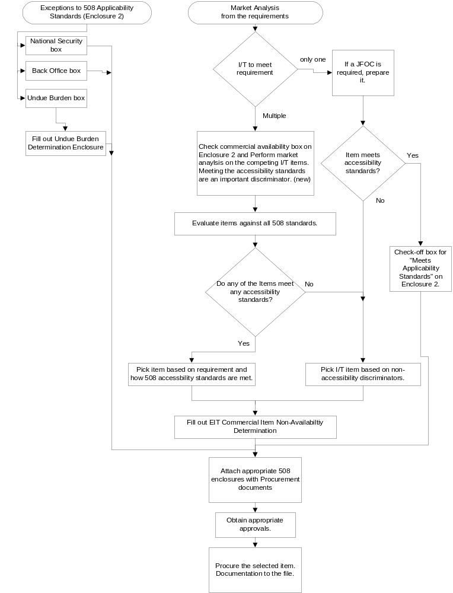

At the very least, all acquisitions must be accompanied with PIC Enclosure 2, “EIT Market Research Template.” PIC Enclosure 2 has 3 major check boxes:
Meets the applicability standards,
Commercial supply or service that may or not meet any or all the applicability standards, and
Exemptions from 508 compliance due to:
a. National Security,
b. IT residing in back office frequented only by maintenance personnel, and
c. Undue Burden.
Check box 2 requires an additional enclosure, “EIT Commercial Item Non-Availability Determination” to be completed. This enclosure documents all the IT that meets the requirements and how they meet the various Accessibility Standards.
The undue burden check box requires the enclosure, “EIT Undue Burden Exception Determination.” Any acquisitions that select Undue Burden must attain the concurrence of the Contracting and Center Legal Officers and the approval of the JSC CIO.
Guidelines for all the above enclosures can be found in the PIC.

8.2 Reference Documents:
- For current IT CIP planning requirements, the contractor must refer to the JSC CIO and CFO web sites. These requirements will contain NASA’s implementation of the Office of Management and Budget’s (OMB’s) IT CIP planning, budgeting, and reporting requirements.
- JSC memorandum AI-01-164 dated November 9, 2001, subject: JSC Information Technology (IT) Planning Process for Fiscal Year 2002 (FY02)
- OMB Circulars A-130 and A-11.
- Executive Order 12845, Energy-efficient Microcomputers
- IT Management Reform Act of 1996 (the "Clinger-Cohen Bill")

8.3 Maintenance: Changes shall be incorporated by change page or complete reissue.

1. DRD Title | 2. Date of current version | 3. DRL Line Item No. |  |  | RFP/Contract No. (Procurement completes)
AUTOMATED INFORMATION SYSTEMS (AIS) SECURITY DOCUMENTATION |  | 10 |  |  | NAS 9-02078
4. Use (Define need for, intended use of, and/or anticipated results of data) |  |  | 5. DRD Category: (check one)
To provide and maintain required security documentation in Data Processing Installations (DPI’s) |  |  |  | Technical  Administrative  SR&QA
6. References (Optional) | 7. Interrelationships (e.g., with other DRDs) (Optional)
8. Preparation Information (Include complete instructions for document preparation)

Certain documents critical to AIS security at JSC have been developed by the JSC AIS Security Committee for all JSC DPI’s and sensitive application software. Maintenance of the following AIS Security documents for those DPI’s is required by JSC. The JSC AIS Security Committee requires review (and updates, if required) of the following documentation yearly, with major updates required less often as dictated by the committee. For new DPI’s or (sensitive) software applications, this documentation must be originated.

- Risk Analysis – Provides a measure of the relative vulnerabilities of the DPI.

- Risk Management Plan – Provides a response to the recommendations discussed in the Risk Analysis.

- Contingency Plan – For each DPI establishes specific measures to be taken or procedures to be in place to deal with certain contingencies.

- Evaluation of Sensitive Applications – Formally documents the system’s safeguards/deficiencies in the areas of change management, audit, trailing, quality assurance, accessibility, data handling procedures, backup/recovery, and documentation along with conclusions/recommendations.

Format (s) shall be in accordance with JPG 2810.1B, JSC Information Technology Security Handbook.

1. DRD Title | 2. Date of current version | 3. DRL Line Item No. |  |  | RFP/Contract No. (Procurement completes)
GIDEP and NASA Advisory Problem Data Sharing and Utilization Program Documentation and Reporting | 06/29/01 | 11 |  |  | NAS 9-02078
4. Use (Define need for, intended use of, and/or anticipated results of data) |  |  | 5. DRD Category: (check one)
This DRD provides the minimum information to be incorporated into the contractor's and subtier contractor implementation procedures and contractual data reporting requirements to comply with the requirement to participate in GIDEP and NASA Advisory Problem Data Sharing and Utilization Program. |  |  |  | Technical  Administrative  SR&QA
6. References (Optional) | 7. Interrelationships (e.g., with other DRDs) (Optional)
SO300-BT-PRO-010 GIDEP Operations Manual  SO300-BU-GYD-010 GIDEP Requirements Guide  NPG 8735.1 NASA Procedure and Guidelines | Non-Conforming Parts and Materials Reports
8. Preparation Information (Include complete instructions for document preparation)

8.1 DESCRIPTION/USE. This DRD provides the minimum information to be incorporated in the contractor and subtier contractor
implementation procedures and contractual data-reporting requirements to comply with the program requirement to participate in
GIDEP and the NASA Advisory Problem Data Sharing and Utilization Program. The types of data include:

a. Contractor and subtier implementation procedures.
b. Preparation and submittal of GIDEP documents.
c. Preparation and submittal of NASA Advisories.
d. Task management, control, and tracking status.
e. Milestone/mission support (assessment/impact status reports).
f. Cost data on special problems (involving criminal investigations).

8.2 DISTRIBUTION. Distribution will comply with the DRL or Contracting Officer letter (must include the JSC GIDEP/NASA Advisory
Coordinator as a minimum).

8.3 INITIAL SUBMITTAL.

a. Contractor and subtier Implementation procedures (60 days after contract award).
b. Release of GIDEP documents (in compliance with GIDEP Operations Manual and Policy).
c. Release of NASA Advisories (in accordance with NASA policy).
d. Problem data assessments (30 days after receipt of the problem data).
e. Milestone/mission support (as required to support the milestone or mission events).
f. Cost data (as required for special problems involving criminal investigations).

8.4 SUBMITTAL FREQUENCY. As required.

8.5 REMARKS. Special controls shall be implemented to comply with the confidentiality of the problem reports involving criminal
investigations. The implementation procedures must address this special need for the control of information with the restricted
distribution as well as the need to track and report the cost of the problem investigation and resolution.

8.6 INTERRELATIONSHIP. Incidents involving non-conforming products or materials are to be reported through the GIDEP Reporting System to comply with Government Policy as defined by Office of Federal Procurement Policy, Policy Letter No. 91-3 (Appendix D of GIDEP Operation Manual, SO300-BT-PRO-010).

8.7 DATA PREPARATION INFORMATION.

8.7.1 Scope. Generic problems reported by GIDEP or NASA Advisory distribution networks shall be assessed to determine if there is a real or potential impact on the program or program assets. Generic problems experienced by the program or by program assets shall be reported in the GIDEP or NASA Advisory network, as appropriate. Management documentation shall be adequate to ensure that (1) the subject problem data are received, properly distributed, and thoroughly assessed for potential impact; (2) identified impact issues are resolved or corrected with NASA program management concurrence; (3) cost data for special problem issues are accumulated and reported; and (4) all this information is captured and retained in a database.

8.7.2 Applicable Documents.

a. SO300-BT-PRO-010, GIDEP Operations Manual and Policy.
b. SO300-BU-GYD-010, GIDEP Requirements Guide.
c. NPG 8735.1, NASA Procedure and Guidelines, "Procedure for Exchanging Parts, Materials, and Safety Problem Data Utilizing the Government-Industry Data Exchange Program and NASA Advisories."

8.7.3 Contents.

a. The contractor and subtier Implementation procedures shall provide details that will ensure that the contractor understands and will implement these procedures, which cover the scope; task importance; management responsibilities; technical expertise to identify and resolve any impacts; "special problem" information sensitivity; and documentation necessary to comply with GIDEP and NASA policies.
b. GIDEP documents are to comply with the GIDEP Operations Manual and Policy requirements for the appropriate document being prepared and released.
c. NASA Advisories are to comply with contents as required to complete the JSC NASA Advisory Form, JSC Form 1159 (JF1159), and to accurately report the problem and conditions.
d. Implementation documentation shall include an index of problem reports received and assessed for impact; hardware/systems/subcontractors subject to the assessments; status of the impact assessments by problem report by hardware/system/subcontractor; and corrective actions for problems with identified impacts, including (1) NASA program management involvement and concurrence, (2) required supporting documentation for all problems experienced on the program/project that meet the criteria for release of a GIDEP report or NASA Advisory and the released GIDEP reports and NASA Advisories, and (3) any other data required to comply with the applicable GIDEP and NASA documents.
e. Details of the required milestone/mission support efforts and reports with the associated roles and responsibilities shall be provided.
f. Financial data to justify and substantiate any reported "cost impacts" are to be included.

8.7.4 Format. Electronic submittal is the preferred medium for providing access to or submittal of information and data under this
DRD. Format guidelines are as follows:

a. The contractor's format is acceptable for their internal implementation procedures.
b. GIDEP documents are to be prepared on the appropriate GIDEP form found in the GIDEP Operations Manual.
c. NASA Advisories are to be prepared on the JSC NASA Advisory Form, JF1159.
d. The contractor's format is acceptable for providing the "Task Management, Control, and Tracking Status," as long as it includes all the necessary information. An electronic database with access permission to appropriate NASA personnel is preferred.
e. Formats for these reports are to comply with the applicable milestone/mission event.
f. Cost data are to be provided as required by the financial management reporting system and as necessary to substantiate the data being submitted in support of criminal investigations.

8.7.5 Maintenance. Data shall be maintained as required to:

a. Document the current implementation procedures and GIDEP and NASA Advisory policies.
b. Ensure that the released GIDEP information is complete, factual, accurate, and up to date.
c. Ensure that the released NASA Advisory information is complete, factual, accurate, and up to date.
d. Tracking status provided periodically to demonstrate complete accomplishment of the task.
e. Stay current and accurate or as requested to support management activities.
f. Substantiate submitted costs or to include additional costs as they are identified.
14.3.4 Implementation documentation shall include an index of problem reports received and assessed for impact, hardware/systems/subcontractors subjected to the assessments, status of the impact assessments by problem report by Hardware/system/subcontractor, corrective actions for problem with identified impacts including NASA program management's involvement and concurrence, and the required supporting documentation for all problems experienced on the program/project that meet the criteria for the release of a GIDEP Report or NASA Advisory and the released GIDEP reports and NASA Advisories. And any other data required to comply with the Applicable GIDEP and NASA documents.
14.3.5 Details of the required Milestone/Mission support efforts and reports with the associated roles and responsibilities.
14.3.6 Financial data to justify and substantiate any reported "Cost impacts"
14.4 FORMAT: Electronic submittal is the preferred media for providing access to or submittal of information and data under this DRD
14.4.1 The Contractor's format is acceptable for their Internal Implementation Procedures.
14.4.2 GIDEP document are to be prepared on appropriate GIDEP form found in the GIDEP Operations Manual.
14.4.3 NASA Advisories are to be prepared on the JSC NASA Advisory form, JF1159.
14.4.4 The contractor's format is acceptable for providing the "Task Management , Control, and Tracking Status" as long as it included all the necessary information. Preferred electronic database with access permission to appropriate NASA personnel.
14.4.5 Formats for these reports are to comply with the applicable Milestone/Mission event. effort.
14.4.6 Cost data is to be provided as required by financial management reporting system and to the details required to support the
criminal investigations.

14.5 MAINTENANCE:
13.5.1 As required to document the current implementation procedures and GIDEP and NASA Advisory policies.
13.5.2 As required to make sure that the released information is complete, factual, accurate and up-to-date.
13.5.3 As required to make sure that the released information is complete, factual, accurate and up-to-date.
13.5.4 As required to stay current and accurate or as requested.
13.5.5 As required to stay current and accurate or as requested
13.5.6 As required to substantiate submitted costs or to included additional costs as they are identified.

1. DRD Title | 2. Date of current version | 3. DRL Line Item No. |  |  | RFP/Contract No. (Procurement completes)
Problem Reporting and Corrective Action (PRACA) for Johnson Space Center (JSC) Government Furnished Equipment (GFE) | 06/29/01 | 12 |  |  | NAS 9-02078
4. Use (Define need for, intended use of, and/or anticipated results of data) |  |  | 5. DRD Category: (check one)
To report problems and to document their subsequent resolution and approval. |  |  |  | Technical  Administrative  SR&QA
6. References (Optional) | 7. Interrelationships (e.g., with other DRDs) (Optional)
JSC 28035, NSTS 22206, SSP 30234 | Nonconformance Record DRD
8. Preparation Information (Include complete instructions for document preparation)

SCOPE:
Nonconformances requiring JSC GFE PRACA reporting are defined in JSC 28035. PRACA reporting is limited to flight equipment, equipment that is representative of flight equipment (flight-like) and critical ground support equipment.

CONTENTS:
A. The following data is mandatory for the initial reporting of a problem. The initial report shall be transmitted to the JSC PRACA Center within 2 business days after isolation to a configuration item but no later than 10 business days after occurrence/detection.

1. PRACA Number [a unique tracking number assigned to the PRACA report]
2. Nonconformance Number [a unique local nonconformance number]
3. Detect Date [The date (mm/dd/yyyy) nonconformance occurred or was detected]
4. Location [The location where the nonconforming item was at, at the time of occurrence/detection]
5. Program [The affected NASA program (SSP, ISS, or both)]
6. Project Office [The responsible NASA Project Office (EVA, FCE, Life Sciences, Orbiter, RMS, Other_____)]
7. Contact [The technical point of contact, organization, and phone number]
8. Report Date [Date the PRACA report was initiated]
9. Detected During [The specific test or operation performed when the nonconformance occurred)]
10. Title [A brief, but descriptive, title for the problem]
11. Description [A narrative description of the problem including the observed event(s) as well as the expected event(s).]
12. Identification of the Configuration Item by:
a. Part name
b. Part number
c. Serial number, lot number, or version
d. Manufacturer's name
e. Manufacturer's Contractor and Government Entity (CAGE) code

B. The following data shall be provided when it becomes known (with the exceptions noted). This data shall be provided as updates to the initial PRACA report. This data is mandatory for the closure of the report.

13. The end item (if not the configuration item), specific subassemblies, and the nonconforming article shall be identified
a. Part name
b. Part number
c. Serial number, lot number, or version
d. Manufacturer's name
e. Manufacturer's CAGE code
14. FMEA No. [Failure Mode and Effects Analyses number. Note: if the hardware is used by the Space Station and the Space Shuttle Programs, provide both FMEA numbers.]
15. FMEA Criticality [criticality per NSTS 22206 or SSP 30234. This data is required within 10 calendar days of opening the problem report.
Note: if the hardware is used by the Space Station and the Space Shuttle Programs, provide both FMEA criticalities.]
16. FMEA/CIL Impact [yes or no, is the FMEA/CIL retention rationale impacted by the occurrence of this problem?]
17. Out-of-Family Problem [yes or no, based on the definitions of In-Family and Out-of-Family in JSC 28035.]
18. Fracture Critical [yes or no, is the material involved fracture critical?]
19. ECD [Estimated Completion Date for submitting a final closure of the problem. This data is required within 30 calendar days of
opening the problem report.]
20. Process Escape [yes or no, per the definition of process escape in JSC 28035]
C. The following data shall be provided to close the report:
21. Final report [A final report documenting the specific information required for closure per JSC 28035, i.e. final closure with corrective action (this is preferred) or final closure without corrective action (explanation)]
22. Approval signatures
23. Date Approved

D. The contractor shall maintain a status list on all open problems including estimated completion date. This status shall be
submitted to the Contracting Officer's Technical Representative and the JSC PRACA Center on a monthly basis during the contract.

FORMAT: The contractor's format is acceptable; however, data shall be easily identifiable to the data labels specified in Contents.
JSC Form 2174 is a preferred document for initiating problem reports.

Reports shall be sent to: Johnson Space Center
2101 NASA Rd 1
JSC PRACA Center
Mail Code NT-52
Houston, TX 77058

Email (preferred): Primary gfepraca@jsc.nasa.gov
. cc terry.l.miller1@jsc.nasa.gov

Voice: Primary 281-244-1941
Secondary 281-244-1935

FacsimilePrimary 281-244-2854

Hours of operation: 8:00 a.m. - 4:30 p.m. Central, Monday through Friday

MAINTENANCE: Update as required

- DRD Title  SA-1-1, Safety and Health Plan |  |  | 2. Current Version Date |  |  |  | 3. DRL Line Item No. |  |  | RFP/Contract No. (Procurement completes)
 |  |  | 7/02 (replaces  6/02 version) |  |  |  | 13 |  |  | NAS 9-02078
4. Use (Define need for, intended use of, and/or anticipated results of data)
Establishes Safety, Health, and Environmental Compliance Plan for contractors providing support to JSC organizations

***The Office of Primary Responsibility for this DRD is the JSC Safety, Reliability, and Quality Assurance Office
5. DRD Category: (check one) |  | Technical |  |  |  | Administrative |  | X | SR&QA
6. References (Optional) |  |  |  | 7. Interrelationships (e.g., with other DRDs) (Optional)
NPG 8715.3 (as revised); JPG 1700.1 (as revised) |  |  |  | See block 8. below
8. Preparation Information (Include complete instructions for document preparation)

NOTE: UPON NASA APPROVAL, THE CONTRACTOR’S SAFETY, HEALTH, and ENVIRONMENTAL COMPLIANCE PLAN ("The Plan") BECOMES A CONTRACTUAL REQUIREMENT.

Frequency of submission. One time only (with the proposal).

Distribution. After the plan is approved by NASA, the Contracting Officer will retain the plan in the contract file. The contractor will send additional copies to each of the following:
NS/Safety and Test Operations Division (2 copies)
SD13/Occupational Health Officer (1 copy)
JA131 / Environmental Services (1 copy)
Contracting Officer’s technical Representative (1 copy)

Subsequent revisions to the plan. The contractor may revise the plan at any time or at the direction of the Government. Revisions are subject to Government review and approval. Distributions of approved revisions will be as described above.

Other deliverables. The requirements for this plan as detailed in the instructions on plan content below include instructions for specific reports and data to be submitted to the Government. These instructions are to be included in the plan and represent contractual commitments by the contractor to provide this information.

Format:

- Cover page - to include as a minimum the signatures of Contractor's project manager and designated safety official (if different); NASA COTR; JSC Occupational Safety Branch; and the NASA Contracting Officer. Other signatures may be required at the discretion of the Government.

- Table of Contents. See content below.

- Body of plan - as required. Contractor’s format is acceptable but should be traceable to the elements of the content below.

- When preparing its plan, the offeror/contractor is expected to review all the items below and tailor its plan accordingly. Certain requirements set forth in this DR may be specific for contractor operations performed at JSC, Ellington Field, or Sonny Carter Training Facility in the Clear Lake, Texas, area; tailoring of the plan to the requirements of specific establishments is acceptable. The plan will clearly identify those resources to be provided by the contractor and provided by the Government. This review and supporting rationale is to be made available to the Government as part of this plan. It can be documented as a checklist or outline, inserted directly in the body of the plan, or in any format developed by the contractor that clearly conveys the results of this review including the basis for any underlying assumptions.

- Authority: FAR 52.223-1 through -5, -10; NFS 18-23.70, 18-52.223-70, 18-52.223-73.

Content:

- Management Leadership and Employee Participation.
  - Policy. Provide the contractor’s safety, health, and environmental compliance policy statement with the plan. Compare the contractor’s policy statement with those of NASA and OSHA and discuss any differences.
  - Goals and Objectives.
    - Describe specific safety and health goals and objectives to be met. Discuss status of safety program using the “Performance Evaluation Profile” as safety performance criteria. Describe the contractor’s approach to continuous improvement (including milestone schedule) using level 5 of the Performance Evaluation Profile as a guideline.
    - Describe Environmental Goals & Objectives to be met for the following:
      - Pollution Prevention and Source Reduction of:
        - Hazardous and Industrial Solid Wastes
        - Solid Wastes (trash, refuse)
        - Wastewater Discharges (sanitary sewerage)
        - Air Emissions
        - Medical & Radiological Discharges
      - Affirmative Procurement (Purchase of Environmentally Preferable Materials IAW Executive Order)
      - Hazardous Materials Handling/Purchasing/Reduction/Replacement
      - Elimination from Specifications and Standards requirements for the use of Hazardous/Toxic Substances & Materials
      - Use of an Environmental Planning Checklist to review & document Impacts of New and Modified Programs, Projects, Activities and Operations.
      - Life cycle analysis and costing
      - Incorporating Environmental Requirements in Subcontracts
      - Participation in JSC Recycling
      - Outreach programs
  - Management Leadership. Describe management’s procedures for implementing its commitment to safety, health, and environmental compliance through visible management activities and initiatives including a commitment to exercise management prerogatives to ensure workplace safety and health. Describe processes and procedures to making this visible in all contract and subcontract activities and products. Include a statement from the project manager or designated safety official indicating that the plan will be implemented as approved and that the project manager will take personal responsibility for its implementation.
  - Employee Involvement. Describe procedures to promote and implement employee (e.g., non-supervisory) involvement in safety, health, and environmental compliance program development, implementation and decision-making. Describe the scope and breadth of employee participation to be achieved so that approximate safety and health risk areas of the contract are equitably represented.
  - Assignment of Responsibility. Describe line and staff responsibilities for safety and health program implementation. Identify any other personnel or organization that provides safety services or exercises any form of control or assurance in these areas. State the means of communication and interface concerning related issues used by line, staff, and others (such as documentation, concurrence requirements, committee structure, sharing of the work site with NASA and other contractors, or other special responsibilities and support.) As a minimum, the contractor will identify the following:
    - Safety Representative - identify by title the individual who will be trained and certified in accordance with JPG 1700.1 to be responsive to Center-wide safety, health, environmental, and fire protection concerns and goals, and who will participate in meetings and other activities related to the JSC Safety and Health program.
    - Company Physician/Occupational Injury/illness case manager - identify a point of contact who is responsible for the transfer or receipt of company medical data and who will be the primary contact for the company in the event any employee suffers a work related injury or illness (such as the company physician) by name, address, and telephone number to the JSC Clinic, mail code SD22. This will facilitate communication of medical data to contractor management. Prompt notification to the JSC Occupational Health/ Clinic shall be given of any changes that occur in the identity of the point of contact. A letter to the JSC Occupational Health Office can accomplish initial identification of point of contact and subsequent updates with a copy sent to the Contracting Officer. The initial letter is to be received by the Government prior to contract start.
    - Building Fire Wardens - provide a roster of fire wardens (their names, phone numbers and pagers, and mail codes). Contractor fire wardens are needed to facilitate the JSC fire safety program, including coordination of related issues with NASA facility managers and emergency planning and response officials and their representatives. Fire wardens will be trained in accordance with JPG 1700.1. The roster shall be maintained by letter to JSC Occupational Safety, mail code NS2, with copies to the Contracting Officer and Contracting Officer's Technical Representative. The initial letter shall be received by the Government not later than 15 days after contract start.
    - Designated Safety Official - identify by title the official(s) responsible for implementation of this plan and all formal contacts with regulatory agencies and with NASA.
  - Provision of Authority. Describe consistency of the plan for compliance with applicable NASA and JSC requirements and contractual direction as well as applicable Federal, state, and local regulations and how compliance will be maintained throughout the life of the contract.

  - Accountability. Describe procedures for ensuring that management and employees will be held accountable for implementing their tasks in a safe and healthful and environmentally compliant manner. The use of traditional and/or innovative personnel management methods (including discipline, motivational techniques, or any other technique that ensures accountability) will be referenced as a minimum and described as appropriate.
  - Program Evaluation. The program evaluation consists of:
    - Participation in a Performance Evaluation Profile (PEP) survey at the request of the Government. The PEP survey normally will be scheduled and administered at the discretion of the Government. If the Government chooses not to do the PEP in a given year, the contractor may at its option initiate its own PEP by contacting JSC Occupational Safety, code NS2, for assistance. The contractor will not be required to take two or more PEP surveys in any contract year.
    - [Reserved.]
    - A written self-evaluation report to be delivered by Sept 30 of each year. The self-evaluation shall follow the VPP program evaluation report format found in OSHA TED 8.1, Revised Voluntary Protection Programs (VPP) Policies and Procedures Manual, Appendix H, "Format for Program Evaluation Report", as mandated by the cognizant OSHA regional office. Contractors who have submitted a written self-evaluation as a VPP site may submit their original report to OSHA in lieu of writing a new self -evaluation provided that all action plans and status are updated. The self evaluation shall as a minimum cover the elements of the approved safety and health plan.
    - Miscellaneous Reports. The contractor will acknowledge the following as standing requests of the Government and to be handled as described below.
      - Roster of Terminated Employees. Identify personnel terminated by contractor. Send to the JSC Occupational Health Officer, mail code SD13, no later than 30 days after the end of each contract year or at the end of the contract, whichever is applicable. At the contractor’s discretion, the report may be submitted for personnel changes during the previous year or cumulated for all years. Information required:
        - Date of report, contractor identity and contract number.
        - For each person listed, provide name, social security number, and date of termination.
        - Name, address, and telephone number of contractor representative to be contacted for questions or other information.
      - Material Safety Data. The contractor shall prepare and/or deliver Material Safety Data for hazardous materials brought onto Government property or included in products delivered to the Government. This data is required by the Occupational Safety and Health Administration (OSHA) regulation, 29 CFR 1910.1200, “Hazard Communication”, EPA “Emergency Planning and Community Right-to-Know (EPCRA, ref. 40 CFR 302, 311, 312); and the Texas Department of Health (TDH, ref. Chapters 505-507 of the Health and Safety Code), and Federal Standard 313 (or FED-STD-313), “Material Safety Data, Transportation Data and Disposal Data for Hazardous Materials Furnished to Government Activities”, as revised. 1 copy of each MSDS will be sent upon receipt of the material for use on NASA property to the JSC Central Repository, Occupational Health and Test Support, Mail Code SD13, along with information on new or changed locations and/or quantities normally stored or used. If the MSDS arrives with the material and is needed for immediate use, the MSDS shall be delivered to the Central Repository by close of business of the next working day after it enters the site.
      - Hazardous Materials Inventory. The contractor shall compile an inventory report of all hazardous materials it has located on Government property not less than annually, and which is within the scope of 29 CFR 1910.1200, “Hazard Communication”; and Federal Standard 313 (or FED-STD-313), “Material Safety Data, Transportation Data and Disposal Data for Hazardous Materials Furnished to Government Activities”, as revised. The call for this annual inventory and instructions for delivery will be issued by the JSC Occupational Health and Test Support Office, mail code SD13. This information shall use the format used by JSC for chemical inventory compilation to provide the following:
        - the identity of the material;
        - the location of the material by building and room;
        - the quantity of each material normally kept at each location
        - peak quantity stored
        - actual or estimated rate of annual usage of each chemical
  - Government Access to Safety and Health Program Documentation. The contractor shall recognize in its plan that it will be expected to make all safety, health, and environmental documentation (including relevant personnel records) available for inspection or audit at the Government’s request. Electronic access by the Government to this data is preferred as long as Privacy Act requirements are met and Government safety and health professionals and their representatives have full and unimpeded access for review and audit purposes. For contractor activities conducted on NASA property, the contractor will identify what records it will make available to the Government in accordance with the Voluntary Protection Program criteria of OSHA as implemented in JPG 1700.1, “JSC Safety and Health Handbook”, as revised. For the purpose of this plan, safety, health, and environmental compliance documentation includes but is not limited to logs, records, minutes, procedures, checklists, statistics, reports, analyses, notes, or other written or electronic document which contains in whole or in part any subject matter pertinent to safety, health, environmental protection, or emergency preparedness.
  - The contractor may be requested to participate in the review and modification of safety requirements that are to be implemented by the Government including any referenced documents therein. This review activity will be implemented at the direction of the NASA Contracting Officer’s Technical Representative in accordance with established NASA directives and procedures.

  - Procurement. Identify procedures used to assure that procurements are reviewed for safety, health and environmental compliance considerations and that specifications contain appropriate safety criteria and instructions. Set forth authority and responsibility to assure that safety tasks are clearly stated in subcontracts.
  - Certified Professional Resources. Discuss your access to certified professional resources for safety, health, and environmental protection. Discuss their roles in motivation/awareness, worksite analysis, hazard prevention and control, and training.
- Worksite Analysis. Hazards shall be systematically identified through a combination of surveys, analyses, and inspections of the workplace, investigations of mishaps and close calls, and the collection and trend analysis of safety and health data such as: records of occupational injuries and illnesses; findings and observations from preventive maintenance activities; reports on hazardous substance spills and inadvertent releases to the environment; facilities related incidents related to partial or full loss of systems functions; etc. Hazards identified by any of the techniques identified below shall be ranked and processed in accordance with JPG 1700.1. All hazards on NASA property, which are immediately dangerous to life or health, shall be reported immediately to the Occupational Safety Office. All safety engineering products that address operations, equipment, etc., on NASA property will be subject to JSC SR&QA review and concurrence unless otherwise waived by the JSC Occupational Safety Office.
  - Industrial Hygiene. Describe your industrial hygiene program and how it will be coordinated with the JSC government provided resources for industrial hygiene. In the event corporate resources are used to determine workplace exposures, copies of all monitoring data shall be provided to JSC Occupational Health within 15 days of receipt of results.
  - Hazard Identification. Describe the procedures and techniques to be taken to compile an inventory of hazards associated with the work to be performed on this contract. This inventory of hazards shall address the work specified in this contract as well as operations and work environments in the vicinity or in close proximity to contract operations. The results will be reported to the Government in a manner suitable for inclusion in facilities baseline documentation as a permanent record of the facility. Specific techniques to be considered include:
    - Comprehensive Survey – A “wall to wall” engineering assessment of the work site including facilities, equipment, processes, and materials (including wastes – (TNRCC/EPA solid & hazardous, radioactive, explosives, medical-infectious-biological)).
    - Change (Pre-use) Analysis – Typically addresses modifications in facilities, equipment, processes, and materials (including waste); and related procedures for operations and maintenance. Change analyses periodically will be driven by new or modified regulatory and NASA requirements.
    - Hazard Analysis – may address facilities, systems/subsystems, operations, processes, materials (including waste), and specific tasks or jobs. Analyses and report formats will be in accordance with JSC 17773, "Preparing of Hazard Analyses for JSC Ground Operations."
  - Inspections.
    - Routine Inspections. Includes assignments, procedures, and frequency for regular inspection and evaluation of work areas for hazards and accountability for implementation of corrective measures. The contractor will describe administrative requirements and procedures for control of and regularly scheduled inspections for fire and explosion hazards. The contractor has the option, in lieu of this detail, to identify policies and procedures with the stipulation that the results (including findings) of inspections conducted on NASA property or involving Government furnished property will be documented in safety program evaluations or the monthly Accident/Incident Summary reports. Inspections will identify
      - Discrepancies between observed conditions and current requirements, and
      - New (not previously identified) or modified hazards.
    - Protective Equipment. Set forth procedures for obtaining, inspecting, and maintaining all appropriate protective equipment, as required, or reference written procedure pertaining to this subject. Set forth methods for keeping records of such inspections and maintenance programs.
  - Employee Reports of Hazards – identification of methods to encourage employee reports of hazardous conditions (e.g., close calls) and analyze/abate hazards. The contractor will describe steps it will take to create reprisal-free employee reporting with emphasis on management support for employees and describe methods to be used to incorporate employee insights into hazard abatement and motivation / awareness activities.
  - Accident and Record Analysis.
    - Mishap Investigation – identification of methods to assure the reporting and investigation of mishaps including corrective actions implemented to prevent recurrence. The contractor will describe the methods to be used to report and investigate mishaps on NASA property and on contractor or third party property. The contractor will describe its procedures for implementing use of NASA forms as specified in JPG 1700.1 and alternate forms used by contractor with emphasis on timely notification of NASA; investigation procedures; exercise of jurisdiction over a mishap investigation involving NASA and other contractor personnel; follow up of corrective actions; communication of lessons learned to NASA; and solutions to minimize duplications in reporting and documentation including use of alternate forms, etc. The contractor will discuss its procedures for immediate notification requirements for fires, hazardous materials releases, and other emergencies. The contractor will include appropriate details to address the use of NASA Form 1627, “Mishap Report” (or equivalent), including 24-hour and ten-day mishap reports to JSC Occupational Safety, mail code NS2. Note: the NASA Form 1627 is not attached since it is a three part carbonless form not conducive to reproduction. This form can be obtained from JSC’s Printing Services.
    - Trend Analysis – describe approach to performing trend analysis of data (occupational injuries and illnesses; facilities, systems, and equipment performance; maintenance findings; etc.) Discuss methods to identify and abate common causes indicated by trend analysis. In support of site-wide trend analysis to be performed by the Government, the contractor will discuss method of providing data as follows:

- Accident/Incident Summary Report. The contractor shall prepare and deliver Accident/Incident Summary Reports as specified on JSC Form 288, “Accident / Incident Statistics” (attached), as revised. All new and open mishaps, including vehicle accidents, incidents, injuries, fires, and close calls shall be described in summary form along with current status. Negative reports are also required monthly. Report frequency is monthly; Date due is the 10th day of the month following each month reported. Report to be delivered to the JSC Safety, Reliability, and Quality Assurance Office through the Occupational Safety Office, mail code NS2, by fax to 281-244-0426 or by attaching to an e-mail and transmitting to mishaps@ems.jsc.nasa.gov.

- Log of Occupational Injuries and Illnesses. For each establishment on and off NASA property that performs work on this Contract, the Contractor shall deliver to the Government a copy of its annual summary of occupational injuries and illnesses (or equivalent) as described in Title 29, Code of Federal Regulations, Subpart 1904.5. Copy of all summaries as required above under Contractor’s cover letter. If contractor is exempt by regulation from maintaining and publishing such logs, equivalent data in contractor’s format is acceptable (such as loss runs from insurance carrier) which contains the data required by JSC Form 288. Data shall be compiled and reported by calendar year and provided to the Government within 45 days after the end of the year to be reported (e.g. not later than February 15 of the year following.)

- Hazard Prevention and Control. Identified hazards must be eliminated or controlled. In the multiple employer environment of the center, it is required that hazards including discrepancies and corrective actions be collected in a center wide information system (Hazard Abatement Tracking System (HATS) for risk management purposes. Describe your approach to implementing this requirement.
  - Appropriate Controls. Discuss approach to consideration and selection of controls. Discuss use of hazard reduction precedence sequence (see JPG 1700.1). Discuss approach to identifying and accepting any residual risk. Discuss implementation of controls including verifying effectiveness. Discuss scope of coverage (hazardous chemicals, equipment, discharges, waste, energies, etc.). Discuss need for coordination with safety, health, environmental services, and emergency authorities at NASA.
  - Hazardous Operations and Processes. Establish methods for notification of personnel when hazardous operations and processes are to be performed in their facilities or when hazardous conditions are found to exist during the course of this contract. JPG 1700.1 will serve as a guide for defining, classifying, and prioritizing hazardous operations; 29 CFR 1910.119 will be the guide for hazardous processes. Develop and maintain a list of hazardous operations and processes to be performed during the life of this contract. The list of hazardous operations and processes will be provided to JSC as part of the plan for review and approval. JSC and the Contractor will decide jointly which operations and processes are to be considered hazardous, with JSC as the final authority. Before hazardous operations or processes commence, the Contractor will develop a schedule to develop written procedures with particular emphasis on identifying the job safety steps required. NASA will have access on request to any contractor data necessary to verify implementation. For all identified operations or processes that may have safety or health implications outside contract operations, the contractor shall identify such circumstances to the JSC Occupational Safety Branch and Occupational Health and Test Support Office who will provide additional instructions for further NASA management review and approval.
  - Written Procedures. Identification of methods to assure that the relevant hazardous situations and proper controls are identified in documentation such as inspection procedures, test procedures, etc., and other related information. Describe methods to assure that written procedures are developed for all hazardous operations, including testing, maintenance, repairs, and handling of hazardous materials and hazardous waste. Procedures will be developed in a format suitable for use as safety documentation (such as a safety manual) and be readily available to personnel as required to correctly perform their duties.
  - Hazardous Operations Permits. Identify facilities, operations and/or tasks where hazardous operations permits will be required as specified in JPG 1700.1 such as confined space entry, hot work, etc.) Set forth guidance to adhere to established NASA JSC procedures. Clearly state the role of the safety group or function to control such permits.
  - Operations Involving Potential Asbestos Exposures. Set forth method by which compliance is assured with JSC Asbestos Control Program as established in JPG 1700.1, as revised, and JPG 8800.1, “Asbestos Control Manual,” as revised.
  - Operations Involving Exposures to Toxic or Unhealthful materials. Such operations must be evaluated by the JSC Occupational Health Office and must be properly controlled as advised by same. JSC Occupational Health Office must be notified prior to initiation of any new or modified operation potentially hazardous to health.
  - Environmental Operations & Activities
    - Operations Involving Hazardous Waste. Identify procedures used to manage hazardous waste from point of generation through disposal. Clearly identify divisions of responsibility between contractor and NASA for hazardous waste generated throughout the life of the contract. Operations that occur on site at JSC, SCTF, or Ellington Field must be evaluated by the JSC Environmental Services Office and must be properly controlled as advised by same. JSC Environmental Services Office must be notified prior to initiation of any new or modified operations, equipment, systems, or activities generating new hazardous wastes or where the chemicals change or there are volume increases of 25% or more on site at JSC, SCTF, or Ellington Field.
    - Operations Involving New or Modified Emissions/Discharges to the Environment. Set forth methods for identifying new or modified emissions/discharges and coordinating results with the Environmental Services Office, mail code JA131. Set forth a plan of procedures to conduct pollution prevention, waste minimization or source reduction/elimination of environmental pollution. Address management and continuous improvement for the reduction of hazardous materials; substitution of non-hazardous or less hazardous materials for hazardous materials; proper segregation of hazardous wastes from non-hazardous wastes; and other methods described by NASA ,

EPA, , GSA, and Executive Order recycled content / affirmative procurement purchases . The JA131/Environmental Office is the single point of contact for coordinating all JSC environmental permits Emphasis shall be placed on providing for sufficient lead time for processing permits through the appropriate state agency and/or the Environmental Protection Agency.
  - Discuss your responsibilities for maintaining facilities baseline documentation in accordance with JSC requirements. The contractor will implement any facilities baseline documentation tasks (including safety engineering) as provided in the contractor's plan approved by NASA or as required by Government direction.
  - Preventive Maintenance. Discuss approach to preventive maintenance. Describe scope, frequency, and supporting rationale for your preventive maintenance program including facilities and /or equipment to be emphasized or de-emphasized. Discuss methods to promote awareness in the NASA community (such as alerts, safety flashes, etc.) when preventive maintenance reveals design or operational concerns in facilities and equipment (and related processes where applicable).
  - Medical (Occupational Healthcare) Program. Discuss your medical surveillance program and injury /illness case management to evaluate personnel and workplace conditions to identify specific health issues and prevent degradation of personnel health as a result of occupational exposures. Discuss approach to Cardiopulmonary Resuscitation (CPR), first aid, and , return to work policies and the use of government provided medical and emergency facilities for the initial treatment of occupational injuries/illnesses.
  - Hazard Correction and Tracking. Discuss your system for correcting and tracking safety, health, and environmental hazards with particular emphasis on integration with JSC's Hazard Abatement Process (found online at http://wwwsrqa.jsc.nasa.gov/HATS/). (The scope is restricted to establishments at JSC, Sonny Carter Training Facility, and Ellington Field.) This includes the following:
    - Personnel awareness of hazards. Discuss your approach to communicate unsafe conditions and approved countermeasures to your employees. Discuss your approach to communicating such conditions to the Government and other contractors whose personnel may be exposed to such unsafe conditions. Discuss communications with facility managers. Discuss use of the NASA Lessons Learned Information System for both obtaining lessons from other sources and as a repository for lessons learned during performance of the contract.
    - Interim and Final Abatement Plans. Describe how you will approach interim and final abatement of hazards. Describe how you will provide data to the JSC Hazard Abatement Tracking System for all hazards that are not finally abated (all interim and final abatement actions completed) within 30 days of discovery. Discuss your approach to posting such plans using JSC Form 1240, "JSC Notice of Safety or Health Hazard and Action Plan", or equivalent. Discuss compatibility of your system with JSC's the role of facility managers in abatement planning, implementation, and verification.
  - Disciplinary System. Describe your system for ensuring safety and health discipline in your personnel (including subcontractors). Describe your approach to modifying personnel behaviors when personnel are exhibiting discrepant safety and health performance.
  - Emergency Preparedness. Discuss approach to emergency preparedness and contingency planning which addresses fire, explosion, inclement weather, environmental spill /releases, etc. Discuss compliance with 29 CFR 1910.120 (HAZWOPER) and role in JSC Incident Command System (see JPG 1700.1 for details). Discuss methods to be used for notification of JSC emergency forces including emergency dispatcher, safety hotline, director’s safety hotline, etc. Discuss establishment of pre-planning strategies through procedures, training, drills, etc. Discuss methods to verify emergency readiness.
4. Safety and Health Training. Describe the contractor's training program including identification of responsibility for training employees to assure understanding of safe work practices, hazard recognition, and appropriate responses for protective and/or emergency countermeasures, including training to meet federal, state, and local regulatory requirements. In doing so, the contractor will factor parallel requirements found in other mandates such as environmental protection [example: 29 CFR 1910.38 for emergency action plans and fire prevention plans versus EPA Resource Conservation & Recovery Act (RCRA) for Emergency Planning and Community Right-to-know (EPCRA).] Describe approach to identifying training needs including traceability to exercises such as job safety analyses, performance evaluation profiles, hazard analyses, mishap investigations, trend analyses, etc. Describe approach to training personnel in the proper use and care of protective equipment (PPE). Discuss tailoring of training towards specific audiences (management, supervisors, and employees) and topics (safety orientation for new hires, specific training for certain tasks or operations). Discuss approach to ensure that training is retained and practiced. Discuss personnel certification programs. Certifications should include documentation that training requirements and physical conditions have been satisfied (examples include physical examination, testing, and on-the-job performance). Address utilization of JSC safety and health training resources (such as asbestos worker training/certification, hazard communication, confined space entry, lockout/tagout, etc.) as appropriate with particular emphasis on programs designed for the multiple employer work environment on NASA property. All training materials and training records will be provided to NASA, and other federal, State, and local agencies for their review upon request. If the contractor wishes to train their personnel in any regulatory mandated training, an agreement will be secured with JSC Occupational Safety Branch and Occupational Health and Test Support office prior to beginning training. The agreement will ensure that safety and health training resources available from NASA are utilized where appropriate and to ensure that contractor-supplied training is in agreement with JSC safety and health processes.

1. DRD Title |  |  | 2. Current Version Date |  |  |  | 3. DRL Line Item No. |  |  | RFP/Contract No. (Procurement completes)
SA-1-3 Safety and Health Program Self Evaluation |  |  | 04/01 (replaces 01/01 version) |  |  |  | 14 |  |  | NAS 9-02078
4. USE (Define need for, intended use of, and/or anticipated results of data)
Self evaluation of Contractor's safety and health program performance.
5. DRD Category: (check one) |  | Technical |  |  |  | Administrative |  | X | SR&QA
6. References (Optional) |  |  |  | 7. Interrelationships (e.g., with other DRDs) (Optional)
JPG 1700.1 (as revised) |  |  |  | .
8. Preparation Information (Include complete instructions for document preparation)

1. The Contractor shall conduct an annual self-evaluation of its safety and health program as required by its safety and health plan.

2. Information required:

2.a. The internal assessment of safety and health program effectiveness during the report period (i.e., the previous year) indicating the status of goals or objectives previously established and areas of strength and weakness in Contractor safety program performance.

2.b. Safety and health concerns and resolutions relating to JSC operations which may have been identified during the report period.

2.c. Unresolved safety and health concerns relating to JSC operations which the Contractor feels merit attention of JSC safety and health management.

2.d. The goals and objectives of the Contractor safety and health program for the next report period.

2.e. An analysis of the contractor's performance at JSC-administered establishments in each of the 32 Voluntary Protection Program sub-elements as found in the Federal Register of July 24, 2000 (available at the following link):
http://www.osha-slc.gov/FedReg_osha_data/FED20000724A.html.
2.f. Action plans shall be attached for identified problem areas. Action plans shall include schedule for periodic progress reports to the Government. Frequency of status reports shall to be agreed to by the Government and the Contractor for each problem area.

3. Format to be as specified in OSHA TED 8.1, "Revised Voluntary Protection Programs (VPP) Policies and Procedures Manual", Appendix H (Program Evaluation Report), Attachment 2 (VPP Onsite Evaluation Format for Safety and Health Programs) for a STAR work site which is found at the following link:

http://www.osha-slc.gov/OshDoc/Directive_data/TED_8_1A.html,

as mandated by the cognizant OSHA regional office. Contractors who have submitted a written self-evaluation as a VPP site may submit their original report to OSHA in lieu of writing a new self -evaluation provided that all action plans and status are updated.

4. Report due September 30th of each year.

1. DRD Title |  |  | 2. Current Version Date |  |  |  | 3. DRL Line Item No. |  |  | RFP/Contract No. (Procurement completes)
SA-1-8, System Safety Program Plan |  |  | 04/99 |  |  |  | 15 |  |  | NAS 9-02078
4. Use (Define need for, intended use of, and/or anticipated results of data)
Establishes system safety tasks and activities to identify, evaluate, and eliminate or
control hazards associated with space flight hardware and related operations.
5. DRD Category: (check one) |  | Technical |  |  |  | Administrative |  | X | SR&QA
6. References (Optional) |  |  |  | 7. Interrelationships (e.g., with other DRDs) (Optional)
See block 8 |  |  |  | See block 8
8. Preparation Information (Include complete instructions for document preparation)

Applicable references for this DRD are as follow:
NHB 1700.1, Volume 1, as revised, "NASA Safety Policy and Requirements Document."
JPG 1700.1, as revised, “JSC Safety and Health Handbook.”
MIL-STD-882, as revised, "System Safety Program for Systems and Associated Subsystems and Equipment, General Requirements for"
NHB 5300.4, 1D-2, as revised, "Safety, Reliability, Maintainability, and Quality Provisions for the Space Shuttle Program."
JSC 17773, as revised, "Instruction for Preparation of Hazard Analyses for JSC Ground Operations."
NSTS 1700.7, as revised, "Safety Policy and Requirements for Payloads Using the Space Transportation System."
45 SPW HB S-100/KHB 1700.7, “Space Transportation System Payload Ground Safety Handbook.”
NSTS 22254, as revised, "Methodology for Conduct of Space Shuttle Program Hazard Analyses."
JESA 30000, Section 9, as revised, "Product Assurance Requirements."
SSP 30309, as revised, "Safety Analysis and Risk Assessment Requirements Document."

NOTE: Detailed System Safety requirements differ according to different flight programs. The elements of a System Safety Program Plan as outlined below are generic; refer to the appropriate applicable references listed above for specific program requirements.

System Safety Program Plans are to be tailored for individual safety engineering projects as integral parts of a formal, disciplined system safety program plan implemented by the contractor. System Safety Program Plan Requirements:

1. Source Documents. The initial issue of the documents cited herein (including those of any applicable amendments and revisions) shall be as reflected in the contract schedule.

2. General. The System Safety Program Plan shall be documented in narrative format and shall:

2.a Describe the scope of the project for which the safety engineering activity is to be tailored.

2.b Describe any interrelationships to other contract requirements, tasks and functional elements including appropriate cross references to minimize duplication.

2.c List the contractor and NASA documents which will be applied either as directives or as guidance in the conduct of the SSPP and related system safety tasks.

2.d Identify the system safety engineering requirements, tasks, and responsibilities on an item-by-item basis in accordance with the schedule.

3. Content.

3.1 System Safety Engineering Organization. The SSPP shall describe:

3.1.a The system safety organization or function within the organization of the contract including charts to show the organizational and functional relationships and lines of communication.

3.1.b The responsibility, authority, and accountability of system safety personnel and other contractor organizational elements (including subcontractors) involved in the system safety effort. Identify each organizational unit responsible for executing each task. Identify the authority in regard to resolution of all identified hazards. Include the title, address, and telephone number of the System Safety Program Manager.

3.1.c The staffing of the system safety organization for the duration of the project including manpower loading and qualifications of assigned key personnel.

3.1.d The procedures by which the contractor will integrate and coordinate the system safety efforts. Include methods of dissemination of system safety requirements to action organizations and subcontractors; coordination of subcontractors' system safety programs; integration of hazard analyses; management and engineering reviews; program status reporting; and the identities and charters of any system safety groups.

3.1.e. The process through which contractor management decisions will be made to include notification and subsequent actions for the following: critical and catastrophic hazards; corrective actions taken; mishaps or malfunctions; waivers to safety requirements; and program deviations.

3.1.f. The interfaces between the system safety organization and all other applicable disciplines such as Engineering, Occupational Safety and Health, Reliability, Quality Assurance, Medical Support, etc., at all levels of the project (NASA, contractor, and subcontractor.)

3.2 System Safety Project Milestones. The SSPP shall:

3.2.a Identify safety milestones required to accomplish evaluations of the effectiveness of the system safety effort at critical safety checkpoints (such as design reviews, self-evaluations, operational readiness reviews, audits, etc.)

3.2.b Provide a contract schedule of safety tasks showing start and completion dates, reports, reviews, and manloading, in relationship to other contract milestones.

3.2.c To preclude duplication, identify integrated system activities (i.e., design analyses, test, demonstrations, etc.) applicable to the system safety program but specified within other engineering tasks. Include as part of this section the estimated system safety manpower loading required to accomplish these integrated tasks.

3.3 System Safety Requirements. The SSPP shall:

3.3.a Describe or reference the methods that will be used to identify and apply hazard control requirements and criteria for the design and operation of equipment, software, and facilities, and for procedures covering all phases of acquisition specified in the schedule. List the safety standards and system specifications which are the sources of safety requirements with which the contractor either is required to comply or intends to adopt as a requirement.
3.3.b Describe the risk assessment procedures including the hazard severity categories, hazard probability (or frequency) levels, the precedence to be followed in satisfying safety requirements. State any qualitative or quantitative measures of system safety which the contractor is required to meet, including a description of the acceptable risk levels. Include system safety definitions which are in addition to those in JSC documents or are unique to the project covered by the SSPP.

3.3.c Describe the management controls that shall be used to ensure compliance or justify waivers and deviations with general design and operational safety criteria and the closed loop procedures to ensure hazard resolution and control.

3.4 Hazard Analyses. The SSPP shall describe:

3.4.a The analysis techniques and format that will be used in qualitative and quantitative analysis to identify hazards, their causes and effects, and recommended corrective actions.

3.4.b The depth to which each analysis technique will be used within the system, operation, or scenario being analyzed. This description will include identification of hazards associated with the system, subsystem, components, personnel, support equipment, government furnished equipment, facilities, and their interrelationships in the logistics support, training, maintenance, transportability, operational environments, and phase out or disposal.

3.4.c The integration of subcontractor hazard analyses and techniques within the overall project including contractor hazard analyses.

3.4.d The techniques to be used to establish a single closed loop tracking system.

3.5 System Safety Data. The SSPP shall:

3.5.a Describe the approach for researching, disseminating, and analyzing pertinent historical hazard or mishap data.

3.5.b Identify deliverable data and the level of approval required for customer acceptance. Attach a copy of the appropriate sheets from the data requirements list (DRL) of the schedule.

3.5.c Identify safety related non-deliverable data and describe the procedures for accessibility by NASA and the retention of data.

3.6. Safety Verification and Audits. The plan shall describe:

3.6.a The verification and audit requirements and procedures for ensuring that the objectives and requirements of the system safety program have been adequately demonstrated and implemented.

3.6.b The procedures for ensuring feedback of safety-pertinent information for management and engineering review and analysis.

3.6.c The review procedures established by the contractor's system safety organization to ensure safe conduct of hazardous tests with particular emphasis on those involving human test subjects.

3.7 Training. Describe techniques and procedures to be used by the contractor to ensure that the objectives and requirements of the system safety program are implemented in training for engineers, test subjects, technicians, operators, and support (including maintenance) personnel.

Authority. NFS 18-52.223-70, 18-52.223-73, 18-52.223-73 (Alt 1); JPI 52.223-92

- DRD Title  SA-1-14, , Monthly Safety and Health Metrics |  |  | 2. Current Version Date |  |  |  | 3. DRL Line Item No. |  |  | RFP/Contract No. (Procurement completes)
 |  |  | 04/01 (replaces  01/01 version) |  |  |  | 16 |  |  | NAS 9-02078
4. Use (Define need for, intended use of, and/or anticipated results of data)
Establishes selected Safety and Health Program metrics
***The Office of Primary Responsibility for this DRD is the JSC Safety, Reliability, and Quality Assurance Office
5. DRD Category: (check one) |  | Technical |  |  |  | Administrative |  | X | SR&QA
6. References (Optional) |  |  |  | 7. Interrelationships (e.g., with other DRDs) (Optional)
 |  |  |  | DRD SA-1-1
8. Preparation Information (Include complete instructions for document preparation)

Frequency of submission. Monthly by 10th of month following month being reported.

Distribution.
NT2/Occupational Safety Branch
SD26/Occupational Health Officer
SA/Contracting Officer’s Technical Representative (COTR)

Format: electronic to NT2, SD26; hard copy to COTR. Send as Excel spreadsheet or in tables compatible with MS Word.

Definitions. Refer to JPG 1700.1 and OSHA requirements for definitions of terms below.

Scope. The scope of the information required is limited to the JSC-administered establishments of Houston Texas at NASA Road One; Sonny Carter Training Facility; and Ellington Field.

Content.

I. Management Commitment and Employee Involvement.

Date of Management  Safety Committee Meeting |  | Type/Title of Meeting |  | No. of Managers attending |  |  | No. of supervisors attending |  |  | No. of non-supervisory attending
This month | Year to date |  |  | This month |  | Year to date | This month |  | Year to date | This month | Year to date
Include electronic copies of minutes or representative information

No. of Employee Safety Meeting |  | Type/Title of Meeting |  | No. of Employees attending |  | No. of managers/supervisors attending
This month | Year to date |  |  | This month | Year to date | This month | Year to date
Include electronic copies of minutes or representative information

II. Worksite Analysis. Refer to JPG 1700.1 for definitions of terms.

Division | No. of Hazard Analyses |  |  |  | No. of Job Safety Analyses |  |  |  | No. of Routine Inspections
 | Required |  | Performed |  | Required |  | Performed |  | Required |  | Performed
 | This month | Year to Date | This month | Year to Date | This month | Year to Date | This month | Year to Date | This month | Year to Date | This month | Year to Date
Total

III. Hazard Prevention and Control - hazards below were found during routine and special inspections, close calls, mishap investigations, etc., and require correction.

No. of Hazards found |  |  | No. of Hazards closed <30 days |  |  | No. of Hazards open <30 days | No. of Hazards open >30 days |  |  | No. of Hazards closed >30 days |  |  | No. of JF1240s in place
Prior to month | This month | Year to date | Prior to month | This month | Year to date |  | Prior to month | This month | Year to date | Prior to month | This month | Year to date
Attach copies (electronic ok if sent by e-mail) of JF 1240's (or equivalent) including monthly updates. Mark JF 1240's where abatement has been completed as closed.

IV. Safety and Health Training - List courses specific to loss control initiatives (such as slips/trips falls, material handling; etc.) Report other training as "Generic safety training not otherwise specified" (examples include Hazard Communication, Confined Space entry, HAZWOPER, system safety, job safety analysis, etc.) Do not include job proficiency course work where safety is an issue (such as radiography, welding, painting, etc.)

Course Title | No. to be Trained | No. Trained | On Schedule

- DRD Title  SA-1-15, Lessons Learned |  |  | 2. Current Version Date |  |  |  | 3. DRL Line Item No. |  |  | RFP/Contract No. (Procurement completes)
 |  |  | 01/2001 |  |  |  | 17 |  |  | NAS 9-02078
4. Use (Define need for, intended use of, and/or anticipated results of data)
Obtains Lessons learned from Contractor for possible publication in NASA Lessons Learned Information System (LLIS)
***The Office of Primary Responsibility for this DRD is the JSC Safety, Reliability, and Quality Assurance Office
5. DRD Category: (check one) |  | Technical |  |  |  | Administrative |  | X | SR&QA
6. References (Optional) |  |  |  | 7. Interrelationships (e.g., with other DRDs) (Optional)
 |  |  |  | DRD SA-1-1, paragraphs 2.5.1 and 3.11.2
8. Preparation Information (Include complete instructions for document preparation)

Criteria for Selecting Lessons Learned. Uncommon insight arising from any event or observation that will benefit from sharing with a larger community of interested parties. Lessons learned are intended to prevent recurrence of undesirable events and to allow NASA and its team members to capitalized to the greatest extent practical on unique successes.

Frequency of submission. 30 days after triggering event or 30 days after mishap investigation or hazard analysis / evaluation is completed.

Distribution.
NT2/Occupational Safety Branch (1 electronic copy including photographs, drawings, etc., in web-ready format such as HTML or JPG)
Contracting Officer’s Technical Representative (COTR) (1 copy)

Content:

Subject - one line subject of the lesson.

Lesson Learned - usually one sentence that describes insight gained

Description of Event - narrative of what happened.

Recommendations - may be an action plan, suggestion, etc., that was adopted at event source.

Supporting documentation - as needed to give clear picture of lesson (photographs, illustrations, drawings, etc.)

Contact name and e-mail address (for follow up by Government prior to publication of lesson)

Definitions. Refer to NASA LLIS at http://llis.gsfc.nasa.gov/ for definitions of terms used.

1. DRD Title |  |  | 2. Current Version Date |  |  |  | 3. DRL Line Item No. |  |  | RFP/Contract No. (Procurement completes)
Quality Plan |  |  | November 2001 |  |  |  | 18 |  |  | NAS 9-02078
4. Use (Define need for, intended use of, and/or anticipated results of data)
The Quality Plan is used to document the specific details of the contractor’s Quality Management System (QMS) related to a specific product or process.
5. DRD Category: (check one) |  | Technical |  |  |  | Administrative |  | x | SR&QA
6. References (Optional) |  |  |  | 7. Interrelationships (e.g., with other DRDs) (Optional)
8. Preparation Information (Include complete instructions for document preparation)

Scope:
A contract specific Quality Plan shall be prepared which identifies activities performed both on-site and off-site of JSC to ensure the quality products and services. The Quality Plan is to be submitted with the Contractor’s proposal. The Contracting Officer will approve the Quality Plan concurrent with Contract award.

Format: The Quality Plan format shall match the elements of the ANSI/ISO/ASQ Q9001-2000 standard.

Contents: The quality plan shall address each element of the ANSI/ISO/ASQ Q9001-2000 standard and the additional requirements identified below:

Additional Requirements:

- Identify the methods, procedures, and controls you will use to ensure the quality, quantity, and timeliness of the required contract requirements.

- Explain how you will provide training to personnel responsible for quality assurance, quality engineering and software quality assurance on-site at JSC, including JSC processes for Discrepancy Reporting and Tracking, Work Authorization Documents (Task Performance Sheets) and Flight Equipment Pre-Shipment Readiness Review.

- Describe how work instructions will be developed and controlled for onsite at JSC and offsite activities.

- Describe how you will assure NASA review and approval of processes used on-site at JSC.

- Explain how you will ensure timely review of technical documents that affect quality and changes thereto.

- Describe your participation including responsibilities/activities in design reviews.

- Explain how you will ensure that quality aspects are fully included in all designs and are continuously maintained in the fabricated articles and during operations.

- Explain how you will ensure that quality requirements are implemented and satisfied throughout all phases of contract performance, including preliminary and engineering design, development, subcontracting, fabrication, processing, assembly, inspection, test, checkout, packaging, shipping, storage, maintenance, field use, flight preparations, flight operations, and post-flight analysis, as applicable, on and off-site JSC.

- Explain how you will monitor, measure, and control the quality of products produced by the contractor and subcontractors. Explain how you will ensure that products, which do not conform to product requirements, are identified and controlled to prevent their unintended use or delivery.

- Describe your methodology for inspection and test planning (economical and effective use of personnel, facilities and equipment) for both off and on-site.

- Describe your methodology/criteria for assigning itinerate or resident quality assurance personnel at subcontractor or supplier facilities.

- Explain how you will monitor and measure cross-utilization of personnel to assure that contract products and services will not be negatively affected.

- Describe your techniques, procedures, and mechanisms to ensure quality output despite schedule and/or priority pressures.

- Provide and explain your schedule, including milestones, outlining your plan on accomplishing ANSI/ISO/ASQ Q9001-2000 registration within one year of the contract award date.

- Explain how you will establish and implement the inspection or other activities necessary for ensuring that purchased product meets specified purchase requirements.

- Explain how you verify that all personnel performing work affecting product quality are competent as a result of appropriate education, training, skills, and experience. In addition explain the system you will use to monitor and maintain this level of personnel competency required during the duration of the contract.

- Describe your responsibilities and requirements for planning and conducting audits (internal and external), and for reporting results and maintaining records.

- Explain how you will be involved in waivers and deviations when quality assurance is affected.

- Explain your methods for measuring the achievement of your quality objectives.

Maintenance:
All changes and updates to the Quality Plan shall be submitted in accordance with DRL# 18.

1. DRD Title | 2. Date of current version | 3. DRL Line Item No. |  |  | RFP/Contract No. (Procurement completes)
Electrical, Electronic, and Electromechanical (EEE) Parts Control Plan | 06/29/01 | 19 |  |  | NAS 9-02078
4. Use (Define need for, intended use of, and/or anticipated results of data) |  |  | 5. DRD Category: (check one)
To define and document the contractor's requirements, system and implementation plan for controlling the selections, acquisitions, traceability, testing, handling, packaging, storage and application of Electrical, Electronic and Electromechanical (EEE) Parts for flight and critical ground support equipment. |  |  |  | Technical  Administrative  SR&QA
6. References (Optional) | 7. Interrelationships (e.g., with other DRDs) (Optional)
NPD 8730.2, NPG 7120.5 (Para.4.5), NSTS 5300.4(1D-2) and SSP 30312
8. Preparation Information (Include complete instructions for document preparation)

The contractor shall implement NASA's policy for controlling risk and enhance reliability by controlling the EEE Parts used in flight and critical ground support equipment. To carry out this policy, the contractor shall accomplish the following:
a. Select parts and packaging technology based on their intended use considering, but not limited to, performance, environmental, criticality, and lifetime requirements. To the greatest extent possible, part selection shall be made from previously qualified parts that are identified in the WEB-Based NASA Parts Selection List (NPSL) without compromising the design.
b. Enhance equipment and system reliability by utilizing documented derating criteria of the parts parameters in the design applications.
c. Utilize the results of surveys/audits as a means to determine capability and qualification of suppliers/sources. When using third party survey result, the survey process used by third-party auditors/surveyors (including those performed by other Government agencies or commercial third-party auditors)and the survey results must be reviewed prior to their use to determine that the process and results
meets minimum NASA requirements. The contractor shall document in a Parts Control Plan the features discussed below as a minimum. The plan shall demonstrate that the contractor has the technical expertise, documentation system and defined management roles and responsibilities that will assure adequate implementation of the Plan.

1. Parts Selection: The Parts Control Plan shall describe a concurrent engineering process, integrated with hardware design, in which parts are selected for use in hardware on the basis of suitability for the intended application. The plan shall identify parts that are considered standard and how other (nonstandard) parts will be evaluated and controlled. As a cost-control initiative and without overly limiting the designer's ability to select emerging technologies, the plan will address how the system will limit the number of different
part types and the number of nonstandard parts used in hardware design.

2. Controlling specifications: Parts shall be controlled by specifications which delineate as a minimum:
a. Complete identification of the part.
b. Physical, environmental, and performance specifications.
c. Reliability requirements, including inspections and tests for qualification, acceptance, and lot sampling.
d. Special handling, packaging, and storage requirements.
e. Documentation, data retention, and submittal requirements.

3. Part Qualification:
a. Parts shall be qualified to the requirements of the controlling specification. Part qualification must demonstrate that the part meets its ratings, that it is suitable for the application, and that the manufacturer is using materials, processes, design, and quality controls that will produce a consistent, reliable, high quality device.
b. Where adequate qualification data are not available, the plan shall describe the process of qualification testing to demonstrate that the part meets its ratings and that it is suitable for the application.
c. Parts shall be requalified in the event of manufacturer process changes, or when a new lot of qualified parts is procured and it cannot be documented that the parts manufacturer has not changed the materials, processes, equipment, or facility used to manufacture the part.
d. The plan shall address how the contractor will document and maintain the documentation to support the "qualified status" of parts and the respective suppliers.

4. Design Configuration Acceptability and Control: The plan must address how the selected parts for a design are reviewed for
suitability for the application and environment, how the parts quality and reliability will meet the operational performance requirements, and if the parts are being used within the specific device ratings (including the NASA derating policy). The selection process, technical acceptability of devices, and application documentation and review results shall be available to NASA to support hardware design reviews, certification, acceptance reviews, problem resolutions, and ground and flight operations. Key elements are as-designed-parts lists, application stress analyses (including radiation effects), and nonstandard parts acceptability assessments.

5. Parts Procurement: The plan must address how the contractor will select, qualify, control, and monitor parts manufacturers. The
procurement must address the contractor's source inspections, receiving inspection (including destructive physical analysis), and
stocking and handling procedures prior to and during assembly. These procedures must address how the contractor will avoid the
procurement and any subsequent installation of parts or "lots" of parts subject to conditions identified in GIDEP and NASA ALERT's. This section of the plan must ensure that the selection and use of the parts will not have an "obsolescence" issue.

6. Radiation Effects: The Parts Control Plan must include the following requirements:
a. It must be shown by analysis or test that Single Event Upset (SEU) or total dose radiation effects will not cause Electrical,
Electronic, or Electromechanical (EEE) parts to fail or malfunction in such a manner as to cause a safety hazard or loss of a mission.
b. EEE parts that are used to control a hazard, or as part of a subsystem that controls a hazard must be immune to the SEU and total
dose radiation environment to which they will be exposed. This requirement can be waived in the event that a radiation hard, or purely mechanical (for example, a fuse, circuit breaker, mechanical thermostat, or pressure relief valve) device is used as a backup hazard control.

7. Commercial Off-The-Shelf (COTS) hardware: The plan shall address the use of COTS hardware for which insufficient parts
information is available. In these cases, parts used in COTS hardware may be qualified by environmental and accelerated life testing of a complete COTS assembly.

8. Documentation: The plan must define the contractor's electronic (preferred) or paper documentation system, data supporting
milestone and design reviews, and NASA's access to the parts electronic data base and files.

APPICABLE DOCUMENTS:
NPD 8730.2 NASA PARTS POLICY
NSTS 5300.4(1D-1) (For Space Shuttle Program equipment)
SSP 30312 (For Space Station Program equipment)

DISTRIBUTION: The contractors Parts Control Plan will be provided to the SR&QA EEE Parts Assurance Activity as a minimum.

INITIAL SUBMITTAL: The plan shall be submitted for approval to assure adequacy within 60 days after contract award and prior to parts selections, procurements and utilization.

SUBMITTAL FREQUENCY: As required by Maintenance and to obtain approval prior to changes..

FORMAT: Electronic format submittal is preferred. The plan is to be an official controlled document.

MAINTENANCE: As required to remain current.

1. DRD Title | 2. Date of current version | 3. DRL Line Item No. |  |  | RFP/Contract No. (Procurement completes)
Software Quality Assurance Plan, Reports | 02/04/02 | 20 |  |  | NAS 9-02078
4. Use (Define need for, intended use of, and/or anticipated results of data) |  |  | 5. DRD Category: (check one)
Software assurance planning is used to document the software assurance activities to be performed during the life cycle phases. Reports document the status of the activities. |  |  |  | Technical  Administrative  SR&QA
6. References (Optional) | 7. Interrelationships (e.g., with other DRDs) (Optional)
See "Reference Documents" in Box 8 below. | Certification Data Package (CDP); Problem Reporting and Corrective Action (PRACA)
8. Preparation Information (Include complete instructions for document preparation)

1.0 REFERENCE DOCUMENTS:

a) NASA-STD-2201-93, Software Assurance Standard
b) NPD 2820.1, NASA Software Policies
c) NASA-STD-2100-91, NASA Software Document Standard
d) ANSI/ASQC Q9001-2000 - Quality Management Systems – Requirements
e) Other approved vendor/contractor, international, U.S., or Military Standards
f) Project planning documents per the SOW (Statement of Work)
g) , EA-WI-025 GFE Flight Project Software and Firmware Development h) NASA-STD-8719.13A, NASA Software Safety Standard

2.0 SCOPE:

Software Assurance includes Quality Assurance, Quality Engineering, Verification and Validation, Nonconformance Reporting and Corrective Action, Safety Assurance, Software Reliability and Security Assurance. Software Assurance activities are conducted during the software development life cycle. The phases of the software development life cycle are:

a) Concept and Initiation Phase
b) Requirements Phase
c) Design Phase
d) Implementation Phase
e) Integration and Test Phase
f) Acceptance and Delivery Phase
g) Operations/Maintenance Phase

2.1 DEFINITIONS:

Software Quality Assurance applies to all software developed for NASA, including:

a) deliverable software,
b) software included as part of deliverable hardware (including firmware),
c) non-deliverable software (Commercially available or user-developed) used for development, fabrication, manufacturing process control, testing, or acceptance of deliverable software or hardware (test and acceptance software; software design, test, and analysis tools; compilers, etc.)
d) Commercially available (COTS), reused, or government-furnished software (GFS)

3.0 CONTENT:

Contractor shall provide a Software Assurance Plan in accordance with M400 as contained in NASA-STD-2100-91. The Software Assurance Plan shall identify the software assurance approval authority responsible for the establishment and composition of all software baselines and any changes to the baseline. (Per NASA-STD-2201-93 section 3.2.6.)

4.0 MAINTENANCE:

Review annually at a minimum.

1. DRD Title | 2. Date of current version | 3. DRL Line Item No. |  |  | RFP/Contract No. (Procurement completes)
Reliability and Maintainability (R&M) Plan | 06/29/01 | 21 |  |  | NAS 9-02078
4. Use (Define need for, intended use of, and/or anticipated results of data) |  |  | 5. DRD Category: (check one)
Used to assure proper implementation of R&M quantitative requirements. Used by program management to verify predictions, allocations, etc., are consistent with program requirements. |  |  |  | Technical  Administrative  SR&QA
6. References (Optional) | 7. Interrelationships (e.g., with other DRDs) (Optional)
NSTS 5300.4 (1D-2)
8. Preparation Information (Include complete instructions for document preparation)

Scope: Formulate an R&M Plan to serve as a master planning, program definition, and control document to govern the R&M
quantitative-related activities required for the project.

Format: Each quantitative requirement shall be addressed in narrative form and in sufficient detail to describe the philosophy and
approach for implementation. Existing policies and procedures can be used if in total compliance with the requirements stated below.

Contents: The plan shall identify and define the following as a minimum:

a) The work to be accomplished for each applicable task.

b) The time phasing and staff loading involved.

c) The organizational element assigned responsibility and authority for implementing the required task.

d) Lines of communication between the organizational element responsible for implementing the task and other interfacing organizational elements.

e) Appropriate NASA-contractor program milestone review points.

f) Method of control over subcontractor and vendor-related tasks.

g) The purpose and expected results of each task. Planned methods for monitoring, assessing, reporting, and taking appropriate action regarding status, accomplishments, and problems.

h) Specific techniques for allocating quantitative requirements to lower level functional elements of the system, subsystem, assembly, or components.

i) Specific techniques for making R&M predictions.

j) The method of data collection and analysis, and plan for ensuring an effective corrective action system.

k) Data base requirements.

l) Contents and submittal schedules of the prediction, allocation, assessment, and verification reports.

m) Means by which demonstration and verification will be accomplished.

1. DRD Title | 2. Date of current version | 3. DRL Line Item No. |  |  | RFP/Contract No. (Procurement completes)
Re-Procurement Data Package | 5/29/02 | 22 |  |  | NAS 9-02078
4. Use (Define need for, intended use of, and/or anticipated results of data) |  |  | 5. DRD Category: (check one)
This data package will assist the Government in developing an independent government estimate of resources and prices prior to submittal of proposals for subsequent contracting efforts. Also, to help assess cost realism during the evaluaion of the proposals. The Government will not release this information to other contractors/offerors. The resources data being requested (labor and non-labor) includes all resources required to perform the then current requirements, including all subcontracts. |  |  |  | Technical  Administrative  SR&QA
6. References (Optional) | 7. Interrelationships (e.g., with other DRDs) (Optional)
8. Preparation Information (Include complete instructions for document preparation)

The Data package should contain the following:
- Labor resources:
  - List of all direct labor skills by labor category,
  - An estimate of indirect labor skills such as business or computer support normally charged through an indirect expense pool or through a service center expense.
  - Current annual average wage rates for each labor category and when these wages were last adjusted for escalation. Also indicate whether any adjustments are projected to be made prior to contract expiration, and
  - The number of FTEs (Full Time Equivalent) and the estimated number of productive hours for each labor category currently on contract segregated by current Work Breakdown Structure (WBS).
  - Seniority levels of all skills on the current contract.
- Non-labor resources:
  - List of all materials, equipment, travel, supplies, etc., and the incurred annual cost by WBS.
  - Provide a discussion associated with the major items identified above, such as the materials estimate includes a prompt payment discount of TBD% due to large volume discounts you have negotiated with your vendors.
- The projected liability cost associated with unused accrued paid leave associated with non-exempt personnel.
Provide a copy of any Collective Bargaining Agreements in place and a current status of any upcoming negotiations with a union.
- Equipment (additional information to that listed in #2, a., above):
List of all contractor-owned equipment (at the time of delivery of this package) being used in the performance of the contract. The listing of equipment shall include the following:
  - Description of the equipment (include make and model #)
  - Supported NASA organization within Bioastronautics
  - Location of the equipment (building and room #)
  - Date purchased
  - Purchase price of the equipment
  - Current depriciated value of the equipment

1. DRD Title | 2. Date of current version | 3. DRL Line Item No. |  |  | RFP/Contract No. (Procurement completes)
Acceptance Data Package (ADP) | 06/29/01 | 23 |  |  | NAS 9-02078
4. Use (Define need for, intended use of, and/or anticipated results of data) |  |  | 5. DRD Category: (check one)
The ADP provides a documented baseline status of deliverable items at the time of acceptance and delivery. |  |  |  | Technical  Administrative  SR&QA
6. References (Optional) | 7. Interrelationships (e.g., with other DRDs) (Optional)
SSP 30695, Acceptance Data Package Requirements
8. Preparation Information (Include complete instructions for document preparation)

SCOPE: The ADP is an accumulation of documentation that provides a verified and complete status of deliverable hardware/software needed by the procuring/using organization to ascertain "as-built" configuration and to continue applicable data maintenance. An ADP shall be submitted with shipment/transfer of each hardware/software end item.

FORMAT: The ADP shall be in the format specified in SSP 30695 (latest revision).

CONTENTS: The ADP, consisting of the applicable data items, shall be accumulated by the contractor/supplier during the
fabrication/development and testing of each deliverable end item. The ADP shall reflect the status of the hardware/software at the time of acceptance and shall be delivered concurrently with the hardware/software end item. Data items and elements are listed in SSP 30695
(latest revision).

The number of sections to be contained in a specific ADP shall be determined by the number of applicable data items required for the subject hardware/software being delivered (i.e., one or more data items may not be applicable to the item being delivered; in that event, only those sections which are applicable would be included in the ADP with the proper annotation on the Index Page.).

MAINTENANCE: Update as required.
1. DRD Title | 2. Date of current version | 3. DRL Line Item No. |  |  | RFP/Contract No. (Procurement completes)
Certification and Acceptance Requirements Document (CARD) | 06/29/01 | 24 |  |  | NAS 9-02078
4. Use (Define need for, intended use of, and/or anticipated results of data) |  |  | 5. DRD Category: (check one)
To establish the joint JSC and hardware provider agreed upon requirements to be used for acceptance and certification of flight hardware |  |  |  | Technical  Administrative  SR&QA
6. References (Optional) | 7. Interrelationships (e.g., with other DRDs) (Optional)
 | GCAR
8. Preparation Information (Include complete instructions for document preparation)
Scope: The CARD is a two part document. Part one addresses hardware and, if applicable, installed software definition, verification
requirements, and acceptance and certification environmental requirements. These verification requirements apply to both the design certification and the acceptance testing of flight hardware. The CARD combines the end item specification and certification plan documents into one document. Part two is the associated Requirements Verification Matrix. The CARD is submitted for approval in the Critical Design Review time frame. Once the CARD is approved, it shall be placed under configuration control. The Requirements Verification Matrix is then used to verify and document the hardware compliance to the established requirements. A copy of the Requirements Verification Matrix, with the column "Verification Documentation" listing the appropriate documentation (e.g. test document number, analysis document number, technical memo number, etc.), shall be completed and submitted as part of the GCAR/Certification Package.

Format: The CARD format shall be as defined in the contents below.

Contents:
Part One:
a. Foreword. This includes, but is not limited to, the company or organization preparing the CARD, for whom the CARD is prepared (e.g. NASA Johnson Space Center), the contract number, project sub-task order number, and any other pertinent information.

b. Abstract. Define the high level scope of the CARD, as it relates to testing, analyses, inspections, etc

c. Table of Contents

d. Tables. List of tables (e.g. Requirements Verification Matrix) and the associated page numbers

e. Figures. List of figures and the associated page number

f. Acronyms. List the applicable acronyms and their explanation

g. Introduction. Discuss the purpose of the CARD and a description of the hardware. Include specific part numbers and dash numbers for the hardware being covered by the CARD. If available, include a line drawing of the hardware. All operational constraints for use of the hardware will be listed and explained in this section.

h. Applicable Documents. List the documents which apply to the hardware (e.g. program level documents, interface control documents, Safety and Mission Assurance documents, etc.).

i. Requirements. List the functional and performance requirements, both general and unique, for the hardware. Also, list any exceptions to existing requirements.

j. Verification.

1) Certification Approach. Give a brief explanation of the approach to be used for certification. This shall include, but is not limited to: The Certification Rationale, describing the certification methods (e.g. assessment, analysis, test, similarity). The
Certification Plan, describing the sequence of test activity, use of the Verification Matrix, the use of test procedures, the documenting of test failures and non-compliance's, etc.

2) Acceptance Approach. Give a brief explanation of the approach to be used for acceptance. This shall include, but is not
limited to: The requirement for acceptance testing of parts, components, assemblies, receiving tests, etc. The requirement for
Pre-Delivery Acceptance (PDA) testing. The requirement for Pre-Installation Acceptance (PIA) testing. The requirement for
Environmental Testing.

Part Two:
This section is the Requirements Verification Matrix, in table format.
This matrix shall list, but is not limited to, the following information:
a) name and part number of the hardware
b) the requirements
c) exceptions to the requirements
d) the verification method (e.g. assessment, analysis, test, or similarity)
e) the test procedure codes (e.g. FC-Fit Check, LT-Load Test, PDA, PIA, TT-Thermal Test, etc.)
f) a comment block for special comments or explanations
1. DRD Title | 2. Date of current version | 3. DRL Line Item No. |  |  | RFP/Contract No. (Procurement completes)
Certification Data Package | 06/29/01 | 25 |  |  | NAS 9-02078
4. Use (Define need for, intended use of, and/or anticipated results of data) |  |  | 5. DRD Category: (check one)
To provide objective evidence to NASA that the delivered item meets requirements. The certification data package, when approved, is the NASA certification. |  |  |  | Technical  Administrative  SR&QA
6. References (Optional) | 7. Interrelationships (e.g., with other DRDs) (Optional)
See "Reference Documents" under item 8 below.
8. Preparation Information (Include complete instructions for document preparation)

Reference Documents:
EA-WI-023 "Project Management of GFE Flight Projects"

SCOPE:
The Certification Data Package contains all data needed to determine that the item meets requirements.

FORMAT and CONTENTS:
a. Hard and soft-copy GCAR (JSC form 1296)
b. (See http://wwwsrqa.jsc.nasa.gov/gcars/ for additional information and instructions)
c. Verification and Validation plan with Annotated Verification Matrix
d. Risk Assessment Executive Summary Report (RAESR) (FMEA and hazard analysis)
e. Materials Certification, and as needed the Fracture Control Report and Materials Usage Agreement
f. Engineering Analysis Reports (Stress analysis, thermal analysis, EEE Parts Stress Analysis/De-rating Analysis, structural analysis, toxicological memo,etc.)
g. Acceptance Test Reports (for qualification unit)
h. Qualification Test Reports
i. Waivers, deviations and NCRs
j. Discrepancy Reports and Problem Closure Reports (for qualification unit)
k. Limited Life Items List
l. Engineering Drawings
m. Project Technical Requirements Specification
n. Approved Change Request to the Project Technical Requirements Specification
o. Listing of Project Approved Operational Controls
p. Structural Integrity Verification Plan (if separate from verification and validation plan)
q. Initial Assessment of Criticality (JF1380)
r. Certification Compliance Matrix, 8080.1 Compliance matrix, and 50021 Compliance matrix
s. Verification Tracking Log (VTL)
t. Task Performance Sheet (TPS)
u. Project Implementation Agreement (PIA)
w. Manifest Change Form
x. Manufacturer’s data called out as a hazard verification or otherwise pertinent

1. DRD Title | 2. Date of current version | 3. DRL Line Item No. |  |  | RFP/Contract No. (Procurement completes)
Government Certification Approval Request | 09/24/00 | 26 |  |  | NAS 9-02078
4. Use (Define need for, intended use of, and/or anticipated results of data) |  |  | 5. DRD Category: (check one)
To establish the joint JSC and hardware provider agreed upon requirements to be used for acceptance and certification of flight hardware. |  |  |  | Technical  Administrative  SR&QA
6. References (Optional) | 7. Interrelationships (e.g., with other DRDs) (Optional)
8. Preparation Information (Include complete instructions for document preparation)

Scope: The GCAR is a form that documents the certification information for an item.

Format: The GCAR form JF 1296 with instructions at http://wwwsrqa.jsc.nasa.gov/gcars/instructions.htm.

Contents: See the instructions at the above website for details.

1. DRD Title | 2. Date of current version | 3. DRL Line Item No. |  |  | RFP/Contract No. (Procurement completes)
Limited Life Items List | 06/29/01 | 27 |  |  | NAS 9-02078
4. Use (Define need for, intended use of, and/or anticipated results of data) |  |  | 5. DRD Category: (check one)
The purpose of this DRD is to provide the necessary information and definitions to consistently and clearly identify limited life components to maintain GFE in a use ready condition. This information permits operations, logistics and maintenance organizations, to plan for the timely removal and replacement of hardware identified with limited life so as to ensure continuation of proper operation. |  |  |  | Technical  Administrative  SR&QA
6. References (Optional) | 7. Interrelationships (e.g., with other DRDs) (Optional)
See "Reference Documents" under item 8 below.
8. Preparation Information (Include complete instructions for document preparation)
Reference Documents:

JSC 17057, GFE Limited Cycle Time/Age Life Item Requirements
NSTS 22206, Requirements for Preparation and Approval of Failure Modes and Effects Analysis (FMEA) and Critical Items List (CIL)
SSP 30234, Instructions for Preparation of Failure Modes and Effects Analyses and Critical Items List for Space Station

Scope: Limited life includes limited shelf life, limited operating life, time-action control sensitive (including maintenance activities), or a combination of these.

Content: At a minimum, the following data shall be provided:
A. Deliverable item:
1. Name;
2. Part Number;
3. Serial number;
4. Contractor and Government Entity (CAGE) code;
5. Life limiting parameter, material, or function (including analyses);
6. Restrictions or limitations on refurbishments;
7. Mean Time Between Failures (MTBF) (only for items identified as criticality 1, 1R, or 2 per NSTS 22206 or SSP 30234); and
8. MTBF units (e.g. hours).

B. For deliverable items which are, or contain, operating time/cycle sensitive items, these additional data shall be provided:
1. Time/cycle item part name;
2. Time/cycle item part number;
3. Time/cycle item part serial number;
4. Time/cycle item part CAGE code;
5. Specification requirement (allowable time/cycles); and
6. Remaining time/cycles from point of delivery.

C. For deliverable items which are, or contain, age-sensitive/time-action items, these additional data shall be provided:
1. Age-sensitive/time-action item part number;
2. Age-sensitive/time-action item part serial/lot number;
3. Age-sensitive/time-action item part CAGE code;
4. Age-sensitive/time-action item part birth date;
5. Age-sensitive/time-action item part expiration date (action due date);
6. Type of action required (i.e., replace, service, inspect, etc.);
7. Last operation and/or servicing date (time-action items only); and
8. Next operation and/or servicing date (time-action items only).

Format: Electronic tables for entry into NASA databases. Analyses (item A.5 above) may be provided via hardcopy, in contractor format. For multiple GFE deliveries, analyses is not required for deliveries subsequent to the initial delivery unless there is a change.

Maintenance: Update as required

1. DRD Title | 2. Date of current version | 3. DRL Line Item No. |  |  | RFP/Contract No. (Procurement completes)
Nonconformance Record | 06/29/01 | 28 |  |  | NAS 9-02078
4. Use (Define need for, intended use of, and/or anticipated results of data) |  |  | 5. DRD Category: (check one)
To provide that all nonconformance are documented in consistent manner and to assure that all the necessary data is included and available. |  |  |  | Technical  Administrative  SR&QA
6. References (Optional) | 7. Interrelationships (e.g., with other DRDs) (Optional)
Problem Reporting and Corrective Action (PRACA) for Johnson
Space Center (JSC) Government Furnished Equipment (GFE)
8. Preparation Information (Include complete instructions for document preparation)

SCOPE: This DRD establishes the minimum data elements necessary to provide records of the closed loop system for the control of nonconforming products. Nonconformances shall commence with initial receipt of materials or articles for the procurement and continue through all subsequent phases of the program. A nonconformance is defined as when an item fails to meet a specified requirement.

CONTENTS: The record shall contain the following data elements:
1. A unique and traceable number;
2. Identification of the nonconforming article or material;
a. Nomenclature
b. Part identification number
c. Serial no./Lot no./Version
d. Manufacturer's name or the Manufacturer's Contractor and Government Entity (CAGE) code (preferable)
3. The date the nonconformance was discovered;
4. The name of the initiator of the nonconformance record;
5. A description of the nonconformance including a description of the required characteristics or specification;
6. The type of activity being conducted (e.g., fabrication, assembly, qualification test, system test, pre-delivery or pre-installation test, etc.,). Reference must be made to applicable procedure numbers;
7. When appropriate, identification of the next higher assembly;
a. Nomenclature
b. Part identification number
c. Manufacturer's name or the Manufacturer's CAGE code (preferable)
8. Disposition of the nonconforming article or material;
9. The signatures of the personnel authorized to provide disposition;
10. Verification that the prescribed disposition was acceptably completed; and
11. When applicable, a cross-reference to an associated PRACA report.

FORMAT: The contractor's format is acceptable.

MAINTENANCE: Update as required. These records shall be available upon request.

1. DRD Title | 2. Date of current version | 3. DRL Line Item No. |  |  | RFP/Contract No. (Procurement completes)
Risk Assessment Executive Summary Report (RAESR) | 06/29/01 | 29 |  |  | NAS 9-02078
4. Use (Define need for, intended use of, and/or anticipated results of data) |  |  | 5. DRD Category: (check one)
To provide management with a single report summarizing S&MA risks. |  |  |  | Technical  Administrative  SR&QA
6. References (Optional) | 7. Interrelationships (e.g., with other DRDs) (Optional)
See "Reference Documents" under item 8 below. | GCAR; HR; CARD; FMEA; CIL
8. Preparation Information (Include complete instructions for document preparation)
Reference Documents:
a. NHB 5300.4 (1D-2), "Safety, Reliability, Maintainability and Quality Provisions for the Space Shuttle Program"
b. NSTS 07700, vol. V, "Information Management"
c. NSTS 22254, "Methodology for Conduct of Space Shuttle Program Hazard Analyses"
d. JSC 17481A, "Safety Requirements Document for JSC Space Shuttle Flight Equipment"
e. NSTS 22206, "Instructions for Preparation of Failure Modes and Effects Analysis and Critical Items List"
f. SSP 30309, Revision E, "Safety Analysis Requirements Document"
g. SSP 50021, "Space Station Safety Requirements"
h. SSP 30599, Revision A, "Safety Review Process"
i. SSP 30234, Rev. E.; "Instructions for Preparation of Failure Modes Effects and Analysis and Critical Items List for Space Station"

SCOPE:
The RAESR documents the results of the risk assessment performed for flight hardware/software and operations and provides
management visibility of the total risk picture. The RAESR consists of four major sections: the system description; the results of the
Safety Analysis including operational safety; the Failure Modes and Effects Analysis (FMEA), and the Risk Reports which includes the combination of Hazard Report and Critical Items List (CIL) data.

FORMAT and CONTENTS:
Outline
i. Cover Page
ii. Signature Page
iii. Table of contents

1.0 Introduction
1.1 Purpose/Scope
1.2 Background
1.3 System Description
1.4 Documentation
1.4.1 Safety Requirements Documents
1.4.2 Reference Documents

2.0 Safety Analysis
2.1 Assumptions
2.2 System Safety Analysis
2.3 Operational Safety Analysis
3.0 Failure Modes and Effects Analysis
3.1 Ground Rules
3.2 Failure Modes and Effects Analysis Worksheets

4.0 Risk Summary

Appendix A
Risk Reports (HR/CIL combination)

Appendix B
Government Certification Approval Request (GCAR)

Appendix C
Definition
1. DRD Title | 2. Date of current version | 3. DRL Line Item No. |  |  | RFP/Contract No. (Procurement completes)
Space Shuttle GFE Safety Analysis Report (SAR) and Hazard Report (HR)[HR_1] | 06/29/01 | 30 |  |  | NAS 9-02078
4. Use (Define need for, intended use of, and/or anticipated results of data) |  |  | 5. DRD Category: (check one)
The SAR is used to document the safety analysis performed on a system Subsystem or operation. The HR is the output of the hazard analysis and is used to provide program management a summary of risk in terms if cause, control and verification. |  |  |  | Technical  Administrative  SR&QA
6. References (Optional) | 7. Interrelationships (e.g., with other DRDs) (Optional)
See "Reference Documents" under item 8. below | GCAR
8. Preparation Information (Include complete instructions for document preparation)

Reference Documents:
a. NHB 5300.4 (1D-2), "Safety, Reliability, Maintainability and Quality Provisions for the Space Shuttle Program"
b. JSC 17481A, "Safety Requirements Document for JSC Space Shuttle Flight Equipment"
c. NSTS 07700, vol. V, "Information Management"

SCOPE: A SAR and HR ’s are applicable to all Government-furnished equipment (GFE) classified flight hardware.

FORMAT: The format of the SAR and HR's shall be in accordance with NSTS 22254 "Methodology for Conduct of Space Shuttle
Program Hazard Analyses"
.

CONTENTS: The hardware provider shall provide the SAR and HR 's for program management visibility.

a. SAR: A safety analysis shall be performed in accordance with NSTS 22254 and a SAR shall contain the following as a minimum:
(1) System, subsystem, assembly, or item identifier
(2) Event and mission phases considered.
(3) Page, date, and revision number.
(4) Identification of the preparer and approvals with signatures.
(5) Description of the type of hazard analysis performed.
(6) Analysis of each generic hazard listed in JSC 17481A and unique hazards showing applicability or inapplicability, controls, and
verifications.
(7) Safety matrix relating equipment subsystems to generic hazards.
(8) Hazard list providing HR number, title, status, and classification for any baselined hazards.
(9) Summary of open HR 's with actions required for closure.
(10) Summary of candidate accepted risks with acceptance rationale.

The SAR may be sufficed by a properly and completely filled out hazard analysis worksheet or Government Certification Approval
Request (GCAR) in situations where the system, subsystem, assembly, or item is non-critical, low cost, and not complex in design.

b. HR 's: If HR 's are required based on the safety analysis performed, the HR's shall comply with the requirements of NSTS 07700,
volume V and NSTS 22254. The HR 's shall contain, by attachment, documentation of work performed to support closure.

1. DRD Title | 2. Date of current version | 3. DRL Line Item No. |  |  | RFP/Contract No. (Procurement completes)
Space Station Hazard Reports (HR's)/System Descriptions [HR_2] | 6/13/02 | 31 |  |  | NAS 9-02078
4. Use (Define need for, intended use of, and/or anticipated results of data) |  |  | 5. DRD Category: (check one)
Station GFE HR's and System Descriptions are used by the Prime Contractor to prepare an integrated Stage Hazard Analysis which will entail the analysis of the interfaces between End Items on-orbit for each mission in support of the Safety Review Panel and Ground Safety Review Panel (GSRP). |  |  |  | Technical  Administrative  SR&QA
6. References (Optional) | 7. Interrelationships (e.g., with other DRDs) (Optional)
 | GCAR
8. Preparation Information (Include complete instructions for document preparation)
This requirement shall consist of system descriptions with Hazard Reports and their supporting data. The hazard reports and system description will cover each element level end item for all phases.

The System Description shall describe the GFE (FLT, OSE, FSE, & GSE) end-items and their systems and associated ground systems and support equipment. The system description shall also include on-orbit assembly, on-orbit operations and start-up sequences. Top-level schematics/functional block diagrams that depict safety features shall be provided.

The flight hazard reports shall address the element level end item interfaces with PG end items, GFE, and CFE. For each subsequent revisit to the station, each GFE provider will assess on-orbit configurations changes to their End Item which may affect the safety of the station and submit as applicable. A contract letter stating no impact is acceptable. The GFE and Ground Operations hazard report will cover the Support Equipment (GSE/TSE) interfacing with flight hardware at KSC as well as the operations to process the flight hardware through KSC for integration into the Orbiter.

CONTENT: Flight Hazard Reports and system descriptions shall be submitted on each end-item and shall address hazards from launch through return/decommissioning. The Hazard Reports document the results of the safety analysis which is performed to identify hazards and their causes, identify specific safety requirements and non-conformances, specify control methods in the design, and identify verification activities for each assembly mission.

Ground Hazard Reports and System descriptions shall address all hazards associated with launch processing and includes the Ground Safety Checklist (JF970).

These submittals shall include the additional forms in Appendix C as appropriate.

Hazard Reports shall be submitted with a level of maturity commensurate with the hardware, software, and operations that are being
reviewed.

Each review will address products with different levels of maturity. The following table shall apply:

Product Maturity Review Phase Report Content

PDR I Hazards identified
CDR II Controls documented
Launch - 1 year III Verification complete*

* All verifications that are not complete at the Phase III level review shall be documented in a verification matrix to be provided in block 5 "status of open work" of the hazard report.

The final submittal of hazard reports and system descriptions shall be grouped by assembly mission. This grouping is necessary to
support FRR.

Hazard reports and their supporting documentation for contractor furnished equipment shall be delivered 90 days prior to the phase safety review for which it is first manifested.

FORMAT: Formats for the Hazard Reports are contained described below. HRs shall be submitted in hard copy and in Microsoft Word.

Flight Hazard Analysis Report and System Description content (See JF1366 and JF1477)

Ground Hazard Analysis Report and System Description content (See JF970)

1. DRD Title | 2. Date of current version | 3. DRL Line Item No. |  |  | RFP/Contract No. (Procurement completes)
Space Station GFE Failure Modes Effects and Analysis (FMEA) and Critical Items List | 06/29/01 | 32 |  |  | NAS 9-02078
4. Use (Define need for, intended use of, and/or anticipated results of data) |  |  | 5. DRD Category: (check one)
To identify failure modes and effects, and critical items to support risk assessment, additional design action, safety analysis, hardware/software interface analyses, test planning, mission planning, preparation of mandatory inspection points, fault detection and isolation, maintainability analyses and planning, maintenance planning and logistics planning |  |  |  | Technical  Administrative  SR&QA
6. References (Optional) | 7. Interrelationships (e.g., with other DRDs) (Optional)
SSP 30234, Instructions for Preparation of Failure Modes and Effects Analysis (FMEA) and Critical Items List (CIL) for the International Space Station
JSC 28484, Initial Assessment of Criticality
SS-SM-005, Reliability and Maintainability Prediction Report
8. Preparation Information (Include complete instructions for document preparation)

SCOPE: Identification of failure modes and effects, and critical items to support risk assessment, additional design action, safety
analyses, hardware/software interface analyses, test planning, mission planning, preparation of mandatory inspection points, fault
detection and isolation, maintainability analyses and planning, maintenance planning, and logistics planning.

The flight hardware and Ground Support Equipment FMEA/CIL shall be documented in accordance with SSP 30234, "Instructions for Preparation of Failure Modes and Effects Analysis (FMEA) and Critical Items List (CIL) for the International Space Station." If the GFE is defined as a criticality 3 using an Initial Assessment of Criticality, JSC 28484 methodology can be used.

FORMAT: The flight hardware FMEA/CIL worksheets shall be prepared in accordance with SSP 30234. Other information supporting the FMEA/CIL (summary tables, ground-rules and assumptions, reliability block diagrams, incomplete design areas) will be part of the RASER.

A Critical Items List (CIL) for Ground Support Equipment (GSE) shall be submitted in hardcopy form only, in subcontractor format, as part of the RASER.

FMEA/CIL worksheets shall be submitted electronically per SSP 30234.

NEED DATE or MILESTONE REQUIRING FMEA/CIL DATA SUPPORT:

The FMEA/CIL data requirements applies to all flight (including OSE, FSE) hardware. ..

The data provided for the first applicable IDR may be preliminary data (data integrity equivalent to that expected at a PDR). If the initial submittal is preliminary data, final data must be provided to support a subsequent IDR (data integrity equivalent to that expected at a CDR).

Multiple deliveries of the GFE do not require corresponding data deliveries.

Note: This DRD also applies to GSE required to support the flight hardware.

SDRL Specifications:

SEQUENCE NUMBER:

TITLE OR DESCRIPTION OF DATA: Failure Modes and Effects Analysis (FMEA) and Critical Items List (CIL)

CONTRACT NUMBER:

STATEMENT OF WORK PARA:

AUTHORITY: (DID/SDS No.) 6

NASA OFFICE OF PRIME RESPONSIBILITY: S&MA

TRANSMITTAL BY:

NASA DOCUMENT TYPE:

ELECTRONIC SUBMITTAL REQUIRED: Yes

FREQUENCY:

AS OF DATE:

DATE OF 1ST SUBMISSION:

DATE OF SUBSEQUENT SUBMISSION / EVENT ID:

DISTRIBUTION AND ADDRESSES:

Remarks:

Applicable Code: Critical item worksheets (Flight Hardware and GSE Hardware) shall be Type 1. Remainder of document shall be
Type 3.

Frequency, Date of first Submission, and Date of Subsequent Submission/Event ID: Initial Submittal shall be 180 days after contract
start date. Subsequent submittals shall be thirty (30) days prior to program milestone reviews as determined by program milestone
review plan. Quarterly delivery of working files provided electronically in a delimited flat ASCII database file per SSP 30234. A
Critical items list (CIL) for Ground Support Equipment (GSE) shall be submitted in hardcopy form only, in Product Group format.

Note: FMEA/CIL supporting information (summary tables, ground rules and assumptions, reliability block diagrams, incomplete
design areas) are reported as part of SS-SM-005 (R&M Predictions Report).
INTERNATIONAL SPACE STATION
FAILURE MODE AND EFFECTS ANALYSI
WORKSHEET HEADER PAGE

PREPARED BY DESIGN
PREPARED BY RELIABILITY
FMEA WORKSHEET NUMBER:

ORIGINAL DATE:

FLIGHT/GSE:

END ITEM:

SYSTEM:

SUBSYSTEM:

SEGMENT FUNCTION:

END ITEM FUNCTION:

SOFTWARE INTERFACE:

ORU NAME:

ORU NO:

CRITICALITY 1 DURING MAINTENANCE:

SUCCESS PATHS:

SUCCESS PATHS REMAINING:

PART NAME:

PART NUMBER:

DRAWING NUMBER:

LCN/REF.DES:

QTY:

ITEM FUNCTION:
WORKSHEET NUMBER:
FAILURE MODE CODE:

FAILURE MODE TEXT:

CRITICAL ITEM (Y/N):
IS FUNCTION RESTORABLE ON-ORBIT:
CHECKOUT PRELAUNCH:
CHECKOUT ON-ORBIT:
DETECTABILITY GROUND CREW:
DETECTABILITY FLIGHT CREW:
LOSS OF REDUNDANCY FROM A SINGLE CAUSE:
CAUSE: 1:
CAUSE: 2:
CAUSE: 3:
CAUSE: 4:
CAUSE: 5:
CAUSE: 6:
STAGE(S) AFFECTED:

ORU/ASSEMBLY
MISSION PHASES FAILURE EFFECT
A. PRELAUNCH
B. TRANSPORTATION
C. ASSEMBLY
D. OPERATIONS
E. RETURN

SUBSYSTEM/NEXT ASSEMBLY
MISSION PHASES FAILURE EFFECT
A. PRELAUNCH
B. TRANSPORTATION
C. ASSEMBLY
D. OPERATIONS
E. RETURN

END ITEM/SEGMENT
MISSION PHASES FAILURE EFFECT
A. PRELAUNCH
B. TRANSPORTATION
C. ASSEMBLY
D. OPERATIONS
E. RETURN
CREW/ISS/ACRV/ORBITER
MISSION PHASES FAILURE EFFECT
A. PRELAUNCH
B TRANSPORTATION
C. ASSEMBLY
D. OPERATIONS
E. RETURN
SOFTWARE INTERFACE EFFECT:
TIME TO EFFECT: QTY: UNITS:
TIME TO DETECT: QTY: UNITS:
CRITICALITY: MSN PHASES:
CORRECTIVE ACTION:

FAILURE DET/VERIF:

WORKSHEET REMARKS:
HAZARD:
HAZARD DOCUMENT ORGANIZATION CODE:
HAZARD NUMBER:
HAZARD DOCUMENT TITLE:

1. DRD Title | 2. Date of current version | 3. DRL Line Item No. |  |  | RFP/Contract No. (Procurement completes)
Shuttle/Station Payload Safety Data Package (SDP) | 06/29/01 | 33 |  |  | NAS 9-02078
4. Use (Define need for, intended use of, and/or anticipated results of data) |  |  | 5. DRD Category: (check one)
This DRD defines the payload safety review process and data required to assist the Shuttle/ISS Payload Organizations in documenting compliance with the payload safety requirements |  |  |  | Technical  Administrative  SR&QA
6. References (Optional) | 7. Interrelationships (e.g., with other DRDs) (Optional)
NSTS/ISS 13830, Payload Safety Review and Data Submittal Requirement
8. Preparation Information (Include complete instructions for document preparation)

The contractor shall submit Safety Data Packages (Phases 0-III) and other supporting documentation as required by NSTS/ISS13830. The payload Safety Process as defined by NSTS/ISS 13830 shall be followed using the latest Revision, which can be found at the following URL’s

http://jsc-web-pub.jsc.nasa.gov/psrp/ (Public Access, JSC Internal Homepage access not required)
http://wwwsrqa.jsc.nasa.gov/pce/ (JSC Internal Homepage access required)

1. DRD Title |  |  | 2. Current Version Date |  |  |  | 3. DRL Line Item No. |  |  | RFP/Contract No. (Procurement completes)
Space Station Reliability and Maintainability Predictions Report |  |  | 6-13-02 |  |  |  | 34 |  |  | NAS 9-02078
4. Use (Define need for, intended use of, and/or anticipated results of data)
To status quantitative R&M characteristics of Space Station functions, capabilities, and equipments.

5. DRD Category: (check one) |  | Technical |  |  |  | Administrative |  | X | SR&QA
6. References (Optional) |  |  |  | 7. Interrelationships (e.g., with other DRDs) (Optional)
-SSP 41000, “System Specification for the International Space Station,” paragraph 3.2.4  -MIL-STD-756 |  |  |  | FMEA;CIL
8. Preparation Information (Include complete instructions for document preparation)

SCOPE: Report shall consist of the Reliability and Maintainability predictions for Space Station flight hardware.

CONTENT: The report shall consist of three volumes, as follows. Each volume may be submitted and approved independently. The volumes may be further subdivided according to subsystem architecture and/or end items, as appropriate.

Volume I

1) General and programmatic information
2) Top-level groundrules and assumptions used in performing the R&M analyses.

Volume II

1) R&M source data in accordance with Table 1.
2) Failure Detection Isolation and Recovery Assessment Information (see Table 2).
3) Perform Preventative Maintenance Assessment per decision matrix (see Figure 1).

Volume III

FMEA/CIL summary information per SSP 30234, including summary tables (index), list of critical items, and identification of incomplete design areas.

FORMAT: See R&M Source Data field definitions in Table 1. R&M Source Data shall be submitted in an electronic table (see Table 3) to be entered into the ISSP Vehicle Master Database (VMDB).

NEED DATE or MILESTONE REQUIRING R&M PREDICTIONS REPORTS SUPPORT:

The R&M Predictions Report data requirements applies to all flight hardware and must be assessable in the Vehicle Master Database (VMDB) 7 days prior to the IDR that covers the first flight deployment of the hardware.

The data provided for the first applicable IDR may be preliminary data (data integrity equivalent to that expected at a PDR). If the initial submittal is preliminary data, final data must be provided to support a subsequent IDR (data integrity equivalent to that expected at a CDR).

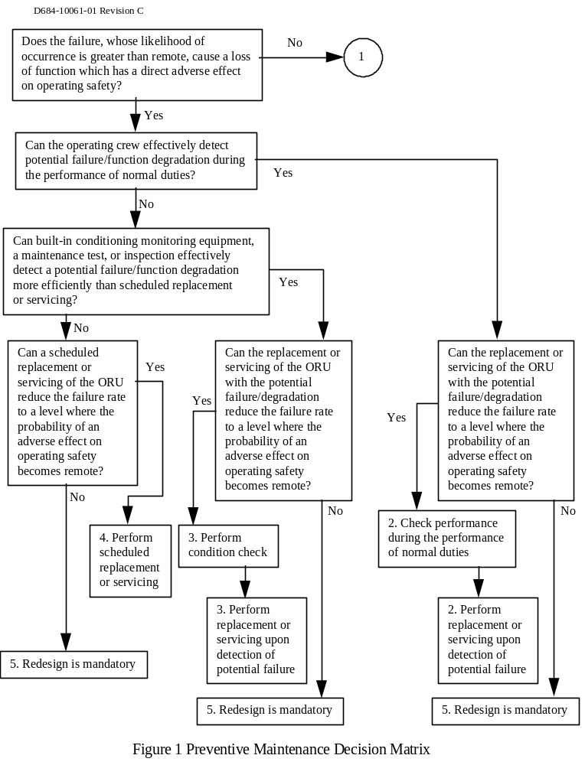
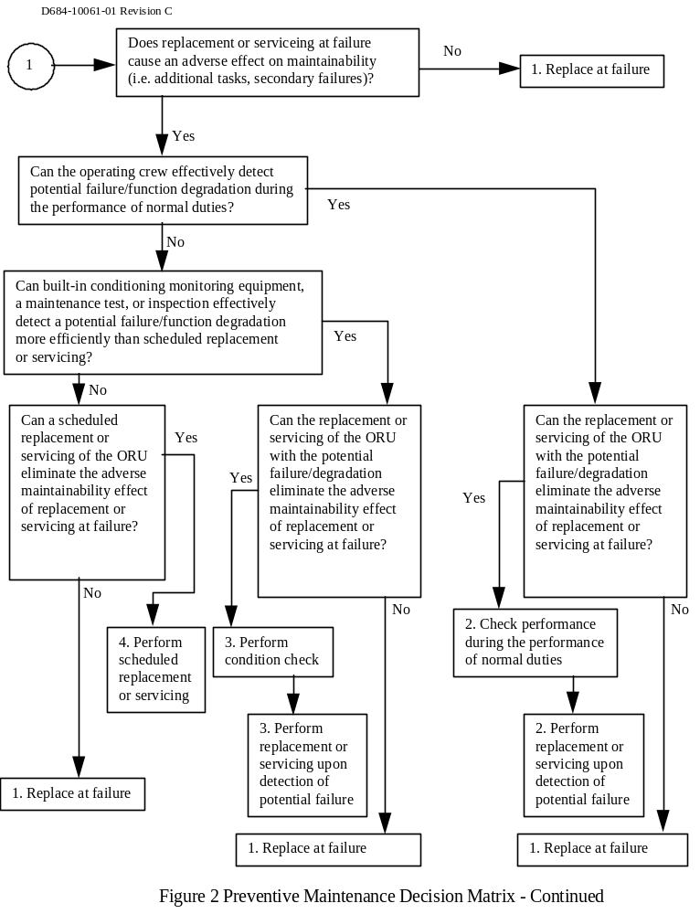

TABLE 1: R&M SOURCE DATA FIELD DEFINITION TABLE

Col DESCRIPTION

A. Item Name - R&M attributes shall be entered for each item which is to be maintained on orbit. The Vehicle Master Data Base (VMDB) nomenclature shall be used for all R&M reporting. R&M is not responsible to develop the Item Name but shall use it as a reference for reporting R&M parameters.

B. Drawing/Part Number - R&M attributes shall be referenced to the Drawing/Part number in the VMDB. R&M is not responsible to develop the Drawing/Part number but shall use it as a reference for reporting R&M parameters.

F. Reliability Class - Reliability classification. The six reliability class codes are as follows:

CODE DESCRIPTION

1 Electronic - equipment which primarily contains digital or low power analog electronics. Moving parts are high power electrical equipment normally constitute less than 5% of the item failure rate in the classification. Electronic type will typically have a fairly high level of Built-In-Testing (BIT).

2 Electrical - equipment which performs electrical power distribution, power storage, signal distribution, and/or radio frequency radiation functions. Moving parts or low power electronics normally constitute less than 5% of the item failure rate in this classification. Electrical types will typically have a low level of BIT.

3 Electro-Mechanical - equipment which contains electrical/electronic and mechanical parts, including devices which use electrical power to produce mechanical motion, and devices which use mechanical motion to produce electrical power or signals. Electro - Mechanical items should contain more than 5% electrical/electronic and more than 5% mechanical parts by failure rate contribution in this classification.

4 Mechanical - equipment which primarily consists of moving parts, fluid handling equipment(including thermal systems), and or seals. High power electrical equipment or low power electronics normally constitute less than 5% of the failure rate in this classification.

5 Structural with Crew Contact - equipment which is primarily structural but encounters planned crew contact or provides equipment protection. This type specifically includes doors, covers, panels, hatches, micro meteoroid/debrise shields, and thermal blankets.

6 Structural with no crew Contact - equipment which is load bearing. Moving parts, electronics, and electrical equipment normally constitute less than 5% of the failure rate in this classification. Structural items should not normally encounter planned crew contact.

G. IVA/EVA/Robotics Code - The code which describes the level of robotic compatibility of the equipment. The codes are as follows:

CODE DESCRIPTION

0 Equipment located in pressurized area.

1 Equipment can be maintained only by EVA crew member. No robotic support is required or intended.

2 Equipment can be maintained using SPDM without EVA. Equipment is SPDM compatible. Compatibility consists of Equipment to SPDM interface. EVA can provide maintenance support in a backup role.

3 Equipment can be maintained using SSRMS without EVA. Equipment is SSRMS compatible. Compatibility consists of Equipment to SSRMS interface. Equipment must be equipped with SSRMS grapple fixture. EVA can provide maintenance support in a backup role.

4 Equipment requires combined SPDM/EVA operations for maintenance.

5 Equipment requires EVA crew member to be positioned on SSRMS for access to the worksite. Equipment requires no robotic compatibility.

6 Equipment requires the Mobile Servicing System/SSRMS for transportation to the EVA worksite. Dimensions or mass of equipment to be replaced are not compatible with EVA/CETA translation. Equipment must be equipped with SSRMS grapple fixture.

J MTBF - Mean Time Between Failures (“Hot” or “operating” MTBF). The estimated average time in hours between failures due to random effects under nominal operating conditions at the maintainable equipment level. Redundancy within the maintainable equipment item which is not necessary to meet failure tolerance requirements (e.g., component redundancy used for reducing maintenance demand) shall be modeled so as to improve the reported MTBF. Worst case estimates shall not be used. Failures of components which are used only during installation or removal (such as deployment motors and mechanisms) shall be excluded where maintenance would not be caused by the components failure. Failures of components which cause degradation of the equipment within the specified limit shall also be excluded. For complex items having components operating at different duty cycles, the operating MTBF may be adjusted to a duty cycle of 1.0. MTBF does not include failures due to Micrometeoroid/Orbital Debris (MM/OD).

K Deleted

L Wearout Life - Expected time to failure (in calendar years at the stated average duty cycles) due to wear-out, degradation, or fatigue conditions in the absence of random failures for age or cycle life limited items. Wearout life should be used as an estimate of characteristic life (L Char) in the algorithms (Table 3). Best available data and engineering judgment should be used to estimate wearout life as the time when 63 percent of a population would have failed due to wearout/aging conditions alone. Minimum design life shall not be reported as the wearout life. No life limit should be reported if the expected wearout life is 20 years or greater.

M MTBPM: Removal/Replacement - Mean Time Between Preventive Maintenance for Removal & Replacement - The average time in calendar hours between all preventive maintenance (PM) replacements. Care should be given when determining if preventive maintenance replacements should be performed in place of waiting until maintenance is required due to gradual performance degradation and eventual wearout (life limits).

Col DESCRIPTION

N MTBPM - Inspect/Service - Mean Time Between Preventive Maintenance for Inspection - The average time between PM inspections and/or servicing expressed in calendar hours. A single MTBPM - Inspect/Service parameter shall be developed for any equipment items requiring multiple servicing and/or inspection actions.

Q CM IVA MTTR - Mean Time to Repair - Nominal elapsed IVA crew hours at the worksite. The MTTR includes remove, replace and fault detection time. Computed for zero-g using task standards. In situations where developer does not control elemental task time enter N/A as the task time.

R Detection Percentage - Percentage of ORU failure modes detected by BIT or other diagnostic techniques.

TABLE 2: FAILURE DETECTION DATA DEFINITION TABLE

Description

Function - Identify the function supported by the ORU.

ORU - Identify the ORU associated with the failure mode code.

Failure Mode Code - Reference the failure mode code for each ORU failure mode as identified in the FMEA.

Cat/Crit Hazard < 24 Hours (Y/N) - May a critical or catastrophic hazard occur in less than 24 hours as a result of the failure mode (Yes or No)

Detection: A/M/N - Specify whether Automatic, Manual or No detection is provided for the failure mode.

Detection: Failure Signature Algorithms - Describe the algorithm (including sensor/system states) used to detect the failure mode.

Detection: SRS/LSAR Reference - Provided a reference to the SRS that documents automatic detection, and/or the LSAR that documents manual detection procedures.

Safe: A/M/N - Specify whether Automatic, Manual or No on-orbit safing is provided for the failure mode.

Safe: Algorithms - Describe the algorithm (including sensor/system states) used to safe a hazard that results from the failure mode.

Safe: SRS/LSAR Reference - Provided a reference to the SRS that documents automatic safing, and/or the LSAR that documents manual safing procedures.

TABLE 3: R&M Source Data Format To Be Entered Into the ISSP Vehicle Master Database (VMDB).

Input Col. # Input Column Name

1 Part Number
2 Mfg. Cage Code
3 Maintainability Serial Number
4 Failure Mode Code
5 Maint. Item Name
6 Maint. Distrib. System Name
7 Maint. Subsystem Name
8 Maint. ORU Function
9 Maint. ORU Des.
10 Maint. Location
11 Maint. Quantity
12 Reliability Class Code
13 Robotics Code
14 Avg. Duty Cycle Prior AC
15 Avg. Duty Cycle After AC
16 MTBF Hot
17 MTBF Cold
18 MTBCF
19 Wearout Life Amount
20 MTBPM RR
21 MTBPM IS
22 CM EVA MTTR
23 CM EVA Crew Size
24 CM IVA MTTR
25 CM IVA Crew Size
26 CM EVR MTTR
27 PM RR EVA MTTR
28 PM RR EVA Crew Size
29 PM RR IVA MTTR
30 PM RR IVA Crew Size
31 PM RR EVR MTTR
32 PM IS EVA MTTR
33 PM IS EVA Crew Size
34 PM IS IVA MTTR
35 PM IS IVA Crew Size
36 PM IS EVR MTTR
37 Manifest Flight
38 Activation Flight
39 EVA RMAT Overhead Code
40 EVR RMAT Overhead Code
41 IVA RMAT Overhead Code
42 EVA Total Maint. Crew Time
43 IVA Total Maint. Crew Time
44 EVR Total Maint. Crew Time
45 Total Maint. Actions
46 Auto 24 Des.
47 Crit. Hazard 24 Hr. Des.
48 Criticality Code
49 Detection Automation Code
50 Detection Algorithm
51 Detection SRS LSAR Ref
52 Isolation Ambiguity Level Mnt.
53 Isolation Automation Code
54 Isolation Algorithm Mnt.
55 Isolation SRS LSAR Ref Mnt.
56 Isolation Automation Code Reco
57 Isolation Algorithm Reco
58 Isolation SRS LSAR Ref Reco
59 Recovery Automation Code
60 Recovery Algorithm
61 Recovery SRS LSAR Ref
62 Safe Automation Code
63 Safe Algorithm
64 Safe SRS LSAR Ref

1. DRD Title | 2. Date of current version | 3. DRL Line Item No. |  |  | RFP/Contract No. (Procurement completes)
Annual Assessment of Baseline Operational Readiness | 6-20-02 | 35 |  |  | NAS 9-02078
4. Use (Define need for, intended use of, and/or anticipated results of data) |  |  | 5. DRD Category: (check one)
Used to report on required annual assessment of the Bioastronautics Baseline Operational Readiness function and recommended actions for best efficiency and effectiveness. |  |  | XX | Technical  Administrative  SR&QA
6. References (Optional) | 7. Interrelationships (e.g., with other DRDs) (Optional)
Section C 1.1.3 | Government approved changes to the Baseline Operational Readiness Plan resulting from this assessment will be documented using Baseline Operational Readiness Plan DRD
8. Preparation Information (Include complete instructions for document preparation)

- This Assessment shall be performed annually. It shall be delivered to the CoTR by the end of July each year.
- The assessment shall review all aspects of the Baseline Operational Readiness task, including all metrics and their efficacy, specifically including metrics on the level of utilization of each baseline Facility and Laboratory including demands for its services that were met and the demands that were not met. Metrics for the Baseline Operational Readiness Task shall be presented for all contract years.
- The assessment shall document the accomplishments of the Baseline Operational Readiness task for the prior year.
- The assessment shall report shortcomings and deficiencies.
- The report shall recommend changes, if any, in the Baseline Operational Readiness Task that could improve the effectiveness and efficiency of the task.
- Each recommendation shall include a cost / benefit analysis showing the anticipated changes in cost and effectiveness in a quantitative comparison with present practice.
- The government shall review all recommendations, and the CO shall authorize changes, if any.
- Authorized changes will be documented using Baseline Operational Readiness Plan DRD.

1. DRD Title | 2. Date of current version | 3. DRL Line Item No. |  |  | RFP/Contract No. (Procurement completes)
Electronic Work Instructions | 6-21-02 | 36 |  |  | NAS 9-02078
4. Use (Define need for, intended use of, and/or anticipated results of data) |  |  | 5. DRD Category: (check one)
This DRD requires that all work instructions used on the Bioastronautics Contract shall be available in electronic format to the CoTR. The DRD also requires that a complete set of current work instructions be delivered a year before the end of the contract and at other times as requested by the CoTR. |  |  | XX | Technical  Administrative  SR&QA
6. References (Optional) | 7. Interrelationships (e.g., with other DRDs) (Optional)
8. Preparation Information (Include complete instructions for document preparation)

- The contractor shall make all current work instructions available in electronic format to the CoTR at all times.
- The contractor shall deliver to the CoTR a complete electronic copy of all the then-current work instructions one year prior to the end of contract.
- The contractor shall deliver to the CoTR a complete electronic copy of all the then-current work instructions within 10 working days of a request from the CoTR. Estimated frequency is not greater than once per year.

1. DRD Title | 2. Date of current version | 3. DRL Line Item No. |  |  | RFP/Contract No. (Procurement completes)
Revisions to the Baseline Operational Readiness Plan | 6-20-02 | 37 |  |  | NAS 9-02078
4. Use (Define need for, intended use of, and/or anticipated results of data) |  |  | 5. DRD Category: (check one)
Used if revisions are required to the Baseline Operational Readiness Plan (J-15). Changes to the Plan shall be implemented in accordance with this DRD. |  |  | XX | Technical  Administrative  SR&QA
6. References (Optional) | 7. Interrelationships (e.g., with other DRDs) (Optional)
Attachment J-15 | The Annual Assessment of the Baseline Operational Readiness DRD may recommend changes. This DRD initiates changes approved by the Government.
8. Preparation Information (Include complete instructions for document preparation)

- The deliverable product of this DRD is a complete version of the Bioastronautics Operational Readiness Plan with all changes that are currently approved. Changes from the previous approved Plan will be marked in the margin.
- The Contracting Officer, Contracting Officer’s Technical Representative (COTR), and authorized Contractor representative will sign and date the revised version of the Bioastronautics Operational Readiness Plan.
- Any changes to the Baseline Operational Baseline Plan resulting from recommendations made in the Annual Assessment of the Baseline Operational Readiness that have been approved by the Contracting Officer will be initiated through this DRD.
- The Government may initiate the use of this DRD at other times as required.
- The Baseline Operational Readiness Plan and approved changes to it documented through this DRD will form the basis for the evaluation of the performance to the requirements of the Baseline Operational Readiness task.
- A revised version of the Baseline Operational Readiness Plan initiated through this DRD will be delivered within 10 working days of the date the Government initiates the use of this DRD.

1. DRD Title |  |  | 2. Current Version Date |  |  |  | 3. DRL Line Item No. |  |  | RFP/Contract No. (Procurement completes)
Space Shuttle GFE Failure Modes and Effects Analysis (FMEA) and Critical Items List (CIL)[FMEA_1] |  |  | 8 Oct 96 |  |  |  | 38 |  |  | NAS 9-02078
4. Use (Define need for, intended use of, and/or anticipated results of data)
To identify to program management the risk associated with design, use, and failure of systems.
5. DRD Category: (check one) |  | Technical |  |  |  | Administrative |  | x | SR&QA
6. References (Optional) |  |  |  | 7. Interrelationships (e.g., with other DRDs) (Optional)
See “Reference Documents” under item 8. below.
8. Preparation Information (Include complete instructions for document preparation)

Reference Documents:

a. NHB 5300.4 (1D-2), “Safety, Reliability, Maintainability and Quality Provisions for the Space Shuttle Program”

SCOPE: The FMEA and CIL are applicable to all Government-furnished equipment classified as flight hardware.

FORMAT: Electronic delivery or through data keyed directly into the NASA application. (JSC will identify the available application.) The format of the FMEA and CIL shall be in accordance with NSTS 22206 “Instructions for Preparation of Failure Modes and Effects Analysis FMEA) and Critical Items List (CIL).
. A suggested format is provided, with the numbers in parentheses corresponding to the data elements in NSTS 22206, table 3.0 for FMEAs and table 4.0 for CILs. Other formats are acceptable provided all FMEA data elements are included.

CONTENTS: The hardware provider shall provide FMEAs and CILs for project and
program management.

An FMEA shall be performed on every system, subsystem, assembly, or item to identify failure modes and the effects thereof for support of additional design action, safety analysis, hardware/software interface analysis, test planning, mission planning, preparation of mandatory inspection points, fault detection and isolation,
maintainability analysis and planning, maintenance planning, and logistics planning.

The FMEA shall be conducted and prepared in accordance with NSTS 22206. The FMEA may be sufficed by a properly completed criticality worksheet alone if the system,
subsystem, assembly, or item under analysis is noncritical.

The CIL is used to identify critical items which require special risk assessments to support the activities supported by the FMEA and waivers to program requirements. The
CIL shall be conducted and prepared in accordance with NSTS 22206.

FAILURE MODE EFFECTS ANALYSIS/CRITICAL ITEMS LIST

FMEA NUMBER: ORIGINATOR PROJECT:
PART NAME: LRUPART NUMBER: QUANTITY:
PART NUMBER: LRU/ORU PART NAME: SYSTEM:
LSC CONTROL NO: DRAWING/REF DESIGNATOR: SUBSYSTEM:
ZONE/LOCATION: EFFECTIVITY/AFFECT STAGE:

CRITICALITY:
CRITICAL ITEM?

CRITICALITY CATEGORY____

REDUNDANCY SCREEN:

ORBITER/SPACE STATION

A -
B -
C -
D.-

FUNCTION:

FAILURE MODE CODE:
FAILURE MODE:

CAUSE:.

FAILURE DETECTION:
REMAINING PATHS: EFFECT/ MISSION PHASE:

___________________________________________________________________________________________________________CORRECTIVE ACTION:

-FAILURE EFFECTS-

END ITEM/LRU/ORU/ASSEMBLY:

SUBSYSTEM/NEXT ASSEMBLY/INTERFACE:

SYSTEM/END ITEM/MISSION:

CREW/VEHICLE :

FAILURE MODE EFFECTS ANALYSIS/CRITICAL ITEMS LIST

FMEA NUMBER: ORIGINATOR PROJECT:
PART NAME: LRUPART NUMBER: QUANTITY:
PART NUMBER: LRU/ORU PART NAME: SYSTEM:
LSC CONTROL NO: DRAWING/REF DESIGNATOR: SUBSYSTEM:
ZONE/LOCATION: EFFECTIVITY/AFFECT STAGE:
HAZARD INFORMATION:

HAZARD: YES___ NO__

HAZARD ORGANIZATION CODE:

HAZARD NUMBER:
TIME TO EFFECT:
TIME TO DETECT:
TIME TO CORRECT:
FAILURE DETECTION/FLIGHT:

REMARKS:

-RATIONALE FOR ACCEPTABILITY-

(A) DESIGN:

(B) TEST:

(C) INSPECTION:

(D) FAILURE HISTORY:

(E) OPERATIONAL USE:

(F) MAINTAINABILITY:

PREPARED BY: REVISION:

DATE: WAIVER NUMBER

