UNDER
PRIME CONTRACT NO. DE-AC36-99-GO10337
SUBCONTRACT NO. ADJ-2-30630-05

STUDIES OF BASIC ELECTRONIC PROPERTIES
OF CdTe-BASED SOLAR CELLS & THEIR EVOLUTION DURING PROCESSING & STRESS

Quarterly Technical Status Report

For Quarter Ended January 31, 2003

Subcontractor: Colorado School of Mines

Principal Investigator: Victor Kaydanov
Principal Investigator: Tim R. Ohno

Professor: Peter Sutter

Grad. Research Associates: James Kestner, Scott Feldman,

Fred Seymour

Contract technical monitor: Kenneth Zweibel

In this project, we emphasize the relationship between structural and electronic material properties and various processing procedures as well as the microscopic mechanisms responsible for cell performance and degradation. Our activities in the past Quarter included further development of both the CdTe deposition techniques and methods for studies of cell electronic and structural properties. The latter was accompanied with application of these methods for characterization of differently processed and stressed cells.

- Optimization of CdTe processing procedure

In Phase I of the project, the Jet Vapor Deposition (JVD) technique replaced the initial APCVD system. The JVD setup results in growth rates up to two orders of magnitude greater and material utilization of at least an order of magnitude better than APCVD. Currently our efforts are aimed at optimization of all cell processing steps for this new deposition technique. Our previous Report [1] provided the results of variation of the CBD CdS layer thickness and pre- CdTe heat treatment. These activities lead to a significant improvement in cell performance. Our recent efforts were focused mostly on CdTe growth conditions and CdCl₂ heat treatment. CdTe films were grown at the “nominal” substrate temperatures of 150, 300, and 450ºC. The actual substrate surface temperature was likely 50-100ºC higher due to additional radiative heating by the CdTe source during deposition. CdTe was deposited on the surface of the 300 nm thick CBD CdS annealed for 50 minutes at 450ºC. These were the substrates that were previously determined to yield the best devices for vapor-deposited CdTe. Following CdTe deposition, films grown at each substrate temperature were annealed at 370, 390, and 410ºC in the presence of CdCl₂ as described in [1]. The cells were completed with application of a Cu/Au back contact.

The substrate temperature of 150°C yielded the poorest devices with the most variability as expected. Devices on the 300°C films appeared to show the most consistent performance as a function of anneal temperature. The best cells were obtained with the 450°C films annealed at 390°C. The films grown at 450ºC showed a dark colored, rough-looking ring around the perimeter of the substrate. SEM images reveal a rather different grain structure and high roughness in this region as compared to the smoother, lighter-colored film in the center. Cells made near the center of the substrates consistently yielded better performance than those near the edge. It is thought that this variation is likely due to gradients in substrate temperature across the sample, and further studies are ongoing to confirm this hypothesis.

The results of these and previous studies show that there is room for further optimization of processing and improvement of the cell performance (currently the efficiency reached is about 9%). In particular, we continue investigating the influence of substrate temperature combined with the temperature and duration of the CdTe post-deposition treatment. Simultaneously, we are developing the PECVD technique for deposition of a high resistance SnO₂ buffer layer on the top of commercial soda lime glass substrates coated with TCO. Supposedly, the buffer layer will allow for the further thinning of CdS that so far was shown to be beneficial for our cells.

- Electroluminescence (EL)

Our previous studies [1] indicated that CdTe/CdS cells emitted light under forward bias in the photon energy range in the vicinity of the CdTe bandgap. The EL spectra were similar to the PL ones, both at room and at low temperatures. Using a CCD camera and a microscope objective we obtain spatially resolved EL images with the average current densities through the cell on the order of J_{sc} or even less. It was found that both average EL intensity and the bright spots pattern are significantly influenced by cell processing and stressing.

In the reported Quarter we continued our efforts to develop further and improve the procedure of EL measuring/imaging and data treatment, as well as studying EL on the cells fabricated by various institutions and stressed under different conditions.

Our optical system allows for imaging only small fragments of the cells of the area that does not exceed 1.6x1.2 mm². To provide images of a greater area or the whole cell we have developed the procedure of stitching together neighboring images using Adobe Photoshop. Improvements also have been made to correct for differing contrast levels. The ability to create EL images of entire cell is important if comparative studies and mapping of non-uniformities are performed using various methods such as EL, LBIC, thermography, etc., on the same cell. It is also beneficial for repeated imaging of the same small fragment in the course of stressing. Fig.1 shows mosaic EL images of the cells fabricated at First Solar (FS) with vapor transport deposition, University of South Florida (USF) – close space sublimation, and University of Toledo (UT) – sputtering. These cells are to be characterized periodically with EL and other methods in the course of stressing.

Figure 1. EL image mosaics. All are to scale in dimensions but not brightness. Note, the FS cell
was scribed from a circle into a sector to approximate the area of the UT cell while
still showing the edge of the original cell.

With the newest imaging station, the resolution at the high magnification setting was also improved. Utilizing the 10x microscope lens, each CCD pixel images a ~0.87 m long square fragment of a cell. This resolution is near the optical limit since the photons emitted have a wavelength close to ~ 0.85 m. A high magnification image of the UT cell from above is shown in Fig. 2. Note the difference in non-uniformity: whereas the image of the entire cell (Fig.1) looks rather uniform, the highly resolved image is visibly inhomogeneous.

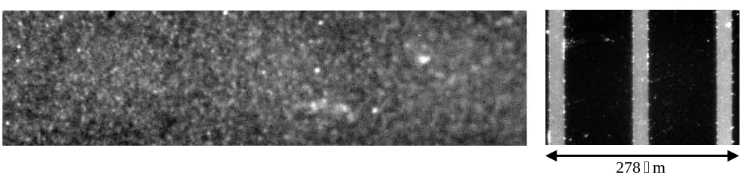
Figure 2. High magnification image of UT cell shown in Fig. 1, above. The calibration grid on
the right has 20 m wide white lines on it.

In addition to viewing the images, particularly bright/dark spots patterns, their sizes and distribution over an entire cell or a small fragment area, we have also developed and used some quantitative approaches to EL characterization.

Intensity data of each pixel in the CCD is imported into Mathematica. The simplest piece of information that can be obtained is the total integrated intensity, or equivalently the mean intensity. To numerically characterize the inhomogeneity of EL emission, a parameter “nonuniformity” is used. Its value is defined as the standard deviation of the pixel EL intensity normalized by the mean EL intensity. In order to characterize the nonuniformity in more detail, namely by the distribution of brightness, a histogram of the pixel brightness is used. Comparing the images in Figs. 1 and 2 provides an opportunity to show how different some histograms hence EL patterns could be. Fig. 3 presents the histograms taken from the fragments in the interior parts of the FS and UT low magnification images in Fig.1 as well as a histogram of a small fragment from the high magnification image in Fig. 2. It is seen that “non-uniformity” is much greater for the FS than for the UT cell, while the mean intensities do not differ significantly. While the UT histogram demonstrates distribution close to that of the gaussian, the FS one has a wide peak with a shoulder, indicating two separate populations. This corresponds to the observed light and dark regions of the cell.
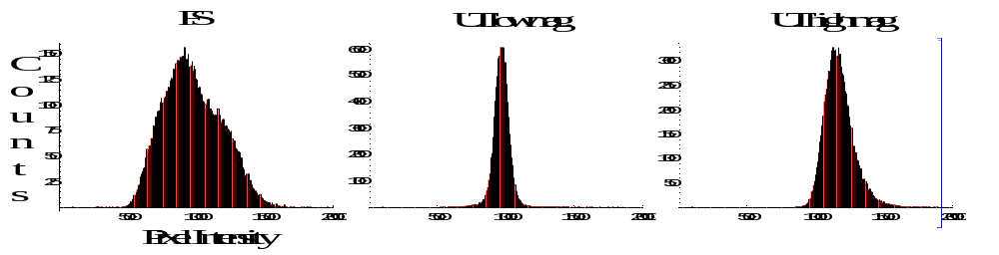
Figure 3. Selected Histograms
The differences between the low- and high-magnification image histograms for the UT cell indicate that there coexist several characteristic non-uniformity spatial scales. To detect and study them we started to use variogram analysis [2] which is a geostatistical technique used to quantify the spatial correlation of data. A variogram consists of determining all sample pair combinations and calculating the sample value difference squared. These sample pairs are divided into classes, or lag cells, based on sample pair separation distance and direction. For each lag cell, the average sample pair value difference squared is computed. Typically, the closely spaced pairs have a smaller mean difference squared than the more widely spaced pairs. The extent of this spatial correlation enables quantifying the scale and anisotropy in the non-uniformity structures underlying the EL data. We tried to apply it to the analysis of the CCD pixel counts for the image taken from a small fragment of a cell. Two correlation structures with a separation of about 10 m and 60 m were found. We are planning to apply this technique to the higher area images, which we believe will detect the additional correlation structures of greater separation. The first step will be studying the mosaic images and then those taken from the pattern of equidistant fragments of a large area cell/submodule.

3. Scanning Tunneling Microscopy and Tunneling Spectroscopy (STM and STS)

In [1] we have presented the results of STM imaging and STS measurements on an almost completed CdTe cell (excluding back contact metallization). The CdTe absorber layer was coated with a nominally 400-500 Å thick ZnTe:Cu back contact interlayer. ST microscopy was performed on the surface of the ZnTe, but with the STM collector on the TCO layer. In this configuration, tunneling electrons are injected into the ZnTe layer, but have to travel into the CdTe absorber to contribute to the tunneling current. Both constant-current ‘topographic’ STM images and current images were obtained on ZnTe/CdTe. In constant-current STM, the tip, controlled by a feedback loop, is scanned at constant bias voltage and tunneling current, thus following and mapping the sample topography. In current imaging, the feedback is switched off at each pixel and a current voltage curve is obtained at this position. From this data set, maps of tunneling current at a given bias voltage can be obtained.

Following our demonstration of the possibility to use scanning tunneling microscopy for spectroscopic imaging on CdTe thin film solar cells, providing maps of current conduction and collection at nanometer resolution, our activities have centered on two major focus areas:
- Modeling of local current injection from an STM tip and of the subsequent current transport
in the cell.
- Design/construction of a microscope dedicated to topographic and current imaging on thin
film solar cells.

Modeling of local current-voltage (I-V) characteristics will allow us to build a solid framework for interpretation of STM current maps on entire CdTe cells. Our model extends previous calculations of the STM I-V spectra, accounting for carrier tunneling across the vacuum gap between the STM tip and cell surface, and for current transport in the cell. From a fit of the model to the experimental data, we should thus be able to extract information on the spatial distribution of current in the cell (with ~ 1 nm resolution), e.g., comparing grain boundaries with intragrain material.

When completed, construction of a dedicated microscope will give us a range of new capabilities that are important for current mapping on thin film solar cells. Among the capabilities of the new microscope are:
- large scans with fields of view of 20 x 20 μm²,
- coarse tip positioning in two axes using a micrometer table with 1cm travel,
- optical access, allowing future combined experiments, e.g., EL mapping together with STM
current imaging.
We are planning to complete the new microscope and make it operational by the end of February, 2003.

- Team Activities

We participate in two CdTe Team inter-institutional programs: “Non-uniformity” and “Defect Chemistry”. For the former we study electroluminescence on the cells fabricated at FS, UT, FSU. They are sent to us by Diana Shvydka from UT, the institution which manages the program. We obtain and analyze the EL images as described in Sec.2. The results obtained are sent back to the UT.

The second program is headed by FS. Cells at different stages of stressing are sent to us by Anke Abken and are the subject for the I-V, admittance spectroscopy (AS) and EL characterization. Recently we have received and started characterization of the cells stressed for 43 days under the open circuit and reverse bias conditions. There is some delay in supplying FS with the results of characterization. The reasons are: (a) Scotty Gilmore who was performing AS measurements has defended his Ph.D thesis and left; his successor, a new graduate student Fred Seymour, has to study in detail the measurement procedures; (b) we are revising once more all our approaches for measuring and interpreting the results of AS; (c) we are developing a system that will allow us to perform the AS in a wide temperature range under varying illumination. After completing I-V and AS measurements the cells are characterized with EL. Currently, the EL characterization has been started on the cells stressed for 7 days.

5. References

- V.I Kaydanov, T.R. Ohno, “Studies of Basic Electronic Properties of CdTe-Based Solar Cells & Their Evolution during Processing and Stress”, Annual Technical Report, Phase I, Oct. 16, 2001 – Oct. 15, 2002. Subcontract No. ADJ-2-30630-05 under Prime Contract No. DE-AC36-99-GO10337. Colorado School of Mines, Golden, Colorado.
2. M. David, “Geostatistical Ore Reserve Estimation”, Elsevier Scientific Publishing , 1977, pages 73-90.

