 FactSheet

National Aeronautics and
Space Administration
Ames Research Center
Moffett Field, California 94035-1000 October 2002

SUPPORTING NASA’S AIRSPACE SYSTEMS PROGRAM

AOS Project brings human factors focus to AS Program capacity and mobility goals

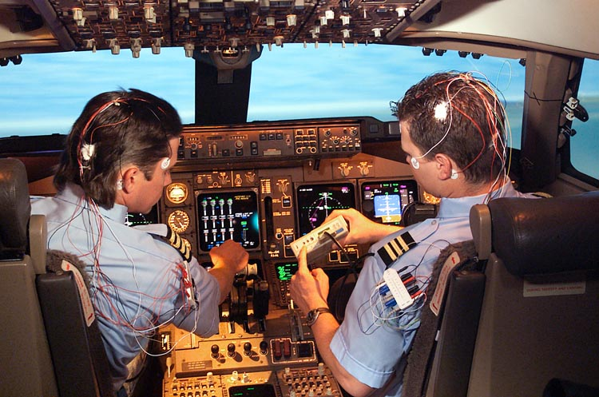
Photo by NASA Ames
Pilot brainwave activity is monitored in the Crew Vehicle System Research Facility’s Boeing 747-400 Simulator during a study to determine fatigue, sleep loss and circadian rhythm disruption during long- and extra-long-haul flights.

Making its official debut October 1 as one of four projects comprising the Airspace Systems (AS) Program, the former Airspace Operations Systems (AOS) Research and Technology Base Program transitioned to the AOS Project in fiscal 2003 as part of a comprehensive Aerospace Technology Enterprise program reformulation plan. The Airspace Systems (AS) Program—itself reformulated from NASA’s former Aviation Systems Capacity Program—is dedicated to two major NASA goals in global civil aviation: to triple aviation system capacity by 2022; and to cut doorstep-to-destination travel time by half.

Safely achieving such increases in the capacity and mobility of an increasingly dense National Airspace System (NAS) will require a new generation of highly automated, complex air transportation system (ATS) tools and technologies. It will also place additional burdens on pilots and air traffic controllers (ATCs) by significantly increasing their cognitive, perceptual and physiological workload. Understanding how to minimize that workload is where the AOS Project provides support. The project aims to ensure through sound design principles and operational guidelines that the advanced automation, interfaces and operations associated with next-generation ATS tools and technologies never contributes to human error or needlessly increases, complicates or interferes with pilot or operator workload.

In pursuit of that aim, the AOS Project pioneers research on the interactions between pilots, ATCs, and other operators of ground, satellite and vehicle systems, with an emphasis on human factors and performance issues—in particular the cognitive, perceptual and physiological aspects of the way that people process information, make decisions, collaborate with one another and interact with automatic systems.

Specific performance objectives in the project’s area of research aim to 1) identify, develop and verify advanced technology concepts, methods and procedures; 2) transfer the results to industry and other government agencies for use in designing advanced systems; 3) provide a foundation for systems technology; and 4) contribute facilities and human factors expertise to industry and government.

AOS Research Teams

Three teams conduct AOS research activities: Human-Automation Integration (HAIR), Human Error and Countermeasures (HEC), and Psychological and Physiological Stressors and Factors (PPSF).

The HAIR research team develops and validates formal methods for human-automation design, analyzes flight control systems and known automation-induced errors, and develops formal methodologies for demonstrating cost effective designs for displays and operational procedures. This year, researchers will develop a preliminary cognitive architecture for analyzing and predicting human performance in complex aerospace systems. The results will improve accuracy in predicting human error, reduce design time and minimize design-induced errors.
HEC researchers develop training protocols, operational procedures and technologies to reduce the potential for human error in aerospace operations and optimize human performance in flight-critical situations. Areas of inquiry include risk and uncertainty in team decision-making, attention span while performing concurrent tasks, pilot and controller communication, pilot “situation awareness,” and the impact of fatigue on performance. This year, researchers will develop training protocols aimed at improving communication between airline pilots and FAA controllers as a means of reducing errors.

The PPSF research team explores the perceptual, cognitive, and physiological processes that people use to detect, interpret and interact with information from the external environment—e.g. aircraft cockpits and ATC towers. Researchers conduct fundamental and applied studies with volunteer human subjects. This year, researchers will develop cognitive and physiological computational models to enable designers of high fidelity displays and aerospace systems to predict and assess pilot and controller performance while executing several tasks concurrently. Research will also assess pilot performance during periods of periods of mental fatigue, boredom, complacency and other “hazardous states of awareness.”

AOS Customers

Customers across the international aerospace community use AOS Project case studies, rapid prototype environments, methodologies, models, metrics, training protocols and other research products. Customers include:

- Designers of flight deck displays, windscreen layouts, simulator visual systems, unmanned aerial vehicle control stations, and 2nd and 3rd generation shuttle cockpit upgrades
- Evaluators of aerospace accidents and incidents
- International standards committees
- US Navy
- FAA
- Defense Advanced Research Projects Agency
- Department of Transportation
- Boeing, Airbus and other commercial airline companies, especially those with long-haul and ultra-long-haul flights

Research Facilities

human factors labs
- Human-Centered Systems Lab
- General Aviation (GA) Simulator Lab
- Fatigue Countermeasures Lab
- Team Decision-Making Lab
- Memory Task Management Lab
- Vestibular Research Facility
- Vertical Motion Simulator
- 20-G Human-Rated Centrifuge
- Vision Research Lab and Facilities
- Virtual Environment Lab
- Haptics Lab
- Spatial Auditory Lab
- Electro-Micrography Lab
- Cockpit Display of Traffic Information Lab
- Center TRACON Automation System (CTAS) Automation Lab
- Air-Ground Integration lab
- Datalink Lab
- North Texas Facility for CTAS

crew vehicle system research facility
- Boeing 747-400 Simulator
- Advanced Concepts Flight Simulator
- Air Traffic Control Simulator

general aviaiton simulator
- Generic device used to simulate single/dual engine general aviation aircraft

airborne integrated research experiments
- B-757 aircraft and simulator

For more information, visit www.asc.nasa.gov and www.aos.arc.nasa.gov or contact the Airspace Systems Program Office at (650) 604-1438.

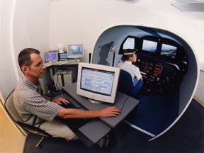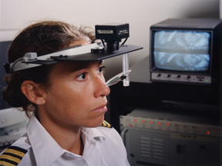
Photos by NASA Ames
An AOS research scientist tracks pilot eye movement in the GA Simulator Lab as part of continuing research in cockpit task management focused on understanding factors affecting task prioritization on commercial flight decks.

