APPLIED ENGINEERING AND TECHNOLOGY DIRECTORATE



Flight Dynamics Analysis Branch

End of Fiscal Year 2001 Report

- Barnes, T. Stengle, S. Truong


National Aeronautics and
Space Administration

Goddard Space Flight Center
Flight Dynamics Analysis Branch/Code 572
Greenbelt, Maryland 20771

December 2001

Flight Dynamics Analysis Branch

End of Fiscal Year 2001 Report

National Aeronautics and
Space Administration

Goddard Space Flight Center
Flight Dynamics Analysis Branch/Code 572
Greenbelt, Maryland 20771

Acknowledgements

The contents of this report are based on inputs generously supplied by members of the Guidance, Navigation, and Control Center (GNCC) Flight Dynamics Analysis Branch (FDAB) at NASA/Goddard Space Flight Center (GSFC).

The primary editors of this report are:
Alex Barnes, Flight Dynamics Analysis Branch, Code 572
Tom Stengle, Head, Flight Dynamics Analysis Branch, Code 572
Son Truong, Flight Dynamics Analysis Branch, Code 572

Additional information concerning FDAB activities may be obtained through the following Branch management:
John P. Lynch, Associate Head, Flight Dynamics Analysis Branch, Code 572
Karen Richon, Associate Head, Flight Dynamics Analysis Branch, Code 572

Published copies of this report are available from:
Catherine A. Waltersdorff
Flight Dynamics Analysis Branch
Code 572
NASA/Goddard Space Flight Center
Greenbelt, MD 20771

A Hypertext Markup Language (HTML) version of this document will be available on the Internet World Wide Web (WWW) in the Uniform Resource Locator (URL):

http://fdab1.gsfc.nasa.gov/

Abstract

This report summarizes the major activities and accomplishments carried out by the Flight Dynamics Analysis Branch (FDAB), Code 572, in support of flight projects and technology development initiatives in Fiscal Year (FY) 2001. The report is intended to serve as a summary of the type of support carried out by the FDAB, as well as a concise reference of key accomplishments and mission experience derived from the various mission support roles. The primary focus of the FDAB is to provide expertise in the disciplines of flight dynamics, spacecraft trajectory, attitude analysis, and attitude determination and control. The FDAB currently provides support for missions and technology development projects involving NASA, government, university, and private industry.

Table of Contents

- Introduction

2.0 Flight Project Support
2.1 Development Missions

2.1.1 Triana
2.1.2 Space Technology (ST5)

2.1.3 Aqua Earth Observing System (EOS)
2.1.4 Aura EOS
2.2 Operational Missions
2.2.1 Microwave Anisotropy Probe (MAP)

2.2.2 Earth Observing (EO) -1
2.2.3 Geostationary Operational Environmental Satellite (GOES)
2.2.4 Landsat-4 Decommissioning
2.2.5 Tropical Rainfall Measuring Mission (TRMM)
2.2.6 InFocus Balloon Program
2.2.7 General Space Operations Management Office (SOMO) Support
3.0 Study Mission Support

3.1 Integrated Mission Design Center (IMDC)
3.2 KRONOS
3.3 Constellation X
3.4 Global Precipitation Mission (GPM)
3.5 Next Generation Space Telescope (NGST)
3.6 Living With A Star: Solar Dynamics Observatory (SDO)
3.7 Magnetospheric Multiscale Mission (MMS)
3.8 Laser Interferometer Space Antenna (LISA)
3.9 Leonardo
4.0 Technology Development Activities
4.1 Advanced Mission Design
4.1.1 Generator Software Tool
4.1.2 SBIR Phase II Research: Optimal Orbit Transfer Analysis for Advanced Space Systems
4.1.3 Optimal Mission Design

4.2 Autonomous Navigation Technologies

4.2.1 Autonomous Onboard Navigation systems
4.2.2 Adaptive Kalman Filter for Autonomous Navigation

4.2.3 Magnetometer Based Navigation
4.3 Formation Flying Technologies

4.3.1 EO-1 Formation Flying Experiment

4.3.2 SBIR Phase II Research: Autonomous Unified Orbit and Attitude Control for Formation Flying Using GPS and LQG/LTR Controller
4.3.3 Decentralized Estimation and Control of Distributed Spacecraft
4.4 Attitude Determination and Modeling Techniques
4.4.1 Attitude and Orbit Model Support
4.4.2 Advanced Attitude Determination and Sensor Calibration
4.4.3 Multi-Mission Attitude Determination System
4.5 Flight Dynamics Automation Studies
5.0 Branch Infrastructure
5.1 Flight Dynamics Tool Program
5.2 Flight Dynamics Lab

5.3 FDAB Web Page

5.4 2001 Flight Mechanics Conference
6.0 Interagency Activities

6.1 GSFC Standards Program
6.2 X-43A Anomaly Investigation
7.0 Outreach Activities
7.1 SAMPEX University Operations
7.2 Undergraduate Student Research Program (USRP)
7.3 PREST Program
7.4 Graduate Student Research Program (GSRP)
7.5 TEAMS Competition
7.6 Public Education/Community Outreach

Appendix A – Awards
Appendix B - University Grants
Appendix C – Conferences and Papers
Appendix D- Acronyms and Abbreviations

1.0 Introduction

The Guidance, Navigation and Control Center (GNCC) at the Goddard Space Flight Center (GSFC) provides the skills, vision and leadership in guidance, navigation and control (GN&C) systems, engineering, operations and mission analysis to enable revolutionary Earth and Space Science discovery. The scope of technical disciplines encompassed by the GNCC is broad and includes all aspects of flight dynamics, propulsion, flight mechanics, guidance, navigation and control engineering for space systems, experiments, and sub-orbital missions. The range of products and services is also broad and requires expertise in skill areas such as advanced component design, control system architecture, propulsion design, trajectory analysis, autonomy and mission design.

Within the GNCC, the Flight Dynamics Analysis Branch (FDAB), Code 572, is responsible for providing Guidance, Navigation and Control analytic expertise for trajectory and attitude systems. This includes dynamics and control analyses and simulations of space vehicles. The Branch creates and maintains state-of-the-art analysis tools for mission design, trajectory optimization, orbit analysis, navigation, attitude determination, and controls analysis. The Branch also provides the expertise to support a wide range of flight dynamics services such as mission design, on-orbit sensor calibration, and launch/early orbit operations. The FDAB also maintains an active technology development program, with special emphasis on developing new techniques and algorithms for autonomous orbit/attitude systems and advanced approaches for trajectory design. Specific areas of expertise resident in the FDAB are:

- Attitude and trajectory analysis and control design
- Control/Structure interaction analysis
- Mission (attitude & trajectory) planning
- Estimation techniques
- Vehicle autonomy
- Constellation analysis
- Flight Dynamics model development

This document summarizes the major activities and accomplishments performed by the FDAB in support of flight projects and technology development initiatives in Fiscal Year (FY) 2001. The document is intended to serve as both an introduction to the type of support carried out by the FDAB, as well as a concise reference summarizing key analysis results and mission experience derived from the various mission support roles assumed over the past year. The FDAB staff that are involved in the various analysis activities within the branch prepared this document. Where applicable, these staff members are identified and can be contacted for additional information on their respective projects.

Among the major highlights by engineers in the FDAB during FY2001 are:

- Successful launch of EO-1 and demonstration of fully autonomous formation flying (with Landsat-7). Principal Investigators for this flight demonstration included David Folta and David Quinn of the FDAB
- Successful flight dynamics support to the MAP mission. Branch engineers were responsible for attitude control system development, testing, early mission checkout and attitude sensor calibration. The FDAB was also responsible for trajectory design (to take the spacecraft to an L2 libration orbit) and trajectory operations.
- Successful launch support for the GOES-M mission. Flight dynamics engineers planned and executed trajectory maneuvers to put this spacecraft on station.
- Successful decommissioning of Landsat-4. FDAB engineers planned and executed orbit maneuvers to take Landsat-4 out of its operational orbit and assure reentry within 25 years.
- Provisional patent application submitted for the MATLAB-ADS system. This generalized system can provide attitude determination and sensor calibration for both 3 axis stabilized and spinning spacecraft.
2.0 Flight Project Support

This section summarizes FDAB support to Goddard flight projects during FY01. For purposes of this report, these projects are classified as:

- Development Missions: Approved missions under development.
- Operational Missions: Missions that were in-flight in FY01. This includes missions that were in the final stages of development and were successfully launched in FY01 (e.g. MAP).

Support to future mission concept studies and proposal support for missions seeking project approval are covered in section 3.

2.1 Development Missions

2.1.1 Triana
http://triana.gsfc.nasa.gov/home/

Triana Trajectory Design

Flight Dynamics Analysis Branch (FDAB) personnel provided cost-effective flight dynamics support for an April 2002 launch. This support included
- automating the nominal trajectory generation
- developing and refining correction maneuver strategies,
- analyzing orbit maneuver propellant use,
- analyzing initial acquisition and orbit determination errors, and
- developing initial acquisition strategies and tracking schedules.
After Triana was removed from the STS manifest (i.e. launch postponed) in March 2001, FDAB performed preliminary analysis of different Triana launch options (e.g. STS at different inclinations, Delta ELV) and presented a trajectory design review in September, 2001 at the request of the Triana Project office.

Triana Attitude Control System (ACS)

The Triana Attitude Control Systems Analysis team successfully completed its final design review. The review covered the structure's flexible modes and the modes’ impact on controller performance and stability. All requirements were met or exceeded, and the Triana Project Office was satisfied with the controller’s performance.

Extensive work was required for the implementation of the controller’s final design. Since examination of the finer aspects of controller performance requires a real-time test environment, the team spent considerable time planning and completing the flight software testing. The team’s final software build should be completed by October 2001. Meanwhile, the integration and testing work required ongoing support, especially in the phasing test area where two hardware wiring problems were identified and successfully corrected. Also key to this year's activities was the design, implementation, and test of the on-board Failure Detection and Correction software and the ancillary contingency planning and simulation. In preparation for the Triana spacecraft’s storage, the team has completed all action items and analysis reports. The team also documented suggested design refinements.

Triana Gyroscopic Upper Stage (GUS)

In addition to the trajectory design and ACS effort applied to the Triana Observatory, the Flight Dynamics Analysis Branch (FDAB) is also responsible for the end-to-end flight performance of the GSFC designed and built Gyroscopic Upper Stage (GUS). The GUS is a multi-function platform specifically designed for Triana. Two Marman clamp interfaces attach the GUS to both Triana and the IRIS, an Alena-Spazio (Italy) built spin table (which was originally used on the LAGEOS mission) that is mounted across the Space Shuttle cargo bay. The major components that comprise the GUS include a Thiokol built Star-48B solid rocket motor (SRM), the Triana Event Sequencing System (TESS), the Nutation Control System (NCS), and a dedicated power and telemetry system.

The mission time line begins with GUS spin-up in the Orbiter to roughly 60 RPM followed by a command to the pyrotechnic bolt-cutters that open the first Marman clamp and allow the spring-driven actuators to eject Triana. After Triana has cleared the IRIS and surrounding structures, the NCS is enabled. Correct inertial pointing is passively maintained by the gyro dynamics throughout one-half (47 minutes) of a 283 km altitude orbit, while the Shuttle maneuvers to a distance and attitude protected from SRM ignition. During the 84 second burn, the SRM provides a 3,175 meters per second perigee boost. The NCS continues to function through powered flight in a second operational mode. Four minutes after burnout, the GUS is separated from the Triana Observatory by triggering the second Marman clamp and releasing additional actuators. The NCS is inactive and its fuel reserves are passively depleted. The GUS is then earmarked for orbital disposal.

The FDAB has provided analysis of all the major time line events described above. These analyses include clearance analysis of the ejection from the STS, flight dynamics analysis from STS ejection to Observatory separation, design and analysis of the NCS, and post-separation Observatory/GUS recontact avoidance.

The ejection analysis uses a multi-body, non-linear simulation to determine the envelope of motion possible for the spacecraft as it exits the IRIS cradle. The model incorporates twelve degrees-of-freedom, six for a rigid model of the spacecraft structure and six for a damped pendulum lumped-mass model of the on-board Hydrazine fuel. The family of trajectories is continuously compared against a dynamic envelope of the surrounding structure. STS safety criteria require that no recontact can occur for any worst-case combination of up to two failures in either the payload and/or Shuttle systems, for all dispersions of system parameters. Analysis showed that these criteria are met. Milestones completed during FY01 include completion of the Phase II Payload Safety Review at Johnson Space Center and application of Monte Carlo techniques to determine the statistics of the initial spacecraft state for orbit propagation after ejection.

Since the Triana spacecraft spins about its minor principle axis, an active NCS is required during the coasting phase of the mission. The NCS maintains the proper orientation along the pointing (angular momentum) vector in the face of environmental disturbances and internal energy dissipation (e.g. fuel slosh). Since there is no feedback of the inertial reference, the NCS must maintain attitude without disturbing pointing while also minimizing propellant consumption (nitrogen cold-gas). Additionally, during the powered flight phase of the mission, the NCS is available to counteract the end-of-burn coning instability known to exist with the Star-48 class of motors. In this second operational mode, the NCS control strategy seeks to minimize response latency and maximize control authority. The entire NCS design and fabrication was a GNCC effort. Considerable analytical support was provided by the FDAB in algorithm design, simulation, and testing. This included the completion of a high fidelity dynamic simulator capable of both off-line analysis and real-time hardware-in-the-loop testing with the flight electronics modules. One of the more challenging aspects of the simulator design was maintaining the 1 kilohertz clock cycle rate used by the NCS micro-controller. By the end of FY01, the simulator will have been used to support flight software testing, integrated system testing of the NCS to the GUS, and stand-alone performance testing of the flight NCS modules on a 3-axes rate table. Additional effort in the NCS development includes completion of the Peer Review, preparation of an Independent Verification and Validation (IV&V) data package, thruster performance testing at Glenn Research Center, and the Phase II STS Safety Review at Johnson Space Center.

Lastly, both analytical and numerical-based analyses have been used to access the potential for recontact between the Triana Observatory and GUS after the planned separation. Of primary concern regarding this event are the clearance reducing effects for a flat (major axis) spin separation, residual thrusting of the spent upper stage, and an NCS thruster failure.

[Technical contacts: Wendy Morgenstern, Greg Marr, Steve Queen]

2.1.2 Space Technology (ST5) (launch 5/04)
http://nmp.jpl.nasa.gov/st5/
Space Technology 5 (ST5) is a mission in the New Millennium Program and NASA’s first experiment in the design of miniaturized satellite constellations. The mission will last 3 months. During this time the constellation of three spin-stabilized spacecraft will validate new technology for spaceflight. These technologies include a miniature cold gas thruster, x-band transponder, flexible interconnects, variable-emissivity coatings, a constellation communications and navigation transceiver, ultra lower-power logic, autonomous constellation management ground software, as well as, various technology improvements embedded in the spacecraft itself. In addition to validating these new technologies and instruments the mission goal is to reduce the weight, size and cost of space missions, while preserving or improving technical capabilities.

The planned orbit will be a Geostationary Transfer Orbit (GTO) with a perigee as low as 270 km in altitude. Analysis has shown that lower perigees run the risk of being lowered by lunar perturbations below 200 km in altitude, which must be avoided due to undesirable thermal conditions and high aerodynamic disturbances caused by the increased atmospheric pressure at lower altitudes. Ongoing flight dynamics analysis is focused on maintaining the constellation. The spacecraft are required to be separated by no more than 1000 km over a two hour window centered at the apogee of the orbit.
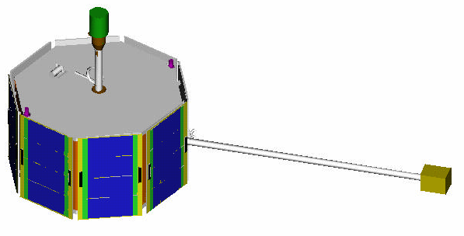
Figure 2.1 ST-5 Spacecraft

The ST5 attitude control system (ACS) must provide an autonomous sun acquisition mode as well as the capability to reorient the spin axis by ground command. The onboard ACS hardware consists of a sun sensor mounted perpendicular to the spin axis, a three-axis magnetometer, and a single cold gas thruster. The cold gas thruster is mounted parallel but offset from the spin axis in order to provide control torque as well as translational acceleration. The challenge was to provide an ACS that uses simple algorithms to minimize onboard processing and work with the limited sensor and actuator compliment. A method that uses Rhumb line precession (common on many spin stabilized spacecraft) to reorient the spin axis will be implemented and tested in hi-fidelity simulations. Nutation will be passively damped using a fluid filled ring damper that is being designed and tested at NASA-GSFC.

Due to tight constraints of the relative orbits of the three spacecraft, careful consideration must be used when planning attitude maneuvers, which change the orbit while precessing the spacecraft spin axis due to the translational and rotational components of the thrust vector. Monte Carlo analysis is being used to determine optimal maneuver planning. The results of this analysis will be used in a high fidelity simulation including high order earth harmonics, solar and lunar perturbations, and accurate atmospheric density models in order to determine the lifetime of the constellation verify that the orbits meet the relative distance requirement.

[Technical contacts: J. Morrissey, M. Woodard, M. Concha]

2.1.3 Aqua Earth Observing System (EOS) (launch 3/02)
http://aqua.gsfc.nasa.gov/

The Flight Dynamics System (FDS) Team provided extensive pre-launch support for the Aqua mission in the areas of attitude determination, mission planning, and flight operations.

The FDS Attitude Team developed specifications for and tested software to support real-time and off-line attitude determination, attitude sensor calibration, and other product planning functions. The new attitude utilities were tested with simulated data from the Aqua Flight Operations Team (FOT). The Attitude Team created stand-alone utilities for project simulation support to meet new Aqua mission requirements.

The FDS Maneuver Team performed various analyses and provided data to support Aqua mission planning. In addition, the Team provided multiple analyses and presentations to demonstrate the feasibility and benefits of phasing Aqua with the EOS AM Constellation. Audiences included the Aqua Project, Earth Science Mission Operation (ESMO) office, and representatives of EOS PM Constellation constituents. The Maneuver Team developed an initial Aqua ascent scenario and, in response to evolving Aqua mission phasing requirements, re-planned the ascent several times. Other analyses completed by the Maneuver Team include Tracking and Data Relay Satellite (TDRS) antenna contact predicts from fairing jettison to separation, TDRS/Polar Ground Station (PGN) contacts during early mission phase, and mission planning product generation. The Maneuver Team provided specification updates and tested the functions for mission products planning. The Maneuver Team provided predict information used in development of the Integrated Mission Timeline, provided inputs for the Delta Detailed Test Objectives (DTO), and generated products for internal GSFC and external Project simulations. In addition, the Team produced simulator initialization parameters required for simulation and testing support.

The FDS Team supported the Aqua FOT with frequent communications, development of documents, and simulations with the Flight Dynamics Facility (FDF). To support testing and to answer questions regarding FDS mission support strategies, the FDS Team communicated frequently with the FOT, Mission Readiness Test Team (MRTT), TRW (spacecraft manufacturer), Raytheon (ground system contractor), and Aqua Project personnel. Communication was both in person and via teleconference. An Operations Procedures Handbook was started and other documents were developed or updated. These other documents include the FDS Timeline, the FDS/Aqua Project Interface Control Documents (ICDs), the FDS/FDF Memorandum of Understanding (MOU), and Operations Agreements between FDS and Earth Mission Operations System (EMOS), and between FDS and FOT. The FDS Team assisted with FDS hardware installation and checkout in the EOS Mission Operations Center (MOC) and defined and tested interfaces of FDS with external entities. The FDS Team coordinated test support with FDF personnel and performed simulations for FDS/FDF product exchanges. Multiple project and internal simulations were also supported.

[Technical contact: D. Tracewell]

2.1.4 Aura EOS (launch 11/2003)
http://eos-aura.gsfc.nasa.gov/

Aura’s major science objective is the study of the chemical interactions and climate change in the Earth's atmosphere, focusing on the upper troposphere and lower stratosphere. The Aura spacecraft is 3-axis stabilized and will operate in a near-circular, sun-synchronous polar orbit at an altitude of about 705 km and an ascending nodal crossing at approximately 1:45 PM mean local solar time. Pre-launch flight dynamics services include mission design, sensor analysis, and operations planning.

During FY2001, FDAB completed a preliminary ascent maneuver plan, station-keeping maneuver analysis, and constellation flying analysis with Aura, Aqua, and other spacecraft. FDAB also presented flight dynamics material at the Aura Ground System Review, provided updates to the Mission Specific Requirements Document (MSRD), refined specifications for products, began development of preliminary Interface Control Documents (ICDs), and participated in meetings of the Afternoon Constellation Working Group. Support was also provided to the Aura Project Scientist at the Aura Science Team meeting in Pasadena, and to the Microwave Limb Sounder (MLS) and Tropospheric Emission Spectrometer (TES) instrument teams. Attitude analysis was performed to determine the best methods for computing attitude data at a frequency of eight Hz.

FDAB worked with the Aura Project Scientist to devise a scheme for flying Aura relative to Aqua in order to obtain coincident imaging between the two spacecraft. The desire is to coordinate observations between the Aqua spacecraft instruments looking in the nadir direction, and the Aura MLS looking forward at the Earth’s limb. The idea is for Aura to view a point on the Earth’s limb a short time after Aqua has flown directly over that point. Aqua will be flying on the World Reference System (WRS) ground track. To accomplish the desired viewing geometry, Aura will fly on an adjacent WRS path with a given offset such that the Aqua ground track will always intersect the Aura MLS field of view at the Earth’s limb, as shown in Figure 2-2. Aura will follow Aqua with an along-track separation between 15 and 22 minutes.

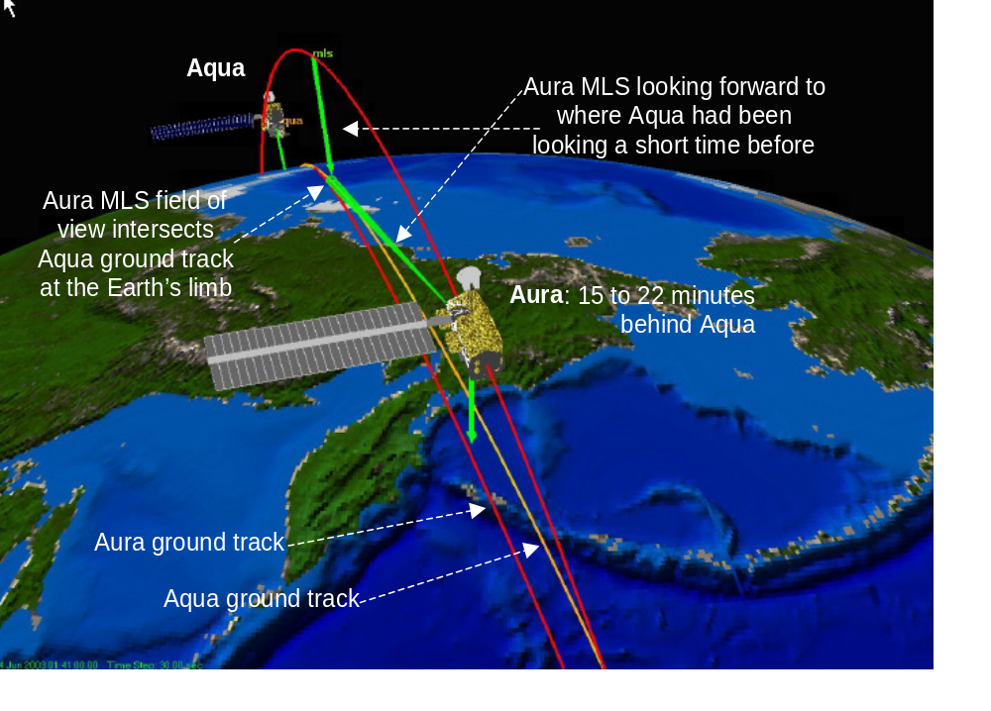Figure 2-2. Relative Positions of Aqua and Aura Showing MLS Viewpoint

[Technical contact: L. Newman]

2.2 Operational Missions

2.2.1 Microwave Anisotropy Probe (MAP)
http://map.gsfc.nasa.gov

Background

FY 2001 has been an extremely productive and busy year for the MAP team as we prepared for launch in the summer of 2001. MAP, shown in Figure 2-3, was successfully launched on June 30, 2001. At this time, MAP is working extremely well, and its thermal stability is as good as the science team had hoped.

MAP is a MIDEX-class mission produced by GSFC in partnership with Princeton University. The goal of MAP is to produce an accurate full-sky map of the cosmic microwave background temperature fluctuations (anisotropy). This map will shed light on several key questions related to the Big Bang theory and expand on the information provided by the NASA Cosmic Background Explorer (COBE) mission. The MAP Mission lifetime is two years with a goal of four years.

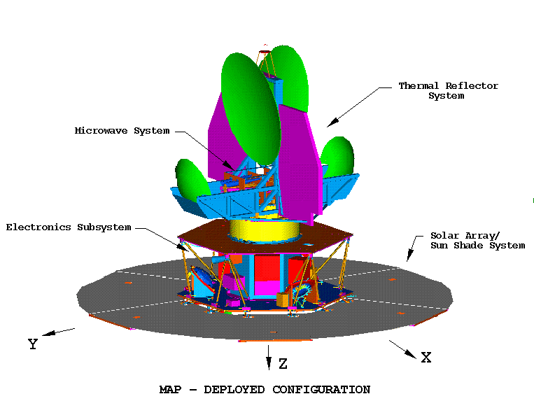
Figure 2-3: The MAP Observatory
AST (2)
IRU (2)
DSS (sun side)
RWA (3)
CSS (6)

Pre-Launch Spacecraft Testing

Mission simulations were run in October 2000, and spacecraft electro-magnetic interference (EMI) tests were run in early November. All the components and the spacecraft as a whole passed the EMI tests. One of the first deployment tests was done in late fall, and the backup two-wheel controller design kickoff meeting was held in early November. Also in November, the spacecraft was prepared for vibration and shock testing, and scripts and procedures for performing maneuvers were generated.

Throughout December 2000, the ACS Team worked hard to prepare for three weeks of thermal vacuum testing followed by thermal balance testing (TV/TB). Procedures were written, and a schedule, temperature profile, and test script were written and refined many times over the course of several months. Functional tests and comprehensive performance tests (CPT) would be performed during TV/TB testing, so all our procedures had to be written and debugged before the testing could begin. Most of January was spent preparing for TV/TB. The testing was 24 hours a day for three weeks, so everyone had to be familiar with every aspect of the hardware, software, scripts, and procedures.

TV testing started January 24 and finished February 20. The thermal profile tested on MAP was the most complicated ever done at Goddard. Everyone involved worked hard, paid attention to details, and didn’t try to cut corners. The only issues were the failure of a survival heater on Autonomous Star Tracker 1 (or AST A), and a question about reaction wheel assembly (RWA) survival versus operational temperatures and conditions. These were both successfully resolved, and the test finished with no outstanding hardware issues. At the end of the testing, everyone on the team had a much better feel for how the system as a whole worked.

Trajectory Design

The MAP trajectory design team presented its work at several major reviews, including peer reviews in January and March, and a red team review in May. The team presented its work on the trajectory design, maneuver operations, and navigation support. The review panels consisted of several internal and external flight dynamics experts. By the red team review, all action items from previous reviews had been fully addressed and closed.

The MAP trajectory team also completed a significant amount of analysis work. In particular, the trajectory team completed and delivered to Boeing the nominal trajectories for the prospective launch months of April, May, June, July, and August; as well as the launch window analysis for the months of July and August. The team completed and documented a number of contingency analyses as well as other trajectory analysis requested by the Trajectory Peer review panel and by the MAP project. A few of the contingency analyses completed and documented are Using Mid-Course Correction (MCC) delta-V to remove L₂ lunar shadows, lunar shadow avoidance at L₂, missed first perigee (P1) maneuver, strategy to move perigee maneuvers into a station contact, and splitting perigee maneuvers. In addition, the team completed an orbit determination covariance analysis for the phasing loops and L₂ phases that was used to derive the orbit determination requirements and tracking requirements for maneuver planning and calibration.

Moreover, the trajectory team built an analytic model for the phasing loops. The model determines delta-V distribution across perigee maneuvers in order to achieve the proper timing and energy. In addition, the trajectory team performed a parametric study and a Monte Carlo analysis to investigate the launch vehicle dispersions so as to guarantee that trajectories that satisfy all mission requirements were available for all dispersions and within the propellant budget. The team developed a Matlab® script to automatically evaluate the maneuver execution errors.

Launch Preparations

Due to the lack of a separate flight ops team, the entire project team held a Flight Ops Retreat in early April 2001. This got the whole team focused on flight operations. Calibration burns and contingencies were discussed throughout the spring. The ACS team also supported the Pre-ship and Red Team reviews held in April 2001. Several Two-Wheel Control Mode design reviews and code walk-throughs were held in the spring for the ACS, project, and Flight Software teams.

The spacecraft was shipped to KSC in mid-April 2001. The ACS team spent the last week of April at KSC doing post-ship testing, including a full multi-day CPT and some pre-launch testing, both of which occurred around the clock. The observatory made the trip with no problems, and all procedures were completed successfully. Stray light problems with the star trackers and the Coarse Sun Sensors (CSSs) were discovered after the solar arrays were attached to the observatory. This was eventually fixed by adding layers of black Kapton tape to the back of the solar arrays and webbing, and around the CSS heads.

May 2001 brought the Operations Readiness Review and the Mission Readiness Review. The GNCC also held its own internal Mission Readiness Review. The Flight Readiness Review was held in June 2001. Also in June, the MAP HiFi simulation was ported to the MAP SMOC. The benefit of having this software readily available in the SMOC was shown many times over when it was used for quick data analysis and verification. The final functional tests were done before and after the spacecraft was moved to the launch pad on June 20, 2001.

Maneuver Operations Planning

The Maneuver Ops Team was formed to address the problems of planning, executing, and verifying all maneuvers. It consisted of representatives from trajectory design, ACS, propulsion, flight software, spacecraft controllers, and navigation disciplines.

The Maneuver Team generated information flow diagrams and developed processes to plan, execute, and verify maneuvers. These processes were demonstrated during several maneuver simulations. Based on the simulations, the processes were refined and updated. The Maneuver team was also instrumental in setting up for these simulations, evaluating anomalies, and verifying the performance of the maneuvers. The team identified interfaces between subsystems, software required to plan maneuvers, and data and file formats. An Interface Control Document (ICD) was written to document the exchange of products within the different sub-teams. In addition, various procedures were written and implemented as a result of the many simulations held. To properly model the effects of thruster firings on the fuel mass and thereby increase the accuracy of the simulations, the team added a propulsion blow down model to the Hybrid Dynamic Simulator (HDS) and to the ACS HiFi simulator. Moreover, propellant budgets were produced many times in support of many reviews during the year.

Post Launch

MAP was launched at 19:46:46 Z from the Cape Canaveral Spaceport aboard a Delta II 7425 expendable launch vehicle. The Delta vehicle placed the MAP spacecraft into a highly elliptical parking orbit with a 28.7° inclination and a 185 km perigee altitude. Transfer from the parking orbit to the mission orbit started in July and will end in December (see Table 2-1).

The transfer consisted of phasing loops followed by a lunar gravity assist (see Figure 2-4). The FDAB Trajectory Team successfully planned and calibrated all phasing loop apsis maneuvers leading to a nominal lunar swing-by. The MAP mission orbit will be a Lissajous orbit about the L₂ Sun-Earth Lagrange point, approximately 1.5 million km from Earth in the anti-Sun direction. This location and orbit were selected to minimize environmental disturbances and maximize observing efficiency. At L₂, the spacecraft will maintain a Lissajous orbit such that the MAP-Earth vector remains between 0.5° and 10.5° off the Sun-Earth vector to satisfy communications requirements while avoiding eclipses. Four station-keeping maneuvers per year are planned to maintain the Lissajous orbit. MAP will be the first spacecraft to orbit about the L₂ Lagrange point for a period of two years.

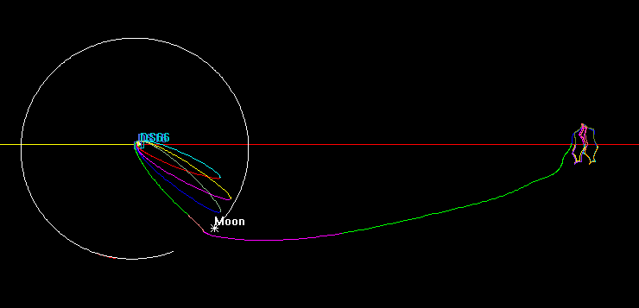
Figure 2-4: Representation of the MAP 3-Loop Trajectory

Table 2-1: MAP Maneuvers

Maneuver Location | Description | Maneuver Start  UTC Date & Time |  |  | Delta-V  (m/s) | Status
A1 | Calibration of Thrusters | July | 04 | 13:22:38 | 2.01 | ★
P1 | Apogee Raising |  | 08 | 04:43:40 | 20.19 | ★
A2 | Engineering Burn |  | 12 | 16:11:54 | 0.25 | ★
P2 | Apogee Raising |  | 17 | 03:38:25 | 2.51 | ★
A3 | Engineering burn |  | 21 | 18:54:43 | 0.30 | ★
P3 | Apogee Raising |  | 26 | 10:29 | 7.35 | ★
 | P3 Correction |  | 27 | 04:30 | 0.31 | ★
Moon | Gravity Assist |  | 30 | 16:37 | N/A | ★
 | MCCM 1 | Aug | 06 | 16:37 | 0.09 | ★
 | MCCM 2 | Sep. | 14 | 16:37 | 0.04 | ★
L2 | LOI | Dec. | 14 | 16:37 | TBD | TBD
A1, A2, A3 = First, Second, and Third Apogee
★ = Successfully Completed

P1, P2, P3 = First, Second, and Third Perigee
MCCM = Mid-Course Correction Maneuver

LOI = Lissajous Orbit Insertion

The MAP ACS team had an incredibly busy month of July. The initial separation and sun acquisition went well. Over the course of a grueling first week or so, team members worked around the clock to check out the spacecraft’s Safe hold modes, inertial modes, and all the thrusters. Calibration pulses were commanded, and sensor calibration slews were performed. Some real-time issues were resolved quickly and efficiently, with the primary goal being spacecraft and orbit safety. A rough alignment and gyro calibration was performed in the first week, with the only glitch being an incorrect velocity aberration correction to the AST data onboard. All the sensors and actuators worked as advertised, and all the flight software worked as it was designed. Additional work done using the high fidelity (HiFi) simulator in the Science Mission Operations Center (SMOC) was a calibration of the wheel tachometers to reduce the error in the system momentum calculation while the observatory is spinning, and a recalculation of the CSS eye outputs to better model the actual output of the heads.

The ACS team had to remain flexible to deal with things like moon and earth interference in the star trackers (this prevented a full Observing Mode), modified thruster calibration maneuvers, and an “anomalous force” on the spacecraft near perigee that increased the system momentum just before a maneuver. Analysis eventually showed that the anomalous force was due to the baking off of outgassed volatiles, and it was properly modeled and predicted for subsequent perigee and perilune passes. Also during July, the Real Time Attitude Determination System was used to generate true attitude knowledge and gyro bias information. The ground analysis shows that we are easily meeting our 1.3 arc minute attitude determination performance. The sensor calibration went well, with residual errors on the order of tens of arc seconds. All of the engineers worked hard to capture all the flight data, and feed back attitude and maneuver information to the rest of the team as quickly as possible, aided by the availability of the MAP HiFi in the SMOC. Often, the trajectory team performed a quick first-order verification of a maneuver within a half hour of the actual burn.

Conclusions

The remaining work includes finishing the coding and testing of the two-wheel controller (Observing II) so that the mission can be accomplished even if one wheel fails. As part of that process, Scott Starin presented his Professional Intern Program (PIP) project on the analysis and simulation of the two-wheel controller. The Maneuver Team continues to support all maneuvers, including planning, generating command sequences, simulation, and validation.

Thank you to all the people on all the teams who made this mission such a success. Thanks should also be given to the people in the GNCC who supported our critical operations by maintaining the computer “Nichols” and working around our hectic schedule, often on short notice. Again, a hearty thanks and congratulations to all who have made MAP a success.

[Technical Contacts: O. Cuevas; S. Andrews]

2.2.2 Earth Observing –1 (EO-1)
http://eo1.gsfc.nasa.gov/miscPages/home.html

In November 2000, the Goddard Space Flight Center launched the Earth Observing -1 (EO-1) spacecraft. The EO-1 mission was dedicated to testing a wide range of spacecraft subsystem and operational technologies, including the next generation of earth sensing instruments that may fly on future Landsat spacecraft. Among the technologies that had a direct bearing on future Flight Dynamics support was a demonstration of formation flying. EO-1 and the Landsat-7 spacecraft operate in a close formation that keeps the two spacecraft about one minute apart along track. The goal of operating in this formation was to have each spacecraft take a series of co-fly images of the same scene approximately one minute apart. The images could then be compared to measure improvements in the EO-1 imaging instruments. See section 4.3.1 for more details on the formation flying experiment.

The FDAB led the Flight Dynamics team that supported the EO-1 Project through four years of pre-launch preparations. Extensive mission analysis was performed to tailor the EO-1 launch for a window only seconds in duration. This analysis was necessitated by the stringent formation flying requirements, launch vehicle dispersions, and a very limited propellant budget. Following launch on a Delta II 7320-10 vehicle, the EO-1 Flight Dynamics team supported nine orbit maneuvers over a four week period to attain the mission orbit. In addition to orbit maneuver support, the FDAB provided support for sensor calibration and alignment, real time attitude computation, orbit determination, and generation of orbit and attitude products for scheduling and image planning. About two months after launch, the FDAB turned over the Flight Dynamics portion of the EO-1 ground system to accomplished Flight Dynamics analysts who were members of the EO-1 Flight Operations Team.

What had been developed as a one-year mission to take 200 co-fly images between EO-1 and Landsat-7 was successfully completed in about six months. Through careful analysis of the launch window and the ascent maneuver sequence, the limited propellant budget was conserved; therefore, the mission can be extended for several years.

[Technical contacts: R. DeFazio, R. Luquette, C. Mendelson]

2.2.3 Geostationary Operational Environmental Satellite (GOES)
http://www.gsfc.nasa.gov/topstory/20010620goesm.html

GOES-M was the fifth and last of a series of geosynchronous meteorological satellites built and launched under NASA/GSFC supervision for NOAA. On July 23, 2001 GOES-M was launched aboard an Atlas IIA launch vehicle into a geosynchronous transfer orbit of 42271 km. x 275 km. with an inclination of 20.54 deg. The launch was nominal and the Flight Dynamics team, led by FDAB personnel, prepared to execute a seven-orbit maneuver sequence to place GOES-M into its checkout orbit. All went as planned until about 25 % of the way into the first Apogee Motor Firing (AMF). At that point the temperature on the Main Satellite Thruster (MST) exceeded the maximum allowable value. The maneuver was aborted at 13 minutes into a 54.5 minute burn. After studying the situation, a second AMF was planned several days later for a maximum of 12 minutes. This second maneuver aborted just four to six seconds short of its completion. From that point onward, all GOES-M orbit maneuvers with the MST were limited to less than 11 minutes. No further aborts were encountered, but the limitation on burn size required a total of nine AMFs instead of the nominal three AMFs of the pre-launch plan. Five additional burns were required to adjust the final orbit with the entire station acquisition sequence taking 29 days instead of the nominally planned 18 days. Except for the problems with the MST, the spacecraft proved to be healthy.

The Flight Dynamics team provided fine support to the GSFC GOES Project during five launches dating from 1994 to the present. This was a dedicated team that worked tirelessly through both good times and bad. This may be the swan song for GOES Flight Dynamics support at GSFC, since the next GOES series will be launched and placed on station by the spacecraft contractor. This saddens many of us who have watched GSFC Flight Dynamics provide quality support to the GOES Project for more than a quarter century. All good things must eventually end and thus it is with GOES Flight Dynamics at GSFC; however, the people who have supported GOES missions will make their presence felt on many other GSFC missions.

[Technical contact: R. DeFazio]

2.2.4 Landsat-4 Decommissioning

The Landsat 4 (L4) spacecraft was funded and launched by the U.S. government and operated by Space Imaging (formerly known as the Earth Observation Satellite Company). In late February, Space Imaging notified the government that they no longer intended to operate the L4 spacecraft; therefore, they transferred L4 to the USGS for decommissioning. In support of the decommissioning, the FDAB was asked to design and execute the maneuvers necessary to comply with NASA guidelines for disposal.

Several days of maneuvers lowered L4’s altitude from 705 km to 580 km. At its original altitude, L4 would have entered the Earth’s atmosphere after 42 to 75 years. At the lower altitude, L4 will enter the atmosphere after 8 to 25 years which satisfies the NMI guidelines for decommissioned spacecraft to enter within 25 years.

In addition to the orbit lowering, on-board energy sources, such as propellants and batteries, were depleted. This satisfied other NMI guidelines based on preventing an accidental explosion, which would create a debris field in space.

http://www.earth.nasa.gov/history/landsat/landsat4.html
http://www.gsfc.nasa.gov/gsfc/gnews/071301/071301.htm#landsat
http://www.usgs.gov/public/press/public_affairs/press_releases/pr1455m.html

[Technical contact: D. Quinn]

2.2.5 Tropical Rainfall Measuring Mission (TRMM)
http://www.gsfc.nasa.gov/news-release/releases/2001/01-84.htm

In July 2000, Flight Dynamics Analysis Branch (FDAB) personnel began preliminary analysis related to TRMM deorbit planning. This analysis indicated early on that the 68 kg of propellant budgeted for the deorbit operation would be inadequate to conform to the requirements and guidelines imposed by NASA Management Instruction (NMI) 1700.8 and NASA Safety Standard (NSS) 1740.14 for spacecraft end-of-life disposal. Detailed analysis performed during the first half of 2001 determined that a controlled deorbit from TRMM’s 350 km altitude could be performed in a manner which satisfied the requirements and guidelines with as little as 158 kg of propellant, 90 kg more than was budgeted. The additional propellant would be taken from the orbit maintenance propellant budget, effectively shortening the mission life by 15 to 17 months. FDAB personnel presented these results at a TRMM deorbit status review in April 2001.

A recommendation was made to assess the operational and science impact of raising TRMM’s mean orbit altitude to 400 km. Raising the orbit altitude would decrease the aerodynamic drag thus reducing the amount of propellant required for orbit maintenance. Analysis indicated that this had the potential of extending the mission life by 4 to 5 years. By May 2001, raising TRMM began to look like a viable option; the deorbit planning was put on hold; and work was focused on the analysis and planning required for raising the orbit. Simulations were run to ensure that the TRMM attitude control system, designed for 350 km, would continue to meet the pointing requirements at 400 km. The orbit raising took place during August 2001 and the spacecraft is now operating at a mean altitude of 402.5 km. A design flaw was discovered in the Earth sensors at the higher altitude. Because of this flaw, TRMM is using the back-up attitude determination algorithms, which use the three-axis magnetometer and digital sun sensors.

The focus is now turning back to the deorbit plan. Over the next several months, the plan will be modified to account for the new orbit altitude as well as operational changes that stem from the orbit raising. Presently, the plan is to let drag decay the orbit to 350 km before starting the burn sequence to deorbit TRMM. The final version of the plan is currently expected to be completed by December 2001.

[Technical contacts: F. Vaughn, J. Morrissey]

2.2.6 InFocus Balloon Program
http://infocus.gsfc.nasa.gov/

Over the past year, the Flight Dynamics Analysis Branch continued its engineering support to develop and operate pointing control systems for use on stratospheric balloon payloads. All efforts were directed to bringing to the balloon community significant new pointing capabilities for stratospheric ballooning.

A primary goal of the science ballooning community is to achieve arc second pointing on X-ray target sources. A major impediment to precision pointing on balloon payloads is caused by disturbances originating from the cable and parachute segment connecting the gondola to the balloon. This segment, called the load train, is 250 ft long. To characterize load train disturbances, GNCC attitude sensors were included on a test flight of the InFocus telescope in August 2000. InFocus is a long focal length (9 meter) imaging X-ray telescope designed as a payload for stratospheric balloons. The measurements of the load train and gondola motions clearly showed that disturbance oscillations occur at several frequencies, and that these disturbances last for hours after the balloon reaches its float altitude.

A second InFocus flight was launched on July 5, 2001 from Palestine, Texas. An existing azimuth/elevation gondola pointing control system was adapted to point the telescope with a desired accuracy of several arc minutes. The GNCC was responsible for establishing the slewing and pointing control parameters and also the azimuth reaction wheel size necessary to maneuver the large telescope. The only practical approach for establishing these values was to conduct pointing tests in high bays at GSFC and in Palestine, Texas. The entire gondola was suspended from the ceiling and allowed to maneuver in azimuth and elevation in conditions as close as practical to the actual flight configuration. Several schemes, both active and passive, were tested in an effort to increase damping. In addition to the tests, simulations of the elevation and the azimuth control loops were generated to further predict what the performance would be when the gondola was suspended from the much longer load train.
From the second InFocus flight it was learned that the azimuth/elevation systems are easily overpowered by high winds; thus, more robust approaches are needed if arc second accuracy is ever to be obtained. One approach now being considered, which was proposed by the science team, is to support the InFocus telescope on the gondola base via a ball and cup having three degrees of rotational freedom. Another lesson from the InFocus flight is that suspended pointing tests, though necessary, can be misleading in judging the performance of the pointing system in flight. This reinforces the need for simulations, which require aerodynamic models based on flight data. Several ideas to collect this data on a regular basis are being pursued including compact measurement modules that could monitor the local rotational motion of where ever they are placed on the balloon, gondola, or load train.

[Technical contact: D. Olney]
Figure 2-5 InFocus During Ascent

2.2.7 General Space Operations Management Office (SOMO) Support

The Space Operations Management Office (SOMO), located at Johnson Space Center, was an important sponsor and funding source in FY01 for many of the FDAB activities. This includes much of the branch’s technology work (covered in Section 4) as well as general mission design and concept development work for future missions (some of the work covered in Section 3 is sponsored by SOMO). The FDAB periodically assisted SOMO in its management of mission services and operations activities, including its management of the Consolidated Space Operations Contract (CSOC). FDAB management meet regularly with CSOC management responsible for the operation of the Flight Dynamics Facility. The purpose of these meetings is not to give direction to routine operations, but to continue to maintain awareness of facility upgrade plans and share knowledge of future mission plans, technology development activities relevant to the facility, and software system upgrades.

[Technical Contact: Tom Stengle]

3.0 Study Mission Support

One of the primary roles of the Flight Dynamics Analysis Branch (FDAB) within the Guidance, Navigation and Control Center (GNCC) is to serve the science community by providing analysis of advanced mission concepts. This includes development of orbit/attitude designs based on science constraints, evaluation of orbit/attitude errors and attitude dynamics analysis. Members of the branch often represent “first access” by Earth Science and Space Science customers to the services offered by the GNCC.

In FY2001, the FDAB continued its participation in supporting a wide variety of future mission concepts. This section describes some of the analyses performed.

3.1 Integrated Mission Design Center (IMDC)

The Integrated Mission design Center (IMDC) is a human and technology resource dedicated to innovation in the development of advanced space mission design concepts to increase scientific value for NASA and its customers. The IMDC provides specific engineering analysis and services for mission design and provides end-to-end mission design products. For information about the IMDC, refer to http://imdc.gsfc.nasa.gov/.

Trajectory engineers from the FDAB supported the IMDC’s customers by providing mission planning, and trajectory analysis and design. Attitude determination and control (ACS) personnel supported IMDC in the area of ACS conceptual design and analysis. This included ACS requirement definition, identification and computation of significant worse case disturbance torques, sensor selection, actuator sizing, component placement specification, control modes design, identification of ACS imposed requirements on other subsystems, risk assessment, issues, concerns and future work identification. In addition, special design consideration and analysis were performed to solve or pinpoint each mission’s unique issue.

A wide range of mission types was supported, including near earth which focus on the earth’s surface and atmosphere and cis-lunar that are interested in the earth’s space environment. Specific studies supported were: Ocean Observer, NPOESS, Geospace Electrodynamic Connections, Carbon Cycle Initiative (Lider, BIRCH), GradSat, Gas & Aerosol Monitoring Sensorcraft Mission (GAMS), Carbon, Black Carbon, Radiation and Aerosols (COBRA), Survey of Infrared Cosmic Evolution (CIRCE), X-ray Mirror Array Sky Survey (XMASS), Magnetospheric Tail Constellation (MTC or name MAGIC), Constellation for Aerosols and Cloud Heights (COACH), ASA Space Science, Super Nova, Stella Image, Global Precipitation Mission (GPM), ST-7 and ACCESS.

(Technical contact: Josephine San, Charles Petruzzo, Aprille Ericsson, Marco Concha, Eric Stoneking)

3.2 KRONOS

The FDAB continued work on an extensive mission feasibility study for High Earth Orbit (HEO) missions such as KRONOS. These unique orbits require a lunar swingby to increase the orbit perigee radius, lift the orbit out of the ecliptic plane, and rotate the line of apsides such that apogee is in the northern hemisphere. The final HEO orbit obtained via this lunar swingby has perigee near 10 Earth Radii (R_{E}) and apogee near lunar distance ( 60 R_{E}). This study, whose results were presented at the 2001 Flight Mechanics Symposium, contains a detailed analysis of HEO orbit characteristics, launch window opportunities, and fuel budget estimates. It is anticipated that the paper presented, “High Earth Orbit Design for Lunar-Assisted Medium Class Explorer Missions,” will be used as part of future mission proposals for KRONOS and other HEO missions. The KRONOS trajectory is shown in Figures 3-1, 3-2, and 3-3.

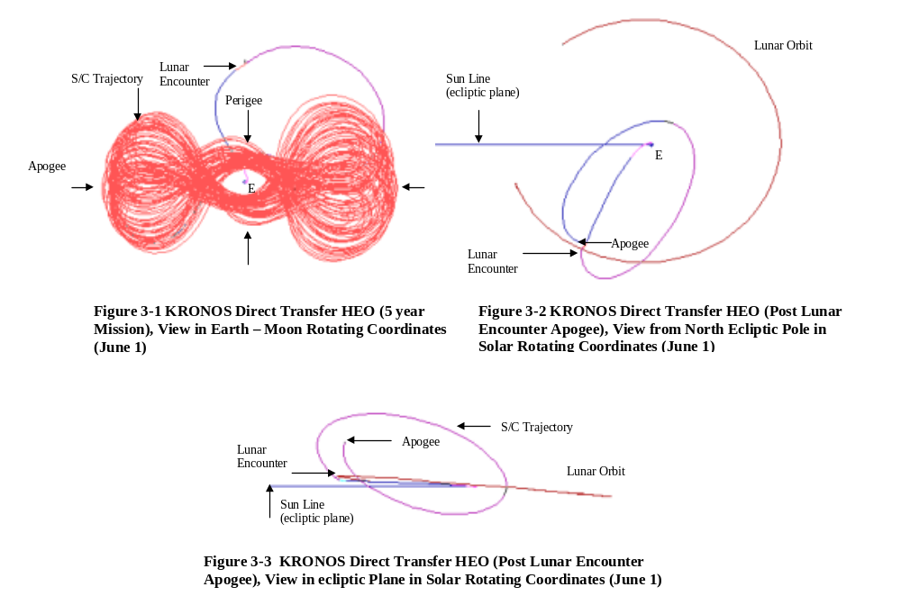
[Technical contact: Steven Cooley]

3.3 Constellation X

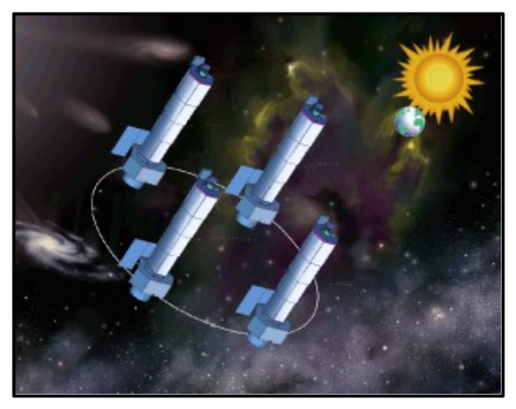
Constellation X is a study mission that uses 2 (possibly 4) x-ray telescopes in constellation at the Earth’s L2 libration point to study black holes and galaxy formation. The instrument consists of a large area X-ray mirror with 100-meter focal length. This year the FDAB has provided support to the Constellation X study team in the area of trajectory design. The baseline plan is to launch the spacecraft aboard an Atlas V launch vehicle. The FDAB performed a study to consider the pros and cons of two mission orbit types that would provide low-radiation environments. The baseline trajectory is an orbit about the Sun-Earth L2 libration point – this was contrasted against a High Earth Orbit (HEO) with apogee at lunar distance to determine differences in shadows and delta-v costs.
Figure 3-4 Constellation X Concept

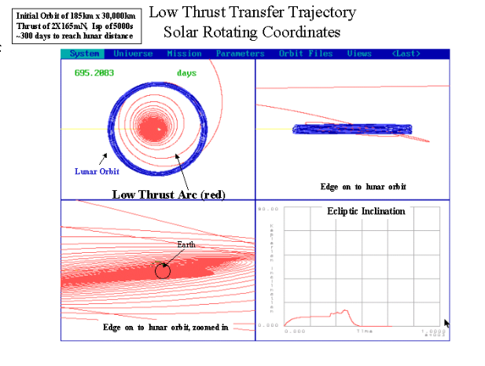
Also, in the event that the Atlas V launch vehicle is not available in the 2010 mission timeframe, the FDAB completed a study to determine the feasibility of launching the spacecraft on Delta II vehicles, then using a combination of hydrazine and low-thrust propulsion to achieve the desired mission orbit. Various low-thrust options were investigated for the Constellation-X mission using a Solar Electric Propulsion (SEP) system and/or a hydrazine or Bi-Propellant system. The SEP was sized to meet orbit requirements and attain the L2 mission orbit within one year. Initial orbit options covered a range of LEO and GTO orbits. Thrust levels were analyzed which provided the required trip time. To obtain a propulsion system thrust level needed to be on the order of 300mN. The propulsion and launch vehicle support groups then used these trajectory designs to define their requirements and cost.
Figure 3-5 Sample Constellation X Transfers

A sample of the transfer trajectory for this type of propulsion system is shown in Figure 3-5.

[Technical contact: Lauri Newman, Dave Folta]

3.4 Global Precipitation Mission (GPM)

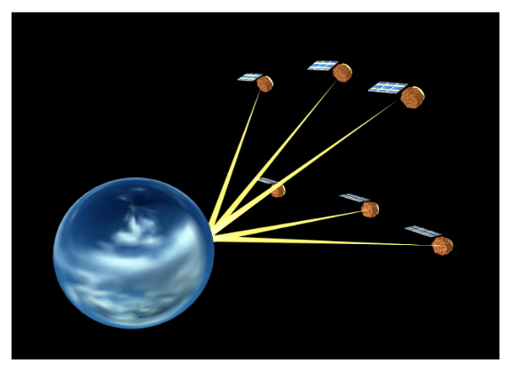
The main objective of the Global Precipitation Measurement (GPM) mission is to provide sufficient sampling to reduce uncertainty in short-term rainfall accumulations in a coverage region between 70º N and 70º S latitude, with a goal being a 3-hour revisit time. The strategy for achieving this objective is to form a constellation of radiometer-carrying satellites using both GPM-specific satellites (Drones) and other satellites with suitable radiometers (Co-op). The Co-op satellites are in defined, fixed orbits, while the Drone satellites are placed in orbits to best complete the desired coverage.

A significant portion of
FDAB effort this year has been related to the development and exercise of a spacecraft constellation optimization tool. Given that some of the s/c are dedicated to other missions and already have their orbits defined, the question becomes: “Where do we place the GPM Drones to best (or optimally) achieve maximum coverage?” Then, of course, we have to ask ourselves how we’re going to deploy and maintain the constellation. It’s a problem that becomes increasingly complex .
Figure 3-6 Global Precipitation Mission

The optimization tool developed to attack this problem is centered around a Genetic Algorithm (GA) approach. This is a technique that is based on natural selection and Darwinian genetics, in that it is population-based and progresses toward survival of the “fittest” solution. One form of output from this tool is a graphical display of coverage regions superimposed on a world map. Since the mission objective is to map the Earth’s surface every 3 hours, one approach we’ve looked at is dividing each day into 8 3-hour “bins.” If a point on the Earth grid has been visited by one or more of the constellation sensor footprints during one of these periods, it is said to occupy that bin. An ideal solution would be to have each point in the study region occupy each bin each day of the mission life.
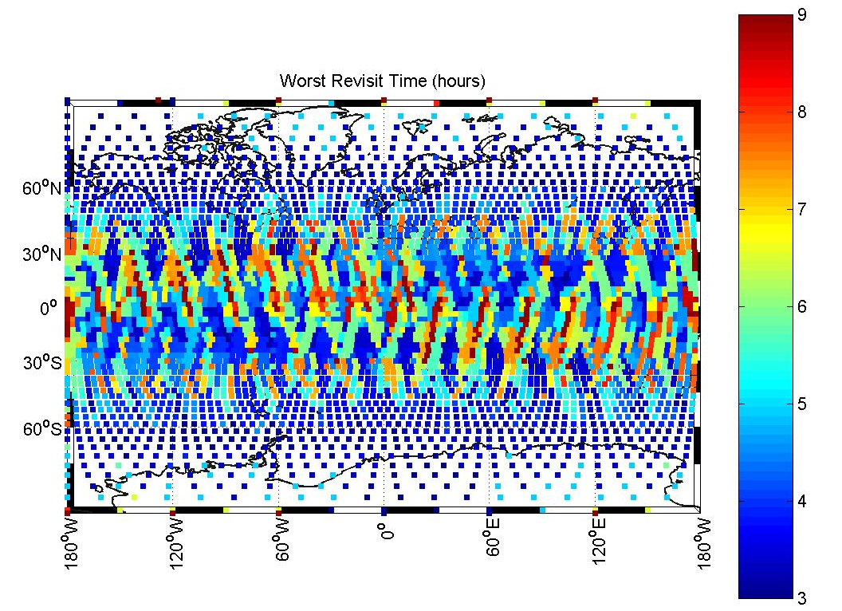
In addition to the constellation optimization effort, FDAB personnel have performed analyses on: ΔV for insertion and maintenance; end of mission life re-entry/disposal; ground station coverage; launch scenarios; sensor calibration opportunities; ground-track repeat cycles; frozen orbit options; and a GPM Core spacecraft-to-ISS range study.
Figure 3-7 Results of Optimization Tool

[Technical contacts: Chad Mendelsohn, David Folta]

3.5 Next Generation Space Telescope (NGST)

The Next Generation Space Telescope (NGST) is slated to replace the Hubble Telescope at the end of this decade. The scientific goals for NGST are discovering and understanding the formation of the first stars and galaxies, the evolution of galaxies and the production of elements by stars, and the process of star and planet formation.
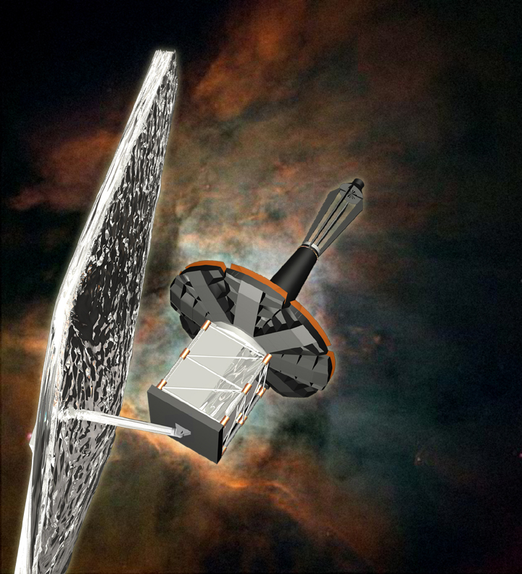
Among the various mission/design architectures being considered for NGST, a proposed architecture, which is based on a non-contacting payload and support modules, was investigated. Linear and nonlinear simulation models were validated and used to verify nominal fine pointing performance (LOS stability), stability margins, and slewing times. Both, time-domain and frequency-domain analysis were used in this verification. A Sensitivity analysis with respect to the variations in the plant and control parameters was performed. A host of parameters were included in the sensitivity analysis, such as mass and inertia properties of the support and payload modules, flexible modal frequencies and damping, geometric properties, sampling time and delays, and many more. An overall assessment of the feasibility of the proposed architecture was made based on the results of the aforementioned analyses.

The NGST mission is baselined as a mission located near the Sun-Earth L2 Libration point. While the final orbit configuration is still being determined, several analyses have been performed and project reviews attended to discuss and provide feedback to potential spacecraft contractors. Analysis by the FDAB was concerned with the effects of the large solar shade and location of thruster placement in relationship to orbit control. Using recent developments in dynamical system theory and its implementation into FDAB software, the analysis focused on biased libration orbits and single axis control. This trajectory design analysis addressed improved methods for attaining constrained orbit parameters and their control at the exterior collinear libration point, L₂. The use of a dynamical systems approach, state-space equations for initial libration orbit control, and optimization to achieve constrained orbit parameters were emphasized. The NGST trajectory design encompasses a direct transfer and orbit maintenance under a constant acceleration. A dynamical systems approach can be used to provide a biased orbit and stationkeeping maintenance method that incorporates the constraint of a single axis correction scheme. This analysis was performed in partnership with Purdue University and showed that several strategies are possible including one with a central manifold design that incorporated pre-defined maneuvers in a given axis, and another that incorporates the acceleration of the solar shade as a solar sail. Two options shown in Figure 3-9 show that NGST control requirements can be met. These are taken from a paper titled “Trajectory Design Strategies for the NGST L₂ Libration Point Mission” presented at the AAS/AIAA conference in February, 2001. The left figure shows central manifold maintenance. For this case, the accelerations can optionally be included in the dynamical systems approach that compute a baseline libration orbit or included in the targeting procedure afterwards. The orbital C3 energy is maintained below zero and return to the Earth region. The figure on the right presents a biased orbit with deterministic control.
Figure 3-8 Next Generation Space Telescope

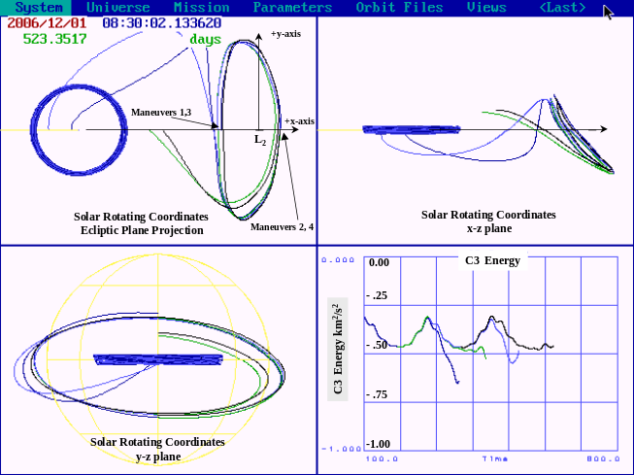

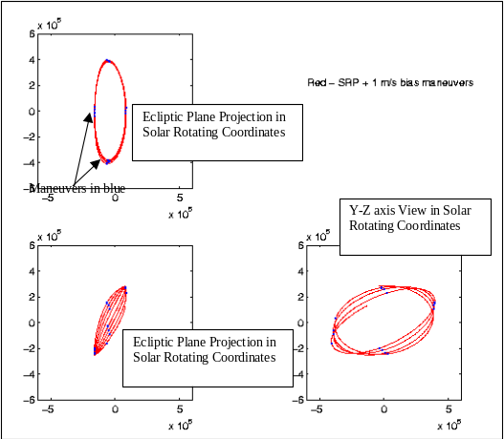
Figure 3-9 NGST Trajectory Planning

[Technical Contact: Peiman Maghami, David Folta ]

3.6 Living With A Star: Solar Dynamics Observatory (SDO)

The Flight Dynamics Analysis Branch (FDAB) has been involved in the formulation of missions for the Living with a Star (LWS) Program. The FDAB was involved with the generation of orbits and products related to a distributed system of spacecraft used to understand the Earth’s environment and the interaction with the sun. The LWS’s Solar Dynamics Observatory (SDO) mission concept was investigated by the FDAB.

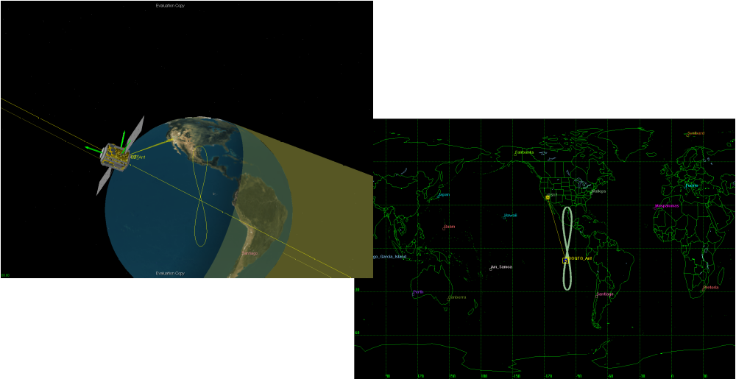
Solar Dynamics Observatory is a solar observer performing continuous and high cadence observations of the full solar disk and coronal imaging in multiple wavelengths to improve understanding and forecasting of the Sun’s impact. FDAB personnel investigated various orbit design considerations from LEO and GEO to Highly Elliptical to Libration orbits. These orbit designs considered the general aspects of these designs and included shadow analysis, station coverage, Delta-V and fuel budgets, sun related orbit parameters, and onboard antenna coverage patterns. From this analysis, a geosynchronous inclined orbit was chosen. Figure 3-10 depicts one final orbit consideration for the geosynchronous inclined orbit option.

Figure 3-10 Solar Dynamics Observatory Trajectory Planning

[ Technical Contact: David Folta]

3.7 Magnetospheric Multiscale Mission (MMS)

MMS is part of the Sun-Earth Connection program, one of the four principal science themes of NASA’s Office of Space Sciences. The major focus of the Sun-Earth Connection program is investigating the physical processes that link the Sun and the Earth. MMS is a four-spacecraft solar-terrestrial probe designed to study magnetic reconnection, charged particle acceleration, and turbulence in the key boundary regions of the Earth’s magnetosphere. A draft version of an Announcement of Opportunity for the instrument complement and principal investigator teams is expected to be issued in October of 2001.

The mission is in its study phase. As far as was possible without the Principal Investigator teams having been selected, a statement of trajectory requirements was developed by the orbit analyst in consultation with MMS study management. The analysis effort is not complete, but much about the orbit dynamics of the mission has been characterized. The mission is divided into distinct phases, each of which uses a trajectory significantly different from the others. Analysis related to the transitions between and within the phases is highly complex and some techniques have yet to be developed. We have demonstrated, in a gross sense, that trajectories can be designed to meet most of the known science and engineering requirements and have estimated the amount of propellant required.

A major consideration in our ability to do the necessary analysis is the availability of software appropriate for the effort. Little of it is in the “off the shelf” category because this is not a routine mission for which analysis techniques are readily available. Though lacking some major features, prototype software finds and analyzes trajectories similar to what MMS would use so that engineering and science characteristics can be considered. A graphics program, in prototype form, illustrates the behavior of the tetrahedron as it changes size and shape throughout each orbit.

For more detailed information about the mission, visit http://mms.gsfc.nasa.gov.

[Technical contact: Charles Petruzzo]

3.8 Laser Interferometer Space Antenna (LISA)

The primary objective of Laser Interferometer Space Antenna (LISA) mission is to detect and measure gravitational waves from massive black holes and galactic binaries in the frequency range of 10^{–4} and 0.1 Hz. The LISA mission comprises three identical spacecraft, 500,000 km apart, which form an equilateral triangle (Figure 3-11). The center of the spacecraft formation is in the ecliptic plane, 1 AU from the Sun and 20° behind the Earth. LISA can essentially be viewed as a Michelson interferometer in space, with a third arm to provide wave polarization information as well as redundancy. Each spacecraft contains two optical assemblies, with each assembly pointing towards an identical assembly on each of the other two spacecraft. A 1 W infrared laser beam (1 μm wavelength) is transmitted to the remote spacecraft via a telescope. The incoming beam is focused on a sensitive photodetector where it is superimposed with a fraction of the original local light. Each optical assembly includes an enclosure containing a free-flying proof mass, which serves as an optical reference mirror for the light beams. A passing gravitational wave changes the length of the optical path between the proof masses in one arm relative to the other arm. The spacecraft is used to provide a drag-free environment for each of the proof masses within it, by shielding the masses from solar radiation pressures. In order to be able to detect gravitational strain levels to the order of 10^{–23}, tight pointing and positioning requirements are placed on the spacecraft and the proof masses (e.g., acceleration requirement on each proof mass: 3x10⁻¹⁵ m/s²/Hz^{-1/2}). To achieve these requirements, the LISA spacecraft are baselined to use electric propulsion thrusters and quadrant photodiodes for position and attitude control of each spacecraft, and capacitive sensing and actuation for relative positioning of each proof mass to the spacecraft.

The FDAB personnel supported the LISA mission in a number of areas: (a) Orbital design, analysis, and optimization; (b) Dynamics and control modeling and analysis; (c) Design and analysis of Disturbance Reduction System (DRS) control; (d) Control system design and analysis of thrust stand facility. Details of some of the orbit design analysis can be found in section 4.1.3.

A number of simulation and analysis models of a single LISA spacecraft were developed and used to assess the feasibility of various technologies, such as Micro-newton thrusters, inertial sensors, capacitive actuation, as well as the Drag-Free Control concept. These models, which have varying degrees of complexities, have been utilized for trade studies, control design and analysis, etc. The most complete of these is the 18-DOF LISA model, which includes full nonlinear translational and rotational dynamics of the spacecraft and each of the proof masses. Gravitational forces from the Sun, the Earth, the moon, and other significant planets are included. DRS control has been fully incorporated, along with instrument models of varying complexity. Approximations for self-gravity and nonlinear stiffness effects (from capacitive sensing and actuation) are included as well.

DRS control is a critical part of the LISA mission. It includes the overall control system architecture for the positioning and pointing of the spacecraft as well as the proof masses relative to the spacecraft. In the baseline configuration, the spacecraft is responsible for maintaining a total drag-free environment (or as close as possible to it) for each of the proof masses. At the same time, fine pointing of each spacecraft with respect to the other two has to be maintained continuously. Preliminary design work for DRS control to achieve the desired pointing and positioning accuracy has been completed. This design is based on a decentralized approach to DRS control, wherein the spacecraft position control is designed to center about the proof masses, and the proof mass control maintains relative position and attitude with respect to the spacecraft. Two options were considered for proof mass translational control in the measurement axis, one with no control and the other with a very low-bandwidth controller.

As part of the technology validation effort for LISA and other missions, a thrust stand facility is being developed at Goddard for characterization of the dynamics and noise characteristics of micro-newton thrusters. The stand is based on a torsional pendulum concept, where a thruster is placed at an offset from the torsion fiber. A thrust force produces a torque about the fiber, and causes it to twist. In an open-loop mode, the twist angle measurement is used to compute the thruster force output. In a so-called “null” mode, capacitive sensing and actuation is used to regulate the twist angle, and the net actuation force/torque is used as a measure of the thruster force output. A digital controller was designed for actuating the capacitors in the null mode as well as regulating the power supply. A detailed simulation and analysis model for the thrust stand was developed to analyze the controller performance.
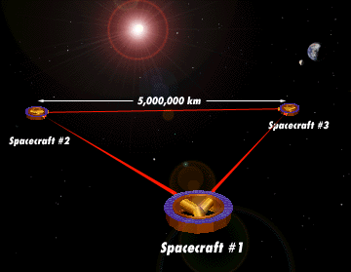

Figure 3-11 Laser Interferometer Space Antenna

[Technical Contacts: Peiman Maghami, Steve Hughes]

3.9 Leonardo

The purpose of the Leonardo mission is to define the Bi-directional Reflectance Distribution Function (BRDF) of sunlight off of Earth’s clouds. Leonardo uses a formation of several spacecraft to measure the sun light reflectance off of a cloud simultaneously from different perspectives.

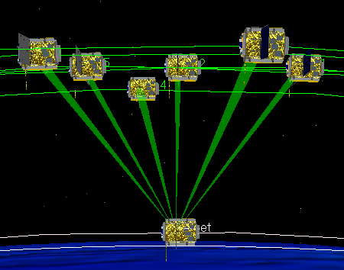
Early FDAB analysis of the Leonardo mission considered a formation of three spacecraft in a sun synchronous orbit. The analysis showed that this configuration required too much propellant. Subsequent analysis has been on a formation of six spacecraft in near equatorial low Earth orbits.

A sophisticated model has been developed to analyze the Leonardo mission. The model includes genetic search and sequential quadratic programming search algorithms, and high fidelity orbit propagation. All of the orbit parameters for each spacecraft are control variables and the scientist’s BRDF algorithms form the objective function. Future work will focus on determining the propellant required for formation initialization and maintenance over the mission life.
Figure 3-12 Leonardo Mission Concept
[Technical Contact: Steve Hughes]

4.0 Technology Development Activities

4.1 Advanced Mission Design

4.1.1 Generator Software Tool

This year the FDAB partnered with Purdue University to develop advanced mission design capabilities for libration orbits using dynamical systems theory, or more specifically, manifold applications. This work culminated in the delivery of a software tool called Generator.

The research goals are to develop and infuse advanced mission design technologies to enable rapid and robust mission design planning and contingency analysis. The primary goal is to reduce operations cost while providing a highly accurate system to increase the efficiency of the orbit design process. The benefits of this effort provide a tremendous time savings in trajectory design and robustness in trajectory design, especially for libration orbit design. This work has application to contingency analysis and enables innovative classes of mission orbits to support science goals.

The potential customers of this research include GSFC’s LWS, SEC, NGST, TRIANA, and Orginis Programs just to name a few. Collaboration with JPL and JSC, are ongoing and will be enhanced with this tool. Our approach was to develop algorithms, prototype/finalize code, and write mathematical specifications for integration into a GN&C MATLAB based system. This provides a design of trajectories using dynamical system theory / manifolds and advanced numerical techniques. The research followed an iterative prototyping approach, with frequent user demonstrations, feedback, and revisions based on user input. Techniques (solar sail accelerations, etc.) and linear and non-linear feedback control were also addressed. TRIANA and NGST were used as the test bed. Below are menu and output from this tool (Figure 4-1).

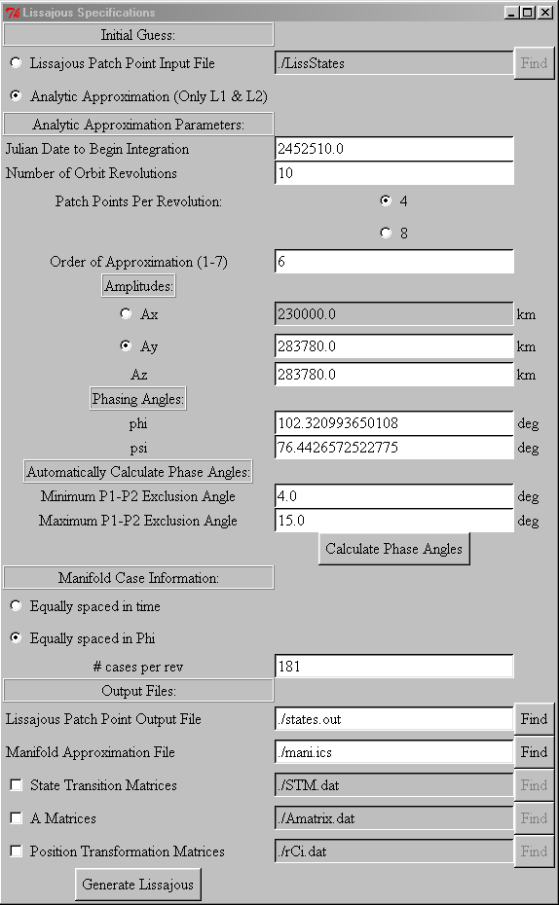
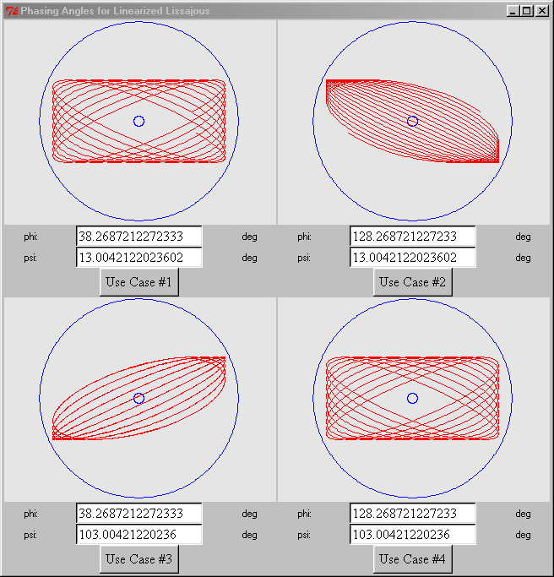
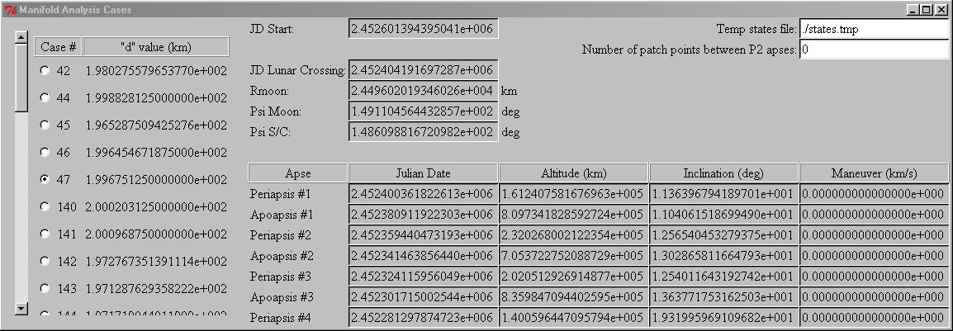
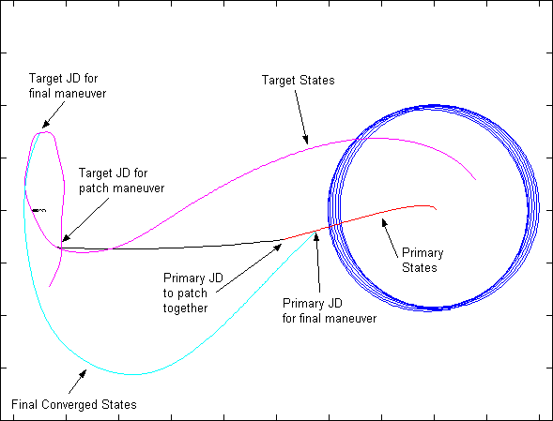

Figure 4-1. Menu and Output from the Generator Software Tool

[Technical Contact: David Folta]

4.1.2 SBIR Phase II Research: Optimal Orbit Transfer Analysis for Advanced Space Systems

As part of overall FDAB research support, we have been supporting SBIR phase-II contracts for advanced methods in Optimal Orbit Transfer Analysis for Advanced Space Systems. Techniques for effectively analyzing orbit transfers of advanced space systems employing low-thrust propulsion are developed and employed. The first two methods, known as collocation and parallel shooting, are trajectory modeling methods useful for solving boundary-value-problems (BVP). Both modeling techniques may be used in either a direct optimization formulation where optimal control problems are transformed into a mathematical programming (MP) problem or a two-point-boundary-value-problem (TPBVP) that results from applying the calculus-of-variations (COV) to optimal control problems. The last two techniques, known as sparse nonlinear programming (SNLP) and genetic algorithms (GA), are mathematical programming methods that together promise to provide a valuable strategy for optimizing a variety of complex orbit transfer problems. Orbit transfer dynamics are modeled using equations-of-motion based upon modified equinoctial orbit elements that include restricted, third-body gravity effects. Software based on these techniques is developed for use in optimizing low-thrust orbit transfers on a variety of challenging science mission scenarios and the relationship between the MP-BVP and the COV-TPBVP formulations is investigated and exploited for the missions investigated.

A delivery of a beta version of an advanced low thrust trajectory design tool with optimization capability was delivered. The tool has capabilities for low thrust ( and near impulsive thrust) for orbit in highly elliptical orbits, transfers to the moon, and libration orbits.

[Technical Contact: David Folta]

4.1.3 Optimal Mission Design

Recent trends in Distributed Spacecraft (DS) mission concepts are challenging conventional approaches to mission design and optimization. In response, we are developing new design approaches that permit optimal mission design for a wide variety of mission objectives. The approach uses Sequential Quadratic Programming to optimize orbits according to a user defined performance measure. The performance measure can be a function of relative spacecraft geometry, science performance, inertial orbit location, and orbit stability to name a few. Furthermore, we can impose constraints on the orbit to satisfy a wide range of mission constraints including maximum eclipse time, periapsis altitude, and relative vehicle dynamics.
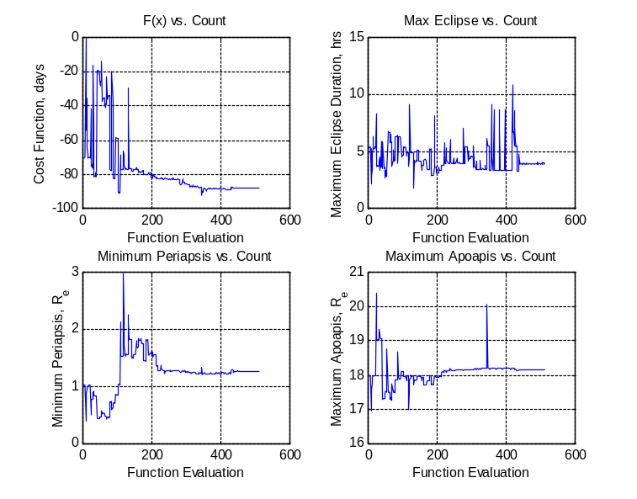

Figure 4-2. Performance and Constraints History
The approach has been applied to two different scenarios that we present briefly here. In the first example the science objective is to study the plasma sheet, and the engineering requirement is to maximize the amount of time that the spacecraft spend in the Plasma sheet. Due to power limitations and orbit correction limitations, there are several constraints that the optimal solution must satisfy. The maximum eclipse time must be four hours or less. Also, the periapsis must be between 1.1 Re and 1.5 Re and apoapsis must be between 17.5 Re and 18.5 Re. In the figure below we can see that by minimizing the negative of the days spent in the Plasma Sheet and satisfying the design constraints each spacecraft will spend about 90 days in the primary region of interest over the two year mission life.

The second design example is the Laser Interferrometer Space Antenna (LISA). LISA is a three spacecraft concept designed to measure gravity waves. One possible measure of performance for LISA is to keep two of the legs of the formation equal over the entire mission life. A baseline orbit was designed by Folker et.al. and was used as an initial guess in the optimization of the formation. Due to science constraints the baseline orbit was chosen to be heliocentric with the three spacecraft rotating about a virtual hub. Some further constraints are imposed on the design due to mechanical limitations of the spacecraft. The rate of change of distance between any two spacecraft must be less than 15 m/s. The angle between the spacecraft must always be between 59 and 61 degrees. Finally, for science, the range between the spacecraft must be on the order of 5 million kilometers. In the figure below, we see an optimal solution that satisfies all of the above constraints. In this case we chose to make the distance between spacecraft 2 and 3 and between spacecraft 1 and 3 as close to equal as possible over the entire mission life. For this particular solution the distances are equal to within a few hundredths of a percent.

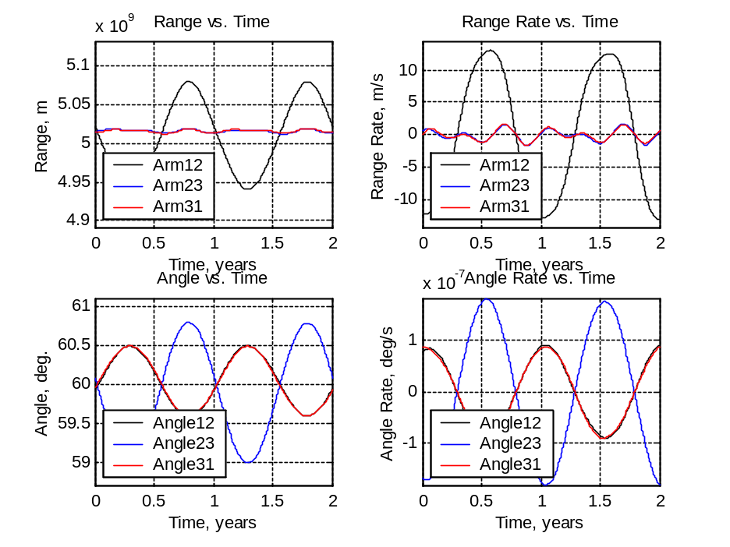

Figure 4-3. Relative Geometry Evolution

References:

Folkner,W.M., Hechler, F., Sweetser, T.H., Vincent, M.A., and Bender, P.L. “LISA Orbit Selection and Stability,” Classical Quantum Gravity, Vol. 14, 1997, pp. 1405-1410.

[Technical Contact: Steven Hughes]

4.2 Autonomous Navigation Technologies

4.2.1 Autonomous Onboard Navigation Systems

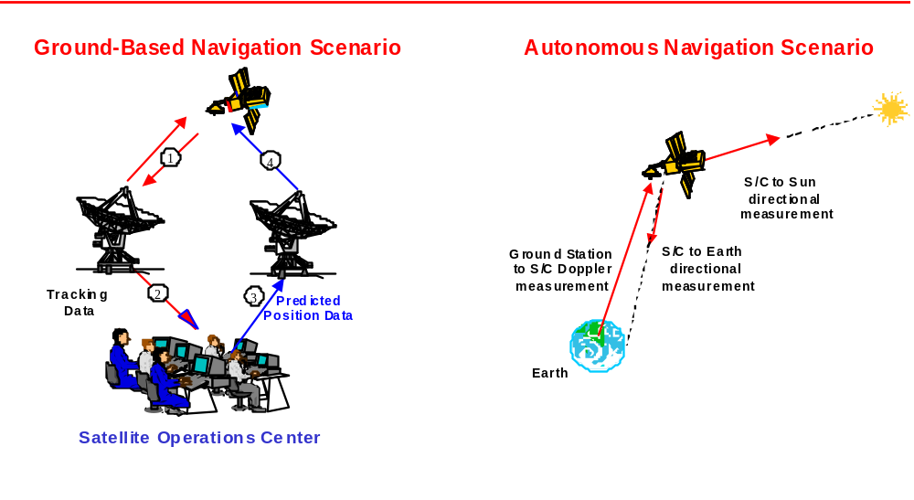

The technologies developed in this work area enable the following: advanced mission concepts such as formation flying, solar sailing, and low-thrust orbit transfer; autonomy for all aspects of navigation including maneuver planning and execution, communication signal acquisition, realtime onboard attitude determination and control; design flexibility by providing a single navigation software system for multiple mission scenarios to enhance autonomy; and highly accurate autonomous onboard inertial and relative navigation for multiple satellites. The approach optimizes use of available sensor data onboard the vehicles. It reduces mission life-cycle cost for single and multi-spacecraft platforms, by minimizing ground and tracking operations, and by reducing the development and test cost of autonomous navigation while increasing the efficiency of the navigation process.
GPS

The technical approach focuses on enabling formation flying and distributed spacecraft by improving automation, autonomy, mission design flexibility, and accuracy of flight dynamics functions. Evaluation of future mission needs and research of existing and state of the art methods is performed. Improved or new algorithms are then developed, prototyped and tested. Feasible developments will advance to flight experiments and eventually transfer to mission operations. Software development emphasizes reusability,
Figure 4-4. Navigation Scenarios

maintainability and easy reconfiguration for various mission needs. Realistic simulated and actual fight
data are used for analysis and testing whenever possible. Partnerships with industry, other government agencies and grants with universities are utilized when appropriate. Below, we describe accomplishments of the FDAB navigation team in the last year in the areas of algorithm and software development, sensor integration and test, flight experiments, and future missions analysis.

Algorithm and Software Development

The primary software product of the FDAB navigation team is the GPS-Enhanced Onboard Navigation System (GEONS), a multi-purpose navigation software package that maximizes software reusability and maintainability, and can be easily reconfigured to a user’s needs. GEONS is the “container” in which research and development activities are captured. GEONS is based on GEODE, a runner-up in NASA’s 2000 Software of the Year competition, which has been successfully transferred to industry, academia, and other U.S. government agencies. A version of GEODE is now successfully operating onboard the EO-1 spacecraft, and it is being integrated into several GPS receivers by teams inside and outside the government. GEONS builds on GEODE by integrating one-way Doppler measurements using GN stations, and celestial navigation capabilities based on data from ACS sensors. A future TDRSS capability will be built on the TONS software, which successfully provides onboard autonomous navigation onboard the Terra spacecraft since early 2000. GEONS will also incorporate the capability for onboard maneuvering, including decentralized cooperative maneuvering by formations of spacecraft, and support for GPS/INS integration, including U.S. Government patented algorithms for GPS attitude determination. The following paragraphs describe our major software releases in the past year.

GEODE 5.4.2
The FDAB navigation team delivered GEODE Release 5.4.2, and the associated System Description and the User’s Guide and Mathematical Specifications. This release, which is available to all licensed GEODE users, has undergone extensive acceptance testing and is intended to be the final release of the GEODE flight software. This version contains enhancements supporting relative navigation capabilities: simultaneous estimation of multiple satellite states; estimation of GPS Space Vehicle measurement biases; processing of measurements from geostationary (GEO) satellites associated with the GPS Wide Area Augmentation System (WAAS); processing of singly differenced GPS and WAAS GEO measurements; and processing of measurements from cross-link receivers. It also fixes a bug associated with filter restart conditions.

GEONS 1.1
The FDAB navigation team delivered GEONS Release 1.1 and the associated Mathematical Specifications and System Description and User’s Guide. This release, which will eventually be made available to licensed GEONS users, incorporates enhancements for Ground-Station-to-satellite Doppler measurements, Doppler compensation prediction, a backup ephemeris computation algorithm, and inclusion of externally measured accelerations in the spacecraft acceleration modeling. GEONS Release 1.1 provides all capabilities previously available in the Ground Onboard Navigation System (GONS) and GEODE Release 5.4.2. We also delivered a report that defines the mathematical algorithms that can be used to provide autonomous navigation using standard spacecraft attitude sensors and communication components. These algorithms have been implemented in the CelNav program and will be implemented in the next version of GEONS.

DATSIM
The FDAB navigation team delivered user instructions and mathematical specifications for the measurement data simulation (DATSIM) program. DATSIM is used to simulate the one-way forward pseudorange, Doppler, and antenna signal-to-noise ratios for the Global Positioning System (GPS), Wide Area Augmentation System (WAAS), cross-link, and ground station tracking systems. The simulated tracking data can then be processed using the Embedded Onboard Navigation System (EONS) and/or GEODE/GEONS software.

Sensor Integration & Test

Low Power Transceiver (LPT)
The LPT is a navigation and communications sensor being developed as a joint effort between ITT and NASA that is incorporating GEODE as its navigation processing software. The FDAB navigation team has provided extensive support to ITT personnel developing the LPT. We processed receiver test data and provided ITT staff with filter tuning parameters consistent with the quality of the pseudorange measurements and the characteristics of the receiver clock. We also provided extensive support in the investigation of timing issues. We also provided extensive consultative support.

PiVoT GPS Receiver
PiVoT is an open-architecture GPS receiver that GSFC is developing in-house (Figure 4-5). We performed a detailed analysis of the PiVoT software that interfaces with the GEODE navigation flight software, identifying several inconsistencies related to the time systems and the contents of interface structures expected by GEODE. We performed a detailed analysis of PiVoT system testing results, identifying several possible causes of the processing errors that we observed. In addition, we recommended tests that could be performed to isolate the cause of the errors.
Figure 4-5. PiVoT Receiver
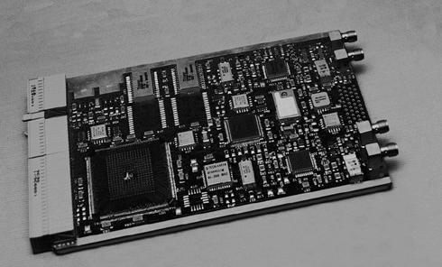
Figure 4-5 PiVoT Receiver

Flight Experiments

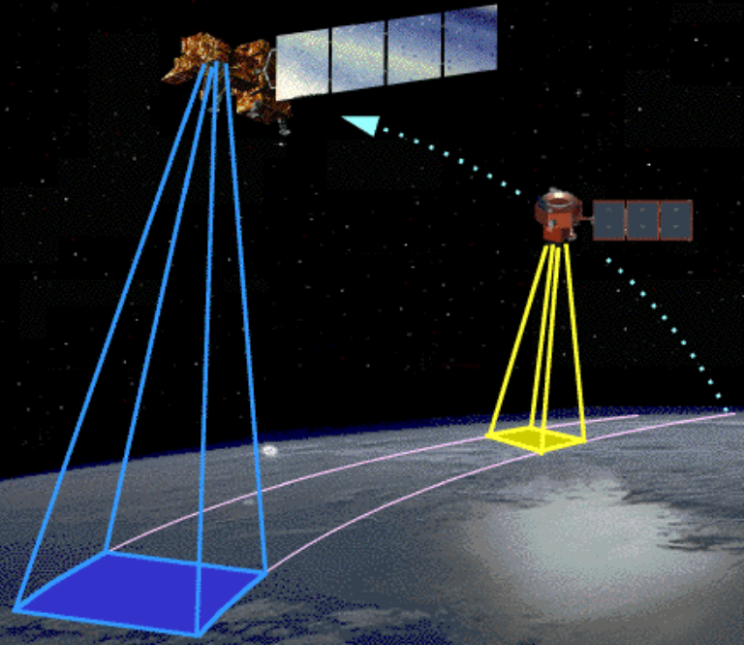
The FDAB navigation team provided extensive analysis of the autonomous navigation accuracy being achieved for the EO-1 mission using GPS, in support of the Extended Formation Flying (EFF) experiment. We performed post-facto processing of the raw measurement data to evaluate achievable accuracies, and filtering of the Loral Tensor GPS receiver’s point solutions and filtered solutions to assess the resultant improvement in these solutions. We provided a detailed summary of resultant navigation accuracies that can be achieved using the various solutions. We also assessed the quality of the operational S-band solutions. Based on this analysis, we prepared the technical report Autonomous Navigation of EO-1 Using GPS, which provides a detailed assessment of the accuracy of the navigation solutions computed by the receiver on EO-1 satellite. Figure 4-6 shows two spacecraft in formation flying configuration.
Figure 4-6. Formation Flying

Future Missions Analysis

Celestial Navigation
The FDAB navigation team delivered the technical report Autonomous Navigation of Libration-Point Orbiters Using Celestial Objects and Doppler Measurements, which provides the results of an analysis of the accuracy achievable using Doppler measurements for autonomous navigation of a satellite orbiting the L1 Sun-Earth libration point. This analysis indicates that after 22 days of processing, the estimated position and velocity errors reach steady-state levels of 6.5 kilometers and 2 millimeters per second root-mean-square, which is comparable to the accuracy of the operational reference solution obtained using DSN round-trip range and range-rate measurements.

The FDAB navigation team also delivered a report that quantifies the navigation performance that can be achieved using standard spacecraft attitude sensors and communication components to provide autonomous navigation for high-Earth orbit missions. Based on the processing of real Polar spacecraft measurements, this analysis demonstrates that an autonomous navigation accuracy of about 10 kilometers root mean square can be achieved for a 1.8-by-9-Earth-radii spacecraft using realistic Sun and Earth sensor measurements. Using high-quality forward-link Doppler measurements, an autonomous navigation accuracy of 1.0 kilometer root mean square is achievable.

Relative Navigation
The FDAB navigation team presented “Evaluation of Relative Navigation Algorithms for Formation Flying Satellites”, at the GSFC Flight Mechanics Symposium held June 19-21, 2001 at GSFC. This evaluation indicates that very accurate relative navigation positions can be achieved for formations in medium-attitude and high-altitude eccentric orbits using only Global Positioning System (GPS) measurements. The addition of round-trip intersatellite range measurements was shown to significantly improve relative navigation accuracy for formations with sparse tracking of the GPS signals. Figure 4-7 shows the orbital geometry with respect to GPS broadcast signal.

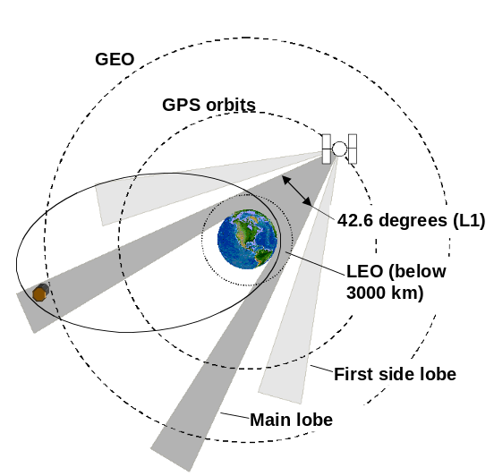

Figure 4-7. Satellite Orbital Geometry With Respect to GPS Signal

Constellation-X
The FDAB navigation team performed an analysis of the autonomous navigation accuracy that could be achieved for the Constellation-X mission. We derived these accuracy estimates based on earlier detailed simulations of navigation accuracy for the SOHO mission as a function of measurement type, measurement accuracy and tracking frequency. We presented these results to the Constellation-X project scientists.

Magic
The FDAB navigation team performed an analysis of the autonomous navigation accuracy that could be achieved for the Magic mission. This analysis included generating truth motion files, processing the GPS measurements collected by the PiVoT receiver, and simulating and processing realistic GPS measurements for two spacecraft in the Magic constellation. We provided a detailed summary of the absolute and relative navigation accuracies that can be achieved using an operational scenario that meets the constraints of the Magic mission. As a result of this analysis, Magic has selected GEONS/PiVoT as their primary navigation system option, which GNCC will provide as GFE to Magic if they are selected in the next phase of Midex missions.

[Technical contacts: Russell Carpenter, David Folta, Cheryl Gramling]

4.2.2 Adaptive Kalman Filter for Autonomous Navigation

The Kalman filter produces recursively optimal estimators of the dynamic state with well-defined statistical properties. It has been extended and modified to support high-accuracy spacecraft navigation on earth orbits. For autonomous navigation, the identification and optimization problem is introduced since the navigation system needs to perform actions that change the structural parameters of the plant the controller is interacting with. In this case, an adaptive or self-tuning filter is needed. In other words, there is a requirement to identify the relevant characteristics of the system in order to control it optimally. Numerous adaptive Kalman filters have been developed. Major adaptive Kalman filters, such as Jazwinski’s and Magill’s, have been usually referred to when dealing with autonomous navigation issues. There are some drawbacks in these techniques when applying to geocentric orbits, where gravity modeling errors play an important role in the orbit estimation problem. For Kalman filters and adaptive Kalman filters, the white process noise hypothesis is essential. Gravity modeling errors, however, have been demonstrated as auto-correlated with respect to time to the extent that any white noise approximation will yield a nonoptimal procedure.

A research was conducted to develop an adaptive technique for autonomous navigation systems on Earth orbits. It proposes a sophisticated application of neuro-fuzzy techniques to perform the self-tuning capability. It also demonstrates the feasibility and efficiency of a self-tuning component built from this concept to augment to a Kalman filter, which performs the state estimation. The core requirement is a method of state estimation that handles uncertainties robustly, is capable of identifying estimation problems, flexible enough to make decisions and adjustments to recover from these problems, and compact enough to run on flight software.

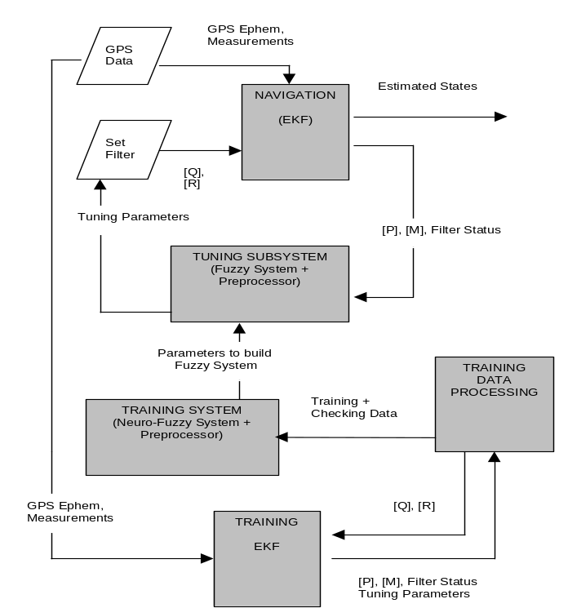

Figure 4-8. Architecture of a Self-Tuning Kalman Filter
for Autonomous Navigation (Using GPS)

The scope of this research has both theoretical and experimental dimensions. In the direction of theory, performance limits of Kalman filter and related major adaptive techniques, and new technologies popular in the areas of system identification and automatic controls are studied, with special emphasis on mathematical issues leading to the optimization of spacecraft navigation autonomy. In the experimental direction, a prototype self-tuning system is designed, developed, and tested. Filtered data from real and simulated GPS measurements are carefully prepared to train and check the accuracy of the system. The experimental implementation establishes the reliability and accuracy of the mathematical foundations of neuro-fuzzy techniques underlying the self-tuning process. Results from the testing of the prototype show that this self-tuning technique can achieve the accuracy of less than 5 cm in total position.

Figure 4-8 illustrates the architecture of a self-tuning Kalman filter for Autonomous Navigation using GPS. The tuning subsystem prototype is simply a three inputs/three outputs neuro-fuzzy system augmented by a preprocessor that gathers filter outputs (i.e. state error covariance) in time series, determines if the filter re-tuning is needed, and uses least-squares process to linearly fit them. The preprocessor also builds a vector that represents the behavior of the covariance and that is input to the neuro-fuzzy system. Parameters are tuned using the hybrid option that is a mixture of least squares and back propagation techniques. The prototype neuro-fuzzy system consists of three Adaptive Neuro Fuzzy Inference Systems (ANFIS). Each ANFIS is built from a three-input Sugeno Fuzzy Model with 27 rules, as shown in Figure 4-9. There are 536 samples generated to train and test this prototype. These samples are selected outputs from 536 runs using GEODE Version 5 for single satellite and clean simulated GPS data as input.

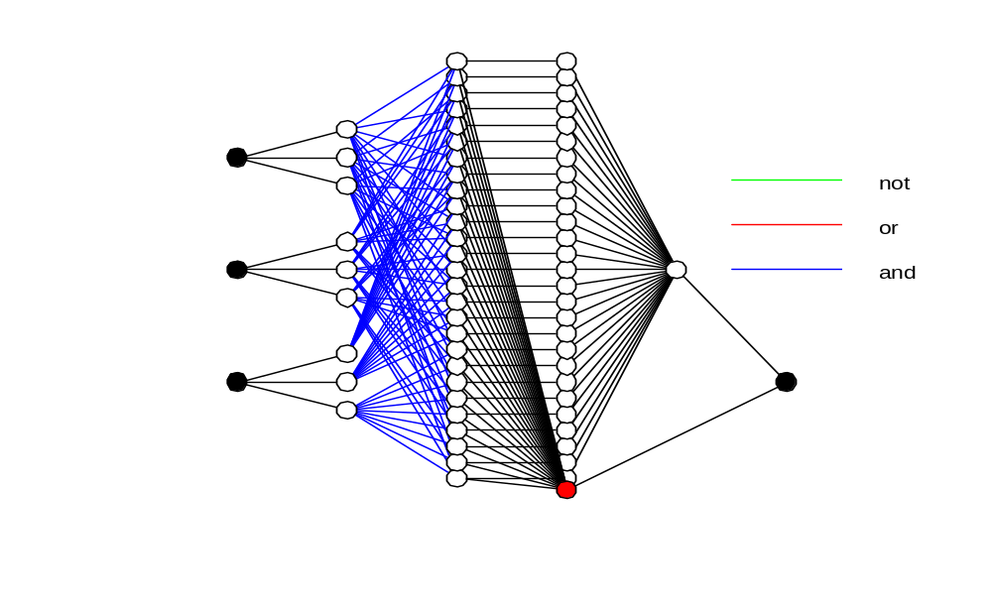

Input Output

Figure 4-9. Diagram of a Three-Input ANFIS with 27 Rules

This concept of a robust and self-tuning Kalman filter for autonomous spacecraft navigation is also extended to broaden its mission scope to include geosynchronous orbits and near-Earth high-eccentricity orbits.

[Technical Contact: Son Truong]

4.2.3 Magnetometer Based Navigation

Overview

Magnetometer based navigation (MAGNAV) provides low cost, autonomous navigation for low Earth orbit (LEO) missions. The magnetometer has four primary advantages. First, it is always part of the sensor complement for LEO missions, primarily for momentum management. Second, it always outputs data; that is, it is not subject to occultation or tracking problems. Third, it is very reliable. Lastly, it provides information on spacecraft attitude, rate, and orbit. The system developed in GNCC is based on an Extended Kalman Filter algorithm, combined with a pseudo-linear Kalman filter, producing the full set of navigation parameters, namely attitude, orbit, and rate. Reducing the complexity of onboard processing, eliminating costly sensors, and reducing ground operating costs, while providing accuracy and reliability are additional objectives of MAGNAV.




To control system
GPS Signals

Attitude, Orbit, Rate

Sensor Processing
MAGNAV Algorithm

‘Black Box’
To ground
Magnetic Field Measurements



Figure 4-10. High Level Overview of Onboard Operation

Typically, the MAGNAV algorithm, in order to provide simultaneous attitude, orbit, and rate estimates, also processes data from an additional sensor, such as a gyro, sun sensor, or GPS (operating alone the magnetometer can provide either attitude and rate or orbit estimates). This improves the accuracy and speed of convergence, and ensures robustness. A magnetometer-gyro configuration has been tested with real data from four GSFC satellites. A magnetometer-sun sensor configuration has been tested with TRACE data and is scheduled for an inflight test onboard the WIRE spacecraft. The magnetometer-GPS configuration (GPSMAG) underwent analytical testing in FY01, with the goal of developing a ‘black-box’ spacecraft navigation system, as depicted in Figure 4-10. Example results are given in Table 4-1 below. It is expected that MAGNAV could be used in a backup mode; startup mode, e.g. initialization; anomaly resolution; or as a prime navigation system for a LEO mission with coarse requirements.

Table 4-1. MAGNAV Performance

Sensor Combination | Orbit | Attitude | Rate
MAG+GYRO | 15-25 km | 0.2-1.4 deg | Gyro dependent
MAG+SUN | 10-40 km | <1 deg | <0.003 deg/sec
MAG+GPS | ~meters | <0.3 deg | <0.003 deg/sec

In-Flight Experiment of MAGNAV on WIRE Spacecraft

An in-flight experiment of the MAGNAV algorithm will take place onboard the WIRE spacecraft. The flight code has been prepared and is undergoing final ground testing. The code is expected to be uplinked and patched into the WIRE onboard computer in early October of 2001, with two weeks of testing to follow. MAGNAV will run as an independent task, in parallel with the fine and coarse onboard attitude determination systems. It is anticipated that this test will demonstrate the capabilities of the MAGNAV algorithm to provide low cost, autonomous estimates of orbit, attitude, and rate for low Earth orbit satellites.

IR&D Funded Research of GPS/Magnetometer Navigation

Analytic testing of the GPSMAG, a version of MAGNAV that incorporates GPS measurements, was conducted during FY01. The testing was performed using Matlab. The spacecraft simulation was based on a UARS ephemeris and included simulation of the GPS constellation. The algorithm was successful in estimating the spacecraft orbit, attitude, rate, and GPS clock errors using simulated measurements from two GPS satellites (both phase and pseudo-range), along with magnetometer measurements. Starting with initial errors of 500 km/axis in position, 0.5 km/sec/axis in velocity, 103 degrees in attitude, and 5 deg/sec/axis in rate, the average RSS errors after 12 hours were less than 0.3 deg in attitude, 0.003 deg/sec in rate, 30 meters in position, and 6.5 cm/sec in velocity. Most of the convergence occurred within the first 50 minutes. Additionally, the algorithm was able to follow a simulated 80-degree rotation about a spacecraft body axis. The results of the testing were presented in two conference papers.

[Technical Contacts: Julie Thienel, Rick Harman]

4.3 Formation Flying Technologies

4.3.1 EO-1 Formation Flying Experiment

NASA’s first-ever autonomous formation flying mission has been successfully completed! With the launch of NASA’s Earth Observer-1 satellite, called EO-1, NASA’s Goddard Space Flight is demonstrating the capability of satellites to react to each other and maintain a close proximity without human intervention. This advancement allows satellites to autonomously react to each other’s orbit changes quickly and more efficiently. It permits scientists to obtain unique measurements by combining data from several satellites rather than flying all the instruments on one costly satellite. It also enables the collection of different types of scientific data unavailable from a single satellite, such as stereo views or simultaneously collecting data of the same ground scene at different angles.

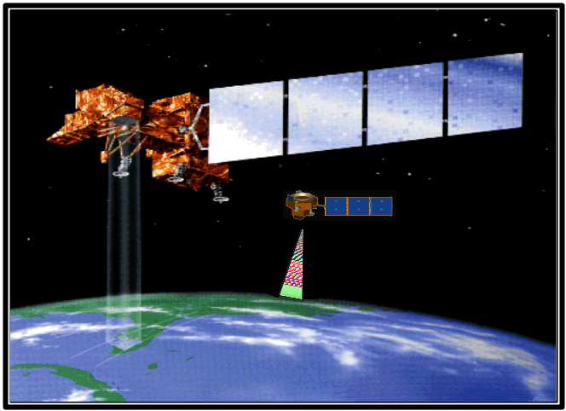
Formation Flying is exactly that, satellites flying in a predetermined formation, and maintained in that formation by using onboard control. Therefore, when one satellite moves, the others move to coordinate their measurements. EO-1 was launched this past December as a technology mission designed to fly in formation with another NASA satellite called Landsat-7, as shown in figure 4-11. Both satellites carry instruments that enable scientists to study high-resolution images and climatic trends in the Earth’s environment. The EO-1 satellite flies only 60 seconds (450 kilometers) behind Landsat-7 and maintains the separation within 2 seconds. This separation is necessary for EO-1 to observe the same ground location through the same atmosphere region. It also demonstrates significantly improved return of science data. The mission allows engineers to compare technological advances made in ground observing instruments that are smaller, cheaper, and more powerful. EO-1 also demonstrates technologies for propulsion, onboard processing, and data storage.
Figure 4-11. EO-1 Following Landsat-7

Previously, satellites did not communicate directly with each other, did not plan and execute orbital maneuvers onboard, nor were they equipped to autonomously accommodate the actions of any other satellite in support of a desired scientific experiment. Onboard EO-1 is an advanced technological controller that is capable of autonomously planning, executing, and calibrating satellite orbit maneuvers. On EO-1 it is used for the computation of maneuvers to maintain the separation between the two satellites. The idea and mathematical algorithm for this NASA first was developed by Dave Folta, John Bristow, and Dave Quinn, Aerospace Engineers of the Flight Dynamics Analysis. It is designed as a universal 3-Dimensional method for controlling the relative motion of multiple satellites in any orbit. Their idea was then combined with a new flight software that is the predecessor of a GSFC sponsored commercial software call FreeFlyer produced by Lanham, MD based a.i.-solutions inc. This flight software provides for the ingest of real-time navigation data from the onboard Global Positioning System (GPS), the transfer of data from the maneuver algorithm for maneuver commands, onboard predictions of where the satellites will be in the future, the necessary attitude pointing, and actual onboard commanding of the thruster firings.

Because maneuver calculations and decisions can be performed onboard the satellite, the lengthy period of ground-based planning currently required prior to maneuver execution will eventually be eliminated. The system is also modular so that it can be easily extended to other mission objectives such as simple orbit maintenance. Furthermore, the flight controller is designed to be compatible with various onboard navigation systems.

Formation flying technologies are primarily concerned with the maintenance of the relative location between many satellites. Much shorter and more precise baselines can be established between the satellites. The satellites can then be combined as part of a “virtual satellite” that should provide previously unobtainable science data using mass produced, single-string, relatively cheap satellite. Multiple scientific instruments often present competing and conflicting requirements on a satellite design and its operation. So much science at stake for a single satellite often requires a great deal of onboard redundancy, which imposes its own overhead on the design process. Separating scientific payloads onto several simpler single-string satellites can accomplish the same complex missions without the added design and operational overhead, while risking only one payload at a time. The proposed approach for onboard formation control will enable a large number of satellites to be managed with a minimum of ground support. The result will be a group of satellites with the ability to detect errors and cooperatively agree on the appropriate maneuver to maintain the desired positions and orientations.

Since this technology is now fully developed and demonstrated, synchronous science measurements occurring on multiple space vehicles will become commonplace and the concept of Earth observing ‘virtual platforms’ will become a reality. In the process, this technology enables the development of autonomous rendezvous. Scientific payloads could be launched from any launch vehicle, rendezvous with and join a formation already in place, and then autonomously maintain this condition or respond to specific requests for science data collection by altering its own orbit. Thus, this technology addresses all of the NASA directives to build revolutionary satellites that are better, faster, and cheaper.
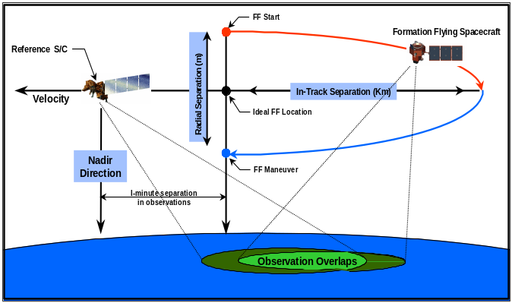

Figure 4.12. Orbit Mechanics of EO-1 Formation Flying

In Figure 4-12, EO-1 starts a formation at the red dot located behind Landsat-7 by 450 kilometers and above by approximately 50 meters. Due to the differences in the accelerations from atmosphere drag and spacecraft design, the EO-1 satellite orbit decays faster than that of Landsat-7. While above Landsat-7, EO-1 is drifting away from Landsat-7. After several days of atmospheric drag, EO-1 will be below Landsat-7 and will drift towards it. When EO-1 is outside the required separation distance or if the Landsat-7 satellite has maneuvered away, EO-1 will autonomously compute and perform a maneuver to reposition it to an initial condition to repeat the relative motion and meet science data collection requirements.

EO-1

[Technical Contact: David Folta]

4.3.2 SBIR Phase II Research: Autonomous Unified Orbit and Attitude Control for Formation Flying using GPS and LQG/LTR Controller

The objective of this work was to provide formation flying control designs that can be used to support many of the GSFC distributed spacecraft architectures of multiple imaging, interferometry, and robust control. The design evolution compliments a complete design of an actual Autonomous On-Board Orbit and Attitude Control System for Formation Flying. The definition of Formation flying used here is where spacecraft are reactive to each other and involve a cross-link communication path between the spacecraft. The spacecraft will be with a line of sight distribution and will revolutionize the way scientific measurements are captured. Figure 4-13 shows spacecraft in formation flying.

The Satellites in these future formations need to be maintained or controlled at designated positions in the formation group. The orbit control system consists of an onboard closed-loop feedback controller and an orbit real-time on-line estimator (i.e. Kalman Filter). The input of the controller is the direct orbit measurement data, possibly GPS or other ground generated states. The attitude needs to also be estimated and controlled, concurrently with the orbit control. The attitude determination system will use an onboard navigation system input with other spacecraft hardware such as gyro inertial units. The attitude controller will also use a non-linear attitude control law. The methods used for control cover LQG/LTR and Lyapunov.
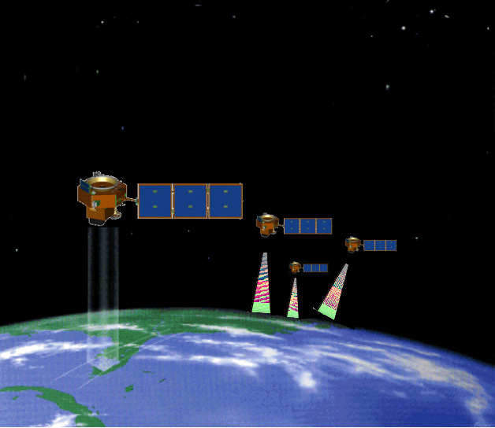
Space Products and Applications (SPA) Inc. has completed a unified orbit and attitude control system to meet distributed spacecraft requirements. This work includes pulse modulation effects of a propulsion system used in a finite maneuver model, GPS models, attitude and orbit estimation, and the relative controllers for each. They incorporated their MATLAB based design into a GSFC high fidelity simulator. Several papers have been published on this topic, with the most recent paper entitled “Design and Implementation of Synchronized Autonomous Orbit and Attitude Control for Multiple Spacecraft Formation Flying Using GPS”.

The completion of this SBIR-II allows GSFC to perform a unified control approach to formation flying and these control algorithms are being proposed for an EO-1 technical onboard formation flying demonstration.
Figure 4-13. Spacecraft in Formation Flying

[Technical Contact: David Folta ]

4.3.3 Decentralized Estimation and Control of Distributed Spacecraft

Decentralized control is an appealing approach to maintaining satellite formations for several reasons. It is non-hierarchical, so that coordination by a central supervisor is not required, but it retains the optimality of centralized control. Each satellite need only process its own local measurement data, in a form of parallel processing. Detected failures degrade system performance gracefully. For a given level of system reliability, a decentralized architecture may be cheaper to build, since the individual spacecraft can be built with much lower individual levels of reliability than the supervisor satellite in a centralized architecture.

When we began this research program two years ago, the basic principles and technology concepts of decentralized control for satellite formations had only just been observed and formulated. To bring this promising technology to a level of readiness feasible for use in upcoming formation flying missions, our research has focused on investigating implementation issues and testing in a relevant environment. In the former area, we studied fault detection, isolation, and recovery, command and data handling system and communications channel noise and latency, and modeling issues related to the handling of nonlinearities inherent in the satellite cluster problem. In the latter area, we augmented existing resources at Goddard, the University of California at Los Angeles (UCLA), the Naval Postgraduate School (NPS), and the Massachusetts Institute of Technology (MIT) to integrate algorithms into closed-loop avionics testbeds, with actual sensor hardware in the loop. As a result of our research activities, the concepts and critical functions relevant to utilizing decentralized architectures for precise formation flying missions have been proven analytically and experimentally. We have also validated many of the necessary algorithms and components, and in some cases, subsystems, in laboratory and flight environments. We have identified collaborations over the next few years that will take the technology through system prototype demonstrations in a space environment. Below, we highlight our key accomplishments, summarize the additional research and development necessary to bring the remainder of the key components and algorithms to the subsystem validation level, and describe the outlook for flight qualification and utilization of decentralized control architectures for future precise formation flying missions. Figure 4-14 shows distributed spacecraft configuration.
Figure 4-14. Distributed Spacecraft

Accomplishments

Our research program was divided into three parallel efforts. The first effort aimed to apply the basic principles and technology concepts of decentralized control to satellite formation flying. The second effort concentrated on developing and validating technology concepts for fault detection, isolation, and recovery to decentralized architectures. The final component of our research was to validate these theoretical results in relevant, hardware-in-the-loop and flight environments.

We have presented some of our research findings at several conferences. Our first annual report included papers presented at the 1999 AIAA GNC conference in Portland, OR, the 1999 AAS Astrodynamics Specialists Meeting in Girdwood, AK, the 2000 ION National Technical Meeting in Anaheim, CA, and the 2000 IEEE Aerospace Conference in Big Sky, MT, and the 2000 CNES International Symposium on Spaceflight Dynamics in Biarritz, France. We have subsequently presented more of our work at the 2001 Goddard Flight Mechanics Symposium, the 2001 SIAM Conference on Control, 2001 American Control Conference, 2001 IEEE Conference on Decision and Control, and the 2001 AAS Astrodynamics Specialist Conference. A version of our final report has been accepted for presentation at the 2002 IEEE Aerospace Conference.

Our work has also been accepted for publication in several refereed technical journals. The Girdwood paper was published in the AIAA Journal of Guidance, Control, and Dynamics. A paper on decentralized fault detection has been published in the ASME Journal of Dynamic Systems, Measurement, and Control. A paper on the extended decentralized controller has been accepted for publication in the International Journal of Robust and Nonlinear Control. The following paragraphs summarize our results.

Application of Decentralized Control Algorithms to Satellite Formation Flying

Natural Motion of Satellite Clusters

Creating a single “virtual” satellite out of several “smallsats” requires placing a cluster of these smallstats in orbit. The relative positions of the satellites within the cluster must be maintained to some degree of precision, depending upon the particular mission requirements. A naïve approach to configuring a satellite array might be to imagine the satellites flying side-by-side through space, circling the earth in parallel orbits. Some reflection on this idea, however, reveals that this is not a natural satellite motion, and therefore cannot be maintained without continuous control force to counteract some portion of the natural forces of gravity. The only practical configuration in which the relative positions of the satellites never changes has them following each other in a single line along a single orbit. For many missions, this is not an acceptable configuration, and thus non-coplanar orbits must be considered. Satellites on non-coplanar orbits will move with respect to each other, and the necessity is to understand that motion, and use it to maintain a cluster formation.

A promising approach to this problem is to consider the motion of satellites about an ideal, spherical planet, in orbits with small eccentricity and slight differences in inclination. The only firm constraint needed to keep the satellites together is that the periods of the orbits be identical (the semimajor axes of all orbits be the same). The paper analyses this behavior in more detail, and examines the use of linearized equations to examine the satellite motion. The limitations of the equations due to linearization are discussed. As the paper deals with idealized circumstances, perturbations are not discussed. This behavior of neighboring satellites can be exploited to create formations of great size and complexity, with no danger of satellite collisions. So long as the semimajor axes and eccentricities of all orbits are identical, the satellite cluster will appear to revolve about its common center, and the satellites will remain very nearly in the same relative positions within the cluster.

Extending these results to orbits with large eccentricities means that the cluster will change in size and distribution during the orbit. It is therefore necessary to allow for this in the control law. If this is not taken into account, the controller may expend large amounts of fuel in an unnecessary effort to eliminate these cyclic variations. It should be noted that even with these variations, there is still no danger of satellite collisions due to natural motion.

Development of an extended decentralized controller

The original decentralized controller that forms the basis for our work required that a linear model of the system dynamics, actuators, and measurements be available. This requirement is particularly restrictive for realistic formation flying applications, since realistic measurements such as GPS and crosslink ranges can almost never be assumed to be linear functions of the state variables. We have developed extensions to the linear decentralized controller that are similar to the commonly used extended Kalman filter, that allows the system to be partitioned in such a way as to exclude the nonlinearities from the essential algebraic relationships that allow the estimation and control to be optimally decentralized. The extended form of the decentralized controller can be used with the linear quadratic regulator (LQR) formulated as a model-based
tracking law, in which minimal data transmission is assured, or as a decentralized estimator for more complex controllers. We have investigated both the LQR-type controllers and a controller of the type that was used for EO-1’s formation flying experiment with Landsat-7.
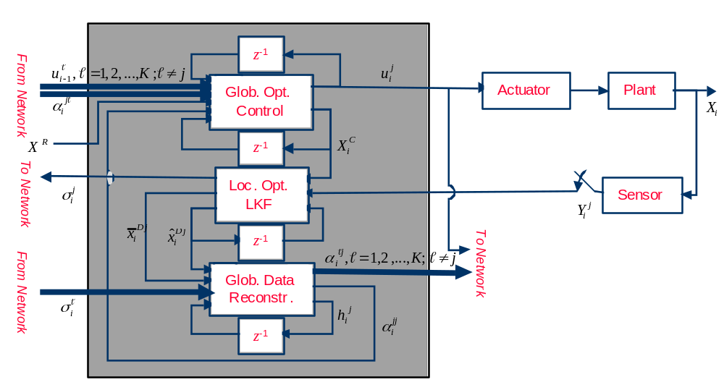

Figure 4-15. Extended Decentralized Controller

Decentralized Control with Communication Constraints
Control algorithms were derived for decentralized control of dynamic teams with minimal amount of communication between the satellites and irregular control schedule. Two relaxed data exchange patterns were studied. It was determined that optimal control laws can be obtained in both cases if linear quadratic Gaussian payoff is used in conjunction with discrete dynamics. It was concluded that the minimal communication necessary for affine optimal controls involves exchanging of the control values between the satellites.
Control and State-Estimate Sharing: In this paradigm, all nodes (satellites) exchange both their local state-estimates and the control values every time a control has been activated at any node. The global state estimates are determined by algebraically combining the local state estimate of each satellite. This creates a uniformly shared global state estimate. The control schedule, however flexible, has to be known in advance to all satellites to permit the dynamic programming solution. The control law for each satellite is an offline function of the last shared global state-estimate, and the local measurements collected since the last communication. Dynamic programming is used to derive the cost to go at each step where controls are engaged. This cost to go at each control actuation in the backward dynamic programming algorithm is manipulated into the form of a static LQG team problem, and the optimal static team solution is used to derive the control gains.

Control Sharing: In this case, only the control values are exchanged noiselessly between the satellites (i.e. after a node executes a control it broadcasts it to all other nodes). Again, knowing the control schedule in advance allows for the construction of the control gains using the dynamic programming backward propagation. The static team solution is used at every control action of the dynamic programming. The control laws are also affine, but now they are functions of the initial condition (a priori state value at the initial time), the local measurement sequence collected since the initial time, and all previous control efforts, executed by all nodes. This appears to be the minimal information exchange that retains affine control laws.

Simulations: The controls were derived for a scalar 10-step example with two nodes, using both data exchange modes. The results were then compared to a centralized solution, which was obtained using a two-state controller instead of two independent nodes. The comparison shows that the performance in both non-classical cases is only moderately degraded from the centralized solution. There is also a moderate cost increase in the control sharing method over the control and state-estimate sharing solution, which is consistent with the stochastic theory of having better results with more information. The control and state-estimate sharing algorithm will next be applied to a satellite cluster, which is to be controlled with minimal effort so that its geometry is maintained relative to a reference orbit. The reference orbit with a given eccentricity is the center of the coordinate frame to be used by every member in the formation and moves as if it were a physical satellite. A schedule of station keeping burns and data transmission are specified a priori to permit a solution by dynamic programming.

Selection of Mechanizations

In our initial work leading up to the Explorers award, we used a very simplified mechanization of the satellite dynamics, actuators, and measurements in order to utilize the original linear decentralized control algorithm. With the development of the extended version of the algorithm, we have been able to begin to add more realism to the mechanization. A significant accomplishment in this area is the development of mechanizations that allow for realistic non-linear measurements, but retain a linear time-invariant model for the regulated variables. This allows us to avoid the need for an online backward sweep of the controller Riccati matrix to determine the optimal controller gain, which is a very computationally complex proposition. Disturbances such as higher-order gravity, drag, etc., can also be accommodated. We have developed such mechanizations for near-circular orbits, and for halo or Lissajous trajectories about the colinear equilibrium points of the three-body problem, e.g. L₁, L₂, and L₃. We have also developed a mechanization for highly elliptical orbits that utilizes true anomaly instead of time as the its independent variable. This leads to a time-varying, but periodic controller gain that is only a function of eccentricity, and may be precomputed and stored online.

Reliability vs. Cost Study

We performed a back-of-the-envelope type of cost/benefits study, focusing on reliability vs. cost. For this study, we developed several tools, including an Excel spreadsheet, in which one can manipulate various assumptions including total number of spacecraft, minimal number of spacecraft required to perform the mission, number of redundant “strings” per spacecraft, probability of unrecoverable faults on spacecraft of varying complexities, cost to build or replace spacecraft of varying complexities, etc. We examined various cases that covered various levels of required reliability, numbers of spacecraft (up to 30), etc. In many cases we found that for a given total mission reliability, decentralized architectures are cheaper, so long as string-level reliability is not free.

Development of generic Matlab code

We have developed an event-driven implementation of the decentralized controller that we call Pluribus that is suitable for real-time embedded systems, using the Matlab commercial-off-the-shelf development environment. Using Matlab tools, Pluribus can be auto-coded directly into C or C++ for implementation on flight microprocessors. Pluribus is of generic design, so that users upload model and boundary condition information specific to their own scenarios. Pluribus is being used by the AFRL/NASA University Nanosat program as part of a program of on-orbit demonstration of formation flying, and the AFRL Techsat-21 Program has expressed in interest in utilizing it as part of its formation flying demonstration mission.
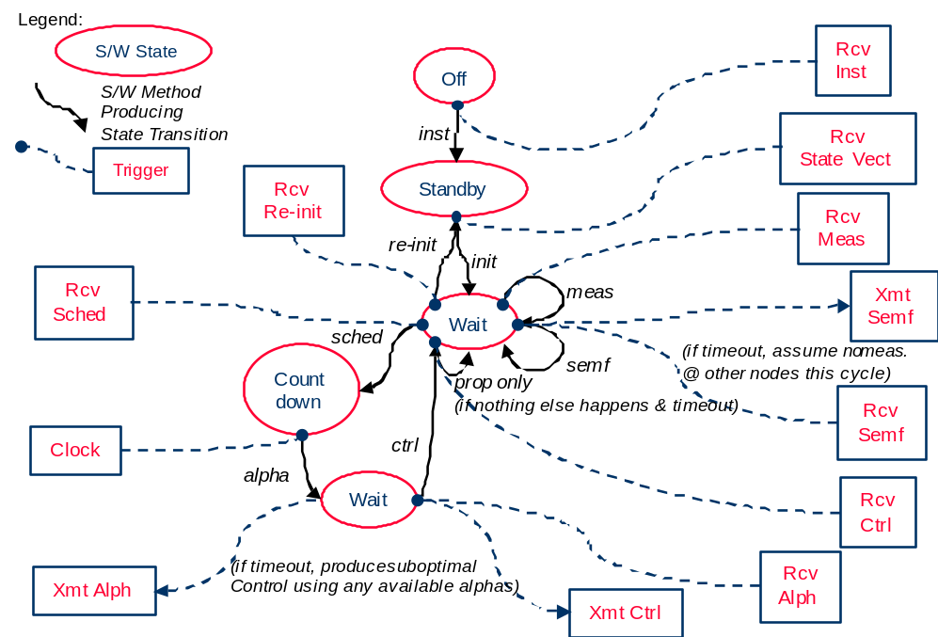

Figure 4-16. Decentralized Controller Data Flow Diagram

Satellite cluster simulations

We have developed several computer programs to model the dynamics of satellite clusters in orbit around the earth. These simulations are suitable for modeling clusters of arbitrary numbers of satellites. The simulations are designed to be extensible, to meet future simulation needs. In all of the simulations, the cluster is modeled by integrating the motion of each satellite separately. The dynamic model of satellite motion includes the effects of solar pressure, atmospheric drag, and the non-spherical terms in the gravitational field of the Earth. In some of the simulations, Sun and Moon point mass perturbations can also be included.

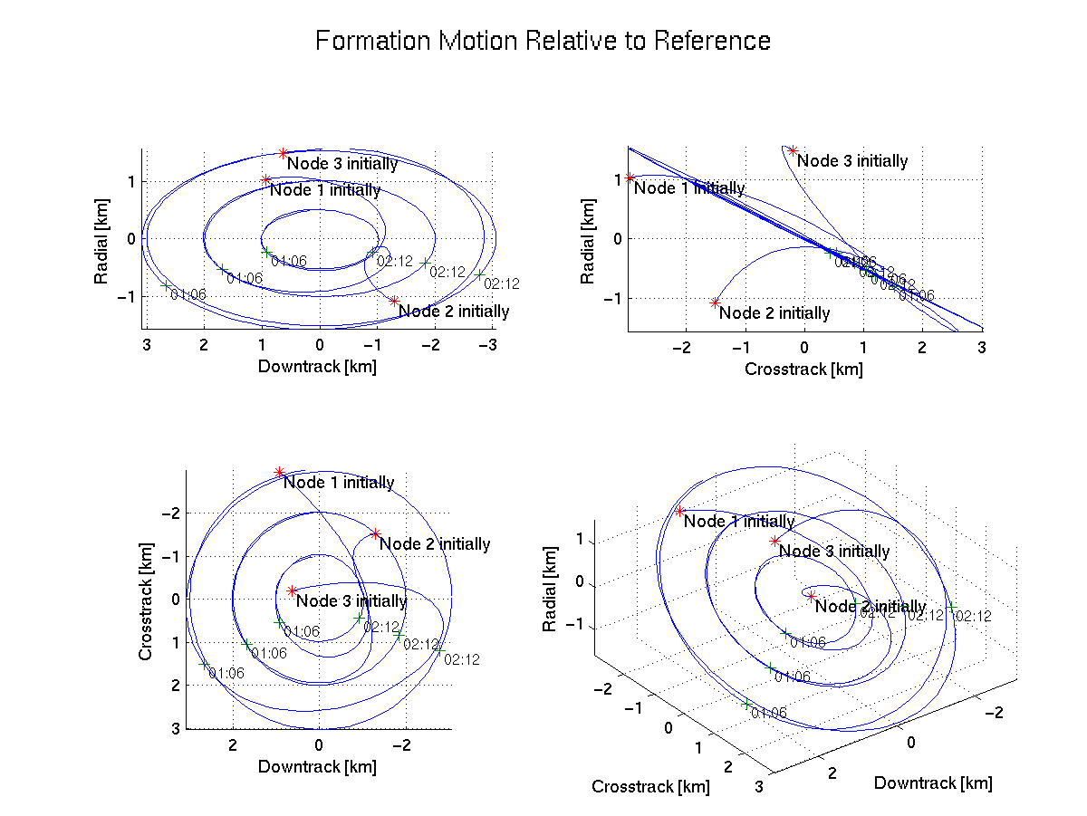

Figure 4-17. Formation Motion Relative to Reference

Mechanically motivated control and orbit analysis

An alternate approach to the control of satellite clusters is based on the geometry of the orbit. It can be shown that any non-collision elliptic orbit can be uniquely described by the Runge-Lenz and the angular momentum vectors of the orbit (non-collision here means that the angular momentum is non-zero). As these vectors are natural constants of the satellite motion, and appear naturally in the solution of the differential equations of Kepler motion, they occupy a space on which the usual algebraic structures of Euclidean space can be applied. It then becomes straightforward to define a "distance" between a current and desired orbit, and to construct Lyapunov functions based on this distance. From these functions, controllers are derived which can be rigorously proven to be stable and convergent. This leads to easily implemented controllers that can be used for arbitrary orbit transfers. Such controllers have been investigated for orbit transfers of a single satellite. The implementation of these controllers to cluster control and use with an oblate Earth model will require further investigation.

Fault Detection, Isolation, and Recovery
The focus in this area has been on defining the potential scenarios that can take place when considering a cluster of satellites flying in formation. Identification of possible absolute and relative sensor systems that will be used in such networks is an essential part of our current task. Moreover, the set of all a priori sensor, actuator, and plant faults to be assumed for these scenarios is being constructed. A bank of robust single fault detection filters is required to monitor, detect and identify a set of possible a priori faults. The importance of the extension to time-varying systems is that they are applicable through dynamical system maneuvers and if the motion is sufficiently quick, these time-varying detection filters should be more accurate than using gain scheduling on a set of time-invariant detection filters. Asymptotic characterization of these detection filters near this limit shows that the dimension of these single fault filters can be greatly reduced.

A particular important property of these single-fault detection filters is that their gains are computed from Riccati equations. This property is a sufficiency condition for the computation of a decentralized detection filter algorithm. The notion is to build local detection filters related to their sensors and a priori fault direction set. A reduced state space for the local detection filters is constructed by choosing a minimal realization associated with the local measurements, the global dynamics, and the local fault direction set. The residual for a global fault detector associated with mutual measurements can then be constructed from the local detection filters. This residual is used to detect faults in the mutual (or relative) measurements.

Currently, detection filters are being developed for individual satellites. A set of possible a priori faults associated with actuation for attitude control and stationkeeping propulsion, and a set of measurements associated with attitude determination and navigation is constructed. These local detection filters will form the basis for constructing the global residual for detection and identification of faults in the relative measurements between spacecraft.

An approach to reconstructing the sensor and actuator faults is developed based on the structure of the fault detection filter. This approach allows for control system reconfiguration in a very straightforward manner by correcting the corrupted instrument or explicitly adjusting the remaining actuators to compensate for the faulty actuator. Fault reconstruction is very important because it greatly increases the flexibility of the system’s reaction to the sensor and actuator faults.

Integrated Hardware-in-the-Loop Testing

Testbeds

An associated benefit of our research is that, in order to demonstrate our algorithms in a flight-like environment, we significantly enhanced the capabilities of hardware-in-the-loop formation flying testbeds at Goddard and UCLA (figure 4-18). We used the GSFC Formation Flying Test Bed (FFTB) to demonstrate a fully decentralized, operational version of the extended decentralized controller, implemented in the Pluribus generic software program. As a result of improvements made to the FFTB through our work, it has become a major institutional resource at Goddard, and has already begun to be utilized by a pre-proposal phase mission that requires precise formation flying capabilities, the Stellar Interferometer (SI) mission. We used the UCLA formation flying testbed to validate the UCLA Formation Flying Instrumentation System (FFIS), a cm-level GPS relative navigation system that forms the basis of our aircraft flight tests, which we discuss further below. The UCLA testbed has since been used to validate relative navigation and control sensors and algorithms for a formation flying flight test using F-18s sponsored by NASA Dryden.

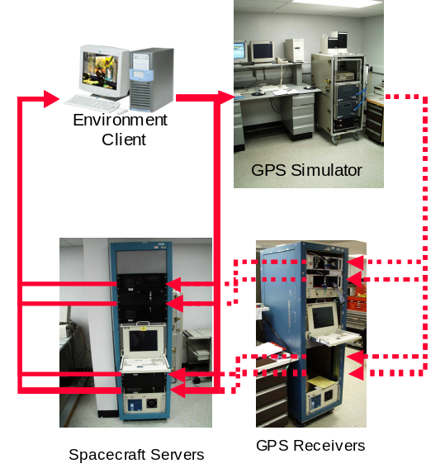

Figure 4-19. Integrated Hardware-in-the-Loop

Aircraft flight test

A series of flight test campaigns in conjunction with the Naval Postgraduate School were conducted. Existing unpiloted air vehicles (UAVs) at UCLA and NPS (known as the “Mule” and the “Frog”) were flown with UCLA’s FFIS, which consists of a dual-frequency GPS receiver, inertial measurement unit, and a flight computer, onboard each aircraft. These flights were conducted at the Camp Roberts flight test range, approximately 40 miles north of Fresno, California.

To begin the campaign, the FFIS was extended to include the ability to read the control surface positions, and to generate pulse-width modulated control signal to the UAV actuators. Control laws were derived using the available aerodynamic models of the Mule and the Frog. These models were somewhat crude, but conservative controllers with healthy safety margins were defined for early use. The test plan called for autonomous flight of the Mule first, then the Frog. Only after it was determined that the FFIS was capable of individual autonomous flight were dual flights to be undertaken.

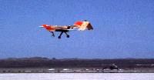
In this campaign, we completed autonomous flights and fully equipped the Frog for autonomous formation flight with the Mule. The Mule was successfully flown by the FFIS several times, and the controller successfully navigated the aircraft through a flight path defined by waypoints, pre-defined positions relative to the launch point of the plane. Unfortunately, a landing mishap (while the Mule was under the control of the human operator) damaged the Mule beyond repair just as the formation flight segment of the program was about to begin. Using program reserve funds, an additional Frog is currently being equipped to replace the "Mule," and we plan to complete the formation flying test campaign this fall. We plan to issue a supplement to this final report at the conclusion of the fall campaign.
Figure 4-20. Aircraft Flight Test

MIT “SPHERES.”

We began collaborating with MIT in the use of small, student-built vehicles called “SPHERES” that are designed to fly inside the Space Shuttle middeck and the International Space Station as research platforms for satellite formation flying. The SPHERES had their first two flight tests on NASA’s KC-135 zero-gravity research aircraft at the Johnson Space Center in Spring of 2000, and have been manifested to fly on the International Space Station flight 9-A, currently manifested for late 2002.

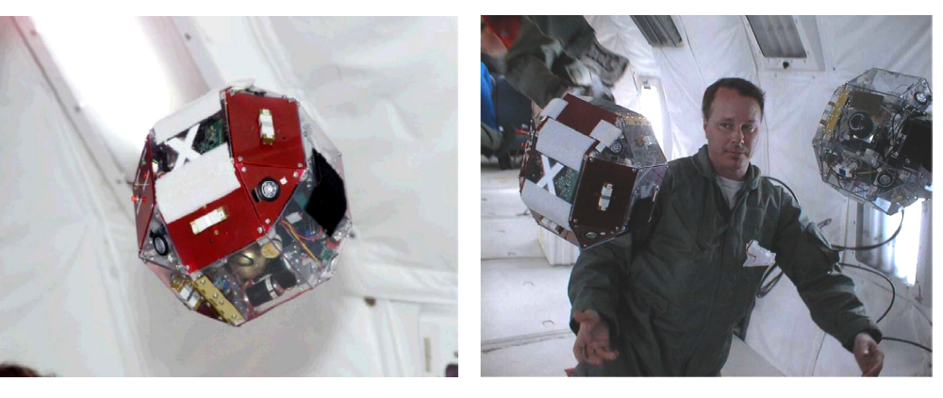
Figure 4-21. MIT “SPHERES”
Left: A free-flying SPHERE Breadboard Satellite on the KC-135 Zero Gravity Trainer Aircraft; Right: Two of the SPHERES Satellites in formation flight on the KC-135.

Next Steps

Although we have accomplished nearly all of our original research objectives, we describe here at a high level what remains to be accomplished to complete subsystem and system level development and validation studies that must precede space flight demonstration. We currently anticipate that continued funding from the Space Base Core Technology Program will enable us carry this work forward to the point of departure for a space flight validation opportunity, such as the New Millenium Program offers.

The most important next steps in our work will be to integrate the decentralized control algorithms we have developed with a high-fidelity orbit determination filter, such as GSFC’s GEONS, and refining the level of detail in our controller mechanizations. The latter effort will include continued investigations of alternative control approaches than the linear quadratic regulator, which formed the core of the present work.

Next, we plan to incorporate the work we have begun in the fault detection area, by integrating a bank of single-fault filters into the decentralized control algorithm. We are also investigating the development of numerical algorithms for generating the optimal filter gains for robust multi-fault detection filter. Our goal is to put the required minimization problem into a form that is convex so that linear matrix inequality techniques may be used. This research is aimed at developing a practical, single, multi-fault filter that could replace the bank of single-fault filters.

This fall, we plan to accomplish a two-week campaign of three-dimensional (6 DOF) flight tests in the microgravity environment aboard NASA’s KC-135. The research goal is to quantify the performance of formation-flying algorithms by testing their applicability for different maneuvers. These flights will also investigate improvements to the global metrology subsystem. Pending continued funding from the Space Base Core Technology Program, we expect to fly with the SPHERES on ISS Flight 9-A sometime in the next year or so.

Outlook

We will continue to work with the University Nanosat and Techsat-21 programs to specifically tailor our algorithms to their missions. These technology demonstration missions will begin to pave the way for precise formation flying to be adopted by a multitude of future missions. We are hopeful that NASA is able to create an opportunity for a full-fledged precise formation flying demonstration mission, perhaps through the New Millenium Program. We would eagerly anticipate the chance to compete for a slot on such a mission.

[Technical contacts: J. Russell Carpenter]

4.4 Attitude Determination and Modeling Techniques

4.4.1 Attitude and Orbit Model Support
This year, there was an update of the SKYMAP Web site (see http://cheli.gsfc.nasa.gov/dist/attitude/SKYMAP_021201_page.html), which makes available to the public and to interested professionals the SKYMAP Master Star Catalogs and the various mission-specific SKYMAP ground and on-board star catalogs. The latest version of the Master Catalog (Version 3) is available for download from this page, but has not yet been released through the Astronomical Data Centers (ADC). The preceding version, which has been widely released, is presently the sixth most frequently downloaded catalog from the Vizier database maintained by the Centre de Donneès Stellaires in Strasbourg, France (see http://vizier.u-strasbg.fr/cats/Usage.htx). The mission-specific catalogs are now available from the SKYMAP Web site accompanied for the first time by the delivery memoranda provided with the catalogs to each mission that had commissioned one. The delivery memoranda describe catalog format and contents, and contain recommendations for the use of the catalogs.
This task completed necessary paperwork and provided necessary documentation to begin the process of commercially releasing the SKYMAP System utility MCDUMP. This program allows a user working with the SKYMAP Master Catalog to create subsets of the 299,160-entry catalog based upon one or more user-specified criteria (e.g., brightness in the Johnson V passband, position on the Celestial Sphere, or known or suspected variability).
Work continued to produce the SKY2000 Version 4 Master Catalog, which will be improved by the global and comprehensive replacement of all variable star identifiers and data fields from the following major variable star data sources: The New Catalogue of Suspected Variable Stars (NSV), the Supplement to the New Catalogue of Suspected Variable Stars (NSVS), the General Catalogue of Variable Stars (GCVS), and the 76th Namelist of Variable Stars (NL76), all available from the Web site of the Sternberg Astronomical Institute (see http://www.sai.msu.su/groups/cluster/gcvs/gcvs/new.htm). This update will provide variable star identifiers and data for many Master Catalog stars not previously identified in the MC as variable. This in turn will assist missions using SKYMAP star catalogs in guide star selection, allowing more reliable avoidance of variable stars where desired. In addition, since much of the more recent work done in the area of variable star astronomy has involved research into the variability of stars at longer wavelengths (e.g., red or infrared), updated variability data in the SKYMAP MC will often be for longer-wavelength passbands. These passbands correspond more closely to the passbands of the CCD chips used in many star trackers than the visual or photographic passbands in which variable stars were often measured in the past.

[Technical contact: David Tracewell]

4.4.2 Advanced Attitude Determination and Sensor Calibration

A new gyro calibration utility was developed for a gyro quadruplet (Figure 4-22) that will be flown on the EOS-AQUA mission. This utility consists of a Kalman Filter that estimates the gyro scale factors, misalignments, biases for all four gyros as well as offers a refined rate and attitude estimate. The refined rates and attitudes are possible by the use of the gyro data and star tracker data itself as a measurement. Figure 4-23 demonstrates the successful determination of gyro parameters for Aqua.

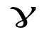
G₄
G₃
G₂
G₁
Y
Z
X

Figure 4-22. The Gyro Configuration of the EOS-AQUA Satellite.

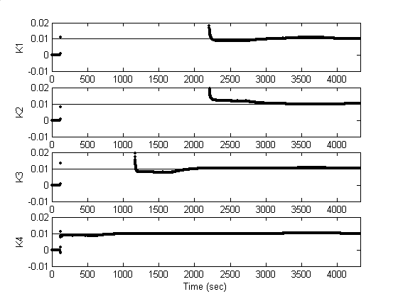

Figure 4-23. AQUA Gyro Scale Factor Estimates (bold) versus Truth (thin)

An advanced Real Time Attitude Determination System (RTADS) was developed for the Microwave Anisotropy Probe (MAP) mission. Besides providing the attitude state at any given time, the system was designed to provide a backup for MAP in case of a gyro failure when the star trackers were inoperable due to radiation belts. In that case, the system’s attitude state would be used to reinitialize the onboard attitude estimate. The rate estimation tool consisted of a Kalman Filter that estimated rate and attitude using available gyro data, the sun sensor data, and star tracker data. This filter was run twice every cycle, once for each gyro configuration. The missing rate information for each gyro was supplemented using the sun sensor data. In case of a gyro failure in the radiation belts, the last computed attitude with a star tracker measurement would be propagated using the two rate axes from the surviving gyro along with the rate derived from the sun sensor measurements for the missing axis. The onboard attitude would be overwritten with the ground computed attitude once the spacecraft attitude profile had stabilized, and the spacecraft would shift to its backup rate algorithm and continue operations. Figure 4-24 shows four of the RTADS displays with the rate estimate and attitude estimate displays on the left, the star tracker display on the upper right, and the star status display in the lower right. The left-most sensor status plot shows the relative star tracker alignment errors. The error can be seen dropping to zero. An alignment correction was uplinked at that time.

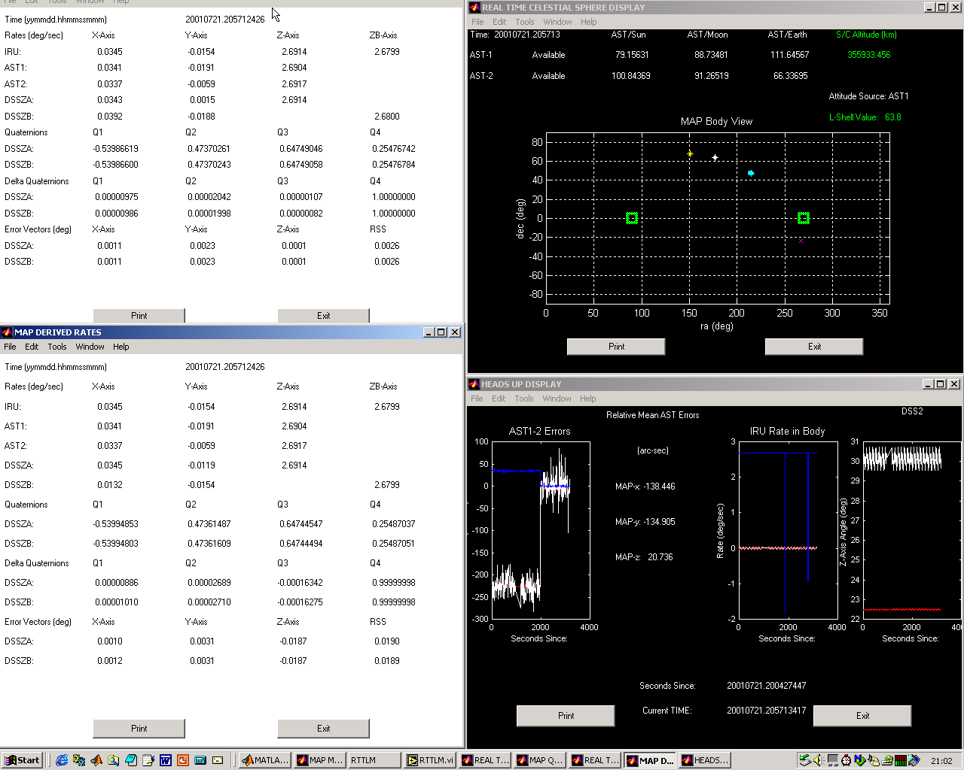

Figure 4-24. The MAP RTADS Displays

The performance analysis of two Lockheed Autonomous Star Trackers (ASTs) was performed using the EO-1 and IMAGE missions. The IMAGE mission is a spin stabilized spacecraft rotating at approximately 0.5 RPM. The noise characteristics were derived by modeling the spacecraft as a rigid body and comparing the attitude profile derived by dynamics to that computed from the AST. The error between the two (neglecting systematic effects) was taken as the sensor noise. The EO-1 spacecraft is a three-axis stabilized spacecraft. The noise characteristic was easier to derive by computing an attitude using a batch least squares estimator, which used the AST data along with gyro data.

[Technical contact: Rick Harman]

4.4.3 Multi-Mission Attitude Determination System

NASA/GSFC recently filed for a provisional patent for the Multi-Mission Attitude Determination System (ADS). This software system analyzes and processes spacecraft attitude sensor and actuator data. This processed data is used to compute spacecraft attitudes and sensor calibrations.

The system architecture, implemented with MATLAB®, offers a flexible environment for adapting and augmenting the configuration to meet specific mission requirements. MATLAB® provides an efficient, straightforward programming language, and compatibility with multiple computer platforms. The ADS, as implemented with MATLAB®, is henceforth referred to as ADS-MATLAB. However, the system design and architecture is independent of MATLAB®, and may be implemented with any appropriate interpretive programming language.

The ADS is comprised of an extensive set of specialized MATLAB® function files, integrated through a series of function calls from one component of the system to another. The operator interacts with the system through a set of graphical user interfaces (GUI’s), organized in the natural sequence of operations for a typical analysis task.

The overall system architecture is depicted in Figure 4-25 and an example main GUI is depicted in figure 4-26.

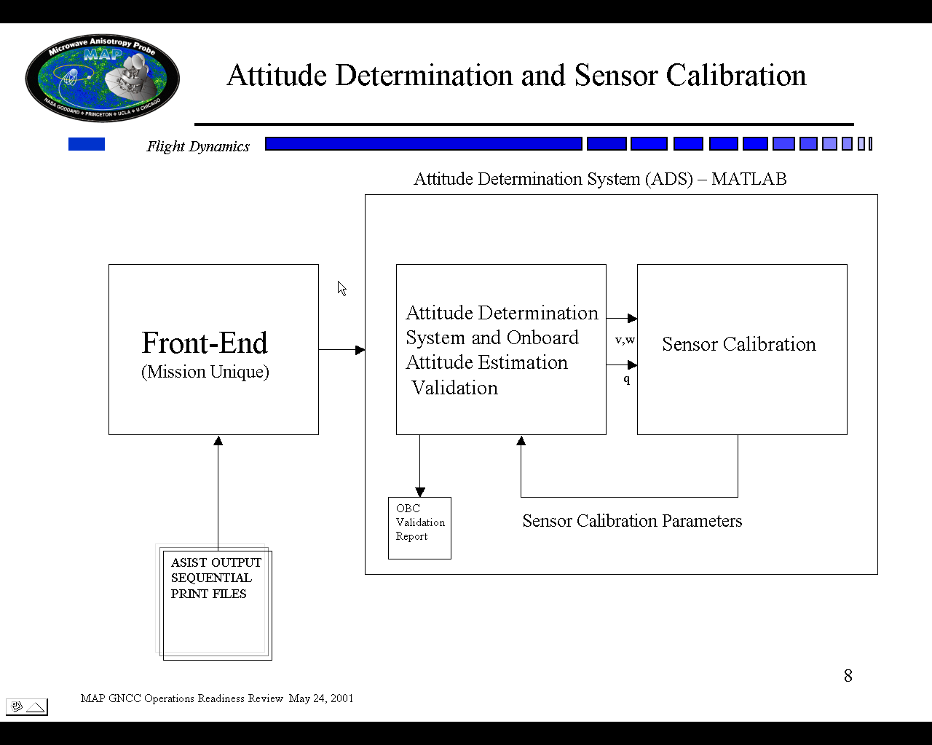

Figure 4-25. ADS-MATLAB Overview

The first button on the main GUI is the Telemetry Processor (TP). This module is a mission unique set of routines, designed to interpret raw telemetry data from the spacecraft. Typically, the attitude sensor data is ingested from large ASCII files containing a significant amount of unnecessary telemetry. The TP extracts the required data, and stores it in arrays for subsequent operations.

The Data Adjuster converts the raw attitude sensor and actuator data from the TP into observation vectors in the satellite body axes and generates corresponding reference vectors in an inertial coordinate frame (such as J2000). Supported sensors and actuators include: Star Trackers with star position angle/magnitude output; Star Trackers with quaternion output; Digital Sun Sensors (High and Low Fidelity); Coarse (Analog) Sun Sensors; Three Axis Magnetometers; Inertial Reference Units/Gyro (rate or accumulated angle output); Earth Sensors; Gimbaled sun sensor; Reaction Wheels; Magnetic Torquer Assembly.

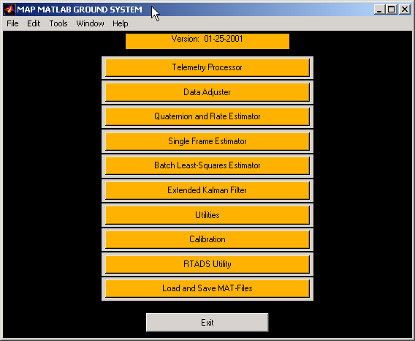

Figure 4-30. ADS MATLAB Main GUI for the MAP Mission

The Star Identification (STARID) module, which is not shown on the MAP ADS-MATLAB, matches observed stars with reference catalog. STARID supports a star catalog loaded as a MATLAB .mat file, or as a SKYMAP MMS Run Catalog. The module provides Direct Match Star Identification, Pattern Match Star Identification, and User Star Identification with a GUI interface.

The Quaternion and Rate Estimator, Single Frame Estimator, Batch Least Squares Estimator, and the Extended Kalman Filter provide the suite of tools for analyzing the sensor and actuator data. Specifically for spinning spacecraft, an azimuth estimator and a despun platform estimator and a predicted-observed attitude data utility are included. Based on operator selection of the analysis tool and sensor/actuator data, the system estimates the spacecraft attitude, spacecraft rate, gyro bias, and/or magnetometer bias.

The Utilities are a collection of tools designed to assist the analyst. The Attitude Validation utility compares ground and On Board Computer (OBC) computed attitude history files, outputting results to both reports and plots. Other utilities provide reference vectors, ephemeris file preview and selection, ephemeris comparison, and quaternion comparison. The system supports all commonly used ephemeris file formats. The GUI is readily adaptable to include additional, mission specific utilities.

The Sensor Calibration module contains a set of utilities to calibrate the sensors for various effects such as field of view errors, biases, scale factors, and misalignments. The calibration utilities include: Magnetometer Calibration (magnetometer alignment, scale factors, and bias, as well as the coupling matrix between the torquer bars and magnetometer); Attitude Dependant Alignment (estimates sensor alignments); Attitude Independent Alignment (computes alignment corrections); IRUCAL (estimates gyro scale factors, alignments and biases); BICAL (estimates gyro scale factors, alignments and biases with the ability to add batches later on to refine your estimation); FSSFOV (Estimates field of view calibration coefficients for a fine sun sensor); SSPPCAL (Estimates gimbal misalignments on which the SSPP is mounted).

The Real Time Attitude Estimation (RTADS) estimates the spacecraft attitude as well as other desired parameters in real time. This system option executes all the ADS-MATLAB functions (DA, STARID, SF, EKF, etc.) as well as user defined functions and displays in real time. The user selects which processes to execute via a GUI and develops scripts (if desired) that can be plugged into the RTADS processing by defining the name of the script in the ADS-MATLAB namelist. The major processing function that is required is the front-end. Again, only the name of the front-end script needs to be defined in the ADS-MATLAB namelist.
The Load and Save module allows the operator to save and reload data, allowing resumption of an analysis session without data reprocessing. The module also provides the operator with a variety of options to save output data arrays and reports, and system configuration settings.

The ADS-MATLAB provides a complete set of portable tools for attitude determination for most spacecraft with a highly adaptable architecture to conform to specific mission configuration requirements. The estimation algorithms represent the current state-of-the-art technology, and are easily modified or extended as methodologies improve. In general, the routines are coded to optimize performance with the MATLAB® environment. Also, many of the individual ADS-MATLAB routines (m-files) form a function library that independently serve as analysis tools, or provide a resource base for building similar systems.

[Technical contact: Rick Harman]

4.5 Flight Dynamics Automation Studies

The University of Maryland Department of Aerospace Engineering has continued to act as a test bed for researching ground system automation techniques for the SAMPEX mission. Work completed to date includes the pre-processing and uploading of tracking data. Work continues on the following: parallel testing of old and new systems; improvement of user interface; enhancement of tracking data conversion methodology; orbit determination based on tracking data; post-processing of orbit determination results into various products and sending the products to their intended recipients. Planned work includes the following: complete the development of a graphical user interface accessible through a web browser which will allow a user to observe the status of the process, obtain the latest results, and to modify the products produced including where certain products should be sent to, as well as when this should occur. This will be done so as to automate the current manual process as well as being flexible enough to address future products

[Technical contact: Joe Toth]

5.0 Branch Infrastructure

5.1 Flight Dynamics Tool Program

The Flight Dynamics Analysis Branch was engaged in activities to maintain and enhance the capabilities of flight dynamics software used for mission feasibility, analysis and operations support. Work was performed in the technical areas of attitude estimation and sensor calibration, attitude control subsystem (ACS) analysis and design, navigation and orbit determination, and trajectory design and mission planning. These activities included identifying and correcting software errors; development, implementation,
testing and validation of new software algorithms; documentation of existing software systems; and, evaluation of commercial off-the-shelf (COTS) products and in-house capabilities. The large systems maintained by this effort include the Attitude Determination Error Analysis System (ADEAS), Orbit Determination Error Analysis System (ODEAS), Goddard Trajectory Determination System (GTDS), General Maneuver (GMAN) Program, Swingby, Multi-mission Spin Axis Stabilized Spacecraft System (MSASS) and Multi-mission Three-Axis Stabilized Spacecraft System (MTASS).

[Technical contact: John Lynch]

5.2 Flight Dynamics Lab

The Flight Dynamics Lab continued to provide support for the development, test, integration and operation of software systems as well as analysis for the performance of flight dynamics functions for operational and new missions during FY 2001. Two new Windows 2000 based machines were added to the lab equipment for use by 570 personnel. The hardware in the FD Lab includes 6 NT/Windows 2000 workstations and 4 UNIX based machines for general use. The lab also houses the prime and backup GNCC servers, the GNCC WEB servers and online storage in excess of 1 terrabyte. The lab has tape back-up capability for this equipment.

The FD Lab began a consolidation of GNCC computing resources during FY 2001. This consolidation will allow for more efficient management of GNCC IT infrastructure, expands access to Lab resources to all GNCC personnel and provides for more uniform security procedures.

Plans for the coming year include the completion of the consolidation of GNCC computing resources and the upgrade of the prime and back-up NT based servers. This upgrade will provide additional online storage space for the GNCC users.

[Technical contact: Sue Hoge]

5.3 FDAB WEB Page

The FDAB WEB page was upgraded this year to include the latest information on projects that the branch is supporting, links to other branch related pages and pictures of all branch members. There is also a flight dynamics WEB tool available through the WEB page. This tool allows the user to perform some very basic flight dynamics analysis functions. The URL for the FDAB WEB page is http://fdab1.gsfc.nasa.gov .

[Technical contact: Sue Hoge]

5.4 2001 FLIGHT MECHANICS SYMPOSIUM

The Flight Mechanics Symposium, sponsored by the Guidance, Navigation and Control Center (GNCC), Code 570, was held in the Building 3 Auditorium on June 19-21, 2001. The symposium provided an opportunity for specialists in spacecraft flight dynamics to present, discuss, and exchange information on a wide variety of topics such as attitude/orbit determination, prediction and control; attitude simulation; attitude sensor calibration; theoretical foundation of attitude computation; dynamics model improvements; autonomous navigation; constellation design and formation flying; estimation theory and computational techniques; Earth environment mission analysis and design; and, spacecraft re-entry mission design and operations. Forty-two technical papers were presented by participants from NASA, other U.S Government agencies, private industry and academia.

[Technical contact: John Lynch]
6.0 Interagency Activities

6.1 GSFC Standards Program

The FDAB supports the GSFC standards program, the Data Standards Steering Council (DSSC), and the Consultative Committee for Space Data Systems (CCSDS).

The GSFC standard program aims to expand the scope of best practices, and to develop an agency-endorsed database of preferred technical standards for NASA.

The Data Standards Steering Council (DSSC) is the hub of the NASA Data Systems Standards Program and is sponsored by the SOMO Chief Engineer.

The Consultative Committee for Space Data Systems (CCSDS) is an international organization of space agencies interested in mutually developing standard data handling techniques, to support space research conducted exclusively for peaceful purposes.

The CCSDS Sub-Panel P1J is specifically chartered to investigate and recommend Navigation Data standards. P1J has a membership representing several international agencies. The work of P1J is accomplished primarily at workshops, conducted at least twice a year, at facilities coordinated by the hosting member agency. The main task of P1J is to develop preferred standards for the exchange of navigation data. The fiscal year 2001 workshops were conducted at the European Space Agency (ESA) Vilspa facility, Spain, in October, and the ESOC facility, Germany, in May.

P1J completed a green book (technical report), titled "Navigation Definitions and Conventions", which was formally released for distribution in July 2001; and a red book, titled "Orbit Data Messages", which proposes a recommendation for space data systems standards for the exchange of spacecraft orbit information. This red book was released for official review by all CCSDS member agencies, in July 2001, and is expected to be approved by the end of the calendar year 2001. Following approval the red book will be promoted to blue book status, formalizing the recommendation as an accepted preferred standard.

Future work of P1J will involve developing new technical reports and recommendations for navigation data exchange in support of proximity operations, tracking, attitude, time services, environmental models and astrodynamic constants.

For information about CCSDS and the GSFC standards program please refer to

http://www.ccsds.org/

http://joy.gsfc.nasa.gov/GTSP/

[Technical contact: Felipe Flores-Amaya]

6.2 X-43A Anomaly Investigation
http://www.dfrc.nasa.gov/Projects/hyperx/developments.html

Hyper-X is a NASA multi-year hypersonic flight research program seeking to advance the state of the art through air-breathing hypersonic flight. The goal of the Hyper-X program is to flight validate key propulsion and related technologies for air-breathing hypersonic aircraft. The program consists of three X43 vehicles, which will fly at speeds of Mach 7 and 10. Each of the vehicles is 12 feet long with a span of about five feet (Figure 6-1). The first X43 and its modified Orbital Sciences Corporation (OSC) Pegasus-XL booster rocket were launched on June 2, 2001 at about 1:43 p.m. from NASA's B-52 launch aircraft flying at about 24,000 feet altitude. The flight was terminated when a major malfunction occurred about eight seconds into the boost phase, causing the X43-A vehicle to lose control. In support of the failure investigation board, FDAB personnel provided support in (a) linear and nonlinear analysis and implementation of the longitudinal autopilot, (b) assessing controls-structures-interaction issues, and (c) validating sensor models.

The OSC’s Autopilot longitudinal design and linear analysis model were examined. An independent Simulink and INCA model for one time step were developed to mitigate the integrity of OSC’s model and analysis. Concerns of digital implementation of the integrator and filter, insufficient frequency range for analysis and the sensitivity of gain margin to rate gain were raised to the board of investigation. Recommendations for future improvement were suggested.

The OSC 6 DOF non-linear model and the flight data load were examined. In the process of reviewing, discrepancy of control gain profile of path steering guidance between linear model and MDL was uncovered which raised a question on the accuracy of the implementation of the design in the actual flight data. Digital implementation of the autopilot in the flight code was also examined and they appeared to be adequate. It was recommended to improve the digital implementation method of the integrator (use Tustin to replace forward transform) to ensure stability.

One of the fault trees considers that the loss of vehicle control may have resulted from a controls-structures-interaction (CSI) brought about by the mis-modeling of the vehicle structural dynamics or an incorrect implementation of the structural dynamic properties into the linear and nonlinear analysis. The flexible body dynamics of the vehicle were independently derived for both the longitudinal and lateral/directional loops. Errors in modeling were identified and corrected in the new model. A technique based on the balanced realization algorithm was used to reduce the order this system for analysis. To assess potential controls-structures interaction issues with Hyper-X a discrete-time linear stability analysis was performed using the independently developed flexible dynamics models. This analysis was followed by a limited perturbation analysis to assess the effects of variations in modal parameters and time delay. The results of these analyses indicated that errors in structural dynamics modeling and implementation were not a factor in the Hyper-X mishap. Recommendations for flexible body model improvement, model reduction, and further investigation of time delays were made to the board.

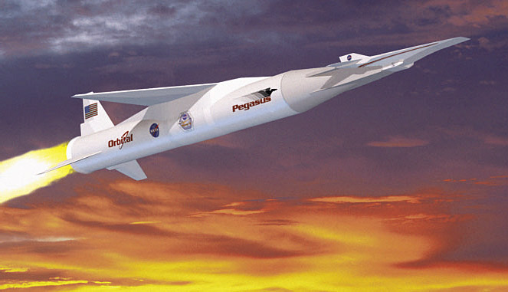

Figure 1 Hyper-X attached to the Booster Rocket
[Technical Contacts: Josephine San, Peiman Maghami, Jim Morrissey]
7.0 Outreach Activities

7.1 SAMPEX University Operations

The University of Maryland Aerospace Engineering Department completed its second full year of sole responsibility for flight dynamics support of the Solar Anomalous and Magnetospheric Particle Explorer (SAMPEX) spacecraft. In this role, a team of University of Maryland undergraduate and graduate students provides routine spacecraft orbit determination, attitude determination, attitude sensor analysis, and flight dynamics product generation. This effort is sponsored and supported by the FDAB, which provides consultation support as needed and periodically reviews the overall program status. This has been a very successful outreach initiative and gives the student team practical experience and training in spacecraft flight dynamics computations, the use of several commercial ground support tools and analysis of flight data. The operation also serves as a test bed for researching ground system automation techniques.

[Technical Contact: Tom Stengle]

7.2 Undergraduate Student Research Program (USRP)

Code 572 sponsored Teddie Brinkley, a Junior from NC State University, as part of the pilot NASA Undergraduate Student Research Program (USRP) at Goddard. Teddie is a Mechanical Engineer who came to GSFC to perform research in the area of formation flying technology. During his 3-month stay at GSFC, Teddie was able to use both his programming and hardware skills. He coded algorithms for the Formation Flying GPS Testbed under the direction of Dr. Russell Carpenter and participated in the testing of the Propulsion Branch's microNewton Thruster Test Stand with Chuck Zakrzwski as his mentor. The thruster test stand is Code 574's technology development project enabling the accurate testing of micro-Newton thrusters to be used on nano satellites for constellations and formations. Teddie especially enjoyed this opportunity to do hands-on work with one of NASA's cutting edge technology development efforts, as seen in the photo below. Code 572's experience with the pilot USRP program was very positive. The USRP is definitely a benefit for GSFC if we can get students of high quality and ability like Teddie Brinkley.

[Technical Contact: Karen Richon]

7.3 PREST Program

During FY01, the FDAB supported Nicholas Hamilton (USAF) under a grant with the George Washington University Program of Research and Education in Space Technology (PREST). This student is currently in residence at the GSFC and is working with branch members on research of formation flying control techniques.

[Technical Contact: Tom Stengle]

7.4 Graduate Student Research Program (GSRP)

The FDAB continued its long standing support of the GSRP program. In FY01, the following GSRP efforts were underway:

- “Decentralized Control of Distributed Satellite Networks.” Researcher: Belanger, UCLA
- “Feasibility of Atmospheric Penetration for Satellite Formation Flying Experiment.” Researcher: Joseph Schultz, University of Maryland
- “ Adaptive Satellite Attitude Control.” Researcher: Kevin Walchdo, University of Florida
- “Investigation of Libration Orbits in the Earth-Moon System.” Researcher: Raquel Jarabek, University of Maryland

[Technical Contact: Tom Stengle]

7.5 TEAMS Competition

The Technology Education Alliance with Middle Schools (TEAMS) Program is supported through an Educational Grant with NASA’s Distributed Spacecraft Technology Development Program. The focus of the TEAMS program is on teamwork and the development of effective teaming skills in middle school students. This focus is accomplished through teams of students who design, develop, and operate teams of robots. The student/robot teams compete in contests that stress the elements of effective teaming (planning, communication, cooperation, and coordination), engage the students through exciting hands-on technologies, and challenge the students with realistic, non-trivial problems to be solved. This year, hundreds of students from local middle schools competed in robotic soccer. Branch volunteers served as competition coordinators, judges and timekeepers in the one-day competition that was held at Goddard Space Flight Center.

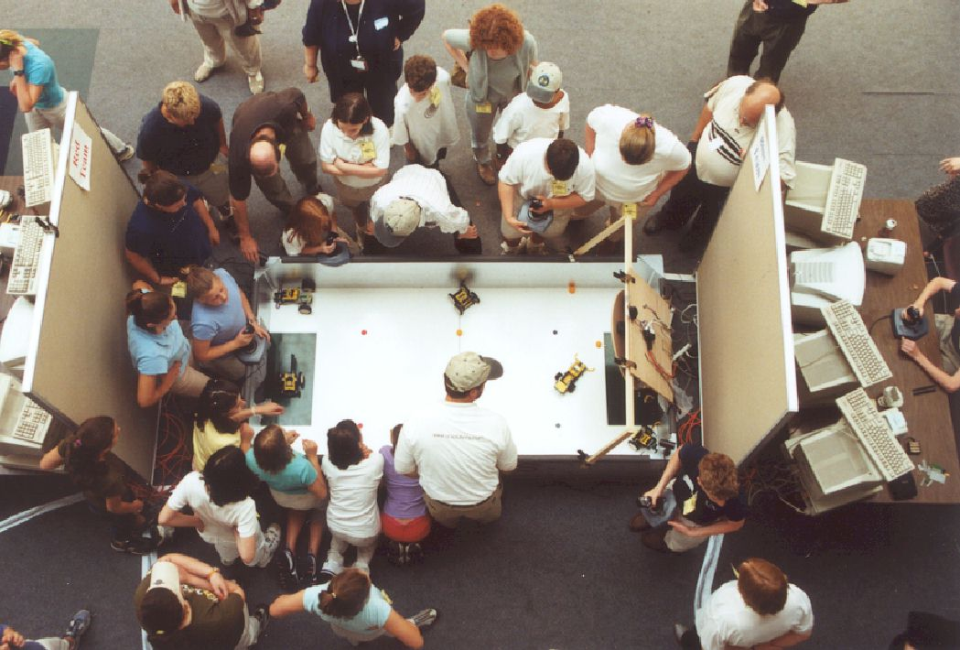

Figure 7-1 TEAMS Robotic Competition at Goddard

[Technical Contact: Tom Stengle]

7.6 Public Education/Community Outreach

A number of branch employees supported a variety of outreach activities. These include:

Science Fair & Engineering Judging or Career Day-
- Future City National Competition, Hyatt Regency, Capitol Hill, 400 NJ Ave, NW, 2/20/01 (Dr. Aprille Ericsson)
- District of Columbia Citywide Science Fair, Howard University, WDC, 3/17/01 (Dr. Aprille Ericsson)
- (Boys) Choir Academy of Harlem, 2005 Madison Ave., Manhattan, NY, 5/18/01 (Dr. Aprille Ericsson)
- South Carroll Covenant Keepers Homeschool Group, 3/01, (Richard Luquette)

Student Engineering Design Projects-
- Take Our Daughter to Work Program, Egg Drop Contest, NASA GSFC, Greenbelt, MD, 4/26/01 (Dr. Aprille Ericsson)
- NASA GSFC SISTER Program, "Rocket Building and MAP Discussion", Greenbelt, MD, 6/26/01 (Dr. Aprille Ericsson)
- High School Botball Tournament, Wakefield High School, Arlington, VA (John Downing)

Career Presentations-
- Buford Middle School, Charlottesville, VA, 10/17/00 (Dr. Aprille Ericsson)
- Windows to the Universe, Family Science Night, Ballou Sr. HS, WDC 10/25/00 (Dr. Aprille Ericsson)
- 2 HS, & Teachers/Staff mtg., Stockton, CA, 11/9/00 (Dr. Aprille Ericsson)
- Junction City Middle School & Manhattan Middle School, Junction City & Manhattan, KS 1/18/01 (Dr. Aprille Ericsson)
- Los Alamos Middle School, Los Alamos, NM, 1/23/01 (Dr. Aprille Ericsson)
- District of Columbia SEED Charter School, 4300 C St, SE, WDC, 2/12/01 (Dr. Aprille Ericsson)
- QEM/MSE National Conference, “You meet the Scientist”, JW Marriott Hotel, WDC, 2/3/01(Dr. Aprille Ericsson)
- Engineers week Family Science night, National Bldg. Museum, WDC, 2/21/01 (Dr. Aprille Ericsson)
- Huron High School, A-A History & Goals Class, Ann Arbor, MI, 3/23/01 (Dr. Aprille Ericsson)
- Windows to the Universe, High School Classroom Visits, Montgomery, AL, 4/30/01-5/2/01 (Dr. Aprille Ericsson)
- Windows to the Universe, Family Science Night, Tuskegee Univ., Tuskegee, AL, 5/1/01 (Dr. Aprille Ericsson)
- 3 Philadelphia MS Schools, PENNLincs, Institute for Research in Cognitive Science, U.Penn, 5/11/01 (Dr. Aprille Ericsson)
- (Boys) Choir Academy of Harlem, 2005 Madison Ave., Manhattan, NY, 5/18/01 (Dr. Aprille Ericsson)
- TRIO Math and Science Program, Howard University, WDC, 7/17/01 (Dr. Aprille Ericsson)

Speeches (Open, Award, Closing & Graduation Ceremonies, Breakfast, Luncheon, Dinner) -
- University of Virginia, Women 2000: Shapers of the World celebration, Charlottesville, VA 10/17/00 (Dr. Aprille Ericsson)
- African American Chamber of Commerce Gala Awards Ceremony, Stockton, CA, 11/10/00 (Dr. Aprille Ericsson)
- University of the Pacific, AMP, Stockton, CA, 11/10/00 (Dr. Aprille Ericsson)
- National Alliance of Black School Educators, Convention Center, Philadelphia, PA, 11/17/00 (Dr. Aprille Ericsson)
- Fernbank Science Ctr/NASA SEMAA, Imagine This: Science Here, There & Everywhere, ATL, GA 11/18/00 (Dr. Aprille Ericsson)
- Mother/Daughter Tea, Celebrating the Past,Creating the Future, Andrew Jackson MS,Forestville,MD, 3/16/01 (Dr. Aprille Ericsson)
- University of MD, 1st Annual Pre-College Program Conf., Adele Stamp Union, College Park, MD 4/21/01 (Dr. Aprille Ericsson)
- NYU Summer Conf. on Urban Science and Math Teaching, "Sharing Our Success", NY, NY, 5/24/01 (Dr. Aprille Ericsson)
- Howard Univ., Upward Bound Mathematics & Science Initiative, Blackburn Ctr. HU, WDC, 7/27/01 (Dr. Aprille Ericsson)

Program Visits NASA GSFC/Mentor Student/Fellow-
- Sunbeams Program, NASA GSFC, Greenbelt, MD (Dr. Aprille Ericsson)
- University of Maryland, Eastern Shore, Summer Program, MCC, NASA GSFC, Greenbelt, MD, 7/5/01 (Dr. Aprille Ericsson)
- University of Maryland, Baltimore County, Myerhoff Program, NASA GSFC, Greenbelt, MD, 7/6/01 (Dr. Aprille Ericsson)
- Delaware State University, Summer Program, NASA GSFC, Greenbelt, MD, 7/13/01 (Dr. Aprille Ericsson)
- FBI Conference Students visiting NASA GSFC, Greenbelt, MD, 7/31/01 (Dr. Aprille Ericsson)
- United Negro College Fund/NASA HQs Harriet Jenkins Fellows, NASA GSFC, Greenbelt, MD 8/4/01 (Dr. Aprille Ericsson)

Seminar Presentations-
- Lawrence Livermore National Laboratories, Science 2001 Lecture Series, LL HS, CA, 9/28/00 (Dr. Aprille Ericsson)
- Kansas State Univ, Following Your Dreams: Life Lessons from a NASA Engineer, Manhattan, KS 1/18/01 (Dr. Aprille Ericsson)
- Los Alamos National Laboratories, Los Alamos, NM, Dr. MLK Jr. Celebration, 1/23/01 (Dr. Aprille Ericsson)
- Patent & Trade Office, “African-Americans in Technology”, Alexandria, VA, 2/20/01 (Dr. Aprille Ericsson)
- John Hopkins Univ.- APL Colloquim, “African-Americans in Technology”, MD, 2/23/01 (Dr. Aprille Ericsson)
- US Library of Congress, Inspiring Stories of Vision of Courage, James Madison Mem. Bldg., WDC, 3/6/01 (Dr. Aprille Ericsson)
- MD Aviation Administration's, "Women's History Month", BWI Airport, Baltimore MD, 3/22/01 (Dr. Aprille Ericsson)
- University of Michigan, IMPACT Program, Ann Arbor, MI, 3/23/01 (Dr. Aprille Ericsson)
- Women In Technology Expo, World Bank Headquarters, Washington, DC, 5/30/01 (Dr. Aprille Ericsson)
- NASA GSFC Summer Interns, “How to make an Outstanding Technical Presentation” GSFC 6/12/01 (Dr. Aprille Ericsson)

Education/Career Conference or Panel-
- NSBE-AE Region II Professional Development Conference, Gaithersburg Hilton, MD, 10/28/00 (Dr. Aprille Ericsson)
- George Mason Univ. African American Studies, "Cookies, Java Beans, and Other Digital Delicacies: Closing the Digital Divide", George W. Johnson Ctr, Fairfax campus, VA, 11/4/00 (Dr. Aprille Ericsson)
- Women’s of Washington, TLT, Women & Power Tools" Four Seasons Hotel, WDC, 3/14/01 (Dr. Aprille Ericsson)
- Black Issues in Higher Learning National Policy Summit on Science, Mathematics, and Technology for African American Students, Reston, VA, 6/15/01 (Dr. Aprille Ericsson)

Television/Radio/Magazine/Website/Newspaper Interviews-
- Woman Engineer, “To Give is to Receive”, Anne Baye Eriksen, 10/00 (Dr. Aprille Ericsson)
- Emerging Markets Magazine, Lillianne Sy, Traci Jones, 10/00 (Dr. Aprille Ericsson)
- The Stockton Record, Stockton CA, Sarah Grunder, 11/10/00 (Dr. Aprille Ericsson)
- Kansas State Univ. Radio Station, Manhattan, KS, Dr. Suzanne E. Franks, 1/18/01 (Dr. Aprille Ericsson)
- Current Biography, Christopher Luna, Bronx, NY, 2/01 (Dr. Aprille Ericsson)
- Space Day, Air & Space, PA Radio Interview, Devilier Assoc., Gretchen Fox , (Dr. Aprille Ericsson)

Proposal/Application Reviewer-
- Intel Science Talent Search, 1719 & 1723 N St, NW, WDC, 12/00 (Dr. Aprille Ericsson)
- NASA CSTEA Review, Howard University, Founders Library, WDC, 2/5/01 (Dr. Aprille Ericsson)
- HU GSAS Mechanical Engineering review, Howard University, Founders Library, WDC, 3/12/01 (Dr. Aprille Ericsson)
- HU Science, Engineering & Mathematics Program Advisory Board, HU School of Engineering, WDC, 4/4/01 (Dr. Aprille Ericsson)
- HU Graduate School, Responsive Ph.D. Initiative Task Force, HU GSAS, WDC, 4/4/01 (Dr. Aprille Ericsson)

Appendix A – Goddard and NASA Awards

Team Awards

EO-1 Flight Dynamics Launch Support Team Outstanding Teamwork Award

GSFC COE group achievement award to the GNC team for the GRO re-entry

Outstanding Teamwork Award - EOS AM Project Team

MAP Trajectory Team Customer Service Excellence Award

MAP Monte Carlo Tool Development and Implementation Customer Service Excellence Award

MAP Thermal Vacuum/Thermal Balance Test Team Customer Service Excellence Award

MAP Integration & Test Team Customer Service Excellence Award

MAP Comprehensive Performance Test Team Customer Service Excellence Award

NASA Group Achievement Award for the CGRO Reentry Team

Individual Goddard/NASA level Awards

Goddard Civil Service Excellence (Lauri Newman)

Customer Service Excellence Award for EO-1 support (David Quinn)

Goddard Award of Merit (Robert DeFazio)

Appendix B - University Grants

The following university grants being administered by FDAB engineers were in place in FY00:

- GRANT NAG5-9961 with the University of Maryland Department of Aerospace Engineering titled “Precise Virtual Rigid Body Control of a Satellite Constellation.” This grant is developing a possible control strategy for formation flying.

[Technical Contact: Thomas Stengle]

- GRANT NAG5-9890 with the University of Maryland Department of Aerospace Engineering titled “Rarefied Flow Aerodynamics for Stability and Control of Formation-Flying Satellites.” This grant is researching problems and control strategies for spacecraft flying in formation with low perigee passes. This research may benefit the development of control approaches for the Geospace Electrodynamics Connections (GEC) mission.

[Technical Contact: Marco Concha]

- GRANTS NAG5-8694 and NAG5-8879 with the University of California at Los Angeles titled “Decentralized Estimation and Control of Distributed Spacecraft,” and “Precise Relative State Estimation and Control of Distributed Satellite Networks.” These grants are developing and applying new decentralized control architectures for satellite formations.

[Technical Conract: Russell Carpenter]

- GRANT NAG5-9829 with the University of Texas at Austin titled “Spacecraft Rendezvous Navigation with Integrated INS-GPS.” This grant is focusing on GPS/INS software architecture development for relative navigation and attitude determination.

[Technical Contact: Russell Carpenter]

- GRANT NAG5-9612 with Cornell University Sibly School of Mechanical and Aerospace Engineering titled “New Algorithms for Magnetometer Orbit and Attitude Estimation.” This grant is studying the feasibility of a moderate precision navigation (<10 km orbit, <0.5 degrees attitude) using Magnetometer data.

[Technical Contact: Richard Harman]

- GRANT NAG5-9748 with Princeton University Department of Mechanical and Aerospace Engineering titled “ Satellite Attitude Estimation with the Two Step Optimal Estimator.” This grant is studying the ability of the two-step algorithm to out perform the standard Extended Kalman Filter currently used for spacecraft and ground attitude estimation.

[Technical Contact: Richard Harman]

- GRANT NAG5-11331 with State University of NY at Buffalo titled, "Attitude Determination Schemes for the CEGANS Sensor.” The CEGANS concept is to perform spacecraft attitude determination by considering the sightline vectors of GPS SVs visible to each antenna element of a multi-element array fixed to the user spacecraft. Simulation data provided by NASA-Goddard will be analyzed at the University of Buffalo in order to investigate robust and optimal attitude determination schemes for the CEGANS sensor.

[Technical Contact: David Quinn]

- GRANT NAG5-10563 with the University of Maryland Department of Aerospace Engineering titled "Automation of SAMPEX Orbit Determination." This grant is researching the automation of the orbit determination of the SAMPEX satellite through the automation of the following phases: data acquisition, data processing, and data output.

[Technical Contact: Joe Toth]
Appendix C – Conferences and Papers

Given below is a list of journal papers, professional papers and technical presentations that were prepared and delivered in FY01 by branch members.

JOURNAL ARTICLES:

R. Azor, I.Y. Bar-Itzhack, J. Deutschmann (now Thienel), and R.R. Harman, “Angular-Rate Estimation Using Delayed Quaternion Measurements”, AIAA Journal of Guidance, Control, and Dynamics, Vol. 24, No. 3, May-June 2001, pp. 436-443.

J.K. Deutschmann (now Thienel) and I.Y. Bar-Itzhack, “Evaluation of Attitude and Orbit Estimation Using Actual Earth Magnetic Field Data”, AIAA Journal of Guidance, Control, and Dynamics, Vol. 24, No. 3, May-June 2001, pp. 616-623.

Carpenter, J. Russell, "Decentralized control for satellite formations," final draft accepted for publication in International Journal of Robust & Nonlinear Control

Carpenter, J. Russell and Schiesser, Emil S. "Semi-major axis knowledge and GPS orbit determination" to appear in upcoming issue of NAVIGATION

CONFERENCE:

24th Annual AAS Guidance and Control Conference, Breckenridge Co, Jan. 31-Feb. 4, 2001

Julie Deutschmann (now Thienel), Itzhack Bar-Itzhack, and Rick Harman, “A LEO Satellite Navigation Algorithm Based on GPS and Magnetometer Data”

S. Hoge & F. Vaughn (GSFC), “Trajectory Design and Control f0r the Compton Gamma Ray Observatory Re-entry”

J. Bolek, E. Holmes, J. O'Donnell, P. Sabelhaus, S. Scott, and J. Story, "On-Orbit ACS Performance of the Landsat 7 Spacecraft"

IEEE Aerospace Conference, Big Sky Montana, March 11-17, 2001

Steven P. Hughes (GSFC) and Laurie M. Mailhe (a.i.solutions), "A Preliminary Formation Flying Orbit Dynamics Analysis for Leonardo-BRDF",

AIAA Aerodynamic Decelerator Systems conference, May 2001, Boston

Carpenter, J. Russell, "Trajectory Reconstruction," (invited seminar)

Flight Mechanics Symposium, NASA Goddard Space Flight Center, Greenbelt, MD, June 19-21, 2001

Julie Thienel (GSFC) and R.M. Sanner Univ. of Md.), “A Nonlinear Spacecraft Attitude Controller and Observer with an Unknown Constant Gyro Bias and Gyro Noise”

Rich Luquette (GSFC) and Rob Sanner (Univ. of Md.), “A Nonlinear Approach to Spacecraft Trajectory Control in the Vicinity of a Libration Point”

D. Kelbel, T. Lee & A. Long (CSC), and R. Carpenter & C. Gramling (GSFC)., “Evaluation of Relative Navigation Algorithms for Formation-Flying Satellites”

D. Folta (GSFC), C. Youn (Univ of CO), A. Ross (Harvard Univ) , “Unique Non-Keplerian Orbit Vantage Locations for Sun-Earth Connection and Earth Science Vision Roadmaps”

D. McGiffin, M. Mathews (CSC), and S. Cooley (GSFC), “High Earth Orbit Design for Lunar-Assisted Medium Class Explorer Missions”

S. Hughes (GSFC), L. Mailhe (aisolutions), “A Preliminary Formation Flying Orbit Dynamics Analysis for Leonardo-BRDF”

S. Belur (CSC) & R. Harman (GSFC) , “Calibration of Gyros with Temperature Dependent Scale Factors”

I. Bar-Itzhack (Technion) & R. Harman (GSFC) , “In-Space Calibration of a Gyro Quadruplet”

I. Bar-Itzhack (Technion) & R. Harman (GSFC), “State-Dependent Pseudo-Linear Filter for Spacecraft Attitude and Rate Estimation”

J. Chen, W. Morgenstern & J. Garrick (GSFC), “Triana Safehold: A New Gyroless Sun-Pointing Attitude Controller”

J. O’Donnell, W. Morgenstern, M. Bartholomew (GSFC), “Using Automation to Improve the Flight Software Testing Process”

S. Starin & J. O’Donnell (GSFC) , “A Two-wheel Observing Mode for the MAP Spacecraft”

D Folta (GSFC) & A. Hawkins (AI Sol), “Preliminary Results of NASA’s first Autonomous Formation Flying Experiment: EO-1”

S. Hoge & F. Vaughn (GSFC), “Trajectory Design and Control f0r the Compton Gamma Ray Observatory Re-entry”

N. Ottenstein, M. Challa, & A. Home (CSC), and R. Harman & R. Burley (GSFC), “IMAGE Mission Attitude Support Experiences”

D.A. Quinn (GSFC), P. Sanneman, S. Shulman, J. Sager (Swales), “The Integration, Testing and Flight of the EO-1 GPS.”

Institute of Navigation 57th Annual Meeting, Albuqurque, NM, June, 2001

J.L. Garrison, M.C. Moreau (GSFC), P. Axelrad (Univ. Colorado), " Tracking Loop Optimization for On-Board GPS Navigation in High Earth Orbit (HEO) Missions,"

2001 American Controls Conference, Arlington, June 25-27

Starin (GSFC), R. K. Yedavalli (Ohio State University) & Andrew Sparks (VACA/AFRL)}, “Design of a LQR Controller of Reduced Inputs for Multiple Spacecraft Formation Flying”

SIAM mini-symposium on Control, Mission Design, and Satellite Dynamics, July 2001, San Diego.

Carpenter, J. Russell, "Distributed Spacecraft Control Architectures" (invited presentation)

AIAA Guidance, Navigation, and Controls Conf., Montreal, Quebec, Canada, August 6-9, 2001

P. G. Maghami (GSFC), and D. E. Cox (LaRC), “Control of Flexible Systems in the Presence of Failures”

Starin (GSFC) , R. K. Yedavalli (Ohio State University) & Andrew Sparks (VACA/AFRL), “Spacecraft Formation Flying Maneuvers Using Linear-Quadratic Regulation with No Radial Axis Inputs”

AAS/AIAA Astrodynamics Specialists Conference, Quebec City, Canada, July 30 August 2, 2001

Rich Luquette (GSFC/GNCC) and Rob Sanner (Univ. of Md.), “A Nonlinear Approach to Spacecraft Formation Control in the Vicinity of a Collinear Libration Point”

Robert L. DeFazio (GSFC), Skip Owens (a.i.solutions), Susan Good (a.i.solutions) "Follow that Satellite: EO-1 Maneuvers into Close Formation with Landsat-7"

Sue Hoge (GSFC) and Frank Vaughn (GSFC), "Trajectory Design and Control for the Compton Gamma-Ray Observatory Re-entry"

Rich Luquette (GSFC) and Rob Sanner (Univ. of Md.), “A Nonlinear Approach to Spacecraft Formation Control in the Vicinity of a Collinear Libration Point”

Space 2001 Conference, Albuqurque, NM, August, 2001

David Quinn, R.E. Farley, “Tethered Formation Configurations: Meeting the Scientific Objectives of Large Aperture and Interferometric Science”

Institute of Navigation 14th International Technical Meeting, Salt Lake City, UT, Sept. 11-14. 2001

Julie Thienel, Itzhack Bar-Itzhack (Technion Institute of Technology), and Rick Harman, “GPS/Magnetometer Based Satellite Navigation and Attitude Determination”

M.C. Moreau (GSFC) , P. Axelrad (Univ. Colorado), J.L. Garrison, M. Wennersten (GSFC) , A.C. Long CSC), " Test Results of the PiVoT Receiver in High Earth Orbits using a GSS GPS
Simulator,"

40th IEEE Conference on Decision and Control, Orlando, FL, December 4-7, 2001

Julie Thienel (GSFC) and R.M. Sanner (Univ. MD), “A Coupled Nonlinear Spacecraft Attitude Controller/Observer with an Unknown Constant Gyro Bias”

Appendix D- Acronyms and Abbreviations

This appendix gives the definitions of acronyms used in this document.

AAS American Astronautical Society
ACS Attitude Control System
ACT Attitude Control Thrusters
AETD Applied Engineering and Technology Directorate
AI Artificial Intelligence
ALI Advanced Land Imager
AO Announcement of Opportunity
APL Applied Physics Laboratory
AST Autonomous Star Tracker
ATMS Advanced Technology Microwave Sounder
CCSDS Consultative Committee for Space Data Systems
CETDP Cross Enterprise Technology Development Program
CGRO Compton Gamma Ray Observatory
COTS Commercial Off-the-Shelf
CPT Comprehensive Performance Test
CSOC Consolidated Space Operations Contract
CVS Concurrent Version System
DACC Distributed Active Archive Center
DoD Department of Defense
DSN Deep Space Network
DSS Digital Sun Sensor
DST Dynamical Systems Theory
EFF Enhanced Formation Flying
EMOS EOS Mission Operations System
EO Earth Observing
EOS Earth Observing System
ESA European Space Agency
ESSP Earth System Science Pathfinder
EUVE Extreme Ultraviolet Explorer
FAA Federal Aviation Administration
FDAB Flight Dynamics Analysis Branch
FDS Flight Dynamics System
FDSS Flight Dynamics Support System
FDF Flight Dynamics Facility
FOT Flight Operations Team
FSW Flight Software
FY Fiscal Year
GEO Geosynchronous Earth Orbit
GEODE GPS Enhanced Orbit Determination Experiment
GEONS GPS-Enhanced Orbit Navigation System
GINA Generalized Information Network Analysis
GNCC Guidance, Navigation, and Control Center
GOES Geostationary Operational Environmental Satellite
GPM Global Precipitation Mission
GPS Global Positioning Satellite
GRO Gamma Ray Observatory
GSE Ground Support Equipment
GSFC Goddard Space Flight Center
GSRP Graduate Student Research Program
GTDS Goddard Trajectory Determination System
GUS Gyroscopic Upper Stage
HD Henry Draper
HDS Hybrid Dynamic Simulator
HEO High Earth Orbit/ Highly Elliptical Orbit
HGA High Gain Antenna
HTML HyperText Markup Language
I&T Integration and Test
ICD Interface Control Document
IHS Inner Heliospheric Sentinels
IM Ionosphere Mapper
IMDC Integrated Mission Design Center
IMU Inertial Measurement Unit
ISU International Space University
ITAR International Traffic In Arms Regulation
ITSO International Telecommunications Satellite Organization
JPL Jet Propulsion Laboratory
LEO Low Earth Orbit
LOR Launch and Orbit Raising
LPT Low Power Transceiver
LQG Linear Quadratic Gaussian
LRR Lightweight Rainfall Radiometer
MAP Microwave Anisotropy Probe

MARSAT Mars Areo-stationary Relay Satellite
MC Master Catalog
MCC Mid Course Correction
MCO Mars Climate Observer
MIT Massachusetts Institute of Technology
MLS Microwave Limb Sounder
MMS Magnetic Multi-scale Mission
MOC Mission Operations Center
MOCC Mission Operations Command and Control
MODIS Moderate Resolution Imaging Spectroradiometer
MOPSS Mission Operations Planning and Scheduling System
MOST Mission Operations Support Team
MOWG Mission Operations Working Group
MSRD Mission Specific Requirements Document
NASA National Aeronautical and Space Administration
NGST Next Generation Space Telescope
NMM Normal Maneuver Mode
NOAA National Oceanic and Atmospherics Administration
NPB Navigation Processor Board
NPM Normal Pointing Mode
NRTS Network Resources and Training Sites
NSF National Science Foundation
NT New Technology
OAT Orbit Adjust Thrusters
ONS Onboard Navigation Systems
OSSM Ocean Surface Salinity Mission
PC Personal Computer
PI Principal Investigator
PLT Post Launch Testing
PREST Program of Research and Education in Space Technology
QuikSCAT Quick Scatterometer
R&D Research and Development
RBM Radiation Belt Mapper
RMS Root-Mean-Square
RPO Radiation Protection Office
RSDO Rapid Spacecraft Development Office
RTOD Real-time Orbit Determination
RWA Reaction Wheel Assembly
RXTE Rossi X-Ray Timing Explorer
SA Selective Availability
SAMPEX Solar Anomalous and Magnetospheric Particle Explorer
SMEX Small Explorer
SOHO Solar and Heliospheric Observatory
SOMO Space Operations Management Office
SPECS Evolution of Cosmic Structure
SPS Standard Positioning Service
ST Space Technology
TDRSS Tracking Data Relay Satellite System
TMM Thruster Maneuver Mode
TONS TDRSS Onboard Navigation System
TRACE Transition Region and Coronal Explorer
TRMM Tropical Rainfall Measuring Mission
URL Uniform Resource Locator
USN Universal Space Network
VCM Velocity Control Mode
VIIRS Visible Infrared Imaging Radiometer Suite
WAAS Wide Area Augmentation System
WIRE Wide-Field Infrared Explorer
WRS World Reference System
WWW World Wide Web

