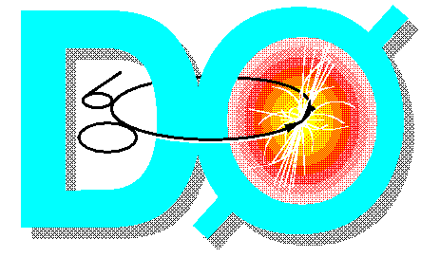

Run 2b Trigger Conceptual Design Proposal

TTF Authorlist

September 5, 2001

Introduction
Goals and Charge
- Increase Instantaneous Luminosity by factor of 2.5
- Improve Rejection of L1
- Maintain Rejection Rate in L2 and L3

Boundary Conditions
- Installation Schedule
- High Probability of Success Required
- Assumed Running Conditions

Document Outline

Level 1 Tracking Trigger
Goals
- Electron and Muon Tagging
- Support of b tagging
- Constraints imposed by muon trigger requirements
- Constraints imposed by STT requirements

Description of Current Tracking Trigger
- Track triggers
- Electron triggers

Performance of Current Tracking Trigger
- Efficiencies ?
- Rates for track triggers
- Number of STT input tracks
- Conclusions and implications for high luminosity

Overview of Options
- Prescale and increase Pt threshold?
- Fine tuning of current system (optimized axial equations)?
- Reduce coincidence levels to improve efficiency?
- Increase coincidence levels to reduce accidentals
- Improve granularity to reduce accidentals

Axial CPS as Ninth Layer
- Concept and tradeoffs
- Rates and Rejection Improvements
- Efficiency/Acceptance
- Implementation
- Cost & Schedule
- Recommendations

Stereo Trigger
- Concept
- Simulation
- Rates and Rejection Improvements
- Efficiency
- Incorporating Axial CPS?
- Implementation
- Cost & Schedule
- Recommendations

Singlet Equations
- Concept
- Simulation
- Rates and Rejection Improvements
- Efficiency
- Implementation
- Cost & Schedule
- Recommendations

L1 Tracking Trigger Summary and Conclusions

Level 1 Calorimeter Trigger

Goals
The primary focus of run 2b will be the search for the Higgs. The increase in luminosity (and thus multiple interactions), and the decreased bunch spacing (132ns) for Run 2b will impose heavy loads on the L1 calorimeter trigger. The goal of the L1 calorimeter trigger upgrade is to provide a number of performance improvements over the run 2a trigger system. It is the totality of these improvements that leads us to propose this upgrade. In the following sections we describe how the L1 calorimeter trigger upgrade will provide
- An improved capability to correctly assign the calorimeter energy deposits to the correct bunch crossing via digital filtering
- A significantly sharper turn-on for jet triggers, thus reducing the rates
- The ability to make shape and isolation cuts on electromagnetic triggers, and thus reducing rates
- The ability to match tracks to energy deposition in calorimeter trigger towers, leading to reduced rates
- The ability to include the energy in the ICD when calculating jet energies and the missing ET
- The ability to add topological triggers which will aid in triggering on specific Higgs final states.
The complete implementation of all these improvements will provide us with the ability to trigger effectively with the calorimeter in the challenging environment of Run 2b.

Description of Calorimeter Electronics

Overview
The charge from the calorimeter is integrated in the charge sensitive preamplifiers located on the calorimeter. The preamplifier input impedence is matched to the 30 Ω cable from the detector, and the preamplifiers have been compensated to match the varying detector capacitances, so as to provide signals that peak uniformly in time. The fall time for the signals has been set to 15 μs. The signals are then transmitted (single ended) on terminated twisted-pair cable to the baseline subtractor cards (BLS) that shape the signal to an approximately unipolar pulse with a risetime of 120 ns (see Figure 1 for a simple overview). The signal on the trigger path is further differentiated by the trigger pickoff to shorten the pulse width. The signals from the different depths in the electromagnetic and hadronic sections are then added with appropriate weights to form the analog trigger tower sums. These analog sums are then output to the L1 calorimeter trigger after passing through the trigger sum drivers. The signals are then transported differentially (on pairs of 80Ω coaxial cable) 80m to the L1 calorimeter trigger. The key elements of the calorimeter trigger path are described below.
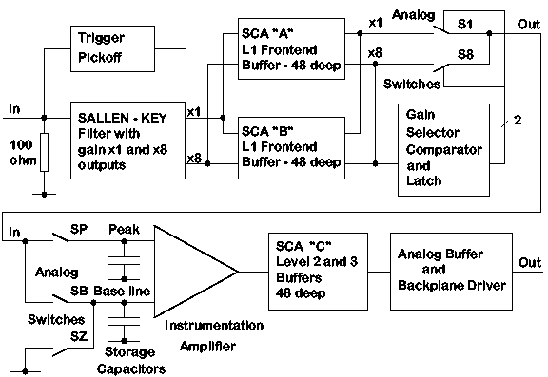
Figure 1: Functional diagram of the BLS system showing the precision readout path and the location of the calorimeter trigger pickoff signal.

Trigger pickoff
The trigger pickoff captures the signal before any shaping (a schematic of the shaping and trigger pickoff in the upper left), as is shown in Figure 2. The preamplifier signal is differentiated hard and passed through an emitter follower to essentially restore the original charge shape (a triangular pulse with a fast rise and a linear fall over 400 ns). This circuitry is located on a small hybrid that plugs into the BLS motherboard. There are 48 such hybrids on a motherboard, and a total of about 55,296 for the complete detector.

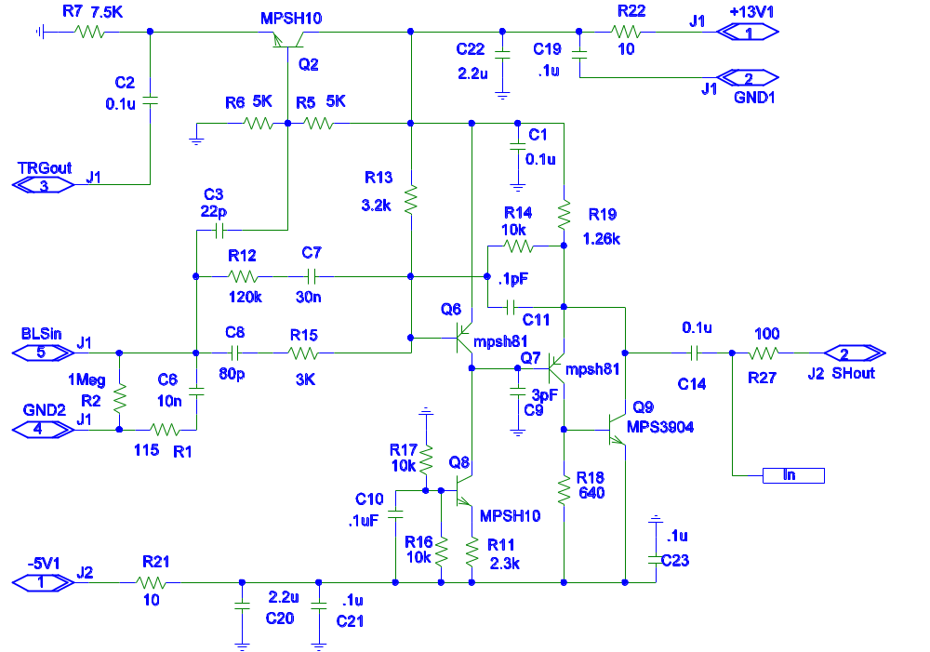
Figure 2: Schematic of the trigger shaper and trigger pickoff (upper left of picture).

Trigger summers
The trigger pickoff signals for EM and HAD sections in a trigger tower are routed on the BLS board to another hybrid plug-in that forms the analogue sums with the correct weighting factors for the different radial depth signals that form a single tower. The weighting is performed using appropriate input resistors to the summing junction of the discrete amplifier. A schematic for this circuitry is shown in xxx.
A single 48 channel BLS board has 8 trigger summer hybrids (4 EM towers and 4 HAD towers). There are a total of 9,216 hybrid trigger summers made up of 75 species. Since they are relatively easy to replace, changes to the weighting schemes can be considered. Recall however that access to the BLS cards themselves requires access to the detector as they are located in the area directly beneath the detector.

Trigger sum driver
The outputs of the 4 EM trigger summers on a single BLS board are summed once more by the trigger sum driver circuit (see the schematic in xxx) where a final overall gain can be introduced. This circuit is also a hybrid plug-in to the BLS board and is thus easily replaceable if necessary (with the same access restrictions discussed for the trigger summers). In addition the driver is capable of driving the coaxial lines to the L1 Calorimeter trigger. There are a total of 2,304 such drivers in 8 species (although most are of two types).
If finer (x2) EM granularity in φ is required for the calorimeter trigger, these hybrids could be replaced to handle the finer segmentation. We expect about 4 man months of work to modify and replace these hybrids. If further simple shaping of the trigger signal is required it could be implemented on this circuit or at the receiver end on the L1 calorimeter trigger.

Signal transmission, cable dispersion
The signals from the trigger driver circuits are transmitted differentially on miniature coax (0.1”). The signal characteristics are significantly better than standard RG174 cable. However first indications are that the signal seen at the end of these cables at the input to the L1 calorimeter trigger are somewhat slower than expected. The cause of the deviation from expectations is not presently known and is under investigation. It is possible that the signal dispersion in these coaxial cables is worse than expected, and possible replacements are under investigation.

Description of Current L1 Calorimeter Trigger

Overview
The DØ uranium-liquid argon calorimeter is constructed of projective towers covering the full 2 π in the azimuthal angle, φ , and approximately 8 units of pseudo-rapidity, η, with eight or nine depth segments which provide convenient subdivision of the Calorimeter Towers in electromagnetic (EM) and hadronic (H) sections. The Calorimeter Tower segmentation in η,φ is 0.1 x 0.1, which results in towers whose transverse size is larger than the expected sizes of EM showers but, considerably smaller than typical sizes of jets.
As a compromise, for triggering purposes, we add four adjacent Calorimeter Towers to form Trigger Towers with a segmentation of 0.2 x 0.2 in η x φ. This yields an array that is 40 in η and 32 in φ or a total of 1,280 EM and 1,280 H tower energies as inputs to the Calorimeter Trigger.
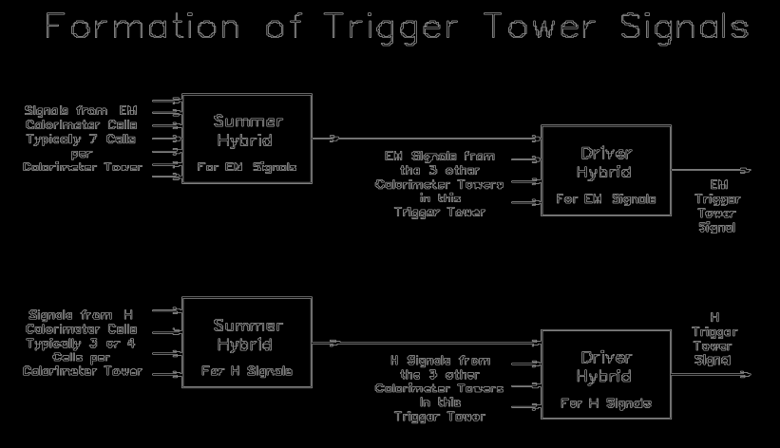
Figure 3: Trigger Tower Formation.
The analog summation of the signals from the various calorimeter cells in a Trigger Tower into the EM and H Trigger Tower signals takes place in two steps. For both EM and H, first all the calorimeter cells in a given Calorimeter Tower are added in the "summer hybrid". The summer hybrids contain a resistor for each calorimeter cell to adjust the relative contribution of that cell to the Calorimeter Tower sum. In the second step, 4 signals, one from each of the Calorimeter Tower making up the Trigger Tower, are summed on the "driver hybrid". The driver hybrid also contains the circuits for driving the Trigger Tower signals over coaxial cable to the Level 1 Calorimeter Trigger. This arrangement for summing the calorimeter cells into Trigger Towers is shown in Figure 3.

Long ribbons of coaxial cable route the 1280 EM and H analog Trigger Tower signals from the Detector Platform through the Shield Wall and then into the first floor of the Moving Counting House where the Level 1 Calorimeter Trigger is located. The first step in the Level 1 Calorimeter Trigger is to scale these signals to represent the E_{T} of the energy deposited in each Trigger Tower and then to digitize these signals at the beam-crossing rate with fast analog to digital converters. The digital output of these 2560 converters is used by the subsequent trigger logic to form the Level 1 Calorimeter Trigger decision for each beam crossing. The converter outputs are also buffered and made available for readout to both the Level 2 Trigger System and the Level 3 Trigger DAQ system.
The digital logic used in the Level 1 Calorimeter Trigger is arranged in a "pipe-lined" design. Each step in the pipe-line is completed at the beam crossing rate and the length of the pipe-line is less than the maximum DØ Level 1 trigger latency for Run II which is 3.3 μsec. This digital logic is used to calculate a number of quantities that are useful in triggering on specific physics processes. Among these are quantities such as the total transverse energy and the missing transverse energy, which we will designate as "global" and information relating to "local" or cluster aspects of the energy deposits in the calorimeter. The latter would include the number of EM and H-like clusters exceeding a set of programmable thresholds.

Global Triggers

Interesting global quantities include:
the total transverse energies:

Total E_{T}EM = 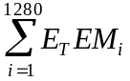

Total E_{T}H = 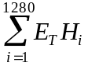
and
Total E_{T} = Total E_{T}EM + Total E_{T}H

the missing transverse energy:

MP_{T} = 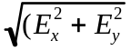

where:

E_{x} = 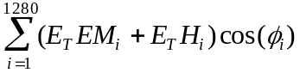
and

E_{y} = 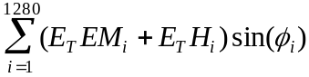

All of these global quantities can be used in constructing triggers. Each quantity is compared to a number of thresholds and the result of these comparisons is passed to the Trigger Framework where up to 128 different Level 1 triggers can be formed.

Cluster Triggers
The DØ detector was designed with the intent of optimizing the detection of leptons, quarks and gluons. The charged leptons will manifest themselves as localized EM energy deposits and the quarks and gluons as hadron-like clusters.
Energy deposited in a Trigger Tower is called EM-like if it exceeds one of the EM E_{T} thresholds and if it is not vetoed by the H energy behind it. Up to four EM E_{T} thresholds and their associated H veto thresholds may be programmed for each of the 1280 Trigger Towers. Hadronic energy deposits are detected by calculating the EM E_{T} + H E_{T} of each Trigger Tower and comparing each of these 1280 sums to four programmable thresholds.
The number of Trigger Towers exceeding each of the four EM thresholds (and not vetoed by the H energy behind it) is calculated and these four counts are compared to a number of count thresholds. The same is done for the four EM E_{T} + H E_{T} thresholds. The results of these count comparisons on the number of Trigger Towers over each threshold is sent to the Trigger Framework where they are used to construct the Level 1 Triggers.

Hardware Implementation

Front End Cards
The analog signals from the calorimeter, representing energies, arrive at the Calorimeter Trigger over coaxial differential signal cables and are connected to the analog front end section of a Calorimeter Trigger Front End Card (CTFE). A schematic diagram of one of the four cells of this card is shown in Figure 4.
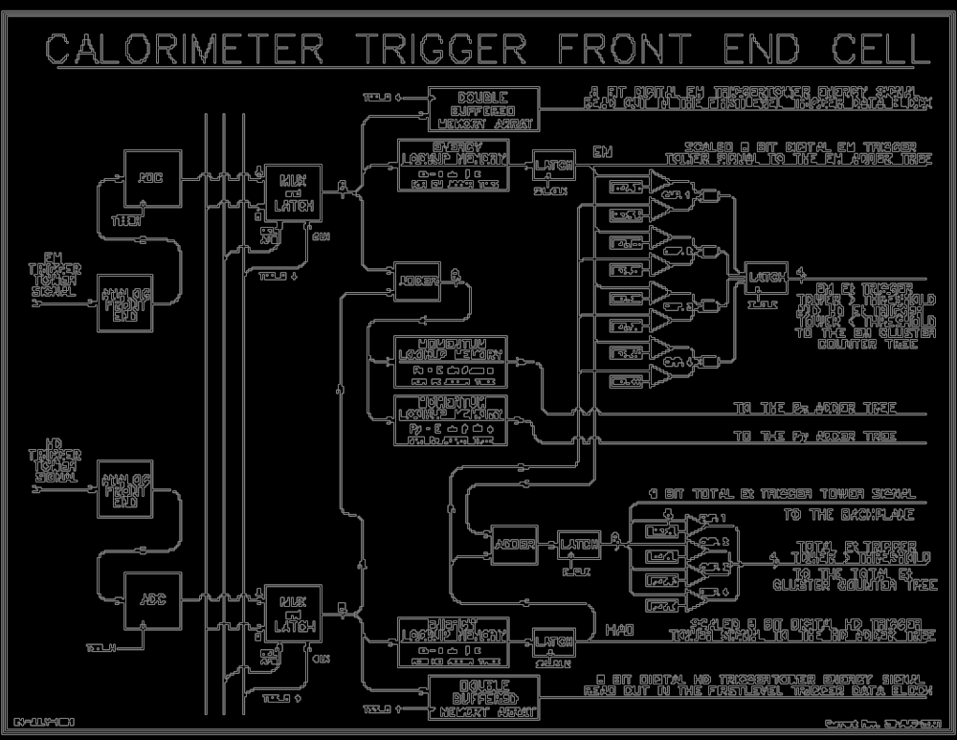
Figure 4: Calorimeter Trigger Front End Cell.
The front-end section contains a differential line receiver and scales the energy signal to its transverse component using a programmable gain stage. The front end also contains digital to analog circuitry for adding a positive bias to the tower energies in accord with downloaded values.
Immediately after the analog front end, the EM or H signal is turned into an 8 bit number by fast (20 ns from input to output) FADC's. With our current choice of 0.25 GeV least count this gives a maximum of 64 GeV for the single tower transverse energy contribution.
The data are synchronized at this point by being clocked into latches and then follow three distinct parallel paths. One of these paths leads to a pipeline register for digital storage to await the L1 trigger decision and subsequent readout to the Level 2 Trigger system and the Level 3 Trigger DAQ system.
On the other two paths, each 8-bit signal becomes the address to a look up memory. The content of the memory at a specified address in one case is the transverse energy with all necessary corrections such as lower energy requirements etc. In the other case, the EM + H transverse energies are first added and then subjected to two look-ups to return the two Cartesian components of the transverse energy for use in constructing MP_{T}. The inherent flexibility of this scheme has a number of advantages: any energy dependent quantity can be generated, individual channels can be corrected or turned off at this level and arbitrary individual tower efficiencies can be accommodated.
The CTFE card performs the function of adding the E_{T}'s of the four individual cells for both the EM and H sections and passing the resulting sums onto the Adder Trees. In addition it tests each of the EM and EM+H tower transverse energies against the four discrete thresholds and increments the appropriate counts. These counts are passed onto the EM cluster counter trees and the total E_{T} counter trees, respectively.

Adder and Counter Trees
The adder and counter trees are similar in that they both quickly add a large number of items to form one sum. At the end of each tree the sum is compared to a number of thresholds and the result this comparison is passed to the Trigger Framework. A typical adder tree is shown in Figure 5.
Physical Layout
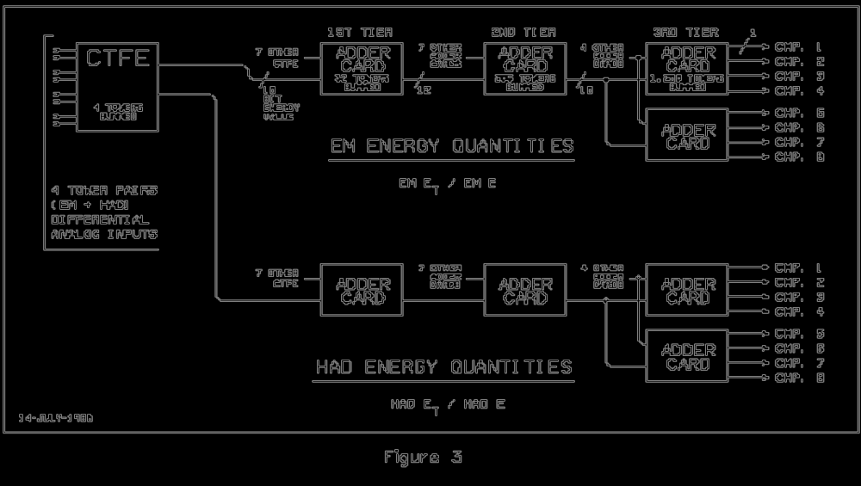
Figure 5: Adder Tree for EM and H.
Ten racks are used to hold the Level 1 Calorimeter Trigger in the first floor moving counting house. The lower section of each rack contains the CTFE cards for 128 Trigger Towers (all 32 φ's for four consecutive η's). The upper section of each rack contains a component of one of the Adder or Counter Trees.

Performance of Current Calorimeter Trigger

Energy measurement and turn-on curves
The size of the 0.2 x 0.2 trigger towers is small compared to the spatial extension of hadronic showers in inelastic events. This is illustrated in Figure 6, which shows for simulated events the ratio of the Et observed by the trigger to the generated Et. A Monte-Carlo sample of QCD events is used here. A cone algorithm with a radius of 0.4 in η-Φ is applied to the generated stable hadrons in order to find the generated jets. The direction of each generated jet is extrapolated to the calorimeter surface, leading to the “center TT” hit by the jet. The highest Et TT in a 3 x 3 region around this center is then used to define the “trigger Et” corresponding to the jet. It can be seen in Figure 6 that this transverse energy is only 25 % of the jet Et on average. Low thresholds are thus needed even to trigger on hard jets. Moreover the trigger Et has a quite bad resolution. As a result, the trigger efficiency (the efficiency for having at least one TT with Et above a given threshold) rises only slowly with increasing jet Et, as shown in Figure 7.


Figure 6 : Ratio of the trigger Et to the transverse energy of the generated jet. Only jets with Et ≈ 40 GeV are used here.


Figure 7: Trigger efficiency as a function of the transverve energy of the generated jet. The curves correspond to thresholds of 1.5, 2, 3, 4, 5 and 6 GeV.

Trigger rates
The trigger Et resolution, convoluted with the steeply falling pt spectrum of QCD events, leads on average to migrations above the true Et of such events. The number of QCD events which pass the L1 trigger is thus larger than what it would be with an ideal trigger Et measurement. Due to the huge cross-section of QCD processes, this results in large trigger rates. For example, as shown in Figure 3, an inclusive unprescaled high Et jet trigger, requiring at least one TT above a threshold defined such that the efficiency on 40 GeV jets is 90 %, would yield a rate of at least 10 kHz at 2 10³² cm² s⁻¹. Maintaining this rate below 1 kHz would imply an efficiency on such high Et jets of 60 % only. Trigger rates increase faster than the luminosity due to the increasing mean number of interactions per bunch crossing. Trigger rates are shown in Figure 4 as a function of the mean number of minimum bias events which overlay the hard interaction. These are shown for two di-jets conditions: requiring at least two TT above 5 GeV, or at least two TT above 5 GeV and at least one TT above 7 GeV. These correspond to reasonable requirements for hard events as can be seen in Figure 2 since a threshold of 5 GeV leads, for 40 GeV jets, to 80 % efficiency only. The rates are shown for a luminosity of 2 10³² cm² s⁻¹ . For a luminosity of 5 10³² cm² s⁻¹, the L1


Figure 8: Efficiency to trigger on 40 GeV jets as a function of the inclusive trigger rate, when one TT above a given threshold is required. Each dot corresponds to a different threshold. The luminosity is 2 1032 cm2 s-1. (figure to be remade with the lower (black) curve only…)
bandwidth would be saturated by such dijet conditions alone, unless large prescale factors are applied.

Figure 4: Inclusive trigger rate as a function of the number of minimum bias events overlaid to the hard interaction. Rates are shown for two di-jet conditions. The luminosity is taken to be 2 10³² cm² s⁻¹.

A more exhaustive study of the evolution of the L1 trigger rate with increasing luminosity can be found in¹. A possible trigger menu has been considered, in which ~ 75 % of the L1 bandwidth is used by multijet triggers. Results are shown in table 1. It can be seen that, at the luminosity foreseen for Run 2b, the trigger rates should be reduced by a factor at least 2 in order to keep a reasonnably small dead time.

Luminosity | Rate L1 High Pt (Hz) | Rate L1 total (Hz)
1 | 1700 | 5000
2 | 4300 | 9500
5 | 6500 | 20 000
Table 1: Evolution of the level 1 trigger rate as function of luminosity expressed in units of 10³² cm² s⁻¹.

Conclusions/implications for high luminosity
An obvious improvement is to select directly at level 1 complete objects, electromagnetic showers and jets. Performing a “clustering” of TT already at L1, as being currently done at L2, could reduce the trigger rates by a factor 2 to 5 as will be shown later. The technical justification for this gain comes from the improvement in the quality of the energy cut, when applied to a cluster of trigger towers. Transferring to level 1 some of the functions that currently belong to level 2 could also permit the introduction of new selection algorithms (topological selection ) at this level.
From a conceptual viewpoint, an important consequence of selecting physics “objects” at level 1 is to allow a more « inclusive » and hence less biased selection of signatures of complex physical phenomena. Thus the trigger menus will become simpler and, above all, less sensitive to biases arising from the combinatories of primary objects.

Overview of Options for Improvement

Global view of options considered

Reducing pileup effects: digital filtering
The shape, especially the rise time, of the pick-up signal is not compatible with 132ns beam crossing separation. There may be temporary fixes to this problem, but the only long-term solution is to apply a stronger shaping to this signal. This could be done by means of an analog filter, but a digital filter is a better solution because it is much more flexible for a similar cost.

Improving jet efficiency turn on: sliding windows

Improving electron efficiency turn on: sliding windows, segmentation, shape cuts

Improving resolutions: adding ICD energies

Reducing backgrounds: track matching

Digital Filtering

Concept & physics implications
The pick-up signal is the result of the electronic chain of the calorimeter applied to the delta function shaped energy deposited in the cells of the calorimeter at each beam crossing. This is characterized by the transfer function of the electronics. The inverse transfer function will transform the pick-up signal back to delta function. This inverse function can be implemented by a FIR (Finite Impulse Response) filter. In presence of noise, the digital filter offers an additional advantage: one can use the theory of optimal filtering to minimize the noise contribution.
In order to define the exact form of digital filter best suited to the task, measurement of noise in pick-up signals would be needed. Studies are expected to progress when such measurements become available.

Pileup rejection
Two different “pile-up” effects arise with increasing luminosity, the first being of physical origin, the second affecting the signal measurement:
Underlying Events: For each triggered beam crossing there are several minimum bias events in the same beam crossing, following a Poisson distribution with a mean proportional to the luminosity. The energy added by these events has a distribution close to a double exponential (Laplacian). It is possible ² to minimize the contribution of this noise by using an appropriate digital filter (Matched Median Filter).
Pulses overlap: The width of the pick-up signal covers several beam crossing (6 at 132ns and counting only the positive part of the signal). When two such pulses are separated by less than these, there is some overlap and the shape of the pick-up signal becomes complex. The inverse filter, by definition, will extract from this signal the two initial delta functions. Consequently, the overlap of pulses is not a concern if one uses digital filtering.

Simulation
Simulations of the FIR response await a better knowledge of the noise contribution to the trigger signal. They will give insights of the optimal number of filter coefficients and provide an estimate of the resolution of the resulting energy measurement.
Coefficients Computation: The most reasonable way to compute coefficients is to use the mean squared (LMS) optimization. This proceeds by minimizing the sum of the square of the differences between many input excitations and their filtered outputs; each input excitation produces a pulse at the input of the ADC and contributes several terms to the sum: one for each beam crossing where the pulse is non-zero. A realistic simulation of the noise must be added to the theoretical pulse (derived from the transfer function of the calorimeter).

Implementation

Sampling rate and precision:
An effective range of 8 bits for the transverse energy of each trigger tower seems sufficient to meet the desired performance and is technically practical. Because calorimeter signals are representative of the energy deposited in the calorimeter while trigger algorithms deal with transverse energy, a scaling from energy to transverse energy needs to be done. Performing this scaling with a programmable analog circuit placed before each ADC could be done but a digital solution is more practical and flexible. In order to preserve a dynamic range of 8 effective bits for signals calibrated in transverse energy, using a 10 bit ADC to convert analog signals seems well adapted.
The conversion rate needs to be at least equal to the beam-crossing rate, but it can be higher than that. Above a certain limit, over sampling will not give any gain because of the relatively slow evolution of the signal.
Actual 10 bits ADCs have a “pipelined” architecture. This implies that the output data is available 4 to 6 cycles after the sampling. As the level 1 trigger operates on a very tight latency budget, it is not acceptable to choose a conversion rate equals to the beam-crossing rate because the data conversion would consume too much latency. In order to reduce the latency of the data conversion, the ADC must run at a frequency higher than that of the beam crossing. ADCs in the 20-60 MHz range are now common and inexpensive. If only a fraction of the samples produced by each ADC is needed for filtering, decimation can be envisaged. One should note that because the signal is over sampled, it seems natural to use that data to improve the overall performance of the digital filtering operation. Recalling Shannon’s sampling theorem, it can be stated that a FIR implementing the exact inverse transfer function considered must have at least a sampling frequency that is twice that of the beam crossing.
Possible solutions to implement the digital filter are discussed below.

Cost & schedule

Recommendations

Sliding Trigger Tower Windows for Jets and Electrons

Concept & physics implications
Various algorithms can be used to cluster the trigger towers and look for “regions of interest” (RoI), i.e. for regions of fixed size S in (η, Φ) in which the deposited Et shows a local maximum. To find those RoIs, a window of size S is slided in both directions by steps of 0.2 in η and Φ. By convention each window unambiguously correspond to one trigger tower T and is labeled S(T). Examples are shown in Figure 4.

Figure 9: Examples of sliding windows S(T) associated to a trigger tower T. Each square represents a 0.2 x 0.2 trigger tower. The trigger tower T is greyed.

Each window S(T₀) such that :
For all trigger towers T in the neighborhood of T₀ , the Et in S(T₀) is greater than that in S(T),
is called a region of interest. There is some freedom in the definition of the neighborhood of trigger towers, resulting in different algorithms. Due to the quantification of the Et of each trigger tower, a prescription has to be chosen to unambiguously define those local maxima. Figure 5 illustrates one possible choice, defining RoI’s as maxima in a 1.0 x 1.0 region. The RoI’s can also be defined as being local maxima in a 0.6 x 0.6 area.


Figure 10: Possible prescription to define a local maximum.
A transverse energy is then associated to each RoI, and these Et constitute the quantities used to issue the trigger decision. This Et can be e.g. the transverse energy contained in the RoI itself, or in the RoI and in its bordering TTs. It is called the trigger Et of the RoI in the following and the region where it is deposited is called a “trigger jet”.

Simulation
Several algorithms defining the regions of interest have been considered and their performances have been compared using samples of simulated events:
- The RoI’s size is 0.6 x 0.6 (Figure 4a) and the trigger Et is the Et contained in the RoI.
- The RoI’s size is 0.4 x 0.4 (Figure 4b) and the trigger Et is the Et contained in the 0.8 x 0.8 region around the RoI.
- The RoI’s size is 1.0 x 1.0 and the trigger Et is the Et contained in the RoI.
In each case, the prescription illustrated in Figure 5 is used to find the local maxima RoIs.
For each algorithm, the transverse energy seen by the trigger for 40 GeV jets is shown in Figure 6. This is to be compared with Figure 1 which shows the Et seen by the current trigger. It can be seen that the “sliding window” algorithms considerably improve the resolution of the trigger Et.

 | 


Figure 11: Ratio of the trigger Et to the transverse energy of the generated jet, using three different algorithms to define the regions of interest. Only jets with Et ≈ 40 GeV are used here. The ration of the RMS to the mean of the distribution is written on each plot.
Moreover the relative resolution is similar in these three cases. The choice of the RoI definition (i.e. of the algorithm) will thus be driven either by more detailed studies, or by considerations relative to the hardware implementation. As an example in the following, we consider the algorithm b) .

Efficiency
The simulated trigger efficiency for the algorithm b), with a threshold set at 10 GeV, is shown as a function of the generated Et in Figure 7. The rise of the efficiency with increasing Et is significantly faster than that of the current trigger, also shown in Figure 7 for two values of the threshold. With a 10 GeV threshold, an efficiency of 80 % is obtained for jets with Et larger than 25 GeV.
The gain in efficiency which is specifically due to the sliding procedure has been studied by considering an algorithm where the TT are clustered 4 x 4, without any overlap in η, Φ. The comparison of the “fixed” and “sliding” algorithms is shown in Figure 8. As shown in Figure 8, using for the trigger decisions the Et deposited in 0.8 x 0.8 non-overlapping regions is much less powerfull.


Figure 12: Trigger efficiency as a function of the transverse energy of the generated jet, for the algorithm b) and for the current trigger.


Figure 13: Trigger efficiencies when the trigger decision relies on the Et deposited in regions of size 0.8 x 0.8 with (full curves) or without (dashed curves) any overlap in η, Φ.

Rates and rejection improvements
The performances of the sliding and current algorithms are studied here by comparing both trigger efficiencies on a given class of processes and inclusive rates as a function of the trigger threshold.
An inclusive jet condition is required here, i.e there should be at least one RoI (one TT) whose trigger Et (whose Et) is above a given threshold for the algorithm b) (for the current trigger). For different threshold values varying by steps of 1 GeV, the inclusive trigger rate and the efficiency for QCD events with pthat > 20 GeV ( 40 GeV ) to fulfill the trigger condition are shown in Figure 9, left (Figure 8, right), for two values of the number of overlaid minimum bias events. On each plot, the upper (lower) curve shows the performance of the sliding (current) algorithm. It can be seen that the proposed algorithm can reduce the inclusive rate by a factor of 2 to 4. The gain brought by the sliding algorithm increases with the number of overlaid minimum bias events.
A selective jet trigger is crucial to select “interesting” physical events which do not contain any high pt lepton. Moreover, the implementation of a “sliding” algorithm in logical devices allows various quantities to be used in the L1 decision, not only the number of towers above predefined thresholds. Two processes have been considered, for which the selectivity of the current trigger will likely be not optimal:
- The production of a Higgs boson in association with a b-bbar pair. This process can have a significant cross-section in supersymmetric models with large tanbeta, where the Yukawa coupling of the b quark is enhanced. When the Higgs decays into two b quarks this leads to a 4b signature. The final state contains two hard jets (from the Higgs decay) accompanied by two much softer jets. Such events could easily be separated from the QCD background in off-line analyses. with help of b-tagging. But it appears challenging to efficiently trigger on these events while retaining low inclusive trigger rates.
- The associated production of a Higgs with a Z boson, followed by H → bb and Z →νν. With the current algorithm, these events could be triggered by a di-jet + missing energy requirement. The threshold on the missing energy could be lowered if a more selective jet trigger is used.

Figure 10 shows the efficiency versus inclusive rate for these two processes. The performances of three trigger conditions are shown:
- at least two fixed trigger towers of 0.2 x 0.2 above a given threshold.
- at least one TT above 10 GeV and two TT above a given threshold.
- at least two “trigger jets” whose summed trigger Et’s is above a given threshold.

 | 
 | 

Figure 14: Trigger efficiency for events with p_{t} hat > 20 GeV (left) and p_{t} hat > 40 GeV (right) as a function of the inclusive trigger rate, for the algorithm b) (full curves) and the current algorithm (dashed curves). Each dot on the curves corre spond to a different trigger threshold. The luminosity is 2 10³² cm² s⁻ and the number of overlaid minimum bias events follows a Poisson distribution of mean equal to 2.5 (upper plots) or to 5 (lower plots).

It can be seen that the third condition is the most selective.

Implementation
These triggering algorithms can be implemented in Field Programmable Gate Arrays on logical processing cards. Each of these cards has responsibility for a region of the calorimeter. Necessarily, there are overlapping areas of these regions as the algorithms must see data belonging to neighboring towers to the tower being analyzed. We can assume that for the processing of one tower, it is necessary to have access to data from a region of maximum size (Δη x Δφ) = 1.0 x 1.0 centered on the tower. This mandates overlap regions of size Δη/Δφ = 1.6 or Δη/Δφ = 0.8 between processing cards.
We estimate that the size of electronic circuits available in one year will be large enough to contain the algorithms for a region (Δη x Δφ) = 4.0 x 1.6. Choosing the largest possible elementary region has the salutary consequence of minimizing the duplication of data among cards. With this choice, the new trigger system will consist of only eight logical processing cards (to be compared with the more than 400 cards in the old system).

Cost & schedule

Recommendations

 | 

Figure 9: Efficiency to trigger on bbh (left) and ZH (right) events as a function of the inclusive rate. The three conditions shown require: at least two TT above a threshold (black curves), at least one TT above 10 GeV and two TT above a threshold (blue curves), at least two trigger jets such that the sum of their trigger Ets is above a given threshold (red curves).

Track Matching and Finer EM Segmentation

Concept & physics implications
The capability to match tracks that are found in the central fiber tracker (CFT) with trigger towers (TT) in the calorimeter is available at a very coarse level in the Run2a detector. The matching of calorimeter trigger towers to CFT tracks is limited to φ quadrants and takes up valuable “and-or”in terms in the trigger framework (TFW). In this section we explore the benefits of significantly increasing the CFT φ granularity used in track matching to the much finer level of track sectors. Such an upgrade is a significant augmentation of the D∅ detector's triggering ability, which may provide a crucial handle to some of the more difficult but desirable physics we wish to study in Run2b.

Simulation
The calorimeter trigger granularity is currently 2.5 times coarser in φ than one tracking sector. For most of the results reported here, we have matched all three of the sectors which at least partially overlap a trigger tower. If there is at least one track with Pt>1.5 GeV pointing at the trigger tower, we consider there to be a match. In our studies for this section, we have utilized five QCD samples. Four of these were generated with QCD jets of Pt> 2 GeV, 5 GeV, 20 GeV and 80 GeV, respectively, and 0.7 min-bias interactions overlayed. One sample was a 20 GeV QCD sample with 5 interactions overlayed.

Rates and rejection improvements
Since triggers will likely select jets of different inherent Pt's with several different tower Et thresholds, we should understand what the dependency of trigger tower track occupancy is on these parameters (see Table 1). For instance, considering trigger towers with non-zero EM+HAD Et, we find that towers in the 2 GeV QCD sample match tracks 2.4% of the time, while 24.2% match in the 80 GeV sample. A more useful understanding for the point-of-view of the trigger can be gotten by looking at the dependence of this occupancy on tower Et within these samples (for studies in the rest of this section, we match to EM towers).
Table 1 Trigger tower track occupancy for different tower Et thresholds and jet Pt’s, where the first line for every Et threshold corresponds to the total number of towers (denominator) and the number of track-matched towers (numerator). The second line gives the fractional occupancy.
EM Et (GeV) | Jet Pt >2GeV | Jet Pt>5GeV | Jet Pt>20GeV | Jet Pt>80GeV
>0.5 | 9k/197k  4.6% | 18k/240k  7.5% | 42k/161k  26.1% | 73k/147k  49.7%
>2 | 69/297  23.2% | 300/1147  26.2% | 4k/7506  53.3% | 16k/19k  84.2%
>5 | 5/9  55% | 27/63  42.9% | 920/1587  58% | 7800/9121  85.5%
>10 | --  -- | 3/7  42.9% | 157/273  57.5% | 4070/4579  88.9%

Where the first line for every Et threshold corresponds to the total number of towers (denominator) and the number of track-matched towers (numerator). The second line gives the fractional occupancy.
Since these results are based on samples corresponding to low-luminosity conditions, it is important to ensure that these rejection factors are robust against the additional interactions that we expect to typically see. Using QCD events with parton threshold ~20 GeV, we compare two samples with 0.7 and 5.0 minimum bias interactions, respectively. The results are shown in Table 2

Table 2: Trigger tower track occupancy for 20 GeV jet Pt and different tower Et thresholds and low (0.7 min bias) and high luminosity (5 min bias) conditions, where the first line for every Et threshold corresponds to the total number of towers (denominator) and the number of track-matched towers (numerator). The second line gives the fractional occupancy.
EM Et (GeV) | 0.7 min bias | 5 min bias
>0.5 | 42k/161k  26.1% | 92k/291k  32.6%
>2 | 4k/7506  53.3% | 2130/3482  61.2%
>5 | 920/1587  58% | 480/703  68.3%
>10 | 157/273  57.5% | 96/125  76.8%

Given the significant rejection factors and robustness to multiple interactions, we would like to know if there is a further way of improving the rejection by segmenting the EM calorimeter towers more finely to better match the CFT granularity. The simplest study one could do divides each tower Et evenly in half between it's two phi halves. If we only consider one of these halves for each tower, and match it to the two sectors which overlap, we should obtain an unbiased estimate of what is gained. Naively, this should be ~30% since we are matching 30% fewer sectors. In practice, one finds the results shown in Table 3 for the QCD Pt>20 GeV sample (0.7mb overlay).

Table 3: Trigger tower track occupancy for 20 GeV jet Pt and different tower Et thresholds for present Δφ segmentation (0.2) and for finer Δφ segmentation (0.1), where the first line for every Et threshold corresponds to the total number of towers (denominator) and the number of track-matched towers (numerator). The second line gives the fractional occupancy.
EM Et (GeV) | Δφ = 0.2 | Δφ = 0.1
>0.5 | 42k/161k  26.1% | 31k/161k  19.3%
>2 | 4k/7506  53.3% | 1160/2460  47.2%
>5 | 920/1587  58% | 130/273  47.6%
>10 | 157/273  57.5% | 19/29  65.5%

It is likely in actual triggering that the track Pt threshold used will be greater than 1.5 GeV, and more like 3 or 5 GeV, and maybe 10 GeV. Since the number of fake high Pt tracks rises dramatically with multiple interactions, we consider our 20 GeV sample with 5min-bias interactions. This sample has 2147 events. We calculate the matching probabilities for how many times a given TT overlaps sectors with tracks with Pt>1.5 GeV, >3 GeV, >5 GeV, and >10 GeV. The results are shown in Table 4.

Table 4: Trigger tower track occupancy for 20 GeV jet Pt and different tower Et thresholds and varying track Pt’s, where the first line for every Et threshold corresponds to the total number of towers (denominator) and the number of track-matched towers (numerator). The second line gives the fractional occupancy.
EM Et (GeV) | Track Pt >1.5GeV | Track Pt >3GeV | Track Pt >5GeV | Track Pt >10GeV
>0.5 | 92k/291k  32.6% | 50k/291k  17.2% | 25k/291k  8.6% | 15k/291k  5.2%
>2 | 2130/3482  61.2% | 1630/3482  46.8% | 1100/3482  31.6% | 400/3482  11.5%
>5 | 480/703  68.3% | 380/703  54.1% | 290/703  41.3% | 140/703  19.9%
>10 | 96/125  76.8% | 80/125  64% | 68/125  54.4% | 37/125  29.6%

The first column in the table is from Table 2. The first column gives the number of TTs matching tracks of the lowest Pt or greater divided by the total number of TT's of that Et. Each of the other columns is relative to the denominator in column 1. This shows, moving left to right, that the tightening of the Pt cut does reduce the rate pretty substantially, particularly for the lower Et towers.

Efficiency

Implementation

Cost & schedule

Recommendations
In summary, although the Et dependence of the rejection is large, the gains from a calorimeter point-of-view are approximately a factor of 4 relative to no match for many of the backgrounds one will be triggering on at level 1. The effect of multiple interactions on this result does not appear to be large. If one were to contemplate further segmenting the EM trigger towers in 0.1 in phi, there would a potential factor of 3 further improvement. Also, if one tightens the track Pt requirement beyond 1.5GeV, then the rejection improves substantially again.

Improving Missing Et Triggering using the Inter-Cryostat Energy at Level 1

Concept & physics implications
Global tower Et sums such as missing Et or scalar Et, while very useful, suffer from several significant problems at the L1 trigger. One significant issue is that the ICR sampling layers are not available in the calculation at Level 1. In addition, the imprecision of the tower Et's gets compounded for global sums, resulting in signifantly degraded effectiveness. This is particularly true in a multiple interaction environment. There are two main possible solutions to these problems. First we can take advantage of work done for Run2a to make the ICR layers available at Level 2 and add these towers back into the global sums at Level 1 in Run2b. Second, we can attempt to come up with a scheme which descriminates towers which are from multiple interactions and avoid adding them into the sum.

Simulation
The region around 0.8<|eta|<1.5 encompasses the transition from showers contained within the CC and showers contained within the EC. There is a gap in EM coverage and a major thinning of FH coverage in this area. Since these are the layers which comprise standard trigger towers, there is a major degradation in Level 1 calorimeter response and resolution in this region. This is exacerbated by the presence of significant dead material in the solenoid in Run2. Simulations of single pions and jets in this region indicate that the energy scale in this region goes as low as 40% of the CC/EC scale, and the resolution is as bad as 6 times worse than in the CC or EC. These results are very consistent with findings from Run1 Level 1 missing Et analyses. One of the major results of this deficiency is that the efficiency and rejection of a Level 1 missing Et selection are noticeably degraded. These simulations also indicate that adding ICD and MG cells into trigger towers can improve the scale by a factor of 2, while optimizing the resolution by a factor of 3.
In principle, it is straightforward to estimate the effect of the ICD and MG to the missing Et calculation. Unfortunately, the Run2 software currently suffers from three major problems in producing a trustworthy study of this matter. The sampling weights valid for the trigger towers, as opposed to the precision readout, are not applied to cell-level energies when trigger towers are constructed for the trigger simulator. Also, there has been no opportunity yet to determine whether the detector simulation accurately reproduces the behavior in the ICR, and this is especially important for the ICD which was substantially more difficult to calibrate than the LAr gaps in Run1. Lastly, the mapping of calorimeter cells has not been instituted into our standard Monte-Carlo sample generation. The last of these problems is easily solved, but the first two present a larger problem.
Until such time as we have resolved these problems, we will estimate the expected improvement based on other studies.

Rates and rejection improvements from ICR energies
To estimate the effect of adding the ICR detectors into the missing Et, we consider the fact that in the region of 1.0<|eta|<1.4, the sampling weight simulations indicate approximately half of the energy will be deposited in the EM+FH, and the other half in the ICD+MG. As a crude estimate of the magnitude of the effect of adding the ICR layers, we will merely consider the missing Et measurement with and without the EM+FH layers in this region and assume the ICR improvement will be similar. Although the sample used for this calculation is a QCD sample with jet Pt>20 GeV and 0 min-bias events overlayed, for historical reasons it is a different sample than that mentioned in the rest of this document with the same specifications. The missing Et mean and RMS in this sample behave as follows:
if remove all ICR TTs: μ/rms = 6.7 GeV / 4.8 GeV
if only use EM+FH TTs: μ/rms = 5.5 GeV / 3.9 GeV
The number of events passing various Level 1 missing Et cuts in this sample are shown in Table 5.
Table 5: Events passing L1 missing Et cuts when the ICR energy is included and when it is removed from the trigger towers.
L1MET | Without ICR | With ICR
> 5GeV | 948 | 766
> 10 GeV | 337 | 185
>15 GeV | 95 | 40
> 20 GeV | 37 | 11
> 25 GeV | 9 | 4

Thus, the region is important to the missing Et calculation and the rates of passing 15 or 20 GeV selection can change by factors of around 3. A proper treatment of the gains from adding in the ICD and MG, however, will have to await a satisfactory treatment of the relative weights of various layers.

Improving Missing Et for Multiple interaction Events
Our experience in Run1 indicated the Level 1 missing Et to be very sensitive to the number of multiple interactions. This results from several factors, including the fact that the fundamental trigger tower fractional energy resolution is poor, especially for very low Et towers, and the numbers of these towers increases substantially with the number of multiple interactions. As a result, we have explored a few ways in which we might improve the Missing Et resolution to reduce this problem in Run2b.
First, we varied the low threshold on the Et of towers going into the global sum. In Run1, this threshold was 0.5 GeV and was apparently not studied in the light of multiple interactions. Again, we've used the QCD Pt>20 samples with 0mb and 5mb overlays for background, and the ttbar sample with 2.5 mb overlays for signal. If we calculate the missing Et mean and RMS in these samples for various Et thresholds, we find the results shown in Table 6.
Table 6: Change in the means and rms for the missing Et for background (QCD) and signal (ttbar) samples as a function of the trigger tower (TT) threshold.
Met calc | QCD 0mb (μ/rms) in GeV | QCD 5mb μ/rms) in GeV | ttbar (μ/rms) in GeV
TT>0.5GeV | 5.1/3.8 | 6.5/4.2 | 35.9/25.4
TT>1GeV | 5.2/3.9 | 5.8/4.0 | 35.4/24.7
TT>1.5GeV | 5.3/4.1 | 5.6/4.0 | 35.0/24.1
TT>2GeV | 5.2/4.2 | 5.4/4.2 | 34.6/23.6

where the error on the mean and RMS for the QCD samples is approximately 0.1 GeV. So the cut of 2GeV reduces the mean of the QCD sample noticeably. Although scalar Et is generally considered a poor variable at Level 1 because of its sensitivity to multiple interactions, we have studied its mean and rms (see Table 7) for the same thresholds to see what is happening:

Table 7: Change in the means and rms for the Et scalar sum for background (QCD) and signal (ttbar) samples as a function of the trigger tower (TT) threshold.
Sum Et calc | QCD 0mb (μ/rms) in GeV | QCD 5mb μ/rms) in GeV | ttbar (μ/rms) in GeV
TT>0.5GeV | 23.5/13.0 | 179.7/68.8 | 57.7/39.3
TT>1GeV | 17.9/11.9 | 26.6/15.8 | 161.1/66.4
TT>1.5GeV | 14.7/11.4 | 18.0/12.5 | 151/64.9
TT>2GeV | 12.5/11.1 | 14.2/11.6 | 143.6/63.8

Comparison of the two QCD samples indicates that low thresholds let in an enormous amount of energy which has nothing to do with the hard scatter interaction.
Another promising variable is that of the TT eta, since the energy in multiple interactions is often thought of as being deposited in the forward region. As we did above for trigger tower thresholds, we apply cuts on TT eta such that various detector ietas are left out of the sum. We have left the TT Et cut at 0.5 GeV for this calculation. The results are the following for missing Et:
Table 8: Change in the means and rms for the missing Et for background (QCD) and signal (ttbar) samples as a function of the trigger tower (TT) η range (using the detector η−index which is 10 x η).
MEt calc | QCD 0mb (μ/rms) in GeV | QCD 5mb μ/rms) in GeV | ttbar (μ/rms) in GeV
TT<34 | 5.1/3.8 | 6.5/4.2 | 35.9/25.5
TT<32 | 5.3/3.9 | 6.7/4.3 | 36.0/25.4
TT<30 | 5.4/4.0 | 6.8/4.4 | 36.0/25.4
TT<28 | 5.6/4.1 | 6.9/4.5 | 36.0/25.4

Which indicates a slight degradation in the missing Et behavior. The scalar Et behaves as follows:
Table 9: Change in the means and rms for the scalar Et for background (QCD) and signal (ttbar) samples as a function of the trigger tower (TT) η range (using the detector η−index which is 10 x η).
Sum Et calc | QCD 0mb (μ/rms) in GeV | QCD 5mb μ/rms) in GeV | ttbar (μ/rms) in GeV
TT<34 | 23.2/13.0 | 53.8/34.9 | 178.9/68.7
TT<32 | 22.6/13.0 | 51.2/32.7 | 178.2/68.7
TT<30 | 22.2/12.9 | 50.0/31.8 | 177.8/68.7
TT<28 | 21.7/12.9 | 48.3/30.6 | 177.3/68.7

indicating that the total amount of Et at high eta is small, which is why there is no effect.
Another concern for the missing Et measurement involves the truncation of trigger tower Et's into 0.5 GeV bins. Since one to two hundred towers are typically added into the Missing Et, this resolution loss can start to be noticeable. Taking the QCD Pt>20 sample with mb=0 and 1648 events, we can use the simulator described above in the ICR discussion and toggle truncation.
MET> | no trunc. | no trunc, TT>0.5GeV | with truncation
5 GeV | 947 | 868 | 766
10 GeV | 309 | 261 | 185
15 GeV | 76 | 51 | 40
20 GeV | 22 | 17 | 11
25 GeV | 7 | 5 | 4

The first column indicates truncation turned off and no threshold applied to trigger towers. The second column also has no truncation and zeros out all towers with Et<0.5. The third column employs the normal 0.5 GeV truncation. Since truncation lowers tower Et's only to the next lowest 0.5 GeV increment, it effectively deweights all of the poorly measured Et in low Et towers. In fact, if we consider the QCD Pt>20 GeV sample with 5mb already discussed, the missing Et mean and RMS are mildly improved over the straight 1.5GeV threshold by a simple weighting scheme. If we choose weights of 5%, 25%, and 75% for Et = 0.5, 1.0, and 1.5 GeV, respectively, we find the following
if TT Et>1.5 GeV: | μ/rms = 5.41 GeV / 4.20 GeV
if weight TT: | μ/rms = 5.41 GeV / 3.96 GeV

If the capability exists in an FPGA to enforce a weighting scheme, then one might devise a scheme which does better than this.
Because the trigger tower threshold seems to be the simplest solution that shows progress, and the weighting also seems to help, one might ask whether rejecting low Et towers unless they are near significant neighbors might help. Looking again in the 5mb QCD sample at missing Et means and sigmas, however, reveals the following:
no cut: | μ/rms = 6.45 GeV / 4.17 GeV
if NN Et > 0.5 GeV: | μ/rms = 6.45 GeV / 4.37 GeV
if NN Et > 1.5 GeV: | μ/rms = 6.56 GeV / 4.37 GeV
if NN Et > 3.0 GeV: | μ/rms = 6.72 GeV / 4.86 GeV
if NN Et > 10 GeV: | μ/rms = 5.62 GeV / 4.57 GeV
if NN Et > 1k GeV: | μ/rms = 5.41 GeV / 4.20 GeV
which indicates a significant degradation in missing Et mean and resolution.

Efficiency

Implementation

Cost & schedule

Recommendations
In this section, we have explored several different ways to improve the calorimeter missing Et measurement at Level 1. Studies leading to the optimization of the Run2a trigger have indicated a large improvement in the scale and resolution of jets in this region if the ICD and MG are used. Although our current simulation samples do not have a proper treatment of this region, a crude estimate indicates that this amount of energy should have a noticeable improvement on the missing Et resolution.
Several attempts were also made to improve the behavior of missing Et in a multiple interaction environment. The most promising appears to be a simple tightening of the Et threshold on a trigger tower to around 1.5 GeV which would reduce the background by around 20% in our QCD sample. The actual degradation in the real data may be larger than we see here, however, and the corresponding gain may also increase. We will be in a better position to evaluate this when we have reliable data at various luminosities. There is some evidence that a weighting scheme would provide further benefits.

Finer EM Tower Segmentation

Concept & physics implications

Simulation
Monte Carlo single electrons have been used to compare the performances of the various options:
Fixed trigger towers of 0.2 x 0.2 (the current system)
Fixed trigger towers of 0.2 x 0.1
Trigger towers of size 0.2 x 0.2 which slide in either the η or Φ direction by steps of 0.1.
The direction of the generated electron is extrapolated to the calorimeter surface and trigger regions are looked for in the neighborhood of the intersection point.
Figure 10 shows the transverse energy seen in the trigger region for cases 2) and 3), normalized to that seen by the current trigger. It can be sen that fixed trigger towers of size 0.2 x 0.1 will see ~ 5% less Et than the current TTs. A slightly larger energy is deposited in windows which are sliding in the η rather than in the Φ direction. This is due to the fact that when the Zvertex is not zero, the calorimeter geometry is not projective in η (while it is always projective in Φ). Figure 11 shows that indeed, when electrons are emitted at Zvertex ≈ 0, overlaps in η and overlaps in Φ yield similar energy deposits in the trigger regions.


Figure 15: Ratio of the Et measured in various possible trigger regions to the Et seen by the trigger when using fixed 0.2 x 0.2 TTs.


Figure 16: Ratio of the trigger Et seen by using sliding windows of 0.1 in η or in Φ to the Et seen in the current trigger towers, as a function of the Zvertex.

Rates and rejection improvements

Efficiency
Efficiencies on single electron events are summarized in the following table:
Et,e  (GeV) | Trigger threshold (GeV) | 0.2 x 0.2 (fixed) | 0.2 x 0.2 sliding in η | 0.2 x 0.2 sliding in Φ | 0.1 x 0.2 | 0.2 x 0.1
10 | 5 | 91.1 | 94.5 | 94.5 | 86.1 | 89.0
10 | 7 | 69.6 | 78.0 | 76.4 | 57.4 | 59.1
20 | 10 | 90.5 | 93.4 | 93.9 | 86.9 | 88.6

Implementation

Cost & schedule

Recommendations

EM Trigger Tower Shape Cuts

Concept & physics implications

Simulation

Rates and rejection improvements

Efficiency

Implementation

Cost & schedule

Recommendations

Missing Et Filtering

Concept & physics implications

Simulation

Rates and rejection improvements

Efficiency

Implementation

Cost & schedule

Recommendations

Topological Considerations

Concept & physics implications (acoplanar jets)
The search for Higgs boson is the central element of the Run IIb physics program. The Run II Higgs workshop report [1] concluded that the channel p pbar -> HZ -> b bbar nu nubar was critical. This final state poses a difficult topology, two relatively soft jets (p_t < M_h/2) with modest missing Et. For a RunI style Di-jet plus ETmiss trigger, the nominal calorimeter trigger tower and missing Et thresholds are such that the efficiency for the b bbar nu nubar channel is compromised. The trigger efficiency is driven by the allowable Level 1 rate. While b-tagging can be used at Level2 to control the rate, it is important to note that b tagging will not be possible at Level 1. Thus, it is clear that this channel relies on alternative triggering techniques at Level 1.
To efficiently trigger on the HZ channel one can exploit the unique topology: the higgs is recoiling off of a massive particle decaying invisibly, thereby leading to an acoplanar jet topology. From Monte Carlo based studies, it has been demonstrated that the L1CTT can be used to identify acoplanar topologies using the fiber tracker. The algorithm is based on identifying the 4.5 degree wide sector having the highest track pt sum within the two 45 degree wide octants having the highest track pt sum. In Figure 17, the opening angle between the leading partons is shown, the binning reflects the CFT azimuthal segmentation. The red histogram represents the true opening angle and the blue is the corresponding angle reconstructed from charged tracks in the CFT using the above algorithm. Note the QCD background is predominately back-to-back (i.e. the most probable opening angle is 40 sectors or 180 degrees) whereas the Higgs signal has a substantial acoplanar component. Figure 18 shows the correlation between delta phi and the ETmiss of the event for signal and representative QCD backgrounds. The figures demonstrate that combining an acoplanar toplogy cut (Nsector < 35) with a looser missing ET requirement can maintain good signal efficiency while still suppressing most of the QCD background.
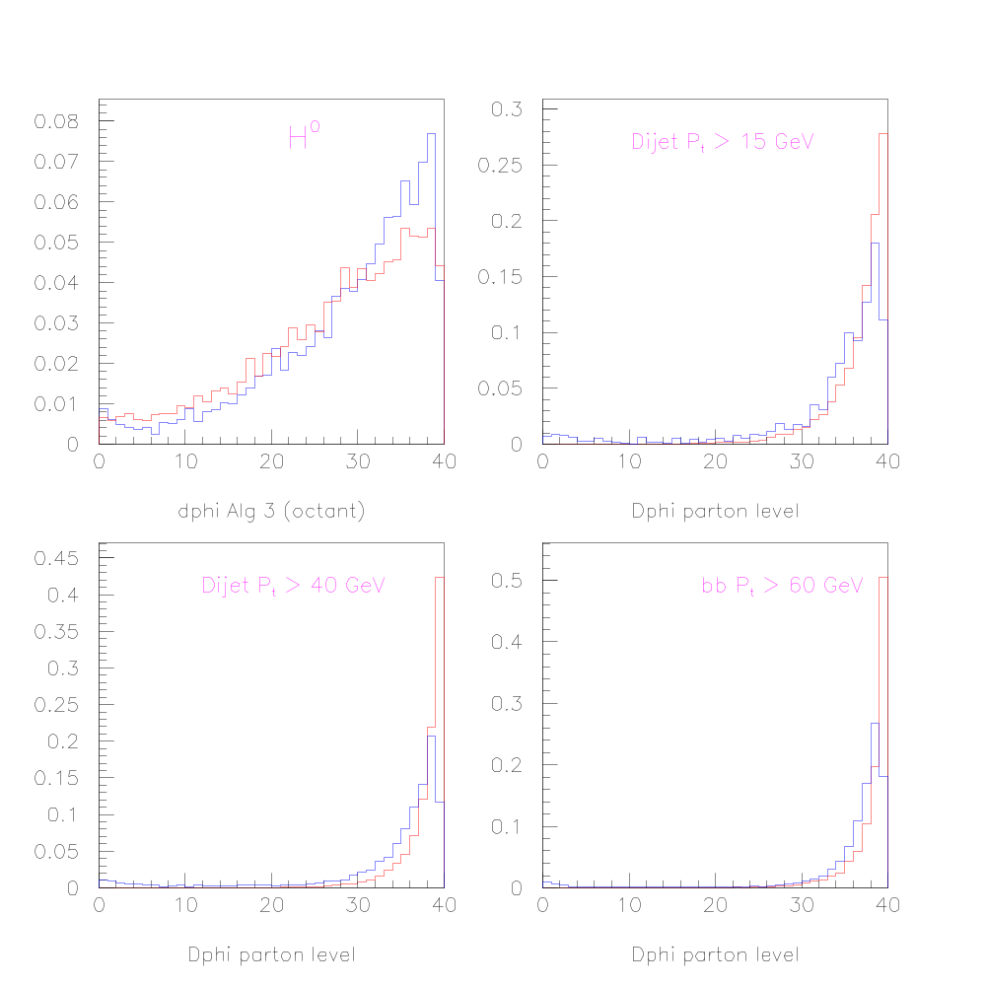
Figure 17: The opening angle between the leading partons.
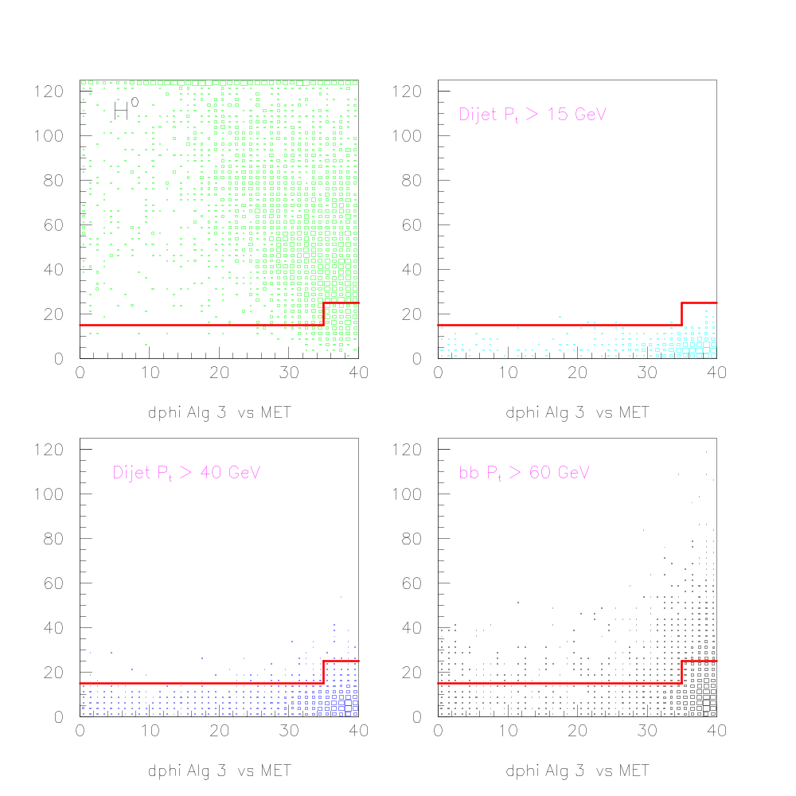
Figure 18: The correlation between delta phi and the ETmiss of the event for signal and representative QCD backgrounds
The use of the CFT phi correlations becomes compromised at high instantaneous luminosity. as shown in Figure 19. Only for relatively high pt jets does the correlation remain. At high luminosity one has to rely on the calorimeter to confirm the CFT jets. Modest trigger thresholds are able to reduce the rate from low pt scatters.
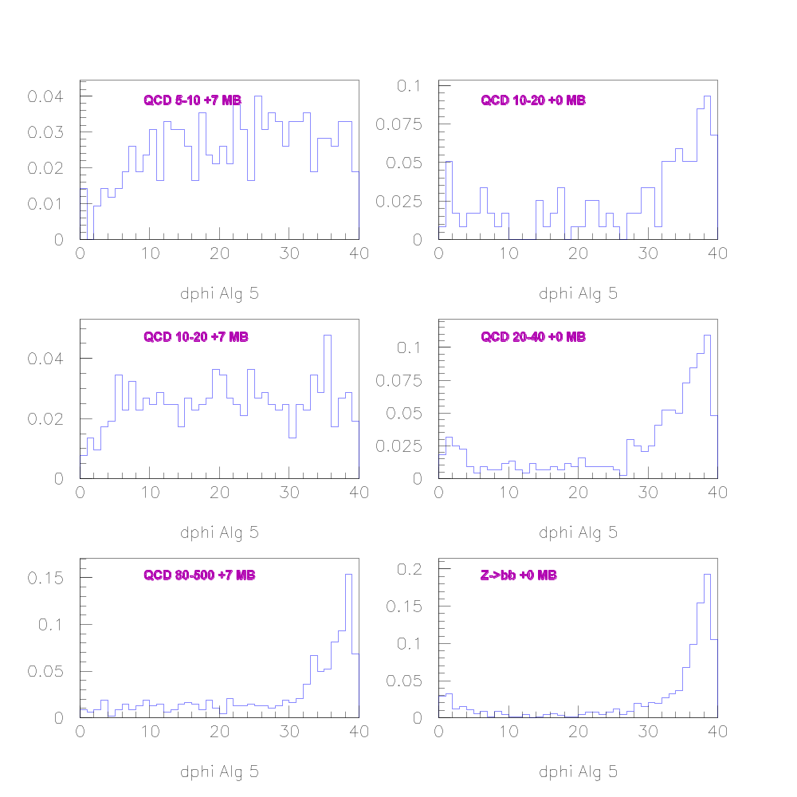
Figure 19: Correlation of Δφ in high luminosity conditions (left hand plots with 7 minimum bias events) and low luminosity (right hand plots with zero additional minimum bias events).
With an improved Level 1 calorimeter trigger that allows correlating CFT and calorimeter based jets these backgrounds can be further suppressed.
References
----------

[1] Report of the Higgs Working Group of the Tevatron Run 2 SUSY/Higgs Workshop,
M. Carena et al, hep-ph/0010338

Simulation

Rates and rejection improvements

Efficiency

Implementation

Cost & schedule

Recommendations

L1 Calorimeter Trigger Implementation Issues
The physics imperatives that drive the need to build a new L1 calorimeter trigger raise a number of implementation issues that will need to be resolved before construction can begin. In this section we discuss the issues that have been raised to date regarding implementation choices that need to be made.

ADC/DFE Split
In the previous sections one has seen that several functions are needed in the system. It is natural to split the system in an ADC part dealing with the analogue signals and a DFE (Digital Front End) part purely digital. These two parts being linked by LVDS links.The location of the digital filter gives two options:

Option 1: “Dumb” ADC
The ADC part contains only the converter. This could be done since the DFE should have enough power to perform both the digital filtering and the physics algorithms. The ADC part produces output samples with 10 bits accuracy. It does not need slow controls. It is cheap, simple and very easy (fast) to implement. However this is incompatible with a sampling rate faster than the beam crossing because of output bandwidth considerations.

Option 2: Filter in ADC
Here the digital filter is implemented in the ADC part. There are several advantages to this option:
- The output of the ADC consists of 8 bits words. This reduces the link bandwidth by 20%.
- There are several special towers (at the boundary between central and end caps) needing an additional treatment. This treatment is needed anyway, but doing it in the ADC makes the DFE completely regular (i.e. easier).
- The data at the output of the ADC is transferred to the level 2 trigger and the read-out. Doing the filtering in the ADC avoids to redo it in level 2 and in off-line processing.

Granularity
The current granularity of the trigger towers is 0.2 x 0.2. It is possible with a modification of the summing mezzanine in the BLS to go to a granularity of 0.1*0.2 while keeping the current cable plant. There are two options to this increase of granularity:
- Cutting only the EM towers (mixed sizes)
- Cutting both EM and Hadronic towers (0.1*0.1).
The gains for physics have been shown previously; here we estimate the cost of the three options, normalized to the cost of the 0.2*0.2 option:
 | 0.2*0.2 | Mixed sizes | 0.1*0.1
ADC | 1 | 1.5 | 2
DFE | 1 | 2 | 4
The problems with the algorithms in the mixed size option have been explained previously.

Overlap
The amount of data produced by the ADC is of the order of 20 Gbytes/s (for 0.2 x 0.2 and twice that for 0.1*0.2). This amount is too large for a single DFE card: the digital processing must be done by tens of DFE cards, each one processing a rectangular piece of the calorimeter. The number and speed of the LVDS links feeding one DFE card determine the number of DFE cards needed. Each DFE card is responsible for the recognition of electrons and jets in its piece of the calorimeter.
In order to implement the algorithms, each DFE needs data from the neighboring ones. The amount of sharing depends on the details of the algorithms; the jet algorithm is the most demanding (because jets are larger than electrons). The overlap must be lower or equal to two cells in all directions to keep a reasonable size to the system. This limits the choice of the jet algorithm. The first limitation comes from the requirement to avoid double counting: the same jet should not be found in two adjacent DFE. The second requirement is to avoid splitting a single jet at the boundary of two DFE. Both limitations can be corrected in the next processing stage, but this should be avoided if possible. There are two options for the overlap:

2 TT overlap in all directions:

This allows for jet algorithms up to 1.0*1.0
It is also needed in the 0.8*0.8 algorithm if one requests separated jets.
This symmetrical arrangement makes the cabling more systematic.

- Alternating 2 TT and 1 TT:
This is the minimum for the 0.8*0.8 algorithm.
This reduces the bandwidth between ADC and DFE by 8%.

DFE design

Reuse of CTT’s DFE
It has been proposed to reuse the DFE of the CTT for this application. Initial studies on the logical mapping of DFE’s to calorimeter sectors, the physical cabling and the required capacity of the links tend to show that an option based on DFEs seems viable. More detailed studies are needed, especially on the implementation of trigger algorithms in FPGA’s, in order to draw a conclusion on the possibility to use DFE’s. We estimate that this solution would roughly divides by two the design effort required, leading to several months of savings in manpower.
This solution mandates that the filter be implemented in the ADC cards because carrying 10 bit samples over DFE links requires 25% more bandwidth than dealing with 8 bit Et calibrated samples. In addition, incorporating a series of digital filters and the trigger algorithm logic may not fit in the FPGA of DFEs. The separation of the digital filter and the trigger algorithm part would also facilitate development and test, especially if these two units are developed at different locations. A last argument in favor of the split is the limitation of bandwidth for slow control on the DFEs that could make filter coefficients loading and update a slow process.
There are however a number of concerns for a DFE based solution:
- Some components of the DFE, especially connectors on the motherboard, may not be available anymore. It may not be possible to build a sufficient number of DFEs and spare cards.
- FPGAs on the daughter card of a DFE are mature devices and will be obsolete when run 2b starts. Although a new daughter card with a more modern FPGA could be designed, the fact that the serial to parallel conversion for the input links is implemented on the motherboard of a DFE places a tight upper limit on link speed and imposes worrisome constraints on FPGA pin counts, printed circuit board design...
- The bandwidth of DFE links is marginally sufficient, even if these can be clocked at 61 MHz instead of the current 53 MHz. This limitation could exclude the possibi1ity to run algorithms that operate on a 1.0*1.0 window in eta-phi space, though using 0.8*0.8 windows would probably fit.
- There is no SCL links in the DFE system: the SCL link must be implemented in the ADC sub-system. This will obviously complicate the design of the ADC cards, offsetting the expected savings in manpower on the DFE side.
- Because DFEs do not receive timing information and are purely data driven, the necessary timing signals must be imbedded in the dataflow by the ADC cards. This places additional constraints on the ADC cards and consumes a small fraction of the (precious) link bandwidth.
- The logic capacity of the FPGA in the current DFE may not be sufficient. This point has not been studied yet. The FPGA manufacturer does not foresee much (>2) larger devices because it has switched to a new footprint.
- The bandwidth of the slow control is insufficient to keep all the functionalities of the current trigger software.
- The mechanics of the front panel connectors has a delicate handling.

A dedicated DFE
In the study of a dedicated DFE a few points were decided:
- Using much faster LVDS links. This is obtained by feeding the links directly into the FPGA, bypassing the slow serializer/deserializer used in the CTT DFE.
- Using SCL data from the back plane for synchronization.
- Using USB2 for slow control.
- Using 12 input links and 6 output links.
- Using latest generation FPGA. Using smaller footprint FPGA because of the reduced number of IO pins obtained by serial IO instead of parallel.
- Placing all IO cables at the rear of the module.

Another possibility

It is possible to modify the previous dedicated DFE to make it compatible with the current CTT DFE. One only needs the following change:
- Use the same LVDS cables.
- Accept the slow control of the DFE crate as an alternate to the normal one.
- Use software compatible FPGA.

This new DFE would provide ample improvement margin for possible CTT upgrades.

L1 Calorimeter Summary & Conclusions

L1 Muon Trigger

Goals
- Efficient triggering on muons
- Rejection of non-muon backgrounds

Description of Current L1 Muon Trigger
- Overview
- Forward muon trigger
- Central muon trigger

Performance of Current L1 Muon Trigger
- Simulation (data?)
- Trigger rates and luminosity dependence
- PDT aging
- Conclusions and implications for high luminosity

L1 Muon Trigger Improvements
- Concept & physics implications
- Simulation
- Rates and rejection improvements
- Efficiency
- Implementation
- Cost & schedule
- Recommendations

L1 Muon Summary and Conclusions

Level 2 Triggers

Goals
- Maintain current rejection

L2 Beta Upgrade
- Concept & physics implications
- Implementation
- Performance scaling
- Cost & schedule
- Recommendations

STT Upgrade
- Concept & physics implications
- Implementation
- Performance scaling
- Cost & schedule
- Recommendations

Other Level 2 Options
- Concept & physics implications
- Implementation
- Performance scaling
- Cost & schedule
- Recommendations

Level 2 Summary and Conclusions

Level 3 Triggers

Goals
- Maintain existing rejection

Level 3 Farm Upgrade
- Concept & physics implications
- Implementation
- Performance scaling
- Cost & schedule
- Recommendations

Replacement DAQ Option
- Concept
- Implementation
- Cost & schedule
- Recommendations

Level 3 Summary and Conclusions

CDP Summary and Conclusions

Below are some templates:
This is an example of a reference.

Second Level Heading

Table 1. Sample Table
Layer | Radius (mm) (approximate) | Axial/ Stereo | Silicon Sensor (#SVX4, length) | # Phi | #Z | # Sensors | # Chips
0 | 16 | A | 1 or 2chip, 8cm | 12 | 8 | 96 | 144
1 | 35 | A | 2 chip, 8cm | 18 | 8 | 144 | 288
2 | 62 | A+S | 5 chip, 12cm | 12 | 6 | 144 | 720
3 | 95 | A+S | 5 chip, 12cm | 18 | 8 | 288 | 1440
4 | 127 | A+S | 5 chip, 12cm | 24 | 8 | 384 | 1920
5 | 160 | A+S | 5 chip, 12cm | 30 | 10 | 600 | 3000
Total |  | 6A, 4S | 3 types |  |  | 1656 | 7512
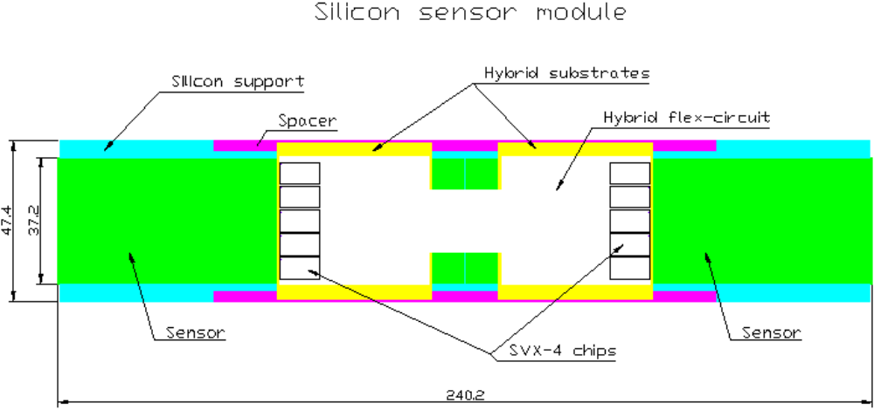
Figure 1: Sample figure.

.

References

These rates are estimated here from samples of Monte-Carlo QCD events, passed through a simulation of the trigger response.
F. Borcherding, “Tracking Triggers at High Luminosity,” D∅ Run 2b Workshop, FNAL, February 28, 2000.

