Introduction
The existence of neutrinos, weakly interacting particles that travel at or near the speed of light, was hypothesized in the early 1930’s to explain aspects of beta decay; without a third “invisible” product of the decay, the conservation of momentum would have been violated. The neutrino proposed by Pauli had unique properties: it was extremely light, it had no electric charge associated with it, and it interacted so weakly it could not be detected. With the inclusion of this new particle, momentum is conserved in beta decay processes because the otherwise missing momentum is carried away by the undetected neutrino. Because a neutrino can traverse a thousand light years of lead with a very small chance of stopping, existence of these nearly intangible particles was not verified unambiguously for twenty years.
Currently accepted theories (the “Standard Model”) identify three separate families of lepton: the electron, the muon, and the tau, each with its associated neutrino (the electron neutrino, muon neutrino, and tau neutrino). These families are referred to as “flavors”.
Neutrinos are produced by natural radioactivity, nuclear reactors, high-energy accelerators like the Tevatron at Fermilab, and fusion processes within our sun and other stars. Because neutrinos interact so weakly that they can pass through vast amounts of matter, they make useful tools for the study of the interior of our sun and the collapsing core of supernovae. Experiments designed for astrophysical studies need large volumes of material to maximize the chance of stopping a neutrino within their detector. In 1971, an astrophysics experiment (Homestake) began to see a large discrepancy between the predicted number of neutrinos incident on the Earth and the number actually detected. While the results were not conclusive, other experiments built to measure neutrino flux with different techniques began to see a similar discrepancy. By 1980, there was considerable interest in the field of neutrino astronomy.
Beams of neutrinos from accelerators were studied to search for the “neutrino oscillation effect”. The lack of the expected numbers of neutrinos could be explained if neutrinos of one flavor could transform into a neutrino of a different flavor. The solar neutrinos could have oscillated into a flavor to which the detectors were not sensitive. The results of these experiments have sparked a great deal of activity and controversy.
This review is divided into six sections. The first section will present the astrophysical and cosmological results that suggest neutrinos may have non-zero mass and the mathematical formalisms developed to describe possible neutrino oscillations. In the second section, a review of kinematical searches for neutrino masses will provide the most stringent upper limits on neutrino masses and detail the methods used to define these limits. The third section will focus on the most recent and controversial accelerator experiment and compare its result to the body of existing work. The fourth section will provide an example of a theoretical prediction based on the existing data set, and the fifth section will outline how the DZero experiment might go about searching for non-zero neutrino mass and what its chances are. Finally, the sixth section will address the question, “What is the best design for a neutrino experiment?”
Several experiments will be discussed in detail in the text of this review. For a listing of other neutrino experiments and brief descriptions, consult Appendix A. A copy of the exam questions prepared by Professor Gregory R. Snow upon which this review is based is included as Appendix B. Questions from committee members subsequent to the initial version of this exam are addressed in Appendix C.

Indications of Neutrino Mass from Cosmology and Astrophysics
The tentative evidence for massive neutrinos stems primarily from astrophysical and cosmological studies. Three empirical observations lead us to suspect that neutrinos may have small but non-zero mass: the solar neutrino problem, the atmospheric neutrino deficit, and the missing matter of the universe.
The first observation involves generally accepted theories that model stellar fusion processes and thus predict the number of neutrinos produced within stars like our sun. Together, these theories comprise what is called the Standard Solar Model (SSM). Many aspects of the SSM have been experimentally verified through analysis of the sun’s electromagnetic spectrum or through helioseismology. If experiment conflicts with a major prediction of the model, many basic theories must be reworked. In fact, the SSM predicts many more observable electron neutrinos from the sun than are detected on Earth; this neutrino deficit is termed the “solar neutrino problem”.
Secondly, cosmic rays incident upon Earth’s atmosphere produce neutrinos as they collide with particles in the upper atmosphere. Cosmic ray interactions predominantly produce showers of pions and kaons, which decay according to the following mechanism:
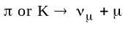,
which is followed by decay of the muon,
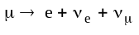.
With knowledge of only these basic processes, the ratio of muon neutrinos to electron neutrinos should be very close to 2. Detailed corrections to this number that include rare decay chains do not substantially change this value. Surprisingly, the measured ratio of neutrinos 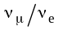 from cosmic rays differs from this basic prediction by 40%. This deficit of atmospheric muon neutrinos is not reconcilable with the current understanding of the way particles shower.
The third hint that neutrinos may be massive arises from cosmological considerations. By seeking correlations between the distance to the furthest stars, the rate at which they are receding, and the age of the oldest observable stars, cosmologists construct a series of models that describe the formation of the universe from the initial moments to its present state. Reasonable constraints (e.g., the oldest stars cannot be older than the universe) imply limits on the maximum and minimum total mass of the universe. Luminous matter accounts for only 10% of the mass required to model the universe in its current observed state, so 90% must be accounted for by non-luminous matter, or so called “dark matter”. Massive neutrinos are a favored candidate for portions of this missing matter.
In the following subsections, we consider each of these problems in more detail. A framework for explaining the source of these effects with massive neutrinos will be developed.

The Solar Neutrino Deficit
Table 1 depicts the various nuclear reactions that, according to the SSM, occur within the sun. Although neutrinos are produced in several different steps, the following discussion centers around the neutrinos produced in the initial pp fusion, the Beryllium reaction, and the Boron reaction. For reactions that produce neutrinos, the resulting neutrino energy is listed as E. The table also lists the relative frequency of each reaction as a termination percentage (T%). For instance, of all the processes that terminate, 15% of them end with a lithium reaction.

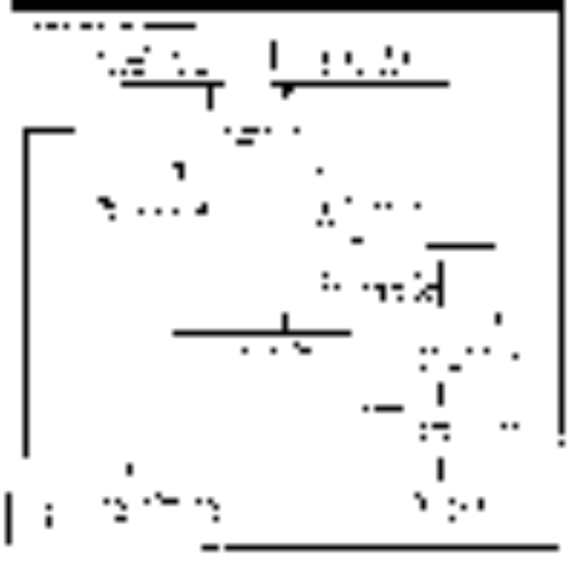
Table 1: Nuclear processes occurring within the sun [1]. Two reaction chains are listed; both chains begin with hydrogen nuclei (protons) and end with helium production. T% is the termination percentage, describing the frequency of the reaction. For reactions that create neutrinos, the energy of the neutrino is indicated as E (MeV). Not shown is the CNO cycle which is believed to contribute only 2% of the sun’s luminance.

The SSM predicts a well-defined number of neutrinos incident upon the Earth in a given period of time. Table 2 lists the neutrino flux expected at the Earth’s distance from the sun, categorized by process. The uncertainty in the calculation is expressed in parentheses. The most abundant solar neutrinos are the least energetic and also the most difficult to detect.

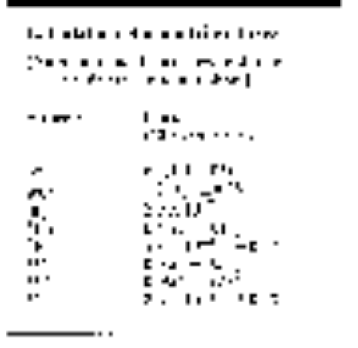

Table 2: Neutrino flux is calculated using the Standard
Solar Model for a distance equivalent to the Earth’s orbit. [1]

Experiments have been designed to detect this flux, most notably the Homestake mine experiment in South Dakota and Kamiokande in Japan (see Appendix A for descriptions). Having energy thresholds of 814 keV and 7.5 MeV respectively, these experiments are not capable of detecting the low energy neutrinos from the pp reaction. The neutrinos from the rare Boron decay comprise the majority of the solar neutrino data sample. Figure 1 depicts the energy spectra of the produced neutrinos as predicted by the SSM.

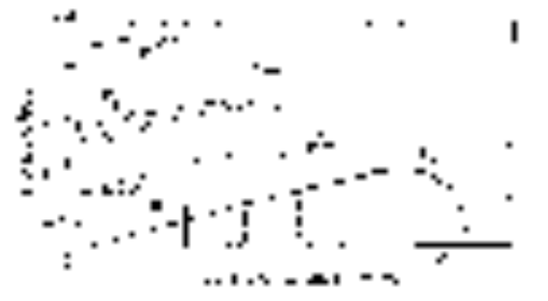
Figure 1: Plots of the expected neutrino
energies from various solar processes. [2]
Unfortunately, only half the predicted numbers of 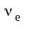 are detected. One attractive solution involves neutrinos oscillating from one flavor to another (in this case 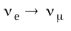) via the Mikheyev, Smirnov, Wolfenstein effect (MSW). [3] A prerequisite for this effect is a non-zero mass difference between the two flavors of neutrino, requiring at least one of their masses be non-zero.
The energy of a neutrino within the sun includes its kinetic energy, its mass energy, and its potential energy. The potential energy results from weak (charged or neutral current) interactions with the surrounding protons, neutrons, and electrons [4]:

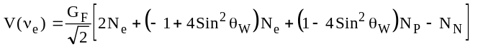,

where G_{F} is the Fermi coupling constant (a ratio of the mass of the W and the weak fine structure constant) and N_{x} is the surrounding density of electrons, protons, and neutrons. θ_{W} is the weak mixing angle, not to be confused with the mixing angle between neutrinos to be introduced later. The first term represents W exchange between the neutrino and electrons. The remaining terms result from Z exchange between the neutrino and electrons, protons, and neutrons, respectively. If the sun is electrically neutral overall, the middle two terms cancel exactly. Also, the number of neutrons in the sun is only one third to one sixth that of electrons [4], so the fourth term can be neglected, leaving only the first term. The total energy of an electron neutrino within the sun is then

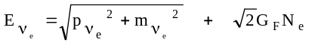,

where the last term describes the interaction potential energy between the electron neutrino and the surrounding electrons. The electron density, N_{e}, is expected to have a maximum near the sun’s core and decrease with increasing distance from the center of the sun.
The expression for the energy of some other neutrino,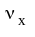, within the sun does not include the W exchange term as muon and tau neutrinos within the sun are not surrounded by a dense medium of their respective charged leptons. Neglecting the Z-exchange terms as before, the energy of this neutrino is simply

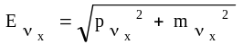.

Now, we search for a form similar to the electron neutrino expression, so

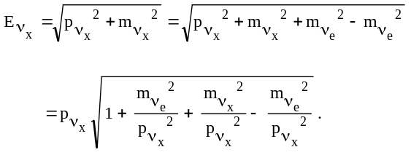
Using the binomial theorem to approximate the square root, we define 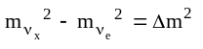 and

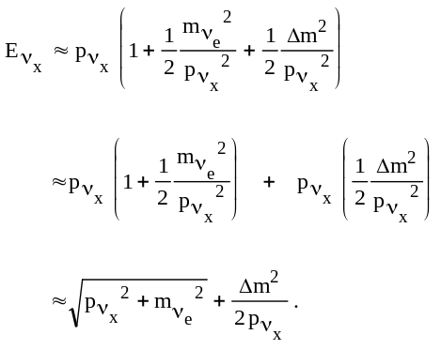

If flavor mixing can occur, a non-zero transition probability arises only when the energies of each flavor-state are equal. Thus, setting 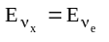, this necessary condition becomes

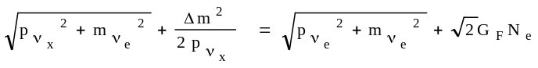.

By conservation of momentum, 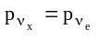, so the square root terms cancel. Finally, because the neutrino is highly relativistic, the total energy is a good approximation for the momentum. The condition for flavor oscillation within the sun becomes

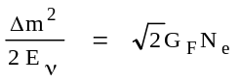.
(Eqn. 1)

Because the Fermi energy of Eqn. 1 is quite small, neutrinos may undergo a flavor change only if their energy is high compared to the mass difference making the left side of the equation similarly small. Thus, the MSW formalism predicts a lack of “high-energy” solar neutrinos compared to the SSM while leaving the prediction for “low-energy” neutrinos unchanged. The precise energy value required to satisfy Eqn. 1 must be determined by experiment. For high-energy neutrinos, the probability of a flavor change is not unity even if Eqn. 1 is satisfied; discussion of mixing angle is reserved for the next section.
To explain solar neutrino data, neutrinos must either be massive and allow mixing between flavors, or aspects of the SSM must be reworked. Theorists have offered some explanations other than the MSW solution that do not require massive neutrinos (modifications to the current solar convection scheme) so the evidence for neutrino mass from solar data is not yet conclusive.

The Atmospheric Neutrino Deficit
Very high-energy particles (including photons) originating from outside our solar system can collide with atoms in our upper atmosphere and generate neutrinos. Predicting the number of muon and electron neutrinos that are generated by these “cosmic rays” is possible; however, the theoretical predictions of the total flux of both 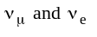 vary by as much as 30%, depending upon which models are used. Because the absolute fluxes are so difficult to calculate, a prediction of the muon neutrino flux relative to the electron neutrino flux is generated. Predictions of the ratio of neutrino fluxes agree to within 5% of one another and are therefore suitable to compare to the ratio measured by experiment.
In atmospheric neutrino experiments, neutrinos are detected from all directions, not just from above. This observation indicates that neutrinos generated in the atmosphere on the far side of the Earth propagate ~10,000 km through the planet to reach the detectors. If one considers only “upward-going” neutrinos and “downward-going” neutrinos, one finds that the ratio 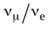 is anomalously low for upward-going neutrinos but is in agreement with theoretical predictions for downward-going neutrinos. Note that these measurements were made by the Kamiokande experiment, which is only sensitive to neutrinos with an energy above 5 MeV [6]; there is no evidence that neutrinos of lower energy exhibit this anomalous behavior. Furthermore, not all experiments have confirmed this high-energy muon neutrino deficit. Figure 2 displays the ratio determined by experiment divided by the predicted ratio of. This so-called “ratio of ratios” has an expected value of unity.
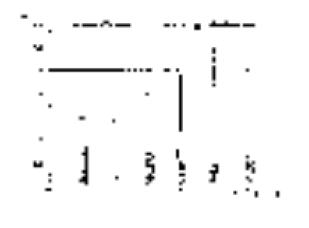
Figure 2: Atmospheric neutrino data from selected experiments. Some experiments have measured a significant deficit of muon neutrinos. [5]

The deficit observed by Kamiokande can be explained if the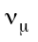 oscillate to one of the other two flavors of neutrinos. The following derivation does not require the neutrino to travel through a dense medium as the MSW calculation did, so the following effect is referred to as a “vacuum oscillation”. If neutrinos are massive and can mix, the flavor eigenstates result from a linear combination of mass eigenstates. In matrix form, this relationship is expressed as

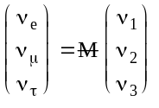, where

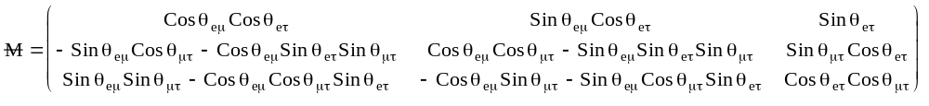

and θ_{xy} are the mixing angles between flavors, to be determined by experiment. This unitary transformation matrix is similar in form to rotation matrices in classical mechanics. To simplify the calculation, assume that muon neutrinos created in the atmosphere oscillate only into tau neutrinos and that oscillations between electron neutrinos and tau neutrinos can be neglected (let θ_{eμ} = θ_{eτ} = 0 in the matrix). Then, the matrix simplifies to

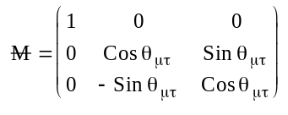.

Explicitly, the muon neutrino eigenstate expressed in terms of neutrino mass states is

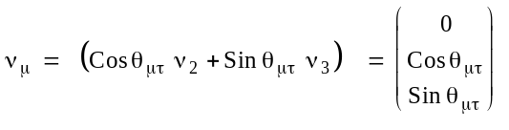

Consider an atmospheric muon neutrino created at time t=0. At some later time, the mixture of mass states has evolved into

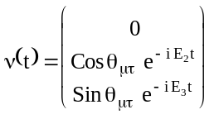,

where E₂ and E₃ are the energies associated with mass-states 2 and 3 given the initial momentum. The probability of the neutrino oscillating into a tau neutrino is

.

Because the mass of the neutrino is small compared to its momentum, we may approximate the energy as

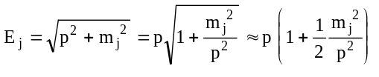,

where j indicates a particular mass state (either ν_{1,} ν_{2,} or ν₃), and we have again approximated using the binomial expansion. The probability becomes

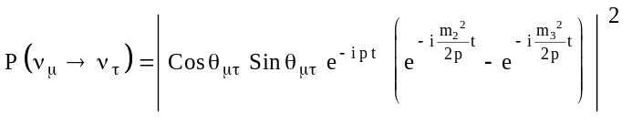.

Using

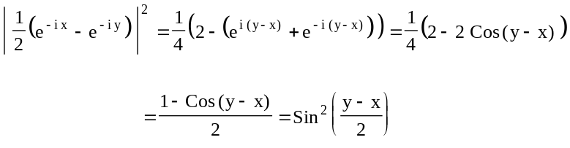
the probability becomes

.
Because the neutrino is very relativistic, the “flight-time” is simply-related to the distance travelled,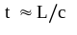and the momentum is simply-related to the energy,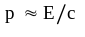, thus

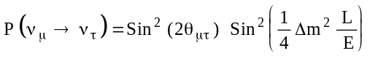.

This equation describes the probability of a muon neutrino oscillating into a tau neutrino if we may assume that the energy is relativistic and neglect other flavor oscillations. The values of Sin² (2θ_{μτ}) and Δm² are physical constants to be determined by examination of data at different values of 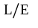. The oscillation length 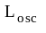, the distance required for the neutrino oscillation probability to oscillate from zero to its maximum and back to zero, is found by

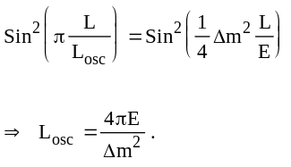

In the literature, the probability equation is often expressed with explicit units for the mass, distance, and energy:
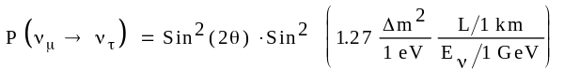.
(Eqn. 2)

Here, the numerical factor of 1.27 results from the unit conversion. Note that this general result does not depend upon the flavor of the target neutrino; our mixing matrix,, would have simplified similarly for any one oscillation pair. While this derivation explicitly assumed mu to tau, the result would be the same for mu neutrinos to electron neutrinos, hence the subscript μτ is omitted from the mixing angle.
This derivation has been criticized in the literature for considering only one type of mixing and neglecting the other two. In a three-flavor mixing analysis, equal and opposite phases may cancel, depending on the mixing angles, yielding very different results for the same values of Δm² and θ. [7] Because there is no a priori reason to neglect two of three mixings, the standard two-flavor analysis presented here may be flawed. [8]
To explain the observed atmospheric neutrino mixing, we require that for 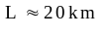 the transition probability be nearly zero (our downward neutrinos) and for 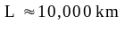 the probability be appreciable. We find that for atmospheric neutrinos of 6 GeV energy or higher, the best fit to all Kamiokande data is 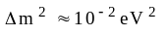, with an upper limit of around 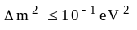. Despite the apparent popularity of representing the entire data set as a single point, data analysis should proceed in a different manner.
The ratio of all muon neutrinos to all electron neutrinos is not useful for an oscillation search, the important parameter is . Each experiment should bin its data in terms of , but most newer experiments lack the statistics to do so at this time.
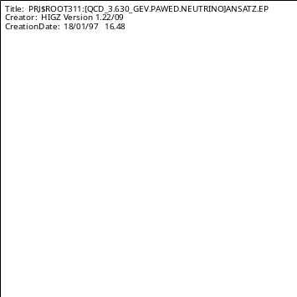
Figure 4a: A plot of the ratio of as predicted by Eqn. 2 along with the Kamiokande data.
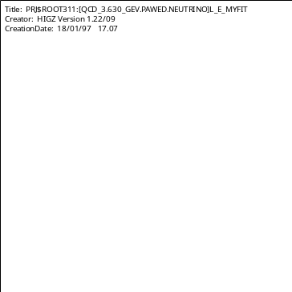
Figure 4b: Fit of the ratio using Eqn. 2 averaged over an interval in . The Kamiokande data is well-described with this method.
A plot of Eqn. 2 yields a sinusoidal function with a maximum of unity, a minimum determined by the mixing angle, and a period determined by Δm² (Figure 4a). Experiments are not capable of measuring the neutrino ratio with infinitely fine resolution in , so Eqn. 2 should not be used to perform a fit. The average of Eqn. 2 over a given interval in must fit the observed data. This interval should match the bin size of the data.
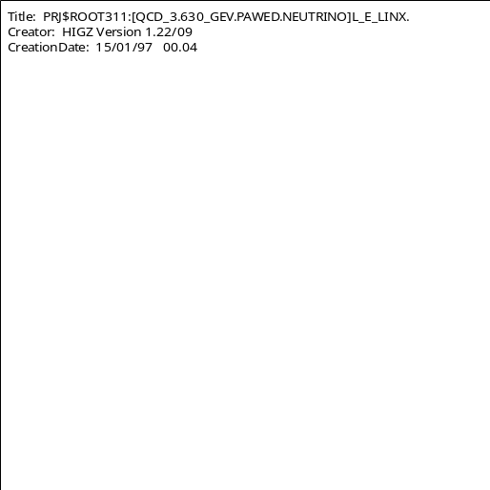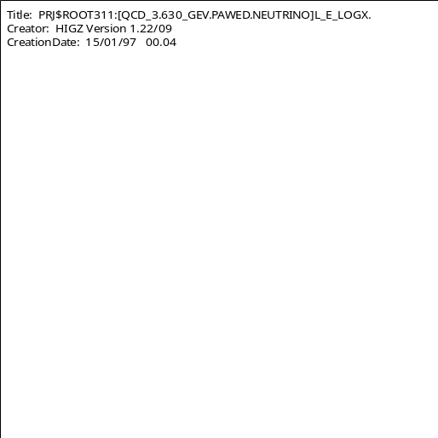
Figure 3: Atmospheric neutrino data, the “ratio of ratios,” plotted as a function of 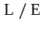. Kamiokande is the only experiment capable of binning their data in this way; all others have only a single bin. The majority of Kamiokande’s points are consistent with a 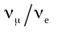 ratio of 0.6, but their leftmost point is consistent with unity. At left, the data are plotted with a linear scale on the x-axis, at right, a logarithmic scale on the x-axis is used to include the point at 12,800 km/GeV. [9]

The fit to the multi-GeV Kamiokande data using this modified Eqn. 2 yields the preferred values

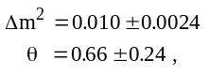

where a bin size of 0.7 * was used to produce a smooth function (Figure 4b). The steep drop between the first and second points drives the Δm² fit; beyond the second point, the solution quickly approaches its average value, which is determined by the mixing angle θ. To reduce the uncertainty of the fit with Eqn. 2, several more points are required along the first quarter-cycle of the of the solution. The very large uncertainty on the value obtained for theta from the fit underlines the need for more data in the low range. Note that several experiments found no disagreement with the predicted ratio of neutrinos. Fitting all the data at once is difficult, so theorists tend to exclude some data sets from consideration when they make their predictions.
Some measurements of the neutrino ratio 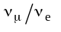 disagree significantly with theoretical predictions that do not incorporate neutrino mixing. Vacuum oscillations of massive muon neutrinos to another flavor could explain this deficit, but the current data samples make comparisons from one experiment to another difficult. Fits to existing data sets yield large uncertainties that cannot decrease until more data has accumulated.

The Dark Matter Problem
According to the generally accepted Big Bang hypothesis, a very large number of neutrinos must have been produced during the birth of the universe. While some interacted during the early moments of expansion, most remained as a uniform sea of particles. The neutrinos are now believed to have “cooled” to a very low energy and experience a negligible number of interactions. Calculations estimate a particle density of 113 “relic neutrinos” of each flavor per cubic centimeter. In addition to this number, cosmic neutrinos are created from type II supernovae, which produce 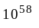 neutrinos of ~10 MeV each. [10] About 10 supernovae occur each second in the observable universe. Finally, stars generate a small percentage of their power in the form of neutrinos during the normal course of their lives. While neutrinos interact very weakly, the universe is very densely populated by them. If neutrinos have mass, no matter how small, they will collectively have a large effect on cosmological calculations.
A typical cosmological model of the early universe invokes inflation, an accelerated expansion, in the first moments. The model explains the measured size of the universe and includes some details of galaxy formation, but it requires the density of the universe to be precisely that density that allows the universe to expand forever at a rate that asymptotically approaches zero. If the density were greater than the critical density, the universe would eventually collapse in upon itself; the theory of inflation would also be invalid, leaving us with no way to explain the universe as it is observed.
Tests of the rate of expansion, as described by the Hubble constant, indicate that the density is very close to the critical value. To reach critical density, most of the matter in the universe (90%) must be non-luminous; the stars we observe are not massive enough. The constraint of explaining the observable universe allows one to make educated guesses about the possible masses of neutrinos.
If all of the non-visible matter in the universe consisted of massive neutrinos, critical density would be reached if the mass of the three known neutrino flavors (just one of each) summed to 30 eV. [11] This value provides a hard upper limit on 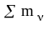. This initial upper limit is further modified by dividing dark matter into a hot, high velocity component and cold, low velocity component. Hot dark matter should comprise approximately 30% of the total dark matter mass. [12] Identifying neutrinos as the hot component of the missing matter, the constraint on neutrino masses becomes

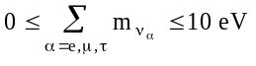.
Cosmologists are anxious to determine whether the universe is open or closed. Recent measurements have not yet been able to make the determination, so there is a great deal of interest in learning more about dark matter to refine models. Neutrinos are the only candidate particles for hot dark matter known to exist in nature; all other candidates are hypothetical. [13]

Summary
Two formalisms, the vacuum oscillation formula and the MSW effect, have been introduced to explain inconsistencies between astrophysical theories and experiment. While the MSW effect is negligible except for extremely dense media, the vacuum oscillation formula is used extensively to make predictions for accelerator experiments.
The preceding three arguments suggest that neutrinos may be massive and consequently mix between flavors. The 40% deviation of the number of observed solar neutrinos from theoretical predictions holds limited weight due the model-dependence of initial flux calculations. Atmospheric neutrino measurements are not consistent with one another; some experiments deviate significantly from predictions, while others observe no deviation. In addition, massive neutrinos would satisfy the need to identify some portion of the missing dark matter required by most cosmological theories, but there is no compelling cosmological reason neutrinos must be massive.
Astrophysical phenomena are not manipulable systems where inputs can be varied to fully study the outputs, as is the case with most terrestrial experiments. Instead, experimentalists must rely heavily on their models of solar activity and cosmic ray showers, introducing a great deal of uncertainty into the predicted results. The determination of neutrino masses and mixing angles (if any) will most likely result from terrestrial experiments and not from additional astrophysics searches.

Kinematic Searches for Neutrino Mass
The most direct searches for neutrino masses study the decay of particles at rest. By conservation of momentum, the vector sum of all product momenta must be zero. Furthermore, the total energy (including mass energy) of the final states must equal the initial total energy. Because neutrinos are so difficult to detect, one measures the energy of the “visible” products of a decay and calculates the missing energy required to balance the initial conditions. This calculation specifies the mass of the non-visible particle, assuming the energy, direction, and identities of the other final states are determined.
Consider a simple two-body decay. A particle of mass M at rest decays into two particles with masses and momenta m₁, p₁ and m₂, p₂, respectively (Figure 5).
Because there are only two products of this decay, the momentum of particle 1 must be equal in magnitude to particle 2’s momentum and opposite in direction. The final energy must always be equal to the initial energy. Even if particle 2 is not detected, its mass and energy are still completely determined by a measurement of particle 1. For instance the mass of particle 2 is expressed as
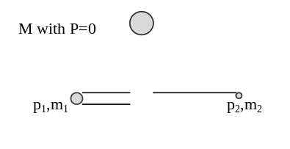
Figure 5: A schematic of a two-body decay. The massive particle decays into two particles of differing masses but equal momenta.
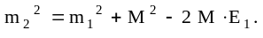
(Eqn. 3)

In a decay with three or more products, the calculation is not so simple. The rigid requirement of equal and opposite momenta in the two-body decay no longer applies. The momentum of the third particle, if very massive, is impossible to measure accurately because the momentum is smaller than the resolution power of detection techniques. In a three-body decay, a study of the momentum spectrum of the fast-moving visible product will be required.
The following is a list of preferred reactions used to search for the neutrino masses of the three standard model flavors. In each case, the experimental method setting the most stringent mass limit is described.

Tritium β decay
In this decay, 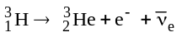, a Tritium atom with one proton and two neutrons converts to a Helium isotope (2 protons 1 neutron), emitting a beta particle (an electron) and an electron anti-neutrino. The massive nucleus remains essentially at rest, making a momentum measurement impossible.
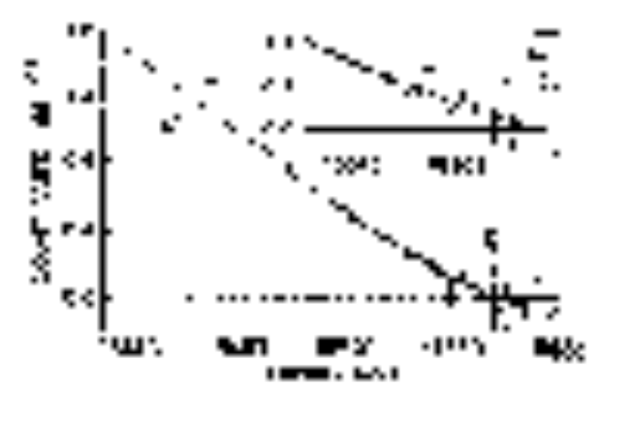
Figure 6: Anomalies in the β decay spectrum. Curve a is the best fit to the data using 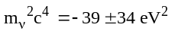. Curve b is a linear fit to the statistically significant points in the last 50 eV; curves c-e are fits using 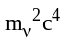=0, 10, and 20 eV, respectively. [14]
A study of the electron momentum spectrum should reveal the presence or absence of neutrino mass. If the neutrino has m² = 0, the electron momenta of many decays should have a distribution that decreases to zero frequency at a value predicted by a two-body decay of tritium into only a helium isotope and an electron. (If the neutrino has zero mass and vanishingly small momentum, then the electron must have all the momentum required to balance the He³ recoil.) If instead, the neutrino has non-zero m², the electron energy spectrum must approach zero frequency at some upper limit prior to the zero-mass two-body prediction.
Instead, experimenters find that the tail consistently exhibits an excess of events (Figure 6), indicating a negative value for 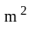 and a seemingly imaginary mass. While most experiments have uncertainties that make their m² result consistent with zero, some results indicate a significantly negative value.
One explanation of this non-physical result is that a molecular ion HeT⁺ forms during the course of the experiment. While models of this ion do not indicate an excitational mode that would explain the observed excess of events, no confirming experimental data on this ion’s excitational spectrum exist. An experiment to investigate the orbital spectrum of the helium-tritium molecular ion would require a detector sensitive to very-ultraviolet photons but such devices have not yet been developed. [15]
The current limits on the mass of the electron neutrino have been set by tritium β decay experiments. Because the center of the probability distribution of m² has a nominally negative value, the upper limit of 3.5 eV is lower than it would be had the central value been zero. It is perhaps better to quote a higher limit as the negative value may indicate a poor understanding of systematic biases in the method or contamination of the data sample. The method used to determine the mass limit is discussed further at the end of this section.

Pion Decay
Assamagan et al. have designed a small unnamed experiment to search for muon neutrino mass at the Paul Scherrer Institute in Switzerland. The simple experiment involves a 590 MeV proton beam incident on a graphite target, producing copious π⁺ mesons. A fraction of these pions come to rest within the target near the surface. When these “surface pions” decay via 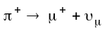, some of the generated muons will have the correct momentum vector to enter the experimental apparatus.
The apparatus consists of a momentum selector designed to accept a 1% wide momentum band centered on 29.75 MeV/c. This band kinematically selects only those muons that likely originated from the decay of a surface pion. The momentum selector also acts as a charge identifier. After passing through several collimators, the muon beam strikes a simple magnetic spectrometer consisting of a homogenous magnetic field and a silicon micro-strip detector.
The experimenters invoke the CPT theorem (they assume the mass of the 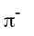 is equal to the mass of the 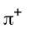) and use the most recent data for the mass of the in their calculation. Because there are two different values of pion mass from two recent analyses, they perform their calculation twice, yielding
( a )
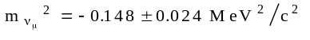
and
( b )
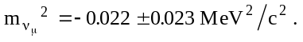

Because the first value is negative by 6.2 standard deviations, they choose to exclude the pion mass that results in value ( a ). The second neutrino mass value ( b ) is quoted as the final result. They calculate a pion mass that corresponds to a value for massless neutrinos and quote it as a lower limit on the true pion mass. The magnitude of this change is slightly larger than the one sigma magnitude of the quoted error on the “original” pion mass. [16]

Tau Decay
Measurements of tau decay into pions and a neutrino have been performed by the ARGUS collaboration, the OPAL collaboration, and more recently ALEPH, which set the current upper limit on the mass of the tau neutrino. Unlike the other experiments described in this document, ARGUS, OPAL, and ALEPH are collider detectors and were not designed for the specific purpose of neutrino physics. This subsection will focus on ALEPH, which was installed in the LEP e⁻e⁺ beam-line at CERN to study Z boson decays.
Similar to many collider detectors, ALEPH is composed of many sub-detectors arranged in concentric cylinders that surround a beam pipe. The innermost sub-detectors effectively track the momentum and charge of product particles as they emerge from the beam pipe. Charge is indicated by the curvature of the trajectory within a 1.5 Tesla magnetic field. [17] The surrounding calorimeter measures particle energies and the outermost layer detects muon position and momentum.
From a sample of 76 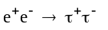 events, ALEPH selects events with at least one tau fragmenting into five daughters, each with an energy greater than 100 MeV. If one or more of the daughters is identified as an electron or photon, the event is rejected. [18] Several other cuts are made to ensure the daughters are correctly identified as pions. The remaining 23 events are classified as 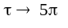. ALEPH also identified two events from the tau-tau sample as 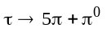. These two events are included in the mass analysis.
The invariant mass of the hadrons from the events is used as the input for a maximum likelihood function. The function describes the probability of obtaining the observed distribution of pions for various possible neutrino masses. The functional form includes selection efficiency, energy-resolution effects, and the theoretical distribution function of the decay mode. This method does not yield a central value directly because input parameters in the non-physical region do not contribute to the likelihood. Instead, this method directly calculates an upper limit on the probable neutrino mass. ALEPH finds the value of the tau neutrino mass is 95% likely to be below 23.8 MeV. [18] While one might expect the actual value for the tau neutrino mass to be less than 100 eV or zero, ALEPH has set the best empirical limit to date. Fixed target experiments dedicated to the search for the mass of the tau neutrino should be able to set much more stringent limits.

Neutrinoless Double Beta Decay
An arbitrary element of atomic number Z and atomic mass A, can undergo a double beta decay according to the following mechanism:

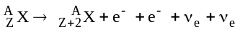,

which is simply two beta decays (as discussed for tritium) occurring simultaneously. One extension of the standard model hypothesizes that it may be possible to emit two beta particles without emitting neutrinos. Such a neutrinoless decay requires that neutrinos be their own anti-particles. [11] This violation of lepton number is not allowed for SM (Dirac) neutrinos, but is described in some super-symmetric models with Majorana neutrinos.
In the Majorana decay, an electron is emitted from a neutron via 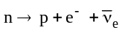 and simultaneously, the neutrino is absorbed by a neighboring neutron via 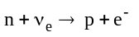. This mechanism requires 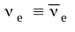, hence the statement that Majorana neutrinos violate lepton number conservation by 2. An alternative to the Majorana scenario is if there exists at least one right-handed partner to the known (left-handed) neutrino flavors. A might then oscillate into a 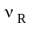, similar to the vacuum oscillations discussed above. (Because the right-handed neutrinos do not experience weak interactions as the three known neutrinos do, they are sometimes referred to as sterile neutrinos.) This extension to the standard model may also permit neutrinoless double beta decay.
Experiments searching for a signal in this channel favor the element Germanium. For an ordinary beta decay with two single decays coincidentally close together in time the two electron energy spectrum should decrease to zero at the highest energy, as for tritium decay. For the neutrinoless case with Majoron exchange, the electrons are kinematically forced to have the maximum energy, resulting in a single line at the high end.
This technique should provide an order of magnitude greater mass sensitivity [19] than the tritium experiments current limit, but only if neutrinos are, in fact, their own anti-particles. If neutrinos are not their own anti-particles, the data sample will be entirely composed of mock double beta decays. Thus far, not a single neutrinoless double beta decay has been observed.

Summary
Despite the strong hints from astrophysics and cosmology, kinematic searches have yet to produce definitive proof of non-zero neutrino mass. Disturbingly, the electron and muon neutrino results consistently favor a negative value for m². While this anomalous result would not be statistically surprising for a single experiment, especially for very small or identically zero neutrino mass, it is not expected to occur in all experiments.
The methods used to determine the most stringent mass limits of the three flavors of neutrino have been summarized. Because some of the best fits to neutrino masses are consistent with zero or non-physical imaginary values, the masses have not been determined. The usual Bayesian approach to setting upper limits on masses must be modified to accommodate a negative value of the mass fits, as summarized in Figure 7 (c.f. Phys. Rev. D, Review of Particle Physics, Sec. 3). Recall that for the tau neutrino mass the limit was calculated directly with a maximum likelihood function, and it was not possible to find a central value for the mass.
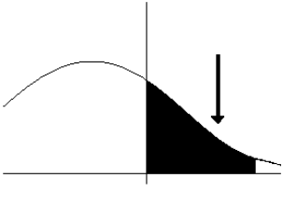
Figure 7: The central value of the mass fit is negative. The black
arrow indicates a point where 90% of the distribution is to the left.
Because some of the distribution is in a non-physical region, the 90% confidence limit is found by considering only the portion of the
distribution in the physical region. The 90% mass limit then corresponds to the border between the black and white regions near
the right corner of the figure.

Table 3 lists the most stringent mass limits to date from the experiments described in this section. The electron and muon neutrino values define a 90% confidence limit, but the tau neutrino limit is at 95% confidence. While the electron neutrino mass is well constrained, the muon and tau neutrino mass values are expected to lie much lower than the current limits.
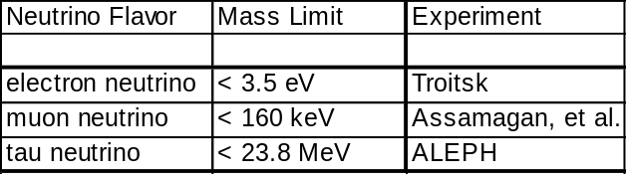
Table 3: Current mass limits from experiment.
The technique used accommodates central values
in the non-physical region.

Neutrino Oscillation Experiments
As discussed in the astrophysics section, the probability of observing a flavor oscillation depends upon the mixing angle, the mass difference, and the parameter . The best opportunities for a transition occur when the distance travelled by the neutrino is long and the neutrino energy is small. Presently, several experiments are searching for vacuum oscillations of various neutrinos, and more experiments are in the planning stages. (See Appendix A for a sample set of neutrino experiments.) The typical scheme for current experiments is to search for 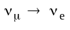 because the former are so easy to create and the latter are relatively easy to detect. These searches are not sensitive to the absolute value of neutrino masses but only to the mass difference between flavors.
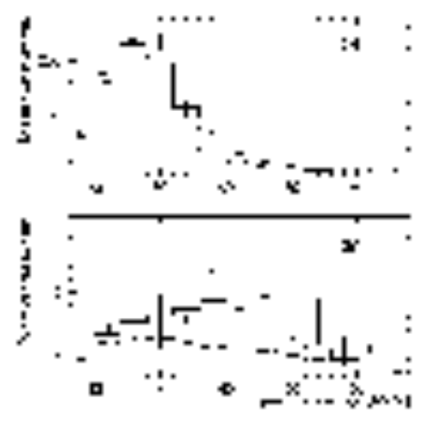
Figure 8: Current results from LANL (unpublished). The number of events detected are shown with the Monte Carlo predictions for SM neutrino background (dashed line) and for neutrino background with neutrino oscillations and large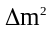 (solid). [20]

- Data and predictions without likelihood cut applied.
- Data and predictions with R > 30.

In the past, there have been announcements that neutrino oscillations had been verified, but all these claims have been disproven. On January 31, 1995 a New York Times front page story claimed that evidence for neutrino oscillations was observed at Los Alamos National Laboratory. The initial data have since been published in Physics Review Letters [20] and the extraordinary result has generated many papers from theoreticians. Because a great deal of controversy surrounds this result, the experiment merits further discussion here.
The Los Alamos Scintillating Neutrino Detector (LSND) consists of 185 tons of baby oil and liquid scintillator surrounded by 1220 photomultipliers. The detector searches for the interaction 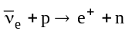 produced by a beam of 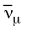 implying 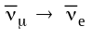 oscillations. The full process is described by the reactions
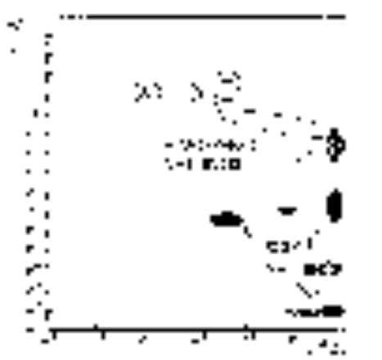
Figure 9: Published results of the LSND experiment at Los Alamos. Their result is not consistent with predictions from astrophysical searches. [5]

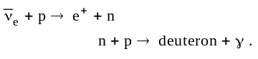

The detector triggers on a positron and the characteristic 2.2 MeV gamma ray in coincidence. The positron energy is recorded only after a 2.2 MeV photon is detected. From the incoming neutrino flux one expects only a few events due to background electron neutrinos, as modeled in a Monte Carlo event generator.
A 780 MeV proton beam incident on a water target produces mainly along with some 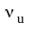 and 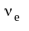 contamination. [20] The detector is located approximately 30 meters from the neutrino source. LSND computes a “likelihood ratio” R to characterize how often a 2.2 MeV photon might accidentally be detected at the same time as a positron. R is determined using laser calibration events and cosmic ray neutron events.
The result of their experiment over the past three years is depicted in Figure 8. LSND finds a significant event peak around 40 MeV. Consistency checks such as cutting the fiducial region in half do not affect the fraction of excess events observed.
The previous LSND results were first published in 1995, but the data suffered from low statistics and concentration of events in the front of the detector. Most of these indications pointed to a poor understanding of background sources. While the data shown in Figure 8 have not yet been published in a refereed journal, the paper indicates a much better set of event selection criteria has been found. In Figure 9, the best fits to the published LSND results are shown with the astrophysics predictions. The latest predictions (only slightly different) are shown in Figure 10.
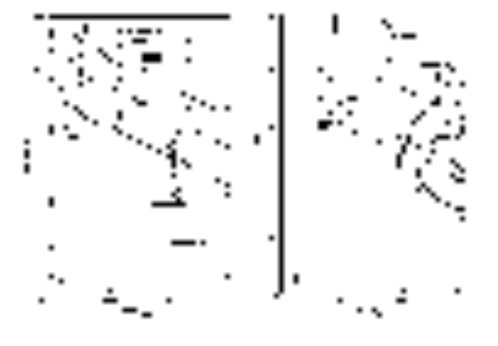
Figure 11: Excluded regions from selected neutrino oscillation searches for 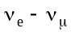 oscillations (left) and 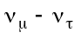 oscillations (right). The regions above and to the right of the lines are excluded at the 95% level. Some of LSND’s preferred parameters for oscillations lie in the excluded regions. [3]
In Figure 9, the preferred values from the best fit to the data are plotted as a point and the uncertainty in the parameters defines the oval regions about these points. The fit parameters generated with the Kamiokande data in an earlier section lie within the oval marked “Atmospheric Neutrinos.” For LSND, the data could be described by several different sets of Δm² and θ. Their ovals do not overlap those of the astrophysics experiments, with the exception of the fit with the largest uncertainty.
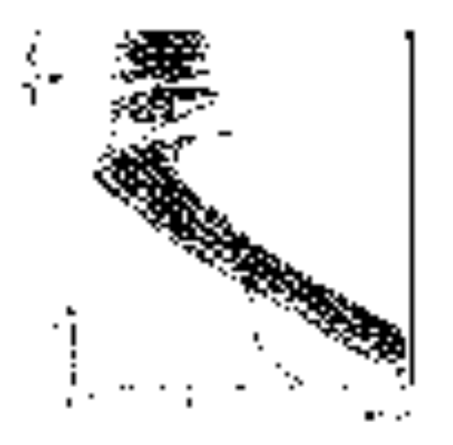
Figure 10: Fits to the most recent LSND results (unpublished). Shaded regions are 90% and 95% likelihood regions. To the right of the dashed line lies the region excluded by KARMEN at ISIS, the dotted line is E776 at BNL, and the dot-dash curve is Bugey (a reactor experiment).
Recall that the fit to the Kamiokande data indicated a Δm² value of 0.01 GeV. The lowest point in was 5 km/GeV and had no deviation; the deviation from the massless neutrino prediction began near 10 km/GeV. For LSND, the deviation (when converted to the same units) begins much sooner, around 0.75 km/GeV. The characteristic length of the neutrino oscillations begins 10 times sooner for LSND than has been observed by Kamiokande and other experiments. Other accelerator experiments have found no deviation from the massless neutrino prediction.
Experiments with a null result (no evidence for neutrino oscillations) define excluded regions of Δm² ⎯Sin² (2θ) parameter space. The curves for many selected neutrino oscillation experiments are plotted in Figure 11. A comparison to Figure 10 reveals that the most favored points of the LSND fit fall within some of the excluded regions. Several experiments had a 90% chance of detecting LSND’s claimed oscillations but did not.

Summary
While the details of the neutrino oscillation searches differ, the underlying physics is the same. A muon neutrino beam is created with a high-energy proton beam incident upon a target and a detector searches for the appearance of a neutrino of different flavor some distance away. The results are used to infer two parameters: the mixing angle θ, characterizing the amplitude of the probability of a transition, and the mass difference, Δm², characterizing the distance required for flavor oscillation.
Several experiments are searching for better limits in the 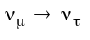 sector, while others are collecting more data in the 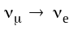 channel with lower energy thresholds than previous work or faster rates due to higher acceptance. The results of LSND have sparked intense interest in the μ-e channel because they are the only accelerator experiment to have found a signal. Accelerator experiments are not able to determine the absolute value of neutrino masses, only the mass differences.

Models for Existing Data
Working within the assumption that there are only three flavors of neutrino and excluding only LSND’s data (currently the most controversial result), we can assemble the data from all experiments to formulate certain constraints on neutrino masses and mixing angles. Gathering all data together narrows the search space, yielding the best chance to detect physics beyond the Standard Model. The other method used to derive limits assumes the existence of currently unknown neutrino flavors or excludes major portions of the worldwide data set from the calculation. Table 4 has been assembled [15] with the first method: only the three known flavors of neutrino exist, but they are linear combinations of massive eigenstates, making them subject to vacuum oscillations and the MSW effect. Also, the neutrino mass states are assumed to be hierarchical: m₁ << m₂ << m₃, similar to the quark mass structure. The masses and mixing angles calculated using other schemes yield slightly different results, but not significantly so. Not surprisingly, all theoretical models have a common theme: the masses and mixing angles of neutrinos lie just out of reach of the ability of current experiments to find them.

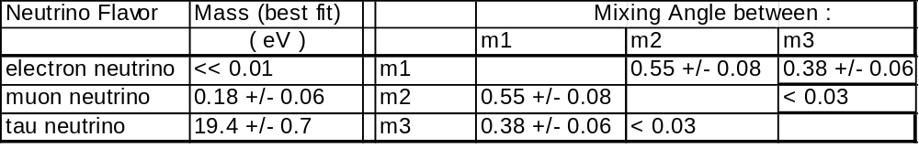

Table 4: Predicted masses and mixing angles θ_{ij} calculated from experimental data. The calculation requires input assumptions:
1 - neutrino masses are assumed to be hierarchical … m1 << m2 << m3
2 - negative m² values are excluded from the input data
These values should be considered to be an example of a set that satisfies most of the data. Other models will predict different masses and angles.

Searching for Neutrino Mass with the DZero Detector
DZero was designed to study high-mass states (such as the top quark and the W and Z bosons) and high-p_{t} phenomena. [21] The Tevatron is a proton-antiproton collider operating with a center of mass energy of 1800 GeV. At this energy the constituents of the proton and anitproton act as nearly-free particles. These constituents, called partons, share the momentum of the entire particle between them. It not possible to determine the exact fraction of the total momentum a particular parton has at the moment of collision, therefore the momentum of the products in the laboratory frame of reference is not necessarily the momentum in the center-of-mass frame of the collision. To extract information from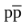 collisions, DZero considers only that fraction of the momentum that is transverse to the beam-pipe. The transverse momentum approaches the true momentum when the products emerge from the beam-pipe at a 90° angle.
To determine DZero’s ability to search for neutrino mass, we ignore the difference between momentum and transverse momentum; by assuming particles decay from rest in the center of the DZero detector, we make the physics calculation as simple as possible. The tau neutrino mass limit was set by a similar collider detector, so we briefly consider the method of ALEPH first: study the decay 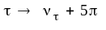.
Because the tau lepton decays into hadrons so quickly, DZero has a difficult time identifying tau events; the lack of a central magnetic field makes it impossible to resolve the closely spaced pion energy deposits from one another. The decay of the Z into the other two lepton flavors cannot determine neutrino masses because the muon escapes the detector before it decays and the electron does not decay at all. Studying the decay of Z into leptons will not allow DZero to determine neutrino masses.
Now consider the decay of the W, specifically, the decay 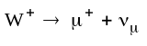. The W decays to one lepton and one neutrino 32.4% of the time. Of these W-to-lepton events there is an equal chance for each flavor, meaning that 10.8% of all W events result in a muon and a muon neutrino; the signature for this decay is a lone muon. We assume that the detector is perfect, always measuring energy correctly and with unlimited precision, we also assume the W decays from rest in the center of the calorimeter. From Eqn. 3 in the section on kinematics, the energy of the muon for the two body decay 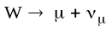 is

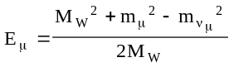.
Entering Particle Data Book values for the mass of the W (80.33 GeV), the mass of the muon (0.105 GeV), and assuming a zero mass for the neutrino, the expected muon energy is 40.1651 GeV. Recalculating with the neutrino mass set at the current upper limit (0.000160 GeV) we find the answer to be identical to the massless case to at least 10 figures. The large mass of the W in the numerator completely suppresses the effect of adding a non-zero neutrino mass to the equation. In fact, setting the muon mass to zero changes the expected energy only one ten-thousandth of a percent! The DZero detector is not sensitive to the mass of the muon in W decays, so it is certainly not sensitive to the mass of the muon neutrino. Because the masses in the electron sector are smaller, the sensitivity vanishes for electron neutrinos as well. If DZero could identify tau leptons with precision, the difference between m²=0 and m²=160keV is still ~4 keV, below the resolution capability of the calorimeter and more than 30 times smaller than the current uncertainty on the mass of the W. We must conclude that the W decay mode is not an effective measure of neutrino mass.
Even when simplifying the physics and assuming the detector is ideal, DZero in its current form cannot search for neutrino mass. It is impossible to search for massive tau neutrinos at DZero as has been done at ALEPH, because there is no sample of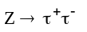 events. These events must be included in the data set, but without a central magnetic field they are indistinguishable from quark-quark dijet events. The mass of the W makes an analysis of the W two-body decay insensitive to small neutrino masses. The future upgrade of the detector includes plans for a central magnetic field, so the next incarnation of DZero will have a much greater ability to search for massive tau neutrinos.

Designing a Neutrino Oscillation Experiment
Given infinite resources, several experiments could be designed to gather neutrino data and definitively confirm neutrino oscillations. The exercise of designing an impractical experiment can be a valuable experience because it forces the architect to decide what information is lacking in the body of existing knowledge and how to gather the information in the most complete way. In this section, an experimental design is presented without the restrictions of practicality imposed. While fanciful and even comical, the advantages of the unlimited experiment will be incorporated into a more viable design, and the disadvantages will be addressed to prevent their inclusion.
Because the topic of discussion in this section is hypothetical and “free-wheeling,” a more informal tone has been adopted, if only for this section.

Idea 1: “Pie in the Sky”
Build a proton accelerator ring around the Earth. Once per day or so, the Earth will rotate into a favorable position. Make the beam of protons strike a very dense target, producing a beam of primarily muon neutrinos that leaves the Earth tangent to the surface. The newly formed neutrino beam travels outward into space where a neutrino detector (a Voyager-type spacecraft) is slowly drifting toward the edge of the solar system. The orbit should be designed to wrap around Neptune and return to the Earth.
While the plan is admittedly just a dream, it is not an impossible one. Fermilab sends a muon neutrino beam into space every time it “dumps” the proton beam. A neutrino detector would be in the vicinity of Pluto now, had Voyager II been filled with a finely segmented drift chamber similar to the one used by NOMAD.

This implausible idea has several advantages that make this brief presentation worthwhile:
- The extremely long baseline ensures adequate time for neutrinos to undergo oscillations.
- The distance travelled by the neutrinos slowly varies with time as the detector travels, yielding a new point in with every burst of neutrinos. This wide range in distances maximizes the detector’s sensitivity to vacuum oscillations.
- The detector searches for the MSW effect for several weeks each year because the neutrinos must pass through the sun to reach the detector.

Disadvantages:

- The spacecraft is subject to a large influx of cosmic rays.
- The extreme cold of space prevents the use of most conventional neutrino-sensitive media.
- The sensitivity of a neutrino detector precludes the use of standard atomic batteries (a tritium β source) to power the equipment aboard the vessel.
- The detector cannot be serviced in the event of break-down.

While whimsical, the main idea at the core of this discussion could be used to good effect. Perhaps the key to observing neutrino oscillations lies not in building bigger and better detectors, but in the more clever implementation of a simple detector.

Idea 2: The Submersible
The only practical places to build neutrino experiments are underground or underwater to avoid cosmic ray contamination. The goal of this section is to present a viable and innovative detector design under the constraint of limited funding. The design should maximize physics exploration while minimizing the need for new technology or heroic construction efforts. To keep the advantages of the previous scheme, we turn our attention now to the deep sea.
I propose sinking a mobile experiment in the ocean. This is not to suggest the use of seawater as a Cerenkov medium like the NESTOR experiment [22], but merely as shielding. Because the detector will be suspended in water, a rigid and expensive tank will not be required. Instead, Kevlar sheets could be stretched over a titanium framework to contain a scintillating liquid as is used by Borexino [23]. The experiment will not suffer from the tremendous pressure because the interior pressure will match the ambient pressure on the exterior. This design makes the experiment easy to move because the scintillating liquid can be pumped out before the framework is brought aboard a transport ship.
Trigger control can originate from a ship/platform on the ocean surface or from shore. The only equipment needed in the detector are the photomultipliers that line the interior of the soft tank and the fiber-optics needed to read them out.
At depths of more than two kilometers, the ocean is very calm and cool. [22] No sea life lives at these great depths, so the detector will rest unmolested.

Advantages:
- Mobility: The detector can be placed in the Pacific Ocean near California, on the order of three thousand kilometers from Fermilab, the source of a neutrino beam. After a number years of data-taking, the detector can be placed in Lake Michigan, on the order of 50 kilometers away. The Gulf of Mexico lies at an intermediate distance. When the Large Hadron Collider at CERN begins operation, the detector can be placed in the Mediterranean Sea close to NESTOR. A survey is required before moving the submersible to a new site, but the placement is more flexible than the requirement of an existing mine shaft or planning new construction.
- Low Energy Threshold: The liquid scintillator proposed by the Borexino collaboration has a threshold energy of 0.25 MeV. Like that used in radiochemical experiments, this medium is sensitive to solar pp neutrinos but the data is analyzed in real-time, allowing energy and direction measurements.
- Excellent Cosmic Ray Shielding: The NESTOR experiment will lie four kilometers beneath the ocean surface. This is twice the shielding material of underground experiments.
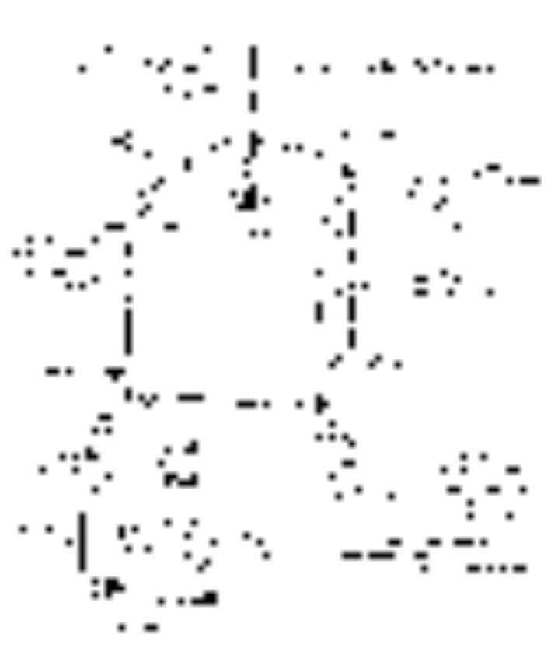
Figure 12: A sketch of the submersible neutrino experiment
A cube measuring 5 meters per side would yield a volume 66% larger than that of the LSND experiment. A cube measuring 7 meters per side would have a volume comparable to Borexino.
To the exterior of the tank must be attached the following equipment (Figure 12):
- simple valves to protect the detector from pressure changes
- corrosion resistant read-out electronics
- data cables, power feed, and main hoist line
- external photomultipliers to assist with beam location
- backup batteries, a signal beacon, and an Ultra Low Frequency (ULF)
communications antenna for limited remote control
in the event the cables snap
Power, data storage, and control can be provided from shore via an umbilical cable. Ideally the experiment could find a semi-permanent base near an oil drilling platform at sea to minimize the length of cables required. The NESTOR experiment proposes a seven mile cable system [22], sufficient for most sites.
Any particle collider can provide the muon neutrino beam. Proper placement of the experiment within the beam could be accomplished by mounting photomultipliers on the outside of the detector to look for the beam from its Cerenkov effect in the surrounding seawater. [22] The proposed MINOS experiment firing a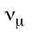 beam from Fermilab to Soudan, Minnesota, expects the beam to spread to ~ 200 meters by the time it reaches the detector 780 km away. [24] A similar beam spread would indicate a width of about 800 meters offshore in the Pacific with a corresponding drop in flux. These numbers describe the width of the “good part” of the beam, where the neutrino distribution is nearly uniform. The beam could be made tighter with existing technology, but the beam width is limited by the precision with which it can be aimed.

Summary
Using the brainstorming exercise of unlimited funding, a viable detector design has been formulated. The design incorporates the desirable qualities of mobility, low energy thresholds, and excellent cosmic ray shielding. The detector is more simple in design and therefore less expensive than most accelerator experiments in terms of capital outlay. The mobility makes the detector flexible enough to provide data in the most interesting sectors of 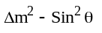 space without foreseeable end.

Review Summary
Three observations lead theorists to suppose that neutrinos may have non-zero mass: the solar neutrino problem, the atmospheric neutrino deficit, and the “missing mass” of the universe. Efforts are underway to better quantify the observed deviations of solar and atmospheric neutrinos from theoretical predictions, but current results are not yet precise enough to confirm neutrino oscillation formalisms. The two most widely accredited mechanisms for neutrino oscillations, the MSW effect and the vacuum oscillation formalism, were presented in full detail.
Experiments searching for kinematic consequences of neutrino mass have set the most stringent upper limits on the mass of the electron neutrino, the muon neutrino, and the tau neutrino. While most of the results have been consistent with zero mass, these experiments all find the square of the neutrino mass to be negative. The non-physical results of these experiments indicate the presence of a poorly understood systematic effect that makes the results suspect. The upper limit set for the electron neutrino mass is of the order of 1 eV but the limits on the muon and tau neutrino masses are far less constrained.
Neutrino oscillations may occur with a short characteristic length or a long characteristic length, depending upon the neutrino energy and the mass difference between flavors. Experiments with several different distance scales search for oscillations of muon neutrinos into each of the two other known flavors. Several experiments that were built to study astrophysical phenomena are now studying neutrinos produced by accelerators as well. The only experiment claiming to have detected a statistically significant signal, LSND, is still studying its systematics because the signal lies in a region of parameter space that has been excluded by several other experiments.
A proposal for a new type of neutrino experiment was presented. The unique design does not require the development of new technology to implement and the materials required for the construction of the detector are inexpensive. The design has the advantage of mobility, giving it the capability to search for neutrino oscillations at any distance scale from tens of miles to the diameter of the Earth. The detector can migrate to share a neutrino beam from an accelerator by positioning itself behind existing experiments. By selecting only materials found in published proposals for other detector designs, the submersible detector has been made viable in principle.
This review of neutrino physics is as comprehensive as possible, written to introduce all aspects of the topic in reasonable detail. The reader should now be adequately prepared to peruse most journal articles germane to this rapidly developing field.

References

[1] Bahcall, John N., “Neutrinos from the Sun: An Astronomical Puzzle,” Mercury, pp. 53-63, Vol. XIX, Number 2, March/April 1990.

[2] Winter, K., “Neutrino Properties and Interactions,” Invited talk presented at the 1995 International Symposium on Lepton-Photon Interactions, Beijing.

[3] Wolfenstein, L., Phys. Rev. D 17, 2369 (1978); S.P. Mikheyev and A. Yu. Smirnov, Yad. Fiz. 42, 1441 (1985), [Sov. J. Nucl. Phys. 42, 913 (1985)].

[4] Kaysar, Boris, “Lectures on the Physics of Massive Neutrinos,” Proceedings of the Fourth BCSPIN School in Physics, Puri, India. January, 1993.

[5] Zuber, K., “Neutrino Oscillations and Dark Matter,” Proceedings Aspects of Dark Matter in Astro- and Particle Physics (Dark 96), Heidelberg Sep. 1996, Germany.

[6] Hirata, et. Al, The Kamiokande-II Collaboration, “Observation of a Small Atmospheric Ratio in Kamiokande,” Phys. Lett. B 280, 146 (1992).

[7] Conforto, G., et. al., “A complete solution to neutrino mixing,” hep-ph/9606226, 4 Jun 1996.

[8] Ahluwalia, D. V., “Notes on the Kinematic Structure of the Three-Flavor Neutrino Oscillation Framework,” hep-ph/9612471 v2 27 Dec 1996.

[9] Kang, Kyungsik, Jihn E. Kim, Pyungwon Ko, “A simple modification of the maximal mixing scenario for three light neutrinos,” hep-ph/9503436, March, 1995. Submitted to Z. Phys. C.

[10] Renton, Peter, ElectroWeak Interactions, An Introduction to the Physics of Quarks and Leptons, Cambridge University Press, 1990.

[11] Morrison, Douglas R.O., “Review of Neutrino Masses,” CERN-PPE/95-47, 5 April, 1995. Lectures at Conf. on Current topics in Astrofundamental Physics, Erice, Italy, Sep 4-16, 1994. Published in School of Astrophysics 1994:93-117 (QB461:A7:1994).

[12] Valle, José W.F., “Schemes for Neutrino Mass and Mixing,” hep-ph/9410380 26 Oct 1994.

[13] Minakata, Hisakazu, “Three-Flavor Analysis of Neutrino Mixing with and without Mass Hierarchy,” hep-ph/9612259, 5 Dec 1996. Presented at Inauguration Conference of the Asia Pacific Center for Theoretical Physics (APCTP), Seoul, Korea, 4-10 Jun 1996 and at Institute for Nuclear Theory Summer Program on Nucleosynthesis in the Big Bang, Stars and Supernovae, Seattle, WA, 24 Jun - 30 Aug 1996.

[14] Belesev, A.I., et. al., “Results of the Troitsk experiment on the search for the electron antineutrino rest mass in tritium beta-decay,” Phys Lett. B350, (1995), 263-272, and Weinheimer, Ch., et. al., (Troitsk), “Improved limit on the electron-antineutrino rest mass from tritium β decay,” Phys. Lett. B300, 210, 1993. Also, V. M. Lobashev, in Proc. of Neutrino 96, ed. K. Enqvist K. Huitu and J. Maalampi ,, ( World Scientific , Singapore, 1996) p.0.

[15] Adelberger, et. Al., The N1 Working Group, “Kinematical Probes of Neutrino Mass,” NSF-PT-95-01 (Snowmass ’94). Talk given at Summer Study on High Energy Physics: Particle and Nuclear Astrophysics and Cosmology in the Next Millennium, Snowmass, CO, Jun 29 - Jun 14, 1994. Published in Snowmass Summer Study 1994:195-214 (QB461:D2:1995).

[16] Assamagan, K., et. al., “Measurement of the muon momentum in pion decay at rest using a surface muon beam,” Phys. Lett. B335, 231, 1994.

[17] Decamp, D., et al., The ALEPH Collaboration., Nucl. Instr. Meth. A 294 (1990) 121.

[18] D. Buskulic et al., ALEPH, “An upper limit for the τ neutrino mass from 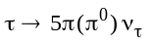decays,” Phys. Lett. B349, 585 (1995).

[19] Kim, C.W., “Neutrino Physics: Fundamentals of Neutrino Oscillations,” hep-ph/9607391, 22 Jul 1996.

[20] Athanassopoulos, C., et. al., “Evidence for 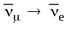 oscillations from the LSND Experiment at LAMPF,” nucl-ex/9605003, 9 May 1996.

[21] Abachi, S., The DZero Collaboration, Nuclear Instruments and Methods in Physics Research A 338, 185-253, 1994.

[22] Capone, A., “NESTOR: a neutrino Astroparticle Physics Laboratory for the Mediterranean, the physics perspective,” and Bottai, S., “Present Status of the NESTOR Project,” talks given at the ICRC '95 Conference.

[23] Baltz, A.J., and J. Weneser, “IMPLICATION OF GALLIUM RESULTS ON THE POSSIBILITY OF OBSERVING DAY - NIGHT MATTER OSCILLATIONS AT SNO, SUPERKAMIOKANDE AND BOREXINO,” Phys. Rev. D50 5971-5979, 1994.

[24] Ables, E., et al. The MINOS Collaboration. “P-875: A Long-baseline Neutrino Oscillation Experiment at Fermilab.” February 1995.

[25] Cherry, M.L., et al., “THE HOMESTAKE LARGE AREA SCINTILLATION DETECTOR AND COSMIC RAY TELESCOPE,” Proceedings, Solar neutrinos and neutrino astronomy, Lead, SD, 1984.

[26] Anselmann, P., et al., “First results from the ⁵¹Cr neutrino source experiment with the GALLEX detector,” Phys. Lett. B342, (1995) 440-450.

[27] Abdurashitov, J.N., et al., “Results from SAGE (The Russian-American Gallium solar neutrino Experiment),” Phys. Lett. B328 (1994) 234-248.

[28] Kajita, T., Kamiokande, “Recent Results from Kamiokande on Solar and Atmospheric Neutrinos,” presented at 26th International Conference on High Energy Physics (ICHEP 92), Dallas, TX, 6-12 Aug 1992.

[29] Bahcall, John N., and Eligio Lisi, “Tests of Electron Flavor Conservation with the Sudbury Neutrino Observatory,” Phys.Rev.D54:5417-5433,1996.

[30] Ayres, David S., SOUDAN-2, “INITIAL DATA FROM THE SOUDAN 2 EXPERIMENT,” Proceedings of the 25th International Conference on High Energy Physics, Singapore, 1990.

[31] Allison, W.W.M., “PROPOSAL FOR A LONG BASELINE NEUTRINO OSCILLATION EXPERIMENT FROM FERMILAB TO SOUDAN: UPDATE TO P822,”
FERMILAB-PROPOSAL-P-822-UPD, Mar 1994.

[32] Cline, David B., “STUDY OF RARE SIGNALS WITH THE ICARUS DETECTOR,” talk given at International Workshop on Future Prospects of Baryon Instability Search in p decay and
n ---> anti-n Oscillation Experiments, Oak Ridge, TN, 28-30 Mar 1996.

[33] Resvanis, L.K., et al., NESTOR Collaboration, “NESTOR: A NEUTRINO PARTICLE ASTROPHYSICS UNDERWATER LABORATORY FOR THE MEDITERRANEAN,”
Nucl. Phys. Proc. Suppl. 35 294-300, 1994.

[34] Gaisser, Thomas K., Francis Halzen, and Todor Stanev, “Particle Astrophysics with High Energy Neutrinos,” Phys. Rept. 258 173-236, 1995.

[35] Arik, E., et al., CHORUS Collaboration, “STATUS REPORT ON CHORUS EXPERIMENT AT CERN,” Nucl. Instrum. Methods A360 (1995) 254-257.

[36] 1996-7 Funding Request for Fermilab E803/COSMOS Short-Baseline Neutrino Oscillations to 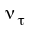, January 8, 1996.

[37] Tanimoto, Morimitsu, “STRUCTURES OF NEUTRINO FLAVOR MIXING MATRIX AND NEUTRINO OSCILLATIONS AT CHORUS AND NOMAD,” Phys. Rev. D53 6632-6637, 1996

[38] Ellis, John, “Outlook On Neutrino Physics,” invited talk, Neutrino 96, Helsinki, June 1996

[39] Arzarello, F. Ciralli, et al., “HELLAZ: a high rate solar neutrino detector with neutrino energy determination. CERN-LAA/94-19, 4/7/94.

Appendix A
Description of Selected Neutrino Experiments

Astrophysics Experiments

I. Counting Experiments
This class of experiment involves simple counting of numbers of neutrino events. These experiments are unable to determine the neutrino’s incident energy or direction because the event is detected weeks after the fact.

- The Homestake experiment
A shaft in the Homestake gold mine in Lead, South Dakota houses a tank filled with 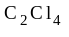 (perchloroethylene), a cleaning fluid. [25] The depth of the mine shields the experiment from background cosmic rays. Neutrinos freely pass through the ground, interacting with the fluid via
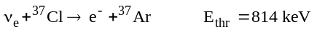.
The fluid is cycled through an extraction apparatus that pulls approximately 20 Ar atoms out per month. Approximately one Ar atom will decay radioactively in a month and the extraction technique is estimated to be 90% efficient, so the total number of Ar atoms generated by neutrino events per month is around 22.
While the experiment is unable to determine the angle or energy of incident neutrinos, it is the longest running neutrino experiment in the world, taking data for the last 30 years (counting since 1967). Its strength is that it is sensitive to very low energy (0.8 MeV) neutrinos, including solar Be neutrinos in addition to the Boron neutrinos.

- Similar Experiments:
GALLEX (near Rome, Italy) and SAGE (Baksan Valley, Caucasus)
Under the shielding of Italy's highest mountain outside the alps, the Gran Sasso d'Italia in the Abruzzo region 150 km east of Rome, the Gallium-based neutrino experiments GALLEX and SAGE, search for
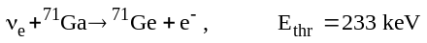.
GALLEX uses GaCL in solution [26], while SAGE uses metallic gallium. [27] Because gallium melts at ~ 86 °F, the metal is easily kept in liquid form and the produced germanium can be chemically extracted every few weeks.
These are two of the lowest energy-threshold experiments currently running or planned; they will be sensitive to solar pp neutrinos. GALLEX has taken data since 1986 and SAGE has been in operation since 1990. Both experiments have qualitatively confirmed results from Homestake and Kamiokande. These experiments, like Homestake, are unable to determine incident angle or energy of neutrinos and are insensitive to muon neutrinos.

II. Real-Time Experiments (Cerenkov and Ionization Experiments)

- The Kamiokande experiment
Located in the Kamioka mine in Japan, this detector consists of a cylindrical water tank holding 4500 tons of water. [28] The perimeter is surrounded with phototubes. An incident neutrino may strike an electon and transfer some of its momentum to it, knocking it free of the 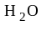 molecule with some of the neutrino’s momentum. The elastic reaction is
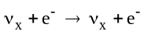.
The resulting particles are detected by their emitted Cerenkov radiation (and accompanying particle shower in the case of the electron). A charged particle emits Cerenkov radiation when its speed exceeds the speed of light in a refractive medium such as water. This velocity limit sets the energy detection threshold of water Cerenkov experiments at ~7.5 MeV.
The timing of the phototube signals determines the track’s position within the tank. The total charge accumulated by the phototubes determines the energy of the electron or muon, which is used to calculate the energy of the original neutrino. The products of muon neutrinos can be distinguished from electron neutrinos from the presence (electron) or absence (muon) of showering radiation in addition to the Cerenkov track. Collaborators believe their identification to be accurate to within 2%. [6]
Kamiokande’s successor sits only 200 m southwest of the original experiment. The cylindrical SuperKamiokande stands on one end, 42 m in height and 39 m in diameter. The event rate scales with volume, so Super-K expects approximately 22 times the counting rate of Kamiokande. (Note: To avoid contamination from non-neutrino events, the detectors only consider interactions that occur some distance away from the walls. While the Super-K is about 10 times larger than the original, the fiducial volume is 22 times larger.) Super-K should begin data-taking later in 1997.
There are plans in the works for a neutrino beam to travel from KEK (the Japanese center for high energy physics research) to the Kamioka site. SuperKamiokande will then have a data set free of astrophysical model-dependence. The expected sensitivity is Δm² > 10⁻⁴ and Sin² θ > 0.1.
Similar experiment: IMB
- Sudbury Neutrino Observatory (SNO, Creighton mine near Sudbury, Canada)
Rather than use ordinary water, SNO uses deuterium-water, or heavy water, as a medium. (A deuteron is a hydrogen atom with an extra neutron in the nucleus, just as tritium has two extra neutrons.) In addition to the elastic scattering observed by Kamiokande, SNO is also sensitive to the two reactions
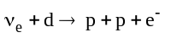
and
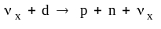,
which are expected to occur at a rate of 20-30 events per day for each process, compared to 2-3 events per day for the elastic process. [29] All processes have an energy threshold close to 5 MeV.
- Borexino
Very similar to both of the preceding Cerenkov experiments, Borexino will use florescent and wavelength-shifting chemicals instead of water as a detection medium. This will lower their expected energy threshold to 0.250 MeV. [23] They expect 20-60 events per day from solar ⁷Be neutrinos alone.
- Soudan II
This experiment lies ½ mile beneath Soudan, Minnesota. This detector is a tightly packed honeycomb array of drift tubes with steel as the absorbing medium, with dimensions of 5.4m high by 8m across by 15m long. [30] There is a possibility of sending a neutrino beam from Fermilab (730 km) to the detector. This accelerator-phase of the experiment will be dubbed MINOS, but it is still in the planning phase. MINOS will have a near-beam detector located at Fermilab in addition to the Soudan site. [31]
- ICARUS
This detector will use 600 tons of liquid Argon as an ionizing medium, searching for the reactions
(5 MeV threshold)
from any neutrino, and
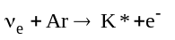.
They hope to add additional 600-ton modules in the future. [32]
- NESTOR
This experiment will use seawater as a Cerenkov medium. Large towers mounted with photomultipliers will be built on the floor of the Mediterranean sea, some 3800 meters below the surface. [33] The experiment can be easily expanded by building more towers. The proposal for this experiment was used to determine the viability of the Submersible outlined the design section of this review.
Similar Experiments: DUMOND (deep water), BAIKAL (lake), AMANDA (Antarctic ice) [34]

Accelerator Experiments
- CHORUS (Switzerland)
This experiment searches for the oscillations of muon neutrinos into tau neutrinos. They search for the creation of tau leptons via
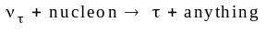
followed by
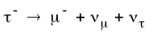.
Like all accelerator-based neutrino oscillation experiments, the neutrino beam is created by sending high-energy protons into a target, creating pions and kaons which decay into muons and muon neutrinos. A dense barrier stops the muons, leaving only the neutrinos. At CERN, the protons have 450 GeV of energy and the barrier is a 410 m thickness of iron and soil. [35]
The detector from front to back consists of
- a nuclear emulsion target backed by a scintillating fiber (sci-fi) tracker to detect tau leptons,
- a hexagonal magnet with sci-fi in front and behind to determine the momentum of charged particles,
- a fiber tracking region without magnetic field,
- an iron and sci-fi calorimeter measuring the energy and position and also stopping all particles but muons,
- and a muon spectrometer, consisting of streamer tubes and drift chambers interspaced with magnets.
The most important element of the detector is the nuclear emulsion target (many layers of special photographic film) designed to detect the short-lived tau. Even at very high energies, the tau travels only 100 micrometers before it decays. Chorus will take data for two years and then pause to develop the emulsion and reconstruct the tracks originating from tau leptons. A kink in the track through the emulsion will mark the decay of a tau. The remainder of the detector will be used to track the daughters of the tau to simplify their search through the emulsion for the parent particle’s position.
Similar experiment: COSMOS (Fermilab) starting 2001 and running for four years. [36]
- NOMAD
The sister experiment to CHORUS is housed in the same hall, uses the same beam, and searches for the same phenomenon with minor differences in technique. [37] NOMAD will search for tau decay within their innovative drift chamber. The chamber walls are composed of Aramid fiber honeycomb to decrease the chances of bremsstrahlung (literally, "braking radiation", due to interactions with nuclei) that would artificially kink particle tracks.

Appendix B
Comprehensive Examination for John Krane

Prepared by
Prof. G. Snow
Dept. of Physics and Astronomy
University of Nebraska
Approved by Krane Supervisory Committee in December, 1996.

NEUTRINO MASSES AND NEUTRINO OSCILLATIONS

THE QUESTION:
Your task is to review the status of what we know about neutrino masses and neutrino oscillations. Our current view of neutrinos is that there are 3 species of neutrinos associated with the charged leptons (electron, muon, tau), that they are likely to be massless, and that they do not "mix", i.e. that lepton number is absolutely conserved. However, a major area of experimental HEP research focuses on measuring neutrino masses and searching for neutrino oscillations.

You will want to address all of the following sub-questions and any others you feel make your paper a complete review.

NEUTRINO MASS:
Review the status of our knowledge of the masses of the 3 neutrinos; describe the decay processes studied in each case, the experiments and techniques which have led to the most stringent upper limits on the mass. What limits the sensitivity in each case, and why are the upper mass limits so different for the 3 species? At DZERO, we routinely produce millions of electron-, muon-, and tau-neutrinos. Imagine using the DZERO detector to measure neutrino mass -- how might we go about making a mass measurement for one or more of the species? Could DZERO make a neutrino mass measurement which is competitive with the experiments above? Why or why not (be quantitative)? What would be the astrophysical consequences of determining that one or more of the species has non-zero mass? How would this enter into the dark matter problem? A few years ago, an experiment claimed to measure a non-zero mass for one of the neutrinos -- what is the status of this claim?

NEUTRINO OSCILLATIONS:
Review the formalism used to describe transitions of one neutrino species into another; what would such a transition imply about neutrino mass? Review the present status of neutrino oscillation searches -- what techniques have been used in the searches, which experiments have produced the most stringent limits and how are these limits expressed quantitatively? Both at Fermilab and CERN, major short- and long-baseline oscillation programs are underway or proposed. What is the status of current efforts and proposals, what improved sensitivity to oscillations can we expect if the proposed efforts go forward, what is the timescale? If the world had to choose to carry out only one of the proposed long-baseline projects, which would be the better investment physics-wise and why? Given infinite DoE/NSF funds and an infinite number of graduate students, how would you design the world's best neutrino oscillation experiment?

Appendix C
The initial version of this review generated several comments and corrections from members of the examination committee. Typographical corrections and mathematical clarifications have been incorporated into the document where required, for instance, the original derivation of Eqn. 2 suffered from a conceptual blunder that has been corrected; I start with the full unitary mixing matrix rather than a simplified one. Some requests for additional information are answered in this section rather than the body of the work to preserve the conceptual flow of the original document. Included here are selected comments from committee members with responses.

1) Page 1, line 7: for pedagogical effect, define "small."

Less than or equal to 50%. I do not think an explicit calculation is necessary, Bahcall and other authors use the stock phrase as an indicator of the magnitude of difficulty faced by experimenters in the field of neutrino physics. This “light-year of lead” statement is a favorite of so many authors of popular articles that the introductory remarks would not be complete without it.

2) Page 5, bottom line: Which aspects should be reworked? What are some of the explanations other than MSW? Wasn't there a PRL recently on this?

The neutrinos detected by most terrestrial experiments originate from Boron decay, representing only 2% of the reactions within the sun. While this percentage can be computed accurately with the help of “reasonable” assumptions, this value may be quite inaccurate should the assumptions prove incorrect. These assumptions include the abundance of elements at the time of formation of the sun and the nature of the Be→B reaction. This reaction is poorly measured (cross section results vary by as much as 100%) and has only been measured at energies higher than that within the sun (117 keV compared to 1-20 keV in the sun). There are uncertainties involved with the extrapolation to solar energies and uncertainties in the effects of plasma screening. [11] The solar opacity affects the luminosity and therefore influences the estimates of reaction chain ratios. [1] For these reasons, many authors complain that solar neutrino theorists habitually underestimate the uncertainties in their predictions.

3) Page 10 middle. I am not sure that it follows that if cap omega is less than 1 that the standard inflation scenario is invalid.

I think you mean “…if the density of the universe were greater than 1…” The standard inflation scenario suggests that Ω is no larger than unity. It is common practice (in the articles I have referenced) to use Ω=1 as a limiting case.

4) Page 12, top: Why does low velocity preclude detection? Neutrons are detected this way all the time.

It does not preclude the detection of the presence of a particle, only the knowledge of its velocity. For Troitsk, the momentum resolution for electrons was of the order of 3-4 eV. For tritium decay, the maximum recoil momentum of the Helium atom is of the same order. Thus, the momentum of the most massive product could not be measured accurately even if the same measurement technique applied for Helium as for electrons (it does not). The offending sentence has been modified for clarity on this point.

5) Page 12. What is the standard name for fig.6? I wouldn't call -39 (+/-) 34 "significantly negative!" Last sentence of next-to-last paragraph: very infrared?.

Figure 6 is a “Linearized Beta Spectrum”. Troitsk has subtracted their estimated background from the measured spectrum and taken the cube root. To first order, this should make the spectrum a straight line, second-order effects include any excitations of the HeT⁺ ion.
While the Troitsk result is nearly consistent with zero neutrino mass, a Los Alamos experiment found -147±68±41 eV (in 1991) and Lawrence Livermore Laboratories found -130±20±15 eV.

The vibrational-rotational spectrum of the HeT⁺ ion lies in the IR region, however, excited electrons should produce photons with wavelengths less than 100 nm—very ultra-violet (but I did correct the spelling).

6) Page 13, Pion section: The author seems taken aback that there might be experiments without names.

Indeed, in the field of high-energy physics, a name for the detector and collaboration is almost mandatory. With more than three names on the author list, a reference will only contain the first name and “et al.” There is much more recognition (scientific and political) in a collaboration name. If not for detector and collaboration names, one might find people changing their names to something like “John AAA-Readme”.

7) Page 18, middle: three flavors can be assumed from SLAC results.

I quote here the recent LEP result (Warsaw ’96) which indicates 2.989±0.012 Standard Model neutrinos (weakly interacting neutrinos), however, this result does not exclude the existence of postulated super-symmetric partners to the neutrinos.

A new family of right-handed neutrinos would not couple to the W or Z boson and therefore would not experience the weak force. Searches for the super-symmetric partner to the W (often denoted W_{R}) place an upper limit on the mass of these “sterile” neutrinos at several hundred GeV; the DZero experiment has set the most stringent upper limit on the mass of a sterile neutrino. Other than a brief mention in the section on double-beta decay (and now in the cosmology section), discussion of super-symmetric partners to neutrinos is beyond the scope of this work.

8) I think idea 2 won't work with thin-glass-envelope PMTs. One would have to have thick mu-metal-shell specials made.

The NESTOR collaboration proposes to use a standard PMT protected with a thick glass spherical housing. Both the PMTs and the housings are off-the-shelf equipment; oceanographers have used similar designs for the past 50 years. Titanium spheres will protect the required front-end electronics. For a full discussion, see reference [22], by S. Bottai.

9) Page 12, perhaps some introductory material on four vectors should precede the final equation or a reference.

This formula (my Eqn. 3) is in the Review of Particle Properties published by Physical Review D (“the PRD manual”). It is also a typical problem in particle physics texts to derive Eqn. 3; Griffiths, the textbook used at UNL, is no exception.

10) Page 12, the tritium beta decay experimental setup should be explained, otherwise the reader has no way to evaluate systematic effects.

Their experiment is really complicated and I did not want to get into it (this is to say, authors of journal articles complain that it is complicated). I’ll beg out of this and refer you to reference [14].

11) Page 14, Fourth paragraph. What IS the theoretical expectation for the tau neutrino mass - from where does it come?

The statement merely indicates that 23.8 MeV is not much of a limit by comparison to the electron and muon sectors. The sentence has been changed to reflect this. Fixed target experiments such as CHORUS and COSMOS should be able to set more stringent limits once their results become available.

12) Page 16, why would LSND expect to find a 40 MeV peak for positron energy if the neutrino had mass. Perhaps some kinematics are required here?

The muon anti-neutrinos produced from pions at rest have a calculated energy spectrum with a maximum energy of 52.8 MeV. The shape of the spectrum is very similar to the curve of the beta decay spectrum of Figure 6. At the same time, the detector has an energy threshold, below which a progressively smaller percentage of signal events is detected. The solid and dashed curves in Figure 8a are the result of both effects: a detector efficiency that increases toward unity with increasing positron energy and a positron energy spectrum that decreases to zero near 53 MeV in correspondence to the spectrum of 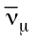 that produced it (via the conceptual chain 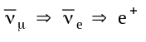). In Figure 8b, the effect is exacerbated with the likelihood cut that has an effect similar to the detector efficiency. Once last complication: there is background noise due to

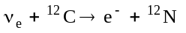.

Electrons produced by the background have an energy < 36 MeV. The sum of these effects explains the shape of the dashed curve (the background curve).

Assuming the points are the result of neutrino oscillations with several possibilities for Δm² and θ, the information in the text can be used to check LSND’s calculation. Given that there is an apparent peak near 40 MeV and the distance travelled by the neutrinos is ~30 meters, I use Eqn 2 to find a value of Δm² that will make the square of the sine a maximum. That is:

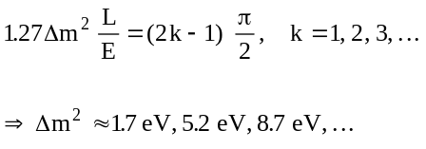

The Δm² results of this “Mickey Mouse” calculation lie close to or within the acceptable regions from LSND’s more rigorous calculations (Figure 10). For sin² θ, you need to know the % of flux that you have accumulated.

13) Page 19, This is entirely optional: given the expected Run II tracking resolution can D0 contribute to the tau mass limit in Run II?

ALEPH has a better energy resolution in their EM calorimeter than does DZERO, most likely because the e⁻e⁺ interaction has no underlying event to deposit extraneous energy in the detector. This energy resolution disadvantage at DZERO will not play a large role because the EM cal will be used to distinguish π±s, π⁰s and photons, the bulk of the analysis will rely on the central tracking system for momentum measurement. DZero’s central magnetic field will be 33.3% stronger than ALEPH’s and should provide a comparable or better momentum resolution as a result. The one difference between the experiments is the initial p_{t} of the intermediate Z boson at a hadron collider. Because the colliding partons may have some non-zero transverse momentum, the subsequent particles will have a small transverse momentum imbalance that will result in a more difficult measurement. DZERO will provide a stronger limit than ALEPH if we obtain a “clean” event sample and can measure the initial p_{t} well enough that the momentum resolution does not suffer. (By clean, I mean single interactions.)

ALEPH reports their mass (momentum) resolution for 5π events was 15 MeV (350 MeV).

14) Page 22 - just for fun - how much would John's Submersible cost? Shall we call it UNO Underwater Neutrino Observatory?

This question is left as an exercise to the reader. I love the name “UNO”!

15) Page 27 - I seem to recall that the Homestake experiment saw oscillations of the neutrino count with time anti-correlated with sun spots(?) Are these deemed significant?

The Homestake experiment shut down for 18 months in 1984-1986. Previous to the shut down, the counting rate fluctuated with the inverse of the sunspot cycle by seven standard deviations. After the shutdown, the rate has been stable and independent of sunspot cycle. Kamiokande has been in operation since 1987 and has never seen a variation corresponding to sunspots. It could be that something unusual happened after 1987, but it is more likely that Homestake had difficulty with their initial setup. See reference [11] for additional discussion.

- You state on page 10 that 30 eV is a hard upper limit. While I believe this upper limit, it is not hard. For example, in the case of neutrino decay, it is completely relaxed. Since all that is needed for neutrinos to decay is lepton number violation, and since neutrino oscillations need lepton number violation as well, neutrino decay is not hard to imagine. Diagrams for neutrino decay tend to put the lifetimes as long, but this is extremely model dependent.

I neglected consideration of unstable neutrinos. Big Bang neucleosynthesis limits metastable neutrino masses to lie outside an intermediate range. A metastable tau neutrino would have mass

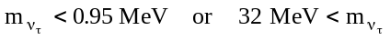

I am not convinced the mass is completely unconstrained in the unstable case. [38] In any event, I tried to make it clear that if you assume only standard model neutrinos with the exception that they have mass, you get the limit of 30 eV for the total mass of the three.

17) I would disagree with your assertion on page 9 about L/E. It is most useful for experiments to report what they measure. In this case it is the mu/e ratio, visible energy and zenith angle. They measure neither L nor E-nu. At low energy, where all of the contained events are, the zenith angle distribution is barely distorted by big L/E effects. With an exponentially falling Energy spectrum, the energy distribution provides a poor lever arm for L/E physics. I believe it is important to keep in mind the L/E_nu aspect of the physics, but not in the manner you suggest.

This point is well taken. Because the scattered electrons are very relativistic, there is a nearly exact correlation between the angle of incidence and the distance an atmospherically generated neutrino has travelled, however, this does not exclude cosmic neutrinos from the data sample. Also, the difference between the energy of the scattered electron and the incident neutrino is more randomized than I first thought.

When an electron from is “kicked out” of an atom, its kinetic energy is decreased by the energy required to escape from the atomic potential. For the complex atoms, this potential energy subtraction can vary greatly depending on the orbital from which the electron originates.

(A new experiment designed to measure E_{υ} to within 5% will use He gas as the ionization medium. The simple atomic potential of helium does not unduly complicate the eυ_{e} cross section (as do nuclear wave-function overlap integrals [38] ), so the neutrino energy should be calculable with electro-weak theory. The low (100 keV) energy threshold will allow HELLAZ to collect and distinguish neutrinos originating from the beryllium, boron, pp, and pep reactions.)

Nonetheless, it would be useful if experiments presented their data in terms of L and E (or theta and E), perhaps as ordered pairs or in a three-dimensional plot. The effects of atomic potentials in elastic collisions can be simulated and useful information can be extracted. The mini-analysis presented on page 9 was not intended to model every effect, only the “first-order” effect. As it stands, the mini-analysis result lies within the published result region.

