Table of Contents

Executive Summary ii
Towards A Methodology for the Characterization of Fire Resistive Materials with Respect to Thermal Performance Models 1
A methodology for characterizing fire resistive materials (FRMs) with respect to thermal performance models is presented. Properties that must be assessed include thermal conductivity, heat capacity, density, and enthalpies of reactions and phase changes. Experimental and computational techniques for quantifying each of these properties are recommended.

Microstructure and Materials Science of Fire Resistive Materials 13
The application of x-ray microtomography to characterizing the three-dimensional microstructure of FRMs is presented. The 3-D microstructures are analyzed to determine the overall "coarse" porosity and the size of each individual pore. This information, along with the microstructure image, can be used to compute estimates of the thermal conductivity of these composite materials as a function of temperature.

A Slug Calorimeter for Evaluating the Thermal Performance of Fire Resistive Materials 22
The design, development, and evaluation of a simple slug calorimeter for evaluating the high temperature thermal conductivity of fire resistive materials are presented. The presented test method provides effective thermal conductivities in the temperature range from 30 ºC to about 700 ºC, and through the use of multiple heating/cooling cycles also provides critical information on the influences of reactions and the convective transport of reaction gases on the measured effective thermal conductivity.

Critical and Subcritical Adhesion Measurements of a Model Epoxy Coating Exposed to Moisture Using the Shaft-Loaded Blister Test 36
A novel test method for adhesive coatings is presented. The shaft-loaded blister test (SLBT) employs a fracture mechanics-based approach, rather than a strength-based approach (pull-off and lap shear), to characterize the adhesion of materials. A fracture mechanics-based approach is advantageous because it explores adhesive failure mechanisms observed in the actual application of the adhesive as well as providing engineering parameters for the design of adhesive joints and coatings.

Influence of Experimental Set-up and Plastic Deformation on the Shaft-loaded Blister Test 51
The viability of using the SLBT as a test method for measuring the adhesion and mechanical properties of thin films and coatings is explored. Evidence is presented that the SLBT is relatively insensitive to the effects of plastic deformation that often affect conventional adhesion test methods such as the peel test.

Comparison of Subcritical Adhesion Test Methods: The Shaft-loaded Blister Test vs. the Wedge Test 70
This work is part of the ongoing effort to develop the shaft-loaded blister test into an adhesion test method that engineers and scientists can use for the design of adhesive joints and coatings. Here, we compare the results from the SLBT with the more conventional double cantilever beam wedge test.

Appendix A. Project Listing for BFRL Research and Development for the Safety of Threatened Buildings Program 77
Executive Summary

As part of its Research and Development for the Safety of Threatened Buildings Program (see Appendix A), the Building and Fire Research Laboratory (BFRL) at the National Institute of Standards and Technology (NIST) has initiated a research project on fire resistive materials (FRMs) for structural steel. This report summarizes the research performed in this program during 2004. The ongoing WTC investigation has highlighted the criticality of the performance of FRMs during a fire or multi-hazard exposure. Both the adhesion and the thermal performance of the FRMs are paramount for successfully protecting the steel from failure due to loss of its mechanical properties when its temperature rises beyond some critical level (around 500 ºC). As with any material, it is the underlying microstructure of the FRM that must be engineered to control the thermal and adhesion properties of the final product. With these considerations in mind, initial BFRL/NIST research on these materials has focused on a three prong approach, characterizing the microstructure, adhesion, and thermal properties of these materials. As is illustrated by the papers included in this report, both computational and experimental methodologies are under development. The ultimate goal is to provide the industry with the measurement and computational tools to make better decisions during their materials’ development and optimization processes, and ultimately to produce better, safer, and more reliable fire resistive materials.

On July 14, 2005, a meeting with industry representatives will be held at NIST to explore the possibility of creating a NIST/industry consortium on Fire Resistive Materials to further advance the goals of this research program. Interested parties may contact any of the three project investigators: Dale Bentz (dale.bentz@nist.gov), Emmett O’Brien (emmett.obrien@nist.gov), or Christopher White (christopher.white@nist.gov).

Submitted to Fire and Materials (2004)

Towards A Methodology for the Characterization of Fire Resistive Materials with Respect to Thermal Performance Models

Dale P. Bentz, Kuldeep R. Prasad, Jiann C. Yang
Building and Fire Research Laboratory
National Institute of Standards and Technology
Gaithersburg, MD 20899-8615
E-mail: dale.bentz@nist.gov
Phone : (301) 975-5865
Fax : (301) 990-6891

Abstract

A methodology is proposed for the characterization of fire resistive materials with respect to thermal performance models. Typically in these models, materials are characterized by their densities, heat capacities, thermal conductivities, and any enthalpies (of reaction or phase changes). For true performance modeling, these thermophysical properties need to be determined as a function of temperature for a wide temperature range from room temperature to over 1000 ºC. Here, a combined experimental/theoretical/modeling approach is proposed for providing these critical input parameters. Particularly, the relationship between the three-dimensional microstructure of the fire resistive materials and their thermal conductivities is highlighted.

Introduction

As progress is made in the integration of structural and fire performance models for structural steel, one key component is a proper and accurate characterization of the thermophysical properties of the fire resistive materials (FRM). To predict the surface temperatures of the steel and its subsequent mechanical performance, an understanding of the energy transfer from the fire to the steel through the FRM is paramount. The four major thermophysical properties needed to model the thermal performance of the FRMs are: density, heat capacity, thermal conductivity, and enthalpy (of reactions and phase changes). Furthermore, these properties are needed as a function of temperature, from room temperature to temperatures greater than 1000 ºC. In this paper, various approaches for obtaining these data are reviewed and critiqued. It appears that a combination of experimental measurements and theoretical/modeling computations will provide the most robust and accurate characterization for these materials. While the mechanical integrity and adhesion properties of the FRMs as a function of temperature are also critical to successful performance during a fire exposure, they will not be considered in this initial study.

Materials

Representative samples of four spray-applied FRMs were obtained from two of the largest manufacturers in the industry. Two of the materials are mainly composed of mineral fibers with a portland cement-based binder. The other two are gypsum-based with either vermiculite or expanded polystyrene beads as lightweight extenders. In the sections that follow, the materials will be identified only by their binder components, portland cement and gypsum, respectively. Two of the materials (one portland cement-based and one gypsum-based) are currently available in the U.S. marketplace, while the other two were of interest for historical reasons and are still in use in various existing structures. In the latter case, the materials were supplied by the manufacturers in a condition that matched the historical materials as closely as possible. Samples of both of the portland cement-based and one of the gypsum-based materials were sent to a commercial testing laboratory for evaluation of thermal conductivity, heat capacity, and density (via mass and thermal expansion measurements).¹ In addition, the materials were characterized by thermogravimetric, dimensional, differential scanning calorimetry, and optical microscopy analysis in the NIST labs.

Properties
Density:

The two contributions to the density of any material are its mass and its volume. FRMs are complex in that both of these contributions are changing during a fire exposure. As exemplified in Figures 1 and 2, most FRMs will lose mass in a monotonic fashion during a high temperature or fire exposure, due to some combination of dehydration, decarbonation, and decomposition of organic compounds. Their volume, however, may either increase or decrease. An increase in volume may be observed as the solid network supporting the FRM expands with increasing temperature or more dramatically when an intumescent coating foams during thermal degradation. A decrease in volume may be observed as shrinkage accompanies the mass loss from this solid network.

Figure 1: Example thermogravimetric results for a gypsum-based spray-applied FRM with a nominal heating rate of 5 ºC/min. Results are for two nominally identical ≈50 mg replicates. Maximum observed coefficient of variation (COV) for mass loss between the two replicate samples is 0.9 %.
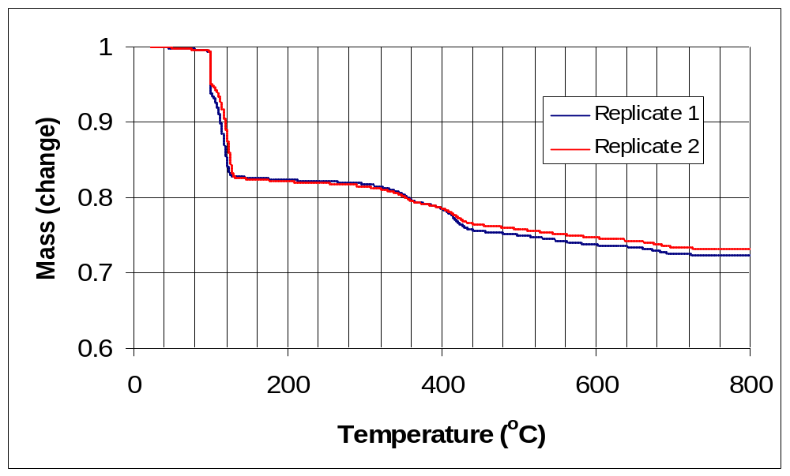

Mass loss can be quantified using thermogravimetric analysis (TGA), as described in ASTM E1131.² Of course, the results will vary with the programmed heating rate, sample size, and sample environment. As shown in Figure 1, spray-applied FRMs may lose as much as 25 % of their initial mass during exposure to 800 ºC. This mass loss also provides critical input for calculating the enthalpies of reaction for the in-place FRM. Once a set of reactions is hypothesized, the standard heats of reactions may be calculated and normalized by the measured mass loss to calculate the enthalpy change for the in-place material, as will be demonstrated later in this paper.

Volume changes (thermal expansion) can be measured using a dilatometer (ASTM E228) or interferometry (ASTM E289).² High temperature measurements (e.g., > 600 ºC) are often complicated by the large dimensional changes that may be experienced in FRMs, along with their generally fragile nature. In addition, spray-applied materials are inherently anisotropic and may thus exhibit different coefficients of thermal expansion in the in-plane and through-thickness dimensions.

Typically, the density at any given temperature is calculated as the ratio of the measured mass at that temperature to the measured volume at that temperature.

Figure 2: Example thermogravimetric results for a portland cement-based spray-applied FRM with a heating rate of 5 ºC/min. Results are given for two nominally identical ≈50 mg replicates. Maximum observed COV for mass loss between the two replicate samples is 0.4 %.
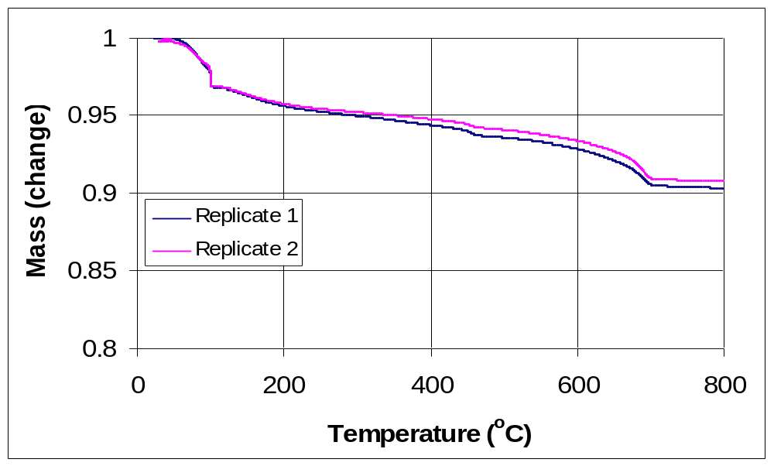

Heat Capacity:

Two common approaches to estimating heat capacity are to 1) calculate C_{p} from a measurement of thermal diffusivity and knowledge of the density and thermal conductivity of the FRM, or 2) measure C_{p} directly using a differential scanning calorimeter (DSC). The former is often complicated by the dynamic nature of FRMs, as they typically lose significant mass during the measurement time. An exciting recent development for the latter method is the availability of commercial simultaneous thermal analysis (STA) units. These units permit the simultaneous monitoring of heat flow and mass during exposure to a (high) temperature regime. With conventional DSC, only the heat flow is measured and to obtain the specific heat per unit mass of material that is the required input for thermal performance models, the results need to be adjusted by mass measurements (TGA) made on a companion sample. The advantages of making both measurements simultaneously on the same material specimen are obvious. In addition, newer commercial STA units may allow for larger sample volumes/masses (on the order of 1 g as opposed to the 50 mg to 100 mg typical of most DSCs). This is especially important for typical spray-applied FRMs that may exhibit a microstructural heterogeneity on the scale of millimeters.
For FRMs whose mass composition is exactly known, an alternative approach is to calculate the FRM heat capacity as a mass-weighted average of the heat capacities of the component materials. Of course, this requires that C_{p} data as a function of temperature are available for each component.

To obtain quantitative C_{p} data (via ASTM E1269 for example²), the typical procedure is to use a sapphire or other reference specimen to obtain a correction factor (graciously named the “calorimetric sensitivity” in the ASTM E1269 standard) under the same operating conditions as those used for the test specimen. Due to typical mass mismatch between the reference and sample pans, further corrections may be needed based on the known tabulated heat capacities of aluminum or gold (pans) as a function of temperature. A typical set of DSC curves for a spray-applied FRM are provided in Figure 3. The presence of several endothermic peaks is clearly indicated. The binder component of this particular FRM is portland cement-based and the first two peaks (around 100 ºC) correspond to the loss of bulk water and (loosely) bound water from gel-like hydration products respectively, the third peak (near 400 ºC) to the loss of chemically bound water from calcium hydroxide, and the fourth peak (near 650 ºC) most likely to the loss of carbon dioxide from carbonated reaction products. This material exhibited about a 10 % mass loss during exposure up to 700 ºC. By integrating the area under these peaks, the corresponding enthalpies of reaction could be estimated. However, with the small sample size employed in this experiment (< 10 mg), a quantitative interpretation is hindered by the previously mentioned heterogeneity of the material, e.g., most likely a representative volume was not sampled in this specific DSC measurement.

Enthalpies of Reaction:

If the chemical composition of the FRM is known, the potential exists to calculate the enthalpies of reaction from heats of formation and heat capacity data.^{3,4} The standard procedure is to “cool” the reactants down from the reaction temperature to a reference state (temperature) of 25 ºC, compute the heat of reaction at 25 ºC, and then heat the products back up to the reaction temperature.⁴ Here, we will illustrate this simple procedure for a gypsum-based FRM. Gypsum, which contains two molecules of water for each molecule of calcium sulfate, undergoes two dehydration reactions when exposed to elevated temperatures, first converting to calcium sulfate hemihydrate and then to the anhydrite form of calcium sulfate. The heat capacities and heats of formation (H_{f}) of the relevant compounds are provided in Table 1.^{3,4} Care must be taken to consider water in its gas phase form as the reaction temperatures being considered are always above 100 ºC. Using these properties and the known dehydration reaction stoichiometries (e.g.,
Figure 3: Example DSC results (original and mass corrected) for a portland cement-based spray-applied FRM using gold pans and a sapphire reference.
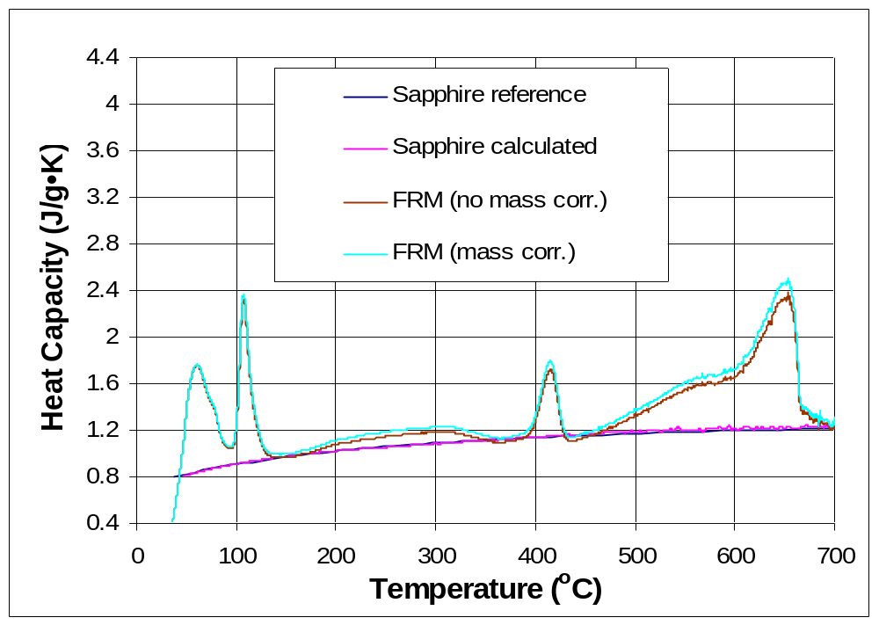

CaSO₄-2H₂O → CaSO₄-0.5H₂O + 1.5 H₂O and CaSO₄-0.5H₂O → CaSO₄ + 0.5 H₂O), heats of reaction of 3.01 kJ/g water lost at 150 ºC and 2.35 kJ/g water lost at 250 ºC are calculated for the dehydrations to hemihydrate and anhydrite, respectively. These values are in reasonable agreement with those recently summarized for gypsum plasterboard by Thomas.⁵ These values could then be multiplied by the corresponding measured mass loss in these temperature ranges (from Figure 1 for example) to obtain the enthalpy changes due to reactions for a particular FRM during fire exposure. Similar calculations can be employed for portland cement-based and intumescent FRMs, as long as their specific decomposition reactions and corresponding thermophysical properties are known.^{6,7} It is worth noting that not all reactions in commercially available FRMs are endothermic in nature, as organic components may provide significant exotherms, further supplementing the energy being provided by a fire.

Table I. Thermophysical Properties for Gypsum-based Compounds at 25 oC.3,4
Compound | Molar mass (g/mol) | C_{p} (J/mol• ºC) | H_{f} (kJ/mol)
Gypsum (CaSO₄-2H₂O) | 172.17 | 186.15 | -2024.1
Hemihydrate  (CaSO₄-0.5H₂O) | 145.15 | 119.5 | -1577.9
Anhydrite (CaSO₄) | 136.14 | 99.73 | -1435.1
H₂O (gas) | 18.02 | 33.62 | -242.01

Thermal Conductivity:

A wide variety of experimental techniques exist for measuring the thermal conductivity of materials at elevated temperatures: high temperature guarded hot plate (ASTM C177), heat flow meter apparatus (ASTM C518), laser flash diffusivity methods (ASTM E1461), and transient line/hot wire (ASTM C1113) and plane source methods.^{2,8-10} Similar to the discussion presented for concrete by Flynn,⁸ these measurements are always complicated by the dynamic nature of the FRM which is undergoing degradation even as its thermal conductivity is being measured.

An alternative to measuring the thermal conductivities of FRMs at high temperatures is to measure the value at room temperature (or perhaps up to 100 ºC) and “predict” the higher temperature values based on some theory for the conductivity of composite (porous) materials. Example theories that are closer to reality than the simplest parallel and series models include those of Russell,¹¹ Frey,¹² and Bruggeman.¹³ For example, the theory of Russell estimates the thermal conductivity of the porous material, k, as¹¹:
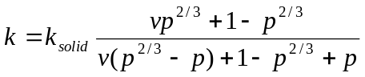 (1)
where v = k_{gas}/k_{solid},
k_{solid}= thermal conductivity of solid material,
p = porosity = (ρ_{max}-ρ_{matl})/ρ_{max},
ρ_{max} = density of solid material in the porous system,
ρ_{matl} = density of the porous material, and
k_{gas} = thermal conductivity of gas = k_{cond} + k_{rad}
For a spherical pore of radius r, the radiation contribution to the overall thermal conductivity of the pore is¹⁴:
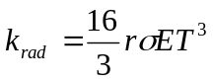 (2)
with σ = Stefan-Boltzmann constant (5.669x10⁻⁸ W/m²•K⁴),
E = emissivity of solid material (1.0 for black bodies), and
T = absolute temperature (K).
Knowing the densities of the FRM and the base solid components (by grinding to a powder and measuring in an alcohol solution, for instance), one can calculate the porosity of the FRM. This, along with estimates of the solid’s thermal conductivity and the material’s typical pore radius, and the tabulated thermal conductivity of air as a function of temperature,^{3,15} permits the estimation of the thermal conductivity of the FRM at elevated temperatures. As shown in Figures 4 and 5, application of this theory to both portland cement-based and gypsum-based spray-applied FRMs yields results in good agreement with existing measurements. While the measured values of ρ_{max} and ρ_{matl} were used in the calculations, in each case, the pore radius was a floating parameter that was adjusted to give a reasonable fit to the experimental data. But, in each case, the adjusted value for the pore radius is in agreement with visual optical microscopy observations of the characteristic pore sizes in these materials (Figures 6 to 8). These figures illustrate the potential of applying this approach in lieu of or to minimize the number of complicated and costly high temperature measurements for these materials. The approach also points out the advantage of incorporating smaller pores into the FRM structure, as the insulating performance of materials with larger ones will suffer significantly due to radiation effects at higher temperatures.

Figure 4: Measured thermal conductivities¹ and predictions based on theory of Russell/Loeb^{11,14} for two similar portland cement-based spray-applied FRMs.
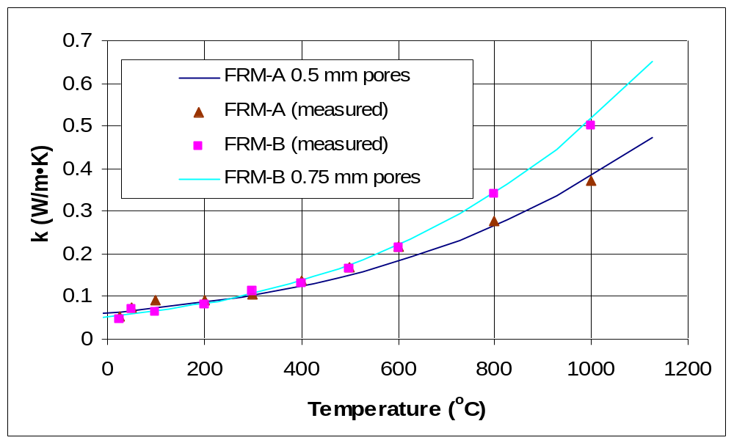

Figure 5: Measured thermal conductivities¹ and predictions based on theory of Russell/Loeb^{11,14} for a gypsum-based spray-applied FRM.
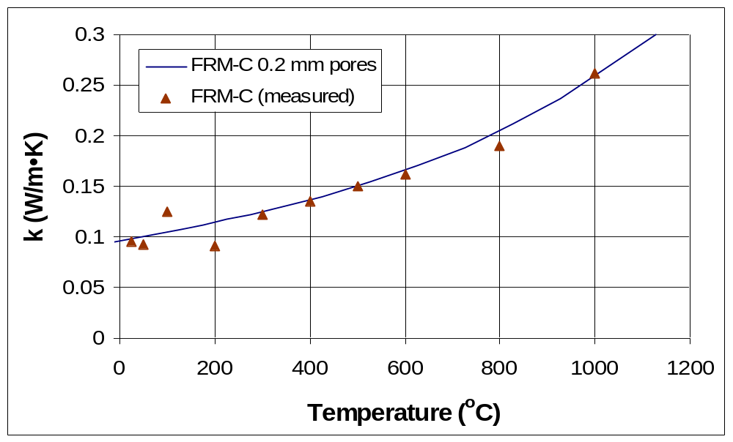

Figure 6: Optical micrograph for portland cement-based spray-applied FRM-A. Typical pore diameter as indicated by the labeled scale bars in the middle of the two images is on the order of 1.0 mm corresponding to a pore radius of 0.5 mm. The original image is on the left and a contrast-enhanced version that better highlights the porosity is shown on the right.
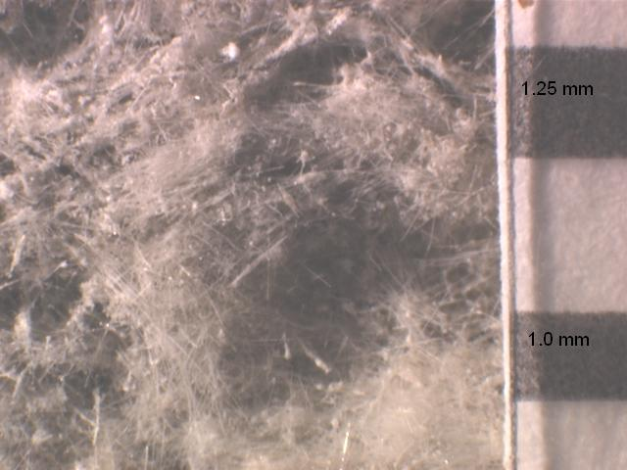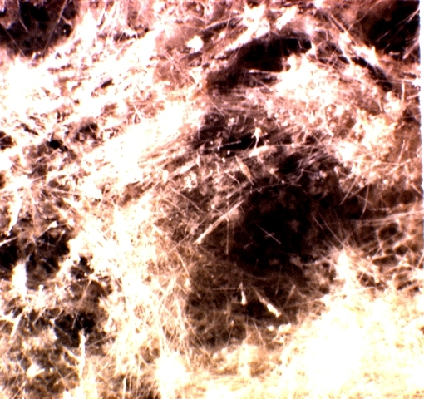

Figure 7: Optical micrograph for portland cement-based spray-applied FRM-B. Typical pore diameter as indicated by the labeled scale bars in the middle of the two images is on the order of 1.5 mm corresponding to a pore radius of 0.75 mm. The original image is on the left and a contrast-enhanced version that better highlights the porosity is shown on the right.
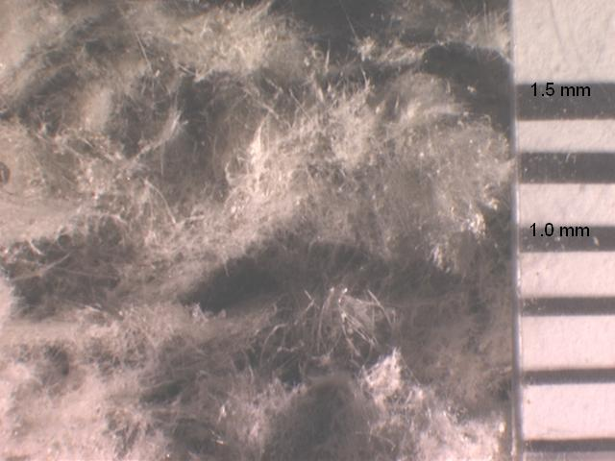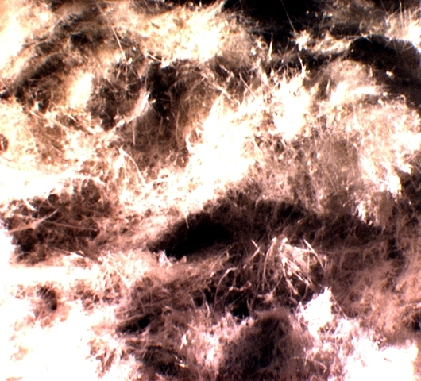

Successful application of this theory requires a detailed understanding of the dynamic microstructure of the FRM. For example, one widely used spray-applied FRM utilizes expanded polystyrene (EPS) beads as a lightweight aggregate. When these highly porous beads burn out at elevated temperatures, even though the total porosity will not change significantly, a new larger size of characteristic pores will be created within the microstructure, potentially leading to an increase in thermal conductivity. Intumescents will also be a challenging application, as in this case, the pore size and total porosity are both dynamic variables that change dramatically during the fire exposure and charring of the coating.

A more detailed microstructural analysis is possible via the utilization of x-ray microtomography which can capture the three-dimensional microstructure of materials with a voxel dimension on the order of micrometers.¹⁶ Example two-dimensional images (slices) obtained for both gypsum-based and portland cement-based FRMs using one of the X-ray microtomography units available at the Center for Quantitative Imaging at Pennsylvania State University are provided in Figure 9. These digital image-based three-dimensional microstructures can be segmented into solid and pore phases, and finite element and finite difference techniques applied to compute their equivalent thermal conductivity.¹⁷ For example, a numerical temperature gradient could be placed across the microstructure and the computed heat flow used to determine the thermal conductivity of the composite 3-D microstructure. Thus, this approach is similar to that used in conventional computational thermal analysis, but it is being applied at the microstructure scale instead of the conventional macro (structure) scale.

Figure 8: Optical micrograph for gypsum-based spray-applied FRM-C. Typical pore diameter as indicated by the labeled scale bars in the middle of the images is on the order of 0.4 mm corresponding to a pore radius of 0.2 mm. The original image is on the left and a contrast-enhanced version that better highlights the porosity is shown on the right.
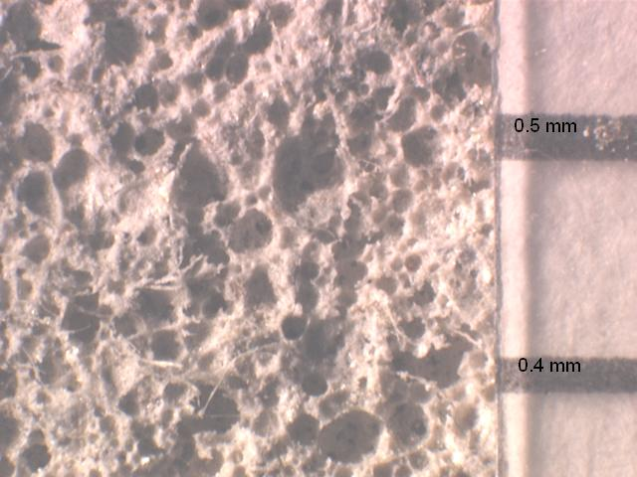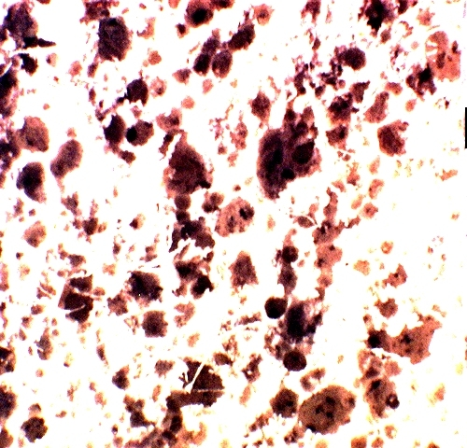

Recommended Procedures

A recommended approach for supplying the thermophysical properties needed by thermal performance models is the following:
1) density – determine density via the concurrent measurement of mass and dimensional changes using thermogravimetric and thermal expansion measurements,
2) heat capacity – determine heat capacity as a function of temperature using the largest readily available sample cell and a STA unit, and following the ASTM E1269 protocols,²
3) enthalpies of reaction – compute enthalpies based on the mass loss (TGA) measurement and the calculated enthalpies of reaction based on a detailed knowledge of the FRM and its thermal decomposition (these calculations can be critically examined by comparison with analysis of the endotherms and exotherms in the STA results), and
4) thermal conductivity – supplement direct “low” temperature thermal conductivity measurements with detailed characterization of the microstructure of the FRM (porosity and pore size) and application of the theory of Russell (or other equivalent) to provide high temperature estimates.

Figure 9: Examples of two-dimensional images from three-dimensional microtomography data sets for gypsum-based (left) and mineral fiber/portland cement-based (right) FRMs. Materials were imaged in a polypropylene tube with a nominal inner diameter (ID) of 27 mm.
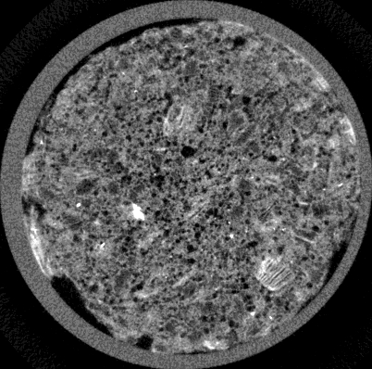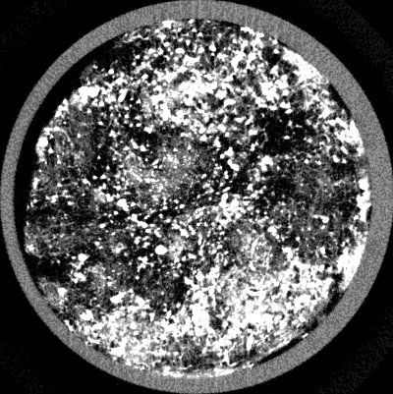

A Word of Caution about Aging Tests

One of the action items that came out of the initial FEMA study¹⁸ of the collapse of the World Trade Center was that the durability of FRMs is a little-considered but critically important component of their long term performance. In response to this, Underwriters Laboratories, along with the FRM industry and end users, are developing a draft standard to assess the durability of FRMs¹⁹, based on their existing evaluations of intumescent coatings for outdoor use. The basic procedure is to expose the FRM to some aging environment and then verify through thermal exposure (fire) testing that the performance of the aged material is at least equivalent to a specified percentage of that of the original material. Performance is generally assessed in terms of the time that it takes a steel (duct) pipe protected with the FRM to reach a specific temperature (typically 538 ºC) when exposed to a standard temperature rise curve “fire environment”. In developing these durability exposures, care must be taken that the exposure conditions are both reasonable and applicable to the various classes of spray-applied FRMs. For example, as shown in Figure 10, the current practice of exposing intumescents to a temperature of 70 ºC for 270 days can result in considerable mass loss for other types of spray-applied FRMs, even for much shorter exposures of two to three months (particularly those based on gypsum binders). Since the loss of water due to dehydration during a fire exposure is one of the mechanisms by which these materials “insulate” the steel substrate, it would be expected that these “aged” materials would exhibit an inferior performance in comparison to their original counterparts. But, is it the material performance or the aging conditions that should be called into question? When moisture is added to the aging exposures, the degradation may become even greater for conventional fibrous insulating materials.²⁰

Figure 10: Mass loss (fraction) upon long term (two month to three month) oven exposure to different temperatures for gypsum-based (FRM-D) and portland cement-based (FRM-E) FRMs (sample size of ≈3 g).
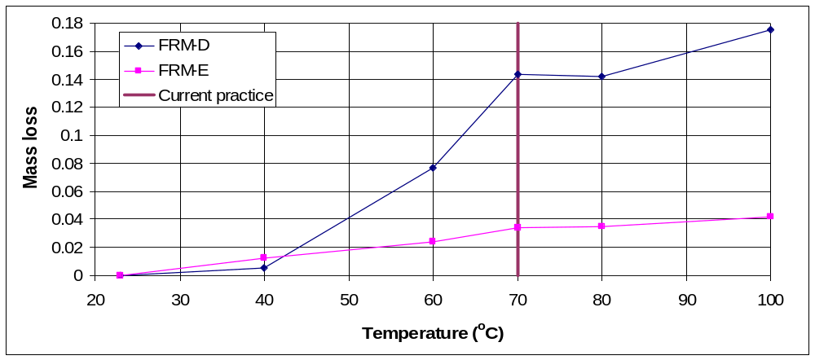

Acknowledgements

The authors would like to thank Dr. Phillip M. Halleck and Dr. Abraham S. Grader of the Center for Quantitative Imaging, Pennsylvania State University, for supplying the microtomographic images shown in Figure 9.

References:

1) Anter Laboratories, Inc., Transmittal of Test Results, report to NIST, 2004.
2) ASTM Annual Book of Standards; ASTM International: West Conshohocken, 2004.
3) CRC Handbook of Chemistry and Physics, 68th Edition; CRC Press: Boca Raton, 1987.
4) Smith JM, Van Ness HC. Introduction to Chemical Engineering Thermodynamics; McGraw-Hill Book Co.: New York, 1975.
5) Thomas G. Fire Mater. 2002; 26:37.
6) Taylor HFW. Cement Chemistry; Thomas Telford: London, 1997.
7) Hansen PF, Hansen J, Hougaard KV, Pedersen EJ. "Thermal Properties of Hardening Cement Paste," Proc. RILEM Int. Conf. on Concrete at Early Ages; RILEM: Paris, 1982, p. 23.
8) Flynn DR. “Response of High Performance Concrete to Fire Conditions: Review of Thermal Property Data and Measurement Techniques,” NIST GCR 99-767, U.S. Department of Commerce, March 1999.
9) Gustafsson SE. Rev. Sci. Instrum. 1991; 62:797.
10) Log T, Gustafsson SE. Fire Mater. 1995; 19:43.
11) Russell HW. J. Amer. Ceram. Soc. 1935; 18:1.
12) Frey S. Z. Elektrochem. 1932; 38:260.
13) Bruggeman DAG. Ann. Der Phys. 1935; 24:636.
14) Loeb AL. J. Amer. Ceram. Soc. 1954; 37:96.
15) Holman JP. Heat Transfer; McGraw-Hill Book Co.: New York, 1981.
16) Bentz DP, Mizell S, Satterfield S, Devaney J, George W, Ketcham P, Graham J, Porterfield J, Quenard D, Vallee F, Sallee H, Boller E, Baruchel J, J. Res. NIST 2002; 107:137.
17) Garboczi EJ. “Finite Element and Finite Difference Programs for Computing the Linear Electric and Elastic Properties of Digital Images of Random Materials,” NISTIR 6269, U.S. Department of Commerce, December 1998.
18) FEMA 403, “World Trade Center Building Performance Study: Data Collection, Preliminary Observations, and Recommendations,” Federal Emergency Management Administration, Washington, DC, May 2002.
19) Standard for Durability Tests for Fire Resistive Materials Applied to Structural Steel, UL 2431, Draft 1.1, Underwriters Laboratories Inc., Northbrook, IL, 2003.
20) Low NMP. “Material Degradation of Thermal Insulating Mineral Fibers,” Thermal Insulation: Materials and Systems, ASTM STP 922, F.J. Powell and S.L. Matthews, Eds., American Society for Testing and Materials: Philadelphia, 1987; p. 477.

Presented at ASCE/SEI Structures Congress, New York, April 2005.

Microstructure and Materials Science of Fire Resistive Materials

Dale P. Bentz¹, Phillip M. Halleck², Michelle N. Clarke¹, Edward J. Garboczi¹,
and Abraham S. Grader²

¹Building and Fire Research Laboratory, National Institute of Standards and Technology, 100 Bureau Drive Stop 8615, Gaithersburg, MD 20899-8615;
PH (301) 975-5865; FAX (301) 990-6891; e-mail: dale.bentz@nist.gov
²Center for Quantitative Imaging, The Pennsylvania State University, University Park, PA 16802-5000; PH (814) 863-1701; FAX (814) 865-3248;
e-mail: phil@pnge.psu.edu

Abstract

Fire resistive materials (FRMs) are a critical component in the design of safe buildings. Current performance testing is strongly based on the ability of the FRM to adhere to and to control the temperature rise of its substrate. A fundamental understanding of the microstructure and performance properties of these materials is sorely needed to model their performance in real world systems and scenarios. While room temperature properties are more easily evaluated, it is the high temperature properties of the materials that are critical to performance during an actual fire. This paper will describe preliminary efforts in an experimental/computer modeling program being conducted at NIST to apply a materials science approach to characterizing the microstructure and properties of these materials. Three-dimensional x-ray microtomography is applied to obtain a representation of the microstructure of the materials. These microstructures can then be analyzed quantitatively to characterize critical parameters such as porosity and pore sizes, and the effects of these parameters on properties such as thermal conductivity. This analysis, along with characterization of the density and heat capacity of the FRM as a function of temperature, will provide the inputs needed for thermal performance models.

Introduction

Fire resistive materials (FRMs) perform a critical function in building safety by protecting steel components from high temperature conditions during a fire or multi-hazard exposure. These materials generally delay the transfer of energy from the ongoing fire to the steel via a combination of a low thermal conductivity and a variety of endothermic reactions, such as dehydration and decarbonation of cementitious and gypsum-based binders. In addition to heat transfer through the FRM by conduction, at higher temperatures, transfer by radiation also makes a substantial contribution to material performance. Radiation transfer in a porous material is influenced by both overall porosity and by the size and shape of the individual “pores” (Russell, 1935; Loeb, 1954).

Currently, FRMs are evaluated and certified based mainly on their ability to limit the temperature rise of the substrate steel when exposed in a furnace to a standard temperature rise curve (ASTM E119; ASTM, 2004). The FRMs are thus rated for a specific period of time for protecting a specific member of the steel construction, e.g., a 2 h rating for protecting beams or a 3 h rating for protecting columns. The E119 test is strictly pass/fail and as such does not truly quantify material performance. Furthermore, it is extremely difficult to extrapolate E119 test results to real fire scenarios. Clearly, the development of new FRMs and an increased understanding of the thermal performance of existing ones would benefit greatly from a materials science-based approach to characterizing these materials.

Recently (Bentz et al., 2004), it has been suggested that to characterize FRMs with respect to thermal performance models, measurements/calculations of the following thermophysical properties are required: thermal conductivity, density, heat capacity, and any enthalpies of reactions or phase changes occurring in the temperature range of interest. This paper focuses on a computational approach to estimating thermal conductivity based on a detailed analysis of the three-dimensional microstructure of the FRMs. Such an approach may provide a viable alternative to the expensive and often difficult measurement of thermal conductivity at elevated temperatures for these dynamic materials. Additionally, the approach should provide valuable insights into the microstructural features that most influence thermal performance, so that existing products may be optimized and new ones formulated with minimal effort.

The basic approach is to capture the three-dimensional microstructure of FRMs at sub-millimeter resolution using x-ray microtomography. Image processing and finite difference computer programs are then utilized to extract the key microstructural features (pores) and determine their influence on the thermal conductivity as a function of material temperature. Finally, the computational results are compared to experimental measurements performed on the same materials to both evaluate the accuracy of the computational approach and to identify areas where improvements are needed.

Experimental Procedures

Sprayed parallelepiped samples of the following FRMs were obtained from their manufacturers: one FRM with a gypsum binder and two FRMs containing mineral fibers with a binder based on portland cement. Samples of each material were sent to a private testing laboratory (Anter Laboratories, 2004) for experimental measurement of their thermal conductivities as a function of temperature using a standard hot wire technique (ASTM, 2004). The testing laboratory reported their results for thermal conductivity to be normally within ± 3 %. For each material, nominal 25 mm (1”) diameter cylindrical cores were carefully extracted using a utility knife. The cores were then placed in 27 mm inner diameter (ID) polypropylene tubes and mounted for viewing by the x-ray microtomography system at the Center for Quantitative Imaging at the Pennsylvania State University.

Volumetric x-ray CT data were collected using the facility's microfocus x-ray source at a voltage setting of 185 kV and a low tube current of 50 μA to minimize focal spot size and thus optimize spatial resolution. We positioned the sample in the gantry to magnify the sample, and calibrated the resulting voxel dimensions against a dimensional standard for precision and to allow combining adjacent data sets without overlapping or skipping portions of the sample volume.

Because of the different microstructures present in the two types of FRMs examined in this study (e.g., characteristic feature dimensions), the microtomography data sets were acquired with different voxel dimensions. The microtomography data sets for the gypsum-based FRM were acquired with voxel dimensions of dx =dy =0.0273 mm and dz =0.0361 mm. Each data set consisted of a 1024 x 1024 x ≈750 array of 16-bit x-ray absorption values on an arbitrary scale. For this sample we collected approximately 750 slices covering a volume about 28 mm long by 28 mm in diameter. For the fiber/cement-based FRMs, in order to cover a larger representative sample volume, the magnification was reduced by repositioning the sample between the source and the detector, resulting in voxel dimensions of dx =dy =0.0586 mm and dz =0.0740 mm, for data arrays 512 pixels by 512 pixels by 492. Thus, the data cover sample volumes about 36 mm long by 30 mm in diameter. Each individual two-dimensional slice was available as a 16-bit tiff-format image for further processing as described below.

Computational Procedures

The three-dimensional FRM microstructure data sets were processed using the following computational procedures:
- segmentation into binary images- utilizing the commercially available Image Pro software package, each two-dimensional FRM slice image was segmented into a binary image of “pores” and “solids” by manually choosing a greylevel threshold; the chosen threshold was held constant for all of the two-dimensional slices comprising each FRM material but varied between the three different materials, due to inherent contrast variations.
- extraction of a subvolume- a 200 by 200 by 200 voxel subvolume was extracted from each three-dimensional data set; in each case, the subvolume was chosen away from the sample edges and in an attempt to select as representative a volume of the overall material as possible.
- isolation of pores and quantification of pore volumes- each binary subvolume data set was further analyzed to identify individual pores and determine their volumes (by voxel counting); computer programs were written in the C programming language to perform pore separations utilizing such common image processing algorithms as erosion/dilation and watershed segmentation (Russ and Russ, 1988).
- prediction of thermal conductivity- the processed subvolumes were used as input into a finite difference program (Garboczi, 1998) to estimate the thermal conductivity of the composite FRMs based on an electrical analogy; a voltage (temperature) gradient was placed across the microstructure and the resulting currents (heat flows) were computed for each microstructure element (node).

To utilize the finite difference program, it is necessary to assign thermal conductivities to the “pore” and “solid” components of the underlying microstructure. Knowing the pore volume of each individual pore, equivalent radii were calculated assuming a spherical pore geometry. Then, the thermal conductivity of a pore of radius r at material temperature T was given by:
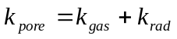 (1)
where:
k_{gas} = thermal conductivity of air at temperature T, and according to (Loeb, 1954),
(2)
with r = pore radius (m),
σ = Stefan-Boltzmann constant (5.669x10⁻⁸ W/m²•K⁴),
E = emissivity of solid material (1.0 for black bodies), and
T = absolute temperature (K).
In this way, each different size pore in the three-dimensional microstructure was assigned a different thermal conductivity value.

When considering the “correct” thermal conductivity to assign to the “solids”, several complications arise. First, while the microtomography clearly indicates the coarser pores (50 μm to 100 μm and greater in diameter) present in the microstructure, the remaining solid phases are themselves porous. While it may have been possible to estimate the local “micro-porosity” based on the greylevel intensity at each solid voxel in the three-dimensional microstructure, instead, a single “fine” porosity value within all solid voxels was estimated based on the measured densities of the original FRMs, the measured densities obtained by grinding them to a fine powder (hopefully removing all internal porosity), and the microtomography-measured coarse porosity volume fraction for each material. Then, the theory of (Russell, 1935) was used to estimate the thermal conductivity of the porous solid component of the microstructures, k_{ps}, as:
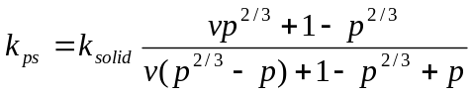 (3)
where v = k_{pore}/k_{solid},
p = porosity of the “solid” voxels,
k_{solid}= thermal conductivity of solid (powder) material, and
k_{pore} = thermal conductivity of pores in the “solid” voxels = k_{gas} + k_{rad}
For calculations of k_{rad} for equation (3), an upper bound pore diameter equal to the smallest of the voxel dimensions was chosen for each material (e.g., 0.0273 mm or 0.0586 mm). The thermal conductivities of the solid powders, k_{solid}, were chosen as 0.8 W/m•K for the gypsum-based FRM and 0.4 W/m•K for the fiber/cement-based FRMs, to provide predictions in agreement with the room temperature measured values of thermal conductivity (Anter Laboratories, 2004). In applying the theory of Russell, the density (porosity) of the porous material was adjusted to account for its measured mass loss as a function of temperature. The gypsum-based FRM loses about 25 % of its mass upon heating to 1000 ºC, while the fiber/cement-based FRMs lose between 10 % and 15 % (Anter Laboratories, 2004).

For the gypsum-based FRM, a further complication is that the thermal conductivity of anhydrite (dehydrated gypsum) is nearly four times that of gypsum (Horai, 1971). Based on the measured mass loss of the gypsum-based FRM and utilizing the Hashin-Shtrikman upper and lowers bounds for thermal conductivity (Hashin and Shtrikman, 1962), it was estimated that upon complete conversion of the gypsum to anhydrite, the thermal conductivity of the solid FRM powder should increase to be on the order of 1.66 W/m•K. Thus, for temperatures above the nominal dehydration temperature for gypsum of about 300 ºC, the finite difference computations were performed with k_{ps} values based on both gypsum and anhydrite for comparison to experimental data.

Results

Figure 1 illustrates the microstructural features captured by the x-ray microtomography for the two types of FRMs. For the gypsum-based material on the left, one can easily observe plate-like vermiculite particles surrounded by a porous gypsum binder. For the fiber/cement-based FRM on the right, substantially larger pores are observed. The bright “particles” observed in this image are most likely agglomerations of the cement particles that are bonding together fibrous subregions of the microstructure. As observed more clearly in the three-dimensional representations of microstructure provided in Figures 2 and 3, while the pores in the gypsum-based FRM definitely appear to be comprised of closed roughly spherical shapes, those in the fiber/cement-based FRM may be interconnected across large regions of the microstructure. These differences in pore shape/connectivity would also be expected to influence the thermal conductivities of these two materials, particularly at elevated temperatures.

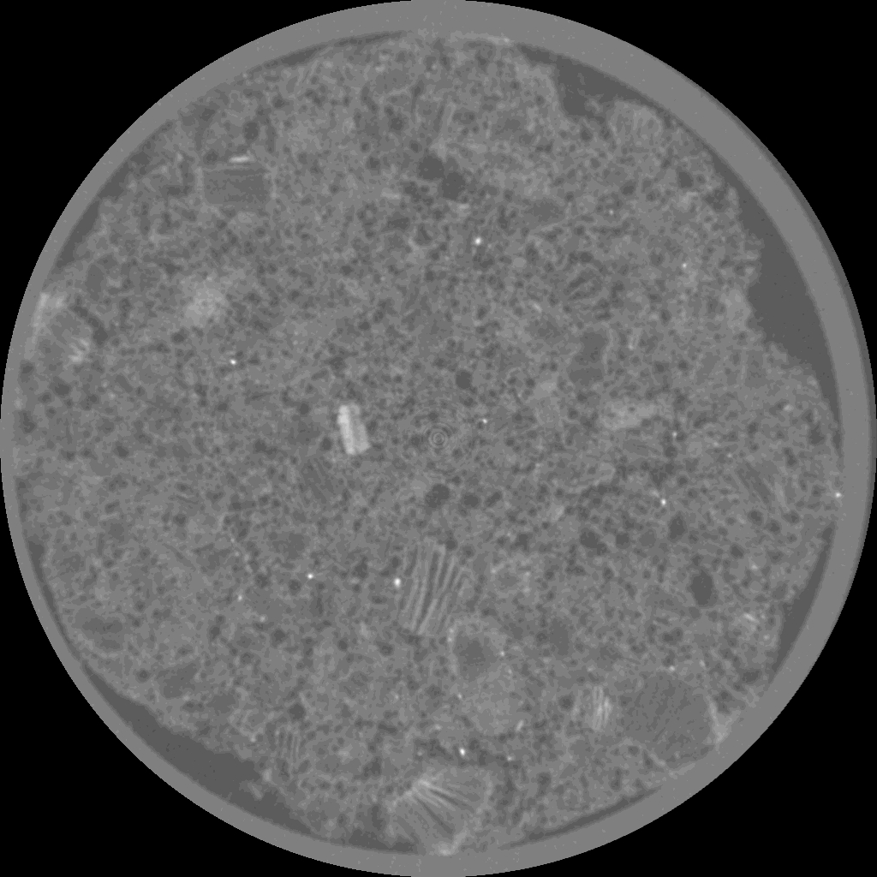
Figure 1. Two-dimensional x-ray microtomography images from a gypsum-based FRM (left: 28 mm by 28 mm) and a fiber/cement-based FRM
(right: 30 mm by 30 mm), illustrating some of the differences in microstructural features.

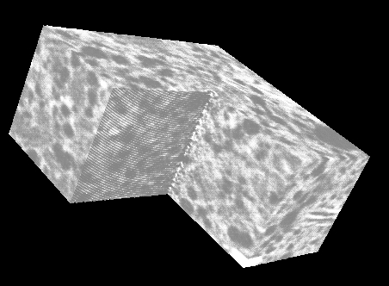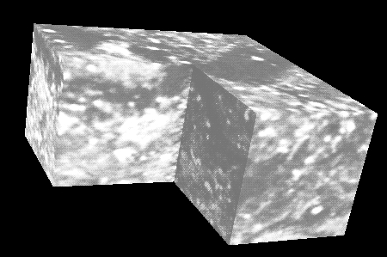
Figure 2. Renderings of the three-dimensional x-ray microtomography original data sets (100 by 200 by 200 voxels with a 100 by 100 by 100 voxel volume removed for increased visual clarity) for a gypsum-based FRM (left) and a fiber/cement-based FRM (right). Pores are dark and “solid” regions are bright.

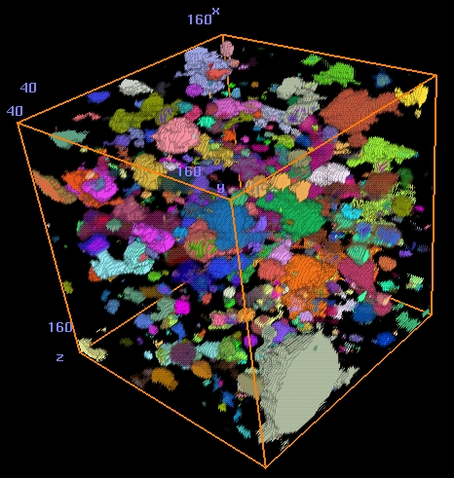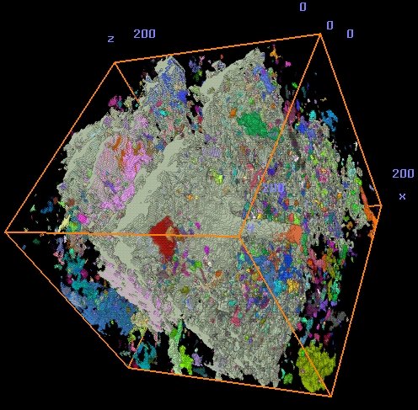
Figure 3. False color renderings of the individual pores isolated using the watershed segmentation algorithm in a gypsum-based FRM (left: 120 by 120 by 120 voxels) and a fiber/cement-based FRM (right: 200 by 200 by 200 voxels).

The thermal conductivity predictions and measurements for the gypsum-based FRM are provided in Figure 4. While good agreement between the experimental results and the computational predictions is observed for temperatures below 300 ºC, above this temperature the gypsum-based predictions underestimate the measured values while the anhydrite-based predictions generally overestimate the measured values, although providing a reasonable fit for temperatures above 600 ºC. This could indicate that (during the experimental measurement of its thermal conductivity) in the intermediate temperature range of 300 ºC to 600 ºC, the FRM possibly contained a mixture of gypsum (hemihydrate) and anhydrite. These results highlight one of the inherent difficulties in equitably measuring the thermal conductivity of FRMs at elevated temperatures, the fact that their mass, their chemical composition, and their microstructure may all be changing during the course of the measurement.

The importance of pore size in controlling high temperature thermal conductivity is indicated by the results shown for the first of the fiber/cement-based FRMs in Figure 5. Here, because of the non-spherical shape of many of the pores, the watershed segmentation algorithm subdivided the largest porous “regions” into two or more individual pores. In this case, better agreement with the experimental data was observed for the three-dimensional microstructure where the pores were identified by the simple application of a burning algorithm without any application of erosions/dilations to the binary image subvolume. As illustrated in Figure 6, similar results were observed for the second fiber/cement-based FRM, where larger thermal conductivities are observed at the highest measured temperatures due to both an increased porosity and a generally larger pore size.

A large degree of anisotropy in the three-dimensional subvolumes was observed for these FRMs, as indicated by the large difference between the computed thermal conductivities for the (x and y) directions and the z direction. In Figure 3, several large flat plate-like porous regions oriented

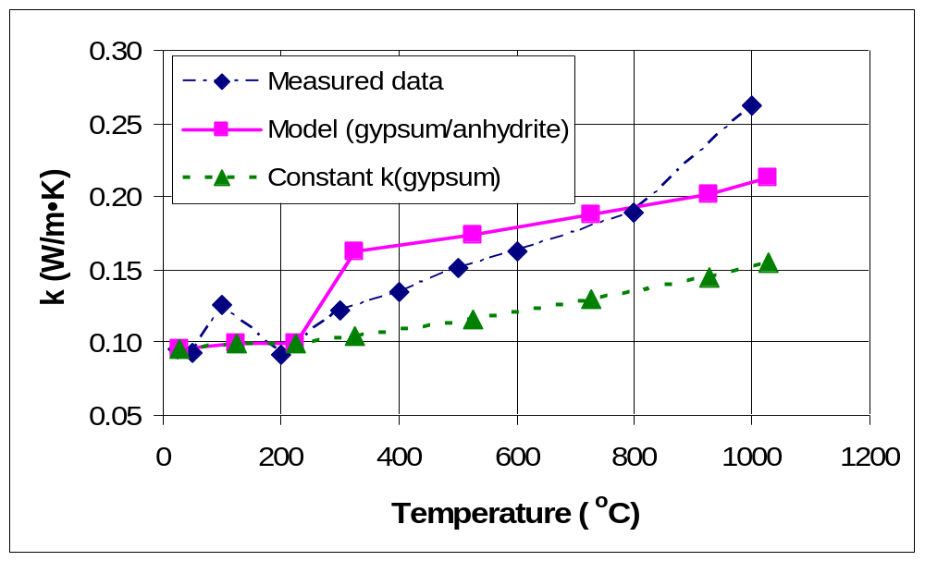
Figure 4. Measured and predicted thermal conductivities for a gypsum-based FRM as a function of temperature, for the case where individual pores were identified using a watershed segmentation algorithm (Russ and Russ, 1988).

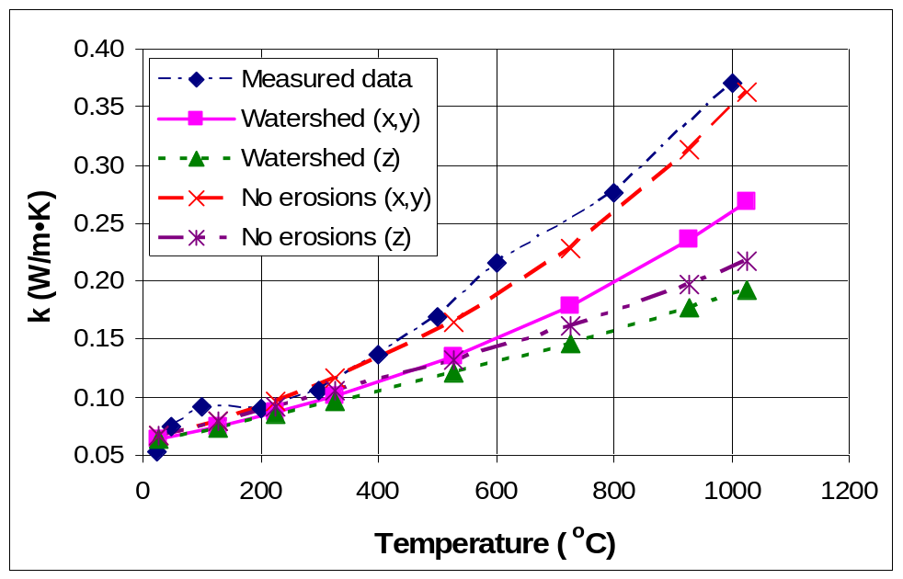
Figure 5. Measured and predicted thermal conductivities for the first fiber/cement-based FRM as a function of temperature.

in the xy (spraying) plane are clearly observed to comprise a major fraction of the subvolume. It should be noted that the three-dimensional box in Figure 3 has been rotated to better view these pores and that the z-direction moves from left to right in the labeled subvolume. Furthermore, for these materials, it must also be noted that some of the underestimation of the experimental results is likely due to energy transfer through the FRMs by radiation transmission and scattering
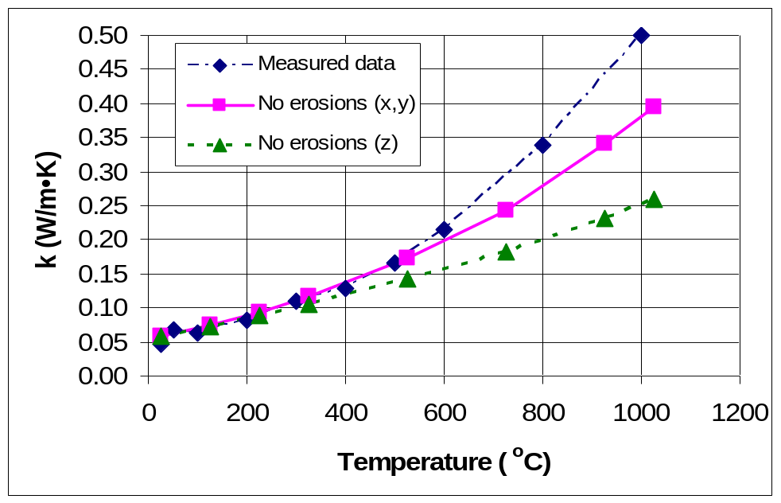
Figure 6. Measured and predicted thermal conductivities for a second fiber/cement-based FRM as a function of temperature.

(Flynn and Gorthala, 1997), due to their overall fibrous nature and likely percolated three-dimensional pore networks. The theory of Loeb (Loeb, 1954) does not account for this mode of radiation transport through the porous material, as it assumes a porous solid comprised of isolated (not interconnected) pores.

Conclusions

The procedures and results presented indicate the viability of utilizing microstructural characterization and computation to estimate the thermal conductivity of FRMs at elevated temperatures. However, the computational procedures can not be applied blindly, due to the many complicating factors present in these materials. It is only with a detailed understanding of the microstructural components of these materials and their changing nature with increasing temperature that truly adequate predictions can be envisioned. The influences of total porosity (or equivalently density), pore size, and pore connectivity on heat transfer were all highlighted in the current case studies.

Acknowledgements

The authors would like to thank Mr. John Winpigler of BFRL/NIST for measuring the powder densities of the various FRMs.

References

Anter Laboratories, Inc. (2004). “Transmittal of Test Results.” report to NIST.
ASTM (2004), ASTM Annual Book of Standards, ASTM International, West Conshohocken.
Bentz, D.P., Prasad, K.R., and Yang, J.C. (2004). “Towards a Methodology for the Characterization of Fire Resistive Materials with Respect to Thermal Performance Models.” submitted to Fire and Materials.
Flynn, D.R., and Gorthala, R. (1997). “Radiation Scattering Versus Radiation Absorption- Effects on Performance of Thermal Insulation Under Non-Steady-State Conditions.” Insulation Materials: Testing and Applications: Third Volume, ASTM STP 1320, American Society for Testing and Materials, West Conshohocken, PA, 366-380.
Garboczi, E.J. (1998). “Finite Element and Finite Difference Programs for Computing the Linear Electric and Elastic Properties of Digital Images of Random Materials.” NISTIR 6269, U.S. Department of Commerce.
Hashin, Z., and Shtrikman, S. (1962). “A Variational Approach to the Theory of the Effective Magnetic Permeability of Multiphase Materials.” J. Appl. Phys., 33, 3125-3131.
Horai, K. (1971). “Thermal Conductivity of Rock-Forming Minerals.” J. Geophys. Res., 76(5), 1278-1308.
Loeb, A.L. (1954). “Thermal Conductivity: VIII, A Theory of Thermal Conductivity of Porous Materials.” J. Am. Ceram. Soc., 37, 96-99.
Russ, J.C., and Russ, J.C. (1988). “Improved Implementation of a Convex Segmentation Algorithm.” Acta Stereologica, 7(1), 33-40.
Russell, H.W. (1935). “Principles of Heat Flow in Porous Insulators.” J. Am. Ceram. Soc., 18, 1-5.
Submitted to Fire and Materials (2004)
A Slug Calorimeter for Evaluating the Thermal Performance of Fire Resistive Materials

D.P. Bentz, D.R. Flynn, J.H. Kim, and R.R. Zarr
Building and Fire Research Laboratory
National Institute of Standards and Technology
Gaithersburg, MD 20899-8615

Abstract

The utilization of a slug calorimeter to evaluate the thermal performance of fire resistive materials (FRMs) is presented. The basic specimen configuration consists of a “sandwich”, with a square central stainless steel plate (slug) surrounded on two sides by the FRM. This sandwich configuration provides an adiabatic boundary condition at the central axis of the slug plate that greatly simplifies the analysis. The other four (thin) sides of the steel plate (and FRM specimens) are insulated using a low thermal conductivity fumed-silica board. Metal plates manufactured from a high temperature alloy, with eight holes for retaining screws, are placed on the exterior surfaces of the FRMs to provide a frame for placing the entire sandwich specimen slightly in compression. The entire configuration is centrally placed at the bottom of an electrically-heated box furnace and the temperatures of the metal slug and exterior FRM surfaces are monitored during multiple heating and cooling cycles. Knowing the heat capacities and densities of the steel slug and the FRM, an effective thermal conductivity for the FRM can be estimated. The effective thermal conductivity of the FRM will be influenced by its true thermal conductivity and by any endothermic or exothermic reactions or phase changes occurring within the FRM. Preliminary tests have been conducted on two commonly used FRMs and on a non-reactive fumed-silica board to demonstrate the feasibility of determining high temperature thermal conductivities using this method. This small scale furnace test can potentially be related to a standard ASTM E119 testing configuration by determining the time necessary for the steel slug to reach a specific “failure” temperature (e.g., 538 ºC).

Introduction

Fire resistive materials (FRMs) are currently generally evaluated using the ASTM standard test method E119.¹ This test provides a time “rating” for which the FRM will adequately protect a specific element or subsystem of a structure. Two of the major criteria determining the performance of a FRM are the measured average and maximum temperatures of a series of thermocouples placed on the (steel) substrate. While useful as practical failure criteria, these data alone provide little insight into the key thermal properties of the FRM that would allow a better understanding of its performance. The thermal performance of the FRM is controlled by its heat capacity, density, thermal conductivity, and any heat released, absorbed, or transported due to chemical reactions (dehydrations, etc.) and phase changes.² The goal of this paper is to present an experimental setup that maintains the “spirit” of the ASTM E119 test setup while providing detailed data on the fundamental thermophysical properties and thermal performance of the FRM.

The key components extracted from the ASTM E119 testing are that a steel substrate is protected by a specific thickness of FRM material and is exposed to a controlled temperature-time environment in a furnace. The test specimen size is reduced from the ASTM E119 testing to a square 152 mm by 152 mm specimen that is nominally 25 mm in thickness. Thermocouples are placed in the steel substrate and also at the “exposed” surfaces of the FRMs to monitor dynamically the temperature gradient that exists across the sample. Additionally, by using a “sandwich” specimen configuration and a central stainless steel plate of known mass and thermal properties, the heat flow through the FRM specimens can be easily estimated from a simple energy balance, taking advantage of the adiabatic boundary condition that exists at the central axis of the steel plate slug. Knowing the heat flow and the temperature gradient, an “effective” thermal conductivity for the FRM as a function of temperature can be determined. This effective thermal conductivity will be influenced by the true thermal conductivity of the material, any endothermic or exothermic reactions occurring in the FRM, and any additional energy/mass transport due to vaporization of water (steam) and other reaction products formed from dehydration, decarbonation, etc. of the FRM material. The influence of these reactions can be conveniently explored by exposing the sandwich specimen to multiple heating/cooling cycles, as the reactions will likely be present only during the first heating cycle. This approach is presented in more detail in the sections that follow. A somewhat similar approach for determining an effective thermal conductivity of intumescent coatings using a cone calorimeter and numerical analysis has been presented recently.³

Experimental

Slug Design
An AISI Type 304 stainless steel plate 152 mm by 152 mm was cut from a sheet having a thickness of 12.7 mm. To monitor the temperature of the steel slug, three vertical holes 3.5 mm in diameter were milled into the plate along its central axis, extending 51 mm, 76 mm, and 102 mm into the plate’s depth. The holes were located at distances of 51 mm, 76 mm, and 102 mm from the plate’s edge as shown in Figure 1. The steel plate mass was 2340 g. A density value of 8000 kg/m³ for 304 stainless steel was taken from the literature⁴, along with heat capacity values as a function of temperature⁵, as shown in Figure 2. Before testing any specimens, the steel plate was heated to a temperature of 700 ºC during two separate runs in the furnace. The plate can be optionally fitted with two allen screws (one on each side) to enable the final sandwich specimen to be suspended from an external balance on two wires. Care must be taken to assure that the wire diameter is sufficient to support the dead load during the temperature rise experienced during an actual test run. For our purposes, 16 gauge Chromel wire has been found to be sufficient, while 24 gauge wire resulted in two premature failures during preliminary tests, with a total load on the order of 5000 g. Optionally, the final sandwich configuration can be set in the bottom center of the (bottom loading) box furnace, as shown in Figure 3, if only temperatures and not mass are to be monitored during the test.

Figure 1- Design of the steel plate slug calorimeter.
152.4 mm
3.45 mm holes at 50.8 mm, 76.2 mm,
and 101.6 mm

n

12.7 mm
50.8 mm
101.6 mm
152.4 mm

Furnace Setup
All experiments were conducted in an electrically-heated box furnace with a working volume of 360 mm by 360 mm by 360 mm and a maximum operating temperature of 1500 ºC. The bottom surface of the furnace is located on hydraulic elements and can be moved up and down for loading and unloading of specimens (Figure 3). A series of five Type N thermocouples, insulated for high temperature applications, were introduced into the furnace through an entry port in the top. The thermocouples were connected to a constant temperature zone box, where their differential voltages were monitored using a digital multimeter and digital voltmeter. The thermocouples were monitored periodically and recorded on a computer. Measurement in ice water yielded an average standard deviation of 0.05 ºC among the five thermocouples.

Figure 2- Literature values⁵ and fitted curve for heat capacity of 304 stainless steel. Fitted curve is of the form c_{p} = A + BT + Cln(T) with T in degrees K.
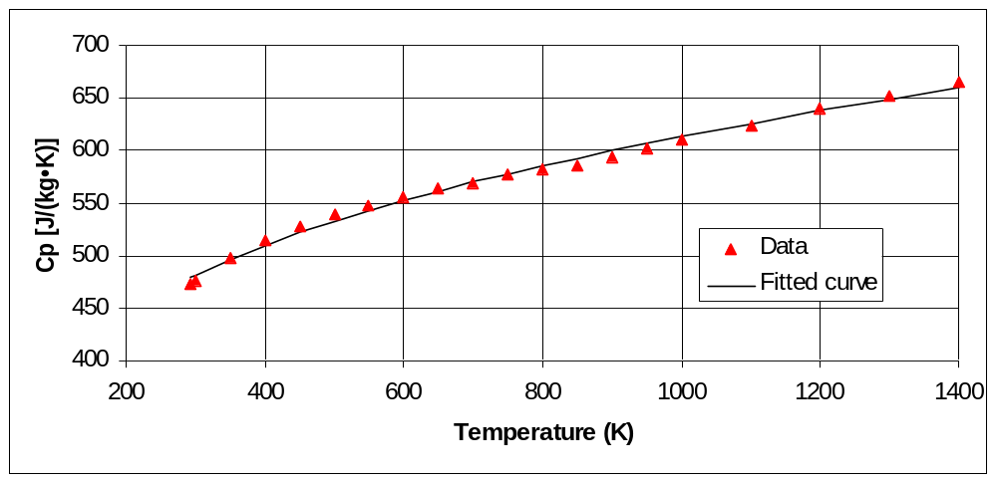

Figure 3– A completed sandwich specimen of the fumed-silica insulation board mounted and ready for testing in the box furnace.
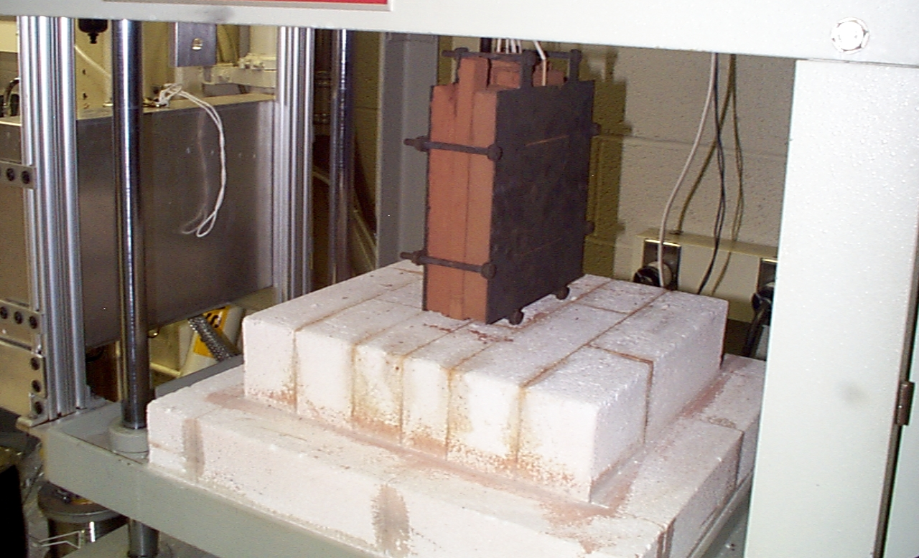

FRM and Insulation Materials
Samples of two mineral fiber/portland cement-based FRMs were obtained from a manufacturer. The samples were of nominal size 300 mm by 300 mm by 25 mm. Heat capacities, densities, and thermal conductivities of these materials had been previously determined by various laboratories.^{2,6,7} Here, the two materials shall be designated as FRM A and FRM B. The room temperature densities of FRM A and FRM B were measured to be 314 kg/m³ and 237 kg/m³, respectively.⁶ The heat capacity and mass loss measurements versus temperature for the two materials are provided in Figures 4 and 5. The testing laboratory reported their heat capacity values to be normally within ± 5 %.⁶ For each test run in the furnace, two panels of dimensions 152 mm by 152 mm by 25 mm were cut from the larger panels to use in the sandwich specimen configuration. The initial mass of each specimen was measured and recorded. The specimens of the FRMs were not preconditioned prior to evaluation in the box furnace.

Figure 4- Measured values⁶ and fitted curves for heat capacities vs. temperature of the two FRMs. Fitted curves are of the form c_{p} = A + BT + Cln(T) with T in degrees K.
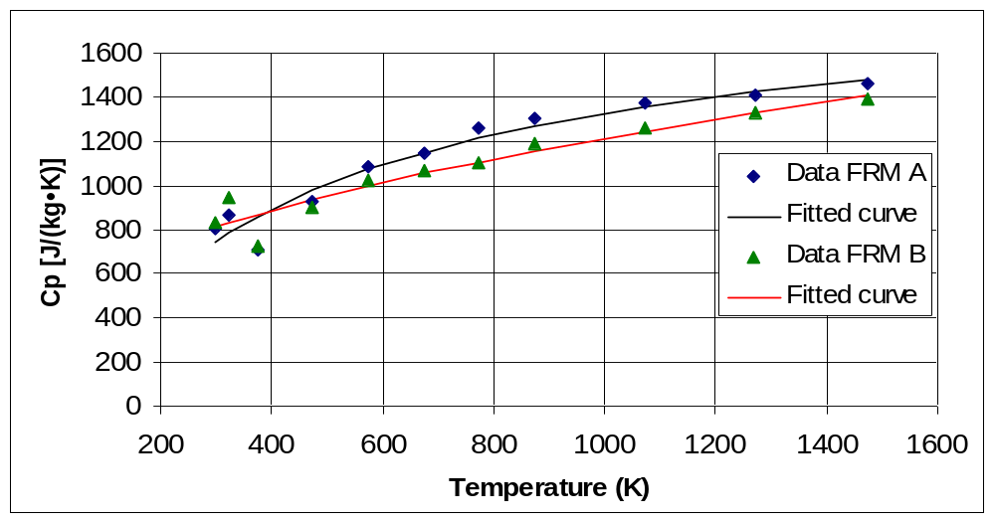

A fumed-silica insulation board with a low thermal conductivity (≈0.02 W/m•K) was used both as thermal insulation in the sandwich configuration and as a non-reactive “reference” material for evaluating the experimental setup. The board is available as NIST Standard Reference Material 1449 (http://ts.nist.gov/) and its room temperature⁸ and high temperature⁹ thermal conductivities have both been previously measured by NIST. Specimens⁸ were obtained in panels having nominal dimensions of 600 mm by 600 mm by 25 mm with a nominal bulk density of about 310 kg/m³. For the purposes of this study, smaller sections were carefully cut as needed from one large panel using a hand saw. All samples were pre-conditioned overnight in a 100 ºC oven prior to being used as insulation or test specimens in the box furnace setup. The panels had been previously heat treated at 650 ºC for 8 h by the manufacturer.⁸ The heat capacity of the fumed-silica board as a function of temperature was measured using a differential scanning calorimeter (DSC) and the ASTM E1269 standard technique¹ and determined to be on the order of (1000 ± 100) J/(kg•K), in good agreement with the limited data available in the literature for similar materials currently in production.^{10,11}

Testing Procedure
The specimens and slug plate were surrounded by a 63.5 mm (total thickness), 25.4 mm wide guard of the fumed-silica insulation board and mounted between two Inconel frame plates (see Figure 3). The entire assembly was held together by a set of eight retaining screws (two on
Figure 5- Values⁶ measured according to ASTM E1131¹ and fitted curves for mass loss vs. temperature of the two FRMs. Fitted curves are of the form M = A + BT + Cln(T) with T in degrees K.
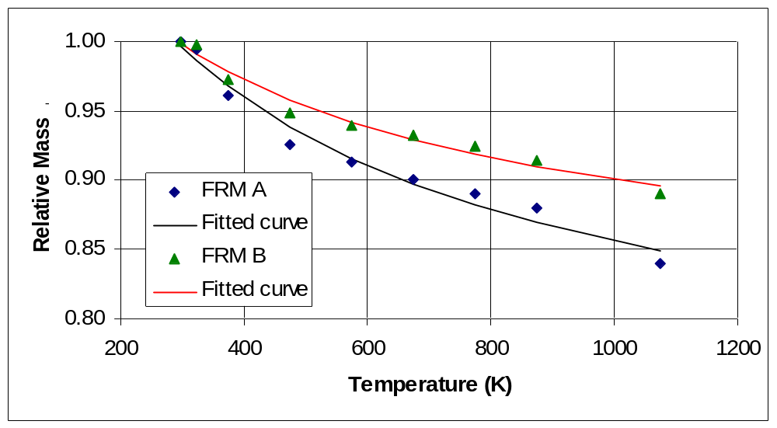

each of the four edges of the plates). The assembled sandwich was either suspended from two wires or simply placed on the bottom center of the box furnace and the thermocouples were mounted; three Type N thermocouples were placed at the various depths in the center slug plate and one each was placed on the two exterior surfaces of the specimens being evaluated, between the specimens and the retaining Inconel plates. In addition to these thermocouples, the temperatures of the zone box and the furnace were also monitored and recorded. In most tests, the furnace temperature was programmed to follow a curve similar to the standard ASTM E119 temperature-time curve¹, but with a less rapid initial temperature rise, due to limitations on the heating rate of the furnace. The actual temperature-time curve employed will be shown in the results to follow. The tests were generally aborted by turning off the furnace power when the central steel slug reached an average temperature of 550 ºC. However, the thermocouples still monitored temperatures during cooling. Thus, while the heating portion of the tests generally occurred over a period of 1 h to 2 h, the cooling portion could take as long as 24 h to 48 h, when the furnace was not opened to accelerate the cooling. Additional tests were conducted at slower heating rates to determine the sensitivity of the computed thermal conductivities to this parameter. Typically, the furnace temperature was linearly raised to 600 ºC during the course of either 4 h or 16 h and then held there until the center slug plate also attained nearly this temperature, at which point the furnace was turned off and a cooling curve monitored.

Analysis

Assuming one-dimensional heat flow through the FRM components of the specimen sandwich, a solution will be determined for the case where the temperature of the surfaces of the exposed specimens is increasing/decreasing at a constant rate. We consider a pair of FRM specimens, each of thickness l, with the initial condition that the temperature is constant through the thickness of the specimen and slug, i.e., T(z,0)=0. By symmetry, the mid-plane of the steel slug plate will be an adiabatic boundary, so that we need only consider one specimen and one half of the steel slug plate. Assuming constant properties, the temperature in the specimen must satisfy:

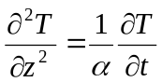 (1)

where α=k/C is the thermal diffusivity [m²/s], k is the thermal conductivity [W/(m•K)], C=ρc_{p} is the volumetric heat capacity [J/(m³•K)], and ρ is density [kg/m³], all for the FRM specimen material. The steel slug plate is assumed to have a sufficiently high thermal conductivity that it can be considered to be isothermal at any given time. The “thermal capacity” of the slug plate, per unit area, is taken to be 2H = (areal density of the plate)x(heat capacity of the plate), with the factor of 2 arising from the fact that we need only consider one half of the steel slug plate. The thermal capacity, H, has units [J/(m²•K)].

The boundary condition at the exposed surface of the specimen, z=0, is:

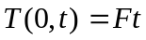 (2)

where F is the (constant) temperature increase rate having the units [K/s]. The boundary condition at the specimen surface, z=l, which is in contact with the steel slug plate is:

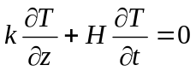 (3)

which follows from the fact that the heat conducted out of this face of the specimen must equal the heat absorbed by (one half of) the steel slug plate.

Assuming that the transient (exponentially decaying) terms in the solution, which depend on the thermal diffusivity of the FRM specimen and time, can be neglected, we arrive at a solution of the form:

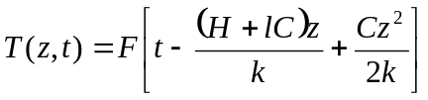 (4)

The temperature difference across the specimen of the FRM, ∆T, is thus:

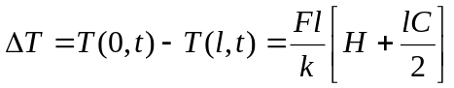 (5)

Finally, the thermal conductivity of the specimen can be computed as:

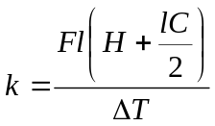 (6)
If the masses of the slug (M_{S}) and FRM specimen (M_{FRM}) are known, equation (6) can be rewritten as:

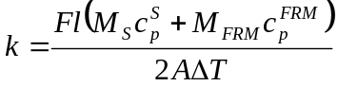 (7)

where A is the cross-sectional area of the slug (or specimen, 0.152 m by 0.152 m = 0.0232 m² in our experimental setup), and c_{p}^{S} and c_{p}^{FRM} refer to the heat capacities of the steel plate and FRM specimen in units of [J/(kg•K)], respectively. A similar analysis can be performed for the cooling case (F<0, T(z,0)=constant), and it can be shown that equation (7) applies in this case as well.

Equation (7) was conveniently implemented in a spreadsheet program to determine the effective thermal conductivity from the acquired temperature-time data points. The measured temperature-versus-time series for the slug and for the exterior FRM surfaces were used to compute the instantaneous values of F (∂T/∂t) and ∆T for use in equation (7). Measured heat capacities of the 304 stainless steel (Figure 2) and FRMs (Figure 4) as a function of temperature and mass losses versus temperature for the FRMs (Figure 5) were used to further refine the parameters used in equation (7). The resulting values of k will be graphed against the mean specimen temperature ([T(0,t)+T(l,t)]/2) in the results that follow. While this paper presents preliminary results to indicate the feasibility of utilizing the slug calorimeter method to evaluate the thermal performance and specifically the effective thermal conductivity of FRMs, an expanded uncertainty analysis could be conducted based on equation (7) and the law of propagation of uncertainty.¹² Assuming that the heat capacities of the steel slug and the FRM specimen are fairly well known and that lengths and masses can be measured with less than 1% uncertainty, the uncertainties in the thermocouple measurements at high temperatures, which are used to calculate both F and ∆T in equation (7), will be the most significant contributors to the overall uncertainty. Thus, the uncertainty can be reduced simply by applying equation (7) over a larger time interval. For example, assuming an optimistic uncertainty of 1 ºC for the thermocouple readings at high temperatures, changing the sampling frequency from 1 min to 5 min reduces the estimated uncertainty in the effective thermal conductivity from about 25 % to about 5 % for thermal conductivities computed in the temperature range of 400 ºC to 700 ºC during heating. During cooling, using a 25 min interval to calculate the effective thermal conductivity reduces its uncertainty to about 8 % from a value of about 40 % for 5 min intervals.

Results and Discussion

1) Fire Resistive Materials
The individual thermocouple temperatures collected during a single heating/cooling cycle of FRM A are provided in Figure 6. The ASTM E119 standard temperature-time curve¹ is shown for comparison to the heating curve achievable in the electric furnace. It is worth noting that during a portion of the heating curve the exterior FRM surface temperatures actually exceed the “ambient” temperature of the furnace, most likely due to enhanced radiation transfer between the Inconel retaining plates and the individual furnace elements. This reinforces the need to center the sandwich specimen in the furnace, so that both sides (specimens) are exposed to nominally the same thermal environment. There is little variability among the three thermocouples mounted in the steel slug, indicating that the assumption that it behaves as an isothermal slug mass is a generally valid one. Since these three thermocouples are also mounted at different depths in the steel plate, a low variability among them also supports the validity of the assumption of one-dimensional heat transfer through the FRM that is critical to the quantitative analysis. In Figure 6, it is clearly observed that even after the furnace is turned off (as indicated by the peak in the furnace and outer FRM temperature curves near 100 min), the temperature in the steel slug continues to rise due to the thermal inertia (lag) of the system. When the interior temperature of the slug exceeds the exterior temperature of the FRM, the direction of the specimen heat flow reverses.

Figure 6- Temperature vs. time data for one heating/cooling cycle for FRM A specimens.
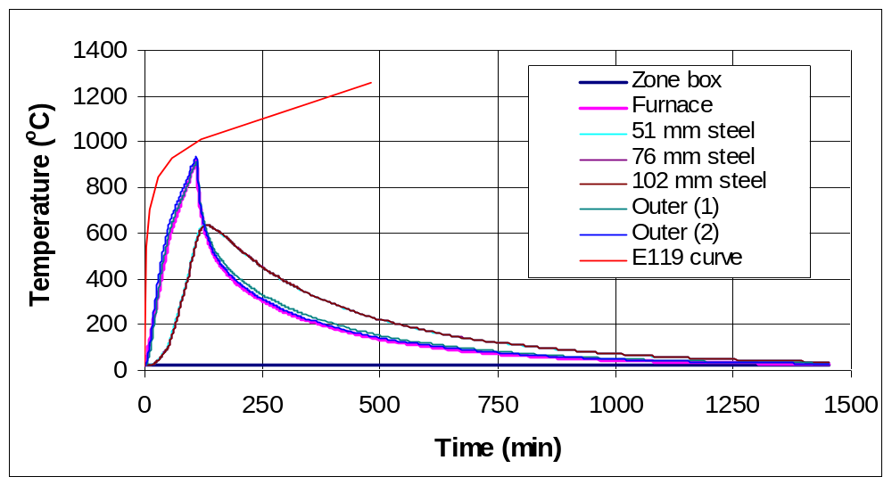

One performance criterion that could be conveniently extracted from the data in Figure 6 is the time necessary for the steel slug to reach some specific temperature, such as 538 ºC for example.¹ For the initial heating cycle of FRM A shown in Figure 6, approximately 105 min were required for the steel slug to achieve this temperature. For two subsequent heating cycles, these times were observed to be on the order of 110 min. These results suggest that most of the performance of this particular FRM is achieved via its “low” thermal conductivity and not via the contribution of significant endothermic reactions, as will be discussed in more detail when the computed thermal conductivity curves are presented below.

Equation (7) was applied to the data shown in Figure 6 and the computed thermal conductivity values for five different heating/cooling cycles are provided in Figure 7 in comparison to the previously measured values. One of the testing laboratories reported their results for thermal conductivity to be normally within ± 3 %.⁶ The first three heating cycles followed the furnace heating curve shown in Figure 6. For the fourth and fifth heating cycles, as outlined above, the furnace temperature was ramped to 600 ºC in 4 h and 16 h, respectively. The cooling curves for the third and fourth cycles are incomplete due to power outages that occurred during the course of these experimental runs. The computed thermal conductivity values agree with the values measured previously using either a hot wire⁶ (ASTM C1113¹) or a transient plane source (TPS) method^{7,13} to within 15 % for temperatures up to 600 ºC. The computed values at temperatures above 600 ºC for the first three heating cycles are clearly higher than those previously measured, which could be due to enhanced heat transfer by radiation in these highly porous fibrous materials¹⁴ sandwiched between the “radiating” exterior Inconel plates and the interior steel slug. It is observed that, after the initial transients, the data for the five different cooling curves are all quite similar, indicating that an equilibrium had been reached within the FRM with respect to reactions after the first heating cycle.

Figure 7– Effective thermal conductivity results for FRM A in comparison to measured data.^{6,7}
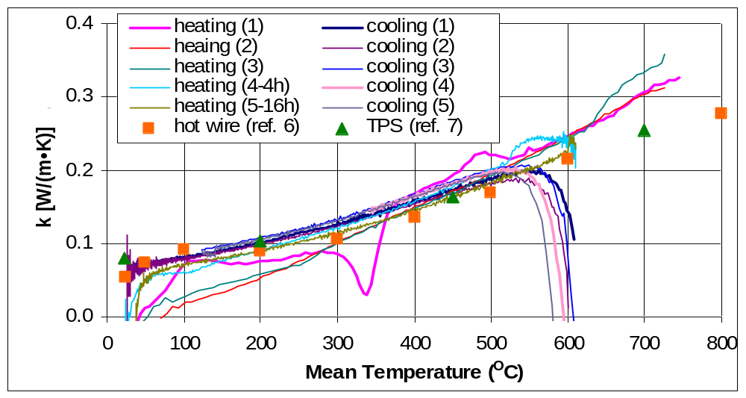

A comparison of the heating curves is even more informative. The differences among the heating curves for the first and the two subsequent runs should be indicative of the reactions, etc. occurring in the FRM. In the data in Figure 7, two phenomena appear to be contributing to these differences. First, there is an endothermic contribution, most likely due to dehydration of the hydrated cement component of the FRM. This is indicated by the downward “peaks” in the first heating curve that fall below the nominal thermal conductivity values. These endothermic reactions should reduce the heat flow through the specimen and thus appear as a reduction in the “effective” thermal conductivity. In Figure 7, they are clearly present for mean temperatures between 300 ºC and 400 ºC. Interestingly, prior to and beyond this range of temperatures, there appear to be several smaller exothermic peaks relative to the baseline curves. There are at least two possibilities for the cause of these apparent exotherms. One would be the presence of true exothermic reactions within the FRM, such as those that would be generally expected during the decomposition of any organic components within the material. The second (more likely) possibility is that this increase in effective thermal conductivity is due to the convection of superheated steam and gases created during the endothermic dehydration reactions. The particular FRMs evaluated in this preliminary study have a high porosity and a fairly open pore structure so that the steam produced during the dehydration reactions (and its accompanying energy) could be easily driven inward towards the stainless steel plate slug. This phenomenon would appear as an apparent increase in the effective thermal conductivity of the FRM material, and would likely only be present during the initial heating cycle. This same transport of steam/gas, or more specifically the lack thereof, is responsible for the often observed spalling of high-performance (low permeability) concrete during fire exposure.¹⁵

In Figure 7, it can be observed that by combining the effective thermal conductivity results produced during a complete heating/cooling cycle such as cycle #2, a much larger temperature range can be covered than that covered by an individual heating or cooling curve. This is due to the transient effects present both during the initial part of the heating curve and during the transition that occurs as the direction of heat flow is reversed during the cooling cycle. Much of the transient effect on heating was removed when the heating rate was slowed to either ≈150 ºC/h or ≈37.5 ºC/h, as illustrated by the results in Figure 7 for heating curves 4 and 5, respectively.

Based on these considerations, the following experimental procedure will be adopted for all future testing of FRMs using this slug calorimeter. The first two heating/cooling cycles will follow the heating curve shown in Figure 6, with natural cooling. Finally, a third heating/cooling cycle will consist of heating the furnace to 600 ºC slowly over the course of 4 h, then holding this temperature until it is also nearly achieved by the slug plate, followed once again by natural cooling. These three sets of curves will be used to characterize the thermal performance of the FRM as presented above.

The testing protocol outlined above was applied to the evaluation of FRM B. For the first two heating curves, times of 104 min and 102 min, respectively, were required for the inner steel slug to reach a temperature of 538 ºC, slightly less than those observed for FRM A above. The effective thermal conductivities computed from equation (7) are provided in Figure 8. The results are quite similar to those in Figure 7 with a few characteristic differences. In comparing the heating curves for the 1st and 2nd cycles in Figure 8, it is observed that the endotherms and exotherms are generally smaller in magnitude in comparison to those observed in Figure 7. This is consistent with the lower mass loss (less reaction) of FRM B relative to FRM A (Figure 5). In addition, there is some indication of an additional high temperature endothermic reaction present for FRM B, possibly due to decarbonation of the carbonated portland cement component of the FRM. Secondly, there is a larger observed difference between the slug calorimeter and the previously measured thermal conductivities at higher temperatures (> 400 ºC) than that observed in Figure 7. Because FRM B has a significantly lower density and higher (open) porosity than FRM A, it would be expected that any increased heat transfer due to radiation between the Inconel plates and the stainless steel slug would be enhanced in this material relative to FRM A. For temperatures below about 400 ºC, where these radiation effects would expected to be much less significant, the agreement between the slug calorimeter effective thermal conductivity values and those previously measured is within 20 %.

2) Fumed-Silica Insulation Board
In addition to being used as a guard insulation material, the fumed-silica board was also utilized as the specimens themselves in one set of three heating/cooling cycles. The material is non- reactive, so that the computed thermal conductivity results can be compared directly to the previously measured values.^{8,9} However, an additional complication arises in this case. When the fumed-silica board is used only as guard insulation, it has a much lower thermal conductivity than the typical FRM specimens and the assumption of one-dimensional heat transfer through the
Figure 8– Effective thermal conductivity results for FRM B in comparison to measured data.^{6,7}
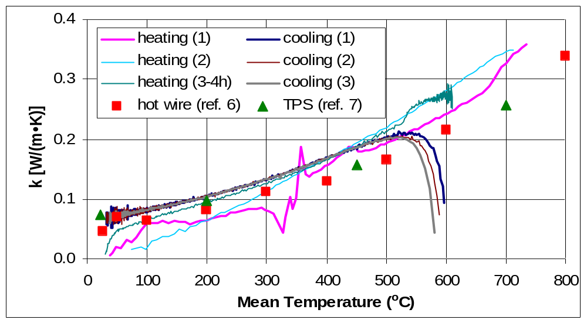

thickness of the guarded square FRM specimens appears to be valid, as indicated by the results presented above. Conversely, when the fumed-silica board is used for the specimens as well, the relative heat transfer through the “guarded” areas of the sandwich configurations becomes significant. While the temperature rise of the slug is still indicative of the heat flow into the slug, the area (A in equation (7)) for this flow is no longer simply 0.152 m by 0.152 m. For the analysis presented below, it has been assumed that in this case, the total area available for heat transfer is given by the total area of specimen surrounded by the guard (0.203 m by 0.203 m) plus the area of the thin sides of one half of the slug calorimeter (two times 0.203 m by 0.00635 m plus two times 0.152 m by 0.00635 m). In addition, the mass of the “FRM” specimen was taken as the mass of the fumed-silica insulation board specimen plus the masses of all of the guard materials comprising one half of the sandwich specimen configuration.

Physically, these first order approximations seem reasonable and as shown in Figure 9, they do produce thermal conductivities for the cooling curves that are both reproducible and that agree with the previously measured data to within about 5 %. The data in Figure 9 appear much noisier than those in Figures 7 and 8, but it must be kept in mind that the scale on the y-axis in Figure 9 has been reduced by a factor of eight relative to that employed in the other two figures. One other point worth noting from Figure 9 is that once again, only the heating results for the third run, where a more gradual heating curve (extending only up to 500 ºC in this case) was employed, compare favorably to the gradual cooling results for the three runs and the previously measured data. In the first two runs that employed basically the same heating rate as that shown in Figure 6, due to the low thermal conductivity (and thermal diffusivity) of the fumed-silica board, “steady-state” conditions were apparently only approached at the very end of the heating curve (500 ºC and beyond). The reproducibility of the heating and cooling curves for the first two runs in Figure 9 does provide further support that the fumed-silica board is indeed behaving as a non-reactive material over the temperature range employed in this preliminary study. The results for run 3 with the slower heating rate indicate once again the potential for piecing together the thermal conductivity values determined from the heating and cooling curves to provide a single thermal conductivity versus temperature curve that covers a larger temperature range than either of its two component curves. Radiation effects are seen to be of much less importance in this material as the computed values of k agree well with those previously measured over the entire temperature range investigated with the slug calorimeter. Of course, the fumed-silica insulation board had been formulated specifically to minimize radiation transfer at high temperatures via the addition of an opacifier.⁸

Figure 9– Computed effective thermal conductivity results for fumed-silica insulation board in comparison to previously measured NIST data (with error bars indicating ± 5 %).^{8,9} Note: NIST data have been corrected to values for one standard atmosphere of pressure (sea level) using the procedure provided in reference 9.
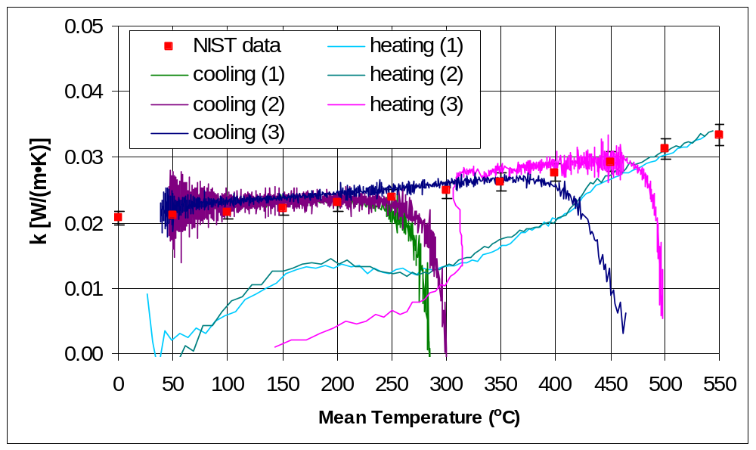

The first two heating tests with the fumed-silica insulation board were terminated when the exterior of the specimens reached a temperature of about 900 ºC, quite similar to the termination point used for the testing of the two FRMs. However, in comparison to the FRMs, where the slug had achieved a temperature of about 540 ºC at this point, for the fumed-silica board, the interior slug temperature was still well below 200 ºC at this time. Naturally, this reinforces the critical importance of using a low thermal conductivity material to protect steel structures exposed to fire.

Conclusions and Future Directions

The use of a slug calorimeter for evaluating the thermal performance of fire resistive materials has been successfully demonstrated. Key components of the system include the use of a “sandwich” specimen to provide an adiabatic boundary condition at its central axis and the utilization of multiple heating/cooling cycles to provide information on the influence of reactions and convective transport on the computed effective thermal conductivity values. The results obtained in this relatively simple small scale test can provide valuable insights into the mechanisms through which the FRM protects the steel substrate in an actual fire.

The current experimental setup is now being modified to include an exhaust fume hood at the top of the furnace so that it may be applied to a wider variety of FRMs that emit organics as well as water and CO₂. It is envisioned that further modifications to the experimental setup may be required to evaluate intumescents and other FRMs that undergo considerable changes in their dimensions during exposure to a fire.

References:

1) ASTM Annual Book of Standards; ASTM International: West Conshohocken, 2004.
2) Bentz, D.P., Prasad, K.R., and Yang, J.C., “Towards a Methodology for the Characterization of Fire Resistive Materials with Respect to Thermal Performance Models,” submitted to Fire and Materials, 2004.
3) Bartholmai, M., Schriever, R., and Schartel, B., “Influence of External Heat Flux and Coating Thickness on the Thermal Insulation Properties of Two Different Intumescent Coatings Using Cone Calorimeter and Numerical Analysis,” Fire and Materials, 27, 151-162, 2003.
4) Metals Handbook, 10th edition, ASM International, Materials Park, OH, 1990.
5) Bogaard, R.H., Desai, P.D., Li, H.H., and Ho, C.Y., “Thermophysical Properties of Stainless Steels,” Thermochimica Acta, 218, 373-393, 1993.
6) Anter Laboratories, Inc., Transmittal of Test Results, report to NIST, 2004.
7) Dinges, C. (Hot Disk Laboratories), Report on Measurements on Samples Supplied by NIST, report to NIST, 2004.
8) Zarr, R.R., Somers, T.A., and Ebberts, D.F., “Room-Temperature Thermal Conductivity of Fumed-Silica Insulation for a Standard Reference Material,” NISTIR 88-3847, U.S. Department of Commerce, October 1988.
9) Smith, D.R., and Hust, J.G., “Microporous Fumed-Silica Insulation Board as a Candidate Standard Reference Material of Thermal Resistance,” NISTIR 88-3901, U.S. Department of Commerce, October 1988.
10) Culimeta Textilglas Technologie GmbH & Co., General Information: Flexipor© Microporous Insulating Board, http://www.culimeta.de, accessed September 2004.
11) Microtherm, Microtherm® Insulation – Product and Performance Data, http://www.microtherm.uk.com, accessed October 2004.
12) Taylor, B.N., and Kuyatt, C.E., “Guidelines for Evaluating and Expressing the Uncertainty of NIST Measurement Results,” NIST Technical Note No. 1297, U.S. Department of Commerce, Washington, D.C., September 1994.
13) Gustafsson, S.E., “Transient Plane Source Techniques for Thermal Conductivity and Thermal Diffusivity Measurements of Solid Materials,” Rev. of Sci. Instrum., 62 (3), 797-804, 1991.
14) Flynn, D.R., and Gorthala, R., “Radiation Scattering Versus Radiation Absorption- Effects on Performance of Thermal Insulation Under Non-Steady-State Conditions,” Insulation Materials: Testing and Applications: Third Volume, ASTM STP 1320, American Society for Testing and Materials, West Conshohocken, PA, 366-380, 1997.
15) Bentz, D.P., "Fibers, Percolation, and Spalling of High Performance Concrete," ACI Materials Journal, 97 (3), 351-359, 2000.
Journal of Adhesion, Vol. 81, 1-18, 2005
Critical and Subcritical Adhesion Measurements of a Model Epoxy Coating Exposed to Moisture Using the Shaft-Loaded Blister Test

E. P. O’Brien◊
Center for Adhesive and Sealant Science
Virginia Tech, Blacksburg, 24061

S. L. Case
Lord Corporation
Cary, North Carolina 27512

T. C. Ward*
Department of Chemistry
Virginia Tech, Blacksburg, 24061
Virginia, USA

*Address correspondence to Thomas C. Ward, Department of Chemistry, 2107 Hahn Hall (0344), Virginia Tech, Blacksburg, VA 24061, USA. E-mail: tward@vt.edu
◊Current address: National Institute of Standards and Technology, Buildings and Fire Research Laboratory, Gaithersburg, Maryland 20899

Abstract
The shaft-loaded blister test (SLBT) was used to investigate the adhesion between a model epoxy coating and a silicon oxide surface as a function of relative humidity. Critical and sub-critical strain energy release rates were measured using specimens that incorporate reinforcing layers of Kapton® film. A simplified procedure that eliminates the need for video imaging to measure the blister radius and fracture energy was developed. A critical relative humidity level for adhesion loss was observed, in agreement with previous measurements for polymeric systems. The SLBT was confirmed to be particularly attractive for fracture energy measurements on thin, strongly adhered coatings and films which otherwise tend to be problematic.

Key Words: shaft-loaded blister test, water-assisted subcritical crack growth, stress corrosion cracking, epoxies, moisture, durability, microelectronics, critical relative humidity, wedge test, coatings, thin films

Introduction
Water is often regarded as the primary agent in the reduction of service life and reliability of adhesive joints and composites. [1] This is resultant from absorption of atmospheric moisture into the polymeric adhesive, which typically accumulates at the interface and displaces the polymer from the adherend surface. [2, 3] Epoxy adhesives are particularly sensitive to moisture, resulting in a dramatic loss of adhesion strength when exposed to moisture above a critical relative humidity level. [4-11] The critical relative humidity level (RH) is typically between (50 – 70) %.
Sub-critical adhesion testing is of practical interest to engineers and scientists because it explores adhesive debonding in a range of crack velocities and applied strain energy release rates, G, which are significantly less than required for catastrophic failure. Therefore sub-critical adhesion testing simulates the failure occurring in the real-life application or service life of the adhesive. Crack growth can be driven by small applied loads generated by residual stresses, thermomechanical cycling, and mechanical or vibrational loading during service. [12] An additional advantage of sub-critical testing over conventional adhesion tests is the reduced ambiguity associated with the dependence on crack velocity of the measured adhesion energy, which is associated with viscoelastic effects at the crack tip and in the bulk adhesive.
The effects of an invasive environment on adhesive bonds can be examined with subcritical adhesion measurements where tests during submersion in heated hostile fluids are possible. The average crack velocity, v (da/dt) and the applied strain energy release rate, G, are measured, where a is the crack length. A schematic of a typical v-G curve is shown in Figure 1. Three regions are usually observed, which are related to the mechanism for crack advancement. [12-14] Region III is associated with critical fracture events, which is independent of the environment for bulk glass fracture. Region II is strongly environment dependent, but only weakly dependent on the crack driving energy. This is characteristic of fracture where diffusion of the penetrant or environmental fluid to the crack tip is the rate limiting step for crack advancement. In Region I low crack velocities and low applied crack driving energies are found. The crack velocity is thought to be controlled by a stress-activated chemical reaction of the penetrant with the bonds at the crack tip. [15] At the lowest crack velocities, below Region I, there exists a threshold value of crack driving energy, G_{Th}, below which no crack propagation is observed.
Figure 1. Schematic of a typical v-G curve illustrating the three regions of crack growth and the threshold value of G.

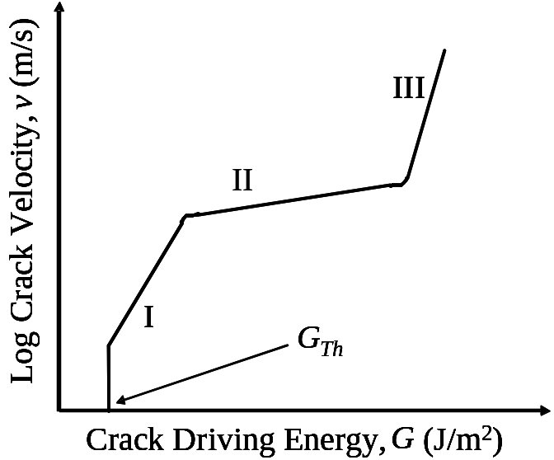

Traditionally, subcritical fracture test specimens have been laminated beams, where the adhesive is bonded between two parallel rectangular rigid adherends. Examples of the laminated beam type experiments are the double cantilever beam (DCB) wedge test [16], the asymmetric double cantilever beam test [15], the double cleavage drilled compression specimen [17], and the four-point flexure samples [18]. The advantages of laminated beam type specimens are: 1) the adhesive is loaded elastically away from the crack tip, 2) high strain energy release rates are obtainable, 3) the fracture mechanics models for analysis are well understood, and 4) the specimens can be self-loading. The disadvantage of these type of tests is that they may require a sophisticated experimental set-up to measure the crack length (video camera, acoustic or electrical methods). Additionally for samples exposed to a fluid environment, the equilibration time may be long due to the two impermeable substrates causing diffusion into the adhesive only from the edge. This leads to a heterogeneous distribution of diffusant in the adhesive joint.

With respect to the laminated beam type specimens, there are advantages to utilizing the shaft-loaded blister test. The time for environmental saturation is relatively short, resulting from the exposed face and short diffusion path. [19, 20] In addition, the specimen geometry is axisymmetric, which reduces any misleading edge effects caused by degradation of the interface away from the crack tip. Some disadvantages of the shaft-loaded blister test are that its fracture mechanics models have not been studied as extensively as the laminated beam specimens; and, like most coatings tests, the maximum value of the strain energy release rate before film rupture occurs is limited by the film’s mechanical strength and the intrinsic interfacial toughness. Plastic yielding of the coating also complicates the analysis. Furthermore, the strain energy release rate is a function of 1/a^{4/3} and therefore will approach a threshold value of G more slowly than beam type specimens. For the DCB wedge test, the strain energy release rate decreases as a function of 1/a⁴. Therefore, a wide range of G values can be obtained for a relatively small change in crack length and the threshold energy can be rapidly approached.

In this work, the shaft-loaded blister test (SLBT) was used to investigate the effects of relative humidity on an epoxy coating bonded to glass and silicon wafers. A typical experiment utilizes the controlled displacement of a spherically capped shaft, driven by a universal testing machine (UTM) to create a growing blister, as an alternative to applying fluid or gas media to generate the fracture (Figure 2). [21-27] Although the SLBT has been used extensively to study polymer and thin film adhesion, to date the technique has not been adapted to the study of moisture assisted subcritical crack growth. Specimens were tested by two methods: (1) the more common critical method where adhesive failure is essentially catastrophic and (2) by modifying the SLBT configuration and measuring adhesion over a long time scale in subcritical crack growth experiment.

Experimental

Materials
The model epoxy adhesive was Epon 862 bisphenol-f resin (Shell Chemical Corporation, Houston, TX) mixed with 10 parts per hundred resin (phr) of 1,4-butanediol (added to increase the solubility of the curing agent) and cured with 3 phr of 4-methyl-2-phenylimidazole. [28] Details of the physical properties of the model epoxy can be found elsewhere. [28] Quartz and silicon wafers were utilized as substrates. The quartz substrates were obtained from ChemGlass Inc. (Vineland, NJ) in a 15.24 x 15.24 x 0.9525 cm³ (6” x 6” x 3/8”) sheet. The silicon wafer substrates, supplied by Hewlett-Packard Co. (Corvallis, OR) were 152.4 mm (6” inch) diameter with a thermally grown silicon oxide 10 nm thick.

Figure 2. Schematic of the shaft-loaded blister test.
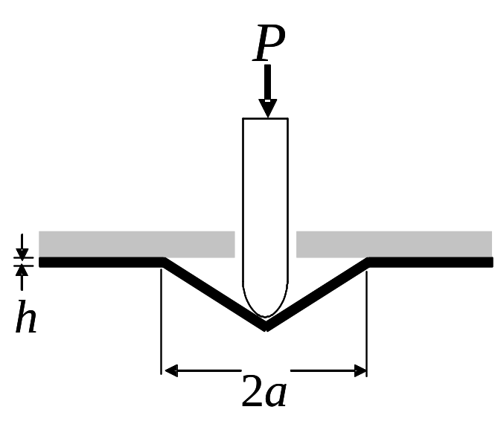

Blister Test Specimen Preparation

Critical Adhesion Measurements
Critical adhesion measurements were made on the model epoxy bonded to quartz. Quartz is an appropriate substrate for our investigation since it will support significant loads (due to its thickness) in convenient SLBT geometries. It is also composed mostly of silicon oxide, having a surface similar to silicon wafers used in the microelectronics industry. A schematic of the critical shaft-loaded blister test specimens is shown in Figure 3. Quartz sheets were cut into 3.6 x 3.6 cm² (1.5 x 1.5 in.²) squares and a 0.8 cm (0.31”) diameter hole was drilled in the center. A pre-crack was fabricated by placing a 0.95 cm (3/8”) diameter piece of Kapton® pressure sensitive adhesive tape (PSAT) over the hole in the center of the quartz substrate. The Kapton® PSAT consists of a 25 μm (1 mil) thick Kapton® backing and a 37.5 μm (1.5 mil) thick acrylic pressure sensitive adhesive. The tape also provided additional mechanical reinforcement to the thin epoxy film at the highly stressed contact area between the coating and shaft-tip. To prepare the specimen, the un-cured model epoxy was first coated on the quartz substrate. A 50 micron (2 mil) thick piece of Kapton® film (no PSA) was then placed on top of the epoxy coating. The Kapton® film acts as a mechanical reinforcing layer for the epoxy coating. The resulting adhesive coating is therefore a composite of the model epoxy, Kapton® PSAT (located solely in the center) and Kapton® film. A schematic of the test specimen is shown in Figure 3. The sample was then cured in a convection oven for one hour at 130 °C and placed in a dessicator to slowly cool (approximately 30 minutes). The typical epoxy film thickness varied between samples from (50 to 100) μm, with ± 5 μm uniformity in the films. Samples were conditioned at constant relative humidity (8, 29, 42, 71, or 98 %) for 3 days at room temperature. This was sufficient time for the adhesive to be saturated. The relative humidity was regulated using saturated salt solutions. [29-31] After environmental exposure, the samples were immediately tested at ambient temperature and humidity (≈50%). Three samples were tested for each relative humidity using an universal testing machine (UTM) and shaft terminated with a ball bearing approximately 0.63 cm (1/4”) in diameter. The UTM cross head displacement rate was 0.1 mm/sec.
Figure 3. Schematic of critical shaft-loaded blister test specimen.

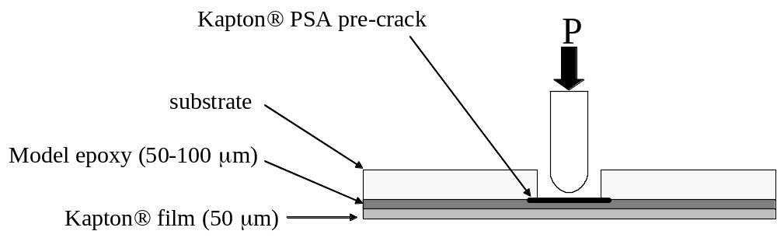

Constant Load Subcritical SLBT Specimens
Subcritical adhesion measurements of the model epoxy were obtained using the silicon wafer substrates. A hole approximately 12.5 mm in diameter was produced in the center of the silicon wafer using a diamond coated drill bit and a Dremel® tool. Care must be taken when drilling the brittle wafers. The wafer was then rinsed with isopropyl alcohol and dried under a stream of ultra-high purity nitrogen gas. The hole in the wafer was then covered with a 0.95 cm (3/8”) diameter piece of Kapton® PSAT. The wafer was uniformly coated with epoxy adhesive using a pneumatically driven doctor blade. A (152.4 x 152.4) mm² (6” x 6”) square piece of Kapton® (50 μm thick) was carefully applied on the wafer to avoid disrupting the adhesive and forming air bubbles. The coated wafer (with Kapton®) was cured under identical conditions to the “critical” specimens described previously.

To develop the sub-critical blister test specimen, a sample must be self-loading, the integrity of the thin adhesive coating must be maintained, and the sample must be exposed to the fluid. A schematic of a scheme meeting these requirements is shown in Figure 4. To fabricate a simple self-loading, yet constant load, SLBT specimen, a hole was punched in the center of the coating that can accommodate a 2.54 mm (or 4/40”) stainless steel machine screw. The machine screw acts as the fastener from which to suspend a “dead load” via a flexible wire. A non-corrosive and high density material such as lead is recommended as the weight because of the corrosive nature of the saturated salt solutions. The punched hole containing the screw was sealed with a room temperature cure epoxy (Devcon 2-ton epoxy, Danvers, MA). The entire SLBT specimen was placed in a large glass vessel and conditioned at constant relative humidity (42, 71, or 98%) at room temperature. These values span the critical relative humidity value for adhesion loss.

Analysis
The strain energy release rate (crack driving energy), G, can be calculated from the “load-based equation” (Equation 1) based on the load, P, and blister radius, a. [12]
Equation 1 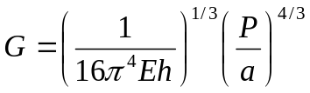

Figure 4. Schematic of the sub-critical shaft-loaded blister test specimen.
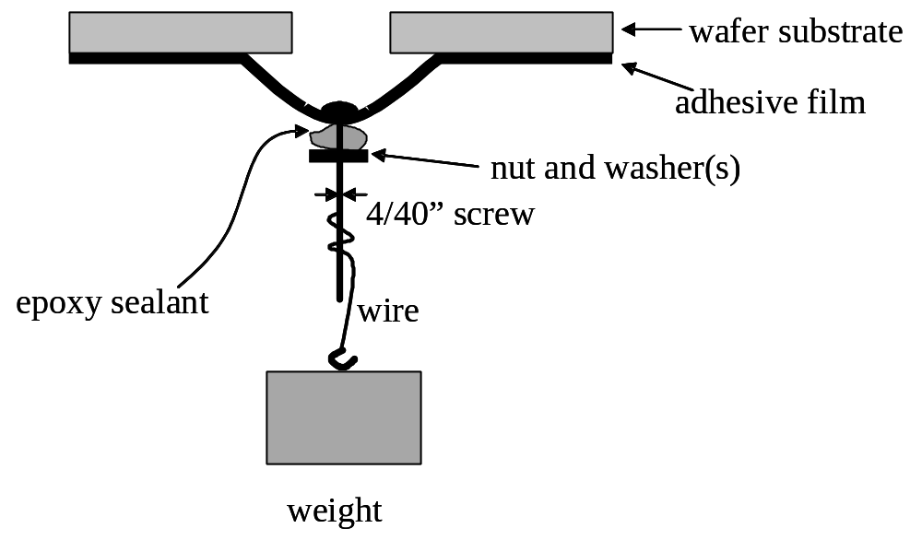

where E is the Young’s tensile modulus, and h is the thickness of the adhesive coating. The modulus of the coating for the bi-layer film (Kapton® and epoxy adhesive) is estimated from a simple rule of mixtures:
Equation 2 E_{composite} = v_{Kapton®} E_{Kapton®} +v_{Epoxy} E_{Epoxy}
where E_{composite} is the modulus of the composite, v_{Kapton®} and v_{Epoxy} are the volume fractions of the Kapton® backing and epoxy, respectively, and E_{Kapton®} and E_{Epoxy} are the moduli of the Kapton® backing and epoxy, approximately 2.5 GPa [28] and 6 GPa [32], respectively.

Equation 1 for the strain energy release rate is independent of the amount of plastic deformation that might occur in the adhesive at the contact zone between the shaft-tip and adhesive coating. [27] This is located in the center of the blister and is also where the load is suspended in the subcritical experiments. The expression for the crack driving energy (Equation 1) is also relatively insensitive to the value of (Eh) because the film’s tensile rigidity (Eh) is raised to the (-1/3) power. As a consequence, the SLBT is particularly advantageous for environmental durability testing since G is not strongly dependent on the values of the modulus and thickness, which are functions of the moisture content, temperature, and exposure time. The contribution of the Kapton® PSAT is negligible for the same reasons that G is independent of plastic deformation in the center of the blister.

For the critical adhesion measurements, samples were tested using loading and unloading cycles, which were repeated up to seven times, to determine the crack length as a function of load. The load applied by the UTM as a function of the resulting central shaft displacement (w₀) for successive cycles on a single sample is shown in Figure 5. In this test procedure, the film was loaded and the crack was allowed to propagate several mm. The load was removed, as was the sample from the UTM, and two or three measurements were made to calculate the average blister radius. This procedure is different from the typical blister radius measurement where the crack is allowed to propagate continuously and the diameter is observed simultaneously with a video camera. An example of our typical load as a function of blister radius curve is shown in Figure 6. Note that the fitted line passes through the origin as Equation 1 suggests. Utilizing the successive loading and unloading cycles, considerable effort involving measuring the blister radius with a video camera has been eliminated. And unlike beam type specimens that utilize opaque adherends, the crack length can be readily measured in our configuration. Therefore, the SLBT requires only an UTM and eliminates the need for sophisticated crack measuring equipment.

Figure 5. Successive load as a function of central shaft displacement curves for 98% relative humidity. The filled in symbols are the loading curves and the unfilled symbols are the unloading curves.
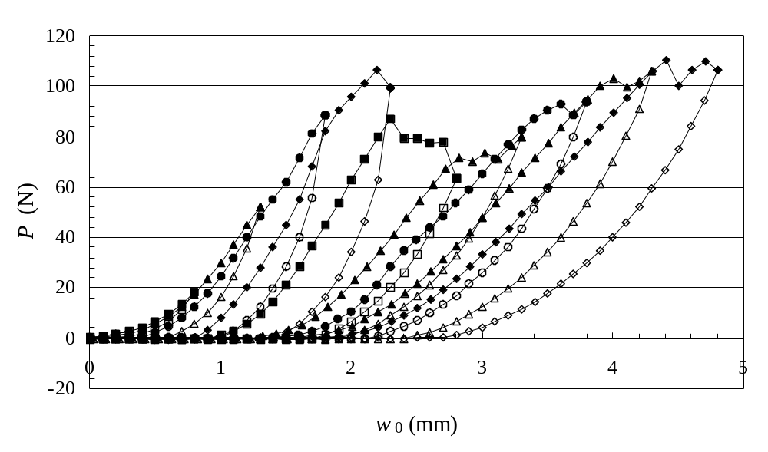
For the sub-critical experiments the average blister radius was measured periodically. The average crack velocity, v, (da/dt) was determined from the relationship between the average blister radius as a function of time. Again, no optical equipment was necessary.

Results and Discussion

Critical Strain Energy Release Rates
The calculated strain energy release rates are shown in Figure 7 as a function of the relative humidity. At (8, 29, and 42) % relative humidity, the film always ruptured before debond growth occurred, indicating very high interfacial toughness. However, the adhesive interface of specimens conditioned at the high relative humidities degrades sufficiently for debonding to occur. The resulting strain energy release rates are (163 ± 27 and 111 ± 27) J/m² for 71 % and 98 % relative humidity, respectively. A dramatic loss of adhesion occurs above 70 % relative humidity, suggesting that there is a critical relative humidity environmental conditioning level for adhesion loss. In the case of film rupture, based on the initial hole size, a₀, and the maximum load at break, a lower bound of the strain energy release rate can be estimated. The values of G calculated from the load at rupture are not reported.

Figure 6. Load (P) as function of blister radius (a) at 98% relative humidity.
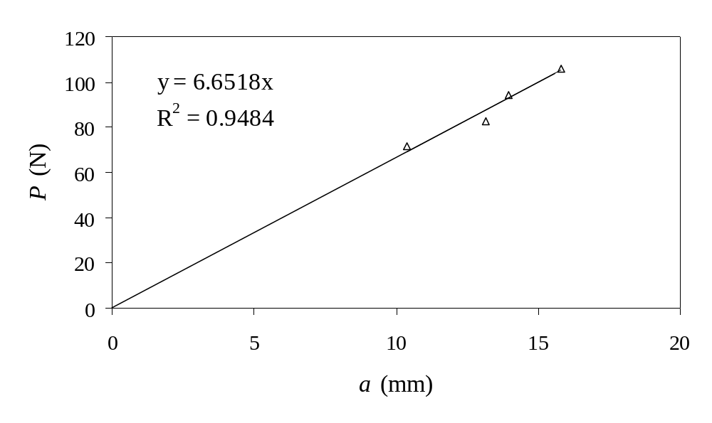
Figure 7. Summary of strain energy release rates G (J/m²) as a function of relative humidity for critical SLBT.
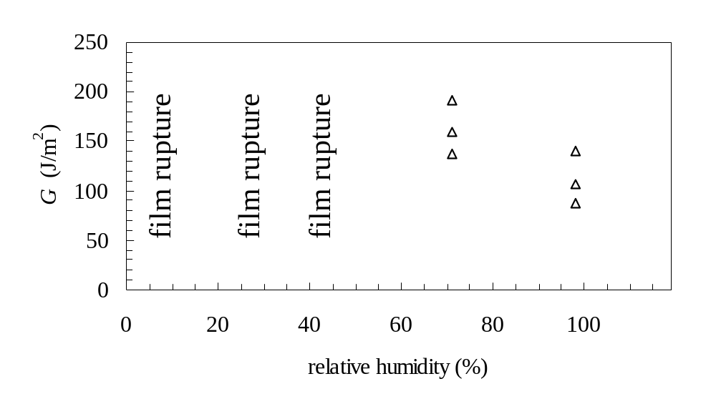
While exhibiting beneficial attributes such as axisymmetric geometry and the short saturation times, and the relatively simple sample preparation and test procedures, the shaft-loaded blister test has some shortcomings; namely, the adhesive film can rupture before debonding occurs resulting in more qualitative observations. This may be assigned to the large stresses generated within the film near the contact area between the film and shaft tip. Significant, visible, plastic deformation at the contact area may still arise, even if film rupture does not occur and crack propagation takes place. However if plastic deformation is confined solely to the center of the blister and not at the crack tip, equation 1 remains valid. [27] One method to reduce plastic deformation and maintain the mechanical integrity of the film is to reduce the applied load, and therefore the stress on the film. This strategy was employed in the subcritical fracture experiments.

Constant Load Sub-Critical Fracture
The v-G curves obtained for the model epoxy as a function of relative humidity (42, 71, and 98 %) are shown in Figure 8. For each specimen, the initial value of the crack driving energy was approximately 40 J/m². As the crack advances, the value of the strain energy release rate gradually decreases as the size of the blister radius increases until the crack appears to arrest at the value of G_{Th}. The average along with one standard deviation of G_{Th} as a function of relative humidity is listed is Table 1. The value of G_{Th} for 42 % relative humidity conditioning is significantly greater than either 71 % or 98 % relative humidity cases. Moreover, G_{Th} is almost identical for the 71 % and 98 % relative humidity exposures. In some cases, G_{Th} has been found to be dependent on the concentration of water molecules at the crack tip, and therefore the relative humidity. [15, 18, 33] Other work has shown that above a critical relative humidity value ranging between (50 to 70) %, the adhesive fracture energy is constant and is independent of the vapor pressure. [34, 35] Condensation at the crack tip due to capillary forces may negate any differences in the effect of moisture level conditioning at high humidity. This behavior is predicted from the classic Kelvin equation for the meniscus radius. From that equation, at 70 % relative humidity the meniscus radius is predicted to be approximately 1 nm, about the size of a bond length or molecule.

Figure 8. SLBT debond velocity (m/s) as a function of crack driving energy, G, (J/m²) and relative humidity (42, 71, and 98 %).

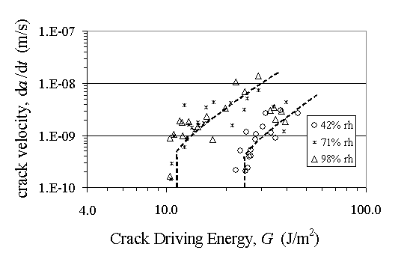

Table 1. Threshold crack driving energy, G_{Th}, as function of relative humidity.
 | 42 % rh | 71% rh | 98% rh
Average G_{Th} (J/m²) | 25.2 | 10.2 | 11.5
Standard Deviation | 4.9 | 2.1 | 2.6

Residual stress can also affect the adhesion measurement, if the G_{Th} is similar in magnitude to G attributable to residual stress. The residual stresses in the coating originate from the contraction of the epoxy during cure and the difference in the coefficient of thermal expansion (CTE) between the substrate, epoxy, and Kapton® backing. During the critical experiments, residual stress is not expected to be a factor as the stress applied by the UTM is much greater than the residual stress in the film.[36] Depending on if the residual stress is tensile or compressive, the applied strain energy release rate will be less than or greater than the zero residual stress condition. [37, 38]

The tensile residual stress in the model epoxy film bonded to glass was estimated from two different methods. In the first method, residual stress was estimated from the radius of curvature of a bimaterial strip of epoxy to glass and found to be 5.5 MPa. [39] In the second method, the residual stresses were estimated from Equation 3. [40]
Equation 3 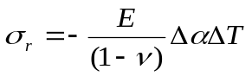
where Δα is the difference in the CTE between the substrate and adhesive and ΔT is the difference between the temperature of the sample and the stress free temperature. Utilizing values of the stress free temperature and CTE [39], the residual stress was found to be as high as 20.7 MPa. These values were for the dry coatings that have been immediately removed from the oven such that the stresses have had little time to relax.

To determine if residual stresses play a role in our subcritical adhesion measurements, the value of G_{Th} was compared to the strain energy release rate of a coating delaminating from residual stress (see Equation 4). [40, 41]
Equation 4 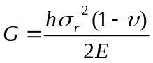
Where σ_{r} is the residual stress and υ is the Poisson ratio. Using the values of residual stress determined from the bimaterial specimen and Equation 3, the strain energy release rate in the dry coating was found to be 0.2 and 2.6 J/m², respectively.

Below the critical relative humidity, at 42 %, the values of G_{Th} obtained by the SLBT are much greater than the G attributable to residual stress. Therefore at 42 % relative humidity, residual stress is not likely a significant factor. However, at high relative humilities, both the G values from residual stress and the SLBT are similar in magnitude which suggests that residual stress may play a role. However at high relative humidities, there is evidence that the tensile residual stresses in the dry state relax and decrease to zero or can even become compressive. [42, 43] In the case where there is compressive residual stress, the measured threshold value of G_{Th} will be greater than the unstressed condition, leading to an overestimation of G_{Th}, suggesting the interface is more durable than it appears. It should be noted that for this adhesive, after saturation, the bimaterial strips did not exhibit any signs of compressive stresses. The evidence shows that debond growth is not driven by tensile residual stresses, but by the applied load and presence of moisture.

The adhesive fracture energy can also be affected by changes in the mechanical properties of the epoxy and backing due to moisture absorption. Although it is expected that the Kapton® will not be drastically affected by the moisture, some epoxies have shown a decrease in the modulus by as much as 80 % in high humidity. [19] The modulus of the model epoxy used in this work was found to decrease modestly by 18 % relative to its dry condition. [39] The modulus change and thickness change due to swelling has little effect on the measured debond driving energy, as G ~ (1 / Eh)^{1/3}. This insensitivity to changes in modulus makes the SLBT particularly advantageous for environmental durability studies. The strain energy release rate can also be calculated as: G = P w / (4 π a²).[44] This expression is independent of the mechanical properties and it requires in addition to the load and blister radius, that the displacement, w, to be measured. Mechanical properties of the film can also change due to creep of the adhesive and backing. Creep in the subcritical SLBT may be caused by the suspended loads and resulting stress, the plasticizing effects of humidity, and the long duration of the experiment which in this work was up to 4 months. Creep should not affect the strain energy release rate because Equation 1 depends solely on the mechanical properties of the film at the crack front. Therefore, as the crack continually advances, the film located directly at the crack front is loaded for only a brief period of time.

Experimental uncertainty in the calculation of the values of G, and crack velocity, v, are introduced from the measurement of the blister radius, a, as well as from any slight asymmetry of the blister. The error associated with measuring the blister radius with the micrometer is approximately ± 0.2 mm. Furthermore, the blister radius may not be perfectly symmetric, although this difference is generally small (0.1 to 0.2 mm). In the most extreme cases, the difference between two measurements of the same blister radius is as large as 0.5 mm. Asymmetry can be caused by differences in thickness, residual stress in the epoxy, in the Kapton® backing [45], and any heterogeneities in the intrinsic interfacial adhesive toughness. The experimental uncertainty due to the asymmetry of the blister is essentially unavoidable and difficult to reduce below 0.1 mm. The error attributable to the blister radius measurement depends on the magnitude of the value of G and crack velocity. For values of G between (20 - 50) J/m² the error is ± (1 – 2) J/m², whereas for values of G between (1 – 20) J/m² the error is between ± (0.1 – 0.5) J/m². Crack velocities on the order of 10⁻⁸ and 10⁻⁹ m/s have errors on the order of ± 10 %, which is much less than the inherent scatter. The error is significant for crack velocities of 10⁻¹⁰ m/s or less. However at these crack velocities, the experimental limit of the measurement has been reached and these cracks appear to arrest.

The quartz substrate and the silicon wafer substrates were expected to produce similar adhesion results given that both have surfaces composed of silicon oxide. In the model epoxy-quartz experiments, a critical level of relative humidity was observed where adhesion loss occurred. That is, at a relative humidity of 42%, the reinforced epoxy film ruptured and the adhesive fracture energy was relatively large. Utilizing the constant load sub-critical SLBT, however, the adhesive system could be characterized above and below the critical relative humidity. Therefore by reducing the applied strain energy release rate, and consequently the applied stresses in the adhesive coating, the integrity of the epoxy coating was maintained and the adhesive could be controllably debonded. In addition, from the sub-critical SLBT experiments the evidence of a critical level of relative humidity for adhesion loss was much more qualitative. These results show that the constant-load sub-critical shaft-loaded blister test is a promising new technique for studying the effects of the environmental degradation on adhesive joints and coatings. Given the great difficulty in testing thin, strongly adhered coatings and films, this technique is particularly attractive. Furthermore, we have demonstrated the sub-critical SLBT can be applied to the study of polymer adhesion to brittle silicon wafers which are usually difficult to test given their fragile nature.

The sub-critical SLBT specimen has clarified the mechanism for crack growth in this adhesive system within the range of applied crack driving energies studied. In this work, specimens are different than the classical subcritical crack growth experiments in glasses. This is because the entire adhesive bond is saturated and moisture is already present at the crack tip and vicinity. Therefore, the rate limiting step for crack growth, which produces Region II (the diffusion of moisture to the crack tip), has been “turned off”. This strongly suggests that the mechanism for crack growth in these experiments is not dependent on moisture diffusion, but rather also dependent on stress. Similar results that showed diffusion was not the rate limiting step for subcritical crack growth were obtained by Singh and Dillard who studied sub-critical fracture of an epoxy bonded to glass in a fluid environment using the DCB wedge test. [46] They tested two types of samples that controlled the path of diffusion of liquid into the adhesive joint and therefore the role of the fluid molecules on debond growth. One set of specimens were saturated with fluid prior to applying the wedge and therefore the mechanism for Region II crack propagation was turned off. The other set of specimens were initially dry (0 % concentration of penetrant) and the wedge was applied at the same time as the specimen was introduced to the fluid environment. They observed identical v-G curves between the two types of samples, which suggests that the diffusion of fluid to the crack tip is not the rate limiting step for debond growth. This supports the argument that the mechanism for crack growth in our work is a stress-dependent phenomenon, and not diffusion controlled, indicating that our present results fall in Region I of the v-G diagram.

This work has shown that the SLBT has a number of advantages over other adhesive coating test methods (1) it is an open face coating that reaches saturation rapidly, (2) axisymmetric, (3) simple sample preparation, (4) easily measured debond growth, (5) self loading samples, (6) insensitivity to plastic deformation and creep away from the crack tip, and (7) measuring adhesion to thin brittle substrates is possible. A few limitations to the SLBT exist which are common to other peel type test geometries. The most prominently when the adhesive interface is strong and the film is thin, the adhesive can experience large stresses, leading to film rupture. Also, a concern is delamination of the backing from the adhesive rather than delamination at the adhesive-substrate interface. Much higher strain energy release rates can be achieved with more conventional beam type specimens, but one may encounter other problems such as sample preparation or crack measurement issues. A possible method to increase the available strain energy release rate in the SLBT is to use a thicker backing that will adhere strongly to the adhesive even in a moist environment and be able to support higher loads without creep. Under these conditions, the adhesive may behave less like a stretching membrane and more like a bending plate and a different expression for the strain energy release rate is applicable. [24]
This work convincingly shows that the subcritical SLBT is an excellent method for testing the durability of adhesive coatings. In addition to studying the effect of water vapor, the effects of temperature, various chemical and mechanical stresses (continuous and cyclic), corrosion, and ultraviolet radiation exposure can be investigated with the SLBT. Any changes in the mechanical properties of the adhesive and backing due to exposure to aggressive conditions must be considered. However, changes at the crack front and in the adhered coating must be accounted for only. This is due to the same reason creep in the film is not considered. Caution must be taken if the test temperature of the adhesive is close to its glass transition or if the yield stress is sufficiently low that plastic deformation and viscoelasticity at the crack front is possible. In the case where the SLBT specimen is exposed to moisture and chemicals, the adhesive may be significantly plasticized or swollen such that there is no longer linear elastic behavior at the crack front. Therefore many types of glassy adhesives can be tested within the assumptions of the model. For soft materials like pressure sensitive adhesives and rubbers, cavitation and finger-like instabilities caused by confinement of the adhesive between the backing and substrate can complicate the analysis.

Conclusions
The SLBT was demonstrated to be a simple and informative method for characterizing the degradation of adhesive bonds accelerated by environmental moisture, without the need for sophisticated crack length measurements. Notably, the SLBT was modified for sub-critical fracture testing by applying a self-loading mechanism whereby a mass is suspended from the center of the inverted blister. Our results illustrate the benefits and shortcomings of the SLBT, suggesting that this test method is advantageous for testing thin adhesive coatings which often rupture under high stresses imposed by more conventional test methods. Furthermore, the low applied stresses enables testing of adhesives bonded to fragile, brittle silicon wafers. This study has also provided an additional example of a critical relative humidity for adhesion loss which has been previously observed in many epoxy systems.

Acknowledgements
The authors would like to gratefully acknowledge the financial support of the Center for Adhesive and Sealant Science at Virginia Tech, the Adhesive and Sealant Council, and the Hewlett-Packard Company (Corvallis, OR). The authors thank David A. Dillard and Kai-Tak Wan for their valuable ideas and discussions. Donation of the epoxy resin by the Shell Corporation (Houston, TX) is appreciated. The authors also acknowledge Aaron Forster, Amanda Forster, and Bryan Vogt for their input on this manuscript. Emmett O’Brien thanks Tom Seery, Christopher White, and Jonathan Martin for funding during the preparation of this manuscript. The authors thank the late Francis VanDamme for fabricating the quartz substrates.
References

[1] Kinloch, A.J., Adhesion and Adhesives: Science and Technology. 1987, New York: Chapman and Hall. 26-34.
[2] Wu, W.L., Orts, W.J., Majkrzak, J., and Hunston, D.L., Polymer Science and Engineering, 35, 1000-1004 (1995)
[3] Kent, M.S., McNamara, W.F., Baca, P.M., Wright, W., Domier, L.A., Wong, A.P.Y., and Wu, W.L., Journal of Adhesion, 69, 139-163 (1999)
[4] Brewis, D.M., Comyn, J., Cope, B.C., and Maloney, A.C., Polymer, 21, 1477 (1980)
[5] Cognard, J., International Journal of Adhesion and Adhesives, 8, 93 (1988)
[6] Brewis, D.M., Comyn, J., Raval, A.K., and Kinloch, A.J., International Journal of Adhesion and Adhesives, 10, 247-253 (1990)
[7] Lefebvre, D.R., Takahashi, K.M., Muller, A.J., and Raju, V.R., Journal of Adhesion Science Technology, 5, 201-227 (1991)
[8] Bowditch, M.R., Hiscock, D., and Moth, D.A., International Journal of Adhesion and Adhesives, 12, 164 (1992)
[9] Cognard, J., Journal of Adhesion, 47, 83 (1994)
[10] Lefebvre, D.R., Elliker, P.R., Takahashi, K.M., and Raju, V.R., Journal of Adhesion Science Technology, 14, 925-937 (2000)
[11] Gledhill, R.A., Kinloch, A.J., and Shaw, S.J., Journal of Adhesion, 11, 3-15 (1980)
[12] Kook, S.Y. and Dauskardt, R.H., Journal of Applied Physics, 91, 1293-1303 (2002)
[13] Weiderhorn, S.M., Fuller Jr, E.R., and Thomson, R., Met. Sci., 14, 450-458 (1980)
[14] Lawn, B.R., J. Mats. Sci., 18, 469-480 (1975)
[15] Gurumurthy, C.K., Kramer, E.J., and Hui, C.Y., International Journal of Fracture, 109, 1-28 (2001)
[16] Cognard, J., International Journal of Adhesion and Adhesives, 8, 93-99 (1988)
[17] Ritter, J.E. and Huseinovic, A., Journal of Electronic Packaging, 123, 401-404 (2001)
[18] Lane, M.W., Snodgrass, J.M., and Dauskardt, R.H., Microelectronics Reliability, 41, 1615-1624 (2001)
[19] Chang, T., Sproat, E.A., Lai, Y.H., Shephard, N.E., and Dillard, D.A., J. Adhesion, 60, 153-162 (1997)
[20] Moidu, A.K., Sinclair, A.N., and Spelt, J.K., Journal of Testing and Evaluation, 26, 247-254 (1998)
[21] Malyshev, B.M. and Salganik, R.L., Int. J. of Fracture Mechanics, 1, 114-128 (1965)
[22] Wan, K.T. and Mai, Y.W., Int. J. of Fracture Mechanics, 74, 181-197 (1995)
[23] Wan, K.T., DiPrima, A., Ye, L., and Mai, Y.W., J. of Matl. Sci., 31, 2109-2116 (1996)
[24] Wan, K.T., J. Adhesion, 70, 209-219 (1999)
[25] Wan, K.T. and Liao, K., Thin Solid Films, 352, 167-172 (1999)
[26] Liao, K. and Wan, K.T., Journal of Composite Technology and Research, 23, 15-20 (2001)
[27] O'Brien, E.P., Ward, T.C., Guo, S., and Dillard, D.A., Journal of Adhesion, 79, 69-97 (2003)
[28] Case, S.L. and Ward, T.C., Journal of Adhesion, 79, 105-122 (2003)
[29] Weast, R.C. and Astle, M.J., eds. CRC Handbook of Chemistry and Physics. 60th ed. 1980, CRC Press Inc.: Boca Raton. E-46.
[30] Young, J.F., Journal of Applied Chemistry, 17, 241-245 (1967)
[31] Wexler, A. and Hasegawa, S., Journal of Research of the National Bureau of Standards, 53, 19-26 (1954)
[32] Eichstadt, A.E., Ph.D. Dept. Material Science and Engineering, Virginia Polytechnic and State University (2002)
[33] Wiederhorn, S.M., Journal of the American Ceramics Society, 50, 407-414 (1967)
[34] Lawn, B., Fracture of Brittle Solids. 1993, Cambridge, England: Cambridge University Press.
[35] Israelachvili, J., Intermolecular and Surface Forces. 1992, San Diego: Academic Press Limited.
[36] Allen, M.G. and Senturia, S.D., J. Adhesion, 25, 303-315 (1988)
[37] Thouless, M.D. and Jensen, H.M., Journal of Adhesion Science and Technology, 8, 579-589 (1994)
[38] Clyne, T.W., Key Engineering Materials, 116-117, 307-330 (1996)
[39] Case, S.L., Ph.D. Department of Chemistry, Virginia Polytechnic and State University (2003)
[40] Hutchinson, J.W. and Suo, Z., Advances in Applied Mechanics, 29, 63-191 (1992)
[41] Perera, E.Y. and Eynde, D.V., Journal of Coatings Technology, 59, 55-63 (1987)
[42] Funke, W. and Negele, O., Progress in Organic Coatings, 28, 285-289 (1996)
[43] Hunley, M.T., Dillard, D.A., and Sun, Z. 27th Annual Meeting of the Adhesion Society, Inc. 2004. Wilmington, NC. 207-209
[44] Williams, J.G., International Journal of Fracture, 87, 265-288 (1997)
[45] Park, T., Dillard, D.A., and Ward, T.C., J. Polym. Sci. Part B-Polym. Phys., 38, 3222-3229 (2000)
[46] Singh, H. and Dillard, D.A., Journal of Adhesion, (In Preparation)

Accepted for Publication in The Journal of Adhesion, 2005
Influence of Experimental Set-up and Plastic Deformation on the Shaft-loaded Blister Test

Emmett P. O’Brien†‡*, Stephanie Goldfarb⊥, Christopher C. White†

†National Institute of Standards and Technology
Buildings and Fire Research Laboratory
Gaithersburg, MD 20899

‡University of Connecticut
Institute of Materials Science
Storrs, CT 06269

⊥Cornell University
Department of Mechanical Engineering
Ithaca, NY 14850

*author of correspondence, E-Mail: emmett.obrien@nist.gov

Key words: pressure sensitive adhesive tapes, coatings, fracture, yielding, thin film, membrane, bending plate, bulge test, point load, sphere, contact radius

Abstract
In the shaft-loaded blister test (SLBT), plastic deformation often occurs at the contact area between the shaft-tip and adhesive layer, leading to a larger displacement (blister height) than if the film was loaded elastically. As a consequence, incorporating the displacement variable into the analysis can result in misleading values of the applied strain energy release rate, G. In this work, the influence of plastic yielding at the contact area on G of a thin film was investigated as a function of some common SLBT experimental variables, namely, substrate hole diameter, film thickness, and shaft tip diameter. Test specimens consisted of plies of pressure sensitive adhesive tape adhered to a rigid glass substrate. G was calculated from the following equations: (1) load-based, (2) hybrid, (3) displacement-based, and (4) combination. Decreasing the film thickness, increasing the hole diameter, or decreasing the shaft-tip diameter lead to more plastic yielding at the contact area as well as to an increase in blister height. The increased blister height due to plastic deformation lead to disagreement among the values of G calculated from the different equations when the displacement variable was included in the calculation. However, the load-based equation, which does not include the displacement, was determined to be independent of plastic yielding and the “correct” equation for calculating G. In addition, the film tensile rigidity (Eh) was calculated using an experimental compliance calibration. The effects of film thickness on the mechanical behavior of the film (bending plate vs. stretching membrane) as well as methods to determine the displacement due to plastic deformation are also discussed.

Introduction
Plastic deformation complicates testing adhesive joints and coatings by invalidating the assumptions of linear elasticity, causing adhesive rupture due to large applied forces and creating creep in long term experiments. Coatings are particularly susceptible to plastic deformation or yielding due to the large stresses generated in the film during testing which is a consequence of the small cross-sectional area (thinness) and strong adhesion [1]. Recently the shaft-loaded blister test (SLBT) has been developed to measure the adhesion [2-9] as well as the mechanical properties of thin films and coatings [2, 6, 10-15]. In this experiment, a spherically-capped shaft applies a central load to a film which results in a deflection and delamination (Figure 1). These blister test geometry experiments and analysis have also recently been adopted for measuring the mechanical response of films using a flat punch in a variety of applications [13, 16-21]. The strain energy release rate, G, can be calculated from the following expressions that were derived using linear elasticity [6]:

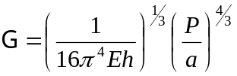 load-based equation (1)

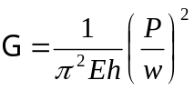 hybrid equation (2)

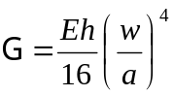 displacement-based equation (3)

Where P is the applied load, a is the debond radius, w is the displacement or blister height, E is Young’s modulus of the adhesive film, and h is the film thickness. The value of G calculated from equation 1 depends strongly on the load and the value of G calculated from equation 3 depends strongly on the displacement. Equation 2 is a combination of equation 1 and 3. Therefore equations 1, 2, and 3 are referred to as the load-based, hybrid, and displacement-based equations, respectively. Combining any two of equations 1, 2, or 3 reveals a fourth equation, denoted as the combination equation, which is identical to that derived by Williams [22] and Jensen [23] and does not incorporate the stiffness (Eh) of the film:

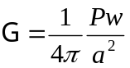 combination equation (4)

The linear elastic equations for a stretching membrane predict the following constitutive relation [6, 10]:

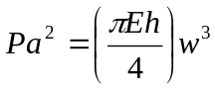 (5)

where collectively Eh is known as the film tensile rigidity, which defines the film stiffness. The value of Eh of the adhesive layer can be calculated from a compliance calibration where a graph of Pa² as a function of w³ yields a slope equal to (πEh) / 4.

Previous work on the SLBT has shown that significant plastic deformation inevitably occurs at the contact area between the shaft-tip and the adhesive film (Figure 2) [2, 6, 9, 10]. As
Figure 1. Schematic of the shaft-loaded blister test. P is the load, w is the displacement or blister height, a is the blister radius, R is the radius of the shaft-tip, and θ is the half angle subtended from the shaft-tip.
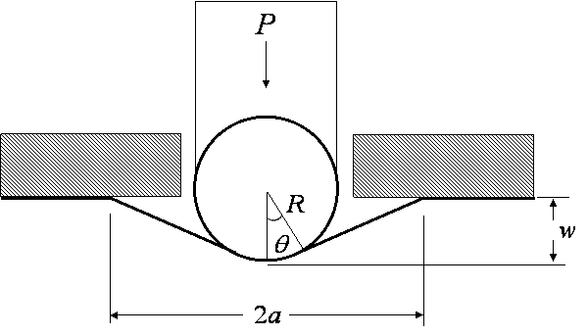

a consequence, the blister height or displacement is overestimated (relative to the elastic model), leading to disagreement among the values of G if the displacement value is incorporated into the calculation (equations 2, 3, and 4). Wan and Mai derived expressions to calculate G that account for plastic deformation at the contact area [6]. However, this increased complexity was found to be unnecessary if G was calculated from the load-based equation, which does not incorporate the displacement value and is believed to be independent of plastic deformation at the contact area [2]. For clarity and convenience we discuss why the load-based equation is believed to be independent of plastic deformation. More details can be found in the work by O’Brien et. al. [2]. In that work, G was measured for stacked layers of PSAT adhered to aluminum. It was argued that if plastic deformation is confined to the area of the shaft-tip, and linear elasticity is valid at the crack front (i.e. the yield stress in the peel arm was not exceeded), then it can be assumed that the load and blister radius are in equilibrium. As a consequence, the assumption of linear elasticity and the application of the load-based equation are valid. Therefore the value of G calculated from load-based equation is “correct” despite the presence of plastic deformation at the contact area. The arguments are supported by consistency of the values of G calculated from the load-based equation for the different stacked layers of PSAT. The work presented in this paper further supports the argument.

As just mentioned, if the stress at the crack front is greater than the yield stress of the film or if the size of the plastic zone at the crack tip is greater than or equal to the film thickness, the linear elastic expressions for G are inapplicable. Equation 6 can be used to calculate the effective membrane stress (for a point load configuration) and can therefore be used to determine if elasticity at the crack front is a good assumption [6]:
Figure 2. Schematic of the area of plastic deformation at the contact area between the shaft-tip and the film. The δ symbol is the penetration of the sphere into the film or displacement due to plastic deformation.

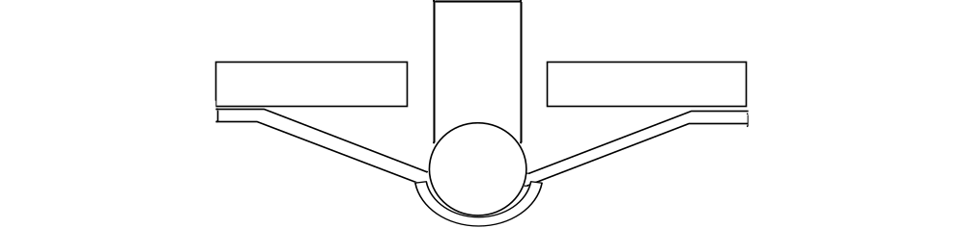
substrate
shaft and shaft-tip
film

N_{eff} = (G Eh)^{1/2} [(log a/r)² + 3/4]^{1/2} (6)

where r is the radial distance from the center of the blister. If the stress exceeds the product of the yield stress, σ_{y}, and the film thickness, h, then yielding can occur (N_{Max} ≥ σ_{y} h). Additional, but more complex, equations for the membrane stress can be found in the work of Wan and Liao [10].

The shaft-tip diameter defines the contact area and thus the stress in the film. Wan and Liao found that the maximum membrane stress, N_{Max}, can be expressed as [10]:

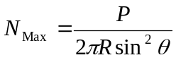 (7)

where R is the radius of the shaft-tip, and θ is the half angle that extends from the contact area to the center of the shaft-tip (Figure 1). As a result, a smaller shaft-tip diameter or a thinner film is expected to result in more plastic deformation and to overestimate displacement.

In this work, the influence of plastic deformation at the contact area on the SLBT is explored by varying the substrate hole diameter, film thickness, and shaft tip diameter. The substrate hole diameter is a test parameter chosen by the experimenter and deserves exploration, despite the fact that for linear elastic conditions the size of the initial debond should not matter. More specifically, the applied load, P, debond radius, a, displacement or blister height, w, are measured and used to calculate G using four equations: (1) load-based, (2) hybrid, (3) displacement-based and (4) combination. With the sole exception of the load-based equation, each equation incorporates the displacement value and is sensitive to the treatment of plastic deformation. In addition, the film tensile rigidity (Eh) was calculated using an experimental compliance calibration. The effects of film thickness on the mechanical behavior of the film (bending plate vs. stretching membrane) as well as methods to determine the displacement due to plastic deformation are also discussed. Test specimens consisted of pressure sensitive adhesive tape (PSAT), up to 3 layers thick, adhered to a rigid glass surface.

Experimental‡
The adhesive tested in this work was Kapton pressure sensitive adhesive tape (PSAT), consisting of a silicon based thermosetting adhesive of thickness 38.1 μm (1.5 mil) covered by a Kapton backing of thickness 25.4 μm (1 mil). The soda lime glass substrate was 9.6 mm thick and was cleaned with acetone prior to each application of the tape. Three different hole diameters were investigated: (6.7, 9.8, and 12.9) mm, denoted as small, medium and large, respectively. To vary the thickness of the film, n stacked plies of PSAT were used, up to n = 3. The Young’s modulus of the Kapton tape is roughly (3.1 ± 0.1) GPa. In the calculation of the film stiffness, Eh, the stiffness of the backing dominates and the soft adhesive layer was ignored. The bonded PSA dimensions were (25.4 x 25.4) mm².

Experiments were performed on a UTM, which measured displacement and load, at a cross-head displacement rate of 0.1 mm/s. Steel ball-bearings were used as the shaft-tip and were fastened to a steel shaft with a 2-part epoxy. The shaft was attached to a 100 kg load cell via a modified drill chuck. Three different shaft-tip diameters were investigated denoted as small, medium, and large: (3.2, 6.4, and 9.5) mm, respectively. During the experiment the image of the propagating blister debond was measured using a digital video camera. Note that a fine powder (or other non-stick layer) can be placed between the film and shaft-tip to reduce adhesion at the contact area.

Uncertainty in the calculated value of G is introduced by the value of the blister radius which is calculated from half the average of the blister diameter in the x and y directions of the video image. The value of the blister radius is affected by any non-symmetry of the blister shape and the measurement from the video image. Asymmetry between the x and y direction was generally small (0.1 mm to 0.2 mm) and was likely caused by residual stress [24] and anisotropy in the Kapton backing [25], and any heterogeneities in the intrinsic interfacial adhesive toughness. The uncertainty in the value of G attributable to the blister radius measurement depends on the magnitude of the value of G and the equation. For the load-based equation and values of G observed in this work ranging between (20 to 50) J/m², the uncertainty is ± (1 to 2) J/m². For the displacement-based equation and G values between (80 to 130) J/m², the uncertainty is ± (10 – 12) J/m². For the combination equation and G values between (35 to 45) J/m², the uncertainty is ± (1 – 2) J/m². For all experiments the standard deviation due to the sample to sample variation is equal to or more than the uncertainty introduced by the blister radius.

Results and Discussion
Effects of Varied Substrate Hole Diameter Size on G
The values of G as a function of the initial substrate hole size were calculated for a single ply and the medium size ball bearing (6.4 mm diameter). The average values for the data sets gathered from these measurements are shown in Figure 3 (a – d) (for clarity error bars are not shown). From the slopes of these plots (a – d) the value of G can be calculated from the load-based, hybrid, displacement-based, and combination equations, respectively. The average values of G and single standard deviation are listed in Table 1. The average and standard deviation are calculated from the values of G obtained from 8 samples.

Figure 3. Adhesion results for varied initial hole size: (a) load as a function of blister radius, (b) load as a function of displacement, (c) displacement as a function of blister radius, and (d) load-displacement as a function of blister radius squared. Symbols are: small diameter (×), medium diameter (▲), and large diameter (○).
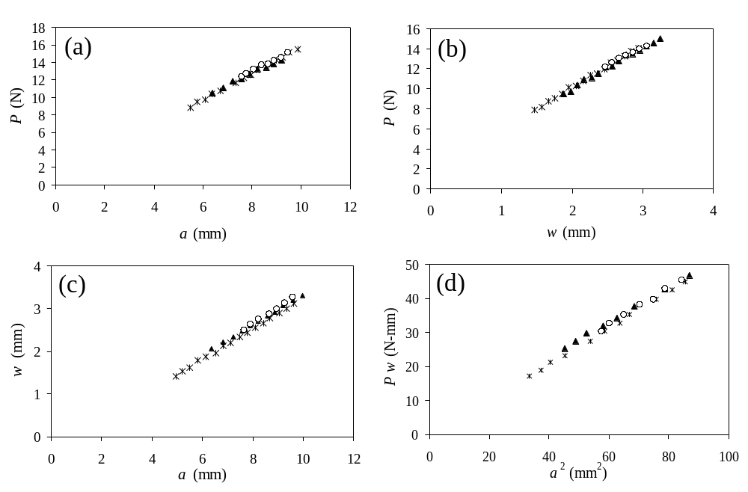

Table 1. Applied strain energy release rate, G, (J/m²) determined from the load-based, hybrid, displacement-based, and combination equation as a function of the blister hole size. The mean ± one standard deviation about the mean is shown.
 | load | hybrid | displacement | combination
small | 32.3 ± 2.2 | 22.4 ± 1.4 | 85.0 ± 6.6 | 40.2 ± 2.0
medium | 30.8 ± 0.7 | 18.5 ± 3.0 | 94.4 ± 31.3 | 39.6 ± 3.5
large | 29.8 ± 4.3 | 15.6 ± 1.6 | 127.0 ± 30.8 | 42.6 ± 2.3

Table 1 shows that the calculated value of G depends on which equation was utilized. This observation is consistent with most shaft-loaded blister test experiments and results, probably due to the always present plastic yielding at the contact area [2, 6, 9, 10]. As discussed in the experimental section, previous work has shown that for a Kapton PSAT bonded to aluminum, that the load-based equation is not only independent of plastic deformation at the contact zone but also agrees well with the value of G obtained from the pull-off test [2]. Note that the assumption of linear elasticity at the debond front is valid because the effective membrane stress N_{eff} (equation 5) is well below the yield stress of the backing. This suggests that the load-based equation (equation 1) is the most “correct” and preferred of equations 2, 3, and 4. Table 1 shows that the value of G calculated from the hybrid equation is smaller, and the values calculated from the displacement-based and combination equation are larger, than the “correct” value of G determined from the load-based equation. Under ideal linear elastic conditions the value of G should be the same for every equation, but the dependence of the calculated G on displacement determines the sensitivity to the “overestimated” displacement (relative to the elastic case). For instance, in the displacement-based equation because the value of displacement is in the numerator and is raised to the fourth power (G ~ w⁴), the G is much greater than the load-based equation where displacement is not used in the calculation.

Although Figure 3 reveals substrate hole size has no significant influence on the measured parameters (P, w, a) over the size range studied; Table 1 shows the hole size can influence the calculated value of G when the displacement is incorporated into the equation. As the hole size increases, the calculated G decreases and increases for the hybrid and displacement-based equations, respectively. This suggests that as the substrate hole size increases, the displacement or blister height increases, presumably due to an increase in plastic deformation at the contact zone. The calculated value of G was not affected by hole size when using the load-based equation which is expected given that the independence on yielding at the contact zone. Calculations based on the combination equation were also independent of hole size.

Effects of Varied Shaft-Tip Diameter Size and Film Thickness on G
Figures 4, 5, and 6 show, for n = 1, the effects of shaft-tip diameter on the measured load, displacement and blister radius. Graphs of the data sets for n = 2 and 3 are not shown, because the same trends were observed as for n = 1. Figures 4 shows the load as a function of blister radius for n = 1 for a variety of shaft-tip diameters. All curves appear to overlap. The graph shows that the relationship between the load and debond radius is unaffected by the shaft-tip diameter, which supports the principle that the load-based equation is independent of plastic deformation at the contact area. Figure 5 shows the displacement as a function of blister radius for n = 1 and varied shaft-tip diameters. The graph shows that as the shaft-tip diameter decreases, displacement increases, presumably due to an increase in plastic deformation at the contact zone. Figure 6 shows the load as a function of displacement for n = 1 and varied shaft-tip diameter. This graph shows the expected trend, that increasing the shaft-tip diameter increases the applied loads for a given displacement [10, 14].

The effects of varying the film thickness are shown in Figures 7 and 8. Figure 7 shows the load as a function of blister radius for different values of n and for all shaft-tip diameters. Figure 8 shows the displacement as a function of blister radius for different values of n and the smallest shaft-tip diameter. Figures 7 and 8 illustrate that increasing the film stiffness (n) increases the applied load, but reduces the displacement and overall reduces plastic yielding. In this case, the increase in load and reduced displacement is due to the increase in available stored elastic energy. In addition, Figure 7 again shows that the load-displacement curves are independent of the plastic deformation at the contact area.
Figure 4. The load as a function of blister radius for n = 1 and varied shaft-tip diameter. Symbols are: small diameter (*), medium diameter (▲), and large diameter (○).
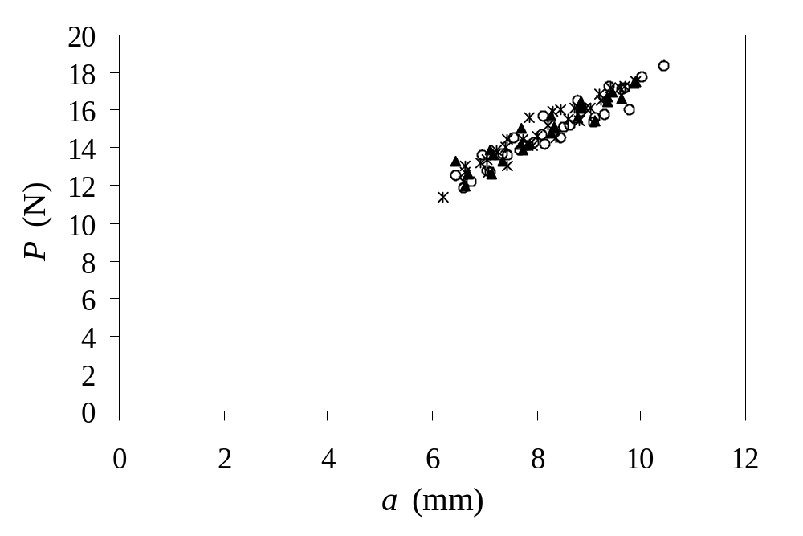
Figure 5. The displacement as a function of blister radius for n = 1 and varied shaft-tip diameter. Symbols are: small diameter (*), medium diameter (▲), and large diameter (○).
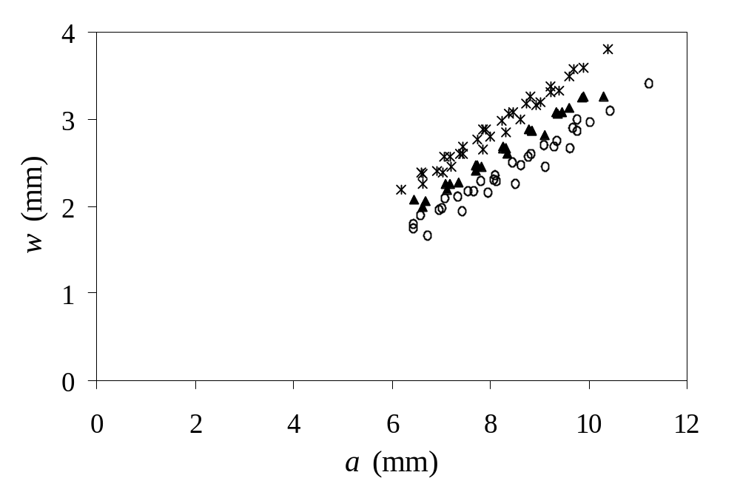
Figures (4 – 8) show that the relationship among P, w, and a change as a function of the shaft-tip diameter and film thickness, but the question remains whether G is also affected. Tables 2, 3, and 4 list the calculated values of G as a function of film thickness and shaft-tip diameter for n = 1, 2 and 3, respectively. The average and standard deviation were calculated from 7 samples each. The expected trend was observed in Table 2 for n = 1, where decreasing the shaft-tip
Figure 6. The load as a function of displacement for n = 1 and varied shaft-tip diameter. Symbols are: small diameter (*), medium diameter (▲), and large diameter (○).
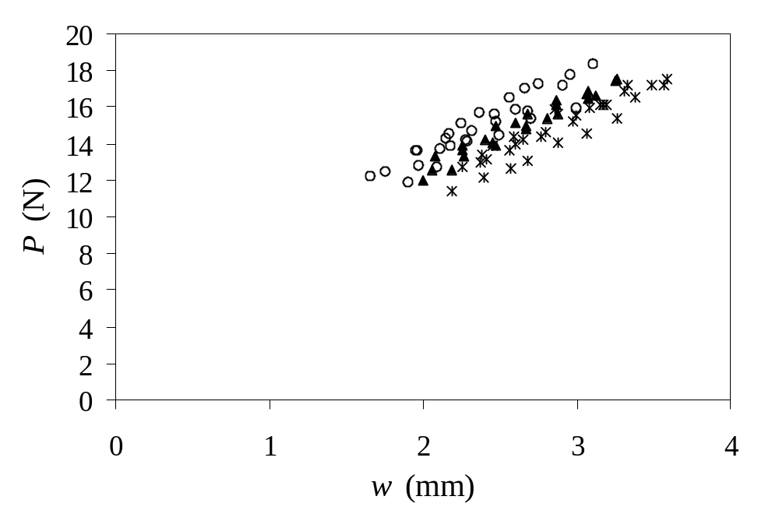

Figure 7. The load as a function of blister radius for different values of n. Data sets from all three shaft-tip sizes are shown. Lines are drawn by hand to aid the eye.
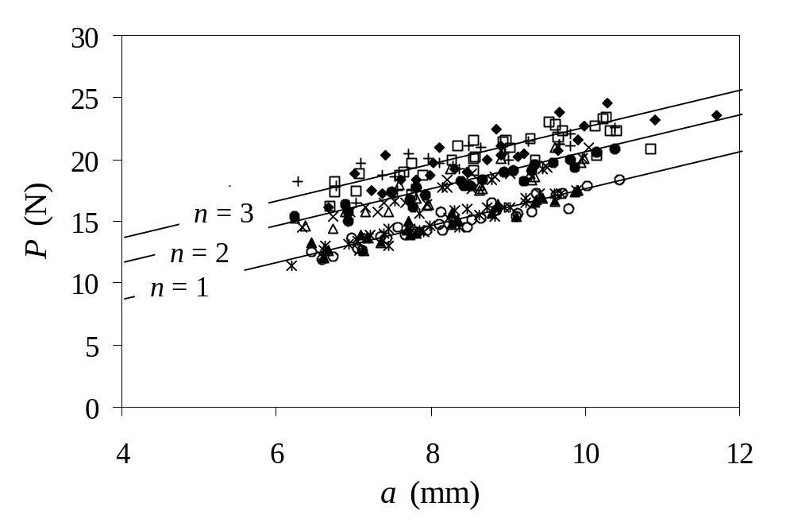
diameter increased the yielding at the contact area and affected calculations of G that incorporated the displacement in the equation. As seen in the study of the effect of the substrate hole size (Table 1), the consistent trend was that values of G calculated from the hybrid, displacement, and combination were lower, much greater, and greater, respectively, relative to the “correct” load-based equation. The only exception was for the n = 1 medium shaft-tip where the values of G between the load-based equation and combination equation were equal.

Figure 8. The displacement as a function of blister radius for different values of n. Data sets from the smallest shaft-tip size are shown. Lines are drawn by hand to aid the eye.
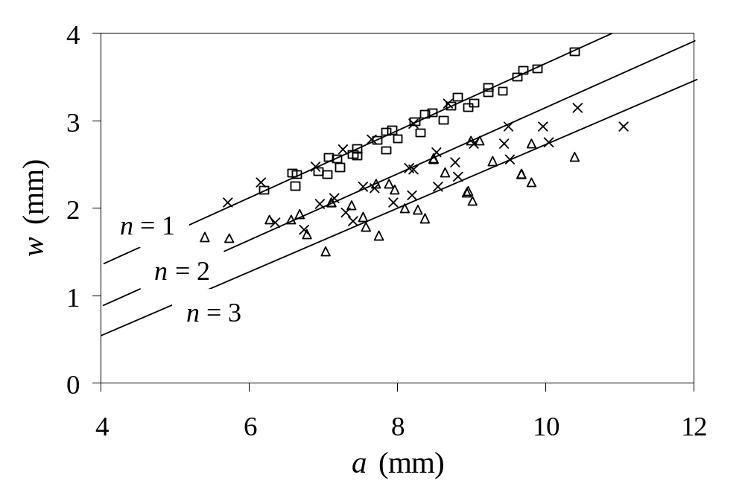
The effects of the shaft-tip diameter and yielding are most apparent for the thinnest film (n = 1) (Table 2) and between the smallest and largest shaft-tip size. As the shaft-tip diameter increased, the values of G calculated from the load-based equation remain constant, while they decreased for the hybrid equation, increased for the displacement-based equation, and exhibited no trend for the combination equation. The size of the shaft-tip diameter does not affect the values of G calculated from the load-based equation. This supports the idea that the load-based equation is independent of plastic deformation at the contact area and is the most preferred expression to calculate G.

Table 2. Applied strain energy release rate, G, (J/m²) determined from the load-based, hybrid, displacement-based, and combination equation as a function of the shaft-tip diameter for n = 1. The mean ± one standard deviation about the mean is shown.
n = 1 | load | hybrid | displacement | combination
small | 34.1 ± 2.2 | 17.7 ± 2.0 | 123.4 ± 14.8 | 46.8 ± 7.4
medium | 34.1 ± 4.6 | 21.3 ± 2.5 | 83.5 ± 22.9 | 34.3 ± 3.8
large | 32.9 ± 3.7 | 25.0 ± 3.9 | 57.6 ± 3.9 | 40.4 ± 3.2

For n = 2 and 3 (Tables 3 and 4), and similar to n = 1, the value of G calculated from the load-based equation is not affected by the shaft-tip diameter. However, increasing the film thickness reduces the value of G calculated from the load-based equation, presumable due to an increase in the bending moment and a reduction of plastic deformation of the adhesive film. The peel test behaves similarly where stiffening of the peel arm [26] (or an increase in tensile residual stress [27]) can cause a reduction in peel force. The values of G calculated from the hybrid equation also decrease as the film thickness increases, presumably due to an increase in bending moment. In fact the reduction in displacement due to an increase in n, which would result in an increase of the value calculated from the hybrid equation, is not enough to overwhelm the effects of increased bending moment.

Table 3. Applied strain energy release rate, G, (J/m²) determined from the load-based, hybrid, displacement-based, and combination equation as a function of the shaft-tip diameter for n = 2. The mean ± one standard deviation about the mean is shown.
n = 2 | load | hybrid | displacement | combination
small | 28.3 ± 2.0 | 16.9 ± 5.1 | 92.2 ± 59.6 | 48.2 ± 11.2
medium | 25.2 ± 3.9 | 16.7 ± 4.3 | 56.4 ± 10.8 | 38.3 ± 5.0
large | 25.5 ± 5.1 | 17.3 ± 3.4 | 59.8 ± 11.4 | 36.8 ± 3.1
Table 4. Applied strain energy release rate, G, (J/m²) determined from the load-based, hybrid, displacement-based, and combination equation as a function of the shaft-tip diameter for n = 3. The mean ± one standard deviation about the mean is shown.

n = 3 | load | hybrid | displacement | combination
small | 24.3 ± 5.9 | 11.7 ± 2.7 | 94.7 ± 43.7 | 42.2 ± 19.2
medium | 22.8 ± 5.0 | 13.8 ± 4.7 | 56.5 ± 8.8 | 35.2 ± 9.8
large | 22.0 ± 3.7 | 13.1 ± 3.8 | 56.7 ± 12.3 | 35.7 ± 3.1

For the hybrid and displacement equations, the influence of the shaft-tip diameter for n = 2 and 3 is not as significant as for n = 1. For the smallest shaft-tip diameter and n = 2 and 3 the average and standard deviation of G calculated from the displacement and combination equation is significantly greater than in any other condition. This is due to the smallest diameter imparting the most plastic deformation and the dependence of the displacement equation on the value of w to the fourth power. The increase in plastic deformation has been is has observed graphically (Figure 5), where reducing the diameter of the shaft-tip leads to larger values of displacement. Also, the smallest shaft-tip diameter leaves the deepest dimple in the center of the blister, indicating plastic deformation. Note that the size of the dimple is reduced as the film thickness increases. Furthermore, the difference in both the values of G and the graphs is much greater between the small diameter and either the medium or large diameter than the difference between the medium and large diameter. The influence of the small diameter shaft-tip on the value of G calculated from the combination equation suggests that the load-equation is more preferable than the combination equation.

Varying the shaft-tip diameter and film thickness caused different amounts of plastic deformation which was evident from the differences in w seen graphically (Figures 5 and 8). However, differences among the values of G due to yielding are small with the exceptions of n = 1 (all sizes) and the smallest shaft-tip size for n = 2 and 3. Therefore we have observed that plastic deformation can influence the calculated value of G in cases where the film is thin or the bearing is small. The yield stress, plastic deformation, film thickness, or the size of the shaft-tip can be increased to reduce the undesirable effects. However, we see that for n = 1 and a large bearing, the effects of plastic deformation are not reduced sufficiently to result in all four expressions of G to agree.

Calculation of the Film Tensile Rigidity (Eh)
The film stiffness of film tensile rigidity (Eh) was calculated using an experimental compliance calibration and equation 5. These results were compared to the film tensile rigidity calculated from the Young’s modulus determined from stress-strain experiment in a UTM. Ideally, if linear elasticity holds and equations 1 to 5 are correct, then the values of Eh determined from the UTM and the compliance calibration should agree. The results for the varied substrate hole size are listed in Table 5. Table 6 lists the calculated values for the varied film thickness and shaft-tip diameter. The values calculated from the stress-strain experiment are 77,500 N/m, 154,900 N/m, and 309,800 N/m for n = 1, 2, and 3, respectively.

Table 5. The film tensile rigidity, Eh, (N/m) calculated from an experimental compliance calibration and equation 5. This data set is for n = 1 and varied substrate hole diameters (small, medium, and large). The value calculated from the stress-strain experiment for a single ply is 77,500 N/m. The mean ± one standard deviation about the mean is shown.

 | small | medium | large
N = 1 | 54,000 ± 5000 | 48,000 ± 4000 | 41,000 ± 3000

Table 6. The film tensile rigidity, Eh, (N/m) calculated from an experimental compliance calibration and equation 5. This data set is for n = 1, 2, and 3 and the varied shaft-tip diameter (small, medium, and large). The values calculated from the stress-strain experiment and UTM are 77,500 N/m, 154,900 N/m, and 309,800 N/m for n = 1, 2, and 3, respectively. The mean ± one standard deviation about the mean is shown.
Note that the values of Eh determined from the UTM and the compliance calibration showed the best agreement for experiments that utilized the largest shaft-tip.

 | small | medium | large
n = 1 | 45,000 ± 9000 | 58,000 ± 8000 | 83,000 ± 9000
n = 2 | 96,000 ± 31,000 | 139,000 ± 32,000 | 169,000 ± 47,000
n = 3 | 155,000 ± 25,000 | 164,000 ± 98,000 | 242,000 ± 28,000
Examination of Table 5 shows that the calculated film tensile rigidity did not depend on the size of the substrate hole diameter. This was not unexpected given the similarity of the curves shown in Figure 3. However, the calculated film tensile rigidity depended strongly on the size of the shaft-tip diameter (Table 6). The results also show that the values of Eh determined from the UTM and the compliance calibration agreed best for experiments that utilized the largest shaft-tip. This is presumable due to the reduction in both plastic deformation and the value of displacement. In addition, disagreement between the two methods may also be due to the multilayer structure of stacked layers of glassy backing and soft adhesive as well as any anisotropy in the PSAT backing . See Li et. al. 2004 for a rigorous treatment of the debonding of layered structures [28].

Begley and Mackin noted that using a point-load solution to measure the mechanical properties of thin films in a shaft-loaded blister test geometry resulted in errors and derived analytical expressions to account for the spherical loading [14]. Wan and Liao also derived expressions to determine the mechanical properties of thin films using the shaft-loaded blister test geometry and predicted that increasing the size of the shaft-tip diameter will change the constitutive equation 5 by a factor Ω₁ [10]:

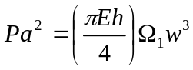 (8)

where Ω₁ is a parameter that depends on shaft-tip radius, R, contact radius, c, and angle, θ (Figure 1). Therefore, it is expected that plasticity at the shaft-tip should result in decreasing the calculated film tensile rigidity. This was observed in this work; however, the decrease in the value of Eh was most likely due to plastic deformation and not solely due to the spherical contact area.

Previous research showed improved agreement among the values of G calculated from equations 1, 2, and 3 when the value of Eh determined from the compliance calibration was utilized in the calculation [2]. This was likely due to the plastic deformation at the contact area and not because the value of Eh determined from the compliance calibration more closely reflects the mechanical behavior of the film under loading conditions encountered in shaft-loaded blister test geometry. The dependence of the value of Eh on the shaft-tip diameter, and therefore the amount of plastic deformation, supports this conclusion.

Methods to Calculate of the Contact Radius
There are several methods to calculate the contact radius, c, and the penetration of the sphere into the film, δ, at the shaft-tip (Figure 2). The contact radius is related to δ by equation 9 [29].

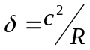 (9)

In the work of Wan and Liao the contact radius can be calculated from the following linear elastic expression [10]:

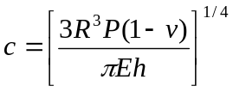 (10)

where v is Poisson’s ratio. This expression assumes a small uniform membrane strain.

Begley and Mackin derived an approximate closed form solution for the contact radius that incorporates the effects of residual stress [14]:

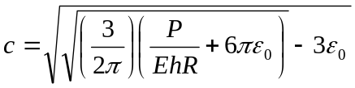 (11)

where ε₀ is the pre-strain in the film attributable to residual stress.

Wan and Mai developed an expression for the yielding radius, a_{p}, that accounted for plastic deformation at the contact area which can be used to estimate the contact radius (a_{p} ≈ c) [6]:

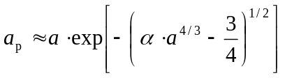 (12)
where

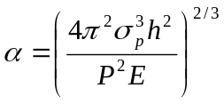 (13)

and σ_{p} is the yield stress of the film determined from a stress-strain experiment.

The actual value of the penetration depth and displacement due to plastic deformation are unknown; however, the magnitude was estimated to be about 1mm from examination of Figures 5 and 8. None of the models discussed previously predict the correct magnitude of the contact radius and penetration depth. This is not unexpected given that models assume elastic deformations (except the model of Wan and Mai). However, the disagreement between the experimental and the model of Wan and Mai is likely also due to the how plasticity is modeled. Unlike linear elasticity, the solutions that incorporate plasticity are not unique. Plastic yielding behavior among polymers can be very different; it may be rate dependent, time dependent, stress hardening, stress softening and small variations in behavior can lead to large differences especially at high strains. Therefore, plasticity models are highly specific and it is not unexpected that the models may not match the experimental data; however, there may be many other systems that do match the model. This suggests that rather than using these models to predict the contact radius, it is best to actually measure the plastic contribution to the blister height. The plastic deformation at the contact area can be measured by loading and unloading the specimen. Just as in a stress-strain experiment the degree of plastic deformation can be deduced from the difference between the loading-unloading curves for successive loadings of the same specimen. For this PSAT, the loading-unloading process is complicated because the PSAT will reattach upon regaining contact with the substrate. In adhesive systems where the adhesive will not re-adhere, like glassy structural adhesives, this approach is possible. However, measuring the amount of plastic deformation may not be necessary if one is only interested in the measuring G and utilizes the load-based equation.
Effect of Film Thickness and Shaft-Tip Diameter on the Mechanical Behavior (Stretching Membrane vs. Bending Plate)
In a peel test geometry the adhesive layer can behave either like a bending plate, a stretching membrane, or a combination of the two. Whether the film behaves like plate or membrane determines which linear elastic equations should be utilized to model the mechanical properties and delamination of the adhesive. If the load is small or if the film is thick or stiff, then bending behavior dominates. If the load is large or if the film is thin or compliant, then stretching behavior dominates [14]. As a consequence there is a predicted bending to stretching transition when the load is first applied during contact with the shaft, up to when the debond initiates.

There are several methods to determine mechanical behavior of the film. A simple method is to plot the logarithmic load as a function of the logarithmic displacement (P ∝ w^{γ}) during the initial loading of the film prior to debond initiation. The value of the slope, γ, indicates the mechanical behavior, where γ = 1 is characteristic of a bending plate and a value of γ = 3 is characteristic of a stretching membrane [10].

In addition, Wan and Liao derived the expressions to determine the normalized membrane stress, β = (N a² / D)^{1/2}, which indicates the ratio of stretching stress to bending rigidity [10]. N is the film stress and D is the flexural rigidity. A small value of β (less than 0.1) indicates a pure bending plate and a large β (greater than 20) indicates a stretching membrane.

A similar dimensionless parameter was derived by Komaragiri et. al. to determine if bending can or can not be ignored (for both pressure loading and point loading) [15]:

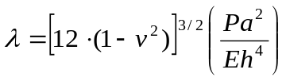 (14)

The value of λ determines if the film behaves more like a bending plate or stretching membrane.

The values of the slope, γ, of the log load as a function of log displacement are listed in Tables 7 for the varied substrate hole size. Table 8 lists the values of γ for the varied shaft-tip diameter and film thickness. Tables 7 and 8 show that for this adhesive the measured value of γ does not depend on the substrate hole size, shaft-tip diameter and film thickness. This is unexpected given that Wan and Liao showed analytically and experimentally that increasing the shaft-tip diameter results in a larger gradient, γ [10]. However, this work agrees with the research of Begley and Martin [14] which showed analytically and experimentally that for both a point load and spherical load of a stretching membrane that it is expected that P ∝ w³. However, the scatter in the data suggests that UTM, which measures the load and displacement, may be insensitive to the effects of substrate hole diameter, shaft-tip diameter and film thickness. The values of γ listed in Tables 7 and 8 is roughly 2.3 ± 0.3 for all test conditions, which suggests that the film behaves more like a stretching membrane than a bending plate. The stretching film behavior of this adhesive is supported by calculations using the methods of Wan and Liao and Komaragiri et. al.

Table 7. The slope, γ , of the log load – log displacement curve (P ∝ w^{γ}). This data set is for n = 1, and the varied substrate hole diameter (small, medium, and large). For a pure bending plate, γ = 1, and for a stretching membrane, γ = 3. The mean ± one standard deviation about the mean is shown.

 | small | medium | large
n = 1 | 2.3 ± 0.3 | 2.3 ± 0.4 | 2.4 ± 0.4

Table 8. The slope, γ , of the log load – log displacement curve (P ∝ w^{γ}). This data set is for n = 1, 2, and 3 and varied shaft-tip diameter (small, medium, and large). For a pure bending plate, γ = 1, and for a stretching membrane, γ = 3. The mean ± one standard deviation about the mean is shown.

 | small | medium | large
N = 1 | 2.2 ± 0.3 | 2.7 ± 0.4 | 2.3 ± 0.2
N = 2 | 2.3 ± 0.3 | 2.2 ± 0.3 | 2.3 ± 0.3
N = 3 | 2.3 ± 0.4 | 2.4 ± 0.4 | 2.1 ± 0.2

Effect of Applying Bending Plate Equations to Calculate G
It is of interest to compare values of G determined for a bending plate model to the stretching membrane model we have used previously (equations 1 to 4). Note that we have shown previously that the adhesive film behaves more like a stretching membrane (γ = 2.3 ± 0.3). Malychev and Salganik derived the load-based, combination and displacement-based equations for a bending plate [30].

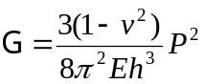 load-based equation (15)

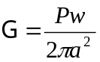 combination equation (16)

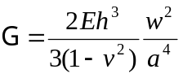 displacement-based equation (17)

The combination equation (eq 16) is identical to that derived by Wan [11] and Williams [22]. For a bending plate, equations 15 to 17 will be most applicable when the displacement in less than the film thickness [31]. Furthermore, for a bending plate, the load is predicted to be constant during delamination. In these experimental results, the displacement is much greater than the film thickness and the load is not constant. Therefore, the membrane equations are more appropriate for the adhesive system investigated in this work.

The strain energy release rate calculated from equation 16 varies by as much as five orders of magnitude from the load-based stretching membrane equation (eq. 1). Note that this difference is significantly reduced as the film thickness increases. The combination equation derived for a bending plate (eq. 16), which does not incorporate the mechanical properties of the film, differs by a factor of 2 from the membrane solution of the combination equation (eq. 4). Therefore, the bending plate equation yields a value of G twice as much as the membrane solution. The displacement-based equation for the bending plate is also very sensitive to the film thickness. For n = 1 the difference between the bending plate and stretching membrane case was less than a factor of two; however, increasing the film thickness increased the difference by as much as four orders of magnitude.

Effect of Shaft-Tip Diameter and Film Thickness on Scaling of Equations 1 to 4
If equations 1 to 4 have been derived correctly and the test specimens behaved linear elastically, then the data plotted in Figures 3 to 8 should be linear and should interpolate back to the origin (P = 0, w = 0 and a = 0). Examination of Figures 3 to 8 reveals three trends. First, graphs of the load as a function of blister radius interpolate through the origin which suggest linear elasticity occurs and supports the idea that the load-based equation is independent of the plastic deformation at the contact area. The second trend is that reducing the shaft-tip diameter causes the graphs to interpolate more closely through the origin. This supports the reasoning that the offset between the interpolated line and origin is due to the finite width of the shaft-tip, which was suggested by Wan and Mai (Wan and Mai 1995). Lastly, as the film thickness was increased, the interpolated line tended to pass further from away from the origin.

Practical Implications for the Shaft-Loaded Blister Test
This work has practical implications for the design of a SLBT experiment. Wan and Liao proposed that to reduce plastic deformation at the contact area, the radius of the shaft-tip should greater than or equal to [10]:

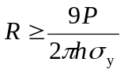 (18)

where σ_{y} is the yield stress of the adhesive film. In other words, one should increase the shaft-tip diameter, reduce the applied load and increase the thickness to reduce the stress and possibility of yielding in the adhesive film. This work has shown that plastic deformation can be reduced by increasing the shaft-tip diameter, despite the expected increase in load. This work has also shown that the size of the shaft-tip does not affect the load-based equation and so the size of the shaft-tip seems to be unimportant; however, the chance for film rupture can be reduced if a larger shaft-tip is utilized and enables the application of greater loads per given displacements and therefore greater strain energy release rates. Begley also notes that the greater applied loads facilitated by a larger shaft-tip diameter provide better load resolution, which has practical implications for applying atomic force microscopy to adhesion studies and measuring the mechanical properties of thin films [14]. By reducing the stress in the film, a thinner film can be utilized, which will more closely follow the assumption of a thin stretching membrane used to derive the expressions of G. Furthermore, a larger bearing that fits snuggly into the initial blister hole enables the shaft-tip and blister to be easily centered and can help to reduce sample to sample scatter.

Plastic deformation may also be influenced by the cross-head displacement rate, which affects the strain rate and therefore the yield stress and yield strain in the adhesive layer. Although no experiments have been performed to investigate the effect of displacement rate on plastic deformation at the contact area, effects similar to those presented in this work could be expected. However, for this PSAT, increasing the test rate results in larger values of G due to increase in the debond velocity and viscoelastic effects in the soft pressure sensitive adhesive layer. Therefore, deconvolution of the effects of plastic deformation and debond velocity on G could prove difficult.

Conclusions
The influence of the film thickness, substrate hole diameter and shaft-tip diameter on plastic deformation at the contact area and blister height were measured. Increasing the hole size slightly increased the amount of plastic deformation, which was evident from the changes in G, but did not significantly affect the measured P, w or a. Increasing the film thickness (n) increased the applied load and decreased the displacement. Decreasing the shaft-tip diameter increased the displacement or blister height due to plastic deformation at the contact area. The presence of both effects suggests that there are differences in the amount of plastic deformation among the different test conditions. Differences in the calculated values of G were observed when the displacement was incorporated into the calculation. Relative to the “correct” load-based equation, differences among the equations for G can be reduced using a large shaft-tip diameter. The value of G calculated from the load-based equation decreased slightly as the film thickness increased. This is a trend typically observed in many other adhesive tests. The film tensile rigidity, Eh, calculated from the experimental compliance calibration agreed best with values determined from a tensile test of the film when the largest shaft-tip diameter was used. The contact radius and displacement due to plastic deformation should be determined experimentally; however, it may be unnecessary if the load-based equation is utilized. Methods to determine if the film behaves like a bending plate or stretching membrane were discussed. Using these techniques it was found that the film behaves mostly like a thin stretching membrane. The values of G were significantly different depending on whether the equations for a bending plate or stretching membrane were used.

Acknowledgements
Financial support for Stephanie Goldfarb was provided by the National Science Foundation through the Summer Undergraduate Research Fellowship (SURF) program at NIST. The authors thank their colleagues at the National Institute of Standards and Technology: Jason Garver and Ned Embree for their mechanical expertise and Xiaohong Gu, Amanda Forster, Aaron Forster, Peter Drzal, Jon Martin, and Bryan Vogt for providing helpful comments. We also appreciate the help of the editor and the comments by the referees.

References

[1] Lai, Y.H. and Dillard, D.A., Journal of Adhesion Science and Technology, 8, 663-678 (1994)
[2] O'Brien, E.P., Ward, T.C., Guo, S., and Dillard, D.A., Journal of Adhesion, 79, 69-97 (2003)
[3] Liao, K. and Wan, K.T., Journal of Materials Science Letters, 19, 57-59 (2000)
[4] Liao, K. and Wan, K.T., Journal of Composite Technology and Research, 23, 15-20 (2001)
[5] Wan, K.T., DiPrima, A., Ye, L., and Mai, Y.W., Journal of Materials Science, 31, 2109-2116 (1996)
[6] Wan, K.T. and Mai, Y.W., International Journal of Fracture Mechanics, 74, 181-197 (1995)
[7] Wan, K.T. and Mai, Y.W., Materials Science Research International, 1, 78-81 (1995)
[8] Xu, X.J., Shearwood, C., and Liao, K., Thin Solid Films, 424, 115-119 (2003)
[9] O'Brien, E.P., Case, S.L., and Ward, T.C., Journal of Adhesion, 81, 1-18 (2005)
[10] Wan, K.T. and Liao, K., Thin Solid Films, 352, 167-172 (1999)
[11] Wan, K.T., Journal of Adhesion, 70, 209-219 (1999)
[12] Wan, K.T., Guo, S., and Dillard, D.A., Thin Solid Films, 425, 150-162 (2003)
[13] Ju, B.F., Liu, K.K., Ling, S.F., and Ng, W.H., Mechanics of Materials, 34, 749-754 (2002)
[14] Begley, M.R. and Mackin, T.J., Journal of the Mechanics and Physics of Solids, 52, 2005-2023 (2004)
[15] Komaragiri, U., Begley, M.R., and Simmonds, J.G., Journal of Applied Mechanics, 72, accepted for publication (2005)
[16] Wan, K.T., Journal of Adhesion, 75, 369-380 (2001)
[17] Liu, K.K. and Ju, B.F., Journal of Physics D- Applied Physics, 34, L91-L94 (2001)
[18] Wan, K.T., Journal of Applied Mechanics-Transactions of the ASME, 69, 110-116 (2002)
[19] Wan, K.T. and Dillard, D.A., Journal of Adhesion, 79, 123-140 (2003)
[20] Liu, K.K., Khoo, H.S., and Tseng, F.G., Review of Scientific Instruments, 75, 524-531 (2004)
[21] Ju, B.F., Wan, K.T., and Liu, K.K., Journal of Applied Physics, 96, 6159-6163 (2004)
[22] Williams, J.G., International Journal of Fracture, 87, 265-288 (1997)
[23] Jensen, H.M., Engineering Fracture Mechanics, 40, 475-486 (1991)
[24] Jensen, H.M. and Thouless, M.D., International Journal of Solids and Structures, 30, 779-795 (1993)
[25] Park, T., Dillard, D.A., and Ward, T.C., Journal of Polymer Science Part B - Polymer Physics, 38, 3222-3229 (2000)
[26] Kim, J., Kim, K.S., and Kim, Y.H., Journal of Adhesion Science and Technology, 3, 175-187 (1989)
[27] Thouless, M.D. and Jensen, H.M., Journal of Adhesion Science and Technology, 8, 579-589 (1994)
[28] Li, S., Wang, J., and Thouless, M.D., Journal of the Mechanics and Physics of Solids, 52, 193-214 (2004)
[29] Barquins, M., Wear, 158, 97-117 (1992)
[30] Malyshev, B.M. and Salganik, R.L., International Journal of Fracture Mechanics, 1, 114-128 (1965)
[31] Williams, M.L., Journal of Applied Polymer Science, 13, 29-40 (1969)

A communication submitted to the International Journal of Adhesion and Adhesives
Comparison of Subcritical Adhesion Test Methods: The Shaft-loaded Blister Test vs. the Wedge Test

Emmett P. O’Brien^{A,B} and Christopher C. White^{A}

^{A}National Institute of Standards and Technology, Buildings and Fire Research Laboratory
Gaithersburg, MD, USA
^{B}Institute of Materials Science, University of Connecticut, Storrs, CT USA

To whom correspondence should be addressed: Email: emmett.obrien@nist.gov

Abstract
Subcritical adhesion testing is of practical interest to engineers and scientists because it enables the study of the mechanisms underlying adhesive failure while closely simulating failure mechanisms and time scales occurring during service. Furthermore, the results from these types of experiments provide engineers with parameters for designing adhesive joints and coatings. Traditionally, subcritical fracture test specimens have been triple-layered laminated beams, where the adhesive is bonded between two rectangular rigid adherends. An example of this type of test specimen is the well known double cantilever beam wedge (DCB) test. Recently, the shaft-loaded blister test (SLBT) was shown to be an alternative method for subcritical adhesion testing of adhesive coatings (O’Brien et. al. J. of Adhesion 2005). In this work, the pros and cons of the SLBT and DCB tests for Subcritical adhesive fracture testing are discussed. As an example, we investigate the effects of moisture on the crack growth between an epoxy and a glass substrate.

1 Introduction
Subcritical adhesion testing or stress corrosion cracking explores adhesive debonding in a range of crack velocities and applied strain energy release rates (SERR), G, that are significantly less than are observed from catastrophic failure. As a consequence, subcritical adhesion testing can closely simulate the failure occurring in the real-life application or service life of the adhesive. Information about the mechanism of failure is gathered from a log-log plot of the average debond velocity, v, as a function of G. A change in the slope is indicative of a change in the rate limiting step for crack advancement and includes such behavior as threshold behavior, stress-dependent chemical reaction or reaction-limited, and transport limited mechanism for debond advancement [1-3].

Traditionally, subcritical fracture test specimens have been triple-layered laminated beams, where the adhesive is bonded between two rectangular rigid adherends. Examples of the laminated beam type experiments are the DCB wedge test [4, 5], the asymmetric double cantilever beam test [6], the double cleavage drilled compression specimen [7, 8], and the four-point flexure samples [1]. The advantages of laminated beam type specimens are: 1) the adhesive is loaded elastically away from the crack tip, 2) high strain energy release rates are obtainable, 3) the fracture mechanics models for analysis are well understood, and 4) the specimens can be self-loading. A disadvantage of these type of tests is that sometimes it is difficult to measure the debond length. For transparent adherends or for a clearly visible crack propagating at the edge of the specimen, an optical microscope may be the only instrument needed to measure the debond length. However, if the debond is not clearly visible, such as for opaque adherends, the use of sophisticated experimental equipment (video camera, acoustic or electrical methods) may be necessary [9, 10]. Additionally, for an adhesive sandwiched between two impermeable substrates, diffusion occurs only from the edge and the equilibration time may be long [11, 12]. This can slow down the speed of research as well as lead to a heterogeneous distribution of diffusant in the adhesive joint.

With respect to the laminated beam type specimens, there are advantages to utilizing the shaft-loaded blister test. The time for environmental saturation is relatively short, due to the exposed face and short diffusion path. [11, 12] In addition, the specimen geometry is axisymmetric, which reduces any misleading edge effects caused by the degradation of the interface away from the crack tip. Some disadvantages of the shaft-loaded blister test are that its fracture mechanics models have not been studied as extensively as models from the laminated beam specimens; and, like most coatings tests, the maximum value of the strain energy release rate before film rupture occurs is limited by the film’s mechanical strength and the intrinsic interfacial toughness. Plastic yielding of the coating may lead to an overestimated blister height (relative to the elastic case) [13], possibly lead to creep [14] and therefore complicate the analysis. Furthermore, the strain energy release rate decreases as a function of a ^{-4/3} and therefore will approach a threshold value of G more slowly than beam type specimens. For the DCB wedge test, the strain energy release rate decreases as a function of a⁻⁴. Therefore, a wide range of G values can be obtained for a relatively small change in crack length and the threshold energy can be rapidly approached. Neither the SLBT nor wedge test are particularly less sensitive than the other to the effects of residual stresses; in both test methods during subcritical testing the residual stress driven release rate may be the same magnitude as the threshold value, G _{Th}, and should therefore be considered [15-18].

In this work, the subcritical adhesion behavior between an epoxy and glass as a function of relative humidity (r.h.) was measured using the DCB wedge test and the SLBT. The results from the two tests are compared and the disadvantages and advantages of each test method are highlighted based on the experimental data.

2. Experimental
The epoxy adhesive utilized in this research was D.E.R. 332 epoxy resin cured with Huntsman Jeffamine T-403. To reduce residual stress in the adhesive, the specimens were cured for 48 h at room temperature followed by a 2 h cure at 130 °C. Borosilicate glass cut into the appropriate dimensions was used as the substrate.

SLBT specimens were (3.5 x 101.6 x 101.6) mm³ squares with an 8 mm diameter hole in the center. A pre-crack was fabricated by placing a 0.95 cm diameter piece of Kapton pressure-sensitive adhesive tape (PSAT) over the hole in the center of the quartz substrate. The Kapton PSAT consists of a 25 μm (1 mil) thick Kapton backing and a 37.5 μm (1.5 mil) thick acrylic pressure sensitive adhesive. The tape also provided additional mechanical reinforcement to the thin epoxy film at the highly stressed contact area between the coating and shaft-tip. To prepare the specimen, first the un-cured model epoxy was coated on to the quartz substrate. A 50 μm (2 mil) thick piece of Kapton-E film (no PSA) was then placed on top of the epoxy coating. The Kapton-E film also acts as a mechanical reinforcing layer for the epoxy coating. The resulting adhesive coating is therefore a composite of the model epoxy, Kapton PSAT (located solely in the center) and Kapton-E film. The average epoxy film thickness of each sample ranged between 100 μm and 150 μm ± 10 (based on one standard deviation and 4 thickness measurements).

To develop a sub-critical blister test specimen the sample must be self-loading, the integrity of the thin adhesive coating must be maintained, and the sample must be exposed to the environment. A schematic of the subcritical SLBT specimen is shown in Figure 1. To fabricate a simple self-loading constant load SLBT specimen, a hole is punched in the coating that can accommodate a 2.54 mm (or 4/40”) stainless steel machine screw. The machine screw acts as the fastener from which to suspend the load (via a flexible copper wire). The punched hole containing the screw is sealed with a room temperature cure epoxy (Devcon 2-ton epoxy). The entire SLBT specimen was placed in a sealed vessel and conditioned at constant r.h. at room temperature using saturated salt solutions [19-21].

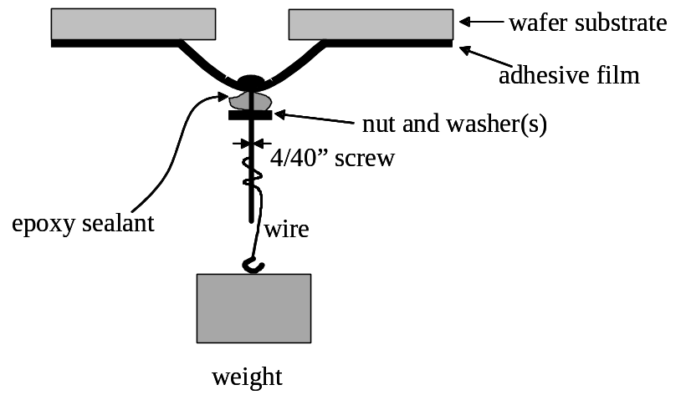
Figure 1. Schematic of the constant load sub-critical shaft-loaded blister test.
The strain energy release rate or crack driving energy, G, was calculated using the load-based equation (equation 1) [22]:

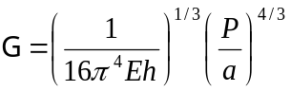 Equation 1.

where P is the load, a is the blister radius, E is the Young’s tensile modulus of the composite film, and h is the thickness of the adhesive coating. The modulus of the coating (E_{c}) for the bi-layer film (Kapton and epoxy) can be estimated from a simple rule of mixtures (E_{c} = Σ v_{i} E_{i}).
DCB samples were prepared from rectangular glass specimens (0.98 x 25 x 75) mm³. To prepare the specimens, a Teflon shim 0.127 mm thick was used to control the thickness of the adhesive layer and to confine the adhesive between two glass rectangular adherends. The shim was cut so that a strip of adhesive (12 x 56) mm² was left in the center in the DCB once the shim was removed. The strain energy release rate was calculated using the following expression:

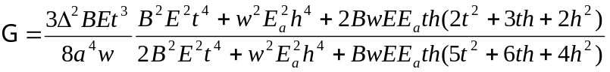 Equation 2.

where ∆ is the end opening, B and w are the width of the adherends and adhesive, respectively, t and h are the thickness of the adherends and adhesive, respectively, and E and E_{a} are the corresponding Young’s moduli of the adherends and adhesive. A stainless steel razor (∆ = 0.25 mm) was used as the wedge. For both the SLBT and DCB sub-critical experiments, a micrometer was utilized to periodically measure the debond length. Like many adhesive tests, the uncertainty due to sample to sample variation is much greater than the uncertainty introduced by measuring the debond length. The average debond velocity, v (da/dt), was determined from the change in average debond length (a) over the elapsed time between measurements.

3. Results and Discussion
The graph of the v-G curves obtained from the constant-load SLBT for 75 % r.h. and 81 % r.h. is shown in Figure 2. SLBT specimens were tested at (30, 44, 54, 66, 75, and 81) % r.h.; however, no debonding was observed for samples tested at 66 % r.h. and below. This is because the applied SERR was not large enough to cause debonding. More details about this will be discussed later.
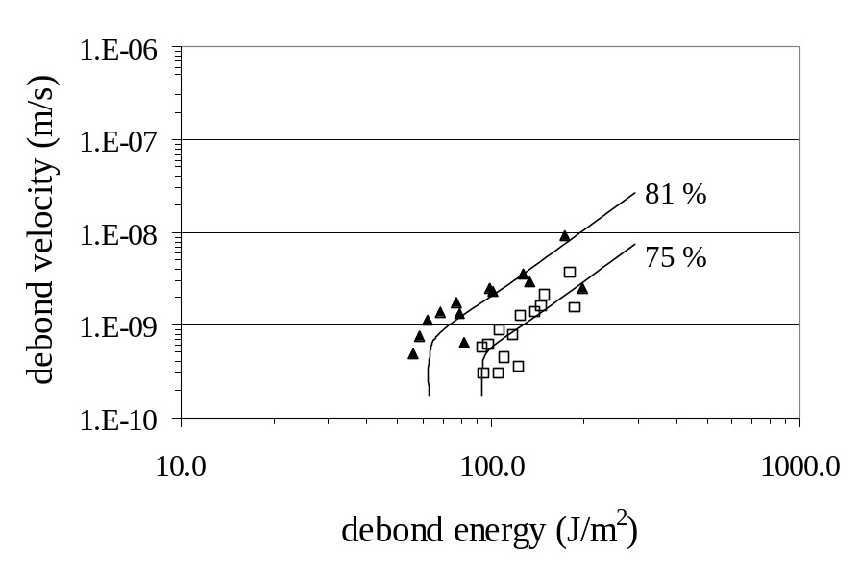
Figure 2. v-G curves obtained from the constant-load SLBT. Symbols are 73 % (□) and 81% (▲) r.h. Note that 100 % r.h. was not tested. Humidity levels of (30, 44, 54, and 66) % r.h. did not exhibit adhesion loss over the experiment’s time scale. The error bars are not shown for clarity.

The graphs of the v-G curves obtained from the DCB test for (15, 33, 43, 66, 81 and 100) % r.h. are shown in Figure 3. Figures 2 and 3 are shown on the same y-scale to facilitate comparison. Error bars are not shown on the graphs because the uncertainty in G and v attributable to measuring the debond length is significantly less than is the sample to sample variation. Data sets from all specimens are shown in the graphs.

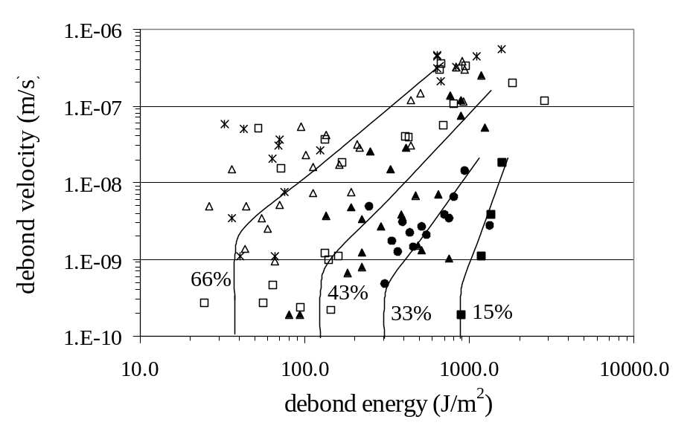
Figure 3. v-G curves obtained from the DCB test. Symbols are: 15% (■), 33% (•), 43% (▲), 66% (∆), 81% (□) and 100% (*) r.h. Lines are drawn in to guide the eye. No line is shown for 81% r.h. and 100% r.h. due to significant scatter. The error bars are not shown for clarity.

For the DCB experiments, the SERR once the wedge is introduced or the “initial SERR” is relatively large; in fact, when the wedge is introduced for a debond length of 1 mm, the value of the SERR is on the order of 10⁶ J/m². The initial SERR in the wedge test is much greater than the intrinsic interfacial toughness of the adhesive and therefore a debond will propagate. As a consequence, debonding is measurable at much lower relative humidities than seen with the SLBT. Figure 2 shows a significant difference between the low humidities (15, 33, and 43) % r.h.. and the high humidities (66, 81, and 100) % r.h.. This is characteristic of a critical relative humidity level for adhesion loss where there is a dramatic loss of adhesion above a critical relative humidity level which is typically between 40 % r.h and 70% r.h. [2, 23]. At 81 % and 100 % r.h.. the debond behaviors are different. At 81 % r.h., during the early stage of the test, the debond grows rapidly and then arrests suddenly. At a 100 % r.h. the crack grows rapidly and then appears to reverse direction. This behavior is probably caused by swelling of the adhesive and the subsequent change in the stress state of the adhesive from tensile to compressive.

For the SLBT experiments, the initial applied strain energy release rate (SERR) was 200 J/m². Therefore, if the intrinsic interfacial fracture toughness exceeded or met 200 J/m², the debond would not propagate, and the test will not work. Increasing the suspended load would increase the SERR; however, the maximum suspended load and hence the SERR is limited by the strength of the film. Any additional load suspended from the center of the blister resulted in significant plastic yielding and rupture of the film. A 100 % r.h. was not tested because it was suspected that the adhesion level would reach a minimum value above the critical relative humidity level. Only 75 % and 81 % r.h. are shown, because at humidity levels below 75 % r.h. no crack growth was observed over the time frame of the experiment, 4 months. Classic debond behavior was observed, where the debond propagates presumably by a stress-controlled reaction at the crack tip, followed by the debond apparently arresting at a threshold value of the SERR, G_{Th}. For 75 % and 81 % r.h. G_{Th} was (95 ± 10) J/m² and (60 ± 10) J/m², respectively. Because no debond growth was observed at low humidity, this suggests that G_{Th} at these moisture levels is greater than 200 J/m².

Ultimately, this study shows that the results from the two tests are different due to the unusual behavior exhibited by the DCB specimens at high % r.h. and because the debond velocities seen in the DCB are much faster than in the SLBT, for an equal applied SERR. However, it is unclear if these differences are directly attributable to the tests (thin film vs. bending plate, mode mixing, geometry, etc.) or are some artifact of the experiment (moisture concentration, residual and swelling stresses, thickness, etc.).

There are a number of advantages and disadvantages for each test highlighted by these experiments. A serious problem with the SLBT, and common to most peel type tests, is the high stress in the film which can cause yielding in the adhesive. For these SLBT experiments, the maximum suspended load and therefore SERR was limited by the strength of the composite film. Furthermore, the applied loads were large enough to cause visible yielding or creep in the adhesive. This was evident from the permanent set in the delaminated film. This may render the expressions for G derived from linear elasticity invalid, depending if elastic conditions at the crack tip exist or not during debond propagation. Therefore caution must be taken to make sure that creep does not affect the adhesion results. In addition, the DCB test utilizes much smaller samples which can occupy significantly less lab space. The time frame of the DCB test is much less than the SLBT: (1 to 1.5) months and (3 to 4) months, respectively. Although, the SLBT specimen is an open-face geometry and should equilibrate in its environment much sooner than a DCB test specimen (a sandwich-type geometry specimen), the time frame of the experiment suggests that there is no advantage to using the SLBT data to increase the rate of environmental degradation during subcritical testing.

Conclusions
The subcritical adhesion test results from the SLBT and DCB were different; however, it was unclear if the differences were due to the tests themselves or some experimental artifact. Significantly greater initial SERR were obtained with the DCB, which facilitated characterizing the adhesion at a wider range of SERR and moisture levels than the SLBT. However, the DCB, exhibited some unusual behavior where the debond apparently reversed direction, probably due to swelling. Lastly, care must be taken when using the SLBT due to the affects of creep.

Acknowledgements
The authors thank Tom Seery for assistance in acquiring financial support. The authors also thank Shu Guo, Hitendra Singh, Aaron Forster, Amanda Forster, Jon Martin, and Don Hunston for their valuable ideas and The Dow Chemical Company for supplying the epoxy resin.

References

[1] Lane, M.W., Snodgrass, J.M., and Dauskardt, R.H., Microelectronics Reliability, 41, 1615-1624 (2001)
[2] Lawn, B., Fracture of Brittle Solids. 1993, Cambridge, England: Cambridge University Press.
[3] Kook, S.Y. and Dauskardt, R.H., Journal of Applied Physics, 91, 1293-1303 (2002)
[4] Cognard, J., International Journal of Adhesion and Adhesives, 8, 93-99 (1988)
[5] Cognard, J., Journal of Adhesion, 26, 155-169 (1988)
[6] Gurumurthy, C.K., Kramer, E.J., and Hui, C.Y., International Journal of Fracture, 109, 1-28 (2001)
[7] Ritter, J.E. and Huseinovic, A., Journal of Electronic Packaging, 123, 401-404 (2001)
[8] Crichton, S.N., Tomozawa, M., Hayden, J.S., Suratwala, T.I., and Campbell, J.H., Journal of the American Ceramics Society, 82, 3097-3104 (1999)
[9] Guyer, E.P. and Dauskardt, R.H., Journal of Materials Research, 19, 3139-3144 (2004)
[10] Nayeb-Hashemi, H., Swet, D., and Vaziri, A., Measurement, 36, 121-129 (2004)
[11] Chang, T., Sproat, E.A., Lai, Y.H., Shephard, N.E., and Dillard, D.A., J. Adhesion, 60, 153-162 (1997)
[12] Moidu, A.K., Sinclair, A.N., and Spelt, J.K., Journal of Testing and Evaluation, 26, 247-254 (1998)
[13] O'Brien, E.P., Ward, T.C., Guo, S., and Dillard, D.A., Journal of Adhesion, 79, 69-97 (2003)
[14] O'Brien, E.P., Case, S.L., and Ward, T.C., Journal of Adhesion, accepted for publication (2005)
[15] Guo, S. and Dillard, D.A., International Journal of Adhesion and Adhesives, prepared for submission to (2005)
[16] Thouless, M.D. and Jensen, H.M., Journal of Adhesion Science and Technology, 8, 579-589 (1994)
[17] Wan, K.T., Guo, S., and Dillard, D.A., Thin Solid Films, 425, 150-162 (2003)
[18] Sun, Z., Wan, K.T., and Dillard, D.A., INTERNATIONAL JOURNAL OF SOLIDS AND STRUCTURES, 41, 717-730 (2004)
[19] Weast, R.C. and Astle, M.J., eds. CRC Handbook of Chemistry and Physics. 60th ed. 1980, CRC Press Inc.: Boca Raton. E-46.
[20] Wexler, A. and Hasegawa, S., Journal of Research of the National Bureau of Standards, 53, 19-26 (1954)
[21] Young, J.F., Journal of Applied Chemistry, 17, 241-245 (1967)
[22] Wan, K.T. and Mai, Y.W., International Journal of Fracture Mechanics, 74, 181-197 (1995)
[23] Lefebvre, D.R., Elliker, P.R., Takahashi, K.M., and Raju, V.R., Journal of Adhesion Science Technology, 14, 925-937 (2000)

Appendix A. Project Listing for BFRL Research and Development for the Safety of Threatened Buildings Program

Prevention of Progressive Collapse

Fire Safety Design and Retrofit of Structures

Fire Protective Coatings for Structural Steel

Standard Test Methods for Evaluating the Fire Resistance of Structural Steel

Methodology for Fire Resistance Determination and Simulation of Building Partitions

Emergency Use of Elevators

Occupant Behavior and Egress

Equipment Standards for First Responders

Guidelines and Technologies for CBR Attacks

Standard Building Information Models

Cost-Effective Risk Management Tools

More information can be found at: http://www.bfrl.nist.gov/goals_programs/prgmSTB.htm
The program is managed by Dr. William Grosshandler (william.grosshandler@nist.gov).

Certain commercial products are identified in this paper to specify the materials used and procedures employed. In no case does such identification imply endorsement by the National Institute of Standards and Technology, nor does it indicate that the products are necessarily the best available for the purpose.
Certain commercial products are identified in this paper to specify the materials used and procedures employed. In no case does such identification imply endorsement by the National Institute of Standards and Technology, nor does it indicate that the products are necessarily the best available for the purpose.
MetSys Corporation, Millwood VA 22646-0317.
Photonics System Team, Korea Photonics Technology Inst., #459-3 Bonchon-Dong, Buk-Gu, Gwangju, 500-210 Republic of Korea.
Certain commercial products are identified in this paper to specify the materials used and procedures employed. In no case does such identification imply endorsement by the National Institute of Standards and Technology, nor does it indicate that the products are necessarily the best available for the purpose.
‡ Certain commercial equipment and materials are identified in this paper in order to specify adequately the experimental procedure. In no case does such identification imply recommendations by the National Institute of Standards and Technology nor does it imply that the material or equipment identified is necessarily the best available for this purpose.
Certain commercial equipment and materials are identified in this paper in order to specify adequately the experimental procedure. In no case does such identification imply recommendations by the national Institute of Standards and Technology nor does it imply that the material or equipment identified is necessarily the best available for this purpose.

