USDA Foreign Agricultural Service
GAIN Report

Template Version 2.09

Global Agriculture Information Network

Required Report - public distribution
Date: 3/1/2008
GAIN Report Number: CH8012
CH8012
China, Peoples Republic of
Grain and Feed
Annual
2008

Approved by:
William Westman
AgBeijing
Prepared by:
Jorge Sanchez and Jiang Junyang

Report Highlights:
Corn production MY07/08 is estimated to drop six percent from the previous year due to an estimated nine percent drop in yield. In MY08/09, government will continue to encourage grain production through a series of policies, including direct payments, price supports, and a machinery subsidy. Comparing with soaring meat and vegetable oil prices, grains price rise has been moderate in MY07/08, however, to ease inflationary pressure and guarantee domestic grain supply, the government has tightened control on grain exports by removing tax incentives on exports and reducing export quota in MY07/08. China will remain a net exporter (though in small volume) for wheat, rice, and corn in MY08/09.

Includes PSD Changes: Yes
Includes Trade Matrix: Yes
Annual Report
Beijing [CH1]
[CH]
Table of Contents
Executive Summary 4
Grain Production, Consumption and Trade 5
Grain Area and Yield 5
Corn 5
Production 5
Consumption 5
Feed Consumption 6
Industrial Use 7
Starch Production 7
Corn Trade 8
Imports 8
Exports 8
Stocks 8
DDGS 9
Regulatory Oversight 9
Market Opportunities 9
Wheat 10
Production 10
Consumption 10
Trade 11
Stocks 11
Rice 11
Production 11
Consumption 12
Trade 12
Stocks 12
Barley 12
Sorghum 13
Ethanol 13
Fuel Ethanol 13
Ethanol Exports 14
Policy 14
Grain Prices and Farmer Income 14
Grain Support Programs 15
Direct Payments for Grain Farmers 16
Seed Subsidy 16
Price Support Programs 16
Subsidy on Farm Machinery 17
Comprehensive Subsidy on Fuel and Fertilizer 17
Elimination of Agricultural Tax 17
Tariff Rate Quotas 17
Statistical Tables 18
PSD tables 18
Table1. Corn PSD Table 18
Table2. Wheat PSD Table 19
Table3. Rice PSD Table 20
Table4. Barley PSD Table 21
Table5. Sorghum PSD Table 22
Price Tables 23
Table6. Corn Price Table 23
Table7. Wheat Price Table 24
Table8. Rice Price Table 25
Trade Tables 26
Table9. Corn Trade Table 26
Table10. Wheat Trade Table 30
Table11. Rice Trade Table 35
Table12. Barley Trade Table 38
Table13. Sorghum Trade Table 40

Executive Summary
China's total grains acreage increased in MY07/08 over the previous year as a result of strong market demand and a government support program for grain farmers. China will continue to implement a state policy of maintaining self-sufficiency in rice, wheat, and corn. In MY08/09, government will continue to encourage grain production through a series of policies, including direct payments, price supports, and a machinery subsidy.

Corn production for MY07/08 is estimated to be 137 million metric tons (MMT), down 6 percent from the previous year as a result of lower yield due to unfavorable weather conditions in the major production region. Corn production in MY08/09 is forecast at 143 MMT. As the Chinese government tightens control on exports, corn exports are forecast to drop to minimal levels in MY08/09. Forecast growth in the livestock sector and expanded industrial use will further draw down corn stock levels in MY08/09. However, China will not import any significant amount of corn in MY08/09 due to the high international corn price. Wheat production in MY07/08 is estimated to be 106 MMT, up slightly from the previous year, and rice output for MY07/08 is estimated at 185 MMT, also up slightly from the previous year. Due to four straight years of expanded wheat and rice production, China is forecast to be a net exporter (though in small volume) for rice and wheat in MY08/09.

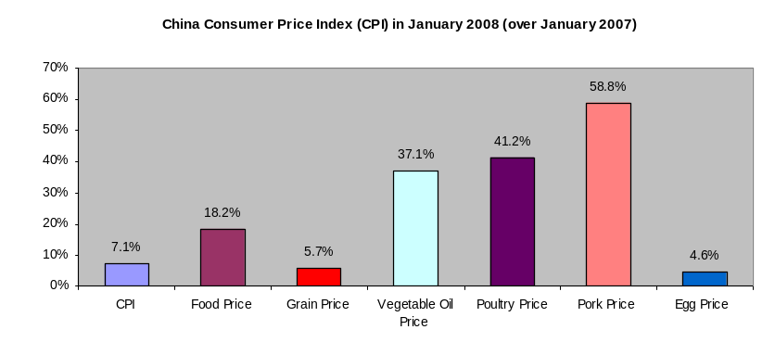
The rising agricultural commodity prices since 2007 have been the leading factor for the surge in overall Consumer Price Index (CPI) in China. (Note: among all agricultural commodities, grains witnessed the lowest price spike in MY07/08). To ease the inflationary pressure, and guarantee domestic grains supply, the government has tightened its control on grain exports by a series of policies including the removal of tax incentives on exports and the reduction of the export quota in MY07/08. Such policies will continue to be in effect in MY08/09.

In order to fulfill a long term policy objective of self sufficiency in grains and raising farmer’s income, the government will continue to expand support programs designated for the agricultural sector, and especially in grain production at least for the next five years.

Grain Production, Consumption and Trade

Grain Area and Yield
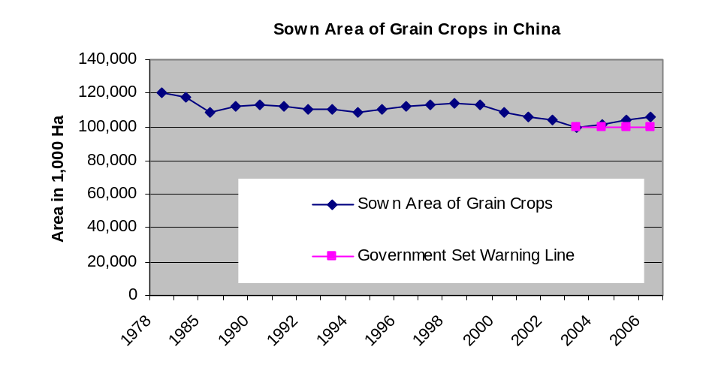
Since 2003 when China encountered a shortage in wheat and subsequently imported 10 MMT, the Chinese government has implemented a series of policies to protect arable land usage and encourage grain (defined as cereals, beans, and tubers) production. Under the 11th (2006-2010) five year plan, the objective is for annual sown area of grains to be at least 100 million hectares (Ha) and to increase average grain yield one percent annually. China’s Ministry of Agriculture (MOA) set a long-term target that maintains grain sown area above 100 million Ha. In the past five years, the sown area for rice, corn, and wheat averaged 80 percent of the total sown area for grains.
(Note: The double cropped or intercropped acreages are included in the sown area, for instance, early season rice and late season rice on one plot are taken into account separately).

Corn

Production
Despite a 4-percent increase in acreage, corn production for MY07/08 is estimated at 137 MMT, down 6 percent from the previous year. The persistent drought in the May-July period adversely impacted the corn yield in northeastern China. Corn production in MY08/09 is forecast at 142 MMT, 5 MMT greater than the previous year. Assuming a normal weather pattern, improvements in irrigation facilities and planting practices such as tighter rows and higher quality seed varieties are expected to contribute to a better than average yield in MY08/09. Corn area for MY08/09 is forecast to increase slightly over the previous year as farmers shift to corn in response to higher market prices.

Post does not accept official Chinese estimate of 148 MMT for MY07/08. According to this estimate, this record production was the result of an above average yield and increased acreage. However, based on Post’s field survey, the weather patterns in 2007 were not favorable for corn growth, in particular during the pollination period. Excessively high temperatures and dryness harmed the crop’s development, thus affecting the yield and quality of the grains. Actual field samples indicate the average yield in northeastern China, the region accounting for 35 percent of national output, to be about 20 percent lower than the previous year because of the drought.

Consumption
Corn is used in China as feed; for industrial production of sugar; starch and biofuel; and, for food, accounting for 72, 20, and less than one percent of domestic use, respectively. The remaining 7 percent is either used as seed or is lost during distribution after harvest.

Feed Consumption
Post estimates feed corn consumption decreased one percent and will increase by three percent respectively in MY07/08 and MY08/09. This is closely linked to changes in meat, especially pork and poultry, production and takes into account the increased efficiencies in feed conversion.

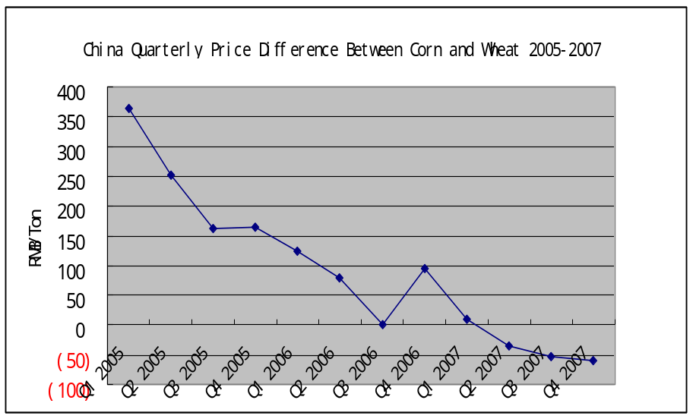
Post estimates that meat production efficiencies gained from better feed mixes have reduced feed corn demand (per unit of meat output). According to an annual survey on household and commercial farms by the National Development and Reform Commission (NDRC), the overall usage of grains and other crude protein ingredients in feed per unit of meat production has been down an average of almost one percent per year over the past ten years as a result of improved feed formulation and additives. Post forecasts this trend will continue in the coming years.

In MY07/08, responding to these price increases for corn, some poultry and swine farms in northern and central China substituted wheat and early season rice into their feed mix, reducing the growth rate for feed corn use. These practices are commonly found in wheat or rice production provinces with an oversupply of lower-quality wheat and rice. As the price gap for wheat and corn has narrowed significantly since MY07/08, Post predicts the continuation of this trend. Higher portions of feed wheat will be substituted for corn in MY08/09.

According to National Statistical Bureau (NSB), in CY2007 the meat production was estimated to drop 3.5 percent from the previous year, among them, pork production, dropped 9.2 percent, because of the outbreaks of swine disease in major producing provinces in MY07/08.

In MY07/08, swine diseases and high prices for feed ingredients combined to drive small household swine farms out of business. Industry sources report that small sized farmers in the disease-hit regions have ceased raising pigs in their backyards because the risk associated with rampant animal disease outbreaks was beyond their control. In the previous marketing years, household farms were estimated to contribute to about 75 percent of total swine production, and pork production is estimated to account for 60 percent of China’s total meat production.

There is no national tracking system for feed corn use. (MOA)’s China Industry Feed Association tracks industrial feed, estimated up less than 2 percent in CY2007 to 111 MMT. Corn content is estimated between 55 and 65 percent of industrial compound feed. Industrial feed is estimated to be between 50 and 65 percent of total feed use.

China: Feed Production by Type (1,000 tons)
 | Total | Compound | Concentrate | Premix
2003 | 87,120 | 64,280 | 19,580 | 3,260
2004 | 96,600 | 70,310 | 22,240 | 4,060
2005 | 107,000 | 77,610 | 24,980 | 4,780
2006 | 109,000 | 81,169 | 24,560 | 4,861
2007 | 111,000 | NA | NA | NA
Source: China Feed Industry Office

The price surge for animal products since mid-2007 has boosted profit margin greatly for animal husbandry sector. Additionally, the government enforced a favorable policy to promote swine production including a subsidy on breeding stocks. However, due to the production cycle and high input prices, Post estimates that the recovery of the swine sector would be delayed until the third quarter in 2008. Mortality from blue ear disease was also much higher than officially reported.

Industrial Use
Industrial use of corn includes the production of starch sweetener, industrial and food starch and ethanol. Post estimates that corn consumption for all industrial uses totaled 34 MMT in MY07/08, up by about 2 MMT from the previous year. The growth rate in corn use in the industrial sector in MY07/08 is estimated at 5 percent while in the previous five years it averaged about 15 percent. In response to mounting concerns over supply shortages of corn being the major cause behind the inflation crisis, the government stopped approving new corn processing plants in 2007 and 2008. Essentially, ethanol production plants were the government’s scapegoat to tighter domestic supplies and higher world prices for corn.

China’s starch and ethanol sectors are estimated to grow by 10 percent in MY07/08 over the previous year (see separate section on Ethanol). While corn is currently the principal ingredient for these sectors, actual corn use depends on the relative costs of corn substitutes, which include wheat, rice, sweet potatoes, and cassava.

China has included a tariff elimination on dry cassava chips in recent free trade agreements with Thailand and other ASEAN countries. As a result of this implementation, imports have exceeded 4 MMT in 2006 and 2007. Industry sources estimate this imported dry cassava chips used in the starch and ethanol sectors were equivalent to more than 4 MMT of corn in CY2007.

China's Cassava (071410) Imports from the World by Metric Ton 2002-2007
 | 2002 | 2003 | 2004 | 2005 | 2006 | 2007 | %change
Total Imports | 1,760,294 | 2,368,260 | 3,442,412 | 3,335,415 | 4,944,562 | 4,619,198 | -6.58
Thailand | 1,425,371 | 1,874,362 | 2,734,389 | 2,695,576 | 3,864,203 | 3,202,647 | -17.12
Vietnam | 212,878 | 453,132 | 522,296 | 411,573 | 935,401 | 1,273,240 | 36.12
Indonesia | 122,040 | 40,766 | 185,728 | 228,265 | 144,784 | 139,124 | -3.91
Laos |  |  |  |  | 0 | 3,524 | 0
Myanmar |  |  |  |  | 0 | 650 | 0
Malaysia |  |  |  |  | 0 | 13

Starch Production
The total corn used for starch manufacturing reached about 20 MMT in MY0708, up 10 percent from the previous year. Approximately 50 percent of corn starch production is used for sweetener and the rest is used in the industrial and food processing sectors including papermaking, textile production, and food-grade starch, including monosodium glutamate (MSG). Cornstarch accounts for 85 percent of total Chinese starch production.

Corn Trade
Imports of corn are estimated at 100,000 tons in MY07/08. Post forecast that no panamax or container ocean shipment will be commercially viable for U.S corn exports to China. China’s corn exports for MY07/08 are estimated at 800,000 tons. Corn exports for MY08/09 are forecast at 500,000 tons as a result of a decline in stocks and the government’s tight control regime on grain exports.

Imports
Due to high ocean freight rates and tight world supplies, the current landed price for imported U.S corn in Guangdong is calculated at $330/ton, which is 60 percent higher than the domestic corn price. Most of China’s corn imports, over land, come from border trade with its Southeastern Asian neighboring countries. In MY08/09, Post forecasts this trade pattern will not change. The increasingly high ocean freight rate and strong U.S corn price is not likely to soften. The vast price difference between U.S. and domestic corn will keep U.S. corn uncompetitive in China.

Exports
Corn exports MY07/08 are estimated at 800,000 MT. Corn exports for MY08/09 are forecast at 500,000 MT. Rising domestic corn demand for feed and industrial use and the limited ability to expand production will limit future exports. The majority of China’s corn exports are destined to South Korea, Japan and Southeast Asian countries.

The Chinese government manages corn exports. The NDRC, the State Administration of Grain (SAG), the Ministry of Finance, and the Agricultural Development Bank jointly determine the export quota based on the annual supply and demand situation. To date, the government has not issued an export quota for corn.

In December 2007 and early January 2008, the government did, however, announce that it would remove the value added tax (VAT) rebate for grain exports and levy provisional export taxes on grains and their flour products to discourage grain exports. These policies are designed to address concerns over rising domestic food prices and criticism that food exports contribute to inflationary pressures (See GAIN Report CH7093 and CH8001).

Post forecasts that under the current grain shortage supply situation the Chinese government will not issue any significant amount of quota for corn exports in CY2008. In the previous three years, the quota ranged between four to six MMT annually. Corn exports prior to 2007 were eligible for a 13 percent value added tax (VAT) rebate worth $17 per MT. The rebate is based on a base price fixed by NDRC rather than the actual traded price. The actual export price has historically exceeded the base price.

Stocks
While stock levels are considered a national secret by the Chinese government, Post estimates ending stocks for MY07/08 to be 36.8 MMT and forecasts ending stocks for MY08/09 to be 35.4 MMT, down by 1.7 MMT and 1.4 MMT, respectively, from the previous year as domestic consumption outpaces production. Although the National Statistical Bureau (NSB) surveyed stock levels of government entities, the survey data was not made public and is, at best, incomplete.

Most corn stocks are held in the northern production provinces of Heilongjiang, Jilin and Inner Mongolia. Central or provincial governments pay the storage fees, estimated at an approximate annual cost of $13.3 (RMB 100) per ton. Because of the high cost of transporting corn to users in the south, in the marketing years prior to 2007, these provinces lobbied the central government to provide export supports (see GAIN report 7015) and transportation subsidies. Since the end of 2007, all of these incentives on exports have been abolished.

DDGS
Domestic distillers dried grains with solubles (DDGS) production is an outgrowth of China's ethanol production and is mostly consumed by swine and dairy cattle or incorporated into animal feed production. Post estimates China's production of corn-based DDGS at 2.5 MMT in MY07/08. Though lower in protein content than protein meals, DDGS are a substitute for soybean and other oilseed meal and are substituted when it is the lower cost alternative. Except around corn ethanol plants, most feed millers, livestock and poultry farms are not familiar with the use of DDGS. There is no national standard labeling and packaging practice for DDGS. The limited availability of DDGS and the variation in quality (depending on the price and availability feedstock) make it difficult for feed millers to incorporate it into their feed production. As price differences vary between feedstocks including corn, wheat, rice, cassava, and sorghum, the plants can make cost-effective substitution accordingly.

Regulatory Oversight
While the domestic ethanol industry and feed mill sources report that domestic production and sale of DDGS are basically unregulated, imports must have a feed import registration and a biotech safety certificate.

The State Council's 2001 Management Regulation on Feed and Feed Additive requires DDGS to be registered at MOA as a feed product. (See GAIN CH6083 on Feed Registration.) After MOA first approved one import registration for DDGS in May 2006, subsequent applications have been made. The procedure is complicated as it requires a feeding test, and may take more than half year to complete. Once complete, the registration is valid for five years. As a feed ingredient, under a 2001 China Taxation Administration and Customs Administration rule, imported DDGS is exempted from a 13-percent value added tax (VAT). (See GAIN Report CH7015)

In addition, U.S. DDGS exporters must apply for a biotech import safety certificate from MOA. The application procedure is the same as the one required for the importation of biotech products, including soybeans and corn. Exporters need to take a copy of the safety certificate, issued to seed companies, to MOA's GMO Office and request an import safety certificate. Post does not foresee any egregious obstacles with the MOA certification process. (See GAIN CH5069.)

Market Opportunities
There are opportunities for U.S. DDGS exports to China because of the higher quality of U.S. DDDS compared to the domestic product. However, feed miller acceptance and competitive pricing is critical.

The U.S. DDGS production process has more consistent inputs meaning that the U.S. product has higher protein levels than domestic DDGS. With the exception of areas in north China near corn ethanol plants, feed millers and industrial farm complexes are not familiar with this relatively new product. Future marketing would require developing an understanding of the nutritional value and use requirements.

The protein level for average Chinese DDGS is about 26 percent while the U.S. DDGS protein (plus fat) is about 36 percent. In May 2007, one feed miller in Guangdong successfully imported one trial shipment of U.S. DDGS. Trade sources estimated that the calculated landed price for U.S DDGS in Guangdong in February 2008 was about $295/ton, while the domestic DDGS price is about $245/ton. However, according to industry experts, the additional nutritional value gained from U.S. DDGS outweighs the current price difference. This could be attested by the strong demand for U.S. DDGS in other Asian countries including Taiwan and South Korea, where feed millers are more familiar with and favor the use of DDGS to substitute both corn and soy meal.

Wheat

Production
Post estimates wheat production in MY07/08 is 106 MMT, up 1.5 percent from the previous year. Good weather and MOA’s production support programs contributed to better than average yields and quality in MY07/09. The acreage in MY07/08 is estimated to be 23.1 million Ha, up slightly from the previous year.

The planted area in MY08/09 is forecast to be 23.1 million Ha, unchanged from the previous year. Wheat production in MY08/09 is forecast at 105 MMT, 1 MMT down from the previous year. Winter wheat acreage accounted for 93 percent of total wheat acreage in MY07/08. The planted winter wheat for MY08/09 is estimated at 21.4 million Ha, unchanged from the previous year. Wheat, like other grains, is considered lower risk, stable, income crops when compared with vegetables, rapeseed, and cotton. Winter wheat in the northern China plain is usually double-cropped with corn. Compared with rice, corn and winter rapeseed, wheat production uses a much higher rate of mechanized planting and harvesting. Farmers in MY08/09 still favor wheat planting as it requires less labor input and field management as compared with oilseed, rice, rapeseed, and vegetables.

Major wheat production provinces include Henan, Shandong, Hebei, Anhui, and Jiangsu provinces. Wheat production in these provinces is estimated at 70 MMT in MY07/08, accounting for 67 percent of the national total. Over the years, MOA has been trying to define and develop production regions by encouraging the production of varieties with specific gluten levels. However, the improvements in wheat quality have been slow. Quality always varies due to differences in input applied and management techniques at small-scale wheat farms in China. The arable land per rural household in China is estimated at 1.4 acre in 2006, according to National Statistical Bureau.

The heavy snow storm in southern China in early 2008 marginally impacted the winter wheat in the region. MOA estimated that by February, affected wheat acreage totaled 584,000 Ha, or less than 3 percent of the total acreage. Agricultural officials estimate that the benefit brought by the snow far outweighs the damages. The snow fall is expected to improve the soil moisture and help reduce the likelihood for wheat diseases in MY08/09.

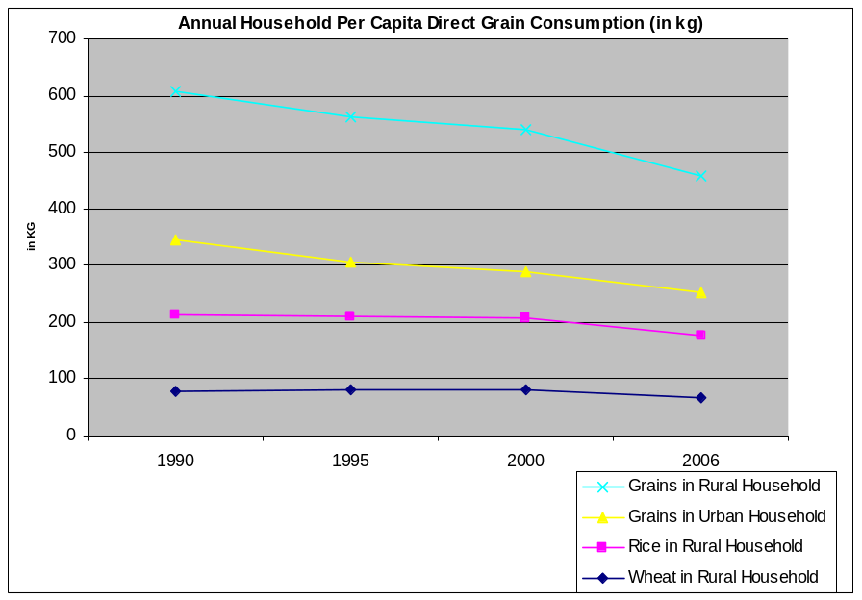
Consumption
Overall wheat consumption has been declining gradually. As incomes rise, consumers replace carbohydrates with protein. By some estimates, per capita food-grain consumption declined by over 1 percent annually in MY06/07 and MY07/08. According to the NSB, in home per capita consumption of grain in rural households dropped to 206 kg in 2006 from 250 kg in 2000 and in home per capita annual consumption of grain by urban households dropped to 76 kg in 2006 from 82 Kg in 2000, annually down about 3 and 1 percent, respectively. Post estimates that this decline will continue, as incomes rise in urban areas and consumers increase their in-take of animal protein instead of carbohydrates.

As urban demand for traditional wheat products (Chinese steamed bread) declines in favor of convenience foods, including instant noodles, biscuits and bakery products, wheat quality is becoming more of a factor for millers. Unlike traditional homemade or home-style Chinese food products, flour for processed foods requires specialized gluten content and consistent quality. Domestic flour millers usually try to satisfy these requirements by blending imported wheat with lower-quality domestic wheat.

Currently, the landed price for imported U.S. wheat is more than twice the price of domestic wheat, which prevents the millers or traders from purchasing directly from the international market. In MY07/08, flour millers purchased imported wheat at auctions held by SinoGrain, a central state-owned grain reserve corporation, or its provincial counterparts. The imported wheat was purchased during 2002-2004 by the central government. Even after three or four years, the quality is still superior to that of domestic wheat.

Trade
Wheat imports for MY07/08 are estimated to drop down by 300,000 tons from the previous marketing year to an estimated 50,000 tons as a result of a good harvest in MY07/08 and an oversupply in the domestic market. Wheat imports in MY08/09 are forecast at 30,000 tons, 20,000 tons lower than the previous year.

Most of China’s wheat and flour exports are destined to southeastern Asian countries (mainly the Philippines). Because of production declines in major wheat supplying countries, China’s wheat exports and its flour products have become increasingly price competitive in the international market, even without the tax incentives such as VAT rebate. However, China’s wheat exports in MY07/08 are estimated at 2.3 MMT, unchanged from the previous year because of the government controlled export quota. Wheat exports for MY08/09 are forecast at 1 MMT, down by 57 percent from the previous year, due to the removal of the tax incentive and a reduced export quota.

Stocks
While official stock level estimate are not available, Post estimates that ending stocks for MY07/08 and MY08/09 will be 40.1 and 42.6 MMT, respectively, up by 3 MMT and 2.5 MMT, respectively, from the previous year as a result of four straight years of bumper harvests. Previously, the NSB surveyed stock levels of government entities, but the survey data was not made public.

Rice

Production
Total rice production is estimated at 185 MMT (unmilled) in MY07/08, up one percent from the previous year. Estimated area planted is 29.6 million Ha, up slightly from the previous year. Early-season rice production is estimated at 32 MMT, unchanged from the previous year. Because of favorable weather for Japonica varieties and late season rice, yield and quality are estimated to be above the five-year average.

Rice production for MY08/09 is forecast at 184 MMT, down slightly from the previous year, assuming an average yield. Acreage is forecast to be unchanged from the previous year. The government's price support program (see Policy section) has guaranteed reasonable returns for rice farmers.

Consumption
MY07/08 consumption is estimated at 127 MMT (milled), down slightly over the previous year. Indica rice varieties have been a predominant staple food for the population in southern China, while Japonica rice varieties are traditionally popular in northern China where people also favor wheat flour based staple foods. As discussed in the wheat section, surveys show per capita in house grain consumption (including rice and wheat) is declining by over 1 percent annually and this trend is projected to continue.

In addition to food use, low quality early rice varieties and stale rice reserves are used to feed swine and poultry at both commercial farms and rural households. In MY07/08, because of a higher corn prices, Post estimates an increased use of rice and wheat for feed. In the ethanol sector, low priced indica rice has replaced some corn feedstock in MY07/08. While there is no reliable data on the feed use of rice, Post estimates that approximately 10 MMT of rice (unmilled) is used annually for feed.

Trade
As of 2007, China signed import quarantine protocols for rice with Thailand, Uruguay, Vietnam, Pakistan, and Japan. Most import varieties were Indica of which Thailand and Vietnam were the principal suppliers in CY2007.

Rice imports for MY07/08 are estimated at 300,000 tons. Rice imports for MY08/09 are forecast at 330,000 tons, up 10 percent from the previous year. Most of the rice imports are Thai fragrant rice, which are consumed in affluent coastal cities.

Rice exports in MY07/08 are estimated at 1 MMT. Rice exports in MY08/09 are forecast at 1.2 MMT. Most of China’s rice exports are low quality Indica exported to African countries. China also exports Japonica varieties to Japan, Russia and South Korea. These exports are small in volume but highly profitable, and are forecast to continue.

Stocks
While official stock level data is not available, Post estimates that ending stocks for MY07/08 are 37.7 MMT, and are forecast to reach 38.6 in MY08/09. Previously, NSB surveyed the stock levels of government entities, but survey data was not made public and is, at best, incomplete.

Barley
MY07/08 barley area is estimated at 950,000 Ha, up four percent over the previous year principally as a result of increased demand from the brewery sector and a short supply in the international market. Production is estimated at 3.6 MMT, unchanged from the previous year. Post forecasts that both barley area and production in MY08/09 will increase slightly over the previous year, as a result of increased demand for malting barley.

Gansu Province is the largest and highest quality barley producer in China and Post estimates its barley production at 800,000 MT, accounting for 22 percent of total production.
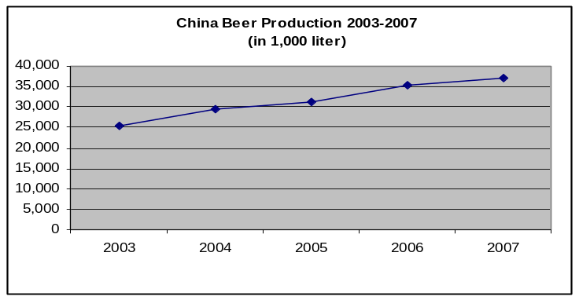
Barley in China is mostly used for brewing. Domestic barley production is inadequate to supply the expanding brewery industry. Industry sources estimate that China’s beer production in 2007 will exceed 37 million kilolitres, up over 5 percent compared to 2006. The sector’s total demand for malting barley is estimated at around 4 MMT annually. However, as a result of a poor crop in Australia and Canada, China’s MY07/08 imported barley is estimated at 800,000 MT, down 30 percent from the previous year. Barley imports in MY08/09 are forecast up slightly as the global supply rebounds. If international stocks remain short and prices remain high, however, feed barley or other grains could be substituted, despite the potential impact on beer quality.

Currently, neither MOA nor provincial authorities consider barley as an important feed grain, nor is it a crop with production assistance.

Sorghum
Post estimates the sorghum planted area is unchanged from the previous year at 550,000 Ha. Production is up almost 25 percent in MY07/08 to 2.6 MMT due to higher yields. The MY08/09 sorghum planted area and production is forecast to fall by 10 percent and 7 percent, respectively. The forecast reduction in acreage reflects farmers intention to turn to more profitable corn in northeastern China. Sorghum is mostly planted on marginal land with no irrigation.

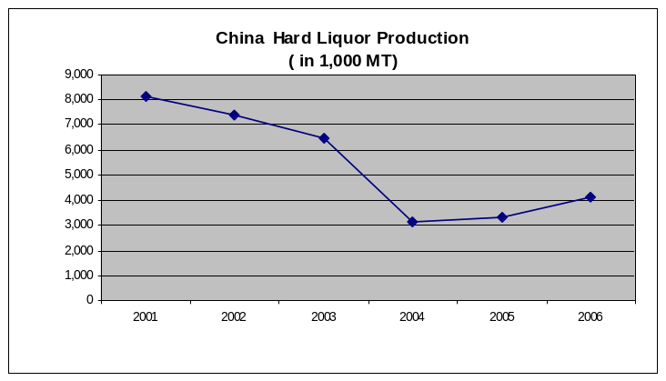
While some sorghum is used for
feed, the majority, approximately 2 MMT, is used for hard liquor (ethanol-based) production. Production of hard liquor is estimated at 4.1 MMT for MY06/07, up 23 percent from the previous year. Hard liquor consumption is forecast to rise as consumer incomes rise and effective marketing campaigns by distillers promote the gift-giving of traditional Chinese alcohol. Promotions include significant prime time TV and other media advertisements in recent years.

Currently, neither MOA nor provincial authorities consider sorghum as an important feed grain, nor is it a crop with production assistance.

Ethanol
Total ethanol production in MY07/08 is estimated at 8 MMT. About 50 percent of total ethanol production is based on grains (mostly corn, but also includes sorghum, wheat and rice) with the remainder based on tubers, including cassava and sweet potatoes. Corn based ethanol production is estimated at 2.8 MMT in MY07/08, including approximately 1.2 MMT of fuel ethanol.

Fuel Ethanol
The government strictly manages the fuel ethanol sector. Currently, only five licensed plants can market their products as fuel ethanol. Fuel ethanol must be sold to one of two state-owned oil companies.

Estimated fuel ethanol production in MY07/08 is 1.5 MMT, with approximately 1 MMT based on corn as an input. According to government guidance, fuel ethanol production in China is set to expand to 3.5 MMT by 2010, but corn will not be a significant part of this expansion. Future plants will mostly be based in the south or west and use either sweet sorghum, tubors, or cassava. (See GAIN Report CH7039)

Total grain consumption in MY06/07 by the fuel ethanol sector is estimated at about 4.5 MMT, of which about 3 MMT is corn. Both central and provincial governments have invested heavily to support the fuel ethanol sector. State media reports that the government offered $225/ton (RMB 1,800/ton) as a subsidy for corn-based ethanol in 2005. In 2006, the government reduced the subsidy by an average of $37.5/ton (RMB300/ton) for the four plants signaling the government’s intention to curb the expansion of grain based ethanol production. In 2008, the government will continue to cut the subsidy level to encourage the improvements in efficiency at these ethanol plants.

Ethanol Exports
Rising international fuel prices in 2006 propelled a leap in China’s ethanol exports, which rose over 500 percent from the previous year. Chinese government concerns that the development of export oriented ethanol plants might lead to domestic grain shortages led to the elimination of the 13-percent VAT rebate on ethanol exports, effective January 2007. The elimination of the VAT rebate led to an 87-percent drop in ethanol exports in 2007. In 2008, as a measure to ease inflationary pressure, the government continues to limit ethanol exports.

China Ethanol Exports in 2004-2007 (in 1,000 MT)
 |  | 2005 | 2006 | % Change | 2007 | %change
Group | Ethanol | 137,873 | 865,112 | 5277% | 110,477 | -87%
220710 | ETHYL ALCOHOL, UNDENAT, | 134,856 | 825,113 | 512% | 94,110 | -89%
220720 | ETHYL ALCOHOL & OTH SPIRITS DENATURED ANY STRENGTH | 3,018 | 39,999 | 12% | 16,367 | -59%
Source of data: China Customs

Policy

China retains its long-term self-sufficiency objective for food grains, and defines food grains to include rice, wheat, and corn. In 2001, concurrent with China's accession to the World Trade Organization (WTO), China adopted policies on grain production and trade, including seed subsidies and tariff rate quotas. In 2003, due to shortage in the national wheat supply, China imported 10 MMT of wheat. In response, China implemented a series of policies, effective 2004, including the elimination of taxes on agricultural land, direct payments to grain farmers, adjustments to price support programs, and in 2005, a subsidy for the purchase of farm machinery. In 2006, in addition to the existing VAT exemption for farm use of seed and fertilizers, China added a direct subsidy for farm use of fuel and fertilizers.

Since 2004, the No. 1 Decree of the central government has been in support of the rural community and to improve farm income. This was incorporated by the National People's Congress in the 11th five-year plan (2006-2010) which includes the specific objective of increasing farm income. MOA has included maintaining the annual sown area of grains above 100 million Ha and increasing average annual grain yield to one percent as a component to meeting this objective.

The rising trend of agricultural commodity prices since 2007 has been the leading factor for the surge in overall Consumer Price Index (CPI) in China. To ease the inflationary pressure, the government will continue to expand support programs for the agricultural sector including grain production at least in the next five years.

Grain Prices and Farmer Income
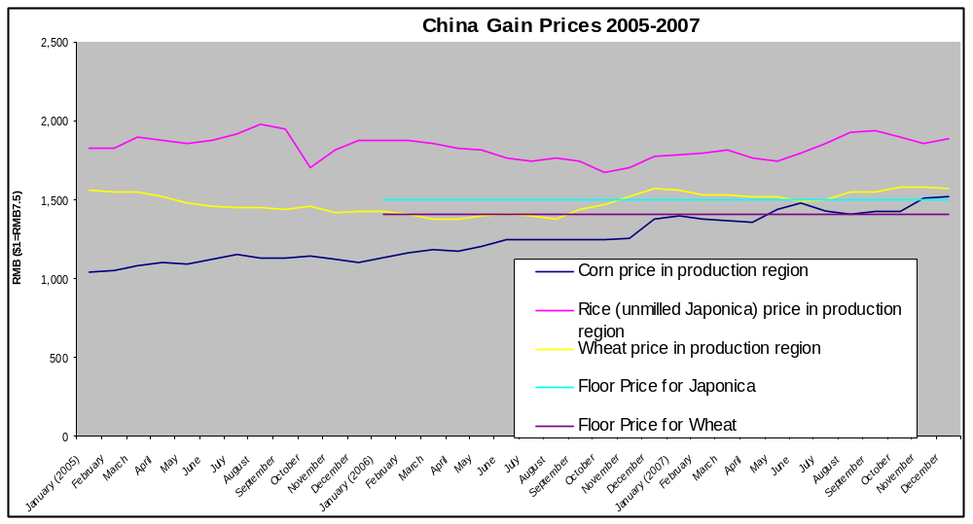
Average prices have been up for corn and wheat in MY07/08, 18 and 9 percent, respectively, over the previous year. The average rice price has been slightly lower than the previous year. Boosted by government procurement at harvest by floor price in MY07/08, the current market price range for wheat and rice are above the floor prices and mostly driven by government auctions of grains purchased in MY07/08 and previous years. (See Price Support Program).

While lower than their urban counterparts, in 2007, net per capita rural income rose by 10 percent to $552 (RMB 4,140), according to state media source, the highest growth rate since 1997. For grain farmers, Post estimates that the average net profit/Ha (wheat, corn and rice) in 2007 will be higher than 2006 due to rising grain prices. See table below.

Net Profit for Grain Farmers (in US $/Ha) in 1998-2006
Year | 1998 | 1999 | 2000 | 2001 | 2002 | 2003 | 2004 | 2005 | 2006
Net Profit/Ha | 144 | 46 | -6 | 71 | 9 | 62 | 393 | 245 | 310
Source: National Development & Reform Commission

Grain Support Programs
China’s rice, wheat, and corn self-sufficiency objective is implemented using direct payments, seed subsidies, tariff rate quotas (discussed separately), price support programs (in the case of rice and wheat), subsidies for farm machinery, and subsidies for farm use of fuel and fertilizers. In MY07/08, these policies have produced a slight oversupply of rice and wheat, allowing for some exports, which will continue in MY08/09. Corn production has mostly been mostly driven by the growing domestic demand for corn from livestock and industrial users. This demand is estimated to outstrip supplies in MY07/08, drawing down stocks and possibly allowing for imports, and is forecast to do the same in MY08/09.

The direct grain subsidy (payment to the grain farmer), seed subsidy, farm machinery subsidy, and comprehensive subsidy totaled $6.84 billion (RMB 51.27 billion) in 2007, up 63 percent from the previous year, according to the state media. In 2008, government spending on the agricultural sector is expected to be higher than the previous year. The budget will be approved and announced after National People’s Congress in March. A separate report by the Ministry of Finance stated that the direct cash payment to grain farmers would average about $82/ha (RMB 615/ha) in 2008, a rise of 75 percent from the previous year.
Government Support Programs in 2005-2008 (in $)
 | Direct Payment | Seed Subsidy | Machinery Subsidy | Fuel/fertilizer Subsidy
2008 | 2 billion | NA | NA | 6.4 billion
2007 | 2 billion | 876 million | 26.6 million | 3.68 billion
2006 | 1.9 billion | 546 million | 800,000 | 1.66 billion
2005 | 1.7 billion | 520 million | 400,000 | NA

Direct Payments for Grain Farmers
In 2004, the central government offered a program of direct payments to grain growers, implemented at the discretion of the provinces. Implementation varies by province with some providing the subsidy based on planted area and others based on quantity produced. The average program payment is $18/ha, slightly less than $9 per average farm household in 2005. In 2006 and 2007, the payment averaged about $10 per farm household.

Seed Subsidy
In 2001, MOA implemented the seed subsidy program for wheat and has subsequently expanded it to corn, rice, and soybeans. The combined value of the seed subsidy for wheat, rice, corn, and soybean was $521 million (RMB 4.07 billion) in 2006, up 5 percent from 2005. The program is intended to expand production through improved seed quality. Funding is principally provided through MOA and implementation is at the provincial level. In 2007, the funding for wheat, rice, and corn was unchanged from the previous year.

Implementation varies by commodity and province but basically falls into two categories: direct payments or discounted seeds. As a direct payment, it is an income support mechanism where the farmer is provided between $19-23/Ha (RMB 10-15/mu) to purchase seeds, but what the farmer actually does with the payment is not monitored.

Alternatively, the subsidy is provided for farmers to purchase high quality seeds at commodity prices. The subsidy is approximately $19/Ha (RMB 10/mu) and may take the form of a payment to the seed company to provide a specific type of seed at commodity prices, or a reimbursement to the farmer for seeds purchased. In Henan, the government first identifies the preferred wheat varieties and then seed companies are asked to offer discount prices. After the sale, the seed company receives a subsidy of approximately 13.3 cent/kg (RMB 1/kg) of wheat seed. (Seed wheat usage averages 10 kg/mu (150 Kg/Ha) in Henan Province.)
Winter Wheat Seed Subsidy Program
 | Total Subsidy ($) | Provinces | Area Covered
2004 | 13,333,333 | 6 | 50%
2005 | 133,333,333 | 11 | 54%
2006 | 133,333,333 | 11 | 54%
2007 | 133,333,333 | NA | NA

Price Support Programs
In 2007, the central government continued its price support program for major producers of rice and wheat. Provinces covered by a floor price program were Jilin, Heilongjiang, Anhui, Jiangxi, Hubei, Hunan, and Sichuan. Provinces covered by a wheat price floor were Hebei, Jiangsu, Anhui, Shandong, Henan, and Hubei.

The floor price is set every year by NDRC in collaboration with the Ministry of Finance, the State Administration for Grains (SAG), the China Agricultural Development Bank (CADB), and MOA. Implementation is by SAG and the quasi-governmental SinoGrain Corporation, and funded by loans from CADB. Loans are recovered by commodity sales later in the marketing year or in subsequent marketing years. In February 2008, NDRC announced that the floor price for wheat and rice will increase by less than 1 percent in 2008 from the previous year.
Government Floor Price for Grains in 2004-2008 ($/ton)
 | 2005 | 2006 | 2007 | 2008
Rice
Early Indica (unmilled) | 192 | 192 | 192 | 207
Japonica (unmilled) | 200 | 200 | 200 | 211
Wheat
White Wheat | 192 | 193 | 192 | 207
Red Wheat | 184 | 184 | 184 | 192

In 2006-2007, the government purchased about 70 MMT of wheat from grain farmers when the market price fell below the prefixed floor price. During the marketing year, the government holds regular auctions at provincial wholesale markets to sell off the wheat. According to industry sources, by end of 2007, about 40 MMT of wheat was sold.

Subsidy on Farm Machinery
In 2007, the central government provided $267 million (RMB 2 billion) for the purchase of farm machinery, up 230 percent, and the program covered two thirds of agricultural counties nationwide. Complementing central government funds, the provincial governments provided $173 million (RMB 1.3 billion) in 2007, up 14 percent from the previous year. .

The program offsets the cost of purchases by reimbursing the farmer or compensating the seller for 20 to 30 percent of the purchase price. The program is implemented at the provincial level and local governments decide on machines and models eligible for the subsidy. The subsidy supported the mechanization of wheat harvesting and rice planting. In 2007, the government started trials on mechanized corn harvesting.

Comprehensive Subsidy on Fuel and Fertilizer
In 2007, the comprehensive subsidy on fuel and fertilizer for grain farmers totaled $ 3.6 billion (RMB 27.6 billion), up 120 percent from the previous year. The program, started in 2006, intends to partially compensate farmers for price increases in fuel, fertilizer and other agricultural inputs. According to the Ministry of Finance, the comprehensive subsidy averaged about $14.5 per farm household in 2007.

Elimination of Agricultural Tax
Since 2004, the government began reducing agricultural taxes on farmland (simultaneously introducing direct payments). Prior to 2004, there had been a decade-old 7 percent tax on agricultural production. In 2006, the government announced that all provinces had eliminated the agricultural tax.

Tariff Rate Quotas
Upon membership to the World Trade Organization (WTO), China established Tariff Rate Quotas (TRQ) for wheat, rice, corn, and several other commodities. These quotas were phased in and reached final levels in 2004. The percentage of the quota reserved for non-state-owned enterprises is 10, 40 and 50 percent for wheat, corn, rice (short and long grain), respectively.
2007 Grain Tariff Rate Quota (TRQ):

Allocation and Fill Rate (Metric Tons )

 |  |  | 2007 |  | 2006
Commodity | TRQ | State Enterprise Share | Imports | Fill Rate | Imports | Fill Rate
Wheat | 9,636,000 | 90% | 112 | <1% | 625 | 1%
Corn | 7,200,000 | 60% | 351,98 | <1% | 62,186 | 1%
Rice | 5,320,000 | 50% | 471,500 | 14% | 719,000 | 14%

Statistical Tables

PSD tables

Table1. Corn PSD Table

China, Peoples Republic of
Corn |  |  |  |  |  | (1000 HA)(1000 MT)(MT/HA)
 | 2006 | Revised |  | 2007 | Estimate |  | 2008 | Forecast
 | USDA  Official | Post  Estimate | Post  Estimate  New | USDA  Official | Post  Estimate | Post  Estimate  New | USDA  Official | Post  Estimate | Post  Estimate  New
Market Year Begin |  | 10-2006 | 10-2006 |  | 10-2007 | 10-2007 |  | 10-2008 | 10-2008
Area Harvested | 26970 | 27000 | 26970 | 28000 | 27200 | 28000 | 0 | 0 | 28200
Beginning Stocks | 35255 | 33890 | 35255 | 32482 | 29490 | 38482 | 28582 | 22290 | 36782
Production | 145480 | 142000 | 145480 | 145000 | 143000 | 137000 | 0 | 0 | 142000
MY Imports | 16 | 100 | 16 | 100 | 800 | 100 | 0 | 0 | 150
TY Imports | 16 | 100 | 16 | 100 | 800 | 100 | 0 | 0 | 150
TY Imp. from U.S. | 49 | 0 | 49 | 0 | 0 | 5 | 0 | 0 | 0
Total Supply | 180751 | 175990 | 180751 | 177582 | 173290 | 175582 | 28582 | 22290 | 178932
MY Exports | 5269 | 4000 | 5269 | 1000 | 1000 | 800 | 0 | 0 | 500
TY Exports | 5269 | 4000 | 5269 | 1000 | 1000 | 800 | 0 | 0 | 500
Feed Consumption | 103000 | 102500 | 97000 | 105000 | 106000 | 96000 | 0 | 0 | 99000
FSI Consumption | 40000 | 40000 | 40000 | 43000 | 44000 | 42000 | 0 | 0 | 44000
Total Consumption | 143000 | 142500 | 137000 | 148000 | 150000 | 138000 | 0 | 0 | 143000
Ending Stocks | 32482 | 29490 | 38482 | 28582 | 22290 | 36782 | 0 | 0 | 35432
Total Distribution | 180751 | 175990 | 180751 | 177582 | 173290 | 175582 | 0 | 0 | 178932

Table2. Wheat PSD Table

China, Peoples Republic of
Wheat |  |  |  |  |  |  |  | (1000 HA)(1000 MT)(MT/HA)
 |  | 2006 | Revised |  | 2007 | Estimate |  |  | 2008 |  | Forecast
 |  | USDA  Official | Post  Estimate | Post  Estimate  New | USDA  Official | Post  Estimate | Post  Estimate  New |  | USDA  Official |  | Post  Estimate | Post  Estimate  New
Market Year Begin |  |  | 07-2006 | 07-2006 |  | 07-2007 | 07-2007 |  |  | 07-2008 |  | 07-2008
Area Harvested |  | 22960 | 23300 | 22960 | 23100 | 23200 | 23100 |  | 0 |  | 0 | 23100
Beginning Stocks |  | 34890 | 34890 | 34890 | 35957 | 35390 | 37382 |  | 39107 |  | 35790 | 40132
Production |  | 104470 | 103000 | 104470 | 106000 | 101000 | 106000 |  | 0 |  | 0 | 105000
MY Imports |  | 380 | 500 | 374 | 150 | 400 | 50 |  | 0 |  | 0 | 30
TY Imports |  | 380 | 500 | 374 | 150 | 400 | 50 |  | 0 |  | 0 | 30
TY Imp. from U.S. |  | 64 | 150 | 66 | 0 | 100 | 15 |  | 0 |  | 0 | 10
Total Supply |  | 139740 | 138390 | 139734 | 142107 | 136790 | 143432 |  | 39107 |  | 35790 | 145162
MY Exports |  | 2783 | 2000 | 2352 | 2500 | 1500 | 2300 |  | 0 |  | 0 | 1000
TY Exports |  | 2783 | 2000 | 2352 | 2500 | 1500 | 2300 |  | 0 |  | 0 | 1000
Feed Consumption |  | 4000 | 4500 | 4000 | 4000 | 4000 | 6000 |  | 0 |  | 0 | 7000
FSI Consumption |  | 97000 | 96500 | 96000 | 96500 | 95500 | 95000 |  | 0 |  | 0 | 94500
Total Consumption |  | 101000 | 101000 | 100000 | 100500 | 99500 | 101000 |  | 0 |  | 0 | 101500
Ending Stocks |  | 35957 | 35390 | 37382 | 39107 | 35790 | 40132 |  | 0 |  | 0 | 42662
Total Distribution |  | 139740 | 138390 | 139734 | 142107 | 136790 | 143432 |  | 0 |  | 0 | 145162

Table3. Rice PSD Table

China, Peoples Republic of
Rice, Milled |  |  |  |  |  | (1000 HA)(1000 MT)(MT/HA)
 | 2006 | Revised |  | 2007 | Estimate |  | 2008 | Forecast
 | USDA  Official | Post  Estimate | Post  Estimate  New | USDA  Official | Post  Estimate | Post  Estimate  New | USDA  Official | Post  Estimate | Post  Estimate  New
Market Year Begin |  | 01-2007 | 01-2007 |  | 01-2008 | 01-2008 |  | 01-2009 | 01-2009
Area Harvested | 29295 | 29200 | 29295 | 29600 | 29400 | 29600 | 0 | 0 | 29500
Beginning Stocks | 36783 | 36327 | 36783 | 35968 | 35027 | 35915 | 35668 | 35327 | 37715
Milled Production | 127800 | 127000 | 127800 | 129500 | 128000 | 129500 | 0 | 0 | 128500
Rough Production | 182571 | 181429 | 182571 | 185000 | 182857 | 185000 | 0 | 0 | 183571
Milling Rate (.9999) | 7000 | 7000 | 7000 | 7000 | 7000 | 7000 | 0 | 0 | 7000
MY Imports | 500 | 900 | 472 | 600 | 900 | 300 | 0 | 0 | 330
TY Imports | 500 | 900 | 472 | 600 | 900 | 300 | 0 | 0 | 330
TY Imp. from U.S. | 0 | 0 | 0 | 0 | 0 | 0 | 0 | 0 | 0
Total Supply | 165083 | 164227 | 165055 | 166068 | 163927 | 165715 | 35668 | 35327 | 166545
MY Exports | 1315 | 1400 | 1340 | 1300 | 1500 | 1000 | 0 | 0 | 1200
TY Exports | 1315 | 1400 | 1340 | 1300 | 1500 | 1000 | 0 | 0 | 1200
Total Consumption | 127800 | 127800 | 127800 | 129100 | 127100 | 127000 | 0 | 0 | 126500
Ending Stocks | 35968 | 35027 | 35915 | 35668 | 35327 | 37715 | 0 | 0 | 38845
Total Distribution | 165083 | 164227 | 165055 | 166068 | 163927 | 165715 | 0 | 0 | 166545

Table4. Barley PSD Table

China, Peoples Republic of
Barley |  |  |  |  |  |  | (1000 HA)(1000 MT)(MT/HA)
 | 2006 | Revised |  | 2007 | Estimate |  | 2008 | Forecast
 | USDA  Official | Post  Estimate | Post  Estimate  New | USDA  Official | Post  Estimate | Post  Estimate  New | USDA  Official | Post  Estimate | Post  Estimate  New
Market Year Begin |  | 10-2006 | 10-2006 |  | 10-2007 | 10-2007 |  | 10-2008 | 10-2008
Area Harvested | 880 | 880 | 915 | 860 | 860 | 950 | 0 | 0 | 980
Beginning Stocks | 261 | 361 | 261 | 88 | 401 | 304 | 78 | 341 | 204
Production | 3500 | 3500 | 3565 | 3400 | 3400 | 3600 | 0 | 0 | 3700
MY Imports | 1127 | 2000 | 1127 | 1300 | 2100 | 800 | 0 | 0 | 1000
TY Imports | 1127 | 2000 | 1127 | 1300 | 2100 | 800 | 0 | 0 | 1000
TY Imp. from U.S. | 0 | 0 | 0 | 0 | 0 | 0 | 0 | 0 | 0
Total Supply | 4888 | 5861 | 4953 | 4788 | 5901 | 4704 | 78 | 341 | 4904
MY Exports | 0 | 10 | 49 | 10 | 10 | 200 | 0 | 0 | 150
TY Exports | 0 | 10 | 49 | 10 | 10 | 200 | 0 | 0 | 150
Feed Consumption | 1000 | 1200 | 800 | 1000 | 1100 | 800 | 0 | 0 | 800
FSI Consumption | 3800 | 4250 | 3800 | 3700 | 4450 | 3500 | 0 | 0 | 3700
Total Consumption | 4800 | 5450 | 4600 | 4700 | 5550 | 4300 | 0 | 0 | 4500
Ending Stocks | 88 | 401 | 304 | 78 | 341 | 204 | 0 | 0 | 254
Total Distribution | 4888 | 5861 | 4953 | 4788 | 5901 | 4704 | 0 | 0 | 4904

Table5. Sorghum PSD Table

China, Peoples Republic of
Sorghum |  |  |  |  |  |  |  | (1000 HA)(1000 MT)(MT/HA)
 | 2006 | Revised |  |  | 2007 | Estimate |  |  | 2008 | Forecast
 | USDA  Official | Post  Estimate | Post  Estimate  New |  | USDA  Official | Post  Estimate | Post  Estimate  New |  | USDA  Official | Post  Estimate | Post  Estimate  New
Market Year Begin |  | 10-2006 | 10-2006 |  |  | 10-2007 | 10-2007 |  |  | 10-2008 | 10-2008
Area Harvested | 590 | 590 | 566 |  | 600 | 600 | 550 |  | 0 | 0 | 500
Beginning Stocks | 185 | 185 | 185 |  | 155 | 225 | 103 |  | 110 | 182 | 128
Production | 2700 | 2800 | 2098 |  | 2600 | 2850 | 2600 |  | 0 | 0 | 2400
MY Imports | 4 | 10 | 4 |  | 10 | 12 | 5 |  | 0 | 0 | 5
TY Imports | 4 | 10 | 4 |  | 10 | 12 | 5 |  | 0 | 0 | 5
TY Imp. from U.S. | 0 | 0 | 0 |  | 0 | 0 | 0 |  | 0 | 0 | 0
Total Supply | 2889 | 2995 | 2287 |  | 2765 | 3087 | 2708 |  | 110 | 182 | 2533
MY Exports | 144 | 30 | 144 |  | 25 | 25 | 180 |  | 0 | 0 | 150
TY Exports | 144 | 30 | 144 |  | 25 | 25 | 180 |  | 0 | 0 | 150
Feed Consumption | 320 | 470 | 140 |  | 290 | 540 | 300 |  | 0 | 0 | 200
FSI Consumption | 2270 | 2270 | 1900 |  | 2340 | 2340 | 2100 |  | 0 | 0 | 2000
Total Consumption | 2590 | 2740 | 2040 |  | 2630 | 2880 | 2400 |  | 0 | 0 | 2200
Ending Stocks | 155 | 225 | 103 |  | 110 | 182 | 128 |  | 0 | 0 | 183
Total Distribution | 2889 | 2995 | 2287 |  | 2765 | 3087 | 2708 |  | 0 | 0 | 2533

Price Tables

Table6. Corn Price Table

China's Average Corn Wholesale Prices
(Renminbi Per Metric Ton, USD 1.00 = RMB 7.5)
 | Producing Region/1 | Consuming Region/2
January (2006) | 1130 | 1340
February | 1160 | 1380
March | 1180 | 1390
April | 1170 | 1370
May | 1200 | 1419
June | 1250 | 1510
July | 1240 | 1490
August | 1240 | 1490
September | 1250 | 1500
October | 1250 | 1400
November | 1260 | 1440
December | 1380 | 1680
January (2007) | 1400 | 1680
February | 1380 | 1680
March | 1370 | 1670
April | 1360 | 1680
May | 1440 | 1640
June | 1480 | 1680
July | 1430 | 1670
August | 1410 | 1660
September | 1430 | 1800
October | 1430 | 1720
November | 1510 | 1850
December | 1520 | 1870
/1 Jilin Province/2 Guangdong Province
Source: China National Grain and Oils Information Center

Table7. Wheat Price Table

China Average Wheat(Grade2) Wholesale Price
(Renminbi Per Metric Ton, USD 1.00 = RMB 7.5)
 | Henan Province | Jiangsu Province
January(2006) | 1,426 | 1,366
February | 1,411 | 1,369
March | 1,381 | 1,370
April | 1,380 | 1,382
May | 1,394 | 1,433
June | 1,409 | 1,401
July | 1,401 | 1,336
August | 1,382 | 1,304
September | 1,440 | 1,351
October | 1,470 | 1,384
November | 1,520 | 1,501
December | 1,569 | 1,544
January (2007) | 1,557 | 1,530
February | 1,531 | 1,530
March | 1,535 | 1,550
April | 1,525 | 1,530
May | 1,520 | 1,520
June | 1,485 | 1,490
July | 1,495 | 1,430
August | 1,550 | 1,520
September | 1,550 | 1,540
October | 1,580 | 1,580
November | 1,580 | 1,620
December | 1,575 | 1,610
Source: China National Grain and Oils Information Center

Table8. Rice Price Table

China's Average Wholesale Japonica Rice Price
(Renminbi Per Metric Ton, USD 1.00 = RMB 7.5)
 | Jiangsu Province | Heilongjiang Province
January (2006) | 1,880 | 1,793
February | 1,880 | 1,806
March | 1,859 | 1,795
April | 1,828 | 1,780
May | 1,814 | 1,809
June | 1,764 | 1,866
July | 1,747 | 1,870
August | 1,770 | 1,885
September | 1,746 | 1,897
October | 1,676 | 1,838
November | 1,699 | 1,793
December | 1,780 | 1,722
January (2007) | 1,782 | 1,676
February | 1,795 | 1,633
March | 1,812 | 1,635
April | 1,763 | 1,661
May | 1,750 | 1,689
June | 1,794 | 1,710
July | 1,855 | 1,700
August | 1,929 | 1,673
September | 1,935 | 1,658
October | 1,903 | 1,629
November | 1,855 | 1,567
December | 1,892 | 1,626
Source: China National Grain and Oils Information Center

Trade Tables

Table9. Corn Trade Table

China Corn Exports by Destination, MY 2006/2007 (Metric Tons)
Country | Oct-Dec | Jan-Mar | April-Jun | Jun-Sept | Total
--World-- - | 804,457 | 2,834,974 | 766,993 | 863,163 | 5,269,587
Korea, South - | 417,263 | 1,766,120 | 557,672 | 608,479 | 3,349,533
Japan - | 177,345 | 387,577 | 91,857 | 164,350 | 821,129
Korea, North - | 7,790 | 3,260 | 6,265 | 14,804 | 32,119
Malaysia - | 147,511 | 289,075 | 111,167 | 56,797 | 604,550
Canada - | 0 | 0 | 0 | 18,672 | 18,672
Switzerland - | 0 | 0 | 0 | 0 | 0
Sweden - | 0 | 0 | 0 | 0 | 0
Bangladesh - | 0 | 0 | 0 | 40 | 40
Myanmar - | 0 | 0 | 12 | 0 | 12
Cambodia - | 0 | 0 | 0 | 0 | 0
Others | 54,548 | 388,942 | 20 | 21 | 443,531
Source: China Customs
HS Codes:10051000,10059000

China Corn Exports by Destination, MY 2007/2008 (Metric Tons)
Country | Oct-Dec | Jan-Mar | April-Jun | Jun-Sept | Total
--World-- - | 382,623 |  |  |  | 382,623
Korea, South - | 251,808 |  |  |  | 251,808
Japan - | 68,633 |  |  |  | 68,633
Korea, North - | 29,359 |  |  |  | 29,359
Malaysia - | 24,999 |  |  |  | 24,999
Canada - | 4,284 |  |  |  | 4,284
Switzerland - | 2,786 |  |  |  | 2,786
Sweden - | 600 |  |  |  | 600
Bangladesh - | 80 |  |  |  | 80
Myanmar - | 76 |  |  |  | 76
Cambodia - | 0 |  |  |  | 0
Others | 0 |  |  |  | 0
Source: China Customs
HS Codes:10051000,10059000

China Corn Imports by Origin, MY 2006/2007 (Metric Tons)
Country | Oct-Dec | Jan-Mar | April-Jun | Jun-Sept | Total
--World-- - | 5,670 | 6,369 | 368 | 3,341 | 15,749
Myanmar - | 700 | 0 | 0 | 0 | 700
Laos - | 2,740 | 5,200 | 0 | 2,806 | 10,746
United States - | 2,012 | 1,123 | 349 | 514 | 3,999
Peru - | 50 | 0 | 0 | 17 | 67
Germany - | 11 | 4 | 0 | 0 | 15
Philippines - | 6 | 6 | 6 | 0 | 17
Chile - | 0 | 1 | 1 | 0 | 2
India - | 0 | 35 | 1 | 0 | 36
France - | 0 | 0 | 0 | 0 | 1
Brazil - | 0 | 0 | 0 | 0 | 0
Others | 150 | 1 | 11 | 4 | 166
Source: China Customs
HS Codes:10051000,10059000

China Corn Imports by Origin, MY 2007/2008 (Metric Tons)
Country | Oct-Dec | Jan-Mar | April-Jun | Jun-Sept | Total
--World-- - | 25,119 |  |  |  | 25,119
Myanmar - | 15,098 |  |  |  | 15,098
Laos - | 8,259 |  |  |  | 8,259
United States - | 1,634 |  |  |  | 1,634
Peru - | 120 |  |  |  | 120
Germany - | 6 |  |  |  | 6
Philippines - | 2 |  |  |  | 2
Chile - | 0 |  |  |  | 0
India - | 0 |  |  |  | 0
France - | 0 |  |  |  | 0
Brazil - | 0 |  |  |  | 0
Others | 0 |  |  |  | 0
Source: China Customs
HS Codes:10051000,10059000

CHINA CORN IMPORTS BY MONTH
(Metric Tons)
 | 2001 | 2002 | 2003 | 2004 | 2005 | 2006 | 2007
January | 18 | 2,449 | 4 | 34 | 20 | 2433 | 611
February | 271 | 378 | 3 | 3 | 113 | 77 | 2,243
March | 901 | 3,237 | 7 | 89 | 138 | 6 | 3,515
April | 8,938 | 42 | 11 | 3 | 154 | 232 | 12
May | 2,215 | 23 | 2 | 41 | 37 | 184 | 227
June | 2,301 | 6 | 1 | 104 | 0 | 274 | 129
July | 716 | 2 |  | 44 | 69 | 94 | 279
August | 7,384 | 55 | 4 | 683 | 321 | 52150 | 1,733
September | 7,156 | 75 | 14 | 1,062 | 483 | 4097 | 1,329
October | 312 | 21 | 0 | 141 | 339 | 2025 | 3,073
November | 4,328 | 19 | 54 | 0 | 217 | 2767 | 10,055
December | 1,569 | 15 | 20 | 104 | 2,083 | 877 | 11,991
JAN-DEC TOTAL | 36,109 | 6,322 | 120 | 2,308 | 3,975 | 65,216 | 35,198
 | (01/02) | (02/03) | (03/04) | (04/05) | (05/06) | (06/07) | (07/08)*
OCT-SEP MY TOTAL | 12,476 | 101 | 2,137 | 1,581 | 62,186 | 15,748 | 25,119
* year to date
HS Code: 1005.1000, 1005.9000
Source: PRC Customs

CHINA'S CORN EXPORTS BY MONTH
(Metric Tons)
 | 2002 | 2003 | 2004 | 2005 | 2006 | 2007
January | 229,842 | 570,290 | 574,731 | 485,419 | 413,848 | 937,538
February | 770,204 | 1,765,212 | 443,422 | 119,673 | 1,005,517 | 770,248
March | 1,100,590 | 1,596,104 | 16,068 | 1,103,745 | 771,717 | 1,127,187
April | 855,122 | 551,026 | 72,177 | 529,075 | 40,086 | 578,553
May | 271,409 | 392,106 | 358,111 | 765,548 | 16,658 | 28,041
June | 257,892 | 1,818,844 | 165,090 | 1,920,091 | 3,923 | 160,399
July | 1,034,190 | 1,446,253 | 157,186 | 1,092,704 | 5,508 | 251,308
August | 1,652,001 | 1,182,624 | 55,373 | 594,601 | 5,487 | 227,792
September | 977,675 | 1,396,462 | 40,614 | 543,503 | 6,798 | 384,063
October | 1,268,340 | 1,531,617 | 48,572 | 400,797 | 73,467 | 213,226
November | 1,349,379 | 858,522 | 43,284 | 467,947 | 261,589 | 125,454
December | 1,906,864 | 3,280,392 | 343,533 | 588,711 | 469,401 | 43,943
JAN-DEC TOTAL | 11,673,508 | 16,389,452 | 2,318,161 | 8,611,815 | 3,073,999 | 4,847,753
 | (02/03) | (03/04) | (04/05) | (05/06) | (06/07) | (07/08)*
OCT-SEP MY TOTAL | 15,243,504 | 7,553,303 | 7,589,748 | 3,726,997 | 5,269,587 | 382,623
* year to date
HS Code: 1005.1000, 1005.9000
Source: PRC Customs

Table10. Wheat Trade Table

China Wheat Imports by Origin, MY 2006/2007 (1,000 Metric Tons)
Country | Jul-Sep | Oct-Dec | Jan-Mar | April-Jun | Total
--World-- | 166 | 124 | 69 | 15 | 374
United States | 51 | 8 | 1 | 6 | 66
Japan | 3 | 3 | 1 | 1 | 9
Australia | 69 | 106 | 19 | 3 | 198
Italy | 1 | 1 | 1 | 1 | 4
Thailand | 0 | 1 | 1 | 1 | 3
Korea, South | 2 | 2 | 1 | 1 | 5
Indonesia | 0 | 0 | 0 | 0 | 1
Hong Kong | 0 | 0 | 0 | 0 | 1
China | 0 | 0 | 0 | 0 | 1
Canada | 37 | 0 | 44 | 0 | 82
Others | 2 | 2 | 0 | 1 | 4
Source: China Customs
HS Codes:10011000,10019010,10019090,11010000,19021900,19023030,19023090, 19024000

China Wheat Imports by Origin, MY 20072008 (1,000 Metric Tons)
Country | Jul-Sep | Oct-Dec | Jan-Mar | April-Jun | Total
--World-- - | 14 | 13 |  |  | 28
United States - | 6 | 6 |  |  | 11
Japan - | 2 | 2 |  |  | 3
Australia - | 3 | 1 |  |  | 4
Italy - | 1 | 1 |  |  | 2
Thailand - | 1 | 1 |  |  | 2
Korea, South - | 1 | 1 |  |  | 2
Indonesia - | 0 | 0 |  |  | 1
Hong Kong - | 0 | 0 |  |  | 0
China - | 0 | 0 |  |  | 0
Canada - | 0 | 0 |  |  | 0
Others | 1 | 1 |  |  | 1
Source: China Customs
HS Codes:10011000,10019010,10019090,11010000,19021900,19023030,19023090, 19024000

CHINA'S WHEAT IMPORTS BY MONTH
(1,000 Metric Tons)
 | 2002 | 2003 | 2004 | 2005 | 2,006 | 2,007
January | 172 | 40 | 42 | 794 | 48 | 20
February | 27 | 4 | 105 | 452 | 4 | 48
March | 16 | 54 | 120 | 664 | 98 | 2
April | 156 | 46 | 439 | 321 | 72 | 6
May | 38 | 31 | 789 | 242 | 62 | 6
June | 57 | 5 | 1,236 | 303 | 51 | 4
July | 50 | 5 | 748 | 174 | 50 | 3
August | 17 | 47 | 654 | 190 | 49 | 6
September | 64 | 112 | 859 | 86 | 67 | 5
October | 40 | 16 | 1009 | 163 | 76 | 3
November | 17 | 34 | 640 | 93 | 33 | 7
December | 7 | 79 | 628 | 72 | 15 | 3
JAN-DEC TOTAL | 661 | 473 | 7,269 | 3,555 | 625 | 112
 | (02/03) | (03/04) | (04/05) | (05/06) | (06/07) | *(07/08)
JUL-JUN MY TOTAL | 375 | 3,024 | 7,314 | 1,113 | 375 | 27
* year to date
Source: PRC Customs
HS Code: 1001.1000, 1001.9010, 1001.9090, 1101.0000, 1902.1100, 1902.1900, 1902.3030,1902.3090, and 1902.4000

China Wheat Exports by Destination, MY 2006/2007 (1,000 Metric Tons)
Country | Jul-Sep | Oct-Dec | Jan-Mar | April-Jun | Total
--World-- - | 423 | 692 | 404 | 833 | 2,352
Indonesia - | 9 | 67 | 14 | 68 | 158
Vietnam - | 8 | 105 | 42 | 27 | 181
Korea, South - | 135 | 286 | 174 | 305 | 900
Philippines - | 159 | 85 | 68 | 273 | 584
Korea, North - | 35 | 35 | 25 | 32 | 128
Thailand - | 14 | 9 | 15 | 21 | 59
Hong Kong - | 34 | 35 | 36 | 36 | 142
Malaysia - | 0 | 0 | 0 | 0 | 1
United Arab Emirates | 0 | 0 | 0 | 0 | 1
Bangladesh - | 0 | 26 | 0 | 0 | 26
Others | 29 | 43 | 30 | 70 | 173
Source: China Customs
HS Codes:10011000,10019010,10019090,11010000,19021900,
19023030,19023090, 19024000

China Wheat Exports by Destination, MY 2007/2008 (1,000 Metric Tons)
Country | Jul-Sep | Oct-Dec | Jan-Mar | April-Jun | Total
--World-- - | 1,008 | 1,007 |  |  | 2,015
Indonesia - | 197 | 341 |  |  | 538
Vietnam - | 48 | 165 |  |  | 212
Korea, South - | 455 | 118 |  |  | 573
Philippines - | 113 | 86 |  |  | 198
Korea, North - | 34 | 52 |  |  | 87
Thailand - | 27 | 48 |  |  | 74
Hong Kong - | 39 | 44 |  |  | 83
Malaysia - | 42 | 39 |  |  | 81
United Arab Emirates | 0 | 27 |  |  | 27
Bangladesh - | 0 | 25 |  |  | 25
Others | 54 | 63 |  |  | 116
Source: China Customs
HS Codes:10011000,10019010,10019090,11010000,19021900
,19023030,19023090, 19024000

CHINA'S WHEAT EXPORTS BY MONTH
(1,000 Metric Tons)
 | 2002 | 2003 | 2004 | 2005 | 2,006 | 2,007
January | 56 | 86 | 94 | 41 | 61 | 221
February | 173 | 133 | 164 | 38 | 52 | 76
March | 71 | 166 | 105 | 52 | 45 | 108
April | 107 | 104 | 127 | 42 | 203 | 179
May | 98 | 308 | 169 | 80 | 143 | 306
June | 177 | 191 | 103 | 80 | 63 | 347
July | 101 | 232 | 63 | 103 | 118 | 345
August | 114 | 240 | 95 | 45 | 125 | 305
September | 87 | 291 | 52 | 72 | 180 | 358
October | 120 | 422 | 106 | 40 | 67 | 238
November | 41 | 195 | 83 | 47 | 351 | 357
December | 85 | 417 | 62 | 115 | 273 | 411
JAN-DEC TOTAL | 1,230 | 2,785 | 1,223 | 755 | 1,681 | 3,252
 | (02/03) | (03/04) | (04/05) | (05/06) | (06/07) | (07/08)*
JUL-JUN MY TOTAL | 1,536 | 2,559 | 793 | 989 | 2,351 | 2,015
* year to date
Source: PRC Customs
HS Code: 1001.1000, 1001.9010, 1001.9090, 1101.0000, 1902.1100,
1902.1900, 1902.3030,1902.3090, and 1902.4000

Table11. Rice Trade Table

China Rice Imports by Origin MY 2006/2007 (Metric Tons)
Country | Jan-Mar | April-Jun | Jun-Sept | Sep-Dec | Total
--World-- - | 147,712 | 89,833 | 83,632 | 150,365 | 471,541
Thailand - | 147,613 | 78,441 | 74,699 | 138,987 | 439,740
Vietnam - | 60 | 11,275 | 8,514 | 6,669 | 26,518
Laos - | 0 | 0 | 0 | 4,396 | 4,396
China - | 0 | 0 | 0 | 120 | 120
United States - | 0 | 0 | 0 | 108 | 108
Pakistan - | 18 | 94 | 95 | 67 | 274
India - | 0 | 20 | 0 | 19 | 39
Italy - | 0 | 0 | 0 | 1 | 1
Taiwan - | 0 | 1 | 1 | 0 | 2
Japan - | 0 | 1 | 23 | 0 | 24
Others | 20 | 0 | 300 | 0 | 320
Source: China Customs
HS Codes:10061011,10061019,10061091,10061099,10062010,10062090
,10063010,10063090,10064010,10064090

China Rice Exports by Destination MY 2006/2007(Metric Tons)
Country | Jan-Mar | April-Jun | Jun-Sept | Sep-Dec | Total
--World-- - | 430,528 | 169,837 | 256,236 | 483,057 | 1,339,658
Cote d'lvoire - | 24,602 | 54,305 | 28,727 | 197,755 | 305,389
Puerto Rico (U.S.) - | 53,855 | 0 | 28,855 | 53,917 | 136,627
Liberia - | 28,038 | 47,574 | 28,034 | 45,452 | 149,098
Korea, North - | 11,394 | 9,686 | 26,288 | 33,373 | 80,741
Papua New Guinea - | 64,968 | 4,148 | 15,425 | 30,621 | 115,162
Japan - | 31,568 | 2,866 | 23,018 | 16,961 | 74,413
Nigeria - | 20,000 | 0 | 0 | 16,450 | 36,450
Mozambique - | 0 | 0 | 0 | 14,650 | 14,650
Vietnam - | 469 | 1,588 | 0 | 9,532 | 11,589
Russia - | 1,691 | 480 | 3,455 | 9,147 | 14,772
Others | 193,943 | 49,190 | 102,434 | 55,199 | 400,766
Source: China Customs
HS Codes:10061011,10061019,10061091,10061099,10062010,10062090
,10063010,10063090,10064010,10064090

CHINA'S MONTHLY RICE IMPORTS (Metric Tons, Milled Basis)
 | 2002 | 2003 | 2004 | 2005 | 2,006 | 2,007
January | 14,139 | 98,410 | 73,217 | 68,586 | 106,306 | 81,658
February | 520 | 16,494 | 42,906 | 24,147 | 52,320 | 37,824
March | 5,311 | 21,073 | 39,703 | 38,600 | 77,026 | 28,230
April | 6,100 | 24,334 | 90,010 | 43,443 | 61,766 | 33,538
May | 37,890 | 9,134 | 64,139 | 20,078 | 31,455 | 23,829
June | 38,864 | 8,298 | 65,197 | 28,007 | 44,157 | 32,466
July | 28,455 | 4,140 | 77,082 | 26,822 | 41,202 | 18,382
August | 10,420 | 9,304 | 32,884 | 31,411 | 31,025 | 17,350
September | 19,040 | 2,420 | 62,978 | 40,224 | 78,904 | 47,900
October | 4,575 | 1,564 | 67,399 | 38,483 | 52,811 | 40,742
November | 16,389 | 5,608 | 55,694 | 50,584 | 45,570 | 40,404
December | 56,165 | 57,791 | 90,501 | 103,581 | 96,468 | 69,219
TOTAL | 237,868 | 258,570 | 761,710 | 513,966 | 719,010 | 471,541
HS Codes: 1006.1011, 1006.1019, 1006.1091, 1006.1099, 1006.2010, 1006.2090,1006.3010, 1006.3090, 1006.4010, 1006.4090
Source: PRC Customs

CHINA'S MONTHLY RICE EXPORTS (Metric Tons, Milled Basis)
 | 2002 | 2003 | 2004 | 2005 | 2006 | 2007
January | 113,566 | 131,654 | 211,346 | 73,325 | 132,225 | 89,970
February | 128,683 | 308,722 | 258,362 | 92,508 | 103,195 | 161,320
March | 112,122 | 124,402 | 231,601 | 35,508 | 66,573 | 179,239
April | 85,502 | 129,579 | 23,229 | 36,104 | 107,292 | 61,364
May | 62,387 | 135,023 | 4,522 | 80,091 | 101,494 | 51,144
June | 153,893 | 314,393 | 10,127 | 84,496 | 92,886 | 57,329
July | 121,934 | 248,894 | 16,483 | 59,461 | 79,838 | 87,746
August | 242,846 | 233,489 | 6,597 | 41,595 | 88,380 | 110,516
September | 290,741 | 254,628 | 14,844 | 29,428 | 75,221 | 57,974
October | 203,786 | 201,805 | 22,781 | 28,138 | 108,215 | 127,126
November | 135,495 | 294,212 | 25,890 | 45,042 | 114,142 | 161,460
December | 332,127 | 233,397 | 70,235 | 66,109 | 167,439 | 194,471
TOTAL | 1,983,082 | 2,610,198 | 896,017 | 671,804 | 1,236,899 | 1,339,658
HS Codes: 1006.1011, 1006.1019, 1006.1091, 1006.1099, 1006.2010, 1006.2090
1006.3010, 1006.3090, 1006.4010, 1006.4090
Source: PRC Customs

Table12. Barley Trade Table

China Barley Imports by Origin, MY 2006/2007 (Metric Tons)
Country | Oct-Dec | Jan-Mar | April-Jun | Jun-Sept | Total
--World-- - | 371,530 | 309,224 | 287,003 | 159,091 | 1,126,849
Australia - | 287,436 | 140,076 | 169,774 | 99,280 | 696,566
France - | 0 | 4,582 | 1,012 | 29,934 | 35,528
Canada - | 84,094 | 164,566 | 116,217 | 29,876 | 394,753
United States - | 0 | 0 | 1 | 0 | 1
Netherlands - | 0 | 0 | 0 | 0 | 0
Spain - | 0 | 0 | 0 | 0 | 0
Finland - | 0 | 0 | 0 | 0 | 0
Mexico - | 0 | 0 | 0 | 0 | 0
New Zealand - | 0 | 0 | 0 | 0 | 0
Japan - | 0 | 0 | 0 | 0 | 0
Others | 1 | 0 | 0 | 0 | 1
Source: China Customs
HS Codes:10030010,10030090

China Barley Imports by Origin, MY 2007/2008 (Metric Tons)
Country | Oct-Dec | Jan-Mar | April-Jun | Jun-Sept | Total
--World-- - | 158,040 |  |  |  | 158,040
Australia - | 71,262 |  |  |  | 71,262
France - | 43,915 |  |  |  | 43,915
Canada - | 42,863 |  |  |  | 42,863
United States - | 0 |  |  |  | 0
Netherlands - | 0 |  |  |  | 0
Spain - | 0 |  |  |  | 0
Finland - | 0 |  |  |  | 0
Mexico - | 0 |  |  |  | 0
New Zealand - | 0 |  |  |  | 0
Japan - | 0 |  |  |  | 0
Others | 0 |  |  |  | 0
Source: China Customs
HS Codes:10030010,10030090

China Barley Exports by Destination, MY 2006/2007 (Metric Tons)
Country | Oct-Dec | Jan-Mar | April-Jun | Jun-Sept | Total
--World-- - | 3,304 | 5,254 | 19,608 | 20,791 | 48,956
Saudi Arabia - | 0 | 0 | 0 | 0 | 0
Japan - | 0 | 0 | 15,374 | 17,837 | 33,211
Korea, South - | 3,290 | 5,205 | 4,220 | 2,905 | 15,620
Russia - | 0 | 0 | 0 | 0 | 0
Philippines - | 0 | 0 | 0 | 20 | 20
Malaysia - | 0 | 0 | 0 | 0 | 0
Mongolia - | 0 | 0 | 0 | 0 | 0
Singapore - | 0 | 0 | 0 | 0 | 0
Bahrain - | 0 | 0 | 0 | 0 | 0
Korea, North - | 0 | 26 | 0 | 2 | 28
Others | 13 | 23 | 15 | 26 | 77
Source: China Customs
HS Codes:10030010,10030090

China Barley Exports by Destination, MY 2007/2008 (Metric Tons)
Country | Oct-Dec | Jan-Mar | April-Jun | Jun-Sept | Total
--World-- - | 72,617 |  |  |  | 72,617
Saudi Arabia - | 43,546 |  |  |  | 43,546
Japan - | 27,471 |  |  |  | 27,471
Korea, South - | 1,535 |  |  |  | 1,535
Russia - | 45 |  |  |  | 45
Philippines - | 20 |  |  |  | 20
Malaysia - | 0 |  |  |  | 0
Mongolia - | 0 |  |  |  | 0
Singapore - | 0 |  |  |  | 0
Bahrain - | 0 |  |  |  | 0
Korea, North - | 0 |  |  |  | 0
Others | 0 |  |  |  | 0

Table13. Sorghum Trade Table

China Sorghum Imports by Origin, MY 2006/2007(Metric Tons)
Country | Oct-Dec | Jan-Mar | April-Jun | Jun-Sept | Total
--World-- - | 2,189 | 800 | 382 | 994 | 4,365
Myanmar - | 2,189 | 800 | 380 | 994 | 4,363
Australia - | 0 | 0 | 2 | 0 | 2
Argentina - | 0 | 0 | 0 | 0 | 0
Brazil - | 0 | 0 | 0 | 0 | 0
Mexico - | 0 | 0 | 0 | 0 | 0
Uruguay - | 0 | 0 | 0 | 0 | 0
United States - | 0 | 0 | 0 | 0 | 0
India - | 0 | 0 | 0 | 0 | 0
Japan - | 0 | 0 | 0 | 0 | 0
Philippines - | 0 | 0 | 0 | 0 | 0
Others | 0 | 0 | 0 | 0 | 0
Source: China Customs
HS Codes:10070010,10070090

China Sorghum Imports by Origin, MY 2007/2008(Metric Tons)
Country | Oct-Dec | Jan-Mar | April-Jun | Jun-Sept | Total
--World-- - | 1,269 |  |  |  | 1,269
Myanmar - | 1,264 |  |  |  | 1,264
Australia - | 5 |  |  |  | 5
Argentina - | 0 |  |  |  | 0
Brazil - | 0 |  |  |  | 0
Mexico - | 0 |  |  |  | 0
Uruguay - | 0 |  |  |  | 0
United States - | 0 |  |  |  | 0
India - | 0 |  |  |  | 0
Japan - | 0 |  |  |  | 0
Philippines - | 0 |  |  |  | 0
Others | 0 |  |  |  | 0
Source: China Customs
HS Codes:10070010,10070090

China Sorghum Export by Destination, MY 2006/2007(Metric Tons)
Country | Oct-Dec | Jan-Mar | April-Jun | Jun-Sept | Total
--World-- - | 11,747 | 42,282 | 58,854 | 31,000 | 143,883
Japan - | 3,212 | 26,746 | 42,908 | 18,710 | 91,577
Taiwan - | 6,152 | 12,527 | 12,774 | 8,592 | 40,045
Philippines - | 301 | 1,098 | 2,200 | 3,010 | 6,608
Korea, South - | 1,650 | 1,500 | 774 | 399 | 4,323
Netherlands - | 48 | 0 | 0 | 0 | 48
Norway - | 0 | 0 | 0 | 0 | 0
Saudi Arabia - | 24 | 45 | 12 | 0 | 81
Greece - | 0 | 0 | 0 | 0 | 0
United Arab Emirates - | 0 | 0 | 0 | 0 | 0
Bahrain - | 58 | 65 | 64 | 0 | 188
Others | 302 | 302 | 123 | 289 | 1,015
Source: China Customs
HS Codes:10070010,10070090

China Sorghum Export by Destination, MY 2007/2008(Metric Tons)
Country | Oct-Dec | Jan-Mar | April-Jun | Jun-Sept | Total
--World-- - | 105,526 |  |  |  | 105,526
Japan - | 78,759 |  |  |  | 78,759
Taiwan - | 10,864 |  |  |  | 10,864
Philippines - | 9,544 |  |  |  | 9,544
Korea, South - | 5,653 |  |  |  | 5,653
Netherlands - | 276 |  |  |  | 276
Norway - | 206 |  |  |  | 206
Saudi Arabia - | 92 |  |  |  | 92
Greece - | 51 |  |  |  | 51
United Arab Emirates - | 42 |  |  |  | 42
Bahrain - | 22 |  |  |  | 22
Others | 17 |  |  |  | 17
Source: China Customs
HS Codes:10070010,10070090

