EOS PM-1 SPACECRAFT

TO

EOS GROUND SYSTEM

INTERFACE CONTROL DOCUMENT

EOS PM PROJECT

March 2002

Revision A



EOS PM-1 SPACECRAFT

TO

EOS GROUND SYSTEM

INTERFACE CONTROL DOCUMENT

EOS PM PROJECT

March 2002
Revision A

NASA Goddard Space Flight Center
Greenbelt, Maryland

EOS PM-1 SPACECRAFT

TO

EOS GROUND SYSTEM

INTERFACE CONTROL DOCUMENT

Based on: TRW Document D22262, Rev. A, Dated June 12, 1999

Original Signed By S. Kim
Modified By: ___________________________________
S. Kim
Computer Sciences Corporation

Original Signed By C. Wu
Modified By: ____________________________________
C. Wu
EOS-Aqua Systems Manager

Original Signed By P. Sabelhaus
Approved By: _____________________________________
P. Sabelhaus
EOS-Aqua Project Manager

Original Signed By R. Menrad
Approved By: ____________________________________
R. Menrad
EOSDIS Project Manager, Acting

CHANGE RECORD PAGE

DOCUMENT TITLE: EOS PM-1 Spacecraft To EOS Ground System
Interface Control Document, Revision A

DOCUMENT DATE: March 2002
ISSUE | DATE | PAGES AFFECTED | DESCRIPTION
Original  CH-01  Revision A | 1/2000  3/2002  3/2002 | All  All  All | This Baseline Release was developed from the Spacecraft Contractor (TRW) deliverable D22262, Revision A, dated  June 12, 1999. (Approved by CCR # 422-11-19-003)  Approved by  CCR# 422-11-19-013  Approved by  CCR# 422-11-19-013  Revision A was approved in conjunction with the approval of CH-01.

DOCUMENT TITLE: EOS PM-1 Spacecraft To EOS Ground System
Interface Control Document, Revision A

DOCUMENT DATE: March 2002
LIST OF AFFECTED PAGES
Page No. | Revision | Page No. | Revision | Page No. | Revision
Cover Page | Revision A | 4-23 | Revision A | 5-19 | Revision A
Title Page | Revision A | 4-24 | Revision A | 5-20 | Revision A
i | Revision A | 4-25 | Revision A | 5-21 | Revision A
ii | Revision A | 4-26 | Revision A | 5-22 | Revision A
iii | Revision A | 4-27 | Revision A | 5-23 | Revision A
iv | Revision A | 4-28 | Revision A | 5-24 | Revision A
v | Revision A | 4-29 | Revision A | 5-25 | Revision A
vi | Revision A | 4-30 | Revision A | 5-26 | Revision A
vii | Revision A | 4-31 | Revision A | 5-27 | Revision A
viii | Revision A | 4-32 | Revision A | 5-28 | Revision A
1-1 | Revision A | 4-33 | Revision A | 5-29 | Revision A
1-2 | Revision A | 4-34 | Revision A | 5-30 | Revision A
1-3 | Revision A | 4-35 | Revision A | 5-31 | Revision A
2-1 | Revision A | 4-36 | Revision A | 5-32 | Revision A
2-2 | Revision A | 4-37 | Revision A | 5-33 | Revision A
2-3 | Revision A | 4-38 | Revision A | 5-34 | Revision A
3-1 | Revision A | 4-39 | Revision A | 5-35 | Revision A
3-2 | Revision A | 4-40 | Revision A | 5-36 | Revision A
3-3 | Revision A | 4-41 | Revision A | 5-37 | Revision A
3-4 | Revision A | 4-42 | Revision A | 5-38 | Revision A
3-5 | Revision A | 4-43 | Revision A | 5-39 | Revision A
4-1 | Revision A | 4-44 | Revision A | 5-40 | Revision A
4-1 | Revision A | 4-45 | Revision A | 5-41 | Revision A
4-2 | Revision A | 4-46 | Revision A | 5-42 | Revision A
4-3 | Revision A | 4-47 | Revision A | 5-43 | Revision A
4-4 | Revision A | 4-48 | Revision A | A-1 | Revision A
4-5 | Revision A | 5-1 | Revision A | A-2 | Revision A
4-6 | Revision A | 5-2 | Revision A | A-3 | Revision A
4-7 | Revision A | 5-3 | Revision A | A-4 | Revision A
4-8 | Revision A | 5-4 | Revision A | B-1 | Revision A
4-9 | Revision A | 5-5 | Revision A | B-2 | Revision A
4-10 | Revision A | 5-6 | Revision A | B-3 | Revision A
4-11 | Revision A | 5-7 | Revision A | B-4 | Revision A
4-12 | Revision A | 5-8 | Revision A | B-5 | Revision A
4-13 | Revision A | 5-9 | Revision A | B-6 | Revision A
4-14 | Revision A | 5-10 | Revision A | B-7 | Revision A
4-15 | Revision A | 5-11 | Revision A | B-8 | Revision A
4-16 | Revision A | 5-12 | Revision A | B-9 | Revision A
4-17 | Revision A | 5-13 | Revision A | C-1 | Revision A
4-18 | Revision A | 5-14 | Revision A | C-2 | Revision A
4-19 | Revision A | 5-15 | Revision A | D-1 | Revision A
4-20 | Revision A | 5-16 | Revision A | D-2 | Revision A
4-21 | Revision A | 5-17 | Revision A | D-3 | Revision A
4-22 | Revision A | 5-18 | Revision A | D-4 | Revision A
EOS 420-CM-04 (4/92)

TABLE OF CONTENTS
Section 1. INTRODUCTION 1-1
1.1 Purpose 1-1
1.2 Interface Identification 1-1
Section 2. DOCUMENTS 2-1
2.1 Applicable Documents 2-1
2.1.1 Government Documents 2-1
2.1.2 Contractor Documents 2-1
2.2 Reference Documents 2-1
2.2.1 Government Documents 2-1
2.2.2 Contractor Documents 2-2
2.2.3 Other Documents 2-3
Section 3. OVERVIEW 3-1
3.1 S/C COMMAND AND DATA HANDLING SUBSYSTEM 3-1
3.2 Command/DATA UPLINK 3-4
3.3 TELEMETRY Downlink 3-4
3.4 Time Management 3-5
Section 4. COMMANDs and DATA uplink FORMATS 4-1
4.1 General Command Channel Structure and Processing 4-1
4.1.1 Command Link Transmission Unit 4-1
4.1.2 Transfer Frame 4-2
4.1.3 Frame Acceptance and Reporting Mechanism 4-2
4.1.4 Command Receipt Verification 4-2
4.2 SUROM, S/C BUS, FMU/SSR AND TIE COMMANDS 4-2
4.2.1 SUROM Commanding 4-2
4.2.2 PM-1 (Aqua) S/C Bus TC Packet Format 4-4
4.2.3 Formatter-Multiplexer Unit Commanding 4-4
4.2.4 Transponder Interface Electronics Commanding 4-4
4.2.5 Clock Maintenance 4-5
4.2.6 Stored Command Sequences 4-37
4.3 PM-1 (AQUA) INSTRUMENT COMMANDS 4-6
4.3.1 PM-1 (Aqua) Instrument TC Packet Format 4-6
4.3.2 AIRS 4-6
4.3.3 AMSU-A1 4-7
4.3.4 AMSU-A2 4-7
4.3.5 AMSR-E 4-7
4.3.6 CERES Instruments 4-7
4.3.7 MODIS Instrument 4-7
4.3.8 HSB 4-8
Section 5. TELEMETRY DATA FORMATS 5-1
5.1 Telemetry Formats 5-1
5.2 General Telemetry Structure and Processing 5-1
5.2.1 S-band Real-time Downlink 5-1
5.2.2 X-band Real-time Downlink 5-1
5.2.3 S-band Playback 5-4
5.2.4 X-band Playback 5-4
5.3 TELEMETRY DATA STRUCTURE 5-4
5.3.1 Multiplexing Protocol Data Unit (M_PDU) 5-4
5.3.2 Coded Virtual Channel Data Unit 5-6
5.3.3 Channel Access Data Unit 5-8
5.3.4 Data Randomization 5-9
5.4 SUROM/TIE TELEMETRY 5-9
5.4.1 SUROM Telemetry 5-9
5.4.2 TIE Status Packet 5-11
5.5 PM-1 (AQUA) spacecraft Bus Telemetry 5-11
5.5.1 Spacecraft Bus Housekeeping Telemetry Packet Format 5-15
5.5.2 S/C Bus Memory Dump 5-17
5.5.3 Time Correlation Data Telemetry Format 5-21
5.5.4 Ground Based Attitude Determination Data 5-22
5.6 instrument Telemetry 5-29
5.6.1 GIRD Instrument Telemetry Packet Format 5-29
5.6.2 AIRS 5-31
5.6.3 AMSR-E 5-31
5.6.4 AMSU-A1 5-37
5.6.5 AMSU-A2 5-37
5.6.6 HSB 5-37
5.6.7 GIIS Instrument Telemetry Packet Format 5-38
5.6.8 MODIS 5-39
5.6.9 CERES 5-41
APPENDIX A PM-1 (AQUA) COMMANDS/DATA UPLINK SUMMARY A-1
APPENDIX B PM-1 (AQUA) TELEMETRY SUMMARY B-1
APPENDIX C ADDITIONAL HOUSEKEEPING DATA FOR SCIENCE DATA ANALYSIS C-1
C.1 MODIS Requirements: C-1
C.2 AIRS, AMSU-A and HSB Requirements C-1
C.2.1 AIRS Passive Analog Telemetry C-1
C.2.2 AMSU-A Passive Analog Telemetry C-2
C.2.3 HSB Active Analog Telemetry C-2
APPENDIX D ACRONYMS D-1

FIGURES
Figure 1.2-1. EOS PM-1 (AQUA) Connectivity 1-3
Figure 3-1. PM-1 (AQUA) C&DH Subsystem 3-3
Figure 4.1-1. Ground Uplinked Command Flow Onboard the S/C 4-1
Figure 4.1-2. Telecommand Data Structures 4-1
Figure 4.1-3. Packetized Command Data Structure 4-1
Figure 4.1.1.2-1. NOP Codeblock Format 4-1
Figure 4.1.1.2-2. CLTU Sequence Pattern 4-1
Figure 4.1.1.3-1. CLTU Format 4-1
Figure 4.1.2.1-1. Transfer Frame Format 4-2
Figure 4.1.3.1-1. FARM-1 Sliding Window 4-2
Figure 4.1.4.1-1. CLCW Structure 4-2
Figure 4.2.1.1-1. SUROM-LSIO TC Packet Format 4-2
Figure 4.2.1.1.1-1. SUROM LSIO Interface Command Formats 4-2
Figure 4.2.1.1.2-1. SUROM Command Format - Generic 4-2
Figure 4.2.1.1.2-2. SUROM Command Data Format - Generic 4-3
Figure 4.2.1.1.3-1. SUROM Commands – Primary 1553 Data Bus I/F 4-3
Figure 4.2.2-1. PM-1 (AQUA) Spacecraft Bus TC Packet Format 4-4
Figure 4.2.2.2-1. Spacecraft Bus Command Structure- Generic 4-4
Figure 4.2.2.2.2-1. S/C Bus Memory Load Buffer 4-4
Figure 4.2.3.1-1. Generic FMU Command Structure 4-4
Figure 4.2.4.1.1-1. TIE Critical Command and Type “BD” Transfer Frame 4-4
Figure 4.2.4.1.2-1. TIE Normal Command Format 4-5
Figure 4.2.5.2.1-1. GIRD Clock Initiation Format 4-5
Figure 4.2.5.2.2-1. CDS Clock Adjustment Format 4-5
Figure 4.2.5.3-1. USO Frequency Adjustment Command Word Format 4-5
Figure 4.2.6.1-1. Stored Command Format 4-6
Figure 4.2.6.1-1. Stored Command Format (Cont’d) 4-6
Figure 4.3.1-1. Instrument TC Packet Format 4-6
Figure 4.3.2-1. AIRS Data Load Command 4-6
Figure 4.3.7.1-1. MODIS Generic Bus Command Structure 4-7
Figure 5.2.1-1. S-band CADU for S/C and Instrument Housekeeping Telemetry 5-2
Figure 5.2.2-1. X-band CADU for Science, Engineering and Housekeeping Data 5-3
Figure 5.3.1.2.2-1. X-Band Fill Packet 5-6
Figure 5.3.2.1-1. CVCDU Primary Header 5-7
Figure 5.3.3.1.1-1. “Fill” CADU - GN Mode - LRC 5-8
Figure 5.3.3.1.2-1. “Fill” CADU - GN Mode - HRC and TDRSS MODE 5-8
Figure 5.3.3.1.5-1. X-band Fill CADU 5-9
Figure 5.4.1.1-1. SUROM/TIE Telemetry Packet Format 5-10
Figure 5.4.2.1-1. TIE Packet Data Field Format 5-11
Figure 5.5-1. Telemetry Packet List 5-12
Figure 5.5-2. Packet Format Tables for Standard Telemetry 5-13
Figure 5.5.1-1. Spacecraft Bus Telemetry Packet Format 5-16
Figure 5.5 2-1. Packet Format Tables for Memory Dump 5-17
Figure 5.5.2.2.1-1. Fault Log Format 5-19
Figure 5.5.2.2.2-1. Activity Log Format 5-20
Figure 5.5.2.2.3-1. TMON Format 5-21
Figure 5.5.4-1. One-Second GBAD Packet Data Field Format 5-25
Figure 5.5.4-2. Four-Second GBAD Packet Data Field Format 5-26
Figure 5.5.4-3. Eight-Second GBAD Packet Data Field Format 5-28
Figure 5.6.1-1. GIRD Instrument Telemetry Packet Format 5-30
Figure 5.6.3.1-1. AMSR-E Active Bi-level Data Byte Format 5-32
Figure 5.6.3.1-2. AMSR-E Housekeeping Data Minor Frame Format 5-33
Figure 5.6.3.1-3. AMSR-E Housekeeping Data Packet 5-34
Figure 5.6.3.2-1. AMSR-E Science and Engineering Data Packet Format 5-36
Figure 5.6.7-1. GIIS Instrument Telemetry Packet Format 5-39
Figure 5.6.8.1.1-1. MODIS Data Frame Format 5-40

TABLES
Table 3.1-1. Controller Memory Capacity 3-2
Table 3.2.1-1. Command Links 3-4
Table 3.3-1. Telemetry Downlink 3-5
Table 4.1.3-1. FARM-1 Operating States 4-2
Table 4.1.3-2. FARM-1 Events 4-2
Table 4.2.2.2.1-1. S/C Bus Command Message Formats 4-4
Table 4.2.5.3.2-2. Bit Weights of GIIS Time Delta Data Word 4-Error! Bookmark not defined.
Table 4.2.5.5.2-1. GIIS Leap Second Adjustment Format 4-6
Table 4.2.6-1. SCS State Transitions 4-6
Table 4.3.2.1-1. AIRS Reset Command Codes 4-7
Table 4.3.3.1.1-1. AMSU-A1 Command Format 4-7
Table 4.3.5.1.1-1. AMSR-E Serial Digital Command Format 4-7
Table 4.3.5.2-1. AMSR-E Command Timing Constraints 4-7
Table 5.5-1. Standard Telemetry Format Table Fields Defined 5-14
Table 5.5-3-1. Time Correlation Data Format 5-22
Table 5.5.4-1. One-Second GBAD Packet Data Field Contents 5-24
Table 5.5.4-2. Four-Second GBAD Packet Data Field Contents 5-25
Table 5.5.4-3. Eight-Second GBAD Packet Data Field Contents 5-27
Table 5.5.4-4. GNCC Status Word 2 Bit Pattern 5-29
Table 5.6.8.4-1. Bus Memory Dump Initiate Command 5-41
Table A-1 Command/Data Format Summary A-1
Table A-2. Telecommand Packet List A-1
Table B-1 Telemetry Packet Format Comparison B-2
Table B-2. S-Band GN Mode 16.384/524.288 Kbps Telemetry Packets B-3
Table B-3A. S-Band SN Mode 4.096 Kbps Nominal Telemetry Packets (Packet List 2) B-7
Table B-3B. S-Band SN Mode 4.096 Kbps Engineering Telemetry Packets (Packet List 3) B-10
Table B-3C. S-Band SN Mode 4.096 Kbps Launch and Ascent Telemetry Packets (Packet List 2) B-12
Table B-4A. S-Band SN Mode 1.024 Kbps Survival/Safe Telemetry Packets (Packet List 0) B-14
Table B-4B. S-Band SN Mode 1.024 Kbps Launch and Ascent Telemetry Packets (Packet List 3) B-15
Table B-5. X-band DB/DP Mode 15/150 Mbps Telemetry Packets B-16

Section 1. INTRODUCTION

1.1 Purpose
This Interface Control Document (ICD) defines the data format interface between the EOS PM-1 (Aqua) Spacecraft and the EOS Ground System. Specifically, this ICD documents the command and telemetry data formats for the EOS PM-1 (Aqua) Spacecraft Bus (i.e. spacecraft subsystems) and the on-board instruments, and any command constraints that are imposed on the ground system by the spacecraft subsystems or the instruments.
Appendix A and Appendix B provide a concise summary of the commands and telemetry. Refer to the main body of the ICD for more details.
This ICD does not provide detailed command and telemetry lists for the Spacecraft. The command and telemetry lists are provided in the PM-1 Command Allocation Document and PM-1 Telemetry Allocation Document, reference section 2.2.2, Documents 9 and 10.
EOS PM-1 (Aqua) S/C requirements, S/C states, and subsystem operating modes may be found in the Contract End Item Specification, reference section 2.1.2, Document 1, and the respective subsystem specifications.
This ICD does not cover the RF interface other than that presented herein. For additional RF information, reference the Radio Frequency Interface Control Document between EOS PM-1 Spacecraft (SC) and Spaceflight Tracking and Data Network (GN), and the Radio Frequency Interface Control Document between EOS PM-1 Spacecraft and the EOS Polar Ground Station (EPGS) or Wallops Orbital Tracking Station (WPS), reference section 2.2.1, Documents 10 and 11.
Command and Data Handling (C&DH) interfaces and S/C timing control interfaces are as defined in section 2.2.2, Document 12.
Flight Software requirements and descriptions are defined in Section 2.1.2, Document 3.
This document does not cover operation plans or procedures other than that defined herein. For operational information, reference section 2.2.2, Document 1 and 16.

1.2 Interface Identification
Figure 1.2-1 depicts the EOS PM-1 (Aqua) connectivity.
The data formats are consistent with the Recommendations of the Consultative Committee for Space Data Systems (CCSDS). Specific CCSDS options selected for EOS PM-1 (Aqua) are documented in this ICD.
The spacecraft communications use S-band and X-band links. The data format for S-band commands and telemetry will be Non-Return to Zero-Level (NRZ-L). The X-band data format will be Non-Return to Zero-Mark (NRZ-M).
The S-band section of the spacecraft Communications Subsystem supports telemetry, command (T&C) and tracking via the Ground Network (GN) Polar Ground Stations (PGSs). The Space Network (SN) supports routine S/C clock correlation and tracking, as well as command and telemetry support for special and emergency operations. In addition, Wallops Ground Station (WGS) provides back-up S-band support.
The X-band section of the Communications Subsystem provides the science and engineering data downlink for the EOS PM-1 (Aqua) common spacecraft. Two modes of operation are provided:
- In the Direct Playback (DP) mode stored science and engineering data is transmitted, at 150 Mbps, to one of the four northern latitude PGSs (Alaska and Norway);
- In the Direct Broadcast (DB) mode all real-time science and engineering data is broadcast, at 15 Mbps, to any receiving station with line of sight view.

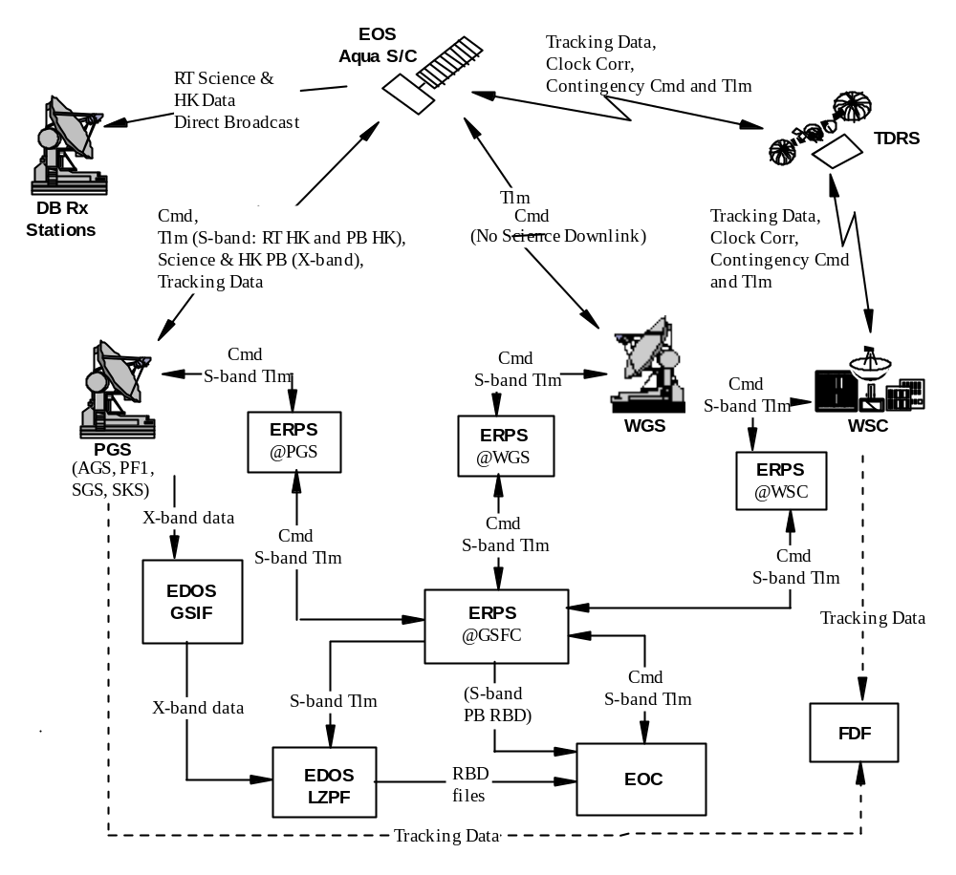

Figure 1.2-1. EOS PM-1 (Aqua) Connectivity

Section 2. DOCUMENTS

2.1 Applicable Documents
The following documents of the exact issue shown form a part of this ICD to extent specified herein. If no revision or date is specified, the latest issue of the applicable document shall apply. In the event of conflict between this ICD and the documents listed below, the documents below shall govern.

2.1.1 Government Documents
1. | GSFC 422-11-12-01 | General Interface Requirements Document (GIRD) for EOS Common Spacecraft/Instruments, Revision B, August 1998
2. | GSFC 420-03-02 | General Instrument Interface Specification
3. | GSFC 422-13-11-01 | EOS Common Spacecraft Specification, August 1994

2.1.2 Contractor Documents
1. | SY1-0029 | EOS Common Spacecraft Contract End Item (CEI) Specification
2. | D26468 | EOS PM-1 Spacecraft Time Management
3. | ES-SDA-001-01B | EOS PM-1 Spacecraft Flight Software Requirements Specification

2.2 Reference Documents
The following documents are used for reference purposes only. These documents do not form a part of this ICD and are not controlled by their reference herein. In the event of a conflict between this ICD and documents listed below, this ICD shall govern.

2.2.1 Government Documents
1. | CCSDS 101.0-B-3 | Recommendation For Space Data Systems Standards; Telemetry Channel Coding, May 1992
2. | CCSDS 102.0-B-3 | Recommendation For Space Data Systems Standards; Packet Telemetry, November 1992
3. | CCSDS 201.0-B-2 | Recommendation For Space Data Systems Standards; Telecommand, Part 1, Channel Service, November 1995
4. | CCSDS 202.0-B-2 | Recommendation For Space Data Systems Standards; Telecommand, Part 2, Data Routing Service, November 1992
5. | CCSDS 202.1-B-1 | Recommendation For Space Data Systems Standards; Telecommand, Part 2.1, Command Operation Procedures, October 1991
6. | CCSDS 203.0-B-1 | Recommendation For Space Data Systems Standards; Telecommand, Part 3, Data Management Service, January 1987
7. | CCSDS 301.0-B-2 | Recommendation For Space Data Systems Standards; Time Code Formats, April 1990
8. | CCSDS 701.0-B-2 | Recommendation For Space Data Systems Standards; Advanced Orbiting Systems, Networks and Data Links, Architectural Specification, November 1992
9. | 530-SNUG | Space Network (SN) User’s Guide, Rev. 7, November 1995
10. | 450-RFICD-EOS PM-1/STDN | Radio Frequency Interface Control Document between EOS PM-1 Spacecraft and Spaceflight Tracking and Data Network (GN)
11. | 450-RFICD-EOS PM-1/EPGS/WPS | Radio Frequency Interface Control Document between EOS PM-1 Spacecraft and the EOS Polar Ground Stations (EPGS) and the Wallops Orbital Tracking Station (WPS)
12. | 530-UGD-GN | Ground Network (GN) Users Guide, June 1993
13. | 531-TR-001 | Users Spacecraft Clock Calibration System (USCCS) User’s Guide, NASA GSFC, Greenbelt, Maryland
14. | MIL-STD-1750A  Notice 1 | Military Standard Sixteen-Bit Computer Instruction Set Architecture, May 1982

2.2.2 Contractor Documents
1. | D26682 | Flight Operations Handbook
2. | D24843 | Interface Control Document for the Atmospheric Infrared Spectrometer (AIRS)
3. | D24844 | Interface Control Document for the Advanced Microwave Sounding Unit 1 (AMSU-A1)
4. | D24845 | Interface Control Document for the Advanced Microwave Sounding Unit 2 (AMSU-A2)
5. | D24846 | Interface Control Document for the Clouds and Earth's Radiant Energy System (CERES)
6. | D24847 | Interface Control Document for the Moderate Resolution Imaging Spectroradiometer (MODIS)
7. | D24848 | Interface Control Document for the Advanced Microwave Scanning Radiometer for EOS (AMSR-E)
8. | D24849 | Interface Control Document for the Humidity Sounder for Brazil (HSB)
9. | D25099 | PM-1 Command Allocation Document
10. | D25100 | PM-1 Telemetry Allocation Document
11. | SS6-0165 | EOS PM-1 Spacecraft Communications Subsystem Specification
12. | SS6-0164 | EOS PM-1 Spacecraft Command and Data Handling Subsystem Requirements Specification
13. | TBD
14. | EQ4 -4951 | EOS Common Spacecraft Equipment Specification for Formatter-Multiplexer/Solid State Recorder Unit (FMU/SSR)
15 | EQ 4-4957 | EOS PM-1 Spacecraft Equipment Specification for Transponder Interface Electronics
16 | D26683 | Flight Operations Procedures

2.2.3 Other Documents
1. | 34111515SRS | Software Requirements Specification for the Earth Observing System Common Processors Startup ROM (SUROM), Computer Software Configuration Item (CSCI), Rev. A, Honeywell Inc., Feb. 19, 1998
2. | 151840 | MODIS Command, Telemetry, Science and Engineering Description, Santa Barbara Remote Sensing, May 1997

Section 3. OVERVIEW
This section provides an overview of the PM-1 (Aqua) Spacecraft command and telemetry links as defined in Section 1.2 and the on-board Time Management System.
3.1 S/C COMMAND AND DATA HANDLING SUBSYSTEM
The PM-1 (Aqua) Spacecraft Command and Data Handling (C&DH) subsystem components are shown in Figure 3-1.
The C&DH subsystem consists of the Transponder Interface Electronics (TIE), the Command Telemetry Controller (CTC), the Instrument Support Controller (ISC), the Power Controller (PC), the Guidance, Navigation and Control Controller (GNCC), the Formatter/Multiplexer Unit/Solid State Recorder (FMU/SSR), and three Ultra Stable Oscillators (USOs).
Each of the four controllers consists of a 1750A processor and the interface electronics for collecting telemetry, distributing commands, and for communications with other spacecraft subsystems. Each controller is internally redundant. One side of each controller is designated as the on-line controller. The other side is designated off-line and may be powered on (CTC) or off (PC, GNCC, and ISC). The TIE is internally redundant, with both sides powered on, and designated the Online or Offline TIE. The USOs are also internally redundant, with one side powered on and the other off. The FMU is redundant, with one side powered on. The SSR is redundant, but the memory is not. The memory is designed to provide the required storage capacity at the end of life, based on the expected memory failure rate.
The CTC is the Bus Controller (BC) for the Primary Command and Telemetry (C&T) 1553 Data Bus. The PC, ISC, GNCC, TIE, FMU, MODIS, AIRS, AMSU-A1&A2 and the two CERES instruments, and off-line CTC controller are Remote Terminals (RTs) on that Bus. The CTC, GNCC, and PC each also have a secondary 1553 data bus, and are the Bus Controllers for those busses.
The controllers collect the housekeeping data, build data packets for unpacketized data, and transmit the packets to the TIE, via the Primary 1553 Data Bus. The housekeeping data packets are also routed to the SSR, via the FMU for formatting and storage. The TIE routes the housekeeping data packets stored in the SSR and real time housekeeping data packets to the transponder for concurrent S-band downlink to the ground. Instrument science and engineering data and spacecraft and instrument housekeeping data are collected/formatted by the FMU and stored in the SSR for later playback or real-time broadcast to the ground via the X-band. The memory capacities of each of the PM-1 (Aqua) Spacecraft controllers are provided in Table 3.1-1.

Table 3.1-1. Controller Memory Capacity
Controller | Size
Command and Telemetry | 768K Words of RAM  512K Words of EEPROM  16K Words of PROM  8K Words of I/O RAM
Instrument Support | 256 Words of RAM  16K Words of PROM  8K Words of I/O RAM
GN&C | 256K Words of RAM  16K Words of PROM  8K Words of I/O RAM
Power | 256K Words of RAM  16K Words of PROM  8K Words of I/O RAM

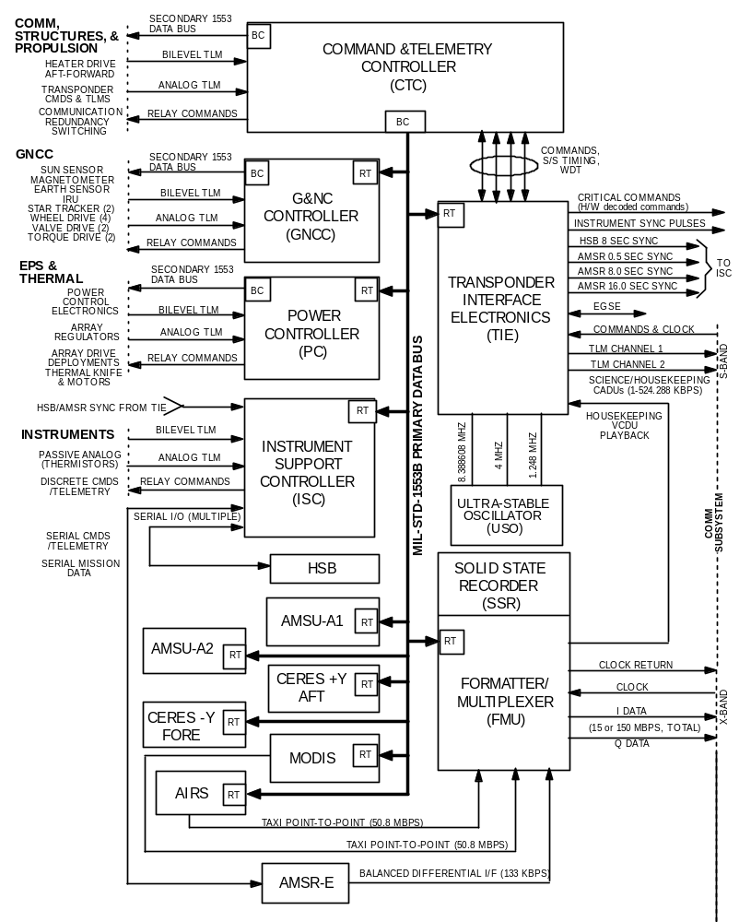

Figure 3-1. PM-1 (Aqua) C&DH Subsystem
3.2 Command/DATA UPLINK
Command data structures associated format requirements and description are provided in Section 4.
The PM-1 (Aqua) Spacecraft receives commands/data uplink at the rates (which includes all CCSDS overhead) shown in Table 3.2.1-1.
Table 3.2.1-1. Command Links
External Interface | Spacecraft  Omni Antenna¹ | Data Rate  (bps) | Usage
TDRSS SSA | Zenith | 1000 | Command and Tracking
TDRSS SSA | Zenith | 500 | Command and Tracking
TDRSS SSA | Zenith | 250 | Command and Tracking
TDRSS SSA | Zenith | 125 | Command and Tracking
TDRSS MA | Zenith | 125 | Command and Tracking
PGSs &WGS | Nadir | 2000 | Command and Tracking²
Note 1: For command links Zenith and Nadir Omni antennae are coupled together.
Note 2: Only Doppler tracking is available through the ground station. Ranging is not available.

3.3 TELEMETRY Downlink
S-band housekeeping and X-band science, engineering and housekeeping data structures and associated format requirements are described in Section 5.
The science data formats for the instruments are specified in Section 2.1.1, Documents 1 and 2. For more detailed format information refer to the specific instrument ICD, reference section 2.2.2, Documents 2 - 8.
In the GN mode, the spacecraft S-band design is capable of simultaneous downlink of two telemetry channels to a PGS. The High Rate Channel (HRC) will carry the stored data at 524.288 Kbps. The Low Rate Channel (LRC) will carry the real-time data at 16.384 Kbps.
For the TDRSS links, the I and Q channels will have identical data and rates. The two channels will be combined at the TDRSS ground station for increased link margin. S-band downlink rates using the TDRSS will be 1.024 Kbps or 4.096 Kbps.
The Spacecraft supports simultaneous downlink of real time S-band housekeeping data and playback X-band science and engineering data, but does not support simultaneous S-band and X-band playback due to SSR output limitations. The 150 Mbps DP and 15 Mbps DB modes of the X-band are mutually exclusive.
The downlinks are shown in Table 3.3-1. The telemetry data rates in the Table include CCSDS and Reed-Solomon coding overhead.

Table 3.3-1. Telemetry Downlink
Return Link Service | Spacecraft Antenna | Downlink Rate¹ |  | Usage
Return Link Service | Spacecraft Antenna | I | Q | Usage
Direct  Playback (DP) | X-Band | 75  Mbps | 75  Mbps | Stored science and engineering data to PGS. Data Rate = 150 Mbps
Direct  Broadcast (DB) | X-Band | 7.5  Mbps | 7.5  Mbps | All real-time science and engineering data to Direct Broadcast ground stations. Data Rate = 15 Mbps
TDRSS MA | S-Band  Zenith Omni | 1.024 Kbps | 1.024 Kbps | Selected real-time data (engineering or diagnostic) or controller data dump. Identical Data on I & Q channels.
TDRSS SSA | S-band  Zenith Omni | 4.096 Kbps | 4.096 Kbps | Selected real-time data (engineering or diagnostic) or controller data dump. Identical Data on I & Q channels.
TDRSS SSA | S-band  Zenith Omni | 1.024 Kbps | 1.024 Kbps | Selected real-time data (engineering or diagnostic) or controller data dump. Identical Data on I & Q channels
 |  | LRC | HRC
PGSs/  WGS S-Band | S-Band  Nadir Omni | 16.384 Kbps | 524.288Kbps | LRC = Real-time Housekeeping Data  HRC = Stored Housekeeping or Controller Data Dump
Note:
1. The downlink rates include Reed-Solomon and CCSDS overhead.

3.4 Time Management
The User Spacecraft Clock Calibration System (USCCS) (see Section 2.1.2, Document 3) will be used for EOS PM-1 (Aqua) Spacecraft clock correlation. The TIE provides time transfer data in telemetry based on TDRSS PN epochs for ground determination of the accuracy of the spacecraft clock.
PM-1 (Aqua) time management approach is described in Document 2, section 2.1.2. The S/C time management function maintains S/C GIRD time in CCSDS Unsegmented Time Code (CUC) format (Figure 5.6.1-1) for use by the spacecraft and the AIRS, AMSU-A, AMSR-E and HSB instruments. The time management function also maintains time in the CCSDS Day Segmented Time Code (CDS), (Figure 5.6.7-1), for use by the CERES and MODIS instruments.
The TIE provides master clocks for GIRD Time and GIIS Time. The GIRD master clock is maintained as a 64-bit counter with a resolution of 476.8 nanoseconds (ns). The GIIS Time master clock is maintained in the CDS format with a resolution of 1 microseconds (µs). The Flight Software Time Management function provides for adjustments to the master clocks, but does not provide for initialization of the master clocks. The ground has the capability to initialize the master clocks on the online and off-line TIE via direct commands to the TIE.

Section 4. COMMANDs and DATA uplink FORMATS
This section details the requirements for the uplink data formats and structures.
Additional information regarding the CCSDS formats may be found in Section 2.2.1 Documents 1 - 8.
Additional S/C Flight Software detail and content may be found in Section 2.1.2, Document 3.
Additional SUROM information, command format and content may be found in Section 2.1.2, Document 3 and Section 2.2.3, Document 1.
For Instrument format and content, Reference Section 2.2.2, Documents 2-8, (Instrument specific) and Section 2.2.3, Document 2 (MODIS specific).
The Command Allocation Document (CAD), Reference Section 2.2.2, Document 9 provides additional information on the command and command database.
For additional information regarding the CCSDS Time Management formats and detail, Reference Section 2.2.1, Document 7. For additional information regarding the S/C Time Management formats and detail, Reference Section 2.1.2, Document 2.
Security Note: Per “NASA Internet Publishing Content Guidelines, Information That Must Not Be Published Via the Internet”, the remaining text in this section except for the paragraph, figure, and table titles have been removed.

4.1 General Command Channel Structure and Processing

Figure 4.1-1. Ground Uplinked Command Flow Onboard the S/C

Figure 4.1-2. Telecommand Data Structures

Figure 4.1-3. Packetized Command Data Structure

4.1.1 Command Link Transmission Unit

4.1.1.1 RF Acquisition Lock

4.1.1.2 TIE Receiver Lock

Figure 4.1.1.2-1. NOP Codeblock Format

Figure 4.1.1.2-2. CLTU Sequence Pattern

4.1.1.3 CLTU Format

Figure 4.1.1.3-1. CLTU Format

4.1.2 Transfer Frame

4.1.2.1 Transfer Frame Format and Content

Figure 4.1.2.1-1. Transfer Frame Format

4.1.2.2 Transfer Frame Control Commands

4.1.3 Frame Acceptance and Reporting Mechanism

4.1.3.1 FARM-1 Sliding Window

Table 4.1.3-1. FARM-1 Operating States

Table 4.1.3-2. FARM-1 Events

Figure 4.1.3.1-1. FARM-1 Sliding Window

4.1.4 Command Receipt Verification

4.1.4.1 Command Link Control Word

Figure 4.1.4.1-1. CLCW Structure
4.2 SUROM, S/C BUS, FMU/SSR AND TIE COMMANDS

4.2.1 SUROM Commanding

4.2.1.1 SUROM – LSIO Telecommand Packet Format

Figure 4.2.1.1-1. SUROM – LSIO TC Packet Format

4.2.1.1.1 SUROM Commands - LSIO Interface
4.2.1.1.2 SUROM Commands - Primary 1553 Data Bus Interface Formats - Generic

4.2.1.1.3 SUROM Commands - Primary 1553 Data Bus (1553B) Interface
4.2.1.1.4 SUROM FW Start-up Control

Figure 4.2.1.1.1-1. SUROM LSIO Interface Command Formats
Figure 4.2.1.1.1-1. SUROM LSIO Interface Command Formats (Cont’d)

Figure 4.2.1.1.2-1. SUROM Command Format - Generic

Figure 4.2.1.1.2-2. SUROM Command Data Format - Generic

Figure 4.2.1.1.3-1. SUROM Commands – Primary 1553 Data Bus I/F
Figure 4.2.1.1.3-1. SUROM Commands – Primary 1553 Data Bus I/F (Cont’d)

Figure 4.2.1.1.3-1. SUROM Commands – Primary 1553 Data Bus I/F (Cont’d)

Figure 4.2.1.1.3-1. SUROM Commands – Primary 1553 Data Bus I/F (Cont’d)

4.2.2 PM-1 (Aqua) S/C Bus TC Packet Format

4.2.2.1 APID

4.2.2.2 Spacecraft Bus Commands

Figure 4.2.2-1. PM-1 (Aqua) Spacecraft Bus TC Packet Format

Figure 4.2.2.2-1. Spacecraft Bus Command Structure- Generic
4.2.2.2.1 Spacecraft Bus Command Message Formats

Table 4.2.2.2.1-1. S/C Bus Command Message Formats
Table 4.2.2.2.1-1. S/C Bus Command Message Formats (Cont’d)
Table 4.2.2.2.1-1. S/C Bus Command Message Formats (Cont’d)

4.2.2.2.2 S/C Bus Memory Loads

4.2.2.3 S/C Bus TC Packet Checksum

Figure 4.2.2.2.2-1. S/C Bus Memory Load Buffer

4.2.3 Formatter-Multiplexer Unit Commanding

4.2.3.1 FMU/SSR Command Structures

Figure 4.2.3.1-1. Generic FMU Command Structure

4.2.4 Transponder Interface Electronics Commanding

4.2.4.1 TIE Commands

4.2.4.1.1 TIE Critical Commands

Figure 4.2.4.1.1-1. TIE Critical Command and Type “BD” Transfer Frame

4.2.4.1.1.1 Non-Operation Commands

4.2.4.1.1.2 TIE Configuration Commands

4.2.4.1.1.3 TIE Critical Relay Commands

4.2.4.1.1.4 TIE Critical Relay Command Rate Constraints

4.2.4.1.2 TIE Normal Command Structures

Figure 4.2.4.1.2-1. TIE Normal Command Format

4.2.5 Clock Maintenance

4.2.5.1 Clock Accuracy

4.2.5.2 Clock Initialization Commanding
4.2.5.2.1 GIRD Clock Initialization Commands

Figure 4.2.5.2.1-1. GIRD Clock Initiation Format
4.2.5.2.1.1 GIRD Time Initialization Constraints
4.2.5.2.2 GIIS Clock Initialization

Figure 4.2.5.2.2-1. CDS Clock Adjustment Format

4.2.5.3 Minor Time Adjustment
4.2.5.3.1 GIRD Time Adjustment
4.2.5.3.1.1 GIRD Time Adjustment Constraints
4.2.5.3.2 GIIS Time Adjustment

4.2.5.4 USO Frequency Adjustment Command

Figure 4.2.5.3-1. USO Frequency Adjustment Command Word Format

4.2.5.5 Leap Second Adjustment
4.2.5.5.1 GIRD Leap Second Adjustment
4.2.5.5.2 GIIS Leap Second Adjustment
Table 4.2.5.5.2-1. GIIS Leap Second Adjustment Format

4.2.5.6 Time Re-Synchronization Commands

4.2.6 Stored Command Sequences

Table 4.2.6-1. SCS State Transitions

4.2.6.1 Stored Command Formats

Figure 4.2.6.1-1. Stored Command Format
Figure 4.2.6.1-1. Stored Command Format (Cont’d)
Figure 4.2.6.1-1. Stored Command Format (Cont’d)
4.3 PM-1 (AQUA) Instrument COMMANDS

4.3.1 PM-1 (Aqua) Instrument TC Packet Format

Figure 4.3.1-1. Instrument TC Packet Format

4.3.1.1 Instrument TC Packet Checksum

4.3.1.2 Instrument Command Field

4.3.2 AIRS

Figure 4.3.2-1. AIRS Data Load Command

4.3.2.1 AIRS Reset Command

Table 4.3.2.1-1. AIRS Reset Command Codes

4.3.2.2 AIRS Command Constraints

4.3.3 AMSU-A1

4.3.3.1 AMSU-A1 Instrument Commands

4.3.3.1.1 AMSU-A1 Command Format

Table 4.3.3.1.1-1. AMSU-A1 Command Format

4.3.3.2 AMSU-A1 Reset Command

4.3.3.3 AMSU-A1 Command Constraints

4.3.4 AMSU-A2

4.3.4.1 AMSU-A2 Instrument Commands

4.3.5 AMSR-E

4.3.5.1 AMSR-E Commands

4.3.5.1.1 AMSR-E SDM Command Formats

Table 4.3.5.1.1-1. AMSR-E Serial Digital Command Format

4.3.5.1.2 AMSR-E Discrete Commands

4.3.5.2 AMSR-E Command Constraints
Table 4.3.5.2-1. AMSR-E Command Timing Constraints

4.3.6 CERES Instruments

4.3.6.1 CERES Instrument Commands

4.3.6.1.1 CERES Command Constraints

4.3.7 MODIS Instrument

4.3.7.1 MODIS Command Message Formats

Figure 4.3.7.1-1. MODIS Generic Bus Command Structure

4.3.7.2 MODIS Command Constraints

4.3.8 HSB

4.3.8.1 HSB Level Discrete Commands

4.3.8.2 HSB Pulse Discrete Commands

4.3.8.4 HSB Command Constraints

Section 5. TELEMETRY DATA FORMATS

5.1 Telemetry Formats
This section will describe the Telemetry Data Message Format and Content to be sent from the PM-1 (Aqua) spacecraft (S/C) to EOS Ground Systems.
For additional information on the CCSDS Recommendations on Telemetry, reference section 2.2.1, Documents 1, 2, and 8.
For additional information on S/C telemetry format and content, telemetry format tables, S/C telemetry process reference section 2.1.2, Documents 3.
For additional SUROM telemetry detail, reference section 2.2.3, Document 1.
5.2 General Telemetry Structure and Processing
The general downlink structure for the Housekeeping (H/K) telemetry, diagnostic telemetry, and science and engineering data is the Channel Access Data Unit (CADU) and the basic unit of S/C or Instrument telemetry shall be the CCSDS Path Protocol Data Unit as specified in Section 2.2.1, Document 8.
The following is a brief overview of the S/C telemetry. Details of telemetry data structure, coding and randomization are described in Section 5.3.

5.2.1 S-band Real-time Downlink
Instrument and Spacecraft H/K packets are transmitted, via 1553B bus, to the TIE. Selected set of packets are formatted into CCSDS interleave depth 1 VCDUs and subsequently CADUs for real-time transmission, via S-band, at 1.024 kbps or 4.096 kbps to TDRSS, or 16.384 kbps directly to the ground stations. A fill CADU is transmitted to keep the link to ground active when no packets are available for transmission to the ground. The spacecraft outputs continuous fill CADUs, if a real-time CADU is not available for the return link. The S-band low rate CADU is 256 octets in length. The application of the CCSDS protocol for the S-band standard telemetry CADU is shown in Figure 5.2.1-1.

5.2.2 X-band Real-time Downlink
The X-band section of the PM-1 (Aqua) S/C communications provides the real-time transmission of instrument science, instrument engineering, instrument housekeeping, and spacecraft housekeeping data to the ground systems via Direct Broadcast to any ground system with the capability to receive the data.
Instrument science and engineering data is transmitted to the FMU via high speed Transparent Asynchronous Transmitter/Receiver Interface (TAXI) (from AIRS and MODIS), a balanced differential serial/digital data interface (AMSR-E) or via an RT-RT transfer on the 1553 bus from the other instruments or the ISC (HSB, AMSR-E). Instrument and spacecraft H/K data are sent to the FMU via the primary 1553 Bus. The FMU formats the data into Multiplexing Protocol Data Units (M_PDUs), processes the M_PDUs, formats VCDUs, generates Reed Solomon code, adds the 32-bit sync code, and generates CADUs. The CADU is sent to the X-band communication equipment for transmission at 15 Mbps to the ground broadcast receiving system, or to the SSR for storage and subsequent playback.

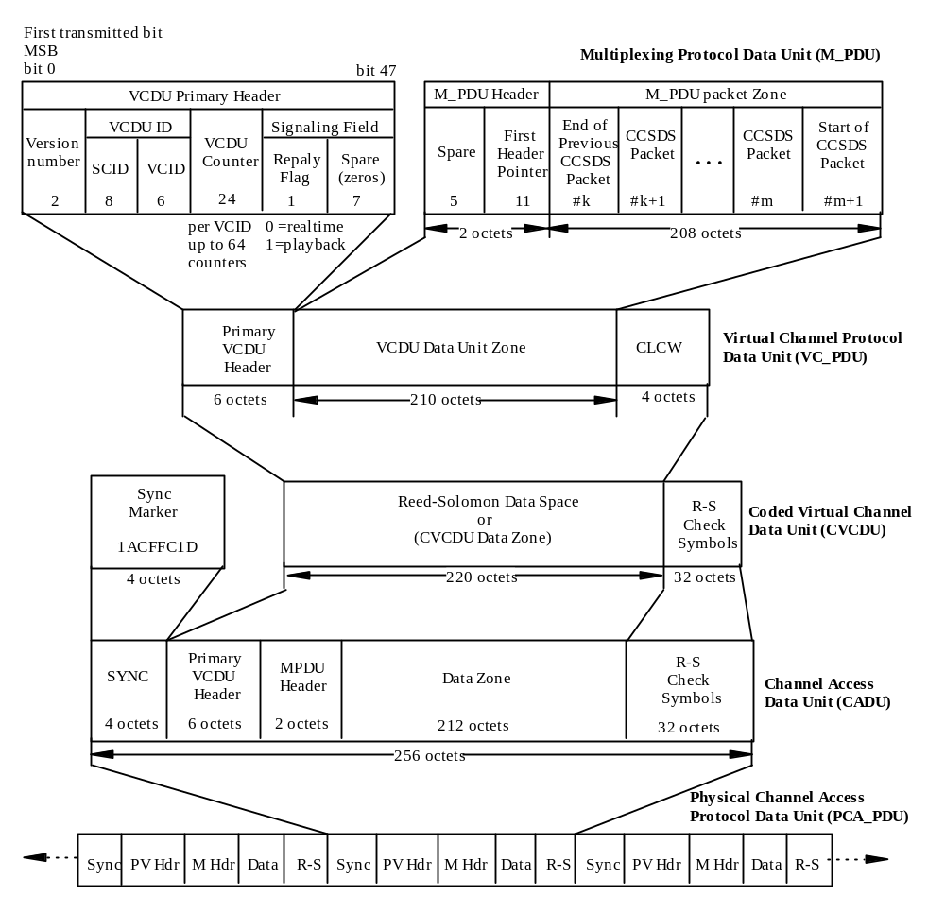

Figure 5.2.1-1. S-band CADU for S/C and Instrument Housekeeping Telemetry
The X-band CADU is identical in structure for both H/K and science and engineering data. The Virtual Channel Identifier distinguishes the CADU as either a H/K or an individual instrument science or engineering CADU. The X-band CADU utilizes interleave depth 4, the CADU length is 1024 octets. The application of the CCSDS protocol for the high-rate X-band CADU is shown in Figure 5.2.2-1.

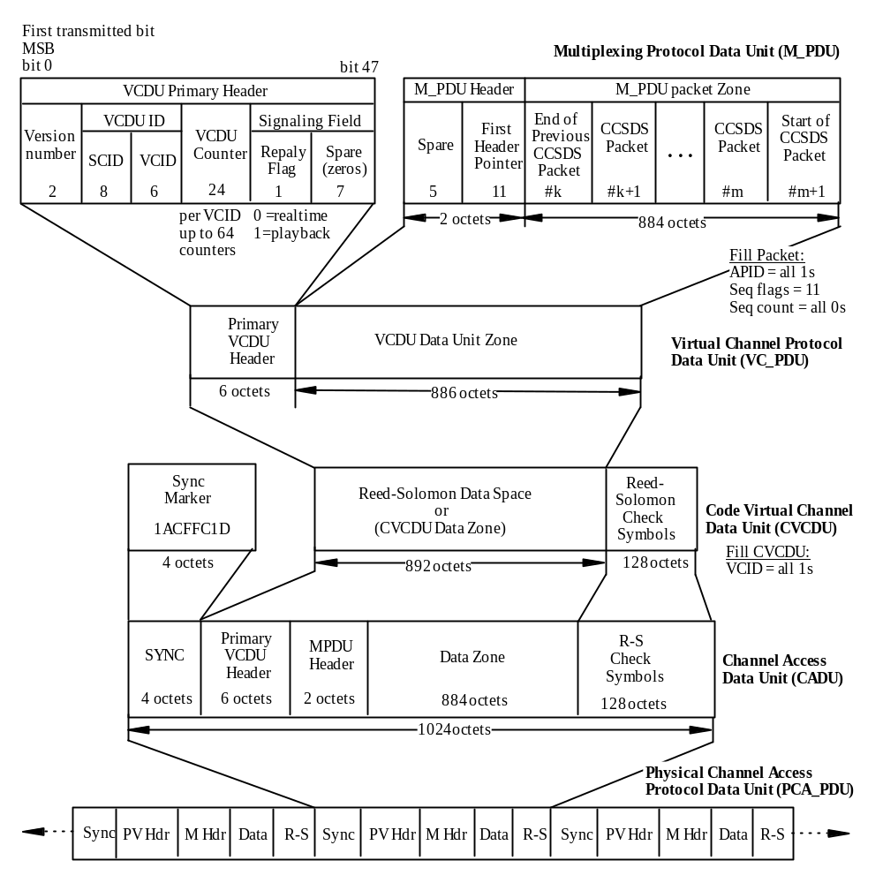

Figure 5.2.2-1. X-band CADU for Science, Engineering and Housekeeping Data

5.2.3 S-band Playback
Packetized H/K data destined for storage is processed by the TIE into VCDUs. The CTC routes the data from the TIE to the FMU via an RT-to-RT transfer on the Primary 1553 Data Bus. The FMU sends the VCDUs to the SSR where they are stored in Bypass mode to a specific H/K storage partition. On playback request, the FMU/SSR retrieves VCDUs from the H/K storage partition in the SSR. The VCDUs are passed on to the TIE which performs Reed-Solomon (R-S) encoding to create Coded Virtual Channel Data Units (CVCDU). The TIE forms the CVCDU into a Channel Access Data Unit (CADU), and finally convolutionally encodes the CADU as it is passed on to the S-band Transponder where it is downlinked to the ground at 524.288 kbps, simultaneously with the 16.384 kbps real-time H/K data. When no S-band playback data is available, the TIE will generate fill CADUs for downlink at 524.288 Kbps.

5.2.4 X-band Playback
All spacecraft and instrument H/K packets and instrument science and engineering packets that are sent to the FMU are formatted into R-S interleave depth 4 X-band CADUs, and passed on to the SSR for storage. Upon playback request, the X-band CADUs are retrieved from the SSR and passed on to the X-band transmitter for DP at 150 Mbps to a PGS.

5.3 TELEMETRY DATA STRUCTURE

5.3.1 Multiplexing Protocol Data Unit (M_PDU)
The TIE and the FMU generate M_PDUs. Packet lengths are variable and can be longer or shorter than the CADU data field, allowing multiple packets per CADU or multiple CADUs per packet. The M_PDU data structure is used to locate the start of a packet in the CADU and allows the insertion of variable length packets into fixed length CADUs.
The M_PDU consists of a Packet Zone in which the CCSDS packets are compiled and a header that points to the first Packet Primary Header in the Packet Zone. The length of the M_PDU is fixed based on the Virtual Channel.
The S-band M_PDU is shown in Figure 5.2.1-1, the X-band M_PDU is shown in Figure 5.2.2-1.

5.3.1.1 M_PDU Header
The M_PDU header contains a 5-bit spare field and an 11-bit First Header Pointer.

5.3.1.1.1 Spare Bits
The first five bits of the M_PDU header are unassigned and shall be set to “00000””.

5.3.1.1.2 First Header Pointer
Variable length packets are multiplexed into the VCDU via the use of an M_PDU. The last 11 bits of the M_PDU header shall provide a binary count, “P” (modulo 2048), which when incremented by 1, shall point to the first byte of the first complete packet header in the M_PDU.
Per CCSDS, the count “P” is required to be expressed as:
P = (Number of the octets) – 1
The M_PDU first header pointer shall be set to all ‘ones’ (1s) if no packet header resides within the M_PDU. If the first packet header in the M_PDU is a partial header (packet header split between two M_PDUs), the first header pointer in that M_PDU shall be set to indicate the start of this packet header. If any packet header is split between two M_PDUs (x) and (x+1) on that virtual channel, the first header pointer in M_PDU (x+1) ignores the remainder of the split packet header, and shall only be set to indicate the start of any subsequent new CCSDS packet header within M_PDU (x+1).

5.3.1.1.3 M_PDU Packet Zone
Packets of data shall be placed end-to-end in the Packet Zone. The beginning of the Packet Zone is not necessarily the beginning of a packet, since it will often be a continuation from a packet from the previous M_PDU.

5.3.1.2 Fill Packets
Fill packets may be used as required to limit the data storage time on board, or to complete an M_PDU data zone. A fill packet is identified by its APID field (all 1’s), Packet Sequence Count (all 0’s), and its data field must contain a minimum of 1 byte of fill data (all 0’s).

5.3.1.2.1 S-band Fill Packets
The TIE will not generate S-band fill packets.

5.3.1.2.2 X-band M_PDU Fill Packets
The S/C shall create a fill packet to complete the M_PDU data zone. The format for the X-band Fill Packet is shown in Figure 5.3.1.2.2-1.

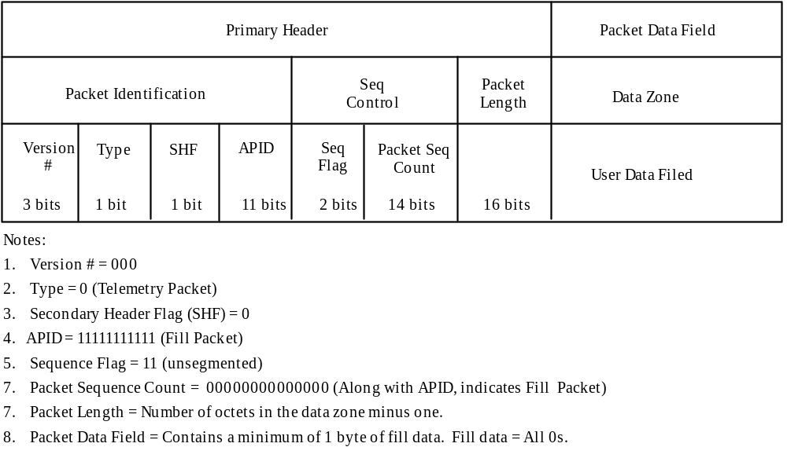

Figure 5.3.1.2.2-1. X-Band Fill Packet

5.3.2 Coded Virtual Channel Data Unit
Section 5 of the CCSDS 701.0-B-2 describes the VCDU Format. The following is the PM-1 (Aqua) spacecraft implementation. A Coded Virtual Channel Data Unit (CVCDU) consists of a CVCDU primary header, a CVCDU Data Unit Zone, and a block of Reed-Solomon check symbols.
The CVCDU structure for S-band telemetry (H/K telemetry, low-rate science, and diagnostic/dump) data is shown in Figure 5.2.1-1. The X-band CVCDU is shown in Figure 5.2.2-1. The S-band telemetry CVCDU has the four octet CLCW, the X-band CVCDU does not.

5.3.2.1 CVCDU Primary Header
The PM-1 (Aqua) S/C CVCDU Primary Header is shown in Figure 5.3.2.1-1.
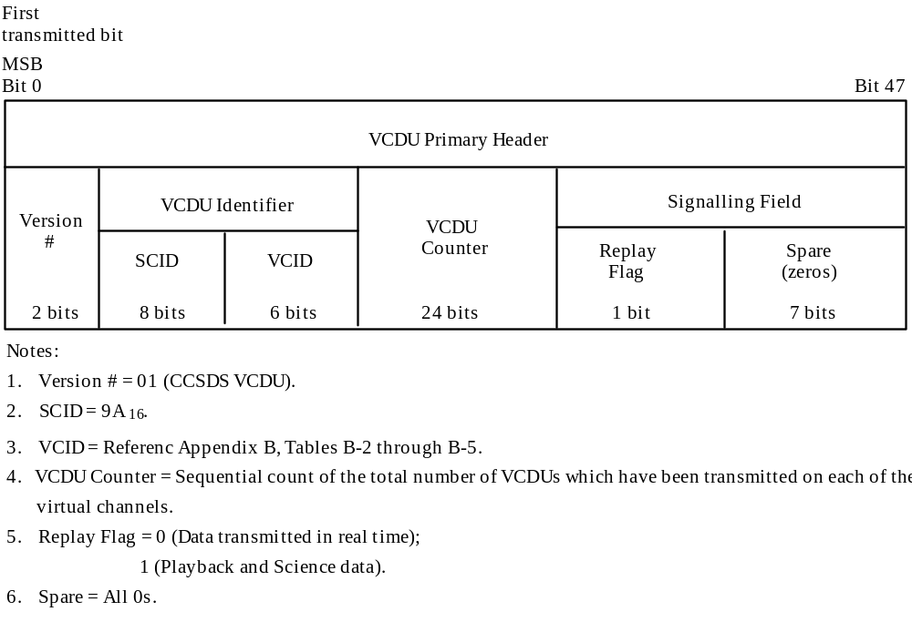

Figure 5.3.2.1-1. CVCDU Primary Header

5.3.2.2 CVCDU Data Unit Zone
The CVCDU Data Unit Zone contains the M_PDU. The length of the S-band CVCDU data zone is 220 octets and the length of the X-band CVCDU data zone is 892 octets.

5.3.2.2.1 Operational Control Field
The 4 octet Operational Control Field shall be used for the CLCW. The CLCW (reference this ICD, section 4.1.4.1) is only utilized with the S-band downlink. The Operational Control Field will be set to 80000000₁₆ when no CLCW is present.

5.3.2.2.2 Command Link Control Word
For each open virtual channel (i.e., VCID 0 and 1), there will be an assigned CLCW.

5.3.2.2.3 Reed-Solomon Check Symbols
The Reed-Solomon Check Symbols are the final bits in the CVCDU and are generated according to CCSDS 101.0-B-3, Recommendation For Space Data Systems Standards; Telemetry Channel Coding. There will be 32 check symbols for every 223 symbols of preceding data in the CVCDU. For the X-band data (interleave depth = 4), there are 128 octets of check symbols and for the S-band telemetry data, (interleave depth = 1), there are 32 octets of check symbols.

5.3.3 Channel Access Data Unit
A fixed 32 bit pattern sync pattern represented in hexadecimal notation as: lACFFClD₁₆, shall be added to the front of each VCDU to create a Channel Access Data Unit (CADU). S-band and X-band CADUs are shown in Figures 5.2.1-1 and 5.2.2-1.

5.3.3.1 Fill CADUs - S-band
The spacecraft outputs continuous data CADUs. If a CADU is not available for the return link, the TIE will generate and transmit fill CADUs in both GN and TDRSS modes. The VCDU Decommutation Function (ground system) for the Fill Removal Function shall recognize “Fill”” VCDUs by their unique VCID value and discard them.

5.3.3.1.1 GN Mode Format - LRC
In GN Mode, when no real-time data is available at VCDU release time, the TIE I-Channel (LRC for Transponder Channel 1) interface will generate a “Fill” VCDU as shown in Figure 5.3.3.1.1-1.
Sync  1ACFFC1D₁₆ | Ver.  01₂ | SCID  9A₁₆ | VCID  3F₁₆ | Seq Count  Monotonically increasing to 2²⁴ | Replay  0₂ | Spare  0₁₆ | VCDU  Data Zone  Fill Pattern  214 octets=11₁₆ | R-S Check Symbols  32 octets

Figure 5.3.3.1.1-1. “Fill” CADU - GN Mode - LRC

5.3.3.1.2 GN Mode Format - HRC
In GN Mode, when no playback data is available at VCDU release time, the TIE Q-Channel (HRC for Transponder Channel 2) interface will generate a “Fill” VCDU as shown in Figure 5.3.3.1.2-1.
Sync  1ACFFC1D₁₆ | Ver.  01₂ | SCID  9A₁₆ | VCID  3F₁₆ | Seq Count  Monotonically increasing to 2²⁴ | Replay  0₂ | Spare  0₁₆ | VCDU  Data Zone  Fill Pattern  214 octets=A5₁₆ | R-S Check Symbols  32 octets

Figure 5.3.3.1.2-1. “Fill” CADU - GN Mode - HRC and TDRSS Mode

5.3.3.1.3 TDRSS Mode Format
In TDRSS Mode, when no real-time data is available at VCDU release time, the TIE I-Channel (Transponder Channel 1) interface and the TIE Q-Channel (Transponder Channel 2) will generate a “Fill” VCDU as shown in Figure 5.3.3.1.2-1.

5.3.3.1.4 FMU/SSR (X-band) Fill CADU
The FMU/SSR shall provide fill CADUs as required to maintain a constant flow of CADU sync headers and data transitions to facilitate maintenance of modulator link synchronization.
The VCDU fill pattern will be “7878₁₆” and distributed bit wise starting with “Q” so that,
I channel: 11 00 11 00 …..
Q channel: 01 10 01 10…..

5.3.3.1.5 Fill CADU Definition
The definition of the VCDU pattern for fill CADUs shall be as specified in CCSDS 701.0-B-2. The pattern is shown in Figure 5.3.3.1.5-1. A CADU is designated as a “fill” CADU when:
1. The VCID contains the fixed fill pattern of “all ones” in the VCDU data unit zone and are non-sequenced.
2. The MPDU Header and Data Zone are replaced with hexadecimal 7878.
3. The Reed-Solomon check symbols form the appropriate code for the VCDU header and 7878 VCDU data zone.

Sync | Version | SCID | VCID | VCDU Count | Replay | Spare | Project Specified fill pattern | Reed-Solomon Check Symbols
32 bits | 2 bits | 8 bits | 6 bits | 24 bits | 1 bit | 7 bits | 886 bytes | 128 bytes
(1ACFFC1D) | 01 | Our pattern | All 1’s | All 0’s | 0 | All 0’s | 7878 | Correct R-S code bits

Figure 5.3.3.1.5-1. X-band Fill CADU

5.3.4 Data Randomization
To ensure adequate bit transition density for the X-band data, a random sequence will be exclusive ORed with each bit of the CADU, exclusive of the Synchronization Marker. The random sequence will be generated using the following polynomial: h (x) = x⁸ + x⁷ + x⁵ + x³ + 1 in accordance with the CCSDS Recommendation (Paragraph 5.4.9.1.2.5 of Reference Document 8 in 2.2.1). This randomization function will be on for X-band DB and DP telemetry by default, but can be commanded off if desired.
S-band telemetry also has on/off commandable CCSDS randomization. The default configuration at launch is as follows: S-band GN mode telemetry is randomized, but S-band SN mode telemetry is not randomized.

5.4 SUROM/TIE TELEMETRY

5.4.1 SUROM Telemetry
In order for the SUROM to provide the same telemetry service regardless of the interface (LSIO or 1553B) through which the commands are received, telemetry are output simultaneously to the LSIO and 1553B.

5.4.1.1 SUROM Telemetry Packet Format
SUROM provides Version-1 CCSDS packets to the TIE via both LSIO and 1553B bus using the same packet format shown in Figure 5.4.1.1-1, the SUROM/TIE Telemetry Packet Format, which has no Secondary Header.
Packet Identification
Version
No.
Type
SHF
APID
Packet
Seq Control
Packet
Length
Data Field
Seq
Flag
Packet
Seq
Count
3 bits
1 bit
1 bit
11 bits
2 bits
14 bits
16 bits
up to 2000 bits
Primary Header
Data Zone
6 octets
Variable
Notes:
1.

Version No. = 000.
2.

Type = 0
(Telemetry packet).

3.

Secondary Header Flag (SHF) = 0 (No Secondary Header present).
4.

APID = Allocated in Appendix B, Table B-2.
5. Sequence Flag = 11 (Unsegmented)
6. Packet Sequence Count = Monotonically increasing number.
7. Packet Length = Total number of octets in the data zone minus one.

8. Data Field:
SUROM: Minimum 154 octets and maximum of 250 octets.
TIE: Absolute 32 octets.

Figure 5.4.1.1-1. SUROM/TIE Telemetry Packet Format

5.4.1.2 SUROM SOH Telemetry
SUROM State of Health (SOH) packets are fixed length 80 words including memory dump telemetry. SUROM SOH telemetry defines the condition of each controller and is downlinked continuously at 1-second intervals and every time a ground command is executed, SUROM telemetry is updated.
For detailed description of SUROM telemetry, reference Section 2.2.3, Document 1.

5.4.1.3 SRAM Memory Dump
Upon receipt of the Memory Dump command, 32 words of SRAM as defined by the physical page and offset will be placed in the SUROM telemetry from word 32 through word 63. These data content will not change until it receives another Memory Dump command.

5.4.1.4 EEPROM Memory Dump
The telemetry location of EEPROM Memory Dump is the same as SRAM memory dump. Upon receipt of the EEPROM dump command, 32 words of EEPROM as defined by the physical page and offset will be placed in the SUROM telemetry from word 32 through word 63.

5.4.2 TIE Status Packet
Once per second the TIE internally generates a configuration and status packet formatted in accordance with Figure 5.4.1.1-1, and referenced to the CUC Time of Day Clock one-second tick. The packet size will be a fixed 38 octets. The TIE packet does not have the Secondary Header Field.

5.4.2.1 TIE Data Field
The TIE packet data field will contain a fixed 32 octets of configuration and status data as shown in Figure 5.4.2.1-1.

 | MSB |  |  |  |  |  | LSB
Word 1 | Bilevel Word 1
Word 2 | Bilevel Word 2
Word 3 | Relay Word 1
Word 4 | Relay Word 2
Word 5 | Critical Transfer Frame Count |  |  | Accepted Codeblock Count
Word 6 | Fixed at 0s |  |  |  |  | TIE Enable Status
Word 7 | I Channel Configuration
Word 8 | I Channel Rate Setting (Most Significant Word)
Word 9 | I Channel Rate Setting (Least Significant Word)
Word 10 | Q Channel Configuration
Word 11 | Q Channel Rate Setting (Most Significant Word)
Word 12 | Q Channel Rate Setting (Least Significant Word)
Word 13 | 1553B BCRT Control Register
Word 14 | 1553B BCRT Status Register
Word 15 | 1553B BCRT RT Address Register
Word 16 | TIE Firmware Processing Error Status Register

Figure 5.4.2.1-1. TIE Packet Data Field Format

5.5 PM-1 (AQUA) spacecraft Bus Telemetry
The PM-1 (Aqua) Spacecraft bus telemetry consists of health and status telemetry and memory dump data. Raw spacecraft data is encapsulated into CCSDS version 1 packets. Each telemetry packet has an associated telemetry Packet List (Figure 5.5-1) and telemetry Format Table (Figure 5.3-2) that determine the contents of the data field of the packet. A standard telemetry format table contains up to 128 entries. Table 5.5-1 defines the standard telemetry format table fields. Table 5.5-2 defines the Telemetry Access Types, which explains how the data are retrieved, processed and output. Packet sizes include the CCSDS headers. Each packet’s telemetry format table can be loaded from the ground and includes the packet’s APID as well as a memory dump indicator. The length of the telemetry packet and the rate of telemetry packet generation are controlled via an active packet list on each controller. The active packet list can be loaded from the ground and includes the packet’s internal identifier (not APID). The spacecraft supports a maximum of 16 packets per controller. Each packet may be up to 256 octets in size with the actual packet size determined by the corresponding telemetry format table. There are up to 4 packet lists per controller and each packet list can select from any of the 16 format tables per CTC (on-line and off-line), PC, and ISC. The GNCC has 20 format tables and 5 packet lists to accommodate the Ground Based Attitude Determination (GBAD) packets. However, only one packet list on each of the four controllers is active at any given time and is selectable via ground command. The ground system may change the entries in any of the telemetry format tables and packet lists via memory loads.

 |  | 0 | 1 | 2 | 3 | 4 | 5 | 6 | 7 | 8 | 9 | 10 | 11 | 12 | 13 | 14 | 15
Pkt  List  # 0  …  # 3 | 0 | Format Table Number |  |  |  |  |  |  |  |  |  |  |  |  |  |  |  | Pkt  # 0
Pkt  List  # 0  …  # 3 | 1 | Sample Period |  |  |  |  |  |  |  |  |  |  |  |  |  |  |  | Pkt  # 0
Pkt  List  # 0  …  # 3 | 2 | Slot Number |  |  |  |  |  |  |  |  |  |  |  |  |  |  |  | Pkt  # 0
Pkt  List  # 0  …  # 3 |  | …  …
Pkt  List  # 0  …  # 3 |  | Format Table Number |  |  |  |  |  |  |  |  |  |  |  |  |  |  |  | Pkt  # 15
Pkt  List  # 0  …  # 3 |  | Sample Period |  |  |  |  |  |  |  |  |  |  |  |  |  |  |  | Pkt  # 15
Pkt  List  # 0  …  # 3 | 191 | Slot Number |  |  |  |  |  |  |  |  |  |  |  |  |  |  |  | Pkt  # 15
Pkt  List  # 4  (GNCC Only) | 192 | Format Table Number |  |  |  |  |  |  |  |  |  |  |  |  |  |  |  | Pkt  # 0
Pkt  List  # 4  (GNCC Only) |  | Sample Period |  |  |  |  |  |  |  |  |  |  |  |  |  |  |  | Pkt  # 0
Pkt  List  # 4  (GNCC Only) |  | Slot Number |  |  |  |  |  |  |  |  |  |  |  |  |  |  |  | Pkt  # 0
Pkt  List  # 4  (GNCC Only) |  | …  …
Pkt  List  # 4  (GNCC Only) |  | Format Table Number |  |  |  |  |  |  |  |  |  |  |  |  |  |  |  | Pkt  # 19
Pkt  List  # 4  (GNCC Only) |  | Sample Period |  |  |  |  |  |  |  |  |  |  |  |  |  |  |  | Pkt  # 19
Pkt  List  # 4  (GNCC Only) | 251 | Slot Number |  |  |  |  |  |  |  |  |  |  |  |  |  |  |  | Pkt  # 19

Figure 5.5-1. Telemetry Packet List

 |  | 0 | 1 | 2 | 3 | 4 | 5 | 6 | 7 | 8 | 9 | 10 | 11 | 12 | 13 | 14 | 15
fmt_tbl number  0  …  15 | 0 | mdf | spare |  | number of entries (*)
fmt_tbl number  0  …  15 | 1 | spare |  |  |  |  | APID
fmt_tbl number  0  …  15 | 2 | access type (*) |  |  |  |  |  |  |  |  | start addr msb (*) |  |  |  |  |  |  | Entry #1
fmt_tbl number  0  …  15 | 3 | start addr lsb (*) |  |  |  |  |  |  |  |  |  |  |  |  |  |  |  | Entry #1
fmt_tbl number  0  …  15 | 4 | access type (*) |  |  |  |  |  |  |  |  | start addr msb (*) |  |  |  |  |  |  | Entry #2
fmt_tbl number  0  …  15 | 5 | Start addr lsb (*) |  |  |  |  |  |  |  |  |  |  |  |  |  |  |  | Entry #2
fmt_tbl number  0  …  15 |  | …
fmt_tbl number  0  …  15 |  | access type (*) |  |  |  |  |  |  |  |  | start addr msb (*) |  |  |  |  |  |  | Entry #128
fmt_tbl number  0  …  15 | 4127 | start addr lsb (*) |  |  |  |  |  |  |  |  |  |  |  |  |  |  |  | Entry #128
fmt_tbl number  16  …  19  (GNCC only) | 4128 | mdf | spare |  | number of entries (*)
fmt_tbl number  16  …  19  (GNCC only) |  | spare |  |  |  |  | APID
fmt_tbl number  16  …  19  (GNCC only) |  | access type (*) |  |  |  |  |  |  |  |  | start addr msb (*) |  |  |  |  |  |  | Entry #1
fmt_tbl number  16  …  19  (GNCC only) |  | start addr lsb (*) |  |  |  |  |  |  |  |  |  |  |  |  |  |  |  | Entry #1
fmt_tbl number  16  …  19  (GNCC only) |  | access type (*) |  |  |  |  |  |  |  |  | start addr msb (*) |  |  |  |  |  |  | Entry #2
fmt_tbl number  16  …  19  (GNCC only) |  | start addr lsb (*) |  |  |  |  |  |  |  |  |  |  |  |  |  |  |  | Entry #2
fmt_tbl number  16  …  19  (GNCC only) |  | …
fmt_tbl number  16  …  19  (GNCC only) |  | access type (*) |  |  |  |  |  |  |  |  | start addr msb (*) |  |  |  |  |  |  | Entry #128
fmt_tbl number  16  …  19  (GNCC only) | 5159 | start addr lsb (*) |  |  |  |  |  |  |  |  |  |  |  |  |  |  |  | Entry #128

Figure 5.5-2. Packet Format Tables for Standard Telemetry

Table 5.5-1. Standard Telemetry Format Table Fields Defined

Field | Description
Memory Dump Flag | Indicates whether the Telemetry Format Table is a standard format table or a memory dump format table. The valid range is 0 - 1.  0 = Standard 1 = Memory Dump
Application Process ID | Contains the packet’s APID. The defined range per controller is allocated in Table B-2, Appendix B
Memory Dump Requests  Region Start Address  Region Word Count | Contains the region requests for memory dumps.  Contains the starting physical address of the memory dump region. This field is only applicable to memory dump format tables. The valid range is as follows:  CTC RAM: 100000H - 1BFFFFH  CTC EEPROM: 200000H - 27FFFFH  PC, GNCC, and ISC RAM: 100000H - 13FFFFH  Contains the number of words to dump from the memory dump region. This field is only applicable to memory dump format tables. The valid range is 1 - 512.
Standard Telemetry Requests  Data Address  Access Type | Contains the data requests for collecting spacecraft telemetry data. This field is only applicable to standard format tables.  This sub-field contains the physical address of the data to be read. The valid range is as follows:  CTC RAM: 100000H - 1BFFFFH  PC, GNCC, and ISC RAM: 100000H - 13FFFFH  This sub-field defines the number of octets to read from the specified Data Address. The valid range is 0 - 8.  0 = MSH 1 = LSH 2 = 16-bit Wd  3 = 2 16-bit Wds 4 = Unused 5 = 24-bit Float  6 = 32-bit Float 7 = 40-bit Float 8 = 48-bit Float

Table 5.5-2. Telemetry Access Types

Access  Type | Words to Retrieve | Processing | Bytes to Output
MSH** | 1 | Extract the 8 MSBs | 1
LSH** | 1 | Extract the 8 LSBs | 1
16-bit word* | 1 | None | 2
2 16-bit words* | 2 | None | 4
24-bit float** | 2 | Bytes 1-2: word 1  (16 MSBs of mantissa)  Byte 3: 8 LSBs of word 2  (exponent) | 3
32-bit float* | 2 | None | 4
40-bit float** | 3 | Bytes 1-4: words 1-2  (24 MSBs of mantissa and entire exponent)  Byte 5: 8 msbs of word 3  (next 8 MSBS of mantissa) | 5
48-bit float* | 3 | None | 6
Note:
* Access types “16-bit word,” “two 16-bit words”, “32-bit float”, and “48-bit float” correspond respectively to “single precision fixed point”, “double precision fixed point”, “32-bit floating point”, and “48-bit extended precision floating point” data types defined in the 1750A specification (see Section 2.2.1, document # 14).
** Access types “MSH”, “LSH”, “24-bit float”, and “40-bit float” do not correspond to any data types defined in the 1750A specification (see Section 2.2.1, document # 14). The FSW provides custom processing for these access types.

5.5.1 Spacecraft Bus Housekeeping Telemetry Packet Format
The PM-1 (Aqua) S/C Bus housekeeping telemetry packet consists of two major components; the Primary Header and the Data Zone as defined in Figure 5.5.1-1.

5.5.1.1 APIDS
Tables B-2, B-3 and B-4 of Appendix B list the APID assignments for the S-band downlink. Table B-5 of Appendix B lists the APID assignments for the X-band downlink.

Packet Identification
Version
No.
Type
SHF
APID
Packet
Seq Control
Packet
Length
Secondary
Header
Telemetry Data
Seq
Flag
Packet
Seq
Count
3 bits
1 bit
1 bit
11 bits
2 bits
14 bits
16 bits
64
bits
up to 1936 bits
Primary Header
Data Zone
48 bits
u
p to

2000
bits
Notes:
1.

Version No. = 000
2.

Type = 0
(Telemetry packet)

3.

Secondary Header Flag (SHF) = 1
4.

APID = Allocated in Appendix B, Table B-2.
5. Sequence Flag = 11 (Unsegmented)
6. Packet Sequence Count = Monotonically increasing number. The
Packet
Sequence Count of the first packet
following a controller power-up shall be zero (0).
7. Packet Length = Total number of octets in the data zone minus one.
8. Secondary Header: Contains the time that the telemetry data in the packet was collected.
The time tag shall be in CCSDS Unsegmented time Code (CUC) where:

p-field:

bit 0 = 1 (second octet pesent)

bits 1 - 3 = 010 (Epoch time = January 1, 1958)

bits 4 - 5 = 11 (4 octets
coarse time present)

bits 6 - 7 = 10 (2 octets fine time present)

p-field extension: bit 0 = 0 (

no continuation of p-field)

bits 1 - 7 = Number of leap seconds to convert TAI to UTC

T-field: Coarse time: bits 0 - 31 = number of seconds since January 1, 1958

T-filed: Fine time: bits 0 - 15 = Sub-seconds (LSB = 15.2 microseconds)
9. Telemetry Data Field: Contains up to 242 octets of data. When an odd number of data octets have been
collected, a single fill octet of all zeros shall be appended to the data to force the packet to end on a 16-bit
boundary
p-field
p-field ext.
coarse time
fine time
8 bits
8 bits
32 bits
16 bits
Time Stamp

Figure 5.5.1-1. Spacecraft Bus Telemetry Packet Format

5.5.2 S/C Bus Memory Dump
The Memory Dump function provides a method for the ground to dump selected regions of any prime or redundant C&DH controllers (PC, GNCC, CTC, ISC) memory while the flight software is running. A standard telemetry format table, Figure 5.5.2-1, will contain a memory dump flag, a physical address and a word count indicating the location of the region of memory and the number of words to be dumped. Memory dumps are enabled/disabled via ground commands. Memory dumps are automatically disabled when all the regions specified in the memory dump format table have been dumped.
On the CTC, memory dumps are the means by which the contents of the EEPROMs can be read. Therefore, the EEPROMS must be powered on by ground command prior to initiating a dump from them. Upon completion of the EEPROM dump, they will be automatically powered off by the CTC telemetry processing function.

 |  | 0 | 1 | 2 | 3 | 4 | 5 | 6 | 7 | 8 | 9 | 10 | 11 | 12 | 13 | 14 | 15
fmt_tbl number  0  …  15 | 0 | mdf | spare |  | number of entries (*)
fmt_tbl number  0  …  15 | 1 | spare |  |  |  |  | APID
fmt_tbl number  0  …  15 | 2 | M words |  |  |  |  |  |  |  |  | start addr msb (*) |  |  |  |  |  |  | Entry #1
fmt_tbl number  0  …  15 | 3 | start addr lsb (*) |  |  |  |  |  |  |  |  |  |  |  |  |  |  |  | Entry #1
fmt_tbl number  0  …  15 | 4 | M words |  |  |  |  |  |  |  |  | start addr msb (*) |  |  |  |  |  |  | Entry #2
fmt_tbl number  0  …  15 | 5 | Start addr lsb (*) |  |  |  |  |  |  |  |  |  |  |  |  |  |  |  | Entry #2
fmt_tbl number  0  …  15 |  | …
fmt_tbl number  0  …  15 |  | M words |  |  |  |  |  |  |  |  | start addr msb (*) |  |  |  |  |  |  | Entry #128
fmt_tbl number  0  …  15 | 4127 | start addr lsb (*) |  |  |  |  |  |  |  |  |  |  |  |  |  |  |  | Entry #128
fmt_tbl number  16  …  19  (GNCC only) | 4128 | mdf | spare |  | number of entries (*)
fmt_tbl number  16  …  19  (GNCC only) |  | spare |  |  |  |  | APID
fmt_tbl number  16  …  19  (GNCC only) |  | M words |  |  |  |  |  |  |  |  | start addr msb (*) |  |  |  |  |  |  | Entry #1
fmt_tbl number  16  …  19  (GNCC only) |  | start addr lsb (*) |  |  |  |  |  |  |  |  |  |  |  |  |  |  |  | Entry #1
fmt_tbl number  16  …  19  (GNCC only) |  | M words |  |  |  |  |  |  |  |  | start addr msb (*) |  |  |  |  |  |  | Entry #2
fmt_tbl number  16  …  19  (GNCC only) |  | start addr lsb (*) |  |  |  |  |  |  |  |  |  |  |  |  |  |  |  | Entry #2
fmt_tbl number  16  …  19  (GNCC only) |  | …
fmt_tbl number  16  …  19  (GNCC only) |  | M words |  |  |  |  |  |  |  |  | start addr msb (*) |  |  |  |  |  |  | Entry #128
fmt_tbl number  16  …  19  (GNCC only) | 5159 | start addr lsb (*) |  |  |  |  |  |  |  |  |  |  |  |  |  |  |  | Entry #128

Figure 5.5.2-1. Packet Format Tables for Memory Dump

5.5.2.1 S/C Bus Memory Dump Packet Format
Spacecraft Bus Telemetry Packet (Figure 5.5.1-1) is the format used for S/C bus memory dump. All the regions specified by the memory dump format table will be contained in several consecutive packets per APID. All packets, except for the last one for a region, will be 256 octets in length. The last packet will contain the remaining data required to complete the dump. The first 32 bits of each packet’s Data Field contains the starting address of the memory dump data in the packet.

5.5.2.2 Log Management
The PM-1 (Aqua) Spacecraft Flight Software maintains Two Fault Logs (Level 1 Faults and Contingency Faults), Activity Log, and a Telemetry Monitor (TMON) Log and are described in subsequent paragraphs.

5.5.2.2.1 Fault Logs
The PM-1 (Aqua) spacecraft Flight Software maintains a fault log to provide a history of faults that have occurred and to provide the ground with visibility of how the spacecraft is functioning as well as helping the ground identify why a fault occurred. Each controller maintains two fault logs. A Level 1 Fault Log contains all of the level 1 faults and the Contingency Fault Log contains all of the level 2 and 3 faults. The C&DH subsystem flight software executes on all controllers and is capable of logging activities in each controller’s Fault Log. Each Fault Log holds up to 16 faults. When more than 16 faults are logged, the last entry in the Fault Log is overwritten until the Fault Log is cleared by the ground via a ground command. Each Fault Log contains an Overflow Flag indicating the Fault Log has filled up and the last entry in the log is being overwritten. The Overflow Flag remains set until the ground clears the Fault Log. The Fault Logs are inserted into the data zone of the Memory Dump Packet and sent to ground. The format of the Fault Logs is shown in Figure 5.5.2.2.1-1.

Log Header
Time Tag
Subsys
ID
Fault
ID
Fault
Specific Data
Fault Entry
Over-
flow
Flag
1 bit
Spare
3 bits
Log
Index
4 bits
Total
Fault
Count
8 bits
Coarse
Time
Fine
Time
12
bits
4 bits
32 bits
16 bits
48 bits
112 bits
...
Notes:
1. Overflow Flag: When set, indicates last entry in the log has been overwritten.
2. Spare: Unused and always set to zero (0).
3. Log Index: Index into fault log. Range: 0 - 15.
Total fault Count: Total number of faults logged. Range is 0 - 255. When the count reaches its
maximum
value, it will remain there until command is received to clear the fault log.

For each Fault Entry:
5. Time Tag: CCSDS Unsegmented Time Code (CUC) format.
4 octets Coarse Time, Range: 0 - 4,294,967,295; Units: seconds
2 octets Fine Time, Range: 0 - 65,536; Units: 15.258 microseconds
Subsystem ID: 0 = C&DH; 1 = GN&C; 2 = EPS; 3= TCS; 4 = Instrument Support; 5 = OBFM;
6 = Executive.
7. Fault ID: Reference Section
2.1.2
, Document
3
; Tables 5.1.7.3-1 through 5.1.7.3-4.
8. Fault Specific data: Up to 3 16-bit words that further clarify the fault logged.
Header
16 bits
Fault Entry #1
112 bits (7 words)
Fault Entry #16
112 bits (7 words)

Figure 5.5.2.2.1-1. Fault Log Format

5.5.2.2.2 Activity Logs
The flight software maintains Activity Logs to provide a history of significant activities that have been initiated by the flight software. Each controller maintains a single Activity Log. The C&DH subsystem flight software executes on all controllers and is capable of logging activities in each controller’s Activity Log. The TMON function maintains its own activity log.
Each Activity Log holds up to 64 activities and contains an Overflow Flag indicating the Activity Log has filled up and that previously logged activities are being overwritten starting at the top of the log. The Overflow Flag remains set until the ground clears the Activity Log.

Log Header
Time Tag
Subsys
ID
Activity

ID
Activity

Specific Data
Activity
Entry
Over-
flow
Flag
1 bit
Spare
3 bits
Log
Index
4 bits
Total
Activity
Count
8 bits
Coarse
Time
Fine
Time
12
bits
4 bits
32 bits
16 bits
16
bits
80
bits
...
Notes:
1. Overflow Flag: When set, indicates that the last activities are being overwritten (i.e., the log has wrapped
around to the top).
2. Spare: Unused and always set to zero (0).
3. Log Index: Index into fault log. Range is 0 - 63.
4. Total Activity Count: Total number of activities logged. Range is 0 - 255. When the count reaches its
maximum value, it will remain there until the command is received to clear the activity log.

For each activity entry:
5. Time Tag: CCSDS Unsegmented Time Code (CUC) format.
4 octets Coarse Time, Range: 0 - 4,294,967,295; Units: seconds
2 octets Fine Time, Range: 0 - 65,536; Units: 15.258 microseconds
Subsystem ID: 0 = C&DH; 1 = GN&C; 2 = EPS; 3= TCS; 4 = Instrument Support; 5 = OBFM;
6 = Executive.
7. Activity ID: Reference Section
2.1.2
, Document
3
; Tables 5.1.7.3-5 through 5.1.7.3-8.
8. Activity Specific Data: A single 16-bit word that further clarifies the activity logged.
Header
16 bits
Activity
Entry #1
80
bits (5 words)
Activity
Entry #
64
80
bits (5 words)

Figure 5.5.2.2.2-1. Activity Log Format

5.5.2.2.3 TMON Log
The Telemetry Monitor (TMON) function performs limit checking on specific data items and is capable of activating a stored command sequence when errors are detected. Tables (Group Tables and Logic Tables) define the data thresholds. The ground is capable of modifying any of the TMON tables via a Memory Load operation. The TMON function compares the collected data with the predefined limits defined in the tables. The ground is capable of controlling what data is checked during specific modes by enabling or inhibiting specific groups by setting the Group Processing Flag (1 = enable). Groups can be inhibited or enabled through a ground command or a stored command sequence. For additional information regarding the TMON function reference Section 2.1.2, Document 3, paragraphs 5.1.7.5.
The format of the TMON Log is shown in Figure 5.5.2.2.3-1.

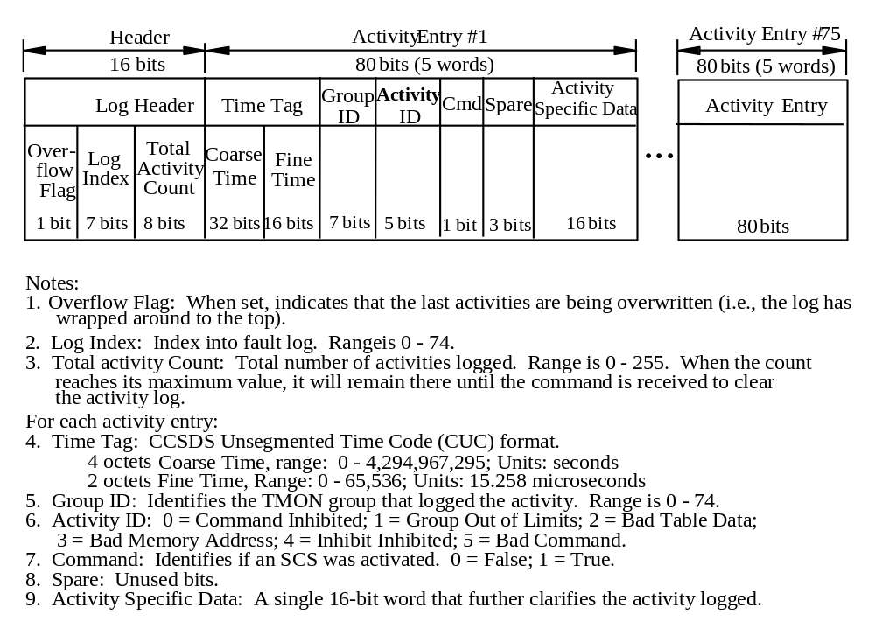Figure 5.5.2.2.3-1. TMON Format

5.5.3 Time Correlation Data Telemetry Format
The data items for time correlation are collected in a time correlation data packet with an APID of 1000. The data items are shown in Table 5.5.3-1. This packet is generated at a rate dependent on the S-band downlink rate: once every 32 seconds at 1.024 Kbps, and once every 8 seconds at 4.096 Kbps.

Table 5.5.3-1 Time Correlation Data Format

Rec  ID | EPOCH Mnemonic | Description | Symbol Name | Symbol  Offset | Bits
5538 | CDH_SS_TIEGRDARMTD1 | TIE GIRD TIME @ EPOCH ARMING (WORD 1) | bst_bc_d_1553.tie_firm_samp | 0 | 16
5539 | CDH_SS_TIEGRDARMTD2 | TIE GIRD TIME @ EPOCH ARMING (WORD 2) | bst_bc_d_1553.tie_firm_samp | 1 | 16
5540 | CDH_SS_TIEGRDARMTD3 | TIE GIRD TIME @ EPOCH ARMING (WORD 3) | bst_bc_d_1553.tie_firm_samp | 2 | 16
5541 | CDH_SS_TIEGRDARMTD4 | TIE GIRD TIME @ EPOCH ARMING (WORD 4) | bst_bc_d_1553.tie_firm_samp | 3 | 16
5534 | CDH_SS_TIEGRDEPCHTD1 | TIE GIRD TIME @ TDRSS PN ALL 1S EPOCH ARRIV (W1) | bst_bc_d_1553.tie_firm_samp | 4 | 16
5535 | CDH_SS_TIEGRDEPCHTD2 | TIE GIRD TIME @ TDRSS PN ALL 1S EPOCH ARRIV (W2) | bst_bc_d_1553.tie_firm_samp | 5 | 16
5536 | CDH_SS_TIEGRDEPCHTD3 | TIE GIRD TIME @ TDRSS PN ALL 1S EPOCH ARRIV (W3) | bst_bc_d_1553.tie_firm_samp | 6 | 16
5537 | CDH_SS_TIEGRDEPCHTD4 | TIE GIRD TIME @ TDRSS PN ALL 1S EPOCH ARRIV (W4) | bst_bc_d_1553.tie_firm_samp | 7 | 16
19871 | CDH_SS_TIEVCDUSQCTR | TIE ARM VCDU SEQUENCE COUNTER | bst_bc_d_1553.tie_firm_samp | 8&9 | 32
11624 | CDH_SS_TIEGISARMUS | TIE GIIS TIME @ EPOCH ARMING US OF MS | bst_bc_d_1553.tie_giis_samp | 0 | 16
11625 | CDH_SS_TIEGISARMMSL | TIE GIIS TIME @ EPOCH ARMING LSW mS | bst_bc_d_1553.tie_giis_samp | 1 | 16
11626 | CDH_SS_TIEGISARMMSM | TIE GIIS TIME @ EPOCH ARMING MSW mS | bst_bc_d_1553.tie_giis_samp | 2 | 16
11627 | CDH_SS_TIEGISARMDAY | TIE GIIS TIME @ EPOCH ARMING #DAYS | bst_bc_d_1553.tie_giis_samp | 3 | 16
5554 | CDH_SS_TIEGISEPCHUS | TIE GIIS TIME @ TDRSS PN ALL 1S EPOCH ARRIV uS | bst_bc_d_1553.tie_giis_samp | 4 | 16
5555 | CDH_SS_TIEGISEPCHMSL | TIE GIIS TIME @ TDRSS PN ALL 1S EPOCH ARRIV LSW mS | bst_bc_d_1553.tie_giis_samp | 5 | 16
5556 | CDH_SS_TIEGISEPCHMSM | TIE GIIS TIME @ TDRSS PN ALL 1S EPOCH ARRIV MSW mS | bst_bc_d_1553.tie_giis_samp | 6 | 16
5557 | CDH_SS_TIEGISEPCHDAY | TIE GIIS TIME @ TDRSS PN ALL 1S EPOCH ARRIV #DAYS | bst_bc_d_1553.tie_giis_samp | 7 | 16

5.5.4 Ground Based Attitude Determination Data

5.5.4.1 GBAD Definitions
Ground Based Attitude Determination (GBAD) data is generated internal to the GNCC controller originally for use by the Flight Dynamics Facility ground system analysts to assess the on-board attitude determination performance and provide high accuracy attitude fixes prior to entering the on-board Star ID acquisition logic. However, the GBAD data has been expanded to include many of the housekeeping data useful for science data analysis. The GBAD data is separate from standard housekeeping telemetry and is transmitted to the ground via X-band Direct Broadcast and Direct Playback only, not via the S-band. An extra four format tables and one additional packet list have been allocated to the GN&C controller for GBAD.
The GBAD data is placed into the Telemetry Data field of a spacecraft bus telemetry packet shown in Figure 5.5.1-1. Three GBAD packets will be generated. One packet, identified by APID 957, will be generated every second. The content and format of the one-second-packet data field is shown in Table 5.5.4-1 and Figure 5.5.4-1. A second packet, identified by APID 958, will be generated every four seconds. The content and format of the four-second-packet data field is shown in Table 5.5.4-2 and Figure 5.5.4-2. A third packet, identified by APID 959, will be generated every 8 seconds. The content and format of the eight-second-packet data field is shown in Table 5.5.4-3 and Figure 5.5.4-3. The contents of the GBAD packets will generally remain fixed once they are finalized during spacecraft integration and test. Changes may be needed, but they will only be made if necessary, will be made in coordination with the ground system, and will require a change to this section of the ICD. Direct Broadcast users should contact NASA PM-1 (Aqua) EOS Operations Center for the actual GBAD format and data description.
The GN&C mode information is located in the GNCC Status Word 2 (Table 5.5.4-4) of the Eight-Second GBAD packet.
When the GN&C mode is other than the Fine Point mode, the spacecraft pointing accuracy do not meet the requirements for science observation, the associated science data should be discarded. When the GN&C mode is in Fine Point Mode, there is still no guarantee the pointing accuracy always meets the requirements (e.g., a GN&C anomaly develops in the Science state, pointing accuracy gradually deteriorates until some threshold is reached, triggering transfer to a non-Science state). It is necessary to check the S/C pointing accuracy to determine which part of the science data are usable, and which part should be discarded.

Table 5.5.4-1. One-Second GBAD Packet Data Field Contents
Description | Notes | Resolution¹ | Units | Sampling Time²
Spacecraft Position(X, Y, Z) | The estimated spacecraft position, calculated using the hi-fidelity interpolation routine, of the spacecraft, expressed in the Earth Centered Inertial frame. (sc_position_eci) | DPFP | Meters | 1 Second
Spacecraft Velocity  (X, Y, Z) | The estimated spacecraft velocity, calculated using the hi-fidelity interpolation routine, of the spacecraft, expressed in the Earth Centered Inertial frame. (sc_velocity_eci) | DPFP | Meters/sec | 1 Second
Attitude Quaternion (1, 2, 3, 4) | The estimated Earth Centered Inertial to Spacecraft Body frame attitude quaternion of the spacecraft. (ap_q_eci2body) | DPFP | none | 1 Second
Attitude Body Rates (X, Y, Z) | The estimated attitude rates of the spacecraft, expressed in the Spacecraft Body frame. (body_rates) | SPFP | Rad/sec | 1 Second
IRU Data Words (1-7) | word 1 – SIRU remote terminal status word  word 2 – SIRU data valid word  word 3 – gyro A integrated angle  word 4 – gyro B integrated angle  word 5 – gyro C integrated angle  word 6 – gyro D integrated angle  word 7 – gyro integration period  (IRU_data_count) | bit-packed  bit-packed  integer  integer  integer  integer  integer | none  none  counts  counts  counts  counts  counts | 1 Second
Status Word 3 | Enable, on/off and direction bits of the magnetic torquer coils used for spacecraft momentum unloading (Status Word 3) | bit-packed | none | 1 Second
Three-axis Magnetometer  (primary X, Y, Z) (redundant X, Y, Z) | The raw measurement of the local magnetic field in TAM coordinates.  (TAMcountsP, TAMcountsR) | Integer | counts | 1 Second
Attitude Body Rates Time Tag | The absolute time tag associated with the IRU data and associated body rate (body_rate_time) | DPFP | Seconds | 1 Second

Notes:
1) Denotes whether data is bit-packed, or expressed in integer format, Double Precision Floating-Point (DPFP) or Single Precision Floating Point (SPFP). The SPFP and DPFP data types are the same as the “32-bit floating point” and “48-bit extended precision floating point” data types defined in MIL-STD-1750A (see Section 2.2.1, Document 14).
2) Time reference specifies the frequency at which the data is downlinked to the ground system.
3) The Attitude Body Rate Time Tag consists of two fields: the integer second and the fractional second fields. The integer second is the number of seconds elapsed since January 1, 1958. The units for both fields are seconds and both are expressed in the DPFP format. The two fields need to be added to obtain the total elapsed time. The time tags are not quantized with a scale factor and an LSB.

Spacecraft Position
Attitude Body Rate
IRU Data
Spacecraft Velocity
Attitude Quaternion
Status

Word 3
Three-Axis Magnetometer
Time Tag
(IRU Body Rates)
X
Y
Z
X
Y
Z
1
2
3
4
X
Y
Z
1
2
3
4
5
6
7
16
bits
16
bits
P
X
P
Y
P
Z
R
X
R
Y
R
Z
Coarse
Fine
48
bits
48
bits
48
bits
48
bits
48
bits
48
bits
48
bits
48
bits
48
bits
48
bits
48
bits
48
bits
16
bits
16
bits
16
bits
16
bits
16
bits
16
bits
16
bits
16
bits
16
bits
16
bits
16
bits
16
bits
32

bits
32

bits
32

bits
Note: P = Prime Three-Axis Magnetometer (TAM)
R = Redundant TAM

Figure 5.5.4-1. One-Second GBAD Packet Data Field Format

Table 5.5.4-2. Four-Second GBAD Packet Data Field Contents
Description | Notes | Resolution¹ | Units | Sampling Time²
Earth Sensor Outputs  (1, 2, 3, 4) | The raw measurements of the ESA detector outputs. (ESA1COUNTS, ESA2COUNTS, ESA3COUNTS, ESA4COUNTS) | Integer | counts | 4 Seconds
Notes: 1) Denotes whether data is bit-packed, or expressed in integer format, Double Precision Floating Point (DPFP) or Single Precision Floating Point (SPFP). The DPFP is the same as Extended Precision Floating Point defined in Mil-Std-1750A (see Section 2.2.1, Document 14).
2) Time reference specifies the frequency at which the data is downlinked to the ground system.

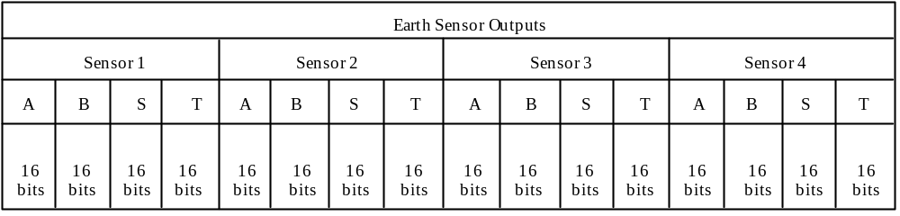

Figure 5.5.4-2. Four-Second GBAD Packet Data Field Format

Table 5.5.4-3. Eight-Second GBAD Packet Data Field Contents
Description | Notes | Resolution¹ | Units | Sampling Time²
Solar Ephemeris (X, Y, Z) | The components of a unit vector, calculated from CSS data and expressed in the Spacecraft Body Reference frame, pointing in the direction of the sun. (css_sun1vec_sbf) | SPFP | none | 8 Seconds
Coarse Sun Sensor Outputs (primary 1, 2, 3, 4) (redundant 1, 2, 3, 4) | The raw measurements of CSS current outputs. (CSSCOUNTSP, CSSCOUNTSR,) | Integer | counts | 8 Seconds
Star Tracker -  (STAout 1 & 2) -  Data Words (1-31) | Word 0 – Time Tag  Word 1 – Time Tag  Word 2 – Status Word  Word 3 – Status Word  Word 4 – Message Counter  Word 5 – Cmd received/rejected  Word 6 – Star 1X position  Word 7 – Star 1Y position  Word 8 – Star 1 intensity  Word 9 – Star 2 X position  Word 10 – Star 2Y position  Word 11 – Star 2 intensity  Word 12 – Star 3 X position  Word 13 – Star 3 Y position  Word 14 – Star 3 intensity  Word 15 – Star 4 X position  Word 16 – Star 4 Y position  Word 17 – Star 4 intensity  Word 18 – Star 5 X position  Word 19 – Star 5 Y position  Word 20 – Star 5 intensity  Word 21 – CDD temperature  Word 22 – Base Plate Temperature  Word 23 – lens temperature  Word 24 – Status Word  Word 25 – Status Word  Word 26 – Back Ground Reading  Word 27 – Full Field Search Count  Word 28 – Status Word  Word 29 – Cancel Code  Word 30 – (Spare) | Integer  Integer  Bit Packed  Bit Packed  Integer  Bit Packed  Integer  Integer  Integer  Integer  Integer  Integer  Integer  Integer  Integer  Integer  Integer  Integer  Integer  Integer  Integer  Integer  Integer  Integer  Bit Packed  Bit Packed  Integer  Integer  Bit Packed  Integer | None | 8 Seconds
Notes:
- Denotes whether data is bit-packed, or expressed in integer format, Double Precision Floating Point (DPFP) or Single Precision Floating Point (SPFP). The SPFP and DPFP data types are the same as the “32-bit floating point” and “48-bit extended precision floating point” data types defined in MIL-STD-1750A (see Section 2.2.1, Document 14).
- Time reference specifies the frequency at which the data is downlinked to the ground system.
- Torque rod magnetic moment is 500 millamps/sec² whenever the Torque Rod is on.
- Torque rod polarity is provided within the Status Word 3 in the one-second packet.
Table 5.5.4-3. Eight-Second GBAD Packet Data Field Contents (Cont’d)
Description | Notes | Resolution¹ | Units | Sampling Time²
Gyro Drift Biases (X, Y, Z) | The Kalman filter estimated gyro drift rates, interpreted with respect to the database constant drift rates (gyro_drift_bias) | DPFP | rad/sec | 8 Seconds
Quaternion Updates (1, 2, 3, 4) | The incremental attitude update quaternion calculated by Kalman filter (kf_q_sw) | DPFP | none | 8 Seconds
TDE On Time | Magnetic Torquer On Time – Cumulative over 16 second periods³ | Integer | 102.4msecs⁴ | 8 Seconds
GNCC Status Word 2  (16 bits) | Indicates GNCC Status (Reference Table 5.5.4-4 for bit assignments) | Integer | none | 8 Seconds
Notes:
1) Denotes whether data is bit-packed, or expressed in integer format, Double Precision Floating Point (DPFP) or Single Precision Floating Point (SPFP). The SPFP and DPFP data types are the same as the “32-bit floating point” and “48-bit extended precision floating point” data types defined in MIL-STD-1750A (see Section 2.2.1, Document 14).
2) Time reference specifies the frequency at which the data is downlinked to the ground system.
3) Torque rod magnetic moment is 500 millamps/sec² whenever the Torque Rod is on.
4) Torque rod polarity is provided within the Status Word 3 in the one-second packet.

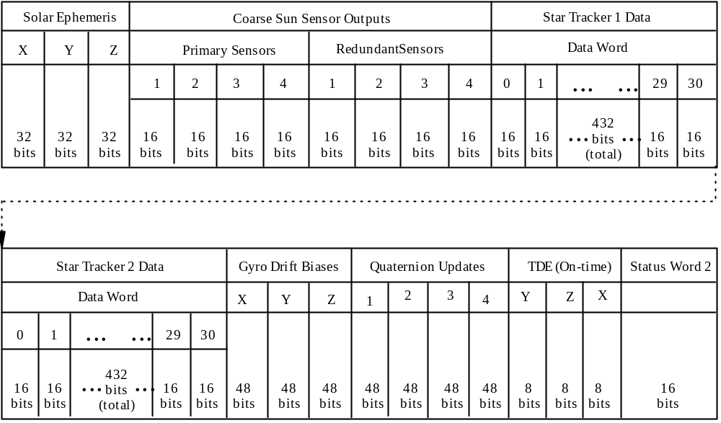

Figure 5.5.4-3. Eight-Second GBAD Packet Data Field Format

Table 5.5.4-4. GNCC Status Word 2 Bit Pattern
Bits (0 1 2) 1 | Parameter
0 0 0 | Mode Zero
1 0 0 | Attitude Hold Mode
0 1 0 | Sun Hold Mode
1 1 0 | Fine Point Mode
0 0 1 | Earth Point Mode
1 0 1 | Sun Point Mode
Bits 3 – 15 | Don’t Care
Note 1. Bit 0 is MSB and Bit 15 is LSB.

5.6 instrument TELEMETRY
The PM-1 (Aqua) spacecraft carries eight science instruments: Advanced Microwave Scanning Radiometer for EOS (AMSR-E); Advanced Microwave Sounding Unit-A (AMSU-A1 and AMSU-A2); Atmospheric Infrared Sounder (AIRS); Clouds and the Earth’s Radiant Energy System (CERES +Y Aft and CERES -Y Fore); Humidity Sounder for Brazil (HSB); and the Moderate Resolution Imaging Spectroradiometer (MODIS).
Instrument telemetry may be classified into three types:
- Instrument science data – Data collected by the instrument for scientific investigation.
- Instrument engineering data – All non-science data provided by the instrument.
- Instrument housekeeping data – The subset of instrument engineering data that are required for health and safety monitoring.
Some instruments (e.g. AIRS and MODIS) have all three types of telemetry, in separate packets. Some instruments have only science telemetry and housekeeping telemetry. Different telemetry types may use different packet formats. The following describes the telemetry formats for different instruments and telemetry types.

5.6.1 GIRD Instrument Telemetry Packet Format
The GIRD Instrument Telemetry Packet Format is shown in Figure 5.6.1-1. It is used for science, engineering and housekeeping data of AIRS, AMSU-A1 & A2, and HSB, as well as for housekeeping data of CERES, MODIS and AMSR-E. The CERES housekeeping data format needs a special comment: The CERES instrument packetizes its housekeeping data using the modified GIIS Instrument Telemetry Packet format and provides the packet to the ISC. The ISC converts the CERES-generated packet into a GIRD Instrument Telemetry packet by inserting the entire packet directly into the Instrument Data Field of a GIRD packet. (For more details, see Section 5.6.9.) The difference between the GIRD Instrument and the Spacecraft Bus Telemetry packets (Figure 5.5.1-1) resides in the format of the secondary header. The GIRD instrument packet contains 1 extra octet in front of the 8 octets of CUC time that both packets have.

Packet Identification
Version
No.
Type
SHF
APID
Packet
Seq Control
Packet
Length
Secondary Header
9 octets (72 bits)
Instrument
Data
Seq
Flag
Packet
Seq
Count
3 bits
1 bit
1 bit
11 bits
2 bits
14 bits
16 bits
64
bits
“Variable”
Primary Header
Data Zone
6 octets (48 bits)
Variable
Notes:
1.

Version No. = 000.
2.

Type = 0
(Telemetry packet).

3.

Secondary Header Flag (SHF) = 1.
4.

APID = Defined in Appendix B, Tables B-2 through B-5.
5. Sequence Flag = 11 (Unsegmented).
6. Packet Sequence Count = Monotonically increasing number.
7. Packet Length = Total number of octets in the data zone minus one.
8. Secondary Header:
Bit 0 = 0.
Quick Look Flag: 0 = Quick look processing not required; 1 = Quick look processing required.
User Flags = Reserved for future instrument use.
Time Stamp = See Figure 5.5.1-1, Note 8.

9. Instrument Data Field:
Instrument data of variable lengths. AIRS, AMSU-A1, and AMSU-A2 science and engineering packets
include a 16-bit checksum; HSB science and engineering packets include no checksum.
p-field
p-field ext.
coarse time
fine time
8 bits
8 bits
32 bits
16 bits
Bit 0
Quick
Look
Flag
User
Flags
Time
Stamp
1 bit
1 bit
6 bits

Figure 5.6.1-1. GIRD Instrument Telemetry Packet Format

5.6.2 AIRS
The Spacecraft-to-AIRS interface consists of a Primary 1553 Data Bus, a TAXI high rate data link, and point-to-point analog channels. The Primary 1553 Data Bus interface is used for commanding the instrument and collecting housekeeping data from it. The TAXI interface provides a direct serial interface to the FMU for science data. As a GIRD compliant instrument, the same GIRD Instrument Telemetry Packet Format defined in Figure 5.6.1-1 is used for all AIRS telemetry, i.e. engineering data, science data, and low-rate housekeeping data.

5.6.2.1 AIRS Housekeeping Telemetry
AIRS outputs 2 housekeeping data packets via the Primary 1553 Data Bus every 3 scans (i.e. 8 seconds). The packets are 256 octets in size, headers included. The last two octets of the Instrument Data field contain an arithmetic checksum. The packets are available whenever AIRS is powered on.

5.6.2.2 AIRS Science and Engineering Telemetry
98 AIRS science and engineering data packets are output to the FMU/SSR via the TAXI interface each scan of 2.67 seconds. 96 are Science packets, and 2 are Engineering packets. The packets are 4,286 octets in size, headers included. The output is available only when AIRS Group 2 power is on and the high rate interface is turned on. Both of these are under operator control using AIRS commands. Both are OFF when AIRS is first powered on.
The 96 science packets consist of 90 scene footprint packets, 4 space look footprint packets, a radiometric calibration footprint packet and a combined photometric/spectral calibration footprint packet. The time stamp in the secondary header is updated every footprint. The AIRS instrument will begin operation with two standard engineering packets. The first packet is the nominal (default) engineering data packet, and the second packet contains memory or buffer status. When needed for diagnostic purposes, flexible high-rate engineering packets replace the nominal high-rate engineering packets. A pair of APIDs (416 and 417) are used for flexible high-rate engineering packets. The internal format of the flexible high-rate engineering packets is specified by an additional parameter contained in the data portion of the packets.

5.6.3 AMSR-E
AMSR-E science data packets are directly fed to the FMU/SSR via a differential balanced circuit interface akin to RS-422. The spacecraft ISC collects and packetizes the housekeeping data from AMSR-E.

5.6.3.1 AMSR-E Housekeeping Telemetry
AMSR-E housekeeping data are transmitted to the ISC via the serial digital interface. Unused portions of the serial digital (SD) telemetry stream shall be filled with all 0’s by the AMSR-E instrument to allow the spacecraft to always read data in sets of 10 bytes. S/C FSW converts the SPC A and SPC B power status from analog to bilevel data. The SPC A and SPC B status is concatenated into the AMSR-E Active Bi-level Data Byte shown in Figure 5.6.3.1-1. The spacecraft shall concatenate the AB, PB, AA, and PA data with the instrument SD telemetry data to create a minor frame as shown in Figure 5.6.3.1-2. The unused octets in each housekeeping minor frame shall be filled with all zeros (0’s) to maintain the minor frame size at 14 octets.

Every 4 seconds, the ISC combines 8 minor frames into a single AMSR-E Housekeeping Data Packet (Figure 5.6.3.1-3) using the GIRD Instrument Telemetry Packet format.
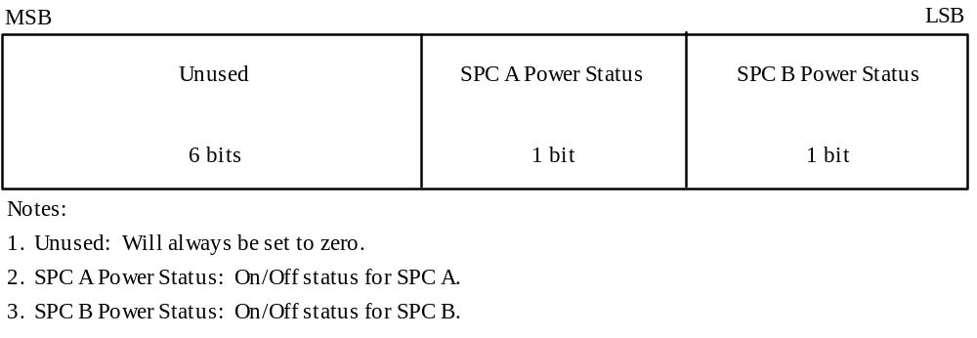

Figure 5.6.3.1-1. AMSR-E Active Bi-level Data Byte Format

MSB |  |  |  |  |  |  | LSB
Serial Digital Telemetry  0 bits |  | Active Bilevel  Data Word  8 bits |  | Passive Bilevel  Data Word  8 bits |  | Active Analog  Data Word  8 bits | Passive Analog  Data Word  8 bits
Notes
1. Serial Digital Telemetry: Read from the Serial Digital Telemetry interface when 10 bytes of data
available. Otherwise, 10 bytes of fill data (00₁₆) will be placed here
2. Active Bilevel Data Word: Formatted as shown in Figure 5.6.3.1-1.
3. Passive Bilevel Data Word: The 8 LSBs of the raw passive bilevel value will be placed here.
4. Active Analog Data Word: ADE A, ADE B, and MWA motor currents and motor speeds. The 8
MSBs of the 12-bit raw analog value will be placed here. The data placed in this field will be in
accordance with the following table:
 | Minor Frame |  | Data
 | 1, 9, 17, 25 |  | ADE A Motor Current
 | 2, 10, 18, 26 |  | ADE A Speed
 | 3, 11, 19, 27 |  | ADE B Motor Current
 | 4, 12, 20, 28 |  | ADE B Speed
 | 5, 12, 21, 29 |  | MWA Motor Current
 | 6, 13, 22, 30 |  | MWA Speed
 | 7, 8, 15, 16 |  | Fill Pattern (00₁₆)
 | 23, 24, 31, 32 |  | Fill Pattern (00₁₆)
5. Passive Analog Data Word: SPC A and SPC B temperatures. The 8 MSBs of the 12-bit raw analog
value is placed here. The data placed in this field will be in accordance with the following table:

 | Minor Frame |  | Data
 | 1, 9, 17, 25 |  | SPC A Temperature
 | 2, 10, 18, 26 |  | SPC B Temperature
 | 3, 11, 19, 27 |  | Fill Pattern (00₁₆)
 | 4, 12, 20, 28 |  | Fill Pattern (00₁₆)
 | 5, 12, 21, 29 |  | Fill Pattern (00₁₆)
 | 6, 13, 22, 30 |  | Fill Pattern (00₁₆)
 | 7, 8, 15, 16 |  | Fill Pattern (00₁₆)
 | 23, 24, 31, 32 |  | Fill Pattern (00₁₆)

Figure 5.6.3.1-2. AMSR-E Housekeeping Data Minor Frame Format

Packet Identification
Version
No.
Type
SHF
APID
Packet
Seq Control
Packet
Length
Secondary
Header
AMSR
Data
Seq
Flag
Packet
Seq
Count
3 bits
1 bit
1 bit
11 bits
2 bits
14 bits
16 bits
72
bits
896 bits
Primary Header
Data Zone
48 bits
968 bits
Minor Frames
Bit Settings
1 - 8
000001
9 - 16
000010
17 - 24
000011
25 - 32
000100
Notes:
1.

Version No.: 000
2.

Type: 0
(Telemetry packet)

3.

Secondary Header Flag (SHF): 1
4.

APID = 220.
5. Sequence Flag = 11 (Unsegmented)
7. Packet Sequence Count: Monotonically increasing number. The
Packet
Sequence Count of the first packet
following an ISC power-up will be zero (0).
7. Packet Length: Total number of octets in the Data Zone minus 1.
8. Secondary Header (bit 0 is the MSB)
a. The first octet of the Secondary Header will be used as follows:
- Bit zero will be set to zero.
- Bit one is the Quick Look Flag and will always be set to zero.
- Bit two through seven will be set as follows:

b. The second through ninth octets of the Secondary Header will contain
the data time tag.
The time tag will represent the time that the first minor frame in the packet was collected.
The CUC time tag is defined in Figure 5.6.1-1, GIRD Instrument Telemetry Packet Format.
9. AMSR Data: Contains eight minor frames of AMSR Engineering Data formatted as shown in
Figure 5.6.3.1-2.

Figure 5.6.3.1-3. AMSR-E Housekeeping Data Packet

5.6.3.2 AMSR-E Science and Engineering Telemetry
The science and engineering data output from AMSR-E instrument are in CCSDS packets with an unique CCSDS packet secondary header format defined in Figure 5.6.3.2-1. No other instrument on the PM-1 (Aqua) spacecraft uses this packet format. Like the GIRD Instrument Telemetry Packet format, the AMSR-E Science Telemetry Packet format (Figure 5.6.3.2-1) has a 9-octet Secondary Header and uses the CUC time code. But unlike the GIRD Telemetry format, the Secondary Header of an AMSR-E Science Packet contains two spacer octets and a time stamp consisting of 1 octet P-field and 5 octets T-field. The single-octet fine time has a resolution of 3.892 msec. The second octet of fine time providing 15.2 micro-sec resolution is placed outside the Secondary Header in the first octet of the data field. The second octet of fine time is not needed for EDOS processing; it is made available for potential use in scientific data processing. The AMSR-E sensor unit rotates at 40 RPM, i.e.1.5 second per revolution. Every 1.5 second AMSR-E outputs a group of 16 science and engineering data packets to the FMU/SSR that have the same APID and time stamp, but monotonically increasing Packet Sequence Counts, each packet 1,024 octet in size. The first and the last packets in the group have Sequence Flags of “01” and “10” respectively; the 14 packets between them all have the same Sequence Flag of “00”.

Packet Identification
Version
No.
Type
SHF
APID
Packet
Seq Control
Packet
Length
Secondary Header
9 octets (72 bits)
Instrument
Data Field
Seq
Flag
Packet
Seq
Count
3 bits
1 bit
1 bit
11 bits
2 bits
14 bits
16 bits
64
bits
8072 bits
Primary Header
Data Zone
6 octets (48 bits)
8144 bits
Notes:
1.

Version No. = 000.
2.

Type = 0
(Telemetry packet).

3.

Secondary Header Flag (SHF) = 1.
4.

APID = Defined in Appendix B, Tables B-2 through B-5.
5. Sequence Flag: 01 = Packet 1;
00 = Packet 2 - 15;
10 = Pacekt 16.

6. Packet Sequence Count = Monotonically increasing number. Science data starts with 0000
16
and continues until
3FFF
16
per packet.

7. Packet Length (Total number of octets in the data zone minus one) = 1017.
8. Secondary Header = 72 bits defined as follows:
Bit 0 = 0.
Quick Look Flag = 0 (Quick look processing not required).
User Flags = bits 2 - 7, Reserved for AMSR use.
Time Stamp (P- and T-Fields shown below); Expressed in CUC where:

Spacer Octet = 8 bits (all 0s).
P-field: bit 0 = 0 (second octet is not present).
bits 1 - 3 = 010 (Epooch time is January 1, 1958).
bits 4 - 5 = 11 (4 octet Coarse Time present).
bits 6 - 7 = 01 (1 octet Fine Time present).
T-field: Coarse Time (bits 0 - 31) = Number of seconds since january 1, 1958.
Fine Time (bits 0 - 7) = Sub-seconds time (Most Significant Half, LSB =
3.90625
msec)
Spacer Octet = 8 bits (all 0s).
p-field
8 bits
8 bits
32 bits
8
bits
Bit 0
Quick
Look
Flag
User
Flags
Time
Stamp
1 bit
1 bit
6 bits
Spacer
8 bits
coarse time
fine time
Spacer
Instrument Data
0
010
11
01
P
-Field
first octet
T-Field
2 - 5 octets
6th octet
Fine Time
LSB =

3.90625
msec.
Coarse Time
LSB = 1 sec
Covers 136 years
denotes
no 2nd
octet
present
Time
Code ID
is [Jan.
1, 1958
Epoch]
denotes
number of
octets of
coarse
time (4)
denotes
number of
octets of
fine
time (1)
TIME CODE FORMAT

Figure 5.6.3.2-1. AMSR-E Science and Engineering Data Packet Format

5.6.4 AMSU-A1
The Spacecraft to AMSU-A1 interface consists of a Primary 1553 Data Bus and point-to-point analog channel. The Primary 1553 Data Bus interface is used for commanding the instrument and collecting Low Rate Housekeeping data and low-rate science data from it. The AMSU-A1 instrument uses GIRD Instrument Telemetry packets (Figure 5.6.1-1) for housekeeping data, science and engineering data. For each instrument observation mode, the science and engineering data collected over the 8 second scan are divided into two packets with identical Secondary Headers but different APIDs and packet sizes. The first packet has an odd APID, and the second packet has an even APID - one greater than the first packet’s. This is intended to facilitate ground re-assembly of the data in the two packets. The ground system should be aware of the fact that the last six octets of the AMSU-A1 packets contain no useful data and should be ignored. The six octets were added by the PM-1 (Aqua) spacecraft flight software to compensate for a packet length error discovered in the AMSU-A1 firmware.

5.6.5 AMSU-A2
The Spacecraft-to-AMSU-A2 interface consists of a Primary 1553 Data Bus and point-to-point analog channel. The Primary 1553 Data Bus interface is used for commanding the instrument and collecting housekeeping data and science and engineering data from it. The AMSU-A2 instrument uses GIRD Instrument Telemetry Packet format (Figure 5.6.1-1) for housekeeping data, science and engineering data.

The AMSU-A2 telemetry packet is the same format for housekeeping and science and engineering data as shown in Figure 5.6.1-1. AMSU-A2 outputs only one science and engineering data packet each 8 second scan. Its housekeeping data packet is also much shorter than AMSU-A1’s. The ground system should be aware of the fact that the last six octets of the AMSU-A2 packets contain no useful data and should be ignored. The six octets were added by the PM-1 (Aqua) spacecraft flight software to compensate for a packet length error discovered in the AMSU-A2 firmware.

5.6.6 HSB
Every 8 seconds HSB completes three scans and sends a total of 80 minor frames of unpacketized data to the spacecraft via a dedicated serial digital interface, 78 of which contains science and engineering data, the first and the last contain no data. Each minor frame contains 25 16-bit words. The spacecraft ISC packetizes the 78 minor frames of data into six science and engineering data packets and three housekeeping packets, i.e. two science and engineering data packets and one housekeeping data packets for each scan. The GIRD Instrument Telemetry Packet format (Figure 5.6.1-1) is used for all HSB telemetry.

5.6.6.1 HSB Science and Engineering Telemetry
The two HSB science and engineering data packets for each scan have the same APID and time stamp, but monotonically increasing Packet Sequence Counts, each packet containing 13 minor frames of data. The Sequence Flag in the Primary Header of the first packet is set to “01” to indicate it contains the first half of the data, and the Sequence Flag is set to “10” for the second packet to indicate it contains the second half of the data.

The time stamp for the first two of the six science and engineering data packets generated every 8 seconds represents the S/C time at the 8 second boundary plus 123.1 msec; this time stamp is incremented by 2.6 seconds for the third and fourth packets, and 5.2 seconds for the fifth and sixth packets.

5.6.6.2 HSB Housekeeping Telemetry
The ISC copies the housekeeping data from minor frames 25-26, 51-52 and 77-78 to form three housekeeping data packets, each 67 octets in size. Each packet contains a single 26-word minor frame of data. The time stamp for the first of the three housekeeping packets generated every 8 seconds represents the S/C time at the 8 second boundary plus 123.1 msec. The time stamp for the other two packets increments in steps of 2.6 second.

5.6.7 GIIS Instrument Telemetry Packet Format
The GIIS Instrument Telemetry Packet format is used for MODIS science and engineering packets that MODIS sends to the FMU/SSR directly via the TAXI interface and for CERES science packets. The main difference between the GIIS and the GIRD Instrument Packet formats is in the secondary header. Unlike the GIRD Instrument Packet, the first 8 octets of the Secondary Header in the GIIS Instrument Packet is the Time Stamp expressed in CCSDS Day Segmented Time Code. The remaining 8 bits are User Flags. Within the Time Code, the first seven bits of the day field are implied and not actually transmitted. That is, this information is not included in the Time Stamp. These seven bits are: 1000001. The transmitted bits shall be binary representations of the number of milliseconds since the beginning of the current day and the number of microseconds in the current millisecond. Figure 5.6.7-1 defines format and content of the GIIS Instrument Telemetry Packet. This packet format is used only for CERES science data and for MODIS science and engineering data.

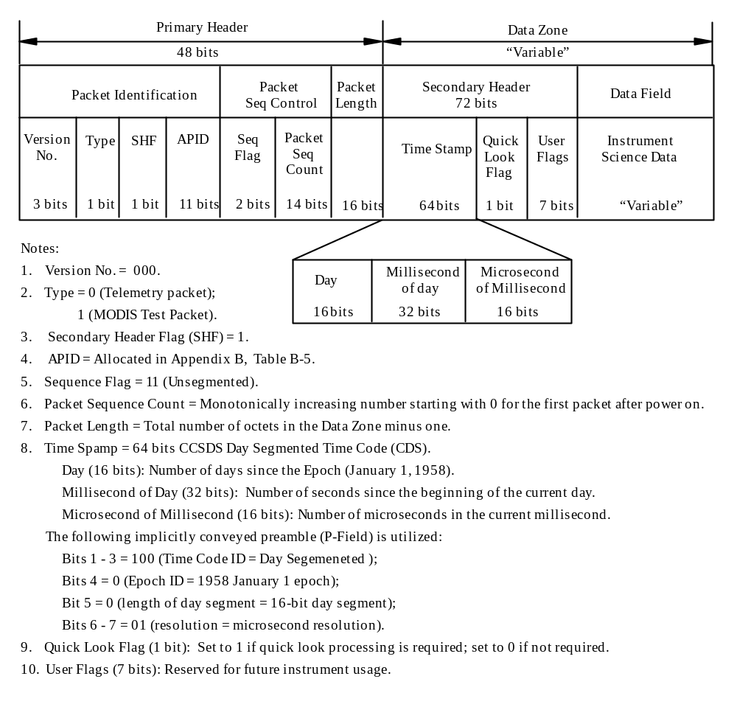
Figure 5.6.7-1. GIIS Instrument Telemetry Packet Format

5.6.8 MODIS
The Spacecraft-to-MODIS interface consists of a Primary 1553 Data bus, high-rate science link, point-to-point relay drive commands, and point-to-point analog and bilevel telemetry channels. The Primary 1553 Data Bus is used for commanding the instrument and collecting low rate housekeeping data from it. MODIS is not GIRD compliant. The housekeeping data output is not packetized.

5.6.8.1 MODIS Housekeeping Telemetry
The ISC is responsible for collection and packetization of MODIS housekeeping data and dump data, and providing synchronization information to MODIS (e.g., major, and minor cycle counts, spacecraft heartbeat). Once every second the ISC packetizes the 32 16-bit words MODIS housekeeping data, as received, into the GIRD Instrument Telemetry Packet Format defined in Figure 5.6.1-1. MODIS does not use Checksum for its housekeeping data.
5.6.8.1.1 MODIS Housekeeping Data Frame
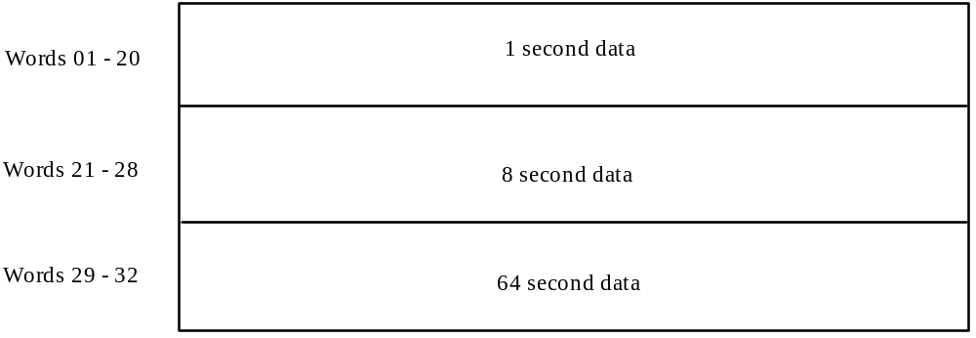
The MODIS Housekeeping Data Frame Format and data collection times is shown in Figure 5.6.8.1.1-1.

Figure 5.6.8.1.1-1. MODIS Data Frame Format

5.6.8.2 MODIS Science and Engineering Telemetry
MODIS also has a TAXI link direct to the FMU/SSR for high rate science and engineering data output. The data is CCSDS packetized in GIIS Instrument Telemetry Packet format shown in Figure 5.6.7-1. MODIS completes one scan in 1.477 second. MODIS collects data in both Day Mode and Night Mode. When in the Day Mode, 3,032 science and engineering data packets are generated each scan, whereas in the Night Mode, 1,678 packets are generated each scan. These packets include a 12 bit Checksum in the Data Field.

5.6.8.2.1 MODIS Fill Data
The instrument data field of the MODIS night packet contains 2,040 bits of data and 12 bits of fill data (all zeroes).

5.6.8.3 MODIS Test Packet
MODIS test packets may be generated on ground or on orbit, the Type bit in the Primary Header is set to “1”, and the APID is changed to 127. The packet will be either the size of the Day Mode science and engineering data packet or that of the Night Mode packet.

5.6.8.4 MODIS Dump Data
MODIS memory dumps consist of a MODIS Dump Initiate Command, shown in Table 5.6.8.4-1, followed by a memory dump buffer read. MODIS dump data is a maximum of 32 words, and is not packetized. The dump data is sent via the 1553 bus to the S/C ISC where it is inserted into the Instrument Data field of a GIRD packet. The S/C will pick up the dump data in 32 word blocks at 1-second intervals and will continue to retrieve the same 32 words of dump data until the next Dump Initiate Command is received or the ground turns off the processing. If less than 32 words of dump data is requested, it will be up to the ground system to know which and how many words were requested in the dump command.

Table 5.6.8.4-1. Bus Memory Dump Initiate Command
MSB LSB
0 4 5 7 8 15
11110 | 101 | Table
P CLS A
Dump start address (most significant word)
Dump start address (least significant word)
Word count (most significant word)
Word count (least significant word)

5.6.9 CERES
The Spacecraft-to-CERES interface consists of a Primary 1553 Data Bus, a high-level pulse for reset, and point-to-point analog channels. The Primary 1553 Data Bus interface is used for collecting housekeeping data and science data from the CERES. Every 6.6 seconds CERES outputs a housekeeping packet and a science packet. The science packet is in the GIIS Instrument Telemetry Packet format shown in Figure 5.6.7-1, while the housekeeping packet is in the modified GIIS Instrument Telemetry Packet format defined in Section 5.6.9.1. The Spacecraft converts the housekeeping packet into a GIRD Instrument Telemetry packet by inserting it directly into the Instrument Data Field of a GIRD packet for downlink to the ground station.
Reference Section 2.2.2, Document 5, for details of the high-level reset pulse and the point-to-point analog channel interfaces.

5.6.9.1 CERES Housekeeping Telemetry
CERES packetizes its housekeeping data using the modified GIIS Instrument Telemetry Packet format, which differs from the GIIS Instrument Telemetry Packet format shown in Figure 5.6.7-1 in that the 72-bit secondary header is reduced to 64 bits by removing the last octet containing the Quick Look flag. The modified GIIS packets are delivered to the PM-1 (Aqua) S/C, which then converts them into GIRD Instrument Telemetry packets (Figure 5.6.1-1) by adding the GIRD Primary and Secondary Headers. The total H/K packet size that is downlinked to the ground is 271 octets, (i.e., 256 octet original CERES Housekeeping packet + 15 octet GIRD Primary and Secondary headers).
5.6.9.2 CERES Science Telemetry
The CERES instrument delivers science data to the spacecraft in GIIS Instrument Telemetry Packet Format as defined in Figure 5.6.7-1. But the Sequence Flag is erroneously set to “00”, and the Quick Look Flag is always set to zero. The 6,994 octet packet is divided into seven data blocks for transfer to the spacecraft. Each block is 1024 octets long except for the last one, whose length is 850 octets. CERES does not use checksum.

APPENDIX A PM-1 (AQUA) COMMANDS/DATA UPLINK SUMMARY

Security Note: Per “NASA Internet Publishing Content Guidelines, Information That Must Not Be Published Via the Internet”, the remaining text in this section except for the table titles have been removed.

Table A-1 Command/Data Format Summary

Table A-2. Telecommand Packet List
Table A-2. Telecommand Packet List (Cont’d)

APPENDIX B PM-1 (AQUA) TELEMETRY SUMMARY
- Two downlink frequencies:
- S-band for S/C bus and instrument housekeeping telemetry:
- GN mode: 16.384/524.288 Kbps for real time and playback housekeeping telemetry, convolutional and Reed-Solomon coded
- SN mode: 1.024 Kbps and 4.096 Kbps housekeeping telemetry, convolutional and Reed-Solomon coded
- On/Off Commandable CCSDS Randomizer – The default configuration at launch is: S-band GN mode telemetry is randomized, S-band SN mode is not.
- X-band for instrument science and engineering data and S/C bus and instrument housekeeping telemetry, Reed-Solomon coded only:
- DB mode: 15 Mbps direct broadcast of real time data to any receiving ground station
- DP mode: 150 Mbps direct playback of stored data to PGSs
- On/Off Commandable CCSDS Randomizer – The default configuration at launch is: X-band telemetry is randomized in both DB mode and DP mode.

- Data format:
- NRZ-L for S-band telemetry
- NRZ-M for X-band telemetry

- Two Types of CADU Formats:
- S-band CADUs (Figure 5.2.1-1): 256 octets in length, interleave depth of 1
- X-band CADUs (Figure 5.2.2-1): 1,024 octets in length, interleave depth of 4

- Three S-band GN Mode Telemetry Virtual Channels (VC):
- VC#1: Playback Housekeeping Telemetry
- VC#2: Real Time Housekeeping Telemetry
- VC#63: Fill CADUs

- Eleven X-band Virtual Channels:
- VC#3: Ground Based Attitude Determination (GBAD) Data
- VC#5: Spacecraft Bus and Instrument Housekeeping Telemetry
- VC#10: CERES +Y Aft Science Data
- VC#15: CERES –Y Fore Science Data
- VC#20: AMSU-A1 Science and Engineering Data
- VC#25: AMSU-A2 Science and Engineering
- VC#30: MODIS Science and Engineering Data
- VC#35: AIRS Science and Engineering Data
- VC#40: AMSR-E Science and Engineering Data
- VC#45: HSB Science and Engineering Data
- VC#63: Fill CADUs

- Five telemetry packet formats:
- GIRD Instrument Telemetry Packet
- GIIS Instrument Telemetry Packet
- AMSR-E Science Telemetry Packet
- S/C Bus Telemetry Packet
- SUROM/TIE Telemetry Packet

The differences are identified in Table B-1 below, most of them are in the secondary header format:
Table B-1 Telemetry Packet Format Comparison
Telemetry Packet Format Type | Reference | Secondary Header Length (Octets) | Time Code  Type | Time Code  P-Field Length (Octets) | Time Code T-Field Length (Octets) | Quicklook Flag Location in Sec. Header
Spacecraft Bus | Figure 5.5.1-1 | 8 | CUC | 2 | 6 | No Flag
SUROM/TIE | Figure 5.4.1.1-1 | 0 | N/A | 0 | 0 | No Flag
GIRD Instrument | Figure 5.6.1-1 | 9 | CUC | 2 | 6 | 2nd Bit
AMSR-E Science | Figure 5.6.3.3-1 | 9 | CUC | 1 | 52 | 2nd Bit
GIIS Instrument1 | Figure 5.6.7-1 | 9 | CDS | 0 | 8 | 65th Bit

Notes:
1 MODIS uses this telemetry packet format for science and engineering data. CERES uses this format for science data only. But CERES packets have the Sequence Flag erroneously set to “00”, while MODIS packets have the correct Sequence Flag value of “11”. The Type bit in the Primary Header is set to “1” for MODIS test packets which have an APID of 127.
2 The 5 octets of the T-field contain 1 octet of fine time (3.90625 msec resolution); the second octet of fine time (15.2 micro-sec resolution) is placed outside the Secondary Header: in the first octet of the data field. This octet is made available for potential use in scientific processing, it is not needed for EDOS processing.
Comments on Sequence Flag of Primary Packet Header:
All PM-1 (Aqua) telemetry packets have the Sequence Flag set at “11” except for the HSB science and engineering data packets and the AMSR-E science and engineering data packets, where the Sequence Flag is used to denote the data sequence for a group of packets. The Sequence Flag is set to “01” for the first packet of the group, “10” for the last packet, and “00” for any in-between packets. HSB science and engineering data packets are in groups of two, so there is no in-between packets. With a packet group of 16, AMSR-E has 14 in-between packets. Another exception is the CERES science packets, whose Sequence Flag is erroneously set to “00”.

Table B-2. S-Band GN Mode 16.384/524.288 Kbps Telemetry Packets
(Packet List 1)
VCID |  | APID | Packet Format Type | Packet Size*  (incl. Hdrs)  (Octets) | Contents
LRC | HRC
2 | 1 | 484 | SUROM/TIE Telemetry | 160 | S/C ISC “A” SUROM
2 | 1 | 487 | SUROM/TIE Telemetry | 160 | S/C ISC “B” SUROM
2 | 1 | 490 | SUROM/TIE Telemetry | 160 | S/C PC “A” SUROM
2 | 1 | 493 | SUROM/TIE Telemetry | 160 | S/C PC “B” SUROM
2 | 1 | 496 | SUROM/TIE Telemetry | 160 | S/C GNCC “A” SUROM
2 | 1 | 499 | SUROM/TIE Telemetry | 160 | S/C GNCC “B” SUROM
2 | 1 | 502 | SUROM/TIE Telemetry | 160 | S/C CTC “A” SUROM
2 | 1 | 505 | SUROM/TIE Telemetry | 160 | S/C CTC “B” SUROM
2 | 1 | 508 | Spacecraft Bus Telemetry | 17 | S/C ISC – FT 0
2 | 1 | 509 | Spacecraft Bus Telemetry | 47 | S/C ISC – FT 1
2 | 1 | 510 | Spacecraft Bus Telemetry | 29 | S/C ISC – FT 2
2 | 1 | 511 | Spacecraft Bus Telemetry | 123 | S/C ISC – FT 3
2 | 1 | 512 | Spacecraft Bus Telemetry | 120 | S/C ISC – FT 4
2 | 1 | 513 | Spacecraft Bus Telemetry | 121 | S/C ISC – FT 5
2 | 1 | 514 - 517 | Spacecraft Bus Telemetry | 16 - 256 | Reserved - S/C ISC
2 | 1 | 522 - 635 | Spacecraft Bus Telemetry | 16 - 256 | Reserved - S/C ISC
2 | 1 | 636 | Spacecraft Bus Telemetry | 20 - 256 | S/C ISC Memory Dump
2 | 1 | 637 - 662 | Spacecraft Bus Telemetry | 16 - 256 | Reserved - S/C ISC
2 | 1 | 663 | Spacecraft Bus Telemetry | 82 | S/C PC –FT 0
2 | 1 | 664 | Spacecraft Bus Telemetry | 175 | S/C PC –FT 1
2 | 1 | 665 | Spacecraft Bus Telemetry | 169 | S/C PC –FT 2
2 | 1 | 666 | Spacecraft Bus Telemetry | 176 | S/C PC –FT 3
2 | 1 | 667 | Spacecraft Bus Telemetry | 31 | S/C PC –FT 4
2 | 1 | 668 | Spacecraft Bus Telemetry | 54 | S/C PC –FT 5
2 | 1 | 669 | Spacecraft Bus Telemetry | 192 | S/C PC –FT 6
2 | 1 | 670 - 672 | Spacecraft Bus Telemetry | 16 - 256 | Reserved - S/C PC
2 | 1 | 679 - 790 | Spacecraft Bus Telemetry | 16 - 256 | Reserved - S/C PC
2 | 1 | 791 | Spacecraft Bus Telemetry | 20 - 256 | S/C PC Memory Dump
2 | 1 | 792 - 817 | Spacecraft Bus Telemetry | 16 - 256 | Reserved - S/C PC
2 | 1 | 818 | Spacecraft Bus Telemetry | 160 | S/C GNCC – FT 0
2 | 1 | 819 | Spacecraft Bus Telemetry | 82 | S/C GNCC – FT 1
2 | 1 | 820 | Spacecraft Bus Telemetry | 239 | S/C GNCC – FT 2
2 | 1 | 821 | Spacecraft Bus Telemetry | 246 | S/C GNCC – FT 3
2 | 1 | 822 | Spacecraft Bus Telemetry | 162 | S/C GNCC – FT 4
2 | 1 | 823 | Spacecraft Bus Telemetry | 147 | S/C GNCC – FT 5
2 | 1 | 824 | Spacecraft Bus Telemetry | 122 | S/C GNCC – FT 6
2 | 1 | 825 | Spacecraft Bus Telemetry | 252 | S/C GNCC – FT 7
2 | 1 | 826 | Spacecraft Bus Telemetry | 250 | S/C GNCC – FT 8
2 | 1 | 827 | Spacecraft Bus Telemetry | 250 | S/C GNCC – FT 9
2 | 1 | 828 | Spacecraft Bus Telemetry | 212 | S/C GNCC – FT 10
2 | 1 | 829 | Spacecraft Bus Telemetry | 142 | S/C GNCC – FT 11
2 | 1 | 830 | Spacecraft Bus Telemetry | 222 | S/C GNCC – FT 12
2 | 1 | 831 | Spacecraft Bus Telemetry | 186 | S/C GNCC – FT 13
2 | 1 | 832 | Spacecraft Bus Telemetry | 226 | S/C GNCC – FT 14
2 | 1 | 834 - 929 | Spacecraft Bus Telemetry | 16 - 256 | Reserved - S/C GNCC
2 | 1 | 930 | Spacecraft Bus Telemetry | 20 - 256 | S/C GNCC Memory Dump
2 | 1 | 931 - 932 | Spacecraft Bus Telemetry | 16 - 256 | Reserved - S/C GNCC
2 | 1 | 934 - 956 | Spacecraft Bus Telemetry | 16 - 256 | Reserved - S/C GNCC
2 | 1 | 973 | Spacecraft Bus Telemetry | 18 | S/C CTC (On-line) – FT 0
2 | 1 | 974 | Spacecraft Bus Telemetry | 168 | S/C CTC (On-line) – FT 1
2 | 1 | 975 | Spacecraft Bus Telemetry | 51 | S/C CTC (On-line) – FT 2
2 | 1 | 976 | Spacecraft Bus Telemetry | 115 | S/C CTC (On-line) – FT 3
2 | 1 | 977 | Spacecraft Bus Telemetry | 113 | S/C CTC (On-line) – FT 4
2 | 1 | 978 | Spacecraft Bus Telemetry | 50 | S/C CTC (On-line) – FT 5
2 | 1 | 979 | Spacecraft Bus Telemetry | 968 | S/C CTC (On-line) – FT 6
2 | 1 | 980 - 981 | Spacecraft Bus Telemetry | 16 - 256 | Reserved - S/C CTC (On-line)
2 | 1 | 987 - 999 | Spacecraft Bus Telemetry | 16 - 256 | Reserved - S/C CTC (On-line)
2 | 1 | 1000 | Spacecraft Bus Telemetry | 50 | S/C CTC (On-Line) – FT 14 GIRD/GIIS Times
2 | 1 | 1001 - 1100 | Spacecraft Bus Telemetry | 16 - 256 | Reserved - S/C CTC (On-line)
2 | 1 | 1101 | Spacecraft Bus Telemetry | 20 - 256 | S/C CTC (On-line) Memory Dump
2 | 1 | 1102 - 1127 | Spacecraft Bus Telemetry | 16 - 256 | Reserved - S/C CTC (On-line)
2 | 1 | 1128 | Spacecraft Bus Telemetry | 72 | S/C CTC (Off-line) – FT 13
2 | 1 | 1129 - 1135 | Spacecraft Bus Telemetry | 16 - 256 | Reserved - S/C CTC (Off-line)
2 | 1 | 1136 | Spacecraft Bus Telemetry | 20 - 256 | S/C CTC (Off-line) Memory Dump
2 | 1 | 1137 - 1147 | Spacecraft Bus Telemetry | 16 - 256 | Reserved - S/C CTC (Off-line)
2 | 1 | 1148 - 1149 | SUROM/TIE Telemetry | 16 - 38 | Reserved - TIE
2 | 1 | 1150 | SUROM/TIE Telemetry | 38 | TIE
2 | 1 | 1151-1153 | SUROM/TIE Telemetry | 16 - 38 | Reserved - TIE
2 | 1 | 113 | GIRD Instrument | 79 | MODIS Dump Data
2 | 1 | 114 | GIRD Instrument | 79 | MODIS Low Rate Housekeeping Data
2 | 1 | 140 | GIRD Instrument | 271 | CERES +Y Aft Low Rate Housekeeping Data

* Packet Size (in octets) = CCSDS-defined Packet Length + 7.
Table B-2. S-Band GN Mode 16.384/524.288 Kbps Telemetry Packets
(Packet List 1 – Cont’d)
VCID |  | APID | Packet Format Type | Packet Size*  (incl. Hdrs)  (Octets) | Contents
LRC | HRC
2 | 1 | 156 | GIRD Instrument | 271 | CERES -Y Fore Low Rate Housekeeping Data
2 | 1 | 220 | GIRD Instrument | 127 | AMSR-E Low Rate Housekeeping Data
2 | 1 | 264 | GIRD Instrument | 162 | AMSU-A1 Low Rate Housekeeping Data - No Mode
2 | 1 | 265 | GIRD Instrument | 162 | AMSU-A1 Low Rate Housekeeping Data - Staring Mode
2 | 1 | 266 | GIRD Instrument | 162 | AMSU-A1 Low Rate Housekeeping Data - Full Scan Mode
2 | 1 | 296 | GIRD Instrument | 88 | AMSU-A2 Low Rate Housekeeping Data - No Mode
2 | 1 | 297 | GIRD Instrument | 88 | AMSU-A2 Low Rate Housekeeping Data - Staring Mode
2 | 1 | 298 | GIRD Instrument | 88 | AMSU-A2 Low Rate Housekeeping Data - Full Scan Mode
2 | 1 | 340 | GIRD Instrument | 67 | HSB Low Rate Housekeeping Data
2 | 1 | 394 | GIRD Instrument | 256 | AIRS Standard Low-Rate 1553B Housekeeping Data Packet #1
2 | 1 | 395 | GIRD Instrument | 256 | AIRS Standard Low-Rate 1553B Housekeeping Data Packet #2
2 | 1 | 396 | GIRD Instrument | 256 | AIRS Flexible Low-Rate 1553B Housekeeping data - Packet # 1
2 | 1 | 397 | GIRD Instrument | 256 | AIRS Flexible Low-Rate 1553B Housekeeping Data - Packet # 2
* Packet Size (in octets) = CCSDS-defined Packet Length + 7.

Table B-3A. S-Band SN Mode 4.096 Kbps Nominal Telemetry Packets
(Packet List 2)
VCID | APID | Packet Format Type | Packet Size*  (incl. Hdrs)  (Octets) | Contents
2 | 518 | Spacecraft Bus Telemetry | 65 | S/C ISC – FT 11
2 | 519 | Spacecraft Bus Telemetry | 123 | S/C ISC – FT 12
2 | 520 | Spacecraft Bus Telemetry | 204 | S/C ISC – FT 13
2 | 521 | Spacecraft Bus Telemetry | 37 | S/C ISC – FT 14
2 | 636 | Spacecraft Bus Telemetry | 20 - 256 | S/C ISC Memory Dump#
2 | 673 | Spacecraft Bus Telemetry | 18 | S/C PC – FT 10
2 | 675 | Spacecraft Bus Telemetry | 161 | S/C PC – FT 12
2 | 676 | Spacecraft Bus Telemetry | 194 | S/C PC – FT 13
2 | 677 | Spacecraft Bus Telemetry | 174 | S/C PC – FT 14
2 | 678 | Spacecraft Bus Telemetry | 151 | S/C PC – FT 11
2 | 791 | Spacecraft Bus Telemetry | 20 - 256 | S/C PC Memory Dump#
2 | 820 | Spacecraft Bus Telemetry | 239 | S/C GNCC – FT 2
2 | 821 | Spacecraft Bus Telemetry | 246 | S/C GNCC – FT 3
2 | 823 | Spacecraft Bus Telemetry | 147 | S/C GNCC – FT 5
2 | 824 | Spacecraft Bus Telemetry | 122 | S/C GNCC – FT 6
2 | 825 | Spacecraft Bus Telemetry | 252 | S/C GNCC – FT 7
2 | 829 | Spacecraft Bus Telemetry | 142 | S/C GNCC – FT 11
2 | 830 | Spacecraft Bus Telemetry | 222 | S/C GNCC – FT 12
2 | 831 | Spacecraft Bus Telemetry | 186 | S/C GNCC – FT 13
2 | 930 | Spacecraft Bus Telemetry | 20 - 256 | S/C GNCC Memory Dump#
2 | 933 | Spacecraft Bus Telemetry | 155 | S/C GNCC – FT 19
2 | 982 | Spacecraft Bus Telemetry | 135 | S/C CTC (On-line) – FT 9
2 | 983 | Spacecraft Bus Telemetry | 132 | S/C CTC (On-line) – FT 10
2 | 984 | Spacecraft Bus Telemetry | 153 | S/C CTC (On-line) – FT 11
2 | 985 | Spacecraft Bus Telemetry | 149 | S/C CTC (On-line) – FT 12
2 | 1000 | Spacecraft Bus Telemetry | 50 | S/C CTC (On-Line) – FT 14  GIRD/GIIS Times
2 | 1101 | Spacecraft Bus Telemetry | 20 - 256 | S/C CTC (On-Line) Memory Dump#
2 | 1128 | Spacecraft Bus Telemetry | 72 | S/C CTC (Off-line) – FT 13
2 | 1136 | Spacecraft Bus Telemetry | 20 - 256 | S/C CTC (Off-Line) Memory Dump#
2 | 1150 | SUROM/TIE Telemetry | 38 | TIE Status
2 | 114 | GIRD Instrument | 79 | MODIS Low Rate Housekeeping Data
2 | 140 | GIRD Instrument | 271 | CERES +Y Aft Low Rate Housekeeping Data

* Packet Size (in octets) = CCSDS-defined Packet Length + 7.
# Memory dumps can be accommodated only if other APIDs are stopped while the dump is taking place.
Table B-3A. S-Band SN Mode 4.096 Kbps Nominal Telemetry Packets
(Packet List 2 – Cont’d)
VCID | APID | Packet Format Type | Packet Size*  (incl. Hdrs)  (Octets) | Contents
2 | 156 | GIRD Instrument | 271 | CERES -Y Fore Low Rate Housekeeping Data
2 | 220 | GIRD Instrument | 127 | AMSR-E Low Rate Housekeeping Data
2 | 264 | GIRD Instrument | 162 | AMSU-A1 Low Rate Housekeeping Data - No Mode
2 | 265 | GIRD Instrument | 162 | AMSU-A1 Low Rate Housekeeping Data - Staring Mode
2 | 266 | GIRD Instrument | 162 | AMSU-A1 Low Rate Housekeeping Data - Full Scan Mode
2 | 296 | GIRD Instrument | 88 | AMSU-A2 Low Rate Housekeeping Data - No Mode
2 | 297 | GIRD Instrument | 88 | AMSU-A2 Low Rate Housekeeping Data - Staring Mode
2 | 298 | GIRD Instrument | 88 | AMSU-A2 Low Rate Housekeeping Data - Full Scan Mode
2 | 340 | GIRD Instrument | 67 | HSB Low Rate Housekeeping Data
2 | 394 | GIRD Instrument | 256 | AIRS Standard Low-Rate 1553B Housekeeping Data Packet #1
2 | 395 | GIRD Instrument | 256 | AIRS Standard Low-Rate 1553B Housekeeping Data Packet #2
2 | 396 | GIRD Instrument | 256 | AIRS Flexible Low-Rate 1553B Housekeeping data - Packet # 1
2 | 397 | GIRD Instrument | 256 | AIRS Flexible Low-Rate 1553B Housekeeping Data - Packet # 2

* Packet Size (in octets) = CCSDS-defined Packet Length + 7.
Table B-3B. S-Band SN Mode 4.096 Kbps Engineering Telemetry Packets
(Packet List 3)

VCID | APID | Packet Format Type | Packet Size*  (incl. Hdr)  (Octets) | Contents
2 | 484 | SUROM/TIE Telemetry | 160 | S/C ISC “A” SUROM
2 | 487 | SUROM/TIE Telemetry | 160 | S/C ISC “B” SUROM
2 | 490 | SUROM/TIE Telemetry | 160 | S/C PC “A” SUROM
2 | 493 | SUROM/TIE Telemetry | 160 | S/C PC “B” SUROM
2 | 496 | SUROM/TIE Telemetry | 160 | S/C GNCC “A” SUROM
2 | 499 | SUROM/TIE Telemetry | 160 | S/C GNCC “B” SUROM
2 | 502 | SUROM/TIE Telemetry | 160 | S/C CTC “A” SUROM
2 | 505 | SUROM/TIE Telemetry | 160 | S/C CTC “B” SUROM
2 | 518 | Spacecraft Bus Telemetry | 65 | S/C ISC – FT 11
2 | 519 | Spacecraft Bus Telemetry | 123 | S/C ISC – FT 12
2 | 520 | Spacecraft Bus Telemetry | 204 | S/C ISC – FT 13
2 | 521 | Spacecraft Bus Telemetry | 37 | S/C ISC – FT 14
2 | 636 | Spacecraft Bus Telemetry | 20 - 256 | S/C ISC Memory Dump
2 | 673 | Spacecraft Bus Telemetry | 18 | S/C PC – FT 10
2 | 675 | Spacecraft Bus Telemetry | 161 | S/C PC – FT 12
2 | 676 | Spacecraft Bus Telemetry | 194 | S/C PC – FT 13
2 | 677 | Spacecraft Bus Telemetry | 174 | S/C PC – FT 14
2 | 678 | Spacecraft Bus Telemetry | 151 | S/C PC – FT 11
2 | 791 | Spacecraft Bus Telemetry | 20 - 256 | S/C PC Memory Dump
2 | 818 | Spacecraft Bus Telemetry | 160 | S/C GNCC – FT 0
2 | 819 | Spacecraft Bus Telemetry | 82 | S/C GNCC – FT 1
2 | 820 | Spacecraft Bus Telemetry | 239 | S/C GNCC – FT 2
2 | 821 | Spacecraft Bus Telemetry | 246 | S/C GNCC – FT 3
2 | 822 | Spacecraft Bus Telemetry | 162 | S/C GNCC – FT 4
2 | 823 | Spacecraft Bus Telemetry | 147 | S/C GNCC – FT 5
2 | 824 | Spacecraft Bus Telemetry | 122 | S/C GNCC – FT 6
2 | 825 | Spacecraft Bus Telemetry | 252 | S/C GNCC – FT 7
2 | 826 | Spacecraft Bus Telemetry | 250 | S/C GNCC – FT 8
2 | 827 | Spacecraft Bus Telemetry | 250 | S/C GNCC – FT 9
2 | 828 | Spacecraft Bus Telemetry | 212 | S/C GNCC – FT 10
2 | 829 | Spacecraft Bus Telemetry | 142 | S/C GNCC – FT 11
2 | 830 | Spacecraft Bus Telemetry | 222 | S/C GNCC – FT 12
2 | 831 | Spacecraft Bus Telemetry | 186 | S/C GNCC – FT 13
2 | 832 | Spacecraft Bus Telemetry | 226 | S/C GNCC – FT 14
2 | 930 | Spacecraft Bus Telemetry | 20 - 256 | S/C GNCC Memory Dump
2 | 982 | Spacecraft Bus Telemetry | 135 | S/C CTC (On-line) – FT 9
2 | 983 | Spacecraft Bus Telemetry | 132 | S/C CTC (On-line) – FT 10
2 | 984 | Spacecraft Bus Telemetry | 153 | S/C CTC (On-line) – FT 11
2 | 985 | Spacecraft Bus Telemetry | 149 | S/C CTC (On-line) – FT 12
2 | 1000 | Spacecraft Bus Telemetry | 50 | S/C CTC (On-Line) – FT 14  GIRD/GIIS Times
2 | 1101 | Spacecraft Bus Telemetry | 20 - 256 | S/C CTC (On-Line) Memory Dump
2 | 1128 | Spacecraft Bus Telemetry | 72 | S/C CTC (Off-line) – FT 13
2 | 1136 | Spacecraft Bus Telemetry | 20 - 256 | S/C CTC (Off-Line) Memory Dump
2 | 1150 | SUROM/TIE Telemetry | 38 | TIE

* Packet Size (in octets) = CCSDS-defined Packet Length + 7.
Table B-3C. S-Band SN Mode 4.096 Kbps Launch and Ascent Telemetry Packets
(Packet List 2)
VCID | APID | Packet Format Type | Packet Size*  (incl. Hdrs)  (Octets) | Contents
2 | 518 | Spacecraft Bus Telemetry | 65 | S/C ISC – FT 11
2 | 519 | Spacecraft Bus Telemetry | 123 | S/C ISC – FT 12
2 | 520 | Spacecraft Bus Telemetry | 204 | S/C ISC – FT 13
2 | 521 | Spacecraft Bus Telemetry | 37 | S/C ISC – FT 14
2 | 636 | Spacecraft Bus Telemetry | 20 - 256 | S/C ISC Memory Dump#
2 | 673 | Spacecraft Bus Telemetry | 18 | S/C PC – FT 10
2 | 675 | Spacecraft Bus Telemetry | 161 | S/C PC – FT 12
2 | 676 | Spacecraft Bus Telemetry | 194 | S/C PC – FT 13
2 | 677 | Spacecraft Bus Telemetry | 174 | S/C PC – FT 14
2 | 678 | Spacecraft Bus Telemetry | 151 | S/C PC – FT 11
2 | 791 | Spacecraft Bus Telemetry | 20 - 256 | S/C PC Memory Dump#
2 | 818 | Spacecraft Bus Telemetry | 160 | S/C GNCC – FT 0
2 | 819 | Spacecraft Bus Telemetry | 82 | S/C GNCC – FT 1
2 | 820 | Spacecraft Bus Telemetry | 239 | S/C GNCC – FT 2
2 | 821 | Spacecraft Bus Telemetry | 246 | S/C GNCC – FT 3
2 | 822 | Spacecraft Bus Telemetry | 162 | S/C GNCC – FT 4
2 | 823 | Spacecraft Bus Telemetry | 147 | S/C GNCC – FT 5
2 | 824 | Spacecraft Bus Telemetry | 122 | S/C GNCC – FT 6
2 | 825 | Spacecraft Bus Telemetry | 252 | S/C GNCC – FT 7
2 | 826 | Spacecraft Bus Telemetry | 250 | S/C GNCC – FT 8
2 | 827 | Spacecraft Bus Telemetry | 250 | S/C GNCC – FT 9
2 | 828 | Spacecraft Bus Telemetry | 212 | S/C GNCC – FT 10
2 | 829 | Spacecraft Bus Telemetry | 142 | S/C GNCC – FT 11
2 | 830 | Spacecraft Bus Telemetry | 222 | S/C GNCC – FT 12
2 | 831 | Spacecraft Bus Telemetry | 186 | S/C GNCC – FT 13
2 | 832 | Spacecraft Bus Telemetry | 226 | S/C GNCC – FT 14
2 | 930 | Spacecraft Bus Telemetry | 20 - 256 | S/C GNCC Memory Dump#
2 | 982 | Spacecraft Bus Telemetry | 135 | S/C CTC (On-line) – FT 9
2 | 983 | Spacecraft Bus Telemetry | 132 | S/C CTC (On-line) – FT 10
2 | 984 | Spacecraft Bus Telemetry | 153 | S/C CTC (On-line) – FT 11
2 | 985 | Spacecraft Bus Telemetry | 149 | S/C CTC (On-line) – FT 12
2 | 1000 | Spacecraft Bus Telemetry | 50 | S/C CTC (On-Line) – FT 14  GIRD/GIIS Times
2 | 1101 | Spacecraft Bus Telemetry | 20 - 256 | S/C CTC (On-Line) Memory Dump#
2 | 1128 | Spacecraft Bus Telemetry | 72 | S/C CTC (Off-line) – FT 13
2 | 1136 | Spacecraft Bus Telemetry | 20 - 256 | S/C CTC (Off-Line) Memory Dump#
2 | 1150 | SUROM/TIE Telemetry | 38 | TIE Status
2 | 220 | GIRD Instrument | 127 | AMSR-E Low Rate Housekeeping Data
* Packet Size (in octets) = CCSDS-defined Packet Length + 7.
# Memory dumps can be accommodated only if other APIDs are stopped while the dump is taking place.

Table B-4A. S-Band SN Mode 1.024 Kbps Survival/Safe Telemetry Packets
(Packet List 0)

VCID | APID | Packet Format | Packet Size*  (incl. Hdrs)  (Octets) | Contents
2 | 518 | Spacecraft Bus Telemetry | 65 | S/C ISC – FT 11
2 | 519 | Spacecraft Bus Telemetry | 123 | S/C ISC – FT 12
2 | 520 | Spacecraft Bus Telemetry | 204 | S/C ISC – FT 13
2 | 521 | Spacecraft Bus Telemetry | 37 | S/C ISC – FT 14
2 | 673 | Spacecraft Bus Telemetry | 18 | S/C PC – FT 10
2 | 675 | Spacecraft Bus Telemetry | 161 | S/C PC – FT 12
2 | 676 | Spacecraft Bus Telemetry | 194 | S/C PC – FT 13
2 | 677 | Spacecraft Bus Telemetry | 174 | S/C PC – FT 14
2 | 678 | Spacecraft Bus Telemetry | 151 | S/C PC – FT 11
2 | 818 | Spacecraft Bus Telemetry | 160 | S/C GNCC – FT 0
2 | 819 | Spacecraft Bus Telemetry | 82 | S/C GNCC – FT 1
2 | 820 | Spacecraft Bus Telemetry | 239 | S/C GNCC – FT 2
2 | 821 | Spacecraft Bus Telemetry | 246 | S/C GNCC – FT 3
2 | 823 | Spacecraft Bus Telemetry | 147 | S/C GNCC – FT 5
2 | 824 | Spacecraft Bus Telemetry | 122 | S/C GNCC – FT 6
2 | 825 | Spacecraft Bus Telemetry | 252 | S/C GNCC – FT 7
2 | 829 | Spacecraft Bus Telemetry | 142 | S/C GNCC – FT 11
2 | 830 | Spacecraft Bus Telemetry | 222 | S/C GNCC – FT 12
2 | 831 | Spacecraft Bus Telemetry | 186 | S/C GNCC – FT 13
2 | 982 | Spacecraft Bus Telemetry | 135 | S/C CTC (On-line) – FT 9
2 | 983 | Spacecraft Bus Telemetry | 132 | S/C CTC (On-line) – FT 10
2 | 984 | Spacecraft Bus Telemetry | 153 | S/C CTC (On-line) – FT 11
2 | 985 | Spacecraft Bus Telemetry | 149 | S/C CTC (On-line) – FT 12
2 | 1000 | Spacecraft Bus Telemetry | 50 | S/C CTC (On-Line) – FT 14  GIRD/GIIS Times
2 | 1128 | Spacecraft Bus Telemetry | 72 | S/C CTC (Off-line) – FT 13
2 | 1150 | SUROM/TIE Telemetry | 38 | TIE Status

* Packet Size (in octets) = CCSDS-defined Packet Length + 7.

Table B-4B. S-Band SN Mode 1.024 Kbps Launch and Ascent Telemetry Packets
(Packet List 3)
VCID | APID | Packet Format Type | Packet Size*  (incl. Hdrs)  (Octets) | Contents
2 | 518 | Spacecraft Bus Telemetry | 65 | S/C ISC – FT 11
2 | 519 | Spacecraft Bus Telemetry | 123 | S/C ISC – FT 12
2 | 520 | Spacecraft Bus Telemetry | 204 | S/C ISC – FT 13
2 | 521 | Spacecraft Bus Telemetry | 37 | S/C ISC – FT 14
2 | 636 | Spacecraft Bus Telemetry | 20 - 256 | S/C ISC Memory Dump#
2 | 675 | Spacecraft Bus Telemetry | 161 | S/C PC – FT 12
2 | 676 | Spacecraft Bus Telemetry | 194 | S/C PC – FT 13
2 | 677 | Spacecraft Bus Telemetry | 174 | S/C PC – FT 14
2 | 678 | Spacecraft Bus Telemetry | 151 | S/C PC – FT 11
2 | 791 | Spacecraft Bus Telemetry | 20 - 256 | S/C PC Memory Dump#
2 | 820 | Spacecraft Bus Telemetry | 239 | S/C GNCC – FT 2
2 | 821 | Spacecraft Bus Telemetry | 246 | S/C GNCC – FT 3
2 | 823 | Spacecraft Bus Telemetry | 147 | S/C GNCC – FT 5
2 | 825 | Spacecraft Bus Telemetry | 252 | S/C GNCC – FT 7
2 | 829 | Spacecraft Bus Telemetry | 142 | S/C GNCC – FT 11
2 | 830 | Spacecraft Bus Telemetry | 222 | S/C GNCC – FT 12
2 | 831 | Spacecraft Bus Telemetry | 186 | S/C GNCC – FT 13
2 | 930 | Spacecraft Bus Telemetry | 20 - 256 | S/C GNCC Memory Dump#
2 | 933 | Spacecraft Bus Telemetry | 155 | S/C GNCC – FT 19
2 | 982 | Spacecraft Bus Telemetry | 135 | S/C CTC (On-line) – FT 9
2 | 983 | Spacecraft Bus Telemetry | 132 | S/C CTC (On-line) – FT 10
2 | 984 | Spacecraft Bus Telemetry | 153 | S/C CTC (On-line) – FT 11
2 | 985 | Spacecraft Bus Telemetry | 149 | S/C CTC (On-line) – FT 12
2 | 1000 | Spacecraft Bus Telemetry | 50 | S/C CTC (On-Line) – FT 14  GIRD/GIIS Times
2 | 1101 | Spacecraft Bus Telemetry | 20 - 256 | S/C CTC (On-Line) Memory Dump#
2 | 1128 | Spacecraft Bus Telemetry | 72 | S/C CTC (Off-line) – FT 13
2 | 1136 | Spacecraft Bus Telemetry | 20 - 256 | S/C CTC (Off-Line) Memory Dump#
2 | 1150 | SUROM/TIE Telemetry | 38 | TIE Status
* Packet Size (in octets) = CCSDS-defined Packet Length + 7.
# Memory dumps can be accommodated only if other APIDs are stopped while the dump is taking place.
Table B-5. X-band DB/DP Mode 15/150 Mbps Telemetry Packets
VCID | APID | Packet Format Type | Packet Size*  (incl. Hdrs)  (Octets) | Contents
3 | 957 | Spacecraft Bus Telemetry | 126 | GBAD 1.0 Sec Packet
3 | 958 | Spacecraft Bus Telemetry | 46 | GBAD 4.0 Sec Packet
3 | 959 | Spacecraft Bus Telemetry | 213 | GBAD 8.0 Sec Packet
3 | 2047 | SUROM/TIE Telemetry | Variable | X-band Fill Packet
5 | All APIDs of Table B-2 Except for Reserved Packets | Packet Format Types as in Table B-2 Except for Reserved Packets | Same packet sizes as Table B-2 | Complete S-Band GN Mode Spacecraft Bus & Instrument Housekeeping Telemetry, i.e. All Packets in Table B-2 Except for Reserved Packets
CERES +Y Aft INSTRUMENT
10 | 141 | GIIS Instrument | 6994 | Science Data
10 | 142 | GIIS Instrument | 6994 | Calibration Data
10 | 143 | GIIS Instrument | 6994 | Diagnostic Data
10 | 144 | GIIS Instrument | 6994 | Fixed Pattern
CERES-Y Fore INSTRUMENT
15 | 157 | GIIS Instrument | 6994 | Science Data
15 | 158 | GIIS Instrument | 6994 | Calibration Data
15 | 159 | GIIS Instrument | 6994 | Diagnostic Data
15 | 160 | GIIS Instrument | 6994 | Fixed Pattern

* Packet Size (in octets) = CCSDS-defined Packet Length + 7.
Table B-5. X-band DB/DP Mode 15/150 Mbps Telemetry Packets (Cont’d)
AMSU-A1 INSTRUMENT
VCID | APID | Packet Format Type | Packet Size*  (incl. Hdrs)  (Octets) | Contents
20 | 257 | GIRD Instrument | 162 | No Mode Data
20 | 259 | GIRD Instrument | 704 | Packet 1 - Staring Mode Data- NADIR, Warm Calibration, Cold Calibration
20 | 260 | GIRD Instrument | 492 | Packet 2 - Staring Mode Data - NADIR, Warm Calibration, Cold Calibration
20 | 261 | GIRD Instrument | 704 | Packet 1 - Full Scan Mode Science and Engineering Data
20 | 262 | GIRD Instrument | 612 | Packet 2 - Full Scan Mode Science and Engineering Data
AMSU-A2 INSTRUMENT
25 | 288 | GIRD Instrument | 88 | No Mode Data
25 | 289 | GIRD Instrument | 326 | Staring Mode Data
25 | 290 | GIRD Instrument | 350 | Full Scan Mode Science and Engineering Data
MODIS INSTRUMENT
30 | 64 | GIIS Instrument | 642 | Science Data/Day/Long
30 | 64 | GIIS Instrument | 276 | Science Data/Night/Short
30 | 64 | GIIS Instrument | 642 | Engineering Data
30 | 127 | GIIS Instrument | 642 / 276 | Test Data, Day/Night Mode
AIRS INSTRUMENT
35 | 404 | GIRD Instrument | 4286 | Science Data - 90 scene footprint packets per scan cycle
35 | 405 | GIRD Instrument | 4286 | Calibration Data - 4 space look calibration packets per cycle
35 | 406 | GIRD Instrument | 4286 | Calibration Data - 1 radiometric calibration packet per cycle
35 | 407 | GIRD Instrument | 4286 | Calibration Data - 1 combined (Spectral +VIS/NIR) calibration packets per scan/orbit

* Packet Size (in octets) = CCSDS-defined Packet Length + 7.
Table B-5. X-band DB/DP Mode 15/150 Mbps Telemetry Packets (Cont’d)
VCID | APID | Packet Format Type | Packet Size*  (incl. Hdrs)  (Octets) | Contents
35 | 414 | GIRD Instrument | 4286 | Standard High Rate Engineering Data Packet 1
35 | 415 | GIRD Instrument | 4286 | Standard High Rate Engineering Data Packet 2
35 | 416 | GIRD Instrument | 4286 | Flexible High Rate Engineering Data Packet 1
35 | 417 | GIRD Instrument | 4286 | Flexible High Rate Engineering Data Packet 2
35 | 418, 419 | GIRD Instrument | 4286 | Not used - Reserved
AMSR-E INSTRUMENT
40 | 402 | AMSR-E Science | 1024 | Science and Engineering Data
HSB INSTRUMENT
45 | 342 | GIRD Instrument | 665 | Science and Engineering Data

* Packet Size (in octets) = CCSDS-defined Packet Length + 7.

APPENDIX C ADDITIONAL HOUSEKEEPING DATA FOR SCIENCE DATA ANALYSIS
A subset of the spacecraft housekeeping data are needed for science data analysis. They are sometimes referred to as “ancillary data”. The Ground Based Attitude Determination (GBAD) data satisfy this need in most cases, in addition to providing data for ground attitude determination. This Appendix documents requirements for additional housekeeping data over and beyond the GBAD data to facilitate science data analysis:

C.1 MODIS Requirements
Eight temperature telemetry points are required for MODIS:
1. MOD_TP_AOPZBYRC - Aft optics lower end +Z temperature near cooler mount
2. MOD_TP_MENXHTSINK - Main electronics module temperature -X heat sink
3. MOD_TP_MEPSRADIATOR - Main electronics module PS1, PS2 radiator area temperature, inside side panel near radiator
4. MOD_TP_MFOBBLKHD - Mainframe inside temperature: +Z mid point of aft optics bulkhead
5. MOD_TP_MFTOPBYKM1 - Mainframe inside temperature: top, by 1-axis KM1
6. MOD_TP_MFTOPBYKM3 - Mainframe inside temperature: top, by 3-axis KM3
7. MOD_TP_PCFAM_RADIATR - Fam temperature inside side panel near radiator
- MOD_TP_PVSAMRADIATR - PV SAM radiator temperature inside side panel near radiator

C.2 AIRS, AMSU-A and HSB Requirements
1. Spacecraft State indicator
- S-band and X-band transmitters on/off status.
- S-band Transmitter RF Power
4. Complete Passive Analog telemetry from AIRS and AMSU-A, and Active Analog Telemetry from HSB, as listed in Paragraphs C.2.1, C.2.2 and C.2.3 below.

C.2.1 AIRS Passive Analog Telemetry
- Instrument Electronics Baseplate Temperature
- Instrument Electronics Baseplate Temperature
- Cooler Baseplate Temperature
- Cooler Baseplate Temperature
- Cooler Electronics Baseplate Temperature
- Cooler Electronics Baseplate Temperature
- Spectrometer Temperature
- Spectrometer Temperature
- Scan Head Housing Temperature
- Scan Head Housing Temperature

C.2.2 AMSU-A Passive Analog Telemetry
- A1-1 RF Shelf #1 Temperature
- A1-2 RF Shelf #1 Temperature
- A1-1 RF Shelf #2 Temperature
- A1-2 RF Shelf #2 Temperature
- A2 RF Shelf Temperature #1
- A2 RF Shelf Temperature #2

C.2.3 HSB Active Analog Telemetry
- +12V (A) Secondary
- –12V (A) Secondary
- +15V (A) Secondary
- –15V (A) Secondary
- +8V (A) Secondary
- +5V (D) Secondary
- +5V (A) Secondary
- –5V (A) Secondary
- +5V Reference Secondary
- ICE Temperature
- MDE Temperature
- PEU Temperature
- PSU Temperature
- Scan Motor Temperature
- Scan Motor Current
- Local Oscillator Temperature Ch 16
- Local Oscillator Temperature Ch 17
- Local Oscillator Temperature Ch18/19/20

APPENDIX D ACRONYMS
AA Active Analog
AB Active Bi-level
AIRS Atmospheric Infrared Sounder
AMSR-E Advanced Microwave Scanning Radiometer for EOS
AMSU-A Advanced Microwave Sounding Unit-A
APID Application Process Identifier

BC Bus Controller
BCH Bose-Chaudhuri-Hocquenghem
bps bits per second

CADU Channel Access Data Unit
CCSDS Consultative Committee for Space Data Systems
C&DH Command and Data Handling
C&DHS Command and Data Handling System
CDS CCSDS Day Segmented (Time Code)
CEI Contract End Item
CERES Clouds and the Earth’s Radiant Energy System
CLCW Command Link Control Word
CLTU Command Link Transmission Unit
CMD Command
COMM Communications
COP Command Operations Procedure
C&T Command and Telemetry
CTC Command and Telemetry Controller
CUC CCSDS Unsegmented (Time Code)
CVCDU Coded Virtual Channel Data Unit

DB Direct Broadcast
DP Direct Playback
DS Discrete

ECF Error Control Field
EDOS EOS Data Operations System
EEPROM Electrically Erasable Programmable Read Only Memory
EOC EOS Operations Center
EOS Earth Observing System
EOSDIS Earth Observing System Data Interface System
EPGS EOS Polar Ground Stations
ESTMS EOC Spacecraft Time Management Software

FARM Frame Acceptance Reporting Mechanism
FDF Flight Dynamics Facility
FMU Formatter/Multiplexer Unit
FOP Frame Operation Procedure
fp Floating Point
FSW Flight Software
FT Format Table
FW Firmware

GBAD Ground Based Attitude Determination
GIIS General Instrument Interface Specification
GIRD General Interface Requirements Document
GN Ground Network
GN&C Guidance, Navigation, and Control
GNCC GN&C Controller
GSE Ground Support Equipment
GSFC Goddard Space Flight Center

HDR Header
H/K Housekeeping
HRC High Rate Channel
HRDL High Rate Data Link
HSB Humidity Sounder for Brazil

ICD Interface Control Document
ID Identifier/Identification
ISC Instrument Support Controller

Kbps Kilobits per second

LRC Low Rate Channel
LSB Least Significant Bit
LSH Least Significant Half
LSIO Low Speed Serial Input/Output
LSW Least Significant Word
LV Launch Vehicle

MA (TDRSS S-band) Multiple Access
MAP Multiplexer Access Point
Mbps Megabits Per Second
MODIS Moderate Resolution Imaging Spectroradiometer
M_PDU Multiplexing Protocol Data Unit
MSB Most Significant Bit
MSH Most Significant Half
MSW Most Significant Word

NA Not Applicable
NASA National Aeronautics and Space Administration
NOP No Operation
NRZ-L Non-Return to Zero-Level
NRZ-M Non-Return to Zero-Mark

OCF Operational Control Field

PA Passive Analog
PB Passive Bi-level
PC Power Controller
PCD Payload Correction Data
PCS Predefined Command Script
PGS Polar Ground Station
PLOP Physical Layer Operation Procedure
PMDB Project Master Database
PN Psuedorandom Noise

QL Quick Look
QPSK Quadrature Phase Shift Keying

RF Radio Frequency
RPM Revolution Per Minute
R-S Reed-Solomon
RT Remote Terminal

SC Spacecraft
SCID Spacecraft Identifier
SCS Stored Command Sequence
SCW Single Command Write
SD Serial Digital
SDM Serial Digital Magnitude
SHF Secondary Header Flag
SIO Serial Input/Output
SMA S-band Multiple Access
SN Space Network
SOH State of Health
SPC Serial Processor of Control (Unit)
SPS Serial Processor of Sensor (Unit)
SSA S-band Single Access
SSR Solid State Recorder
SUROM Start Up Read Only Memory

TAI International Atomic Time
TAXI Transparent Asynchronous Transmitter/Receiver Interface
TBD To Be Determined
TBR To Be Reviewed
TBS To Be Supplied
TC Telecommand
TDRS Tracking and Data Relay Satellite
TDRSS Tracking and Data Relay Satellite System
TIE Transponder Interface Electronics
TLM Telemetry
TMON Telemetry Monitor

USCCS User Spacecraft Clock Calibration System
USO Ultra Stable Oscillator
UTC Universal Time Coordinated

VC Virtual Channel
VCDU Virtual Channel Data Unit
VCID Virtual Channel Identifier

WPS Wallops Orbital Tracking Station

