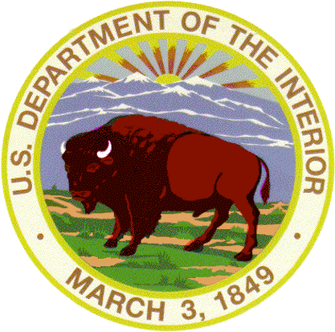 | United States Department of the Interior  NATIONAL PARK SERVICE  Zion National Park  Springdale, Utah 84767 | 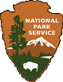
IN REPLY REFER TO: L76

July 24, 2008

Norman R. Elrod
Federal Aviation Administration
Air Transportation Division
135 Air Carrier Operations Branch, AFS-250
800 Independence Ave., SW
Washington, DC 20591

Subject: Zion National Park Comment on Docket No. FAA-2008-0713

Dear Mr. Elrod:

This letter is in reference to the Federal Register Notice published Tuesday, July 8, 2008 regarding a Notice of Interim Operating Authority Granted to Commercial Air Tour Operators over National Parks and Tribal Lands Within or Abutting National Parks [Vol. 73, No. 131, paged 39073-39074] [Docket No. FAA-2008-0713].

The National Park Air Tour Management Act (the Act) of 2000 [49 USC 4012] states:

(2) The Federal Aviation Administration has the authority to preserve, protect, and enhance the environment by minimizing, mitigating, or preventing the adverse effects of aircraft overflights on public and tribal lands.
(3) The National Park service has the responsibility of conserving the scenery and natural and historic objects and wildlife in national parks and of providing for the enjoyment of the national parks in ways that leave the national parks unimpaired for future generations. [Sec. 802]

The Act clearly articulates the intent of Congress for the Federal Aviation Administration (FAA) and the National Park Service (NPS) to work together to preserve, protect and enhance the natural environment for the enjoyment visitors and to conserve the natural and cultural resources in national parks.

The Act provides a process to grant interim operating authority (IOA) to commercial air tour companies if they were “an existing commercial air tour operator.” The Act also addresses new applications (new entrants) for IOA (not an existing operator) with the following:

(A) In general.--The Administrator, in cooperation with the Director, may grant interim operating authority under this paragraph to an air tour operator for a national park or tribal lands for which that operator is a new entrant air tour operator if the Administrator determines the authority is necessary to ensure competition in the provision of commercial air tour operations over the park or tribal lands.
(B) Safety limitation.--The Administrator may not grant interim operating authority under subparagraph (A) if the Administrator determines that it would create a safety problem at the park or on the tribal lands, or the Director determines that it would create a noise problem at the park or on the tribal lands. [Sec. 803 § 40128 (c)(3)]

Again the Act reiterates the intent of Congress for the FAA and the NPS to cooperate on issues relating to commercial air tour operations over national parks. This is especially important in determining when, and if, to grant interim operating authority to a new entrant. Further, Congress through the Act, provides clear direction on when it is appropriate to grant IOA to new entrants.

The FAA should describe, in the Federal Register, how they determined that adding another operator would “ensure the necessary competition.” This is the key justification the Act gives to grant IOA to new entrants. The FAA must demonstrate how they arrived at this determination. There are currently 15 companies with IOA for Zion National Park; with a total of 782 flights per year. Fifteen air tour operators do ensure ample competition.

Adding an additional 120 air tour flights per year over the park would contribute to the growing noise problem. We continue to receive complaints from visitors, adjacent town governments and town residents about the noise made by air craft over and in the vicinity of the park.

The park is over 90 percent recommended wilderness and is managed as such. Two of the key components of the wilderness experience, as stated in the Wilderness Act of September 3, 1964 are that the lands retain:

…its primeval character and influence, without permanent improvements or human habitation, which is protected and managed so as to preserve its natural conditions and which (1) generally appears to have been affected primarily by the forces of nature, with the imprint of man's work substantially unnoticeable; (2) has outstanding opportunities for solitude or a primitive and unconfined type of recreation;…

The opportunities for solitude are impaired by aircraft overflights, especially low flying scenic overflights. If the Director determines that adding additional flights “would create a noise problem at the park” the Act states that the Administrator may not grant interim operating authority. We believe this is the case.

The Act also requires that Air Tour Management Plans (ATMPs) be prepared for any national park for which a plan is not in effect whenever a person applies for authority to conduct commercial air tours over that park. To date the FAA has not begun the plan for Zion. The Act outlines the objectives of the ATMPs:

…shall be to develop acceptable and effective measures to mitigate or prevent the significant adverse impacts, if any, of commercial air tour operations upon the natural and cultural resources, visitor experiences, and tribal lands .[Sec. 803 § 40128 (b)(1)(B)]

The section goes on to say that ATMPs:

…may prohibit commercial air tour operations in whole or in part;
may establish conditions for the conduct of commercial air tour operations, including commercial air tour routes, maximum or minimum altitudes, time-of-day restrictions, restrictions for particular events, maximum number of flights per unit of time, intrusions on privacy on tribal lands, and mitigation of noise, visual, or other impacts;….[Sec. 803 § 40128 (b)(3)(A)&(B)]

The National Park Service Organic Act established the National Park Service in 1916 with the following:

…which purpose is to conserve the scenery and the natural and historic objects and the wildlife therein and to provide for the enjoyment of the same in such manner and by such means as will leave them unimpaired for the enjoyment of future generations…

NPS Management Policies 2006 [1.4.5] defines impairment that is prohibited by the Organic Act as:

…an impact that, in the professional judgment of the responsible NPS manager, would harm the integrity of park resources and values, including the opportunity that would otherwise be present for the enjoyment of those resources and values…

It is premature to grant IOA to new entrants for air tour operations before the ATMP is completed. Granting this authority to a new entrant precludes any type of adequate analysis of the impacts of such an operation. This prevents the NPS from identifying mitigation to prevent significant impacts caused by the operation which could constitute an “impairment” to park resources and visitor experience.

The Act states that the ATMP planning process could conclude that air tour operations are inappropriate for a particular park. The ATMP could prohibit commercial air tour operations in whole or in part.

Zion National Perk strongly objects to granting IOA to any new entrants at this time. We believe that a full analysis of the impacts of the existing operations, through the ATMP process, must occur before any new entrants are authorized.

If you have any questions, please contact Kristin Legg, Chief of Resource Management and Research, at 435-772-0208 or kristin_legg@nps.gov.

Sincerely,
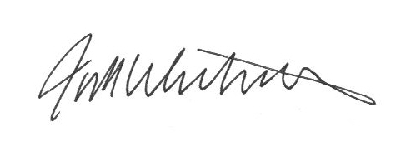
Jock F. Whitworth
Superintendent

