Comparison of Radar Emission Spectra Measured in the Frequency Domain Versus FFT Results from Time Domain Sampling

1. Introduction.

Waveforms in the time domain can be represented in the frequency domain via the Fourier transform. For purposes of computational practicality and convenience, discretely time-sampled waveforms are ordinarily converted to frequency domain representations via the fast Fourier transform (FFT). In principle, an emission spectrum of a transmitter should be measurable either directly in the frequency domain or else indirectly via FFTs of time domain samples, and both techniques should yield the same emission spectrum. Depending upon operational contingencies, it could be argued on this basis that each ITU administration might choose to pursue either approach to emission spectrum measurements of radars for verification of compliance with such emission mask criteria as ITU-R Recommendation SM.1541. It has been suggested that it may therefore be desirable to modify ITU-R Recommendation M.1177 to include a new provision for the measurement of radar spectra using FFTs generated from discrete time domain data samples.

SM.1541 specifies that the emission mask should be applied to the peak envelopes of radar emission spectra. This requirement for compliance with peak emission levels effectively means that any measurement techniques that are to be used to verify compliance with SM.1541 or other, similar emission spectrum mask criteria should yield peak spectrum emission levels. Alternatively, it might be possible that a technique yielding average spectrum emission levels might be adapted to provide emission mask compliance data if it were found to be possible to either convert the average data into peak data, or if there existed a constant, frequency-independent amplitude offset between the peak and average emission spectra of a radar transmitter throughout both the in-band and unwanted emission regions. If such a frequency-independent offset could be shown to exist, then average emission spectrum envelopes would show the same ratio between in-band and unwanted emission levels as peak emission envelopes.

The problem addressed in this contribution is whether time-sampled FFT radar emission spectra will necessarily be the same as peak-detected radar emission spectra measured directly in the frequency domain with the stepped-frequency technique described in M.1177 (or at least might have the same ratio of in-band to unwanted levels as is observed in frequency-domain peak-detected measurements).

In order to examine this issue, the United Sates administration has performed a series of emission spectrum measurements on high frequency (HF) radars that employ FMCW and gated FMCW waveforms. The measurements have been performed independently with two different techniques. The first technique is that given in M.1177, in which peak-sampled emission spectra are measured in the frequency domain with a spectrum analyzer using a stepped-frequency algorithm. The second technique generates radar emission spectra from FFTs of time-domain data collected with a type of high-speed digitizer known as a vector signal analyzer (VSA). The details of how these measurements were performed and the resulting emission spectra that were measured with these two techniques are presented and compared in this contribution.

It is shown that for the radar emission waveforms that have been examined the spectra are different. This is because the M.1177 stepped-frequency technique produces the peak envelope of the measured radar emission spectra, whereas the FFT results from time-domain sampling produce average emission spectra. Furthermore, the amplitude offset between the frequency-domain spectra and the FFT spectra are not constant across the in-band and unwanted emission regions. The time-sampled FFT technique yields unwanted emission levels that are lower relative to the FFT-measured in-band power than the peak levels of the unwanted emissions relative to the peak in-band emission level. The FFT technique is demonstrated to not produce a radar emission spectrum envelope that can be used to verify compliance with existing emission mask criteria such as SM.1541.

2. Stepped-Frequency Radar Spectrum Measurement Technique.

As described in M.1177, measurements of radar emission spectra may be performed by sequentially tuning a spectrum analyzer to a series of individually selected frequencies and measuring the maximum, peak-detected power at each frequency. As a practical matter the analyzer is computer controlled. The technique relies upon a time-based measurement of power within a bandwidth at each measured frequency. The spectrum analyzer used for the measurement is effectively operated as a slow-motion oscilloscope with an RF detector at each measured frequency. The analyzer dwells on each measurement frequency in zero-span mode long enough to measure the peak power response at that frequency. The time required to complete a measurement at each frequency is slightly longer than the beam-scanning interval of the radar being measured. (E.g., if a radar scans a spatial beam across the measurement location every 5 seconds, then the time required for a power measurement at each frequency might be 5.2 seconds.)

The measurement bandwidth needs to be equal to or less than the radar emission bandwidth as computed from its pulse characteristics. (E.g., if a radar transmits 1-µs-long pulses, then the measurement bandwidth should be 1 MHz or less.) M.1177 provides further guidance on the technical details of such measurements. To measure the in-band, out-of-band (OOB), and spurious domain components of a radar’s emission spectrum, the analyzer is stepped in frequency across the band of interest in increments that are equal to or less than the 3-dB measurement bandwidth. (E.g., if the measurement bandwidth is 1 MHz at its 3-dB points, then the interval between measured frequencies should be 1 MHz or less.)

An M.1177-style measurement system ordinarily uses a low noise amplifier (LNA) in front of the spectrum analyzer to reduce the system noise figure. A tunable, narrow-band filter, typically based on yttrium-iron-garnet (YIG) technology, is used ahead of the LNA to prevent it from overloading on in-band radar power when the measurement frequencies are within the OOB and spurious frequency regions. A variable-level attenuator is used ahead of the filter and the amplifier. It is used to increase the dynamic range of the measurement system by being set to zero decibels when measurements are being performed in the spurious region, set to intermediate values (perhaps 20 to 40 dB) when the measurement is being performed in the OOB region, and set to maximum levels (60 to 70 dB) when the measurement is being performed within the fundamental (in-band) region.

Radar emission spectra measured with this RF front-end design and the stepped-frequency technique can routinely achieve dynamic ranges of 110 dB to 120 dB. Spectra that are measured with swept-frequency techniques (which do not allow dynamic adjustment of front-end attenuation across the spectrum) exhibit much more limited dynamic range, usually not exceeding 60 dB to 70 dB. Typically, this is not enough dynamic range to verify compliance with emission masks, as the measurement dynamic range needs to be at least 10 dB greater than the ultimate suppression level specified by a mask.

An attractive feature of the stepped-frequency approach to measuring radar emission spectra is that particular frequencies where problems occur in the course of the measurement can be selectively re-measured on a one-by-one basis. For example, if either the transmitter or the measurement system experience some sort of failure on any particular frequency or frequencies, the problematic portion of the spectrum is easily and immediately re-measured. Furthermore, measurement personnel can (and ordinarily do) observe the time-domain behavior of the radar transmitter on a frequency-by-frequency basis as the measurement proceeds. This allows unusual, unexpected, or anomalous behaviors of the transmitter to be observed. This feature turned out to be critical in the analysis of the measurements that are described in this contribution.

3. Time-Sampled FFT Radar Spectrum Measurement Technique.

An alternative spectrum measurement technique is to collect discretely spaced time-domain samples of radar energy using a high-speed digitizer and then transform those measurements to the frequency domain using a FFT. The radar time waveform needs to be directly sampled at a rate that meets or exceeds the Nyquist requirement for the highest frequency component in the spectrum that is to be measured. In practice, this rate must be somewhat higher than twice the highest frequency that is to be measured.

The sampling process records, in effect, the total complex-number representation of the waveform (i.e., the amplitude, frequency, and phase information in the radar emission). After the data have been collected for a number of radar pulse cycles, the stored waveform samples are processed through an FFT computational engine to produce an emission spectrum. The FFT spectrum can represent a convolution with any effective bandwidth that is equal to or narrower than the half of the rate at which the data were sampled.As described in the accompanying JRG contribution, measured data may be zero-padded to force the FFT to sample at more tightly spaced frequency points, although no new information is added by this process. As also described in an accompanying JRG contribution, it may be desirable and sometimes necessary to sample the emitted radar waveform over multiple pulse cycles to obtain an accurate FFT spectrum from the collected time samples.

VSA-based time-sampling systems work as follows. Incoming radar waveforms are downconverted, digitized, and stored into high-speed time memory. The captured data are stored as blocks from which time, frequency, and modulation domain data are derived. The data may be replayed through the acquisition device (a VSA) at full or reduced speed, saved to mass storage, or transferred to other software applications such as Matlab©.

VSA data bandwidth is limited by the sampling rate (e.g., 95 Msamples/sec) and whatever RF and IF filtering might be installed in the VSA. VSA sampling allows a wide range of data acquisition options in which the frequency span of the measurement, the number of calculated frequency points, and the effective resolution bandwidth of output FFTs are all interrelated.

Depending upon circumstances, it may be desirable to install an LNA at the RF input of a VSA measurement system to reduce its noise figure. But the overall measurement system dynamic range will be restricted to the smallest instantaneous dynamic range of either the front-end LNA or the analog-to-digital converter (ADC). It is not possible with a time-sampling system to use the M.1177 RF front-end combination of LNA, tunable RF filter, and variable attenuator to extend the measurement system dynamic range. Conversely, the time-sampling system can potentially collect a given portion of the radar spectrum much faster than the stepped-frequency algorithm.

4. Stepped-Frequency Versus Time-Sampled FFT Measurements on FMCW and Gated FMCW HF radars.

Radars that have been measured for this study are used for scientific ocean-surface observations. Deployed on beaches and buoys, they are used to observe wave and current patterns at coastal locations. Emission characteristics of the radars are given in JRG-[XX]. For the purposes of this contribution, the most important features or these radars are that they operate in the HF (2-30 MHz) portion of the spectrum and utilize FMCW and gated FMCW waveforms.

Each of the radar emission spectra were measured first with an M.1177-type spectrum analyzer-based system and then with a time-sampling VSA-based system. The two systems are shown in block-diagram schematic form in Figures 1 and 2. The VSA diagram of Figure 2 expands the internal processing stages to show its signal processing technique more clearly. Optional notch filters for the M.1177-type system of Figure 1 were available to measurement personnel but were ultimately deemed to not be necessary and were not used. A single antenna, a slant-polarized HF dipole, was used for both measurement systems. Other than the inherent differences between the use of a spectrum analyzer for the stepped-frequency algorithm versus the use of a VSA to collect time samples for FFT processing, the most significant difference between the two systems was the use of a specialized RF front-end with the spectrum analyzer to extend the dynamic range of the M.1177 system. As discussed above, this sort of RF front end cannot extend the dynamic range of a time-sampling system. Thus the measurement system antenna was directly connected to the input of the VSA without an LNA or any additional external filtering or attenuation. There was a built-in 37 MHz-wide IF bandpass filter inside the VSA, as shown in Figure 2.

For all but one of the radars, the measurement system antenna was located within 60 feet (about 18 m) of the radar transmitter and a cable run of fifty feet (about 15 m) of RG-58 coaxial cable connected the antenna to each of the measurement systems in turn. Because the same antenna was used for both measurement systems at a fixed location for each of the radars, no differences in the emission spectra generated by the two measurement systems could be attributed to variations in the measurement antenna or its placement.

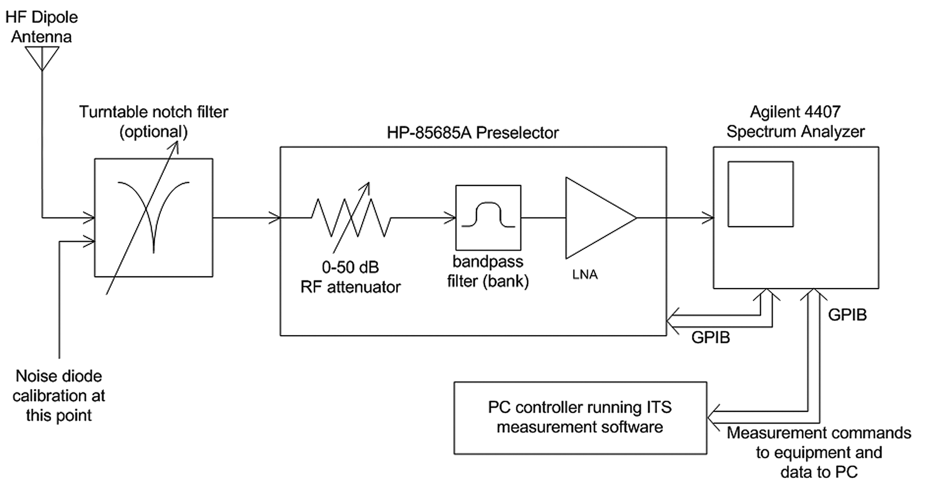
Figure 1. Block diagram of HF radar spectrum measurement system in which the ITU-R Recommendation M.1177 technique was implemented.

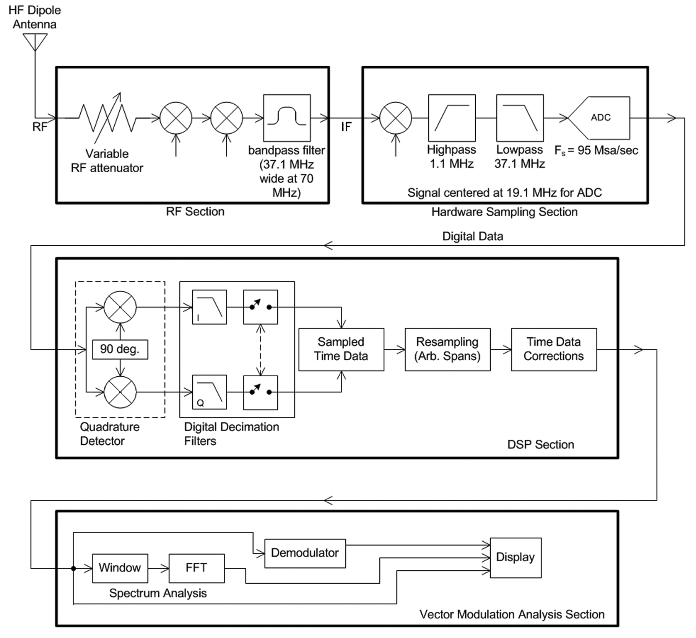
Figure 2. Block diagram of HF radar spectrum measurement system in which the discretely time sampled FFT technique was implemented.

The measurement bandwidth for the stepped-frequency, spectrum analyzer-based measurement system met the criterion of M.1177. For the gated FMCW waveforms this meant the measurement bandwidth was less than (B_{c}/T)^{1/2}, where B_{c} was the FM bandwidth of the radar (e.g.: 49.4 kHz for the 13.46 MHz system) and T was the length of time of the gating structure of the frequency sweep (e.g., 669 us for the 13.46 MHz system). For the FMCW radar, for example, the measurement bandwidth was 1 kHz. The measurement IF (or resolution) bandwidth of the spectrum analyzer was variously set to values between 1 kHz to 10 kHz for the other radars. The frequency-step interval, or dwell time, for the M.1177 measurements was set at 0.6 sec per frequency step, which was slightly longer than the 0.5-sec frequency-sweep interval of each of the radar transmitters.

The VSA samples for each of the radars were collected for a minimum of 10 seconds. This ensured that data for each of the radars were collected over at least 20 complete frequency-sweep periods. An FFT was performed on each set of collected data to generate emission spectra after the measurements were completed and the data were post-processed. A detailed description of this computational process, including the effect of zero-padding the time-sampled data and transforming multiple time sampled pulses to obtain a frequency domain measurement output is contained in JRG document [XX].

Data acquired with the M.1177 technique are peak-detected in a resolution bandwidth, and therefore the resulting spectra are peak emission envelopes. They are obtained real-time and do not need to be post-processed. In contrast, FFT spectra generated from VSA data are average emission envelopes. If a given radar spectrum has a constant decibel amplitude offset between its peak and average emission envelopes, then both spectra will have the same relative decibel amplitude offset between the levels of their in-band emissions and their unwanted emissions. For purpose of verifying compliance with emission mask criteria such as SM.1541, it is conceivable that under such a circumstance an average emission spectrum envelope might be adequate to show that the emission mask criteria are met, even though SM.1541 specifies that the mask criteria are to be applied to peak radar spectrum emission levels.

However, if an emission spectrum does not have a constant (frequency-independent) decibel amplitude offset between its peak and average emission envelopes, then the peak and average emission spectra will have different ratios between the levels of their in-band emissions and their unwanted emissions. For the purpose of verifying compliance with emission mask criteria such as SM.1541, this sort of average emission spectrum will not be adequate to verify compliance with emission mask criteria. As shown in the next section, such spectra do exist.

5. Comparison of Stepped-Frequency Versus VSA Spectrum Envelopes for Radar Emissions.

Figures 3 through 6 show the peak-detected emission spectra for a pair of HF radars that operate with FMCW (Figure 3) and gated FMCW (Figures 4-6) waveforms, as measured with the M.1177 system shown in Figure 1. These spectra could be used to verify compliance of these radars with the emission criteria of SM.1541.

5.1 Comparison of Stepped-Frequency Versus VSA Spectrum Envelopes for FMCW Radar Emissions.

In order to see the differences between stepped-frequency, peak-detected spectra and Fourier transformed time-sampled spectra for selected radars, figures have been generated in which the respective spectra have been overlaid. These comparison figures have been created for both FMCW and gated FMCW radar signals.

Figures 7 through 9 show the in-band and OOB measurements of the FMCW radar using the M.1177 technique (from the spectrum curve of Figure 3) superimposed on spectra generated from FFTs of time-sampled data that were acquired on the same radar with the VSA system of Figure 2. The FFT spectra were generated with and without zero padding for 1 to 8 radar pulses, respectively.

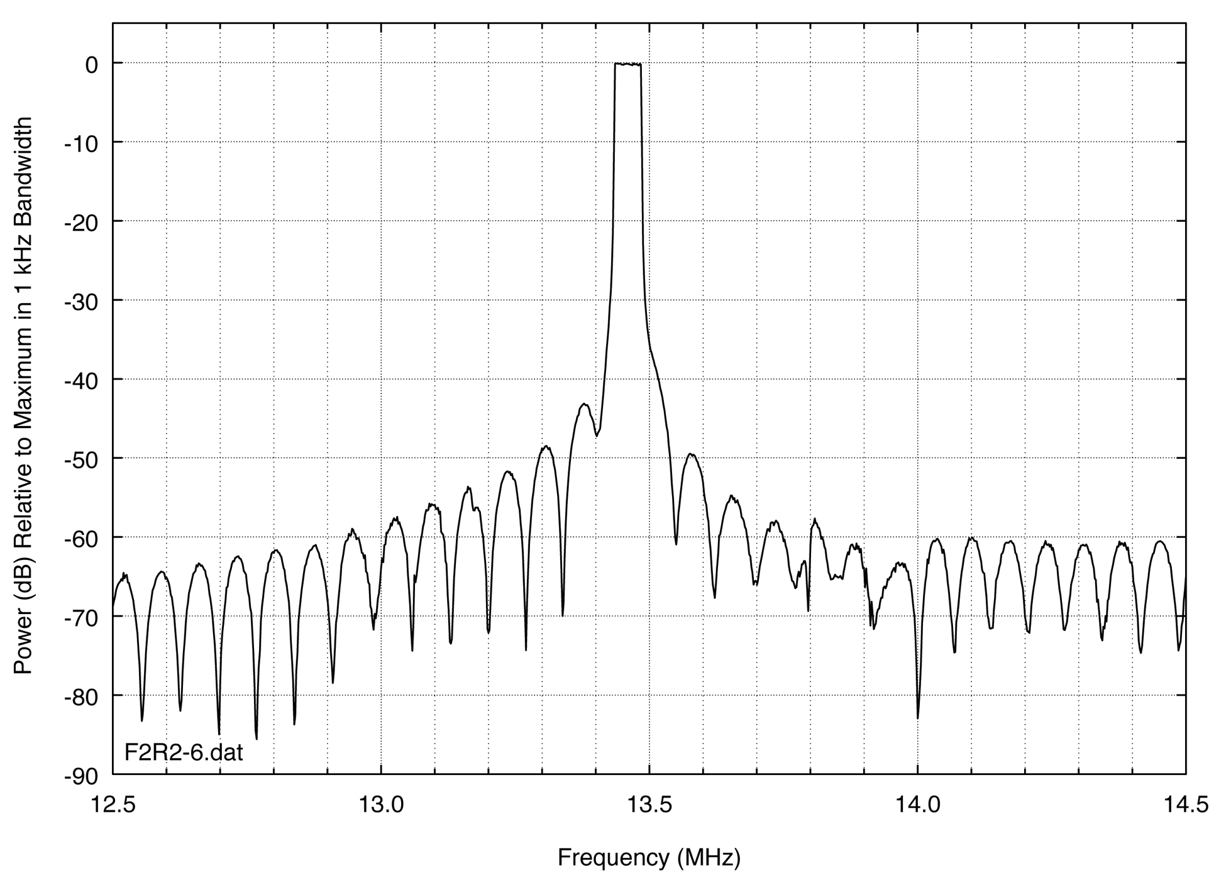
Figure 3. Peak-detected emission spectrum of a FMCW HF radar.

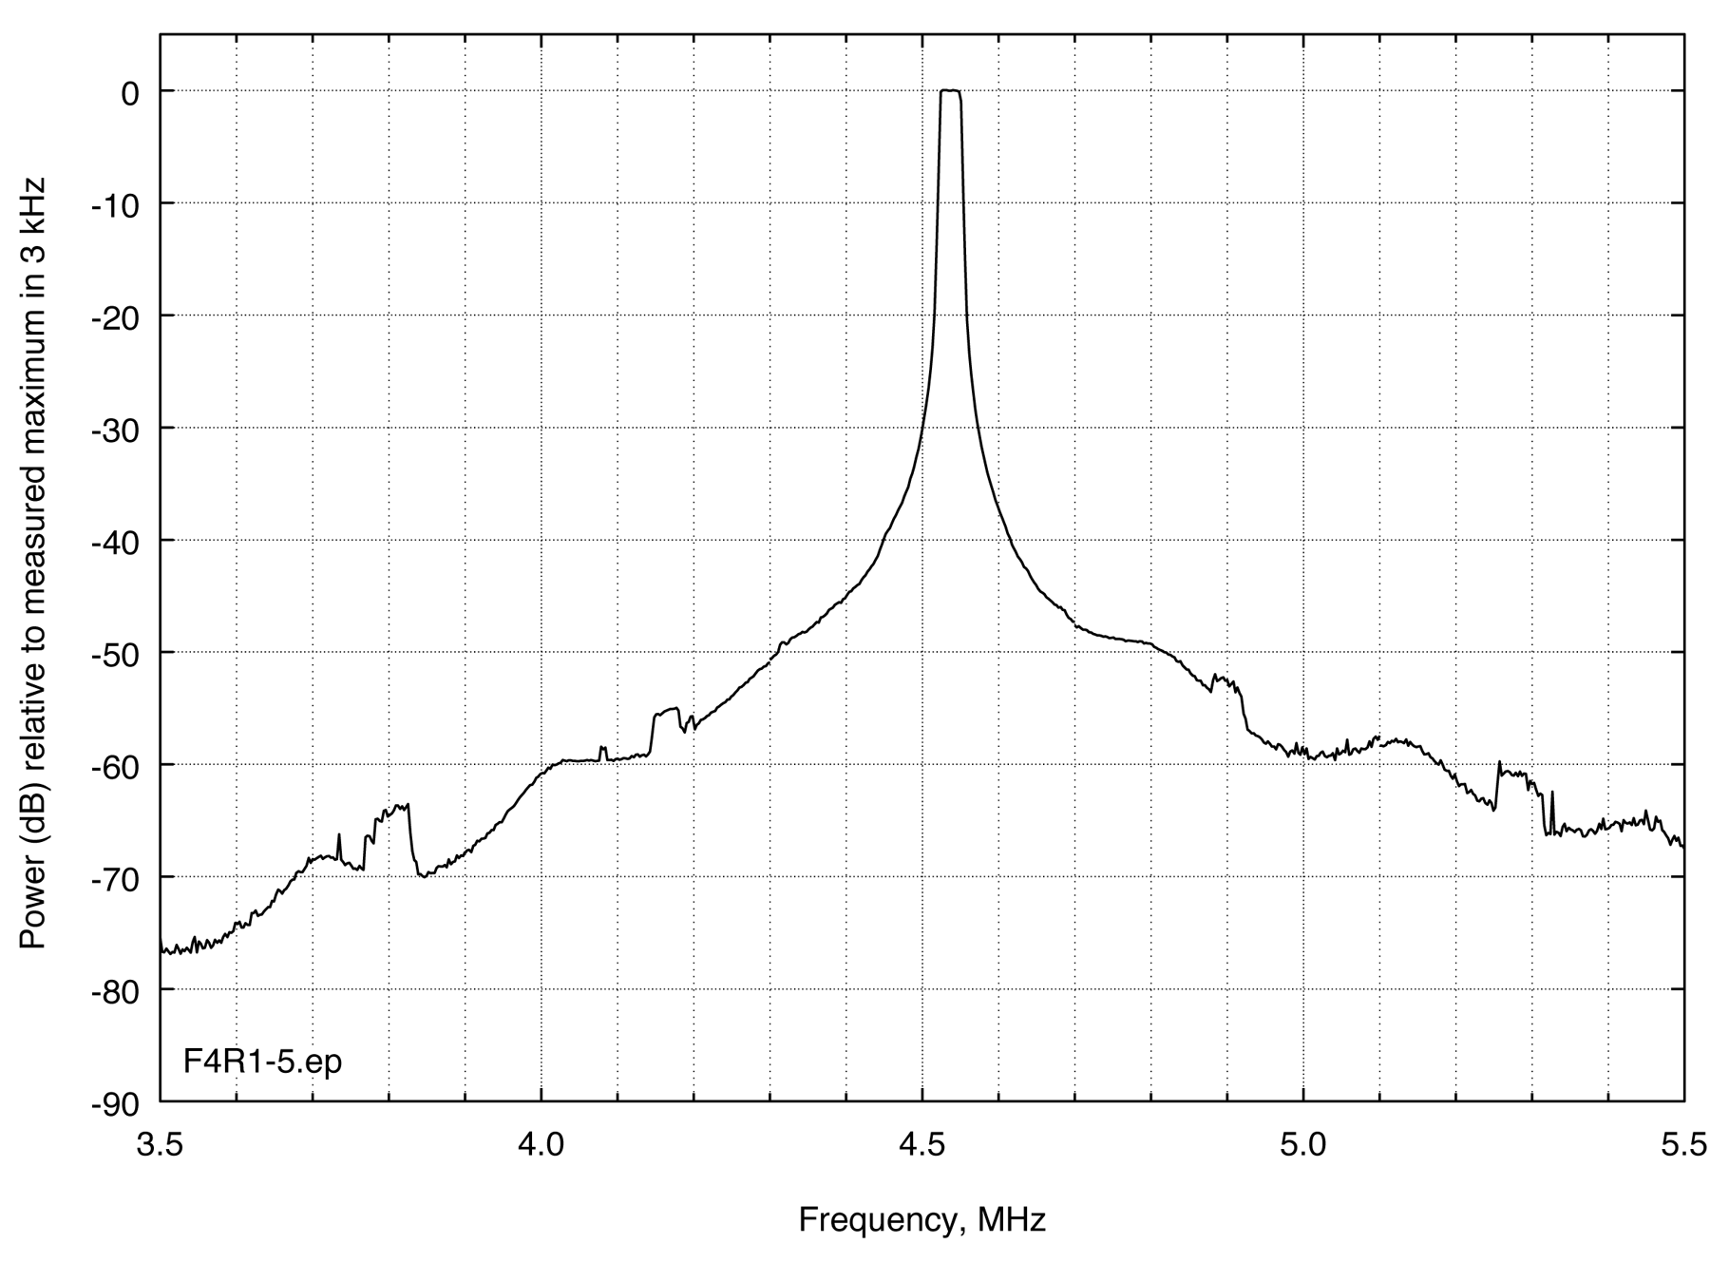
Figure 4. Peak-detected emission spectrum of a gated FMCW HF radar at 4.5 MHz.
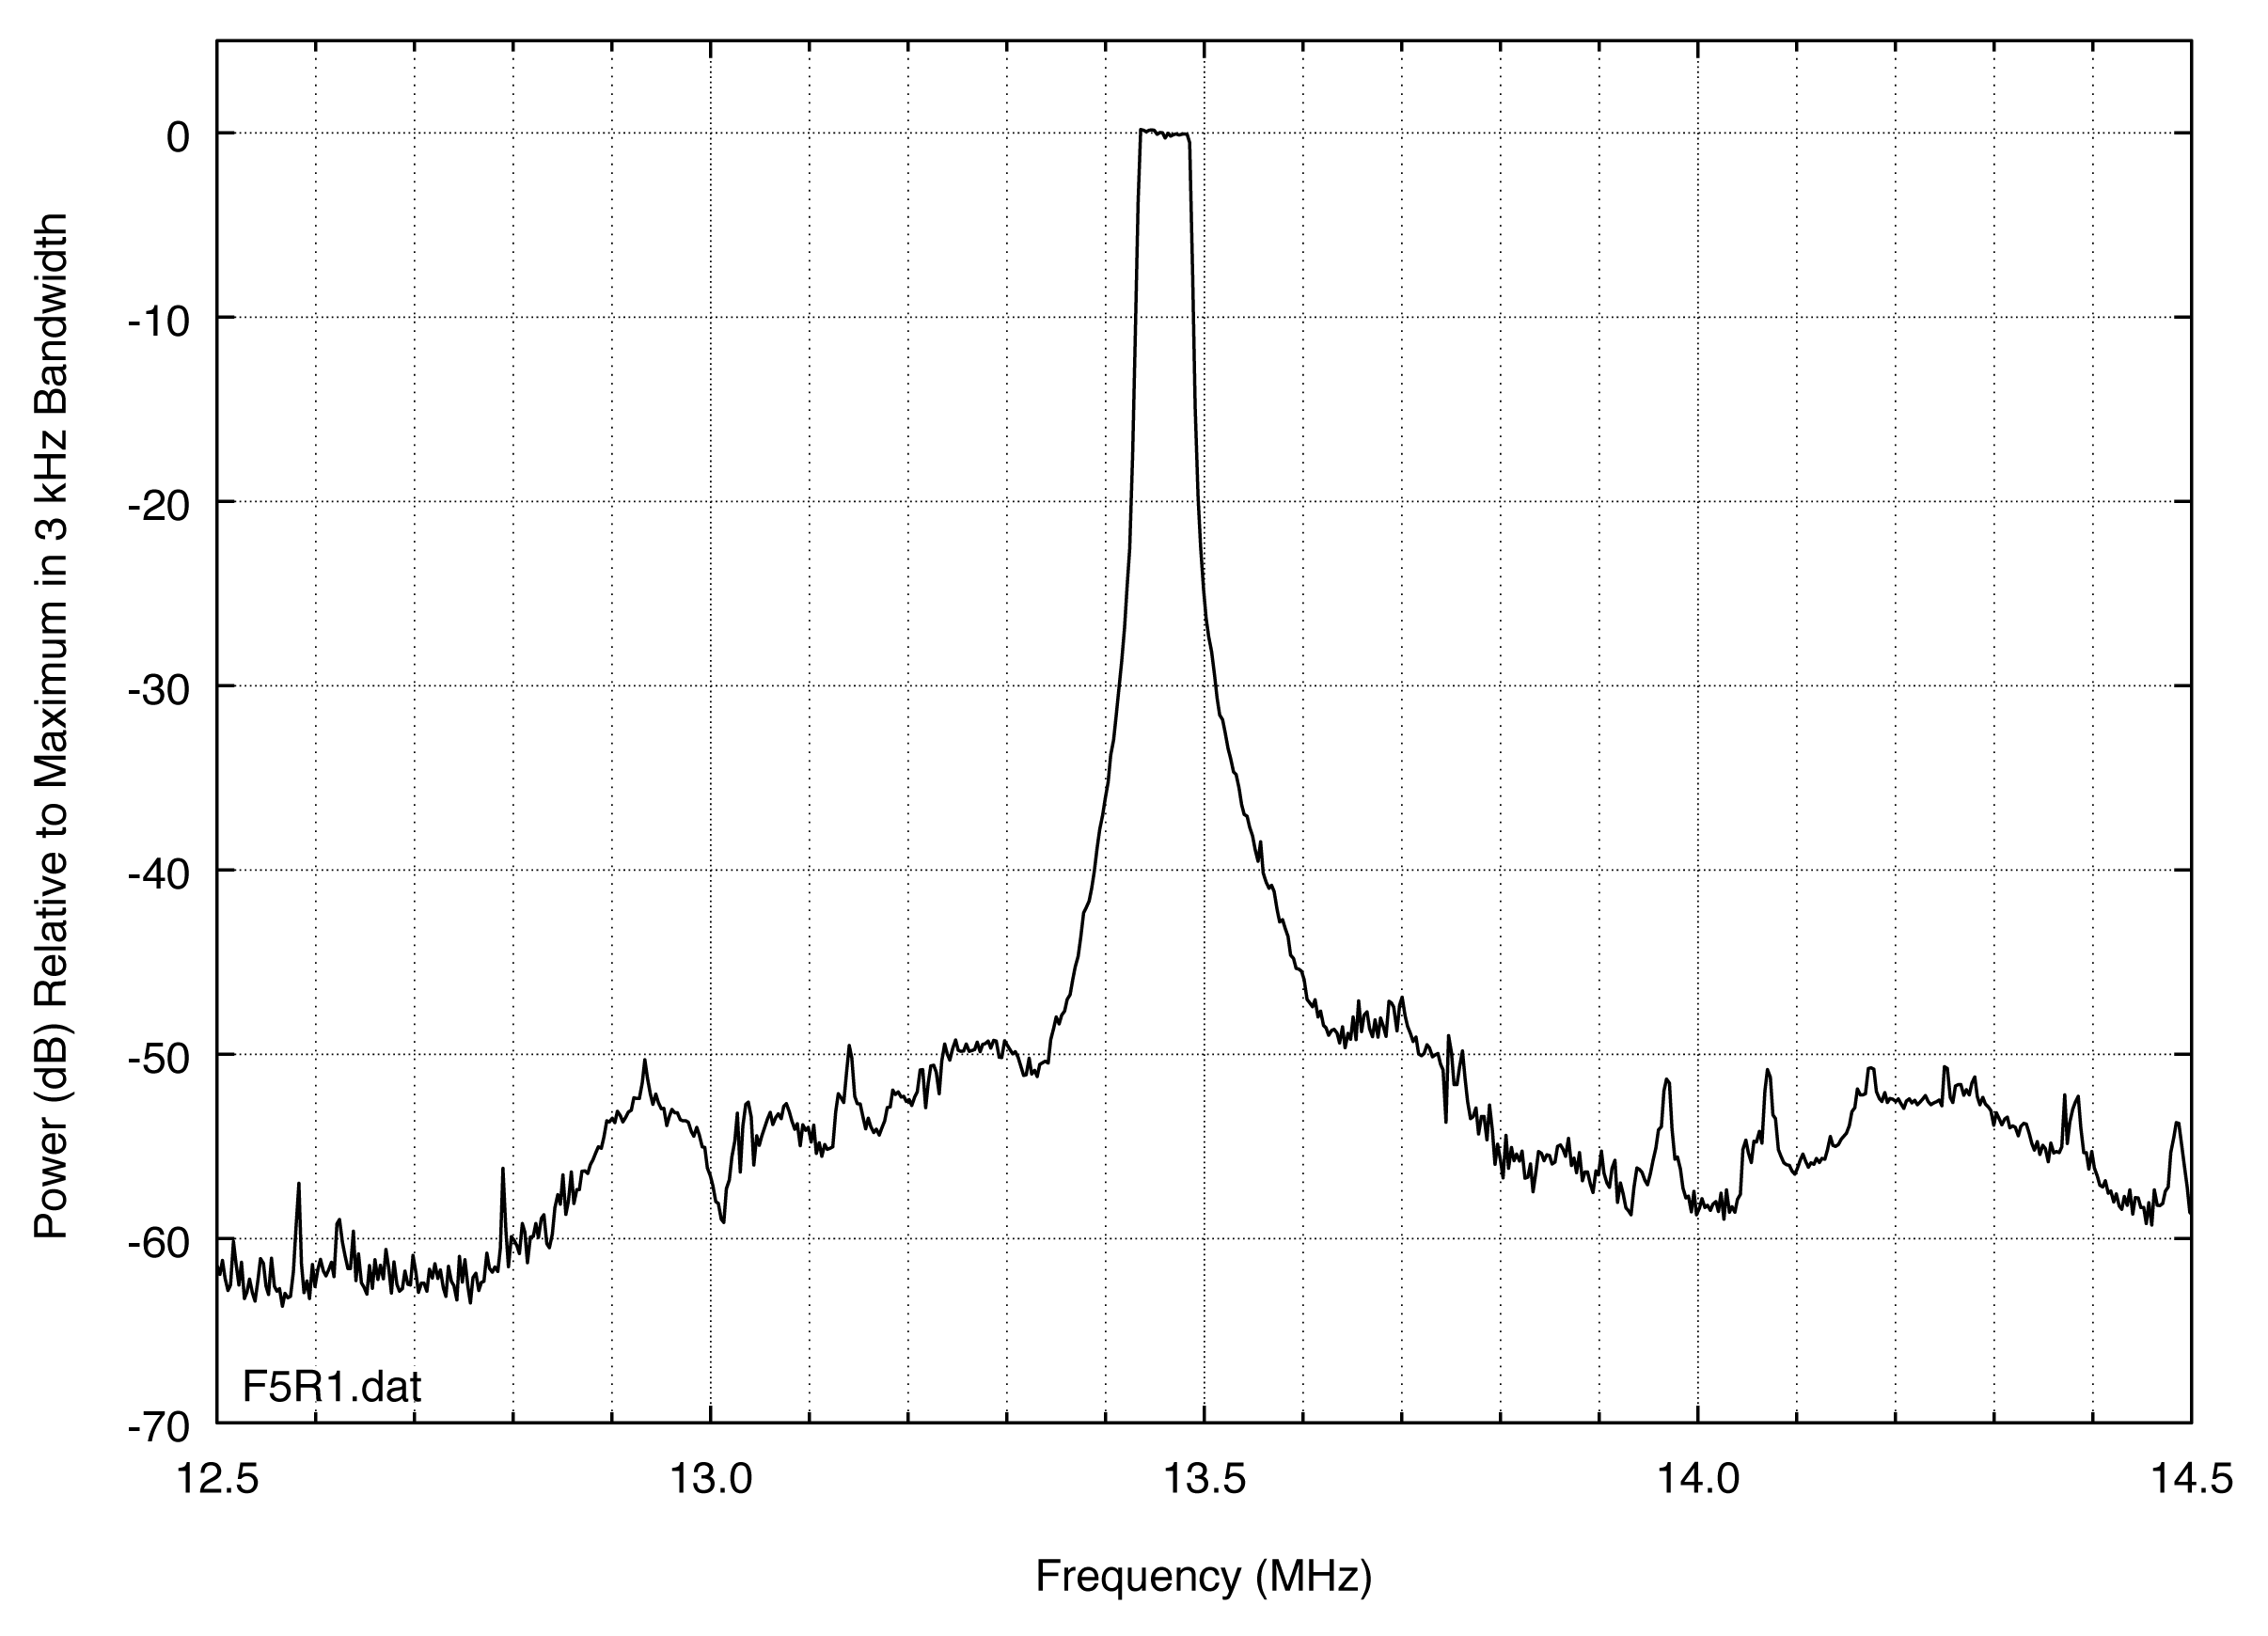
Figure 5. Peak-detected emission spectrum of a gated FMCW HF radar at 13.5 MHz.
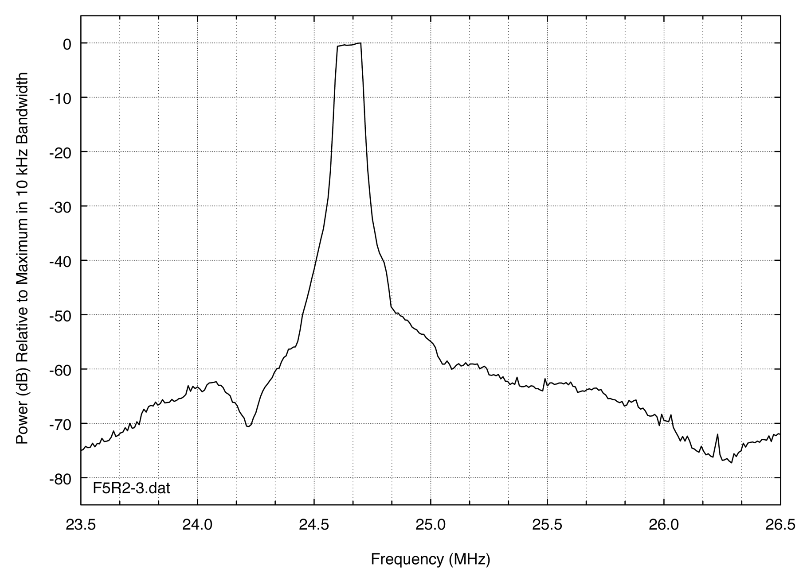
Figure 6. Peak-detected emission spectrum of a gated FMCW HF radar at 24.6 MHz.
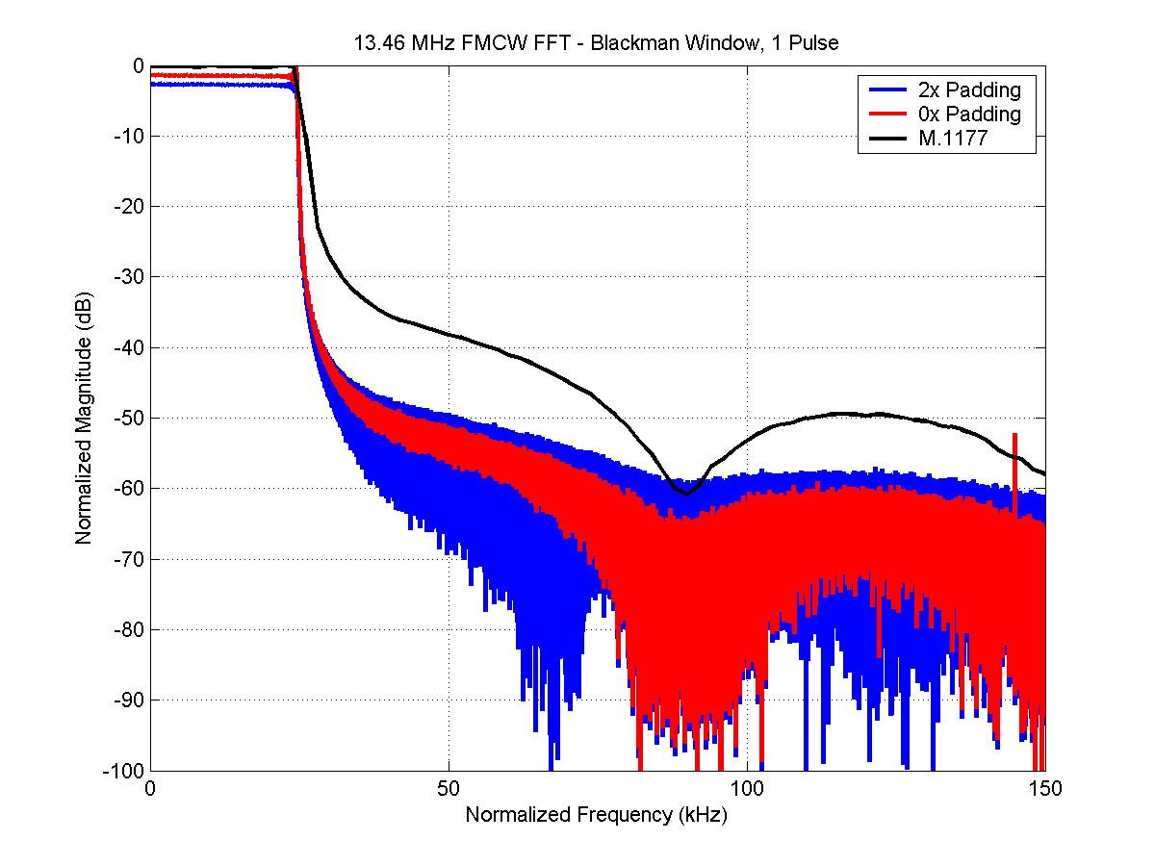
Figure 7. FMCW waveform with M.1177 data superimposed on an FFT spectrum of 1-pulse transformed time-sampled data.

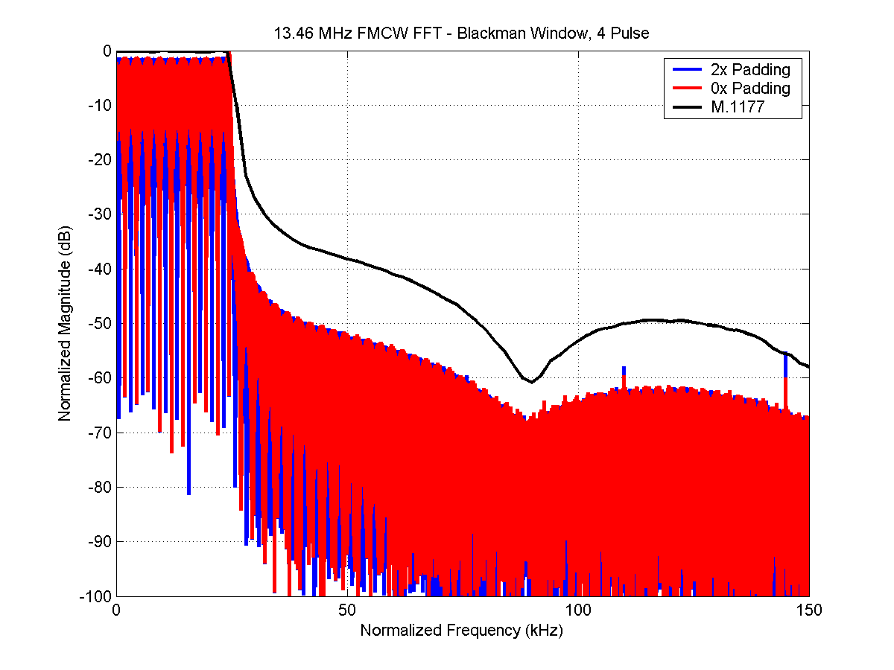
Figure 8. FMCW waveform with M.1177 data superimposed on an FFT spectrum of 4-pulse transformed time-sampled data.
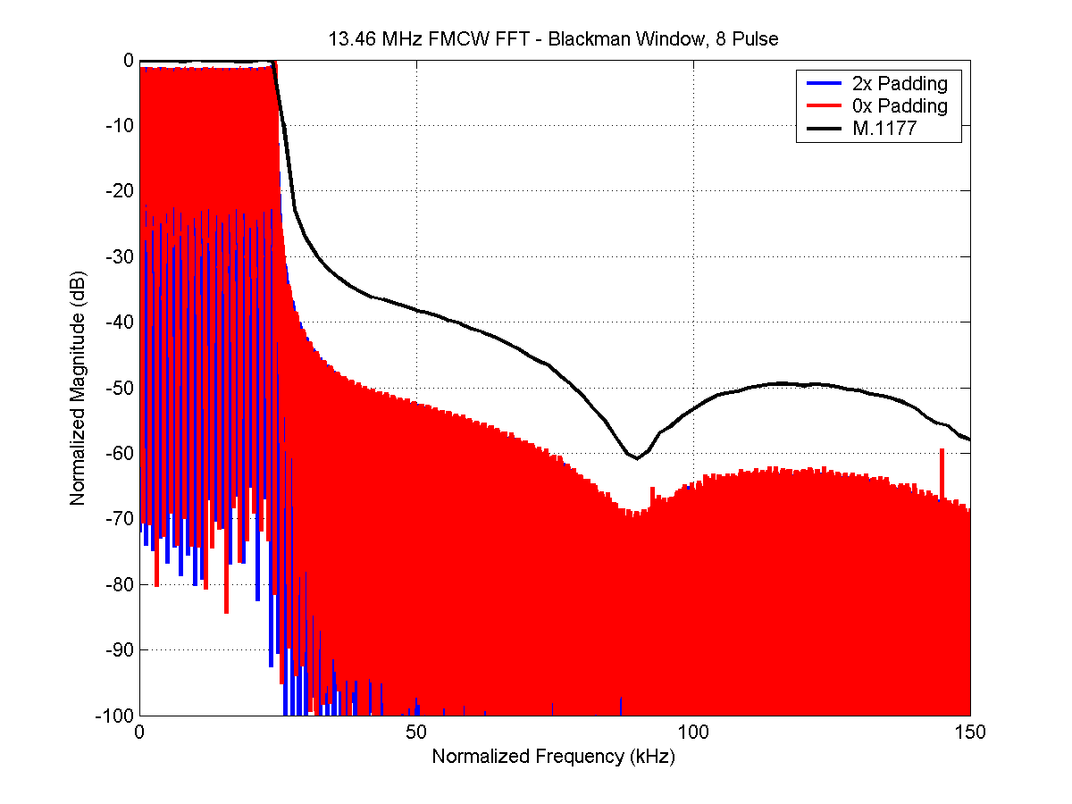
Figure 9. FMCW waveform with M.1177 data superimposed on an FFT spectrum of 8-pulse transformed time-sampled data.

Figures 7 through 9 show that FFT transformed time sampled data are 8-12 dB below the peak detected emission spectra in the OOB and spurious domains of the FMCW waveform, relative to the measured power in the in-band part of the spectrum. This effect is due to the time-sampled waveform in effect being measured by the VSA at an average level, as if an analog root mean square (RMS) detector had been used in an analog measurement receiver instead of a peak detector.

Figures 10 and 11 illustrate the source of this effect. In Figure 10, the radar emission is shown in the time domain at an in-band emission frequency. In Figure 11, the radar emission is shown in the time domain as it typically appeared at any given frequency in the unwanted emission region. In the in-band region, both peak and average detection register the same output level. But in the unwanted emission region a short-duration ‘tic’ in the time domain occurs at the moment that the radar transmitter undergoes a phase change during its swept-frequency flyback. This tic (which, as Figure 10 shows, also occurs at the in-band frequencies but which is much lower in amplitude than the desired emission in the in-band region) registers on a peak detector but will not register on an average detector or the equivalent FFT spectrum output of a set of VSA data.

Comparison of the frequency domain and time domain data from the M.1177 measurement and the time-sampled VSA measurement show that when the measured in-band spectrum power levels are normalized for the M.1177 and VSA techniques, the two techniques yield OOB and spurious emission levels that differ by 10-12 dB. The source of the difference is the existence of a 10-12 dB difference between the peak and average emission levels in the unwanted emissions, a difference that does not exist for the in-band emission levels. The FFT spectra generated from
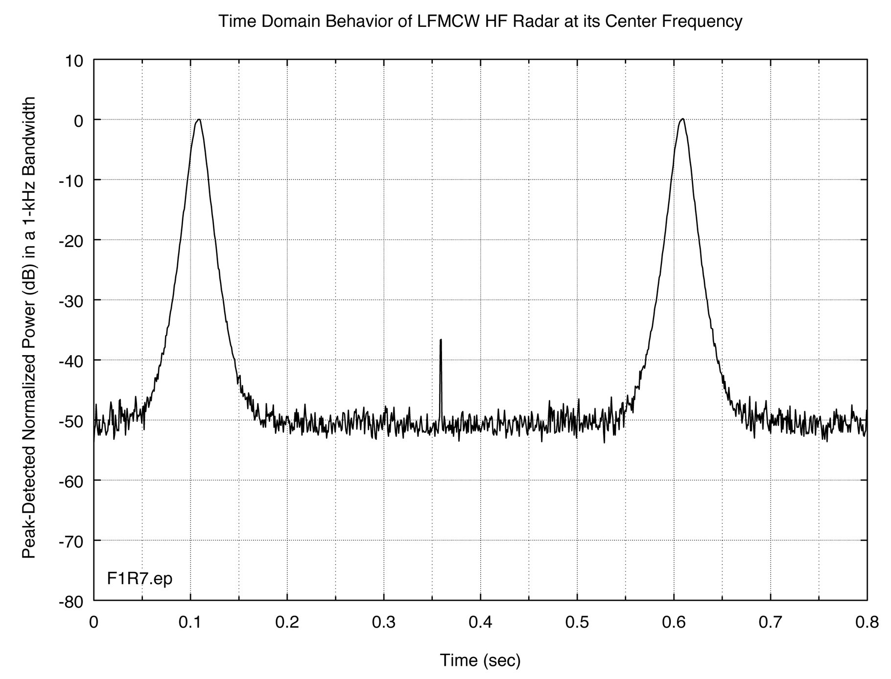
Figure 10. Time domain behavior of the FMCW radar of Figure 3 in its in-band region, as documented during the M.1177 stepped-frequency measurement. Peak and average detectors register the same output levels for this emission.

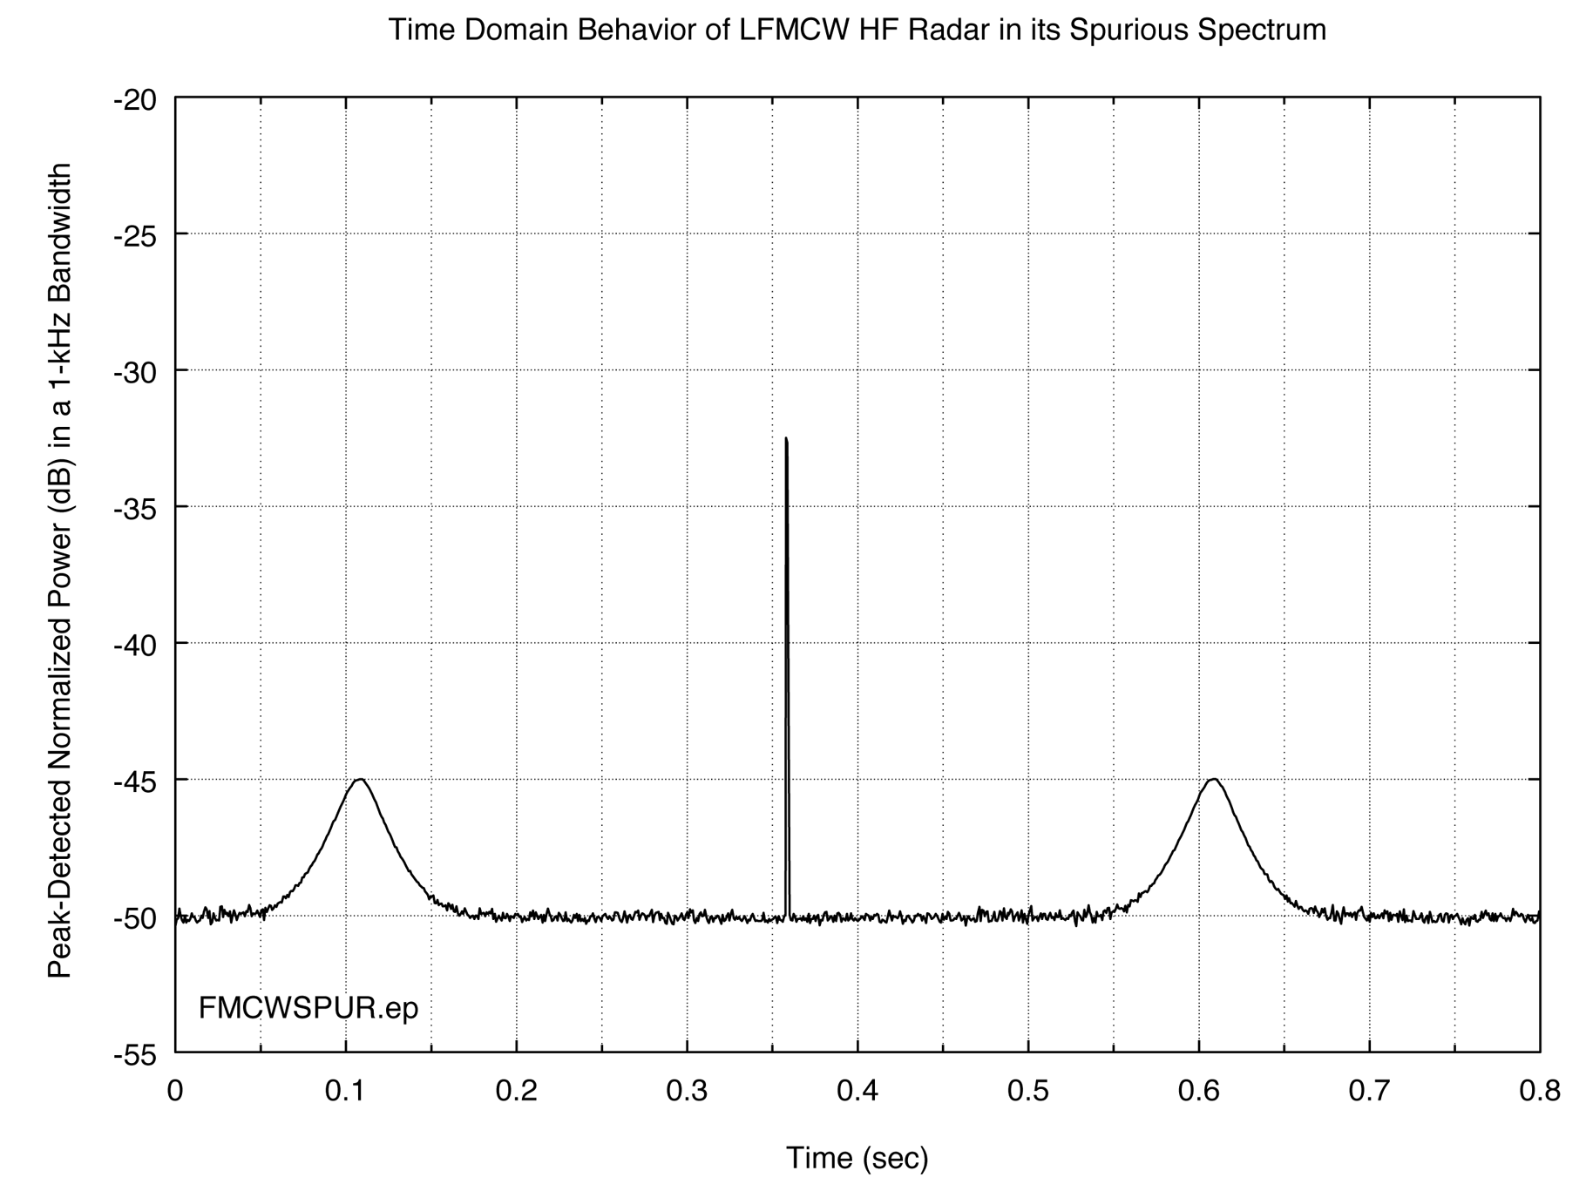
Figure 11. Time domain behavior of the FMCW radar in its unwanted emission region.

The phase-switching flyback transient at 0.35 sec dominates; peak detection or a very high sampling rate is required to measure it. The VSA sampling rate is not high enough to capture the flyback transient. In contrast, it registers the power level of the emissions at 0.1 sec and 0.6 sec, which are about 12 dB lower than the transient power level. The VSA measurement fails to detect the peak and indicates that the unwanted emission levels are lower than they really are. The VSA time-sampled data do not capture the radar waveform’s transient phase-switch component because the VSA FFT is, in effect, using RMS detection on the spectrum.

The figures also illustrate a feature in the spectrum plots that arises when the time-sampled data are transformed using multiple pulses of the radar waveform. Transforming multiple time-sampled pulses to generate the frequency domain plots generates better resolution and gives the appearance of reducing the emissions in the OOB, as compared to the M.1177 peak detected measurements. Figures 7-9 show this effect when 1, 4, and 8 pulses are processed, respectively.

5.2 Comparison of Stepped-Frequency Versus VSA Spectrum Envelopes for Gated FMCW Radar Emissions.

Figures 12 through 14 show the measurements of the gated FMCW radar waveforms using the M.1177 technique along with the VSA FFT time-sampled data with 2x zero padding and multiple pulses.

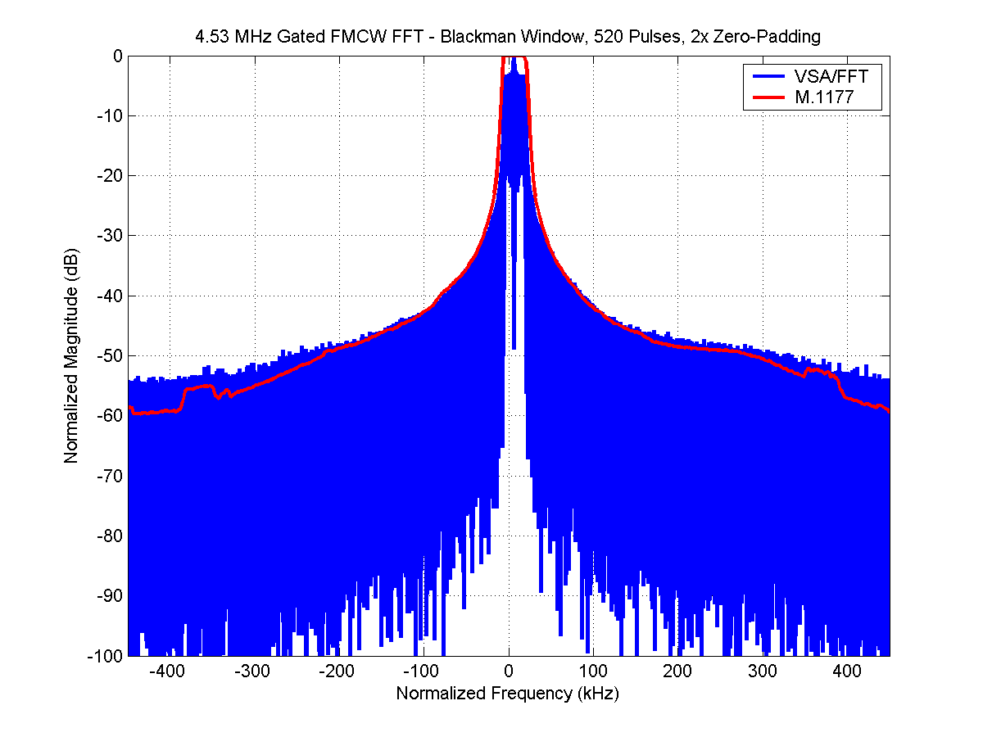
Figure 12. Gated FMCW (4.53 MHz) waveform with M.1177 data superimposed on an FFT spectrum of 520-pulse transformed time-sampled data.

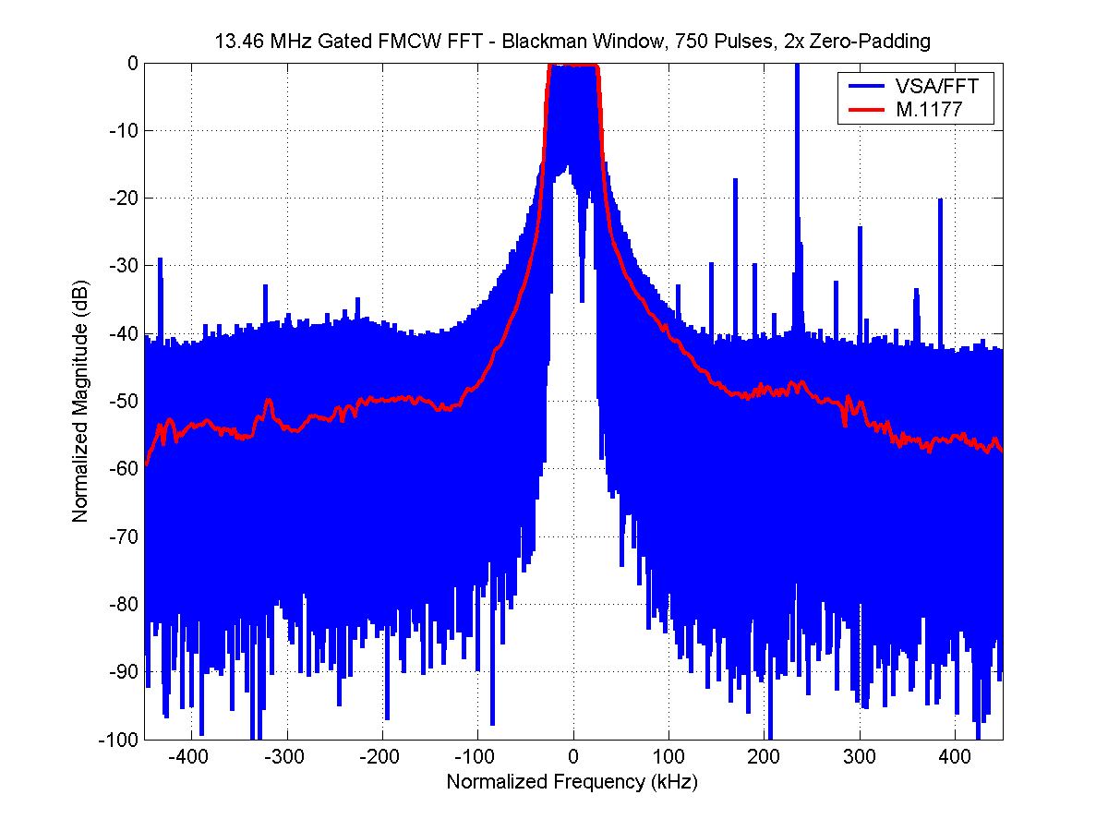
Figure 13. Gated FMCW (13.46 MHz) waveform with M.1177 data superimposed on an FFT spectrum of 750-pulse transformed time-sampled data.

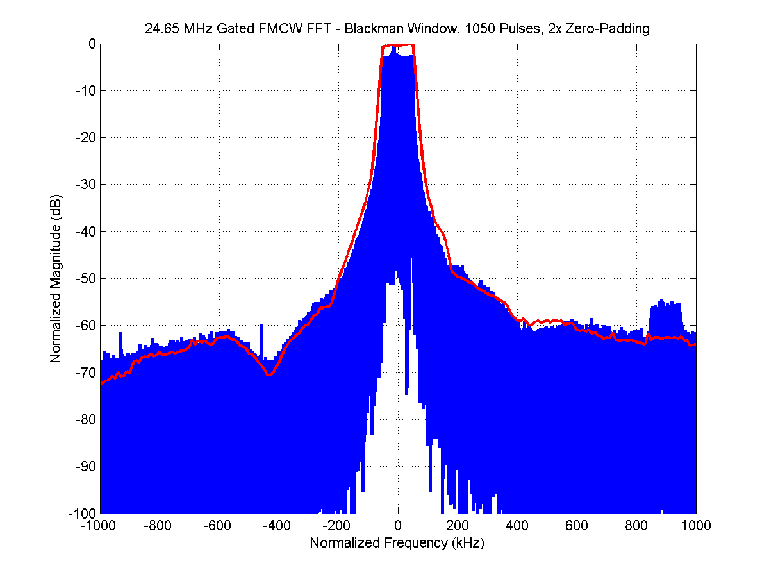
Figure 14. Gated FMCW (24.65 MHz) waveform with M.1177 data superimposed on an FFT spectrum of 520-pulse transformed time-sampled data.
In Figures 12 through 14, the emission spectra measured using the M.1177 stepped-frequency, peak detection technique (from Figures 4-6) are drawn as red traces. Figures 12 and 14 generally show a good agreement between the transformed time-sampled waveforms and the frequency domain measurements. Figure 13 does not show such good agreement between the results of the two different techniques. In Figure 13 the difference between the curves in the OOB region is on the order of 15 dB. However, as explained above, the VSA system did not include an LNA. Its inherent noise was greater than the received measured signal, and this noise thereby dominated the data in the OOB region. The OOB measurement of Figure 13 shows VSA noise rather than radar emission energy. This happened because the radar transmitter was over 300 feet away from the measurement system receiver antenna and was partially hidden behind sand dunes. The M.1177 measurement included an LNA that provided a low enough noise figure to overcome this problem.

Referring to the data in Figures 12 and 14, the M.1177 spectra and the FFT spectra made from the VSA data are in good agreement. This is because the peak and average emission levels of these radar spectra were either the same across the span of the measurement, or else because there existed a constant decibel-level offset between the peak and average emission levels of the radar spectra.

6. Summary.

The data presented in this contribution demonstrate that radar emission spectra produced by FFTs of discrete time-sampled data will not necessarily agree with peak-detection data collected with M.1177-type measurement systems, such as for example a FMCW waveform with time transient artifacts. When in-band emission data taken with the same measurement antenna on the same radar for this type of waveform are normalized, the FFT spectra can be at least 10-12 dB lower in the unwanted emission region than the peak-envelope spectra. The difference arises when the power ratio between the in-band and unwanted emissions has a different value for peak-detected emission spectra than it does for average emission spectra.

FFT processing of an increasing number of radar pulses lowers the apparent relative level of the unwanted emissions compared to the level of the in-band emissions and makes the difference between the results for the unwanted emission power levels for the two techniques larger. For shorter time sequences with fewer pulses this smaller difference arises from the effect of the sampling window. The longer time sequences with more pulses more closely estimate the average power spectrum and deviate more from the peak-detected measurement. The apparent improvement in the unwanted radar emission spectrum power levels that is derived from processing increased numbers of radar pulses is illusory, if the goal of the measurement is to obtain the peak emission envelope of the radar spectrum.

For pulsed or gated FMCW waveforms, the two measurement techniques produced similar results. For these waveforms, a constant (frequency-independent) decibel amplitude offset existed between the peak and average emission envelopes of the radar spectra. In this case, when the peak and average spectra were normalized (to zero decibels in the in-band emission region), they overlaid each other almost perfectly.

7. Conclusions.

While it may be possible to use FFT spectra for radar waveforms that generate a constant (frequency-independent) decibel amplitude offset between the peak and average emission levels throughout the in-band and unwanted emission spectrum regions, the only way to verify that this situation exists is to use an M.1177 compliant measurement system based on peak detection. But performing verification with M.1177 stepped-frequency measurements would make an additional set of FFT/VSA emission spectrum measurements redundant.

Another concern is that the windowing function used for the FFT and the number of pulses that are measured for the FFT can significantly affect the shape of the emission spectra and can have the effect of reducing the levels of the unwanted emissions relative to the measured in-band power level. This effect is contrary to the goal of obtaining peak emission spectrum envelopes for verification of compliance with existing emission spectrum mask criteria such as SM.1541.

Since some radar waveforms generate different offsets between the peak and average emission levels in the in-band versus unwanted emission regions, only an M.1177-compliant, peak-detected, stepped-frequency measurement should be used at present to verify a radar’s compliance with SM.1541 emission mask criteria or other criteria that are based on peak emission spectrum envelopes. Until or unless the failure of the FFT/VSA measurement approach to measure peak emission levels is resolved, it would seem to be premature at this time to consider modifications to M.1177 to include a new, FFT-based spectrum measurement technique.

ITU-R SM.1541, Section 1.5: “Both the in-band and the unwanted emissions should be evaluated in terms of peak values.”
The spectrum analyzer was an Agilent 4407.
The VSA was an Agilent 89600S series model number 89641A, that accepts RF inputs up to 6 GHz.
For example, if the ultimate suppression level for unwanted radar emissions is -60 dBc relative to the measured peak in-band power level, the measurement system’s dynamic range should be at least 70 dB. This characteristic will ensure that the measurement system’s internal noise does not add measurably to the power of the unwanted emissions. Similarly, a suppression requirement of -80 dBc would require a dynamic range capability of at least 90 dB for the measurement system.
If a sampling device cannot achieve a sufficiently high sampling rate for a radar RF frequency, then the radar RF energy is downconverted to a lower frequency before it is channelled into the digitizer. In practice this IF frequency is typically 19 MHz.
“Sampling process” here includes the ADC sampling followed by quadrature detection and decimation.
Under some circumstances the maximum effective convolution bandwidth can be equal to the sampling rate, but it is safest to assume as a general rule that the maximum bandwidth will be less than half that wide.
The time length of a VSA data record is (N-1)/∆f, where N = number of computed frequency points and ∆f is the frequency span of the measurement. The time sample resolution is 1/(k*∆f), where k = 2.56 for a VSA baseband data mode.
A spectrum frequency range that may require an hour to measure with the stepped-frequency M.1177 technique might be collected in about 1 minute with a VSA-based system, albeit with potentially less dynamic range for the VSA data.
This distance placed the measurement and radar antennas within their respective near fields. This was acceptable because the goal of the measurements was to establish the differences, if any, between the outputs of the two measurement systems for identical RF inputs. Also, some emission spectrum compliance measurements (as opposed to antenna pattern and gain measurements) can be adequately performed within near-field distances.
See JRG-01 Section 3, along with Table 1 (waveform parameters) and Figure 1 (waveform structure) for a discussion on the specifics of each CODAR waveform parameter.
To see a discussion of why multiple (500 or more) pulses were taken in the FFT, refer to Section 5.2 of JRG-01.

