Innovative Approaches to Resolving Orphan Materials

Problems in the DOE Complex

Gary F. Polansky
Sandia National Laboratories*
Albuquerque, New Mexico
gfpolan@sandia.gov

David L. Parks
Idaho National Engineering and Environmental Laboratory
Idaho Falls, Idaho
dlp@inel.gov

Abstract

The Nonactinide Isotope and Sealed Sources Management Group (NISSMG) is sponsored by the Department of Energy (DOE) Office of Environmental Management and managed by Albuquerque Operations Office to serve as a complex-wide resource for the management of DOE-owned Nonactinide Isotope and Sealed Source (NISS) materials. NISS materials are defined as including (1) any isotope in sealed sources or standards and (2) isotopes with atomic number less than 90, regardless of form. The NISSMG assists the DOE sites with the storage, reuse, disposition, transportation, and processing of these materials. The mission of the NISSMG is to enhance the effective management of NISS materials in the DOE complex by:
- Facilitating the Paths to Closure¹ strategy by providing assistance to closure sites and closure facilities to ensure timely shipment of their NISS materials from these sites and facilities.
- Implementing DOE’s pollution prevention strategies by providing an effective mechanism for the reuse and recycle of NISS materials.
- Enhancing worker and public safety by reducing inventories of excess NISS materials in the DOE complex and thereby the potential for loss of control of these materials.
- Reducing costs and risks associated with the management of NISS materials by sharing knowledge and developing procedures for common NISS materials management activities.
- Reducing costs associated with acquiring and disposing NISS materials by providing effective systems that ensure that these materials are reused or recycled whenever possible.
The NISSMG has focused its efforts to date at DOE closure sites due to the immediacy of their problems. In the future, these efforts will be broadened to include closure facilities at non-closure sites and then all DOE sites. This paper documents the lessons learned in managing NISS materials at DOE closure sites.

*Sandia is a multiprogram laboratory operated by Sandia Corporation, a Lockheed Martin Company, for the United States Department of Energy under contract DE-AC04-94AL85000.

Nuclear Material Integration

On January 20, 1998, the Department of Energy’s Office of the Deputy Assistant Secretary for Nuclear Material and Facility Stabilization (DOE/EM-60) initiated the Nuclear Material Integration (NMI) Project. The goals of the NMI were to inventory and analyze the nuclear materials in the DOE Complex. The scope of this project included not only materials owned by EM but also those owned by other programs and stored in EM facilities. In addition, materials expected to be transferred to EM ownership by 2015 were to be considered. The purpose of the analysis was to support both risk and mortgage reduction efforts in the complex and to make recommendations for material management and disposition. The ultimate goal of this effort was to develop a comprehensive nuclear material management plan for the complex that would support EM’s accelerated cleanup vision.

Four teams were formed to implement the NMI Project. Three material management teams were responsible for the different groups of materials in the DOE Complex:
- Transuranic (TRU) Team, responsible for most transuranic elements
- Uranium/Thorium Team, responsible for most uranium and thorium materials
- Nonactinide Isotope and Sealed Sources (NISS) Team, responsible for all radioactive isotopes with an atomic number less than 90 and all sealed sources, irrespective of atomic number.
The fourth team formed was the Integration Team, which has responsibility for overall project direction and coordination among the material teams.

While the Transuranic and Uranium/Thorium Teams could focus on a relatively small number of sites, the NISS Team had a much broader range of sites and facilities to survey. In the first phase, the NISS team focused on acquiring site inventory data for NISS materials and understanding the site baseline for these materials. During this project phase, the NISS Team met with representatives of more than 30 sites in the DOE Complex. The team developed a complex-wide database of NISS materials, which included more than 33,000 records and 72 million curies of material, mostly representing small quantities items (<10 of curies) in diverse chemical and physical forms. This database provides the most comprehensive overview to date of the magnitude of the complex-wide problems associated with NISS materials. From the database, the NISS Team developed baseline disposition maps to capture site plans for these materials and elicited site perspectives on their capabilities to execute these baseline plans.

In the second phase of the NISS Team efforts, the team evaluated site baseline plans and disposition path maturity and explored opportunities for improvement. In this project phase, the NISS Team worked in conjunction with site material managers and the other NMI material teams to develop a complex-wide view of NISS materials. Several common problems were identified across the sites, and the team developed 15 alternate disposition paths to address issues. Most of the alternates used cross-site resources to attempt to resolve problems not well suited to single-site resolution. The 15 alternative disposition paths were then applied to the site baselines that had been undefined in the initial evaluation. The applied alternatives were seen to provide a technically defensible disposal path for the undefined material streams. After this alternatives analysis was completed, a much smaller group of orphan materials, with no clear disposition path, remained. The NISS team documented these efforts in a material management plan².

NISSMG Closure Site Activities

After completing its report, the NISS team continued to assist the sites in transferring or dispositioning orphan materials. The continued need for cross-site support and communication regarding orphaned NISS materials has been recognized as a critically needed activity and continues to be supported by DOE/AL. As a result DOE/AL sponsored NISSMG in mid FY2000. The initial efforts of NISSMG have focused on closure sites, where NISS materials were either already impacting the critical path to closure, or threatening to do so. The primary sites assisted to date are the Miamisburg Environmental Management Project (Mound Plant), the Fernald Environmental Management Project (FEMP), and the Rocky Flats Environmental Technology Site (RFETS). As the work at the Mound Plant is nearing completion, it has been selected as the basis of this discussion.

The NISS materials disposition activities at the Mound site are summarized in the sites' Nuclear Material Disposition Maps presented in Figure 1. The sites' inventory of NISS materials is grouped by material category and shown in the boxes down the left side of the figure. The boxes going to the right then summarize the activities required to remove the materials from the site and the material’s end state. All materials indicated in gray were part of the initial assessment that was performed when the NISS team visited the site in 1998. Materials indicated in red were identified at later dates. Examples of NISSMG assistance include substantiating that the materials meet DOT requirements for shipping in Type B containers and analyzing potential gas generation rates. Material streams where the NISSMG provided substantial assistance are indicated in Figures 1 thorough 3. Actual or projected shipping dates are shown for all materials. As can be seen, the Mound site is making good progress towards its goal of removing all major nuclear materials from the site by the end of fiscal year 2000.

Lessons Learned

The NISSMG work on orphan materials at closure sites has produced a number of lessons learned. These include:

- NISS materials will impact the critical path to closure for sites and facilities - Closure sites naturally focus on the larger quantities of problematic materials that must be removed from the site and tend to delay work on NISS materials until they are close to their closure date. It is easy to underestimate the difficulty associated with identifying appropriate disposition options for a diverse group of NISS materials. The lead times to find receiver sites and make transportation arrangements can also be significant. In addition, NISS materials are often neglected until after critical site facilities have been closed, increasing the challenges associated with characterizing and packaging the materials for off-site shipment. Delays in addressing NISS materials issues can also result in lost opportunities as key elements of infrastructure, such as processing facilities or transportation containers, may no longer be available by the time they are needed. This combination of factors can make NISS materials a significant driver as closure deadlines approach.

- Expect growth in NISS materials inventories from initial assessments - As most NISS materials are not accountable from a safeguards and security standpoint, many sites do not maintain centralized inventories of these materials. Therefore, it should be expected that additional materials will be identified as facilities are closed and all materials removed. Therefore it is important to maintain some flexibility in site capabilities to deal with these materials until the site is confident that all materials have been identified. At the Mound Plant, seventeen material steams were identified in the initial assessment and six additional material streams were identified in subsequent activities, representing more than a 35% increase.

- Always investigate reuse as the first option when dealing with orphan materials - Closure sites are interested in removing their materials as quickly as possible and at minimum cost. Many times it is assumed that disposing material as waste will satisfy these objectives. The NISSMG has shown that reuse options do exist for many NISS materials, which can be cost effective, satisfy closure schedules, and implement DOE pollution prevention objectives. One major success was at the Mound Plant, where thorium capsules, originally irradiated for isotope production in 1960, had remained an orphan material for nearly 40 years. Disposition of this material as low-level waste was going to be a difficult and expensive process. An alternative was developed to process this material to recover valuable isotopes which, alone, will ultimately save taxpayers more than $250,000 over disposal as low level waste. At the Mound Plant, reuse options were identified for nine of the seventeen total material streams.

- Recognize the limitations that many sites now have in nuclear material operations – Most closure sites suffer from a lack of facilities, experienced personnel, and process knowledge. The issue of experienced personnel can be addressed by bringing in outside expertise to address closure site issues. The NISSMG has developed an informal network of technical experts to assist the closure sites with their nuclear material issues and will be formalizing this structure in fiscal year 2001. The lack of process knowledge for previous site activities is requiring sites around the complex to contact former employees to gain knowledge of previous site activities. As many of the activities of interest occurred nearly fifty years ago, this tactic only remains viable for a limited time. The issue of a lack of facilities at a site is a more immediate concern. Often facilities are required onsite to perform certain characterization functions before materials can be transported. This is currently the situation at the Mound Plant, where even a simple glovebox is unavailable to support such activities. In these cases, it is necessary to develop alternatives that function within these facility constraints. The broader issue of identifying critical facilities across the complex to support NISS materials activities will be part of a future NISSMG study.

- Seek solutions that leverage resources from across the complex and private industry – In the post-cold-war era there is a decreased level of interaction between the DOE sites. This is particularly true at the closure sites, which no longer have an enduring mission for the DOE complex. These sites tend to be less aware of expertise and facilities that exist in the DOE complex and private industry. One of the primary functions of the NISSMG has been to stimulate the interaction of the closure sites with other DOE sites and private industry to develop solutions for their NISS materials problems. This function is achieved through site visits, workshops, and trade studies. This interaction has been essential to solving many NISS materials problems, as the closure sites retain limited capabilities to address these issues.

- Challenge all assumptions regarding orphan materials – Many orphan materials issues have existed at the sites for many years or sometimes, even decades. Initial discussions of these materials are often punctuated with phrases such as “we tried that” and “that will never work.” For problem materials, it is important to go back and re-examine all options carefully and not dismiss any option prematurely. It was the application of this principle that led to the development of the alternative for the irradiated thorium capsules discussed above. The option of processing these materials for isotope recovery had been previously determined to be “not cost effective.” It was only when this option was re-examined in terms of life-cycle cost that it became the preferred option.

- Seek optimal solutions, not just “paths forward” – The pressures of trying to achieve closure milestones can push sites to seek the most expedient way possible to get the orphan material off the site, irrespective of the future liabilities that are created. As responsible stewards of these materials, the NISSMG must employ life-cycle approaches to cost, risk, waste generation, and other performance metrics, consistent with site constraints. In many respects, this is one of the most important functions of the NISSMG, as no other organization in DOE has a complex-wide, long-term stake for NISS materials.

This discussion has been developed primarily on the basis of interactions with the Mound Plant, but these lessons learned seem to apply equally well at FEMP and RFETS. In the near future the NISSMG will begin to address NISS materials at closure facilities located at non-closure sites. It is expected that the experience working at these sites will be somewhat different than at the closure sites. As a part of the NISSMG vision, the group will be able to address problems and issues associated with excess NISS materials at all DOE sites and facilities.

Conclusions

The highly diverse nature of NISS materials pose unique challenges to their management in the DOE complex. As a central management group for EM materials, the NISSMG is proving an effective resource in assisting the closure sites in dealing with NISS materials issues. Based on the experience of a nearly completed de-inventory of the Mound Plant, a set of lessons learned have been developed that is serving as a basis for interactions with other closure sites. The NISSMG plans to expand its activities in to begin to address NISS materials issues at other sites. The NISSMG is also initiating studies of key issues as NISS materials management occurs across the complex. NISSMG is evolving toward a more proactive role of identifying future DOE complex requirements for NISS materials management.

References

¹Accelerating Cleanup: Paths to Closure, U.S. Department of Energy, Office of Environmental Management, DOE/EM-0362, June 1998.

²Materials Management Plan for Nonactinide Isotopes and Sealed Sources, Nuclear Materials Stewardship Program, Department of Energy Albuquerque Operations Office, December 4, 1998.
Figure 1 - Mound Nuclear Materials Disposition Map - Page 1

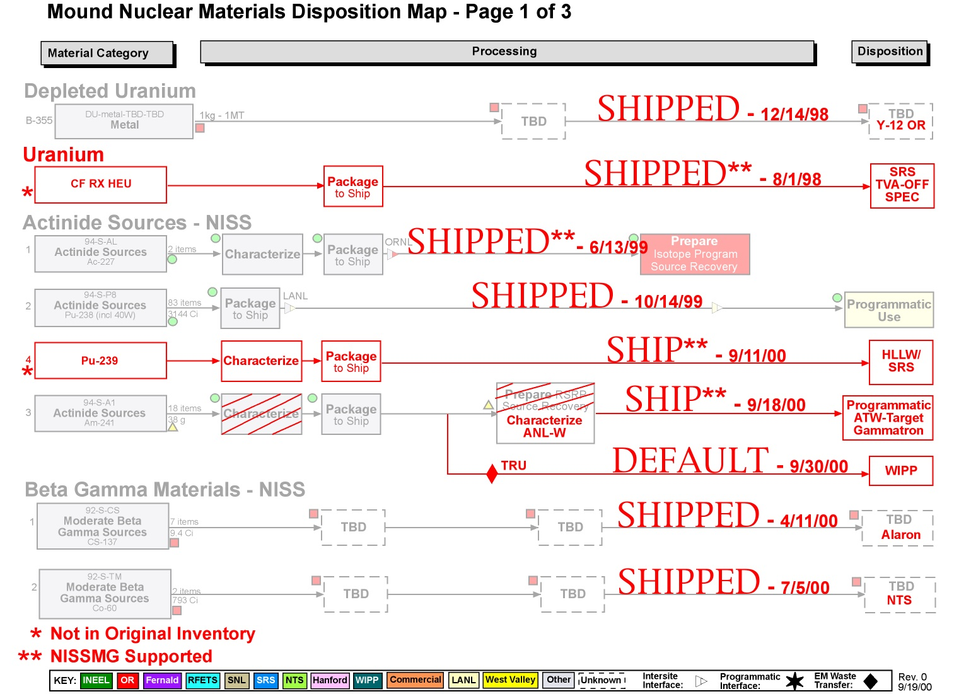
Figure 2 - Mound Nuclear Materials Disposition Map - Page 2

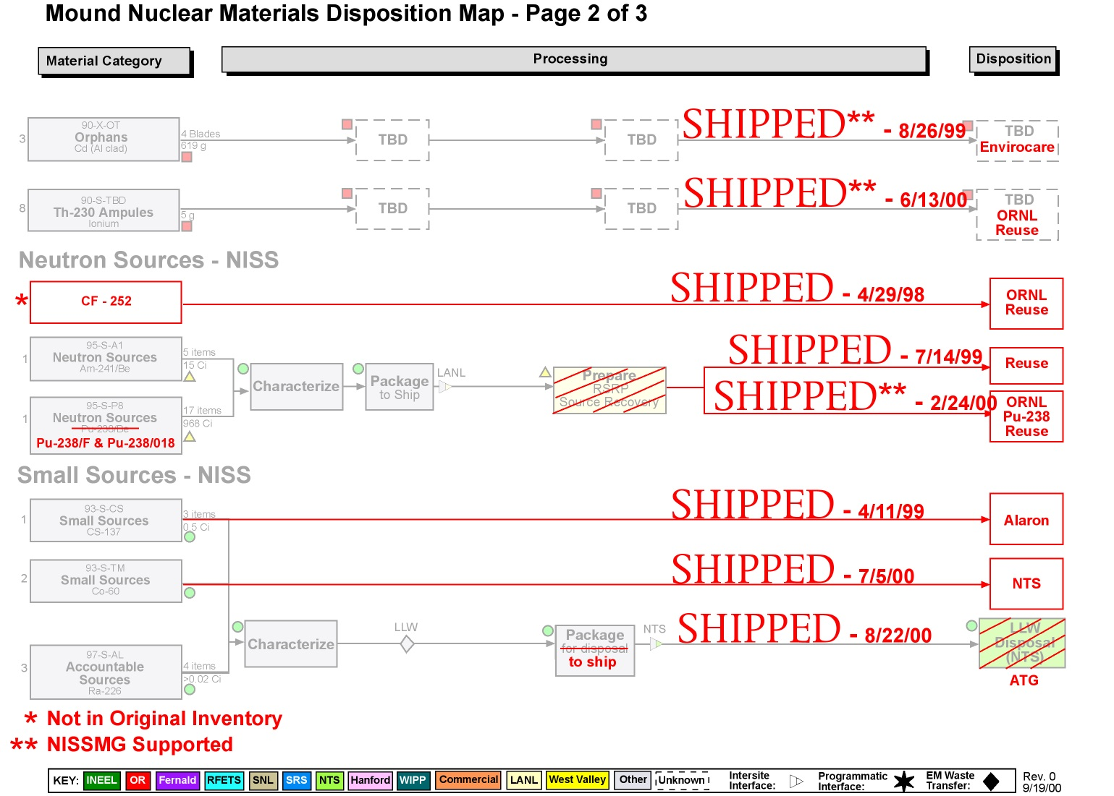
Figure 3 - Mound Nuclear Materials Disposition Map - Page 3

