Measuring Vector Mesons with Dileptons
Besides the direct measurement of open charm hadrons, the HFT will serve as a powerful device to discriminate primordial electrons from background electrons in the measurement of electromagnetic probes.
Photons and leptons emitted from the early stages of heavy ion collisions suffer few interactions with their surroundings since they interact via the electromagnetic force instead of the strong one. Therefore, electromagnetic probes are ideal tools to study the properties of matter created by relativistic heavy ion collisions.
On the other hand, processes which produce photons and leptons are rare and are overwhelmed by photons and leptons from electromagnetic decays of hadrons and subsequent γ conversions to leptons. In addition, the final state electrons and positrons are the integrated yield of radiation over the whole evolution of the colliding system. Despite all the experimental difficulties, the low and intermediate mass dileptons have been measured at the CERN-SPS and an excess of radiation above the hadron cocktail has been observed in the invariant mass region at 0.2 < M_{ee} < 0.6 GeV/c² in semi-central Pb+Au collisions,. Also, new and exciting results from the first three RHIC runs indicate that jets have lost a large fraction of their energy in dense matter and the hadronic phase is relatively short. We believe that these observations at RHIC favor experimental measurements of photons and dileptons due to thermal radiation and will result in a clearer signature than from lower energy heavy ion collisions.
At STAR, electron identification is made possible by a combination of a measurement of the energy lost by charged particles due to ionization of the TPC gas (dE/dx) and a velocity measurement with the time-of-flight system. The relativistic rise of the electron dE/dx separates the electron dE/dx from those of hadrons except at the crossovers with pions at momentum of ~ 0.2 GeV/c, kaons at ~ 0.6 GeV/c, protons at ~ 1.1 GeV/c and deuterons at ~ 1.5 GeV/c. A time-of-flight measurement, using a requirement that |1-β| < 0.03, eliminates slow hadrons and cleans up the crossovers. This results in clean electron identification, as shown in Figure 1. The plot on the top left shows the conventional dE/dx measurement in the TPC gas as a function of particle momentum. The lower plot shows the same dE/dx measurement but now requiring at TOF of |1-β| < 0.03. The upper electron band is clearly separated from the lower pion band. Heavier particles (e.g. kaons and protons) are completely removed by the TOF requirement. The right hand plot of Figure 1 shows a dE/dx projection in the transverse momentum range p_{T} = 1.0-1.5 GeV/c. Even at this rather large momentum, the dE/dx band of the electrons is clearly separated from that of charged hadrons at lower energy losses.
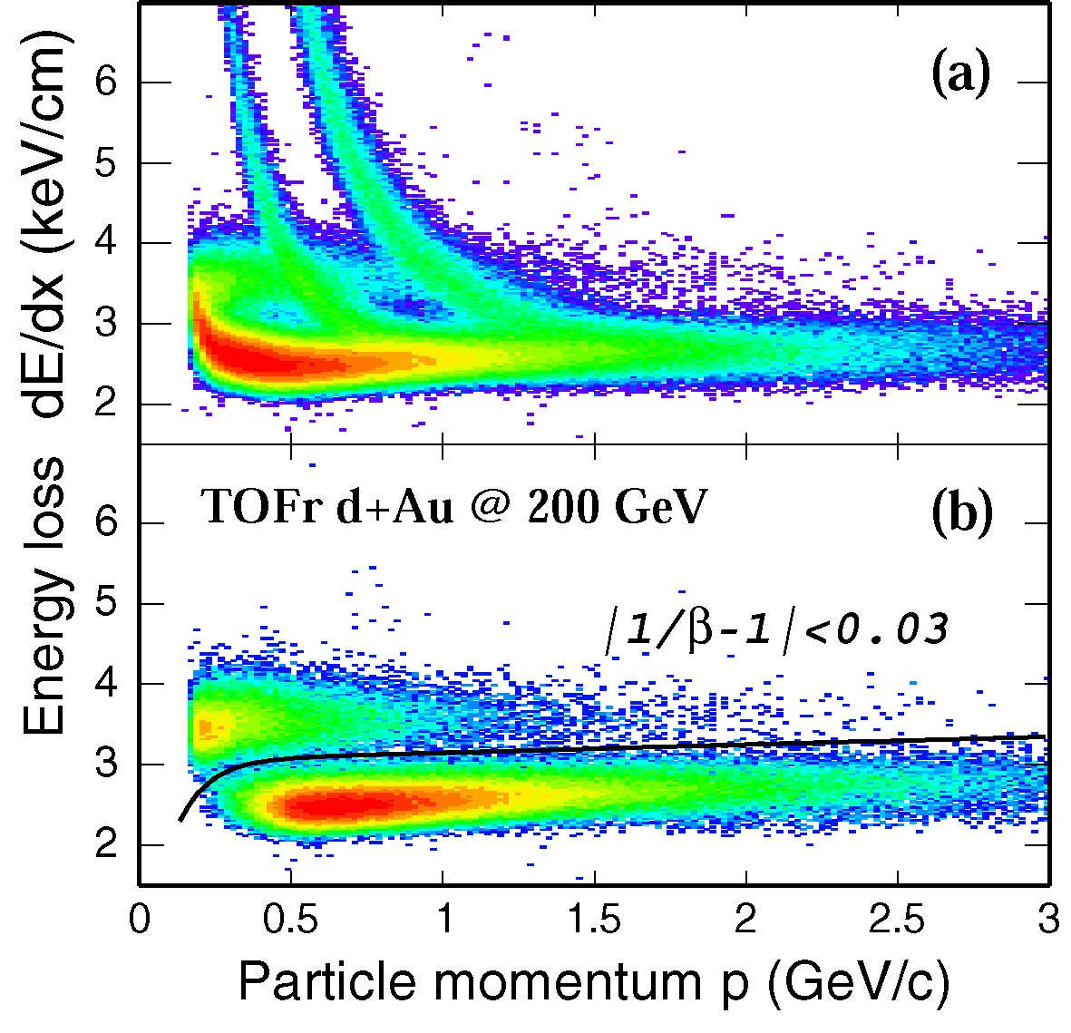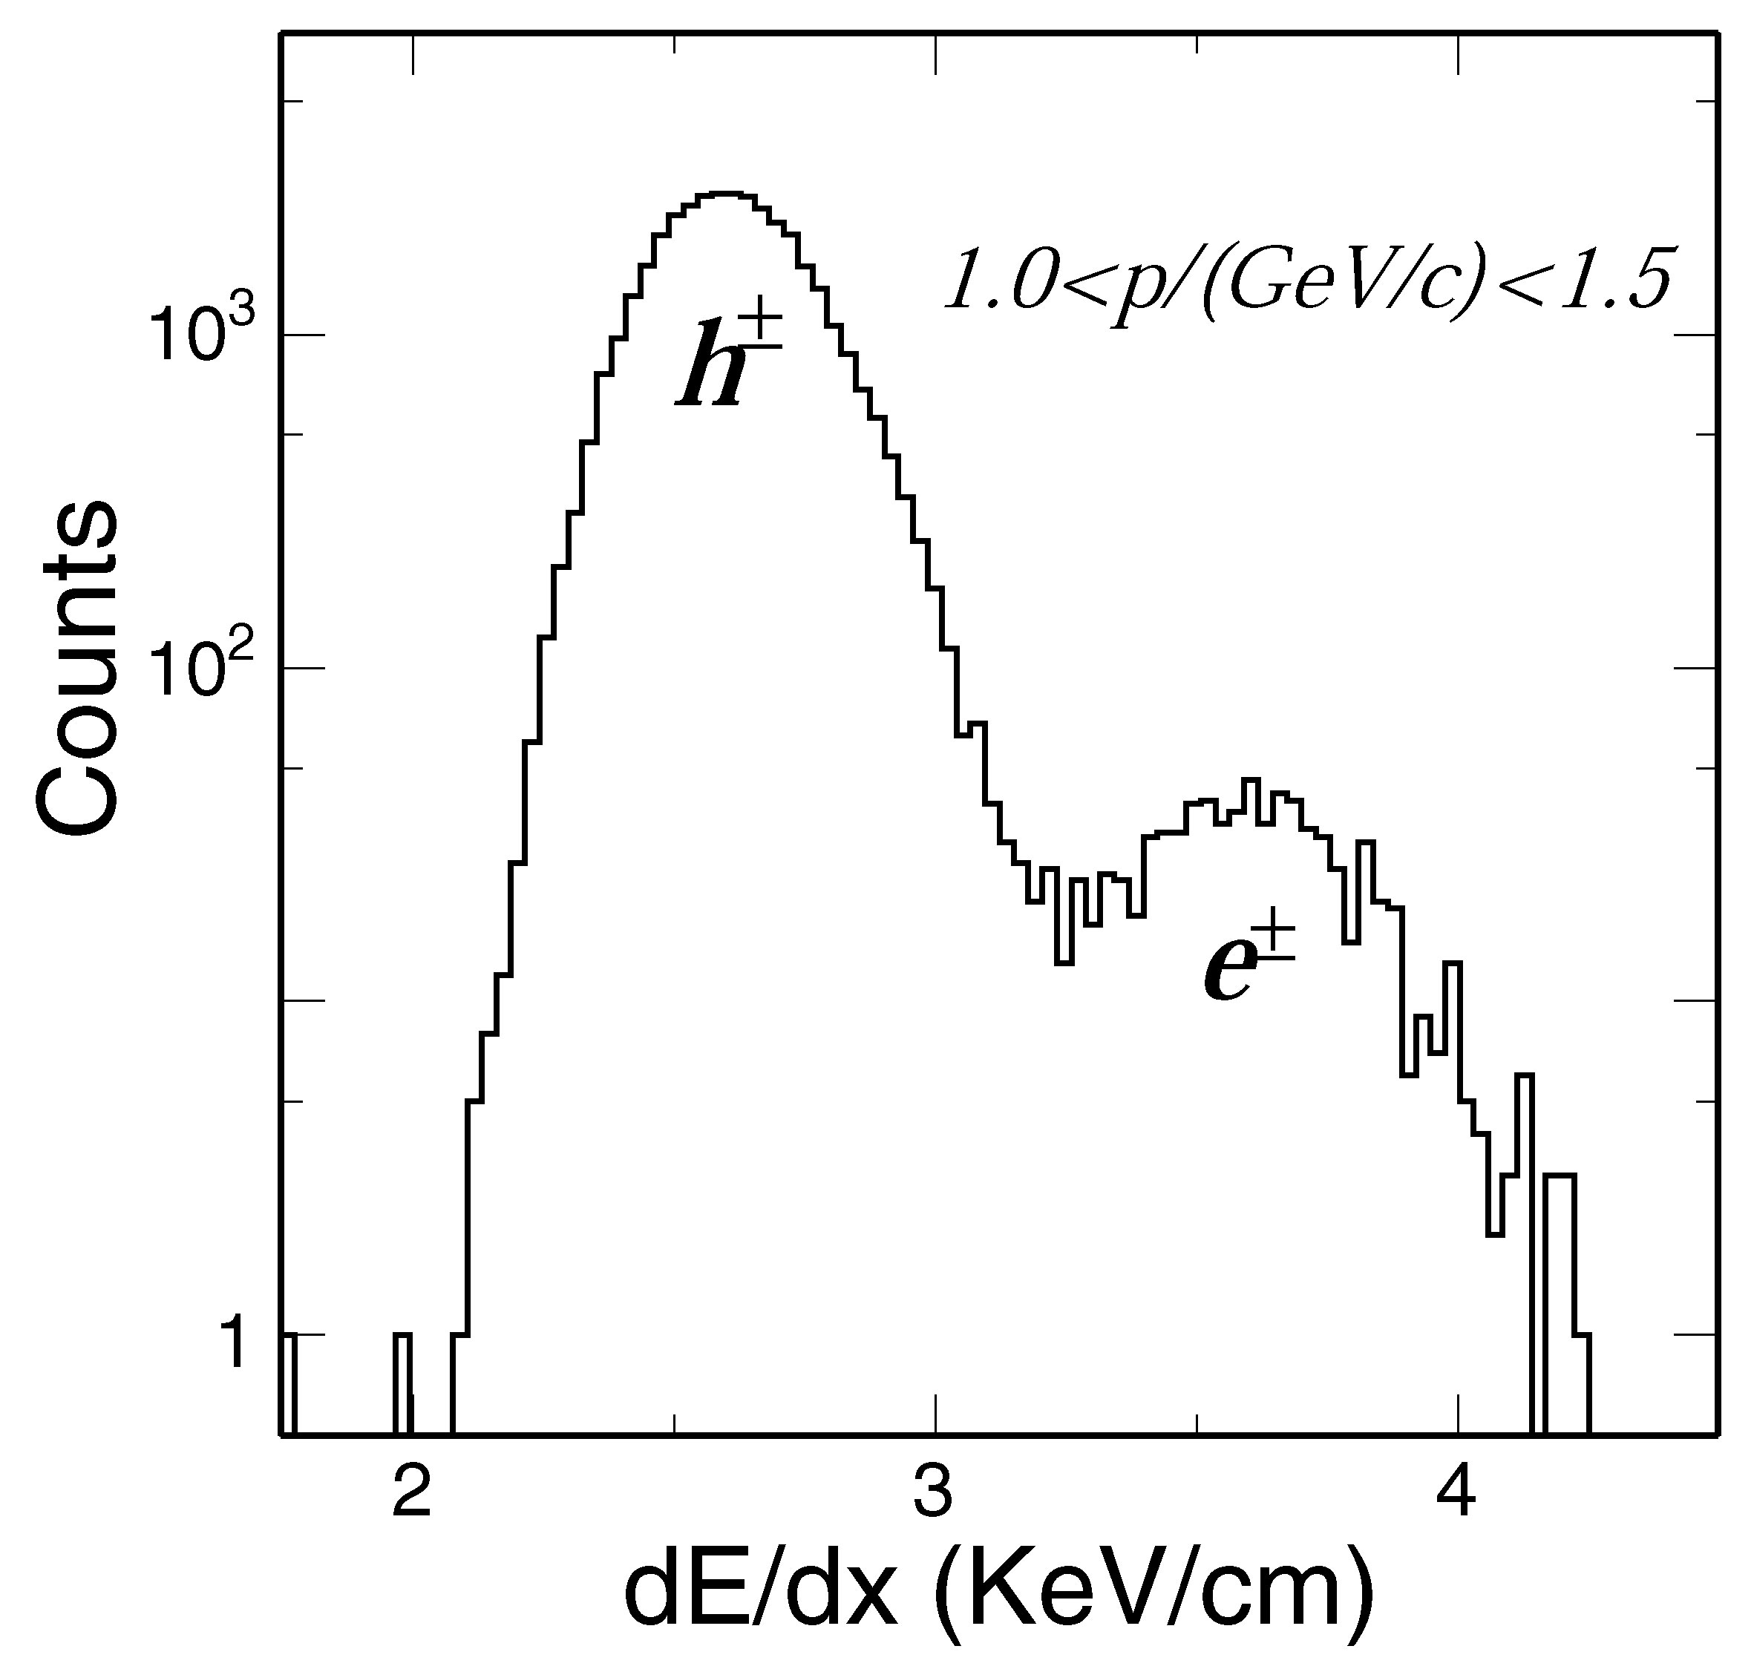
Figure 1: Left top: TPC dE/dx vs p in d+Au collisions. Left bottom: TPC dE/dx vs p after TOFr PID selection of | 1-β | < 0.03. Clean electron identification is achieved. Right: dE/dx from TPC after TOFr PID selection (left bottom panel) for 1.0 < p < 1.5 GeV/c.
These electrons are, to a large extent, from photons converting into electron-positron pairs γ → e⁺ e⁻ in the detector material. The HFT detector will reduce the background electrons and positrons from these γ conversions. By requiring hits in the HFT, electrons from photon conversion outside the HFT, i.e. the SVT, SSD, and TPC inner field cage, are rejected. Figure 2 shows the resulting yield from pure Monte Carlo simulations (no tracking involved) of conversion electrons when requiring hits in the TPC only (open circles), hits in the TPC and SVT (open triangles) and hits in the TPC+SVT+HFT (closed circles). The requirement of hits in the HFT reduces the detected yield of conversion electrons by a factor of 50. Full simulation with appropriate pile-up events shows that the rate of a random ghost track is 5%. This means that we can achieve a maximum gamma rejection by a factor of 20. To estimate the signal-to-background ratio in the vector meson measurements, we take a reasonable conservative approach and assume that HFT can reject gamma conversion by a factor of 10. Another source of electron background stems from the semi-leptonic decays of heavy quarks, charm and bottom. The dominant source at intermediate mass, is from the semi-leptonic decays of open charm. Due to the large charm yield at RHIC energies, the e+e- from charm-anti-charm decays are comparable to that from gamma conversion and π and η Dalitz decays after HFT rejection described above. Due to the lifetime of ~ 100 μm of heavy-flavor hadrons, this charm semileptonic decay background can be greatly reduced by measuring the displaced decay vertex with high resolution as provided by the HFT detector. Detailed simulations show that HFT is capable of rejecting 75% of e+e- pairs from the D0 decay while preserving 50% of the primordial e+e- pairs. This increases the signal-to-background ratio by a factor of 2.
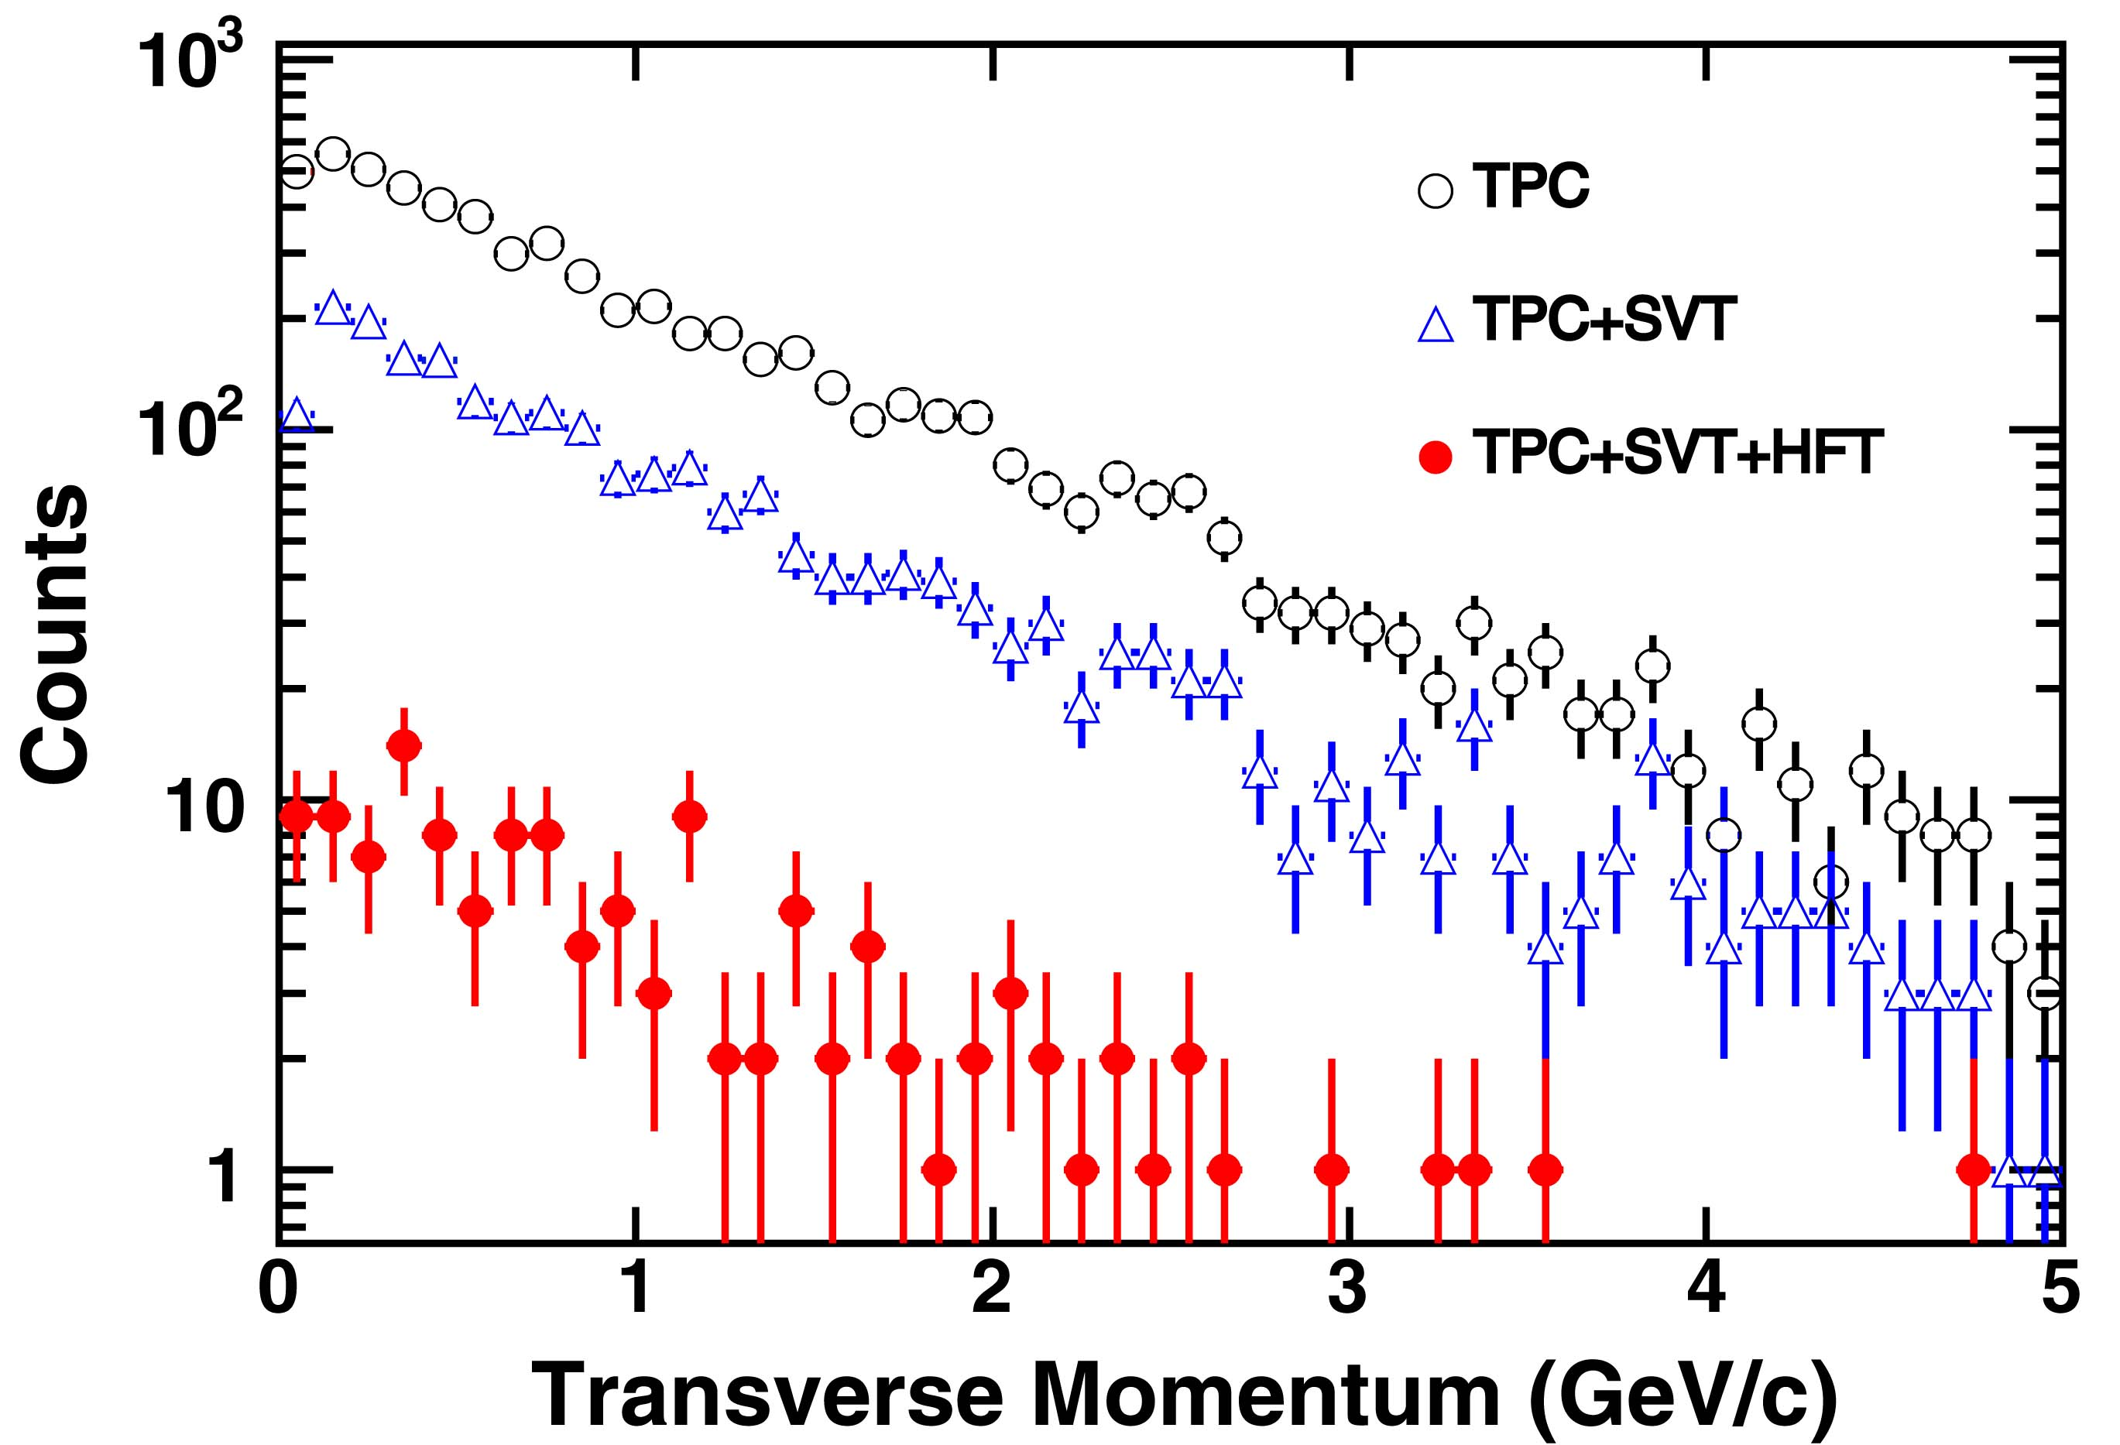
Figure 2: Electron p_{T} spectra from γ conversions reconstructed by requiring TPC tracking, a TPC hit and 2 SVT hits, or a TPC hit and 2 SVT hits and 2 HFT hits. The rejection factor with an additional SVT hit (2 hits) is 3 and with an additional HFT hit is 50.
The large reduction in electron background will enable us to observe electromagnetic decays of short-lived vector meson, e.g. φ, ω → e⁺e⁻, and intermediate mass dileptons with a few hundred thousand central Au+Au events in STAR. The rejection of π⁰ and  η Dalitz decays by a factor of 3 (single track) can be achieved by measuring both electrons in the pair which is possible due to the large acceptance of the STAR TPC. Table 1 shows our estimate of central Au+Au collisions needed in order to observe a signal with a statistical significance of 3σ. Compared to measurements incorporating only the TPC and TOF, the HFT will enhance the sensitivity of electro-magnetic vector meson decay by a factor 20-40. We are in the process of simulating the effects of the combinatorial background in more detail.

Detectors | ω | φ
TPC+TOF | 8M | 2M
TPC+TOF+SVT+HFT | 200K | 100K
Table 1: Number of central Au + Au events required to observe a 3-σ signal for ω and φ in their leptonic decay channels under different detector configurations.

A. Marín et al., J. Phys. G: Nucl. Part. Phys. 30, S709 (2004).
D. Adamova et al. (CERES Collaboration), Phys. Rev. Lett. 91 (2003) 042301
R. Rapp, Phys. Rev. C63, 054907 (2001).
R. Rapp, Pramana 60, 675 (2003).

