Guide to SWEET Ontologies

Rob Raskin

NASA/Jet Propulsion Lab

Pasadena, CA

raskin@seastar.jpl.nasa.gov

The ontologies within the Semantic Web for Earth and Environmental Terminology (SWEET) provide an upper-level ontology for Earth system science. The SWEET ontologies include several thousand terms, spanning a broad extent of Earth system science and related concepts (such as data characteristics) using the OWL language. The ontologies can be downloaded from http://sweet.jpl.nasa.gov/sweet. To support such a large collection and adhere to the guiding principles, the concepts are divided, where possible, into orthogonal dimensions or facets in support of reductionism. The primary ontologies are shown in Figure and explained below. Each box represents a separate ontology, and a connecting line indicates where major properties are used to define concepts across ontology spaces.

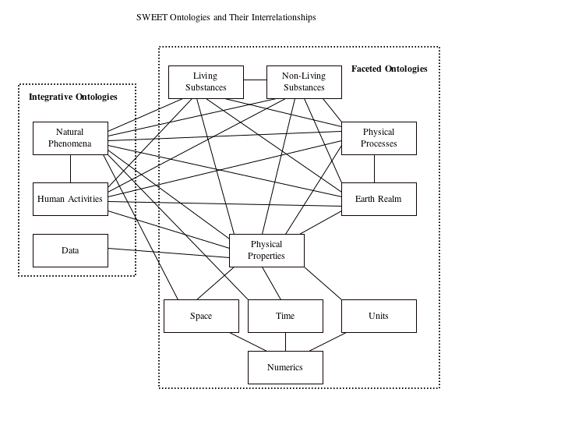

EarthRealm
The “spheres” of the Earth constitute an EarthRealm ontology, based upon the physical properties of the planet. Elements of this ontology include “atmosphere”, “ocean”, and “solid earth”, and associated subrealms (such as “ocean floor” and “atmospheric boundary layer”). The subrealms are often distinguished from their parent classes, based on the property of altitude, e.g., “troposphere” is the subclass of “atmosphere” where elevation is between 0 and 15 km. This ontology can be considered a “state” of the planet that is extendable to past or future time periods, (as well as to other planets).

Non-LivingSubstances
The non-living building blocks of nature include: particles, electromagnetic radiation, and chemical compounds. These substances constitute an ontology of physics and chemistry.

LivingSubstances
The living substances include plant and animal species. This ontology was imported from the “biosphere” taxonomy of GCMD.

PhysicalProcesses
Physical processes include processes that affect living and non-living substances, such as diffusion, evaporation, etc.

PhysicalProperties
A separate ontology was developed for physical properties, including those observable or associated with other components. PhysicalProperties include “temperature”, “pressure”, “height”, “2composition”, etc., and could apply to NonLivingSubstances, LivingSubstances, PhysicalProcesses, etc. These properties typically are measured physical quantities (or qualities) with units.

Units
Units are defined using Unidata’s UDUnits. The resulting ontology includes conversion factors between various units. Prefixed units such as km are defined as a special case of m with appropriate conversion factor.

Time
Time is essentially a numerical scale with terminology specific to the temporal domain. We developed a time ontology in which the temporal extents and relations are special cases of numeric extents and relations, respectively. Temporal extents include: duration, season, century, 1996, etc. Temporal relations include: after, before, etc.

Space

Space is essentially a multidimensional numerical scale with terminology specific to the spatial domain. We developed a space ontology in which the spatial extents and relations are special cases of numeric extents and relations, respectively. Spatial extents include: country, Antarctica, equator, inlet, etc. Spatial relations include: above, northOf, etc.

Numerics
Numerical extents include: interval, point, 0, R², etc. Numerical relations include: greaterThan, max. etc. We defined multidimensional concepts, as these are not native to the OWL and XML environments.

PhysicalPhenomena
A phenomena ontology is used to define transient events. A phenomenon crosses bounds of other ontology elements. Examples include: hurricane, earthquake, El Nino, volcano, terrorist event, and each has associated Time, Space, EarthRealms, NonLivingElements, LivingElements, etc. We also include specific instances of phenomena, spanning approximately 50 events over the past two decades.

HumanActivities
This ontology is included for representing activities that humans engage in, such as commerce, fisheries, etc. This ontology is included because scientific processes and phenomena have human impacts, and there is a need for representing such activities.

Data
The data ontology provides support for dataset concepts, including representation, storage, modeling, format, resources, services, and distribution.

These ontologies constitute a concept space for Earth system science. The expression of a concept in words may differ from one person to another depending upon their scientific community, cultural background, language, and level of expertise. SWEET enables the same concept to be represented using various phrases to satisfy these needs. Rather than define a compound concept such as air temperature, we separated the physical property (temperature) from the element that the property applies to (air). This provides a more scalable solution to a growing knowledge base. In this case, knowledge of the independent concepts of the substance “air” and property “temperature” provide a complete understanding of “air temperature” without a need to create an explicit definition of the compound concept. Such a decomposition does not preclude term recompositions, but the compound terms are designated as synonymous with their integral parts. In other instances, the compound concepts contain more meaning than their component parts (e.g., static pressure) and are explicitly included in the ontology.

A deficiency of RDF and OWL is that the languages contain no direct support for numerical concepts, and must rely on a limited XSD (XML Schema Definition) specification of datatypes. This spec defines number types (e.g., floating point, unsigned integer) and methods to create derivations of these types (e.g. the closed interval between 0 and 1), but contains no operations or relations on these numbers. This is a deficiency, because many scientific concepts are defined through numeric concepts. For example, “brighter”, “higher”, “later”, and “more northerly” are special cases of the “greater than” relation, applied in specific domains. In particular, spectral regions are defined in terms of wavelength (e.g., visible light is between 0.4 and 0.7 micrometers), atmospheric layers are defined by altitude (e.g., troposphere is between 0 and 15 km), etc. This specification also has no notion of a multidimensional space R^{n}. The Numerics ontology adds extensions needed to define scientific concepts and is used to define concepts in the spatial and temporal ontologies. Although other spatial and temporal ontologies exist, none exploit the fact that space and time are numerical scales. Without such a connecting thread, many numerical concepts must be reinvented to create definitions of space and time.

The first several ontologies listed above represent orthogonal concepts (or dimensions), often called facets. Traversing down a tree associated with a facet follows the scientific path of reductionism by adding additional details and specialization to more general concepts. The unifying ontologies (phenomena and human activities) represent the opposite approach, as these concepts are synergetic rather than mutually orthogonal. These entries define holistic, synthesizing concepts using elements from the faceted ontologies (e.g., a hurricane is associated with particular coastal areas, and is characterized by high winds, rainfall, flood impacts, etc.). Taken together, these two complementary approaches mirror the scientist’s dual methods of reductionism and synthesis, and support a comprehensive framework for capturing scientific knowledge and investigation.

Based on our experiences, we identified five design principles in constructing scientific ontologies:

Scalability: An ontology should be easily extendable to enable specialized domains to build upon more general ontologies already generated.

Application-independence: The structure and contents of an ontology should be based upon the inherent knowledge of the discipline, rather than on how the domain knowledge is used.

Natural language-independence: The structure should provide a representation of concepts, rather than of terms. The concepts remain the same regardless of the inclusion of slang, technical jargon, foreign languages, etc. Synonymous terms (e.g., marine, ocean, sea, oceanography, ocean science) can be mapped separately to an ontology element

Orthogonality: Compound concepts should be decomposed into their component parts, to make it easy to recombine concepts in new ways.

Community involvement: Community input should guide the development of any ontology.

