Setting Up New HEMI Entourage Account

Purpose
Due to Hurricane Rita Contingency support activities, many e-mail services were migrated from Johnson Space Center to Marshall Space Flight Center. The result of these activities means that you have now a new HEMI account.

Unfortunately, we were not able to migrate all mailboxes to MSFC before JSC was shut down. This means that the first time you log-in to your HEMI account, you will ONLY see e-mail and calendar items from the date and time your new mailbox was created at MSFC. All prior mail and calendar data saved on the server has been temporarily lost. This data will be recoverable once we return to normal service. However, if your Entourage client was left configured at its original settings to use “cached mail” (mail saved locally to your hard drive), you will be able to re-establish connections to the new mail account, while at the same time keeping the older mail that was saved locally. This document describes the steps to save your existing cached email, configure your new HEMI email account, and to login and access your cached mail.

You only need perform these steps once, the first time you launch Entourage.

Saving Cached Email
- Launch Entourage. You will be asked to login (See Figure 1, below.) CLICK CANCEL AT THIS PROMPT – DO NOT LOG IN!
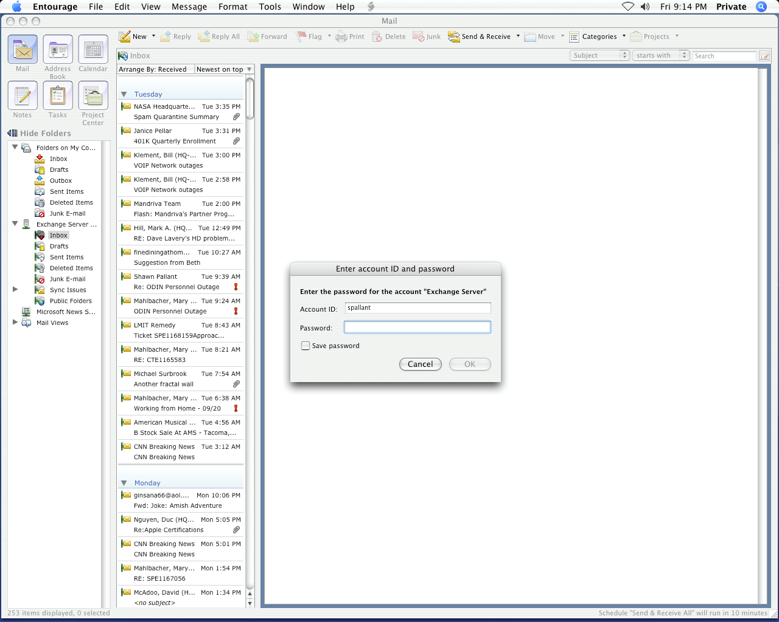
Click the cancel button; do not log in!
Figure 1
- Find the folders list on the left side of the Entourage window. Hold down the Control key and click on Folders on My Computer. A sub-menu will appear (See Figure 2, below). Select New Subfolder from this menu and click.

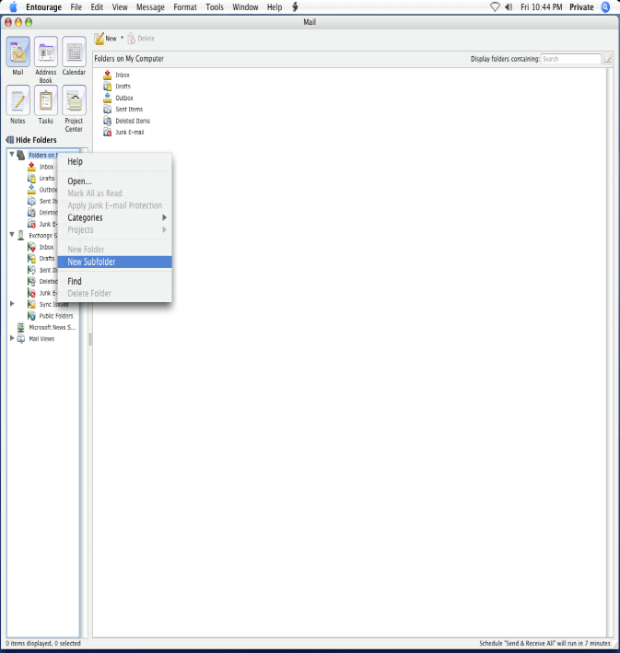
Figure 2

- Name the folder ~Recovered In (See Figure 3). You can call this folder anything you wish, such as “Old In Box,” etc. For this document, we will refer to it as “~Recovered In.”
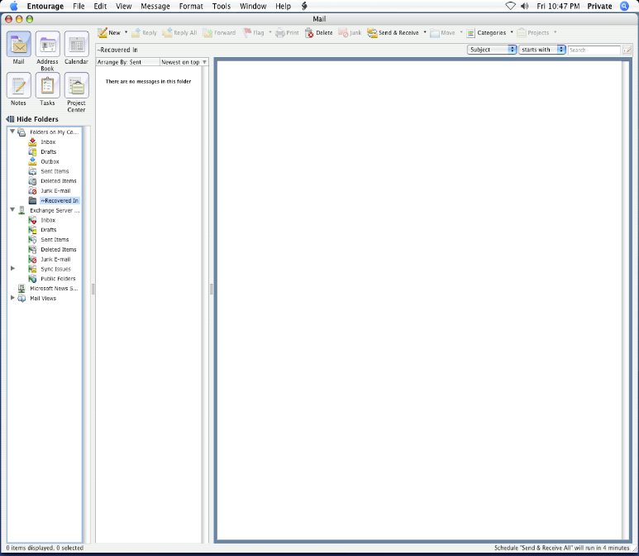
Figure 3

- Click on the Inbox located in the Exchange Server Profile (See Figure 4). Your local copies of former In-Box messages will be displayed. Highlight all messages within this folder.
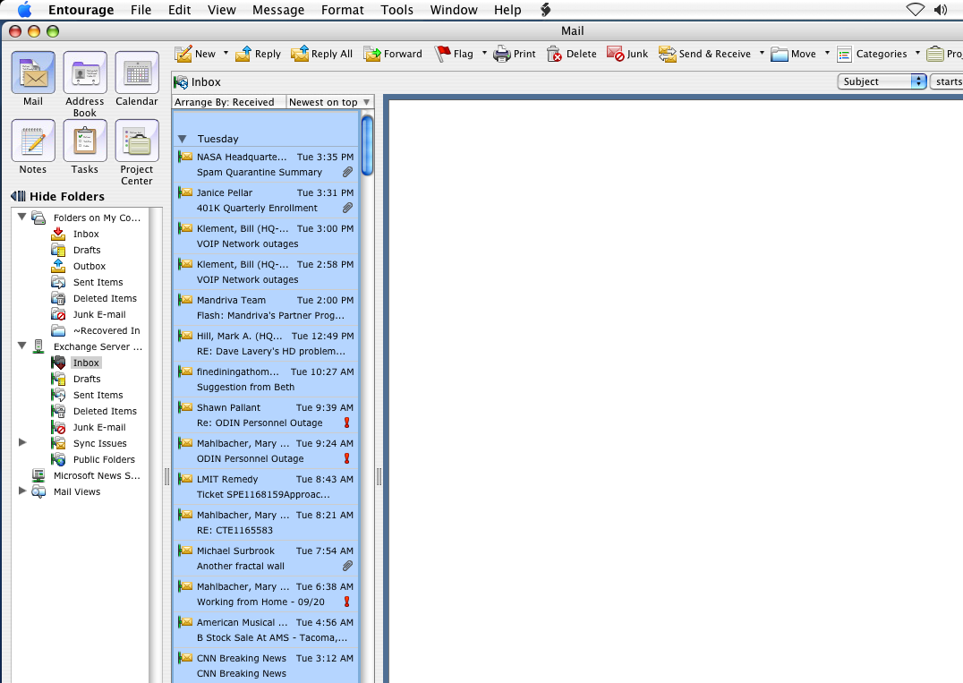
Highlight all messages in this folder
Figure 4

- From the toolbar, click on the Move menu and select Move To Folder… (See Figure 5).

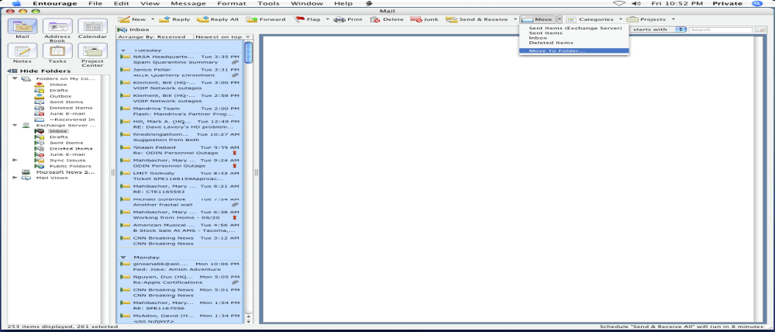
Figure 5

- A “Move to Folder” dialog box will appear. Select the ~Recovered In folder under the “Folders On My Computer” (or choose the folder you created in Step 3, above). Click the Move button.
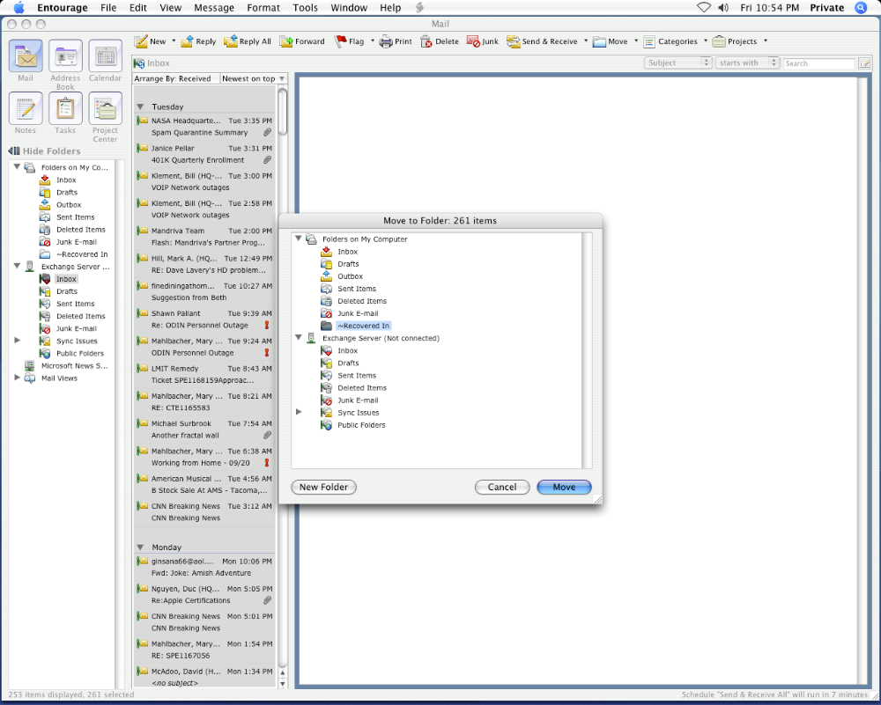
Select the folder you created in Step 3
After selecting the folder, Click Move
Figure 6

- The locally cached “Inbox” will not be moved to the new folder.
- Perform Steps 2 – 6 again for each folder you have under the “Exchange Server” folder list (i.e. Sent Items, Outbox. etc.)

You have now completed the actions required to save your locally cached e-mail configuration steps and are ready to configure your new account.

- Launch Entourage. At login screen, enter your password. Click OK.

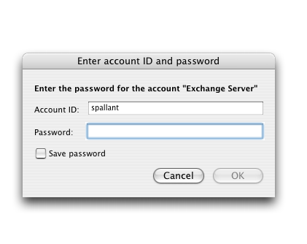

- Your Entourage client will auto-configure, and update your mailboxes. The Inbox in the “Exchange Server” list will now contain new mail received since the relocation of your mailbox to MSFC. Select the ~Recovered In folder under the “Folders On My Computer” (or choose the folder you created in Step 3, above).to find all of your previous mail. If you wish, you can copy this mail back to the corresponding mail boxes on the Exchange Server.

Should you have any questions regarding these instructions, please contact the IT Help Desk at 358-HELP (4357), 1-866-4NASAHQ (462-7247), mailto:service@hq.nasa.gov, or http://www.odin.lmit.com/hq/helpdesk.html.

