Control Number ED-OIG/A04-B0015

Dr. Johnnetta B. Cole, President

Bennett College

900 East Washington Street

Greensboro, North Carolina 27401

Dear Dr. Cole:

This Final Audit Report (Control Number ED-OIG/A04-B0015) presents the results of our audit of Bennett College’s (College) compliance with cash management and refund procedures for Department of Education (ED) funds for the period July 1, 1997, through June 30, 2000. Our objectives were to determine whether the College was in compliance with Title III and Title IV cash management regulations, the standard of conduct for a fiduciary in the administration of Title IV, and Title IV refund requirements.

In its written response to the draft report, a copy of which is included as an attachment, the College concurred with the audit findings. However, the College did not concur with Recommendation No. 1.3 relating to the repayment of $634,000 in excess Federal Work Study (FWS) program funds. The College’s response to the draft report and our comments to the response are summarized in the Findings sections of the report.

AUDIT RESULTS

The College did not comply with the Title IV cash management requirements and breached its fiduciary responsibility when it drew down $5,686,362 of Title IV Direct Loan funds and $679,238 of FWS funds in excess of its needs, did not promptly return the excess funds, and failed to deposit $146,712 of interest earned on excess funds into the Federal account. The excess Direct Loan funds were used to open a $5 million money market account. These excess Direct Loan funds were eventually returned to ED, but the interest earned on the money market account was not returned. The majority of the excess FWS funds ($634,000) remained outstanding as of the end of the audit period.

Further, the College was not in compliance with the ED General Administrative Regulations (EDGAR) when it drew down $456,000 of Title III and $63,311 of Minority Science Improvement Program (MISIP) grant funds in excess of its immediate needs and did not promptly return the excess funds.

In addition, the College was not in compliance with the Title IV requirement to pay refunds timely when it made such payments 23 to 65 days late.

FINDING NO. 1 – Bennett College Did Not Adhere to ED Title IV Regulations for Cash Management and the Standard of Conduct for a Fiduciary in the Administration of the Title IV Programs

In 1998, the College did not comply with the Title IV cash management requirements when it drew down $5,743,800 in the William D. Ford Federal Direct Loan (Direct Loan) program and $686,100 in Federal Work Study (FWS) program funds. The drawdowns were over $6.3 million in excess of needs and the excess funds were not promptly returned to the Department. The College also breached its Title IV fiduciary responsibility when it opened a separate interest bearing account with $5 million of the excess Direct Loan funds. The $146,712 interest earned was not deposited into the Federal account as required.

The Title IV cash management regulations are intended to “[p]romote sound cash management of [T]itle IV, HEA program funds [and] [m]inimize the financing costs to the Federal Government . . . .” 34 C.F.R. § 668.161(a)(i) and (ii). The regulations further provide:

The Secretary considers excess cash to be any amount of [T]itle IV, HEA program funds, that an institution does not disburse to students or parents by the end of the third business day following the date the institution received those funds from the Secretary. [34 C.F.R. § 668.166(a)(1)]

[F]unds received by an institution under the [T]itle IV, HEA programs are held in trust for the intended student beneficiaries and the Secretary. . . . The institution, as a trustee of Federal funds, may not use or hypothecate (i.e. use as collateral) [T]itle IV, HEA program funds for any other purpose. [34 C.F.R. § 668.161(b)]

If an institution maintains Direct Loan . . . program funds in an interest-bearing or investment account, the institution may keep the initial $250 it earns on those funds during an award year. By June 30 of that award year, the institution must remit to the Secretary any earnings over $250. [34 C.F.R § 668.163(c)(4)]

An institution must maintain accounting and internal control systems that . . . (ii) Identify the earnings on [T]itle IV, HEA program funds maintained in the institution’s bank or investment account . . . . [34 C.F.R § 668.163(d)(1)]

A participating institution . . . acts in the nature of a fiduciary in the administration of the Title IV, HEA programs. To participate in any Title IV, HEA program, the institution . . . must at all times act with the competency and integrity necessary to qualify as a fiduciary. [34 C.F.R. § 668.82(a)]

The failure of a participating institution . . . to administer a Title IV, HEA program, or to account for the funds that the institution . . . receives under that program, in accordance with the highest standard of care and diligence required of a fiduciary, constitutes grounds for (1) an emergency action against the institution, a fine on the institution, or the limitation, suspension, or termination of the institution’s participation in that program . . . . [34 C.F.R. § 668.82(c)]

In January 1998, the College’s Business Office drew down $5,743,800 in Direct Loan funds and $686,100 in FWS funds. The College’s immediate needs at that time were $57,438 in Direct Loan and $6,862 in FWS funds. As a result, the College drew down excess Direct Loan and FWS funds totaling $6,365,600 ($5,686,362 Direct Loan and $679,238 FWS). The College did not immediately return the excess funds.

In February 1998, a former College President opened a money market account with $5 million of the excess Direct Loan funds. From February 1998 through November 1998, the College earned and improperly retained interest totaling $146,712 on the Direct Loan funds it deposited into the money market account. The College did not deposit the interest earned into the Federal account as required by ED regulations for maintaining and accounting for funds.

Between October 1998 and August 1999, the College made 10 payments to the ED Loan Origination Center repaying $5,332,903 of the excess Direct Loan funds. As of June 30, 2000 (the end of the audit period), the College had a $16,959 cash balance in its Direct Loan account. As of August 17, 2001, the College had a zero cash balance in its Direct Loan account. The College did not remit any of the $146,712 interest earnings on the money market account to the Department or identify the earnings on the investment account.

In addition, the College had $634,000 in ED funds in excess of FWS program expenditures as of June 30, 2000. The source of these excess funds was the January 1998 FWS draw down of $686,100. As of the end of the audit period, the College retained the $634,000 in its operating account.

By not immediately returning the Direct Loan and FWS funds drawn down in excess of needs and using those funds for other than their intended purpose, the College breached its fiduciary responsibility to the Secretary. We determined that the imputed interest cost to the Government as a result of not returning the funds was $249,212 for the Direct Loan program and $79,052 for the FWS program. The imputed interest costs were calculated as of June 30, 2000 (the end of the audit period). The imputed interest costs to the Government were greater than the interest earned on the money market account; therefore, we recommend recovery of the imputed interest costs.

The College also drew down excessive Title III grant funds and did not return the funds to the Department in a timely manner. This also resulted in imputed interest costs owed to the Government. See Finding 2 for a discussion of the excessive draw down of Title III funds.
RECOMMENDATIONS

We recommend that the Chief Operating Officer for Federal Student Aid (FSA):

  - Require Bennett College to pay the $249,212 in imputed interest costs for the excess cash balance maintained for Direct Loan programs.

  - Require Bennett College to pay the $79,052 in imputed interest costs for the excess cash maintained for the FWS.

  - Require Bennett College to return the $634,000 in FWS funds that were not spent on ED programs and absorbed into the College’s operating account.

  - Initiate appropriate administrative action against the College as set forth in 34 C.F.R. Part 668, Subpart G, Fine, Limitation, Suspension and Termination Proceedings.

BENNETT COLLEGE RESPONSE

The College concurred with the finding and that imputed interest is due to the Department on the balances not returned to the Department. However, the College did not concur that the $634,000 in FWS funds remained outstanding. The College’s response stated that all principal funds due the Department (directly related to this finding) have been returned. However, due to new staff not familiar with the analysis related to these transactions, the College will complete a detailed analysis of the flow of funds directly related to the FWS draw down to determine the exact disposition of these funds. The target date for completion of this analysis is no later than September 30, 2002. See attachment for the College’s written response to the draft report.

OIG COMMENTS

The excessive FWS draw down occurred in January 1998. The $634,000 amount represents the audited balance of the FWS account as of June 30, 2000. As of that date, the College had not returned the excess FWS funds from the excessive 1998 draw down. The College was required to spend the FWS funds within three business days after receipt or return the funds. As of the end of the audit period (June 30, 2000), the College had not spent $634,000 in FWS program funds in excess of receipts and those funds had been transferred to the College’s operating account.

The College should provide evidence to the Department that it repaid the $634,000 or documentation that it had additional FWS program expenditures equal to $634,000 since June 30, 2000. If the College is not able to provide such documentation, the $634,000 should be returned to the Department. The related imputed interest cost was calculated as of June 30, 2000, and should be paid to the Department.

FINDING NO. 2 – Bennett College Did Not Meet EDGAR Financial Management System Standards for Administration of Grants

The College did not comply with financial management system standards for the administration of grants when it drew down $456,000 Title III and $63,611 MISIP grant funds and did not immediately disburse the funds for grant expenditures.

Under the requirements of 34 C.F.R. § 74.21(b), the College’s financial management systems must provide:

Records that identify adequately the source and application of funds for [F]ederally-sponsored activities. These records shall contain information pertaining to awards, authorizations, obligations, unobligated balances, assets, outlays, income, and interest.

Effective control over and accountability for all funds, property, and other assets. Recipients shall adequately safeguard all assets and assure they are used solely for authorized purposes.

Under the grant payment rules, “[c]ash advances to a recipient organization are limited to the minimum amounts needed and [must] be timed to be in accordance with the actual, immediate cash requirements for carrying out . . . the approved program or project. 34 C.F.R. § 74.22(b)(2)

A memorandum dated October 22, 1998, from a former College President stated: “We have just completed the planning review for Title III for the compilation of the draw down at this time. Please draw down $456,000.” The $456,000 draw down depleted the Title III grant and represented 41 percent of the year’s Title III grant award. The funds were not immediately used for Title III expenditures, nor was the draw down supported by Title III expenditure documentation. On October 23, 1998, one day after the request for the $456,000, the College repaid $500,000 of the excess Title IV Direct Loan funds.

Subsequent Title III draw down requests were supported by Title III expenditure documentation. The College continued to draw down Title III grant funds until the end of May 1999. At that time, the Business Office accountant informed the Title III Director that there were no ED funds available to fund the Title III grant through the end of the award period, September 30, 1999. The Title III Director stated that grant activities continued through September 30, 1999, and surmised that the College relied on institutional funds.

As of September 30, 1999, the end of the grant year, the College had drawn down $213,979 of Title III grant funds in excess of expenditures. The College maintained Title III funds in excess of expenditures until June 29, 2000.

Our analysis of the College’s receipts and expenditures for other ED grant programs revealed that the College maintained unneeded funds for its MISIP grant. On August 1, 1997, the College drew down the entire grant amount of $63,311 and did not spend all of the funds until June 4, 1999.

By drawing down Title III and MISIP grant funds and not disbursing the funds for program purposes as close as possible to disbursement, the College failed to meet ED standards for grantee financial management systems. We determined that the imputed interest costs to the Government were $31,665 and $3,384 for the Title III and MISIP grants, respectively. The imputed interest costs were calculated as of June 29, 2000, and June 4, 1999, for Title III and MISIP, respectively.

RECOMMENDATIONS

We recommend that the Assistant Secretary for the Office of Postsecondary Education:

  - Require Bennett College to repay the $31,665 in imputed interest costs for the excess cash maintained for the Title III grant.

  - Require Bennett College to repay the $3,384 in imputed interest costs for the excess cash maintained for the MISIP grant.

BENNETT COLLEGE RESPONSE

The College concurred with the finding and recommendations to repay the cited imputed interest costs for the Title III and MISIP grants. See attachment for the College’s complete response to the draft report.

FINDING NO. 3 - Bennett College Did Not Make Timely Payments of Refunds

The College was not in compliance with the Title IV requirement to pay refunds timely when it made such payments 23 to 65 days late.

Pursuant to 34 C.F.R. § 668.22, an institution must return the amount of Title IV funds for which it is responsible no later than 30 days after the date of the institution’s determination that the student withdrew.

Seventeen students were eligible for a Title IV refund during academic years 1997-1998 through 2000-2001. We reviewed 15 of the 17 student’s account records and refund calculation sheets. The College was unable to locate files for two students. The College calculated the refunds accurately; however, it did not make refund payments within the required 30 days of the withdrawal date. Refund payments were 23 to 65 days late.

Coordination between the various College offices responsible for student withdrawals was lacking. The Registrar’s Office did not notify the Financial Aid Office timely that a student had withdrawn, which delayed the calculation of a refund. As a result, the Financial Aid Office did not get the refund information to the Business Office timely and the Business Office did not make refunds to ED within the 30-day timeframe.

Bennett College officials revised the withdrawal procedures so that each office involved in the process has access to information that allows it to know the withdrawal date soon after the Registrar determines the date. We did not test the adequacy of the revised procedures.

RECOMMENDATION

We recommend that the Chief Operating Officer for Federal Student Aid require the College to:

3.1 Institute procedures to ensure that the College pays Title IV refunds within 30 days of when it determines a student has withdrawn.

BENNETT COLLEGE RESPONSE

The College concurred with the finding and recommendation to institute procedures to ensure payment of Title IV refunds within 30 days of student withdrawals. The response stated that the College modified its withdrawal procedures and the financial management system to facilitate access to information by each institutional office involved in the refund process. The response stated that the Business Office reviews the withdrawal report on a weekly basis to ensure that any refund calculations are completed within 30 days. See attachment for the College’s complete response.

OIG COMMENTS

The response indicated that the new procedures implemented by the College would ensure that refund calculations are completed within 30 days; however, the new procedures should also ensure that refunds are paid within 30 days. The Department should ensure that the procedures implemented are sufficient to make timely payments of refunds.

BACKGROUND

Bennett College, founded in 1873, is a church affiliated 4-year liberal arts college for women, located in Greensboro, NC. The College offers 30 majors and awards the Bachelor of Arts, Bachelor of Science, Bachelor of Arts and Sciences in Interdisciplinary Studies, and the Bachelor of Social Work degrees. Bennett College has an average enrollment of about 600.

The College participates in the following Title IV programs: William D. Ford Direct Loan, Federal Pell Grant, Federal Supplemental Education Opportunity Grant, and Federal Work Study. The College is also a Title III, Part B, and Minority Science Program grant recipient. College expenditures for ED programs for the 3 years ending June 30, 2000, totaled $15.8 million.

OBJECTIVES, SCOPE, AND METHODOLOGY

Our initial audit objectives were to determine whether Bennett College was in compliance with the Title IV cash management regulations, the standard of conduct for a fiduciary in the administration of Title IV, and the Title IV refund requirements. The audit objectives were expanded to include compliance with the cash management requirements for the administration of Title III and other ED grant programs. Audit coverage included the period July 1, 1997, through June 30, 2000; with additional testing of Title IV refund procedures through the 2000-2001 academic year.

To accomplish the audit objectives, we performed the following:

- Reviewed applicable regulations.
- Reviewed the latest independent auditors’ A-133 and Compliance reports, and Financial Statements for the years ended June 30, 1998, and June 30, 1999.
- Interviewed College officials responsible for cash management, Federal student aid, and enrollment services.
- Verified and compared the amounts and dates of receipts and expenditures for Title IV and other ED grant programs.
- Compared the College’s Title IV refunds to ED guidelines and verified the accuracy and timeliness of Title IV refunds.
- Contacted and obtained data from Direct Loan officials in Washington, DC, and the Loan Origination Center in Montgomery, Alabama.

During the audit, we relied on computer-processed data contained in the College’s computerized accounting system and student records database. We used award and disbursement data from the Department’s Grants Accounting and Payment System (GAPS) and the Direct Loan Origination Center database to corroborate information obtained from the College. We did this by comparing ED program and grant awards, disbursements, and repayments in the Department’s records with the College’s data.

We also held discussions with College officials to gain an understanding of the processes for requesting and drawing down Federal funds, and for the accounting of revenue from Department programs and grants. Based on these tests and assessments, we concluded that the data were sufficiently reliable for our use in meeting the audit objectives.

We performed fieldwork at Bennett College, Greensboro, North Carolina, from June 4 through June 14, 2001. We held an exit conference with College officials on August 24, 2001.

The audit was performed in accordance with Government Auditing Standards appropriate to scope of the audit described above.

STATEMENT ON MANAGEMENT CONTROLS

As part of our review, we assessed the system of management controls, policies, and practices applicable to the College’s administration of cash management for ED funds and Title IV refund procedures. Our assessment was performed to determine the level of control risk for determining the nature, extent, and timing of our substantive tests to accomplish the audit objectives.

Because of inherent limitations, a study and evaluation made for the limited purpose described above would not necessarily disclose all material weaknesses in the management controls. However, our assessment disclosed management control weaknesses that affected the College’s ability to comply with cash management requirements in 1998 and Title IV institutional refund and repayment requirements. These weaknesses and their effects are fully discussed in the AUDIT RESULTS section of this report.

ADMINISTRATIVE MATTERS

If you have any additional comments or information that you believe may have a bearing on the resolution of this audit, you should send them directly to the following Education Department official, who will consider them before taking final Departmental action on the audit:

Theresa S. Shaw, Chief Operating Officer
Federal Student Aid
Department of Education
Union Center Plaza, Room 112G1
830 1st Street NE
Washington, D.C. 20202

Office of Management and Budget Circular A-50 directs Federal agencies to expedite the resolution of audits by initiating timely action on the findings and recommendations contained therein. Therefore, receipt of your comments within 30 days would be greatly appreciated.

In accordance with the Freedom of Information Act (5 U.S. C. §552), reports issued by the Office of Inspector General are available to members of the press and general public to the extent information contained therein is not subject to exemptions in the Act.

If you have any questions or if you wish to discuss the contents of this report, please contact J. Wayne Bynum, Regional Inspector General for Audit, at 404-562-6477. Please refer to the Control Number ED/OIG A04-B0015 in all correspondence relating to this report.

Sincerely,

Thomas A. Carter
Assistant Inspector General for Audit Services

Attachment
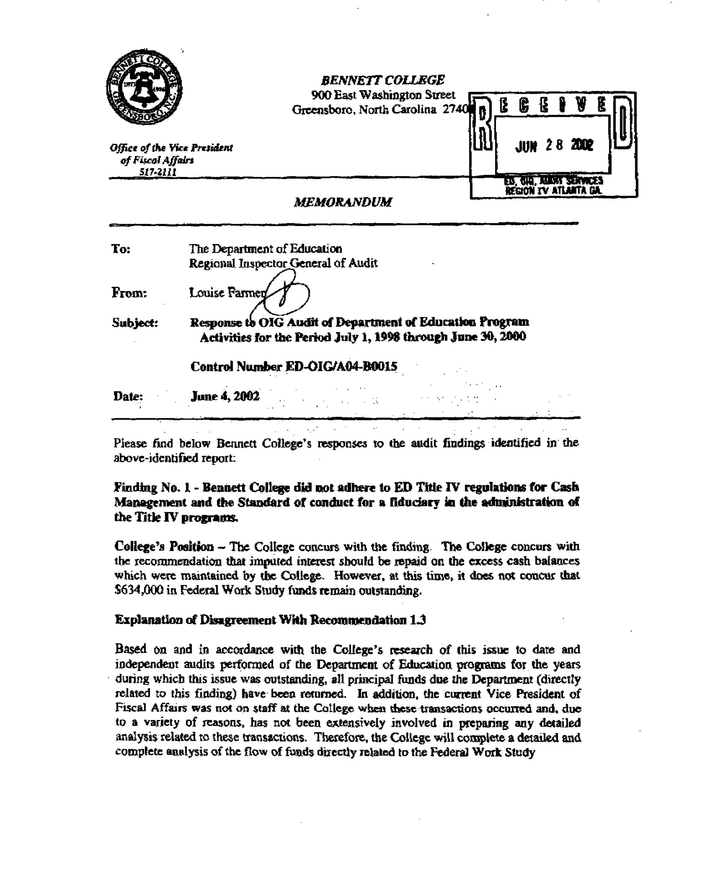
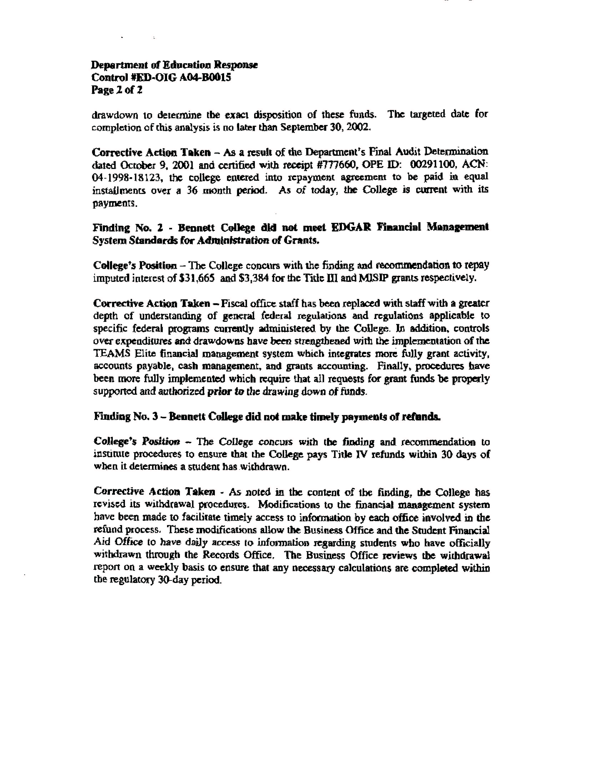

REPORT DISTRIBUTION LIST
Control Number OIG / A04-B0015

Copies
Auditee
Dr. Johnnetta B. Cole 1
President
Bennett College

ED Action Official
Theresa S. Shaw, Chief Operating Officer 1
Federal Student Aid
Department of Education

ED Collateral Action Official
Sally Stroup 1
Assistant Secretary
Office of Postsecondary Education

Other ED Officials (electronic copy)
Audit Liaison Officer, Office of Postsecondary Education 1
Chief of Staff, Office of the Secretary 1
Deputy Secretary, Office of the Deputy Secretary 1
Under Secretary, Office of the Under Secretary 1
Assistant Secretary, Office of Intergovernmental and Interagency Affairs 1
Office of General Counsel 1
Correspondence Control, Office of General Counsel 1
Chief Financial Officer, Office of the Chief Financial Officer 1
Post Audit Group, Office of the Chief Financial Officer 1
Director of Financial Improvement and Post Audit Operations, 1
Office of the Chief Financial Officer
Legislation and Congressional Affairs 1
Director, Office of Public Affairs 1
Director, Communications 1
Area Case Director for Case Management and Oversight 1

Office of Inspector General
Inspector General 1
Deputy Inspector General 1
Assistant Inspector General for Analysis and Inspection 1
Assistant Inspector General for Investigation 1
Assistant Inspector General for Audit 1
Regional Audit Offices 1
General Operations Team 1
Director, Student Financial Advisory and Assist Team 1
Director, Financial Statements Internal Audit Team 1
Director, Systems Internal Audit Team 1
Director, Operations Internal Audit Team 1
Director, Advanced Techniques Coordination Team 1
Audit Team Members 1

Imputed interest cost is the Government’s cost of borrowing money to replace funds transferred from the U.S. Treasury unnecessarily. The cost is calculated at the Treasury’s cost of borrowing money during the period that excess funds are issued until the funds are repaid.

