CCD development R&D

The development of high resistivity, n-type CCDs for SNAP is divided into two efforts. First, the LBNL in-house fabrication facility is used to test advanced design concepts and to establish performance benchmarks for commercial CCDs. Second, these designs and their fabrication recipe are transferred to a commercial foundry so that large production runs can be done quickly and inexpensively.

To support the development efforts, a testing facility is being built to measure CCD electrical and optical performance. For a subset of devices, we perform pre and post radiation exposure measurements. Prior to testing, individual CCDs must be packaged to allow thermal and electrical contact. We are building a clean room for this activity.

The R&D tasks described below are
- Commercialize CCDs.
- Build test facility.
- Test CCDs.
- Build assembly facility.
- CD1 planning.

Commercialize CCDs

In this set of activities we are advancing design ideas in the LBNL fabrication facility and pushing multiple runs of CCDs through a commercial foundry.

LBNL fabrication

To date, two LBNL large format CCD runs have been started. One is complete and the other is mostly so. Devices as large as 2k x 4k with 15 μm pixels have been built and tested with good results. On the same wafers there are modestly large devices with 10.5 μm and 12 μm pixel sizes that are relevant for SNAP. Testing of these has only begun. There are also a variety of readout structures on these devices – various sizes of source follower FETs and layout. Noise measurements and other electrical tests are leading to a selection among the options.

In early 2001, additional fabrication of CCDs will start. While these will not be of the SNAP format, large devices will cover the area of the wafer that could be populated with SNAP devices. From this, we will obtain yield information to evaluate LBNL as a backup foundry for CCDs. There will be other devices on the periphery for additional testing of small pixel sizes and readout structures that are relevant to SNAP. All devices will be used as controls for monitoring the commercially produced ones.

LBNL fabricated 4” wafer containg an 2k x 4k, 15 μm CCD.
The other two large devices have 10.5 μm and 12 μm pixels.

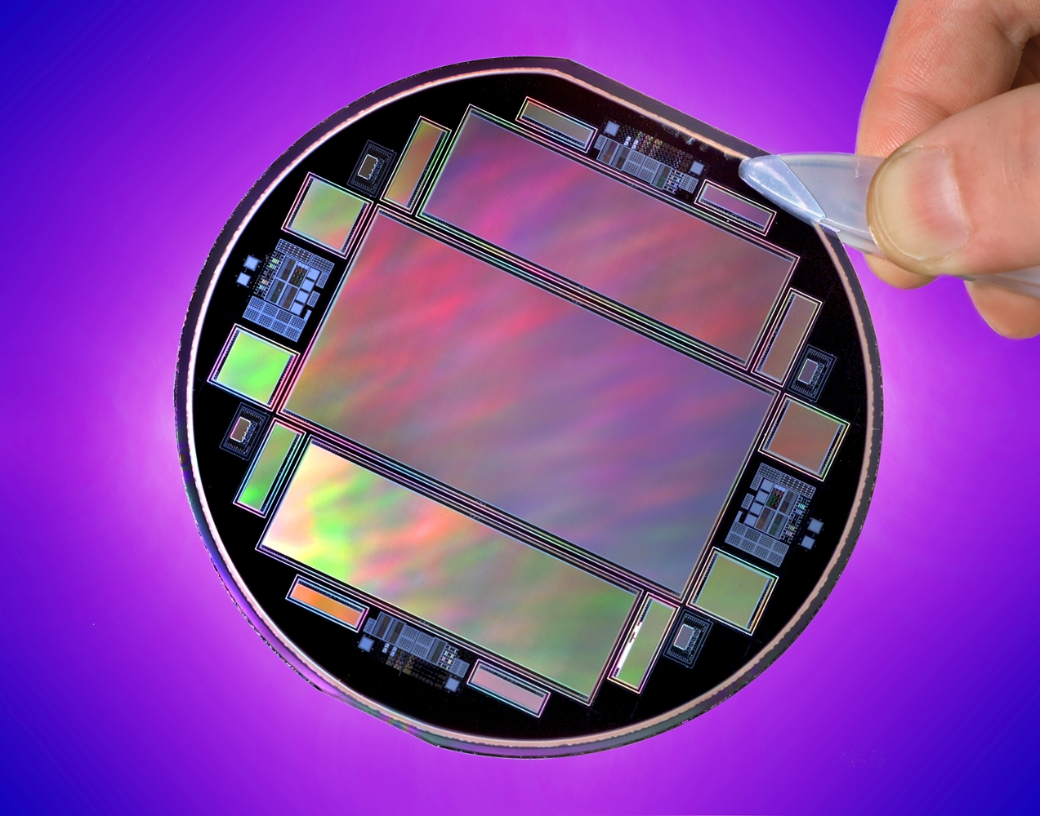

Commercially produced 4” wafer containing LBNL 2k x 2k, 15 μm CCDs.

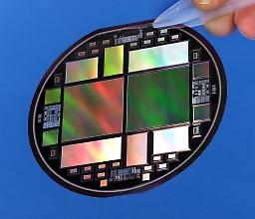

Commercial fabrication

The design for the first LBNL large format CCDs has been fabricated at a commercial foundry. The 2k x 2k devices are functional and many of the smaller format devices have been tested electrically and optically and a few have been radiation damaged. The results are encouraging.

The commercial vendor has switched from 4” wafers to 6” ones. To monitor the critical steps of the new process, wafers comprised of an array of 3 mm x 3 mm PIN diodes has been fabricated. These should be complete in December 2000 and we will then map the areal quality of the wafers. Some will also be measured for dark current after radiation exposure.

In January 2001 we will submit a design containing our best current guess for the physical format of a SNAP CCD. At the moment, we think that nine CCDs can be packed onto a production wafer. These first wafers will not contain SNAP format CCDs exclusively, but the SNAP ones will be of the production format and contain samples with 10.5 μm and 12 μm pixels. This run of wafers will have two lots. The first lot will not go through the wafer thinning process so that we can receive a lot as soon as possible to perform electrical and radiation tolerance measurements. The second lot will be thinned to 300 μm so that optical performance can be measured. The first lot should be available 16 weeks after design submission, a schedule quoted by the vendor.

We hope to be able to submit two additional prototyping runs during the period of the R&D phase. The second run will incorporate additional guard ring structures if our radiation damage tests on in-hand prototypes show them to be effective. Both runs will include the crucial wafer-thinning step.

Build test facility

To support the testing of CCDs we have purchased or constructed three dewars and have purchased two UCSD controllers interfaced to two SUN workstations. One dewar and controller have been in service for well over a year and the local electronics has been continually evolving to reduce system noise and to provide clocking flexibility to readout the CCDs in their various modes. The newest generation of this electronics is being outfitted to all three dewars.

The software in the controllers and in the workstations is continually evolving as new measurement procedures are established, become routine, and need to be automated. For example, an IDL control panel has been developed to easily measure CTE, dark current, x-ray spectra, and noise. The controller DSP software has been embellished to allow setting voltages in volts rather than digital units. Further enhancements needed are support for trap measurement via pocket pumping and for additional CTE measurement methods. Other needs will arise over the next 18 months as we elaborate out test procedures, especially as more optical testing is introduced.

Test CCDs

For well over a year we have building up our test abilities. Until very recently these have concentrated on non-optical measurements. Over the next year we will be adding more optical performance test capabilities.

At the end of the R&D phase we will have developed documented procedures for qualifying CCDs. Besides insuring quality control during construction, this will determine how complex a production test facility we will have to build.

Non-optic measurements

The first things we measure on a new CCD are its dark current and read noise using dark exposures. For parts packaged for front illumination an ⁵⁵Fe source is used. If we can see the Mn Kα and Kβ peaks we are pretty sure we have a functioning device. The Kα line is then used to measure parallel and serial CTEs.

It would be interesting to measure the dark current and CTE as a function of temperature. This has proven difficult because of uncertainty of our temperature and its stability. A program to improve the temperature regulation is being implemented now.

As part of a general improvement to our on-cryostat electronics to reduce system noise, we are implementing a scheme to control the linear rise and fall times of the clocks. These will be used to optimize gain and noise as we start increasing the readout rate to 100 kHz required by SNAP.

Optical measurements

We are in the early stages being able to project light onto CCDs. We have successfully imaged flat fields, test patterns, and pin holes. With the pinholes we have been able to study linearity and well depth for different pixel sizes and to study erase strategies for persistent images from over exposures.

Improvements over the next year will permit a measurement of CTE as a function of pixel charge, locate trap sites, and measure MTF and QE. These require a combination of software enhancements and hardware purchases.

Another important program for the next year is to understand diffusion for backside illuminated devices. For our thick devices, diffusion is a function of the thickness, wavelength, and depletion voltage. This can be measured with pinholes of varying size. We note that cosmic rays can also provide an interesting measurement of diffusion.

Radiation damage testing

Degradation of CTE and creation of blemishes due to radiation in space are a critical concern for CCDs. While our n-type, high resistivity, p-channel devices should be inherently more hardy than devices used before, we must demonstrate this. At LBNL we have access to the 88” Cyclotron where w are doing radiation dosing approximately bi-monthly. Our first test was ambitious. We exposed a cold, powered device up to 6x10⁹ protons/cm² at 13 MeV and it survived with some observed shifts in the operating point of the source follower FET. This is well in excess of the expected SNAP lifetime exposure.

Our more recent studies have been done with unpowered devices at room temperature. We have so far tested four devices during two runs, incrementally upping the integrated dose in each. A third exposure of these devices will be done at the end of January. Our procedure is to measure the source follower I-V and sub-threshold curves pre and post radiation. The devices are then tested cold pre and post radiation for dark current, CTE, read noise, and blemishes. Results today are very encouraging. After the completion of the third exposure we will see if thermal annealing provides any damage recovery.

Slated instrumentation improvements to improve our radiation studies are lower system noise to better detect subtle changes and the introduction of a pocket-pumping test to map out trap sites. Radiation testing will be on going. We want to move towards performing exposures at lower, more realistic dose rates on powered, cold devices. Besides the 88” Cyclotron, we also have access to a ⁶⁰Co source at LBNL if we determine that pure ionization radiation dosing can produce additional information.

Build assembly facility

Before a CCD can be tested it needs to be packaged so that thermal and electrical contact can be made. To date, we have been doing packaging in a conventional lab environment. This has been adequate for the electrical of the last year. As optical measurements become more important we need to control dust. Also, to measure the yield of CCD production we need to implement strict, repeatable ESD protection procedures. We have constructed a Class 10000 clean room for assembling the CCDs onto their mounts. Supporting equipment installed are a refrigerator for epoxy storage, a vacuum oven, a laminar flow bench, and a wire-bonder.

CD1 planning

A major deliverable at the end of R&D is a cost and schedule for producing fully tested CCDs. From the prototyping runs we will know the foundry production costs and turn-around times and our testing program will measure the yield of usable devices. From these we can establish a fabrication cost and schedule.

The yield of devices will also determine how large a production test facility we will have to construct. Our experience with the R&D test facility will establish the equipment and labor costs required for a production facility.

Planning for long lead procurements

It is likely that at the time of CD1 we would seek approval to move ahead with the procurement of production CCDs as fast as possible, subject to the state of the prototype development. There are three reasons for this. One, ASIC fabrication runs have an associated risk of failure where months of delay can be incurred while the problem is diagnosed and parts are re-fabricated. Two, production yields can vary and additional time can be required for additional production runs. Three, a chosen semiconductor technology may not be long lived and may no longer be available if there is a large gap between development and production, e.g., our present foundry has changed from 4” to 6” wafer size during our brief relationship with them.

R&D deliverables

The table below highlights deliverables generated during the R&D effort.

Deliverable | Completion Date
Development CCDs
LBNL | Jul-2001
Commercial 2 | May-2001
Commercial 3 | Nov-2001
Commercial 4 | Jun-2002
Requirements for production test facility and test procedures | 2-Aug-2002
Fabrication & test cost and schedule | 2-Oct-2002

Risk assessment

Preliminary indications are that both LBNL CCDs and commercially produced versions function well: read noise is low, CTEs are good, dark current is low, and radiation tolerance is acceptable. The statistics are low at this time but the number of tested devices will increase greatly over the next twelve months. The risk areas for the construction phase are 1) can 6” wafers be thinned to 300 μm or less with good yield, 2) will the yield from commercial vendor be acceptable, and 3) will the commercial vendor be interested in production at the end of the development phase. One and two effect the cost and time of production and testing. There is no indication that three will be a problem. To cover all three risk areas we are exploring using the LBNL 4” fabrication line as a backup. The first run of 2001 will answer wafer yield questions including thinning and we will be assessing upgrade costs to make this a small production facility.

Manpower

The table below shows the manpower estimates that have been derived from a resource load schedule.

Personnel | Category | FTE
 |  | FY01 | FY02
S. Holland | Engineer | 1.00 | 1.00
N. Palaio | Engineer | 1.00 | 1.00
G. Wang | Engineer | 1.00 | 1.00
A. Karcher | Engineer | 1.00 | 1.00
W. Kolbe | Engineer | 0.90 | 0.90
B. Turko | Engineer | 0.25 | 0.25
J. Lee | Technician | 1.00 | 1.00
R. Kuiper | Machinist | 0.05 | 0.05
M. Uslenghi | Scientist | 1.00 | 1.00
A. Secroun | Scientist | 1.00 | 1.00
B. Frye | Scientist | 1.00 | 1.00

A brief description of the personnel follows:
- Steve Holland is an LBNL engineer and is the inventor of the high resistivity, n-type CCD detectors. He heads the LBNL Micro Systems Lab where the in-house devices have been fabricated.
- Nick Palaio is an LBNL semiconductor process engineer at the Micro Systems Lab.
- Guobin Wang is an LBNL semiconductor engineer at the Micro Systems Lab.
- Armin Karcher is an electrical engineer with experience in digital board level design and has been responsible for establishing the LBNL CCD test facility.
- Bill Kolbe is an LBNL engineer with a broad experience in developing scientific instruments many incorporating optics systems.
- Boyan Turko is an LBNL engineer with a long history in the application of CCDs and their low noise readout.
- Joong Lee is an LBNL technician in the CCD lab with responsibility for electronics support and for developing the SUN-based readout software.
- Richard Kuiper is a machinist adjacent to the CCD lab and does occasional fabrication.
- Michela Uslenghi is a UC Berkeley postdoc with prior experience in the use of CCDs with image intensifiers.
- Aurelia Secroun is a UC Berkeley postdoc who has prior experience in CCD testing and has most recently been developing the requirements for the SNAP star tracker.
- Brenda Frye is an LBNL postdoc who has been working with supernova cosmology project.

Budget summary

The table below contains the budget summary in k$ excluding scientist salaries.

WBS |  | FY01 |  |  | FY02
 | EDIA | Material | Total | EDIA | Material | Total
A.1.12.3 | 452 | 276 | 728 | 475 | 97 | 571

Schedule summary

A schedule summary is shown below which tracks the narrative above. The fully expanded schedule is provided elsewhere.

