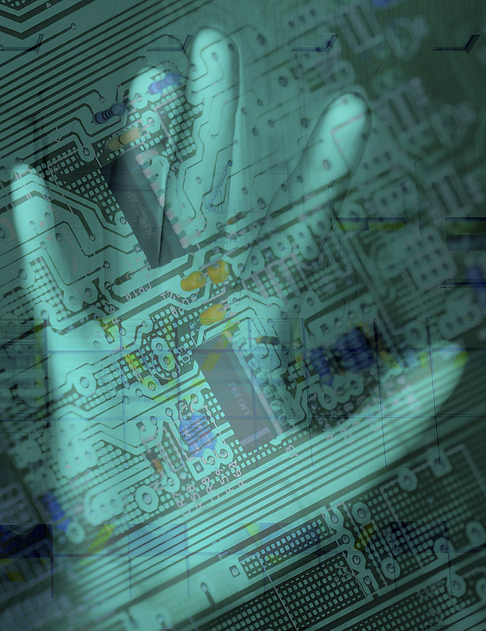

Geeks Bearing Gifts
unwrapping new technology trends

 | :unwrapping new technologies

- Introduction (10 minutes)
- Can You Hear Me Now: new waves in audio and video (25 minutes)
- Blackberry Thumb: instant messaging, chat, and SMS (20 minutes)
- I Always Feel Like Somebody’s Watching Me: spyware and other malware (25 minutes)
- Alphabet Soup: wireless standards (25 minutes)
- Break (15 minutes)
- Faster Than a Speeding Bullet! internet2 (20 minutes)
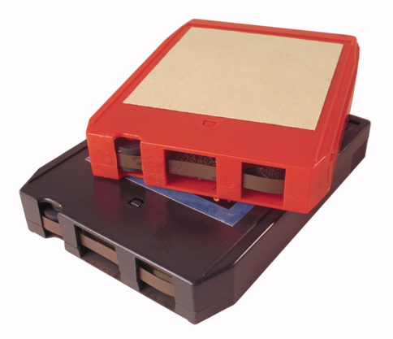
- Let My Software Go: the open source software movement (10 minutes)
- I Know What You Took Last Night: radio frequency identifiers (RFID) (20 minutes)
- Technolust: foxy new equipment (15 minutes)
- Web Gone Wild: wikis, rss, blogs, and social networking software (60 minutes)
- Conclusion, questions, evaluations (15 minutes)

Can You Hear Me Now:
new waves in audio and video

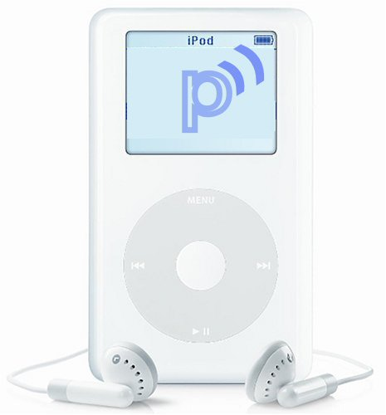 | Podcasting

Podcasting is a method of publishing audio programs via the Internet, allowing users to subscribe to a feed of new files (usually MP3s). It became popular in late 2004, largely due to automatic downloading of audio onto portable players or personal computers. Podcasting is distinct from other types of online media delivery because of its subscription model, which uses a feed (such as RSS or Atom) to deliver an enclosed file. Podcasting enables independent producers to create self-published, syndicated “radio shows,” and gives broadcast radio programs a new distribution method. Listeners may subscribe to feeds using “podcatching” software (a type of aggregator), which periodically checks for and downloads new content automatically. Most podcatching software enables the user to copy podcasts to portable music players. Any digital audio player or computer with audio-playing software can play podcasts. From the earliest RSS-enclosure tests, feeds have been used to deliver video files as well as audio. By 2005 some aggregators and mobile devices could receive and play video, but the “podcast” name remained most associated with audio.
“Podcasting” is a portmanteau word that combines the words “broadcasting” and “iPod.” The term can be misleading since neither podcasting nor listening to podcasts requires an iPod or any portable player. Aware of that misleading association from the beginning, some writers have suggested alternative names or reinterpretations of the letters “p-o-d”, without winning much of a following. Another little-used alternative is “blogcasting”, which implies content based on, or similar in format to, blogs.
Uses
- Distribution of ad hoc or informal “radio shows” such as Greg Schwartz’s library-oriented show “Open Stacks.”
- Education: course lectures and hands-on language exercised can be podcast.
- Religious groups podcast talks and sermons. This is known as Godcasting.

Adapted from the wikipedia article: http://en.wikipedia.org/wiki/Podcast
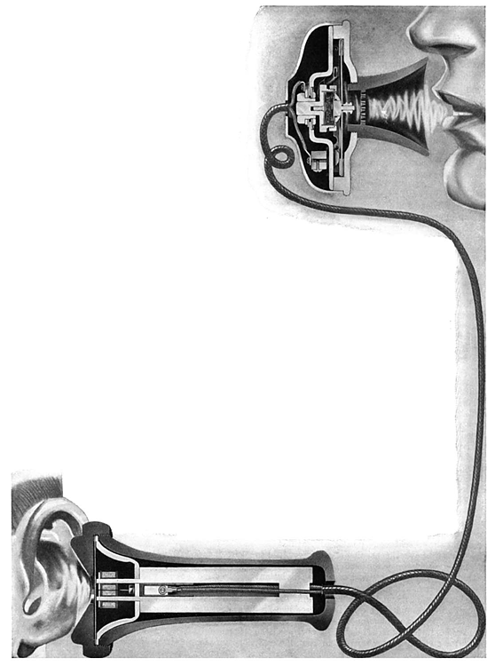
Podcast
Resources

How To
- How-To: Podcasting (get Podcasts and make your own) from Engadget
http://tinyurl.com/3tran
- Howto: Create Your Own Podcasting Show on Windows from ZefHemel.com
http://tinyurl.com/a5uy4
- How to Explain Podcasting to a Flashing 12
http://www.podcast411.com/f12.html
- How to Make an RSS/XML Audio Feed from audiofeeds.org
http://audiofeeds.org/tutorial.php
Directories
- Blast Podcast  http://www.blastpodcast.com | - iTunes (“Podcatcher” and directory)  http://www.apple.com/itunes/
- Podcast Alley
http://www.podcastalley.com

Library-Related Podcasts
- Open Stacks
Promoting information access and literacy for all.
http://openstacks.net/os/

Health-Related Podcasts
- Family Health
A daily series of 2 1/2 minute radio programs heard on over 250 radio stations.Providing practical, easy-to-understand, honest health information on common health problems and the latest health care developments.
Topics have included side effects of medications, cause and treatment of insomnia, variocele and young men, good cholesterol numbers and heart attacks, and preventing skin injuries
http://fhradio.org/
- NPR: Health and Science
From NPR: in-depth reports on medicine, the environment, space and more. The best of Morning Edition, All Things Considered and other award-winning NPR programs.
Stories from one episode included information about recovering from Hurricane Katrina and bird flu.
http://tinyurl.com/b7xza
- Mayo Clinic – Medical Edge Radio
Medical Edge Radio from Mayo Clinic -- a daily 60-second health segment -- features general health and people-focused stories covering medical breakthroughs and compelling health information. Mayo Clinic physicians rigorously evaluate all stories for medical validity and newsworthiness.
Topics have included wrist fractures in children, wrinkles, TPA for stroke, hypertension, and juvenile arthritis.
Available as podcast only through iTunes
- The New England Journal of Medicine Audio Interviews
The New England Journal of Medicine (NEJM) Audio interview RSS feed. NEJM (http://www.nejm.org) is a weekly general medical journal that publishes new medical research findings, review articles, and editorial opinion on a wide variety of topics of importance to biomedical science and clinical practice.
http://tinyurl.com/af9cx
- Blast Podcast health-related podcasts
http://tinyurl.com/7brxy
- There are many other health-related podcasts available through iTunes by searching on “health” or “medicine.”

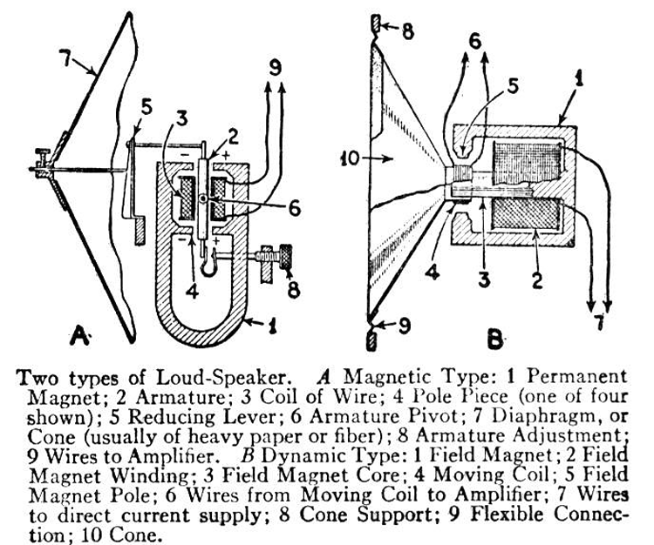
Podcatchers
for Windows
- iTunes
http://www.apple.com/itunes/
- iPodder
http://ipodder.sourceforge.net/index.php
- Doppler
http://www.dopplerradio.net/
- Nimig
http://www.nimiq.nl/
- Podfeeder (Currently for Windows only. OSX and Linux in the works.)
http://www.podfeeder.com/

for Macintosh
- iTunes
http://www.apple.com/itunes/
- iPodderX
http://ipodder.sourceforge.net/index.php
- PlayPod
http://www.iggsoftware.com/playpod/

 | Vodcasting

Vodcast is an emerging term used for the online delivery of video on demand content via RSS enclosures. The format is used by video weblogs (also known as vlogs, vodding, vlogcasting, or vidcasting). The term is an evolution specialized for video, coming from the generally audio-based "podcast."

Vodcast Resources

Directories

- Vodcasts.tv
http://www.vodcasts.tv

- Tech Shows
http://www.filefarmer.com/techshows/

- iTunes
http://www.apple.com/itunes/

Adapted from the wikipedia article: http://en.wikipedia.org/wiki/Vodcast
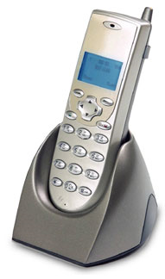 | VoIP  (Voice over IP)

Voice over Internet Protocol (also called VoIP, IP Telephony, Internet telephony, and Digital Phone) is the routing of voice conversations over the Internet or any other IP-based network. The voice data flows over a general-purpose packet-switched network, instead of traditional dedicated, circuit-switched voice transmission lines.

Definition: packet switching and circuit switching | The difference between a packet switching network and a circuit switching network is that the former breaks transmitted data into small, discrete groups of information that are individually routed between nodes over conduits that may be shared by other nodes and the latter establishes a direct and exclusive connection between two the two nodes for the duration of the exchange.

Voice over IP traffic may be deployed on any IP network, including ones lacking a connection to the rest of the Internet, for instance on a private building-wide LAN.

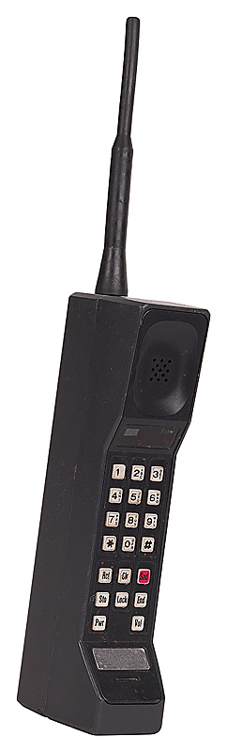
Advantages
- Innovation: VoIP developers respond to market pressures rather than at the pace of the International Telecommunications Union (ITU), resulting in speedy adoption of new or advanced features.
- Lower cost: supporters claim that VoIP is cheaper than service from traditional services, and, in fact, VoIP is cheaper since calls, even international calls, may be considered to be free; however, many VoIP services require subscription to a data service also. For instance, a telecommunications service that advertises VoIP as free may require the user to obtain DSL service. For instance, Skype is considered, in some instance, to be free. The assumption is that the user already has access to a broadband connection, which may or may not be cheaper than traditional telephone service. For users who already have broadband service, this can be a major cost savings.
- Increased Functionality. VoIP makes easy some things that are difficult to impossible with traditional phone networks.
  - Incoming phone calls are automatically routed to your VoIP phone, irrespective of where you are connected to the network. Take your VOIP phone with you on a trip, and anywhere you connect it to the Internet, you can receive your incoming calls.
  - Call center agents using VoIP phones can easily work from anywhere with a good Internet \be provided. This includes sending and receiving messages or data files in parallel with the voice conversation, audio conferencing, managing address books and passing information about whether others (e.g. friends or colleagues) are available online to interested parties.

Disadvantages
- Power dependence: Traditional telephones are powered by telephone lines; therefore, they continue to work even when the power goes down. VoIP phones use broadband modems which go down when the power is out.
- Latency: While packet switching takes best advantage of the structure of the internet, IP packets can often be lost or delayed between the end points of the communication.
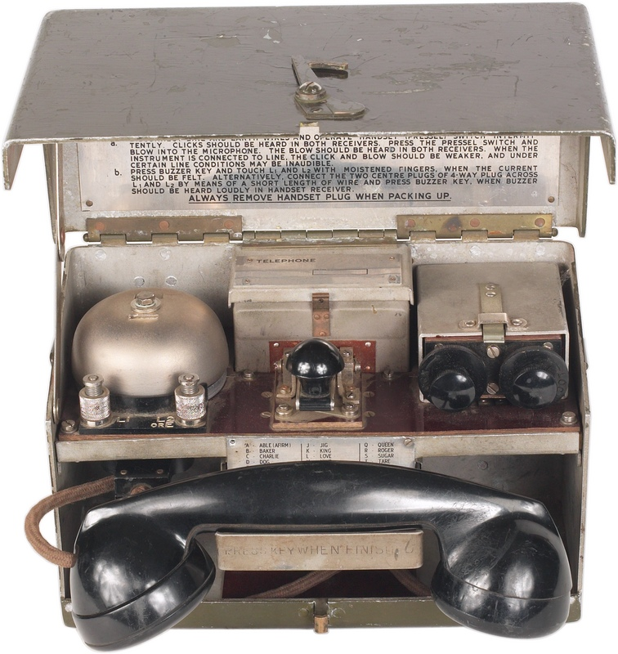
- 911: IP, as a non-geographically oriented technology, makes it difficult for emergency services to locate a caller who uses VoIP unless the caller can tell where she is. Moreover, some 911 callers may not even be connected to emergency dispatch if they dial the number on a VoIP phone. However, the US government has mandated that VoIP carriers must implement Enhanced 911 (e911) services by a certain date. Some VoIP carriers, however, are appealing the deadline.
- Lack of Integration into global telephone number system:
While the traditional Plain Old Telephone System (POTS) and mobile phone networks share a common global standard (E.164) which allocates and identifies any specific telephone line, there is no widely adopted similar standard for VoIP networks. Some allocate an E.164 number which can be used for VoIP as well as incoming/external calls. However, there are often different, incompatible schemes when calling between VoIP providers which use short codes that are provider specific.
Adapted from the wikipedia article: http://en.wikipedia.org/wiki/Voip



BlackBerry Thumb:
instant messaging, chat, and SMS

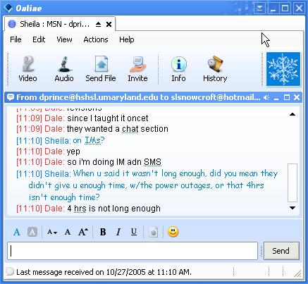 | Instant messaging (IM)

Instant messaging
Instant messaging is the act of instantly communicating between two or more people over a network such as the Internet.

Overview
Instant messaging requires the use of a client program that hooks up an instant messaging service and differs from e-mail in that conversations are then able to happen in realtime. Most services offer a "presence awareness" feature, indicating whether people on one's list of contacts are currently online and available to chat. This may be called a 'Buddy List'. In early instant messaging programs, each letter appeared as it was typed, and when letters were deleted to correct typos this was also seen in real time. This made it more like a telephone conversation than exchanging letters. In modern instant messenging programs, the other party in the conversation generally only sees each line of text right after a new line is started. Most instant messaging applications also include the ability to set a status message, roughly analogous to the message on a telephone answering machine.
Popular instant messaging services on the public Internet include Qnext, MSN Messenger, AOL Instant Messenger, Yahoo! Messenger, Google Talk, .NET Messenger Service, Jabber and ICQ. These services owe many ideas to an older (and still popular) online chat medium known as Internet Relay Chat (IRC).

In early instant messaging programs each character appeared as it was typed. The UNIX "talk" command shown in these screenshots was popular in the 1980s and early 1990s.

History
An early form of instant messaging was implemented on the PLATO system in the early 1970s. Later the UNIX/LINUX "talk" instant messaging system was widely used by engineers and academics in the 1980s and 1990s to communicate across the internet. ICQ was the first general instant messenger introduced for non-UNIX/LINUX computers in November 1996. After its introduction, a number of variations of instant messaging have arisen in parallel in many places, each with its own protocol. This has led to users running many instant messaging applications simultaneously to be available on several networks. Alternatively they could use a client which supports many protocols, such as Gaim, Trillian or Jabber clients.
Recently, many instant messaging services have begun to offer video conferencing features, Voice Over IP (VoIP), and web conferencing services have begun to integrate both video conferencing and instant messaging capabilities. Hence, the boundaries among these media have become blurred.
On December 19, 2002, AOL Time Warner announced that ICQ had been issued a United States patent for instant messaging, but they also said that they had no plans on enforcing their patent at the present time.
The term "instant messenger" is a Service Mark of AOL Time Warner and may not be used in software not affiliated with AOL. For this reason, the instant messaging client formerly known as GAIM or gAIM is now only to be referred to as Gaim or gaim.

Origin of term
The phrase "instant message" was devised by Paul M. A. Linebarger for a gimmick in the science-fiction stories he wrote in the 1960s under the pseudonym Cordwainer Smith. His instant messages were to be across interstellar distances at speeds faster than that of light, and said to be expensive so he could write plots concerning their unaffordability. From there, the phrase was picked up by members of New England Science Fiction Association, many of whom were computer professionals, for their weekly mimeographed newsletter. The phrase may have come from there. It should be noted that America Online did not originally refer to their own IM service as an instant messenger. The early software releases referred to it as "FlashMail." Early users spoke of "flashing" one another, which was probably one reason that the name was changed.

Cooperation
There have been several attempts to create a unified standard for instant messaging: IETF's SIP (Session Initiation Protocol) and SIMPLE (SIP for Instant Messaging and Presence Leverage), APEX (Application Exchange), Prim (Presence and Instant Messaging Protocol), the open XML-based XMPP (Extensible Messaging and Presence Protocol), more commonly known as Jabber and OMA's (Open Mobile Alliance) IMPS (Instant Messaging and Presence Service) created specifically for mobile devices.
Most attempts at creating a unified standard for the major IM providers (AOL, Yahoo! and Microsoft) have failed and each continues to use its own proprietary protocol although on October 13, 2005 Microsoft and Yahoo! announced that by Summer of 2006 they would interoperate.
There are two ways to to combine the many disparate protocols:
- One way is to combine the many disparate protocols inside the IM client application. Examples include Trillian, Zango Messenger, Gaim, Fire, Proteus, Miranda IM, Adium, Everybuddy, Ayttm, Kopete, Centericq, BitlBee, and IMVITE.

- The other way is to combine the many disparate protocols inside the IM server application. This approach moves the task of communicating to the other services to the server. Clients need not know or care about other IM protocols. This approach is popular in Jabber/XMPP protocol servers however the presently available server bridge modules are immature and limited with respect to the full capabilities of the IM systems they bridge to.
The IMPS standard mentioned earlier is part of a mobile telephone industry initiative to bring instant messaging to mobile phones. The Open Mobile Alliance took over the standards, originally called Wireless Village, in November 2002. There is a free IMPS-based service called Yamigo which allows instant messaging on mobile phones even if your carrier doesn't provide its own Wireless Village service. Yamigo acts as a standalone instant messaging network, but can also integrate with ICQ, AIM, MSN, Yahoo and Jabber.
Some approaches, such as that adopted by the Sonork enterprise IM software or the Jabber/XMPP network, allow organizations to create their own private instant messaging network by enabling them to limit access to the server (often with the IM network entirely behind their firewall) and administer user permissions. Typically, a dedicated corporate IM server has several advantages such as pre-populated contact lists, integrated authentication, and better security and privacy.
Some networks have made changes to prevent them from being utilized by such multi-network IM clients. For example, Trillian had to release several revisions and patches to allow its users to access the MSN, AOL, and Yahoo networks, after changes were made to these networks. The major IM providers typically cite the need for formal agreements as well as security concerns as reasons for making these changes.
Retrieved from "http://en.wikipedia.org/wiki/Instant_messaging"

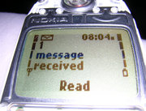 | Short message service: (SMS)

Short message service (SMS) is a service available on most digital mobile phones that permits the sending of short messages (also known as text messages, messages, or more colloquially SMSes, texts or even txts) between mobile phones, other handheld devices and even landline telephones.

History
The inventor of SMS is a Finnish civil servant by the name Matti Makkonen who then worked for a state-owned postal and telecommunications company Posti (Finland). He presented the idea in a pizzeria in Copenhagen, during a conference of mobile phone communication's future in fall of 1982. Today M. Makkonen is the CEO of Finnet. Initially conceptualized as Message Handling Services, SMS was proposed to be included in the GSM digital mobile phone standard as early as in 1984 by the Nordic Countries (in GSM WP3, a group chaired by J. Audestad). SMS was further discussed in the main GSM Group in February 1985 and it was included in the draft GSM spec (GSM Doc.28-85) the same year. The technical standard known today was largely created by IDEG's Draft Group on Message Handling in 1987–1990, first chaired by Friedhelm Hillebrand. The first commercial short message was sent on 3 December 1992 by Neil Papworth of Sema Group from a personal computer to Richard Jarvis of Vodafone on the Vodafone GSM network in the United Kingdom.
SMS was originally designed as part of GSM, but is now available on a wide range of networks, including 3G networks. However, not all text messaging systems use SMS, and some notable alternate implementations of the concept include J-Phone's SkyMail and NTT Docomo's Short Mail, both in Japan. E-mail messaging from phones, as popularized by NTT Docomo's i-mode and the RIM BlackBerry, also typically use standard mail protocols such as SMTP over TCP/IP, not SMS.
Definitions:  GSM & 3G | GSM: Global System for Mobile Communications, a mobile phone standard that has built in data communications: both voice and signaling are digital. GSM is a 2G technology.  3G: third generation mobile phone technology: includes both voice data and non-voice data such as information, email, instant messaging, music, and movies.

Popularity
Short message services are developing very rapidly throughout the world. By mid-2004 texts were being sent at a rate of 500 billion messages per annum. At an average cost of USD 0.10 per message, this generates revenues in excess of 50 billion for mobile telephone operators and represents close to 100 text messages for every person in the world. Growth has been rapid; in 2001, 250 billion SMS messages were sent, in 2000 just 17 billion. SMS is particularly popular in Europe, Asia (excluding Japan and Korea) and Australia. Popularity has grown to a sufficient extent that the term texting (used as a verb meaning the act of cell phone users sending SMS text messages back and forth) has entered the common lexicon. In China, SMS is very popular, and has brought service providers large profit (18 billion SMS were sent in 2001).
SMS messages are particularly popular amongst young urbanites. In many markets, the service is comparatively cheap. For example, in Australia a message typically costs between AUD 0.20 and AUD 0.25 to send, compared to a voice call, which costs anywhere between AUD 0.40 and AUD 2.00 per minute.
The most frequent texters are found in south-east Asia. In Singapore, hundreds of messages can be sent per month for free, after which messages cost between SGD 0.05 and SGD 0.07 each to send. The same pricing format is followed in the Philippines where the average user sent 2,300 messages in 2003, making it the world's most avid texting nation. SMS is a part in almost all marketing campaigns, advocacy, and entertainment. In fact, SMS is so inexpensive (messages cost PHP 1.00 (about USD 0.02) to send), influential, powerful, and addictive for Filipinos that several local dotcoms like Chikka Messenger, GoFISH Mobile, and Bidshot now fully utilize SMS for their services.
Europe follows next behind Asia in terms of the popularity of texting. In 2003, an average of 16 billion messages were sent each month. Users in Spain sent a little more than fifty messages per month on average in 2003. In Italy, Germany and the United Kingdom the figure was around 35–40 texts per month. In each of these countries the cost of sending a text varies from as little as £0.03 - £0.18 depending on the payment plan. Curiously France has not taken to texting in the same way, sending just under 20 texts on average per user per month. France has the same GSM technology as other European countries so the uptake is not hampered by technical restrictions. Part of the reason for the lack of uptake may be due higher prices due to weak competition in the mobile market - the key player Orange is owned by subsidized France Télécom. However some telecom analysts suggest that this factor has dissipated in recent years and say that the reason may be cultural - text messaging is associated with a fast pace of life and France is more reluctant than others to dispense with its traditions.

In the US, however, the appeal of SMS is even more limited. Although a SMS usually costs only USD 0.05 (many providers also offer monthly allotments), only 13 messages were sent by the average user in 2003. The reasons for this are varied – many users have unlimited "mobile-to-mobile" minutes, high monthly minute allotments, or unlimited service. Moreover, push to talk services offer the instant connectivity of SMS service and are typically unlimited. Further the integration between competing providers and technologies necessary for cross-network texting has only been available recently. SMS is also typically an opt-in service in the United States - thus sending a message is much less a guarantee of receipt than in other countries. However the recent addition of AT&T-powered SMS voting on the television program American Idol has introduced many Americans to SMS, and usage is on the rise.
In addition to SMS voting, a different phenomenon has risen in more cell phone saturated countries. In Finland some TV channels began "SMS Chat", which involved sending short messages to a phone number, and after a certain while the message would be shown on TV. Chats are always moderated, which prevents sending harmful material to the channel. The craze soon became popular and evolved into games, first slow-paced quiz and strategy games. After a while, faster paced games designed for television and SMS control were designed. Games tend to involve registering one's nickname, and after that sending SMSs for controlling a character on screen. Messages usually cost 0.05 to 0.86 euros apiece, and games can require sending dozens of messages. In December 2003 Finnish TV-channel MTV3 put on air Santa Claus character reading aloud messages sent by SMS. Some customers were later accused of "hacking" after they discovered a way to control Santa's speech synthesizer. More recent late-night attractions on the same channel include "Beach Volley", in which bikini-clad female hostess blocks balls "shot" with text-messages. On March 12 2004, first entirely "interactive" TV-channel "VIISI" began its operation in Finland. That did not last long, though, as SBS Finland Oy took over the channel and made it a music channel named "The Voice" in November 2004.
Text messaging is also popular in Japan. However, it is known by different names depending on the mobile service. With NTT DoCoMo, it is known as "i-mode mail." With AU, it is known as "C-Mail." Mobile e-mail is usually the norm when sending messages between phones with different services, but between phones using the same service, text messaging is more prevalent.
A few widely publicized speed contests have been held between expert Morse code operators and expert SMS users (see references). Morse code has consistently won the contests, leading to speculation that cellphone manufacturers may eventually build a Morse code interface into cellphones. The interface would automatically translate the Morse code input into text so that it could be sent to any SMS-capable cellphone so therefore the receiver of the message need not know Morse code to read it. Other speculated applications include taking an existing assistive application of Morse code and using the vibrating alert feature on the cellphone to translate SMS messages to Morse code for silent, hands free "reading" of the incoming messages. Several cellphones already have informative audible Morse code ring tones and alert messages, for example: many Nokia cellphones have an option to beep SMS in Morse code when it receives an SMS text message. There are third party applications already available for some cellphones that allow Morse input for SMS (see references).
An increasing trend towards spamming cell phone users through SMS has prompted cellular service carriers to take steps against the practice, before it becomes a widespread problem. No major spamming incidents involving SMS have been reported as of October 2003, but the existence of cell-phone spam has already been noted by industry watchdogs, including Consumer Reports magazine.

Txt speak
Because of the limited message lengths and tiny user interface of mobile phones, SMS users commonly make extensive use of abbreviations, particularly the use of numbers for words (for example, "4" in place of the word "for"), the omission of vowels, as in the phrase "txt msg", or the replacement of spaces with capitalization, such as "ThisIsVeryCool". To avoid the even more limited message lengths allowed when using Cyrillic or Greek letters, some Eastern Europeans use the Latin alphabet for their own language.
Historically, this language developed out of shorthand used in chatrooms on the Internet, where users would abbreviate some words to allow a response to be typed more quickly. However, this became much more pronounced in SMS, where mobile phone users don't generally have fully access to a QWERTY keyboard as chatroom users did, and more effort is required to type each character.
In Mandarin Chinese, numbers that sound similar to words are used in place of those words. For example, the numbers 521 in Chinese ("wu er yi") sound like the words for "I love you" ("wo ai ni"). The sequence 748 ("qi si ba") sounds like the curse for "drop dead".
Predictive text software that attempts to guess words (AOL's T9) or letters (Eatoni's LetterWise) reduces the labor of time-consuming input. This makes abbreviations not only less necessary, but slower to type than regular words which are in the software's dictionary. However it does make the texts longer, often requiring the text message to be sent in multiple parts and therefore costing more to send.
An example of some is the following passage translated from William Shakespeare's A Midsummer Night's Dream: If we shadwoes ave ofendd. Thnk bt ths & al is mnded. That u ave but slumer’d ere; while thse visions did appr; & this wk & idel theme; no mre yielding bt a dream. Gentles, do nt reprehend; if u pardon we wil mend; & I am honst Puck;

Social Impact of SMS
SMS has caused subtle but interesting changes in society since it became popular. News worthy events include (in chronological order):
- In January 2001, Joseph Estrada was forced to resign from the post of president of the Philippines. The popular campaign against him was widely reported to have been co-ordinated with SMS chain letters.
- In July 2001, Malaysia's government decreed that an Islamic divorce (which consists of saying "I divorce you" three times in succession) was not valid if sent by SMS.
- A cheating scheme was uncovered during final-exam week at the University of Maryland, College Park in December 2002, when a dozen students were caught cheating on an accounting exam through the use of text messages on their cell phones. Similarly, Hitotsubashi University in Japan failed 26 students in December 2002 for receiving e-mailed exam answers on their cell phones.
- In October 2003, a Filipino immigrant living in Belgium was arrested by police after a friend sent him a joke SMS pretending to be the world's most wanted terrorist. The SMS read 'I was wondering if I can stay with you for a couple of days. Everybody's so angry at me. And I really need a friend. Yours truly, Osama bin Laden.' .
- During the 2004 Philippine presidential elections, SMS was a popular form of electoral campaigning for and against candidates such as incumbent president Gloria Macapagal-Arroyo and main contender Fernando Poe, Jr..
- In June 2004, a British punk rock fan was questioned by police, regarding a text message containing lyrics from "Tommy Gun" by The Clash, "How about this for Tommy Gun? OK - so let's agree about the price and make it one jet airliner for 10 prisoners.".
- In August 2005, a SMS chat sculpture was installed at the annual diploma exhibition of Dresden's University of Art HfBK. The artist Matthias Haase explores today's means of social interaction. Visitors may participate in the art work by sending a text message to the sculpture, which projectes the SMS onto a screen 1, SMS chat sculpture.
- A hoax involving SMS following the Helios Airways Flight 522 plane crash on August 14, 2005: News media widely reported that shortly before the crash a passenger sent a SMS transmission indicating that the pilot had become blue in the face, or roughly translated as "The pilot is dead. Farewell, my cousin, here we're frozen." Police later arrested Nektarios-Sotirios Voutas, a 32 year-old private employee from Thessaloniki who admitted that he had made up the story and given several interviews in order to get attention.
- During Hurricane Katrina many residents, unable to make contact with relatives/friends using traditonal landline phones, communicated via text messaging.
Adapted from "http://en.wikipedia.org/wiki/Short_message_service"



I Always Feel Like Somebody’s Watching Me:
spyware and other malware

 | The Software Who Loved Me:  spyware
Spyware is a broad category of malicious software intended to intercept or take partial control of a computer's operation without the user's informed consent. While the term taken literally suggests software that surreptitiously monitors the user, it has come to refer more broadly to software that subverts the computer's operation for the benefit of a third party.
Spyware differs from viruses and worms in that it does not usually self-replicate. Like many recent viruses, spyware is designed to exploit infected computers for commercial gain. Typical tactics furthering this goal include delivery of unsolicited pop-up advertisements; theft of personal information (including financial information such as credit card numbers); monitoring of Web-browsing activity for marketing purposes; or routing of HTTP requests to advertising sites. In some cases, spyware may be used to verify compliance with a software license agreement (or EULA).
As of 2005, spyware is only a common problem for computers running Microsoft Windows operating systems. Some worms or rootkits able to attack Linux and other Unix platforms include spyware-like functions, and keyloggers or other similar monitoring software exists for nearly every operating system.
According to an October 2004 study by America Online and the National Cyber-Security Alliance, 80% of surveyed users' computers had some form of spyware, with an average of 93 spyware components per computer. 89% of surveyed users with spyware reported that they did not know of its presence, and 95% reported that they had not given permission for it to be installed.

Spyware, "adware", and tracking
The term adware frequently refers to any software which displays advertisements, whether or not it does so with the user's consent. Programs such as the Eudora mail client display advertisements as an alternative to shareware registration fees. These classify as "adware" in the sense of advertising-supported software, but not as spyware. They do not operate surreptitiously or mislead the user.
Many of the programs frequently classified as spyware function as adware in a different sense: their chief observed behavior consists of displaying advertising. Claria Corporation's Gator Software provides an example of this sort of program. Visited Web sites frequently install Gator on client machines in a surreptitious manner, and it directs revenue to the installing site and to Claria by displaying advertisements to the user. The user's experience is that their computer begins displaying a large number of pop-up advertisements.
Other spyware behaviors, such as reporting on Web sites the user visits, frequently accompany the displaying of advertisements. The goal of monitoring Web activity is to build up a marketing profile on the user in order to sell "targeted" advertisement impressions. The prevalence of spyware has cast suspicion upon other programs that track Web browsing, even for statistical or research purposes. Some observers describe the Alexa Toolbar, an Internet Explorer plug-in published by Amazon.com, as spyware (and some anti-spyware programs report it as such) although many users choose to install it.


Routes of infection
Spyware does not directly spread in the manner of a computer virus or worm: generally, an infected system does not attempt to transmit the infection to other computers. Instead, spyware gets on a system through deception of the user or through exploitation of software vulnerabilities.
The most direct route by which spyware can get on a computer is for the user to install it. However, users are unlikely to install software if they know that it may disrupt their working environment and compromise their privacy. So many spyware programs deceive the user, either by piggybacking on a piece of desirable software, or by tricking the user to do something that installs the software without realizing it.
Classically, the definition of a Trojan horse involves something dangerous that comes in the guise of something desirable. Some spyware programs are distributed in just this manner. The distributor of spyware presents the program as a useful utility—for instance as a "Web accelerator" or as a helpful software agent. Users download and install the software, only to find out later that it can cause harm. For example, Bonzi Buddy, a spyware program targeted at children, claims that:
He will explore the Internet with you as your very own friend and sidekick! He can talk, walk, joke, browse, search, e-mail, and download like no other friend you've ever had! He even has the ability to compare prices on the products you love and help you save money! Best of all, he's FREE!
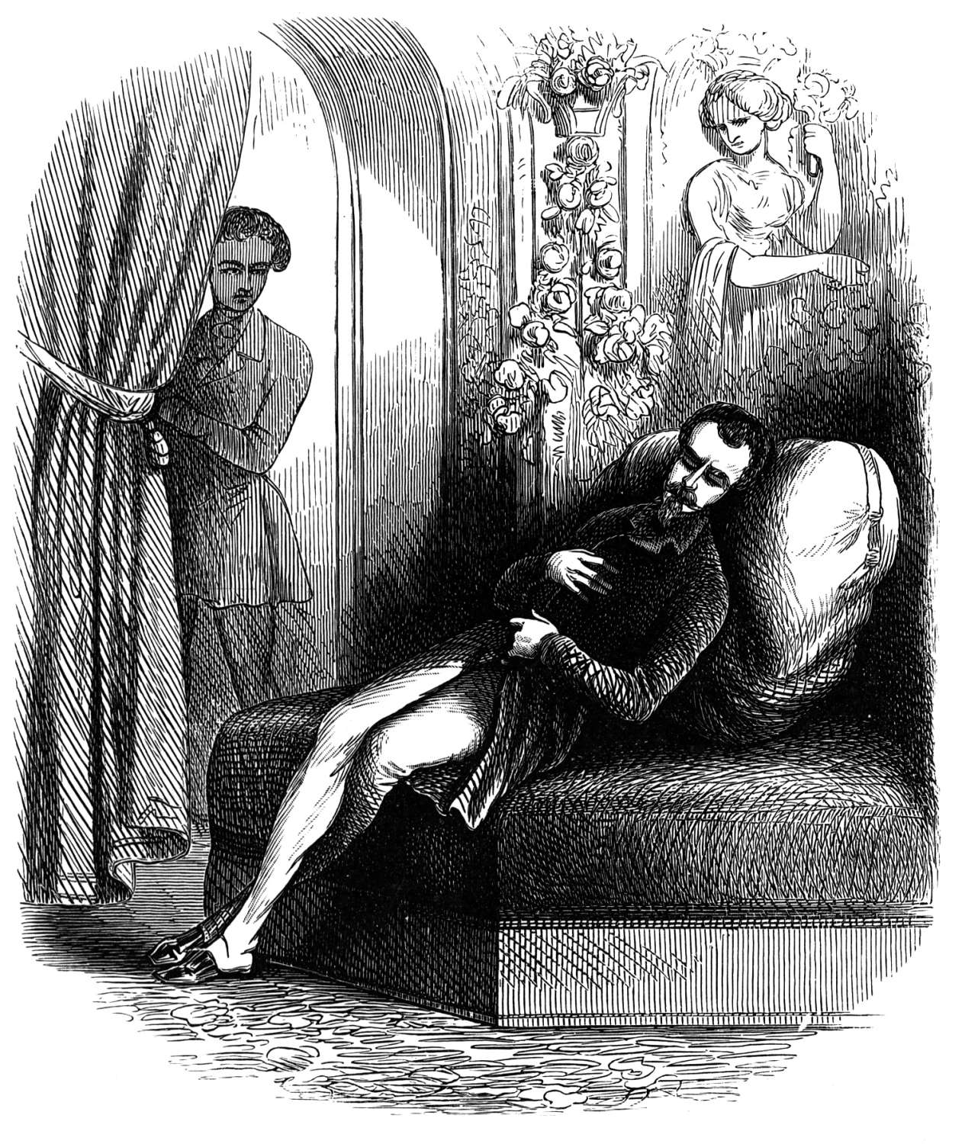
Spyware can also come bundled with shareware or other downloadable software. The user downloads a program—for instance, a music program or a file-trading utility—and installs it; the installer additionally installs the spyware. Although the desirable software itself may do no harm, the bundled spyware does. In some cases, spyware authors have paid shareware authors to bundle spyware with their software, as with the Gator spyware now marketed by Claria. In other cases, spyware authors have repackaged desirable software with installers that add spyware.
A third way of distributing spyware involves tricking users by manipulating security features designed to prevent unwanted installations. The design of the Internet Explorer Web browser is intended not to allow Web sites to initiate an unwanted download. Instead, a user action, such as clicking on a link, has to trigger a download. However, links can prove deceptive: for instance, a pop-up ad may appear like a standard Windows dialog box. The box contains a message such as "Would you like to optimize your Internet access?" with links which look like buttons reading Yes and No. No matter which "button" the user presses, a download starts, placing the spyware on the user's system. Later versions of Internet Explorer offer fewer avenues for this attack.
Some spyware authors infect a system by attacking security holes in the Web browser or in other software. When the user navigates to a Web page controlled by the spyware author, the page contains code which attacks the browser and forces the download and install of spyware. This has become known as a "drive-by download", by analogy to drive-by shooting in which the user is a hapless bystander. Common attacks target security vulnerabilities in Internet Explorer and in the Microsoft Java runtime. Given that Internet Explorer is still the most widely used browser and that many users' systems are not up to date, it creates an attractive entry point for the less scrupulous advertisers.
Internet Explorer also serves as a point of attachment for these programs, which install themselves as Browser Helper Object plugins.
In a few cases, a worm or virus has delivered a payload of spyware. For instance, some attackers used the W32.Spybot.Worm worm to install spyware that popped up pornographic ads on the infected system's screen. By directing traffic to ads set up to channel funds to the spyware authors, they can profit even by such clearly illegal behavior.

Effects and behaviors
Windows-based computers can rapidly accumulate a great many spyware components. The consequences of a moderate to severe spyware infection (privacy issues aside) generally include a substantial loss of system performance (over 50% for bad infections), and major stability issues (crashes and hangs). Difficulty in connecting to the Internet is another common symptom.
Spyware infection occasions more visits to professional computer repairers than any other single cause. In many cases, the user has no awareness of spyware and assumes that the system performance, stability, and/or connectivity issues relate to hardware, to Windows installation problems, or to a virus. To have spyware professionally removed typically costs about $50 US. Some owners of badly infected systems resort to buying an entire new computer system because the existing system "has become too slow". For badly infected systems, a clean reinstall may be required to restore the system to a working order—a time-consuming project even for experienced users.
Only rarely does a single piece of software render a computer unusable. Rather, a computer rarely has only one infection. As the 2004 AOL study noted, if a computer has any spyware at all, it typically has dozens of different pieces installed. The cumulative effect, and the interactions between spyware components, typically cause the stereotypical symptoms reported by users—a computer which slows to a crawl, overwhelmed by the many parasitic processes running on it. Moreover, some types of spyware disable software firewalls and anti-virus software, and reduce browser security settings, opening the system to further opportunistic infections, much like an immune deficiency disease. There are also documented cases where a spyware program disabled other spyware programs created by the competitors.

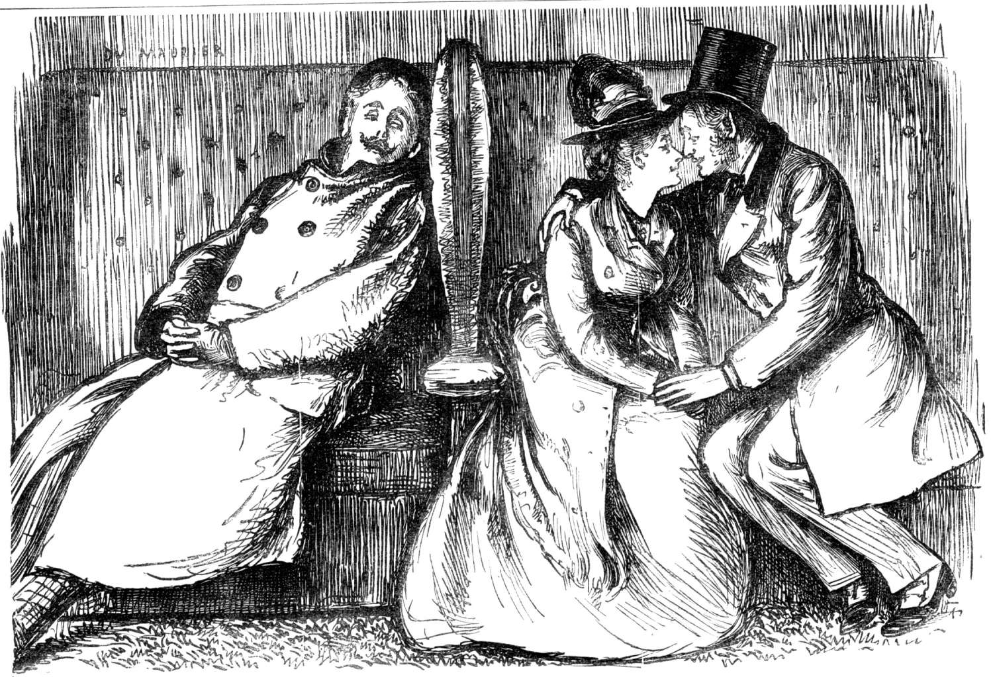Advertisements
The most visible behavior of many spyware programs is to display advertisements. Some programs simply display pop-up ads on a regular basis -- for instance, one every several minutes, or one when the user opens a new browser window. Others display ads in response to specific sites that the user visits. Spyware operators present this feature as desirable to advertisers, who may buy ad placement in pop-ups displayed when the user visits a particular site. It is also one of the purposes for which spyware programs gather information on user behavior.
Pop-up advertisements lead to some of users' most common complaints about spyware. The first is simply that the computer can become overwhelmed downloading or displaying ads. An infected computer rarely has only one spyware component installed -- they more often number in the dozens -- and so while a single program might display ads only infrequently, the cumulative effect is overwhelming.
Irritating or offensive advertisements are another common complaint. As with many banner ads, many spyware advertisements are animated, flickering banners designed to catch the eye -- that is, they are highly visually distracting. Pop-up ads for pornography are often displayed indiscriminately, including when children are using the computer -- possibly in violation of laws on the subject.
A further issue in the case of some spyware programs has to do with the replacement of banner ads on viewed web sites. Spyware which acts as a web proxy or a Browser Helper Object can replace references to a site's own advertisements (which fund the site) with advertisements which instead fund the spyware operator. This cuts into the margins of advertising-funded Web sites.

"Stealware" and affiliate fraud
A few spyware vendors, notably WhenU and 180 Solutions, have written what the New York Times has dubbed "stealware", and spyware researcher Ben Edelman terms affiliate fraud, also known as click fraud. These redirect the payment of affiliate marketing revenues from the legitimate affiliate to the spyware vendor.
Affiliate marketing networks work by tracking users who follow an advertisement from an "affiliate" and subsequently purchase something from the advertised Web site. Online merchants such as eBay and Dell are among the larger companies which use affiliate marketing. In order for affiliate marketing to work, the affiliate places a tag such as a cookie or a session variable on the user's request, which the merchant associates with any purchases made. The affiliate then receives a small commission.
Spyware which attacks affiliate networks does so by placing the spyware operator's affiliate tag on the user's activity -- replacing any other tag, if there is one. This harms just about everyone involved in the transaction other than the spyware operator. The user is harmed by having their choices thwarted. A legitimate affiliate is harmed by having their earned income redirected to the spyware operator. Affiliate marketing networks are harmed by the degradation of their reputation. Vendors are harmed by having to pay out affiliate revenues to an "affiliate" who did not earn them according to contract.
Affiliate fraud is a violation of the terms of service of most affiliate marketing networks. As a result, spyware operators such as WhenU and 180 Solutions have been terminated from affiliate networks including LinkShare and ShareSale.

Spyware and cookies
Anti-spyware programs often report Web advertisers' HTTP cookies as spyware. Cookies are not software of any sort—they are variables set by Web sites (including advertisers) which can be used to track Web-browsing activity, for instance to maintain a "shopping cart" for an online store or to maintain consistent user settings on a search engine.
Cookies can only be accessed by the Web site that sets them. In the case of cookies associated with advertisements, this is generally not the Web site that the user intended to visit, but a third-party site referenced by a banner ad image. Some Web browsers and privacy tools offer to reject cookies from sites other than the one that the user requested.
Advertisers use cookies to track people's browsing among various sites carrying ads from the same firm and thus to build up a marketing profile of the person or family using the computer. It is for this reason that many users object to such cookies, and that anti-spyware programs offer to remove them.

Typical examples of spyware
A few examples of common spyware programs may serve to illustrate the diversity of behaviors found in these attacks.
CoolWebSearch, a group of programs, installs through the exploitation of Internet Explorer vulnerabilities. The programs direct traffic to advertisements on Web sites including coolwebsearch.com. To this end, they display pop-up ads, rewrite search engine results, and alter the infected computer's hosts file to direct DNS lookups to these sites.
Internet Optimizer, also known as DyFuCa, redirects Internet Explorer error pages to advertising. When users follow a broken link or enter an erroneous URL, they see a page of advertisements. However, because password-protected Web sites (HTTP Basic authentication) use the same mechanism as HTTP errors, Internet Optimizer makes it impossible for the user to access password-protected sites.
180 Solutions transmits extensive information to advertisers about the Web sites which users visit. It also alters HTTP requests for affiliate advertisements linked from a Web site, so that the advertisements make unearned profit for the 180 Solutions company. It opens pop-up ads that cover over the Web sites of competing companies.
HuntBar, aka WinTools or Adware.Websearch, is a small family of spyware programs distributed by Traffic Syndicate. It is installed by ActiveX drive-by download at affiliate Web sites, or by advertisements displayed by other spyware programs -- an example of how spyware can install more spyware. These programs add toolbars to Internet Explorer, track Web browsing behavior, redirect affiliate references, and display advertisements.

Remedies and prevention
As the spyware threat has worsened, a number of techniques have emerged to counteract it. These include programs designed to remove or to block spyware, as well as various user practices which reduce the chance of getting spyware on a system.
Nonetheless, spyware remains a costly problem. When a large number of pieces of spyware have infected a Windows computer, the only remedy may involve backing up user data, and fully reinstalling the operating system.

Anti-spyware programs
Many programmers and commercial firms have released products designed to remove or block spyware. Steve Gibson's OptOut, mentioned above, pioneered a growing category. Programs such as Lavasoft's Ad-Aware and Patrick Kolla's Spybot - Search & Destroy rapidly gained popularity as effective tools to remove, and in some cases intercept, spyware programs. More recently Microsoft acquired the GIANT Anti-Spyware software, rebadging it as Windows AntiSpyware Beta and releasing it as a free download for Windows XP, Windows 2000, and Windows 2003 users. The Windows AntiSpyware Beta is a time-limited program, set to expire at the end of December 2005. The GIANT AntiSpyware database was also licensed to Sunbelt Software for its CounterSpy home product. Another popular spyware remover program is SpySweeper 4.0 from Webroot. Webroot received the #1 rated spyware remover program by PC Magazine in their 2005 security issue.
Major anti-virus firms such as Symantec, McAfee and Sophos have come later to the table, adding anti-spyware features to their existing anti-virus products. Early on, anti-virus firms expressed reluctance to add anti-spyware functions, citing lawsuits brought by spyware authors against the authors of web sites and programs which described their products as "spyware". However, recent versions of these major firms' home and business anti-virus products do include anti-spyware functions, albeit treated differently from viruses. Symantec Anti-Virus, for instance, categorizes spyware programs as "extended threats" and does not offer real-time protection from them as it does for viruses.
Anti-spyware programs can combat spyware in two ways: real-time protection, which prevents spyware from being installed, and scanning and removal of spyware. Scanning and removal is usually simpler, and so many more programs have become available which do so. The program inspects the contents of the Windows registry, the operating system files, and installed programs, and removes files and entries which match a list of known spyware components. Real-time protection from spyware works identically to real-time anti-virus protection: the software scans incoming network data and disk files at download time, and blocks the activity of components known to represent spyware. In some cases, it may also intercept attempts to install start-up items or to modify browser settings.
Earlier versions of anti-spyware programs focused chiefly on scanning and removal. Javacool Software's SpywareBlaster was one of the first to offer real-time protection, blocking the installation of ActiveX-based and other spyware programs. To date, other programs such as Ad-Aware and Windows AntiSpyware now combine the two approaches, while SpywareBlaster remains focused on real-time protection.
If a spyware program is not blocked and manages to get itself installed, it may resist attempts to terminate or uninstall it. Some programs work in pairs: when an anti-spyware scanner (or the user) terminates one running process, the other one respawns the killed program. Likewise, some spyware will detect attempts to remove registry keys and immediately add them again. Usually, booting the infected computer in safe mode allows an anti-spyware program a better chance of removing persistent spyware.
Malicious programmers have released a large number of fake anti-spyware programs, and widely distributed Web banner ads now spuriously warn users that their computers have been infected with spyware, directing them to purchase programs which do not actually remove spyware—or worse, may add more spyware of their own.

Security practices
To deter spyware, computer users have found a number of techniques useful in addition to installing anti-spyware software.
Many systems install a web browser other than Microsoft's Internet Explorer (IE), such as Opera or Mozilla Firefox. While other web browsers have also had security vulnerabilities, Internet Explorer has contributed to the spyware problem in two ways: first, many spyware programs hook themselves into IE's functionality (as a Browser Helper Object or a toolbar); second, malicious Web advertisers have frequently used security holes in Internet Explorer to force the browser to download spyware. Many users of non-IE browsers on Windows report that they have switched from IE because of security concerns, including concerns about spyware.
Internet Explorer users can improve security by keeping up-to-date on security patches, and by altering settings in the browser — particularly those disabling scripting technologies such as ActiveX. (However, Web sites that make use of ActiveX will not work in this scenario.) The version of IE which comes with Windows XP Service Pack 2 also has substantially-improved security defaults, although spyware infections can still occur.
Some Internet sites — particularly colleges and universities — have taken a different approach to blocking spyware: they use their network firewalls and web proxies to block access to Web sites known to install spyware. On March 31, 2005, Cornell University's Information Technology department released a report detailing the behavior of one particular piece of proxy-based spyware, Marketscore, and the steps the university took to intercept it. Many other educational institutions have taken similar steps against Marketscore and other spyware. Spyware programs which redirect network traffic cause greater technical-support problems than programs which merely display ads or monitor users' behavior, and so may attract institutional attention more readily.
Spyware may get installed via certain shareware programs offered for download. Downloading programs only from reputable sources can provide some protection from this source of attack. One site, CleanSoftware.org, founded as an alternative to other popular Windows software sites, offers only software verified not to contain "nasties" such as spyware. Recently, C|Net revamped their download directory and will only keep files that pass inspection by Ad-Aware and Spyware Doctor.

Must to Avoid!
- Atomic clock sync
- Bearshare
- Bonzi Buddy
- Cliprex DVD player
- DivX (except for the paid version, and the 'standard' version without the encoder. DivX announced removal of GAIN software from version 5.2)
- Dope Wars
- Download Accelerator Pro
- ErrorGuard
- FlashGet (free version)
- Gator
- Grokster
- Kazaa
- Messenger Plus (optional) (This has caused controversy with Microsoft as it's anti-spyware program identifies MsgPlus as the spyware, not C2.Lop)
- Napster Light (when not entering credit card information)
- RadLight
- WeatherBug
- WildTangent

Gotten Their Act Together
- AOL Instant Messenger
- EDonkey2000
- LimeWire (spyware was included in all versions other than the non-windows versions, the paid versions, and the free versions after 3.9.3)

Guides (URLs available at http://en.wikipedia.org/wiki/Spyware)
- Magoo's Guide to Eliminating Spyware — Infomation on how to get rid of spyware and keep it from returning
- CareOfWindowsXP Spyware guide — Advice on spyware for beginners
- Bleeping Computer Spyware Removal Tutorials — tutorials for HijackThis, Spybot, and Ad-Aware.
- Dedicated 2 spyware — Reviews of Antispyware programs, Corrupt anti-spyware list, tutorials, Library of files and encyclopedia of parasites.

Prevention
- How Spyware And The Weapons Against It Are Evolving — Article discussing why the spyware problem has grown and possible remedies
Adapted from "http://en.wikipedia.org/wiki/Spyware"

 | Odd Jobs:  Other Malware

Classes of malicious software
Two common types of malware are viruses and worms. These types of programs have in common that they are both able to self-replicate; they can spread (possibly modified) copies of themselves. Not every program that copies itself is a virus or worm; for instance, backup software may copy itself to other media as part of a system backup. To be classified as a virus or worm, at least some of these copies have to be able to replicate themselves too, such that the virus or worm can propagate itself. The difference between a virus and a worm is that a worm operates more or less independently of other files, whereas a virus depends on hosts to spread itself.

Virus
Viruses have used many sorts of hosts. When computer viruses first originated, common targets were executable files that are part of application programs and the boot sectors of floppy disks. More recently, most viruses have embedded themselves in e-mail as Email attachments, depending on a curious user opening the viral attachment. In the case of executable files, the infection routine of the virus arranges that when the host code is executed, the viral code gets executed as well. Normally, the host program keeps functioning after it is infected by the virus. Some viruses overwrite other programs with copies of themselves which destroys them altogether. Viruses can spread across computers when the software or document they've attached themselves to is transferred from one computer to the other.

Worms
Computer worms are similar to viruses but are stand-alone software and thus do not require host files (or other types of host code) to spread themselves. They do modify their host operating system, however, at least to the extent that they are started as part of the boot process. To spread, worms either exploit some vulnerability of the target system or use some kind of social engineering to trick users into executing them.

Wabbit
A third, uncommon, type of self-replicating malware is the wabbit. Unlike viruses, wabbits do not infect host programs or documents. Unlike worms, wabbits do not use network functionality in order to spread to other computers. An example of a simple wabbit is a fork bomb.


Trojan
A trojan horse program is a harmful piece of software that is disguised as legitimate software. Trojan horses cannot replicate themselves, in contrast to viruses or worms. A trojan horse can be deliberately attached to otherwise useful software by a programmer, or it can be spread by tricking users into believing that it is useful. To complicate matters, some trojan horses can spread or activate other malware, such as viruses. These programs are called 'droppers'. A common aftermath is the Trojan attracting a large amount of adware/spyware, causing lots of popups and web browser instability.

Backdoor
A backdoor is a piece of software that allows access to the computer system bypassing the normal authentication procedures. Based on how they work and spread, there are two groups of backdoors. The first group works much like a Trojan, i.e., they are manually inserted into another piece of software, executed via their host software and spread by their host software being installed. The second group works more like a worm in that they get executed as part of the boot process and are usually spread by worms carrying them as their payload. The term Ratware has arisen to describe backdoor malware that turns computers into zombies for sending spam. The installed software can also be used for anonymizing traffic, brute force cracking of passwords and encryptions, and distributed denial of service attacks (DDOS).

Spyware

Spyware is a piece of software that collects and sends information (such as browsing patterns in the more benign cases or credit card numbers in more malicious cases) about users or, more precisely, the results of their computer activity, typically without explicit notification. They usually work and spread like Trojan horses. The category of spyware is sometimes taken to include adware of the less-forthcoming sort.

Exploit
An exploit is a piece of software that attacks a particular security vulnerability. Exploits are not necessarily malicious in intent — they are often devised by security researchers as a way of demonstrating that a vulnerability exists. However, they are a common component of malicious programs such as network worms.

Rootkit
A rootkit is software inserted onto a computer system after an attacker has gained control of the system. Rootkits often include functions to hide the traces of the attack, as by deleting log entries or cloaking the attacker's processes. Rootkits may also include backdoors, allowing the attacker to easily regain access later; or exploit software to attack other systems. Because they often hook into the operating system at the kernel level to hide their presence rootkits can be very hard to detect. The consensus of computer security experts is that if your system has been compromised by a rootkit you should wipe your hard drives and reinstall the operating system since you can never know if you have successfully removed all traces of the rootkit.

Key Logger
A keylogger is software that copies a computer user's keystrokes to a file, which it may send to a hacker at a later time. Often the keylogger will only "awaken" when a computer user connects to a secure website, such as a bank. It then logs the keystrokes, which may include account numbers, PIN's and passwords, before they are encrypted by the secure website.

Dialers
A dialer is a program that either replaces the phone number in a modem's dial-up connection with a long-distance number, often out of the country, in order to run up phone charges on pay-per-dial numbers, or dials out at night to send keylogger or other information to a hacker.

URL injection

This software modifies the browser's behavior with respect to some- or all domains. It modifies the url submitted to the server to profit from a given affiliate scheme by the content provider of the given domain. This is often transparent to the user. The author profits at the expense of the user -- often surreptitiously. The Mozilla Firefox BetterSearch extension is one such example as its affiliate "feature" is often unknown to the user. Moreover the user has no option to disable that aspect.

Overuse of the term "virus"
Because viruses were historically the first to appear, the term "virus" is often applied, especially in the popular media, to all sorts of malware. Modern anti-viral software strengthen this broader sense of the term as their operation is never limited to viruses.
Malware should not be confused with defective software, that is, software which is intended for a legitimate purpose but has errors or bugs.

