MISSION NAME?

to Quantify and Track Global Changes in Atmospheric Composition,
and Their Effects on Air Quality, Climate Change and Variability,
and Ozone Layer Stability

draft summary by
Nathaniel Livesey, Michelle Santee, Paul Stek, Joe Waters
California Institute of Technology, Jet Propulstion Laboratory, USA
and
Pieternel Levelt, Hennie Kelder, Pepijn Veefkind, Marcel Dobber
Royal Netherlands Meteorological Institute, The Netherlands

This draft summary was produced using material already available from our CAMEO concept study, modified for an 830-km 53º inclination orbit.
We understand and appreciate that more consideration is needed on whether, overall, a precessing-local-time orbit (as discussed here) or a sun-synchronous orbit is most beneficial, overall, to atmospheric science and societal needs. Appendix 5 has coverage plots for both sun-synchronous and precessing orbits to provide information for helping with the choice of orbit.
More material probably needs to be added on the use of measurements by other satellites (especially, NPOESS, and METOP) to help meet the goals of this mission. Appendix 4 shows the measurement overlaps with NPOESS/METOP for the orbit considered here.

MISSION NAME?
to Quantify and Track Global Changes in Atmospheric Composition
and Their Effects on Air Quality, Climate Change and Variability, and Ozone Layer Stability
Human activities are changing atmospheric composition in ways that can adversely affect life on Earth. Unhealthful pollution episodes are common. Increasing pollution worldwide can affect global air quality and the atmosphere’s ability to cleanse itself. Increasing greenhouse gases, pollution and aerosol can affect climate. Global stratospheric chlorine, now more than 5x the natural amount, has the potential in a changing climate to cause more severe ozone loss before it decreases to near-natural abundances in ~50 years.
Policy decisions related to atmospheric composition – requiring balances between economic and environmental concerns – must be made and continuously validated, but obtaining the necessary political consensus is difficult. However, regulations on ozone depleting substances demonstrate that consensus can be reached if sufficient scientific information is produced. Such information requires global measurements of atmospheric composition.
MISSION NAME? provides atmospheric composition measurements needed for policy decisions related to air quality and climate change, and for determining whether regulations on ozone depleting substances are working. It quantifies the worldwide emissions and transport of pollution – essential for international policy to improve and protect regional and global air quality. It globally measures the diurnal cycle of convective deposition of water vapor and pollution into the upper troposphere and the relationships among upper tropospheric water vapor, pollution and clouds – essential for improving predictions of climate variability at all time scales. It globally tracks the vertical distribution of stratospheric ozone, key chemicals affecting it, and tracers that separate chemical and dynamical influences – essential for validating (and improving) our understanding of the ozone layer’s behavior in response to existing international regulations.
MISSION NAME? provides data that are essential for meeting NASA’s 2006 Strategic Plan goal 3A.1 “Progress in understanding and improving predictive capability for changes in the ozone layer, climate forcing, and air quality associated with changes in atmospheric composition”, and contributes to goals 3A.2 “Progress in enabling predictive capability for weather and extreme weather events” and 3A.5 “Progress in understanding the role of oceans, atmosphere, and ice in the climate system and in improving predictive capability for its future evolution.”
MISSION NAME? remedies measurement deficiencies that have previously limited our progress in science and applications directly linked to societal needs and benefits, and continues needed key measurements, by providing:
- an unprecedented suite of composition measurements and an unprecedented combination of temporal, vertical and horizontal resolution – and global coverage – for needed air quality and climate change measurements,
- upper tropospheric cloud ice and water vapor measurements with the temporal, vertical and horizontal resolution needed to improve the accuracy of global circulation models used for weather/climate prediction,
- stratospheric measurements needed to track stability of the ozone layer and detect changes well before they are evident in ozone itself.
MISSION NAME? uses advanced technology in three instruments of types that have been proven extremely successful on previous missions:
- SMLS, the Scanning Microwave Limb Sounder, an advanced version of MLS on Aura, measures microwave limb emission in very broad spectral bands centered at 240 and 640 GHz. Major improvements from Aura MLS are (a) azimuth scanning – simultaneous with the vertical scanning – to give 50x50 km horizontal sampling (cross-track sampling 50x better than Aura MLS; along-track 3x better) needed for quantifying convective deposition of pollution into the upper troposphere and its resulting long-range transport and (b) in-orbit programmability of the suite of measurements. SMLS measures more molecules than Aura MLS while having a simpler signal chain and fewer radiometers.
- TROPI, the TROpospheric Pollution Imager, an advanced version of OMI on Aura with long heritage from TOMS, measures reflected and backscattered solar radiation at ultraviolet and visible wavelengths Major improvements over OMI are (a) 10x10 km horizontal resolution (2-4x better than OMI) needed for resolving pollution sources and more cloud-free observations, and (b) bands in the near-infrared for improved measurements of cloud and surface properties which greatly improve the accuracy of the tropospheric observations
- TIMS, the Tropospheric Infrared Mapping Spectrometer, an advanced version of (? what can we say here? heritage from MOPITT or SCIA?) measures reflected and backscattered radiation in the short-wavelength infrared for lower tropospheric CO, CH₄ and CO₂ measurements. (A sentence or two more needs to be added here).
Appendices 1-3 give more information on these instruments.

upper
troposphere

column and
inferred
lower
troposphere

stratosphere
SO₂
volcanic SO₂
HO₂
NO
HNO3
H₂O₂
CH₄
ClO
HCl
HOCl CH₃Cl

cloud ice amount and particle size parameter
temper-
ature and geo-potential height
cloud
and
aerosol
properties
NO₂
NO₂
BrO
BrO
CH₂O
CH₂O
O₃
O₃
CO₂
CO
CO
H₂O
HDO
H₂¹⁸O
OCS
CH₃COCH₃
(acetone)
N₂O
HCN
CH₃CN CH₃OH

Fig. 1. MISSION NAME? measurement suite. Yellow shows SMLS measurements (where dotted lines indicate goals), cyan shows TROPI measurements, and red shows TIMS measurements. Surface UV-B flux is also measured by TROPI.
MISSION NAME? implements the international cooperation advocated by the Earth Observation Summit held July 2003 in Washington, D.C. TROPI is proposed to be developed by the Netherlands/ESA and is a modified version of the TROPOMI instrument on the “Troposphere Composition and Air Quality (TRAQ)” mission now in pre-phase-A studies by the European Space Agency. Strong UK participation in SMLS is anticipated.
Figure. 1 shows MISSION NAME?’s measurement suite. SMLS measures stratospheric profiles with a few percent precision and accuracy, and temperature profiles with 0.1K precision and ~1K accuracy. The SMLS upper tropospheric precision is addressed in Figure A1-4 of Appendix 1. TROPI tropospheric column measurement accuracy is several percent for O₃, CH₄, 10-20% for O₃, NO₂ and CO, and ~50% for CH₂O and SO₂, depending on atmospheric conditions. This accuracy will be improved for O₃, CO, NO₂ and CH₂O by differencing TROPI total columns and SMLS stratospheric columns. Differencing TROPI total column from SMLS columns for the upper troposphere and above yields lower (or mid-lower) tropospheric abundances for O₃, CO, CH₂O and potentially NO₂. Need to add similar statements for TIMS.
MISSION NAME?’s measurements are chosen to fulfill recognized needs in the following scientific and applications areas (Decadal Survey references are from interim panel reports made publicly available in April 2006):
- Air quality. MISSION NAME? makes all the priority tropospheric measurements (O₃, CO, NO₂, CH₂O, SO₂, aerosols) identified by the February 2006 “Community Workshop on Air Quality Remote Sensing from Space: Defining an Optimum Observing Strategy” and the NRC Decadal Study Panel on Human Health and Security. It provides the global measurements that are essential for obtaining international agreements on air quality issues.
- UV exposure. MISSION NAME? makes all the NRC Decadal Study Human Health and Security Panel’s ‘UV exposure and skin cancer’ priority chemical measurements (O₃, H₂O, HO₂, NO₂, ClO, BrO, HNO₃, HCl, H₂CO, HDO, H₂¹⁸O, CO₂, CO, NO_{y}, N₂O, CH₄) – except for OH (for which HO₂ is a good proxy), IO (which cannot be done from space), and halogen source molecules (for which HCl and BrO give adequate information). Its additional measurements of H₂O₂, NO, HOCl, CH₃Cl, and volcanic SO₂ also help track stability of the ozone layer.
- Climate variability and change. MISSION NAME? makes measurements for climate variability and change that have been identified as crucial by many studies, including the NRC Decadal Study Panel on Climate Variability and Change. It provides global and simultaneous measurements of pollution (both gaseous and aerosol) and upper tropospheric cloud ice needed for progress in understanding how changes in composition may affect cloud properties and, thus, climate. Its simultaneous measurements of water vapor, cloud ice and temperature – made with resolution needed for progress in quantifying the effects of convection – improve model predictions of seasonal to interannual climate variability and of long-term natural and anthropogenic-induced climate changes. Itmeasures convective deposition of trace gases that affect ozone in the upper troposphere, where ozone’s radiative forcing of climate is greatest.
- Global circulation models used for climate variability and weather predictions. MISSION NAME?’s measurements of cloud properties (height, fraction, ice mass and particle size information), and their diurnal variations, improve model parameterizations of cloud processes that affect prediction skill. MISSION NAME?’s temporal resolution improves worldwide extreme event forecasting and hazard assessment. Its novel data sampling enhances the performance of data assimilation systems and regional forecast models.
Fig. 2. Temporal and global coverage of MISSION NAME? in 830 km, 53º inclination, orbit. Everywhere within a given color is measured that number of times per 24-hour period. Measurements are made in ‘spurts’ of ~1.7 hour intervals (approximately the orbit period) followed by a several-hour gap. The temporal pattern precesses through all local times during every 36-day period. The SMLS thermal emission measurements (left column) have a frequency pattern that is nearly constant throughout the year. The TROPI measurements (reflected and backscattered sunlight) have a pattern that varies annually, for the UV/Vis bands as shown in the bottom right panel: mid-latitudes are measured 3-5 times per day over month-long periods that switch between north and south (GOME-2 on METOP will provide UV/Vis measurements – but with poorer spatial resolution – that fill the TROPI gaps with once-per-day measurements). The top right panel shows the TROPI measurement frequency in mid-July, a time of peak urban pollution in the northern hemisphere. Need to add coverage plot for TIMS.
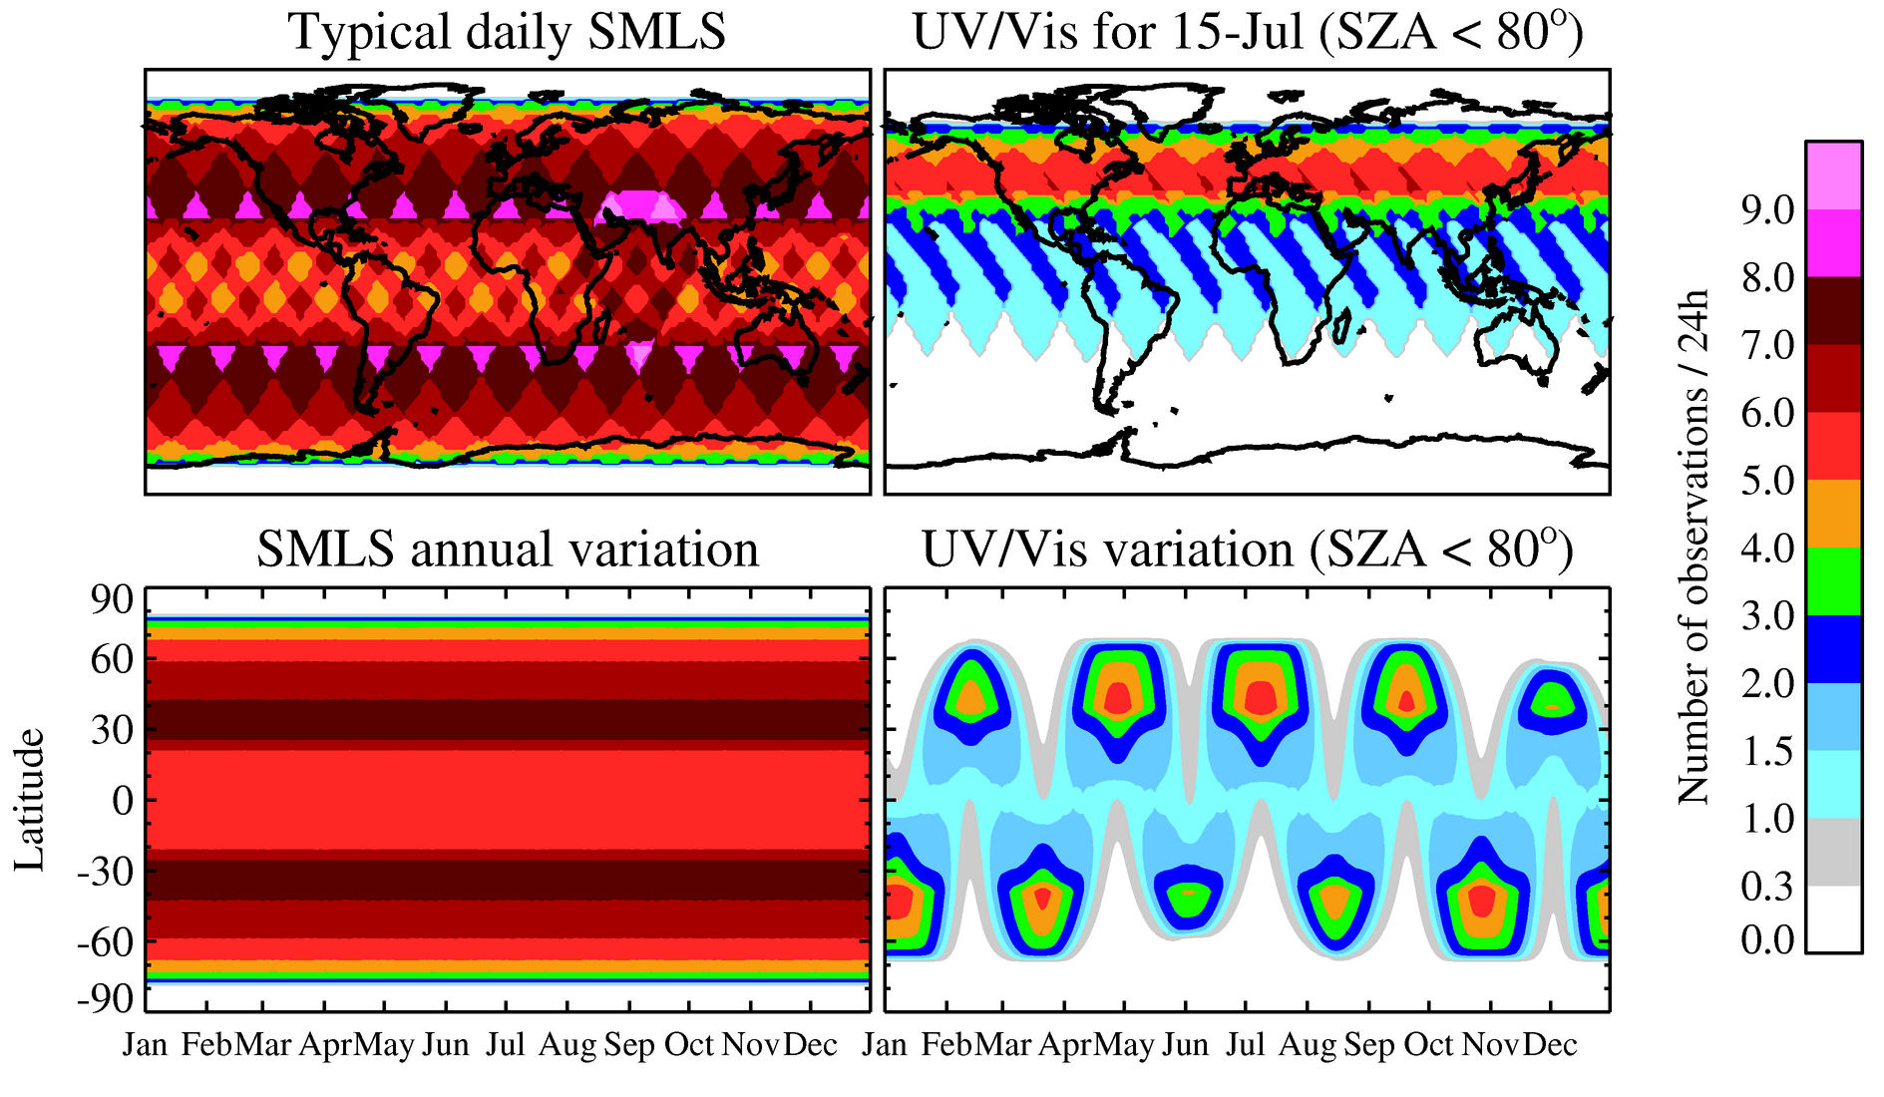
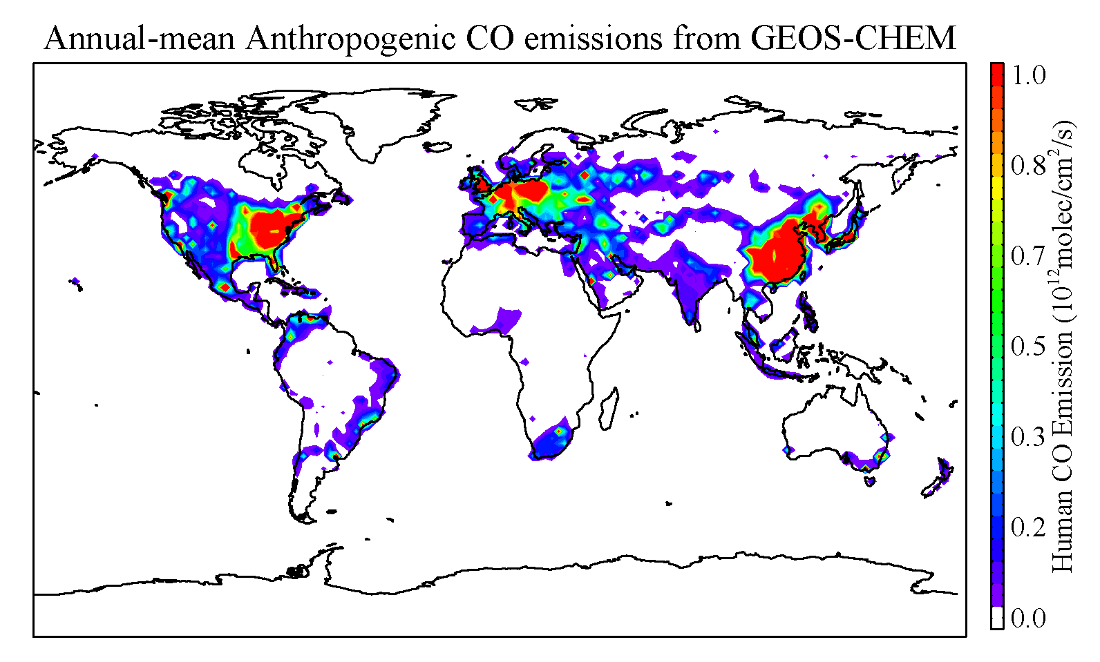
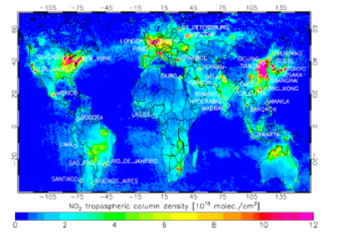
Figure 2 shows the MISSION NAME? temporal and global coverage for 830 km orbit height (that of NPOESS) and 53º orbit inclination. SMLS makes − for every 24-hour period everywhere in both northern and southern hemispheres − 6 or more measurements at 25-60º latitudes, 4-6 measurements at 0-25º, and measurements to 80º on each orbit. TROPI makes 3-5 measurements per day everywhere over a 30-60º latitude band that covers the dominant regions of anthropogenic pollution emission, shown in Figure 3, and which alternates between northern and southern hemispheres on a monthly basis. TROPI also makes 1-2 measurements per day everywhere at ~±30º latitudes. Although the TROPI mid-latitude coverage gaps are certainly undesirable, NASA’s A-train is already providing a tremendous multi-year record of continuous once-per-day global composition measurements, and GOME-2 on EUMETSAT’s METOP (to be operational 2007-2020) will provide once-per-day global UV/Vis measurements of column O₃, NO₂, SO₂, and perhaps others – but with poorer spatial resolution than TROPI. MISSION NAME? gives unprecedented multiple-per-day measurements needed globally to improve understanding of hourly-scale processes that critically affect our ability to predict climate change and global air quality. Coincidences between MISSION NAME? measurements and those of relevant sensors on operational missions planned for the same time period are shown in Appendix 4: there are always multiple daily coincidences with SMLS at mid and high latitudes, and coincidences with TROPI for about 50% of the time. (An alternative sun-synchronous orbit provides TROPI measurements without the alternating mid-latitude gaps, but with only 1-2 measurements per day, as shown in Appendix 5.)
Fig 3. Examples of the global distribution of tropospheric pollution. Left: Tropospheric NO₂ measured by OMI near 1:30 p.m. local time for the month of October 2004. Right: Annual-mean anthropogenic CO emission climatology from GEOS-CHEM model.

The improved TROPI resolution, compared to that of OMI on Aura, provides considerably more cloud-free data and more accurate determination of pollution sources and sinks (e.g., by using inverse modeling techniques). The temporal resolution of TROPI gives essential information on the diurnal cycle of worldwide boundary layer pollution. As an example, Figure 4 shows the variation of NO₂ pollution in the southeastern United States between 1 and 7 pm on 17 August 2000 as would be sampled with the TROPI spatial and temporal resolution. The much larger NO₂ pollution abundances that occur later in the day, as compared to mid-day when previous global measurements have been made (e.g., those in the left panel of Figure 3), are clearly evident. Understanding, and quantifying by measurement, the global inventory of tropospheric pollution requires global observations over a range of local times, which MISSION NAME? provides for the first time.
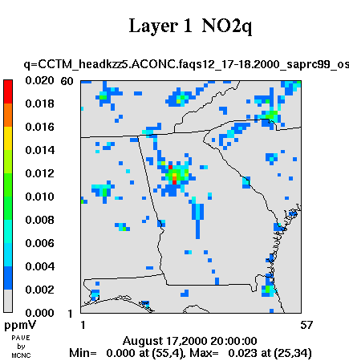
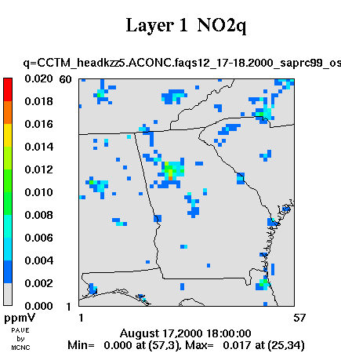
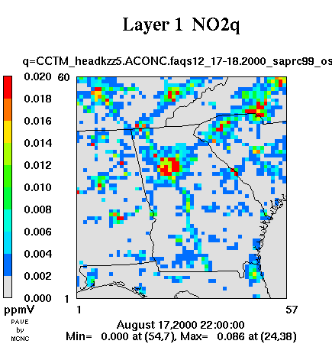
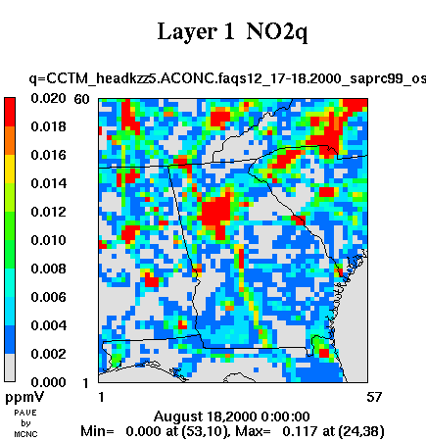
1 pm
5 pm
7 pm
Atlanta
3 pm
Fig. 4. EPA CMAQ EPA CMAQ regional model results for 17 August 2000 NO₂ pollution in the southeastern U.S., sampled at the TROPI temporal and spatial resolution. (courtesy of Yongtao Hu, Georgia Tech.)

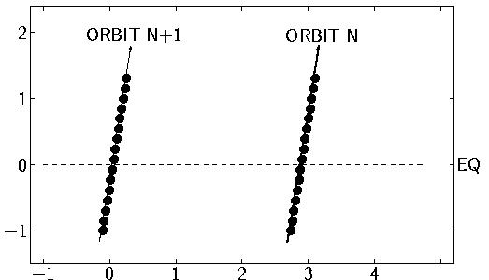
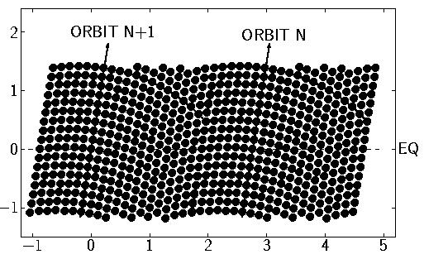
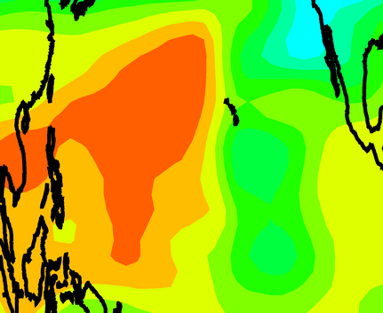
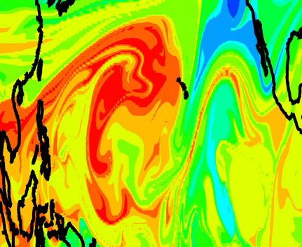
Fig 4. The left two panels show the improvement in horizontal resolution of SMLS over that of Aura MLS. Each point gives the location of a vertical profile measurement.. The right two panels show mapping of a high-resolution model upper tropospheric CO field as sampled by Aura MLS and by SMLS. Among many things evident from SMLS, but not from Aura MLS, is the thin filament (arrow) connecting enhanced CO above the Americas to Asian CO pollution.
Aura MLS
Scanning MLS
Aura MLS
Scanning MLS

Figure 4 shows the dramatic improvement in SMLS horizontal resolution over that of Aura MLS, and the value of this improved resolution for tracking intercontinental transport of pollution in the upper troposphere. Figure 5 illustrates the typical spatial and temporal scales for convective deposition of boundary layer air into the upper troposphere. Figure 6 shows the diurnal variation of convection, and how MISSION NAME? greatly supplements the information now being obtained from NASA’s “A-train” of satellites. MISSION NAME?’s SMLS provides the first global data set for quantifying the extent to which convection “short-circuits” the upper troposphere to the boundary layer. Such “short-circuiting” of the upper troposphere to the boundary layer has serious implications for climate change, long-range transport of pollution, and the stability of the ozone layer. The SMLS measurements of H₂O, H₂¹⁸O and HDO allow unique identification of air masses associated with convection. These, along with the simultaneous measurements of cloud ice and temperature, provide unprecedented and needed new information – especially on diurnal variations – to improve the parameterization of convection and cloud microphysics in general circulation models (GCMs) that are used both for weather and climate change predictions.

MISSION NAME?, in addition to producing data files that are archived and publicly available for scientific research, will produce direct-broadcast and near-real-time data that can be used for operational purposes.

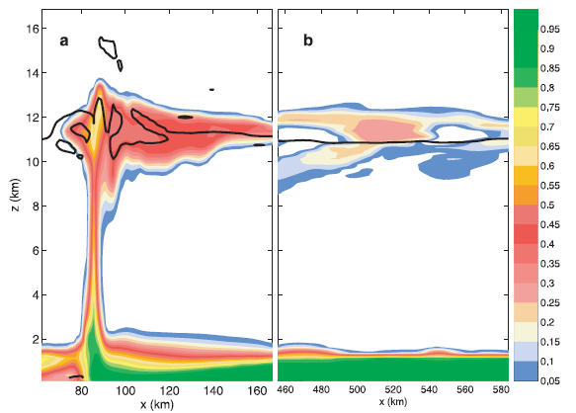
t_{o} +
10 hour
80 120 160
480 520 560
14
12
10
8
6
4
2
vertical / km
t_{o} +
2 hour
horizontal / km
Fig 5. Convective deposition of boundary-layer air into the upper troposphere. [From Mullendore et al., J. Geophys. Res., 110, D06113, 2005, with crosses added to show the SMLS spatial resolution. Color shows the abundance of a boundary layer tracer at 2 hours (left panel) and 10 hours (right panel) into a convective simulation. See also, Lopez et al., J. Geophys. Res. 111, D09035, 2006.) SMLS measurements extend down to ~8 km at the mid-low latitudes for which this figure applies.

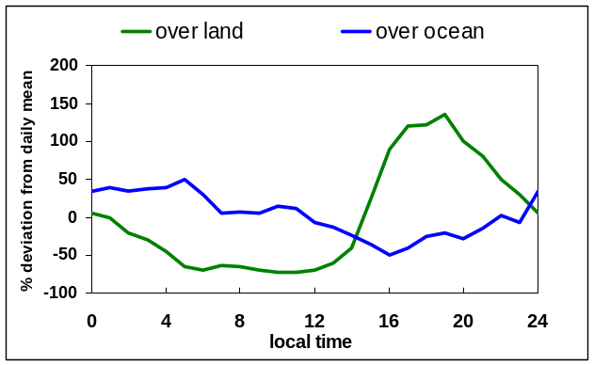
S
S
S
S
S
S
every 36 days
A
local time / hour
S
A
Fig 6. Diurnal variation of deep convection. The curves, from Chen and Houze [Q. J. Roy. Met. Soc., 123, 357, 1997], show diurnal variation in percent high cloudiness for clouds with infrared temperatures less than 208 K. Data are from the Japanese Geosynchronous Meteorological Satellite, binned at ~10 km spatial and 1 hour temporal resolution, where averages for the period of November 1992 through February 1993 are shown. The green curve is for measurements over land (northern Australia), and the blue for measurements over ocean (10ºS-10ºN, 152-180ºE). “A” shows the temporal sampling of NASA’s “A-train” of satellites. “S” shows the SMLS typical mid-latitude temporal sampling for the 830-km, 53º-inclination orbit discussed here. The dashed horizontal arrow indicates that the SMLS sampling precesses through all local times every 36 days.

Appendix 1. The Scanning Microwave Limb Sounder (SMLS)
SMLS has been under development at JPL for several years. It combines (a) ultra-sensitive SIS (superconductor-insulator-superconductor) radiometers, which have been used in atmospheric measurements for ~30 years and are now integrated in the Japanese SMILES flight instrument planned for the Space Station and (with JPL SIS devices) in the HIFI instrument for the European Herschel astrophysics mission, and (b) a novel azimuth-scanning antenna whose principle has been demonstrated by functional models, with geometric and physical optics designs already performed specifically for the SMLS instrument. Flight-qualified coolers, of the general type required for the SIS devices, are already integrated in the Japanese SMILES instrument and being used in the European Planck astrophysics mission. U.S. industrial sources exist for the SMLS cooler, which is expected to be similar to those being developed for the James Webb Space Telescope. The SMLS design requires <180 W, including all inefficiencies, for the cooler drive power.
Advanced SIS radiometers that cover more than 100 GHz bandwidth, and have been demonstrated by Caltech in radio astronomy applications, are used in SMLS. The sensitivity of these radiometers is ~30× better than Aura MLS, as needed (1) for useful precision with the short measurement times available at each azimuth position, and (2) for obtaining measurements of additional trace chemical species. SMLS measures more molecules than Aura MLS, while having a simpler signal chain and fewer radiometers. It contains radiometers in two broad bands: 180-280 GHz (both polarizations) mainly for the troposphere, and 580-680 GHz mainly for the stratosphere. The National Radio Astronomy Observatory is implementing an array of 200 SIS sideband-separating radiometers, as used by SMLS, around 230 GHz. NASA’s Advanced Component Technology (ACT) program is supporting development of 200 GHz SIS radiometers for specific application to needed new tropospheric measurements and potential deployment in SMLS (Ultra Low Noise Radiometers for Tropospheric and Stratospheric Limb Sounding – Karen Lee, JPL, Principal Investigator). Stratospheric measurements (less difficult than tropospheric measurements) by SIS in the ~580-680 GHz region have been done from both aircraft and balloon.
All SMLS measurements are of thermal emission, and thus made both day and night. Vertical profiles are obtained for all measurements. An important feature of the MLS technique is its ability to make measurements in the presence of ice clouds that degrade or prevent measurements by shorter-wavelength techniques.
A major advance of SMLS over Aura MLS – needed for progress in quantifying key upper tropospheric processes affecting climate change, global air quality, and ozone layer stability – is its dramatic improvement in horizontal coverage illustrated in Figure A1-1. Also, its greatly improved sensitivity can provide many more chemical measurements than possible with Aura MLS. SMLS measures many more molecules than Aura MLS while having a simpler signal chain and fewer radiometers.
Aura MLS
Scanning MLS
Fig. A1-1. Comparing horizontal coverages of Aura MLS and SMLS. Each point is the location of a vertical profile measurements; portions of two orbits are shown.

The size of the SMLS antenna is determined, primarily, by (1) the desired width of the measurement swath, which sets the azimuth scan range and overall ‘width’ of the antenna system, and (2) the desired vertical resolution which sets the ‘height’ of the antenna primary reflector. For the desired SMLS swath width (~5000 km from ~800 km orbit, corresponding to ±65º azimuth scan range), a ~2 m ‘wide’ antenna is required, which is not expected to be a
problem for spacecraft accommodation. For the desired vertical resolution (1.5 km, ~2x better than Aura), a ~4 m ‘high’ primary reflector is required. If a 4 m primary reflector cannot be accommodated or afforded, then a smaller one can be considered (down to ~2 m as flown on Aura MLS – but as large a reflector as can be accommodated is extremely desirable. Figure A1-2 shows vertical resolution versus precision for 4 m and 2 m primary reflectors.
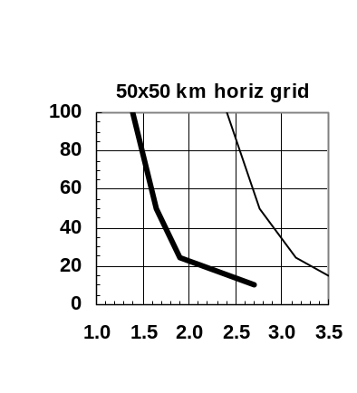
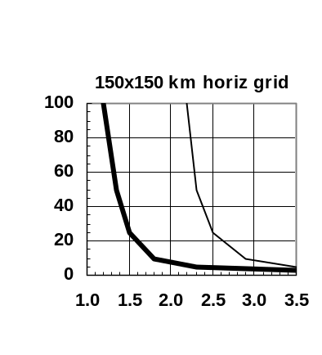
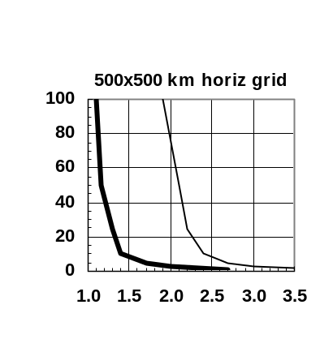
vertical resolution / km
CO precision / ppbv
♦
♦
♦
typical
polluted abundances

typical
background abundances
♦
♦
♦

Fig. A1-2. Examples of vertical resolution versus precision; SMLS upper tropospheric (215 hPa) CO measurements are illustrated here. Thick-lines are for a 4 m SMLS primary reflector and thin are for 2 m, and the three panels are for the three separate horizontal grids on which standard SMLS data products are currently planned. The tradeoff between resolution and precision is set by choosing a ‘smoothing parameter’ in the data processing algorithms, and reasonable choices are indicated by the diamond symbols. Horizontal lines indicate typical polluted and typical background abundances.

Figure A1-3 shows a drawing of SMLS instrument and its signal flow block diagram. The antenna system, consisting of primary, secondary, tertiary and scan mirrors, is scanned in the vertical by ~1º rotation, as on Aura MLS,. A vertical scan is performed every ~10 s, to give along-track sampling of 50-100 km. The conical azimuth limb scan is repeated every ~0.5 s during the vertical scan, by ±65º rotation of a small (~10-cm diameter) reflector. A measurement is made every ~3 ms to give 50-100 km cross-track sampling to match the along-track sampling. ‘Overscan’ in the vertical accounts for Earth’s oblateness and changes in vertical scan range with azimuth. A multipoint calibration is performed between each azimuth scan. All mechanisms have 5-year (or longer) operational lifetime. Table A1-1 gives estimates of the SMLS mass, power and data rate. Momentum compensation of the SMLS antenna scan is not included; it will be studied later if needed to meet spacecraft attitude stability requirements.
Figure ??. SMLS signal flow. The signal exits the scanning antenna system along the vertical scan axis, as on previous MLS instruments, eliminating the need for flexible connectors in the signal path.
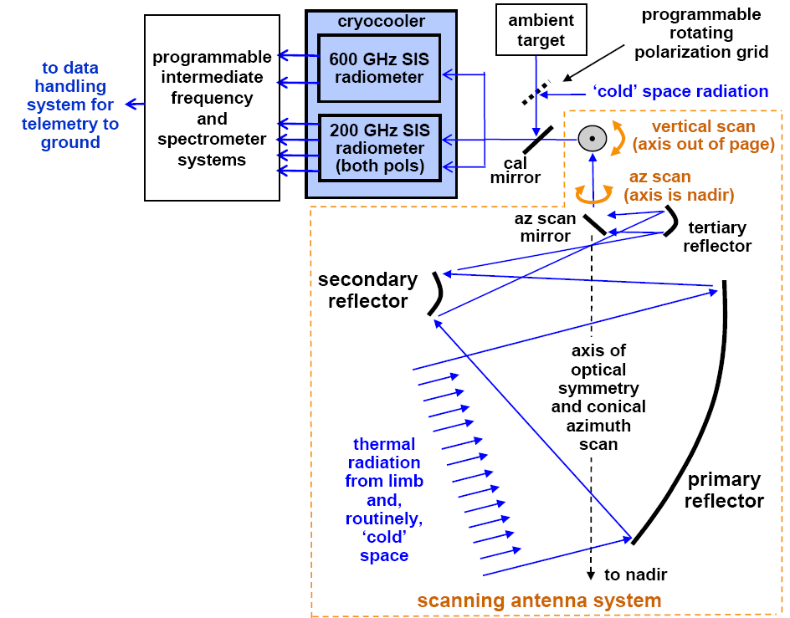
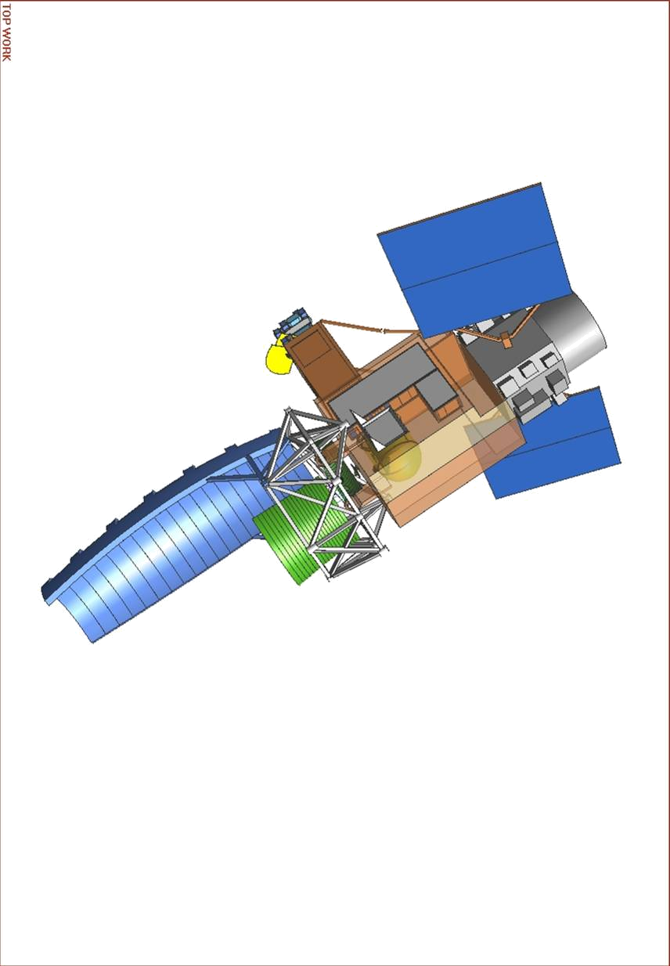
primary
reflector
module containing crycooler and
radiometers
secondary
reflector
4 m

Fig. A1-3. Signal-flow block diagram of SMLS (left) and drawing (right). The SMLS signal exits the scanning antenna system along the vertical scan axis, as on previous MLS

Table A1-1. SMLS mass, power and data rate estimates.
overall mass | 500 kg
full-up power | 400 W
data rate | 10 Mb/s
Both the SMLS azimuth and vertical scans are programmable to enable efficient use of measurement time and fulfill various scientific objectives. A ‘continuum’ of scan modes, easily implemented by programming the scan ranges, is available, and the measurement time (which determines the measurement signal-to-noise) depends upon the scan mode. The SMLS measurement time needed for an upper tropospheric spectral line radiance signal-to-noise of 10 for various species is shown in the Figure A1-4. A ‘maximum global mode’ with measurements at 20 points in the vertical and every 50x50 km in the horizontal over a 5000 km cross-track width allows 0.003 s for each individual measurement; a ‘regional study mode’ with, for example, measurements at 5 points in the vertical and every 50x50 km in the horizontal over a cross-track width of 2000 km allows 0.05 s for each measurement; a ‘local study mode’ with, for example, measurements at 3 points in the vertical and every 50x50 km in the horizontal over a 200 km cross-track width allows 1 s for each measurement. The available measurement time can be increased by degrading the spatial or temporal resolution: a factor of 4 increase, for example, is gained by changing from 50x50 km to 100x100 km horizontal resolution, which can be done in ground data processing. Because of the large dynamic range of manyabundances, useful measurements can be obtained with a signal-to-noise of 3, which reduces the required measurement time 9x from that shown here. Figure A1-5 shows the fraction of the troposphere over which MLS is expected to make trace gas measurements; this is the upper 40-50% for most of the globe
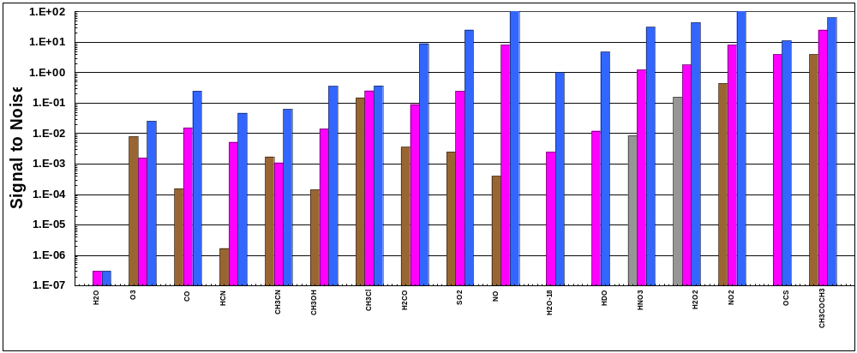
The SMLS measurement suite is also programmable, simply by programmable tuning of local oscillators within the instrument. One set of measurements is made continuously (e.g., H₂O and perhaps its isotopes, cloud ice, temperature, O₃, CO); other sets of related measurements are time-shared to reduce the required number of spectrometers. Time-sharing modes can be changed, in principle, as often as each vertical scan. The programmability and spectral coverage allow measurements of additional species: in principle, nearly any species with a dipole moment. SMLS can, as needed, make spectral surveys to test the completeness of our knowledge of atmospheric composition.
H₂O
200 ppmv
10 ppmv
10⁻⁶
10⁻³
1
O₃
90 ppbv
200 ppbv
50 ppbv
H₂O₂
5 ppbv
1.5 ppbv
0.3 ppbv
OCS
0.5 ppbv
0.3 ppbv
CH₃COCH₃
(acetone)
2 ppbv
0.8 ppbv
0.5 ppbv
CO
4 ppmv
0.4 ppmv
0.1 ppmv
HCN
50 ppbv
0.9 ppbv
0.3 ppbv
CH₃OH
50 ppbv
5 ppbv
1 ppbv
H₂CO
10 ppbv
2 ppbv
0.2 ppbv
NO
1 ppmv
7 ppbv
0.1 ppbv
HDO
30 ppbv
1.5 ppbv
CH₃CN
1.2 ppbv
1.5 ppbv
0.2 ppbv
CH₃Cl
0.9 ppbv
0.7 ppbv
0.6 ppbv
SO₂
20 ppbv
2 ppbv
0.2 ppbv
H₂¹⁸O
0.4 ppmv
0.02 ppmv
HNO₃
3 ppbv
250 pptv
50 pptv
NO₂
30 ppbv
7 ppbv
0.1 ppbv
Measurement time (in seconds)
required for signal-to-noise of 10

Fig. A1-4. SMLS measurement time needed for an upper tropospheric spectral line radiance signal-to-noise of 10 for various species. Colors of the bars give representative abundances for different situations. Blue is for typical or minimum abundances; pink for enhanced abundances that have been observed or inferred; brown for enhanced boundary layer abundances that can be convectively transported to the upper troposphere; grey for soluble species that may reach the upper troposphere less easily. Because of the large dynamic range in many species abundances, useful measurements can be obtained with a signal-to-noise of 3, which reduces the required measurement time 9x from that shown here. This plot is for a tropical ‘background’ atmosphere and 9 km height; it includes 2-3x attenuation of the target molecule signals by water vapor continuum, and spectral line wings of ‘interfering’ gases. For the tropical troposphere above 12 km, a region of considerable current interest, SMLS signals are typically 2-3x stronger than indicated here. All these measurements are made in the 180-280 GHz region, from spectral lines selected by considerations of (a) line strength, (b) freedom from interference, and (c) instrument simplification. Cloud ice measurements from ‘continuum’ emission, and temperature from O¹⁸O, are obtained with good signal-to-noise in milliseconds.
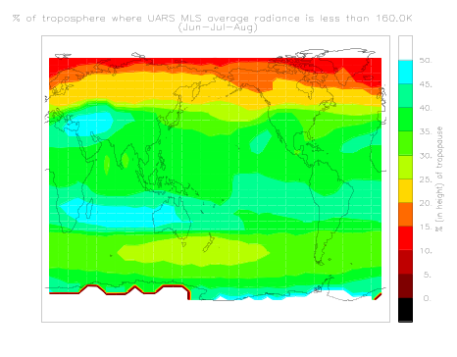
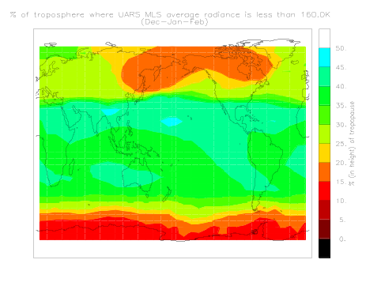
Fig. A1-5. Percent of the troposphere measured by SMLS. These maps give the climatology, from MLS measurements for the percent of the troposphere (in height from the tropopause down) where 200 GHz limb radiances are <160K, indicating optical depth small enough for composition measurement. The effects of clouds are included.
50%
25%
0%
Jun-Jul-Aug
Dec-Jan-Feb

Appendix 2. The TROpospheric Pollution Imager (TROPI)

TROPI is a modified version of the TROPOMI instrument on the Tropospheric Air Quality (TRAQ) mission now in pre-phase A study by the European Space Agency. It measures reflected and scattered solar radiation in ultraviolet (UV), visible (Vis) and near-infrared (NIR) bands. TROPI consists of two modules: the UV/Vis/NIR module and the electronics module. Table A2-1 gives the atmospheric measurements and other characteristics for the TROPI spectral bands. Figure A2-1 is a drawing of the UV/Vis/NIR module.
Table A2-1. Atmospheric measurements and other characteristics for the TROPI spectral bands. Signal-to-noise values are for small solar zenith angles and low surface albedo, which corresponds to the minimum input radiance scenario in which the absorption structures have a small amplitude.
 | UV/Vis/NIR module
spectral band | UV1 | UV2 | Visible | Near IR
measurements | stratosphere and upper troposphere O₃ | O₃  SO₂  H₂CO | NO₂,  O₂-O₂ cloud fraction and  pressure | cloud  optical thickness, pressure, fraction  aerosol height  distribution  H₂O
spectral range (nm) | 270-320 | 300-400 | 380-490 | 710-775
spectral resolution/sampling (nm) | 1.1/0.3 | 0.45/0.11 | 0.52/0.13 | 0.45/0.11
signal-to-noise | 100@270nm  1000@310nm | 1000 | 1500 | absorption 100  continuum 500
horizontal pixel size (km x km) | 20x40 | 10x10
cross-track swath width (km) | 2600

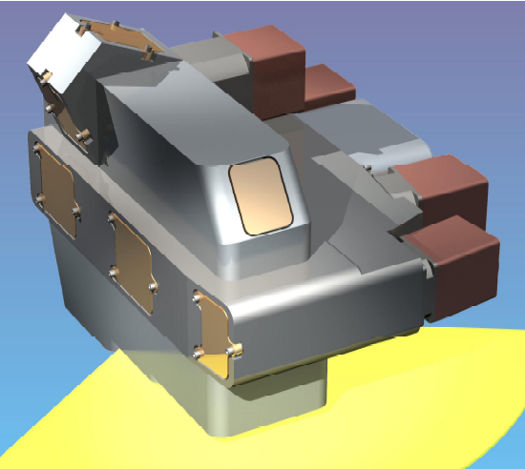

UV/Vis/NIR module

Fig. A2-1. Drawing of the TROPI UV/Vis/NIR module.
The TROPI design, by TNO and Dutch Space in The Netherlands, has a strong heritage from the Aura Ozone Monitoring Instrument (OMI) [Levelt et al, 2005] that was designed and built by the same Dutch industry expected to build TROPI. The compact design has been optimized to give a wide swath, high spatial and spectral resolution, high S/N and polarization scrambling . Two-dimensional detector arrays are used, with one axis of the array giving spectral information and the other giving cross-track spatial information.
The UV/Vis/NIR module consists of the optical bench (telescope and spectrograph) and a detector for each channel (i.e. four detectors in total). The optical bench is operated at room temperature and the detectors at 233 K. To accommodate the temperature gradients between the optical bench and the detectors a “labyrinth” construction is used, similar to that in the Scanning Imaging Absorption Spectrometer for Atmospheric Chartography (SCIAMACHY) on the ESA Envisat satellite. The cold parts are passively cooled. The temperatures of both the detectors and the optical bench are actively stabilized. An important element in the optical design is the polarization scrambler. Results from OMI demonstrate that this concept works very well and avoids the need for polarization measurement devices to correct for the polarization state of the incident light.
In-orbit calibration is done by regular solar irradiance measurements using various types of diffusers. The optical design, like that of OMI, is optimized to minimize the differences in the light paths for radiance and irradiance measurements in the instrument. This design feature cancels any remaining calibration errors and minimizes the impact of in-flight degradation. Other on-board calibration sources are light emitting diodes near each detector and a white light source to monitor potential detector, electronics and optical degradation.
Si-based CMOS (Complementary Metal Oxide Semiconductor) detector technology will most likely be used. Compared to the frame-transfer CCDs employed in OMI-Aura, the CMOS detectors have better radiation hardness, require less off-chip circuitry and consume less power. Each detector has a 14 bit analogue-to-digital converter with digital interface to the electronics module, which allows co-adding of the measured spectra up to 5 bits.
The electronics module provides the interface for the UV/Vis/NIR module to the satellite bus. This module also controls the detector readout, heaters and mechanisms, handles the video and thermistor data and provides power to the UV/Vis/NIR module. It is a high-density box in terms of power consumption and operates at about 310 – 315 K and, therefore, needs to be located at some distance from the TROPI UV/Vis/NIR module. The temperature of the electronics box will be actively stabilized.
Table A2-2 gives the estimated size, mass, power and data rates for the three TROPI modules.
Table A2-2. Estimated size, mass, power and data rate for the TROPI modules. Studies are underway to obtain more accurate values for mass and data rate.
module | size | mass  (kg) | power  (W) | data rate  (Mbytes/s)¹⁾ | notes
UV/Vis/NIR | 38x45x56 cm³ | 80 | 60 nominal  100 peak | 1.5 -6 | Need unobstructed cross track view +/- 58º from nadir, unobstructed view for the solar port, and cold space view for the passive coolers.  Perform daily calibration views of the sun.
electronics | 0.04 m³ | 20 | 40 nominal  50 peak | negligible | Shape can be modified as needed
total mass, power, and data rate |  | 100 | 100 nominal  150 peak | 1.5 -6
¹⁾ The nominal average data rate will be 1.5 Mbytes / s, the peak data rate can be up to 6 MBytes / s. The peak data rate will only be used during special events or calibration campaigns (max 2 weeks) and during the Launch and Early Operations Phase.

Appendix 3. The Tropospheric Infrared Mapping Spectrometer (TIMS)

Material to be added.
Appendix 4. Measurement coincidences with some relevant sensors on operational satellites

The figure below quantifies the coincidences between MISSION NAME? (in 830 km high, 53º inclination, orbit) observations and thermal infrared observations from NPOESS/METOP. The top plot shows that, of the 6-8 daily SMLS observations made everywhere from 30-60º latitude, 1-3 are coincident (within 30 minutes) with an observation by CRIS on NPOESS (13:30 and 17:30 equator crossing times) or by IASI on METOP (21:30 crossing time) every day. In the tropics, SMLS and CRIS/IASI coincidences occur in ~1 month periods with ~1 month gaps. The lower plot shows those observations that are also coincident with TROPI observations. This pattern naturally follows the TROPI coverage, shown in figure 2 of the text of this document, with one or more coincidences occurring about 50% of the time at mid-latitudes.

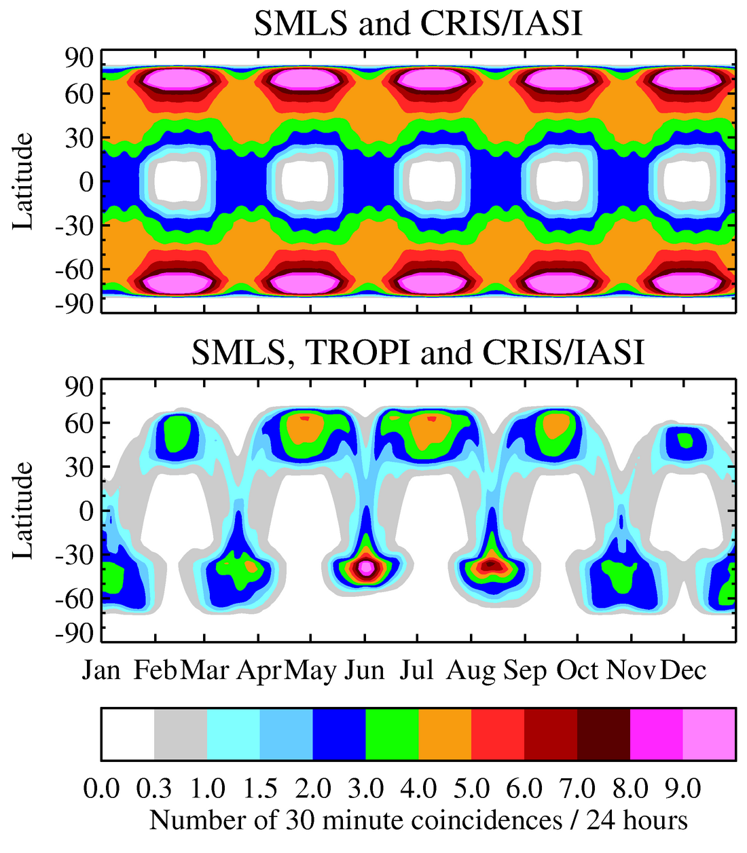

Appendix 5. Comparing coverages from precessing and from sun-synchronous orbits
The figures below compare global and temporal coverage of SMLS and TROPI UV/Vis in an 830-km 53º-inclination precessing-local-time orbit (top), and in an 830-km 99º-inclination sun-synchronous orbit (bottom). Everywhere within a given color is measured that number of times per 24-hour period.

830 km 55º-inclination precessing-local-time orbit

830 km sun-synchronous orbit

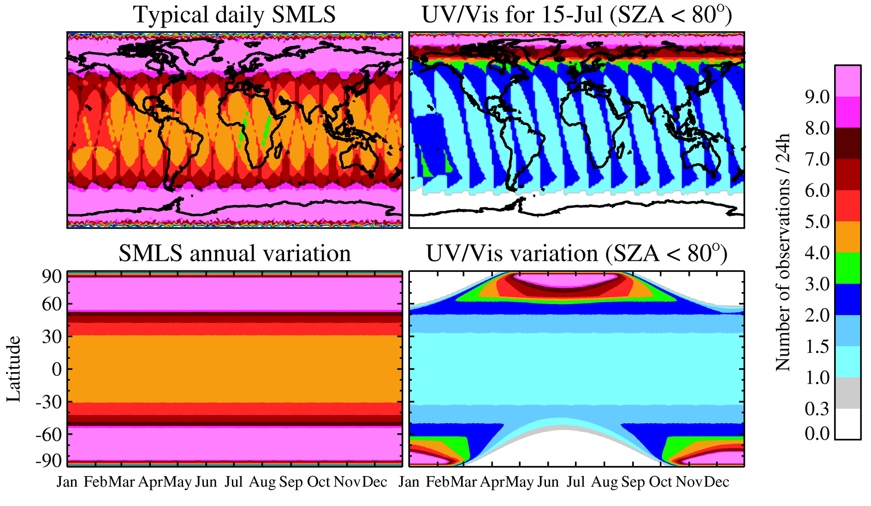

Pieternel Levelt lead investigator, Claude Camy-Peyret, co-lead investigator.

