Statement of
RANDI SPIVAK
Executive Director
American Lands Alliance
before the
Subcommittee on Public Lands and Forests
of the
Committee on Energy and Natural Resources
United States Senate

Policy and Management of Late-Successional Forests in the Pacific Northwest

March 13, 2008

My name is Randi Spivak and I am the executive director of American Lands Alliance. I want to thank the subcommittee for holding this hearing and for inviting me to talk about the importance of the Pacific Northwest’s mature and old-growth forests. American Lands was created at the height of the Pacific Northwest ancient forest wars to give local citizens a voice in how their public forests are managed. My organization has worked on forest policy issues and specifically for the protection of old-growth forests since our inception 16 years ago.

When I speak of “late-successional” forests, I am referring to both mature and old-growth forests as defined in the Northwest Forest Plan (NWFP). Both kinds are extraordinarily valuable — not just ecologically, but socially and economically as well. Without question, they are some of the most beautiful forests in this country, maybe even in the world. These magnificent forests cleanse the air we breathe and filter and produce clean drinking water. They are home for countless rare animals and plants and they shelter the rivers that produce some of the last best runs of wild salmon. Late-successional forests are more resistant to fire and can also reduce damages from flooding. These older forests are the playground and spiritual retreat for millions of Americans who go there to hike, hunt, fish, camp, and bike. These activities also generate significant revenues to local economies. In short, late-successional forests are the natural legacy of the Pacific Northwest.

Pacific Northwest Forests, Carbon Sequestration, and Climate Mitigation

A mere 0.017% of the earth’s land surface, old-growth forest conversion [in western Oregon and western Washington] appears to account for a noteworthy 2% of the total [Carbon] released [into the atmosphere] because of land use changes in the last 100 years. (Harmon, Ferrell and Franklin 1990)

Another crucial role that these late-successional forests play is helping to mitigate climate change by absorbing and storing substantial amounts of carbon from the atmosphere. More carbon is stored per acre in the moist “Westside” portions of the Pacific Northwest than any other forests in the world (Smithwick et al. 2002, Franklin and Waring 1980). Though the forests in Washington, Oregon, and California comprise only 19% of the forested area of the United States (USDA ERS 2002), they contain 39% of the United States’ total forest carbon (Birdsey 1992). Logging late-successional forests releases this carbon into the atmosphere. And these carbon emissions will not be absorbed by younger managed stands for centuries to come (Janisch 2001).

Historic and Current Extent of Late-Successional Forests

Late-successional forests once blanketed the Pacific Northwest. Before European settlement they covered approximately two-thirds of the landscape. But today, after decades of logging, they cover less than one-fifth. The majority of the remaining old growth, about 83%, is on public land in Washington, Oregon, and in Northern California. (See Appendix A)

Defining “Old Growth”

In order to develop sound and effective policies that protect mature and old-growth forests, we must be able to identify late-successional stands and trees. So a central question is, how do you define “old growth?”

While there are several definitions of old-growth forests, there is not a lot of variation among these definitions. According to the Forest Ecosystem Management Assessment Team (FEMAT), which laid the ecological foundation for the Northwest Forest Plan:

Old-growth stands are usually at least 180 to 220 years old with moderate-to-high canopy closure; a multi-layered, multi-species canopy dominated by large overstory trees; high incidence of large trees, some with broken tops and other indications of old and decaying wood (decadence); numerous large snags; and heavy accumulations of wood, including large logs on the ground (FEMAT 1993).

From an ecological perspective, a key component of protecting old growth is to also protect mature forests. Mature forest characteristics generally begin to appear at 80 to 100 years of age depending on site conditions. Like old growth, the mature age class is also ecologically valuable, but the most important role these forests serve is as the recruitment class for future old growth. As mature trees transition to old growth, they replace old growth lost to disturbance, ensuring that viable amounts of old growth will remain across the landscape.

Mature forests are those that have reached the culmination of mean annual increment (CMAI). CMAI is a time-tested method of foresters that identifies where the maximum rate of tree growth has peaked. CMAI also serves to generally define the beginning of the transition of a stand of trees to the mature stage.

Mature forests continue to grow — both upward and outward. An important transition between the mature and old-growth conditions is that while old-growth trees continue to grow, they do so mostly in diameter rather than height.

Besides scientific definitions, there is a social definition of “old growth.” How does the public define old growth? Approximately three-quarters of Oregon and Washington voters say that trees are old growth when they are 100 years old. (Davis and Hibbitts 2002)

Given the tremendous ecological deficit of late-successional forests across the landscape, any policy must protect both the mature and old growth age classes. CMAI can serve as a workable demarcation point that will provide enough specificity to accurately identify mature trees and enough flexibility to distinguish between species and local site conditions.

If we are serious about restoring ecological integrity and resilience to our publicly owned forests, late-successional forests must also be restored across the landscape over time, allowing these forests to return to historic levels.

Public Support for Protection

There is very strong public support for such a policy. Poll after poll has shown that Pacific Northwesterners and Americans in general want to protect old-growth forests. In a 2002 poll of Oregon and Washington residents, 75% wanted to protect old growth. (See Appendix B)

Protection and Restoration of Late-Successional Forests

Legislative protection for late-successional forests is essential to permanently resolve this resource conflict and provide clear direction to land management agencies concerning management priorities. Without it, we will continue to see efforts to eliminate and weaken existing protections, more litigation, and public controversy. The NWFP leaves over 1 million acres of mature and old growth open to logging. The Bush administration seeks to eviscerate what protections exist for water quality, salmon, rare species, the northern spotted owl, and the marbled murrelet in order to pave the way for even more logging of mature and old-growth forests than is already allowed by the NWFP.

The Bush administration proposes to significantly increase the logging of mature and old-growth forests. On BLM lands in western Oregon, they are proposing a 700% increase in old growth logging. There is a better path. That path is restoration of degraded public forests.

Past logging, grazing, and fire suppression has transformed many northwest forests creating a need for ecologically-based thinning that can both help restore the landscape and produce non-controversial timber volume. In the moist forests on the westside of the Cascade Crest, there are hundreds of thousands of acres of monoculture plantations that would benefit from variable density thinning to accelerate the re-establishment of late-successional forests. On dry forests east of the Cascade Crest, thinning small-diameter trees from below reduces fuels and therefore helps restore natural fire regimes which in turn, protects and restores the original structure of old-growth forests. Many conservation groups, community-based forestry organizations, mill owners, and loggers have found common ground focusing on small-diameter thinning. Such projects are moving forward without controversy or litigation (examples include the Siuslaw, Gifford Pinchot and Rogue-Siskiyou National Forests).

For the most part, the Pacific Northwest timber industry has already made the transition away from logging old-growth timber. Only a handful of mills still rely on old-growth logs. Today, no wood products are worth the further loss of mature and old-growth forests as every acre counts. Substitute materials are readily available to replace products made from old-growth trees.

These last few old-growth mills are like the last whaling stations. It was once thought that only ivory from elephant tusks would do for piano keys and billiard balls or whale oil for lighting. Killing whales or elephants to make products that can be made from other materials is no longer socially acceptable; it is morally wrong. The same is true for logging mature and old-growth forests. Consider the recent public outrage over the Bureau of Land Management’s Western Oregon Plan Revision to increase old-growth logging by over 700% in western Oregon. It is being opposed even in counties that would benefit greatly from increased logging revenues. The public will not stand for it.

Conclusion

It is time to resolve the controversy and get on with the business of protecting mature and old growth logging and restoring our national forests. Only clear direction from Congress to the federal forest management agencies can do this.

Unlogged mature and old-growth forests are more valuable to society than logged for short term economic gain. Late-successional forests are economic engines for commercial and sports fisheries, recreation, and tourism, as well as for the ecosystem services, carbon sequestration and social benefits they provide. There is significant wood volume and related jobs that can come from ecologically-based thinning of plantations and fire-suppressed stands. Logging the last of the mature and old-growth forests would simply be morally wrong.

In addition to a focused program of forest restoration, a comparable program of aquatic restoration is urgently needed. When we speak of forests we also mean watersheds. As degraded forests are restored to health, so too must degraded watersheds. One cannot separate the trees in a watershed from the watershed itself. There are countless miles of old and unnecessary roads that neither the public can afford to maintain nor the fish can afford to tolerate.

Please see that the Pacific Northwest protects and restores one of its most important natural legacies. While Congress did not create late-successional forests, only Congress can protect the last of the old-growth forests and restore them for this and future generations.

Sources

Birdsey, R. A. 1992. Carbon storage and accumulation in United States forest ecosystems. USDA, Forest Service, GTR-WO-59.

David and Hibbits 2002. Poll on Public Attitudes Toward Old-Growth Forests. Portland, Oregon.

FEMAT (Forest Ecosystem Management Assessment Team). 1993. Forest ecosystem management: an ecological, economic, and social assessment. Number 1993-793-071. U.S. Government Printing Office, Washington, D.C., USA.

Franklin, J. F. and R. H. Waring. (1980) Distinctive features of the northwestern coniferous forest: development, structure, and function. In: Forests: fresh perspectives from ecosystem analysis. Oregon State University Press, Corvallis, OR. Pp. 59-86.

Harmon, Mark E., William K. Ferrell, Jerry F. Franklin. 1990. Effects on carbon storage of old-growth forests to young forests. Science 247 (4943): 701.

Janisch, J. E. 2001. Carbon storage in a Pacific Northwest forest ecosystem: a chronosequence approach, Forest Science, Oregon State University, Corvallis.

Smithwick, E. A. H., M. E. Harmon, S. M. Remillard, S. A. Acker, and J. F. Franklin. 2002. Potential upper bounds of carbon stores in forests of the Pacific Northwest. Ecological Applications 12 (5):1303-1317.

USDA Economic Research Service. 2002. Forest Land use. (EIB 14).

Appendix A

The Need for Protecting Both Mature and Old-Growth Forests
In the Pacific Northwest

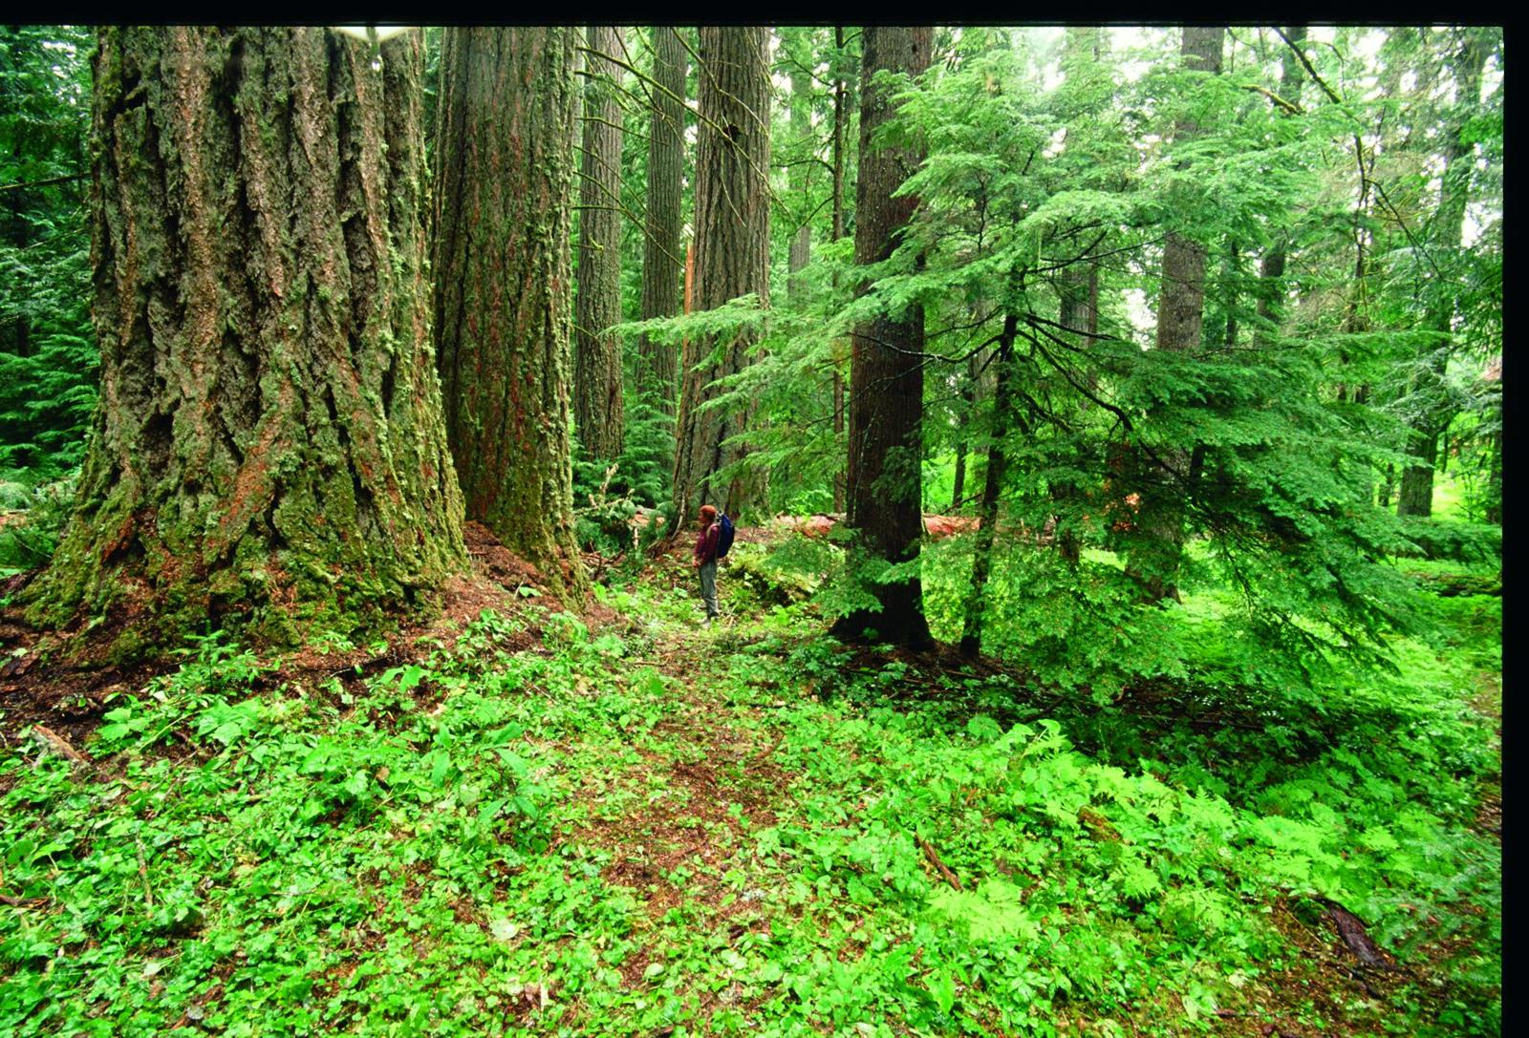
Old-growth Douglas-fir/western red cedar forest in the Big Bottom area along the banks of the Clackamas River in the Mount Hood National Forest in northwest Oregon.
(Photo by Bob Holmstrom)

Mature and old-growth forests of the Pacific Northwest are irreplaceable reservoirs for plants and wildlife, provide clean air and pure water, and mitigate climate change by storing vast amounts of carbon. Yet these magnificent forests are in great danger of being lost unless they are preserved on public lands. Old-growth forests used to comprise roughly two-thirds of the forestlands in Washington, Oregon, and Northern California, but today cover less than one-fifth. Mature forests, which become old growth as they age, have also been greatly diminished. The vast majority of remaining old growth is on public lands and there is little likelihood that mature growth on private lands will be allowed to transition to old growth. Therefore, in order to maintain current levels, and to promote the gradual return of old growth across the forest landscape, all mature and old-growth forests on public lands need to be protected.

Why older forests are important: Older forests and the structure provided by their large, live trees, standing dead trees (snags), and downed trees (often called logs) are essential to many ecological functions that make forests healthy. Specifically, older forests:

- Provide habitat for numerous fish (such as various Pacific salmon stocks) and wildlife species, including rare species and others threatened with extinction. Many wildlife species also depend on large blocks of dense older forests whose canopy layers are closed for shelter and nesting (e.g. northern spotted owl, Pacific fisher, American martin, and deer).

- Provide invaluable ecosystem services including clean drinking water, filtering the air we breathe, and cycling nutrients, which are essential for soil development.

- Are less susceptible to pest outbreaks and large-scale disturbances, like fire, than younger forests (NRC 2000). Diversity of tree and plant species, and the abundance of spiders and other invertebrates limit pest outbreaks in older forests that could otherwise over-run densely packed monocultures (Schowalter 1995). The thick bark of older trees allows them to withstand more heat, and their great height allows them to escape many surface fires. The heterogeneous structure, higher humidity, and litter moisture of many older forests also inhibit fire (NRC 2000).

- May be more resilient to climate change than younger forests because of the diverse plant and animal species they sustain (NRC 2000; Elmqvist et al. 2003; Hooper et al. 2005; Tilman et al. 2006). Some of these plants may contain invaluable medicines. For example, the Pacific yew tree, long considered a “trash tree” by lumber companies, contains taxol, an anticancer chemical.

- Store more carbon than any other terrestrial ecosystem on earth (including tropical rainforests) and therefore play a pivotal role in long-term carbon sequestration and climate change mitigation. Carbon storage in western Pacific Northwest forests is higher per acre than other forests in the United States (Smith et al. 2006; EPA 2007; Woodbury et al. 2007) and is in fact the highest in the world (Smithwick et al. 2002, Franklin and Waring 1980) because:

  - Favorable climate conditions promote growth during all seasons, not just during the normal summer growing season.
  - The dominant tree species of the region grow in diameter and height throughout their lives and produce large amounts of decay-resistant litter.
  - Infrequent natural disturbances such as wildfires and windstorms allow trees to grow very old (Wayburn et al. 2000).

Birdsey (1992) found that forests in Washington, Oregon, and California contain 39% of the United States’ total forest carbon. Smithwick et al. (2002) estimated that if allowed to return to historical old-growth status across the landscape, Pacific Northwest forests could store two to three times more carbon than they currently store. Considering that the U.S. net forest carbon sink offsets over 10% of all annual U.S. CO₂ emissions (EPA 2007), allowing forests in the Pacific Northwest to return to old-growth conditions would play a significant role in helping to mitigate climate change.

The Westside and Eastside forests are generally separated by the Cascade mountain range, which extends through Washington and Oregon to Northern California. Westside forests, which include ~24 million acres of federal forests, have very high rainfall and moderate seasonal temperature variability. Eastside forests, which include ~15 million acres of federal forests, generally grow in less productive soils than the Westside, in a climate that is hotter and drier in summer, and colder in the winter. Historically, the Westside forests have been most associated with Douglas-fir, while the Eastside forests have been most associated with ponderosa pine.

How much old growth was there and how much is there now?

Estimates of how much old growth existed in the Pacific Northwest prior to Euro-American settlement in the early 1800s generally rely on the first forest surveys. Those surveys (Andrews and Cowlin 1942; Cowlin et al. 1940), conducted in the mid-1930s for both the Douglas-fir (Westside) forests and ponderosa pine (Eastside) forests, revealed that despite extensive logging and related fires like the Tillamook Burn that had already occurred, the forests were still primarily old growth. The National Research Council (2000), relying heavily on the 1930s forest surveys, concluded that roughly two-thirds of western Oregon and Washington forests were old growth when Euro-Americans arrived in the area, and that similar old-growth coverage had existed in the Eastside forests. This is in line with a more recent study by Strittholt et al. (2006) that found that 64% of the entire land area of western Washington, Oregon, and Northern California was covered in old growth (which it defined as 150 years or older) before settlement, as well as the Forest Service’s estimate (Moeur et al. 2005) that 60 to 70% of the Northwest Forest Plan area had been late-successional (older than 80 years) before settlement.

Since the 1930s, other studies have sought to measure the extent of current old growth in the Pacific Northwest. Despite the differing parameters of each study, including the definitions used for old growth, time frames, geographic areas (e.g. Westside forests, Eastside forests, individual states), ownerships (various federal jurisdictions, state, and private), and land uses (forests only, or forests combined with other land cover), every study has shown that there has been a substantial decrease of old-growth forests caused by logging. The estimates of current old growth have generally ranged from 13% of forests in western Washington and Oregon (Morrison 1991) to 18% (Bolsinger and Waddell 1993) of forests in the entire states of Washington, Oregon, and Northern California. Strittholt et al. (2006) employed satellite imagery from 2000 to examine the over 60 million acre area of the western Pacific Northwest, regardless of ownership or land cover, and found that 18% of the land is currently covered in old growth. A Forest Service survey (Bolsinger and Waddell 1993) examined 56.5 million acres of forest inventories from virtually all public and private forests in Oregon, Washington, and Northern California, and found that 18% of forests were old growth (based on varying old-growth definitions for different states and ownerships). Therefore, based on the various studies:

- There has been more than a 70% decline in the amount of old growth in the states of Washington, Oregon, and in Northern California.

Another key finding, by the Bolsinger and Waddell survey (1993) is:

- The majority of remaining old growth (~83%) in the states of Washington, Oregon, and in Northern California is on public land.

Westside Older Forests

The Northwest Forest Plan (NWFP), implemented in 1994, covers ~24 million acres of U.S. Forest Service, Bureau of Land Management, and National Park Service lands in the Westside forests of Oregon, Washington, and California, and a small portion of Eastside federal forests in Oregon and Washington near the Cascade crest. The NWFP largely shifted federal lands management from resource extraction to an ecosystem management focus within the range of the northern spotted owl, which was listed as threatened under the Endangered Species Act in 1990. This dramatically reduced the amount of logging on federal lands by ~80% (Strittholt et al. 2006). The NWFP is based on the ecological framework of protecting “late-successional” forests, which includes both “old-growth” and “mature” stands. According to the NWFP, old-growth stands are:

Usually at least 180 to 220 years old with moderate-to-high canopy closure; a multi-layered, multi-species canopy dominated by large overstory trees; high incidence of large trees, some with broken tops and other indications of old and decaying wood (decadence); numerous large snags; and heavy accumulations of wood, including large logs on the ground (FEMAT 1993).

Old-growth stands generally contain trees with a larger average diameter, more age class variation, and more structural complexity than mature-growth stands of the same forest type. Mature stands are generally greater than 80 to 100 years and less than 180 to 200 years old. Mature forests are those that have reached the culmination of mean annual increment (CMAI), or where the maximum rate of tree growth has peaked. Mature forests continue to grow rapidly, both upward and outward. An important transition between the mature and old-growth states is that old-growth stands continue to grow, but less so in the height of trees and more so in the diameter, and not as rapidly. Like old growth, the mature age class also plays an important ecological role, but perhaps most importantly, mature trees are the recruitment trees for future old growth. As mature trees transition to old growth, they replace old growth that has been lost to disturbance, ensuring that viable amounts of old growth will remain across the landscape.

Strittholt et al. (2006), in addition to determining that large substantial losses of old growth have occurred in western Pacific Northwest (see chart below), also determined that there is very little mature growth (which it defined as 50 to 150 years or older) left in western Pacific Northwest:

- There are ~11.76 million acres of existing mature growth compared with ~11.53 million acres of old growth.

- There is significantly less mature growth (~5.9 million acres) on public lands than there is old growth (~9 million acres) on public lands.

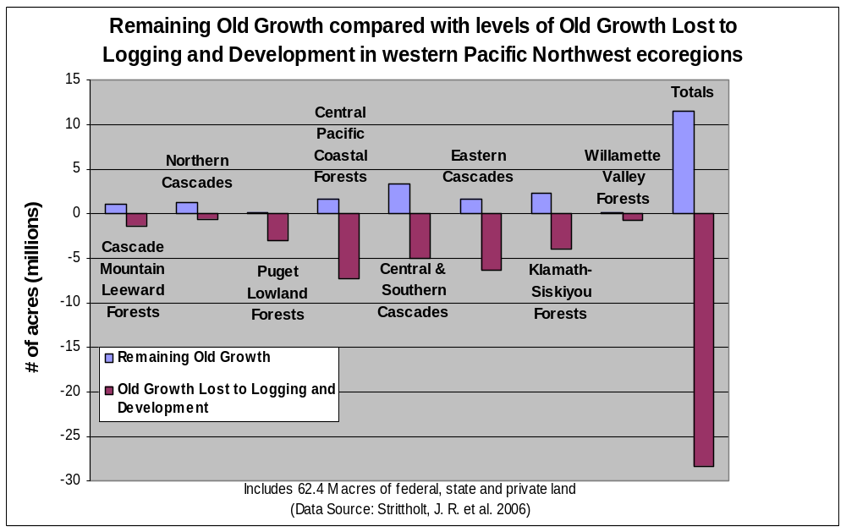

Eastside Older Forests

Like the Westside forests, every study measuring the Eastside forests of Oregon and Washington (“Eastside” forests do not generally include any forests in California, though a portion of the Modoc National Forest is, in fact “Eastside” in character), have shown that significant old-growth logging has taken place (Lehmkuhl 1994, Bolsinger and Waddell 1993). The Eastside Forests Scientific Panel (Henjum 1994) concluded that late-successional/old-growth forests, which it defined as forests with trees at least 150 years old or greater than 21 inches in diameter in the overstory (dominant or upper part of the forest as seen from above), make up between one-quarter and one-third of Eastside national forests. When other public and private land is considered, the amount drops to below one-fifth. This is well below historical levels; the first extensive survey of Eastside forests in Oregon and Washington (but excluding northeastern Washington) conducted in 1936, showed that 73% of all commercial forest was old growth (Cowlin et al. 1942).

The 1936 survey also found that nearly two-thirds of Eastside forestlands were dominated by ponderosa pine, with typical stands containing trees up to 60 to 70 inches in diameter at breast height (dbh) with most of the stand volume in trees of 20 to 44 inches dbh. Based on the 1936 survey, Henjum et al. (1994) concluded that:

- Less than 15% of the original ponderosa pine of Eastside forests remains.

- Only 3 to 5% of the pre-settlement ponderosa pine old growth remains in Deschutes National Forest, and only 2 to 8% remains in Fremont National Forest.

Conclusion

There is a severe deficit of mature and old-growth forests across the Pacific Northwest. Like old-growth forests, mature forests are ecologically important as habitat for species that depend on closed-canopies and as replacements for older forests in a dynamic landscape. Protecting and restoring mature and old-growth forests are critical to restoring ecologically robust forests. To have fully functioning forests that are resilient to natural disturbances, able to support abundant levels of plants and wildlife, capable of maximum carbon storage over time, all mature and old-growth forests need to be protected. To do so will require not only protecting what is left, but also restoring older forests across the landscape and over time.

The forest canopy describes the area above the forest floor where the tree crowns meet to form an interactive web of life.
A classic definition of "late-successional" forest was a state "in which shade-tolerant tree species, such as western hemlock and grand fir, begin to attain dominance" and such "conditions in the Pacific Northwest forests occurred rarely, only after many years in the old-growth condition and in the absence of significant disturbances that maintained dominance of less shade-tolerant species (most commonly Douglas-fir or ponderosa pine)." (NRC 2000 citing Spurr and Barnes 1973). With the publication of FEMAT (1993) and the Northwest Forest Plan Record of Decision (1994), "late-successional" has generally come to mean forests that have attained the culmination of mean annual increment and includes both "mature" and "old-growth" forests.

