Avian Inventory at Six National Capital Region National Parks

Final Report (Revised)

John A. Sinclair, Marcus Koenen, Sybil Hood, Mikaila Milton, and Christina Wright

National Park Service
Inventory and Monitoring Program
National Capital Region Network
Washington, D.C.

1 September 2004

TIC#: NCRO D-48

Table of Contents

Summary 3
Acknowledgments 4
Introduction 5
Results 7
Discussion 9
Literature Cited 11

List of Figures

Figure 1. Maps of the six National Capital Region Network parks showing the division of each park into its associated birding sections. 12
Figure 2. Species accumulation curves. 18

List of Tables

Table 1. Status of species recorded at each park: 19
Table 2. Bird species recorded by park section 34
Table 3. Resident (R) and migrant (M) bird species expected to occur, but not observed 47

Appendices

Appendix A. Species Expected in Parks of the National Capital Region Network as produced in Gray and Koenen 2001. 50
Appendix B. Species of concern as produced in Gray and Koenen 2001.. 56

Summary

Biological Inventories to identify bird species in six National Capital Region Network parks (Antietam National Battlefield, Catoctin Mountain Park, Harper’s Ferry National Historical Park, Manassas National Battlefield, Prince William Forest Park, and Wolf Trap National Park for the Performing Arts) were initiated in 2001. The goals of the inventories were to identify 90% of the bird species occurring in each park and to determine their breeding status and spatial distribution. Surveys were concluded in 2003, and a total of 175 species were identified in the Network parks; species richness ranged from 76 species at Wolf Trap National Park for the Performing Arts to 151 species at Manassas National Battlefield. Two methods were used to assess the completeness of the inventories (i.e., 90% species documentation): a direct comparison to an expected species list and species accumulation curves. Based on the results of the two methods of analysis it was concluded that 90% of the species had been documented in the six network parks. Additional inventories, utilizing a different survey methodology, may be beneficial to document the occurrence of the remaining species.

Acknowledgments

Many individuals contributed time and effort to the National Capital Region Network bird inventory, and the program succeeded because of their strong commitment. Those participating in the bird surveys included Scott Bates, Doris Berger, David Boone, Alan Biggs, Laura Catterton, Larry Cartwright, Connee Chandler, Christine Cover, Shirley Ford, Bart Frazier, Kurt Gaskill, Katherine Grandine, Sue Heath, Charles Hesler, Janet Hesler, Anna Hutzell, Paul Kane, Lois Kauffman, Mary Keedy, Robert Keedy, Robert Klarquist, Marcus Koenen, Sarah Koenen, Judith Lilga, Paul Mauss, Linda Millington, Ann Mitchell, Elizabeth Pitney, Jonathan Putnam, Marc Ribaudo, Rich Rieger, Maurice Salata, Frank Schaff, Robert Shewack, Janet Shields, Janeann Snyder, Vaughn Snyder, Paula Sullivan, Dorothy Tella, Marilyn Virts, Porter Ward, Haji Warf, Dave Weesner, Christopher Wilson, Sandra Wilson, and Betty Wolfe. Others providing technical support with the database, data entry, and maps included Jeff Runde, Nelson Torres, and Christina Wright. We thank the National Park Service staff, and in particular the resource managers, at Antietam National Battlefield, Catoctin Mountain Park, Harper’s Ferry National Historical Park, Manassas National Battlefield, Prince William Forest Park, and Wolf Trap National Park for the Performing Arts. We especially thank Deanna Dawson for reviewing existing data for the parks and providing comments on earlier drafts of this report.

Introduction

Basic biological inventories can provide important species-related information to resource managers. Information gathered from inventories can be used to educate park visitors on the importance of biological diversity and the role of parks in conserving it, and to alert them to opportunities to observe wildlife in parks. Within National Parks, inventory information can provide the basis for long-term monitoring, identify important habitats, and assist in the development of species or habitat conservation plans. Unfortunately, basic biological information is missing for many of our National Parks. As of 1994, the majority of National Parks surveyed did not have complete inventories of major taxonomic groups (Stohlgren et al. 1995). To remedy this situation, Congress in 1998 authorized funding to begin basic inventories and long-term monitoring of biological resources (National Park Service 1999). The National Park Service used this funding to establish 32 Inventory and Monitoring (I&M) Networks of parks with significant natural resources.

The National Capital Region Network (NCRN) is one of these Inventory and Monitoring Networks. The NCRN is composed of 11 National Park units with significant natural resources: Antietam National Battlefield (ANTI), Catoctin Mountain Park (CATO), Chesapeake and Ohio Canal National Historical Park (CHOH), George Washington Memorial Parkway (GWMP), Harper’s Ferry National Historical Park (HAFE), Manassas National Battlefield Park (MANA), Monocacy National Battlefield (MONO), National Capital Parks- East (NACE), Prince William Forest park (PRWI), Rock Creek National Park (ROCR), and Wolf Trap National Park for the Performing Arts (WOTR).

In 2001, the NCRN developed a Biological Inventories Study Plan (Gray and Koenen 2001),which outlined the procedures the Network would use to implement inventories of vertebrates and vascular plants. The study plan identified six NCRN parks (ANTI, CATO, HAFE, MANA, PRWI, WOTR) that were in need of additional information on the bird species present. An inventory of birds at the six NCRN parks was begun in 2001.

The goals of the project were to:

1. Conduct field surveys to document 90% of the bird species occurring within the parks.

2. Determine the status and spatial distribution of the documented species at each park and in particular species of special concern.

Parks

The six NCRN parks targeted for additional surveys range in size from 53 to 7,518 hectares (ha), and encompass the Ridge and Valley, Piedmont, and Coastal Plain physiographic provinces.

Antietam National Battlefield (www.nps.gov/anti) is managed within the historical context of General Robert E. Lee's first invasion of the North in September 1862 during the Civil War. The 1,318 ha park is located in the heart of Maryland, on rolling hills dotted with farm fields and pastures reminiscent of the day of the battle. Patches of forests, open meadows, croplands, and karsts are found within the park.

Catoctin Mountain Park (www.nps.gov/cato) originated as a Recreation Demonstration Area (RDA) under the National Industrial Recovery Act of 1933, and was transferred to the National Park Service in 1936. The park encompasses 2,336 ha of forested landscape located in the mountains of the Catoctin Ridge in north-central Maryland. Unique geological formations, consisting of metamorphic sandstone and greenish-gray metabasalts forming cliffs, occur in the park.

Harpers Ferry National Historical Park (www.nps.gov/hafe) is located at the confluence of the Shenandoah and Potomac Rivers in West Virginia, Virginia, and Maryland. The 926-ha park lies within the Blue Ridge physiographic province and contains forested mountains, riparian habitats, and floodplains that surround the park’s historic town area. Caves are also found within park boundaries.

Manassas National Battlefield Park (www.nps.gov/mana) was established in 1940 to preserve the scene of two major Civil War battles that took place a few miles north of the prized railroad junction of Manassas, Virginia, in 1861 and 1862. The 2,064 ha park is located approximately 72 km southwest of Washington, D.C., within the Triassic basin of the northern Virginia Piedmont. The park is characterized by gently rolling hills with a patchwork of open fields and a successional range of oak-hickory forests with riparian vegetation along the streams.

Prince William Forest Park (www.nps.gov/prwi) is centered in the Quantico Creek watershed, which drains into the nearby Potomac River. Because the park includes two physiographic provinces (Piedmont and Coastal Plain) and lies in the transition zone between northern and southern climates, it exhibits a wide range of habitats and vegetative communities. It currently is the only natural area in the National Park System that contains a significant expanse of Piedmont Forest. The park contains several rare communities, including a seepage swamp and remote stands of eastern hemlock, which contain old growth specimens.

Wolf Trap National Park (www.nps.gov/wotr) encompasses 53 ha of rolling hills and woods originally donated to the National Park Service by Catherine Filene Shouse to be used exclusively for the performing arts. Wolf Trap lies entirely within the Piedmont physiographic province. Natural habitats within the park include streams, meadows and heavily wooded areas.

Methods

Documented observations on bird species in all 11 NCRN parks were compiled in 2000. This information was reviewed by a subject expert (Deanna Dawson, USGS-BRD), who prepared an expected species list for each park (Appendix A). It was determined that ANTI, CATO, HAFE, MANA, PRWI, and WOTR lacked enough supporting evidence to conclude that 90% of their park’s bird species had been documented.

The NCRN noted that various bird inventories were being conducted in surrounding areas through volunteer efforts. Using a similar approach, volunteers were selected based on their ability to identify birds by sight and sound. Inexperienced birders were allowed to participate, but were asked to survey with an experienced birder. All volunteers conducted at least one survey with I&M staff or a volunteer group leader identified by I&M staff. No further standard testing was conducted to assess the capabilities of volunteers.

The NCRN developed a standard protocol and datasheet (Gray and Koenen 2001) to be used during all surveys. Volunteers were asked to spend at least 5 hours in the park per month, and collect presence / absence data on all birds seen or heard. Special effort was made to confirm the residency, migration or breeding status of all birds, and in particular the status of birds designated as Species of Special Concern by Partners in Flight (Pashley et al. 2000). Breeding status was assigned using standard Breeding Bird Atlas methodology (Robbins and Blom 1996, American Birding Association 2000). Residents were defined as species documented more than two months out of the year but were not documented breeders in the park. Migrants were defined as species seen for no more than two months out of the year. To determine a species distribution within a park, parks were divided into sections (Figure 1). Because of its small size, WOTR was not subdivided. Volunteers were asked to keep separate observations for each park section. Datasheets were submitted to the I&M staff and entered into a Database Template formatted for the bird inventory.

Information was queried from the database and analyzed by two methods to determine if 90% of the bird species at each park had been documented. The first method was to plot the number of new species observed on each survey visit versus the cumulative number of hours spent surveying at each park. This creates a species accumulation curve for each park. When the plotted data reaches a plateau, it can be concluded that 90% of the species have been documented. The second method used was to compare the species documented by the volunteers to the expected species list created for each park. This analysis was constrained to breeding and winter resident species because of the logistical difficulties in conducting thorough surveys of migrating birds. Queries were also used to assess each species breeding status and park distribution.

Results

Forty-seven individuals participated in the bird inventory project, including volunteers and park staff. Overall, participants spent 1809.1 hours conducting surveys and identified 175 bird species.

Antietam National Battlefield

Surveys began on 2 February 2001 and continued through 12 October 2002. Overall, 183 surveys were conducted (426.72 total survey hours) and 124 species were documented (Table 1); 112 species were documented in Section 1, 104 species were documented in Section 2, and 23 and 14 were documented in Sections 2A and 2B (subsections of 2), respectively (Table 2). Forty-eight species were confirmed as breeders in the park (Table 1).

This effort resulted in documentation of 86.8% of the expected resident species (breeders and winter residents), based on a comparison with the expected species list; 16 expected residents and 54 expected migrants were not documented (Table 3). Species accumulation curves demonstrate a significant plateau, and only 0.07 new species were documented per survey hour in 2002, the last calendar year surveys were conducted (Figure 2).

Catoctin Mountain Park

One hundred thirty-one surveys were conducted between 6 February 2001 and 28 November 2002 (507.00 total survey hours). Overall, 108 species were documented (Table 1), 80 in Section 1, 81 in Section 2, 64 in Section 3, 46 in Section 4; 9 additional species were documented but were not designated to a Section (Table 2). Forty-one species were confirmed as breeders in the park (Table 1).

80.6% of the expected resident species (breeders and winter residents) have been documented based on a comparison with the expected species list; 18 expected residents and 24 expected migrants were not documented (Table 3). Species accumulation curves demonstrate a significant plateau, and only 0.07 new species were documented per survey hour in 2002, the last calendar year surveys were conducted (Figure 2).

Harper’s Ferry National Historical Park

Surveys began on 10 February 2001 and continued through 14 November 2002. Overall, 64 surveys were conducted (219.75 total survey hours) and 114 species were documented (Table 1); Section 1 was not surveyed, 83 species were documented in Section 2, 74 species were documented in Section 3, and 103 species were documented in Section 4 (Table 2). Nine species were confirmed as breeders in the park (Table 1).

75.6% of the resident species (breeders and winter residents) expected to occur in the park have been documented; 31 expected residents and 51 expected migrants were not documented (Table 3). Species accumulation curves demonstrate a plateau, and only 0.16 new species were documented per survey hour in 2002, the last calendar year surveys were conducted (Figure 2).

Manassas National Battlefield

Surveys began on 3 February 2001 and continued through 13 September 2002. Overall, 172 surveys were conducted (522.58 total survey hours) and 151 species were documented (Table 1); 113 species were documented in Section 1, 73 species were documented in Section 2, 133 species were documented in Section 3, 111 species were documented in Section 4, 110 species were documented in Section 5, and 105 species were documented in Section 6 (Table 2). Fifty-four species were confirmed as breeding in the park (Table 1).

In the assessment of 90% species documentation, 89.3% of the resident species (breeders and winter residents) have been documented based on a comparison with the expected species list; 13 expected residents and 40 expected migrants were not documented (Table 3). Species accumulation curves demonstrate a significant plateau, and only 0.03 new species were documented per survey hour in 2002, the last calendar year surveys were conducted (Figure 2).

Prince William Forest Park

Surveys began on 12 January 2001 and continued through 5 November 2001. Overall, 41 surveys were conducted (84.98 total survey hours) and 100 species were documented (Table 1), 64 species in Section 1, 34 species in Section 2, 58 species in Section 3, 81 species in Section 4, 47 species in Section 5, and 34 species in Section 6 (Table 2). Five species were confirmed as breeders in the park (Table 1).

74.8% of the expected resident species (breeders and winter residents) have been documented based on a comparison with the expected species list; 17 expected residents and 42 expected migrants were not documented (Table 3). The species accumulation curves demonstrate a plateau; however only one year of data is available (Figure 2).

Wolf Trap National Park for the Performing Arts

Surveys began on 23 February 2001 and continued through 29 June 2003. Overall, 23 surveys were conducted (48.08 total survey hours) and 76 species were documented (Table 1). Fourteen species were confirmed as breeders in the park (Table 1).

75.3% of the resident species (breeders and winter residents) expected to occur in the park were documented based on a comparison with the expected species list; 20 expected residents and 39 expected migrants were not documented (Table 3). Species accumulation curves demonstrate a plateau, and only 0.22 new species were documented per survey hour in 2003, the last calendar year surveys were conducted (Figure 2).

Discussion

Biological inventories of birds began in the winter of 2001 and have added greatly to our knowledge on bird species diversity within NCRN parks. Surveys documented 175 species, ranging from 76 at WOTR to 151 at MANA. For comparison, bird species richness ranged from 94 to 163 at six Pennsylvania National Parks where 186 species were documented (Yahner et al. 2001).

In an attempt to evaluate the completeness of the NCRN bird inventories (i.e., Goal 1. documenting 90% of the bird species), we utilized two methods 1) a direct comparison to an expected species list and 2) species accumulation curves. Each method of analysis has potential flaws. The direct comparison makes the assumption that all expected species currently occur within a park. However, some species may not actually occur within the park, just in the region, so would not be found even on targeted survey efforts. Other species may be present in some but not all years or use park habitats only occasionally.

Species accumulation curves provide a visual assessment of the number of new species documented versus survey effort. As the accumulation curve levels off, few new species are expected to be documented, even with additional surveys. However, accumulation curves only assess the likelihood of documenting a new species utilizing the same survey methodology; changing survey methodology may increase the likelihood of finding new species.

Evaluating the completeness of inventories with both analysis methods reduces some of the problems with interpreting the results. For instance, based on the expected species list analysis, no park has reached 90% species documentation. MANA had documented the most expected species with 89%. However, the species accumulation curve had leveled off, and in the last year of surveys, only 3 new species (including migrants) were documented per 100 survey hours. Even for WOTR, where occurrence of only 75% of the expected species was documented, only 2 new species were documented per survey hour in the last calendar year (only 1 was a resident). Therefore, although the percentage of expected species documented ranges from 75 to 89, the likelihood of documenting new species with the current sampling methodology is minimal. Overall, because more than 75% of expected resident species have been identified in each of the six network parks, and because of the low likelihood of documenting additional species, less than 2 per 10 survey hours, we believe we have met the first goal of the bird inventories.

Querying biological and distributional information from the database, allowed us to achieve the second goal of generating distribution information. It should be noted, however, that some sections were not visited frequently and the species distribution data should be considered preliminary and incomplete. Section 1 in HAFE, for example, was not visited at all because of difficult access. Section 6 at PRWI was not visited frequently suggesting why the species list may be lower than for other sections in the park. In addition, it should be noted that volunteers generally stayed on trails. Unique habitats such as marshy areas found only away from trails in Section 1 at PRWI were not surveyed.

In addition to addressing the two goals, this survey provides evidence for species of concern in the six parks. Overall, 20 of 23 species of concern were documented. Forest species including the Acadian Flycatcher, Wood Thrush, Louisiana Waterthrush, and Scarlet Tanager were documented during the breeding season at all six parks and were confirmed breeding at most. Shrub and grassland birds were generally rare although the Grasshopper Sparrow was confirmed at both ANTI and MANA. The Northern Bobwhite was documented as a probable breeding species at MANA. Coverage of both forested areas and grassland areas was good. Lack of evidence of Henslow Sparrow indicates they were not present in the parks during the time of the inventory even though they were considered potentially present. Lack of evidence of the American Woodcock, Whip-poor-will, American, American Black Duck, American and Least Bittern is likely due their being rare in addition to requiring more specialized survey techniques.

Despite having achieved the goals of the bird inventory program, we believe that there may be a benefit in conducting additional inventories for particular species groups. We recommend reviewing the list of expected species not documented in each park (Table 3), and working with bird specialists to develop survey methodologies to target them. Many of the undocumented species or species groups may be rare and may need management attention.

Literature Cited

Gray, E. S. and M. T. Koenen. 2001. A study plan to inventory vascular plants and vertebrates: National Capital Network, National Park Service. Unpublished.

National Park Service. 1999. Guidelines for biological inventories. Inventory and Monitoring Program, National Park Service. Unpublished.

Pashley, D. N., C. J. Beardmore, J. A. Fitzgerald, R. P. Ford, W. C. Hunter, M. S. Morrison, and K. V. Rosenberg. 2000. Partners in Flight: Conservation of the Land Birds of the United States. American Bird Conservancy, The Plains, VA.

Robbins, C. S. and E. A. T. Blom. 1996. Atlas of the Breeding Birds of Maryland and the District of Columbia. University of Pittsburgh Press.

Stohlgren, T. J., J. F. Quinn, M. Ruggiero, and G. S. Waggoner. 1995. Status of biotic inventories in US National Parks. Biological Conservation 71:97-106.

Yahner, R. H., B. D. Ross, G. S. Keller, and D. S. Klute. 2001. Comprehensive Inventory Program for Birds at Six Pennsylvania National Parks. Technical Report NPS/PHSO/NRTR-01/084.

Figure 1. Maps of the six National Capital Region Network parks showing the division of each park into its associated birding sections. Antietam National Battlefield (ANTI), Catoctin Mountain Park (CATO), Harper’s Ferry National Historical Park (HAFE), Manassas National Battlefield (MANA), Prince William Forest Park (PRWI), Wolf Trap National Park for the Performing Arts (WOTR).

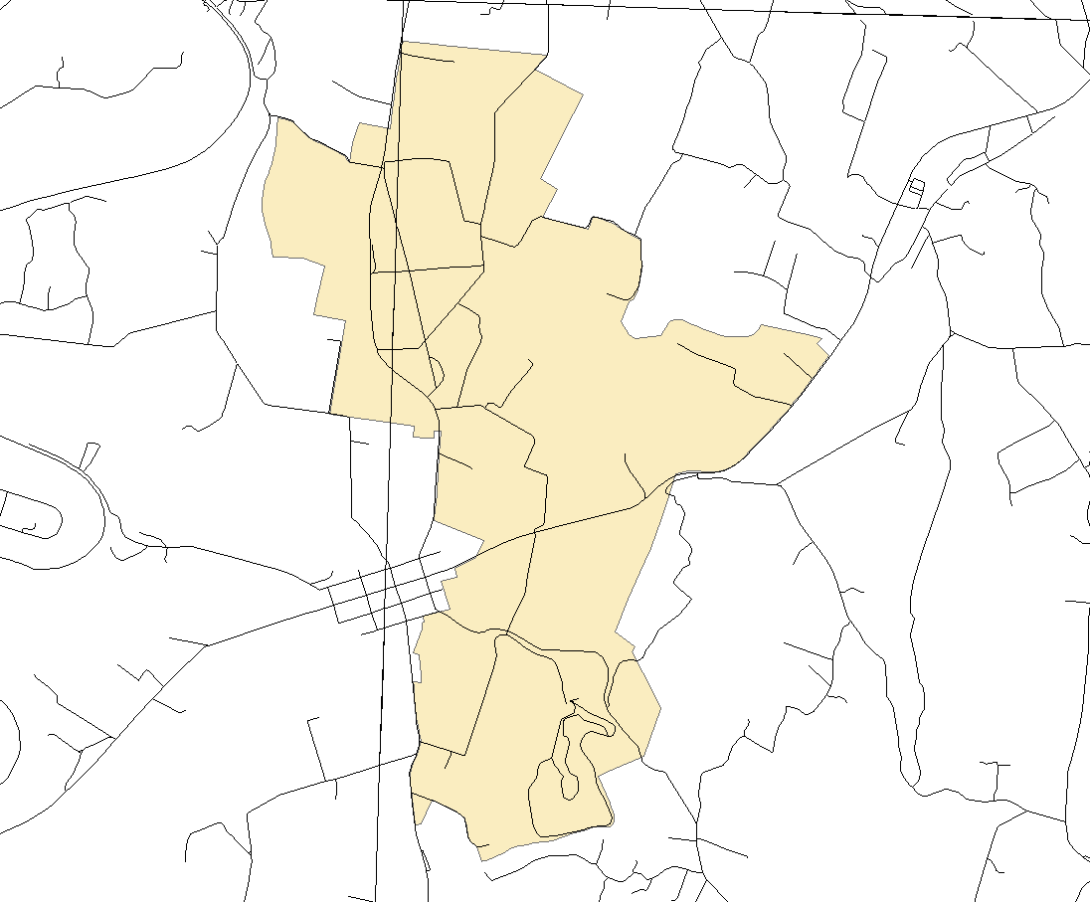
ANTI
2A
2B
Section 1
Section 2

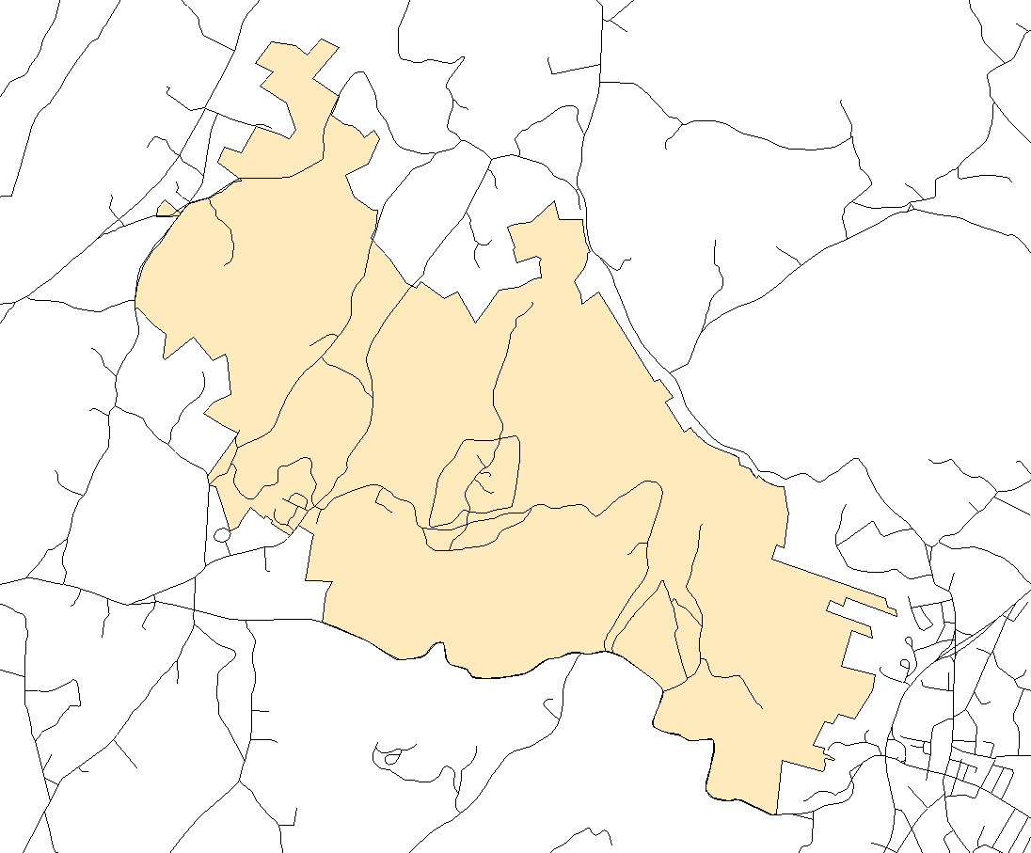
CATO
Section 1
Section 2
Section 3
Section 4

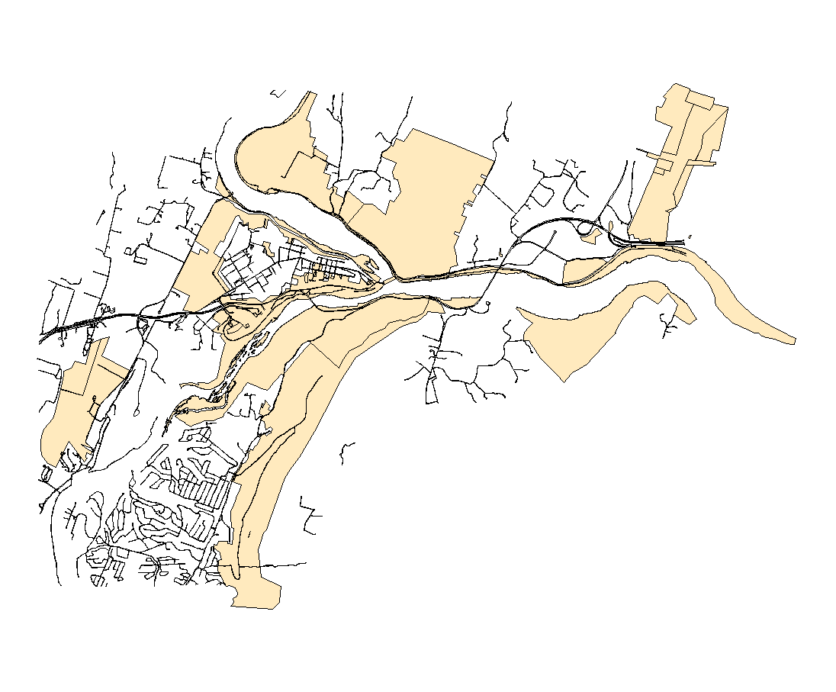
HAFE
Section 1
Section 2
Section 3
Section 4

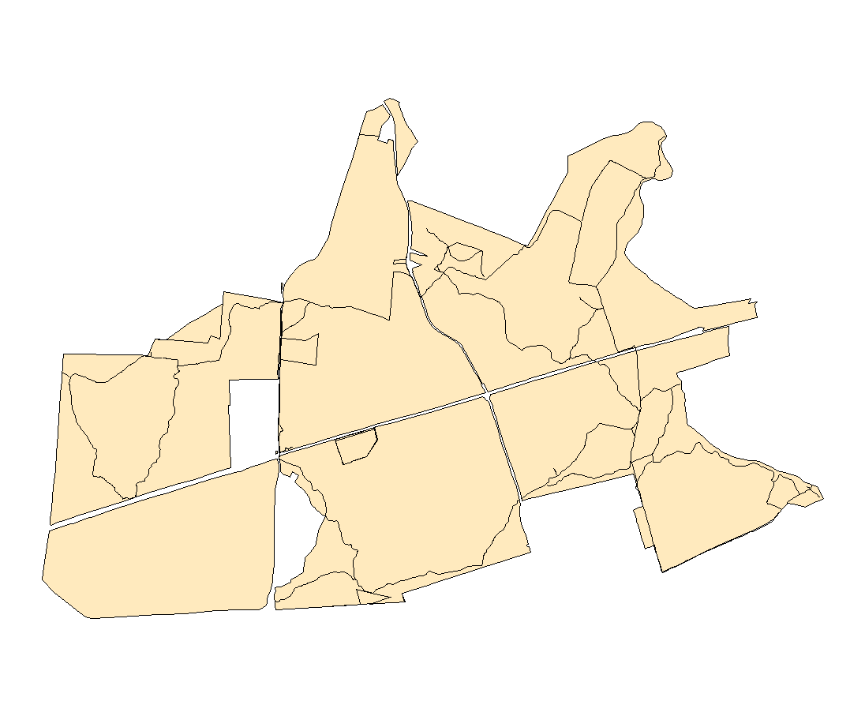
MANA
Section 1
Section 2
Section 3
Section 4
Section 5
Section 6

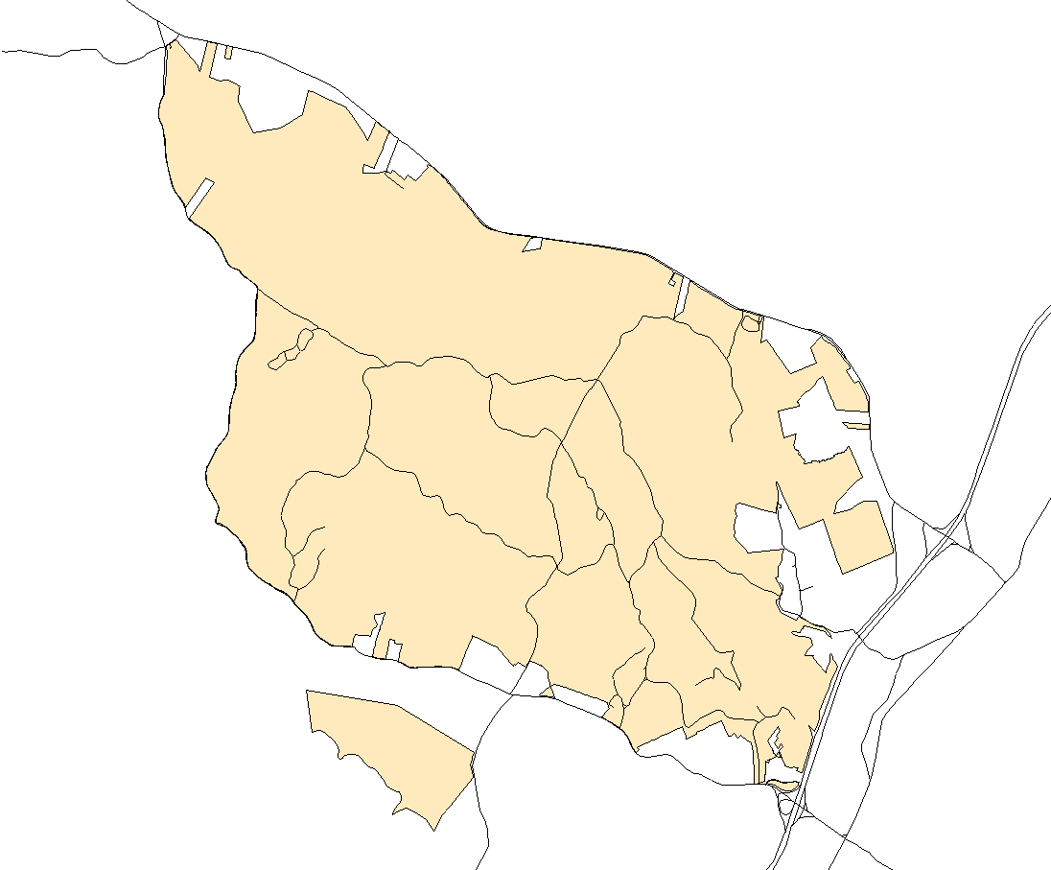
PRWI
Section 1
Section 6
Section 4
Section 2
Section 3
Section 5

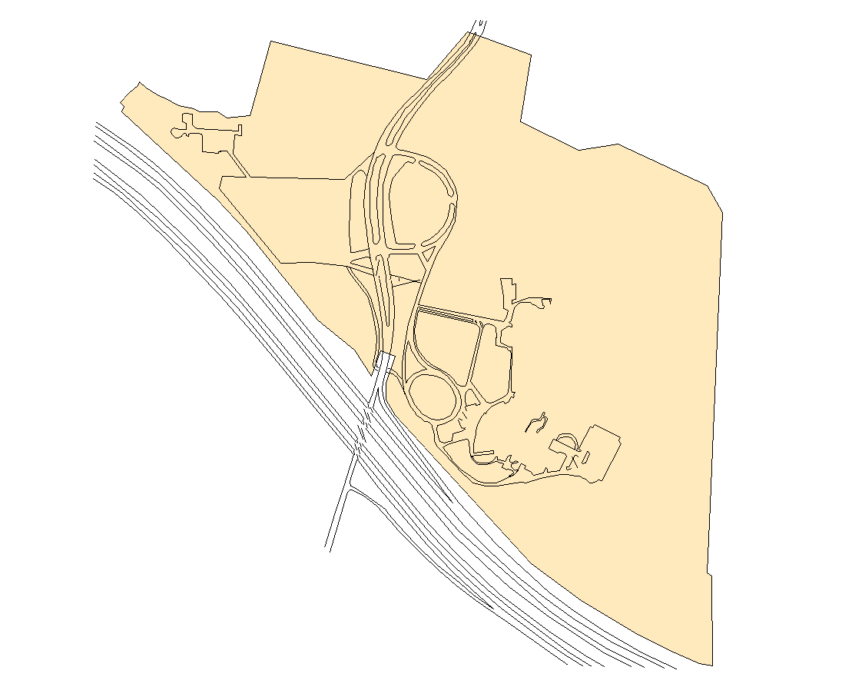
WOTR
One All Inclusive Section

Figure 2. Species accumulation curves. The number of species documented versus effort (survey hours) for Antietam National Battlefield (ANTI), Catoctin Mountain Park (CATO), Harper’s Ferry National Historical Park (HAFE), Manassas National Battlefield (MANA), Prince William Forest Park (PRWI), and Wolf Trap National Park for the Performing Arts (WOTR).

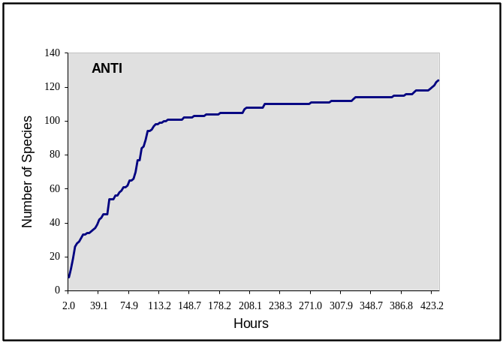 | 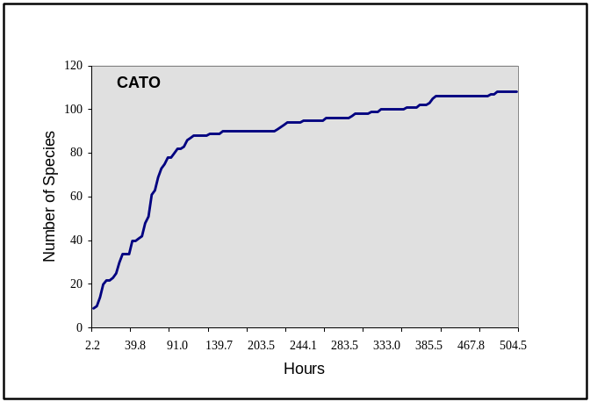
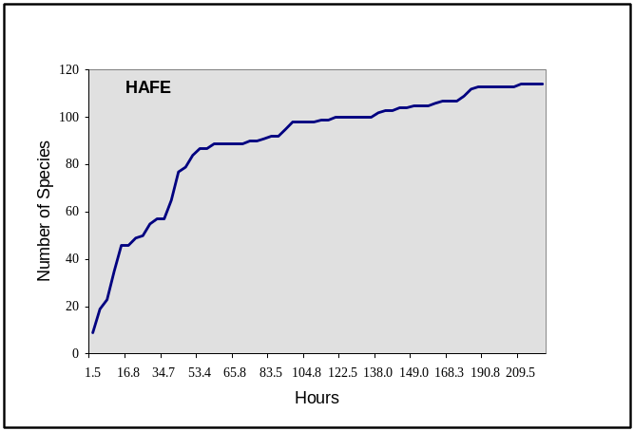 | 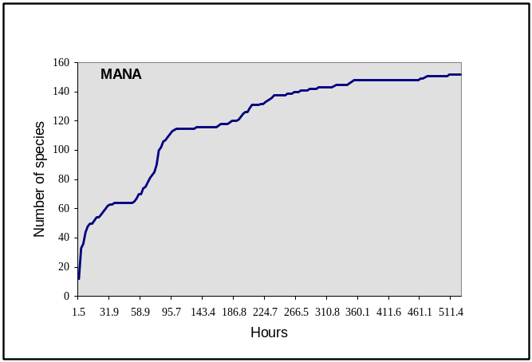
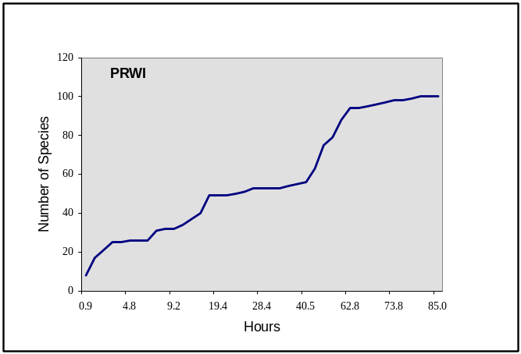 | 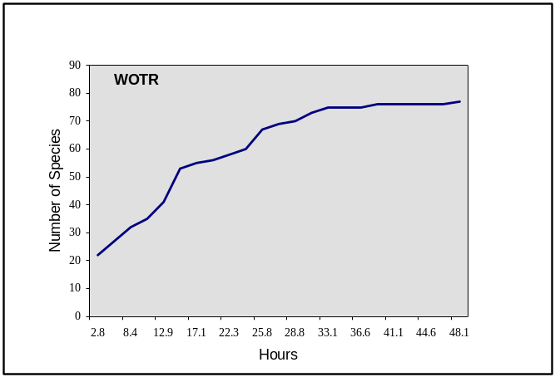

Table 1. Status of species (common (CO), probable (PR), possible (PO), observed (OB)) recorded at each park: (a) Antietam National Battlefield (ANTI), (b), Catoctin Mountain Park (CATO) (c), Harpers Ferry National Historical Park (HAFE), (d) Manassas National Battlefield (MANA), (e), Prince William Forest Park (PRWI), and (f) Wolf Trap National Park for the Performing Arts (WOTR).

Park Code | Species | CO | PR | PO | OB
ANTI | Great Blue Heron |  | x |  | x
ANTI | Great Egret |  |  |  | x
ANTI | Green Heron |  | x | x | x
ANTI | Black Vulture |  |  |  | x
ANTI | Turkey Vulture |  |  | x | x
ANTI | Canada Goose | x | x | x | x
ANTI | Wood Duck |  | x | x | x
ANTI | Mallard | x | x | x | x
ANTI | Common Merganser |  |  |  | x
ANTI | Osprey |  |  |  | x
ANTI | Northern Harrier |  |  |  | x
ANTI | Sharp-Shinned Hawk |  |  |  | x
ANTI | Cooper's Hawk |  |  |  | x
ANTI | Red-shouldered Hawk |  |  |  | x
ANTI | Broad-winged Hawk |  |  |  | x
ANTI | Red-tailed Hawk | x | x | x | x
ANTI | American Kestrel | x |  | x | x
ANTI | Wild Turkey |  | x |  | x
ANTI | Northern Bobwhite |  |  |  | x
ANTI | Killdeer |  | x |  | x
ANTI | Greater Yellowlegs |  |  |  | x
ANTI | Solitary Sandpiper |  |  |  | x
ANTI | Ring-billed Gull |  |  |  | x
ANTI | Rock Dove |  | x | x | x
ANTI | Mourning Dove | x | x | x | x
ANTI | Black-billed Cuckoo |  |  |  | x
ANTI | Yellow-billed Cuckoo |  | x | x | x
ANTI | Eastern Screech-Owl |  | x |  | x
ANTI | Great Horned Owl | x | x | x | x
ANTI | Barred Owl |  | x |  | x
ANTI | Common Nighthawk |  |  |  | x
ANTI | Chimney Swift |  | x | x | x
ANTI | Ruby-throated Hummingbird |  |  | x | x
ANTI | Belted Kingfisher |  | x | x | x
ANTI | Red-headed Woodpecker | x | x | x | x
ANTI | Red-bellied Woodpecker | x | x | x | x
ANTI | Yellow-Bellied Sapsucker |  |  |  | x
ANTI | Downy Woodpecker | x | x | x | x
ANTI | Hairy Woodpecker |  | x |  | x
ANTI | Northern Flicker | x | x | x | x
ANTI | Pileated Woodpecker | x | x | x | x
ANTI | Eastern Wood-Pewee |  | x | x | x
ANTI | Acadian Flycatcher |  | x | x | x
ANTI | Eastern Phoebe |  | x | x | x
ANTI | Great Crested Flycatcher |  | x | x | x
ANTI | Eastern Kingbird | x | x | x | x
ANTI | Loggerhead Shrike |  |  |  | x
ANTI | White-eyed Vireo | x | x | x | x
ANTI | Blue-headed Vireo |  |  |  | x
ANTI | Warbling Vireo |  | x |  | x
ANTI | Red-eyed Vireo |  | x | x | x
ANTI | Blue Jay |  | x | x | x
ANTI | American Crow | x | x | x | x
ANTI | Fish Crow |  |  | x | x
ANTI | Common Raven |  |  |  | x
ANTI | Horned Lark |  |  | x | x
ANTI | Purple Martin | x |  | x | x
ANTI | Tree Swallow | x | x | x | x
ANTI | Northern Rough-winged Swallow | x | x | x | x
ANTI | Barn Swallow | x | x | x | x
ANTI | Carolina Chickadee | x | x | x | x
ANTI | Tufted Titmouse | x | x | x | x
ANTI | White-breasted Nuthatch |  | x | x | x
ANTI | Brown Creeper |  |  |  | x
ANTI | Carolina Wren | x | x | x | x
ANTI | House Wren | x | x | x | x
ANTI | Winter Wren |  |  |  | x
ANTI | Golden-crowned Kinglet |  |  |  | x
ANTI | Ruby-crowned Kinglet |  |  |  | x
ANTI | Blue-gray Gnatcatcher | x | x | x | x
ANTI | Eastern Bluebird | x | x | x | x
ANTI | Veery |  |  |  | x
ANTI | Hermit Thrush |  |  |  | x
ANTI | Wood Thrush | x | x | x | x
ANTI | American Robin | x | x | x | x
ANTI | Gray Catbird | x | x | x | x
ANTI | Northern Mockingbird | x | x | x | x
ANTI | Brown Thrasher | x | x | x | x
ANTI | European Starling | x | x | x | x
ANTI | American Pipit |  |  |  | x
ANTI | Cedar Waxwing |  | x | x | x
ANTI | Northern Parula |  |  |  | x
ANTI | Yellow Warbler |  |  |  | x
ANTI | Magnolia Warbler |  |  |  | x
ANTI | Yellow-rumped Warbler |  |  |  | x
ANTI | Black-throated Green Warbler |  |  |  | x
ANTI | Blackburnian Warbler |  |  |  | x
ANTI | Pine Warbler |  | x |  | x
ANTI | Prairie Warbler |  | x |  | x
ANTI | Palm Warbler |  |  |  | x
ANTI | Blackpoll Warbler |  |  |  | x
ANTI | American Redstart |  |  |  | x
ANTI | Louisiana Waterthrush |  | x | x | x
ANTI | Common Yellowthroat |  | x |  | x
ANTI | Hooded Warbler |  |  |  | x
ANTI | Yellow-breasted Chat | x | x | x | x
ANTI | Scarlet Tanager |  | x | x | x
ANTI | Eastern Towhee | x | x | x | x
ANTI | American Tree Sparrow |  | x |  | x
ANTI | Chipping Sparrow | x | x | x | x
ANTI | Field Sparrow | x | x | x | x
ANTI | Vesper Sparrow |  | x | x | x
ANTI | Savannah Sparrow |  | x |  | x
ANTI | Grasshopper Sparrow | x | x | x | x
ANTI | Fox Sparrow |  |  |  | x
ANTI | Song Sparrow | x | x | x | x
ANTI | White-throated Sparrow |  | x |  | x
ANTI | White-crowned Sparrow |  |  |  | x
ANTI | Dark-eyed Junco |  |  |  | x
ANTI | Northern Cardinal | x | x | x | x
ANTI | Rose-breasted Grosbeak |  |  |  | x
ANTI | Blue Grosbeak | x | x | x | x
ANTI | Indigo Bunting | x | x | x | x
ANTI | Bobolink |  |  |  | x
ANTI | Red-winged Blackbird | x | x | x | x
ANTI | Eastern Meadowlark | x | x | x | x
ANTI | Common Grackle | x | x | x | x
ANTI | Brown-headed Cowbird | x | x | x | x
ANTI | Orchard Oriole | x | x | x | x
ANTI | Baltimore Oriole | x | x | x | x
ANTI | Purple Finch |  |  |  | x
ANTI | House Finch | x | x | x | x
ANTI | American Goldfinch | x | x | x | x
ANTI | House Sparrow | x | x | x | x
CATO | Great Blue Heron |  |  |  | x
CATO | Black Vulture |  |  |  | x
CATO | Turkey Vulture |  |  | x | x
CATO | Canada Goose | x |  |  | x
CATO | Sharp-shinned Hawk |  |  |  | x
CATO | Cooper's Hawk |  |  | x | x
CATO | Red-shouldered Hawk |  |  | x | x
CATO | Broad-winged Hawk | x | x | x | x
CATO | Red-tailed Hawk |  | x |  | x
CATO | Peregrine Falcon |  |  |  | x
CATO | Ruffed Grouse |  |  |  | x
CATO | Wild Turkey | x | x | x | x
CATO | Ring-billed Gull |  |  |  | x
CATO | Rock Dove |  |  |  | x
CATO | Mourning Dove | x | x | x | x
CATO | Yellow-billed Cuckoo | x | x | x | x
CATO | Eastern Screech-Owl |  |  |  | x
CATO | Great Horned Owl |  |  | x | x
CATO | Barred Owl |  | x | x | x
CATO | Chimney Swift |  | x | x | x
CATO | Ruby-throated Hummingbird |  |  | x | x
CATO | Belted Kingfisher | x | x | x | x
CATO | Red-bellied Woodpecker | x | x | x | x
CATO | Yellow-bellied Sapsucker |  | x | x | x
CATO | Downy Woodpecker | x | x | x | x
CATO | Hairy Woodpecker | x | x | x | x
CATO | Northern Flicker | x | x | x | x
CATO | Pileated Woodpecker | x | x | x | x
CATO | Eastern Wood-Pewee | x | x | x | x
CATO | Acadian Flycatcher | x | x | x | x
CATO | Eastern Phoebe | x | x | x | x
CATO | Great Crested Flycatcher | x | x | x | x
CATO | Eastern Kingbird |  |  |  | x
CATO | White-eyed Vireo |  |  | x | x
CATO | Yellow-throated Vireo | x | x | x | x
CATO | Blue-headed Vireo |  |  |  | x
CATO | Red-eyed Vireo | x | x | x | x
CATO | Blue Jay | x | x | x | x
CATO | American Crow | x | x | x | x
CATO | Common Raven |  |  | x | x
CATO | Barn Swallow | x |  |  | x
CATO | Carolina Chickadee | x | x | x | x
CATO | Black-capped Chickadee |  |  |  | x
CATO | Tufted Titmouse | x | x | x | x
CATO | Red-breasted Nuthatch |  |  |  | x
CATO | White-breasted Nuthatch | x | x | x | x
CATO | Brown Creeper |  |  | x | x
CATO | Carolina Wren | x | x | x | x
CATO | House Wren |  | x | x | x
CATO | Winter Wren |  |  |  | x
CATO | Golden-crowned Kinglet |  |  |  | x
CATO | Ruby-crowned Kinglet |  | x | x | x
CATO | Blue-gray Gnatcatcher | x | x | x | x
CATO | Eastern Bluebird | x | x | x | x
CATO | Veery | x | x | x | x
CATO | Swainson's Thrush |  |  |  | x
CATO | Hermit Thrush |  | x |  | x
CATO | Wood Thrush | x | x | x | x
CATO | American Robin | x | x | x | x
CATO | Gray Catbird | x | x | x | x
CATO | Northern Mockingbird |  |  | x | x
CATO | Brown Thrasher |  | x |  | x
CATO | European Starling |  | x | x | x
CATO | Cedar Waxwing |  |  | x | x
CATO | Tennessee Warbler |  |  |  | x
CATO | Orange-crowned Warbler |  |  |  | x
CATO | Nashville Warbler |  |  |  | x
CATO | Northern Parula |  | x | x | x
CATO | Yellow Warbler |  |  |  | x
CATO | Chestnut-sided Warbler |  | x | x | x
CATO | Magnolia Warbler |  |  | x | x
CATO | Black-throated Blue Warbler |  |  | x | x
CATO | Yellow-rumped Warbler |  |  | x | x
CATO | Black-throated Green Warbler |  |  | x | x
CATO | Blackburnian Warbler |  |  |  | x
CATO | Pine Warbler |  |  |  | x
CATO | Palm Warbler |  |  |  | x
CATO | Blackpoll Warbler |  | x |  | x
CATO | Cerulean Warbler | x | x | x | x
CATO | Black-and-white Warbler |  |  | x | x
CATO | American Redstart | x | x | x | x
CATO | Worm-eating Warbler |  | x | x | x
CATO | Ovenbird | x | x | x | x
CATO | Louisiana Waterthrush | x | x | x | x
CATO | Kentucky Warbler | x | x | x | x
CATO | Common Yellowthroat |  |  |  | x
CATO | Hooded Warbler | x | x | x | x
CATO | Canada Warbler |  |  |  | x
CATO | Scarlet Tanager | x | x | x | x
CATO | Eastern Towhee | x | x | x | x
CATO | Chipping Sparrow | x | x | x | x
CATO | Field Sparrow |  |  |  | x
CATO | Fox Sparrow |  |  |  | x
CATO | Song Sparrow |  |  |  | x
CATO | White-throated Sparrow |  |  | x | x
CATO | White-crowned Sparrow |  |  |  | x
CATO | Dark-eyed Junco |  |  |  | x
CATO | Northern Cardinal | x | x | x | x
CATO | Rose-breasted Grosbeak |  |  |  | x
CATO | Indigo Bunting |  | x |  | x
CATO | Red-winged Blackbird |  |  |  | x
CATO | Common Grackle |  | x | x | x
CATO | Brown-headed Cowbird | x | x | x | x
CATO | Baltimore Oriole |  | x | x | x
CATO | Purple Finch |  |  |  | x
CATO | House Finch |  |  |  | x
CATO | American Goldfinch |  | x | x | x
CATO | House Sparrow |  | x | x | x
HAFE | Double-crested Cormorant |  |  |  | x
HAFE | Great Blue Heron |  |  |  | x
HAFE | Great Egret |  |  |  | x
HAFE | Green Heron |  |  |  | x
HAFE | Black Vulture |  |  |  | x
HAFE | Turkey Vulture |  |  |  | x
HAFE | Canada Goose | x |  |  | x
HAFE | Wood Duck | x |  |  | x
HAFE | American Black Duck |  |  |  | x
HAFE | Mallard |  |  |  | x
HAFE | Canvasback |  |  |  | x
HAFE | Bufflehead |  |  |  | x
HAFE | Common Merganser |  |  |  | x
HAFE | Osprey |  |  |  | x
HAFE | Bald Eagle |  |  |  | x
HAFE | Sharp-shinned Hawk |  |  |  | x
HAFE | Cooper's Hawk |  |  |  | x
HAFE | Red-shouldered Hawk |  |  |  | x
HAFE | Broad-winged Hawk |  |  |  | x
HAFE | Red-tailed Hawk |  |  |  | x
HAFE | Peregrine Falcon |  |  |  | x
HAFE | Wild Turkey |  |  |  | x
HAFE | Northern Bobwhite |  |  |  | x
HAFE | Killdeer |  |  |  | x
HAFE | Spotted Sandpiper |  |  | x | x
HAFE | Laughing Gull |  |  |  | x
HAFE | Ring-billed Gull |  |  |  | x
HAFE | Herring Gull |  |  |  | x
HAFE | Rock Dove |  |  |  | x
HAFE | Mourning Dove |  |  |  | x
HAFE | Yellow-billed Cuckoo |  |  |  | x
HAFE | Chimney Swift |  |  |  | x
HAFE | Ruby-throated Hummingbird |  |  |  | x
HAFE | Belted Kingfisher |  |  |  | x
HAFE | Red-bellied Woodpecker | x | x |  | x
HAFE | Yellow-bellied Sapsucker |  |  |  | x
HAFE | Downy Woodpecker |  | x |  | x
HAFE | Hairy Woodpecker |  |  |  | x
HAFE | Northern Flicker |  |  |  | x
HAFE | Pileated Woodpecker |  |  |  | x
HAFE | Eastern Wood-Pewee | x | x |  | x
HAFE | Acadian Flycatcher |  |  |  | x
HAFE | Eastern Phoebe |  |  |  | x
HAFE | Great Crested Flycatcher |  | x |  | x
HAFE | Eastern Kingbird |  |  |  | x
HAFE | White-eyed Vireo |  |  |  | x
HAFE | Yellow-throated Vireo |  |  |  | x
HAFE | Blue-headed Vireo |  |  |  | x
HAFE | Warbling Vireo |  | x |  | x
HAFE | Red-eyed Vireo |  | x |  | x
HAFE | Blue Jay |  |  |  | x
HAFE | American Crow |  |  |  | x
HAFE | Fish Crow |  |  |  | x
HAFE | Common Raven |  |  |  | x
HAFE | Purple Martin |  |  |  | x
HAFE | Tree Swallow |  |  |  | x
HAFE | Northern Rough-winged Swallow | x |  |  | x
HAFE | Barn Swallow |  |  |  | x
HAFE | Carolina Chickadee |  |  |  | x
HAFE | Black-capped Chickadee |  |  |  | x
HAFE | Tufted Titmouse |  | x |  | x
HAFE | Red-breasted Nuthatch |  |  |  | x
HAFE | White-breasted Nuthatch |  |  |  | x
HAFE | Brown Creeper |  |  |  | x
HAFE | Carolina Wren |  | x |  | x
HAFE | House Wren |  |  | x | x
HAFE | Winter Wren |  |  |  | x
HAFE | Golden-crowned Kinglet |  |  |  | x
HAFE | Ruby-crowned Kinglet |  |  |  | x
HAFE | Blue-gray Gnatcatcher |  |  |  | x
HAFE | Eastern Bluebird |  | x |  | x
HAFE | Hermit Thrush |  |  |  | x
HAFE | Wood Thrush | x | x |  | x
HAFE | American Robin |  |  |  | x
HAFE | Gray Catbird |  |  |  | x
HAFE | Northern Mockingbird |  |  |  | x
HAFE | Brown Thrasher |  | x |  | x
HAFE | European Starling |  |  |  | x
HAFE | Cedar Waxwing |  |  |  | x
HAFE | Northern Parula |  |  |  | x
HAFE | Yellow Warbler |  |  |  | x
HAFE | Black-throated Blue Warbler |  |  |  | x
HAFE | Yellow-rumped Warbler |  |  |  | x
HAFE | Black-throated Green Warbler |  |  |  | x
HAFE | Blackburnian Warbler |  |  |  | x
HAFE | Yellow-throated Warbler |  |  |  | x
HAFE | Prairie Warbler |  |  | x | x
HAFE | Black-and-white Warbler |  |  |  | x
HAFE | American Redstart |  |  |  | x
HAFE | Prothonotary Warbler |  |  |  | x
HAFE | Worm-eating Warbler |  | x |  | x
HAFE | Ovenbird |  |  |  | x
HAFE | Louisiana Waterthrush |  | x |  | x
HAFE | Scarlet Tanager |  | x | x | x
HAFE | Eastern Towhee |  |  |  | x
HAFE | Chipping Sparrow |  |  |  | x
HAFE | Field Sparrow |  |  | x | x
HAFE | Savannah Sparrow |  |  |  | x
HAFE | Grasshopper Sparrow |  | x |  | x
HAFE | Song Sparrow |  | x |  | x
HAFE | White-throated Sparrow |  |  |  | x
HAFE | Dark-eyed Junco |  |  |  | x
HAFE | Northern Cardinal |  | x |  | x
HAFE | Rose-breasted Grosbeak |  |  |  | x
HAFE | Indigo Bunting | x | x |  | x
HAFE | Red-winged Blackbird |  |  |  | x
HAFE | Common Grackle | x |  |  | x
HAFE | Brown-headed Cowbird |  |  |  | x
HAFE | Orchard Oriole |  |  |  | x
HAFE | Baltimore Oriole |  | x | x | x
HAFE | Purple Finch |  |  |  | x
HAFE | House Finch |  |  |  | x
HAFE | American Goldfinch |  |  |  | x
HAFE | House Sparrow | x |  |  | x
MANA | Common Loon |  |  |  | x
MANA | Pied-billed Grebe |  |  |  | x
MANA | Double-crested Cormorant |  |  |  | x
MANA | Great Blue Heron |  |  | x | x
MANA | Green Heron | x | x | x | x
MANA | Black-Crowned Night-Heron |  |  |  | x
MANA | White Ibis |  |  |  | x
MANA | Black Vulture |  |  | x | x
MANA | Turkey Vulture |  |  | x | x
MANA | Canada Goose | x |  | x | x
MANA | Wood Duck | x | x | x | x
MANA | Mallard |  | x | x | x
MANA | Hooded Merganser |  |  |  | x
MANA | Red-breasted Merganser |  |  |  | x
MANA | Osprey |  |  |  | x
MANA | Bald Eagle |  |  |  | x
MANA | Northern Harrier |  |  |  | x
MANA | Sharp-shinned Hawk |  |  |  | x
MANA | Cooper's Hawk |  |  | x | x
MANA | Red-shouldered Hawk |  | x | x | x
MANA | Red-tailed Hawk | x | x | x | x
MANA | American Kestrel | x | x | x | x
MANA | Merlin |  |  |  | x
MANA | Wild Turkey | x |  | x | x
MANA | Northern Bobwhite |  | x | x | x
MANA | Killdeer |  |  | x | x
MANA | Solitary Sandpiper |  |  |  | x
MANA | Spotted Sandpiper |  |  |  | x
MANA | Common Snipe |  |  |  | x
MANA | American Woodcock |  |  |  | x
MANA | Ring-billed Gull |  |  |  | x
MANA | Rock Dove |  |  | x | x
MANA | Mourning Dove | x | x | x | x
MANA | Black-billed Cuckoo |  |  |  | x
MANA | Yellow-billed Cuckoo |  | x | x | x
MANA | Great Horned Owl |  |  |  | x
MANA | Barred Owl |  |  | x | x
MANA | Long-eared Owl |  |  |  | x
MANA | Chimney Swift |  |  | x | x
MANA | Ruby-throated Hummingbird |  |  | x | x
MANA | Belted Kingfisher |  | x | x | x
MANA | Red-headed Woodpecker |  |  |  | x
MANA | Red-bellied Woodpecker | x | x | x | x
MANA | Yellow-bellied Sapsucker |  |  |  | x
MANA | Downy Woodpecker | x | x | x | x
MANA | Hairy Woodpecker | x |  | x | x
MANA | Northern Flicker | x | x | x | x
MANA | Pileated Woodpecker |  | x | x | x
MANA | Eastern Wood-Pewee |  | x | x | x
MANA | Acadian Flycatcher | x |  | x | x
MANA | Willow Flycatcher | x | x | x | x
MANA | Eastern Phoebe | x | x | x | x
MANA | Great Crested Flycatcher | x | x | x | x
MANA | Eastern Kingbird | x | x | x | x
MANA | White-eyed Vireo |  | x | x | x
MANA | Yellow-throated Vireo |  | x | x | x
MANA | Blue-headed Vireo |  |  |  | x
MANA | Philadelphia Vireo |  |  |  | x
MANA | Red-eyed Vireo | x | x | x | x
MANA | Blue Jay | x |  | x | x
MANA | American Crow | x | x | x | x
MANA | Fish Crow |  |  | x | x
MANA | Common Raven |  |  |  | x
MANA | Purple Martin |  | x |  | x
MANA | Tree Swallow |  |  | x | x
MANA | Northern Rough-winged Swallow |  |  | x | x
MANA | Barn Swallow | x | x | x | x
MANA | Carolina Chickadee | x | x | x | x
MANA | Tufted Titmouse | x | x | x | x
MANA | Red-breasted Nuthatch |  |  |  | x
MANA | White-breasted Nuthatch | x | x | x | x
MANA | Brown Creeper |  |  |  | x
MANA | Carolina Wren | x | x | x | x
MANA | House Wren |  | x | x | x
MANA | Winter Wren |  |  |  | x
MANA | Marsh Wren |  |  |  | x
MANA | Golden-crowned Kinglet |  |  |  | x
MANA | Ruby-crowned Kinglet |  |  |  | x
MANA | Blue-gray Gnatcatcher | x | x | x | x
MANA | Eastern Bluebird | x | x | x | x
MANA | Veery |  |  |  | x
MANA | Swainson's Thrush |  |  |  | x
MANA | Hermit Thrush |  |  |  | x
MANA | Wood Thrush | x | x | x | x
MANA | American Robin | x |  | x | x
MANA | Gray Catbird | x | x | x | x
MANA | Northern Mockingbird | x | x | x | x
MANA | Brown Thrasher | x | x | x | x
MANA | European Starling | x |  | x | x
MANA | Cedar Waxwing |  |  | x | x
MANA | Blue-winged Warbler |  |  |  | x
MANA | Golden-winged Warbler |  |  |  | x
MANA | Tennessee Warbler |  |  |  | x
MANA | Nashville Warbler |  |  |  | x
MANA | Northern Parula | x | x | x | x
MANA | Yellow Warbler |  |  | x | x
MANA | Chestnut-sided Warbler |  |  |  | x
MANA | Magnolia Warbler |  |  |  | x
MANA | Black-throated Blue Warbler |  |  |  | x
MANA | Yellow-rumped Warbler |  |  |  | x
MANA | Black-throated Green Warbler |  | x |  | x
MANA | Blackburnian Warbler |  |  |  | x
MANA | Yellow-throated Warbler |  |  |  | x
MANA | Pine Warbler | x | x | x | x
MANA | Prairie Warbler | x | x | x | x
MANA | Palm Warbler |  |  |  | x
MANA | Bay-breasted Warbler |  |  |  | x
MANA | Blackpoll Warbler |  |  |  | x
MANA | Cerulean Warbler |  |  |  | x
MANA | Black-and-white Warbler |  |  | x | x
MANA | American Redstart |  |  | x | x
MANA | Worm-eating Warbler |  |  | x | x
MANA | Ovenbird | x | x | x | x
MANA | Louisiana Waterthrush | x |  | x | x
MANA | Kentucky Warbler |  | x | x | x
MANA | Common Yellowthroat | x | x | x | x
MANA | Hooded Warbler |  |  |  | x
MANA | Wilson's Warbler |  |  |  | x
MANA | Canada Warbler |  |  |  | x
MANA | Yellow-breasted Chat |  | x | x | x
MANA | Scarlet Tanager | x |  | x | x
MANA | Eastern Towhee | x | x | x | x
MANA | American Tree Sparrow |  |  |  | x
MANA | Chipping Sparrow | x | x | x | x
MANA | Clay-colored Sparrow |  |  |  | x
MANA | Field Sparrow | x | x | x | x
MANA | Vesper Sparrow |  |  | x | x
MANA | Savannah Sparrow |  |  | x | x
MANA | Grasshopper Sparrow | x | x | x | x
MANA | Fox Sparrow |  |  |  | x
MANA | Song Sparrow | x | x | x | x
MANA | Lincoln's Sparrow |  |  |  | x
MANA | Swamp Sparrow |  |  | x | x
MANA | White-throated Sparrow |  | x |  | x
MANA | White-crowned Sparrow |  |  |  | x
MANA | Dark-eyed Junco |  |  |  | x
MANA | Northern Cardinal | x | x | x | x
MANA | Rose-breasted Grosbeak |  |  |  | x
MANA | Blue Grosbeak | x | x | x | x
MANA | Indigo Bunting | x | x | x | x
MANA | Red-winged Blackbird | x | x | x | x
MANA | Eastern Meadowlark | x | x | x | x
MANA | Rusty Blackbird |  |  |  | x
MANA | Common Grackle |  |  | x | x
MANA | Brown-headed Cowbird | x | x | x | x
MANA | Orchard Oriole | x | x | x | x
MANA | Baltimore Oriole | x | x | x | x
MANA | Purple Finch |  |  |  | x
MANA | House Finch | x | x | x | x
MANA | American Goldfinch | x | x | x | x
MANA | House Sparrow |  |  |  | x
PRWI | Great Blue Heron |  |  |  | x
PRWI | Black Vulture |  |  |  | x
PRWI | Turkey Vulture |  |  |  | x
PRWI | Canada Goose |  |  |  | x
PRWI | Tundra Swan |  |  |  | x
PRWI | Wood Duck |  |  |  | x
PRWI | Mallard |  |  |  | x
PRWI | Hooded Merganser |  |  |  | x
PRWI | Bald Eagle |  |  |  | x
PRWI | Sharp-shinned Hawk |  |  |  | x
PRWI | Red-shouldered Hawk |  |  |  | x
PRWI | Broad-winged Hawk |  |  |  | x
PRWI | Red-tailed Hawk |  |  |  | x
PRWI | Killdeer |  |  |  | x
PRWI | American Woodcock |  |  |  | x
PRWI | Ring-billed Gull |  |  |  | x
PRWI | Mourning Dove |  |  |  | x
PRWI | Yellow-billed Cuckoo |  |  |  | x
PRWI | Eastern Screech-Owl |  |  |  | x
PRWI | Chimney Swift |  |  |  | x
PRWI | Ruby-throated Hummingbird |  |  |  | x
PRWI | Belted Kingfisher |  |  |  | x
PRWI | Red-bellied Woodpecker | x |  |  | x
PRWI | Yellow-bellied Sapsucker |  |  |  | x
PRWI | Downy Woodpecker | x |  |  | x
PRWI | Hairy Woodpecker |  |  |  | x
PRWI | Northern Flicker |  |  |  | x
PRWI | Pileated Woodpecker |  |  |  | x
PRWI | Eastern Wood-Pewee |  |  |  | x
PRWI | Acadian Flycatcher |  |  |  | x
PRWI | Eastern Phoebe | x | x |  | x
PRWI | Great Crested Flycatcher |  |  |  | x
PRWI | White-eyed Vireo |  |  |  | x
PRWI | Yellow-throated Vireo |  |  |  | x
PRWI | Blue-headed Vireo |  |  |  | x
PRWI | Warbling Vireo |  |  |  | x
PRWI | Red-eyed Vireo |  | x |  | x
PRWI | Blue Jay |  |  |  | x
PRWI | American Crow |  |  |  | x
PRWI | Fish Crow |  |  |  | x
PRWI | Northern Rough-winged Swallow |  |  |  | x
PRWI | Carolina Chickadee |  |  |  | x
PRWI | Tufted Titmouse | x | x |  | x
PRWI | Red-breasted Nuthatch |  |  |  | x
PRWI | White-breasted Nuthatch |  | x |  | x
PRWI | Brown Creeper |  |  |  | x
PRWI | Carolina Wren |  |  |  | x
PRWI | Winter Wren |  |  |  | x
PRWI | Golden-crowned Kinglet |  |  |  | x
PRWI | Ruby-crowned Kinglet |  |  |  | x
PRWI | Blue-gray Gnatcatcher |  | x |  | x
PRWI | Eastern Bluebird |  |  |  | x
PRWI | Veery |  |  |  | x
PRWI | Swainson's Thrush |  |  |  | x
PRWI | Hermit Thrush |  |  |  | x
PRWI | Wood Thrush |  | x | x | x
PRWI | American Robin |  | x |  | x
PRWI | Gray Catbird |  |  |  | x
PRWI | Brown Thrasher |  |  |  | x
PRWI | European Starling |  |  |  | x
PRWI | Cedar Waxwing |  |  |  | x
PRWI | Northern Parula |  |  |  | x
PRWI | Yellow Warbler |  |  |  | x
PRWI | Cape May Warbler |  |  |  | x
PRWI | Black-throated Blue Warbler |  |  |  | x
PRWI | Yellow-rumped Warbler |  |  |  | x
PRWI | Black-throated Green Warbler |  |  |  | x
PRWI | Yellow-throated Warbler |  |  |  | x
PRWI | Pine Warbler |  | x |  | x
PRWI | Prairie Warbler |  |  |  | x
PRWI | Palm Warbler |  |  |  | x
PRWI | Blackpoll Warbler |  |  |  | x
PRWI | Black-and-white Warbler |  |  |  | x
PRWI | American Redstart |  |  |  | x
PRWI | Prothonotary Warbler |  |  |  | x
PRWI | Worm-eating Warbler |  |  |  | x
PRWI | Ovenbird |  | x |  | x
PRWI | Louisiana Waterthrush |  | x |  | x
PRWI | Kentucky Warbler |  |  |  | x
PRWI | Common Yellowthroat |  | x |  | x
PRWI | Hooded Warbler |  | x |  | x
PRWI | Scarlet Tanager | x | x |  | x
PRWI | Eastern Towhee |  | x |  | x
PRWI | Chipping Sparrow |  |  |  | x
PRWI | Field Sparrow |  |  |  | x
PRWI | Fox Sparrow |  |  |  | x
PRWI | Song Sparrow |  |  |  | x
PRWI | Swamp Sparrow |  |  |  | x
PRWI | White-throated Sparrow |  |  |  | x
PRWI | Dark-eyed Junco |  |  |  | x
PRWI | Northern Cardinal |  | x |  | x
PRWI | Rose-breasted Grosbeak |  |  |  | x
PRWI | Indigo Bunting |  |  |  | x
PRWI | Red-winged Blackbird |  |  |  | x
PRWI | Rusty Blackbird |  |  |  | x
PRWI | Common Grackle |  |  |  | x
PRWI | Brown-headed Cowbird |  |  |  | x
PRWI | Purple Finch |  |  |  | x
PRWI | House Finch |  |  |  | x
PRWI | American Goldfinch |  |  |  | x
WOTR | Great Blue Heron |  |  |  | x
WOTR | Green Heron |  |  |  | x
WOTR | Black-crowned Night-Heron |  |  |  | x
WOTR | Black Vulture |  |  |  | x
WOTR | Turkey Vulture |  |  |  | x
WOTR | Canada Goose |  |  |  | x
WOTR | Wood Duck | x |  |  | x
WOTR | Mallard |  | x |  | x
WOTR | Sharp-shinned Hawk |  |  |  | x
WOTR | Red-shouldered Hawk |  | x | x | x
WOTR | Red-tailed Hawk |  |  |  | x
WOTR | Rock Dove |  |  |  | x
WOTR | Mourning Dove |  | x | x | x
WOTR | Yellow-billed Cuckoo |  |  |  | x
WOTR | Barn Owl |  |  |  | x
WOTR | Chimney Swift |  |  |  | x
WOTR | Belted Kingfisher |  |  |  | x
WOTR | Red-bellied Woodpecker |  | x |  | x
WOTR | Yellow-bellied Sapsucker |  |  |  | x
WOTR | Downy Woodpecker |  | x | x | x
WOTR | Hairy Woodpecker |  |  |  | x
WOTR | Northern Flicker |  | x |  | x
WOTR | Pileated Woodpecker | x |  |  | x
WOTR | Eastern Wood-Pewee |  | x | x | x
WOTR | Acadian Flycatcher |  | x | x | x
WOTR | Eastern Phoebe | x | x | x | x
WOTR | Great Crested Flycatcher |  |  |  | x
WOTR | Eastern Kingbird |  |  |  | x
WOTR | Blue-headed Vireo |  |  |  | x
WOTR | Warbling Vireo |  |  |  | x
WOTR | Red-eyed Vireo |  |  | x | x
WOTR | Blue Jay | x |  | x | x
WOTR | American Crow |  |  | x | x
WOTR | Fish Crow |  |  |  | x
WOTR | Carolina Chickadee |  | x | x | x
WOTR | Tufted Titmouse | x | x | x | x
WOTR | White-breasted Nuthatch | x |  |  | x
WOTR | Brown Creeper |  |  |  | x
WOTR | Carolina Wren | x | x | x | x
WOTR | House Wren |  | x | x | x
WOTR | Golden-crowned Kinglet |  |  |  | x
WOTR | Blue-gray Gnatcatcher |  |  | x | x
WOTR | Eastern Bluebird | x | x | x | x
WOTR | Veery |  |  |  | x
WOTR | Swainson's Thrush |  |  |  | x
WOTR | Hermit Thrush |  |  |  | x
WOTR | Wood Thrush | x | x | x | x
WOTR | American Robin | x | x | x | x
WOTR | Gray Catbird |  |  |  | x
WOTR | Northern Mockingbird |  |  | x | x
WOTR | European Starling |  |  |  | x
WOTR | Cedar Waxwing |  |  |  | x
WOTR | Northern Parula |  |  |  | x
WOTR | Black-throated Blue Warbler |  |  |  | x
WOTR | Yellow-rumped Warbler |  |  |  | x
WOTR | Pine Warbler |  |  |  | x
WOTR | Black-and-white Warbler |  |  |  | x
WOTR | Ovenbird |  | x | x | x
WOTR | Louisiana Waterthrush |  |  | x | x
WOTR | Common Yellowthroat |  |  |  | x
WOTR | Scarlet Tanager |  |  | x | x
WOTR | Eastern Towhee |  | x | x | x
WOTR | Chipping Sparrow | x | x | x | x
WOTR | Song Sparrow |  |  | x | x
WOTR | White-throated Sparrow |  |  |  | x
WOTR | Dark-eyed Junco |  |  |  | x
WOTR | Northern Cardinal |  | x | x | x
WOTR | Indigo Bunting |  |  | x | x
WOTR | Rusty Blackbird |  |  |  | x
WOTR | Common Grackle |  | x |  | x
WOTR | Brown-headed Cowbird |  |  |  | x
WOTR | Orchard Oriole |  | x |  | x
WOTR | Baltimore Oriole |  |  | x | x
WOTR | House Finch | x |  | x | x
WOTR | American Goldfinch | x | x | x | x
WOTR | House Sparrow | x |  |  | x

Table 2. Bird species recorded by park section for a) Antietam National Battlefield (ANTI), Catoctin Mountain Park (CATO), and Harper’s Ferry National Historical Park (HAFE), and for b) Manassas National Battlefield (MANA) and Prince William Forest Park (PRWI).

Species at ANTI | Section Unknown | Section 1 | Section 2A | Section 2AB | Section 2B
Great Blue Heron | x | x |  | x
Great Egret |  |  |  | x
Green Heron |  | x |  | x
Black Vulture |  | x |  | x
Turkey Vulture | x | x | x | x | x
Canada Goose | x | x |  | x | x
Wood Duck | x | x
Mallard |  | x |  | x
Common Merganser |  | x
Osprey |  | x
Northern Harrier |  |  |  | x
Sharp-Shinned Hawk |  | x |  | x
Cooper's Hawk |  | x |  | x
Red-shouldered Hawk |  | x |  | x
Broad-winged Hawk |  |  |  | x
Red-tailed Hawk |  | x | x | x | x
American Kestrel |  | x |  | x
Wild Turkey |  | x |  | x
Northern Bobwhite |  | x |  | x
Killdeer |  | x |  | x
Greater Yellowlegs |  |  |  | x
Solitary Sandpiper |  |  |  | x
Ring-billed Gull |  |  |  | x
Rock Dove | x | x | x | x
Mourning Dove | x | x | x | x
Black-billed Cuckoo |  | x
Yellow-billed Cuckoo |  | x |  | x
Eastern Screech-Owl |  | x
Great Horned Owl |  | x |  | x
Barred Owl |  | x |  | x
Common Nighthawk |  | x
Chimney Swift |  | x |  | x
Ruby-throated Hummingbird | x | x |  | x
Belted Kingfisher | x | x |  | x
Red-headed Woodpecker |  | x |  | x
Red-bellied Woodpecker | x | x | x | x
Yellow-Bellied Sapsucker |  | x |  | x
Downy Woodpecker |  | x |  | x
Hairy Woodpecker |  | x |  | x
Northern Flicker |  | x |  | x
Pileated Woodpecker |  | x |  | x
Eastern Wood-Pewee | x | x |  | x
Acadian Flycatcher |  | x |  | x
Eastern Phoebe | x | x |  | x
Great Crested Flycatcher |  | x |  | x
Eastern Kingbird | x | x |  | x
Loggerhead Shrike |  |  |  | x
White-eyed Vireo |  | x |  | x
Blue-headed Vireo |  | x
Warbling Vireo |  | x |  | x
Red-eyed Vireo |  | x |  | x
Blue Jay | x | x | x | x | x
American Crow | x | x | x | x | x
Fish Crow |  | x |  | x
Common Raven |  | x |  | x
Horned Lark |  | x |  | x
Purple Martin |  | x |  | x
Tree Swallow | x | x |  | x
Northern Rough-winged Swallow | x | x |  | x
Barn Swallow | x | x |  | x
Carolina Chickadee | x | x |  | x
Tufted Titmouse | x | x | x | x
White-breasted Nuthatch |  | x |  | x
Brown Creeper |  | x |  | x
Carolina Wren | x | x | x | x
House Wren |  | x |  | x
Winter Wren |  | x
Golden-crowned Kinglet |  | x |  | x
Ruby-crowned Kinglet |  | x |  | x
Blue-gray Gnatcatcher | x | x |  | x
Eastern Bluebird | x | x | x | x | x
Veery |  |  |  | x
Hermit Thrush |  |  |  | x
Wood Thrush |  | x |  | x
American Robin | x | x | x | x | x
Gray Catbird | x | x |  | x
Northern Mockingbird | x | x | x | x
Brown Thrasher |  | x |  | x
European Starling | x | x | x | x | x
American Pipit |  |  |  | x
Cedar Waxwing |  | x | x | x | x
Northern Parula |  | x
Yellow Warbler |  | x |  | x
Magnolia Warbler |  | x
Yellow-rumped Warbler |  | x | x | x
Black-throated Green Warbler |  |  |  | x
Blackburnian Warbler |  | x
Pine Warbler |  | x |  | x
Prairie Warbler |  | x
Palm Warbler |  | x |  | x
Blackpoll Warbler |  | x
American Redstart |  | x
Louisiana Waterthrush |  | x
Common Yellowthroat |  | x
Hooded Warbler |  | x
Yellow-breasted Chat |  | x |  | x
Scarlet Tanager |  | x |  | x
Eastern Towhee | x | x |  | x
American Tree Sparrow |  | x |  | x
Chipping Sparrow | x | x |  | x
Field Sparrow | x | x |  | x
Vesper Sparrow | x | x |  | x
Savannah Sparrow |  | x |  | x
Grasshopper Sparrow | x | x |  | x
Fox Sparrow |  | x
Song Sparrow | x | x | x | x | x
White-throated Sparrow |  | x | x | x | x
White-crowned Sparrow |  | x |  | x
Dark-eyed Junco |  | x | x | x | x
Northern Cardinal | x | x | x | x | x
Rose-breasted Grosbeak |  |  |  | x
Blue Grosbeak |  | x |  | x
Indigo Bunting | x | x |  | x
Bobolink |  | x
Red-winged Blackbird | x | x |  | x
Eastern Meadowlark |  | x |  | x
Common Grackle | x | x | x | x
Brown-headed Cowbird | x | x |  | x
Orchard Oriole | x | x |  | x
Baltimore Oriole | x | x |  | x
Purple Finch |  | x
House Finch | x | x | x | x | x
American Goldfinch | x | x | x | x
House Sparrow | x | x | x | x
Total | 42 | 112 | 23 | 104 | 14

Species at CATO | Section Unknown | Section 1 | Section 2 | Section 3 | Section 4
Great Blue Heron | x |  |  | x
Black Vulture | x | x | x
Turkey Vulture | x | x | x | x | x
Canada Goose | x | x | x | x
Sharp-shinned Hawk | x | x
Cooper's Hawk |  | x | x
Red-shouldered Hawk | x | x | x | x
Broad-winged Hawk | x | x | x | x | x
Red-tailed Hawk | x | x | x | x | x
Peregrine Falcon | x
Ruffed Grouse |  | x | x
Wild Turkey | x | x | x
Ring-billed Gull |  | x |  | x
Rock Dove | x | x | x
Mourning Dove | x | x | x | x | x
Yellow-billed Cuckoo | x | x | x | x | x
Eastern Screech-Owl |  | x |  | x
Great Horned Owl | x |  | x
Barred Owl | x | x | x
Chimney Swift | x |  | x
Ruby-throated Hummingbird | x | x | x | x
Belted Kingfisher | x
Red-bellied Woodpecker | x | x | x | x | x
Yellow-bellied Sapsucker | x | x | x | x
Downy Woodpecker | x | x | x | x | x
Hairy Woodpecker | x | x | x | x
Northern Flicker | x | x | x | x
Pileated Woodpecker | x | x | x | x | x
Eastern Wood-Pewee | x | x | x | x | x
Acadian Flycatcher | x | x | x | x | x
Eastern Phoebe | x | x | x | x | x
Great Crested Flycatcher | x | x | x | x | x
Eastern Kingbird | x
White-eyed Vireo | x |  | x
Yellow-throated Vireo | x | x | x | x
Blue-headed Vireo |  |  | x | x
Red-eyed Vireo | x | x | x | x | x
Blue Jay | x | x | x | x | x
American Crow | x | x | x | x | x
Common Raven | x | x | x | x
Barn Swallow | x | x
Carolina Chickadee | x | x | x | x | x
Black-capped Chickadee |  | x |  |  | x
Tufted Titmouse | x | x | x | x | x
Red-breasted Nuthatch | x | x
White-breasted Nuthatch | x | x | x | x | x
Brown Creeper | x | x | x | x
Carolina Wren | x | x | x | x | x
House Wren | x | x | x | x
Winter Wren |  | x | x |  | x
Golden-crowned Kinglet | x | x | x | x | x
Ruby-crowned Kinglet | x | x | x | x
Blue-gray Gnatcatcher | x | x | x | x | x
Eastern Bluebird | x | x | x | x
Veery | x | x | x | x
Swainson's Thrush |  |  | x |  | x
Hermit Thrush | x | x | x
Wood Thrush | x | x | x | x | x
American Robin | x | x | x | x | x
Gray Catbird | x | x | x | x | x
Northern Mockingbird | x | x | x | x
Brown Thrasher |  | x | x
European Starling | x | x | x | x
Cedar Waxwing | x | x | x | x
Tennessee Warbler | x
Orange-crowned Warbler | x
Nashville Warbler | x | x
Northern Parula | x |  | x
Yellow Warbler |  |  | x
Chestnut-sided Warbler |  |  | x | x
Magnolia Warbler | x |  | x | x
Black-throated Blue Warbler | x | x |  |  | x
Yellow-rumped Warbler | x | x | x |  | x
Black-throated Green Warbler | x | x | x |  | x
Blackburnian Warbler |  |  |  | x
Pine Warbler |  |  |  |  | x
Palm Warbler |  | x
Blackpoll Warbler |  |  | x |  | x
Cerulean Warbler | x |  | x
Black-and-white Warbler | x |  | x |  | x
American Redstart | x | x | x | x | x
Worm-eating Warbler | x | x
Ovenbird | x | x | x | x | x
Louisiana Waterthrush | x | x | x | x | x
Kentucky Warbler | x | x | x | x
Common Yellowthroat | x
Hooded Warbler | x | x | x | x
Canada Warbler | x
Scarlet Tanager | x | x | x | x | x
Eastern Towhee | x | x | x | x | x
Chipping Sparrow | x | x | x | x | x
Field Sparrow |  |  | x
Fox Sparrow | x | x
Song Sparrow | x | x | x | x
White-throated Sparrow | x | x | x | x | x
White-crowned Sparrow | x |  |  |  | x
Dark-eyed Junco | x | x | x | x
Northern Cardinal | x | x | x | x | x
Rose-breasted Grosbeak |  |  | x
Indigo Bunting | x | x | x |  | x
Red-winged Blackbird | x | x |  | x
Common Grackle | x | x | x | x | x
Brown-headed Cowbird | x | x | x | x | x
Baltimore Oriole | x | x |  | x
Purple Finch |  | x
House Finch | x
American Goldfinch | x | x | x | x | x
House Sparrow | x
Total | 90 | 81 | 81 | 64 | 46

Species at HAFE | Section 2 | Section 3 | Section 4
Double-crested Cormorant | x | x | x
Great Blue Heron | x | x | x
Great Egret |  | x | x
Green Heron |  |  | x
Black Vulture | x | x | x
Turkey Vulture | x | x | x
Canada Goose | x | x | x
Wood Duck | x | x | x
American Black Duck | x | x | x
Mallard | x | x | x
Canvasback |  | x | x
Bufflehead |  | x
Common Merganser | x | x
Osprey | x |  | x
Bald Eagle |  |  | x
Sharp-shinned Hawk | x |  | x
Cooper's Hawk |  | x | x
Red-shouldered Hawk |  |  | x
Broad-winged Hawk | x |  | x
Red-tailed Hawk | x | x | x
Peregrine Falcon | x
Wild Turkey | x |  | x
Northern Bobwhite |  |  | x
Killdeer | x | x | x
Spotted Sandpiper |  |  | x
Laughing Gull |  |  | x
Ring-billed Gull | x | x | x
Herring Gull |  | x
Rock Dove | x | x | x
Mourning Dove | x | x | x
Yellow-billed Cuckoo | x | x | x
Chimney Swift |  | x | x
Ruby-throated Hummingbird |  | x | x
Belted Kingfisher | x | x | x
Red-bellied Woodpecker | x | x | x
Yellow-bellied Sapsucker | x | x | x
Downy Woodpecker | x | x | x
Hairy Woodpecker | x | x | x
Northern Flicker | x | x | x
Pileated Woodpecker | x | x | x
Eastern Wood-Pewee | x | x | x
Acadian Flycatcher | x | x | x
Eastern Phoebe | x |  | x
Great Crested Flycatcher | x | x | x
Eastern Kingbird | x | x | x
White-eyed Vireo | x |  | x
Yellow-throated Vireo | x | x | x
Blue-headed Vireo | x | x | x
Warbling Vireo | x |  | x
Red-eyed Vireo | x | x | x
Blue Jay | x | x | x
American Crow | x | x | x
Fish Crow |  | x | x
Common Raven | x | x | x
Purple Martin |  |  | x
Tree Swallow | x |  | x
Northern Rough-winged Swallow |  | x | x
Barn Swallow |  |  | x
Carolina Chickadee | x | x | x
Black-capped Chickadee | x | x | x
Tufted Titmouse | x | x | x
Red-breasted Nuthatch | x
White-breasted Nuthatch | x | x | x
Brown Creeper | x | x | x
Carolina Wren | x | x | x
House Wren | x | x | x
Winter Wren | x
Golden-crowned Kinglet | x | x | x
Ruby-crowned Kinglet | x | x | x
Blue-gray Gnatcatcher | x |  | x
Eastern Bluebird | x |  | x
Hermit Thrush | x |  | x
Wood Thrush | x | x | x
American Robin | x | x | x
Gray Catbird | x |  | x
Northern Mockingbird |  | x | x
Brown Thrasher |  |  | x
European Starling | x | x | x
Cedar Waxwing | x | x | x
Northern Parula |  |  | x
Yellow Warbler |  |  | x
Black-throated Blue Warbler | x | x | x
Yellow-rumped Warbler |  | x | x
Black-throated Green Warbler | x | x | x
Blackburnian Warbler | x
Yellow-throated Warbler |  |  | x
Prairie Warbler |  |  | x
Black-and-white Warbler | x | x | x
American Redstart | x |  | x
Prothonotary Warbler | x
Worm-eating Warbler | x | x
Ovenbird | x | x
Louisiana Waterthrush | x | x | x
Scarlet Tanager | x | x | x
Eastern Towhee | x | x | x
Chipping Sparrow |  |  | x
Field Sparrow |  |  | x
Savannah Sparrow |  |  | x
Grasshopper Sparrow |  |  | x
Song Sparrow | x | x | x
White-throated Sparrow | x | x | x
Dark-eyed Junco | x |  | x
Northern Cardinal | x | x | x
Rose-breasted Grosbeak | x
Indigo Bunting | x | x | x
Red-winged Blackbird | x |  | x
Common Grackle | x | x | x
Brown-headed Cowbird | x | x | x
Orchard Oriole | x |  | x
Baltimore Oriole | x | x | x
Purple Finch |  |  | x
House Finch |  | x | x
American Goldfinch | x | x | x
House Sparrow |  | x | x
Total | 83 | 74 | 103

Species at MANA | Section 1 | Section 2 | Section 3 | Section 4 | Section 5 | Section 6
Common Loon |  |  | x
Pied-billed Grebe |  |  |  | x
Double-crested Cormorant |  |  |  |  |  | x
Great Blue Heron | x | x | x | x | x | x
Green Heron | x |  | x | x |  | x
Black-Crowned Night-Heron |  |  |  | x
White Ibis |  |  |  |  |  | x
Black Vulture | x | x | x | x | x | x
Turkey Vulture | x | x | x | x | x | x
Canada Goose | x | x | x | x | x | x
Wood Duck | x |  | x | x | x | x
Mallard | x | x | x | x | x | x
Hooded Merganser |  |  | x | x |  | x
Red-breasted Merganser | x |  |  |  |  | x
Osprey | x |  |  |  | x
Bald Eagle | x |  | x | x
Northern Harrier |  | x | x | x
Sharp-shinned Hawk | x |  | x | x | x | x
Cooper's Hawk | x | x | x | x | x
Red-shouldered Hawk | x | x | x | x | x | x
Red-tailed Hawk | x | x | x | x | x | x
American Kestrel | x |  | x | x | x | x
Merlin |  |  | x | x
Wild Turkey | x |  | x | x | x
Northern Bobwhite | x | x | x | x |  | x
Killdeer | x |  | x | x |  | x
Solitary Sandpiper | x |  | x |  |  | x
Spotted Sandpiper |  |  | x |  |  | x
Common Snipe |  |  |  | x
American Woodcock | x |  | x |  | x
Ring-billed Gull | x | x | x | x | x | x
Rock Dove |  | x | x | x | x | x
Mourning Dove | x | x | x | x | x | x
Black-billed Cuckoo |  |  | x
Yellow-billed Cuckoo | x | x | x | x | x | x
Great Horned Owl |  |  | x
Barred Owl | x | x |  |  | x | x
Long-eared Owl |  |  | x
Chimney Swift | x | x | x | x | x | x
Ruby-throated Hummingbird |  |  | x | x | x | x
Belted Kingfisher | x |  | x | x | x
Red-headed Woodpecker |  |  | x | x | x | x
Red-bellied Woodpecker | x | x | x | x | x | x
Yellow-bellied Sapsucker | x | x | x | x | x | x
Downy Woodpecker | x | x | x | x | x | x
Hairy Woodpecker | x | x | x | x | x | x
Northern Flicker | x | x | x | x | x | x
Pileated Woodpecker | x | x | x | x | x | x
Eastern Wood-Pewee | x | x | x | x | x | x
Acadian Flycatcher | x |  | x | x | x | x
Willow Flycatcher | x |  |  |  | x
Eastern Phoebe | x | x | x | x | x | x
Great Crested Flycatcher | x | x | x | x | x | x
Eastern Kingbird | x |  | x | x | x | x
White-eyed Vireo | x |  | x | x | x | x
Yellow-throated Vireo | x |  | x | x | x | x
Blue-headed Vireo | x | x | x | x | x
Philadelphia Vireo |  |  | x |  | x
Red-eyed Vireo | x | x | x | x | x | x
Blue Jay | x | x | x | x | x | x
American Crow | x | x | x | x | x | x
Fish Crow | x | x | x | x | x | x
Common Raven | x |  | x | x
Purple Martin | x |  | x | x
Tree Swallow | x |  | x | x | x | x
Northern Rough-winged Swallow |  |  | x |  |  | x
Barn Swallow | x | x | x | x | x | x
Carolina Chickadee | x | x | x | x | x | x
Tufted Titmouse | x | x | x | x | x | x
Red-breasted Nuthatch | x | x | x | x | x | x
White-breasted Nuthatch | x | x | x | x | x | x
Brown Creeper | x | x | x | x | x | x
Carolina Wren | x | x | x | x | x | x
House Wren |  |  | x | x | x | x
Winter Wren |  |  | x | x |  | x
Marsh Wren |  |  |  |  | x
Golden-crowned Kinglet | x | x | x | x | x | x
Ruby-crowned Kinglet | x | x | x | x | x | x
Blue-gray Gnatcatcher | x | x | x | x | x | x
Eastern Bluebird | x | x | x | x | x | x
Veery |  |  | x |  | x
Swainson's Thrush | x |  | x | x | x
Hermit Thrush | x | x | x | x | x
Wood Thrush | x | x | x | x | x | x
American Robin | x | x | x | x | x | x
Gray Catbird | x | x | x | x | x | x
Northern Mockingbird | x | x | x | x | x | x
Brown Thrasher | x | x | x | x | x | x
European Starling | x | x | x | x | x | x
Cedar Waxwing | x |  | x | x | x | x
Blue-winged Warbler |  |  | x |  | x
Golden-winged Warbler | x |  |  |  | x
Tennessee Warbler |  |  | x |  | x
Nashville Warbler | x |  | x |  | x
Northern Parula | x |  | x | x | x | x
Yellow Warbler | x |  | x |  |  | x
Chestnut-sided Warbler | x |  | x | x | x
Magnolia Warbler | x | x | x | x | x | x
Black-throated Blue Warbler | x |  | x |  | x | x
Yellow-rumped Warbler | x | x | x | x | x | x
Black-throated Green Warbler | x |  | x | x | x
Blackburnian Warbler |  |  | x |  | x
Yellow-throated Warbler | x
Pine Warbler | x | x | x | x | x | x
Prairie Warbler | x | x | x | x | x | x
Palm Warbler | x | x | x | x | x | x
Bay-breasted Warbler |  |  | x |  | x
Blackpoll Warbler | x |  | x |  | x
Cerulean Warbler |  |  |  | x
Black-and-white Warbler | x |  | x | x | x
American Redstart | x | x | x | x | x | x
Worm-eating Warbler |  |  |  |  |  | x
Ovenbird | x | x | x | x | x | x
Louisiana Waterthrush |  |  | x |  | x
Kentucky Warbler |  |  | x
Common Yellowthroat | x | x | x | x | x | x
Hooded Warbler |  |  |  | x
Wilson's Warbler |  |  | x
Canada Warbler | x |  | x | x | x
Yellow-breasted Chat | x |  | x |  |  | x
Scarlet Tanager | x | x | x | x | x | x
Eastern Towhee | x | x | x | x | x | x
American Tree Sparrow | x
Chipping Sparrow | x | x | x | x | x | x
Clay-colored Sparrow |  |  |  |  |  | x
Field Sparrow | x | x | x | x | x | x
Vesper Sparrow |  |  | x | x |  | x
Savannah Sparrow | x |  | x | x |  | x
Grasshopper Sparrow | x |  | x |  | x | x
Fox Sparrow | x | x | x | x | x | x
Song Sparrow | x | x | x | x | x | x
Lincoln's Sparrow |  |  | x
Swamp Sparrow | x |  | x | x |  | x
White-throated Sparrow | x | x | x | x | x | x
White-crowned Sparrow |  |  | x | x
Dark-eyed Junco | x | x | x | x | x | x
Northern Cardinal | x | x | x | x | x | x
Rose-breasted Grosbeak | x |  | x | x | x | x
Blue Grosbeak | x |  | x | x |  | x
Indigo Bunting | x | x | x | x | x | x
Red-winged Blackbird | x | x | x | x | x | x
Eastern Meadowlark | x | x | x | x | x | x
Rusty Blackbird |  |  |  | x
Common Grackle | x | x | x | x | x | x
Brown-headed Cowbird | x | x | x | x | x | x
Orchard Oriole | x |  | x |  | x | x
Baltimore Oriole | x |  | x |  | x | x
Purple Finch | x | x | x |  | x | x
House Finch | x | x | x | x | x | x
American Goldfinch | x | x | x | x | x | x
House Sparrow |  |  | x
Total | 113 | 73 | 133 | 111 | 110 | 105

Species at PRWI | Section 1 | Section 2 | Section 3 | Section 4 | Section 5 | Section 6
Great Blue Heron | x | x |  | x | x
Black Vulture | x
Turkey Vulture | x | x | x | x | x | x
Canada Goose | x | x | x | x | x
Tundra Swan |  |  |  | x
Wood Duck | x | x | x | x | x
Mallard |  | x |  |  | x
Hooded Merganser |  | x |  |  | x
Bald Eagle |  |  |  |  |  | x
Sharp-shinned Hawk |  |  |  | x | x
Red-shouldered Hawk |  |  | x | x
Broad-winged Hawk | x |  |  | x
Red-tailed Hawk |  | x |  | x | x
Killdeer |  |  |  | x
American Woodcock |  |  |  | x
Ring-billed Gull | x | x | x | x |  | x
Mourning Dove | x | x | x | x | x | x
Yellow-billed Cuckoo | x
Eastern Screech-Owl |  |  |  | x
Chimney Swift |  |  |  | x
Ruby-throated Hummingbird |  |  |  | x
Belted Kingfisher |  |  | x | x | x
Red-bellied Woodpecker | x | x | x | x | x | x
Yellow-bellied Sapsucker | x |  | x | x | x | x
Downy Woodpecker | x | x | x | x | x | x
Hairy Woodpecker | x |  | x | x | x | x
Northern Flicker | x |  | x | x | x | x
Pileated Woodpecker | x | x | x | x | x | x
Eastern Wood-Pewee | x |  | x | x | x | x
Acadian Flycatcher | x |  | x | x
Eastern Phoebe | x | x | x | x | x | x
Great Crested Flycatcher | x
White-eyed Vireo | x |  |  | x
Yellow-throated Vireo |  |  | x | x
Blue-headed Vireo | x |  | x | x
Warbling Vireo | x
Red-eyed Vireo | x |  | x | x | x | x
Blue Jay | x | x | x | x | x | x
American Crow | x | x | x | x | x | x
Fish Crow |  |  | x | x | x
Northern Rough-winged Swallow |  |  |  | x
Carolina Chickadee | x | x | x | x | x | x
Tufted Titmouse | x | x | x | x | x | x
Red-breasted Nuthatch |  |  |  | x
White-breasted Nuthatch | x | x | x | x | x | x
Brown Creeper | x | x | x | x | x
Carolina Wren | x | x | x | x | x | x
Winter Wren |  | x | x |  |  | x
Golden-crowned Kinglet | x | x | x | x | x | x
Ruby-crowned Kinglet | x | x | x | x | x | x
Blue-gray Gnatcatcher | x |  | x | x |  | x
Eastern Bluebird |  | x | x | x
Veery | x
Swainson's Thrush |  |  |  | x
Hermit Thrush | x | x | x | x | x | x
Wood Thrush | x |  | x | x | x | x
American Robin | x | x | x | x | x | x
Gray Catbird | x |  |  | x | x
Brown Thrasher | x |  | x
European Starling | x |  | x
Cedar Waxwing |  |  |  | x
Northern Parula | x |  | x | x | x
Yellow Warbler | x
Cape May Warbler |  |  |  | x
Black-throated Blue Warbler |  |  |  | x
Yellow-rumped Warbler | x | x | x | x |  | x
Black-throated Green Warbler | x |  |  | x
Yellow-throated Warbler | x
Pine Warbler | x | x | x | x | x | x
Prairie Warbler |  |  |  | x
Palm Warbler |  |  |  | x
Blackpoll Warbler | x
Black-and-white Warbler | x |  |  | x | x
American Redstart |  |  |  | x
Prothonotary Warbler | x
Worm-eating Warbler |  |  |  | x
Ovenbird | x |  | x | x | x | x
Louisiana Waterthrush | x |  | x | x | x
Kentucky Warbler |  |  |  | x
Common Yellowthroat | x |  |  | x
Hooded Warbler | x |  | x | x | x
Scarlet Tanager | x |  | x | x
Eastern Towhee | x | x | x | x | x | x
Chipping Sparrow |  |  |  | x
Field Sparrow | x |  | x
Fox Sparrow |  |  | x | x | x
Song Sparrow | x | x | x | x | x
Swamp Sparrow | x
White-throated Sparrow | x | x | x | x | x | x
Dark-eyed Junco | x | x | x | x | x | x
Northern Cardinal | x | x | x | x | x | x
Rose-breasted Grosbeak |  |  |  | x
Indigo Bunting |  |  | x
Red-winged Blackbird |  |  | x | x
Rusty Blackbird |  |  |  | x
Common Grackle | x |  | x | x
Brown-headed Cowbird | x | x | x | x | x
Purple Finch |  |  | x | x
House Finch |  |  | x
American Goldfinch | x |  | x | x | x | x
Total | 64 | 34 | 58 | 81 | 47 | 34

Table 3. Resident (R) and migrant (M) bird species expected to occur, but not observed, at Antietam National Battlefield (ANTI), Catoctin Mountain Park (CATO), Harper’s Ferry National Historical Park (HAFE), Manassas National Battlefield (MANA), Prince William Forest Park (PRWI), and Wolf Trap National Park for the Performing Arts (WOTR).
Common Name | ANTI | CATO | HAFE | MANA | PRWI | WOTR
Pied-billed Grebe | M |  | M |  | M
American Bittern* | M |  |  | M
Little Blue Heron |  |  | M
Green Heron |  | R |  |  | R
Wood Duck |  | R
Green-winged Teal | M |  | M | M | R
American Black Duck* | M |  |  | M | R
Mallard |  | R
Northern Pintail | M |  | M | M | M
Blue-winged Teal | M |  | M | M | M
Northern Shoveler | M |  | M | M | M
Gadwall | M |  | M | M | R
American Wigeon | M |  | M | M | M
Canvasback | M |  |  | M | R
Redhead | M |  | M | M | M
Ring-necked Duck | M |  | M | M | R
Lesser Scaup | M |  | R | M | R
Bufflehead | M |  |  | M | R
Hooded Merganser | M |  | M
Common Merganser |  |  |  | M | M
Red-breasted Merganser |  |  | M
Ruddy Duck | M |  | M | M | M
Osprey |  | M |  |  | M
Bald Eagle | M | M
Northern Harrier |  |  | R
Cooper's Hawk |  |  |  |  | R | R
Broad-winged Hawk |  |  |  | R |  | M
Rough-legged Hawk | R |  | R | R
American Kestrel |  | R | R |  | M | R
Merlin | M | M | M |  | M | M
Peregrine Falcon* | M |  |  | M | M | M
Ring-necked Pheasant | R |  | R | R
Ruffed Grouse | R |  | R
Wild Turkey |  |  |  |  | R
Virginia Rail | M |  |  | M
Sora | M |  |  | M
American Coot | M |  | M | M | R
Killdeer |  | M |  |  |  | R
Greater Yellowlegs |  |  |  | M | M
Lesser Yellowlegs | M |  |  | M | M
Solitary Sandpiper |  | M | M |  | M | M
Spotted Sandpiper | M | M |  |  | M
Upland Sandpiper | M |  | M | M
Least Sandpiper | M |  |  | M | M
Pectoral Sandpiper | M |  |  | M | M
Common Snipe | M |  | M |  |  | M
American Woodcock* | R | R | R |  |  | M
Bonaparte's Gull |  |  | M
Ring-billed Gull |  |  |  |  |  | R
Rock Dove |  |  |  |  | R
Black-billed Cuckoo |  | R | R |  | R
Barn Owl | R | R | R | R
Eastern Screech-Owl |  |  | R | R |  | R
Great Horned Owl |  |  | R |  | R | R
Barred Owl |  |  | R |  | R | R
Short-eared Owl | R |  | R | R
Common Nighthawk |  |  | R | M |  | M
Whip-poor-will* |  | R | R | R | R
Ruby-throated Hummingbird |  |  |  |  |  | R
Red-headed Woodpecker |  | M | R |  | M | M
Yellow-bellied Flycatcher | M | M | M | M | M | M
Alder Flycatcher | M | M | M | M | M | M
Willow Flycatcher | R | M | R |  | M | M
Least Flycatcher | M | M | M | M | M | M
Eastern Kingbird |  |  |  |  | R
Horned Lark |  |  | R | R
Purple Martin |  |  |  |  |  | R
Tree Swallow |  |  |  |  | R
Bank Swallow |  |  | M | M
Cliff Swallow | M |  | R | M
Barn Swallow | R |  |  |  | R | R
Fish Crow |  | R
Black-capped Chickadee | R
House Wren |  |  |  |  | R
Winter Wren |  |  |  |  |  | R
Ruby-crowned Kinglet |  |  |  |  |  | M
Veery* |  |  | M
Gray-cheeked Thrush | M | M | M | M | M | M
Swainson's Thrush | M |  | M
Northern Mockingbird |  |  |  |  | R
Brown Thrasher |  |  |  |  |  | R
American Pipit |  |  | M | M
Loggerhead Shrike* |  |  | R | R
White-eyed Vireo |  |  |  |  |  | R
Yellow-throated Vireo | R |  |  |  |  | R
Warbling Vireo |  | R |  | R
Philadelphia Vireo | M | M | M |  | M | M
Blue-winged Warbler | R | R | M |  | M | M
Golden-winged Warbler* | M | M | M |  | M | M
Tennessee Warbler | M |  | M |  | M | M
Orange-crowned Warbler | M |  | M | M | M | M
Nashville Warbler | M |  | M |  | M | M
Yellow Warbler |  |  |  |  |  | R
Chestnut-sided Warbler | M |  | M |  | M | M
Magnolia Warbler |  |  | M |  | M | M
Cape May Warbler | M | M | M | M |  | M
Black-throated Blue Warbler | M
Black-throated Green Warbler |  |  |  |  |  | M
Blackburnian Warbler |  |  |  |  | M | M
Prairie Warbler* |  | R
Palm Warbler |  |  | M |  |  | M
Bay-breasted Warbler | M | M | M |  | M | M
Blackpoll Warbler |  |  | M |  |  | M
Cerulean Warbler* | M |  | R |  | M | M
Black-and-white Warbler | M
American Redstart |  |  |  |  |  | M
Worm-eating Warbler* | M
Ovenbird | R
Northern Waterthrush | M | M | M | M | M | M
Kentucky Warbler* | R |  | R |  |  | R
Connecticut Warbler | M | M | M | M | M | M
Mourning Warbler | M | M | M | M | M | M
Common Yellowthroat |  |  | R
Hooded Warbler* |  |  | R |  |  | M
Wilson’s Warbler | M | M | M |  | M | M
Canada Warbler | M |  | M |  | M | M
Yellow-breasted Chat |  | R | R |  | R | R
Summer Tanager |  |  |  |  | R
Rose-breasted Grosbeak |  |  |  |  |  | M
Blue Grosbeak |  | R | R |  |  | R
Dickcissel | R |  | R | R
American Tree Sparrow |  | R | R |  | R
Vesper Sparrow |  |  | R
Grasshopper Sparrow* |  | R
Fox Sparrow |  |  | M |  |  | R
Lincoln’s Sparrow | M |  | M |  |  | M
Swamp Sparrow | M | M | M
White-crowned Sparrow |  |  | R
Lapland Longspur | R |  |  | R
Snow Bunting | R |  |  | R
Bobolink |  |  | M | M
Red-winged Blackbird |  |  |  |  |  | R
Eastern Meadowlark |  | R | R
Rusty Blackbird | M | M | M
Orchard Oriole |  | R |  |  | R
Baltimore Oriole |  |  |  |  | R
Purple Finch |  |  |  |  |  | M
Pine Siskin |  | M | M | M | M
Evening Grosbeak |  | M | M | M | M
House Sparrow |  |  |  |  | R

* Indicates Species of Concern (Gray and Koenen 2001).

Appendix A. Species Expected in Parks of the National Capital Region Network as produced in Gray and Koenen 2001.

1. Bird Species

Bird species (228) that are expected in the National Capital Network (Iliff, M. J., R. F. Ringler, J. L. Stasz. 1996. Birds of Maryland. Maryland Ornithological Society; C. S. Robbins. 1996. Atlas of the Breeding Birds of Maryland and the District of Columbia. Univ. of Pittsburgh Press; J. S. Hatfield, S. A. Ricciardi, G. A. Gough, D. Bystrak, S. Droege, and C. S. Robbins. 1994. Distribution and abundance of birds wintering in Maryland, 1988-1993. Maryland Birdlife 50: 1-83; Stewart, R. E. and C. S. Robbins. 1958. Birds of Maryland and the District of Columbia. USDI Fish and Wildlife Service, North American Fauna No. 62; reviewed by D. Dawson of USGS, Patuxent Wildlife Research Center, Maryland). Key: x = breeding has been recorded in the region, w = winter resident, m = migrant, p = possible occurrence, and pr = probable occurrence.

 |  | National Parks of the National Capital Network
Common Name | Breeding records in the region  (H = historic) |  | ANTI | CATO | CHOH | GWMP | HAFE | MANA | MONO | NACE | PRWI | ROCR | WOTR
Common Loon |  |  |  |  | m | w |  |  |  | w
Pied-billed Grebe | x |  | m |  | Po | Po | m | m | m | Po | m
Horned Grebe |  |  |  |  |  | w |  |  |  | w
Double-crested Cormorant | x |  |  |  | Po | Po | m |  |  | Po
American Bittern* | x |  | m |  | m | Po |  | m | m | Po
Least Bittern* | x |  |  |  |  | Po |  |  |  | Po
Great Blue Heron | x |  | Po | Po | Po | Po | Po | Po | Po | Po | Po | Po | Po
Great Egret |  |  |  |  | m | m | m |  |  | m
Snowy Egret |  |  |  |  |  | m |  |  |  | m
Little Blue Heron |  |  |  |  | m | m | m |  |  | m
Cattle Egret |  |  |  |  |  | m |  |  |  | m
Green Heron | x |  | Po | Po | Po | Po | Po | Po | Po | Pr | Po | Po | Po
Black-crowned Night-Heron | H |  |  |  | Po | Po |  |  |  | Po |  | Po
Yellow-crowned Night-Heron | x |  |  |  | Po | Po |  |  |  | Po
Glossy Ibis |  |  |  |  |  | m |  |  |  | m
Tundra Swan |  |  |  |  |  | w |  |  |  | w
Canada Goose | x |  | Pr | Po | Pr | Pr | Pr | Po | Pr | Pr | Po | Po | Po
Wood Duck | x |  | Pr | Po | Pr | Pr | Po | Po | Pr | Pr | Po | Po | Po
Green-winged Teal |  |  | m |  | w | w | m | m | m | w | w
American Black Duck* | x |  | m |  | w | Po | m | m | m | Po | w
Mallard | x |  | Pr | Po | Po | Pr | Po | Pr | Po | Pr | Po | Po | Po
Northern Pintail |  |  | m |  | m | w | m | m | m | w | m
Blue-winged Teal | H |  | m |  | m | m | m | m | m | m | m
Northern Shoveler |  |  | m |  | m | m | m | m | m | m | m
Gadwall |  |  | m |  | m | w | m | m | m | w | w
American Wigeon |  |  | m |  | m | m | m | m | m | m | m
Canvasback |  |  | m |  | m | w | m | m | m | w | w
Redhead |  |  | m |  | m | m | m | m | m | m | m
Ring-necked Duck |  |  | m |  | w | w | m | m | m | w | w
Lesser Scaup |  |  | m |  | w | w | w | m | m | w | w
Bufflehead |  |  | m |  | w | w | w | m | m | w | w
Hooded Merganser |  |  | m |  | w | w | m | m | m | w | w
Common Merganser |  |  | m |  | w | w | w | m | w | w | m
Red-breasted Merganser |  |  |  |  | m | w | m |  |  | w
Ruddy Duck |  |  | m |  | m | w | m | m | m | w | m
Black Vulture | x |  | Po | Po | Po | Po | Po | Po | Po | Po | Po | Po
Turkey Vulture | x |  | Po | Pr | Pr | Po | Po | Po | Po | Po | Po | m | m
Osprey | x |  | m | m | Po | Po | m | m | m | Pr | m | m
Bald Eagle | x |  | m | m | Pr | Po | m | m | m | Pr | Po
Northern Harrier |  |  | w |  | m | m | w | w | w | m
Sharp-shinned Hawk |  |  | w | w | w | w | w | w | w | w | w | w | W
Cooper's Hawk | x |  | w | Po | Po | Po | Po | Po | w | Po | Po | w | W
Red-shouldered Hawk | x |  | Po | Po | Pr | Po | Po | Po | Po | Pr | Pr | Po | m
Broad-winged Hawk | x |  | m | Po | Po | Po | Po | Po | Po | Po | Po | Po | m
Red-tailed Hawk | x |  | Po | Po | Pr | Po | Po | Po | Po | Pr | Po | m | m
Rough-legged Hawk |  |  | w |  |  |  | w | w | w
American Kestrel | x |  | Po | Po | Po | Po | Po | Po | Po | Po | m | m | Po
Merlin |  |  | m | m | m | m | m | m | m | m | m | m | m
Peregrine Falcon* |  |  | m | m | m | m | m | m | m | m | m | m | m
Ring-necked Pheasant | x |  | Po |  |  |  | Po | Po | Po
Ruffed Grouse | x |  | Po | Po | Po |  | Po
Wild Turkey | x |  | Po | Pr | Po | Po | Po | Po | Po | Po | Po
Northern Bobwhite* | x |  | Po |  | Po | Po | Po | Po | Po | Pr
King Rail | x |  |  |  |  | Po |  |  |  | Po
Virginia Rail | x |  | m |  | m | Po |  | m | m | Po
Sora | H |  | m |  | m | m |  | m | m | m
Common Moorhen | x |  |  |  | m | Po |  |  |  | Po
American Coot | H |  | m |  | w | w | m | m | m | w | w
Semipalmated Plover |  |  |  |  |  | m |  |  |  | m
Killdeer | x |  | Pr | m | Po | Po | Po | Po | Pr | Pr | m | Po | Po
Greater Yellowlegs |  |  | m |  | m | m |  | m | m | m | m
Lesser Yellowlegs |  |  | m |  | m | m |  | m | m | m | m
Solitary Sandpiper |  |  | m | m | m | m | m | m | m | m | m | m | m
Spotted Sandpiper |  |  | m | m | m | m | m | m | m | m | m | m
Upland Sandpiper |  |  | m |  |  |  | m | m | m
Semipalmated Sandpiper |  |  |  |  |  | m |  |  |  | m
Western Sandpiper |  |  |  |  |  | m |  |  |  | m
Least Sandpiper |  |  | m |  |  | m |  | m | m | m | m
Pectoral Sandpiper |  |  | m |  |  | m |  | m | m | m | m
Dunlin |  |  |  |  |  | m |  |  |  | m
Short-billed Dowitcher |  |  |  |  |  | m |  |  |  | m
Common Snipe |  |  | m |  | m | w | m | m | m | w |  | m | m
American Woodcock* | x |  | Po | Po | Po | Po | Po | Po | Po | Po | Po | m | m
Laughing Gull |  |  |  |  | m | m |  |  |  | m
Bonaparte's Gull |  |  |  |  | m | m | m |  |  | m
Ring-billed Gull |  |  | m |  | w | w | w | m | m | w | m | w | W
Herring Gull |  |  |  |  | m | w | m |  |  | w |  | w
Great Black-backed Gull |  |  |  |  | w | w |  |  |  | w |  | w
Caspian Tern |  |  |  |  | m | m |  |  |  | m
Forster's Tern |  |  |  |  | m | m |  |  |  | m
Black Tern |  |  |  |  | m | m |  |  |  | m
Rock Dove | x |  | Pr | Po | Po | Po | Pr | Po | Pr | Po | Po | Pr | Pr
Mourning Dove | x |  | Pr | Pr | Pr | Pr | Pr | Pr | Pr | Pr | Pr | Pr | Pr
Black-billed Cuckoo | x |  | Po | Po | Po | Po | Po | Po | Po | Po | Po | m
Yellow-billed Cuckoo | x |  | Po | Pr | Pr | Po | Po | Po | Po | Pr | Pr | Po | Po
Barn Owl | x |  | Po | Po | Po | Po | Po | Po | Po | Po
Eastern Screech-Owl | x |  | Pr | Pr | Pr | Po | Po | Po | Po | Pr | Po | Pr | Po
Great Horned Owl | x |  | Po | Pr | Pr | Po | Po | Po | Po | Pr | Po | Po | Po
Barred Owl | x |  | Po | Pr | Pr | Po | Po | Po | Po | Pr | Po | Po | Po
Short-eared Owl |  |  | w |  |  |  | w | w | w
Common Nighthawk | x |  | m |  |  | m | Po | m | m | m |  | m | m
Whip-poor-will* | x |  |  | Po | Po |  | Po | Po |  | Po | Po
Chimney Swift | x |  | Pr | Po | Po | Po | Pr | Po | Po | Po | Po | Po | Po
Ruby-throated Hummingbird | x |  | Po | Pr | Pr | Pr | Pr | Pr | Po | Pr | Pr | Pr | Po
Belted Kingfisher | x |  | Po | Po | Po | Po | Po | Po | Po | Po | Po | Po
Red-headed Woodpecker | x |  | Po | m | Po | m | Po | Po | Po | m | m | m | m
Red-bellied Woodpecker | x |  | Pr | Pr | Pr | Pr | Pr | Pr | Pr | Pr | Pr | Pr | Pr
Yellow-bellied Sapsucker |  |  | w | w | w | w | w | w | w | w | w | w | W
Downy Woodpecker | x |  | Pr | Pr | Pr | Pr | Pr | Pr | Pr | Pr | Pr | Pr | Pr
Hairy Woodpecker | x |  | Po | Pr | Pr | Pr | Pr | Po | Po | Pr | Pr | Pr | Po
Northern Flicker | x |  | Pr | Pr | Pr | Pr | Pr | Pr | Pr | Pr | Pr | Pr | Pr
Pileated Woodpecker | x |  | Po | Pr | Pr | Pr | Pr | Po | Po | Pr | Pr | Po | Po
Eastern Wood-Pewee | x |  | Pr | Pr | Pr | Pr | Pr | Pr | Pr | Pr | Pr | Pr | Pr
Yellow-bellied Flycatcher |  |  | m | m | m | m | m | m | m | m | m | m | m
Acadian Flycatcher* | x |  | Pr | Pr | Pr | Pr | Pr | Pr | Pr | Pr | Pr | Pr | Po
Alder Flycatcher |  |  | m | m | m | m | m | m | m | m | m | m | m
Willow Flycatcher | x |  | Po | m | m | Po | Po | Po | Po | Pr | m | m | m
Least Flycatcher | x |  | m | m | Po | m | m | m | m | m | m | m | m
Eastern Phoebe | x |  | Pr | Pr | Pr | Pr | Pr | Pr | Pr | Pr | Pr | Pr | Pr
Great Crested Flycatcher | x |  | Pr | Pr | Pr | Pr | Pr | Pr | Pr | Pr | Pr | Pr | Po
Eastern Kingbird | x |  | Pr | Po | Pr | Pr | Pr | Pr | Pr | Pr | Po | Pr | Po
Horned Lark | x |  | Po |  |  |  | Po | Po | Po | Po
Purple Martin | x |  | Po |  | Po | Po | Po | Po | Po | Po |  |  | Po
Tree Swallow | x |  | Po |  | Pr | Po | Po | Po | Po | Pr | Po
Northern Rough-winged Swallow | x |  | Po |  | Pr | Po | Pr | Po | Po | Pr |  | Po
Bank Swallow | x |  | m |  | Po | Po | m | m | m | Pr
Cliff Swallow | x |  | m |  | Pr | m | Po | m | m | m
Barn Swallow | x |  | Pr |  | Po | Po | Pr | Pr | Pr | Pr | Po | Po | Po
Blue Jay | x |  | Pr | Pr | Pr | Pr | Pr | Pr | Pr | Pr | Pr | Pr | Pr
American Crow | x |  | Pr | Pr | Pr | Pr | Pr | Pr | Pr | Pr | Pr | Pr | Po
Fish Crow | x |  | Po | Po | Pr | Pr | Pr | Po | Po | Pr | Po | Po | Po
Common Raven | x |  |  | Po | Po |  | Po
Black-capped Chickadee | x |  | Po | Pr | Pr |  | Po
Carolina Chickadee | x |  | Pr | Pr | Pr | Pr | Pr | Pr | Pr | Pr | Pr | Pr | Pr
Tufted Titmouse | x |  | Pr | Pr | Pr | Pr | Pr | Pr | Pr | Pr | Pr | Pr | Pr
Red-breasted Nuthatch |  |  |  | w | w |  |  | w |  | w | w | w
White-breasted Nuthatch | x |  | Pr | Pr | Pr | Pr | Pr | Pr | Pr | Pr | Pr | Pr | Pr
Brown Creeper | x |  | w | Po | w | w | w | w | w | w | w | w | W
Carolina Wren | x |  | Pr | Pr | Pr | Pr | Pr | Pr | Pr | Pr | Pr | Pr | Pr
House Wren | x |  | Pr | Po | Pr | Pr | Pr | Pr | Pr | Pr | Pr | Pr | Po
Winter Wren |  |  | w | w | w | w | w | w | w | w | w | w | W
Marsh Wren | x |  |  |  |  | Po |  |  |  | Po
Golden-crowned Kinglet |  |  | w | w | w | w | w | w | w | w | w | w | W
Ruby-crowned Kinglet |  |  | m | m | m | m | m | m | m | m | m | m | m
Blue-gray Gnatcatcher | x |  | Pr | Pr | Pr | Pr | Pr | Pr | Pr | Pr | Pr | Pr | Pr
Eastern Bluebird | x |  | Pr | Po | Pr | Pr | Pr | Pr | Pr | Pr | Po | Po | Pr
Veery* | x |  | m | Po | Po | m | m | Po | m | m | m | Po | m
Gray-cheeked Thrush |  |  | m | m | m | m | m | m | m | m | m | m | m
Swainson's Thrush |  |  | m | m | m | m | m | m | m | m | m | m | m
Hermit Thrush |  |  | w | w | w | w | w | w | w | w | w | w | W
Wood Thrush* | x |  | Pr | Pr | Pr | Pr | Pr | Pr | Pr | Pr | Pr | Pr | Pr
American Robin | x |  | Pr | Pr | Pr | Pr | Pr | Pr | Pr | Pr | Pr | Pr | Pr
Gray Catbird | x |  | Pr | Pr | Pr | Pr | Pr | Pr | Pr | Pr | Pr | Pr | Pr
Northern Mockingbird | x |  | Pr | Po | Pr | Pr | Pr | Pr | Pr | Pr | Po | Pr | Pr
Brown Thrasher | x |  | Pr | Po | Po | Po | Po | Pr | Po | Pr | Po | Po | Po
American Pipit |  |  | m |  |  | m | m | m | m | m |  | m
Cedar Waxwing | x |  | Po | Po | Pr | Po | Pr | Po | Po | Po | Po | Po | Po
Loggerhead Shrike* | x |  | Po |  |  |  | Po | Po | Po
European Starling | x |  | Pr | Pr | Pr | Pr | Pr | Pr | Pr | Pr | Pr | Pr | Pr
White-eyed Vireo | x |  | Pr | Po | Pr | Pr | Pr | Po | Po | Pr | Pr | Po | Po
Blue-headed Vireo (Solitary) |  |  | m | m | m | m | m | m | m | m | m | m | m
Yellow-throated Vireo | x |  | Po | Pr | Pr | Po | Pr | Po | Po | Po | Pr | Po | Po
Warbling Vireo | x |  | Pr | Po | Pr | Pr | Pr | Po | Pr | Pr
Philadelphia Vireo |  |  | m | m | m | m | m | m | m | m | m | m | m
Red-eyed Vireo | x |  | Pr | Pr | Pr | Pr | Pr | Pr | Pr | Pr | Pr | Pr | Pr
Blue-winged Warbler | x |  | Po | Po | Po | m | m | Po | Po | m | m | m | m
Golden-winged Warbler* | x |  | m | m | Po | m | m | m | m | m | m | m | m
Tennessee Warbler |  |  | m | m | m | m | m | m | m | m | m | m | m
Orange-crowned Warbler |  |  | m | m | m | m | m | m | m | m | m | m | m
Nashville Warbler |  |  | m | m | m | m | m | m | m | m | m | m | m
Northern Parula | x |  | Po | Po | Pr | Pr | Pr | Po | Po | Pr | Pr | Pr | Po
Yellow Warbler | x |  | Po | Po | Po | Po | Po | Po | Po | Pr |  | m | Po
Chestnut-sided Warbler | x |  | m | Po | m | m | m | m | m | m | m | m | m
Magnolia Warbler |  |  | m | m | m | m | m | m | m | m | m | m | m
Cape May Warbler |  |  | m | m | m | m | m | m | m | m | m | m | m
Black-throated Blue Warbler |  |  | m | m | m | m | m | m | m | m | m | m | m
Yellow-rumped Warbler |  |  | w | w | w | w | w | w | w | w | w | w | W
Black-throated Green Warbler | x |  | m | Po | m | m | m | m | m | m | m | m | m
Blackburnian Warbler | H |  | m | m | m | m | m | m | m | m | m | m | m
Yellow-throated Warbler* | x |  |  |  | Pr | Po | Po |  |  | Po | Po
Pine Warbler | x |  |  | Po | Po | Po |  | Pr |  | Pr | Pr | Po
Prairie Warbler* | x |  | Pr | Po | Po | Po | Po | Po | Po | Po | Po
Palm Warbler |  |  | m | m | m | m | m | m | m | m | m | m | m
Bay-breasted Warbler |  |  | m | m | m | m | m | m | m | m | m | m | m
Blackpoll Warbler |  |  | m | m | m | m | m | m | m | m | m | m | m
Cerulean Warbler* | x |  | m | Pr | Pr | Po | Po | m | m | m | m | m | m
Black-and-white Warbler | x |  | m | Pr | Po | Po | Po | Po | Po | Po | Po | m | m
American Redstart | x |  | m | Po | Pr | m | Po | m | m | m | m | m | m
Prothonotary Warbler* | x |  |  |  | Pr | Po | Po |  |  | Pr
Worm-eating Warbler* | x |  | m | Pr | Pr | Po | Po | Po | Po | Pr | Pr | m
Ovenbird | x |  | Po | Pr | Pr | Pr | Pr | Po | Po | Pr | Pr | Pr | Po
Northern Waterthrush |  |  | m | m | m | m | m | m | m | m | m | m | m
Louisiana Waterthrush* | x |  | Po | Pr | Pr | Pr | Po | Po | Po | Pr | Pr | Pr | Po
Kentucky Warbler* | x |  | Po | Po | Pr | Pr | Po | Po | Po | Pr | Po | Po | Po
Connecticut Warbler |  |  | m | m | m | m | m | m | m | m | m | m | m
Mourning Warbler |  |  | m | m | m | m | m | m | m | m | m | m | m
Common Yellowthroat | x |  | Pr | Pr | Pr | Pr | Pr | Pr | Pr | Pr | Pr | Pr | Pr
Hooded Warbler* | x |  | m | Po | Po | Po | Po | Po | m | Pr | Po | Po | m
Wilson’s Warbler |  |  | m | m | m | m | m | m | m | m | m | m | m
Canada Warbler |  |  | m | m | m | m | m | m | m | m | m | m | m
Yellow-breasted Chat | x |  | Po | Po | Po | Po | Po | Po | Po | Pr | Po | Po | Po
Summer Tanager | x |  |  |  |  |  |  |  |  | Po | Po
Scarlet Tanager* | x |  | Po | Pr | Pr | Pr | Pr | Pr | Po | Pr | Pr | Pr | Po
Northern Cardinal | x |  | Pr | Pr | Pr | Pr | Pr | Pr | Pr | Pr | Pr | Pr | Pr
Rose-breasted Grosbeak | x |  | m | Po | Po | m | m | m | m | m | m | m | m
Blue Grosbeak | x |  | Po | Po | Po | Po | Po | Po | Po | Pr |  |  | Po
Indigo Bunting | x |  | Pr | Pr | Pr | Pr | Pr | Pr | Pr | Pr | Pr | Pr | Pr
Dickcissel | x |  | Po |  |  |  | Po | Po | Po
Eastern Towhee | x |  | Po | Pr | Pr | Pr | Pr | Pr | Po | Pr | Pr | Pr | Po
American Tree Sparrow |  |  | w | w | w | w | w | w | w | w | w | w
Chipping Sparrow | x |  | Pr | Po | Pr | Pr | Pr | Pr | Pr | Pr | Po | Po | Po
Field Sparrow* | x |  | Pr | Po | Po | Po | Po | Pr | Po | Pr | Po | m
Vesper Sparrow | x |  | Po |  | Po |  | Po | Po | Po | m |  | m
Savannah Sparrow | x |  | Po |  |  | w | Po | Po | Po | w |  | m
Grasshopper Sparrow* | x |  | Pr | Po |  |  | Po | Po | Po | Po |  | m
Fox Sparrow |  |  | m | m | w | w | m | w | m | w | w | w | w
Song Sparrow | x |  | Pr | Pr | Pr | Pr | Pr | Pr | Pr | Pr | Pr | Pr | Pr
Lincoln’s Sparrow |  |  | m |  | m | m | m | m | m | m |  | m | m
Swamp Sparrow |  |  | m | m | m | w | m | m | m | w | m | m
White-throated Sparrow |  |  | w | w | w | w | w | w | w | w | w | w | w
White-crowned Sparrow |  |  | w |  | m | m | w | w | w | m |  | m
Dark-eyed Junco |  |  | w | w | w | w | w | w | w | w | w | w | w
Lapland Longspur |  |  | w |  |  |  |  | w | w
Snow Bunting |  |  | w |  |  |  |  | w | w
Bobolink |  |  | m |  |  | m | m | m | m | m |  | m
Red-winged Blackbird | x |  | Pr | Po | Pr | Pr | Pr | Pr | Pr | Pr | Po | Po | Po
Eastern Meadowlark | x |  | Pr | Po |  |  | Po | Pr | Po | Po
Rusty Blackbird |  |  | m | m | w | w | m | w | m | w | w | m
Common Grackle | x |  | Pr | Pr | Pr | Pr | Pr | Pr | Pr | Pr | Pr | Pr | Pr
Brown-headed Cowbird | x |  | Pr | Pr | Pr | Pr | Pr | Pr | Pr | Pr | Pr | Pr | Pr
Orchard Oriole | x |  | Po | Po | Pr | Po | Po | Pr | Po | Pr | Po | Po | Po
Baltimore Oriole | x |  | Pr | Pr | Pr | Pr | Pr | Po | Po | Pr | Po | Po | Po
Purple Finch |  |  | m | m | m | m | m | m | m | m | m | m | m
House Finch | x |  | Pr | Po | Pr | Pr | Pr | Pr | Pr | Pr | Po | Pr | Pr
Pine Siskin |  |  |  | m | m | m | m | m |  | m | m | m
American Goldfinch | x |  | Pr | Pr | Pr | Pr | Pr | Pr | Pr | Pr | Pr | Pr | Pr
Evening Grosbeak |  |  |  | m | m | m | m | m |  | m | m | m
House Sparrow | x |  | Pr | Po | Pr | Pr | Pr | Pr | Pr | Pr | Po | Pr | Pr
Total | 137 |  | 191 | 147 | 197 | 210 | 194 | 194 | 189 | 218 | 164 | 150 | 128
Total breeding |  |  | 97 | 98 | 113 | 108 | 109 | 103 | 98 | 112 | 84 | 74 | 69
* Indicates Species of Concern (Gray and Koenen 2001).
Appendix B. Species of concern as produced in Gray and Koenen 2001.

American Bittern
Least Bittern
American Black Duck
Bald Eagle
Peregrine Falcon
Northern Bobwhite
American Woodcock
Acadian Flycatcher
Veery
Wood Thrush
Golden-Winged Warbler
Yellow-Throated Warbler
Prairie Warbler
Cerulean Warbler
Prothonotary Warbler
Worm-Eating Warbler
Louisiana Waterthrush
Kentucky Warbler
Hooded Warbler
Scarlet Tanager
Field Sparrow
Grasshopper Sparrow
Henslow's Sparrow



