


Testimony of

Frank A. Pinto
Pennsylvania Association of Community Bankers

On behalf of the
Independent Community Bankers of America
and
America’s Community Bankers

Before the

Congress of the United States
House of Representatives
Subcommittee on Conservation, Credit, Energy, and Research
of the
Committee on Agriculture

Hearing on

“The Availability of Credit in Rural America”

March 27, 2007
Washington, D.C.

Statement of Frank A. Pinto

Good afternoon. Chairman Holden, Ranking Member Lucas, and Members of the Subcommittee. I appreciate being invited to testify on the important topic of credit availability in rural America. It is an honor to be here this afternoon representing the Independent Community Bankers of America (ICBA) and America’s Community Bankers (ACB). My name is Frank A. Pinto. I currently serve as President of the Pennsylvania Association of Community Bankers (PACB). PACB is affiliated with both ACB and ICBA, and in 2005-6 I served on ACB’s Board of Directors.

Our testimony this morning is divided into three sections.

Section one discusses the role of community banks serving rural areas and the availability of credit in rural America.

Section two discusses proposals and activities of the Farm Credit System and the reasons why we object to what we quite frankly see as a very unconstructive, dangerous and overreaching agenda.

Section three discusses some of our concerns with the FCS’s regulator, the Farm Credit Administration (FCA) and suggests that reforms are needed.

Our testimony also explains that the FCS is pursuing broad expansion powers in the legislative arena while at the same time the FCA has scheduled agenda items on the regulatory docket that would allow FCS to broadly finance non-farm credit needs and provide financially related services. The FCS is in essence pursuing a strategy of ‘double-dipping’ in an effort to become commercial banks while retaining government sponsored enterprise (GSE) status and advantages.

Mr. Chairman, community banks are very involved in providing credit to rural America. We have listed the benefits that community banks bring to local and rural areas. These benefits to rural America compare well against the rapidly consolidating number of Farm Credit System institutions, many of which are no longer locally-based, but rather regionally based. It is important to understand the important role that community banks play in rural America because it directly factors into the question of credit availability in rural America.

Section I – Credit in Rural America

Community Banks Benefit Rural America

- Community banks focus attention on the needs of local families, businesses, and farmers.

- Community banks channel their loans to the neighborhoods where their depositors live and work, helping to keep local communities vibrant and growing. They do not take deposits from one state and lend in other states.

- Community bank officers are generally accessible to their customers on site. They are often headquartered at locations close to their daily customer dealings.

- Community bank officers are typically deeply involved in local community affairs and are physically and emotionally attached to the communities where their bank and branches are located. Community bankers are involved with their local school boards, hospitals, and involved in economic and community planning initiatives.

- Many community banks are willing to consider character, family history and discretionary spending in making loans.

- Community banks offer nimble decision-making on business loans with decisions made locally rather than needing loan approval from a headquarters office far removed from the community.

- Because community banks are themselves small businesses, they understand the needs of small business owners. Their core concern is lending to small businesses, farms and consumers.

Serving Rural America in Good Times and Bad

The commercial banking industry is the largest single sector provider of credit to American agriculture, supplying nearly forty percent of agriculture’s credit needs. Community banks have consistently been the largest provider of agricultural credit within the commercial banking sector.

In fact, more so than any other lender segment, including the FCS, community bankers serve their rural customers in both good times and bad. Community banks have no other option than to stick with their customers through thick and thin as their bank’s success is tied to the success of their communities. This fact was painfully evident during the agricultural credit crisis of the 1980s when hundreds of community banks were allowed to fail while the FCS received a federal bailout through a $4 billion line of credit to the U.S. Treasury.

In addition, community bankers are often the catalysts for developing and attracting new and expanded businesses opportunities within their communities to ensure the long-term economic viability of their communities.

The Availability of Credit in Rural America

To understand the availability of credit in rural areas it is helpful to know how many community banks serve rural America. There are approximately 8,500 community banks in the U.S. Eighty percent of these banks, nearly 6,800 institutions, are in cities of less than 50,000 people, or what some would call non-metropolitan areas.
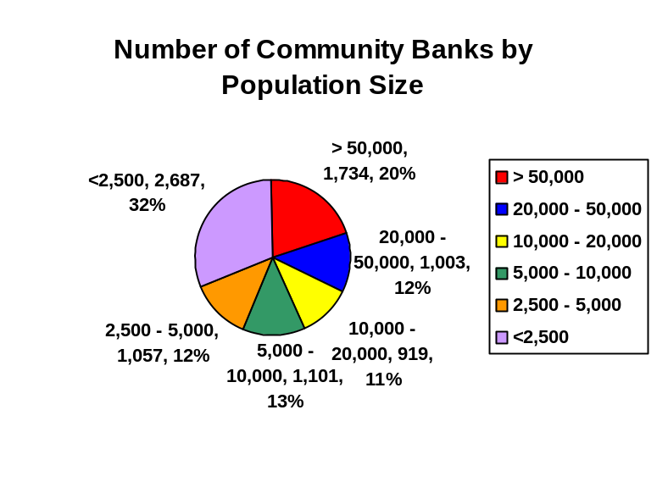Nearly seventy percent of all community banks, approximately 5,800, are located in communities of less than 20,000 people. Slightly less than 5,000 banks, or fifty-seven percent, are in communities of less than 10,000 people. Approximately 3,800 banks, about forty-five percent, are in towns of less than 5,000 people. Over thirty percent of all community banks, approximately 2,700 institutions, are in communities of less than 2,500. Thousands of community banks serve smaller, remote, rural areas.

These statistics reveal that there are numerous financial institutions that are ready, willing and able to continue serving the credit needs of rural America. The thousands of community banks serving rural areas provide a substantial and unique delivery system of credit for rural customers. These numbers do not include the additional thousands of bank branches that serve rural areas, nor do they count other non-governmental lenders such as finance companies, insurance companies, credit unions, and others.

Survey Results
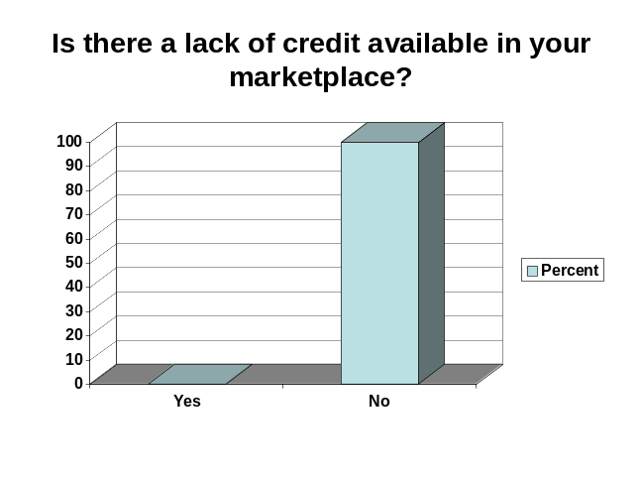
The ICBA recently conducted a survey to over 1,000 randomly selected rural bankers geographically dispersed across all regions of the U.S. Approximately three hundred bankers returned responses to our survey, more than three times the number of lenders within the FCS. These bankers are keenly aware of the credit needs of rural communities since they finance commercial businesses, farmers and ranchers, and consumers every day. The findings provide the Members of the Subcommittee clear answers to questions regarding the availability of credit in rural areas.

When specifically asked the question: “Is there a lack of credit available in your marketplace, Yes or No?” one hundred percent of the respondents answered “NO”.

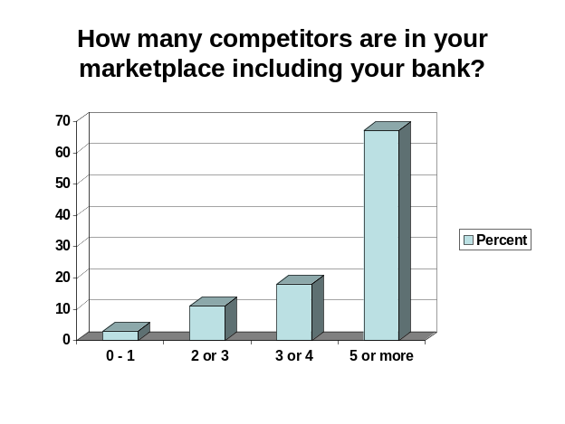Survey Findings

- There is No Lack of Credit in Rural America
- There is No Lack of Competition in rural America

Approximately two-thirds of the banks in our survey reported having five or more competitors in their local marketplace.

The vast majority of respondents also observed that adoption of proposals by the FCS for new legislation in the farm bill and by FCA to expand eligibility of processing and marketing firms that are not farmer owned and controlled, but rather investor-owned and controlled, would undermine competition, not enhance it. This is due to the negative impact that heavily subsidized FCS lenders would have on the ability of private sector lenders to continue offering specialized lending and expertise in the agricultural and rural marketplace.
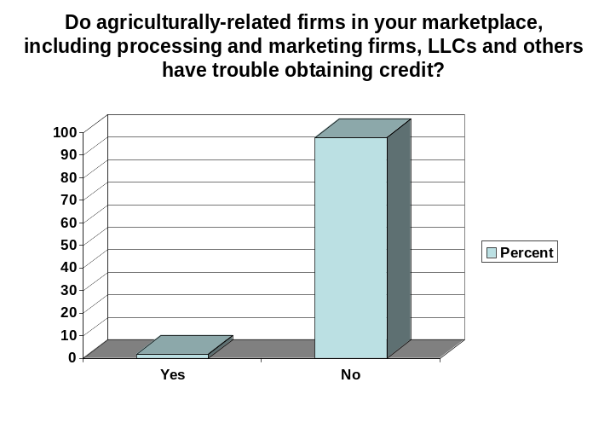
We also asked whether the array of agricultural related businesses in rural markets have trouble obtaining credit. Respondents overwhelmingly reported that agri-businesses do not have trouble obtaining credit.

Survey Findings

- There are numerous private sector lenders serving local markets
- Agribusiness and commercial firms have no trouble accessing credit

It is also quite revealing to view the actual comments of bankers responding to the question of whether allowing FCS expanded powers to lend to agribusinesses and commercial businesses in rural areas would enhance competition. Samples of their responses follow.

Sample Banker Comments
- We already have 6 banks, two credit unions, Ford Motor Credit, GMAC financing, American Express Financial, State Farm Insurance/Bank.
- There are already multiple sources of credit available to all of the commercial and agricultural accounts in this area.
- Their tax preferred status would keep the current banks from competing
- Too many banks are now competing for market share.
- These firms are already being serviced by existing financial institutions.
- Local tax paying banks cannot compete with subsidized lenders, consequently no competition.
- It would effectively stifle competition since FCS does not play by the same rules. Eventually it would decrease competition with smaller banks selling out.
- Our customers already have the choice of several banks as well as seed companies, feed companies, co-ops, etc.
- In our community, lending is cutthroat. If FCS wants to compete, please remove their subsidy and let them pay taxes like our bank.
- There are 40 bank and credit union locations within 25 miles.
- Credit is available in our community for any viable borrowing entity. Competition from surrounding banks ensures fair pricing.
- There is no shortage of lenders in our market, we are outside of the corn belt, but there are other types of producers in our area that are serviced by local banks, and there are plenty of banks in our market area. I don't see how a subsidized lender would help but to drive out competition by not competing on a level playing field.
- We currently have more than a dozen financial firms vying for the same business - competition is already fierce and probably under priced to risk.
- Competition is sky high in my area and Farm Credit does not help competition but merely monopolizes a community due to their unfair balance sheet financing.
- It would not provide an "enhancement" since credit is readily available and at reasonable terms.

Results of the 1996 Rural Manufacturing Survey

USDA’s Economic Research Service (ERS), in cooperation with Washington State University, conducted the 1996 Rural Manufacturing Survey (RMS) to address a number of questions relating to rural manufacturing businesses. This report considered such issues as whether rural manufacturers were adopting computerized automated production technologies and new management practices, skill levels of rural workers, adequate labor availability and, other key issues including access to credit, services, local infrastructure, and schools. The report noted that “Globalization of industry means the ability to compete in world markets is crucial to business success and job creation.” (Emphasis added)

Interviews were conducted with 2,844 manufacturing establishments in non metropolitan areas of the United States and 1,065 establishments in metropolitan areas. Respondents were representative of establishments with 10 or more employees in all manufacturing industries. The report’s goal was to provide a unique source of information on rural businesses that could serve as a vital tool for rural policymakers in USDA, Congress, other Federal agencies, and State and local governments.

The survey reported this significant finding in terms of the availability of credit for rural businesses:

“Fifty-seven percent of nonmetro manufacturers reported a major expansion or modernization during 1992-1995, with nearly two-thirds of those companies using funds borrowed from a bank or savings and loan. Capital seems to be equally available for both metro and nonmetro manufacturers.” (Emphasis added)

The report also stated in its conclusion: “The similarity of the metro and nonmetro responses suggests that capital is equally available to metro and nonmetro manufacturing establishments.”

Irrefutable that the FCS is a Heavily Subsidized Competitor

That the FCS, as a government sponsored enterprise, is heavily subsidized is not a point that can be easily dismissed. For instance, when FCA, at FCS’s bidding, proposed a ‘National Charter’ framework to unleash all FCS lenders into any geographic market, the Treasury Department, in a May 2, 2001 letter, raised several concerns to FCA. One concern was whether it was necessary to introduce a heavily subsidized GSE retail lender into markets that are well served by the private sector. Treasury noted:

“But the existence of such (private sector) competitors again suggests that the market failures that have existed in the past in providing agricultural credit may no longer exist. We question whether enabling a GSE-subsidized competitor to better compete in this market advances a public purpose … the System is a GSE, operating with a federal charter, a federal mission and federal subsidies.” (Emphasis added)

In an October, 2000 public statement the Treasury pointed out the FCS is a heavily subsidized enterprise that enjoys competitive advantages over the private sector.

“GSEs are private sector entities created by Congress and given a special set of benefits by Congress to accomplish a public purpose. Like other GSEs, the FCS is limited to a particular line of business – providing credit and related services in agricultural communities – and receive various government benefits that lower the System’s operating costs and enable it to borrow at rates much lower than other financial institutions.

“Some of these benefits include an exemption from registering securities with the SEC and exemptions from federal state, and local taxes … GSEs are an exception to our general approach of avoiding differential treatment among financial institutions. The potential benefits that GSEs bring to a particular market must be balanced, therefore, against potential risks to the financial system and potential effects on market competition.” (Emphasis added)

The Treasury Department’s letter also stated:

“Because FCS associations lend much like private sector banks, it is tempting to think of them as just another competitor in the agricultural credit market. But they are not just another competitor: they are a lender to which the government has given significant competitive advantages.” (Emphasis added)

The Treasury Department noted at the time that expanding FCS’s powers through unlimited geographical constraints “might well diminish competition and innovation in the medium- to long term by driving other competitors from the market.” (Emphasis added)

Simply put, driving private sector competitors out of the rural marketplace harms rural America. Furthermore, it is not credible for FCS/FCA to claim that commercial banks as well as other types of private sector competitors have comparable subsidies.

As the Treasury Department’s comments emphasize, expanding the powers of the FCS must be balanced with the potential harm to the financial system and the potential effects on the competitive landscape of the rural marketplace. FCA’s proposal makes no effort to achieve this common sense balance and therefore will be quite harmful to rural America in many respects.

A New “Groundhog” Day

Mr. Chairman, it seems that with the FCS and their legislative proposals, every new Congress is another ‘Groundhog Day’, in reference to the popular movie. In practically every new Congress we were told by FCS and the FCA that the FCS needs new powers. In 1995, for example, during debate on the 1996 farm bill, FCS witnesses testified that they ‘needed’ new lending authorities. The rationale was similar then to what is being expressed today. FCS stated that “new production techniques, export markets, increasing foreign and domestic competition, and environmental regulations are dictating the way American agriculture does business.” This sounds eerily familiar to the Horizons pitch of 2007.

In fact, many of the same proposals touted then are being dusted off under the guise of the System having done a new, major, internal assessment to address changing trends in rural America.

In 1995, on several occasions FCS witnesses stated, “We also believe that FCS should be given the authority to directly lend to those rural businesses related to agriculture.” FCS witnesses also asked for expanded mortgage lending authorities and the removal of borrower stock and borrower rights requirements.

We have only received FCS’s legislative proposal in just the past few days. This proposal contains very similar, but apparently even more dramatic initiatives than those mentioned above. The System, of course, did not share their legislative proposals with the banking industry, demonstrating that they knew the proposals are overreaching. What the System is requesting could cause the demise of hundreds, perhaps thousands, of community banks.

Section II – FCS Issues

FCS’s Agenda: Becoming the New Commercial Bankers

The FCS is a government sponsored enterprise. As the Treasury Department noted, GSEs are granted special benefits by Congress to accomplish a public purpose. The ‘mission’ of GSEs is limited by Congress in recognition of the special competitive advantages that GSEs have over private sector lenders. As the Congressional Research Service (CRS) noted in their January 2007 report, “Each GSE is given certain benefits such as implicit federal guarantees or tax exemptions, presumably to overcome barriers faced by purely private markets. FCS is the only direct lender among the GSEs; other GSEs such as Fannie Mae are secondary markets.” As CRS noted, “most investors feel the federal government will not allow a GSE to fail.”

By proposing expanded powers legislation, just as they have during previous farm bill debates, the FCS is seeking to leverage its significant competitive advantages as a GSE into direct lending to the commercial business sector and to essentially perform the same role as commercial banks.

FCS Proposal on Commercial Business Lending – The FCS proposes to lend to non-farmer owned and non-farmer controlled corporations (persons) engaged in virtually any activity that benefits farmers. In other words, any business that ‘touches’ farm products or engages in activities that either directly or indirectly benefit farmers would become eligible to borrow from the FCS. The only nominal constraint is the requirement that the business be ‘primarily engaged’ in these activities, an undefined term in FCS’s proposal that FCS apparently hopes would be left to their captive regulator to liberally interpret.

However, the FCA certainly has lost any credibility in terms of enforcing mission compliance due to the agency’s recent actions.

As one respondent to the banker survey stated:

“I am a former Farm Credit Administration examiner, now working with a community bank. As an examiner, I oftentimes was uncomfortable with the extent to which farm credit institutions strayed from their chartered purpose. Now, as a community banker, I am disturbed with the System's push to gain further powers. It is unfortunate that community banks, institutions that oftentimes are the bedrock of small community economies, are being assaulted by the Farm Credit System and enabled by the Farm Credit Administration.”

FCA’s recent proposal to increase the eligibility of processing and marketing firms illustrates the point. Current regulations provide that a borrower is eligible for FCS financing for a processing or marketing operation only if the borrower is eligible to borrow from the FCS under statutory definitions or is a legal entity in which eligible borrowers own more than 50 percent of the voting stock or equity. The proposal would eliminate this specific requirement and replace it with a series of subjective determinations that would look to the circumstances regarding the control, the authority, or the dependent financial condition of the legal entity that would make them eligible borrowers. The proposal, however, does not provide guidance or specificity on the process that will be used to make such determinations, and provides no indication that there would be any public input, oversight or ability to challenge a funding decision. The proposal eliminates the objective regulatory limitation on the ability of a FCS entity to finance a borrower and replaces it subjective and unenforceable criteria.

The FCS’s latest legislative proposal would allow very subjective interpretations of the statute. The FCS is proposing to eliminate much of the system of deliberate constraints established by Congress to prevent abuse of the FCS’s GSE advantages which would: 1) significantly damage private sector lenders in rural America; and 2) create a powerful incentive for the FCS to lend to businesses only tangentially linked to agricultural producers, and certainly not owned and controlled by bona fide farmers, ranchers, and aquatic producers and harvesters. The first result would significantly weaken a vibrant network of private sector lenders that are essential to a competitive market for credit in rural areas. The second result would distract the FCS from concentrating its activities on those it is intended to serve. As a consequence, community banking and private enterprise would be weakened, the implicit burden on government and taxpayers would be expanded, and public benefits would not be conferred where needed or intended. Moreover, there is no evidence that the private sector is not serving these borrows; to the contrary, community banks are active in these markets and serve their customers very well.

FCS’s latest legislative proposal appears to allow FCS to finance small to medium size businesses on Main Street as well as large corporate entities, including large, diversified manufacturers and retailers, even publicly traded firms. While FCS suggests these firms be agribusinesses – a new class of borrowrers, FCS would be authorized to finance – the term ‘primarily engaged’ would be defined by the regulator in the broadest manner possible. FCS’s rationale for this proposal appears to be that somehow having a subsidized lender driving private sector competitors out of the marketplace will result in greater economic activity and result in more jobs, thus benefitting rural communities.

FCS argues that it is trying to grow the economic pie in rural America – an amazing argument given that FCS has not consulted with the banking industry on its proposals. However, statistics indicate that rural 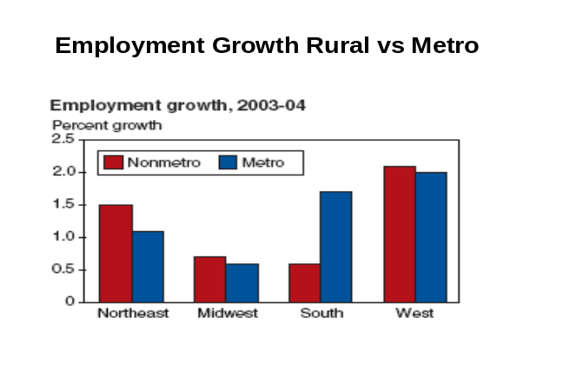employment growth is comparable percentagewise to employment growth in metro areas. Job growth in rural areas is a key concern of community bankers and they work hard to bring jobs to their communities.

Forcing many community banks out of rural areas, the inevitable result of FCS’s proposals, would harm the ability of rural areas to stimulate job growth. Additionally, FCS is asking Congress to take a huge leap of faith, that dousing rural America in subsidized credit when these markets already have an abundance of lenders and credit available is the answer to creating more jobs. This is a highly suspect assumption. The 1996 Rural Manufacturing Survey referenced above explained that credit access is not the chief factor leading to new job creation: “Many rural development efforts are aimed at improving access to credit, transportation and tele-communications infrastructure, and technical assistance. In this survey, however, both rural and urban businesses tend to report these as being relatively minor problems.” (Emphasis added)

FCS Proposal on Mortgage Loans in Cities – There are many troubling aspects of FCS’s proposal to offer all types of mortgage products in cities of 50,000 people. This is a dramatic increase not only in population allowed but in types of borrowers allowed and size of loans allowed. Income from such loans is tax exempt, which again allows FCS to cherry-pick the prime credits from private sector lenders.

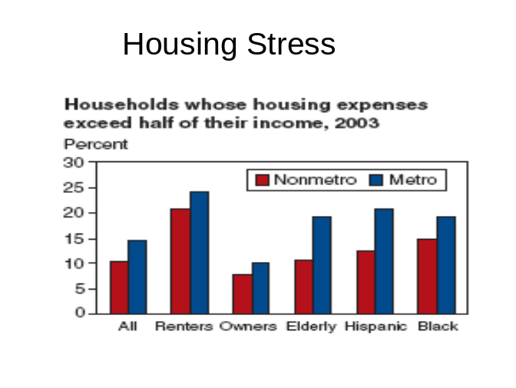Even the most casual observer realizes that the mortgage markets are awash in credit for credit worthy borrowers. FCS is certainly not going to target low-income borrowers under these authorities. Furthermore, with these authorities, FCS would be able to offer mortgages in areas surrounding nearly every major U.S. city, including suburbs of Washington DC and New York City.

FCS has stated its desire previously in allowing individual FCS institutions to determine their own loan limits in order to allow FCS to finance very large mortgage loans. An example given in the ‘confidential’ FCS Horizons report regarded financing homes in bedroom communities where houses were selling for $600,000. Other GSEs have conforming loan limits and requirements to apportion a percentage of their income into affordable housing funds for low-income individuals.

The FCS also indicated a desire in this report to finance developers, multi-family housing projects and offer home equity loans. This would mark a dramatic shift by FCS away from serving farmers and towards serving non-farmers for non-farm lending purposes. Home equity loans can be used for any purpose including any non-housing related and non-farm purpose. This will allow FCS over time to dramatically shift their attention away from serving farmers.
USDA statistics offer very revealing information regarding housing, comparing metro to nonmetro areas in terms of housing stress and home ownership. Housing stress is greater across all categories in metro areas than it is for nonmetro areas. Sectors reviewed include renters, owners, the elderly, Hispanic and Black.

USDA statistics also show a higher degree of homeownership for nonmetro areas than for metro areas. All categories were looked at including Black, Hispanic, and the Elderly. This information raises numerous questions, including a very basic one: what is the need to allow FCS to expand into mortgages beyond towns of 2,500? As stated earlier, over 2,500 banks are located in towns of this size and this population level is representative of the size of many rural communities.

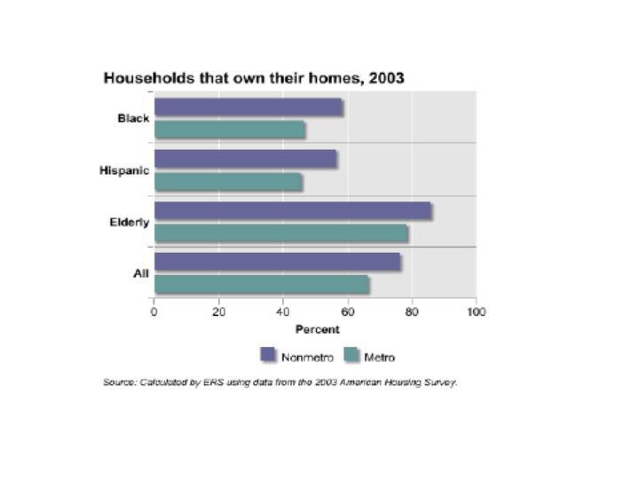Congress intended FCS to focus on rural, remote areas and even gave them a tax exemption for doing so. Has FCS ever reported the extent to which it serves these rural, remote areas? We have previously asked the FCA to report such data but have not gotten a satisfactory response. Congress should not reward FCS with the authority to serve a significantly expanded market when the market is already awash in credit. Many would wonder why a tax subsidy should be afforded to a GSE to lend to high net worth consumers. This scenario completely distorts public policy precedents of targeting subsidies towards low-income households / borrowers. We also emphasize that FCS housing proposals do not target high stress borrowers, minorities, the elderly or low-income borrowers.

FCS Proposal to Remove Borrower Stock Requirements – FCS proposes to allow individual institutions to determine whether they require borrowers to purchase stock. Requiring borrowers to own stock is a fundamental tenet of cooperatives. FCS has in the past sought to justify their special benefits on the basis of their cooperative nature. This proposal undermines FCS’s cooperative nature and has numerous troubling ramifications.

One outcome would be FCS urging their regulator to also remove borrower rights requirements, which were established by Congress in the mid 1980s as a result of FCS’s heavy handed treatment and liquidation of thousands of farmer borrowers.

Another outcome would allow businesses and individuals to borrow from FCS without any stock ownership and without any commitment to the FCS as a ‘cooperative’. If FCS wants to lend to almost any borrower that commercial banks lend to and do away with its cooperative principals over time, then FCS should simply allow its institutions to convert their charters to banks.

One would also expect non-farm businesses and other ‘eligible borrowers’ to be able to purchase any product over the internet without being a farmer-owner of the FCS. This would allow FCS to engage in broad commercial and consumer lending. It would also result in complaints of discriminatory treatment as some borrowers will be required to purchase stock and others will not.

This would create different classes of “owners” with one class allowed voting stock and a second class of borrowers without voting privileges and without the benefits of belonging to a cooperative. Borrowers’ stock requirements are already minimal with borrowers required to purchase stock equal to the lesser of two percent of the loan amount or $1000.

FCS Experiencing ‘Unprecedented Growth’

As mentioned, Mr. Chairman, we seem to go through a semi-annual rite in every new Congress of being presented expanded powers proposals by FCS and their regulator. These proposals are typically not based on any credit need in rural America but rather a desire by FCS managers to grow their empire. And the empire has grown quite dramatically over the last decade.

For example, FCS loan volume has tripled since 1994, from $55 billion to over $155 billion. FCA stated recently that the FCS is experiencing ‘unprecedented growth’ in assets of over 14% as of the end of the third quarter, 2006. FCS net income in 2006 will approach $2.5 billion. Furthermore, FCA recently stated, “Loan volume grew by over 12 percent (in 2006). This represents the System’s highest growth rate since 1981.”

FCS has achieved this dramatic growth under current authorities. If this rate of growth continues, FCS will double their assets within five years; quadruple their assets within ten years and grow their assets by ten times within a decade and a half.

When presented with such facts, FCS representatives try to suggest that ‘commercial bankers are experiencing record profits.’ FCS doesn’t, however, portray an accurate picture. What FCS doesn’t explain is that the growth of FCS institutions far exceeds the growth of community banks in rural areas. For comparison, the average return on assets (ROA) of FCS institutions in 2005 was 1.6%. For commercial banks, the ROA was much smaller as of year-end 2006, with banks of under $1 billion reporting a 1.14 percent ROA.

There is an even greater disparity for smaller community banks. As FDIC Chairman Sheila Bair pointed out earlier this month: “There are challenges. For example, the return on assets for the smallest institutions – those with total assets under $100 million – was only 0.93 percent. These banks typically have higher overhead expenses and fewer means of generating non-interest income than their larger competitors. Also, a persistent flat-to-inverted yield curve and stiff competition on both sides of the balance sheet have created a difficult operating environment. As a result, net interest margins have narrowed to an 18-year low (emphasis added). While this erosion has occurred across the spectrum of institutions, shrinking margins tend to disproportionately affect you. This is because community banks typically derive most operating revenue from net interest income.”

FCS has utilized its GSE tax and funding advantages to grow much more rapidly than the private sector with the highest growth rate since 1981, a time just prior to the FCS collapse and subsequent bailout by the federal government. FCA stated in its Feb. 9 Memorandum to FCS lenders: “System loan volume has continued to grow very rapidly from many sources.” FCS lenders are experiencing this unprecedented growth under current authorities. No new powers are needed for the System.

FCS Lenders Target Customers Least in Need of Subsidized Financing

As was noted in a recent letter to the committee, Non-farm lending is the new “Horizons” that FCS is seeking. Horizons will not cause new loans to be made. The new authorities will be used by FCS lenders to shift loans off the books of local, tax-paying community banks and onto the books of larger, more regionally based, tax-exempt, FCS institutions. This will cause a significant tax loss to state and local governments, making it more difficult for rural communities to maintain an adequate level of services, schools, roads and other necessary infrastructure.

The former FCA chairman admitted this potential threat during a public hearing in June, 2003, stating: “GSEs produce a variety of indirect and direct public benefits and costs in the marketplace … Public costs, for example, result from a GSE’s reduced or limited tax liability …”. (Emphasis added)

The typical experience of bankers is that FCS lenders consistently choose to serve mainly the prime credits in the marketplace. While FCS and FCA like to claim that the FCS has done a better job recently in serving young, beginning, and small farmers, this simply is not the real world experience of community bankers serving the agricultural markets. Survey responses of bankers were quite revealing in this regard. Sample comments included the following:

- In no case has FCS EVER refinanced a farmer from our bank that was in trouble from years of drought or falling commodity prices. They always use their unfair advantage to take the best customers. (Emphasis added)
- As a past employee of the FCS I am very aware of its history and original charter. Since the consolidation of 1986 the FCS has greatly changed how it does business and who it wants to do business with. Its matrix lending has limited their customer base to a select group of the very best farmers.
- The competition in our market is already fierce. When FCS competes in our market, they only target the very best customers and then they take advantage of their government sponsored funding sources and lower operating expenses to buy the customers’ business.
- They are able to skim the best customers away from commercial banks based on interest rate differential.
- Typically, Farm Credit cherry-picks the market leaving the banking community to address the needs of marginal or struggling enterprises. The hallmark of Farm Credit is only those who don't need their help qualify. (Emphasis added)
- They are in our area and only talk to the large farmers of our bank
- The FCA has a history in our community of coming in and "cherry-picking" our best customers. This is definitely detrimental to all of the banks in the area. (Emphasis added)
- It continues to appear that FCS is simply interested in the "cream of the crop" in our area and is very aggressive in rates and terms. I can only imagine that this will continue if they are granted expanded powers to serve non-farm operations and consumer needs.
- FCS's mission seems to be attempting to "cherry-pick" our best customers by low-ball pricing due to their GSE status.
- We are able to provide agricultural financing in our area. FCS only loans to the strongest and larger operations in our area. We have lost a number of loans to FCS because of their ability to offer lower interest rates to strong borrowers.
- Farm Credit has a tendency to finance only the lower risk operations in the marketplace. Most of the borrowers that they take on could obtain financing any number of places. (Emphasis added)
- FCS has been able to cherry pick the best customers that the banks would like to have but our costs of funds are higher then what FCS has.
- We see local FCS offices cherry picking our largest and most financially secure farmers, and giving them interest rates much lower than prime rates offered by large banks, giving them an unfair business advantage against us.
- The FCS has become a system that "cherry picks" the best customers using interest rates to do so.
- The FCS does not do beginning farmer and small farm loans unless their parents are good customers of theirs and willing to guarantee the loan.
- The local Farm Credit office advertised for a credit officer. The criteria included calling on operations that were over $500,000 in gross sales. What happened to the original mission?

FCA should enforce the predatory pricing prohibitions in current statute and prevent the System from operating as a GSE whose apparent public mission has become one of cherry picking the best loans in the markets in which they compete. The comments above provide ample, real evidence that the FCA is allowing the FCS to get away with focusing on cherry picking the best loans. This situation would only be exacerbated under FCA’s proposals, which make no attempt to target any verified underserved market or low-income borrowing categories.

The FCS likes to say that their proposals just offer ‘more competition’. But as the above surveys reveal, there are thousands of lenders competing for business in rural America every day. As the Treasury Department stated: “The potential benefits that GSEs bring to a particular market must be balanced, therefore, against potential risks to the financial system and potential effects on market competition.” Remember the law of unintended consequences. American farmers aren’t afraid of competing in foreign markets, but they want a level playing field. So do we.

Section III – FCA Issues / Recommendations

Has FCA Delegated Agency Supervision Over Mission Compliance?

Bankers have often complained about FCS’s lack of mission compliance. That FCS lenders have often skirted their charter in an illegal manner is public knowledge. In fact, former FCA Chairman Michael Reyna made the following statement during a June, 2003 public hearing:

“While it is unclear whether it is a case of system institutions “asking for forgiveness, rather than asking for permission,” today’s hearing is also being held because of questions and concerns among our examiners who are increasingly finding violations of these same regulations.

“For example, our examiners are finding some System institutions financing non-agricultural commercial enterprises that exceed the borrower’s agricultural operations in terms of assets or income. Similarly, some institutions have been found financing the acquisition of agricultural real estate by developers; and, still others have been found to be financing the construction of houses for persons who own agricultural land but have minimal or no farming income.

Are these instances examples of a GSE attempting to fulfill its mission and congressionally mandated charter? Or are they instances of “mission creep” and attempts by some to use a GSE -- a public tool -- chartered by Congress to serve agriculture, for very different purposes; purposes that legitimately could and should be served by private sector lenders?” (Emphasis added)

FCA’s recent liberal, creative and questionable interpretations of statute are quite alarming since it appears that mission compliance is now being determined by FCS institutions. This appears to be the gist of comments recently made by FCA. For example, FCA’s Chairman, recently stated:

“First, you have been hearing about the changes in the way we examine and have begun to experience this … we are now doing it differently … We are relying on your good governance and your internal systems of controls more and more … we are committed to continue making sound policy decisions that address System mission accomplishment … we have worked to provide appropriate flexibility while holding System institutions responsible for making the right decisions in financing borrowers within the System’s charter.”

In fact, a Feb. 9, 2007 FCA memo to FCS institutions, FCA seemed to express concerns about FCS’s neglecting the issue of mission compliance, stating:

“Meeting those needs does not include non-mission related real estate development or speculative purposes. Such lending practices are not consistent with FCA regulations and may significantly increase risk to the overall favorable reputation enjoyed by the System at large. System lenders must ensure that they maintain sound credit and a sound reputation by focusing on agricultural and rural lending permitted by FCA regulations § 613.3000 and § 613.3005, as was recently clarified by guidance found in Examination Bulletin 2006-2. If your institution is growing at a significant rate, you should be sure that growth is consistent with the FCS mission.”

Why has FCA apparently abdicated its oversight over mission compliance to individual FCS institutions? In regards to the last sentence of this statement, we raise the question as to why the admonition to better monitor mission compliance relates only to those FCS institutions ‘growing at significant rate’. Has FCA given those who may interpret their growth as not significant wider latitude to avoid mission compliance? Raising these issues of mission compliance indicate internal FCA awareness of abuses. If illegal practices were occurring in the commercial banking industry, bank regulators would make them public. FCA needs to publicize illegal activities of FCS associations. We need greater transparency from FCA.

Ineligible Lending & Deposit Taking

In addition to lax attention to mission compliance, FCA has developed several novel approaches that allow FCS lenders to skirt the law and engage in ineligible lending activities. This is appalling behavior for a federal agency supposedly accountable to the public.

Exemption Letters – A November 26, 2006 article in the Des Moines Register noted that the former FCA chairman “ended the (FCA) board’s practice of issuing letters to institutions who wanted cover for lending practices that might be questioned later.” Federal banking regulators have not had similar allowances for banks.

Investment Bond Program – Bankers are also perplexed and amazed at the FCA’s development and implementation of a series of broad-based pilot programs under the name “Investments in Rural America”. Under this program FCA is allowing FCS lenders to engage in loans that would otherwise be illegal if the loans are labeled as “investments” on the institutions’ books. An October 2006 article by ArborOne (ArborOneACA.COM) explained that the FCS institution had made its first-ever health facility ‘loan’.

The article noted that the financing was a loan both in the article’s headline and the text. Their justification was that: 1) ArborOne had an expanding role within the rural community; 2) there is now a broader interpretation of FCS institutions’ role helping rural communities prosper and grow; and 3) FCS is “now able to serve more people in more ways by opening new doors and stretching our boundaries.”
Community banks in this market reported they were quite willing to extend financing for this loan. This is a perfect example of how FCS and FCA’s expansion efforts are undermining private sector capital.

It is particularly perplexing that FCA has covered this program in a shroud of secrecy. FCA did not issue a proposed regulation on the “Investments in Rural America Program” The full committee has in the past reprimanded FCA for not complying with the Administrative Procedures Act when the agency tried to impose the National Charters proposal without a public comment process. When the National Charters program did see the light of day through a public comment process, intense criticism from a variety of sources both within and from outside the System and from the Treasury Department led to FCA’s withdrawal of the proposal.

It appears that history is repeating itself with FCA’s Investment Bond program and the astonishing lack of public information available. For example, FCA failed to provide any details on the program to a FOIA request. In fact, the agency responded with a ten page document that blacked out most or all of the materials relating to the following categories: Issues/Decisions, Background, Recommendation, and Financial Profile data. The agency stated that it had also redacted 128 pages of additional material. The FCA’s FOIA response in essence provided no useful information on the program and no understanding of its purpose or need. Such responses from FCA seem typical of the agency and reflect an appalling lack of transparency and secret dealings for a federal agency.

The CRS, in a March, 2007 briefing paper, provided this description:

“Selected FCS institutions also have begun investing in “agricultural and rural community bonds” as a pilot project, with the approval of FCA. The bonds, issued by private or public enterprises, are assets to the FCS institution with structured payment terms. The bonds effectively result in loans to businesses and communities, some of which may not otherwise qualify for FCS loans. For the FCS institution, the bonds are treated as an investment and thus not subject to loan eligibility regulations.” (Emphasis added)

This program has no real basis in statute or legislative history. It was never discussed nor contemplated by Congress. It makes a mockery of congressional efforts to place appropriate constraints upon the FCS, as a subsidized, special purpose GSE lender. We strongly urge the Subcommittee to request FCA halt the program and provide all background information on this program for public review. FCA needs to prohibit non-mission related activities of FCS institutions. FCA should also be required to testify annually to Congress, providing an evaluation of the performance of the FCS in carrying out its mission and provide assurance that no ineligible lending activities are occurring. We need more transparency from the FCA.

Deposit Taking – In yet another example of allowing abusive practices, bankers complain the agency is allowing FCS institutions to essentially engage in deposit taking, check writing and cash management services. These practices take money out of local communities that community banks would otherwise use to finance loans in these same communities. FCS lenders have even promoted the idea that cooperatives and customers should not leave their money in local institutions but allow larger FCS lenders to engage in various cash management arrangements through a large commercial bank. This practice harms rural communities and siphons local deposits from the very rural communities that FCS says it wants to help with expanded powers.

Bankers have also been told by local customers that FCS institutions are offering checking accounts in addition to lines of credit needed to repay loans, clearly inconsistent with statute and legislative history. Implementing deposit taking mechanisms is a totally inappropriate practice for FCA to allow and is harmful to rural communities. These programs are simply a method by FCS to prevent borrowers from using products and services offered by community banks.

Non-Farm Lending & Financially Related Services

FCA plans to propose this year broad new scope and eligibility provisions allowing FCS to finance the non-farm credit needs of farmers. If FCS’s legislative proposals were adopted, this would dramatically expand the categories of borrowers eligible for non-farm financing with the term ‘bona-fide farmers and ranchers’ apparently applying to virtually anyone. FCA attempted the same regulatory expansion in the mid-1990s. At that time, FCA proposed allowing ‘farmers’ to receive non-farm financing from FCS equal to the value of their farming assets. Agricultural assets are valued at well over a trillion dollars. FCA also proposed removing any requirement that ‘farmers’ actually have any agricultural credit needs financed as part of an overall financial package. Such proposals are simply outrageous. FCS was established to serve farmers and ranchers. Allowing FCS to finance all non-farm needs of anyone labeled a farmer, even though they have no agricultural credit needs, is ridiculous.

FCA also intends to propose allowing FCS entities to engage in a broad range of financially related activities. Again, the focus by the FCS and the FCA is to become commercial bank like. Former FCA Chairman Reyna succinctly pointed out during the 2003 public hearing:

“Government-sponsored enterprises, like the Farm Credit System, are established to serve a specific public purpose, rather than a general public purpose. For example, Fannie Mae and Freddie Mac were established to facilitate the flow of funds to housing; whereas, the System was established to do the same for agriculture. Commercial and community banks, in contrast, are chartered to serve a more general public purpose.” (Emphasis added)

USDA Guaranteed Loan Programs

Mr. Chairman, the USDA’s guaranteed farm loan programs continue to be important to many customers of community banks. We urge adequate funding levels be maintained in the new farm bill. There are several issues relating to the administration of the farm loan programs which bankers will want to address with the subcommittee in the near future. The elimination of borrower term limits and USDA’s regulations regarding the setting of interest rates are two issues of concern.

Conclusion -- Reforms Need

Mr. Chairman it is quite clear that rural America is awash in credit. It is also clear that the FCA is not supervising sufficiently to prevent the FCS to engage in illegal lending and abusive and harmful lending practices. The former chairman of the FCA stated in the Des Moines Register article that the FCA board should be expanded to include additional members with regulatory backgrounds. We wholeheartedly agree. There is clearly a need for greater public transparency, accountability and reform.

Banker representatives will soon be presenting the committee with a number of very positive reform minded ideas. We will also propose ways for community banks and FCS lenders to work together in a mutually beneficial manner, rather than the ‘winner-take-all’ proposals put forth by the FCS. We realize that typically the FCS has refused such suggestions because they desire a totally unlevel playing field tilted in their favor. The FCS was granted privileged GSE status in an effort to bring capital from Wall Street to serve agriculture. Rather than shifting dramatically away from serving real farmers, FCS appears intent on pursuing the demise of many community banks by unwarranted legislative and regulatory proposals. The FCS should seek a more constructive path and work cooperatively with community banks to finance the agricultural sector and FCS should be a key source of funding for commercial banks.

We are aware that FCA reports there was a total of $14 billion in ‘participations and syndications’ conducted in 2006. However, FCA has not broken down this dollar figure by how much was actually done in participations with community banks. FCA has not indicated what categories of financial activities it includes in the categories. Syndications are typically very large financial transactions. Furthermore, if FCS and the FCA achieve their legislative and regulatory agenda, there will be no incentive for FCS lenders to engage in loan participations with community banks.

Mr. Chairman, eighty percent of the 8,500 community banks are in rural areas. There is ample credit available and fierce competition for loans. While FCS proposals to expand their powers are a regular occurrence in Washington, the double whammy of legislative and regulatory changes the FCS is pointing at the community banking industry is both dangerous and overreaching. Congress should not pursue any legislative agenda that displaces rural community banks from the rural marketplace. FCS should be required to pursue a much more constructive agenda going forward and we look forward to discussing ways to achieve this outcome with the committee.

Thank you.

The Independent Community Bankers of America represents the largest constituency of community banks of all sizes and charter types in the nation, and is dedicated exclusively to representing the interests of the community banking industry. With nearly 5,000 members, representing more than 18,000 locations nationwide and employing over 268,000 Americans, ICBA members hold more than $908 billion in assets, $726 billion in deposits, and more than $619 billion in loans to consumers, small businesses and the agricultural community. For more information, visit ICBA's website at www.icba.org.
America's Community Bankers is an independent national trade association that represents the nation's community banks of all charter types and sizes. ACB members pursue progressive, entrepreneurial and service-oriented strategies in providing financial services to benefit their customers and communities. For more information about ACB, visit www.americascommunitybankers.org.
PACB represents, exclusively, the interests of almost 200 community banks across the state of Pennsylvania. Despite the differing structural makeup of our member institutions (commercial banks, savings banks & thrifts), they all share a strong commitment and philosophy -- meeting the financial needs of their community and citizens through hometown, quality service. PACB and its members believe that "community" banks are better able to serve their local area than financial entities whose policies are not set locally and thus may not meet local needs. What sets community banks apart is their commitment to keeping the people of their communities first in the list of considerations for every financial decision they make.

