FAA Grant 2001-G-35
Final Report
28 February 2006

Sigma Overbound and Change Detection in LAAS

Pratap Misra
MIT Lincoln Laboratory
244 Wood Street
Lexington, MA 02420

Summary

The objective of the grant was (i) to develop overbounding techniques based on analysis of data from the LAAS Test Prototype and to address issues related to LAAS commissioning and operations, and (ii) to explore new approaches to integrity monitoring during GPS-guided precision approaches.
We performed an extensive analysis of data from the LAAS Test Prototype provided by the FAA, and examined ways to identify outliers to make the distribution more compact and reduce the size of sigma inflation factor. While such approaches were successful in a narrow sense, they also highlighted problems underlying the basic LAAS model for integrity monitoring: (i) A zero-mean Gaussian model is inappropriate for the error data, and change detection is unlikely to be quick enough to meet LAAS' requirements. (ii) The concept of overbounding the statistics of a non-stationary process is an ill-posed problem.
We proposed and analyzed two promising new approaches to integrity monitoring. The first is based on the GPS receiver clock. We have shown that if the clock can meet certain requirements of "smoothness," it can serve as a source of reliable error bound on the vertical position estimate. The second approach exploits the richly redundant set of pseudorange measurements which would become available when the European system Galileo becomes operational in a few years. Both approaches have been documented in papers to be published.

1. Integrity Monitoring for GPS-based Precision Approaches: A Novel Approach Based on “Smooth” Receiver Clock

The errors in the vertical position and clock bias estimates obtained from GPS pseudorange measurements are highly correlated. Therefore, the error in a vertical position estimate can be predicted if we know the clock bias estimation error. The latter can be estimated if the clock bias changes smoothly and, therefore, predictably. The current technology appears capable of manufacturing clocks which can meet this smoothness requirement within the constraints of size, weight and cost for airborne use. We discuss the theoretical basis and present empirical data from laboratory and field experiments with a commercial Rubidium standard to explore the benefits of integrity monitoring for precision approaches based on the receiver clock.

1.1 Introduction
In safety-of-life applications of satellite navigation, integrity monitoring deals with the all-important, bottom-line question: Is the error in a given position estimate less than a certain preset threshold? The question must be answered in real time, and the consequences of a wrong answer can be disastrous. This requirement is what separates the FAA’s Wide Area Augmentation System (WAAS) and Local Area Augmentation System (LAAS) from the many differential GPS (DGPS) services now available. WAAS and LAAS have not had an easy time of integrity monitoring for precision approaches. We describe a novel approach to the problem based on an overlooked resource: GPS receiver clock.
At present, GPS receivers do not ask much of a clock beyond a loose requirement on phase noise so as to maintain carrier tracking. The manufacturers have focused on building clocks to minimize size, power consumption and cost. Frequency stability has not been a performance criterion because the benefits of stability have not been clear. Actually, there are substantial benefits to be derived in aviation applications if a receiver clock can meet modest stability requirements in airborne use. Examples of other applications now exploring the benefits of receiver clock stability are assisted GPS (AGPS) [1] and GPS-INS integration [2].
In order to answer the question of integrity raised above, we need an algorithm for generating a tight, high-confidence upper bound on the error in a position estimate given the pseudorange measurements from satellites in view and differential corrections from WAAS or LAAS. The current method of integrity monitoring is based on modeling the remaining error in the differentially corrected pseudorange measurements as zero-mean Gaussian with a known standard deviation. While the Gaussian model simplifies analysis, it’s a challenge to demonstrate in real time that the data conform to this model. The proposed approach is tolerant of deviation of the uncompensated pseudorange errors from a Gaussian distribution, but it requires that the receiver clock exhibit a certain smoothness for which we can test in real time.

1.2 Precision Approaches and Integrity Requirements
An instrument approach consists of a predefined procedure to be executed when the pilot can’t see the runway and must be guided toward it by instruments in the cockpit that display the aircraft’s deviation from its intended path. A precision approach is an instrument approach in which the pilot receives both lateral and vertical navigational guidance from the cockpit instruments to descend to anywhere between 200 feet above the ground (for Category I) and all the way to touchdown (for Category III) without the benefit of visual reference to terrain. There are specific certification criteria for the navigation system, the aircraft and the pilot training for each category of precision approach. In the U.S., precision approaches have been flown for the past 50 years using the instrument landing system (ILS), a terrestrial radio navigational aid serving a specific runway end. LAAS has the potential of offering a significant economic advantage over the ILS.
LAAS for Category I precision approaches, now under development, provides for multiple reference receivers sited on the airport surface. Pseudorange measurements from these receivers are processed centrally to determine the pseudorange corrections that are broadcast to approaching aircraft. Associated with these corrections is an estimate of the standard deviation of their error. There are, however, additional errors that are introduced into the measurements at the aircraft by sources not common to those at the reference receivers on the ground. The avionics use models to account for these error sources and generate an estimate of the standard deviation of the remaining pseudorange error.
The accuracy of GPS-based position estimates is excellent, in general, but not assured in each instance. Accuracy requirements are typically stated in terms of aggregate behavior: error statistics (e.g., rms error) or an error distribution (e.g., 95th percentile). Both GPS/WAAS and a prototype of GPS/LAAS have demonstrated the ability to meet the vertical accuracy requirement for Category I precision approaches, which is 4 meters (95th percentile). Integrity monitoring, on the other hand, deals with the individual outcomes, requiring that each position estimate offered to the pilot come with a guarantee in the form of an error bound.
The basic objective of integrity monitoring is to warn the pilot when the navigational guidance provided by a system may be erroneous to the point of being hazardous. The source of faulty navigational guidance may be an undetected malfunction or out-of-tolerance condition in the system, or it may be a poor position estimate due to weak satellite geometry or a rare combination of the usual random errors. Integrity requirements are stated in terms of maximum error allowable, called alert limit, and the permitted rates of false alarm and missed detection in recognizing that the actual position error exceeds this threshold. As expected, the alert limit varies with the phase of flight. A horizontal position error of 1 kilometer is acceptable during the en route phase, when the aircraft is flying at 30,000 feet, but the limit is 40 meters when the aircraft is executing a Category I precision approach and has descended to an altitude of 200 feet. The real challenge of precision approaches, however, lies in vertical guidance, and the vertical alert limit (VAL) is 10 meters for Category I precision approaches and lower for Category II and Category III approaches.
In practical terms, integrity monitoring consists of attaching an upper bound to the error in each position estimate. Such an error bound, called protection level, is to be computed in the avionics on the basis of its pseudorange measurements, differential corrections, satellite geometry, and certain parameter values characterizing the quality of the measurements and differential corrections. If the computed protection level is below the applicable alert limit, the approach can proceed; if not, the pilot must be alerted within the specified time-to-alarm, and the approach must be aborted. The horizontal and vertical components of the position error are treated separately. In this paper, we focus on the specific example of generating the vertical protection levels (VPLs) for Category I approaches.
The false alarms raised by an integrity monitoring algorithm must be kept below a specified value for reasons of safety and economy and, more importantly, missed detection of an alert limit violation (“integrity failure”) must be extremely rare. For Category I approaches, an integrity failure will result if the true vertical error in a position estimate exceeds 10 meters but the computed error bound is lower. Such failure is allowed no more than once in 10 million approaches:
Prob {vertical position error > 10 m | computed error bound ≤ 10 m} < 10^{–7}.
The requirements for Category II and Category III precision approaches, now under discussion, will be even more stringent, with lower alert limits and lower tolerance for integrity failure.
It’s a challenge to “prove” that an integrity monitoring scheme meets the stringent requirement on missed detections stated above. Clearly, we don’t have the option of building a system and flying 10 million approaches to evaluate it. The integrity monitoring performance must be demonstrated with mathematical models, which are developed and validated using limited amounts of empirical data and validated models.

1.3 Gaussian Error Models for Integrity Monitoring
We outline below the conventional approach to integrity monitoring based on Gaussian error models.
- If the pseudorange error is Gaussian, the three components of the resultant position error are also Gaussian. Specifically, if the pseudorange error is distributed as zero-mean Gaussian with a known standard deviation 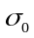, which we represent as N(0,), the vertical position error will be distributed as N(0,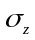), where can be written in terms of and the direction cosine terms in the user’s satellite geometry matrix [3]. (For simplicity, we have modeled the pseudorange error distribution to be common to all satellites in view.)
- The VPL (i.e., vertical error bound corresponding to the missed detection probability of 10^{–7}) can be determined easily from Gaussian probability tables as 5.3. Therefore, the approach can be executed only if 5.3 ≤ 10 meters for each position estimate during the approach lasting two to three minutes.

There are two problems associated with the above model. First, real-life data almost never follow a Gaussian distribution exactly, especially deep into the tails. Measurements over extended periods at multiple test sites show that the empirical distribution functions of the pseudorange errors have longer and fatter tails than those of a Gaussian distribution with the same standard distribution [4]. Apparently, this deviation from Gaussianity stems from the nature of multipath, a dominant source of error in differential GPS. The issue of accounting for such deviation in the calculation of the VPL remains unresolved. One approach is to define a Gaussian distribution N(0, ) which would dominate or “overbound” the observed pseudorange error distributions. Inflating σ₀, however, has an obvious price in terms of system availability. The second problem is that the model requires a priori knowledge of the two parameters of a Gaussian distribution, even though the environment is inherently nonstationary
While we too adopt a Gaussian model, there are important differences. We don’t require that the pseudorange error be Gaussian with known mean and variance. Our VPL calculation described below is based on a Gaussian model for a conditional probability distribution of the vertical position error. This conditional distribution appears much closer to a Gaussian even if the distribution of pseudorange errors has long, fat tails. This would be the subject of a future paper.

1.4 Receiver Clock-Based Integrity Monitoring

Benefits of a “Perfect” receiver clock
There is a common misconception that the price we pay for using an inexpensive GPS receiver clock is that we have to “sacrifice” one pseudorange measurement to estimate its instantaneous bias relative to GPS Time (GPST). This misconception, combined with the everyday observation that the vertical dilution of precision (VDOP) is invariably larger than the corresponding horizontal dilution of precision (HDOP) [3], leads to the erroneous conclusion that the vertical position estimates obtained from GPS are inherently less accurate than the horizontal position estimates.
Consider the hypothetical case of a receiver equipped with a clock that keeps GPS Time. How can we exploit this perfect clock? We know a priori that the clock bias (b) is zero, and we only need to estimate the three unknown position coordinates (x, y, z). Thus, we need measurements from only three satellites (versus four when b is unknown). While true, this benefit is hardly worth pursuing, given that there are typically six to nine satellites visible to the aircraft. Actually, we have shown in earlier papers [5, 6] that the rms vertical estimation error from GPS could be cut by more than half if estimation of b were not required (i.e., if we could measure ranges to the satellites rather than pseudoranges). Interestingly, the horizontal position error is substantially unaffected. If we redefine the dilution of precision parameters for the problem of position estimation with range measurements, and call them HDOP3 and VDOP3 to keep them separate from the conventional HDOP and VDOP, then HDOP3 HDOP, but VDOP3 < 0.5 * VDOP.
Returning to estimation of 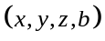 from pseudorange measurements, we can illustrate the basis for the claims of the previous paragraph by noting that the errors in the estimates of vertical position and clock bias are highly correlated (correlation coefficient r > 0.9). Figures 1.1 and 1.2 give two representations of this relationship. Note that clock bias is presented in units of length (1 nanosecond = 0.3 meters). The horizontal position error is essentially uncorrelated with the clock bias estimation error, and is not shown. The main point, which we pursue below, is that the quality of the vertical position estimates can be improved greatly if the clock bias can be estimated from the past measurements and only the position (x, y, z) is estimated from the current pseudorange measurements [5]. But, as noted previously, the horizontal and vertical position estimates obtained from WAAS and LAAS prototypes easily meet the accuracy requirements for precision approaches and there is little incentive to sharpen them further. The real challenge is to find a basis to “prove” in real time that the error in each vertical position estimate doesn’t exceed the specified alert limit.

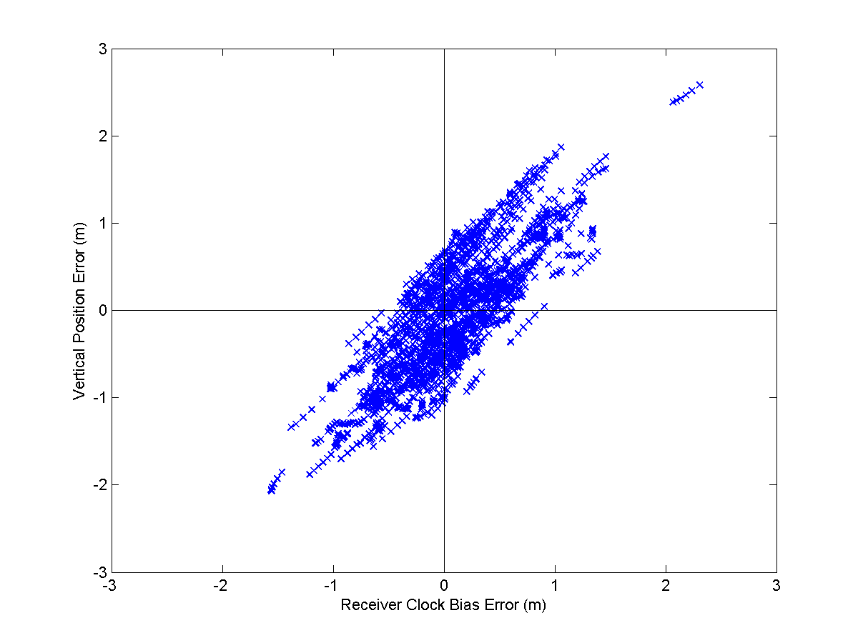
Figure 1.1. Scatter plot of the vertical position error and clock bias error in estimates obtained over a 24-hour period (1-minute samples) from a surveyed location using an external Cesium standard with a GPS receiver used in differential mode. Note that the clock bias is expressed in units of length (1 nanosecond = 0.3 meters).

Our approach to integrity monitoring is summarized as follows. Given a perfect receiver clock, we can estimate four parameters (x, y, z, b), as before, but now take advantage of the fact that we know a part of the answer (i.e., b = 0). The knowledge of the error in the clock bias estimate can serve as a quality check on the vertical position estimate. If the error in the clock bias estimate is small, the error in the vertical position estimate will be small, and vice versa. Below we develop a decision rule for smooth clocks based on this statement, defining a value of the vertical protection level (VPL) given the error in the current clock bias estimate.

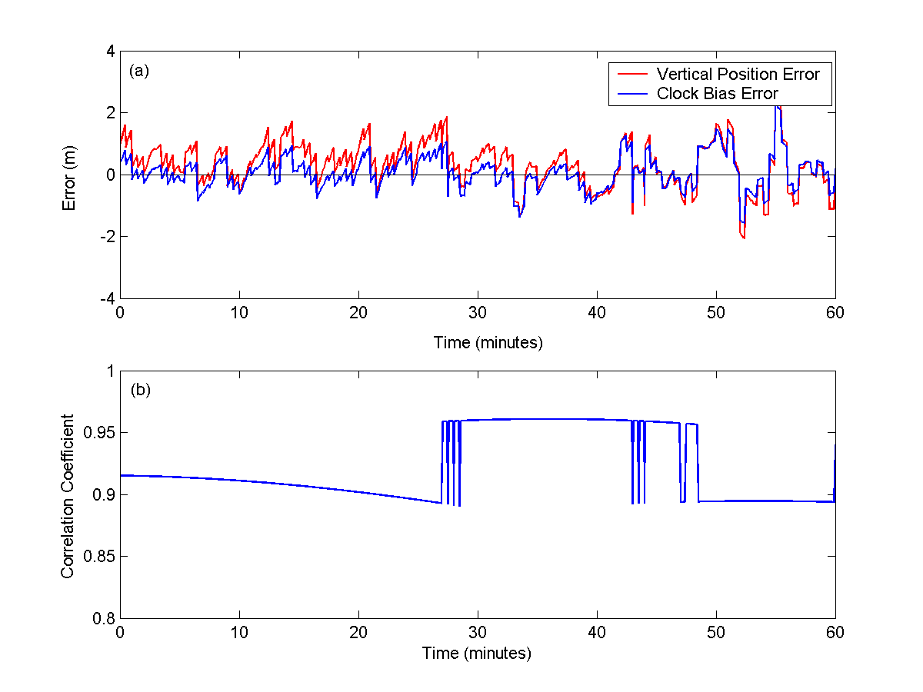
Figure 1.2. Temporal plots of (a) errors in estimation of vertical position and clock bias obtained from code measurements in differential mode, as in Figure 1.1, and (b) the corresponding correlation coefficients.

Smooth Clocks
A receiver clock is not required to keep GPS Time perfectly in order to derive the benefits described above. We could have defined our perfect clock simply as one whose bias is known or is perfectly predictable. In practice, we can’t know or predict the clock bias perfectly. But the bias can be estimated on the basis of its past values if the changes are smooth – without jumps or corners. With such a clock, we can extrapolate a trend based on the past measurements to predict clock bias over the next few seconds. We’ll refer to such clocks as “smooth.”
Note that smoothness doesn’t require that the clock frequency hold constant. Frequency drift is allowed, but not frequency jumps. What’s required is that the frequency drift rate remain essentially constant in the short term (over minutes, as we’ll see). As we show below, the smoother the clock, the more accurate the predicted clock bias, and the greater the benefit.
Commercial Rubidium and Cesium standards typically behave smoothly in the controlled environment of a laboratory. The challenge, of course, comes from the physical environment of the avionics bay in an aircraft where a receiver clock is subject to vibrations and changes in temperature, pressure, humidity, magnetic field, etc. The current technology appears capable of producing clocks for GPS avionics which would demonstrate the requisite stability of the frequency drift rate, and which would also meet the usual requirements of size, weight, and cost. The clock manufacturers, however, have had no incentive to develop such clocks.
We present below data from experiments with a commercial Rubidium standard that met our requirements for smoothness in road tests. But first we outline the proposed algorithm for integrity monitoring, given a smooth clock.

1.5 Integrity Monitoring Algorithm for a Smooth Receiver Clock
The proposed integrity monitoring algorithm consists of the following steps:
- Model the receiver clock bias adaptively on the basis of recent measurements, and predict its value in the future. Estimate the rms error associated with this prediction. This measure forms the basis for deciding if the clock is smooth enough for this approach to work. Examples are shown in the next section where we present empirical data.
- Estimate on the basis of the current pseudorange measurements, as usual. Below we’ll be concerned only with , the vertical position estimate, and , the clock bias estimate, and we’ll refer to them as conventional estimates. Compute the error in the conventional clock bias estimate as
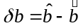 (1)
- Model the joint distribution of 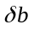 and the vertical position error 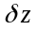
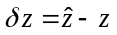 (2)
as jointly Gaussian with means zero, standard deviations and 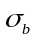, respectively, and correlation coefficient r. Actually, this is more than we need. The main assumption we require is that the conditional probability density of given is Gaussian [7]

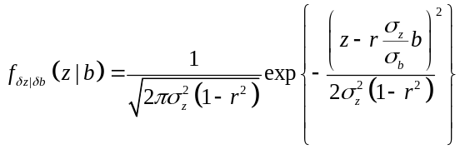 (3)

In this formulation, is estimated from the recent measurements of using a moving window-type screen, and is the rss of errors in estimating b and in predicting it on the basis of a curve fit. is estimated from

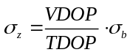 (4)

and the correlation coefficient r is computed from the instantaneous geometry matrix G [3] as

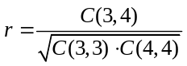

where 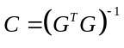.

- The conditional mean of the vertical position error is

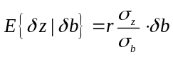 (5)

The attraction of this approach becomes clear when we look at the conditional variance

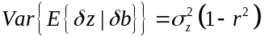 (6)

which is only about a quarter of the unconditional variance of the conventional vertical position estimate.

- Refine the vertical position estimate and define an error bound (VPL) corresponding to a missed detection (i.e., integrity failure) level 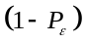.

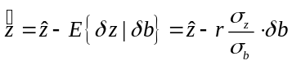 (7)
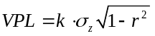 (8)

where k = 5.3 for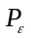 = 10⁻⁷, as noted previously. The above expression (8) for VPL offers a direct comparison with the conventional definition. With r > 0.9, a smooth clock can cut VPL by more than half.
The above implementation is intended only as an example. Results from limited tests are given below. Full-scale validation of this type of algorithm will be based on extensive Monte Carlo simulations with tens of millions of trials using actual satellite geometries, realistic models of pseudorange error distributions, and empirical models of clocks developed to exhibit the requisite smooth behavior.

1.6 Empirical Data from Laboratory and Road Tests
Below we present results from laboratory and road tests using a commercial, off-the-shelf Rubidium standard: Model AR-61A, Militarized Rubidium Standard (including an optional feature of low phase noise under vibrations) manufactured by AccuBeat Ltd., Jerusalem, Israel. The main purpose of these tests is to offer an “existence proof” that the requirements for smoothness in an avionics bay-type environment can in fact be met.

Test Setup
Our laboratory setup is straightforward: A stationary antenna on the roof at a surveyed spot, a civil GPS receiver with the provision to accept an external clock input, and the Rubidium standard AR-61A. The road test setup is more interesting: an old diesel truck with a bad suspension to carry an antenna on a tripod tied down on the bed, and the receiver, clock, power supply, and several uninterrupted power supply (UPS) units riding in the cab. The clock sits behind the power supply in Figure 1.3, next to the laptop computer.
The road tests were conducted at Hanscom Air Force Base in January 2004. A test typically consisted of driving the truck around for 30 minutes, and then standing for an hour with engine running and chassis vibrating, collecting GPS data all the while for post-processing. In order to establish good ground truth, we needed differential corrections (code and carrier) from a site employing a smooth clock. Fortunately, the MIT Haystack Observatory, about 25 km away, provided measurements from a GPS receiver connected to a hydrogen maser.
The results from laboratory and road tests are presented side by side, where appropriate, to provide an indication of the performance degradation due to the environmental factors.

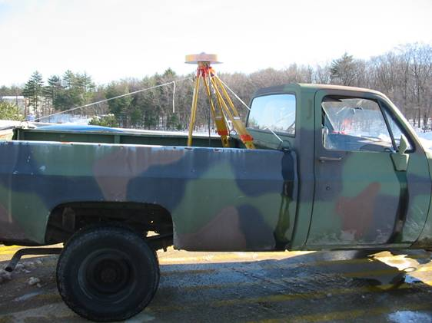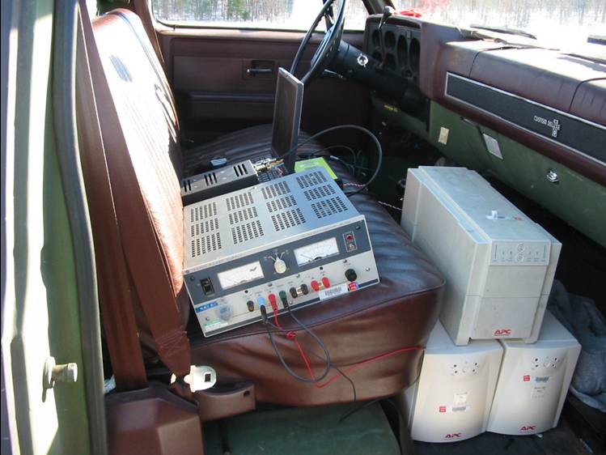
Figure 1.3. Road test equipment

Adaptive Clock Modeling
Prediction of clock bias and clock bias rate is at the heart of our approach. As shown in Figure 1.4, code measurements provide relatively noisy clock bias estimates epoch by epoch. Carrier phase-based measurements offer precise estimates of the clock bias rate. The two can be combined to obtain accurate carrier-smoothed clock bias estimates. Figure 1.5 shows samples of these estimates for data collected in the laboratory and the truck over 60-minute periods. While the scale for the clock bias appears coarse for the road test, it’s clear that the bias is changing smoothly, and is predictable. (The road test shows a larger frequency offset than the laboratory test. This is a consequence of starting and stopping the clock several times in the days between the two tests. )

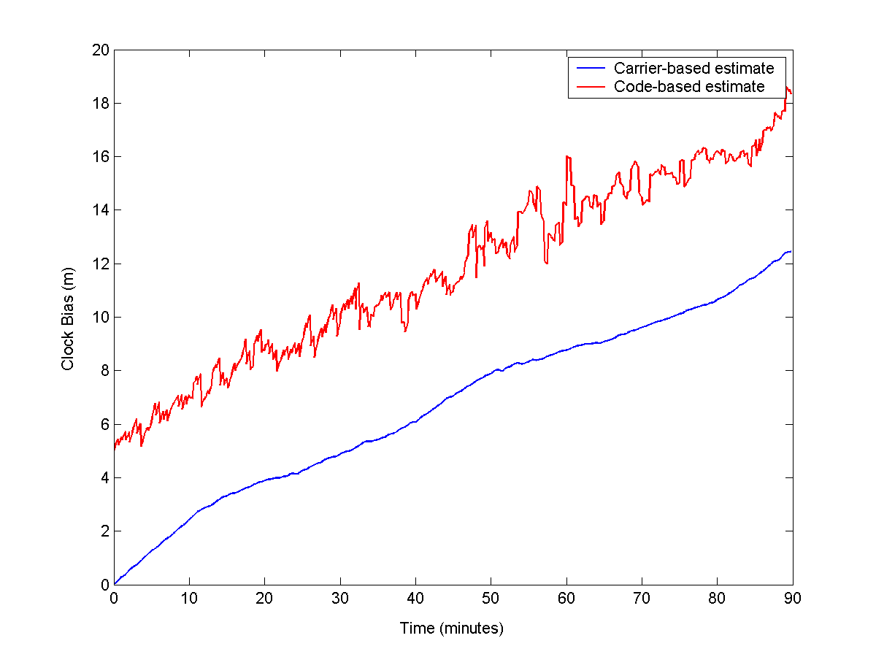
Figure 1.4. Estimates of clock bias based on pseudorange measurements display the characteristic noise. Estimates of changes in the clock bias based on Doppler frequency measurements are precise. The two can be combined to obtain accurate carrier-smoothed clock bias estimates.

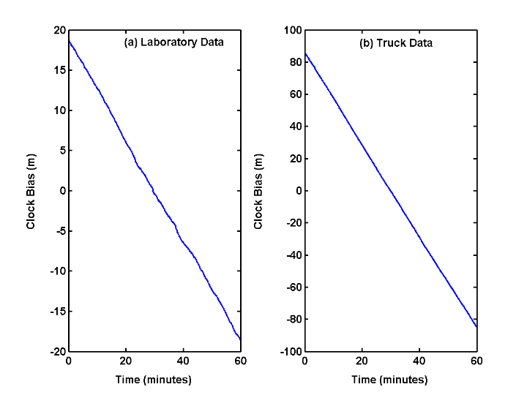

Figure 1.5. Change in receiver clock bias in (a) laboratory and (b) road test.

Our scheme for clock prediction consists of fitting a quadratic function to the best estimates of the clock bias over the previous 10 minutes and extrapolating it over the next five to 60 seconds. The results obtained in the laboratory and road test are shown in Figure 1.6. For 5-second predictions, the results are very similar for the laboratory and the road data, with rms errors of 0.07 meters and 0.11 meters, respectively. We expect the prediction error to grow with the prediction interval. The rms error for 60-second predictions nearly doubles but remains acceptable for our approach to work: 0.13 meters in the laboratory, and 0.21 meters in the road test. The 60-second prediction is intended only to demonstrate robustness of the scheme. In practice, we expect to predict the clock bias several seconds ahead, and the results presented in the next section are based on 5-second predictions.

Laboratory Test Road Test
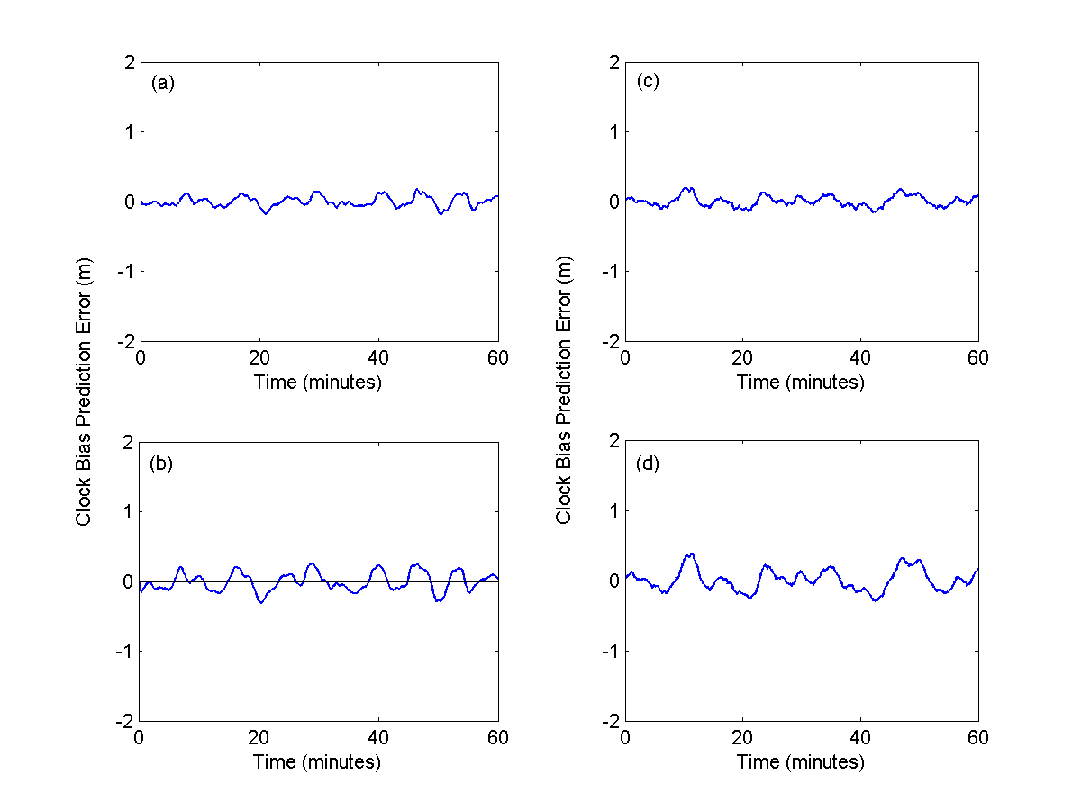
Figure 1.6. Clock bias prediction error based on fitting a quadratic function to the clock bias estimates over 10 minutes. Laboratory test: (a) 5-second prediction interval and (b) 1-minute prediction interval. Road test: (c) 5-second prediction interval and (d) 1-minute prediction interval.

Vertical Protection Level (VPL)
The actual error in the conventional vertical position estimates, δz, is plotted in Figure 1.7 for measurements taken over 60-minute periods in the laboratory and during a road test. Figure 1.7 also shows our estimate of this error at each epoch, given the corresponding clock bias error, δb. Removal of this error will make the vertical position estimates much more accurate. This figure is our main result. It demonstrates that the quality of the conventional vertical position estimates can be improved dramatically. This improvement will be reflected in the tightened values of error bounds (i.e., VPL).
The remaining error in the clock-aided estimates, , corresponding to Figure 1.7(a) is shown in Figure 1.8. The corresponding vertical protection levels obtained from our algorithm (Equations (1) through (8)) are also shown in Figure 1.8 (for k = 5.3) for completeness. As noted previously, it would require a much larger sample to “prove” the algorithm. Our purpose is simply to demonstrate the promise of a new approach, and Figures 1.7 and 1.8 do just that.
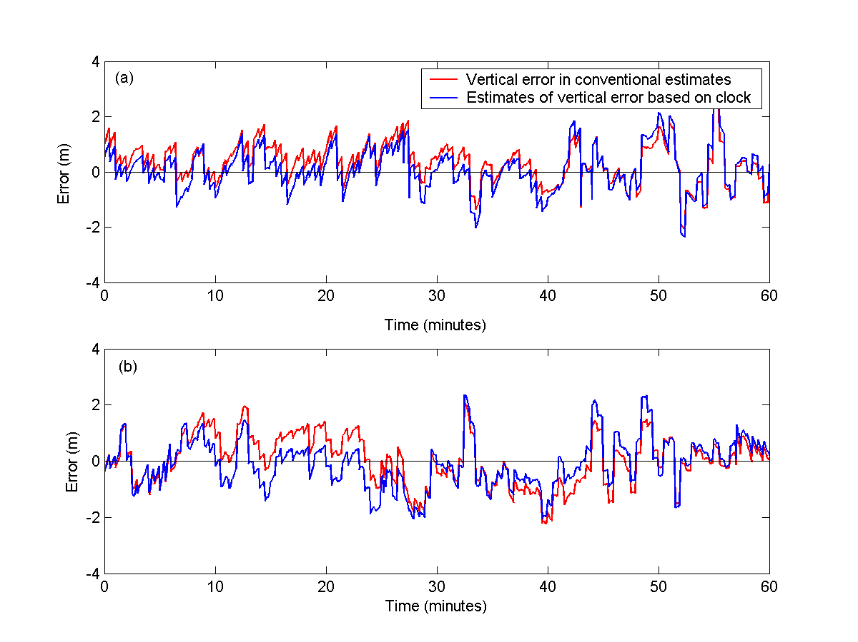
Figure 1.7. Actual vertical position error in conventional estimates and their conditional expectations, given the estimated clock bias error: (a) laboratory data, (b) road test.

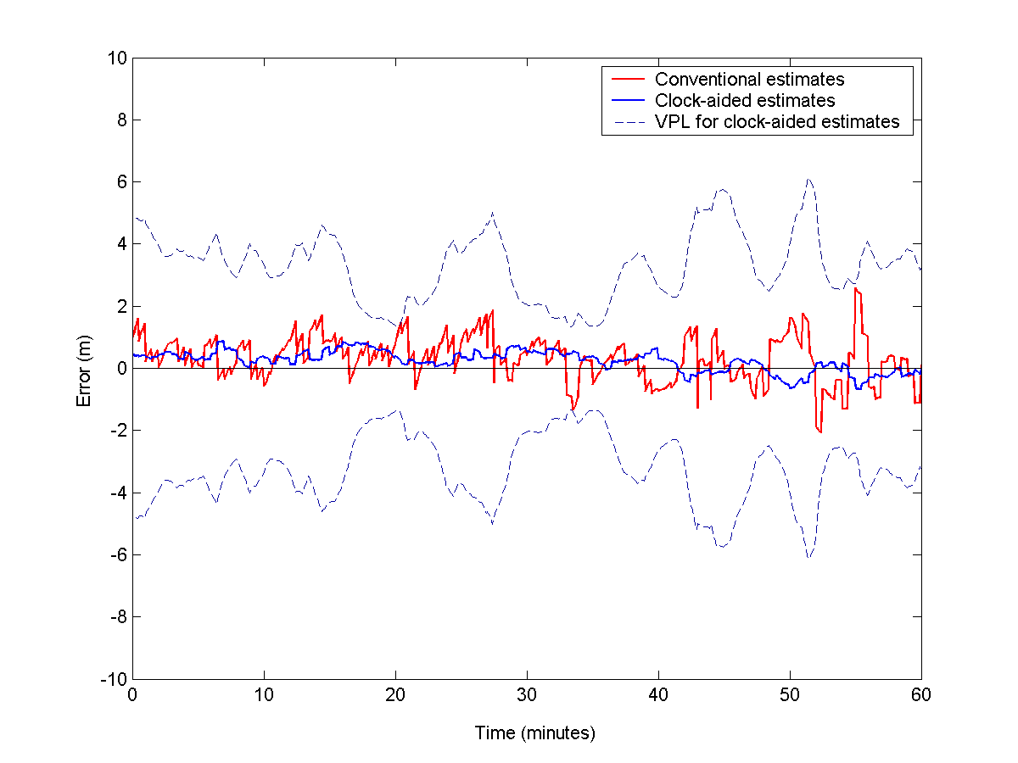
Figure 1.8. Vertical position errors in conventional and clock-aided estimates. Also shown are the vertical protection levels (VPLs) for the clock-aided estimates.

1.7 Conclusions
We have presented a promising, new approach to integrity monitoring for GPS-based precision approaches based on a smooth receiver clock. The potential benefit is much ‘tighter’ vertical protection levels (VPLs) than available from the conventional approach. In fact, the VPLs are cut in half! The proposed approach requires that the receiver clock bias change smoothly and predictably over a period of minutes, to be verified in real time. In other words, the frequency drift rate of the clock must remain essentially constant over several minutes. An informal survey of clock manufacturers indicates that the requirement can be met in the airborne environment within the reasonable constraints of cost, size, and power. A commercial Rubidium standard was demonstrated to meet the smoothness requirement in a rough-riding truck.

2. Robust Integrity Monitoring for Precision Approaches Using GPS+Galileo
In safety-of-life applications of satellite navigation, integrity monitoring deals with the all-important, bottom-line question: Is the error in a given position estimate less than a certain preset threshold? The question must be answered in real time, and the consequences of a wrong answer can be severe. This requirement is what separates the FAA’s Wide Area Augmentation System (WAAS) and Local Area Augmentation System (LAAS) from the many differential GPS (DGPS) services now available. WAAS and LAAS have not had an easy time of integrity monitoring for precision approaches. This would change when Galileo becomes operational.
In order to answer the question above, we need an algorithm for generating a tight, high-confidence upper bound on error in a position estimate, given the pseudorange measurements from satellites in view and differential corrections from WAAS or LAAS. The current method of integrity monitoring is based on modeling the remaining error in the differentially corrected pseudorange measurements in the avionics as zero-mean Gaussian with a known standard deviation. While the Gaussian model simplifies analysis, it’s a challenge to demonstrate in real time that the data conform to this model.
We analyze an alternate approach to integrity monitoring which needs no assumptions regarding the distribution of the uncompensated pseudorange errors but requires that the measurement set be “richly redundant.” A GPS-type constellation of about 40 satellites appears to be the minimum needed for this approach to work. The combined GPS+Galileo constellation of 50-plus satellites will be more than adequate. (Of course, GPS+GLONASS would also be adequate, but this combination, though close to the authors’ hearts, doesn’t seem to be in the cards.) We define a test statistic which serves as a measure of the variability (or “scatter”) of the position estimates computed from “suitably selected” subsets of the measurements, and show that a bound on the position error can be based reliably on this statistic. Our approach is a generalization of a scheme proposed earlier by Brown and McBurney for use with GPS (see Further Reading).
The proposed approach works unchanged with or without differential corrections, from en route navigation to precision approaches. The derived position error bound adjusts itself with the quality of the measurements.

2.1 Precision Approaches and Integrity Requirements
An instrument approach consists of a predefined procedure to be executed when the pilot can’t see the runway and must be guided toward it by instruments in the cockpit which display the aircraft’s deviation from its intended path. A precision approach is an instrument approach in which the pilot receives both lateral and vertical navigational guidance from the cockpit instruments to descend to anywhere between 200 feet above the ground (for Category I) and all the way to touchdown (for Category III) without the benefit of visual reference to terrain. There are specific certification criteria for the navigation system, the aircraft, and pilot training for each category of precision approaches. In the U.S., precision approaches have been flown for the past 50 years using the instrument landing system (ILS), a terrestrial radio navigational aid serving a specific runway end. LAAS has the potential of offering a significant advantage over the ILS.
The LAAS for Category I precision approaches, now under development, provides for multiple reference receivers sited on the airport surface. The pseudorange measurements from these reference receivers are processed centrally to determine the pseudorange corrections to be broadcast to the approaching aircraft. Associated with the pseudorange corrections is an estimate of the standard deviation of the error in these corrections. This error, however, is only one component of the overall uncompensated pseudorange error at the airplane. Additional errors are introduced in the measurements at the airplane by error sources which are not in common with those at the reference receivers on the ground. The avionics use models to account for these error sources and generate an estimate of the standard deviation of the remaining pseudorange error.
The basic objective of integrity monitoring is to warn the pilot when the navigational guidance provided by a system may be erroneous to the point of being hazardous. The source of faulty navigation guidance may be an undetected malfunction or out-of-tolerance condition in the system, or just a rare combination of the usual random errors. The integrity requirements are stated in terms of maximum error allowable, called alert limit, and the permitted rates of false alarm and missed detection in recognizing that the actual position error exceeds this threshold. The alert limit varies, as expected, with the phase of flight. A horizontal position error of 1 kilometer is acceptable in en route phase when the aircraft is flying at 30,000 feet, but 40 meters is the limit when the aircraft is executing a Category I precision approach and has descended to an altitude of 200 feet. The real challenge of precision approaches, however, lies in vertical guidance, and the vertical alert limit (VAL) for Category I precision approaches is 10 meters.
In practical terms, integrity monitoring consists of attaching an upper bound to the error in each position estimate. Such error bound, called protection level, is to be computed in the avionics on the basis of its pseudorange measurements, differential corrections, satellite geometry, and certain parameter values characterizing the quality of the measurements and differential corrections. If the computed protection level is below the applicable alert limit, the approach can proceed; if not, the pilot must be alerted within the specified time-to-alarm, and the approach must be aborted. The horizontal and vertical components of the position error are treated separately. In this paper, we focus on generating the vertical protection levels (VPLs) for Category I precision approaches.
The false alarms raised by an integrity monitoring method must be kept below the specified value for reasons of safety and economy and, more importantly, missed detection of alert limit violations (“integrity failure”) must be extremely rare. For Category I approaches, an integrity failure would result if the true vertical error in a position estimate exceeds 10 meters but the computed error bound is lower. Such failure is allowed no more than once in 10 million approaches:
Prob {vertical position error > 10 m/ computed error bound < 10 m} < 10^{–7}.
The requirements for Category II and Category III precision approaches, now under discussion, would be even more stringent, with lower alert limits and lower tolerance for integrity failure.
Extensive tests with GPS/WAAS and a prototype of GPS/LAAS have shown that the 95th percetile of the vertical error distribution is less than 2 meters, well below the alert limit for Category I approaches. This observation on aggregate behavior, though encouraging, is of little help with integrity monitoring which requires that each position estimate offered to the pilot come with a guarantee that its vertical error doesn’t exceed 10 meters.

2.2 Integrity Monitoring
It’s a challenge to “prove” that an integrity monitoring scheme meets the stringent requirement on missed detection stated above. Clearly, we don’t have the option of building a system and flying 10 million approaches to evaluate it. The integrity monitoring performance has to be demonstrated with mathematical models, to be developed and validated using limited amounts of empirical data.

Gaussian Error Model
If the error in the differentially corrected pseudorange measurements at the airplane were known to be Gaussian with known values of mean and standard deviation, integrity monitoring would be easy.
- If the pseudorange error is Gaussian, the three components of the resultant position error would be Gaussian as well. If the pseudorange error is distributed as zero-mean Gaussian with standard deviation σ₀, which we represent as N(0, σ₀), the vertical position error would be distributed as N(0, σ_{P}), where σ_{P} can be written in terms of σ₀ and the direction cosine terms in the user’s satellite geometry matrix. (For simplicity, we have modeled the pseudorange error distribution to be common for all satellites in view.)
- The vertical error bound corresponding to the missed detection probability of 10^{–7} can be determined easily from Gaussian probability tables as 5.2 σ_{P}. Therefore, the approach can be executed only if: 5.2 σ_{P} < 10 meters, for each position estimate during the minute-long approach.
The empirical probability density functions of errors in LAAS pseudorange corrections in fact appear “nearly” Gaussian, but have longer and fatter tails than those of a Gaussian distribution with the same standard deviation. We must account for this deviation from Gaussian-ness in definition of error bound and estimation of the probability of integrity failure, but that’s not easy. A considerable effort, therefore, has gone into defining a Gaussian distribution N(0, σ₀) which would dominate or “overbound” the observed error distributions. Both WAAS and LAAS require comprehensive modeling of specific threats, including unusual events (e.g., satellite peak distortions and localized or traveling ionospheric disturbances), in order to arrive at a conservative a priori estimate of σ₀. Actually, the errors constitute a nonstationary process, and it’s unclear if a dominating Gaussian distribution can be defined.

2.3 An Alternate Approach Exploiting Redundant Measurements
Given a redundant set of pseudorange measurements without any prior assurances regarding its quality, we compute a position estimate and ask the question: How good is this position estimate? If we could somehow generate estimates of bias and variance of this position estimate, we’d have an idea of how large the position error might be. In order to generate such measures, we can turn to the jackknife and bootstrap methods, general techniques of computational statistics for assessing the stability of the measures of variability of a parameter estimate. Actually, given our stringent requirements on missed detection, estimates of bias and variance wouldn’t be enough. We have to go much further and attempt to nail down the probability density function of the position estimate. We adapt the bootstrap method to our purpose as follows.
An intuitive approach to answer the question raised above (“How good is a position estimate?”) is as follows: Generate additional position estimates based on appropriate subsets of the measurements (generated by dropping one or more measurements in turn), and examine their variability. If the position estimates form a “tight” cluster, this would suggest that the measurements are “consistent” (i.e., the measurements errors are all “small”). The tighter is the cluster of position estimates, the greater would be our faith in the integrity of the position estimate, and the lower would be the bound on position error. If the position estimates are “widely scattered,” our conclusion would be less clear-cut: Either the measurements are “inconsistent” (i.e., some or all of the measurements have “large” errors), or the satellite geometry associated with one or more of the measurement subsets is “poor.” In the latter case, this approach would fail to provide an answer.
Brown and McBurney evaluated this approach in pre-DGPS days for integrity monitoring for en route phase (horizontal alert limit > 1 km) and non-precision approaches (horizontal alert limit ≈ 0.5 km). The relatively large values of these alert limits notwithstanding, the GPS constellation often didn’t offer enough redundant measurements and a significant proportion of the time the algorithm was unusable. The civil aviation community instead adopted a different approach based on a specific threat model centered on failure of one of the satellites. Integrity monitoring, therefore, amounted to answering the question: Is the error in one of the pseudoranges excessive? If the answer was no, the position error was acceptable. Such an error model, however, is irrelevant to a DGPS user who can count on a prompt notification of satellite failure from the reference station. A DGPS user, therefore, would like to accommodate all types of “ordinary” errors without undue restrictions.
Given a richly redundant measurement set, the cluster of position estimates generated by discarding one measurement at a time (à la Brown-McBurney) turns out to be uninformative. Selecting satellite subsets entirely randomly isn’t effective either because it introduces problematic subsets with poor satellite geometry. In order to tie the size of the cluster reliably to a bound on position error, it is necessary to select subsets so that each is associated with a “good” satellite geometry. And with a richly redundant measurement set, we have plenty of such subsets to choose from. We’ll refer to this algorithm as LGG1.
The algorithm consists of the following elements:
- a method to select satellite subsets with good geometries;
- a metric to characterize the scatter of position estimates obtained from the measurement subsets; and
- a rule to obtain the error bound or protection level based on the size of the scatter.

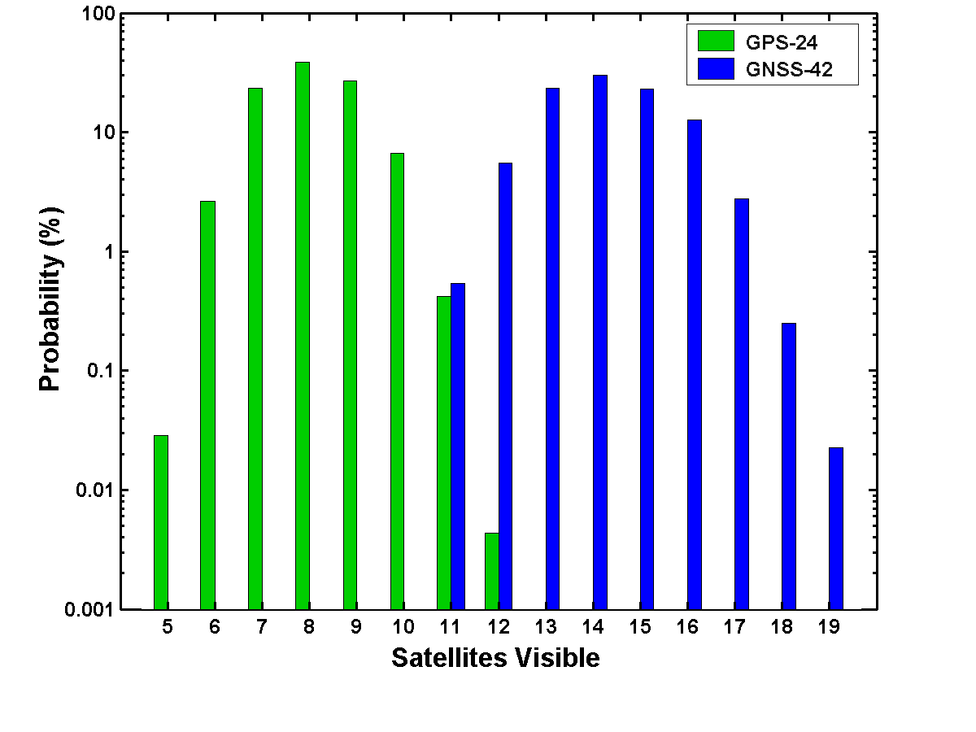
Figure 2.1. Distribution of the number of satellites in view from GPS-24 and GNSS-42 (elevation > 5°)

In order to demonstrate that the algorithm generates usable protection levels which meet the requirements of missed detection regardless of the nature or distribution of the pseudorange errors, we have to conduct extensive simulations to establish the joint distribution of the actual position error and scatter for each candidate distribution for the pseudorange error. It would take tens of millions of trials to get a good handle on the tails of the distribution in each case. Fortunately, that’s not difficult in this day of cheap and fast computation.

2.4 Algorithm LGG1
To illustrate LGG1, consider a simple Galileo-like implementation corresponding to 42 satellites arranged as a Walker 42/7/1 constellation [i.e., 42 satellites arranged uniformly in each of the seven evenly distributed orbital planes with satellites in successive planes offset by (360/42) x 1 deg]. We call this satellite constellation GNSS-42. For illustrative purposes, we set up a hypothetical problem as follows: Develop a rule for a bound on 3-D position error for GNSS-42 users, and evaluate it for an alert limit of 10 meters. This is an overly conservative formulation of integrity monitoring problem for the Category I precision approaches. But we can use it to demonstrate the main ideas behind the algorithm.
The basic computational steps (to be implemented in the avionics) are as follows.

- Determine satellites in view (elevation > 5 deg): K. (11 ≤ K ≤ 18, see Figure 2.1)
Determine the corresponding pseudoranges.
Apply pseudorange corrections, if available.
Compute position: x

- Divide satellites into bins depending upon location of each in the sky:
Characterize satellites as high (elevation > 40 deg) or low.
Divide the low satellites into four bins by azimuth: E, W, N, and S
Divide the high satellites into two bins: E and W

(iii) Select 4K subsets with 8-9 pseudorange measurements each as follows and compute corresponding position estimates:

Select one satellite randomly from each of the six bins defined above. (The bins are rarely empty.)
Select two more satellites randomly from those remaining.
If PDOP > 3, select one more satellite randomly from those remaining.

The specific definition above of bins in which to divide the satellites and scheme for selection of 4K subsets of 8-9 satellites each are only intended as a simple example. See Figure 2.2 for histograms of PDOP corresponding to all available measurements, and PDOP_{SUB-MAX}, the largest PDOP for subsets defined as above. Figure 2.3 gives an example of two 8-satellite subsets selected in accordance with the above scheme out of the 15 that are in view. The satellites selected in a sample are shown in a bright color; those not selected appear as gray.

Compute position: 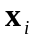, i = 1, 2, …, 4K.

- Compute test statistic called “scatter”:
Scatter = max 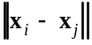, 1≤ i, j ≤ 4K
We have adopted the Brown-McBurney metric of cluster size, though a simpler statistic may work as well or better. (We intend to try next: Scatter = max 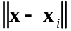, 1≤ i ≤ 4K.)
(v) Compute error bound from the decision rule:
3-D Error Bound = Scatter
For simplicity, we define the decision rule as linear in scatter. Limited simulation results for GNSS-42 (discussed below) obtained with the above algorithm lead to α = 4.5, but we expect this value to increase somewhat. We also expect that higher redundancy offered by a larger satellite constellation (e.g., GPS+Galileo) can be exploited more effectively to yield a tighter bound (i.e., lower α).

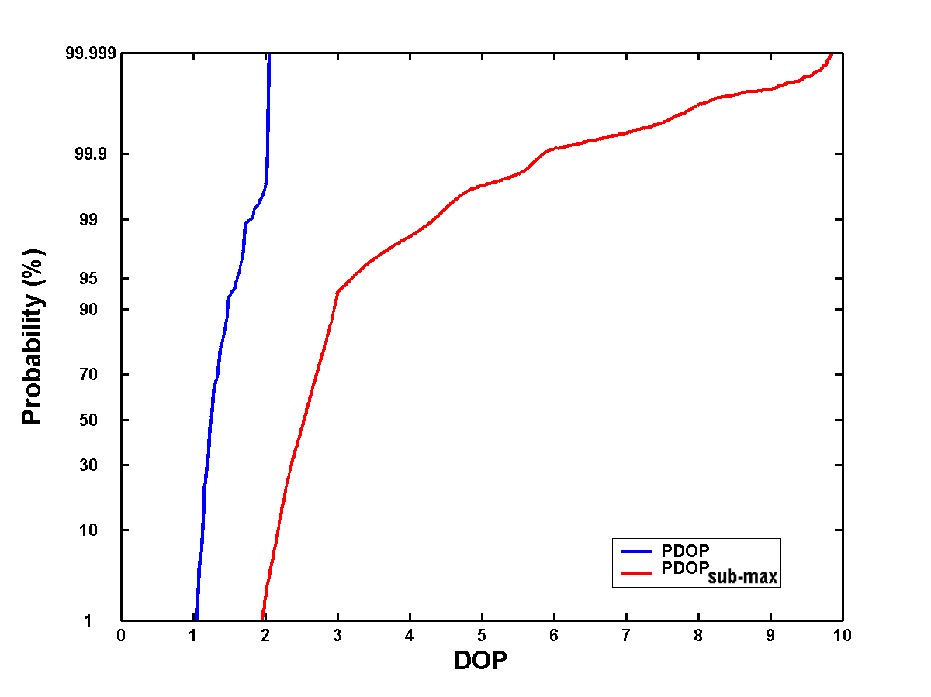
Figure 2.2. Cumulative distribution functions for GNSS-42 of (i) PDOP for satellites in view (elevation > 5°), and (ii) PDOP_{sub-max}, the largest PDOP among the satellite subsets chosen for computation of scatter.

2.5 Performance of LGG1

We have evaluated the performance of LGG1 for GNSS-42 by simulations in which pseudorange measurement errors are drawn from different probability distributions. The results are presented in Figures 2.4 and 5. Our main purpose in each case is to define the bivariate probability density function (actually, bivariate histogram) of the 3-D position error and scatter computed in accordance with LGG1, paying special attention to the tails. As noted earlier, it would require tens of millions of trials to define the tails adequately to verify that the requirements of missed detection are being met. Our simulations are relatively modest in size and are intended only to show the potential of this approach. Each simulation consists of about five million independent trials in which the user position and time are selected randomly for each trial and the errors are independent from satellite to satellite. Note the color coding of the histograms in Figures 2.4 and 2.5: A dark blue pixel represents the outcome of a single trial, and a dark red pixel represents the common outcome of several thousand independent trials.

- (Figure 2.4) Idealized Gaussian errors, N(0, 1 m). As discussed previously, the remaining error in differentially corrected pseudoranges is commonly modeled as zero-mean Gaussian. Standard deviation of 1 meter is chosen as a convenience for establishing the shape of the joint distribution, and is not a constraint. The axes can be scaled appropriately to account for a different value of the standard deviation. If the pseudorange error is cut in half, both position error and scatter are cut in half as well. The shape of the distribution remains unchanged.

Our simple decision rule (3-D error bound = 4.5 x Scatter) is based on Figure 2.4a.
If the error in differentially corrected pseudoranges actually conformed to N(0, 1 m), most of the aircraft attempting Category I precision approaches would be disallowed because their position error bounds would exceed 10 meters, the alert limit. This level of pseudorange error is simply too high for precision approaches. If the actual error were lower and could be modeled as N(0, 0.5 m), about 40% of the aircraft attempting Category I approaches would be allowed to proceed. In other words, the availability of service would be about 40%. This is seen in Figure 2.4b, where we have also delimited and labeled areas corresponding to false alarm, missed detection, and service unavailable. The thin sliver of unlabeled area with green crosshatching corresponds to “service available.” The availability of service would be nearly 98% if the errors could be reduced to N(0, 0.25 m), as shown in Figure 2.4c. Actually, economic considerations dictate a much higher availability and, therefore, the errors have to be lower.

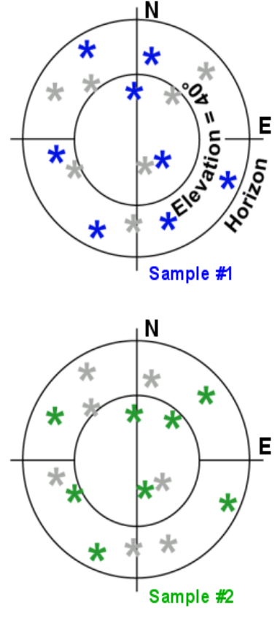

Figure 2.3. A sky view of two satellite subsets chosen for the computation of scatter ensuring good geometry for each.

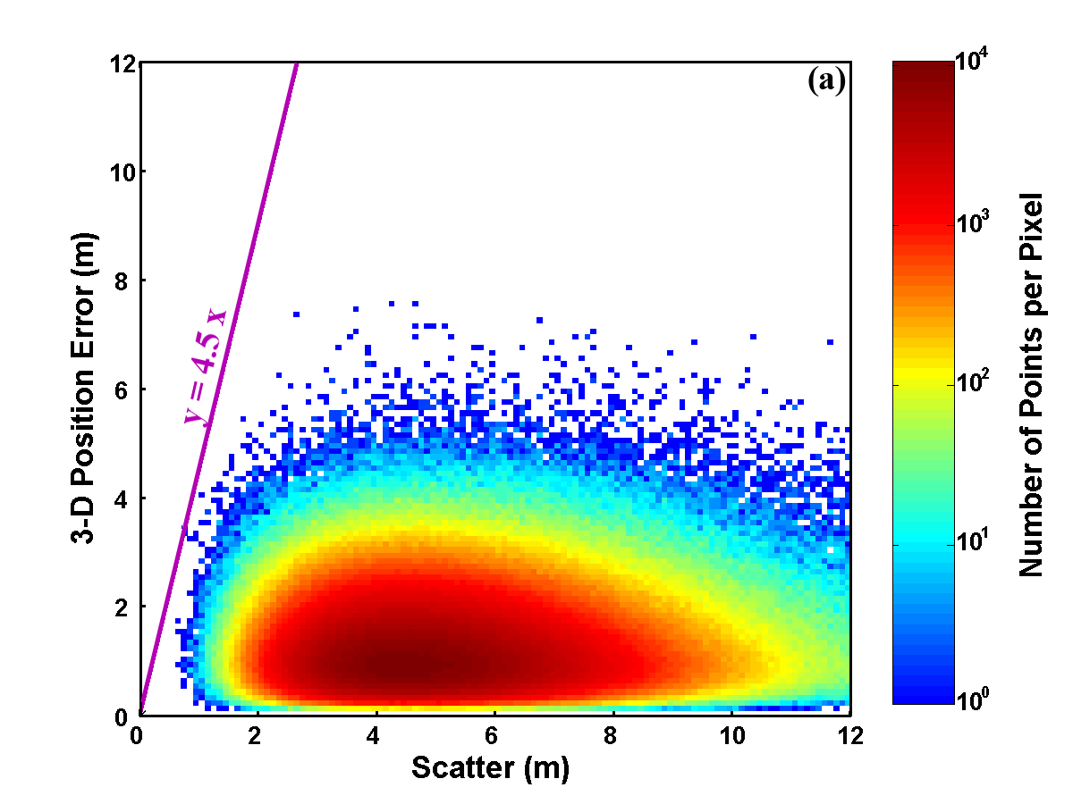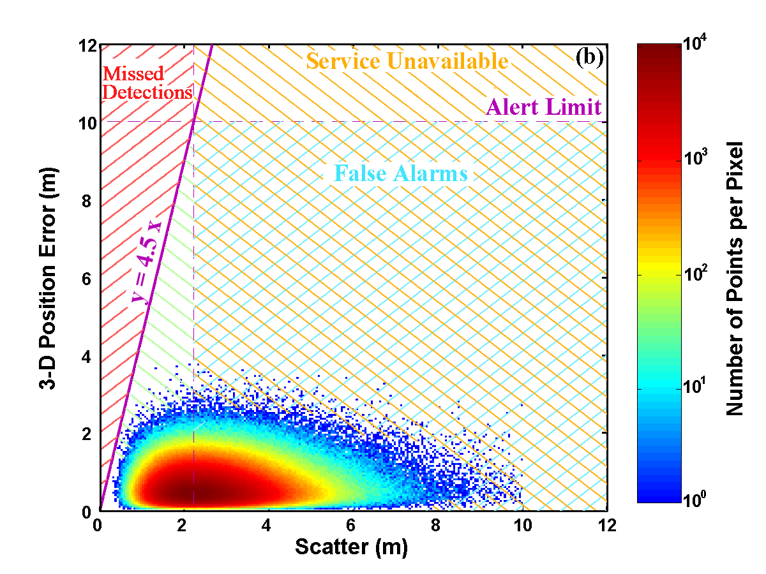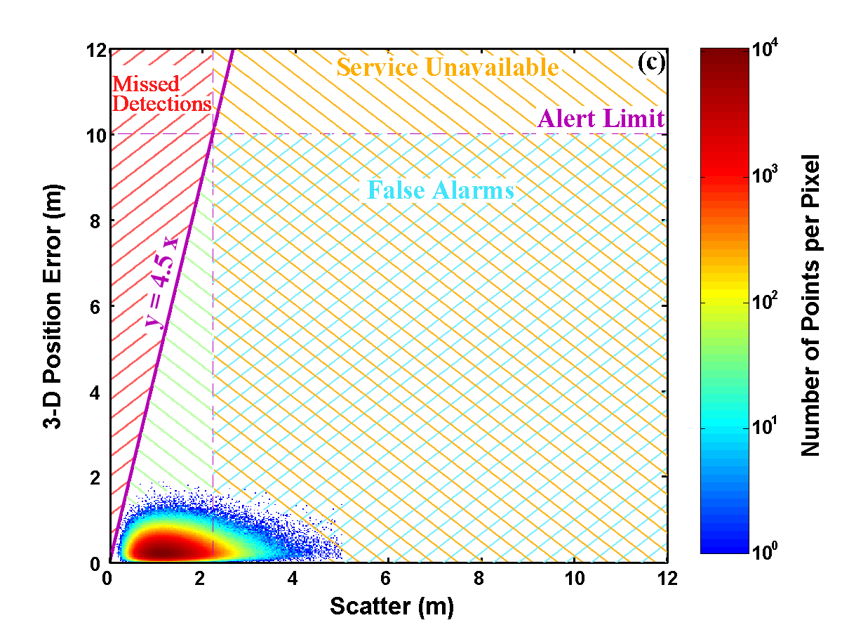

Figure 2.4. Joint distribution for GNSS-42 of 3-D position error and scatter for pseudorange errors drawn from (a) N (0, 1m), (b) N (0, 0.5 m), and (c) N (0,0.25 m)

The main point of Figure 2.4 is that the algorithm accounts for the size of the errors automatically without asking for a value of sigma. If for any reason the pseudorange errors grow and sigma doubles, the position error bound would double as well. The availability suffers but the probability of missed detection is not affected. Note also in Figure 2.4 that while our position error bound seems tight for small values of scatter, it’s too loose for large values.

- (Figure 2.5a) Error distribution closer to what’s observed in practice: Gaussian-like except for long, fat tails, simulated as a Gaussian mixture 0.9 N(0, 1 m) + 0.1 N(0, 3 m), i.e., the errors are drawn randomly from N(0, 1 m) in 90% of the cases and from N(0, 3 m) in 10% of the cases. Actually, this model of pseudorange errors exaggerates the tails beyond what has been observed. As expected, the bivariate distribution spreads out more and service availability is lower than that in Figure 2.4a. The remarks above about error size and availability apply to Figure 2.5a as well. The main conclusion is that the decision rule for position error bound continues to hold even when the error distribution deviates somewhat from the Gaussian.

- (Figure 2.5b) Errors freed up even more: Uniformly distributed between –5 meters and +5 meters, represented as U(-5 m, 5 m). We use this overly demanding and unrealistic model for the pseudorange errors to make our main point that the position error bound can be based on scatter without regard to the size or distribution of the pseudorange errors. That’s what “robust” in the title of this paper refers to. The bivariate distribution spreads out a lot more but the triangular white space adjoining the y-axis remains inviolate and, what’s more, our decision rule for the position error bound doesn’t seem so loose anymore. With such large errors, it’s no surprise that the availability of service is dismal. However, the availability exceeds 99.9% for error distribution U(-0.25 m, 0.25 m).

Several observations are in order. First, while our decision rule is not violated in any of these 15 million trials, we can’t be sure that the missed detection requirement is being met. It would take 100 million trials to establish the missed detection rate with confidence. Secondly, as noted previously, a larger satellite constellation would allow a tighter error bound and offer a higher availability of service. Thirdly, the algorithm places a significant computational load on the avionics. And, finally, having avoided making any assumptions about the distribution of the errors has a price. We don’t expect a general tool to perform as well as a specialized tool for a task. In other words, if the errors were indeed Gaussian, we’d be better off exploiting this fact in our decision rule. On the other hand, the idea of adopting an essentially open-loop approach and an error model with uncertain parameter values has obvious flaws. The main benefit of the proposed approach is that it closes the loop by introducing a conditioning statistic. As the pseudorange errors change, scatter changes, and the resultant position error bound changes.
This approach is also usable for precise relative navigation based on carrier phase measurements with potential applications in docking of spacecraft, formation flying, and landing aircraft on carriers. The focus in these applications is generally on integer ambiguities, which, if estimated correctly, can provide centimeter-level positioning accuracy. Unfortunately, it isn’t easy to prove in real time that the integer estimates are correct. But what if a decimeter-level position error is acceptable? The estimates of integer ambiguities no longer have to be all correct, or even integers, in order to meet this integrity requirement. The focus thus shifts from the integers to the quality of the position estimates and integrity monitoring.
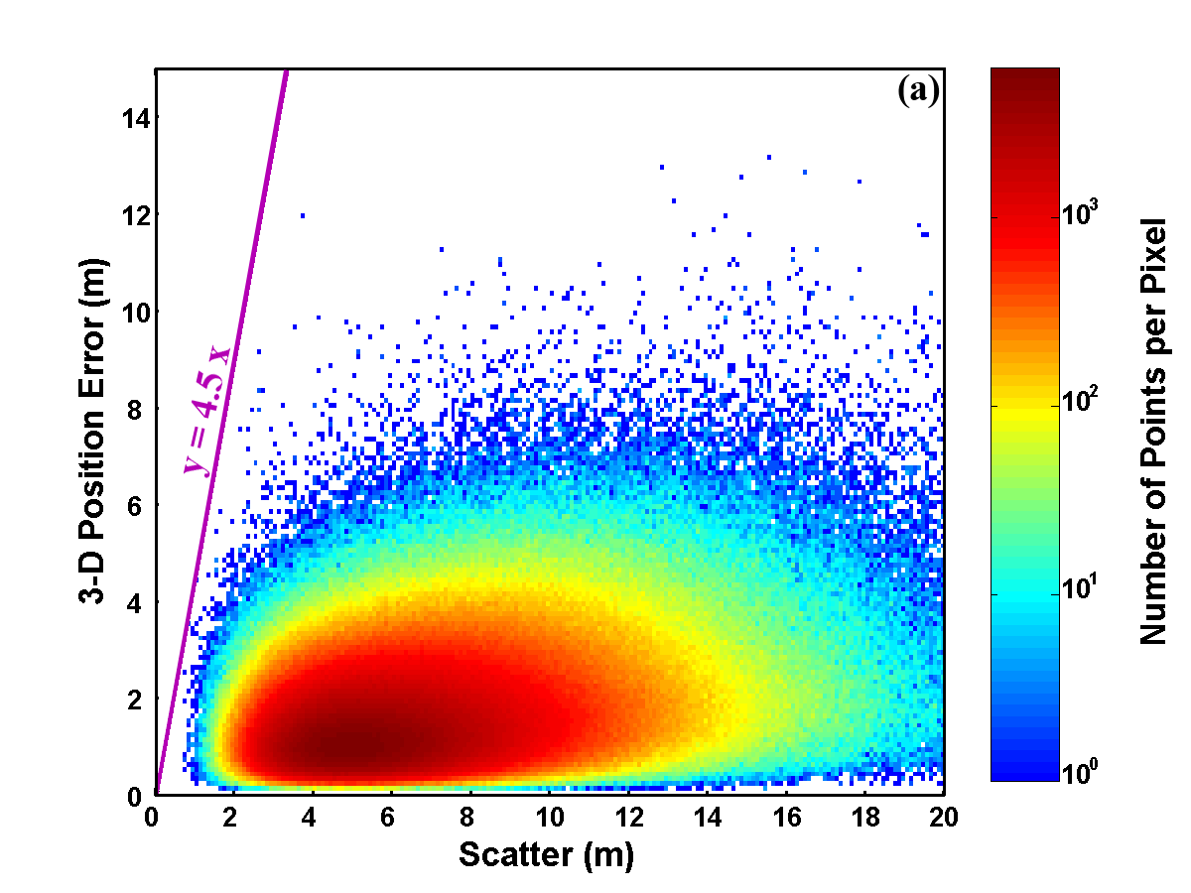

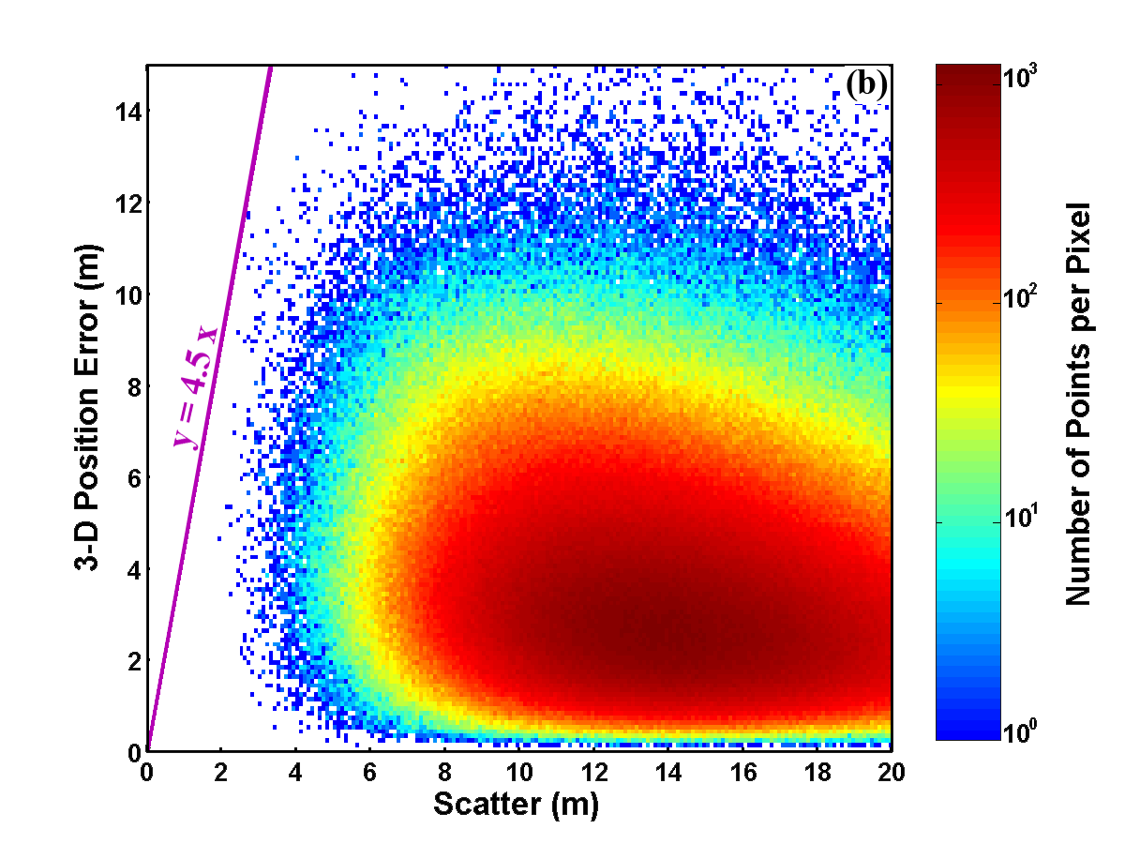
Figure 2.5. Joint distribution for GNSS-42 of 3-D position error and scatter for pseudorange errors drawn from (a) Gaussian mixture 0.9 N (0, 1m) + 0.1 N (0, 3 m), and (b) uniform distribution U(-5 m, 5 m)

This approach doesn’t work well with GPS alone because a significant number of users don’t have enough redundant measurements (see Figure 2.1). Figure 2.6 presents the bivariate histogram of 3-D position error and scatter for the baseline constellation GPS-24 corresponding to pseudorange error of N(0, 1 m). The scheme used to generate the scatter of position estimates consists of dropping one measurement in turn, as proposed earlier by Brown and McBurney. Note in the histogram that certain combinations of random errors result in near-zero

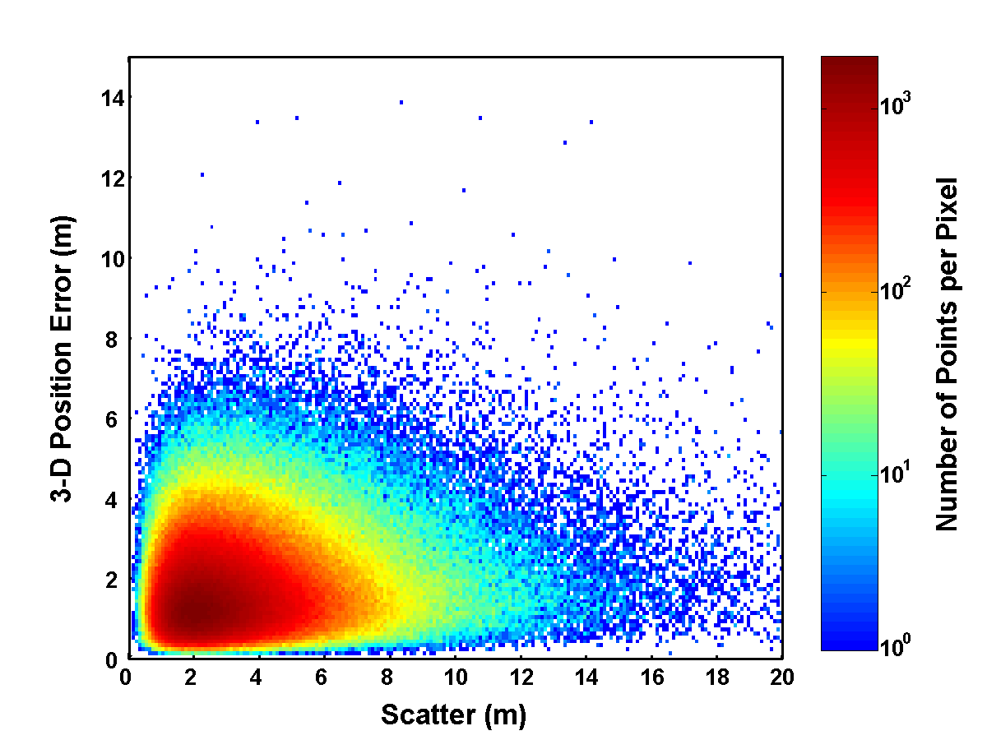
Figure 2.6. Joint distribution for GPS-24 of 3-D position error and scatter for pseudorange errors drawn from Gaussian distribution N(0, 1 m).

scatter and large position error. These points, all of which correspond to trials in which the number of satellites in view is low (K ≤ 7), represent outcomes which are contrary to our basic premise.

2.6 Summary
We have discussed an approach to receiver-autonomous or self-contained integrity monitoring applicable to a wide range of applications of Global Navigation Satellite Systems involving safety-of-life considerations. This approach requires that all users have richly redundant measurement sets typical of constellations of 40-plus satellites. The principal benefit is that we dispense with any assumptions regarding the size or distribution of the uncompensated pseudorange errors.

The results presented here are based on an idealized satellite constellation, a simple implementation of the algorithm, and modest-sized simulations to illustrate the approach. In order to prove that the algorithm will meet the false alarm and missed detection requirements of precision approaches, more extensive simulations must be carried with a satellite constellation more representative of GPS+Galileo.

References

[1] L. Vittorini and B. Robinson, “Receiver Frequency Standards: Optimizing Indoor Navigation Performance,” GPS World, November 2003, pp. 40-48.
[2] D. Domey, J.C. Lanoue and J. Studenny, “The ‘Digital Indirectly Compensated Crystal Oscillator’ (DICXO): A High-Performance Clock for Aircraft Landing Applications,” Institute of Navigation, Proc. ON GPS 2002, pp. 1619-1629.
[3] P. Misra and P. Enge, Global Positioning System: Signals, Measurements, and Performance, Ganga-Jamuna Press, Lincoln, Mass., 2001, pp. 178-188.
[4] Varner, C. C., “Gaussian and Mixed-Gaussian Methods of LAAS Overbounding,” Institute of Navigation, Proc. National Technical Meeting, 2002, pp. 531-538.
[5] P. Misra, The Role of the Clock in a GPS Receiver, GPS World, May 1996, pp. 60-66.
[6] S. Bednarz, Adaptive Modeling of Receiver Clock for Integrity Monitoring During Precision Approaches, Master’s Thesis, Department of Aeronautics and Astronautics, Massachusetts Institute of Technology, June 2004.
[7] C. W. Helstrom, Probability and Stochastic Processes for Engineers, Second Edition, Macmillan Publishing Co., New York, 1991, pp. 160-163, 190-193.
[8] R. Grover Brown and Paul W. McBurney, “Self-contained GPS Integrity Check Using Maximum Solution Separation,” NAVIGATION, Vol. 35, No. 1, 1988, pp. 41-53.
[9] Braff, Ron, “Description of the FAA’s Local Area Augmentation System (LAAS),” NAVIGATION, Vol. 44, No. 4, winter 1997-1998.
[10] Liu, Fan, Tim Murphy, and Trent Skidmore, “LAAS Signal-in-Space Integrity Monitoring Description and Verification Plan,” Proc. ION GPS-97, pp. 485–497.
[11] Warburton, John, “Towards Validation of the Standards in SARPS Section B,” International Civil Aviation Organization (ICAO), Global Navigation Satellite Systems Panel (GNSSP), Working Group B Meeting, Working paper GNSSP/WG-B WP/51, Seattle, WA, 2000.
[12] Varner, Christopher C., “Gaussian and Mixed-Gaussian Methods of LAAS Overbounding,” Proc. ION National Technical Meeting, 2002, pp. 531-538
[12] RTCA, “Minimum Operational Performance Standards for GPS Local Area Augmentation System Airborne Equipment, RTCA, SC-159, DO-253A, 2001.
[13] US DOT/FAA, “Category I Local Area Augmentation System Ground Facility, Specification FAA-E-2937A,” 2002.
[14] Efron, Bradley, The Jackknife, the Bootstrap, and Other Resampling Plans, Society for Industrial and Applied Mathematics, 1982.
[15] F. Mosteller and J. W. Tukey, Data Analysis and Regression, Addison-Wesley Publishing Co., 1977, pp. 133-162.
[16] Gerard Lachapelle, M. Elizabeth Cannon, Kyle O’Keefe, and Paul Alves, “How will Galileo Improve Positioning Performance,” GPS World, September 2002, pp. 38-48.
[17] Sandra Verhagen, “Performance Analysis of GPS, Galileo, and Integrated GPS-Galileo,” Proc. ION GPS 2002, pp. 2208-2215.
[18] Arian Leonard, Helmut Blomenhofer, Isabel Izquierdo, “GPS and Galileo: Interoperability and Synergies,” Proc. ION GPS 2002, pp. 330-341.
[19] Marcus Burns, “Benefits and Issues related to the combination of Galileo and GPS,” International Civil Aviation Organization (ICAO), Global Navigation Satellite Systems Panel (GNSSP), Working Group of the Whole Meeting, Working Paper ICAO GNSSP WP-8, San Antonio, TX, 2002.

