
NASA Goddard Space Flight Center
Greenbelt, Maryland 20771

Goddard Technical Standard

Low Density Parity Check Code for Rate 7/8
GSFC – STD – 9100
Release Pending
May 1, 2006

THIS STANDARD HAS NOT BEEN REVIEWED FOR EXPORT CONTROL RESTICTIONS; CONSULT YOU CENTER/HEADQUARTERS EXPORT CONTROL PROCEDURES/AUTHORITY PRIOR TO DISTRIBUTION OF THIS DOCUMENT

CONTENTS
Section Page

1. Purpose 1
2. Scope 1
3. Numbering Convention 1
4. Conformance 2
5. Technical Introduction 2
6. Baselined (8176,7156) LDPC Code 4
7. Encoding 6
8. Proposed Shortened (8160, 7136) Code Standard 9
9. Randomization and Synchronization 10
10. References 10
11. Appendix A – Generator Matrix Circulant Table (Normative) 11
12. Appendix B – Complexity (Informative) 13
13. Appendix C – FPGA Test Results (Informative) 14

LIST OF FIGURES

Figures Page

Figure 1: Bit Numbering Convention 2
Figure 2. Example of a 15 x 15 circulant matrix 3
Figure 3. Example of a quasi-cyclic matrix 3
Figure 4. Base Parity Check Matrix of the (8176, 7156) LDPC code 4
Figure 5. Scatter Chart of Parity Check Matrix 5
Figure 6. Systematic Circulant Generator Matrix of 14 x 16 Cirulants 7
Figure 7. Encoder Diagram 8
Figure 8. Proposed Shortened Codeword Standard 9
Figure 9. Bit Error Rate Test Results 14
Figure 10. Block Error Rate Test Results 15

LIST OF TABLES

Table Page

Table 1. Specification of Circulants 5
Table 2. Table of Circulants for the Generator Matrix 11

Purpose

The purpose of this document is to establish a common GSFC channel coding standard for bandwidth efficient spacecraft communications. Currently many Goddard missions use the concatenated Reed-Solomon and convolutional coding technique for space to ground links. While this standard has served NASA well in the past it is bandwidth inefficient. The need for bandwidth efficiency has prompted the Microwave and Communication Systems Branch (Code 567) to search for a new channel code that require less bandwidth without paying a heavy penalty in power requirement and complexity. This document details the result of that search. It gives a technical description of this new channel coding called low density parity check (LDPC) coding (Section 5). A description of the baselined LDPC code is presented in Section 6 and it’s encoding in Section 7. However, the baselined code needs to be modified to ease implementations for current space and ground systems. This modification is the proposed standard and is described in Section 8. Section 9 outlines synchronization issues and the Sections 12 and 13 of the Appendices discusses complexity issues and performance testing respectively. The reader is assumed to have a basic understanding of channel coding theory (linear algebra also) and digital communications. (The reader is encouraged to review [7] for an overview of linear block codes).

Scope

The concepts and protocols for this document are designed for any space communications link although it was initially targeted for communications links between spacecraft to ground elements. Current advances in space qualified field programmable gate array (FPGA) technology has potentially given rise to implementations for space to space communication links as well. As a result, this document can apply to any space link that requires bandwidth efficient communications.

Numbering Convention

This document adheres to the following convention with few exceptions: the first bit in a data field (e.g. codeword or column of matrix as it relates to the codeword) to be transmitted is defined to be “Bit 1”; the following bit is defined to be “Bit 2” and so on up to “Bit N”, as shown in Figure 1. In the instances where the data field begins with Bit 0, it will end with Bit N-1 but follow the same ascending order. When the field is used to express a binary value, the most significant bit (MSB) is the first transmitted bit of the field.
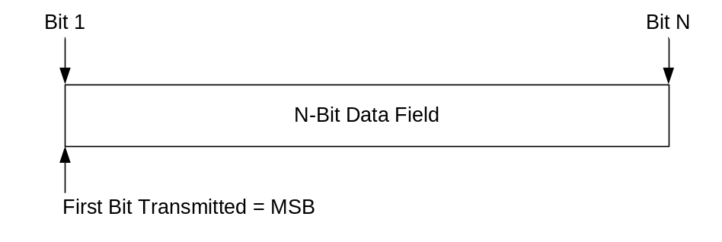
Figure 1: Bit Numbering Convention

Conformance

An implementation conforms to this standard by conforming to Sections 6-8, the normative references of Section 10, and Section 11. Sections 6, 7 and 11 specifies the encoding, while 8 section define the format of the codeword. Section 9 is a recommendation for pseudo-randomization of the codeword and codeword synchronization. While not essential to this standard, methods to guarantee sufficient bit transitions and to provide codeword synchronization to the receiver are required. Therefore, Section 9 is strongly recommended.

Technical Introduction

A linear block code is designated in this specification by (n, k) where n is the length of the codeword (or block) and k is the length of the information sequence. LDPC codes are linear block codes in which the ratio of the total number of 1’s to the total number of elements in the parity check matrix is << 0.5. The distribution of the 1’s determine the structure and performance of the decoder. An LDPC code is defined by its parity check matrix. The k x n generator matrix which is used to encode a linear block code can be derived from the parity check matrix through linear operations. In general, a codeword v is obtained by matrix multiplication of the information sequence or vector u and the generator matrix G.

The LDPC code considered in this specification is a member of a class of codes called Quasi-Cyclic codes. The construction of these codes involves juxtaposing smaller circulants (or cyclic submatrices) to form a larger parity check or base matrix.

An example of a circulant is shown in Figure 2. Notice that every row is one bit right cyclic shift (where the end bit is wrapped around to the beginning bit) of the previous row. The entire circulant is uniquely determined and specified by its first row. For this example the first row has 4 1’s or a row weight of 4.
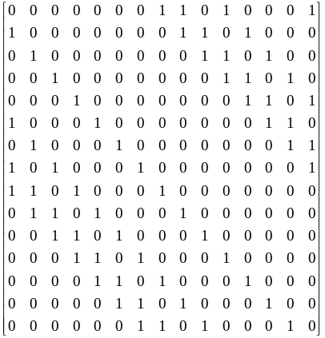
Figure 2. Example of a 15 x 15 circulant matrix

An example of a quasi-cyclic parity check matrix is shown in Figure 3. In this case, a quasi-cyclic 10 x 25 matrix is formed by an array of 2 x 5 circulant submatrices of size 5 x 5. To unambiguously describe this matrix, only the position of the 1’s in the first row of every circulant submatrix and the location of each submatrix within the base matrix is needed.

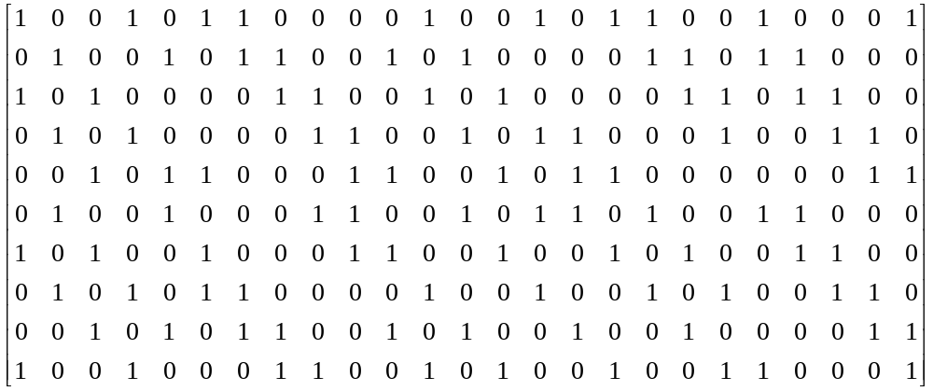

Figure 3. Example of a quasi-cyclic matrix

Constructing parity check matrices in this manner produces two positive features:
1. the encoding complexity can be made linear with the code length or parity bits using shift registers, and
2. encoder and decoder routing complexity in the interconnections of integrated circuits is reduced.

Baselined (8176,7156) LDPC Code

The baselined LDPC code described in this section is the foundation for the proposed standard shortened code defined in Section 8.

The parity check matrix for the baselined (8176, 7156) LDPC code is formed by using a 2 x 16 array of 511 x 511 square circulants. This creates a parity check matrix of dimension 1022 x 8176. The structure of the parity check base matrix is shown in Figure 4.

Figure 4. Base Parity Check Matrix of the (8176, 7156) LDPC code

Each A_{i,j} is a 511 x 511 circulant. The row weight of the each of the 32 circulants is 2, i.e. there are two 1’s in each row. The total row weight of each row in the parity check matrix is 2 x 16 or 32. The column weight of each circulant is also 2, i.e. there are two 1’s in each column. The total weight of each column in the parity check matrix is 2 x 2 or 4. The position of the 1’s in each circulant is defined in table 1. A scatter chart of the parity check matrix is shown in Figure 5 where every 1 bit in the matrix is represented by a point.

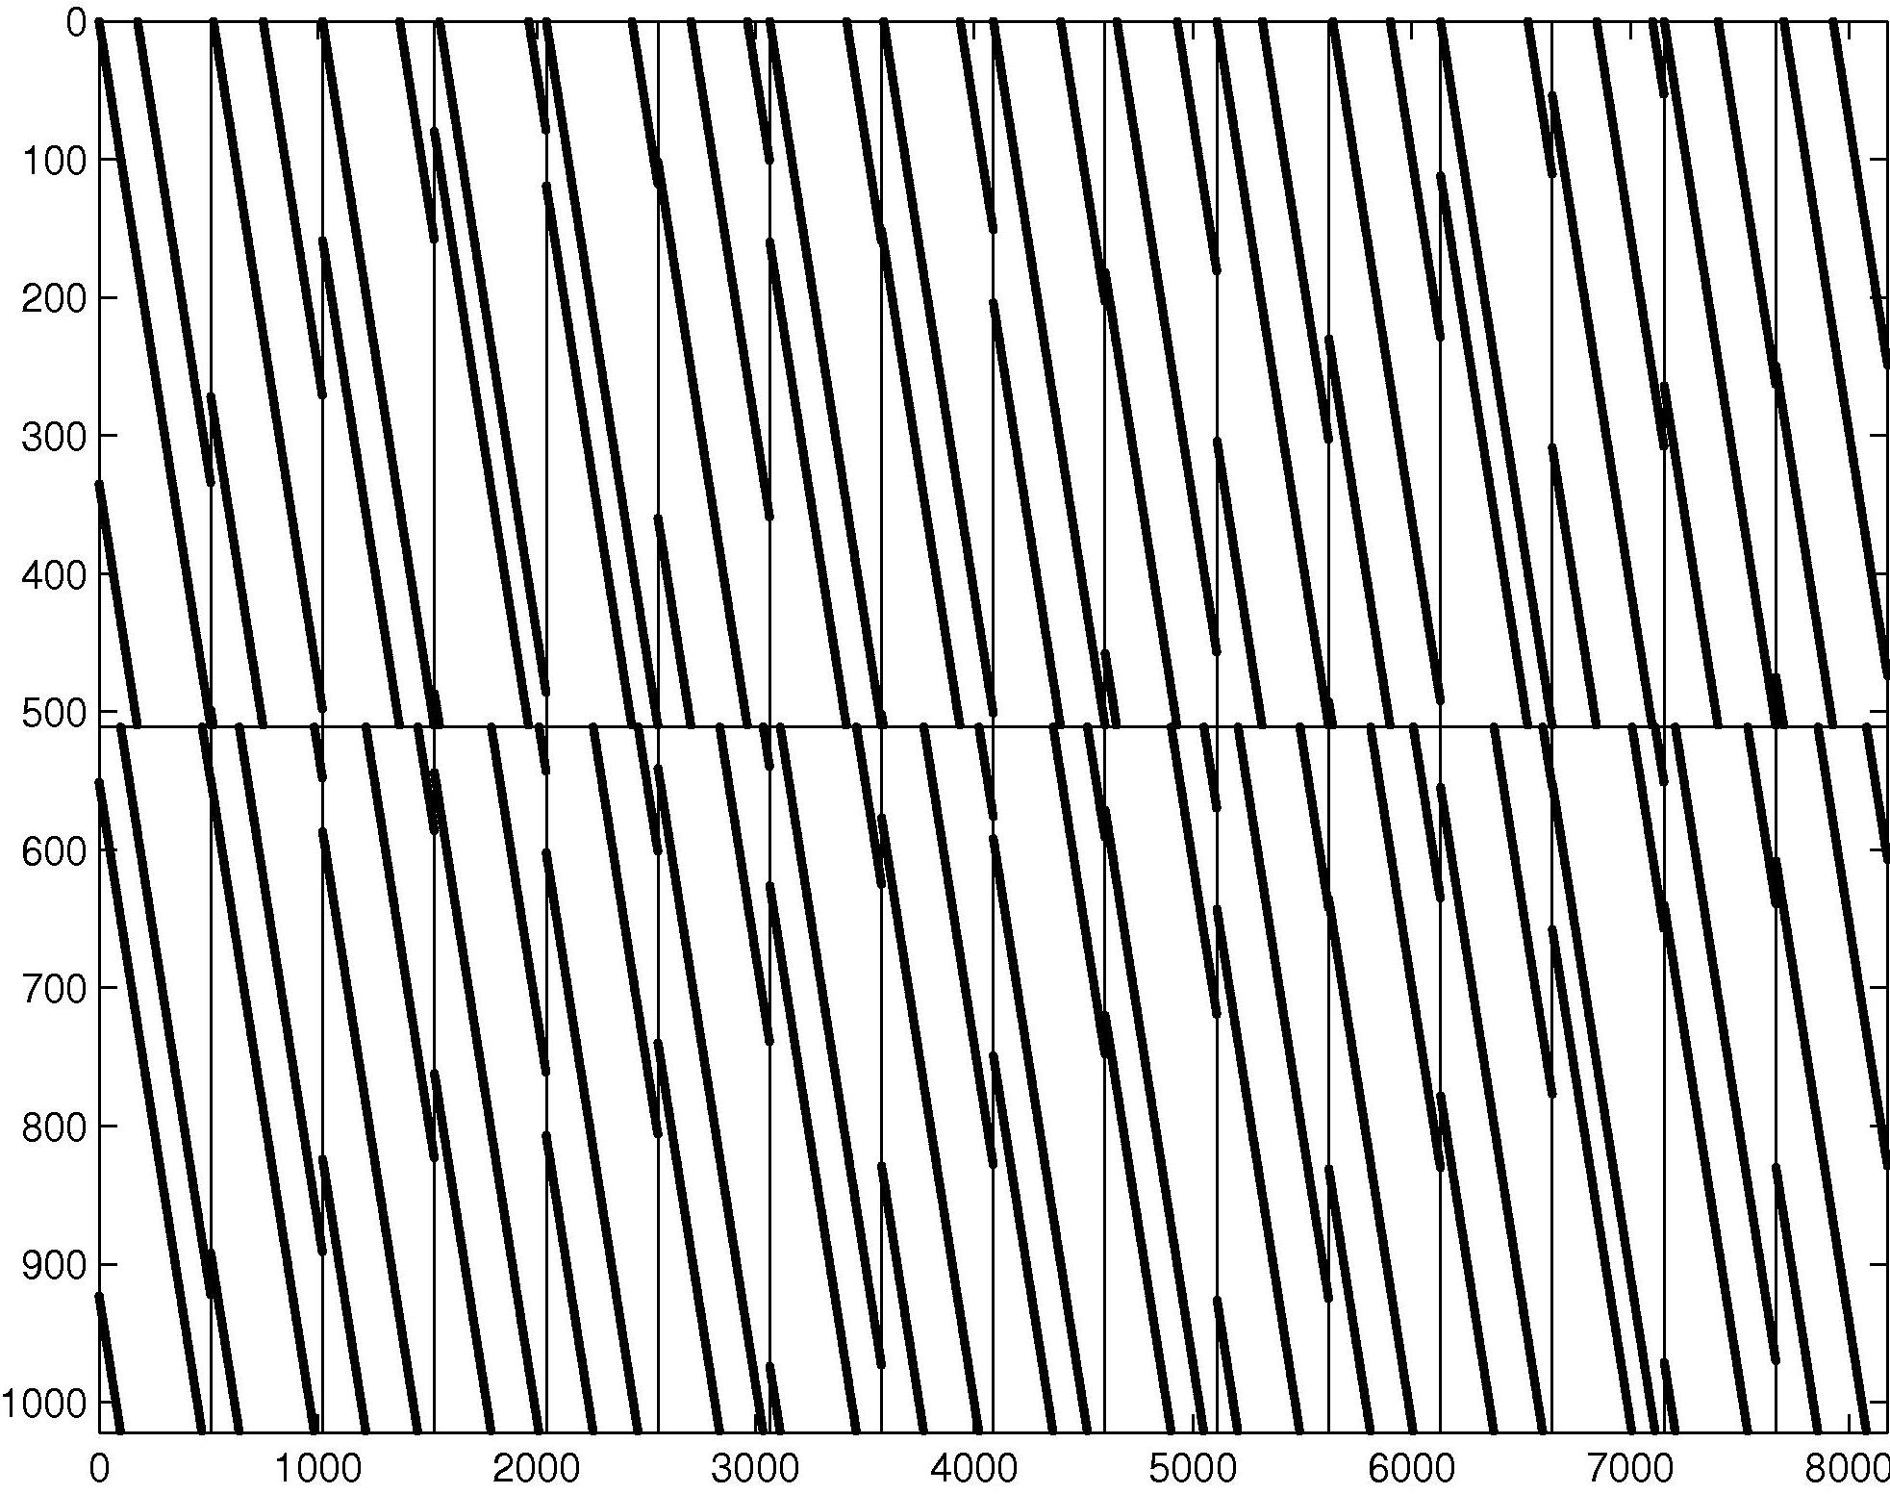
Figure 5. Scatter Chart of Parity Check Matrix

Table 1. Specification of Circulants

Circulant | 1’s position in 1st row of circulant | Absolute 1’s position in 1st row of Parity Check Matrix
A_{1,1} | 0, 176 | 0, 176
A_{1,2} | 12, 239 | 523, 750
A_{1,3} | 0, 352 | 1022, 1374
A_{1,4} | 24, 431 | 1557, 1964
A_{1,5} | 0, 392 | 2044, 2436
A_{1,6} | 151, 409 | 2706, 2964
A_{1,7} | 0, 351 | 3066, 3417
A_{1,8} | 9, 359 | 3586, 3936
A_{1,9} | 0, 307 | 4088, 4395
A_{1,10} | 53, 329 | 4652, 4928
A_{1,11} | 0, 207 | 5110, 5317
A_{1,12} | 18, 281 | 5639, 5902
A_{1,13} | 0, 399 | 6132, 6531
A_{1,14} | 202, 457 | 6845, 7100
A_{1,15} | 0, 247 | 7154, 7401
A_{1,16} | 36, 261 | 7701, 7926
A_{2,1} | 99, 471 | 99, 471
A_{2,2} | 130, 473 | 641, 984
A_{2,3} | 198, 435 | 1220, 1457
A_{2,4} | 260, 478 | 1793, 2011
A_{2,5} | 215, 420 | 2259, 2464
A_{2,6} | 282, 481 | 2837, 3036
A_{2,7} | 48, 396 | 3114, 3462
A_{2,8} | 193, 445 | 3770, 4022
A_{2,9} | 273, 430 | 4361, 4518
A_{2,10} | 302, 451 | 4901, 5050
A_{2,11} | 96, 379 | 5206, 5489
A_{2,12} | 191, 386 | 5812, 6007
A_{2,13} | 244, 467 | 6376, 6599
A_{2,14} | 364, 470 | 7007, 7113
A_{2,15} | 51, 382 | 7205, 7536
A_{2,16} | 192, 414 | 7857, 8079

Note that the numbers in the second column represent the relative column position of the 1’s in the first row of each circulant. Since there are only 511 possible positions, these numbers can only range from 0 to 510. The third column represents the absolute position of the 1’s in the parity-check matrix. There are exactly 8176 possible; therefore these numbers can only range from 0 to 8175.

Encoding
The generator matrix for the baselined (8176, 7156) code (Figure 4) consists of two components:
- The first component is a 7154 x 8176 submatix in systematic-circulant form as shown in Figure 6. It consists of a 7154 x 7154 identity matrix and two columns of 511 x 511 circulants B_{i,j}’s, each column consisting of 14 circulants. The I’s are the 511 x 511 identity submatrices and the 0’s are the all zero 511 x 511 submatrices.
- The second component consists of two independent rows (not shown).
The first component generates a (8176, 7154) LDPC subcode of the (8176, 7156) code. The subcode is a subset of codewords from the baseline code. Each codeword in the subcode consists of 7154 information bits and 1022 parity-check bits. For reasons given in Section 8, there are advantages in using only the subcode implementation. The diagram in Figure 7 is an example of how an encoder can be designed using the circulants B_{i,j}’s. (Please refer to [8] for additional information on encoding.) Appendix A gives the values of the first row of these circulants. These values are initialized or loaded in the shifted registers at the start of each information sequence. The top circuit is responsible for parity bits P1 to P511 and the bottom circuit for bits P512 to P1022. After initialization, two parity bits are created, P1 and P512, then after 510 shifts, all of the parity bits are generated. Afterwards, a codeword shortening procedure is performed in accordance to Section 8.

There are many other ways to design the encoder based on the generator matrix in Figure 6. These schemes have complexities that are proportional to the length of the codeword or parity check bits [8].

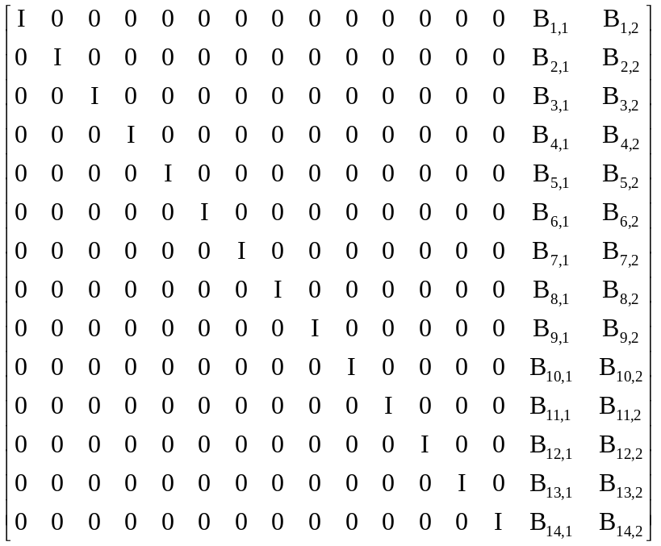
Figure 6. Systematic Circulant Generator Matrix of 14 x 16 Cirulants

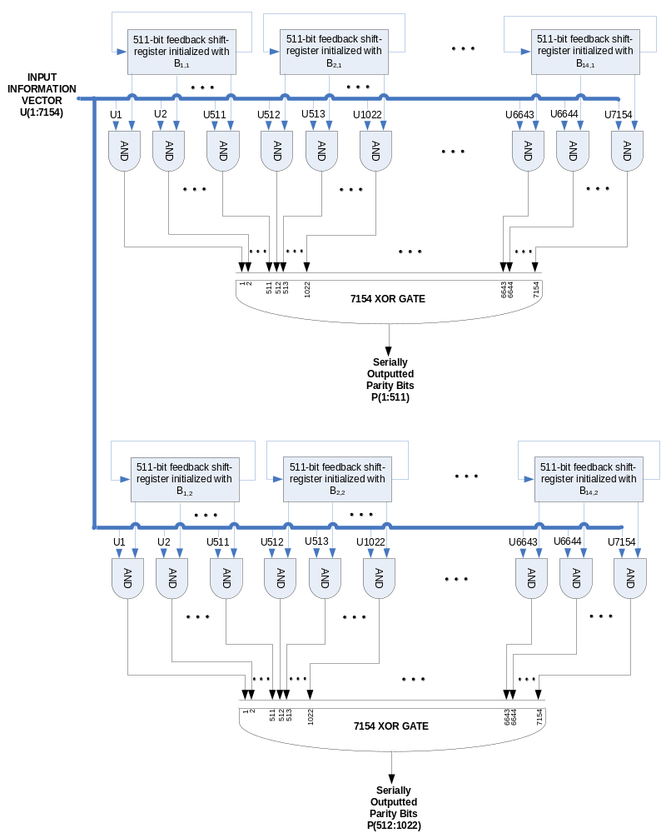
Figure 7. Encoder Diagram

Shortened (8160, 7136) Code Standard

The code described in section 6 is shortened to the dimensions of (8160, 7136) by the method outlined in this section.

Using the generator matrix given by Figure 6, an encoder can be implemented using circuits described in section 7 and in [8]. This encoder generates a (8176, 7154) LDPC subcode of the (8176, 7156) code. Current spacecraft and ground systems manipulate and process data at 32-bit computer word size. Neither (8176, 7154) or (8176, 7156) is a multiple of 32. It is beneficial to shorten the codeword to the dimensions of (8160, 7136). In other words, by shortening the information sequence to 7136 through the use of 18 bits of virtual fill, the (8176, 7154) subcode encoder can be used. This is accomplished by encoding the virtual fill bits with zeros but not transmitting them; thus the total codeword length becomes 8158. Note that it is not necessary to add two independent rows to the generator matrix to encode the full (8176, 7156) code because these bits would be shortened anyway and so the subcode is sufficient and less complicated for this application. Since the codelength of 8158 is two bits shy of 8160, an exact multiple of 32, two bits of actual transmitted zero fill are appended to end of the codeword to achieve a shortened code dimension of (8160, 7136) bits or (1020, 892) octets or (255, 223) 32-bit words. The shortened codeword is shown in Figure 8.

The received shortened codeword would require the removal of the 2 zero fill bits prior to decoding. The decoder would then reproduce the 18 virtual fill zeros after processing but would, in general, not pass these 18 zeros on to the ground equipment.

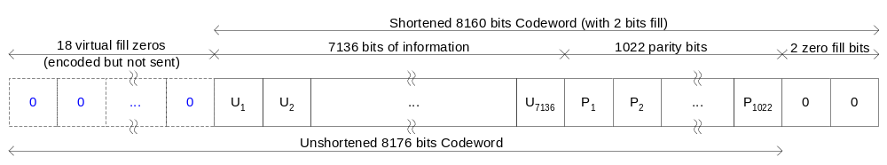
Figure 8. Proposed Shortened Codeword Standard

Randomization and Synchronization
The use of the shortened (8160, 7136) LDPC standard code does not guarantee sufficient bit (symbol) transitions to acquire or maintain bit (symbol) synchronization. It is highly recommended that a pseudo-randomizer be used after encoding in accordance to CCSDS recommendation 131.0-B-1, TM Synchronization and Channel Coding. Blue Book. Issue 1. September 2003 Section 7.

In addition, codeword synchronization is required so that the receiver can identify the beginning of the codeword for proper decoding. The use of an attached sync marker (ASM) as specified in CCSDS recommendation 131.0-B-1, TM Synchronization and Channel Coding. Blue Book. Issue 1. September 2003 Section 6.6 is required. Note that the ASM is not pseudo-randomized.

References

Informative References:

[1] D. J. C. MacKay and R. M. Neal, “Near Shannon limit performance of low density parity check codes,” Electro. Lett., vol. 32, pp. 1645-1646, Aug. 1996.

[2] R. G. Gallager, “Low density parity check codes,” IRE Trans. Inform. Theory, IT-8, pp. 21-28, Jan. 1962.

[3] T. Richardson and R. Urbanke, “Design of capacity-approaching low density parity check codes,” IEEE Trans. Inform. Theory, vol. 47, pp. 619-637, Feb. 2001.

[4] Y. Kou, S. Lin, and M. P. C. Fossorier, “Low-density parity-check codes based on finite geometries: a rediscovery and new results,” IEEE Trans. Information Theory, vol. 47, pp. 2711-2736, Nov. 2001.

[5] W. Fong, “White Paper for Low Density Parity Check (LDPC) Codes for CCSDS Channel Coding Blue Book,” CCSDS P1B Channel Coding Meeting: Houston, TX, Oct. 2002.

[6] J. Heo, “Analysis of scaling soft information on low density parity check code,” Electro. Lett., vol. 39, pp. 219-221, Jan. 2003.

[7] S. Lin and D. Costello, Jr. Error Control Coding, 2nd Ed. New Jersey: Pearson Prentice Hall, 2004.

Normative References:

[8] Z. Li, L. Chen, L. Zeng, S. Lin, and W. Fong, “Efficient Encoding of Quasi-Cyclic Low Density Parity Check Codes,” IEEE Transactions on Communication, vol. 53, pp. 71-81, Jan. 2006.

Appendix A – Generator Matrix Circulant Table (Normative)

Table 2. Table of Circulants for the Generator Matrix

Circulant | 1st row of circulant
B_{1,1} | 55BF56CC55283DFEEFEA8C8CFF04E1EBD9067710988E25048D67525426939E2068D2DC6FCD2F822BEB6BD96C8A76F4932AAE9BC53AD20A2A9C86BB461E43759C
B_{1,2} | 6855AE08698A50AA3051768793DC238544AF3FE987391021AAF6383A6503409C3CE971A80B3ECE12363EE809A01D91204F1811123EAB867D3E40E8C652585D28
B_{2,1} | 62B21CF0AEE0649FA67B7D0EA6551C1CD194CA77501E0FCF8C85867B9CF679C18BCF7939E10F8550661848A4E0A9E9EDB7DAB9EDABA18C168C8E28AACDDEAB1E
B_{2,2} | 64B71F486AD57125660C4512247B229F0017BA649C6C11148FB00B70808286F1A9790748D296A593FA4FD2C6D7AAF7750F0C71B31AEE5B400C7F5D73AAF00710
B_{3,1} | 681A8E51420BD8294ECE13E491D618083FFBBA830DB5FAF330209877D801F92B5E07117C57E75F6F0D873B3E520F21EAFD78C1612C6228111A369D5790F5929A
B_{3,2} | 04DF1DD77F1C20C1FB570D7DD7A1219EAECEA4B2877282651B0FFE713DF338A63263BC0E324A87E2DC1AD64C9F10AAA585ED6905946EE167A73CF04AD2AF9218
B_{4,1} | 35951FEE6F20C902296C9488003345E6C5526C5519230454C556B8A04FC0DC642D682D94B4594B5197037DF15B5817B26F16D0A3302C09383412822F6D2B234E
B_{4,2} | 7681CF7F278380E28F1262B22F40BF3405BFB92311A8A34D084C086464777431DBFDDD2E82A2E6742BAD6533B51B2BDEE0377E9F6E63DCA0B0F1DF97E73D5CD8
B_{5,1} | 188157AE41830744BAE0ADA6295E08B79A44081E111F69BBE7831D07BEEBF76232E065F752D4F218D39B6C5BF20AE5B8FF172A7F1F680E6BF5AAC3C4343736C2
B_{5,2} | 5D80A6007C175B5C0DD88A442440E2C29C6A136BBCE0D95A58A83B48CA0E7474E9476C92E33D164BFF943A61CE1031DFF441B0B175209B498394F4794644392E
B_{6,1} | 60CD1F1C282A1612657E8C7C1420332CA245C0756F78744C807966C3E1326438878BD2CCC83388415A612705AB192B3512EEF0D95248F7B73E5B0F412BF76DB4
B_{6,2} | 434B697B98C9F3E48502C8DBD891D0A0386996146DEBEF11D4B833033E05EDC28F808F25E8F314135E6675B7608B66F7FF3392308242930025DDC4BB65CD7B6E
B_{7,1} | 766855125CFDC804DAF8DBE3660E8686420230ED4E049DF11D82E357C54FE256EA01F5681D95544C7A1E32B7C30A8E6CF5D0869E754FFDE6AEFA6D7BE8F1B148
B_{7,2} | 222975D325A487FE560A6D146311578D9C5501D28BC0A1FB48C9BDA173E869133A3AA9506C42AE9F466E85611FC5F8F74E439638D66D2F00C682987A96D8887C
B_{8,1} | 14B5F98E8D55FC8E9B4EE453C6963E052147A857AC1E08675D99A308E7269FAC5600D7B155DE8CB1BAC786F45B46B523073692DE745FDF10724DDA38FD093B1C
B_{8,2} | 1B71AFFB8117BCF8B5D002A99FEEA49503C0359B056963FE5271140E626F6F8FCE9F29B37047F9CA89EBCE760405C6277F329065DF21AB3B779AB3E8C8955400
B_{9,1} | 0008B4E899E5F7E692BDCE69CE3FAD997183CFAEB2785D0C3D9CAE510316D4BD65A2A06CBA7F4E4C4A80839ACA81012343648EEA8DBBA2464A68E115AB3F4034
B_{9,2} | 5B7FE6808A10EA42FEF0ED9B41920F82023085C106FBBC1F56B567A14257021BC5FDA60CBA05B08FAD6DC3B0410295884C7CCDE0E56347D649DE6DDCEEB0C95E
B_{10,1} | 5E9B2B33EF82D0E64AA2226D6A0ADCD179D5932EE1CF401B336449D0FF775754CA56650716E61A43F963D59865C7F017F53830514306649822CAA72C152F6EB2
B_{10,2} | 2CD8140C8A37DE0D0261259F63AA2A420A8F81FECB661DBA5C62DF6C817B4A61D2BC1F068A50DFD0EA8FE1BD387601062E2276A4987A19A70B460C54F215E184
B_{11,1} | 06F1FF249192F2EAF063488E267EEE994E7760995C4FA6FFA0E4241825A7F5B65C74FB16AC4C891BC008D33AD4FF97523EE5BD14126916E0502FF2F8E4A07FC2
B_{11,2} | 65287840D00243278F41CE1156D1868F24E02F91D3A1886ACE906CE741662B40B4EFDFB90F76C1ADD884D920AFA8B3427EEB84A759FA02E00635743F50B942F0
B_{12,1} | 4109DA2A24E41B1F375645229981D4B7E88C36A12DAB64E91C764CC43CCEC188EC8C5855C8FF488BB91003602BEF43DBEC4A621048906A2CDC5DBD4103431DB8
B_{12,2} | 2185E3BC7076BA51AAD6B199C8C60BCD70E8245B874927136E6D8DD527DF0693DC10A1C8E51B5BE93FF7538FA138B335738F4315361ABF8C73BF40593AE22BE4
B_{13,1} | 228845775A262505B47288E065B23B4A6D78AFBDDB2356B392C692EF56A35AB4AA27767DE72F058C6484457C95A8CCDD0EF225ABA56B7657B7F0E947DC17F972
B_{13,2} | 2630C6F79878E50CF5ABD353A6ED80BEACC7169179EA57435E44411BC7D566136DFA983019F3443DE8E4C60940BC4E31DCEAD514D755AF95A622585D69572692
B_{14,1} | 7273E8342918E097B1C1F5FEF32A150AEF5E11184782B5BD5A1D8071E94578B0AC722D7BF49E8C78D391294371FFBA7B88FABF8CC03A62B940CE60D669DFB7B6
B_{14,2} | 087EA12042793307045B283D7305E93D8F74725034E77D25D3FF043ADC5F8B5B186DB70A968A816835EFB575952EAE7EA4E76DF0D5F097590E1A2A978025573E

Note that the numbers in the second column represent the hexadecimal representation of the first row of each circulant. Since there are only 511 possible positions, the leftmost bit is padded with a zero to allow a 128 digit hexadecimal number. Table 2 cannot be as efficiently described as table 1 due to the fact that the generator circulants do not have a low density of 1’s.

Appendix B – Complexity (informative)

The complexity of LDPC codes has been an area of research and discussion. For an FPGA or application specific integrated circuit (ASIC) implementation, the encoder’s complexity are dominated by two factors: 1. the total number of required logic gates and 2. the routing complexity. For the code presented in this document, the quasi-cylic property allows for the use of shift registers whose required number of logic gates is proportional to n-k [8] or 8176-7156= 1020 (unshortened). In regards to the routing complexity, there is currently no way to predict this figure and would depend on a number of factors such as the choice of the FPGA or ASIC, routing algorithm and the layout of the device.

The decoder’s complexity is larger than the encoder’s and even more difficult predict. The primary complexity factors (the total number of required logic gates and the routing complexity) are a function of the choice of Belief Propagation (BP) decoding algorithm (there are many) [4, 6, 7] as well as the architectural decisions (i.e. parallel or serial processing, number of bits of finite precision, fixed number of iterations or stopping rule, use of look up tables, etc.) These choices also determine the decoder’s bit error rate (BER) performance.

For the development of the baselined (8176, 7156) code, an FPGA implementation was used to confirm the software simulations. A Xilinx 8000 Virtex-2 FPGA was used for the test. The device contained both the encoder and decoder. The decoder algorithm was a Scaled Min-Sum parallel BP decoder (SMSPD) described in [6]. The encoder algorithm was a shift register based encoder described in [8]. An architectural evaluation was performed prior to implementation to produce a quasi-optimal implementation based on routing, logic requirements and BER performance.

The FPGA had the following statistics: 1. encoder used 2,535 logic slices out of 46,592 available or 5.4% and 4 memory blocks out of 168 available or 2.4%; 2. decoder used 21,803 logic slices out of 46,592 or 46.8% and 137 memory blocks out of 168 or 81.5%. The number of logic slices is an aggregate measure of the number of logic gates required and the routing complexity while the memory blocks figure is the number of dedicated FPGA memory blocks used. It is clear from these statistics that the encoder is of much lower complexity than the decoder using only 5.4% of the logic slices resources while the decoder requires 46%.

Appendix C summarizes the test results.

Appendix C – FPGA Test Results (informative)

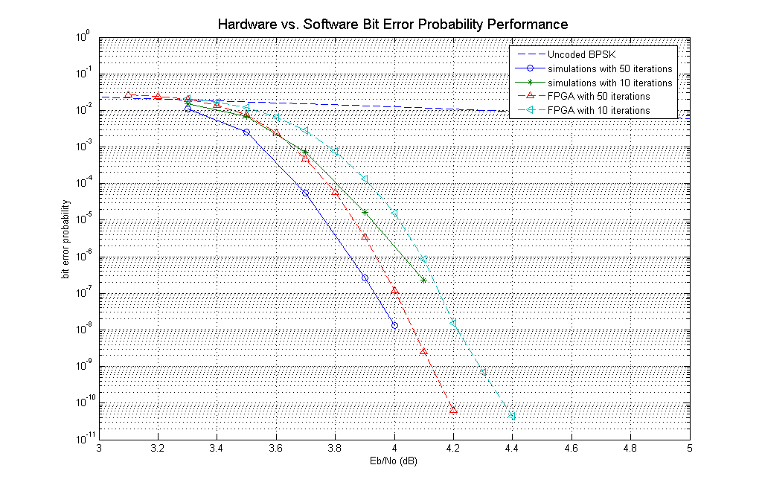
Figure 9. Bit Error Rate Test Results

Figure 9 shows the BER and Figure 10 shows the Block Error Rate (BLER) test results for 50 and 10 maximum iterations from an FPGA implementation of the baselined (8176, 7156) code. Note that for both cases the difference between simulations and hardware tests was 0.1 dB or less.

The encoder data rate was limited to 2 x system clock while the decoder operated at 14 x system clock / number of iterations. For testing, the system clock was set to 100 MHz, so for 10 iterations, the decoder operated at 140 Mbps. Although, the shortened (8160, 7136) was not tested, it is reasonable to say that the baselined (8176, 7156) code and the shortened (8160, 7136) standard code will have similar results.

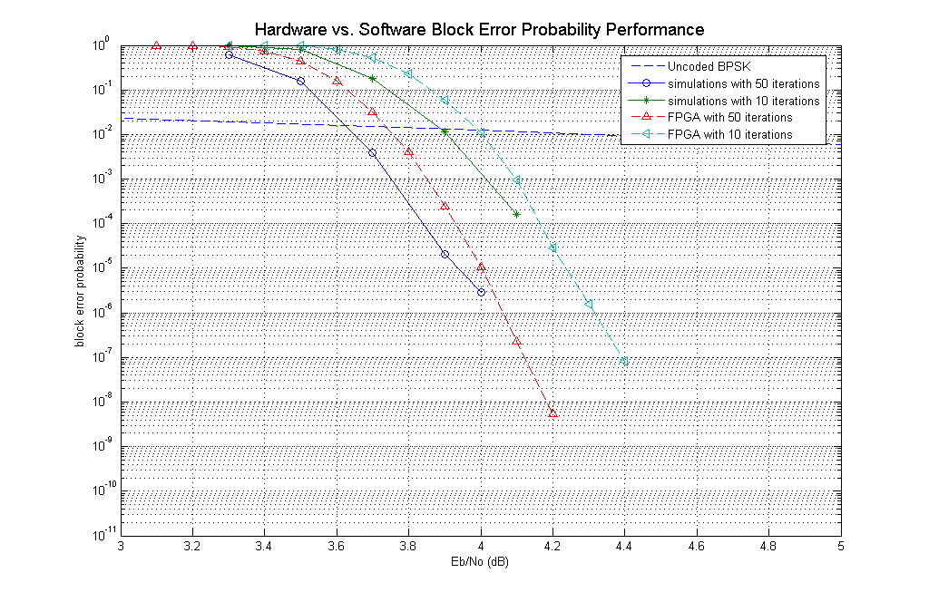
Figure 10. Block Error Rate Test Results

