NASA AMES RESEARCH CENTER
SIMULATION LABORATORIES

Dean P. Giovannetti, NASA Ames Research Center

NASA AMES
Simulation Laboratories

The National Aeronautics and Space Administration’s Simulation Laboratories at Ames Research Center are world-class research and development facility offering unparalleled capabilities for conducting exciting and challenging research experiments involving aeronautics and aerospace disciplines. The entire collection of simulation components, support equipment, associated facilities and buildings are known as SimLabs. The intent of this article is to inform the simulation community of these resources, their capabilities and availability for use by private industry, academia and government agencies for simulation research.

The SimLabs consists of numerous simulators developed, operated and maintained by an in-house staff of nationally recognized simulation experts supporting the widest possible range of aeronautical simulation research. SimLabs business concept is based on a building block approach that involves maintaining as distinct resources a conglomeration of simulation elements or components that can be integrated to form a complete system in a variety of different ways. This simulation system approach allows the simulator configuration to be tuned to the needs of specific research by employing only those components necessary for a particular test, tuning these components specifically for the test and using the most appropriate interchangeable components to suit specific test requirements. Additionally, specialized equipment can be integrated more easily and facility improvements can be implemented by up grading individual components rather than the entire simulator.

SimLabs staff assists researchers with their simulation research providing expertise in all aspects of simulation including, but not limited to, design and fabrication of high fidelity motion and non-motion simulators from concept specification through full operation, including software, hardware, mechanical, cockpit controls and displays, guidance and controls, visual data- bases, automation design and fabrication. In- house experts offer guidance in research experiment planning, data gathering, analysis, aviation human factors, airspace operations, air traffic management, specification writing and publication, technology development and transfer.

The laboratories consist of 3 main facilities; the Vertical Motion Simulator Complex, the Crew Vehicle Systems Research Facility and FutureFlight Central. The following sections describe these unique facilities.

VERTICAL MOTION SIMULATOR COMPLEX

The Vertical Motion Simulator Complex (VMSC) has been in operation since the mid- 1970’s and is a one-of-a-kind simulation research and development facility offering unparalleled capabilities for conducting studies and experiments involving some of the most challenging aerospace disciplines. The VMSC consists of the world’s largest motion base simulator and 5 interchangeable cabs (I-cabs), which can also be used for fixed base simulation. The I-cabs support simulation of various types of flight vehicles including transports, Space Shuttle, helicopters, fighters, and rotorcraft to name a few. The large-amplitude motion system was designed to aid in the study of helicopter and vertical/short take-off landing (V/STOL) issues specifically relating to research in controls, guidance, displays, automation and handling qualities of existing or proposed aircraft. It is also an excellent tool for investigating issues relevant to nap-of-the-earth flight, and landing and rollout studies. The facility is not only renowned for its large amplitude motion system but also for its efficient production of high fidelity, low cost, and rapid concept to research data producing capability, of simulations for existing and future advanced aerospace vehicles. The VMSC is a stand-alone facility with the ability to rapidly prototype any aspect of a simulation including but not limited to real time host computer interfaces, flight deck graphics systems, out the window image generation systems, cockpit controls, cueing devices and high fidelity motion.

The VMSC Motion System is a six-degree of freedom electromechanical/electro hydraulic servo system. It is located in and partially supported by a specially constructed 73 feet wide by 36 feet deep by 120 feet high tower, and the motion system uses virtually the entire interior volume of this tower. In addition to its size another unique feature of this facility is that it can simulate the physical cueing environment of a large range of vehicles. Five cabs representing the cockpits of a variety of vehicles and each with its own instruments, controls, visual display and audio cueing systems can be placed on the motion cueing system of the Vertical Motion Simulator (VMS). The motion platform consists of a 40-foot long beam, which travels ±30 feet vertically. On top of the beam is a carriage that traverses the 40-foot length of the beam. On top of the carriage is a gimbal system providing ±4 feet of lateral travel, ±18 deg. of roll and pitch and ±24 deg. of yaw. (See Fig 1.)
Figure 1
Photograph of VMS Tower with cut away view and artist rendering of motion system and interchangeable cab. Note size of tower in comparison to automobiles in lower left of picture.

INTERCHANGEABLE CABS (I-cabs)

Five Interchangeable Cabs (I-cabs) are maintained and operated by SimLab and provide the capability to simulate the cockpit/crew station for almost any imaginable aerospace vehicle. The I-cabs are built up around essentially identical structures that furnish a basis and framework for installing and mounting the numerous items that make up an aircraft cockpit crew station. The basic design and construction of the I-cabs is illustrated in
Figure 2.

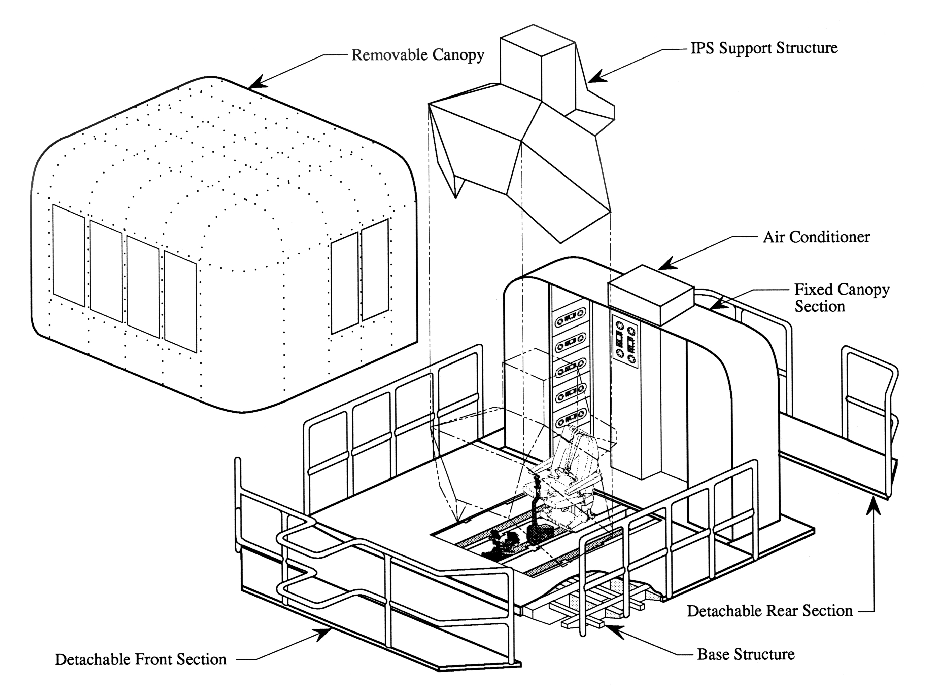

Figure 2

In order to achieve the desired interchangeability the I-cabs are built to rigid mechanical, hydraulic and electrical interface specifications. The structure of each cab is composed of four substructures: the base structure, the fixed canopy section, the removable canopy and the Image Presentation System (IPS) support structure. The base structure is a large flat weldment fabricated from aluminum channels, tubing and plate. It forms the floor of the cab and serves as the attachment to the motion system. All the other substructures are bolted to it. Detachable front and rear sections facilitate transporting the cab between the off-line development area and the motion system. The under-floor structure is designed to provide three adjacent oil-tight bays to accommodate electrohydraulic control loaders used to simulate the primary aircraft flight controls. The three different locations allow for either a single, centrally located pilot station or a two place, side-by-side arrangement. Wiring harnesses, hydraulic lines, junction boxes, instrument panels and consoles, electrical power outlets as well as other items are mounted directly to the base structure. The fixed canopy section forms the rear wall of the cab providing a sturdy structure for mounting a number of items including cab lighting, sound system speakers, pilot observation cameras, head tracking support equipment and standard aircraft size equipment racks. The removable canopy section forms the front wall, sidewalls and roof of the cab and its primary functions are to enclose the equipment contained inside the cab and provide a sound/light barrier to prevent distractions to the pilot. As its name implies, this section can be easily removed with an overhead crane allowing unrestricted access to the other internal items and substructures. The image presentation system (IPS) varies markedly from cab to cab in Field of View (FOV) capabilities. Each IPS is tailored to a specific class of aircraft such as Helicopter, Space Shuttle, Large Commercial and/or heavy lift military aircraft, Tilt Rotor and Military Fighter. No one compact visual system exists that can provide the cumulative FOV requirements for each of class of listed aircraft, hence the need for five cabs. Lastly, all five cabs have removable access porches and can be retrofitted with a wide range of pilot inceptors, seats, instrument panels, etc., from SimLabs’ vast inventory of aircraft simulation equipment.

The five I-cabs are not only used for flexibility but also for efficiency. While any one cab is on the VMS motion platform the others are being reconfigured and readied for the next vehicle they will simulate. When an I-cab reconfiguration is complete the cab is stored until the current simulation on the VMS motion platform ends. When the simulation currently running on the VMS motion platform simulation is complete the I-cab used for that simulation is replaced with the readied I-cab in storage. It takes approximately one eight hour shift to change I-cabs on the VMSC motion platform and prepare the motion system for a completely different simulation. The short time it takes to exchange cabs allows almost constant utilization and availability of the VMS motion system.

VIRTUAL LABORATORY

Virtual Laboratory (VLAB) is a virtual reality environment providing remote access from the researchers desktop to Ames Research Center simulation laboratories for interactive participation with live experiments. VLAB is capable of simulation model control, controls and display development, virtual prototyping, and data browsing. VLAB allows NASA expertise to benefit government and industry in a hands-on fashion by providing convenient access to national simulation resources enabling industry to improve its design process, yielding aeronautical products with a true competitive edge.

Using VLAB, multiple researcher’s in different locations participating in the same experiment can monitor and actively participate in a simulation from any location in the US.
VLAB enables industry/government partnerships to benefit from US aeronautics by providing easy access to national facilities, shared databases, and more effective and efficient design processes. VLAB reduces delays in distribution of experiment results by making data available in real-time within the lab and elsewhere reducing costs associated with human-in-the-loop simulation experiments. VLAB allows multiple researchers to remotely participate in concurrent experiments and in various phases of the design cycle. The system allows researchers to develop math models, displays, control systems, validate models for higher quality experiments, and provide fully compatible software modules all from their integrated desktop. VLAB has thus far been extensively used for Space Shuttle, Civil Tilt Rotor, NTSB and DOD simulations, research associate presentations, VIP demos, and education purposes.

Photo of researcher using VLAB graphical interface

VLAB represents a fresh approach to conducting simulation experiments. The concepts and methodologies developed using VLAB are anticipated to become a “springboard” for a new approach to aeronautical research and development.

Crew-Vehicle Systems Research Facility

The Crew-Vehicle Systems Research Facility (CVSRF) is a unique national research resource designed for the study of human factors in aviation safety. The facility is used to analyze performance characteristics of flight crews; formulate principles and design criteria for future aviation environments; evaluate new and contemporary air traffic control procedures; and develop new training and simulation techniques required by the continued technical evolution of flight systems. The CVSRF allows scientists to study how errors are made, as well as the effects of automation, advanced instrumentation, and other factors, such as fatigue, on human performance in aircraft.

The facility includes two flight simulators, a Boeing 747-400 and an Advanced Concepts Flight Simulator (ACFS), and a simulated Air Traffic Control (ATC) System. Both flight simulators are capable of full-mission simulation. Each has a dedicated experimenter’s control lab, capable of monitoring and controlling its respective simulator. Visual systems provide out-the-window cues in both cockpits. The Air Traffic Control System simulator provides a realistic air traffic control environment, including communication with the cockpits allowing study of air-to-ground communications systems as they impact crew performance.

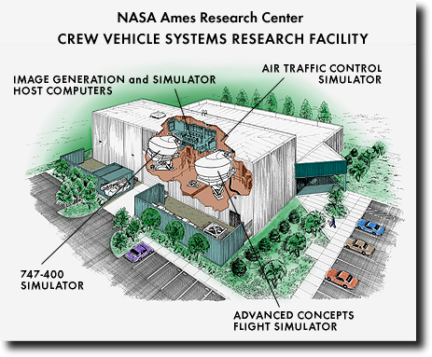
Cut-away view of the Crew-vehicle systems research facility

Boeing 747-400 Simulator

A key component of the facility is a Boeing 747-400 flight simulator. This simulator represents a cockpit of one of the most sophisticated airplanes flying today. The simulator is equipped with programmable flight displays that can be easily modified to create displays aimed at enhancing flight crew situational awareness and thus improving system safety. The simulator also has a fully digital control loading system, a six degree-of-freedom motion system, a digital sound and aural cues system, and a fully integrated autoflight system, which provides aircraft guidance and control. It is also equipped with a weather radar system. The visual system can depict out-the-window scenes in day, dusk, night or twilight modes. The visual, weather radar, and motion systems are tightly coupled simulating weather effects with a high degree of realism.

The 747-400 simulator provides all modes of airplane operation from cockpit preflight to parking and shutdown at destination. The simulator flight crew compartment is a fully detailed replica of a current airline cockpit. All instruments, controls and switches operate as they do in the aircraft. All functional systems of the aircraft are simulated in accordance with aircraft data. To ensure simulator fidelity the 747-400 simulator is constantly maintained to the highest possible level of certification for airplane simulators as established by inspectors of the Federal Aviation Administration (FAA).

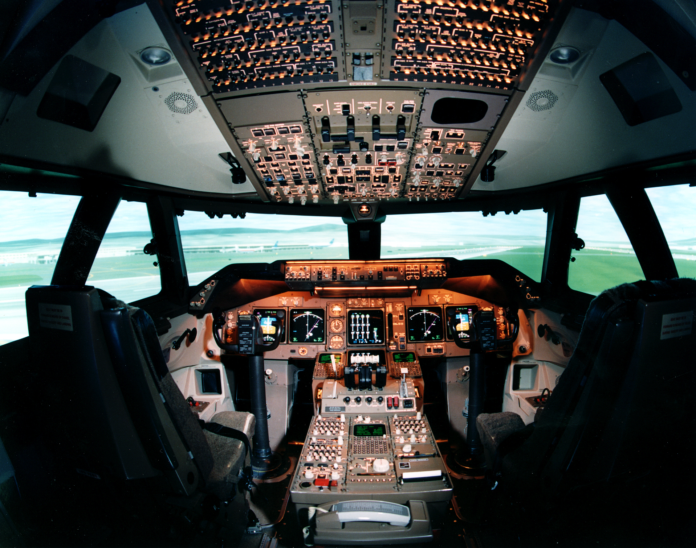
Boeing 747-400 Simulator Cockpit

Advanced Concepts Flight Simulator

Another key element of the facility is the Advanced Concepts Flight Simulator (ACFS). Like the B747-400 simulator, the ACFS is also equipped with a six degree-of-freedom motion system, programmable flight displays, digital sound and aural cueing system, and a visual system with a 180-degree field of view. The simulator systems provide an extremely realistic full mission environment. The ACFS is configured as a generic commercial transport aircraft employing many advanced flight systems as well as features existing in the newest aircraft being built today. Among its advanced flight systems, the ACFS includes touch sensitive electronic checklists, advanced graphical flight displays such as airport moving maps and graphical aircraft systems schematics, a flight management system linked to ATC, and a Head Up Display (HUD) guidance system. In addition, the ACFS utilizes sidestick controllers for aircraft control in the pitch and roll axes. The ACFS generic aircraft was formulated and sized on the basis of projected user needs into the 21st century.

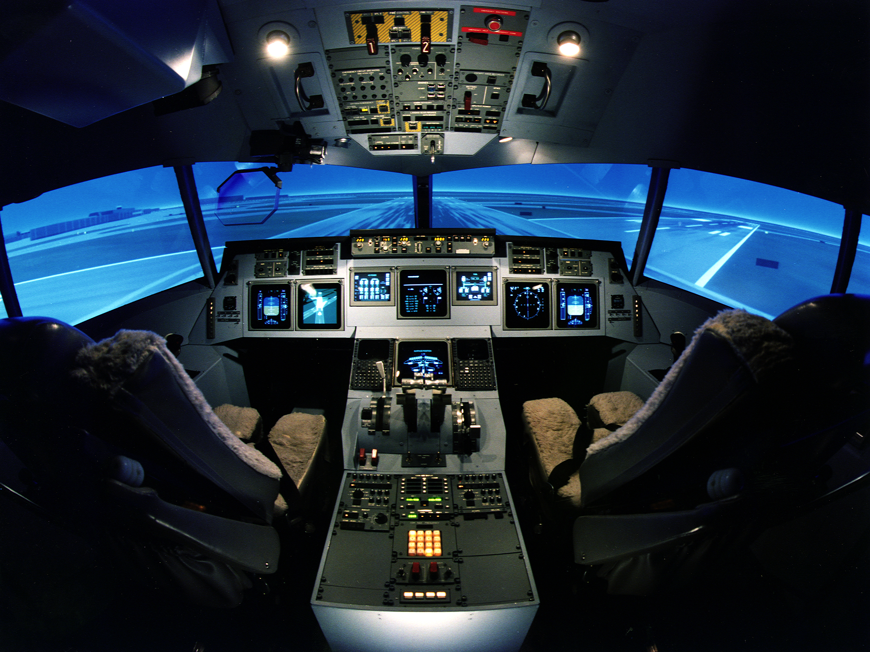
Advanced Concepts Flight Simulator Cockpit

Air Traffic Control Simulator

The Air Traffic Control (ATC) environment is a significant contributor to pilot workload and therefore to the performance of crews in flight. Full-mission simulation is greatly affected by the realism with which the ATC environment is modeled. From the crew’s standpoint, this environment consists of dynamically changing verbal or data-link messages, some addressed to or generated by the crew, others addressed to or generated by other aircraft flying in the immediate vicinity. The ATC simulator is capable of operating in three modes: stand-alone, without participation by the rest of the facility; single-cab mode, with either the ACFS or the 747-400 participating in the study; and dual-cab mode, with both cabs participating.

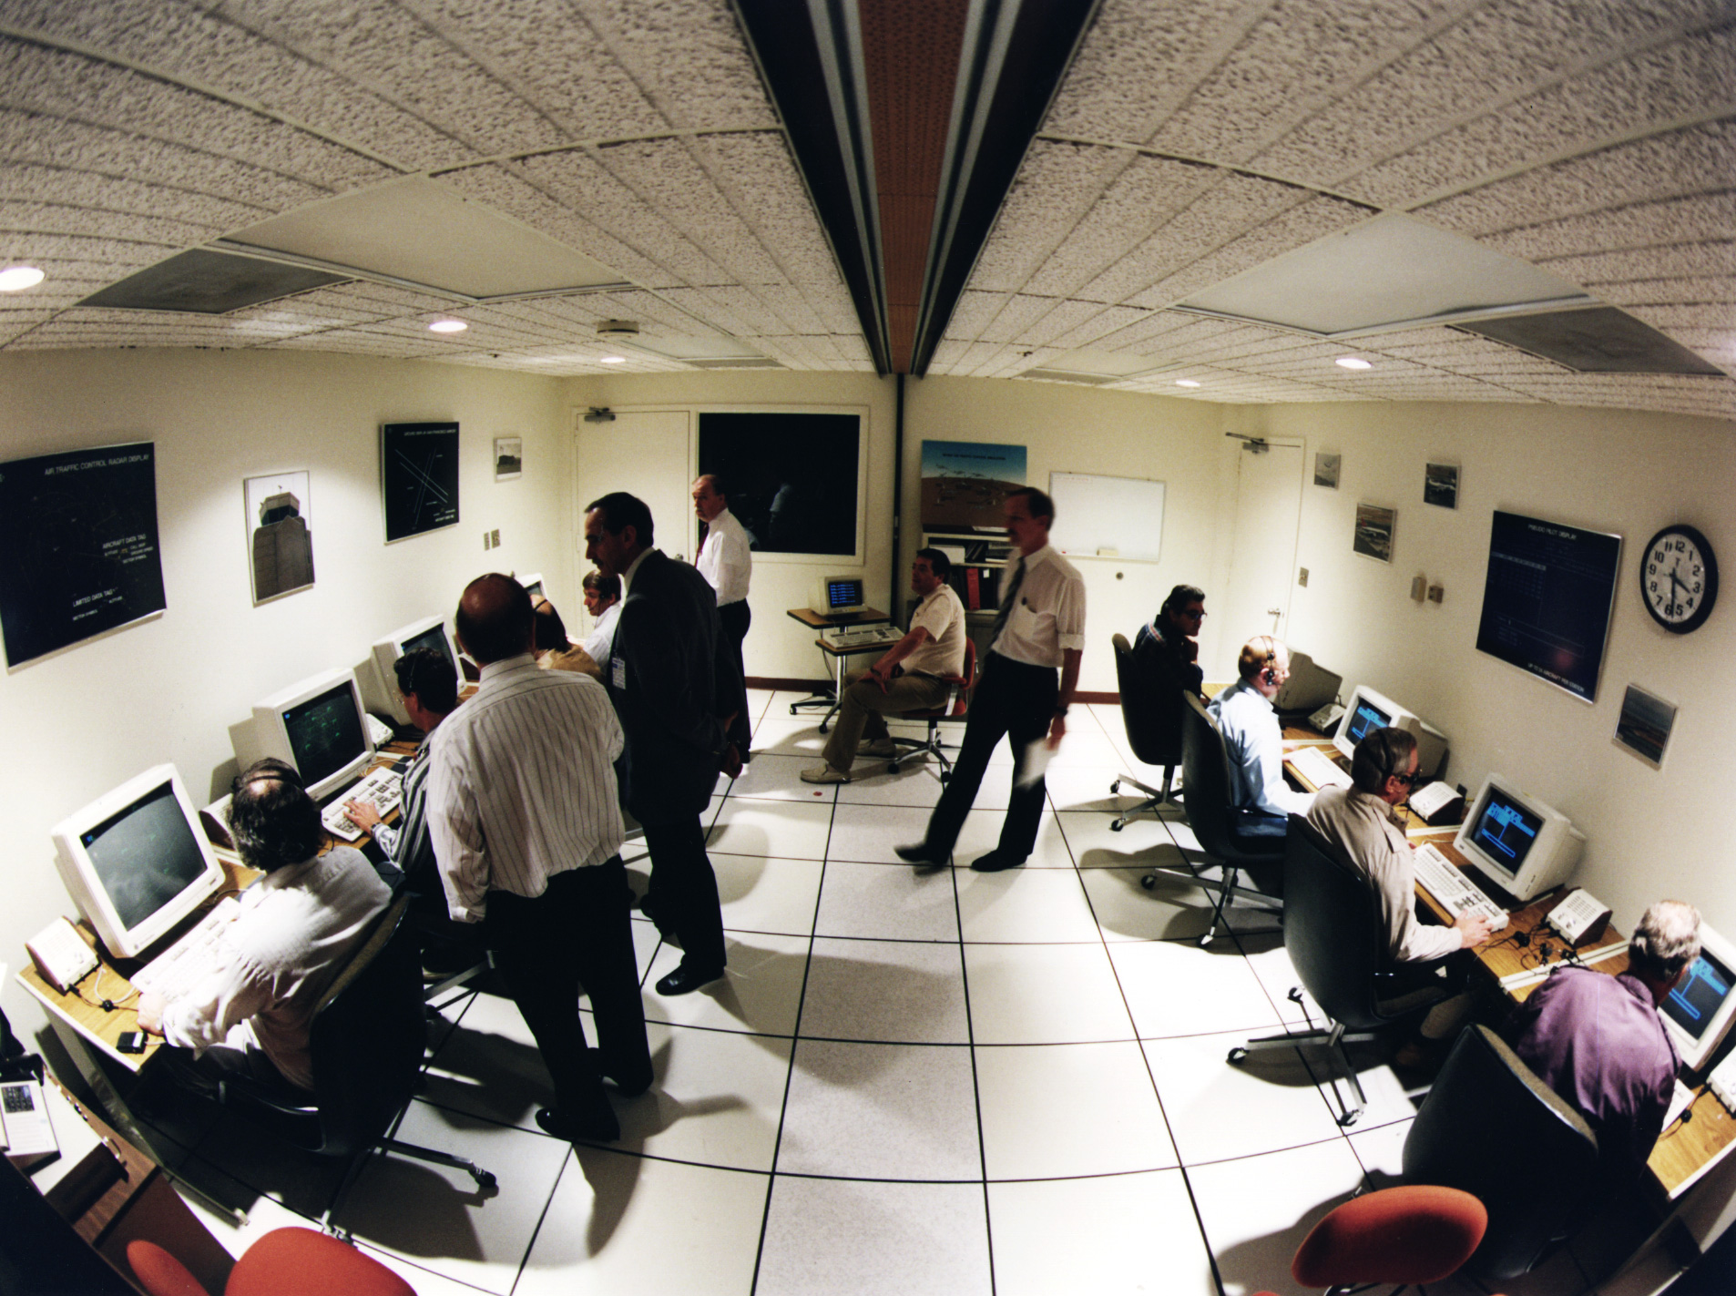
Air Traffic Control Laboratory

Future Flight Central

Future Flight Central (FFC) is a full scale air traffic control tower simulator that has the "look and feel" of an actual airport tower with a 360-degree, continuous field of view, high fidelity out-the-window visual scene. FFC is a national Air Traffic Control/Air Traffic Management test facility dedicated to solving the present and emerging capacity problems of the nation's leading airports. The facility offers a full-scale real-time simulation of an airport tower, where controllers, pilots and airport personnel participate to optimize expansion plans, operating procedures, and evaluate new technologies. The facility is used for planning new runway configurations, optimizing new ground traffic and tower communication procedures, testing new technologies and validating air traffic planning simulations. It supports cost-benefit studies, human factor assessments, and proof-of-concept evaluations through qualitative and quantitative measurements of workload, airport capacity and efficiency under realistic conditions.

Future Flight Central Tower Simulator

Interior Photo of FutureFlight Central Simulator

FFC-detailed and highly realistic 3-D airport database models are displayed on twelve projection screens to provide a 360-degree out-the-window view of the airport. The database supports views from any location, allowing the simulation and playback recordings to show the views from the air traffic control tower, ramp tower, pilot and ground vehicle operator. Interactive displays support all air and ground positions controlling traffic within a terminal air space. The voice communication system can be configured to support all radio frequencies operating at an airport control tower. Controllers, ramp operators and pseudo-pilots participating in the simulation are each equipped with a communication touch screen interface and headset.

Quad-split video recording

FutureFlight Central air traffic scenarios encompass the terminal air space and surface of the airfield. Up to twelve controller positions, eight ramp tower positions and thirteen pseudo-pilot positions are networked in real-time. During a simulation run, FutureFlight Central can collect measurements of surface performance for ground vehicles and aircraft, controller/pilot communication, and audio/video observational data including:

• Replay of an entire simulation run
• Summary statistics such as taxi time, departure rate, runway occupancy time, and non- movement area time
• Digital audio recordings of pilot/controller radio transmissions for voice communication analysis
• Audio recordings of non-transmitted controller-to-controller coordination within the tower cab
• Video recordings of controller movements using cameras installed throughout the tower cab

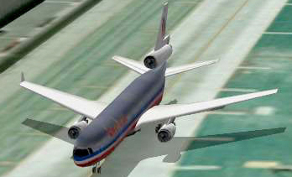 MD-11 as modeled in FutureFlight Central

Aircraft and ground vehicles are controlled by pseudo-pilots using interactive displays to control many aspects of aircraft movement. Examples of modeled parameters include:

• Push back and Engine startup time
• Taxi route and Taxi speed
• Aircraft lights
• Ground acceleration/deceleration
• Takeoff speed and Climb speed
• Aircraft stall speed (Dirty/Clean)
• Rate of turn/climb/descent
• Fade from radar
• Cruise speed
• Flight plan True Air Speed (TAS)
• Descent speed
• Terminal area speed
• Intermediate approach speed
• Final approach speed
• Landing speed
• Landing distance
• Landing options: visual, ILS, go-around, missed approach

The simulator’s aircraft model database currently contains over 100 3-D aircraft and ground vehicle models. The library collection includes detailed liveries of airlines represented at the airport under study. FutureFlight Central continuously updates this collection based on research needs.

FutureFlight Central contains facilities for recording broadcast quality presentation materials. A professional presentation of simulation results with narrated out-the-window and in-tower video, including audio recordings and graphical presentation of data can also be generated.

SUMMARY

The NASA Ames SimLabs are world class
Simulation research and development facilities available for use by government, DOD, private industry and academia, offering neutral unbiased guidance in simulation development planning, data gathering, investigative research and analysis. All SimLabs are equipped with the most current motion, visual, computational, etc., simulation equipment with the ability to operate remotely and/or networked with other simulation laboratories.

A complete list and in-depth description of simulations conducted at the SimLabs is available at the SimLabs web site http://www.simlabs.arc.nasa.gov
under Annual Reports.

For additional information or to request use of the laboratories please contact,

Tom Alderete
Assistant Division Chief, Aviation Systems
NASA Ames Research Center
Moffett Field, CA 94035-1000
Email: Thomas.S.Alderete@nasa.gov
Phone: 650-604-3271
Fax: 650-604-3952

Or

Barry Sullivan
Chief, Aerospace Simulation Operations Branch
NASA Ames Research Center
Moffett Field, CA 94035-1000
Email: Barry.T.Sullivan@nasa.gov
Phone: 650-604-6756
Fax: 650-604-3952

Or

Dean Giovannetti
Assistant Chief,
Aerospace Simulation Operations Branch
NASA Ames Research Center
Moffett Field, CA 94035-1000
Email: Dean.P.Giovannetti@nasa.gov
Phone: 650-604-3871
Fax: 650-604-3952

Or

Visit the SimLabs web site at
http://www.simlabs.arc.nasa.gov
for more detailed facility descriptions, information and photos.

