Production Management Standards:

Requirements Analysis for Shop Floor Status

Christophe LeCapitaine, Frank Riddick, Albert Jones
Manufacturing Systems Engineering Group
Manufacturing Systems Integration Division
Manufacturing Engineering Laboratory
National Institute of Standards and Technology
Gaithersburg, MD 20899 USA

Table of Contents

1 Scope 6
1.1 Application Activity Model (AAM) 6
1.1.1 AAM definitions and abbreviations 6
1.1.2 AAM Diagrams 13
2 Standards Review 20
3 Definitions and Abbreviations 21
3.1 Terms Defined in Other Documents or Standards 21
3.2 Other Definitions 22
3.3 Abbreviations 23
4 INFORMATION REQUIREMENTS 23
4.1 Units of Functionality 23
4.1.1 factory_status UoF 24
4.1.2 status_message UoF 24
4.2 Application Objects 24
4.2.1 Id 25
4.2.2 buffer 25
4.2.3 jobstep 25
4.2.4 load 25
4.2.5 load_pair 28
4.2.6 material 29
4.2.7 message 29
4.2.8 order 36
4.2.9 product 36
4.2.10 resource 36
4.2.11 resource_pair 38
4.3 Application Assertions 39
4.3.1 Buffer to create_buffer 39
4.3.2 Buffer to delete_buffer 39
4.3.3 Buffer to resource 39
4.3.4 Jobstep to load 39
4.3.5 Load to buffer 39
4.3.6 Load to change_load 39
4.3.7 Load to create_buffer 40
4.3.8 Load to create_load 40
4.3.9 Load to delete_load 40
4.3.10 Load to resource 40
4.3.11 Load_pair to change_load 40
4.3.12 Order to create_load 40
4.3.13 Order to load 40
4.3.14 Product to create_load 40
4.3.15 Product to load 41
4.3.16 Product to resource 41
4.3.17 Resource to change_resource 41
4.3.18 Resource to create_resource 41
4.3.19 Resource to delete_resource 41
4.3.20 Resource_pair to change_resource 41
5 References 42
6 Appendices 43
6.1 Appendix A 44
6.1.1 AMP Aerospace 44
6.1.2 BFGoodrich 48
6.1.3 Black & Decker 52
6.2 Appendix B 55

Preface

The High Performance Computing and Communication (HPCC) program [1] was formally established by the High Performance Computing Act of 1991 (Public Law 102-194). The goal of this program is to accelerate the development of future generations of high performance computers and networks and the use of these resources in the government and throughout the U.S. economy. The National Institute of Standards and Technology's (NIST) Systems Integration of Manufacturing Applications (SIMA) Program [2] coordinates many of the agency's HPCC activities. SIMA is addressing the information interface needs of the U.S. manufacturing community. Specifically, the SIMA program works with U.S. industry to:

- Develop information exchange and interface protocols to address manufacturing integration problems,
- Establish test mechanisms for validating protocols and implementations, and
- Transfer information technology solutions to manufacturing enterprises.

The primary output of the SIMA Program will be a collection of specifications called Initial Manufacturing Exchange Specification (IMES) [3]. IMES provide the means to improve the SIMA Program's ability to meet the needs of U.S. industry in the area of standards and testing methods by providing a structured approach to the SIMA Program's activities in this arena. They will fill an important void in the manufacturing systems integration process as it exists today. Each IMES will be developed through an industry review and consensus process. It is expected that the manufacturing community will accept them as an authoritative specification.

Three types of IMES have been identified: an interface specification between a human being and a software application; an interface specification between two or more software applications; and a reference information repository specification. Each IMES involves several components that define the integration aspect, specifies a definitive solution to the integration problem, and demonstrates the validity of the proposed solution. It must contain a clear description of WHAT information the interface or repository MUST convey, and possibly HOW it is conveyed. The content is usually specified by an information model of all the objects and related information attributes which are covered by the specification.

To support the scope and domain specifications, the IMES shall address a particular "example scenario," identifying an actual interface/information requirement derived from a real industrial problem. The proof of the value of the IMES to industry will be the ability to build a prototype to the IMES, using the software applications actually used by the industrial practitioners, and solving the cited problem. To support the development of an IMES, SIMA projects will have seven phases: identify/define the industry need, conduct requirements analysis, develop proposed solution, validate proposed solution, build consensus, transfer technology, and initiate standardization. Each of these phases has a well-defined set of deliverables.

The Phase I IMES document for Production Management [4] proposed that work proceeds in three stages. In stage one, specifications would be developed to enable the integration of shop floor scheduling and shop floor data collection applications. In stage two, specifications would be developed to enable the integration of shop floor scheduling with production planning, process planning, and shop floor control. In the last stage, specifications will be developed for the integration of shop floor scheduling with Manufacturing Execution Systems (MES) and Enterprise Resource Planning (ERP) systems.

This document describes the results of the requirements analysis phase for shop floor status. It specifies the information required during the exchange of shop floor status between shop floor scheduling and shop floor data collection applications.

Work described in this paper was sponsored by the NIST Systems Integration of Manufacturing Applications (SIMA) program and the US Navy Manufacturing Technology program. Certain commercial software and hardware products are identified in this paper. This does not imply approval or endorsement by NIST, nor does it imply that the identified products are necessarily the best available for the purpose.

Scope

Production Management is one of the focus areas within the Systems Integration of Manufacturing Applications (SIMA) Production and Product Data Management project [2]. The Phase I IMES [4] document identified and documented the industry need, a manufacturing scenario, potential collaborators, and the proposed technical approach for the Production Management project. It stated that the goal of this project is the development and demonstration of generic interface specifications for the integration of production management software applications.

The Phase I IMES document for Production Management also proposed that work toward this goal would proceed in three stages. In stage one, specifications would be developed to enable the integration of shop floor scheduling and shop floor data collection applications. In stage two, specifications would be developed to enable the integration of shop floor scheduling with production planning, process planning, and shop floor control. In the last stage, specifications would be developed for the integration of shop floor scheduling with Manufacturing Execution Systems (MES) and Enterprise Resource Planning (ERP) systems.

The scope of this document is described in the remainder of section 1. Briefly, it is the specifications required for the integration of shop floor scheduling and shop floor data collection applications. This integration is achieved through the exchange of what is commonly called "shop floor status". This document will specify the information requirements for this shop floor status. These requirements, which are described in detailed in section 4, are decomposed into units of functionality, application objects, and application assertions. Sections 2 and 3 of this document present standards and definitions related to the designation of these requirements.

Application Activity Model (AAM)

The Application Activity Model (AAM) is provided to aid the understanding of the scope and information requirements defined in this IMES. The model is presented as a set of definitions for the activities and data flow between these activities. These activities are represented as level diagrams using IDEF0 (Integration DEFinition) notation [5]: activities/functions are represented by “boxes”, data/objects such as inputs, controls, outputs and mechanisms are represented by “arrows” and boxes and arrows are labeled. If an activity at one level can be decomposed into sub-activities, a separate level is included. As with any IDEF0 model, the application activity model is dependent on a particular viewpoint and purpose. The viewpoint of the AAM is that the engineering and production manager is responsible for assigning the engineering and production tasks. The purpose of the AAM is to identify the functions and interfaces required of manufacturing applications software systems.

AAM definitions and abbreviations
The following terms are used in the application activity model.

Control and Monitor Jobs (Activity A452)

Implement the production schedule. Direct routing of jobs to workstations; direct delivery of tooling and materials. Track lots and workpieces and monitor job status against schedule. Make adjustments to schedules and priorities.

Control Equipment (Activity A454)

Execute the fabrication, assembly and inspection operations and/or control the equipment that performs them. Control and monitor the parameters of the process. Monitor the time on task and time in service for equipment and tooling. Identify problems and anomalous behavior.

Control Production (Activity A45)

Implement the production schedule, perform the fabrication, assembly and inspection operations, move tooling and workpieces, track job and workpiece status on the floor.

Coordinate Equipment Groups (Activity A453)

Assign tasks to subsystems involving independently controlled machines or human resources. Define the interactions of such subsystems; coordinate the actions of subsystems in the of a single task. Coordinate the physical and temporal interactions of equipment systems (both human and automated) performing different tasks within a work area/volume.

Create Master Schedule (Activity A411)

Using the current customer orders and due dates, market projections and the gross production requirements for the products, determine the product volumes that will be produced during each successive planning period covering some predetermined long term planning horizon (which can range from several months to several years). This is called the Master Production Schedule. Entries in the Master Production Schedule identify end products, quantities and target completion dates. For a make-to-order product, the entries in the Master Production Schedule will be (or be derived from) customer orders. For a make-to-inventory product, the entries will be based on projected demand, rather than actual orders. A single facility might have a mixture of make-to-order and make-to-inventory products.

Create Production Orders (Activity A413)

Using the end items from the Master Production Schedule together with the exploded Bill Of Materials for each of those end items and the expected yields from the manufacturing processes, create production orders for manageable quantities with specific due dates. One or more production orders may be required for each end item. The number of these orders will depend on the quantities required and the nature of the item (component, sub-assembly, tool, special fixture, etc.). The projected available capacity and manufacturing capabilities are used to determine which orders will be produced in-house (and in what facilities) and which will be sent out to bid. For products made-to-order, the relationship between production orders and customer orders is the subject of both business decisions (such as priority and delivery schedule) and technical decisions (such as production capacity and materials availability).

Define Capacity Requirements (Activity A412)

Using the target production levels contained in the Master Production Schedule, determine the long-term capacity requirements for the factory. As shorter-term schedules are produced, the actual used and unused capacity, and the actual product yields are also monitored and used to update the long-term projections.

Define Jobs (Activity A421)

Decompose or aggregate those production orders which are produced in-house into batches or lots. These batches/lots are called Jobs, and each is scheduled, monitored, and tracked as single entity, with a system-maintained Job identifier. Some Jobs are to make products, some are to make components or subassemblies, and some are to make tooling and fixtures. There may also be Jobs to make prototypes or test engineering specifications, and Jobs to perform setup or maintenance processes, depending on the way in which facility usage is planned. For those Jobs that produce products (or components of products), as distinct from tooling, this activity maintains the relationships, if any, between these Jobs and the production orders. The relationship of Jobs to orders may be complex, involving both business decisions, such as priorities, and technical decisions, such as batch sizes and expected yield.

Define Production Jobs (Activity A42)

Using the production orders derived from the Master Production Schedule, define Jobs or batches of Parts to be made in the facility, and supporting tasks for the preparation of tooling, kits and materials. Coordinate the production of components and assemblies and the preparation of materials and tooling with the manufacturing processes. Issue Jobs to the scheduler when the requisite components, materials and tooling (will) become available.

Develop Production Plan (Activity A41)

Using customer orders and projected demand for the products of the facility, define the Master Production Schedule -- the expected product output of the facility over a fairly long term. Define corresponding capacity requirements and projections. Define and coordinate the production orders for the Parts that make up the products, and any related tooling and materials. This includes those orders that are Jobs to be performed in the facility and those that are sent to external suppliers.

Direct Personnel and Machines (Activity A451)

Assign personnel to workstations, monitor performance of personnel and equipment and identify problems. Provide expertise in problem diagnosis and take corrective actions. Determine equipment status and failures. Identify human and equipment resource shortages and specify overtime requirements required to meet production schedules.

Engineer Manufacture of Product (Activity A2)

Define the process of making the product, including the elementary stock materials and components to be acquired, the equipment, tooling and skills to be used and the details of that usage. Details include the exact sequence of setups and operations to be performed, and the complete instructions for each operation, whether by human or automated resources. By extension, the process of making the product includes measurement and inspection activities performed during production for process control and quality assurance.

Generate Delivery Schedules (Activity A443)

Using the routing sheets, and schedules for tooling, components and other materials from the Job schedule, generate pickup and delivery schedules for all tools, fixtures, raw/in-process/ materials, and other components specified in the Bill Of Materials so that they are present when where they are needed. (In many cases, these schedules are developed dynamically, using dispatch rules to prioritize and respond to delivery requests as they are posted).

Generate Job Schedule (Activity A441)

Using the current Job schedule, maintenance and employee schedules, the scheduling package for the Job (the routing plan and per step resource requirements), and the availability of the required materials and tooling, insert the newly released Jobs into the existing detailed production schedule. Assign the planned steps to specific major resource stations at specific times, and generate the Job schedule that defines the scheduled itinerary for each Part batch. This activity may be performed incrementally, or a queue of waiting Jobs may be developed and the scheduling of all waiting Jobs for a particular time period may be undertaken at one time

Generate Operations Schedules (Activity A442)

For those workstations/cells which comprise multiple equipment units capable of simultaneous tasks, schedule the operations within the Job steps assigned to the cell, interleaving steps from separate Jobs and performing them in parallel where possible, to optimize equipment utilization and meet the step completion times on the Job schedules. Generate the corresponding schedules for assignment of the operations to the subsystems of the workcell. This activity is often performed dynamically in the workcell. The workcell scheduling process is usually much simpler than the facility scheduling process, especially when the workcell has unique resources or when the multiple resources are essentially equivalent machines with an internal materials handling system.

Generate Tool and Stock orders (Activity A422)

Using the most up-to-date production schedule, including due dates for customer orders, issue orders for the required tools, raw/in-process materials, fixtures, and other components specified in the Bill Of Materials from appropriate inventory managers. The delivery of these items must be scheduled so that the Jobs can begin with sufficient lead times to meet the production schedule.

Job routing (output: A441; input: A441, A442, A443, A444)

A matrix showing which steps in the plan for each Job are assigned to which major resources (machines and artisans) at which times, including the expected start and finish time for those steps, and the materials and tooling which must be at that workstation to perform the corresponding Job step.

Job schedule (output: A44, A443, A442, A441; input: A45, A46)

For each major equipment station (or artisan station or workcell), a list of the current Jobs (and due dates) assigned to the station, together with the operations sheets, tools, fixtures, etc. needed to perform the jobstep at that station. This information is also called the Dispatch list. In some cases, the Job schedule is more conveniently decomposed into Job routings and multiple Operations schedules.

Job status (output: A45; input: A46, A44, A444)

Report of the state of all scheduled Jobs. State information contained in the report could include - completed, on time, late, waiting to be started, in process at machine x, waiting for something at machine x, aborted, and needs to be rescheduled, etc. For workcells in which operations are separately scheduled, the Job status report may include the operations status report.

Manage Tooling and Materials (Activity A43)

Manage materials, tools, fixtures, and component inventories. Track order, receipt, assignment, location, and use of tooling and materials. Prepare tooling and fixture assemblies according to specification. Test and inspect incoming materials. Prepare raw materials in the proper quantities, combinations and rough sizes for Part batches. Prepare tooling and materials kits. Decommission used tooling (breakdown, regrind, etc.). Recapture and process reusable and recyclable materials. This is a loose collection of related activities that are viewed differently by different organizations, somewhat according to the kinds of products they make. (Not further developed in this cycle.)

Monitor Job Completion (Activity A424)

Using feedback from the shop floor and scheduling system, note completions of released Jobs and update Work-In-Process and status of the corresponding production orders.

Monitor Production Orders (Activity A414)

Using Work-In-Process, completion and delivery reports from the production facilities, monitor the status of the production orders. Update products inventory levels and production rate and yield statistics. Maintain the relationship between production orders and customer orders, if any, and update projected and actual completion status for customer orders.

Operations status (output: A444; input: A442)

In a complex workcell, report of the state of all scheduled operations. The notions are identical to those of Job status, except that a “Job” of the workcell is a “step” in the plan for a larger “Job” in the whole shop, and a “step” of the workcell plan is considered an “operation” by the shop scheduler.

Produce Products (Activity A4)

Provide and maintain the production facilities and produce the Parts according to the specifications in the process plans. This involves defining the production schedules and controlling the flow of materials into and out of the production facility, scheduling, controlling and executing the production processes themselves, providing and maintaining the production equipment and the human resources involved, developing and tracking the tooling and materials, etc.

Production order status (input: A414, A421; output: A424)

Status of the Part quantities specified by the production orders. This includes quantities actually completed, quantities in process and projected completion dates, and quantities not yet in process. This may also include estimates of effective yield or gross and net quantities.

Release Jobs (Activity A423)

Using the current and projected resource availability and the anticipated availability times for components, tooling and materials, release Jobs to the shop (scheduler) for production and specify when they must be completed. Revise estimates of used and unused resource capacity. This activity determines the Work-In-Process for the facility.

Released Jobs (output: A42; input: A44, A441)

Jobs for production of specific batches of Parts/products, for which tooling and materials are scheduled to be available within the current planning horizon. Each Job description represents a requirement to manufacture a specific quantity (a batch) of a single Part (which may be an assembly). It includes the batch size, a priority, and an earliest scheduling time (possibly for specific steps). For each Job there is a plan which defines the sequence of steps required to make that batch, where each step requires a different major resource -- a different kind of equipment or a different equipment configuration. That plan is part of the scheduling package. An operations sheet defines the operations that are to be performed within each step.

Resource states (output: A45; input: A46)

Reports of current/new states of personnel and equipment, including both scheduled and unexpected changes of state, such as equipment problem reports. State information could include: resource currently up and busy on Job x, machine x currently down for pre-planned maintenance, or machine x currently down for remedial maintenance, employee x out on sick leave, etc.

Schedule Jobs (Activity A44)

Define the detailed production schedule for all Jobs that have been released: which workstations will perform which operations on which Part lots when.

Scheduling package (output: A2; control: A44, A441, A442)

A plan that specifies the sequence of workstation or workstations types to be visited by the workpiece in process, including both processing stations and inspection stations. For each station the plan specifies:

- the station or station type,
- special operator/artisan skills required at that station,
- the tooling and materials required at that station,
- the size of the Part lot to be processed at one time,
- the length of time required to process the lot through that station,
- the operations sheets and control programs for that station.

Track Jobs (Activity A444)

For each Job on the floor, track its progress including where it is physically, the current step in the process routing, and the expectation of completion on schedule.

Work-In-Process (output: A42, A421, A423, A424; input: A41, A411, A414)

Identification of Part batches completed, batches currently scheduled and in production on the shop floor, and batches not yet scheduled. For each batch, the batch size and either the effective yield or the estimated yield is identified. Completed batches have actual completion times, in-production batches have scheduled completion times, and unscheduled batches have estimated release dates. The production of a Part batch is a Job, and every Part batch (and Job) is associated with some production order(s). The Work-In-Process report, therefore, can be seen as a production order status report. Part batches may identify the individual workpieces/Parts and each Part may be associated with a specific production order (especially if the production order directly reflects customer orders), or only the batch may be tracked.

AAM Diagrams
The application activity model is given in the following diagrams. The graphical form of the application activity model is presented in the IDEF0 activity-modeling format, and taken from the SIMA Reference Architecture [6].
The blue lines are used to show what relations deal with the Production Management Standards.
Fig. 1
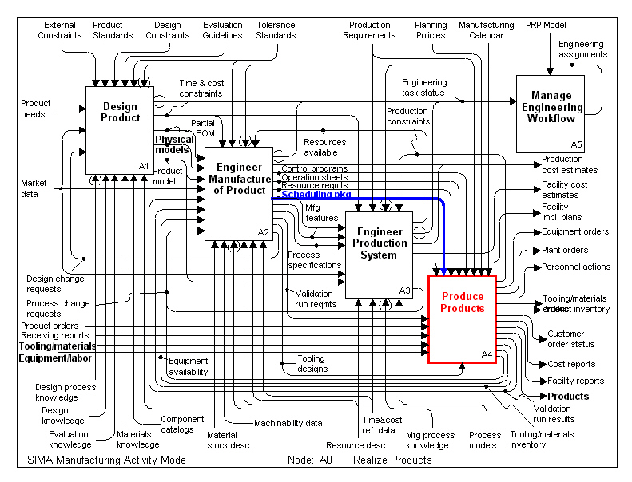
Fig. 2
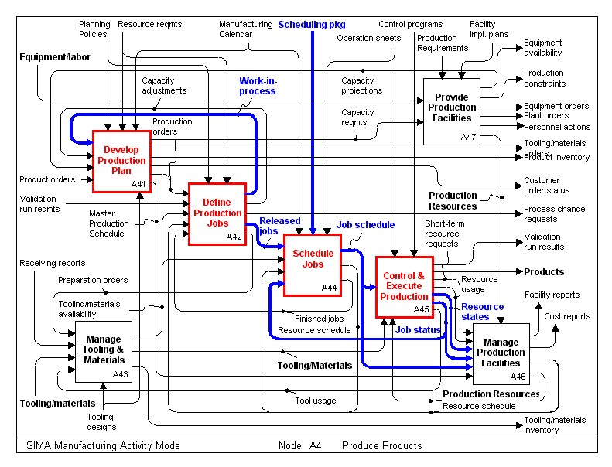
Fig. 3
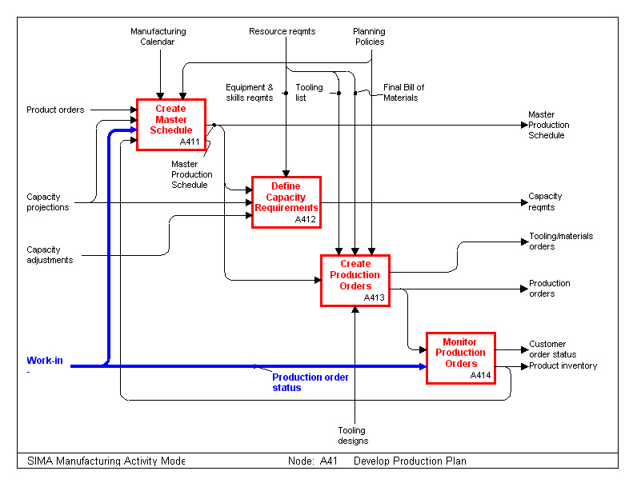
Fig. 4
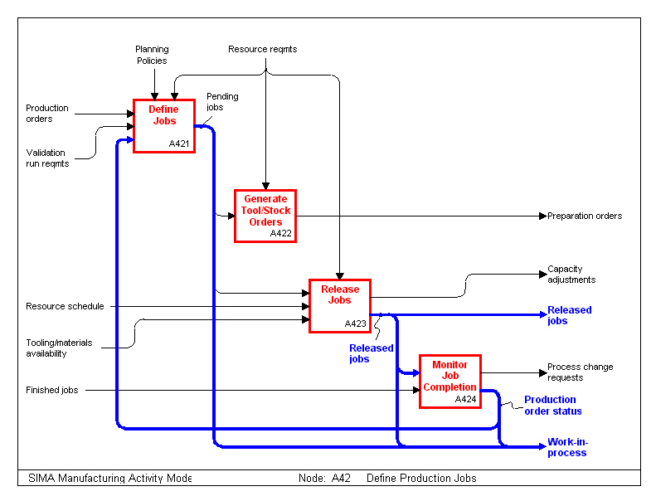
Fig. 5
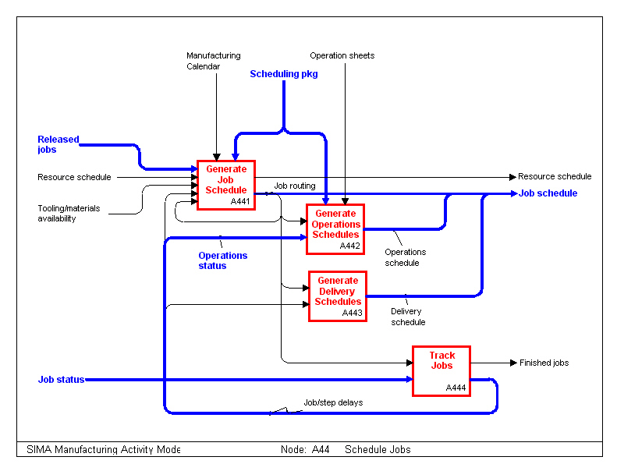
Fig. 6
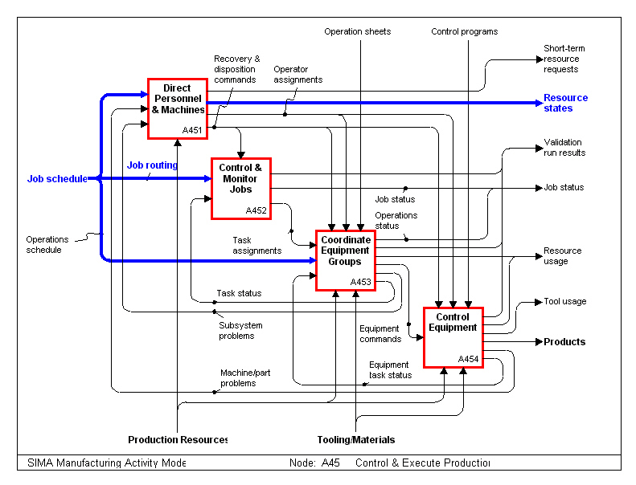

Standards Review

The following standards contain provisions that, through reference in this text, constitute provisions of IMES. All standards are subject to revision and parties to agreements based on this IMES are encouraged to investigate the possibility of applying the most recent editions of the standards indicated below.

ISO 8824-1:1994, Information technology - Open systems interconnection - Abstract syntax notation one (ASN.1) - Part 1: Specification of basic notation.

ISO 10303-11: 1994, Industrial automation systems and integration - Product data representation and exchange - Part 11: Description methods: The EXPRESS language reference manual.

ISO 10303-21: 1994, Industrial automation systems and integration - Product data representation and exchange - Part 21: Implementation methods: Clear text encoding of the exchange structure.

ISO 10303-227:1995, Industrial automation systems and integration - Product data representation and exchange - Part 227: Application Protocol: Plant Spatial Configuration.

Definitions and Abbreviations

Terms Defined in Other Documents or Standards

This IMES document makes use of the following terms defined in ISO 10303-1:

- application,

- application activity model (AAM),

- application context,

- application object,

- assembly,

- component,

- data,

- data exchange,

- exchange structure,

- implementation method,

- information,

- information model,

- product,

- product data,

- product information,

- resource construct,

- unit of functionality (UoF).

Other Definitions

For the purposes of this IMES, the following definitions apply:

- activity analysis: the process of analyzing the interrelationships among production activities. The analysis is primarily concerned with the non-quantitative factors that influence the location of activities.

- assembling process: the joining of two or more Parts or assemblies by using mechanical force or bonding such as clamping machine.

- buffer: defines the state of an area used to temporally hold loads. This entity provides the list of loads contained in the buffer, and could provide the resource that is associated with it. In our approach, we do not consider the queue that sometimes is used in simulations software as a specific type of buffer. Furthermore, specifying one resource as a resource associated with a buffer handles this situation.

- casting and molding process: the process that holds liquid or semiliquid (plastic) material in a mold cavity.

- conditioning process; a process that uses heat, chemical action, or mechanical to change the mechanical properties, such as hardness, ductility, and elasticity of the material.

- finishing process: a process that uses electroplating, vacuum metalizing, anodizing, painting, galvanizing, or polishing technique to beautify and/or protect the surface of a material.

- flow analysis: the process of analyzing the flow of materials, people and equipment with the flow of material as the primary concern. The analysis concentrates on some quantitative measures of movement between activities.

- forming process: a process that uses a shaping device and pressure to cause material to take on a new size and shape, such as the processes performed by stamping and lathing machines.

- load: the state of the collection of products. This entity provides information on the changes in the amount of Parts in the load. It also provides time characteristics on the process, the states of the load, and the resources that are currently associate with it.

- material: a consumable item that is used in manufacturing processes.

- resource: the state for things which will be used to manufacture products; that may be operators, machines, tools or fixtures. This entity provides the description of the resource, maintenance time characteristics and information about the load currently associated with this resource.

- separating process: a process that removes excess material to produce the desired size, shape, and surface finish.

- slitting: action to cut lengthwise into strips.

Abbreviations

For the purposes of this IMES, the following abbreviations apply:

AAM Application Activity Model

HPCC High Performance Computing and Communication program

id identifier

IFIP International Federation for Information Processing

IMES Initial Manufacturing Exchange Specifications

NIST National Institute of Standards and Technology

SIMA The NIST's Systems Integration of Manufacturing Applications Program

STEP Standard for the Exchange of Product Model Data

UoF Unit of Functionality

INFORMATION REQUIREMENTS

This clause specifies the information required for the exchange of status information between the status database and shop floor data collection. The information requirements are specified as a set of units of functionality, application objects, and application assertions. These assertions pertain to individual application objects and to relationships between application objects. The information requirements are defined using terminology of the subject area of this IMES.

Units of Functionality

This sub-class specifies the UoFs for the Production Management application protocol. This IMES specifies the following UoFs:

- factory_status,
- status_message.

factory_status UoF

The factory_status UoF specifies the information needed for maintaining the shop floor status. Because of the limited capabilities of shop floor data collectors, only information which a shop floor data collector might reasonably be expected to have access to is included in this UoF.

The following objects are used by the factory_status UoF:

- timestamp,

- product,

- order,

- jobstep,

- load,

- resource,

- buffer,

- material.

status_message UoF

The status_message UoF specifies the basic message model for communicating status information.

The following objects are used by the status_message UoF:

- message,

- load_pair,

- resource_pair.

Application Objects

This sub-class specifies the application objects for the Production Management application protocol. Each application object is an atomic element that embodies a unique application concept and contains attributes specifying the data elements of the object. The application objects and their definitions are given below.

Id
An Id is an identifier for a particular object.

buffer
A buffer is used to define the state of an area used to temporarily hold loads.

The attributes associated with buffer are the following:

- id,

- contents,

- associated_resource.

contents

The loads contained in the buffer

associated_resource

(See resource)

jobstep
A jobstep is used to provide for the identification of a manufacturing operation that will be performed on a load.

The attributes associated with jobstep are the following:
- id.

load
A load is used to define the state of a collection of products upon which manufacturing operations will be performed.

The data associated with load are the following:

-id,

- product,

- order,

- current_amount,

- start_amount,

- start_date,

- due_date,

- release_date,

- current_jobstep,

- current_jobstep_start_time,

- pieces_complete,

- up_time_logged,

- previous_state,

- current_state.

product
The product being produced.

order

The order which created the load.

current_amount

Current number of Parts in a load.

start_amount

Beginning number of Parts in a load.

start_date

The planned starting date.

due_date

The planned completion date.

release_date

The actual start date.

current_jobstep

The currently associated jobstep.

current_jobstep_start_time

The time when this jobstep started.

pieces_complete

The quantity from the original load that have been completed.

up_time_logged

The amount of time this load has actually been processing.

previous_state

The previous processing state of the load.

current_state

The current processing state of the load.

load_pair

These entities are used to define the pairs (one keyword and one value) which could exist in a change_load message. The sub-objects associated with load_pair are the following:

- product_pair,

- order_pair,

- current_amount_pair,

- start_amount_pair,

- start_date_pair,

- due_date_pair,

- release_date_pair,

- resources_pair,

- current_jobstep_pair,

- current_jobstep_start_time_pair,

- piece_complete_percentage_pair,

- up_time_logged_pair,

- previous_state_pair,

- current_state_pair,

- associated_buffer_pair.

The same data associated with all the previous sub-objects, is:

- the_value.

The information ‘the_value’ respects the type of the sub-object associated with. For instance, due_date is a time type so ‘the_value’ of due_date_pair sub-object will be time type.

material
A material is used to define the level of a consumable item that is used in manufacturing processes.
The data associated with material are the following:

- id,

- level.

level

Specifies how much of the specified material there is.

message
Messages are used to transmit the data defined above between the sender and the receiver. A three level hierarchy of messages was constructed. The top-level contains three action messages (create, delete and change). At the next level in the hierarchy, there are four element types (load, buffer, material, and resource). At the lowest level, there are twelve entities that result from the cross-product of each action type with each element type.

The data associated with message are the following:

- operation,

- class,

- time.

The action messages are the following:

- change,

- create,

- delete.

class

Specifies the entity type (buffer, load, material, or resource).

operation

Specify the type of the message (change, delete, or create).

time

The update time.

change

Change messages allow the system to modify any dynamic characteristics of an element. The change messages do not change the static attributes of entities.

The constant associated with change is the following:

- operation = ‘change’.

The sub-objects associated with change are the following:

- change_buffer,

- change_load,

- change_material,

- change_resource.

change_buffer

The data associated with change_buffer is the following:

- add_load,

- load_id.

add_load

If add_load is true, a load is added in the buffer, if it is false, the load is removed from the buffer.

load_id

Identify the load which is added or removed from the buffer.

change_load

The data associated with change_load is the following:

- id_load,

- param.

id_load

Identifier for a load.

param

This specifies the attributes of the load to be changed and their associated values.

change_material

The data associated with change_material is the following:

- vol.

vol

The material’s volume is increased or decreased.

change_resource

The data associated with change_resource is the following:

- param.

param

This specifies the attributes of the load to be changed and their associated values.

create

Create messages allow the system to create new elements (load, buffer, material, or resource) in the status database. The create messages define only a description of the static attributes of an element.

The constant associated with create is the following:

- operation = ‘create’.

The sub-objects associated with create are the following:

- create_buffer,

- create_load,

- create_material,

- create_resource.

create_buffer

The data associated with create_buffer is the following:

- buffer_id,

- contents.

buffer_id

Identifier for a buffer.

contents

Content of a buffer (load_id).

create_load

The data associated with create_load are the following:

- load_id,

- product_id,

- order_id,

- due_date,

- start_amount.

load_id

Identifier for a load.

product_id

The product being produced.

order_id

The order which created the load.

due_date

The planned completion date.

start_amount

Beginning number of Parts in a load.

create_material

The data associated with create_material are the following:

- create_id,

- level.

create_id

Identifier for a material.

level

Specifies how much material there is.

create_resource

The data associated with create_resource are the following:

- resource_id,

- resource_type.

resource_id

Identifier for a resource.

resource_type

The resource's type.

delete

Delete messages allow the system to delete elements from the database when they become obsolete.

The constant associated with delete is the following:

- operation = ‘delete’.

The sub-objects associated with delete are the following:

- delete_buffer,

- delete_load,

- delete_material,

- delete_resource.

delete_buffer

The data associated with delete_buffer is the following:

- buffer_id.

buffer_id

Identifier for the buffer to be deleted.

delete_load

The data associated with delete_load is the following:

- load_id.

load_id

Identifier for the load to be deleted.

delete_material

The data associated with delete_material is the following:

- material_id.

material_id

Identifier for the material to be deleted.

delete_resource

The data associated with delete_resource is the following:

- resource_id.

resource_id

Identifier for the resource to be deleted.

order
An order is used to provide for the identification of a request to build a particular product as part of a load.

The data associated with buffer is the following:

- id.

product
A product is used to provide for the identification of a Part or sub-assembly that is being produced in the factory.

The data associated with buffer is the following:

- id.

resource
A resource is used to define the state for things that will be used to manufacture products. Resources may be operators, machines, tools or fixtures.

The data associated with resource are the following:

- current_load,

- current_state,

- expected_time,

- id,

- last_product_processed,

- previous_state,

- resource_type,

- resource_usage,

- time_of_last_update.

current_load

The load associated with this resource.

current_state

The current status of the resource.

expected_time

Expected time in current state (break down).

last_product_processed

The product last associated with the resource.

previous_state

The previous status of the resource.

resource_type

The resource’s type.

resource_usage

The total amount of time a resource has been used since it has been put into service or refreshed.

time_of_last_update

The time of the last update.

resource_pair

This object is used to define the pairs (one keyword and one value) which could exist in a change_resource message.

The sub-objects associated with resource_pair are the following:

- resource_type_pair,

- resource_previous_state_pair,

- resource_current_state_pair,

- last_product_processed_pair,

- expected_time_pair,

- resource_usage_pair,

- time_of_last_update_pair,

- resource_group_pair,

- current_load_pair.

All these sub-objects have the same data associated with:

- the_value.

The information ‘the_value’ respects the type of the sub-object associated with. For instance, expected_time is a time type so ‘the_value’ of expected_time_pair sub-object will be time type.

Application Assertions

This sub-class specifies the application assertions for the Production Management application protocol. Application assertions specify all relationships among application objects, the cardinality of the relationships and the rules required for the integrity and validity of the application objects and UoFs. The application assertions and their definitions are given below.

Buffer to create_buffer

Buffer is used by one or many create_buffer objects. Create_buffer uses one or many buffers.

Buffer to delete_buffer

One or many delete_buffer objects delete buffer. Delete_buffer deletes one or many buffers.

Buffer to resource

Each buffer is connected to one or many resource objects. Each resource is connected to one or many buffers.

Jobstep to load

A jobstep is associated with zero or one load object. A load is associated with zero or one jobstep.

Load to buffer

Each buffer holds zero, one or many load objects. Each load is held by zero, one or many buffers.

Load to change_load

One or many change_load objects change load. Change_load changes one or many loads.

Load to create_buffer

Load is used by one or many create_buffer objects. Create_buffer uses one or many loads.

Load to create_load

Load is used by one or many create_load objects. Create_load creates one or many loads.

Load to delete_load

One or many delete_load objects delete load. Delete_load deletes one or more loads.

Load to resource

Each load is processed by zero or one resource object. Each resource processes zero or one load.

Load_pair to change_load

Load_pair checks one to fifteen doubles in change_load objects. One to fifteen Load_pair objects check Change_load.

Order to create_load

One or many create_load objects use order. Create_load uses one or more loads.

Order to load

One or many order objects order each load. Each order orders one or more loads.

Product to create_load

One or many create_load objects use product. Create_load uses one or more products.

Product to load

Each product defines zero or one load object. Each load is defined by zero or one product.

Product to resource

Each product has been lastly processed by zero or one resource object. Each resource has lastly processed zero or one product.

Resource to change_resource

One or many change_resource objects change resource. Change_resource changes one or many resources.

Resource to create_resource

One or many create_resource objects create each resource. Each create_resource creates one or many resources.

Resource to delete_resource

One or many delete_resource objects delete resource. Delete_resource deletes one or many resources.

Resource_pair to change_resource

Resource_pair checks one to seven doubles in change_resource objects. One to seven resource_pair objects check change_resource.

References

[1] Howe, S., High Performance Computing and Communications: Toward a National Information Infrastructure, Government Printing Office, Washington, DC, USA, 1994.

[2] Barkmeyer, E., Hopp, T., Pratt, M., and Rinaudot, G., “Background Study -Requisite Elements, Rationale, and Technology Overview for the Systems Integration for Manufacturing Applications (SIMA) Program”, NISTIR 5662, National Institute of Standards and Technology, Gaithersburg, MD, September, 1995.

[3] Kemmerer, S. and Fowler J., “Initial Manufacturing Exchange Specification (IMES): IMES Concept Document For Manufacturing Systems Integration”, NISTIR 5978, National Institute of Standards and Technology, Gaithersburg, MD, February 1997.

[4] Jones, A. and McLean, C., “Production Management Standards: Industrial Need”, NISTIR 6058, National Institute of Standards and Technology, Gaithersburg, MD, September 1997.

[5] Federal Information Processing Standards Publication 183, Integration Definition for Functional Modeling (IDEF0), National Institute of Standards and Technology, available from National Technical Information Service, U.S. Department of Commerce, Springfield, VA, December 1993.

[6] Barkmeyer, E.J.,[ed.] (1996),: “SIMA Reference Architecture, Part 1: Activity Models,” NISTIR 5939, National Institute of Standards and Technology, Gaithersburg, MD, December 1996.

Appendices

Appendix A

Industry Data

Here are data coming from industry and the different contractors. NIST uses these data to build the testbed.

{The goal of this section is to show to the readers that the NIST approach is based on data coming from industry. Nevertheless, the NIST approach remains generic and has to show a high degree of interoperability so that we should be able to use the system with any commercial software as scheduler or simulation tools.}

AMP Aerospace

Product description

From AMP Aerospace’s data, NIST generates the routing files:

- Part: W145029_2_M00

ROUTE | STEP | STNFAM | PTIME | PTUNITS | PTPER | SETUP | SDIST | STIME | STUNITS | WHEN
R5 | 10 | MOLDING | 812 | hr | piece/time | constant |  | 8 | hr | need

- Part: W145103_1_O00

ROUTE | STEP | STNFAM | PTIME | PTUNITS | PTPER
R5 | 10 | STAMPING | 240000 | hr | piece/time

- Part: W145103_3_O00

ROUTE | STEP | STNFAM | PTIME | PTUNITS | PTPER | STIME | STUNITS | WHEN | SUBPART | SUBQTY | SUBPER
R1 | 20 | PLATING | 864000 | hr | piece/time | 0.5 | hr | need | W145103_1_O00 | 1 | piece

- Part: W145103_6_O00

ROUTE | STEP | STNFAM | PTIME | PTUNITS | PTPER | SUBPART | SUBQTY | SUBPER
R1 | 30 | SLITTER | 36000000 | hr | piece/time | W145103_3_O00 | 1 | piece

- Part: W145028_1_A00

ROUTE | STEP | STNFAM | PTIME | PTUNITS | PTPER | STIME | STUNITS | WHEN | SUBPART | SUBQTY | SUBPER
R6 | 40 | ASSEMBLY | 3600 | hr | piece/time | 1.5 | hr | need | W145029_2_M00 | 1 | piece
 | 40 | ASSEMBLY | 3600 | hr | piece/time |  |  |  | W145103_6_O00 | 2 | piece
 | 50 | PACKING | 4400 | hr | piece/time | 1.25 | hr | need

- Part: W145022_5_T00

ROUTE | STEP | STNFAM | PTIME | PTUNITS | PTPER | SETUP | SDIST | STIME | STUNITS | WHEN
R7 | 10 | MOLDING | 812 | hr | piece/time |  | constant | 8 | hr | need

- Part: W145109_1_D00

ROUTE | STEP | STNFAM | PTIME | PTUNITS | PTPER
R3 | 10 | STAMPING | 240000 | hr | piece/time

- Part: W145109_4_D00

ROUTE | STEP | STNFAM | PTIME | PTUNITS | PTPER | SETUP | STIME | STUNITS | WHEN | SUBPART | SUBQTY | SUBPER
R3 | 20 | PLATING | 864000 | hr | piece/time |  | 0.5 | hr | need | W145109_1_D00 | 1 | piece

- Part: W1_145109_5_D00

ROUTE | STEP | STNFAM | PTIME | PTUNITS | PTPER | SUBPART | SUBQTY | SUBPER
R5 | 30 | SLITTER | 36000000 | hr | piece/time | W145109_4_D00 | 1 | piece

- Part: W145035_1_A00

ROUTE | STEP | STNFAM | PTIME | PTUNITS | PTPER | SETUP | STIME | STUNITS | WHEN | SUBPART | SUBQTY | SUBPER
R8 | 40 | ASSEMBLY | 3600 | hr | piece/time |  | 1.5 | hr | need | W145022_5_T00 | 1 | piece
 | 40 | ASSEMBLY | 3600 | hr | piece/time |  |  |  |  | W1_145109_5_D00 | 2 | piece
 | 50 | PACKING | 4400 | hr | piece/time |  | 1.25 | hr | need

- Part: W145004_2_N00

ROUTE | STEP | STNFAM | PTIME | PTUNITS | PTPER | SETUP | SDIST | STIME | STUNITS | WHEN
R1 | 10 | MOLDING | 812 | hr | piece/time |  | constant | 8 | hr | need

- Part: W145103_5_O00

ROUTE | STEP | STNFAM | PTIME | PTUNITS | PTPER | SETUP | STIME | STUNITS | WHEN | SUBPART | SUBQTY | SUBPER
R6 | 20 | PLATING | 864000 | hr | piece/time |  | 0.5 | hr | need | W145103_1_O00 | 1 | piece

- Part: W145103_8_O00

ROUTE | STEP | STNFAM | PTIME | PTUNITS | PTPER | SUBPART | SUBQTY | SUBPER
R11 | 30 | SLITTER | 36000000 | hr | piece/time | W145103_5_O00 | 1 | piece

- Part: W145108_1_O00

ROUTE | STEP | STNFAM | PTIME | PTUNITS | PTPER | SETUP | STIME | STUNITS | WHEN | SUBPART | SUBQTY | SUBPER
R15 | 40 | ASSEMBLY | 3600 | hr | piece/time |  | 1.5 | hr | need | W145004_2_N00 | 1 | piece
 | 40 | ASSEMBLY | 3600 | hr | piece/time |  |  |  |  | W145103_8_O00 | 2 | piece
 | 50 | PACKING | 4400 | hr | piece/time |  | 1.25 | hr | need

The different machines used are:

STNFAM | STN
MOLDING | MOLD_1
 | MOLD_2
 | MOLD_3
 | MOLD_4
STAMPING | STAMP_1
 | STAMP_2
PLATING | PLAT_1
SLITTER | SLIT_1
ASSEMBLY | ASSEM_1
PACKING | PACK_1

Shop floor model

See Fig. 7.

Fig. 7
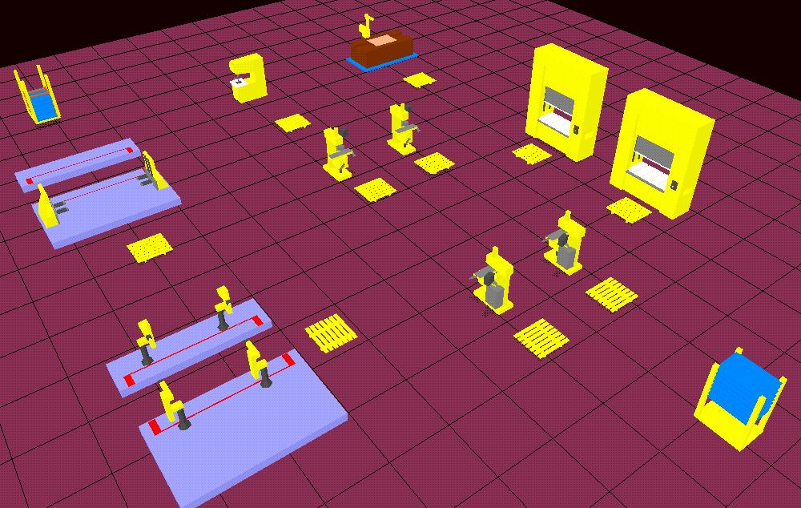

BFGoodrich

Product description

From BFGoodrich’s data, NIST generates the routing files for the part:

- Part: W1000517_1

STEP | STNFAM | PTIME | PTUNITS | PTPER | STIME | STUNITS | WHEN
20 | DBF340 | 0.75 | hr | piece | 1.84 | hr | need
30 | DBF340 | 0.066 | hr | piece | 0.1 | hr | need
35 | DGF240 | 0.001 | hr | piece | 0.25 | hr | need
40 | DBQ110 | 0.001 | hr | piece | 0.25 | hr | need
50 | DGF120 | 0.034 | hr | piece | 0.1 | hr | need
80 | DBF340 | 0.084 | hr | piece | 0.57 | hr | need
85 | DBF270 | 0.017 | hr | piece | 0.1 | hr | need
100 | DBF130 | 0.05 | hr | piece | 0.51 | hr | need
110 | DGF170 | 0.008 | hr | piece | 0.1 | hr | need
120 | DBQ110 | 0.001 | hr | piece | 0.25 | hr | need

- Part: W465285

STEP | STNFAM | PTIME | PTUNITS | PTPER | STIME | STUNITS | WHEN
10 | DBF340 | 0.016 | hr | piece | 0.92 | hr | need
20 | DGF240 | 0.002 | hr | piece | 0.1 | hr | need
50 | DGQ170 | 0.002 | hr | piece | 0.25 | hr | need

- Part: W20182_1311_0201

STEP | STNFAM | PTIME | PTUNITS | PTPER | STIME | STUNITS | WHEN
15 | DBF340 | 0.326 | hr | piece | 1.15 | hr | need
25 | DBF340 | 0.138 | hr | piece | 0.75 | hr | need
40 | DGF240 | 0.008 | hr | piece | 0.1 | hr | need
50 | DGF120 | 0.02 | hr | piece | 0.1 | hr | need
60 | DBF130 | 0.1 | hr | piece | 0.25 | hr | need
70 | DGF170 | 0.02 | hr | piece | 0.1 | hr | need
80 | DBF140 | 0.1 | hr | piece | 0.3 | hr | need
90 | DBQ110 | 0.08 | hr | piece | 0.25 | hr | need

- Part: W1520_1_300

STEP | STNFAM | PTIME | PTUNITS | PTPER | STIME | STUNITS | WHEN
20 | DBF340 | 0.15 | hr | piece | 1.09 | hr | need
30 | DBF270 | 0.03 | hr | piece | 0.1 | hr | need
40 | DBQ110 | 0.008 | hr | piece | 0.25 | hr | need

- Part: W465752_002

STEP | STNFAM | PTIME | PTUNITS | PTPER | STIME | STUNITS | WHEN
20 | DBF340 | 0.015 | hr | piece | 0.015 | hr | need
30 | DBF270 | 0.008 | hr | piece | 0.008 | hr | need
40 | DGF240 | 0.001 | hr | piece | 0.001 | hr | need
50 | DBQ110 | 0.001 | min | piece | 0.001 | hr | need
60 | DGF130 | 0.02 | hr | piece | 0.02 | hr | need

- Part: W465722

STEP | STNFAM | PTIME | PTUNITS | PTPER | STIME | STUNITS | WHEN
20 | DBF340 | 0.02 | hr | piece | 0.8 | hr | need
40 | DGF240 | 0.001 | hr | piece | 0.3 | hr | need
50 | DBQ110 | 0.001 | hr | piece | 0.25 | hr | need
60 | DGF130 | 0.02 | hr | piece | 0.1 | hr | need
70 | DBQ110 | 0.001 | hr | piece | 0.25 | min | need

- Part: W1003285_1

STEP | STNFAM | PTIME | PTUNITS | PTPER | STIME | STUNITS | WHEN
10 | DBF340 | 0.016 | hr | piece | 0.016 | hr | need
15 | DBF270 | 0.002 | hr | piece | 0.002 | hr | need
20 | DGF240 | 0.001 | hr | piece | 0.001 | hr | need
50 | DBQ110 | 0.002 | hr | piece | 0.002 | hr | need

The different machines used are:

STNFAM STN
EKF110 EKF110_1
DBF340 DBF340_1
DBF240 DBF240_1
DBF240_2
DGF120 DGF120_1
DGF130 DGF130_1
DGF170 DGF170_1
DBQ110 DBQ110_1
DBF270 DBF270_1
DBF270_2
DBF140 DBF140_1
EKF430 EKF430_1
DBF130 DBF130_1
DGQ170 DGQ170_1
DGF240 DGF240_1
DGF160 DGF160_1
DBF350 DBF350_1
DBF330 DBF330_1
BCA220 BCA220_1
BCA310 BCA310_1
DGF535 DGF535_1
DHA170 DHA170_1
DBF210 DBF210_1
DBF260 DBF260_1
EKF210 EKF210_1
DBF320 DBF320_1
EKA130 EKA130_1
DBF230 DBF230_1
DGF150 DGF150_1
DBF310 DBF310_1
DBF220 DBF220_1

Shop floor model

See Fig. 8.

Fig. 8
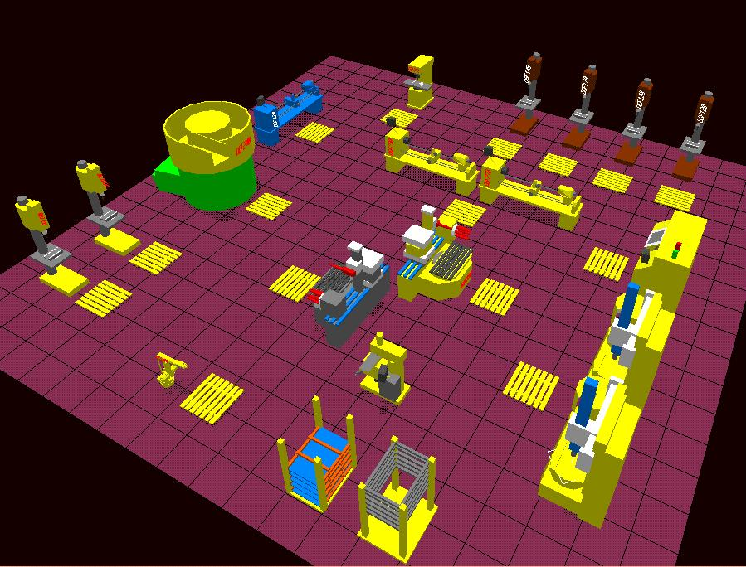

Black & Decker

Product description

Black & Decker wants to process this machine:
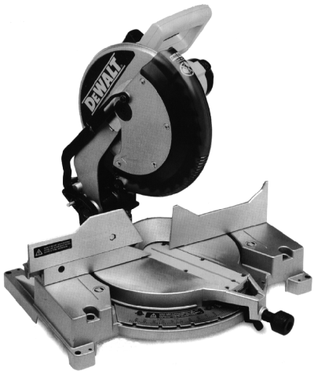

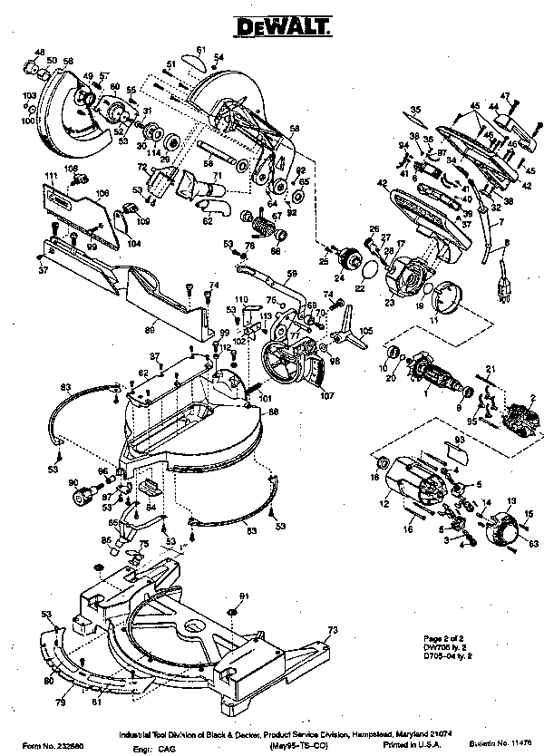

This device is composed of many sub-parts. NIST, in its model, focused mainly on the processing of four of them. From Black & Decker’s data, NIST generates the routing files:

- Part: Worm Drive Saw Gear Case

STEP | STNFAM | PTIME | PTUNITS | PTPER
Fix_A1 | StnfamF | 240 | sec | lot
Mach_A1 | StnfamA | 102 | sec | piece
Mach_C | StnfamC | 51 | sec | piece
Fix_RA1 | StnfamF | 240 | sec | lot
Debur | StnfamD | 1020 | sec | lot

- Part: Prof Circular Saw Gear Case

STEP | STNFAM | PTIME | PTUNITS | PTPER
Fix_A2 | StnfamF | 240 | sec | lot
Mach_A2 | StnfamA | 102 | sec | piece
Fix_B | StnfamF | 240 | sec | lot
Mach_B | StnfamB | 102 | sec | piece
Fix_RB | StnfamF | 240 | sec | lot
Debur | StnfamD | 1020 | sec | lot

- Part: Consumer Mirer Saw Ma Upper

STEP | STNFAM | PTIME | PTUNITS | PTPER
Fix_A3 | StnfamF | 240 | sec | lot
Fix_A3 | StnfamF | 240 | sec | lot
Mach_A3 | StnfamA | 102 | sec | piece
Fix_A4 | StnfamF | 240 | sec | lot
Mach_A4 | StnfamA | 102 | sec | piece
Fix_RA4 | StnfamF | 240 | sec | lot
Debur | StnfamD | 1020 | sec

- Part: Wildcat Grinder Field Case

STEP | STNFAM | PTIME | PTUNITS | PTPER
Fix_A5 | StnfamF | 240 | sec | lot
Mach_A5 | StnfamA | 102 | sec | piece
Fix_A5 | StnfamF | 240 | sec | lot
Debur | StnfamD | 1020 | sec | lot

The different machines used are:

STNFAM STN
StnfamF Fix_R
StnfamA A_1
A_2
A_3
A_4
StnfamB MachineB
StnfamC MachineC
StnfamD DeburR

Shop floor model

See Fig. 9.

Fig. 9

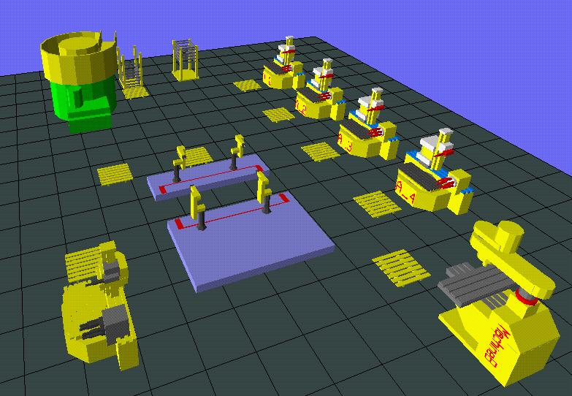

Appendix B

Application Software Review

The following is a list of tools used in this project. A description of their use is also stated.

• The EXPRESS language:
EXPRESS is an International Standard (ISO/IS 10303.11). It is a formal information modeling language created to specify the information requirements of other parts of the Standard for the Exchange of Product model data (STEP).

• QUESTTM is a simulation shop floor application produced by Deneb Robotics. QUESTTM provides an environment to create a model of a shop floor, encod processing and routing instructions for parts to be processed on the shop floor, simulate the operation of the shop floor model and performance analysis of the simulation.

• AutoschedTM, produced by AutosimulationTM, is designed to model, accurately and simply, discrete products manufacturing facilities. Model building consists of providing data for the definition of factory resources, products and production requirements. This packaging tool focuses on capacity planning and scheduling.

• FactorTM, produced by Pritsker Corporation, is a simulation-based tool. You can use it to develop and analyze production schedules. You can schedule production at your facility over any period of time and respond to crises such as machine failure with a revised schedule that, in this case, routes production to other machines.

