Space Transportation
Concept of Operations Annex
For NextGen

Draft Version 3.1

FOREWORD
The Space Transportation Annex to the Next Generation Air Transportation System (NextGen) Concept of Operations (ConOps) was prepared by representatives from the Federal Aviation Administration (FAA), National Aeronautics and Space Administration (NASA) and the Department of Defense (DoD - Air Force Space Command). This annex, which is based on the Future Interagency Range and Spaceport Technologies (FIRST) partners’ Space Vehicle Operators Concept of Operations (October 2004), is intended as a guide for the transformation of U.S. air and space transportation operations and infrastructure toward an integrated national transportation of system under NextGen.

EXECUTIVE SUMMARY

The purpose of this ConOps is to outline a common national vision for conducting spaceflight operations in the future. Spaceflight operations includes the planning, scheduling, coordination, and management of space transportation activities, including the shared use of spaceport and range support elements worldwide, to accommodate multiple simultaneous flights of different types of vehicles to, through, and from space using a variety of control centers tied together through a distributed network-centric architecture to coordinate ground and flight operations and support. The processes and activities presented in this ConOps are described from the perspective of future spaceflight operators at various types of control centers and flight crews aboard spaceflight vehicles.

Time Frames
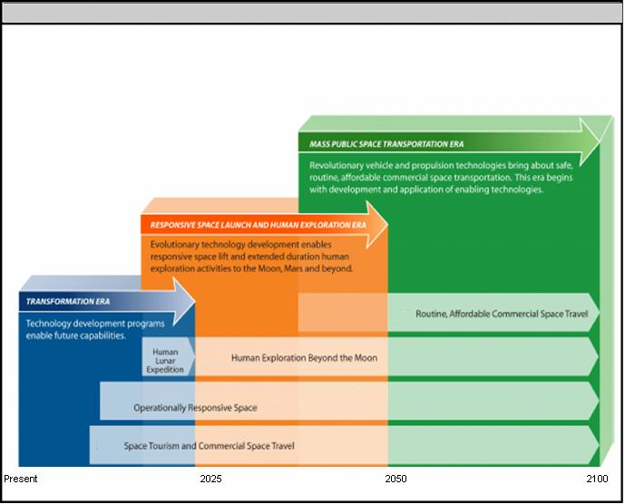
Future Space Transportation System (FSTS) Planning Eras
Planning Eras
Figure ES-1. Future Space Transportation System (FSTS) Planning Eras
The nation’s spaceflight operations capabilities will evolve through a series of incremental development steps, implemented through three eras as depicted in Figure ES-1. The first era is called the transformation era. Transformation refers to fundamental change involving advanced technologies to enable new concepts of operation that are implemented and institutionalized through collaborative organizational change. New types of spaceflight operations characterize the second, or Responsive Space Launch and Human Exploration Era. This era is poised to begin in the next decade. The third era, mass public space transportation, is envisioned to begin when the economics and technology of space travel align with the demands of a mass market characterized by safe, routine, affordable commercial space travel.
This ConOps is based on several key assumptions, including:
- A variety of new space transportation vehicles and programs will be deployed and operated concurrently in the coming decades.
- Retirement of NASA’s Space Transportation System (Space Shuttle) in 2010.
- Traditional functions provided by today’s ranges, spaceports and operations organizations will merge into a comprehensive, integrated Future Space Transportation System (FSTS).
- In the Mass Public Space Transportation Era, launch vehicle reliability will approach that of airline reliability.
Conceptual Architecture
The Spaceflight Operations architecture consists of a network-centric capability to coordinate and control space transportation assets and activities around the world using a variety of control centers and user facilities connected through a distributed network-centric architecture.
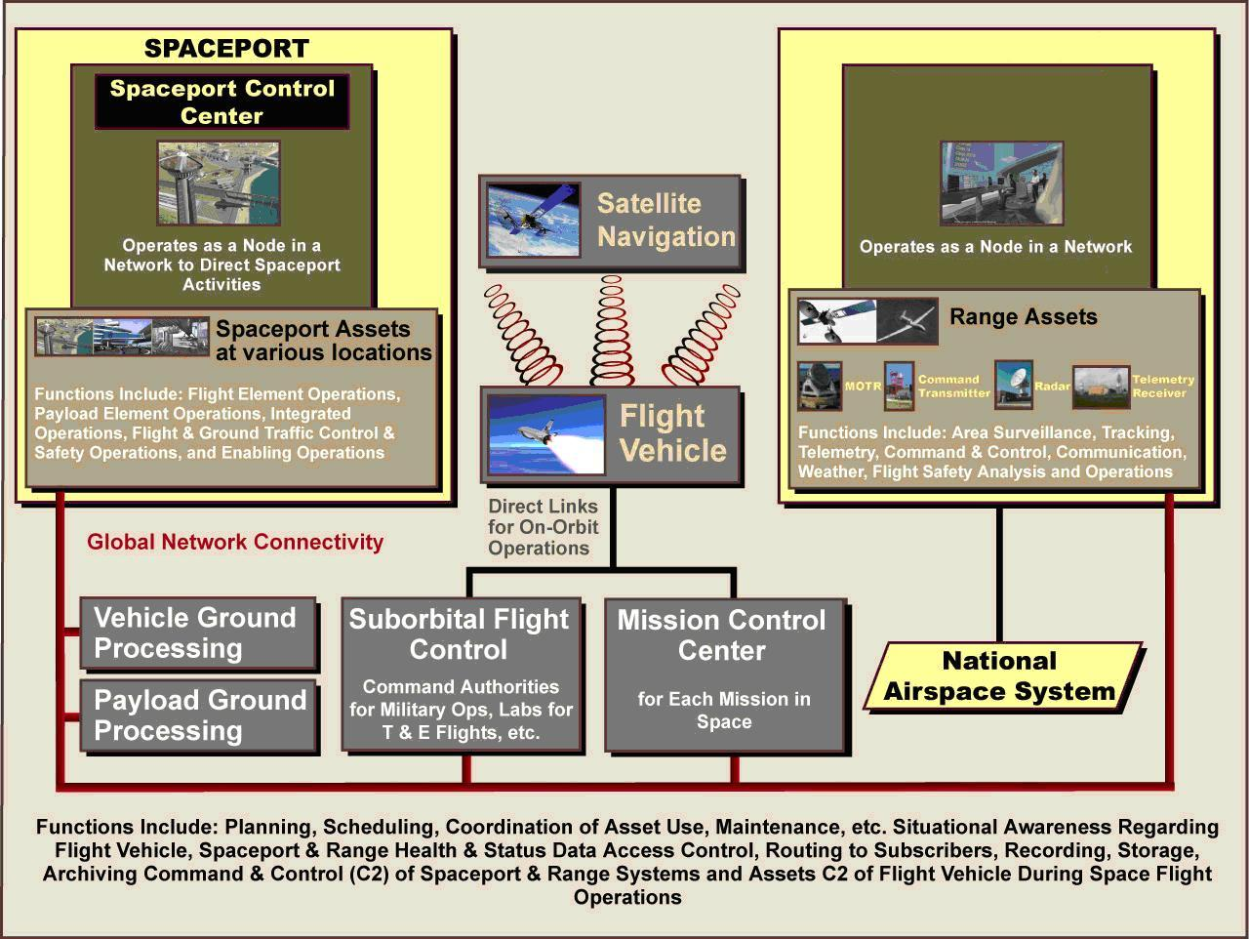
Space Traffic
Management
Distributed Network

Figure ES-2. Conceptual Architecture to Support Spaceflight Operations

As shown in Figure ES-2, the future spaceflight operations architecture must accommodate a variety of spaceflight operations and activities. The primary elements of the future spaceflight operations conceptual architecture are:
- Spaceports at various locations around the world, operating as nodes in a global network.
- Global space launch and test range assets, including shared-use satellites and airborne platforms, and ground-based assets at various locations.
- A distributed network-centric architecture—an integrated network to coordinate support for spaceflight operations, as described below.
- A hierarchy of control centers and associated controllers to manage the various operational aspects of spaceflights.
- User facilities, including those that are operated by a flight vehicle owner, a payload owner, command authorities for military operations, laboratories and program offices.
- Automated planning, scheduling, coordination systems supported by automated decision support tools to provide course of action options and recommendations.
- A variety of sensor systems, and self-diagnosing, self-reconfiguring, and self-healing systems to provide situational awareness information through the global network.

Distributed Network-Centric Architecture
The distributed network-centric architecture refers to an integrated system of systems used to coordinate and control space transportation assets and activities around the world during flight phases associated with transportation—launch, takeoff, reentry, and landing. Realization of the vision for future spaceflight operations relies on this distributed network-centric architecture that will be integrated into the overall NextGen architecture and a hierarchy of operations management and control centers.

The Distributed Network-Centric Architecture provides for a central data repository in support of spaceflight operations.
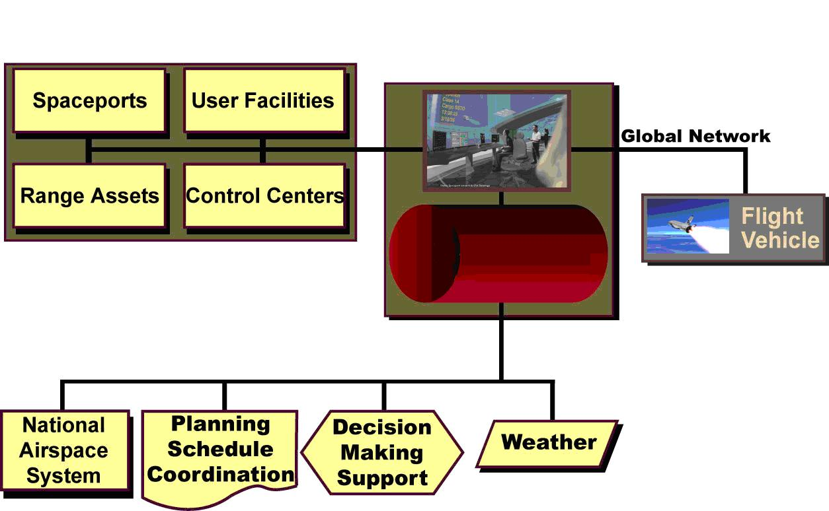
Central Data
Repository
Distributed Network-Centric
Architecture

Figure ES-3. Specific Roles in the Distributed Network-Centric Architecture
The distributed network-centric architecture is used to direct and coordinate range and spaceport operations and provides access to situational awareness information. Figure ES-3 provides an illustration of how the architecture will support space transportation operations, and the technical capabilities that enable them, which include:
- A central repository for information pertaining to the health and status of flight vehicle, spaceport and range systems.
- Situational awareness information with regard to ground and flight vehicle traffic of interest, areas that must be cleared for safety and security reasons, and current and forecasted weather conditions.

Hierarchy of Control Centers and Controllers
The FSTS architecture relies on a hierarchy of control centers to conduct safe, reliable, and routine spaceflight operations.
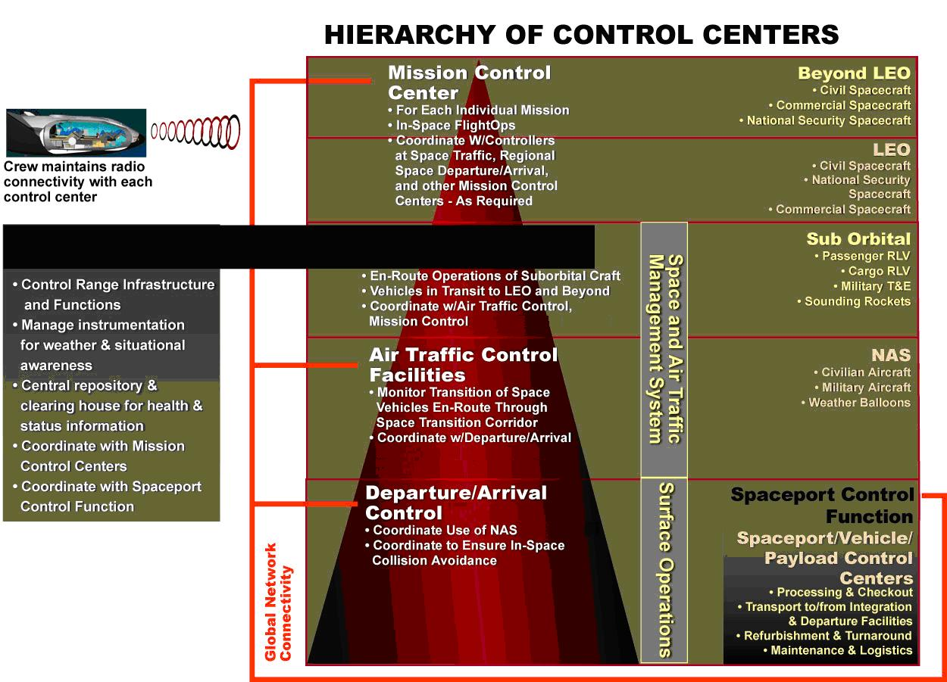
Net-Centric Functions Space Traffic Management
Figure ES-4. Hierarchy of Control Center Functions
As depicted in Figure ES-4, various types of control centers will manage spaceflight vehicle operations (including payloads, cargo, and passengers). These include:
- Vehicle and Payload Processing Control Centers that control the pre- and post-flight processing and checkout of flight vehicles and payloads, along with ground movement.
- Spaceports that coordinate range support, use of NextGen assets, and information on collision avoidance with objects in space.
- Air traffic control facilities (ATC facilities) coordinate and manage use of the NextGen.
- Space traffic management centers for monitoring, coordinating and scheduling flights to and from space.
- Mission control centers (MCC) for operations in orbit that rely on dedicated links for voice, video, and data for national security, civil, and commercial satellites, deep space probes, and crewed missions to the International Space Station, to the Moon, and beyond.

Regions of Jurisdiction
To implement the concept of a hierarchy of control centers, all spaceflight operations are managed by control centers with jurisdiction over specific regions as illustrated in Figure ES-5.
Each type of control center has its own region of authority.
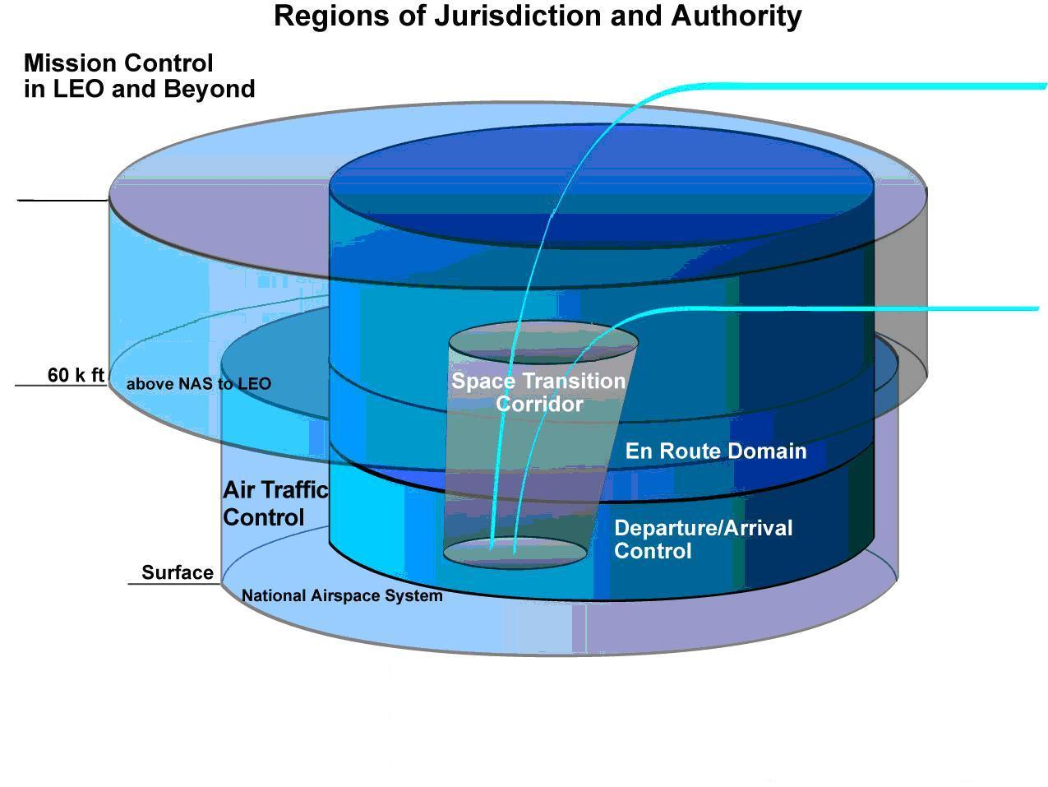
100 mi
Space Traffic
Management

Figure ES-5. Regional Authority for Each Type of Control Center
Future Spaceflight Operations
Spaceflight operations are typically conducted in six sequential phases.
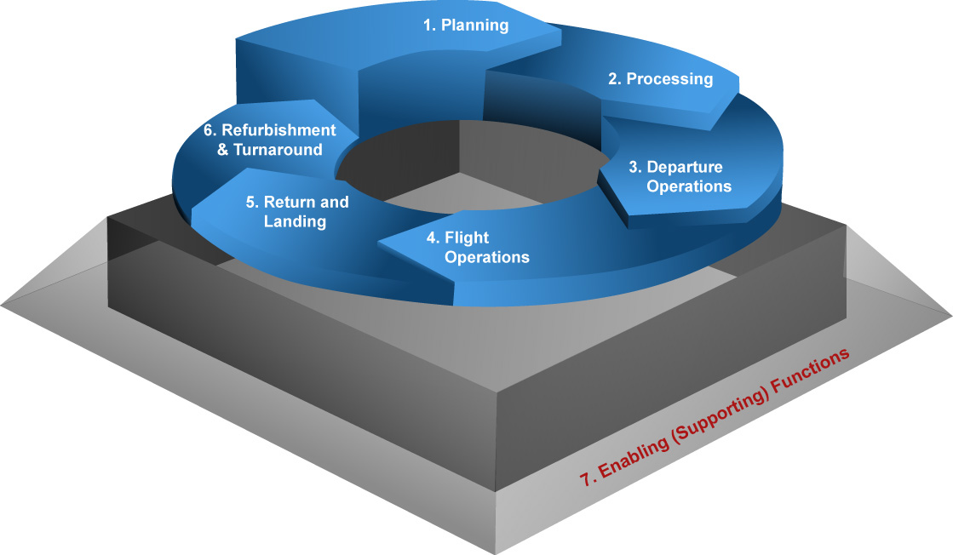
Figure ES-6. Six Phases of Spaceflight Operations.
Several spaceflight operations functions are performed in each phase, as shown in Figure ES-7.

Phase | Spaceflight Operations Functions
Planning | - Flight Planning and Scheduling  - Training and Certification
Processing | - Flight Readiness Verification  - Transportation Between Facilities
Departure Operation | - Countdown and Final Launch Commit  - Launch/Takeoff and Initial Flight
Flight Operations | - In-flight activities  - Monitoring in “Notification” Mode
Return and Landing | - Reentry  - Return Flight  - Landing/Recovery
Refurbishment and Turnaround | - Post-Flight Processing  - Data Archival, Analysis and Reporting
Figure ES-7. Spaceflight Operation Functions in Each Phase

The following paragraphs describe how each of the spaceflight operations functions will be carried out in the Responsive Space Launch and Human Exploration Era.
Planning & Scheduling: Automated decision support systems analyze weather data with vehicle performance and characteristics to determine the operational limits on each planned spaceflight operation. Assignments for use of airspace are derived from automated simulations of the flight profile and its effects on air traffic. The centralized planning and scheduling system uses software tools to standardize recurring schedule items, expert systems for workload planning, and models to project the availability of spaceport and range assets and other support resources.
Training and Certification: Generic training includes requirements that remain consistent over time regardless of the purpose of a particular mission, flight, vehicle or facility. Flight-specific training includes training requirements that are unique to a given mission, flight, vehicle or payload. As the space transportation architecture becomes more standardized and interoperable over time, there will be fewer vehicle-centric training requirements, and most training and certification requirements will fall into either the generic category or mission specific. Automated processes, self-diagnosing/self-healing systems and decision support systems will reduce the amount of training needed by operations personnel.
Flight Readiness Verification: Intelligent computing systems assess readiness in real-time based on information from all elements of the spaceflight operations system to enable responsive space launches. Advanced computing techniques and intelligent system support responsive operations.
Transportation Between Facilities: Operators at Vehicle and Payload Control Centers maintain communication with spaceport facilities, support equipment, and the flight vehicles, payloads, cargo, crew, and passengers to maintain situational awareness and direct control of all ground processing activities associated with the elements they’re responsible for. The distributed network-centric architecture is used to allocate spaceport and range assets to provide support for the ground processing activities being directed by the Vehicle and Payload Control Centers.
Countdown and Final Launch Commit: Operators at the spaceport monitor the status reports from automated health monitoring systems and, like airport control tower operators today, monitor departures and arrivals in the terminal area of the spaceport. They also monitor integrated situational awareness displays to ensure weather is acceptable for launch or takeoff.
Launch/Takeoff and Initial Flight: Operators at the spaceport monitor launch/takeoff and ascent to ensure vehicles are flying in accordance with approved flight profiles. Air traffic control facilities and space traffic managers provide routing instructions as required to clear the airspace and ensure separation from other aircraft and traffic and/or debris in space as vehicles transit their regions of jurisdiction. Space vehicle operations within the NAS and NextGen are managed using space transition corridors.
In-flight Activities: Air traffic control facilities and space traffic managers that monitor and issue routing instructions to suborbital hypersonic point-to-point flights as they fly en route between spaceports to ensure safety and separation from other traffic and potential hazards including weather systems and orbiting debris.
Space Operations: For spaceflight operations in LEO or beyond, the mission control center maintains contact with the flight vehicle (and crew, if applicable) during the duration of the mission. The mission control center maintains operational control of the vehicle during orbital (LEO, transition and GEO) operations.
Monitoring in “Notification” Mode: For spaceflight operations in LEO or beyond, the mission control center maintains continuous contact with the flight vehicle (and crew, if applicable) and with the global network that’s managed by the distributed network-centric architecture. All other control centers passively monitor the network in “notification” mode in case the mission control center issues a message requesting support for an unscheduled return, reentry and/or landing/recovery.
Reentry: The mission control center (and the flight crew, if applicable) maintains direct contact with control centers that have authority and jurisdiction over the regions being traversed along the flight path. Space traffic managers monitor and ensure safety and separation during de-orbit and reentry maneuvers. For vehicles returning to Earth, the applicable air traffic control facilities work with the mission control centers and space traffic managers to plan and coordinate the clearing of airspace along the return trajectory.
Return Flight: Once the vehicle enters the National Airspace System, the responsible space traffic managers hand-off responsibility to the applicable spaceport where the vehicle will land. The spaceport coordinates with the applicable air traffic control facilities to ensure safety and separation during the descending flight through the atmosphere.
Landing/Recovery: The spaceport maintains responsibility for issuing routing instructions to the flight crew (when applicable) and/or to the mission control center responsible for the flight, throughout return flight and landing/recovery at the spaceport.
Data Archival, Analysis and Reporting: After the completion of a spaceflight operation, automated expert systems generate post-flight anomaly reports and schedule maintenance and repair activities. The central archival database makes data available at user request as needed to complete post flight analysis and reports.
Spaceflight Operations in the Third Era, to Support Mass Public Space Travel
Spaceflight operations in the third era are conducted so frequently and routinely that some of the steps in the lifecycle described above are combined and compressed.
Planning and Scheduling: Flight routes between major destinations are well-defined and established for frequent and routine flights. The distributed network-centric architecture is used to manage the functions of dozens of spaceports and hundreds of flights each day, supported by the same types of control centers that operated during the first two eras.
Processing, Refurbishment, and Turnaround: Accommodating such a busy flight schedule drives the need for processing, refurbishment, and turnaround of reusable spaceflight vehicles (and their support systems) between flights in ways that resemble airline processing operations at airports today. Integrated health monitoring systems enable as-needed maintenance actions to be detected and conducted quickly on an exception basis. Most processing and turnaround operations between flights are conducted in parallel using adjustable ground support equipment to accommodate different vehicle configurations.
Spaceport Departure and Arrival, Return and Landing Operations: The spaceport operates much like the Terminal Control Center at airports today, controlling departure, arrival, return, and landing operations. As the flight vehicle leaves its area of responsibility, the spaceport hands-off responsibility for routing routine suborbital flights to the space traffic management authority. For longer flights, it in turn, hands-off responsibility to the next space traffic manager along the intended flight path, and so on, until arriving at the spaceport where the vehicle is scheduled to land takes responsibility.
Flight Operations: As vehicles depart the spaceport, space-based and ground-based systems in the third era have the capacity to support increased space transportation traffic. Increasingly sophisticated automated decision support systems allow control center operators and flight crews to concentrate on only those critical decisions and flight-unique operations that actually require human intervention. The use of intelligent expert systems and sensors to improve situational awareness increases safety and reliability and decreases operator workload. Consequently, operators in control centers are able to support more flights simultaneously.

Enabling Capabilities
This enabling technology roadmap presents a time-phased approach to addressing the technical challenges associated with achieving the necessary capabilities for the envisioned future spaceflight operations described in this ConOps.
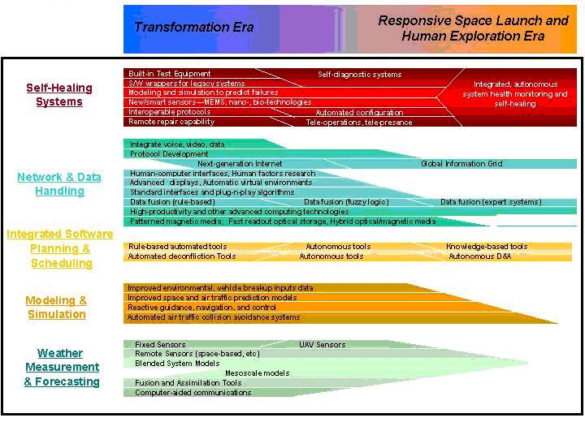
Figure ES-8. Enabling Technology Roadmap

A variety of enabling capabilities will be necessary to enable future spaceflight operations as described in this ConOps. This ConOps describes new ways of operating with technologies or capabilities that are likely to exist in the future. It describes a variety of technology areas and standardization approaches that address the technical challenges that stand in the way of achieving the necessary capabilities to enable future spaceflight operations as envisioned.
The enabling technology roadmap depicted in Figure ES-8 presents the recommended time-phased approach to pursuing these technology development and demonstration activities over time. The five technology areas addressed in this section are: Self-Healing Systems, Network and Data-Handling, Integrated Software Planning and Scheduling, Modeling and Simulation, and Weather Measurement and Forecasting.
In addition, standardization is another enabling element. The body of the ConOps describes many opportunities and recommendations regarding development and demonstration activities that should be pursued to address each of these areas and enable the future capabilities envisioned in this ConOps.
Conclusion
Pursuing opportunities for technology development and demonstration activities will enable the development of the future capabilities described in this ConOps. Only by developing these capabilities will future spaceflight operations be able to satisfy the future demands for space transportation from the civil, commercial, and national security space sectors. Section 8 presents some general capabilities that NextGen will need to provide to support space operations described in this ConOps.

1.0 PURPOSE
The purpose of this ConOps is to outline a common national vision for conducting spaceflight operations in the future. Spaceflight operations includes the planning, scheduling, coordination, and management of space transportation activities, including the shared use of spaceport and range support elements worldwide, to accommodate multiple simultaneous flights of different types of vehicles to, through, and from space using a variety of control centers tied together via the distributed network-centric architecture to coordinate ground and flight operations and support. Space transportation architectures have been designed from a vehicle-centric perspective. The strategy applied in this ConOps looks at space transportation from a broader “systems approach” vision that aims toward developing an integrated Future Space Transportation System (FSTS).
The vision described offers an integrated, interoperable approach for conducting future civil, national security and commercial space transportation operations in ways that resemble management of the commercial air transportation system. This approach envisions a spaceflight operations model that is independent of vehicle architecture, making it more economical and streamlined than today’s approach to spaceflight operations. Consequently, this approach will enable the FSTS to accommodate more frequent flights with shorter lead times, manage multiple flights and activities simultaneously, be less manpower-intensive, and integrate seamlessly within NextGen.
This Space Transportation Annex to the NextGen ConOps describes future space transportation activities from the perspective of spaceflight operators, and a future network-centric control center conceptual architecture and operating model that will support future spaceflight operations. It also discusses some technology areas that would enable and enhance the nation’s ability to more effectively support current emerging, and projected future national security, civil, and commercial spaceflight operations to, through, and from space.

2.0 TIME FRAMES
The nation’s spaceflight operations capabilities will evolve from their current state (relying almost exclusively on vehicle-specific, fixed-location, ground-based assets), through a series of incremental spiral development steps. These steps will be implemented through three eras as depicted in Figure 1.
The first era is called the transformation era. This era represents a period in which new enabling technologies are developed and implemented through collaborative organizational change.

Future Space Transportation System (FSTS) Planning Eras
Future Space Transportation System (FSTS) Planning Eras
Planning Eras
Figure 1. Future Space Transportation System (FSTS) Program Eras

The second era is referred to as the Responsive Space Launch and Human Exploration Era. This era is poised to begin soon, with activities that overlap with activities that were begun in the Transformational Era. Within this overlap period, future spaceflight operations will be enabled by the Operationally Responsive Space (ORS) and the Orion Crew Exploration Vehicle (CEV) development efforts that began in the Transformation Era. These capabilities enable prompt global strike in support of military objectives as well as human space exploration of the moon, Mars, and beyond.
The third era, the Mass Public Space Transportation Era, is envisioned to dominate the latter half of this century. It is distinguished by routine commercial space travel that is both affordable and safe. In this era, space transportation will be an integral part of the global mass public transportation system moving people and cargo daily anywhere in the world.

3.0 ASSUMPTIONS
This ConOps is based on several key assumptions:
A variety of new space transportation vehicles and programs will be deployed and operated concurrently in the coming decades.
- Programs now underway in the civil, national security, and commercial space sectors will lead to new space transportation vehicles and activities. These include; NASA’s Constellation program to the International Space Station and the moon, the continuation of exploration to Mars and beyond. Operationally responsive space (ORS) activities for national security. Commercial sub-orbital reusable launch vehicle (RLV) flights to carry passengers to, through, and from space. Collectively these new types of vehicles and operations will drive the need for a FSTS made up of spaceport and range capabilities and various control centers linked together by the distributed network-centric architecture. To support these future vehicles, the FSTS must be more responsive than today’s spaceport and range capabilities. It must also be capable of providing global connectivity using standardized and interoperable systems to support multiple concurrent operations involving different types of vehicles at a variety of locations while cost-effectively accommodating fluctuations in projected workload.
The trend in U.S. spaceflight operations will be toward “airport-like” operations at federal and non-federal spaceports, and spaceflight operations in the third era occur nearly daily and resemble commercial airliner operations.
- As space travel and access to space become more routine (with new vehicles, increased traffic, and concurrent operations), traffic and capacity will increase. This will push the operating model toward standardization for pre-flight preparation, departure and return. Pre-approved flight paths and regulation of space travel will become mandatory to ensure orderly, safe transportation to, through, and from space while ensuring safety of life and property. In the third era, spaceflight operations are expected to include frequent point-to-point flights to transport people, payloads, and cargo. Spaceflight operations are envisioned to be an integral part of the world’s transportation capability.
Traditional functions provided by today’s ranges, spaceports and operations organizations will merge into a comprehensive, integrated FSTS.
- Traditional definitions, and the strict delineation of functions that are today assigned to ranges, spaceports or spaceflight operations, will blend together more seamlessly as future developments lead toward a global space transportation capability. While each of the traditional functions will still be performed, future vehicles and activities are expected to require global coverage in support of point-to-point operations to and from a variety of locations around the world. This will drive the evolution of traditional functions toward a more integrated set of capabilities.
In the Mass Public Space Transportation Era, launch vehicle reliability will approach that of airline reliability.
- Future sub-orbital and orbital reusable launch vehicles (RLVs) will be so reliable as to be able to fly over populated areas without elevating risks to public safety above the currently acceptable levels associated with commercial air traffic today.
Spaceflight operators participate in or perform operations functions during the lifecycle associated with the spaceflight operations.
- Personnel specifically dedicated to performing functions or tasks in support of a particular spaceflight operation include flight crew, planners and schedulers, flight controllers, trainers, vehicle and payload processing and range operations controllers. Personnel who operate shared supporting range, spaceport and operations support functions (e.g., maintenance, modernization, infrastructure support functions, etc) not needed to support a specific flight are not considered spaceflight operators.
Spaceflight operations includes the phases of a mission that relate to preparing for and conducting transportation to, through, and from space near the vicinity of Earth.
- Spaceflight operations include all tasks performed in the course of preparing a vehicle, payload, cargo, crew, and passengers to conduct a spaceflight mission. It also includes establishing requirements for the flight, scheduling assets to meet them, ensuring all FSTS elements are ready to support, and supporting actual spaceflight operations including final commit to launch, countdown, launch/departure, reentry, landing or recovery, and post-flight activities.
- In some cases, the “mission” is to provide transportation, so in these cases the “mission” is completely encompassed by the term “spaceflight operations.” (This is analogous to civil aviation and commercial airline operations today where the “mission” is transportation.) Examples in this category where “spaceflight operations” address the entire “mission” include:
  - Flights of commercial reusable launch vehicles to deliver passengers and/or cargo from point to point
  - Operationally responsive space (ORS) missions conducted by the national security space sector to deliver sensor platforms and/or munitions to target areas on short notice
  - Flight test and evaluation (T&E) missions
- In other cases, the “mission” itself includes more than the “spaceflight operations” (or near-Earth space transportation operations conducted over a period of hours) addressed in this ConOps. For example:
  - Satellite processing and expendable launch vehicle operations are included in “spaceflight operations,” along with the launch itself. However, the actual “mission” is to operate the satellite for a period of days to years once it reaches its intended orbit. This ConOps does not address the mission of the satellite while it is operating in Earth orbit.
  - NASA missions to conduct repairs or experiments in low Earth orbit, to conduct operations associated with the International Space Station, and Constellation flights to explore the moon or Mars (with or without a crew) include “spaceflight operations” to get to and return from LEO, and those activities are addressed in this ConOps. However, the “mission” itself is conducted in or beyond low Earth orbit over a period of days to years so it is not addressed by this ConOps.
Shared use of common infrastructure makes standardization an important consideration.
- The expectation is that launch vehicle “users” of spaceflight operations in the third era will share use of Common FSTS facilities and infrastructure for support, such as facilities, instrumentation, command, control, and communication systems, etc, among other things. The current reliance on dedicated systems and infrastructure will be phased out as legacy launch vehicles reach their end of life and give way to a more common approach.

4.0 DESCRIPTION OF ARCHITECTURE
The future spaceflight operations architecture must accommodate the same types of test and operational activities that are supported today, plus a variety of additional spaceflight operations and activities as illustrated in Figure 2.
Accommodating the variety of projected future activities will drive needs for new approaches to spaceflight operations.

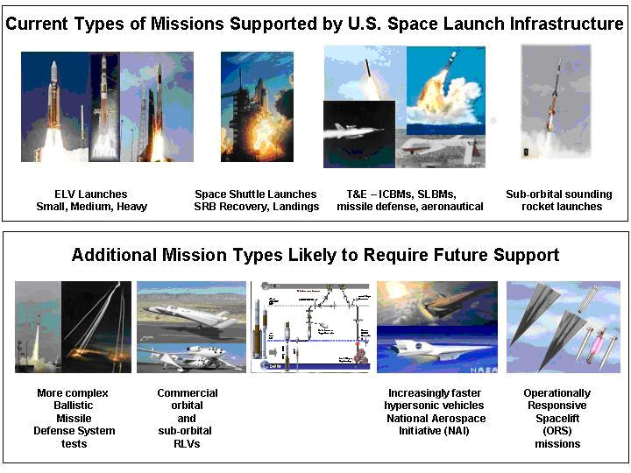
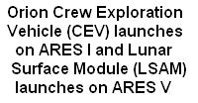
Figure 2. Current and Future Spaceflight Operations
Future Operationally Responsive Space (ORS) missions for national security, crew rescue missions, and emerging Suborbital Reusable Launch Vehicles (RLVs) for space tourism will all drive the need for more responsive spaceport, range, and operations support. New spaceports in non-traditional locations, hypersonic flight testing, and more operationally realistic ballistic missile defense testing will drive needs for hemisphere-scale coverage to provide tracking and communications. Operationally Responsive Space (ORS) missions will require global coverage to enable re-targeting or mission aborts. New missions (especially for test and evaluation) will transmit telemetry data at higher rates at the same time as other users of the frequency spectrum are also continuing to expand their interests and demands for bandwidth, driving needs for improved use of frequency spectrum. To support new types of spaceflight operations and associated activities, future systems must take advantage of an open architecture, interoperability, and standards (existing as well as future) to enable the transition of new systems, technologies, and capabilities into operational use. Standardization and interoperability will be essential to efficiently accommodate the routine operations being conducted by diverse users of the future space transportation system with shared-use infrastructure. Approaches to ensuring public safety will also have to be enhanced to accommodate routine operations of diverse flight vehicles flying over population centers on their way to and from a variety of new and traditional spaceport locations. Flexibility and adaptability in the design and operation of the future space transportation system will enable it to efficiently accommodate fluctuations in workload, new and diverse activities, and unanticipated future capabilities. Supporting routine operations at high flight rates will require the FSTS to have the capacity to support concurrent operations, just as today’s airports routinely support multiple simultaneous flights and numerous ground operations.

The Spaceflight Operations architecture consists of a network-centric capability to coordinate and control space transportation assets and activities around the world using a variety of control centers and user facilities connected through a distributed network-centric architecture.
Space Traffic
Management
Distributed Network
Figure 3. Conceptual Architecture to Support Spaceflight Operations

As shown in Figure 3, the primary elements of the spaceflight operations conceptual architecture are:
- Spaceports at various locations around the world, operating as nodes in a global network.
- Global space launch and test range assets, including shared-use satellites and airborne platforms, plus ground-based assets at various locations.
- The distributed network-centric architecture —an integrated network to coordinate support for spaceflight operations by providing information on a global basis, and to control range assets around the world in support of space traffic planning and operations management.
- A hierarchy of control centers and associated controllers to manage the various operational aspects of spaceflights and interface with each other to maintain seamless and safe flight operations throughout all phases and altitudes of the flight, from operations within the National Airspace System to operations beyond low Earth orbit.
- User facilities, including those that are operated by a flight vehicle owner, a payload owner, command authorities for military operations (like operationally responsive spaceflights), laboratories and program offices that are conducting test and evaluation, and others as required to support particular spaceflight operations. In some cases, User Facilities also support on-orbit operations using a direct interface through a mission control center for particular spaceflight operations.
- Automated planning, scheduling, coordination systems supported by automated decision support tools to provide course of action options and recommendations based on modeling, simulation and analysis of potential implications.
- A variety of sensor systems, and self-diagnosing, self-reconfiguring, and self-healing vehicle and support systems to provide situational awareness information through the global network.
- Improved telemetry, command, control, monitoring, and communication systems to provide:
  - Continuous data access control, routing, recording and archiving from spaceport and range assets and flight vehicles.
  - Standard communication protocols to allow command, control, communications and interoperability (C³I) of spaceport/range assets worldwide from a variety of COTS/GOTS providers.
  - Routing of command and control data from control centers to flight vehicles during spaceflight operations
An essential part of the vision for future spaceflight operations described in this ConOps relies on the distributed network-centric architecture and the hierarchy of control centers. These elements play integral parts in the ways spaceflight operations functions are conducted. The following sections discuss these, and the other elements of the conceptual architecture, in detail.

4.1 Conceptual Architecture
4.1.1 Planning, Scheduling, and Coordination
Future spaceflight operations rely primarily on a centralized, network-based automated planning, scheduling, and coordination system that are accessible through the distributed network-centric architecture to integrate and coordinate the schedules for use of all spaceports, ranges, and control centers to ensure one planned activity will not impact another.
As illustrated in Figure 4, the conceptual architecture for the planning, scheduling, and coordination function consists of an integrated suite of automated, network-based processes and capabilities to enable all users of range support to interactively access the centrally-managed, automated schedule to understand and stay abreast of schedule constraints and availability. This conceptual architecture also allows users and operators to enter information through secure network connections regarding their planned activities involving spaceflight operations and off-line maintenance, modifications, and upgrades of spaceport and range assets.
Planning, scheduling, and coordination systems rely on automated decision support tools.
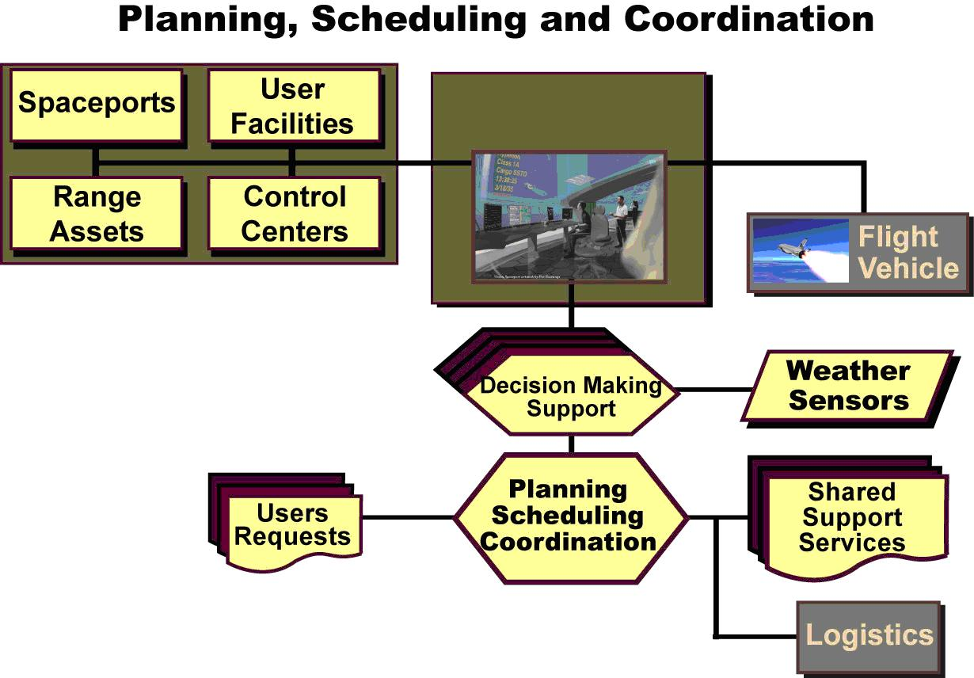
Distributed Network
Figure 4. Conceptual Architecture for Planning, Scheduling, and Coordination
The automated planning and scheduling system consists of advanced software programs that accept user and operator inputs using standard Internet protocols through the global network. The automated scheduling system processes these inputs by taking into account real-time constraints and historical trend data through the global network to calculate plans and schedules for use of spaceport and range assets. This system relies on high-speed computing capabilities based on increasingly fast commercial processors, embedded coding, and serializer/deserializer (SerDes) chips and associated standard communication protocols.
This automated system generates schedules for spaceport and range assets to support of spaceflight operations and for off-line maintenance, modifications, and upgrades. The scheduling software automatically coordinates operations, maintenance, modifications and upgrades with the automated logistics system and shared support services. This automated scheduling capability is enabled by commercial schedule de-confliction engines, data fusion and information extraction/mining techniques being developed by the U.S. military for processing intelligence data, and learning databases with applications in lossless data compression techniques.
The end result is that the software automatically produces and regularly updates an integrated (and de-conflicted) schedule for the use of all spaceport and range assets as its output on the global network. It also notifies and keeps users, operators and maintainers informed through the global network regarding any changes to plans and schedules that involve them.
The automated planning, scheduling, and coordination system is supported by automated decision support tools to provide course of action options and recommendations based on experience (lessons learned), modeling, simulation and analysis of potential implications. The scheduling function uses these automated decision support tools to automatically assess plans and schedules for range asset capacity and availability based on all user and operator requests, as well as maintenance and repair schedules and other constraints. These decision support tools rely on more complete input data based on empirical information regarding flight vehicle performance, potential toxic and debris hazards, environmental sensitivities, population density and location, traffic patterns, and weather conditions. They also rely on advanced modeling and simulation programs based on expert systems and artificial intelligence, including three-dimensional dispersion models and propellant combustion models, for example.
The automated scheduling system also enables users and operators to coordinate flight profiles with proper authorities to ensure that each spaceflight operation will be conducted safely without impacting other scheduled air and space traffic. This capability is enabled by ensuring all control centers have continuous and secure access to the high-capacity global communication network.
4.1.2 Situational Awareness
As shown in Figure 5, a variety of weather sensors, area surveillance systems, and integrated health monitoring systems aboard vehicle and embedded in spaceport/range systems provide information through the global network where it is fused and distributed as integrated situational awareness information through the distributed network-centric architecture. Weather measurement and forecast information is provided by a central hub facility based on integrated inputs from a variety of site-specific regional and national weather sensors and models. Weather measurement and forecasting capabilities rely to a large extent on cooperative arrangements with external providers for sensors, instrumentation, systems, data, formats, and models. The centralized hub function analyzes and provides display data from weather radars, satellite imagery, and a variety of sensors to provide forecasts and hazardous weather watches, advisories, and warnings for ground processing, launch, flight, landing, and recovery operations.

The Distributed Network-Centric Architecture provides situational awareness information by integrating weather, air traffic and system health and status inputs.
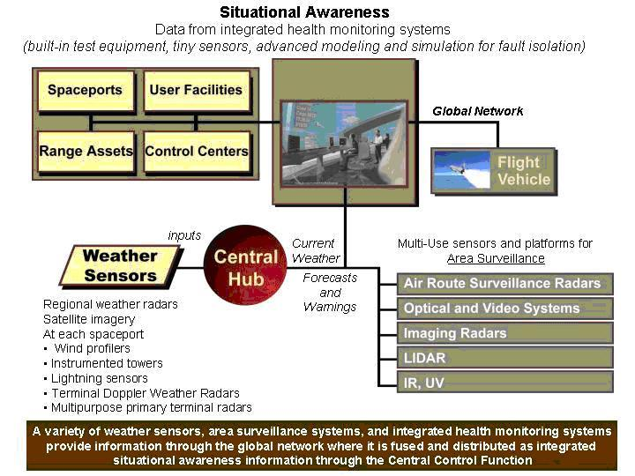
A variety of national and international weather assets including weather sensors, surveillance systems, and integrated health monitoring systems provide information through a global network.
Distributed Network
Figure 5. Conceptual Architecture for Situational Awareness
Systems in the vicinity of each primary takeoff/launch/landing/recovery site (i.e., spaceport) to collect weather data include ground-based and mobile airborne wind profilers; instrumented towers with sensors from 6 to 500 feet above ground level to gather enough wind, temperature, humidity and pressure data to provide inputs for mesoscale weather models; sensors to detect, measure, and predict the potential for lightning, including surface and airborne electric field mills, airborne optical pulse sensors, peak-gated, wideband magnetic direction finders (MDF), and VHF receiver sites to detect radiation from inter-cloud and intra-cloud lightning. Re-tuned Terminal Doppler Weather Radars (TDWR) and multipurpose primary terminal radars at each active spaceport also provides weather data.
Area surveillance data for safety, security, and mission assurance in any potentially hazardous land, sea, or airspace areas, and along the entire intended flight path, is provided by a variety of multi-use sensors and platforms. Examples include ground-based air route surveillance radars, as well as various systems that can be ground-based or mounted aboard UAVs or high-altitude airships (HAAs). Examples include optical and video systems, imaging radars, LIDAR to detect objects through smoke and clouds, and detection/imaging systems that operate at other wavelengths (e.g., IR, UV). Data from these various systems and sources is fused to provide real-time situational awareness with regard to air traffic in areas of interest.
Spaceport and range systems, as well as flight vehicles, include integrated health monitoring systems to continuously generate and report status and needs for maintenance and repair through their connections to the global network. These capabilities are enabled by built-in test equipment to perform fault detection and isolation as inputs for self-diagnostic systems. Micro-electromechanical sensors, enabled by nanotechnology, make these systems practical. Advanced modeling and simulation capabilities (based on expert systems, learning databases, and artificial intelligence) better predict component and system failures as means of enhancing the self-diagnostic capabilities.
4.1.3 Data Access Control, Routing, Recording and Archiving
Another element of the conceptual architecture for future spaceflight operations is the global network. This global network routes all the data that flows to and from spaceport and range assets in real time, controls access to restricted data, routes data (as requested) to valid network subscribers, and records, stores, and archives data for later retrieval. The design of this global network addresses information assurance (IA) by ensuring its systems and networks provide:
- Availability: assured and timely access to data and information services for authorized users.
- Data Integrity: protection of data to ensure it has not been destroyed, changed, modified, or altered from its original state as a result of any unauthorized, accidental, or malicious action.
- Authentication: security measures designed to establish the validity of a transmission, message, or originator, or as a means of verifying an individual's authorization to receive specific categories of information.
- Confidentiality: assurance that information is not disclosed to unauthorized persons, processes, or devices.
- Non-repudiation: undeniable assurance that the sender of data is provided with proof of delivery and the recipient is provided with proof of the sender's identity, so neither can later deny having received or processed the data.
The network addresses these IA principles by using improved encryption and defense-in-depth strategies, enhanced firewalls and password protection, screening software and intelligent agents, and technologies for detecting and tracing attempts at system intrusions (e.g., biometrics).
The FSTS relies on interconnected information systems, which results in sharing of security risks among all interconnected elements. Consequently, coordination of IA efforts across all systems, operators, and users is important to maintain adequate security.
Communications to support future spaceflight operations relies primarily on ground-based networks for data transfer among ground-based locations, with some long-distance data relay provided using space-based assets. The range communication system of the future can relay data at rates up to 40 Gbps through space-based and mobile assets, while ground-based networks are handling data at rates in the tera- (i.e., trillion, or 10¹²) bits per second. The most economical approach for this future architecture is to share use of communication relay satellites with other users to offset the costs associated with development, acquisition, deployment, and operation.
In addition, local area networks within spaceport facilities include wire, cable, umbilical, fiber optic, and wireless (e.g., IR, ultra-wideband, etc) connections to provide interfaces between launch vehicles/payloads/cargo and ground support equipment, and to connect all of these elements to the global network.
4.1.4 Command and Control of Spaceport/Range Assets and Flight Vehicles
The same ground network and satellites that make up the communication architecture also provide continuous, redundant global coverage for the relay of command and control data to spaceport and range assets as well as flight vehicles. Command and control includes the ability to (1) manually, automatically or autonomously abort or terminate flight when a vehicle equipped with a flight termination system (FTS) poses unacceptable risk to public safety or property, (2) provide remote guidance, attitude, payload control, and other uplink communications functions for some vehicles, and (3) configure, position and operate range assets to support operations or perform maintenance from a remote location. (Some vehicles—particularly reusable vehicles designed to carry people—include autonomous capabilities for intact abort and emergency landing instead of flight termination systems.)
The ground network and satellites are used to provide relay services for sending data and information to operators providing and overseeing command and control of flight vehicles during the transportation phases of each spaceflight operation. The distributed network-centric architecture provides an infrastructure for command and control services from start to finish for some spaceflight operations, including for example:
- Suborbital flights when the purpose is to transport people and/or cargo from point to point. In some cases, the flight crew may pilot the vehicle according to a pre-approved flight profile and (to the extent possible) to comply with instructions from control centers with proper authority.
- Some military Operationally Responsive Space (ORS) missions, including Prompt Global Strike (PGS) and/or Conventional Strike Missile (CSM) and other activities with sufficiently short duration as to make a transfer of operational responsibility impractical during the course of the spaceflight operation.
- Flight test and evaluation (T&E).

4.2 Organizational Architecture
The control of spaceflight operations is aligned and organized to facilitate coordinated interactions among the distributed network-centric architecture, various types of control centers, and the flight vehicles themselves, including their crews when applicable. This section explains the major roles of each of these control centers.
4.2.1 Distributed Network-Centric Architecture
One of the primary elements of the ConOps for future spaceflight operations is the distributed network-centric architecture. The distributed network-centric architecture is used to coordinate and manage access to shared-use space transportation assets around the world during flight phases associated with space transportation—launch, ascent, reentry, and landing.
The distributed network-centric architecture is at the core of the concept for future spaceflight operations that are enabled and supported by future spaceports and the envisioned global space launch and test range. It is one of the most fundamental distinguishing features that enable future operations to be conducted more efficiently and responsively than today’s systems by enabling concurrent operations and increased operations tempo. Without a distributed network-centric architecture, it will be difficult to build an integrated system that coordinates the operations of new users with existing users with sufficient capacity to enable and support more ambitious and frequent space launch and flight test activities.
The distributed network-centric architecture provides an infrastructure to coordinate range and spaceport operations by providing scheduling and situational awareness information. Operating as a node in a global network, it provides a variety of services including user interfaces and automated intelligent decision support systems to produce information for output displays. Its major focus is directed toward safely and efficiently managing the use and condition of spaceport and range assets, while also serving users’ information needs on a subscriber service basis.
The Distributed Network-Centric Architecture provides access to a central data repository in support of spaceflight operations.
Health and status data on spaceport and range systems
Situational awareness information with regard to ground and flight vehicle traffic, areas that must be cleared for safety and security, and forecasted weather conditions
Distributed Network-Centric
Architecture

Central Data
Repository
Figure 6. Specific Roles of the Distributed Network-Centric Architecture
As illustrated in Figure 6, the specific functions of the distributed network-centric architecture, and the technical capabilities that enable them, include:
- Acting as a repository for information pertaining to the health and status of flight vehicle, spaceport and range systems, except for those spaceport systems that are only used to support ground processing between flights. (Those facilities are managed by a spaceport control center at each spaceport.) This capability is enabled by global network management technologies being developed for the next-generation Internet, and new optical, magnetic, and hybrid data storage and data mining technologies.
- Acting as a central for situational awareness information with regard to ground and flight vehicle traffic of interest, areas that must be cleared for safety and security reasons, and current and forecasted weather conditions. This capability is enabled by on-board and satellite-based navigation to generate tracking information, a primarily space-based telemetry receiving capability providing global coverage, a network of ground-based and airborne weather sensors coupled with sophisticated meso-scale models, an integrated suite of modeling and simulation tools based on expert systems and artificial intelligence to take real-time and historical data into account to generate and evaluate alternative courses of action and present recommendations to support decisions, and a high-capacity global communication network to distribute this information.
4.2.2 Hierarchy of Control Centers and Controllers
The FSTS architecture relies on a hierarchy of control centers to conduct safe, reliable, and routine spaceflight operations.
Net-Centric Functions Space Traffic Management
Figure 7. Hierarchy of Control Center Functions

Spaceflight operations rely on a distinct set of functions accomplished by a hierarchy of control centers and controllers. These control centers are linked through a global network to facilitate interfaces through the distributed network-centric architecture.
As depicted in Figure 7, in addition to the command and control functions supported by the distributed network-centric architecture, there are five different types of control centers involved in managing the operation of spaceflight vehicles and their payloads, cargo, and passengers:
- Vehicle and Payload Processing Control Centers (i.e., space vehicle operators) interact with the Spaceport Control Center to coordinate all surface operations, including control of the pre- and post-flight processing and checkout of flight vehicles and payloads, along with movement between facilities, and maintenance and logistics between flights. The Spaceport Control Center controls the spaceport infrastructure involved in supporting surface operations.
- The spaceport coordinates range safety support, use of the NAS and NextGen, and information on collision avoidance with objects in space for departing and arriving flights.
- Air traffic control facilities (ATC facilities) coordinate and manage use of the NAS and NextGen to ensure that spaceflight vehicles transiting the airspace on the way to or from space can be safely integrated with scheduled air traffic.
- Space traffic management for coordinating and scheduling flights to and from space to ensure that flight vehicles operating in or through space can be safely accommodated along with other vehicles flying in space, while avoiding debris hazards.
- Mission control centers (MCC) for spaceflights that include missions in orbit and beyond, include dedicated links for voice, video, and data connectivity to flight vehicles to provide tracking, telemetry, and commanding for national security, civil, and commercial satellites, deep space probes, and crewed missions in orbit, to the Moon, and beyond.
To effectively implement the concept of a hierarchy of control centers, each control center operator—and the flight crew (if applicable)—must fully understand and act within the bounds of clearly-established roles, responsibilities, and procedures commensurate with the bounds of their authority. For instance, all spaceflight operations are managed by control centers with jurisdiction over specific flight regions:
- On the surface of the Earth (Vehicle and Payload Processing Control Centers)
- Through the NAS and NextGen (spaceports and air traffic control facilities)
- On suborbital trajectories (spaceports, in coordination with space traffic management)
- In LEO (mission control centers, in coordination with space traffic management)
- Beyond LEO (mission control centers)
As depicted by the shape of the pyramid in Figure 7, a greater number of control centers are required to control traffic at lower altitudes because the volume of traffic is greater in these regions and flight operations in these regions have a more immediate potential to impact public safety if there is an incident or accident. In LEO and beyond, fewer control centers are required to support spaceflight operations because there is less total traffic in a much larger volume of space, and orbiting objects are less likely to impact public safety as immediately as flight vehicles operating along suborbital trajectories or in the Earth’s atmosphere (i.e., during launch and reentry).
For this hierarchy of control centers to function effectively, rules and regulations are established to accommodate frequent space traffic, a variety of spaceports, various types of vehicles, and additional control centers of each type as they become operational. These rules and regulations define roles and responsibilities, the boundaries of spaceflight regions (suborbital, LEO, beyond LEO, etc.) and clearly distinguish the authority of each control center.

Each type of control center has its own region of authority.
100 mi
Space Traffic
Management
Figure 8. Regional Authority for Each Type of Control Center
Boundaries of authority for each type of control center are illustrated in Figure 8.
The control centers maintain contact and actively work with each other. These rules and regulations enable operators to work more smoothly with each other based on a common understanding of each control center’s authority and the appropriate protocols for transferring and receiving control of a spaceflight vehicle.
All of the control centers supporting spaceflight operations are connected through a global network that’s managed by the distributed network-centric architecture, so their physical locations are not as important as their functions. In some cases, control centers are located in proximity to each other, or to physical takeoff/launch/landing/recovery sites, but there is no requirement that they be co-located.
For vehicles that carry a crew, the pilots and support crew are assisted by various controllers on the ground to control the flight of the vehicle during all phases of its spaceflight, to include launch or takeoff, ascent, suborbital flight, reentry, return flight, and landing or recovery on Earth. The degree of control in the hands of the crew varies depending on the type of vehicle and operation. In some cases, flight crew operations are predominant, while in other cases, more control may be exerted by automated systems on board the flight vehicle or from one or more of the ground-based control centers.
Some of the control center functions described here could be merged where practical and desirable, as determined by key stakeholders with proper authority. For example, the space traffic management function could be merged with the local air traffic control function to form one integrated air and space traffic management center to support commercial suborbital RLV traffic within a particularly active region.
The following subsections discuss the functions of each of the types of spaceflight operations control centers and operators in more detail.
4.2.2.1 Vehicle and Payload Processing Spaceport Control Centers
While the distributed network-centric architecture is the information and management hub for coordinating all spaceport, range, and flight vehicle activities, the functions associated with monitoring and controlling flight vehicle and payload/cargo/passenger operations on the Earth’s surface are provided by Vehicle and Payload Processing Control Centers. These functions include flight vehicle and payload processing (including assembly) and checkout, transporting flight vehicles and payloads/cargo/passengers from one facility to another, taxiing on runways, integration of payloads/cargo/passengers with flight vehicles, refurbishment and turnaround between flights, maintenance and logistics. Vehicle and Payload Processing Control Centers may be co-located at the spaceport which they will be launched from, or located at the manufacturing facility. If they are located at the launch site, the control center may be integrated into the spaceport control center, along with departure/arrival control.
Vehicle and payload controllers at the Vehicle and Payload Processing Control Centers are responsible for preparing spaceflight vehicles and payloads/cargo for flight. Vehicle controllers have a detailed understanding of the vehicle or payload systems and operational specifications and limitations. Vehicle and payload controllers are responsible for command and control of the vehicle or payload systems and related ground support equipment during preparation for flight. Vehicle and payload controllers are also responsible for planned maintenance and major modifications to their vehicles or payloads, as required.
Payload and cargo processing can be conducted at the manufacturing location, with the integrated health monitoring system keeping track of the system status from that point on. This enables compressed processing schedules at the launch site, streamlining payload and cargo handling.
The vehicle and payload processing control centers are connected to other control centers performing other functions through the distributed network-centric architecture.
4.2.2.2 Spaceport Departure/Arrival
The spaceport is responsible for managing the immediate pre-flight checkout (and countdown, if required), including coordination of all departure, flight plan approval, and landing activities with air traffic control facilities and space traffic management, including those that would support any emergency return/recovery/landing operations in the event of an abort early in the flight.
The spaceport operators are analogous to terminal controllers in the air traffic control system, who control air traffic operating near airports. Terminal controllers give pilots instructions for use of taxiways and runways for takeoff and landing. They also communicate routing and spacing instructions to pilots to ensure safe and efficient operations during initial departure and arrival near the airport. Once the aircraft depart the geographic area of responsibility near the airport, the terminal controller hands off responsibility for managing the traffic to an air traffic control facilities. Similarly, spaceport operators are responsible for coordinating and issuing clearances for flight profiles and for communicating instructions to other control centers (and flight crews, as appropriate) to coordinate and control safe and efficient departure and arrival operations.
The spaceport also operates as a node in the network controlled by the distributed network-centric architecture.
4.2.2.3 Air Traffic Control Facilities
In the future operational environment, ATC facilities will be responsible for maintaining the safe and efficient flow of both air traffic and space traffic within the NAS and NextGen. ATC facilities work with spaceports and space traffic management to ensure safe and efficient operations within the NAS and NextGen as spaceflight vehicles depart and return on their way to or from space. ATC facilities have the authority to impose airspace restrictions, reroute air traffic, instruct spaceports to hold spaceflight vehicles on the ground, or (in emergency situations) divert flight vehicles to alternate destinations, as means of accommodating spaceflight vehicle departure and return operations through the NAS and NextGen.
Air traffic controllers are responsible for en route air traffic, receiving control of aircraft coming into their airspace from controllers at adjacent facilities. As aircraft operate en route between airports, Air traffic controllers communicate directly with flight crews to provide routing instructions, air traffic clearances and advice regarding flight conditions. Air traffic controllers ensure separation between aircraft in flight or operating in and out of airports not serviced by terminal (control tower) facilities. Air traffic controllers transfer control of aircraft to controllers in adjacent centers, approach control, or terminals, when the aircraft enters that facility’s airspace. Air traffic controllers also interface with flight crews and spaceport to manage spaceflight operations as they move through the NAS and NextGen.
ATC facilities are connected to all other control centers as nodes in the network controlled by the distributed network-centric architecture.
4.2.2.4 Space Traffic Management
Space traffic management centers plan and schedule suborbital space traffic within a designated geographic region as spaceflight vehicles transit orbital altitudes. Space traffic management functions and responsibilities are similar to those of air traffic control facilities managing traffic within the NAS and NextGen—to ensure safe and efficient traffic flow.
Space traffic management centers coordinate spaceflight operations along suborbital trajectories and coordinate in-space transportation operations to and from LEO and beyond. Similar to the ATC facilities functions in managing the safe and efficient use of the NextGen, space traffic management centers have the authority to ensure adequate separation between planned flight profiles in space and orbiting objects. Space traffic managers would also manage the trajectory of discarded vehicle stages or booster motors to insure safe re-entry. Space traffic management centers also provide information on space weather, orbital object tracking, and warning notifications when conjunctions are possible.
Examples of suborbital spaceflight operations include commercial tourist and cargo transport flights, flight test and evaluation activities involving ballistic missiles, and operationally responsive space (ORS) activities conducted by the national security space sector to deliver munitions and/or intelligence, surveillance, and reconnaissance (ISR) payloads to a target location on Earth.
Six possible Space Traffic Management Centers have defined geographic areas of responsibility for safe and efficient suborbital spaceflight operations around the world.
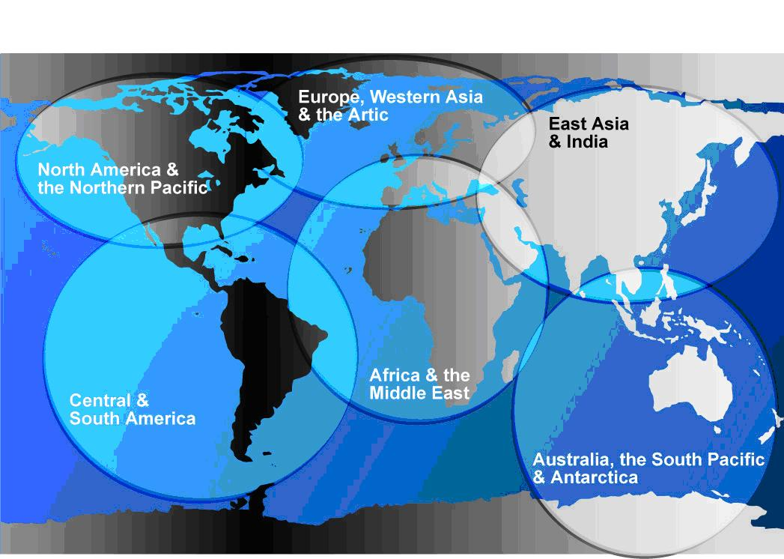
Six Possible Global Space Traffic Management Regions
Figure 9. Possible Global Space Traffic Management Responsibilities
As illustrated in Figure 9, a possible architecture includes six space traffic management regions of responsibility, one for each of the following geographic regions:
- North America and the Arctic
- South and Central America
- Europe and Western Asia
- Africa and the Middle East
- East Asia and India
- Australia, the South Pacific, and the Antarctic
Each space traffic manager works with ATC facilities, mission control centers, and space traffic management to ensure safety and ensure collision avoidance as spaceflight vehicles travel at altitudes where other vehicles are operating in LEO or beyond.
Space traffic managers monitor and coordinate all space transportation traffic in near-Earth space by providing instructions to flight crews and control centers (as appropriate) to ensure traffic separation. This includes issuing warnings when conjunctions are approaching among spacecraft, orbital debris and naturally occurring celestial bodies. Space traffic managers interface with other mission elements and spaceflight vehicle crews through the distributed network-centric architecture during departure and return operations, and through mission control centers during on-orbit operations. Space traffic managers interface directly with air traffic controllers, mission controllers, and crew during on-orbit operations. Each space traffic manager is connected to all other control centers as nodes in the distributed network-centric architecture for departure and return operations of vehicles traveling to and from space. For activities in orbit, the space traffic manager has a link to the mission control center for each flight to report pertinent data such as collision warning notifications.
4.2.2.5 Mission Control Centers
Mission control centers (MCCs) are responsible for managing the in-space activities associated with spaceflight operations in LEO and beyond for days to years at a time. (As discussed above, not every spaceflight operation has a mission control center.) Mission controllers manning positions in these centers monitor systems and activities aboard spaceflight vehicles and payloads during satellite deployment and operation, retrieval, repair, human exploration, and in-space assembly or repair of structures in orbit or on planetary bodies. Mission controllers are directed by the mission manager.
Mission managers have the authority to make spaceflight operation decisions during all phases of the spaceflight operations lifecycle. This includes certifying flight readiness of their flight vehicle, making the final launch commit decision and approving alternative courses of actions for unplanned events during flight. Not every spaceflight operation will have a mission manager. Mission managers will most likely be associated with civil, national security, and certain commercial (e.g. heavy lift ELV) launch activities. Commercial suborbital flights, which will bear similarity to airline point-to-point flights, will not need the same formal flight readiness and launch commit approvals that are needed for civil and national security spaceflight operations.
During departure and return operations, the MCC maintains contact with other control centers goes via the distributed network-centric architecture.
MCCs are staffed by mission controllers who are trained to effectively monitor all vehicle systems and phases of flight. In the case of spaceflight vehicles without a crew, mission controllers command and control the flight vehicle, its systems and payloads from the ground. For spaceflight vehicles that do include a crew, the mission controllers work in collaboration with the flight crew to carry out the specific objectives of the spaceflight operation.
The controllers in the MCC work actively with the flight controllers in the spaceport and the space traffic manager until the vehicle safely reaches orbit. Once a flight vehicle safely reaches orbit, the MCC retains primary responsibility for the spaceflight operations.
Before the vehicle reaches orbit, the MCC establishes direct communications and data links with the spaceflight vehicle. From the time the spaceflight vehicle enters orbit until the vehicle prepares for reentry, the MCC maintains contact with the vehicle and/or crew to direct and/or assist in managing all of its in-space operations.
In the event a vehicle must return to Earth unexpectedly, the MCC informs the appropriate space traffic manager, ATC facilities, and spaceport.

5.0 FUTURE SPACEFLIGHT OPERATIONS
While the previous section described the functions of the major elements that make up the future spaceflight operations conceptual architecture, this section describes the processes associated with performing future spaceflight operations. This section is divided into two parts:
- The first part describes future spaceflight operations during the first and second eras, characterized by transformation and responsive space launch/human exploration, respectively.
- The second part describes how future spaceflight operations are conducted for routine operational RLV flights operating as part of a global space transportation system in the third era, characterized by mass public space transportation.
Spaceflight operations are typically conducted to align with the six sequential phases depicted in Figure 10.
Spaceflight operations are typically conducted in six sequential phases.
Figure 10. Six Phases of Spaceflight Operations.
As illustrated in Figure 10, there are six phases of spaceflight operations. The major functions in spaceflight operations are:
- Planning spaceflight operations (including flight profiles) to meet requirements within applicable constraints, and scheduling the use of assets and resources to meet those requirements. This phase of activity also includes training and certification of various types of operators to work effectively in control centers within the bounds of their clearly defined roles, responsibilities, and authorities.
- Processing, including coordinating, controlling, and supporting pre-flight ground operations to ensure that each flight vehicle and payload/cargo element, as well as crew and passengers (when applicable), are ready to fly.
- Departure operations, including coordinating, (in some cases, controlling), and supporting initial flight operations in the vicinity of the takeoff/launch site.
- Flight operations, including coordinating and supporting spaceflight operations between departure and arrival. In some cases, this also includes controlling in-flight operations (e.g., to conduct a prompt global strike). In other cases, it only involves monitoring the in-flight operations on an exception basis (i.e., in “notification” mode during the conduct of the spaceflight in LEO or beyond), to be prepared to coordinate support for return flight and landing/recovery in the event of an emergency or in-flight abort.
- Arrival operations, including coordinating, (in some cases, controlling), and supporting flight operations in the vicinity of the landing/recovery site.
- Refurbishment and turnaround, including coordinating, controlling, and supporting operations for each flight vehicle and payload/cargo element, as well as crew and passengers (when applicable) after each flight. This also includes data processing and analysis as well as post-flight reporting.
These six phases of space launch and flight test activities are explained in more detail in Appendix 1. Within each of these phases, several spaceflight operations functions are performed. These functions align with the phases as shown in Figure 11.

Phase | Spaceflight Operations Functions
Planning | - Flight Planning and Scheduling  - Training and Certification
Processing | - Flight Readiness Verification  - Transportation Between Facilities
Departure Operation | - Countdown and Final Launch Commit  - Launch/Takeoff and Initial Flight
Flight Operations | - In-flight activities  - Monitoring in “Notification” Mode
Return and Landing | - Reentry  - Return Flight  - Landing/Recovery
Refurbishment and Turnaround | - Post-Flight Processing  - Data Archival, Analysis and Reporting
Figure 11. Spaceflight Operation Functions in Each Phase
The remainder of this section explains each of these spaceflight operations function in more detail.

5.1 Transformation, Responsive Space Launch and Human Exploration
In the Transformation Era, the incremental deployment of evolutionary technologies begins to enable more responsive spaceflight and human exploration activities in space using new vehicles and spaceports by improving interfaces and network operations. Flexibility, standardization and interoperability become developmental drivers required to meet increasing complexity in spaceflight operations, along with increased traffic.
As a result of these developments, future spaceflight operations during the Responsive Space Launch and Human Exploration Era are supported by an integrated, centrally-managed, network-centric capability (orchestrated by the distributed network-centric architecture). A distributed network-centric architecture command center, as depicted in Figure 12, coordinates (in some cases, controls), and manages interactions among range assets, spaceports, and control centers around the world during each phase of a spaceflight operation. Each flight vehicle, range and spaceport asset, and control center is addressable as a node in the distributed network-centric architecture.
Spaceflight operations are coordinated, and in some cases controlled, through a distributed network-centric architecture.
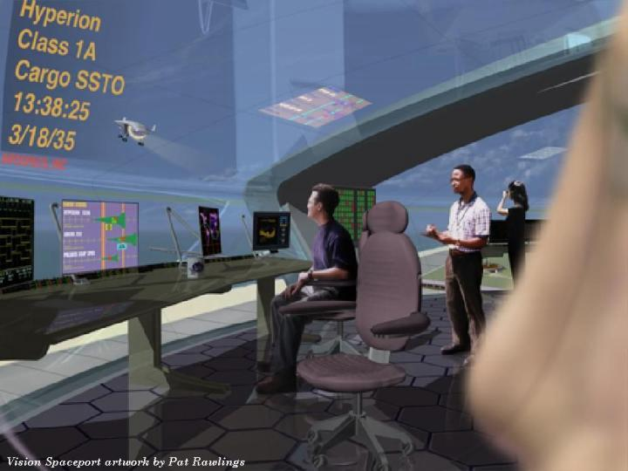
Figure 12. Distributed Network-Centric Architecture
A variety of control centers work in concert via the distributed network-centric architecture. Some examples exist and operate as they do during the Transformation Era, including air traffic control facilities throughout the nation and NASA’s Mission Control Center in Houston and Launch Control Center in Florida, while others only begin operating during the Responsive Space Launch and Human Exploration Era.
During the Transformation Era, new standards are developed and applied incrementally throughout the systems that are used to support spaceflight operations. Standards are applied and implemented first at each spaceport/range/control center, or as part of a larger launch vehicle program. The standards, once adopted, then begin implementation regionally, then nationally, and finally globally. Over time, as new spaceports and vehicles are added to the overall FSTS, they are designed, built, and operated in ways that comply with the existing set of established and accepted standards for spaceflight operations.
The following sections describe in more detail how each of the spaceflight operations functions will be carried out during each phase of a spaceflight operation in the Responsive Space Launch and Human Exploration Era.
5.1.1 Planning
5.1.1.1 Planning & Scheduling
Planning for spaceflight operations includes:
- 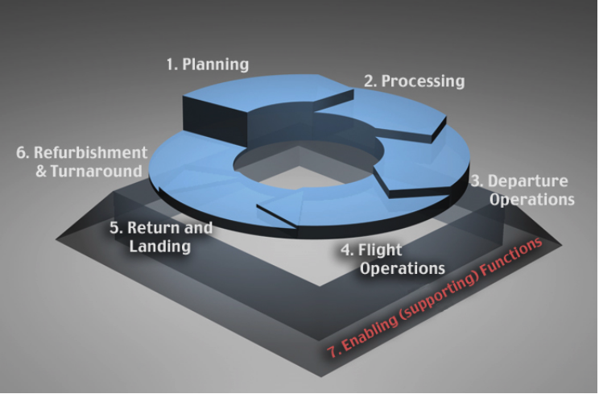Defining the scope, objectives and requirements for a spaceflight operation, along with strategies for accomplishing them
- Developing flight profiles based on an understanding of the flight environment and accounting for programmatic and operational constraints and/or dependencies
- Identifying support requirements, including processing and takeoff, launch and range facilities, data relay and command and control rates, etc.
- Integrating this plan into the master schedule along with all other planned flights and activities.
Figure 13 is a process flow diagram illustrating the relationships among these steps in planning spaceflight operations.
Flight scheduling takes the products of flight planning and breaks them down into the individual tasks to be completed for each individual flight. It also includes assigning the available resources to support each task, accounting for availability and constraints such as launch windows required to intersect celestial orbits. Finally, it includes integrating the resulting schedules for individual flights into a single master schedule for all scheduled flights and available resources. Scheduling is an iterative process due to the dynamic nature of spaceflight operations; therefore these schedules require numerous updates as events impact original requirements and plans.
Automated decision support systems analyze forecasted weather data along with vehicle performance and other characteristics (including breakup and debris data) to determine the restrictions and operational limits on each planned spaceflight operation. Flight profiles are filed and treated as flight plans to coordinate the integration of spaceflight operations within the National Airspace System. During the responsive space launch and human exploration era, flight profile inputs are treated individually to drive the assignment of air traffic control resources and restrictions, as necessary to provide effective support without adversely affecting the usual flow of air traffic.
Planning spaceflight operations accounts for flight-specific parameters and constraints to generate a Flight Profile, then via distributed network-centric architecture generates support requests.
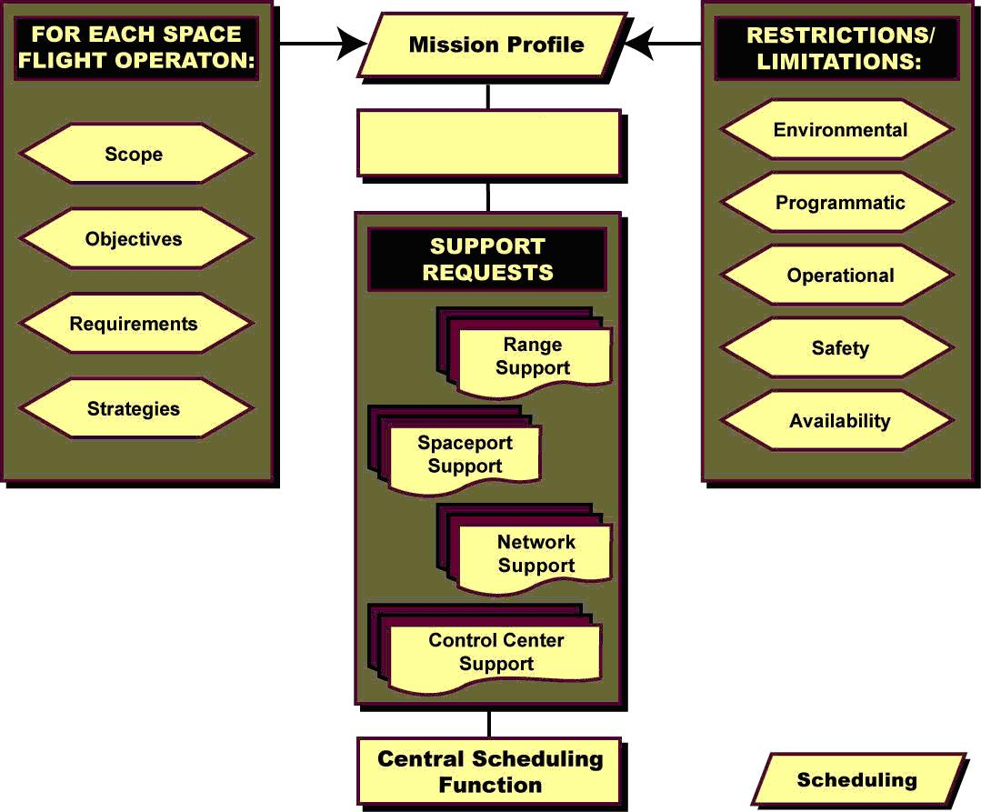
Distributed Network
Figure 13. Planning Process for Spaceflight Operations
Assignments for use of airspace are derived from the results of automated simulations that address the flight profile (within a calculated set of limitations based on weather, performance, and other vehicle characteristics) and its effects on air traffic. These simulations assess alternative courses of action and recommend primary and alternative (or contingency) solutions that minimize disruptions to other traffic, minimize the potential for re-scheduling, and preserve safety.
As envisioned and illustrated by Figure 14, the job of the planner and scheduler in the future will be greatly simplified by this centralized planning and scheduling system. This automated system uses software tools to standardize recurring scheduling functions and notify users and operators of schedule changes. The ability to handle dynamic changes and forecast impacts to plans or schedules is enhanced by implementing expert systems for workload planning and models to project the availability of spaceport and range assets, ground processing, facilities, and other support resources. As these processes become more efficient using these advanced capabilities, the number of planners and schedulers required by all elements of the space transportation system can be reduced. At the same time, these schedulers can also handle more spaceflight operations and schedules while coordinating with users and operators in real time as required.
Spaceflight operations are scheduled using an automated decision support system to generate alternative courses of action and recommendations.
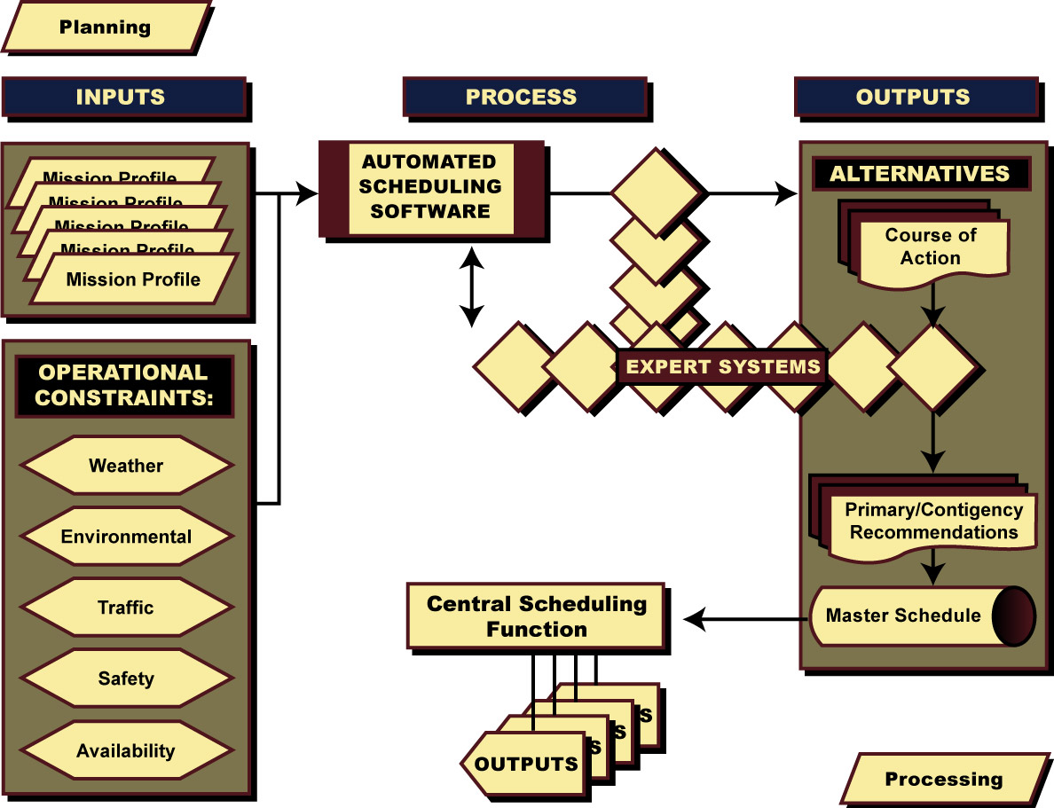
Figure 14. Scheduling Process for Spaceflight Operations
Using this network-centric automated system, authorized users and operators make inputs for individual flights regardless of location. The architectural elements of this centralized function provide a secure interface to the system, including a method for classified access for those flights requiring secure operations. Users receive real-time feedback notifying them whether the request is approved, whether it conflicts with other events or resource schedules, or if the request is disapproved due to resource constraints.
The planning and scheduling system enables collaborative planning among multiple organizations simultaneously. The system quickly generates complex, concurrent plans while ensuring maximum flexibility and capability for re-planning to accommodate equipment problems, changing weather conditions, or short-notice changes to a spaceflight operation. When schedule conflicts do arise, the system automatically adjusts the schedule for optimum use of all flight and support elements. This automated capability uses advanced modeling and simulation techniques and constraint-based computer algorithms to assign priorities, identify areas of conflict, automatically repopulate the schedule, and notify all users of any changes. All users affected by any adjustment are notified in real-time of any changes affecting their activities, enabling them to have continuous access to the latest master schedule and plans through the global network that’s controlled by the distributed network-centric architecture.
5.3.1.2 Training and Certification
Training for spaceflight operations includes all activities required to prepare flight crews and control center operators to perform assigned flight-specific tasks. Training seeks to build a set of skills to enable crew members and control center operators to perform a particular job. As shown in Figure 15, training includes identifying a realistic scope of what the job entails, clearly stating performance objectives, selecting an appropriate methodology (such as simulation, part-task training, classroom instruction, etc) to meet the performance objectives, and creating opportunities to practice the skills with feedback and suggestions for improvement.
The training process for Spaceflight Operations can use a variety of methods, but always includes feedback and suggestions for improvement.
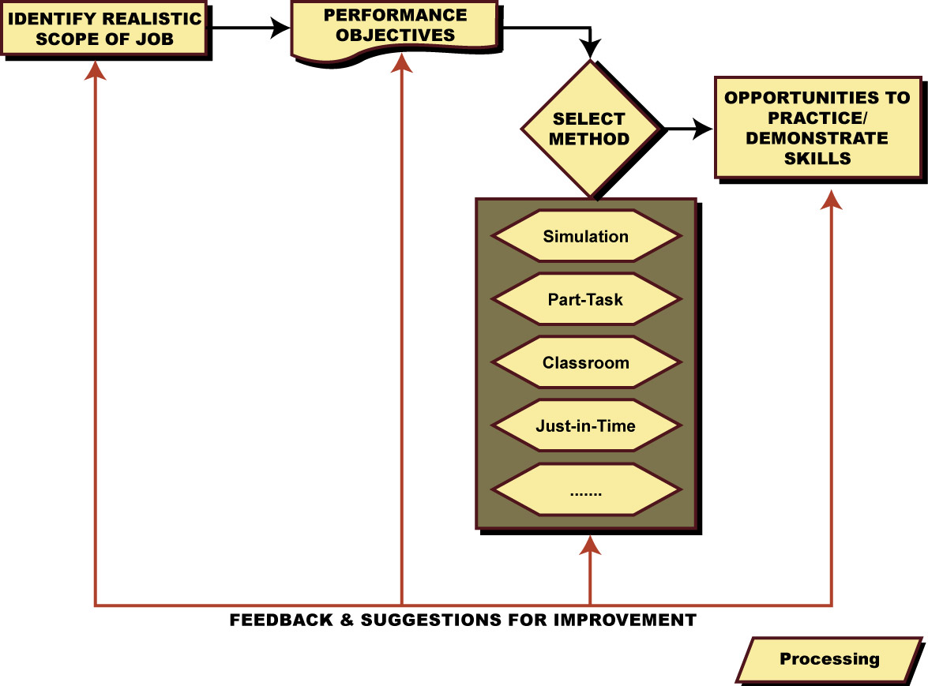
Figure 15. Training Process for Spaceflight Operations
Certification for spaceflight operations requires that crew members or control center operators to meet certain performance criteria indicating they can adequately perform the assigned tasks. Certification includes the assessment of a person’s learned skills after training to determine if that person can adequately perform a particular job. The certification process ensures that crew members and control center operators understand and are capable of safely, reliably, and routinely performing their assigned functions and responsibilities with competence and professionalism, particularly in the face of off-nominal conditions and situations.
As shown in Figure 16, the training and certification of future spaceflight operators is divided into two categories: generic operations training and flight-specific operations training. Generic training includes training requirements that remain consistent over time regardless of the purpose of a particular flight, vehicle or facility. Examples include management of ascent/departure or reentry/return flight operations. Flight-specific training includes training requirements that are unique to a given flight, vehicle or payload.
Training for Spaceflight Operations includes generic and flight-specific elements.
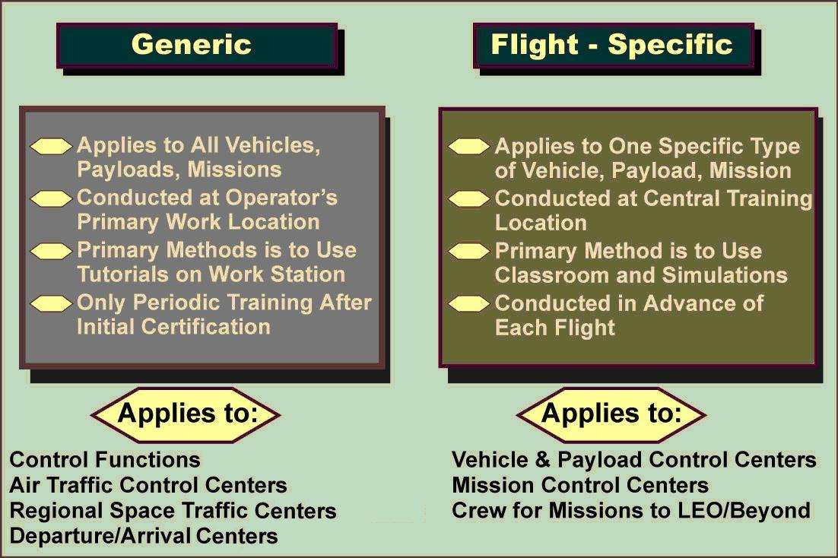
Figure 16. Generic and Flight-Specific Training for Spaceflight Operations
Generic training is conducted at the location where the operator works (such as the spaceport, range, particular type of control center, etc). It is delivered by a variety of methods and supplemented by intelligent training tutorials built into workstations. Operators also receive initial training on the standard transportation systems and standardized vehicle and payload interfaces at the spaceport, range or operations center. After they’re certified, operators only receive periodic refresher training or additional training when system design changes are implemented.
Flight-specific training requirements for specific vehicles, payloads and flight objectives is provided on an exception basis, and only for specific flights (or types of flights) when such training is required to deal with unusual or unique attributes. The vehicle operators are responsible for the flight-specific training of their flight controllers or crew for a spaceflight operation that falls into this category. These operators are responsible for addressing any flight-specific issues through all phases of the spaceflight operation. They subscribe to the centralized control function to access vehicle and payload data and send commands or communicate with the vehicle via a node on the web.
In this era, as the infrastructure becomes more standardized and interoperable between space transportation facilities, the need for each facility to maintain its own specialized operations personnel for many functions greatly diminishes. For example, commercial RLV flights taking passengers and cargo from point to point will resemble commercial air transportation today. Generic training is provided to departure/arrival controllers and space traffic managers who monitor the vehicles as they transit to and from space. They will not be tasked with monitoring the vehicle and its systems, just getting it safely from point A to point B. That task will fall to the crew member flying the RLV.
There is still a need for flight-specific training for civil, national security and development and test activities during this era. The training that NASA or the military provides to flight crews and flight controllers on a particular vehicle or particular type of spaceflight operation objectives is flight-specific operations training. In these cases, the vehicle operator (NASA, DoD, industry) will still be responsible for providing training and certification for crew and flight controller training requirements for these spaceflight operations. In cases where NASA or the DoD chooses to purchase the services of a launch vehicle provider to carry payloads or other space vehicles (such as the Crew Exploration Vehicle), they may find it more cost-efficient to contract those services directly from the vehicle operator rather than maintain a staff of vehicle specific training personnel.
As the space transportation architecture becomes more standardized and interoperable over time, there will be fewer vehicle-centric training requirements, and most training and certification requirements will fall into the generic category. Vehicle operators, especially in the civil and national security space sectors, will still be required to provide training for specific unique requirements.
For unique or critical requirements, traditional training methods such as simulations continue to be used, but new methods accommodate new needs. The spaceflight operations tempo of the future will make the training and certification of personnel more difficult because in many cases there will be very little lead-time to prepare and train for a flight. Training and certification for future spaceflight operations, to include the ability to meet shortened training timelines, will rely on just in time (JIT) training tools and job aids, artificial intelligence and intelligent tutoring systems.
Just in time training tools and job aids eliminate the need for lengthy training lead time for flight requirements peculiar to a specific vehicle or payload. JIT will be accessible through the distributed network-centric architecture and will enable users to access training information on demand for various flight elements and processes from their office, remote locations, workstations (consoles), wireless and handheld devices. Based on the individual user inputs, the user receives basic, intermediate or advanced training that is tailored to his or her specific needs—and is able to put that training to use immediately after receiving it. Flight-specific training needs can also be supplemented using JIT tools prior to or during real-time spaceflight operations and in cases where long training lead times are not possible, for instance to support crew or satellite rescue. These tools will provide the capability and flexibility for operators to be called upon and ready to support short notice, responsive space launches as well.
Artificial intelligence and intelligent tutoring systems aid spaceflight operators by providing “expert” guidance in real time for vehicle and payload systems as well as providing decision-making support and course of action determination given failure indications or other unexpected events. Removing the need for humans to perform these tasks based on pre-defined courses of action will allow them to focus on those critical decisions and unique operations that do require human focus and interaction. Training requirements are reduced because the humans no longer have to go through the time-consuming step-by-by decision-making actions that the artificial intelligence systems perform for them. These artificial intelligence and intelligent tutoring systems will be available to all subscribers, local or remote, via the global network that’s controlled via the distributed network-centric architecture, enabling continuous availability to all users regardless of location or workstation setup.
In addition to the training systems mentioned above, training and certification of spaceflight operations personnel benefits greatly from the conceptual architecture principles set forth in the Spaceport and Range ConOps such as standardization, automation and self-healing systems.
The use of standardized interfaces, or modular plug-and-play components, eliminates the need for lengthy training programs associated with unique or proprietary hardware and software systems. Standardized components, processes, and functions allow operators to receive initial training and certification for a particular job regardless of the flight, vehicle or payload. Rather than having to retrain operations personnel from scratch every time there is a different vehicle, payload or flight, only periodic re-qualifications will be required to ensure that operations personnel have maintained proficiency.
The emergence of automated processes/tools, self-diagnosing/self-healing systems and decision support systems will reduce the amount of training needed by operations personnel. Automating numerous, repetitive, manual processes and tasks performed by operators will reduce the need to train these personnel to perform those tasks. Employing self-healing systems will also reduce the need to train operations personnel on the critical signature recognition, decision-making and course of action determination required for systems without self-diagnosis/self-repair capability.
5.1.2 Processing
5.1.2.1 Flight Readiness Verification
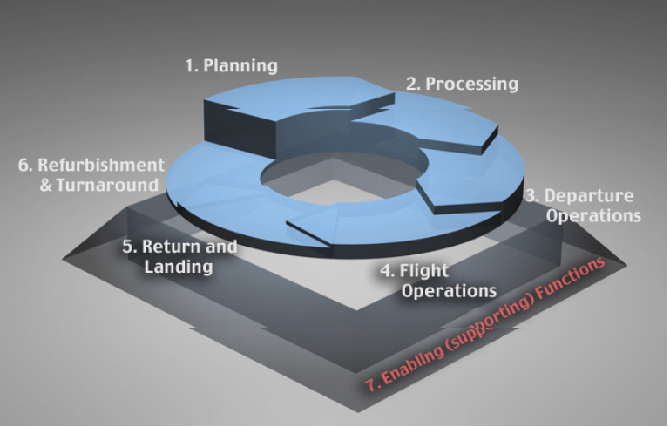
Processing includes flight readiness verification, meaning the assembly, testing, checkout, and examination of all flight hardware, software, operations organizations and procedural elements to ensure each is ready for flight. It also includes a formal process of surveying all flight organizations, functions and elements to formally certify and document readiness for flight.
Flight readiness verification uses the global information network that’s managed Center (and the flight crew via the distributed network-centric architecture to initiate and analyze results from automated processes. It also relies on standardization and intelligent computing systems to assess readiness in real-time based on information gathered from all elements of the space transportation system. These processes and connections are depicted in Figure 17.

Processing operations include flight readiness verification and transferring vehicles, payloads, cargo, and passengers between facilities.
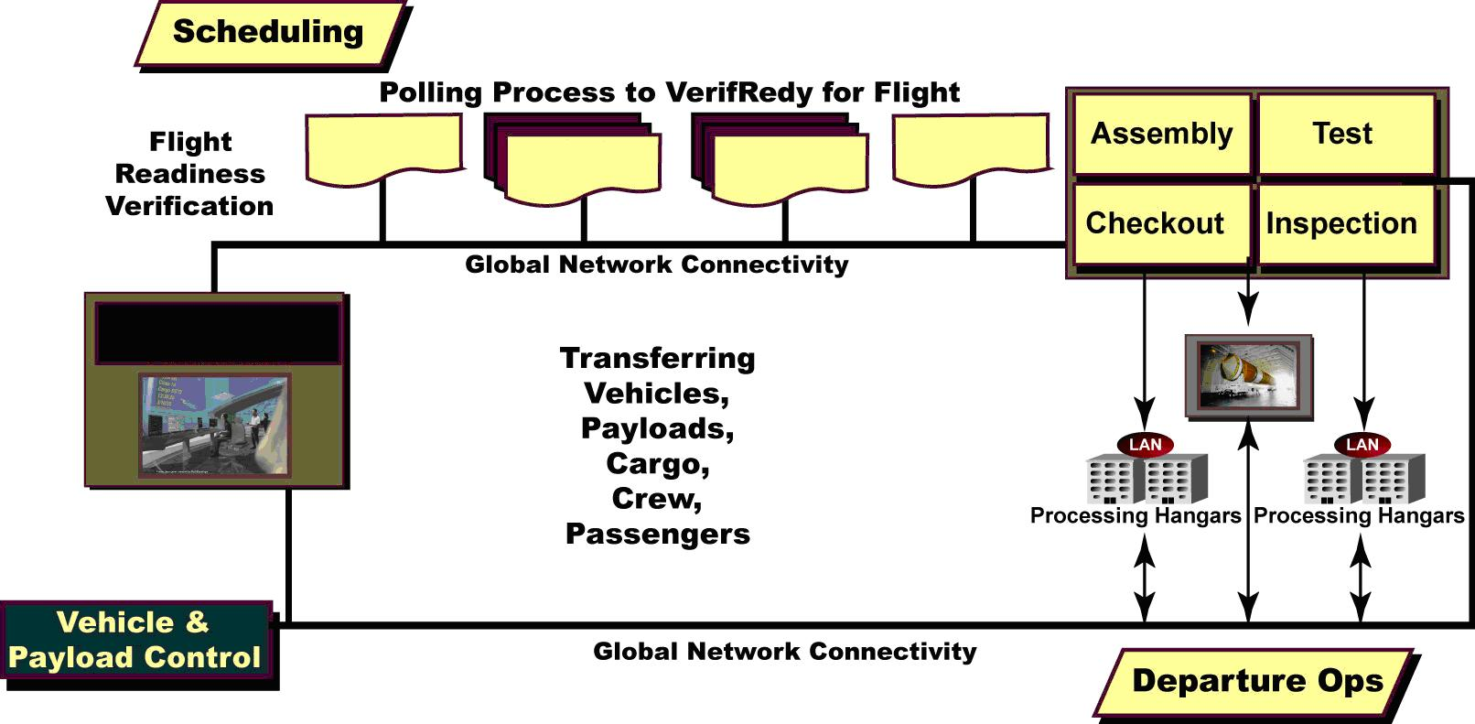
Spaceport
Range
MCC
ATC
Distributed Network
Figure 17. Processing Operations
Problems are highlighted and anticipated by automated processes to support management decisions. This sort of automated capability is necessary to enable responsive space launches. Because the time from notification to launch is extremely compressed, advanced computing techniques and intelligent system play a crucial role in enabling real-time verification and certification of system readiness to support responsive operations.
Through the use of automated processes, standardization and intelligent computing systems, flight readiness can be tracked in real-time based on information gathered from all elements of the space transportation system through the global network that’s managed using the distributed network-centric architecture. Problems are highlighted and anticipated by automated processes to support management decisions.
Managers at dispersed locations will subscribe to data to be displayed at their location, receiving immediate status of all required functions and an indicator of which items are complete or incomplete. Should decisions need to be made, the automated system provides instant video teleconferencing capabilities to all flight managers for a particular spaceflight operation. This sort of automated capability is necessary to enable responsive space launch missions. Because the time from notification to launch is extremely compressed, advanced computing techniques and intelligent system play a crucial role in enabling real-time verification and certification of system readiness to support responsive spaceflight operations.
5.1.2.2 Transportation Between Facilities
Processing also includes the transfer of vehicles, payloads, cargo, crew, and passengers between facilities, as required, to prepare for departure operations. The Vehicle and Payload Control Centers retain primary control of these ground transportation operations between facilities during processing.
Operators at these Vehicle and Payload Control Centers maintain communication interfaces with spaceport facilities, support equipment, and the flight vehicles, payloads, cargo, crew, and passengers through the global network that’s managed through the distributed network-centric architecture. Using these interfaces, these operators maintain situational awareness and direct control of all ground processing activities associated with the elements they’re responsible for.
The distributed network-centric architecture is used to direct spaceport and range assets as required to provide support for the ground processing activities being directed by the Vehicle and Payload Control Centers.
5.1.3 Departure Operations
Departure operations include countdown and final launch commit, as well as launch or takeoff, and initial flight.
The spaceport retains primary responsibility for departure/arrival operations, using the distributed network-centric architecture to interface with the other types of control centers involved in managing various aspects of the flight.

5.1.3.1 Countdown and Final Launch Commit
Countdown and final launch commit includes propellant loading and late stowage of items onto vehicle, final range interface checks, official launch commit based on vehicle and weather conditions, final range/airspace safety checks and collision avoidance verifications. Some future spaceflight operations could be called up and ready to launch within hours of notice. To accomplish the shortened timeline for countdown and launch commit (which begins days prior to liftoff in most cases involving current systems), new approaches to accomplish this function are employed.

Departure operations are controlled primarily by the spaceport. It polls the other control centers through the distributed network-centric architecture during countdown for final launch commit, and coordinates with them during launch/takeoff and initial flight.
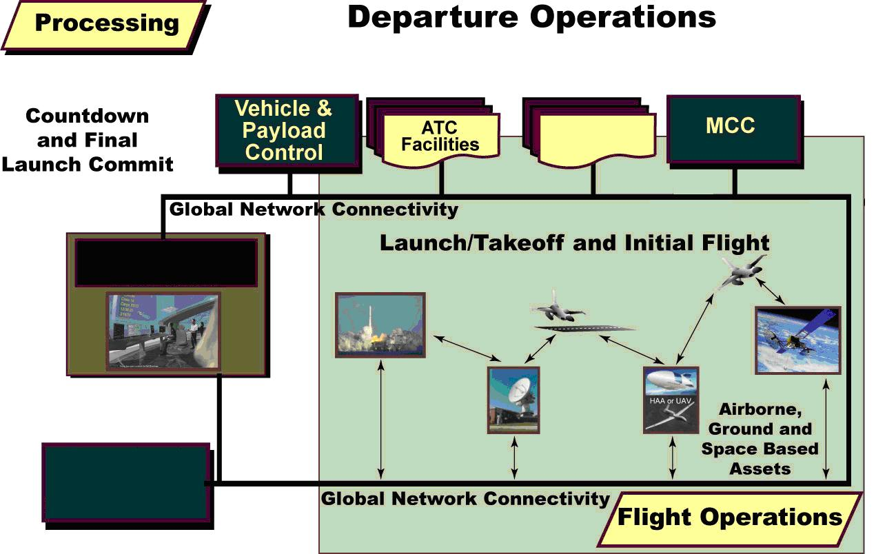
Spaceport
Distributed Network
Space Traffic Management
Figure 18. Departure Operations
As illustrated by the global network connectivity depicted in Figure 18, vehicle, ground support systems, and range systems are monitored by built-in test and integrated health monitoring equipment during the countdown. Vehicle or ground support equipment detecting system, hardware or software problems automatically identify failures, and reconfigure to a redundant system or repair themselves autonomously, eliminating the need to halt the countdown.
Propellant and consumable loading are accomplished using on-demand propellant servicing to the flight vehicle while the automated vehicle and ground health monitoring systems verify that the loading operations and outcomes are proceeding as expected.
Operators at the spaceport monitor the status reports from these automated health monitoring systems through the distributed network-centric architecture and global network. These controllers, like airport control tower operators today, monitor all space vehicle departures and arrivals in the terminal area of the spaceport.
Working through the distributed network-centric architecture and in coordination with applicable air traffic control facilities and space traffic managers, the spaceport operators ensure the proper flight profile approvals and flight route clearances have been obtained. They also monitor integrated situational awareness displays to ensure weather is acceptable for launch or takeoff.
Typically, only civil and national security sector spaceflights that involve long-duration activities in LEO or beyond are controlled through mission control centers. Operators in mission control centers are connected to the global network that’s managed by the distributed network-centric architecture, so they have access to all the data on the network that’s applicable to their vehicles and flight operations.
For suborbital spaceflights—whether civil, national security, and commercial, and with or without crews and/or passengers aboard—the distributed network-centric architecture provides services for managing the interfaces and approvals among all involved control centers (and the crew, in cases involving vehicles with flight crews aboard).
Commercial vehicle operators at remote locations can access voice, video, and data relating to the flight vehicle and payload/cargo through the global network as needed.
As the countdown proceeds toward liftoff, all participating control centers are polled via the distributed network-centric architecture to provide their final launch commit through the global network. Various launch commit criteria are established during the planning phase of the flight, and all relevant considerations and data are continuously monitored by automated systems and the results and recommendations of expert system analysis are displayed as part of the overall situational awareness information available to all operators on the network.
If the system determines that all launch commit criteria are “go”, the countdown continues. If the system determines that a particular criterion is “no-go” even after system self-diagnosis and recovery, then the launch/departure manager issues a “hold” command and notifies all users on the global network. Automated expert systems evaluate all of the available data using modeling and simulation tools to generate a list of alternative courses of action. These systems also provide a recommended primary and contingency course of action.
Depending on the option chosen, the launch countdown may be resumed, held for a time until a course of action or workaround is selected and implemented, or the launch is scrubbed and re-scheduled. Upon initiation of a scrub, the launch/departure manager issues a shutdown command that starts a series of events to safe and reconfigure all vehicle, spaceport and range systems for the next scheduled event. The launch/departure manager also notifies the planning and scheduling systems of the scrub, placing the flight back in the queue for whatever actions may be needed before another launch attempt.
5.1.3.2 Launch/Takeoff and Initial Flight
Launch/takeoff and initial flight include departure of a space vehicle from a spaceport and flight through the NAS and NextGen into a desired orbit or along a sub orbital trajectory (for point-to-point flights). Aborts are also included in this phase in the event the vehicle must make an unscheduled return to the launch or takeoff site because of system failures or vehicle ascent performance problems that are unable to be fixed.
Figure 18 also shows that operators at the spaceport monitor tracking and telemetry data during the launch/takeoff and ascent of the flight vehicle to ensure it is flying in accordance with its planned and approved flight profile. Operators in applicable air traffic control facilities and space traffic managers also monitor the progress of the flight as it ascends within their regions of jurisdiction.
Operators at the spaceport work closely with Operators in applicable air traffic control facilities, space traffic managers, and the flight crew (if applicable) during initial flight.
During departure operations, the flight crew communicates directly with the spaceport. If the crew is conducting a spaceflight operation in LEO or beyond, then the mission control center will also be in contact with the crew throughout the flight.
Applicable air traffic control facilities and space traffic managers monitor the ascent and provide routing instructions as required to clear the involved airspace to ensure safety and separation from other aircraft and traffic and/or debris in space while as vehicle transits their regions of jurisdiction. Space vehicle operations within the NAS and NextGen are managed using space transition corridors. Depending on the flight profile and vehicle performance characteristics, the space transition corridors are used to segregate different types of flights, to concurrently accommodate different phases of activity (e.g., launches versus re-entries), and to ensure safety in the event of in-flight anomalies or emergencies. Air traffic control facilities maintain contact with space traffic managers to hand-off responsibility once the vehicle reaches the upper limit of the National Airspace System.
For flights along suborbital trajectories, the spaceport also works closely with air traffic control facilities and space traffic managers to hand-off responsibility for monitoring and routing the vehicle once it flies over the horizon from the launch/takeoff site. Before the vehicle proceeds the horizon from the launch/takeoff location, the spaceport hands-off responsibility for issuing routing instructions to the applicable space traffic managers. In most cases, the distributed network-centric architecture provides an infrastructure for coordinating and controlling suborbital flights.
For launches to low Earth orbit and beyond, the spaceport maintains communications with the mission control center and the vehicle until the vehicle has passed beyond the jurisdiction of the space traffic managers that monitor its ascent and injection into orbit. At that point, the spaceport hands-off responsibility to the mission control center and the mission control center takes over responsibility for managing on-orbit or in-space activities.
Once a vehicle is in Earth orbit or beyond, the spaceport, air traffic control facilities, and space traffic managers only monitor and contact the mission control center on an exception basis in “notification” mode. In this mode, automated alerts notify these center operators only if the flight is cut short in orbit (e.g., due to an anomaly or an emergency) and requires support for an unscheduled reentry and landing/recovery.
5.1.4 Flight Operations
5.1.4.1 In-flight Activities
In-flight activities include maintaining the control, monitoring, coordination and overall situational awareness with regard to flight-specific activities conducted while a vehicle is conducting a spaceflight operation.
Because the nature of flight to, through, and from space is intrinsically dangerous, it is unlikely that fully autonomous launch, in-space and re-entry operations will occur in the foreseeable future. Human operators will still be needed to manage and control flights to, through and from space but utilizing advanced technologies, tools and architectural concepts described in the Spaceport and Range ConOps, the number of operators required to support all flights will decrease as these improvements enable operators to handle the increased capacity, multiple vehicles and simultaneous, and dispersed operations.
While all spaceflight operations involving transportation to, from, or through near-Earth space are coordinated using the distributed network-centric architecture, some are controlled through it as well. This is the case when the mission is to provide transportation and the spaceflight operation is conducted using a vehicle without a crew on board. For suborbital flights, the distributed network-centric architecture provides support throughout the entire spaceflight operation, interfacing with the spaceport, air traffic control facilities, and space traffic managers, as required, as the vehicle moves from one region of jurisdiction to another.
When a flight vehicle providing transportation has a crew on board, the crew controls the vehicle. For flights of vehicles with a crew aboard, the distributed network-centric architecture is used by the flight crew and mission controllers (in cases involving a mission control center) during departure and return operations or in the event of an early in-flight abort, leading to an emergency return and landing/recovery.
When the mission is conducted over an extended period of time in or beyond Earth orbit, then a mission control center provides the control. The functions of a mission control center are separate from the functions of the distributed network-centric architecture, though the mission control center does interface with other control centers through the network during the transportation phases of the mission. The distributed network-centric architecture is not typically utilized during the routine on-orbit operations in LEO or beyond (except to monitor them on an exception basis, in “notification” mode) to coordinate and prepare to support emergency or unplanned reentry and return flight, along with landing/recovery.
Figure 19 illustrates the connectivity and interactions among the various types of control centers during in-flight activities.

The Distributed Network-Centric Architecture allocates command and control authority for suborbital flights. For a long-duration spaceflight in LEO or beyond, the Mission Control Center has primary authority. Air Traffic Control Facilities and Space Traffic Managers have authority to provide routing instructions during flight through regions of jurisdiction.
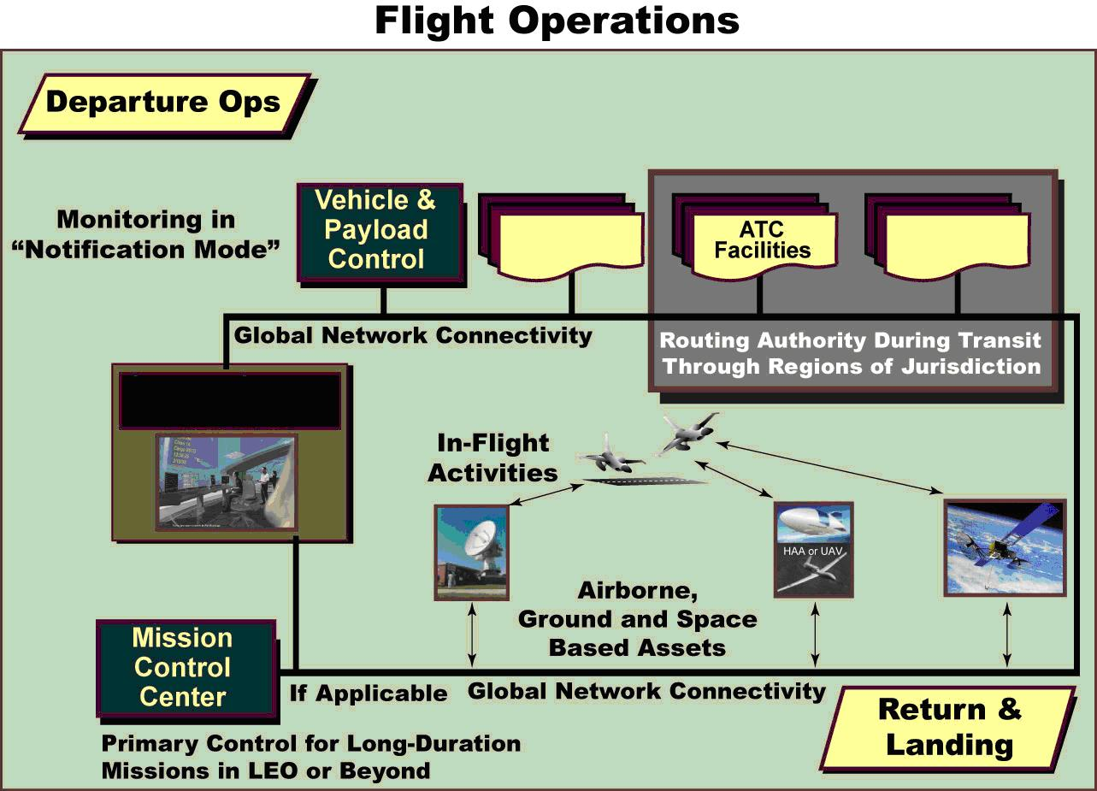
Spaceport
Space Traffic Management
Distributed Network
Figure 19. Flight Operations
As noted in Figure 19, air traffic control facilities and space traffic managers monitor and issue routing instructions to suborbital hypersonic point-to-point flights as they fly en route between spaceports to ensure safety and separation from other traffic and potential hazards including weather systems and orbiting debris.
Further, automated on-board systems perform flight control activities according to the predefined (and approved) flight profile. In the event of in-flight anomalies, onboard vehicle and payload diagnostic systems identify the problem, notify the vehicle operator (i.e., the flight crew or a ground controller) and autonomously switch to redundant systems or implement self-healing processes, as applicable. These onboard systems generate a notification to all concerned parties and distribute the findings through the vehicle’s telemetry stream to the distributed network-centric architecture, where it’s distributed to all interested parties on the global network. If required based on the automated analysis of expert systems, the distributed network-centric architecture also passes the information to the scheduling function to revise post-flight maintenance and refurbishment schedules, order parts through the automated logistics system, etc.
During flight operations in LEO and beyond, the mission control center is responsible for monitoring and controlling spaceflight activities such as payload deployments, on-orbit repair of space-based assets, and the assembly of space vehicles and systems for exploration. During on-orbit operations, the crew maintains contact with the mission control center via a direct link. The MCC works with the crew to carry out all of its objectives and to respond to unexpected events.
5.1.4.2 Monitoring in “Notification” Mode
For spaceflight operations in LEO or beyond, the mission control center maintains continuous contact with the flight vehicle (and crew, if applicable). The mission control center remains connected to the global network that’s managed by the distributed network-centric architecture. All other control centers passively monitor the network in “notification” mode in case the mission control center issues a message requesting support for an unscheduled return and landing/recovery through the distributed network-centric architecture.
When such a request is received, the distributed network-centric architecture processes requests for emergency support from space traffic managers, air traffic control facilities, and spaceports, as required. Each of these centers actively monitors the operation from that point until its conclusion. It also tasks automated expert systems to modify the schedule for spaceport and range support to ensure assets will be available to support the emergency reentry, return flight, and landing/recovery.
5.1.5 Return and Landing
The return and landing function includes the monitoring, commanding, and control of a space vehicle as well as the execution of operations related to de-orbit, reentry and return flight through the NAS and NextGen. This also includes the safe return of expendable stages or strap on motors during launch and reusable flight vehicles after in-space operations are complete.
For vehicles returning to Earth, the spaceport (and MCC, if applicable) work in conjunction with the applicable space traffic manager and ATC Facility to hand-off (i.e., positively transfer responsibility) from one control center to another as the vehicle transitions from spaceflight to atmospheric flight during the reentry phase. In every case, this handoff process requires a request from the control center that is handing off responsibility, an acknowledgement from the center that is picking up the responsibility, and a confirmation from the original center.
Figure 20 illustrates the roles of each type of control center in supporting return and landing operations.

The spaceport retains primary control over return and landing operations, while Air Traffic Control Facilities and Space Traffic Managers in coordination with Mission Control Center, if applicable) provide routing instructions during transit through their regions of jurisdiction.
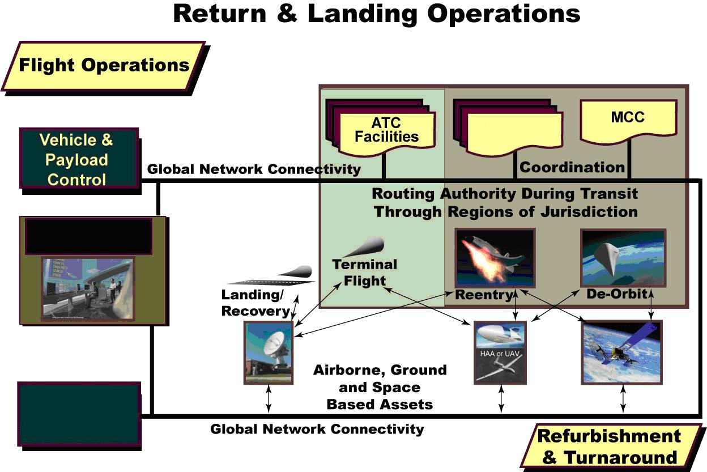
Space Traffic Management
Distributed Network
Spaceport
Figure 20. Return and Landing Operations
Emergency reentry/return/landing/recovery operations are implemented to accommodate unscheduled return flights in case of system failures or vehicle performance problems that result in flights being aborted.
5.1.5.1 Reentry
Prior to de-orbit, the mission control center has the primary responsibility for all preparation activities leading up to reentry into the Earth’s atmosphere, including coordination through the distributed network-centric architecture for all required support from other control centers that are responsible for the regions the vehicle will transit on its way toward landing/recovery.
The mission control center (and the flight crew, if applicable) maintains direct contact (through the global network that’s managed by the distributed network-centric architecture) with control centers that have authority and jurisdiction over the regions being traversed along the flight path. Space traffic managers monitor and ensure safety and separation during de-orbit and reentry maneuvers. For vehicles returning to Earth, the applicable Air Traffic Control Facility works with the applicable space traffic managers to clear the airspace as the vehicle transitions to gliding, powered, or ballistic flight after the reentry phase. This also includes the safe return of expendable stages or strap on motors during launch and reusable flight vehicles after in-space operations are complete.
5.1.5.2 Return Flight
Once the vehicle enters the National Airspace System, the responsible space traffic managers hand-off responsibility to the applicable spaceport where the vehicle will land. The spaceport coordinates with the applicable air traffic control facilities to ensure safety and separation during the descending flight through the atmosphere.
5.1.5.3 Landing/Recovery
The spaceport maintains responsibility for issuing routing instructions to the flight crew (when applicable) and/or to the ground control center responsible for the flight, throughout return flight and landing/recovery at the applicable spaceport.
5.1.6 Refurbishment and Turnaround
5.1.6.1 Post-Flight Processing
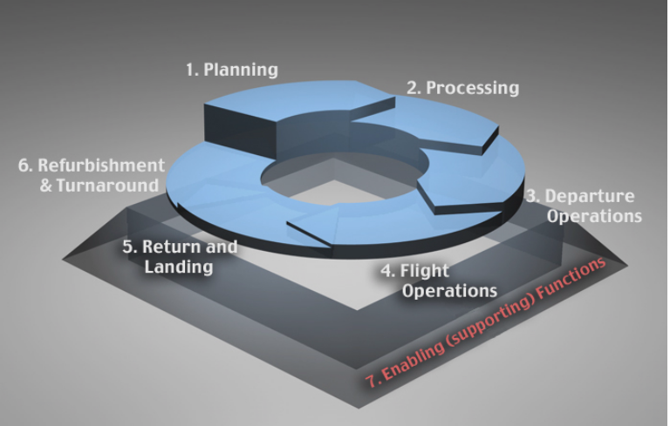
Post-flight processing includes deactivating the flight vehicle and support systems that were engaged in managing its safe return and landing/recovery.
It includes activating the facilities and ground support systems that will be used in safing and de-servicing the flight vehicle and payload/cargo to eliminate potential hazards.
It also includes ensuring the safe egress of the flight crew and/or passengers from the flight vehicle. It also includes taking actions to address any anomaly reports or repair orders that were generated during the flight by the on-board health monitoring system.
Upon completion of a spaceflight operation, automated health management systems report status to the distributed network-centric architecture. This information is used to generate and distribute routine post-operation reports on operations center usage and performance. These reports are used to generate bills for users and provide updated inputs to the automated scheduling system to generate maintenance and repair orders.
As is the case during pre-launch processing, problems are highlighted and anticipated by automated processes to support management decisions. Through the use of automated processes, standardization and intelligent computing systems, post-flight processing requirements can be tracked in real-time based on information gathered from all elements of the space transportation system through the global network that’s managed by the distributed network-centric architecture.
Figure 21 illustrates the processes and interactions involved in refurbishment and turnaround operations.

The Vehicle and Payload Control Centers have primary control over refurbishment and turnaround operations.
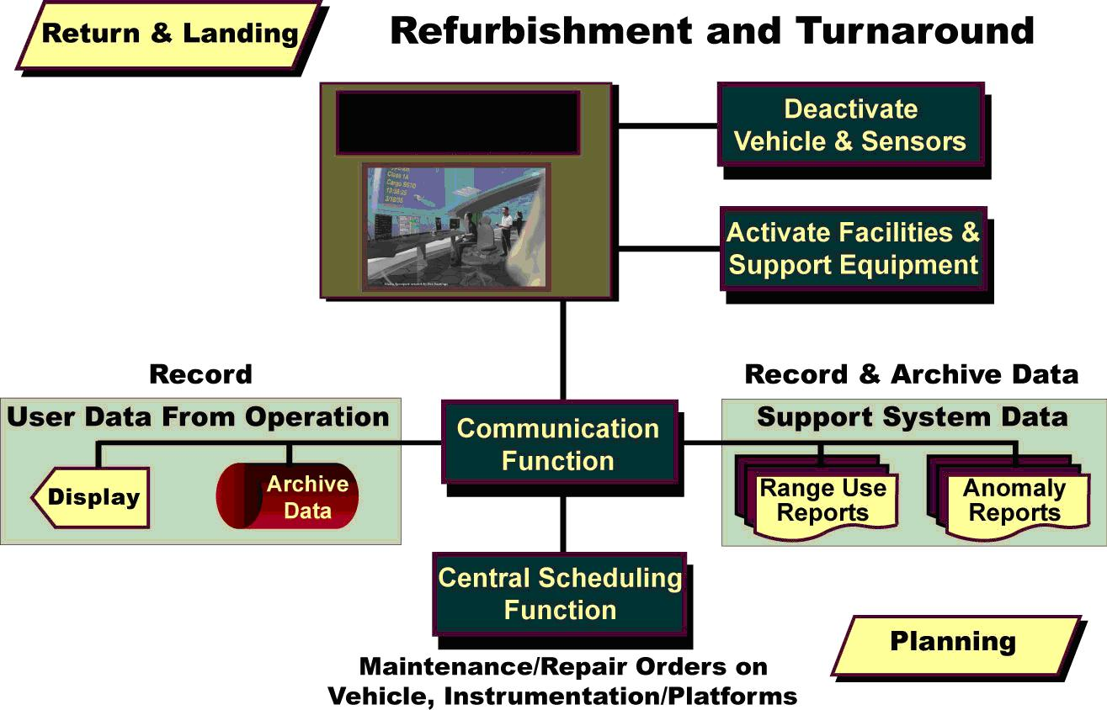
Distributed Network
Figure 21. Refurbishment and Turnaround
5.1.6.2 Data Archival, Analysis and Reporting
Data archival, analysis and reporting includes preserving flight operations and vehicle data. After the completion of a spaceflight operation, this data is analyzed by automated expert systems to provide more complete understanding and insight into such things as vehicle performance, trends, system anomalies, and maintenance or repair actions. The results from this analysis are used to generate post-flight anomaly reports and to schedule maintenance and repair activities.
Data is digitally recorded, stored, archived using expandable, modular, network-accessible systems for mass storage of voice, video and data streaming from each flight. This data is stored in the central archival database and is available at user request without bandwidth and data latency limitations. Final flight data is retrieved as needed by various users in completing post flight analysis and reports.

5.2 Mass Public Space Transportation
Spaceflight operations in the first two eras are transformed over time through incremental technology development steps to make spaceflight safer, more responsive and cost-effective. As a result, in the third era, space travel is transformed from an occasional occurrence to a routine and frequently-used mode of mass public space transportation using a variety of spaceports around the world, as illustrated in Figure 22. This transformation is reminiscent of the growth of the global commercial air transportation system that emerged and grew through the second half of the twentieth century.
The incremental deployment of technologies and standards throughout the previous two eras can be viewed as an incremental, spiral development approach toward a global space transportation model that provides routine, affordable travel to, through, and from space. Spaceports and vehicles comply with compatibility standards in this era, resulting in global interoperability across spaceports, vehicles and various types of control centers. This degree of interoperability allows practically any type of reusable spaceflight vehicle to be processed, launched from, or landed/recovered at virtually any spaceport worldwide. The global network of spaceports—each with standardized interfaces—enables routine hypersonic point-to-point flights to destinations around the world.
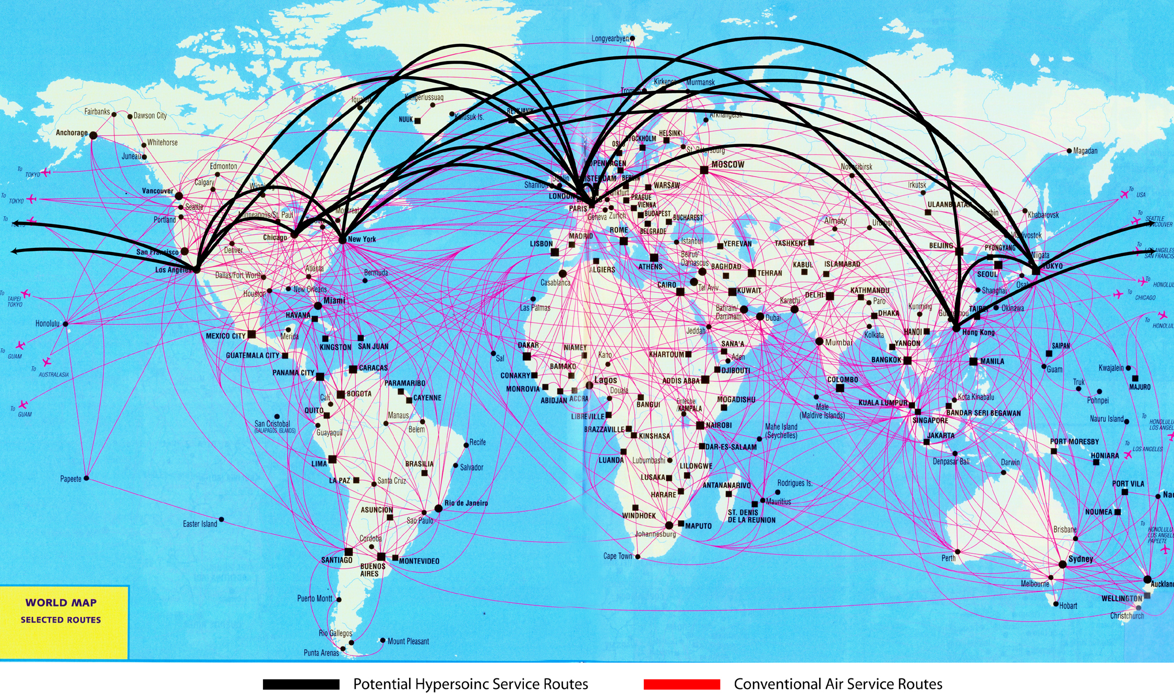
Figure 22. Future Spaceports Around the World
Spaceflight operations in the third era are conducted so frequently and routinely that some of the steps in the lifecycle described above are combined and compressed, as explained in the following paragraphs.
5.2.1 Planning and Scheduling
An important feature of the FSTS in the third era is that flight profiles for suborbital point-to-point flights are constrained by orbital mechanics, so the flight routes between major destinations are well-defined and established for frequent and routine flights. These constraints help to bound the planning and schedule de-confliction processes, helping to make them manageable by automated systems. These automated systems rely on artificial intelligence and sophisticated computer models using real-time situational awareness information to analyze alternative courses of action and automatically develop solutions with a minimum of human intervention.
To enable planning and scheduling during the third era, all launch and support systems are part of an integrated, high-capacity, redundant, self-configuring, secure, worldwide network. This network is controlled and managed by the distributed network-centric architecture, as in the previous eras, but the network is much more extensive in the third era, requiring even more automation and capacity than before to support greater numbers of nodes and operations. The network is accessible by all authenticated operators and users, regardless of their locations, including those who manage spaceport and range support for spaceflight operations, as well as those who provide transportation services by conducting routine spaceflight operations.
The distributed network-centric architecture is now used to manage the functions of dozens of spaceports and hundreds of flights each day. These activities are supported by the same types of control centers that operated during the first two eras. This control center architecture is still analogous to today’s air traffic management system. However, the operators in these control centers in the third era rely on even more heavily on sophisticated automated capabilities to manage more types of vehicles and more frequent flights, including multiple simultaneous operations. Automated data fusion and data mining techniques enable users and operators at each type of control center to quickly extract relevant information from the data that’s being collected and routed on the global network.
State-of-the-art weather forecasting and decision support systems nearly eliminate launch delays and scrubs due to conservatism and buffers to account for the lack of precision in weather forecasts, improving the availability of spaceport facilities and systems to support the routine launch and landing of spaceflight vehicles.
5.2.2 Processing, Refurbishment, and Turnaround
The efficiency of vehicle processing and operations during the third era enables the commercial spaceflight market to flourish and become an integral part of the worldwide multi-modal transportation system. Dozens of flights per day are common at each active spaceport around the world, with takeoffs and landings occurring multiple times per hour. Thousands of passengers depart and arrive on hundreds of hypersonic RLV flights around the world each day, servicing dozens of destinations across the country and all over the globe.
Accommodating such a busy flight schedule drives the need for processing, refurbishment, and turnaround of reusable spaceflight vehicles (and their support systems) between flights in ways that resemble airline processing operations at airports today. That means integrated health monitoring systems are reliable and accurate enough to enable as-needed maintenance actions to be detected and conducted quickly on an exception basis without requiring the flight vehicle to be transported to specialized maintenance facilities. It also means most processing and turnaround operations between flights are conducted in parallel to accommodate tight turnaround schedules. Finally, it means that Vehicle and Payload Processing Control Centers and dedicated facilities are only used for major depot-level maintenance and periodic overhaul or fleet modernization activities—not for routine between-flight maintenance.
Instead, safer and more automated vehicle and ground systems enable more efficient parallel processing and maintenance actions between routine flights. Propellant loading operations use safe, automated, efficient, standardized interfaces and procedures, requiring less time and reduced standoffs compared to today’s systems. All vehicle interfaces at spaceports, including electrical power and air conditioning from ground systems, cargo loading/unloading, and crew/passenger ingress and egress paths, rely on adjustable ground support equipment to accommodate different vehicle configurations, within the limits defined by the widely-accepted standards. In short, in the third era, RLV processing between flights resembles airline operations at gates on the ground at airports today.
5.2.3 Departure and Arrival, Return and Landing Operations
The spaceport operates much like the Terminal Control Center at airports today, controlling departure, arrival, return, and landing operations. The spaceport coordinates departing and arriving flights with air traffic control facilities in the area, and with the space traffic managers with jurisdiction over parts of the world. As the flight vehicle leaves its area of responsibility, the spaceport hands-off responsibility for routing routine suborbital flights to the space traffic manager. For longer flights, it in turn, hands-off responsibility to another space traffic manager along the intended flight path, and so on, until the vehicle arrives at the spaceport where the spacecraft is scheduled to land.
5.2.4 Flight Operations
As vehicles depart the spaceport, future range capabilities (now integrated seamlessly with the spaceport capabilities through the distributed network-centric architecture) provide continuous, robust, and redundant worldwide tracking, telemetry, commanding, and communications coverage. As a result of the spiral development over the previous two eras, space-based and ground-based systems in the third era have the capacity to support increased space transportation traffic. As a result, uncrewed aerial vehicles and high altitude airships are still used to provide additional tracking telemetry, command, control and communications for some specific operations (mainly flight test and evaluation), but these supplemental capabilities are typically not used to support the routine and frequent spaceflight operations between well-established spaceports that characterize the bulk of the activity in the third era.
Incremental technology development over the first two eras reduces the human workload involved in supporting spaceflight operations in the third era. Increasingly sophisticated automated decision support systems allow control center operators and flight crews to concentrate on only those critical decisions and flight-unique operations that actually require human intervention. The use of intelligent expert systems and sensors to improve situational awareness increases safety and reliability and decreases operator workload.
Consequently, operators in control centers are able to support more flights simultaneously. Another benefit is the reduction in human errors from misdiagnosis of anomalous data signatures, lack of complete situational awareness with regard to system health and status, and errors in entering or communicating instructions or commands. Additionally, using standard interfaces and commercial off the shelf (COTS) products to deliver data provide shared situational awareness in real-time for operations personnel dispersed across the nation and the globe, enabling them to work together to achieve a smooth flow of operations and handoffs from one control center to another.
Spaceflight operations in the third era still require a certain amount of human involvement in some activities, however, the use of artificial intelligence and expert systems and self-diagnosing, self-healing systems both on the ground and onboard vehicles, provide rapid anomaly identification and resolution so operators make informed, well-timed decisions during all aspects of flight operations.

6.0 design reference missions
This section describes how future spaceflight operations and activities are conducted to support multiple types of space transportation and flight test activities. These examples were chosen from the three Design Reference Missions (DRM) categories illustrated in Figure 23.
Three Design Reference Mission categories address routine and responsive ops plus T&E.
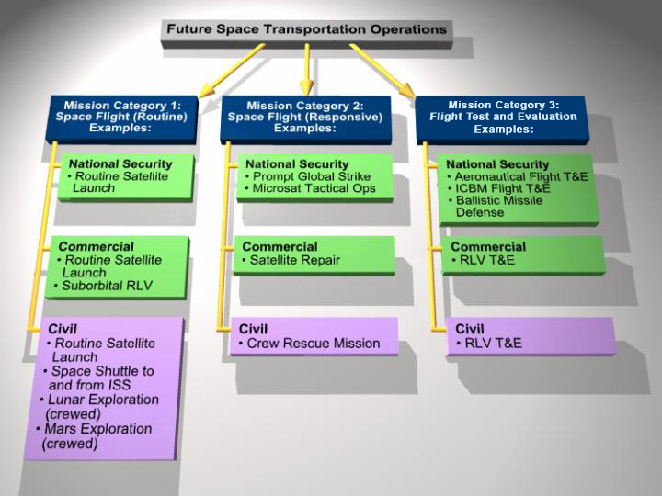
Figure 23. Design Reference Missions and Example Scenarios
The scenario described in this section highlights several examples of spaceflight operations derived from the DRMs, but it only depicts one day’s operations. The context for that day’s operations is depicted in the year-long schedule of activities in Figure 24.

A typical future year, as envisioned for the third era, will include many routine, responsive, and flight test and evaluation activities, with frequent overlapping and concurrent operations.
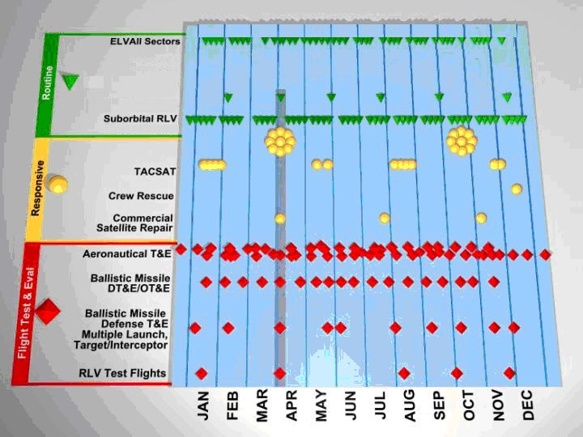
CSM
Ares+Orion
to Moon &

Ares+Orion
to Mars

Figure 24. Example Missions for a Future Year in the Third Era
Each spaceflight operation described in this section was chosen to illustrate how particular functions and capabilities are employed in support of each of the DRMs in the third era, and how the spaceflight concept of operations provides responsive, flexible, adaptable capabilities to support a variety of spaceflight operations and activities, when needed anywhere in the world. As highlighted in Figure 24, the six specific example flights are:
- Routine commercial suborbital RLV flight
- Routine scheduled NASA launch to support a crewed spaceflight to the Moon
- Scheduled NASA launch to support a crewed spaceflight to Mars
- Operationally Responsive Space (ORS) Prompt Global Strike (PGS), and/or Conventional Strike Missile (CSM).
- Flight test of a new prototype DoD Hypersonic Cruise Vehicle (HCV)
- Ballistic Missile Defense System (BMDS) flight test involving two targets and two interceptors

Flight #1 Routine Commercial RLV Flight - A routine, regularly scheduled sub orbital commercial tourist flight from Oklahoma to California illustrates the need for the future range to provide enhanced capabilities in terms of:
Flight Rate | Hundreds of sub orbital flights per year in the second era, characterized by responsive space launch and human exploration, and dozens per week in the third era, characterized by mass public space travel
Responsiveness | Frequent flights, changes to flight plans, contingency operations
Global Coverage | To accommodate takeoffs and landings at dispersed locations
Standardization/ Interoperability | To enable point-to-point flights using multiple spaceports
Evolve Safety | To enable flights of commercial RLVs over populated centers
Flexibility/Adaptability | To support operations to and from new locations
Concurrent Operations | To routinely accommodate multiple simultaneous flights
Minimize Cost Growth | To enable development of commercial tourism, package delivery, and other markets

Flight #2 Routine NASA launch supporting a crewed spaceflight to the Moon - A scheduled launch of a NASA Orion crew exploration vehicle (CEV) aboard an Ares I Launch Vehicle (EELV) to rendezvous with a previously launched heavy lift launch vehicle, Ares V, with a Lunar Surface Exploration Module (LSAM) to embark on a crewed spaceflight to the Moon illustrates the need for:
Evolve Safety | To enable flights of crewed vehicles on expendable boosters
Flexibility/Adaptability | To support operations with virtually instantaneous launch windows
Concurrent Operations | To routinely accommodate multiple simultaneous flights
Minimize Cost Growth | To enable an affordable human exploration program

Flight #3 NASA launch supporting a crewed spaceflight to Mars – A pioneering launch of a NASA super heavy lift launch vehicle to lift some spacecraft elements into orbit to support a first ever crewed spaceflight to Mars illustrates the need for improvements in the following areas:
Global Coverage | To accommodate two-way high data-rate voice, video, telemetry data, command, control, and communication to and from multiple vehicles virtually worldwide, through launch and on-orbit operations, and throughout the course of extended duration deep-space missions
Evolve Safety | To enable flights of crewed vehicles on expendable boosters
Flexibility/Adaptability | To support operations with virtually instantaneous launch windows
Concurrent Operations | To routinely accommodate multiple simultaneous flights
Minimize Cost Growth | To enable an affordable human exploration program

Flight #4 Operationally Responsive Space (ORS), Prompt Global Strike (PGS), and/or Conventional Strike Missile (CSM) – Operationally Responsive Space (ORS) to inspect a damaged spacecraft in orbit and to deliver Conventional Strike Missile (CSM) prompt global strike platforms in response to foreign acts of aggression on United States interests illustrate the need for future spaceflight operations to provide enhanced capabilities in terms of:
Flight Rate | Up to dozens of sub orbital flights per week in the second era, characterized by responsive space launch and human exploration, and dozens per week in the third era, characterized by mass public space travel
Responsiveness | Launch within hours of notification in the first and second era and within minutes of notification in the third era
Global Coverage | To provide continuous, reliable, secure communications connectivity worldwide for telemetry and positive command and control between the operations control center and the launch vehicle, inspection spacecraft, and CSM throughout the duration of the mission, including through plasma during reentry
Standardization/ Interoperability | To enable use of multiple launch sites in the continental U.S. as well as airborne platforms over the Oceans
Evolve Safety | To enable responsive launches during development, operational testing, and operations in response to threats
Flexibility/Adaptability | To support operations to and from new locations
Concurrent Operations | To routinely accommodate multiple simultaneous flights
Minimize Cost Growth | To enable development and use of CSM when needed

Flight #5 - Flight Test of a New, Prototype DoD Hypersonic Cruise Vehicle - A flight test of a new, prototype DoD Hypersonic Cruise Vehicle (HCV) in development illustrates the need for future spaceflight operations to provide enhanced capabilities in terms of:
Responsiveness | Aeronautical systems typically undergo multiple flight tests per day, requiring constant schedule flexibility and short-notice re-scheduling of operations and range support
Global Coverage | To support concurrent operations, each with its own high data-rate telemetry requirements, within the limits of available spectrum
Standardization/ Interoperability | Aeronautical systems (including hypersonic vehicles) operate point-to-point using multiple takeoff and landing sites
Evolve Safety | To enable responsive launches during development, operational testing, and operations in response to threats
Flexibility/Adaptability | To support operations to and from new locations
Concurrent Operations | With various aeronautical systems typically undergoing multiple flight tests per day (resulting in thousands of flight tests per year), it’s very common to have to provide range support for multiple simultaneous operations

Flight #6 Ballistic Missile Defense System (BMDS) flight test involving two targets and two interceptors - A ballistic missile defense system (BMDS) flight test involving two targets and two interceptors, each flying over the Pacific Ocean from different launch locations, tests the ability of the interceptors to engage and destroy the targets during all phases of flight, and illustrates the need to provide enhanced spaceflight operational capabilities in terms of:
Global Coverage | Telemetry, optics, radar, IR/UV coverage over most of the Pacific Ocean
Standardization/ Interoperability | To enable target and interceptor test launches from multiple locations, to support realistic test scenarios that are representative of actual threat scenarios
Evolve Safety | To enable launches and complex intercepts in multiple locations, again in support of realistic and representative threat scenarios
Flexibility/Adaptability | To accommodate frequent flight test operations using multiple locations

The scenario described in this section includes examples to illustrate the operations associated with each of these spaceflight operations, including interactions among them when operations overlap and require concurrent support as shown in 24.

The design reference missions described in this section includes a variety of overlapping and concurrent spaceflight operations.
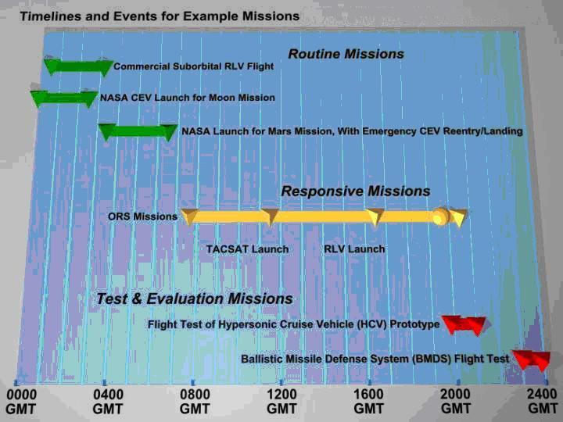
5 CSM Launches
Figure 25. Reference Mission Scenarios
While it is unlikely any actual single day would be quite as eventful as the day described in this scenario, the examples are intended to illustrate how a future network-centric range with global connectivity is able to responsively support various types of concurrent spaceflight operations and activities, using its inherent flexibility and adaptability to transition from one operation to another.
Based on the assumptions listed in Section 3.0, as well as the description of the capabilities in the Architecture section, this scenario is intended to illustrate an integrated, interoperable approach for conducting future civil, national security and commercial space transportation operations that is more:
- Similar to the operation of today’s commercial air transportation system
- Independent of vehicle architecture
- Economical and streamlined than today’s approach to spaceflight operations
- Able to accommodate more frequent flights with shorter lead time
- Able to manage multiple flights and activities simultaneously
- Automated and less manpower-intensive
- Seamlessly integrated with the NAS and NextGen via the Space and Air Traffic Management System (SATMS).
This scenario illustrates how operations are conducted in the third era characterized by mass public space transportation. This section emphasizes the actions of spaceflight operators (whether on-board flight vehicles or in various types of control centers) and their interactions with other elements of the FSTS: spaceports and ranges. It builds on the conceptual architecture and operating models for future spaceflight operations described above, to conduct current, emerging, and projected future national security, civil, and commercial flight operations to, through, and from space.

Routine Commercial Suborbital RLV Flight
A routine commercial suborbital flight from Oklahoma to California highlights needs for responsive support from various Control Centers with the capacity to support frequent and concurrent flights, standardization & interoperability to support point-to-point flights, safety approvals for overland flight, flexibility and adaptability to accommodate schedule changes, and low-cost operations to sustain and expand commercial markets.

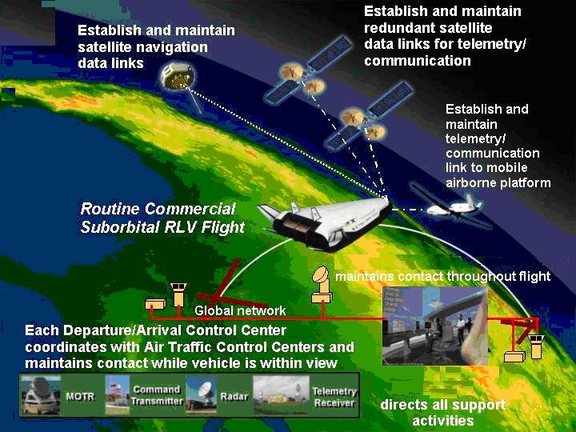
Distributed Network
(Spaceport)
Space Traffic Management
Figure 26. Operations Support for Commercial Suborbital RLV Flight

NASA Crew Exploration Vehicle (CEV) Launch to the Moon
A NASA launch of a crew exploration vehicle (CEV) for a human expedition to the moon highlights the need for evolved safety to enable flights of crewed vehicles on expendable boosters, flexibility and adaptability to support operations with virtually instantaneous launch windows, concurrent operations to routinely accommodate multiple simultaneous flights, and minimized cost to enable an affordable human exploration program.

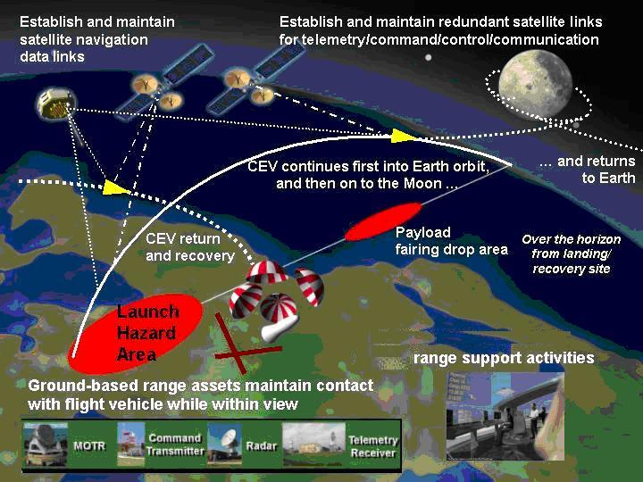
Distributed network used to coordinate
Figure 27. NASA Launch of Crewed Spaceflight to the Moon

6.3 NASA Super Heavy Lift Vehicle for Spaceflight to Mars
A NASA launch of a super heavy lift vehicle to support a crewed spaceflight to Mars highlights the need for more efficient use of frequency spectrum to provide telemetry, command, control, and communication links with sufficient capacity.

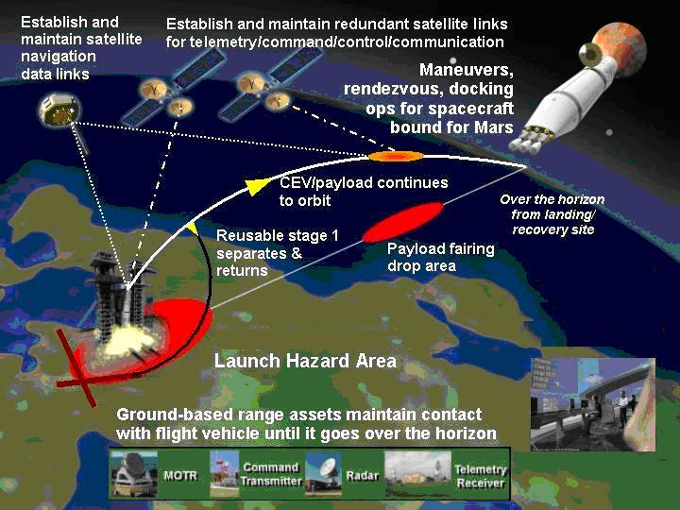
Distributed network used to coordinate range support activities
Figure 28. NASA Launch of Crewed Spaceflight to Mars

6.4 Operationally Responsive Space (ORS), Prompt Global Strike (PGS), and/or Conventional Strike Missile (CSM)
Operationally Responsive Space (ORS) launches of prompt global strikes highlight the need for responsive operations with the capacity to support frequent and concurrent flights, global communication connectivity for positive control throughout the flights, standardization & interoperability to support launches from multiple locations, safety approvals for responsive flights, flexibility and adaptability to accommodate frequent flights from multiple locations, efficient use of frequency spectrum for secure communication worldwide, and through plasma during reentry, and low-cost operations.

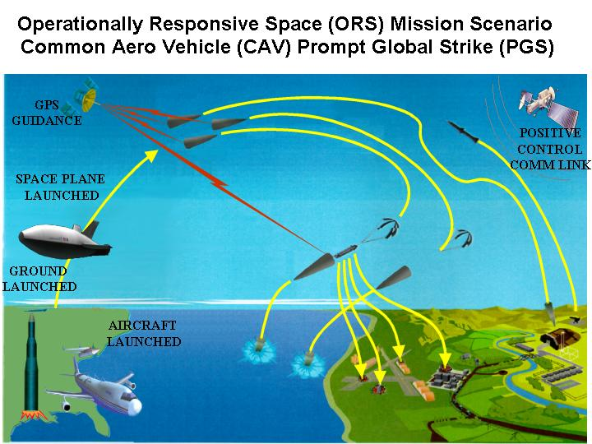
Operationally Responsive Space (ORS) Mission Scenario
Prompt Global Strike and/or Conventional Strike Missile (CSM)
Figure 29. Operationally Responsive Space (ORS) Prompt Global Strike (PGS) and/or Conventional Strike Missile (CSM)

6.5 Flight Test of a New Prototype DoD Hypersonic Cruise Vehicle (HCV)
Flight test & evaluation of a new prototype DoD hypersonic cruise vehicle highlights needs for responsiveness to support multiple concurrent aeronautical flight tests per day, standardization and interoperability to enable point-to-point flight operations, and efficient use of frequency spectrum to support high data-rate requirements for multiple vehicles.

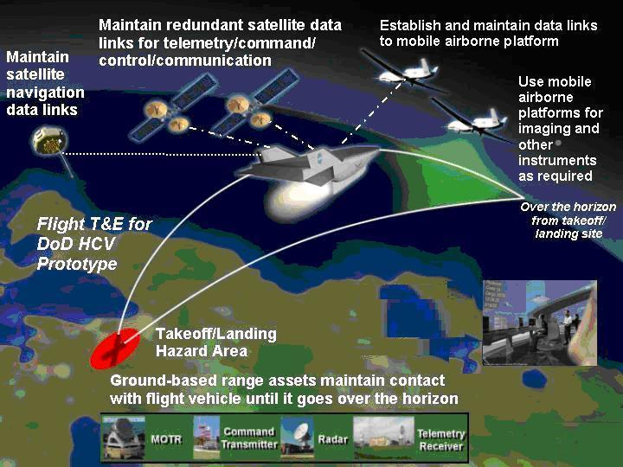
Distributed network used to coordinate range support activities
Figure 30. Flight Test & Evaluation for New Prototype DoD Hypersonic Cruise Vehicle (HCV)

6.6 Ballistic Missile Defense System (BMDS) Flight Test
A mission scenario depicting a two-on-two ballistic missile defense system (BMDS) flight test involving two targets and two interceptors. Each launched from a different location highlights needs for global coverage to provide telemetry, optics, radar, and other support over broad ocean areas, standardization and interoperability to enable target and interceptor launches from multiple locations, evolved safety approval processes to enable complex intercept tests, and flexibility and adaptability to accommodate frequent flights and schedule changes.

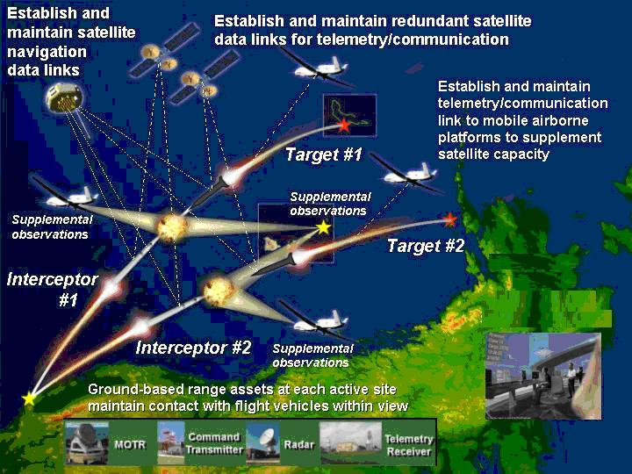
Distributed network used to coordinate range support activities
Figure 31. Two-on-Two Ballistic Missile Defense System Flight Test

7.0 ENABLING CAPABILITIES
This section describes the enabling capabilities that will be necessary to enable future spaceflight operations as described in this ConOps. While it is not the primary purpose of this ConOps to envision new technologies or capabilities, this ConOps is intended to describe new ways of operating with technologies or capabilities that are likely to exist in the future. Hence, this section describes a variety of technology areas and standardization approaches that address the technical challenges that stand in the way of achieving the necessary capabilities to enable future spaceflight operations as envisioned.

7.1 Technologies
This enabling technology roadmap presents a time-phased approach to addressing the technical challenges associated with achieving the necessary capabilities for the envisioned future spaceflight operations described in this ConOps.
Figure 32. Enabling Technology Roadmap
The enabling technology roadmap depicted in Figure 32 presents the recommended time-phased approach to pursuing these technology development and demonstration activities over time. The five technology areas addressed in this section are:
- Self-Healing Systems
- Network and Data-Handling
- Integrated Software Planning and Scheduling
- Modeling and Simulation
- Weather Measurement and Forecasting
The remainder of this section describes opportunities and recommendations regarding development and demonstration activities that should be pursued to address each of these areas and enable the future spaceflight operations capabilities envisioned in this ConOps.
7.1.1 Self-Healing Systems
Technology development and demonstration activities to enable the incorporation of integrated health monitoring, auto-configuring and self-healing capabilities into future spaceport, range, and flight vehicle systems will:
- Enhance reliability and availability;
- Enable automated planning, scheduling, coordination and configuration of spaceport and range assets to support responsive and concurrent ground processing and spaceflight operations at a higher operations tempo;
- Support improved real-time situational awareness based on area surveillance and flight vehicle information; and
- Enable automated decision-making support capabilities.
This enabling technology area could be pursued in the near-term by adapting built-in test equipment from the automotive and aviation industries, along with use of software wrappers to enable continued use of some legacy spaceport and range systems in the new network-centric environment while individual new systems are incrementally brought on-line to improve future range operations. In the mid-term, these technologies could be combined to enable the development of self-diagnostic systems. The roadmap also recommends pursuing parallel near- and mid-term technology improvements in tiny sensors along with modeling and simulation to better predict component and system failures as means of enhancing the built-in diagnostic capabilities of range systems.
In parallel, near-term technology efforts to improve interoperability and remote repair capabilities could enable evolution in the mid-term to technologies for automated system configuration and tele-operations to accomplish repairs of remotely-located systems and components. All of these technologies could be combined in the far-term to enable systems with integrated and autonomous health monitoring, diagnostic, auto-reconfiguration, and ultimately, self-healing capabilities.
7.1.2 Network and Data Handling
Improving the data handling and network capabilities to distribute, record, store, archive, and retrieve voice, video, and data over the global network will:
- Improve interoperability among spaceports, ranges and control centers, with national airspace management systems, and with user networks and systems.
- Take advantage of common, standard interfaces, protocols, and formats for processing, transferring, displaying, and coordinating data and information so it can be fused and integrated more simply for information displays depicting situational awareness.
- Leverage use of commercial-off-the-shelf systems that incorporate standard, expandable, plug-and-play capabilities and network architectures to enable use of advanced data handling capabilities being developed for a variety of applications, as well as a variety of innovative digital data storage and display capabilities.
Technology efforts in this area focus on leveraging ground and wireless network development efforts being pursued for commercial applications. Technologies to improve ground-based networks include near-term integration of digital voice, video, and data streams along with development of new protocols and next-generation Internet research that’s already being pursued for a variety of commercial applications. These technologies should be further refined, combined, and leveraged to ensure that future range data transport systems are compatible with the planned and emerging Global Information Grid.
Data handling technologies should focus in the near-term on standard interfaces and plug-and-play algorithms. In parallel, future technology development efforts should focus on enabling increasingly sophisticated levels of data fusion from a variety of disparate sources, starting with rule-based methods, then incorporating fuzzy logic, and expert systems later. Meanwhile, the development of standards and protocols to document data and network-based embedded software should be pursued in parallel to enhance the compatibility of data and simplify its combined use.
Commercial advances in computing technologies should also be leveraged and pursued in parallel to enhance data handling capabilities on ranges. Under the data processing heading, commercial technologies to improve the speed of processors, coding and embedded processors, including serializer/deserializer (SerDes) chips and associated protocols, should be leveraged to enhance global network capabilities.
With regard to digital data recording, storage, archiving, and retrieval, commercial off the shelf, expandable, modular, network-accessible, automated mixed media library systems are available today to enable access to more than a dozen types of storage media. A wide variety of research projects are currently underway for a variety of commercial and defense applications. Some explore new digital data recording, storage, archiving, and retrieval architectures concepts, techniques, and implementations that reduce data bandwidth and data access latency limitations. commercial efforts to improve data recording and archiving technologies (e.g., magnetic, optical, and hybrid arrays) should also be leveraged for use as part of the global network supporting spaceflight operations. Others are intended to simplify the design of complex embedded systems by focusing on ways to automate network controller design and systems integration. Still other projects are pursuing standards for high-density optical, magnetic, volumetric, hybrid, organic, cellular, and tissue-based memory systems that are less sensitive to losses induced from reading the data. All of these technology development activities could be leveraged to improve the ability of the FSTS and its global network to efficiently handle data.
Finally, display technologies should address improvements in human-machine interfaces, human factors, and various technologies to enhance the ability to display information in ways that are both intuitive and meaningful to system operators and users as well as flight crews.
7.1.3 Integrated Software Planning and Scheduling
Various integrated software planning and scheduling technologies should be leveraged from the commercial sector to:
- Improve the efficiency of planning, scheduling, and coordinating spaceport, range, and control center support, and
- Enable centralized control of more complex and frequent global operations.
These include commercial efforts to develop increasingly sophisticated, automated, and autonomous tools using rule- and knowledge-based algorithms, data mining techniques, and methods of standardization and integration to enable sharing of databases and automation of scheduling functions, including de-confliction of large numbers of operations using limited resources. Information assurance principles must be included and addressed in parallel to enable these capabilities to be applied in applications that could include safety and security risks associated with spaceflight operations.
7.1.4 Modeling and Simulation
Technologies to improve modeling and simulation apply to a variety of spaceflight operations functions, but focus in large part on:
- Safety, as enhanced by automated decision-making analysis and support, relating to toxic, debris, and collision hazards;
- Weather-related constraints, including modeling of atmospheric and environmental parameters in combination with the dispersal characteristics of leaking or exploding propellants and vehicle debris after breakup;
- Simulation of the reliability and failure modes of spaceport, range, and control center assets to support planning, scheduling, and coordination of assets for operational use and maintenance/repair; and
- Training, using sophisticated modeling and simulation capabilities.
Data handling technologies described above can contribute to modeling and simulation, but technologies to improve visualization and integration of modeling outputs should also be pursued to take full advantage of the increasingly capable models. Increasingly capable models also rely on more accurate input data and more complete understanding of physical processes, so improved sensor capabilities can also contribute to improvements in this area.
Three technology areas would have to be developed together to enable enhancements in collision avoidance: increasingly sophisticated predictive models for air and space traffic, adaptive guidance/navigation/control technologies that can respond correctly and in time to avoid impending collisions, and automated systems to assist in executing collision avoidance maneuvers within the structural limitations of vehicles in various phases of flight from launch through landing.
7.1.5 Weather Measurement and Forecasting
A variety of technologies should be pursued to enhance the ability of spaceports and ranges to measure and forecast weather conditions, including lightning, to enhance the safety and efficiency of ground processing and flight operations.
These include improved sensor technologies, first on the ground and later as instruments to be carried on space-based or mobile airborne platforms, improved models to take multiple conditions and phenomena into account in modeling and forecasting regional (or meso-scale) weather patterns. Communicating the inputs and results of these improved models also requires improvements in technologies for data assimilation and fusion, combined with computerized output generation and communication.
As a final note, many of the technology areas listed above and depicted on the enabling technology roadmap overlap with many other areas of applicability besides spaceflight operations. This overlap leads to possibilities for synergy and collaboration to advocate, develop, and demonstrate technologies with a variety of applications, both on and outside ranges.

7.2 Standardization
Even today, the nation’s spaceports, ranges, and control centers are the product of substantial investments to provide shared-use supporting infrastructure for flight test and operational spaceflights. For future spaceflight operations capabilities, standardization is an important element of any strategy to increase availability of shared resources and boost interoperability among vehicles operating to and from multiple locations—a key element of the vision for future civil, commercial and military space transportation that involves routine and frequent point-to-point flights.
Designing flight vehicles to be compatible with a standard set of spaceport, range, and control center interfaces would reduce the total amount of infrastructure required to support projected future missions, enhance interoperability by providing a common network-centric architecture for connecting assets, improve safety (especially under emergency conditions), and reduce total costs.
Standardization is most economical and operationally beneficial in cases—as envisioned for the third era—characterized by mass public space transportation and:
- High operations tempo (i.e., more traffic)
- Many different vehicle types interfacing with the same support infrastructure
- Multiple takeoff/launch/landing/recovery locations in use to support point-to-point flights.
Adopting standards will also lead to benefits in designing future in-space infrastructure in and beyond Earth orbit to support the U.S. vision for space exploration to pursue Moon and Mars exploration. The in-space navigation and communication infrastructure that will be required to support these operations could leverage advanced technologies developed initially for terrestrial applications.
Examples of areas where standardization will be both beneficial and practical for enhancing the nation’s ability to conduct spaceflight operations include:
- Wireless communication protocols
- Schedule integration
- Shared common databases
Standardization of spaceport, range, and control center infrastructure is not a new concept, but it is essential to achieve the NextGen vision. Standards will only be accepted if they benefit users by providing economic advantages, improved capabilities, or more efficient operations. Any standards development activities for the future of spaceflight operations must be coordinated with and leverage established standardization organizations and processes.

8.0 NextGen Capabilities

There are needed capabilities within NextGen to support the space transportation ConOps. These are:

Integrated communications, navigation and surveillance (CNS) services;
- automated spaceflight management tools;
- policies, procedures and standards for safely separating space and air traffic, and managing the risk associated with space vehicles operating within extended NAS boundaries.

Integrated CNS Services
NextGen will need to accommodate spacecraft transitioning to and from space through the NAS. To accomplish this, space and air traffic operations will need to be seamlessly integrated under a common CNS infrastructure. Air traffic service providers will need to obtain real-time space vehicle data (i.e., position and state vectors) for situational awareness to support Collaborative Air Traffic Management (CATM) and to protect air traffic from hazards associated with spaceflight operations.
Automatic Dependent Surveillance – Broadcast (ADS-B) can transmit Global Positioning System (GPS) derived data (time, position, type, speed, and aircraft identification) by means of a broadcast-mode data link to users that are equipped to receive and process the data. In addition to providing local air traffic information to the flight deck, aircraft track data is transmitted to air traffic controllers on the ground. The FAA anticipates that ADS-B will provide many benefits, including extending the coverage of current ground-based secondary surveillance radar, especially in en route and terminal areas, to increasing air-to-air situational awareness, as well as on airport surfaces to reduce incursions. ADS-B is being developed to meet future aviation requirements. However, space vehicles transitioning to and from space will also be operating in ADS-B serviced airspace. An enhanced version of ADS-B that also meets the navigation and surveillance needs for space vehicles operating within extended NAS boundaries will be needed.
Track data and other space vehicle state information could be provided to air traffic services via satellite data link and disseminated over the System-Wide Information Management (SWIM) network. According to the current Communications Enterprise Architecture (EA), the FAA is planning to conduct studies to identify needs, requirements, and designs for mobile air/ground communications. The EA roadmap shows digital aeronautical-mobile services being developed in the 2008-2018 timeframe and commercial satellite communications capabilities being developed in the 2016-2022 timeframe. Aeronautical Data Link (ADL), another key component of the EA, is scheduled to be developed in the 2008 to 2012 timeframe, with enhancements to provide expanded services being developed in the 2016 to 2022 timeframe. This migration to a space-based aeronautical communications architecture offers an opportunity to include new customers, such as space vehicles, in the future communications infrastructure not as add-ons, but as integrated components of NextGen.
The FAA currently requires that operators have two independent methods of tracking their space vehicles during ascent and descent. ADS-B could satisfy one method of tracking, and an onboard Inertial Navigations System (INS) with ADL could serve as the independent backup method. Typically, telemetry data, which includes INS state vectors and other vehicle and payload data, is down-linked from the rocket to the mission control center (MCC) and the range during flight. In the future, communications satellites could provide that link and an interface to SWIM. SWIM will be both an information sharing and an application integration platform which can provide authorized users and applications the ability to securely obtain information in the required format from source(s) at the appropriate time(s), independent of location. Furthermore, SWIM will be compatible with other agency information systems such as the Department of Defense’s (DoD’s) Global Information Grid (GIG) Enterprise Services and other data sources.

The FAA, NASA and DoD are developing space-based CNS capabilities for similar reasons – all three agencies believe that a space-based architecture provides global CNS services at a lower cost than ground-based systems. Additionally, space and air traffic operations are greatly affected by weather. These space and air traffic systems have traditionally been, for the most part, separate and independent from each other. Below are some of the benefits of developing a common integrated space-based CNS infrastructure for both air traffic and space operations:

- It should be cheaper to combine the resources of three agencies to develop space-based CNS services, than if each agency were to independently develop separate systems.
- The NextGen plan, which represents the interests of seven federal agencies, calls for the harmonization of avionics and procedures worldwide. An integrated space-based CNS infrastructure is probably the only feasible architecture to accomplish this goal.
- SATMS will require integrated CNS services and a situational awareness picture that can provide flight plan, vehicle state, and CATM information for both aircraft and space vehicles operating in the NAS.
- A common space-based CNS infrastructure is probably the best method to satisfy an FAA licensing requirement for tracking space vehicles, while also providing data to make national traffic flow management decisions that are equitable for all NAS users, especially as more spaceports become operational in the future.

Spaceflight Management Tools
Advances in vehicle design, avionics, and air and space traffic management technologies will make frequent commercial space access a reality. Spaceflight management tools will be needed to help air traffic service providers manage a diverse traffic mix of aircraft and space vehicles operating within extended NAS boundaries. These tools will require interfaces with space mission control centers, range, weather, spacecraft, launch and landing support vehicles, and possibly other data sources to provide situational awareness information.
Space transition corridor status information, space and air traffic scheduling, and over-flight hazard area and exclusion zones, which vary with time in size and geometry, will be managed with the help of advanced decision support tools. The FAA is currently developing prototype tools that could be used for off-line strategic planning and tactical real-time operations. The tools will provide for centralized command at the Air Traffic Control System Command Center (ATCSCC), with localized control at Air Route Traffic Control Centers (ARTCCs) and Terminal Radar Approach Control (TRACON) facilities. The primary function of these tools will be to mitigate the risk to aircraft in close proximity to space operations. Range and spaceport operators and the FAA must ensure that surrounding airspace is clear of aircraft and that procedures to protect the flying public from hazards associated with spaceflight operations are implemented. In the off-line mode, simulation and modeling tools will support the approval process for spaceport site licenses, and space vehicle operator’s licenses and permits. Pre-flight planning tools will be used to evaluate the impact of space operations on air traffic, and will help mission planners and air traffic service providers to find optimal solutions to safely manage concurrent operations. In real-time, space vehicle track data will be integrated with air traffic data vis a common CNS infrastructure. Tactical tools will be used to monitor operations, and when necessary, to implement procedures that protect air traffic from potential hazards.

Policies, Procedures and Standards
The following lists some issues and challenges with developing new policies, procedures and standards for integration space operations into NextGen:

- Define new upper limits to the NAS and establish air traffic procedures for issuing clearances for operating within expanded NAS boundaries, including space transition corridors (STCs).

- Establish new flight plans for space operations, and processing and disseminating flight plan data to the appropriate stakeholders.

- Establish new air traffic procedures for space vehicle flight régimes such as controlled power ascent and descent, aircraft-ferried spacecraft, uncontrolled parachute descent, glider, etc.

- Develop air traffic standards for separating aircraft and spacecraft in shared airspace while accounting for potential hazards and safety considerations associated with space vehicles, such as debris dispersion, toxic plume, overpressure shock wave, hazardous materials, unscheduled de-orbit, etc.

- Determine flight deck, mission control, and air traffic control distributed air-ground decision making authorities and responsibilities.

- Establish rules and procedures for operating autonomously controlled and remotely controlled vehicles, such as expendable launch vehicles (ELVs).

- Establish standards and protocols for interfacing space CNS systems with air traffic systems.

- Determine controller workload and crew rest requirements for space operations.

- Develop standards for evaluating and approving proposed spaceflight operations, new vehicle concepts, and demonstrating new air traffic procedures.

APPENDIX 1 – GLOSSARY
Abort. A premature termination of an operation for any reason. The abort may occur at any point from initiation of an operation to expected completion.
Airspace. Space above the surface of the earth or a particular portion of such space; usually defined by the boundaries of an area on the surface, projected upward. Controlled airspace is the space within which some or all aircraft may be subject to air traffic control.
Analysis. The verification by quantitative/qualitative evaluation using system, subsystem, or component representation (e.g., mathematical and/or computer models, simulations, algorithms, equations), charts, graphs, circuit diagrams, and representative data or evaluation of previously qualified equipment.
Archive. This function stores data for subsequent retrieval.
Asset. Anything available to the range that can be scheduled. Examples of assets include instruments, facilities, vehicles and personnel. Consumables are not assets.
Automated. The application of methods for making processes, functions, algorithms, or equipment self-acting or self-moving; to make automatic.
Availability. A measure of the degree to which an item is in an operable and committable state at the start of a flight when the flight is called for at an unknown (random) time. Availability is dependent on reliability, maintainability, and logistics supportability.
Centralized. A capability of assets, group of assets, components, functions, or processes anywhere in the LTRS such that they can be monitored, controlled, displayed, recorded, etc.
Collect. The acquisition of data from various sources including sensing, signal reception, generation, measurement, and observation.
Commercial-Off-The-Shelf (COTS). Commercial product/equipment designed for commercial use. It is procured exactly as found in the commercial market, and the product/equipment changes and upgrades are the same as vendor provides to his commercial customers.
Concept of Operations (ConOps). An Air Force document which describes the sequenced actions and capabilities required to generate the desired effects needed to achieve military objectives.
Concurrent. The occurrence of separate activities or events during the same time interval, where the individual steps of the separate activities or events do not necessarily occur at precisely the same time.
Configuration. A collection of interfaced assets supporting a particular spaceflight operation.
Configure. The act of arranging components to operate in a defined state.
Countdown. See "launch countdown"
Data. Information that is used as a basis for mechanical or electronic computation, or a collection of facts, numbers, letters, symbols, etc., from which a conclusion can be drawn. Range data may be raw or processed, and in analog, digital, hard copy, and/or electronic formats. Types of data include but are not limited to; telemetry, space object, timing, weather, metric, imaging, range asset health and status, voice, hazard, vehicle uplink, and data products.
Debris. The parts of a launch vehicle, satellite, missile, or reentry vehicle that are either jettisoned, broken off, or a result of flight termination.
Deconflicted. Asset(s) or group of assets that have no higher priority required, and/or are not scheduled to be in use.
Display Data. Visual presentation of information (e.g., graphical, textual or discrete "image"). Display function determines not only the information to be shown, but the methods of presentation. Various purposes for displays are: 1) Continuous system control, 2) System status monitoring, 3) Briefing, 4) Search and identification, and 5) Decision making. Information can be presented on a surface, cathode ray tube (CRT) window, or screen.
Distribute Data. To prepare data for transmission, including: identification of the destination(s) for data, formatting data appropriate for the destination(s), and presentation of data to the transport media, either physical or electronic.
Failure. The loss of proper service that is suffered by the user interface to the asset.
Hold. A temporary interruption of a launch countdown script.
Image. The representation of an object by optical, microwave, chemical, or other processes.
Instrumentation. Devices or a system of devices used to collect and/or process data.
Interoperability. A measure of the ability to seamlessly share data and information with other sources, systems, agencies, etc.
Launch Commit Criteria. The implied decision tree which determines the go/no-go decision for the launch. Range safety and the range user will each have their own independent criteria.
Launch Countdown. The operation implementation of the scripted procedure that ends in the "commit to launch."
Maintenance. The technical process of keeping LTRS equipment in an operational state, or repairing a malfunctioning unit once the equipment is in use. The act of preserving LTRS (e.g., hardware, or software) from failure or decline. Maintenance is one element of sustainment that can begin before the system is deployed in the field.
Operation. Any procedure, function requiring the use of resources.
Operationally Responsive Space (ORS).
Readiness. A measure of the ability to immediately execute an assigned activity or operation.
Reusable Launch Vehicle (RLV).
Reconfiguration Time. The time from final range release of an asset from one operation to asset ready to support a countdown or the next scheduled range operation. Reconfiguration is a known, pre-planned activity that includes asset deconfliction, configuration, calibration, and verification. Reconfiguration time excludes asset relocation.
Record. This function stores data, short term, for subsequent playback.
Reliability. Reliability is the probability that a system is operable and can perform its required function for the spaceflight operation’s duration or a specified period of time. For the reliability requirements, this is represented by the probability that, under stated initial and operational conditions, the Range will be able to sustain specific functional capabilities over a designated period of time (t, defined below), without incurring a loss of those functional capabilities.
Retrieval. This function allows selective recovery of data from the storage media and provides it to the authorized requester.
Schedule [noun]. Published interdependencies of assets allocated to a particular activity or related sequence of activities, set for exact location(s), date(s), and time(s) that do not conflict with the use of assets allocated to other activities.
Standardization. The use of standard requirements to maintain performance over a wide range of common applications. Standardization applies to hardware, software, services, methods, and other processes.
Support. An activity which enables the fulfillment or accomplishment of a separate activity.
Telemetry (TLM). The process by which a measurement of a quantity is transmitted from a remote location to be recorded, displayed, or processed.
Test. The verification through systematic exercising of an item under appropriate conditions, with instrumentation and data collection and processing (followed by analysis and evaluation of quantitative data).
User. A Military organization, Government agency, civil, or commercial organization that makes use of range services and/or facilities.
Verification [by Demonstration]. The qualitative determination of properties or function of an end-item or component by observation. Demonstration will be used with and without special test equipment, simulators, recorded data and scenarios to verify requirement characteristics such as operational performance, human engineering features, service access features, transportability, display data and integration integrity.)

APPENDIX 2 – ACRONYM LIST
ADL Aeronautical Data Link
ADS-B Automatic Dependent Surveillance – Broadcast
AFSPC Air Force Space Command
ASAT Anti-Satellite
ATC Air Traffic Control
BMDS Ballistic Missile Defense System
CATM Collaborative Air Traffic Management
CSM Conventional Strike Missile
CEV Crew Exploration Vehicle
ConOps Concept of Operations
COTS Commercial Off the Shelf
DoD Department of Defense
DO T&E Director of Operational Test and Evaluation
DRM Design Reference Mission
ELV Expendable Launch Vehicle
EELV Evolved Expendable Launch Vehicle
FAA Federal Aviation Administration
FAA/AST Associate Administrator for Commercial Space Transportation
FIRST Future Interagency Range and Spaceport Technologies
GIG Global Information Grid
GMT Greenwich Mean Time
GPS Global Positioning System
HCV Hypersonic Cruise Vehicle
INS Inertial Navigations System
IVHM Integrated Vehicle Health Monitoring (System)
KSC Kennedy Space Center
LEO Low Earth Orbit (altitude above 100 mi.)
MCC Mission Control Center
NAS National Airspace System
NASA National Aeronautics and Space Administration
NextGen Next Generation Air Transportation System
ORS Operationally Responsive Space
PGS Prompt Global Strike
RLV Reusable Launch Vehicle
SATMS Space and Air Traffic Management System
SWIM System-Wide Information Management
STC Space Transition Corridor
TACSAT Tactical Satellite
TT&C Telemetry, Tracking and Control
T&E Test and Evaluation
UAV Unmanned Aerial Vehicle

