National Park Service  U.S. Department of the Interior | Great Basin National Park  Use the complete site name here (e.g. Palo Alto Battlefield Historic Site). |  | 100 Great Basin National Park  Baker, Nevada 89311  775-234-7331 phone  775-234-7269 fax
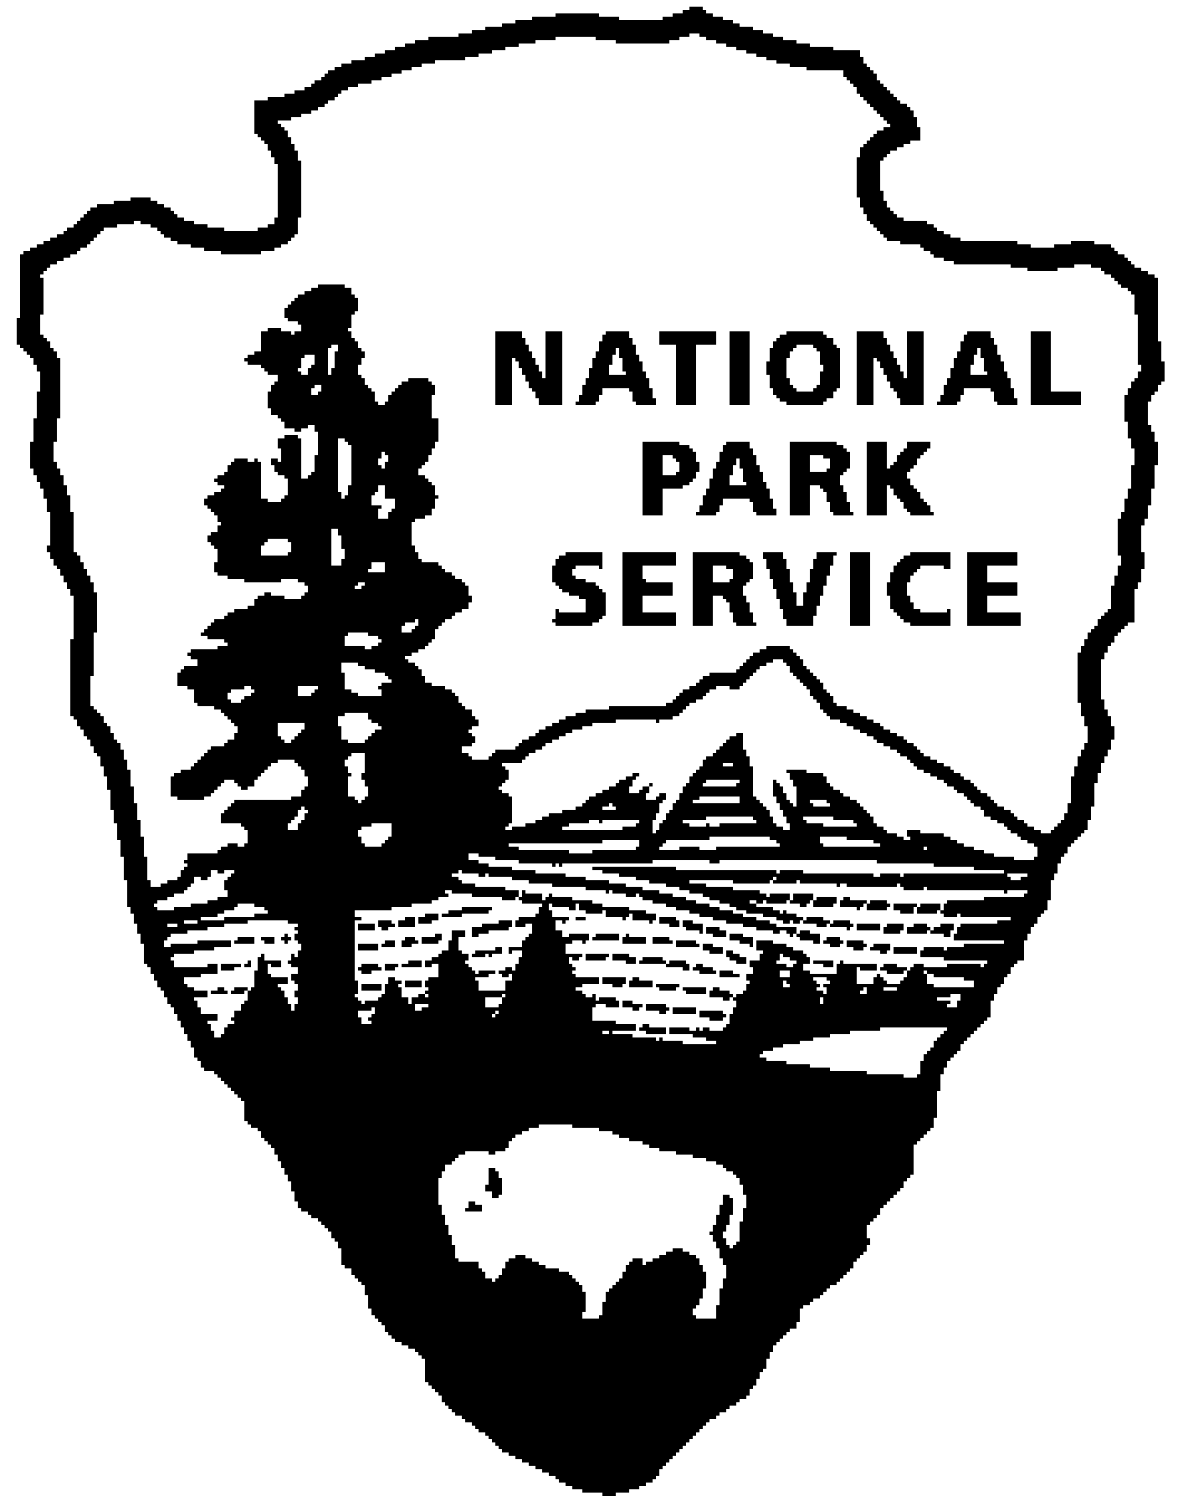
Great Basin National Park News Release
Use a “short-hand” version of the site name here (e.g. Palo Alto Battlefield not Palo Alto Battlefield National Historical Site).

Release Date: Immediate

Contact: Roberta Moore, Park Ranger

Phone Number: (775) 234-7331

Email: Roberta_Moore@nps.gov

Date: August 2, 2007

Great Basin National Park
Night sky program August 11 & 12

Great Basin National Park will host two night sky programs, Saturday, August 11 and Sunday August 12. Both programs will be held at the Great Basin Visitor Center on Highway 487 in Baker, Nevada. These programs are free and open to the public.
The best opportunities to see the annual Perseid Meteor Showers are August 11 and 12. Salt Lake Astronomy Society’s Tom Sevcik will present a special program Saturday night at 8:30 p.m. (PDT), talking about digital camera use and taking photos of the meteor showers. This part of the program will also cover how the public can take part in the scientific survey of the Perseid Meteor Showers, conducted by the International Meteor Organization (IMO). At approximately 9:00 p.m. visitors will be able to participate in star program viewing night sky objects such as planets, stars, galaxies and star clusters.
August 12 at 9 p.m. (PDT) the public is invited to gather at the Great Basin Visitor Center to view impressive Persied meteor displays. Early evening Persied meteors enter the Earth's atmosphere at a low angle, thus "skimming" the upper layers while at the same time making for some of the most breath-taking views of the shower's members. Participants are invited to participate in the IMO scientific survey. Participants should bring jackets, a flash light, a folding chair.

-NPS-

