TECHNICAL NOTE

USDA - Natural Resources Conservation Service
Boise, Idaho – Salt Lake City, Utah – Spokane, Washington

Biology Technical Note No. 24 SEPTEMBER 2007

PLANTS FOR POLLINATORS
IN THE INTERMOUNTAIN WEST

Dan Ogle, Plant Materials Specialist, NRCS, Boise, Idaho
Jim Cane, Bee Biology and Systematics Lab, ARS, Logan, Utah
Frank Fink, State Biologist, NRCS, Boise, Idaho
Loren St. John, Manager, NRCS, Plant Materials Center, Aberdeen, Idaho
Mark Stannard, Manager, NRCS, Plant Materials Center, Pullman, Washington
Tim Dring, State Biologist, NRCS, Spokane, Washington
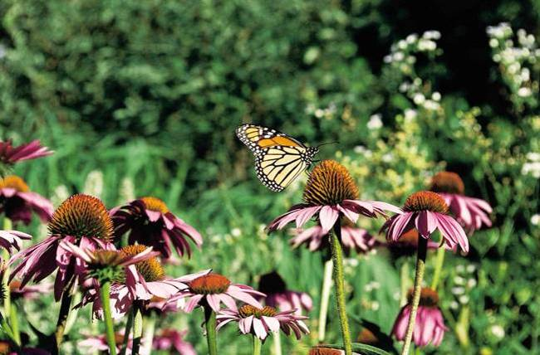

MONARCH BUTTERFLY ON A PURPLE CONEFLOWER

The purpose of this technical note is to provide information on perennial flowering species including forbs, legumes, shrubs and trees and the design and implementation of plantings to enhance habitat for floral visitors and pollinators including bees, wasps, butterflies, moths and hummingbirds.

PLANTS FOR POLLINATORS IN THE INTERMOUNTAIN WEST
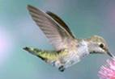
Many of the world’s crop species benefit from insect pollination mostly provided by bees. In North America, honey bees pollinate about $14 billion dollars worth of crops annually and native bees for an additional estimated $3 billion. Up to one quarter of our diet comes from crops whose production benefits from pollinating bees.

Pollinators include bees, moths, flies, beetles, wasps, desert bats,
hummingbirds, and butterflies. Many of these are critical to the
function of terrestrial ecosystems because they enhance plant reproduction. Plants, both native and introduced species, provide food and cover for numerous wildlife species, help stabilize the soil and serve as buffers to improve water quality. As a group, pollinators are threatened world-wide by habitat loss, habitat fragmentation, pesticides, disease and parasites. This has serious economic implications for humans and for ecosystem diversity and stability.

The Natural Resources Conservation Service can assist landowners with habitat enhancement for pollinators by encouraging the establishment of an array of attractive plants that flower throughout the growing season, especially early spring and late fall. Plants, both herbaceous and woody species, that provide a source of nectar, food and cover habitat for adult and immature pollinators, will also provide habitat for a large array of other wildlife species.
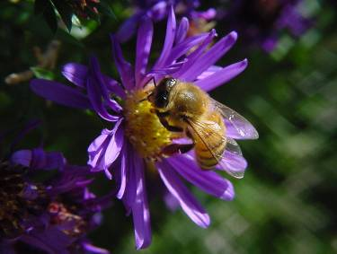

Grasses, forbs, legumes, shrubs and trees planted along farm and ranch borders and within fields attract wildlife, including pollinators and other beneficial insects. The correct mix of plant species that bloom during most of the growing season will provide a continuous source of nectar and pollen needed by pollinators and other beneficial insects.

Annual plants can be useful tools in pollinator plantings because they produce tremendous amounts of flowers. However, annual crops can be very competitive with perennial plantings. Consequently, annuals should be considered for small odd areas and should not be mixed with perennial species. A few annual species that readily attract pollinators include buckwheat, canola, safflower, berseem clover, red clover, camolina, lentils, and dry peas.

Pollinator Friendly Plantings

- Reduce Pesticide Use – sequentially flowering annual and perennial plants provide forage and cover for predatory and parasitic insects that help control pest species; established plant communities resist weed invasion.

- Stabilize Soil and Provide Ground Cover – root systems and above ground vegetation hold soil in place, improve soil moisture infiltration, reduce the risk of erosion and serve as buffers which protects against surface water pollution. Legumes contribute nitrogen to the soil.

- Serve as Windbreaks and Shelterbelts – shrubs and trees protect farmsteads, feeding areas, crops and livestock from wind and dust damage. They also provide food, nesting and cover habitat for a great variety of wildlife, pollinators and other beneficial insects.

ESTABLISHING POLLINATOR FRIENDLY PLANTINGS

- Start Right. Most grasses and flowering forbs, including legumes can be started by direct seeding or in some cases by transplanting nursery seedlings. Flowering shrubs and trees are often best established by transplanting nursery seedlings.

- Determine Soil Drainage and Other Soil Limitation Factors. Most species will not do well in heavy, poorly drained or saline to sodic soils; select species that can perform well in the soils you have.

- Match Plants with Similar Site Preferences. Choose plants that share similar site, soil and water requirements and that are adapted to the local climate.

- Water Wisely. Tree and shrub plantings in the drier portions of the Intermountain West and Great Basin will require irrigation. For the best establishment biweekly watering the first 2 to 3 years is recommended. Once the plants are well established, watering less frequently, but for a longer duration to drive the moisture deeper into the soil will ensure that the plants develop their roots more fully ensuring long term survival.

- Control Weeds. Most plants do not compete well with weeds during establishment. Start with a weed free area or create one using appropriate herbicides or tillage equipment. Keep the area relatively weed free for the first 2 to 3 years of establishment. Mowing weeds during plant establishment will help suppress weed competition and encourage desired plants.

- Protect Planting from Wildlife and Livestock. Fencing to protect planting may be required in areas with abundant deer, antelope or elk or with livestock such as sheep, cattle or horses.

- Plant Species. Plantings should include at least one grass for interspace cover and one forb or legume or shrub adapted to the site from each of the three seasonal flowering categories; i.e. early, mid, and late. See Table 1 – note this is a partial list of species to consider for pollinator plantings. Additional species may be available or become available that were not considered for this technical note. Care was taken to list species that are commercially available.

- Pollinator Habitat Plantings. Plantings installed to improve pollinator habitat should remain ungrazed and undisturbed throughout the flowering season. This will ensure that flowers are available as a nectar source to adult pollinators. Bee larvae are fed pollen; those of other pollinating species may eat succulent foliage.

- Maintenance. Treatments such as haying or mowing may be required outside of the flowering period to remove plant litter that may affect plant health.

- Planting Size. For best results, plantings should be at least 0.5 acres in size.

TABLE 1
FLOWERING FORBS - LEGUMES | ORIGIN |  | GROWTH TYPE |  |  | BLOOM PERIOD
PERENNIAL PLANTS
PLANT NAME | NATIVE | INTRODUCED | FORB/LEGUME | SHRUB/TREE |  | EARLY | MID | LATE
ALFALFA |  | x | x |  |  | x | x
ASTER, HAIRY GOLDEN | x |  | x |  |  |  | x | x
ASTER, SMOOTH | x |  | x |  |  |  | x | x
BEEBALM | x |  | x |  |  |  | x | x
BEEPLANT, ROCKY MOUNTAIN | x |  | x |  |  | x
BLANKET-FLOWER |  | x | x |  |  |  | x | x
BURNET, SMALL |  | x | x |  |  |  | x
BUTTERFLY BUSH |  | x | x |  |  | x | x
CLOVER, ALSIKE |  | x | x |  |  | x
CLOVER, WHITE (LADINO) |  | x | x |  |  |  | x
CLOVER, WHITE DUTCH |  | x | x |  |  | x | x
COLUMBINE, RED | x |  | x |  |  | x
CONEFLOWER | x |  | x |  |  |  | x | x
EVENING-PRIMROSE | x |  | x |  |  | x
FLAX, BLUE |  | x | x |  |  | x | x
FLAX, LEWIS | x |  | x |  |  | x | x
GLOBEMALLOW SPECIES | x |  | x |  |  | x | x
MILKVETCH, CICER |  | x | x |  |  |  |  | x
PENSTEMON, FIRECRACKER | x |  | x |  |  | x
PENSTEMON, HOTROCK | x |  | x |  |  | x
PENSTEMON, ROCKY MTN | x |  | x |  |  |  | x
PENSTEMON, VENUS | x |  | x |  |  |  | x
PRAIRIECLOVER, PURPLE |  | x | x |  |  |  | x
PRAIRIECLOVER, WHITE |  | x | x |  |  |  | x
SAINFOIN |  | x | x |  |  | x | x
SUNFLOWER SPECIES | x |  | x |  |  |  | x | x
SWEETCLOVER, WHITE |  | x | x |  |  | x | x
SWEETCLOVER, YELLOW |  | x | x |  |  | x | x
SWEETVETCH, NORTHERN | x |  | x |  |  | x | x
TREFOIL, BIRDSFOOT |  | x | x |  |  |  |  | x
YARROW, WESTERN | x |  | x |  |  |  | x | x
TABLE 1
FLOWERING SHRUBS - TREES | ORIGIN |  | GROWTH TYPE |  |  | BLOOM PERIOD
PERENNIAL PLANTS
PLANT NAME | NATIVE | INTRODUCED | FORB/LEGUME | SHRUB/TREE |  | EARLY | MID | LATE
BITTERBRUSH, ANTELOPE | x |  |  | x |  | x
BUFFALOBERRY, SILVER | x |  |  | x |  | x | x
BUCKWHEAT, SNOW | x |  |  | x |  |  | x | x
BUCKWHEAT, SULPHURFLOWER | x |  |  | x |  |  | x | x
BUCKWHEAT, WYETH | x |  |  | x |  |  | x | x
CHOKECHERRY | x |  |  | x |  | x
CHERRY, NANKING |  | x |  | x |  | x
CLEMATIS, WESTERN | x |  |  | x |  | x | x
CURRANT, GOLDEN | x |  |  | x |  | x
CINQUEFOIL, SHRUBBY | x |  |  | x |  | x | x
CRABAPPLE |  | x |  | x |  | x
DOGWOOD, RED-OSIER | x |  |  | x |  | x
ELDERBERRY | x |  |  | x |  |  | x
HAWTHORN, BLACK | x |  |  | x |  | x
HONEYSUCKLE, TWINBERRY | x |  |  | x |  | x | x
LILAC |  | x |  | x |  | x
PEASHRUB, SIBERIAN |  | x |  | x |  | x | x
PLUM, AMERICAN | x |  |  | x |  | x
RABBITBRUSH, GREEN | x |  |  | x |  |  |  | x
RABBITBRUSH, RUBBER | x |  |  | x |  |  |  | x
ROSE, WOOD’S | x |  |  | x |  | x | x
SAGE, PURPLE | x |  |  | x |  | x
SAGE, RUSSIAN |  | x |  | x |  | x | x
SANDCHERRY, WESTERN |  | x |  | x |  | x
SERVICEBERRY | x |  |  | x |  | x
SNOWBERRY | x |  |  | x |  |  | x
SPIREA, DOUGLAS | x |  |  | x |  | x
SUMAC, SKUNKBUSH | x |  |  | x |  | x
WILLOW SPECIES | x | x |  | x |  | x

HABITAT CONSIDERATIONS

Habitat needs for pollinators are similar to other animal species: food, shelter, nesting sites and sometimes water. Shelter and nesting sites may be a limiting factor in your project area and should be considered during planning.

Nectar and pollen from flowering plants provide food for pollinators. Water needs can be met with birdbaths, fountains, ponds or puddles. Moist salt licks help provide mineral requirements for butterflies and sweat bees. Shelter and nesting habitat needs differ by pollinator species and include bare or partially vegetated, well drained soil; soil banks and cliffs, dead standing or fallen trees with beetle emergence holes, live trees, clumps of grass, live brush, tall grass, piles of leaves and sticks, wood piles, tree bark and rock crevices. See Table 2 for additional information.
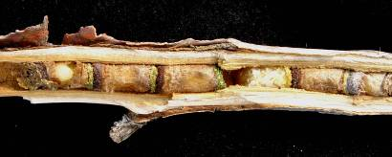
Most native bees are solitary, nesting underground or above
ground using beetle holes in dead-wood or dead pithy stems
(e.g. elderberry, sumac or rose). Bumblebees are social with
colonies of dozens to hundreds of workers. They typically nest on the ground under leaves and grass, in tree hollows or below-ground in old rodent burrows.

In pollinator plantings use of pesticides should be avoided, especially insecticides. Leave some areas untreated as refugial habitat for predatory and parasitic insects and pollinators that can recolonize treated areas.

TABLE 2 HABITAT REQUIREMENTS FOR GENERAL NATIVE POLLINATORS

Pollinators Food Shelter
Solitary bees | Nectar and pollen | Nest in bare and partially vegetated soils where water won’t pond; or in beetle holes in deadwood, within pithy stems or twigs or construct nests of mud or leaf pulp
Bumblebees | Nectar and pollen | Nest cavity underground, often in old rodent burrows, hollow trees, underground or beneath clumps of grass
Butterflies and Moths | Nectar; nutrients, minerals and salts from rotting fruit, tree sap, clay deposits and mud puddles | Leaves and stems of larval host plants; also small woodpiles used by species that winter as adults
Bats (pollinators in the North American Southwest only) | Fruit, pollen, nectar, or insects | Tree branches, cavities, caves, rock crevices, under tree bark, under structures that provide overhang and artificial structures

PLANTS FOR POLLINATORS FORBS AND LEGUMES
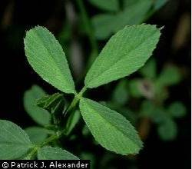
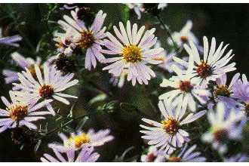

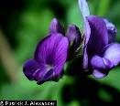

ALFALFA Medicago sativa ASTER Aster species
Origin: introduced legume Origin: native forb
Mature Height: 2- 3 feet Mature Height: 0.5- 2 feet
Growth Rate: fast Growth Rate: moderate
Growth Habit: upright Growth Habit: upright
Wildlife Value: excellent forage Wildlife Value: excellent food and cover
Attracts: cutter bees Attracts: butterflies, bees
Flowers: purple Flowers: creamy white to purple
Blooms: May – July (delay by cutting) Blooms: June - September
Broadcast Seeding Rate: 10 lbs/ac Broadcast Seeding Rate: 4 lbs/ac
In-row Spacing: N/A In-row Spacing: 1- 2 feet

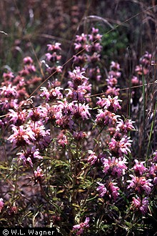
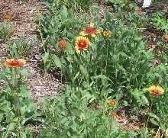

BEEBALM, WILD Monarda fistulosa BLANKETFLOWER Gaillardia aristata
Origin: introduced forb Origin: native forb - Great Plains
Mature Height: 1- 2 feet Mature Height: 1- 1.5 feet
Growth Rate: moderate Growth Rate: moderate
Growth Habit: upright, spreading Growth Habit: upright
Wildlife Value: excellent forage Wildlife Value: excellent food and cover
Attracts: butterflies, bees Attracts: bees
Flowers: purple Flowers: creamy white to purple
Blooms: June - August Blooms: July - September
Broadcast Seeding Rate: 2 lbs/ac Broadcast Seeding Rate: 16 lbs/ac
In-row Spacing: 1- 2 feet In-row Spacing: 1- 2 feet

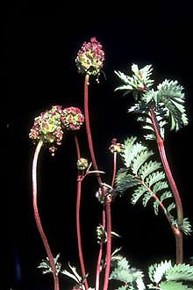
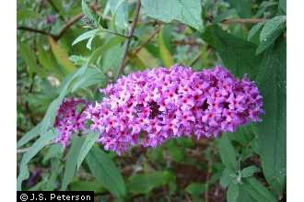

BURNET, SMALL Sanguisorba minor BUTTERFLY BUSH Buddleja species
Origin: introduced forb Origin: introduced forb
Mature Height: 1- 2.5 feet Mature Height: 2- 4 feet
Growth Rate: rapid Growth Rate: moderate to rapid
Growth Habit: upright Growth Habit: upright
Wildlife Value: excellent forage Wildlife Value: excellent food and cover
Attracts: bees Attracts: bees
Flowers: non-descript Flowers: purple
Blooms: June - August Blooms: June - July
Broadcast Seeding Rate: 30 lbs/ac Broadcast Seeding Rate: establish w/ plants
In-row Spacing: 2– 3 feet In-row Spacing: 3- 4 feet

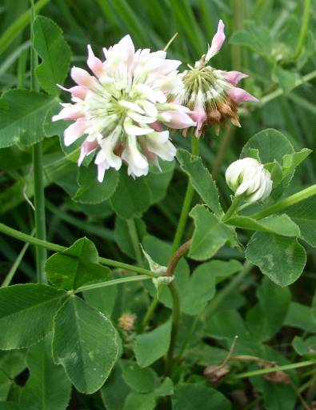
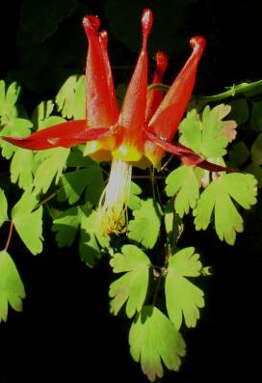

CLOVER species Trifolium species COLUMBINE Aquilegia formosa
Origin: introduced legume Origin: native forb
Mature Height: 0.5 - 2 feet Mature Height: 1- 2 feet
Growth Rate: rapid Growth Rate: moderate to rapid
Growth Habit: upright Growth Habit: upright
Wildlife Value: excellent forage Wildlife Value: excellent food
Attracts: bees Attracts: hummingbirds
Flowers: white to red Flowers: red
Blooms: April - June Blooms: June - July
Broadcast Seeding Rate: 12 lbs/ac Broadcast Seeding Rate: 6 lbs/ac
In-row Spacing: N/A In-row Spacing: 1- 3 feet
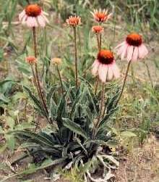
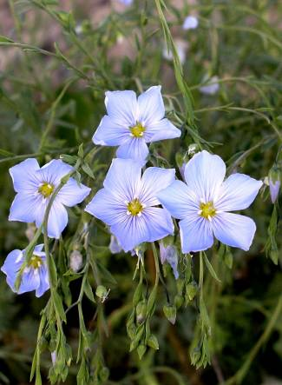

CONEFLOWER Echinacea species FLAX species Linum species
Origin: native forb Origin: native and introduced forb
Mature Height: 1.5 - 3 feet Mature Height: 1- 2 feet
Growth Rate: rapid Growth Rate: moderate to rapid
Growth Habit: upright Growth Habit: upright
Wildlife Value: excellent forage Wildlife Value: excellent food
Attracts: butterflies, many bees Attracts: some bees
Flowers: white to purple Flowers: white to deep blue
Blooms: July - September Blooms: May - July
Broadcast Seeding Rate: 20 lbs/ac Broadcast Seeding Rate: 8 lbs/ac
In-row Spacing: 1- 2 feet In-row Spacing: 1- 2 feet

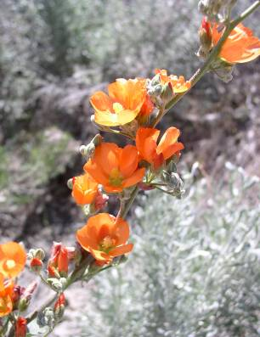
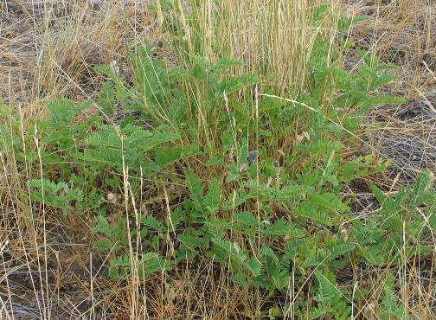

GLOBEMALLOW Sphaeralcea species MILKVETCH, CICER Astragalus cicer
Origin: native forb Origin: introduced legume
Mature Height: 1.5 - 3 feet Mature Height: 1- 3 feet
Growth Rate: rapid Growth Rate: moderate to rapid
Growth Habit: upright Growth Habit: upright (lodges at maturity)
Wildlife Value: excellent forage Wildlife Value: excellent forage
Attracts: many bees Attracts: bees
Flowers: orange to red Flowers: white
Blooms: April - June Blooms: May - July
Broadcast Seeding Rate: 4 lbs/ac Broadcast Seeding Rate: 14 lbs/ac
In-row Spacing: 2– 4 feet In-row Spacing: N/A
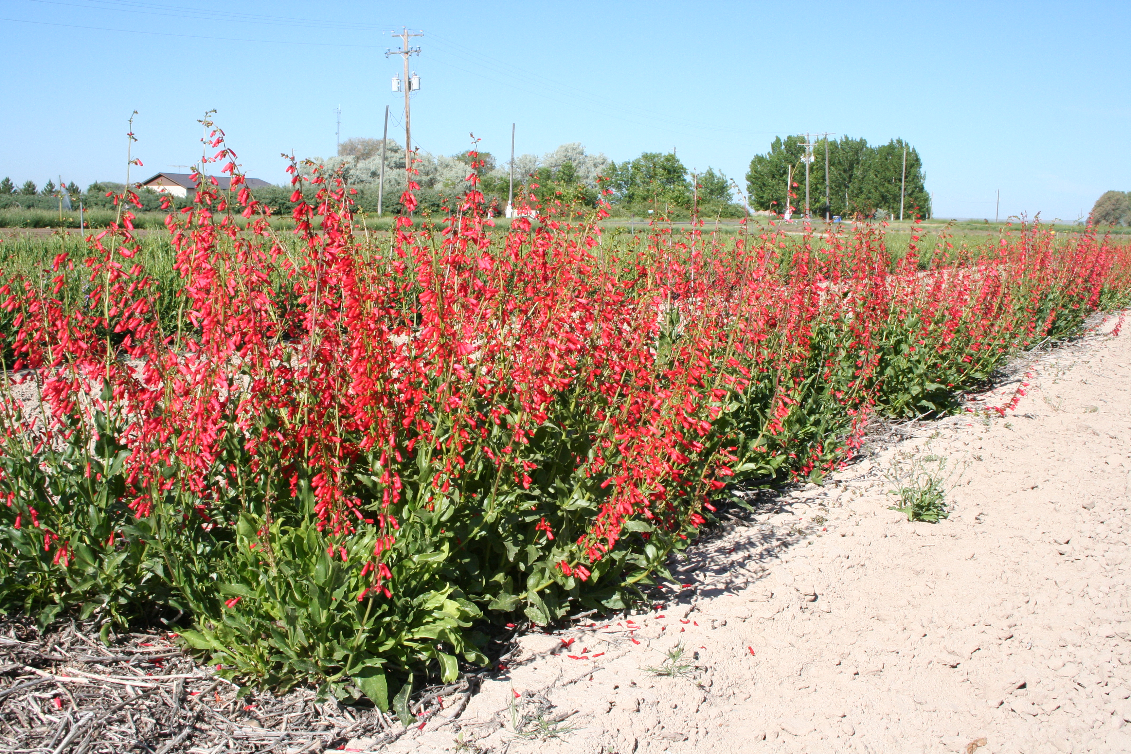
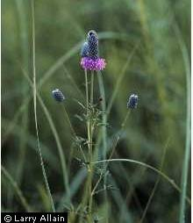
PENSTEMON Penstemon species PRAIRIECLOVER Dalea species
Origin: native forbs Origin: native - Great Plains legume
Mature Height: 0.5 - 3 feet Mature Height: 1- 2.5 feet
Growth Rate: rapid Growth Rate: moderate
Growth Habit: upright Growth Habit: upright
Wildlife Value: excellent forage Wildlife Value: excellent forage
Attracts: some bees, wasps, hummingbirds Attracts: most bees
Flowers: white – red - blue Flowers: white to purple
Blooms: April – June Blooms: June - August
Broadcast Seeding Rate: 8 lbs/ac Broadcast Seeding Rate: 14 lbs/ac
In-row Spacing: 2- 3 feet In-row Spacing: 1- 3 feet

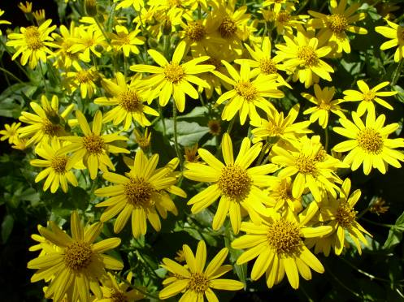
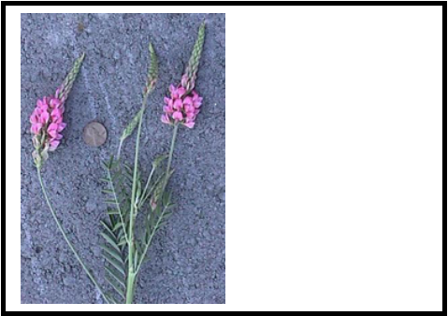

SAINFOIN Onobrychis viciifolia SUNFLOWER Helianthus species
Origin: introduced legume Origin: native and introduced forb
Mature Height: 2 - 5 feet Mature Height: 2 - 5 feet
Growth Rate: rapid Growth Rate: rapid
Growth Habit: upright Growth Habit: upright
Wildlife Value: excellent forage Wildlife Value: good winter food
Attracts: larger bees Attracts: butterflies, many bees
Flowers: pink Flowers: yellow to orange
Blooms: May – July (delay by cutting) Blooms: July – September
Broadcast Seeding Rate: 34 lbs/ac Broadcast Seeding Rate: 10 lbs/ac
In-row Spacing: N/A In-row Spacing: 2- 4 feet

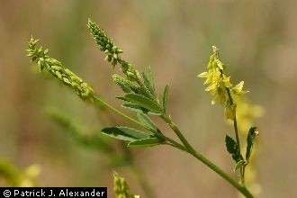
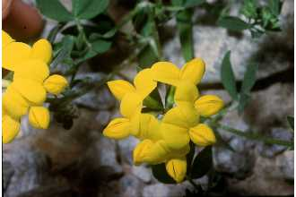

SWEETCLOVER Melilotus species TREFOIL, BIRDSFOOT Lotus corniculatus
Origin: introduced legume Origin: introduced legume
Mature Height: 1- 3 feet Mature Height: 1.5 - 3 feet
Growth Rate: rapid Growth Rate: rapid
Growth Habit: upright Growth Habit: upright
Wildlife Value: fair forage Wildlife Value: good winter food
Attracts: many bees Attracts: bees
Flowers: white to yellow Flowers: yellow
Blooms: June – July Blooms: July – September
Broadcast Seeding Rate: 8 lbs/ac Broadcast Seeding Rate: 10 lbs/ac
In-row Spacing: N/A In-row Spacing: N/A

INCLUDEPICTURE "http://plants.usda.gov/gallery/standard/acla5_001_svd.jpg" \* MERGEFORMATINET
INCLUDEPICTURE "http://plants.usda.gov/gallery/standard/acla5_001_svd.jpg" \* MERGEFORMATINET

YARROW, WESTERN Achillea millefolium
Origin: native forb
Mature Height: 0.5 – 1.5 feet
Growth Rate: rapid
Growth Habit: upright to prostate
Wildlife Value: good forage
Attracts: butterflies, some bees
Flowers: white to yellow
Blooms: June - August
Broadcast Seeding Rate: 1.0 lbs/ac
In-row Spacing: N/A

PLANTS FOR POLLINATORS SHRUBS AND TREES
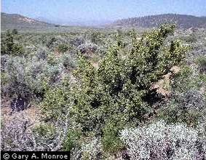
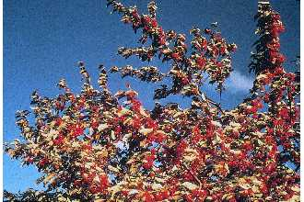
BITTERBRUSH, ANTELOPE Purshia tridentata BUFFALOBERRY Shepherdia argentea
Origin: native shrub Origin: native shrub
Mature Height: 2 - 6 feet Mature Height: 6- 20 feet
Growth Rate: moderate Growth Rate: moderate
Growth habit: upright shrub Growth Habit: upright, suckering-spreading
Wildlife Value: cover, fall forage Wildlife Value: browse; fruit red-orange
Attracts: butterflies Attracts: butterflies, bees
Flowers: yellow Flowers: yellow-male; inconspicuous-female
Bloom: May - June Blooms: May - July
In-row Spacing: 3- 5 feet In-row Spacing: 8 -10 feet

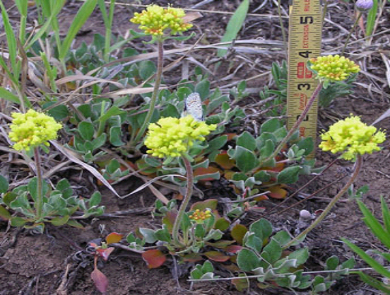
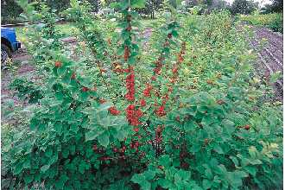
BUCKWHEAT, Species Eriogonum species CHERRY, NANKING Prunus tomentosa
Origin: native sub-shrub Origin: introduced shrub
Mature Height: 0.5 - 2 feet Mature Height: 6- 10 feet
Growth Rate: moderate Growth Rate: moderate
Growth habit: spreading open sub-shrub Growth Habit: upright, semi-spreading
Wildlife Value: cover, fall forage Wildlife Value: browse; fruit for song birds
Attracts: moths, butterflies, bees Attracts: butterflies, bees
Flowers: yellow to white Flowers: small pink
Bloom: July – September Blooms: April – May
In-row Spacing: 1- 3 feet In-row Spacing: 6– 8 feet
INCLUDEPICTURE "http://plants.usda.gov/gallery/standard/prvi_004_shp.jpg" \* MERGEFORMATINET
INCLUDEPICTURE "http://plants.usda.gov/gallery/standard/prvi_002_shp.jpg" \* MERGEFORMATINET
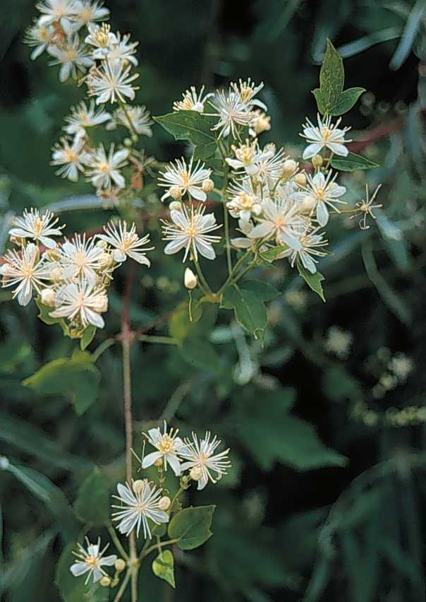
CHOKECHERRY Prunus virginiana CLEMATIS Clematis ligusticifolia
Origin: native shrub Origin: native shrub
Mature Height: 12- 25 feet Mature Height: 1 foot
Growth Rate: moderate Growth Rate: moderate
Growth Habit: oval to round; suckering Growth Habit: spreading and climbing vine
Wildlife Value: excellent food and cover Wildlife Value: cover
Attracts: butterflies, bees Attracts: moths, bees
Flowers: creamy white Flowers: white
Blooms: April – May Blooms: May - July
In-row Spacing: 8- 12 feet In-row Spacing: 2- 6 feet

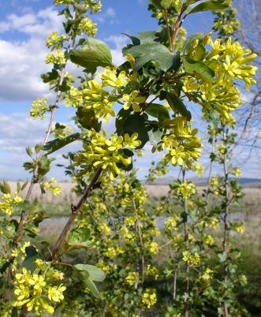
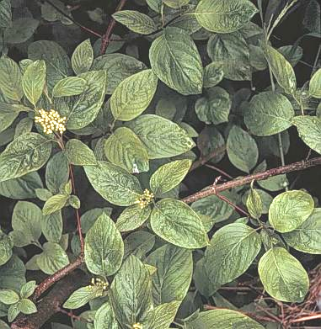

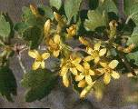

CURRANT, GOLDEN Ribes aureum DOGWOOD, REDOSIER Cornus sericea
Origin: native shrub Origin: native shrub
Mature Height: 5- 8 feet Mature Height: 7- 10 feet
Growth Rate: moderate Growth Rate: rapid
Growth Habit: spreading and upright Growth Habit: loose and round many stems
Wildlife Value: roosting, loafing, nesting Wildlife Value: dense cover and browse
Attracts: early spring bees, bumblebees Attracts: butterflies, bees
Flowers: fragrant golden yellow Flowers: creamy white
Bloom: April – May Blooms: April - May
In-row Spacing: 4– 6 feet In-row Spacing: 6– 10 feet

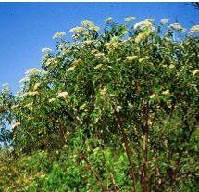
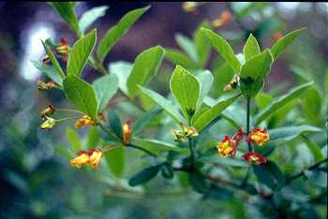

ELDERBERRY Sambucus cerulea HONEYSUCKLE Lonicera involucrata
Origin: native shrub Origin: native shrub
Mature Height: 6- 15 feet Mature Height: 6- 10 feet
Growth Rate: moderate Growth Rate: moderate
Growth Habit: upright, leggy Growth Habit: upright open shrub
Wildlife Value: nesting, food Wildlife Value: fruit readily eaten, cover
Attracts: butterflies, nesting bees Attracts: butterflies, bees, hummingbirds
Flowers: white to cream Flowers: yellow
Blooms: June - July Bloom: April - July
In-row Spacing: 4– 6 feet In-row Spacing: 5- 8 feet

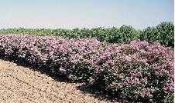
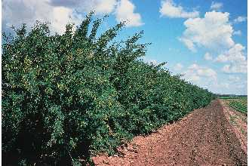

LILAC, COMMON Syringa vulgaris PEASHRUB, SIBERIAN Caragana spp
Origin: introduced shrub Origin: introduced shrub
Mature Height: 6- 12 feet Mature Height: 6- 20 feet
Growth Rate: moderate Growth Rate: rapid
Growth Habit: upright, leggy, suckering Growth Habit: erect oval shrub
Wildlife Value: nesting Wildlife Value: nesting
Attracts: early spring bees Attracts: large bees (especially bumblebees)
Flowers: white to purple, fragrant and showy Flowers: small showy yellow
Blooms: April – May Bloom: April - June
In-row Spacing: 5– 10 feet In-row Spacing: 5- 10 feet

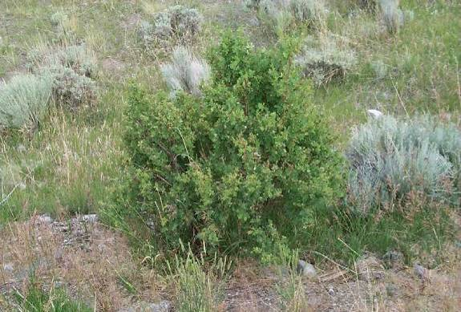
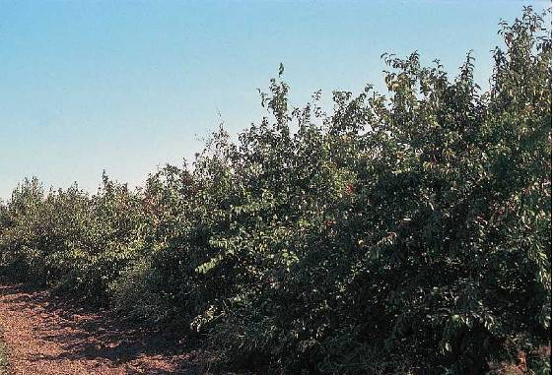

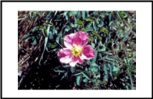

PLUM, AMERICAN Prunus americana ROSE, WOODS Rosa woodsii
Origin: native shrub Origin: native shrub
Mature Height: 8- 10 feet Mature Height: 3- 6 feet
Growth Rate: moderate Growth Rate: moderate
Growth Habit: round-headed crown, suckers Growth Habit: upright, semi-weeping,suckers
Wildlife Value: nesting, loafing, food, browse Wildlife Value: nesting, cover and exc. food
Attracts: butterflies, bees Attracts: bees
Flowers: white Flowers: showy pink
Bloom: April – May Bloom: June – July
In-row Spacing: 6- 10 feet In-row Spacing: 3- 5 feet

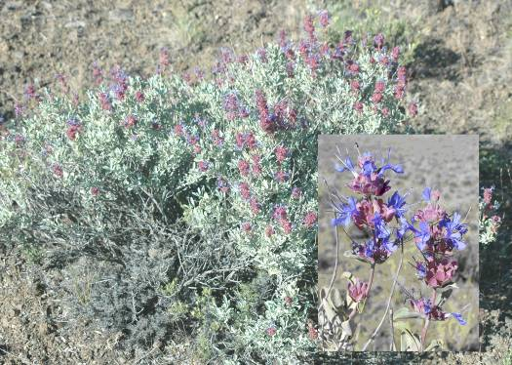
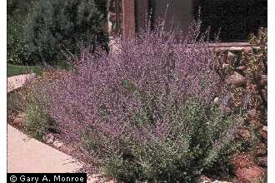
SAGE, PURPLE Salvia dorrii SAGE, RUSSIAN Perovskia atriplicifolia
Origin: introduced half shrub Origin: introduced half shrub
Mature Height: 1.5 – 2.5 feet Mature Height: 1- 3 feet
Growth Rate: moderate Growth Rate: rapid
Growth Habit: upright Growth Habit: upright
Wildlife Value: fair Wildlife Value: good
Attracts: many bees Attracts: many bees
Flowers: purple Flowers: purple
Blooms: May - June Blooms: June - July
Spacing in row: 2- 3 feet Spacing in row: 3- 5 feet

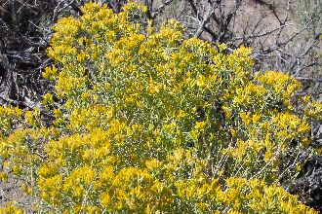
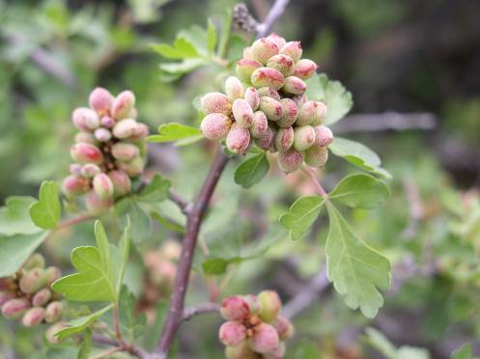

RABBITBRUSH Chrysothamnus species SUMAC, SKUNKBUSH Rhus trilobata
Origin: native shrub Origin: native shrub
Mature Height: 2- 6 feet Mature Height: 6- 8 feet
Growth Rate: moderate Growth Rate: slow to moderate
Growth Habit: open spreading Growth Habit:ascending, new branches hairy
Wildlife Value: loafing, food, and browse Wildlife Value: browse, nesting, bird food
Attracts: butterflies, many small bees Attracts: early bees
Flowers: yellow Flower: light yellow
Bloom: August – October Blooms: May – June
In-row Spacing: 3- 6 feet In-row Spacing: 4- 6 feet

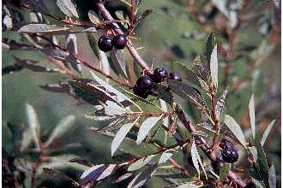
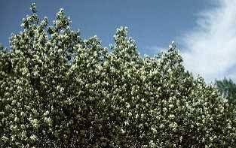
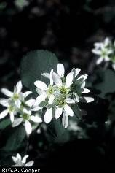

SANDCHERRY, WESTERN Prunus pumila SERVICEBERRY Amelanchier alnifolia
Origin: native shrub Origin: native shrub
Mature Height: 3- 6 feet Mature Height: 6- 15 feet
Growth Rate: moderate Growth Rate: slow
Growth Habit: open and spreading Growth Habit: upright
Wildlife Value: loafing, food, browse Wildlife Value: good cover and food
Attracts: butterflies, bees Attracts: butterflies, bees
Flowers: white Flowers: white
Bloom: April – May Bloom: May - June
In-row Spacing: 3- 6 feet In-row Spacing: 5- 10 feet

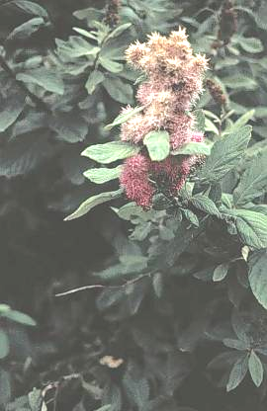
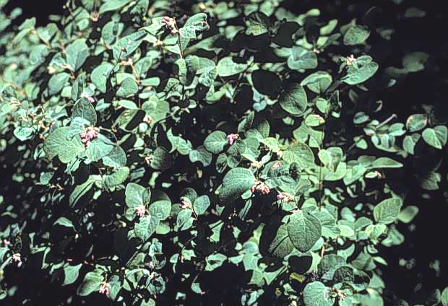

SNOWBERRY Symphoricarpos species SPIREA, DOUGLAS Spirea douglasii
Origin: native shrub Origin: native shrub
Mature Height: 2- 3 feet Mature Height: 4- 6 feet
Growth Rate: moderate Growth Rate: rapid
Growth Habit: open and spreading Growth Habit: thicket forming - upright
Wildlife Value: loafing, food, browse Wildlife Value: cover
Attracts: butterflies, bees, hummingbirds Attracts: butterflies, bees
Flowers: pink Flowers: rose - pink
Bloom: June – August Bloom: June
In-row Spacing: 3- 4 feet In-row Spacing: 2- 4 feet

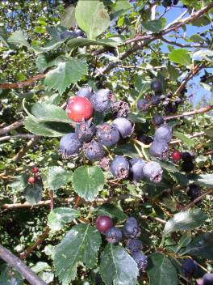

BLACK HAWTHORN Crataegus douglasii
Origin: native shrub
Mature Height 15 - 20 feet
Growth Rate: slow
Growth Habit: upright
Wildlife Value: cover and food
Attracts: moths, bees, butterflies, and beetles
Flower: white
Blooms: May-June
In-row Spacing: 4 - 8 feet

PHOTO CREDITS

Butterfly on Coneflower – unknown Hummingbird – unknown
Bee – Jim Cane Bee Nest in Sumac Stem – Jim Cane
Alfalfa – Patrick J. Alexander Aster – G. A. Cooper
Beebalm – W. L. Wagner Blanketflower – J. S. Peterson
Burnet Small – Joe F. Duft Butterfly Bush – J. S. Peterson
Clover species – Tim Dring Columbine – Tim Dring
Coneflower – Larry Allain Flax, Blue – Derek Tilley
Globemallow – Tim Dring Milkvetch, Cicer – Dan Ogle
Penstemon, Firecracker – Loren St. John Prairieclover – Gary Monroe
Sainfoin - unknown Sage, Louisiana – Larry Allain/N. L. Britton
Sunflower – Tim Dring Sweetclover - Patrick J. Alexander
Trefoil, Birdsfoot – Robert H. Mohlenbrock Yarrow, Western – Dan Ogle/N. L. Britton
Bitterbrush – Gary Monroe Buffaloberry - D. E. Herman
Buckwheat, Sulphurflower – Derek Tilley Cherry, Nanking – D. E. Herman
Chokecherry – Gary Monroe/M. Williams Clematis – Tim Dring
Currant, Golden – Tim Dring Dogwood, Redosier – Tim Dring
Elderberry – Ted Bodner Honeysuckle – Emmet J. Judziewiez
Lilac, Common – D. E. Herman Peashrub, Siberian – D. E. Herman
Plum, American – D. E. Herman Rose, Woods – J. S. Peterson
Rabbitbrush, Green – BLM Sage, Purple – Tim Dring
Sage, Russian – Gary Monroe Saltbush, Fourwing – Dan Ogle
Sandcherry, Western – D. E. Herman Serviceberry – Margaret Williams
Snowberry – Tim Dring Spirea, Douglas – Tim Dring
Sumac, Skunkbush - Tim Dring Black Hawthorn - Tim Dring

REFERENCES

USDA, NRCS, Creating Native Landscapes in the Northern Great Plains and Rocky Mountains. 2001. 16p.

USDA, NRCS, Idaho Biology Technical Note No. 1. Pollinators. 2007. 1p.

USDA, NRCS, Idaho Plant Materials Technical Note No. 43. Tree Planting, Care and Management. 2002. 32p.

USDA, NRCS, Montana Native Plants for Pollinator Friendly Plantings. 2005. 8p.

USDA, NRCS, Montana Biology Technical Note No. 20. Habitat Development for Pollinator Insects. 2004. 2p.

USDA, NRCS and FS, Agroforestry Note No. 33. Improving Forage for Native Bee Crop Pollinators. 2006. 4p.

USDA, NRCS and FS, Agroforestry Note No. 35. Pesticide Considerations for Native Bees in Agroforestry. 2007. 4p.

USDI, BLM, Technical Reference 1730-3. Landscaping with Native Plants of the Intermountain Region. 2003. 47p.

For additional information:

See USDA, NRCS, Idaho Plant Materials Technical Notes at:
http://www.id.nrcs.usda.gov/programs/tech_ref.html#TechNotes

See "Native Pollinators", "Butterflies", "Bats", and "Ruby Throated Hummingbird" Fish and Wildlife Habitat Management Leaflet Numbers 34, 15, 5, and 14 respectively. http://www.whmi.nrcs.usda.gov/technical/leaflet.htm

Agroforestry Note on nest sites (since they are referenced in the table on habitat needs) http://www.unl.edu/nac/agroforestrynotes/an34g08.pdf
Farming for Bees guidelines http://www.xerces.org/pubs_merch/Farming_for_Bees.htm
Pollinator Conservation Handbook is also a great overall reference that covers all of the invertebrate pollinators. This book isn't available for download, but is full of useful information. http://www.xerces.org/pubs_merch/PCH.htm
How to Reduce Bee Poisoning from Pesticides would be another useful addition http://extension.oregonstate.edu/catalog/pdf/pnw/pnw591.pdf

