SAVE-IT

A Final Report of
SAfety VEhicles using adaptive Interface Technology (Phase II: Task 11):
Data Fusion for
Distraction Mitigation and
Safety Warning Countermeasures

Prepared by:

Matthew Smith
Deborah L. Bakowski
Gerald J. Witt
Harry Zhang

Delphi Electronics & Safety
Phone: (765)-451-9816
Email: matt.smith@delphi.com

January 2008
Table of Contents

11.0. EXECUTIVE SUMMARY 3
11.1. PROGRAM OVERVIEW 8
11.2. INTRODUCTION 9
11.3. DISTRACTION MITIGATION PREPARATION 13
11.3.1. Method 13
11.3.2. Results 14
11.3.3. Discussion 26
11.4. ITERATIVE ON-ROAD TESTING AND DEVELOPMENT 29
11.4.1. Method 29
11.4.2. Results 31
11.5. ON-ROAD ADAPTIVE WARNING VALIDATION 38
11.5.1. FCW Validation Method 38
11.5.2. FCW Validation Results 43
11.5.3. LDW Validation Method 54
11.5.4. LDW Validation Results 57
11.5.5. Discussion 65
11.6. CONCLUSIONS AND SAVE-IT IMPLEMENTATION SUMMARY 68
References 73

11.0. EXECUTIVE SUMMARY

The data fusion task was a collection of studies that were necessary to bridge the gaps between the component tasks (1-10) and the final system integration (Task 13), in preparation for the Task 14 evaluations. Data fusion consisted of three major efforts:

Distraction Mitigation Preparation—The results of Task 2 were not yet ready for integration into the SAVE-IT system and so additional work was required in order to develop a functioning algorithm for detecting driving task demand.

Iterative On-Road Testing and Development—Due to the complexity of the SAVE-IT systems, the optimal method for developing and refining these systems was a highly iterative process of development and on-road testing that examined the system behavior and subjective driver feedback.

On-Road Adaptive Warning Validation—Task 9 primarily focused on the safety effectiveness evaluation of FCW and LDW. As a precursor to the evaluations (Task 14), additional on-road work was conducted to evaluate the acceptance of the adaptive FCW and LDW systems.

Distraction Mitigation Preparation
Vehicle data were generated by driving an instrumented vehicle on various roads and traffic environments. From this raw data, one hundred 8-s video segments were selected that represented different levels of traffic, road types, number of lanes and various driving maneuvers. Based on the subjects’ judgments, the video segments were assigned to one of three demand categories (low, medium, and high).

The driving task demand increased with either a reduction of time headway or a reduction in the normalized range between the host vehicle and targets. As a result, the equation that produced the best prediction of driving demand evaluated the number of targets surrounding the vehicle, their directional movement (towards, away, stationary), the minimum value between normalized range and time headway, and the longitudinal distance between the host and targets. A weight was computed for each of the video segments using this equation but adjusted for yaw rate, GPS info, lane width, speed and brake pedal depression. The resulting weights (predicted) were classified into three demand groups: Low, Medium and High Demand. The predicted weights were correlated with the median demand ratings yielding a correlation coefficient of 0.79. Moreover, 75% of the videos matched the algorithm-generated demand group and the median demand ratings group. Examination of the mismatches showed that most occurred with borderline cases and that the rating cut-off values could be adjusted to generate better matches (increased to 93%).

Subjects also provided judgment on visual distraction feedback and on demand-based advisories for IVIS functions. These judgments were correlated with the median demand ratings. The results indicated that as ratings of driving demand increase, so do judgments of visual distraction and advisories for IVIS functions. Subject judgments also indicated that when the driving task demand is high, drivers should be advised to refrain from using the IVIS functions. Note that these results replicate the results from Task 2 (Driving Task Demand).

Iterative On-Road Testing and Development
As an extension of previous, simulator-based experiments, on-road drives were completed to observe the behavior of the adaptive interfaces on real roadways and to collect a wide range of subjective measures. The drives were conducted as part of an iterative process that allowed for immediate cycles of implementation, testing and refinement based on both subjective and objective measures. This iterative refinement process afforded a data-driven methodology to support this complex data-fusion task. As the performance of the component systems and their resultant interactions with the overall system became apparent, system functionality could be modified to provide more effective and acceptable SAVE-IT adaptations.

Twelve drivers participated in this study across a two-month period. Each researcher-accompanied drive encompassed a variety of driving environments including, highway, interstate, city, suburban retail district, and wooded/hilly, and took place during either morning or afternoon. These naïve-subject drives were also supplemented with numerous engineering drives and commutes that assessed specific effects of the adaptive systems. As part of the iterative nature of this evaluation, the type and depth of training administered by the researcher varied across participants. Initially, drivers were introduced to each of the four warning systems (Forward Collision Warning (FCW), Lane Departure Warning (LDW), Distraction Alerts, and Proximity Alerts) and were given specific details about how the systems worked (e.g. time headway, thresholds, minimum speed activation), as well as, the intent and behavior of adaptation (e.g. warning suppression, implications of driver head pose). Drivers were encouraged to share their reactions, comments and questions, with drives taking on an informal think aloud approach.

In an effort to realize more naturalistic driving, later drives withheld adaptation details from the training and simplified the warning system explanations by eliminating discussion of the more technical aspects of the system. Likewise, during subsequent drives, the researcher did not provide specific answers to the participants’ questions until the drive was complete. It was thought that the streamlined training, coupled with increased warning exposure during the demonstration, would provide drivers with a more meaningful and practical representation of the warning systems. The importance of driving naturally and, specifically not inducing alerts were emphasized to each driver.
Reports from participants and researcher observations led to the optimization of the adaptive interfaces.

The distraction alert system presented unique challenges. Drivers consistently experienced a high frequency of alerts, but more importantly, were often unable to associate these alerts with their cause. Users reported receiving alerts when they did not perceive themselves as being distracted or when performing regular driving maneuvers, like checking a blind spot. As a result, high levels of frustration and annoyance became associated with this system. After much testing, the distraction alert was abandoned, due to the unresolved nuisance alert rate and the fear that real-time feedback could add distraction.

On-Road Adaptive Warning Validation
After establishing the final adaptive warning interfaces and algorithms through the process of iterative testing and development, the data fusion task conducted an on-road evaluation of the optimized SAVE-IT configuration for Adaptive FCW and LDW. These on-road drives afforded 28 naïve participants a chance to contrast the non-adaptive mode with the SAVE-IT adaptations, and provided a number of dependent measures, across two studies. Objective results revealed reductions in overall alert-frequency for the adaptive versions of both FCW and LDW. Drivers received significantly fewer alerts, and fewer alerts per mile, in the adaptive mode of both the FCW and LDW studies. The FCW and LDW warning systems demonstrated high adaptive suppression rates, approximately 70% and 95% respectively. Significantly more drivers expressed a preference for adaptive mode in both studies, and when they did so, the most popular reason provided was the lower alert-rate. It appears that the difference in alert frequency between modes was the most salient aspect of both systems, and it directly influenced several subjective ratings. The trend across both warning systems was for drivers to report that the adaptive warning system was more acceptable, had fewer nuisance alerts, and was less distracting.

Conclusions and Final SAVE-IT Implementations
The various SAVE-IT tasks have generated algorithms and strategies for distraction mitigation. Data fusion has yielded five adaptive interfaces (adaptive FCW, adaptive LDW, trip report, adaptive infotainment availability and advisory, and adaptive phone management) to be implemented in the Task 14 evaluations (see Figure 11.1).

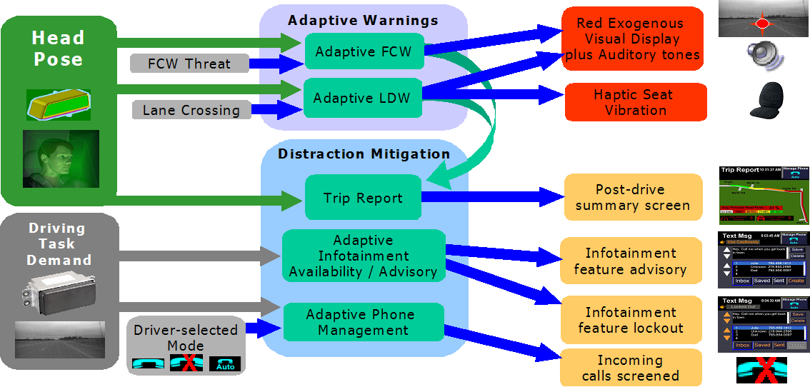
Figure 11.1. Summary of the SAVE-IT countermeasures as a function of sensing systems.

- Adaptive Forward Collision Warning. As a result of both Task 9 driving simulator research and the on-road acceptance testing of the data fusion task, the differential alert timing strategy appeared to be the most promising. In this particular implementation, the timing adjustment for the forward attention state was quite extreme (assumed reaction time of 0.5 s) in order to suppress almost all alerts when the driver’s head pose was forward. When the driver’s head pose is not forward, the driver will experience very early alerts that allow for a long driver brake reaction time.

- Adaptive Forward Collision Warning. The final form of adaptation that was selected for LDW was the suppression strategy. Due to the fact that cognitive distraction and brief or small-angle visual distractions do not appear to significantly degrade lane-keeping performance (see Tasks 5 and 9), LDW is unlikely to provide a safety benefit for visually-attentive drivers. The prevalence of rapid head pose changes resulting from mirror checks just prior to a lane crossing required a distinction between head pose not forward for an extended period of time versus the instantaneous head pose state.

- Trip report. In order to mitigate additional distraction by providing the driver with feedback in real time, a delayed feedback mechanism will also be implemented in the form of a trip report. This report will be presented to the driver at the end of the drive and includes information on the driver’s head pose behavior during the drive and a summary of the FCW and LDW incidents. Although this countermeasure would be voluntary in a production implementation, it is expected that the trip report could be implemented in a manner that might trigger the driver’s curiosity. Task 4 (Distraction Mitigation) demonstrated that post-drive feedback could improve the driver’s behavior on subsequent drives.

- Adaptive Infotainment Availability and Advisory. As driving task demand increases, drivers are advised to shed more IVIS function in order to concentrate on the driving task. An amber color was used on the buttons to signal that the feature was not advisable given the current driving task demand level. In addition to the color change of the button, the “Use Cautiously” text appeared just under the page heading to help communicate to the driver the intention of the adaptation. As the driving task demand gets to greater levels, some of the most demanding IVIS features are locked-out. Initially it was expected that the lock-out of features had the potential of being too annoying or too confusing, however the Task 4 results seemed to indicate that lock-out might be a potentially useful distraction-mitigation strategy if it could be implemented in a way that clearly communicates the intention to the driver. By using the gray-out effect that is now common in computer GUIs (graphical user interfaces), and tying it to the text just below the page description, it appears that driver-confusion may be avoided.

- Phone screening based on driver preference and driving task demand. Task 4 demonstrated that driver-initiated mitigation methods are more acceptable to drivers than system-initiated methods. Task 11a showed that the perceived risk associated with phone functions increases with driving task demand. In order to optimize driver acceptance, drivers will be given three choices for phone screening: no screening, do-not-disturb, and automatic screening. If the driver selects automatic screening, the SAVE-IT system will determine whether a call should be routed to the driver or to voice mail based on the concurrent driving task demand.

11.1. PROGRAM OVERVIEW

Driver distraction is a major contributing factor to automobile crashes. The National Highway Traffic Safety Administration (NHTSA) has estimated that approximately 25% of crashes are attributed to driver distraction and inattention (Wang, Knipling, & Goodman, 1996). Recent estimates from the 100-Car study suggest that distraction may contribute to more than three quarters of all crashes (Dingus, Klauer, Neale, Petersen, Lee, Sudweeks, Perez, Hankey, Ramsey, Gupta, Bucjer, Doersaph, Jermeland, & Knipling, 2006). The issue of driver distraction may become more critical in the coming years because increasingly elaborate electronic devices (e.g., cell phones, navigation systems, wireless Internet and email devices) are being brought into vehicles that may further compromise safety. In response to this situation, the John A. Volpe National Transportation Systems Center (VNTSC), in support of NHTSA's Office of Vehicle Safety Research, awarded a contract to a diverse team led by Delphi Electronics & Safety including Ford, the University of Michigan Transportation Research Institute (UMTRI) and the University of Iowa. The goal of this program was to develop, demonstrate, and evaluate the potential safety benefits of adaptive interface technologies that manage the information from in-vehicle systems based on real-time monitoring of the roadway and the state of the driver. The contract, known as SAfety VEhicle(s) using adaptive Interface Technology (SAVE-IT), is designed to mitigate distraction with effective countermeasures and enhance the effectiveness of safety warning systems.

The SAVE-IT program serves several important objectives. Perhaps the most important objective is that of demonstrating a viable proof of concept that is capable of reducing distraction-related crashes and enhancing the effectiveness of safety warning systems. Program success is dependent on integrated closed-loop principles that incorporate the state of the driver. This closed-loop vehicle system is achieved by measuring the driver’s state, assessing the situational threat, prioritizing information presentation, providing adaptive countermeasures to minimize distraction, and optimizing collision warning systems.

11.2. INTRODUCTION

The purpose of Task 11 was to fuse the data from component tasks and implement the SAVE-IT adaptive interfaces in instrumented vehicles in order to further develop and refine the most promising set of countermeasures for the Task 14 evaluations. This report describes the data fusion efforts for both the distraction mitigation and the adaptive warning countermeasures. For distraction mitigation, mitigation methods and algorithms were extracted from the research findings in Tasks 2 (driving task demand), 3 (performance), 4 (distraction mitigation), 5 (cognitive distraction), 6 (telematics demand), 7 (visual distraction), 8 (intent or maneuver prediction), and 10 (technology development). For the adaptive warnings, adaptation methods and algorithms were extracted from the research findings in Tasks 1 (crash scenario analysis), 3 (performance), 5 (cognitive distraction), 7 (visual distraction), 8 (intent or maneuver prediction), 9 (safety warning countermeasures), and 10 (technology development).

As an input to this data fusion task, there was a huge body of work conducted in the previous phases of SAVE-IT that would help guide the design of the final algorithms and interfaces. On the sensing side, tasks had focused on cognitive and visual distraction, maneuver prediction, and driving task demand. The performance task (Task 3) had demonstrated that it is difficult to assess the driver’s state merely by using performance measures (e.g., derivations of steering wheel, throttle position, lane position). The distribution of these kinds of measures varied widely across the types of situations that were encountered and provided more information about the driving task demand than the driver’s state. The maneuver prediction task had also begun to identify diagnostic measures that indicated the driver was about to engage in a maneuver, however, this work could not be completed in time to provide a useful input into the data fusion task. Furthermore, due to the requirement of a Task 9C (Safety Warning Countermeasures) effort that was not originally planned, the resources of Task 8 (Maneuver Prediction) were migrated toward the more urgent needs of Task 9C. Like the maneuver prediction task, the driving task demand task (Task 2) was not on schedule, and although the effort provided groundwork for an algorithm that was capable of detecting the real-time demand of the driving task, this work was not far enough along to be incorporated in the final SAVE-IT vehicle configuration. Thus a portion of the data fusion task needed to devote resources to the task of developing an algorithm to detect the driving task demand as a function of the available sensor data (e.g., radar, yaw-rate, windshield wipers).

Task 5 (Cognitive distraction) developed some sophisticated algorithms to support the detection of the driver’s degree of cognitive distraction and although the performance of the detection algorithm appeared was impressive, the countermeasure tasks (Task 4: Distraction Mitigation and Task 9: Safety Warning Countermeasures) did not reveal any reasonable countermeasures to make use of the driver distraction data. The Safety Warning Countermeasures task revealed that the strategies that used cognitive distraction as a basis of adaptation performed less favorably than non-adaptive systems. At this stage, there was no clear method for responding to cognitive distraction in a manner that drivers would be likely to accept. It is questionable whether drivers would be open to a countermeasure that asks them to “think less” about non-driving related material. Some Task 5 work appears to suggest that there may be some important interactions between visual and cognitive distraction, however, the requirements for supporting a system that can detect cognitive distraction were beyond the current state-of-the-art for automotive grade hardware, requiring relatively fine discriminations of the driver’s eye positions. Although the detection of cognitive distraction is apparently possible with expensive research-grade apparatus, it appears unlikely that a system that can reliably detect cognitive distraction will become available in the automotive market in the next decade. Therefore, although Task 5 (Cognitive distraction) clearly provides an impressive body of work and a valuable contribution to the science of cognitive distraction, the results of this task were not incorporated into the final SAVE-IT vehicle configuration.

The component countermeasure tasks (Task 4: Distraction Mitigation and Task 9: Safety Warning Countermeasures) had already laid much groundwork for the development of adaptive interfaces. However, because this work had been conducted in the relatively simplistic environments of the driving simulators, prior to data fusion, little was known about how these systems would interact with real roadways or how drivers would accept them when presented as a more concrete reality. The Task 4 and 9 work had already rejected some unfavorable adaptive interface candidates and had begun to refine the countermeasures as a function of safety effectiveness. The major need for the data fusion task was to expose the system to real roadways and further develop the countermeasures as a function of on-road performance and the resulting driver feedback.

In the early stages of this data fusion task, as naïve drivers began to experience the systems on real roadways, it became increasingly apparent that a critical requirement was that the countermeasures needed to be understandable. Countermeasures that were more elaborate or included more hidden assumptions were not well tolerated by drivers. As the early countermeasures began to be subjected to on-road testing with naïve subjects, it became clear that the countermeasures needed to be simple and coherent. As the need for simplicity and clarity increasingly became the overriding principle for the SAVE-IT countermeasures during the iterative development and testing cycles, the more complex countermeasures tended to be abandoned in favor of the simpler or more transparent countermeasures. Through iterative development and testing cycles, it became increasingly clear that the most promising decision making techniques were simple rules that a typical driver might be capable of digesting. For example, a driver might not understand an algorithm that takes into account both the driver’s level of distraction and the demand level of the driving task in determining whether a collision warning should be issued. A more simple rule such as, if the driver’s head pose is directed away from the forward scene a collision warning is issued earlier, is more likely to be digestible. Furthermore, it became clear that for the adaptive warnings, only the most recent or instantaneous head pose information was useful for determining whether a warning should be issued. Prior to lane changes and other situations that frequently lead to FCW and LDW nuisance alerts, drivers would often check mirrors, thus increasing the proportion of time that the driver’s head pose is away from the forward scene. This consideration led to the simple rule that if the driver’s head pose is forward, the prior history of head pose is ignored for the purposes of adaptive warnings.

Ultimately, the SAVE-IT system amounted to something relatively simple. Figure 11.2 displays the inputs and outputs of the SAVE-IT countermeasures, and how the countermeasures group into the two branches of distraction mitigation and adaptive warnings. Whereas adaptive warnings include adaptive FCW, adaptive LDW, the distraction mitigation includes the trip report, the adaptive infotainment availability / advisory, and the adaptive phone management. The SAVE-IT configuration also included a proximity alert, however, this was not an adaptive interface because, in order to preserve consistency, it did not adapt with either head pose of driving task demand, and simply alerted the driver with an amber exogenous display when time headway was beneath 0.5 s.

Figure 11.2. Summary of the SAVE-IT countermeasures as a function of sensing systems.

As Figure 11.2 reveals, the two major inputs into the countermeasures are head pose and driving task demand, and these inputs operate relatively independently, such that a system is either adapted by head pose or by the demand of the environment, but not both. This implementation ultimately resulted from the need to maintain a simple system that the driver would be able to comprehend. Much iteration of on-road testing and development cycles were used to select and refine the relatively simple rules that govern these countermeasures.

This report is divided into the following sections:

11.3 Distraction Mitigation Preparation: This section describes the experiment conducted during the data fusion task that was used to derive an algorithm that predicts driver ratings of driving task demand based on vehicle sensor data. The experiment not only asked participants to rate the driving task demand but also to suggest when certain features should be available, providing useful data for guiding both the adaptive infotainment availability / advisory and the adaptive phone management countermeasures.

11.4 Iterative On-Road Testing and Development: This section describes the iterative on-road testing that was used to guide the development of the countermeasures and to finally settle on the configuration that was tested in the evaluation phase of SAVE-IT.

11.5 On-Road Adaptive Warning Validation: This section describes the on-road testing of the Adaptive FCW and LDW systems once they had reached maturity. Several drivers were exposed to the systems on-road in order to collect some subjective feedback and alert rate data. The purpose of this testing was to provide some level of confidence that these systems were ready for the evaluation testing that followed.

11.6 Conclusions and SAVE-IT Implementation Summary: The conclusion section will summarize the final SAVE-IT configuration and highlight some of the conclusions reached during the data fusion task.

11.3. DISTRACTION MITIGATION PREPARATION

Task 2 (driving task demand) has provided a wealth of information regarding the determination of driving task demand from road conditions (e.g., road curvature), traffic, and weather (Cullinane & Green, 2004; Eby & Kostyniuk, 2004b, 2004c). A considerable amount of information is based on driving simulator research (Cullinane & Green, 2004). In Task 14, evaluations of SAVE-IT systems will be performed both in driving simulators and on-road. In order to fulfill the need for Task 14 (especially the on-road portion of the evaluation), a substantial portion of the data fusion task consisted of a new experiment that was performed to assess driving task demand using vehicle sensor data. An algorithm was developed to predict driving task demand in real time.

11.3.1. Method

Participants
Ten subjects (five males and five females) were recruited from the salaried employee pool at Delphi Electronics and Safety in Kokomo, Indiana. They were required to be in the range of 35-55 years old and possess a valid driver's license. Subjects had a minimum vision of 20/40 (vision correction with eyeglasses permitted) as tested with the Snellen Eye Chart. The actual age for the ten subjects ranged between 35-53, averaged 43, and had a standard deviation of 5. They were paid a $50 Wal-Mart gift card for their participation in the 2-h experiment.

Apparatus
A 2000 Buick Le SABRE® was equipped with a forward looking radar, a forward looking camera, a yaw sensor, a steering wheel angle sensor, a photo cell, and other sensors for determining the brake pedal depression, turn signal activation, wiper status, and ambient temperature. The forward-looking radar and a micro-controller produced the range and range rate for up to 20 objects (targets) in the forward scene.

An experimenter drove the instrumented vehicle in the Indianapolis and Kokomo areas for approximately 7 hours. The roads driven included urban, suburban, and rural surface streets and highways. The drives covered both rush hours and off-peak times. Vehicle data including the vehicle speed, target range and range rate were recorded in the text format for subsequent processing. The forward-looking camera was routed to a video recording device to record the forward scenes (in black-and-white).

After reviewing the 7-hour videos, the experimenter selected 103 8-s videos that spanned a wide range of driving conditions, including different levels of traffic (no traffic, low, medium, and high traffic density), road types (e.g., urban, suburban, rural), number of lanes (e.g., 2, 4, 6), and various driving maneuvers (e.g., lane change, merge, high entry or exiting). Eight seconds were selected because it was long enough for a reliable measurement of vehicle sensor data and subjective ratings and short enough to capture changes in the driving task demand.

Procedure
After completing the consent form, subjects were asked to watch three practice videos one at a time and rate the driving task demand. Subjects were then given one hundred videos one at a time and asked to rate the driving task demand on a 7-point scale. The driving task demand scale was as follows,

"Driving Demand: On a scale of 1-7 (1-low, 4-medium, 7-high), rate how
attentive you need to be in order to detect unexpected events and hazards,
control vehicle speed and lane position, and avoid crashes and road departures."

For each video, subjects were asked to determine whether visual distraction should be curtailed when driving under the condition that was portrayed by the video by answering the following question.

"Visual Distraction: In your judgment, should you look away from the forward
road less often than nominal? (yes/no)"

Subjects were also asked to answer the following questions to determine if certain IVIS features should be advised against or disallowed.

"IVIS: In your judgment, which of the following features should be 1 (allowed),
2 (advised not to be used), or 3 (disallowed) when driving under the condition
that is portrayed by the video clip?
Tuning radio (with seek or preset buttons)
Play satellite radio (Select by genre or favorites)
Play CD (track selection, random selection)
MP3 (Search by artist, album, genre and select from playlist)
Manually dialing a 7-digit number
Answering a phone call
Talking on cell phone
Enter nearest points of interest on navigation system
Read maps on navigation system
Use turn-by-turn directions on navigation system
Read text messages (SMS or email)."

11.3.2. Results

Demand ratings
Because there were large individual differences among the demand ratings provided by the ten subjects, the median rating was chosen to represent the rated demand for a particular video. This ensured that the result reflected the result of the majority and prevented a potentially divergent response from a single subject overly influencing the result. As shown in Figure 11.3, the median demand ratings ranged from 1.5 to 6. They were classified into the following three groups:
A. 13 videos with a low demand level (with the median demand rating <= 3),
B. 63 videos with a medium demand level (with the median demand rating is >= 3.5 and <= 5),
C. 24 videos with a high demand level (with the median demand rating >= 5.5).

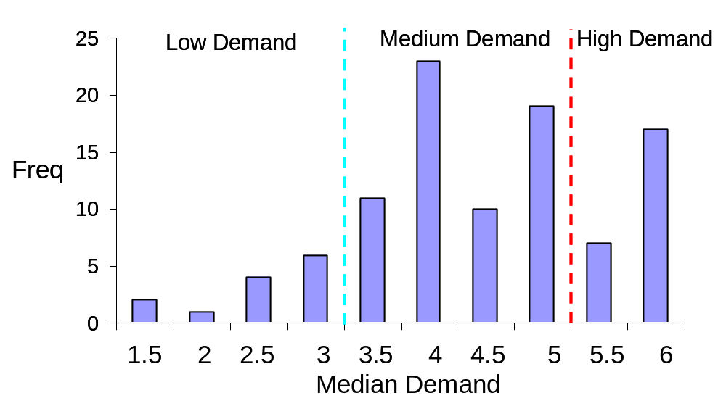
Figure 11.3. Distribution of median demand ratings.

Predicting rated demand from vehicle sensor data
The vehicle sensor data were analyzed for the middle 5-s portion of the 8-s video to predict the median demand ratings. The rated demand was highly correlated with several vehicle sensor variables, including the mean range value that was calculated with the 5-s time window (r=-0.60). It had a moderate correlation with variables including mean time headway (r=-0.34), standard deviation of time headway (r=0.33), and speed variability for the host vehicle (r=0.31) that were calculated with the 5-s time window. It had a low correlation with variables including speed variability among targets (r=-0.11) and speed variability for lead vehicles (r=0.15) that were calculated with the 5-s time window.

The vehicle sensor variables that were correlated with the rated demand were fused to derive an equation that can predict driving task demand. The equation that produced the best prediction was as follows,

Where k was a constant, which was 1 for moving targets that moved in the same direction as the host vehicle, 5 for moving targets that moved in the opposite direction (e.g., in oncoming lanes), and 0 for stationary targets. The normalized range was defined as follows,



Time headway was defined as

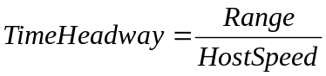

The normalized angle was defined as



Where angle is the angle for targets and angleCIPV is the angle for the closest in-path moving vehicle.

The minimum value between normalized range and time headway represented the range variable that was most demanding to subjects. In general, driving task demand increased with a reduction in either normalized range or time headway. The normalized angle variable indicated that the driving task demand was lower for targets that were laterally farther away from the longitudinal path of the host vehicle. The summation across tracks/targets indicated that the driving task demand increased with an increasing number of targets.

The weight equation above was adjusted based on the following factors.
- Yaw rate which indicates turning and driving on curves.
- GPS info (e.g., merge, highway entry, exit, interchange)
- Lane width
- Speed
- Brake pedal depression

The adjusted (predicted) weights were classified into three demand groups as follow,
A. Low demand (if the adjusted weight < 0.5),
B. Medium demand (if the adjusted weight >=0.5 and <2.18),
C. High demand (if the adjusted weight >= 2.18).

Figure 11.4 presents the median demand ratings against the adjusted (predicted) weights. The dark diagonal line represented the best-fitting regression line (Y=3.03+0.82X). It was clear from Figure 11.4 that most of the data points were near the regression line. The Pearson correlation coefficient between the adjusted (predicted) weights and median demand ratings was 0.79. This high correlation indicated that the demand algorithm was able to predict the rated demand very well.

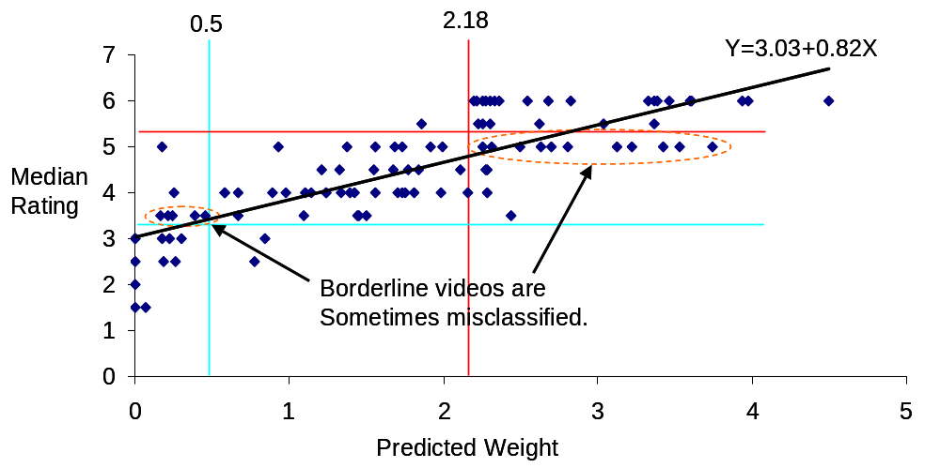

Figure 11.4. A scatter plot of median demand ratings against the adjusted (predicted) demand weight.

The demand groups for the predicted demand (from the predicted weight) and median demand ratings were tabulated in Table 11.1. When there was a match between the predicted and rated demand groups (e.g., both were high demand), the cell was colored green. When the predicted and rated demand groups mismatched by one group (e.g., high and medium demands), the cell was colored yellow. When the mismatch was two groups (e.g., low vs. high demand), the cell was colored red. It was clear from Table 11.1 that all red cells were 0, indicating no gross mismatches. There were some yellow non-zero cells, indicating some small mismatches. The largest cell values were green, indicating a reasonable match between the predicted and rated demands. The green cells represented 75% of the videos.

Table 11.1. Tabulation of Predicted and Rated Demand Groups.
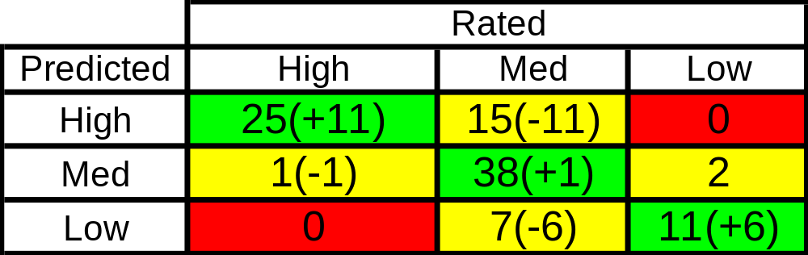
Note. The values in the parentheses represent the borderline videos that could have been re-classified.

A close examination of Figure 11.4 and Table 11.1 indicated that most of the mismatches were borderline cases. As shown in Figure 11.4, out of the 15 videos that were predicted to have a high demand level but rated as a medium demand level, 11 videos had a rated demand of 5, which was very close to a high demand rating (if rating >=5.5). Out of the 7 videos that were predicted to have a low demand level but rated as a medium demand level, 6 videos had a rated demand of 3.5, which was very close to a low demand rating (if rating <=3). Furthermore, the experimenter reviewed these videos and indicated that they could have been re-classified to match the predicted demand. If these videos were re-classified (as shown in Table 11.1), the percentage of matches between the predicted and rated demands was increased to 93%.

Visual distraction feedback
Figure 11.5 presents the number of "yes" responses to curtail off-road glances or the amount of visual distraction based on the driving task demand. The correlation coefficient between the number of "yes" responses and driving task demand rating was 0.76. As shown in Figure 11.5, drivers believed that as the driving task demand increased, more visual distraction should be curtailed. The regression line was:
Y= -2.9+1.48X, where Y was the number of "yes" responses to curtail the amount of visual distraction and X was the rated demand. In other words, the allowable visual distraction should be reduced as the driving task demand increased. These results supported the SAVE-IT approach and distraction mitigation concepts.

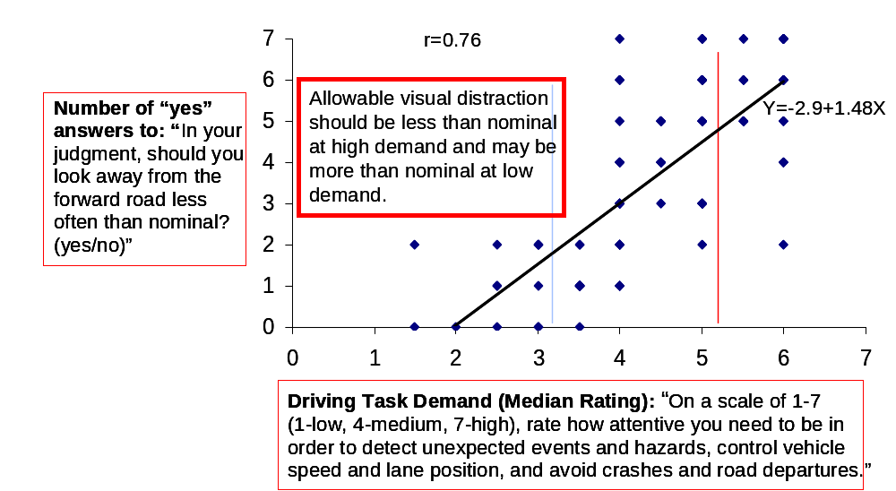

Figure 11.5. The number of responses to curtail off-road glances (visual distraction) as a function of driving task demand.

Demand-based advisories against using certain IVIS tasks
Figure 11.6 presents the median ratings for allowable radio tuning as a function of driving task demand. As the driving task demand increased, the median rating for advisories against the use of radio tuning also increased. The correlation coefficient was 0.65. The regression line was Y = 0.04+0.29X, where Y was the median rating for advisories against the use of radio tuning and X was the rated demand. Because the median rating was below 2 even for the highest level of demand, the distraction mitigation strategy was to allow radio tuning at all demand levels.

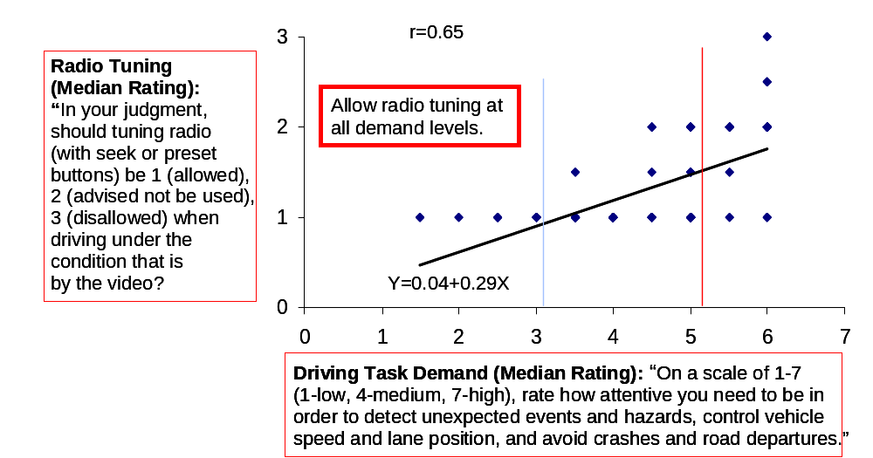

Figure 11.6. Median ratings of allowable radio tuning as a function of driving task demand.

Figure 11.7 presents the median ratings for allowable use of satellite radio as a function of driving task demand. As the rated demand increased, the median rating for advisories against the use of satellite radio also increased. The Pearson correlation coefficient was 0.72. The regression line was Y=0.07+0.35X, where Y was the median rating for advisories against the use of satellite radio and X was the rated demand. As shown in Figure 11.7, the median rating for advisories against the use of satellite radio approached 2 (advised not to be used) at the highest demand level. The distraction mitigation strategy was therefore to advise against the use of satellite radio when the demand was high.

Figure 11.8 presents the median rating for advisories against the use of CD functions as a function of driving task demand. The correlation coefficient was 0.65 and the regression line was Y=0.04+0.3X, where Y was the median rating against the use of CD functions and X was the rated demand. As the rated demand increased, the median rating for advisories against the use of CD functions also increased. It approached a median rating of 2 (advised not to be used) when the rated demand was high. The distraction mitigation strategy was therefore to provide advisories against using CD functions when the driving task demand was high and no advisories when the driving task demand was low or medium.

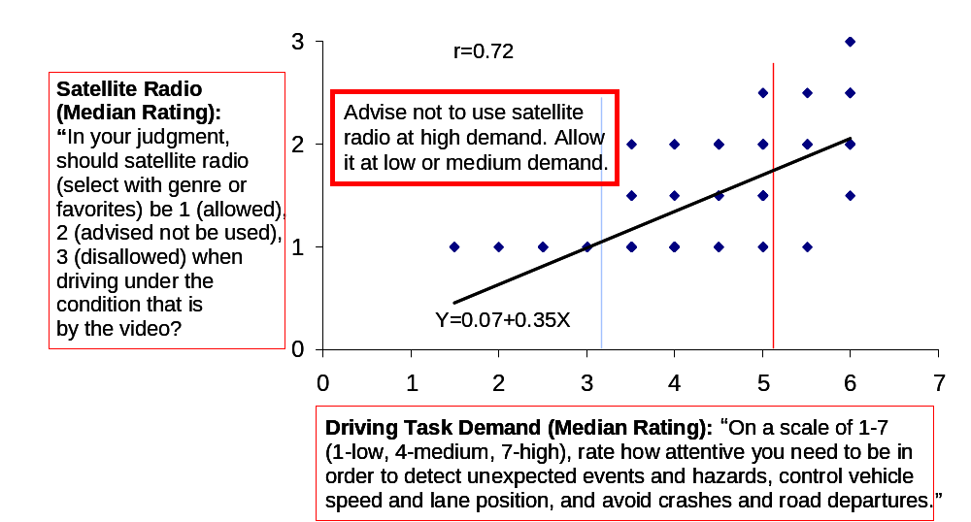

Figure 11.7. Median ratings of allowable satellite radio use as a function of driving task demand.

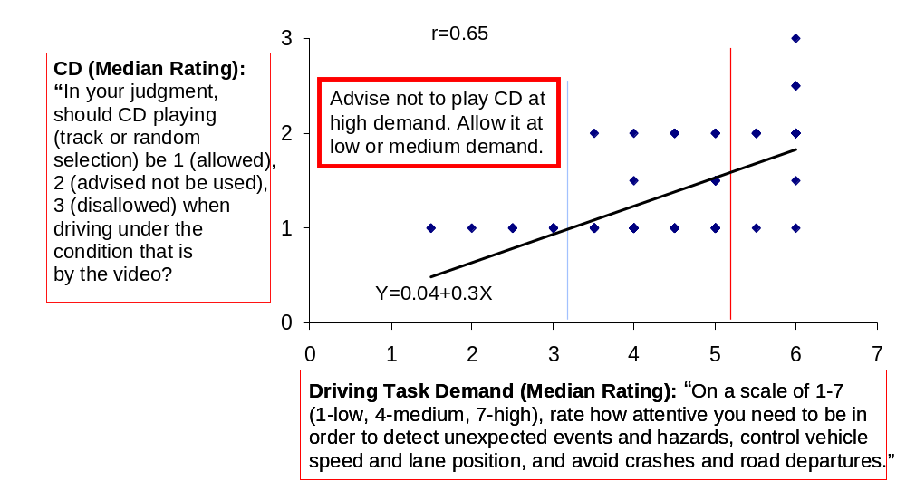

Figure 11.8. Median ratings of allowable CD use as a function of driving task demand.

Figure 11.9 presents the median rating for advisories against the use of MP3 functions as a function of driving task demand. The correlation coefficient was 0.75 and the regression line was Y=0.15+0.39X, where Y was the median rating for advisories against the use of MP3 functions and X was the driving task demand. As shown in Figure 11.9, the median rating for advisories against the use of MP3 functions increased sharply with the driving task demand. It approached a median rating of 2 (advised not to be used) when the driving task demand was medium and exceeded a median rating of 2 when the driving demand was high. Therefore, the distraction mitigation strategy was to provide advisories against the use of MP3 when the driving task demand was medium or high, and no advisories when the driving task demand was low.

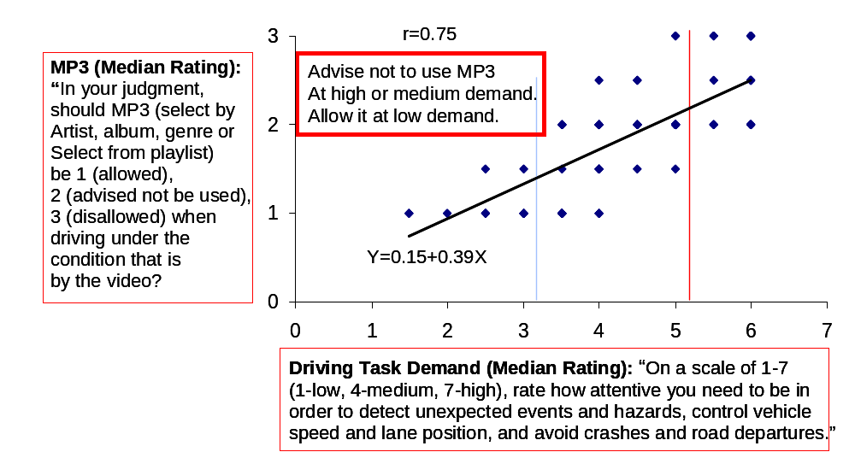

Figure 11.9. Median ratings of allowable MP3 use as a function of driving task demand.

Figure 11.10 presents the median rating for advisories against manual phone dialing as a function of driving task demand. The correlation coefficient between the median rating for phone dialing advisories and the rated demand was 0.72. The regression line was Y=0.85+0.34X, where Y was the median rating for advisories against manual phone dialing and X was the driving task demand. As the driving task demand increased, the median rating for phone dialing advisories also increased. The median rating for phone dialing advisories was approximately 2 when the driving task demand was medium and approached 3 when the driving task demand was high. Therefore, the distraction mitigation strategy was to provide advisories against manually dialing 7- or 10-digit phone numbers when the driving task demand was medium, advisories against any type of phone dialing (including speed dial) when the driving task demand was high, and no advisories when the driving task demand was low.

Figure 11.11 presents the median rating for advisories against answering a phone call as a function of driving task demand. As the driving task demand increased, the median rating for call answering advisories also increased. The Pearson correlation coefficient was 0.79, and the regression line was Y=-0.1+0.39X, where Y was the median rating for advisories against answering phone calls and X was the driving task demand. When the driving task demand was high, the median rating for call answering advisories exceeded 2 (advised not to be used). The distraction mitigation strategy was then to provide advisories against answering phone calls when the driving task demand was high and no advisories when the driving task demand was low or medium.

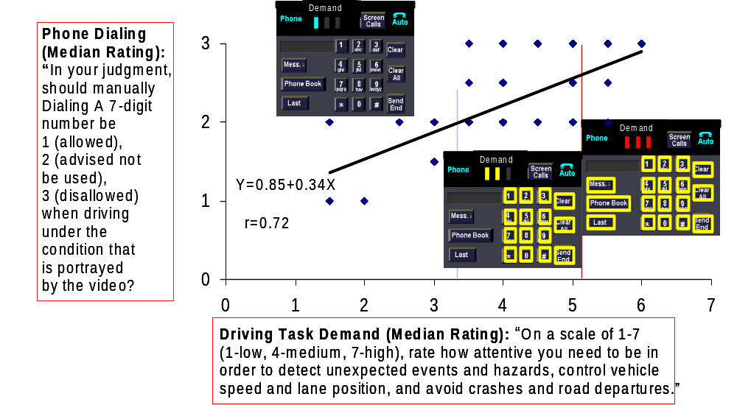
Figure 11.10. Median ratings of allowable phone dialing as a function of driving task demand.

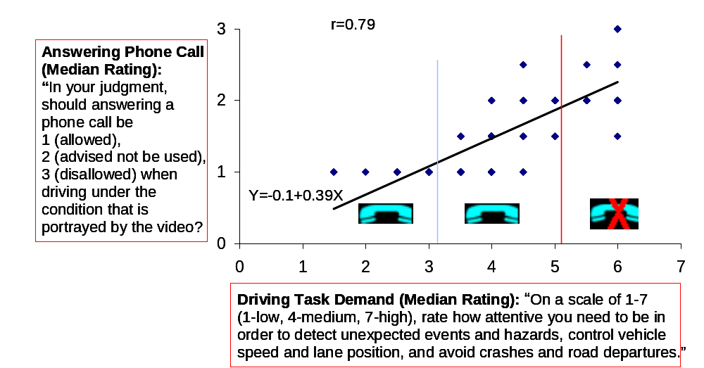

Figure 11.11. Median ratings of allowable phone call answering as a function of driving task demand.
Figure 11.12 presents the median rating for advisories against telephone conversation as a function of driving task demand. As the driving task demand increased, the median rating for phone conversation advisories also increased. The correlation coefficient between them was 0.72, and the regression line was Y=0.16+0.27X, where Y was the median rating for advisories against telephone conversation and X was the driving task demand. When the driving task demand was high, the median rating for telephone conversation advisories approached 2 (advised not be used). The distraction mitigation strategy was therefore to provide advisories against having a phone conversation when the driving task demand was high and no advisories when the driving task demand was low or medium.
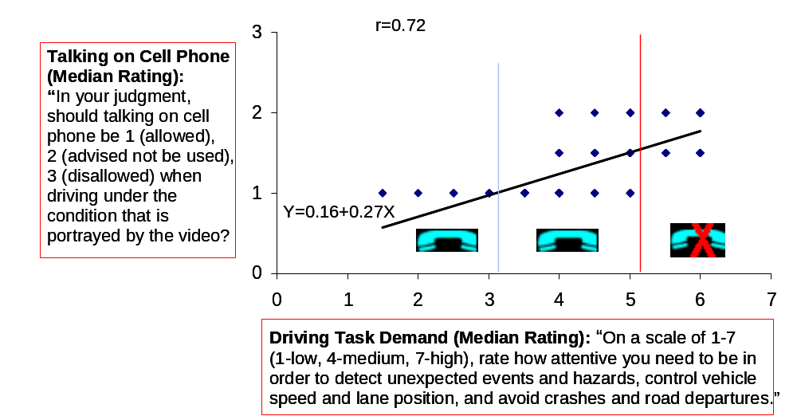

Figure 11.12. Median ratings of allowable phone conversation as a function of driving task demand.

Figure 11.13 presents the median rating for advisories against the use of the point-of-interest function on a navigation system as a function of driving task demand. The Pearson correlation coefficient between them was 0.70, and the regression line was Y=0.94+0.34X, where Y was the median rating for advisories against the use of navigation point-of-interest function and X was the driving task demand. The median rating for point-of-interest advisories exceeded 2 when the driving task demand was medium and approached 3 when the driving task demand was high. The distraction mitigation strategy was therefore to provide advisories against the use of navigation point-of-interest functions when the driving task demand was high or medium and no advisories when the driving task demand was low.

Figure 11.14 presents the median rating for advisories against map reading on a navigation system as a function of driving task demand. The Pearson correlation coefficient between them was 0.79 and the regression line was Y=0.38+0.41X, where Y was the median rating for map reading advisories and X was the driving task demand. The median rating for map reading advisories was approximately 2 when the driving task demand was medium and 3 when the driving task demand was high. The distraction mitigation strategy was therefore to provide advisories against reading maps on a navigation system when the driving task demand was high or medium and no advisories when the driving task demand was low.
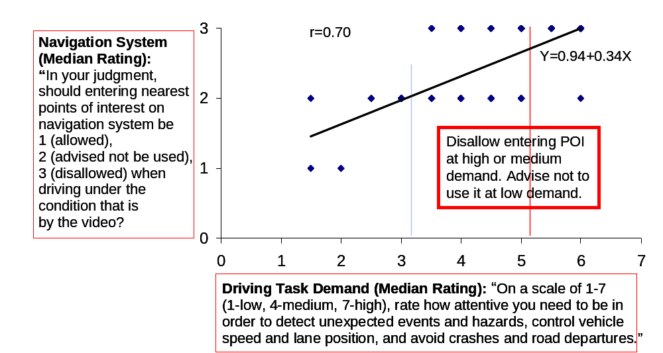

Figure 11.13. Median ratings of allowable use of navigation point-of-interest feature as a function of driving task demand.

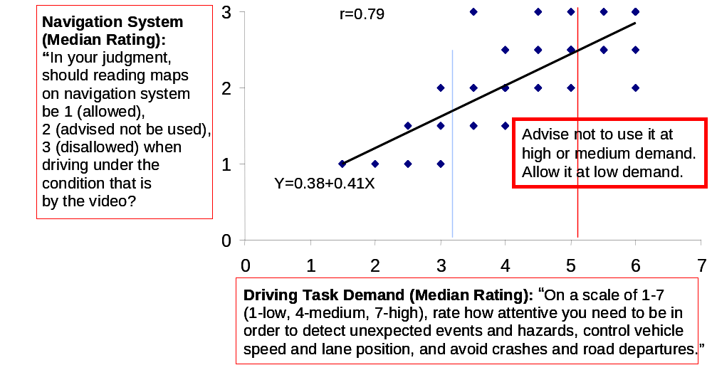

Figure 11.14. Median ratings of allowable map reading on the navigation system as a function of driving task demand.
Figure 11.15 presents the median rating for advisories against using the turn-by-turn function on a navigation system as a function of driving task demand. The correlation coefficient between them was 0.61, and the regression line was Y=0.74+0.28X, where Y was the median rating for advisories against using the turn-by-turn function and X was the driving task demand. The median rating for advisories against using the turn-by-turn function was approximately 2 when the driving task demand was high or medium. Therefore the distraction mitigation strategy was to provide advisories against using the turn-by-turn function when the driving task demand was high or medium and no advisories when the driving task demand was low.
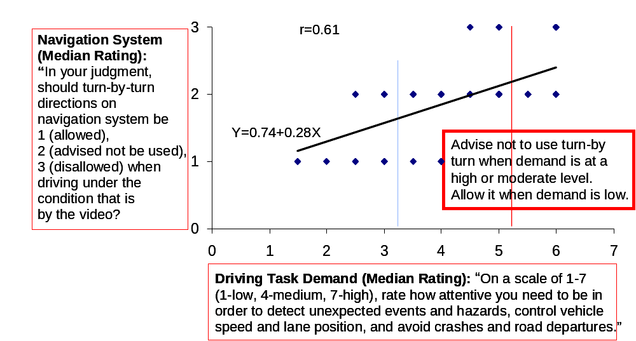

Figure 11.15. Median ratings of allowable use of navigation turn-by-turn feature as a function of driving task demand.

Figure 11.16 presents the median rating for advisories against reading text messages as a function of driving task demand. The Pearson correlation coefficient between them was 0.71, and the regression line was Y=1.78+0.23X, where Y was the median rating for text message advisories and X was the driving task demand. As shown in Figure 11.16, the median rating for text message advisories exceeded 2 when the driving task demand was high, medium, or low. Therefore, the distraction mitigation strategy was to provide advisories against reading text messages when the driving task demand was high, medium, or low.
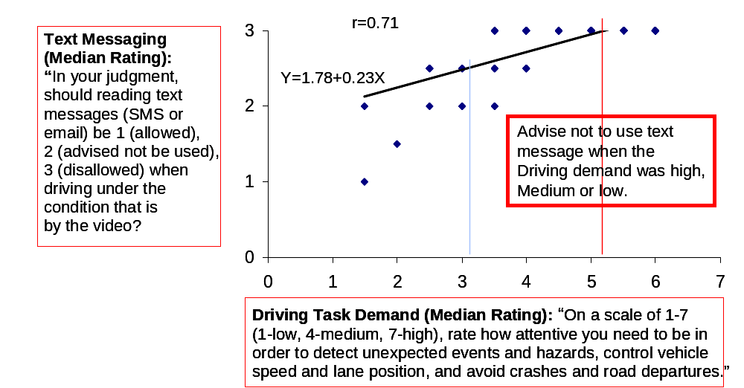

Figure 11.16. Median ratings of allowable use of text messaging as a function of driving task demand.

11.3.3. Discussion
The demand experiments provided information not only about how to detect driving task demand as a function of the sensor data but also about how the countermeasures that use demand should be implemented. At the time of this research, the set of distraction mitigation countermeasures included the following:

- Adaptive Infotainment Advisory: This countermeasure displayed the driving task demand level on the center console screen at all times (see Figure 11.17) and changed the color of the buttons to yellow in order to indicate to the driver that using the feature was not advisable given the current driving task demand level.
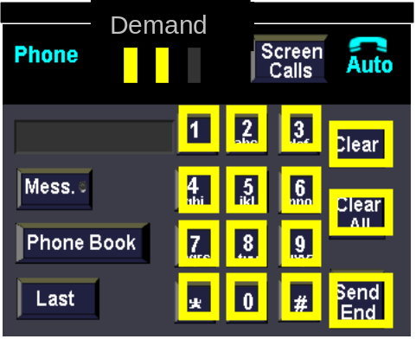

Figure 11.17. The preliminary method for indicating adaptive infotainment advisories.
- Adaptive Phone Management: The driver selects between the three different modes of no screening (allows all calls through), do-not-disturb (screens all calls to voicemail), and automatic screening (allows calls through when driving task demand is low and otherwise screens the calls to voicemail). Only the automatic screening utilized the driving task demand information to determine whether calls were allowed or screened.

- Real-time Distraction Feedback: Prior to the iterative on-road testing, the SAVE-IT program had planned to provide real-time distraction feedback in the form of an amber bezel around the infotainment screen (see Figure 11.18). During the iterative on-road testing (described in the next section), this interface was replaced with an amber exogenous display for a distraction alert, due to the potential for feedback on the infotainment screen to maintain the driver’s attention on the center console area. Task 4 (Distraction Mitigation) had demonstrated that driver’s reaction times could actually increase as a result of this countermeasure. Ultimately the iterative on-road testing led to the total abandoning of real-time distraction feedback, including the amber exogenous display, due to the high rate of nuisance alerts and fears that this countermeasure would be overly annoying to the drivers.
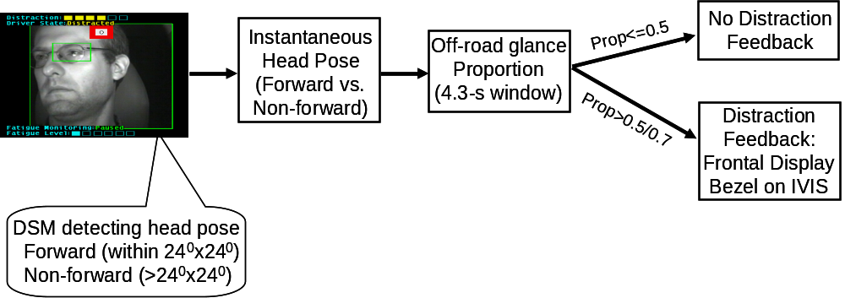

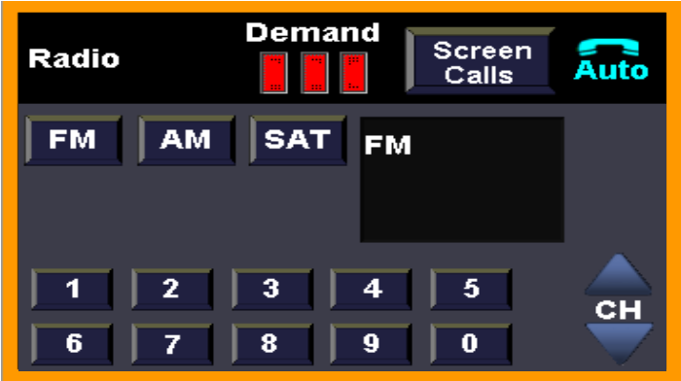

Figure 11.18..A flow chart for real-time distraction feedback and the amber bezel used to advise drivers to reduce off-road glances

- Trip Report: Rather than displaying distraction feedback in real-time and risking adding additional distraction during the driving task, the strategy of providing feedback at the end of the drive (Trip Report) was used. Post-drive feedback was investigated in Task 4 and appeared to be a promising alternative to providing real-time distraction feedback. Due to its late emergence, this strategy was not evaluated in the iterative on-road testing. Although the trip report could have presented driving task demand information to the driver, the goal was to keep the presentation relatively simple and present only the information that would most likely change the driver’s future driving behavior.

The next section describes the process of how the iterative on-road testing was used to refine the final set of SAVE-IT countermeasures that were implemented in the evaluation phase.

11.4. ITERATIVE ON-ROAD TESTING AND DEVELOPMENT

Before the final on-road evaluation could commence, an iterative development process was used to evaluate drivers’ perceptions and acceptance of the adaptation strategies in the context of on-road driving, and refine the adaptations accordingly. The primary purpose of this initial portion data fusion task was to use insights gained through on-road evaluations to facilitate the refinement and final selection of the adaptation strategies and HMI. As an extension of previous, simulator-based experiments, on-road drives were completed so that a range of subjective measures, in addition to metrics representing the effectiveness of adaptation, could be examined. These drives were conducted as an iterative process that allowed for immediate cycles of implementation, testing and refinement based on both subjective and objective measures that were indicative of system performance. This iterative refinement process afforded a data-driven methodology to support this complex, multi-faceted data-fusion task. As the performance of the component systems and their resultant interactions with the overall system became apparent, system functionality could be modified to provide more effective and acceptable SAVE-IT adaptations. Whereas the component tasks (Tasks 4 and Task 9) had focused more on the safety-benefit of the respective systems, these on-road evaluations were used to assess the feasibility of the alternatives in terms of how easily understood the countermeasures were and driver acceptance.

11.4.1. Method

Participants
Twelve employees, 10 men and 2 women, at Delphi Electronics and Safety Systems in Kokomo, Indiana, participated in the on-road testing. Employees were randomly informed about the study by email and were selected for participation based on the information provided in a screening questionnaire. In order to qualify, participants were required to have a valid driver’s license, be able to drive without eyeglasses, not take driving-impairing drugs prior to departure, agree not to wear sunglasses during the testing, not work directly with the products being tested, and women could not be pregnant.

All participants were between 30 and 48 years of age, with a mean age of 38, had between 14 and 33 years of driving experience, and drove between 6,000 and 25,000 miles per year. All but one of the participants were engineers, with the exception being a background in a computer-related technical field. Per information provided on the screening questionnaire, five participants reported a familiarity with FCW systems, and four with LDW systems. None of the participants acknowledged having had exposure to DSM (Driver State Monitor) prior the drive. Accident and driving history were not considered as part of the selection process. Participants were paid for their participation with a $75 Best Buy gift certificate.

Apparatus
The test vehicle used during these drives was a 2000 Buick Le SABRE®, equipped with safety warning, driver monitoring and data collection systems. The vehicle included FCW, LDW, proximity alert, distraction alert, and driving task demand systems, in addition to a DSM unit that was secured near the instrument cluster. Data and video feeds were collected using several methods, including camcorders and a custom data-acquisition software tool on laptops, which were always displayed out-of-view of the driver.

Design
All of these researcher-accompanied drives occurred on public roads. Drives took place on weekdays, departed Delphi Electronics and Safety Systems between 8:00am and 1:00pm, and typically lasted about 3 hours. All but two drives were completed in dry conditions. Drivers were not asked to engage in a secondary task, but were asked to glance at the IVIS screen when they were comfortable doing so to observe changes in the driving task demand, which was being displayed in a manner similar to that shown in Figures 11.17 and 11.18. The iterative nature and the immediate implementation of feedback during this portion of testing demanded that a number of variables not be held constant and, instead, allow for variation and refinement across participants. Variations in the warning systems, driver training, and route had the greatest impact on drivers’ experiences and afforded the most effective refinement process. Because of the iterative nature of the testing no formal set of dependent variables were selected a priori, and unstructured observations were the basis of the decision making process.

Warning Systems
The testing began with five drives that included simultaneous activation of FCW, LDW, proximity alert, and driving task demand systems. The final seven drives included the addition of the distraction alert, active only in adaptive mode. Later drives included improvements and updates to the DSM system and to the presentation of driving task demand indicators. While the majority of drives focused on a comparison between non-adaptive and adaptive modes, two drives limited exposure to only the adaptive mode. By using a three-part format, the final three drives gave participants a chance to explore the warning systems before the researcher presented training information. Feedback from participants about the frequency of warnings, their interpretation of the alerts, and their perception of nuisance alerts, guided the iterative refinement process. However, it was particularly problematic for drivers to evaluate multiple warning systems in areas with heavier traffic, due to the increased alert-rate and the limited interval between alerts for discussion or clarification with the researcher. Drivers also reported only a basic understanding of the warning systems when training was not provided prior to the drive.

Training
As part of the iterative nature of this evaluation, the type and depth of training administered by the researcher varied across participants. Initially, drivers were introduced to each of the four warning systems, FCW, LDW, proximity alert and driving task demand, provided a demonstration, and given specific details about how each system worked (e.g., time headways, distraction thresholds, imminent collision criteria). The intent and behavior of the adaptation strategies were also described to participants (e.g., auditory, timing, and suppression strategies, as well as, the implications of driver head pose). Drivers were encouraged to share their reactions, comments and questions, with drives taking on an informal “think aloud” approach. During testing, detailed answers were provided when a driver made an inquiry about the camera, radar, or one of the warning systems.

In an effort to realize more naturalistic driving, later drives simplified the training by eliminating discussion of the details of the adaptation (e.g., specific adaptation strategies), in addition to the more technical aspects of the warning systems (e.g., time headways, distraction thresholds, and imminent collision criteria). Most drivers found the inclusion of so much detail overwhelming and much too challenging to grasp during a brief exposure. It was thought that the streamlined training, coupled with increased warning exposure during the demonstration, would provide drivers with a more meaningful and practical representation of the warning systems. In addition, the redesigned training also afforded drivers a more natural process of discovery and they were encouraged to continue to share their impressions. The importance of driving as they normally would and specifically, not inducing alerts, was strongly emphasized to each driver during training.

Route
Two different routes encompassed a variety of driving environments. The first route included, highway, city, suburban retail district, and wooded/hilly, and a second route provided exposure to interstate driving. The length of drives varied between 100 mi and 120 mi. While most of the drivers were generally familiar with a majority of each route, some participants did not frequently travel on these roads and some drivers were new to the area. These diverse routes revealed that road and traffic conditions can impact warning system behavior. The wooded/hilly portion proved especially important for understanding the high-rate of out-of-path, stationary alerts. Drivers’ curiosity while traveling through an unfamiliar area resulted in a tendency to look away from the road and also impacted system behavior and alert-rate.

11.4.2. Results

The twelve naïve-subject drives described here were also supplemented with numerous engineering drives and commutes that assessed specific effects of the adaptive systems. A compilation of data from those engineering drives, reports from participants, and researcher observations drove the iterative optimization of the FCW, LDW, distraction alert, and proximity alert systems, their respective adaptive enhancements. It became apparent that warning system behavior can be quite variable for different types of driving styles and individual differences became an important consideration as modifications were considered. A summary of key modifications is shown in Table 11.2.

Table 11.2. Summary of Key Observations and their Resultant System Modifications.
System | On-Road Evaluation | Modification
Exogenous Display | Amber exogenous display appeared too large and too bright. | Diameter and brightness of the amber exogenous display were reduced.
DSM | Head pose ‘forward’ angle too narrow, causing frequent nuisance alerts when the driver was attending to the road but had a slightly angled head posture. | ‘Forward’ angle was increased to 20 deg. This is consistent with some of the 100-Car study observations that glances outside of the 20 deg region are particularly problematic.
FCW | Auditory car horn alert was too startling. | Auditory car horn alert changed to tonal alert.
FCW | Volume of auditory alerts too startling. | Volume of alerts reduced.
FCW | Adaptive FCW auditory suppression strategy perceived as inconsistent. | Auditory FCW suppression removed in favor of differential alert timing approach.
FCW | Alerts for out-of-path, stationary objects too frequent. | Alerts for stationary objects (CIPS) were suppressed.
LDW | Warnings perceived as nuisance alerts at lower speeds. | Minimum speed criterion for alerts increased. Permissible lane width increased.
Proximity Alert | Behavior of alerts caused confusion. | Complex dimming and flashing algorithm replaced by solid exogenous display at a fixed 0.5-s threshold.
Distraction Alert | High frequency of nuisance alerts. | Experimented with Different thresholds but ultimately determined that the problems could not be resolved and abandoned this countermeasure.

Several of the first on-road evaluations provided strong feedback about the auditory portion of the FCW system. Drivers reported the auditory car horn warning to be startling and, depending on the context of the driving situation, not always indicative of a forward event (e.g., when making a lane change). The auditory warning was replaced with a series of four, quick, 400-Hz tones. Although the car horn had shown promise in the driving simulator for speeding up driver responses, there was insufficient time to examine the risk of driver confusion that might be caused by using this sound. However, when the first warning exposures continued to produce a startle effect, volume of the warning was adjusted to provide a more ideal balance between capturing the attention of and startling the driver. It quickly became clear that the number of FCW events triggered by out-of-path, or off-road, stationary objects was far too frequent. Early questionnaire results also reflected similar concerns. Due to the time constraints on developing the FCW algorithm, it was decided that the alerts for stationary targets would be suppressed, reflecting the functionality of many production implementations. The likelihood of recommending or buying the FCW system was most negatively impacted by the frequency, volume, and pitch of warnings.

The initial LDW system also presented concerns for several of the participants. Drivers demonstrated a tendency to categorize warnings as nuisance alerts when they occurred at lower speeds and expressed that the warnings occurred too early, well before the threat of a lane departure. A high alert-rate was cited as the reason for not recommending or purchasing the LDW system. In order to reduce the number of perceived nuisance alerts, the minimum activation speed was raised and lane width was increased, effectively delaying the activation of warnings. In addition to these enhancements, an LDW auditory warning was also implemented, as it is considered to be more representative of production systems. The auditory warning, similar to a rumble strip sound, was issued in synchrony with the exogenous display and haptic seat vibration.

Several changes to the proximity alerts were implemented during the on-road evaluation. The original system included dimming and flashing of the exogenous display for various stages of adaptation and time headway, but drivers expressed uncertainty and annoyance about what each display represented. Several improvements to the presentation of the alerts were incorporated in an effort to communicate a clearer, less-distracting message to drivers. The flashing and dimming were removed to produce a solid amber exogenous display. Questionnaire responses revealed that drivers thought the timing of the alert was too early and that a closer following distance, such as is maintained in heavy traffic, should be allowed. The characteristics of the exogenous display became especially salient during proximity alerts, when the display was active for an extended period. Several drivers commented that the exogenous display was too large and too bright. While this effect was reduced as nuisance alerts across warnings were reduced, the exogenous display was also modified to address drivers’ concerns. The brightness and diameter of the amber proximity alert display were both slightly reduced.

The Distraction Alert system presented unique challenges. Drivers consistently experienced a high alert-rate, but more importantly, were often unable to associate these alerts with their cause. Users reported receiving alerts when they did not perceive themselves to be distracted or when performing regular driving maneuvers, like checking a blind spot. As a result, high levels of frustration and annoyance became associated with this system. The first modification made was to widen the head pose angle that DSM defines as ‘forward’ to 20 deg. The 20 deg window was based on the 100-Car Study observation that the risk increased significantly for glances outside of 20 deg (Klauer, Dingus, Neale, Sudweeks, & Ramsey 2006). Secondly, the temporal distraction criterion was lengthened to reduce the number of alerts. The alert rate was drastically reduced when the glance away threshold for the distraction rate was increased. Variable thresholds were implemented, ranging from 2 to 4 s, depending on the time headway to the lead vehicle. Although alerts were relatively rare, the proportion of alerts that were false was still too high. Because the time thresholds were so high, the most common cause for alerts were from the failure of DSM to detect momentary glances back to the forward scene. The DSM would detect glances away, however, after missing the rapid glances back that often only involved the eyes returning and not the head, the glance duration was summed over multiple glances away, reaching the threshold over several glances away. Often the distraction alerts were issued at the same moment that the driver returned their attention to the forward roadway. Furthermore, the impact on safety of the distraction alerts was not clear. Task 4 (Distraction Mitigation) had demonstrated that distraction alerts may actually increase driver reaction times, perhaps because the distraction alerts themselves actually added a source of distraction. Due to the unresolved nuisance alert issues and the unclear safety implications the real-time distraction alerts were abandoned in favor of the post-drive distraction feedback. This countermeasure (trip report) appeared to late to be tested in the data fusion task, however, it had been investigated in the late stages of Task 4 (Distraction Mitigation) and so Delphi and the University of Iowa were able to work quickly to install the trip report countermeasure for the Task 14 NADS evaluation.

Conclusions
After numerous iterations of development and testing, the performance of the SAVE-IT systems began to converge on a final implementation that appeared to best balance the constraints of acceptance and safety. As the rate of iterative improvements began to decline, the system began to solidify and was frozen in place. Table 11.3 displays the final system configuration for Adaptive FCW that was tested in Task 14 (Evaluation). After much research in Task 9 and some on-road acceptance testing in Task 11, the Differential Alert Timing strategy appeared to be the most promising. In this particular implementation, the timing adjustment for the forward attention state was quite extreme (assumed reaction time of 0.5 s) in order to suppress almost all alerts when the driver’s head pose was forward. This adaptation method was selected because it at least provides some coverage for driver’s who are visually oriented to the forward scene but might benefit from an alert for some other reason (e.g., drowsiness or cognitive distraction). When the driver’s head pose is not forward, the driver will experience very early alerts that allow for a long driver brake reaction time.

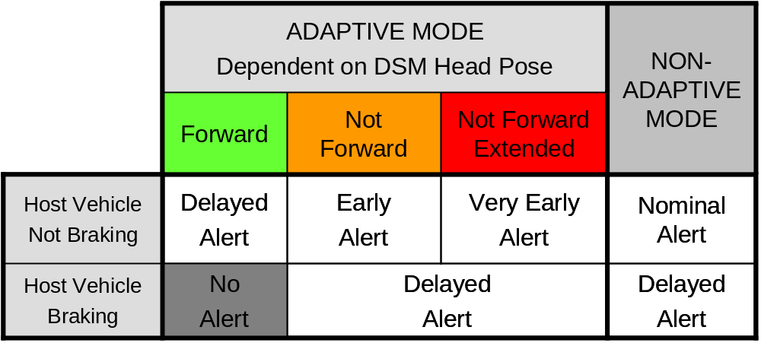
Table 11.3. Adaptive and Non-Adaptive mode Forward Collision Warning as a Function of Driver Head Pose.

A distinction was made between head pose not forward and an extended period during which head pose was not forward. This was an important distinction that allowed drivers to glance away from the forward scene for brief moments (such as mirror checks) yet still experience the potential nuisance-alert suppression of the SAVE-IT system. The distinction between glances away for greater than 2 s compared with shorter driving-related glances away from the forward roadway (such as mirror checks) is supported by the results of the 100-Car Study (Klauer et al., 2006).

The final form of adaptation that was selected for LDW was the suppression strategy (see Table 11.4). This strategy was selected because several drivers experienced confusion with the differential alert stimuli strategy (suppression of the auditory warning stimulus; see Task 9) because the interface lacked consistency. Due to the fact that cognitive distraction and brief or small-angle visual distractions do not appear to significantly degrade lane-keeping performance (see Tasks 5 and 9), LDW provides little safety benefit for visually-attentive drivers. The distinction between head pose not forward for an extended period of time versus the instantaneous state was especially necessary for LDW, where lane changes were often preceded by mirror checks just before the lane-crossing. The CAMP workload program revealed that the number of and duration of glances to the secondary task were the best predictors of lane crossings (Angell, Auflick, Austria, Kochhar, Tijerina, Biever, Diptiman, Hogsett, & Kiger, 2006). It is expected that the SAVE-IT implementation of adaptive LDW will not compromise the safety benefit of LDW because only with prolonged distraction episodes is it likely that drivers will lose lateral control of the vehicle without being able to make the appropriate corrective response. For an alert to be generated in adaptive mode, the driver’s head pose needed to be away for a minimum of 2 s, and at least 1 s of the head-pose away needed to occur prior to the lane crossing. This was because if drivers looked away just as they were about to cross the lane, it could be assumed that they were aware of the lane crossing.

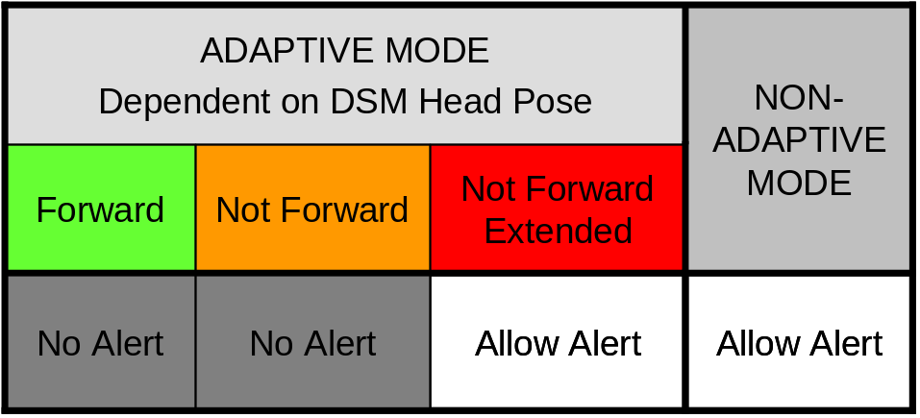
Table 11.4. Adaptive and Non-Adaptive mode Lane Departure Warning as a Function of Driver Head Pose.

For similar reasons, the suppression strategy was also tested for the FCW system, however, it was subsequently abandoned in favor of a timing strategy. The timing strategy that was finally implemented is similar to a suppression strategy in that it is likely to suppress virtually all alerts while the driver’s head pose is ‘forward’ because the system will wait until the last possible moment before issuing the alert. When the driver’s head pose is ‘not forward’, the driver will experience very early alerts that allow for a long driver brake reaction time.

These final implementations of adaptive FCW and LDW were evaluated separately in on-road studies that are described in the next section. Due to the relatively low baseline rate of FCW alerts generated by typical algorithms, the FCW algorithm was sensitized in both the baseline and adaptive conditions. This was necessary in order to provide drivers with some exposure in the relatively short durations of both the data fusion and Task 14 UMTRI on-road evaluations. Without sensitization, it would be likely that many drivers would not experience a single alert in either adaptive or non-adaptive mode. In the non-adaptive mode, the algorithm assumed a brake reaction time of 2.5 s to the alert (see Figure 11.19). In the adaptive mode, the algorithm would assume a brake reaction time of 0.5 s when the driver’s head pose is forward, and 3.5 s when the driver’s head pose is away for an extended period of time (e.g., 2 s). When the driver’s head pose was first directed away from the roadway, the brake reaction time would begin at 1.5 s and then linearly increase towards 3.5 s, which would be reached at a 2-s extended away pose. The iterative testing and development suggested that, although the non-adaptive and adaptive alert rates were elevated, they did not appear to be excessive. Alerts still seemed to have similar causes to those of a more typically tuned algorithm.
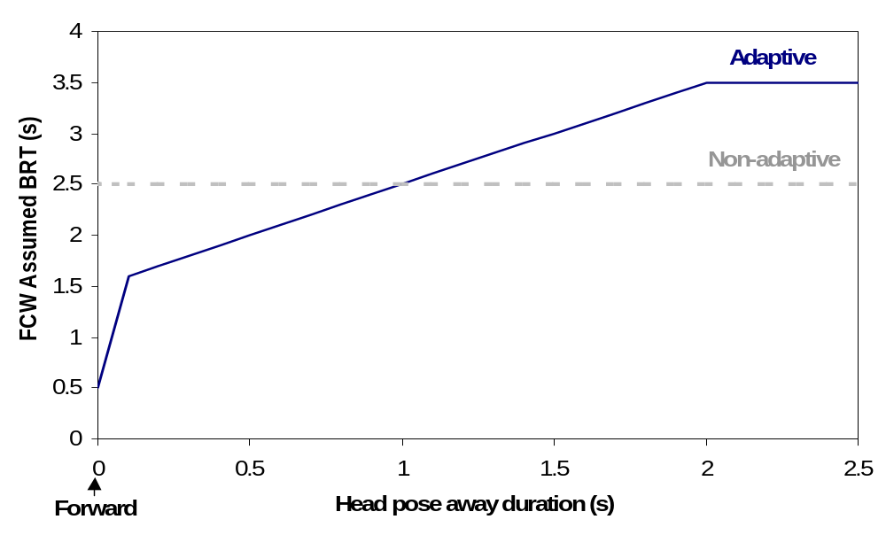

Figure 11.19. FCW assumed brake reaction times (BRT) for adaptive and non-adaptive systems.

11.5. ON-ROAD ADAPTIVE WARNING VALIDATION

Following the conclusion of the iterative testing and development, Task 11 provided an opportunity to examine drivers’ perceptions and acceptance of the newly optimized adaptive warnings. Particular emphasis was placed on obtaining a comparison between the non-adaptive and adaptive modes, in a naturalistic driving context by measuring the frequency of warnings in addition to the drivers’ subjective experiences. During the iterative testing and development, it was observed that the simultaneous exposure to four warning systems was usually overwhelming for most participants and precluded a clear understanding of the behavior of the warning systems, adaptation strategy, and HMI. As a result, the on-road testing was narrowed to two separate studies, allowing the FCW and LDW systems to be tested independently of one another. It was anticipated that this refined approach would help to increase the transparency of warning system behavior and the contrasts between the non-adaptive and adaptive modes.

11.5.1. FCW Validation Method

Participants
Fourteen employees (eight men and six women) at Delphi Electronics and Safety Systems in Kokomo, Indiana, participated in the on-road FCW study. Employees were invited to participate via a randomly distributed email and were selected when they successfully met the participation requirements. In order to be eligible for the study, participants could not require eyeglasses to drive, had to have a valid driver’s license, had to agree not to take driving-impairing drugs for at least 4 hours before their scheduled drive, had to agree not to wear sunglasses for the duration of the drive, could not work directly with the products being tested, and women could not be pregnant.

All participants were between 36 and 59 years of age, with a mean age of 48, had between 20 and 43 years of driving experience, and drove between 10,000 and 40,000 miles per year. Five participants wore contact lenses and nine did not require any vision correction. Six of the participants, all male, were engineers, and the remaining eight participants had no background in engineering or safety warning systems. Prior to testing, seven of the 14 participants indicated that they were familiar with FCW systems to some degree, typically through exposure at work, participation in previous testing, or mainstream media. However, none of the 14 participants acknowledged that they were familiar with the concept of adaptation. One driver had brief exposure to the DSM unit, but was not familiar with its interaction with the warning systems. Accident and driving history were not considered as part of the selection process. Participants were paid for their participation with a $75 Best Buy gift certificate.

Apparatus
Equipment used in this experiment included the test vehicle driven by participants, a 2000 Buick Le SABRE®, modified to include safety warning, driver monitoring, and data collection systems. The FCW system installed on the test vehicle consisted of a forward-looking radar mounted above the front bumper and a forward-looking camera. Per the results of the iterative testing and development, alerts were only generated for moving targets or targets previously seen to move. The FCW system HMI included auditory and visual warnings. A tonal sound served as the auditory FCW alert and consisted of a series of four pulses of 400 Hz for a total duration of 0.5 s. The exogenous FCW alert consisted of a red LED, reflected onto the windshield. When activated, the exogenous display flashed three times at 5 Hz for a 0.5-s duration. The auditory and visual warnings activated simultaneously when an FCW alert occurred.

The test vehicle incorporated a Driver State Monitor (DSM) system that included a combination camera and IR light source positioned in front of the instrument cluster, partially occluding the gear selector and the bottom of the speedometer. The test vehicle was also fitted with an infotainment system that included a touch screen interface in the center console area. Data were collected on a laptop using custom data-acquisition software and included the processed DSM video, in addition to video feeds from four camera locations: interior roof-mounted, exterior left side, exterior right side, and forward-view. CANalyzer software captured and displayed information about host vehicle speed and acceleration, lead vehicle speed and acceleration, range, brake switch activation, and steering angle. The software also recorded information about FCW events, including the time of the event, alert suppression status, the brake reaction time dictated by adaptation for each event, and the activity of auditory and exogenous displays. The laptop computer responsible for recording and displaying video and data was located in the backseat, out-of-view of the driver.

Design
All participants drove using the same FCW system, and experienced the same non-adaptive and adaptive modes of the warning system, the order of which was counterbalanced. The route was prescribed by the researcher but consisted entirely of public roads. Although the majority of driving took place on dry roads, two drives encountered snow flurries and partially wet roadways and one drive experienced rain during part of the route. No tests were conducted during heavy precipitation, on snow-covered roads, or in icy conditions. In as much as it was possible to achieve a naturalistic driving environment, drivers were instructed not to induce FCW events or to test the warning system. Likewise, the accompanying researcher had no control over the FCW system, the manner in which adaptation was applied to the warning system, or the actions of other drivers. While all participants generally drove the same route, there was some variation. The length of FCW drives varied between 108 mi and 136 mi, with an average length of 122 mi. The second half of the drive followed the reverse of the first half. All drives took place on weekdays, departed Delphi Electronics and Safety Systems between 10:00am and 1:00pm, and typically lasted about 4 hours. Early-morning and evening drives were not scheduled as a means of maintaining comparable traffic density across drives.

The primary goal of the on-road FCW testing was to achieve a comparison of the non-adaptive versus adaptive modes by examining alert frequency, the effectiveness of adaptation, and subjective experiences of drivers. Dependent measures included objective measures (i.e., alert-rate) and subjective ratings (i.e., mode preference, annoyance, acceptability, and HMI preferences).

Procedure
After arriving at the test vehicle at Delphi Electronics and Safety Systems, participants were instructed to adjust and position the driver’s seat, side and rear-view mirrors, fan, temperature, and steering wheel height as they normally would. Participants were given a $75 Best Buy gift certificate and asked to provide the last four digits of their Social Security Number for Delphi Vehicle Administration. The researcher provided participants with the following information about the study:

The purpose of this drive is to evaluate a Forward Collision Warning (FCW) system. The intent of Forward Collision Warning systems is to warn drivers of the threat of a collision with a vehicle, or object, in front of them. In other words, the goal of a Forward Collision Warning System is to reduce rear-end collisions by warning drivers when there is a threat of colliding with the vehicle in front of them. The focus of this test is to evaluate two different versions of that FCW system, non-adaptive and adaptive.

Figure 11.20 was used as a visual aid to explain the concept of adaptation. This simplified explanation of the adaptation strategies was incorporated into training as a means of introducing concepts to drivers by providing them with a tangible example of how they could expect the system to behave. This explanation was not intended to capture the specifics of alert timing (earlier, nominal, later) or the distinctions between head pose (forward, not forward, extended not forward). As was observed during the iterative testing and development, presenting naïve drivers with too many specific details tended to impede their understanding of the adaptation. It is preferable to achieve a balance between identifying the system attributes being tested and providing a complete list of system specifications. In-depth training was also withheld so as to create a more naturalistic environment, so that drivers felt less compelled to alter their normal driving behavior. The researcher explained to participants:

In the non-adaptive mode, the FCW system provides all possible warnings to a driver, regardless of the driver’s head-pose. In adaptive mode, however, the FCW system monitors head-pose and suppresses FCW alerts when the driver’s head-pose is forward.

The camera, mounted to the steering column, is able to monitor the driver’s head-pose. By head-pose, we mean where the driver’s head is pointed, either ‘forward’ or ‘not forward’ (demonstrated by the researcher). We are not, however, referring to eye gaze or eye closure, as fatigue testing is not the focus of this study.

So, looking at the examples (see Figure 11.18), in the non-adaptive mode, the driver receives an FCW alert each and every time the threat of a forward collision is detected. In adaptive mode, when the driver’s head-pose is very far to the left or very far to the right and the vehicle detects the threat of a forward collision, the driver receives an FCW alert, however, when the driver’s head-pose is forward, or straight-ahead, an assumption is made that their attention is forward, they are likely aware of the situation, and can be expected to respond appropriately. In those cases the warning is turned off, or suppressed. Finally, the FCW system has a minimum activation speed of 20 mph, so below that speed, the system is completely inactive.

If your car detected the threat of a Forward Collision… | …and your Head Pose was: |  | …then the Non-Adaptive system will: | …then the Adaptive system will:
Forward Collision Threat Detected | Looking Straight-ahead | 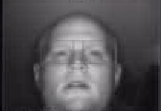 | Warn You | Not Warn You
Forward Collision Threat Detected | Checking the Driver-side Mirror | 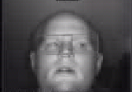 | Warn You | Not Warn You
Forward Collision Threat Detected | Checking the Passenger-side Mirror | 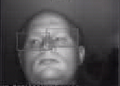 | Warn You | Not Warn You
Forward Collision Threat Detected | Staring out the Passenger-side Window | 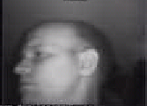 | Warn You | Warn You
Forward Collision Threat Detected | Checking the Speedometer | 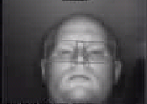 | Warn You | Not Warn You
Forward Collision Threat Detected | Staring out the Driver-side Window | 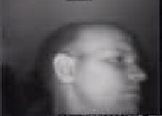 | Warn You | Warn You
Forward Collision Threat Detected | Checking the Rearview Mirror | 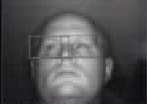 | Warn You | Not Warn You
Forward Collision Threat Detected | Staring at the Navigation System | 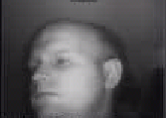 | Warn You | Warn You
Figure 11.20. A comparison of adaptation as applied to the FCW system.

After receiving this explanation, participants were given an opportunity to ask any questions they had about the instructions they had just heard. Common questions included a clarification about head-pose versus eye gaze and a restatement of the behavior of the non-adaptive versus adaptive modes. Following some discussion, participants generally agreed that they understood the concepts. Drives were divided into two halves, non-adaptive and adaptive modes, the order of which was counterbalanced. The researcher then asked the driver to look forward, as they would while driving, and demonstrated the FCW alert three times for the participant, pointing out both the auditory and visual components of the warning. Participants were also informed that cruise control was not active on the test vehicle and were cautioned against resting their hand at the top of the steering wheel, so as not to block the DSM camera.

The researcher strongly emphasized to all drivers the importance of driving as they normally would, not testing the system by inducing FCW alerts, and not altering their driving to receive more or fewer alerts. In accordance with the overall purpose of on-road testing, the goal of the drives was not to achieve as many or as few FCW alerts as possible, nor was it to evaluate participants’ driving. Rather, it was to realize a baseline frequency of FCW alerts during normal driving conditions and to assess the effectiveness and acceptability of adaptation. Participants were encouraged to report any impressions or opinions they had about the FCW system and were told they would be given a questionnaire at the end of the drive that focused heavily on the comparison between the non-adaptive and adaptive modes. Drivers were told to carefully focus on the comparison between the two halves of their drives, as they might notice a difference in alert-rate or in the timing of the alerts. Participants were encouraged to stop the drive at any time if they did not feel comfortable with road conditions and were told to let the researcher know if and when they needed a break.

Next, the researcher confirmed, via the video displayed on the laptop, that DSM had successfully captured their image. In some cases, the DSM camera had to be adjusted slightly or the participant was asked to raise the height of the driver’s seat, while maintaining a comfortable position. In an effort to add clarity to the testing and reinforce the concepts introduced during training, drivers were reminded which mode, non-adaptive or adaptive, they were currently experiencing and how that mode was intended to behave, as the drive began.

During the drive, the researcher provided turn-by-turn directions to the drivers, as needed. The FCW route primarily covered three areas: Kokomo, IN, Indiana State Route 26, and Lafayette/West Lafayette, IN (see Table 11.5 for a description of the three areas). At no time were drivers asked to engage in a secondary task. Halfway through the drive, at approximately 60 mi for most drives, the researcher changed the FCW system to the second mode, again reminded drivers of the concepts (non-adaptive and adaptive) introduced during training, and emphasized the distinction between the two halves. The second half of all drives retraced the route traveled in the first half. All participants were familiar with the main roads traveled in the study and about one third of drivers were familiar with the downtown and university campus portions of the route. When a driver did receive an FCW alert, the researcher made note of the nearest intersection or landmark and asked the participant what their interpretation of the event was. One drive was cut short and not included in the results due to heavy rain. At the completion of the second half of the drive, participants were reminded which mode each half of the drive corresponded to, how many alerts they had received during each half, and were then administered the questionnaire.

Table 11.5. On-Road FCW Testing: Route Description.
 |  | Encountered as part of FCW Route
Location¹ | Description | Roadway Type(s) | Miles | Posted Speed |  | Traffic Lights
 |  |  |  | Min. | Max.
Kokomo, IN | pop. 46,100²  61 mi North of  Indianapolis, IN | Downtown City  4-lane highway | 11 | 25 mph | 45 mph | 47
Indiana State Route 26 | Russiaville, IN  Sedalia, IN  Rossville, IN | 2-lane rural highway | 36 | 30 mph | 55 mph | 3
Lafayette, IN  West Lafayette, IN | pop. 91,000^{2,3}  65 mi Northwest of Indianapolis, IN | Downtown City  4-lane highway  Purdue University | 14 | 25 mph | 55 mph | 40
¹ Description represents one half of complete FCW Route
² Population, 2003 Census
³ Combined Population

11.5.2. FCW Validation Results
During the course of the study, a total of 83 alerts were issued. One of those alerts did not include the auditory component because of a system malfunction. In that case, the exogenous component of that FCW alert was observed by the driver and brought to the researcher’s attention. Upon examination of the recorded data at the completion of the study, two more FCW alerts were discovered. It is unlikely that the auditory warning was activated in these cases, but it is unknown whether their respective drivers detected the exogenous display, and since neither acknowledged to the researcher that they were aware of those warnings, these two FCW alerts were not included in the results. One driver engaged in a cell phone conversation while driving, but did not encounter any FCW incidents during that time. Several drivers did not participate in a conversation, but interacted with cell phones to make adjustments such as turning off the ringer.

FCW Alert Rates
Across both the non-adaptive and adaptive modes, drivers received a total of 83 FCW alerts, 64 and 19, respectively. Drivers experienced significantly more FCW alerts while in the non-adaptive mode (M = 4.57, SD = 1.65) than in comparison to the adaptive mode (M = 1.36, SD = 1.39), t(26) = 5.56, p < .01. See Table 11.6 for a summary of total miles traveled and a total count of FCW alerts. The rate of suppression reported in Table 11.6 is an approximate estimate based on the difference in the number of alerts experienced in non-adaptive and adaptive modes for that portion of the testing. As cited during the iterative testing and development, driving styles ranged from conservative to slightly aggressive at times and influenced the number of alerts incurred by drivers. Total FCW alerts for an individual driver ranged from between two to ten alerts.

Table 11.6. On-Road FCW Testing: Alert Rate, Total Miles, and Suppression Rate.
Non-Adaptive | Adaptive |  | Overall |  | Rate of Suppression
Kokomo, IN |  | Miles |  | 150 |  | 150 |  | 300 | 80%
 |  | Alerts |  | 25 |  | 5 |  | 30 | 80%
 |  | Mean Alerts |  | 1.79 |  | 0.36 |  | 1.07 | 80%
 |  | Alerts per Mile |  | 0.17 |  | 0.03 |  | 0.10 | 80%
Indiana State  Route 26 |  | Miles |  | 504 |  | 504 |  | 1008 | 80%
 |  | Alerts |  | 10 |  | 2 |  | 12 | 80%
 |  | Mean Alerts |  | 0.71 |  | 0.14 |  | 0.43 | 80%
 |  | Alerts per Mile |  | 0.01 |  | 0.004 |  | 0.01 | 80%
Lafayette  &  West  Lafayette, IN |  | Miles |  | 195 |  | 195 |  | 390 | 59%
 |  | Alerts |  | 29 |  | 12 |  | 41 | 59%
 |  | Mean Alerts |  | 2.07 |  | 0.86 |  | 1.46 | 59%
 |  | Alerts per Mile |  | 0.15 |  | 0.06 |  | 0.11 | 59%
Overall |  | Miles |  | 849 |  | 849 |  | 1698 | 70%
 |  | Alerts |  | 64 |  | 19 |  | 83 | 70%
 |  | Mean Alerts |  | 4.57 |  | 1.36 |  | 5.93 | 70%
 |  | Alerts per Mile |  | 0.07 |  | 0.02 |  | 0.05 | 70%

Drivers experienced a higher alert-rate per mile in the non-adaptive mode (M = .07, SD = .03) than in the adaptive mode (M = .02, SD = .02), t(26) = 5.71, p < .01. An inspection of road types showed that the rate of alerts per mile for city driving (Kokomo and Lafayette/West Lafayette combined) (M = .10, SD = .05) was higher than that of rural highway (Route 26) (M = .01, SD = .01), t(26) = 6.99, p < .01 (see Table 11.6).

FCW Cause
When an FCW alert occurred, drivers were asked what their interpretation of the event was (see Table 11.7). Out of a total of 83 FCW events, the most common cause reported by drivers was the lead vehicle turning out of path (n = 37), usually onto a cross street or into a parking lot. The second most frequent cause was the lead vehicle braking or slowing for either a traffic signal or slower/congested traffic (n = 21). The host vehicle changing lanes, usually as part of a passing maneuver, was the next most popular cause (n = 17). Together, the top three categories accounted for more than 90 percent of FCW alerts, as reported by the participant. In all but one of the 83 instances, the driver’s interpretation of the cause agreed with the accompanying researcher’s opinion.

Table 11.7. On-Road FCW Testing: Alert Cause.
FCW Cause  (as reported by driver) | Non-Adaptive | Adaptive | Total | Percent of Total
Lead Vehicle Turning Out of Path | 30 | 7 | 37 | 44.6%
Lead Vehicle Braking/Slowing | 14 | 7 | 21 | 25.3%
Host Vehicle Changing Lanes and Passing | 14 | 3 | 17 | 20.5%
Lead Vehicle Changing Lanes (Departing Host Lane) | 4 | 0 | 4 | 4.8%
Lead Vehicle Perpendicularly Crossed Path of Host | 1 | 1 | 2 | 2.4%
Lead Vehicle Braking/Slowing in Adjacent Lane | 1 | 0 | 1 | 1.2%
Opposing Lead Vehicle in Opposing Left Turn Lane¹ | 0 | 1 | 1 | 1.2%
Total | 64 | 19 | 83
¹ Driver possibly misinterpreted event; likely cause was Lead Vehicle Braking/Slowing.

Unless otherwise noted, all 14 drivers responded to each of the following questions.

FCW System and Adaptation Understandability
Following completion of the drive, participants were asked to rate their agreement with the following statement, “The distinction between non-adaptive and adaptive modes was clear after a) training and b) driving”, on a 4-point Likert Scale (Strongly Disagree = 1, Somewhat Disagree = 2, Somewhat Agree = 3, Strongly Agree = 4). Respondents typically agreed that the distinction was clear after both training (M = 3.64, SD = .84) and driving (M = 3.79, SD = .43). Across both questions, only one of the 14 participants reported that they ‘Strongly Disagreed’ with the statement regarding training. It is plausible that this answer was an error, as the participant expressed no concerns to the researcher during training and provided a correct explanation of adaptation on the post-drive questionnaire.

In an effort to confirm participants’ reported level of understanding, drivers were asked, “How would you explain the FCW system, the non-adaptive mode, and the adaptive mode in detail to someone who was unfamiliar them?” A number of participants gave incomplete answers, and several drivers provided inaccurate information. Four out of the 14 drivers provided explanations that could be declared at least partially incorrect, as rated by the researcher.

One driver reported that the FCW system “cautions [a] driver that a vehicle either in front or behind him [is] closing in the ‘safety gap’”. A second driver said the FCW system “lets you know when the vehicle ahead is stopping or changing lanes”. Another participant said the non-adaptive mode alerts drivers “every time a car stops abruptly or changes lanes” and the adaptive mode alerts when “you stop abruptly”. The adaptive mode was described by one driver as a “front/back object detection warning notifying the driver to check driving road and/or mirrors for warning signal cause”.

It is apparent that these participants failed to capture the intention of the FCW system, which is to warn drivers when they incur the threat of an imminent forward collision, rather than any time the lead vehicle simply slows or changes lanes. This error may reflect their experience with the FCW system during the drive, particularly if they perceived those FCW alerts that occurred during lead vehicle lane changes to be nuisance warnings. Likewise, the pre-drive training administered by the researcher may have failed to clearly communicate the severity of an imminent forward collision threat. Two drivers questioned whether the FCW system detected collision threats from the rear of their vehicle and warned them if they were about to be struck. This confusion might have been avoided by noting the location of the radar during training.

These answers also generally fail to capture an accurate representation of adaptation. It is possible that the four drivers who failed to provide accurate descriptions may have been hesitant or less motivated to ask for clarification when they had questions. There is little doubt that one participant was simply not engaged in the task. Some participants, particularly those with an engineering background, demonstrated a curiosity about the behavior of the warning system and an awareness of the concepts, prompting questions and observations from them throughout the drive. Drivers without an engineering background might be less likely to consider the specific concepts involved, making errors on this type of question more likely. Notably, all four drivers whose answers could not be classified as correct were non-engineers. This observation suggests important considerations about an introduction method of the adaptation strategy to a broader audience. It also brings to light concerns about accepting participants’ self-report measures for assessing their level of understanding about a particular concept. In all four of these cases, participants’ willingness to ‘Strongly Agree’ that the distinction between modes did not reflect their ability to accurately explain those differences in their own words.

FCW Preferred Mode
When asked which mode of the FCW system they would prefer to use, more drivers chose adaptive (n = 10), as compared with non-adaptive (n= 3), and ‘not sure’ (n = 1). Only one driver received an equal number of alerts in each half and, accordingly, selected ‘not sure’ in response to preference. The remaining 13 drivers all received more alerts in non-adaptive than in adaptive. The preference for adaptive mode approached statistical significance, χ²(1) = 3.77, p = .052.

When drivers preferred the adaptive mode, they reported that their preference was based predominantly on the frequency of the FCW alerts they had experienced, that is, fewer alerts in adaptive mode than in non-adaptive. Almost all of the ten drivers who selected the adaptive mode stated that the lower alert-rate was the most important factor in their decision. It is fair to assume the pre-drive explanations provided by the researcher also contributed to their understanding and acceptance of why fewer alerts were generated in adaptive. One participant elaborated by saying that she preferred the lower alert rate because most of the FCW “situations were not that threatening”. Another driver suggested that he preferred the lower alert rate because he thought drivers would “become immune” to the warning if it sounded too often and it would eventually fail to capture their attention.

Drivers who expressed a preference for the non-adaptive mode offered several explanations. One participant said that adaptive “felt like it wasn’t doing anything”. He added that he would rather be “safe than sorry” and since the warning is “no more annoying than a turn signal”, he preferred the non-adaptive mode. A second driver expressed a similar sentiment and said that “it felt like it [the adaptive mode] wasn’t on”. She added that the non-adaptive mode brought more to her attention by making her more aware of the surroundings. Another driver stated that she did not find the warnings to be annoying and preferred that the warning system provide an alert even when she was looking forward, but “daydreaming”, or cognitively distracted. The same respondent did express concern that if the alert was presented too often, she might “develop a tolerance to it”. The perception that the FCW alert was not annoying and that more than one driver anticipated that frequent exposure might lead to a failure to capture the driver’s attention is notable. A long-term study might offer insight into whether these perceptions persist, or are the effect of relatively short exposure to the system.

Although the overall preference for adaptive mode was expected, warning system behavior and the adaptive strategy were less transparent to drivers than originally anticipated. While they did attribute the lower alert-rate to adaptation, drivers generally did not identify the specifics of adaptation, like the effect of head pose on timing, in their explanations or during the drive. Several issues might have contributed to this result.

- It seemed to have been challenging for some drivers to appreciate that they, and specifically their head pose, could play a role in an alert’s activation or suppression. In several instances, drivers in adaptive mode commented that they would have expected an FCW alert after a particular lead vehicle event, and wondered why they had not received one. It seemed that some drivers had to be reminded that they were in adaptive mode, where alerts are delayed and often suppressed when the driver’s head pose is forward, and were encouraged to consider what their head pose was at the time of the event and how that might have impacted the behavior of the potential FCW alert.

- In many cases, drivers commented to the researcher that they did not understand why they had received a particular FCW alert. While they were almost always able to identify the lead vehicle that had been the target of the alert, drivers often said that they felt like they had maintained a sufficient distance and did not know why their car was warning them. It proved especially difficult in these cases to overcome their concerns about the validity of the alert and have them instead focus on how their head pose might have influenced the alerts or to consider the timing of the alert. In response to some of their observations, the researcher attempted to refocus the driver on what their preference for receiving an FCW alert in that situation would have been, and encouraged them to consider their level of attentiveness (head pose), rather than external factors like the radar’s detection range or the intent of the lead vehicle’s driver.

Developing a complete working knowledge of the details of the FCW system and the nuances of the adaptation strategy may not be reasonable in a relatively short exposure like this one. While drivers had a clear preference for the adaptive mode, it is apparent that alert frequency was one of the largest, and in some cases one of the only, factors that influenced their decision.

FCW Alert Timing
Drivers were asked to rate the timing of the FCW alerts that they received in each of the two modes on a 5-point Likert Scale (1 = Very Early, 2 = Somewhat Early, 3 = Just Right, 4 = Somewhat Late, 5 = Very Late). On average, drivers rated the adaptive mode (n = 13, M = 2.85, SD = .38) closer to ‘Just Right’ than the non-adaptive mode, (M = 2.71, SD = .91). Responses for the non-adaptive mode varied from ‘Very Early’ to ‘Somewhat Late’, whereas only two drivers rated the adaptive mode anything other than ‘Just Right’ (see Figure 11.21).
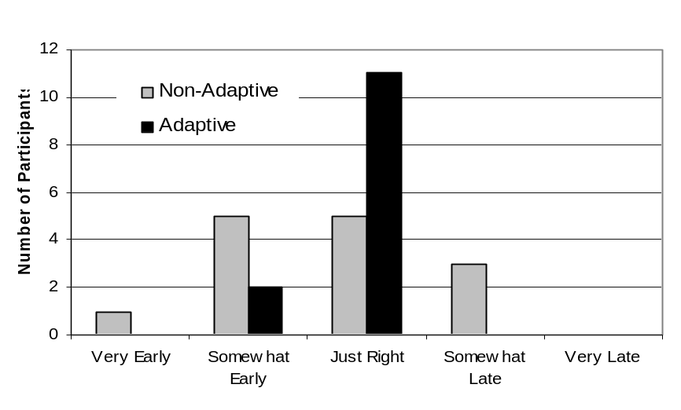
Figure 11.21. FCW Alert Timing as Rated by Drivers.

FCW Alert Behavior
Participants’ expectations of alert behavior were measured on a 4-point Likert Scale. Drivers were slightly more likely to agree that the adaptive mode (M = 3.29, SD = .61) behaved as they had expected it to as compared with the non-adaptive mode (M = 3.14, SD = .36) (see Figure 11.22). More participants ‘Strongly Agreed’ that the adaptive mode behaved as they had expected it to than the non-adaptive. One driver, who reported he ‘Somewhat Disagreed’ with the adaptive statement thought he had been looking forward when an FCW alert occurred. Another driver commented that he was “surprised at the adjacent lane warning”.
FCW Acceptability of Alert Frequency
Participants rated their agreement with the statement, “the frequency of FCW alerts would be acceptable to me, in my own car, during everyday driving”, on a 4-point Likert Scale. Respondents rated their agreement in the adaptive mode (M = 3.43, SD = .76) higher than in the non-adaptive mode (M = 2.57, SD = .85) (see Figure 11.22). Of the two drivers who chose ‘Somewhat Disagree’ for adaptive mode, one reported a preference for the non-adaptive mode, preferring the higher alert-rate.

Inevitably, the acceptance of alerts was partially influenced by individual differences. Some drivers responded to alerts by commenting that, “I must have been too close to that [lead] vehicle”, and seemingly accepted the alert as a correction. Other drivers, however, announced that they “had plenty of room”, and did not understand the reason for the warning. In a few cases, they seemed to view the alert as an unreasonable critique of their driving.

FCW Perception of Nuisance Alerts
Drivers were asked “what percentage of FCW alerts would you classify as nuisance warnings?” and chose between, 0% - 24%, 25% - 49%, 50% - 74%, or 75% - 100%. As shown in Figure 11.22, 13 out of 14 selections fell below 50% in adaptive, while only six of 14 fell below 50% in their non-adaptive ratings. Interestingly, participants differed in their interpretation of a ‘nuisance alert’. One driver commented that provided that the auditory and visual components did not annoy her, she did not consider it a nuisance alert. A second driver expressed that he did not classify them as nuisance alerts provided that, “I understood why I was getting them”.

FCW Acceptability of Nuisance Alert Frequency
As a follow-up to question, drivers were asked to rate their agreement with, “the frequency of nuisance FCW alerts would be acceptable to me, in my own car, during everyday driving”. The mean response, on a 4-point Likert Scale was higher for adaptive (M = 3.43, SD = .65), than for non-adaptive, (M = 2.57, SD = .94) (see Figure 11.22).

FCW On-Road Safety
Drivers were asked to rate their agreement with “the FCW system enhances on-road safety”. The higher alert-rate in non-adaptive appeared to have only a small impact on drivers’ perceptions of safety. Adaptive mode (M = 3.36, SD = .50) was rated only slightly higher than non-adaptive (M = 3.21, SD = .70) (see Figure 11.22).

FCW Alert Distraction
Participants rated their agreement with, “the FCW system was distracting”. As shown in Figure 11.22, the non-adaptive mode received a higher rating (M = 2.00, SD = .96) than adaptive (M = 1.50, SD = .76). Drivers presumably found the adaptive mode less distracting because of the lower alert-rate and the explanation of the adaptation concept during training.

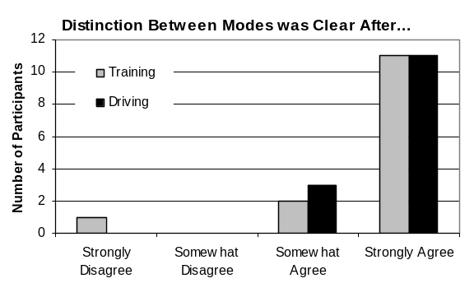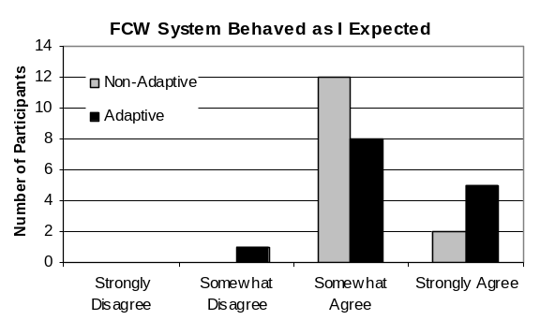
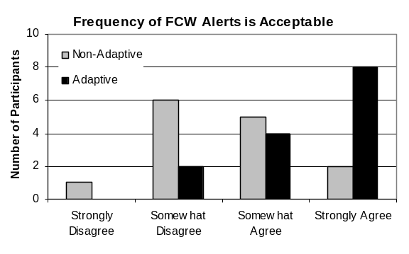
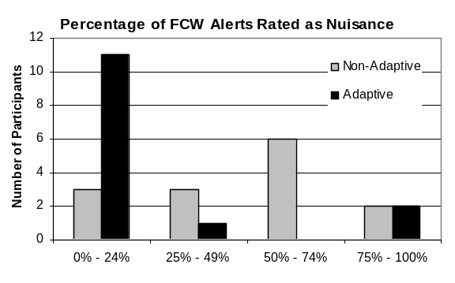
Figure 11.22. Subjective FCW ratings for Adaptation Understandability, Alert Behavior, Acceptability of Alert Frequency, Perception of Nuisance Alerts, Acceptability of Nuisance Alert Frequency, On-Road Safety, Alert Distraction, and Likelihood to Recommend.

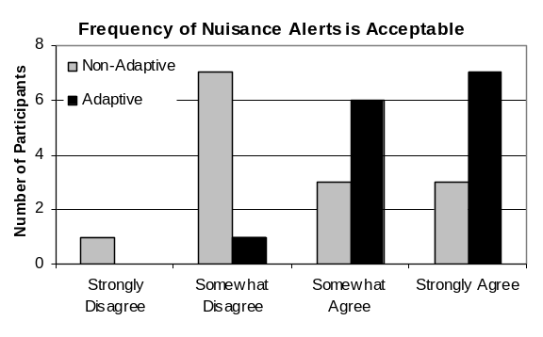
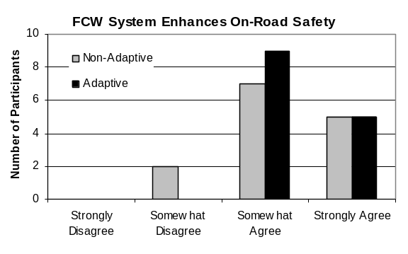
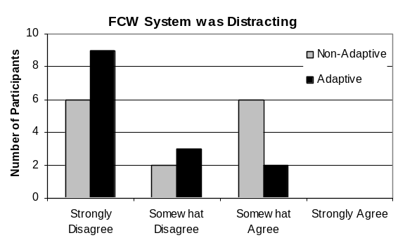
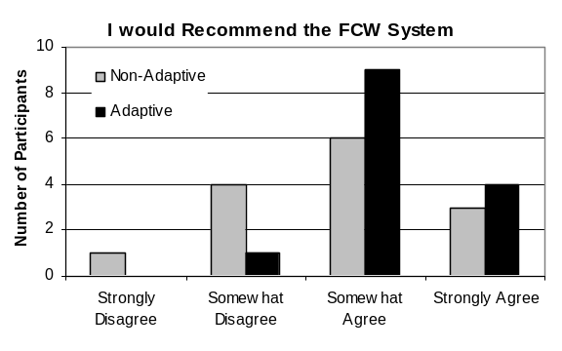

FCW Likelihood to Recommend
In order to ascertain drivers’ overall attitudes toward each mode, participants were asked to rate their agreement with the following statement, “I would recommend the FCW system to other drivers”, on a 4-point Likert Scale. The mean response for the adaptive mode (M = 3.21, SD = .58) was higher in comparison to the non-adaptive mode (M = 2.79, SD = .89) (see Figure 11.22). Only one of 14 disagreed in response to a recommendation of the adaptive mode, while five drivers disagreed with the non-adaptive mode. One of the three drivers who preferred the non-adaptive mode was the only driver to ‘Somewhat Disagree’ with an adaptive mode recommendation. He reported that, “adaptive seemed to filter virtually everything out”. One driver commented that she chose not to recommend non-adaptive because of the higher alert-rate, and added that this mode felt “too sensitive”. A second driver reiterated that comment by saying the non-adaptive mode felt “too sensitive and too proactive” and called it “annoying”. A third driver also reported that the non-adaptive mode could be “a little less sensitive”. He later added that he felt he had received alerts for turning lead vehicles that were “almost through the turn”, implying that those warnings were unnecessary. Another driver reported that she was more likely to recommend the adaptive mode because it was a “little more accurate”. One participant disagreed with the non-adaptive recommendation because there were “too many nuisance alerts”.

FCW Alerts
As FCW Alerts occurred during the drive, the researcher noted a location or landmark to identify it and drivers were asked to provide specific ratings for each of those alerts on the post-drive questionnaire. On 5-point Likert Scales (1 = Not at All and 5 = Very Much), drivers rated how threatening the situation was, whether they understood the alert, how annoying the alert was, how useful the alert was, how distracted they were at the moment of the alert, how much they needed the alert to avoid colliding with the lead vehicle, and how acceptable the alert was. They also responded to, “I would have preferred that this FCW was suppressed”, on a 4-point agreement scale. Ratings were obtained for each of the 83 FCW alerts. The mean rating and standard deviation for each question as a function of adaptation are displayed in Table 11.8, and as a function of the top three FCW causes in Table 11.9.

Table 11.8. On-Road FCW Testing: Alert Ratings by Adaptation.
 | Non-Adaptive  (n = 64) | Adaptive  (n = 19)
This situation posed a threat.² | 1.7 (0.8)¹ | 1.5 (0.8)
I understood the cause of this FCW.² | 4.0 (1.3) | 3.4 (1.7)
The FCW was annoying.² | 2.5 (1.1)* | 1.8 (0.9)*
The FCW was useful.² | 2.6 (1.1) | 2.1 (1.0)
I was distracted at the time of this FCW.² | 1.5 (0.8) | 1.4 (0.1)
I needed this FCW in order to avoid colliding with the vehicle in front of me.² | 1.3 (0.5) | 1.2 (0.4)
This FCW was acceptable.² | 3.2 (1.0) | 2.8 (1.3)
I would have preferred that this FCW was suppressed.³ | 2.5 (1.0) | 2.8 (1.0)
¹ Mean (SD)
² 5-point Scale (1 = Not at All 5 = Very Much)
³ 4-point Scale (1 = Strongly Disagree 4 = Strongly Agree).
* p < .05
There appear to be far fewer differences between ratings of the non-adaptive and adaptive modes than expected. The only significant different between non-adaptive and adaptive modes occurred for annoyance. Drivers rated the non-adaptive alerts (M = 2.5, SD = 1.1) as more annoying than the adaptive alerts (M = 1.8, SD = 0.9) (χ² (4) = 10.159, p = .038). Trends in results suggest that drivers may have had a slightly greater understanding of alert cause in non-adaptive (M = 4.0, SD = 1.3), than in adaptive (M = 3.4, SD = 1.7). While non-adaptive alerts were significantly more annoying, they were also slightly more useful (M = 2.6, SD = 1.1) and slightly more acceptable (M = 3.2, SD = 1.0) than their adaptive counterparts, (M = 2.1, SD = 1.0) and (M = 2.8, SD = 1.3). It is apparent that drivers did not consider themselves ‘distracted’ in either the non-adaptive (M = 1.7, SD = 0.8) or adaptive modes (M = 1.5, SD = 0.8), which raises an important consideration about the definitions and language applied to DSM and adaptive mode. Drivers might have been more likely to agree if the question referred to ‘non-forward’ head pose (e.g., checking a blind spot) rather than ‘distraction’. Providing a definition of the term ‘distraction’ in the context of this study to include all non-forward head poses (e.g., looking at a cell phone, doing a blind spot check) might have added more clarity to this question and reduced some of the negative connotation associated with it. The term, ‘distraction’, was likely misapplied in this question, particularly since it was not used during training. The large difference between the number of alerts in each category (non-adaptive = 64, adaptive = 19), likely contributed to the large number of results that were not significantly different.

Table 11.9. On-Road FCW Testing: Alert Ratings by Top Three FCW Causes.
 | Lead Vehicle Turning Out of Path  (n = 37) |  | Lead Vehicle Braking/ Slowing  (n = 21) |  | Host Vehicle Changing Lanes and Passing  (n = 17)
This situation posed a threat.² | 1.5 | (0.7) | 1.8 | (0.9) | 1.6 | (0.8)
I understood the cause of this FCW.² | 4.1 | (1.4) | 3.4 | (1.6) | 3.9 | (1.3)
The FCW was annoying.² | 2.5 | (1.1) | 2.2 | (0.9) | 2.3 | (1.1)
The FCW was useful.² | 2.3 | (1.1) | 2.7 | (1.1) | 2.5 | (1.3)
I was distracted at the time of this FCW.² | 1.4 | (0.8)* | 1.7 | (1.1)* | 1.5 | (0.7)*
I needed this FCW in order to avoid colliding with the vehicle in front of me.² | 1.2 | (0.4) | 1.4 | (0.7) | 1.2 | (0.4)
This FCW was acceptable.² | 2.8 | (1.1) | 3.3 | (1.2) | 3.4 | (0.8)
I would have preferred that this FCW was suppressed.³ | 2.7 | (1.0) | 2.5 | (1.0) | 2.5 | (0.8)
¹ Mean (SD)
² 5-point Scale (1 = Not at All, 5 = Very Much)
³ 4-point Scale (1 = Strongly Disagree, 4 = Strongly Agree).
* p < .05

The individual alert ratings provided an opportunity to further examine the three most common causes of FCW alerts, as perceived by the driver, lead vehicle turning out of path (n = 37), lead vehicle braking/slowing (n = 21), and host vehicle changing lanes and passing (n = 17). The only significant result was found in the ratings for distraction (χ² (6) = 15.477, p = .017). It is notable that drivers did not feel that any of the top three causes constituted a threatening situation, as the means for all causes were ≤ 1.8. Trends in the data show that drivers seemed to have had a greater understanding of lead vehicle turning out of path alerts, but also found them the most annoying, the least useful, and the least acceptable.

FCW HMI
Drivers were asked several questions about their HMI preferences, the first of which was, “of the two types of FCW alerts that you experienced, which one was best at capturing your attention?” All but one of the 14 respondents chose ‘audio’, χ²(1) = 10.29, p < .001 (see Figure 11.23). The next HMI question asked drivers, “which of the two warning types was most annoying?” The majority, 10 of 14 respondents, again selected ‘audio’. Three drivers added that they had not found either type of warning to be especially annoying. One driver, whose mode preference was non-adaptive, added that he selected ‘visual’ as most annoying, in part, because he anticipated that he might focus more on “the light than the lead vehicle’s bumper”. His observation is particularly interesting because this concern could be alleviated by using the adaptive mode, instead of non-adaptive. Another participant added that the light might be especially annoying in the dark.
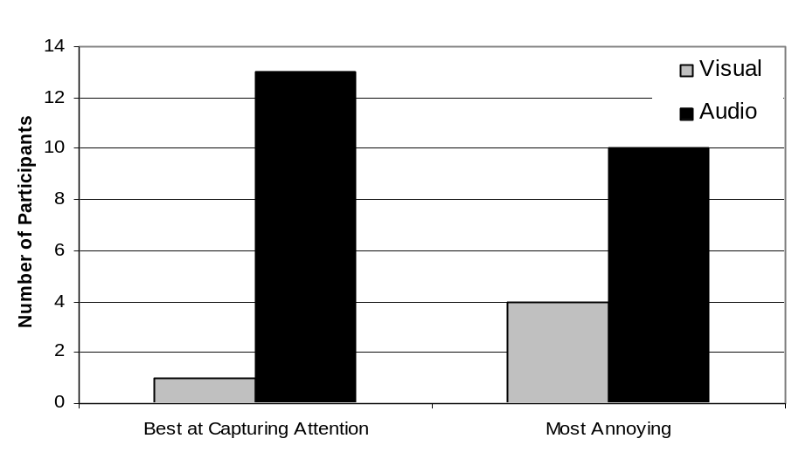
Figure 11.23. FCW HMI Ratings.

The next series of HMI questions asked drivers “if you were to receive an FCW alert while you were a) attentive, b) distracted, and c) fatigued, which combination of warnings would you prefer?” Responses to the attentive state were nearly equally distributed across ‘audio only’, ‘visual only’, and ‘audio and visual’ (see Figure 11.24). However, responses to the distracted and fatigued states showed a much stronger preference for ‘audio and visual’. A chi-square test indicated that the preference for the combination of warnings while distracted was significant, χ²(1) = 4.57, p < 0.03. A chi-square test indicated that the preference for warning type while fatigued was also significant, χ²(1) = 7.14, p < 0.01.
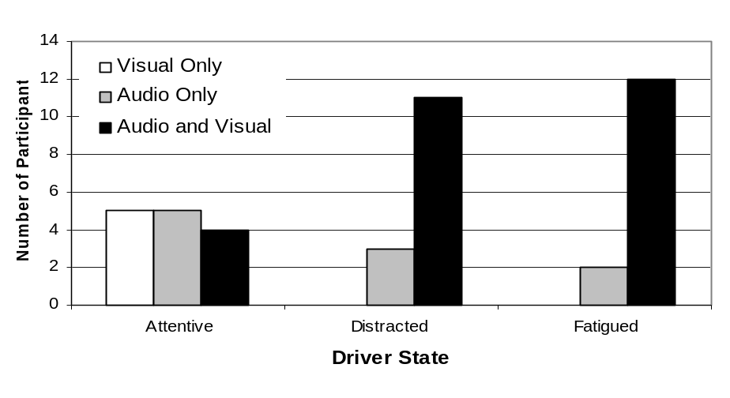

Figure 11.24. FCW HMI Preferences.

On a final note about drivers’ HMI experiences, several drivers found that the cover of the exogenous display was noticeably reflective on the windshield, and was in some cases, bothersome.

11.5.3. LDW Validation Method

Participants
Fourteen employees, eleven men and three women, at Delphi Electronics and Safety Systems in Kokomo, Indiana, participated in the on-road LDW study. Employees were invited to participate using the same method and were selected using the same criteria as the previous study. All participants were between 29 and 54 years of age, with a mean age of 42, had between 13 and 38 years of driving experience, and drove between 10,000 and 30,000 miles per year. Two participants wore contact lenses and 11 did not require any vision correction. Although driving without eyeglasses was a criterion for the study, one participant was included who wore them. Eleven of the participants (eight men, three women) were engineers, and the remaining three participants did not have a background in engineering. No driver participated in more than one of the data fusion studies.

Prior to testing, three of the 14 participants indicated that they were familiar with LDW systems to some degree, typically through exposure at work, participation in previous testing, or mainstream media. However, as with the FCW study, none of the 14 participants acknowledged that they were familiar with the concept of adaptation. Accident and driving history were not considered as part of the selection process. Participants were paid for their participation with a $75 Best Buy gift certificate.

Apparatus
Equipment used in this experiment included the same test vehicle, a 2000 Buick Le SABRE®, described in the FCW study. The LDW system consisted of a forward-looking camera and an HMI that included audio, visual, and haptic warnings. A rumble strip sound, four 125-msec bursts of 100 Hz tones served as the auditory LDW alert and was issued on the corresponding side of the lane crossing. The exogenous LDW alert consisted of a red LED, reflected onto the windshield. When activated, the exogenous display flashed three times at 5 Hz for 0.5 s. The LDW system also included the addition of a haptic warning. A HoMedics BK 4500 Back Massager was used for the haptic-seat warning. This consumer product is a car seat overlay with offset motors used to create vibration. It was modified to accommodate the needs of the experiment by adjusting it to provide vibration in four locations in the bottom of the seat when the warnings were issued. The motors used to provide the vibration on the back of the seat were disabled. The seat vibration was issued as a series of four 125-msec bursts, which corresponded to the direction of the LDW event, and lasted a total of 1 s. The audio, visual, and haptic warnings were activated simultaneously when an LDW alert occurred.

Design
All participants drove using the same LDW system, and experienced the same non-adaptive and adaptive modes of the warning system, the order of which was counterbalanced. The route was dictated by the researcher and consisted entirely of public roads. All driving took place on dry roads, on sunny or partly sunny days.

As in the FCW study, drivers were encouraged not to induce LDW events or to test the warning system. Likewise, the accompanying researcher had no control over the LDW system, the manner in which adaptation was applied to the warning system, or the actions of other drivers. While all participants generally drove the same route, there was some variation. The length of LDW drives varied between 76 mi and 155 mi, with an average of length of 149 mi. All drives took place on weekdays, departed Delphi Electronics and Safety Systems between 8:00am and 1:00pm, and typically lasted about 4 hours.

The goals of the LDW testing were identical to the previous study, that was to achieve a comparison of the non-adaptive versus adaptive modes by examining alert frequency, the effectiveness of adaptation, and drivers’ subjective experiences. Dependent measures included objective measures (i.e., alert-rate) and subjective ratings (i.e., mode preference, annoyance, acceptability, and HMI preferences).

Procedure
With the exception of the warning system details noted below, the procedure replicated that of the FCW drives. The researcher provided participants with the following information about the study:

The purpose of this drive is to evaluate a Lane Departure Warning (LDW) system. The intent of Lane Departure Warning systems is to warn drivers when they inadvertently drift out of their lane. In other words, the goal of a Lane Departure Warning system is to reduce the threat of drifting out of your lane into an adjacent lane, an opposing lane, or off of the road. The focus of this test is to evaluate two different versions of that LDW system, non-adaptive and adaptive.
A chart, similar to Figure 11.20, and adapted for the LDW system, was used as a visual aid. The researcher explained to participants:

In the non-adaptive mode, the LDW system provides all possible warnings to a driver, regardless of the driver’s head-pose. In adaptive mode, however, the LDW system monitors head-pose and suppresses LDW alerts when the driver’s head-pose is forward.

So, looking at the examples (see Figure 11.20), in the non-adaptive mode, the driver receives an LDW alert each and every time an LDW threat is detected. In adaptive mode, when the driver’s head-pose is very far to the left or very far to the right and the vehicle detects an inadvertent lane departure, the driver receives an LDW alert, however, when the driver’s head-pose is forward, or straight-ahead, an assumption is made that their attention is forward, they are likely aware of the situation, and can be expected to respond appropriately. In those cases the warning is turned off, or suppressed. Finally, the LDW system has a minimum activation speed of 40 mph, so below that speed, the system is completely inactive.

The researcher then asked the driver to look forward, as they would while driving, and demonstrated the LDW alert three times for the participant, pointing out the auditory, visual, and haptic components of the warning. During the drive, the researcher provided turn-by-turn directions to the drivers, as needed. At no time were drivers asked to engage in a secondary task. The LDW route primarily covered three areas: Indiana State Route 26, Interstates 65, 70, and 465 in and around Indianapolis, IN, and U.S. Highway 31 (See Table 11.10, for a description of the three areas).

Table 11.10. On-Road LDW Testing: Route Description.
 |  | Encountered as part of LDW Route
Location¹ | Description | Roadway Type(s) | Miles | Posted Speed |  | Traffic Lights
 |  |  |  | Min. | Max. | Traffic Lights
Indiana State Route 26 | Russiaville, IN  Sedalia, IN  Rossville, IN | 2-lane rural highway  Bends, Straight | 36 | 30 mph | 55 mph | 6
Interstate | I-65  I-70  I-465 | 6-lane interstate  Rural, Suburban, City  Bends, Straight | 79 | 55 mph | 70 mph | 0
U.S. Highway 31 | Carmel, IN  Westfield, IN  Kokomo, IN | 4 - 6 lane divided highway  Straight | 40 | 45 mph | 60 mph | 26
¹Description represents complete LDW Route.

Halfway through the drive, at approximately 70 mi for most drives, the researcher switched the LDW system to the second mode, again reminded drivers of the concepts (non-adaptive and adaptive) that were introduced during training, and emphasized the distinction between the two halves. Participants were generally more familiar with the State Route and Highway than Interstate portions of the drive.

When a driver did receive an LDW alert, the researcher asked them to report the direction of the alert, which, in all cases, matched the researcher’s perception. Due to circumstances unrelated to the study, one drive was cut short and did not include the Interstate or Highway portions of the route.

11.5.4. LDW Validation Results
Although drivers were strongly encouraged not to induce alerts, it seemed especially tempting to test the LDW system, and in two different instances drivers intentionally triggered an LDW alert by crossing into the adjacent lane or onto the shoulder of the Interstate. Those two LDW events were not included in the final analysis. While several drivers interacted with their cell phones to turn off a ringer, for example, no driver engaged in a cell phone conversation while driving.

LDW Alert Rates
In the non-adaptive and adaptive modes, participants experienced a total of 85 LDW alerts, 81 and 4, respectively. The mean number of alerts received by drivers was higher in the non-adaptive mode (M = 5.79, SD = 5.12) than the adaptive mode (M = .29, SD = 0.62), t(26) = 3.99, p < 0.01. The rate of suppression reported in Table 11.11 is an approximate estimate based on the difference in the number of alerts experienced in non-adaptive and adaptive modes for that portion of the testing. It is evident that the variation in driving styles also influenced the number of LDW alerts that drivers experienced. In part, a variation in the driving styles contributed to drivers receiving a range of total alerts between two and 19.

LDW alerts occurred at a higher rate per mile in non-adaptive (M = .07, SD = 0.05) than in adaptive (M = .004, SD = .01), t(26) = 4.99, p < 0.01. A summary of miles traveled, alerts, and suppression rates are shown in Table 11.11. An examination of road type revealed that the mean alert-rate per mile was not significantly different for interstate (M = 0.04, SD = 0.06) as compared with highway (Route 26 and Highway 31 combined) (M = 0.03, SD = 0.02), t(25) = -.374, p = 0.71. The researcher did, however, observe that LDW alerts generally occurred more frequently while traveling through bends than on straight portions of the roadway, independent of road type.

Table 11.11. On-Road LDW Testing: Alert Rate, Total Miles, and Suppression Rate.
Non-Adaptive | Adaptive |  | Overall |  | Rate of Suppression
Indiana State  Route 26 |  | Miles |  | 288 |  | 252 |  | 540 | 95%
 |  | Alerts |  | 21 |  | 1 |  | 22 | 95%
 |  | Mean Alerts |  | 2.63 |  | 0.14 |  | 1.47 | 95%
 |  | Alerts per Mile |  | 0.07 |  | 0.004 |  | 0.04 | 95%
Interstate |  | Miles |  | 506 |  | 521 |  | 1027 | 95%
 |  | Alerts |  | 43 |  | 2 |  | 45 | 95%
 |  | Mean Alerts |  | 3.31 |  | 0.15 |  | 1.73 | 95%
 |  | Alerts per Mile |  | 0.08 |  | 0.004 |  | 0.04 | 95%
U.S. Highway 31 |  | Miles |  | 244 |  | 280 |  | 524 | 94%
 |  | Alerts |  | 17 |  | 1 |  | 18 | 94%
 |  | Mean Alerts |  | 1.21 |  | 0.07 |  | 0.64 | 94%
 |  | Alerts per Mile |  | 0.07 |  | 0.004 |  | 0.03 | 94%
Overall |  | Miles |  | 1038 |  | 1053 |  | 2091 | 95%
 |  | Alerts |  | 81 |  | 4 |  | 85 | 95%
 |  | Mean Alerts |  | 5.79 |  | 0.29 |  | 6.07 | 95%
 |  | Alerts per Mile |  | 0.07 |  | 0.004 |  | 0.04 | 95%

Unless otherwise noted, all 14 drivers responded to each of the following questions.

LDW System and Adaptation Understandability
Following completion of the drive, participants were asked to rate their agreement with the following statement, “the distinction between non-adaptive and adaptive modes was clear after a) training and b) driving”, on a 4-point Likert Scale. Respondents typically agreed that the distinction was clear after both training (M = 3.79, SD = 0.43) and driving (M = 3.79, SD = 0.43). None of 14 participants disagreed with either of the two statements.

Drivers were then asked, “how would you explain the LDW system in detail to someone who was unfamiliar it?” Again, some participants failed to provide complete answers, but two out of the 14 responders provided answers that did not meaningfully capture the critical attributes of the system and were labeled as incorrect. One driver said the, “non-adaptive system works by detecting where you are in the lane without compensating for little corrections; [and the] adaptive system compensates for little corrections…” A second participant answered that, in addition to the lane departure warning, “a warning will sound as the driver is distracted from paying attention to what is in front of the vehicle as it is moving”. A lack of task-engagement or insufficient training are plausible explanations for these incorrect responses. Unlike the respondents with incorrect answers in the FCW study, both of these participants were engineers.

More drivers in the LDW study correctly answered this question than in the FCW study. This is likely attributable to drivers’ perception of the LDW system as a more tangible concept, one that does not require a consideration of variables like time headway, range, or deceleration rate. In fact, after being told during training that the LDW system will provide an alert when a driver has drifted out of their lane, one participant quickly said, “I’ll have to tell my wife they’ve automated her!” However, the transparency of the LDW concept did not necessarily translate to LDW events on the drive. Participants often commented that they did not understand an LDW alert or did not perceive their vehicle as being close enough to a lane marker to warrant the alert.

LDW Preferred Mode
When asked which mode of the LDW system they would prefer to use, more drivers chose adaptive (n = 12), than non-adaptive (n = 2), χ²(1) = 7.14, p = 0.008. All 14 drivers received more alerts during the non-adaptive portions of their drives than the adaptive. Of the twelve drivers who expressed a preference for adaptive mode, almost all reported the lower alert-rate as the foremost reason for choosing adaptive mode. Similar to the FCW training, the pre-drive LDW explanation likely contributed to their understanding and acceptance of the lower alert-rate.

Drivers who preferred the non-adaptive mode offered a number of reasons. One driver, who received three non-adaptive and zero adaptive warnings, indicated that he appreciated the warnings and that they “helped me to focus”. He went on to say that receiving the warnings in non-adaptive mode confirmed for him that the LDW “system was working and helping me” and he did not consider the increased alert-rate to be a negative attribute. A second driver, who received the same proportion of alerts, said that the adaptive system “felt unresponsive” and the LDW alerts were “acceptable”. In addition to these two drivers, nine other drivers experienced zero alerts in adaptive mode and several expressed concern to the researcher during the drive that the system was not on or working properly. One driver commented, “[I] did not even know it was there”. It seems that an extended absence of alerts, combined with a lack of feedback about system status, might actually create mistrust of the LDW system for some drivers.

As in the FCW study, this result is qualified by drivers’ strong tendency to cite alert-rate as their reason for preferring the adaptive mode. Drivers also had a tendency to respond more to the behavior of the LDW system than to the nuances of the adaptation strategy. Particularly noticeable to drivers were anomalies in the LDW alerts, including alert triggers such as seam lines in the pavement or tire skid marks on the road surface. Interestingly though, none of the LDW participants anticipated the problem of drivers receiving too many alerts overtime and becoming unresponsive to them, a concern expressed by several FCW drivers. This is unlikely due to the actual number of total alerts experienced in LDW as compared to FCW, 85 and 83 respectively, since they were so similar. Drivers may, however, have perceived the severity of an FCW versus LDW threat differently. If the consequences of not responding to an FCW alert are greater than that of an LDW, then any degradation of reaction time to an FCW alert might have a far greater negative impact.

LDW Alert Timing
On a 5-point Likert Scale, drivers reported their perception of the timing of LDW alerts. Participants rated the adaptive mode (M = 3.11, SD = 0.33) slightly closer to ‘Just Right’ than non-adaptive (n = 9, M = 2.57, SD = 0.76) (see Figure 11.25). Five drivers who received zero adaptive alerts, did not provide a response. The biggest difference between the two modes was six drivers rating non-adaptive as ‘Very Early’ or ‘Somewhat Early’, whereas adaptive did not receive any early ratings.
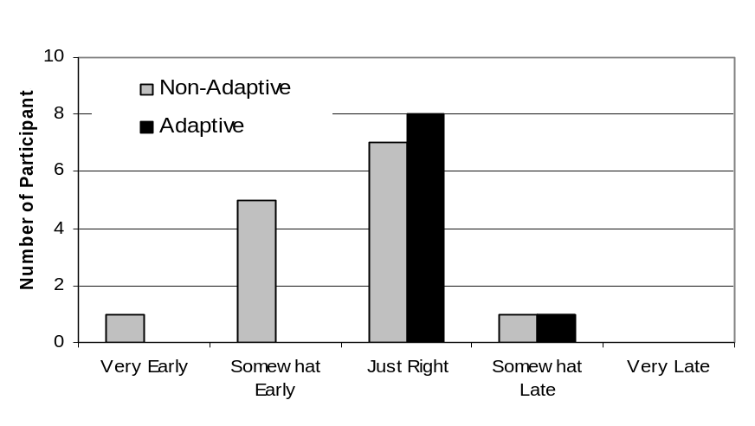
Figure 11.25. LDW Alert Timing as Rated by Drivers.

LDW Alert Behavior
A 4-point agreement scale measured drivers’ responses to, “the LDW system behaved as I expected it to”. Adaptive mode (n = 13, M = 3.69, SD = 0.48) received a higher agreement rating than non-adaptive (M = 3.29, SD = 0.73) (see Figure 11.26). One driver who was the recipient of zero alerts in adaptive did not provide a response for that mode. Two drivers ‘Somewhat Disagreed’ that the non-adaptive mode behaved as they had expected it to, while there was no ‘Disagreement’ with adaptive mode. One driver who disagreed with non-adaptive, said that it, “alarmed on a curve that I was taking normally and [I was] still within my lane [and it] alarmed on a wide lane where I was not near the center line”. A second driver who provided the same response, wrote, “I didn’t perceive to be out of my lane or moving out of my lane when it went off”. Drivers who ‘Somewhat Agreed’ with the non-adaptive statement offered similar sentiments: “there were a couple of times I didn’t believe I was drifting” and “I think the non-adaptive went off several times, even though the car was not crossing over the lanes”.

A point of confusion about the LDW system was evident in the following response, the non-adaptive mode “alerted several times when switching between lanes, but not having any issues (i.e. looking straight ahead, no obstructions, etc)”. It seems that this participant might have confused the purpose of the LDW system with that of a blind-spot detection system, a problem evident in an earlier answer from this driver.

A second misconception about the intention of the LDW system also influenced a driver’s response to this question. One driver, who responded ‘Somewhat Agree’ to adaptive, commented, “I enjoy driving and seeing things I haven’t noticed or something new, I thought for sure the system would catch me”. As evidenced in a prior response, this driver failed to realize that head pose is only relevant during lane departure events.

One driver who ‘Somewhat Agreed’ in the adaptive mode commented, “in one case I thought I was looking ahead and it went off when car drifted left. I was OK with the alarm, my eyes were partially focused on vehicle to my right and ahead”. This comment seems to imply a possible lack of distinction between eye gaze and head pose. More comprehensive pre-drive training might have prevented errors like these. As is also strongly evidenced by these comments, it can be challenging for drivers to consider the nuances of adaptation without focusing on the behavior of LDW system itself.

LDW Acceptability of Alert Frequency
Participants rated their agreement with, “the frequency of LDW alerts would be acceptable to me, in my own car, during everyday driving” higher in adaptive (M = 3.57, SD = .65) than in non-adaptive (M = 2.07, SD = .83) (see Figure 11.26). While only one driver in adaptive disagreed, 11 drivers disagreed with the non-adaptive statement. This ratio follows a similar pattern in the FCW testing. Across warning systems, alert-frequency appears to be one of the most salient attributes to drivers.

LDW Perception of Nuisance Alerts
Participants indicated what percentage of LDW alerts they classified as nuisance alerts. While drivers responded with a full range of answers in non-adaptive, all 14 participants selected “0 – 24%” in adaptive mode (see Figure 11.26). This result seems to be driven by individual perception of what constitutes a nuisance alert, in addition to the number of alerts in each mode. Whereas in non-adaptive, the number of alerts ranged from two to 19, adaptive mode alerts ranged from zero to two, with 11 drivers receiving zero adaptive alerts.

LDW Acceptability of Nuisance Alert Frequency
Drivers were asked to rate their agreement with the statement, “the frequency of nuisance LDW alerts would be acceptable to me, in my own car, during everyday driving”, on a 4-point Likert Scale. In accordance with the results from the previous question, drivers reported a higher level of agreement in adaptive (M = 3.36, SD = .74), than in comparison with non-adaptive (M = 1.86, SD = .77) (see Figure 11.26). Respondents were equally split between agree and disagree in adaptive mode, while only three of the 14 drivers agreed with the statement in response to the non-adaptive question.

LDW On-Road Safety
Participants rated their agreement with, “the LDW system enhances on-road safety”. Most respondents agreed, with the level of agreement being slightly lower in non-adaptive (M = 3.21, SD = .89) than in adaptive (M = 3.79, SD = .43) (see Figure 11.26). Two participants did not agree that the non-adaptive mode enhanced safety. Based on comments provided in other questions, the higher level of agreement in adaptive is thought to correspond to a lower nuisance alert-rate.

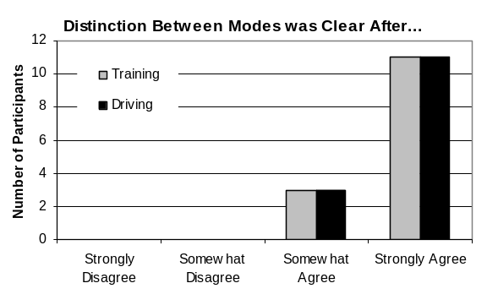
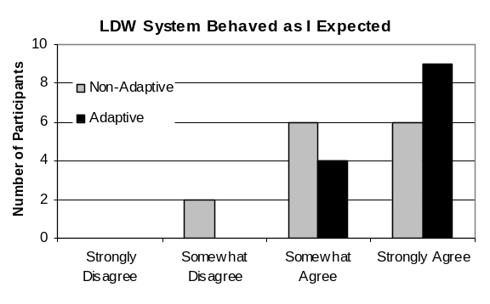
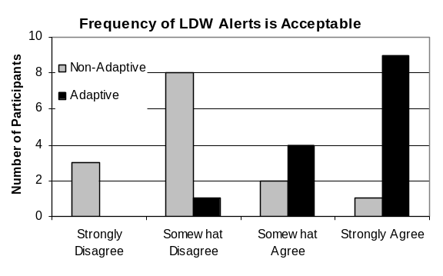
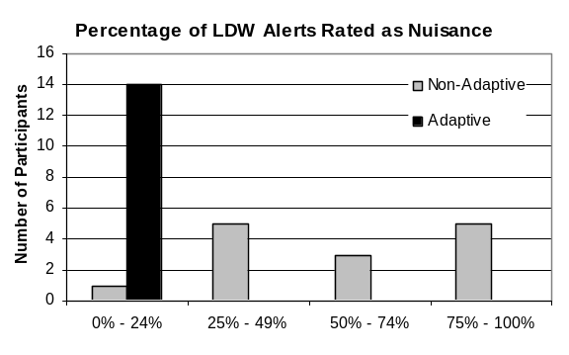
Figure 11.26. Subjective LDW ratings for Adaptation Understandability, Alert Behavior, Acceptability of Alert Frequency, Perception of Nuisance Alerts, Acceptability of Nuisance Alert Frequency, On-Road Safety, Alert Distraction, and Likelihood to Recommend.

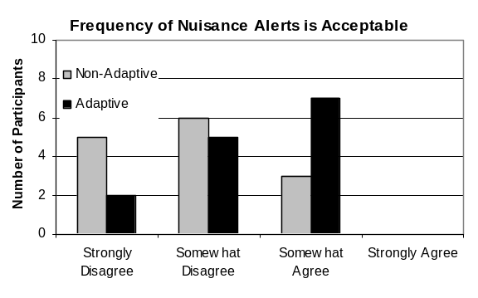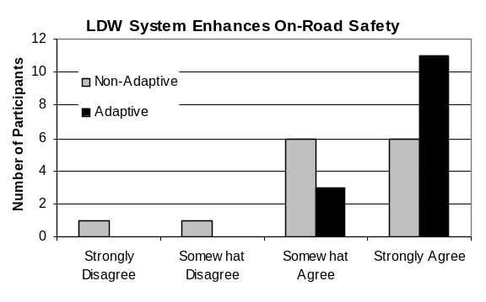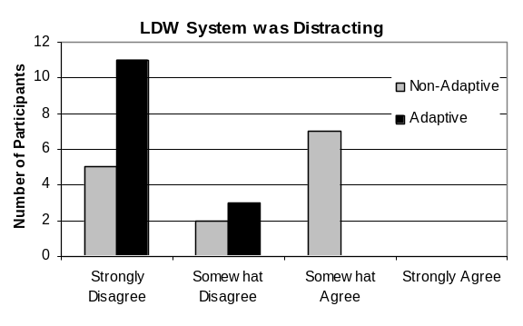
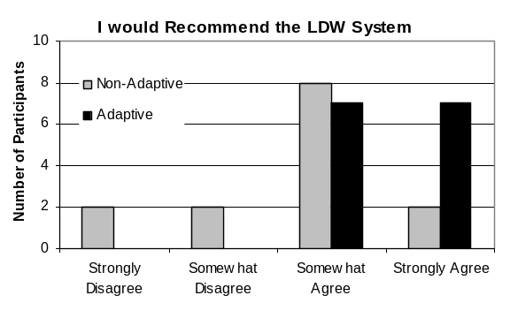

LDW Alert Distraction
As shown in Figure 11.26, a higher nuisance alert-rate in non-adaptive is also thought to have influenced drivers’ response to, “the LDW system was distracting”. Non-adaptive mode (M = 2.14, SD = .95) received a higher agreement rating than adaptive mode (M = 1.21, SD = .43), indicating that participants regarded the system as more distracting in the non-adaptive mode.

LDW Likelihood to Recommend
In an effort to measure drivers’ overall experiences with each mode, participants were asked to rate their level of agreement with the statement, “I would recommend the LDW system to other drivers”. The results revealed that drivers had a slightly higher level of agreement with adaptive mode (M = 3.50, SD = .52) than they did with non-adaptive mode (M = 2.71, SD = .91) (see Figure 11.26). Four drivers disagreed that they would recommend the non-adaptive system, while all 14 respondents agreed with the adaptive mode. One participant said he could not recommend the non-adaptive mode because of the need to “reduce/eliminate false alarms”. Other drivers said, “I wouldn’t have it go off quite as early”, “change [it] to be more like the adaptive system”, and “nuisance warnings were a bother.” After agreeing to recommend the adaptive mode, one driver wrote, “I would make [the] adaptive feature on/off. If driving tired or in bad weather I may want the earlier/more frequent warning”.

LDW HMI
Drivers were asked several questions about their HMI preferences. The response to the first question, “of the three types of LDW alerts that you experienced, which one was best at capturing your attention?” was unanimous. All 14 participants agreed that the ‘haptic’ alert was best at capturing their attention (see Figure 11.27).

The next question, “which of the three LDW alerts was most annoying”, yielded less decisive results. Results were distributed across the three warning types, χ²(2, n = 14) = 1.00, p < .61, with ‘audio’ being rated as most annoying and ‘haptic’ as the least (see Figure 11.27). One driver, whose mode preference was non-adaptive, said that he chose ‘visual’ as most annoying because “it didn’t get my attention as well as the other two”. A second driver said that he found himself “focusing on the light”, while in non-adaptive mode, but ultimately appreciated the purpose of an exogenous display for distracted drivers in adaptive mode. Another driver agreed and said that since the exogenous display is “right in [the driver’s] line of sight, it felt distracting”. Observations like these may have also contributed to drivers’ overall preference for the adaptive mode, across both studies.
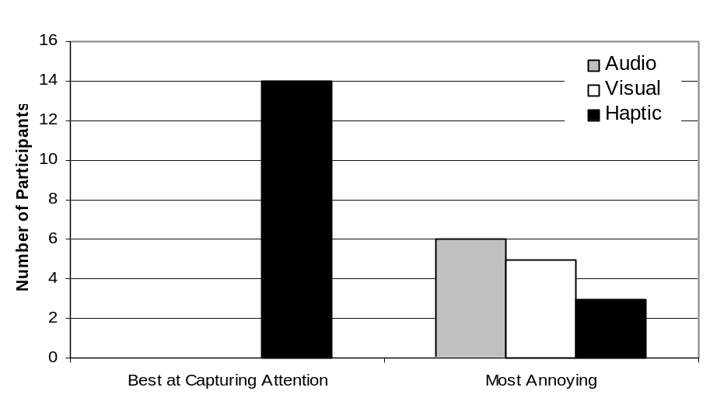
Figure 11.27. LDW HMI Ratings.

Drivers had a unique reaction to the haptic seat as a warning device. The researcher observed that many drivers were surprised when this particular warning method was introduced during the demonstration and it almost always prompted a remark from drivers. Several participants commented about the novelty of a vibrating seat in a vehicle, since auditory alarms and displays have become so ubiquitous. Upon receiving the demonstration, one driver announced the haptic warning was “like a Disney World-experience”. All drivers found the seat in combination with the directional component of the warning, to be salient throughout the drive.

The next series of HMI questions asked, “If you were to receive an LDW alert while you were a) attentive, b) distracted, and c) fatigued, which combination of the two warnings would you prefer?” Responses reflected drivers’ strong impressions of the haptic seat. Participants’ selections were nearly evenly distributed between ‘Visual and Haptic’ and ‘Audio and Haptic’. Only one participant chose the combination that did not include the haptic component, ‘Audio and Visual’. This participant later commented that removing the “haptic warning might make [the warning system] more acceptable”. For distracted drivers, participants had a clear preference for the ‘Haptic and Audio’ combination, with only driver selecting a different combination, ‘Visual and Haptic’. Following a similar pattern for fatigued operators, drivers again expressed a strong preference for the haptic seat paired with the auditory warning, with all 14 participants selecting this same combination (see Figure 11.28 for a summary of HMI preferences). There is a noticeable contrast between the LDW HMI responses and those in the FCW study. Drivers in the previous study reported a strong preference toward ‘Audio and Visual’ for distracted and fatigued drivers, while none of the LDW drivers selected this combination for either state. It appears then that when the haptic seat is introduced as a third warning alternative, nearly all participants viewed it as an especially effective warning method.

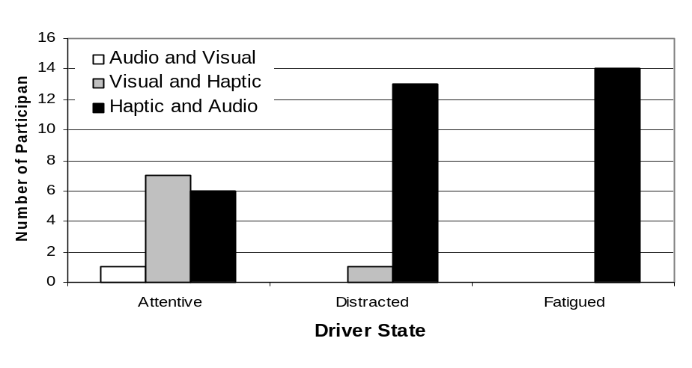

Figure 11.28. LDW HMI Preferences.

A second explanation for why LDW drivers, in comparison to FCW drivers, did not express concern about operators becoming too tolerant of frequent alerts (see LDW Preferred Mode), might be the addition of the haptic component of the warning. Drivers viewed the seat vibration as a unique warning method, the best for attention capture, but also the least annoying of the three different warnings. While it seems that these attributes might have helped to resolve concerns about the warning lacking saliency over time, long-term exposure is required to validate these initial opinions. Finally, as was the case in the FCW study, several drivers commented that the cover of the exogenous display was noticeably reflective in the windshield, particularly on tree-lined streets in sunny weather.

11.5.5. Discussion
After establishing the final adaptation strategies and HMI through the process of iterative testing and development, the data fusion task conducted an evaluation of the optimized SAVE-IT configuration in the context of real roadways. The final adaptation strategies and HMI were the focus of 28 on-road drives wherein drivers experienced either the FCW or LDW systems. These on-road drives afforded each participant a chance to contrast the non-adaptive mode with SAVE-IT adaptation, and resulted in a number of dependent measures, across two studies.

It was anticipated that drivers would prefer the SAVE-IT adaptation to the non-adaptive mode, across both warning systems. Drivers were expected to receive fewer alerts in adaptive, as compared to the non-adaptive mode, and to perceive the lower alert-rate as the more acceptable alternative. In addition to a lower frequency of alerts, drivers were expected to appreciate that adaptation was a function of head pose, and that the timing of the FCW alerts and the suppression of the LDW alerts were a direct result of adaptation. Subjective measures were intended to capture drivers’ perceptions of these attributes. It was expected that drivers would not only rate the adaptive version of each warning system as more acceptable and less annoying, but would appreciate that adaptive warnings were generated when the operator had a greater need for them. Inherent in these expectations is the assumption that drivers would be able to evaluate the adaptive strategies independent of the of the warning system behavior itself.

Objective results showed strong support for the SAVE-IT adaptation in terms of a reduction in overall alert-frequency. Drivers received significantly fewer alerts, and fewer alerts per mile, in the adaptive mode of both the FCW and LDW studies. The FCW and LDW warning systems both experienced high suppression rates, approximately 70% and 95% respectively. Significantly more drivers expressed a preference for adaptive mode in both studies, and when they did so, the most popular reason provided was the lower alert-rate, a result common to both studies. It appears that the difference in alert frequency between modes was the most salient aspect of both systems, and it directly influenced several subjective ratings. The trend across both warning systems was for drivers to report that the adaptive warning system was more acceptable, had fewer nuisance alerts, and was less distracting. It is likely that the pre-drive training also contributed to drivers’ preference and acceptance of the lower, adaptive, alert-rate.

Despite the strong preference for adaptive mode, the behavior of the adaptation strategies and the warning systems were not as transparent to drivers as anticipated. Several drivers expressed uncertainty about the behavior of the FCW system to the researcher during the drive. Although participants easily identified the target of FCW alerts, it was common for them to question why an alert had been generated when no threat of a forward collision was perceived. Upon further discussion, it was clear that, in at least a portion of these cases, drivers failed to consider the criteria for generating an alert (i.e., inputs to the radar: vehicle range, lead vehicle deceleration, and host speed), instead, basing their decision on their knowledge of lead vehicle’s intent (e.g., turning-out-of-path) or their own intent (e.g., quickly decelerating or changing lanes). From their perspective, an FCW alert seemed unwarranted if they knew the lead vehicle was turning or if they intended to depart their lane, regardless of range or speed at that particular moment. This proved to be especially problematic, not only in terms of understanding the behavior of the FCW system, but also for assessing the adaptation strategy. In these cases, drivers found it especially difficult to overcome their concerns about the validity of the alert and to consider attributes associated with adaptation (e.g., alert timing, head pose). At times, their contention that the alert was a nuisance warning, superseded a comparison of non-adaptive and adaptive modes. Similar examples occurred in the LDW testing too. However, understanding the LDW concept was far less problematic for drivers, likely because as a less tangible concept, FCW requires the consideration of a multitude of factors, like time headway, thresholds, and the behavior of other vehicles, whereas lane position is the single variable in the LDW system. In addition, when the study takes place in such a dynamic, naturalistic environment and no two events are ever identical, gaining an understanding of a warning system is especially difficult. While drivers still questioned, and sometimes disagreed with LDW alerts, the criteria for an alert was much more tangible. It seems then, that for an effective assessment of the FCW and LDW adaptation strategies, it is important for drivers to not only understand the concept of adaptation, but also to understand how and why alerts are generated by the warning system. It is apparent in the FCW and LDW studies that, had drivers been able to isolate the behavior of adaptation from that of the warning systems themselves, more consideration and concentration could have been given to head pose, alert timing (FCW), and alert suppression (LDW). It is clear then that the positive effects of adaptation come from the reduced frequency of alerts overtime, rather than interpretation of individual alerts.

Further, when asked to provide explanations on the post-drive questionnaire, several drivers submitted incorrect answers about both the intent of the warning systems and the purpose of adaptation. While this is likely a result of a lack of motivation and engagement with the task, it also suggests an opportunity to improve upon the current training method. Training might be enhanced by providing visual examples of what constitutes a ‘lane departure’ or an ‘imminent forward collision’, as well as an explanation about the factors used in assessing an FCW threat, like range, deceleration, and speed. Providing drivers with more examples of forward and non-forward head poses might better communicate what seem like abstract boundaries to some drivers. Finally, giving participants the chance to interact with the warning systems on a closed course or for a longer duration might provide an outlet for their curiosity, and more importantly, give them the opportunity form a realistic set of expectations about the behavior of the warnings, so the focus of on-road driving can truly be an assessment of adaptation.

Future studies might provide drivers with real time feedback about alerts that are suppressed in adaptive mode or those that would have been suppressed if adaptation had been active in order to aid in a comparison of the two modes. An opportunity to test on a closed track might help to eliminate some of the constraints of on-road testing, providing more frequent and controlled exposure, including distracted states, to FCW and LDW events. This type of testing was conducted as a portion of the Task 14 UMTRI evaluation and the Dana Test Track.

11.6. CONCLUSIONS AND SAVE-IT IMPLEMENTATION SUMMARY

Due to the overriding need to create simple interfaces that the driver would be able to comprehend, the most effective method for refining the countermeasures was to expose them to real on-road conditions and observe the associated behavior of the systems and the resulting driver responses. In driving simulators, the countermeasure tasks (Task 4: Distraction Mitigation and Task 9: Safety Warning Countermeasures) had investigated the effectiveness of the various countermeasures for improving safety. As a result of the observed effectiveness at improving safety in these tasks, some countermeasure strategies had already been abandoned prior to the data fusion task and other countermeasure strategies had been refined to differing extents. The primary need for data fusion was to examine the interaction between the countermeasures and the real world. For example, it was not yet clear what kinds of FCW alert rate would result from the differential timing strategy or what kinds of alert rates would result from the real-time distraction alerts. Furthermore, the driving simulator experiments were not an ideal venue for examining the acceptance of the different adaptive interfaces. Based on these needs, it was clear that the most important aspect of the data fusion task was to expose the SAVE-IT systems to real roadways. Based on the observed rates of interventions and the resulting driver acceptance and comments, the countermeasures were iteratively refined. The following final set of countermeasures emerged from the data fusion task and will be evaluated in Task 14 (evaluation):

Distraction Mitigation
- Adaptive Infotainment Availability and Advisory
- Adaptive Phone Management
- Trip report
Adaptive Warnings
- Adaptive Forward Collision Warning
- Adaptive Lane Departure Warning

- Adaptive Infotainment Availability and Advisory. As driving task demand increases, drivers are advised to shed more IVIS functions in order to concentrate on the driving task itself. Table 11.12 lists the advisories’ logic for the IVIS functions. The advisories are signaled by coloring the text of the buttons responsible for that function in an amber color that was dimmer than the normal color used for that text (see Figures 11.29 and 11.30). In addition to the color change of the button, the “Use Cautiously” text appeared just under the page heading to help communicate to the driver the intention of the adaptation. As the driving task demand gets to greater levels, some of the most demanding IVIS features are locked-out. Initially it was expected that the lock-out of features had the potential of being too annoying or too confusing, however the Task 4 results seemed to indicate that lock-out might be a potentially useful distraction-mitigation strategy if it could be implemented in a way that clearly communicates the intention to the driver. By using the gray-out effect that is now common in computer GUIs (graphical user interfaces), and clearly tying it to the text just below the page description, driver-confusion may be avoided. Whereas the Task 11 on-road testing provides a preliminary indication that drivers understand this mitigation strategy, Task 14 (evaluation) will specifically test whether this strategy is likely to have some counter-intuitive negative impacts on safety.

Table 11.12. Driving task demand-based advisories and lock-outs of IVIS functions
IVIS Task | Driving Task Demand
IVIS Task | In park | Low | Medium | High
Radio Tuning (r=.65) | No Advisories | No Advisories | No Advisories | No Advisories
Satellite Radio (r=.72) | No Advisories | No Advisories | No Advisories | Advisories
CD (r=.65) | No Advisories | No Advisories | No Advisories | Advisories
MP3 (r=.75) | No Advisories | No Advisories | Advisories | Advisories
Phone Dialing (r=.72) | No Advisories | No Advisories | Advisories | Lock-out
Answering Phone (r=.79) | No Advisories | Adaptive Phone Management
Phone Conversation (r=.72) | No Advisories
Navigation POI (r=.70) | No Advisories | No Advisories | Advisories | Lock-out
Navigation Map Reading (r=.79) | No Advisories | No Advisories | Advisories | Lock-out
Navigation Turn-by-turn (r=.61) | No Advisories | No Advisories | Advisories | Advisories
Text Messaging (r=.71) | No Advisories | Advisories | Lock-out | Lock-out

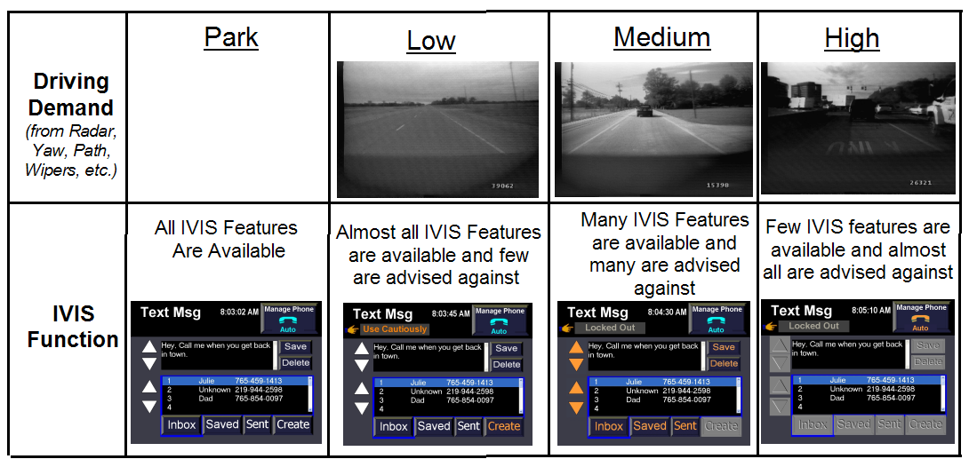
Figure 11.29. Task demand-based advisory and lockout for IVIS features.

- Adaptive Phone Management. Task 4 showed that driver-initiated mitigation methods are more acceptable to drivers than system-initiated methods. The distraction mitigation preparation portion of data fusion demonstrated that the perceived risk associated with phone functions increases with driving task demand. In order to optimize driver acceptance, drivers will be given three choices for phone screening: no screening, do-not-disturb and automatic screening (see Figure 11.31). If the driver selects automatic screening, the SAVE-IT system will determine whether a call should be routed to driver or to voice mail based on the concurrent driving task demand.

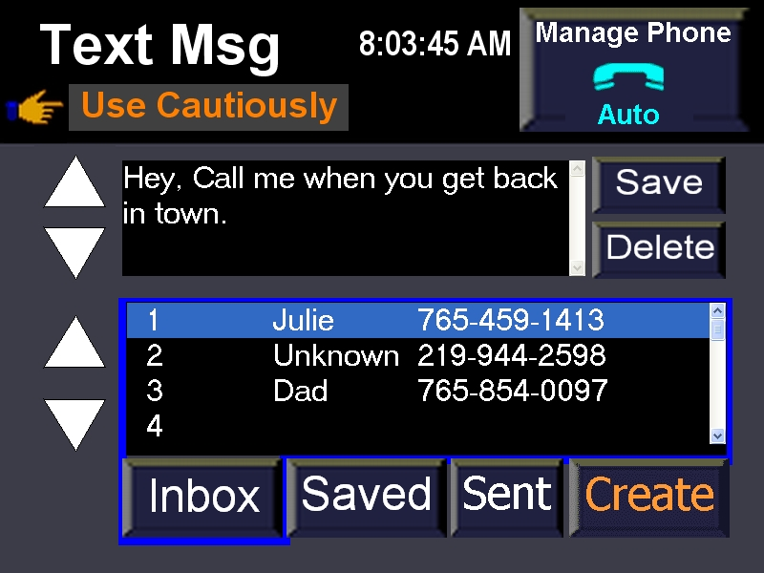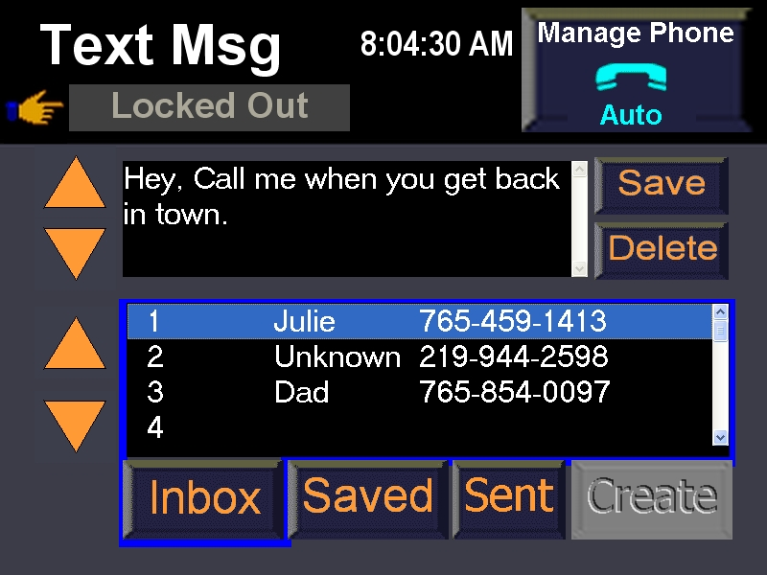
Figure 11.30. Task demand-based advisory (low demand) and lockout (medium demand) for creating text messages.

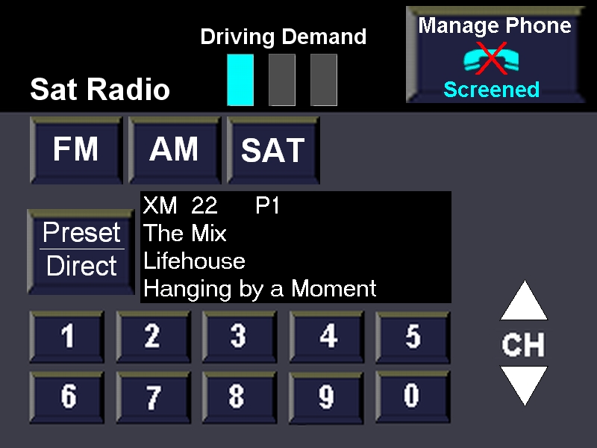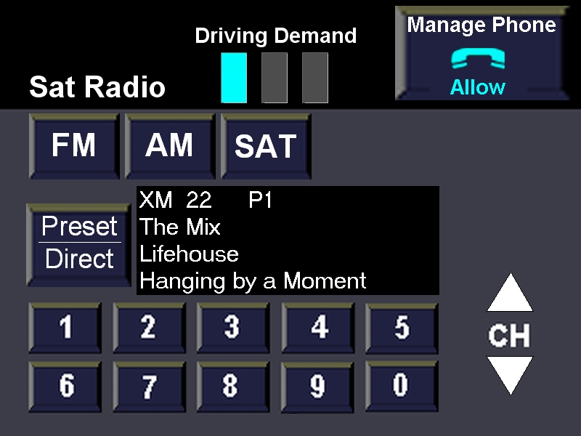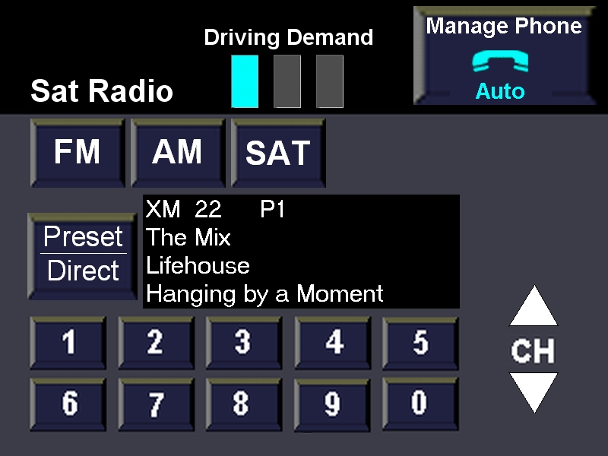
Figure 11.31. The three driver-selected modes of phone management. Only the auto mode (right) is responsive to the instantaneous assessment of driving-task demand.

- Trip report. In order to mitigate additional distraction by providing the driver with feedback in real time, a delayed feedback mechanism will be implemented in the form of a trip report. This report will be presented to the driver at the end of the drive. Drivers can review these reports and possibly modify their driving behavior on subsequent drives. The format of the trip report is displayed in Figure 11.32 and includes the driver’s percentage of forward head-pose overlaid on the trip route and an overall average attention level for the trip. This information is color coded to make it easier to interpret. The trip report also displays the number and location of FCW and LDW alerts. Because in production the trip report would ultimately be a voluntary countermeasure, in an attempt to trigger the driver’s curiosity, the trip report also displays the number of miles driven and the gas mileage for the trip.

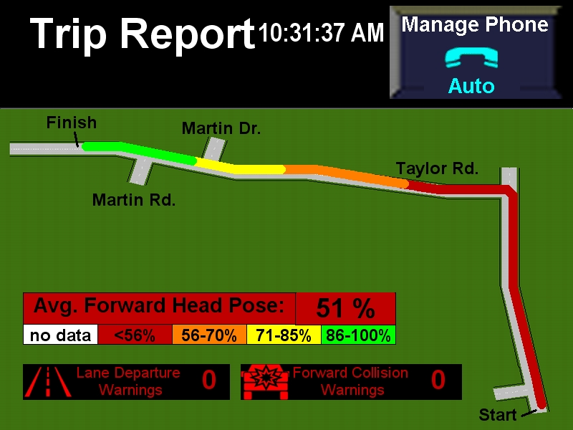

Driving Attention Level
Miles driven: 14.5 miles
Gas mileage: 25.6 mpg

Figure 11.32. The trip report format displayed to drivers at the conclusion of the trip, displaying the color-coded percentage of head pose forward for the trip, and the number of FCW and LDW alerts.

- Adaptive Forward Collision Warning. Table 11.13 displays the final system configuration for Adaptive FCW that was tested in Task 14 (Evaluation). After much research in Task 9 and some on-road acceptance testing in Task 11, the Differential Alert Timing strategy appeared to be the most promising. In this particular implementation, the timing adjustment for the forward attention state was quite extreme (assumed reaction time of 0.5 s) in order to suppress almost all alerts when the drivers head pose was forward. This adaptation method was selected because it at least provides some coverage for driver’s who are visually oriented to the forward scene but might benefit from an alert for some other reason (e.g., drowsiness or cognitive distraction). When the driver’s head pose is not forward, the driver will experience very early alerts that allow for a long driver brake reaction time. For a more complete description of the final FCW configuration, see Section 11.4.
Table 11.13. Adaptive and Non-Adaptive mode Forward Collision Warning as a Function of Driver Head Pose.

- The final form of adaptation that was selected for LDW was the suppression strategy (see Table 11.14). This strategy was selected because several drivers experienced confusion with the differential alert stimuli strategy (suppression of the auditory warning stimulus; see Task 9) because the interface lacked consistency. Due to the fact that cognitive distraction and brief or small-angle visual distractions do not appear to significantly degrade lane-keeping performance (see Tasks 5 and 9), LDW provides little safety benefit for visually-attentive drivers. For a more complete description of the final LDW configuration, see Section 11.4.

Table 11.14. Adaptive and Non-Adaptive mode Lane Departure Warning as a Function of Driver Head Pose.
The final SAVE-IT configuration also included a proximity alert that simply displayed a steady amber exogenous alert when the time headway to the lead vehicle fell below 0.5 s. Because this feature was not an adaptive interface, it was not a major focus of the Task 14 evaluation task. Furthermore, although the distraction alert (also utilizing the amber exogenous display) has been implemented in the SAVE-IT platforms, due to unresolved driver acceptance issues and the potential for distracting the driver, this feature will be disabled during the majority of the Task 14 evaluation testing. As it is implemented, the distraction alert flashes the amber exogenous display when the driver’s head pose is away from forward for a prolonged period of time that varies as a function of the headway to the lead vehicle. The other five countermeasures described above became the focus of the evaluations at the National Advanced Driving Simulator (NADS), on the Dana Test Track by the University of Michigan Transportation Research Institute (UMTRI), and at Ford’s VIRTTEX (VIRtual Test Track EXperiment) driving simulator. The results of these evaluations will be presented in separate SAVE-IT reports.

References
Angell, L., Auflick, J., Austria, P.A., Kochhar, D., Tijerina, L., Biever, W., Diptiman, T., Hogsett, J., & Kiger, S. (2006) Driver Workload Metrics Project: Final Report. Sponsored by National Highway Traffic Safety Administration, Washington, D.C., November 2006. DOT HS 810 635.

Cullinane, B., & Green, P. (2004). SAfety VEhicles using adaptive Interface Technology
(Task 2b): Visual Demand of Curves and Fog-Limited Sight Distance and Its
Relationship to Brake Response Time. Retrieved from: http://www.volpe.dot.gov/hf/roadway/saveit/docs/dec04/finalrep_2b.doc

Eby, D. W., & Kostyniuk, L. P. (2004a). SAfety VEhicles using adaptive Interface Technology (Task 1): Crashes and Driver Distraction: A Review of Databases, Crash Scenarios, and Distracted-Driving Scenarios. Retrieved from: http://www.volpe.dot.gov/hf/roadway/saveit/docs/dec04/litrev_1.pdf

Eby, D. W., & Kostyniuk, L. P. (2004b). SAfety VEhicles using adaptive Interface
Technology (Task 2a): Estimating driving task demand from crash probabilities: A review of the literature and assessment of crash databases. Retrieved from: http://www.volpe.dot.gov/hf/roadway/saveit/docs/dec04/litrev_2a.pdf

Eby, D. W., & Kostyniuk, L. P. (2004c). SAfety VEhicles using adaptive Interface
Technology (Task 2a): Using Michigan highway safety information system (HSIS)
data for estimating driving task demand. Retrieved from: http://www.volpe.dot.gov/hf/roadway/saveit/docs/dec04/finalrep_2a1.pdf

Edenborough, N., Hammoud, R., Harbach, A., Ingold, A., Kisačanin, B., Malawey, P.,
Newman, T., Scharenbroch, G., Skiver, S., Smith, M., Wilhelm, A., Witt, G.,
Yoder, E., & Zhang, H. (2004). Drowsy driver monitor from Delphi. Proceedings
of IEEE CVPR 2004, Washington, D.C., June 2004.

Donmez, B., Boyle, L., Lee, J. D., McGehee, D. V. (2004a). SAfety VEhicles using
adaptive Interface Technology (Task 4): A Literature Review of Distraction Mitigation Strategies. Retrieved from: http://www.volpe.dot.gov/hf/roadway/saveit/docs/dec04/litrev_4a.pdf

Donmez, B., Boyle, L., Lee, J. D., McGehee, D. V. (2004b). SAfety VEhicles using
adaptive Interface Technology (Task 4): Experiments for Distraction Mitigation
Strategies. Retrieved from: http://www.volpe.dot.gov/hf/roadway/saveit/docs/dec04/finalrep_4b.pdf

Kantowitz, B. H., & Premkumar, S. (2004). SAfety VEhicles using adaptive Interface
Technology (Task 6b): Identify Demand Levels of Telematic Tasks. Retrieved from: http://www.volpe.dot.gov/hf/roadway/saveit/docs/dec04/finalrep_6b.pdf

Klauer, S. G., Dingus, T. A., Neale, V. L., Sudweeks, J., and Ramsey, D. J. (2006). The Impact of Driver Inattention on Near-Crash/Crash Risk: An Analysis Using the 100-Car Naturalistic Driving Study Data. Virginia Tech Transportation Institute. National Highway Traffic Safety Administration. DOT HS 810 594. Washington, DC. Retrieved from: http://www-nrd.nhtsa.dot.gov/departments/nrd-13/driver distraction/PDF/DriverInattention.pdf

Lee, J., Reyes, M., Smyser, T., Liang, Y., Thornburg, K. (2004). Safety Vehicle(s) using adaptive Interface Technology (SAVE-IT): (Task 5) Final Report: Phase 1. Retrieved from: http://www.volpe.dot.gov/hf/roadway/saveit/docs/dec04/finalrep_5b.pdf

Scharenbroch, G. K. (2005). SAfety VEhicles using adaptive Interface Technology (Task 10): Technology Review. Retrieved from: http://www.volpe.dot.gov/hf/roadway/saveit/docs/dec04/finalrep_10.pdf

Smith, M. R. H., & Zhang, H. (2004a). A Final Report of SAfety VEhicles using adaptive Interface Technology (Phase I: Task 8). Retrieved from: http://www.volpe.dot.gov/hf/roadway/saveit/docs/dec04/finalrep_8b.pdf

Smith, M. R. H. & Zhang, H. (2004b). Safety Vehicle(s) using adaptive Interface Technology (SAVE-IT): Task 9 Final Report: Safety Warning Countermeasures. Retrieved from: http://www.volpe.dot.gov/hf/roadway/saveit/docs/dec04/finalrep_9b.pdf

Wang, J. S., Knipling, R. R., & Goodman, M. J. (1996). The role of driver inattention in
crashes; New statistics from the 1995 crashworthiness data system (pp. 377-
39). 40th Annual Proceedings of the Association for the Advancement of
Automotive Medicine. Vancouver, British Columbia.

Zhang, H. & Smith, M. R. H. (2004). Safety Vehicle(s) using adaptive Interface Technology (SAVE-IT): (Phase I: Task 7): Visual Distraction Research. Retrieved from: http://www.volpe.dot.gov/hf/roadway/saveit/docs/dec04/finalrep_7b.pdf

Zylstra, B., Tsimhoni, O., Green, P., & Mayer, K. (2004). SAfety VEhicles using adaptive
Interface Technology (Task 3B): Driving Performance for Dialing, Radio Tuning,
and Destination Entry while Driving Straight Roads. Retrieved from: http://www.volpe.dot.gov/hf/roadway/saveit/docs/dec04/finalrep_3b.pdf

The exception to this is that various forms of driver impairment (e.g., drowsiness) also degrade lane-keeping performance. A comprehensive system should also be capable of monitoring and providing countermeasures for driver impairment. Driver impairment is beyond the scope of the SAVE-IT program and so the driver will be assumed to be in a non-impaired state.
In actuality, the adaptive FCW system does provide an alert, although later, to drivers with a forward head pose. Given the simplified training method this study employed, the participant was not exposed to this level of detail about the timing suppression aspect of the adaptation strategy.
The advised-against functions are not locked-out and remain functional during advisory.
The exception to this is that various forms of driver impairment (e.g., drowsiness) are known to degrade lane-keeping performance. A comprehensive system should also be capable of monitoring and providing countermeasures for driver impairment. Driver impairment is beyond the scope of the SAVE-IT program and so the driver will be assumed to be in a non-impaired state.

